GEOBIT LARGE SPATIAL MODEL

Sample: Agriculture, Fresno County: report
Project: Sample: Agriculture, Fresno County
Goal: Describe the project Sample: Agriculture, Fresno County: run the analyses that tell the most about its data, draw every result, and write a cited report.
Run: 7221484b-d66d-48ff-94e1-dbedfe96dc7c (running, 12 agent run(s))
Generated: 2026-10-18T06:07:57Z, version 1
Model cost: USD 0.0000 over 5 model call(s)

Data used
Data | Kind | Rows | Time span | Summary | Source
Fields | vector, Polygon | 60 |  | 60 polygon (area) features; 'crop' has 5 values (top: tomato 16, almond 16, grape 11); 'irrigation' has 3 values (top: drip 28, micro sprinkler 22, furrow 10); 'area_ha' 43.1 to 43.1 (mean 43.1); 'planted_year' 2,008 to 2,025 (mean 2016); named by 'name' (e.g. Field 001 South, Field 002 South, Field 003 South); total area 25.83 km2; extent -120.0841,36.6269 to -120.0159,36.6731. Areas (Fields) with area_ha to compare and map. | [100]
Satellite scene 2026-04-15 | raster |  | 2026-04-15 | 4-band float32 raster (imagery), 300 x 250 cells; resolution 20; band 1 0.014 to 0.113; acquired 2026-04-15; extent -120.0844,36.6267 to -120.0156,36.6733. Imagery for visual and change analysis. | [101]
Satellite scene 2026-08-15 | raster |  | 2026-08-15 | 4-band float32 raster (imagery), 300 x 250 cells; resolution 20; band 1 0.015 to 0.145; acquired 2026-08-15; extent -120.0844,36.6267 to -120.0156,36.6733. Imagery for visual and change analysis. | [102]
Soil samples | vector, Point | 600 | 2025-10-01 to 2026-02-27 | 600 point features; dated by 'sampled_on' from 2025-10-01 to 2026-02-27; 'ph' 6.4 to 9 (mean 7.401); 'organic_matter_pct' 0.11 to 1.99 (mean 1.236); 'nitrate_ppm' 3.6 to 65.5 (mean 17.55); extent -120.0834,36.6274 to -120.0174,36.6729. Dated point events: where and when Soil samples happen. | [2]
Irrigation canals | vector, LineString | 5 |  | 5 line features; 'type' has 2 values (top: lateral 3, canal 2); 'capacity_cfs' 38 to 232 (mean 143); named by 'name' (e.g. Canal 1, Canal 2, Lateral 1); total length 26.99 km; extent -120.0838,36.6270 to -120.0162,36.6730. Lines (Irrigation canals) such as routes or networks. | [103]
Wells | vector, Point | 40 |  | 40 point features; 'depth_ft' 307 to 871 (mean 604.4); 'pump_hp' 75 to 200 (mean 140.6); 'static_level_ft' 120 to 418 (mean 282.7); extent -120.0823,36.6281 to -120.0188,36.6714. Point locations of Wells. | [104]
Pest scouting | vector, Point | 520 | 2026-04-01 to 2026-09-14 | 520 point features; dated by 'observed_at' from 2026-04-01 to 2026-09-14; 'pest' has 4 values (top: aphid 235, navel orangeworm 110, lygus 92); 'threshold_exceeded' has 2 values (top: False 374, True 146); 'count_per_trap' 0 to 13 (mean 4.477); extent -120.0833,36.6271 to -120.0169,36.6728. Dated point events by pest: where and when Pest scouting happen. | [3]
Weather stations | vector, Point | 3 |  | 3 point features; 'elevation_m' 57 to 65 (mean 61.67); named by 'name' (e.g. Farm weather station 1, Farm weather station 2, Farm weather station 3); extent -120.0663,36.6367 to -120.0366,36.6639. Point locations of Weather stations. | [105]
Yields by season | table | 300 | 2021-01-01 to 2025-01-01 | Table of 300 rows and 5 columns without geometry; dated by 'season' from 2021-01-01 to 2025-01-01; 'crop' has 5 values (top: tomato 80, almond 80, grape 55); 'yield_t_ha' 1.19 to 120.7 (mean 33.16); 'water_af_per_acre' 2.6 to 4.2 (mean 3.395). A table of Yields by season without locations. | [4]
Field operations | table | 272 | 2026-02-01 to 2026-09-27 | Table of 272 rows and 5 columns without geometry; dated by 'date' from 2026-02-01 to 2026-09-27; 'operation' has 4 values (top: cultivate 74, irrigate 68, spray 67); 'product' has 3 values (top: UAN-32 67, sulfur 65, water 64); 'rate' 5.1 to 59.9 (mean 33.66). A table of Field operations without locations. | [5]
Agronomist season notes | document |  |  | 1-page md document 'Agronomist season notes, August 2026'; language en; mentions 7 place(s): Field 001 South (1), Field 010 South (1), Field 017 South (1), Field 018 South (1), Field (1). A document about Field 001 South, Field 010 South, Field 017 South. | [106]
Sample: Agriculture, Fresno County | record |  |  |  | [107]
Summarize within: Fields | layer, Polygon | 60 |  |  | [108]
Summarize within: Fields | layer, Polygon | 60 |  |  | [109]
Summarize within: Fields | layer, Polygon | 60 |  |  | [110]
Emerging hot spots: Pest scouting | layer, Polygon | 48 |  |  | [111]
Emerging hot spots: Soil samples | layer, Polygon | 51 |  |  | [112]
Repeat and near repeat classification: Pest scouting | layer, Point | 520 |  |  | [113]
NDVI change Satellite scene 2026-04-15 to Satellite scene 2026-08-15 | layer | 0 |  |  | [114]
NDVI decrease / increase | layer | 0 |  |  | [115]
NDVI change polygons | layer, Polygon | 175 |  |  | [116]
Difference Satellite scene 2026-04-15 to Satellite scene 2026-08-15 | layer | 0 |  |  | [117]
Hot spot analysis: Pest scouting | layer, Polygon | 134 |  |  | [118]
Hot spot analysis: Wells | layer, Polygon | 13 |  |  | [119]
Hot spot analysis: Soil samples | layer, Polygon | 139 |  |  | [120]
Calculate density: Pest scouting | layer, Polygon | 937 |  |  | [121]
Calculate density: Wells | layer, Polygon | 75 |  |  | [122]
Calculate density: Soil samples | layer, Polygon | 953 |  |  | [123]
Find point clusters: Pest scouting | layer, Point | 520 |  |  | [124]
Find point clusters: cluster hulls | layer, Polygon | 4 |  |  | [125]
Find point clusters: Wells | layer, Point | 40 |  |  | [126]
Find point clusters: cluster hulls | layer, Polygon | 5 |  |  | [127]
Find point clusters: Soil samples | layer, Point | 600 |  |  | [128]

Timeline
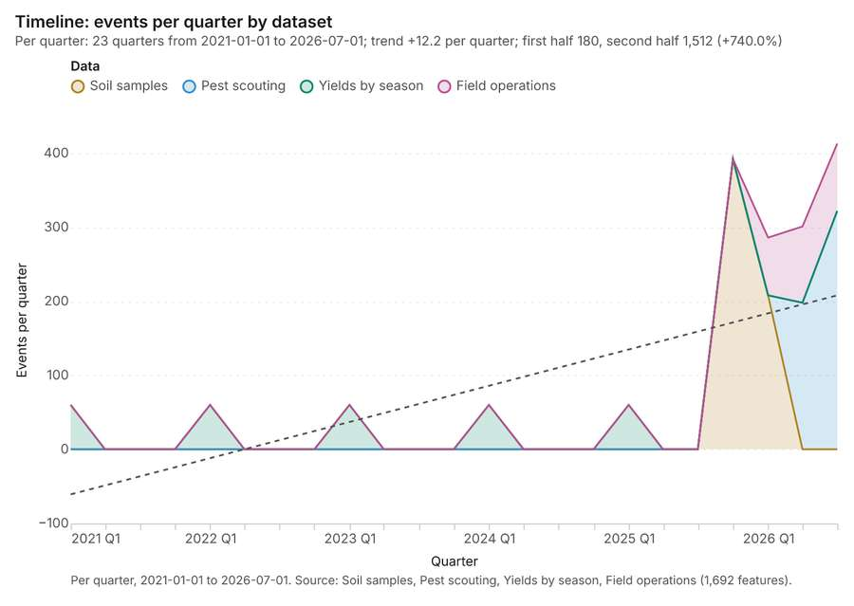
Figure 1. Timeline: events per quarter by dataset [1]. Per quarter, 2021-01-01 to 2026-07-01. Source: Soil samples, Pest scouting, Yields by season, Field operations (1,692 features). The data is in the appendix.
The timeline counts 1,692 dated events in Soil samples, Pest scouting, Yields by season and 1 more per quarter, from Q1 2021 to Q3 2026 [1][2][3][4][5]. By dataset: Soil samples 600; Pest scouting 520; Yields by season 300; Field operations 272 [1]. The trend is +12.2 events per quarter; the second half of the quarters has 1,512 against 180 in the first (+740.0%) [1]. 14 of the 23 quarters had no events [1].
Busiest quarters
- Q3 2026: 413 events [1]
- Q4 2025: 392 events [1]
- Q2 2026: 301 events [1]
Quietest quarters with events
- Q1 2021: 60 events [1]
- Q1 2022: 60 events [1]
- Q1 2023: 60 events [1]

Summarize within
What this analysis is. Summarize within: Count and aggregate the features inside each polygon (or bin), proportionally for lines and polygons [6]. In ArcGIS it is Summarize Within or Aggregate Points; in QGIS, native:countpointsinpolygon or native:sumlinelengths [6].
Why it was run on this data. Count Weather stations inside each feature of Fields; the counts map as a choropleth (natural breaks, sequential colors) [7].
What it found. Summarize within on Weather stations, Fields: Summarize within: 1 layer saved: Summarize within: Fields (60 features) [8][9][10]. It reported result, count 60; result, elapsed ms 2; billing, cost 0.01128; billing, list price 0.01128; billing, upstream cost 0 [8].
Result | Value
result, count | 60
result, elapsed ms | 2
billing, cost | 0.01128
billing, list price | 0.01128
billing, upstream cost | 0

Findings
- Evidenced: Summarize within on Weather stations, Fields: Summarize within: 1 layer saved: Summarize within: Fields (60 features) [8][9][10].
- Evidenced: It reported result, count 60; result, elapsed ms 2; billing, cost 0.01128; billing, list price 0.01128; billing, upstream cost 0 [8].
Tool gp_summarize_within; parameters {"stats": [{"stat": "sum", "field": "elevation_m"}], "project": "c0ff746c-cbbb-48c5-a026-444453a7b463", "features": {"layer": "Weather stations (7a8242c6)"}, "polygons": {"layer": "Fields (a196eb79)"}}

Summarize within
What this analysis is. Summarize within: Count and aggregate the features inside each polygon (or bin), proportionally for lines and polygons [6]. In ArcGIS it is Summarize Within or Aggregate Points; in QGIS, native:countpointsinpolygon or native:sumlinelengths [6].
Why it was run on this data. Count Weather stations inside each feature of Fields; the counts map as a choropleth (natural breaks, sequential colors) [7].
What it found. Summarize within on Pest scouting, Fields: Summarize within: 1 layer saved: Summarize within: Fields (60 features) [10][11][12]. It reported result, count 60; result, elapsed ms 2; billing, cost 0.02162; billing, list price 0.02162; billing, upstream cost 0 [11].
Result | Value
result, count | 60
result, elapsed ms | 2
billing, cost | 0.02162
billing, list price | 0.02162
billing, upstream cost | 0

Findings
- Evidenced: Summarize within on Pest scouting, Fields: Summarize within: 1 layer saved: Summarize within: Fields (60 features) [10][11][12].
- Evidenced: It reported result, count 60; result, elapsed ms 2; billing, cost 0.02162; billing, list price 0.02162; billing, upstream cost 0 [11].
Tool gp_summarize_within; parameters {"stats": [{"stat": "sum", "field": "count_per_trap"}], "project": "c0ff746c-cbbb-48c5-a026-444453a7b463", "features": {"layer": "Pest scouting (815c2b2c)"}, "group_by": "pest", "polygons": {"layer": "Fields (a196eb79)"}}

Summarize within
What this analysis is. Summarize within: Count and aggregate the features inside each polygon (or bin), proportionally for lines and polygons [6]. In ArcGIS it is Summarize Within or Aggregate Points; in QGIS, native:countpointsinpolygon or native:sumlinelengths [6].
Why it was run on this data. Count Weather stations inside each feature of Fields; the counts map as a choropleth (natural breaks, sequential colors) [7].
What it found. Summarize within on Wells, Fields: Summarize within: 1 layer saved: Summarize within: Fields (60 features) [10][13][14]. It reported result, count 60; result, elapsed ms 1; billing, cost 0.01202; billing, list price 0.01202; billing, upstream cost 0 [13].
Result | Value
result, count | 60
result, elapsed ms | 1
billing, cost | 0.01202
billing, list price | 0.01202
billing, upstream cost | 0

Findings
- Evidenced: Summarize within on Wells, Fields: Summarize within: 1 layer saved: Summarize within: Fields (60 features) [10][13][14].
- Evidenced: It reported result, count 60; result, elapsed ms 1; billing, cost 0.01202; billing, list price 0.01202; billing, upstream cost 0 [13].
Tool gp_summarize_within; parameters {"stats": [{"stat": "sum", "field": "depth_ft"}], "project": "c0ff746c-cbbb-48c5-a026-444453a7b463", "features": {"layer": "Wells (15d08948)"}, "polygons": {"layer": "Fields (a196eb79)"}}

Space time hot spots
What this analysis is. Emerging hot spots: Where hot spots are new, consecutive, intensifying, persistent, diminishing, sporadic, oscillating or historical over time [15]. In ArcGIS it is Emerging Hot Spot Analysis or Create Space Time Cube [15].
Why it was run on this data. Pest scouting carry dates in 'observed_at': emerging hot spot analysis finds new, intensifying and fading hot spots per week [16].
What it found. The process began with the "Pest scouting" input [12]. Running the "gp_space_time_hot_spots" tool yielded a result containing 48 features [17]. This analysis required using 520 features and completed in 8 milliseconds [17]. The computational cost for this operation was 0.126 [17].
Result | Value
result, count | 48
result, elapsed ms | 8
result, resolution | 8
result, features used | 520
result, time neighbors | 0
billing, cost | 0.126
billing, list price | 0.126
billing, upstream cost | 0

Findings
- Evidenced: Space time hot spots on Pest scouting: Emerging hot spots: 1 layer saved: Emerging hot spots: Pest scouting (48 features) [12][17].
- Evidenced: It reported result, count 48; result, elapsed ms 8; result, resolution 8; result, features used 520; result, time neighbors 0; billing, cost 0.126 [17].
Tool gp_space_time_hot_spots; parameters {"project": "c0ff746c-cbbb-48c5-a026-444453a7b463", "features": {"layer": "Pest scouting (815c2b2c)"}, "interval": "week", "bin_shape": "h3", "resolution": 8, "time_field": "observed_at"}

Space time hot spots
What this analysis is. Emerging hot spots: Where hot spots are new, consecutive, intensifying, persistent, diminishing, sporadic, oscillating or historical over time [15]. In ArcGIS it is Emerging Hot Spot Analysis or Create Space Time Cube [15].
Why it was run on this data. Soil samples carry dates in 'sampled_on': emerging hot spot analysis finds new, intensifying and fading hot spots per week [18].
What it found. The analysis processed the Soil samples [20] and resulted in 51 emerging
Result | Value
result, count | 51
result, elapsed ms | 8
result, resolution | 8
result, features used | 600
result, time neighbors | 0
billing, cost | 0.13
billing, list price | 0.13
billing, upstream cost | 0

Findings
- Evidenced: Space time hot spots on Soil samples: Emerging hot spots: 1 layer saved: Emerging hot spots: Soil samples (51 features) [19][20].
- Evidenced: It reported result, count 51; result, elapsed ms 8; result, resolution 8; result, features used 600; result, time neighbors 0; billing, cost 0.13 [19].
Tool gp_space_time_hot_spots; parameters {"project": "c0ff746c-cbbb-48c5-a026-444453a7b463", "features": {"layer": "Soil samples (caf67b23)"}, "interval": "week", "bin_shape": "h3", "resolution": 8, "time_field": "sampled_on"}

Near repeat
What this analysis is. Repeat and near repeat classification: Classify incidents as originators, repeats (same place) or near repeats within a distance and time window, with a Knox test table [21]. In ArcGIS it is Repeat and Near Repeat Classification or Near Repeat Calculator [21].
Why it was run on this data. Near repeat analysis tests whether Pest scouting close in space also follow each other within 17 days [22].
What it found. Near repeat on Pest scouting: Repeat and near repeat classification: 1 layer saved: Repeat and near repeat classification: Pest scouting (520 features) [12][23]. It reported result, days 17; result, count 520; result, chains 48; result, distance m 200; result, elapsed ms 11; result, pairs linked 529 [23].
Result | Value
result, days | 17
result, count | 520
result, chains | 48
result, distance m | 200
result, elapsed ms | 11
result, pairs linked | 529
billing, cost | 0.0656
billing, list price | 0.0656
billing, upstream cost | 0

Findings
- Evidenced: Near repeat on Pest scouting: Repeat and near repeat classification: 1 layer saved: Repeat and near repeat classification: Pest scouting (520 features) [12][23].
- Evidenced: It reported result, days 17; result, count 520; result, chains 48; result, distance m 200; result, elapsed ms 11; result, pairs linked 529 [23].
Tool gp_near_repeat; parameters {"days": 17, "project": "c0ff746c-cbbb-48c5-a026-444453a7b463", "features": {"layer": "Pest scouting (815c2b2c)"}, "distance_m": 200.0, "time_field": "observed_at"}

Index change
What this analysis is. Spectral index change: Change of a spectral index (NDVI, NDWI, NDBI, NBR …) or a band expression between two images: before, after and difference rasters, decrease / increase classes beyond the threshold with polygons and areas; NBR also gives dNBR with burn severity classes [24].
Why it was run on this data. Index change between Satellite scene 2026-04-15 (2026-04-15) and Satellite scene 2026-08-15 (2026-08-15): the changed area, with the changed places as polygons [25].
What it found. Index change: Spectral index change: created NDVI change Satellite scene 2026-04-15 to Satellite scene 2026-08-15 (300 x 250 cells, 20.00 m) [26]. plus 1 more raster layer(s) [26]. and layer NDVI change polygons with 175 feature(s) [26]. mean before 0.7068; mean after 0.5038; mean difference -0.203; decrease ha 1,053; increase ha 5.32 [26]. It reported stats, polygons 175; stats, mean after 0.5038; stats, decrease ha 1,053; stats, increase ha 5.32; stats, mean before 0.7068; stats, masked pixels 0 [26].
Result | Value
stats, polygons | 175
stats, mean after | 0.5038
stats, decrease ha | 1,053
stats, increase ha | 5.32
stats, mean before | 0.7068
stats, masked pixels | 0
stats, mean difference | -0.203
elapsed ms | 175

Findings
- Evidenced: Index change: Spectral index change: created NDVI change Satellite scene 2026-04-15 to Satellite scene 2026-08-15 (300 x 250 cells, 20.00 m) [26].
- Evidenced: plus 1 more raster layer(s) [26].
- Evidenced: and layer NDVI change polygons with 175 feature(s) [26].
- Evidenced: mean before 0.7068; mean after 0.5038; mean difference -0.203; decrease ha 1,053; increase ha 5.32 [26].
- Evidenced: It reported stats, polygons 175; stats, mean after 0.5038; stats, decrease ha 1,053; stats, increase ha 5.32; stats, mean before 0.7068; stats, masked pixels 0 [26].
Tool im_index_change; parameters {"after_id": "Satellite scene 2026-08-15 (34efa462)", "polygons": true, "before_id": "Satellite scene 2026-04-15 (6c1f22ed)"}

Compute change raster
What this analysis is. Compute change raster: Pixel value or spectral change between two co-registered images: difference, relative difference, absolute difference, log ratio (radar, dB), Euclidean spectral distance, spectral angle (radians) or the band with most change [27].
Why it was run on this data. A change raster between Satellite scene 2026-04-15 (2026-04-15) and Satellite scene 2026-08-15 (2026-08-15): where and how much the pixels changed [28].
What it found. Compute change raster: Compute change raster: created Difference Satellite scene 2026-04-15 to Satellite scene 2026-08-15 (300 x 250 cells, 20.00 m) [29]. mean 0.02217; std 0.03434; min -0.037; max 0.116; masked pixels 0 [29]. It reported stats, max 0.116; stats, min -0.037; stats, std 0.03434; stats, mean 0.02217; stats, masked pixels 0; elapsed ms 88 [29].
Result | Value
stats, max | 0.116
stats, min | -0.037
stats, std | 0.03434
stats, mean | 0.02217
stats, masked pixels | 0
elapsed ms | 88

Findings
- Evidenced: Compute change raster: Compute change raster: created Difference Satellite scene 2026-04-15 to Satellite scene 2026-08-15 (300 x 250 cells, 20.00 m) [29].
- Evidenced: mean 0.02217; std 0.03434; min -0.037; max 0.116; masked pixels 0 [29].
- Evidenced: It reported stats, max 0.116; stats, min -0.037; stats, std 0.03434; stats, mean 0.02217; stats, masked pixels 0; elapsed ms 88 [29].
Tool im_compute_change_raster; parameters {"after_id": "Satellite scene 2026-08-15 (34efa462)", "before_id": "Satellite scene 2026-04-15 (6c1f22ed)"}

Hot spots
What this analysis is. Hot spot analysis: Getis-Ord Gi* hot and cold spots with z-scores, p-values and confidence bins [30]. In ArcGIS it is Find Hot Spots or Hot Spot Analysis (Getis-Ord Gi*); in QGIS, qgis:hotspot (plugin) [30].
Why it was run on this data. 520 points: Getis-Ord Gi* tests whether the concentrations in Pest scouting are statistically significant [31].
What it found. Hot spots on Pest scouting: Hot spot analysis: 1 layer saved: Hot spot analysis: Pest scouting (134 features) [12][32]. It reported result, bins 134; result, count 134; result, elapsed ms 10; result, cell size m 500; result, incidents used 520; result, distance band m 500 [32].
Result | Value
result, bins | 134
result, count | 134
result, elapsed ms | 10
result, cell size m | 500
result, incidents used | 520
result, distance band m | 500
billing, cost | 0.0604
billing, list price | 0.0604
billing, upstream cost | 0

Findings
- Evidenced: Hot spots on Pest scouting: Hot spot analysis: 1 layer saved: Hot spot analysis: Pest scouting (134 features) [12][32].
- Evidenced: It reported result, bins 134; result, count 134; result, elapsed ms 10; result, cell size m 500; result, incidents used 520; result, distance band m 500 [32].
A model draft was discarded because a sentence did not cite a source of this section.
Tool gp_hot_spots; parameters {"project": "c0ff746c-cbbb-48c5-a026-444453a7b463", "features": {"layer": "Pest scouting (815c2b2c)"}, "aggregation": "hexagon", "cell_size_m": 500.0, "distance_band_m": 500.0}

Hot spots
What this analysis is. Hot spot analysis: Getis-Ord Gi* hot and cold spots with z-scores, p-values and confidence bins [30]. In ArcGIS it is Find Hot Spots or Hot Spot Analysis (Getis-Ord Gi*); in QGIS, qgis:hotspot (plugin) [30].
Why it was run on this data. 40 points: Getis-Ord Gi* tests whether the concentrations in Wells are statistically significant [33].
What it found. The utilization of the Hot spot analysis tool (`gp_hot_spots`) processed the Wells data [14]. The analysis yielded a saved layer with 13 features [34]. Performance metrics showed that the analysis involved 13 bins, counted 13 results, and took 2 elapsed ms [34].
Result | Value
result, bins | 13
result, count | 13
result, elapsed ms | 2
result, cell size m | 2,000
result, incidents used | 40
result, distance band m | 2,000
billing, cost | 0.0508
billing, list price | 0.0508
billing, upstream cost | 0

Findings
- Evidenced: Hot spots on Wells: Hot spot analysis: 1 layer saved: Hot spot analysis: Wells (13 features) [14][34].
- Evidenced: It reported result, bins 13; result, count 13; result, elapsed ms 2; result, cell size m 2,000; result, incidents used 40; result, distance band m 2,000 [34].
Tool gp_hot_spots; parameters {"project": "c0ff746c-cbbb-48c5-a026-444453a7b463", "features": {"layer": "Wells (15d08948)"}, "aggregation": "hexagon", "cell_size_m": 2000.0, "distance_band_m": 2000.0}

Hot spots
What this analysis is. Hot spot analysis: Getis-Ord Gi* hot and cold spots with z-scores, p-values and confidence bins [30]. In ArcGIS it is Find Hot Spots or Hot Spot Analysis (Getis-Ord Gi*); in QGIS, qgis:hotspot (plugin) [30].
Why it was run on this data. 600 points: Getis-Ord Gi* tests whether the concentrations in Soil samples are statistically significant [35].
What it found. Hot spots on Soil samples: Hot spot analysis: 1 layer saved: Hot spot analysis: Soil samples (139 features) [20][36]. It reported result, bins 139; result, count 139; result, elapsed ms 10; result, cell size m 500; result, incidents used 600; result, distance band m 500 [36].
Result | Value
result, bins | 139
result, count | 139
result, elapsed ms | 10
result, cell size m | 500
result, incidents used | 600
result, distance band m | 500
billing, cost | 0.062
billing, list price | 0.062
billing, upstream cost | 0

Findings
- Evidenced: Hot spots on Soil samples: Hot spot analysis: 1 layer saved: Hot spot analysis: Soil samples (139 features) [20][36].
- Evidenced: It reported result, bins 139; result, count 139; result, elapsed ms 10; result, cell size m 500; result, incidents used 600; result, distance band m 500 [36].
Tool gp_hot_spots; parameters {"project": "c0ff746c-cbbb-48c5-a026-444453a7b463", "features": {"layer": "Soil samples (caf67b23)"}, "aggregation": "hexagon", "cell_size_m": 500.0, "distance_band_m": 500.0}

Calculate density
What this analysis is. Calculate density: Kernel density per square kilometer on a grid [37]. In ArcGIS it is Calculate Density or Kernel Density; in QGIS, native:heatmapkerneldensityestimation [37].
Why it was run on this data. 520 points in Pest scouting: a density surface shows where they concentrate [38].
What it found. Calculate density on Pest scouting: Calculate density: 1 layer saved: Calculate density: Pest scouting (937 features) [12][39]. It reported result, count 937; result, elapsed ms 41; result, bandwidth m 500; result, cell size m 200; result, excluded null 0; result, max density per km2 111.6 [39].
Result | Value
result, count | 937
result, elapsed ms | 41
result, bandwidth m | 500
result, cell size m | 200
result, excluded null | 0
result, max density per km2 | 111.6
billing, cost | 0.0604
billing, list price | 0.0604
billing, upstream cost | 0

Findings
- Evidenced: Calculate density on Pest scouting: Calculate density: 1 layer saved: Calculate density: Pest scouting (937 features) [12][39].
- Evidenced: It reported result, count 937; result, elapsed ms 41; result, bandwidth m 500; result, cell size m 200; result, excluded null 0; result, max density per km2 111.6 [39].
Tool gp_calculate_density; parameters {"kernel": "quartic", "project": "c0ff746c-cbbb-48c5-a026-444453a7b463", "features": {"layer": "Pest scouting (815c2b2c)"}, "bandwidth_m": 500.0, "cell_size_m": 200.0}

Calculate density
What this analysis is. Calculate density: Kernel density per square kilometer on a grid [37]. In ArcGIS it is Calculate Density or Kernel Density; in QGIS, native:heatmapkerneldensityestimation [37].
Why it was run on this data. 40 points in Wells: a density surface shows where they concentrate [40].
What it found. Calculate density on Wells: Calculate density: 1 layer saved: Calculate density: Wells (75 features) [14][41]. It reported result, count 75; result, elapsed ms 3; result, bandwidth m 2,000; result, cell size m 1,000; result, excluded null 0; result, max density per km2 1.638 [41].
Result | Value
result, count | 75
result, elapsed ms | 3
result, bandwidth m | 2,000
result, cell size m | 1,000
result, excluded null | 0
result, max density per km2 | 1.638
billing, cost | 0.0508
billing, list price | 0.0508
billing, upstream cost | 0

Findings
- Evidenced: Calculate density on Wells: Calculate density: 1 layer saved: Calculate density: Wells (75 features) [14][41].
- Evidenced: It reported result, count 75; result, elapsed ms 3; result, bandwidth m 2,000; result, cell size m 1,000; result, excluded null 0; result, max density per km2 1.638 [41].
Tool gp_calculate_density; parameters {"kernel": "quartic", "project": "c0ff746c-cbbb-48c5-a026-444453a7b463", "features": {"layer": "Wells (15d08948)"}, "bandwidth_m": 2000.0, "cell_size_m": 1000.0}

Calculate density
What this analysis is. Calculate density: Kernel density per square kilometer on a grid [37]. In ArcGIS it is Calculate Density or Kernel Density; in QGIS, native:heatmapkerneldensityestimation [37].
Why it was run on this data. 600 points in Soil samples: a density surface shows where they concentrate [42].
What it found. Calculate density on Soil samples: Calculate density: 1 layer saved: Calculate density: Soil samples (953 features) [20][43]. It reported result, count 953; result, elapsed ms 30; result, bandwidth m 500; result, cell size m 200; result, excluded null 0; result, max density per km2 46.63 [43].
Result | Value
result, count | 953
result, elapsed ms | 30
result, bandwidth m | 500
result, cell size m | 200
result, excluded null | 0
result, max density per km2 | 46.63
billing, cost | 0.062
billing, list price | 0.062
billing, upstream cost | 0

Findings
- Evidenced: Calculate density on Soil samples: Calculate density: 1 layer saved: Calculate density: Soil samples (953 features) [20][43].
- Evidenced: It reported result, count 953; result, elapsed ms 30; result, bandwidth m 500; result, cell size m 200; result, excluded null 0; result, max density per km2 46.63 [43].
Tool gp_calculate_density; parameters {"kernel": "quartic", "project": "c0ff746c-cbbb-48c5-a026-444453a7b463", "features": {"layer": "Soil samples (caf67b23)"}, "bandwidth_m": 500.0, "cell_size_m": 200.0}

Find point clusters
What this analysis is. Find point clusters: Density-based clusters (DBSCAN, HDBSCAN or OPTICS, optionally space-time) with hulls and noise [44]. In ArcGIS it is Find Point Clusters or Density-based Clustering; in QGIS, native:dbscanclustering or native:stdbscanclustering [44].
Why it was run on this data. DBSCAN finds dense groups of Pest scouting and separates noise [45].
What it found. Find point clusters on Pest scouting: Find point clusters: 2 layers saved: Find point clusters: Pest scouting (520 features); Find point clusters: cluster hulls (4 features) [12][46]. It reported result, count 520; result, noise 113; result, distance m 500; result, elapsed ms 13; result, min points 13; billing, cost 0.0604 [46].
Result | Value
result, count | 520
result, noise | 113
result, distance m | 500
result, elapsed ms | 13
result, min points | 13
billing, cost | 0.0604
billing, list price | 0.0604
billing, upstream cost | 0

Findings
- Evidenced: Find point clusters on Pest scouting: Find point clusters: 2 layers saved: Find point clusters: Pest scouting (520 features); Find point clusters: cluster hulls (4 features) [12][46].
- Evidenced: It reported result, count 520; result, noise 113; result, distance m 500; result, elapsed ms 13; result, min points 13; billing, cost 0.0604 [46].
Tool gp_find_point_clusters; parameters {"method": "dbscan", "project": "c0ff746c-cbbb-48c5-a026-444453a7b463", "features": {"layer": "Pest scouting (815c2b2c)"}, "distance_m": 500.0, "min_points": 13}

Find point clusters
What this analysis is. Find point clusters: Density-based clusters (DBSCAN, HDBSCAN or OPTICS, optionally space-time) with hulls and noise [44]. In ArcGIS it is Find Point Clusters or Density-based Clustering; in QGIS, native:dbscanclustering or native:stdbscanclustering [44].
Why it was run on this data. DBSCAN finds dense groups of Wells and separates noise [47].
What it found. Find point clusters on Wells: Find point clusters: 2 layers saved: Find point clusters: Wells (40 features); Find point clusters: cluster hulls (5 features) [14][48]. It reported result, count 40; result, noise 0; result, distance m 1,000; result, elapsed ms 3; result, min points 3; billing, cost 0.0508 [48].
Result | Value
result, count | 40
result, noise | 0
result, distance m | 1,000
result, elapsed ms | 3
result, min points | 3
billing, cost | 0.0508
billing, list price | 0.0508
billing, upstream cost | 0

Findings
- Evidenced: Find point clusters on Wells: Find point clusters: 2 layers saved: Find point clusters: Wells (40 features); Find point clusters: cluster hulls (5 features) [14][48].
- Evidenced: It reported result, count 40; result, noise 0; result, distance m 1,000; result, elapsed ms 3; result, min points 3; billing, cost 0.0508 [48].
Tool gp_find_point_clusters; parameters {"method": "dbscan", "project": "c0ff746c-cbbb-48c5-a026-444453a7b463", "features": {"layer": "Wells (15d08948)"}, "distance_m": 1000.0, "min_points": 3}

Find point clusters
What this analysis is. Find point clusters: Density-based clusters (DBSCAN, HDBSCAN or OPTICS, optionally space-time) with hulls and noise [44]. In ArcGIS it is Find Point Clusters or Density-based Clustering; in QGIS, native:dbscanclustering or native:stdbscanclustering [44].
Why it was run on this data. DBSCAN finds dense groups of Soil samples and separates noise [49].
What it found. Find point clusters on Soil samples: Find point clusters: 1 layer saved: Find point clusters: Soil samples (600 features) [20][50]. It reported result, count 600; result, noise 600; result, distance m 200; result, elapsed ms 9; result, min points 15; billing, cost 0.062 [50].
Result | Value
result, count | 600
result, noise | 600
result, distance m | 200
result, elapsed ms | 9
result, min points | 15
billing, cost | 0.062
billing, list price | 0.062
billing, upstream cost | 0

Findings
- Evidenced: Find point clusters on Soil samples: Find point clusters: 1 layer saved: Find point clusters: Soil samples (600 features) [20][50].
- Evidenced: It reported result, count 600; result, noise 600; result, distance m 200; result, elapsed ms 9; result, min points 15; billing, cost 0.062 [50].
Tool gp_find_point_clusters; parameters {"method": "dbscan", "project": "c0ff746c-cbbb-48c5-a026-444453a7b463", "features": {"layer": "Soil samples (caf67b23)"}, "distance_m": 200.0, "min_points": 15}

Zonal statistics
What this analysis is. Zonal statistics: count/min/max/mean/std/sum/median/majority per polygon as a table and as GeoJSON [51]. In ArcGIS it is Zonal Statistics as Table (polygons) [51].
Why it was run on this data. Statistics of Satellite scene 2026-04-15 inside each feature of Fields [52].
What it found. The analysis used the Zonal statistics tool, specifically rs_zonal_statistics, at step 0 [53]. This process resulted in 60 row(s) of data [53]. Furthermore, the zonal statistics encompassed a total of 60 zones [53].
Findings
- Evidenced: Zonal statistics: Zonal statistics: 60 row(s) [53].
- Evidenced: zones 60 [53].
Tool rs_zonal_statistics; parameters {"stats": ["mean", "min", "max", "std"], "zones": "Fields (a196eb79)", "raster_id": "Satellite scene 2026-04-15 (6c1f22ed)"}

Zonal statistics
What this analysis is. Zonal statistics: count/min/max/mean/std/sum/median/majority per polygon as a table and as GeoJSON [51]. In ArcGIS it is Zonal Statistics as Table (polygons) [51].
Why it was run on this data. Statistics of Satellite scene 2026-04-15 inside each feature of Fields [52].
What it found. The analysis utilized the Zonal statistics tool, specifically rs_zonal_statistics [54]. The results indicate an output containing 60 rows [54]. Furthermore, the process calculated statistics across 60 distinct zones [54].
Findings
- Evidenced: Zonal statistics: Zonal statistics: 60 row(s) [54].
- Evidenced: zones 60 [54].
Tool rs_zonal_statistics; parameters {"stats": ["mean", "min", "max", "std"], "zones": "Fields (a196eb79)", "raster_id": "Satellite scene 2026-08-15 (34efa462)"}

Maps and charts
The run also made 22 map image(s) [55][56][57][58][59][60][61][62][63][64][65][66][67][68][69][70][71][72][73][74][75][76] and 23 chart(s) [77][78][79][80][81][82][83][84][85][86][87][88][89][90][91][92][93][94][95][96][97][98][99].
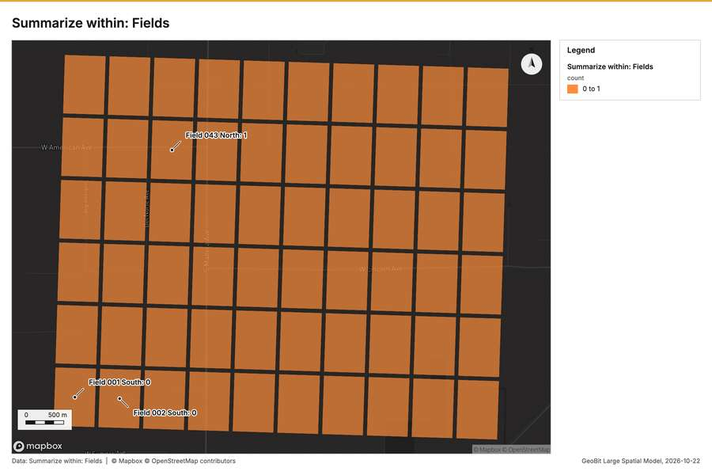
Figure 2. Summarize within: Fields [55]
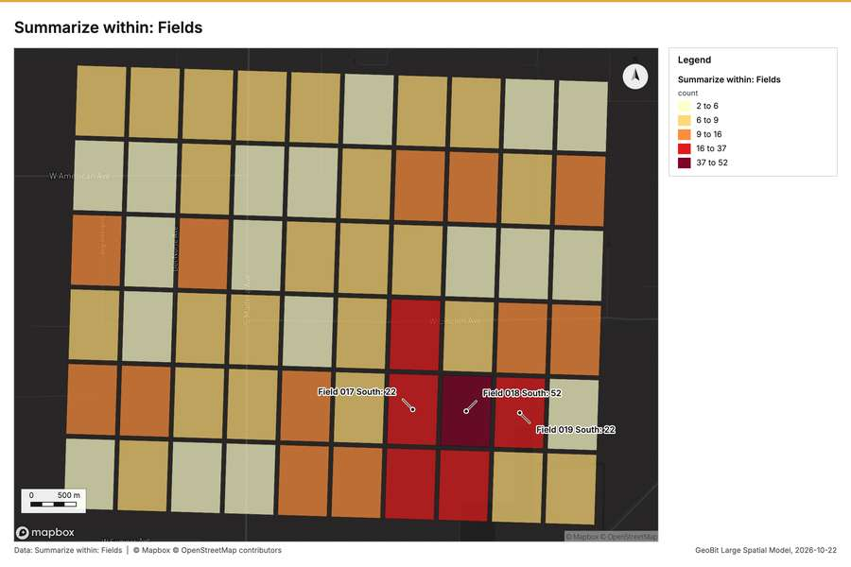
Figure 3. Summarize within: Fields [56]
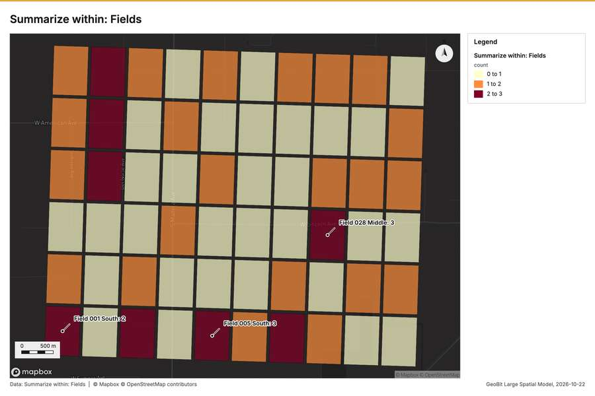
Figure 4. Summarize within: Fields [57]
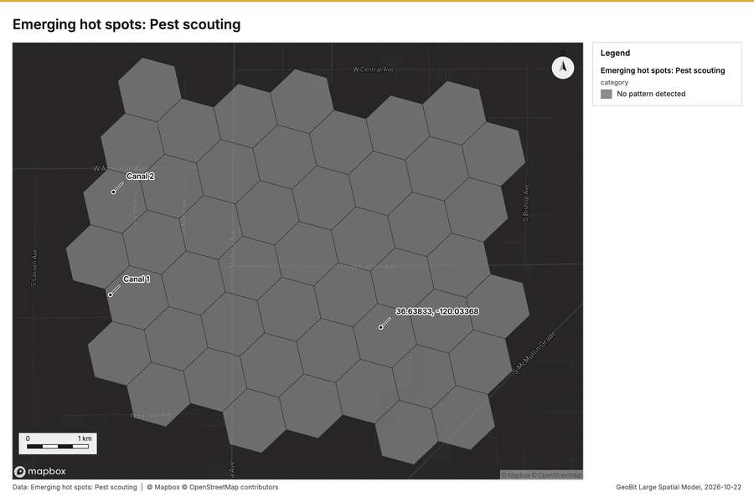
Figure 5. Emerging hot spots: Pest scouting [58]
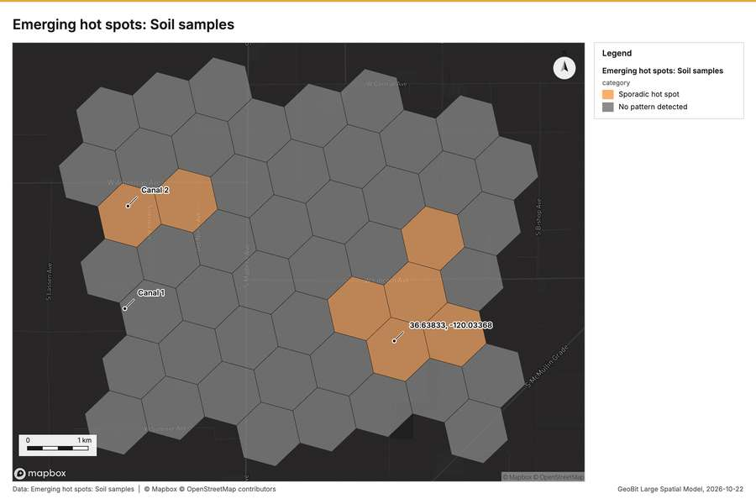
Figure 6. Emerging hot spots: Soil samples [59]
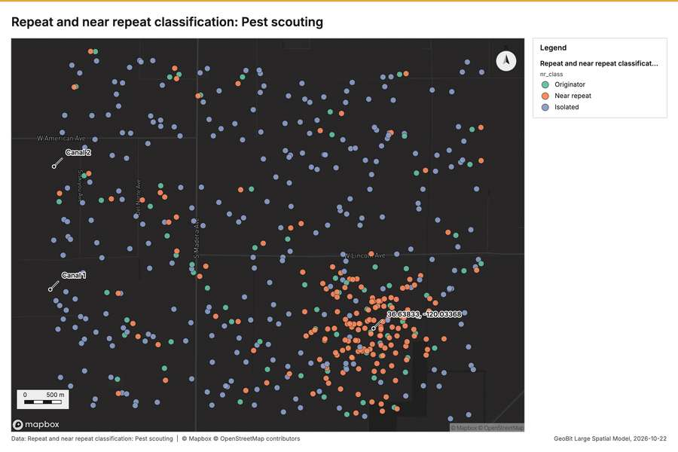
Figure 7. Repeat and near repeat classification: Pest scouting [60]
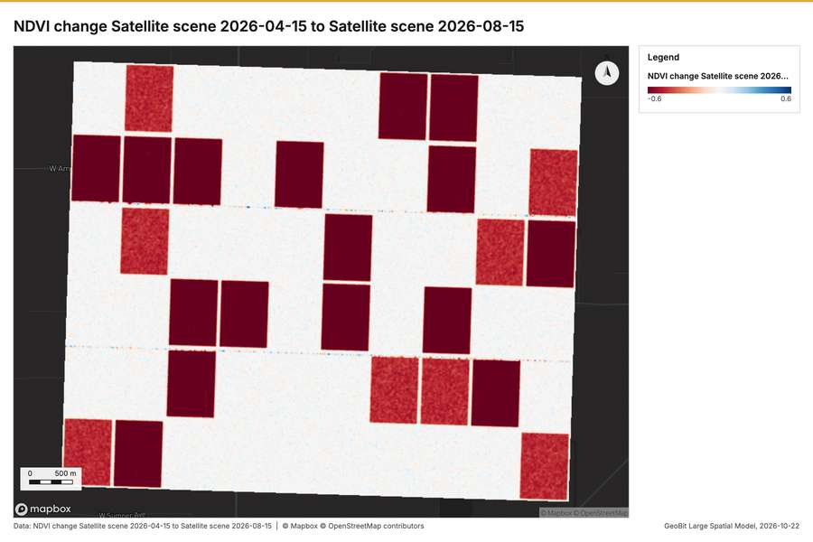
Figure 8. NDVI change Satellite scene 2026-04-15 to Satellite scene 2026-08-15 [61]
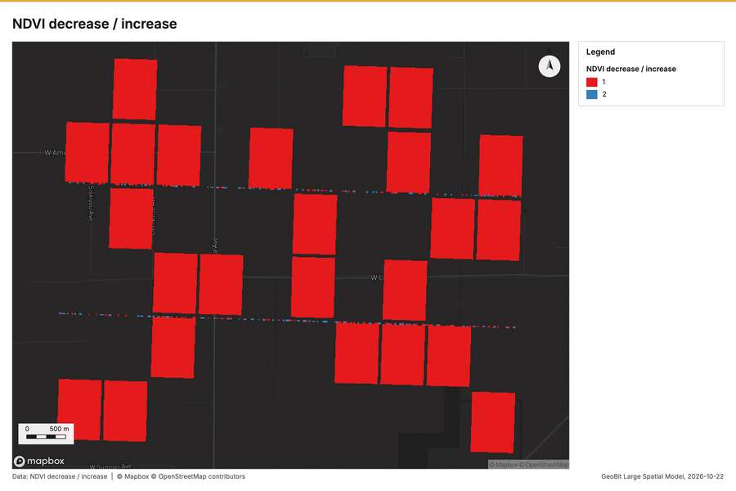
Figure 9. NDVI decrease / increase [62]
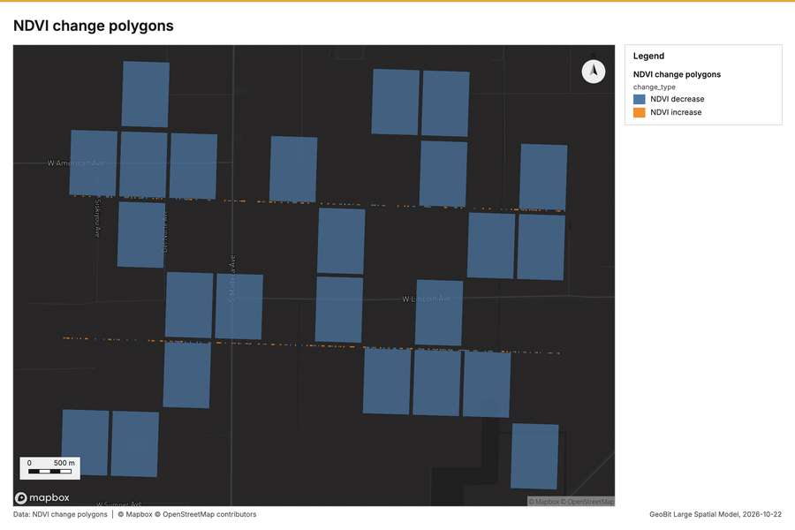
Figure 10. NDVI change polygons [63]
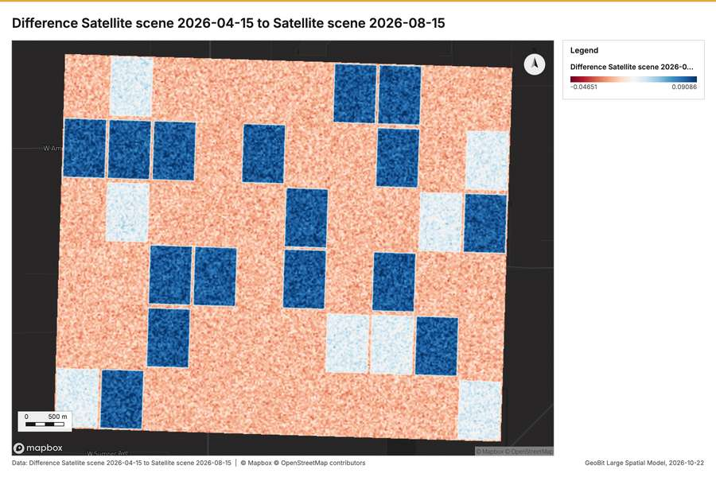
Figure 11. Difference Satellite scene 2026-04-15 to Satellite scene 2026-08-15 [64]
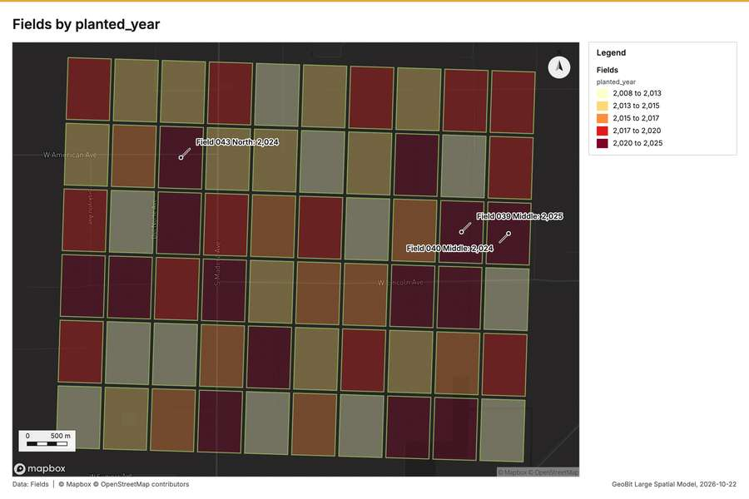
Figure 12. Fields by planted_year [65]
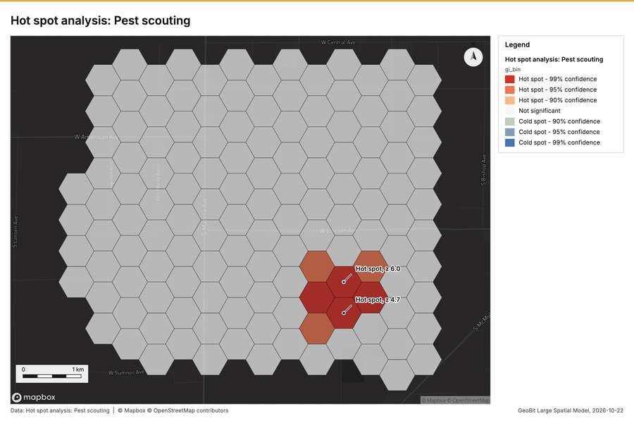
Figure 13. Hot spot analysis: Pest scouting [66]
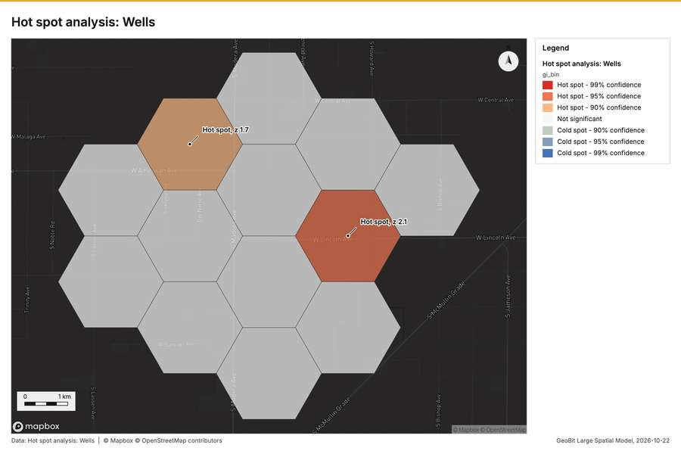
Figure 14. Hot spot analysis: Wells [67]
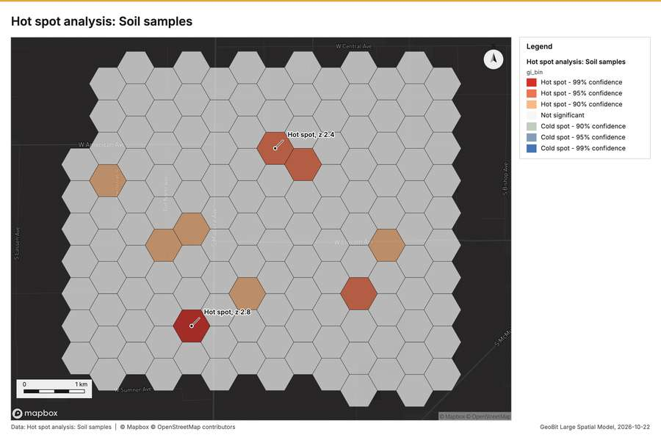
Figure 15. Hot spot analysis: Soil samples [68]
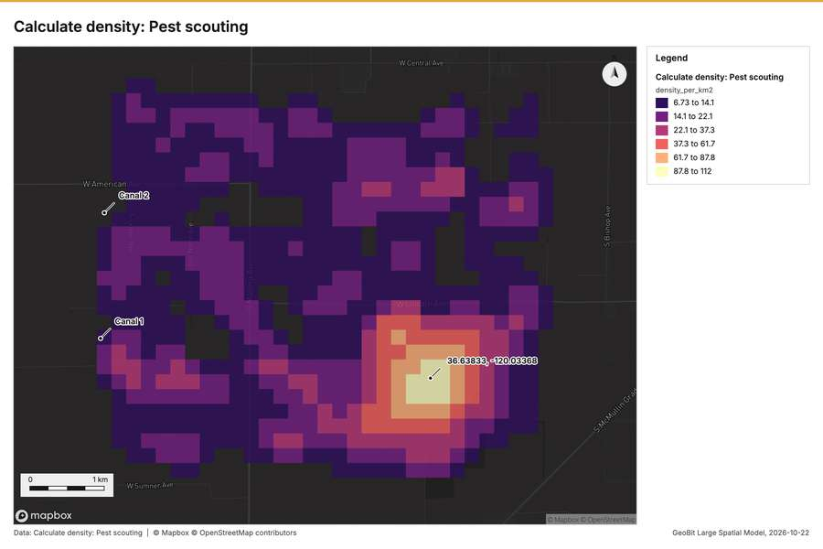
Figure 16. Calculate density: Pest scouting [69]
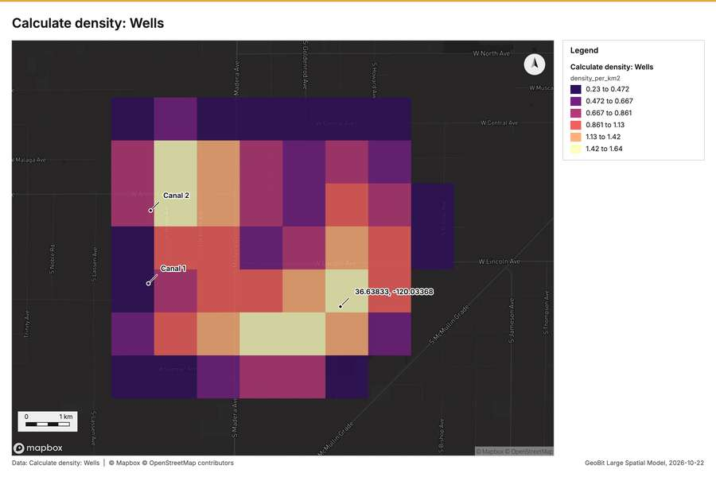
Figure 17. Calculate density: Wells [70]
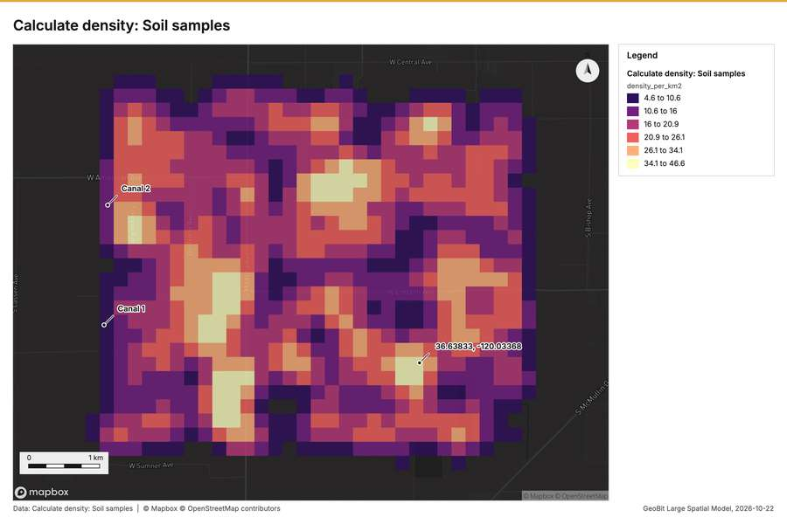
Figure 18. Calculate density: Soil samples [71]
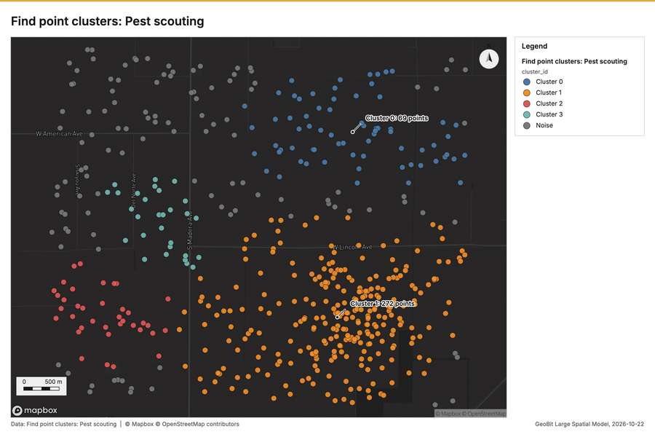
Figure 19. Find point clusters: Pest scouting [72]
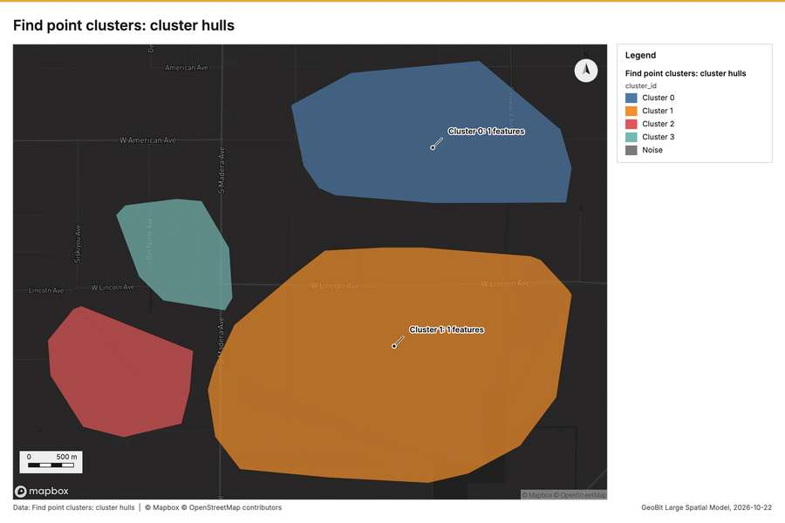
Figure 20. Find point clusters: cluster hulls [73]
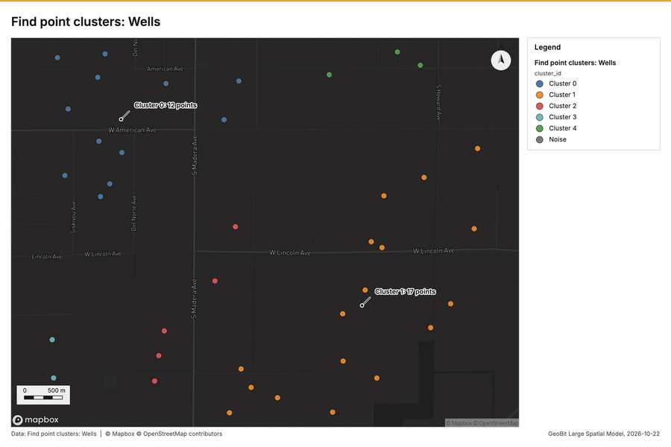
Figure 21. Find point clusters: Wells [74]
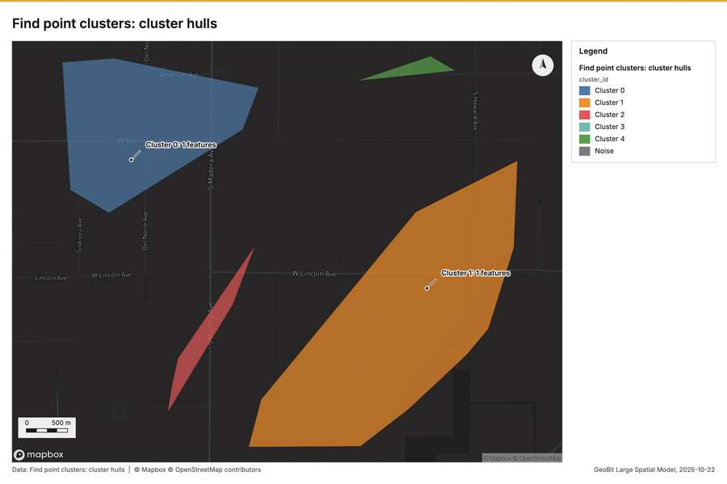
Figure 22. Find point clusters: cluster hulls [75]
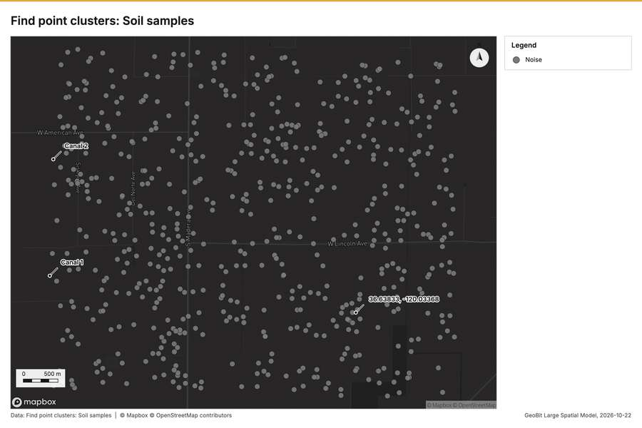
Figure 23. Find point clusters: Soil samples [76]
What the map shows. This map illustrates the concentration of "Fields" across the area, [57]
Inferred: read from the image by gemma4:e4b, not evidence.
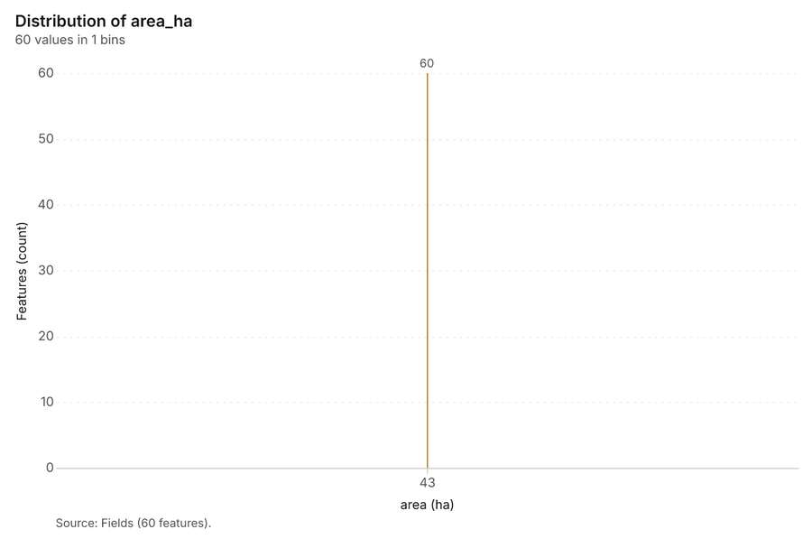
Figure 24. Fields over time (planted_year) [77]. Source: Fields (60 features). The data is in the appendix.
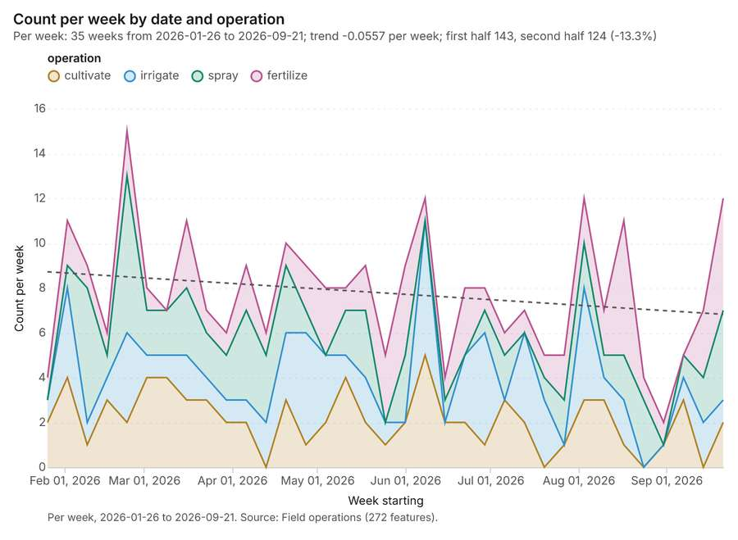
Figure 25. Field operations over time (date) [78]. Per week, 2026-01-26 to 2026-09-21. Source: Field operations (272 features). The data is in the appendix.
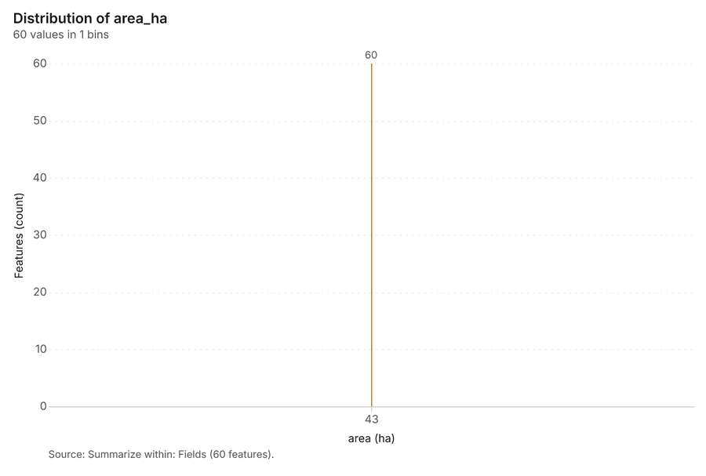
Figure 26. Summarize within: Fields [79]. Source: Summarize within: Fields (60 features). The data is in the appendix.
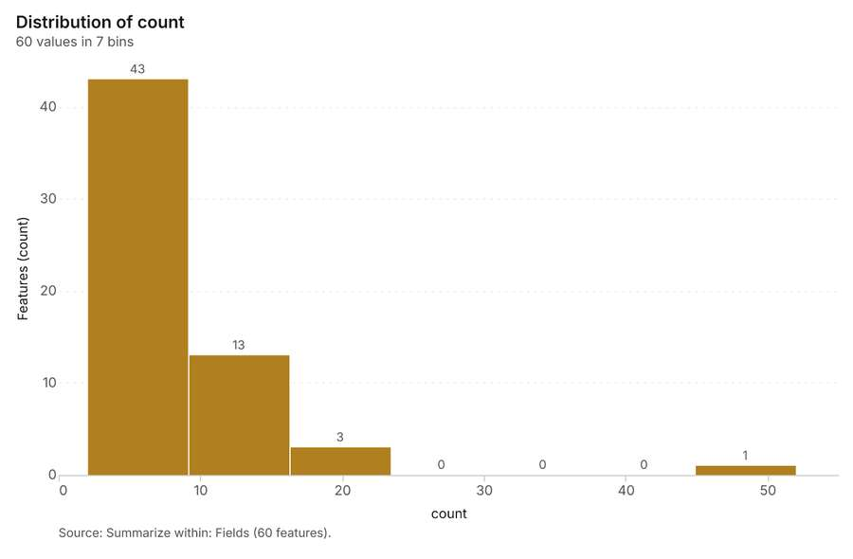
Figure 27. Summarize within: Fields [80]. Source: Summarize within: Fields (60 features). The data is in the appendix.
Figure 28. Summarize within: Fields [81]. Source: Summarize within: Fields (60 features). The data is in the appendix.
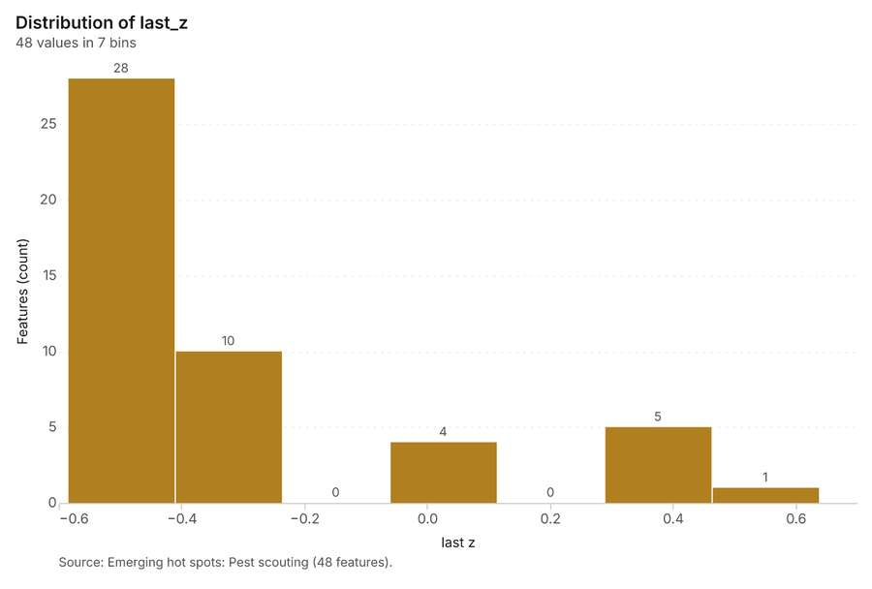
Figure 29. Emerging hot spots: Pest scouting [82]. Source: Emerging hot spots: Pest scouting (48 features). The data is in the appendix.
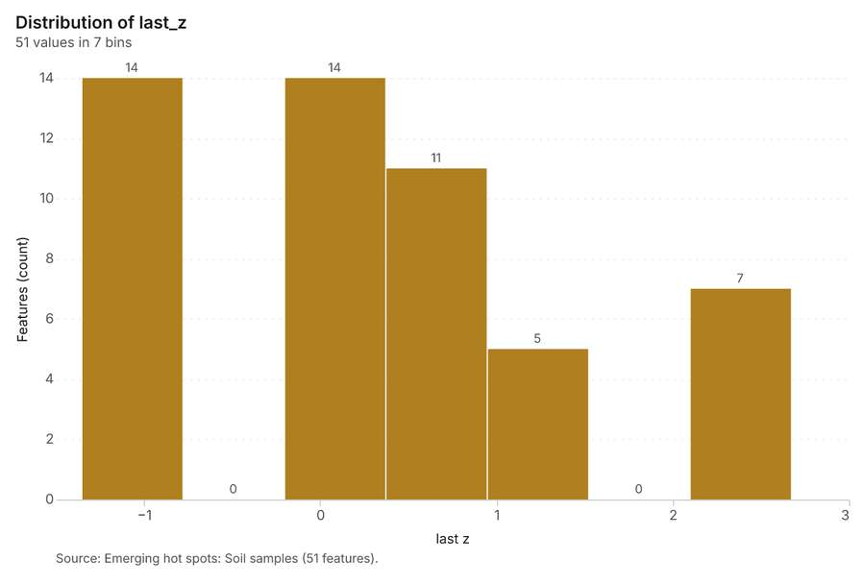
Figure 30. Emerging hot spots: Soil samples [83]. Source: Emerging hot spots: Soil samples (51 features). The data is in the appendix.
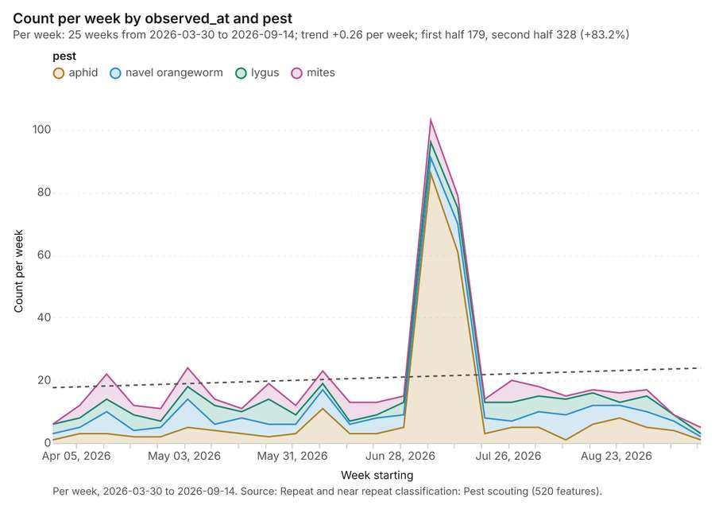
Figure 31. Repeat and near repeat classification: Pest scouting [84]. Per week, 2026-03-30 to 2026-09-14. Source: Repeat and near repeat classification: Pest scouting (520 features). The data is in the appendix.
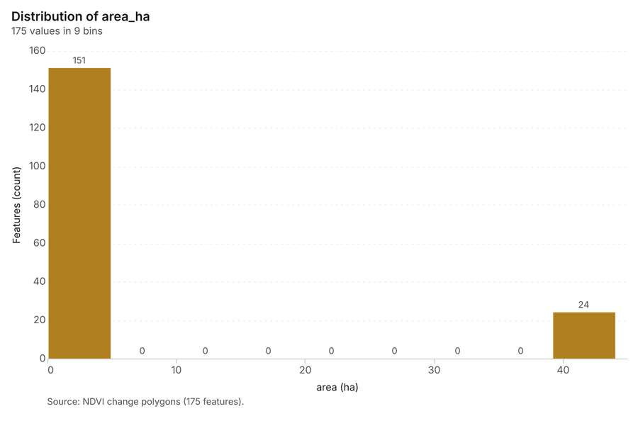
Figure 32. NDVI change polygons [85]. Source: NDVI change polygons (175 features). The data is in the appendix.
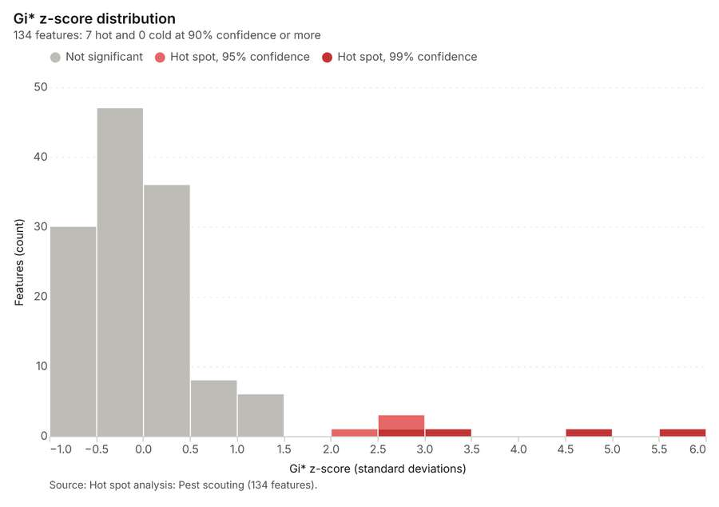
Figure 33. Hot spot analysis: Pest scouting [86]. Source: Hot spot analysis: Pest scouting (134 features). The data is in the appendix.
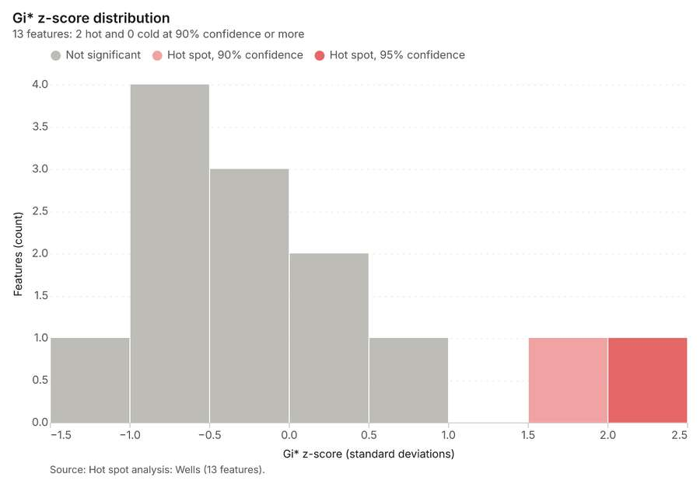
Figure 34. Hot spot analysis: Wells [87]. Source: Hot spot analysis: Wells (13 features). The data is in the appendix.
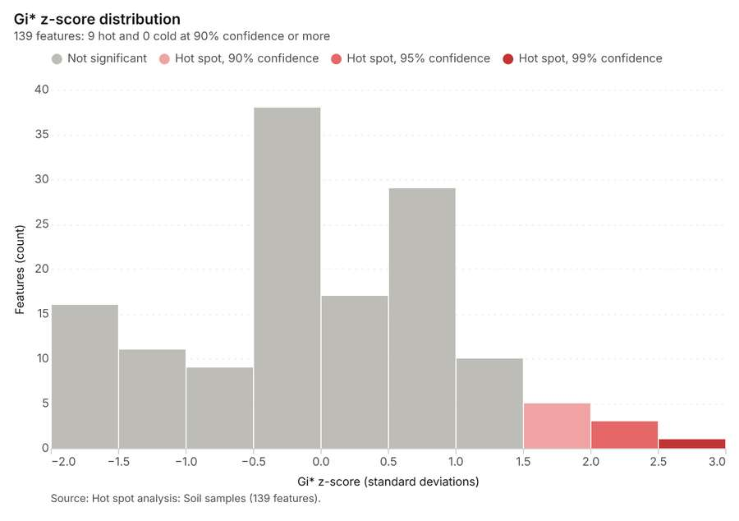
Figure 35. Hot spot analysis: Soil samples [88]. Source: Hot spot analysis: Soil samples (139 features). The data is in the appendix.
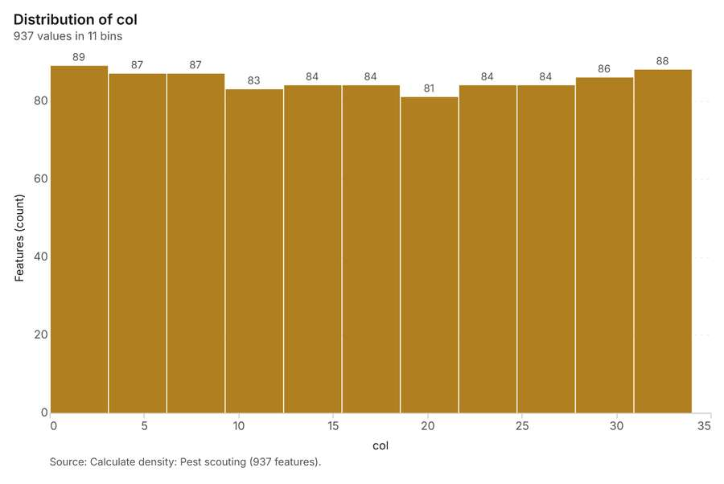
Figure 36. Calculate density: Pest scouting [89]. Source: Calculate density: Pest scouting (937 features). The data is in the appendix.
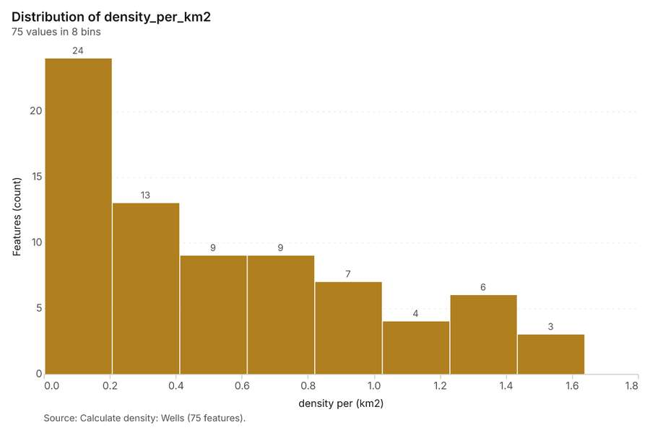
Figure 37. Calculate density: Wells [90]. Source: Calculate density: Wells (75 features). The data is in the appendix.
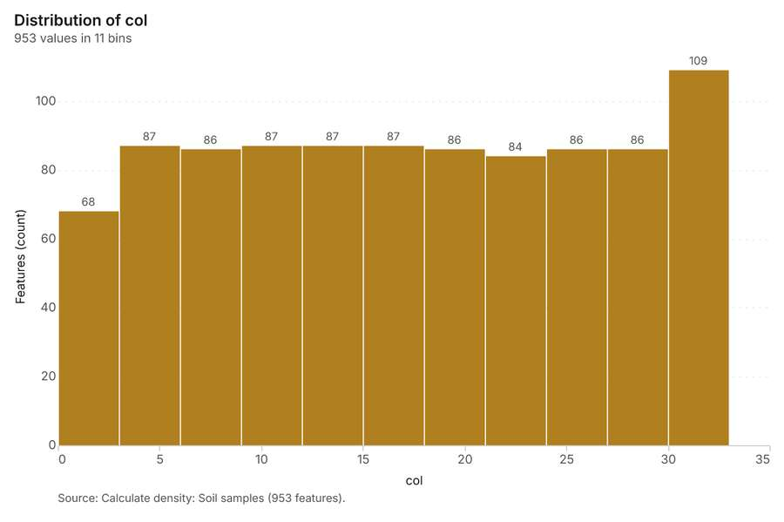
Figure 38. Calculate density: Soil samples [91]. Source: Calculate density: Soil samples (953 features). The data is in the appendix.
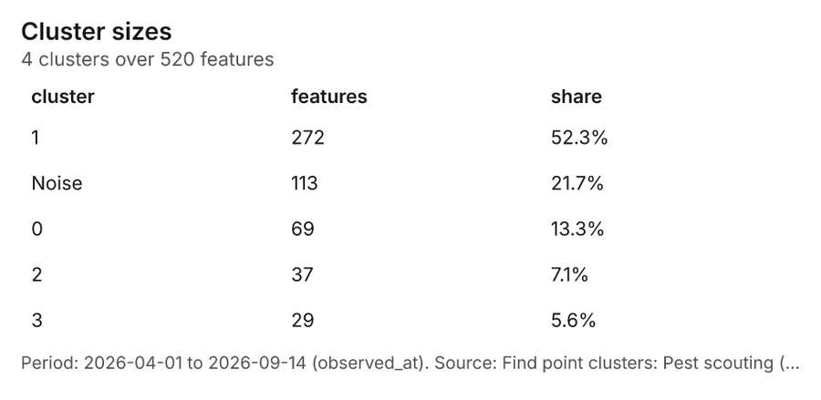
Figure 39. Find point clusters: Pest scouting [92]. Period: 2026-04-01 to 2026-09-14 (observed_at). Source: Find point clusters: Pest scouting (520 features). The data is in the appendix.
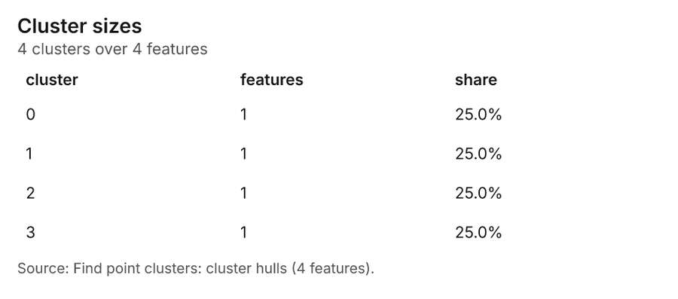
Figure 40. Find point clusters: cluster hulls [93]. Source: Find point clusters: cluster hulls (4 features). The data is in the appendix.
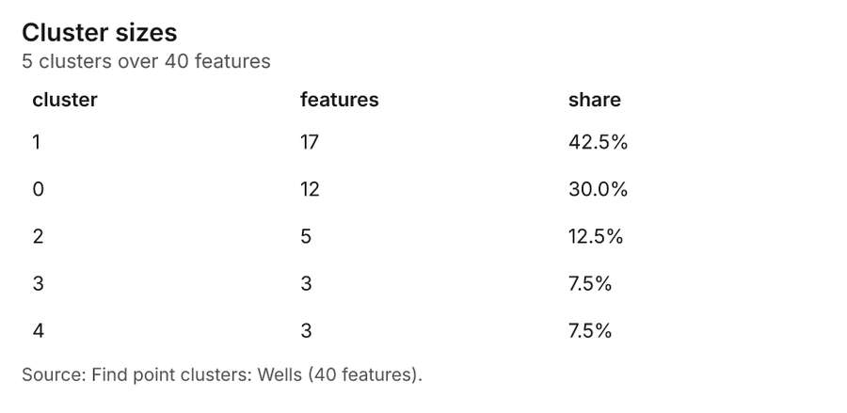
Figure 41. Find point clusters: Wells [94]. Source: Find point clusters: Wells (40 features). The data is in the appendix.
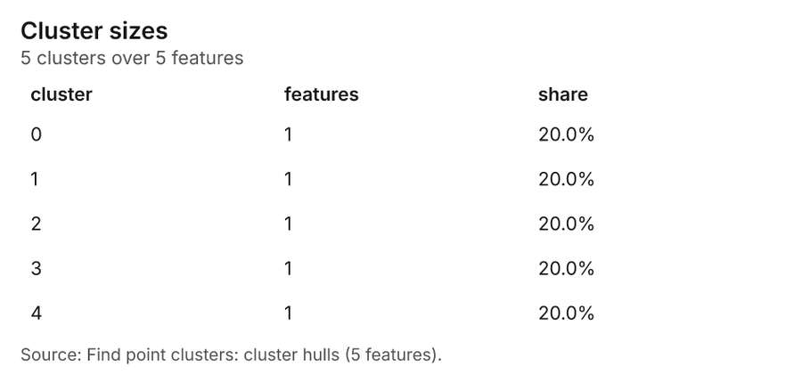
Figure 42. Find point clusters: cluster hulls [95]. Source: Find point clusters: cluster hulls (5 features). The data is in the appendix.
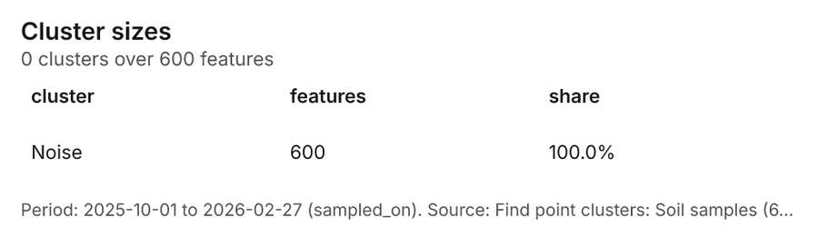
Figure 43. Find point clusters: Soil samples [96]. Period: 2025-10-01 to 2026-02-27 (sampled_on). Source: Find point clusters: Soil samples (600 features). The data is in the appendix.
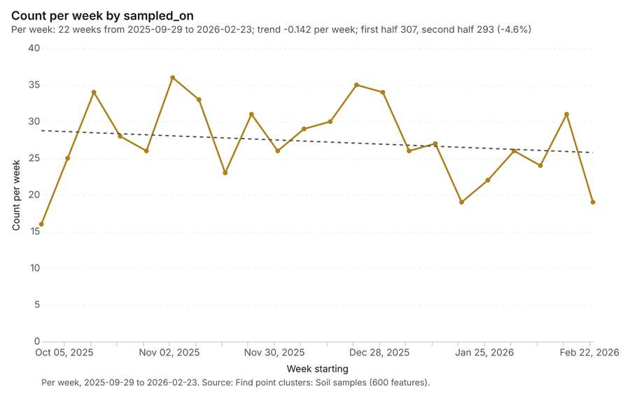
Figure 44. Find point clusters: Soil samples over time [97]. Per week, 2025-09-29 to 2026-02-23. Source: Find point clusters: Soil samples (600 features). The data is in the appendix.
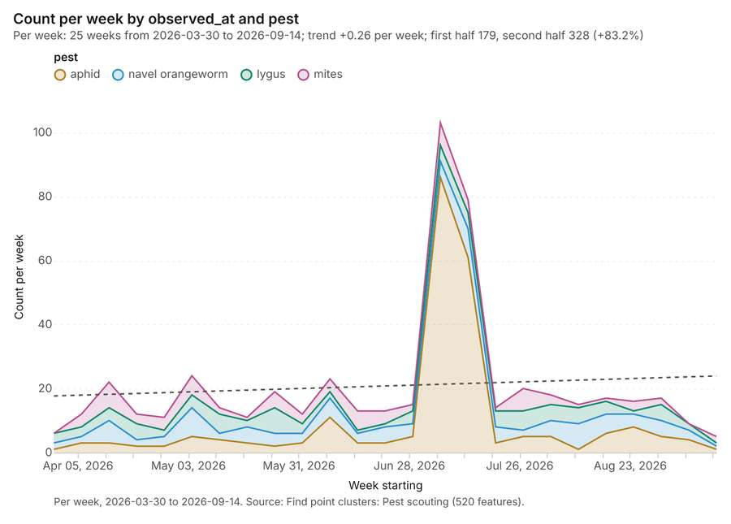
Figure 45. Find point clusters: Pest scouting over time [98]. Per week, 2026-03-30 to 2026-09-14. Source: Find point clusters: Pest scouting (520 features). The data is in the appendix.
Figure 46. Repeat and near repeat classification: Pest scouting over time [99]. Per week, 2026-03-30 to 2026-09-14. Source: Repeat and near repeat classification: Pest scouting (520 features). The data is in the appendix.

Changes since the last run
This is the first report of this project.

Sources
[1] Rendering: Chart: Timeline: events per quarter by dataset. 92 rows (id 210bf478-e864-4742-9c56-7c7e371b620c)
[2] Dataset: Soil samples. vector, 600 rows (id f4ae2248-8882-412c-b6a9-09b418581a65)
[3] Dataset: Pest scouting. vector, 520 rows (id 63eec720-9e01-4dce-9c81-975e42e92d0b)
[4] Dataset: Yields by season. table, 300 rows (id a530983b-a4cf-4197-96b4-ac4ee482921b)
[5] Dataset: Field operations. table, 272 rows (id a8bf3d14-5f38-4346-878a-d28bc636b06e)
[6] Catalog: Summarize within (operation catalog, gp_summarize_within). Count and aggregate the features inside each polygon (or bin), proportionally for lines and polygons. ArcGIS: Summarize Within, Aggregate Points. QGIS: native:countpointsinpolygon, native:sumlinelengths. (id gp_summarize_within)
[7] Plan: Weather stations per feature of Fields (the Start plan's candidate c_454a5cc5eea8). Count Weather stations inside each feature of Fields; the counts map as a choropleth (natural breaks, sequential colors). (id ae3647a3-d230-4a37-b0e8-19aa34415db3:c_454a5cc5eea8)
[8] Tool result: gp_summarize_within, step 0. Summarize within: 1 layer saved: Summarize within: Fields (60 features). (id dccd77e6-8290-42cb-9255-e52125568f63:0)
[9] Layer: Weather stations. 3 features (id 7a8242c6-adef-4d23-9e5b-df9ccaca27ad)
[10] Layer: Fields. 60 features (id a196eb79-1c58-44ab-9608-3f8de23cc587)
[11] Tool result: gp_summarize_within, step 1. Summarize within: 1 layer saved: Summarize within: Fields (60 features). (id dccd77e6-8290-42cb-9255-e52125568f63:1)
[12] Layer: Pest scouting. 520 features (id 815c2b2c-fc4f-4927-8f05-1744f43ca273)
[13] Tool result: gp_summarize_within, step 2. Summarize within: 1 layer saved: Summarize within: Fields (60 features). (id dccd77e6-8290-42cb-9255-e52125568f63:2)
[14] Layer: Wells. 40 features (id 15d08948-7e45-4cf2-ad71-6bb21299a25d)
[15] Catalog: Emerging hot spots (operation catalog, gp_space_time_hot_spots). Where hot spots are new, consecutive, intensifying, persistent, diminishing, sporadic, oscillating or historical over time. ArcGIS: Emerging Hot Spot Analysis, Create Space Time Cube. (id gp_space_time_hot_spots)
[16] Plan: Space time hot spots of Pest scouting (the Start plan's candidate c_45dd616af1e5). Pest scouting carry dates in 'observed_at': emerging hot spot analysis finds new, intensifying and fading hot spots per week. (id ae3647a3-d230-4a37-b0e8-19aa34415db3:c_45dd616af1e5)
[17] Tool result: gp_space_time_hot_spots, step 0. Emerging hot spots: 1 layer saved: Emerging hot spots: Pest scouting (48 features). (id 4244d4f5-f923-4458-9154-022dacee4c61:0)
[18] Plan: Space time hot spots of Soil samples (the Start plan's candidate c_850c0bb45f60). Soil samples carry dates in 'sampled_on': emerging hot spot analysis finds new, intensifying and fading hot spots per week. (id ae3647a3-d230-4a37-b0e8-19aa34415db3:c_850c0bb45f60)
[19] Tool result: gp_space_time_hot_spots, step 1. Emerging hot spots: 1 layer saved: Emerging hot spots: Soil samples (51 features). (id 4244d4f5-f923-4458-9154-022dacee4c61:1)
[20] Layer: Soil samples. 600 features (id caf67b23-0043-4bf5-8531-43267ce2ed9f)
[21] Catalog: Repeat and near repeat classification (operation catalog, gp_near_repeat). Classify incidents as originators, repeats (same place) or near repeats within a distance and time window, with a Knox test table. ArcGIS: Repeat and Near Repeat Classification, Near Repeat Calculator. (id gp_near_repeat)
[22] Plan: Near repeat of Pest scouting (the Start plan's candidate c_a26d0b1eb35d). Near repeat analysis tests whether Pest scouting close in space also follow each other within 17 days. (id ae3647a3-d230-4a37-b0e8-19aa34415db3:c_a26d0b1eb35d)
[23] Tool result: gp_near_repeat, step 2. Repeat and near repeat classification: 1 layer saved: Repeat and near repeat classification: Pest scouting (520 features). (id 4244d4f5-f923-4458-9154-022dacee4c61:2)
[24] Catalog: Spectral index change (analysis catalog, im_index_change). Change of a spectral index (NDVI, NDWI, NDBI, NBR ...) or a band expression between two images: before, after and difference rasters, decrease / increase classes beyond the threshold with polygons and areas; NBR also gives dNBR with burn severity classes. (id im_index_change)
[25] Plan: Index change of Satellite scene 2026-04-15 and Satellite scene 2026-08-15 (the Start plan's candidate c_09e02b8174f1). Index change between Satellite scene 2026-04-15 (2026-04-15) and Satellite scene 2026-08-15 (2026-08-15): the changed area, with the changed places as polygons. (id ae3647a3-d230-4a37-b0e8-19aa34415db3:c_09e02b8174f1)
[26] Tool result: im_index_change, step 0. Spectral index change: created NDVI change Satellite scene 2026-04-15 to Satellite scene 2026-08-15 (300 x 250 cells, 20.00 m). plus 1 more raster layer(s). and layer NDVI change polygons with 175 feature(s). mean before 0.7068; mean after 0.5038; mean difference -0.203; decrease ha 1,053; increase (id aa0bd809-0fe9-498d-b9f1-719c7c0e70f8:0)
[27] Catalog: Compute change raster (analysis catalog, im_compute_change_raster). Pixel value or spectral change between two co-registered images: difference, relative difference, absolute difference, log ratio (radar, dB), Euclidean spectral distance, spectral angle (radians) or the band with most change. Clouds and shadows are masked when the images have (id im_compute_change_raster)
[28] Plan: Compute change raster of Satellite scene 2026-04-15 and Satellite scene 2026-08-15 (the Start plan's candidate c_c88ddec02454). A change raster between Satellite scene 2026-04-15 (2026-04-15) and Satellite scene 2026-08-15 (2026-08-15): where and how much the pixels changed. (id ae3647a3-d230-4a37-b0e8-19aa34415db3:c_c88ddec02454)
[29] Tool result: im_compute_change_raster, step 1. Compute change raster: created Difference Satellite scene 2026-04-15 to Satellite scene 2026-08-15 (300 x 250 cells, 20.00 m). mean 0.02217; std 0.03434; min -0.037; max 0.116; masked pixels 0. (id aa0bd809-0fe9-498d-b9f1-719c7c0e70f8:1)
[30] Catalog: Hot spot analysis (operation catalog, gp_hot_spots). Getis-Ord Gi* hot and cold spots with z-scores, p-values and confidence bins. ArcGIS: Find Hot Spots, Hot Spot Analysis (Getis-Ord Gi*). QGIS: qgis:hotspot (plugin). (id gp_hot_spots)
[31] Plan: Hot spots of Pest scouting (the Start plan's candidate c_e6241d85c30d). 520 points: Getis-Ord Gi* tests whether the concentrations in Pest scouting are statistically significant. (id ae3647a3-d230-4a37-b0e8-19aa34415db3:c_e6241d85c30d)
[32] Tool result: gp_hot_spots, step 0. Hot spot analysis: 1 layer saved: Hot spot analysis: Pest scouting (134 features). (id abe0cc5c-b82d-4992-9626-cf301845c602:0)
[33] Plan: Hot spots of Wells (the Start plan's candidate c_5a29d39e7d24). 40 points: Getis-Ord Gi* tests whether the concentrations in Wells are statistically significant. (id ae3647a3-d230-4a37-b0e8-19aa34415db3:c_5a29d39e7d24)
[34] Tool result: gp_hot_spots, step 1. Hot spot analysis: 1 layer saved: Hot spot analysis: Wells (13 features). (id abe0cc5c-b82d-4992-9626-cf301845c602:1)
[35] Plan: Hot spots of Soil samples (the Start plan's candidate c_236d56d345ee). 600 points: Getis-Ord Gi* tests whether the concentrations in Soil samples are statistically significant. (id ae3647a3-d230-4a37-b0e8-19aa34415db3:c_236d56d345ee)
[36] Tool result: gp_hot_spots, step 2. Hot spot analysis: 1 layer saved: Hot spot analysis: Soil samples (139 features). (id abe0cc5c-b82d-4992-9626-cf301845c602:2)
[37] Catalog: Calculate density (operation catalog, gp_calculate_density). Kernel density per square kilometer on a grid. ArcGIS: Calculate Density, Kernel Density. QGIS: native:heatmapkerneldensityestimation. (id gp_calculate_density)
[38] Plan: Kernel density of Pest scouting (the Start plan's candidate c_a69023aa1d48). 520 points in Pest scouting: a density surface shows where they concentrate. (id ae3647a3-d230-4a37-b0e8-19aa34415db3:c_a69023aa1d48)
[39] Tool result: gp_calculate_density, step 0. Calculate density: 1 layer saved: Calculate density: Pest scouting (937 features). (id 0aef980e-7aff-47d5-becc-3abd115d0df6:0)
[40] Plan: Kernel density of Wells (the Start plan's candidate c_f362031aa57c). 40 points in Wells: a density surface shows where they concentrate. (id ae3647a3-d230-4a37-b0e8-19aa34415db3:c_f362031aa57c)
[41] Tool result: gp_calculate_density, step 1. Calculate density: 1 layer saved: Calculate density: Wells (75 features). (id 0aef980e-7aff-47d5-becc-3abd115d0df6:1)
[42] Plan: Kernel density of Soil samples (the Start plan's candidate c_031ecade8328). 600 points in Soil samples: a density surface shows where they concentrate. (id ae3647a3-d230-4a37-b0e8-19aa34415db3:c_031ecade8328)
[43] Tool result: gp_calculate_density, step 2. Calculate density: 1 layer saved: Calculate density: Soil samples (953 features). (id 0aef980e-7aff-47d5-becc-3abd115d0df6:2)
[44] Catalog: Find point clusters (operation catalog, gp_find_point_clusters). Density-based clusters (DBSCAN, HDBSCAN or OPTICS, optionally space-time) with hulls and noise. ArcGIS: Find Point Clusters, Density-based Clustering. QGIS: native:dbscanclustering, native:stdbscanclustering. (id gp_find_point_clusters)
[45] Plan: Cluster points of Pest scouting (the Start plan's candidate c_d5b8ebbc13e3). DBSCAN finds dense groups of Pest scouting and separates noise. (id ae3647a3-d230-4a37-b0e8-19aa34415db3:c_d5b8ebbc13e3)
[46] Tool result: gp_find_point_clusters, step 0. Find point clusters: 2 layers saved: Find point clusters: Pest scouting (520 features); Find point clusters: cluster hulls (4 features). (id d3e49c76-baed-436b-aed4-42467a2d8691:0)
[47] Plan: Cluster points of Wells (the Start plan's candidate c_cb6793249bdf). DBSCAN finds dense groups of Wells and separates noise. (id ae3647a3-d230-4a37-b0e8-19aa34415db3:c_cb6793249bdf)
[48] Tool result: gp_find_point_clusters, step 1. Find point clusters: 2 layers saved: Find point clusters: Wells (40 features); Find point clusters: cluster hulls (5 features). (id d3e49c76-baed-436b-aed4-42467a2d8691:1)
[49] Plan: Cluster points of Soil samples (the Start plan's candidate c_c62ca5d55d3c). DBSCAN finds dense groups of Soil samples and separates noise. (id ae3647a3-d230-4a37-b0e8-19aa34415db3:c_c62ca5d55d3c)
[50] Tool result: gp_find_point_clusters, step 2. Find point clusters: 1 layer saved: Find point clusters: Soil samples (600 features). (id d3e49c76-baed-436b-aed4-42467a2d8691:2)
[51] Catalog: Zonal statistics (analysis catalog, rs_zonal_statistics). count/min/max/mean/std/sum/median/majority per polygon as a table and as GeoJSON. ArcGIS: Zonal Statistics as Table (polygons). (id rs_zonal_statistics)
[52] Plan: Zonal statistics of Satellite scene 2026-04-15 and Fields (the Start plan's candidate c_e314d28606e4). Statistics of Satellite scene 2026-04-15 inside each feature of Fields. (id ae3647a3-d230-4a37-b0e8-19aa34415db3:c_e314d28606e4)
[53] Tool result: rs_zonal_statistics, step 0. Zonal statistics: 60 row(s). zones 60. (id 65e47d44-0efb-439a-97dd-b6f970b5def8:0)
[54] Tool result: rs_zonal_statistics, step 1. Zonal statistics: 60 row(s). zones 60. (id 65e47d44-0efb-439a-97dd-b6f970b5def8:1)
[55] Rendering: Map: Summarize within: Fields (id 7230104f-7ded-41b5-8137-03d3472c4fda)
[56] Rendering: Map: Summarize within: Fields (id 8653af7e-4e73-4408-a171-1f6950196dca)
[57] Rendering: Map: Summarize within: Fields (id 7cd707d4-3613-4819-8d43-7e3c43279eac)
[58] Rendering: Map: Emerging hot spots: Pest scouting (id b78dba51-33f9-4ea8-835a-48251bebd889)
[59] Rendering: Map: Emerging hot spots: Soil samples (id 391b8c8e-89d7-4099-a7bb-e45b7ee88e6b)
[60] Rendering: Map: Repeat and near repeat classification: Pest scouting (id 90157d45-c4a6-4d1d-9dcf-b704c93e0eb5)
[61] Rendering: Map: NDVI change Satellite scene 2026-04-15 to Satellite scene 2026-08-15 (id 0de86fc2-8ff8-4ce7-b077-43a5ab4bb376)
[62] Rendering: Map: NDVI decrease / increase (id e74e322f-5c79-4f18-a2f6-d502e8b31d86)
[63] Rendering: Map: NDVI change polygons (id 89e60139-e1e3-409e-8bc0-bcf9c32a5e30)
[64] Rendering: Map: Difference Satellite scene 2026-04-15 to Satellite scene 2026-08-15 (id df6ad400-4033-420c-8150-f286d0d0ce02)
[65] Rendering: Map: Fields by planted_year (id b7bcce2d-b7d0-4b90-bed2-1e960095b8f5)
[66] Rendering: Map: Hot spot analysis: Pest scouting (id 3a23b5af-27f8-49c6-bf66-fa49b20a08aa)
[67] Rendering: Map: Hot spot analysis: Wells (id cd3c7db8-cfb5-4aed-809a-15a9c2e1ee04)
[68] Rendering: Map: Hot spot analysis: Soil samples (id 94b47520-81ad-4a35-9ed1-2ed221c66501)
[69] Rendering: Map: Calculate density: Pest scouting (id bf1a8ba7-ca53-469d-b24c-54ae7dbb680b)
[70] Rendering: Map: Calculate density: Wells (id fa642946-bff5-47a9-a9cd-c67b1f2f7bfe)
[71] Rendering: Map: Calculate density: Soil samples (id 8413c226-61fc-4fdd-92b1-023ff3edb997)
[72] Rendering: Map: Find point clusters: Pest scouting (id 51fe83ea-2c87-4a9e-8844-7feb42f6f11a)
[73] Rendering: Map: Find point clusters: cluster hulls (id e7e8fe55-e846-4d44-a326-06cac7e2cfca)
[74] Rendering: Map: Find point clusters: Wells (id fed095c7-3edc-4fd2-a373-d17fc6251739)
[75] Rendering: Map: Find point clusters: cluster hulls (id 400e2024-a606-405d-8c29-65b08ce86104)
[76] Rendering: Map: Find point clusters: Soil samples (id 37d0f2ff-28af-4ea5-88ad-7955526003bf)
[77] Rendering: Chart: Fields over time (planted_year). 1 rows (id 4fae63f6-4165-4c37-9583-b5e8b7fbe000)
[78] Rendering: Chart: Field operations over time (date). 140 rows (id 2b4ce56e-b8f2-4990-87a1-8e81d44ab30b)
[79] Rendering: Chart: Summarize within: Fields. 1 rows (id f44f0c04-6401-435e-908e-61b78a5cedb0)
[80] Rendering: Chart: Summarize within: Fields. 7 rows (id e36c7df7-7eb0-4113-a898-84173c1635a7)
[81] Rendering: Chart: Summarize within: Fields. 1 rows (id b56c5a2b-ea58-4c97-871a-e80878d78549)
[82] Rendering: Chart: Emerging hot spots: Pest scouting. 7 rows (id 314c5791-c320-418e-8128-46033cad4c68)
[83] Rendering: Chart: Emerging hot spots: Soil samples. 7 rows (id 212eb454-b769-41a6-8a5f-e897a360eff2)
[84] Rendering: Chart: Repeat and near repeat classification: Pest scouting. 100 rows (id 4ec337e3-0fad-4735-a5cd-35ba6454f64c)
[85] Rendering: Chart: NDVI change polygons. 9 rows (id b6caeb8f-73bd-4c12-bb71-811ad9d4f4fc)
[86] Rendering: Chart: Hot spot analysis: Pest scouting. 11 rows (id 11c79607-7ed1-452c-ab6e-436e1580c59b)
[87] Rendering: Chart: Hot spot analysis: Wells. 7 rows (id 5e81ab47-dc6c-4c0b-bf73-cb9a953888c8)
[88] Rendering: Chart: Hot spot analysis: Soil samples. 10 rows (id aa8f7bb7-d4a0-4160-acf0-4c3df1175537)
[89] Rendering: Chart: Calculate density: Pest scouting. 11 rows (id cb76c785-37e5-43e8-8f0d-40da98f49b28)
[90] Rendering: Chart: Calculate density: Wells. 8 rows (id 542ea61d-ff29-475d-b5fa-ebe52baa7deb)
[91] Rendering: Chart: Calculate density: Soil samples. 11 rows (id 07136eeb-2846-4054-ab99-30695bfabe15)
[92] Rendering: Chart: Find point clusters: Pest scouting. 5 rows (id 281d1a9c-7ff6-4172-a7c6-6af005d6f6bb)
[93] Rendering: Chart: Find point clusters: cluster hulls. 4 rows (id 133c6e8d-eb2d-492b-8bbb-1a76f6947626)
[94] Rendering: Chart: Find point clusters: Wells. 5 rows (id 647d827f-dbff-458c-b5c6-646ed6c20169)
[95] Rendering: Chart: Find point clusters: cluster hulls. 5 rows (id ca4b1c22-b048-4fd3-8fe4-a0d9efa5b4ae)
[96] Rendering: Chart: Find point clusters: Soil samples. 1 rows (id fec77e96-06d0-41b0-93d3-a8270db698ce)
[97] Rendering: Chart: Find point clusters: Soil samples over time. 22 rows (id 4fc7d651-51f3-4c40-90d5-b49a93b06ea2)
[98] Rendering: Chart: Find point clusters: Pest scouting over time. 100 rows (id 9aedbf91-7578-44d6-98ab-cb2d3aa2bc15)
[99] Rendering: Chart: Repeat and near repeat classification: Pest scouting over time. 100 rows (id 32669449-e850-4080-86e2-4007127d571f)
[100] Dataset: Fields. vector, 60 rows (id ae5ec258-e5f4-4d17-bdc8-60502e957eff)
[101] Dataset: Satellite scene 2026-04-15. raster, ? rows (id afcb6073-f5d0-4e9b-9733-f8ff25683e32)
[102] Dataset: Satellite scene 2026-08-15. raster, ? rows (id e159db17-63d9-49cf-89e5-b0ae9c8b48a2)
[103] Dataset: Irrigation canals. vector, 5 rows (id 97634f60-fee7-4f4e-a64e-637edfb86b11)
[104] Dataset: Wells. vector, 40 rows (id 74fc7b42-f33b-42ca-8b5d-9cfcb97c141a)
[105] Dataset: Weather stations. vector, 3 rows (id 0f5f59b7-502a-40bb-b75d-bdadd47f3080)
[106] Dataset: Agronomist season notes. document, ? rows (id d84db76e-6efd-462b-9106-b94192b7b788)
[107] Record: Sample: Agriculture, Fresno County (id c0ff746c-cbbb-48c5-a026-444453a7b463)
[108] Layer: Summarize within: Fields. 60 features (id b2fdbfbb-e5aa-42e7-94a1-89a27706bffe)
[109] Layer: Summarize within: Fields. 60 features (id 4f0023ee-b3ec-488f-bf30-f0fc9b0f5b3a)
[110] Layer: Summarize within: Fields. 60 features (id 951c1d69-082b-442b-a64e-e85bf3484a2f)
[111] Layer: Emerging hot spots: Pest scouting. 48 features (id 0be5bf67-1fa9-4a8c-83c8-e34bc93079d1)
[112] Layer: Emerging hot spots: Soil samples. 51 features (id 2a629716-c8ab-4b63-9c37-e87b9441d065)
[113] Layer: Repeat and near repeat classification: Pest scouting. 520 features (id fe782344-23a8-476a-b62d-d355ef2335ff)
[114] Layer: NDVI change Satellite scene 2026-04-15 to Satellite scene 2026-08-15. 0 features (id 8e44c499-3d6d-40a2-bf98-2aadc140cd8a)
[115] Layer: NDVI decrease / increase. 0 features (id bb4c7791-d581-4575-8cb4-3ef1435080f6)
[116] Layer: NDVI change polygons. 175 features (id f16ca8cc-e568-476b-891d-77e47b995583)
[117] Layer: Difference Satellite scene 2026-04-15 to Satellite scene 2026-08-15. 0 features (id a67372cb-7b7e-4c71-947c-5b97fba5d52f)
[118] Layer: Hot spot analysis: Pest scouting. 134 features (id 9e178787-e1af-447d-b9a8-b00743fc24e6)
[119] Layer: Hot spot analysis: Wells. 13 features (id d441f28d-a4a4-41b6-ae29-45dd731e936a)
[120] Layer: Hot spot analysis: Soil samples. 139 features (id 8e554e35-3a16-4452-9c1b-514be82182a7)
[121] Layer: Calculate density: Pest scouting. 937 features (id c70c03ec-c02f-4e66-b411-9818647d6aeb)
[122] Layer: Calculate density: Wells. 75 features (id 5b6288ae-67ae-41cd-84c7-b081bfc8198d)
[123] Layer: Calculate density: Soil samples. 953 features (id 1b537a1d-851e-429a-a0a3-2796431cad1c)
[124] Layer: Find point clusters: Pest scouting. 520 features (id 531e30e6-075f-4448-8903-ceb10bcec608)
[125] Layer: Find point clusters: cluster hulls. 4 features (id 3290f356-6d63-4379-ad57-5da11d5df04b)
[126] Layer: Find point clusters: Wells. 40 features (id 4497616c-038d-4f7d-bfd7-4a1fba479ca8)
[127] Layer: Find point clusters: cluster hulls. 5 features (id 973c4eb5-10d8-4c78-81b4-8d4b2dce4966)
[128] Layer: Find point clusters: Soil samples. 600 features (id a1768046-65e4-431b-b327-112b2874c867)

Appendix: the data behind the charts

Figure 1. Timeline: events per quarter by dataset [1]
period | series | value
2021-01-01 | Soil samples | 0
2021-01-01 | Pest scouting | 0
2021-01-01 | Yields by season | 60
2021-01-01 | Field operations | 0
2021-04-01 | Soil samples | 0
2021-04-01 | Pest scouting | 0
2021-04-01 | Yields by season | 0
2021-04-01 | Field operations | 0
2021-07-01 | Soil samples | 0
2021-07-01 | Pest scouting | 0
2021-07-01 | Yields by season | 0
2021-07-01 | Field operations | 0
2021-10-01 | Soil samples | 0
2021-10-01 | Pest scouting | 0
2021-10-01 | Yields by season | 0
2021-10-01 | Field operations | 0
2022-01-01 | Soil samples | 0
2022-01-01 | Pest scouting | 0
2022-01-01 | Yields by season | 60
2022-01-01 | Field operations | 0
2022-04-01 | Soil samples | 0
2022-04-01 | Pest scouting | 0
2022-04-01 | Yields by season | 0
2022-04-01 | Field operations | 0
2022-07-01 | Soil samples | 0
2022-07-01 | Pest scouting | 0
2022-07-01 | Yields by season | 0
2022-07-01 | Field operations | 0
2022-10-01 | Soil samples | 0
2022-10-01 | Pest scouting | 0
2022-10-01 | Yields by season | 0
2022-10-01 | Field operations | 0
2023-01-01 | Soil samples | 0
2023-01-01 | Pest scouting | 0
2023-01-01 | Yields by season | 60
2023-01-01 | Field operations | 0
2023-04-01 | Soil samples | 0
2023-04-01 | Pest scouting | 0
2023-04-01 | Yields by season | 0
2023-04-01 | Field operations | 0
2023-07-01 | Soil samples | 0
2023-07-01 | Pest scouting | 0
2023-07-01 | Yields by season | 0
2023-07-01 | Field operations | 0
2023-10-01 | Soil samples | 0
2023-10-01 | Pest scouting | 0
2023-10-01 | Yields by season | 0
2023-10-01 | Field operations | 0
2024-01-01 | Soil samples | 0
2024-01-01 | Pest scouting | 0
2024-01-01 | Yields by season | 60
2024-01-01 | Field operations | 0
2024-04-01 | Soil samples | 0
2024-04-01 | Pest scouting | 0
2024-04-01 | Yields by season | 0
2024-04-01 | Field operations | 0
2024-07-01 | Soil samples | 0
2024-07-01 | Pest scouting | 0
2024-07-01 | Yields by season | 0
2024-07-01 | Field operations | 0
2024-10-01 | Soil samples | 0
2024-10-01 | Pest scouting | 0
2024-10-01 | Yields by season | 0
2024-10-01 | Field operations | 0
2025-01-01 | Soil samples | 0
2025-01-01 | Pest scouting | 0
2025-01-01 | Yields by season | 60
2025-01-01 | Field operations | 0
2025-04-01 | Soil samples | 0
2025-04-01 | Pest scouting | 0
2025-04-01 | Yields by season | 0
2025-04-01 | Field operations | 0
2025-07-01 | Soil samples | 0
2025-07-01 | Pest scouting | 0
2025-07-01 | Yields by season | 0
2025-07-01 | Field operations | 0
2025-10-01 | Soil samples | 392
2025-10-01 | Pest scouting | 0
2025-10-01 | Yields by season | 0
2025-10-01 | Field operations | 0
2026-01-01 | Soil samples | 208
2026-01-01 | Pest scouting | 0
2026-01-01 | Yields by season | 0
2026-01-01 | Field operations | 78
2026-04-01 | Soil samples | 0
2026-04-01 | Pest scouting | 198
2026-04-01 | Yields by season | 0
2026-04-01 | Field operations | 103
2026-07-01 | Soil samples | 0
2026-07-01 | Pest scouting | 322
2026-07-01 | Yields by season | 0
2026-07-01 | Field operations | 91

Figure 24. Fields over time (planted_year) [77]
bin_start | bin_end | count
43.1 | 43.1 | 60

Figure 25. Field operations over time (date) [78]
period | series | value
2026-01-26 | cultivate | 2
2026-01-26 | irrigate | 1
2026-01-26 | spray | 0
2026-01-26 | fertilize | 1
2026-02-02 | cultivate | 4
2026-02-02 | irrigate | 4
2026-02-02 | spray | 1
2026-02-02 | fertilize | 2
2026-02-09 | cultivate | 1
2026-02-09 | irrigate | 1
2026-02-09 | spray | 6
2026-02-09 | fertilize | 1
2026-02-16 | cultivate | 3
2026-02-16 | irrigate | 1
2026-02-16 | spray | 1
2026-02-16 | fertilize | 1
2026-02-23 | cultivate | 2
2026-02-23 | irrigate | 4
2026-02-23 | spray | 7
2026-02-23 | fertilize | 2
2026-03-02 | cultivate | 4
2026-03-02 | irrigate | 1
2026-03-02 | spray | 2
2026-03-02 | fertilize | 1
2026-03-09 | cultivate | 4
2026-03-09 | irrigate | 1
2026-03-09 | spray | 2
2026-03-09 | fertilize | 0
2026-03-16 | cultivate | 3
2026-03-16 | irrigate | 2
2026-03-16 | spray | 3
2026-03-16 | fertilize | 3
2026-03-23 | cultivate | 3
2026-03-23 | irrigate | 1
2026-03-23 | spray | 2
2026-03-23 | fertilize | 1
2026-03-30 | cultivate | 2
2026-03-30 | irrigate | 1
2026-03-30 | spray | 2
2026-03-30 | fertilize | 1
2026-04-06 | cultivate | 2
2026-04-06 | irrigate | 1
2026-04-06 | spray | 4
2026-04-06 | fertilize | 2
2026-04-13 | cultivate | 0
2026-04-13 | irrigate | 2
2026-04-13 | spray | 3
2026-04-13 | fertilize | 1
2026-04-20 | cultivate | 3
2026-04-20 | irrigate | 3
2026-04-20 | spray | 3
2026-04-20 | fertilize | 1
2026-04-27 | cultivate | 1
2026-04-27 | irrigate | 5
2026-04-27 | spray | 1
2026-04-27 | fertilize | 2
2026-05-04 | cultivate | 2
2026-05-04 | irrigate | 3
2026-05-04 | spray | 0
2026-05-04 | fertilize | 3
2026-05-11 | cultivate | 4
2026-05-11 | irrigate | 1
2026-05-11 | spray | 2
2026-05-11 | fertilize | 1
2026-05-18 | cultivate | 2
2026-05-18 | irrigate | 2
2026-05-18 | spray | 3
2026-05-18 | fertilize | 2
2026-05-25 | cultivate | 1
2026-05-25 | irrigate | 1
2026-05-25 | spray | 0
2026-05-25 | fertilize | 3
2026-06-01 | cultivate | 2
2026-06-01 | irrigate | 0
2026-06-01 | spray | 3
2026-06-01 | fertilize | 4
2026-06-08 | cultivate | 5
2026-06-08 | irrigate | 6
2026-06-08 | spray | 0
2026-06-08 | fertilize | 1
2026-06-15 | cultivate | 2
2026-06-15 | irrigate | 0
2026-06-15 | spray | 1
2026-06-15 | fertilize | 1
2026-06-22 | cultivate | 2
2026-06-22 | irrigate | 3
2026-06-22 | spray | 0
2026-06-22 | fertilize | 3
2026-06-29 | cultivate | 1
2026-06-29 | irrigate | 5
2026-06-29 | spray | 1
2026-06-29 | fertilize | 1
2026-07-06 | cultivate | 3
2026-07-06 | irrigate | 0
2026-07-06 | spray | 2
2026-07-06 | fertilize | 1
2026-07-13 | cultivate | 2
2026-07-13 | irrigate | 4
2026-07-13 | spray | 0
2026-07-13 | fertilize | 1
2026-07-20 | cultivate | 0
2026-07-20 | irrigate | 3
2026-07-20 | spray | 1
2026-07-20 | fertilize | 1
2026-07-27 | cultivate | 1
2026-07-27 | irrigate | 0
2026-07-27 | spray | 2
2026-07-27 | fertilize | 2
2026-08-03 | cultivate | 3
2026-08-03 | irrigate | 5
2026-08-03 | spray | 2
2026-08-03 | fertilize | 2
2026-08-10 | cultivate | 3
2026-08-10 | irrigate | 1
2026-08-10 | spray | 1
2026-08-10 | fertilize | 2
2026-08-17 | cultivate | 1
2026-08-17 | irrigate | 2
2026-08-17 | spray | 2
2026-08-17 | fertilize | 6
2026-08-24 | cultivate | 0
2026-08-24 | irrigate | 0
2026-08-24 | spray | 3
2026-08-24 | fertilize | 1
2026-08-31 | cultivate | 1
2026-08-31 | irrigate | 0
2026-08-31 | spray | 0
2026-08-31 | fertilize | 1
2026-09-07 | cultivate | 3
2026-09-07 | irrigate | 1
2026-09-07 | spray | 1
2026-09-07 | fertilize | 0
2026-09-14 | cultivate | 0
2026-09-14 | irrigate | 2
2026-09-14 | spray | 2
2026-09-14 | fertilize | 3
2026-09-21 | cultivate | 2
2026-09-21 | irrigate | 1
2026-09-21 | spray | 4
2026-09-21 | fertilize | 5

Figure 26. Summarize within: Fields [79]
bin_start | bin_end | count
43.1 | 43.1 | 60

Figure 27. Summarize within: Fields [80]
bin_start | bin_end | count
2 | 9.143 | 43
9.143 | 16.29 | 13
16.29 | 23.43 | 3
23.43 | 30.57 | 0
30.57 | 37.71 | 0
37.71 | 44.86 | 0
44.86 | 52 | 1

Figure 28. Summarize within: Fields [81]
bin_start | bin_end | count
43.1 | 43.1 | 60

Figure 29. Emerging hot spots: Pest scouting [82]
bin_start | bin_end | count
-0.586 | -0.4111 | 28
-0.4111 | -0.2363 | 10
-0.2363 | -0.06143 | 0
-0.06143 | 0.1134 | 4
0.1134 | 0.2883 | 0
0.2883 | 0.4631 | 5
0.4631 | 0.638 | 1

Figure 30. Emerging hot spots: Soil samples [83]
bin_start | bin_end | count
-1.356 | -0.7807 | 14
-0.7807 | -0.2054 | 0
-0.2054 | 0.3699 | 14
0.3699 | 0.9451 | 11
0.9451 | 1.52 | 5
1.52 | 2.096 | 0
2.096 | 2.671 | 7

Figure 31. Repeat and near repeat classification: Pest scouting [84]
period | series | value
2026-03-30 | aphid | 1
2026-03-30 | navel orangeworm | 2
2026-03-30 | lygus | 3
2026-03-30 | mites | 0
2026-04-06 | aphid | 3
2026-04-06 | navel orangeworm | 2
2026-04-06 | lygus | 3
2026-04-06 | mites | 4
2026-04-13 | aphid | 3
2026-04-13 | navel orangeworm | 7
2026-04-13 | lygus | 4
2026-04-13 | mites | 8
2026-04-20 | aphid | 2
2026-04-20 | navel orangeworm | 2
2026-04-20 | lygus | 5
2026-04-20 | mites | 3
2026-04-27 | aphid | 2
2026-04-27 | navel orangeworm | 3
2026-04-27 | lygus | 2
2026-04-27 | mites | 4
2026-05-04 | aphid | 5
2026-05-04 | navel orangeworm | 9
2026-05-04 | lygus | 4
2026-05-04 | mites | 6
2026-05-11 | aphid | 4
2026-05-11 | navel orangeworm | 2
2026-05-11 | lygus | 6
2026-05-11 | mites | 2
2026-05-18 | aphid | 3
2026-05-18 | navel orangeworm | 5
2026-05-18 | lygus | 2
2026-05-18 | mites | 1
2026-05-25 | aphid | 2
2026-05-25 | navel orangeworm | 4
2026-05-25 | lygus | 8
2026-05-25 | mites | 5
2026-06-01 | aphid | 3
2026-06-01 | navel orangeworm | 3
2026-06-01 | lygus | 3
2026-06-01 | mites | 3
2026-06-08 | aphid | 11
2026-06-08 | navel orangeworm | 6
2026-06-08 | lygus | 2
2026-06-08 | mites | 4
2026-06-15 | aphid | 3
2026-06-15 | navel orangeworm | 3
2026-06-15 | lygus | 1
2026-06-15 | mites | 6
2026-06-22 | aphid | 3
2026-06-22 | navel orangeworm | 5
2026-06-22 | lygus | 1
2026-06-22 | mites | 4
2026-06-29 | aphid | 5
2026-06-29 | navel orangeworm | 4
2026-06-29 | lygus | 4
2026-06-29 | mites | 2
2026-07-06 | aphid | 86
2026-07-06 | navel orangeworm | 5
2026-07-06 | lygus | 5
2026-07-06 | mites | 7
2026-07-13 | aphid | 61
2026-07-13 | navel orangeworm | 9
2026-07-13 | lygus | 5
2026-07-13 | mites | 4
2026-07-20 | aphid | 3
2026-07-20 | navel orangeworm | 5
2026-07-20 | lygus | 5
2026-07-20 | mites | 1
2026-07-27 | aphid | 5
2026-07-27 | navel orangeworm | 2
2026-07-27 | lygus | 6
2026-07-27 | mites | 7
2026-08-03 | aphid | 5
2026-08-03 | navel orangeworm | 5
2026-08-03 | lygus | 5
2026-08-03 | mites | 3
2026-08-10 | aphid | 1
2026-08-10 | navel orangeworm | 8
2026-08-10 | lygus | 5
2026-08-10 | mites | 1
2026-08-17 | aphid | 6
2026-08-17 | navel orangeworm | 6
2026-08-17 | lygus | 4
2026-08-17 | mites | 1
2026-08-24 | aphid | 8
2026-08-24 | navel orangeworm | 4
2026-08-24 | lygus | 1
2026-08-24 | mites | 3
2026-08-31 | aphid | 5
2026-08-31 | navel orangeworm | 5
2026-08-31 | lygus | 5
2026-08-31 | mites | 2
2026-09-07 | aphid | 4
2026-09-07 | navel orangeworm | 3
2026-09-07 | lygus | 2
2026-09-07 | mites | 0
2026-09-14 | aphid | 1
2026-09-14 | navel orangeworm | 1
2026-09-14 | lygus | 1
2026-09-14 | mites | 2

Figure 32. NDVI change polygons [85]
bin_start | bin_end | count
0.04 | 4.933 | 151
4.933 | 9.827 | 0
9.827 | 14.72 | 0
14.72 | 19.61 | 0
19.61 | 24.51 | 0
24.51 | 29.4 | 0
29.4 | 34.29 | 0
34.29 | 39.19 | 0
39.19 | 44.08 | 24

Figure 33. Hot spot analysis: Pest scouting [86]
bin_start | bin_end | band | band_label | count
-1 | -0.5 | not_significant | Not significant | 30
-0.5 | 0 | not_significant | Not significant | 47
0 | 0.5 | not_significant | Not significant | 36
0.5 | 1 | not_significant | Not significant | 8
1 | 1.5 | not_significant | Not significant | 6
2 | 2.5 | hot_95 | Hot spot, 95% confidence | 1
2.5 | 3 | hot_95 | Hot spot, 95% confidence | 2
2.5 | 3 | hot_99 | Hot spot, 99% confidence | 1
3 | 3.5 | hot_99 | Hot spot, 99% confidence | 1
4.5 | 5 | hot_99 | Hot spot, 99% confidence | 1
5.5 | 6 | hot_99 | Hot spot, 99% confidence | 1

Figure 34. Hot spot analysis: Wells [87]
bin_start | bin_end | band | band_label | count
-1.5 | -1 | not_significant | Not significant | 1
-1 | -0.5 | not_significant | Not significant | 4
-0.5 | 0 | not_significant | Not significant | 3
0 | 0.5 | not_significant | Not significant | 2
0.5 | 1 | not_significant | Not significant | 1
1.5 | 2 | hot_90 | Hot spot, 90% confidence | 1
2 | 2.5 | hot_95 | Hot spot, 95% confidence | 1

Figure 35. Hot spot analysis: Soil samples [88]
bin_start | bin_end | band | band_label | count
-2 | -1.5 | not_significant | Not significant | 16
-1.5 | -1 | not_significant | Not significant | 11
-1 | -0.5 | not_significant | Not significant | 9
-0.5 | 0 | not_significant | Not significant | 38
0 | 0.5 | not_significant | Not significant | 17
0.5 | 1 | not_significant | Not significant | 29
1 | 1.5 | not_significant | Not significant | 10
1.5 | 2 | hot_90 | Hot spot, 90% confidence | 5
2 | 2.5 | hot_95 | Hot spot, 95% confidence | 3
2.5 | 3 | hot_99 | Hot spot, 99% confidence | 1

Figure 36. Calculate density: Pest scouting [89]
bin_start | bin_end | count
0 | 3.091 | 89
3.091 | 6.182 | 87
6.182 | 9.273 | 87
9.273 | 12.36 | 83
12.36 | 15.45 | 84
15.45 | 18.55 | 84
18.55 | 21.64 | 81
21.64 | 24.73 | 84
24.73 | 27.82 | 84
27.82 | 30.91 | 86
30.91 | 34 | 88

Figure 37. Calculate density: Wells [90]
bin_start | bin_end | count
0.001753 | 0.2063 | 24
0.2063 | 0.4108 | 13
0.4108 | 0.6154 | 9
0.6154 | 0.8199 | 9
0.8199 | 1.024 | 7
1.024 | 1.229 | 4
1.229 | 1.433 | 6
1.433 | 1.638 | 3

Figure 38. Calculate density: Soil samples [91]
bin_start | bin_end | count
0 | 3 | 68
3 | 6 | 87
6 | 9 | 86
9 | 12 | 87
12 | 15 | 87
15 | 18 | 87
18 | 21 | 86
21 | 24 | 84
24 | 27 | 86
27 | 30 | 86
30 | 33 | 109

Figure 39. Find point clusters: Pest scouting [92]
cluster | features | fraction | share
1 | 272 | 0.5231 | 52.3%
Noise | 113 | 0.2173 | 21.7%
0 | 69 | 0.1327 | 13.3%
2 | 37 | 0.07115 | 7.1%
3 | 29 | 0.05577 | 5.6%

Figure 40. Find point clusters: cluster hulls [93]
cluster | features | fraction | share
0 | 1 | 0.25 | 25.0%
1 | 1 | 0.25 | 25.0%
2 | 1 | 0.25 | 25.0%
3 | 1 | 0.25 | 25.0%

Figure 41. Find point clusters: Wells [94]
cluster | features | fraction | share
1 | 17 | 0.425 | 42.5%
0 | 12 | 0.3 | 30.0%
2 | 5 | 0.125 | 12.5%
3 | 3 | 0.075 | 7.5%
4 | 3 | 0.075 | 7.5%

Figure 42. Find point clusters: cluster hulls [95]
cluster | features | fraction | share
0 | 1 | 0.2 | 20.0%
1 | 1 | 0.2 | 20.0%
2 | 1 | 0.2 | 20.0%
3 | 1 | 0.2 | 20.0%
4 | 1 | 0.2 | 20.0%

Figure 43. Find point clusters: Soil samples [96]
cluster | features | fraction | share
Noise | 600 | 1 | 100.0%

Figure 44. Find point clusters: Soil samples over time [97]
period | value
2025-09-29 | 16
2025-10-06 | 25
2025-10-13 | 34
2025-10-20 | 28
2025-10-27 | 26
2025-11-03 | 36
2025-11-10 | 33
2025-11-17 | 23
2025-11-24 | 31
2025-12-01 | 26
2025-12-08 | 29
2025-12-15 | 30
2025-12-22 | 35
2025-12-29 | 34
2026-01-05 | 26
2026-01-12 | 27
2026-01-19 | 19
2026-01-26 | 22
2026-02-02 | 26
2026-02-09 | 24
2026-02-16 | 31
2026-02-23 | 19

Figure 45. Find point clusters: Pest scouting over time [98]
period | series | value
2026-03-30 | aphid | 1
2026-03-30 | navel orangeworm | 2
2026-03-30 | lygus | 3
2026-03-30 | mites | 0
2026-04-06 | aphid | 3
2026-04-06 | navel orangeworm | 2
2026-04-06 | lygus | 3
2026-04-06 | mites | 4
2026-04-13 | aphid | 3
2026-04-13 | navel orangeworm | 7
2026-04-13 | lygus | 4
2026-04-13 | mites | 8
2026-04-20 | aphid | 2
2026-04-20 | navel orangeworm | 2
2026-04-20 | lygus | 5
2026-04-20 | mites | 3
2026-04-27 | aphid | 2
2026-04-27 | navel orangeworm | 3
2026-04-27 | lygus | 2
2026-04-27 | mites | 4
2026-05-04 | aphid | 5
2026-05-04 | navel orangeworm | 9
2026-05-04 | lygus | 4
2026-05-04 | mites | 6
2026-05-11 | aphid | 4
2026-05-11 | navel orangeworm | 2
2026-05-11 | lygus | 6
2026-05-11 | mites | 2
2026-05-18 | aphid | 3
2026-05-18 | navel orangeworm | 5
2026-05-18 | lygus | 2
2026-05-18 | mites | 1
2026-05-25 | aphid | 2
2026-05-25 | navel orangeworm | 4
2026-05-25 | lygus | 8
2026-05-25 | mites | 5
2026-06-01 | aphid | 3
2026-06-01 | navel orangeworm | 3
2026-06-01 | lygus | 3
2026-06-01 | mites | 3
2026-06-08 | aphid | 11
2026-06-08 | navel orangeworm | 6
2026-06-08 | lygus | 2
2026-06-08 | mites | 4
2026-06-15 | aphid | 3
2026-06-15 | navel orangeworm | 3
2026-06-15 | lygus | 1
2026-06-15 | mites | 6
2026-06-22 | aphid | 3
2026-06-22 | navel orangeworm | 5
2026-06-22 | lygus | 1
2026-06-22 | mites | 4
2026-06-29 | aphid | 5
2026-06-29 | navel orangeworm | 4
2026-06-29 | lygus | 4
2026-06-29 | mites | 2
2026-07-06 | aphid | 86
2026-07-06 | navel orangeworm | 5
2026-07-06 | lygus | 5
2026-07-06 | mites | 7
2026-07-13 | aphid | 61
2026-07-13 | navel orangeworm | 9
2026-07-13 | lygus | 5
2026-07-13 | mites | 4
2026-07-20 | aphid | 3
2026-07-20 | navel orangeworm | 5
2026-07-20 | lygus | 5
2026-07-20 | mites | 1
2026-07-27 | aphid | 5
2026-07-27 | navel orangeworm | 2
2026-07-27 | lygus | 6
2026-07-27 | mites | 7
2026-08-03 | aphid | 5
2026-08-03 | navel orangeworm | 5
2026-08-03 | lygus | 5
2026-08-03 | mites | 3
2026-08-10 | aphid | 1
2026-08-10 | navel orangeworm | 8
2026-08-10 | lygus | 5
2026-08-10 | mites | 1
2026-08-17 | aphid | 6
2026-08-17 | navel orangeworm | 6
2026-08-17 | lygus | 4
2026-08-17 | mites | 1
2026-08-24 | aphid | 8
2026-08-24 | navel orangeworm | 4
2026-08-24 | lygus | 1
2026-08-24 | mites | 3
2026-08-31 | aphid | 5
2026-08-31 | navel orangeworm | 5
2026-08-31 | lygus | 5
2026-08-31 | mites | 2
2026-09-07 | aphid | 4
2026-09-07 | navel orangeworm | 3
2026-09-07 | lygus | 2
2026-09-07 | mites | 0
2026-09-14 | aphid | 1
2026-09-14 | navel orangeworm | 1
2026-09-14 | lygus | 1
2026-09-14 | mites | 2

Figure 46. Repeat and near repeat classification: Pest scouting over time [99]
period | series | value
2026-03-30 | aphid | 1
2026-03-30 | navel orangeworm | 2
2026-03-30 | lygus | 3
2026-03-30 | mites | 0
2026-04-06 | aphid | 3
2026-04-06 | navel orangeworm | 2
2026-04-06 | lygus | 3
2026-04-06 | mites | 4
2026-04-13 | aphid | 3
2026-04-13 | navel orangeworm | 7
2026-04-13 | lygus | 4
2026-04-13 | mites | 8
2026-04-20 | aphid | 2
2026-04-20 | navel orangeworm | 2
2026-04-20 | lygus | 5
2026-04-20 | mites | 3
2026-04-27 | aphid | 2
2026-04-27 | navel orangeworm | 3
2026-04-27 | lygus | 2
2026-04-27 | mites | 4
2026-05-04 | aphid | 5
2026-05-04 | navel orangeworm | 9
2026-05-04 | lygus | 4
2026-05-04 | mites | 6
2026-05-11 | aphid | 4
2026-05-11 | navel orangeworm | 2
2026-05-11 | lygus | 6
2026-05-11 | mites | 2
2026-05-18 | aphid | 3
2026-05-18 | navel orangeworm | 5
2026-05-18 | lygus | 2
2026-05-18 | mites | 1
2026-05-25 | aphid | 2
2026-05-25 | navel orangeworm | 4
2026-05-25 | lygus | 8
2026-05-25 | mites | 5
2026-06-01 | aphid | 3
2026-06-01 | navel orangeworm | 3
2026-06-01 | lygus | 3
2026-06-01 | mites | 3
2026-06-08 | aphid | 11
2026-06-08 | navel orangeworm | 6
2026-06-08 | lygus | 2
2026-06-08 | mites | 4
2026-06-15 | aphid | 3
2026-06-15 | navel orangeworm | 3
2026-06-15 | lygus | 1
2026-06-15 | mites | 6
2026-06-22 | aphid | 3
2026-06-22 | navel orangeworm | 5
2026-06-22 | lygus | 1
2026-06-22 | mites | 4
2026-06-29 | aphid | 5
2026-06-29 | navel orangeworm | 4
2026-06-29 | lygus | 4
2026-06-29 | mites | 2
2026-07-06 | aphid | 86
2026-07-06 | navel orangeworm | 5
2026-07-06 | lygus | 5
2026-07-06 | mites | 7
2026-07-13 | aphid | 61
2026-07-13 | navel orangeworm | 9
2026-07-13 | lygus | 5
2026-07-13 | mites | 4
2026-07-20 | aphid | 3
2026-07-20 | navel orangeworm | 5
2026-07-20 | lygus | 5
2026-07-20 | mites | 1
2026-07-27 | aphid | 5
2026-07-27 | navel orangeworm | 2
2026-07-27 | lygus | 6
2026-07-27 | mites | 7
2026-08-03 | aphid | 5
2026-08-03 | navel orangeworm | 5
2026-08-03 | lygus | 5
2026-08-03 | mites | 3
2026-08-10 | aphid | 1
2026-08-10 | navel orangeworm | 8
2026-08-10 | lygus | 5
2026-08-10 | mites | 1
2026-08-17 | aphid | 6
2026-08-17 | navel orangeworm | 6
2026-08-17 | lygus | 4
2026-08-17 | mites | 1
2026-08-24 | aphid | 8
2026-08-24 | navel orangeworm | 4
2026-08-24 | lygus | 1
2026-08-24 | mites | 3
2026-08-31 | aphid | 5
2026-08-31 | navel orangeworm | 5
2026-08-31 | lygus | 5
2026-08-31 | mites | 2
2026-09-07 | aphid | 4
2026-09-07 | navel orangeworm | 3
2026-09-07 | lygus | 2
2026-09-07 | mites | 0
2026-09-14 | aphid | 1
2026-09-14 | navel orangeworm | 1
2026-09-14 | lygus | 1
2026-09-14 | mites | 2

