GEOBIT LARGE SPATIAL MODEL

Sample: Banking, Mumbai: report
Project: Sample: Banking, Mumbai
Goal: Describe the project Sample: Banking, Mumbai: run the analyses that tell the most about its data, draw every result, and write a cited report.
Run: cd8e89bb-fb40-4fa7-a600-6d9a7cc0c9e5 (running, 11 agent run(s))
Generated: 2026-10-18T06:25:52Z, version 1
Model cost: USD 0.0000 over 0 model call(s)

Data used
Data | Kind | Rows | Time span | Summary | Source
Branches | vector, Point | 30 |  | 30 point features; 'type' has 3 values (top: full service 16, digital 8, business 6); 'staff' 6 to 38 (mean 20.37); 'deposits_inr_cr' 171 to 1,143 (mean 517.5); named by 'name' (e.g. Canal Side branch, Station Quarter branch, Market Hill branch); extent 72.8294,19.0285 to 72.9005,19.0885. Point locations of Branches by type. | [90]
ATMs | vector, Point | 140 |  | 140 point features; 'location_type' has 4 values (top: station 37, branch 36, mall 34); 'uptime_pct' 88.1 to 99.8 (mean 93.51); extent 72.8284,19.0257 to 72.9010,19.0951. Point locations of ATMs by location_type. | [91]
Service areas | vector, Polygon | 24 |  | 24 polygon (area) features; 'population' 16,226 to 160,336 (mean 8.265e+04); 'median_income_inr' 23,680 to 83,761 (mean 5.115e+04); named by 'name' (e.g. Kingsmead, Larchfield, Maple Cross); total area 60.53 km2; extent 72.8270,19.0236 to 72.9032,19.0966. Areas (Service areas) with population to compare and map. | [92]
New customer accounts | vector, Point | 1,971 | 2025-04-01 to 2026-09-30 | 1,971 point features; dated by 'opened_on' from 2025-04-01 to 2026-09-30; 'product' has 4 values (top: current 529, loan 521, salary 463); 'channel' has 3 values (top: app 951, branch 818, agent 202); named by 'account_ref' (e.g. AC000001, AC000002, AC000003); extent 72.8271,19.0243 to 72.9024,19.0957. Dated point events by product: where and when New customer accounts happen. | [2]
ATM faults | vector, Point | 650 | 2026-04-01 to 2026-09-30 | 650 point features; dated by 'reported_at' from 2026-04-01 to 2026-09-30; 'fault' has 4 values (top: cash out 173, network 172, card reader 160); 'downtime_h' 0.3 to 28.9 (mean 4.26); extent 72.8284,19.0257 to 72.9010,19.0951. Dated point events by fault: where and when ATM faults happen. | [3]
Business clients | vector, Point | 259 |  | 259 point features; 'sector' has 5 values (top: retail 62, food 53, logistics 52); 'turnover_inr_cr' 1 to 167.7 (mean 17.91); extent 72.8272,19.0249 to 72.9018,19.0952. Point locations of Business clients by sector. | [93]
Competitor branches | vector, Point | 80 |  | 80 point features; 'bank' has 4 values (top: Bank P 26, Bank Q 25, Bank R 15); extent 72.8187,19.0271 to 72.9006,19.0949. Point locations of Competitor branches by bank. | [94]
Transactions by area and month | table | 432 | 2025-04-01 to 2026-09-01 | Table of 432 rows and 6 columns without geometry; dated by 'month' from 2025-04-01 to 2026-09-01; 'card_txn' 6,490 to 124,927 (mean 3.929e+04); 'upi_txn' 29,206 to 753,312 (mean 2.088e+05); 'cash_withdrawals_lakh' 10.9 to 128.3 (mean 60.79). A table of Transactions by area and month without locations. | [4]
Branch targets | table | 90 |  | Table of 90 rows and 5 columns without geometry; 'quarter' has 3 values (top: 2026-Q1 30, 2026-Q2 30, 2026-Q3 30); 'deposits_target_cr' 31 to 109 (mean 60.63); 'loans_target_cr' 17 to 78 (mean 37.02); 'achieved_pct' 75.2 to 124.8 (mean 102.8). A table of Branch targets without locations. | [95]
Suburban rail lines | vector, LineString | 3 |  | 3 line features; 'daily_riders' 759,730 to 1,011,722 (mean 8.475e+05); named by 'name' (e.g. Western line, Central line, Harbor link); total length 22.43 km; extent 72.8434,19.0237 to 72.9029,19.0963. Lines (Suburban rail lines) such as routes or networks. | [96]
Branch network strategy memo | document |  |  | 1-page md document 'Branch network strategy memo'; language en; mentions 3 place(s): 19.08544, 72.87250 (1), Canal Side branch (1), Station Quarter branch (1). A document about 19.08544, 72.87250, Canal Side branch, Station Quarter branch. | [97]
Sample: Banking, Mumbai | record |  |  |  | [98]
Emerging hot spots: ATM faults | layer, Polygon | 84 |  |  | [99]
Emerging hot spots: New customer accounts | layer, Polygon | 106 |  |  | [100]
Summarize within: Service areas | layer, Polygon | 24 |  |  | [101]
Summarize within: Service areas | layer, Polygon | 24 |  |  | [102]
Summarize within: Service areas | layer, Polygon | 24 |  |  | [103]
Hot spot analysis: ATM faults | layer, Polygon | 240 |  |  | [104]
Hot spot analysis: ATMs | layer, Polygon | 68 |  |  | [105]
Hot spot analysis: Branches | layer, Polygon | 16 |  |  | [106]
Calculate density: ATM faults | layer, Polygon | 1,893 |  |  | [107]
Calculate density: ATMs | layer, Polygon | 459 |  |  | [108]
Calculate density: Branches | layer, Polygon | 88 |  |  | [109]
Find point clusters: ATM faults | layer, Point | 650 |  |  | [110]
Find point clusters: cluster hulls | layer, Polygon | 14 |  |  | [111]
Find point clusters: ATMs | layer, Point | 140 |  |  | [112]
Find point clusters: cluster hulls | layer, Polygon | 1 |  |  | [113]
Find point clusters: Branches | layer, Point | 30 |  |  | [114]
Find point clusters: cluster hulls | layer, Polygon | 1 |  |  | [115]
Find outliers: Service areas | layer, Polygon | 24 |  |  | [116]
Repeat and near repeat classification: ATM faults | layer, Point | 650 |  |  | [117]

Timeline
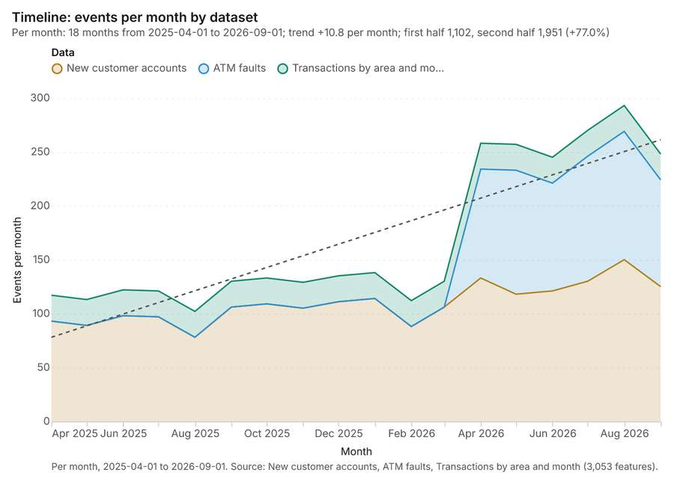
Figure 1. Timeline: events per month by dataset [1]. Per month, 2025-04-01 to 2026-09-01. Source: New customer accounts, ATM faults, Transactions by area and month (3,053 features). The data is in the appendix.
The timeline counts 3,053 dated events in New customer accounts, ATM faults, Transactions by area and month per month, from April 2025 to September 2026 [1][2][3][4]. By dataset: New customer accounts 1,971; ATM faults 650; Transactions by area and month 432 [1]. The trend is +10.8 events per month; the second half of the months has 1,951 against 1,102 in the first (+77.0%) [1].
Busiest months
- August 2026: 293 events [1]
- July 2026: 270 events [1]
- April 2026: 258 events [1]
Quietest months
- August 2025: 102 events [1]
- February 2026: 112 events [1]
- May 2025: 113 events [1]

Space time hot spots
What this analysis is. Emerging hot spots: Where hot spots are new, consecutive, intensifying, persistent, diminishing, sporadic, oscillating or historical over time [5]. In ArcGIS it is Emerging Hot Spot Analysis or Create Space Time Cube [5].
Why it was run on this data. ATM faults carry dates in 'reported_at': emerging hot spot analysis finds new, intensifying and fading hot spots per week [6].
What it found. The process saved a layer named Emerging hot spots: ATM faults, which contained 84 features [7]. Using ATM faults as input [8], the operation completed with an elapsed time of 24 milliseconds [7]. The analysis utilized 650 features and generated a count of 84 results [7].
Result | Value
result, count | 84
result, elapsed ms | 24
result, resolution | 8
result, features used | 650
result, time neighbors | 0
billing, cost | 0.1325
billing, list price | 0.1325
billing, upstream cost | 0

Findings
- Evidenced: Space time hot spots on ATM faults: Emerging hot spots: 1 layer saved: Emerging hot spots: ATM faults (84 features) [7][8].
- Evidenced: It reported result, count 84; result, elapsed ms 24; result, resolution 8; result, features used 650; result, time neighbors 0; billing, cost 0.1325 [7].
Tool gp_space_time_hot_spots; parameters {"project": "36cc8b7b-aabc-4b71-981b-a2c53e8f31ad", "features": {"layer": "ATM faults (2bdf3635)"}, "interval": "week", "bin_shape": "h3", "resolution": 8, "time_field": "reported_at"}

Space time hot spots
What this analysis is. Emerging hot spots: Where hot spots are new, consecutive, intensifying, persistent, diminishing, sporadic, oscillating or historical over time [5]. In ArcGIS it is Emerging Hot Spot Analysis or Create Space Time Cube [5].
Why it was run on this data. New customer accounts carry dates in 'opened_on': emerging hot spot analysis finds new, intensifying and fading hot spots per month [9].
What it found. Space time hot spots on New customer accounts: Emerging hot spots: 1 layer saved: Emerging hot spots: New customer accounts (106 features) [10][11]. It reported result, count 106; result, elapsed ms 21; result, resolution 8; result, features used 1,971; result, time neighbors 0; billing, cost 0.1986 [10].
Result | Value
result, count | 106
result, elapsed ms | 21
result, resolution | 8
result, features used | 1,971
result, time neighbors | 0
billing, cost | 0.1986
billing, list price | 0.1986
billing, upstream cost | 0

Findings
- Evidenced: Space time hot spots on New customer accounts: Emerging hot spots: 1 layer saved: Emerging hot spots: New customer accounts (106 features) [10][11].
- Evidenced: It reported result, count 106; result, elapsed ms 21; result, resolution 8; result, features used 1,971; result, time neighbors 0; billing, cost 0.1986 [10].
Tool gp_space_time_hot_spots; parameters {"project": "36cc8b7b-aabc-4b71-981b-a2c53e8f31ad", "features": {"layer": "New customer accounts (e03b0fae)"}, "interval": "month", "bin_shape": "h3", "resolution": 8, "time_field": "opened_on"}

Summarize within
What this analysis is. Summarize within: Count and aggregate the features inside each polygon (or bin), proportionally for lines and polygons [12]. In ArcGIS it is Summarize Within or Aggregate Points; in QGIS, native:countpointsinpolygon or native:sumlinelengths [12].
Why it was run on this data. Count ATM faults inside each feature of Service areas by fault; the counts map as a choropleth (natural breaks, sequential colors) [13].
What it found. The process of summarizing ATM faults using the Service areas feature set retrieved 24 features [14]. This execution involved analyzing the Service areas [15] and clocked an elapsed time of 4 ms [14]. The analysis reported a billing cost and list price of 0.0235, noting an upstream cost of 0 [14].
Result | Value
result, count | 24
result, elapsed ms | 4
billing, cost | 0.0235
billing, list price | 0.0235
billing, upstream cost | 0

Findings
- Evidenced: Summarize within on ATM faults, Service areas: Summarize within: 1 layer saved: Summarize within: Service areas (24 features) [8][14][15].
- Evidenced: It reported result, count 24; result, elapsed ms 4; billing, cost 0.0235; billing, list price 0.0235; billing, upstream cost 0 [14].
Tool gp_summarize_within; parameters {"stats": [{"stat": "sum", "field": "downtime_h"}], "project": "36cc8b7b-aabc-4b71-981b-a2c53e8f31ad", "features": {"layer": "ATM faults (2bdf3635)"}, "group_by": "fault", "polygons": {"layer": "Service areas (6344158f)"}}

Summarize within
What this analysis is. Summarize within: Count and aggregate the features inside each polygon (or bin), proportionally for lines and polygons [12]. In ArcGIS it is Summarize Within or Aggregate Points; in QGIS, native:countpointsinpolygon or native:sumlinelengths [12].
Why it was run on this data. Count ATM faults inside each feature of Service areas by fault; the counts map as a choropleth (natural breaks, sequential colors) [13].
What it found. The `gp_summarize_within` tool was executed to process Service areas [15] using ATMs [17] as input [16]. This process resulted in a count of 24 for the service areas [16]. Costs associated with this operation included a billing cost and list price of 0.0133 [16]. The upstream cost for the billing was zero [16].
Result | Value
result, count | 24
result, elapsed ms | 1
billing, cost | 0.0133
billing, list price | 0.0133
billing, upstream cost | 0

Findings
- Evidenced: Summarize within on ATMs, Service areas: Summarize within: 1 layer saved: Summarize within: Service areas (24 features) [15][16][17].
- Evidenced: It reported result, count 24; result, elapsed ms 1; billing, cost 0.0133; billing, list price 0.0133; billing, upstream cost 0 [16].
Tool gp_summarize_within; parameters {"stats": [{"stat": "sum", "field": "uptime_pct"}], "project": "36cc8b7b-aabc-4b71-981b-a2c53e8f31ad", "features": {"layer": "ATMs (f9f05311)"}, "group_by": "location_type", "polygons": {"layer": "Service areas (6344158f)"}}

Summarize within
What this analysis is. Summarize within: Count and aggregate the features inside each polygon (or bin), proportionally for lines and polygons [12]. In ArcGIS it is Summarize Within or Aggregate Points; in QGIS, native:countpointsinpolygon or native:sumlinelengths [12].
Why it was run on this data. Count ATM faults inside each feature of Service areas by fault; the counts map as a choropleth (natural breaks, sequential colors) [13].
What it found. Summarize within on Branches, Service areas: Summarize within: 1 layer saved: Summarize within: Service areas (24 features) [15][18][19]. It reported result, count 24; result, elapsed ms 1; billing, cost 0.0111; billing, list price 0.0111; billing, upstream cost 0 [18].
Result | Value
result, count | 24
result, elapsed ms | 1
billing, cost | 0.0111
billing, list price | 0.0111
billing, upstream cost | 0

Findings
- Evidenced: Summarize within on Branches, Service areas: Summarize within: 1 layer saved: Summarize within: Service areas (24 features) [15][18][19].
- Evidenced: It reported result, count 24; result, elapsed ms 1; billing, cost 0.0111; billing, list price 0.0111; billing, upstream cost 0 [18].
Tool gp_summarize_within; parameters {"stats": [{"stat": "sum", "field": "staff"}], "project": "36cc8b7b-aabc-4b71-981b-a2c53e8f31ad", "features": {"layer": "Branches (8f400be9)"}, "group_by": "type", "polygons": {"layer": "Service areas (6344158f)"}}

Hot spots
What this analysis is. Hot spot analysis: Getis-Ord Gi* hot and cold spots with z-scores, p-values and confidence bins [20]. In ArcGIS it is Find Hot Spots or Hot Spot Analysis (Getis-Ord Gi*); in QGIS, qgis:hotspot (plugin) [20].
Why it was run on this data. 650 points: Getis-Ord Gi* tests whether the concentrations in ATM faults are statistically significant [21].
What it found. Hot spots on ATM faults: Hot spot analysis: 1 layer saved: Hot spot analysis: ATM faults (240 features) [8][22]. It reported result, bins 240; result, count 240; result, elapsed ms 19; result, cell size m 500; result, incidents used 650; result, distance band m 1,000 [22].
Result | Value
result, bins | 240
result, count | 240
result, elapsed ms | 19
result, cell size m | 500
result, incidents used | 650
result, distance band m | 1,000
billing, cost | 0.063
billing, list price | 0.063
billing, upstream cost | 0

Findings
- Evidenced: Hot spots on ATM faults: Hot spot analysis: 1 layer saved: Hot spot analysis: ATM faults (240 features) [8][22].
- Evidenced: It reported result, bins 240; result, count 240; result, elapsed ms 19; result, cell size m 500; result, incidents used 650; result, distance band m 1,000 [22].
Tool gp_hot_spots; parameters {"project": "36cc8b7b-aabc-4b71-981b-a2c53e8f31ad", "features": {"layer": "ATM faults (2bdf3635)"}, "aggregation": "hexagon", "cell_size_m": 500.0, "distance_band_m": 1000.0}

Hot spots
What this analysis is. Hot spot analysis: Getis-Ord Gi* hot and cold spots with z-scores, p-values and confidence bins [20]. In ArcGIS it is Find Hot Spots or Hot Spot Analysis (Getis-Ord Gi*); in QGIS, qgis:hotspot (plugin) [20].
Why it was run on this data. 140 points: Getis-Ord Gi* tests whether the concentrations in ATMs are statistically significant [23].
What it found. The hot spot analysis tool processed the ATMs layer to generate one layer containing 68 features [24].
Result | Value
result, bins | 68
result, count | 68
result, elapsed ms | 5
result, cell size m | 1,000
result, incidents used | 140
result, distance band m | 2,000
billing, cost | 0.0528
billing, list price | 0.0528
billing, upstream cost | 0

Findings
- Evidenced: Hot spots on ATMs: Hot spot analysis: 1 layer saved: Hot spot analysis: ATMs (68 features) [17][24].
- Evidenced: It reported result, bins 68; result, count 68; result, elapsed ms 5; result, cell size m 1,000; result, incidents used 140; result, distance band m 2,000 [24].
Tool gp_hot_spots; parameters {"project": "36cc8b7b-aabc-4b71-981b-a2c53e8f31ad", "features": {"layer": "ATMs (f9f05311)"}, "aggregation": "hexagon", "cell_size_m": 1000.0, "distance_band_m": 2000.0}

Hot spots
What this analysis is. Hot spot analysis: Getis-Ord Gi* hot and cold spots with z-scores, p-values and confidence bins [20]. In ArcGIS it is Find Hot Spots or Hot Spot Analysis (Getis-Ord Gi*); in QGIS, qgis:hotspot (plugin) [20].
Why it was run on this data. 30 points: Getis-Ord Gi* tests whether the concentrations in Branches are statistically significant [25].
What it found. The hot spot analysis processed the Branches layer [19], saving one layer containing 16 features [26]. The analysis utilized 30 incidents and generated 16 bins [26].
Result | Value
result, bins | 16
result, count | 16
result, elapsed ms | 2
result, cell size m | 2,000
result, incidents used | 30
result, distance band m | 2,000
billing, cost | 0.0506
billing, list price | 0.0506
billing, upstream cost | 0

Findings
- Evidenced: Hot spots on Branches: Hot spot analysis: 1 layer saved: Hot spot analysis: Branches (16 features) [19][26].
- Evidenced: It reported result, bins 16; result, count 16; result, elapsed ms 2; result, cell size m 2,000; result, incidents used 30; result, distance band m 2,000 [26].
Tool gp_hot_spots; parameters {"project": "36cc8b7b-aabc-4b71-981b-a2c53e8f31ad", "features": {"layer": "Branches (8f400be9)"}, "aggregation": "hexagon", "cell_size_m": 2000.0, "distance_band_m": 2000.0}

Calculate density
What this analysis is. Calculate density: Kernel density per square kilometer on a grid [27]. In ArcGIS it is Calculate Density or Kernel Density; in QGIS, native:heatmapkerneldensityestimation [27].
Why it was run on this data. 650 points in ATM faults: a density surface shows where they concentrate [28].
What it found. Calculate density on ATM faults: Calculate density: 1 layer saved: Calculate density: ATM faults (1893 features) [8][29]. It reported result, count 1,893; result, elapsed ms 61; result, bandwidth m 1,000; result, cell size m 200; result, excluded null 0; result, max density per km2 45.95 [29].
Result | Value
result, count | 1,893
result, elapsed ms | 61
result, bandwidth m | 1,000
result, cell size m | 200
result, excluded null | 0
result, max density per km2 | 45.95
billing, cost | 0.063
billing, list price | 0.063
billing, upstream cost | 0

Findings
- Evidenced: Calculate density on ATM faults: Calculate density: 1 layer saved: Calculate density: ATM faults (1893 features) [8][29].
- Evidenced: It reported result, count 1,893; result, elapsed ms 61; result, bandwidth m 1,000; result, cell size m 200; result, excluded null 0; result, max density per km2 45.95 [29].
Tool gp_calculate_density; parameters {"kernel": "quartic", "project": "36cc8b7b-aabc-4b71-981b-a2c53e8f31ad", "features": {"layer": "ATM faults (2bdf3635)"}, "bandwidth_m": 1000.0, "cell_size_m": 200.0}

Calculate density
What this analysis is. Calculate density: Kernel density per square kilometer on a grid [27]. In ArcGIS it is Calculate Density or Kernel Density; in QGIS, native:heatmapkerneldensityestimation [27].
Why it was run on this data. 140 points in ATMs: a density surface shows where they concentrate [30].
What it found. Calculate density on ATMs: Calculate density: 1 layer saved: Calculate density: ATMs (459 features) [17][31]. It reported result, count 459; result, elapsed ms 15; result, bandwidth m 2,000; result, cell size m 500; result, excluded null 0; result, max density per km2 3.678 [31].
Result | Value
result, count | 459
result, elapsed ms | 15
result, bandwidth m | 2,000
result, cell size m | 500
result, excluded null | 0
result, max density per km2 | 3.678
billing, cost | 0.0528
billing, list price | 0.0528
billing, upstream cost | 0

Findings
- Evidenced: Calculate density on ATMs: Calculate density: 1 layer saved: Calculate density: ATMs (459 features) [17][31].
- Evidenced: It reported result, count 459; result, elapsed ms 15; result, bandwidth m 2,000; result, cell size m 500; result, excluded null 0; result, max density per km2 3.678 [31].
Tool gp_calculate_density; parameters {"kernel": "quartic", "project": "36cc8b7b-aabc-4b71-981b-a2c53e8f31ad", "features": {"layer": "ATMs (f9f05311)"}, "bandwidth_m": 2000.0, "cell_size_m": 500.0}

Calculate density
What this analysis is. Calculate density: Kernel density per square kilometer on a grid [27]. In ArcGIS it is Calculate Density or Kernel Density; in QGIS, native:heatmapkerneldensityestimation [27].
Why it was run on this data. 30 points in Branches: a density surface shows where they concentrate [32].
What it found. The density calculation successfully processed 88 branches [33]. Parameters used in the calculation included a bandwidth of 2,000 m and a cell size of 1,000 m [33]. The analysis generated a maximum density of 0.9778 per km² [33]. The total billing cost associated with this calculation was 0.0506 [33].
Result | Value
result, count | 88
result, elapsed ms | 3
result, bandwidth m | 2,000
result, cell size m | 1,000
result, excluded null | 0
result, max density per km2 | 0.9778
billing, cost | 0.0506
billing, list price | 0.0506
billing, upstream cost | 0

Findings
- Evidenced: Calculate density on Branches: Calculate density: 1 layer saved: Calculate density: Branches (88 features) [19][33].
- Evidenced: It reported result, count 88; result, elapsed ms 3; result, bandwidth m 2,000; result, cell size m 1,000; result, excluded null 0; result, max density per km2 0.9778 [33].
Tool gp_calculate_density; parameters {"kernel": "quartic", "project": "36cc8b7b-aabc-4b71-981b-a2c53e8f31ad", "features": {"layer": "Branches (8f400be9)"}, "bandwidth_m": 2000.0, "cell_size_m": 1000.0}

Find point clusters
What this analysis is. Find point clusters: Density-based clusters (DBSCAN, HDBSCAN or OPTICS, optionally space-time) with hulls and noise [34]. In ArcGIS it is Find Point Clusters or Density-based Clustering; in QGIS, native:dbscanclustering or native:stdbscanclustering [34].
Why it was run on this data. DBSCAN finds dense groups of ATM faults and separates noise [35].
What it found. Find point clusters on ATM faults: Find point clusters: 2 layers saved: Find point clusters: ATM faults (650 features); Find point clusters: cluster hulls (14 features) [8][36]. It reported result, count 650; result, noise 232; result, distance m 500; result, elapsed ms 14; result, min points 16; billing, cost 0.063 [36].
Result | Value
result, count | 650
result, noise | 232
result, distance m | 500
result, elapsed ms | 14
result, min points | 16
billing, cost | 0.063
billing, list price | 0.063
billing, upstream cost | 0

Findings
- Evidenced: Find point clusters on ATM faults: Find point clusters: 2 layers saved: Find point clusters: ATM faults (650 features); Find point clusters: cluster hulls (14 features) [8][36].
- Evidenced: It reported result, count 650; result, noise 232; result, distance m 500; result, elapsed ms 14; result, min points 16; billing, cost 0.063 [36].
Tool gp_find_point_clusters; parameters {"method": "dbscan", "project": "36cc8b7b-aabc-4b71-981b-a2c53e8f31ad", "features": {"layer": "ATM faults (2bdf3635)"}, "distance_m": 500.0, "min_points": 16}

Find point clusters
What this analysis is. Find point clusters: Density-based clusters (DBSCAN, HDBSCAN or OPTICS, optionally space-time) with hulls and noise [34]. In ArcGIS it is Find Point Clusters or Density-based Clustering; in QGIS, native:dbscanclustering or native:stdbscanclustering [34].
Why it was run on this data. DBSCAN finds dense groups of ATMs and separates noise [37].
What it found. Find point clusters on ATMs: Find point clusters: 2 layers saved: Find point clusters: ATMs (140 features); Find point clusters: cluster hulls (1 feature) [17][38]. It reported result, count 140; result, noise 0; result, distance m 1,000; result, elapsed ms 3; result, min points 4; billing, cost 0.0528 [38].
Result | Value
result, count | 140
result, noise | 0
result, distance m | 1,000
result, elapsed ms | 3
result, min points | 4
billing, cost | 0.0528
billing, list price | 0.0528
billing, upstream cost | 0

Findings
- Evidenced: Find point clusters on ATMs: Find point clusters: 2 layers saved: Find point clusters: ATMs (140 features); Find point clusters: cluster hulls (1 feature) [17][38].
- Evidenced: It reported result, count 140; result, noise 0; result, distance m 1,000; result, elapsed ms 3; result, min points 4; billing, cost 0.0528 [38].
Tool gp_find_point_clusters; parameters {"method": "dbscan", "project": "36cc8b7b-aabc-4b71-981b-a2c53e8f31ad", "features": {"layer": "ATMs (f9f05311)"}, "distance_m": 1000.0, "min_points": 4}

Find point clusters
What this analysis is. Find point clusters: Density-based clusters (DBSCAN, HDBSCAN or OPTICS, optionally space-time) with hulls and noise [34]. In ArcGIS it is Find Point Clusters or Density-based Clustering; in QGIS, native:dbscanclustering or native:stdbscanclustering [34].
Why it was run on this data. DBSCAN finds dense groups of Branches and separates noise [39].
What it found. Find point clusters on Branches: Find point clusters: 2 layers saved: Find point clusters: Branches (30 features); Find point clusters: cluster hulls (1 feature) [19][40]. It reported result, count 30; result, noise 0; result, distance m 2,000; result, elapsed ms 2; result, min points 3; billing, cost 0.0506 [40].
Result | Value
result, count | 30
result, noise | 0
result, distance m | 2,000
result, elapsed ms | 2
result, min points | 3
billing, cost | 0.0506
billing, list price | 0.0506
billing, upstream cost | 0

Findings
- Evidenced: Find point clusters on Branches: Find point clusters: 2 layers saved: Find point clusters: Branches (30 features); Find point clusters: cluster hulls (1 feature) [19][40].
- Evidenced: It reported result, count 30; result, noise 0; result, distance m 2,000; result, elapsed ms 2; result, min points 3; billing, cost 0.0506 [40].
Tool gp_find_point_clusters; parameters {"method": "dbscan", "project": "36cc8b7b-aabc-4b71-981b-a2c53e8f31ad", "features": {"layer": "Branches (8f400be9)"}, "distance_m": 2000.0, "min_points": 3}

Outliers
What this analysis is. Find outliers: Anselin local Moran’s I: HH, LL clusters and HL, LH outliers [41]. In ArcGIS it is Find Outliers or Cluster and Outlier Analysis (Anselin Local Moran’s I) [41].
Why it was run on this data. Local Moran's I maps clusters and outliers of 'population' [42].
What it found. Outliers on Service areas: Find outliers: 1 layer saved: Find outliers: Service areas (24 features) [15][43]. It reported result, count 24; result, elapsed ms 6; result, permutations 199; result, excluded null 0; result, distance band m 1,844; billing, cost 0.05072 [43].
Result | Value
result, count | 24
result, elapsed ms | 6
result, permutations | 199
result, excluded null | 0
result, distance band m | 1,844
billing, cost | 0.05072
billing, list price | 0.05072
billing, upstream cost | 0

Findings
- Evidenced: Outliers on Service areas: Find outliers: 1 layer saved: Find outliers: Service areas (24 features) [15][43].
- Evidenced: It reported result, count 24; result, elapsed ms 6; result, permutations 199; result, excluded null 0; result, distance band m 1,844; billing, cost 0.05072 [43].
Tool gp_outliers; parameters {"field": "population", "project": "36cc8b7b-aabc-4b71-981b-a2c53e8f31ad", "features": {"layer": "Service areas (6344158f)"}, "aggregation": "hexagon"}

Near repeat
What this analysis is. Repeat and near repeat classification: Classify incidents as originators, repeats (same place) or near repeats within a distance and time window, with a Knox test table [44]. In ArcGIS it is Repeat and Near Repeat Classification or Near Repeat Calculator [44].
Why it was run on this data. Near repeat analysis tests whether ATM faults close in space also follow each other within 18 days [45].
What it found. Near repeat on ATM faults: Repeat and near repeat classification: 1 layer saved: Repeat and near repeat classification: ATM faults (650 features) [8][46]. It reported result, days 18; result, count 650; result, chains 119; result, distance m 200; result, elapsed ms 23; result, pairs linked 690 [46].
Result | Value
result, days | 18
result, count | 650
result, chains | 119
result, distance m | 200
result, elapsed ms | 23
result, pairs linked | 690
billing, cost | 0.0695
billing, list price | 0.0695
billing, upstream cost | 0

Findings
- Evidenced: Near repeat on ATM faults: Repeat and near repeat classification: 1 layer saved: Repeat and near repeat classification: ATM faults (650 features) [8][46].
- Evidenced: It reported result, days 18; result, count 650; result, chains 119; result, distance m 200; result, elapsed ms 23; result, pairs linked 690 [46].
Tool gp_near_repeat; parameters {"days": 18, "project": "36cc8b7b-aabc-4b71-981b-a2c53e8f31ad", "features": {"layer": "ATM faults (2bdf3635)"}, "distance_m": 200.0, "time_field": "reported_at"}

Maps and charts
The run also made 20 map image(s) [47][48][49][50][51][52][53][54][55][56][57][58][59][60][61][62][63][64][65][66] and 23 chart(s) [67][68][69][70][71][72][73][74][75][76][77][78][79][80][81][82][83][84][85][86][87][88][89].
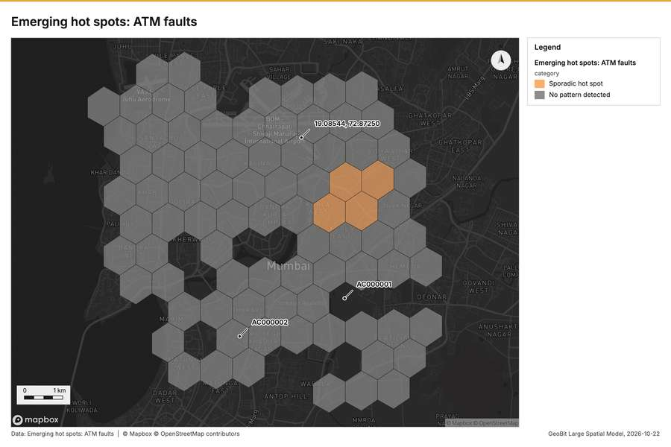
Figure 2. Emerging hot spots: ATM faults [47]
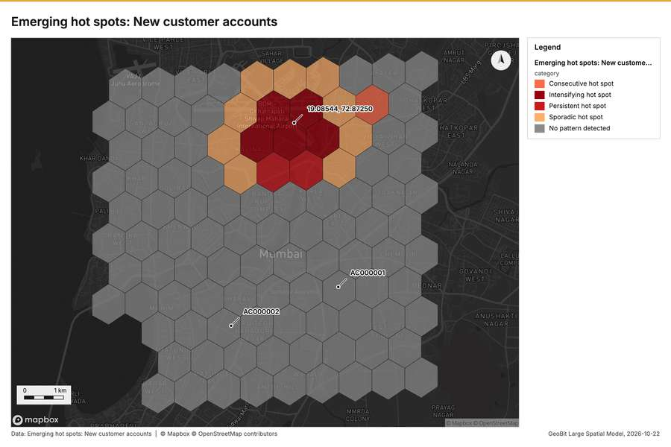
Figure 3. Emerging hot spots: New customer accounts [48]
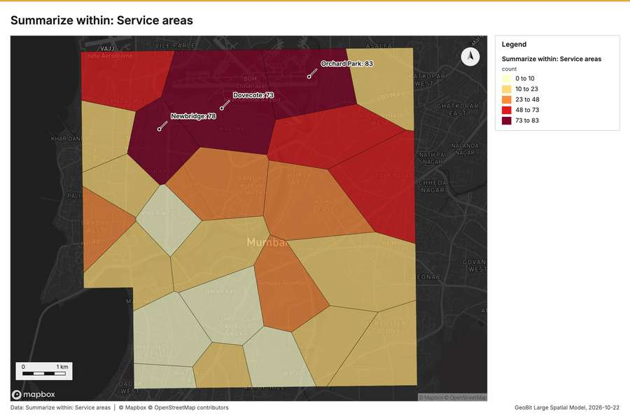
Figure 4. Summarize within: Service areas [49]
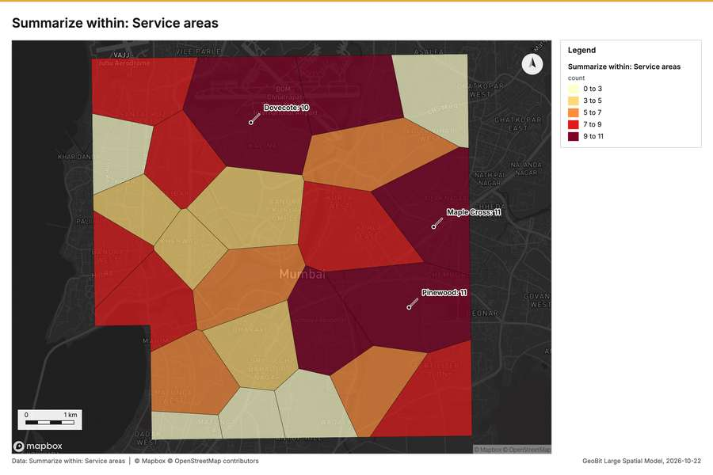
Figure 5. Summarize within: Service areas [50]
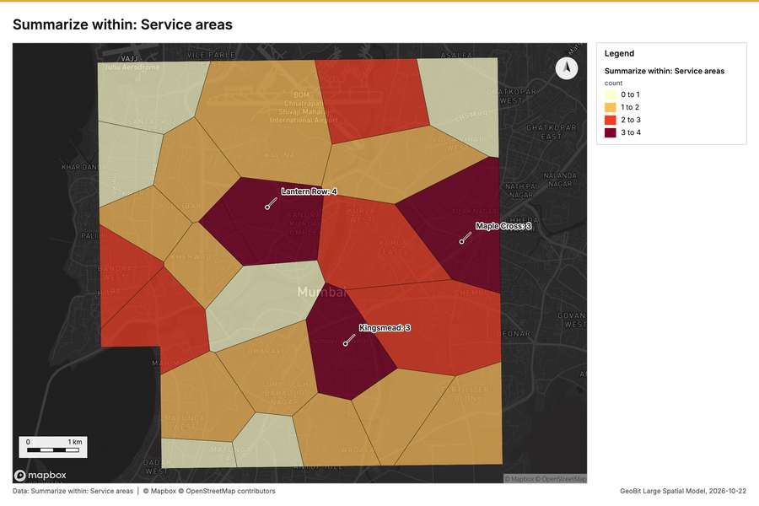
Figure 6. Summarize within: Service areas [51]
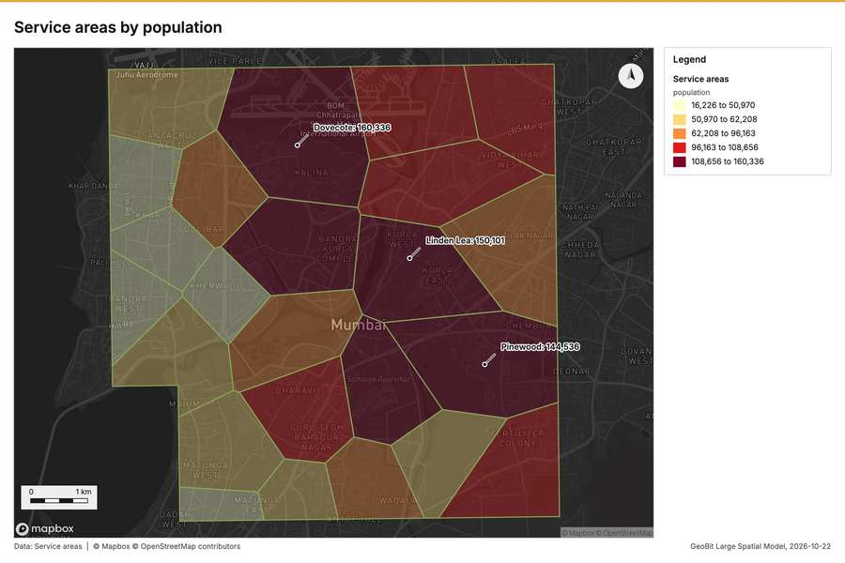
Figure 7. Service areas by population [52]
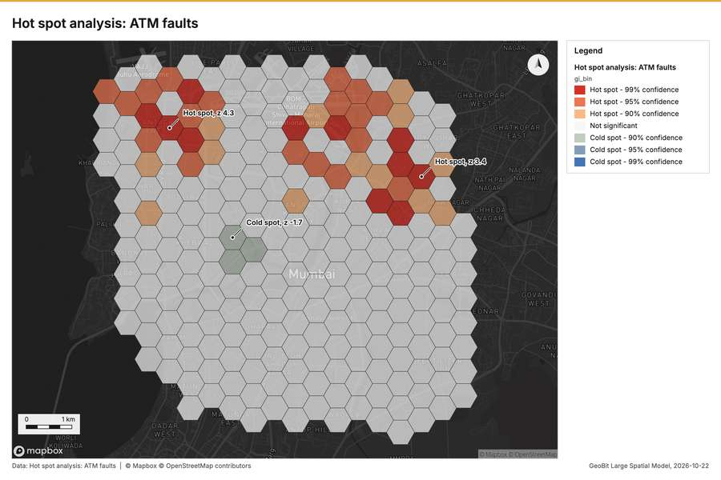
Figure 8. Hot spot analysis: ATM faults [53]
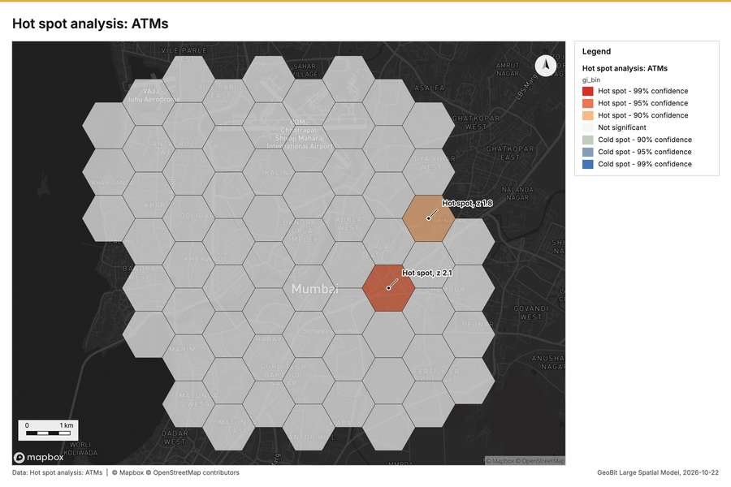
Figure 9. Hot spot analysis: ATMs [54]
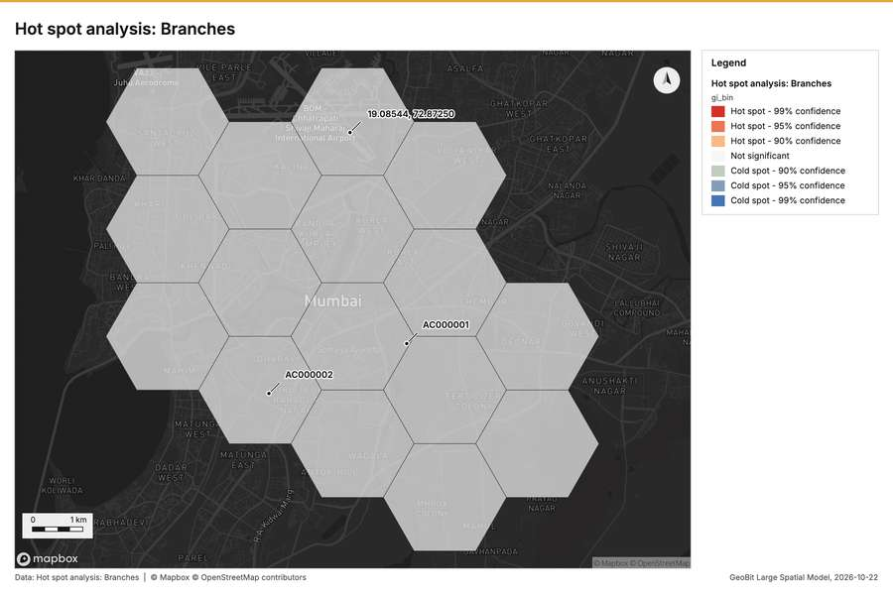
Figure 10. Hot spot analysis: Branches [55]
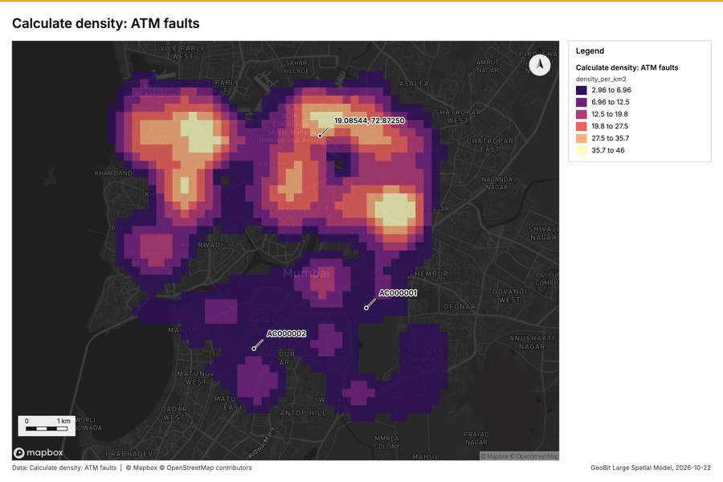
Figure 11. Calculate density: ATM faults [56]
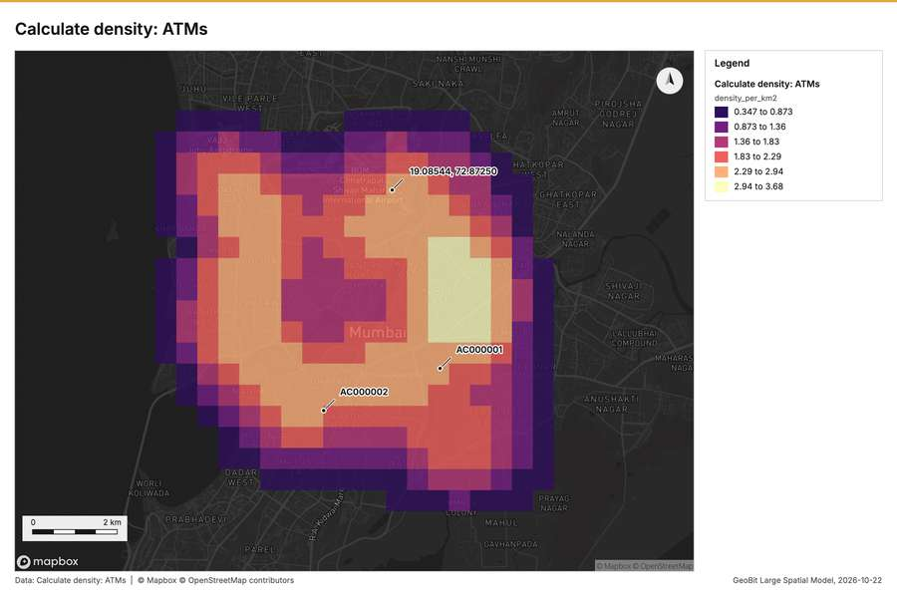
Figure 12. Calculate density: ATMs [57]
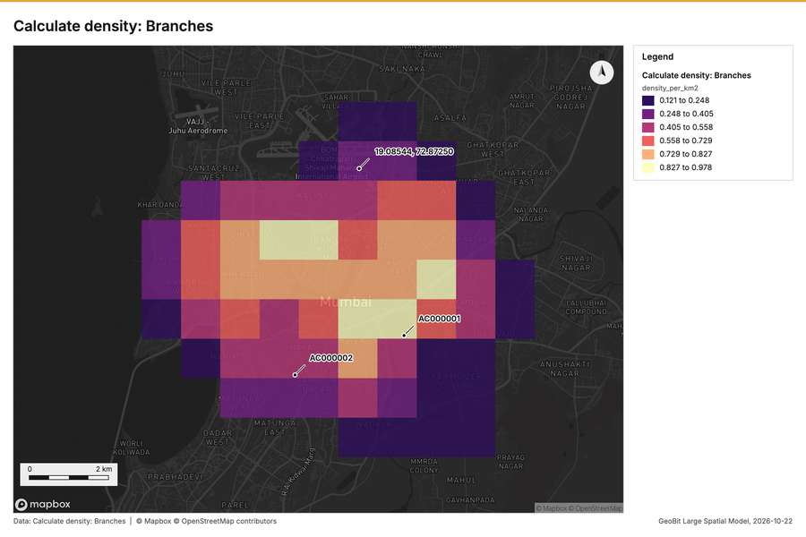
Figure 13. Calculate density: Branches [58]
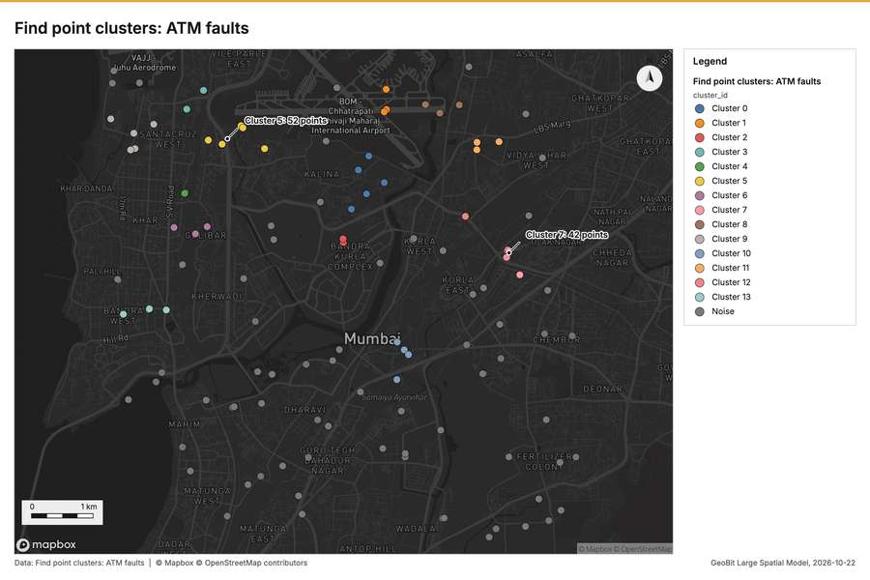
Figure 14. Find point clusters: ATM faults [59]
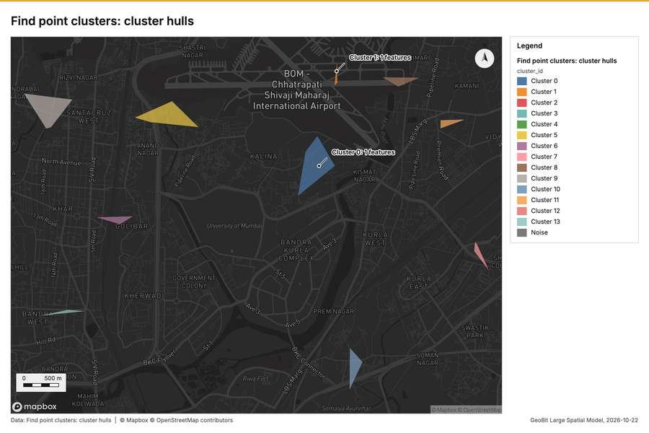
Figure 15. Find point clusters: cluster hulls [60]
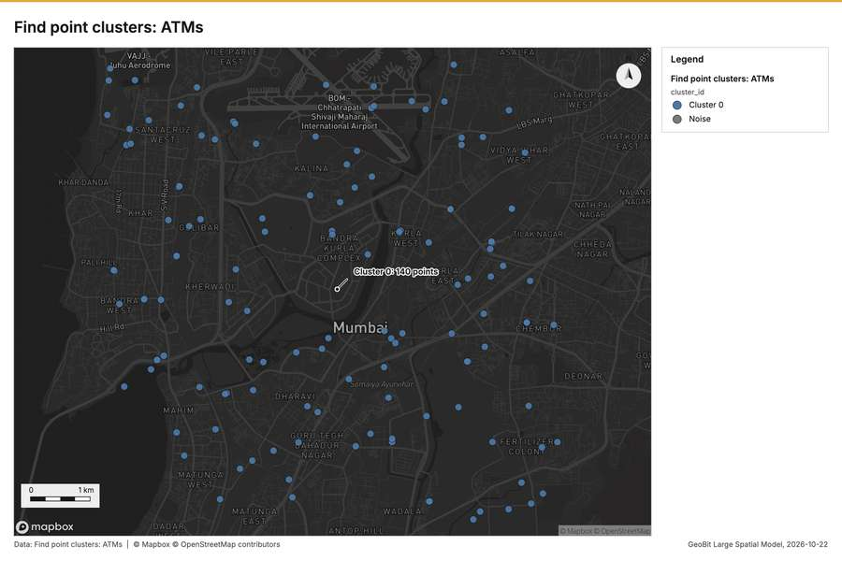
Figure 16. Find point clusters: ATMs [61]
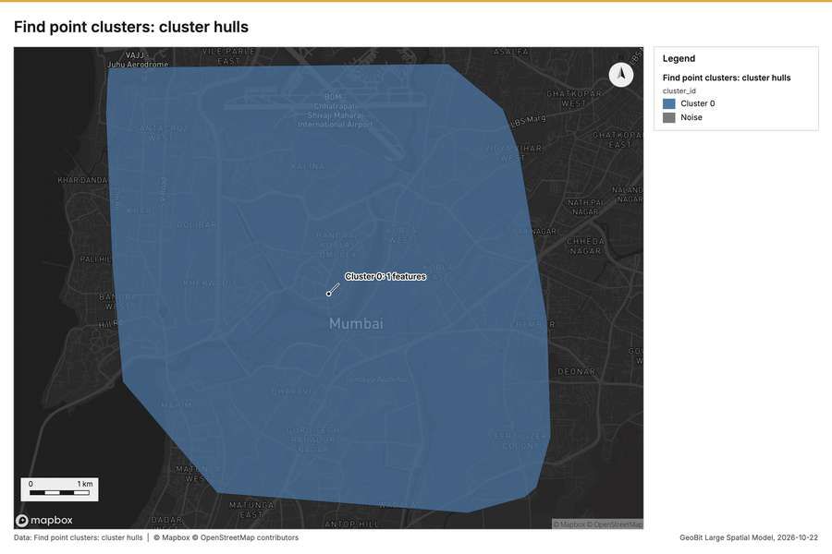
Figure 17. Find point clusters: cluster hulls [62]
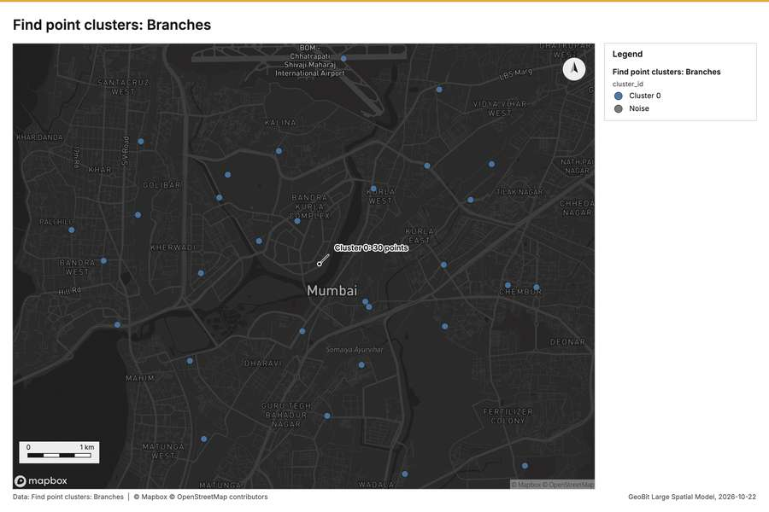
Figure 18. Find point clusters: Branches [63]
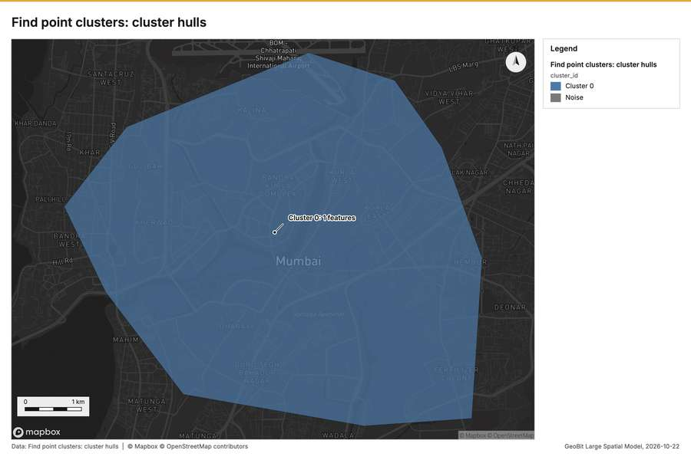
Figure 19. Find point clusters: cluster hulls [64]
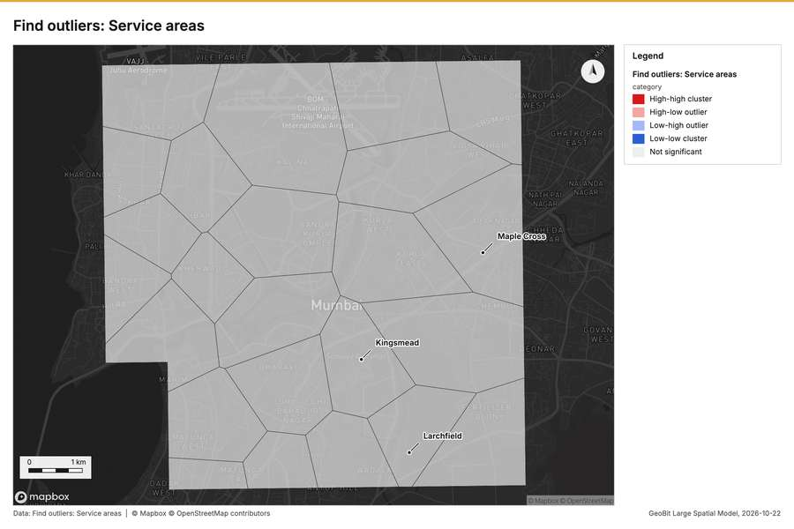
Figure 20. Find outliers: Service areas [65]
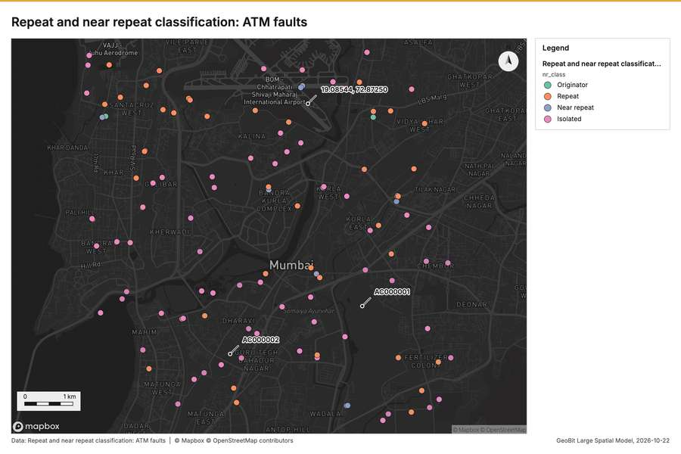
Figure 21. Repeat and near repeat classification: ATM faults [66]
What the map shows. A highly defined cluster of emerging hot spots is visible in the upper-center portion of the map, indicating concentrated areas for new customer accounts. Within this core area, the color coding reveals a [48]
Inferred: read from the image by gemma4:e4b, not evidence.
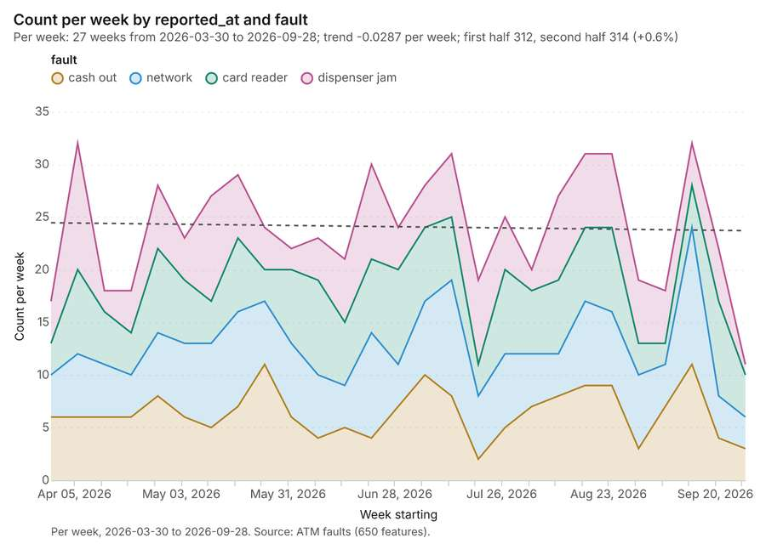
Figure 22. ATM faults over time (reported_at) [67]. Per week, 2026-03-30 to 2026-09-28. Source: ATM faults (650 features). The data is in the appendix.
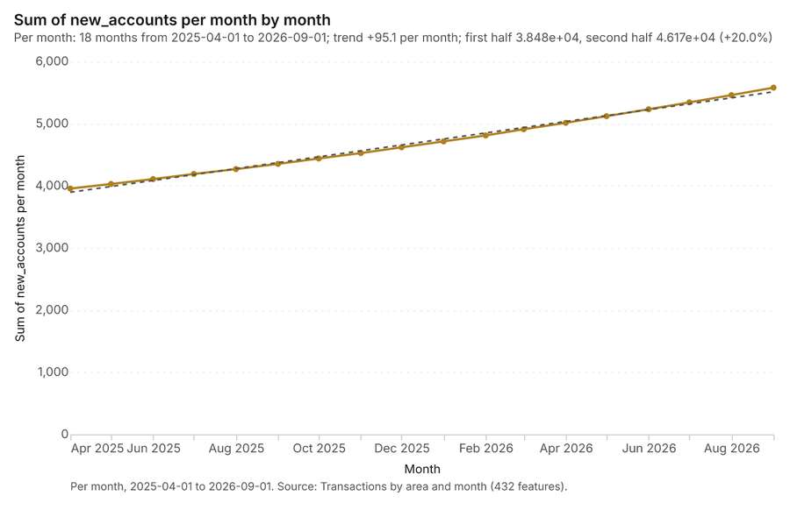
Figure 23. Transactions by area and month over time (month) [68]. Per month, 2025-04-01 to 2026-09-01. Source: Transactions by area and month (432 features). The data is in the appendix.
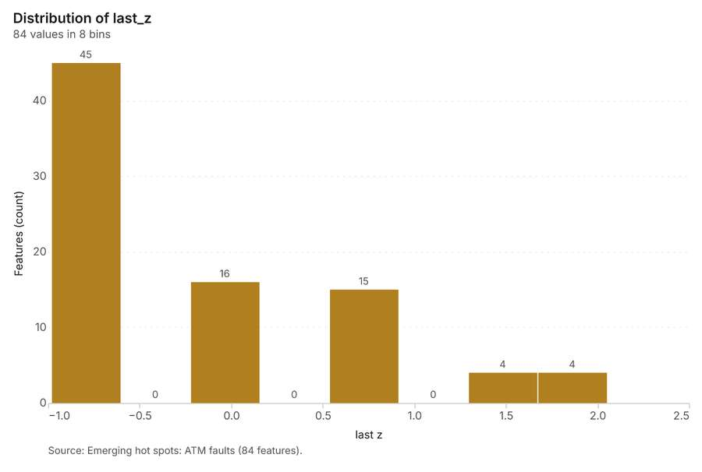
Figure 24. Emerging hot spots: ATM faults [69]. Source: Emerging hot spots: ATM faults (84 features). The data is in the appendix.
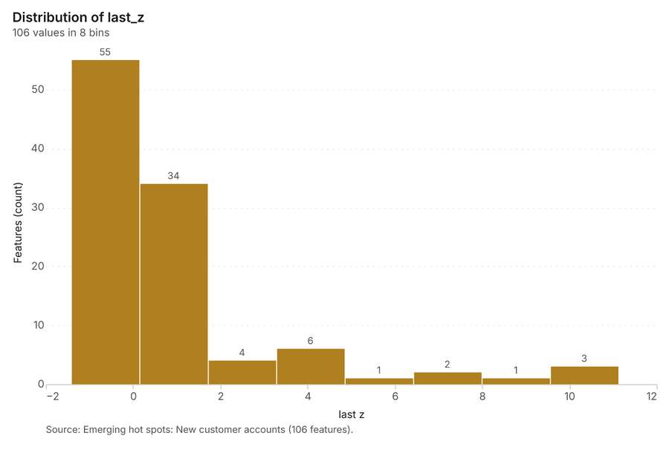
Figure 25. Emerging hot spots: New customer accounts [70]. Source: Emerging hot spots: New customer accounts (106 features). The data is in the appendix.
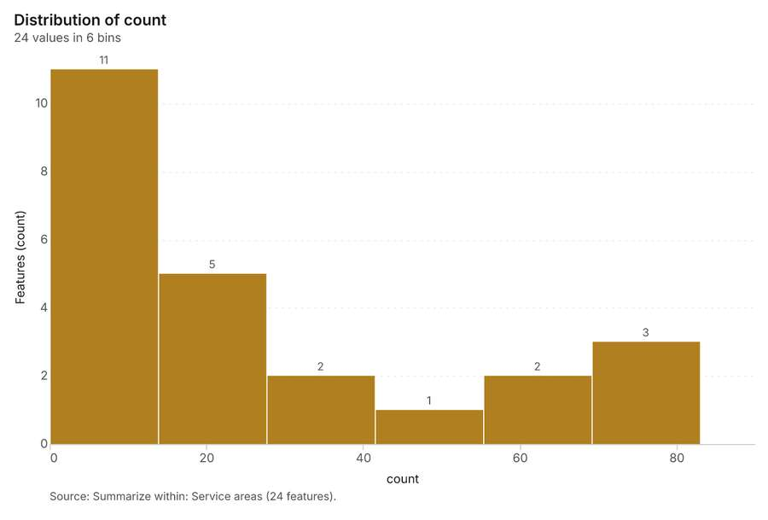
Figure 26. Summarize within: Service areas [71]. Source: Summarize within: Service areas (24 features). The data is in the appendix.
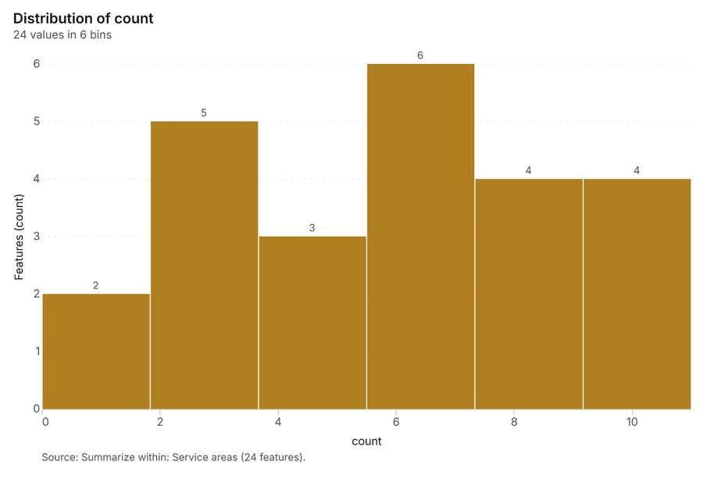
Figure 27. Summarize within: Service areas [72]. Source: Summarize within: Service areas (24 features). The data is in the appendix.
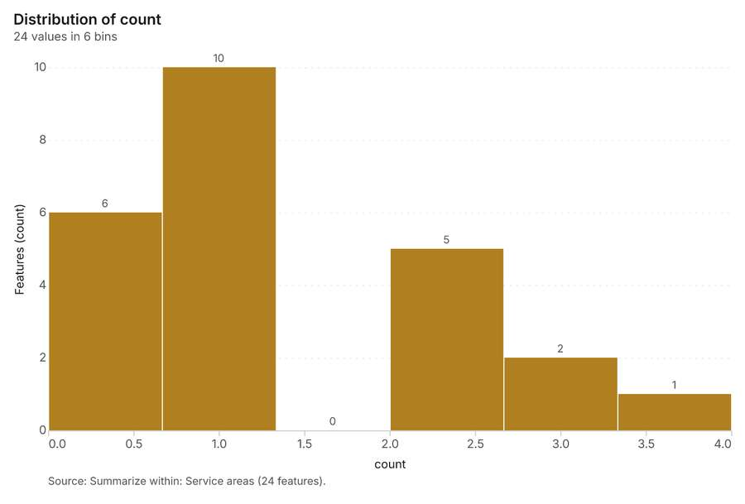
Figure 28. Summarize within: Service areas [73]. Source: Summarize within: Service areas (24 features). The data is in the appendix.
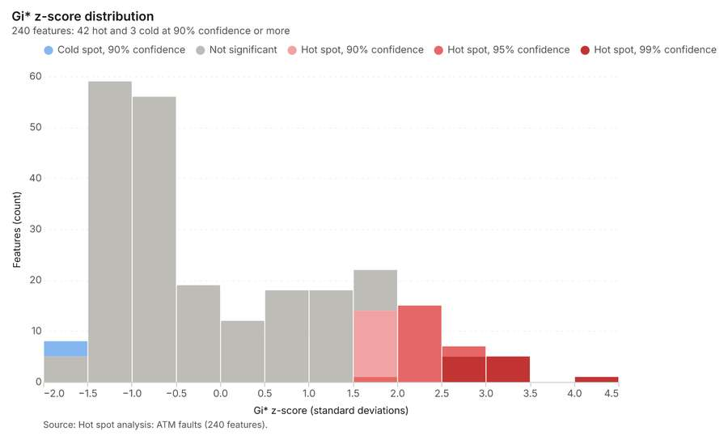
Figure 29. Hot spot analysis: ATM faults [74]. Source: Hot spot analysis: ATM faults (240 features). The data is in the appendix.
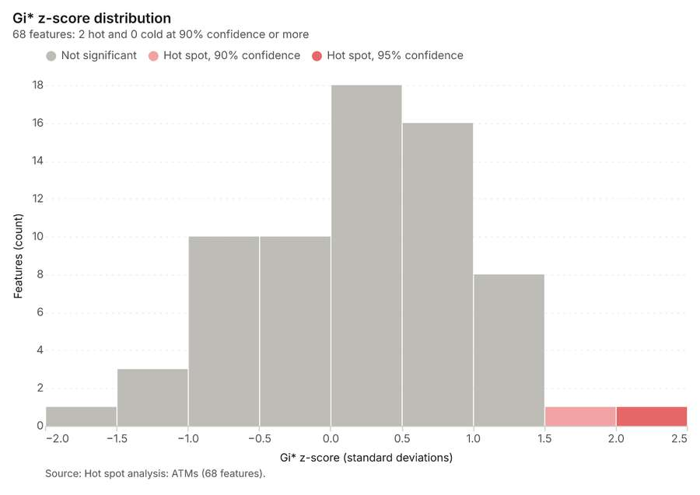
Figure 30. Hot spot analysis: ATMs [75]. Source: Hot spot analysis: ATMs (68 features). The data is in the appendix.
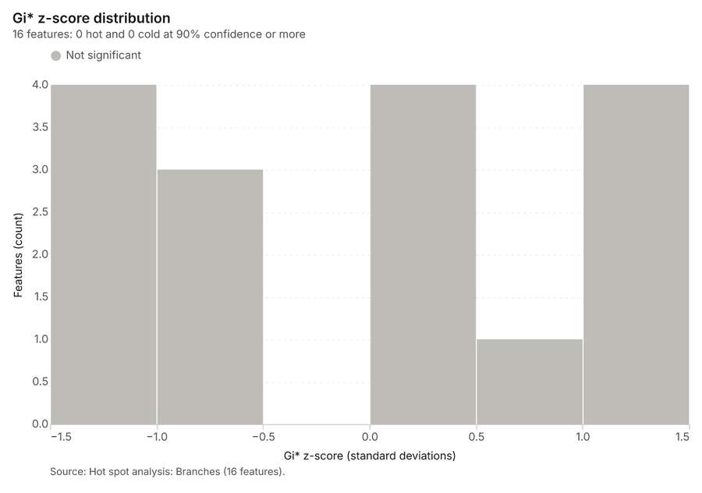
Figure 31. Hot spot analysis: Branches [76]. Source: Hot spot analysis: Branches (16 features). The data is in the appendix.
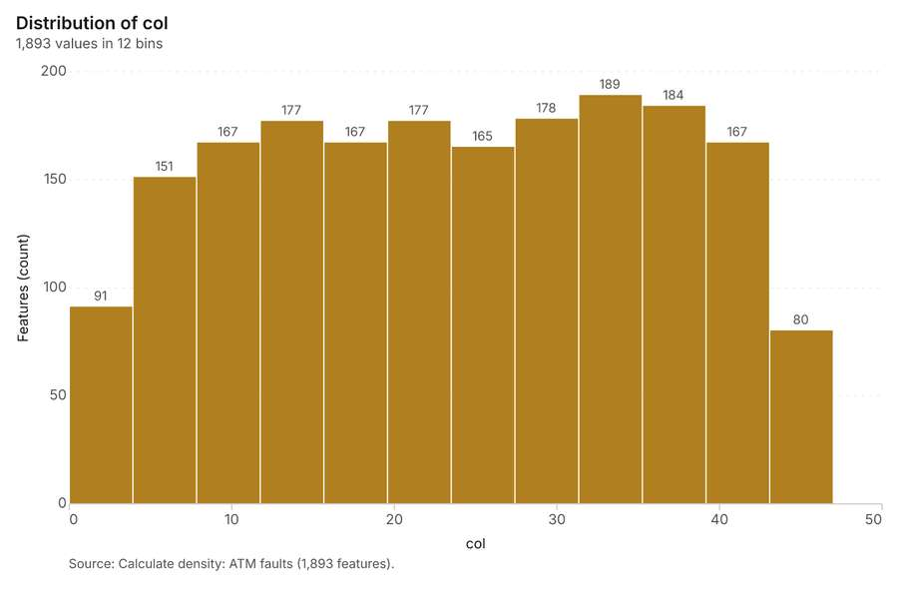
Figure 32. Calculate density: ATM faults [77]. Source: Calculate density: ATM faults (1,893 features). The data is in the appendix.
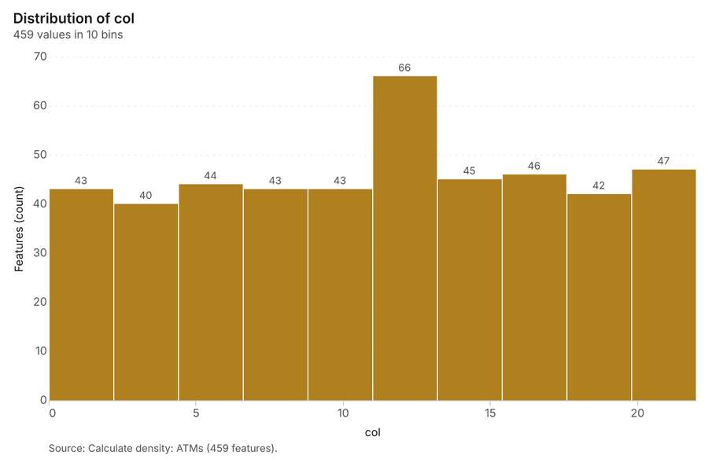
Figure 33. Calculate density: ATMs [78]. Source: Calculate density: ATMs (459 features). The data is in the appendix.
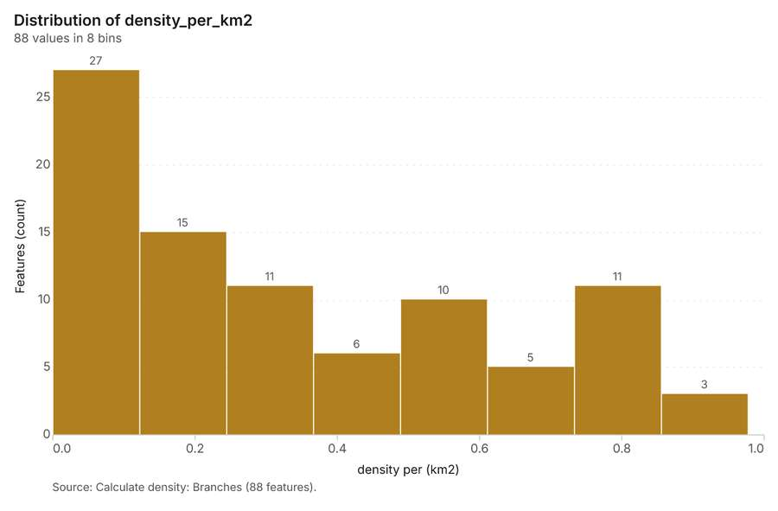
Figure 34. Calculate density: Branches [79]. Source: Calculate density: Branches (88 features). The data is in the appendix.
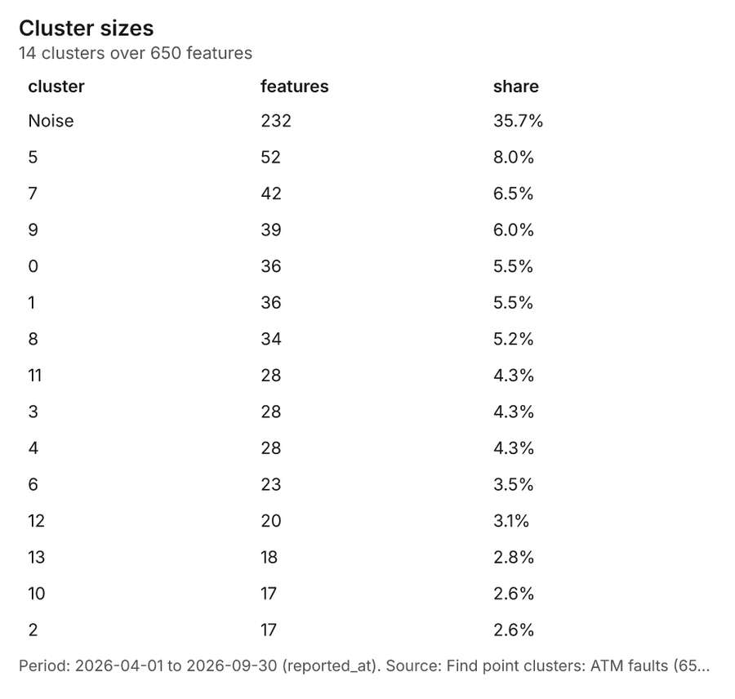
Figure 35. Find point clusters: ATM faults [80]. Period: 2026-04-01 to 2026-09-30 (reported_at). Source: Find point clusters: ATM faults (650 features). The data is in the appendix.
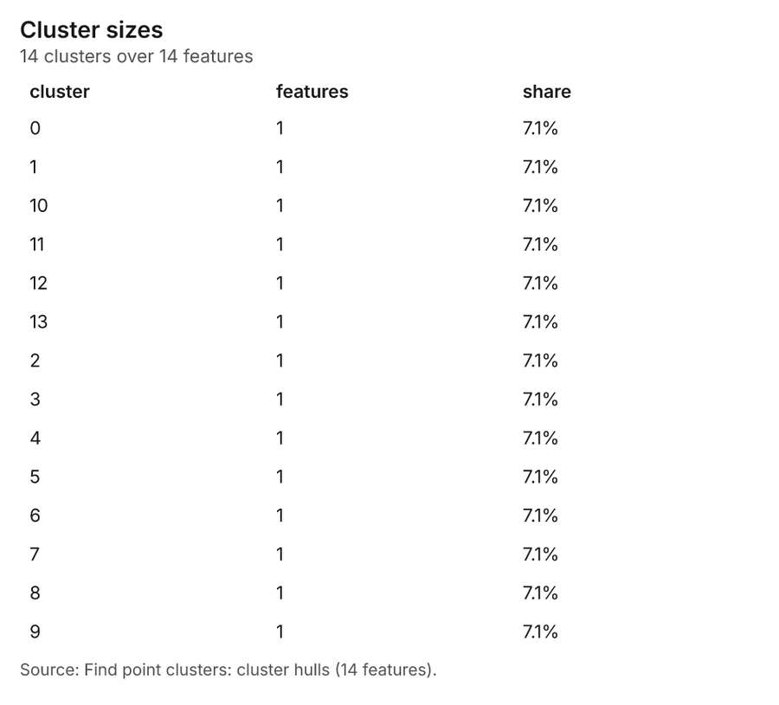
Figure 36. Find point clusters: cluster hulls [81]. Source: Find point clusters: cluster hulls (14 features). The data is in the appendix.
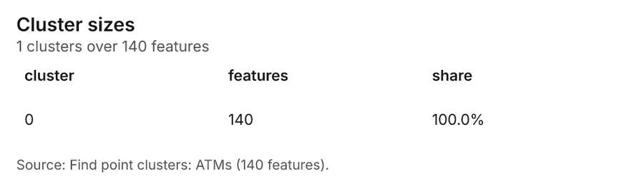
Figure 37. Find point clusters: ATMs [82]. Source: Find point clusters: ATMs (140 features). The data is in the appendix.
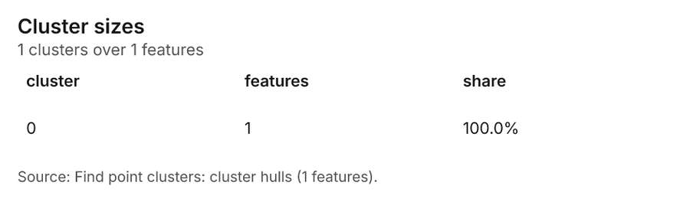
Figure 38. Find point clusters: cluster hulls [83]. Source: Find point clusters: cluster hulls (1 features). The data is in the appendix.
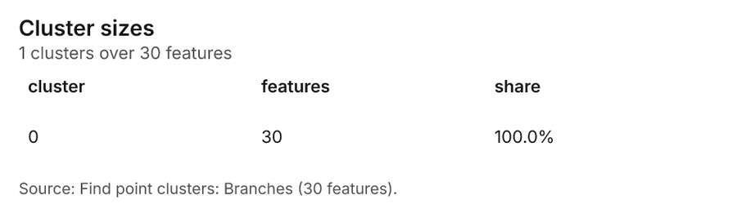
Figure 39. Find point clusters: Branches [84]. Source: Find point clusters: Branches (30 features). The data is in the appendix.
Figure 40. Find point clusters: cluster hulls [85]. Source: Find point clusters: cluster hulls (1 features). The data is in the appendix.
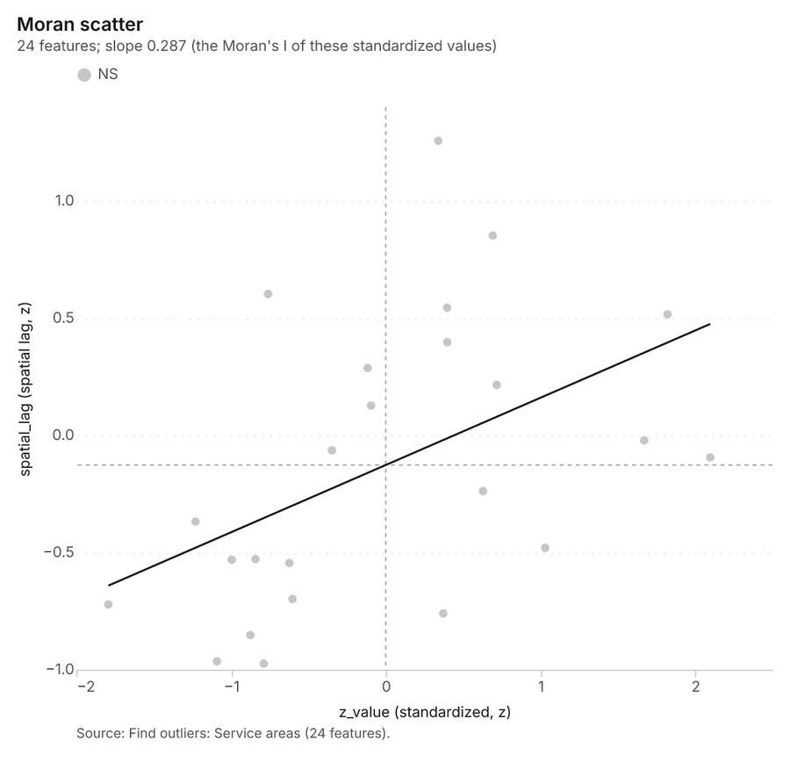
Figure 41. Find outliers: Service areas [86]. Source: Find outliers: Service areas (24 features). The data is in the appendix.
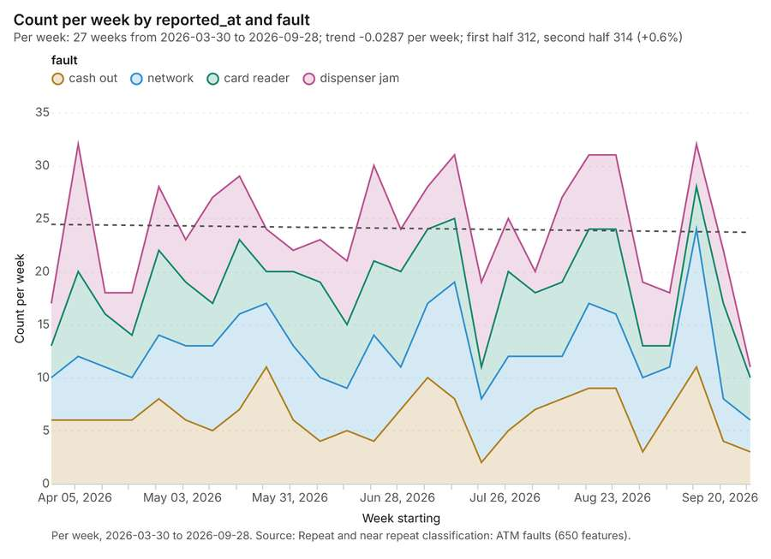
Figure 42. Repeat and near repeat classification: ATM faults [87]. Per week, 2026-03-30 to 2026-09-28. Source: Repeat and near repeat classification: ATM faults (650 features). The data is in the appendix.
Figure 43. Repeat and near repeat classification: ATM faults over time [88]. Per week, 2026-03-30 to 2026-09-28. Source: Repeat and near repeat classification: ATM faults (650 features). The data is in the appendix.
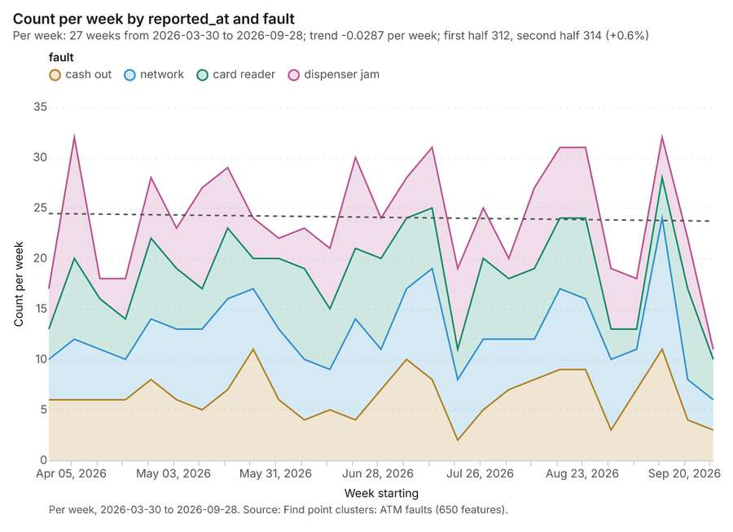
Figure 44. Find point clusters: ATM faults over time [89]. Per week, 2026-03-30 to 2026-09-28. Source: Find point clusters: ATM faults (650 features). The data is in the appendix.

Changes since the last run
This is the first report of this project.

Sources
[1] Rendering: Chart: Timeline: events per month by dataset. 54 rows (id 5350075e-73c1-474d-950e-d360606711fc)
[2] Dataset: New customer accounts. vector, 1971 rows (id ca1a5fee-d2f1-4e7a-96ff-a2ae025365b9)
[3] Dataset: ATM faults. vector, 650 rows (id 1a89d4d2-5bd2-4af8-8992-58556152d450)
[4] Dataset: Transactions by area and month. table, 432 rows (id d861cdce-91fa-4661-9b4c-084d3fdfa2af)
[5] Catalog: Emerging hot spots (operation catalog, gp_space_time_hot_spots). Where hot spots are new, consecutive, intensifying, persistent, diminishing, sporadic, oscillating or historical over time. ArcGIS: Emerging Hot Spot Analysis, Create Space Time Cube. (id gp_space_time_hot_spots)
[6] Plan: Space time hot spots of ATM faults (the Start plan's candidate c_11dd443868e3). ATM faults carry dates in 'reported_at': emerging hot spot analysis finds new, intensifying and fading hot spots per week. (id 8966c973-8846-4a37-90ad-665c80260ba6:c_11dd443868e3)
[7] Tool result: gp_space_time_hot_spots, step 0. Emerging hot spots: 1 layer saved: Emerging hot spots: ATM faults (84 features). (id b6f5a2bb-6262-4265-bcee-f2cfddd03ddb:0)
[8] Layer: ATM faults. 650 features (id 2bdf3635-4c99-4580-a937-de55490e43f5)
[9] Plan: Space time hot spots of New customer accounts (the Start plan's candidate c_bb1839f07414). New customer accounts carry dates in 'opened_on': emerging hot spot analysis finds new, intensifying and fading hot spots per month. (id 8966c973-8846-4a37-90ad-665c80260ba6:c_bb1839f07414)
[10] Tool result: gp_space_time_hot_spots, step 1. Emerging hot spots: 1 layer saved: Emerging hot spots: New customer accounts (106 features). (id b6f5a2bb-6262-4265-bcee-f2cfddd03ddb:1)
[11] Layer: New customer accounts. 1,971 features (id e03b0fae-60ec-4079-913e-15d82b331701)
[12] Catalog: Summarize within (operation catalog, gp_summarize_within). Count and aggregate the features inside each polygon (or bin), proportionally for lines and polygons. ArcGIS: Summarize Within, Aggregate Points. QGIS: native:countpointsinpolygon, native:sumlinelengths. (id gp_summarize_within)
[13] Plan: ATM faults per feature of Service areas (the Start plan's candidate c_b3b30286944f). Count ATM faults inside each feature of Service areas by fault; the counts map as a choropleth (natural breaks, sequential colors). (id 8966c973-8846-4a37-90ad-665c80260ba6:c_b3b30286944f)
[14] Tool result: gp_summarize_within, step 0. Summarize within: 1 layer saved: Summarize within: Service areas (24 features). (id 55a6123f-a37d-4fea-bc56-f3134e981a4d:0)
[15] Layer: Service areas. 24 features (id 6344158f-5202-4018-adf5-fef914f7efc7)
[16] Tool result: gp_summarize_within, step 1. Summarize within: 1 layer saved: Summarize within: Service areas (24 features). (id 55a6123f-a37d-4fea-bc56-f3134e981a4d:1)
[17] Layer: ATMs. 140 features (id f9f05311-d0d9-491b-b60e-76d6074147ae)
[18] Tool result: gp_summarize_within, step 2. Summarize within: 1 layer saved: Summarize within: Service areas (24 features). (id 55a6123f-a37d-4fea-bc56-f3134e981a4d:2)
[19] Layer: Branches. 30 features (id 8f400be9-7e82-4433-96cb-438a2b6ed3d3)
[20] Catalog: Hot spot analysis (operation catalog, gp_hot_spots). Getis-Ord Gi* hot and cold spots with z-scores, p-values and confidence bins. ArcGIS: Find Hot Spots, Hot Spot Analysis (Getis-Ord Gi*). QGIS: qgis:hotspot (plugin). (id gp_hot_spots)
[21] Plan: Hot spots of ATM faults (the Start plan's candidate c_33af6577a5c2). 650 points: Getis-Ord Gi* tests whether the concentrations in ATM faults are statistically significant. (id 8966c973-8846-4a37-90ad-665c80260ba6:c_33af6577a5c2)
[22] Tool result: gp_hot_spots, step 0. Hot spot analysis: 1 layer saved: Hot spot analysis: ATM faults (240 features). (id 2f94438c-e0a6-41b8-a152-e3151a6def70:0)
[23] Plan: Hot spots of ATMs (the Start plan's candidate c_eacb2979e4db). 140 points: Getis-Ord Gi* tests whether the concentrations in ATMs are statistically significant. (id 8966c973-8846-4a37-90ad-665c80260ba6:c_eacb2979e4db)
[24] Tool result: gp_hot_spots, step 1. Hot spot analysis: 1 layer saved: Hot spot analysis: ATMs (68 features). (id 2f94438c-e0a6-41b8-a152-e3151a6def70:1)
[25] Plan: Hot spots of Branches (the Start plan's candidate c_b3e06b1ef787). 30 points: Getis-Ord Gi* tests whether the concentrations in Branches are statistically significant. (id 8966c973-8846-4a37-90ad-665c80260ba6:c_b3e06b1ef787)
[26] Tool result: gp_hot_spots, step 2. Hot spot analysis: 1 layer saved: Hot spot analysis: Branches (16 features). (id 2f94438c-e0a6-41b8-a152-e3151a6def70:2)
[27] Catalog: Calculate density (operation catalog, gp_calculate_density). Kernel density per square kilometer on a grid. ArcGIS: Calculate Density, Kernel Density. QGIS: native:heatmapkerneldensityestimation. (id gp_calculate_density)
[28] Plan: Kernel density of ATM faults (the Start plan's candidate c_984c04544f87). 650 points in ATM faults: a density surface shows where they concentrate. (id 8966c973-8846-4a37-90ad-665c80260ba6:c_984c04544f87)
[29] Tool result: gp_calculate_density, step 0. Calculate density: 1 layer saved: Calculate density: ATM faults (1893 features). (id 8c87dbcb-4a64-4e28-b285-e529fd8b7cc4:0)
[30] Plan: Kernel density of ATMs (the Start plan's candidate c_0c2ac7adbfb7). 140 points in ATMs: a density surface shows where they concentrate. (id 8966c973-8846-4a37-90ad-665c80260ba6:c_0c2ac7adbfb7)
[31] Tool result: gp_calculate_density, step 1. Calculate density: 1 layer saved: Calculate density: ATMs (459 features). (id 8c87dbcb-4a64-4e28-b285-e529fd8b7cc4:1)
[32] Plan: Kernel density of Branches (the Start plan's candidate c_fbae95ca186a). 30 points in Branches: a density surface shows where they concentrate. (id 8966c973-8846-4a37-90ad-665c80260ba6:c_fbae95ca186a)
[33] Tool result: gp_calculate_density, step 2. Calculate density: 1 layer saved: Calculate density: Branches (88 features). (id 8c87dbcb-4a64-4e28-b285-e529fd8b7cc4:2)
[34] Catalog: Find point clusters (operation catalog, gp_find_point_clusters). Density-based clusters (DBSCAN, HDBSCAN or OPTICS, optionally space-time) with hulls and noise. ArcGIS: Find Point Clusters, Density-based Clustering. QGIS: native:dbscanclustering, native:stdbscanclustering. (id gp_find_point_clusters)
[35] Plan: Cluster points of ATM faults (the Start plan's candidate c_7a7e6112a7c4). DBSCAN finds dense groups of ATM faults and separates noise. (id 8966c973-8846-4a37-90ad-665c80260ba6:c_7a7e6112a7c4)
[36] Tool result: gp_find_point_clusters, step 0. Find point clusters: 2 layers saved: Find point clusters: ATM faults (650 features); Find point clusters: cluster hulls (14 features). (id ddb39481-1f8b-4e18-afe9-2b1c4db1b0ef:0)
[37] Plan: Cluster points of ATMs (the Start plan's candidate c_0807abb77372). DBSCAN finds dense groups of ATMs and separates noise. (id 8966c973-8846-4a37-90ad-665c80260ba6:c_0807abb77372)
[38] Tool result: gp_find_point_clusters, step 1. Find point clusters: 2 layers saved: Find point clusters: ATMs (140 features); Find point clusters: cluster hulls (1 feature). (id ddb39481-1f8b-4e18-afe9-2b1c4db1b0ef:1)
[39] Plan: Cluster points of Branches (the Start plan's candidate c_5c9c54534fb2). DBSCAN finds dense groups of Branches and separates noise. (id 8966c973-8846-4a37-90ad-665c80260ba6:c_5c9c54534fb2)
[40] Tool result: gp_find_point_clusters, step 2. Find point clusters: 2 layers saved: Find point clusters: Branches (30 features); Find point clusters: cluster hulls (1 feature). (id ddb39481-1f8b-4e18-afe9-2b1c4db1b0ef:2)
[41] Catalog: Find outliers (operation catalog, gp_outliers). Anselin local Moran’s I: HH, LL clusters and HL, LH outliers. ArcGIS: Find Outliers, Cluster and Outlier Analysis (Anselin Local Moran’s I). (id gp_outliers)
[42] Plan: Local morans i of Service areas (the Start plan's candidate c_82c4828c335b). Local Moran's I maps clusters and outliers of 'population'. (id 8966c973-8846-4a37-90ad-665c80260ba6:c_82c4828c335b)
[43] Tool result: gp_outliers, step 0. Find outliers: 1 layer saved: Find outliers: Service areas (24 features). (id ebdb002d-2e5b-42ca-870b-a29352cb798d:0)
[44] Catalog: Repeat and near repeat classification (operation catalog, gp_near_repeat). Classify incidents as originators, repeats (same place) or near repeats within a distance and time window, with a Knox test table. ArcGIS: Repeat and Near Repeat Classification, Near Repeat Calculator. (id gp_near_repeat)
[45] Plan: Near repeat of ATM faults (the Start plan's candidate c_0525e54ffa77). Near repeat analysis tests whether ATM faults close in space also follow each other within 18 days. (id 8966c973-8846-4a37-90ad-665c80260ba6:c_0525e54ffa77)
[46] Tool result: gp_near_repeat, step 0. Repeat and near repeat classification: 1 layer saved: Repeat and near repeat classification: ATM faults (650 features). (id decafdf2-8712-4857-a4f0-3ed34c0aec6c:0)
[47] Rendering: Map: Emerging hot spots: ATM faults (id 76ee6f37-74c8-4c56-85ba-bc6f47108994)
[48] Rendering: Map: Emerging hot spots: New customer accounts (id 09264e18-ba78-46fb-a2ce-7ab906f160d8)
[49] Rendering: Map: Summarize within: Service areas (id ef256995-4467-474b-80ab-8a608ad3fd72)
[50] Rendering: Map: Summarize within: Service areas (id 35df054b-4186-4e03-a63c-67a7f2baaa23)
[51] Rendering: Map: Summarize within: Service areas (id 6fbc5d26-341e-436b-b24d-678ad5b8ef4b)
[52] Rendering: Map: Service areas by population (id b341088d-2db3-4a29-8635-157f59123b60)
[53] Rendering: Map: Hot spot analysis: ATM faults (id b6494a6c-b71f-443e-b39b-2d54712e5f62)
[54] Rendering: Map: Hot spot analysis: ATMs (id ca6b7c1c-7a7b-4dc0-96b2-9562dc7d9dda)
[55] Rendering: Map: Hot spot analysis: Branches (id 71bb9dc5-68ce-41c3-b0e3-97c35130725d)
[56] Rendering: Map: Calculate density: ATM faults (id 61e8469a-ca23-498c-a844-56c1eb1808e4)
[57] Rendering: Map: Calculate density: ATMs (id 050ba628-bb1f-487e-a378-542769c03674)
[58] Rendering: Map: Calculate density: Branches (id 2bb0e1f9-4b39-400e-8731-95ab5d3eb007)
[59] Rendering: Map: Find point clusters: ATM faults (id 4a3ddce9-b286-4982-b29f-e520074e1420)
[60] Rendering: Map: Find point clusters: cluster hulls (id 60fbd3c3-41cf-4188-af84-ac3eb9ec45f4)
[61] Rendering: Map: Find point clusters: ATMs (id f933545e-ee47-43ac-8a7c-7f5ab4f3a26a)
[62] Rendering: Map: Find point clusters: cluster hulls (id 712b47f2-0a18-4783-bd5f-42b3ab911373)
[63] Rendering: Map: Find point clusters: Branches (id baa9825c-0a0a-41a0-8deb-28d4fe342b5d)
[64] Rendering: Map: Find point clusters: cluster hulls (id b7e4a16c-e3ce-489f-8e8e-7709e70f30c5)
[65] Rendering: Map: Find outliers: Service areas (id 097cd92c-bdca-494e-8c39-c6c9f8f013ff)
[66] Rendering: Map: Repeat and near repeat classification: ATM faults (id c50405e6-0141-4a62-a6fa-302fdbda1f8e)
[67] Rendering: Chart: ATM faults over time (reported_at). 108 rows (id 7e58d05f-f91f-4b43-b9a7-53ede05aab3c)
[68] Rendering: Chart: Transactions by area and month over time (month). 18 rows (id 43d54876-a680-44f0-8807-97d30add6c7b)
[69] Rendering: Chart: Emerging hot spots: ATM faults. 8 rows (id 05240352-4094-459b-93b9-b0b39ff66388)
[70] Rendering: Chart: Emerging hot spots: New customer accounts. 8 rows (id d171a240-e329-4555-b7f7-dd2e1a4eb630)
[71] Rendering: Chart: Summarize within: Service areas. 6 rows (id 34d3fffd-c931-4253-8f1c-b9a3d02f33a2)
[72] Rendering: Chart: Summarize within: Service areas. 6 rows (id cfdf43ab-0f4b-483a-b49f-f59ae44a4cb6)
[73] Rendering: Chart: Summarize within: Service areas. 6 rows (id 102d8194-390f-4002-a602-f35d93571a68)
[74] Rendering: Chart: Hot spot analysis: ATM faults. 16 rows (id afea17ba-ef2f-4c29-a788-e9eb93790b0a)
[75] Rendering: Chart: Hot spot analysis: ATMs. 9 rows (id 06f70b45-9da8-41dd-b783-99cdc39a5ed1)
[76] Rendering: Chart: Hot spot analysis: Branches. 5 rows (id 8dac2f16-e156-4c0c-a3bc-1abdd53acf19)
[77] Rendering: Chart: Calculate density: ATM faults. 12 rows (id 5300cc79-ddc9-4789-ba0e-8117219edc08)
[78] Rendering: Chart: Calculate density: ATMs. 10 rows (id 85a5ca6f-877a-4152-ad20-9962042d8773)
[79] Rendering: Chart: Calculate density: Branches. 8 rows (id a4e1be4d-2170-4fa2-8eaf-e621a6e88889)
[80] Rendering: Chart: Find point clusters: ATM faults. 15 rows (id 7475dab8-8ac2-451a-896a-2cba2b21ceb0)
[81] Rendering: Chart: Find point clusters: cluster hulls. 14 rows (id 050ea633-9bb7-4f6f-b729-e48e19e2f29f)
[82] Rendering: Chart: Find point clusters: ATMs. 1 rows (id 0a6689e7-beeb-407c-a93a-968bb7b5fd18)
[83] Rendering: Chart: Find point clusters: cluster hulls. 1 rows (id b2c962a7-8efd-4811-b98b-b95c07a42f91)
[84] Rendering: Chart: Find point clusters: Branches. 1 rows (id 51e26a99-7c7f-4f46-b42b-db4446790e9b)
[85] Rendering: Chart: Find point clusters: cluster hulls. 1 rows (id 74c8188c-0eb1-4132-b48c-c6f932d42986)
[86] Rendering: Chart: Find outliers: Service areas. 24 rows (id 685cf60b-64b0-4c10-abc0-8d35b5d3fe39)
[87] Rendering: Chart: Repeat and near repeat classification: ATM faults. 108 rows (id 5fedd8da-8a3c-43d9-b089-3ef291f6037b)
[88] Rendering: Chart: Repeat and near repeat classification: ATM faults over time. 108 rows (id 39e30229-db4d-4477-9cf4-6a0e357a9214)
[89] Rendering: Chart: Find point clusters: ATM faults over time. 108 rows (id 15d42b9c-5969-49e7-92a7-e2d8d7ee3bed)
[90] Dataset: Branches. vector, 30 rows (id 723808dc-deb7-4f84-8a71-4d9971c7481d)
[91] Dataset: ATMs. vector, 140 rows (id 67e0988a-c269-4f42-9feb-d3f8cc8e6cce)
[92] Dataset: Service areas. vector, 24 rows (id edb72b32-4d2f-4324-82c3-07d95a35855a)
[93] Dataset: Business clients. vector, 259 rows (id fc7b0810-e2b6-4b63-b451-6145da616183)
[94] Dataset: Competitor branches. vector, 80 rows (id dc85622c-0f83-43c4-b78a-de81f9514dc0)
[95] Dataset: Branch targets. table, 90 rows (id 1805a967-c33f-4bec-bae7-33ddb672f5c2)
[96] Dataset: Suburban rail lines. vector, 3 rows (id be0b9524-ec6b-46e9-8d03-12477e584565)
[97] Dataset: Branch network strategy memo. document, ? rows (id a09d49c1-003f-46cd-89de-81aa969e1f47)
[98] Record: Sample: Banking, Mumbai (id 36cc8b7b-aabc-4b71-981b-a2c53e8f31ad)
[99] Layer: Emerging hot spots: ATM faults. 84 features (id 7a9e76b7-6a9c-4142-9b1b-2ba16950826e)
[100] Layer: Emerging hot spots: New customer accounts. 106 features (id d2737b97-6e34-4724-9cc1-4fc26dc27ef0)
[101] Layer: Summarize within: Service areas. 24 features (id 82ed72b3-93b8-44f3-aed9-b04c683016ac)
[102] Layer: Summarize within: Service areas. 24 features (id 65d1f682-3dbc-430d-9611-73e246f61c59)
[103] Layer: Summarize within: Service areas. 24 features (id b0085626-4a10-4142-a439-fee139d0d654)
[104] Layer: Hot spot analysis: ATM faults. 240 features (id 2f93886f-42ab-46e3-9a7f-1af360604373)
[105] Layer: Hot spot analysis: ATMs. 68 features (id a1c55487-2858-4142-ad20-bd6b5d7310eb)
[106] Layer: Hot spot analysis: Branches. 16 features (id 35e39240-1bef-45a6-a63c-a0d865426146)
[107] Layer: Calculate density: ATM faults. 1,893 features (id 8c0ee5b1-c9d1-478d-b5b1-c98fa86bd9f8)
[108] Layer: Calculate density: ATMs. 459 features (id f79c3fc8-1034-4abe-a828-0eb4004201cd)
[109] Layer: Calculate density: Branches. 88 features (id 1902ddf0-4227-4a92-ac7c-939bc604a5b3)
[110] Layer: Find point clusters: ATM faults. 650 features (id 05658f04-f9ea-4c40-a4c5-30b7e4e77625)
[111] Layer: Find point clusters: cluster hulls. 14 features (id de772841-b4f1-4f69-8eba-cfe862a45c01)
[112] Layer: Find point clusters: ATMs. 140 features (id 4db94fe3-4761-4f5a-9ec9-577c48d7d13a)
[113] Layer: Find point clusters: cluster hulls. 1 features (id a0af9a60-4b16-4861-a4d6-0aac7ae08c50)
[114] Layer: Find point clusters: Branches. 30 features (id 139f426e-3703-4fb2-818e-11512ded6292)
[115] Layer: Find point clusters: cluster hulls. 1 features (id 8dc3f93c-e454-4aa6-a12a-36f3ccd4a02a)
[116] Layer: Find outliers: Service areas. 24 features (id 02024e38-4d51-481d-a141-856333b7c347)
[117] Layer: Repeat and near repeat classification: ATM faults. 650 features (id c209894e-f1ec-4882-a054-494986b09a69)

Appendix: the data behind the charts

Figure 1. Timeline: events per month by dataset [1]
period | series | value
2025-04-01 | New customer accounts | 93
2025-04-01 | ATM faults | 0
2025-04-01 | Transactions by area and month | 24
2025-05-01 | New customer accounts | 89
2025-05-01 | ATM faults | 0
2025-05-01 | Transactions by area and month | 24
2025-06-01 | New customer accounts | 98
2025-06-01 | ATM faults | 0
2025-06-01 | Transactions by area and month | 24
2025-07-01 | New customer accounts | 97
2025-07-01 | ATM faults | 0
2025-07-01 | Transactions by area and month | 24
2025-08-01 | New customer accounts | 78
2025-08-01 | ATM faults | 0
2025-08-01 | Transactions by area and month | 24
2025-09-01 | New customer accounts | 106
2025-09-01 | ATM faults | 0
2025-09-01 | Transactions by area and month | 24
2025-10-01 | New customer accounts | 109
2025-10-01 | ATM faults | 0
2025-10-01 | Transactions by area and month | 24
2025-11-01 | New customer accounts | 105
2025-11-01 | ATM faults | 0
2025-11-01 | Transactions by area and month | 24
2025-12-01 | New customer accounts | 111
2025-12-01 | ATM faults | 0
2025-12-01 | Transactions by area and month | 24
2026-01-01 | New customer accounts | 114
2026-01-01 | ATM faults | 0
2026-01-01 | Transactions by area and month | 24
2026-02-01 | New customer accounts | 88
2026-02-01 | ATM faults | 0
2026-02-01 | Transactions by area and month | 24
2026-03-01 | New customer accounts | 106
2026-03-01 | ATM faults | 0
2026-03-01 | Transactions by area and month | 24
2026-04-01 | New customer accounts | 133
2026-04-01 | ATM faults | 101
2026-04-01 | Transactions by area and month | 24
2026-05-01 | New customer accounts | 118
2026-05-01 | ATM faults | 115
2026-05-01 | Transactions by area and month | 24
2026-06-01 | New customer accounts | 121
2026-06-01 | ATM faults | 100
2026-06-01 | Transactions by area and month | 24
2026-07-01 | New customer accounts | 130
2026-07-01 | ATM faults | 116
2026-07-01 | Transactions by area and month | 24
2026-08-01 | New customer accounts | 150
2026-08-01 | ATM faults | 119
2026-08-01 | Transactions by area and month | 24
2026-09-01 | New customer accounts | 125
2026-09-01 | ATM faults | 99
2026-09-01 | Transactions by area and month | 24

Figure 22. ATM faults over time (reported_at) [67]
period | series | value
2026-03-30 | cash out | 6
2026-03-30 | network | 4
2026-03-30 | card reader | 3
2026-03-30 | dispenser jam | 4
2026-04-06 | cash out | 6
2026-04-06 | network | 6
2026-04-06 | card reader | 8
2026-04-06 | dispenser jam | 12
2026-04-13 | cash out | 6
2026-04-13 | network | 5
2026-04-13 | card reader | 5
2026-04-13 | dispenser jam | 2
2026-04-20 | cash out | 6
2026-04-20 | network | 4
2026-04-20 | card reader | 4
2026-04-20 | dispenser jam | 4
2026-04-27 | cash out | 8
2026-04-27 | network | 6
2026-04-27 | card reader | 8
2026-04-27 | dispenser jam | 6
2026-05-04 | cash out | 6
2026-05-04 | network | 7
2026-05-04 | card reader | 6
2026-05-04 | dispenser jam | 4
2026-05-11 | cash out | 5
2026-05-11 | network | 8
2026-05-11 | card reader | 4
2026-05-11 | dispenser jam | 10
2026-05-18 | cash out | 7
2026-05-18 | network | 9
2026-05-18 | card reader | 7
2026-05-18 | dispenser jam | 6
2026-05-25 | cash out | 11
2026-05-25 | network | 6
2026-05-25 | card reader | 3
2026-05-25 | dispenser jam | 4
2026-06-01 | cash out | 6
2026-06-01 | network | 7
2026-06-01 | card reader | 7
2026-06-01 | dispenser jam | 2
2026-06-08 | cash out | 4
2026-06-08 | network | 6
2026-06-08 | card reader | 9
2026-06-08 | dispenser jam | 4
2026-06-15 | cash out | 5
2026-06-15 | network | 4
2026-06-15 | card reader | 6
2026-06-15 | dispenser jam | 6
2026-06-22 | cash out | 4
2026-06-22 | network | 10
2026-06-22 | card reader | 7
2026-06-22 | dispenser jam | 9
2026-06-29 | cash out | 7
2026-06-29 | network | 4
2026-06-29 | card reader | 9
2026-06-29 | dispenser jam | 4
2026-07-06 | cash out | 10
2026-07-06 | network | 7
2026-07-06 | card reader | 7
2026-07-06 | dispenser jam | 4
2026-07-13 | cash out | 8
2026-07-13 | network | 11
2026-07-13 | card reader | 6
2026-07-13 | dispenser jam | 6
2026-07-20 | cash out | 2
2026-07-20 | network | 6
2026-07-20 | card reader | 3
2026-07-20 | dispenser jam | 8
2026-07-27 | cash out | 5
2026-07-27 | network | 7
2026-07-27 | card reader | 8
2026-07-27 | dispenser jam | 5
2026-08-03 | cash out | 7
2026-08-03 | network | 5
2026-08-03 | card reader | 6
2026-08-03 | dispenser jam | 2
2026-08-10 | cash out | 8
2026-08-10 | network | 4
2026-08-10 | card reader | 7
2026-08-10 | dispenser jam | 8
2026-08-17 | cash out | 9
2026-08-17 | network | 8
2026-08-17 | card reader | 7
2026-08-17 | dispenser jam | 7
2026-08-24 | cash out | 9
2026-08-24 | network | 7
2026-08-24 | card reader | 8
2026-08-24 | dispenser jam | 7
2026-08-31 | cash out | 3
2026-08-31 | network | 7
2026-08-31 | card reader | 3
2026-08-31 | dispenser jam | 6
2026-09-07 | cash out | 7
2026-09-07 | network | 4
2026-09-07 | card reader | 2
2026-09-07 | dispenser jam | 5
2026-09-14 | cash out | 11
2026-09-14 | network | 13
2026-09-14 | card reader | 4
2026-09-14 | dispenser jam | 4
2026-09-21 | cash out | 4
2026-09-21 | network | 4
2026-09-21 | card reader | 9
2026-09-21 | dispenser jam | 5
2026-09-28 | cash out | 3
2026-09-28 | network | 3
2026-09-28 | card reader | 4
2026-09-28 | dispenser jam | 1

Figure 23. Transactions by area and month over time (month) [68]
period | value
2025-04-01 | 3,954
2025-05-01 | 4,028
2025-06-01 | 4,107
2025-07-01 | 4,189
2025-08-01 | 4,267
2025-09-01 | 4,351
2025-10-01 | 4,438
2025-11-01 | 4,525
2025-12-01 | 4,618
2026-01-01 | 4,713
2026-02-01 | 4,809
2026-03-01 | 4,909
2026-04-01 | 5,012
2026-05-01 | 5,119
2026-06-01 | 5,230
2026-07-01 | 5,341
2026-08-01 | 5,458
2026-09-01 | 5,578

Figure 24. Emerging hot spots: ATM faults [69]
bin_start | bin_end | count
-0.984 | -0.6045 | 45
-0.6045 | -0.225 | 0
-0.225 | 0.1545 | 16
0.1545 | 0.534 | 0
0.534 | 0.9135 | 15
0.9135 | 1.293 | 0
1.293 | 1.673 | 4
1.673 | 2.052 | 4

Figure 25. Emerging hot spots: New customer accounts [70]
bin_start | bin_end | count
-1.425 | 0.1437 | 55
0.1437 | 1.712 | 34
1.712 | 3.281 | 4
3.281 | 4.85 | 6
4.85 | 6.419 | 1
6.419 | 7.987 | 2
7.987 | 9.556 | 1
9.556 | 11.12 | 3

Figure 26. Summarize within: Service areas [71]
bin_start | bin_end | count
0 | 13.83 | 11
13.83 | 27.67 | 5
27.67 | 41.5 | 2
41.5 | 55.33 | 1
55.33 | 69.17 | 2
69.17 | 83 | 3

Figure 27. Summarize within: Service areas [72]
bin_start | bin_end | count
0 | 1.833 | 2
1.833 | 3.667 | 5
3.667 | 5.5 | 3
5.5 | 7.333 | 6
7.333 | 9.167 | 4
9.167 | 11 | 4

Figure 28. Summarize within: Service areas [73]
bin_start | bin_end | count
0 | 0.6667 | 6
0.6667 | 1.333 | 10
1.333 | 2 | 0
2 | 2.667 | 5
2.667 | 3.333 | 2
3.333 | 4 | 1

Figure 29. Hot spot analysis: ATM faults [74]
bin_start | bin_end | band | band_label | count
-2 | -1.5 | cold_90 | Cold spot, 90% confidence | 3
-2 | -1.5 | not_significant | Not significant | 5
-1.5 | -1 | not_significant | Not significant | 59
-1 | -0.5 | not_significant | Not significant | 56
-0.5 | 0 | not_significant | Not significant | 19
0 | 0.5 | not_significant | Not significant | 12
0.5 | 1 | not_significant | Not significant | 18
1 | 1.5 | not_significant | Not significant | 18
1.5 | 2 | hot_90 | Hot spot, 90% confidence | 13
1.5 | 2 | hot_95 | Hot spot, 95% confidence | 1
1.5 | 2 | not_significant | Not significant | 8
2 | 2.5 | hot_95 | Hot spot, 95% confidence | 15
2.5 | 3 | hot_95 | Hot spot, 95% confidence | 2
2.5 | 3 | hot_99 | Hot spot, 99% confidence | 5
3 | 3.5 | hot_99 | Hot spot, 99% confidence | 5
4 | 4.5 | hot_99 | Hot spot, 99% confidence | 1

Figure 30. Hot spot analysis: ATMs [75]
bin_start | bin_end | band | band_label | count
-2 | -1.5 | not_significant | Not significant | 1
-1.5 | -1 | not_significant | Not significant | 3
-1 | -0.5 | not_significant | Not significant | 10
-0.5 | 0 | not_significant | Not significant | 10
0 | 0.5 | not_significant | Not significant | 18
0.5 | 1 | not_significant | Not significant | 16
1 | 1.5 | not_significant | Not significant | 8
1.5 | 2 | hot_90 | Hot spot, 90% confidence | 1
2 | 2.5 | hot_95 | Hot spot, 95% confidence | 1

Figure 31. Hot spot analysis: Branches [76]
bin_start | bin_end | band | band_label | count
-1.5 | -1 | not_significant | Not significant | 4
-1 | -0.5 | not_significant | Not significant | 3
0 | 0.5 | not_significant | Not significant | 4
0.5 | 1 | not_significant | Not significant | 1
1 | 1.5 | not_significant | Not significant | 4

Figure 32. Calculate density: ATM faults [77]
bin_start | bin_end | count
0 | 3.917 | 91
3.917 | 7.833 | 151
7.833 | 11.75 | 167
11.75 | 15.67 | 177
15.67 | 19.58 | 167
19.58 | 23.5 | 177
23.5 | 27.42 | 165
27.42 | 31.33 | 178
31.33 | 35.25 | 189
35.25 | 39.17 | 184
39.17 | 43.08 | 167
43.08 | 47 | 80

Figure 33. Calculate density: ATMs [78]
bin_start | bin_end | count
0 | 2.2 | 43
2.2 | 4.4 | 40
4.4 | 6.6 | 44
6.6 | 8.8 | 43
8.8 | 11 | 43
11 | 13.2 | 66
13.2 | 15.4 | 45
15.4 | 17.6 | 46
17.6 | 19.8 | 42
19.8 | 22 | 47

Figure 34. Calculate density: Branches [79]
bin_start | bin_end | count
1.546e-06 | 0.1222 | 27
0.1222 | 0.2445 | 15
0.2445 | 0.3667 | 11
0.3667 | 0.4889 | 6
0.4889 | 0.6111 | 10
0.6111 | 0.7334 | 5
0.7334 | 0.8556 | 11
0.8556 | 0.9778 | 3

Figure 35. Find point clusters: ATM faults [80]
cluster | features | fraction | share
Noise | 232 | 0.3569 | 35.7%
5 | 52 | 0.08 | 8.0%
7 | 42 | 0.06462 | 6.5%
9 | 39 | 0.06 | 6.0%
0 | 36 | 0.05538 | 5.5%
1 | 36 | 0.05538 | 5.5%
8 | 34 | 0.05231 | 5.2%
11 | 28 | 0.04308 | 4.3%
3 | 28 | 0.04308 | 4.3%
4 | 28 | 0.04308 | 4.3%
6 | 23 | 0.03538 | 3.5%
12 | 20 | 0.03077 | 3.1%
13 | 18 | 0.02769 | 2.8%
10 | 17 | 0.02615 | 2.6%
2 | 17 | 0.02615 | 2.6%

Figure 36. Find point clusters: cluster hulls [81]
cluster | features | fraction | share
0 | 1 | 0.07143 | 7.1%
1 | 1 | 0.07143 | 7.1%
10 | 1 | 0.07143 | 7.1%
11 | 1 | 0.07143 | 7.1%
12 | 1 | 0.07143 | 7.1%
13 | 1 | 0.07143 | 7.1%
2 | 1 | 0.07143 | 7.1%
3 | 1 | 0.07143 | 7.1%
4 | 1 | 0.07143 | 7.1%
5 | 1 | 0.07143 | 7.1%
6 | 1 | 0.07143 | 7.1%
7 | 1 | 0.07143 | 7.1%
8 | 1 | 0.07143 | 7.1%
9 | 1 | 0.07143 | 7.1%

Figure 37. Find point clusters: ATMs [82]
cluster | features | fraction | share
0 | 140 | 1 | 100.0%

Figure 38. Find point clusters: cluster hulls [83]
cluster | features | fraction | share
0 | 1 | 1 | 100.0%

Figure 39. Find point clusters: Branches [84]
cluster | features | fraction | share
0 | 30 | 1 | 100.0%

Figure 40. Find point clusters: cluster hulls [85]
cluster | features | fraction | share
0 | 1 | 1 | 100.0%

Figure 41. Find outliers: Service areas [86]
value | lag | type
0.7175 | 0.2147 | NS
-0.7605 | 0.6028 | NS
0.3397 | 1.256 | NS
-0.0948 | 0.1267 | NS
0.3969 | 0.5444 | NS
1.671 | -0.0215 | NS
-0.1173 | 0.2867 | NS
-0.3478 | -0.0641 | NS
-0.7889 | -0.9745 | NS
-1.23 | -0.3683 | NS
-0.6027 | -0.6988 | NS
0.6917 | 0.8524 | NS
0.3711 | -0.7605 | NS
0.6284 | -0.2384 | NS
1.821 | 0.5157 | NS
-1.793 | -0.7222 | NS
-1.091 | -0.9646 | NS
2.097 | -0.0948 | NS
-0.6233 | -0.5452 | NS
-0.8751 | -0.8528 | NS
-0.8417 | -0.5287 | NS
1.031 | -0.4806 | NS
0.3971 | 0.3969 | NS
-0.9956 | -0.5311 | NS

Figure 42. Repeat and near repeat classification: ATM faults [87]
period | series | value
2026-03-30 | cash out | 6
2026-03-30 | network | 4
2026-03-30 | card reader | 3
2026-03-30 | dispenser jam | 4
2026-04-06 | cash out | 6
2026-04-06 | network | 6
2026-04-06 | card reader | 8
2026-04-06 | dispenser jam | 12
2026-04-13 | cash out | 6
2026-04-13 | network | 5
2026-04-13 | card reader | 5
2026-04-13 | dispenser jam | 2
2026-04-20 | cash out | 6
2026-04-20 | network | 4
2026-04-20 | card reader | 4
2026-04-20 | dispenser jam | 4
2026-04-27 | cash out | 8
2026-04-27 | network | 6
2026-04-27 | card reader | 8
2026-04-27 | dispenser jam | 6
2026-05-04 | cash out | 6
2026-05-04 | network | 7
2026-05-04 | card reader | 6
2026-05-04 | dispenser jam | 4
2026-05-11 | cash out | 5
2026-05-11 | network | 8
2026-05-11 | card reader | 4
2026-05-11 | dispenser jam | 10
2026-05-18 | cash out | 7
2026-05-18 | network | 9
2026-05-18 | card reader | 7
2026-05-18 | dispenser jam | 6
2026-05-25 | cash out | 11
2026-05-25 | network | 6
2026-05-25 | card reader | 3
2026-05-25 | dispenser jam | 4
2026-06-01 | cash out | 6
2026-06-01 | network | 7
2026-06-01 | card reader | 7
2026-06-01 | dispenser jam | 2
2026-06-08 | cash out | 4
2026-06-08 | network | 6
2026-06-08 | card reader | 9
2026-06-08 | dispenser jam | 4
2026-06-15 | cash out | 5
2026-06-15 | network | 4
2026-06-15 | card reader | 6
2026-06-15 | dispenser jam | 6
2026-06-22 | cash out | 4
2026-06-22 | network | 10
2026-06-22 | card reader | 7
2026-06-22 | dispenser jam | 9
2026-06-29 | cash out | 7
2026-06-29 | network | 4
2026-06-29 | card reader | 9
2026-06-29 | dispenser jam | 4
2026-07-06 | cash out | 10
2026-07-06 | network | 7
2026-07-06 | card reader | 7
2026-07-06 | dispenser jam | 4
2026-07-13 | cash out | 8
2026-07-13 | network | 11
2026-07-13 | card reader | 6
2026-07-13 | dispenser jam | 6
2026-07-20 | cash out | 2
2026-07-20 | network | 6
2026-07-20 | card reader | 3
2026-07-20 | dispenser jam | 8
2026-07-27 | cash out | 5
2026-07-27 | network | 7
2026-07-27 | card reader | 8
2026-07-27 | dispenser jam | 5
2026-08-03 | cash out | 7
2026-08-03 | network | 5
2026-08-03 | card reader | 6
2026-08-03 | dispenser jam | 2
2026-08-10 | cash out | 8
2026-08-10 | network | 4
2026-08-10 | card reader | 7
2026-08-10 | dispenser jam | 8
2026-08-17 | cash out | 9
2026-08-17 | network | 8
2026-08-17 | card reader | 7
2026-08-17 | dispenser jam | 7
2026-08-24 | cash out | 9
2026-08-24 | network | 7
2026-08-24 | card reader | 8
2026-08-24 | dispenser jam | 7
2026-08-31 | cash out | 3
2026-08-31 | network | 7
2026-08-31 | card reader | 3
2026-08-31 | dispenser jam | 6
2026-09-07 | cash out | 7
2026-09-07 | network | 4
2026-09-07 | card reader | 2
2026-09-07 | dispenser jam | 5
2026-09-14 | cash out | 11
2026-09-14 | network | 13
2026-09-14 | card reader | 4
2026-09-14 | dispenser jam | 4
2026-09-21 | cash out | 4
2026-09-21 | network | 4
2026-09-21 | card reader | 9
2026-09-21 | dispenser jam | 5
2026-09-28 | cash out | 3
2026-09-28 | network | 3
2026-09-28 | card reader | 4
2026-09-28 | dispenser jam | 1

Figure 43. Repeat and near repeat classification: ATM faults over time [88]
period | series | value
2026-03-30 | cash out | 6
2026-03-30 | network | 4
2026-03-30 | card reader | 3
2026-03-30 | dispenser jam | 4
2026-04-06 | cash out | 6
2026-04-06 | network | 6
2026-04-06 | card reader | 8
2026-04-06 | dispenser jam | 12
2026-04-13 | cash out | 6
2026-04-13 | network | 5
2026-04-13 | card reader | 5
2026-04-13 | dispenser jam | 2
2026-04-20 | cash out | 6
2026-04-20 | network | 4
2026-04-20 | card reader | 4
2026-04-20 | dispenser jam | 4
2026-04-27 | cash out | 8
2026-04-27 | network | 6
2026-04-27 | card reader | 8
2026-04-27 | dispenser jam | 6
2026-05-04 | cash out | 6
2026-05-04 | network | 7
2026-05-04 | card reader | 6
2026-05-04 | dispenser jam | 4
2026-05-11 | cash out | 5
2026-05-11 | network | 8
2026-05-11 | card reader | 4
2026-05-11 | dispenser jam | 10
2026-05-18 | cash out | 7
2026-05-18 | network | 9
2026-05-18 | card reader | 7
2026-05-18 | dispenser jam | 6
2026-05-25 | cash out | 11
2026-05-25 | network | 6
2026-05-25 | card reader | 3
2026-05-25 | dispenser jam | 4
2026-06-01 | cash out | 6
2026-06-01 | network | 7
2026-06-01 | card reader | 7
2026-06-01 | dispenser jam | 2
2026-06-08 | cash out | 4
2026-06-08 | network | 6
2026-06-08 | card reader | 9
2026-06-08 | dispenser jam | 4
2026-06-15 | cash out | 5
2026-06-15 | network | 4
2026-06-15 | card reader | 6
2026-06-15 | dispenser jam | 6
2026-06-22 | cash out | 4
2026-06-22 | network | 10
2026-06-22 | card reader | 7
2026-06-22 | dispenser jam | 9
2026-06-29 | cash out | 7
2026-06-29 | network | 4
2026-06-29 | card reader | 9
2026-06-29 | dispenser jam | 4
2026-07-06 | cash out | 10
2026-07-06 | network | 7
2026-07-06 | card reader | 7
2026-07-06 | dispenser jam | 4
2026-07-13 | cash out | 8
2026-07-13 | network | 11
2026-07-13 | card reader | 6
2026-07-13 | dispenser jam | 6
2026-07-20 | cash out | 2
2026-07-20 | network | 6
2026-07-20 | card reader | 3
2026-07-20 | dispenser jam | 8
2026-07-27 | cash out | 5
2026-07-27 | network | 7
2026-07-27 | card reader | 8
2026-07-27 | dispenser jam | 5
2026-08-03 | cash out | 7
2026-08-03 | network | 5
2026-08-03 | card reader | 6
2026-08-03 | dispenser jam | 2
2026-08-10 | cash out | 8
2026-08-10 | network | 4
2026-08-10 | card reader | 7
2026-08-10 | dispenser jam | 8
2026-08-17 | cash out | 9
2026-08-17 | network | 8
2026-08-17 | card reader | 7
2026-08-17 | dispenser jam | 7
2026-08-24 | cash out | 9
2026-08-24 | network | 7
2026-08-24 | card reader | 8
2026-08-24 | dispenser jam | 7
2026-08-31 | cash out | 3
2026-08-31 | network | 7
2026-08-31 | card reader | 3
2026-08-31 | dispenser jam | 6
2026-09-07 | cash out | 7
2026-09-07 | network | 4
2026-09-07 | card reader | 2
2026-09-07 | dispenser jam | 5
2026-09-14 | cash out | 11
2026-09-14 | network | 13
2026-09-14 | card reader | 4
2026-09-14 | dispenser jam | 4
2026-09-21 | cash out | 4
2026-09-21 | network | 4
2026-09-21 | card reader | 9
2026-09-21 | dispenser jam | 5
2026-09-28 | cash out | 3
2026-09-28 | network | 3
2026-09-28 | card reader | 4
2026-09-28 | dispenser jam | 1

Figure 44. Find point clusters: ATM faults over time [89]
period | series | value
2026-03-30 | cash out | 6
2026-03-30 | network | 4
2026-03-30 | card reader | 3
2026-03-30 | dispenser jam | 4
2026-04-06 | cash out | 6
2026-04-06 | network | 6
2026-04-06 | card reader | 8
2026-04-06 | dispenser jam | 12
2026-04-13 | cash out | 6
2026-04-13 | network | 5
2026-04-13 | card reader | 5
2026-04-13 | dispenser jam | 2
2026-04-20 | cash out | 6
2026-04-20 | network | 4
2026-04-20 | card reader | 4
2026-04-20 | dispenser jam | 4
2026-04-27 | cash out | 8
2026-04-27 | network | 6
2026-04-27 | card reader | 8
2026-04-27 | dispenser jam | 6
2026-05-04 | cash out | 6
2026-05-04 | network | 7
2026-05-04 | card reader | 6
2026-05-04 | dispenser jam | 4
2026-05-11 | cash out | 5
2026-05-11 | network | 8
2026-05-11 | card reader | 4
2026-05-11 | dispenser jam | 10
2026-05-18 | cash out | 7
2026-05-18 | network | 9
2026-05-18 | card reader | 7
2026-05-18 | dispenser jam | 6
2026-05-25 | cash out | 11
2026-05-25 | network | 6
2026-05-25 | card reader | 3
2026-05-25 | dispenser jam | 4
2026-06-01 | cash out | 6
2026-06-01 | network | 7
2026-06-01 | card reader | 7
2026-06-01 | dispenser jam | 2
2026-06-08 | cash out | 4
2026-06-08 | network | 6
2026-06-08 | card reader | 9
2026-06-08 | dispenser jam | 4
2026-06-15 | cash out | 5
2026-06-15 | network | 4
2026-06-15 | card reader | 6
2026-06-15 | dispenser jam | 6
2026-06-22 | cash out | 4
2026-06-22 | network | 10
2026-06-22 | card reader | 7
2026-06-22 | dispenser jam | 9
2026-06-29 | cash out | 7
2026-06-29 | network | 4
2026-06-29 | card reader | 9
2026-06-29 | dispenser jam | 4
2026-07-06 | cash out | 10
2026-07-06 | network | 7
2026-07-06 | card reader | 7
2026-07-06 | dispenser jam | 4
2026-07-13 | cash out | 8
2026-07-13 | network | 11
2026-07-13 | card reader | 6
2026-07-13 | dispenser jam | 6
2026-07-20 | cash out | 2
2026-07-20 | network | 6
2026-07-20 | card reader | 3
2026-07-20 | dispenser jam | 8
2026-07-27 | cash out | 5
2026-07-27 | network | 7
2026-07-27 | card reader | 8
2026-07-27 | dispenser jam | 5
2026-08-03 | cash out | 7
2026-08-03 | network | 5
2026-08-03 | card reader | 6
2026-08-03 | dispenser jam | 2
2026-08-10 | cash out | 8
2026-08-10 | network | 4
2026-08-10 | card reader | 7
2026-08-10 | dispenser jam | 8
2026-08-17 | cash out | 9
2026-08-17 | network | 8
2026-08-17 | card reader | 7
2026-08-17 | dispenser jam | 7
2026-08-24 | cash out | 9
2026-08-24 | network | 7
2026-08-24 | card reader | 8
2026-08-24 | dispenser jam | 7
2026-08-31 | cash out | 3
2026-08-31 | network | 7
2026-08-31 | card reader | 3
2026-08-31 | dispenser jam | 6
2026-09-07 | cash out | 7
2026-09-07 | network | 4
2026-09-07 | card reader | 2
2026-09-07 | dispenser jam | 5
2026-09-14 | cash out | 11
2026-09-14 | network | 13
2026-09-14 | card reader | 4
2026-09-14 | dispenser jam | 4
2026-09-21 | cash out | 4
2026-09-21 | network | 4
2026-09-21 | card reader | 9
2026-09-21 | dispenser jam | 5
2026-09-28 | cash out | 3
2026-09-28 | network | 3
2026-09-28 | card reader | 4
2026-09-28 | dispenser jam | 1

