GEOBIT LARGE SPATIAL MODEL

Sample: Conservation, Okavango Delta near Maun: report
Project: Sample: Conservation, Okavango Delta near Maun
Goal: Describe the project Sample: Conservation, Okavango Delta near Maun: run the analyses that tell the most about its data, draw every result, and write a cited report.
Run: 02856b25-6165-4e7c-bf67-eecb1dfb06b6 (running, 12 agent run(s))
Generated: 2026-10-18T05:10:01Z, version 1
Model cost: USD 0.0000 over 4 model call(s)

Data used
Data | Kind | Rows | Time span | Summary | Source
Protected areas | vector, Polygon | 5 |  | 5 polygon (area) features; 'area_km2' 2.5 to 42 (mean 24.5); 'established' 1,963 to 2,019 (mean 2003); named by 'name' (e.g. Northern wildlife concession, Delta game reserve, Community trust area); total area 122.5 km2; extent 23.2921,-19.8459 to 23.4079,-19.7541. Areas (Protected areas) with area_km2 to compare and map. | [105]
Wildlife sightings | vector, Point | 2,000 | 2020-01-03 to 2025-12-30 | 2,000 point features; dated by 'observed_at' from 2020-01-03 to 2025-12-30; 'species' has 9 values (top: elephant 570, buffalo 310, giraffe 232); 'observer' has 4 values (top: researcher 525, ranger 512, guide 498); 'count' 1 to 47 (mean 10.29); extent 23.2929,-19.8447 to 23.4072,-19.7547. Dated point events by species: where and when Wildlife sightings happen. | [2]
River channels | vector, LineString | 2 |  | 2 line features; named by 'name' (e.g. Main channel, Southern channel); total length 31.87 km; extent 23.2927,-19.8258 to 23.4074,-19.7811. Lines (River channels) such as routes or networks. | [106]
Camera traps | vector, Point | 40 |  | 40 point features; 'working' has 2 values (top: True 34, False 6); 'installed_year' 2,020 to 2,020 (mean 2020); named by 'name' (e.g. Camera trap 01, Camera trap 02, Camera trap 03); extent 23.2940,-19.8426 to 23.4047,-19.7566. Point locations of Camera traps by working. | [107]
Patrol tracks | vector, LineString | 150 | 2024-01-12 to 2025-12-28 | 150 line features; dated by 'date' from 2024-01-12 to 2025-12-28; 'team' has 3 values (top: Alpha 63, Charlie 46, Bravo 41); 'snares_found' 0 to 4 (mean 0.9067); total length 985.6 km; extent 23.2921,-19.8472 to 23.4085,-19.7533. Lines (Patrol tracks) such as routes or networks. | [3]
Water points | vector, Point | 25 |  | 25 point features; 'type' has 3 values (top: borehole 10, pan 8, lagoon 7); 'permanent' has 2 values (top: True 14, False 11); extent 23.2942,-19.8258 to 23.3495,-19.7772. Point locations of Water points by type. | [108]
Habitat scene 2020-09-15 | raster |  | 2020-09-15 | 4-band float32 raster (imagery), 300 x 250 cells; resolution 40; band 1 0.009 to 0.079; acquired 2020-09-15; extent 23.2921,-19.8459 to 23.4079,-19.7541. Imagery for visual and change analysis. | [109]
Habitat scene 2025-09-15 | raster |  | 2025-09-15 | 4-band float32 raster (imagery), 300 x 250 cells; resolution 40; band 1 0.007 to 0.182; acquired 2025-09-15; extent 23.2921,-19.8459 to 23.4079,-19.7541. Imagery for visual and change analysis. | [110]
Patrol effort by month | table | 120 | 2024-01-01 to 2025-12-01 | Table of 120 rows and 5 columns without geometry; dated by 'month' from 2024-01-01 to 2025-12-01; 'area_code' has 5 values (top: PA1 24, PA2 24, PA3 24); 'patrol_km' 130 to 707 (mean 338.4); 'snares_removed' 0 to 7 (mean 1.275); 'carcasses_found' 0 to 3 (mean 0.425). A table of Patrol effort by month without locations. | [4]
Transect counts by year | table | 256 | 2018-01-01 to 2025-01-01 | Table of 256 rows and 4 columns without geometry; dated by 'year' from 2018-01-01 to 2025-01-01; 'species' has 4 values (top: elephant 64, buffalo 64, red lechwe 64); 'count' 6 to 287 (mean 61.94). A table of Transect counts by year without locations. | [5]
Annual wildlife monitoring report | document |  |  | 1-page md document 'Annual wildlife monitoring report 2025'; language en; mentions 4 place(s): Community trust area (2), Northern wildlife concession (1), -19.77328, 23.32099 (1), Main channel (1). A document about Community trust area, Northern wildlife concession, -19.77328, 23.32099. | [111]
Sample: Conservation, Okavango Delta near Maun | record |  |  |  | [112]
Emerging hot spots: Wildlife sightings | layer, Polygon | 187 |  |  | [113]
Repeat and near repeat classification: Wildlife sightings | layer, Point | 2,000 |  |  | [114]
Hot spot analysis: Camera traps | layer, Polygon | 11 |  |  | [115]
Hot spot analysis: Wildlife sightings | layer, Point | 2,000 |  |  | [116]
NDVI change Habitat scene 2020-09-15 to Habitat scene 2025-09-15 | layer | 0 |  |  | [117]
NDVI decrease / increase | layer | 0 |  |  | [118]
NDVI change polygons | layer, Polygon | 984 |  |  | [119]
Difference Habitat scene 2020-09-15 to Habitat scene 2025-09-15 | layer | 0 |  |  | [120]
Calculate density: Water points | layer, Polygon | 67 |  |  | [121]
Calculate density: Camera traps | layer, Polygon | 95 |  |  | [122]
Calculate density: Wildlife sightings | layer, Polygon | 3,384 |  |  | [123]
Summarize within: Protected areas | layer, Polygon | 5 |  |  | [124]
Summarize within: Protected areas | layer, Polygon | 5 |  |  | [125]
Summarize within: Protected areas | layer, Polygon | 5 |  |  | [126]
Find point clusters: Water points | layer, Point | 25 |  |  | [127]
Find point clusters: cluster hulls | layer, Polygon | 1 |  |  | [128]
Find point clusters: Camera traps | layer, Point | 40 |  |  | [129]
Find point clusters: cluster hulls | layer, Polygon | 2 |  |  | [130]
Find point clusters: Wildlife sightings | layer, Point | 2,000 |  |  | [131]
Find point clusters: cluster hulls | layer, Polygon | 10 |  |  | [132]
NDVI change polygons | layer, Polygon | 984 |  |  | [133]

Timeline
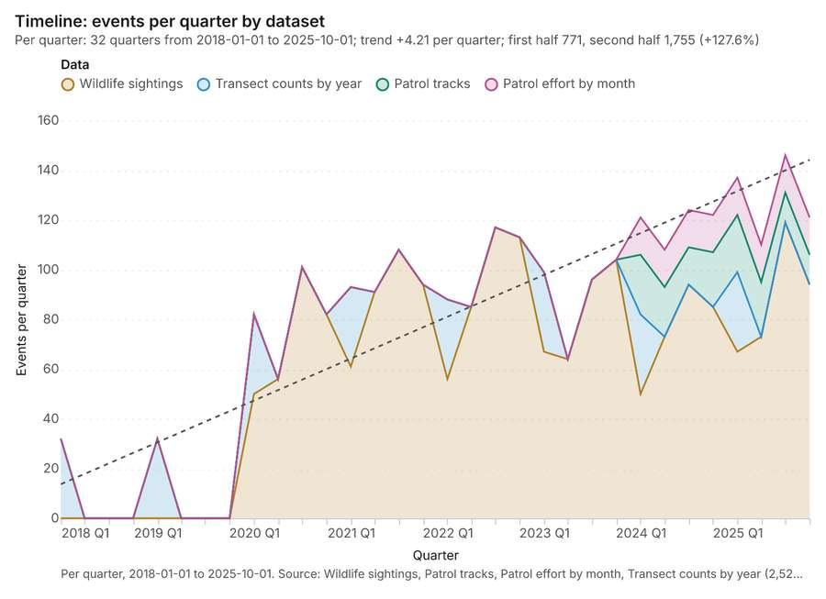
Figure 1. Timeline: events per quarter by dataset [1]. Per quarter, 2018-01-01 to 2025-10-01. Source: Wildlife sightings, Patrol tracks, Patrol effort by month, Transect counts by year (2,526 features). The data is in the appendix.
The timeline counts 2,526 dated events in Wildlife sightings, Patrol tracks, Patrol effort by month and 1 more per quarter, from Q1 2018 to Q4 2025 [1][2][3][4][5]. By dataset: Wildlife sightings 2,000; Transect counts by year 256; Patrol tracks 150; Patrol effort by month 120 [1]. The trend is +4.21 events per quarter; the second half of the quarters has 1,755 against 771 in the first (+127.6%) [1]. 6 of the 32 quarters had no events [1]. Change point detection found no shift in the counts [6].
Busiest quarters
- Q3 2025: 146 events [1]
- Q1 2025: 137 events [1]
- Q3 2024: 124 events [1]
Quietest quarters with events
- Q1 2018: 32 events [1]
- Q1 2019: 32 events [1]
- Q2 2020: 56 events [1]

Space time hot spots
What this analysis is. Emerging hot spots: Where hot spots are new, consecutive, intensifying, persistent, diminishing, sporadic, oscillating or historical over time [7]. In ArcGIS it is Emerging Hot Spot Analysis or Create Space Time Cube [7].
Why it was run on this data. Wildlife sightings carry dates in 'observed_at': emerging hot spot analysis finds new, intensifying and fading hot spots per month [8].
What it found. The process generated 187 features for emerging hot spots: Wildlife sightings [9]. The analysis utilized the Wildlife sightings input layer [10], processing 2,000 features and reaching a resolution of 8 [9].
Result | Value
result, count | 187
result, elapsed ms | 74
result, resolution | 8
result, features used | 2,000
result, time neighbors | 0
billing, cost | 0.2
billing, list price | 0.2
billing, upstream cost | 0

Findings
- Evidenced: Space time hot spots on Wildlife sightings: Emerging hot spots: 1 layer saved: Emerging hot spots: Wildlife sightings (187 features) [9][10].
- Evidenced: It reported result, count 187; result, elapsed ms 74; result, resolution 8; result, features used 2,000; result, time neighbors 0; billing, cost 0.2 [9].
Tool gp_space_time_hot_spots; parameters {"agg": "sum", "project": "750b4ce3-8424-4738-b383-c6a58973ae02", "features": {"layer": "Wildlife sightings (49c8e07e)"}, "interval": "month", "bin_shape": "h3", "resolution": 8, "time_field": "observed_at", "value_field": "count"}

Near repeat
What this analysis is. Repeat and near repeat classification: Classify incidents as originators, repeats (same place) or near repeats within a distance and time window, with a Knox test table [11]. In ArcGIS it is Repeat and Near Repeat Classification or Near Repeat Calculator [11].
Why it was run on this data. Near repeat analysis tests whether Wildlife sightings close in space also follow each other within 30 days [12].
What it found. Near repeat on Wildlife sightings: Repeat and near repeat classification: 1 layer saved: Repeat and near repeat classification: Wildlife sightings (2000 features) [10][13]. It reported result, days 30; result, count 2,000; result, chains 72; result, distance m 200; result, elapsed ms 29; result, pairs linked 87 [13].
Result | Value
result, days | 30
result, count | 2,000
result, chains | 72
result, distance m | 200
result, elapsed ms | 29
result, pairs linked | 87
billing, cost | 0.11
billing, list price | 0.11
billing, upstream cost | 0

Findings
- Evidenced: Near repeat on Wildlife sightings: Repeat and near repeat classification: 1 layer saved: Repeat and near repeat classification: Wildlife sightings (2000 features) [10][13].
- Evidenced: It reported result, days 30; result, count 2,000; result, chains 72; result, distance m 200; result, elapsed ms 29; result, pairs linked 87 [13].
Tool gp_near_repeat; parameters {"days": 30, "project": "750b4ce3-8424-4738-b383-c6a58973ae02", "features": {"layer": "Wildlife sightings (49c8e07e)"}, "distance_m": 200.0, "time_field": "observed_at"}

Change point detection
What this analysis is. Change point detection: When did the level, count, trend or variability change [14]? For the whole study area or for every bin [14]. In ArcGIS it is Change Point Detection [14].
Why it was run on this data. Change point detection finds when the monthly count of Wildlife sightings shifted [15].
What it found. The change point detection tool, `gp_change_point_detection` [6], was run using the Wildlife sightings data [10]. The analysis confirmed that change point detection was done [6]. The output indicated that there was no map output [6].
Findings
- Evidenced: Change point detection on Wildlife sightings: Change point detection: done; no map output [6][10].
Tool gp_change_point_detection; parameters {"method": "count", "project": "750b4ce3-8424-4738-b383-c6a58973ae02", "features": {"layer": "Wildlife sightings (49c8e07e)"}, "interval": "month", "time_field": "observed_at"}

Hot spots
What this analysis is. Hot spot analysis: Getis-Ord Gi* hot and cold spots with z-scores, p-values and confidence bins [16]. In ArcGIS it is Find Hot Spots or Hot Spot Analysis (Getis-Ord Gi*); in QGIS, qgis:hotspot (plugin) [16].
Why it was run on this data. 40 points: Getis-Ord Gi* tests whether the concentrations in Camera traps are statistically significant [17].
What it found. Hot spots on Camera traps: Hot spot analysis: 1 layer saved: Hot spot analysis: Camera traps (11 features) [18][19]. It reported result, bins 11; result, count 11; result, elapsed ms 3; result, cell size m 5,000; result, incidents used 40; result, distance band m 5,000 [18].
Result | Value
result, bins | 11
result, count | 11
result, elapsed ms | 3
result, cell size m | 5,000
result, incidents used | 40
result, distance band m | 5,000
billing, cost | 0.0508
billing, list price | 0.0508
billing, upstream cost | 0

Findings
- Evidenced: Hot spots on Camera traps: Hot spot analysis: 1 layer saved: Hot spot analysis: Camera traps (11 features) [18][19].
- Evidenced: It reported result, bins 11; result, count 11; result, elapsed ms 3; result, cell size m 5,000; result, incidents used 40; result, distance band m 5,000 [18].
Tool gp_hot_spots; parameters {"project": "750b4ce3-8424-4738-b383-c6a58973ae02", "features": {"layer": "Camera traps (2952931c)"}, "aggregation": "hexagon", "cell_size_m": 5000.0, "distance_band_m": 5000.0}

Hot spots
What this analysis is. Hot spot analysis: Getis-Ord Gi* hot and cold spots with z-scores, p-values and confidence bins [16]. In ArcGIS it is Find Hot Spots or Hot Spot Analysis (Getis-Ord Gi*); in QGIS, qgis:hotspot (plugin) [16].
Why it was run on this data. 2000 points: Getis-Ord Gi* tests whether the concentrations in Wildlife sightings are statistically significant [20].
What it found. Hot spots on Wildlife sightings: Hot spot analysis: 1 layer saved: Hot spot analysis: Wildlife sightings (2000 features) [10][21]. It reported result, count 2,000; result, elapsed ms 27; result, excluded null 0; result, distance band m 500; billing, cost 0.09; billing, list price 0.09 [21].
Result | Value
result, count | 2,000
result, elapsed ms | 27
result, excluded null | 0
result, distance band m | 500
billing, cost | 0.09
billing, list price | 0.09
billing, upstream cost | 0

Findings
- Evidenced: Hot spots on Wildlife sightings: Hot spot analysis: 1 layer saved: Hot spot analysis: Wildlife sightings (2000 features) [10][21].
- Evidenced: It reported result, count 2,000; result, elapsed ms 27; result, excluded null 0; result, distance band m 500; billing, cost 0.09; billing, list price 0.09 [21].
Tool gp_hot_spots; parameters {"field": "count", "project": "750b4ce3-8424-4738-b383-c6a58973ae02", "features": {"layer": "Wildlife sightings (49c8e07e)"}, "aggregation": "hexagon", "cell_size_m": 500.0, "distance_band_m": 500.0}

Index change
What this analysis is. Spectral index change: Change of a spectral index (NDVI, NDWI, NDBI, NBR …) or a band expression between two images: before, after and difference rasters, decrease / increase classes beyond the threshold with polygons and areas; NBR also gives dNBR with burn severity classes [22].
Why it was run on this data. Index change between Habitat scene 2020-09-15 (2020-09-15) and Habitat scene 2025-09-15 (2025-09-15): the changed area, with the changed places as polygons [23].
What it found. Index change: Spectral index change: created NDVI change Habitat scene 2020-09-15 to Habitat scene 2025-09-15 (300 x 250 cells, 40.00 m) [24]. plus 1 more raster layer(s) [24]. and layer NDVI change polygons with 984 feature(s) [24]. mean before 0.5613; mean after 0.4592; mean difference -0.1022; decrease ha 2,822; increase ha 185.28 [24]. It reported stats, polygons 984; stats, mean after 0.4592; stats, decrease ha 2,822; stats, increase ha 185.3; stats, mean before 0.5613; stats, masked pixels 0 [24].
Result | Value
stats, polygons | 984
stats, mean after | 0.4592
stats, decrease ha | 2,822
stats, increase ha | 185.3
stats, mean before | 0.5613
stats, masked pixels | 0
stats, mean difference | -0.1022
elapsed ms | 383

Findings
- Evidenced: Index change: Spectral index change: created NDVI change Habitat scene 2020-09-15 to Habitat scene 2025-09-15 (300 x 250 cells, 40.00 m) [24].
- Evidenced: plus 1 more raster layer(s) [24].
- Evidenced: and layer NDVI change polygons with 984 feature(s) [24].
- Evidenced: mean before 0.5613; mean after 0.4592; mean difference -0.1022; decrease ha 2,822; increase ha 185.28 [24].
- Evidenced: It reported stats, polygons 984; stats, mean after 0.4592; stats, decrease ha 2,822; stats, increase ha 185.3; stats, mean before 0.5613; stats, masked pixels 0 [24].
A model draft was discarded because a sentence did not cite a source of this section.
Tool im_index_change; parameters {"after_id": "Habitat scene 2025-09-15 (f6387687)", "polygons": true, "before_id": "Habitat scene 2020-09-15 (de16b11c)"}

Compute change raster
What this analysis is. Compute change raster: Pixel value or spectral change between two co-registered images: difference, relative difference, absolute difference, log ratio (radar, dB), Euclidean spectral distance, spectral angle (radians) or the band with most change [25].
Why it was run on this data. A change raster between Habitat scene 2020-09-15 (2020-09-15) and Habitat scene 2025-09-15 (2025-09-15): where and how much the pixels changed [26].
What it found. Compute change raster: Compute change raster: created Difference Habitat scene 2020-09-15 to Habitat scene 2025-09-15 (300 x 250 cells, 40.00 m) [27]. mean 0.01608; std 0.03381; min -0.04; max 0.15; masked pixels 0 [27]. It reported stats, max 0.15; stats, min -0.04; stats, std 0.03381; stats, mean 0.01608; stats, masked pixels 0; elapsed ms 88 [27].
Result | Value
stats, max | 0.15
stats, min | -0.04
stats, std | 0.03381
stats, mean | 0.01608
stats, masked pixels | 0
elapsed ms | 88

Findings
- Evidenced: Compute change raster: Compute change raster: created Difference Habitat scene 2020-09-15 to Habitat scene 2025-09-15 (300 x 250 cells, 40.00 m) [27].
- Evidenced: mean 0.01608; std 0.03381; min -0.04; max 0.15; masked pixels 0 [27].
- Evidenced: It reported stats, max 0.15; stats, min -0.04; stats, std 0.03381; stats, mean 0.01608; stats, masked pixels 0; elapsed ms 88 [27].
Tool im_compute_change_raster; parameters {"after_id": "Habitat scene 2025-09-15 (f6387687)", "before_id": "Habitat scene 2020-09-15 (de16b11c)"}

Calculate density
What this analysis is. Calculate density: Kernel density per square kilometer on a grid [28]. In ArcGIS it is Calculate Density or Kernel Density; in QGIS, native:heatmapkerneldensityestimation [28].
Why it was run on this data. 25 points in Water points: a density surface shows where they concentrate [29].
What it found. The density calculation was performed on the Water points data [31]. The process successfully created 1 layer and analyzed a total of 67 water points [30]. Key metrics reported include a bandwidth of 2,000 meters, a cell size of 1,000 meters, and a maximum density of 1.208 per km² [30].
Result | Value
result, count | 67
result, elapsed ms | 3
result, bandwidth m | 2,000
result, cell size m | 1,000
result, excluded null | 0
result, max density per km2 | 1.208
billing, cost | 0.0505
billing, list price | 0.0505
billing, upstream cost | 0

Findings
- Evidenced: Calculate density on Water points: Calculate density: 1 layer saved: Calculate density: Water points (67 features) [30][31].
- Evidenced: It reported result, count 67; result, elapsed ms 3; result, bandwidth m 2,000; result, cell size m 1,000; result, excluded null 0; result, max density per km2 1.208 [30].
Tool gp_calculate_density; parameters {"kernel": "quartic", "project": "750b4ce3-8424-4738-b383-c6a58973ae02", "features": {"layer": "Water points (2b4e30e1)"}, "bandwidth_m": 2000.0, "cell_size_m": 1000.0}

Calculate density
What this analysis is. Calculate density: Kernel density per square kilometer on a grid [28]. In ArcGIS it is Calculate Density or Kernel Density; in QGIS, native:heatmapkerneldensityestimation [28].
Why it was run on this data. 40 points in Camera traps: a density surface shows where they concentrate [32].
What it found. The density calculation, which utilized the Camera traps layer [19], reported a maximum density per km2 of 0.3737
Result | Value
result, count | 95
result, elapsed ms | 3
result, bandwidth m | 5,000
result, cell size m | 2,000
result, excluded null | 0
result, max density per km2 | 0.3737
billing, cost | 0.0508
billing, list price | 0.0508
billing, upstream cost | 0

Findings
- Evidenced: Calculate density on Camera traps: Calculate density: 1 layer saved: Calculate density: Camera traps (95 features) [19][33].
- Evidenced: It reported result, count 95; result, elapsed ms 3; result, bandwidth m 5,000; result, cell size m 2,000; result, excluded null 0; result, max density per km2 0.3737 [33].
Tool gp_calculate_density; parameters {"kernel": "quartic", "project": "750b4ce3-8424-4738-b383-c6a58973ae02", "features": {"layer": "Camera traps (2952931c)"}, "bandwidth_m": 5000.0, "cell_size_m": 2000.0}

Calculate density
What this analysis is. Calculate density: Kernel density per square kilometer on a grid [28]. In ArcGIS it is Calculate Density or Kernel Density; in QGIS, native:heatmapkerneldensityestimation [28].
Why it was run on this data. 2000 points in Wildlife sightings: a density surface shows where they concentrate [34].
What it found. The density calculation was performed on the Wildlife sightings layer [10], yielding a result count of 3,384 [35]. The process successfully ran with an elapsed time of 92 milliseconds [35]. The resulting surface covered a bandwidth of 500 meters and utilized a 200-meter cell size [35].
Result | Value
result, count | 3,384
result, elapsed ms | 92
result, bandwidth m | 500
result, cell size m | 200
result, excluded null | 0
result, max density per km2 | 771.7
billing, cost | 0.09
billing, list price | 0.09
billing, upstream cost | 0

Findings
- Evidenced: Calculate density on Wildlife sightings: Calculate density: 1 layer saved: Calculate density: Wildlife sightings (3384 features) [10][35].
- Evidenced: It reported result, count 3,384; result, elapsed ms 92; result, bandwidth m 500; result, cell size m 200; result, excluded null 0; result, max density per km2 771.7 [35].
Tool gp_calculate_density; parameters {"kernel": "quartic", "project": "750b4ce3-8424-4738-b383-c6a58973ae02", "features": {"layer": "Wildlife sightings (49c8e07e)"}, "bandwidth_m": 500.0, "cell_size_m": 200.0, "weight_field": "count"}

Summarize within
What this analysis is. Summarize within: Count and aggregate the features inside each polygon (or bin), proportionally for lines and polygons [36]. In ArcGIS it is Summarize Within or Aggregate Points; in QGIS, native:countpointsinpolygon or native:sumlinelengths [36].
Why it was run on this data. Count Water points inside each feature of Protected areas by type; the counts map as a choropleth (natural breaks, sequential colors) [37].
What it found. The `gp_summarize_within` tool was run using Water points [31] and
Result | Value
result, count | 5
result, elapsed ms | 0
billing, cost | 0.0106
billing, list price | 0.0106
billing, upstream cost | 0

Findings
- Evidenced: Summarize within on Water points, Protected areas: Summarize within: 1 layer saved: Summarize within: Protected areas (5 features) [31][38][39].
- Evidenced: It reported result, count 5; result, elapsed ms 0; billing, cost 0.0106; billing, list price 0.0106; billing, upstream cost 0 [38].
Tool gp_summarize_within; parameters {"stats": [], "project": "750b4ce3-8424-4738-b383-c6a58973ae02", "features": {"layer": "Water points (2b4e30e1)"}, "group_by": "type", "polygons": {"layer": "Protected areas (446c314f)"}}

Summarize within
What this analysis is. Summarize within: Count and aggregate the features inside each polygon (or bin), proportionally for lines and polygons [36]. In ArcGIS it is Summarize Within or Aggregate Points; in QGIS, native:countpointsinpolygon or native:sumlinelengths [36].
Why it was run on this data. Count Water points inside each feature of Protected areas by type; the counts map as a choropleth (natural breaks, sequential colors) [37].
What it found. Summarize within on Camera traps, Protected areas: Summarize within: 1 layer saved: Summarize within: Protected areas (5 features) [19][39][40]. It reported result, count 5; result, elapsed ms 0; billing, cost 0.0109; billing, list price 0.0109; billing, upstream cost 0 [40].
Result | Value
result, count | 5
result, elapsed ms | 0
billing, cost | 0.0109
billing, list price | 0.0109
billing, upstream cost | 0

Findings
- Evidenced: Summarize within on Camera traps, Protected areas: Summarize within: 1 layer saved: Summarize within: Protected areas (5 features) [19][39][40].
- Evidenced: It reported result, count 5; result, elapsed ms 0; billing, cost 0.0109; billing, list price 0.0109; billing, upstream cost 0 [40].
Tool gp_summarize_within; parameters {"stats": [], "project": "750b4ce3-8424-4738-b383-c6a58973ae02", "features": {"layer": "Camera traps (2952931c)"}, "group_by": "working", "polygons": {"layer": "Protected areas (446c314f)"}}

Summarize within
What this analysis is. Summarize within: Count and aggregate the features inside each polygon (or bin), proportionally for lines and polygons [36]. In ArcGIS it is Summarize Within or Aggregate Points; in QGIS, native:countpointsinpolygon or native:sumlinelengths [36].
Why it was run on this data. Count Water points inside each feature of Protected areas by type; the counts map as a choropleth (natural breaks, sequential colors) [37].
What it found. The `gp_summarize_within` function was executed using Wildlife sightings [10] and Protected areas [39] as
Result | Value
result, count | 5
result, elapsed ms | 3
billing, cost | 0.05012
billing, list price | 0.05012
billing, upstream cost | 0

Findings
- Evidenced: Summarize within on Wildlife sightings, Protected areas: Summarize within: 1 layer saved: Summarize within: Protected areas (5 features) [10][39][41].
- Evidenced: It reported result, count 5; result, elapsed ms 3; billing, cost 0.05012; billing, list price 0.05012; billing, upstream cost 0 [41].
Tool gp_summarize_within; parameters {"stats": [{"stat": "sum", "field": "count"}], "project": "750b4ce3-8424-4738-b383-c6a58973ae02", "features": {"layer": "Wildlife sightings (49c8e07e)"}, "group_by": "species", "polygons": {"layer": "Protected areas (446c314f)"}}

Find point clusters
What this analysis is. Find point clusters: Density-based clusters (DBSCAN, HDBSCAN or OPTICS, optionally space-time) with hulls and noise [42]. In ArcGIS it is Find Point Clusters or Density-based Clustering; in QGIS, native:dbscanclustering or native:stdbscanclustering [42].
Why it was run on this data. DBSCAN finds dense groups of Water points and separates noise [43].
What it found. Find point clusters on Water points: Find point clusters: 2 layers saved: Find point clusters: Water points (25 features); Find point clusters: cluster hulls (1 feature) [31][44]. It reported result, count 25; result, noise 0; result, distance m 2,000; result, elapsed ms 5; result, min points 3; billing, cost 0.0505 [44].
Result | Value
result, count | 25
result, noise | 0
result, distance m | 2,000
result, elapsed ms | 5
result, min points | 3
billing, cost | 0.0505
billing, list price | 0.0505
billing, upstream cost | 0

Findings
- Evidenced: Find point clusters on Water points: Find point clusters: 2 layers saved: Find point clusters: Water points (25 features); Find point clusters: cluster hulls (1 feature) [31][44].
- Evidenced: It reported result, count 25; result, noise 0; result, distance m 2,000; result, elapsed ms 5; result, min points 3; billing, cost 0.0505 [44].
Tool gp_find_point_clusters; parameters {"method": "dbscan", "project": "750b4ce3-8424-4738-b383-c6a58973ae02", "features": {"layer": "Water points (2b4e30e1)"}, "distance_m": 2000.0, "min_points": 3}

Find point clusters
What this analysis is. Find point clusters: Density-based clusters (DBSCAN, HDBSCAN or OPTICS, optionally space-time) with hulls and noise [42]. In ArcGIS it is Find Point Clusters or Density-based Clustering; in QGIS, native:dbscanclustering or native:stdbscanclustering [42].
Why it was run on this data. DBSCAN finds dense groups of Camera traps and separates noise [45].
What it found. Find point clusters on Camera traps: Find point clusters: 2 layers saved: Find point clusters: Camera traps (40 features); Find point clusters: cluster hulls (2 features) [19][46]. It reported result, count 40; result, noise 3; result, distance m 2,000; result, elapsed ms 2; result, min points 3; billing, cost 0.0508 [46].
Result | Value
result, count | 40
result, noise | 3
result, distance m | 2,000
result, elapsed ms | 2
result, min points | 3
billing, cost | 0.0508
billing, list price | 0.0508
billing, upstream cost | 0

Findings
- Evidenced: Find point clusters on Camera traps: Find point clusters: 2 layers saved: Find point clusters: Camera traps (40 features); Find point clusters: cluster hulls (2 features) [19][46].
- Evidenced: It reported result, count 40; result, noise 3; result, distance m 2,000; result, elapsed ms 2; result, min points 3; billing, cost 0.0508 [46].
Tool gp_find_point_clusters; parameters {"method": "dbscan", "project": "750b4ce3-8424-4738-b383-c6a58973ae02", "features": {"layer": "Camera traps (2952931c)"}, "distance_m": 2000.0, "min_points": 3}

Find point clusters
What this analysis is. Find point clusters: Density-based clusters (DBSCAN, HDBSCAN or OPTICS, optionally space-time) with hulls and noise [42]. In ArcGIS it is Find Point Clusters or Density-based Clustering; in QGIS, native:dbscanclustering or native:stdbscanclustering [42].
Why it was run on this data. DBSCAN finds dense groups of Wildlife sightings and separates noise [47].
What it found. Find point clusters on Wildlife sightings: Find point clusters: 2 layers saved: Find point clusters: Wildlife sightings (2000 features); Find point clusters: cluster hulls (10 features) [10][48]. It reported result, count 2,000; result, noise 812; result, distance m 500; result, elapsed ms 208; result, min points 20; billing, cost 0.09 [48].
Result | Value
result, count | 2,000
result, noise | 812
result, distance m | 500
result, elapsed ms | 208
result, min points | 20
billing, cost | 0.09
billing, list price | 0.09
billing, upstream cost | 0

Findings
- Evidenced: Find point clusters on Wildlife sightings: Find point clusters: 2 layers saved: Find point clusters: Wildlife sightings (2000 features); Find point clusters: cluster hulls (10 features) [10][48].
- Evidenced: It reported result, count 2,000; result, noise 812; result, distance m 500; result, elapsed ms 208; result, min points 20; billing, cost 0.09 [48].
Tool gp_find_point_clusters; parameters {"method": "dbscan", "project": "750b4ce3-8424-4738-b383-c6a58973ae02", "features": {"layer": "Wildlife sightings (49c8e07e)"}, "distance_m": 500.0, "min_points": 20}

Zonal statistics
What this analysis is. Zonal statistics: count/min/max/mean/std/sum/median/majority per polygon as a table and as GeoJSON [49]. In ArcGIS it is Zonal Statistics as Table (polygons) [49].
Why it was run on this data. Statistics of Habitat scene 2020-09-15 inside each feature of Protected areas [50].
What it found. The analysis utilized the Zonal statistics tool, identified as rs_zonal_statistics [51]. The resulting zonal statistics summary documented 5 row(s) [51]. This process analyzed the data across 5 zones [51].
Findings
- Evidenced: Zonal statistics: Zonal statistics: 5 row(s) [51].
- Evidenced: zones 5 [51].
Tool rs_zonal_statistics; parameters {"stats": ["mean", "min", "max", "std"], "zones": "Protected areas (446c314f)", "raster_id": "Habitat scene 2020-09-15 (de16b11c)"}

Zonal statistics
What this analysis is. Zonal statistics: count/min/max/mean/std/sum/median/majority per polygon as a table and as GeoJSON [49]. In ArcGIS it is Zonal Statistics as Table (polygons) [49].
Why it was run on this data. Statistics of Habitat scene 2020-09-15 inside each feature of Protected areas [50].
What it found. Zonal statistics were applied utilizing the rs_zonal_statistics tool [52]. The tool summary indicates that the analysis resulted in 5 row(s) [52]. Additionally, the analysis covered 5 zones [52].
Findings
- Evidenced: Zonal statistics: Zonal statistics: 5 row(s) [52].
- Evidenced: zones 5 [52].
Tool rs_zonal_statistics; parameters {"stats": ["mean", "min", "max", "std"], "zones": "Protected areas (446c314f)", "raster_id": "Habitat scene 2025-09-15 (f6387687)"}

Index change
What this analysis is. Spectral index change: Change of a spectral index (NDVI, NDWI, NDBI, NBR …) or a band expression between two images: before, after and difference rasters, decrease / increase classes beyond the threshold with polygons and areas; NBR also gives dNBR with burn severity classes [22].
Why it was run on this data. Index change between Habitat scene 2020-09-15 (2020-09-15) and Habitat scene 2025-09-15 (2025-09-15): the changed area, with the changed places as polygons [23].
What it found. Index change: Spectral index change: created NDVI change Habitat scene 2020-09-15 to Habitat scene 2025-09-15 (300 x 250 cells, 40.00 m) [53]. plus 1 more raster layer(s) [53]. and layer NDVI change polygons with 984 feature(s) [53]. mean before 0.5613; mean after 0.4592; mean difference -0.1022; decrease ha 2,822; increase ha 185.28 [53]. It reported stats, polygons 984; stats, mean after 0.4592; stats, decrease ha 2,822; stats, increase ha 185.3; stats, mean before 0.5613; stats, masked pixels 0 [53].
Result | Value
stats, polygons | 984
stats, mean after | 0.4592
stats, decrease ha | 2,822
stats, increase ha | 185.3
stats, mean before | 0.5613
stats, masked pixels | 0
stats, mean difference | -0.1022
elapsed ms | 500

Findings
- Evidenced: Index change: Spectral index change: created NDVI change Habitat scene 2020-09-15 to Habitat scene 2025-09-15 (300 x 250 cells, 40.00 m) [53].
- Evidenced: plus 1 more raster layer(s) [53].
- Evidenced: and layer NDVI change polygons with 984 feature(s) [53].
- Evidenced: mean before 0.5613; mean after 0.4592; mean difference -0.1022; decrease ha 2,822; increase ha 185.28 [53].
- Evidenced: It reported stats, polygons 984; stats, mean after 0.4592; stats, decrease ha 2,822; stats, increase ha 185.3; stats, mean before 0.5613; stats, masked pixels 0 [53].
Tool im_index_change; parameters {"after_id": "Habitat scene 2025-09-15 (f6387687)", "polygons": true, "before_id": "Habitat scene 2020-09-15 (de16b11c)"}

Compute change raster
What this analysis is. Compute change raster: Pixel value or spectral change between two co-registered images: difference, relative difference, absolute difference, log ratio (radar, dB), Euclidean spectral distance, spectral angle (radians) or the band with most change [25].
Why it was run on this data. A change raster between Habitat scene 2020-09-15 (2020-09-15) and Habitat scene 2025-09-15 (2025-09-15): where and how much the pixels changed [26].
What it found. Compute change raster: Compute change raster: created Difference Habitat scene 2020-09-15 to Habitat scene 2025-09-15 (300 x 250 cells, 40.00 m) [54]. mean 0.01608; std 0.03381; min -0.04; max 0.15; masked pixels 0 [54]. It reported stats, max 0.15; stats, min -0.04; stats, std 0.03381; stats, mean 0.01608; stats, masked pixels 0; elapsed ms 124 [54].
Result | Value
stats, max | 0.15
stats, min | -0.04
stats, std | 0.03381
stats, mean | 0.01608
stats, masked pixels | 0
elapsed ms | 124

Findings
- Evidenced: Compute change raster: Compute change raster: created Difference Habitat scene 2020-09-15 to Habitat scene 2025-09-15 (300 x 250 cells, 40.00 m) [54].
- Evidenced: mean 0.01608; std 0.03381; min -0.04; max 0.15; masked pixels 0 [54].
- Evidenced: It reported stats, max 0.15; stats, min -0.04; stats, std 0.03381; stats, mean 0.01608; stats, masked pixels 0; elapsed ms 124 [54].
Tool im_compute_change_raster; parameters {"after_id": "Habitat scene 2025-09-15 (f6387687)", "before_id": "Habitat scene 2020-09-15 (de16b11c)"}

Maps and charts
The run also made 25 map image(s) [55][56][57][58][59][60][61][62][63][64][65][66][67][68][69][70][71][72][73][74][75][76][77][78][79] and 25 chart(s) [80][81][82][83][84][85][86][87][88][89][90][91][92][93][94][95][96][97][98][99][100][101][102][103][104].
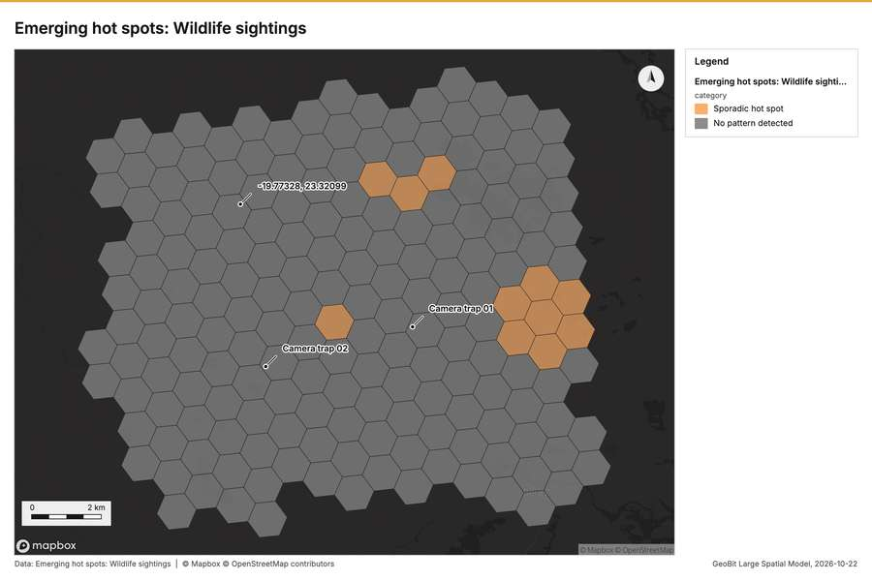
Figure 2. Emerging hot spots: Wildlife sightings [55]
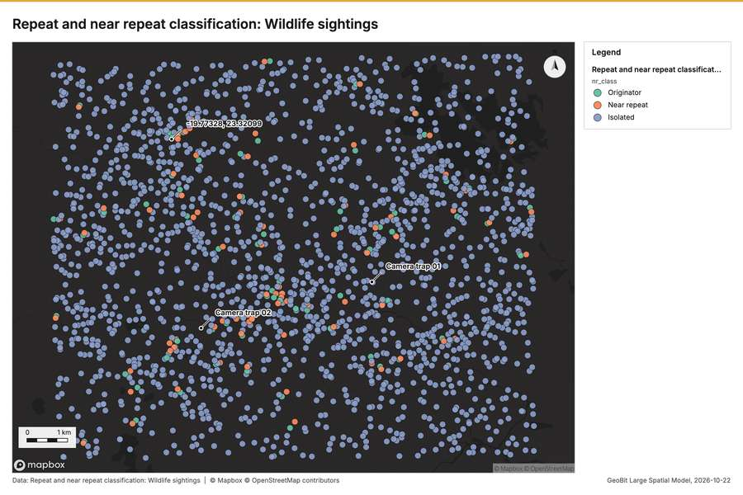
Figure 3. Repeat and near repeat classification: Wildlife sightings [56]
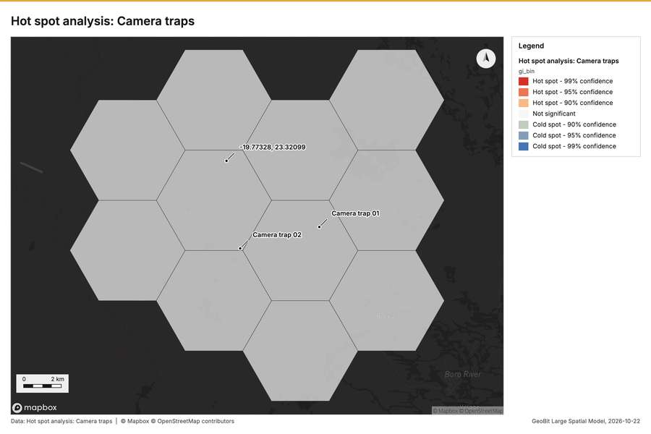
Figure 4. Hot spot analysis: Camera traps [57]
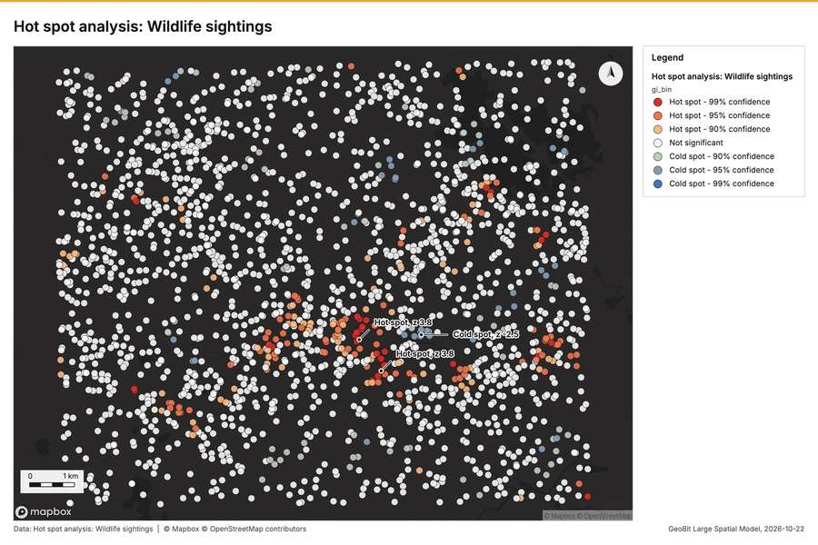
Figure 5. Hot spot analysis: Wildlife sightings [58]
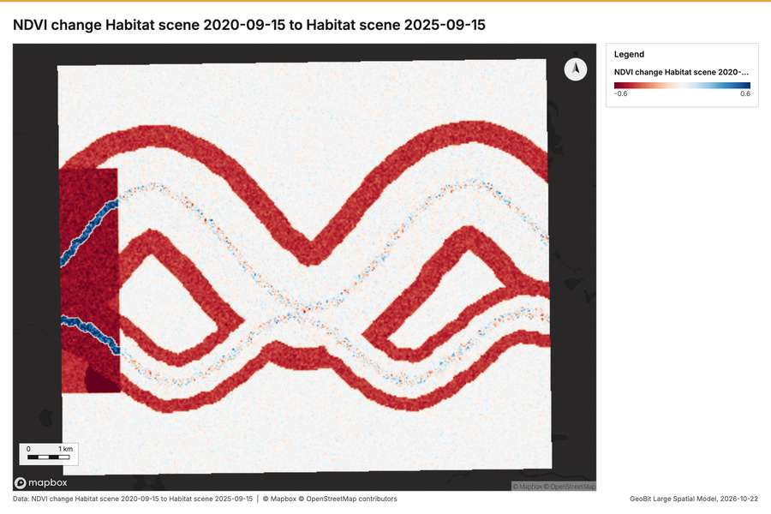
Figure 6. NDVI change Habitat scene 2020-09-15 to Habitat scene 2025-09-15 [59]
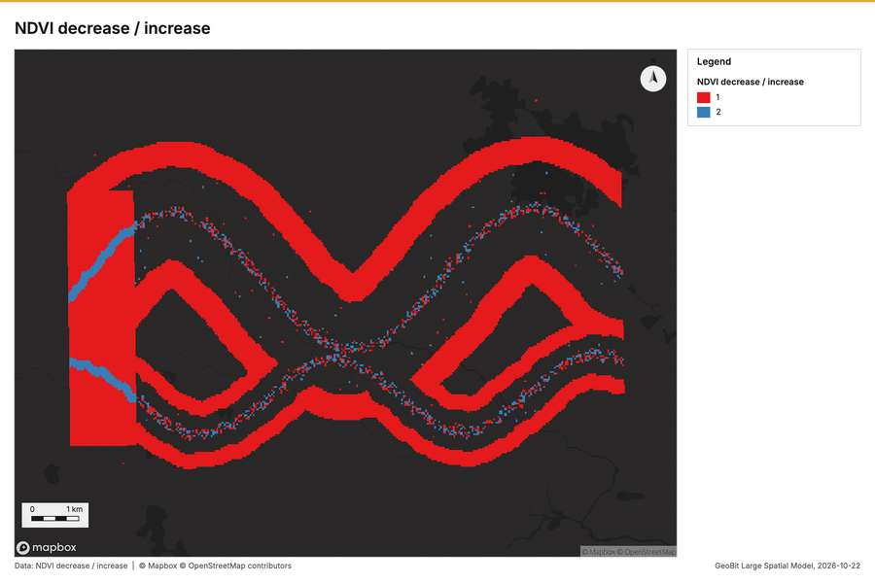
Figure 7. NDVI decrease / increase [60]
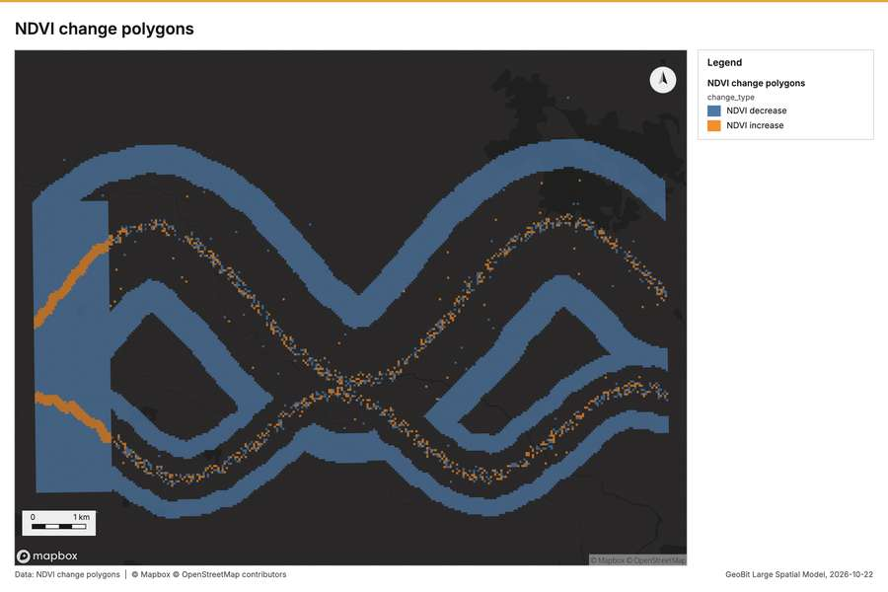
Figure 8. NDVI change polygons [61]
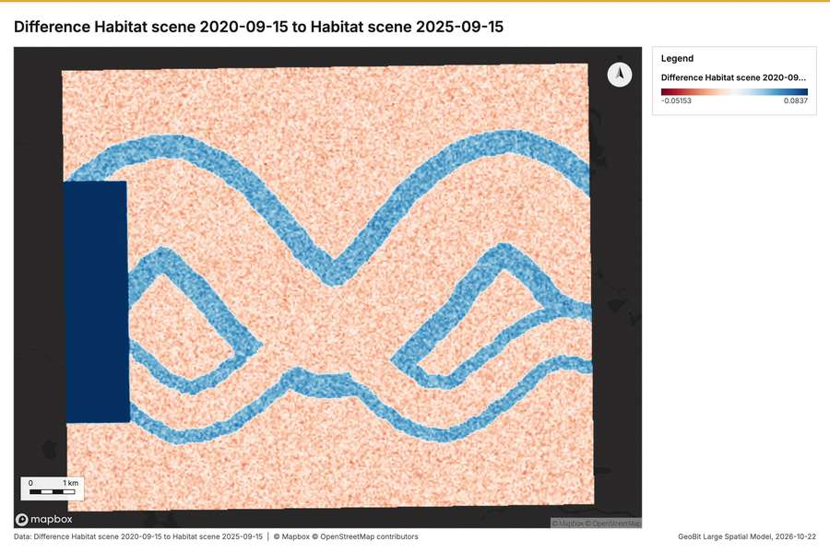
Figure 9. Difference Habitat scene 2020-09-15 to Habitat scene 2025-09-15 [62]
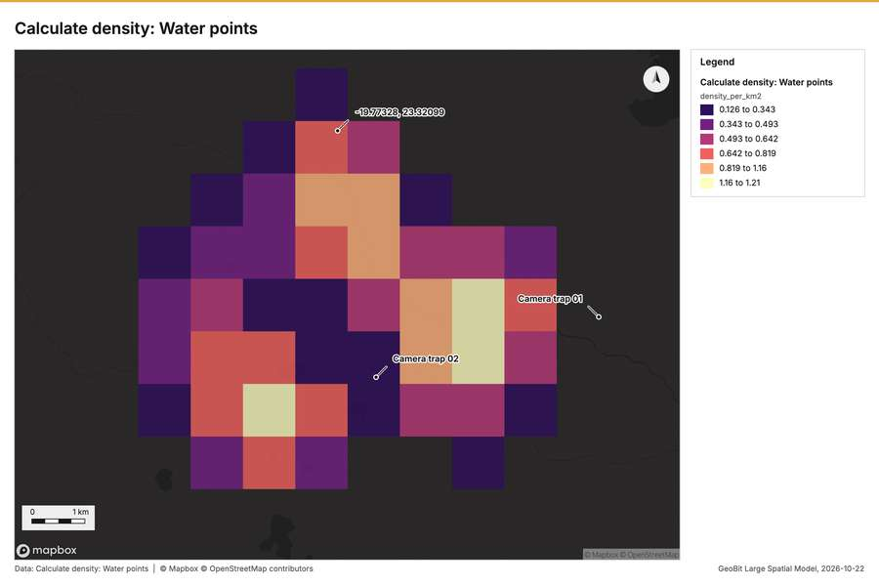
Figure 10. Calculate density: Water points [63]
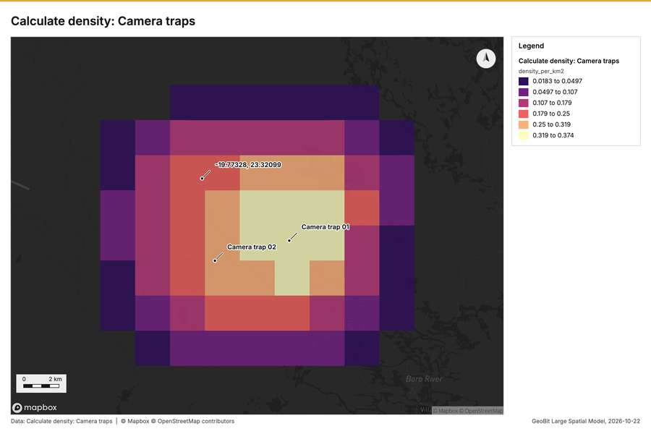
Figure 11. Calculate density: Camera traps [64]
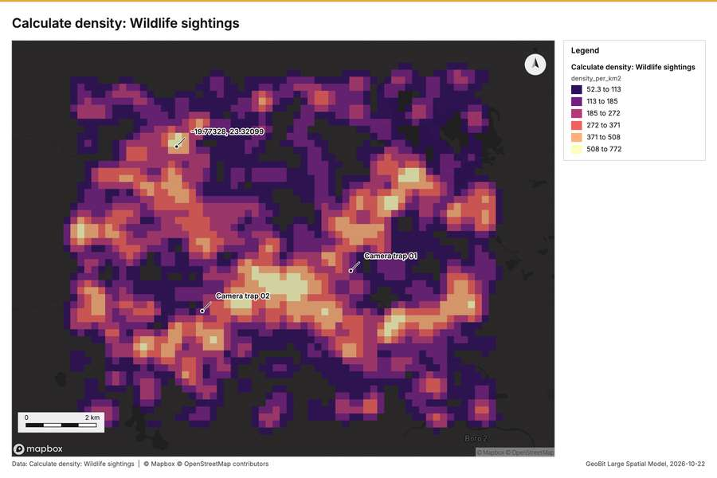
Figure 12. Calculate density: Wildlife sightings [65]
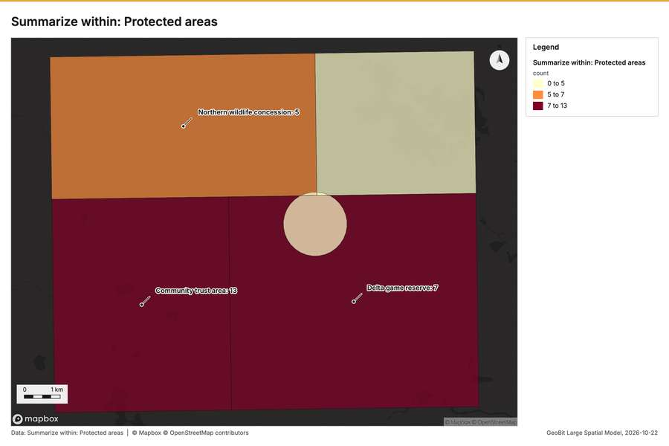
Figure 13. Summarize within: Protected areas [66]
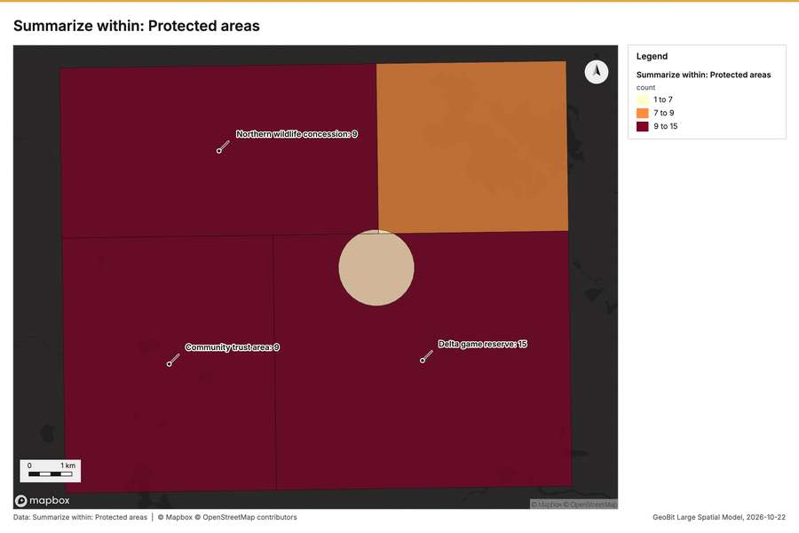
Figure 14. Summarize within: Protected areas [67]
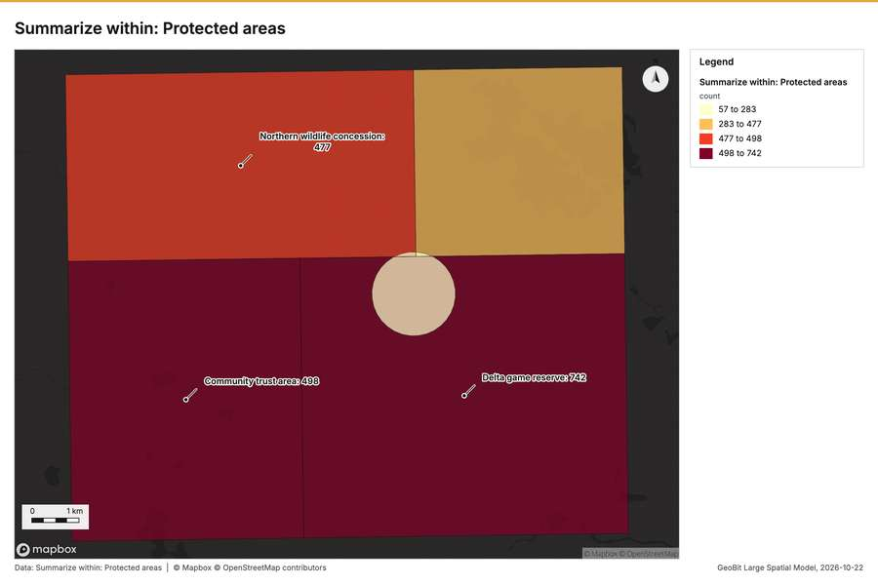
Figure 15. Summarize within: Protected areas [68]
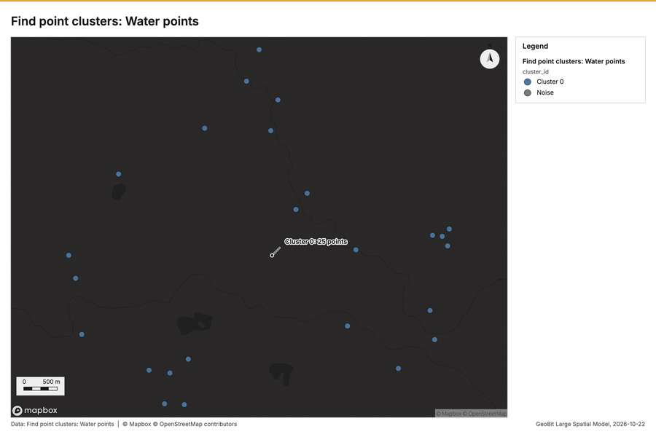
Figure 16. Find point clusters: Water points [69]
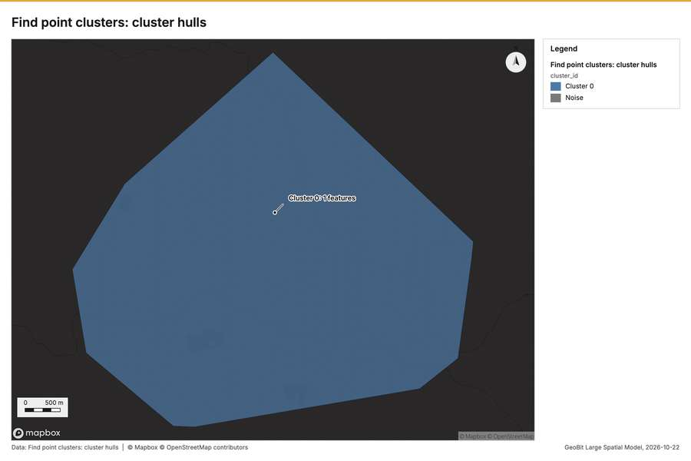
Figure 17. Find point clusters: cluster hulls [70]
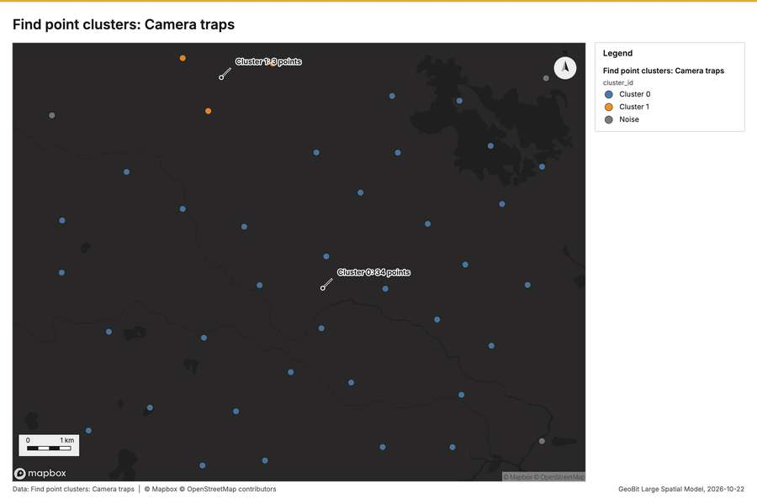
Figure 18. Find point clusters: Camera traps [71]
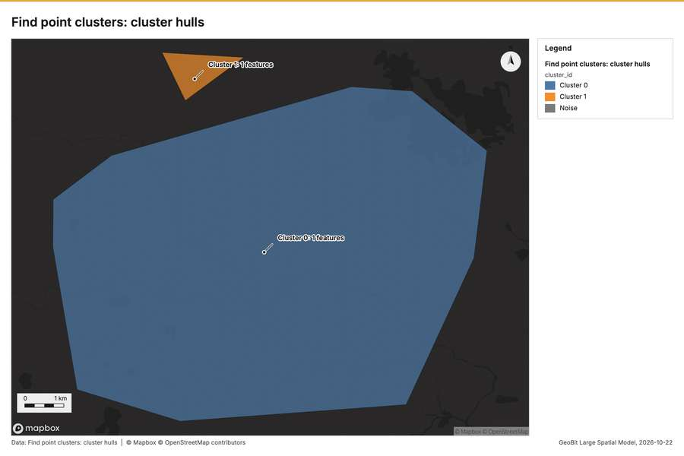
Figure 19. Find point clusters: cluster hulls [72]
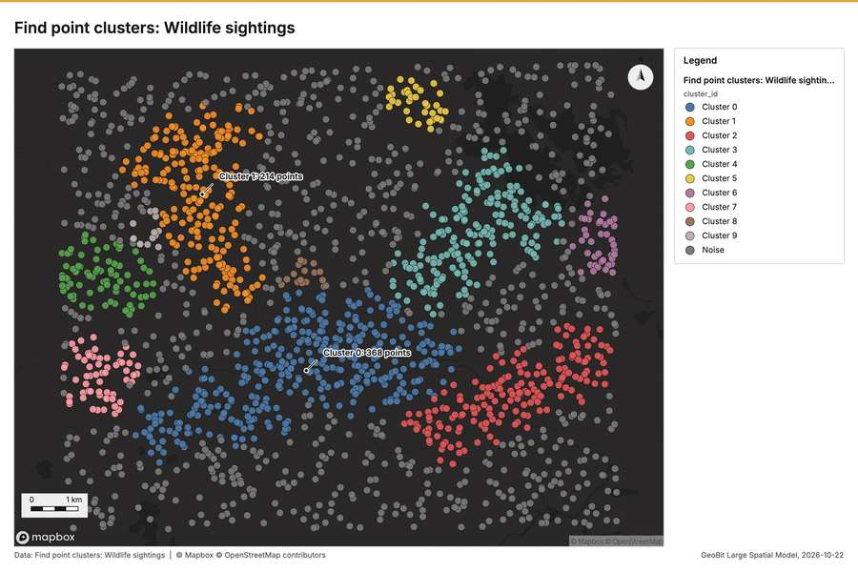
Figure 20. Find point clusters: Wildlife sightings [73]
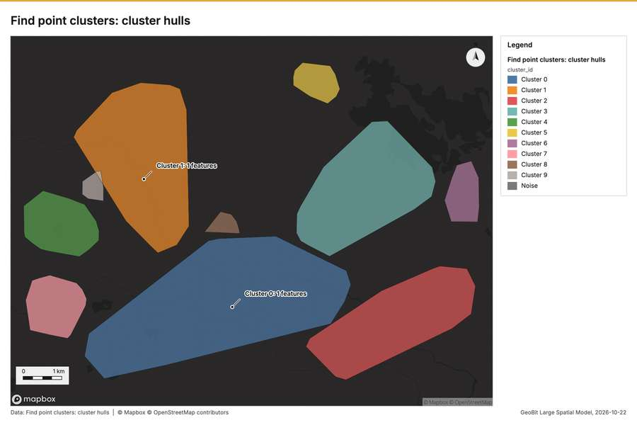
Figure 21. Find point clusters: cluster hulls [74]
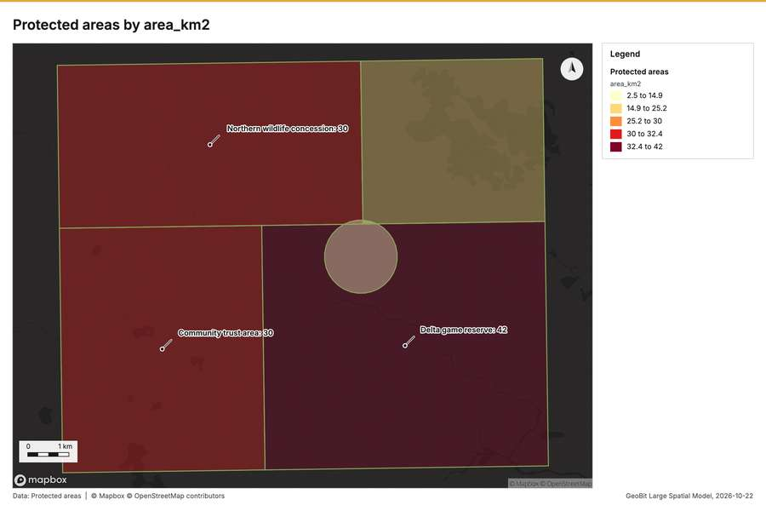
Figure 22. Protected areas by area_km2 [75]
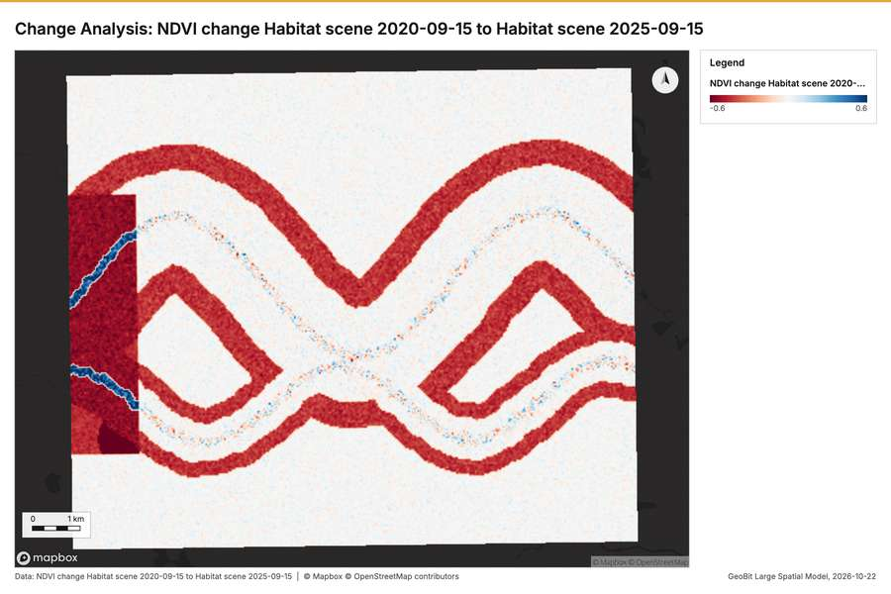
Figure 23. Change Analysis: NDVI change Habitat scene 2020-09-15 to Habitat scene 2025-09-15 [76]
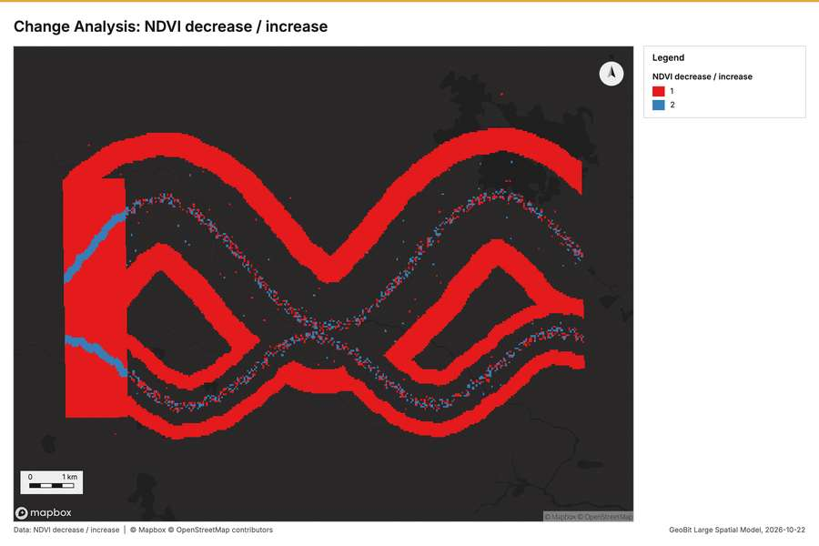
Figure 24. Change Analysis: NDVI decrease / increase [77]
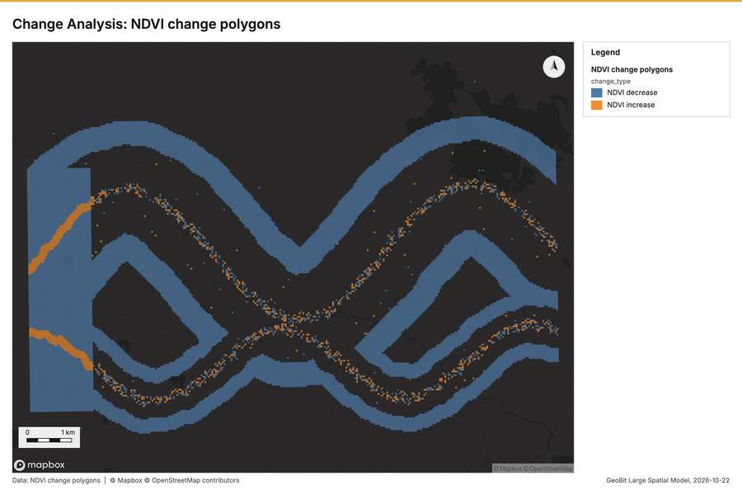
Figure 25. Change Analysis: NDVI change polygons [78]
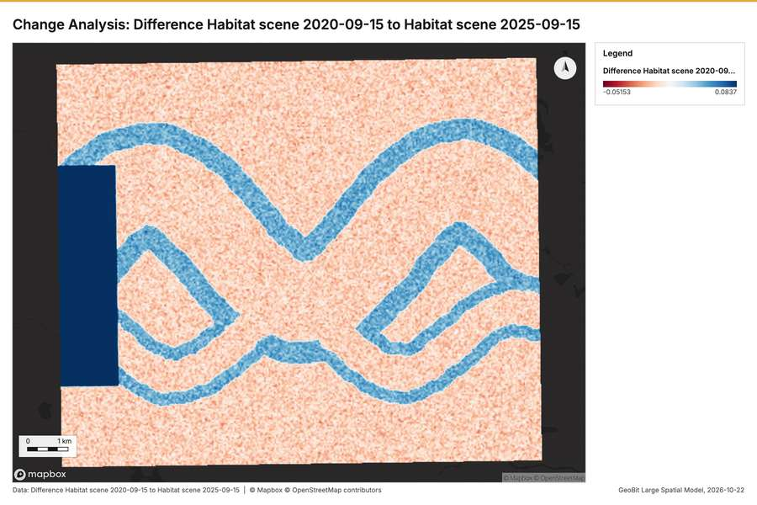
Figure 26. Change Analysis: Difference Habitat scene 2020-09-15 to Habitat scene 2025-09-15 [79]
What the map shows. The map illustrates the presence of potential wildlife hot spots based on the [55]
Inferred: read from the image by gemma4:e4b, not evidence.
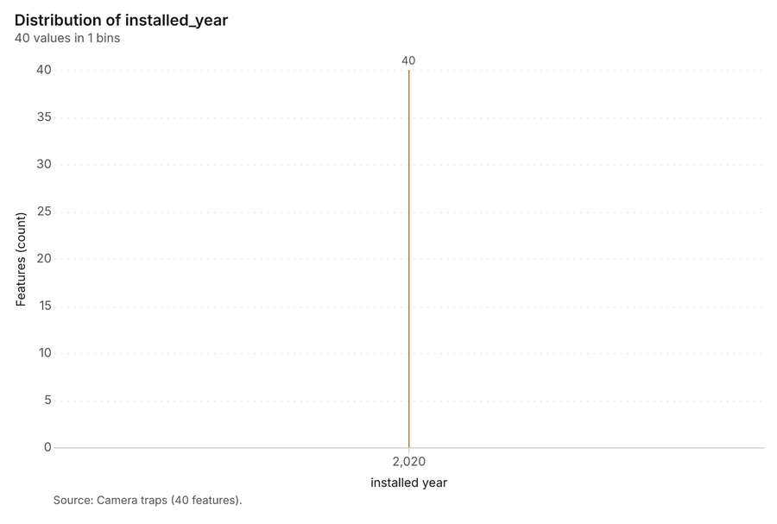
Figure 27. Camera traps over time (installed_year) [80]. Source: Camera traps (40 features). The data is in the appendix.
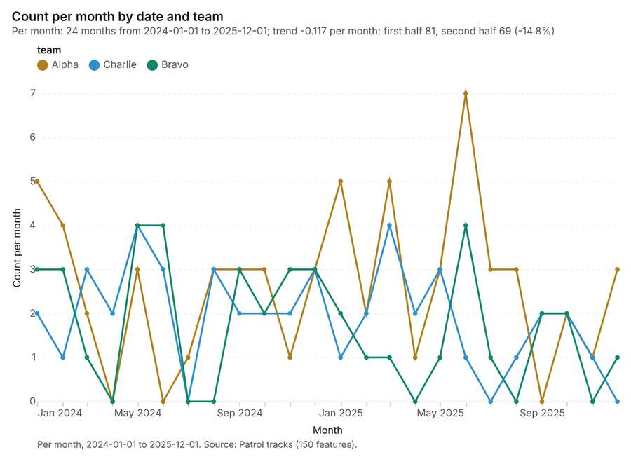
Figure 28. Patrol tracks over time (date) [81]. Per month, 2024-01-01 to 2025-12-01. Source: Patrol tracks (150 features). The data is in the appendix.
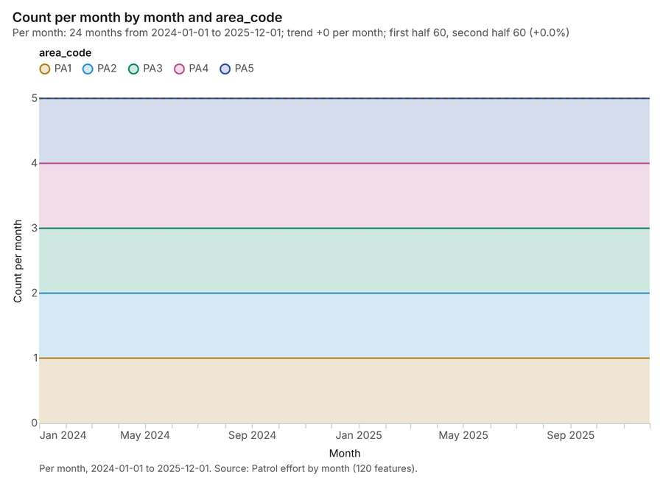
Figure 29. Patrol effort by month over time (month) [82]. Per month, 2024-01-01 to 2025-12-01. Source: Patrol effort by month (120 features). The data is in the appendix.
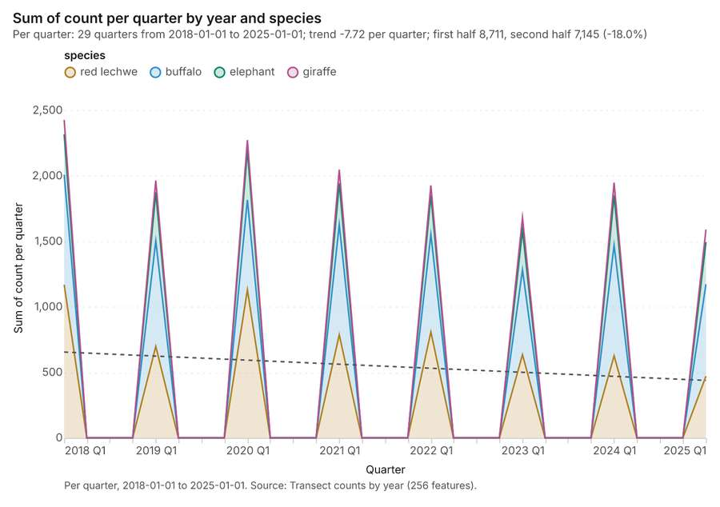
Figure 30. Transect counts by year over time (year) [83]. Per quarter, 2018-01-01 to 2025-01-01. Source: Transect counts by year (256 features). The data is in the appendix.
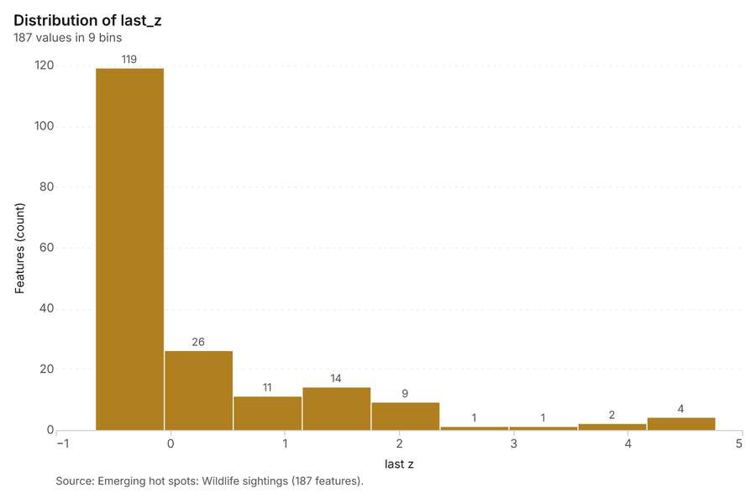
Figure 31. Emerging hot spots: Wildlife sightings [84]. Source: Emerging hot spots: Wildlife sightings (187 features). The data is in the appendix.
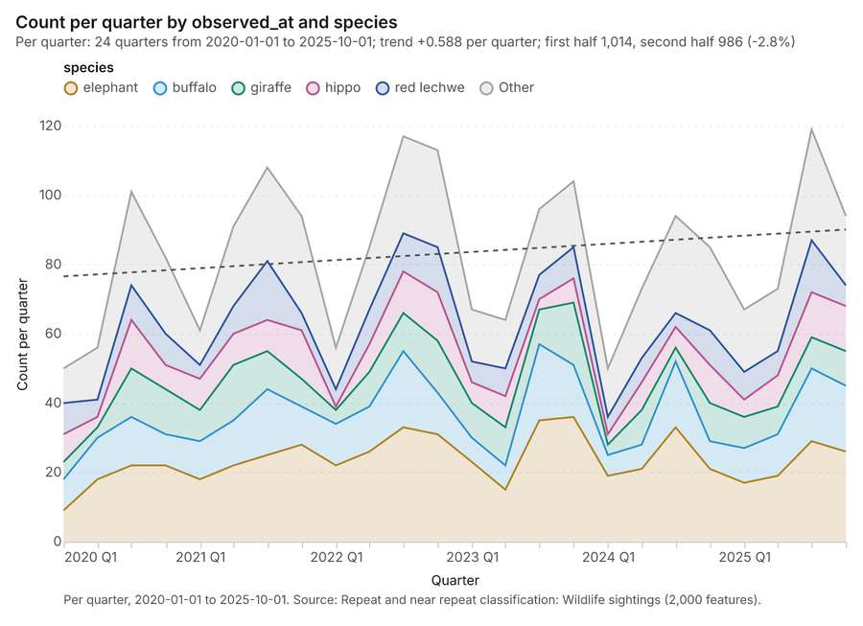
Figure 32. Repeat and near repeat classification: Wildlife sightings [85]. Per quarter, 2020-01-01 to 2025-10-01. Source: Repeat and near repeat classification: Wildlife sightings (2,000 features). The data is in the appendix.
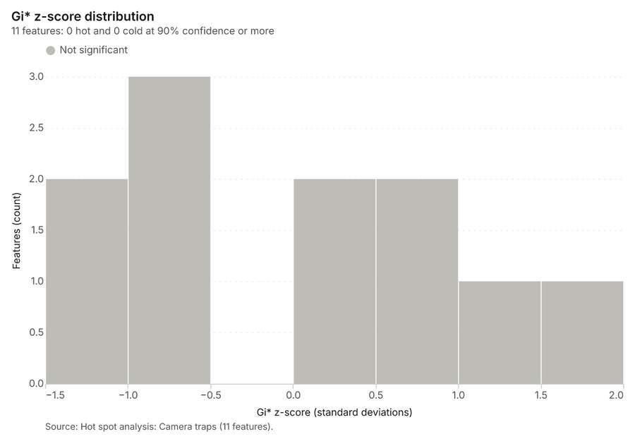
Figure 33. Hot spot analysis: Camera traps [86]. Source: Hot spot analysis: Camera traps (11 features). The data is in the appendix.
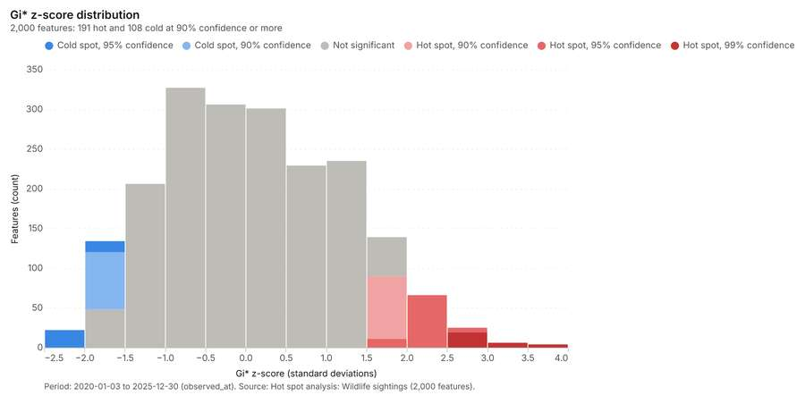
Figure 34. Hot spot analysis: Wildlife sightings [87]. Period: 2020-01-03 to 2025-12-30 (observed_at). Source: Hot spot analysis: Wildlife sightings (2,000 features). The data is in the appendix.
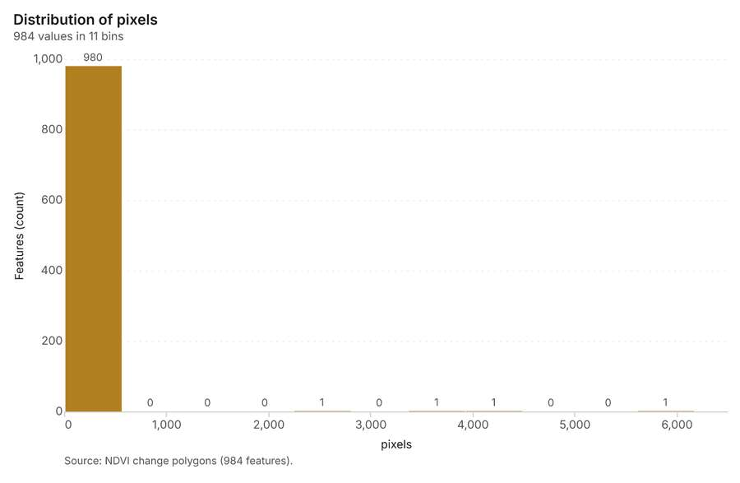
Figure 35. NDVI change polygons [88]. Source: NDVI change polygons (984 features). The data is in the appendix.
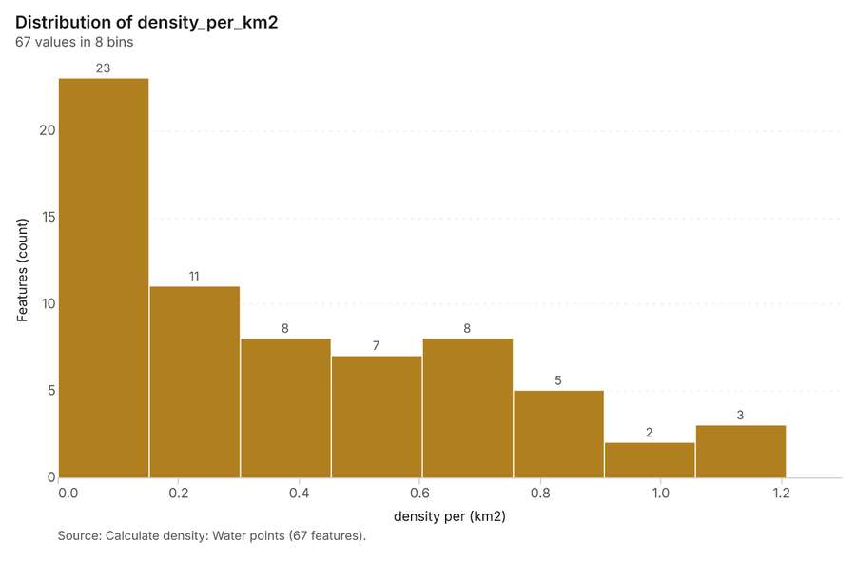
Figure 36. Calculate density: Water points [89]. Source: Calculate density: Water points (67 features). The data is in the appendix.
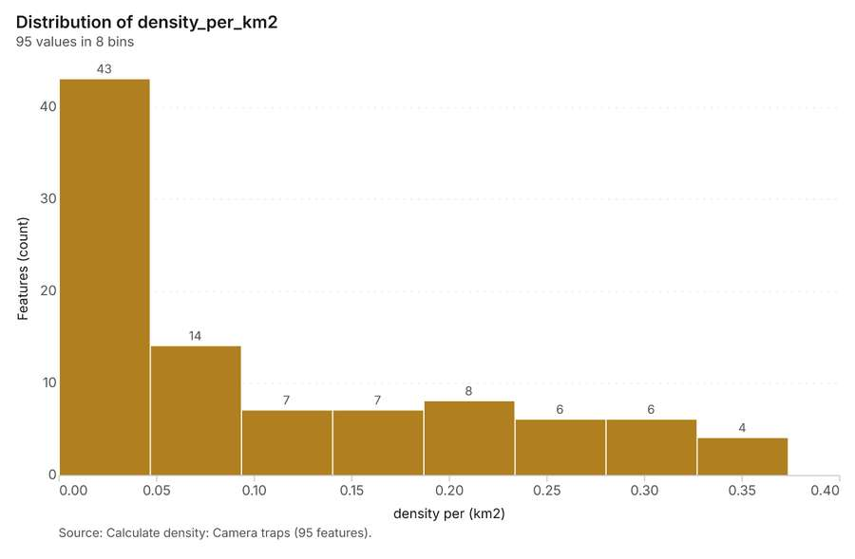
Figure 37. Calculate density: Camera traps [90]. Source: Calculate density: Camera traps (95 features). The data is in the appendix.
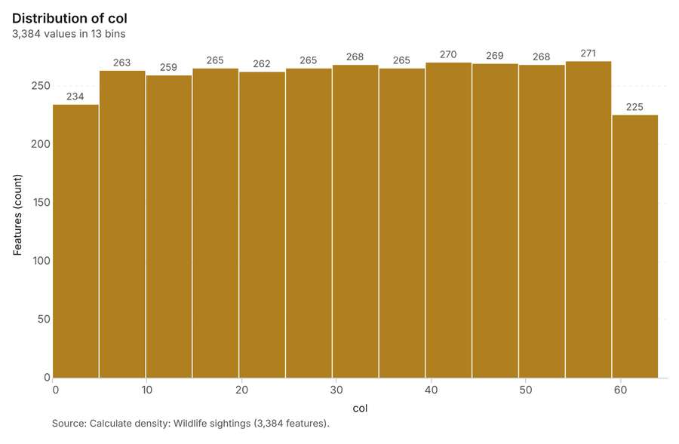
Figure 38. Calculate density: Wildlife sightings [91]. Source: Calculate density: Wildlife sightings (3,384 features). The data is in the appendix.
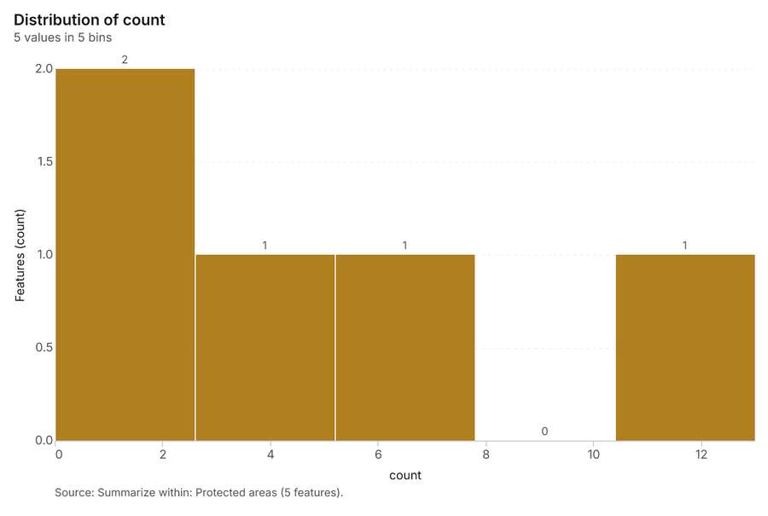
Figure 39. Summarize within: Protected areas [92]. Source: Summarize within: Protected areas (5 features). The data is in the appendix.
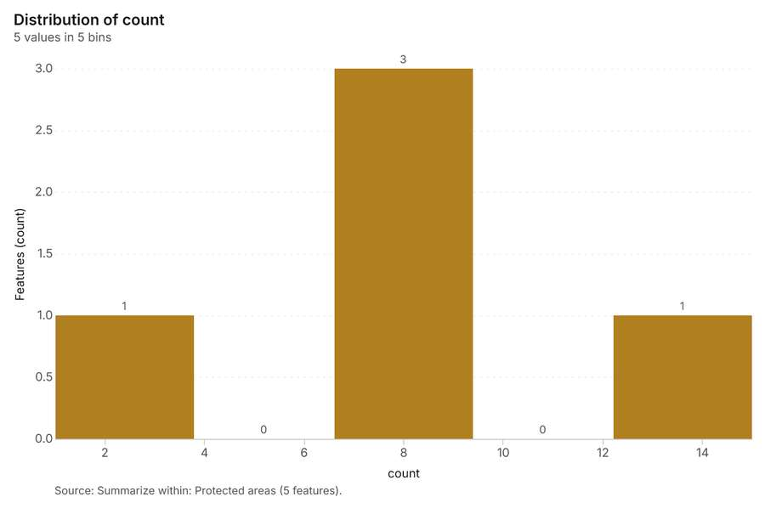
Figure 40. Summarize within: Protected areas [93]. Source: Summarize within: Protected areas (5 features). The data is in the appendix.
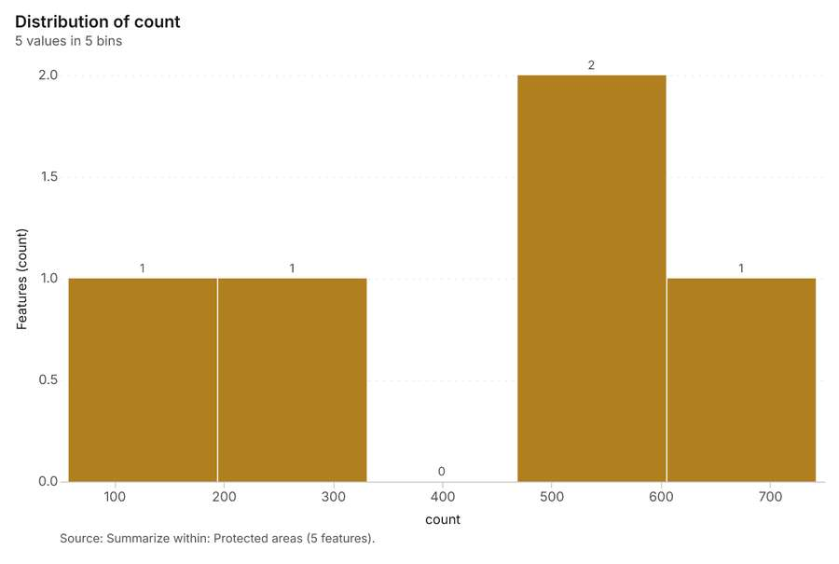
Figure 41. Summarize within: Protected areas [94]. Source: Summarize within: Protected areas (5 features). The data is in the appendix.
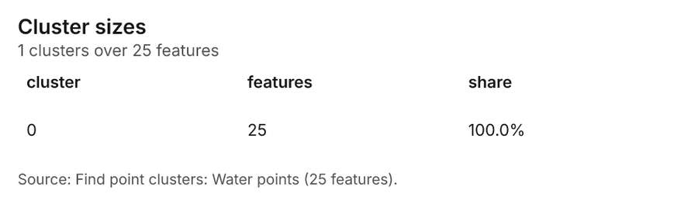
Figure 42. Find point clusters: Water points [95]. Source: Find point clusters: Water points (25 features). The data is in the appendix.
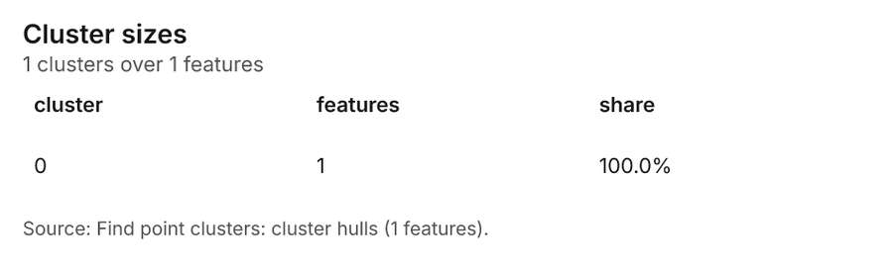
Figure 43. Find point clusters: cluster hulls [96]. Source: Find point clusters: cluster hulls (1 features). The data is in the appendix.
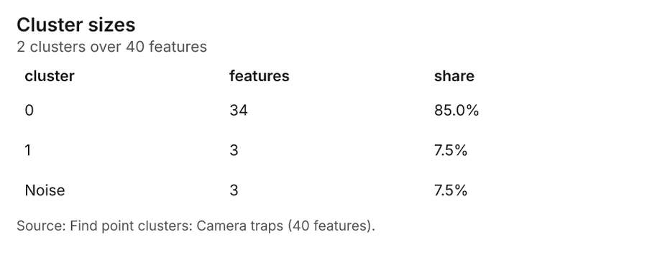
Figure 44. Find point clusters: Camera traps [97]. Source: Find point clusters: Camera traps (40 features). The data is in the appendix.
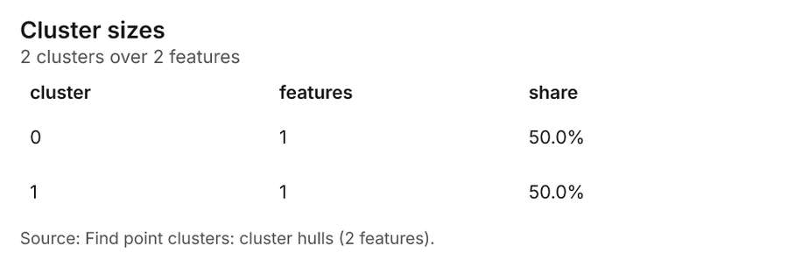
Figure 45. Find point clusters: cluster hulls [98]. Source: Find point clusters: cluster hulls (2 features). The data is in the appendix.
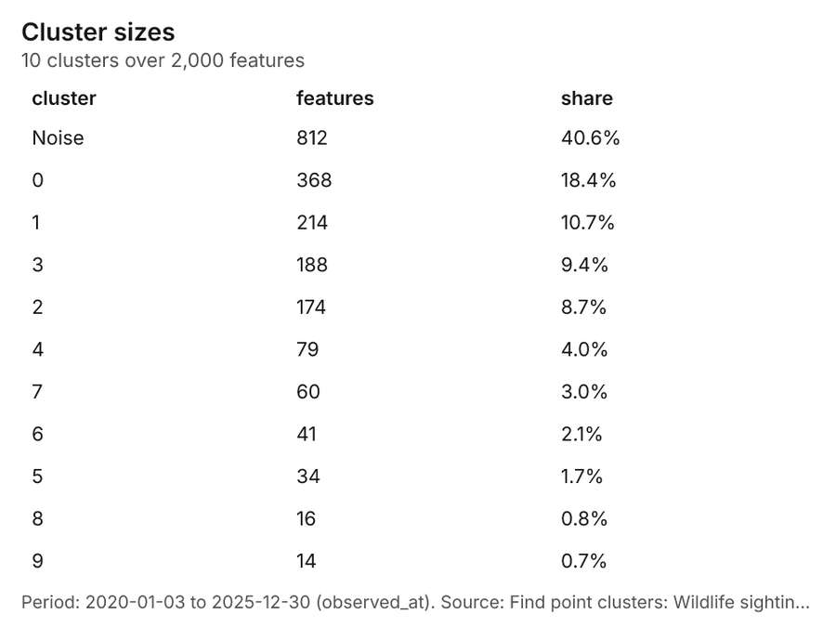
Figure 46. Find point clusters: Wildlife sightings [99]. Period: 2020-01-03 to 2025-12-30 (observed_at). Source: Find point clusters: Wildlife sightings (2,000 features). The data is in the appendix.
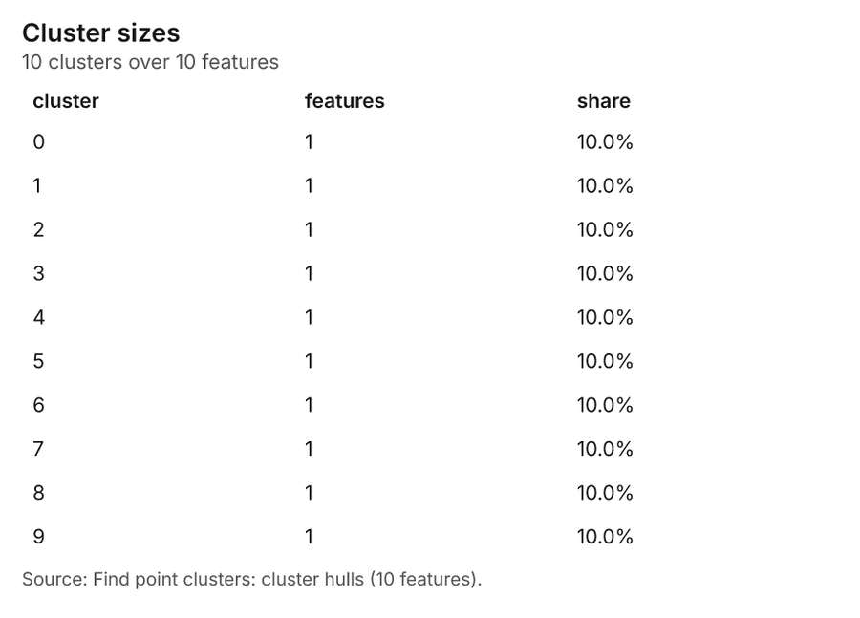
Figure 47. Find point clusters: cluster hulls [100]. Source: Find point clusters: cluster hulls (10 features). The data is in the appendix.
Figure 48. NDVI change polygons [101]. Source: NDVI change polygons (984 features). The data is in the appendix.
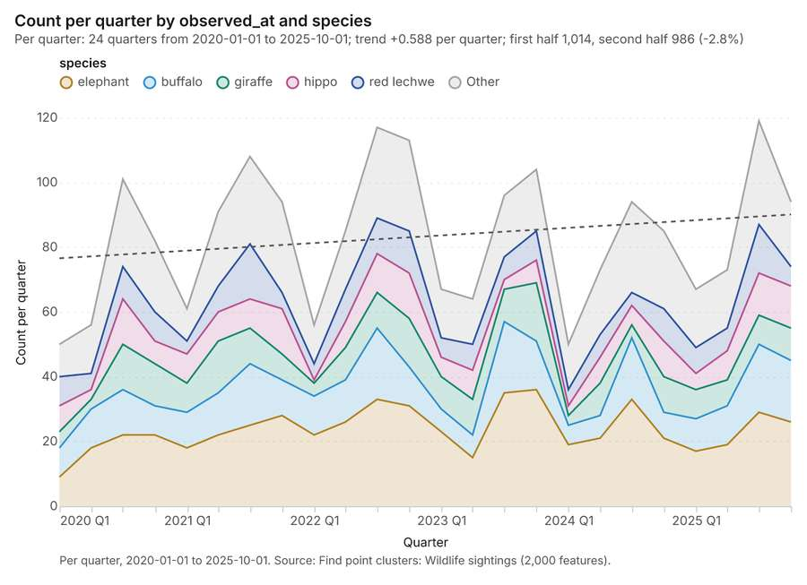
Figure 49. Find point clusters: Wildlife sightings over time [102]. Per quarter, 2020-01-01 to 2025-10-01. Source: Find point clusters: Wildlife sightings (2,000 features). The data is in the appendix.
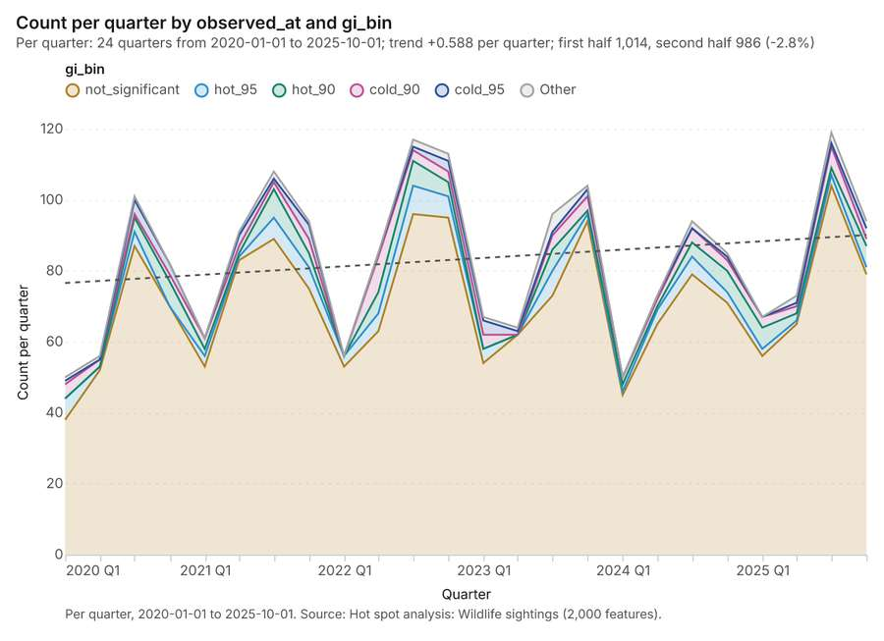
Figure 50. Hot spot analysis: Wildlife sightings over time [103]. Per quarter, 2020-01-01 to 2025-10-01. Source: Hot spot analysis: Wildlife sightings (2,000 features). The data is in the appendix.
Figure 51. Repeat and near repeat classification: Wildlife sightings over time [104]. Per quarter, 2020-01-01 to 2025-10-01. Source: Repeat and near repeat classification: Wildlife sightings (2,000 features). The data is in the appendix.

Changes since the last run
This is the first report of this project.

Sources
[1] Rendering: Chart: Timeline: events per quarter by dataset. 128 rows (id 0724d535-2e2e-4bb7-b82c-698b724a5b84)
[2] Dataset: Wildlife sightings. vector, 2000 rows (id 9a6b5c20-62ec-407e-8ddc-4a0caffd3d78)
[3] Dataset: Patrol tracks. vector, 150 rows (id 814d9a40-6257-4402-aefd-0471b089fe13)
[4] Dataset: Patrol effort by month. table, 120 rows (id 7ff2c071-222a-49b6-9c45-0ab36a6fa275)
[5] Dataset: Transect counts by year. table, 256 rows (id 19804e2c-33c7-475b-976e-0a261338d7ca)
[6] Tool result: gp_change_point_detection, step 2. Change point detection: done; no map output. (id ae9291dd-465c-483c-82b1-be209e5ed950:2)
[7] Catalog: Emerging hot spots (operation catalog, gp_space_time_hot_spots). Where hot spots are new, consecutive, intensifying, persistent, diminishing, sporadic, oscillating or historical over time. ArcGIS: Emerging Hot Spot Analysis, Create Space Time Cube. (id gp_space_time_hot_spots)
[8] Plan: Space time hot spots of Wildlife sightings (the Start plan's candidate c_410f48d3d771). Wildlife sightings carry dates in 'observed_at': emerging hot spot analysis finds new, intensifying and fading hot spots per month. (id 41c286e6-f1de-4fb3-ab1e-55065e9e3167:c_410f48d3d771)
[9] Tool result: gp_space_time_hot_spots, step 0. Emerging hot spots: 1 layer saved: Emerging hot spots: Wildlife sightings (187 features). (id ae9291dd-465c-483c-82b1-be209e5ed950:0)
[10] Layer: Wildlife sightings. 2,000 features (id 49c8e07e-b766-4e5c-87e7-a09af4f67da6)
[11] Catalog: Repeat and near repeat classification (operation catalog, gp_near_repeat). Classify incidents as originators, repeats (same place) or near repeats within a distance and time window, with a Knox test table. ArcGIS: Repeat and Near Repeat Classification, Near Repeat Calculator. (id gp_near_repeat)
[12] Plan: Near repeat of Wildlife sightings (the Start plan's candidate c_90899865dc1b). Near repeat analysis tests whether Wildlife sightings close in space also follow each other within 30 days. (id 41c286e6-f1de-4fb3-ab1e-55065e9e3167:c_90899865dc1b)
[13] Tool result: gp_near_repeat, step 1. Repeat and near repeat classification: 1 layer saved: Repeat and near repeat classification: Wildlife sightings (2000 features). (id ae9291dd-465c-483c-82b1-be209e5ed950:1)
[14] Catalog: Change point detection (operation catalog, gp_change_point_detection). When did the level, count, trend or variability change? For the whole study area or for every bin. ArcGIS: Change Point Detection. (id gp_change_point_detection)
[15] Plan: Change points of Wildlife sightings (the Start plan's candidate c_732496fb9369). Change point detection finds when the monthly count of Wildlife sightings shifted. (id 41c286e6-f1de-4fb3-ab1e-55065e9e3167:c_732496fb9369)
[16] Catalog: Hot spot analysis (operation catalog, gp_hot_spots). Getis-Ord Gi* hot and cold spots with z-scores, p-values and confidence bins. ArcGIS: Find Hot Spots, Hot Spot Analysis (Getis-Ord Gi*). QGIS: qgis:hotspot (plugin). (id gp_hot_spots)
[17] Plan: Hot spots of Camera traps (the Start plan's candidate c_7aa48c367385). 40 points: Getis-Ord Gi* tests whether the concentrations in Camera traps are statistically significant. (id 41c286e6-f1de-4fb3-ab1e-55065e9e3167:c_7aa48c367385)
[18] Tool result: gp_hot_spots, step 0. Hot spot analysis: 1 layer saved: Hot spot analysis: Camera traps (11 features). (id c80e3725-e679-4389-b91c-8fcf60553593:0)
[19] Layer: Camera traps. 40 features (id 2952931c-dfd9-4179-ac00-717ec101503d)
[20] Plan: Hot spots of Wildlife sightings (the Start plan's candidate c_1dd1e67c3631). 2000 points: Getis-Ord Gi* tests whether the concentrations in Wildlife sightings are statistically significant. (id 41c286e6-f1de-4fb3-ab1e-55065e9e3167:c_1dd1e67c3631)
[21] Tool result: gp_hot_spots, step 1. Hot spot analysis: 1 layer saved: Hot spot analysis: Wildlife sightings (2000 features). (id c80e3725-e679-4389-b91c-8fcf60553593:1)
[22] Catalog: Spectral index change (analysis catalog, im_index_change). Change of a spectral index (NDVI, NDWI, NDBI, NBR ...) or a band expression between two images: before, after and difference rasters, decrease / increase classes beyond the threshold with polygons and areas; NBR also gives dNBR with burn severity classes. (id im_index_change)
[23] Plan: Index change of Habitat scene 2020-09-15 and Habitat scene 2025-09-15 (the Start plan's candidate c_f9c63f3ce298). Index change between Habitat scene 2020-09-15 (2020-09-15) and Habitat scene 2025-09-15 (2025-09-15): the changed area, with the changed places as polygons. (id 41c286e6-f1de-4fb3-ab1e-55065e9e3167:c_f9c63f3ce298)
[24] Tool result: im_index_change, step 0. Spectral index change: created NDVI change Habitat scene 2020-09-15 to Habitat scene 2025-09-15 (300 x 250 cells, 40.00 m). plus 1 more raster layer(s). and layer NDVI change polygons with 984 feature(s). mean before 0.5613; mean after 0.4592; mean difference -0.1022; decrease ha 2,822; increase ha (id 25b17de9-ec4a-4fc2-a10c-3cc5543c313b:0)
[25] Catalog: Compute change raster (analysis catalog, im_compute_change_raster). Pixel value or spectral change between two co-registered images: difference, relative difference, absolute difference, log ratio (radar, dB), Euclidean spectral distance, spectral angle (radians) or the band with most change. Clouds and shadows are masked when the images have (id im_compute_change_raster)
[26] Plan: Compute change raster of Habitat scene 2020-09-15 and Habitat scene 2025-09-15 (the Start plan's candidate c_64fec8a79a74). A change raster between Habitat scene 2020-09-15 (2020-09-15) and Habitat scene 2025-09-15 (2025-09-15): where and how much the pixels changed. (id 41c286e6-f1de-4fb3-ab1e-55065e9e3167:c_64fec8a79a74)
[27] Tool result: im_compute_change_raster, step 1. Compute change raster: created Difference Habitat scene 2020-09-15 to Habitat scene 2025-09-15 (300 x 250 cells, 40.00 m). mean 0.01608; std 0.03381; min -0.04; max 0.15; masked pixels 0. (id 25b17de9-ec4a-4fc2-a10c-3cc5543c313b:1)
[28] Catalog: Calculate density (operation catalog, gp_calculate_density). Kernel density per square kilometer on a grid. ArcGIS: Calculate Density, Kernel Density. QGIS: native:heatmapkerneldensityestimation. (id gp_calculate_density)
[29] Plan: Kernel density of Water points (the Start plan's candidate c_8769ce6eb6cd). 25 points in Water points: a density surface shows where they concentrate. (id 41c286e6-f1de-4fb3-ab1e-55065e9e3167:c_8769ce6eb6cd)
[30] Tool result: gp_calculate_density, step 0. Calculate density: 1 layer saved: Calculate density: Water points (67 features). (id 01964fe7-6064-4d8e-821d-2f1fc44a40a7:0)
[31] Layer: Water points. 25 features (id 2b4e30e1-0347-4c58-b093-eb060c234f8b)
[32] Plan: Kernel density of Camera traps (the Start plan's candidate c_04d8c646d639). 40 points in Camera traps: a density surface shows where they concentrate. (id 41c286e6-f1de-4fb3-ab1e-55065e9e3167:c_04d8c646d639)
[33] Tool result: gp_calculate_density, step 1. Calculate density: 1 layer saved: Calculate density: Camera traps (95 features). (id 01964fe7-6064-4d8e-821d-2f1fc44a40a7:1)
[34] Plan: Kernel density of Wildlife sightings (the Start plan's candidate c_e2212fdd849b). 2000 points in Wildlife sightings: a density surface shows where they concentrate. (id 41c286e6-f1de-4fb3-ab1e-55065e9e3167:c_e2212fdd849b)
[35] Tool result: gp_calculate_density, step 2. Calculate density: 1 layer saved: Calculate density: Wildlife sightings (3384 features). (id 01964fe7-6064-4d8e-821d-2f1fc44a40a7:2)
[36] Catalog: Summarize within (operation catalog, gp_summarize_within). Count and aggregate the features inside each polygon (or bin), proportionally for lines and polygons. ArcGIS: Summarize Within, Aggregate Points. QGIS: native:countpointsinpolygon, native:sumlinelengths. (id gp_summarize_within)
[37] Plan: Water points per feature of Protected areas (the Start plan's candidate c_04513400fd64). Count Water points inside each feature of Protected areas by type; the counts map as a choropleth (natural breaks, sequential colors). (id 41c286e6-f1de-4fb3-ab1e-55065e9e3167:c_04513400fd64)
[38] Tool result: gp_summarize_within, step 0. Summarize within: 1 layer saved: Summarize within: Protected areas (5 features). (id 6776e53d-c51a-4c30-9da5-d711d9628f48:0)
[39] Layer: Protected areas. 5 features (id 446c314f-bc35-4126-af57-469e6d5aa55b)
[40] Tool result: gp_summarize_within, step 1. Summarize within: 1 layer saved: Summarize within: Protected areas (5 features). (id 6776e53d-c51a-4c30-9da5-d711d9628f48:1)
[41] Tool result: gp_summarize_within, step 2. Summarize within: 1 layer saved: Summarize within: Protected areas (5 features). (id 6776e53d-c51a-4c30-9da5-d711d9628f48:2)
[42] Catalog: Find point clusters (operation catalog, gp_find_point_clusters). Density-based clusters (DBSCAN, HDBSCAN or OPTICS, optionally space-time) with hulls and noise. ArcGIS: Find Point Clusters, Density-based Clustering. QGIS: native:dbscanclustering, native:stdbscanclustering. (id gp_find_point_clusters)
[43] Plan: Cluster points of Water points (the Start plan's candidate c_e10b266f027d). DBSCAN finds dense groups of Water points and separates noise. (id 41c286e6-f1de-4fb3-ab1e-55065e9e3167:c_e10b266f027d)
[44] Tool result: gp_find_point_clusters, step 0. Find point clusters: 2 layers saved: Find point clusters: Water points (25 features); Find point clusters: cluster hulls (1 feature). (id 0c30535f-d016-409b-b4ab-3f26aba08abc:0)
[45] Plan: Cluster points of Camera traps (the Start plan's candidate c_008a367bf2dc). DBSCAN finds dense groups of Camera traps and separates noise. (id 41c286e6-f1de-4fb3-ab1e-55065e9e3167:c_008a367bf2dc)
[46] Tool result: gp_find_point_clusters, step 1. Find point clusters: 2 layers saved: Find point clusters: Camera traps (40 features); Find point clusters: cluster hulls (2 features). (id 0c30535f-d016-409b-b4ab-3f26aba08abc:1)
[47] Plan: Cluster points of Wildlife sightings (the Start plan's candidate c_5e77fd8554c0). DBSCAN finds dense groups of Wildlife sightings and separates noise. (id 41c286e6-f1de-4fb3-ab1e-55065e9e3167:c_5e77fd8554c0)
[48] Tool result: gp_find_point_clusters, step 2. Find point clusters: 2 layers saved: Find point clusters: Wildlife sightings (2000 features); Find point clusters: cluster hulls (10 features). (id 0c30535f-d016-409b-b4ab-3f26aba08abc:2)
[49] Catalog: Zonal statistics (analysis catalog, rs_zonal_statistics). count/min/max/mean/std/sum/median/majority per polygon as a table and as GeoJSON. ArcGIS: Zonal Statistics as Table (polygons). (id rs_zonal_statistics)
[50] Plan: Zonal statistics of Habitat scene 2020-09-15 and Protected areas (the Start plan's candidate c_70c74078ffd8). Statistics of Habitat scene 2020-09-15 inside each feature of Protected areas. (id 41c286e6-f1de-4fb3-ab1e-55065e9e3167:c_70c74078ffd8)
[51] Tool result: rs_zonal_statistics, step 0. Zonal statistics: 5 row(s). zones 5. (id 0285f5a2-ee85-41f6-8973-17e457b19d16:0)
[52] Tool result: rs_zonal_statistics, step 1. Zonal statistics: 5 row(s). zones 5. (id 0285f5a2-ee85-41f6-8973-17e457b19d16:1)
[53] Tool result: im_index_change, step 0. Spectral index change: created NDVI change Habitat scene 2020-09-15 to Habitat scene 2025-09-15 (300 x 250 cells, 40.00 m). plus 1 more raster layer(s). and layer NDVI change polygons with 984 feature(s). mean before 0.5613; mean after 0.4592; mean difference -0.1022; decrease ha 2,822; increase ha (id d6cae56b-660a-4f0f-8c67-4f9de89853d8:0)
[54] Tool result: im_compute_change_raster, step 1. Compute change raster: created Difference Habitat scene 2020-09-15 to Habitat scene 2025-09-15 (300 x 250 cells, 40.00 m). mean 0.01608; std 0.03381; min -0.04; max 0.15; masked pixels 0. (id d6cae56b-660a-4f0f-8c67-4f9de89853d8:1)
[55] Rendering: Map: Emerging hot spots: Wildlife sightings (id 9c331cfd-4983-4a73-9cb8-323c32e4aa1a)
[56] Rendering: Map: Repeat and near repeat classification: Wildlife sightings (id 54dedce7-b568-41ed-8a3e-2f16e78eef00)
[57] Rendering: Map: Hot spot analysis: Camera traps (id cccc83e3-4db7-4fb9-8950-5bb38a673af5)
[58] Rendering: Map: Hot spot analysis: Wildlife sightings (id 10d58a93-f8d6-4c71-9a15-b562b40f6767)
[59] Rendering: Map: NDVI change Habitat scene 2020-09-15 to Habitat scene 2025-09-15 (id 8d6f1690-5b0d-4f4b-a7cd-cd5c4e8cf6ad)
[60] Rendering: Map: NDVI decrease / increase (id 15ba8d9d-bf64-4548-aaea-5c255f214c41)
[61] Rendering: Map: NDVI change polygons (id 940f75e7-4b4a-480a-8452-4e0055c12596)
[62] Rendering: Map: Difference Habitat scene 2020-09-15 to Habitat scene 2025-09-15 (id d642c322-d610-40f6-a2a4-680edf061662)
[63] Rendering: Map: Calculate density: Water points (id 5d0cbf7a-68de-42e2-ac67-cc0feb01919f)
[64] Rendering: Map: Calculate density: Camera traps (id 0131588b-7e0d-44b3-857c-6b7e3c992904)
[65] Rendering: Map: Calculate density: Wildlife sightings (id 4a1dfe19-c4df-4468-8985-e90b8be9a66a)
[66] Rendering: Map: Summarize within: Protected areas (id 8d6cfb31-1e7a-46c0-8b3b-14fcca86feb3)
[67] Rendering: Map: Summarize within: Protected areas (id ab4707fc-4ac2-4e7f-aace-3c12d9aefc49)
[68] Rendering: Map: Summarize within: Protected areas (id e92c8c09-d62d-4c61-a41e-9eab93106689)
[69] Rendering: Map: Find point clusters: Water points (id 2ef976fe-c86c-4852-8d50-e2334804cffb)
[70] Rendering: Map: Find point clusters: cluster hulls (id f0f01aa8-ceb0-4578-8cee-1fc54b125c7f)
[71] Rendering: Map: Find point clusters: Camera traps (id 68fe64f6-4d5e-4456-b415-8b0c5e137963)
[72] Rendering: Map: Find point clusters: cluster hulls (id 6fd1e101-3103-4507-8297-e61eceb58e4c)
[73] Rendering: Map: Find point clusters: Wildlife sightings (id e4f56f90-c90d-4bb8-8df9-27afdf318b33)
[74] Rendering: Map: Find point clusters: cluster hulls (id d1316f24-5049-469b-85c8-67c1984de3ec)
[75] Rendering: Map: Protected areas by area_km2 (id ac009abe-f117-45f7-bd9a-48427ea82fb6)
[76] Rendering: Map: Change Analysis: NDVI change Habitat scene 2020-09-15 to Habitat scene 2025-09-15 (id 8e0b0fa2-feed-49ea-ad2a-f565d878327d)
[77] Rendering: Map: Change Analysis: NDVI decrease / increase (id 91e47706-6cbf-4b9c-8ad1-484d35b3c7c6)
[78] Rendering: Map: Change Analysis: NDVI change polygons (id c91b140f-5f07-4863-a6c6-4e2c84bba5c8)
[79] Rendering: Map: Change Analysis: Difference Habitat scene 2020-09-15 to Habitat scene 2025-09-15 (id 005f6107-414f-4f41-87b6-5198fc10e839)
[80] Rendering: Chart: Camera traps over time (installed_year). 1 rows (id 11efc874-2e1c-49fb-8011-bc470de56923)
[81] Rendering: Chart: Patrol tracks over time (date). 72 rows (id 566504c3-02f8-45bc-a5af-5d3cfd7b26b1)
[82] Rendering: Chart: Patrol effort by month over time (month). 120 rows (id d26c312f-f3e6-410e-a665-caa60c2be84e)
[83] Rendering: Chart: Transect counts by year over time (year). 116 rows (id f30bd747-c4d1-4069-8332-200a119caf4a)
[84] Rendering: Chart: Emerging hot spots: Wildlife sightings. 9 rows (id 336187f6-9aa6-4fdb-a2b2-bcbd01a6d11f)
[85] Rendering: Chart: Repeat and near repeat classification: Wildlife sightings. 144 rows (id dfae20b3-c296-4b80-83de-7c8cfc621e38)
[86] Rendering: Chart: Hot spot analysis: Camera traps. 6 rows (id 632e8a2c-1eff-4f6a-985c-67a89d6a4947)
[87] Rendering: Chart: Hot spot analysis: Wildlife sightings. 18 rows (id 05576c19-da08-403f-8daa-289e88599168)
[88] Rendering: Chart: NDVI change polygons. 11 rows (id af589c3a-4e8f-4939-be0e-214f2b289c2e)
[89] Rendering: Chart: Calculate density: Water points. 8 rows (id 789e658b-0a46-4ccb-bb9f-0605baba7590)
[90] Rendering: Chart: Calculate density: Camera traps. 8 rows (id 194574a5-7da8-4372-9aab-0ed2c503366c)
[91] Rendering: Chart: Calculate density: Wildlife sightings. 13 rows (id 79663709-0cd5-4172-bc17-e223c6dbe444)
[92] Rendering: Chart: Summarize within: Protected areas. 5 rows (id 8141e260-100f-4d40-bc34-7e64674372da)
[93] Rendering: Chart: Summarize within: Protected areas. 5 rows (id 5b5cde74-67ec-4fb8-99ab-8c31a9c6e86e)
[94] Rendering: Chart: Summarize within: Protected areas. 5 rows (id c0ce8baf-5831-4348-9566-b519e6175395)
[95] Rendering: Chart: Find point clusters: Water points. 1 rows (id 9cf9975c-ea09-45a0-bdad-c7265f897ff2)
[96] Rendering: Chart: Find point clusters: cluster hulls. 1 rows (id 8da356a8-27a4-4bb9-84c2-9620eac3b532)
[97] Rendering: Chart: Find point clusters: Camera traps. 3 rows (id 89f781cf-b6ae-46e1-81a8-a915a2588c57)
[98] Rendering: Chart: Find point clusters: cluster hulls. 2 rows (id 64aebe57-1b31-48ca-9fc9-5f83f833cc53)
[99] Rendering: Chart: Find point clusters: Wildlife sightings. 11 rows (id 6b044701-7146-43e9-9a25-9a912c844922)
[100] Rendering: Chart: Find point clusters: cluster hulls. 10 rows (id da54ed0a-3d83-4640-bf04-d09c9c2ab1f2)
[101] Rendering: Chart: NDVI change polygons. 11 rows (id 6ae7db91-618b-4063-9d4a-e4c147eb49cc)
[102] Rendering: Chart: Find point clusters: Wildlife sightings over time. 144 rows (id c0d9a68a-73b7-4840-9446-0e8a318f3bdd)
[103] Rendering: Chart: Hot spot analysis: Wildlife sightings over time. 144 rows (id 78f16216-e0fa-4a2f-9c0a-c0f2476bc9a0)
[104] Rendering: Chart: Repeat and near repeat classification: Wildlife sightings over time. 144 rows (id 3241845c-4265-44df-bc31-31e0200b158c)
[105] Dataset: Protected areas. vector, 5 rows (id 1e486b97-508d-4337-ae50-e69a1b8ffb02)
[106] Dataset: River channels. vector, 2 rows (id 7315f4d9-c391-406c-bed2-14d9ab7690f0)
[107] Dataset: Camera traps. vector, 40 rows (id 6baeccec-3617-4b56-be6a-c455cd0fbafb)
[108] Dataset: Water points. vector, 25 rows (id 03d16489-5533-4abf-ac13-90fb1db77364)
[109] Dataset: Habitat scene 2020-09-15. raster, ? rows (id 5d31a198-7af1-43ff-b987-95e63692238f)
[110] Dataset: Habitat scene 2025-09-15. raster, ? rows (id c4cf3368-47bc-4215-9a15-2e33536e69ae)
[111] Dataset: Annual wildlife monitoring report. document, ? rows (id bc1ed059-741b-47ee-9e3d-4ea6e56612e1)
[112] Record: Sample: Conservation, Okavango Delta near Maun (id 750b4ce3-8424-4738-b383-c6a58973ae02)
[113] Layer: Emerging hot spots: Wildlife sightings. 187 features (id 25f740dd-9467-44c8-ac92-0b3093bb596c)
[114] Layer: Repeat and near repeat classification: Wildlife sightings. 2,000 features (id b3ca8ebf-0745-4ec4-8a45-bbe2a690f0db)
[115] Layer: Hot spot analysis: Camera traps. 11 features (id e7a89409-c9ed-463d-823f-677e22ab631c)
[116] Layer: Hot spot analysis: Wildlife sightings. 2,000 features (id f319351b-b79e-40cc-af73-16512c8cd363)
[117] Layer: NDVI change Habitat scene 2020-09-15 to Habitat scene 2025-09-15. 0 features (id 1e7295c4-437f-4592-ae40-ba4bbdb0717b)
[118] Layer: NDVI decrease / increase. 0 features (id 92900ecf-ab3e-4b43-b4cf-6b08b036e3fe)
[119] Layer: NDVI change polygons. 984 features (id bf42f4f1-8b33-44ec-966f-18e38ceabf89)
[120] Layer: Difference Habitat scene 2020-09-15 to Habitat scene 2025-09-15. 0 features (id 33686ef4-9edd-4167-a443-df679ae27b18)
[121] Layer: Calculate density: Water points. 67 features (id 7b558d2e-7e39-420e-9603-d53f4706d94e)
[122] Layer: Calculate density: Camera traps. 95 features (id 087d5d69-2b6f-47bb-9d24-4ebfe7828e43)
[123] Layer: Calculate density: Wildlife sightings. 3,384 features (id 5109f215-01e5-45df-bd1a-8d7fd591dbd4)
[124] Layer: Summarize within: Protected areas. 5 features (id 31880463-9414-41cb-b944-378bf5fd3fbd)
[125] Layer: Summarize within: Protected areas. 5 features (id cd5df3dd-2597-4703-9f13-db82b5b55d6f)
[126] Layer: Summarize within: Protected areas. 5 features (id 83d77110-e66e-43fa-a592-e7204275b8e2)
[127] Layer: Find point clusters: Water points. 25 features (id c0112b91-150f-4a55-a360-f76b0bd99a95)
[128] Layer: Find point clusters: cluster hulls. 1 features (id 24c2763d-d1eb-4805-91d1-cbfd5661bad4)
[129] Layer: Find point clusters: Camera traps. 40 features (id 4649022a-052c-47f0-b5f3-ea841d10a2ce)
[130] Layer: Find point clusters: cluster hulls. 2 features (id 69fa523b-63c9-49ac-b08f-33713597df34)
[131] Layer: Find point clusters: Wildlife sightings. 2,000 features (id 6c25135b-35a1-4dc6-9bad-5e2bb9a95460)
[132] Layer: Find point clusters: cluster hulls. 10 features (id 7326560f-58fb-4bab-867c-48455d3e5469)
[133] Layer: NDVI change polygons. 984 features (id d12c4629-9f52-437d-be16-1038367b3ca0)

Appendix: the data behind the charts

Figure 1. Timeline: events per quarter by dataset [1]
period | series | value
2018-01-01 | Wildlife sightings | 0
2018-01-01 | Transect counts by year | 32
2018-01-01 | Patrol tracks | 0
2018-01-01 | Patrol effort by month | 0
2018-04-01 | Wildlife sightings | 0
2018-04-01 | Transect counts by year | 0
2018-04-01 | Patrol tracks | 0
2018-04-01 | Patrol effort by month | 0
2018-07-01 | Wildlife sightings | 0
2018-07-01 | Transect counts by year | 0
2018-07-01 | Patrol tracks | 0
2018-07-01 | Patrol effort by month | 0
2018-10-01 | Wildlife sightings | 0
2018-10-01 | Transect counts by year | 0
2018-10-01 | Patrol tracks | 0
2018-10-01 | Patrol effort by month | 0
2019-01-01 | Wildlife sightings | 0
2019-01-01 | Transect counts by year | 32
2019-01-01 | Patrol tracks | 0
2019-01-01 | Patrol effort by month | 0
2019-04-01 | Wildlife sightings | 0
2019-04-01 | Transect counts by year | 0
2019-04-01 | Patrol tracks | 0
2019-04-01 | Patrol effort by month | 0
2019-07-01 | Wildlife sightings | 0
2019-07-01 | Transect counts by year | 0
2019-07-01 | Patrol tracks | 0
2019-07-01 | Patrol effort by month | 0
2019-10-01 | Wildlife sightings | 0
2019-10-01 | Transect counts by year | 0
2019-10-01 | Patrol tracks | 0
2019-10-01 | Patrol effort by month | 0
2020-01-01 | Wildlife sightings | 50
2020-01-01 | Transect counts by year | 32
2020-01-01 | Patrol tracks | 0
2020-01-01 | Patrol effort by month | 0
2020-04-01 | Wildlife sightings | 56
2020-04-01 | Transect counts by year | 0
2020-04-01 | Patrol tracks | 0
2020-04-01 | Patrol effort by month | 0
2020-07-01 | Wildlife sightings | 101
2020-07-01 | Transect counts by year | 0
2020-07-01 | Patrol tracks | 0
2020-07-01 | Patrol effort by month | 0
2020-10-01 | Wildlife sightings | 82
2020-10-01 | Transect counts by year | 0
2020-10-01 | Patrol tracks | 0
2020-10-01 | Patrol effort by month | 0
2021-01-01 | Wildlife sightings | 61
2021-01-01 | Transect counts by year | 32
2021-01-01 | Patrol tracks | 0
2021-01-01 | Patrol effort by month | 0
2021-04-01 | Wildlife sightings | 91
2021-04-01 | Transect counts by year | 0
2021-04-01 | Patrol tracks | 0
2021-04-01 | Patrol effort by month | 0
2021-07-01 | Wildlife sightings | 108
2021-07-01 | Transect counts by year | 0
2021-07-01 | Patrol tracks | 0
2021-07-01 | Patrol effort by month | 0
2021-10-01 | Wildlife sightings | 94
2021-10-01 | Transect counts by year | 0
2021-10-01 | Patrol tracks | 0
2021-10-01 | Patrol effort by month | 0
2022-01-01 | Wildlife sightings | 56
2022-01-01 | Transect counts by year | 32
2022-01-01 | Patrol tracks | 0
2022-01-01 | Patrol effort by month | 0
2022-04-01 | Wildlife sightings | 85
2022-04-01 | Transect counts by year | 0
2022-04-01 | Patrol tracks | 0
2022-04-01 | Patrol effort by month | 0
2022-07-01 | Wildlife sightings | 117
2022-07-01 | Transect counts by year | 0
2022-07-01 | Patrol tracks | 0
2022-07-01 | Patrol effort by month | 0
2022-10-01 | Wildlife sightings | 113
2022-10-01 | Transect counts by year | 0
2022-10-01 | Patrol tracks | 0
2022-10-01 | Patrol effort by month | 0
2023-01-01 | Wildlife sightings | 67
2023-01-01 | Transect counts by year | 32
2023-01-01 | Patrol tracks | 0
2023-01-01 | Patrol effort by month | 0
2023-04-01 | Wildlife sightings | 64
2023-04-01 | Transect counts by year | 0
2023-04-01 | Patrol tracks | 0
2023-04-01 | Patrol effort by month | 0
2023-07-01 | Wildlife sightings | 96
2023-07-01 | Transect counts by year | 0
2023-07-01 | Patrol tracks | 0
2023-07-01 | Patrol effort by month | 0
2023-10-01 | Wildlife sightings | 104
2023-10-01 | Transect counts by year | 0
2023-10-01 | Patrol tracks | 0
2023-10-01 | Patrol effort by month | 0
2024-01-01 | Wildlife sightings | 50
2024-01-01 | Transect counts by year | 32
2024-01-01 | Patrol tracks | 24
2024-01-01 | Patrol effort by month | 15
2024-04-01 | Wildlife sightings | 73
2024-04-01 | Transect counts by year | 0
2024-04-01 | Patrol tracks | 20
2024-04-01 | Patrol effort by month | 15
2024-07-01 | Wildlife sightings | 94
2024-07-01 | Transect counts by year | 0
2024-07-01 | Patrol tracks | 15
2024-07-01 | Patrol effort by month | 15
2024-10-01 | Wildlife sightings | 85
2024-10-01 | Transect counts by year | 0
2024-10-01 | Patrol tracks | 22
2024-10-01 | Patrol effort by month | 15
2025-01-01 | Wildlife sightings | 67
2025-01-01 | Transect counts by year | 32
2025-01-01 | Patrol tracks | 23
2025-01-01 | Patrol effort by month | 15
2025-04-01 | Wildlife sightings | 73
2025-04-01 | Transect counts by year | 0
2025-04-01 | Patrol tracks | 22
2025-04-01 | Patrol effort by month | 15
2025-07-01 | Wildlife sightings | 119
2025-07-01 | Transect counts by year | 0
2025-07-01 | Patrol tracks | 12
2025-07-01 | Patrol effort by month | 15
2025-10-01 | Wildlife sightings | 94
2025-10-01 | Transect counts by year | 0
2025-10-01 | Patrol tracks | 12
2025-10-01 | Patrol effort by month | 15

Figure 27. Camera traps over time (installed_year) [80]
bin_start | bin_end | count
2,020 | 2,020 | 40

Figure 28. Patrol tracks over time (date) [81]
period | series | value
2024-01-01 | Alpha | 5
2024-01-01 | Charlie | 2
2024-01-01 | Bravo | 3
2024-02-01 | Alpha | 4
2024-02-01 | Charlie | 1
2024-02-01 | Bravo | 3
2024-03-01 | Alpha | 2
2024-03-01 | Charlie | 3
2024-03-01 | Bravo | 1
2024-04-01 | Alpha | 0
2024-04-01 | Charlie | 2
2024-04-01 | Bravo | 0
2024-05-01 | Alpha | 3
2024-05-01 | Charlie | 4
2024-05-01 | Bravo | 4
2024-06-01 | Alpha | 0
2024-06-01 | Charlie | 3
2024-06-01 | Bravo | 4
2024-07-01 | Alpha | 1
2024-07-01 | Charlie | 0
2024-07-01 | Bravo | 0
2024-08-01 | Alpha | 3
2024-08-01 | Charlie | 3
2024-08-01 | Bravo | 0
2024-09-01 | Alpha | 3
2024-09-01 | Charlie | 2
2024-09-01 | Bravo | 3
2024-10-01 | Alpha | 3
2024-10-01 | Charlie | 2
2024-10-01 | Bravo | 2
2024-11-01 | Alpha | 1
2024-11-01 | Charlie | 2
2024-11-01 | Bravo | 3
2024-12-01 | Alpha | 3
2024-12-01 | Charlie | 3
2024-12-01 | Bravo | 3
2025-01-01 | Alpha | 5
2025-01-01 | Charlie | 1
2025-01-01 | Bravo | 2
2025-02-01 | Alpha | 2
2025-02-01 | Charlie | 2
2025-02-01 | Bravo | 1
2025-03-01 | Alpha | 5
2025-03-01 | Charlie | 4
2025-03-01 | Bravo | 1
2025-04-01 | Alpha | 1
2025-04-01 | Charlie | 2
2025-04-01 | Bravo | 0
2025-05-01 | Alpha | 3
2025-05-01 | Charlie | 3
2025-05-01 | Bravo | 1
2025-06-01 | Alpha | 7
2025-06-01 | Charlie | 1
2025-06-01 | Bravo | 4
2025-07-01 | Alpha | 3
2025-07-01 | Charlie | 0
2025-07-01 | Bravo | 1
2025-08-01 | Alpha | 3
2025-08-01 | Charlie | 1
2025-08-01 | Bravo | 0
2025-09-01 | Alpha | 0
2025-09-01 | Charlie | 2
2025-09-01 | Bravo | 2
2025-10-01 | Alpha | 2
2025-10-01 | Charlie | 2
2025-10-01 | Bravo | 2
2025-11-01 | Alpha | 1
2025-11-01 | Charlie | 1
2025-11-01 | Bravo | 0
2025-12-01 | Alpha | 3
2025-12-01 | Charlie | 0
2025-12-01 | Bravo | 1

Figure 29. Patrol effort by month over time (month) [82]
period | series | value
2024-01-01 | PA1 | 1
2024-01-01 | PA2 | 1
2024-01-01 | PA3 | 1
2024-01-01 | PA4 | 1
2024-01-01 | PA5 | 1
2024-02-01 | PA1 | 1
2024-02-01 | PA2 | 1
2024-02-01 | PA3 | 1
2024-02-01 | PA4 | 1
2024-02-01 | PA5 | 1
2024-03-01 | PA1 | 1
2024-03-01 | PA2 | 1
2024-03-01 | PA3 | 1
2024-03-01 | PA4 | 1
2024-03-01 | PA5 | 1
2024-04-01 | PA1 | 1
2024-04-01 | PA2 | 1
2024-04-01 | PA3 | 1
2024-04-01 | PA4 | 1
2024-04-01 | PA5 | 1
2024-05-01 | PA1 | 1
2024-05-01 | PA2 | 1
2024-05-01 | PA3 | 1
2024-05-01 | PA4 | 1
2024-05-01 | PA5 | 1
2024-06-01 | PA1 | 1
2024-06-01 | PA2 | 1
2024-06-01 | PA3 | 1
2024-06-01 | PA4 | 1
2024-06-01 | PA5 | 1
2024-07-01 | PA1 | 1
2024-07-01 | PA2 | 1
2024-07-01 | PA3 | 1
2024-07-01 | PA4 | 1
2024-07-01 | PA5 | 1
2024-08-01 | PA1 | 1
2024-08-01 | PA2 | 1
2024-08-01 | PA3 | 1
2024-08-01 | PA4 | 1
2024-08-01 | PA5 | 1
2024-09-01 | PA1 | 1
2024-09-01 | PA2 | 1
2024-09-01 | PA3 | 1
2024-09-01 | PA4 | 1
2024-09-01 | PA5 | 1
2024-10-01 | PA1 | 1
2024-10-01 | PA2 | 1
2024-10-01 | PA3 | 1
2024-10-01 | PA4 | 1
2024-10-01 | PA5 | 1
2024-11-01 | PA1 | 1
2024-11-01 | PA2 | 1
2024-11-01 | PA3 | 1
2024-11-01 | PA4 | 1
2024-11-01 | PA5 | 1
2024-12-01 | PA1 | 1
2024-12-01 | PA2 | 1
2024-12-01 | PA3 | 1
2024-12-01 | PA4 | 1
2024-12-01 | PA5 | 1
2025-01-01 | PA1 | 1
2025-01-01 | PA2 | 1
2025-01-01 | PA3 | 1
2025-01-01 | PA4 | 1
2025-01-01 | PA5 | 1
2025-02-01 | PA1 | 1
2025-02-01 | PA2 | 1
2025-02-01 | PA3 | 1
2025-02-01 | PA4 | 1
2025-02-01 | PA5 | 1
2025-03-01 | PA1 | 1
2025-03-01 | PA2 | 1
2025-03-01 | PA3 | 1
2025-03-01 | PA4 | 1
2025-03-01 | PA5 | 1
2025-04-01 | PA1 | 1
2025-04-01 | PA2 | 1
2025-04-01 | PA3 | 1
2025-04-01 | PA4 | 1
2025-04-01 | PA5 | 1
2025-05-01 | PA1 | 1
2025-05-01 | PA2 | 1
2025-05-01 | PA3 | 1
2025-05-01 | PA4 | 1
2025-05-01 | PA5 | 1
2025-06-01 | PA1 | 1
2025-06-01 | PA2 | 1
2025-06-01 | PA3 | 1
2025-06-01 | PA4 | 1
2025-06-01 | PA5 | 1
2025-07-01 | PA1 | 1
2025-07-01 | PA2 | 1
2025-07-01 | PA3 | 1
2025-07-01 | PA4 | 1
2025-07-01 | PA5 | 1
2025-08-01 | PA1 | 1
2025-08-01 | PA2 | 1
2025-08-01 | PA3 | 1
2025-08-01 | PA4 | 1
2025-08-01 | PA5 | 1
2025-09-01 | PA1 | 1
2025-09-01 | PA2 | 1
2025-09-01 | PA3 | 1
2025-09-01 | PA4 | 1
2025-09-01 | PA5 | 1
2025-10-01 | PA1 | 1
2025-10-01 | PA2 | 1
2025-10-01 | PA3 | 1
2025-10-01 | PA4 | 1
2025-10-01 | PA5 | 1
2025-11-01 | PA1 | 1
2025-11-01 | PA2 | 1
2025-11-01 | PA3 | 1
2025-11-01 | PA4 | 1
2025-11-01 | PA5 | 1
2025-12-01 | PA1 | 1
2025-12-01 | PA2 | 1
2025-12-01 | PA3 | 1
2025-12-01 | PA4 | 1
2025-12-01 | PA5 | 1

Figure 30. Transect counts by year over time (year) [83]
period | series | value
2018-01-01 | red lechwe | 1,169
2018-01-01 | buffalo | 839
2018-01-01 | elephant | 309
2018-01-01 | giraffe | 110
2018-04-01 | red lechwe | 0
2018-04-01 | buffalo | 0
2018-04-01 | elephant | 0
2018-04-01 | giraffe | 0
2018-07-01 | red lechwe | 0
2018-07-01 | buffalo | 0
2018-07-01 | elephant | 0
2018-07-01 | giraffe | 0
2018-10-01 | red lechwe | 0
2018-10-01 | buffalo | 0
2018-10-01 | elephant | 0
2018-10-01 | giraffe | 0
2019-01-01 | red lechwe | 698
2019-01-01 | buffalo | 804
2019-01-01 | elephant | 372
2019-01-01 | giraffe | 90
2019-04-01 | red lechwe | 0
2019-04-01 | buffalo | 0
2019-04-01 | elephant | 0
2019-04-01 | giraffe | 0
2019-07-01 | red lechwe | 0
2019-07-01 | buffalo | 0
2019-07-01 | elephant | 0
2019-07-01 | giraffe | 0
2019-10-01 | red lechwe | 0
2019-10-01 | buffalo | 0
2019-10-01 | elephant | 0
2019-10-01 | giraffe | 0
2020-01-01 | red lechwe | 1,130
2020-01-01 | buffalo | 686
2020-01-01 | elephant | 380
2020-01-01 | giraffe | 77
2020-04-01 | red lechwe | 0
2020-04-01 | buffalo | 0
2020-04-01 | elephant | 0
2020-04-01 | giraffe | 0
2020-07-01 | red lechwe | 0
2020-07-01 | buffalo | 0
2020-07-01 | elephant | 0
2020-07-01 | giraffe | 0
2020-10-01 | red lechwe | 0
2020-10-01 | buffalo | 0
2020-10-01 | elephant | 0
2020-10-01 | giraffe | 0
2021-01-01 | red lechwe | 787
2021-01-01 | buffalo | 840
2021-01-01 | elephant | 316
2021-01-01 | giraffe | 104
2021-04-01 | red lechwe | 0
2021-04-01 | buffalo | 0
2021-04-01 | elephant | 0
2021-04-01 | giraffe | 0
2021-07-01 | red lechwe | 0
2021-07-01 | buffalo | 0
2021-07-01 | elephant | 0
2021-07-01 | giraffe | 0
2021-10-01 | red lechwe | 0
2021-10-01 | buffalo | 0
2021-10-01 | elephant | 0
2021-10-01 | giraffe | 0
2022-01-01 | red lechwe | 809
2022-01-01 | buffalo | 743
2022-01-01 | elephant | 298
2022-01-01 | giraffe | 77
2022-04-01 | red lechwe | 0
2022-04-01 | buffalo | 0
2022-04-01 | elephant | 0
2022-04-01 | giraffe | 0
2022-07-01 | red lechwe | 0
2022-07-01 | buffalo | 0
2022-07-01 | elephant | 0
2022-07-01 | giraffe | 0
2022-10-01 | red lechwe | 0
2022-10-01 | buffalo | 0
2022-10-01 | elephant | 0
2022-10-01 | giraffe | 0
2023-01-01 | red lechwe | 635
2023-01-01 | buffalo | 647
2023-01-01 | elephant | 303
2023-01-01 | giraffe | 95
2023-04-01 | red lechwe | 0
2023-04-01 | buffalo | 0
2023-04-01 | elephant | 0
2023-04-01 | giraffe | 0
2023-07-01 | red lechwe | 0
2023-07-01 | buffalo | 0
2023-07-01 | elephant | 0
2023-07-01 | giraffe | 0
2023-10-01 | red lechwe | 0
2023-10-01 | buffalo | 0
2023-10-01 | elephant | 0
2023-10-01 | giraffe | 0
2024-01-01 | red lechwe | 626
2024-01-01 | buffalo | 844
2024-01-01 | elephant | 382
2024-01-01 | giraffe | 96
2024-04-01 | red lechwe | 0
2024-04-01 | buffalo | 0
2024-04-01 | elephant | 0
2024-04-01 | giraffe | 0
2024-07-01 | red lechwe | 0
2024-07-01 | buffalo | 0
2024-07-01 | elephant | 0
2024-07-01 | giraffe | 0
2024-10-01 | red lechwe | 0
2024-10-01 | buffalo | 0
2024-10-01 | elephant | 0
2024-10-01 | giraffe | 0
2025-01-01 | red lechwe | 471
2025-01-01 | buffalo | 702
2025-01-01 | elephant | 321
2025-01-01 | giraffe | 96

Figure 31. Emerging hot spots: Wildlife sightings [84]
bin_start | bin_end | count
-0.658 | -0.05533 | 119
-0.05533 | 0.5473 | 26
0.5473 | 1.15 | 11
1.15 | 1.753 | 14
1.753 | 2.355 | 9
2.355 | 2.958 | 1
2.958 | 3.561 | 1
3.561 | 4.163 | 2
4.163 | 4.766 | 4

Figure 32. Repeat and near repeat classification: Wildlife sightings [85]
period | series | value
2020-01-01 | elephant | 9
2020-01-01 | buffalo | 9
2020-01-01 | giraffe | 5
2020-01-01 | hippo | 8
2020-01-01 | red lechwe | 9
2020-01-01 | Other | 10
2020-04-01 | elephant | 18
2020-04-01 | buffalo | 12
2020-04-01 | giraffe | 3
2020-04-01 | hippo | 3
2020-04-01 | red lechwe | 5
2020-04-01 | Other | 15
2020-07-01 | elephant | 22
2020-07-01 | buffalo | 14
2020-07-01 | giraffe | 14
2020-07-01 | hippo | 14
2020-07-01 | red lechwe | 10
2020-07-01 | Other | 27
2020-10-01 | elephant | 22
2020-10-01 | buffalo | 9
2020-10-01 | giraffe | 13
2020-10-01 | hippo | 7
2020-10-01 | red lechwe | 9
2020-10-01 | Other | 22
2021-01-01 | elephant | 18
2021-01-01 | buffalo | 11
2021-01-01 | giraffe | 9
2021-01-01 | hippo | 9
2021-01-01 | red lechwe | 4
2021-01-01 | Other | 10
2021-04-01 | elephant | 22
2021-04-01 | buffalo | 13
2021-04-01 | giraffe | 16
2021-04-01 | hippo | 9
2021-04-01 | red lechwe | 8
2021-04-01 | Other | 23
2021-07-01 | elephant | 25
2021-07-01 | buffalo | 19
2021-07-01 | giraffe | 11
2021-07-01 | hippo | 9
2021-07-01 | red lechwe | 17
2021-07-01 | Other | 27
2021-10-01 | elephant | 28
2021-10-01 | buffalo | 11
2021-10-01 | giraffe | 8
2021-10-01 | hippo | 14
2021-10-01 | red lechwe | 5
2021-10-01 | Other | 28
2022-01-01 | elephant | 22
2022-01-01 | buffalo | 12
2022-01-01 | giraffe | 4
2022-01-01 | hippo | 1
2022-01-01 | red lechwe | 5
2022-01-01 | Other | 12
2022-04-01 | elephant | 26
2022-04-01 | buffalo | 13
2022-04-01 | giraffe | 10
2022-04-01 | hippo | 8
2022-04-01 | red lechwe | 10
2022-04-01 | Other | 18
2022-07-01 | elephant | 33
2022-07-01 | buffalo | 22
2022-07-01 | giraffe | 11
2022-07-01 | hippo | 12
2022-07-01 | red lechwe | 11
2022-07-01 | Other | 28
2022-10-01 | elephant | 31
2022-10-01 | buffalo | 12
2022-10-01 | giraffe | 15
2022-10-01 | hippo | 14
2022-10-01 | red lechwe | 13
2022-10-01 | Other | 28
2023-01-01 | elephant | 23
2023-01-01 | buffalo | 7
2023-01-01 | giraffe | 10
2023-01-01 | hippo | 6
2023-01-01 | red lechwe | 6
2023-01-01 | Other | 15
2023-04-01 | elephant | 15
2023-04-01 | buffalo | 7
2023-04-01 | giraffe | 11
2023-04-01 | hippo | 9
2023-04-01 | red lechwe | 8
2023-04-01 | Other | 14
2023-07-01 | elephant | 35
2023-07-01 | buffalo | 22
2023-07-01 | giraffe | 10
2023-07-01 | hippo | 3
2023-07-01 | red lechwe | 7
2023-07-01 | Other | 19
2023-10-01 | elephant | 36
2023-10-01 | buffalo | 15
2023-10-01 | giraffe | 18
2023-10-01 | hippo | 7
2023-10-01 | red lechwe | 9
2023-10-01 | Other | 19
2024-01-01 | elephant | 19
2024-01-01 | buffalo | 6
2024-01-01 | giraffe | 3
2024-01-01 | hippo | 3
2024-01-01 | red lechwe | 5
2024-01-01 | Other | 14
2024-04-01 | elephant | 21
2024-04-01 | buffalo | 7
2024-04-01 | giraffe | 10
2024-04-01 | hippo | 8
2024-04-01 | red lechwe | 7
2024-04-01 | Other | 20
2024-07-01 | elephant | 33
2024-07-01 | buffalo | 19
2024-07-01 | giraffe | 4
2024-07-01 | hippo | 6
2024-07-01 | red lechwe | 4
2024-07-01 | Other | 28
2024-10-01 | elephant | 21
2024-10-01 | buffalo | 8
2024-10-01 | giraffe | 11
2024-10-01 | hippo | 11
2024-10-01 | red lechwe | 10
2024-10-01 | Other | 24
2025-01-01 | elephant | 17
2025-01-01 | buffalo | 10
2025-01-01 | giraffe | 9
2025-01-01 | hippo | 5
2025-01-01 | red lechwe | 8
2025-01-01 | Other | 18
2025-04-01 | elephant | 19
2025-04-01 | buffalo | 12
2025-04-01 | giraffe | 8
2025-04-01 | hippo | 9
2025-04-01 | red lechwe | 7
2025-04-01 | Other | 18
2025-07-01 | elephant | 29
2025-07-01 | buffalo | 21
2025-07-01 | giraffe | 9
2025-07-01 | hippo | 13
2025-07-01 | red lechwe | 15
2025-07-01 | Other | 32
2025-10-01 | elephant | 26
2025-10-01 | buffalo | 19
2025-10-01 | giraffe | 10
2025-10-01 | hippo | 13
2025-10-01 | red lechwe | 6
2025-10-01 | Other | 20

Figure 33. Hot spot analysis: Camera traps [86]
bin_start | bin_end | band | band_label | count
-1.5 | -1 | not_significant | Not significant | 2
-1 | -0.5 | not_significant | Not significant | 3
0 | 0.5 | not_significant | Not significant | 2
0.5 | 1 | not_significant | Not significant | 2
1 | 1.5 | not_significant | Not significant | 1
1.5 | 2 | not_significant | Not significant | 1

Figure 34. Hot spot analysis: Wildlife sightings [87]
bin_start | bin_end | band | band_label | count
-2.5 | -2 | cold_95 | Cold spot, 95% confidence | 22
-2 | -1.5 | cold_90 | Cold spot, 90% confidence | 72
-2 | -1.5 | cold_95 | Cold spot, 95% confidence | 14
-2 | -1.5 | not_significant | Not significant | 48
-1.5 | -1 | not_significant | Not significant | 206
-1 | -0.5 | not_significant | Not significant | 327
-0.5 | 0 | not_significant | Not significant | 306
0 | 0.5 | not_significant | Not significant | 301
0.5 | 1 | not_significant | Not significant | 229
1 | 1.5 | not_significant | Not significant | 235
1.5 | 2 | hot_90 | Hot spot, 90% confidence | 79
1.5 | 2 | hot_95 | Hot spot, 95% confidence | 11
1.5 | 2 | not_significant | Not significant | 49
2 | 2.5 | hot_95 | Hot spot, 95% confidence | 66
2.5 | 3 | hot_95 | Hot spot, 95% confidence | 6
2.5 | 3 | hot_99 | Hot spot, 99% confidence | 19
3 | 3.5 | hot_99 | Hot spot, 99% confidence | 6
3.5 | 4 | hot_99 | Hot spot, 99% confidence | 4

Figure 35. NDVI change polygons [88]
bin_start | bin_end | count
1 | 561.9 | 980
561.9 | 1,123 | 0
1,123 | 1,684 | 0
1,684 | 2,245 | 0
2,245 | 2,806 | 1
2,806 | 3,366 | 0
3,366 | 3,927 | 1
3,927 | 4,488 | 1
4,488 | 5,049 | 0
5,049 | 5,610 | 0
5,610 | 6,171 | 1

Figure 36. Calculate density: Water points [89]
bin_start | bin_end | count
7.272e-05 | 0.1511 | 23
0.1511 | 0.3021 | 11
0.3021 | 0.453 | 8
0.453 | 0.604 | 7
0.604 | 0.755 | 8
0.755 | 0.906 | 5
0.906 | 1.057 | 2
1.057 | 1.208 | 3

Figure 37. Calculate density: Camera traps [90]
bin_start | bin_end | count
8.135e-06 | 0.04672 | 43
0.04672 | 0.09343 | 14
0.09343 | 0.1401 | 7
0.1401 | 0.1868 | 7
0.1868 | 0.2336 | 8
0.2336 | 0.2803 | 6
0.2803 | 0.327 | 6
0.327 | 0.3737 | 4

Figure 38. Calculate density: Wildlife sightings [91]
bin_start | bin_end | count
0 | 4.923 | 234
4.923 | 9.846 | 263
9.846 | 14.77 | 259
14.77 | 19.69 | 265
19.69 | 24.62 | 262
24.62 | 29.54 | 265
29.54 | 34.46 | 268
34.46 | 39.38 | 265
39.38 | 44.31 | 270
44.31 | 49.23 | 269
49.23 | 54.15 | 268
54.15 | 59.08 | 271
59.08 | 64 | 225

Figure 39. Summarize within: Protected areas [92]
bin_start | bin_end | count
0 | 2.6 | 2
2.6 | 5.2 | 1
5.2 | 7.8 | 1
7.8 | 10.4 | 0
10.4 | 13 | 1

Figure 40. Summarize within: Protected areas [93]
bin_start | bin_end | count
1 | 3.8 | 1
3.8 | 6.6 | 0
6.6 | 9.4 | 3
9.4 | 12.2 | 0
12.2 | 15 | 1

Figure 41. Summarize within: Protected areas [94]
bin_start | bin_end | count
57 | 194 | 1
194 | 331 | 1
331 | 468 | 0
468 | 605 | 2
605 | 742 | 1

Figure 42. Find point clusters: Water points [95]
cluster | features | fraction | share
0 | 25 | 1 | 100.0%

Figure 43. Find point clusters: cluster hulls [96]
cluster | features | fraction | share
0 | 1 | 1 | 100.0%

Figure 44. Find point clusters: Camera traps [97]
cluster | features | fraction | share
0 | 34 | 0.85 | 85.0%
1 | 3 | 0.075 | 7.5%
Noise | 3 | 0.075 | 7.5%

Figure 45. Find point clusters: cluster hulls [98]
cluster | features | fraction | share
0 | 1 | 0.5 | 50.0%
1 | 1 | 0.5 | 50.0%

Figure 46. Find point clusters: Wildlife sightings [99]
cluster | features | fraction | share
Noise | 812 | 0.406 | 40.6%
0 | 368 | 0.184 | 18.4%
1 | 214 | 0.107 | 10.7%
3 | 188 | 0.094 | 9.4%
2 | 174 | 0.087 | 8.7%
4 | 79 | 0.0395 | 4.0%
7 | 60 | 0.03 | 3.0%
6 | 41 | 0.0205 | 2.1%
5 | 34 | 0.017 | 1.7%
8 | 16 | 0.008 | 0.8%
9 | 14 | 0.007 | 0.7%

Figure 47. Find point clusters: cluster hulls [100]
cluster | features | fraction | share
0 | 1 | 0.1 | 10.0%
1 | 1 | 0.1 | 10.0%
2 | 1 | 0.1 | 10.0%
3 | 1 | 0.1 | 10.0%
4 | 1 | 0.1 | 10.0%
5 | 1 | 0.1 | 10.0%
6 | 1 | 0.1 | 10.0%
7 | 1 | 0.1 | 10.0%
8 | 1 | 0.1 | 10.0%
9 | 1 | 0.1 | 10.0%

Figure 48. NDVI change polygons [101]
bin_start | bin_end | count
1 | 561.9 | 980
561.9 | 1,123 | 0
1,123 | 1,684 | 0
1,684 | 2,245 | 0
2,245 | 2,806 | 1
2,806 | 3,366 | 0
3,366 | 3,927 | 1
3,927 | 4,488 | 1
4,488 | 5,049 | 0
5,049 | 5,610 | 0
5,610 | 6,171 | 1

Figure 49. Find point clusters: Wildlife sightings over time [102]
period | series | value
2020-01-01 | elephant | 9
2020-01-01 | buffalo | 9
2020-01-01 | giraffe | 5
2020-01-01 | hippo | 8
2020-01-01 | red lechwe | 9
2020-01-01 | Other | 10
2020-04-01 | elephant | 18
2020-04-01 | buffalo | 12
2020-04-01 | giraffe | 3
2020-04-01 | hippo | 3
2020-04-01 | red lechwe | 5
2020-04-01 | Other | 15
2020-07-01 | elephant | 22
2020-07-01 | buffalo | 14
2020-07-01 | giraffe | 14
2020-07-01 | hippo | 14
2020-07-01 | red lechwe | 10
2020-07-01 | Other | 27
2020-10-01 | elephant | 22
2020-10-01 | buffalo | 9
2020-10-01 | giraffe | 13
2020-10-01 | hippo | 7
2020-10-01 | red lechwe | 9
2020-10-01 | Other | 22
2021-01-01 | elephant | 18
2021-01-01 | buffalo | 11
2021-01-01 | giraffe | 9
2021-01-01 | hippo | 9
2021-01-01 | red lechwe | 4
2021-01-01 | Other | 10
2021-04-01 | elephant | 22
2021-04-01 | buffalo | 13
2021-04-01 | giraffe | 16
2021-04-01 | hippo | 9
2021-04-01 | red lechwe | 8
2021-04-01 | Other | 23
2021-07-01 | elephant | 25
2021-07-01 | buffalo | 19
2021-07-01 | giraffe | 11
2021-07-01 | hippo | 9
2021-07-01 | red lechwe | 17
2021-07-01 | Other | 27
2021-10-01 | elephant | 28
2021-10-01 | buffalo | 11
2021-10-01 | giraffe | 8
2021-10-01 | hippo | 14
2021-10-01 | red lechwe | 5
2021-10-01 | Other | 28
2022-01-01 | elephant | 22
2022-01-01 | buffalo | 12
2022-01-01 | giraffe | 4
2022-01-01 | hippo | 1
2022-01-01 | red lechwe | 5
2022-01-01 | Other | 12
2022-04-01 | elephant | 26
2022-04-01 | buffalo | 13
2022-04-01 | giraffe | 10
2022-04-01 | hippo | 8
2022-04-01 | red lechwe | 10
2022-04-01 | Other | 18
2022-07-01 | elephant | 33
2022-07-01 | buffalo | 22
2022-07-01 | giraffe | 11
2022-07-01 | hippo | 12
2022-07-01 | red lechwe | 11
2022-07-01 | Other | 28
2022-10-01 | elephant | 31
2022-10-01 | buffalo | 12
2022-10-01 | giraffe | 15
2022-10-01 | hippo | 14
2022-10-01 | red lechwe | 13
2022-10-01 | Other | 28
2023-01-01 | elephant | 23
2023-01-01 | buffalo | 7
2023-01-01 | giraffe | 10
2023-01-01 | hippo | 6
2023-01-01 | red lechwe | 6
2023-01-01 | Other | 15
2023-04-01 | elephant | 15
2023-04-01 | buffalo | 7
2023-04-01 | giraffe | 11
2023-04-01 | hippo | 9
2023-04-01 | red lechwe | 8
2023-04-01 | Other | 14
2023-07-01 | elephant | 35
2023-07-01 | buffalo | 22
2023-07-01 | giraffe | 10
2023-07-01 | hippo | 3
2023-07-01 | red lechwe | 7
2023-07-01 | Other | 19
2023-10-01 | elephant | 36
2023-10-01 | buffalo | 15
2023-10-01 | giraffe | 18
2023-10-01 | hippo | 7
2023-10-01 | red lechwe | 9
2023-10-01 | Other | 19
2024-01-01 | elephant | 19
2024-01-01 | buffalo | 6
2024-01-01 | giraffe | 3
2024-01-01 | hippo | 3
2024-01-01 | red lechwe | 5
2024-01-01 | Other | 14
2024-04-01 | elephant | 21
2024-04-01 | buffalo | 7
2024-04-01 | giraffe | 10
2024-04-01 | hippo | 8
2024-04-01 | red lechwe | 7
2024-04-01 | Other | 20
2024-07-01 | elephant | 33
2024-07-01 | buffalo | 19
2024-07-01 | giraffe | 4
2024-07-01 | hippo | 6
2024-07-01 | red lechwe | 4
2024-07-01 | Other | 28
2024-10-01 | elephant | 21
2024-10-01 | buffalo | 8
2024-10-01 | giraffe | 11
2024-10-01 | hippo | 11
2024-10-01 | red lechwe | 10
2024-10-01 | Other | 24
2025-01-01 | elephant | 17
2025-01-01 | buffalo | 10
2025-01-01 | giraffe | 9
2025-01-01 | hippo | 5
2025-01-01 | red lechwe | 8
2025-01-01 | Other | 18
2025-04-01 | elephant | 19
2025-04-01 | buffalo | 12
2025-04-01 | giraffe | 8
2025-04-01 | hippo | 9
2025-04-01 | red lechwe | 7
2025-04-01 | Other | 18
2025-07-01 | elephant | 29
2025-07-01 | buffalo | 21
2025-07-01 | giraffe | 9
2025-07-01 | hippo | 13
2025-07-01 | red lechwe | 15
2025-07-01 | Other | 32
2025-10-01 | elephant | 26
2025-10-01 | buffalo | 19
2025-10-01 | giraffe | 10
2025-10-01 | hippo | 13
2025-10-01 | red lechwe | 6
2025-10-01 | Other | 20

Figure 50. Hot spot analysis: Wildlife sightings over time [103]
period | series | value
2020-01-01 | not_significant | 38
2020-01-01 | hot_95 | 6
2020-01-01 | hot_90 | 0
2020-01-01 | cold_90 | 4
2020-01-01 | cold_95 | 1
2020-01-01 | Other | 1
2020-04-01 | not_significant | 52
2020-04-01 | hot_95 | 1
2020-04-01 | hot_90 | 0
2020-04-01 | cold_90 | 2
2020-04-01 | cold_95 | 0
2020-04-01 | Other | 1
2020-07-01 | not_significant | 87
2020-07-01 | hot_95 | 4
2020-07-01 | hot_90 | 4
2020-07-01 | cold_90 | 1
2020-07-01 | cold_95 | 4
2020-07-01 | Other | 1
2020-10-01 | not_significant | 70
2020-10-01 | hot_95 | 0
2020-10-01 | hot_90 | 7
2020-10-01 | cold_90 | 2
2020-10-01 | cold_95 | 3
2020-10-01 | Other | 0
2021-01-01 | not_significant | 53
2021-01-01 | hot_95 | 3
2021-01-01 | hot_90 | 2
2021-01-01 | cold_90 | 3
2021-01-01 | cold_95 | 0
2021-01-01 | Other | 0
2021-04-01 | not_significant | 83
2021-04-01 | hot_95 | 1
2021-04-01 | hot_90 | 1
2021-04-01 | cold_90 | 2
2021-04-01 | cold_95 | 3
2021-04-01 | Other | 1
2021-07-01 | not_significant | 89
2021-07-01 | hot_95 | 6
2021-07-01 | hot_90 | 8
2021-07-01 | cold_90 | 2
2021-07-01 | cold_95 | 1
2021-07-01 | Other | 2
2021-10-01 | not_significant | 75
2021-10-01 | hot_95 | 6
2021-10-01 | hot_90 | 4
2021-10-01 | cold_90 | 4
2021-10-01 | cold_95 | 4
2021-10-01 | Other | 1
2022-01-01 | not_significant | 53
2022-01-01 | hot_95 | 3
2022-01-01 | hot_90 | 0
2022-01-01 | cold_90 | 0
2022-01-01 | cold_95 | 0
2022-01-01 | Other | 0
2022-04-01 | not_significant | 63
2022-04-01 | hot_95 | 5
2022-04-01 | hot_90 | 6
2022-04-01 | cold_90 | 10
2022-04-01 | cold_95 | 1
2022-04-01 | Other | 0
2022-07-01 | not_significant | 96
2022-07-01 | hot_95 | 8
2022-07-01 | hot_90 | 7
2022-07-01 | cold_90 | 3
2022-07-01 | cold_95 | 1
2022-07-01 | Other | 2
2022-10-01 | not_significant | 95
2022-10-01 | hot_95 | 6
2022-10-01 | hot_90 | 4
2022-10-01 | cold_90 | 3
2022-10-01 | cold_95 | 3
2022-10-01 | Other | 2
2023-01-01 | not_significant | 54
2023-01-01 | hot_95 | 4
2023-01-01 | hot_90 | 0
2023-01-01 | cold_90 | 4
2023-01-01 | cold_95 | 4
2023-01-01 | Other | 1
2023-04-01 | not_significant | 62
2023-04-01 | hot_95 | 0
2023-04-01 | hot_90 | 0
2023-04-01 | cold_90 | 0
2023-04-01 | cold_95 | 1
2023-04-01 | Other | 1
2023-07-01 | not_significant | 73
2023-07-01 | hot_95 | 7
2023-07-01 | hot_90 | 6
2023-07-01 | cold_90 | 4
2023-07-01 | cold_95 | 1
2023-07-01 | Other | 5
2023-10-01 | not_significant | 94
2023-10-01 | hot_95 | 2
2023-10-01 | hot_90 | 1
2023-10-01 | cold_90 | 4
2023-10-01 | cold_95 | 2
2023-10-01 | Other | 1
2024-01-01 | not_significant | 45
2024-01-01 | hot_95 | 1
2024-01-01 | hot_90 | 2
2024-01-01 | cold_90 | 2
2024-01-01 | cold_95 | 0
2024-01-01 | Other | 0
2024-04-01 | not_significant | 65
2024-04-01 | hot_95 | 4
2024-04-01 | hot_90 | 1
2024-04-01 | cold_90 | 2
2024-04-01 | cold_95 | 1
2024-04-01 | Other | 0
2024-07-01 | not_significant | 79
2024-07-01 | hot_95 | 5
2024-07-01 | hot_90 | 4
2024-07-01 | cold_90 | 4
2024-07-01 | cold_95 | 0
2024-07-01 | Other | 2
2024-10-01 | not_significant | 71
2024-10-01 | hot_95 | 3
2024-10-01 | hot_90 | 6
2024-10-01 | cold_90 | 3
2024-10-01 | cold_95 | 1
2024-10-01 | Other | 1
2025-01-01 | not_significant | 56
2025-01-01 | hot_95 | 2
2025-01-01 | hot_90 | 6
2025-01-01 | cold_90 | 3
2025-01-01 | cold_95 | 0
2025-01-01 | Other | 0
2025-04-01 | not_significant | 65
2025-04-01 | hot_95 | 1
2025-04-01 | hot_90 | 2
2025-04-01 | cold_90 | 2
2025-04-01 | cold_95 | 1
2025-04-01 | Other | 2
2025-07-01 | not_significant | 104
2025-07-01 | hot_95 | 3
2025-07-01 | hot_90 | 2
2025-07-01 | cold_90 | 6
2025-07-01 | cold_95 | 1
2025-07-01 | Other | 3
2025-10-01 | not_significant | 79
2025-10-01 | hot_95 | 2
2025-10-01 | hot_90 | 6
2025-10-01 | cold_90 | 2
2025-10-01 | cold_95 | 3
2025-10-01 | Other | 2

Figure 51. Repeat and near repeat classification: Wildlife sightings over time [104]
period | series | value
2020-01-01 | elephant | 9
2020-01-01 | buffalo | 9
2020-01-01 | giraffe | 5
2020-01-01 | hippo | 8
2020-01-01 | red lechwe | 9
2020-01-01 | Other | 10
2020-04-01 | elephant | 18
2020-04-01 | buffalo | 12
2020-04-01 | giraffe | 3
2020-04-01 | hippo | 3
2020-04-01 | red lechwe | 5
2020-04-01 | Other | 15
2020-07-01 | elephant | 22
2020-07-01 | buffalo | 14
2020-07-01 | giraffe | 14
2020-07-01 | hippo | 14
2020-07-01 | red lechwe | 10
2020-07-01 | Other | 27
2020-10-01 | elephant | 22
2020-10-01 | buffalo | 9
2020-10-01 | giraffe | 13
2020-10-01 | hippo | 7
2020-10-01 | red lechwe | 9
2020-10-01 | Other | 22
2021-01-01 | elephant | 18
2021-01-01 | buffalo | 11
2021-01-01 | giraffe | 9
2021-01-01 | hippo | 9
2021-01-01 | red lechwe | 4
2021-01-01 | Other | 10
2021-04-01 | elephant | 22
2021-04-01 | buffalo | 13
2021-04-01 | giraffe | 16
2021-04-01 | hippo | 9
2021-04-01 | red lechwe | 8
2021-04-01 | Other | 23
2021-07-01 | elephant | 25
2021-07-01 | buffalo | 19
2021-07-01 | giraffe | 11
2021-07-01 | hippo | 9
2021-07-01 | red lechwe | 17
2021-07-01 | Other | 27
2021-10-01 | elephant | 28
2021-10-01 | buffalo | 11
2021-10-01 | giraffe | 8
2021-10-01 | hippo | 14
2021-10-01 | red lechwe | 5
2021-10-01 | Other | 28
2022-01-01 | elephant | 22
2022-01-01 | buffalo | 12
2022-01-01 | giraffe | 4
2022-01-01 | hippo | 1
2022-01-01 | red lechwe | 5
2022-01-01 | Other | 12
2022-04-01 | elephant | 26
2022-04-01 | buffalo | 13
2022-04-01 | giraffe | 10
2022-04-01 | hippo | 8
2022-04-01 | red lechwe | 10
2022-04-01 | Other | 18
2022-07-01 | elephant | 33
2022-07-01 | buffalo | 22
2022-07-01 | giraffe | 11
2022-07-01 | hippo | 12
2022-07-01 | red lechwe | 11
2022-07-01 | Other | 28
2022-10-01 | elephant | 31
2022-10-01 | buffalo | 12
2022-10-01 | giraffe | 15
2022-10-01 | hippo | 14
2022-10-01 | red lechwe | 13
2022-10-01 | Other | 28
2023-01-01 | elephant | 23
2023-01-01 | buffalo | 7
2023-01-01 | giraffe | 10
2023-01-01 | hippo | 6
2023-01-01 | red lechwe | 6
2023-01-01 | Other | 15
2023-04-01 | elephant | 15
2023-04-01 | buffalo | 7
2023-04-01 | giraffe | 11
2023-04-01 | hippo | 9
2023-04-01 | red lechwe | 8
2023-04-01 | Other | 14
2023-07-01 | elephant | 35
2023-07-01 | buffalo | 22
2023-07-01 | giraffe | 10
2023-07-01 | hippo | 3
2023-07-01 | red lechwe | 7
2023-07-01 | Other | 19
2023-10-01 | elephant | 36
2023-10-01 | buffalo | 15
2023-10-01 | giraffe | 18
2023-10-01 | hippo | 7
2023-10-01 | red lechwe | 9
2023-10-01 | Other | 19
2024-01-01 | elephant | 19
2024-01-01 | buffalo | 6
2024-01-01 | giraffe | 3
2024-01-01 | hippo | 3
2024-01-01 | red lechwe | 5
2024-01-01 | Other | 14
2024-04-01 | elephant | 21
2024-04-01 | buffalo | 7
2024-04-01 | giraffe | 10
2024-04-01 | hippo | 8
2024-04-01 | red lechwe | 7
2024-04-01 | Other | 20
2024-07-01 | elephant | 33
2024-07-01 | buffalo | 19
2024-07-01 | giraffe | 4
2024-07-01 | hippo | 6
2024-07-01 | red lechwe | 4
2024-07-01 | Other | 28
2024-10-01 | elephant | 21
2024-10-01 | buffalo | 8
2024-10-01 | giraffe | 11
2024-10-01 | hippo | 11
2024-10-01 | red lechwe | 10
2024-10-01 | Other | 24
2025-01-01 | elephant | 17
2025-01-01 | buffalo | 10
2025-01-01 | giraffe | 9
2025-01-01 | hippo | 5
2025-01-01 | red lechwe | 8
2025-01-01 | Other | 18
2025-04-01 | elephant | 19
2025-04-01 | buffalo | 12
2025-04-01 | giraffe | 8
2025-04-01 | hippo | 9
2025-04-01 | red lechwe | 7
2025-04-01 | Other | 18
2025-07-01 | elephant | 29
2025-07-01 | buffalo | 21
2025-07-01 | giraffe | 9
2025-07-01 | hippo | 13
2025-07-01 | red lechwe | 15
2025-07-01 | Other | 32
2025-10-01 | elephant | 26
2025-10-01 | buffalo | 19
2025-10-01 | giraffe | 10
2025-10-01 | hippo | 13
2025-10-01 | red lechwe | 6
2025-10-01 | Other | 20

