GEOBIT LARGE SPATIAL MODEL

Sample: Construction, Al Reem Island: report
Project: Sample: Construction, Al Reem Island
Goal: Describe the project Sample: Construction, Al Reem Island: run the analyses that tell the most about its data, draw every result, and write a cited report.
Run: 92888b09-8bee-40e6-98f7-92f663833df1 (running, 12 agent run(s))
Generated: 2026-10-18T06:18:56Z, version 1
Model cost: USD 0.0000 over 6 model call(s)

Data used
Data | Kind | Rows | Time span | Summary | Source
Site boundary | vector, Polygon | 1 |  | 1 polygon (area) features; 'area_ha' 592.2 to 592.2 (mean 592.2); named by 'site' (e.g. Plot RI-27); total area 5.917 km2; extent 54.3909,24.4853 to 54.4191,24.5047. Areas (Site boundary) with area_ha to compare and map. | [110]
Work zones | vector, Polygon | 8 |  | 8 polygon (area) features; 'pct_complete' 20 to 89 (mean 64.75); named by 'name' (e.g. Foundations and basement, Tower A, Tower B); total area 0.5156 km2; extent 54.3920,24.4875 to 54.4156,24.5026. Areas (Work zones) with pct_complete to compare and map. | [111]
Site progress scene 2026-03-01 | raster |  | 2026-03-01 | 4-band float32 raster (imagery), 300 x 250 cells; resolution 10; band 1 0.038 to 0.185; acquired 2026-03-01; extent 54.3900,24.4835 to 54.4200,24.5065. Imagery for visual and change analysis. | [112]
Site progress scene 2026-09-01 | raster |  | 2026-09-01 | 4-band float32 raster (imagery), 300 x 250 cells; resolution 10; band 1 0.032 to 0.237; acquired 2026-09-01; extent 54.3900,24.4835 to 54.4200,24.5065. Imagery for visual and change analysis. | [113]
Site terrain model (DEM) | raster |  |  | 1-band float32 raster (dem), 600 x 500 cells; resolution 5; band 1 -10.8 to 10.14; extent 54.3900,24.4835 to 54.4200,24.5065. An elevation surface for terrain analysis. | [114]
Inspections and defects | vector, Point | 900 | 2026-03-01 to 2026-09-30 | 900 point features; dated by 'inspected_at' from 2026-03-01 to 2026-09-30; 'type' has 3 values (top: quality 458, safety 349, environmental 93); 'severity' has 3 values (top: minor 542, major 292, critical 66); extent 54.3920,24.4875 to 54.4156,24.5025. Dated point events by type: where and when Inspections and defects happen. | [2]
Site roads | vector, LineString | 3 |  | 3 line features; 'surface' has 1 values (top: asphalt 3); 'one_way' has 1 values (top: False 3); total length 7.167 km; extent 54.3911,24.4855 to 54.4189,24.5045. Lines (Site roads) such as routes or networks. | [115]
Tower cranes | vector, Point | 4 |  | 4 point features; 'radius_m' 50 to 70 (mean 62.5); 'max_load_t' 8 to 16 (mean 12); extent 54.3991,24.4895 to 54.4140,24.4960. Point locations of Tower cranes. | [116]
Settlement monitoring | vector, Point | 270 | 2026-01-01 to 2026-09-01 | 270 point features; dated by 'month' from 2026-01-01 to 2026-09-01; 'settlement_mm' -14.4 to 0.6 (mean -2.731); extent 54.3969,24.4943 to 54.4020,24.4978. Dated point events: where and when Settlement monitoring happen. | [3]
Daily progress by zone | table | 1,264 | 2026-03-01 to 2026-08-31 | Table of 1,264 rows and 6 columns without geometry; dated by 'date' from 2026-03-01 to 2026-08-31; 'concrete_m3' 0 to 294 (mean 44.64); 'workers' 20 to 260 (mean 142); 'crane_hours' 0 to 9 (mean 4.423). A table of Daily progress by zone without locations. | [4]
Deliveries log | table | 400 | 2026-03-01 to 2026-08-31 | Table of 400 rows and 6 columns without geometry; dated by 'date' from 2026-03-01 to 2026-08-31; 'material' has 5 values (top: ready-mix concrete 93, rebar 80, MEP 77); 'gate' has 2 values (top: Gate 1 206, Gate 2 194); 'quantity' 5 to 59.8 (mean 33.76). A table of Deliveries log without locations. | [5]
Monthly progress report | document |  |  | 1-page pdf document 'Monthly progress report'; language en; mentions 6 place(s): Tower B (3), Tower A (1), Podium (1), Foundations and basement (1), Laydown yard (1). A document about Tower B, Tower A, Podium. | [117]
Sample: Construction, Al Reem Island | record |  |  |  | [118]
Emerging hot spots: Inspections and defects | layer, Polygon | 28 |  |  | [119]
Emerging hot spots: Settlement monitoring | layer, Polygon | 10 |  |  | [120]
Repeat and near repeat classification: Inspections and defects | layer, Point | 900 |  |  | [121]
Hot spot analysis: Inspections and defects | layer, Polygon | 317 |  |  | [122]
Hot spot analysis: Settlement monitoring | layer, Polygon | 87 |  |  | [123]
Hot spot analysis: Work zones | layer, Polygon | 8 |  |  | [124]
NDVI change Site progress scene 2026-03-01 to Site progress scene 2026-09-01 | layer | 0 |  |  | [125]
NDVI decrease / increase | layer | 0 |  |  | [126]
NDVI change polygons | layer, Polygon | 1,078 |  |  | [127]
Difference Site progress scene 2026-03-01 to Site progress scene 2026-09-01 | layer | 0 |  |  | [128]
Calculate density: Inspections and defects | layer, Polygon | 976 |  |  | [129]
Calculate density: Settlement monitoring | layer, Polygon | 806 |  |  | [130]
Summarize within: Work zones | layer, Polygon | 8 |  |  | [131]
Summarize within: Work zones | layer, Polygon | 8 |  |  | [132]
Summarize within: Work zones | layer, Polygon | 8 |  |  | [133]
Slope (degrees) | layer | 0 |  |  | [134]
Find point clusters: Inspections and defects | layer, Point | 900 |  |  | [135]
Find point clusters: cluster hulls | layer, Polygon | 7 |  |  | [136]
Find point clusters: Settlement monitoring | layer, Point | 270 |  |  | [137]
Find point clusters: cluster hulls | layer, Polygon | 19 |  |  | [138]
NDVI change polygons | layer, Polygon | 1,078 |  |  | [139]

Timeline
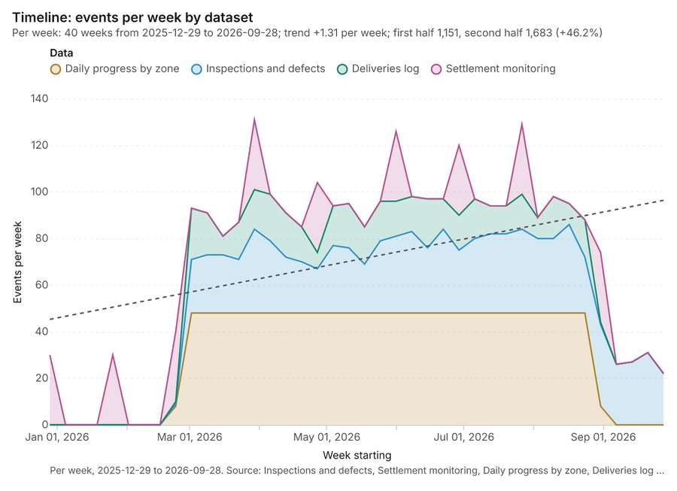
Figure 1. Timeline: events per week by dataset [1]. Per week, 2025-12-29 to 2026-09-28. Source: Inspections and defects, Settlement monitoring, Daily progress by zone, Deliveries log (2,834 features). The data is in the appendix.
The timeline counts 2,834 dated events in Inspections and defects, Settlement monitoring, Daily progress by zone and 1 more per week, from week of 2025-12-29 to week of 2026-09-28 [1][2][3][4][5]. By dataset: Daily progress by zone 1,264; Inspections and defects 900; Deliveries log 400; Settlement monitoring 270 [1]. The trend is +1.31 events per week; the second half of the weeks has 1,683 against 1,151 in the first (+46.2%) [1]. 6 of the 40 weeks had no events [1].
Busiest weeks
- week of 2026-03-30: 131 events [1]
- week of 2026-07-27: 129 events [1]
- week of 2026-06-01: 126 events [1]
Quietest weeks with events
- week of 2026-09-28: 22 events [1]
- week of 2026-09-07: 26 events [1]
- week of 2026-09-14: 27 events [1]

Space time hot spots
What this analysis is. Emerging hot spots: Where hot spots are new, consecutive, intensifying, persistent, diminishing, sporadic, oscillating or historical over time [6]. In ArcGIS it is Emerging Hot Spot Analysis or Create Space Time Cube [6].
Why it was run on this data. Inspections and defects carry dates in 'inspected_at': emerging hot spot analysis finds new, intensifying and fading hot spots per week [7].
What it found. The `gp_space_time_hot_spots` tool was run using the `Inspections and defects` input layer [9] [8
Result | Value
result, count | 28
result, elapsed ms | 16
result, resolution | 9
result, features used | 900
result, time neighbors | 0
billing, cost | 0.145
billing, list price | 0.145
billing, upstream cost | 0

Findings
- Evidenced: Space time hot spots on Inspections and defects: Emerging hot spots: 1 layer saved: Emerging hot spots: Inspections and defects (28 features) [8][9].
- Evidenced: It reported result, count 28; result, elapsed ms 16; result, resolution 9; result, features used 900; result, time neighbors 0; billing, cost 0.145 [8].
Tool gp_space_time_hot_spots; parameters {"project": "d4e5404f-06e4-4689-a539-31a71b8348eb", "features": {"layer": "Inspections and defects (2d513b03)"}, "interval": "week", "bin_shape": "h3", "resolution": 9, "time_field": "inspected_at"}

Space time hot spots
What this analysis is. Emerging hot spots: Where hot spots are new, consecutive, intensifying, persistent, diminishing, sporadic, oscillating or historical over time [6]. In ArcGIS it is Emerging Hot Spot Analysis or Create Space Time Cube [6].
Why it was run on this data. Settlement monitoring carry dates in 'month': emerging hot spot analysis finds new, intensifying and fading hot spots per week [10].
What it found. Space time hot spots on Settlement monitoring: Emerging hot spots: 1 layer saved: Emerging hot spots: Settlement monitoring (10 features) [11][12]. It reported result, count 10; result, elapsed ms 2; result, resolution 9; result, features used 270; result, time neighbors 0; billing, cost 0.1135 [11].
Result | Value
result, count | 10
result, elapsed ms | 2
result, resolution | 9
result, features used | 270
result, time neighbors | 0
billing, cost | 0.1135
billing, list price | 0.1135
billing, upstream cost | 0

Findings
- Evidenced: Space time hot spots on Settlement monitoring: Emerging hot spots: 1 layer saved: Emerging hot spots: Settlement monitoring (10 features) [11][12].
- Evidenced: It reported result, count 10; result, elapsed ms 2; result, resolution 9; result, features used 270; result, time neighbors 0; billing, cost 0.1135 [11].
A model draft was discarded because a sentence did not cite a source of this section.
Tool gp_space_time_hot_spots; parameters {"project": "d4e5404f-06e4-4689-a539-31a71b8348eb", "features": {"layer": "Settlement monitoring (425841af)"}, "interval": "week", "bin_shape": "h3", "resolution": 9, "time_field": "month"}

Near repeat
What this analysis is. Repeat and near repeat classification: Classify incidents as originators, repeats (same place) or near repeats within a distance and time window, with a Knox test table [13]. In ArcGIS it is Repeat and Near Repeat Classification or Near Repeat Calculator [13].
Why it was run on this data. Near repeat analysis tests whether Inspections and defects close in space also follow each other within 21 days [14].
What it found. Near repeat on Inspections and defects: Repeat and near repeat classification: 1 layer saved: Repeat and near repeat classification: Inspections and defects (900 features) [9][15]. It reported result, days 21; result, count 900; result, chains 65; result, distance m 50; result, elapsed ms 78; result, pairs linked 3,856 [15].
Result | Value
result, days | 21
result, count | 900
result, chains | 65
result, distance m | 50
result, elapsed ms | 78
result, pairs linked | 3,856
billing, cost | 0.077
billing, list price | 0.077
billing, upstream cost | 0

Findings
- Evidenced: Near repeat on Inspections and defects: Repeat and near repeat classification: 1 layer saved: Repeat and near repeat classification: Inspections and defects (900 features) [9][15].
- Evidenced: It reported result, days 21; result, count 900; result, chains 65; result, distance m 50; result, elapsed ms 78; result, pairs linked 3,856 [15].
Tool gp_near_repeat; parameters {"days": 21, "project": "d4e5404f-06e4-4689-a539-31a71b8348eb", "features": {"layer": "Inspections and defects (2d513b03)"}, "distance_m": 50.0, "time_field": "inspected_at"}

Hot spots
What this analysis is. Hot spot analysis: Getis-Ord Gi* hot and cold spots with z-scores, p-values and confidence bins [16]. In ArcGIS it is Find Hot Spots or Hot Spot Analysis (Getis-Ord Gi*); in QGIS, qgis:hotspot (plugin) [16].
Why it was run on this data. 900 points: Getis-Ord Gi* tests whether the concentrations in Inspections and defects are statistically significant [17].
What it found. The hot spot analysis was performed on the Inspections and defects layer [9], generating a result layer with 317 features [18]. This process used 900 incidents [18] and covered a distance band of 200 m [18]. The analysis report indicates a cell size of 100 m [18] and resulted in an elapsed time of 19 ms [18]. The total billing cost for this analysis was 0.068 [18].
Result | Value
result, bins | 317
result, count | 317
result, elapsed ms | 19
result, cell size m | 100
result, incidents used | 900
result, distance band m | 200
billing, cost | 0.068
billing, list price | 0.068
billing, upstream cost | 0

Findings
- Evidenced: Hot spots on Inspections and defects: Hot spot analysis: 1 layer saved: Hot spot analysis: Inspections and defects (317 features) [9][18].
- Evidenced: It reported result, bins 317; result, count 317; result, elapsed ms 19; result, cell size m 100; result, incidents used 900; result, distance band m 200 [18].
Tool gp_hot_spots; parameters {"project": "d4e5404f-06e4-4689-a539-31a71b8348eb", "features": {"layer": "Inspections and defects (2d513b03)"}, "aggregation": "hexagon", "cell_size_m": 100.0, "distance_band_m": 200.0}

Hot spots
What this analysis is. Hot spot analysis: Getis-Ord Gi* hot and cold spots with z-scores, p-values and confidence bins [16]. In ArcGIS it is Find Hot Spots or Hot Spot Analysis (Getis-Ord Gi*); in QGIS, qgis:hotspot (plugin) [16].
Why it was run on this data. 270 points: Getis-Ord Gi* tests whether the concentrations in Settlement monitoring are statistically significant [19].
What it found. Hot spots on Settlement monitoring: Hot spot analysis: 1 layer saved: Hot spot analysis: Settlement monitoring (87 features) [12][20]. It reported result, bins 87; result, count 87; result, elapsed ms 5; result, cell size m 50; result, incidents used 270; result, distance band m 100 [20].
Result | Value
result, bins | 87
result, count | 87
result, elapsed ms | 5
result, cell size m | 50
result, incidents used | 270
result, distance band m | 100
billing, cost | 0.0554
billing, list price | 0.0554
billing, upstream cost | 0

Findings
- Evidenced: Hot spots on Settlement monitoring: Hot spot analysis: 1 layer saved: Hot spot analysis: Settlement monitoring (87 features) [12][20].
- Evidenced: It reported result, bins 87; result, count 87; result, elapsed ms 5; result, cell size m 50; result, incidents used 270; result, distance band m 100 [20].
Tool gp_hot_spots; parameters {"project": "d4e5404f-06e4-4689-a539-31a71b8348eb", "features": {"layer": "Settlement monitoring (425841af)"}, "aggregation": "hexagon", "cell_size_m": 50.0, "distance_band_m": 100.0}

Hot spots
What this analysis is. Hot spot analysis: Getis-Ord Gi* hot and cold spots with z-scores, p-values and confidence bins [16]. In ArcGIS it is Find Hot Spots or Hot Spot Analysis (Getis-Ord Gi*); in QGIS, qgis:hotspot (plugin) [16].
Why it was run on this data. Gi* hot spots of 'pct_complete' across the areas [21].
What it found. The hot spot analysis was performed using the Work zones layer [23] and generated a saved layer titled Hot spot analysis: Work zones [22].
Result | Value
result, count | 8
result, elapsed ms | 1
result, excluded null | 0
result, distance band m | 872.7
billing, cost | 0.05016
billing, list price | 0.05016
billing, upstream cost | 0

Findings
- Evidenced: Hot spots on Work zones: Hot spot analysis: 1 layer saved: Hot spot analysis: Work zones (8 features) [22][23].
- Evidenced: It reported result, count 8; result, elapsed ms 1; result, excluded null 0; result, distance band m 872.7; billing, cost 0.05016; billing, list price 0.05016 [22].
Tool gp_hot_spots; parameters {"field": "pct_complete", "project": "d4e5404f-06e4-4689-a539-31a71b8348eb", "features": {"layer": "Work zones (a87c9da1)"}}

Index change
What this analysis is. Spectral index change: Change of a spectral index (NDVI, NDWI, NDBI, NBR …) or a band expression between two images: before, after and difference rasters, decrease / increase classes beyond the threshold with polygons and areas; NBR also gives dNBR with burn severity classes [24].
Why it was run on this data. Index change between Site progress scene 2026-03-01 (2026-03-01) and Site progress scene 2026-09-01 (2026-09-01): the changed area, with the changed places as polygons [25].
What it found. Index change: Spectral index change: created NDVI change Site progress scene 2026-03-01 to Site progress scene 2026-09-01 (300 x 250 cells, 10.00 m) [26]. plus 1 more raster layer(s) [26]. and layer NDVI change polygons with 1078 feature(s) [26]. mean before 0.08239; mean after 0.08535; mean difference 0.002955; decrease ha 9.00; increase ha 15.70 [26]. It reported stats, polygons 1,078; stats, mean after 0.08535; stats, decrease ha 9; stats, increase ha 15.7; stats, mean before 0.08239; stats, masked pixels 0 [26].
Result | Value
stats, polygons | 1,078
stats, mean after | 0.08535
stats, decrease ha | 9
stats, increase ha | 15.7
stats, mean before | 0.08239
stats, masked pixels | 0
stats, mean difference | 0.002955
elapsed ms | 692

Findings
- Evidenced: Index change: Spectral index change: created NDVI change Site progress scene 2026-03-01 to Site progress scene 2026-09-01 (300 x 250 cells, 10.00 m) [26].
- Evidenced: plus 1 more raster layer(s) [26].
- Evidenced: and layer NDVI change polygons with 1078 feature(s) [26].
- Evidenced: mean before 0.08239; mean after 0.08535; mean difference 0.002955; decrease ha 9.00; increase ha 15.70 [26].
- Evidenced: It reported stats, polygons 1,078; stats, mean after 0.08535; stats, decrease ha 9; stats, increase ha 15.7; stats, mean before 0.08239; stats, masked pixels 0 [26].
Tool im_index_change; parameters {"after_id": "Site progress scene 2026-09-01 (0e506696)", "polygons": true, "before_id": "Site progress scene 2026-03-01 (44bcba49)"}

Compute change raster
What this analysis is. Compute change raster: Pixel value or spectral change between two co-registered images: difference, relative difference, absolute difference, log ratio (radar, dB), Euclidean spectral distance, spectral angle (radians) or the band with most change [27].
Why it was run on this data. A change raster between Site progress scene 2026-03-01 (2026-03-01) and Site progress scene 2026-09-01 (2026-09-01): where and how much the pixels changed [28].
What it found. Compute change raster: Compute change raster: created Difference Site progress scene 2026-03-01 to Site progress scene 2026-09-01 (300 x 250 cells, 10.00 m) [29]. mean -0.001083; std 0.01804; min -0.134; max 0.091; masked pixels 0 [29]. It reported stats, max 0.091; stats, min -0.134; stats, std 0.01804; stats, mean -0.001083; stats, masked pixels 0; elapsed ms 115 [29].
Result | Value
stats, max | 0.091
stats, min | -0.134
stats, std | 0.01804
stats, mean | -0.001083
stats, masked pixels | 0
elapsed ms | 115

Findings
- Evidenced: Compute change raster: Compute change raster: created Difference Site progress scene 2026-03-01 to Site progress scene 2026-09-01 (300 x 250 cells, 10.00 m) [29].
- Evidenced: mean -0.001083; std 0.01804; min -0.134; max 0.091; masked pixels 0 [29].
- Evidenced: It reported stats, max 0.091; stats, min -0.134; stats, std 0.01804; stats, mean -0.001083; stats, masked pixels 0; elapsed ms 115 [29].
Tool im_compute_change_raster; parameters {"after_id": "Site progress scene 2026-09-01 (0e506696)", "before_id": "Site progress scene 2026-03-01 (44bcba49)"}

Calculate density
What this analysis is. Calculate density: Kernel density per square kilometer on a grid [30]. In ArcGIS it is Calculate Density or Kernel Density; in QGIS, native:heatmapkerneldensityestimation [30].
Why it was run on this data. 900 points in Inspections and defects: a density surface shows where they concentrate [31].
What it found. The calculation of density using Inspections and defects [9] generated a result containing 976 features [32]. The maximum density calculated was 7,380 per km2 [32]. This process was completed with an elapsed time of 36 ms [32] and incurred a cost of 0.068 [32].
Result | Value
result, count | 976
result, elapsed ms | 36
result, bandwidth m | 200
result, cell size m | 50
result, excluded null | 0
result, max density per km2 | 7,380
billing, cost | 0.068
billing, list price | 0.068
billing, upstream cost | 0

Findings
- Evidenced: Calculate density on Inspections and defects: Calculate density: 1 layer saved: Calculate density: Inspections and defects (976 features) [9][32].
- Evidenced: It reported result, count 976; result, elapsed ms 36; result, bandwidth m 200; result, cell size m 50; result, excluded null 0; result, max density per km2 7,380 [32].
Tool gp_calculate_density; parameters {"kernel": "quartic", "project": "d4e5404f-06e4-4689-a539-31a71b8348eb", "features": {"layer": "Inspections and defects (2d513b03)"}, "bandwidth_m": 200.0, "cell_size_m": 50.0}

Calculate density
What this analysis is. Calculate density: Kernel density per square kilometer on a grid [30]. In ArcGIS it is Calculate Density or Kernel Density; in QGIS, native:heatmapkerneldensityestimation [30].
Why it was run on this data. 270 points in Settlement monitoring: a density surface shows where they concentrate [33].
What it found. Calculate density on Settlement monitoring: Calculate density: 1 layer saved: Calculate density: Settlement monitoring (806 features) [12][34]. It reported result, count 806; result, elapsed ms 22; result, bandwidth m 100; result, cell size m 20; result, excluded null 0; result, max density per km2 3,721 [34].
Result | Value
result, count | 806
result, elapsed ms | 22
result, bandwidth m | 100
result, cell size m | 20
result, excluded null | 0
result, max density per km2 | 3,721
billing, cost | 0.0554
billing, list price | 0.0554
billing, upstream cost | 0

Findings
- Evidenced: Calculate density on Settlement monitoring: Calculate density: 1 layer saved: Calculate density: Settlement monitoring (806 features) [12][34].
- Evidenced: It reported result, count 806; result, elapsed ms 22; result, bandwidth m 100; result, cell size m 20; result, excluded null 0; result, max density per km2 3,721 [34].
Tool gp_calculate_density; parameters {"kernel": "quartic", "project": "d4e5404f-06e4-4689-a539-31a71b8348eb", "features": {"layer": "Settlement monitoring (425841af)"}, "bandwidth_m": 100.0, "cell_size_m": 20.0}

Summarize within
What this analysis is. Summarize within: Count and aggregate the features inside each polygon (or bin), proportionally for lines and polygons [35]. In ArcGIS it is Summarize Within or Aggregate Points; in QGIS, native:countpointsinpolygon or native:sumlinelengths [35].
Why it was run on this data. Count Inspections and defects inside each feature of Work zones by type; the counts map as a choropleth (natural breaks, sequential colors) [36].
What it found. Summarize within on Inspections and defects, Work zones: Summarize within: 1 layer saved: Summarize within: Work zones (8 features) [9][23][37]. It reported result, count 8; result, elapsed ms 1; billing, cost 0.02816; billing, list price 0.02816; billing, upstream cost 0 [37].
Result | Value
result, count | 8
result, elapsed ms | 1
billing, cost | 0.02816
billing, list price | 0.02816
billing, upstream cost | 0

Findings
- Evidenced: Summarize within on Inspections and defects, Work zones: Summarize within: 1 layer saved: Summarize within: Work zones (8 features) [9][23][37].
- Evidenced: It reported result, count 8; result, elapsed ms 1; billing, cost 0.02816; billing, list price 0.02816; billing, upstream cost 0 [37].
Tool gp_summarize_within; parameters {"stats": [], "project": "d4e5404f-06e4-4689-a539-31a71b8348eb", "features": {"layer": "Inspections and defects (2d513b03)"}, "group_by": "type", "polygons": {"layer": "Work zones (a87c9da1)"}}

Summarize within
What this analysis is. Summarize within: Count and aggregate the features inside each polygon (or bin), proportionally for lines and polygons [35]. In ArcGIS it is Summarize Within or Aggregate Points; in QGIS, native:countpointsinpolygon or native:sumlinelengths [35].
Why it was run on this data. Count Inspections and defects inside each feature of Work zones by type; the counts map as a choropleth (natural breaks, sequential colors) [36].
What it found. Summarize within on Settlement monitoring, Work zones: Summarize within: 1 layer saved: Summarize within: Work zones (8 features) [12][23][38]. It reported result, count 8; result, elapsed ms 0; billing, cost 0.01558; billing, list price 0.01558; billing, upstream cost 0 [38].
Result | Value
result, count | 8
result, elapsed ms | 0
billing, cost | 0.01558
billing, list price | 0.01558
billing, upstream cost | 0

Findings
- Evidenced: Summarize within on Settlement monitoring, Work zones: Summarize within: 1 layer saved: Summarize within: Work zones (8 features) [12][23][38].
- Evidenced: It reported result, count 8; result, elapsed ms 0; billing, cost 0.01558; billing, list price 0.01558; billing, upstream cost 0 [38].
Tool gp_summarize_within; parameters {"stats": [{"stat": "sum", "field": "settlement_mm"}], "project": "d4e5404f-06e4-4689-a539-31a71b8348eb", "features": {"layer": "Settlement monitoring (425841af)"}, "polygons": {"layer": "Work zones (a87c9da1)"}}

Summarize within
What this analysis is. Summarize within: Count and aggregate the features inside each polygon (or bin), proportionally for lines and polygons [35]. In ArcGIS it is Summarize Within or Aggregate Points; in QGIS, native:countpointsinpolygon or native:sumlinelengths [35].
Why it was run on this data. Count Inspections and defects inside each feature of Work zones by type; the counts map as a choropleth (natural breaks, sequential colors) [36].
What it found. Summarize within on Tower cranes, Work zones: Summarize within: 1 layer saved: Summarize within: Work zones (8 features) [23][39][40]. It reported result, count 8; result, elapsed ms 0; billing, cost 0.01026; billing, list price 0.01026; billing, upstream cost 0 [39].
Result | Value
result, count | 8
result, elapsed ms | 0
billing, cost | 0.01026
billing, list price | 0.01026
billing, upstream cost | 0

Findings
- Evidenced: Summarize within on Tower cranes, Work zones: Summarize within: 1 layer saved: Summarize within: Work zones (8 features) [23][39][40].
- Evidenced: It reported result, count 8; result, elapsed ms 0; billing, cost 0.01026; billing, list price 0.01026; billing, upstream cost 0 [39].
Tool gp_summarize_within; parameters {"stats": [{"stat": "sum", "field": "radius_m"}], "project": "d4e5404f-06e4-4689-a539-31a71b8348eb", "features": {"layer": "Tower cranes (a6101de1)"}, "polygons": {"layer": "Work zones (a87c9da1)"}}

Zonal statistics
What this analysis is. Zonal statistics: count/min/max/mean/std/sum/median/majority per polygon as a table and as GeoJSON [41]. In ArcGIS it is Zonal Statistics as Table (polygons) [41].
Why it was run on this data. Statistics of Site terrain model (DEM) inside each feature of Work zones [42].
What it found. The analysis utilized the Zonal statistics tool rs_zonal_statistics [43]. This tool processed 8 row(s) of zonal statistics [43]. The resulting analysis covered a total of 8 zones [43].
Findings
- Evidenced: Zonal statistics: Zonal statistics: 8 row(s) [43].
- Evidenced: zones 8 [43].
Tool rs_zonal_statistics; parameters {"stats": ["mean", "min", "max", "std"], "zones": "Work zones (a87c9da1)", "raster_id": "Site terrain model (DEM) (0c6d4acd)"}

Zonal statistics
What this analysis is. Zonal statistics: count/min/max/mean/std/sum/median/majority per polygon as a table and as GeoJSON [41]. In ArcGIS it is Zonal Statistics as Table (polygons) [41].
Why it was run on this data. Statistics of Site terrain model (DEM) inside each feature of Work zones [42].
What it found. The zonal statistics generated an output containing 1 row(s) spanning 1 zone [44]. The analysis confirmed that the count of zones was 1 and the count of features was 1 [44]. The process completed its execution in 31 elapsed ms [44].
Result | Value
stats, zones | 1
features, count | 1
elapsed ms | 31

Findings
- Evidenced: Zonal statistics: Zonal statistics: 1 row(s) [44].
- Evidenced: zones 1 [44].
- Evidenced: It reported stats, zones 1; features, count 1; elapsed ms 31 [44].
Tool rs_zonal_statistics; parameters {"stats": ["mean", "min", "max", "std"], "zones": "Site boundary (3902997c)", "raster_id": "Site terrain model (DEM) (0c6d4acd)"}

Slope
What this analysis is. Slope: Horn slope in degrees or percent, with the share of ground in six grade classes [45]. In ArcGIS it is Slope (Spatial Analyst); in QGIS, Slope (GDAL DEM) [45].
Why it was run on this data. Slope of the Site terrain model (DEM) surface [46].
What it found. The slope analysis over 7.50 km2 revealed a mean of 0.36 degrees and a maximum slope of 18.73 degrees; specifically, 1.19 of the ground was steeper than 15% [47]. This analysis utilized the Site terrain model (DEM) as its core input [48]. The resulting slope grid was defined by 500 rows and 600 columns [47].
Result | Value
dem, cols | 600
dem, rows | 500
dem, cell m | 5
dem, relief m | 20.94
dem, elev max m | 10.14
dem, elev min m | -10.8
dem, elev mean m | 3.4
dem, missing frac | 0
cost, usd | 0
grid, cols | 600
grid, rows | 500
grid, cell m | 5
stats, max | 18.73
stats, min | 0
stats, mean | 0.36
stats, median | 0.16
stats, steeper than 15pct | 1.19
rows left out | 0

Findings
- Evidenced: Slope on Site terrain model (DEM): Slope over 7.50 km2: mean 0.36 degrees, max 18.73 degrees; 1% of the ground is steeper than 15% [47][48].
- Evidenced: DEM: Site terrain model (DEM) [47][48].
- Evidenced: Verified: 2 checks passed [47][48].
- Evidenced: It reported dem, cols 600; dem, rows 500; dem, cell m 5; dem, relief m 20.94; dem, elev max m 10.14; dem, elev min m -10.8 [47].
Tool tr_slope; parameters {"dem": {"layer": "Site terrain model (DEM) (0c6d4acd)"}, "project": "d4e5404f-06e4-4689-a539-31a71b8348eb"}

Find point clusters
What this analysis is. Find point clusters: Density-based clusters (DBSCAN, HDBSCAN or OPTICS, optionally space-time) with hulls and noise [49]. In ArcGIS it is Find Point Clusters or Density-based Clustering; in QGIS, native:dbscanclustering or native:stdbscanclustering [49].
Why it was run on this data. DBSCAN finds dense groups of Inspections and defects and separates noise [50].
What it found. Find point clusters on Inspections and defects: Find point clusters: 2 layers saved: Find point clusters: Inspections and defects (900 features); Find point clusters: cluster hulls (7 features) [9][51]. It reported result, count 900; result, noise 43; result, distance m 100; result, elapsed ms 18; result, min points 20; billing, cost 0.068 [51].
Result | Value
result, count | 900
result, noise | 43
result, distance m | 100
result, elapsed ms | 18
result, min points | 20
billing, cost | 0.068
billing, list price | 0.068
billing, upstream cost | 0

Findings
- Evidenced: Find point clusters on Inspections and defects: Find point clusters: 2 layers saved: Find point clusters: Inspections and defects (900 features); Find point clusters: cluster hulls (7 features) [9][51].
- Evidenced: It reported result, count 900; result, noise 43; result, distance m 100; result, elapsed ms 18; result, min points 20; billing, cost 0.068 [51].
Tool gp_find_point_clusters; parameters {"method": "dbscan", "project": "d4e5404f-06e4-4689-a539-31a71b8348eb", "features": {"layer": "Inspections and defects (2d513b03)"}, "distance_m": 100.0, "min_points": 20}

Find point clusters
What this analysis is. Find point clusters: Density-based clusters (DBSCAN, HDBSCAN or OPTICS, optionally space-time) with hulls and noise [49]. In ArcGIS it is Find Point Clusters or Density-based Clustering; in QGIS, native:dbscanclustering or native:stdbscanclustering [49].
Why it was run on this data. DBSCAN finds dense groups of Settlement monitoring and separates noise [52].
What it found. Find point clusters on Settlement monitoring: Find point clusters: 2 layers saved: Find point clusters: Settlement monitoring (270 features); Find point clusters: cluster hulls (19 features) [12][53]. It reported result, count 270; result, noise 0; result, distance m 50; result, elapsed ms 8; result, min points 7; billing, cost 0.0554 [53].
Result | Value
result, count | 270
result, noise | 0
result, distance m | 50
result, elapsed ms | 8
result, min points | 7
billing, cost | 0.0554
billing, list price | 0.0554
billing, upstream cost | 0

Findings
- Evidenced: Find point clusters on Settlement monitoring: Find point clusters: 2 layers saved: Find point clusters: Settlement monitoring (270 features); Find point clusters: cluster hulls (19 features) [12][53].
- Evidenced: It reported result, count 270; result, noise 0; result, distance m 50; result, elapsed ms 8; result, min points 7; billing, cost 0.0554 [53].
Tool gp_find_point_clusters; parameters {"method": "dbscan", "project": "d4e5404f-06e4-4689-a539-31a71b8348eb", "features": {"layer": "Settlement monitoring (425841af)"}, "distance_m": 50.0, "min_points": 7}

Nearest neighbor index
What this analysis is. Average nearest neighbor: Clark-Evans ratio: clustered, dispersed or random [54]. In ArcGIS it is Average Nearest Neighbor; in QGIS, native:nearestneighbouranalysis [54].
Why it was run on this data. The average nearest neighbor ratio says whether Inspections and defects are clustered, random or dispersed [55].
What it found. Nearest neighbor index on Inspections and defects: Average nearest neighbor: done; no map output [9][56]. It reported result, n 900; result, p value 0; result, z score -36.26; result, elapsed ms 4; result, study area m2 2,804,596; result, nearest neighbor ratio 0.3682 [56].
Result | Value
result, n | 900
result, p value | 0
result, z score | -36.26
result, elapsed ms | 4
result, study area m2 | 2,804,596
result, nearest neighbor ratio | 0.3682
result, expected mean distance m | 27.91
result, observed mean distance m | 10.28
billing, cost | 0.02
billing, list price | 0.02
billing, upstream cost | 0

Findings
- Evidenced: Nearest neighbor index on Inspections and defects: Average nearest neighbor: done; no map output [9][56].
- Evidenced: It reported result, n 900; result, p value 0; result, z score -36.26; result, elapsed ms 4; result, study area m2 2,804,596; result, nearest neighbor ratio 0.3682 [56].
Tool gp_nearest_neighbor_index; parameters {"project": "d4e5404f-06e4-4689-a539-31a71b8348eb", "features": {"layer": "Inspections and defects (2d513b03)"}}

Zonal statistics
What this analysis is. Zonal statistics: count/min/max/mean/std/sum/median/majority per polygon as a table and as GeoJSON [41]. In ArcGIS it is Zonal Statistics as Table (polygons) [41].
Why it was run on this data. Statistics of Site progress scene 2026-09-01 inside each feature of Work zones [57].
What it found. The analysis utilized the Zonal statistics tool, specifically rs_zonal_statistics [58]. The summary generated by the tool states the completion of zonal statistics [58]. These results indicate there are 8 row(s) recorded [58]. Moreover, the analysis covered a total of 8 zones [58].
Findings
- Evidenced: Zonal statistics: Zonal statistics: 8 row(s) [58].
- Evidenced: zones 8 [58].
Tool rs_zonal_statistics; parameters {"stats": ["mean", "min", "max", "std"], "zones": "Work zones (a87c9da1)", "raster_id": "Site progress scene 2026-09-01 (0e506696)"}

Zonal statistics
What this analysis is. Zonal statistics: count/min/max/mean/std/sum/median/majority per polygon as a table and as GeoJSON [41]. In ArcGIS it is Zonal Statistics as Table (polygons) [41].
Why it was run on this data. Statistics of Site progress scene 2026-09-01 inside each feature of Work zones [57].
What it found. The analysis section utilized the `rs_zonal_statistics` tool for the first step [59]. The zonal statistics report indicates 1 row(s) analyzed across 1 zone [59].
Result | Value
stats, zones | 1
features, count | 1
elapsed ms | 35

Findings
- Evidenced: Zonal statistics: Zonal statistics: 1 row(s) [59].
- Evidenced: zones 1 [59].
- Evidenced: It reported stats, zones 1; features, count 1; elapsed ms 35 [59].
Tool rs_zonal_statistics; parameters {"stats": ["mean", "min", "max", "std"], "zones": "Site boundary (3902997c)", "raster_id": "Site progress scene 2026-09-01 (0e506696)"}

Zonal statistics
What this analysis is. Zonal statistics: count/min/max/mean/std/sum/median/majority per polygon as a table and as GeoJSON [41]. In ArcGIS it is Zonal Statistics as Table (polygons) [41].
Why it was run on this data. Statistics of Site progress scene 2026-09-01 inside each feature of Work zones [57].
What it found. Zonal statistics: Zonal statistics: 8 row(s) [60]. zones 8 [60].
Findings
- Evidenced: Zonal statistics: Zonal statistics: 8 row(s) [60].
- Evidenced: zones 8 [60].
Tool rs_zonal_statistics; parameters {"stats": ["mean", "min", "max", "std"], "zones": "Work zones (a87c9da1)", "raster_id": "Site progress scene 2026-03-01 (44bcba49)"}

Index change
What this analysis is. Spectral index change: Change of a spectral index (NDVI, NDWI, NDBI, NBR …) or a band expression between two images: before, after and difference rasters, decrease / increase classes beyond the threshold with polygons and areas; NBR also gives dNBR with burn severity classes [24].
Why it was run on this data. Index change between Site progress scene 2026-03-01 (2026-03-01) and Site progress scene 2026-09-01 (2026-09-01): the changed area, with the changed places as polygons [25].
What it found. Index change: Spectral index change: created NDVI change Site progress scene 2026-03-01 to Site progress scene 2026-09-01 (300 x 250 cells, 10.00 m) [61]. plus 1 more raster layer(s) [61]. and layer NDVI change polygons with 1078 feature(s) [61]. mean before 0.08239; mean after 0.08535; mean difference 0.002955; decrease ha 9.00; increase ha 15.70 [61]. It reported stats, polygons 1,078; stats, mean after 0.08535; stats, decrease ha 9; stats, increase ha 15.7; stats, mean before 0.08239; stats, masked pixels 0 [61].
Result | Value
stats, polygons | 1,078
stats, mean after | 0.08535
stats, decrease ha | 9
stats, increase ha | 15.7
stats, mean before | 0.08239
stats, masked pixels | 0
stats, mean difference | 0.002955
elapsed ms | 537

Findings
- Evidenced: Index change: Spectral index change: created NDVI change Site progress scene 2026-03-01 to Site progress scene 2026-09-01 (300 x 250 cells, 10.00 m) [61].
- Evidenced: plus 1 more raster layer(s) [61].
- Evidenced: and layer NDVI change polygons with 1078 feature(s) [61].
- Evidenced: mean before 0.08239; mean after 0.08535; mean difference 0.002955; decrease ha 9.00; increase ha 15.70 [61].
- Evidenced: It reported stats, polygons 1,078; stats, mean after 0.08535; stats, decrease ha 9; stats, increase ha 15.7; stats, mean before 0.08239; stats, masked pixels 0 [61].
Tool im_index_change; parameters {"after_id": "Site progress scene 2026-09-01 (0e506696)", "polygons": true, "before_id": "Site progress scene 2026-03-01 (44bcba49)"}

Compute change raster
What this analysis is. Compute change raster: Pixel value or spectral change between two co-registered images: difference, relative difference, absolute difference, log ratio (radar, dB), Euclidean spectral distance, spectral angle (radians) or the band with most change [27].
Why it was run on this data. A change raster between Site progress scene 2026-03-01 (2026-03-01) and Site progress scene 2026-09-01 (2026-09-01): where and how much the pixels changed [28].
What it found. Compute change raster: Compute change raster: created Difference Site progress scene 2026-03-01 to Site progress scene 2026-09-01 (300 x 250 cells, 10.00 m) [62]. mean -0.001083; std 0.01804; min -0.134; max 0.091; masked pixels 0 [62]. It reported stats, max 0.091; stats, min -0.134; stats, std 0.01804; stats, mean -0.001083; stats, masked pixels 0; elapsed ms 151 [62].
Result | Value
stats, max | 0.091
stats, min | -0.134
stats, std | 0.01804
stats, mean | -0.001083
stats, masked pixels | 0
elapsed ms | 151

Findings
- Evidenced: Compute change raster: Compute change raster: created Difference Site progress scene 2026-03-01 to Site progress scene 2026-09-01 (300 x 250 cells, 10.00 m) [62].
- Evidenced: mean -0.001083; std 0.01804; min -0.134; max 0.091; masked pixels 0 [62].
- Evidenced: It reported stats, max 0.091; stats, min -0.134; stats, std 0.01804; stats, mean -0.001083; stats, masked pixels 0; elapsed ms 151 [62].
Tool im_compute_change_raster; parameters {"method": "difference", "after_id": "Site progress scene 2026-09-01 (0e506696)", "before_id": "Site progress scene 2026-03-01 (44bcba49)"}

Maps and charts
The run also made 24 map image(s) [63][64][65][66][67][68][69][70][71][72][73][74][75][76][77][78][79][80][81][82][83][84][85][86] and 23 chart(s) [87][88][89][90][91][92][93][94][95][96][97][98][99][100][101][102][103][104][105][106][107][108][109].
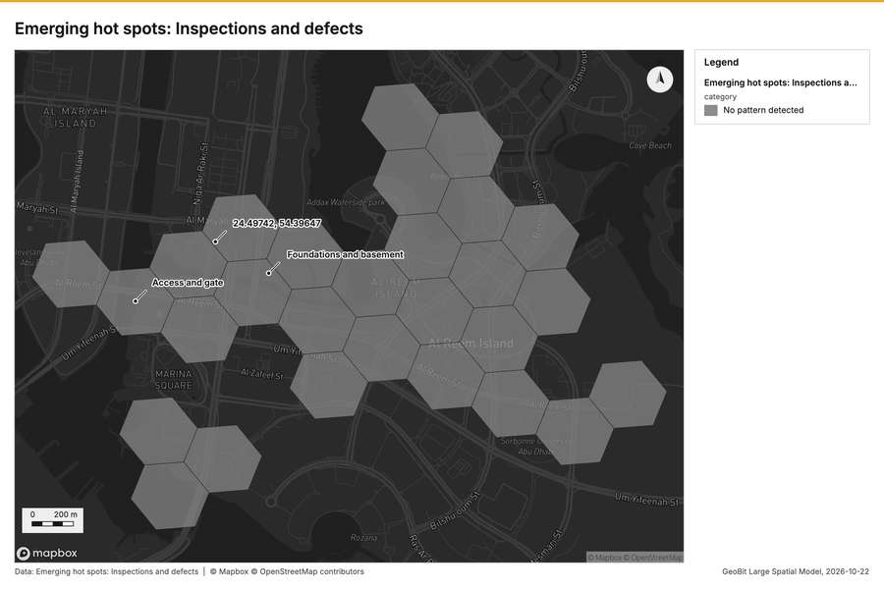
Figure 2. Emerging hot spots: Inspections and defects [63]
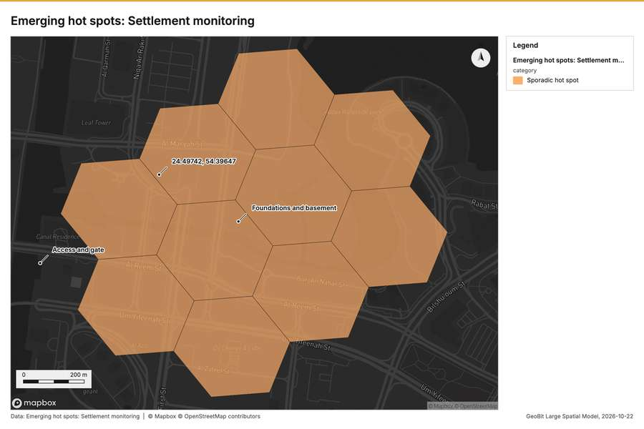
Figure 3. Emerging hot spots: Settlement monitoring [64]
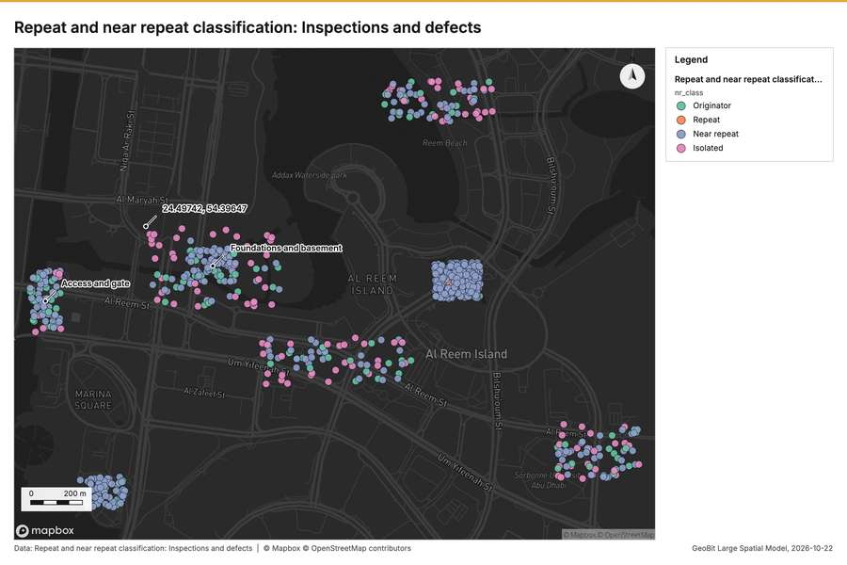
Figure 4. Repeat and near repeat classification: Inspections and defects [65]
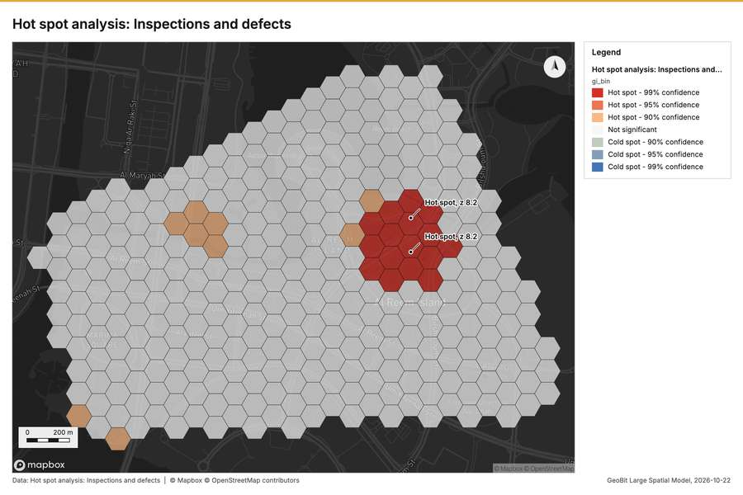
Figure 5. Hot spot analysis: Inspections and defects [66]
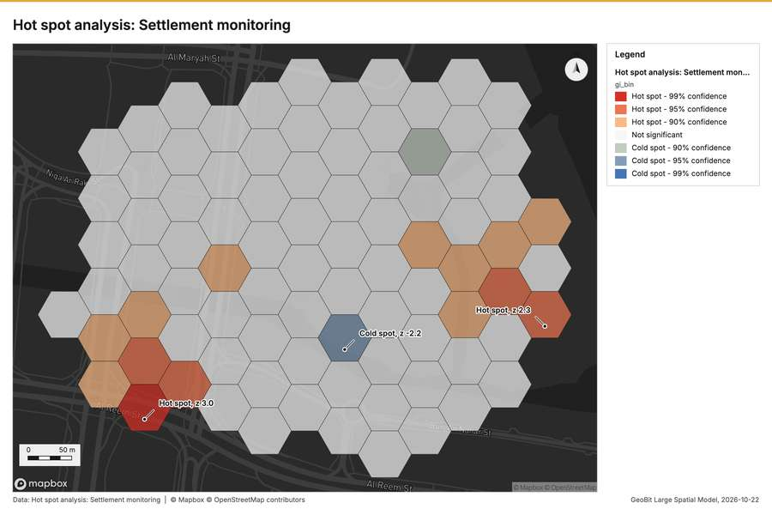
Figure 6. Hot spot analysis: Settlement monitoring [67]
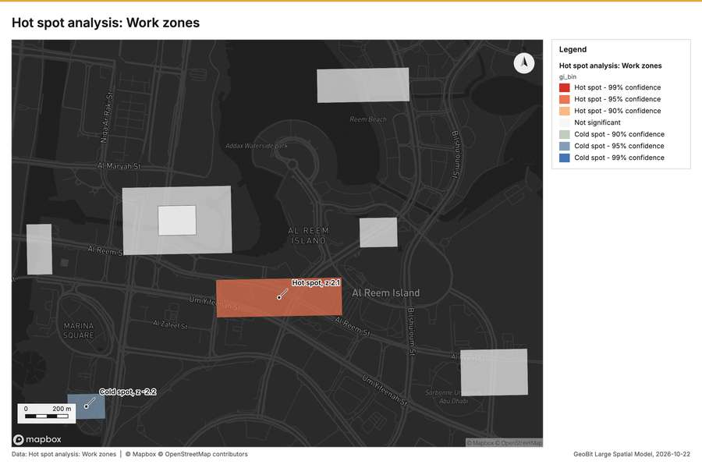
Figure 7. Hot spot analysis: Work zones [68]
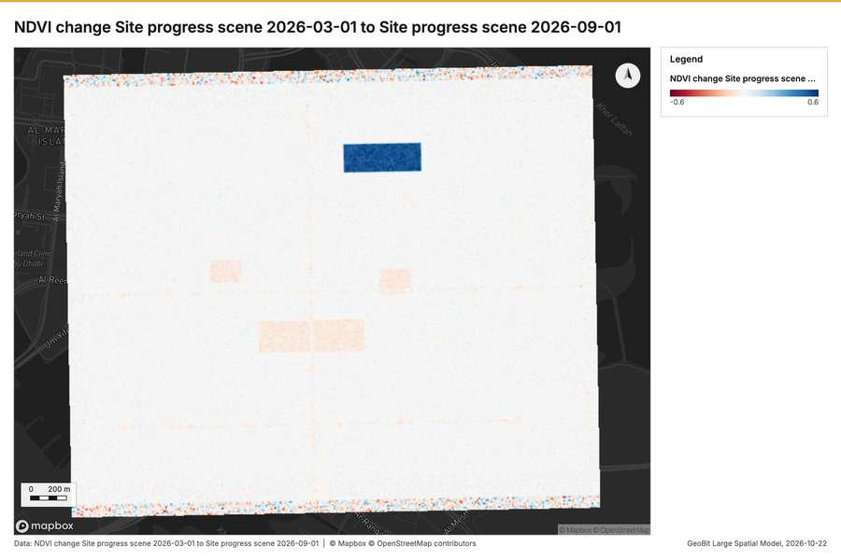
Figure 8. NDVI change Site progress scene 2026-03-01 to Site progress scene 2026-09-01 [69]
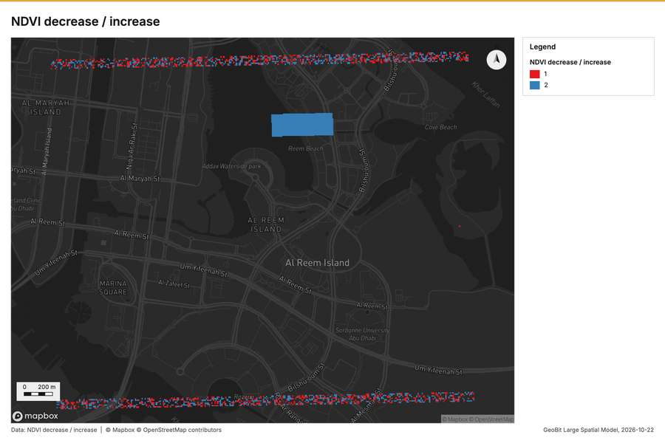
Figure 9. NDVI decrease / increase [70]
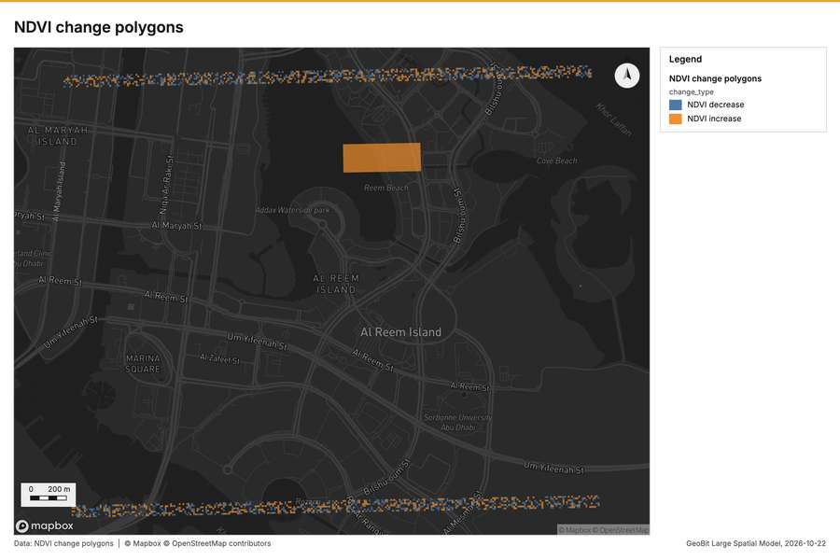
Figure 10. NDVI change polygons [71]
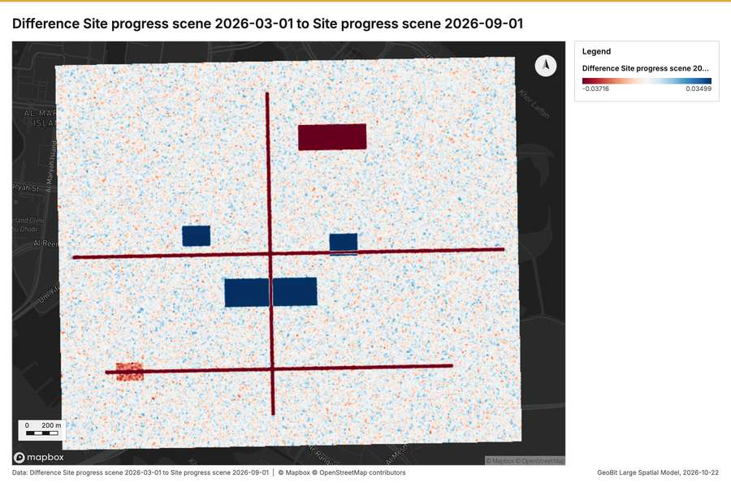
Figure 11. Difference Site progress scene 2026-03-01 to Site progress scene 2026-09-01 [72]
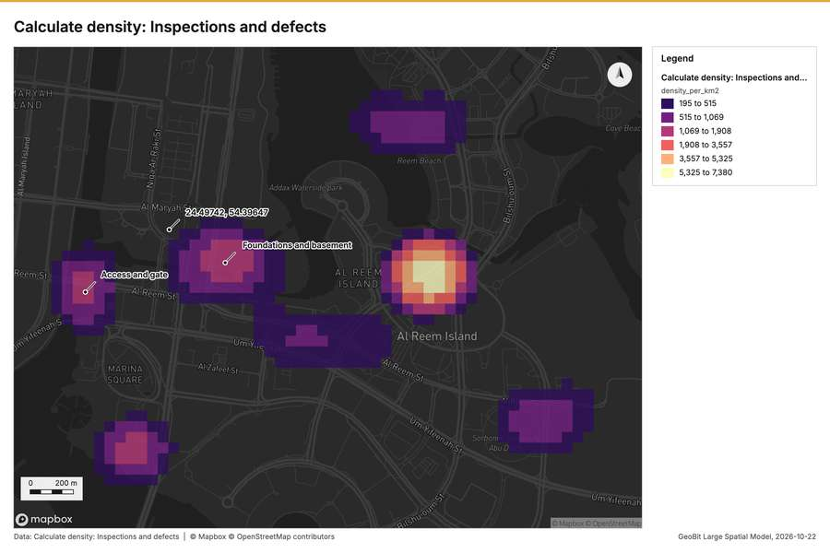
Figure 12. Calculate density: Inspections and defects [73]
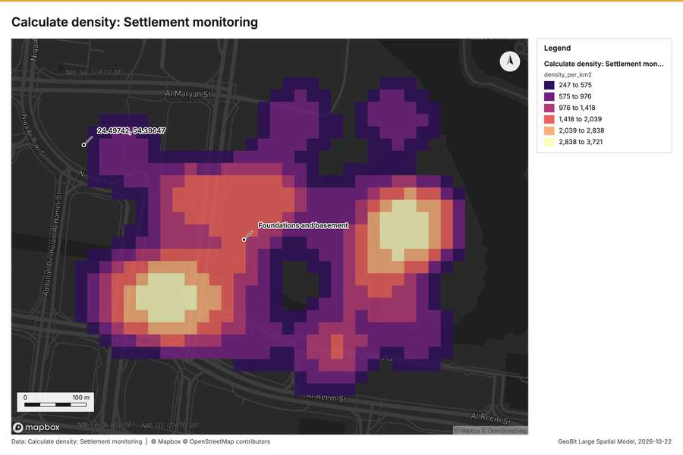
Figure 13. Calculate density: Settlement monitoring [74]
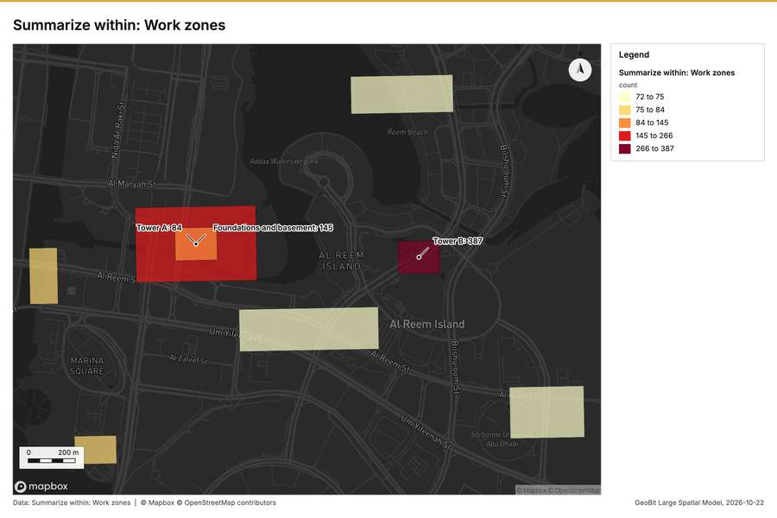
Figure 14. Summarize within: Work zones [75]
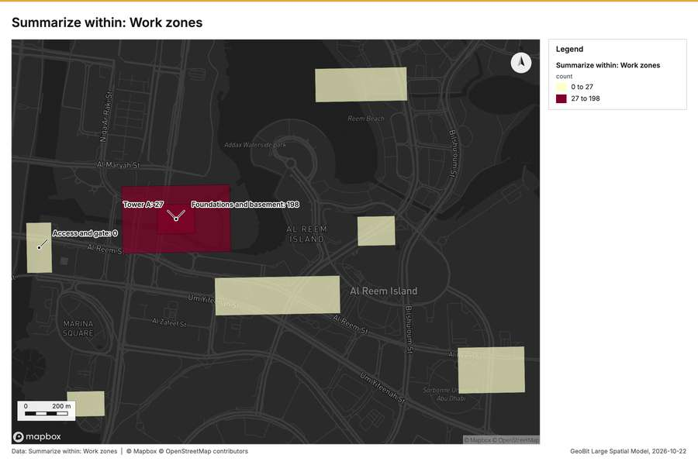
Figure 15. Summarize within: Work zones [76]
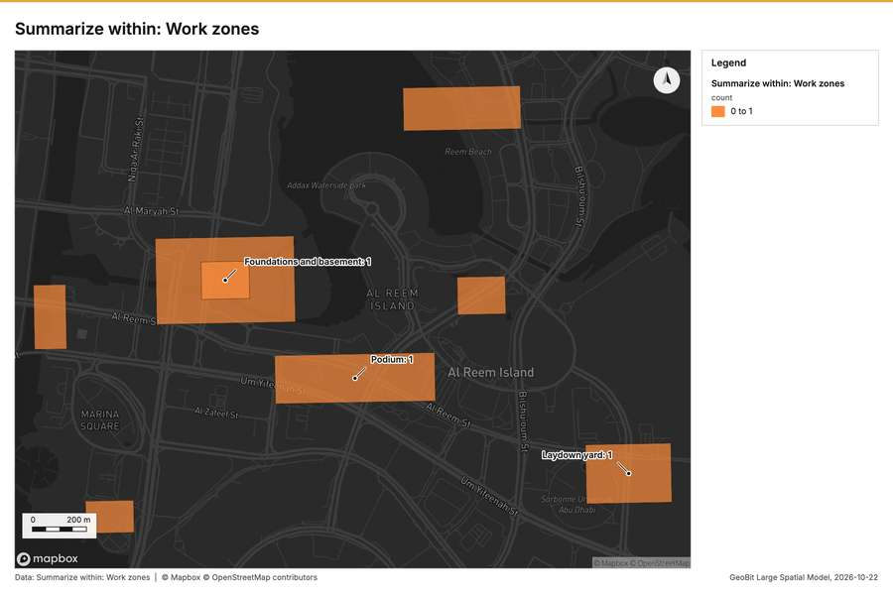
Figure 16. Summarize within: Work zones [77]
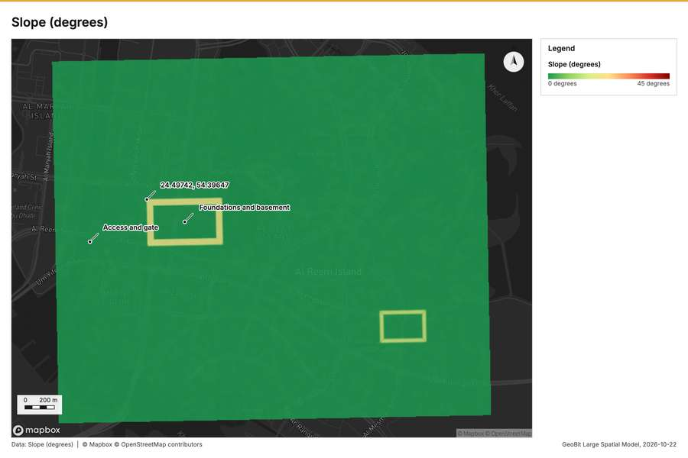
Figure 17. Slope (degrees) [78]
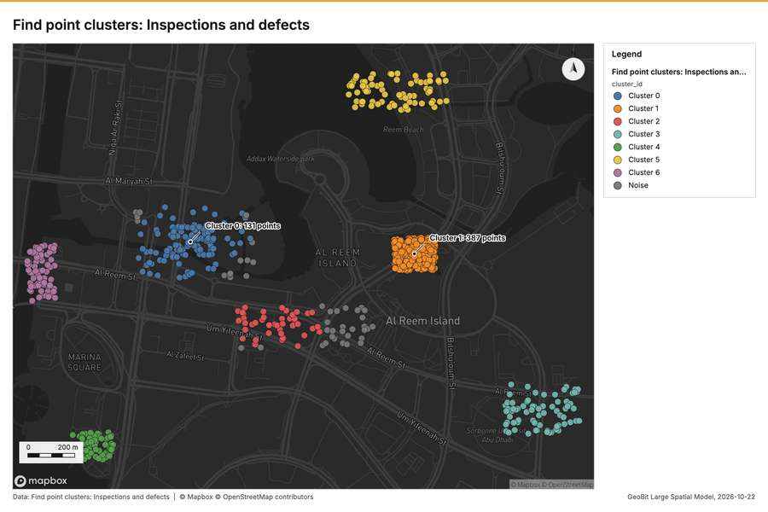
Figure 18. Find point clusters: Inspections and defects [79]
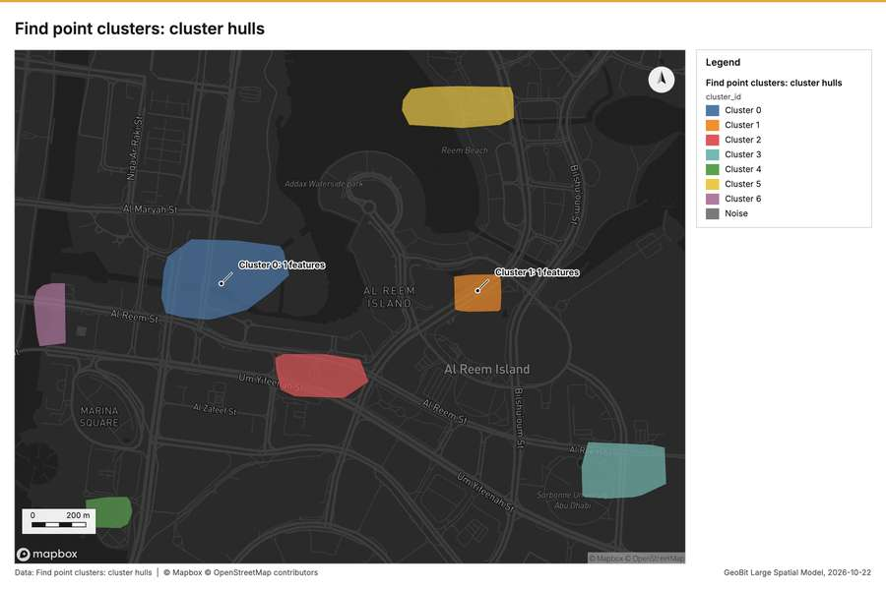
Figure 19. Find point clusters: cluster hulls [80]
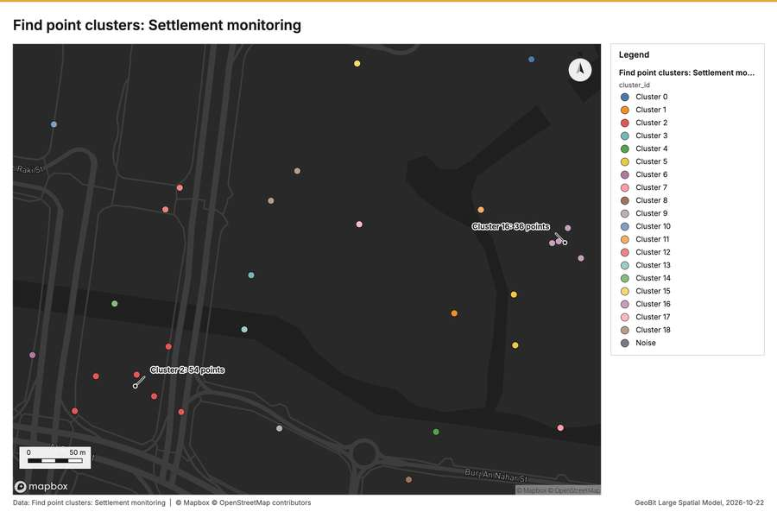
Figure 20. Find point clusters: Settlement monitoring [81]
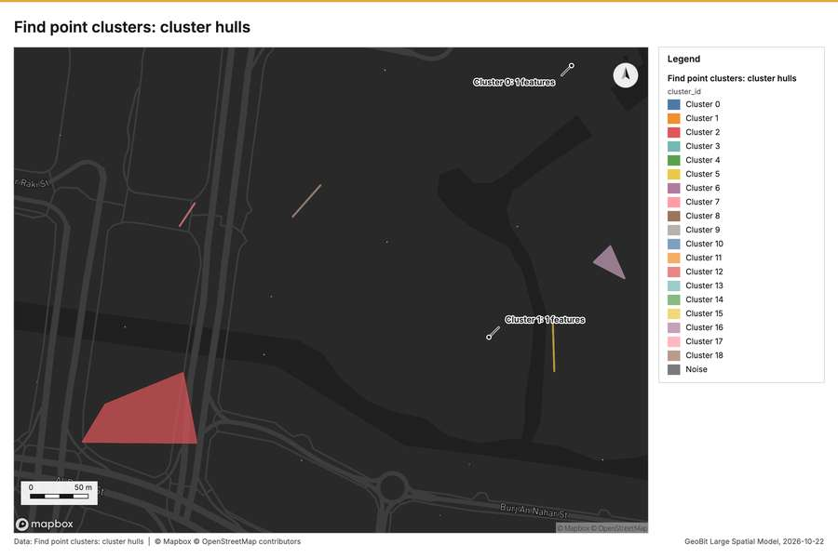
Figure 21. Find point clusters: cluster hulls [82]
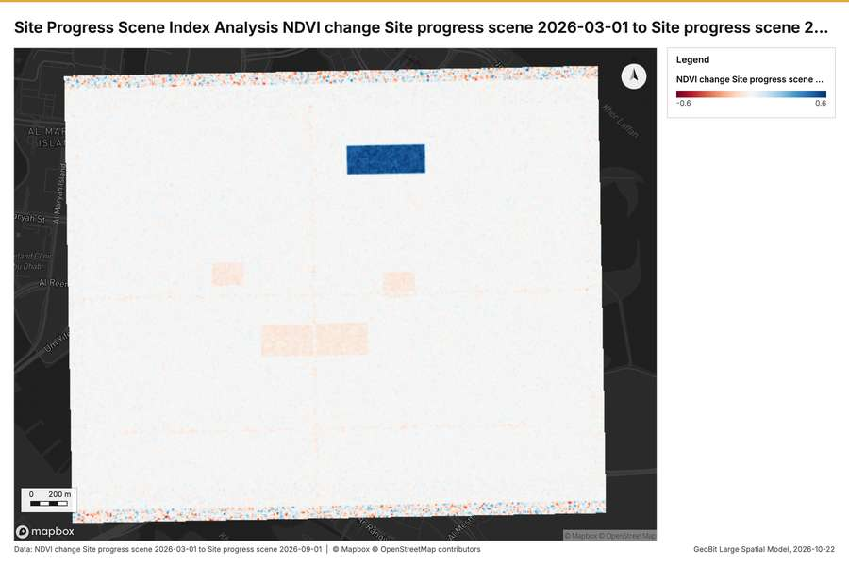
Figure 22. Site Progress Scene Index Analysis NDVI change Site progress scene 2026-03-01 to Site progress scene 2026-09-01 [83]
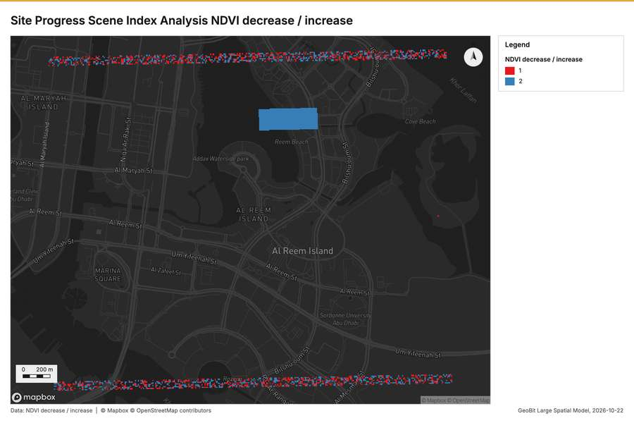
Figure 23. Site Progress Scene Index Analysis NDVI decrease / increase [84]
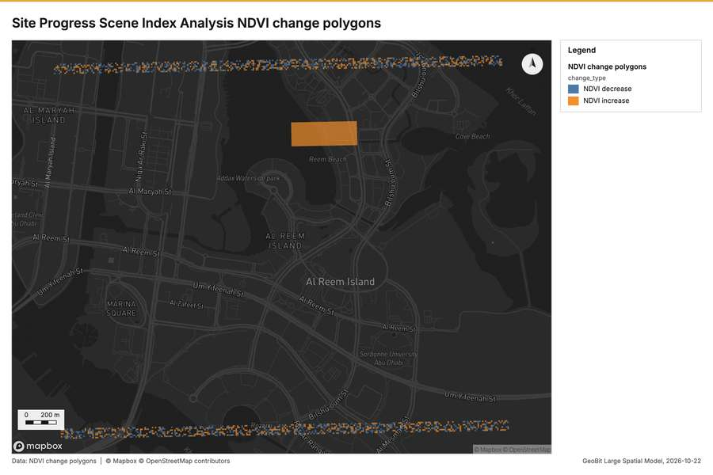
Figure 24. Site Progress Scene Index Analysis NDVI change polygons [85]
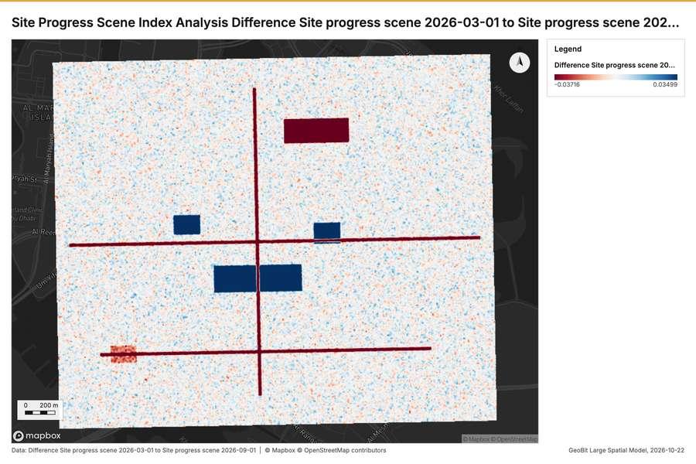
Figure 25. Site Progress Scene Index Analysis Difference Site progress scene 2026-03-01 to Site progress scene 2026-09-01 [86]
What the map shows. The map is titled "Emerging spots: Inspections and defects" and appears to be a spatial analysis designed to identify unusual clustering of inspections or defects. According to the legend, the analysis result indicates that "No pattern detected" for emerging hot spots in this area. Though the map displays various adjacent polygons filled with gray tones, the formal analysis provided does not show any specific hot spots or significant geographic patterns of defects. Overall, the image reports a lack of detectable spatial [63]
Inferred: read from the image by gemma4:e4b, not evidence.
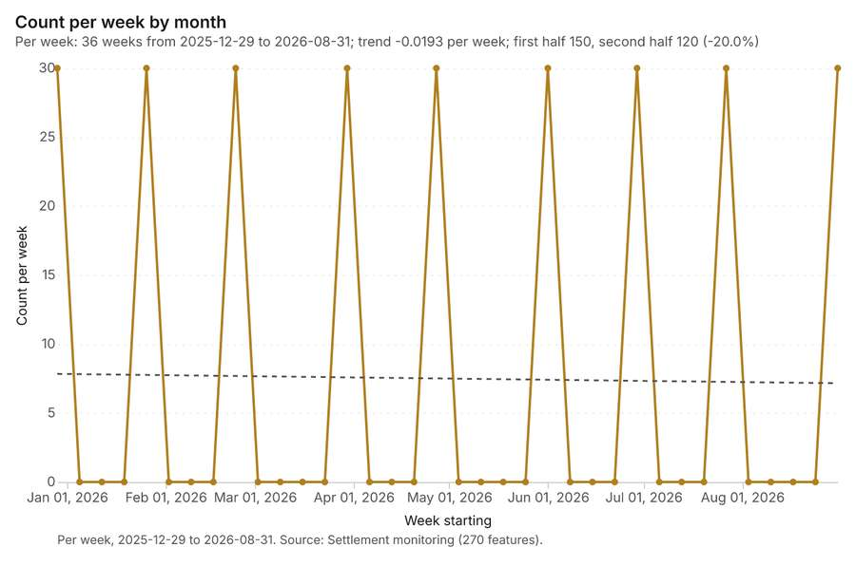
Figure 26. Settlement monitoring over time (month) [87]. Per week, 2025-12-29 to 2026-08-31. Source: Settlement monitoring (270 features). The data is in the appendix.
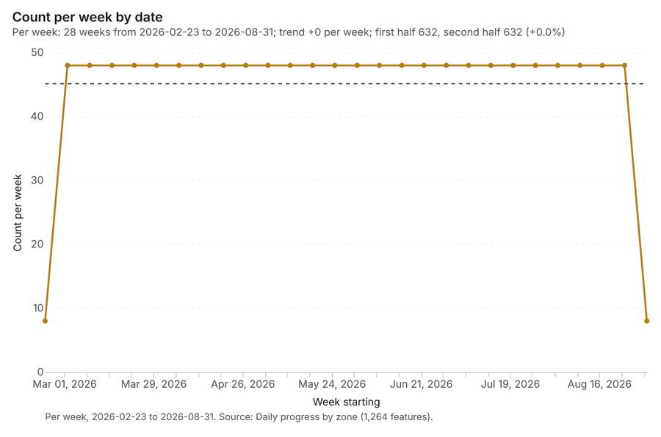
Figure 27. Daily progress by zone over time (date) [88]. Per week, 2026-02-23 to 2026-08-31. Source: Daily progress by zone (1,264 features). The data is in the appendix.
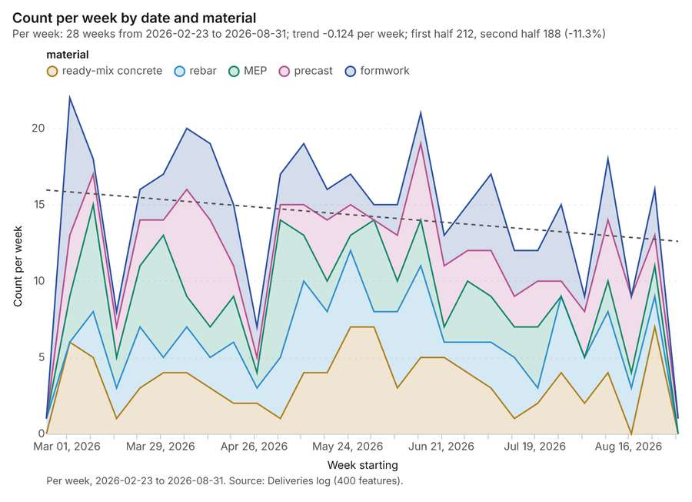
Figure 28. Deliveries log over time (date) [89]. Per week, 2026-02-23 to 2026-08-31. Source: Deliveries log (400 features). The data is in the appendix.
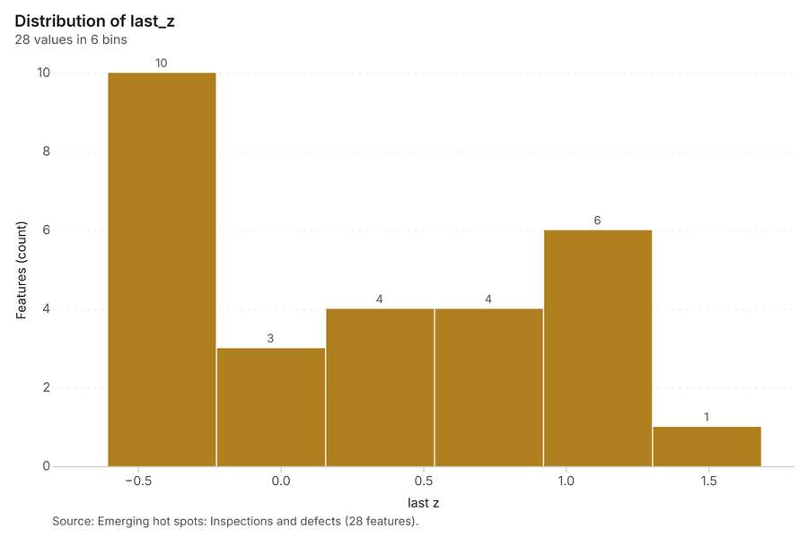
Figure 29. Emerging hot spots: Inspections and defects [90]. Source: Emerging hot spots: Inspections and defects (28 features). The data is in the appendix.
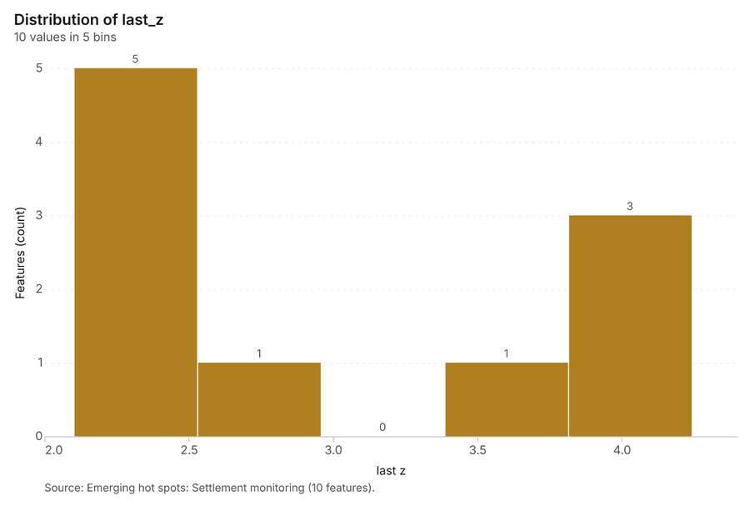
Figure 30. Emerging hot spots: Settlement monitoring [91]. Source: Emerging hot spots: Settlement monitoring (10 features). The data is in the appendix.
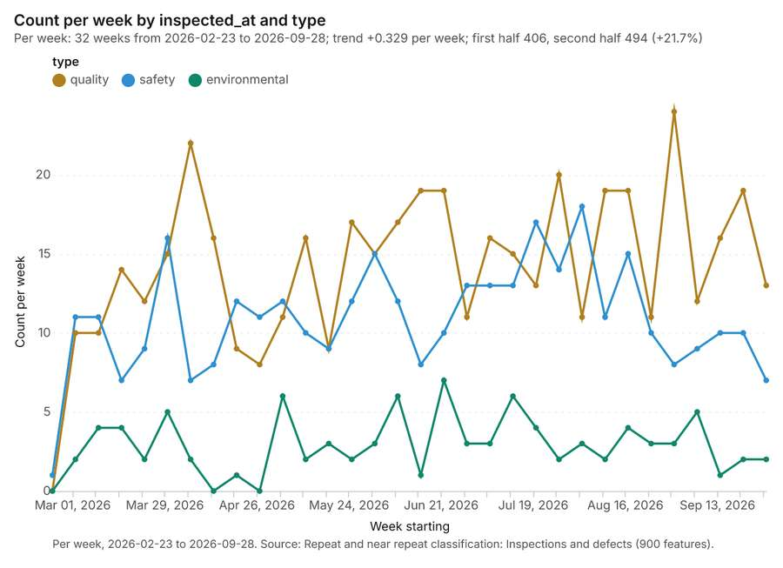
Figure 31. Repeat and near repeat classification: Inspections and defects [92]. Per week, 2026-02-23 to 2026-09-28. Source: Repeat and near repeat classification: Inspections and defects (900 features). The data is in the appendix.
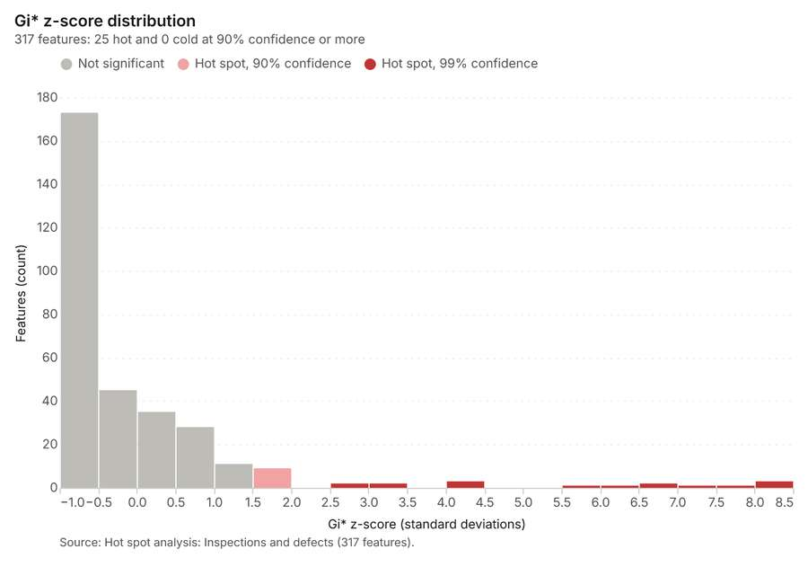
Figure 32. Hot spot analysis: Inspections and defects [93]. Source: Hot spot analysis: Inspections and defects (317 features). The data is in the appendix.
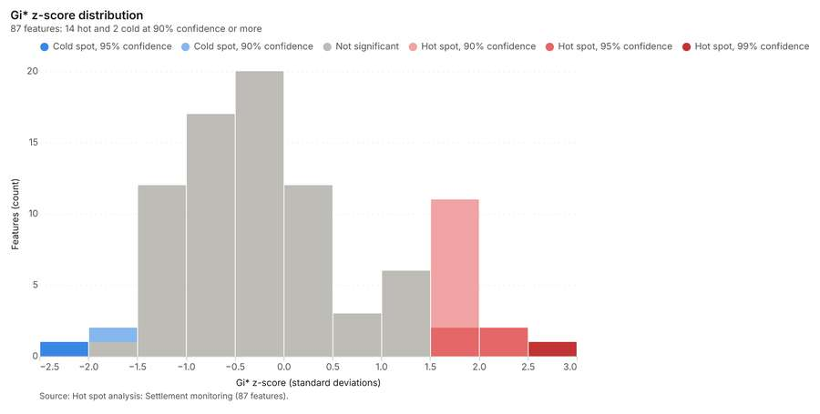
Figure 33. Hot spot analysis: Settlement monitoring [94]. Source: Hot spot analysis: Settlement monitoring (87 features). The data is in the appendix.
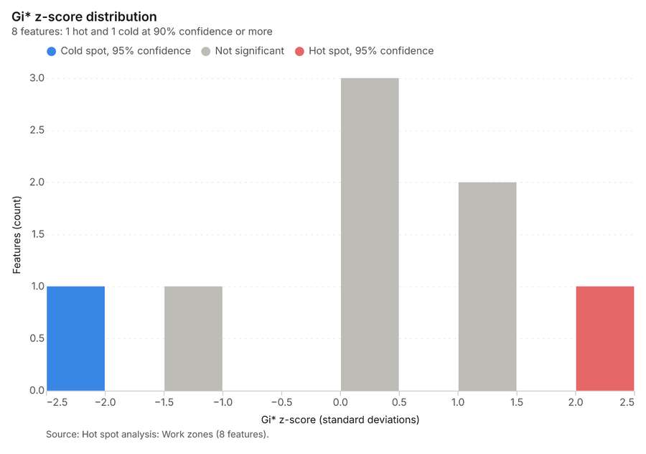
Figure 34. Hot spot analysis: Work zones [95]. Source: Hot spot analysis: Work zones (8 features). The data is in the appendix.
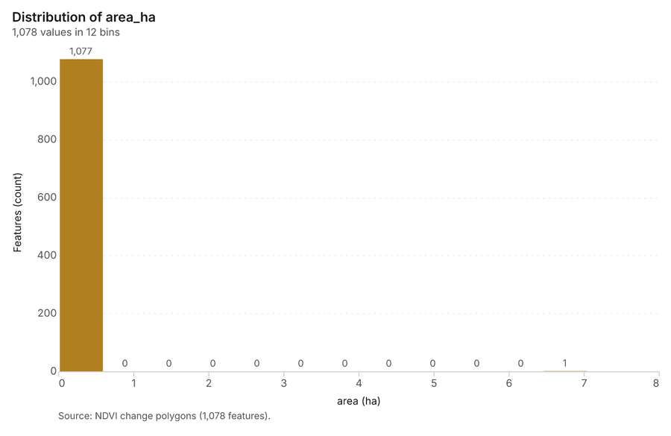
Figure 35. NDVI change polygons [96]. Source: NDVI change polygons (1,078 features). The data is in the appendix.
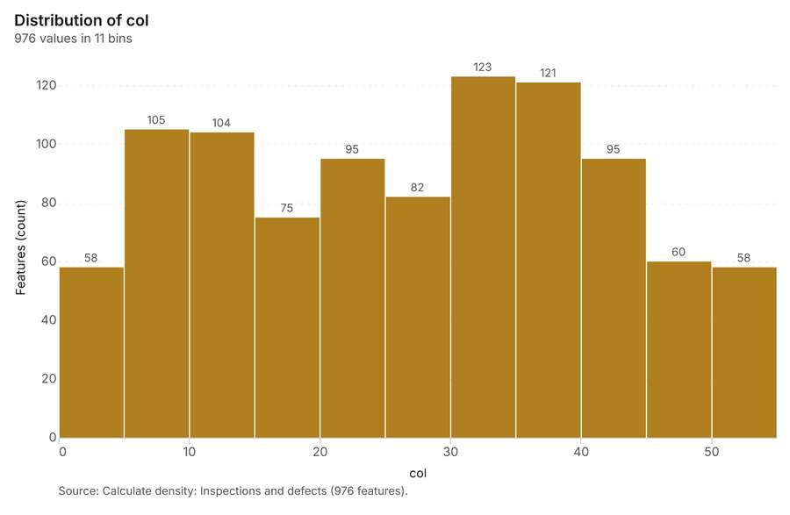
Figure 36. Calculate density: Inspections and defects [97]. Source: Calculate density: Inspections and defects (976 features). The data is in the appendix.
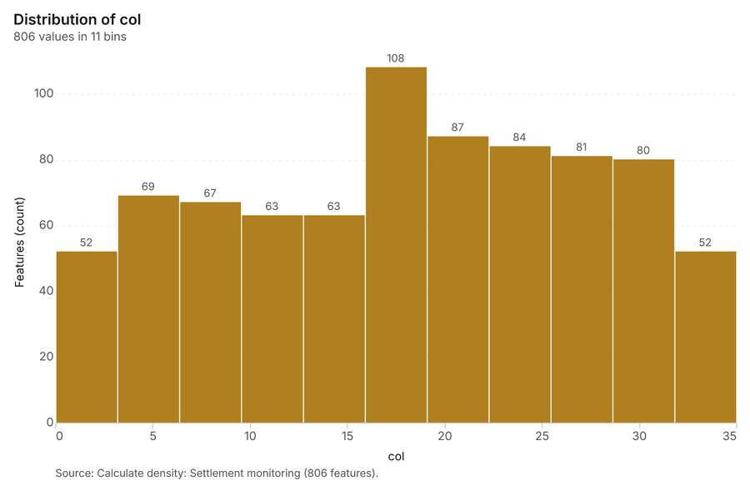
Figure 37. Calculate density: Settlement monitoring [98]. Source: Calculate density: Settlement monitoring (806 features). The data is in the appendix.
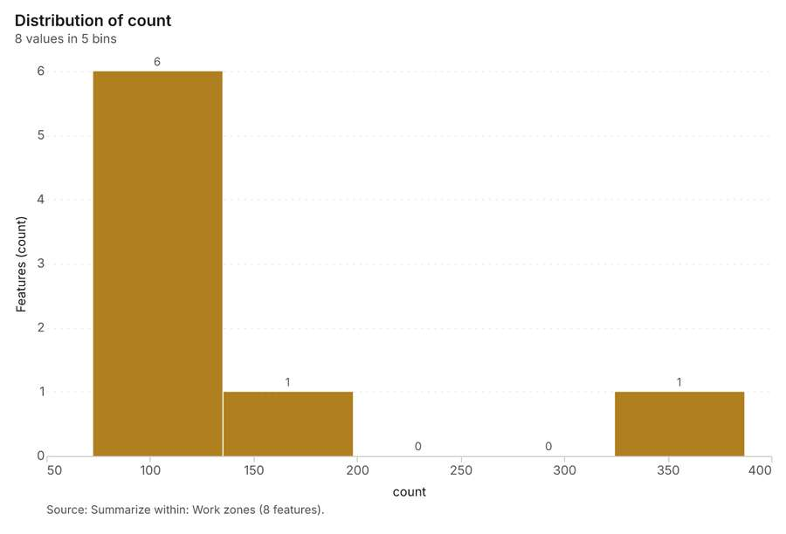
Figure 38. Summarize within: Work zones [99]. Source: Summarize within: Work zones (8 features). The data is in the appendix.
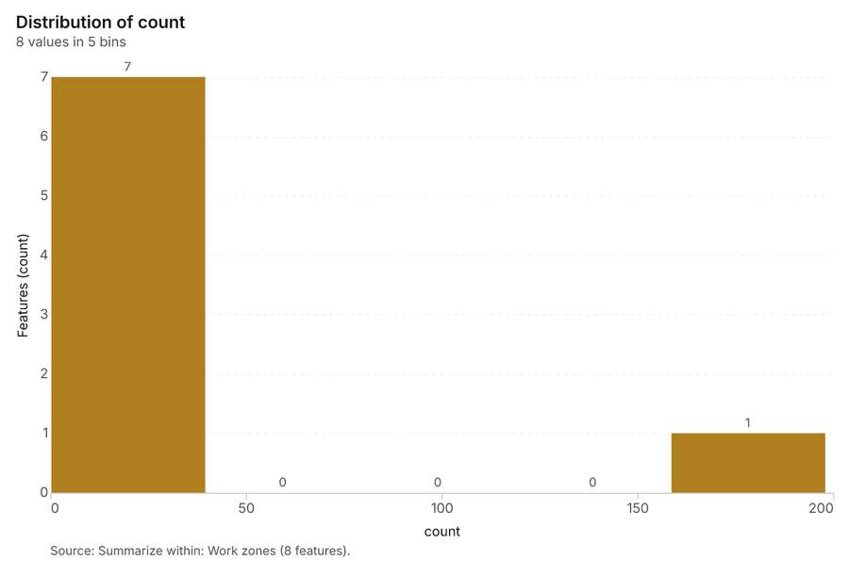
Figure 39. Summarize within: Work zones [100]. Source: Summarize within: Work zones (8 features). The data is in the appendix.
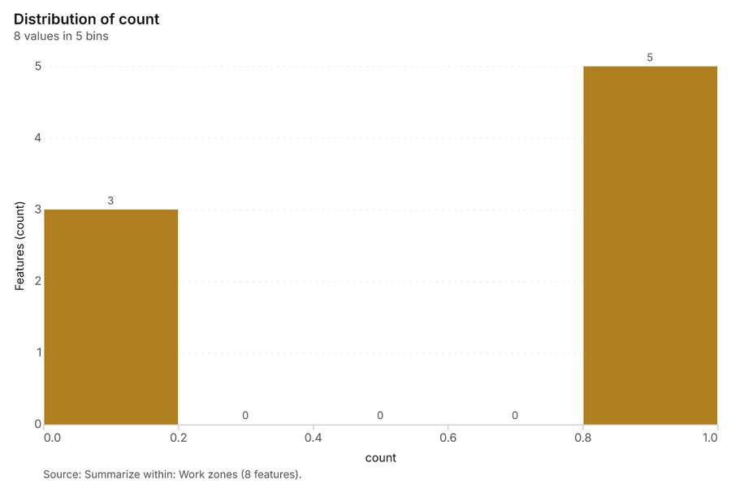
Figure 40. Summarize within: Work zones [101]. Source: Summarize within: Work zones (8 features). The data is in the appendix.
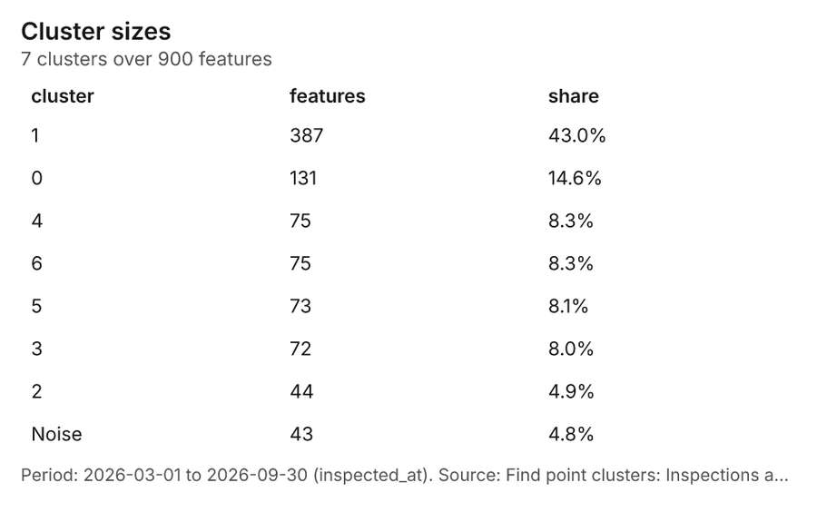
Figure 41. Find point clusters: Inspections and defects [102]. Period: 2026-03-01 to 2026-09-30 (inspected_at). Source: Find point clusters: Inspections and defects (900 features). The data is in the appendix.
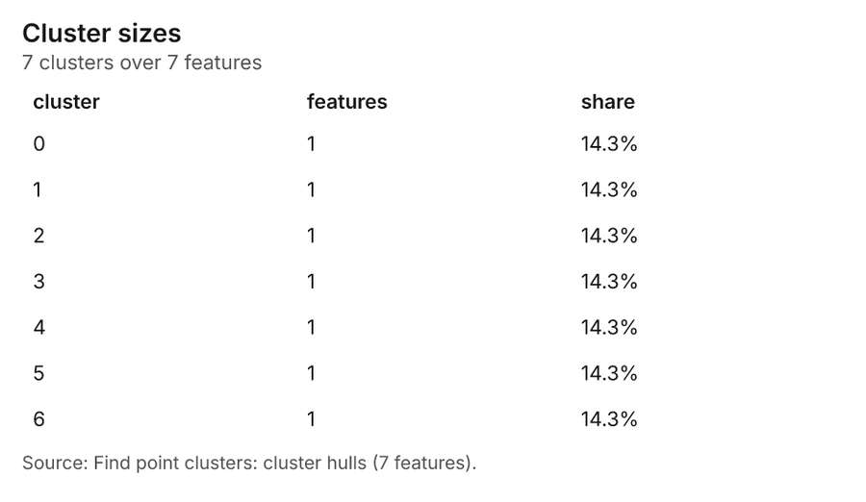
Figure 42. Find point clusters: cluster hulls [103]. Source: Find point clusters: cluster hulls (7 features). The data is in the appendix.
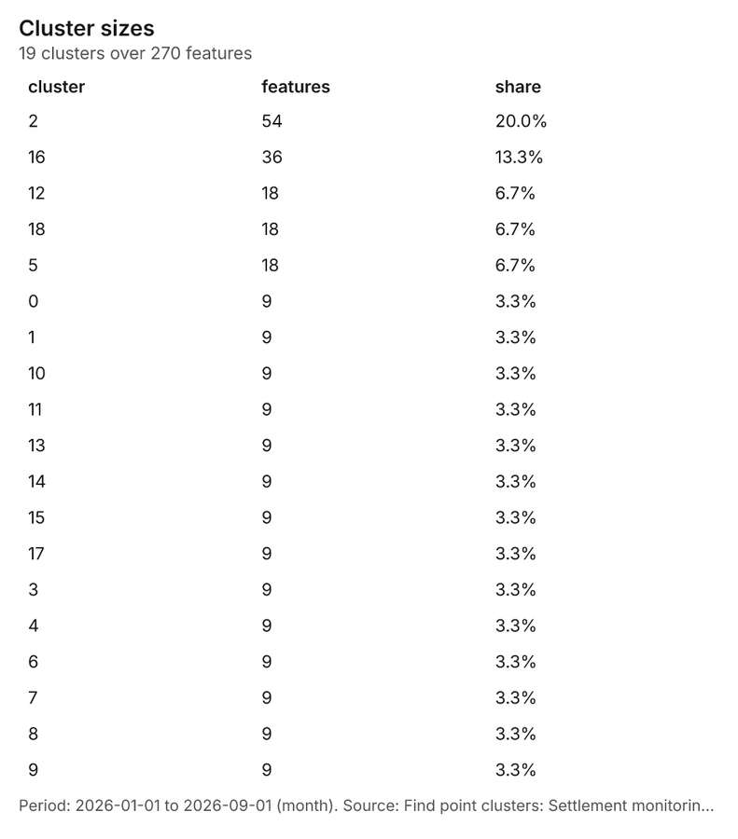
Figure 43. Find point clusters: Settlement monitoring [104]. Period: 2026-01-01 to 2026-09-01 (month). Source: Find point clusters: Settlement monitoring (270 features). The data is in the appendix.
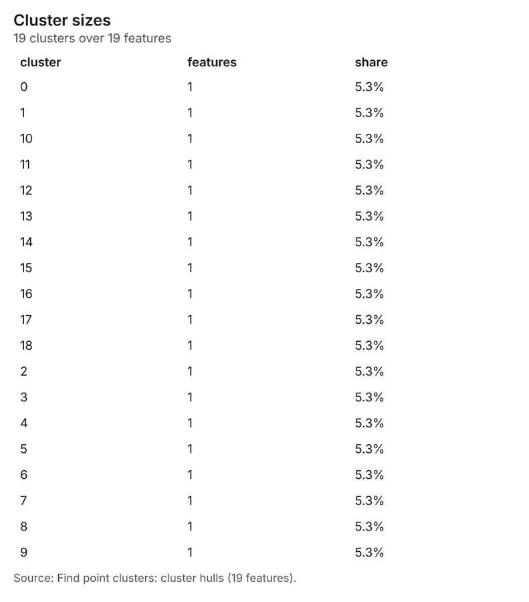
Figure 44. Find point clusters: cluster hulls [105]. Source: Find point clusters: cluster hulls (19 features). The data is in the appendix.
Figure 45. NDVI change polygons [106]. Source: NDVI change polygons (1,078 features). The data is in the appendix.
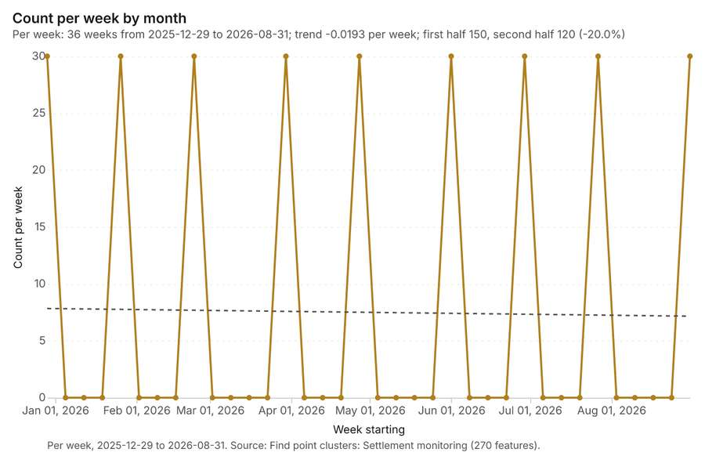
Figure 46. Find point clusters: Settlement monitoring over time [107]. Per week, 2025-12-29 to 2026-08-31. Source: Find point clusters: Settlement monitoring (270 features). The data is in the appendix.
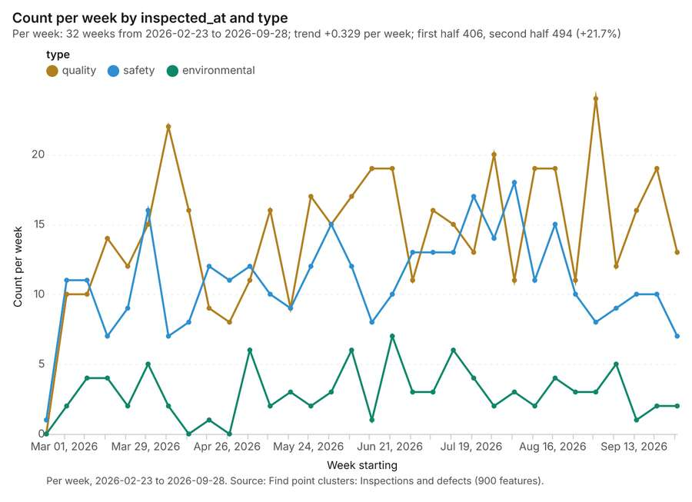
Figure 47. Find point clusters: Inspections and defects over time [108]. Per week, 2026-02-23 to 2026-09-28. Source: Find point clusters: Inspections and defects (900 features). The data is in the appendix.
Figure 48. Repeat and near repeat classification: Inspections and defects over time [109]. Per week, 2026-02-23 to 2026-09-28. Source: Repeat and near repeat classification: Inspections and defects (900 features). The data is in the appendix.

Changes since the last run
This is the first report of this project.

Sources
[1] Rendering: Chart: Timeline: events per week by dataset. 160 rows (id 9f2bb274-af82-407c-9900-4bc77773b75b)
[2] Dataset: Inspections and defects. vector, 900 rows (id 3a360dc7-0b8b-4224-98e8-aba6b17ab2e0)
[3] Dataset: Settlement monitoring. vector, 270 rows (id 806d8b39-f228-4065-a394-d600f3812c49)
[4] Dataset: Daily progress by zone. table, 1264 rows (id 85f34f63-e5d5-45af-b627-04240488c239)
[5] Dataset: Deliveries log. table, 400 rows (id 25ca0509-fbcd-465c-ad7c-3d5ff8495ec0)
[6] Catalog: Emerging hot spots (operation catalog, gp_space_time_hot_spots). Where hot spots are new, consecutive, intensifying, persistent, diminishing, sporadic, oscillating or historical over time. ArcGIS: Emerging Hot Spot Analysis, Create Space Time Cube. (id gp_space_time_hot_spots)
[7] Plan: Space time hot spots of Inspections and defects (the Start plan's candidate c_daa895129d49). Inspections and defects carry dates in 'inspected_at': emerging hot spot analysis finds new, intensifying and fading hot spots per week. (id a0327f1f-63f3-4f6a-b834-207b8f9700a5:c_daa895129d49)
[8] Tool result: gp_space_time_hot_spots, step 0. Emerging hot spots: 1 layer saved: Emerging hot spots: Inspections and defects (28 features). (id c3736b48-18ef-4b5f-917c-a3f44e49df09:0)
[9] Layer: Inspections and defects. 900 features (id 2d513b03-8124-4d94-9ddd-e0e8d35ed9ae)
[10] Plan: Space time hot spots of Settlement monitoring (the Start plan's candidate c_a657847729a2). Settlement monitoring carry dates in 'month': emerging hot spot analysis finds new, intensifying and fading hot spots per week. (id a0327f1f-63f3-4f6a-b834-207b8f9700a5:c_a657847729a2)
[11] Tool result: gp_space_time_hot_spots, step 1. Emerging hot spots: 1 layer saved: Emerging hot spots: Settlement monitoring (10 features). (id c3736b48-18ef-4b5f-917c-a3f44e49df09:1)
[12] Layer: Settlement monitoring. 270 features (id 425841af-4239-4ea3-bb9a-66322270d86d)
[13] Catalog: Repeat and near repeat classification (operation catalog, gp_near_repeat). Classify incidents as originators, repeats (same place) or near repeats within a distance and time window, with a Knox test table. ArcGIS: Repeat and Near Repeat Classification, Near Repeat Calculator. (id gp_near_repeat)
[14] Plan: Near repeat of Inspections and defects (the Start plan's candidate c_dab5834d48f7). Near repeat analysis tests whether Inspections and defects close in space also follow each other within 21 days. (id a0327f1f-63f3-4f6a-b834-207b8f9700a5:c_dab5834d48f7)
[15] Tool result: gp_near_repeat, step 2. Repeat and near repeat classification: 1 layer saved: Repeat and near repeat classification: Inspections and defects (900 features). (id c3736b48-18ef-4b5f-917c-a3f44e49df09:2)
[16] Catalog: Hot spot analysis (operation catalog, gp_hot_spots). Getis-Ord Gi* hot and cold spots with z-scores, p-values and confidence bins. ArcGIS: Find Hot Spots, Hot Spot Analysis (Getis-Ord Gi*). QGIS: qgis:hotspot (plugin). (id gp_hot_spots)
[17] Plan: Hot spots of Inspections and defects (the Start plan's candidate c_a14382cda44d). 900 points: Getis-Ord Gi* tests whether the concentrations in Inspections and defects are statistically significant. (id a0327f1f-63f3-4f6a-b834-207b8f9700a5:c_a14382cda44d)
[18] Tool result: gp_hot_spots, step 0. Hot spot analysis: 1 layer saved: Hot spot analysis: Inspections and defects (317 features). (id b3ca19ef-101a-41ac-92ce-bbbc2c003a80:0)
[19] Plan: Hot spots of Settlement monitoring (the Start plan's candidate c_40b66c08f429). 270 points: Getis-Ord Gi* tests whether the concentrations in Settlement monitoring are statistically significant. (id a0327f1f-63f3-4f6a-b834-207b8f9700a5:c_40b66c08f429)
[20] Tool result: gp_hot_spots, step 1. Hot spot analysis: 1 layer saved: Hot spot analysis: Settlement monitoring (87 features). (id b3ca19ef-101a-41ac-92ce-bbbc2c003a80:1)
[21] Plan: Hot spots of Work zones (the Start plan's candidate c_c596ca1fffb2). Gi* hot spots of 'pct_complete' across the areas. (id a0327f1f-63f3-4f6a-b834-207b8f9700a5:c_c596ca1fffb2)
[22] Tool result: gp_hot_spots, step 2. Hot spot analysis: 1 layer saved: Hot spot analysis: Work zones (8 features). (id b3ca19ef-101a-41ac-92ce-bbbc2c003a80:2)
[23] Layer: Work zones. 8 features (id a87c9da1-d753-4f2a-ab7d-b864dabbbe8f)
[24] Catalog: Spectral index change (analysis catalog, im_index_change). Change of a spectral index (NDVI, NDWI, NDBI, NBR ...) or a band expression between two images: before, after and difference rasters, decrease / increase classes beyond the threshold with polygons and areas; NBR also gives dNBR with burn severity classes. (id im_index_change)
[25] Plan: Index change of Site progress scene 2026-03-01 and Site progress scene 2026-09-01 (the Start plan's candidate c_be7290b1b94a). Index change between Site progress scene 2026-03-01 (2026-03-01) and Site progress scene 2026-09-01 (2026-09-01): the changed area, with the changed places as polygons. (id a0327f1f-63f3-4f6a-b834-207b8f9700a5:c_be7290b1b94a)
[26] Tool result: im_index_change, step 0. Spectral index change: created NDVI change Site progress scene 2026-03-01 to Site progress scene 2026-09-01 (300 x 250 cells, 10.00 m). plus 1 more raster layer(s). and layer NDVI change polygons with 1078 feature(s). mean before 0.08239; mean after 0.08535; mean difference 0.002955; decrease ha 9.0 (id 7ffbeb87-0a83-4448-a1e2-6acaf335bc0c:0)
[27] Catalog: Compute change raster (analysis catalog, im_compute_change_raster). Pixel value or spectral change between two co-registered images: difference, relative difference, absolute difference, log ratio (radar, dB), Euclidean spectral distance, spectral angle (radians) or the band with most change. Clouds and shadows are masked when the images have (id im_compute_change_raster)
[28] Plan: Compute change raster of Site progress scene 2026-03-01 and Site progress scene 2026-09-01 (the Start plan's candidate c_7e48e7dad7f6). A change raster between Site progress scene 2026-03-01 (2026-03-01) and Site progress scene 2026-09-01 (2026-09-01): where and how much the pixels changed. (id a0327f1f-63f3-4f6a-b834-207b8f9700a5:c_7e48e7dad7f6)
[29] Tool result: im_compute_change_raster, step 1. Compute change raster: created Difference Site progress scene 2026-03-01 to Site progress scene 2026-09-01 (300 x 250 cells, 10.00 m). mean -0.001083; std 0.01804; min -0.134; max 0.091; masked pixels 0. (id 7ffbeb87-0a83-4448-a1e2-6acaf335bc0c:1)
[30] Catalog: Calculate density (operation catalog, gp_calculate_density). Kernel density per square kilometer on a grid. ArcGIS: Calculate Density, Kernel Density. QGIS: native:heatmapkerneldensityestimation. (id gp_calculate_density)
[31] Plan: Kernel density of Inspections and defects (the Start plan's candidate c_b027c874c560). 900 points in Inspections and defects: a density surface shows where they concentrate. (id a0327f1f-63f3-4f6a-b834-207b8f9700a5:c_b027c874c560)
[32] Tool result: gp_calculate_density, step 0. Calculate density: 1 layer saved: Calculate density: Inspections and defects (976 features). (id b4af9d8c-897b-4cb3-a492-826d8edde822:0)
[33] Plan: Kernel density of Settlement monitoring (the Start plan's candidate c_d14b64b8c3f9). 270 points in Settlement monitoring: a density surface shows where they concentrate. (id a0327f1f-63f3-4f6a-b834-207b8f9700a5:c_d14b64b8c3f9)
[34] Tool result: gp_calculate_density, step 1. Calculate density: 1 layer saved: Calculate density: Settlement monitoring (806 features). (id b4af9d8c-897b-4cb3-a492-826d8edde822:1)
[35] Catalog: Summarize within (operation catalog, gp_summarize_within). Count and aggregate the features inside each polygon (or bin), proportionally for lines and polygons. ArcGIS: Summarize Within, Aggregate Points. QGIS: native:countpointsinpolygon, native:sumlinelengths. (id gp_summarize_within)
[36] Plan: Inspections and defects per feature of Work zones (the Start plan's candidate c_9b02c6bcc3d7). Count Inspections and defects inside each feature of Work zones by type; the counts map as a choropleth (natural breaks, sequential colors). (id a0327f1f-63f3-4f6a-b834-207b8f9700a5:c_9b02c6bcc3d7)
[37] Tool result: gp_summarize_within, step 0. Summarize within: 1 layer saved: Summarize within: Work zones (8 features). (id c58995ca-42b1-4b4e-86fb-a88fb13acf0b:0)
[38] Tool result: gp_summarize_within, step 1. Summarize within: 1 layer saved: Summarize within: Work zones (8 features). (id c58995ca-42b1-4b4e-86fb-a88fb13acf0b:1)
[39] Tool result: gp_summarize_within, step 2. Summarize within: 1 layer saved: Summarize within: Work zones (8 features). (id c58995ca-42b1-4b4e-86fb-a88fb13acf0b:2)
[40] Layer: Tower cranes. 4 features (id a6101de1-0f97-42bb-a976-2736f8fc42cd)
[41] Catalog: Zonal statistics (analysis catalog, rs_zonal_statistics). count/min/max/mean/std/sum/median/majority per polygon as a table and as GeoJSON. ArcGIS: Zonal Statistics as Table (polygons). (id rs_zonal_statistics)
[42] Plan: Zonal statistics of Site terrain model (DEM) and Work zones (the Start plan's candidate c_2be6fba28be6). Statistics of Site terrain model (DEM) inside each feature of Work zones. (id a0327f1f-63f3-4f6a-b834-207b8f9700a5:c_2be6fba28be6)
[43] Tool result: rs_zonal_statistics, step 0. Zonal statistics: 8 row(s). zones 8. (id b9751382-9c63-45f7-aeeb-df532c540b48:0)
[44] Tool result: rs_zonal_statistics, step 1. Zonal statistics: 1 row(s). zones 1. (id b9751382-9c63-45f7-aeeb-df532c540b48:1)
[45] Catalog: Slope (analysis catalog, tr_slope). Horn slope in degrees or percent, with the share of ground in six grade classes. ArcGIS: Slope (Spatial Analyst). QGIS: Slope (GDAL DEM). (id tr_slope)
[46] Plan: Slope of Site terrain model (DEM) (the Start plan's candidate c_9bcc9b88376e). Slope of the Site terrain model (DEM) surface. (id a0327f1f-63f3-4f6a-b834-207b8f9700a5:c_9bcc9b88376e)
[47] Tool result: tr_slope, step 2. Slope over 7.50 km2: mean 0.36 degrees, max 18.73 degrees; 1% of the ground is steeper than 15%. DEM: Site terrain model (DEM). Verified: 2 checks passed. (id b9751382-9c63-45f7-aeeb-df532c540b48:2)
[48] Layer: Site terrain model (DEM). 0 features (id 0c6d4acd-4d8d-4cf4-b654-e096f06f71ff)
[49] Catalog: Find point clusters (operation catalog, gp_find_point_clusters). Density-based clusters (DBSCAN, HDBSCAN or OPTICS, optionally space-time) with hulls and noise. ArcGIS: Find Point Clusters, Density-based Clustering. QGIS: native:dbscanclustering, native:stdbscanclustering. (id gp_find_point_clusters)
[50] Plan: Cluster points of Inspections and defects (the Start plan's candidate c_6339b071c51c). DBSCAN finds dense groups of Inspections and defects and separates noise. (id a0327f1f-63f3-4f6a-b834-207b8f9700a5:c_6339b071c51c)
[51] Tool result: gp_find_point_clusters, step 0. Find point clusters: 2 layers saved: Find point clusters: Inspections and defects (900 features); Find point clusters: cluster hulls (7 features). (id a18ea698-d2a7-4e8a-b749-f525e603592f:0)
[52] Plan: Cluster points of Settlement monitoring (the Start plan's candidate c_4199c930b59b). DBSCAN finds dense groups of Settlement monitoring and separates noise. (id a0327f1f-63f3-4f6a-b834-207b8f9700a5:c_4199c930b59b)
[53] Tool result: gp_find_point_clusters, step 1. Find point clusters: 2 layers saved: Find point clusters: Settlement monitoring (270 features); Find point clusters: cluster hulls (19 features). (id a18ea698-d2a7-4e8a-b749-f525e603592f:1)
[54] Catalog: Average nearest neighbor (operation catalog, gp_nearest_neighbor_index). Clark-Evans ratio: clustered, dispersed or random. ArcGIS: Average Nearest Neighbor. QGIS: native:nearestneighbouranalysis. (id gp_nearest_neighbor_index)
[55] Plan: Nearest neighbor index of Inspections and defects (the Start plan's candidate c_16c101371f91). The average nearest neighbor ratio says whether Inspections and defects are clustered, random or dispersed. (id a0327f1f-63f3-4f6a-b834-207b8f9700a5:c_16c101371f91)
[56] Tool result: gp_nearest_neighbor_index, step 2. Average nearest neighbor: done; no map output. (id a18ea698-d2a7-4e8a-b749-f525e603592f:2)
[57] Plan: Zonal statistics of Site progress scene 2026-09-01 and Work zones (the Start plan's candidate c_fbbb0c518f13). Statistics of Site progress scene 2026-09-01 inside each feature of Work zones. (id a0327f1f-63f3-4f6a-b834-207b8f9700a5:c_fbbb0c518f13)
[58] Tool result: rs_zonal_statistics, step 0. Zonal statistics: 8 row(s). zones 8. (id f697e2f1-f28e-4342-8c96-78425e7ef30c:0)
[59] Tool result: rs_zonal_statistics, step 1. Zonal statistics: 1 row(s). zones 1. (id f697e2f1-f28e-4342-8c96-78425e7ef30c:1)
[60] Tool result: rs_zonal_statistics, step 2. Zonal statistics: 8 row(s). zones 8. (id f697e2f1-f28e-4342-8c96-78425e7ef30c:2)
[61] Tool result: im_index_change, step 0. Spectral index change: created NDVI change Site progress scene 2026-03-01 to Site progress scene 2026-09-01 (300 x 250 cells, 10.00 m). plus 1 more raster layer(s). and layer NDVI change polygons with 1078 feature(s). mean before 0.08239; mean after 0.08535; mean difference 0.002955; decrease ha 9.0 (id a50cf479-ac3c-4eaf-ba13-51b573e1a936:0)
[62] Tool result: im_compute_change_raster, step 1. Compute change raster: created Difference Site progress scene 2026-03-01 to Site progress scene 2026-09-01 (300 x 250 cells, 10.00 m). mean -0.001083; std 0.01804; min -0.134; max 0.091; masked pixels 0. (id a50cf479-ac3c-4eaf-ba13-51b573e1a936:1)
[63] Rendering: Map: Emerging hot spots: Inspections and defects (id 44c54df1-3ef4-4f48-bfdf-373e1dcae072)
[64] Rendering: Map: Emerging hot spots: Settlement monitoring (id cc8b26b5-2189-437a-ae60-bb5505e01bb3)
[65] Rendering: Map: Repeat and near repeat classification: Inspections and defects (id fa93e6d7-4351-4807-954d-94f0348da021)
[66] Rendering: Map: Hot spot analysis: Inspections and defects (id f6d190a7-d4f9-4493-be19-1be9956826b5)
[67] Rendering: Map: Hot spot analysis: Settlement monitoring (id fc9ccdba-f38f-47eb-997b-8a386b4ddb71)
[68] Rendering: Map: Hot spot analysis: Work zones (id efda6f0a-8900-45e7-97f8-c2c08b7ee7a9)
[69] Rendering: Map: NDVI change Site progress scene 2026-03-01 to Site progress scene 2026-09-01 (id 33bfa5c4-92ac-43df-86aa-b50106359dd2)
[70] Rendering: Map: NDVI decrease / increase (id f22e9812-824b-4eb6-8554-f8a7732bce15)
[71] Rendering: Map: NDVI change polygons (id 4fe5d947-63bf-4602-a7df-f7fceecf47aa)
[72] Rendering: Map: Difference Site progress scene 2026-03-01 to Site progress scene 2026-09-01 (id 53be4756-2fc4-4c8f-8dff-b832cdf6d17a)
[73] Rendering: Map: Calculate density: Inspections and defects (id 397fd56d-b01c-410e-84ef-a8e0aa7bcc27)
[74] Rendering: Map: Calculate density: Settlement monitoring (id f12560e9-420f-49e4-a19c-4fe1b9459ba8)
[75] Rendering: Map: Summarize within: Work zones (id 7d4caaef-9484-48dc-9123-64a0072860b6)
[76] Rendering: Map: Summarize within: Work zones (id f7131359-06b3-4304-8a0c-6106da84afdc)
[77] Rendering: Map: Summarize within: Work zones (id 43631e4b-9ad3-4475-8715-3bf283b8f106)
[78] Rendering: Map: Slope (degrees) (id c3664af4-8bb7-47c6-abf3-7aceea809124)
[79] Rendering: Map: Find point clusters: Inspections and defects (id cc3d7893-ab41-4034-a602-437ec73a0b31)
[80] Rendering: Map: Find point clusters: cluster hulls (id 7d94af92-e519-4c82-8a96-ffde80cf991c)
[81] Rendering: Map: Find point clusters: Settlement monitoring (id 96e2071a-d82a-40e3-9a4b-6cf33279bbbb)
[82] Rendering: Map: Find point clusters: cluster hulls (id 2c3db94d-30bb-47b3-9454-ae7ef2846a1d)
[83] Rendering: Map: Site Progress Scene Index Analysis NDVI change Site progress scene 2026-03-01 to Site progress scene 2026-09-01 (id 292b34c5-61b7-475e-96fe-f7b859c107ed)
[84] Rendering: Map: Site Progress Scene Index Analysis NDVI decrease / increase (id 01e5e6a9-49bd-4ac6-b2e8-ddda771b5582)
[85] Rendering: Map: Site Progress Scene Index Analysis NDVI change polygons (id 86d28d82-9108-431d-9ad3-a2feeec950c7)
[86] Rendering: Map: Site Progress Scene Index Analysis Difference Site progress scene 2026-03-01 to Site progress scene 2026-09-01 (id 7a29f585-6966-47f6-9e4c-058f8691bb28)
[87] Rendering: Chart: Settlement monitoring over time (month). 36 rows (id 9ead02da-348b-44ba-8ee7-269c1c2d63f3)
[88] Rendering: Chart: Daily progress by zone over time (date). 28 rows (id 39d65924-a112-4224-9302-9115ac3dd0da)
[89] Rendering: Chart: Deliveries log over time (date). 140 rows (id 8e7bf61d-a5a0-42f3-b502-875288bf1e29)
[90] Rendering: Chart: Emerging hot spots: Inspections and defects. 6 rows (id ef7d42dd-f3fa-4e99-a910-15f7ec83297b)
[91] Rendering: Chart: Emerging hot spots: Settlement monitoring. 5 rows (id dd35971b-2787-4a8d-9a43-aba57f75d47e)
[92] Rendering: Chart: Repeat and near repeat classification: Inspections and defects. 96 rows (id 8ca20871-10d1-40b1-834b-38cd1849b4b8)
[93] Rendering: Chart: Hot spot analysis: Inspections and defects. 15 rows (id 12698a56-ae20-4fae-aedd-bd8d3179f94f)
[94] Rendering: Chart: Hot spot analysis: Settlement monitoring. 13 rows (id 02c89ac1-1d31-4844-914d-6077abf66479)
[95] Rendering: Chart: Hot spot analysis: Work zones. 5 rows (id 9177a78d-8b65-410f-af6d-d56ceda4a636)
[96] Rendering: Chart: NDVI change polygons. 12 rows (id 61c75041-5982-429d-ac74-d9605047def1)
[97] Rendering: Chart: Calculate density: Inspections and defects. 11 rows (id abcf7e57-ebc5-4630-98dd-65228e550aa6)
[98] Rendering: Chart: Calculate density: Settlement monitoring. 11 rows (id 0aa266b1-0ecb-4312-8fb6-a3063dc7c7e5)
[99] Rendering: Chart: Summarize within: Work zones. 5 rows (id 5ee14e18-ab1d-46fd-8640-7feb7d508da7)
[100] Rendering: Chart: Summarize within: Work zones. 5 rows (id 67e6d938-9903-48f6-9a48-91d47bee8a02)
[101] Rendering: Chart: Summarize within: Work zones. 5 rows (id 2a7e5e5b-93c2-4898-8a7b-d8fb4045b928)
[102] Rendering: Chart: Find point clusters: Inspections and defects. 8 rows (id 5fd0ca87-fab6-488d-b580-707c3e546506)
[103] Rendering: Chart: Find point clusters: cluster hulls. 7 rows (id 0bbf6b08-675a-421e-a2b9-10bda913071e)
[104] Rendering: Chart: Find point clusters: Settlement monitoring. 19 rows (id 668ea7e9-018e-4e3a-8dc8-d454151ecdba)
[105] Rendering: Chart: Find point clusters: cluster hulls. 19 rows (id cce16250-17dc-44a0-90b3-1effbf06eee0)
[106] Rendering: Chart: NDVI change polygons. 12 rows (id bf7e96fd-8ac6-4ea5-abba-531dddd6c242)
[107] Rendering: Chart: Find point clusters: Settlement monitoring over time. 36 rows (id 8741d3df-a209-4ea2-b13f-828908da90f7)
[108] Rendering: Chart: Find point clusters: Inspections and defects over time. 96 rows (id 1dd42be8-67ac-47fa-bdce-1ee0deeb71f1)
[109] Rendering: Chart: Repeat and near repeat classification: Inspections and defects over time. 96 rows (id b8a63915-574e-487c-bc0e-b1f8099863a6)
[110] Dataset: Site boundary. vector, 1 rows (id bb559260-1c80-48a4-b1cf-f8d45912c652)
[111] Dataset: Work zones. vector, 8 rows (id 0e3a49ca-6c53-4c6a-9921-e5f541953931)
[112] Dataset: Site progress scene 2026-03-01. raster, ? rows (id d5b68dc5-16d9-4cfd-968a-c8903d998eed)
[113] Dataset: Site progress scene 2026-09-01. raster, ? rows (id 4032b2ca-3632-4bc3-b9ad-60d3a59b951f)
[114] Dataset: Site terrain model (DEM). raster, ? rows (id 454c0b82-bbf9-4c73-9e4c-e939f6a3fb53)
[115] Dataset: Site roads. vector, 3 rows (id 0f387307-aec2-41f8-92eb-4838eb3282bb)
[116] Dataset: Tower cranes. vector, 4 rows (id 9f4ea7c1-9e1c-47e8-8184-8cb05533c4ac)
[117] Dataset: Monthly progress report. document, ? rows (id 026a6911-73c9-4c20-aaf9-809a17446401)
[118] Record: Sample: Construction, Al Reem Island (id d4e5404f-06e4-4689-a539-31a71b8348eb)
[119] Layer: Emerging hot spots: Inspections and defects. 28 features (id b6e6a183-1b27-496c-a678-9f8df4e4b081)
[120] Layer: Emerging hot spots: Settlement monitoring. 10 features (id 97e34fec-6ba0-4f5b-aa10-f76b28b24d30)
[121] Layer: Repeat and near repeat classification: Inspections and defects. 900 features (id f23bce2c-8508-4e9c-8458-fd8faf8ec029)
[122] Layer: Hot spot analysis: Inspections and defects. 317 features (id ef4eb056-e817-462a-9733-a58fd43d00cb)
[123] Layer: Hot spot analysis: Settlement monitoring. 87 features (id cfbaa203-6871-498f-b688-d75ec0db6fa9)
[124] Layer: Hot spot analysis: Work zones. 8 features (id 006e9ce1-b483-4c73-acfb-5f48e1852b8f)
[125] Layer: NDVI change Site progress scene 2026-03-01 to Site progress scene 2026-09-01. 0 features (id 771ca68b-d2ee-4ff2-bbba-c4f0576cbae9)
[126] Layer: NDVI decrease / increase. 0 features (id 15acb616-2cef-42cf-a5e4-15164cafb21e)
[127] Layer: NDVI change polygons. 1,078 features (id 96ff870f-9163-461c-9f71-1cd79c835ecc)
[128] Layer: Difference Site progress scene 2026-03-01 to Site progress scene 2026-09-01. 0 features (id b963eb25-56c3-4309-af9d-4e029ccf90c5)
[129] Layer: Calculate density: Inspections and defects. 976 features (id 21b40807-b901-4510-b690-3a72503d53bb)
[130] Layer: Calculate density: Settlement monitoring. 806 features (id 4c96ec2a-2ff3-470f-a6f4-a4fe2e2c0f31)
[131] Layer: Summarize within: Work zones. 8 features (id 61db1d60-2cda-4ce2-ab31-ab3c66cf5242)
[132] Layer: Summarize within: Work zones. 8 features (id b32e8596-c2a2-453b-9f24-50829120080e)
[133] Layer: Summarize within: Work zones. 8 features (id 9b7216b5-5c39-4fa7-95fc-419178fd4681)
[134] Layer: Slope (degrees). 0 features (id 04fe23a2-183b-4b40-99ed-00c0a1c62545)
[135] Layer: Find point clusters: Inspections and defects. 900 features (id 483f389f-6f5f-4686-9358-d8ba8dfecc0c)
[136] Layer: Find point clusters: cluster hulls. 7 features (id a3ed91a3-93ec-4c1d-8f39-d00038f33711)
[137] Layer: Find point clusters: Settlement monitoring. 270 features (id e11e55d7-847b-4fb0-9ce1-b78d3ec3f87c)
[138] Layer: Find point clusters: cluster hulls. 19 features (id b5149260-c6f8-4546-8616-94dd97d60029)
[139] Layer: NDVI change polygons. 1,078 features (id ac97061d-6bed-44e0-9705-e3ab6f002d53)

Appendix: the data behind the charts

Figure 1. Timeline: events per week by dataset [1]
period | series | value
2025-12-29 | Daily progress by zone | 0
2025-12-29 | Inspections and defects | 0
2025-12-29 | Deliveries log | 0
2025-12-29 | Settlement monitoring | 30
2026-01-05 | Daily progress by zone | 0
2026-01-05 | Inspections and defects | 0
2026-01-05 | Deliveries log | 0
2026-01-05 | Settlement monitoring | 0
2026-01-12 | Daily progress by zone | 0
2026-01-12 | Inspections and defects | 0
2026-01-12 | Deliveries log | 0
2026-01-12 | Settlement monitoring | 0
2026-01-19 | Daily progress by zone | 0
2026-01-19 | Inspections and defects | 0
2026-01-19 | Deliveries log | 0
2026-01-19 | Settlement monitoring | 0
2026-01-26 | Daily progress by zone | 0
2026-01-26 | Inspections and defects | 0
2026-01-26 | Deliveries log | 0
2026-01-26 | Settlement monitoring | 30
2026-02-02 | Daily progress by zone | 0
2026-02-02 | Inspections and defects | 0
2026-02-02 | Deliveries log | 0
2026-02-02 | Settlement monitoring | 0
2026-02-09 | Daily progress by zone | 0
2026-02-09 | Inspections and defects | 0
2026-02-09 | Deliveries log | 0
2026-02-09 | Settlement monitoring | 0
2026-02-16 | Daily progress by zone | 0
2026-02-16 | Inspections and defects | 0
2026-02-16 | Deliveries log | 0
2026-02-16 | Settlement monitoring | 0
2026-02-23 | Daily progress by zone | 8
2026-02-23 | Inspections and defects | 1
2026-02-23 | Deliveries log | 1
2026-02-23 | Settlement monitoring | 30
2026-03-02 | Daily progress by zone | 48
2026-03-02 | Inspections and defects | 23
2026-03-02 | Deliveries log | 22
2026-03-02 | Settlement monitoring | 0
2026-03-09 | Daily progress by zone | 48
2026-03-09 | Inspections and defects | 25
2026-03-09 | Deliveries log | 18
2026-03-09 | Settlement monitoring | 0
2026-03-16 | Daily progress by zone | 48
2026-03-16 | Inspections and defects | 25
2026-03-16 | Deliveries log | 8
2026-03-16 | Settlement monitoring | 0
2026-03-23 | Daily progress by zone | 48
2026-03-23 | Inspections and defects | 23
2026-03-23 | Deliveries log | 16
2026-03-23 | Settlement monitoring | 0
2026-03-30 | Daily progress by zone | 48
2026-03-30 | Inspections and defects | 36
2026-03-30 | Deliveries log | 17
2026-03-30 | Settlement monitoring | 30
2026-04-06 | Daily progress by zone | 48
2026-04-06 | Inspections and defects | 31
2026-04-06 | Deliveries log | 20
2026-04-06 | Settlement monitoring | 0
2026-04-13 | Daily progress by zone | 48
2026-04-13 | Inspections and defects | 24
2026-04-13 | Deliveries log | 19
2026-04-13 | Settlement monitoring | 0
2026-04-20 | Daily progress by zone | 48
2026-04-20 | Inspections and defects | 22
2026-04-20 | Deliveries log | 15
2026-04-20 | Settlement monitoring | 0
2026-04-27 | Daily progress by zone | 48
2026-04-27 | Inspections and defects | 19
2026-04-27 | Deliveries log | 7
2026-04-27 | Settlement monitoring | 30
2026-05-04 | Daily progress by zone | 48
2026-05-04 | Inspections and defects | 29
2026-05-04 | Deliveries log | 17
2026-05-04 | Settlement monitoring | 0
2026-05-11 | Daily progress by zone | 48
2026-05-11 | Inspections and defects | 28
2026-05-11 | Deliveries log | 19
2026-05-11 | Settlement monitoring | 0
2026-05-18 | Daily progress by zone | 48
2026-05-18 | Inspections and defects | 21
2026-05-18 | Deliveries log | 16
2026-05-18 | Settlement monitoring | 0
2026-05-25 | Daily progress by zone | 48
2026-05-25 | Inspections and defects | 31
2026-05-25 | Deliveries log | 17
2026-05-25 | Settlement monitoring | 0
2026-06-01 | Daily progress by zone | 48
2026-06-01 | Inspections and defects | 33
2026-06-01 | Deliveries log | 15
2026-06-01 | Settlement monitoring | 30
2026-06-08 | Daily progress by zone | 48
2026-06-08 | Inspections and defects | 35
2026-06-08 | Deliveries log | 15
2026-06-08 | Settlement monitoring | 0
2026-06-15 | Daily progress by zone | 48
2026-06-15 | Inspections and defects | 28
2026-06-15 | Deliveries log | 21
2026-06-15 | Settlement monitoring | 0
2026-06-22 | Daily progress by zone | 48
2026-06-22 | Inspections and defects | 36
2026-06-22 | Deliveries log | 13
2026-06-22 | Settlement monitoring | 0
2026-06-29 | Daily progress by zone | 48
2026-06-29 | Inspections and defects | 27
2026-06-29 | Deliveries log | 15
2026-06-29 | Settlement monitoring | 30
2026-07-06 | Daily progress by zone | 48
2026-07-06 | Inspections and defects | 32
2026-07-06 | Deliveries log | 17
2026-07-06 | Settlement monitoring | 0
2026-07-13 | Daily progress by zone | 48
2026-07-13 | Inspections and defects | 34
2026-07-13 | Deliveries log | 12
2026-07-13 | Settlement monitoring | 0
2026-07-20 | Daily progress by zone | 48
2026-07-20 | Inspections and defects | 34
2026-07-20 | Deliveries log | 12
2026-07-20 | Settlement monitoring | 0
2026-07-27 | Daily progress by zone | 48
2026-07-27 | Inspections and defects | 36
2026-07-27 | Deliveries log | 15
2026-07-27 | Settlement monitoring | 30
2026-08-03 | Daily progress by zone | 48
2026-08-03 | Inspections and defects | 32
2026-08-03 | Deliveries log | 9
2026-08-03 | Settlement monitoring | 0
2026-08-10 | Daily progress by zone | 48
2026-08-10 | Inspections and defects | 32
2026-08-10 | Deliveries log | 18
2026-08-10 | Settlement monitoring | 0
2026-08-17 | Daily progress by zone | 48
2026-08-17 | Inspections and defects | 38
2026-08-17 | Deliveries log | 9
2026-08-17 | Settlement monitoring | 0
2026-08-24 | Daily progress by zone | 48
2026-08-24 | Inspections and defects | 24
2026-08-24 | Deliveries log | 16
2026-08-24 | Settlement monitoring | 0
2026-08-31 | Daily progress by zone | 8
2026-08-31 | Inspections and defects | 35
2026-08-31 | Deliveries log | 1
2026-08-31 | Settlement monitoring | 30
2026-09-07 | Daily progress by zone | 0
2026-09-07 | Inspections and defects | 26
2026-09-07 | Deliveries log | 0
2026-09-07 | Settlement monitoring | 0
2026-09-14 | Daily progress by zone | 0
2026-09-14 | Inspections and defects | 27
2026-09-14 | Deliveries log | 0
2026-09-14 | Settlement monitoring | 0
2026-09-21 | Daily progress by zone | 0
2026-09-21 | Inspections and defects | 31
2026-09-21 | Deliveries log | 0
2026-09-21 | Settlement monitoring | 0
2026-09-28 | Daily progress by zone | 0
2026-09-28 | Inspections and defects | 22
2026-09-28 | Deliveries log | 0
2026-09-28 | Settlement monitoring | 0

Figure 26. Settlement monitoring over time (month) [87]
period | value
2025-12-29 | 30
2026-01-05 | 0
2026-01-12 | 0
2026-01-19 | 0
2026-01-26 | 30
2026-02-02 | 0
2026-02-09 | 0
2026-02-16 | 0
2026-02-23 | 30
2026-03-02 | 0
2026-03-09 | 0
2026-03-16 | 0
2026-03-23 | 0
2026-03-30 | 30
2026-04-06 | 0
2026-04-13 | 0
2026-04-20 | 0
2026-04-27 | 30
2026-05-04 | 0
2026-05-11 | 0
2026-05-18 | 0
2026-05-25 | 0
2026-06-01 | 30
2026-06-08 | 0
2026-06-15 | 0
2026-06-22 | 0
2026-06-29 | 30
2026-07-06 | 0
2026-07-13 | 0
2026-07-20 | 0
2026-07-27 | 30
2026-08-03 | 0
2026-08-10 | 0
2026-08-17 | 0
2026-08-24 | 0
2026-08-31 | 30

Figure 27. Daily progress by zone over time (date) [88]
period | value
2026-02-23 | 8
2026-03-02 | 48
2026-03-09 | 48
2026-03-16 | 48
2026-03-23 | 48
2026-03-30 | 48
2026-04-06 | 48
2026-04-13 | 48
2026-04-20 | 48
2026-04-27 | 48
2026-05-04 | 48
2026-05-11 | 48
2026-05-18 | 48
2026-05-25 | 48
2026-06-01 | 48
2026-06-08 | 48
2026-06-15 | 48
2026-06-22 | 48
2026-06-29 | 48
2026-07-06 | 48
2026-07-13 | 48
2026-07-20 | 48
2026-07-27 | 48
2026-08-03 | 48
2026-08-10 | 48
2026-08-17 | 48
2026-08-24 | 48
2026-08-31 | 8

Figure 28. Deliveries log over time (date) [89]
period | series | value
2026-02-23 | ready-mix concrete | 0
2026-02-23 | rebar | 1
2026-02-23 | MEP | 0
2026-02-23 | precast | 0
2026-02-23 | formwork | 0
2026-03-02 | ready-mix concrete | 6
2026-03-02 | rebar | 0
2026-03-02 | MEP | 3
2026-03-02 | precast | 4
2026-03-02 | formwork | 9
2026-03-09 | ready-mix concrete | 5
2026-03-09 | rebar | 3
2026-03-09 | MEP | 7
2026-03-09 | precast | 2
2026-03-09 | formwork | 1
2026-03-16 | ready-mix concrete | 1
2026-03-16 | rebar | 2
2026-03-16 | MEP | 2
2026-03-16 | precast | 2
2026-03-16 | formwork | 1
2026-03-23 | ready-mix concrete | 3
2026-03-23 | rebar | 4
2026-03-23 | MEP | 4
2026-03-23 | precast | 3
2026-03-23 | formwork | 2
2026-03-30 | ready-mix concrete | 4
2026-03-30 | rebar | 1
2026-03-30 | MEP | 8
2026-03-30 | precast | 1
2026-03-30 | formwork | 3
2026-04-06 | ready-mix concrete | 4
2026-04-06 | rebar | 3
2026-04-06 | MEP | 2
2026-04-06 | precast | 7
2026-04-06 | formwork | 4
2026-04-13 | ready-mix concrete | 3
2026-04-13 | rebar | 2
2026-04-13 | MEP | 2
2026-04-13 | precast | 7
2026-04-13 | formwork | 5
2026-04-20 | ready-mix concrete | 2
2026-04-20 | rebar | 4
2026-04-20 | MEP | 3
2026-04-20 | precast | 2
2026-04-20 | formwork | 4
2026-04-27 | ready-mix concrete | 2
2026-04-27 | rebar | 1
2026-04-27 | MEP | 1
2026-04-27 | precast | 1
2026-04-27 | formwork | 2
2026-05-04 | ready-mix concrete | 1
2026-05-04 | rebar | 4
2026-05-04 | MEP | 9
2026-05-04 | precast | 1
2026-05-04 | formwork | 2
2026-05-11 | ready-mix concrete | 4
2026-05-11 | rebar | 6
2026-05-11 | MEP | 3
2026-05-11 | precast | 2
2026-05-11 | formwork | 4
2026-05-18 | ready-mix concrete | 4
2026-05-18 | rebar | 4
2026-05-18 | MEP | 2
2026-05-18 | precast | 4
2026-05-18 | formwork | 2
2026-05-25 | ready-mix concrete | 7
2026-05-25 | rebar | 5
2026-05-25 | MEP | 1
2026-05-25 | precast | 2
2026-05-25 | formwork | 2
2026-06-01 | ready-mix concrete | 7
2026-06-01 | rebar | 1
2026-06-01 | MEP | 6
2026-06-01 | precast | 0
2026-06-01 | formwork | 1
2026-06-08 | ready-mix concrete | 3
2026-06-08 | rebar | 5
2026-06-08 | MEP | 2
2026-06-08 | precast | 3
2026-06-08 | formwork | 2
2026-06-15 | ready-mix concrete | 5
2026-06-15 | rebar | 6
2026-06-15 | MEP | 3
2026-06-15 | precast | 5
2026-06-15 | formwork | 2
2026-06-22 | ready-mix concrete | 5
2026-06-22 | rebar | 1
2026-06-22 | MEP | 1
2026-06-22 | precast | 4
2026-06-22 | formwork | 2
2026-06-29 | ready-mix concrete | 4
2026-06-29 | rebar | 2
2026-06-29 | MEP | 4
2026-06-29 | precast | 2
2026-06-29 | formwork | 3
2026-07-06 | ready-mix concrete | 3
2026-07-06 | rebar | 3
2026-07-06 | MEP | 3
2026-07-06 | precast | 3
2026-07-06 | formwork | 5
2026-07-13 | ready-mix concrete | 1
2026-07-13 | rebar | 4
2026-07-13 | MEP | 2
2026-07-13 | precast | 2
2026-07-13 | formwork | 3
2026-07-20 | ready-mix concrete | 2
2026-07-20 | rebar | 1
2026-07-20 | MEP | 4
2026-07-20 | precast | 3
2026-07-20 | formwork | 2
2026-07-27 | ready-mix concrete | 4
2026-07-27 | rebar | 5
2026-07-27 | MEP | 0
2026-07-27 | precast | 1
2026-07-27 | formwork | 5
2026-08-03 | ready-mix concrete | 2
2026-08-03 | rebar | 3
2026-08-03 | MEP | 0
2026-08-03 | precast | 3
2026-08-03 | formwork | 1
2026-08-10 | ready-mix concrete | 4
2026-08-10 | rebar | 4
2026-08-10 | MEP | 2
2026-08-10 | precast | 4
2026-08-10 | formwork | 4
2026-08-17 | ready-mix concrete | 0
2026-08-17 | rebar | 3
2026-08-17 | MEP | 1
2026-08-17 | precast | 5
2026-08-17 | formwork | 0
2026-08-24 | ready-mix concrete | 7
2026-08-24 | rebar | 2
2026-08-24 | MEP | 2
2026-08-24 | precast | 2
2026-08-24 | formwork | 3
2026-08-31 | ready-mix concrete | 0
2026-08-31 | rebar | 0
2026-08-31 | MEP | 0
2026-08-31 | precast | 1
2026-08-31 | formwork | 0

Figure 29. Emerging hot spots: Inspections and defects [90]
bin_start | bin_end | count
-0.608 | -0.226 | 10
-0.226 | 0.156 | 3
0.156 | 0.538 | 4
0.538 | 0.92 | 4
0.92 | 1.302 | 6
1.302 | 1.684 | 1

Figure 30. Emerging hot spots: Settlement monitoring [91]
bin_start | bin_end | count
2.101 | 2.529 | 5
2.529 | 2.958 | 1
2.958 | 3.386 | 0
3.386 | 3.815 | 1
3.815 | 4.243 | 3

Figure 31. Repeat and near repeat classification: Inspections and defects [92]
period | series | value
2026-02-23 | quality | 0
2026-02-23 | safety | 1
2026-02-23 | environmental | 0
2026-03-02 | quality | 10
2026-03-02 | safety | 11
2026-03-02 | environmental | 2
2026-03-09 | quality | 10
2026-03-09 | safety | 11
2026-03-09 | environmental | 4
2026-03-16 | quality | 14
2026-03-16 | safety | 7
2026-03-16 | environmental | 4
2026-03-23 | quality | 12
2026-03-23 | safety | 9
2026-03-23 | environmental | 2
2026-03-30 | quality | 15
2026-03-30 | safety | 16
2026-03-30 | environmental | 5
2026-04-06 | quality | 22
2026-04-06 | safety | 7
2026-04-06 | environmental | 2
2026-04-13 | quality | 16
2026-04-13 | safety | 8
2026-04-13 | environmental | 0
2026-04-20 | quality | 9
2026-04-20 | safety | 12
2026-04-20 | environmental | 1
2026-04-27 | quality | 8
2026-04-27 | safety | 11
2026-04-27 | environmental | 0
2026-05-04 | quality | 11
2026-05-04 | safety | 12
2026-05-04 | environmental | 6
2026-05-11 | quality | 16
2026-05-11 | safety | 10
2026-05-11 | environmental | 2
2026-05-18 | quality | 9
2026-05-18 | safety | 9
2026-05-18 | environmental | 3
2026-05-25 | quality | 17
2026-05-25 | safety | 12
2026-05-25 | environmental | 2
2026-06-01 | quality | 15
2026-06-01 | safety | 15
2026-06-01 | environmental | 3
2026-06-08 | quality | 17
2026-06-08 | safety | 12
2026-06-08 | environmental | 6
2026-06-15 | quality | 19
2026-06-15 | safety | 8
2026-06-15 | environmental | 1
2026-06-22 | quality | 19
2026-06-22 | safety | 10
2026-06-22 | environmental | 7
2026-06-29 | quality | 11
2026-06-29 | safety | 13
2026-06-29 | environmental | 3
2026-07-06 | quality | 16
2026-07-06 | safety | 13
2026-07-06 | environmental | 3
2026-07-13 | quality | 15
2026-07-13 | safety | 13
2026-07-13 | environmental | 6
2026-07-20 | quality | 13
2026-07-20 | safety | 17
2026-07-20 | environmental | 4
2026-07-27 | quality | 20
2026-07-27 | safety | 14
2026-07-27 | environmental | 2
2026-08-03 | quality | 11
2026-08-03 | safety | 18
2026-08-03 | environmental | 3
2026-08-10 | quality | 19
2026-08-10 | safety | 11
2026-08-10 | environmental | 2
2026-08-17 | quality | 19
2026-08-17 | safety | 15
2026-08-17 | environmental | 4
2026-08-24 | quality | 11
2026-08-24 | safety | 10
2026-08-24 | environmental | 3
2026-08-31 | quality | 24
2026-08-31 | safety | 8
2026-08-31 | environmental | 3
2026-09-07 | quality | 12
2026-09-07 | safety | 9
2026-09-07 | environmental | 5
2026-09-14 | quality | 16
2026-09-14 | safety | 10
2026-09-14 | environmental | 1
2026-09-21 | quality | 19
2026-09-21 | safety | 10
2026-09-21 | environmental | 2
2026-09-28 | quality | 13
2026-09-28 | safety | 7
2026-09-28 | environmental | 2

Figure 32. Hot spot analysis: Inspections and defects [93]
bin_start | bin_end | band | band_label | count
-1 | -0.5 | not_significant | Not significant | 173
-0.5 | 0 | not_significant | Not significant | 45
0 | 0.5 | not_significant | Not significant | 35
0.5 | 1 | not_significant | Not significant | 28
1 | 1.5 | not_significant | Not significant | 11
1.5 | 2 | hot_90 | Hot spot, 90% confidence | 9
2.5 | 3 | hot_99 | Hot spot, 99% confidence | 2
3 | 3.5 | hot_99 | Hot spot, 99% confidence | 2
4 | 4.5 | hot_99 | Hot spot, 99% confidence | 3
5.5 | 6 | hot_99 | Hot spot, 99% confidence | 1
6 | 6.5 | hot_99 | Hot spot, 99% confidence | 1
6.5 | 7 | hot_99 | Hot spot, 99% confidence | 2
7 | 7.5 | hot_99 | Hot spot, 99% confidence | 1
7.5 | 8 | hot_99 | Hot spot, 99% confidence | 1
8 | 8.5 | hot_99 | Hot spot, 99% confidence | 3

Figure 33. Hot spot analysis: Settlement monitoring [94]
bin_start | bin_end | band | band_label | count
-2.5 | -2 | cold_95 | Cold spot, 95% confidence | 1
-2 | -1.5 | cold_90 | Cold spot, 90% confidence | 1
-2 | -1.5 | not_significant | Not significant | 1
-1.5 | -1 | not_significant | Not significant | 12
-1 | -0.5 | not_significant | Not significant | 17
-0.5 | 0 | not_significant | Not significant | 20
0 | 0.5 | not_significant | Not significant | 12
0.5 | 1 | not_significant | Not significant | 3
1 | 1.5 | not_significant | Not significant | 6
1.5 | 2 | hot_90 | Hot spot, 90% confidence | 9
1.5 | 2 | hot_95 | Hot spot, 95% confidence | 2
2 | 2.5 | hot_95 | Hot spot, 95% confidence | 2
2.5 | 3 | hot_99 | Hot spot, 99% confidence | 1

Figure 34. Hot spot analysis: Work zones [95]
bin_start | bin_end | band | band_label | count
-2.5 | -2 | cold_95 | Cold spot, 95% confidence | 1
-1.5 | -1 | not_significant | Not significant | 1
0 | 0.5 | not_significant | Not significant | 3
1 | 1.5 | not_significant | Not significant | 2
2 | 2.5 | hot_95 | Hot spot, 95% confidence | 1

Figure 35. NDVI change polygons [96]
bin_start | bin_end | count
0.01 | 0.5958 | 1,077
0.5958 | 1.182 | 0
1.182 | 1.768 | 0
1.768 | 2.353 | 0
2.353 | 2.939 | 0
2.939 | 3.525 | 0
3.525 | 4.111 | 0
4.111 | 4.697 | 0
4.697 | 5.282 | 0
5.282 | 5.868 | 0
5.868 | 6.454 | 0
6.454 | 7.04 | 1

Figure 36. Calculate density: Inspections and defects [97]
bin_start | bin_end | count
0 | 5 | 58
5 | 10 | 105
10 | 15 | 104
15 | 20 | 75
20 | 25 | 95
25 | 30 | 82
30 | 35 | 123
35 | 40 | 121
40 | 45 | 95
45 | 50 | 60
50 | 55 | 58

Figure 37. Calculate density: Settlement monitoring [98]
bin_start | bin_end | count
0 | 3.182 | 52
3.182 | 6.364 | 69
6.364 | 9.545 | 67
9.545 | 12.73 | 63
12.73 | 15.91 | 63
15.91 | 19.09 | 108
19.09 | 22.27 | 87
22.27 | 25.45 | 84
25.45 | 28.64 | 81
28.64 | 31.82 | 80
31.82 | 35 | 52

Figure 38. Summarize within: Work zones [99]
bin_start | bin_end | count
72 | 135 | 6
135 | 198 | 1
198 | 261 | 0
261 | 324 | 0
324 | 387 | 1

Figure 39. Summarize within: Work zones [100]
bin_start | bin_end | count
0 | 39.6 | 7
39.6 | 79.2 | 0
79.2 | 118.8 | 0
118.8 | 158.4 | 0
158.4 | 198 | 1

Figure 40. Summarize within: Work zones [101]
bin_start | bin_end | count
0 | 0.2 | 3
0.2 | 0.4 | 0
0.4 | 0.6 | 0
0.6 | 0.8 | 0
0.8 | 1 | 5

Figure 41. Find point clusters: Inspections and defects [102]
cluster | features | fraction | share
1 | 387 | 0.43 | 43.0%
0 | 131 | 0.1456 | 14.6%
4 | 75 | 0.08333 | 8.3%
6 | 75 | 0.08333 | 8.3%
5 | 73 | 0.08111 | 8.1%
3 | 72 | 0.08 | 8.0%
2 | 44 | 0.04889 | 4.9%
Noise | 43 | 0.04778 | 4.8%

Figure 42. Find point clusters: cluster hulls [103]
cluster | features | fraction | share
0 | 1 | 0.1429 | 14.3%
1 | 1 | 0.1429 | 14.3%
2 | 1 | 0.1429 | 14.3%
3 | 1 | 0.1429 | 14.3%
4 | 1 | 0.1429 | 14.3%
5 | 1 | 0.1429 | 14.3%
6 | 1 | 0.1429 | 14.3%

Figure 43. Find point clusters: Settlement monitoring [104]
cluster | features | fraction | share
2 | 54 | 0.2 | 20.0%
16 | 36 | 0.1333 | 13.3%
12 | 18 | 0.06667 | 6.7%
18 | 18 | 0.06667 | 6.7%
5 | 18 | 0.06667 | 6.7%
0 | 9 | 0.03333 | 3.3%
1 | 9 | 0.03333 | 3.3%
10 | 9 | 0.03333 | 3.3%
11 | 9 | 0.03333 | 3.3%
13 | 9 | 0.03333 | 3.3%
14 | 9 | 0.03333 | 3.3%
15 | 9 | 0.03333 | 3.3%
17 | 9 | 0.03333 | 3.3%
3 | 9 | 0.03333 | 3.3%
4 | 9 | 0.03333 | 3.3%
6 | 9 | 0.03333 | 3.3%
7 | 9 | 0.03333 | 3.3%
8 | 9 | 0.03333 | 3.3%
9 | 9 | 0.03333 | 3.3%

Figure 44. Find point clusters: cluster hulls [105]
cluster | features | fraction | share
0 | 1 | 0.05263 | 5.3%
1 | 1 | 0.05263 | 5.3%
10 | 1 | 0.05263 | 5.3%
11 | 1 | 0.05263 | 5.3%
12 | 1 | 0.05263 | 5.3%
13 | 1 | 0.05263 | 5.3%
14 | 1 | 0.05263 | 5.3%
15 | 1 | 0.05263 | 5.3%
16 | 1 | 0.05263 | 5.3%
17 | 1 | 0.05263 | 5.3%
18 | 1 | 0.05263 | 5.3%
2 | 1 | 0.05263 | 5.3%
3 | 1 | 0.05263 | 5.3%
4 | 1 | 0.05263 | 5.3%
5 | 1 | 0.05263 | 5.3%
6 | 1 | 0.05263 | 5.3%
7 | 1 | 0.05263 | 5.3%
8 | 1 | 0.05263 | 5.3%
9 | 1 | 0.05263 | 5.3%

Figure 45. NDVI change polygons [106]
bin_start | bin_end | count
0.01 | 0.5958 | 1,077
0.5958 | 1.182 | 0
1.182 | 1.768 | 0
1.768 | 2.353 | 0
2.353 | 2.939 | 0
2.939 | 3.525 | 0
3.525 | 4.111 | 0
4.111 | 4.697 | 0
4.697 | 5.282 | 0
5.282 | 5.868 | 0
5.868 | 6.454 | 0
6.454 | 7.04 | 1

Figure 46. Find point clusters: Settlement monitoring over time [107]
period | value
2025-12-29 | 30
2026-01-05 | 0
2026-01-12 | 0
2026-01-19 | 0
2026-01-26 | 30
2026-02-02 | 0
2026-02-09 | 0
2026-02-16 | 0
2026-02-23 | 30
2026-03-02 | 0
2026-03-09 | 0
2026-03-16 | 0
2026-03-23 | 0
2026-03-30 | 30
2026-04-06 | 0
2026-04-13 | 0
2026-04-20 | 0
2026-04-27 | 30
2026-05-04 | 0
2026-05-11 | 0
2026-05-18 | 0
2026-05-25 | 0
2026-06-01 | 30
2026-06-08 | 0
2026-06-15 | 0
2026-06-22 | 0
2026-06-29 | 30
2026-07-06 | 0
2026-07-13 | 0
2026-07-20 | 0
2026-07-27 | 30
2026-08-03 | 0
2026-08-10 | 0
2026-08-17 | 0
2026-08-24 | 0
2026-08-31 | 30

Figure 47. Find point clusters: Inspections and defects over time [108]
period | series | value
2026-02-23 | quality | 0
2026-02-23 | safety | 1
2026-02-23 | environmental | 0
2026-03-02 | quality | 10
2026-03-02 | safety | 11
2026-03-02 | environmental | 2
2026-03-09 | quality | 10
2026-03-09 | safety | 11
2026-03-09 | environmental | 4
2026-03-16 | quality | 14
2026-03-16 | safety | 7
2026-03-16 | environmental | 4
2026-03-23 | quality | 12
2026-03-23 | safety | 9
2026-03-23 | environmental | 2
2026-03-30 | quality | 15
2026-03-30 | safety | 16
2026-03-30 | environmental | 5
2026-04-06 | quality | 22
2026-04-06 | safety | 7
2026-04-06 | environmental | 2
2026-04-13 | quality | 16
2026-04-13 | safety | 8
2026-04-13 | environmental | 0
2026-04-20 | quality | 9
2026-04-20 | safety | 12
2026-04-20 | environmental | 1
2026-04-27 | quality | 8
2026-04-27 | safety | 11
2026-04-27 | environmental | 0
2026-05-04 | quality | 11
2026-05-04 | safety | 12
2026-05-04 | environmental | 6
2026-05-11 | quality | 16
2026-05-11 | safety | 10
2026-05-11 | environmental | 2
2026-05-18 | quality | 9
2026-05-18 | safety | 9
2026-05-18 | environmental | 3
2026-05-25 | quality | 17
2026-05-25 | safety | 12
2026-05-25 | environmental | 2
2026-06-01 | quality | 15
2026-06-01 | safety | 15
2026-06-01 | environmental | 3
2026-06-08 | quality | 17
2026-06-08 | safety | 12
2026-06-08 | environmental | 6
2026-06-15 | quality | 19
2026-06-15 | safety | 8
2026-06-15 | environmental | 1
2026-06-22 | quality | 19
2026-06-22 | safety | 10
2026-06-22 | environmental | 7
2026-06-29 | quality | 11
2026-06-29 | safety | 13
2026-06-29 | environmental | 3
2026-07-06 | quality | 16
2026-07-06 | safety | 13
2026-07-06 | environmental | 3
2026-07-13 | quality | 15
2026-07-13 | safety | 13
2026-07-13 | environmental | 6
2026-07-20 | quality | 13
2026-07-20 | safety | 17
2026-07-20 | environmental | 4
2026-07-27 | quality | 20
2026-07-27 | safety | 14
2026-07-27 | environmental | 2
2026-08-03 | quality | 11
2026-08-03 | safety | 18
2026-08-03 | environmental | 3
2026-08-10 | quality | 19
2026-08-10 | safety | 11
2026-08-10 | environmental | 2
2026-08-17 | quality | 19
2026-08-17 | safety | 15
2026-08-17 | environmental | 4
2026-08-24 | quality | 11
2026-08-24 | safety | 10
2026-08-24 | environmental | 3
2026-08-31 | quality | 24
2026-08-31 | safety | 8
2026-08-31 | environmental | 3
2026-09-07 | quality | 12
2026-09-07 | safety | 9
2026-09-07 | environmental | 5
2026-09-14 | quality | 16
2026-09-14 | safety | 10
2026-09-14 | environmental | 1
2026-09-21 | quality | 19
2026-09-21 | safety | 10
2026-09-21 | environmental | 2
2026-09-28 | quality | 13
2026-09-28 | safety | 7
2026-09-28 | environmental | 2

Figure 48. Repeat and near repeat classification: Inspections and defects over time [109]
period | series | value
2026-02-23 | quality | 0
2026-02-23 | safety | 1
2026-02-23 | environmental | 0
2026-03-02 | quality | 10
2026-03-02 | safety | 11
2026-03-02 | environmental | 2
2026-03-09 | quality | 10
2026-03-09 | safety | 11
2026-03-09 | environmental | 4
2026-03-16 | quality | 14
2026-03-16 | safety | 7
2026-03-16 | environmental | 4
2026-03-23 | quality | 12
2026-03-23 | safety | 9
2026-03-23 | environmental | 2
2026-03-30 | quality | 15
2026-03-30 | safety | 16
2026-03-30 | environmental | 5
2026-04-06 | quality | 22
2026-04-06 | safety | 7
2026-04-06 | environmental | 2
2026-04-13 | quality | 16
2026-04-13 | safety | 8
2026-04-13 | environmental | 0
2026-04-20 | quality | 9
2026-04-20 | safety | 12
2026-04-20 | environmental | 1
2026-04-27 | quality | 8
2026-04-27 | safety | 11
2026-04-27 | environmental | 0
2026-05-04 | quality | 11
2026-05-04 | safety | 12
2026-05-04 | environmental | 6
2026-05-11 | quality | 16
2026-05-11 | safety | 10
2026-05-11 | environmental | 2
2026-05-18 | quality | 9
2026-05-18 | safety | 9
2026-05-18 | environmental | 3
2026-05-25 | quality | 17
2026-05-25 | safety | 12
2026-05-25 | environmental | 2
2026-06-01 | quality | 15
2026-06-01 | safety | 15
2026-06-01 | environmental | 3
2026-06-08 | quality | 17
2026-06-08 | safety | 12
2026-06-08 | environmental | 6
2026-06-15 | quality | 19
2026-06-15 | safety | 8
2026-06-15 | environmental | 1
2026-06-22 | quality | 19
2026-06-22 | safety | 10
2026-06-22 | environmental | 7
2026-06-29 | quality | 11
2026-06-29 | safety | 13
2026-06-29 | environmental | 3
2026-07-06 | quality | 16
2026-07-06 | safety | 13
2026-07-06 | environmental | 3
2026-07-13 | quality | 15
2026-07-13 | safety | 13
2026-07-13 | environmental | 6
2026-07-20 | quality | 13
2026-07-20 | safety | 17
2026-07-20 | environmental | 4
2026-07-27 | quality | 20
2026-07-27 | safety | 14
2026-07-27 | environmental | 2
2026-08-03 | quality | 11
2026-08-03 | safety | 18
2026-08-03 | environmental | 3
2026-08-10 | quality | 19
2026-08-10 | safety | 11
2026-08-10 | environmental | 2
2026-08-17 | quality | 19
2026-08-17 | safety | 15
2026-08-17 | environmental | 4
2026-08-24 | quality | 11
2026-08-24 | safety | 10
2026-08-24 | environmental | 3
2026-08-31 | quality | 24
2026-08-31 | safety | 8
2026-08-31 | environmental | 3
2026-09-07 | quality | 12
2026-09-07 | safety | 9
2026-09-07 | environmental | 5
2026-09-14 | quality | 16
2026-09-14 | safety | 10
2026-09-14 | environmental | 1
2026-09-21 | quality | 19
2026-09-21 | safety | 10
2026-09-21 | environmental | 2
2026-09-28 | quality | 13
2026-09-28 | safety | 7
2026-09-28 | environmental | 2

