GEOBIT LARGE SPATIAL MODEL

Sample: Disaster response, Kathmandu: report
Project: Sample: Disaster response, Kathmandu
Goal: Describe the project Sample: Disaster response, Kathmandu: run the analyses that tell the most about its data, draw every result, and write a cited report.
Run: 2199067b-8747-4c82-b083-7c3d54abda8f (running, 11 agent run(s))
Generated: 2026-10-18T05:36:27Z, version 1
Model cost: USD 0.0000 over 0 model call(s)

Data used
Data | Kind | Rows | Time span | Summary | Source
Wards | vector, Polygon | 20 |  | 20 polygon (area) features; 'population' 26,870 to 97,681 (mean 5.61e+04); 'households' 6,248 to 22,716 (mean 1.305e+04); named by 'name' (e.g. Ward 1 Oakwood, Ward 2 Ashby Green, Ward 3 Cedar Vale); total area 56.01 km2; extent 85.2789,27.6679 to 85.3610,27.7321. Areas (Wards) with population to compare and map. | [96]
Damage assessments | vector, Point | 2,000 | 2026-09-02 to 2026-09-22 | 2,000 point features; dated by 'assessed_at' from 2026-09-02 to 2026-09-22; 'occupancy' has 4 values (top: residential 792, commercial 425, school 397); 'construction' has 3 values (top: RC frame 680, brick in mud 671, brick in cement 649); 'damage_grade' 1 to 5 (mean 2.374); 'storeys' 1 to 5 (mean 2.846); 'people_displaced' 0 to 14 (mean 3.328); extent 85.2803,27.6689 to 85.3599,27.7310. Dated point events by occupancy: where and when Damage assessments happen. | [2]
Shelters | vector, Point | 25 |  | 25 point features; 'type' has 3 values (top: open space 10, school 9, tent camp 6); 'capacity' 150 to 1,200 (mean 716); named by 'name' (e.g. Elmstead open space shelter, Hawthorn Rise open space shelter, Kingsmead open space shelter); extent 85.2832,27.6721 to 85.3569,27.7277. Point locations of Shelters by type. | [97]
Road status | vector, LineString | 160 | 2026-09-03 to 2026-09-20 | 160 line features; dated by 'updated_on' from 2026-09-03 to 2026-09-20; 'status' has 3 values (top: open 122, restricted 21, blocked 17); 'cause' has 1 values (top: debris 38); named by 'name' (e.g. Tol Path, Bagh Path, Pul Path); total length 26.39 km; extent 85.2805,27.6687 to 85.3596,27.7311. Lines (Road status) such as routes or networks. | [3]
Water points | vector, Point | 60 |  | 60 point features; 'type' has 3 values (top: well 27, tap stand 17, tanker point 16); 'working' has 2 values (top: True 48, False 12); 'litres_per_day' 3,306 to 43,201 (mean 1.409e+04); extent 85.2811,27.6709 to 85.3594,27.7290. Point locations of Water points by type. | [98]
Health posts | vector, Point | 20 |  | 20 point features; 'functional' has 2 values (top: True 14, False 6); 'beds' 5 to 25 (mean 14.7); named by 'name' (e.g. Health post Ashby Green, Health post Cedar Vale, Health post Elmstead); extent 85.2869,27.6701 to 85.3532,27.7259. Point locations of Health posts by functional. | [99]
Relief distributions | vector, Point | 320 | 2026-09-04 to 2026-09-22 | 320 point features; dated by 'date' from 2026-09-04 to 2026-09-22; 'item' has 4 values (top: blanket 87, tarpaulin 85, hygiene kit 77); 'agency' has 3 values (top: relief society 109, municipality 108, NGO partner 103); 'households_served' 21 to 400 (mean 209.4); extent 85.2828,27.6718 to 85.3572,27.7279. Dated point events by item: where and when Relief distributions happen. | [4]
Ward needs by day | table | 420 | 2026-09-02 to 2026-09-22 | Table of 420 rows and 5 columns without geometry; dated by 'date' from 2026-09-02 to 2026-09-22; 'ward_code' has 20 values (top: W01 21, W02 21, W03 21); 'households_need_shelter' 62 to 1,174 (mean 276.6); 'water_l_per_person' 11 to 32 (mean 21.77); 'food_kits_needed' 51 to 503 (mean 155.4). A table of Ward needs by day without locations. | [5]
Shelter register | table | 25 |  | Table of 25 rows and 5 columns without geometry; 'managed_by' has 3 values (top: NGO 11, municipality 8, army 6); 'capacity' 150 to 1,200 (mean 716); 'occupants' 98 to 1,663 (mean 808.5); 'toilets' 4 to 30 (mean 18.84). A table of Shelter register without locations. | [100]
Situation report No. 4 | document |  |  | 1-page pdf document 'Situation report No. 4'; language en; mentions 4 place(s): Ward 20 Upton Vale (1), 27.68758, 85.33803 (1), Ward (1), Elmstead open space shelter (1). A document about Ward 20 Upton Vale, 27.68758, 85.33803, Ward. | [101]
Sample: Disaster response, Kathmandu | record |  |  |  | [102]
Hot spot analysis: Relief distributions | layer, Point | 320 |  |  | [103]
Hot spot analysis: Water points | layer, Polygon | 20 |  |  | [104]
Hot spot analysis: Damage assessments | layer, Point | 2,000 |  |  | [105]
Emerging hot spots: Relief distributions | layer, Polygon | 54 |  |  | [106]
Emerging hot spots: Damage assessments | layer, Polygon | 87 |  |  | [107]
Repeat and near repeat classification: Relief distributions | layer, Point | 320 |  |  | [108]
Summarize within: Wards | layer, Polygon | 20 |  |  | [109]
Summarize within: Wards | layer, Polygon | 20 |  |  | [110]
Summarize within: Wards | layer, Polygon | 20 |  |  | [111]
Find point clusters: Shelters | layer, Point | 25 |  |  | [112]
Find point clusters: cluster hulls | layer, Polygon | 1 |  |  | [113]
Find point clusters: Relief distributions | layer, Point | 320 |  |  | [114]
Find point clusters: cluster hulls | layer, Polygon | 21 |  |  | [115]
Find point clusters: Health posts | layer, Point | 20 |  |  | [116]
Find point clusters: cluster hulls | layer, Polygon | 2 |  |  | [117]
Calculate density: Shelters | layer, Polygon | 90 |  |  | [118]
Calculate density: Relief distributions | layer, Polygon | 222 |  |  | [119]
Calculate density: Health posts | layer, Polygon | 228 |  |  | [120]
Situation report No. 4 | document |  |  |  | [121]
Find outliers: Wards | layer, Polygon | 20 |  |  | [122]

Timeline
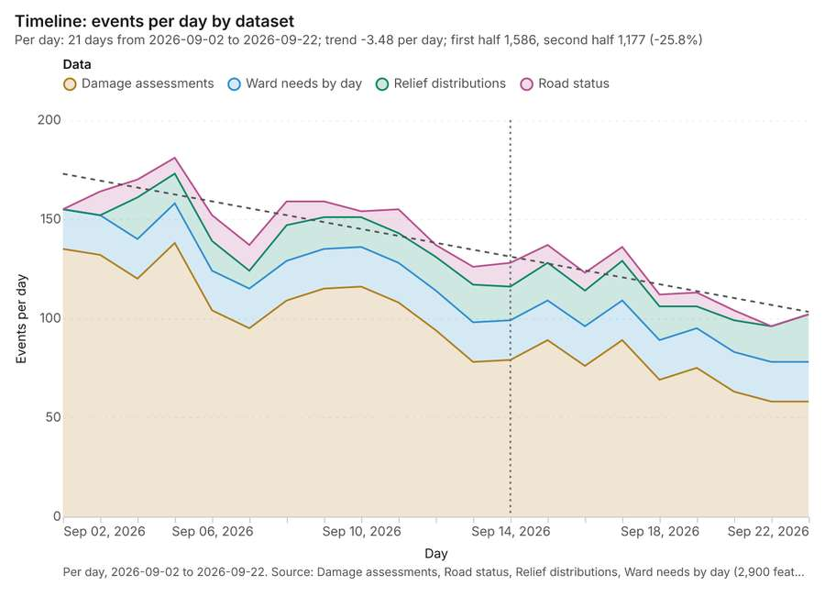
Figure 1. Timeline: events per day by dataset [1]. Per day, 2026-09-02 to 2026-09-22. Source: Damage assessments, Road status, Relief distributions, Ward needs by day (2,900 features). Dotted lines mark dates named in the project's documents. The data is in the appendix.
The timeline counts 2,900 dated events in Damage assessments, Road status, Relief distributions and 1 more per day, from 2026-09-02 to 2026-09-22 [1][2][3][4][5]. By dataset: Damage assessments 2,000; Ward needs by day 420; Relief distributions 320; Road status 160 [1]. The trend is -3.48 events per day; the second half of the days has 1,177 against 1,586 in the first (-25.8%) [1]. The project's documents name 1 date inside this span, drawn as dotted lines; the most named is 2026-09-14 (Situation report No [6]. 4, page 1, 1 mention) [6].
Busiest days
- 2026-09-05: 181 events [1]
- 2026-09-04: 170 events [1]
- 2026-09-03: 164 events [1]
Quietest days
- 2026-09-21: 96 events [1]
- 2026-09-22: 102 events [1]
- 2026-09-20: 104 events [1]

Hot spots
What this analysis is. Hot spot analysis: Getis-Ord Gi* hot and cold spots with z-scores, p-values and confidence bins [7]. In ArcGIS it is Find Hot Spots or Hot Spot Analysis (Getis-Ord Gi*); in QGIS, qgis:hotspot (plugin) [7].
Why it was run on this data. 320 points: Getis-Ord Gi* tests whether the concentrations in Relief distributions are statistically significant [8].
What it found. Hot spot analysis was performed using the Relief distributions layer [10]. The resulting analysis generated 320 features [9] and took 5 milliseconds to complete [9]. The total billing cost for this operation was 0.0564 [9].
Result | Value
result, count | 320
result, elapsed ms | 5
result, excluded null | 0
result, distance band m | 1,000
billing, cost | 0.0564
billing, list price | 0.0564
billing, upstream cost | 0

Findings
- Evidenced: Hot spots on Relief distributions: Hot spot analysis: 1 layer saved: Hot spot analysis: Relief distributions (320 features) [9][10].
- Evidenced: It reported result, count 320; result, elapsed ms 5; result, excluded null 0; result, distance band m 1,000; billing, cost 0.0564; billing, list price 0.0564 [9].
Tool gp_hot_spots; parameters {"field": "households_served", "project": "affd1e20-248c-4f96-b09d-48d3027477be", "features": {"layer": "Relief distributions (83cbe688)"}, "aggregation": "hexagon", "cell_size_m": 1000.0, "distance_band_m": 1000.0}

Hot spots
What this analysis is. Hot spot analysis: Getis-Ord Gi* hot and cold spots with z-scores, p-values and confidence bins [7]. In ArcGIS it is Find Hot Spots or Hot Spot Analysis (Getis-Ord Gi*); in QGIS, qgis:hotspot (plugin) [7].
Why it was run on this data. 60 points: Getis-Ord Gi* tests whether the concentrations in Water points are statistically significant [11].
What it found. The hot spot analysis used "Water points" as its input [13]. The process saved one layer titled "Hot spot analysis: Water points (20 features)" [12]. Results for the analysis indicated 20 bins and 20 counts, based on a cell size of 2,000 m [12]. The final billing cost associated with this analysis was 0.0512 [12].
Result | Value
result, bins | 20
result, count | 20
result, elapsed ms | 3
result, cell size m | 2,000
result, incidents used | 60
result, distance band m | 2,000
billing, cost | 0.0512
billing, list price | 0.0512
billing, upstream cost | 0

Findings
- Evidenced: Hot spots on Water points: Hot spot analysis: 1 layer saved: Hot spot analysis: Water points (20 features) [12][13].
- Evidenced: It reported result, bins 20; result, count 20; result, elapsed ms 3; result, cell size m 2,000; result, incidents used 60; result, distance band m 2,000 [12].
Tool gp_hot_spots; parameters {"project": "affd1e20-248c-4f96-b09d-48d3027477be", "features": {"layer": "Water points (2a061d8c)"}, "aggregation": "hexagon", "cell_size_m": 2000.0, "distance_band_m": 2000.0}

Hot spots
What this analysis is. Hot spot analysis: Getis-Ord Gi* hot and cold spots with z-scores, p-values and confidence bins [7]. In ArcGIS it is Find Hot Spots or Hot Spot Analysis (Getis-Ord Gi*); in QGIS, qgis:hotspot (plugin) [7].
Why it was run on this data. 2000 points: Getis-Ord Gi* tests whether the concentrations in Damage assessments are statistically significant [14].
What it found. The hot spot analysis successfully generated one saved layer titled "Hot spot analysis: Damage assessments" [15].
Result | Value
result, count | 2,000
result, elapsed ms | 35
result, excluded null | 0
result, distance band m | 500
billing, cost | 0.09
billing, list price | 0.09
billing, upstream cost | 0

Findings
- Evidenced: Hot spots on Damage assessments: Hot spot analysis: 1 layer saved: Hot spot analysis: Damage assessments (2000 features) [15][16].
- Evidenced: It reported result, count 2,000; result, elapsed ms 35; result, excluded null 0; result, distance band m 500; billing, cost 0.09; billing, list price 0.09 [15].
Tool gp_hot_spots; parameters {"field": "people_displaced", "project": "affd1e20-248c-4f96-b09d-48d3027477be", "features": {"layer": "Damage assessments (26bd99f3)"}, "aggregation": "hexagon", "cell_size_m": 500.0, "distance_band_m": 500.0}

Space time hot spots
What this analysis is. Emerging hot spots: Where hot spots are new, consecutive, intensifying, persistent, diminishing, sporadic, oscillating or historical over time [17]. In ArcGIS it is Emerging Hot Spot Analysis or Create Space Time Cube [17].
Why it was run on this data. Relief distributions carry dates in 'date': emerging hot spot analysis finds new, intensifying and fading hot spots per day [18].
What it found. Space time hot spots on Relief distributions: Emerging hot spots: 1 layer saved: Emerging hot spots: Relief distributions (54 features) [10][19]. It reported result, count 54; result, elapsed ms 10; result, resolution 8; result, features used 320; result, time neighbors 0; billing, cost 0.116 [19].
Result | Value
result, count | 54
result, elapsed ms | 10
result, resolution | 8
result, features used | 320
result, time neighbors | 0
billing, cost | 0.116
billing, list price | 0.116
billing, upstream cost | 0

Findings
- Evidenced: Space time hot spots on Relief distributions: Emerging hot spots: 1 layer saved: Emerging hot spots: Relief distributions (54 features) [10][19].
- Evidenced: It reported result, count 54; result, elapsed ms 10; result, resolution 8; result, features used 320; result, time neighbors 0; billing, cost 0.116 [19].
Tool gp_space_time_hot_spots; parameters {"agg": "sum", "project": "affd1e20-248c-4f96-b09d-48d3027477be", "features": {"layer": "Relief distributions (83cbe688)"}, "interval": "day", "bin_shape": "h3", "resolution": 8, "time_field": "date", "value_field": "households_served"}

Space time hot spots
What this analysis is. Emerging hot spots: Where hot spots are new, consecutive, intensifying, persistent, diminishing, sporadic, oscillating or historical over time [17]. In ArcGIS it is Emerging Hot Spot Analysis or Create Space Time Cube [17].
Why it was run on this data. Damage assessments carry dates in 'assessed_at': emerging hot spot analysis finds new, intensifying and fading hot spots per day [20].
What it found. Space time hot spots on Damage assessments: Emerging hot spots: 1 layer saved: Emerging hot spots: Damage assessments (87 features) [16][21]. It reported result, count 87; result, elapsed ms 18; result, resolution 8; result, features used 2,000; result, time neighbors 0; billing, cost 0.2 [21].
Result | Value
result, count | 87
result, elapsed ms | 18
result, resolution | 8
result, features used | 2,000
result, time neighbors | 0
billing, cost | 0.2
billing, list price | 0.2
billing, upstream cost | 0

Findings
- Evidenced: Space time hot spots on Damage assessments: Emerging hot spots: 1 layer saved: Emerging hot spots: Damage assessments (87 features) [16][21].
- Evidenced: It reported result, count 87; result, elapsed ms 18; result, resolution 8; result, features used 2,000; result, time neighbors 0; billing, cost 0.2 [21].
Tool gp_space_time_hot_spots; parameters {"agg": "sum", "project": "affd1e20-248c-4f96-b09d-48d3027477be", "features": {"layer": "Damage assessments (26bd99f3)"}, "interval": "day", "bin_shape": "h3", "resolution": 8, "time_field": "assessed_at", "value_field": "people_displaced"}

Near repeat
What this analysis is. Repeat and near repeat classification: Classify incidents as originators, repeats (same place) or near repeats within a distance and time window, with a Knox test table [22]. In ArcGIS it is Repeat and Near Repeat Classification or Near Repeat Calculator [22].
Why it was run on this data. Near repeat analysis tests whether Relief distributions close in space also follow each other within 3 days [23].
What it found. Near repeat on Relief distributions: Repeat and near repeat classification: 1 layer saved: Repeat and near repeat classification: Relief distributions (320 features) [10][24]. It reported result, days 3; result, count 320; result, chains 41; result, distance m 500; result, elapsed ms 13; result, pairs linked 742 [24].
Result | Value
result, days | 3
result, count | 320
result, chains | 41
result, distance m | 500
result, elapsed ms | 13
result, pairs linked | 742
billing, cost | 0.0596
billing, list price | 0.0596
billing, upstream cost | 0

Findings
- Evidenced: Near repeat on Relief distributions: Repeat and near repeat classification: 1 layer saved: Repeat and near repeat classification: Relief distributions (320 features) [10][24].
- Evidenced: It reported result, days 3; result, count 320; result, chains 41; result, distance m 500; result, elapsed ms 13; result, pairs linked 742 [24].
Tool gp_near_repeat; parameters {"days": 3, "project": "affd1e20-248c-4f96-b09d-48d3027477be", "features": {"layer": "Relief distributions (83cbe688)"}, "distance_m": 500.0, "time_field": "date"}

Summarize within
What this analysis is. Summarize within: Count and aggregate the features inside each polygon (or bin), proportionally for lines and polygons [25]. In ArcGIS it is Summarize Within or Aggregate Points; in QGIS, native:countpointsinpolygon or native:sumlinelengths [25].
Why it was run on this data. Count Shelters inside each feature of Wards by type; the counts map as a choropleth (natural breaks, sequential colors) [26].
What it found. Summarize within on Shelters, Wards: Summarize within: 1 layer saved: Summarize within: Wards (20 features) [27][28][29]. It reported result, count 20; result, elapsed ms 0; billing, cost 0.01092; billing, list price 0.01092; billing, upstream cost 0 [27].
Result | Value
result, count | 20
result, elapsed ms | 0
billing, cost | 0.01092
billing, list price | 0.01092
billing, upstream cost | 0

Findings
- Evidenced: Summarize within on Shelters, Wards: Summarize within: 1 layer saved: Summarize within: Wards (20 features) [27][28][29].
- Evidenced: It reported result, count 20; result, elapsed ms 0; billing, cost 0.01092; billing, list price 0.01092; billing, upstream cost 0 [27].
Tool gp_summarize_within; parameters {"stats": [{"stat": "sum", "field": "capacity"}], "project": "affd1e20-248c-4f96-b09d-48d3027477be", "features": {"layer": "Shelters (ee1b31b2)"}, "group_by": "type", "polygons": {"layer": "Wards (b338e26e)"}}

Summarize within
What this analysis is. Summarize within: Count and aggregate the features inside each polygon (or bin), proportionally for lines and polygons [25]. In ArcGIS it is Summarize Within or Aggregate Points; in QGIS, native:countpointsinpolygon or native:sumlinelengths [25].
Why it was run on this data. Count Shelters inside each feature of Wards by type; the counts map as a choropleth (natural breaks, sequential colors) [26].
What it found. Summarize within on Relief distributions, Wards: Summarize within: 1 layer saved: Summarize within: Wards (20 features) [10][29][30]. It reported result, count 20; result, elapsed ms 1; billing, cost 0.01682; billing, list price 0.01682; billing, upstream cost 0 [30].
Result | Value
result, count | 20
result, elapsed ms | 1
billing, cost | 0.01682
billing, list price | 0.01682
billing, upstream cost | 0

Findings
- Evidenced: Summarize within on Relief distributions, Wards: Summarize within: 1 layer saved: Summarize within: Wards (20 features) [10][29][30].
- Evidenced: It reported result, count 20; result, elapsed ms 1; billing, cost 0.01682; billing, list price 0.01682; billing, upstream cost 0 [30].
Tool gp_summarize_within; parameters {"stats": [{"stat": "sum", "field": "households_served"}], "project": "affd1e20-248c-4f96-b09d-48d3027477be", "features": {"layer": "Relief distributions (83cbe688)"}, "group_by": "item", "polygons": {"layer": "Wards (b338e26e)"}}

Summarize within
What this analysis is. Summarize within: Count and aggregate the features inside each polygon (or bin), proportionally for lines and polygons [25]. In ArcGIS it is Summarize Within or Aggregate Points; in QGIS, native:countpointsinpolygon or native:sumlinelengths [25].
Why it was run on this data. Count Shelters inside each feature of Wards by type; the counts map as a choropleth (natural breaks, sequential colors) [26].
What it found. Summarize within on Health posts, Wards: Summarize within: 1 layer saved: Summarize within: Wards (20 features) [29][31][32]. It reported result, count 20; result, elapsed ms 0; billing, cost 0.01082; billing, list price 0.01082; billing, upstream cost 0 [31].
Result | Value
result, count | 20
result, elapsed ms | 0
billing, cost | 0.01082
billing, list price | 0.01082
billing, upstream cost | 0

Findings
- Evidenced: Summarize within on Health posts, Wards: Summarize within: 1 layer saved: Summarize within: Wards (20 features) [29][31][32].
- Evidenced: It reported result, count 20; result, elapsed ms 0; billing, cost 0.01082; billing, list price 0.01082; billing, upstream cost 0 [31].
Tool gp_summarize_within; parameters {"stats": [{"stat": "sum", "field": "beds"}], "project": "affd1e20-248c-4f96-b09d-48d3027477be", "features": {"layer": "Health posts (7aed59a8)"}, "group_by": "functional", "polygons": {"layer": "Wards (b338e26e)"}}

Find point clusters
What this analysis is. Find point clusters: Density-based clusters (DBSCAN, HDBSCAN or OPTICS, optionally space-time) with hulls and noise [33]. In ArcGIS it is Find Point Clusters or Density-based Clustering; in QGIS, native:dbscanclustering or native:stdbscanclustering [33].
Why it was run on this data. DBSCAN finds dense groups of Shelters and separates noise [34].
What it found. The `gp_find_point_clusters` tool was used on the Shelters data [28] to identify point clusters. The process resulted in a count of 25 clusters and 2 noise points [35]. The output contained 2 layers, specifically listing "Shelters (25 features)" and "cluster hulls (1 feature)" [35]. The computation was efficient, completing in an elapsed time of 4 ms [35].
Result | Value
result, count | 25
result, noise | 2
result, distance m | 2,000
result, elapsed ms | 4
result, min points | 3
billing, cost | 0.0505
billing, list price | 0.0505
billing, upstream cost | 0

Findings
- Evidenced: Find point clusters on Shelters: Find point clusters: 2 layers saved: Find point clusters: Shelters (25 features); Find point clusters: cluster hulls (1 feature) [28][35].
- Evidenced: It reported result, count 25; result, noise 2; result, distance m 2,000; result, elapsed ms 4; result, min points 3; billing, cost 0.0505 [35].
Tool gp_find_point_clusters; parameters {"method": "dbscan", "project": "affd1e20-248c-4f96-b09d-48d3027477be", "features": {"layer": "Shelters (ee1b31b2)"}, "distance_m": 2000.0, "min_points": 3}

Find point clusters
What this analysis is. Find point clusters: Density-based clusters (DBSCAN, HDBSCAN or OPTICS, optionally space-time) with hulls and noise [33]. In ArcGIS it is Find Point Clusters or Density-based Clustering; in QGIS, native:dbscanclustering or native:stdbscanclustering [33].
Why it was run on this data. DBSCAN finds dense groups of Relief distributions and separates noise [36].
What it found. Find point clusters on Relief distributions: Find point clusters: 2 layers saved: Find point clusters: Relief distributions (320 features); Find point clusters: cluster hulls (21 features) [10][37]. It reported result, count 320; result, noise 12; result, distance m 500; result, elapsed ms 10; result, min points 8; billing, cost 0.0564 [37].
Result | Value
result, count | 320
result, noise | 12
result, distance m | 500
result, elapsed ms | 10
result, min points | 8
billing, cost | 0.0564
billing, list price | 0.0564
billing, upstream cost | 0

Findings
- Evidenced: Find point clusters on Relief distributions: Find point clusters: 2 layers saved: Find point clusters: Relief distributions (320 features); Find point clusters: cluster hulls (21 features) [10][37].
- Evidenced: It reported result, count 320; result, noise 12; result, distance m 500; result, elapsed ms 10; result, min points 8; billing, cost 0.0564 [37].
Tool gp_find_point_clusters; parameters {"method": "dbscan", "project": "affd1e20-248c-4f96-b09d-48d3027477be", "features": {"layer": "Relief distributions (83cbe688)"}, "distance_m": 500.0, "min_points": 8}

Find point clusters
What this analysis is. Find point clusters: Density-based clusters (DBSCAN, HDBSCAN or OPTICS, optionally space-time) with hulls and noise [33]. In ArcGIS it is Find Point Clusters or Density-based Clustering; in QGIS, native:dbscanclustering or native:stdbscanclustering [33].
Why it was run on this data. DBSCAN finds dense groups of Health posts and separates noise [38].
What it found. Find point clusters on Health posts: Find point clusters: 2 layers saved: Find point clusters: Health posts (20 features); Find point clusters: cluster hulls (2 features) [32][39]. It reported result, count 20; result, noise 1; result, distance m 2,000; result, elapsed ms 1; result, min points 3; billing, cost 0.0504 [39].
Result | Value
result, count | 20
result, noise | 1
result, distance m | 2,000
result, elapsed ms | 1
result, min points | 3
billing, cost | 0.0504
billing, list price | 0.0504
billing, upstream cost | 0

Findings
- Evidenced: Find point clusters on Health posts: Find point clusters: 2 layers saved: Find point clusters: Health posts (20 features); Find point clusters: cluster hulls (2 features) [32][39].
- Evidenced: It reported result, count 20; result, noise 1; result, distance m 2,000; result, elapsed ms 1; result, min points 3; billing, cost 0.0504 [39].
Tool gp_find_point_clusters; parameters {"method": "dbscan", "project": "affd1e20-248c-4f96-b09d-48d3027477be", "features": {"layer": "Health posts (7aed59a8)"}, "distance_m": 2000.0, "min_points": 3}

Calculate density
What this analysis is. Calculate density: Kernel density per square kilometer on a grid [40]. In ArcGIS it is Calculate Density or Kernel Density; in QGIS, native:heatmapkerneldensityestimation [40].
Why it was run on this data. 25 points in Shelters: a density surface shows where they concentrate [41].
What it found. Calculate density on Shelters: Calculate density: 1 layer saved: Calculate density: Shelters (90 features) [28][42]. It reported result, count 90; result, elapsed ms 4; result, bandwidth m 2,000; result, cell size m 1,000; result, excluded null 0; result, max density per km2 0.8364 [42].
Result | Value
result, count | 90
result, elapsed ms | 4
result, bandwidth m | 2,000
result, cell size m | 1,000
result, excluded null | 0
result, max density per km2 | 0.8364
billing, cost | 0.0505
billing, list price | 0.0505
billing, upstream cost | 0

Findings
- Evidenced: Calculate density on Shelters: Calculate density: 1 layer saved: Calculate density: Shelters (90 features) [28][42].
- Evidenced: It reported result, count 90; result, elapsed ms 4; result, bandwidth m 2,000; result, cell size m 1,000; result, excluded null 0; result, max density per km2 0.8364 [42].
Tool gp_calculate_density; parameters {"kernel": "quartic", "project": "affd1e20-248c-4f96-b09d-48d3027477be", "features": {"layer": "Shelters (ee1b31b2)"}, "bandwidth_m": 2000.0, "cell_size_m": 1000.0}

Calculate density
What this analysis is. Calculate density: Kernel density per square kilometer on a grid [40]. In ArcGIS it is Calculate Density or Kernel Density; in QGIS, native:heatmapkerneldensityestimation [40].
Why it was run on this data. 320 points in Relief distributions: a density surface shows where they concentrate [43].
What it found. Calculate density on Relief distributions: Calculate density: 1 layer saved: Calculate density: Relief distributions (222 features) [10][44]. It reported result, count 222; result, elapsed ms 7; result, bandwidth m 1,000; result, cell size m 500; result, excluded null 0; result, max density per km2 5,070 [44].
Result | Value
result, count | 222
result, elapsed ms | 7
result, bandwidth m | 1,000
result, cell size m | 500
result, excluded null | 0
result, max density per km2 | 5,070
billing, cost | 0.0564
billing, list price | 0.0564
billing, upstream cost | 0

Findings
- Evidenced: Calculate density on Relief distributions: Calculate density: 1 layer saved: Calculate density: Relief distributions (222 features) [10][44].
- Evidenced: It reported result, count 222; result, elapsed ms 7; result, bandwidth m 1,000; result, cell size m 500; result, excluded null 0; result, max density per km2 5,070 [44].
Tool gp_calculate_density; parameters {"kernel": "quartic", "project": "affd1e20-248c-4f96-b09d-48d3027477be", "features": {"layer": "Relief distributions (83cbe688)"}, "bandwidth_m": 1000.0, "cell_size_m": 500.0, "weight_field": "households_served"}

Calculate density
What this analysis is. Calculate density: Kernel density per square kilometer on a grid [40]. In ArcGIS it is Calculate Density or Kernel Density; in QGIS, native:heatmapkerneldensityestimation [40].
Why it was run on this data. 20 points in Health posts: a density surface shows where they concentrate [45].
What it found. The density was calculated using the `gp_calculate_density` tool [46], processing the Health posts layer [32] across 228 features [46].
Result | Value
result, count | 228
result, elapsed ms | 6
result, bandwidth m | 5,000
result, cell size m | 1,000
result, excluded null | 0
result, max density per km2 | 6.578
billing, cost | 0.0504
billing, list price | 0.0504
billing, upstream cost | 0

Findings
- Evidenced: Calculate density on Health posts: Calculate density: 1 layer saved: Calculate density: Health posts (228 features) [32][46].
- Evidenced: It reported result, count 228; result, elapsed ms 6; result, bandwidth m 5,000; result, cell size m 1,000; result, excluded null 0; result, max density per km2 6.578 [46].
Tool gp_calculate_density; parameters {"kernel": "quartic", "project": "affd1e20-248c-4f96-b09d-48d3027477be", "features": {"layer": "Health posts (7aed59a8)"}, "bandwidth_m": 5000.0, "cell_size_m": 1000.0, "weight_field": "beds"}

Outliers
What this analysis is. Find outliers: Anselin local Moran’s I: HH, LL clusters and HL, LH outliers [47]. In ArcGIS it is Find Outliers or Cluster and Outlier Analysis (Anselin Local Moran’s I) [47].
Why it was run on this data. Local Moran's I maps clusters and outliers of 'population' [48].
What it found. Outliers on Wards: Find outliers: 1 layer saved: Find outliers: Wards (20 features) [29][49]. It reported result, count 20; result, elapsed ms 4; result, permutations 199; result, excluded null 0; result, distance band m 1,735; billing, cost 0.0506 [49].
Result | Value
result, count | 20
result, elapsed ms | 4
result, permutations | 199
result, excluded null | 0
result, distance band m | 1,735
billing, cost | 0.0506
billing, list price | 0.0506
billing, upstream cost | 0

Findings
- Evidenced: Outliers on Wards: Find outliers: 1 layer saved: Find outliers: Wards (20 features) [29][49].
- Evidenced: It reported result, count 20; result, elapsed ms 4; result, permutations 199; result, excluded null 0; result, distance band m 1,735; billing, cost 0.0506 [49].
Tool gp_outliers; parameters {"field": "population", "project": "affd1e20-248c-4f96-b09d-48d3027477be", "features": {"layer": "Wards (b338e26e)"}, "aggregation": "hexagon"}

Maps and charts
The run also made 20 map image(s) [50][51][52][53][54][55][56][57][58][59][60][61][62][63][64][65][66][67][68][69] and 26 chart(s) [70][71][72][73][74][75][76][77][78][79][80][81][82][83][84][85][86][87][88][89][90][91][92][93][94][95].
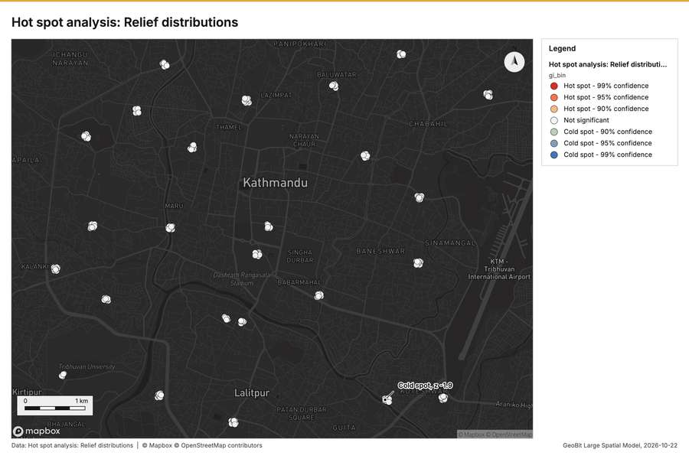
Figure 2. Hot spot analysis: Relief distributions [50]
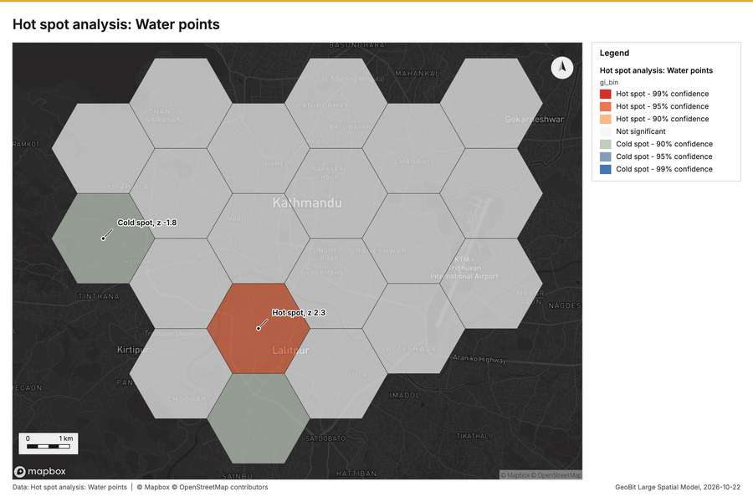
Figure 3. Hot spot analysis: Water points [51]
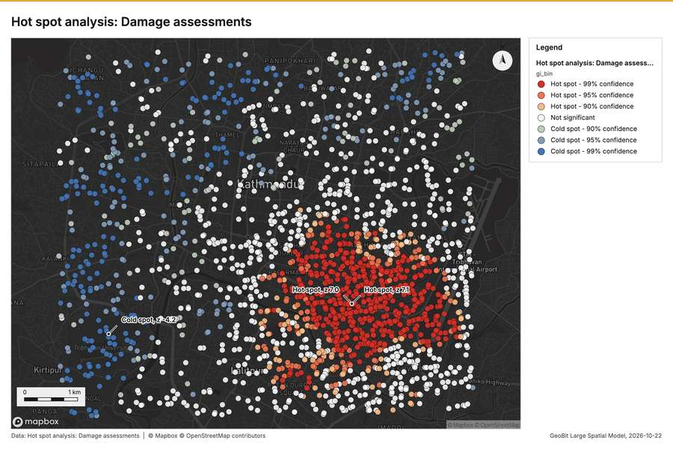
Figure 4. Hot spot analysis: Damage assessments [52]
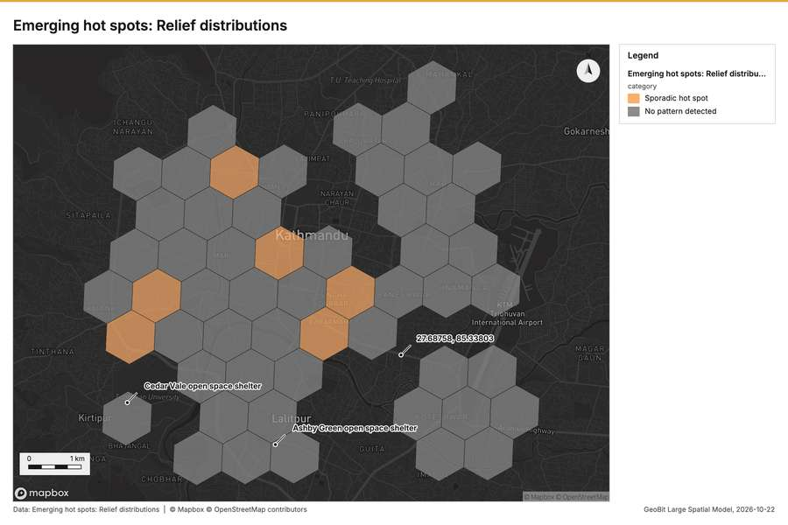
Figure 5. Emerging hot spots: Relief distributions [53]
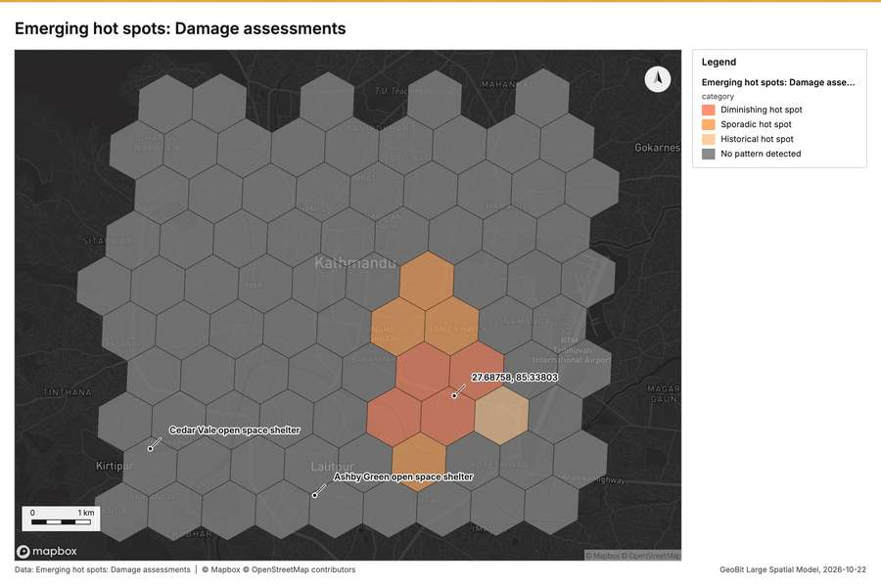
Figure 6. Emerging hot spots: Damage assessments [54]
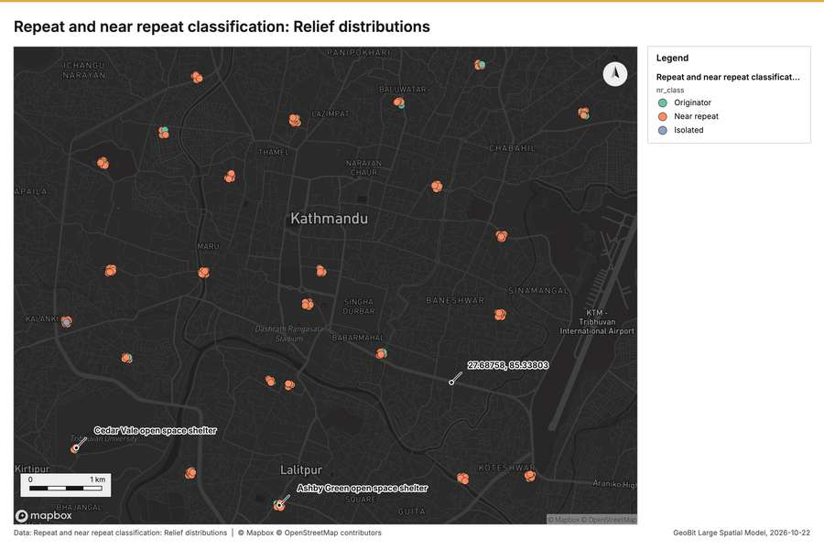
Figure 7. Repeat and near repeat classification: Relief distributions [55]
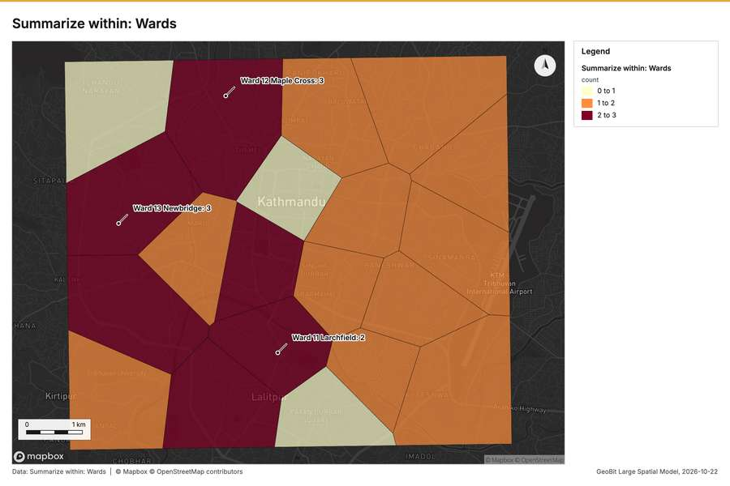
Figure 8. Summarize within: Wards [56]
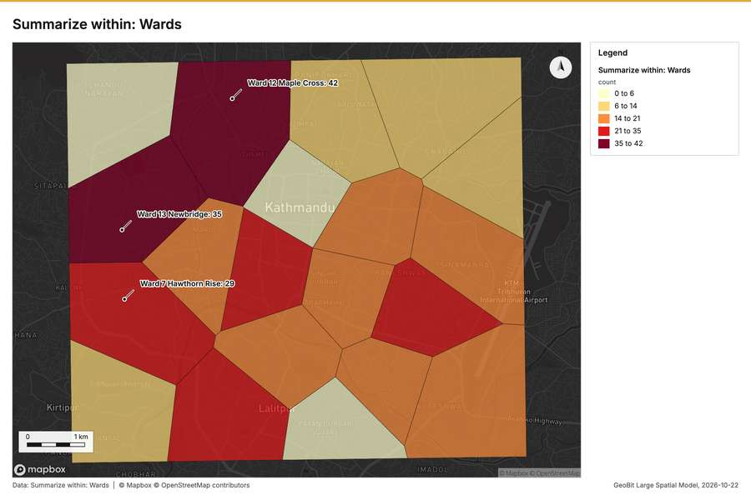
Figure 9. Summarize within: Wards [57]
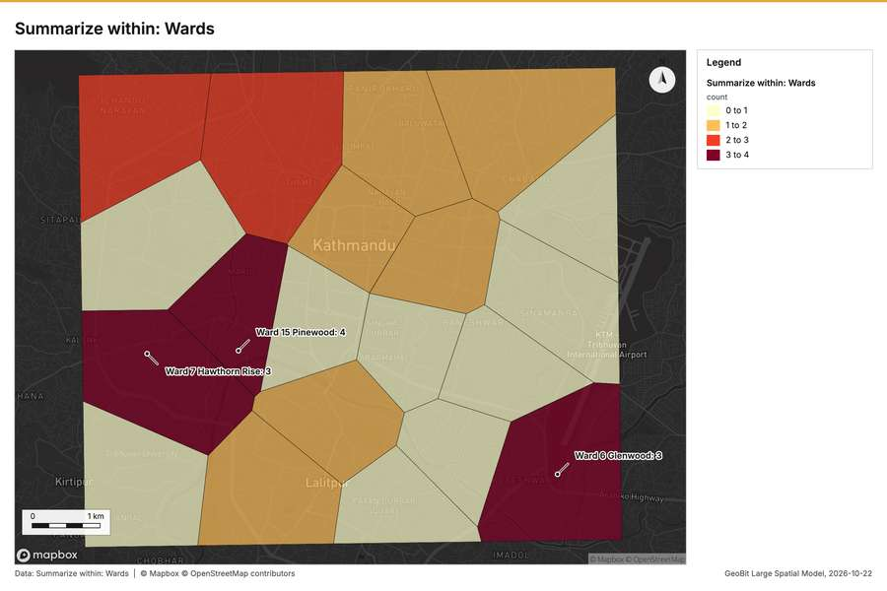
Figure 10. Summarize within: Wards [58]
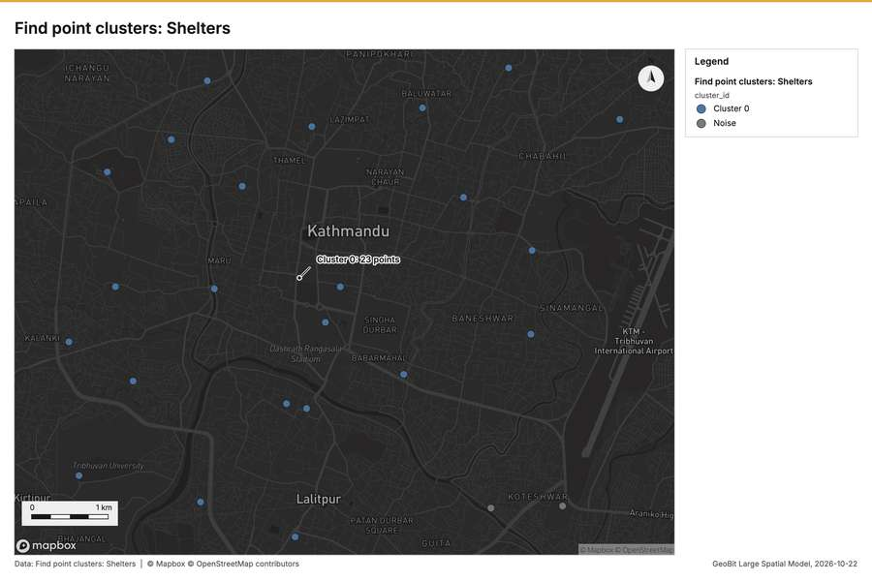
Figure 11. Find point clusters: Shelters [59]
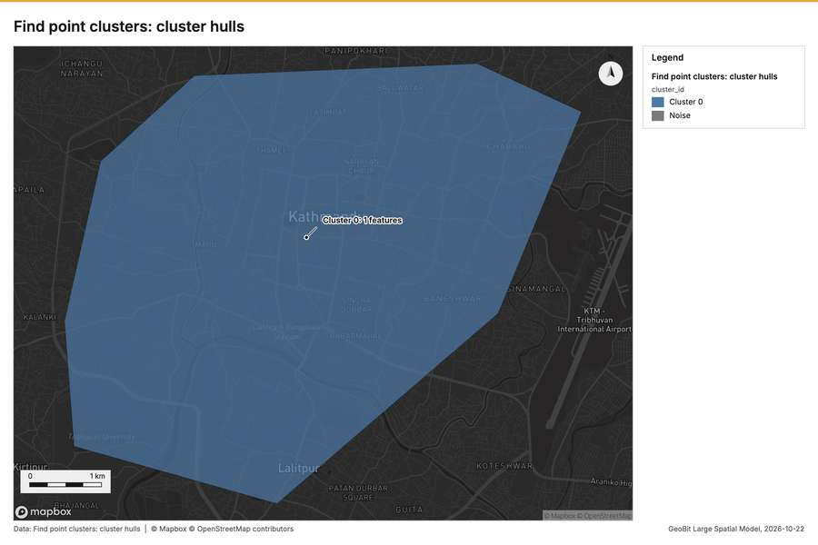
Figure 12. Find point clusters: cluster hulls [60]
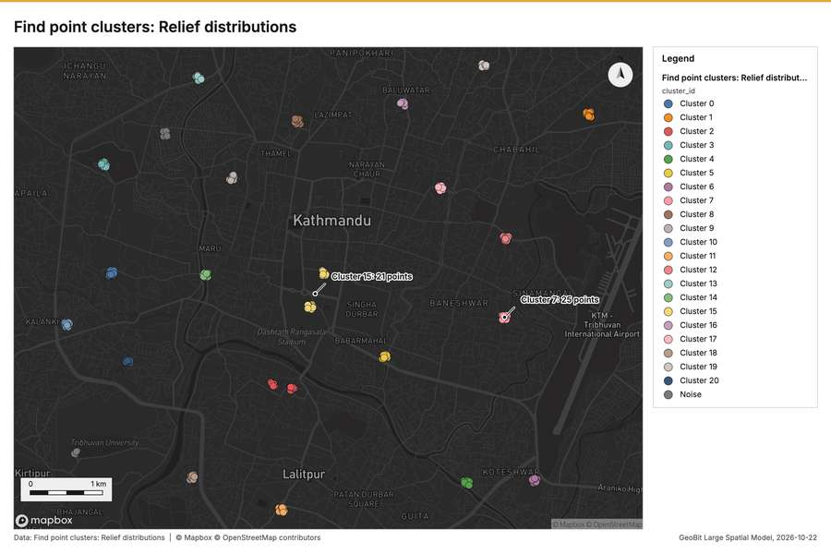
Figure 13. Find point clusters: Relief distributions [61]
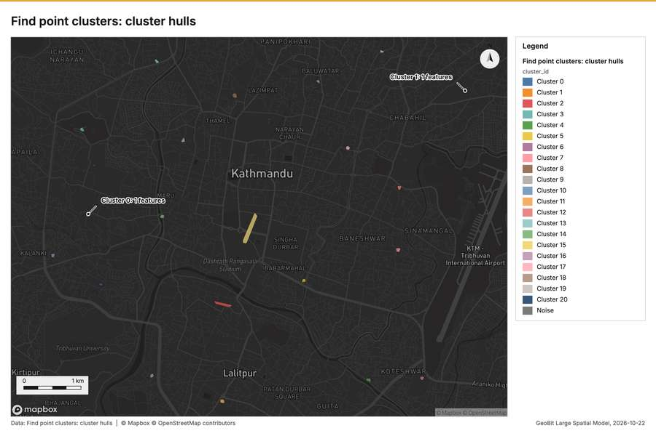
Figure 14. Find point clusters: cluster hulls [62]
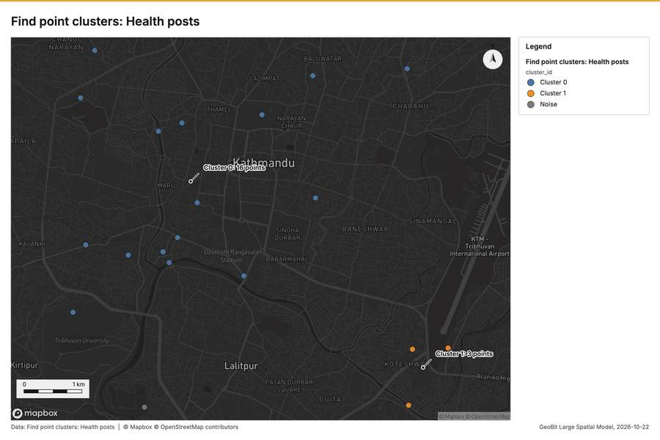
Figure 15. Find point clusters: Health posts [63]
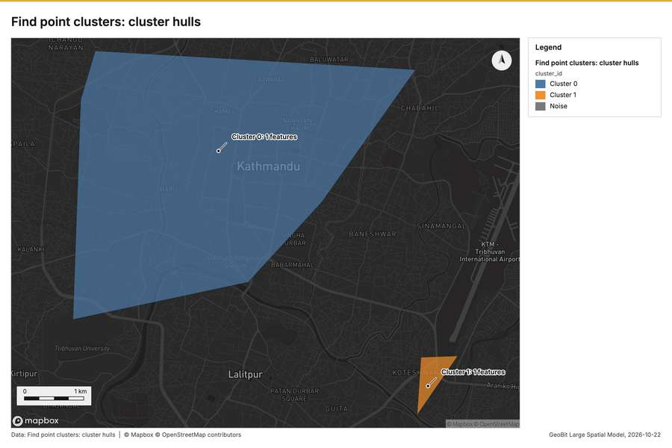
Figure 16. Find point clusters: cluster hulls [64]
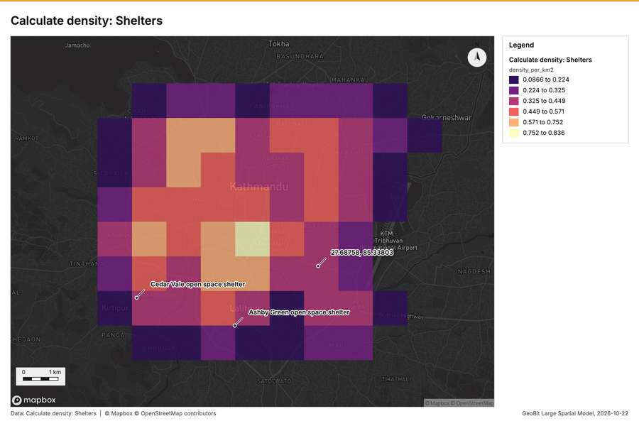
Figure 17. Calculate density: Shelters [65]
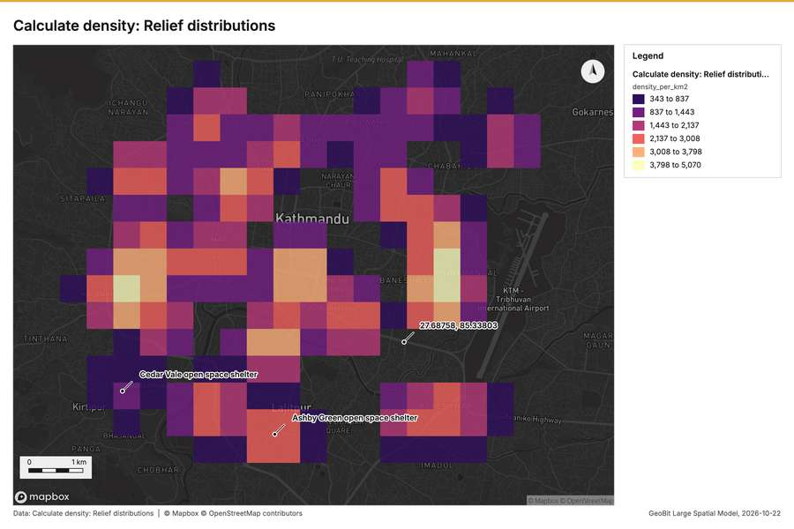
Figure 18. Calculate density: Relief distributions [66]
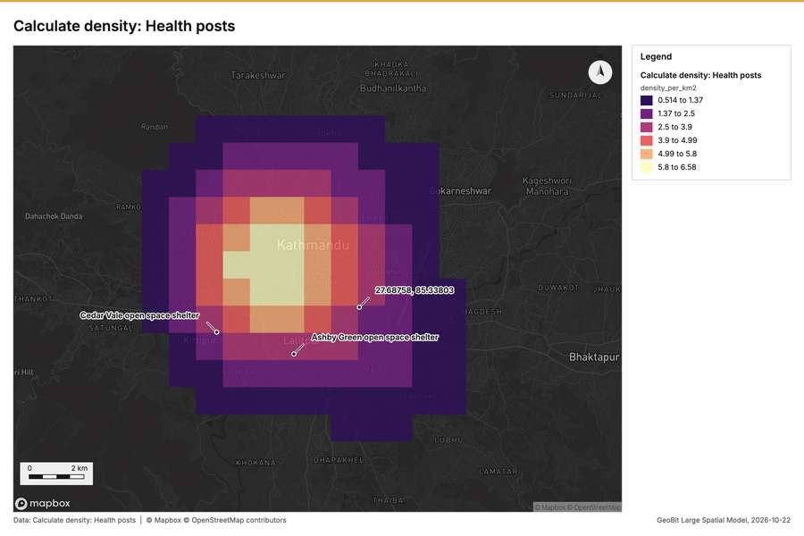
Figure 19. Calculate density: Health posts [67]
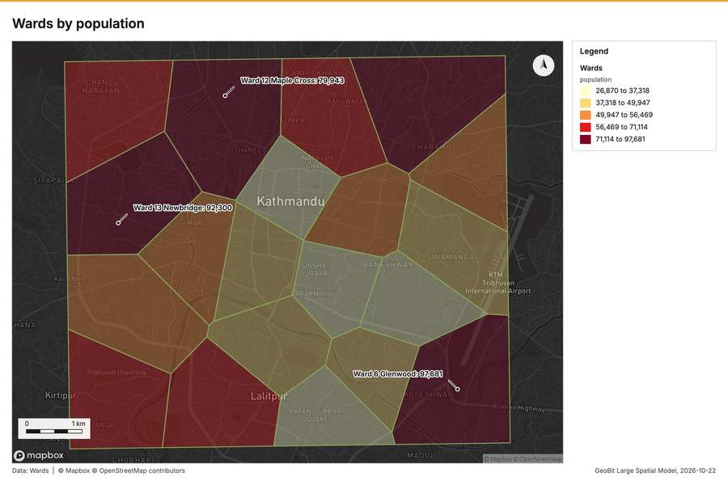
Figure 20. Wards by population [68]
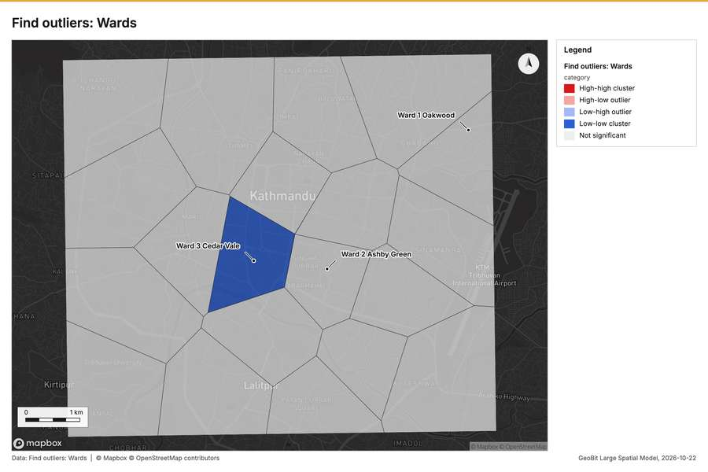
Figure 21. Find outliers: Wards [69]
What the map shows. The map illustrates the results of an emerging hot spot analysis for relief distributions, categorizing areas based on detected patterns. The legend indicates that "Sporadic hot spot" areas are colored orange, while regions with "No pattern detected" are [53]
Inferred: read from the image by gemma4:e4b, not evidence.
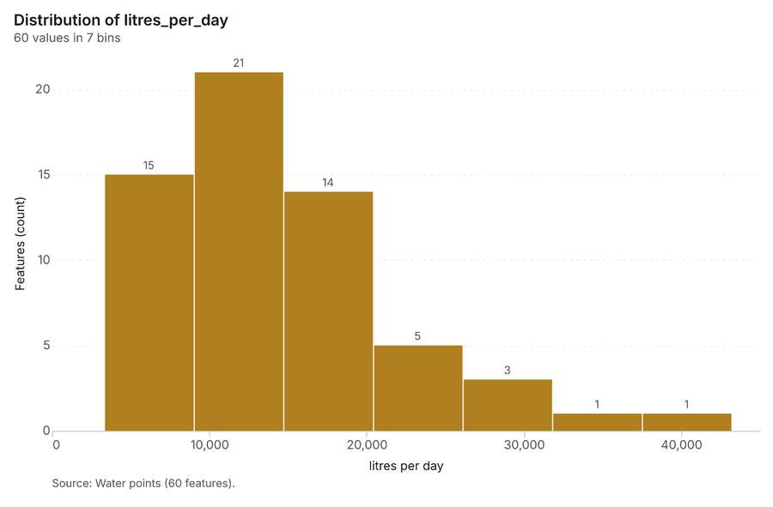
Figure 22. Water points over time (litres_per_day) [70]. Source: Water points (60 features). The data is in the appendix.
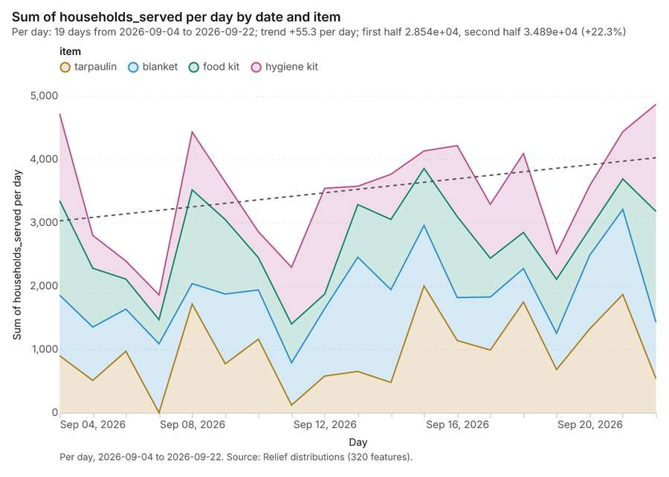
Figure 23. Relief distributions over time (date) [71]. Per day, 2026-09-04 to 2026-09-22. Source: Relief distributions (320 features). The data is in the appendix.
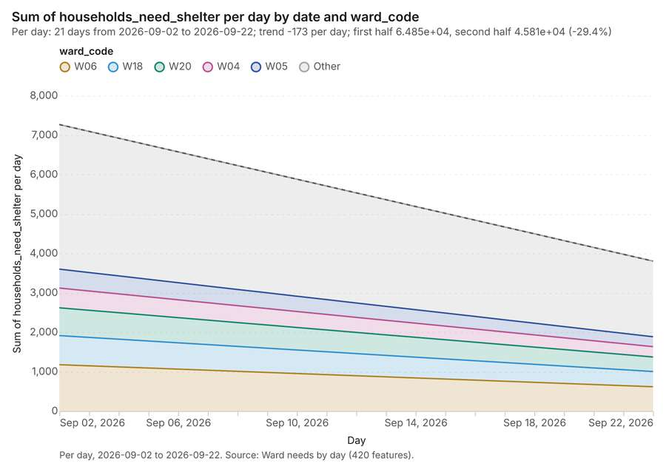
Figure 24. Ward needs by day over time (date) [72]. Per day, 2026-09-02 to 2026-09-22. Source: Ward needs by day (420 features). The data is in the appendix.
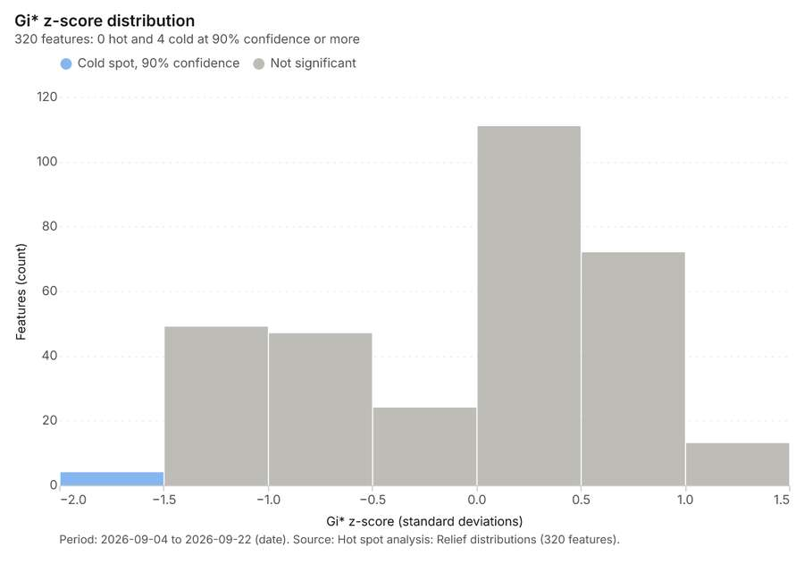
Figure 25. Hot spot analysis: Relief distributions [73]. Period: 2026-09-04 to 2026-09-22 (date). Source: Hot spot analysis: Relief distributions (320 features). The data is in the appendix.
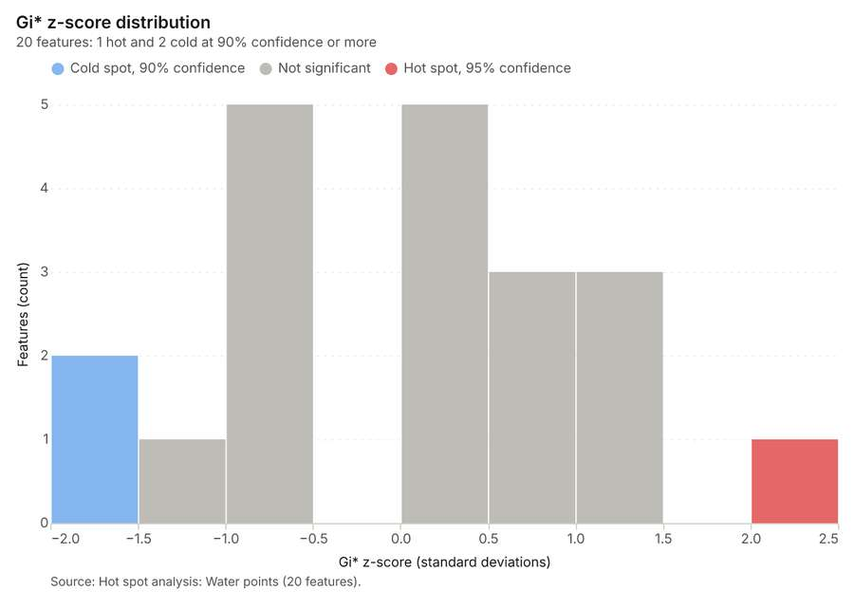
Figure 26. Hot spot analysis: Water points [74]. Source: Hot spot analysis: Water points (20 features). The data is in the appendix.
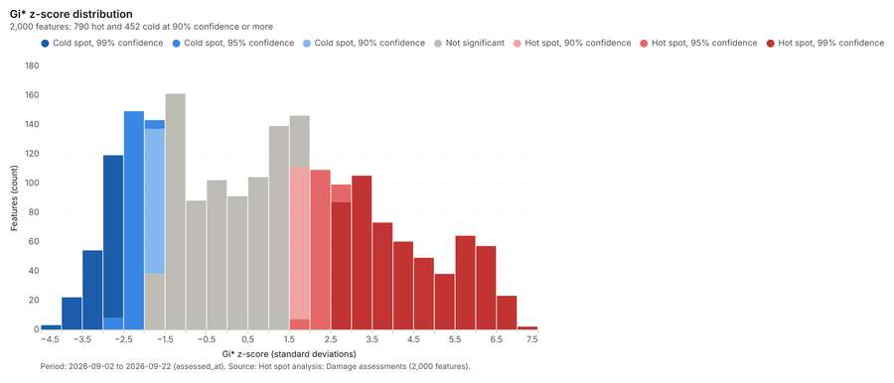
Figure 27. Hot spot analysis: Damage assessments [75]. Period: 2026-09-02 to 2026-09-22 (assessed_at). Source: Hot spot analysis: Damage assessments (2,000 features). The data is in the appendix.
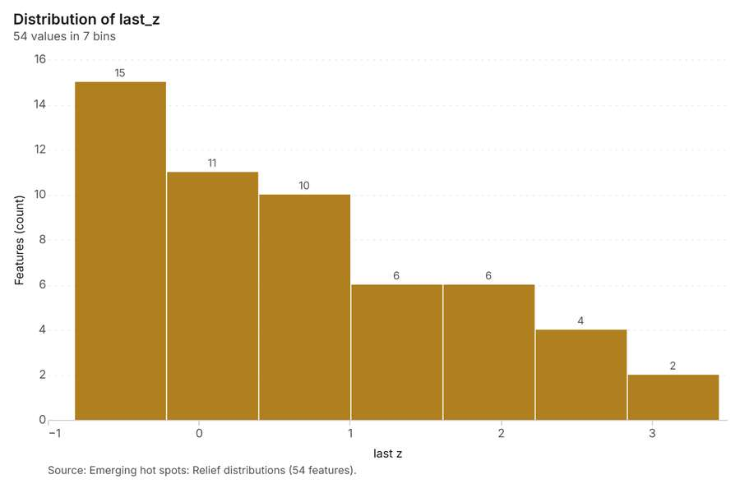
Figure 28. Emerging hot spots: Relief distributions [76]. Source: Emerging hot spots: Relief distributions (54 features). The data is in the appendix.
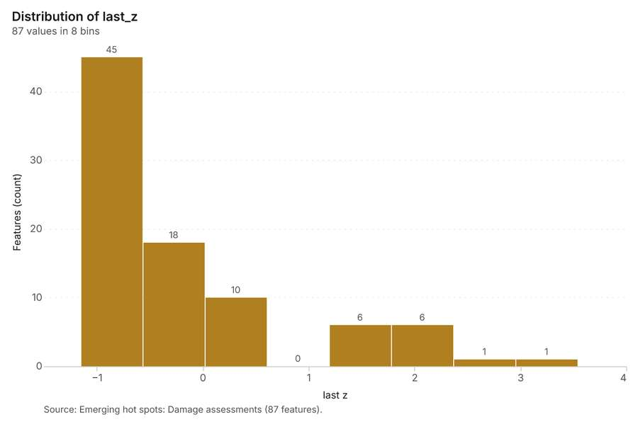
Figure 29. Emerging hot spots: Damage assessments [77]. Source: Emerging hot spots: Damage assessments (87 features). The data is in the appendix.
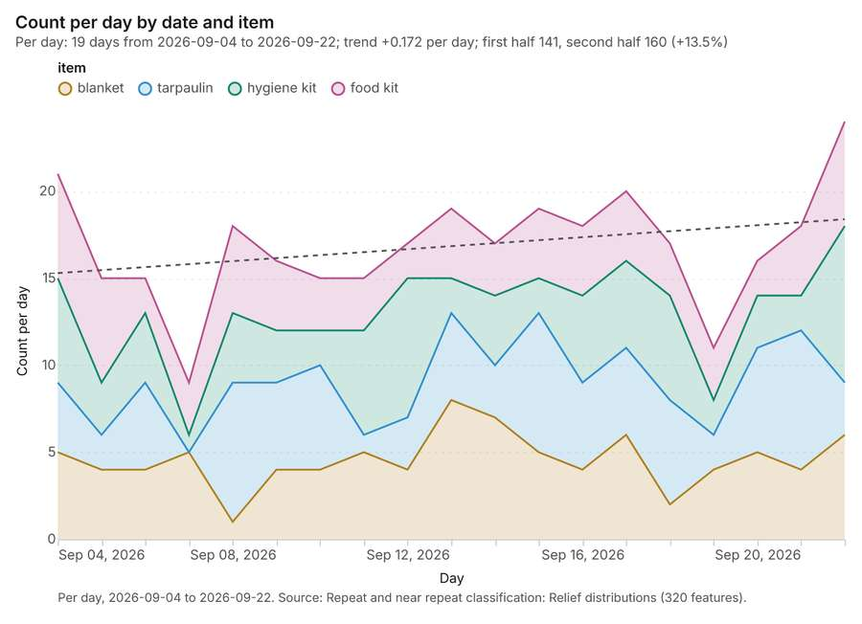
Figure 30. Repeat and near repeat classification: Relief distributions [78]. Per day, 2026-09-04 to 2026-09-22. Source: Repeat and near repeat classification: Relief distributions (320 features). The data is in the appendix.
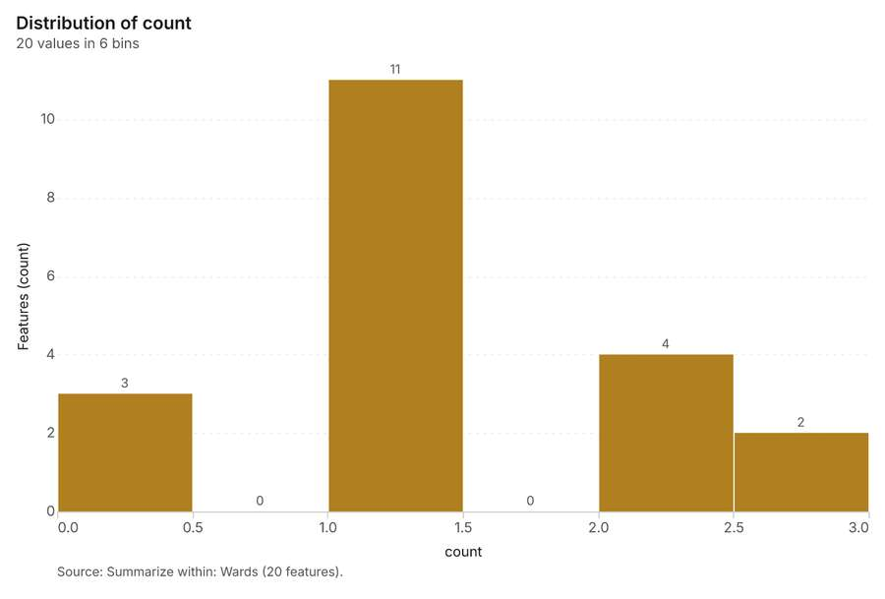
Figure 31. Summarize within: Wards [79]. Source: Summarize within: Wards (20 features). The data is in the appendix.
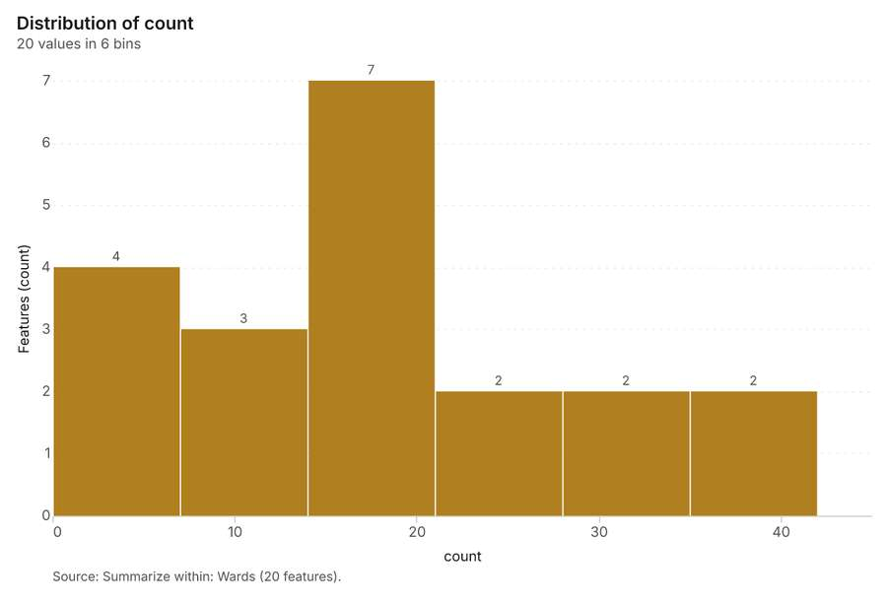
Figure 32. Summarize within: Wards [80]. Source: Summarize within: Wards (20 features). The data is in the appendix.
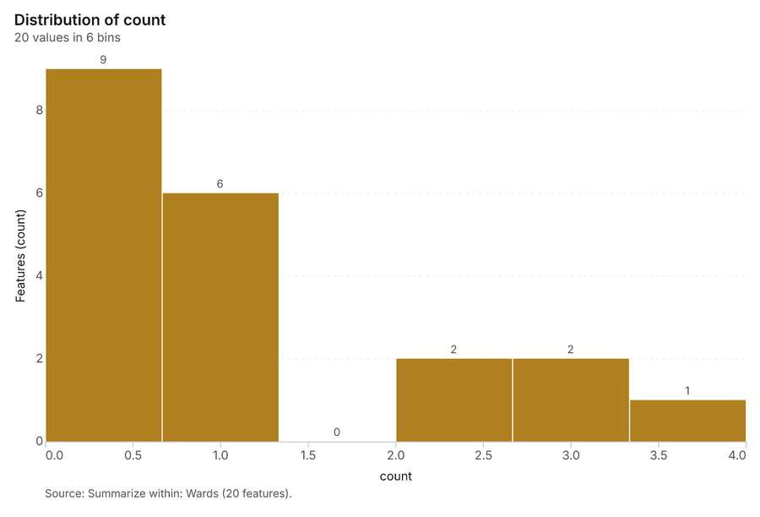
Figure 33. Summarize within: Wards [81]. Source: Summarize within: Wards (20 features). The data is in the appendix.
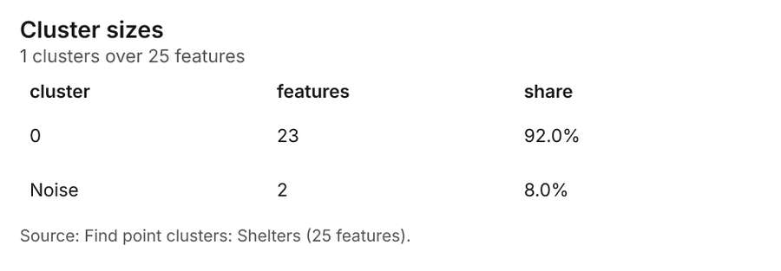
Figure 34. Find point clusters: Shelters [82]. Source: Find point clusters: Shelters (25 features). The data is in the appendix.
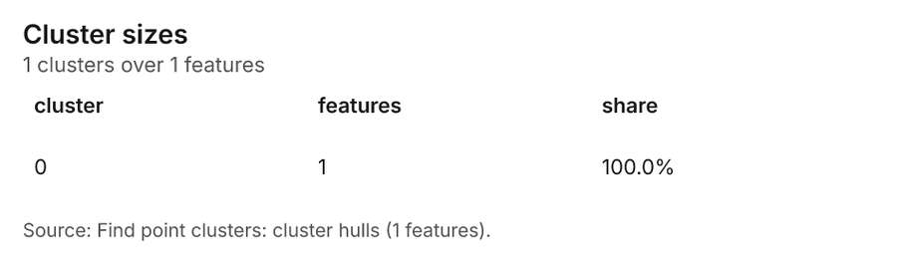
Figure 35. Find point clusters: cluster hulls [83]. Source: Find point clusters: cluster hulls (1 features). The data is in the appendix.
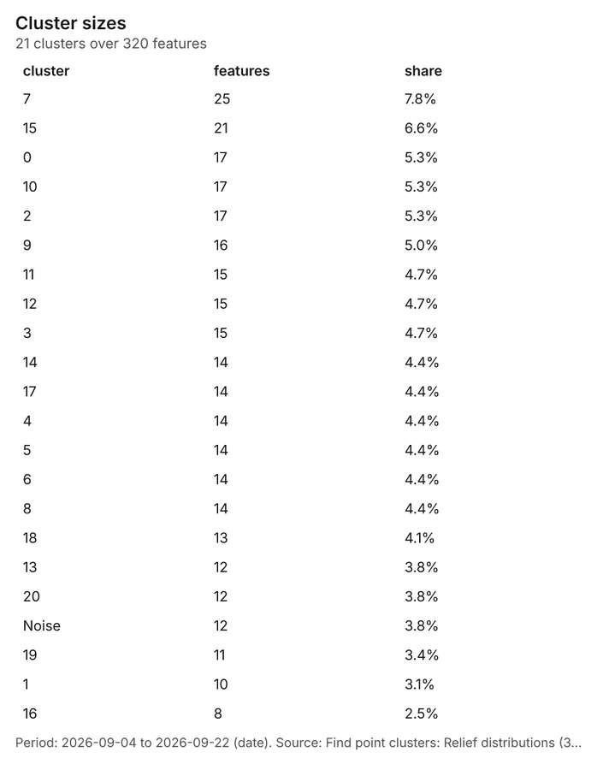
Figure 36. Find point clusters: Relief distributions [84]. Period: 2026-09-04 to 2026-09-22 (date). Source: Find point clusters: Relief distributions (320 features). The data is in the appendix.
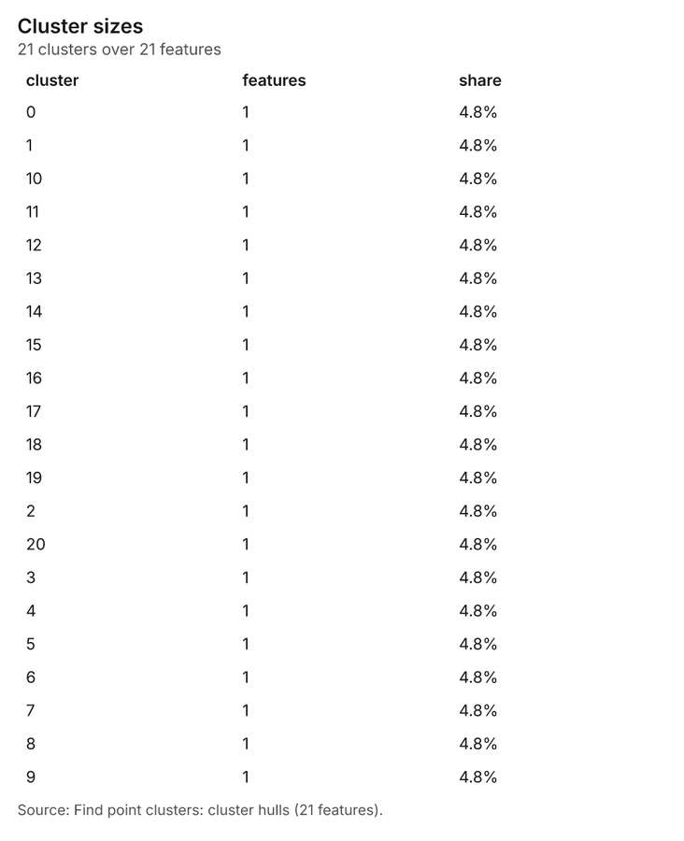
Figure 37. Find point clusters: cluster hulls [85]. Source: Find point clusters: cluster hulls (21 features). The data is in the appendix.
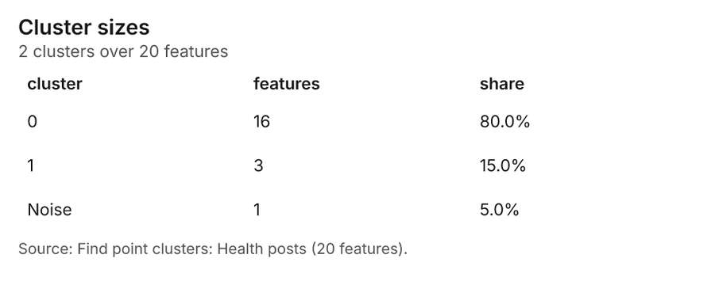
Figure 38. Find point clusters: Health posts [86]. Source: Find point clusters: Health posts (20 features). The data is in the appendix.
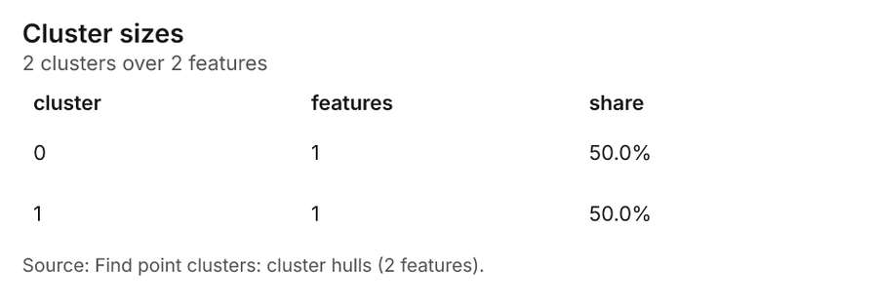
Figure 39. Find point clusters: cluster hulls [87]. Source: Find point clusters: cluster hulls (2 features). The data is in the appendix.
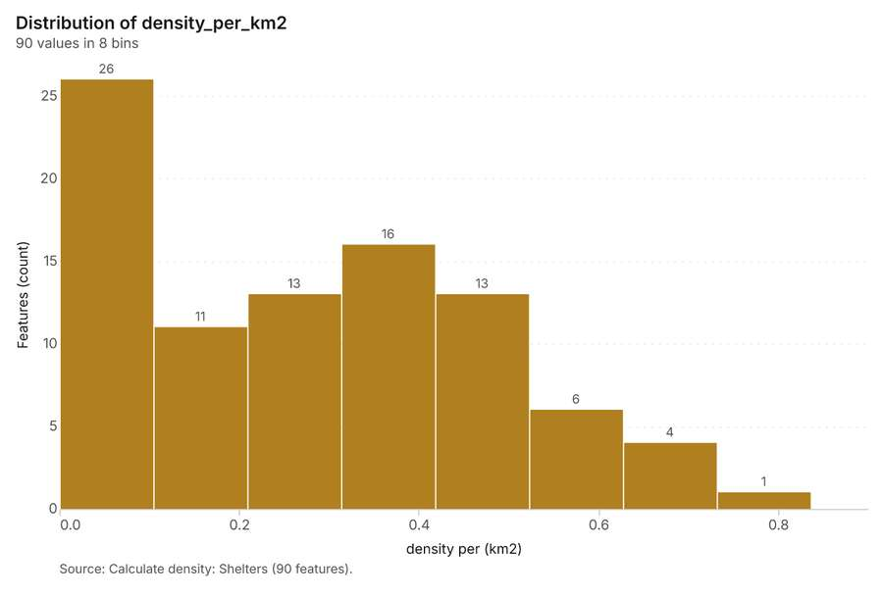
Figure 40. Calculate density: Shelters [88]. Source: Calculate density: Shelters (90 features). The data is in the appendix.
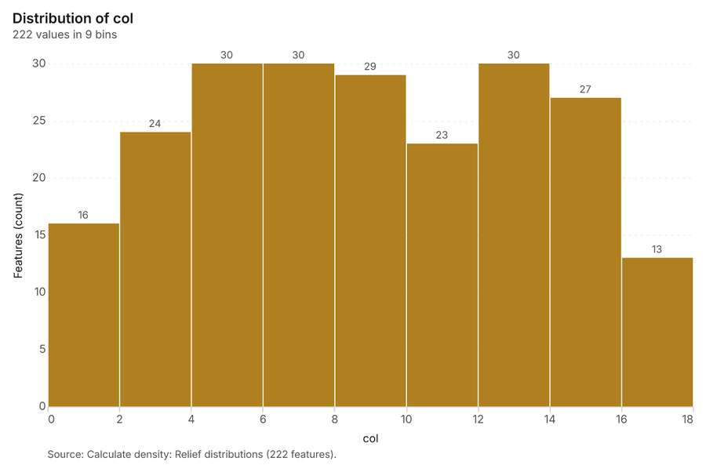
Figure 41. Calculate density: Relief distributions [89]. Source: Calculate density: Relief distributions (222 features). The data is in the appendix.
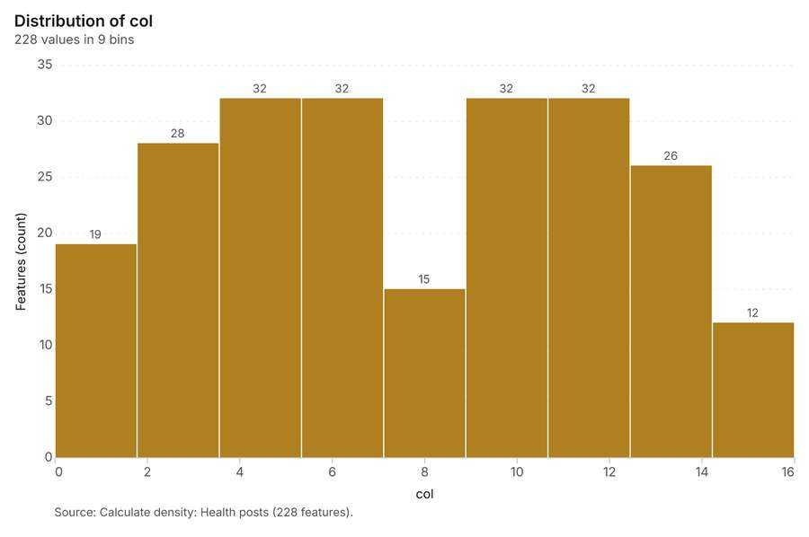
Figure 42. Calculate density: Health posts [90]. Source: Calculate density: Health posts (228 features). The data is in the appendix.
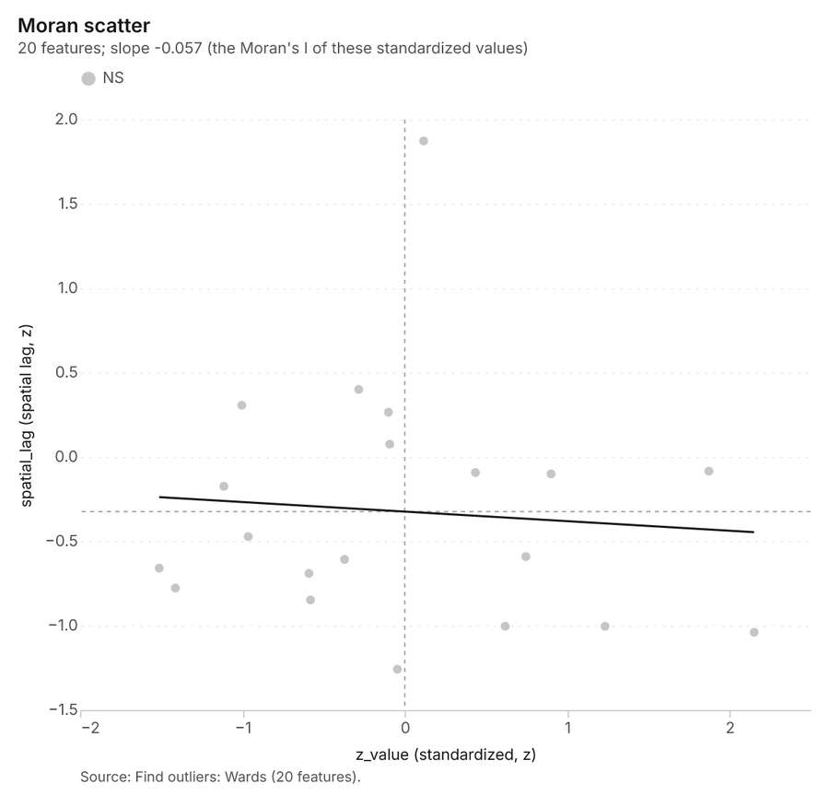
Figure 43. Find outliers: Wards [91]. Source: Find outliers: Wards (20 features). The data is in the appendix.
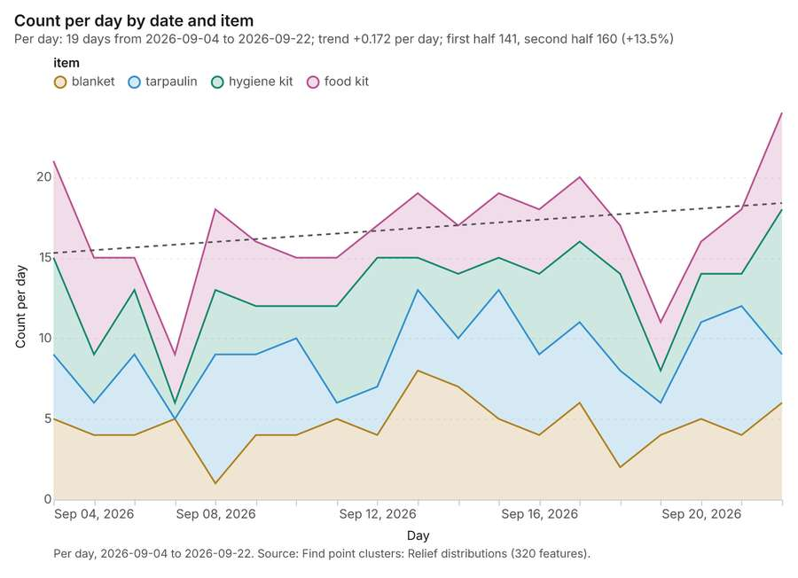
Figure 44. Find point clusters: Relief distributions over time [92]. Per day, 2026-09-04 to 2026-09-22. Source: Find point clusters: Relief distributions (320 features). The data is in the appendix.
Figure 45. Repeat and near repeat classification: Relief distributions over time [93]. Per day, 2026-09-04 to 2026-09-22. Source: Repeat and near repeat classification: Relief distributions (320 features). The data is in the appendix.
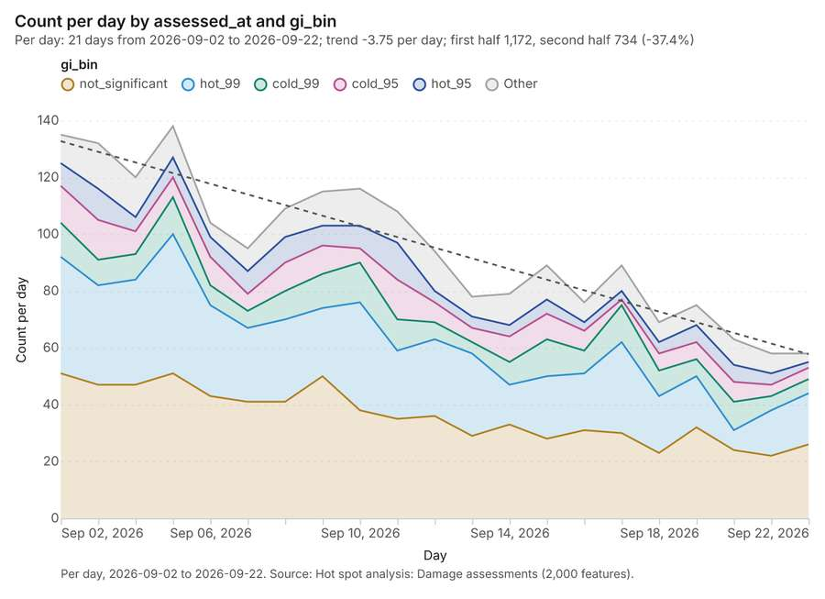
Figure 46. Hot spot analysis: Damage assessments over time [94]. Per day, 2026-09-02 to 2026-09-22. Source: Hot spot analysis: Damage assessments (2,000 features). The data is in the appendix.
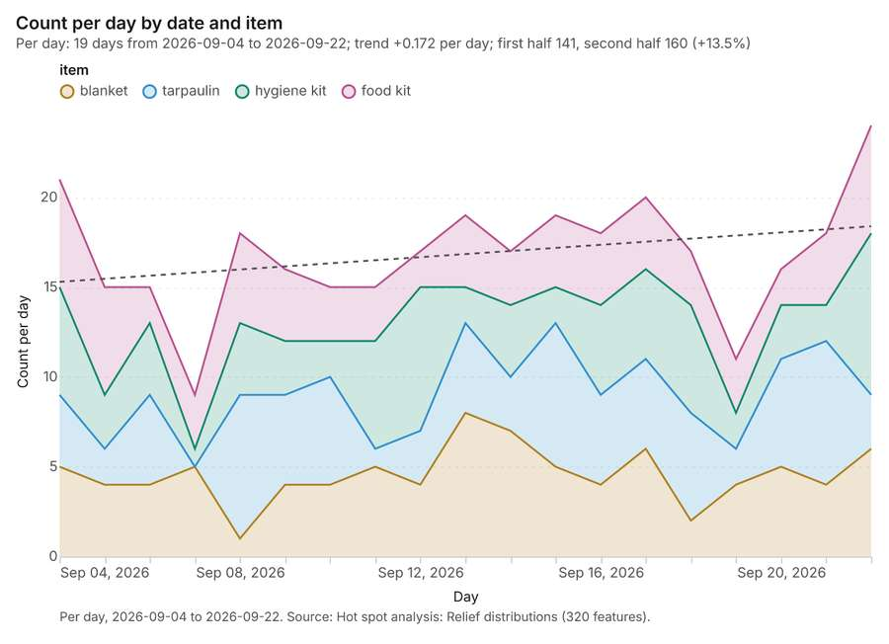
Figure 47. Hot spot analysis: Relief distributions over time [95]. Per day, 2026-09-04 to 2026-09-22. Source: Hot spot analysis: Relief distributions (320 features). The data is in the appendix.

Changes since the last run
This is the first report of this project.

Sources
[1] Rendering: Chart: Timeline: events per day by dataset. 84 rows (id 9bebc2a3-106c-4b25-9db2-00e0031eb8f3)
[2] Dataset: Damage assessments. vector, 2000 rows (id f5a03720-aeb0-4ef8-aac1-6cee065b688a)
[3] Dataset: Road status. vector, 160 rows (id f3c7c4b5-fd2f-4d56-9b57-5acf7a4d0374)
[4] Dataset: Relief distributions. vector, 320 rows (id 27e9cd9e-cac7-4864-8dbe-27172247ad35)
[5] Dataset: Ward needs by day. table, 420 rows (id b8f0859d-75f2-425c-a636-bd120d62d172)
[6] Document page: Situation report No. 4, page 1. 2026-09-14 (id c492201b-e67e-4ae4-b97c-58a6ff283bc1:1)
[7] Catalog: Hot spot analysis (operation catalog, gp_hot_spots). Getis-Ord Gi* hot and cold spots with z-scores, p-values and confidence bins. ArcGIS: Find Hot Spots, Hot Spot Analysis (Getis-Ord Gi*). QGIS: qgis:hotspot (plugin). (id gp_hot_spots)
[8] Plan: Hot spots of Relief distributions (the Start plan's candidate c_2bd4e1c1361d). 320 points: Getis-Ord Gi* tests whether the concentrations in Relief distributions are statistically significant. (id 5a15d461-f147-4d9e-923e-64f1e88fcd39:c_2bd4e1c1361d)
[9] Tool result: gp_hot_spots, step 0. Hot spot analysis: 1 layer saved: Hot spot analysis: Relief distributions (320 features). (id 312e7d93-9021-497b-95d6-33778143cdfe:0)
[10] Layer: Relief distributions. 320 features (id 83cbe688-753d-41e3-963d-5ac6a237060b)
[11] Plan: Hot spots of Water points (the Start plan's candidate c_0814d71ea2c0). 60 points: Getis-Ord Gi* tests whether the concentrations in Water points are statistically significant. (id 5a15d461-f147-4d9e-923e-64f1e88fcd39:c_0814d71ea2c0)
[12] Tool result: gp_hot_spots, step 1. Hot spot analysis: 1 layer saved: Hot spot analysis: Water points (20 features). (id 312e7d93-9021-497b-95d6-33778143cdfe:1)
[13] Layer: Water points. 60 features (id 2a061d8c-77a7-4d5f-9dfd-426a08595f03)
[14] Plan: Hot spots of Damage assessments (the Start plan's candidate c_5240b7fee4b7). 2000 points: Getis-Ord Gi* tests whether the concentrations in Damage assessments are statistically significant. (id 5a15d461-f147-4d9e-923e-64f1e88fcd39:c_5240b7fee4b7)
[15] Tool result: gp_hot_spots, step 2. Hot spot analysis: 1 layer saved: Hot spot analysis: Damage assessments (2000 features). (id 312e7d93-9021-497b-95d6-33778143cdfe:2)
[16] Layer: Damage assessments. 2,000 features (id 26bd99f3-3f2e-40d8-9e45-68835e95f651)
[17] Catalog: Emerging hot spots (operation catalog, gp_space_time_hot_spots). Where hot spots are new, consecutive, intensifying, persistent, diminishing, sporadic, oscillating or historical over time. ArcGIS: Emerging Hot Spot Analysis, Create Space Time Cube. (id gp_space_time_hot_spots)
[18] Plan: Space time hot spots of Relief distributions (the Start plan's candidate c_a90b274940ea). Relief distributions carry dates in 'date': emerging hot spot analysis finds new, intensifying and fading hot spots per day. (id 5a15d461-f147-4d9e-923e-64f1e88fcd39:c_a90b274940ea)
[19] Tool result: gp_space_time_hot_spots, step 0. Emerging hot spots: 1 layer saved: Emerging hot spots: Relief distributions (54 features). (id 6a511518-66af-49c2-9961-06cf7330178d:0)
[20] Plan: Space time hot spots of Damage assessments (the Start plan's candidate c_e9b3cd3966d9). Damage assessments carry dates in 'assessed_at': emerging hot spot analysis finds new, intensifying and fading hot spots per day. (id 5a15d461-f147-4d9e-923e-64f1e88fcd39:c_e9b3cd3966d9)
[21] Tool result: gp_space_time_hot_spots, step 1. Emerging hot spots: 1 layer saved: Emerging hot spots: Damage assessments (87 features). (id 6a511518-66af-49c2-9961-06cf7330178d:1)
[22] Catalog: Repeat and near repeat classification (operation catalog, gp_near_repeat). Classify incidents as originators, repeats (same place) or near repeats within a distance and time window, with a Knox test table. ArcGIS: Repeat and Near Repeat Classification, Near Repeat Calculator. (id gp_near_repeat)
[23] Plan: Near repeat of Relief distributions (the Start plan's candidate c_d2196a8324bf). Near repeat analysis tests whether Relief distributions close in space also follow each other within 3 days. (id 5a15d461-f147-4d9e-923e-64f1e88fcd39:c_d2196a8324bf)
[24] Tool result: gp_near_repeat, step 2. Repeat and near repeat classification: 1 layer saved: Repeat and near repeat classification: Relief distributions (320 features). (id 6a511518-66af-49c2-9961-06cf7330178d:2)
[25] Catalog: Summarize within (operation catalog, gp_summarize_within). Count and aggregate the features inside each polygon (or bin), proportionally for lines and polygons. ArcGIS: Summarize Within, Aggregate Points. QGIS: native:countpointsinpolygon, native:sumlinelengths. (id gp_summarize_within)
[26] Plan: Shelters per feature of Wards (the Start plan's candidate c_51fb9e92bbf5). Count Shelters inside each feature of Wards by type; the counts map as a choropleth (natural breaks, sequential colors). (id 5a15d461-f147-4d9e-923e-64f1e88fcd39:c_51fb9e92bbf5)
[27] Tool result: gp_summarize_within, step 0. Summarize within: 1 layer saved: Summarize within: Wards (20 features). (id 0979c79d-77b1-475d-a7be-e19a6678cb6f:0)
[28] Layer: Shelters. 25 features (id ee1b31b2-fece-4bec-a323-47ac9bdb3e6e)
[29] Layer: Wards. 20 features (id b338e26e-89d1-4de4-af0b-e9e1f797c2dd)
[30] Tool result: gp_summarize_within, step 1. Summarize within: 1 layer saved: Summarize within: Wards (20 features). (id 0979c79d-77b1-475d-a7be-e19a6678cb6f:1)
[31] Tool result: gp_summarize_within, step 2. Summarize within: 1 layer saved: Summarize within: Wards (20 features). (id 0979c79d-77b1-475d-a7be-e19a6678cb6f:2)
[32] Layer: Health posts. 20 features (id 7aed59a8-fdc9-4dca-9da9-530aea39fdf7)
[33] Catalog: Find point clusters (operation catalog, gp_find_point_clusters). Density-based clusters (DBSCAN, HDBSCAN or OPTICS, optionally space-time) with hulls and noise. ArcGIS: Find Point Clusters, Density-based Clustering. QGIS: native:dbscanclustering, native:stdbscanclustering. (id gp_find_point_clusters)
[34] Plan: Cluster points of Shelters (the Start plan's candidate c_f692379d6a4c). DBSCAN finds dense groups of Shelters and separates noise. (id 5a15d461-f147-4d9e-923e-64f1e88fcd39:c_f692379d6a4c)
[35] Tool result: gp_find_point_clusters, step 0. Find point clusters: 2 layers saved: Find point clusters: Shelters (25 features); Find point clusters: cluster hulls (1 feature). (id e8b434c3-b356-440a-9abe-58d49d66cc97:0)
[36] Plan: Cluster points of Relief distributions (the Start plan's candidate c_349573557ecd). DBSCAN finds dense groups of Relief distributions and separates noise. (id 5a15d461-f147-4d9e-923e-64f1e88fcd39:c_349573557ecd)
[37] Tool result: gp_find_point_clusters, step 1. Find point clusters: 2 layers saved: Find point clusters: Relief distributions (320 features); Find point clusters: cluster hulls (21 features). (id e8b434c3-b356-440a-9abe-58d49d66cc97:1)
[38] Plan: Cluster points of Health posts (the Start plan's candidate c_ff423f0ff11e). DBSCAN finds dense groups of Health posts and separates noise. (id 5a15d461-f147-4d9e-923e-64f1e88fcd39:c_ff423f0ff11e)
[39] Tool result: gp_find_point_clusters, step 2. Find point clusters: 2 layers saved: Find point clusters: Health posts (20 features); Find point clusters: cluster hulls (2 features). (id e8b434c3-b356-440a-9abe-58d49d66cc97:2)
[40] Catalog: Calculate density (operation catalog, gp_calculate_density). Kernel density per square kilometer on a grid. ArcGIS: Calculate Density, Kernel Density. QGIS: native:heatmapkerneldensityestimation. (id gp_calculate_density)
[41] Plan: Kernel density of Shelters (the Start plan's candidate c_af35bc95bb98). 25 points in Shelters: a density surface shows where they concentrate. (id 5a15d461-f147-4d9e-923e-64f1e88fcd39:c_af35bc95bb98)
[42] Tool result: gp_calculate_density, step 0. Calculate density: 1 layer saved: Calculate density: Shelters (90 features). (id dd271da2-1bea-419c-8888-9b686b947d5a:0)
[43] Plan: Kernel density of Relief distributions (the Start plan's candidate c_346097776d28). 320 points in Relief distributions: a density surface shows where they concentrate. (id 5a15d461-f147-4d9e-923e-64f1e88fcd39:c_346097776d28)
[44] Tool result: gp_calculate_density, step 1. Calculate density: 1 layer saved: Calculate density: Relief distributions (222 features). (id dd271da2-1bea-419c-8888-9b686b947d5a:1)
[45] Plan: Kernel density of Health posts (the Start plan's candidate c_18ec87c25f18). 20 points in Health posts: a density surface shows where they concentrate. (id 5a15d461-f147-4d9e-923e-64f1e88fcd39:c_18ec87c25f18)
[46] Tool result: gp_calculate_density, step 2. Calculate density: 1 layer saved: Calculate density: Health posts (228 features). (id dd271da2-1bea-419c-8888-9b686b947d5a:2)
[47] Catalog: Find outliers (operation catalog, gp_outliers). Anselin local Moran’s I: HH, LL clusters and HL, LH outliers. ArcGIS: Find Outliers, Cluster and Outlier Analysis (Anselin Local Moran’s I). (id gp_outliers)
[48] Plan: Local morans i of Wards (the Start plan's candidate c_de4b9b365cb7). Local Moran's I maps clusters and outliers of 'population'. (id 5a15d461-f147-4d9e-923e-64f1e88fcd39:c_de4b9b365cb7)
[49] Tool result: gp_outliers, step 0. Find outliers: 1 layer saved: Find outliers: Wards (20 features). (id 82ada6bc-afff-4238-9ffd-a1a3201c03ab:0)
[50] Rendering: Map: Hot spot analysis: Relief distributions (id 9390dd7d-eb52-4fef-b240-a9e39c60419a)
[51] Rendering: Map: Hot spot analysis: Water points (id c442f0af-9418-4ebb-bfcb-511695a7dfa4)
[52] Rendering: Map: Hot spot analysis: Damage assessments (id bf47cbcc-a7c2-4872-8e54-35d0ac4ff377)
[53] Rendering: Map: Emerging hot spots: Relief distributions (id 25f4f54c-4c45-48cf-a569-65f18477854c)
[54] Rendering: Map: Emerging hot spots: Damage assessments (id 6a4358fa-15b6-48b5-8954-acdaa394ce25)
[55] Rendering: Map: Repeat and near repeat classification: Relief distributions (id 9939dbb6-e3f8-4379-ac14-09eaa503d896)
[56] Rendering: Map: Summarize within: Wards (id 7e37ed6c-8912-44a3-bf3e-ee68208d7033)
[57] Rendering: Map: Summarize within: Wards (id be38a33a-5f20-4c0b-8912-57fa7895a19e)
[58] Rendering: Map: Summarize within: Wards (id b5d154ed-f63d-4d53-9377-fa605622ef5a)
[59] Rendering: Map: Find point clusters: Shelters (id c9d2bd3b-593e-4289-8016-4c68db15e487)
[60] Rendering: Map: Find point clusters: cluster hulls (id 6a3bb4df-0c93-47d3-ac5d-799d9cc55d97)
[61] Rendering: Map: Find point clusters: Relief distributions (id 7e541131-6f4c-4bb1-b407-1446d58780c9)
[62] Rendering: Map: Find point clusters: cluster hulls (id 38f01879-759a-4a13-835c-d8b021e78321)
[63] Rendering: Map: Find point clusters: Health posts (id 3e2a4e84-8386-4533-beff-b52a92b8455a)
[64] Rendering: Map: Find point clusters: cluster hulls (id 2e4605ac-3908-4fc6-9ef3-f84a99eee64a)
[65] Rendering: Map: Calculate density: Shelters (id 4c369f35-f8c0-44c2-af51-a805408d3d2c)
[66] Rendering: Map: Calculate density: Relief distributions (id 1fe838e1-34dc-4443-9b06-a8e4dfca95b1)
[67] Rendering: Map: Calculate density: Health posts (id 757ffe50-e313-4da5-9be2-6dc7c3f38b2c)
[68] Rendering: Map: Wards by population (id 74dd8da4-312d-43c5-85e7-bb2fb6224f53)
[69] Rendering: Map: Find outliers: Wards (id 7bf81023-a30e-4346-ab12-ff2513b7947f)
[70] Rendering: Chart: Water points over time (litres_per_day). 7 rows (id be19f3c9-7c18-4737-8ac1-c4b65ed62211)
[71] Rendering: Chart: Relief distributions over time (date). 76 rows (id 2be61f8a-8348-49a8-8c78-1ea19f2626a3)
[72] Rendering: Chart: Ward needs by day over time (date). 126 rows (id 3683d15b-0f5f-4034-99d3-c60bbd06867c)
[73] Rendering: Chart: Hot spot analysis: Relief distributions. 7 rows (id 8a54330c-390f-456b-b3e3-6ba7256e4df3)
[74] Rendering: Chart: Hot spot analysis: Water points. 7 rows (id beea2a8b-78df-4622-919a-df7a4d7bf1a9)
[75] Rendering: Chart: Hot spot analysis: Damage assessments. 30 rows (id b6ec9de8-9bcf-49e9-ba5e-2e62a12c8ca5)
[76] Rendering: Chart: Emerging hot spots: Relief distributions. 7 rows (id bde631a0-88da-4ec0-881b-6dc66cb32acc)
[77] Rendering: Chart: Emerging hot spots: Damage assessments. 8 rows (id 5060f9d4-d1f0-4a03-b624-4e1aa484e60d)
[78] Rendering: Chart: Repeat and near repeat classification: Relief distributions. 76 rows (id ad7da8c7-ed67-45e8-86ad-6f21ca29cbfd)
[79] Rendering: Chart: Summarize within: Wards. 6 rows (id eb5740e9-38f8-42ba-9d54-b9bec7d81080)
[80] Rendering: Chart: Summarize within: Wards. 6 rows (id 87ce8246-fadd-470c-b5a7-eb0629fc5ea3)
[81] Rendering: Chart: Summarize within: Wards. 6 rows (id 190869f4-a9ae-4fed-a451-67bc4560549c)
[82] Rendering: Chart: Find point clusters: Shelters. 2 rows (id 7be17c77-d4b9-4caf-8e86-10eb6d9d53e2)
[83] Rendering: Chart: Find point clusters: cluster hulls. 1 rows (id 382198e8-9ac9-4b75-9e8e-ef34700f25cd)
[84] Rendering: Chart: Find point clusters: Relief distributions. 22 rows (id bae50ece-0f0f-4399-87fd-3618eed224a5)
[85] Rendering: Chart: Find point clusters: cluster hulls. 21 rows (id 7bff01e1-9aeb-448c-8822-197f969c18f3)
[86] Rendering: Chart: Find point clusters: Health posts. 3 rows (id c1d4618b-97c3-444b-b7e7-445c2a95bc45)
[87] Rendering: Chart: Find point clusters: cluster hulls. 2 rows (id 004552ff-ca8c-4bd5-9838-b11d434b85b3)
[88] Rendering: Chart: Calculate density: Shelters. 8 rows (id 4716859b-53cb-4d5a-8441-47de226233ed)
[89] Rendering: Chart: Calculate density: Relief distributions. 9 rows (id a66c3a3a-0d79-4a90-8ba8-25684b82f78c)
[90] Rendering: Chart: Calculate density: Health posts. 9 rows (id 6d33660c-fb55-4ce5-9407-14cede82f1f7)
[91] Rendering: Chart: Find outliers: Wards. 20 rows (id 2c943aea-f0e1-4d2e-9a74-b1f3a68cccaf)
[92] Rendering: Chart: Find point clusters: Relief distributions over time. 76 rows (id ae09526f-b719-40fa-9352-7253703419e6)
[93] Rendering: Chart: Repeat and near repeat classification: Relief distributions over time. 76 rows (id d25012cc-f981-414f-b270-f5188a23b23a)
[94] Rendering: Chart: Hot spot analysis: Damage assessments over time. 126 rows (id dddbf0f7-9186-4260-86f0-90b42b3a2b7c)
[95] Rendering: Chart: Hot spot analysis: Relief distributions over time. 76 rows (id 75a753b2-7ec0-435d-93af-df87c5a2fdf9)
[96] Dataset: Wards. vector, 20 rows (id cd24d135-3a85-486d-b85d-aad5c710434a)
[97] Dataset: Shelters. vector, 25 rows (id 1a4488fc-1d07-4261-9f0e-01b2b1f2dca2)
[98] Dataset: Water points. vector, 60 rows (id c5cb6996-b665-4741-91b9-eb2b235d60b3)
[99] Dataset: Health posts. vector, 20 rows (id 8e654bff-294d-4ad6-be89-593de050aebf)
[100] Dataset: Shelter register. table, 25 rows (id 71a97a94-2ec4-4a02-b6d8-66a6192053f9)
[101] Dataset: Situation report No. 4. document, ? rows (id 919b6864-e3dc-42c9-b9dc-71340dbf1f59)
[102] Record: Sample: Disaster response, Kathmandu (id affd1e20-248c-4f96-b09d-48d3027477be)
[103] Layer: Hot spot analysis: Relief distributions. 320 features (id 9e5f578c-630b-43eb-8ebe-8545f6fca7c2)
[104] Layer: Hot spot analysis: Water points. 20 features (id bb294769-aa54-4b53-b8ab-a11a9895ae52)
[105] Layer: Hot spot analysis: Damage assessments. 2,000 features (id 363b8c44-c958-4210-beb4-e032340f3591)
[106] Layer: Emerging hot spots: Relief distributions. 54 features (id 6f8363b7-e1a7-432e-b17e-f0e1a5b04c12)
[107] Layer: Emerging hot spots: Damage assessments. 87 features (id 26abf030-7544-4caa-a068-87e5fbf6fc76)
[108] Layer: Repeat and near repeat classification: Relief distributions. 320 features (id 176d38bd-d5dd-4e59-bcf4-f4f67c442f05)
[109] Layer: Summarize within: Wards. 20 features (id 59ed06c8-19f7-4cdc-bf0a-93f1af3df0bb)
[110] Layer: Summarize within: Wards. 20 features (id 60eb7f4c-9283-4a68-b158-7fe6014e035b)
[111] Layer: Summarize within: Wards. 20 features (id d2a68fd2-e432-4366-8c8c-79cfc7fbd916)
[112] Layer: Find point clusters: Shelters. 25 features (id db7ac08f-e31a-41c7-b06d-b7bc5b1ddae1)
[113] Layer: Find point clusters: cluster hulls. 1 features (id 1a61db01-7dbf-4a4b-a14e-619c2d2130e2)
[114] Layer: Find point clusters: Relief distributions. 320 features (id 80a3b728-2f6b-44e4-962f-eac228b32051)
[115] Layer: Find point clusters: cluster hulls. 21 features (id ab1e3ae7-0d91-4e6a-8a58-5afda7d572e8)
[116] Layer: Find point clusters: Health posts. 20 features (id f387abca-2c2c-4945-9f86-d310b94a5d2e)
[117] Layer: Find point clusters: cluster hulls. 2 features (id 0ee12d31-db24-4ae2-ba77-bea3bd72c010)
[118] Layer: Calculate density: Shelters. 90 features (id 70bc6150-3af3-4110-ba8a-60400c37bf40)
[119] Layer: Calculate density: Relief distributions. 222 features (id 3d315b62-8343-4e06-9cb9-c92f6b2c53e0)
[120] Layer: Calculate density: Health posts. 228 features (id dc129652-f329-497f-8a85-b1a55c7c00b4)
[121] Document: Situation report No. 4 (id c492201b-e67e-4ae4-b97c-58a6ff283bc1)
[122] Layer: Find outliers: Wards. 20 features (id a6dabb92-ab09-424d-95b6-28b66295aba0)

Appendix: the data behind the charts

Figure 1. Timeline: events per day by dataset [1]
period | series | value
2026-09-02 | Damage assessments | 135
2026-09-02 | Ward needs by day | 20
2026-09-02 | Relief distributions | 0
2026-09-02 | Road status | 0
2026-09-03 | Damage assessments | 132
2026-09-03 | Ward needs by day | 20
2026-09-03 | Relief distributions | 0
2026-09-03 | Road status | 12
2026-09-04 | Damage assessments | 120
2026-09-04 | Ward needs by day | 20
2026-09-04 | Relief distributions | 21
2026-09-04 | Road status | 9
2026-09-05 | Damage assessments | 138
2026-09-05 | Ward needs by day | 20
2026-09-05 | Relief distributions | 15
2026-09-05 | Road status | 8
2026-09-06 | Damage assessments | 104
2026-09-06 | Ward needs by day | 20
2026-09-06 | Relief distributions | 15
2026-09-06 | Road status | 13
2026-09-07 | Damage assessments | 95
2026-09-07 | Ward needs by day | 20
2026-09-07 | Relief distributions | 9
2026-09-07 | Road status | 13
2026-09-08 | Damage assessments | 109
2026-09-08 | Ward needs by day | 20
2026-09-08 | Relief distributions | 18
2026-09-08 | Road status | 12
2026-09-09 | Damage assessments | 115
2026-09-09 | Ward needs by day | 20
2026-09-09 | Relief distributions | 16
2026-09-09 | Road status | 8
2026-09-10 | Damage assessments | 116
2026-09-10 | Ward needs by day | 20
2026-09-10 | Relief distributions | 15
2026-09-10 | Road status | 3
2026-09-11 | Damage assessments | 108
2026-09-11 | Ward needs by day | 20
2026-09-11 | Relief distributions | 15
2026-09-11 | Road status | 12
2026-09-12 | Damage assessments | 94
2026-09-12 | Ward needs by day | 20
2026-09-12 | Relief distributions | 17
2026-09-12 | Road status | 6
2026-09-13 | Damage assessments | 78
2026-09-13 | Ward needs by day | 20
2026-09-13 | Relief distributions | 19
2026-09-13 | Road status | 9
2026-09-14 | Damage assessments | 79
2026-09-14 | Ward needs by day | 20
2026-09-14 | Relief distributions | 17
2026-09-14 | Road status | 12
2026-09-15 | Damage assessments | 89
2026-09-15 | Ward needs by day | 20
2026-09-15 | Relief distributions | 19
2026-09-15 | Road status | 9
2026-09-16 | Damage assessments | 76
2026-09-16 | Ward needs by day | 20
2026-09-16 | Relief distributions | 18
2026-09-16 | Road status | 9
2026-09-17 | Damage assessments | 89
2026-09-17 | Ward needs by day | 20
2026-09-17 | Relief distributions | 20
2026-09-17 | Road status | 7
2026-09-18 | Damage assessments | 69
2026-09-18 | Ward needs by day | 20
2026-09-18 | Relief distributions | 17
2026-09-18 | Road status | 6
2026-09-19 | Damage assessments | 75
2026-09-19 | Ward needs by day | 20
2026-09-19 | Relief distributions | 11
2026-09-19 | Road status | 7
2026-09-20 | Damage assessments | 63
2026-09-20 | Ward needs by day | 20
2026-09-20 | Relief distributions | 16
2026-09-20 | Road status | 5
2026-09-21 | Damage assessments | 58
2026-09-21 | Ward needs by day | 20
2026-09-21 | Relief distributions | 18
2026-09-21 | Road status | 0
2026-09-22 | Damage assessments | 58
2026-09-22 | Ward needs by day | 20
2026-09-22 | Relief distributions | 24
2026-09-22 | Road status | 0

Figure 22. Water points over time (litres_per_day) [70]
bin_start | bin_end | count
3,306 | 9,005 | 15
9,005 | 1.47e+04 | 21
1.47e+04 | 2.04e+04 | 14
2.04e+04 | 2.61e+04 | 5
2.61e+04 | 3.18e+04 | 3
3.18e+04 | 3.75e+04 | 1
3.75e+04 | 4.32e+04 | 1

Figure 23. Relief distributions over time (date) [71]
period | series | value
2026-09-04 | tarpaulin | 900
2026-09-04 | blanket | 956
2026-09-04 | food kit | 1,490
2026-09-04 | hygiene kit | 1,373
2026-09-05 | tarpaulin | 509
2026-09-05 | blanket | 843
2026-09-05 | food kit | 928
2026-09-05 | hygiene kit | 519
2026-09-06 | tarpaulin | 970
2026-09-06 | blanket | 665
2026-09-06 | food kit | 474
2026-09-06 | hygiene kit | 285
2026-09-07 | tarpaulin | 0
2026-09-07 | blanket | 1,088
2026-09-07 | food kit | 381
2026-09-07 | hygiene kit | 391
2026-09-08 | tarpaulin | 1,716
2026-09-08 | blanket | 322
2026-09-08 | food kit | 1,480
2026-09-08 | hygiene kit | 913
2026-09-09 | tarpaulin | 772
2026-09-09 | blanket | 1,101
2026-09-09 | food kit | 1,175
2026-09-09 | hygiene kit | 591
2026-09-10 | tarpaulin | 1,161
2026-09-10 | blanket | 777
2026-09-10 | food kit | 509
2026-09-10 | hygiene kit | 409
2026-09-11 | tarpaulin | 120
2026-09-11 | blanket | 668
2026-09-11 | food kit | 612
2026-09-11 | hygiene kit | 896
2026-09-12 | tarpaulin | 579
2026-09-12 | blanket | 1,064
2026-09-12 | food kit | 229
2026-09-12 | hygiene kit | 1,670
2026-09-13 | tarpaulin | 652
2026-09-13 | blanket | 1,803
2026-09-13 | food kit | 830
2026-09-13 | hygiene kit | 290
2026-09-14 | tarpaulin | 477
2026-09-14 | blanket | 1,465
2026-09-14 | food kit | 1,109
2026-09-14 | hygiene kit | 713
2026-09-15 | tarpaulin | 2,002
2026-09-15 | blanket | 954
2026-09-15 | food kit | 900
2026-09-15 | hygiene kit | 276
2026-09-16 | tarpaulin | 1,140
2026-09-16 | blanket | 678
2026-09-16 | food kit | 1,279
2026-09-16 | hygiene kit | 1,119
2026-09-17 | tarpaulin | 989
2026-09-17 | blanket | 837
2026-09-17 | food kit | 612
2026-09-17 | hygiene kit | 851
2026-09-18 | tarpaulin | 1,746
2026-09-18 | blanket | 528
2026-09-18 | food kit | 572
2026-09-18 | hygiene kit | 1,245
2026-09-19 | tarpaulin | 681
2026-09-19 | blanket | 574
2026-09-19 | food kit | 851
2026-09-19 | hygiene kit | 408
2026-09-20 | tarpaulin | 1,323
2026-09-20 | blanket | 1,162
2026-09-20 | food kit | 418
2026-09-20 | hygiene kit | 680
2026-09-21 | tarpaulin | 1,866
2026-09-21 | blanket | 1,343
2026-09-21 | food kit | 481
2026-09-21 | hygiene kit | 746
2026-09-22 | tarpaulin | 538
2026-09-22 | blanket | 891
2026-09-22 | food kit | 1,749
2026-09-22 | hygiene kit | 1,689

Figure 24. Ward needs by day over time (date) [72]
period | series | value
2026-09-02 | W06 | 1,174
2026-09-02 | W18 | 738
2026-09-02 | W20 | 705
2026-09-02 | W04 | 501
2026-09-02 | W05 | 480
2026-09-02 | Other | 3,667
2026-09-03 | W06 | 1,146
2026-09-03 | W18 | 720
2026-09-03 | W20 | 688
2026-09-03 | W04 | 489
2026-09-03 | W05 | 468
2026-09-03 | Other | 3,581
2026-09-04 | W06 | 1,118
2026-09-04 | W18 | 703
2026-09-04 | W20 | 672
2026-09-04 | W04 | 477
2026-09-04 | W05 | 457
2026-09-04 | Other | 3,492
2026-09-05 | W06 | 1,090
2026-09-05 | W18 | 685
2026-09-05 | W20 | 655
2026-09-05 | W04 | 465
2026-09-05 | W05 | 445
2026-09-05 | Other | 3,405
2026-09-06 | W06 | 1,062
2026-09-06 | W18 | 667
2026-09-06 | W20 | 638
2026-09-06 | W04 | 453
2026-09-06 | W05 | 434
2026-09-06 | Other | 3,318
2026-09-07 | W06 | 1,034
2026-09-07 | W18 | 650
2026-09-07 | W20 | 621
2026-09-07 | W04 | 441
2026-09-07 | W05 | 422
2026-09-07 | Other | 3,230
2026-09-08 | W06 | 1,006
2026-09-08 | W18 | 632
2026-09-08 | W20 | 604
2026-09-08 | W04 | 429
2026-09-08 | W05 | 411
2026-09-08 | Other | 3,143
2026-09-09 | W06 | 978
2026-09-09 | W18 | 615
2026-09-09 | W20 | 588
2026-09-09 | W04 | 417
2026-09-09 | W05 | 400
2026-09-09 | Other | 3,055
2026-09-10 | W06 | 950
2026-09-10 | W18 | 597
2026-09-10 | W20 | 571
2026-09-10 | W04 | 405
2026-09-10 | W05 | 388
2026-09-10 | Other | 2,968
2026-09-11 | W06 | 922
2026-09-11 | W18 | 580
2026-09-11 | W20 | 554
2026-09-11 | W04 | 393
2026-09-11 | W05 | 377
2026-09-11 | Other | 2,880
2026-09-12 | W06 | 894
2026-09-12 | W18 | 562
2026-09-12 | W20 | 537
2026-09-12 | W04 | 381
2026-09-12 | W05 | 365
2026-09-12 | Other | 2,792
2026-09-13 | W06 | 866
2026-09-13 | W18 | 544
2026-09-13 | W20 | 520
2026-09-13 | W04 | 370
2026-09-13 | W05 | 354
2026-09-13 | Other | 2,705
2026-09-14 | W06 | 838
2026-09-14 | W18 | 527
2026-09-14 | W20 | 504
2026-09-14 | W04 | 358
2026-09-14 | W05 | 342
2026-09-14 | Other | 2,616
2026-09-15 | W06 | 811
2026-09-15 | W18 | 509
2026-09-15 | W20 | 487
2026-09-15 | W04 | 346
2026-09-15 | W05 | 331
2026-09-15 | Other | 2,530
2026-09-16 | W06 | 783
2026-09-16 | W18 | 492
2026-09-16 | W20 | 470
2026-09-16 | W04 | 334
2026-09-16 | W05 | 320
2026-09-16 | Other | 2,442
2026-09-17 | W06 | 755
2026-09-17 | W18 | 474
2026-09-17 | W20 | 453
2026-09-17 | W04 | 322
2026-09-17 | W05 | 308
2026-09-17 | Other | 2,355
2026-09-18 | W06 | 727
2026-09-18 | W18 | 457
2026-09-18 | W20 | 436
2026-09-18 | W04 | 310
2026-09-18 | W05 | 297
2026-09-18 | Other | 2,270
2026-09-19 | W06 | 699
2026-09-19 | W18 | 439
2026-09-19 | W20 | 420
2026-09-19 | W04 | 298
2026-09-19 | W05 | 285
2026-09-19 | Other | 2,180
2026-09-20 | W06 | 671
2026-09-20 | W18 | 421
2026-09-20 | W20 | 403
2026-09-20 | W04 | 286
2026-09-20 | W05 | 274
2026-09-20 | Other | 2,093
2026-09-21 | W06 | 643
2026-09-21 | W18 | 404
2026-09-21 | W20 | 386
2026-09-21 | W04 | 274
2026-09-21 | W05 | 262
2026-09-21 | Other | 2,006
2026-09-22 | W06 | 615
2026-09-22 | W18 | 386
2026-09-22 | W20 | 369
2026-09-22 | W04 | 262
2026-09-22 | W05 | 251
2026-09-22 | Other | 1,918

Figure 25. Hot spot analysis: Relief distributions [73]
bin_start | bin_end | band | band_label | count
-2 | -1.5 | cold_90 | Cold spot, 90% confidence | 4
-1.5 | -1 | not_significant | Not significant | 49
-1 | -0.5 | not_significant | Not significant | 47
-0.5 | 0 | not_significant | Not significant | 24
0 | 0.5 | not_significant | Not significant | 111
0.5 | 1 | not_significant | Not significant | 72
1 | 1.5 | not_significant | Not significant | 13

Figure 26. Hot spot analysis: Water points [74]
bin_start | bin_end | band | band_label | count
-2 | -1.5 | cold_90 | Cold spot, 90% confidence | 2
-1.5 | -1 | not_significant | Not significant | 1
-1 | -0.5 | not_significant | Not significant | 5
0 | 0.5 | not_significant | Not significant | 5
0.5 | 1 | not_significant | Not significant | 3
1 | 1.5 | not_significant | Not significant | 3
2 | 2.5 | hot_95 | Hot spot, 95% confidence | 1

Figure 27. Hot spot analysis: Damage assessments [75]
bin_start | bin_end | band | band_label | count
-4.5 | -4 | cold_99 | Cold spot, 99% confidence | 3
-4 | -3.5 | cold_99 | Cold spot, 99% confidence | 22
-3.5 | -3 | cold_99 | Cold spot, 99% confidence | 54
-3 | -2.5 | cold_95 | Cold spot, 95% confidence | 8
-3 | -2.5 | cold_99 | Cold spot, 99% confidence | 111
-2.5 | -2 | cold_95 | Cold spot, 95% confidence | 149
-2 | -1.5 | cold_90 | Cold spot, 90% confidence | 99
-2 | -1.5 | cold_95 | Cold spot, 95% confidence | 6
-2 | -1.5 | not_significant | Not significant | 38
-1.5 | -1 | not_significant | Not significant | 161
-1 | -0.5 | not_significant | Not significant | 88
-0.5 | 0 | not_significant | Not significant | 102
0 | 0.5 | not_significant | Not significant | 91
0.5 | 1 | not_significant | Not significant | 104
1 | 1.5 | not_significant | Not significant | 139
1.5 | 2 | hot_90 | Hot spot, 90% confidence | 104
1.5 | 2 | hot_95 | Hot spot, 95% confidence | 7
1.5 | 2 | not_significant | Not significant | 35
2 | 2.5 | hot_95 | Hot spot, 95% confidence | 109
2.5 | 3 | hot_95 | Hot spot, 95% confidence | 12
2.5 | 3 | hot_99 | Hot spot, 99% confidence | 87
3 | 3.5 | hot_99 | Hot spot, 99% confidence | 105
3.5 | 4 | hot_99 | Hot spot, 99% confidence | 73
4 | 4.5 | hot_99 | Hot spot, 99% confidence | 60
4.5 | 5 | hot_99 | Hot spot, 99% confidence | 49
5 | 5.5 | hot_99 | Hot spot, 99% confidence | 38
5.5 | 6 | hot_99 | Hot spot, 99% confidence | 64
6 | 6.5 | hot_99 | Hot spot, 99% confidence | 57
6.5 | 7 | hot_99 | Hot spot, 99% confidence | 23
7 | 7.5 | hot_99 | Hot spot, 99% confidence | 2

Figure 28. Emerging hot spots: Relief distributions [76]
bin_start | bin_end | count
-0.827 | -0.2167 | 15
-0.2167 | 0.3936 | 11
0.3936 | 1.004 | 10
1.004 | 1.614 | 6
1.614 | 2.224 | 6
2.224 | 2.835 | 4
2.835 | 3.445 | 2

Figure 29. Emerging hot spots: Damage assessments [77]
bin_start | bin_end | count
-1.153 | -0.5664 | 45
-0.5664 | 0.02025 | 18
0.02025 | 0.6069 | 10
0.6069 | 1.194 | 0
1.194 | 1.78 | 6
1.78 | 2.367 | 6
2.367 | 2.953 | 1
2.953 | 3.54 | 1

Figure 30. Repeat and near repeat classification: Relief distributions [78]
period | series | value
2026-09-04 | blanket | 5
2026-09-04 | tarpaulin | 4
2026-09-04 | hygiene kit | 6
2026-09-04 | food kit | 6
2026-09-05 | blanket | 4
2026-09-05 | tarpaulin | 2
2026-09-05 | hygiene kit | 3
2026-09-05 | food kit | 6
2026-09-06 | blanket | 4
2026-09-06 | tarpaulin | 5
2026-09-06 | hygiene kit | 4
2026-09-06 | food kit | 2
2026-09-07 | blanket | 5
2026-09-07 | tarpaulin | 0
2026-09-07 | hygiene kit | 1
2026-09-07 | food kit | 3
2026-09-08 | blanket | 1
2026-09-08 | tarpaulin | 8
2026-09-08 | hygiene kit | 4
2026-09-08 | food kit | 5
2026-09-09 | blanket | 4
2026-09-09 | tarpaulin | 5
2026-09-09 | hygiene kit | 3
2026-09-09 | food kit | 4
2026-09-10 | blanket | 4
2026-09-10 | tarpaulin | 6
2026-09-10 | hygiene kit | 2
2026-09-10 | food kit | 3
2026-09-11 | blanket | 5
2026-09-11 | tarpaulin | 1
2026-09-11 | hygiene kit | 6
2026-09-11 | food kit | 3
2026-09-12 | blanket | 4
2026-09-12 | tarpaulin | 3
2026-09-12 | hygiene kit | 8
2026-09-12 | food kit | 2
2026-09-13 | blanket | 8
2026-09-13 | tarpaulin | 5
2026-09-13 | hygiene kit | 2
2026-09-13 | food kit | 4
2026-09-14 | blanket | 7
2026-09-14 | tarpaulin | 3
2026-09-14 | hygiene kit | 4
2026-09-14 | food kit | 3
2026-09-15 | blanket | 5
2026-09-15 | tarpaulin | 8
2026-09-15 | hygiene kit | 2
2026-09-15 | food kit | 4
2026-09-16 | blanket | 4
2026-09-16 | tarpaulin | 5
2026-09-16 | hygiene kit | 5
2026-09-16 | food kit | 4
2026-09-17 | blanket | 6
2026-09-17 | tarpaulin | 5
2026-09-17 | hygiene kit | 5
2026-09-17 | food kit | 4
2026-09-18 | blanket | 2
2026-09-18 | tarpaulin | 6
2026-09-18 | hygiene kit | 6
2026-09-18 | food kit | 3
2026-09-19 | blanket | 4
2026-09-19 | tarpaulin | 2
2026-09-19 | hygiene kit | 2
2026-09-19 | food kit | 3
2026-09-20 | blanket | 5
2026-09-20 | tarpaulin | 6
2026-09-20 | hygiene kit | 3
2026-09-20 | food kit | 2
2026-09-21 | blanket | 4
2026-09-21 | tarpaulin | 8
2026-09-21 | hygiene kit | 2
2026-09-21 | food kit | 4
2026-09-22 | blanket | 6
2026-09-22 | tarpaulin | 3
2026-09-22 | hygiene kit | 9
2026-09-22 | food kit | 6

Figure 31. Summarize within: Wards [79]
bin_start | bin_end | count
0 | 0.5 | 3
0.5 | 1 | 0
1 | 1.5 | 11
1.5 | 2 | 0
2 | 2.5 | 4
2.5 | 3 | 2

Figure 32. Summarize within: Wards [80]
bin_start | bin_end | count
0 | 7 | 4
7 | 14 | 3
14 | 21 | 7
21 | 28 | 2
28 | 35 | 2
35 | 42 | 2

Figure 33. Summarize within: Wards [81]
bin_start | bin_end | count
0 | 0.6667 | 9
0.6667 | 1.333 | 6
1.333 | 2 | 0
2 | 2.667 | 2
2.667 | 3.333 | 2
3.333 | 4 | 1

Figure 34. Find point clusters: Shelters [82]
cluster | features | fraction | share
0 | 23 | 0.92 | 92.0%
Noise | 2 | 0.08 | 8.0%

Figure 35. Find point clusters: cluster hulls [83]
cluster | features | fraction | share
0 | 1 | 1 | 100.0%

Figure 36. Find point clusters: Relief distributions [84]
cluster | features | fraction | share
7 | 25 | 0.07812 | 7.8%
15 | 21 | 0.06563 | 6.6%
0 | 17 | 0.05312 | 5.3%
10 | 17 | 0.05312 | 5.3%
2 | 17 | 0.05312 | 5.3%
9 | 16 | 0.05 | 5.0%
11 | 15 | 0.04688 | 4.7%
12 | 15 | 0.04688 | 4.7%
3 | 15 | 0.04688 | 4.7%
14 | 14 | 0.04375 | 4.4%
17 | 14 | 0.04375 | 4.4%
4 | 14 | 0.04375 | 4.4%
5 | 14 | 0.04375 | 4.4%
6 | 14 | 0.04375 | 4.4%
8 | 14 | 0.04375 | 4.4%
18 | 13 | 0.04063 | 4.1%
13 | 12 | 0.0375 | 3.8%
20 | 12 | 0.0375 | 3.8%
Noise | 12 | 0.0375 | 3.8%
19 | 11 | 0.03438 | 3.4%
1 | 10 | 0.03125 | 3.1%
16 | 8 | 0.025 | 2.5%

Figure 37. Find point clusters: cluster hulls [85]
cluster | features | fraction | share
0 | 1 | 0.04762 | 4.8%
1 | 1 | 0.04762 | 4.8%
10 | 1 | 0.04762 | 4.8%
11 | 1 | 0.04762 | 4.8%
12 | 1 | 0.04762 | 4.8%
13 | 1 | 0.04762 | 4.8%
14 | 1 | 0.04762 | 4.8%
15 | 1 | 0.04762 | 4.8%
16 | 1 | 0.04762 | 4.8%
17 | 1 | 0.04762 | 4.8%
18 | 1 | 0.04762 | 4.8%
19 | 1 | 0.04762 | 4.8%
2 | 1 | 0.04762 | 4.8%
20 | 1 | 0.04762 | 4.8%
3 | 1 | 0.04762 | 4.8%
4 | 1 | 0.04762 | 4.8%
5 | 1 | 0.04762 | 4.8%
6 | 1 | 0.04762 | 4.8%
7 | 1 | 0.04762 | 4.8%
8 | 1 | 0.04762 | 4.8%
9 | 1 | 0.04762 | 4.8%

Figure 38. Find point clusters: Health posts [86]
cluster | features | fraction | share
0 | 16 | 0.8 | 80.0%
1 | 3 | 0.15 | 15.0%
Noise | 1 | 0.05 | 5.0%

Figure 39. Find point clusters: cluster hulls [87]
cluster | features | fraction | share
0 | 1 | 0.5 | 50.0%
1 | 1 | 0.5 | 50.0%

Figure 40. Calculate density: Shelters [88]
bin_start | bin_end | count
4.952e-05 | 0.1046 | 26
0.1046 | 0.2091 | 11
0.2091 | 0.3137 | 13
0.3137 | 0.4182 | 16
0.4182 | 0.5227 | 13
0.5227 | 0.6273 | 6
0.6273 | 0.7318 | 4
0.7318 | 0.8364 | 1

Figure 41. Calculate density: Relief distributions [89]
bin_start | bin_end | count
0 | 2 | 16
2 | 4 | 24
4 | 6 | 30
6 | 8 | 30
8 | 10 | 29
10 | 12 | 23
12 | 14 | 30
14 | 16 | 27
16 | 18 | 13

Figure 42. Calculate density: Health posts [90]
bin_start | bin_end | count
0 | 1.778 | 19
1.778 | 3.556 | 28
3.556 | 5.333 | 32
5.333 | 7.111 | 32
7.111 | 8.889 | 15
8.889 | 10.67 | 32
10.67 | 12.44 | 32
12.44 | 14.22 | 26
14.22 | 16 | 12

Figure 43. Find outliers: Wards [91]
value | lag | type
-0.1006 | 0.265 | NS
-1.513 | -0.6592 | NS
-0.5809 | -0.8478 | NS
-0.3709 | -0.6076 | NS
-0.0457 | -1.258 | NS
2.151 | -1.039 | NS
-0.0925 | 0.0756 | NS
-1.004 | 0.3063 | NS
0.1157 | 1.873 | NS
0.9009 | -0.1006 | NS
-0.5907 | -0.6902 | NS
1.234 | -1.004 | NS
1.873 | -0.0841 | NS
0.7456 | -0.5907 | NS
-0.2838 | 0.3999 | NS
-1.413 | -0.7775 | NS
0.4349 | -0.0925 | NS
-0.9643 | -0.4722 | NS
0.6182 | -1.004 | NS
-1.115 | -0.1741 | NS

Figure 44. Find point clusters: Relief distributions over time [92]
period | series | value
2026-09-04 | blanket | 5
2026-09-04 | tarpaulin | 4
2026-09-04 | hygiene kit | 6
2026-09-04 | food kit | 6
2026-09-05 | blanket | 4
2026-09-05 | tarpaulin | 2
2026-09-05 | hygiene kit | 3
2026-09-05 | food kit | 6
2026-09-06 | blanket | 4
2026-09-06 | tarpaulin | 5
2026-09-06 | hygiene kit | 4
2026-09-06 | food kit | 2
2026-09-07 | blanket | 5
2026-09-07 | tarpaulin | 0
2026-09-07 | hygiene kit | 1
2026-09-07 | food kit | 3
2026-09-08 | blanket | 1
2026-09-08 | tarpaulin | 8
2026-09-08 | hygiene kit | 4
2026-09-08 | food kit | 5
2026-09-09 | blanket | 4
2026-09-09 | tarpaulin | 5
2026-09-09 | hygiene kit | 3
2026-09-09 | food kit | 4
2026-09-10 | blanket | 4
2026-09-10 | tarpaulin | 6
2026-09-10 | hygiene kit | 2
2026-09-10 | food kit | 3
2026-09-11 | blanket | 5
2026-09-11 | tarpaulin | 1
2026-09-11 | hygiene kit | 6
2026-09-11 | food kit | 3
2026-09-12 | blanket | 4
2026-09-12 | tarpaulin | 3
2026-09-12 | hygiene kit | 8
2026-09-12 | food kit | 2
2026-09-13 | blanket | 8
2026-09-13 | tarpaulin | 5
2026-09-13 | hygiene kit | 2
2026-09-13 | food kit | 4
2026-09-14 | blanket | 7
2026-09-14 | tarpaulin | 3
2026-09-14 | hygiene kit | 4
2026-09-14 | food kit | 3
2026-09-15 | blanket | 5
2026-09-15 | tarpaulin | 8
2026-09-15 | hygiene kit | 2
2026-09-15 | food kit | 4
2026-09-16 | blanket | 4
2026-09-16 | tarpaulin | 5
2026-09-16 | hygiene kit | 5
2026-09-16 | food kit | 4
2026-09-17 | blanket | 6
2026-09-17 | tarpaulin | 5
2026-09-17 | hygiene kit | 5
2026-09-17 | food kit | 4
2026-09-18 | blanket | 2
2026-09-18 | tarpaulin | 6
2026-09-18 | hygiene kit | 6
2026-09-18 | food kit | 3
2026-09-19 | blanket | 4
2026-09-19 | tarpaulin | 2
2026-09-19 | hygiene kit | 2
2026-09-19 | food kit | 3
2026-09-20 | blanket | 5
2026-09-20 | tarpaulin | 6
2026-09-20 | hygiene kit | 3
2026-09-20 | food kit | 2
2026-09-21 | blanket | 4
2026-09-21 | tarpaulin | 8
2026-09-21 | hygiene kit | 2
2026-09-21 | food kit | 4
2026-09-22 | blanket | 6
2026-09-22 | tarpaulin | 3
2026-09-22 | hygiene kit | 9
2026-09-22 | food kit | 6

Figure 45. Repeat and near repeat classification: Relief distributions over time [93]
period | series | value
2026-09-04 | blanket | 5
2026-09-04 | tarpaulin | 4
2026-09-04 | hygiene kit | 6
2026-09-04 | food kit | 6
2026-09-05 | blanket | 4
2026-09-05 | tarpaulin | 2
2026-09-05 | hygiene kit | 3
2026-09-05 | food kit | 6
2026-09-06 | blanket | 4
2026-09-06 | tarpaulin | 5
2026-09-06 | hygiene kit | 4
2026-09-06 | food kit | 2
2026-09-07 | blanket | 5
2026-09-07 | tarpaulin | 0
2026-09-07 | hygiene kit | 1
2026-09-07 | food kit | 3
2026-09-08 | blanket | 1
2026-09-08 | tarpaulin | 8
2026-09-08 | hygiene kit | 4
2026-09-08 | food kit | 5
2026-09-09 | blanket | 4
2026-09-09 | tarpaulin | 5
2026-09-09 | hygiene kit | 3
2026-09-09 | food kit | 4
2026-09-10 | blanket | 4
2026-09-10 | tarpaulin | 6
2026-09-10 | hygiene kit | 2
2026-09-10 | food kit | 3
2026-09-11 | blanket | 5
2026-09-11 | tarpaulin | 1
2026-09-11 | hygiene kit | 6
2026-09-11 | food kit | 3
2026-09-12 | blanket | 4
2026-09-12 | tarpaulin | 3
2026-09-12 | hygiene kit | 8
2026-09-12 | food kit | 2
2026-09-13 | blanket | 8
2026-09-13 | tarpaulin | 5
2026-09-13 | hygiene kit | 2
2026-09-13 | food kit | 4
2026-09-14 | blanket | 7
2026-09-14 | tarpaulin | 3
2026-09-14 | hygiene kit | 4
2026-09-14 | food kit | 3
2026-09-15 | blanket | 5
2026-09-15 | tarpaulin | 8
2026-09-15 | hygiene kit | 2
2026-09-15 | food kit | 4
2026-09-16 | blanket | 4
2026-09-16 | tarpaulin | 5
2026-09-16 | hygiene kit | 5
2026-09-16 | food kit | 4
2026-09-17 | blanket | 6
2026-09-17 | tarpaulin | 5
2026-09-17 | hygiene kit | 5
2026-09-17 | food kit | 4
2026-09-18 | blanket | 2
2026-09-18 | tarpaulin | 6
2026-09-18 | hygiene kit | 6
2026-09-18 | food kit | 3
2026-09-19 | blanket | 4
2026-09-19 | tarpaulin | 2
2026-09-19 | hygiene kit | 2
2026-09-19 | food kit | 3
2026-09-20 | blanket | 5
2026-09-20 | tarpaulin | 6
2026-09-20 | hygiene kit | 3
2026-09-20 | food kit | 2
2026-09-21 | blanket | 4
2026-09-21 | tarpaulin | 8
2026-09-21 | hygiene kit | 2
2026-09-21 | food kit | 4
2026-09-22 | blanket | 6
2026-09-22 | tarpaulin | 3
2026-09-22 | hygiene kit | 9
2026-09-22 | food kit | 6

Figure 46. Hot spot analysis: Damage assessments over time [94]
period | series | value
2026-09-02 | not_significant | 51
2026-09-02 | hot_99 | 41
2026-09-02 | cold_99 | 12
2026-09-02 | cold_95 | 13
2026-09-02 | hot_95 | 8
2026-09-02 | Other | 10
2026-09-03 | not_significant | 47
2026-09-03 | hot_99 | 35
2026-09-03 | cold_99 | 9
2026-09-03 | cold_95 | 14
2026-09-03 | hot_95 | 11
2026-09-03 | Other | 16
2026-09-04 | not_significant | 47
2026-09-04 | hot_99 | 37
2026-09-04 | cold_99 | 9
2026-09-04 | cold_95 | 8
2026-09-04 | hot_95 | 5
2026-09-04 | Other | 14
2026-09-05 | not_significant | 51
2026-09-05 | hot_99 | 49
2026-09-05 | cold_99 | 13
2026-09-05 | cold_95 | 7
2026-09-05 | hot_95 | 7
2026-09-05 | Other | 11
2026-09-06 | not_significant | 43
2026-09-06 | hot_99 | 32
2026-09-06 | cold_99 | 7
2026-09-06 | cold_95 | 10
2026-09-06 | hot_95 | 7
2026-09-06 | Other | 5
2026-09-07 | not_significant | 41
2026-09-07 | hot_99 | 26
2026-09-07 | cold_99 | 6
2026-09-07 | cold_95 | 6
2026-09-07 | hot_95 | 8
2026-09-07 | Other | 8
2026-09-08 | not_significant | 41
2026-09-08 | hot_99 | 29
2026-09-08 | cold_99 | 10
2026-09-08 | cold_95 | 10
2026-09-08 | hot_95 | 9
2026-09-08 | Other | 10
2026-09-09 | not_significant | 50
2026-09-09 | hot_99 | 24
2026-09-09 | cold_99 | 12
2026-09-09 | cold_95 | 10
2026-09-09 | hot_95 | 7
2026-09-09 | Other | 12
2026-09-10 | not_significant | 38
2026-09-10 | hot_99 | 38
2026-09-10 | cold_99 | 14
2026-09-10 | cold_95 | 5
2026-09-10 | hot_95 | 8
2026-09-10 | Other | 13
2026-09-11 | not_significant | 35
2026-09-11 | hot_99 | 24
2026-09-11 | cold_99 | 11
2026-09-11 | cold_95 | 14
2026-09-11 | hot_95 | 13
2026-09-11 | Other | 11
2026-09-12 | not_significant | 36
2026-09-12 | hot_99 | 27
2026-09-12 | cold_99 | 6
2026-09-12 | cold_95 | 7
2026-09-12 | hot_95 | 4
2026-09-12 | Other | 14
2026-09-13 | not_significant | 29
2026-09-13 | hot_99 | 29
2026-09-13 | cold_99 | 4
2026-09-13 | cold_95 | 5
2026-09-13 | hot_95 | 4
2026-09-13 | Other | 7
2026-09-14 | not_significant | 33
2026-09-14 | hot_99 | 14
2026-09-14 | cold_99 | 8
2026-09-14 | cold_95 | 9
2026-09-14 | hot_95 | 4
2026-09-14 | Other | 11
2026-09-15 | not_significant | 28
2026-09-15 | hot_99 | 22
2026-09-15 | cold_99 | 13
2026-09-15 | cold_95 | 9
2026-09-15 | hot_95 | 5
2026-09-15 | Other | 12
2026-09-16 | not_significant | 31
2026-09-16 | hot_99 | 20
2026-09-16 | cold_99 | 8
2026-09-16 | cold_95 | 7
2026-09-16 | hot_95 | 3
2026-09-16 | Other | 7
2026-09-17 | not_significant | 30
2026-09-17 | hot_99 | 32
2026-09-17 | cold_99 | 13
2026-09-17 | cold_95 | 2
2026-09-17 | hot_95 | 3
2026-09-17 | Other | 9
2026-09-18 | not_significant | 23
2026-09-18 | hot_99 | 20
2026-09-18 | cold_99 | 9
2026-09-18 | cold_95 | 6
2026-09-18 | hot_95 | 4
2026-09-18 | Other | 7
2026-09-19 | not_significant | 32
2026-09-19 | hot_99 | 18
2026-09-19 | cold_99 | 6
2026-09-19 | cold_95 | 6
2026-09-19 | hot_95 | 6
2026-09-19 | Other | 7
2026-09-20 | not_significant | 24
2026-09-20 | hot_99 | 7
2026-09-20 | cold_99 | 10
2026-09-20 | cold_95 | 7
2026-09-20 | hot_95 | 6
2026-09-20 | Other | 9
2026-09-21 | not_significant | 22
2026-09-21 | hot_99 | 16
2026-09-21 | cold_99 | 5
2026-09-21 | cold_95 | 4
2026-09-21 | hot_95 | 4
2026-09-21 | Other | 7
2026-09-22 | not_significant | 26
2026-09-22 | hot_99 | 18
2026-09-22 | cold_99 | 5
2026-09-22 | cold_95 | 4
2026-09-22 | hot_95 | 2
2026-09-22 | Other | 3

Figure 47. Hot spot analysis: Relief distributions over time [95]
period | series | value
2026-09-04 | blanket | 5
2026-09-04 | tarpaulin | 4
2026-09-04 | hygiene kit | 6
2026-09-04 | food kit | 6
2026-09-05 | blanket | 4
2026-09-05 | tarpaulin | 2
2026-09-05 | hygiene kit | 3
2026-09-05 | food kit | 6
2026-09-06 | blanket | 4
2026-09-06 | tarpaulin | 5
2026-09-06 | hygiene kit | 4
2026-09-06 | food kit | 2
2026-09-07 | blanket | 5
2026-09-07 | tarpaulin | 0
2026-09-07 | hygiene kit | 1
2026-09-07 | food kit | 3
2026-09-08 | blanket | 1
2026-09-08 | tarpaulin | 8
2026-09-08 | hygiene kit | 4
2026-09-08 | food kit | 5
2026-09-09 | blanket | 4
2026-09-09 | tarpaulin | 5
2026-09-09 | hygiene kit | 3
2026-09-09 | food kit | 4
2026-09-10 | blanket | 4
2026-09-10 | tarpaulin | 6
2026-09-10 | hygiene kit | 2
2026-09-10 | food kit | 3
2026-09-11 | blanket | 5
2026-09-11 | tarpaulin | 1
2026-09-11 | hygiene kit | 6
2026-09-11 | food kit | 3
2026-09-12 | blanket | 4
2026-09-12 | tarpaulin | 3
2026-09-12 | hygiene kit | 8
2026-09-12 | food kit | 2
2026-09-13 | blanket | 8
2026-09-13 | tarpaulin | 5
2026-09-13 | hygiene kit | 2
2026-09-13 | food kit | 4
2026-09-14 | blanket | 7
2026-09-14 | tarpaulin | 3
2026-09-14 | hygiene kit | 4
2026-09-14 | food kit | 3
2026-09-15 | blanket | 5
2026-09-15 | tarpaulin | 8
2026-09-15 | hygiene kit | 2
2026-09-15 | food kit | 4
2026-09-16 | blanket | 4
2026-09-16 | tarpaulin | 5
2026-09-16 | hygiene kit | 5
2026-09-16 | food kit | 4
2026-09-17 | blanket | 6
2026-09-17 | tarpaulin | 5
2026-09-17 | hygiene kit | 5
2026-09-17 | food kit | 4
2026-09-18 | blanket | 2
2026-09-18 | tarpaulin | 6
2026-09-18 | hygiene kit | 6
2026-09-18 | food kit | 3
2026-09-19 | blanket | 4
2026-09-19 | tarpaulin | 2
2026-09-19 | hygiene kit | 2
2026-09-19 | food kit | 3
2026-09-20 | blanket | 5
2026-09-20 | tarpaulin | 6
2026-09-20 | hygiene kit | 3
2026-09-20 | food kit | 2
2026-09-21 | blanket | 4
2026-09-21 | tarpaulin | 8
2026-09-21 | hygiene kit | 2
2026-09-21 | food kit | 4
2026-09-22 | blanket | 6
2026-09-22 | tarpaulin | 3
2026-09-22 | hygiene kit | 9
2026-09-22 | food kit | 6

