GEOBIT LARGE SPATIAL MODEL

Sample: Education, Toronto: report
Project: Sample: Education, Toronto
Goal: Describe the project Sample: Education, Toronto: run the analyses that tell the most about its data, draw every result, and write a cited report.
Run: 95849996-3ab1-4ed0-9250-b76a5d0b816f (running, 11 agent run(s))
Generated: 2026-10-18T06:06:03Z, version 1
Model cost: USD 0.0000 over 0 model call(s)

Data used
Data | Kind | Rows | Time span | Summary | Source
Schools | vector, Point | 45 |  | 45 point features; 'level' has 3 values (top: elementary 30, middle 8, secondary 7); 'capacity' 350 to 1,597 (mean 663.3); 'enrolment' 266 to 1,355 (mean 603); 'built_year' 1,918 to 2,019 (mean 1965); named by 'name' (e.g. Southgate Elementary School, Eastfield Elementary School, Westbrook Elementary School); extent -79.4521,43.6511 to -79.3505,43.7074. Point locations of Schools by level. | [109]
School catchments | vector, Polygon | 45 |  | 45 polygon (area) features; 'children_5_17' 924 to 5,561 (mean 2113); named by 'name' (e.g. Southgate Elementary School catchment, Eastfield Elementary School catchment, Westbrook Elementary School catchment); total area 63.02 km2; extent -79.4566,43.6477 to -79.3433,43.7123. Areas (School catchments) with children_5_17 to compare and map. | [110]
Student homes | vector, Point | 2,500 | 2023-08-01 to 2026-09-30 | 2,500 point features; dated by 'enrolled_on' from 2023-08-01 to 2026-09-30; 'transport' has 4 values (top: walk 1125, bus 740, car 497); 'grade' 0 to 12 (mean 6.081); 'distance_km' 0.01 to 1.35 (mean 0.4847); named by 'student_ref' (e.g. ST00001, ST00002, ST00003); extent -79.4552,43.6481 to -79.3453,43.7112. Dated point events by transport: where and when Student homes happen. | [2]
Bus stops | vector, Point | 80 |  | 80 point features; 'school_run' has 2 values (top: True 45, False 35); 'routes' 1 to 4 (mean 2.425); extent -79.4545,43.6514 to -79.3453,43.7096. Point locations of Bus stops by school_run. | [111]
Childcare centers | vector, Point | 60 |  | 60 point features; 'spaces' 22 to 118 (mean 75.68); 'waitlist' 0 to 79 (mean 43.85); extent -79.4542,43.6525 to -79.3469,43.7106. Point locations of Childcare centers. | [112]
Housing developments | vector, Point | 40 | 2023-03-01 to 2027-11-01 | 40 point features; dated by 'completion_month' from 2023-03-01 to 2027-11-01; 'units' 53 to 629 (mean 243.4); 'family_units_pct' 11 to 59 (mean 33.98); extent -79.4441,43.6566 to -79.3486,43.7079. Dated point events: where and when Housing developments happen. | [3]
Major roads | vector, LineString | 22 |  | 22 line features; 'lanes' 4 to 4 (mean 4); named by 'name' (e.g. Bloor Nova Street, Dundas Nova Street, Front Street); total length 133.7 km; extent -79.4555,43.6484 to -79.3453,43.7111. Lines (Major roads) such as routes or networks. | [113]
Enrollment by school and year | table | 270 | 2021-09-01 to 2026-09-01 | Table of 270 rows and 6 columns without geometry; dated by 'school_year' from 2021-09-01 to 2026-09-01; 'enrolment' 266 to 1,389 (mean 593.7); 'capacity' 350 to 1,597 (mean 663.3); 'utilization_pct' 72 to 134.5 (mean 90.88). A table of Enrollment by school and year without locations. | [4]
Staffing | table | 45 |  | Table of 45 rows and 4 columns without geometry; 'teachers' 12 to 61 (mean 26.89); 'support_staff' 2 to 14 (mean 8.267); 'portables' 0 to 8 (mean 0.8667). A table of Staffing without locations. | [114]
School capacity review | document |  |  | 1-page md document 'School capacity review 2026'; language en; mentions 4 place(s): Maple Cross Elementary School (1), Parkside Middle School (1), Wren Park Elementary School (1), 43.69843, -79.36600 (1). A document about Maple Cross Elementary School, Parkside Middle School, Wren Park Elementary School. | [115]
Sample: Education, Toronto | record |  |  |  | [116]
Emerging hot spots: Student homes | layer, Polygon | 96 |  |  | [117]
Emerging hot spots: Housing developments | layer, Polygon | 22 |  |  | [118]
Repeat and near repeat classification: Student homes | layer, Point | 2,500 |  |  | [119]
Summarize within: School catchments | layer, Polygon | 45 |  |  | [120]
Summarize within: School catchments | layer, Polygon | 45 |  |  | [121]
Summarize within: School catchments | layer, Polygon | 45 |  |  | [122]
Hot spot analysis: Student homes | layer, Polygon | 281 |  |  | [123]
Hot spot analysis: Childcare centers | layer, Polygon | 20 |  |  | [124]
Hot spot analysis: Housing developments | layer, Point | 40 |  |  | [125]
Calculate density: Student homes | layer, Polygon | 1,838 |  |  | [126]
Calculate density: Childcare centers | layer, Polygon | 112 |  |  | [127]
Calculate density: Housing developments | layer, Polygon | 80 |  |  | [128]
Find point clusters: Student homes | layer, Point | 2,500 |  |  | [129]
Find point clusters: cluster hulls | layer, Polygon | 1 |  |  | [130]
Find point clusters: Childcare centers | layer, Point | 60 |  |  | [131]
Find point clusters: cluster hulls | layer, Polygon | 8 |  |  | [132]
Find point clusters: Housing developments | layer, Point | 40 |  |  | [133]
Find point clusters: cluster hulls | layer, Polygon | 1 |  |  | [134]
Find outliers: School catchments | layer, Polygon | 45 |  |  | [135]
Find nearest: Student homes | layer, Point | 2,500 |  |  | [136]
Find nearest: Student homes | layer, Point | 2,500 |  |  | [137]
Find nearest: Student homes | layer, Point | 2,251 |  |  | [138]

Timeline
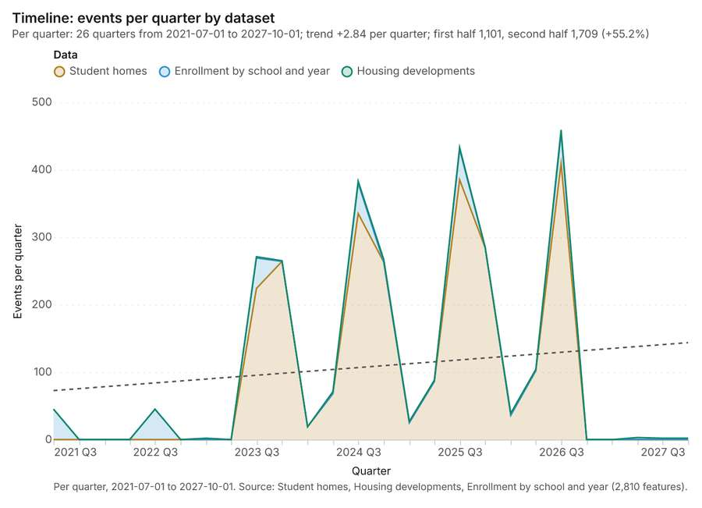
Figure 1. Timeline: events per quarter by dataset [1]. Per quarter, 2021-07-01 to 2027-10-01. Source: Student homes, Housing developments, Enrollment by school and year (2,810 features). The data is in the appendix.
The timeline counts 2,810 dated events in Student homes, Housing developments, Enrollment by school and year per quarter, from Q3 2021 to Q4 2027 [1][2][3][4]. By dataset: Student homes 2,500; Enrollment by school and year 270; Housing developments 40 [1]. The trend is +2.84 events per quarter; the second half of the quarters has 1,709 against 1,101 in the first (+55.2%) [1]. 7 of the 26 quarters had no events [1].
Busiest quarters
- Q3 2026: 459 events [1]
- Q3 2025: 433 events [1]
- Q3 2024: 383 events [1]
Quietest quarters with events
- Q1 2023: 2 events [1]
- Q3 2027: 2 events [1]
- Q4 2027: 2 events [1]

Space time hot spots
What this analysis is. Emerging hot spots: Where hot spots are new, consecutive, intensifying, persistent, diminishing, sporadic, oscillating or historical over time [5]. In ArcGIS it is Emerging Hot Spot Analysis or Create Space Time Cube [5].
Why it was run on this data. Student homes carry dates in 'enrolled_on': emerging hot spot analysis finds new, intensifying and fading hot spots per month [6].
What it found. The analysis generated 96 features for the "Emerging hot spots: Student homes" layer [7].
Result | Value
result, count | 96
result, elapsed ms | 19
result, resolution | 8
result, features used | 2,500
result, time neighbors | 0
billing, cost | 0.225
billing, list price | 0.225
billing, upstream cost | 0

Findings
- Evidenced: Space time hot spots on Student homes: Emerging hot spots: 1 layer saved: Emerging hot spots: Student homes (96 features) [7][8].
- Evidenced: It reported result, count 96; result, elapsed ms 19; result, resolution 8; result, features used 2,500; result, time neighbors 0; billing, cost 0.225 [7].
Tool gp_space_time_hot_spots; parameters {"project": "89129455-9e05-4edb-9cc1-dcfb440cc5ba", "features": {"layer": "Student homes (05789208)"}, "interval": "month", "bin_shape": "h3", "resolution": 8, "time_field": "enrolled_on"}

Space time hot spots
What this analysis is. Emerging hot spots: Where hot spots are new, consecutive, intensifying, persistent, diminishing, sporadic, oscillating or historical over time [5]. In ArcGIS it is Emerging Hot Spot Analysis or Create Space Time Cube [5].
Why it was run on this data. Housing developments carry dates in 'completion_month': emerging hot spot analysis finds new, intensifying and fading hot spots per month [9].
What it found. The analysis processed the Housing developments layer [11], resulting in an Emerging hot spots layer containing 22 features [10].
Result | Value
result, count | 22
result, elapsed ms | 4
result, resolution | 7
result, features used | 40
result, time neighbors | 0
billing, cost | 0.102
billing, list price | 0.102
billing, upstream cost | 0

Findings
- Evidenced: Space time hot spots on Housing developments: Emerging hot spots: 1 layer saved: Emerging hot spots: Housing developments (22 features) [10][11].
- Evidenced: It reported result, count 22; result, elapsed ms 4; result, resolution 7; result, features used 40; result, time neighbors 0; billing, cost 0.102 [10].
Tool gp_space_time_hot_spots; parameters {"agg": "sum", "project": "89129455-9e05-4edb-9cc1-dcfb440cc5ba", "features": {"layer": "Housing developments (afc1332b)"}, "interval": "month", "bin_shape": "h3", "resolution": 7, "time_field": "completion_month", "value_field": "units"}

Near repeat
What this analysis is. Repeat and near repeat classification: Classify incidents as originators, repeats (same place) or near repeats within a distance and time window, with a Knox test table [12]. In ArcGIS it is Repeat and Near Repeat Classification or Near Repeat Calculator [12].
Why it was run on this data. Near repeat analysis tests whether Student homes close in space also follow each other within 30 days [13].
What it found. Near repeat on Student homes: Repeat and near repeat classification: 1 layer saved: Repeat and near repeat classification: Student homes (2500 features) [8][14]. It reported result, days 30; result, count 2,500; result, chains 284; result, distance m 200; result, elapsed ms 61; result, pairs linked 1,594 [14].
Result | Value
result, days | 30
result, count | 2,500
result, chains | 284
result, distance m | 200
result, elapsed ms | 61
result, pairs linked | 1,594
billing, cost | 0.125
billing, list price | 0.125
billing, upstream cost | 0

Findings
- Evidenced: Near repeat on Student homes: Repeat and near repeat classification: 1 layer saved: Repeat and near repeat classification: Student homes (2500 features) [8][14].
- Evidenced: It reported result, days 30; result, count 2,500; result, chains 284; result, distance m 200; result, elapsed ms 61; result, pairs linked 1,594 [14].
Tool gp_near_repeat; parameters {"days": 30, "project": "89129455-9e05-4edb-9cc1-dcfb440cc5ba", "features": {"layer": "Student homes (05789208)"}, "distance_m": 200.0, "time_field": "enrolled_on"}

Summarize within
What this analysis is. Summarize within: Count and aggregate the features inside each polygon (or bin), proportionally for lines and polygons [15]. In ArcGIS it is Summarize Within or Aggregate Points; in QGIS, native:countpointsinpolygon or native:sumlinelengths [15].
Why it was run on this data. Count Student homes inside each feature of School catchments by transport; the counts map as a choropleth (natural breaks, sequential colors) [16].
What it found. Summarize within on Student homes, School catchments: Summarize within: 1 layer saved: Summarize within: School catchments (45 features) [8][17][18]. It reported result, count 45; result, elapsed ms 6; billing, cost 0.06092; billing, list price 0.06092; billing, upstream cost 0 [17].
Result | Value
result, count | 45
result, elapsed ms | 6
billing, cost | 0.06092
billing, list price | 0.06092
billing, upstream cost | 0

Findings
- Evidenced: Summarize within on Student homes, School catchments: Summarize within: 1 layer saved: Summarize within: School catchments (45 features) [8][17][18].
- Evidenced: It reported result, count 45; result, elapsed ms 6; billing, cost 0.06092; billing, list price 0.06092; billing, upstream cost 0 [17].
Tool gp_summarize_within; parameters {"stats": [{"stat": "sum", "field": "grade"}], "project": "89129455-9e05-4edb-9cc1-dcfb440cc5ba", "features": {"layer": "Student homes (05789208)"}, "group_by": "transport", "polygons": {"layer": "School catchments (534622c6)"}}

Summarize within
What this analysis is. Summarize within: Count and aggregate the features inside each polygon (or bin), proportionally for lines and polygons [15]. In ArcGIS it is Summarize Within or Aggregate Points; in QGIS, native:countpointsinpolygon or native:sumlinelengths [15].
Why it was run on this data. Count Student homes inside each feature of School catchments by transport; the counts map as a choropleth (natural breaks, sequential colors) [16].
What it found. Summarize within on Childcare centers, School catchments: Summarize within: 1 layer saved: Summarize within: School catchments (45 features) [18][19][20]. It reported result, count 45; result, elapsed ms 1; billing, cost 0.01212; billing, list price 0.01212; billing, upstream cost 0 [19].
Result | Value
result, count | 45
result, elapsed ms | 1
billing, cost | 0.01212
billing, list price | 0.01212
billing, upstream cost | 0

Findings
- Evidenced: Summarize within on Childcare centers, School catchments: Summarize within: 1 layer saved: Summarize within: School catchments (45 features) [18][19][20].
- Evidenced: It reported result, count 45; result, elapsed ms 1; billing, cost 0.01212; billing, list price 0.01212; billing, upstream cost 0 [19].
Tool gp_summarize_within; parameters {"stats": [{"stat": "sum", "field": "spaces"}], "project": "89129455-9e05-4edb-9cc1-dcfb440cc5ba", "features": {"layer": "Childcare centers (9489916f)"}, "polygons": {"layer": "School catchments (534622c6)"}}

Summarize within
What this analysis is. Summarize within: Count and aggregate the features inside each polygon (or bin), proportionally for lines and polygons [15]. In ArcGIS it is Summarize Within or Aggregate Points; in QGIS, native:countpointsinpolygon or native:sumlinelengths [15].
Why it was run on this data. Count Student homes inside each feature of School catchments by transport; the counts map as a choropleth (natural breaks, sequential colors) [16].
What it found. Summarize within on Housing developments, School catchments: Summarize within: 1 layer saved: Summarize within: School catchments (45 features) [11][18][21]. It reported result, count 45; result, elapsed ms 1; billing, cost 0.01172; billing, list price 0.01172; billing, upstream cost 0 [21].
Result | Value
result, count | 45
result, elapsed ms | 1
billing, cost | 0.01172
billing, list price | 0.01172
billing, upstream cost | 0

Findings
- Evidenced: Summarize within on Housing developments, School catchments: Summarize within: 1 layer saved: Summarize within: School catchments (45 features) [11][18][21].
- Evidenced: It reported result, count 45; result, elapsed ms 1; billing, cost 0.01172; billing, list price 0.01172; billing, upstream cost 0 [21].
Tool gp_summarize_within; parameters {"stats": [{"stat": "sum", "field": "units"}], "project": "89129455-9e05-4edb-9cc1-dcfb440cc5ba", "features": {"layer": "Housing developments (afc1332b)"}, "polygons": {"layer": "School catchments (534622c6)"}}

Hot spots
What this analysis is. Hot spot analysis: Getis-Ord Gi* hot and cold spots with z-scores, p-values and confidence bins [22]. In ArcGIS it is Find Hot Spots or Hot Spot Analysis (Getis-Ord Gi*); in QGIS, qgis:hotspot (plugin) [22].
Why it was run on this data. 2500 points: Getis-Ord Gi* tests whether the concentrations in Student homes are statistically significant [23].
What it found. Hot spots on Student homes: Hot spot analysis: 1 layer saved: Hot spot analysis: Student homes (281 features) [8][24]. It reported result, bins 281; result, count 281; result, elapsed ms 23; result, cell size m 500; result, incidents used 2,500; result, distance band m 500 [24].
Result | Value
result, bins | 281
result, count | 281
result, elapsed ms | 23
result, cell size m | 500
result, incidents used | 2,500
result, distance band m | 500
billing, cost | 0.1
billing, list price | 0.1
billing, upstream cost | 0

Findings
- Evidenced: Hot spots on Student homes: Hot spot analysis: 1 layer saved: Hot spot analysis: Student homes (281 features) [8][24].
- Evidenced: It reported result, bins 281; result, count 281; result, elapsed ms 23; result, cell size m 500; result, incidents used 2,500; result, distance band m 500 [24].
A model draft was discarded because a sentence did not cite a source of this section.
Tool gp_hot_spots; parameters {"project": "89129455-9e05-4edb-9cc1-dcfb440cc5ba", "features": {"layer": "Student homes (05789208)"}, "aggregation": "hexagon", "cell_size_m": 500.0, "distance_band_m": 500.0}

Hot spots
What this analysis is. Hot spot analysis: Getis-Ord Gi* hot and cold spots with z-scores, p-values and confidence bins [22]. In ArcGIS it is Find Hot Spots or Hot Spot Analysis (Getis-Ord Gi*); in QGIS, qgis:hotspot (plugin) [22].
Why it was run on this data. 60 points: Getis-Ord Gi* tests whether the concentrations in Childcare centers are statistically significant [25].
What it found. Hot spots on Childcare centers: Hot spot analysis: 1 layer saved: Hot spot analysis: Childcare centers (20 features) [20][26]. It reported result, bins 20; result, count 20; result, elapsed ms 2; result, cell size m 2,000; result, incidents used 60; result, distance band m 2,000 [26].
Result | Value
result, bins | 20
result, count | 20
result, elapsed ms | 2
result, cell size m | 2,000
result, incidents used | 60
result, distance band m | 2,000
billing, cost | 0.0512
billing, list price | 0.0512
billing, upstream cost | 0

Findings
- Evidenced: Hot spots on Childcare centers: Hot spot analysis: 1 layer saved: Hot spot analysis: Childcare centers (20 features) [20][26].
- Evidenced: It reported result, bins 20; result, count 20; result, elapsed ms 2; result, cell size m 2,000; result, incidents used 60; result, distance band m 2,000 [26].
Tool gp_hot_spots; parameters {"project": "89129455-9e05-4edb-9cc1-dcfb440cc5ba", "features": {"layer": "Childcare centers (9489916f)"}, "aggregation": "hexagon", "cell_size_m": 2000.0, "distance_band_m": 2000.0}

Hot spots
What this analysis is. Hot spot analysis: Getis-Ord Gi* hot and cold spots with z-scores, p-values and confidence bins [22]. In ArcGIS it is Find Hot Spots or Hot Spot Analysis (Getis-Ord Gi*); in QGIS, qgis:hotspot (plugin) [22].
Why it was run on this data. 40 points: Getis-Ord Gi* tests whether the concentrations in Housing developments are statistically significant [27].
What it found. The hot spot analysis was performed using the Housing developments layer [11] and saved one layer, "Hot spot analysis: Housing developments," containing 40 features [28]. This execution step resulted in an elapsed time of 1 ms [28]. The analysis also generated a result set with 0 excluded null values [28], and total billing costs for the process amounted to 0.0508 [28].
Result | Value
result, count | 40
result, elapsed ms | 1
result, excluded null | 0
result, distance band m | 2,000
billing, cost | 0.0508
billing, list price | 0.0508
billing, upstream cost | 0

Findings
- Evidenced: Hot spots on Housing developments: Hot spot analysis: 1 layer saved: Hot spot analysis: Housing developments (40 features) [11][28].
- Evidenced: It reported result, count 40; result, elapsed ms 1; result, excluded null 0; result, distance band m 2,000; billing, cost 0.0508; billing, list price 0.0508 [28].
Tool gp_hot_spots; parameters {"field": "units", "project": "89129455-9e05-4edb-9cc1-dcfb440cc5ba", "features": {"layer": "Housing developments (afc1332b)"}, "aggregation": "hexagon", "cell_size_m": 2000.0, "distance_band_m": 2000.0}

Calculate density
What this analysis is. Calculate density: Kernel density per square kilometer on a grid [29]. In ArcGIS it is Calculate Density or Kernel Density; in QGIS, native:heatmapkerneldensityestimation [29].
Why it was run on this data. 2500 points in Student homes: a density surface shows where they concentrate [30].
What it found. The density calculation was performed using the Student homes dataset [31]. This process analyzed 1,838 features and reported a maximum density per km2 of 388.8 [31].
Result | Value
result, count | 1,838
result, elapsed ms | 59
result, bandwidth m | 500
result, cell size m | 200
result, excluded null | 0
result, max density per km2 | 388.8
billing, cost | 0.1
billing, list price | 0.1
billing, upstream cost | 0

Findings
- Evidenced: Calculate density on Student homes: Calculate density: 1 layer saved: Calculate density: Student homes (1838 features) [8][31].
- Evidenced: It reported result, count 1,838; result, elapsed ms 59; result, bandwidth m 500; result, cell size m 200; result, excluded null 0; result, max density per km2 388.8 [31].
Tool gp_calculate_density; parameters {"kernel": "quartic", "project": "89129455-9e05-4edb-9cc1-dcfb440cc5ba", "features": {"layer": "Student homes (05789208)"}, "bandwidth_m": 500.0, "cell_size_m": 200.0}

Calculate density
What this analysis is. Calculate density: Kernel density per square kilometer on a grid [29]. In ArcGIS it is Calculate Density or Kernel Density; in QGIS, native:heatmapkerneldensityestimation [29].
Why it was run on this data. 60 points in Childcare centers: a density surface shows where they concentrate [32].
What it found. Calculate density on Childcare centers: Calculate density: 1 layer saved: Calculate density: Childcare centers (112 features) [20][33]. It reported result, count 112; result, elapsed ms 3; result, bandwidth m 2,000; result, cell size m 1,000; result, excluded null 0; result, max density per km2 1.453 [33].
Result | Value
result, count | 112
result, elapsed ms | 3
result, bandwidth m | 2,000
result, cell size m | 1,000
result, excluded null | 0
result, max density per km2 | 1.453
billing, cost | 0.0512
billing, list price | 0.0512
billing, upstream cost | 0

Findings
- Evidenced: Calculate density on Childcare centers: Calculate density: 1 layer saved: Calculate density: Childcare centers (112 features) [20][33].
- Evidenced: It reported result, count 112; result, elapsed ms 3; result, bandwidth m 2,000; result, cell size m 1,000; result, excluded null 0; result, max density per km2 1.453 [33].
Tool gp_calculate_density; parameters {"kernel": "quartic", "project": "89129455-9e05-4edb-9cc1-dcfb440cc5ba", "features": {"layer": "Childcare centers (9489916f)"}, "bandwidth_m": 2000.0, "cell_size_m": 1000.0}

Calculate density
What this analysis is. Calculate density: Kernel density per square kilometer on a grid [29]. In ArcGIS it is Calculate Density or Kernel Density; in QGIS, native:heatmapkerneldensityestimation [29].
Why it was run on this data. 40 points in Housing developments: a density surface shows where they concentrate [34].
What it found. Calculate density on Housing developments: Calculate density: 1 layer saved: Calculate density: Housing developments (80 features) [11][35]. It reported result, count 80; result, elapsed ms 3; result, bandwidth m 2,000; result, cell size m 1,000; result, excluded null 0; result, max density per km2 881.6 [35].
Result | Value
result, count | 80
result, elapsed ms | 3
result, bandwidth m | 2,000
result, cell size m | 1,000
result, excluded null | 0
result, max density per km2 | 881.6
billing, cost | 0.0508
billing, list price | 0.0508
billing, upstream cost | 0

Findings
- Evidenced: Calculate density on Housing developments: Calculate density: 1 layer saved: Calculate density: Housing developments (80 features) [11][35].
- Evidenced: It reported result, count 80; result, elapsed ms 3; result, bandwidth m 2,000; result, cell size m 1,000; result, excluded null 0; result, max density per km2 881.6 [35].
Tool gp_calculate_density; parameters {"kernel": "quartic", "project": "89129455-9e05-4edb-9cc1-dcfb440cc5ba", "features": {"layer": "Housing developments (afc1332b)"}, "bandwidth_m": 2000.0, "cell_size_m": 1000.0, "weight_field": "units"}

Find point clusters
What this analysis is. Find point clusters: Density-based clusters (DBSCAN, HDBSCAN or OPTICS, optionally space-time) with hulls and noise [36]. In ArcGIS it is Find Point Clusters or Density-based Clustering; in QGIS, native:dbscanclustering or native:stdbscanclustering [36].
Why it was run on this data. DBSCAN finds dense groups of Student homes and separates noise [37].
What it found. Find point clusters on Student homes: Find point clusters: 2 layers saved: Find point clusters: Student homes (2500 features); Find point clusters: cluster hulls (1 feature) [8][38]. It reported result, count 2,500; result, noise 1,490; result, distance m 200; result, elapsed ms 32; result, min points 20; billing, cost 0.1 [38].
Result | Value
result, count | 2,500
result, noise | 1,490
result, distance m | 200
result, elapsed ms | 32
result, min points | 20
billing, cost | 0.1
billing, list price | 0.1
billing, upstream cost | 0

Findings
- Evidenced: Find point clusters on Student homes: Find point clusters: 2 layers saved: Find point clusters: Student homes (2500 features); Find point clusters: cluster hulls (1 feature) [8][38].
- Evidenced: It reported result, count 2,500; result, noise 1,490; result, distance m 200; result, elapsed ms 32; result, min points 20; billing, cost 0.1 [38].
A model draft was discarded because a sentence did not cite a source of this section.
Tool gp_find_point_clusters; parameters {"method": "dbscan", "project": "89129455-9e05-4edb-9cc1-dcfb440cc5ba", "features": {"layer": "Student homes (05789208)"}, "distance_m": 200.0, "min_points": 20}

Find point clusters
What this analysis is. Find point clusters: Density-based clusters (DBSCAN, HDBSCAN or OPTICS, optionally space-time) with hulls and noise [36]. In ArcGIS it is Find Point Clusters or Density-based Clustering; in QGIS, native:dbscanclustering or native:stdbscanclustering [36].
Why it was run on this data. DBSCAN finds dense groups of Childcare centers and separates noise [39].
What it found. Find point clusters on Childcare centers: Find point clusters: 2 layers saved: Find point clusters: Childcare centers (60 features); Find point clusters: cluster hulls (8 features) [20][40]. It reported result, count 60; result, noise 1; result, distance m 1,000; result, elapsed ms 3; result, min points 3; billing, cost 0.0512 [40].
Result | Value
result, count | 60
result, noise | 1
result, distance m | 1,000
result, elapsed ms | 3
result, min points | 3
billing, cost | 0.0512
billing, list price | 0.0512
billing, upstream cost | 0

Findings
- Evidenced: Find point clusters on Childcare centers: Find point clusters: 2 layers saved: Find point clusters: Childcare centers (60 features); Find point clusters: cluster hulls (8 features) [20][40].
- Evidenced: It reported result, count 60; result, noise 1; result, distance m 1,000; result, elapsed ms 3; result, min points 3; billing, cost 0.0512 [40].
Tool gp_find_point_clusters; parameters {"method": "dbscan", "project": "89129455-9e05-4edb-9cc1-dcfb440cc5ba", "features": {"layer": "Childcare centers (9489916f)"}, "distance_m": 1000.0, "min_points": 3}

Find point clusters
What this analysis is. Find point clusters: Density-based clusters (DBSCAN, HDBSCAN or OPTICS, optionally space-time) with hulls and noise [36]. In ArcGIS it is Find Point Clusters or Density-based Clustering; in QGIS, native:dbscanclustering or native:stdbscanclustering [36].
Why it was run on this data. DBSCAN finds dense groups of Housing developments and separates noise [41].
What it found. Find point clusters on Housing developments: Find point clusters: 2 layers saved: Find point clusters: Housing developments (40 features); Find point clusters: cluster hulls (1 feature) [11][42]. It reported result, count 40; result, noise 3; result, distance m 2,000; result, elapsed ms 1; result, min points 3; billing, cost 0.0508 [42].
Result | Value
result, count | 40
result, noise | 3
result, distance m | 2,000
result, elapsed ms | 1
result, min points | 3
billing, cost | 0.0508
billing, list price | 0.0508
billing, upstream cost | 0

Findings
- Evidenced: Find point clusters on Housing developments: Find point clusters: 2 layers saved: Find point clusters: Housing developments (40 features); Find point clusters: cluster hulls (1 feature) [11][42].
- Evidenced: It reported result, count 40; result, noise 3; result, distance m 2,000; result, elapsed ms 1; result, min points 3; billing, cost 0.0508 [42].
Tool gp_find_point_clusters; parameters {"method": "dbscan", "project": "89129455-9e05-4edb-9cc1-dcfb440cc5ba", "features": {"layer": "Housing developments (afc1332b)"}, "distance_m": 2000.0, "min_points": 3}

Outliers
What this analysis is. Find outliers: Anselin local Moran’s I: HH, LL clusters and HL, LH outliers [43]. In ArcGIS it is Find Outliers or Cluster and Outlier Analysis (Anselin Local Moran’s I) [43].
Why it was run on this data. Local Moran's I maps clusters and outliers of 'children_5_17' [44].
What it found. The `gp_outliers` tool was executed using the `School catchments` layer [18]. The process generated 45 results [45], completing with an elapsed time of 4 ms [45]. Furthermore, the analysis utilized 199 permutations [45] and established a distance band of 1,430 m [45].
Result | Value
result, count | 45
result, elapsed ms | 4
result, permutations | 199
result, excluded null | 0
result, distance band m | 1,430
billing, cost | 0.05135
billing, list price | 0.05135
billing, upstream cost | 0

Findings
- Evidenced: Outliers on School catchments: Find outliers: 1 layer saved: Find outliers: School catchments (45 features) [18][45].
- Evidenced: It reported result, count 45; result, elapsed ms 4; result, permutations 199; result, excluded null 0; result, distance band m 1,430; billing, cost 0.05135 [45].
Tool gp_outliers; parameters {"field": "children_5_17", "project": "89129455-9e05-4edb-9cc1-dcfb440cc5ba", "features": {"layer": "School catchments (534622c6)"}, "aggregation": "hexagon"}

Spatial autocorrelation
What this analysis is. Spatial autocorrelation: Global Moran’s I: is the pattern clustered, dispersed or random [46]. In ArcGIS it is Spatial Autocorrelation (Global Moran’s I) [46].
Why it was run on this data. Global Moran's I says whether similar values of 'children_5_17' sit next to each other [47].
What it found. Spatial autocorrelation on School catchments: Spatial autocorrelation: done; no map output [18][48]. It reported result, n 45; result, p value 0.4896; result, z score 0.6909; result, morans i 0.05071; result, variance 0.0113; result, elapsed ms 2 [48].
Result | Value
result, n | 45
result, p value | 0.4896
result, z score | 0.6909
result, morans i | 0.05071
result, variance | 0.0113
result, elapsed ms | 2
result, expected i | -0.02273
result, excluded null | 0
result, distance band m | 1,430
result, p value normality | 0.5075
result, z score normality | 0.6627
result, variance normality | 0.01228
billing, cost | 0.02
billing, list price | 0.02
billing, upstream cost | 0

Findings
- Evidenced: Spatial autocorrelation on School catchments: Spatial autocorrelation: done; no map output [18][48].
- Evidenced: It reported result, n 45; result, p value 0.4896; result, z score 0.6909; result, morans i 0.05071; result, variance 0.0113; result, elapsed ms 2 [48].
Tool gp_spatial_autocorrelation; parameters {"field": "children_5_17", "project": "89129455-9e05-4edb-9cc1-dcfb440cc5ba", "features": {"layer": "School catchments (534622c6)"}}

Find nearest
What this analysis is. Find nearest: The k nearest features for each input, with geodesic distance and bearing [49]. In ArcGIS it is Find Nearest or Near; in QGIS, native:joinbynearest or native:nearestneighbouranalysis [49].
Why it was run on this data. The nearest of Major roads to each of Student homes, with distances [50].
What it found. Find nearest on Major roads, Student homes: Find nearest: 1 layer saved: Find nearest: Student homes (2500 features) [8][51][52]. It reported result, count 2,500; result, elapsed ms 1,073; billing, cost 0.06044; billing, list price 0.06044; billing, upstream cost 0 [51].
Result | Value
result, count | 2,500
result, elapsed ms | 1,073
billing, cost | 0.06044
billing, list price | 0.06044
billing, upstream cost | 0

Findings
- Evidenced: Find nearest on Major roads, Student homes: Find nearest: 1 layer saved: Find nearest: Student homes (2500 features) [8][51][52].
- Evidenced: It reported result, count 2,500; result, elapsed ms 1,073; billing, cost 0.06044; billing, list price 0.06044; billing, upstream cost 0 [51].
Tool gp_find_nearest; parameters {"k": 1, "to": {"layer": "Major roads (f801bcde)"}, "from": {"layer": "Student homes (05789208)"}, "project": "89129455-9e05-4edb-9cc1-dcfb440cc5ba", "max_distance_m": 2000.0}

Find nearest
What this analysis is. Find nearest: The k nearest features for each input, with geodesic distance and bearing [49]. In ArcGIS it is Find Nearest or Near; in QGIS, native:joinbynearest or native:nearestneighbouranalysis [49].
Why it was run on this data. The nearest of Major roads to each of Student homes, with distances [50].
What it found. Find nearest on Childcare centers, Student homes: Find nearest: 1 layer saved: Find nearest: Student homes (2500 features) [8][20][53]. It reported result, count 2,500; result, elapsed ms 129; billing, cost 0.0612; billing, list price 0.0612; billing, upstream cost 0 [53].
Result | Value
result, count | 2,500
result, elapsed ms | 129
billing, cost | 0.0612
billing, list price | 0.0612
billing, upstream cost | 0

Findings
- Evidenced: Find nearest on Childcare centers, Student homes: Find nearest: 1 layer saved: Find nearest: Student homes (2500 features) [8][20][53].
- Evidenced: It reported result, count 2,500; result, elapsed ms 129; billing, cost 0.0612; billing, list price 0.0612; billing, upstream cost 0 [53].
Tool gp_find_nearest; parameters {"k": 1, "to": {"layer": "Childcare centers (9489916f)"}, "from": {"layer": "Student homes (05789208)"}, "project": "89129455-9e05-4edb-9cc1-dcfb440cc5ba", "max_distance_m": 2000.0}

Find nearest
What this analysis is. Find nearest: The k nearest features for each input, with geodesic distance and bearing [49]. In ArcGIS it is Find Nearest or Near; in QGIS, native:joinbynearest or native:nearestneighbouranalysis [49].
Why it was run on this data. The nearest of Major roads to each of Student homes, with distances [50].
What it found. The `gp_find_nearest` tool was utilized with Housing developments [11] and Student homes [8] as inputs [54]. The operation successfully generated 2,251 results [54]. Specific performance metrics showed the elapsed time was 118 ms [54]. Furthermore, the recorded billing cost for this process was 0.0608 [54].
Result | Value
result, count | 2,251
result, elapsed ms | 118
billing, cost | 0.0608
billing, list price | 0.0608
billing, upstream cost | 0

Findings
- Evidenced: Find nearest on Housing developments, Student homes: Find nearest: 1 layer saved: Find nearest: Student homes (2251 features) [8][11][54].
- Evidenced: It reported result, count 2,251; result, elapsed ms 118; billing, cost 0.0608; billing, list price 0.0608; billing, upstream cost 0 [54].
Tool gp_find_nearest; parameters {"k": 1, "to": {"layer": "Housing developments (afc1332b)"}, "from": {"layer": "Student homes (05789208)"}, "project": "89129455-9e05-4edb-9cc1-dcfb440cc5ba", "max_distance_m": 2000.0}

Maps and charts
The run also made 23 map image(s) [55][56][57][58][59][60][61][62][63][64][65][66][67][68][69][70][71][72][73][74][75][76][77] and 31 chart(s) [78][79][80][81][82][83][84][85][86][87][88][89][90][91][92][93][94][95][96][97][98][99][100][101][102][103][104][105][106][107][108].
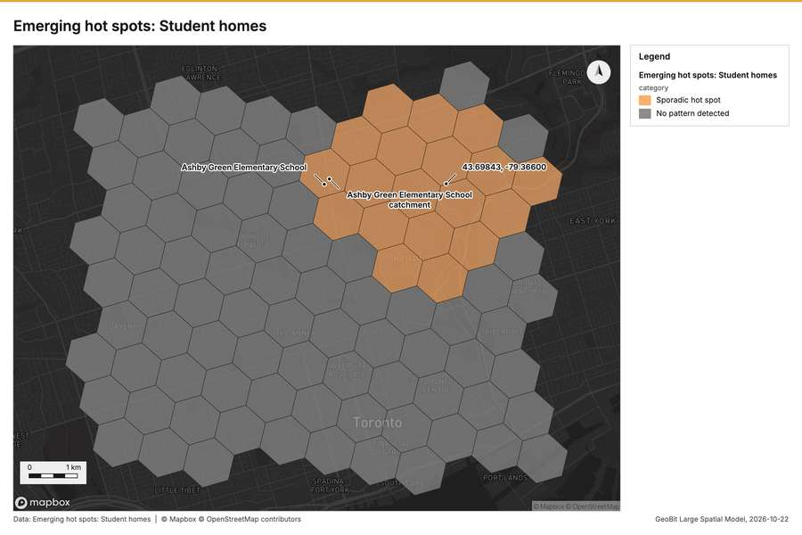
Figure 2. Emerging hot spots: Student homes [55]
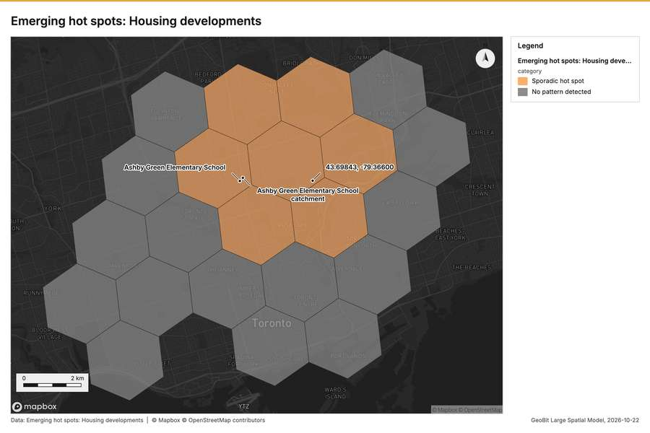
Figure 3. Emerging hot spots: Housing developments [56]
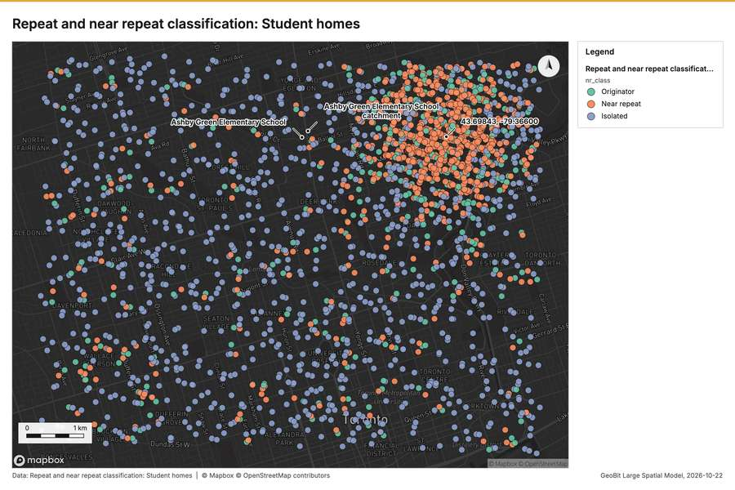
Figure 4. Repeat and near repeat classification: Student homes [57]
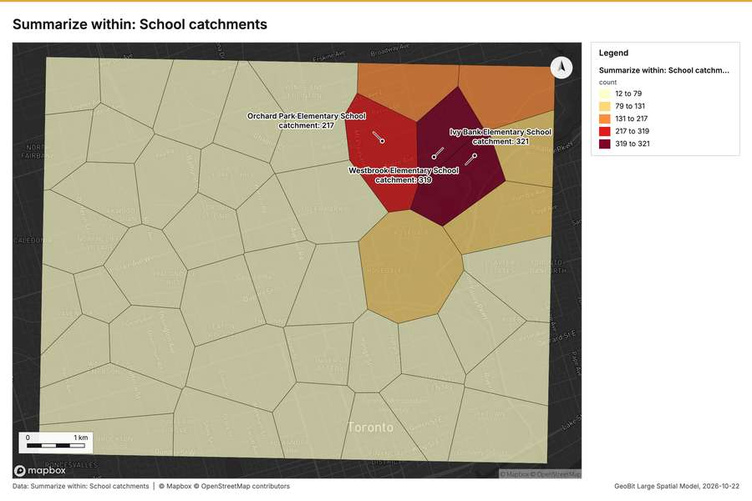
Figure 5. Summarize within: School catchments [58]
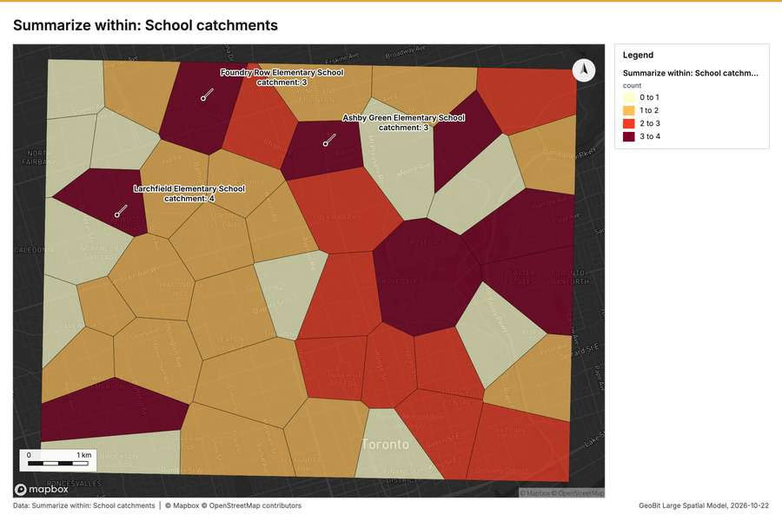
Figure 6. Summarize within: School catchments [59]
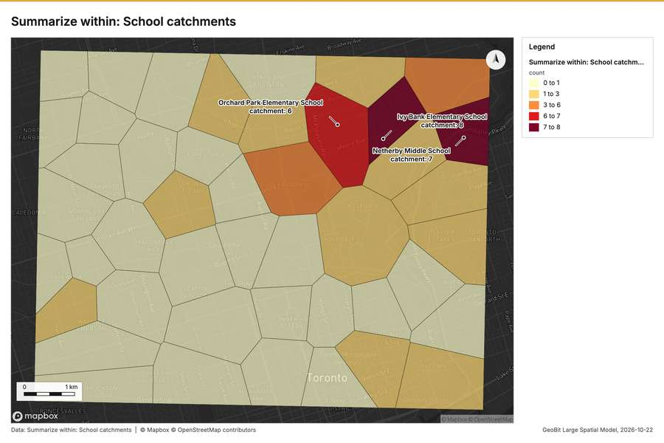
Figure 7. Summarize within: School catchments [60]
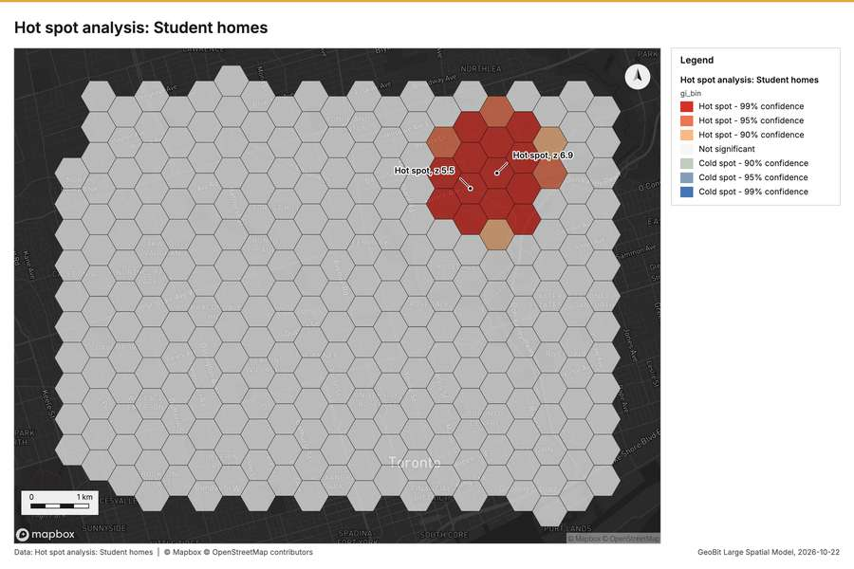
Figure 8. Hot spot analysis: Student homes [61]
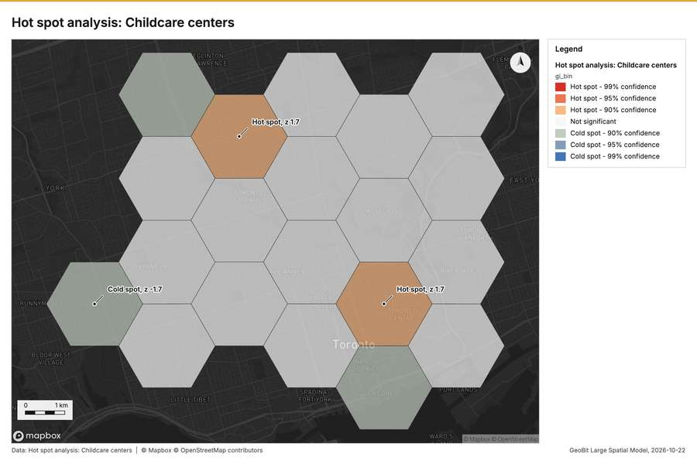
Figure 9. Hot spot analysis: Childcare centers [62]
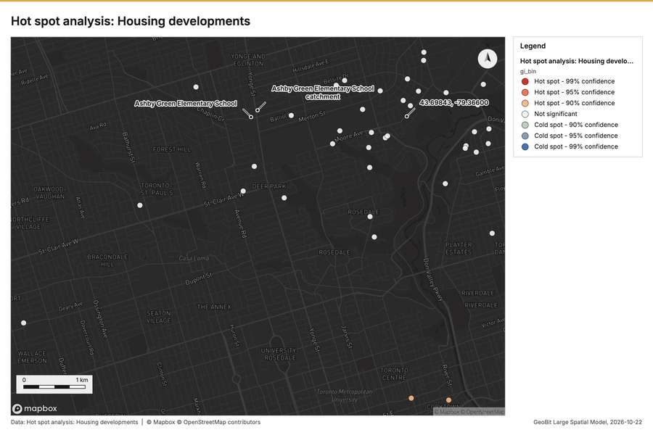
Figure 10. Hot spot analysis: Housing developments [63]
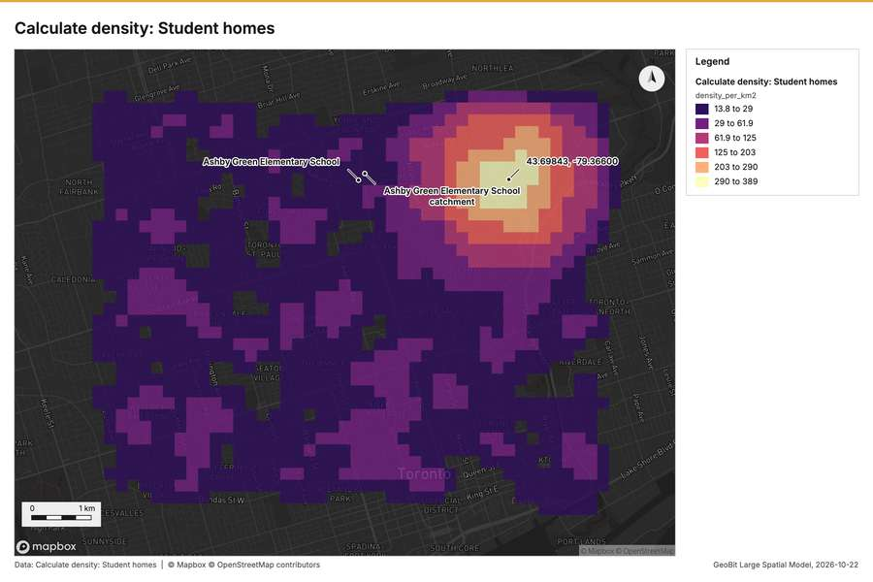
Figure 11. Calculate density: Student homes [64]
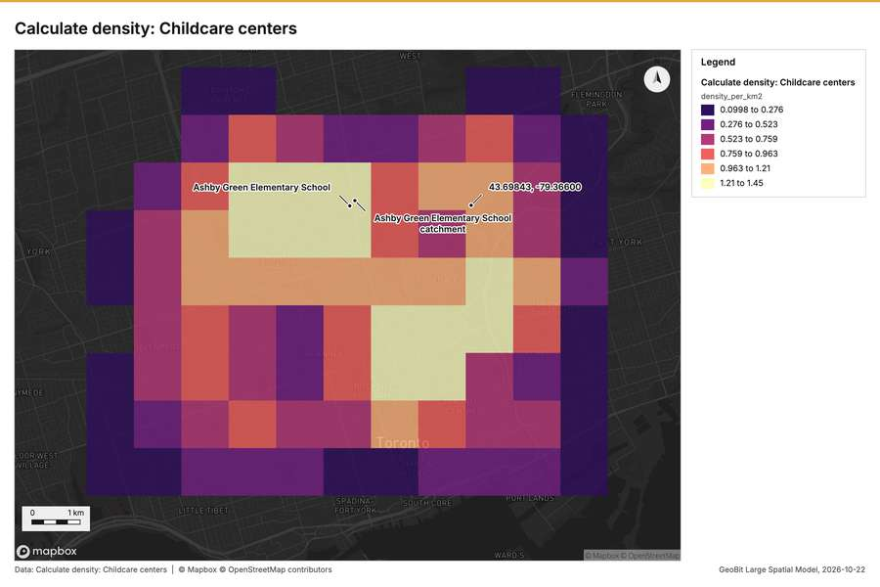
Figure 12. Calculate density: Childcare centers [65]
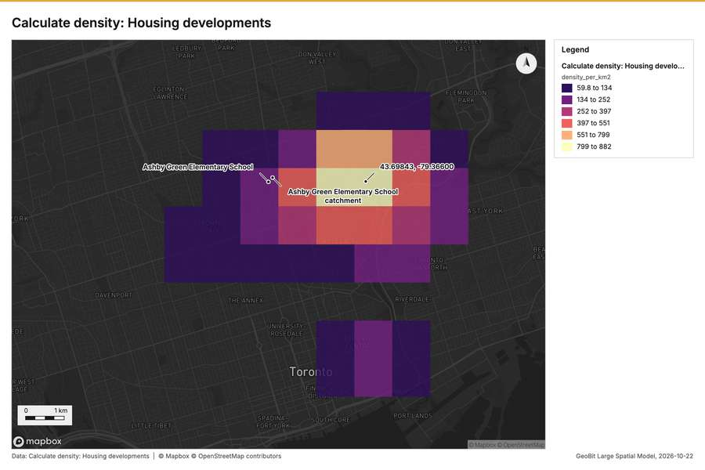
Figure 13. Calculate density: Housing developments [66]
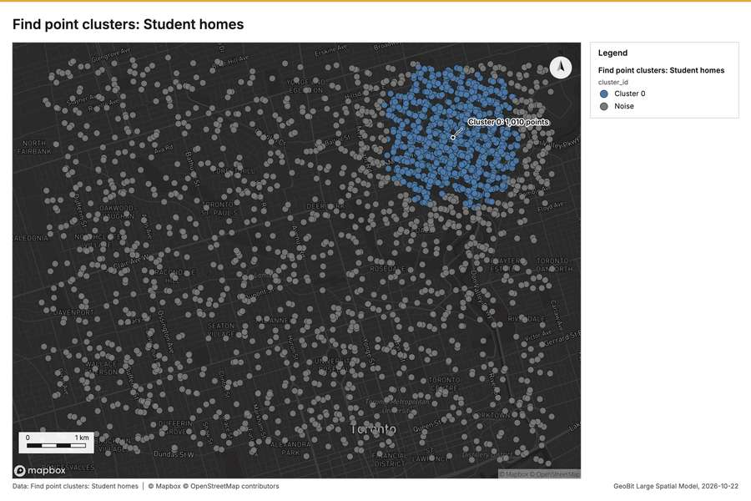
Figure 14. Find point clusters: Student homes [67]
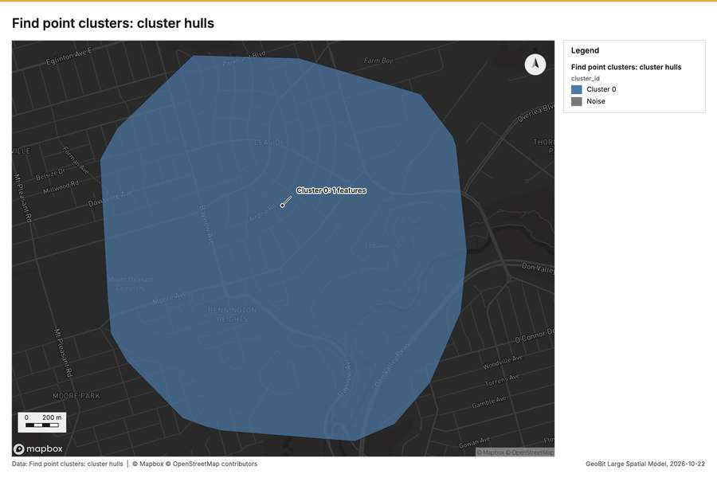
Figure 15. Find point clusters: cluster hulls [68]
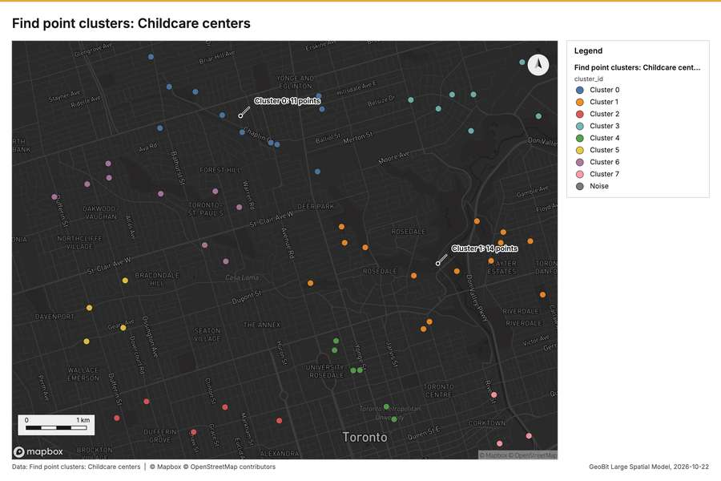
Figure 16. Find point clusters: Childcare centers [69]
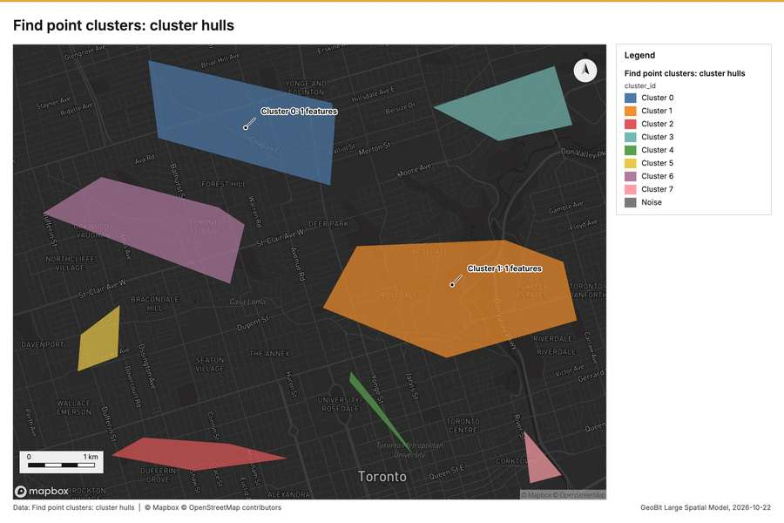
Figure 17. Find point clusters: cluster hulls [70]
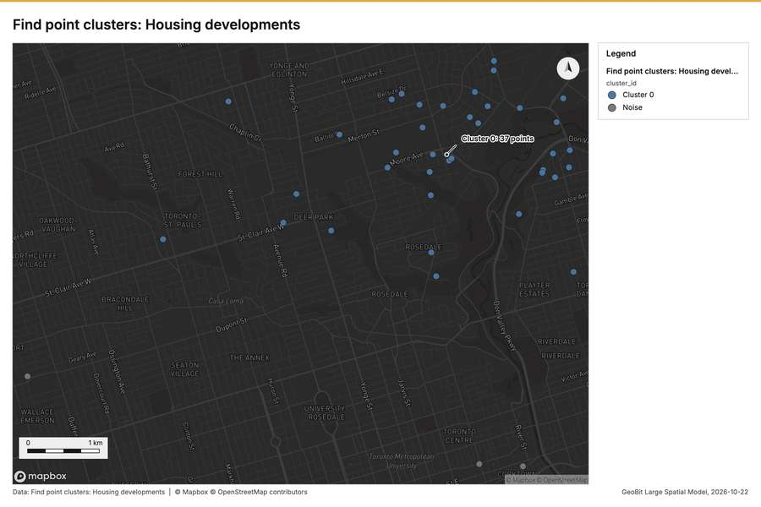
Figure 18. Find point clusters: Housing developments [71]
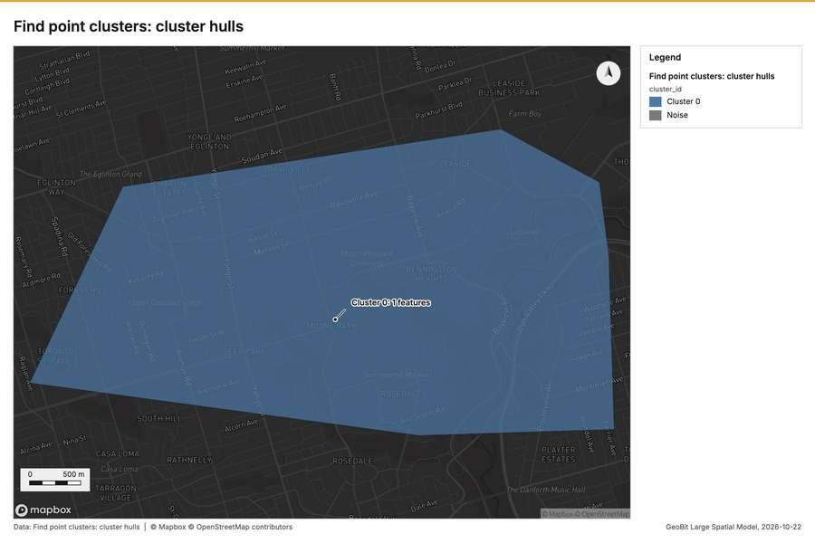
Figure 19. Find point clusters: cluster hulls [72]
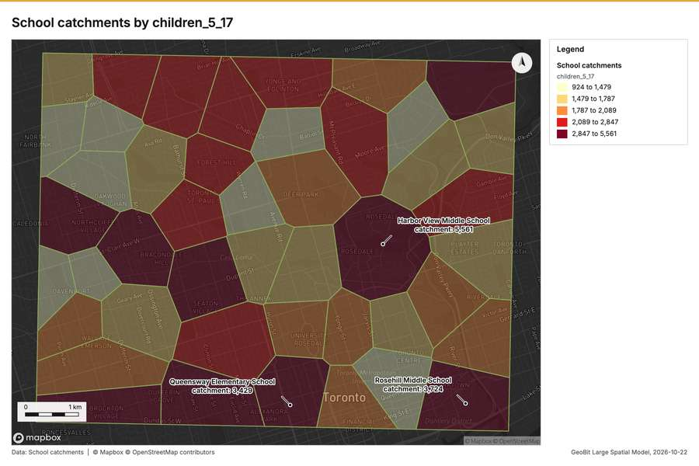
Figure 20. School catchments by children_5_17 [73]
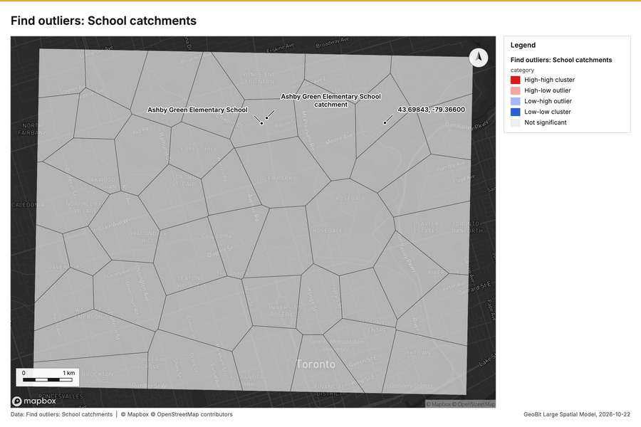
Figure 21. Find outliers: School catchments [74]
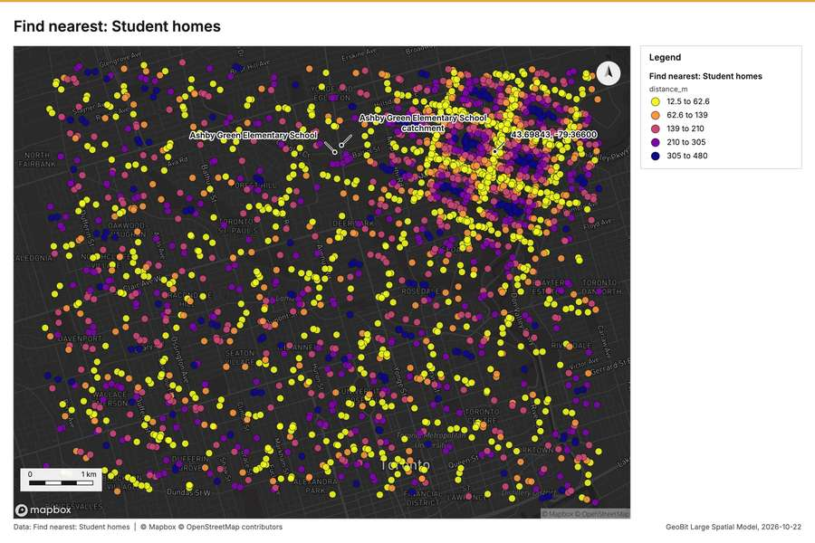
Figure 22. Find nearest: Student homes [75]
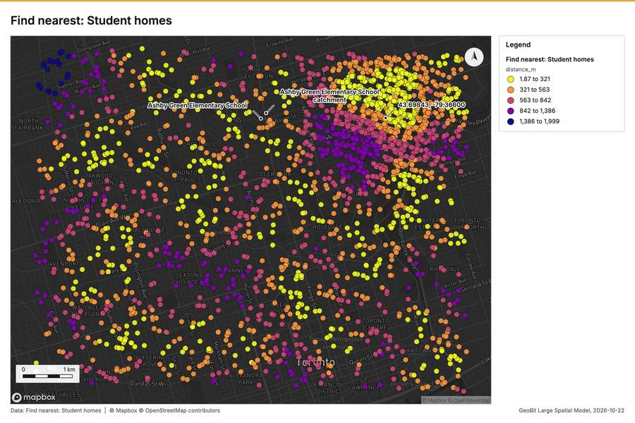
Figure 23. Find nearest: Student homes [76]
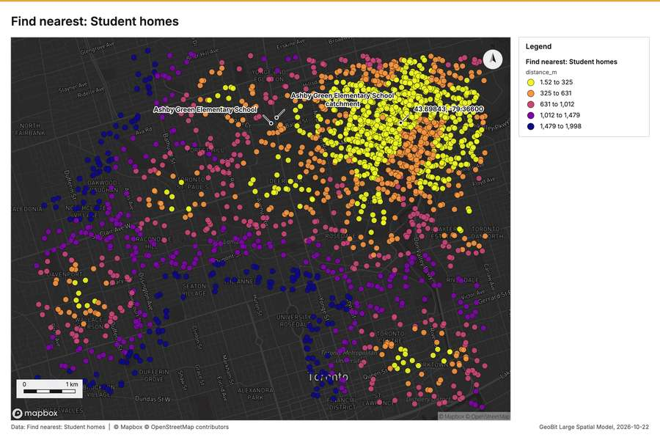
Figure 24. Find nearest: Student homes [77]
What the map shows. The map displays the emerging hot spots for student homes across a grid area. A distinct, concentrated cluster of "Sporadic hot spot" areas, colored orange, is visible in the upper-central portion of the map. The majority of the geographical area is colored gray, corresponding to [55]
Inferred: read from the image by gemma4:e4b, not evidence.
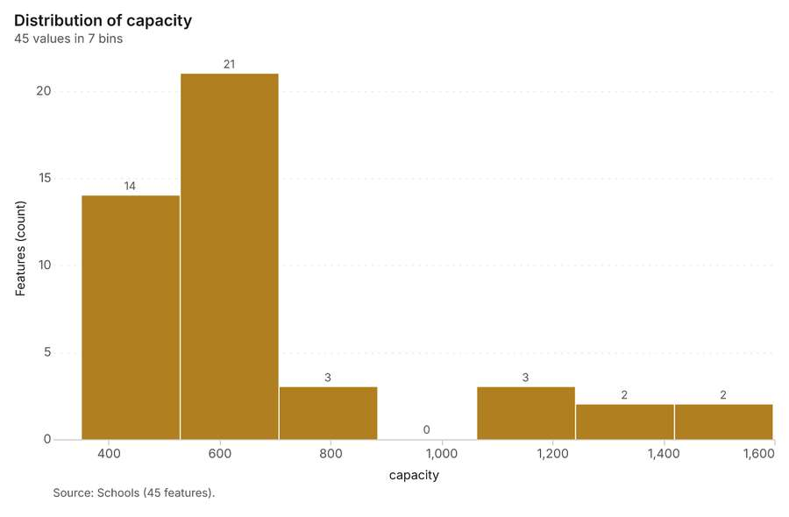
Figure 25. Schools over time (built_year) [78]. Source: Schools (45 features). The data is in the appendix.
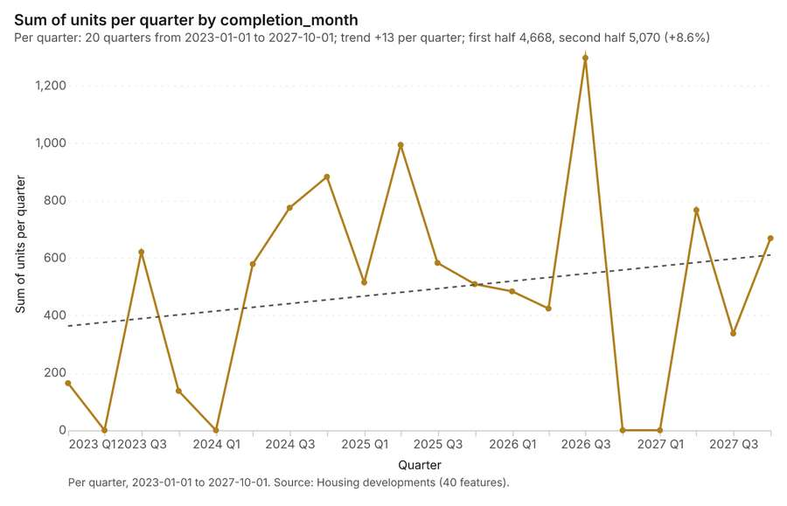
Figure 26. Housing developments over time (completion_month) [79]. Per quarter, 2023-01-01 to 2027-10-01. Source: Housing developments (40 features). The data is in the appendix.
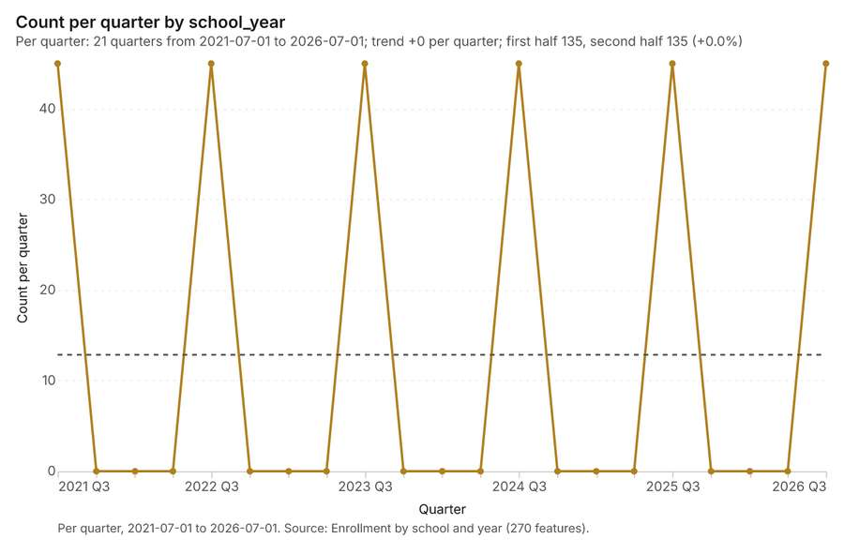
Figure 27. Enrollment by school and year over time (school_year) [80]. Per quarter, 2021-07-01 to 2026-07-01. Source: Enrollment by school and year (270 features). The data is in the appendix.
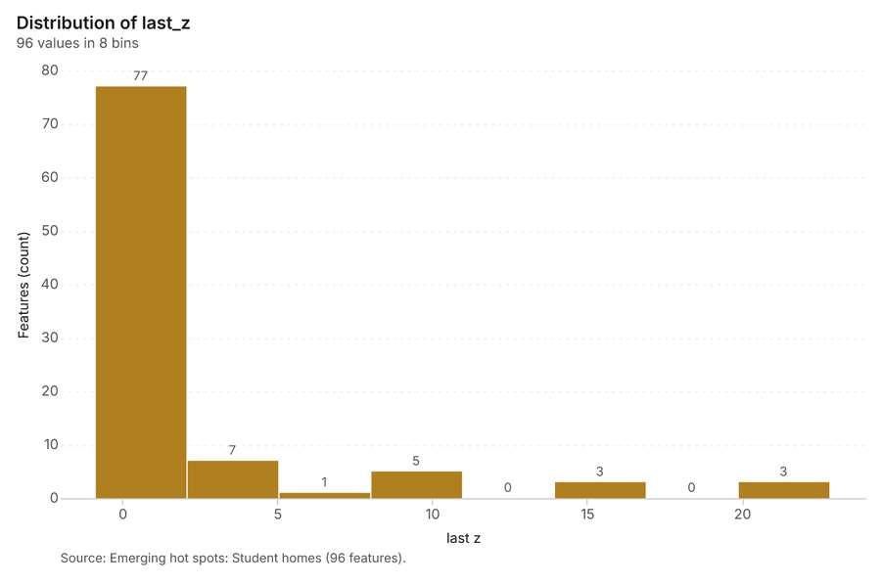
Figure 28. Emerging hot spots: Student homes [81]. Source: Emerging hot spots: Student homes (96 features). The data is in the appendix.
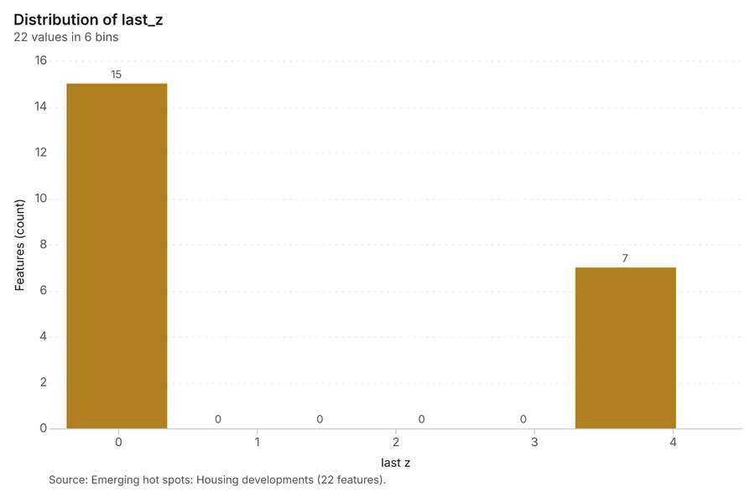
Figure 29. Emerging hot spots: Housing developments [82]. Source: Emerging hot spots: Housing developments (22 features). The data is in the appendix.
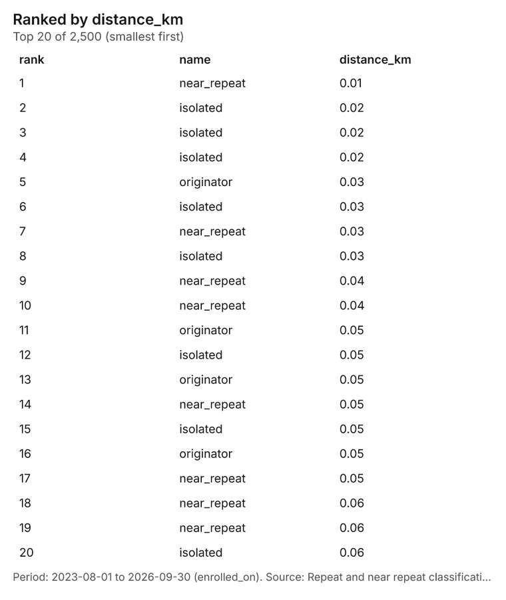
Figure 30. Repeat and near repeat classification: Student homes [83]. Period: 2023-08-01 to 2026-09-30 (enrolled_on). Source: Repeat and near repeat classification: Student homes (2,500 features). The data is in the appendix.
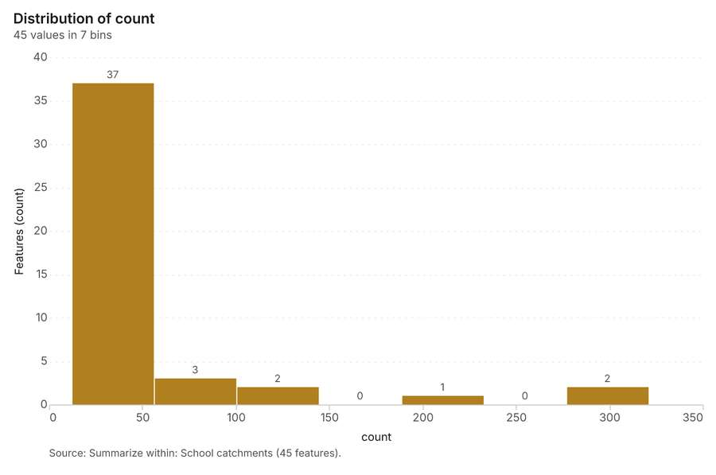
Figure 31. Summarize within: School catchments [84]. Source: Summarize within: School catchments (45 features). The data is in the appendix.
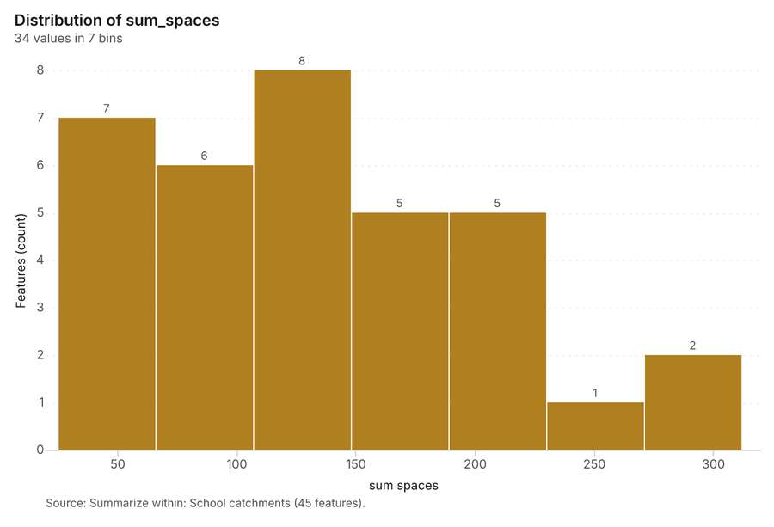
Figure 32. Summarize within: School catchments [85]. Source: Summarize within: School catchments (45 features). The data is in the appendix.
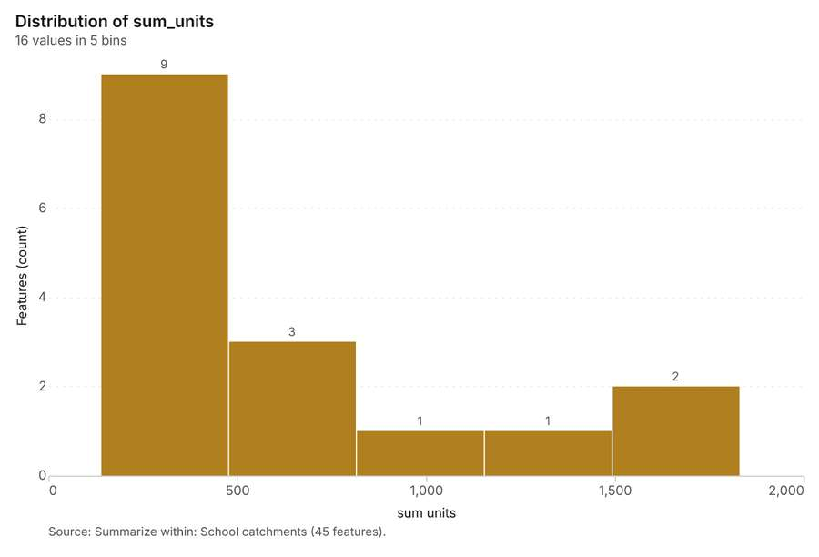
Figure 33. Summarize within: School catchments [86]. Source: Summarize within: School catchments (45 features). The data is in the appendix.
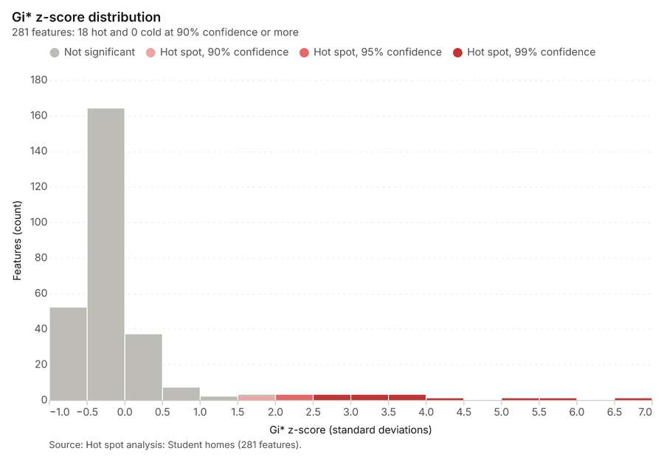
Figure 34. Hot spot analysis: Student homes [87]. Source: Hot spot analysis: Student homes (281 features). The data is in the appendix.
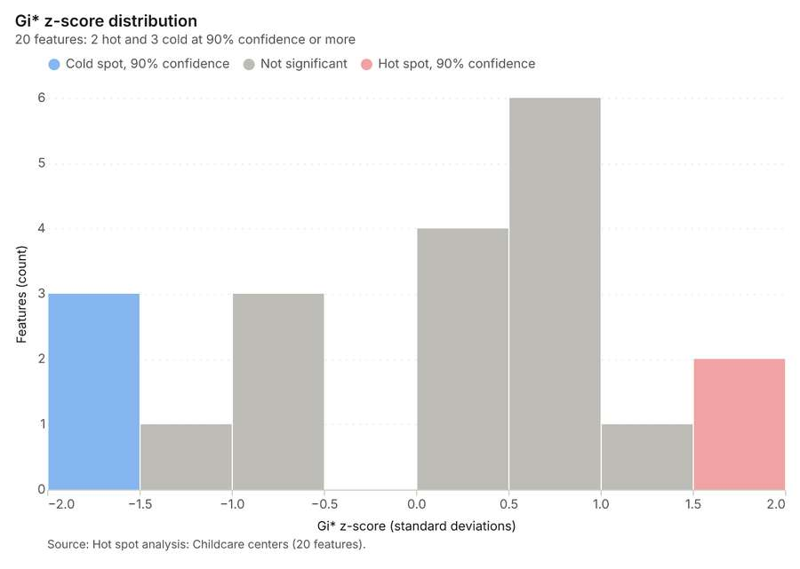
Figure 35. Hot spot analysis: Childcare centers [88]. Source: Hot spot analysis: Childcare centers (20 features). The data is in the appendix.
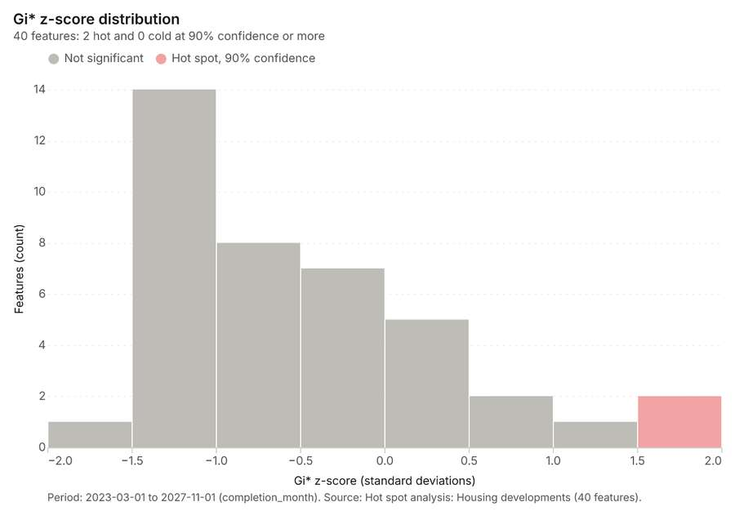
Figure 36. Hot spot analysis: Housing developments [89]. Period: 2023-03-01 to 2027-11-01 (completion_month). Source: Hot spot analysis: Housing developments (40 features). The data is in the appendix.
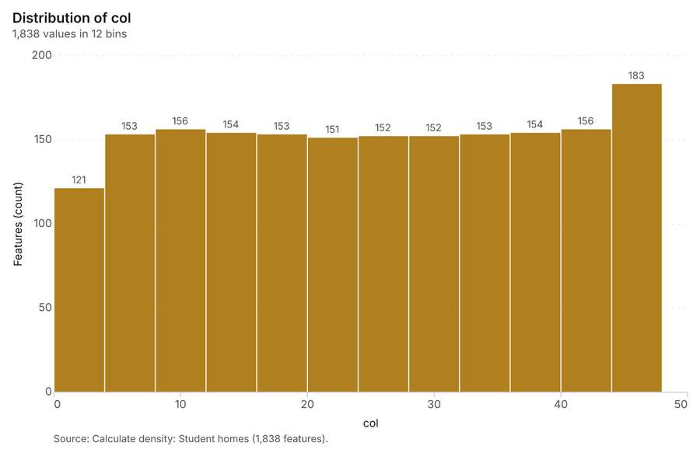
Figure 37. Calculate density: Student homes [90]. Source: Calculate density: Student homes (1,838 features). The data is in the appendix.
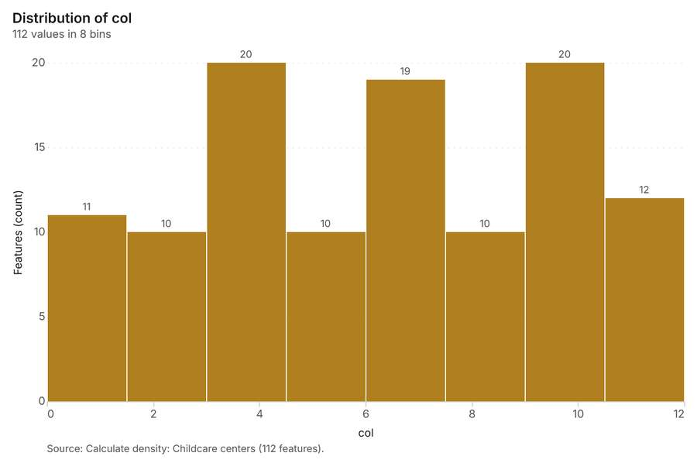
Figure 38. Calculate density: Childcare centers [91]. Source: Calculate density: Childcare centers (112 features). The data is in the appendix.
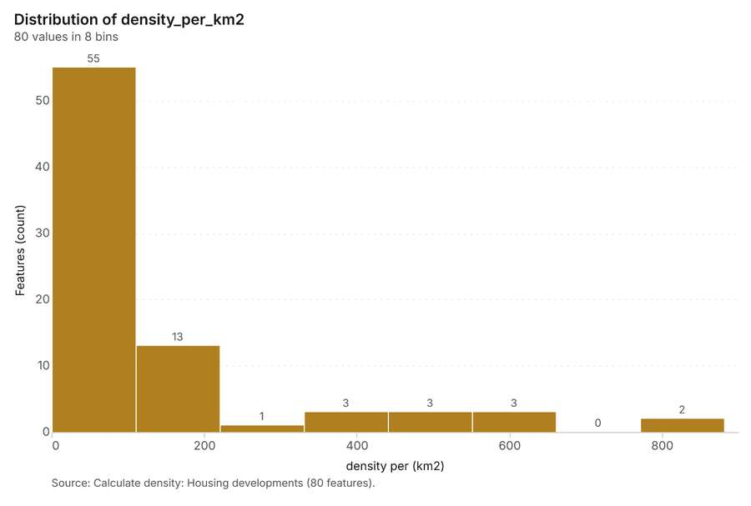
Figure 39. Calculate density: Housing developments [92]. Source: Calculate density: Housing developments (80 features). The data is in the appendix.
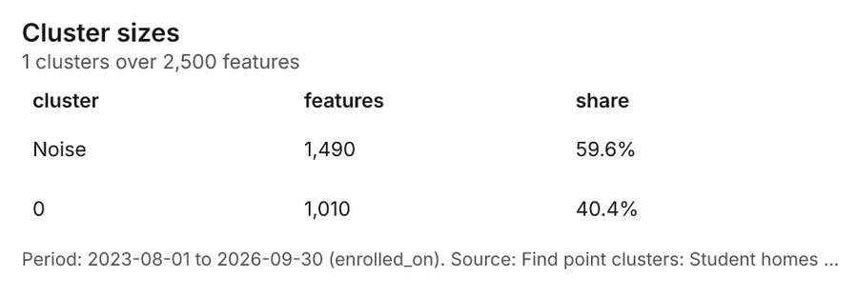
Figure 40. Find point clusters: Student homes [93]. Period: 2023-08-01 to 2026-09-30 (enrolled_on). Source: Find point clusters: Student homes (2,500 features). The data is in the appendix.
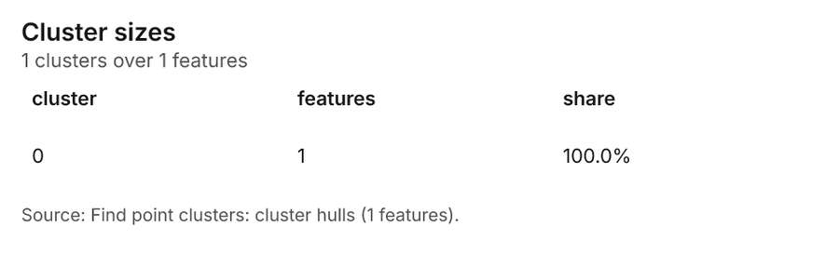
Figure 41. Find point clusters: cluster hulls [94]. Source: Find point clusters: cluster hulls (1 features). The data is in the appendix.
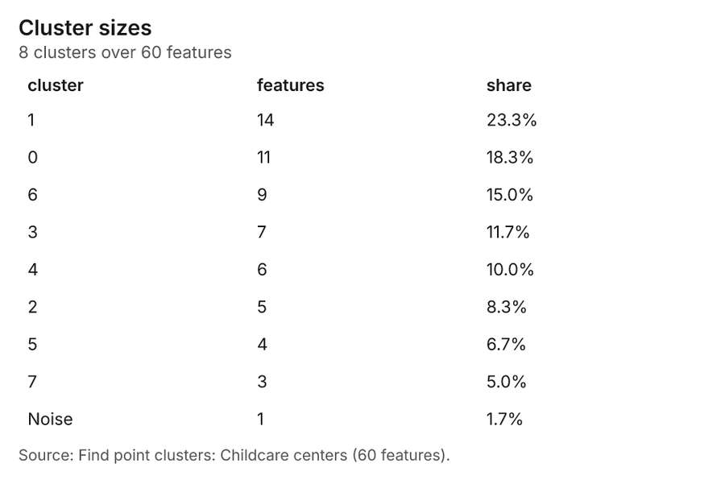
Figure 42. Find point clusters: Childcare centers [95]. Source: Find point clusters: Childcare centers (60 features). The data is in the appendix.
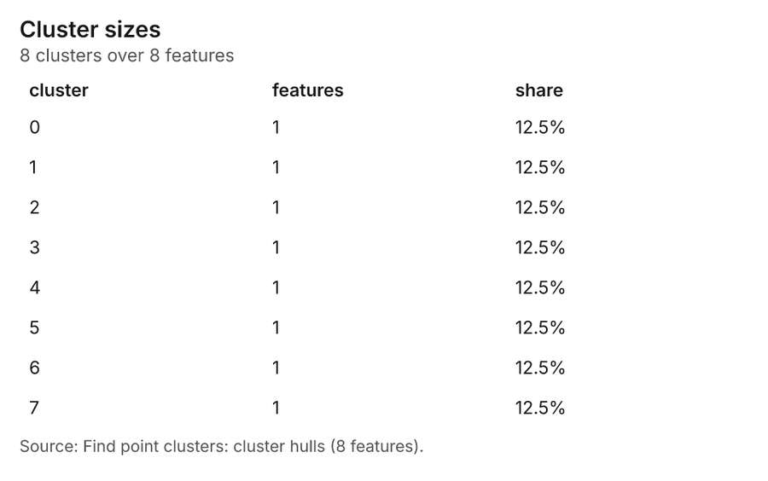
Figure 43. Find point clusters: cluster hulls [96]. Source: Find point clusters: cluster hulls (8 features). The data is in the appendix.
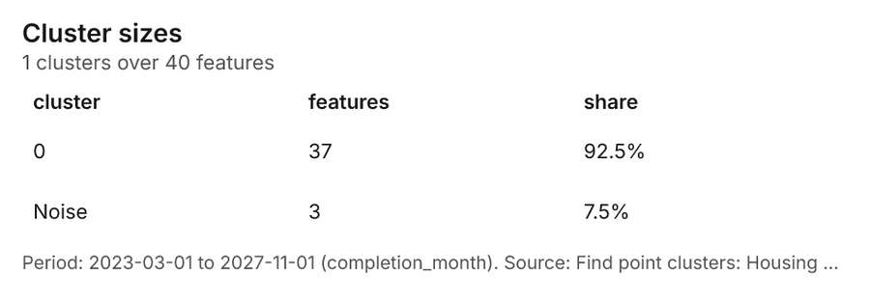
Figure 44. Find point clusters: Housing developments [97]. Period: 2023-03-01 to 2027-11-01 (completion_month). Source: Find point clusters: Housing developments (40 features). The data is in the appendix.
Figure 45. Find point clusters: cluster hulls [98]. Source: Find point clusters: cluster hulls (1 features). The data is in the appendix.
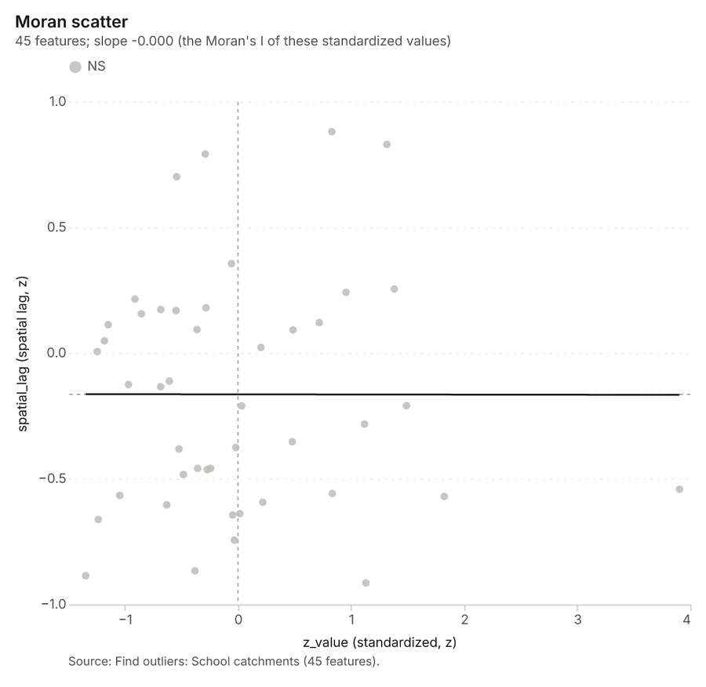
Figure 46. Find outliers: School catchments [99]. Source: Find outliers: School catchments (45 features). The data is in the appendix.
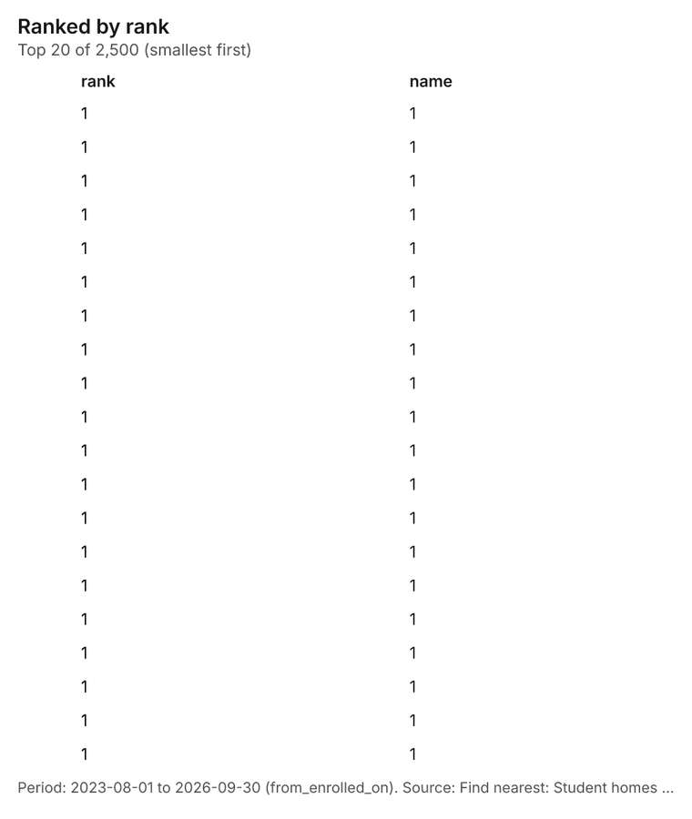
Figure 47. Find nearest: Student homes [100]. Period: 2023-08-01 to 2026-09-30 (from_enrolled_on). Source: Find nearest: Student homes (2,500 features). The data is in the appendix.
Figure 48. Find nearest: Student homes [101]. Period: 2023-08-01 to 2026-09-30 (from_enrolled_on). Source: Find nearest: Student homes (2,500 features). The data is in the appendix.
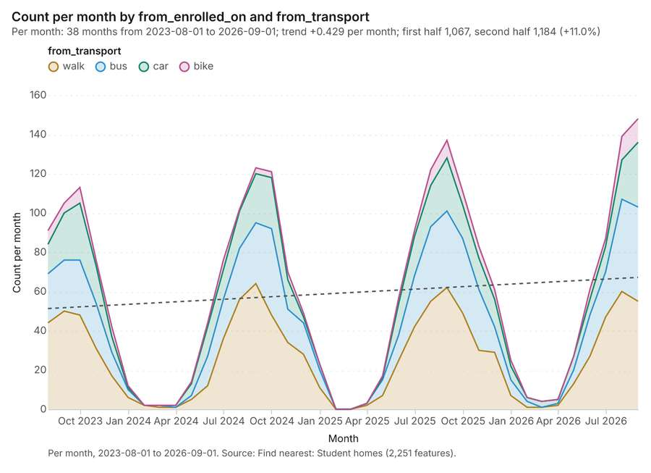
Figure 49. Find nearest: Student homes over time [102]. Per month, 2023-08-01 to 2026-09-01. Source: Find nearest: Student homes (2,251 features). The data is in the appendix.
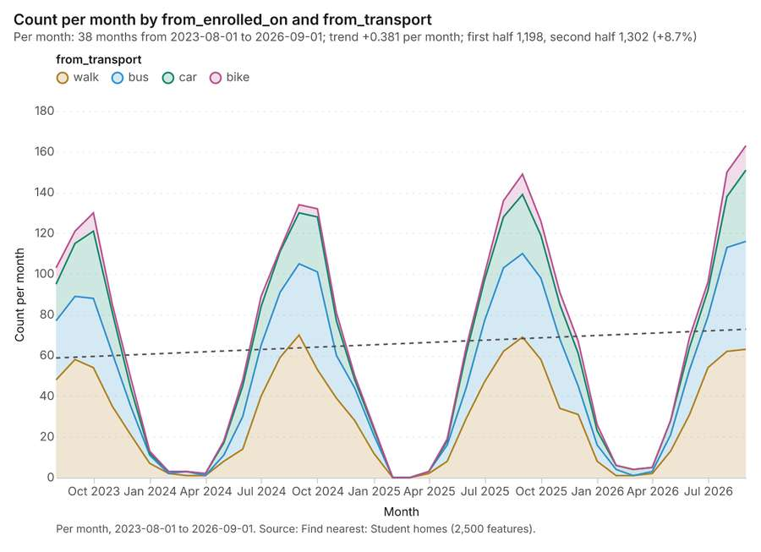
Figure 50. Find nearest: Student homes over time [103]. Per month, 2023-08-01 to 2026-09-01. Source: Find nearest: Student homes (2,500 features). The data is in the appendix.
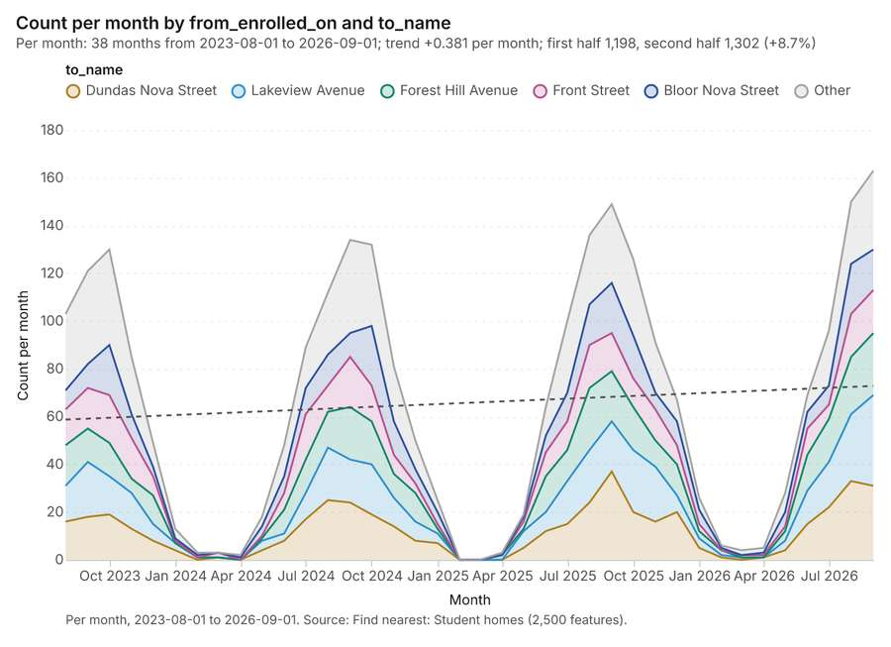
Figure 51. Find nearest: Student homes over time [104]. Per month, 2023-08-01 to 2026-09-01. Source: Find nearest: Student homes (2,500 features). The data is in the appendix.
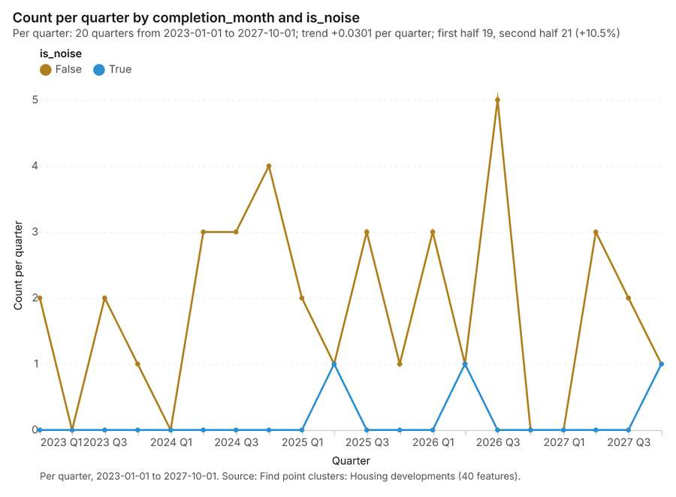
Figure 52. Find point clusters: Housing developments over time [105]. Per quarter, 2023-01-01 to 2027-10-01. Source: Find point clusters: Housing developments (40 features). The data is in the appendix.
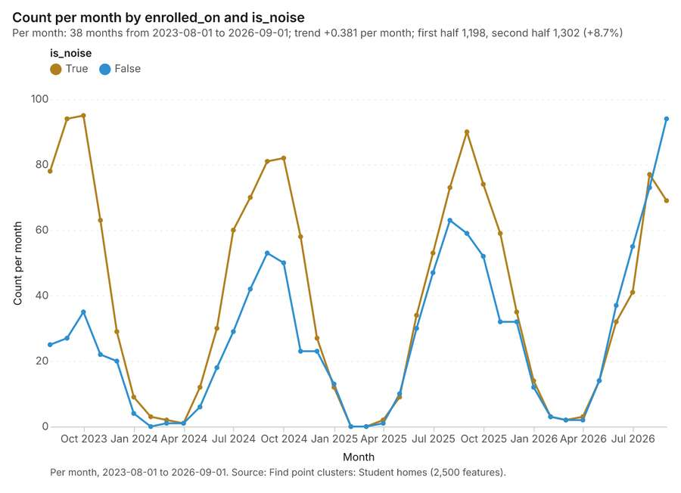
Figure 53. Find point clusters: Student homes over time [106]. Per month, 2023-08-01 to 2026-09-01. Source: Find point clusters: Student homes (2,500 features). The data is in the appendix.
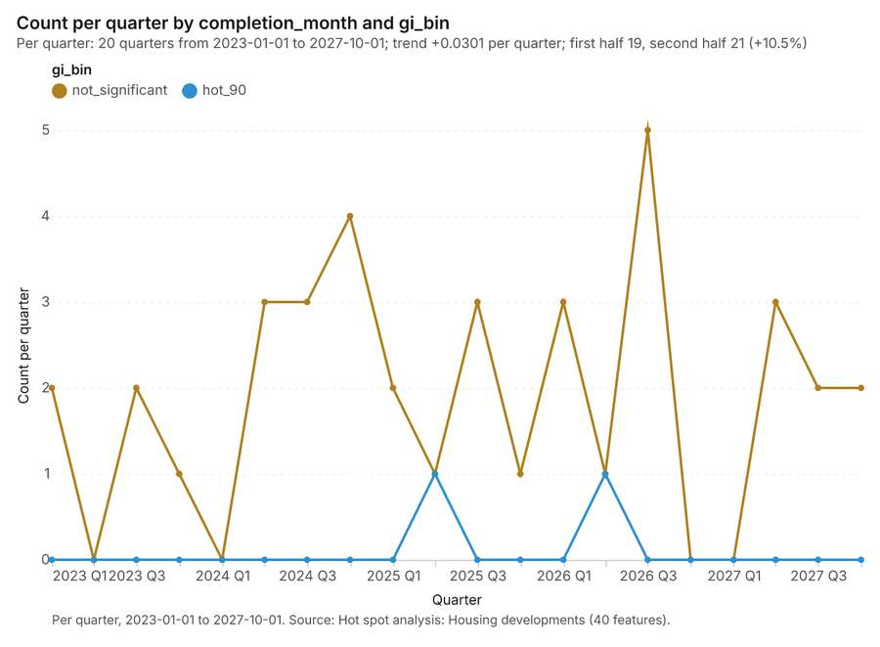
Figure 54. Hot spot analysis: Housing developments over time [107]. Per quarter, 2023-01-01 to 2027-10-01. Source: Hot spot analysis: Housing developments (40 features). The data is in the appendix.
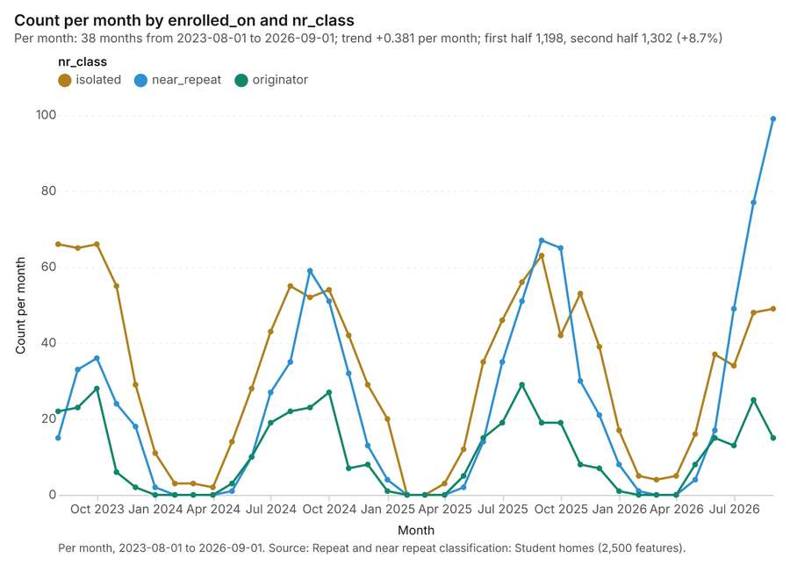
Figure 55. Repeat and near repeat classification: Student homes over time [108]. Per month, 2023-08-01 to 2026-09-01. Source: Repeat and near repeat classification: Student homes (2,500 features). The data is in the appendix.

Changes since the last run
This is the first report of this project.

Sources
[1] Rendering: Chart: Timeline: events per quarter by dataset. 78 rows (id 79388dbd-a74a-40df-b300-c9c05078ac9c)
[2] Dataset: Student homes. vector, 2500 rows (id 28ef32ad-fdbf-4e64-879d-ef97c69d99c8)
[3] Dataset: Housing developments. vector, 40 rows (id 9073798d-0507-463a-99b0-0f74516b77ea)
[4] Dataset: Enrollment by school and year. table, 270 rows (id af8cf345-1c02-4892-beda-cb8f239c4cd1)
[5] Catalog: Emerging hot spots (operation catalog, gp_space_time_hot_spots). Where hot spots are new, consecutive, intensifying, persistent, diminishing, sporadic, oscillating or historical over time. ArcGIS: Emerging Hot Spot Analysis, Create Space Time Cube. (id gp_space_time_hot_spots)
[6] Plan: Space time hot spots of Student homes (the Start plan's candidate c_7f1ecb93fe03). Student homes carry dates in 'enrolled_on': emerging hot spot analysis finds new, intensifying and fading hot spots per month. (id da4c2c71-fa66-4f6d-b51a-fc46626d4137:c_7f1ecb93fe03)
[7] Tool result: gp_space_time_hot_spots, step 0. Emerging hot spots: 1 layer saved: Emerging hot spots: Student homes (96 features). (id 9aff1884-9259-4a26-929a-88629da03a75:0)
[8] Layer: Student homes. 2,500 features (id 05789208-552f-4f37-be96-0e77b9279a4e)
[9] Plan: Space time hot spots of Housing developments (the Start plan's candidate c_e422a5866706). Housing developments carry dates in 'completion_month': emerging hot spot analysis finds new, intensifying and fading hot spots per month. (id da4c2c71-fa66-4f6d-b51a-fc46626d4137:c_e422a5866706)
[10] Tool result: gp_space_time_hot_spots, step 1. Emerging hot spots: 1 layer saved: Emerging hot spots: Housing developments (22 features). (id 9aff1884-9259-4a26-929a-88629da03a75:1)
[11] Layer: Housing developments. 40 features (id afc1332b-5445-4ac2-9d98-ebb6b1520bd2)
[12] Catalog: Repeat and near repeat classification (operation catalog, gp_near_repeat). Classify incidents as originators, repeats (same place) or near repeats within a distance and time window, with a Knox test table. ArcGIS: Repeat and Near Repeat Classification, Near Repeat Calculator. (id gp_near_repeat)
[13] Plan: Near repeat of Student homes (the Start plan's candidate c_a7cb51bb85b3). Near repeat analysis tests whether Student homes close in space also follow each other within 30 days. (id da4c2c71-fa66-4f6d-b51a-fc46626d4137:c_a7cb51bb85b3)
[14] Tool result: gp_near_repeat, step 2. Repeat and near repeat classification: 1 layer saved: Repeat and near repeat classification: Student homes (2500 features). (id 9aff1884-9259-4a26-929a-88629da03a75:2)
[15] Catalog: Summarize within (operation catalog, gp_summarize_within). Count and aggregate the features inside each polygon (or bin), proportionally for lines and polygons. ArcGIS: Summarize Within, Aggregate Points. QGIS: native:countpointsinpolygon, native:sumlinelengths. (id gp_summarize_within)
[16] Plan: Student homes per feature of School catchments (the Start plan's candidate c_525cc89e9df7). Count Student homes inside each feature of School catchments by transport; the counts map as a choropleth (natural breaks, sequential colors). (id da4c2c71-fa66-4f6d-b51a-fc46626d4137:c_525cc89e9df7)
[17] Tool result: gp_summarize_within, step 0. Summarize within: 1 layer saved: Summarize within: School catchments (45 features). (id 0c3a09c9-8654-4d86-b171-2c58372abb46:0)
[18] Layer: School catchments. 45 features (id 534622c6-56d8-4348-94c9-c424e61a442d)
[19] Tool result: gp_summarize_within, step 1. Summarize within: 1 layer saved: Summarize within: School catchments (45 features). (id 0c3a09c9-8654-4d86-b171-2c58372abb46:1)
[20] Layer: Childcare centers. 60 features (id 9489916f-d13f-4283-b308-ff5bcae62a0d)
[21] Tool result: gp_summarize_within, step 2. Summarize within: 1 layer saved: Summarize within: School catchments (45 features). (id 0c3a09c9-8654-4d86-b171-2c58372abb46:2)
[22] Catalog: Hot spot analysis (operation catalog, gp_hot_spots). Getis-Ord Gi* hot and cold spots with z-scores, p-values and confidence bins. ArcGIS: Find Hot Spots, Hot Spot Analysis (Getis-Ord Gi*). QGIS: qgis:hotspot (plugin). (id gp_hot_spots)
[23] Plan: Hot spots of Student homes (the Start plan's candidate c_7a39d826a935). 2500 points: Getis-Ord Gi* tests whether the concentrations in Student homes are statistically significant. (id da4c2c71-fa66-4f6d-b51a-fc46626d4137:c_7a39d826a935)
[24] Tool result: gp_hot_spots, step 0. Hot spot analysis: 1 layer saved: Hot spot analysis: Student homes (281 features). (id 9c081bf6-6d02-4b46-93ef-d4823a0030c1:0)
[25] Plan: Hot spots of Childcare centers (the Start plan's candidate c_0bdc4dd83b93). 60 points: Getis-Ord Gi* tests whether the concentrations in Childcare centers are statistically significant. (id da4c2c71-fa66-4f6d-b51a-fc46626d4137:c_0bdc4dd83b93)
[26] Tool result: gp_hot_spots, step 1. Hot spot analysis: 1 layer saved: Hot spot analysis: Childcare centers (20 features). (id 9c081bf6-6d02-4b46-93ef-d4823a0030c1:1)
[27] Plan: Hot spots of Housing developments (the Start plan's candidate c_6f57933191fe). 40 points: Getis-Ord Gi* tests whether the concentrations in Housing developments are statistically significant. (id da4c2c71-fa66-4f6d-b51a-fc46626d4137:c_6f57933191fe)
[28] Tool result: gp_hot_spots, step 2. Hot spot analysis: 1 layer saved: Hot spot analysis: Housing developments (40 features). (id 9c081bf6-6d02-4b46-93ef-d4823a0030c1:2)
[29] Catalog: Calculate density (operation catalog, gp_calculate_density). Kernel density per square kilometer on a grid. ArcGIS: Calculate Density, Kernel Density. QGIS: native:heatmapkerneldensityestimation. (id gp_calculate_density)
[30] Plan: Kernel density of Student homes (the Start plan's candidate c_4c71448e6d05). 2500 points in Student homes: a density surface shows where they concentrate. (id da4c2c71-fa66-4f6d-b51a-fc46626d4137:c_4c71448e6d05)
[31] Tool result: gp_calculate_density, step 0. Calculate density: 1 layer saved: Calculate density: Student homes (1838 features). (id a4a004d3-3ba6-400d-932e-b8110651d1ff:0)
[32] Plan: Kernel density of Childcare centers (the Start plan's candidate c_069e6a20b03a). 60 points in Childcare centers: a density surface shows where they concentrate. (id da4c2c71-fa66-4f6d-b51a-fc46626d4137:c_069e6a20b03a)
[33] Tool result: gp_calculate_density, step 1. Calculate density: 1 layer saved: Calculate density: Childcare centers (112 features). (id a4a004d3-3ba6-400d-932e-b8110651d1ff:1)
[34] Plan: Kernel density of Housing developments (the Start plan's candidate c_441f3db47c68). 40 points in Housing developments: a density surface shows where they concentrate. (id da4c2c71-fa66-4f6d-b51a-fc46626d4137:c_441f3db47c68)
[35] Tool result: gp_calculate_density, step 2. Calculate density: 1 layer saved: Calculate density: Housing developments (80 features). (id a4a004d3-3ba6-400d-932e-b8110651d1ff:2)
[36] Catalog: Find point clusters (operation catalog, gp_find_point_clusters). Density-based clusters (DBSCAN, HDBSCAN or OPTICS, optionally space-time) with hulls and noise. ArcGIS: Find Point Clusters, Density-based Clustering. QGIS: native:dbscanclustering, native:stdbscanclustering. (id gp_find_point_clusters)
[37] Plan: Cluster points of Student homes (the Start plan's candidate c_e4e6b0b009c4). DBSCAN finds dense groups of Student homes and separates noise. (id da4c2c71-fa66-4f6d-b51a-fc46626d4137:c_e4e6b0b009c4)
[38] Tool result: gp_find_point_clusters, step 0. Find point clusters: 2 layers saved: Find point clusters: Student homes (2500 features); Find point clusters: cluster hulls (1 feature). (id d27977c5-a8cd-4f40-9af6-797ca9424ec9:0)
[39] Plan: Cluster points of Childcare centers (the Start plan's candidate c_43ed026ce5e0). DBSCAN finds dense groups of Childcare centers and separates noise. (id da4c2c71-fa66-4f6d-b51a-fc46626d4137:c_43ed026ce5e0)
[40] Tool result: gp_find_point_clusters, step 1. Find point clusters: 2 layers saved: Find point clusters: Childcare centers (60 features); Find point clusters: cluster hulls (8 features). (id d27977c5-a8cd-4f40-9af6-797ca9424ec9:1)
[41] Plan: Cluster points of Housing developments (the Start plan's candidate c_ac70f2a99d9b). DBSCAN finds dense groups of Housing developments and separates noise. (id da4c2c71-fa66-4f6d-b51a-fc46626d4137:c_ac70f2a99d9b)
[42] Tool result: gp_find_point_clusters, step 2. Find point clusters: 2 layers saved: Find point clusters: Housing developments (40 features); Find point clusters: cluster hulls (1 feature). (id d27977c5-a8cd-4f40-9af6-797ca9424ec9:2)
[43] Catalog: Find outliers (operation catalog, gp_outliers). Anselin local Moran’s I: HH, LL clusters and HL, LH outliers. ArcGIS: Find Outliers, Cluster and Outlier Analysis (Anselin Local Moran’s I). (id gp_outliers)
[44] Plan: Local morans i of School catchments (the Start plan's candidate c_98e5a5704b62). Local Moran's I maps clusters and outliers of 'children_5_17'. (id da4c2c71-fa66-4f6d-b51a-fc46626d4137:c_98e5a5704b62)
[45] Tool result: gp_outliers, step 0. Find outliers: 1 layer saved: Find outliers: School catchments (45 features). (id 2d7fd4ea-3928-4276-820c-93cbaa5d8370:0)
[46] Catalog: Spatial autocorrelation (operation catalog, gp_spatial_autocorrelation). Global Moran’s I: is the pattern clustered, dispersed or random. ArcGIS: Spatial Autocorrelation (Global Moran’s I). (id gp_spatial_autocorrelation)
[47] Plan: Global morans i of School catchments (the Start plan's candidate c_62c90091b007). Global Moran's I says whether similar values of 'children_5_17' sit next to each other. (id da4c2c71-fa66-4f6d-b51a-fc46626d4137:c_62c90091b007)
[48] Tool result: gp_spatial_autocorrelation, step 1. Spatial autocorrelation: done; no map output. (id 2d7fd4ea-3928-4276-820c-93cbaa5d8370:1)
[49] Catalog: Find nearest (operation catalog, gp_find_nearest). The k nearest features for each input, with geodesic distance and bearing. ArcGIS: Find Nearest, Near, Generate Near Table. QGIS: native:joinbynearest, native:nearestneighbouranalysis. (id gp_find_nearest)
[50] Plan: Find nearest of Student homes and Major roads (the Start plan's candidate c_b5e7bf8242db). The nearest of Major roads to each of Student homes, with distances. (id da4c2c71-fa66-4f6d-b51a-fc46626d4137:c_b5e7bf8242db)
[51] Tool result: gp_find_nearest, step 0. Find nearest: 1 layer saved: Find nearest: Student homes (2500 features). (id 96f791ed-0415-4640-9ce5-4a248513b9be:0)
[52] Layer: Major roads. 22 features (id f801bcde-56b2-4e61-ba19-14d0273cc0a8)
[53] Tool result: gp_find_nearest, step 1. Find nearest: 1 layer saved: Find nearest: Student homes (2500 features). (id 96f791ed-0415-4640-9ce5-4a248513b9be:1)
[54] Tool result: gp_find_nearest, step 2. Find nearest: 1 layer saved: Find nearest: Student homes (2251 features). (id 96f791ed-0415-4640-9ce5-4a248513b9be:2)
[55] Rendering: Map: Emerging hot spots: Student homes (id 99865f9e-61ae-4a54-8e71-4f24fa9e045e)
[56] Rendering: Map: Emerging hot spots: Housing developments (id c6a807f2-4f43-4cf7-bbdd-0d94e82be22b)
[57] Rendering: Map: Repeat and near repeat classification: Student homes (id f7b40372-ed14-4b51-9886-d46e8380e886)
[58] Rendering: Map: Summarize within: School catchments (id 16071de3-2db4-4d2a-9f22-069707921f74)
[59] Rendering: Map: Summarize within: School catchments (id 6880f2c7-fb2a-402c-b96c-562b236be148)
[60] Rendering: Map: Summarize within: School catchments (id 7370b20e-f371-4cfd-b692-ca80e8c8b321)
[61] Rendering: Map: Hot spot analysis: Student homes (id 81a795ec-10a3-41fe-8418-bb2735586194)
[62] Rendering: Map: Hot spot analysis: Childcare centers (id d79041bc-d5c3-40bc-9a8b-1efee804ea40)
[63] Rendering: Map: Hot spot analysis: Housing developments (id 53ecf3c1-e4a9-4b9b-9614-b876299daf76)
[64] Rendering: Map: Calculate density: Student homes (id bfebe2b5-1bfa-44c5-b02d-d31e232f58c2)
[65] Rendering: Map: Calculate density: Childcare centers (id 4d64bc05-4b18-466d-9916-7cbaaba82672)
[66] Rendering: Map: Calculate density: Housing developments (id 9939a26d-3d46-4228-a88e-6276ccbbfce9)
[67] Rendering: Map: Find point clusters: Student homes (id 61cf32ac-295f-43d1-b073-76ae493477dd)
[68] Rendering: Map: Find point clusters: cluster hulls (id a6559fb3-821b-4fe4-ba92-a09934cf2f3c)
[69] Rendering: Map: Find point clusters: Childcare centers (id ece220ce-fe57-4bdc-a842-471ae4c94bed)
[70] Rendering: Map: Find point clusters: cluster hulls (id f519a030-b3a6-484c-93cf-8681144e4a8b)
[71] Rendering: Map: Find point clusters: Housing developments (id d14109fd-c380-468c-85e3-d7337bbf109e)
[72] Rendering: Map: Find point clusters: cluster hulls (id 078cb00b-7d37-4f3e-a204-57bd1a525b99)
[73] Rendering: Map: School catchments by children_5_17 (id a27302ad-817f-4696-a735-0a3a66fbb8ef)
[74] Rendering: Map: Find outliers: School catchments (id da831d0f-f5f9-4acb-b0cd-29083c443756)
[75] Rendering: Map: Find nearest: Student homes (id 40e2475f-79fa-4fc0-b95d-0920bd10ac82)
[76] Rendering: Map: Find nearest: Student homes (id 70ebd047-6948-4216-9cf9-75b35e49c830)
[77] Rendering: Map: Find nearest: Student homes (id 5b49f3b5-9a72-4fd4-96f3-f2c2703027ab)
[78] Rendering: Chart: Schools over time (built_year). 7 rows (id 880207dc-7868-40f4-b250-d08848fe4f7c)
[79] Rendering: Chart: Housing developments over time (completion_month). 20 rows (id ee6bae39-81ad-4908-93f3-48e4b8dab2f3)
[80] Rendering: Chart: Enrollment by school and year over time (school_year). 21 rows (id 3c99d290-2ab6-4f32-bf72-5e28a47a0305)
[81] Rendering: Chart: Emerging hot spots: Student homes. 8 rows (id c2759717-bd77-4ab7-80f2-0ff5624d1d0d)
[82] Rendering: Chart: Emerging hot spots: Housing developments. 6 rows (id 9da321f7-d9db-457c-b398-aadc13a51b1d)
[83] Rendering: Chart: Repeat and near repeat classification: Student homes. 20 rows (id e9d40fe4-2dcb-4274-a637-c4492395395e)
[84] Rendering: Chart: Summarize within: School catchments. 7 rows (id ed117d61-c2b8-4711-8e6b-6162a4f09bdd)
[85] Rendering: Chart: Summarize within: School catchments. 7 rows (id 538dd834-8935-4acf-aa77-c6b3e48cbffe)
[86] Rendering: Chart: Summarize within: School catchments. 5 rows (id eb2e00b9-1335-4b02-9b76-1e583e9b01a0)
[87] Rendering: Chart: Hot spot analysis: Student homes. 15 rows (id 12fec60a-bec0-4c49-8e09-a74a94fa49f5)
[88] Rendering: Chart: Hot spot analysis: Childcare centers. 7 rows (id 40554f68-7964-4f45-a1ac-19d17066ae79)
[89] Rendering: Chart: Hot spot analysis: Housing developments. 8 rows (id 01cab3a4-6f58-49af-8dd9-3f246085fc6b)
[90] Rendering: Chart: Calculate density: Student homes. 12 rows (id e75022eb-77cc-4f13-ae4e-64fa1d81fa6d)
[91] Rendering: Chart: Calculate density: Childcare centers. 8 rows (id 6c204cf8-7a68-44be-80f5-4f7cde56072e)
[92] Rendering: Chart: Calculate density: Housing developments. 8 rows (id ca34157f-9a27-457d-81e1-29b86f4f275e)
[93] Rendering: Chart: Find point clusters: Student homes. 2 rows (id e0334377-b051-4859-a2cd-6fbb987551b4)
[94] Rendering: Chart: Find point clusters: cluster hulls. 1 rows (id ef7a2223-1d85-448d-b093-0c2513affca5)
[95] Rendering: Chart: Find point clusters: Childcare centers. 9 rows (id 29ef1518-618b-4ea4-a5ee-2c96e1ec5827)
[96] Rendering: Chart: Find point clusters: cluster hulls. 8 rows (id 208e1927-bbe9-4755-a5ef-4f46a24d4689)
[97] Rendering: Chart: Find point clusters: Housing developments. 2 rows (id 40ab1fbd-7eab-4e95-ba32-5f9e4781e9d4)
[98] Rendering: Chart: Find point clusters: cluster hulls. 1 rows (id e4c8befa-2e05-41d0-bb8c-8fe8283edd90)
[99] Rendering: Chart: Find outliers: School catchments. 45 rows (id a50e1dab-42b9-4ff9-ae70-a9480fc0b696)
[100] Rendering: Chart: Find nearest: Student homes. 20 rows (id 4fc59395-9d71-4f81-958d-f88bf5cb6659)
[101] Rendering: Chart: Find nearest: Student homes. 20 rows (id 0852c0c8-a586-4261-b871-7d8105dd7e1b)
[102] Rendering: Chart: Find nearest: Student homes over time. 152 rows (id 75d40924-ed16-40d7-b9b0-3c4a873dd613)
[103] Rendering: Chart: Find nearest: Student homes over time. 152 rows (id b06f7c1c-a6b8-4ca2-8124-9b931b6d16b9)
[104] Rendering: Chart: Find nearest: Student homes over time. 228 rows (id 1007cf6f-af9a-4bc4-a5e5-aba4c425e396)
[105] Rendering: Chart: Find point clusters: Housing developments over time. 40 rows (id 96ec5cd7-6530-4341-a797-33f6a56e2fb7)
[106] Rendering: Chart: Find point clusters: Student homes over time. 76 rows (id 8bc71da9-95da-46d6-9855-df0cfc359e93)
[107] Rendering: Chart: Hot spot analysis: Housing developments over time. 40 rows (id 9cfa00e8-1d3c-4faa-95d0-f0720805090f)
[108] Rendering: Chart: Repeat and near repeat classification: Student homes over time. 114 rows (id b240dc06-1b76-4e65-bbc3-8914c9a85bb6)
[109] Dataset: Schools. vector, 45 rows (id febb26e1-84d6-4ddb-9a3f-f5e1f0b7f795)
[110] Dataset: School catchments. vector, 45 rows (id ad5953fb-dbca-4073-bc92-0e08c51e1651)
[111] Dataset: Bus stops. vector, 80 rows (id bb1e7508-4720-407c-b71c-a26b23a4f915)
[112] Dataset: Childcare centers. vector, 60 rows (id 4fef3ba9-e30d-4b7d-a5d6-605ce87f7d10)
[113] Dataset: Major roads. vector, 22 rows (id 2a9a4d23-28ed-4b9f-9748-91ea14603b7a)
[114] Dataset: Staffing. table, 45 rows (id afb73c89-d4b1-4d19-a074-f8a824e6cbbc)
[115] Dataset: School capacity review. document, ? rows (id 4d0bbaf0-8f67-45ac-b564-ab860018c60d)
[116] Record: Sample: Education, Toronto (id 89129455-9e05-4edb-9cc1-dcfb440cc5ba)
[117] Layer: Emerging hot spots: Student homes. 96 features (id 7dda31be-8b88-4be6-9357-f49b99e0ad3f)
[118] Layer: Emerging hot spots: Housing developments. 22 features (id 967c6193-6c0c-406a-a2c6-546a83bbbc65)
[119] Layer: Repeat and near repeat classification: Student homes. 2,500 features (id 4b593664-c2f4-4a80-95fe-f240335119a6)
[120] Layer: Summarize within: School catchments. 45 features (id d0384b31-144b-4c4f-a178-ec4c53caae50)
[121] Layer: Summarize within: School catchments. 45 features (id 478d8495-5caf-48d5-b6fa-eb6fb6b4293d)
[122] Layer: Summarize within: School catchments. 45 features (id 975d2d0e-1edb-42ad-b028-67b76335136f)
[123] Layer: Hot spot analysis: Student homes. 281 features (id a502e8fe-ffa2-4e21-9f58-9ec29380391f)
[124] Layer: Hot spot analysis: Childcare centers. 20 features (id 1b0dfd64-2343-44f2-94d6-e1605b181217)
[125] Layer: Hot spot analysis: Housing developments. 40 features (id e4d2879f-df41-457c-becc-2143c520d6c0)
[126] Layer: Calculate density: Student homes. 1,838 features (id 0a6f63b2-6a88-4993-a597-e2734a63f13a)
[127] Layer: Calculate density: Childcare centers. 112 features (id 9a43b28a-a83c-403a-89b3-276f72a30159)
[128] Layer: Calculate density: Housing developments. 80 features (id db78cd56-46ef-4a6b-8256-28f6febc19e9)
[129] Layer: Find point clusters: Student homes. 2,500 features (id 6619977a-546f-41cf-a5d9-f9fa92133533)
[130] Layer: Find point clusters: cluster hulls. 1 features (id 93e7b932-a3f4-42f8-9d0a-b4d8266c9326)
[131] Layer: Find point clusters: Childcare centers. 60 features (id 394eb585-c105-412b-8add-e49c4579ae41)
[132] Layer: Find point clusters: cluster hulls. 8 features (id eac0e935-66fc-4c67-b7eb-367618a58b3c)
[133] Layer: Find point clusters: Housing developments. 40 features (id e8272a5f-e728-40d3-9f70-cc41284df4b6)
[134] Layer: Find point clusters: cluster hulls. 1 features (id e315ede4-4e6c-4399-b511-158bba19ae68)
[135] Layer: Find outliers: School catchments. 45 features (id c01d8927-0a79-40f8-ac32-3d74384c6f2c)
[136] Layer: Find nearest: Student homes. 2,500 features (id 9df5c370-c651-40e7-be15-05353e74ecf7)
[137] Layer: Find nearest: Student homes. 2,500 features (id a2c749a0-1ba4-4b20-92aa-88c388a66e07)
[138] Layer: Find nearest: Student homes. 2,251 features (id f6524eb3-a994-493f-8273-4c78a1381cac)

Appendix: the data behind the charts

Figure 1. Timeline: events per quarter by dataset [1]
period | series | value
2021-07-01 | Student homes | 0
2021-07-01 | Enrollment by school and year | 45
2021-07-01 | Housing developments | 0
2021-10-01 | Student homes | 0
2021-10-01 | Enrollment by school and year | 0
2021-10-01 | Housing developments | 0
2022-01-01 | Student homes | 0
2022-01-01 | Enrollment by school and year | 0
2022-01-01 | Housing developments | 0
2022-04-01 | Student homes | 0
2022-04-01 | Enrollment by school and year | 0
2022-04-01 | Housing developments | 0
2022-07-01 | Student homes | 0
2022-07-01 | Enrollment by school and year | 45
2022-07-01 | Housing developments | 0
2022-10-01 | Student homes | 0
2022-10-01 | Enrollment by school and year | 0
2022-10-01 | Housing developments | 0
2023-01-01 | Student homes | 0
2023-01-01 | Enrollment by school and year | 0
2023-01-01 | Housing developments | 2
2023-04-01 | Student homes | 0
2023-04-01 | Enrollment by school and year | 0
2023-04-01 | Housing developments | 0
2023-07-01 | Student homes | 224
2023-07-01 | Enrollment by school and year | 45
2023-07-01 | Housing developments | 2
2023-10-01 | Student homes | 264
2023-10-01 | Enrollment by school and year | 0
2023-10-01 | Housing developments | 1
2024-01-01 | Student homes | 19
2024-01-01 | Enrollment by school and year | 0
2024-01-01 | Housing developments | 0
2024-04-01 | Student homes | 68
2024-04-01 | Enrollment by school and year | 0
2024-04-01 | Housing developments | 3
2024-07-01 | Student homes | 335
2024-07-01 | Enrollment by school and year | 45
2024-07-01 | Housing developments | 3
2024-10-01 | Student homes | 263
2024-10-01 | Enrollment by school and year | 0
2024-10-01 | Housing developments | 4
2025-01-01 | Student homes | 25
2025-01-01 | Enrollment by school and year | 0
2025-01-01 | Housing developments | 2
2025-04-01 | Student homes | 86
2025-04-01 | Enrollment by school and year | 0
2025-04-01 | Housing developments | 2
2025-07-01 | Student homes | 385
2025-07-01 | Enrollment by school and year | 45
2025-07-01 | Housing developments | 3
2025-10-01 | Student homes | 284
2025-10-01 | Enrollment by school and year | 0
2025-10-01 | Housing developments | 1
2026-01-01 | Student homes | 36
2026-01-01 | Enrollment by school and year | 0
2026-01-01 | Housing developments | 3
2026-04-01 | Student homes | 102
2026-04-01 | Enrollment by school and year | 0
2026-04-01 | Housing developments | 2
2026-07-01 | Student homes | 409
2026-07-01 | Enrollment by school and year | 45
2026-07-01 | Housing developments | 5
2026-10-01 | Student homes | 0
2026-10-01 | Enrollment by school and year | 0
2026-10-01 | Housing developments | 0
2027-01-01 | Student homes | 0
2027-01-01 | Enrollment by school and year | 0
2027-01-01 | Housing developments | 0
2027-04-01 | Student homes | 0
2027-04-01 | Enrollment by school and year | 0
2027-04-01 | Housing developments | 3
2027-07-01 | Student homes | 0
2027-07-01 | Enrollment by school and year | 0
2027-07-01 | Housing developments | 2
2027-10-01 | Student homes | 0
2027-10-01 | Enrollment by school and year | 0
2027-10-01 | Housing developments | 2

Figure 25. Schools over time (built_year) [78]
bin_start | bin_end | count
350 | 528.1 | 14
528.1 | 706.3 | 21
706.3 | 884.4 | 3
884.4 | 1,063 | 0
1,063 | 1,241 | 3
1,241 | 1,419 | 2
1,419 | 1,597 | 2

Figure 26. Housing developments over time (completion_month) [79]
period | value
2023-01-01 | 164
2023-04-01 | 0
2023-07-01 | 621
2023-10-01 | 137
2024-01-01 | 0
2024-04-01 | 579
2024-07-01 | 775
2024-10-01 | 883
2025-01-01 | 515
2025-04-01 | 994
2025-07-01 | 583
2025-10-01 | 509
2026-01-01 | 484
2026-04-01 | 424
2026-07-01 | 1,297
2026-10-01 | 0
2027-01-01 | 0
2027-04-01 | 767
2027-07-01 | 337
2027-10-01 | 669

Figure 27. Enrollment by school and year over time (school_year) [80]
period | value
2021-07-01 | 45
2021-10-01 | 0
2022-01-01 | 0
2022-04-01 | 0
2022-07-01 | 45
2022-10-01 | 0
2023-01-01 | 0
2023-04-01 | 0
2023-07-01 | 45
2023-10-01 | 0
2024-01-01 | 0
2024-04-01 | 0
2024-07-01 | 45
2024-10-01 | 0
2025-01-01 | 0
2025-04-01 | 0
2025-07-01 | 45
2025-10-01 | 0
2026-01-01 | 0
2026-04-01 | 0
2026-07-01 | 45

Figure 28. Emerging hot spots: Student homes [81]
bin_start | bin_end | count
-0.896 | 2.069 | 77
2.069 | 5.033 | 7
5.033 | 7.998 | 1
7.998 | 10.96 | 5
10.96 | 13.93 | 0
13.93 | 16.89 | 3
16.89 | 19.86 | 0
19.86 | 22.82 | 3

Figure 29. Emerging hot spots: Housing developments [82]
bin_start | bin_end | count
-0.379 | 0.3548 | 15
0.3548 | 1.089 | 0
1.089 | 1.823 | 0
1.823 | 2.556 | 0
2.556 | 3.29 | 0
3.29 | 4.024 | 7

Figure 30. Repeat and near repeat classification: Student homes [83]
rank | name | distance_km
1 | near_repeat | 0.01
2 | isolated | 0.02
3 | isolated | 0.02
4 | isolated | 0.02
5 | originator | 0.03
6 | isolated | 0.03
7 | near_repeat | 0.03
8 | isolated | 0.03
9 | near_repeat | 0.04
10 | near_repeat | 0.04
11 | originator | 0.05
12 | isolated | 0.05
13 | originator | 0.05
14 | near_repeat | 0.05
15 | isolated | 0.05
16 | originator | 0.05
17 | near_repeat | 0.05
18 | near_repeat | 0.06
19 | near_repeat | 0.06
20 | isolated | 0.06

Figure 31. Summarize within: School catchments [84]
bin_start | bin_end | count
12 | 56.14 | 37
56.14 | 100.3 | 3
100.3 | 144.4 | 2
144.4 | 188.6 | 0
188.6 | 232.7 | 1
232.7 | 276.9 | 0
276.9 | 321 | 2

Figure 32. Summarize within: School catchments [85]
bin_start | bin_end | count
25 | 66 | 7
66 | 107 | 6
107 | 148 | 8
148 | 189 | 5
189 | 230 | 5
230 | 271 | 1
271 | 312 | 2

Figure 33. Summarize within: School catchments [86]
bin_start | bin_end | count
137 | 475.6 | 9
475.6 | 814.2 | 3
814.2 | 1,153 | 1
1,153 | 1,491 | 1
1,491 | 1,830 | 2

Figure 34. Hot spot analysis: Student homes [87]
bin_start | bin_end | band | band_label | count
-1 | -0.5 | not_significant | Not significant | 52
-0.5 | 0 | not_significant | Not significant | 164
0 | 0.5 | not_significant | Not significant | 37
0.5 | 1 | not_significant | Not significant | 7
1 | 1.5 | not_significant | Not significant | 2
1.5 | 2 | hot_90 | Hot spot, 90% confidence | 2
1.5 | 2 | not_significant | Not significant | 1
2 | 2.5 | hot_95 | Hot spot, 95% confidence | 3
2.5 | 3 | hot_99 | Hot spot, 99% confidence | 3
3 | 3.5 | hot_99 | Hot spot, 99% confidence | 3
3.5 | 4 | hot_99 | Hot spot, 99% confidence | 3
4 | 4.5 | hot_99 | Hot spot, 99% confidence | 1
5 | 5.5 | hot_99 | Hot spot, 99% confidence | 1
5.5 | 6 | hot_99 | Hot spot, 99% confidence | 1
6.5 | 7 | hot_99 | Hot spot, 99% confidence | 1

Figure 35. Hot spot analysis: Childcare centers [88]
bin_start | bin_end | band | band_label | count
-2 | -1.5 | cold_90 | Cold spot, 90% confidence | 3
-1.5 | -1 | not_significant | Not significant | 1
-1 | -0.5 | not_significant | Not significant | 3
0 | 0.5 | not_significant | Not significant | 4
0.5 | 1 | not_significant | Not significant | 6
1 | 1.5 | not_significant | Not significant | 1
1.5 | 2 | hot_90 | Hot spot, 90% confidence | 2

Figure 36. Hot spot analysis: Housing developments [89]
bin_start | bin_end | band | band_label | count
-2 | -1.5 | not_significant | Not significant | 1
-1.5 | -1 | not_significant | Not significant | 14
-1 | -0.5 | not_significant | Not significant | 8
-0.5 | 0 | not_significant | Not significant | 7
0 | 0.5 | not_significant | Not significant | 5
0.5 | 1 | not_significant | Not significant | 2
1 | 1.5 | not_significant | Not significant | 1
1.5 | 2 | hot_90 | Hot spot, 90% confidence | 2

Figure 37. Calculate density: Student homes [90]
bin_start | bin_end | count
0 | 4 | 121
4 | 8 | 153
8 | 12 | 156
12 | 16 | 154
16 | 20 | 153
20 | 24 | 151
24 | 28 | 152
28 | 32 | 152
32 | 36 | 153
36 | 40 | 154
40 | 44 | 156
44 | 48 | 183

Figure 38. Calculate density: Childcare centers [91]
bin_start | bin_end | count
0 | 1.5 | 11
1.5 | 3 | 10
3 | 4.5 | 20
4.5 | 6 | 10
6 | 7.5 | 19
7.5 | 9 | 10
9 | 10.5 | 20
10.5 | 12 | 12

Figure 39. Calculate density: Housing developments [92]
bin_start | bin_end | count
0.0577 | 110.2 | 55
110.2 | 220.4 | 13
220.4 | 330.6 | 1
330.6 | 440.8 | 3
440.8 | 551 | 3
551 | 661.2 | 3
661.2 | 771.4 | 0
771.4 | 881.6 | 2

Figure 40. Find point clusters: Student homes [93]
cluster | features | fraction | share
Noise | 1,490 | 0.596 | 59.6%
0 | 1,010 | 0.404 | 40.4%

Figure 41. Find point clusters: cluster hulls [94]
cluster | features | fraction | share
0 | 1 | 1 | 100.0%

Figure 42. Find point clusters: Childcare centers [95]
cluster | features | fraction | share
1 | 14 | 0.2333 | 23.3%
0 | 11 | 0.1833 | 18.3%
6 | 9 | 0.15 | 15.0%
3 | 7 | 0.1167 | 11.7%
4 | 6 | 0.1 | 10.0%
2 | 5 | 0.08333 | 8.3%
5 | 4 | 0.06667 | 6.7%
7 | 3 | 0.05 | 5.0%
Noise | 1 | 0.01667 | 1.7%

Figure 43. Find point clusters: cluster hulls [96]
cluster | features | fraction | share
0 | 1 | 0.125 | 12.5%
1 | 1 | 0.125 | 12.5%
2 | 1 | 0.125 | 12.5%
3 | 1 | 0.125 | 12.5%
4 | 1 | 0.125 | 12.5%
5 | 1 | 0.125 | 12.5%
6 | 1 | 0.125 | 12.5%
7 | 1 | 0.125 | 12.5%

Figure 44. Find point clusters: Housing developments [97]
cluster | features | fraction | share
0 | 37 | 0.925 | 92.5%
Noise | 3 | 0.075 | 7.5%

Figure 45. Find point clusters: cluster hulls [98]
cluster | features | fraction | share
0 | 1 | 1 | 100.0%

Figure 46. Find outliers: School catchments [99]
value | lag | type
-0.9672 | -0.1255 | NS
1.383 | 0.255 | NS
-0.6288 | -0.6039 | NS
-0.0459 | -0.6442 | NS
0.7193 | 0.1212 | NS
1.317 | 0.8302 | NS
-0.0572 | 0.3557 | NS
0.0175 | -0.639 | NS
-0.5212 | -0.3817 | NS
-0.356 | -0.459 | NS
0.4873 | 0.0922 | NS
0.2043 | 0.0226 | NS
-0.9095 | 0.2148 | NS
-0.2881 | 0.7917 | NS
0.9559 | 0.2419 | NS
-0.2405 | -0.4586 | NS
-0.6061 | -0.1115 | NS
-0.2824 | 0.1801 | NS
-1.147 | 0.1129 | NS
-1.243 | 0.0056 | NS
-1.18 | 0.049 | NS
-1.044 | -0.5665 | NS
1.131 | -0.9146 | NS
-0.0311 | -0.7442 | NS
0.2201 | -0.5934 | NS
-0.3798 | -0.8665 | NS
1.49 | -0.2094 | NS
1.824 | -0.5705 | NS
-0.0198 | -0.3756 | NS
0.8348 | -0.5589 | NS
0.0322 | -0.2103 | NS
-0.5473 | 0.169 | NS
-1.234 | -0.6621 | NS
-0.5416 | 0.7018 | NS
-0.4816 | -0.4831 | NS
-1.345 | -0.8861 | NS
-0.3617 | 0.0937 | NS
-0.8529 | 0.1562 | NS
-0.2711 | -0.4635 | NS
3.903 | -0.5416 | NS
-0.6831 | -0.1341 | NS
0.8302 | 0.8808 | NS
1.119 | -0.2824 | NS
-0.682 | 0.1734 | NS
0.4805 | -0.3526 | NS

Figure 47. Find nearest: Student homes [100]
rank | name
1 | 1
1 | 1
1 | 1
1 | 1
1 | 1
1 | 1
1 | 1
1 | 1
1 | 1
1 | 1
1 | 1
1 | 1
1 | 1
1 | 1
1 | 1
1 | 1
1 | 1
1 | 1
1 | 1
1 | 1

Figure 48. Find nearest: Student homes [101]
rank | name
1 | 1
1 | 1
1 | 1
1 | 1
1 | 1
1 | 1
1 | 1
1 | 1
1 | 1
1 | 1
1 | 1
1 | 1
1 | 1
1 | 1
1 | 1
1 | 1
1 | 1
1 | 1
1 | 1
1 | 1

Figure 49. Find nearest: Student homes over time [102]
period | series | value
2023-08-01 | walk | 44
2023-08-01 | bus | 25
2023-08-01 | car | 15
2023-08-01 | bike | 7
2023-09-01 | walk | 50
2023-09-01 | bus | 26
2023-09-01 | car | 24
2023-09-01 | bike | 5
2023-10-01 | walk | 48
2023-10-01 | bus | 28
2023-10-01 | car | 29
2023-10-01 | bike | 8
2023-11-01 | walk | 31
2023-11-01 | bus | 23
2023-11-01 | car | 19
2023-11-01 | bike | 3
2023-12-01 | walk | 17
2023-12-01 | bus | 12
2023-12-01 | car | 8
2023-12-01 | bike | 5
2024-01-01 | walk | 6
2024-01-01 | bus | 4
2024-01-01 | car | 1
2024-01-01 | bike | 1
2024-02-01 | walk | 2
2024-02-01 | bus | 0
2024-02-01 | car | 0
2024-02-01 | bike | 0
2024-03-01 | walk | 1
2024-03-01 | bus | 1
2024-03-01 | car | 0
2024-03-01 | bike | 0
2024-04-01 | walk | 1
2024-04-01 | bus | 0
2024-04-01 | car | 1
2024-04-01 | bike | 0
2024-05-01 | walk | 5
2024-05-01 | bus | 2
2024-05-01 | car | 6
2024-05-01 | bike | 1
2024-06-01 | walk | 12
2024-06-01 | bus | 15
2024-06-01 | car | 15
2024-06-01 | bike | 2
2024-07-01 | walk | 36
2024-07-01 | bus | 20
2024-07-01 | car | 15
2024-07-01 | bike | 5
2024-08-01 | walk | 56
2024-08-01 | bus | 26
2024-08-01 | car | 19
2024-08-01 | bike | 1
2024-09-01 | walk | 64
2024-09-01 | bus | 31
2024-09-01 | car | 25
2024-09-01 | bike | 3
2024-10-01 | walk | 48
2024-10-01 | bus | 44
2024-10-01 | car | 26
2024-10-01 | bike | 3
2024-11-01 | walk | 34
2024-11-01 | bus | 17
2024-11-01 | car | 15
2024-11-01 | bike | 4
2024-12-01 | walk | 28
2024-12-01 | bus | 16
2024-12-01 | car | 3
2024-12-01 | bike | 2
2025-01-01 | walk | 11
2025-01-01 | bus | 9
2025-01-01 | car | 3
2025-01-01 | bike | 0
2025-02-01 | walk | 0
2025-02-01 | bus | 0
2025-02-01 | car | 0
2025-02-01 | bike | 0
2025-03-01 | walk | 0
2025-03-01 | bus | 0
2025-03-01 | car | 0
2025-03-01 | bike | 0
2025-04-01 | walk | 2
2025-04-01 | bus | 1
2025-04-01 | car | 0
2025-04-01 | bike | 0
2025-05-01 | walk | 7
2025-05-01 | bus | 8
2025-05-01 | car | 1
2025-05-01 | bike | 1
2025-06-01 | walk | 25
2025-06-01 | bus | 13
2025-06-01 | car | 16
2025-06-01 | bike | 3
2025-07-01 | walk | 42
2025-07-01 | bus | 26
2025-07-01 | car | 20
2025-07-01 | bike | 3
2025-08-01 | walk | 55
2025-08-01 | bus | 38
2025-08-01 | car | 21
2025-08-01 | bike | 8
2025-09-01 | walk | 62
2025-09-01 | bus | 39
2025-09-01 | car | 27
2025-09-01 | bike | 9
2025-10-01 | walk | 49
2025-10-01 | bus | 38
2025-10-01 | car | 17
2025-10-01 | bike | 7
2025-11-01 | walk | 30
2025-11-01 | bus | 31
2025-11-01 | car | 16
2025-11-01 | bike | 6
2025-12-01 | walk | 29
2025-12-01 | bus | 13
2025-12-01 | car | 14
2025-12-01 | bike | 5
2026-01-01 | walk | 7
2026-01-01 | bus | 8
2026-01-01 | car | 7
2026-01-01 | bike | 3
2026-02-01 | walk | 1
2026-02-01 | bus | 3
2026-02-01 | car | 2
2026-02-01 | bike | 0
2026-03-01 | walk | 1
2026-03-01 | bus | 0
2026-03-01 | car | 3
2026-03-01 | bike | 0
2026-04-01 | walk | 2
2026-04-01 | bus | 1
2026-04-01 | car | 2
2026-04-01 | bike | 0
2026-05-01 | walk | 13
2026-05-01 | bus | 7
2026-05-01 | car | 7
2026-05-01 | bike | 0
2026-06-01 | walk | 27
2026-06-01 | bus | 21
2026-06-01 | car | 8
2026-06-01 | bike | 5
2026-07-01 | walk | 47
2026-07-01 | bus | 23
2026-07-01 | car | 13
2026-07-01 | bike | 4
2026-08-01 | walk | 60
2026-08-01 | bus | 47
2026-08-01 | car | 20
2026-08-01 | bike | 12
2026-09-01 | walk | 55
2026-09-01 | bus | 48
2026-09-01 | car | 33
2026-09-01 | bike | 12

Figure 50. Find nearest: Student homes over time [103]
period | series | value
2023-08-01 | walk | 48
2023-08-01 | bus | 29
2023-08-01 | car | 18
2023-08-01 | bike | 8
2023-09-01 | walk | 58
2023-09-01 | bus | 31
2023-09-01 | car | 26
2023-09-01 | bike | 6
2023-10-01 | walk | 54
2023-10-01 | bus | 34
2023-10-01 | car | 33
2023-10-01 | bike | 9
2023-11-01 | walk | 35
2023-11-01 | bus | 26
2023-11-01 | car | 20
2023-11-01 | bike | 4
2023-12-01 | walk | 21
2023-12-01 | bus | 14
2023-12-01 | car | 9
2023-12-01 | bike | 5
2024-01-01 | walk | 7
2024-01-01 | bus | 4
2024-01-01 | car | 1
2024-01-01 | bike | 1
2024-02-01 | walk | 2
2024-02-01 | bus | 0
2024-02-01 | car | 1
2024-02-01 | bike | 0
2024-03-01 | walk | 1
2024-03-01 | bus | 2
2024-03-01 | car | 0
2024-03-01 | bike | 0
2024-04-01 | walk | 1
2024-04-01 | bus | 0
2024-04-01 | car | 1
2024-04-01 | bike | 0
2024-05-01 | walk | 8
2024-05-01 | bus | 3
2024-05-01 | car | 6
2024-05-01 | bike | 1
2024-06-01 | walk | 14
2024-06-01 | bus | 16
2024-06-01 | car | 15
2024-06-01 | bike | 3
2024-07-01 | walk | 40
2024-07-01 | bus | 25
2024-07-01 | car | 19
2024-07-01 | bike | 5
2024-08-01 | walk | 59
2024-08-01 | bus | 32
2024-08-01 | car | 20
2024-08-01 | bike | 1
2024-09-01 | walk | 70
2024-09-01 | bus | 35
2024-09-01 | car | 25
2024-09-01 | bike | 4
2024-10-01 | walk | 53
2024-10-01 | bus | 48
2024-10-01 | car | 27
2024-10-01 | bike | 4
2024-11-01 | walk | 39
2024-11-01 | bus | 21
2024-11-01 | car | 17
2024-11-01 | bike | 4
2024-12-01 | walk | 28
2024-12-01 | bus | 16
2024-12-01 | car | 4
2024-12-01 | bike | 2
2025-01-01 | walk | 12
2025-01-01 | bus | 9
2025-01-01 | car | 3
2025-01-01 | bike | 1
2025-02-01 | walk | 0
2025-02-01 | bus | 0
2025-02-01 | car | 0
2025-02-01 | bike | 0
2025-03-01 | walk | 0
2025-03-01 | bus | 0
2025-03-01 | car | 0
2025-03-01 | bike | 0
2025-04-01 | walk | 2
2025-04-01 | bus | 1
2025-04-01 | car | 0
2025-04-01 | bike | 0
2025-05-01 | walk | 8
2025-05-01 | bus | 8
2025-05-01 | car | 2
2025-05-01 | bike | 1
2025-06-01 | walk | 29
2025-06-01 | bus | 15
2025-06-01 | car | 17
2025-06-01 | bike | 3
2025-07-01 | walk | 47
2025-07-01 | bus | 30
2025-07-01 | car | 20
2025-07-01 | bike | 3
2025-08-01 | walk | 62
2025-08-01 | bus | 41
2025-08-01 | car | 25
2025-08-01 | bike | 8
2025-09-01 | walk | 69
2025-09-01 | bus | 41
2025-09-01 | car | 29
2025-09-01 | bike | 10
2025-10-01 | walk | 58
2025-10-01 | bus | 40
2025-10-01 | car | 21
2025-10-01 | bike | 7
2025-11-01 | walk | 34
2025-11-01 | bus | 34
2025-11-01 | car | 17
2025-11-01 | bike | 6
2025-12-01 | walk | 31
2025-12-01 | bus | 14
2025-12-01 | car | 16
2025-12-01 | bike | 6
2026-01-01 | walk | 8
2026-01-01 | bus | 8
2026-01-01 | car | 7
2026-01-01 | bike | 3
2026-02-01 | walk | 1
2026-02-01 | bus | 3
2026-02-01 | car | 2
2026-02-01 | bike | 0
2026-03-01 | walk | 1
2026-03-01 | bus | 0
2026-03-01 | car | 3
2026-03-01 | bike | 0
2026-04-01 | walk | 2
2026-04-01 | bus | 1
2026-04-01 | car | 2
2026-04-01 | bike | 0
2026-05-01 | walk | 13
2026-05-01 | bus | 8
2026-05-01 | car | 7
2026-05-01 | bike | 0
2026-06-01 | walk | 31
2026-06-01 | bus | 22
2026-06-01 | car | 11
2026-06-01 | bike | 5
2026-07-01 | walk | 54
2026-07-01 | bus | 25
2026-07-01 | car | 13
2026-07-01 | bike | 4
2026-08-01 | walk | 62
2026-08-01 | bus | 51
2026-08-01 | car | 25
2026-08-01 | bike | 12
2026-09-01 | walk | 63
2026-09-01 | bus | 53
2026-09-01 | car | 35
2026-09-01 | bike | 12

Figure 51. Find nearest: Student homes over time [104]
period | series | value
2023-08-01 | Dundas Nova Street | 16
2023-08-01 | Lakeview Avenue | 15
2023-08-01 | Forest Hill Avenue | 17
2023-08-01 | Front Street | 15
2023-08-01 | Bloor Nova Street | 8
2023-08-01 | Other | 32
2023-09-01 | Dundas Nova Street | 18
2023-09-01 | Lakeview Avenue | 23
2023-09-01 | Forest Hill Avenue | 14
2023-09-01 | Front Street | 17
2023-09-01 | Bloor Nova Street | 10
2023-09-01 | Other | 39
2023-10-01 | Dundas Nova Street | 19
2023-10-01 | Lakeview Avenue | 16
2023-10-01 | Forest Hill Avenue | 14
2023-10-01 | Front Street | 20
2023-10-01 | Bloor Nova Street | 21
2023-10-01 | Other | 40
2023-11-01 | Dundas Nova Street | 13
2023-11-01 | Lakeview Avenue | 15
2023-11-01 | Forest Hill Avenue | 6
2023-11-01 | Front Street | 17
2023-11-01 | Bloor Nova Street | 10
2023-11-01 | Other | 24
2023-12-01 | Dundas Nova Street | 8
2023-12-01 | Lakeview Avenue | 7
2023-12-01 | Forest Hill Avenue | 12
2023-12-01 | Front Street | 8
2023-12-01 | Bloor Nova Street | 4
2023-12-01 | Other | 10
2024-01-01 | Dundas Nova Street | 4
2024-01-01 | Lakeview Avenue | 3
2024-01-01 | Forest Hill Avenue | 0
2024-01-01 | Front Street | 1
2024-01-01 | Bloor Nova Street | 1
2024-01-01 | Other | 4
2024-02-01 | Dundas Nova Street | 0
2024-02-01 | Lakeview Avenue | 1
2024-02-01 | Forest Hill Avenue | 0
2024-02-01 | Front Street | 0
2024-02-01 | Bloor Nova Street | 1
2024-02-01 | Other | 1
2024-03-01 | Dundas Nova Street | 1
2024-03-01 | Lakeview Avenue | 0
2024-03-01 | Forest Hill Avenue | 0
2024-03-01 | Front Street | 2
2024-03-01 | Bloor Nova Street | 0
2024-03-01 | Other | 0
2024-04-01 | Dundas Nova Street | 0
2024-04-01 | Lakeview Avenue | 0
2024-04-01 | Forest Hill Avenue | 0
2024-04-01 | Front Street | 0
2024-04-01 | Bloor Nova Street | 1
2024-04-01 | Other | 1
2024-05-01 | Dundas Nova Street | 4
2024-05-01 | Lakeview Avenue | 4
2024-05-01 | Forest Hill Avenue | 1
2024-05-01 | Front Street | 1
2024-05-01 | Bloor Nova Street | 4
2024-05-01 | Other | 4
2024-06-01 | Dundas Nova Street | 8
2024-06-01 | Lakeview Avenue | 3
2024-06-01 | Forest Hill Avenue | 10
2024-06-01 | Front Street | 7
2024-06-01 | Bloor Nova Street | 7
2024-06-01 | Other | 13
2024-07-01 | Dundas Nova Street | 17
2024-07-01 | Lakeview Avenue | 11
2024-07-01 | Forest Hill Avenue | 14
2024-07-01 | Front Street | 19
2024-07-01 | Bloor Nova Street | 11
2024-07-01 | Other | 17
2024-08-01 | Dundas Nova Street | 25
2024-08-01 | Lakeview Avenue | 22
2024-08-01 | Forest Hill Avenue | 15
2024-08-01 | Front Street | 11
2024-08-01 | Bloor Nova Street | 13
2024-08-01 | Other | 26
2024-09-01 | Dundas Nova Street | 24
2024-09-01 | Lakeview Avenue | 18
2024-09-01 | Forest Hill Avenue | 22
2024-09-01 | Front Street | 21
2024-09-01 | Bloor Nova Street | 10
2024-09-01 | Other | 39
2024-10-01 | Dundas Nova Street | 19
2024-10-01 | Lakeview Avenue | 21
2024-10-01 | Forest Hill Avenue | 18
2024-10-01 | Front Street | 15
2024-10-01 | Bloor Nova Street | 25
2024-10-01 | Other | 34
2024-11-01 | Dundas Nova Street | 14
2024-11-01 | Lakeview Avenue | 12
2024-11-01 | Forest Hill Avenue | 10
2024-11-01 | Front Street | 8
2024-11-01 | Bloor Nova Street | 14
2024-11-01 | Other | 23
2024-12-01 | Dundas Nova Street | 8
2024-12-01 | Lakeview Avenue | 8
2024-12-01 | Forest Hill Avenue | 12
2024-12-01 | Front Street | 4
2024-12-01 | Bloor Nova Street | 6
2024-12-01 | Other | 12
2025-01-01 | Dundas Nova Street | 7
2025-01-01 | Lakeview Avenue | 4
2025-01-01 | Forest Hill Avenue | 2
2025-01-01 | Front Street | 2
2025-01-01 | Bloor Nova Street | 5
2025-01-01 | Other | 5
2025-02-01 | Dundas Nova Street | 0
2025-02-01 | Lakeview Avenue | 0
2025-02-01 | Forest Hill Avenue | 0
2025-02-01 | Front Street | 0
2025-02-01 | Bloor Nova Street | 0
2025-02-01 | Other | 0
2025-03-01 | Dundas Nova Street | 0
2025-03-01 | Lakeview Avenue | 0
2025-03-01 | Forest Hill Avenue | 0
2025-03-01 | Front Street | 0
2025-03-01 | Bloor Nova Street | 0
2025-03-01 | Other | 0
2025-04-01 | Dundas Nova Street | 0
2025-04-01 | Lakeview Avenue | 0
2025-04-01 | Forest Hill Avenue | 2
2025-04-01 | Front Street | 0
2025-04-01 | Bloor Nova Street | 0
2025-04-01 | Other | 1
2025-05-01 | Dundas Nova Street | 5
2025-05-01 | Lakeview Avenue | 7
2025-05-01 | Forest Hill Avenue | 1
2025-05-01 | Front Street | 3
2025-05-01 | Bloor Nova Street | 2
2025-05-01 | Other | 1
2025-06-01 | Dundas Nova Street | 12
2025-06-01 | Lakeview Avenue | 8
2025-06-01 | Forest Hill Avenue | 15
2025-06-01 | Front Street | 10
2025-06-01 | Bloor Nova Street | 7
2025-06-01 | Other | 12
2025-07-01 | Dundas Nova Street | 15
2025-07-01 | Lakeview Avenue | 18
2025-07-01 | Forest Hill Avenue | 13
2025-07-01 | Front Street | 12
2025-07-01 | Bloor Nova Street | 12
2025-07-01 | Other | 30
2025-08-01 | Dundas Nova Street | 24
2025-08-01 | Lakeview Avenue | 22
2025-08-01 | Forest Hill Avenue | 26
2025-08-01 | Front Street | 18
2025-08-01 | Bloor Nova Street | 17
2025-08-01 | Other | 29
2025-09-01 | Dundas Nova Street | 37
2025-09-01 | Lakeview Avenue | 21
2025-09-01 | Forest Hill Avenue | 21
2025-09-01 | Front Street | 16
2025-09-01 | Bloor Nova Street | 21
2025-09-01 | Other | 33
2025-10-01 | Dundas Nova Street | 20
2025-10-01 | Lakeview Avenue | 26
2025-10-01 | Forest Hill Avenue | 18
2025-10-01 | Front Street | 12
2025-10-01 | Bloor Nova Street | 18
2025-10-01 | Other | 32
2025-11-01 | Dundas Nova Street | 16
2025-11-01 | Lakeview Avenue | 23
2025-11-01 | Forest Hill Avenue | 11
2025-11-01 | Front Street | 13
2025-11-01 | Bloor Nova Street | 7
2025-11-01 | Other | 21
2025-12-01 | Dundas Nova Street | 20
2025-12-01 | Lakeview Avenue | 7
2025-12-01 | Forest Hill Avenue | 13
2025-12-01 | Front Street | 8
2025-12-01 | Bloor Nova Street | 10
2025-12-01 | Other | 9
2026-01-01 | Dundas Nova Street | 5
2026-01-01 | Lakeview Avenue | 4
2026-01-01 | Forest Hill Avenue | 3
2026-01-01 | Front Street | 3
2026-01-01 | Bloor Nova Street | 6
2026-01-01 | Other | 5
2026-02-01 | Dundas Nova Street | 1
2026-02-01 | Lakeview Avenue | 1
2026-02-01 | Forest Hill Avenue | 2
2026-02-01 | Front Street | 0
2026-02-01 | Bloor Nova Street | 1
2026-02-01 | Other | 1
2026-03-01 | Dundas Nova Street | 0
2026-03-01 | Lakeview Avenue | 1
2026-03-01 | Forest Hill Avenue | 0
2026-03-01 | Front Street | 1
2026-03-01 | Bloor Nova Street | 0
2026-03-01 | Other | 2
2026-04-01 | Dundas Nova Street | 1
2026-04-01 | Lakeview Avenue | 0
2026-04-01 | Forest Hill Avenue | 0
2026-04-01 | Front Street | 1
2026-04-01 | Bloor Nova Street | 1
2026-04-01 | Other | 2
2026-05-01 | Dundas Nova Street | 4
2026-05-01 | Lakeview Avenue | 4
2026-05-01 | Forest Hill Avenue | 4
2026-05-01 | Front Street | 2
2026-05-01 | Bloor Nova Street | 6
2026-05-01 | Other | 8
2026-06-01 | Dundas Nova Street | 15
2026-06-01 | Lakeview Avenue | 14
2026-06-01 | Forest Hill Avenue | 15
2026-06-01 | Front Street | 11
2026-06-01 | Bloor Nova Street | 7
2026-06-01 | Other | 7
2026-07-01 | Dundas Nova Street | 22
2026-07-01 | Lakeview Avenue | 19
2026-07-01 | Forest Hill Avenue | 18
2026-07-01 | Front Street | 6
2026-07-01 | Bloor Nova Street | 8
2026-07-01 | Other | 23
2026-08-01 | Dundas Nova Street | 33
2026-08-01 | Lakeview Avenue | 28
2026-08-01 | Forest Hill Avenue | 24
2026-08-01 | Front Street | 18
2026-08-01 | Bloor Nova Street | 21
2026-08-01 | Other | 26
2026-09-01 | Dundas Nova Street | 31
2026-09-01 | Lakeview Avenue | 38
2026-09-01 | Forest Hill Avenue | 26
2026-09-01 | Front Street | 18
2026-09-01 | Bloor Nova Street | 17
2026-09-01 | Other | 33

Figure 52. Find point clusters: Housing developments over time [105]
period | series | value
2023-01-01 | False | 2
2023-01-01 | True | 0
2023-04-01 | False | 0
2023-04-01 | True | 0
2023-07-01 | False | 2
2023-07-01 | True | 0
2023-10-01 | False | 1
2023-10-01 | True | 0
2024-01-01 | False | 0
2024-01-01 | True | 0
2024-04-01 | False | 3
2024-04-01 | True | 0
2024-07-01 | False | 3
2024-07-01 | True | 0
2024-10-01 | False | 4
2024-10-01 | True | 0
2025-01-01 | False | 2
2025-01-01 | True | 0
2025-04-01 | False | 1
2025-04-01 | True | 1
2025-07-01 | False | 3
2025-07-01 | True | 0
2025-10-01 | False | 1
2025-10-01 | True | 0
2026-01-01 | False | 3
2026-01-01 | True | 0
2026-04-01 | False | 1
2026-04-01 | True | 1
2026-07-01 | False | 5
2026-07-01 | True | 0
2026-10-01 | False | 0
2026-10-01 | True | 0
2027-01-01 | False | 0
2027-01-01 | True | 0
2027-04-01 | False | 3
2027-04-01 | True | 0
2027-07-01 | False | 2
2027-07-01 | True | 0
2027-10-01 | False | 1
2027-10-01 | True | 1

Figure 53. Find point clusters: Student homes over time [106]
period | series | value
2023-08-01 | True | 78
2023-08-01 | False | 25
2023-09-01 | True | 94
2023-09-01 | False | 27
2023-10-01 | True | 95
2023-10-01 | False | 35
2023-11-01 | True | 63
2023-11-01 | False | 22
2023-12-01 | True | 29
2023-12-01 | False | 20
2024-01-01 | True | 9
2024-01-01 | False | 4
2024-02-01 | True | 3
2024-02-01 | False | 0
2024-03-01 | True | 2
2024-03-01 | False | 1
2024-04-01 | True | 1
2024-04-01 | False | 1
2024-05-01 | True | 12
2024-05-01 | False | 6
2024-06-01 | True | 30
2024-06-01 | False | 18
2024-07-01 | True | 60
2024-07-01 | False | 29
2024-08-01 | True | 70
2024-08-01 | False | 42
2024-09-01 | True | 81
2024-09-01 | False | 53
2024-10-01 | True | 82
2024-10-01 | False | 50
2024-11-01 | True | 58
2024-11-01 | False | 23
2024-12-01 | True | 27
2024-12-01 | False | 23
2025-01-01 | True | 12
2025-01-01 | False | 13
2025-02-01 | True | 0
2025-02-01 | False | 0
2025-03-01 | True | 0
2025-03-01 | False | 0
2025-04-01 | True | 2
2025-04-01 | False | 1
2025-05-01 | True | 9
2025-05-01 | False | 10
2025-06-01 | True | 34
2025-06-01 | False | 30
2025-07-01 | True | 53
2025-07-01 | False | 47
2025-08-01 | True | 73
2025-08-01 | False | 63
2025-09-01 | True | 90
2025-09-01 | False | 59
2025-10-01 | True | 74
2025-10-01 | False | 52
2025-11-01 | True | 59
2025-11-01 | False | 32
2025-12-01 | True | 35
2025-12-01 | False | 32
2026-01-01 | True | 14
2026-01-01 | False | 12
2026-02-01 | True | 3
2026-02-01 | False | 3
2026-03-01 | True | 2
2026-03-01 | False | 2
2026-04-01 | True | 3
2026-04-01 | False | 2
2026-05-01 | True | 14
2026-05-01 | False | 14
2026-06-01 | True | 32
2026-06-01 | False | 37
2026-07-01 | True | 41
2026-07-01 | False | 55
2026-08-01 | True | 77
2026-08-01 | False | 73
2026-09-01 | True | 69
2026-09-01 | False | 94

Figure 54. Hot spot analysis: Housing developments over time [107]
period | series | value
2023-01-01 | not_significant | 2
2023-01-01 | hot_90 | 0
2023-04-01 | not_significant | 0
2023-04-01 | hot_90 | 0
2023-07-01 | not_significant | 2
2023-07-01 | hot_90 | 0
2023-10-01 | not_significant | 1
2023-10-01 | hot_90 | 0
2024-01-01 | not_significant | 0
2024-01-01 | hot_90 | 0
2024-04-01 | not_significant | 3
2024-04-01 | hot_90 | 0
2024-07-01 | not_significant | 3
2024-07-01 | hot_90 | 0
2024-10-01 | not_significant | 4
2024-10-01 | hot_90 | 0
2025-01-01 | not_significant | 2
2025-01-01 | hot_90 | 0
2025-04-01 | not_significant | 1
2025-04-01 | hot_90 | 1
2025-07-01 | not_significant | 3
2025-07-01 | hot_90 | 0
2025-10-01 | not_significant | 1
2025-10-01 | hot_90 | 0
2026-01-01 | not_significant | 3
2026-01-01 | hot_90 | 0
2026-04-01 | not_significant | 1
2026-04-01 | hot_90 | 1
2026-07-01 | not_significant | 5
2026-07-01 | hot_90 | 0
2026-10-01 | not_significant | 0
2026-10-01 | hot_90 | 0
2027-01-01 | not_significant | 0
2027-01-01 | hot_90 | 0
2027-04-01 | not_significant | 3
2027-04-01 | hot_90 | 0
2027-07-01 | not_significant | 2
2027-07-01 | hot_90 | 0
2027-10-01 | not_significant | 2
2027-10-01 | hot_90 | 0

Figure 55. Repeat and near repeat classification: Student homes over time [108]
period | series | value
2023-08-01 | isolated | 66
2023-08-01 | near_repeat | 15
2023-08-01 | originator | 22
2023-09-01 | isolated | 65
2023-09-01 | near_repeat | 33
2023-09-01 | originator | 23
2023-10-01 | isolated | 66
2023-10-01 | near_repeat | 36
2023-10-01 | originator | 28
2023-11-01 | isolated | 55
2023-11-01 | near_repeat | 24
2023-11-01 | originator | 6
2023-12-01 | isolated | 29
2023-12-01 | near_repeat | 18
2023-12-01 | originator | 2
2024-01-01 | isolated | 11
2024-01-01 | near_repeat | 2
2024-01-01 | originator | 0
2024-02-01 | isolated | 3
2024-02-01 | near_repeat | 0
2024-02-01 | originator | 0
2024-03-01 | isolated | 3
2024-03-01 | near_repeat | 0
2024-03-01 | originator | 0
2024-04-01 | isolated | 2
2024-04-01 | near_repeat | 0
2024-04-01 | originator | 0
2024-05-01 | isolated | 14
2024-05-01 | near_repeat | 1
2024-05-01 | originator | 3
2024-06-01 | isolated | 28
2024-06-01 | near_repeat | 10
2024-06-01 | originator | 10
2024-07-01 | isolated | 43
2024-07-01 | near_repeat | 27
2024-07-01 | originator | 19
2024-08-01 | isolated | 55
2024-08-01 | near_repeat | 35
2024-08-01 | originator | 22
2024-09-01 | isolated | 52
2024-09-01 | near_repeat | 59
2024-09-01 | originator | 23
2024-10-01 | isolated | 54
2024-10-01 | near_repeat | 51
2024-10-01 | originator | 27
2024-11-01 | isolated | 42
2024-11-01 | near_repeat | 32
2024-11-01 | originator | 7
2024-12-01 | isolated | 29
2024-12-01 | near_repeat | 13
2024-12-01 | originator | 8
2025-01-01 | isolated | 20
2025-01-01 | near_repeat | 4
2025-01-01 | originator | 1
2025-02-01 | isolated | 0
2025-02-01 | near_repeat | 0
2025-02-01 | originator | 0
2025-03-01 | isolated | 0
2025-03-01 | near_repeat | 0
2025-03-01 | originator | 0
2025-04-01 | isolated | 3
2025-04-01 | near_repeat | 0
2025-04-01 | originator | 0
2025-05-01 | isolated | 12
2025-05-01 | near_repeat | 2
2025-05-01 | originator | 5
2025-06-01 | isolated | 35
2025-06-01 | near_repeat | 14
2025-06-01 | originator | 15
2025-07-01 | isolated | 46
2025-07-01 | near_repeat | 35
2025-07-01 | originator | 19
2025-08-01 | isolated | 56
2025-08-01 | near_repeat | 51
2025-08-01 | originator | 29
2025-09-01 | isolated | 63
2025-09-01 | near_repeat | 67
2025-09-01 | originator | 19
2025-10-01 | isolated | 42
2025-10-01 | near_repeat | 65
2025-10-01 | originator | 19
2025-11-01 | isolated | 53
2025-11-01 | near_repeat | 30
2025-11-01 | originator | 8
2025-12-01 | isolated | 39
2025-12-01 | near_repeat | 21
2025-12-01 | originator | 7
2026-01-01 | isolated | 17
2026-01-01 | near_repeat | 8
2026-01-01 | originator | 1
2026-02-01 | isolated | 5
2026-02-01 | near_repeat | 1
2026-02-01 | originator | 0
2026-03-01 | isolated | 4
2026-03-01 | near_repeat | 0
2026-03-01 | originator | 0
2026-04-01 | isolated | 5
2026-04-01 | near_repeat | 0
2026-04-01 | originator | 0
2026-05-01 | isolated | 16
2026-05-01 | near_repeat | 4
2026-05-01 | originator | 8
2026-06-01 | isolated | 37
2026-06-01 | near_repeat | 17
2026-06-01 | originator | 15
2026-07-01 | isolated | 34
2026-07-01 | near_repeat | 49
2026-07-01 | originator | 13
2026-08-01 | isolated | 48
2026-08-01 | near_repeat | 77
2026-08-01 | originator | 25
2026-09-01 | isolated | 49
2026-09-01 | near_repeat | 99
2026-09-01 | originator | 15

