GEOBIT LARGE SPATIAL MODEL

Sample: Electricity utility, Houston: report
Project: Sample: Electricity utility, Houston
Goal: Describe the project Sample: Electricity utility, Houston: run the analyses that tell the most about its data, draw every result, and write a cited report.
Run: 370b2dd2-5561-44b3-aa6f-5fe633bbe222 (running, 11 agent run(s))
Generated: 2026-10-18T05:29:19Z, version 1
Model cost: USD 0.0000 over 0 model call(s)

Data used
Data | Kind | Rows | Time span | Summary | Source
Substations | vector, Point | 14 |  | 14 point features; 'voltage_kv' 35 to 69 (mean 64.14); 'capacity_mva' 40 to 120 (mean 68.57); 'commissioned' 1,970 to 2,017 (mean 1994); named by 'name' (e.g. Juniper Rise Substation, Kingsmead Substation, Larchfield Substation); extent -95.4070,29.7335 to -95.3261,29.7908. Point locations of Substations. | [98]
Feeder lines | vector, LineString | 79 |  | 79 line features; 'construction' has 2 values (top: overhead 46, underground 33); 'conductor' has 4 values (top: 1/0 ACSR 24, 477 AAC 21, 750 Cu UG 19); 'install_year' 1,964 to 2,022 (mean 1990); 'voltage_kv' 12.47 to 12.47 (mean 12.47); 'length_m' 540 to 3,063 (mean 1690); total length 133.5 km; extent -95.4215,29.7253 to -95.3181,29.7966. Lines (Feeder lines) such as routes or networks. | [99]
Service areas | vector, Polygon | 14 |  | 14 polygon (area) features; 'customers' 4,420 to 13,419 (mean 7965); 'peak_load_mw' 17.1 to 50.9 (mean 36.91); named by 'name' (e.g. Juniper Rise Substation area, Kingsmead Substation area, Larchfield Substation area); total area 79.96 km2; extent -95.4223,29.7234 to -95.3173,29.7974. Areas (Service areas) with customers to compare and map. | [100]
Outages | vector, Point | 1,650 | 2024-10-01 to 2026-09-30 | 1,650 point features; dated by 'started_at' from 2024-10-01 to 2026-09-30; 'cause' has 6 values (top: vegetation 644, equipment 427, weather 343); 'duration_min' 10 to 2,740 (mean 195); 'customers_affected' 6 to 3,173 (mean 234.9); extent -95.4212,29.7255 to -95.3187,29.7961. Dated point events by cause: where and when Outages happen. | [2]
Vegetation work orders | vector, Point | 480 | 2024-10-04 to 2026-09-21 | 480 point features; dated by 'date' from 2024-10-04 to 2026-09-21; 'trim_type' has 3 values (top: hazard tree 161, cycle trim 160, hot spot 159); 'spans' 1 to 12 (mean 6.692); 'cost_usd' 566 to 12,478 (mean 2667); extent -95.4210,29.7258 to -95.3186,29.7961. Dated point events by trim_type: where and when Vegetation work orders happen. | [3]
Critical customers | vector, Point | 60 |  | 60 point features; 'type' has 5 values (top: water plant 20, emergency shelter 11, fire station 10); 'backup_generator' has 2 values (top: False 39, True 21); 'priority' 1 to 3 (mean 1.683); extent -95.4198,29.7261 to -95.3218,29.7961. Point locations of Critical customers by type. | [101]
Poles | vector, Point | 450 |  | 450 point features; 'material' has 3 values (top: wood 207, concrete 131, steel 112); 'inspection_grade' has 4 values (top: B 187, D 95, A 87); 'install_year' 1,967 to 2,024 (mean 2001); extent -95.4214,29.7313 to -95.3201,29.7964. Point locations of Poles by material. | [102]
Feeder reliability by year | table | 316 | 2022-01-01 to 2025-01-01 | Table of 316 rows and 6 columns without geometry; dated by 'year' from 2022-01-01 to 2025-01-01; 'saidi_min' 35.2 to 486.9 (mean 121.6); 'saifi' 0.45 to 2.49 (mean 1.177); 'caidi_min' 29.3 to 391 (mean 106.5). A table of Feeder reliability by year without locations. | [4]
Transformer assets | table | 300 |  | Table of 300 rows and 6 columns without geometry; 'mount' has 2 values (top: pole 164, pad 136); 'kva' 25 to 167 (mean 83.32); 'install_year' 1,970 to 2,024 (mean 1997); 'condition_score' 1 to 10 (mean 5.301). A table of Transformer assets without locations. | [103]
Storm season reliability report | document |  |  | 1-page pdf document 'Storm season reliability report'; language en; mentions 3 place(s): Juniper Rise Substation (2), Kingsmead Substation (1), Larchfield Substation (1). A document about Juniper Rise Substation, Kingsmead Substation, Larchfield Substation. | [104]
Sample: Electricity utility, Houston | record |  |  |  | [105]
Emerging hot spots: Outages | layer, Polygon | 100 |  |  | [106]
Emerging hot spots: Vegetation work orders | layer, Polygon | 89 |  |  | [107]
Hot spot analysis: Poles | layer, Polygon | 79 |  |  | [108]
Hot spot analysis: Outages | layer, Point | 1,650 |  |  | [109]
Hot spot analysis: Vegetation work orders | layer, Polygon | 86 |  |  | [110]
Calculate density: Poles | layer, Polygon | 344 |  |  | [111]
Calculate density: Outages | layer, Polygon | 1,588 |  |  | [112]
Calculate density: Vegetation work orders | layer, Polygon | 350 |  |  | [113]
Summarize within: Service areas | layer, Polygon | 14 |  |  | [114]
Summarize within: Service areas | layer, Polygon | 14 |  |  | [115]
Summarize within: Service areas | layer, Polygon | 14 |  |  | [116]
Find point clusters: Poles | layer, Point | 450 |  |  | [117]
Find point clusters: cluster hulls | layer, Polygon | 12 |  |  | [118]
Find point clusters: Outages | layer, Point | 1,650 |  |  | [119]
Find point clusters: cluster hulls | layer, Polygon | 12 |  |  | [120]
Find point clusters: Vegetation work orders | layer, Point | 480 |  |  | [121]
Find point clusters: cluster hulls | layer, Polygon | 9 |  |  | [122]
Find outliers: Service areas | layer, Polygon | 14 |  |  | [123]
Repeat and near repeat classification: Outages | layer, Point | 1,650 |  |  | [124]

Timeline
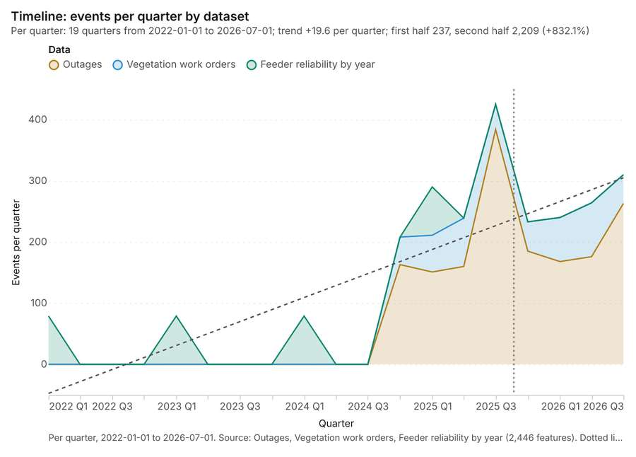
Figure 1. Timeline: events per quarter by dataset [1]. Per quarter, 2022-01-01 to 2026-07-01. Source: Outages, Vegetation work orders, Feeder reliability by year (2,446 features). Dotted lines mark dates named in the project's documents. The data is in the appendix.
The timeline counts 2,446 dated events in Outages, Vegetation work orders, Feeder reliability by year per quarter, from Q1 2022 to Q3 2026 [1][2][3][4]. By dataset: Outages 1,650; Vegetation work orders 480; Feeder reliability by year 316 [1]. The trend is +19.6 events per quarter; the second half of the quarters has 2,209 against 237 in the first (+832.1%) [1]. 8 of the 19 quarters had no events [1]. The project's documents name 1 date inside this span, drawn as dotted lines; the most named is 2025-08-22 (Storm season reliability report, page 1, 1 mention) [5].
Busiest quarters
- Q3 2025: 425 events [1]
- Q3 2026: 310 events [1]
- Q1 2025: 290 events [1]
Quietest quarters with events
- Q1 2022: 79 events [1]
- Q1 2023: 79 events [1]
- Q1 2024: 79 events [1]

Space time hot spots
What this analysis is. Emerging hot spots: Where hot spots are new, consecutive, intensifying, persistent, diminishing, sporadic, oscillating or historical over time [6]. In ArcGIS it is Emerging Hot Spot Analysis or Create Space Time Cube [6].
Why it was run on this data. Outages carry dates in 'started_at': emerging hot spot analysis finds new, intensifying and fading hot spots per month [7].
What it found. The `gp_space_time_hot_spots` tool utilized the Outages input [9] and generated a result with 100 features [8].
Result | Value
result, count | 100
result, elapsed ms | 17
result, resolution | 8
result, features used | 1,650
result, time neighbors | 0
billing, cost | 0.1825
billing, list price | 0.1825
billing, upstream cost | 0

Findings
- Evidenced: Space time hot spots on Outages: Emerging hot spots: 1 layer saved: Emerging hot spots: Outages (100 features) [8][9].
- Evidenced: It reported result, count 100; result, elapsed ms 17; result, resolution 8; result, features used 1,650; result, time neighbors 0; billing, cost 0.1825 [8].
Tool gp_space_time_hot_spots; parameters {"agg": "sum", "project": "99e378b8-9e64-42f5-8930-fca7c2a73f57", "features": {"layer": "Outages (74249532)"}, "interval": "month", "bin_shape": "h3", "resolution": 8, "time_field": "started_at", "value_field": "customers_affected"}

Space time hot spots
What this analysis is. Emerging hot spots: Where hot spots are new, consecutive, intensifying, persistent, diminishing, sporadic, oscillating or historical over time [6]. In ArcGIS it is Emerging Hot Spot Analysis or Create Space Time Cube [6].
Why it was run on this data. Vegetation work orders carry dates in 'date': emerging hot spot analysis finds new, intensifying and fading hot spots per month [10].
What it found. Space time hot spots on Vegetation work orders: Emerging hot spots: 1 layer saved: Emerging hot spots: Vegetation work orders (89 features) [11][12]. It reported result, count 89; result, elapsed ms 12; result, resolution 8; result, features used 480; result, time neighbors 0; billing, cost 0.124 [11].
Result | Value
result, count | 89
result, elapsed ms | 12
result, resolution | 8
result, features used | 480
result, time neighbors | 0
billing, cost | 0.124
billing, list price | 0.124
billing, upstream cost | 0

Findings
- Evidenced: Space time hot spots on Vegetation work orders: Emerging hot spots: 1 layer saved: Emerging hot spots: Vegetation work orders (89 features) [11][12].
- Evidenced: It reported result, count 89; result, elapsed ms 12; result, resolution 8; result, features used 480; result, time neighbors 0; billing, cost 0.124 [11].
Tool gp_space_time_hot_spots; parameters {"project": "99e378b8-9e64-42f5-8930-fca7c2a73f57", "features": {"layer": "Vegetation work orders (d3eba75a)"}, "interval": "month", "bin_shape": "h3", "resolution": 8, "time_field": "date"}

Hot spots
What this analysis is. Hot spot analysis: Getis-Ord Gi* hot and cold spots with z-scores, p-values and confidence bins [13]. In ArcGIS it is Find Hot Spots or Hot Spot Analysis (Getis-Ord Gi*); in QGIS, qgis:hotspot (plugin) [13].
Why it was run on this data. 450 points: Getis-Ord Gi* tests whether the concentrations in Poles are statistically significant [14].
What it found. Hot spots on Poles: Hot spot analysis: 1 layer saved: Hot spot analysis: Poles (79 features) [15][16]. It reported result, bins 79; result, count 79; result, elapsed ms 5; result, cell size m 1,000; result, incidents used 450; result, distance band m 1,000 [15].
Result | Value
result, bins | 79
result, count | 79
result, elapsed ms | 5
result, cell size m | 1,000
result, incidents used | 450
result, distance band m | 1,000
billing, cost | 0.059
billing, list price | 0.059
billing, upstream cost | 0

Findings
- Evidenced: Hot spots on Poles: Hot spot analysis: 1 layer saved: Hot spot analysis: Poles (79 features) [15][16].
- Evidenced: It reported result, bins 79; result, count 79; result, elapsed ms 5; result, cell size m 1,000; result, incidents used 450; result, distance band m 1,000 [15].
Tool gp_hot_spots; parameters {"project": "99e378b8-9e64-42f5-8930-fca7c2a73f57", "features": {"layer": "Poles (cb7cbff1)"}, "aggregation": "hexagon", "cell_size_m": 1000.0, "distance_band_m": 1000.0}

Hot spots
What this analysis is. Hot spot analysis: Getis-Ord Gi* hot and cold spots with z-scores, p-values and confidence bins [13]. In ArcGIS it is Find Hot Spots or Hot Spot Analysis (Getis-Ord Gi*); in QGIS, qgis:hotspot (plugin) [13].
Why it was run on this data. 1650 points: Getis-Ord Gi* tests whether the concentrations in Outages are statistically significant [17].
What it found. The hot spot analysis used the Outages layer as the input data [9]. The analysis generated a total of 1,650 features, with the process completing in 27 ms [18].
Result | Value
result, count | 1,650
result, elapsed ms | 27
result, excluded null | 0
result, distance band m | 500
billing, cost | 0.083
billing, list price | 0.083
billing, upstream cost | 0

Findings
- Evidenced: Hot spots on Outages: Hot spot analysis: 1 layer saved: Hot spot analysis: Outages (1650 features) [9][18].
- Evidenced: It reported result, count 1,650; result, elapsed ms 27; result, excluded null 0; result, distance band m 500; billing, cost 0.083; billing, list price 0.083 [18].
Tool gp_hot_spots; parameters {"field": "customers_affected", "project": "99e378b8-9e64-42f5-8930-fca7c2a73f57", "features": {"layer": "Outages (74249532)"}, "aggregation": "hexagon", "cell_size_m": 500.0, "distance_band_m": 500.0}

Hot spots
What this analysis is. Hot spot analysis: Getis-Ord Gi* hot and cold spots with z-scores, p-values and confidence bins [13]. In ArcGIS it is Find Hot Spots or Hot Spot Analysis (Getis-Ord Gi*); in QGIS, qgis:hotspot (plugin) [13].
Why it was run on this data. 480 points: Getis-Ord Gi* tests whether the concentrations in Vegetation work orders are statistically significant [19].
What it found. Hot spots on Vegetation work orders: Hot spot analysis: 1 layer saved: Hot spot analysis: Vegetation work orders (86 features) [12][20]. It reported result, bins 86; result, count 86; result, elapsed ms 6; result, cell size m 1,000; result, incidents used 480; result, distance band m 1,000 [20].
Result | Value
result, bins | 86
result, count | 86
result, elapsed ms | 6
result, cell size m | 1,000
result, incidents used | 480
result, distance band m | 1,000
billing, cost | 0.0596
billing, list price | 0.0596
billing, upstream cost | 0

Findings
- Evidenced: Hot spots on Vegetation work orders: Hot spot analysis: 1 layer saved: Hot spot analysis: Vegetation work orders (86 features) [12][20].
- Evidenced: It reported result, bins 86; result, count 86; result, elapsed ms 6; result, cell size m 1,000; result, incidents used 480; result, distance band m 1,000 [20].
Tool gp_hot_spots; parameters {"project": "99e378b8-9e64-42f5-8930-fca7c2a73f57", "features": {"layer": "Vegetation work orders (d3eba75a)"}, "aggregation": "hexagon", "cell_size_m": 1000.0, "distance_band_m": 1000.0}

Calculate density
What this analysis is. Calculate density: Kernel density per square kilometer on a grid [21]. In ArcGIS it is Calculate Density or Kernel Density; in QGIS, native:heatmapkerneldensityestimation [21].
Why it was run on this data. 450 points in Poles: a density surface shows where they concentrate [22].
What it found. Calculate density on Poles: Calculate density: 1 layer saved: Calculate density: Poles (344 features) [16][23]. It reported result, count 344; result, elapsed ms 10; result, bandwidth m 1,000; result, cell size m 500; result, excluded null 0; result, max density per km2 24.11 [23].
Result | Value
result, count | 344
result, elapsed ms | 10
result, bandwidth m | 1,000
result, cell size m | 500
result, excluded null | 0
result, max density per km2 | 24.11
billing, cost | 0.059
billing, list price | 0.059
billing, upstream cost | 0

Findings
- Evidenced: Calculate density on Poles: Calculate density: 1 layer saved: Calculate density: Poles (344 features) [16][23].
- Evidenced: It reported result, count 344; result, elapsed ms 10; result, bandwidth m 1,000; result, cell size m 500; result, excluded null 0; result, max density per km2 24.11 [23].
A model draft was discarded because a sentence did not cite a source of this section.
Tool gp_calculate_density; parameters {"kernel": "quartic", "project": "99e378b8-9e64-42f5-8930-fca7c2a73f57", "features": {"layer": "Poles (cb7cbff1)"}, "bandwidth_m": 1000.0, "cell_size_m": 500.0}

Calculate density
What this analysis is. Calculate density: Kernel density per square kilometer on a grid [21]. In ArcGIS it is Calculate Density or Kernel Density; in QGIS, native:heatmapkerneldensityestimation [21].
Why it was run on this data. 1650 points in Outages: a density surface shows where they concentrate [24].
What it found. Calculate density on Outages: Calculate density: 1 layer saved: Calculate density: Outages (1588 features) [9][25]. It reported result, count 1,588; result, elapsed ms 45; result, bandwidth m 500; result, cell size m 200; result, excluded null 0; result, max density per km2 4.538e+04 [25].
Result | Value
result, count | 1,588
result, elapsed ms | 45
result, bandwidth m | 500
result, cell size m | 200
result, excluded null | 0
result, max density per km2 | 4.538e+04
billing, cost | 0.083
billing, list price | 0.083
billing, upstream cost | 0

Findings
- Evidenced: Calculate density on Outages: Calculate density: 1 layer saved: Calculate density: Outages (1588 features) [9][25].
- Evidenced: It reported result, count 1,588; result, elapsed ms 45; result, bandwidth m 500; result, cell size m 200; result, excluded null 0; result, max density per km2 4.538e+04 [25].
Tool gp_calculate_density; parameters {"kernel": "quartic", "project": "99e378b8-9e64-42f5-8930-fca7c2a73f57", "features": {"layer": "Outages (74249532)"}, "bandwidth_m": 500.0, "cell_size_m": 200.0, "weight_field": "customers_affected"}

Calculate density
What this analysis is. Calculate density: Kernel density per square kilometer on a grid [21]. In ArcGIS it is Calculate Density or Kernel Density; in QGIS, native:heatmapkerneldensityestimation [21].
Why it was run on this data. 480 points in Vegetation work orders: a density surface shows where they concentrate [26].
What it found. The maximum density calculated was 24.16 per km2 [27].
Result | Value
result, count | 350
result, elapsed ms | 10
result, bandwidth m | 1,000
result, cell size m | 500
result, excluded null | 0
result, max density per km2 | 24.16
billing, cost | 0.0596
billing, list price | 0.0596
billing, upstream cost | 0

Findings
- Evidenced: Calculate density on Vegetation work orders: Calculate density: 1 layer saved: Calculate density: Vegetation work orders (350 features) [12][27].
- Evidenced: It reported result, count 350; result, elapsed ms 10; result, bandwidth m 1,000; result, cell size m 500; result, excluded null 0; result, max density per km2 24.16 [27].
Tool gp_calculate_density; parameters {"kernel": "quartic", "project": "99e378b8-9e64-42f5-8930-fca7c2a73f57", "features": {"layer": "Vegetation work orders (d3eba75a)"}, "bandwidth_m": 1000.0, "cell_size_m": 500.0}

Summarize within
What this analysis is. Summarize within: Count and aggregate the features inside each polygon (or bin), proportionally for lines and polygons [28]. In ArcGIS it is Summarize Within or Aggregate Points; in QGIS, native:countpointsinpolygon or native:sumlinelengths [28].
Why it was run on this data. Count Poles inside each feature of Service areas by material; the counts map as a choropleth (natural breaks, sequential colors) [29].
What it found. Summarize within on Poles, Service areas: Summarize within: 1 layer saved: Summarize within: Service areas (14 features) [16][30][31]. It reported result, count 14; result, elapsed ms 1; billing, cost 0.0193; billing, list price 0.0193; billing, upstream cost 0 [30].
Result | Value
result, count | 14
result, elapsed ms | 1
billing, cost | 0.0193
billing, list price | 0.0193
billing, upstream cost | 0

Findings
- Evidenced: Summarize within on Poles, Service areas: Summarize within: 1 layer saved: Summarize within: Service areas (14 features) [16][30][31].
- Evidenced: It reported result, count 14; result, elapsed ms 1; billing, cost 0.0193; billing, list price 0.0193; billing, upstream cost 0 [30].
Tool gp_summarize_within; parameters {"stats": [{"stat": "sum", "field": "install_year"}], "project": "99e378b8-9e64-42f5-8930-fca7c2a73f57", "features": {"layer": "Poles (cb7cbff1)"}, "group_by": "material", "polygons": {"layer": "Service areas (af824cfb)"}}

Summarize within
What this analysis is. Summarize within: Count and aggregate the features inside each polygon (or bin), proportionally for lines and polygons [28]. In ArcGIS it is Summarize Within or Aggregate Points; in QGIS, native:countpointsinpolygon or native:sumlinelengths [28].
Why it was run on this data. Count Poles inside each feature of Service areas by material; the counts map as a choropleth (natural breaks, sequential colors) [29].
What it found. Summarize within on Outages, Service areas: Summarize within: 1 layer saved: Summarize within: Service areas (14 features) [9][31][32]. It reported result, count 14; result, elapsed ms 3; billing, cost 0.0433; billing, list price 0.0433; billing, upstream cost 0 [32].
Result | Value
result, count | 14
result, elapsed ms | 3
billing, cost | 0.0433
billing, list price | 0.0433
billing, upstream cost | 0

Findings
- Evidenced: Summarize within on Outages, Service areas: Summarize within: 1 layer saved: Summarize within: Service areas (14 features) [9][31][32].
- Evidenced: It reported result, count 14; result, elapsed ms 3; billing, cost 0.0433; billing, list price 0.0433; billing, upstream cost 0 [32].
Tool gp_summarize_within; parameters {"stats": [{"stat": "sum", "field": "customers_affected"}], "project": "99e378b8-9e64-42f5-8930-fca7c2a73f57", "features": {"layer": "Outages (74249532)"}, "group_by": "cause", "polygons": {"layer": "Service areas (af824cfb)"}}

Summarize within
What this analysis is. Summarize within: Count and aggregate the features inside each polygon (or bin), proportionally for lines and polygons [28]. In ArcGIS it is Summarize Within or Aggregate Points; in QGIS, native:countpointsinpolygon or native:sumlinelengths [28].
Why it was run on this data. Count Poles inside each feature of Service areas by material; the counts map as a choropleth (natural breaks, sequential colors) [29].
What it found. Summarize within on Vegetation work orders, Service areas: Summarize within: 1 layer saved: Summarize within: Service areas (14 features) [12][31][33]. It reported result, count 14; result, elapsed ms 1; billing, cost 0.0199; billing, list price 0.0199; billing, upstream cost 0 [33].
Result | Value
result, count | 14
result, elapsed ms | 1
billing, cost | 0.0199
billing, list price | 0.0199
billing, upstream cost | 0

Findings
- Evidenced: Summarize within on Vegetation work orders, Service areas: Summarize within: 1 layer saved: Summarize within: Service areas (14 features) [12][31][33].
- Evidenced: It reported result, count 14; result, elapsed ms 1; billing, cost 0.0199; billing, list price 0.0199; billing, upstream cost 0 [33].
Tool gp_summarize_within; parameters {"stats": [{"stat": "sum", "field": "spans"}], "project": "99e378b8-9e64-42f5-8930-fca7c2a73f57", "features": {"layer": "Vegetation work orders (d3eba75a)"}, "group_by": "trim_type", "polygons": {"layer": "Service areas (af824cfb)"}}

Find point clusters
What this analysis is. Find point clusters: Density-based clusters (DBSCAN, HDBSCAN or OPTICS, optionally space-time) with hulls and noise [34]. In ArcGIS it is Find Point Clusters or Density-based Clustering; in QGIS, native:dbscanclustering or native:stdbscanclustering [34].
Why it was run on this data. DBSCAN finds dense groups of Poles and separates noise [35].
What it found. Find point clusters on Poles: Find point clusters: 2 layers saved: Find point clusters: Poles (450 features); Find point clusters: cluster hulls (12 features) [16][36]. It reported result, count 450; result, noise 149; result, distance m 500; result, elapsed ms 9; result, min points 11; billing, cost 0.059 [36].
Result | Value
result, count | 450
result, noise | 149
result, distance m | 500
result, elapsed ms | 9
result, min points | 11
billing, cost | 0.059
billing, list price | 0.059
billing, upstream cost | 0

Findings
- Evidenced: Find point clusters on Poles: Find point clusters: 2 layers saved: Find point clusters: Poles (450 features); Find point clusters: cluster hulls (12 features) [16][36].
- Evidenced: It reported result, count 450; result, noise 149; result, distance m 500; result, elapsed ms 9; result, min points 11; billing, cost 0.059 [36].
Tool gp_find_point_clusters; parameters {"method": "dbscan", "project": "99e378b8-9e64-42f5-8930-fca7c2a73f57", "features": {"layer": "Poles (cb7cbff1)"}, "distance_m": 500.0, "min_points": 11}

Find point clusters
What this analysis is. Find point clusters: Density-based clusters (DBSCAN, HDBSCAN or OPTICS, optionally space-time) with hulls and noise [34]. In ArcGIS it is Find Point Clusters or Density-based Clustering; in QGIS, native:dbscanclustering or native:stdbscanclustering [34].
Why it was run on this data. DBSCAN finds dense groups of Outages and separates noise [37].
What it found. Find point clusters on Outages: Find point clusters: 2 layers saved: Find point clusters: Outages (1650 features); Find point clusters: cluster hulls (12 features) [9][38]. It reported result, count 1,650; result, noise 985; result, distance m 200; result, elapsed ms 22; result, min points 20; billing, cost 0.083 [38].
Result | Value
result, count | 1,650
result, noise | 985
result, distance m | 200
result, elapsed ms | 22
result, min points | 20
billing, cost | 0.083
billing, list price | 0.083
billing, upstream cost | 0

Findings
- Evidenced: Find point clusters on Outages: Find point clusters: 2 layers saved: Find point clusters: Outages (1650 features); Find point clusters: cluster hulls (12 features) [9][38].
- Evidenced: It reported result, count 1,650; result, noise 985; result, distance m 200; result, elapsed ms 22; result, min points 20; billing, cost 0.083 [38].
Tool gp_find_point_clusters; parameters {"method": "dbscan", "project": "99e378b8-9e64-42f5-8930-fca7c2a73f57", "features": {"layer": "Outages (74249532)"}, "distance_m": 200.0, "min_points": 20}

Find point clusters
What this analysis is. Find point clusters: Density-based clusters (DBSCAN, HDBSCAN or OPTICS, optionally space-time) with hulls and noise [34]. In ArcGIS it is Find Point Clusters or Density-based Clustering; in QGIS, native:dbscanclustering or native:stdbscanclustering [34].
Why it was run on this data. DBSCAN finds dense groups of Vegetation work orders and separates noise [39].
What it found. Find point clusters on Vegetation work orders: Find point clusters: 2 layers saved: Find point clusters: Vegetation work orders (480 features); Find point clusters: cluster hulls (9 features) [12][40]. It reported result, count 480; result, noise 157; result, distance m 500; result, elapsed ms 9; result, min points 12; billing, cost 0.0596 [40].
Result | Value
result, count | 480
result, noise | 157
result, distance m | 500
result, elapsed ms | 9
result, min points | 12
billing, cost | 0.0596
billing, list price | 0.0596
billing, upstream cost | 0

Findings
- Evidenced: Find point clusters on Vegetation work orders: Find point clusters: 2 layers saved: Find point clusters: Vegetation work orders (480 features); Find point clusters: cluster hulls (9 features) [12][40].
- Evidenced: It reported result, count 480; result, noise 157; result, distance m 500; result, elapsed ms 9; result, min points 12; billing, cost 0.0596 [40].
Tool gp_find_point_clusters; parameters {"method": "dbscan", "project": "99e378b8-9e64-42f5-8930-fca7c2a73f57", "features": {"layer": "Vegetation work orders (d3eba75a)"}, "distance_m": 500.0, "min_points": 12}

Outliers
What this analysis is. Find outliers: Anselin local Moran’s I: HH, LL clusters and HL, LH outliers [41]. In ArcGIS it is Find Outliers or Cluster and Outlier Analysis (Anselin Local Moran’s I) [41].
Why it was run on this data. Local Moran's I maps clusters and outliers of 'customers' [42].
What it found. Outliers on Service areas: Find outliers: 1 layer saved: Find outliers: Service areas (14 features) [31][43]. It reported result, count 14; result, elapsed ms 2; result, permutations 199; result, excluded null 0; result, distance band m 2,472; billing, cost 0.05042 [43].
Result | Value
result, count | 14
result, elapsed ms | 2
result, permutations | 199
result, excluded null | 0
result, distance band m | 2,472
billing, cost | 0.05042
billing, list price | 0.05042
billing, upstream cost | 0

Findings
- Evidenced: Outliers on Service areas: Find outliers: 1 layer saved: Find outliers: Service areas (14 features) [31][43].
- Evidenced: It reported result, count 14; result, elapsed ms 2; result, permutations 199; result, excluded null 0; result, distance band m 2,472; billing, cost 0.05042 [43].
Tool gp_outliers; parameters {"field": "customers", "project": "99e378b8-9e64-42f5-8930-fca7c2a73f57", "features": {"layer": "Service areas (af824cfb)"}, "aggregation": "hexagon"}

Spatial autocorrelation
What this analysis is. Spatial autocorrelation: Global Moran’s I: is the pattern clustered, dispersed or random [44]. In ArcGIS it is Spatial Autocorrelation (Global Moran’s I) [44].
Why it was run on this data. Global Moran's I says whether similar values of 'customers' sit next to each other [45].
What it found. The spatial autocorrelation tool was run using Service areas [31], yielding a Moran's I of 0.02059 [46]. Analysis of this result showed a p value of 0.6627 [46] and a z score of 0.4361 [46]. Furthermore, the expected I value for the analysis was calculated to be -0.07692 [46].
Result | Value
result, n | 14
result, p value | 0.6627
result, z score | 0.4361
result, morans i | 0.02059
result, variance | 0.04999
result, elapsed ms | 1
result, expected i | -0.07692
result, excluded null | 0
result, distance band m | 2,472
result, p value normality | 0.671
result, z score normality | 0.4248
result, variance normality | 0.05269
billing, cost | 0.02
billing, list price | 0.02
billing, upstream cost | 0

Findings
- Evidenced: Spatial autocorrelation on Service areas: Spatial autocorrelation: done; no map output [31][46].
- Evidenced: It reported result, n 14; result, p value 0.6627; result, z score 0.4361; result, morans i 0.02059; result, variance 0.04999; result, elapsed ms 1 [46].
Tool gp_spatial_autocorrelation; parameters {"field": "customers", "project": "99e378b8-9e64-42f5-8930-fca7c2a73f57", "features": {"layer": "Service areas (af824cfb)"}}

Near repeat
What this analysis is. Repeat and near repeat classification: Classify incidents as originators, repeats (same place) or near repeats within a distance and time window, with a Knox test table [47]. In ArcGIS it is Repeat and Near Repeat Classification or Near Repeat Calculator [47].
Why it was run on this data. Near repeat analysis tests whether Outages close in space also follow each other within 30 days [48].
What it found. Near repeat on Outages: Repeat and near repeat classification: 1 layer saved: Repeat and near repeat classification: Outages (1650 features) [9][49]. It reported result, days 30; result, count 1,650; result, chains 266; result, distance m 200; result, elapsed ms 42; result, pairs linked 1,171 [49].
Result | Value
result, days | 30
result, count | 1,650
result, chains | 266
result, distance m | 200
result, elapsed ms | 42
result, pairs linked | 1,171
billing, cost | 0.0995
billing, list price | 0.0995
billing, upstream cost | 0

Findings
- Evidenced: Near repeat on Outages: Repeat and near repeat classification: 1 layer saved: Repeat and near repeat classification: Outages (1650 features) [9][49].
- Evidenced: It reported result, days 30; result, count 1,650; result, chains 266; result, distance m 200; result, elapsed ms 42; result, pairs linked 1,171 [49].
Tool gp_near_repeat; parameters {"days": 30, "project": "99e378b8-9e64-42f5-8930-fca7c2a73f57", "features": {"layer": "Outages (74249532)"}, "distance_m": 200.0, "time_field": "started_at"}

Maps and charts
The run also made 20 map image(s) [50][51][52][53][54][55][56][57][58][59][60][61][62][63][64][65][66][67][68][69] and 28 chart(s) [70][71][72][73][74][75][76][77][78][79][80][81][82][83][84][85][86][87][88][89][90][91][92][93][94][95][96][97].
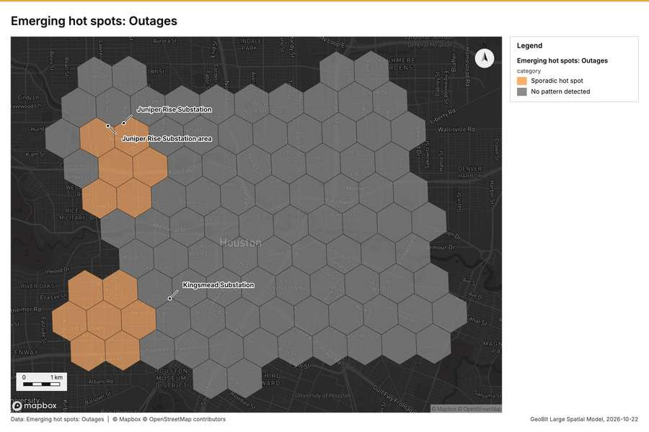
Figure 2. Emerging hot spots: Outages [50]
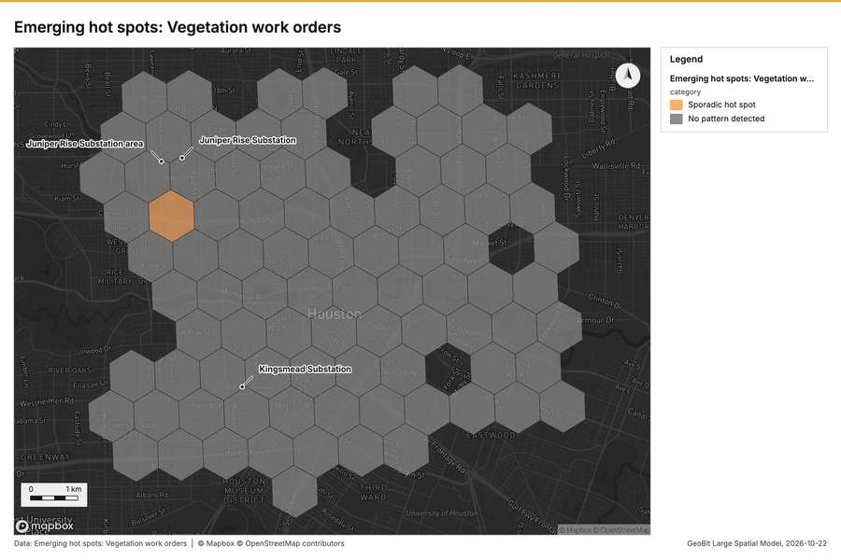
Figure 3. Emerging hot spots: Vegetation work orders [51]
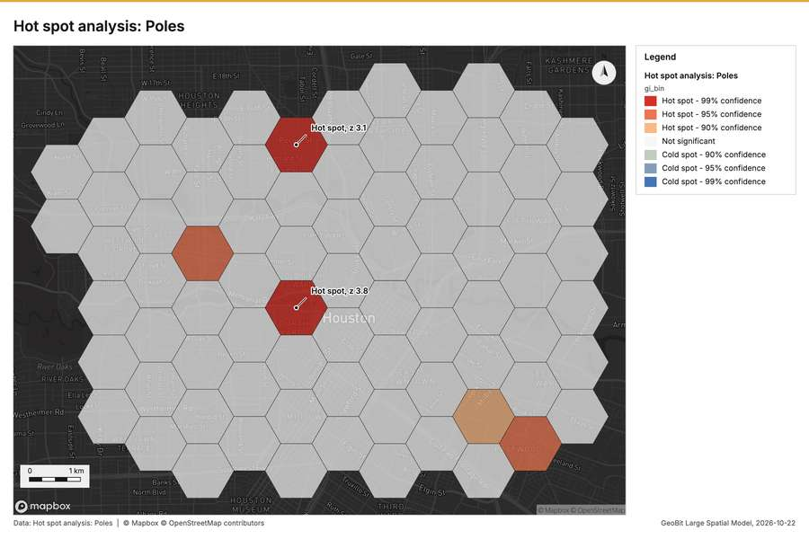
Figure 4. Hot spot analysis: Poles [52]
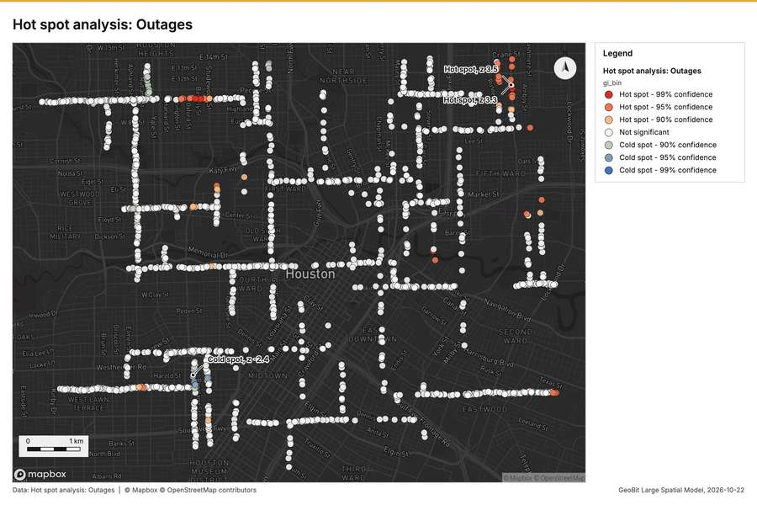
Figure 5. Hot spot analysis: Outages [53]
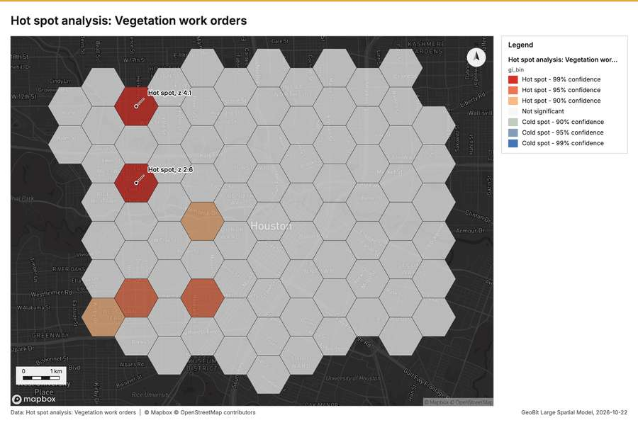
Figure 6. Hot spot analysis: Vegetation work orders [54]
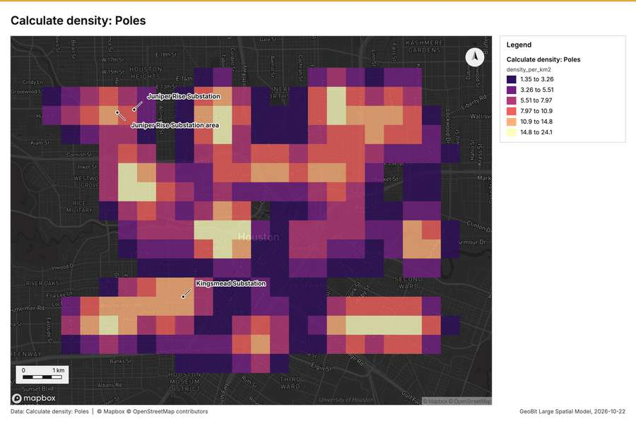
Figure 7. Calculate density: Poles [55]
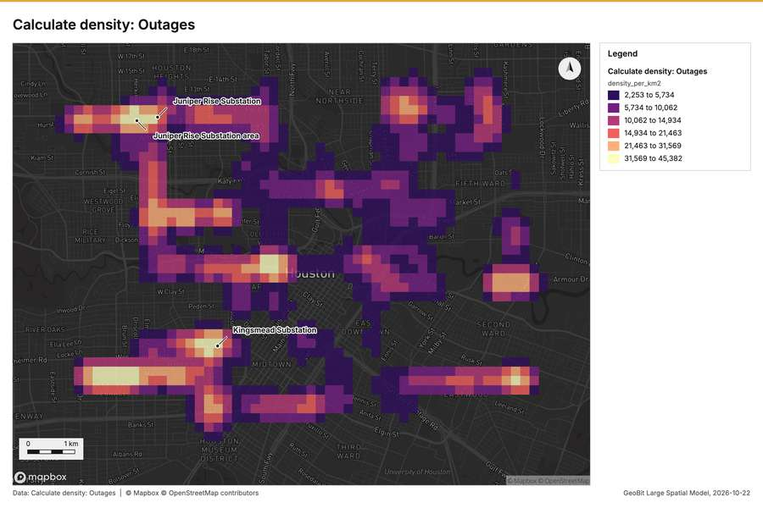
Figure 8. Calculate density: Outages [56]
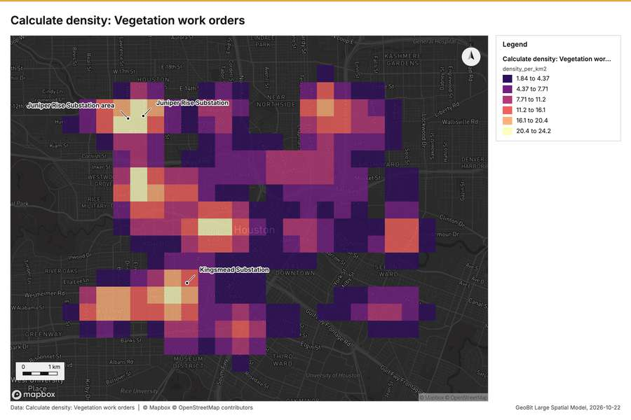
Figure 9. Calculate density: Vegetation work orders [57]
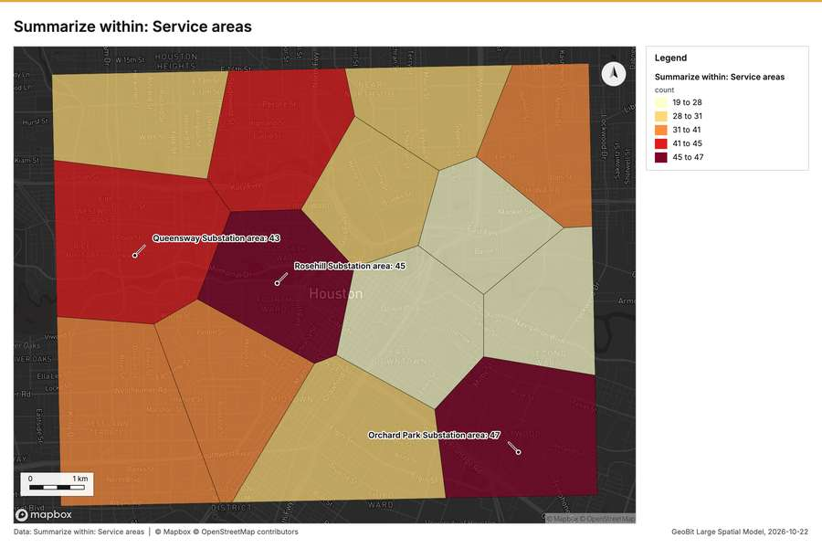
Figure 10. Summarize within: Service areas [58]
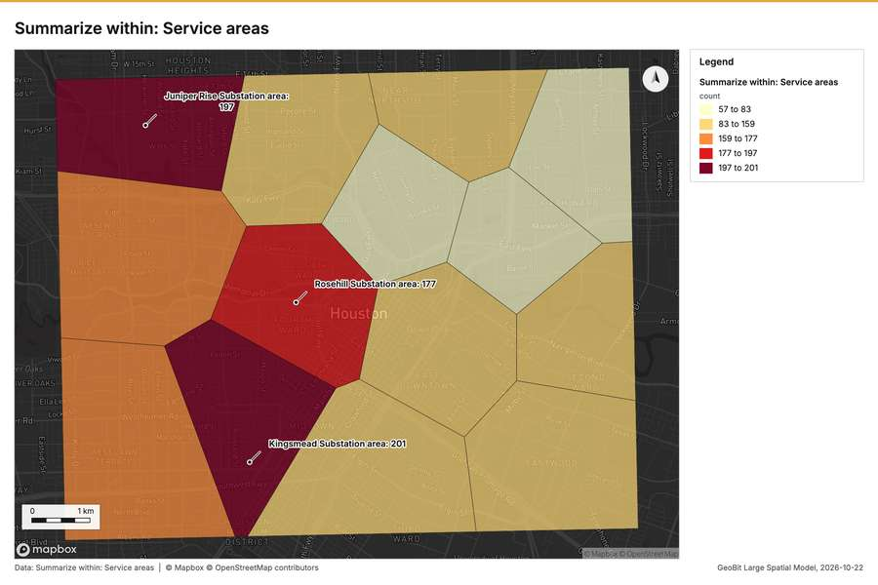
Figure 11. Summarize within: Service areas [59]
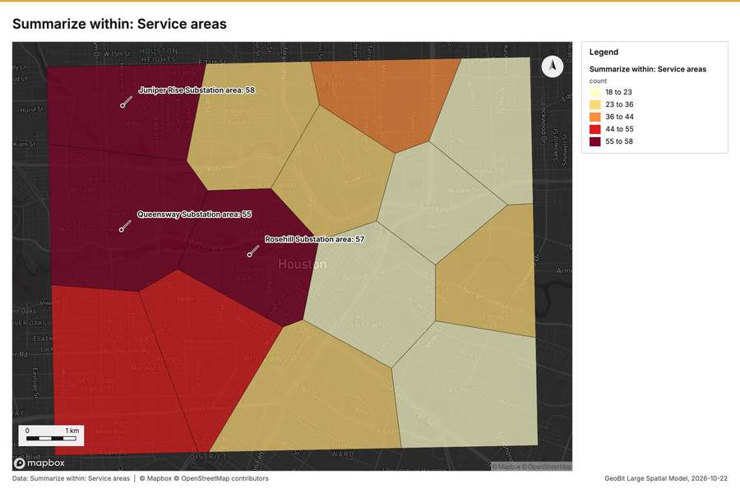
Figure 12. Summarize within: Service areas [60]
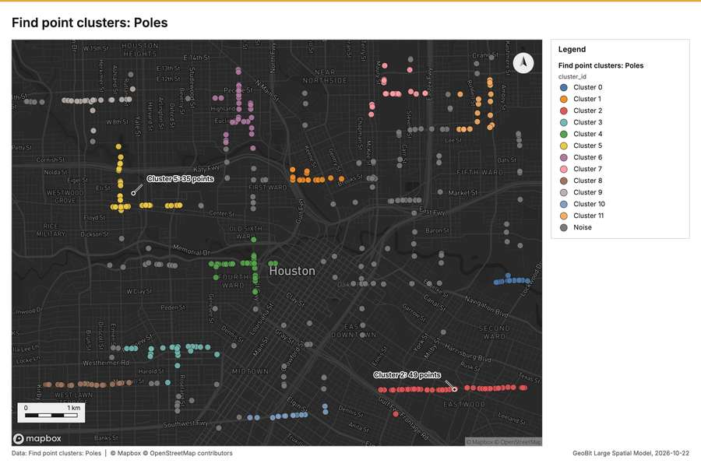
Figure 13. Find point clusters: Poles [61]
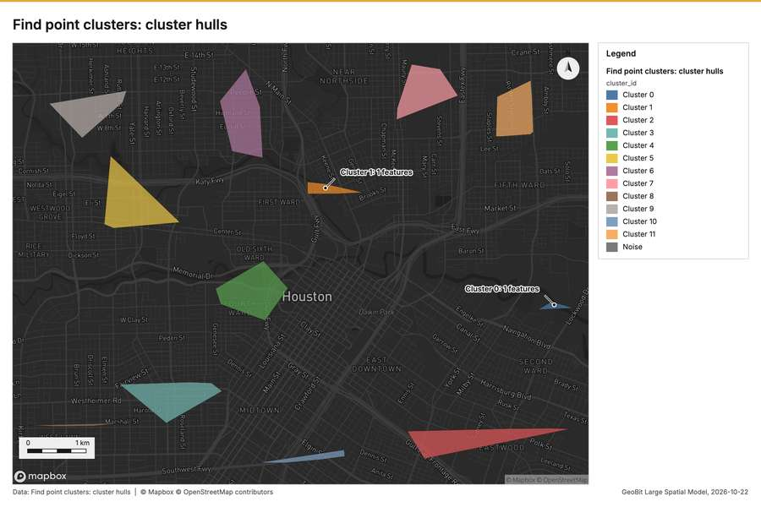
Figure 14. Find point clusters: cluster hulls [62]
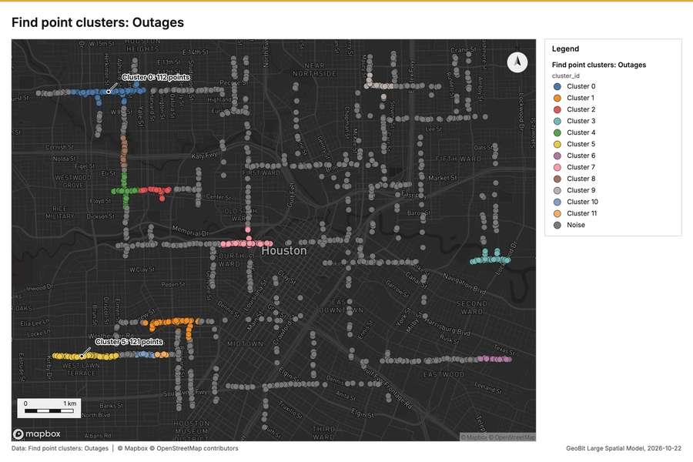
Figure 15. Find point clusters: Outages [63]
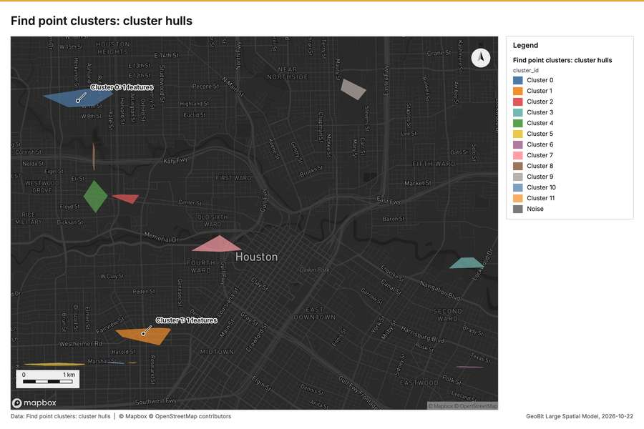
Figure 16. Find point clusters: cluster hulls [64]
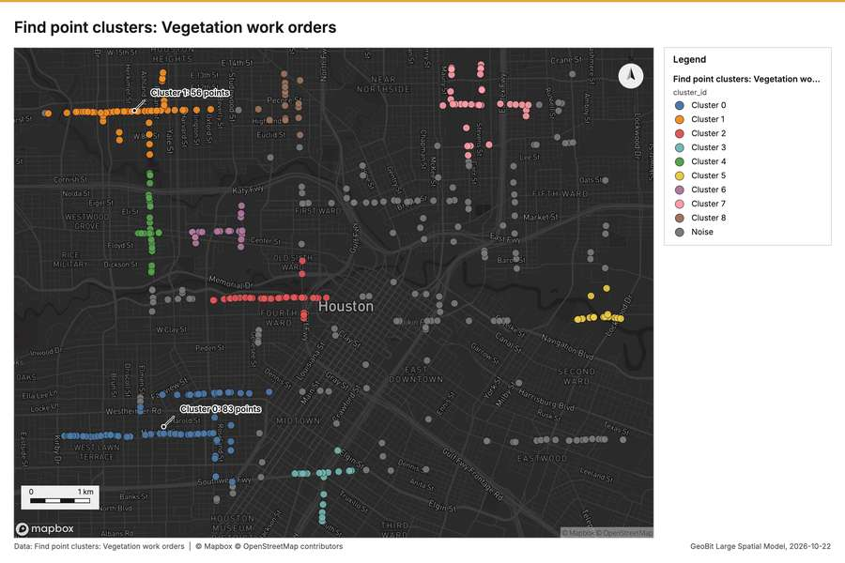
Figure 17. Find point clusters: Vegetation work orders [65]
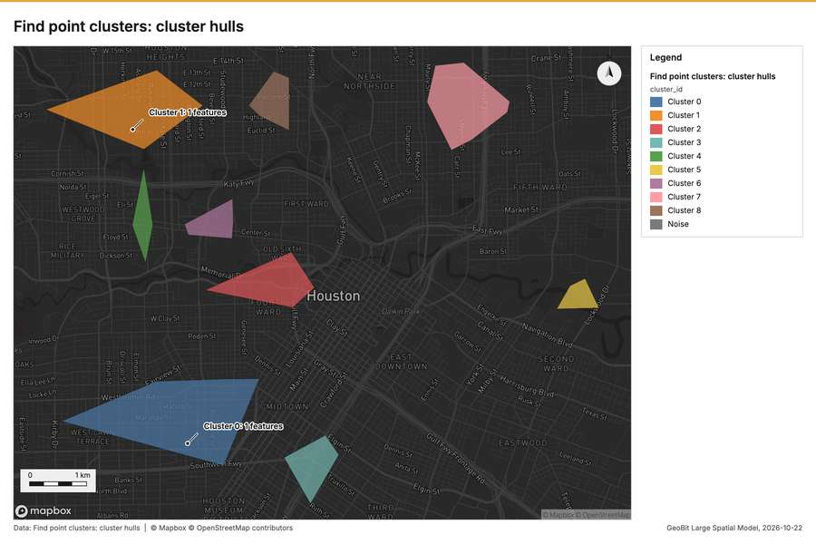
Figure 18. Find point clusters: cluster hulls [66]
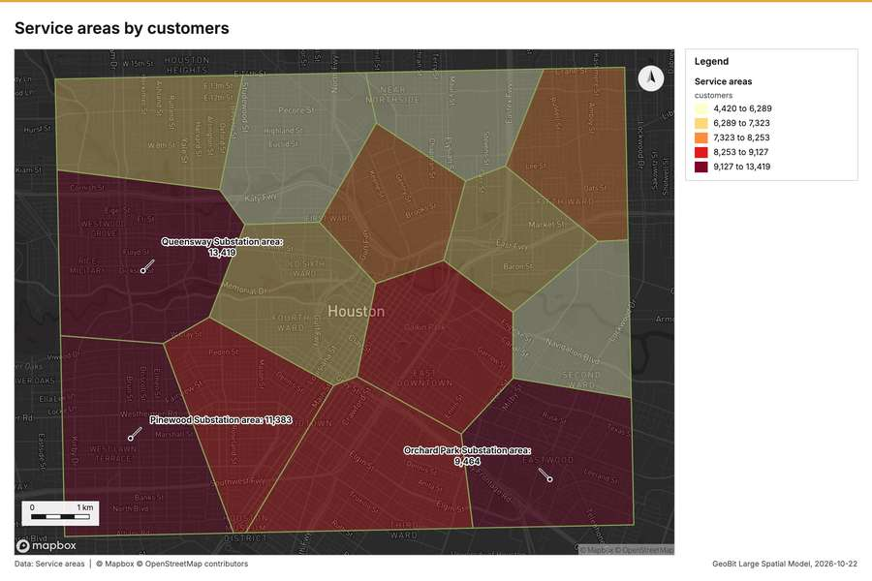
Figure 19. Service areas by customers [67]
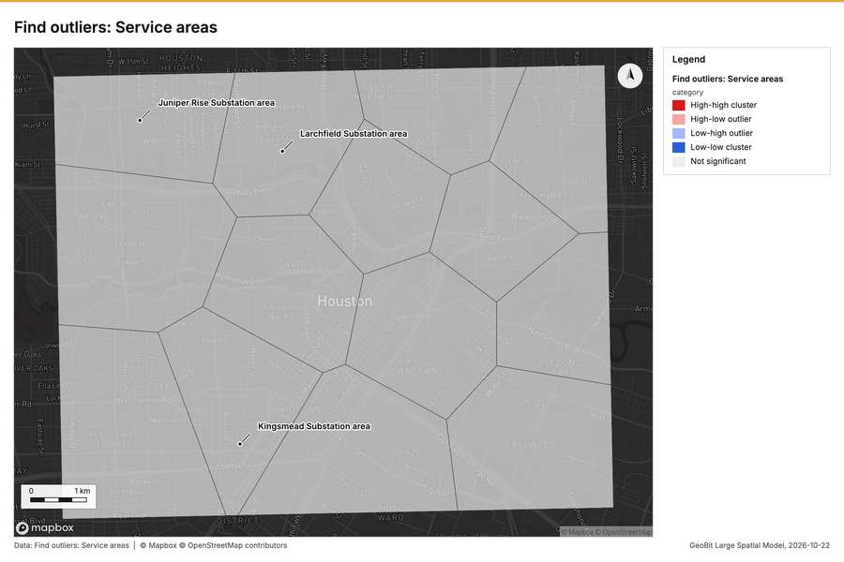
Figure 20. Find outliers: Service areas [68]
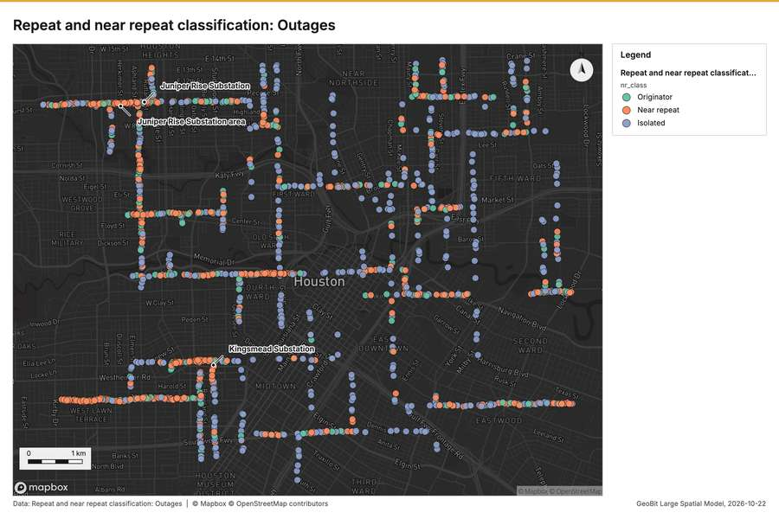
Figure 21. Repeat and near repeat classification: Outages [69]
What the map shows. The map visualizes a hot spot analysis for vegetation work orders, classifying areas as having a pattern or having none. The majority of [51]
Inferred: read from the image by gemma4:e4b, not evidence.
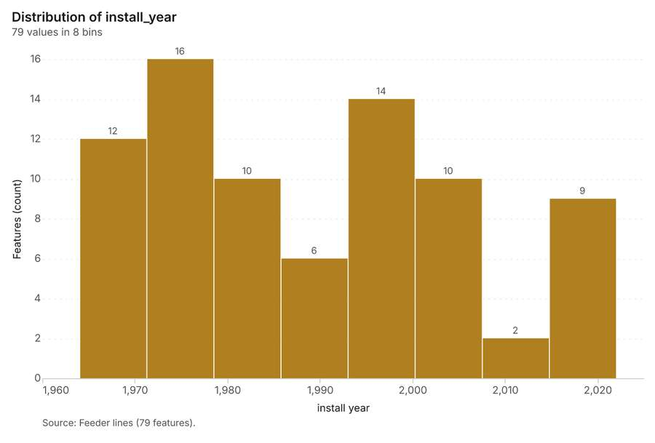
Figure 22. Feeder lines over time (install_year) [70]. Source: Feeder lines (79 features). The data is in the appendix.
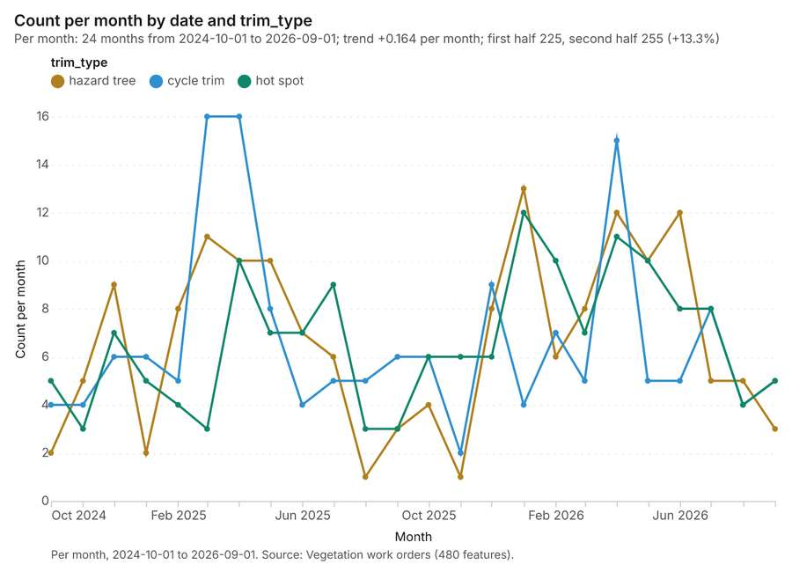
Figure 23. Vegetation work orders over time (date) [71]. Per month, 2024-10-01 to 2026-09-01. Source: Vegetation work orders (480 features). The data is in the appendix.
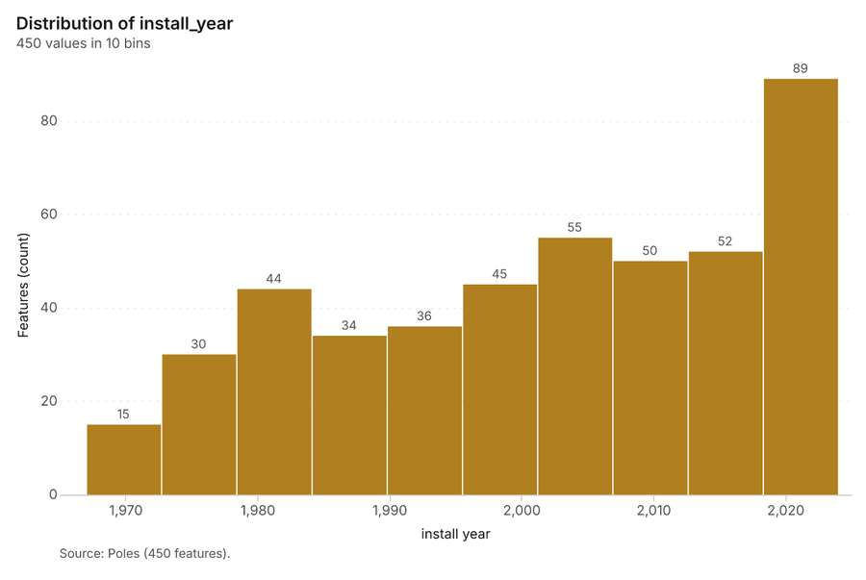
Figure 24. Poles over time (install_year) [72]. Source: Poles (450 features). The data is in the appendix.
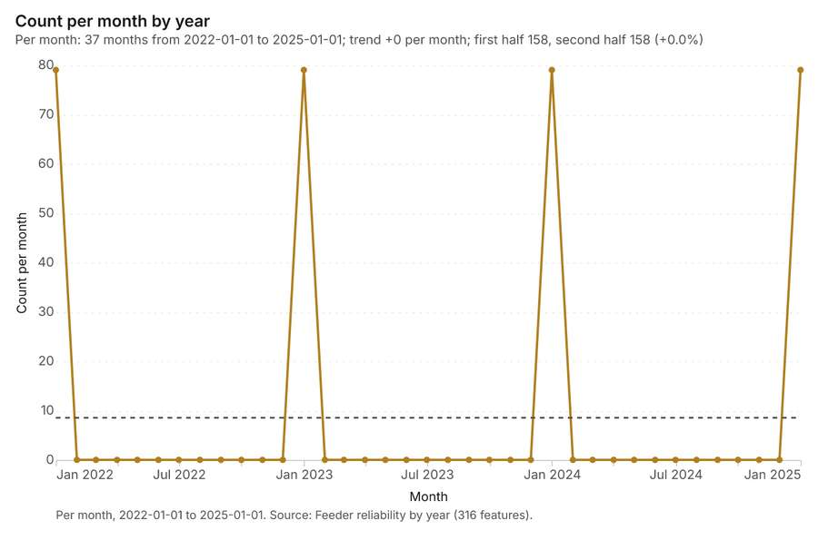
Figure 25. Feeder reliability by year over time (year) [73]. Per month, 2022-01-01 to 2025-01-01. Source: Feeder reliability by year (316 features). The data is in the appendix.
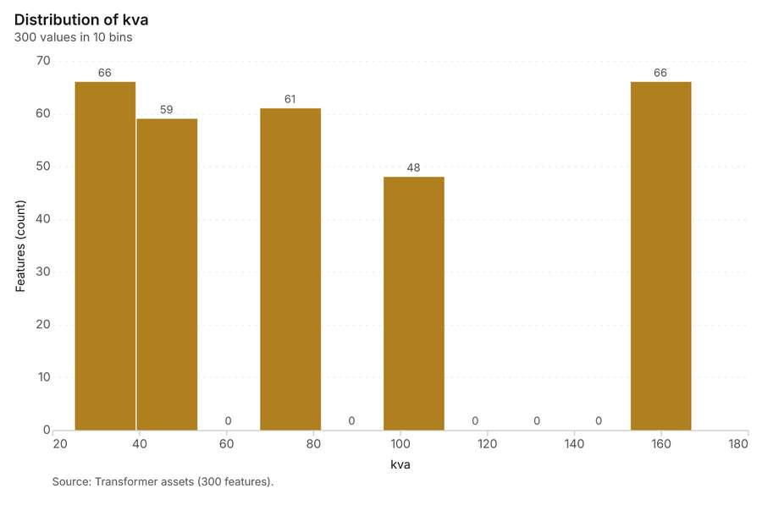
Figure 26. Transformer assets over time (install_year) [74]. Source: Transformer assets (300 features). The data is in the appendix.
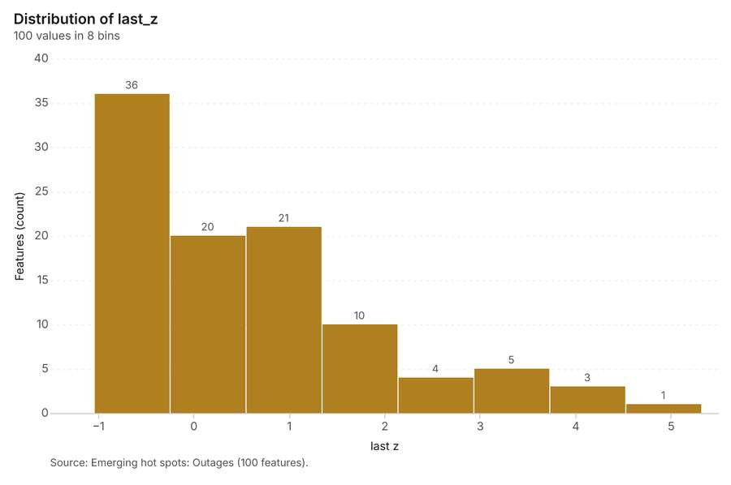
Figure 27. Emerging hot spots: Outages [75]. Source: Emerging hot spots: Outages (100 features). The data is in the appendix.
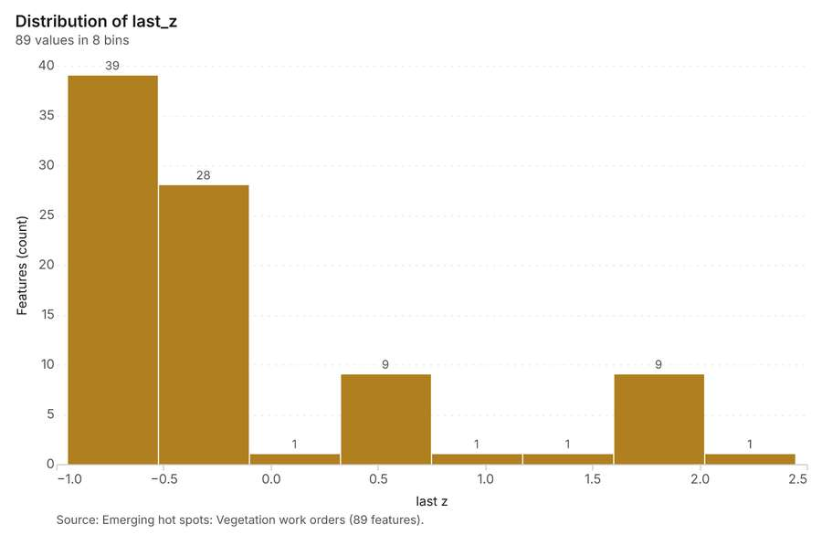
Figure 28. Emerging hot spots: Vegetation work orders [76]. Source: Emerging hot spots: Vegetation work orders (89 features). The data is in the appendix.
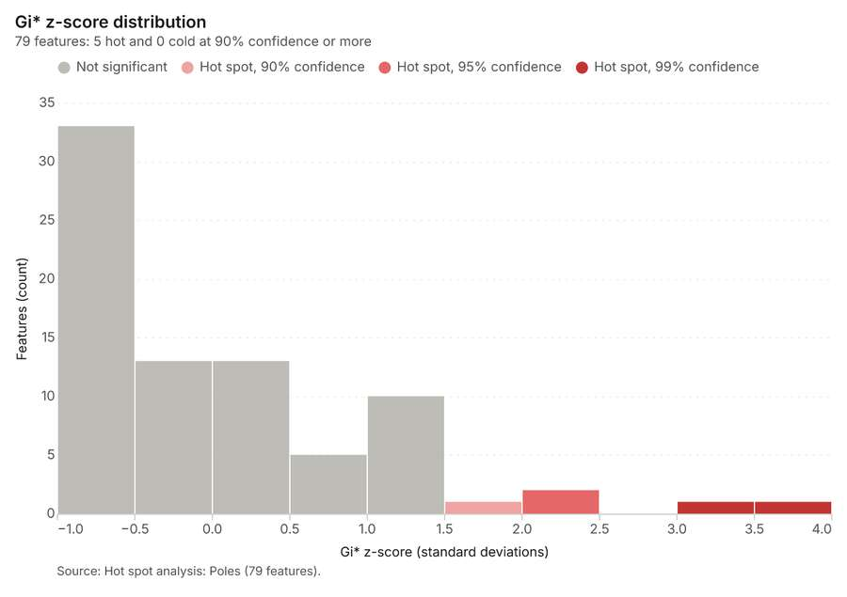
Figure 29. Hot spot analysis: Poles [77]. Source: Hot spot analysis: Poles (79 features). The data is in the appendix.
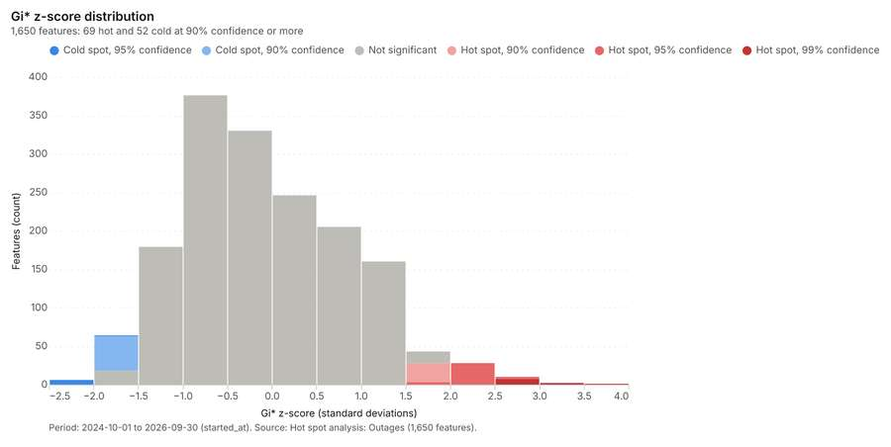
Figure 30. Hot spot analysis: Outages [78]. Period: 2024-10-01 to 2026-09-30 (started_at). Source: Hot spot analysis: Outages (1,650 features). The data is in the appendix.
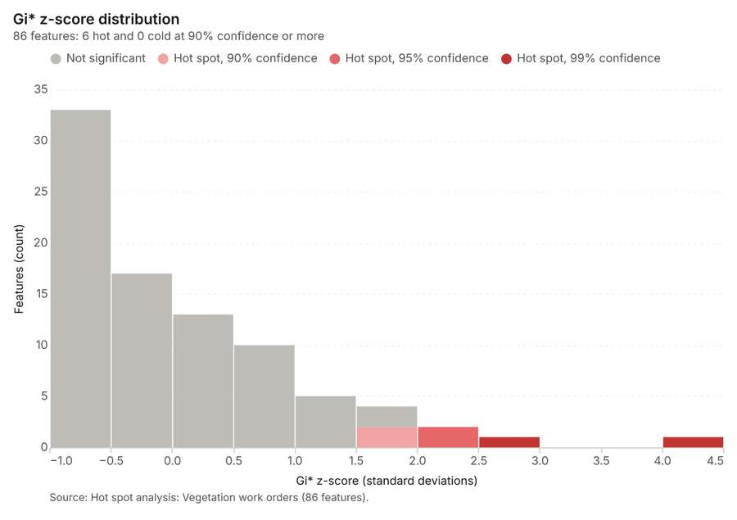
Figure 31. Hot spot analysis: Vegetation work orders [79]. Source: Hot spot analysis: Vegetation work orders (86 features). The data is in the appendix.
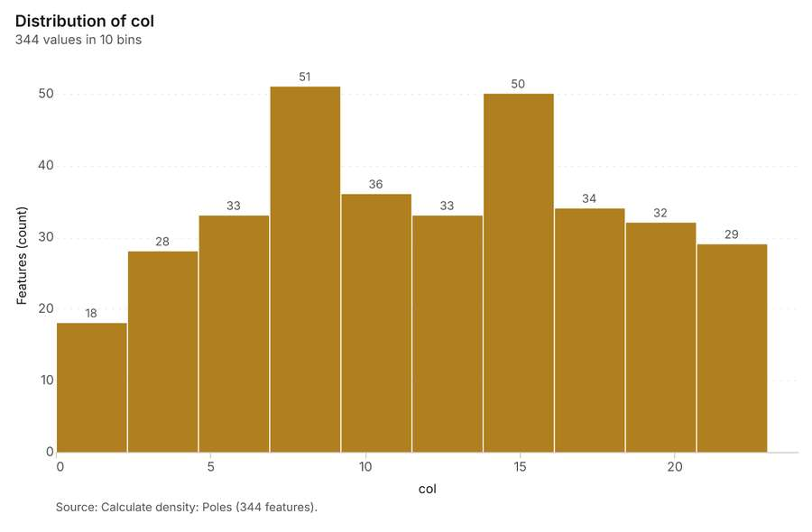
Figure 32. Calculate density: Poles [80]. Source: Calculate density: Poles (344 features). The data is in the appendix.
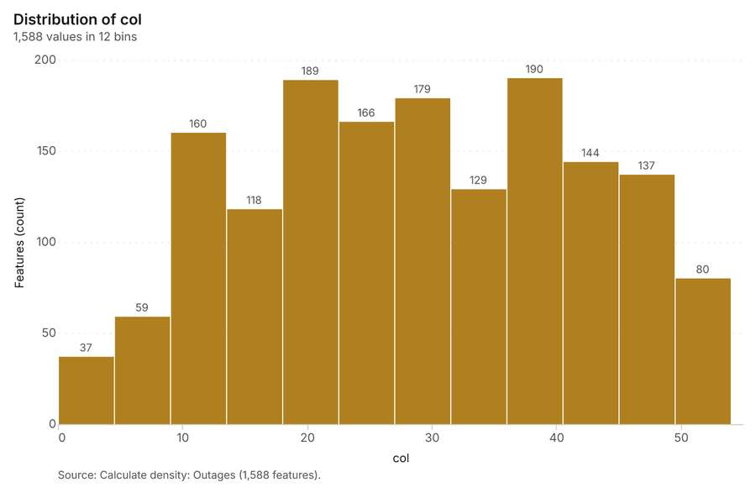
Figure 33. Calculate density: Outages [81]. Source: Calculate density: Outages (1,588 features). The data is in the appendix.
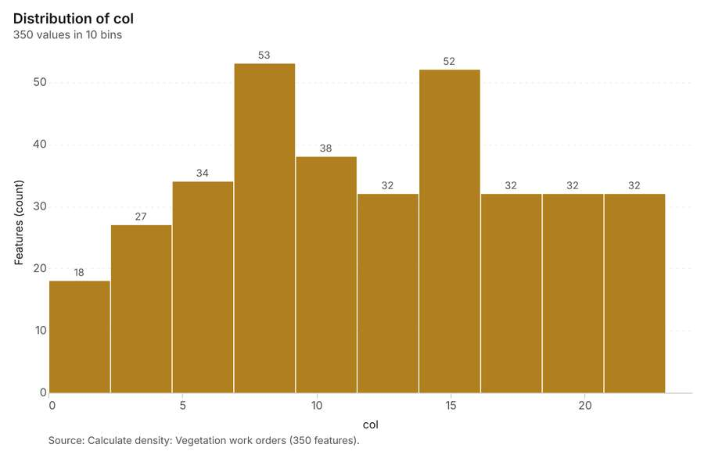
Figure 34. Calculate density: Vegetation work orders [82]. Source: Calculate density: Vegetation work orders (350 features). The data is in the appendix.
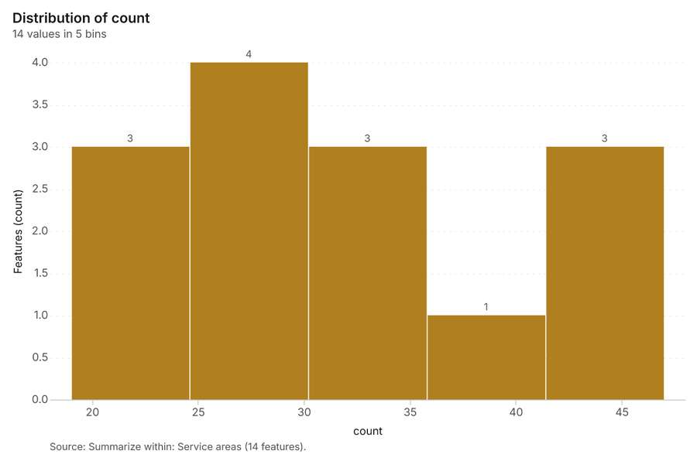
Figure 35. Summarize within: Service areas [83]. Source: Summarize within: Service areas (14 features). The data is in the appendix.
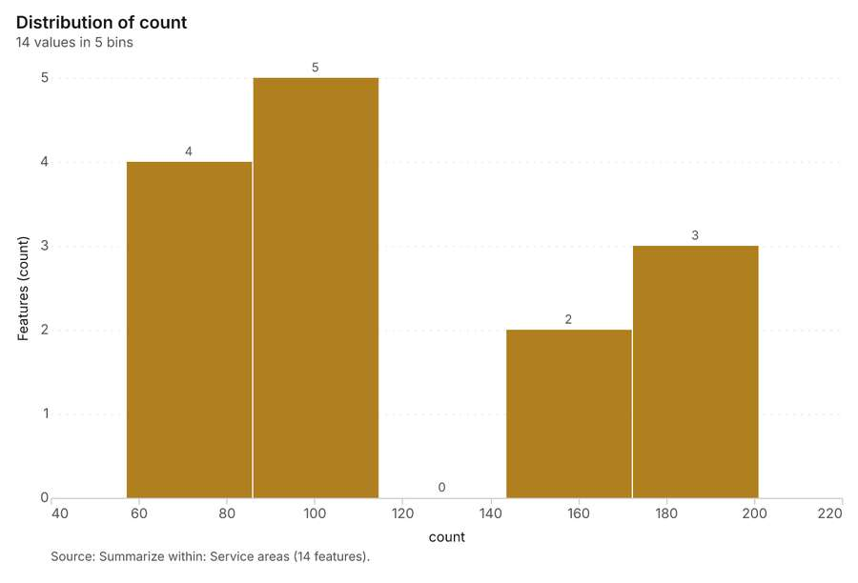
Figure 36. Summarize within: Service areas [84]. Source: Summarize within: Service areas (14 features). The data is in the appendix.
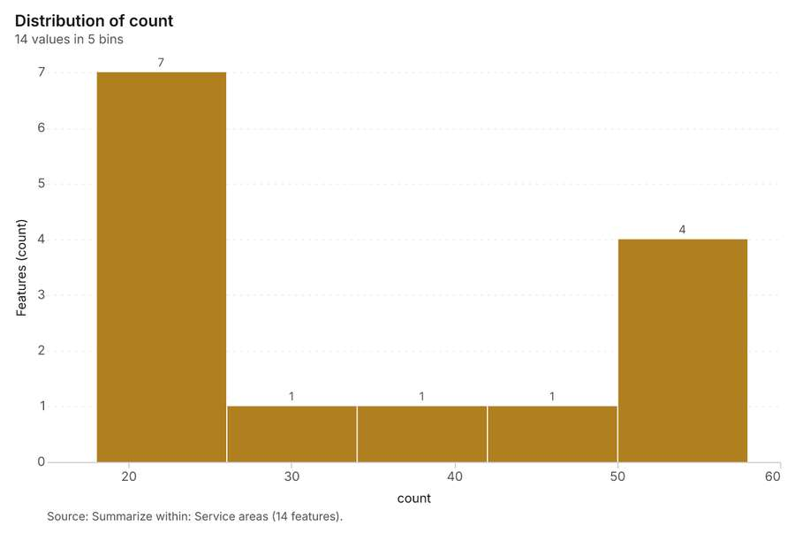
Figure 37. Summarize within: Service areas [85]. Source: Summarize within: Service areas (14 features). The data is in the appendix.
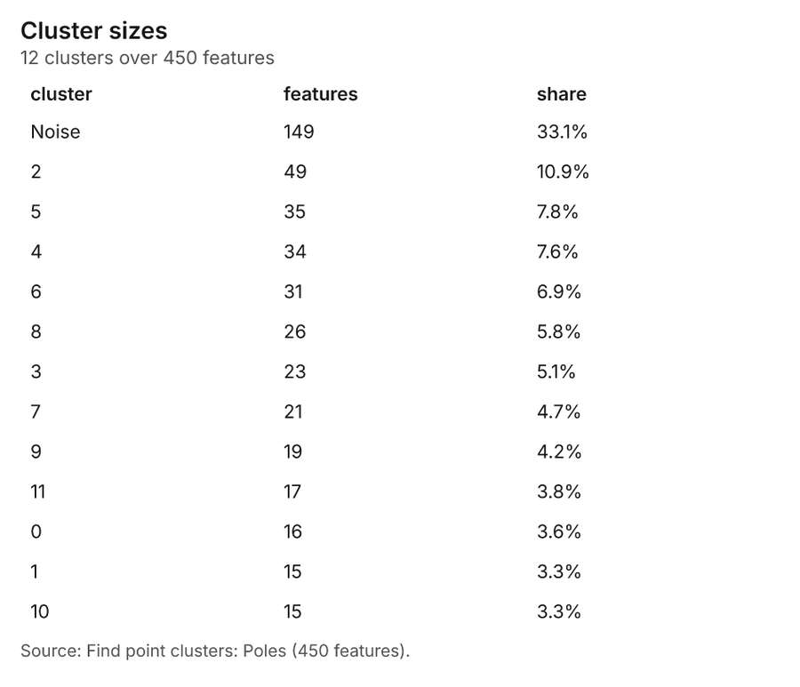
Figure 38. Find point clusters: Poles [86]. Source: Find point clusters: Poles (450 features). The data is in the appendix.
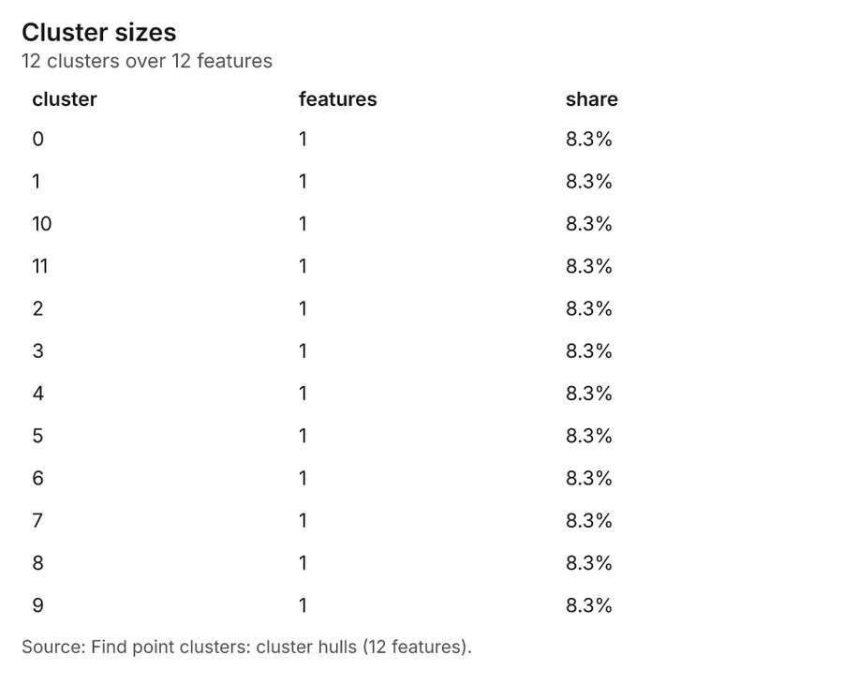
Figure 39. Find point clusters: cluster hulls [87]. Source: Find point clusters: cluster hulls (12 features). The data is in the appendix.
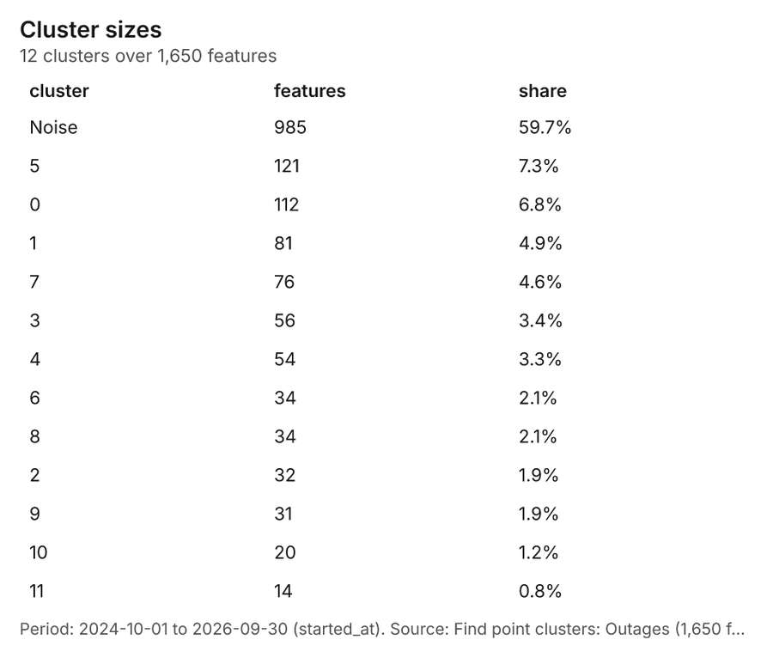
Figure 40. Find point clusters: Outages [88]. Period: 2024-10-01 to 2026-09-30 (started_at). Source: Find point clusters: Outages (1,650 features). The data is in the appendix.
Figure 41. Find point clusters: cluster hulls [89]. Source: Find point clusters: cluster hulls (12 features). The data is in the appendix.
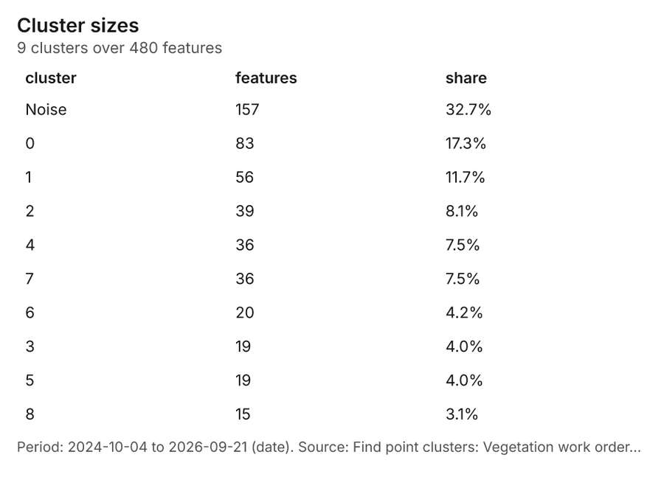
Figure 42. Find point clusters: Vegetation work orders [90]. Period: 2024-10-04 to 2026-09-21 (date). Source: Find point clusters: Vegetation work orders (480 features). The data is in the appendix.
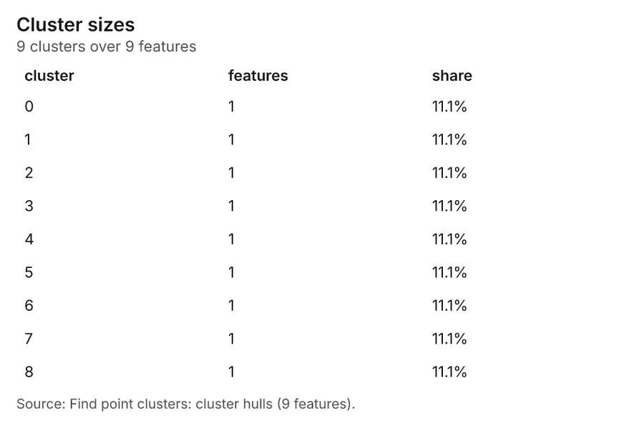
Figure 43. Find point clusters: cluster hulls [91]. Source: Find point clusters: cluster hulls (9 features). The data is in the appendix.
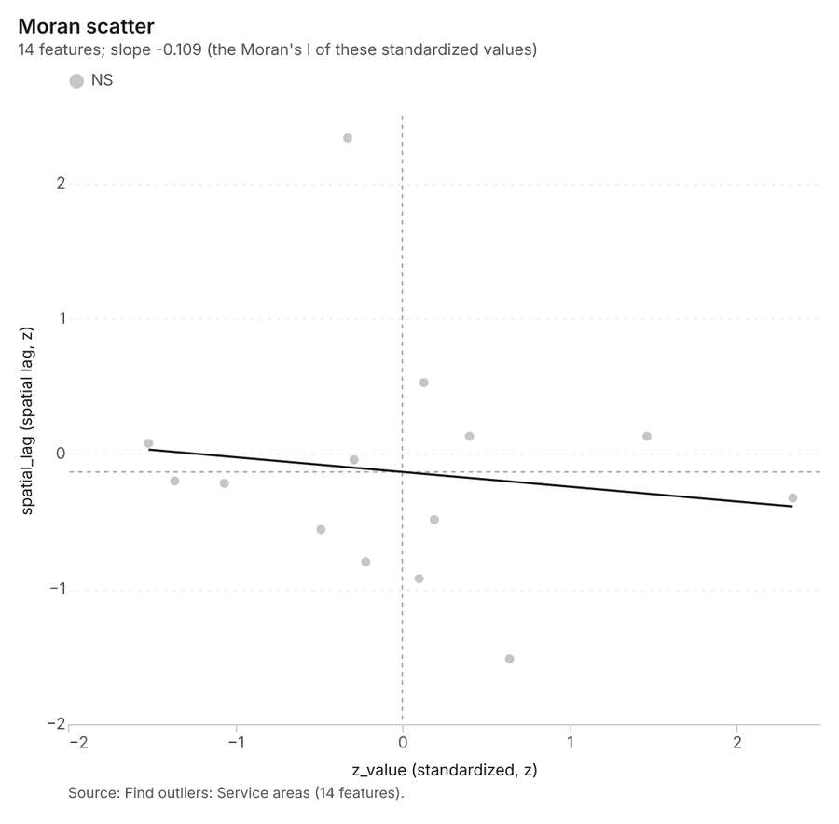
Figure 44. Find outliers: Service areas [92]. Source: Find outliers: Service areas (14 features). The data is in the appendix.
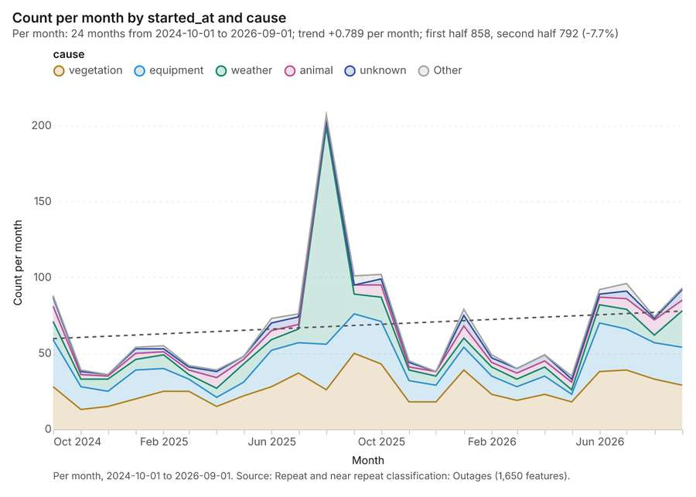
Figure 45. Repeat and near repeat classification: Outages [93]. Per month, 2024-10-01 to 2026-09-01. Source: Repeat and near repeat classification: Outages (1,650 features). The data is in the appendix.
Figure 46. Repeat and near repeat classification: Outages over time [94]. Per month, 2024-10-01 to 2026-09-01. Source: Repeat and near repeat classification: Outages (1,650 features). The data is in the appendix.
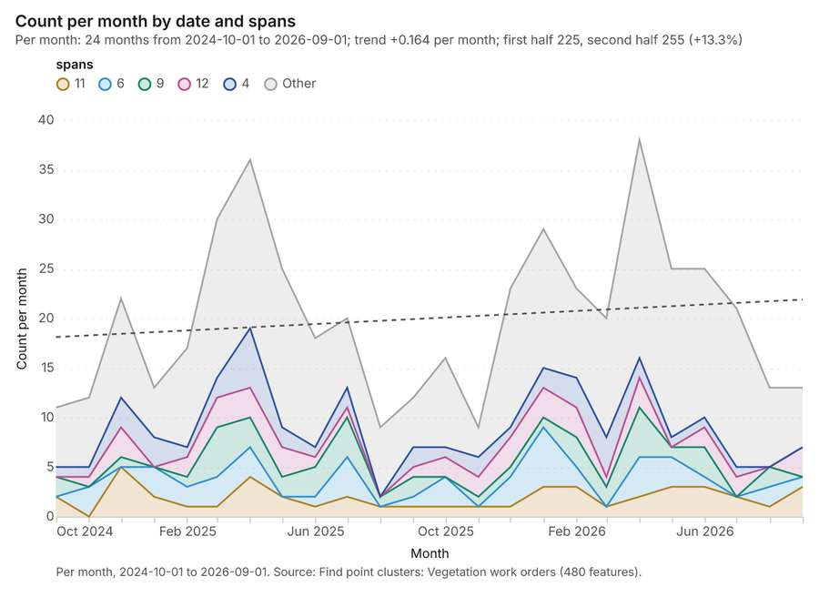
Figure 47. Find point clusters: Vegetation work orders over time [95]. Per month, 2024-10-01 to 2026-09-01. Source: Find point clusters: Vegetation work orders (480 features). The data is in the appendix.
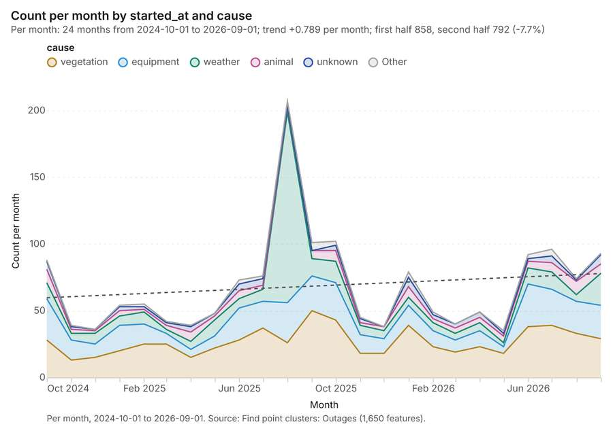
Figure 48. Find point clusters: Outages over time [96]. Per month, 2024-10-01 to 2026-09-01. Source: Find point clusters: Outages (1,650 features). The data is in the appendix.
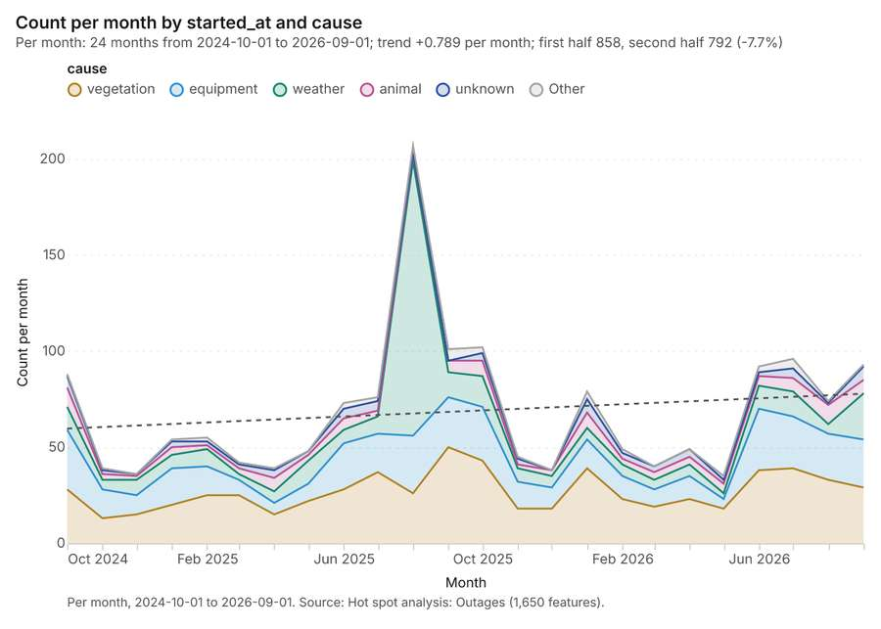
Figure 49. Hot spot analysis: Outages over time [97]. Per month, 2024-10-01 to 2026-09-01. Source: Hot spot analysis: Outages (1,650 features). The data is in the appendix.

Changes since the last run
This is the first report of this project.

Sources
[1] Rendering: Chart: Timeline: events per quarter by dataset. 57 rows (id 4819230f-295d-49a7-99bf-6b7163fc6b06)
[2] Dataset: Outages. vector, 1650 rows (id 39df98b3-8a4f-4af6-838d-170705e0bb48)
[3] Dataset: Vegetation work orders. vector, 480 rows (id 3aea1163-22b4-4a72-88d7-bcae1ecdad23)
[4] Dataset: Feeder reliability by year. table, 316 rows (id 887eeeea-0f49-451b-93f4-5d68b309bfad)
[5] Document page: Storm season reliability report, page 1. 22 August 2025 (id 32e35a86-4090-49ec-8ae9-87f7b6be0d6b:1)
[6] Catalog: Emerging hot spots (operation catalog, gp_space_time_hot_spots). Where hot spots are new, consecutive, intensifying, persistent, diminishing, sporadic, oscillating or historical over time. ArcGIS: Emerging Hot Spot Analysis, Create Space Time Cube. (id gp_space_time_hot_spots)
[7] Plan: Space time hot spots of Outages (the Start plan's candidate c_de6ee55db604). Outages carry dates in 'started_at': emerging hot spot analysis finds new, intensifying and fading hot spots per month. (id a5b6c9d4-e26f-4c51-adac-5b8547525805:c_de6ee55db604)
[8] Tool result: gp_space_time_hot_spots, step 0. Emerging hot spots: 1 layer saved: Emerging hot spots: Outages (100 features). (id 7e39f2a8-86e1-4856-b7a7-61e069df845f:0)
[9] Layer: Outages. 1,650 features (id 74249532-c045-44c9-a616-0fafb7c162a0)
[10] Plan: Space time hot spots of Vegetation work orders (the Start plan's candidate c_90f82b668b6e). Vegetation work orders carry dates in 'date': emerging hot spot analysis finds new, intensifying and fading hot spots per month. (id a5b6c9d4-e26f-4c51-adac-5b8547525805:c_90f82b668b6e)
[11] Tool result: gp_space_time_hot_spots, step 1. Emerging hot spots: 1 layer saved: Emerging hot spots: Vegetation work orders (89 features). (id 7e39f2a8-86e1-4856-b7a7-61e069df845f:1)
[12] Layer: Vegetation work orders. 480 features (id d3eba75a-4345-496b-b3c1-cfad466d3d73)
[13] Catalog: Hot spot analysis (operation catalog, gp_hot_spots). Getis-Ord Gi* hot and cold spots with z-scores, p-values and confidence bins. ArcGIS: Find Hot Spots, Hot Spot Analysis (Getis-Ord Gi*). QGIS: qgis:hotspot (plugin). (id gp_hot_spots)
[14] Plan: Hot spots of Poles (the Start plan's candidate c_8543237d7e01). 450 points: Getis-Ord Gi* tests whether the concentrations in Poles are statistically significant. (id a5b6c9d4-e26f-4c51-adac-5b8547525805:c_8543237d7e01)
[15] Tool result: gp_hot_spots, step 0. Hot spot analysis: 1 layer saved: Hot spot analysis: Poles (79 features). (id dd7f4187-7acb-4060-a294-8f874d038e7b:0)
[16] Layer: Poles. 450 features (id cb7cbff1-729f-45fd-bbbc-a31c0a2b6043)
[17] Plan: Hot spots of Outages (the Start plan's candidate c_2edeaea7ec43). 1650 points: Getis-Ord Gi* tests whether the concentrations in Outages are statistically significant. (id a5b6c9d4-e26f-4c51-adac-5b8547525805:c_2edeaea7ec43)
[18] Tool result: gp_hot_spots, step 1. Hot spot analysis: 1 layer saved: Hot spot analysis: Outages (1650 features). (id dd7f4187-7acb-4060-a294-8f874d038e7b:1)
[19] Plan: Hot spots of Vegetation work orders (the Start plan's candidate c_63c929cc68f4). 480 points: Getis-Ord Gi* tests whether the concentrations in Vegetation work orders are statistically significant. (id a5b6c9d4-e26f-4c51-adac-5b8547525805:c_63c929cc68f4)
[20] Tool result: gp_hot_spots, step 2. Hot spot analysis: 1 layer saved: Hot spot analysis: Vegetation work orders (86 features). (id dd7f4187-7acb-4060-a294-8f874d038e7b:2)
[21] Catalog: Calculate density (operation catalog, gp_calculate_density). Kernel density per square kilometer on a grid. ArcGIS: Calculate Density, Kernel Density. QGIS: native:heatmapkerneldensityestimation. (id gp_calculate_density)
[22] Plan: Kernel density of Poles (the Start plan's candidate c_39401f3daf3b). 450 points in Poles: a density surface shows where they concentrate. (id a5b6c9d4-e26f-4c51-adac-5b8547525805:c_39401f3daf3b)
[23] Tool result: gp_calculate_density, step 0. Calculate density: 1 layer saved: Calculate density: Poles (344 features). (id cddccd9e-fca2-4947-ac52-4a032f65ccd9:0)
[24] Plan: Kernel density of Outages (the Start plan's candidate c_5f4ad3832af3). 1650 points in Outages: a density surface shows where they concentrate. (id a5b6c9d4-e26f-4c51-adac-5b8547525805:c_5f4ad3832af3)
[25] Tool result: gp_calculate_density, step 1. Calculate density: 1 layer saved: Calculate density: Outages (1588 features). (id cddccd9e-fca2-4947-ac52-4a032f65ccd9:1)
[26] Plan: Kernel density of Vegetation work orders (the Start plan's candidate c_fcff6300c7b4). 480 points in Vegetation work orders: a density surface shows where they concentrate. (id a5b6c9d4-e26f-4c51-adac-5b8547525805:c_fcff6300c7b4)
[27] Tool result: gp_calculate_density, step 2. Calculate density: 1 layer saved: Calculate density: Vegetation work orders (350 features). (id cddccd9e-fca2-4947-ac52-4a032f65ccd9:2)
[28] Catalog: Summarize within (operation catalog, gp_summarize_within). Count and aggregate the features inside each polygon (or bin), proportionally for lines and polygons. ArcGIS: Summarize Within, Aggregate Points. QGIS: native:countpointsinpolygon, native:sumlinelengths. (id gp_summarize_within)
[29] Plan: Poles per feature of Service areas (the Start plan's candidate c_0abb031a5451). Count Poles inside each feature of Service areas by material; the counts map as a choropleth (natural breaks, sequential colors). (id a5b6c9d4-e26f-4c51-adac-5b8547525805:c_0abb031a5451)
[30] Tool result: gp_summarize_within, step 0. Summarize within: 1 layer saved: Summarize within: Service areas (14 features). (id 7abde2bd-08d7-47d0-ac4b-96744e82d444:0)
[31] Layer: Service areas. 14 features (id af824cfb-eb9c-4c01-a5c2-df454a844893)
[32] Tool result: gp_summarize_within, step 1. Summarize within: 1 layer saved: Summarize within: Service areas (14 features). (id 7abde2bd-08d7-47d0-ac4b-96744e82d444:1)
[33] Tool result: gp_summarize_within, step 2. Summarize within: 1 layer saved: Summarize within: Service areas (14 features). (id 7abde2bd-08d7-47d0-ac4b-96744e82d444:2)
[34] Catalog: Find point clusters (operation catalog, gp_find_point_clusters). Density-based clusters (DBSCAN, HDBSCAN or OPTICS, optionally space-time) with hulls and noise. ArcGIS: Find Point Clusters, Density-based Clustering. QGIS: native:dbscanclustering, native:stdbscanclustering. (id gp_find_point_clusters)
[35] Plan: Cluster points of Poles (the Start plan's candidate c_49349f7319f8). DBSCAN finds dense groups of Poles and separates noise. (id a5b6c9d4-e26f-4c51-adac-5b8547525805:c_49349f7319f8)
[36] Tool result: gp_find_point_clusters, step 0. Find point clusters: 2 layers saved: Find point clusters: Poles (450 features); Find point clusters: cluster hulls (12 features). (id a1a5ebf4-55fc-498c-bc42-232278d7fd50:0)
[37] Plan: Cluster points of Outages (the Start plan's candidate c_9d082d10c718). DBSCAN finds dense groups of Outages and separates noise. (id a5b6c9d4-e26f-4c51-adac-5b8547525805:c_9d082d10c718)
[38] Tool result: gp_find_point_clusters, step 1. Find point clusters: 2 layers saved: Find point clusters: Outages (1650 features); Find point clusters: cluster hulls (12 features). (id a1a5ebf4-55fc-498c-bc42-232278d7fd50:1)
[39] Plan: Cluster points of Vegetation work orders (the Start plan's candidate c_ec3997c2afdb). DBSCAN finds dense groups of Vegetation work orders and separates noise. (id a5b6c9d4-e26f-4c51-adac-5b8547525805:c_ec3997c2afdb)
[40] Tool result: gp_find_point_clusters, step 2. Find point clusters: 2 layers saved: Find point clusters: Vegetation work orders (480 features); Find point clusters: cluster hulls (9 features). (id a1a5ebf4-55fc-498c-bc42-232278d7fd50:2)
[41] Catalog: Find outliers (operation catalog, gp_outliers). Anselin local Moran’s I: HH, LL clusters and HL, LH outliers. ArcGIS: Find Outliers, Cluster and Outlier Analysis (Anselin Local Moran’s I). (id gp_outliers)
[42] Plan: Local morans i of Service areas (the Start plan's candidate c_14f3a517187f). Local Moran's I maps clusters and outliers of 'customers'. (id a5b6c9d4-e26f-4c51-adac-5b8547525805:c_14f3a517187f)
[43] Tool result: gp_outliers, step 0. Find outliers: 1 layer saved: Find outliers: Service areas (14 features). (id 0eeb802a-0001-4240-800b-19f28e01e992:0)
[44] Catalog: Spatial autocorrelation (operation catalog, gp_spatial_autocorrelation). Global Moran’s I: is the pattern clustered, dispersed or random. ArcGIS: Spatial Autocorrelation (Global Moran’s I). (id gp_spatial_autocorrelation)
[45] Plan: Global morans i of Service areas (the Start plan's candidate c_ce02f9951480). Global Moran's I says whether similar values of 'customers' sit next to each other. (id a5b6c9d4-e26f-4c51-adac-5b8547525805:c_ce02f9951480)
[46] Tool result: gp_spatial_autocorrelation, step 1. Spatial autocorrelation: done; no map output. (id 0eeb802a-0001-4240-800b-19f28e01e992:1)
[47] Catalog: Repeat and near repeat classification (operation catalog, gp_near_repeat). Classify incidents as originators, repeats (same place) or near repeats within a distance and time window, with a Knox test table. ArcGIS: Repeat and Near Repeat Classification, Near Repeat Calculator. (id gp_near_repeat)
[48] Plan: Near repeat of Outages (the Start plan's candidate c_c8acd413fa13). Near repeat analysis tests whether Outages close in space also follow each other within 30 days. (id a5b6c9d4-e26f-4c51-adac-5b8547525805:c_c8acd413fa13)
[49] Tool result: gp_near_repeat, step 0. Repeat and near repeat classification: 1 layer saved: Repeat and near repeat classification: Outages (1650 features). (id 7d19f92c-f4e9-48f3-93b0-dae3bf87b4ee:0)
[50] Rendering: Map: Emerging hot spots: Outages (id 85c7e950-dc12-47d7-9698-4f3e33d102c5)
[51] Rendering: Map: Emerging hot spots: Vegetation work orders (id d57a1eed-7833-4fa0-ba3b-1d34a14adf8d)
[52] Rendering: Map: Hot spot analysis: Poles (id 9c171d35-6e8a-404e-b179-3a277cac6680)
[53] Rendering: Map: Hot spot analysis: Outages (id 8b2915ad-3dc8-4c93-8998-6f8c60edde26)
[54] Rendering: Map: Hot spot analysis: Vegetation work orders (id 1951c285-f42c-4fe7-a12b-c61e0f8e89b1)
[55] Rendering: Map: Calculate density: Poles (id 77494a3a-e8bf-4ba9-8c9f-bbca3ed39699)
[56] Rendering: Map: Calculate density: Outages (id 2539e062-6c7a-48d8-915c-ceb004cf1c30)
[57] Rendering: Map: Calculate density: Vegetation work orders (id 90718fcc-1e9e-4189-b307-dd23cdc248d7)
[58] Rendering: Map: Summarize within: Service areas (id aaf8c40e-6ba8-477d-9349-b080f65d9f6f)
[59] Rendering: Map: Summarize within: Service areas (id 205c58ca-663e-465b-b5da-e58df3a3a282)
[60] Rendering: Map: Summarize within: Service areas (id baad37d3-dcec-4a96-add7-fa1a886f6434)
[61] Rendering: Map: Find point clusters: Poles (id 244f950b-322a-4f47-9af0-a30ad8fb8bad)
[62] Rendering: Map: Find point clusters: cluster hulls (id d83dd986-dc80-4bfd-886c-ff9fb5202ae7)
[63] Rendering: Map: Find point clusters: Outages (id a84598e8-6ff6-4f96-960b-18389e35387e)
[64] Rendering: Map: Find point clusters: cluster hulls (id f19bdfd5-1091-44cd-baae-dbac01077b12)
[65] Rendering: Map: Find point clusters: Vegetation work orders (id f99266a6-079b-44d5-852d-676355c69c8f)
[66] Rendering: Map: Find point clusters: cluster hulls (id d61dc500-d849-4c67-8699-7c2b54d04ac2)
[67] Rendering: Map: Service areas by customers (id 053475d3-62c9-4ca9-9150-1780c6628edd)
[68] Rendering: Map: Find outliers: Service areas (id 40748e31-9982-4c38-83df-2e829b1cd052)
[69] Rendering: Map: Repeat and near repeat classification: Outages (id 2dd79f43-b1db-44d1-b050-cb0ad8062f39)
[70] Rendering: Chart: Feeder lines over time (install_year). 8 rows (id a6ddfbd0-4d56-4fd4-95e4-dccff9b3fe14)
[71] Rendering: Chart: Vegetation work orders over time (date). 72 rows (id fe31e6f1-8de6-4739-b859-5ca5639a090e)
[72] Rendering: Chart: Poles over time (install_year). 10 rows (id 1a338811-8c8f-4624-affb-5f6f2a386c21)
[73] Rendering: Chart: Feeder reliability by year over time (year). 37 rows (id 81342282-782d-4f77-a6ab-c97a78fe8806)
[74] Rendering: Chart: Transformer assets over time (install_year). 10 rows (id 8b1d0ff4-f186-4254-b010-9684ed1844c3)
[75] Rendering: Chart: Emerging hot spots: Outages. 8 rows (id d57c5b66-d8b2-462a-85ae-76e9926eb3b1)
[76] Rendering: Chart: Emerging hot spots: Vegetation work orders. 8 rows (id d126a2b6-196d-4f93-93d5-5ce7f5d9f891)
[77] Rendering: Chart: Hot spot analysis: Poles. 9 rows (id b3100e77-5cbe-4a62-b253-290a5d536bb5)
[78] Rendering: Chart: Hot spot analysis: Outages. 18 rows (id cec85df8-5d0a-4af6-ba88-696eca4ce437)
[79] Rendering: Chart: Hot spot analysis: Vegetation work orders. 10 rows (id 1a614d2a-305a-4dfc-a43d-d303a95fb7b7)
[80] Rendering: Chart: Calculate density: Poles. 10 rows (id 2ea4b4d0-a10d-4113-b8f2-fb2372244db4)
[81] Rendering: Chart: Calculate density: Outages. 12 rows (id a201fc49-4d81-4320-8155-2f3eb69bd7da)
[82] Rendering: Chart: Calculate density: Vegetation work orders. 10 rows (id 1a66e57b-240e-4644-ab5f-f5d3fceeebe6)
[83] Rendering: Chart: Summarize within: Service areas. 5 rows (id ac78768b-6dc9-4d58-b972-2cf6dec976ea)
[84] Rendering: Chart: Summarize within: Service areas. 5 rows (id 0ee3a30f-bde2-4bb4-9019-791dd822ac96)
[85] Rendering: Chart: Summarize within: Service areas. 5 rows (id 1cd10d51-b513-49a7-b54f-6694f693c6a5)
[86] Rendering: Chart: Find point clusters: Poles. 13 rows (id 4d716dc4-27b8-4ca0-8c8b-b4246f0cf77f)
[87] Rendering: Chart: Find point clusters: cluster hulls. 12 rows (id d68e61ee-9527-48bd-93b1-e6d214930ddb)
[88] Rendering: Chart: Find point clusters: Outages. 13 rows (id 658b2721-1008-4707-8089-5fc9e67e755d)
[89] Rendering: Chart: Find point clusters: cluster hulls. 12 rows (id 3c8e6159-5e84-4f48-a0a3-71bc429bc627)
[90] Rendering: Chart: Find point clusters: Vegetation work orders. 10 rows (id 77d5d6a0-286e-48b2-83b6-f1379a2b6e25)
[91] Rendering: Chart: Find point clusters: cluster hulls. 9 rows (id ebdaf978-c973-42d9-b815-55c700b8af71)
[92] Rendering: Chart: Find outliers: Service areas. 14 rows (id c9960c12-89e8-43ab-83aa-898a65c8d7e1)
[93] Rendering: Chart: Repeat and near repeat classification: Outages. 144 rows (id 59506424-cd43-4c06-82b9-310f05aa3ef1)
[94] Rendering: Chart: Repeat and near repeat classification: Outages over time. 144 rows (id e21c9039-2700-4091-9c70-031cd03ca122)
[95] Rendering: Chart: Find point clusters: Vegetation work orders over time. 144 rows (id 17f450e3-64de-4bba-a8b9-1f01286c5da9)
[96] Rendering: Chart: Find point clusters: Outages over time. 144 rows (id 7c632546-38e2-4ef7-a37f-a50b9e7200a4)
[97] Rendering: Chart: Hot spot analysis: Outages over time. 144 rows (id 89489499-b4a2-4e58-b157-ba3c649aecd2)
[98] Dataset: Substations. vector, 14 rows (id f259f42c-1706-41ba-a78a-1361f3914e06)
[99] Dataset: Feeder lines. vector, 79 rows (id ecfb48ff-6d02-430b-9ebb-f111ab17967c)
[100] Dataset: Service areas. vector, 14 rows (id f3d1d854-cd9c-48c7-8f7a-a2e854a8ceb6)
[101] Dataset: Critical customers. vector, 60 rows (id e19506c9-69b8-4925-bb88-2c0235b75a70)
[102] Dataset: Poles. vector, 450 rows (id 3786e568-d7a4-4d47-b594-453c79329fb0)
[103] Dataset: Transformer assets. table, 300 rows (id 2e9131d9-123c-4a43-986c-82f9c9221692)
[104] Dataset: Storm season reliability report. document, ? rows (id b535c355-1229-4d0f-9126-2fe58457bcec)
[105] Record: Sample: Electricity utility, Houston (id 99e378b8-9e64-42f5-8930-fca7c2a73f57)
[106] Layer: Emerging hot spots: Outages. 100 features (id c053bfd3-6311-4cf3-a811-669d5782bdb3)
[107] Layer: Emerging hot spots: Vegetation work orders. 89 features (id 1cbdbfca-5f5d-4277-87ce-4d482b63ec8e)
[108] Layer: Hot spot analysis: Poles. 79 features (id ddab229d-5eab-4322-8c2b-76442371347b)
[109] Layer: Hot spot analysis: Outages. 1,650 features (id 152d5bad-10c2-42e3-98ef-f598b1d425bd)
[110] Layer: Hot spot analysis: Vegetation work orders. 86 features (id aa682980-c78f-45bf-a39c-e6c25235ecf0)
[111] Layer: Calculate density: Poles. 344 features (id 092a4943-ffb6-462a-afdb-cfca08b63795)
[112] Layer: Calculate density: Outages. 1,588 features (id c9cfc32c-1601-4e5a-9160-a0a02112b586)
[113] Layer: Calculate density: Vegetation work orders. 350 features (id c3b70581-64dc-4b78-82c2-af051c400b18)
[114] Layer: Summarize within: Service areas. 14 features (id 080e40ba-f7ec-49b3-856b-2145df7839bf)
[115] Layer: Summarize within: Service areas. 14 features (id 9f88918e-62a5-4499-b99b-d19d559ee0a7)
[116] Layer: Summarize within: Service areas. 14 features (id a4302e84-efd6-417d-9791-39532ad03ea3)
[117] Layer: Find point clusters: Poles. 450 features (id d8bd47c0-3090-477e-9f4e-99798bfd2778)
[118] Layer: Find point clusters: cluster hulls. 12 features (id 99b9ab3e-1fc2-4630-afb7-f5a5db637828)
[119] Layer: Find point clusters: Outages. 1,650 features (id 402ad5f6-a892-490a-a647-e6e94f591e27)
[120] Layer: Find point clusters: cluster hulls. 12 features (id 56caa497-390e-42c8-9f4d-6813ec441e8c)
[121] Layer: Find point clusters: Vegetation work orders. 480 features (id 9ab95317-7431-4636-b94c-06bb41924b25)
[122] Layer: Find point clusters: cluster hulls. 9 features (id 134428d0-3eb6-4afb-b65a-2f63ca197338)
[123] Layer: Find outliers: Service areas. 14 features (id 31a2a6ae-e1c2-4384-bdb2-7d30ebff9f80)
[124] Layer: Repeat and near repeat classification: Outages. 1,650 features (id 9fd9267d-3aae-4cac-90a0-3de6c177fa4f)

Appendix: the data behind the charts

Figure 1. Timeline: events per quarter by dataset [1]
period | series | value
2022-01-01 | Outages | 0
2022-01-01 | Vegetation work orders | 0
2022-01-01 | Feeder reliability by year | 79
2022-04-01 | Outages | 0
2022-04-01 | Vegetation work orders | 0
2022-04-01 | Feeder reliability by year | 0
2022-07-01 | Outages | 0
2022-07-01 | Vegetation work orders | 0
2022-07-01 | Feeder reliability by year | 0
2022-10-01 | Outages | 0
2022-10-01 | Vegetation work orders | 0
2022-10-01 | Feeder reliability by year | 0
2023-01-01 | Outages | 0
2023-01-01 | Vegetation work orders | 0
2023-01-01 | Feeder reliability by year | 79
2023-04-01 | Outages | 0
2023-04-01 | Vegetation work orders | 0
2023-04-01 | Feeder reliability by year | 0
2023-07-01 | Outages | 0
2023-07-01 | Vegetation work orders | 0
2023-07-01 | Feeder reliability by year | 0
2023-10-01 | Outages | 0
2023-10-01 | Vegetation work orders | 0
2023-10-01 | Feeder reliability by year | 0
2024-01-01 | Outages | 0
2024-01-01 | Vegetation work orders | 0
2024-01-01 | Feeder reliability by year | 79
2024-04-01 | Outages | 0
2024-04-01 | Vegetation work orders | 0
2024-04-01 | Feeder reliability by year | 0
2024-07-01 | Outages | 0
2024-07-01 | Vegetation work orders | 0
2024-07-01 | Feeder reliability by year | 0
2024-10-01 | Outages | 163
2024-10-01 | Vegetation work orders | 45
2024-10-01 | Feeder reliability by year | 0
2025-01-01 | Outages | 151
2025-01-01 | Vegetation work orders | 60
2025-01-01 | Feeder reliability by year | 79
2025-04-01 | Outages | 160
2025-04-01 | Vegetation work orders | 79
2025-04-01 | Feeder reliability by year | 0
2025-07-01 | Outages | 384
2025-07-01 | Vegetation work orders | 41
2025-07-01 | Feeder reliability by year | 0
2025-10-01 | Outages | 185
2025-10-01 | Vegetation work orders | 48
2025-10-01 | Feeder reliability by year | 0
2026-01-01 | Outages | 168
2026-01-01 | Vegetation work orders | 72
2026-01-01 | Feeder reliability by year | 0
2026-04-01 | Outages | 176
2026-04-01 | Vegetation work orders | 88
2026-04-01 | Feeder reliability by year | 0
2026-07-01 | Outages | 263
2026-07-01 | Vegetation work orders | 47
2026-07-01 | Feeder reliability by year | 0

Figure 22. Feeder lines over time (install_year) [70]
bin_start | bin_end | count
1,964 | 1,971 | 12
1,971 | 1,978 | 16
1,978 | 1,986 | 10
1,986 | 1,993 | 6
1,993 | 2,000 | 14
2,000 | 2,008 | 10
2,008 | 2,015 | 2
2,015 | 2,022 | 9

Figure 23. Vegetation work orders over time (date) [71]
period | series | value
2024-10-01 | hazard tree | 2
2024-10-01 | cycle trim | 4
2024-10-01 | hot spot | 5
2024-11-01 | hazard tree | 5
2024-11-01 | cycle trim | 4
2024-11-01 | hot spot | 3
2024-12-01 | hazard tree | 9
2024-12-01 | cycle trim | 6
2024-12-01 | hot spot | 7
2025-01-01 | hazard tree | 2
2025-01-01 | cycle trim | 6
2025-01-01 | hot spot | 5
2025-02-01 | hazard tree | 8
2025-02-01 | cycle trim | 5
2025-02-01 | hot spot | 4
2025-03-01 | hazard tree | 11
2025-03-01 | cycle trim | 16
2025-03-01 | hot spot | 3
2025-04-01 | hazard tree | 10
2025-04-01 | cycle trim | 16
2025-04-01 | hot spot | 10
2025-05-01 | hazard tree | 10
2025-05-01 | cycle trim | 8
2025-05-01 | hot spot | 7
2025-06-01 | hazard tree | 7
2025-06-01 | cycle trim | 4
2025-06-01 | hot spot | 7
2025-07-01 | hazard tree | 6
2025-07-01 | cycle trim | 5
2025-07-01 | hot spot | 9
2025-08-01 | hazard tree | 1
2025-08-01 | cycle trim | 5
2025-08-01 | hot spot | 3
2025-09-01 | hazard tree | 3
2025-09-01 | cycle trim | 6
2025-09-01 | hot spot | 3
2025-10-01 | hazard tree | 4
2025-10-01 | cycle trim | 6
2025-10-01 | hot spot | 6
2025-11-01 | hazard tree | 1
2025-11-01 | cycle trim | 2
2025-11-01 | hot spot | 6
2025-12-01 | hazard tree | 8
2025-12-01 | cycle trim | 9
2025-12-01 | hot spot | 6
2026-01-01 | hazard tree | 13
2026-01-01 | cycle trim | 4
2026-01-01 | hot spot | 12
2026-02-01 | hazard tree | 6
2026-02-01 | cycle trim | 7
2026-02-01 | hot spot | 10
2026-03-01 | hazard tree | 8
2026-03-01 | cycle trim | 5
2026-03-01 | hot spot | 7
2026-04-01 | hazard tree | 12
2026-04-01 | cycle trim | 15
2026-04-01 | hot spot | 11
2026-05-01 | hazard tree | 10
2026-05-01 | cycle trim | 5
2026-05-01 | hot spot | 10
2026-06-01 | hazard tree | 12
2026-06-01 | cycle trim | 5
2026-06-01 | hot spot | 8
2026-07-01 | hazard tree | 5
2026-07-01 | cycle trim | 8
2026-07-01 | hot spot | 8
2026-08-01 | hazard tree | 5
2026-08-01 | cycle trim | 4
2026-08-01 | hot spot | 4
2026-09-01 | hazard tree | 3
2026-09-01 | cycle trim | 5
2026-09-01 | hot spot | 5

Figure 24. Poles over time (install_year) [72]
bin_start | bin_end | count
1,967 | 1,973 | 15
1,973 | 1,978 | 30
1,978 | 1,984 | 44
1,984 | 1,990 | 34
1,990 | 1,996 | 36
1,996 | 2,001 | 45
2,001 | 2,007 | 55
2,007 | 2,013 | 50
2,013 | 2,018 | 52
2,018 | 2,024 | 89

Figure 25. Feeder reliability by year over time (year) [73]
period | value
2022-01-01 | 79
2022-02-01 | 0
2022-03-01 | 0
2022-04-01 | 0
2022-05-01 | 0
2022-06-01 | 0
2022-07-01 | 0
2022-08-01 | 0
2022-09-01 | 0
2022-10-01 | 0
2022-11-01 | 0
2022-12-01 | 0
2023-01-01 | 79
2023-02-01 | 0
2023-03-01 | 0
2023-04-01 | 0
2023-05-01 | 0
2023-06-01 | 0
2023-07-01 | 0
2023-08-01 | 0
2023-09-01 | 0
2023-10-01 | 0
2023-11-01 | 0
2023-12-01 | 0
2024-01-01 | 79
2024-02-01 | 0
2024-03-01 | 0
2024-04-01 | 0
2024-05-01 | 0
2024-06-01 | 0
2024-07-01 | 0
2024-08-01 | 0
2024-09-01 | 0
2024-10-01 | 0
2024-11-01 | 0
2024-12-01 | 0
2025-01-01 | 79

Figure 26. Transformer assets over time (install_year) [74]
bin_start | bin_end | count
25 | 39.2 | 66
39.2 | 53.4 | 59
53.4 | 67.6 | 0
67.6 | 81.8 | 61
81.8 | 96 | 0
96 | 110.2 | 48
110.2 | 124.4 | 0
124.4 | 138.6 | 0
138.6 | 152.8 | 0
152.8 | 167 | 66

Figure 27. Emerging hot spots: Outages [75]
bin_start | bin_end | count
-1.044 | -0.2486 | 36
-0.2486 | 0.5467 | 20
0.5467 | 1.342 | 21
1.342 | 2.138 | 10
2.138 | 2.933 | 4
2.933 | 3.728 | 5
3.728 | 4.524 | 3
4.524 | 5.319 | 1

Figure 28. Emerging hot spots: Vegetation work orders [76]
bin_start | bin_end | count
-0.951 | -0.5264 | 39
-0.5264 | -0.1017 | 28
-0.1017 | 0.3229 | 1
0.3229 | 0.7475 | 9
0.7475 | 1.172 | 1
1.172 | 1.597 | 1
1.597 | 2.021 | 9
2.021 | 2.446 | 1

Figure 29. Hot spot analysis: Poles [77]
bin_start | bin_end | band | band_label | count
-1 | -0.5 | not_significant | Not significant | 33
-0.5 | 0 | not_significant | Not significant | 13
0 | 0.5 | not_significant | Not significant | 13
0.5 | 1 | not_significant | Not significant | 5
1 | 1.5 | not_significant | Not significant | 10
1.5 | 2 | hot_90 | Hot spot, 90% confidence | 1
2 | 2.5 | hot_95 | Hot spot, 95% confidence | 2
3 | 3.5 | hot_99 | Hot spot, 99% confidence | 1
3.5 | 4 | hot_99 | Hot spot, 99% confidence | 1

Figure 30. Hot spot analysis: Outages [78]
bin_start | bin_end | band | band_label | count
-2.5 | -2 | cold_95 | Cold spot, 95% confidence | 6
-2 | -1.5 | cold_90 | Cold spot, 90% confidence | 45
-2 | -1.5 | cold_95 | Cold spot, 95% confidence | 1
-2 | -1.5 | not_significant | Not significant | 18
-1.5 | -1 | not_significant | Not significant | 179
-1 | -0.5 | not_significant | Not significant | 376
-0.5 | 0 | not_significant | Not significant | 330
0 | 0.5 | not_significant | Not significant | 246
0.5 | 1 | not_significant | Not significant | 205
1 | 1.5 | not_significant | Not significant | 160
1.5 | 2 | hot_90 | Hot spot, 90% confidence | 25
1.5 | 2 | hot_95 | Hot spot, 95% confidence | 3
1.5 | 2 | not_significant | Not significant | 15
2 | 2.5 | hot_95 | Hot spot, 95% confidence | 28
2.5 | 3 | hot_95 | Hot spot, 95% confidence | 3
2.5 | 3 | hot_99 | Hot spot, 99% confidence | 7
3 | 3.5 | hot_99 | Hot spot, 99% confidence | 2
3.5 | 4 | hot_99 | Hot spot, 99% confidence | 1

Figure 31. Hot spot analysis: Vegetation work orders [79]
bin_start | bin_end | band | band_label | count
-1 | -0.5 | not_significant | Not significant | 33
-0.5 | 0 | not_significant | Not significant | 17
0 | 0.5 | not_significant | Not significant | 13
0.5 | 1 | not_significant | Not significant | 10
1 | 1.5 | not_significant | Not significant | 5
1.5 | 2 | hot_90 | Hot spot, 90% confidence | 2
1.5 | 2 | not_significant | Not significant | 2
2 | 2.5 | hot_95 | Hot spot, 95% confidence | 2
2.5 | 3 | hot_99 | Hot spot, 99% confidence | 1
4 | 4.5 | hot_99 | Hot spot, 99% confidence | 1

Figure 32. Calculate density: Poles [80]
bin_start | bin_end | count
0 | 2.3 | 18
2.3 | 4.6 | 28
4.6 | 6.9 | 33
6.9 | 9.2 | 51
9.2 | 11.5 | 36
11.5 | 13.8 | 33
13.8 | 16.1 | 50
16.1 | 18.4 | 34
18.4 | 20.7 | 32
20.7 | 23 | 29

Figure 33. Calculate density: Outages [81]
bin_start | bin_end | count
0 | 4.5 | 37
4.5 | 9 | 59
9 | 13.5 | 160
13.5 | 18 | 118
18 | 22.5 | 189
22.5 | 27 | 166
27 | 31.5 | 179
31.5 | 36 | 129
36 | 40.5 | 190
40.5 | 45 | 144
45 | 49.5 | 137
49.5 | 54 | 80

Figure 34. Calculate density: Vegetation work orders [82]
bin_start | bin_end | count
0 | 2.3 | 18
2.3 | 4.6 | 27
4.6 | 6.9 | 34
6.9 | 9.2 | 53
9.2 | 11.5 | 38
11.5 | 13.8 | 32
13.8 | 16.1 | 52
16.1 | 18.4 | 32
18.4 | 20.7 | 32
20.7 | 23 | 32

Figure 35. Summarize within: Service areas [83]
bin_start | bin_end | count
19 | 24.6 | 3
24.6 | 30.2 | 4
30.2 | 35.8 | 3
35.8 | 41.4 | 1
41.4 | 47 | 3

Figure 36. Summarize within: Service areas [84]
bin_start | bin_end | count
57 | 85.8 | 4
85.8 | 114.6 | 5
114.6 | 143.4 | 0
143.4 | 172.2 | 2
172.2 | 201 | 3

Figure 37. Summarize within: Service areas [85]
bin_start | bin_end | count
18 | 26 | 7
26 | 34 | 1
34 | 42 | 1
42 | 50 | 1
50 | 58 | 4

Figure 38. Find point clusters: Poles [86]
cluster | features | fraction | share
Noise | 149 | 0.3311 | 33.1%
2 | 49 | 0.1089 | 10.9%
5 | 35 | 0.07778 | 7.8%
4 | 34 | 0.07556 | 7.6%
6 | 31 | 0.06889 | 6.9%
8 | 26 | 0.05778 | 5.8%
3 | 23 | 0.05111 | 5.1%
7 | 21 | 0.04667 | 4.7%
9 | 19 | 0.04222 | 4.2%
11 | 17 | 0.03778 | 3.8%
0 | 16 | 0.03556 | 3.6%
1 | 15 | 0.03333 | 3.3%
10 | 15 | 0.03333 | 3.3%

Figure 39. Find point clusters: cluster hulls [87]
cluster | features | fraction | share
0 | 1 | 0.08333 | 8.3%
1 | 1 | 0.08333 | 8.3%
10 | 1 | 0.08333 | 8.3%
11 | 1 | 0.08333 | 8.3%
2 | 1 | 0.08333 | 8.3%
3 | 1 | 0.08333 | 8.3%
4 | 1 | 0.08333 | 8.3%
5 | 1 | 0.08333 | 8.3%
6 | 1 | 0.08333 | 8.3%
7 | 1 | 0.08333 | 8.3%
8 | 1 | 0.08333 | 8.3%
9 | 1 | 0.08333 | 8.3%

Figure 40. Find point clusters: Outages [88]
cluster | features | fraction | share
Noise | 985 | 0.597 | 59.7%
5 | 121 | 0.07333 | 7.3%
0 | 112 | 0.06788 | 6.8%
1 | 81 | 0.04909 | 4.9%
7 | 76 | 0.04606 | 4.6%
3 | 56 | 0.03394 | 3.4%
4 | 54 | 0.03273 | 3.3%
6 | 34 | 0.02061 | 2.1%
8 | 34 | 0.02061 | 2.1%
2 | 32 | 0.01939 | 1.9%
9 | 31 | 0.01879 | 1.9%
10 | 20 | 0.01212 | 1.2%
11 | 14 | 0.008485 | 0.8%

Figure 41. Find point clusters: cluster hulls [89]
cluster | features | fraction | share
0 | 1 | 0.08333 | 8.3%
1 | 1 | 0.08333 | 8.3%
10 | 1 | 0.08333 | 8.3%
11 | 1 | 0.08333 | 8.3%
2 | 1 | 0.08333 | 8.3%
3 | 1 | 0.08333 | 8.3%
4 | 1 | 0.08333 | 8.3%
5 | 1 | 0.08333 | 8.3%
6 | 1 | 0.08333 | 8.3%
7 | 1 | 0.08333 | 8.3%
8 | 1 | 0.08333 | 8.3%
9 | 1 | 0.08333 | 8.3%

Figure 42. Find point clusters: Vegetation work orders [90]
cluster | features | fraction | share
Noise | 157 | 0.3271 | 32.7%
0 | 83 | 0.1729 | 17.3%
1 | 56 | 0.1167 | 11.7%
2 | 39 | 0.08125 | 8.1%
4 | 36 | 0.075 | 7.5%
7 | 36 | 0.075 | 7.5%
6 | 20 | 0.04167 | 4.2%
3 | 19 | 0.03958 | 4.0%
5 | 19 | 0.03958 | 4.0%
8 | 15 | 0.03125 | 3.1%

Figure 43. Find point clusters: cluster hulls [91]
cluster | features | fraction | share
0 | 1 | 0.1111 | 11.1%
1 | 1 | 0.1111 | 11.1%
2 | 1 | 0.1111 | 11.1%
3 | 1 | 0.1111 | 11.1%
4 | 1 | 0.1111 | 11.1%
5 | 1 | 0.1111 | 11.1%
6 | 1 | 0.1111 | 11.1%
7 | 1 | 0.1111 | 11.1%
8 | 1 | 0.1111 | 11.1%

Figure 44. Find outliers: Service areas [92]
value | lag | type
-0.3267 | 2.336 | NS
0.129 | 0.5255 | NS
-1.064 | -0.2187 | NS
-0.2187 | -0.8003 | NS
-0.4868 | -0.5612 | NS
0.642 | -1.518 | NS
1.464 | 0.129 | NS
2.336 | -0.3267 | NS
-0.289 | -0.0449 | NS
0.4018 | 0.129 | NS
-1.361 | -0.2016 | NS
-1.518 | 0.0776 | NS
0.1915 | -0.4868 | NS
0.1007 | -0.924 | NS

Figure 45. Repeat and near repeat classification: Outages [93]
period | series | value
2024-10-01 | vegetation | 28
2024-10-01 | equipment | 31
2024-10-01 | weather | 12
2024-10-01 | animal | 10
2024-10-01 | unknown | 6
2024-10-01 | Other | 1
2024-11-01 | vegetation | 13
2024-11-01 | equipment | 15
2024-11-01 | weather | 5
2024-11-01 | animal | 3
2024-11-01 | unknown | 2
2024-11-01 | Other | 1
2024-12-01 | vegetation | 15
2024-12-01 | equipment | 10
2024-12-01 | weather | 8
2024-12-01 | animal | 2
2024-12-01 | unknown | 1
2024-12-01 | Other | 0
2025-01-01 | vegetation | 20
2025-01-01 | equipment | 19
2025-01-01 | weather | 7
2025-01-01 | animal | 4
2025-01-01 | unknown | 3
2025-01-01 | Other | 1
2025-02-01 | vegetation | 25
2025-02-01 | equipment | 15
2025-02-01 | weather | 9
2025-02-01 | animal | 2
2025-02-01 | unknown | 2
2025-02-01 | Other | 2
2025-03-01 | vegetation | 25
2025-03-01 | equipment | 8
2025-03-01 | weather | 3
2025-03-01 | animal | 3
2025-03-01 | unknown | 2
2025-03-01 | Other | 1
2025-04-01 | vegetation | 15
2025-04-01 | equipment | 6
2025-04-01 | weather | 6
2025-04-01 | animal | 7
2025-04-01 | unknown | 4
2025-04-01 | Other | 1
2025-05-01 | vegetation | 22
2025-05-01 | equipment | 9
2025-05-01 | weather | 12
2025-05-01 | animal | 3
2025-05-01 | unknown | 2
2025-05-01 | Other | 0
2025-06-01 | vegetation | 28
2025-06-01 | equipment | 24
2025-06-01 | weather | 7
2025-06-01 | animal | 6
2025-06-01 | unknown | 5
2025-06-01 | Other | 3
2025-07-01 | vegetation | 37
2025-07-01 | equipment | 20
2025-07-01 | weather | 9
2025-07-01 | animal | 3
2025-07-01 | unknown | 5
2025-07-01 | Other | 2
2025-08-01 | vegetation | 26
2025-08-01 | equipment | 30
2025-08-01 | weather | 143
2025-08-01 | animal | 4
2025-08-01 | unknown | 1
2025-08-01 | Other | 3
2025-09-01 | vegetation | 50
2025-09-01 | equipment | 26
2025-09-01 | weather | 13
2025-09-01 | animal | 6
2025-09-01 | unknown | 0
2025-09-01 | Other | 6
2025-10-01 | vegetation | 43
2025-10-01 | equipment | 28
2025-10-01 | weather | 16
2025-10-01 | animal | 8
2025-10-01 | unknown | 4
2025-10-01 | Other | 3
2025-11-01 | vegetation | 18
2025-11-01 | equipment | 14
2025-11-01 | weather | 7
2025-11-01 | animal | 2
2025-11-01 | unknown | 3
2025-11-01 | Other | 1
2025-12-01 | vegetation | 18
2025-12-01 | equipment | 11
2025-12-01 | weather | 6
2025-12-01 | animal | 3
2025-12-01 | unknown | 0
2025-12-01 | Other | 0
2026-01-01 | vegetation | 39
2026-01-01 | equipment | 15
2026-01-01 | weather | 6
2026-01-01 | animal | 8
2026-01-01 | unknown | 7
2026-01-01 | Other | 4
2026-02-01 | vegetation | 23
2026-02-01 | equipment | 12
2026-02-01 | weather | 6
2026-02-01 | animal | 3
2026-02-01 | unknown | 3
2026-02-01 | Other | 2
2026-03-01 | vegetation | 19
2026-03-01 | equipment | 9
2026-03-01 | weather | 5
2026-03-01 | animal | 4
2026-03-01 | unknown | 3
2026-03-01 | Other | 0
2026-04-01 | vegetation | 23
2026-04-01 | equipment | 12
2026-04-01 | weather | 6
2026-04-01 | animal | 4
2026-04-01 | unknown | 4
2026-04-01 | Other | 0
2026-05-01 | vegetation | 18
2026-05-01 | equipment | 5
2026-05-01 | weather | 3
2026-05-01 | animal | 5
2026-05-01 | unknown | 2
2026-05-01 | Other | 2
2026-06-01 | vegetation | 38
2026-06-01 | equipment | 32
2026-06-01 | weather | 12
2026-06-01 | animal | 5
2026-06-01 | unknown | 2
2026-06-01 | Other | 3
2026-07-01 | vegetation | 39
2026-07-01 | equipment | 27
2026-07-01 | weather | 13
2026-07-01 | animal | 7
2026-07-01 | unknown | 5
2026-07-01 | Other | 5
2026-08-01 | vegetation | 33
2026-08-01 | equipment | 24
2026-08-01 | weather | 5
2026-08-01 | animal | 10
2026-08-01 | unknown | 1
2026-08-01 | Other | 1
2026-09-01 | vegetation | 29
2026-09-01 | equipment | 25
2026-09-01 | weather | 24
2026-09-01 | animal | 7
2026-09-01 | unknown | 7
2026-09-01 | Other | 1

Figure 46. Repeat and near repeat classification: Outages over time [94]
period | series | value
2024-10-01 | vegetation | 28
2024-10-01 | equipment | 31
2024-10-01 | weather | 12
2024-10-01 | animal | 10
2024-10-01 | unknown | 6
2024-10-01 | Other | 1
2024-11-01 | vegetation | 13
2024-11-01 | equipment | 15
2024-11-01 | weather | 5
2024-11-01 | animal | 3
2024-11-01 | unknown | 2
2024-11-01 | Other | 1
2024-12-01 | vegetation | 15
2024-12-01 | equipment | 10
2024-12-01 | weather | 8
2024-12-01 | animal | 2
2024-12-01 | unknown | 1
2024-12-01 | Other | 0
2025-01-01 | vegetation | 20
2025-01-01 | equipment | 19
2025-01-01 | weather | 7
2025-01-01 | animal | 4
2025-01-01 | unknown | 3
2025-01-01 | Other | 1
2025-02-01 | vegetation | 25
2025-02-01 | equipment | 15
2025-02-01 | weather | 9
2025-02-01 | animal | 2
2025-02-01 | unknown | 2
2025-02-01 | Other | 2
2025-03-01 | vegetation | 25
2025-03-01 | equipment | 8
2025-03-01 | weather | 3
2025-03-01 | animal | 3
2025-03-01 | unknown | 2
2025-03-01 | Other | 1
2025-04-01 | vegetation | 15
2025-04-01 | equipment | 6
2025-04-01 | weather | 6
2025-04-01 | animal | 7
2025-04-01 | unknown | 4
2025-04-01 | Other | 1
2025-05-01 | vegetation | 22
2025-05-01 | equipment | 9
2025-05-01 | weather | 12
2025-05-01 | animal | 3
2025-05-01 | unknown | 2
2025-05-01 | Other | 0
2025-06-01 | vegetation | 28
2025-06-01 | equipment | 24
2025-06-01 | weather | 7
2025-06-01 | animal | 6
2025-06-01 | unknown | 5
2025-06-01 | Other | 3
2025-07-01 | vegetation | 37
2025-07-01 | equipment | 20
2025-07-01 | weather | 9
2025-07-01 | animal | 3
2025-07-01 | unknown | 5
2025-07-01 | Other | 2
2025-08-01 | vegetation | 26
2025-08-01 | equipment | 30
2025-08-01 | weather | 143
2025-08-01 | animal | 4
2025-08-01 | unknown | 1
2025-08-01 | Other | 3
2025-09-01 | vegetation | 50
2025-09-01 | equipment | 26
2025-09-01 | weather | 13
2025-09-01 | animal | 6
2025-09-01 | unknown | 0
2025-09-01 | Other | 6
2025-10-01 | vegetation | 43
2025-10-01 | equipment | 28
2025-10-01 | weather | 16
2025-10-01 | animal | 8
2025-10-01 | unknown | 4
2025-10-01 | Other | 3
2025-11-01 | vegetation | 18
2025-11-01 | equipment | 14
2025-11-01 | weather | 7
2025-11-01 | animal | 2
2025-11-01 | unknown | 3
2025-11-01 | Other | 1
2025-12-01 | vegetation | 18
2025-12-01 | equipment | 11
2025-12-01 | weather | 6
2025-12-01 | animal | 3
2025-12-01 | unknown | 0
2025-12-01 | Other | 0
2026-01-01 | vegetation | 39
2026-01-01 | equipment | 15
2026-01-01 | weather | 6
2026-01-01 | animal | 8
2026-01-01 | unknown | 7
2026-01-01 | Other | 4
2026-02-01 | vegetation | 23
2026-02-01 | equipment | 12
2026-02-01 | weather | 6
2026-02-01 | animal | 3
2026-02-01 | unknown | 3
2026-02-01 | Other | 2
2026-03-01 | vegetation | 19
2026-03-01 | equipment | 9
2026-03-01 | weather | 5
2026-03-01 | animal | 4
2026-03-01 | unknown | 3
2026-03-01 | Other | 0
2026-04-01 | vegetation | 23
2026-04-01 | equipment | 12
2026-04-01 | weather | 6
2026-04-01 | animal | 4
2026-04-01 | unknown | 4
2026-04-01 | Other | 0
2026-05-01 | vegetation | 18
2026-05-01 | equipment | 5
2026-05-01 | weather | 3
2026-05-01 | animal | 5
2026-05-01 | unknown | 2
2026-05-01 | Other | 2
2026-06-01 | vegetation | 38
2026-06-01 | equipment | 32
2026-06-01 | weather | 12
2026-06-01 | animal | 5
2026-06-01 | unknown | 2
2026-06-01 | Other | 3
2026-07-01 | vegetation | 39
2026-07-01 | equipment | 27
2026-07-01 | weather | 13
2026-07-01 | animal | 7
2026-07-01 | unknown | 5
2026-07-01 | Other | 5
2026-08-01 | vegetation | 33
2026-08-01 | equipment | 24
2026-08-01 | weather | 5
2026-08-01 | animal | 10
2026-08-01 | unknown | 1
2026-08-01 | Other | 1
2026-09-01 | vegetation | 29
2026-09-01 | equipment | 25
2026-09-01 | weather | 24
2026-09-01 | animal | 7
2026-09-01 | unknown | 7
2026-09-01 | Other | 1

Figure 47. Find point clusters: Vegetation work orders over time [95]
period | series | value
2024-10-01 | 11 | 2
2024-10-01 | 6 | 0
2024-10-01 | 9 | 2
2024-10-01 | 12 | 0
2024-10-01 | 4 | 1
2024-10-01 | Other | 6
2024-11-01 | 11 | 0
2024-11-01 | 6 | 3
2024-11-01 | 9 | 0
2024-11-01 | 12 | 1
2024-11-01 | 4 | 1
2024-11-01 | Other | 7
2024-12-01 | 11 | 5
2024-12-01 | 6 | 0
2024-12-01 | 9 | 1
2024-12-01 | 12 | 3
2024-12-01 | 4 | 3
2024-12-01 | Other | 10
2025-01-01 | 11 | 2
2025-01-01 | 6 | 3
2025-01-01 | 9 | 0
2025-01-01 | 12 | 0
2025-01-01 | 4 | 3
2025-01-01 | Other | 5
2025-02-01 | 11 | 1
2025-02-01 | 6 | 2
2025-02-01 | 9 | 1
2025-02-01 | 12 | 2
2025-02-01 | 4 | 1
2025-02-01 | Other | 10
2025-03-01 | 11 | 1
2025-03-01 | 6 | 3
2025-03-01 | 9 | 5
2025-03-01 | 12 | 3
2025-03-01 | 4 | 2
2025-03-01 | Other | 16
2025-04-01 | 11 | 4
2025-04-01 | 6 | 3
2025-04-01 | 9 | 3
2025-04-01 | 12 | 3
2025-04-01 | 4 | 6
2025-04-01 | Other | 17
2025-05-01 | 11 | 2
2025-05-01 | 6 | 0
2025-05-01 | 9 | 2
2025-05-01 | 12 | 3
2025-05-01 | 4 | 2
2025-05-01 | Other | 16
2025-06-01 | 11 | 1
2025-06-01 | 6 | 1
2025-06-01 | 9 | 3
2025-06-01 | 12 | 1
2025-06-01 | 4 | 1
2025-06-01 | Other | 11
2025-07-01 | 11 | 2
2025-07-01 | 6 | 4
2025-07-01 | 9 | 4
2025-07-01 | 12 | 1
2025-07-01 | 4 | 2
2025-07-01 | Other | 7
2025-08-01 | 11 | 1
2025-08-01 | 6 | 0
2025-08-01 | 9 | 1
2025-08-01 | 12 | 0
2025-08-01 | 4 | 0
2025-08-01 | Other | 7
2025-09-01 | 11 | 1
2025-09-01 | 6 | 1
2025-09-01 | 9 | 2
2025-09-01 | 12 | 1
2025-09-01 | 4 | 2
2025-09-01 | Other | 5
2025-10-01 | 11 | 1
2025-10-01 | 6 | 3
2025-10-01 | 9 | 0
2025-10-01 | 12 | 2
2025-10-01 | 4 | 1
2025-10-01 | Other | 9
2025-11-01 | 11 | 1
2025-11-01 | 6 | 0
2025-11-01 | 9 | 1
2025-11-01 | 12 | 2
2025-11-01 | 4 | 2
2025-11-01 | Other | 3
2025-12-01 | 11 | 1
2025-12-01 | 6 | 3
2025-12-01 | 9 | 1
2025-12-01 | 12 | 3
2025-12-01 | 4 | 1
2025-12-01 | Other | 14
2026-01-01 | 11 | 3
2026-01-01 | 6 | 6
2026-01-01 | 9 | 1
2026-01-01 | 12 | 3
2026-01-01 | 4 | 2
2026-01-01 | Other | 14
2026-02-01 | 11 | 3
2026-02-01 | 6 | 2
2026-02-01 | 9 | 3
2026-02-01 | 12 | 3
2026-02-01 | 4 | 3
2026-02-01 | Other | 9
2026-03-01 | 11 | 1
2026-03-01 | 6 | 0
2026-03-01 | 9 | 2
2026-03-01 | 12 | 1
2026-03-01 | 4 | 4
2026-03-01 | Other | 12
2026-04-01 | 11 | 2
2026-04-01 | 6 | 4
2026-04-01 | 9 | 5
2026-04-01 | 12 | 3
2026-04-01 | 4 | 2
2026-04-01 | Other | 22
2026-05-01 | 11 | 3
2026-05-01 | 6 | 3
2026-05-01 | 9 | 1
2026-05-01 | 12 | 0
2026-05-01 | 4 | 1
2026-05-01 | Other | 17
2026-06-01 | 11 | 3
2026-06-01 | 6 | 1
2026-06-01 | 9 | 3
2026-06-01 | 12 | 2
2026-06-01 | 4 | 1
2026-06-01 | Other | 15
2026-07-01 | 11 | 2
2026-07-01 | 6 | 0
2026-07-01 | 9 | 0
2026-07-01 | 12 | 2
2026-07-01 | 4 | 1
2026-07-01 | Other | 16
2026-08-01 | 11 | 1
2026-08-01 | 6 | 2
2026-08-01 | 9 | 2
2026-08-01 | 12 | 0
2026-08-01 | 4 | 0
2026-08-01 | Other | 8
2026-09-01 | 11 | 3
2026-09-01 | 6 | 1
2026-09-01 | 9 | 0
2026-09-01 | 12 | 3
2026-09-01 | 4 | 0
2026-09-01 | Other | 6

Figure 48. Find point clusters: Outages over time [96]
period | series | value
2024-10-01 | vegetation | 28
2024-10-01 | equipment | 31
2024-10-01 | weather | 12
2024-10-01 | animal | 10
2024-10-01 | unknown | 6
2024-10-01 | Other | 1
2024-11-01 | vegetation | 13
2024-11-01 | equipment | 15
2024-11-01 | weather | 5
2024-11-01 | animal | 3
2024-11-01 | unknown | 2
2024-11-01 | Other | 1
2024-12-01 | vegetation | 15
2024-12-01 | equipment | 10
2024-12-01 | weather | 8
2024-12-01 | animal | 2
2024-12-01 | unknown | 1
2024-12-01 | Other | 0
2025-01-01 | vegetation | 20
2025-01-01 | equipment | 19
2025-01-01 | weather | 7
2025-01-01 | animal | 4
2025-01-01 | unknown | 3
2025-01-01 | Other | 1
2025-02-01 | vegetation | 25
2025-02-01 | equipment | 15
2025-02-01 | weather | 9
2025-02-01 | animal | 2
2025-02-01 | unknown | 2
2025-02-01 | Other | 2
2025-03-01 | vegetation | 25
2025-03-01 | equipment | 8
2025-03-01 | weather | 3
2025-03-01 | animal | 3
2025-03-01 | unknown | 2
2025-03-01 | Other | 1
2025-04-01 | vegetation | 15
2025-04-01 | equipment | 6
2025-04-01 | weather | 6
2025-04-01 | animal | 7
2025-04-01 | unknown | 4
2025-04-01 | Other | 1
2025-05-01 | vegetation | 22
2025-05-01 | equipment | 9
2025-05-01 | weather | 12
2025-05-01 | animal | 3
2025-05-01 | unknown | 2
2025-05-01 | Other | 0
2025-06-01 | vegetation | 28
2025-06-01 | equipment | 24
2025-06-01 | weather | 7
2025-06-01 | animal | 6
2025-06-01 | unknown | 5
2025-06-01 | Other | 3
2025-07-01 | vegetation | 37
2025-07-01 | equipment | 20
2025-07-01 | weather | 9
2025-07-01 | animal | 3
2025-07-01 | unknown | 5
2025-07-01 | Other | 2
2025-08-01 | vegetation | 26
2025-08-01 | equipment | 30
2025-08-01 | weather | 143
2025-08-01 | animal | 4
2025-08-01 | unknown | 1
2025-08-01 | Other | 3
2025-09-01 | vegetation | 50
2025-09-01 | equipment | 26
2025-09-01 | weather | 13
2025-09-01 | animal | 6
2025-09-01 | unknown | 0
2025-09-01 | Other | 6
2025-10-01 | vegetation | 43
2025-10-01 | equipment | 28
2025-10-01 | weather | 16
2025-10-01 | animal | 8
2025-10-01 | unknown | 4
2025-10-01 | Other | 3
2025-11-01 | vegetation | 18
2025-11-01 | equipment | 14
2025-11-01 | weather | 7
2025-11-01 | animal | 2
2025-11-01 | unknown | 3
2025-11-01 | Other | 1
2025-12-01 | vegetation | 18
2025-12-01 | equipment | 11
2025-12-01 | weather | 6
2025-12-01 | animal | 3
2025-12-01 | unknown | 0
2025-12-01 | Other | 0
2026-01-01 | vegetation | 39
2026-01-01 | equipment | 15
2026-01-01 | weather | 6
2026-01-01 | animal | 8
2026-01-01 | unknown | 7
2026-01-01 | Other | 4
2026-02-01 | vegetation | 23
2026-02-01 | equipment | 12
2026-02-01 | weather | 6
2026-02-01 | animal | 3
2026-02-01 | unknown | 3
2026-02-01 | Other | 2
2026-03-01 | vegetation | 19
2026-03-01 | equipment | 9
2026-03-01 | weather | 5
2026-03-01 | animal | 4
2026-03-01 | unknown | 3
2026-03-01 | Other | 0
2026-04-01 | vegetation | 23
2026-04-01 | equipment | 12
2026-04-01 | weather | 6
2026-04-01 | animal | 4
2026-04-01 | unknown | 4
2026-04-01 | Other | 0
2026-05-01 | vegetation | 18
2026-05-01 | equipment | 5
2026-05-01 | weather | 3
2026-05-01 | animal | 5
2026-05-01 | unknown | 2
2026-05-01 | Other | 2
2026-06-01 | vegetation | 38
2026-06-01 | equipment | 32
2026-06-01 | weather | 12
2026-06-01 | animal | 5
2026-06-01 | unknown | 2
2026-06-01 | Other | 3
2026-07-01 | vegetation | 39
2026-07-01 | equipment | 27
2026-07-01 | weather | 13
2026-07-01 | animal | 7
2026-07-01 | unknown | 5
2026-07-01 | Other | 5
2026-08-01 | vegetation | 33
2026-08-01 | equipment | 24
2026-08-01 | weather | 5
2026-08-01 | animal | 10
2026-08-01 | unknown | 1
2026-08-01 | Other | 1
2026-09-01 | vegetation | 29
2026-09-01 | equipment | 25
2026-09-01 | weather | 24
2026-09-01 | animal | 7
2026-09-01 | unknown | 7
2026-09-01 | Other | 1

Figure 49. Hot spot analysis: Outages over time [97]
period | series | value
2024-10-01 | vegetation | 28
2024-10-01 | equipment | 31
2024-10-01 | weather | 12
2024-10-01 | animal | 10
2024-10-01 | unknown | 6
2024-10-01 | Other | 1
2024-11-01 | vegetation | 13
2024-11-01 | equipment | 15
2024-11-01 | weather | 5
2024-11-01 | animal | 3
2024-11-01 | unknown | 2
2024-11-01 | Other | 1
2024-12-01 | vegetation | 15
2024-12-01 | equipment | 10
2024-12-01 | weather | 8
2024-12-01 | animal | 2
2024-12-01 | unknown | 1
2024-12-01 | Other | 0
2025-01-01 | vegetation | 20
2025-01-01 | equipment | 19
2025-01-01 | weather | 7
2025-01-01 | animal | 4
2025-01-01 | unknown | 3
2025-01-01 | Other | 1
2025-02-01 | vegetation | 25
2025-02-01 | equipment | 15
2025-02-01 | weather | 9
2025-02-01 | animal | 2
2025-02-01 | unknown | 2
2025-02-01 | Other | 2
2025-03-01 | vegetation | 25
2025-03-01 | equipment | 8
2025-03-01 | weather | 3
2025-03-01 | animal | 3
2025-03-01 | unknown | 2
2025-03-01 | Other | 1
2025-04-01 | vegetation | 15
2025-04-01 | equipment | 6
2025-04-01 | weather | 6
2025-04-01 | animal | 7
2025-04-01 | unknown | 4
2025-04-01 | Other | 1
2025-05-01 | vegetation | 22
2025-05-01 | equipment | 9
2025-05-01 | weather | 12
2025-05-01 | animal | 3
2025-05-01 | unknown | 2
2025-05-01 | Other | 0
2025-06-01 | vegetation | 28
2025-06-01 | equipment | 24
2025-06-01 | weather | 7
2025-06-01 | animal | 6
2025-06-01 | unknown | 5
2025-06-01 | Other | 3
2025-07-01 | vegetation | 37
2025-07-01 | equipment | 20
2025-07-01 | weather | 9
2025-07-01 | animal | 3
2025-07-01 | unknown | 5
2025-07-01 | Other | 2
2025-08-01 | vegetation | 26
2025-08-01 | equipment | 30
2025-08-01 | weather | 143
2025-08-01 | animal | 4
2025-08-01 | unknown | 1
2025-08-01 | Other | 3
2025-09-01 | vegetation | 50
2025-09-01 | equipment | 26
2025-09-01 | weather | 13
2025-09-01 | animal | 6
2025-09-01 | unknown | 0
2025-09-01 | Other | 6
2025-10-01 | vegetation | 43
2025-10-01 | equipment | 28
2025-10-01 | weather | 16
2025-10-01 | animal | 8
2025-10-01 | unknown | 4
2025-10-01 | Other | 3
2025-11-01 | vegetation | 18
2025-11-01 | equipment | 14
2025-11-01 | weather | 7
2025-11-01 | animal | 2
2025-11-01 | unknown | 3
2025-11-01 | Other | 1
2025-12-01 | vegetation | 18
2025-12-01 | equipment | 11
2025-12-01 | weather | 6
2025-12-01 | animal | 3
2025-12-01 | unknown | 0
2025-12-01 | Other | 0
2026-01-01 | vegetation | 39
2026-01-01 | equipment | 15
2026-01-01 | weather | 6
2026-01-01 | animal | 8
2026-01-01 | unknown | 7
2026-01-01 | Other | 4
2026-02-01 | vegetation | 23
2026-02-01 | equipment | 12
2026-02-01 | weather | 6
2026-02-01 | animal | 3
2026-02-01 | unknown | 3
2026-02-01 | Other | 2
2026-03-01 | vegetation | 19
2026-03-01 | equipment | 9
2026-03-01 | weather | 5
2026-03-01 | animal | 4
2026-03-01 | unknown | 3
2026-03-01 | Other | 0
2026-04-01 | vegetation | 23
2026-04-01 | equipment | 12
2026-04-01 | weather | 6
2026-04-01 | animal | 4
2026-04-01 | unknown | 4
2026-04-01 | Other | 0
2026-05-01 | vegetation | 18
2026-05-01 | equipment | 5
2026-05-01 | weather | 3
2026-05-01 | animal | 5
2026-05-01 | unknown | 2
2026-05-01 | Other | 2
2026-06-01 | vegetation | 38
2026-06-01 | equipment | 32
2026-06-01 | weather | 12
2026-06-01 | animal | 5
2026-06-01 | unknown | 2
2026-06-01 | Other | 3
2026-07-01 | vegetation | 39
2026-07-01 | equipment | 27
2026-07-01 | weather | 13
2026-07-01 | animal | 7
2026-07-01 | unknown | 5
2026-07-01 | Other | 5
2026-08-01 | vegetation | 33
2026-08-01 | equipment | 24
2026-08-01 | weather | 5
2026-08-01 | animal | 10
2026-08-01 | unknown | 1
2026-08-01 | Other | 1
2026-09-01 | vegetation | 29
2026-09-01 | equipment | 25
2026-09-01 | weather | 24
2026-09-01 | animal | 7
2026-09-01 | unknown | 7
2026-09-01 | Other | 1

