GEOBIT LARGE SPATIAL MODEL

Sample: Field operations terrain, Sennybridge: report
Project: Sample: Field operations terrain, Sennybridge
Goal: Describe the project Sample: Field operations terrain, Sennybridge: run the analyses that tell the most about its data, draw every result, and write a cited report.
Run: a36509fb-c3ff-418d-888b-dfbec0c1819e (running, 11 agent run(s))
Generated: 2026-10-18T05:50:35Z, version 1
Model cost: USD 0.0000 over 0 model call(s)

Data used
Data | Kind | Rows | Time span | Summary | Source
Observation posts | vector, Point | 10 |  | 10 point features; 'manned' has 2 values (top: True 7, False 3); 'height_m' 2 to 2 (mean 2); 'ground_m' 449.5 to 532.4 (mean 493.7); named by 'name' (e.g. Observation post 1, Observation post 2, Observation post 3); extent -3.6612,52.0113 to -3.5369,52.0492. Point locations of Observation posts by manned. | [93]
Areas of operation | vector, Polygon | 6 |  | 6 polygon (area) features; 'priority' 1 to 3 (mean 1.667); named by 'name' (e.g. AO North West, AO North, AO North East); total area 80.06 km2; extent -3.6734,51.9936 to -3.5267,52.0663. Areas (Areas of operation) with priority to compare and map. | [94]
Tracks and routes | vector, LineString | 10 |  | 10 line features; 'surface' has 3 values (top: track 6, footpath 3, valley road 1); 'max_vehicle' has 4 values (top: foot only 5, 4x4 3, truck 1); total length 101.9 km; extent -3.6731,51.9938 to -3.5267,52.0661. Lines (Tracks and routes) such as routes or networks. | [95]
Patrol reports | vector, Point | 650 | 2026-09-07 to 2026-10-04 | 650 point features; dated by 'reported_at' from 2026-09-07 to 2026-10-04; 'type' has 4 values (top: observation 173, vehicle 165, movement 156); 'confidence' has 3 values (top: medium 238, low 206, high 206); extent -3.6728,52.0126 to -3.5271,52.0491. Dated point events by type: where and when Patrol reports happen. | [2]
Obstacles | vector, Point | 90 | 2026-08-24 to 2026-10-04 | 90 point features; dated by 'date' from 2026-08-24 to 2026-10-04; 'type' has 5 values (top: fallen tree 20, fence 20, washout 20); 'passable_by' has 2 values (top: tracked 37, foot only 26); extent -3.6713,51.9949 to -3.5392,52.0467. Dated point events by type: where and when Obstacles happen. | [3]
Landing zones | vector, Polygon | 6 |  | 6 polygon (area) features; 'surface' has 2 values (top: grass 5, heather 1); 'slope_deg' 1.8 to 2.7 (mean 2.267); named by 'name' (e.g. Landing zone 1, Landing zone 2, Landing zone 3); total area 0.1524 km2; extent -3.6535,51.9966 to -3.5514,52.0625. Areas (Landing zones) with slope_deg to compare and map. | [96]
Water crossings | vector, Point | 20 |  | 20 point features; 'type' has 3 values (top: ford 8, culvert 7, bridge 5); 'max_depth_m' 0.2 to 1.2 (mean 0.735); extent -3.6513,52.0278 to -3.5856,52.0321. Point locations of Water crossings by type. | [97]
Training area terrain model (DEM) | raster |  |  | 1-band float32 raster (dem), 500 x 400 cells; resolution 20; band 1 237.7 to 543.7; extent -3.6734,51.9936 to -3.5267,52.0663. An elevation surface for terrain analysis. | [98]
Patrol log | table | 180 | 2026-09-07 to 2026-10-04 | Table of 180 rows and 6 columns without geometry; dated by 'date' from 2026-09-07 to 2026-10-04; 'ao_code' has 6 values (top: AO2 37, AO5 34, AO6 31); 'distance_km' 3 to 17.7 (mean 10.23); 'duration_h' 2 to 9 (mean 5.54); 'reports' 0 to 9 (mean 2.961). A table of Patrol log without locations. | [4]
Unit roster | table | 12 |  | Table of 12 rows and 5 columns without geometry; 'ao_code' has 6 values (top: AO1 2, AO2 2, AO3 2); 'role' has 3 values (top: logistics 4, infantry 4, engineers 4); 'personnel' 35 to 119 (mean 67); 'vehicles' 0 to 12 (mean 6.667). A table of Unit roster without locations. | [99]
Exercise orders | document |  |  | 1-page pdf document 'Exercise orders'; language en; mentions 10 place(s): Observation (2), Observation post 1 (1), Observation post 6 (1), Observation post 7 (1), Observation post 10 (1). A document about Observation, Observation post 1, Observation post 6. | [100]
Sample: Field operations terrain, Sennybridge | record |  |  |  | [101]
Hot spot analysis: Obstacles | layer, Polygon | 17 |  |  | [102]
Hot spot analysis: Patrol reports | layer, Polygon | 154 |  |  | [103]
Summarize within: Areas of operation | layer, Polygon | 6 |  |  | [104]
Summarize within: Areas of operation | layer, Polygon | 6 |  |  | [105]
Summarize within: Areas of operation | layer, Polygon | 6 |  |  | [106]
Find point clusters: Observation posts | layer, Point | 10 |  |  | [107]
Find point clusters: cluster hulls | layer, Polygon | 1 |  |  | [108]
Find point clusters: Obstacles | layer, Point | 90 |  |  | [109]
Find point clusters: cluster hulls | layer, Polygon | 4 |  |  | [110]
Find point clusters: Patrol reports | layer, Point | 650 |  |  | [111]
Find point clusters: cluster hulls | layer, Polygon | 1 |  |  | [112]
Slope (degrees) | layer | 0 |  |  | [113]
Emerging hot spots: Obstacles | layer, Polygon | 23 |  |  | [114]
Emerging hot spots: Patrol reports | layer, Polygon | 53 |  |  | [115]
Repeat and near repeat classification: Obstacles | layer, Point | 90 |  |  | [116]
Calculate density: Obstacles | layer, Polygon | 92 |  |  | [117]
Calculate density: Patrol reports | layer, Polygon | 917 |  |  | [118]
Calculate density: Water crossings | layer, Polygon | 307 |  |  | [119]
Exercise orders | document |  |  |  | [120]

Timeline
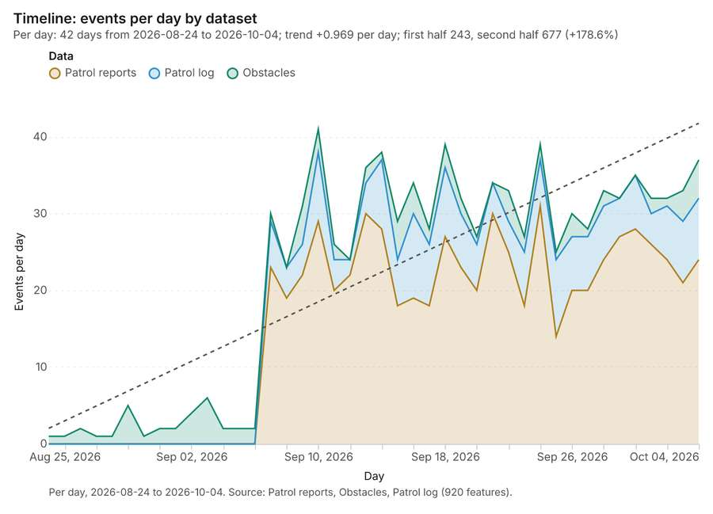
Figure 1. Timeline: events per day by dataset [1]. Per day, 2026-08-24 to 2026-10-04. Source: Patrol reports, Obstacles, Patrol log (920 features). The data is in the appendix.
The timeline counts 920 dated events in Patrol reports, Obstacles, Patrol log per day, from 2026-08-24 to 2026-10-04 [1][2][3][4]. By dataset: Patrol reports 650; Patrol log 180; Obstacles 90 [1]. The trend is +0.969 events per day; the second half of the days has 677 against 243 in the first (+178.6%) [1].
Busiest days
- 2026-09-10: 41 events [1]
- 2026-09-18: 39 events [1]
- 2026-09-24: 39 events [1]
Quietest days
- 2026-08-24: 1 event [1]
- 2026-08-25: 1 event [1]
- 2026-08-27: 1 event [1]

Hot spots
What this analysis is. Hot spot analysis: Getis-Ord Gi* hot and cold spots with z-scores, p-values and confidence bins [5]. In ArcGIS it is Find Hot Spots or Hot Spot Analysis (Getis-Ord Gi*); in QGIS, qgis:hotspot (plugin) [5].
Why it was run on this data. 90 points: Getis-Ord Gi* tests whether the concentrations in Obstacles are statistically significant [6].
What it found. Hot spots on Obstacles: Hot spot analysis: 1 layer saved: Hot spot analysis: Obstacles (17 features) [7][8]. It reported result, bins 17; result, count 17; result, elapsed ms 4; result, cell size m 2,000; result, incidents used 90; result, distance band m 2,000 [7].
Result | Value
result, bins | 17
result, count | 17
result, elapsed ms | 4
result, cell size m | 2,000
result, incidents used | 90
result, distance band m | 2,000
billing, cost | 0.0518
billing, list price | 0.0518
billing, upstream cost | 0

Findings
- Evidenced: Hot spots on Obstacles: Hot spot analysis: 1 layer saved: Hot spot analysis: Obstacles (17 features) [7][8].
- Evidenced: It reported result, bins 17; result, count 17; result, elapsed ms 4; result, cell size m 2,000; result, incidents used 90; result, distance band m 2,000 [7].
Tool gp_hot_spots; parameters {"project": "9f6aa8f7-f5fe-4630-ab44-f56a90a94683", "features": {"layer": "Obstacles (10e309c5)"}, "aggregation": "hexagon", "cell_size_m": 2000.0, "distance_band_m": 2000.0}

Hot spots
What this analysis is. Hot spot analysis: Getis-Ord Gi* hot and cold spots with z-scores, p-values and confidence bins [5]. In ArcGIS it is Find Hot Spots or Hot Spot Analysis (Getis-Ord Gi*); in QGIS, qgis:hotspot (plugin) [5].
Why it was run on this data. 650 points: Getis-Ord Gi* tests whether the concentrations in Patrol reports are statistically significant [9].
What it found. Hot spots on Patrol reports: Hot spot analysis: 1 layer saved: Hot spot analysis: Patrol reports (154 features) [10][11]. It reported result, bins 154; result, count 154; result, elapsed ms 13; result, cell size m 500; result, incidents used 650; result, distance band m 500 [10].
Result | Value
result, bins | 154
result, count | 154
result, elapsed ms | 13
result, cell size m | 500
result, incidents used | 650
result, distance band m | 500
billing, cost | 0.063
billing, list price | 0.063
billing, upstream cost | 0

Findings
- Evidenced: Hot spots on Patrol reports: Hot spot analysis: 1 layer saved: Hot spot analysis: Patrol reports (154 features) [10][11].
- Evidenced: It reported result, bins 154; result, count 154; result, elapsed ms 13; result, cell size m 500; result, incidents used 650; result, distance band m 500 [10].
A model draft was discarded because a sentence did not cite a source of this section.
Tool gp_hot_spots; parameters {"project": "9f6aa8f7-f5fe-4630-ab44-f56a90a94683", "features": {"layer": "Patrol reports (5e87153f)"}, "aggregation": "hexagon", "cell_size_m": 500.0, "distance_band_m": 500.0}

Summarize within
What this analysis is. Summarize within: Count and aggregate the features inside each polygon (or bin), proportionally for lines and polygons [12]. In ArcGIS it is Summarize Within or Aggregate Points; in QGIS, native:countpointsinpolygon or native:sumlinelengths [12].
Why it was run on this data. Count Observation posts inside each feature of Areas of operation by manned; the counts map as a choropleth (natural breaks, sequential colors) [13].
What it found. Summarize within on Observation posts, Areas of operation: Summarize within: 1 layer saved: Summarize within: Areas of operation (6 features) [14][15][16]. It reported result, count 6; result, elapsed ms 1; billing, cost 0.01034; billing, list price 0.01034; billing, upstream cost 0 [14].
Result | Value
result, count | 6
result, elapsed ms | 1
billing, cost | 0.01034
billing, list price | 0.01034
billing, upstream cost | 0

Findings
- Evidenced: Summarize within on Observation posts, Areas of operation: Summarize within: 1 layer saved: Summarize within: Areas of operation (6 features) [14][15][16].
- Evidenced: It reported result, count 6; result, elapsed ms 1; billing, cost 0.01034; billing, list price 0.01034; billing, upstream cost 0 [14].
A model draft was discarded because a sentence did not cite a source of this section.
Tool gp_summarize_within; parameters {"stats": [{"stat": "sum", "field": "ground_m"}], "project": "9f6aa8f7-f5fe-4630-ab44-f56a90a94683", "features": {"layer": "Observation posts (fd2e56d2)"}, "group_by": "manned", "polygons": {"layer": "Areas of operation (eb593b97)"}}

Summarize within
What this analysis is. Summarize within: Count and aggregate the features inside each polygon (or bin), proportionally for lines and polygons [12]. In ArcGIS it is Summarize Within or Aggregate Points; in QGIS, native:countpointsinpolygon or native:sumlinelengths [12].
Why it was run on this data. Count Observation posts inside each feature of Areas of operation by manned; the counts map as a choropleth (natural breaks, sequential colors) [13].
What it found. The `gp_summarize_within` tool was executed [17], utilizing areas of operation [16] and obstacles [8] as inputs. The operation yielded a count of 6 [17]. Measurements showed the process took an elapsed time of 0 ms [17].
Result | Value
result, count | 6
result, elapsed ms | 0
billing, cost | 0.01192
billing, list price | 0.01192
billing, upstream cost | 0

Findings
- Evidenced: Summarize within on Obstacles, Areas of operation: Summarize within: 1 layer saved: Summarize within: Areas of operation (6 features) [8][16][17].
- Evidenced: It reported result, count 6; result, elapsed ms 0; billing, cost 0.01192; billing, list price 0.01192; billing, upstream cost 0 [17].
Tool gp_summarize_within; parameters {"stats": [], "project": "9f6aa8f7-f5fe-4630-ab44-f56a90a94683", "features": {"layer": "Obstacles (10e309c5)"}, "group_by": "type", "polygons": {"layer": "Areas of operation (eb593b97)"}}

Summarize within
What this analysis is. Summarize within: Count and aggregate the features inside each polygon (or bin), proportionally for lines and polygons [12]. In ArcGIS it is Summarize Within or Aggregate Points; in QGIS, native:countpointsinpolygon or native:sumlinelengths [12].
Why it was run on this data. Count Observation posts inside each feature of Areas of operation by manned; the counts map as a choropleth (natural breaks, sequential colors) [13].
What it found. Summarize within on Patrol reports, Areas of operation: Summarize within: 1 layer saved: Summarize within: Areas of operation (6 features) [11][16][18]. It reported result, count 6; result, elapsed ms 1; billing, cost 0.02312; billing, list price 0.02312; billing, upstream cost 0 [18].
Result | Value
result, count | 6
result, elapsed ms | 1
billing, cost | 0.02312
billing, list price | 0.02312
billing, upstream cost | 0

Findings
- Evidenced: Summarize within on Patrol reports, Areas of operation: Summarize within: 1 layer saved: Summarize within: Areas of operation (6 features) [11][16][18].
- Evidenced: It reported result, count 6; result, elapsed ms 1; billing, cost 0.02312; billing, list price 0.02312; billing, upstream cost 0 [18].
Tool gp_summarize_within; parameters {"stats": [], "project": "9f6aa8f7-f5fe-4630-ab44-f56a90a94683", "features": {"layer": "Patrol reports (5e87153f)"}, "group_by": "type", "polygons": {"layer": "Areas of operation (eb593b97)"}}

Find point clusters
What this analysis is. Find point clusters: Density-based clusters (DBSCAN, HDBSCAN or OPTICS, optionally space-time) with hulls and noise [19]. In ArcGIS it is Find Point Clusters or Density-based Clustering; in QGIS, native:dbscanclustering or native:stdbscanclustering [19].
Why it was run on this data. DBSCAN finds dense groups of Observation posts and separates noise [20].
What it found. The `gp_find_point_clusters` tool was run using the Observation posts data [15], saving 2 layers, including Observation posts and cluster hulls [21].
Result | Value
result, count | 10
result, noise | 4
result, distance m | 2,000
result, elapsed ms | 5
result, min points | 3
billing, cost | 0.0502
billing, list price | 0.0502
billing, upstream cost | 0

Findings
- Evidenced: Find point clusters on Observation posts: Find point clusters: 2 layers saved: Find point clusters: Observation posts (10 features); Find point clusters: cluster hulls (1 feature) [15][21].
- Evidenced: It reported result, count 10; result, noise 4; result, distance m 2,000; result, elapsed ms 5; result, min points 3; billing, cost 0.0502 [21].
Tool gp_find_point_clusters; parameters {"method": "dbscan", "project": "9f6aa8f7-f5fe-4630-ab44-f56a90a94683", "features": {"layer": "Observation posts (fd2e56d2)"}, "distance_m": 2000.0, "min_points": 3}

Find point clusters
What this analysis is. Find point clusters: Density-based clusters (DBSCAN, HDBSCAN or OPTICS, optionally space-time) with hulls and noise [19]. In ArcGIS it is Find Point Clusters or Density-based Clustering; in QGIS, native:dbscanclustering or native:stdbscanclustering [19].
Why it was run on this data. DBSCAN finds dense groups of Obstacles and separates noise [22].
What it found. The `gp_find_point_clusters` tool utilized the Obstacles layer for analysis [23]. This process resulted in 90 features being discovered, alongside 4 cluster hulls [23].
Result | Value
result, count | 90
result, noise | 1
result, distance m | 1,000
result, elapsed ms | 6
result, min points | 3
billing, cost | 0.0518
billing, list price | 0.0518
billing, upstream cost | 0

Findings
- Evidenced: Find point clusters on Obstacles: Find point clusters: 2 layers saved: Find point clusters: Obstacles (90 features); Find point clusters: cluster hulls (4 features) [8][23].
- Evidenced: It reported result, count 90; result, noise 1; result, distance m 1,000; result, elapsed ms 6; result, min points 3; billing, cost 0.0518 [23].
Tool gp_find_point_clusters; parameters {"method": "dbscan", "project": "9f6aa8f7-f5fe-4630-ab44-f56a90a94683", "features": {"layer": "Obstacles (10e309c5)"}, "distance_m": 1000.0, "min_points": 3}

Find point clusters
What this analysis is. Find point clusters: Density-based clusters (DBSCAN, HDBSCAN or OPTICS, optionally space-time) with hulls and noise [19]. In ArcGIS it is Find Point Clusters or Density-based Clustering; in QGIS, native:dbscanclustering or native:stdbscanclustering [19].
Why it was run on this data. DBSCAN finds dense groups of Patrol reports and separates noise [24].
What it found. Find point clusters on Patrol reports: Find point clusters: 2 layers saved: Find point clusters: Patrol reports (650 features); Find point clusters: cluster hulls (1 feature) [11][25]. It reported result, count 650; result, noise 44; result, distance m 500; result, elapsed ms 16; result, min points 16; billing, cost 0.063 [25].
Result | Value
result, count | 650
result, noise | 44
result, distance m | 500
result, elapsed ms | 16
result, min points | 16
billing, cost | 0.063
billing, list price | 0.063
billing, upstream cost | 0

Findings
- Evidenced: Find point clusters on Patrol reports: Find point clusters: 2 layers saved: Find point clusters: Patrol reports (650 features); Find point clusters: cluster hulls (1 feature) [11][25].
- Evidenced: It reported result, count 650; result, noise 44; result, distance m 500; result, elapsed ms 16; result, min points 16; billing, cost 0.063 [25].
Tool gp_find_point_clusters; parameters {"method": "dbscan", "project": "9f6aa8f7-f5fe-4630-ab44-f56a90a94683", "features": {"layer": "Patrol reports (5e87153f)"}, "distance_m": 500.0, "min_points": 16}

Zonal statistics
What this analysis is. Zonal statistics: count/min/max/mean/std/sum/median/majority per polygon as a table and as GeoJSON [26]. In ArcGIS it is Zonal Statistics as Table (polygons) [26].
Why it was run on this data. Statistics of Training area terrain model (DEM) inside each feature of Landing zones [27].
What it found. The Zonal statistics tool rs_zonal_statistics was employed for this analysis [28]. The execution involved step 0 of the process [28]. A total of 6 zones were analyzed, resulting in 6 row(s) of zonal statistics data [28].
Findings
- Evidenced: Zonal statistics: Zonal statistics: 6 row(s) [28].
- Evidenced: zones 6 [28].
Tool rs_zonal_statistics; parameters {"stats": ["mean", "min", "max", "std"], "zones": "Landing zones (6405dd78)", "raster_id": "Training area terrain model (DEM) (e55808a8)"}

Zonal statistics
What this analysis is. Zonal statistics: count/min/max/mean/std/sum/median/majority per polygon as a table and as GeoJSON [26]. In ArcGIS it is Zonal Statistics as Table (polygons) [26].
Why it was run on this data. Statistics of Training area terrain model (DEM) inside each feature of Landing zones [27].
What it found. The rs_zonal_statistics tool executed with 6 row(s) and 6 zones [29]. The analysis generated statistics for 6 zones [29]. Additionally, the tool counted 6 features [29]. The entire process was completed in 40 elapsed milliseconds [29].
Result | Value
stats, zones | 6
features, count | 6
elapsed ms | 40

Findings
- Evidenced: Zonal statistics: Zonal statistics: 6 row(s) [29].
- Evidenced: zones 6 [29].
- Evidenced: It reported stats, zones 6; features, count 6; elapsed ms 40 [29].
Tool rs_zonal_statistics; parameters {"stats": ["mean", "min", "max", "std"], "zones": "Areas of operation (eb593b97)", "raster_id": "Training area terrain model (DEM) (e55808a8)"}

Slope
What this analysis is. Slope: Horn slope in degrees or percent, with the share of ground in six grade classes [30]. In ArcGIS it is Slope (Spatial Analyst); in QGIS, Slope (GDAL DEM) [30].
Why it was run on this data. Slope of the Training area terrain model (DEM) surface [31].
What it found. Slope on Training area terrain model (DEM): Slope over 80.00 km2: mean 6.45 degrees, max 17.54 degrees; 35% of the ground is steeper than 15% [32][33]. DEM: Training area terrain model (DEM) [32][33]. Verified: 2 checks passed [32][33]. It reported dem, cols 500; dem, rows 400; dem, cell m 20; dem, relief m 306; dem, elev max m 543.7; dem, elev min m 237.7 [32].
Result | Value
dem, cols | 500
dem, rows | 400
dem, cell m | 20
dem, relief m | 306
dem, elev max m | 543.7
dem, elev min m | 237.7
dem, elev mean m | 370.9
dem, missing frac | 0
cost, usd | 0
grid, cols | 500
grid, rows | 400
grid, cell m | 20
stats, max | 17.54
stats, min | 0.01
stats, mean | 6.45
stats, median | 6.41
stats, steeper than 15pct | 35.02
rows left out | 0

Findings
- Evidenced: Slope on Training area terrain model (DEM): Slope over 80.00 km2: mean 6.45 degrees, max 17.54 degrees; 35% of the ground is steeper than 15% [32][33].
- Evidenced: DEM: Training area terrain model (DEM) [32][33].
- Evidenced: Verified: 2 checks passed [32][33].
- Evidenced: It reported dem, cols 500; dem, rows 400; dem, cell m 20; dem, relief m 306; dem, elev max m 543.7; dem, elev min m 237.7 [32].
Tool tr_slope; parameters {"dem": {"layer": "Training area terrain model (DEM) (e55808a8)"}, "project": "9f6aa8f7-f5fe-4630-ab44-f56a90a94683"}

Space time hot spots
What this analysis is. Emerging hot spots: Where hot spots are new, consecutive, intensifying, persistent, diminishing, sporadic, oscillating or historical over time [34]. In ArcGIS it is Emerging Hot Spot Analysis or Create Space Time Cube [34].
Why it was run on this data. Obstacles carry dates in 'date': emerging hot spot analysis finds new, intensifying and fading hot spots per day [35].
What it found. Space time hot spots on Obstacles: Emerging hot spots: 1 layer saved: Emerging hot spots: Obstacles (23 features) [8][36]. It reported result, count 23; result, elapsed ms 5; result, resolution 7; result, features used 90; result, time neighbors 0; billing, cost 0.1045 [36].
Result | Value
result, count | 23
result, elapsed ms | 5
result, resolution | 7
result, features used | 90
result, time neighbors | 0
billing, cost | 0.1045
billing, list price | 0.1045
billing, upstream cost | 0

Findings
- Evidenced: Space time hot spots on Obstacles: Emerging hot spots: 1 layer saved: Emerging hot spots: Obstacles (23 features) [8][36].
- Evidenced: It reported result, count 23; result, elapsed ms 5; result, resolution 7; result, features used 90; result, time neighbors 0; billing, cost 0.1045 [36].
A model draft was discarded because a sentence did not cite a source of this section.
Tool gp_space_time_hot_spots; parameters {"project": "9f6aa8f7-f5fe-4630-ab44-f56a90a94683", "features": {"layer": "Obstacles (10e309c5)"}, "interval": "day", "bin_shape": "h3", "resolution": 7, "time_field": "date"}

Space time hot spots
What this analysis is. Emerging hot spots: Where hot spots are new, consecutive, intensifying, persistent, diminishing, sporadic, oscillating or historical over time [34]. In ArcGIS it is Emerging Hot Spot Analysis or Create Space Time Cube [34].
Why it was run on this data. Patrol reports carry dates in 'reported_at': emerging hot spot analysis finds new, intensifying and fading hot spots per day [37].
What it found. The `gp_space_time_hot_spots` tool was run using the `Patrol reports` [11] and successfully identified 53 emerging hot spots [38].
Result | Value
result, count | 53
result, elapsed ms | 10
result, resolution | 8
result, features used | 650
result, time neighbors | 0
billing, cost | 0.1325
billing, list price | 0.1325
billing, upstream cost | 0

Findings
- Evidenced: Space time hot spots on Patrol reports: Emerging hot spots: 1 layer saved: Emerging hot spots: Patrol reports (53 features) [11][38].
- Evidenced: It reported result, count 53; result, elapsed ms 10; result, resolution 8; result, features used 650; result, time neighbors 0; billing, cost 0.1325 [38].
Tool gp_space_time_hot_spots; parameters {"project": "9f6aa8f7-f5fe-4630-ab44-f56a90a94683", "features": {"layer": "Patrol reports (5e87153f)"}, "interval": "day", "bin_shape": "h3", "resolution": 8, "time_field": "reported_at"}

Near repeat
What this analysis is. Repeat and near repeat classification: Classify incidents as originators, repeats (same place) or near repeats within a distance and time window, with a Knox test table [39]. In ArcGIS it is Repeat and Near Repeat Classification or Near Repeat Calculator [39].
Why it was run on this data. Near repeat analysis tests whether Obstacles close in space also follow each other within 4 days [40].
What it found. Near repeat on Obstacles: Repeat and near repeat classification: 1 layer saved: Repeat and near repeat classification: Obstacles (90 features) [8][41]. It reported result, days 4; result, count 90; result, chains 18; result, distance m 1,000; result, elapsed ms 5; result, pairs linked 76 [41].
Result | Value
result, days | 4
result, count | 90
result, chains | 18
result, distance m | 1,000
result, elapsed ms | 5
result, pairs linked | 76
billing, cost | 0.0527
billing, list price | 0.0527
billing, upstream cost | 0

Findings
- Evidenced: Near repeat on Obstacles: Repeat and near repeat classification: 1 layer saved: Repeat and near repeat classification: Obstacles (90 features) [8][41].
- Evidenced: It reported result, days 4; result, count 90; result, chains 18; result, distance m 1,000; result, elapsed ms 5; result, pairs linked 76 [41].
Tool gp_near_repeat; parameters {"days": 4, "project": "9f6aa8f7-f5fe-4630-ab44-f56a90a94683", "features": {"layer": "Obstacles (10e309c5)"}, "distance_m": 1000.0, "time_field": "date"}

Calculate density
What this analysis is. Calculate density: Kernel density per square kilometer on a grid [42]. In ArcGIS it is Calculate Density or Kernel Density; in QGIS, native:heatmapkerneldensityestimation [42].
Why it was run on this data. 90 points in Obstacles: a density surface shows where they concentrate [43].
What it found. The density calculation processed 92 features from the Obstacles layer [44].
Result | Value
result, count | 92
result, elapsed ms | 3
result, bandwidth m | 2,000
result, cell size m | 1,000
result, excluded null | 0
result, max density per km2 | 4.231
billing, cost | 0.0518
billing, list price | 0.0518
billing, upstream cost | 0

Findings
- Evidenced: Calculate density on Obstacles: Calculate density: 1 layer saved: Calculate density: Obstacles (92 features) [8][44].
- Evidenced: It reported result, count 92; result, elapsed ms 3; result, bandwidth m 2,000; result, cell size m 1,000; result, excluded null 0; result, max density per km2 4.231 [44].
Tool gp_calculate_density; parameters {"kernel": "quartic", "project": "9f6aa8f7-f5fe-4630-ab44-f56a90a94683", "features": {"layer": "Obstacles (10e309c5)"}, "bandwidth_m": 2000.0, "cell_size_m": 1000.0}

Calculate density
What this analysis is. Calculate density: Kernel density per square kilometer on a grid [42]. In ArcGIS it is Calculate Density or Kernel Density; in QGIS, native:heatmapkerneldensityestimation [42].
Why it was run on this data. 650 points in Patrol reports: a density surface shows where they concentrate [45].
What it found. Density was calculated using the Patrol reports [11], generating a total of 917 features [46]. The analysis determined that the maximum density recorded was 160.4 per km² [46]. This calculation was completed in 27 ms [46] and generated a billing cost of 0.063 [46].
Result | Value
result, count | 917
result, elapsed ms | 27
result, bandwidth m | 500
result, cell size m | 200
result, excluded null | 0
result, max density per km2 | 160.4
billing, cost | 0.063
billing, list price | 0.063
billing, upstream cost | 0

Findings
- Evidenced: Calculate density on Patrol reports: Calculate density: 1 layer saved: Calculate density: Patrol reports (917 features) [11][46].
- Evidenced: It reported result, count 917; result, elapsed ms 27; result, bandwidth m 500; result, cell size m 200; result, excluded null 0; result, max density per km2 160.4 [46].
Tool gp_calculate_density; parameters {"kernel": "quartic", "project": "9f6aa8f7-f5fe-4630-ab44-f56a90a94683", "features": {"layer": "Patrol reports (5e87153f)"}, "bandwidth_m": 500.0, "cell_size_m": 200.0}

Calculate density
What this analysis is. Calculate density: Kernel density per square kilometer on a grid [42]. In ArcGIS it is Calculate Density or Kernel Density; in QGIS, native:heatmapkerneldensityestimation [42].
Why it was run on this data. 20 points in Water crossings: a density surface shows where they concentrate [47].
What it found. Calculate density on Water crossings: Calculate density: 1 layer saved: Calculate density: Water crossings (307 features) [48][49]. It reported result, count 307; result, elapsed ms 8; result, bandwidth m 1,000; result, cell size m 200; result, excluded null 0; result, max density per km2 9.049 [48].
Result | Value
result, count | 307
result, elapsed ms | 8
result, bandwidth m | 1,000
result, cell size m | 200
result, excluded null | 0
result, max density per km2 | 9.049
billing, cost | 0.0504
billing, list price | 0.0504
billing, upstream cost | 0

Findings
- Evidenced: Calculate density on Water crossings: Calculate density: 1 layer saved: Calculate density: Water crossings (307 features) [48][49].
- Evidenced: It reported result, count 307; result, elapsed ms 8; result, bandwidth m 1,000; result, cell size m 200; result, excluded null 0; result, max density per km2 9.049 [48].
Tool gp_calculate_density; parameters {"kernel": "quartic", "project": "9f6aa8f7-f5fe-4630-ab44-f56a90a94683", "features": {"layer": "Water crossings (208d3baf)"}, "bandwidth_m": 1000.0, "cell_size_m": 200.0}

Maps and charts
The run also made 20 map image(s) [50][51][52][53][54][55][56][57][58][59][60][61][62][63][64][65][66][67][68][69] and 23 chart(s) [70][71][72][73][74][75][76][77][78][79][80][81][82][83][84][85][86][87][88][89][90][91][92].
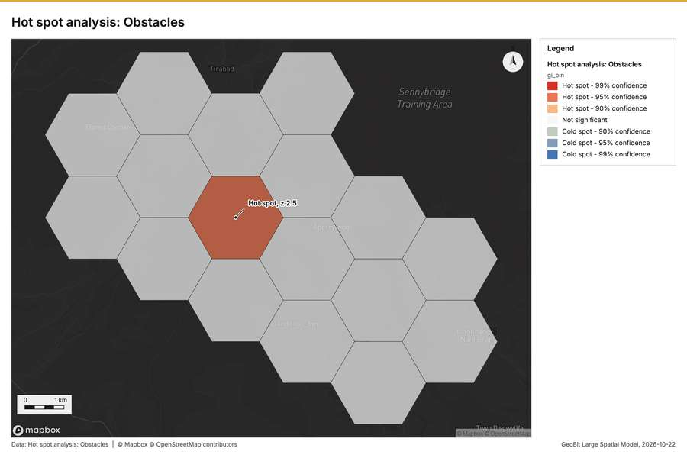
Figure 2. Hot spot analysis: Obstacles [50]
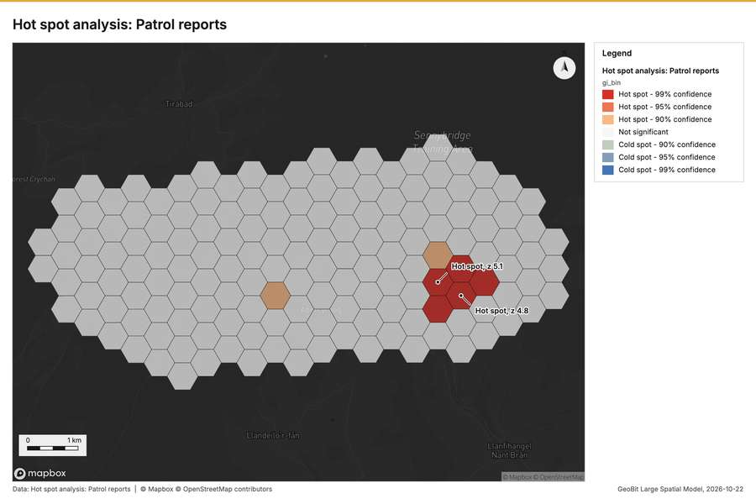
Figure 3. Hot spot analysis: Patrol reports [51]
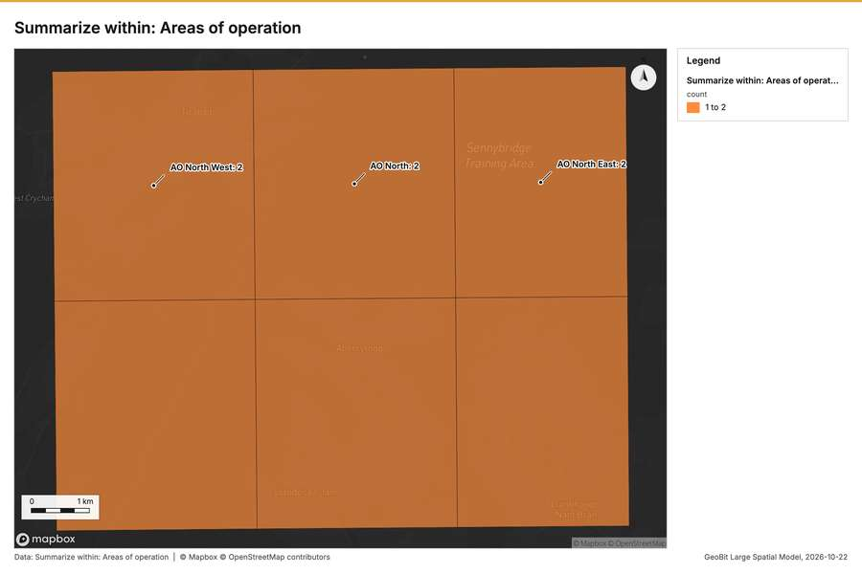
Figure 4. Summarize within: Areas of operation [52]
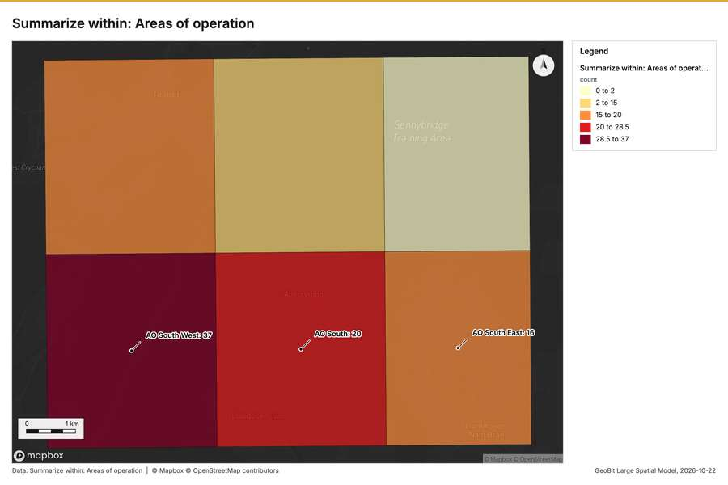
Figure 5. Summarize within: Areas of operation [53]
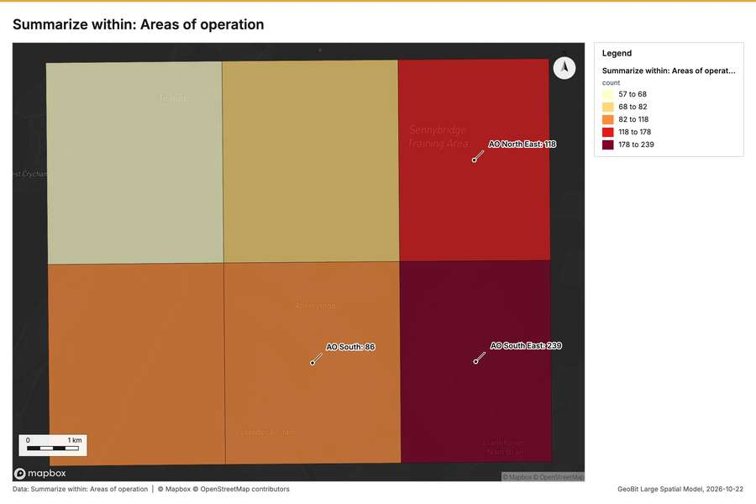
Figure 6. Summarize within: Areas of operation [54]
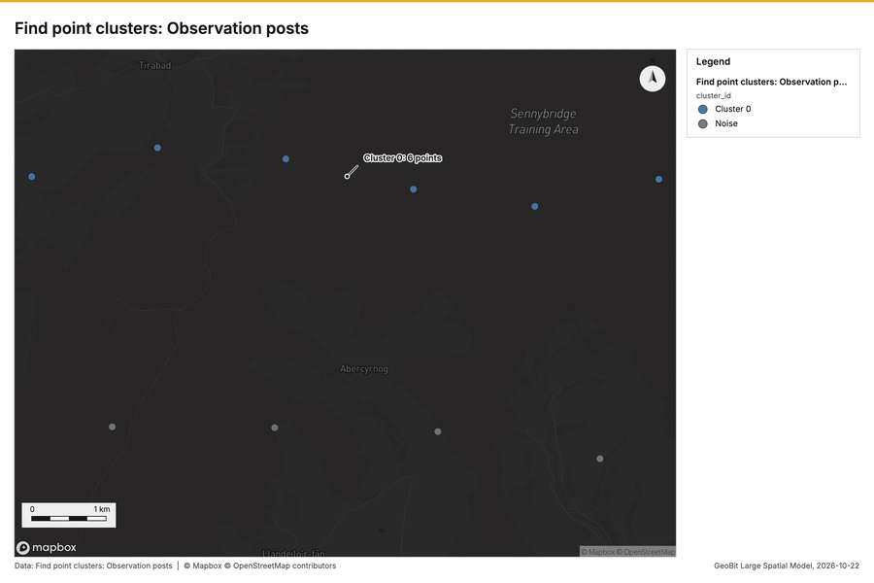
Figure 7. Find point clusters: Observation posts [55]
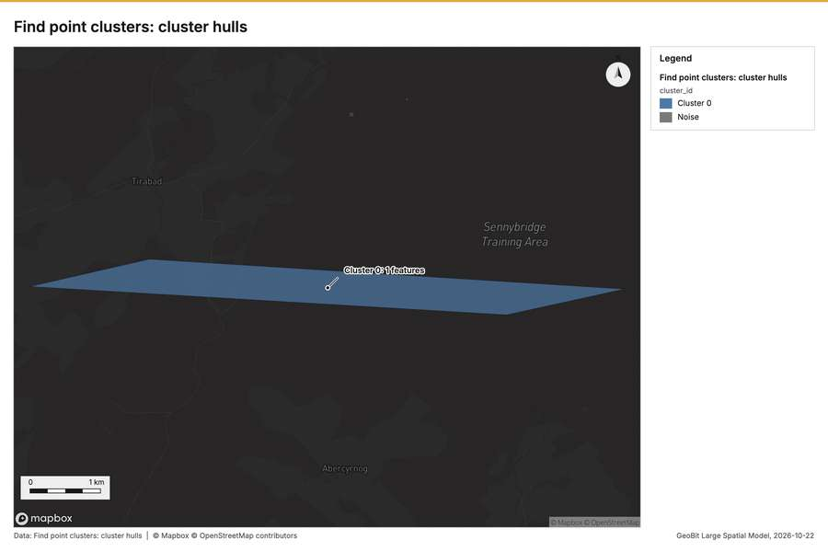
Figure 8. Find point clusters: cluster hulls [56]
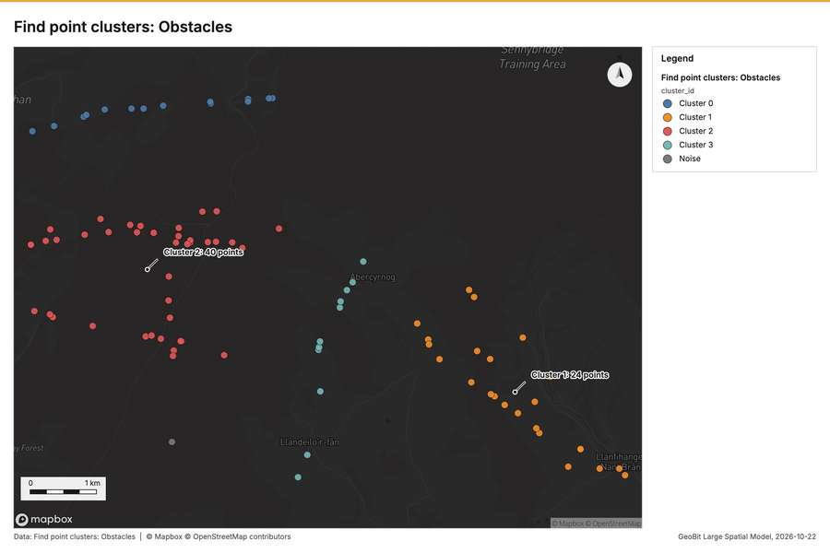
Figure 9. Find point clusters: Obstacles [57]
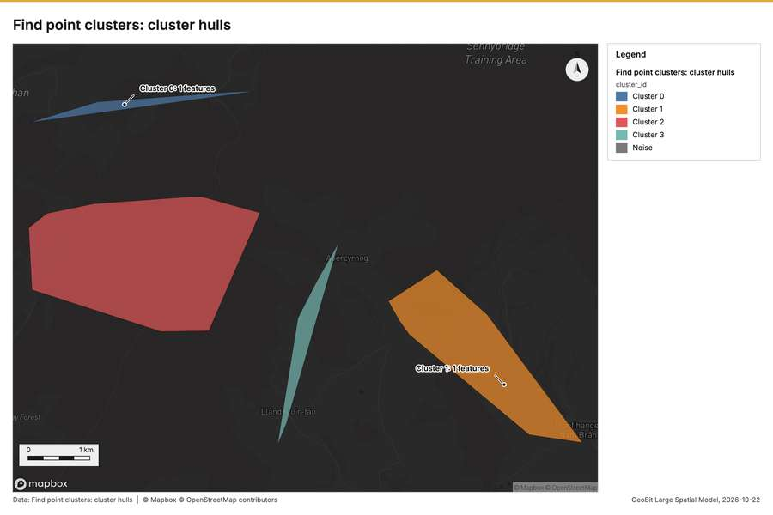
Figure 10. Find point clusters: cluster hulls [58]
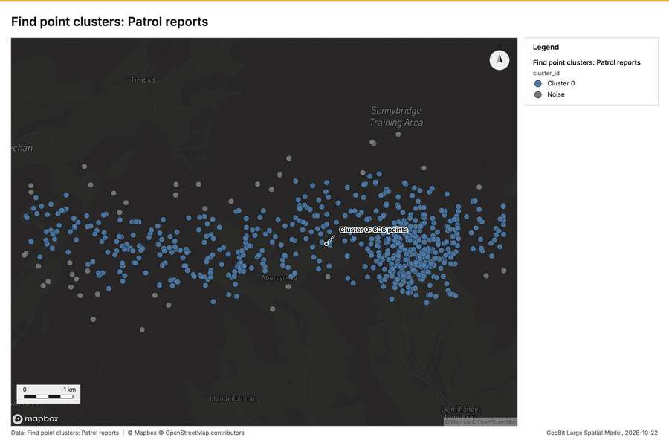
Figure 11. Find point clusters: Patrol reports [59]
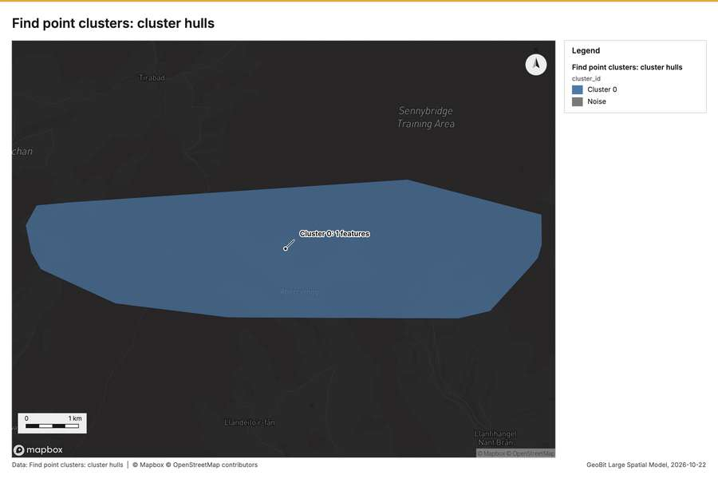
Figure 12. Find point clusters: cluster hulls [60]
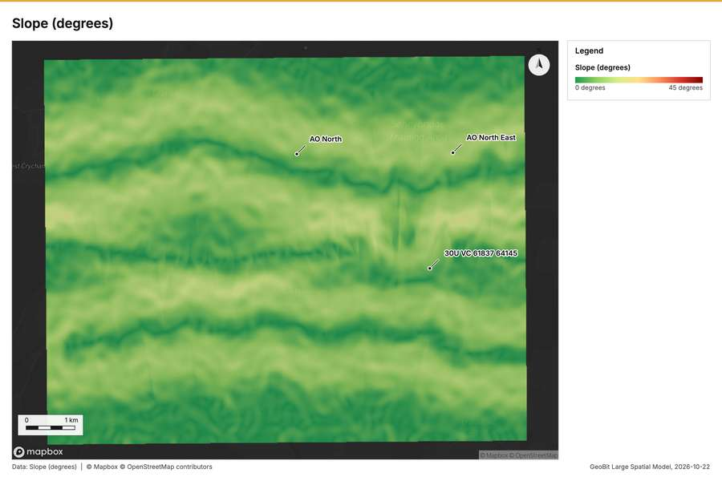
Figure 13. Slope (degrees) [61]
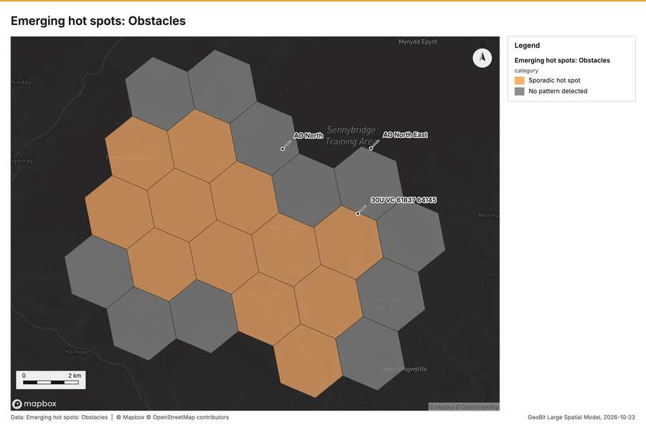
Figure 14. Emerging hot spots: Obstacles [62]
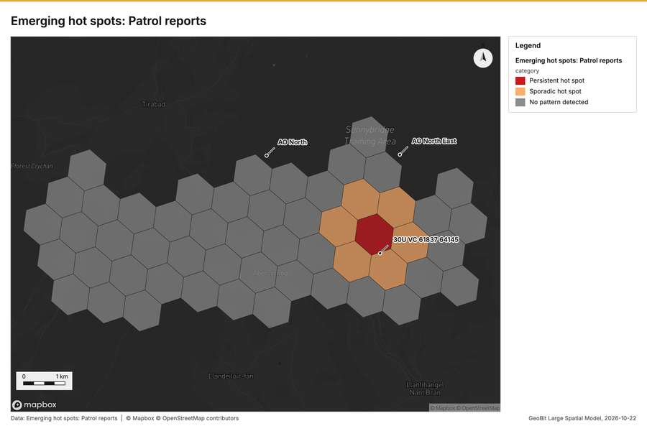
Figure 15. Emerging hot spots: Patrol reports [63]
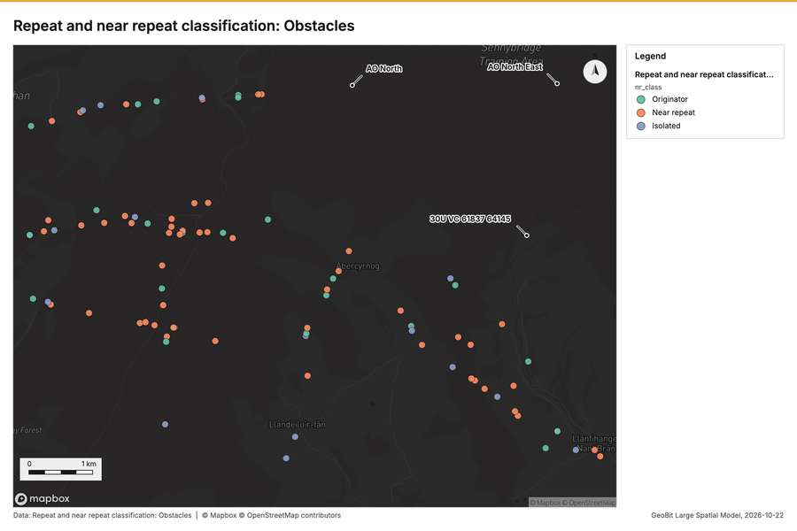
Figure 16. Repeat and near repeat classification: Obstacles [64]
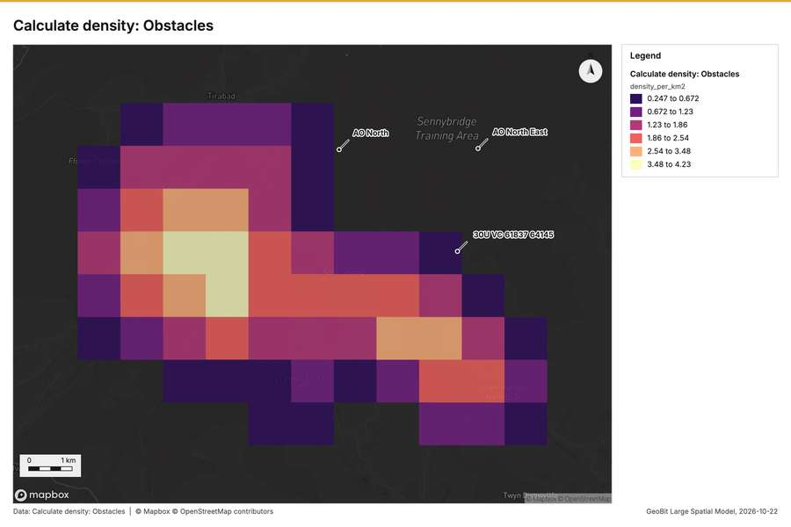
Figure 17. Calculate density: Obstacles [65]
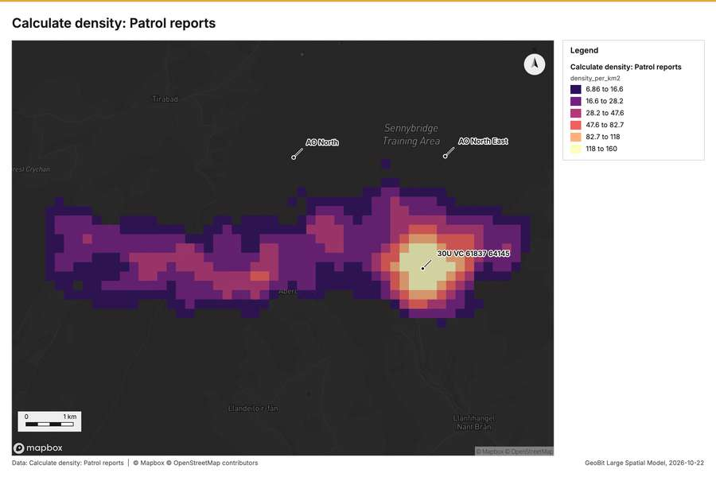
Figure 18. Calculate density: Patrol reports [66]
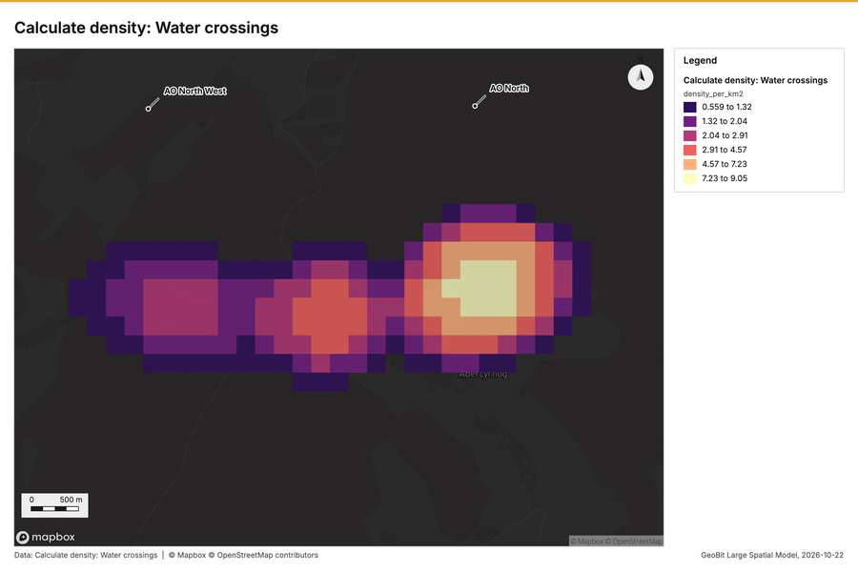
Figure 19. Calculate density: Water crossings [67]
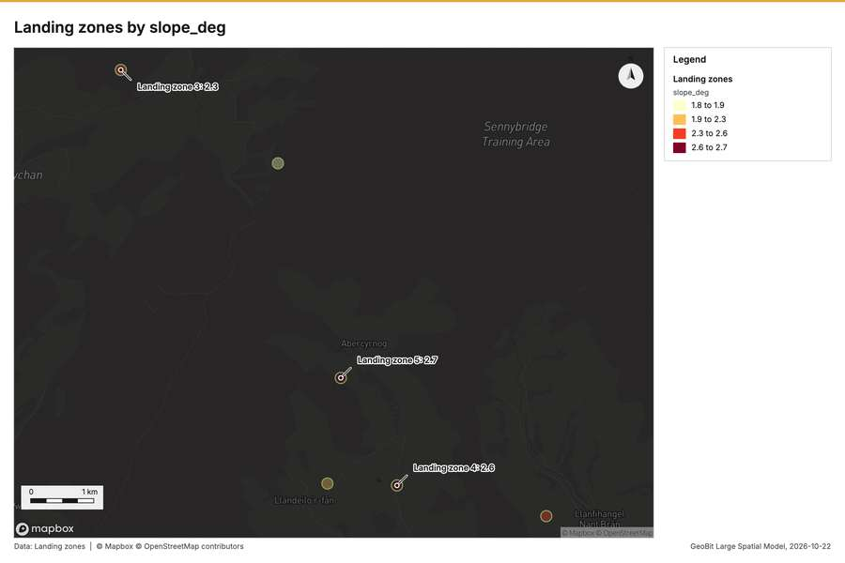
Figure 20. Landing zones by slope_deg [68]
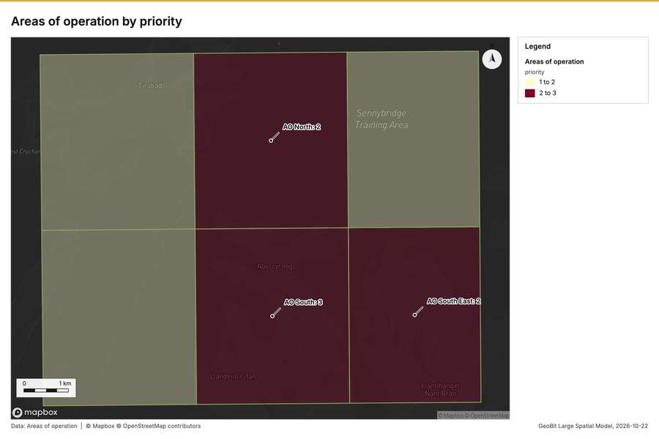
Figure 21. Areas of operation by priority [69]
What the map shows. The map illustrates the count of "Areas of operation [52]
Inferred: read from the image by gemma4:e4b, not evidence.
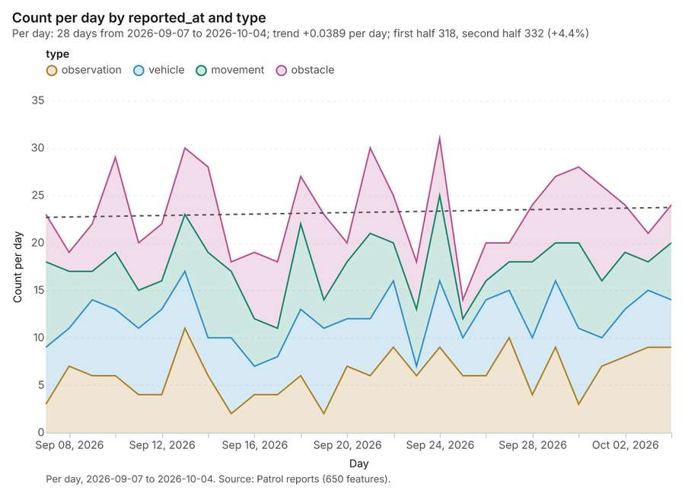
Figure 22. Patrol reports over time (reported_at) [70]. Per day, 2026-09-07 to 2026-10-04. Source: Patrol reports (650 features). The data is in the appendix.
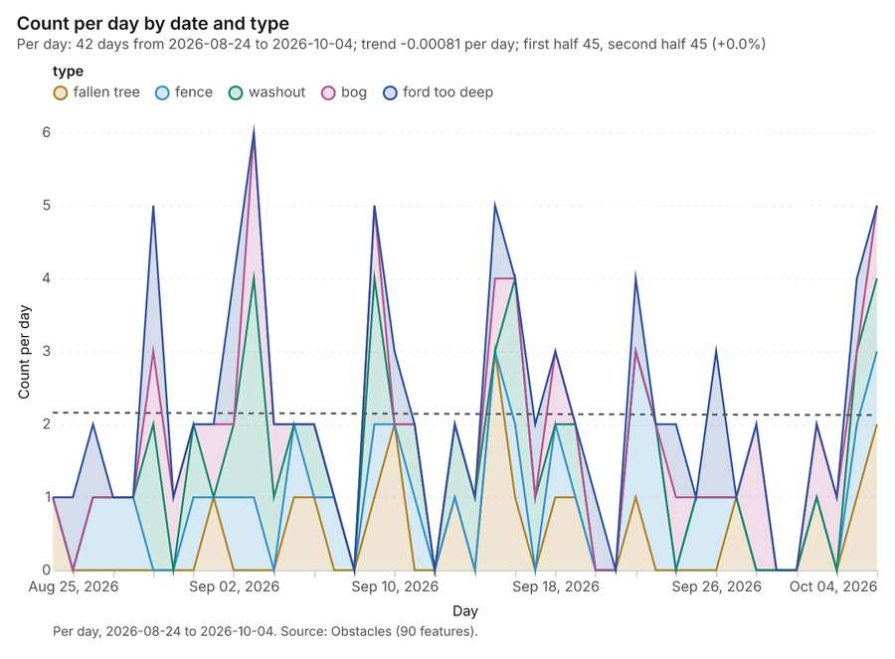
Figure 23. Obstacles over time (date) [71]. Per day, 2026-08-24 to 2026-10-04. Source: Obstacles (90 features). The data is in the appendix.
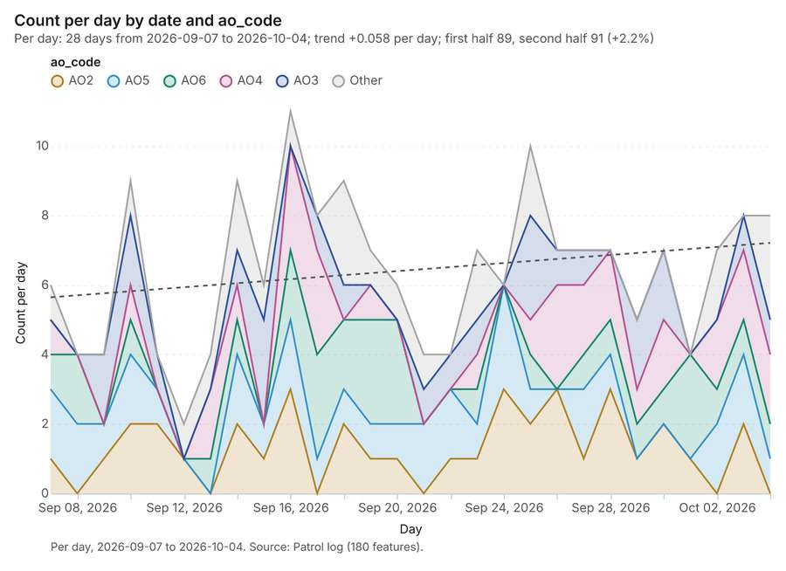
Figure 24. Patrol log over time (date) [72]. Per day, 2026-09-07 to 2026-10-04. Source: Patrol log (180 features). The data is in the appendix.
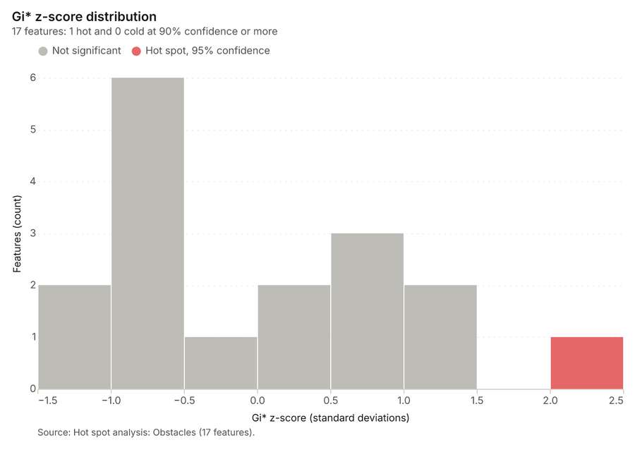
Figure 25. Hot spot analysis: Obstacles [73]. Source: Hot spot analysis: Obstacles (17 features). The data is in the appendix.
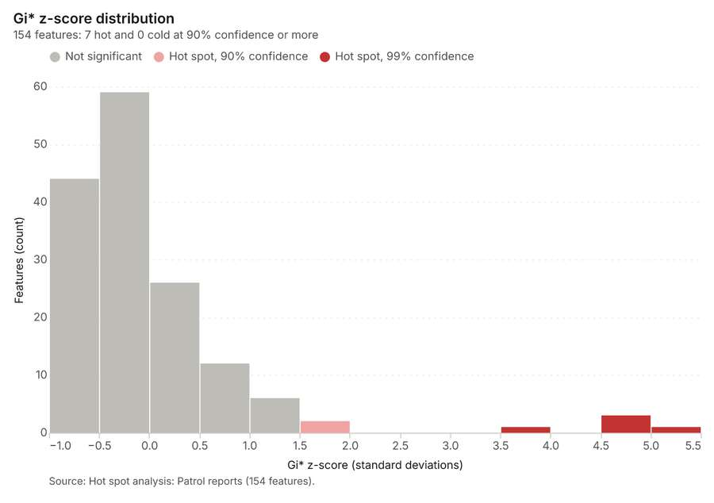
Figure 26. Hot spot analysis: Patrol reports [74]. Source: Hot spot analysis: Patrol reports (154 features). The data is in the appendix.
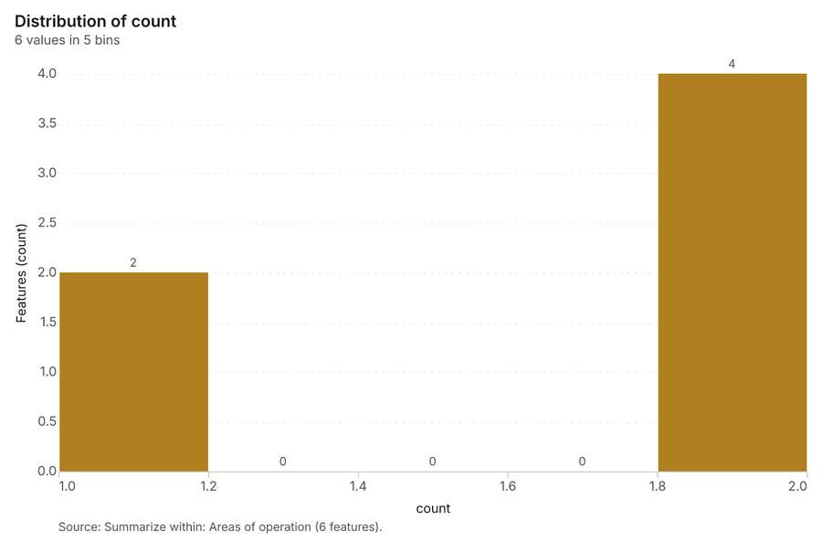
Figure 27. Summarize within: Areas of operation [75]. Source: Summarize within: Areas of operation (6 features). The data is in the appendix.
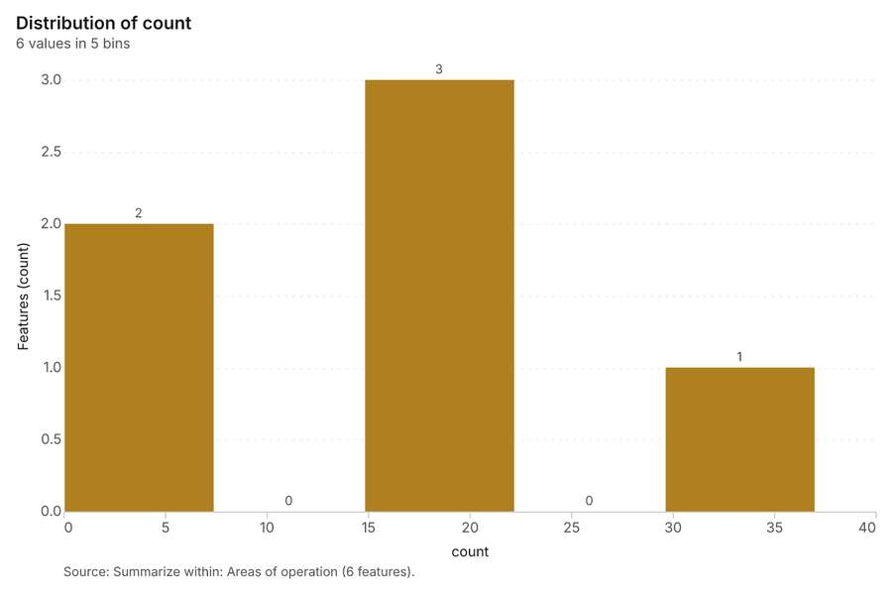
Figure 28. Summarize within: Areas of operation [76]. Source: Summarize within: Areas of operation (6 features). The data is in the appendix.
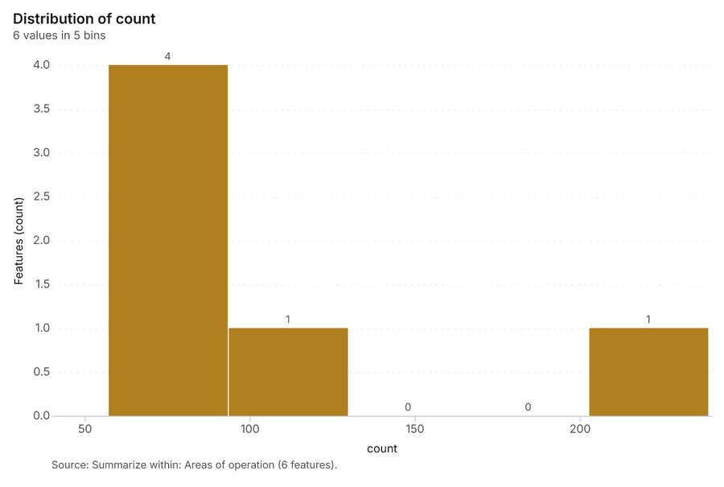
Figure 29. Summarize within: Areas of operation [77]. Source: Summarize within: Areas of operation (6 features). The data is in the appendix.
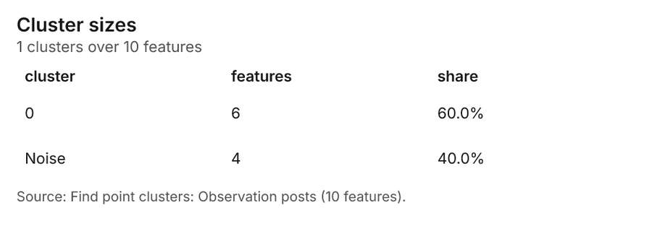
Figure 30. Find point clusters: Observation posts [78]. Source: Find point clusters: Observation posts (10 features). The data is in the appendix.
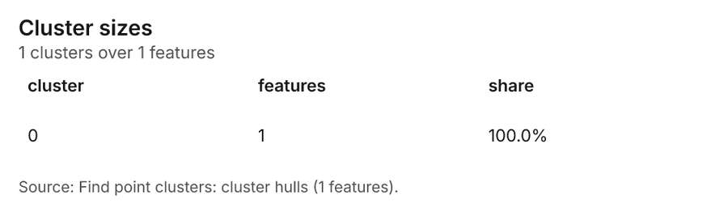
Figure 31. Find point clusters: cluster hulls [79]. Source: Find point clusters: cluster hulls (1 features). The data is in the appendix.
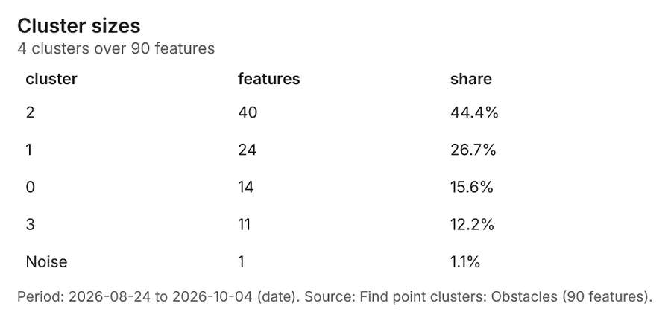
Figure 32. Find point clusters: Obstacles [80]. Period: 2026-08-24 to 2026-10-04 (date). Source: Find point clusters: Obstacles (90 features). The data is in the appendix.
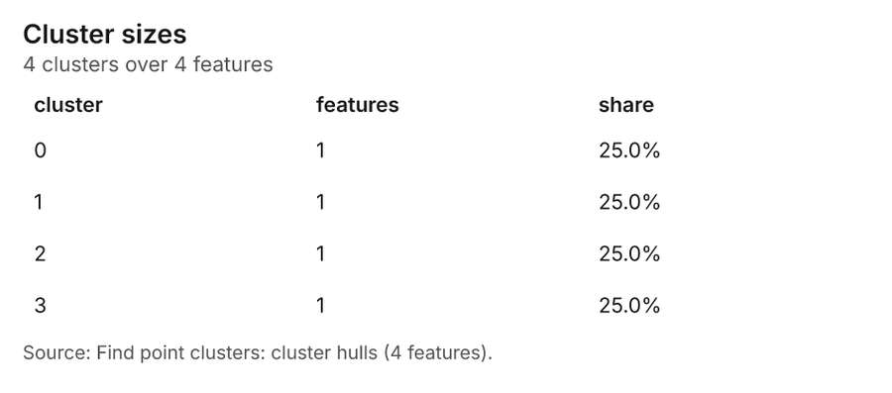
Figure 33. Find point clusters: cluster hulls [81]. Source: Find point clusters: cluster hulls (4 features). The data is in the appendix.
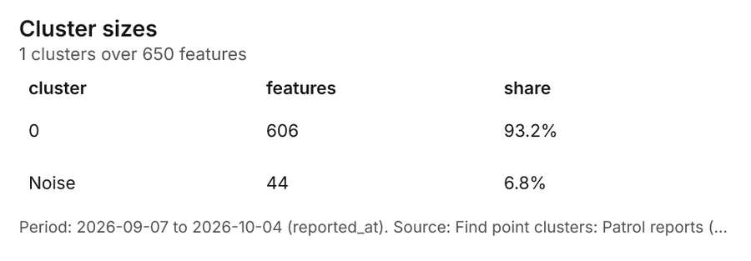
Figure 34. Find point clusters: Patrol reports [82]. Period: 2026-09-07 to 2026-10-04 (reported_at). Source: Find point clusters: Patrol reports (650 features). The data is in the appendix.
Figure 35. Find point clusters: cluster hulls [83]. Source: Find point clusters: cluster hulls (1 features). The data is in the appendix.
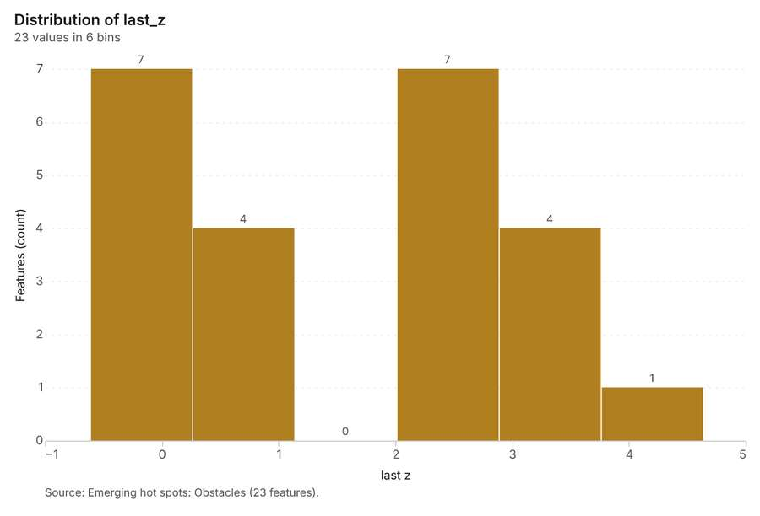
Figure 36. Emerging hot spots: Obstacles [84]. Source: Emerging hot spots: Obstacles (23 features). The data is in the appendix.
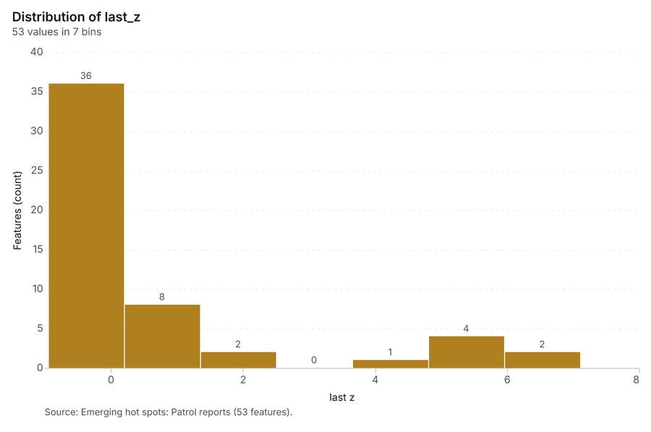
Figure 37. Emerging hot spots: Patrol reports [85]. Source: Emerging hot spots: Patrol reports (53 features). The data is in the appendix.
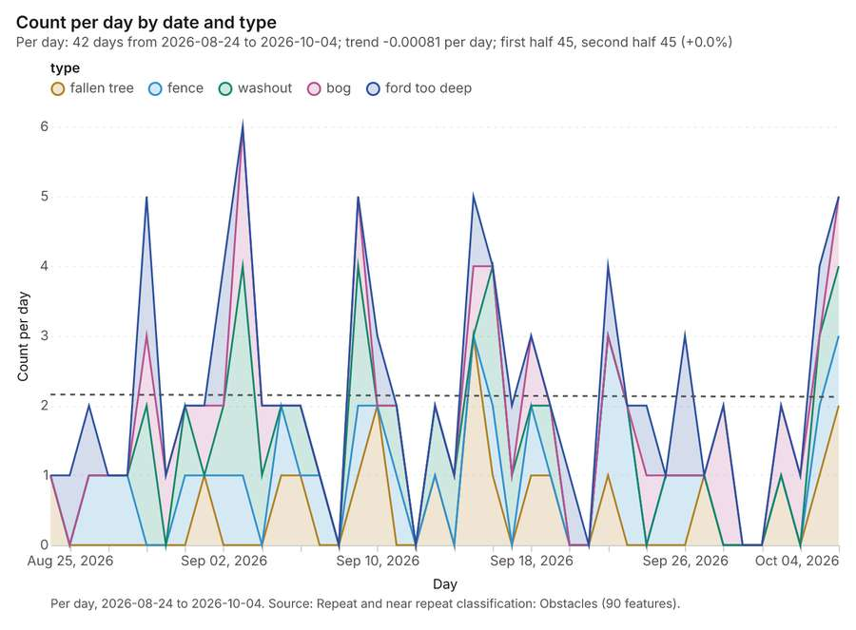
Figure 38. Repeat and near repeat classification: Obstacles [86]. Per day, 2026-08-24 to 2026-10-04. Source: Repeat and near repeat classification: Obstacles (90 features). The data is in the appendix.
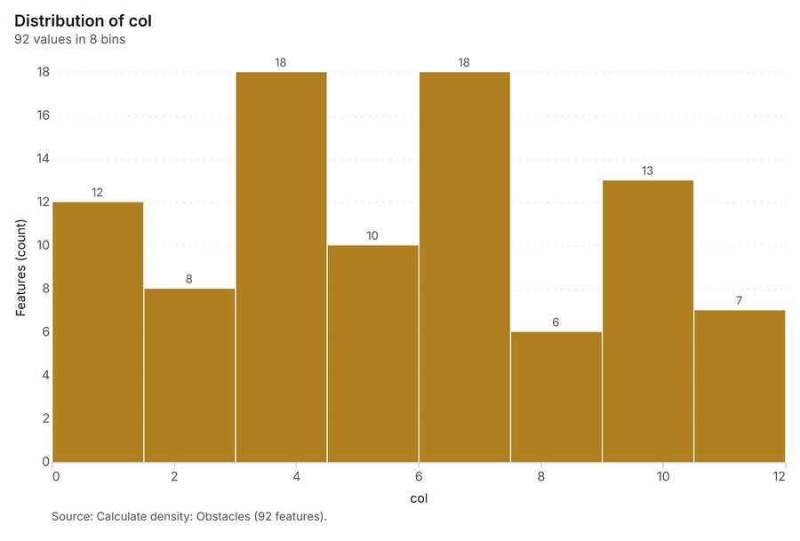
Figure 39. Calculate density: Obstacles [87]. Source: Calculate density: Obstacles (92 features). The data is in the appendix.
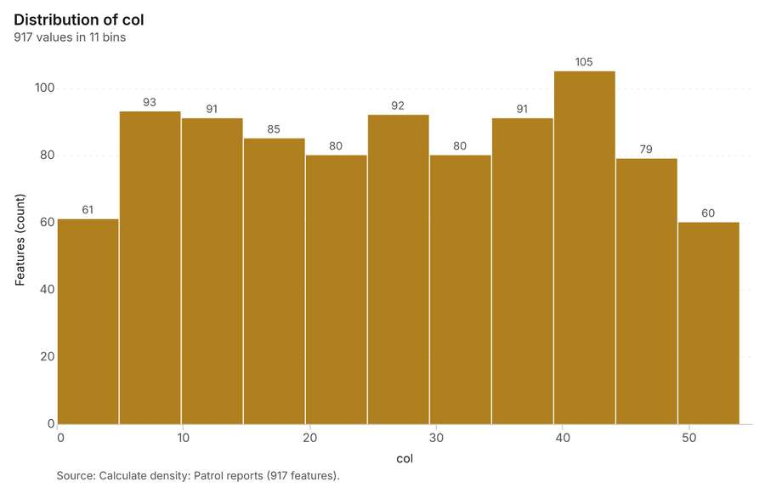
Figure 40. Calculate density: Patrol reports [88]. Source: Calculate density: Patrol reports (917 features). The data is in the appendix.
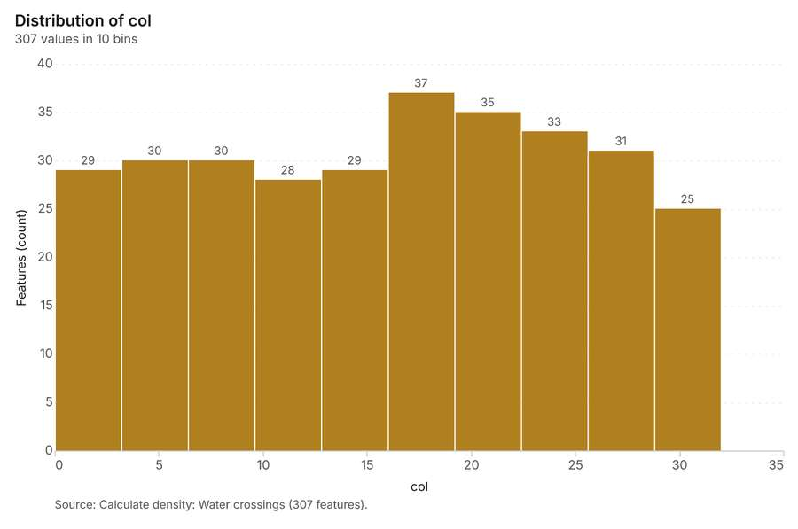
Figure 41. Calculate density: Water crossings [89]. Source: Calculate density: Water crossings (307 features). The data is in the appendix.
Figure 42. Repeat and near repeat classification: Obstacles over time [90]. Per day, 2026-08-24 to 2026-10-04. Source: Repeat and near repeat classification: Obstacles (90 features). The data is in the appendix.
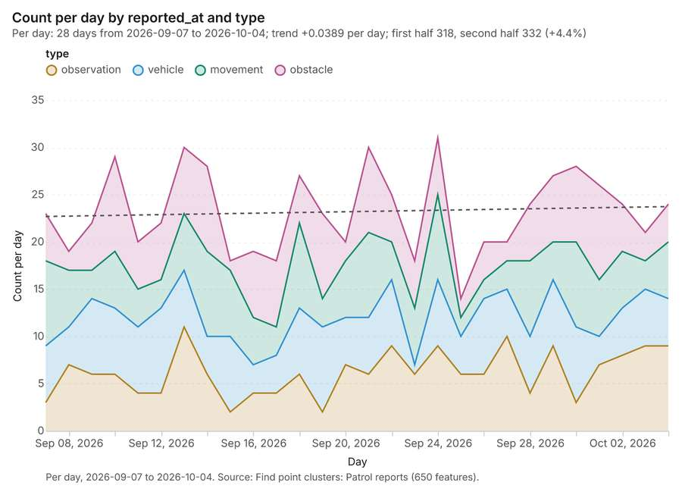
Figure 43. Find point clusters: Patrol reports over time [91]. Per day, 2026-09-07 to 2026-10-04. Source: Find point clusters: Patrol reports (650 features). The data is in the appendix.
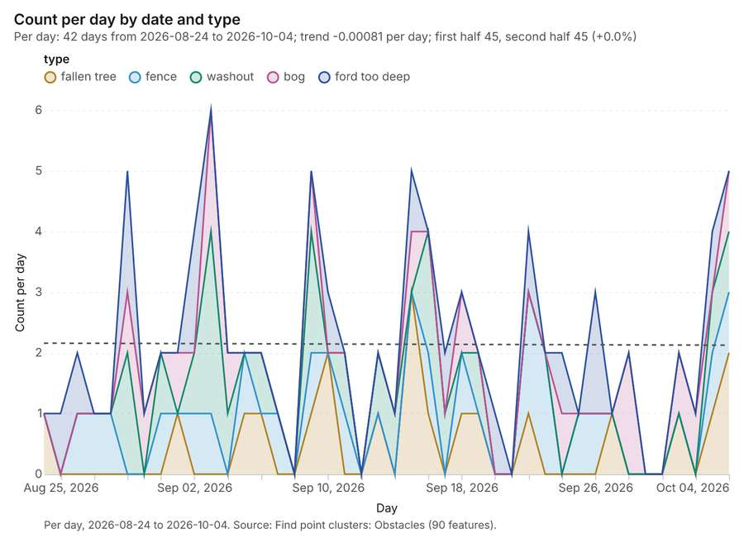
Figure 44. Find point clusters: Obstacles over time [92]. Per day, 2026-08-24 to 2026-10-04. Source: Find point clusters: Obstacles (90 features). The data is in the appendix.

Changes since the last run
This is the first report of this project.

Sources
[1] Rendering: Chart: Timeline: events per day by dataset. 126 rows (id a075601f-8af4-4c36-b946-28a1dfddb7fe)
[2] Dataset: Patrol reports. vector, 650 rows (id c25eb5cb-2e9d-49b2-9627-f99a5f226a66)
[3] Dataset: Obstacles. vector, 90 rows (id 9d65a5e4-b04a-4392-a9de-b8effe3904cf)
[4] Dataset: Patrol log. table, 180 rows (id 955d11b9-aa3e-47bb-9ff6-b65e6ac4fa73)
[5] Catalog: Hot spot analysis (operation catalog, gp_hot_spots). Getis-Ord Gi* hot and cold spots with z-scores, p-values and confidence bins. ArcGIS: Find Hot Spots, Hot Spot Analysis (Getis-Ord Gi*). QGIS: qgis:hotspot (plugin). (id gp_hot_spots)
[6] Plan: Hot spots of Obstacles (the Start plan's candidate c_1654b7ad37e0). 90 points: Getis-Ord Gi* tests whether the concentrations in Obstacles are statistically significant. (id 3357fd3d-8b81-4a47-98ef-82353b0fc69a:c_1654b7ad37e0)
[7] Tool result: gp_hot_spots, step 0. Hot spot analysis: 1 layer saved: Hot spot analysis: Obstacles (17 features). (id c02bea9a-84b4-471a-af11-fcc136bfd834:0)
[8] Layer: Obstacles. 90 features (id 10e309c5-03a3-4ad1-ae11-ae448d606dc2)
[9] Plan: Hot spots of Patrol reports (the Start plan's candidate c_c76128ed5dc0). 650 points: Getis-Ord Gi* tests whether the concentrations in Patrol reports are statistically significant. (id 3357fd3d-8b81-4a47-98ef-82353b0fc69a:c_c76128ed5dc0)
[10] Tool result: gp_hot_spots, step 1. Hot spot analysis: 1 layer saved: Hot spot analysis: Patrol reports (154 features). (id c02bea9a-84b4-471a-af11-fcc136bfd834:1)
[11] Layer: Patrol reports. 650 features (id 5e87153f-3c7f-4d6a-8b1b-b4466de16a73)
[12] Catalog: Summarize within (operation catalog, gp_summarize_within). Count and aggregate the features inside each polygon (or bin), proportionally for lines and polygons. ArcGIS: Summarize Within, Aggregate Points. QGIS: native:countpointsinpolygon, native:sumlinelengths. (id gp_summarize_within)
[13] Plan: Observation posts per feature of Areas of operation (the Start plan's candidate c_9615a25895d8). Count Observation posts inside each feature of Areas of operation by manned; the counts map as a choropleth (natural breaks, sequential colors). (id 3357fd3d-8b81-4a47-98ef-82353b0fc69a:c_9615a25895d8)
[14] Tool result: gp_summarize_within, step 0. Summarize within: 1 layer saved: Summarize within: Areas of operation (6 features). (id 708827d4-b092-40cb-a1ae-61f53ad70619:0)
[15] Layer: Observation posts. 10 features (id fd2e56d2-1032-4b2b-9046-8f9286496779)
[16] Layer: Areas of operation. 6 features (id eb593b97-39dd-4550-80e3-2d7a82b95f79)
[17] Tool result: gp_summarize_within, step 1. Summarize within: 1 layer saved: Summarize within: Areas of operation (6 features). (id 708827d4-b092-40cb-a1ae-61f53ad70619:1)
[18] Tool result: gp_summarize_within, step 2. Summarize within: 1 layer saved: Summarize within: Areas of operation (6 features). (id 708827d4-b092-40cb-a1ae-61f53ad70619:2)
[19] Catalog: Find point clusters (operation catalog, gp_find_point_clusters). Density-based clusters (DBSCAN, HDBSCAN or OPTICS, optionally space-time) with hulls and noise. ArcGIS: Find Point Clusters, Density-based Clustering. QGIS: native:dbscanclustering, native:stdbscanclustering. (id gp_find_point_clusters)
[20] Plan: Cluster points of Observation posts (the Start plan's candidate c_7723da134a11). DBSCAN finds dense groups of Observation posts and separates noise. (id 3357fd3d-8b81-4a47-98ef-82353b0fc69a:c_7723da134a11)
[21] Tool result: gp_find_point_clusters, step 0. Find point clusters: 2 layers saved: Find point clusters: Observation posts (10 features); Find point clusters: cluster hulls (1 feature). (id 93f15f4c-77ae-405b-a031-78b5514fb666:0)
[22] Plan: Cluster points of Obstacles (the Start plan's candidate c_98311896c483). DBSCAN finds dense groups of Obstacles and separates noise. (id 3357fd3d-8b81-4a47-98ef-82353b0fc69a:c_98311896c483)
[23] Tool result: gp_find_point_clusters, step 1. Find point clusters: 2 layers saved: Find point clusters: Obstacles (90 features); Find point clusters: cluster hulls (4 features). (id 93f15f4c-77ae-405b-a031-78b5514fb666:1)
[24] Plan: Cluster points of Patrol reports (the Start plan's candidate c_4e02d942d100). DBSCAN finds dense groups of Patrol reports and separates noise. (id 3357fd3d-8b81-4a47-98ef-82353b0fc69a:c_4e02d942d100)
[25] Tool result: gp_find_point_clusters, step 2. Find point clusters: 2 layers saved: Find point clusters: Patrol reports (650 features); Find point clusters: cluster hulls (1 feature). (id 93f15f4c-77ae-405b-a031-78b5514fb666:2)
[26] Catalog: Zonal statistics (analysis catalog, rs_zonal_statistics). count/min/max/mean/std/sum/median/majority per polygon as a table and as GeoJSON. ArcGIS: Zonal Statistics as Table (polygons). (id rs_zonal_statistics)
[27] Plan: Zonal statistics of Training area terrain model (DEM) and Landing zones (the Start plan's candidate c_70866e78d829). Statistics of Training area terrain model (DEM) inside each feature of Landing zones. (id 3357fd3d-8b81-4a47-98ef-82353b0fc69a:c_70866e78d829)
[28] Tool result: rs_zonal_statistics, step 0. Zonal statistics: 6 row(s). zones 6. (id 57fd4b1c-0b21-474c-8fbb-5585fed0e5d0:0)
[29] Tool result: rs_zonal_statistics, step 1. Zonal statistics: 6 row(s). zones 6. (id 57fd4b1c-0b21-474c-8fbb-5585fed0e5d0:1)
[30] Catalog: Slope (analysis catalog, tr_slope). Horn slope in degrees or percent, with the share of ground in six grade classes. ArcGIS: Slope (Spatial Analyst). QGIS: Slope (GDAL DEM). (id tr_slope)
[31] Plan: Slope of Training area terrain model (DEM) (the Start plan's candidate c_5f66d5e2b63c). Slope of the Training area terrain model (DEM) surface. (id 3357fd3d-8b81-4a47-98ef-82353b0fc69a:c_5f66d5e2b63c)
[32] Tool result: tr_slope, step 2. Slope over 80.00 km2: mean 6.45 degrees, max 17.54 degrees; 35% of the ground is steeper than 15%. DEM: Training area terrain model (DEM). Verified: 2 checks passed. (id 57fd4b1c-0b21-474c-8fbb-5585fed0e5d0:2)
[33] Layer: Training area terrain model (DEM). 0 features (id e55808a8-3d73-4245-b822-111fb86d9827)
[34] Catalog: Emerging hot spots (operation catalog, gp_space_time_hot_spots). Where hot spots are new, consecutive, intensifying, persistent, diminishing, sporadic, oscillating or historical over time. ArcGIS: Emerging Hot Spot Analysis, Create Space Time Cube. (id gp_space_time_hot_spots)
[35] Plan: Space time hot spots of Obstacles (the Start plan's candidate c_31f5f28e0062). Obstacles carry dates in 'date': emerging hot spot analysis finds new, intensifying and fading hot spots per day. (id 3357fd3d-8b81-4a47-98ef-82353b0fc69a:c_31f5f28e0062)
[36] Tool result: gp_space_time_hot_spots, step 0. Emerging hot spots: 1 layer saved: Emerging hot spots: Obstacles (23 features). (id f9327690-03fb-4bc8-a73e-29675f948fa0:0)
[37] Plan: Space time hot spots of Patrol reports (the Start plan's candidate c_f4213213eb44). Patrol reports carry dates in 'reported_at': emerging hot spot analysis finds new, intensifying and fading hot spots per day. (id 3357fd3d-8b81-4a47-98ef-82353b0fc69a:c_f4213213eb44)
[38] Tool result: gp_space_time_hot_spots, step 1. Emerging hot spots: 1 layer saved: Emerging hot spots: Patrol reports (53 features). (id f9327690-03fb-4bc8-a73e-29675f948fa0:1)
[39] Catalog: Repeat and near repeat classification (operation catalog, gp_near_repeat). Classify incidents as originators, repeats (same place) or near repeats within a distance and time window, with a Knox test table. ArcGIS: Repeat and Near Repeat Classification, Near Repeat Calculator. (id gp_near_repeat)
[40] Plan: Near repeat of Obstacles (the Start plan's candidate c_d6531d225d6c). Near repeat analysis tests whether Obstacles close in space also follow each other within 4 days. (id 3357fd3d-8b81-4a47-98ef-82353b0fc69a:c_d6531d225d6c)
[41] Tool result: gp_near_repeat, step 2. Repeat and near repeat classification: 1 layer saved: Repeat and near repeat classification: Obstacles (90 features). (id f9327690-03fb-4bc8-a73e-29675f948fa0:2)
[42] Catalog: Calculate density (operation catalog, gp_calculate_density). Kernel density per square kilometer on a grid. ArcGIS: Calculate Density, Kernel Density. QGIS: native:heatmapkerneldensityestimation. (id gp_calculate_density)
[43] Plan: Kernel density of Obstacles (the Start plan's candidate c_f16b85e1e450). 90 points in Obstacles: a density surface shows where they concentrate. (id 3357fd3d-8b81-4a47-98ef-82353b0fc69a:c_f16b85e1e450)
[44] Tool result: gp_calculate_density, step 0. Calculate density: 1 layer saved: Calculate density: Obstacles (92 features). (id 60e730b7-dd00-400a-a140-c96bac46f2c5:0)
[45] Plan: Kernel density of Patrol reports (the Start plan's candidate c_e02ad3b592ff). 650 points in Patrol reports: a density surface shows where they concentrate. (id 3357fd3d-8b81-4a47-98ef-82353b0fc69a:c_e02ad3b592ff)
[46] Tool result: gp_calculate_density, step 1. Calculate density: 1 layer saved: Calculate density: Patrol reports (917 features). (id 60e730b7-dd00-400a-a140-c96bac46f2c5:1)
[47] Plan: Kernel density of Water crossings (the Start plan's candidate c_15ca28f2d2d2). 20 points in Water crossings: a density surface shows where they concentrate. (id 3357fd3d-8b81-4a47-98ef-82353b0fc69a:c_15ca28f2d2d2)
[48] Tool result: gp_calculate_density, step 2. Calculate density: 1 layer saved: Calculate density: Water crossings (307 features). (id 60e730b7-dd00-400a-a140-c96bac46f2c5:2)
[49] Layer: Water crossings. 20 features (id 208d3baf-a4d2-484f-8e16-b9702114da9b)
[50] Rendering: Map: Hot spot analysis: Obstacles (id b36c2235-8c38-40a3-8157-25e56c6a1e0f)
[51] Rendering: Map: Hot spot analysis: Patrol reports (id 5cda70fb-0d99-4a7a-8495-a97496733283)
[52] Rendering: Map: Summarize within: Areas of operation (id 1e1b5d41-642e-48b0-8269-a66c0ef32d78)
[53] Rendering: Map: Summarize within: Areas of operation (id 168d2ce0-cf77-4595-bde8-43e1862982cc)
[54] Rendering: Map: Summarize within: Areas of operation (id 0d8537f4-dd3c-4f73-ab89-6f8174e81d97)
[55] Rendering: Map: Find point clusters: Observation posts (id 70c9dab4-7a4d-4fec-8552-055022f5cbb7)
[56] Rendering: Map: Find point clusters: cluster hulls (id 6236e4ce-4459-48d1-a70d-b79e0117c1ec)
[57] Rendering: Map: Find point clusters: Obstacles (id 563df080-8000-41a7-8a11-a694ccd89b08)
[58] Rendering: Map: Find point clusters: cluster hulls (id e92c0248-744d-4cc3-8589-370dfcad30f2)
[59] Rendering: Map: Find point clusters: Patrol reports (id ab13ea19-de86-4b69-80e0-c8ef4aa30931)
[60] Rendering: Map: Find point clusters: cluster hulls (id 7ca4199b-5d6b-4f23-ab37-2fa1f56526a8)
[61] Rendering: Map: Slope (degrees) (id 6a63c78c-3d1e-4205-a842-31ad40a4b309)
[62] Rendering: Map: Emerging hot spots: Obstacles (id 29d7b2e3-d895-4a09-a771-5fc05603e430)
[63] Rendering: Map: Emerging hot spots: Patrol reports (id 1bc16b89-3c2b-4b82-9207-eb27a894493d)
[64] Rendering: Map: Repeat and near repeat classification: Obstacles (id bcbe80a5-b991-4d6f-96f1-a3139a300291)
[65] Rendering: Map: Calculate density: Obstacles (id 7d62948d-b214-4047-b1cf-5bd2a67def12)
[66] Rendering: Map: Calculate density: Patrol reports (id 250c5714-f0d3-4b1c-9640-dc6880c56e2b)
[67] Rendering: Map: Calculate density: Water crossings (id 7b8c83ac-abff-4e12-ab23-c44d4c789f3d)
[68] Rendering: Map: Landing zones by slope_deg (id 74f2a1da-dfd2-4448-b5de-b8702a8f25d4)
[69] Rendering: Map: Areas of operation by priority (id d834336f-0a25-476c-b121-230662c23d0a)
[70] Rendering: Chart: Patrol reports over time (reported_at). 112 rows (id 07478869-2a69-4581-87e3-17496cf5e136)
[71] Rendering: Chart: Obstacles over time (date). 210 rows (id 9d813213-59c6-4415-82b3-c93e26844b7f)
[72] Rendering: Chart: Patrol log over time (date). 168 rows (id 034a55d7-21be-4129-a31d-9eee119f54f5)
[73] Rendering: Chart: Hot spot analysis: Obstacles. 7 rows (id 72a5d350-6ab1-4962-b0f7-d1bad4f53392)
[74] Rendering: Chart: Hot spot analysis: Patrol reports. 9 rows (id ace8f4ef-f3d3-4b05-a439-cfc49e5df712)
[75] Rendering: Chart: Summarize within: Areas of operation. 5 rows (id eb14ddb9-15a6-48d4-8ae8-f9529a04a3cb)
[76] Rendering: Chart: Summarize within: Areas of operation. 5 rows (id 1eb7527a-597b-41b9-a99a-45938cd7dc50)
[77] Rendering: Chart: Summarize within: Areas of operation. 5 rows (id 792139b3-4b0e-4de4-bd8a-43603bb5f6bd)
[78] Rendering: Chart: Find point clusters: Observation posts. 2 rows (id 534f28e5-77b1-4f4e-acb4-709551f06798)
[79] Rendering: Chart: Find point clusters: cluster hulls. 1 rows (id 97f55bbe-4bbd-44f1-bd3f-936b63a5a2b0)
[80] Rendering: Chart: Find point clusters: Obstacles. 5 rows (id b4e5e438-92bd-4da6-8403-7a4589823441)
[81] Rendering: Chart: Find point clusters: cluster hulls. 4 rows (id b3a2459b-e772-43f2-ab39-976f2ffc561d)
[82] Rendering: Chart: Find point clusters: Patrol reports. 2 rows (id 74922feb-fe7f-4a01-89dc-69b5df2a31d8)
[83] Rendering: Chart: Find point clusters: cluster hulls. 1 rows (id ca1b9fb6-ec2c-401a-b77a-adefc366594e)
[84] Rendering: Chart: Emerging hot spots: Obstacles. 6 rows (id 7467a03d-7a04-4edd-b500-2571d8ed1ff7)
[85] Rendering: Chart: Emerging hot spots: Patrol reports. 7 rows (id 1cb4af9d-0884-4a75-8acf-df058d69feec)
[86] Rendering: Chart: Repeat and near repeat classification: Obstacles. 210 rows (id 02424072-0bed-4b29-aed1-3ae65502761a)
[87] Rendering: Chart: Calculate density: Obstacles. 8 rows (id 65b9b20c-13c3-4077-83f5-ddb3fa4dbbf1)
[88] Rendering: Chart: Calculate density: Patrol reports. 11 rows (id 732b7459-ac9a-498c-8134-64ac33368d43)
[89] Rendering: Chart: Calculate density: Water crossings. 10 rows (id c5e21893-6553-4771-b9ec-1404e4bde3e4)
[90] Rendering: Chart: Repeat and near repeat classification: Obstacles over time. 210 rows (id 85c408a0-c4a6-494e-889b-9629715d60f3)
[91] Rendering: Chart: Find point clusters: Patrol reports over time. 112 rows (id 2b6755a5-cbe0-4c45-af22-1c437c4c3148)
[92] Rendering: Chart: Find point clusters: Obstacles over time. 210 rows (id 09f78ff6-4149-4a54-a883-9acb717cebb8)
[93] Dataset: Observation posts. vector, 10 rows (id 8f0f1a87-dd0f-4c0b-8acd-1987833c2dfb)
[94] Dataset: Areas of operation. vector, 6 rows (id 57abb88c-382d-49e5-af70-78724688b7aa)
[95] Dataset: Tracks and routes. vector, 10 rows (id fa0f7594-2e32-484b-b0ef-259c88036060)
[96] Dataset: Landing zones. vector, 6 rows (id 1e58cf31-c3d8-4fc1-8126-5d80f9746b7f)
[97] Dataset: Water crossings. vector, 20 rows (id f536fc8e-2668-4ca3-84d6-d02229976802)
[98] Dataset: Training area terrain model (DEM). raster, ? rows (id 4e625b8c-d8a8-495f-bcc1-48bc10c548e6)
[99] Dataset: Unit roster. table, 12 rows (id 9792cc27-8080-4d5c-9bca-d91704c915e7)
[100] Dataset: Exercise orders. document, ? rows (id 4186fc2a-074a-4dee-8f0f-dab84dbe40c0)
[101] Record: Sample: Field operations terrain, Sennybridge (id 9f6aa8f7-f5fe-4630-ab44-f56a90a94683)
[102] Layer: Hot spot analysis: Obstacles. 17 features (id f4dc8e71-227a-4c0d-ad3d-1bf4d7b0007a)
[103] Layer: Hot spot analysis: Patrol reports. 154 features (id 3915a1a8-7346-4d03-aed4-c92fac1c921a)
[104] Layer: Summarize within: Areas of operation. 6 features (id 23f3ae18-b552-4200-8914-682e1fecfaa8)
[105] Layer: Summarize within: Areas of operation. 6 features (id 1f4497dc-e816-43d0-ab77-866fac5cc34c)
[106] Layer: Summarize within: Areas of operation. 6 features (id 727ecbb2-90f8-4fe2-9e60-2c9101f12b0d)
[107] Layer: Find point clusters: Observation posts. 10 features (id 16d6caee-b512-4773-9ba1-66108569c4a9)
[108] Layer: Find point clusters: cluster hulls. 1 features (id 0bdf2a2b-41e8-4e1c-8aa7-7ee0e119ca1b)
[109] Layer: Find point clusters: Obstacles. 90 features (id 0f5f0385-f10d-4121-988c-42dfafc82df7)
[110] Layer: Find point clusters: cluster hulls. 4 features (id 01da6a57-d000-4e39-b882-1f40bb33050d)
[111] Layer: Find point clusters: Patrol reports. 650 features (id 4f52bebf-3f65-4820-866c-85abbe31c6e0)
[112] Layer: Find point clusters: cluster hulls. 1 features (id e3c5e7a6-2962-4719-b63c-271a1f761b44)
[113] Layer: Slope (degrees). 0 features (id 2c8b4aff-3457-42fc-b96c-11c77a0ac8d3)
[114] Layer: Emerging hot spots: Obstacles. 23 features (id ed581997-aff0-48ca-90b6-5aaf76587ff9)
[115] Layer: Emerging hot spots: Patrol reports. 53 features (id 49cb95cf-68cc-4d39-8757-8bec5c021a79)
[116] Layer: Repeat and near repeat classification: Obstacles. 90 features (id 12ba7636-bbf6-4484-b67c-076a475693ee)
[117] Layer: Calculate density: Obstacles. 92 features (id b54dddde-3720-4c5c-8833-27f6868f361e)
[118] Layer: Calculate density: Patrol reports. 917 features (id b5456c96-3d51-4f5f-8e7a-cea776032203)
[119] Layer: Calculate density: Water crossings. 307 features (id 6828b511-9b90-421e-b1c0-82df009bcd2c)
[120] Document: Exercise orders (id a3a42113-5e5d-4af0-bcf8-a95ed08b3dfe)

Appendix: the data behind the charts

Figure 1. Timeline: events per day by dataset [1]
period | series | value
2026-08-24 | Patrol reports | 0
2026-08-24 | Patrol log | 0
2026-08-24 | Obstacles | 1
2026-08-25 | Patrol reports | 0
2026-08-25 | Patrol log | 0
2026-08-25 | Obstacles | 1
2026-08-26 | Patrol reports | 0
2026-08-26 | Patrol log | 0
2026-08-26 | Obstacles | 2
2026-08-27 | Patrol reports | 0
2026-08-27 | Patrol log | 0
2026-08-27 | Obstacles | 1
2026-08-28 | Patrol reports | 0
2026-08-28 | Patrol log | 0
2026-08-28 | Obstacles | 1
2026-08-29 | Patrol reports | 0
2026-08-29 | Patrol log | 0
2026-08-29 | Obstacles | 5
2026-08-30 | Patrol reports | 0
2026-08-30 | Patrol log | 0
2026-08-30 | Obstacles | 1
2026-08-31 | Patrol reports | 0
2026-08-31 | Patrol log | 0
2026-08-31 | Obstacles | 2
2026-09-01 | Patrol reports | 0
2026-09-01 | Patrol log | 0
2026-09-01 | Obstacles | 2
2026-09-02 | Patrol reports | 0
2026-09-02 | Patrol log | 0
2026-09-02 | Obstacles | 4
2026-09-03 | Patrol reports | 0
2026-09-03 | Patrol log | 0
2026-09-03 | Obstacles | 6
2026-09-04 | Patrol reports | 0
2026-09-04 | Patrol log | 0
2026-09-04 | Obstacles | 2
2026-09-05 | Patrol reports | 0
2026-09-05 | Patrol log | 0
2026-09-05 | Obstacles | 2
2026-09-06 | Patrol reports | 0
2026-09-06 | Patrol log | 0
2026-09-06 | Obstacles | 2
2026-09-07 | Patrol reports | 23
2026-09-07 | Patrol log | 6
2026-09-07 | Obstacles | 1
2026-09-08 | Patrol reports | 19
2026-09-08 | Patrol log | 4
2026-09-08 | Obstacles | 0
2026-09-09 | Patrol reports | 22
2026-09-09 | Patrol log | 4
2026-09-09 | Obstacles | 5
2026-09-10 | Patrol reports | 29
2026-09-10 | Patrol log | 9
2026-09-10 | Obstacles | 3
2026-09-11 | Patrol reports | 20
2026-09-11 | Patrol log | 4
2026-09-11 | Obstacles | 2
2026-09-12 | Patrol reports | 22
2026-09-12 | Patrol log | 2
2026-09-12 | Obstacles | 0
2026-09-13 | Patrol reports | 30
2026-09-13 | Patrol log | 4
2026-09-13 | Obstacles | 2
2026-09-14 | Patrol reports | 28
2026-09-14 | Patrol log | 9
2026-09-14 | Obstacles | 1
2026-09-15 | Patrol reports | 18
2026-09-15 | Patrol log | 6
2026-09-15 | Obstacles | 5
2026-09-16 | Patrol reports | 19
2026-09-16 | Patrol log | 11
2026-09-16 | Obstacles | 4
2026-09-17 | Patrol reports | 18
2026-09-17 | Patrol log | 8
2026-09-17 | Obstacles | 2
2026-09-18 | Patrol reports | 27
2026-09-18 | Patrol log | 9
2026-09-18 | Obstacles | 3
2026-09-19 | Patrol reports | 23
2026-09-19 | Patrol log | 7
2026-09-19 | Obstacles | 2
2026-09-20 | Patrol reports | 20
2026-09-20 | Patrol log | 6
2026-09-20 | Obstacles | 1
2026-09-21 | Patrol reports | 30
2026-09-21 | Patrol log | 4
2026-09-21 | Obstacles | 0
2026-09-22 | Patrol reports | 25
2026-09-22 | Patrol log | 4
2026-09-22 | Obstacles | 4
2026-09-23 | Patrol reports | 18
2026-09-23 | Patrol log | 7
2026-09-23 | Obstacles | 2
2026-09-24 | Patrol reports | 31
2026-09-24 | Patrol log | 6
2026-09-24 | Obstacles | 2
2026-09-25 | Patrol reports | 14
2026-09-25 | Patrol log | 10
2026-09-25 | Obstacles | 1
2026-09-26 | Patrol reports | 20
2026-09-26 | Patrol log | 7
2026-09-26 | Obstacles | 3
2026-09-27 | Patrol reports | 20
2026-09-27 | Patrol log | 7
2026-09-27 | Obstacles | 1
2026-09-28 | Patrol reports | 24
2026-09-28 | Patrol log | 7
2026-09-28 | Obstacles | 2
2026-09-29 | Patrol reports | 27
2026-09-29 | Patrol log | 5
2026-09-29 | Obstacles | 0
2026-09-30 | Patrol reports | 28
2026-09-30 | Patrol log | 7
2026-09-30 | Obstacles | 0
2026-10-01 | Patrol reports | 26
2026-10-01 | Patrol log | 4
2026-10-01 | Obstacles | 2
2026-10-02 | Patrol reports | 24
2026-10-02 | Patrol log | 7
2026-10-02 | Obstacles | 1
2026-10-03 | Patrol reports | 21
2026-10-03 | Patrol log | 8
2026-10-03 | Obstacles | 4
2026-10-04 | Patrol reports | 24
2026-10-04 | Patrol log | 8
2026-10-04 | Obstacles | 5

Figure 22. Patrol reports over time (reported_at) [70]
period | series | value
2026-09-07 | observation | 3
2026-09-07 | vehicle | 6
2026-09-07 | movement | 9
2026-09-07 | obstacle | 5
2026-09-08 | observation | 7
2026-09-08 | vehicle | 4
2026-09-08 | movement | 6
2026-09-08 | obstacle | 2
2026-09-09 | observation | 6
2026-09-09 | vehicle | 8
2026-09-09 | movement | 3
2026-09-09 | obstacle | 5
2026-09-10 | observation | 6
2026-09-10 | vehicle | 7
2026-09-10 | movement | 6
2026-09-10 | obstacle | 10
2026-09-11 | observation | 4
2026-09-11 | vehicle | 7
2026-09-11 | movement | 4
2026-09-11 | obstacle | 5
2026-09-12 | observation | 4
2026-09-12 | vehicle | 9
2026-09-12 | movement | 3
2026-09-12 | obstacle | 6
2026-09-13 | observation | 11
2026-09-13 | vehicle | 6
2026-09-13 | movement | 6
2026-09-13 | obstacle | 7
2026-09-14 | observation | 6
2026-09-14 | vehicle | 4
2026-09-14 | movement | 9
2026-09-14 | obstacle | 9
2026-09-15 | observation | 2
2026-09-15 | vehicle | 8
2026-09-15 | movement | 7
2026-09-15 | obstacle | 1
2026-09-16 | observation | 4
2026-09-16 | vehicle | 3
2026-09-16 | movement | 5
2026-09-16 | obstacle | 7
2026-09-17 | observation | 4
2026-09-17 | vehicle | 4
2026-09-17 | movement | 3
2026-09-17 | obstacle | 7
2026-09-18 | observation | 6
2026-09-18 | vehicle | 7
2026-09-18 | movement | 9
2026-09-18 | obstacle | 5
2026-09-19 | observation | 2
2026-09-19 | vehicle | 9
2026-09-19 | movement | 3
2026-09-19 | obstacle | 9
2026-09-20 | observation | 7
2026-09-20 | vehicle | 5
2026-09-20 | movement | 6
2026-09-20 | obstacle | 2
2026-09-21 | observation | 6
2026-09-21 | vehicle | 6
2026-09-21 | movement | 9
2026-09-21 | obstacle | 9
2026-09-22 | observation | 9
2026-09-22 | vehicle | 7
2026-09-22 | movement | 4
2026-09-22 | obstacle | 5
2026-09-23 | observation | 6
2026-09-23 | vehicle | 1
2026-09-23 | movement | 6
2026-09-23 | obstacle | 5
2026-09-24 | observation | 9
2026-09-24 | vehicle | 7
2026-09-24 | movement | 9
2026-09-24 | obstacle | 6
2026-09-25 | observation | 6
2026-09-25 | vehicle | 4
2026-09-25 | movement | 2
2026-09-25 | obstacle | 2
2026-09-26 | observation | 6
2026-09-26 | vehicle | 8
2026-09-26 | movement | 2
2026-09-26 | obstacle | 4
2026-09-27 | observation | 10
2026-09-27 | vehicle | 5
2026-09-27 | movement | 3
2026-09-27 | obstacle | 2
2026-09-28 | observation | 4
2026-09-28 | vehicle | 6
2026-09-28 | movement | 8
2026-09-28 | obstacle | 6
2026-09-29 | observation | 9
2026-09-29 | vehicle | 7
2026-09-29 | movement | 4
2026-09-29 | obstacle | 7
2026-09-30 | observation | 3
2026-09-30 | vehicle | 8
2026-09-30 | movement | 9
2026-09-30 | obstacle | 8
2026-10-01 | observation | 7
2026-10-01 | vehicle | 3
2026-10-01 | movement | 6
2026-10-01 | obstacle | 10
2026-10-02 | observation | 8
2026-10-02 | vehicle | 5
2026-10-02 | movement | 6
2026-10-02 | obstacle | 5
2026-10-03 | observation | 9
2026-10-03 | vehicle | 6
2026-10-03 | movement | 3
2026-10-03 | obstacle | 3
2026-10-04 | observation | 9
2026-10-04 | vehicle | 5
2026-10-04 | movement | 6
2026-10-04 | obstacle | 4

Figure 23. Obstacles over time (date) [71]
period | series | value
2026-08-24 | fallen tree | 1
2026-08-24 | fence | 0
2026-08-24 | washout | 0
2026-08-24 | bog | 0
2026-08-24 | ford too deep | 0
2026-08-25 | fallen tree | 0
2026-08-25 | fence | 0
2026-08-25 | washout | 0
2026-08-25 | bog | 0
2026-08-25 | ford too deep | 1
2026-08-26 | fallen tree | 0
2026-08-26 | fence | 1
2026-08-26 | washout | 0
2026-08-26 | bog | 0
2026-08-26 | ford too deep | 1
2026-08-27 | fallen tree | 0
2026-08-27 | fence | 1
2026-08-27 | washout | 0
2026-08-27 | bog | 0
2026-08-27 | ford too deep | 0
2026-08-28 | fallen tree | 0
2026-08-28 | fence | 1
2026-08-28 | washout | 0
2026-08-28 | bog | 0
2026-08-28 | ford too deep | 0
2026-08-29 | fallen tree | 0
2026-08-29 | fence | 0
2026-08-29 | washout | 2
2026-08-29 | bog | 1
2026-08-29 | ford too deep | 2
2026-08-30 | fallen tree | 0
2026-08-30 | fence | 0
2026-08-30 | washout | 0
2026-08-30 | bog | 1
2026-08-30 | ford too deep | 0
2026-08-31 | fallen tree | 0
2026-08-31 | fence | 1
2026-08-31 | washout | 1
2026-08-31 | bog | 0
2026-08-31 | ford too deep | 0
2026-09-01 | fallen tree | 1
2026-09-01 | fence | 0
2026-09-01 | washout | 0
2026-09-01 | bog | 1
2026-09-01 | ford too deep | 0
2026-09-02 | fallen tree | 0
2026-09-02 | fence | 1
2026-09-02 | washout | 1
2026-09-02 | bog | 0
2026-09-02 | ford too deep | 2
2026-09-03 | fallen tree | 0
2026-09-03 | fence | 1
2026-09-03 | washout | 3
2026-09-03 | bog | 2
2026-09-03 | ford too deep | 0
2026-09-04 | fallen tree | 0
2026-09-04 | fence | 0
2026-09-04 | washout | 1
2026-09-04 | bog | 1
2026-09-04 | ford too deep | 0
2026-09-05 | fallen tree | 1
2026-09-05 | fence | 1
2026-09-05 | washout | 0
2026-09-05 | bog | 0
2026-09-05 | ford too deep | 0
2026-09-06 | fallen tree | 1
2026-09-06 | fence | 0
2026-09-06 | washout | 1
2026-09-06 | bog | 0
2026-09-06 | ford too deep | 0
2026-09-07 | fallen tree | 0
2026-09-07 | fence | 1
2026-09-07 | washout | 0
2026-09-07 | bog | 0
2026-09-07 | ford too deep | 0
2026-09-08 | fallen tree | 0
2026-09-08 | fence | 0
2026-09-08 | washout | 0
2026-09-08 | bog | 0
2026-09-08 | ford too deep | 0
2026-09-09 | fallen tree | 1
2026-09-09 | fence | 1
2026-09-09 | washout | 2
2026-09-09 | bog | 1
2026-09-09 | ford too deep | 0
2026-09-10 | fallen tree | 2
2026-09-10 | fence | 0
2026-09-10 | washout | 0
2026-09-10 | bog | 0
2026-09-10 | ford too deep | 1
2026-09-11 | fallen tree | 0
2026-09-11 | fence | 1
2026-09-11 | washout | 1
2026-09-11 | bog | 0
2026-09-11 | ford too deep | 0
2026-09-12 | fallen tree | 0
2026-09-12 | fence | 0
2026-09-12 | washout | 0
2026-09-12 | bog | 0
2026-09-12 | ford too deep | 0
2026-09-13 | fallen tree | 1
2026-09-13 | fence | 0
2026-09-13 | washout | 1
2026-09-13 | bog | 0
2026-09-13 | ford too deep | 0
2026-09-14 | fallen tree | 0
2026-09-14 | fence | 0
2026-09-14 | washout | 1
2026-09-14 | bog | 0
2026-09-14 | ford too deep | 0
2026-09-15 | fallen tree | 3
2026-09-15 | fence | 0
2026-09-15 | washout | 0
2026-09-15 | bog | 1
2026-09-15 | ford too deep | 1
2026-09-16 | fallen tree | 1
2026-09-16 | fence | 1
2026-09-16 | washout | 2
2026-09-16 | bog | 0
2026-09-16 | ford too deep | 0
2026-09-17 | fallen tree | 0
2026-09-17 | fence | 0
2026-09-17 | washout | 1
2026-09-17 | bog | 0
2026-09-17 | ford too deep | 1
2026-09-18 | fallen tree | 1
2026-09-18 | fence | 1
2026-09-18 | washout | 0
2026-09-18 | bog | 1
2026-09-18 | ford too deep | 0
2026-09-19 | fallen tree | 1
2026-09-19 | fence | 0
2026-09-19 | washout | 1
2026-09-19 | bog | 0
2026-09-19 | ford too deep | 0
2026-09-20 | fallen tree | 0
2026-09-20 | fence | 0
2026-09-20 | washout | 0
2026-09-20 | bog | 0
2026-09-20 | ford too deep | 1
2026-09-21 | fallen tree | 0
2026-09-21 | fence | 0
2026-09-21 | washout | 0
2026-09-21 | bog | 0
2026-09-21 | ford too deep | 0
2026-09-22 | fallen tree | 1
2026-09-22 | fence | 2
2026-09-22 | washout | 0
2026-09-22 | bog | 0
2026-09-22 | ford too deep | 1
2026-09-23 | fallen tree | 0
2026-09-23 | fence | 2
2026-09-23 | washout | 0
2026-09-23 | bog | 0
2026-09-23 | ford too deep | 0
2026-09-24 | fallen tree | 0
2026-09-24 | fence | 0
2026-09-24 | washout | 0
2026-09-24 | bog | 1
2026-09-24 | ford too deep | 1
2026-09-25 | fallen tree | 0
2026-09-25 | fence | 1
2026-09-25 | washout | 0
2026-09-25 | bog | 0
2026-09-25 | ford too deep | 0
2026-09-26 | fallen tree | 0
2026-09-26 | fence | 1
2026-09-26 | washout | 0
2026-09-26 | bog | 0
2026-09-26 | ford too deep | 2
2026-09-27 | fallen tree | 1
2026-09-27 | fence | 0
2026-09-27 | washout | 0
2026-09-27 | bog | 0
2026-09-27 | ford too deep | 0
2026-09-28 | fallen tree | 0
2026-09-28 | fence | 0
2026-09-28 | washout | 0
2026-09-28 | bog | 2
2026-09-28 | ford too deep | 0
2026-09-29 | fallen tree | 0
2026-09-29 | fence | 0
2026-09-29 | washout | 0
2026-09-29 | bog | 0
2026-09-29 | ford too deep | 0
2026-09-30 | fallen tree | 0
2026-09-30 | fence | 0
2026-09-30 | washout | 0
2026-09-30 | bog | 0
2026-09-30 | ford too deep | 0
2026-10-01 | fallen tree | 1
2026-10-01 | fence | 0
2026-10-01 | washout | 0
2026-10-01 | bog | 1
2026-10-01 | ford too deep | 0
2026-10-02 | fallen tree | 0
2026-10-02 | fence | 0
2026-10-02 | washout | 0
2026-10-02 | bog | 1
2026-10-02 | ford too deep | 0
2026-10-03 | fallen tree | 1
2026-10-03 | fence | 1
2026-10-03 | washout | 1
2026-10-03 | bog | 0
2026-10-03 | ford too deep | 1
2026-10-04 | fallen tree | 2
2026-10-04 | fence | 1
2026-10-04 | washout | 1
2026-10-04 | bog | 1
2026-10-04 | ford too deep | 0

Figure 24. Patrol log over time (date) [72]
period | series | value
2026-09-07 | AO2 | 1
2026-09-07 | AO5 | 2
2026-09-07 | AO6 | 1
2026-09-07 | AO4 | 1
2026-09-07 | AO3 | 0
2026-09-07 | Other | 1
2026-09-08 | AO2 | 0
2026-09-08 | AO5 | 2
2026-09-08 | AO6 | 2
2026-09-08 | AO4 | 0
2026-09-08 | AO3 | 0
2026-09-08 | Other | 0
2026-09-09 | AO2 | 1
2026-09-09 | AO5 | 1
2026-09-09 | AO6 | 0
2026-09-09 | AO4 | 0
2026-09-09 | AO3 | 2
2026-09-09 | Other | 0
2026-09-10 | AO2 | 2
2026-09-10 | AO5 | 2
2026-09-10 | AO6 | 1
2026-09-10 | AO4 | 1
2026-09-10 | AO3 | 2
2026-09-10 | Other | 1
2026-09-11 | AO2 | 2
2026-09-11 | AO5 | 1
2026-09-11 | AO6 | 0
2026-09-11 | AO4 | 0
2026-09-11 | AO3 | 1
2026-09-11 | Other | 0
2026-09-12 | AO2 | 1
2026-09-12 | AO5 | 0
2026-09-12 | AO6 | 0
2026-09-12 | AO4 | 0
2026-09-12 | AO3 | 0
2026-09-12 | Other | 1
2026-09-13 | AO2 | 0
2026-09-13 | AO5 | 0
2026-09-13 | AO6 | 1
2026-09-13 | AO4 | 2
2026-09-13 | AO3 | 0
2026-09-13 | Other | 1
2026-09-14 | AO2 | 2
2026-09-14 | AO5 | 2
2026-09-14 | AO6 | 1
2026-09-14 | AO4 | 1
2026-09-14 | AO3 | 1
2026-09-14 | Other | 2
2026-09-15 | AO2 | 1
2026-09-15 | AO5 | 1
2026-09-15 | AO6 | 0
2026-09-15 | AO4 | 0
2026-09-15 | AO3 | 3
2026-09-15 | Other | 1
2026-09-16 | AO2 | 3
2026-09-16 | AO5 | 2
2026-09-16 | AO6 | 2
2026-09-16 | AO4 | 3
2026-09-16 | AO3 | 0
2026-09-16 | Other | 1
2026-09-17 | AO2 | 0
2026-09-17 | AO5 | 1
2026-09-17 | AO6 | 3
2026-09-17 | AO4 | 3
2026-09-17 | AO3 | 1
2026-09-17 | Other | 0
2026-09-18 | AO2 | 2
2026-09-18 | AO5 | 1
2026-09-18 | AO6 | 2
2026-09-18 | AO4 | 0
2026-09-18 | AO3 | 1
2026-09-18 | Other | 3
2026-09-19 | AO2 | 1
2026-09-19 | AO5 | 1
2026-09-19 | AO6 | 3
2026-09-19 | AO4 | 1
2026-09-19 | AO3 | 0
2026-09-19 | Other | 1
2026-09-20 | AO2 | 1
2026-09-20 | AO5 | 1
2026-09-20 | AO6 | 3
2026-09-20 | AO4 | 0
2026-09-20 | AO3 | 0
2026-09-20 | Other | 1
2026-09-21 | AO2 | 0
2026-09-21 | AO5 | 2
2026-09-21 | AO6 | 0
2026-09-21 | AO4 | 0
2026-09-21 | AO3 | 1
2026-09-21 | Other | 1
2026-09-22 | AO2 | 1
2026-09-22 | AO5 | 2
2026-09-22 | AO6 | 0
2026-09-22 | AO4 | 0
2026-09-22 | AO3 | 1
2026-09-22 | Other | 0
2026-09-23 | AO2 | 1
2026-09-23 | AO5 | 1
2026-09-23 | AO6 | 1
2026-09-23 | AO4 | 1
2026-09-23 | AO3 | 1
2026-09-23 | Other | 2
2026-09-24 | AO2 | 3
2026-09-24 | AO5 | 3
2026-09-24 | AO6 | 0
2026-09-24 | AO4 | 0
2026-09-24 | AO3 | 0
2026-09-24 | Other | 0
2026-09-25 | AO2 | 2
2026-09-25 | AO5 | 1
2026-09-25 | AO6 | 1
2026-09-25 | AO4 | 1
2026-09-25 | AO3 | 3
2026-09-25 | Other | 2
2026-09-26 | AO2 | 3
2026-09-26 | AO5 | 0
2026-09-26 | AO6 | 0
2026-09-26 | AO4 | 3
2026-09-26 | AO3 | 1
2026-09-26 | Other | 0
2026-09-27 | AO2 | 1
2026-09-27 | AO5 | 2
2026-09-27 | AO6 | 1
2026-09-27 | AO4 | 2
2026-09-27 | AO3 | 1
2026-09-27 | Other | 0
2026-09-28 | AO2 | 3
2026-09-28 | AO5 | 1
2026-09-28 | AO6 | 1
2026-09-28 | AO4 | 2
2026-09-28 | AO3 | 0
2026-09-28 | Other | 0
2026-09-29 | AO2 | 1
2026-09-29 | AO5 | 0
2026-09-29 | AO6 | 1
2026-09-29 | AO4 | 1
2026-09-29 | AO3 | 2
2026-09-29 | Other | 0
2026-09-30 | AO2 | 2
2026-09-30 | AO5 | 0
2026-09-30 | AO6 | 1
2026-09-30 | AO4 | 2
2026-09-30 | AO3 | 2
2026-09-30 | Other | 0
2026-10-01 | AO2 | 1
2026-10-01 | AO5 | 0
2026-10-01 | AO6 | 3
2026-10-01 | AO4 | 0
2026-10-01 | AO3 | 0
2026-10-01 | Other | 0
2026-10-02 | AO2 | 0
2026-10-02 | AO5 | 2
2026-10-02 | AO6 | 1
2026-10-02 | AO4 | 2
2026-10-02 | AO3 | 0
2026-10-02 | Other | 2
2026-10-03 | AO2 | 2
2026-10-03 | AO5 | 2
2026-10-03 | AO6 | 1
2026-10-03 | AO4 | 2
2026-10-03 | AO3 | 1
2026-10-03 | Other | 0
2026-10-04 | AO2 | 0
2026-10-04 | AO5 | 1
2026-10-04 | AO6 | 1
2026-10-04 | AO4 | 2
2026-10-04 | AO3 | 1
2026-10-04 | Other | 3

Figure 25. Hot spot analysis: Obstacles [73]
bin_start | bin_end | band | band_label | count
-1.5 | -1 | not_significant | Not significant | 2
-1 | -0.5 | not_significant | Not significant | 6
-0.5 | 0 | not_significant | Not significant | 1
0 | 0.5 | not_significant | Not significant | 2
0.5 | 1 | not_significant | Not significant | 3
1 | 1.5 | not_significant | Not significant | 2
2 | 2.5 | hot_95 | Hot spot, 95% confidence | 1

Figure 26. Hot spot analysis: Patrol reports [74]
bin_start | bin_end | band | band_label | count
-1 | -0.5 | not_significant | Not significant | 44
-0.5 | 0 | not_significant | Not significant | 59
0 | 0.5 | not_significant | Not significant | 26
0.5 | 1 | not_significant | Not significant | 12
1 | 1.5 | not_significant | Not significant | 6
1.5 | 2 | hot_90 | Hot spot, 90% confidence | 2
3.5 | 4 | hot_99 | Hot spot, 99% confidence | 1
4.5 | 5 | hot_99 | Hot spot, 99% confidence | 3
5 | 5.5 | hot_99 | Hot spot, 99% confidence | 1

Figure 27. Summarize within: Areas of operation [75]
bin_start | bin_end | count
1 | 1.2 | 2
1.2 | 1.4 | 0
1.4 | 1.6 | 0
1.6 | 1.8 | 0
1.8 | 2 | 4

Figure 28. Summarize within: Areas of operation [76]
bin_start | bin_end | count
0 | 7.4 | 2
7.4 | 14.8 | 0
14.8 | 22.2 | 3
22.2 | 29.6 | 0
29.6 | 37 | 1

Figure 29. Summarize within: Areas of operation [77]
bin_start | bin_end | count
57 | 93.4 | 4
93.4 | 129.8 | 1
129.8 | 166.2 | 0
166.2 | 202.6 | 0
202.6 | 239 | 1

Figure 30. Find point clusters: Observation posts [78]
cluster | features | fraction | share
0 | 6 | 0.6 | 60.0%
Noise | 4 | 0.4 | 40.0%

Figure 31. Find point clusters: cluster hulls [79]
cluster | features | fraction | share
0 | 1 | 1 | 100.0%

Figure 32. Find point clusters: Obstacles [80]
cluster | features | fraction | share
2 | 40 | 0.4444 | 44.4%
1 | 24 | 0.2667 | 26.7%
0 | 14 | 0.1556 | 15.6%
3 | 11 | 0.1222 | 12.2%
Noise | 1 | 0.01111 | 1.1%

Figure 33. Find point clusters: cluster hulls [81]
cluster | features | fraction | share
0 | 1 | 0.25 | 25.0%
1 | 1 | 0.25 | 25.0%
2 | 1 | 0.25 | 25.0%
3 | 1 | 0.25 | 25.0%

Figure 34. Find point clusters: Patrol reports [82]
cluster | features | fraction | share
0 | 606 | 0.9323 | 93.2%
Noise | 44 | 0.06769 | 6.8%

Figure 35. Find point clusters: cluster hulls [83]
cluster | features | fraction | share
0 | 1 | 1 | 100.0%

Figure 36. Emerging hot spots: Obstacles [84]
bin_start | bin_end | count
-0.615 | 0.2598 | 7
0.2598 | 1.135 | 4
1.135 | 2.01 | 0
2.01 | 2.884 | 7
2.884 | 3.759 | 4
3.759 | 4.634 | 1

Figure 37. Emerging hot spots: Patrol reports [85]
bin_start | bin_end | count
-0.949 | 0.2023 | 36
0.2023 | 1.354 | 8
1.354 | 2.505 | 2
2.505 | 3.656 | 0
3.656 | 4.807 | 1
4.807 | 5.959 | 4
5.959 | 7.11 | 2

Figure 38. Repeat and near repeat classification: Obstacles [86]
period | series | value
2026-08-24 | fallen tree | 1
2026-08-24 | fence | 0
2026-08-24 | washout | 0
2026-08-24 | bog | 0
2026-08-24 | ford too deep | 0
2026-08-25 | fallen tree | 0
2026-08-25 | fence | 0
2026-08-25 | washout | 0
2026-08-25 | bog | 0
2026-08-25 | ford too deep | 1
2026-08-26 | fallen tree | 0
2026-08-26 | fence | 1
2026-08-26 | washout | 0
2026-08-26 | bog | 0
2026-08-26 | ford too deep | 1
2026-08-27 | fallen tree | 0
2026-08-27 | fence | 1
2026-08-27 | washout | 0
2026-08-27 | bog | 0
2026-08-27 | ford too deep | 0
2026-08-28 | fallen tree | 0
2026-08-28 | fence | 1
2026-08-28 | washout | 0
2026-08-28 | bog | 0
2026-08-28 | ford too deep | 0
2026-08-29 | fallen tree | 0
2026-08-29 | fence | 0
2026-08-29 | washout | 2
2026-08-29 | bog | 1
2026-08-29 | ford too deep | 2
2026-08-30 | fallen tree | 0
2026-08-30 | fence | 0
2026-08-30 | washout | 0
2026-08-30 | bog | 1
2026-08-30 | ford too deep | 0
2026-08-31 | fallen tree | 0
2026-08-31 | fence | 1
2026-08-31 | washout | 1
2026-08-31 | bog | 0
2026-08-31 | ford too deep | 0
2026-09-01 | fallen tree | 1
2026-09-01 | fence | 0
2026-09-01 | washout | 0
2026-09-01 | bog | 1
2026-09-01 | ford too deep | 0
2026-09-02 | fallen tree | 0
2026-09-02 | fence | 1
2026-09-02 | washout | 1
2026-09-02 | bog | 0
2026-09-02 | ford too deep | 2
2026-09-03 | fallen tree | 0
2026-09-03 | fence | 1
2026-09-03 | washout | 3
2026-09-03 | bog | 2
2026-09-03 | ford too deep | 0
2026-09-04 | fallen tree | 0
2026-09-04 | fence | 0
2026-09-04 | washout | 1
2026-09-04 | bog | 1
2026-09-04 | ford too deep | 0
2026-09-05 | fallen tree | 1
2026-09-05 | fence | 1
2026-09-05 | washout | 0
2026-09-05 | bog | 0
2026-09-05 | ford too deep | 0
2026-09-06 | fallen tree | 1
2026-09-06 | fence | 0
2026-09-06 | washout | 1
2026-09-06 | bog | 0
2026-09-06 | ford too deep | 0
2026-09-07 | fallen tree | 0
2026-09-07 | fence | 1
2026-09-07 | washout | 0
2026-09-07 | bog | 0
2026-09-07 | ford too deep | 0
2026-09-08 | fallen tree | 0
2026-09-08 | fence | 0
2026-09-08 | washout | 0
2026-09-08 | bog | 0
2026-09-08 | ford too deep | 0
2026-09-09 | fallen tree | 1
2026-09-09 | fence | 1
2026-09-09 | washout | 2
2026-09-09 | bog | 1
2026-09-09 | ford too deep | 0
2026-09-10 | fallen tree | 2
2026-09-10 | fence | 0
2026-09-10 | washout | 0
2026-09-10 | bog | 0
2026-09-10 | ford too deep | 1
2026-09-11 | fallen tree | 0
2026-09-11 | fence | 1
2026-09-11 | washout | 1
2026-09-11 | bog | 0
2026-09-11 | ford too deep | 0
2026-09-12 | fallen tree | 0
2026-09-12 | fence | 0
2026-09-12 | washout | 0
2026-09-12 | bog | 0
2026-09-12 | ford too deep | 0
2026-09-13 | fallen tree | 1
2026-09-13 | fence | 0
2026-09-13 | washout | 1
2026-09-13 | bog | 0
2026-09-13 | ford too deep | 0
2026-09-14 | fallen tree | 0
2026-09-14 | fence | 0
2026-09-14 | washout | 1
2026-09-14 | bog | 0
2026-09-14 | ford too deep | 0
2026-09-15 | fallen tree | 3
2026-09-15 | fence | 0
2026-09-15 | washout | 0
2026-09-15 | bog | 1
2026-09-15 | ford too deep | 1
2026-09-16 | fallen tree | 1
2026-09-16 | fence | 1
2026-09-16 | washout | 2
2026-09-16 | bog | 0
2026-09-16 | ford too deep | 0
2026-09-17 | fallen tree | 0
2026-09-17 | fence | 0
2026-09-17 | washout | 1
2026-09-17 | bog | 0
2026-09-17 | ford too deep | 1
2026-09-18 | fallen tree | 1
2026-09-18 | fence | 1
2026-09-18 | washout | 0
2026-09-18 | bog | 1
2026-09-18 | ford too deep | 0
2026-09-19 | fallen tree | 1
2026-09-19 | fence | 0
2026-09-19 | washout | 1
2026-09-19 | bog | 0
2026-09-19 | ford too deep | 0
2026-09-20 | fallen tree | 0
2026-09-20 | fence | 0
2026-09-20 | washout | 0
2026-09-20 | bog | 0
2026-09-20 | ford too deep | 1
2026-09-21 | fallen tree | 0
2026-09-21 | fence | 0
2026-09-21 | washout | 0
2026-09-21 | bog | 0
2026-09-21 | ford too deep | 0
2026-09-22 | fallen tree | 1
2026-09-22 | fence | 2
2026-09-22 | washout | 0
2026-09-22 | bog | 0
2026-09-22 | ford too deep | 1
2026-09-23 | fallen tree | 0
2026-09-23 | fence | 2
2026-09-23 | washout | 0
2026-09-23 | bog | 0
2026-09-23 | ford too deep | 0
2026-09-24 | fallen tree | 0
2026-09-24 | fence | 0
2026-09-24 | washout | 0
2026-09-24 | bog | 1
2026-09-24 | ford too deep | 1
2026-09-25 | fallen tree | 0
2026-09-25 | fence | 1
2026-09-25 | washout | 0
2026-09-25 | bog | 0
2026-09-25 | ford too deep | 0
2026-09-26 | fallen tree | 0
2026-09-26 | fence | 1
2026-09-26 | washout | 0
2026-09-26 | bog | 0
2026-09-26 | ford too deep | 2
2026-09-27 | fallen tree | 1
2026-09-27 | fence | 0
2026-09-27 | washout | 0
2026-09-27 | bog | 0
2026-09-27 | ford too deep | 0
2026-09-28 | fallen tree | 0
2026-09-28 | fence | 0
2026-09-28 | washout | 0
2026-09-28 | bog | 2
2026-09-28 | ford too deep | 0
2026-09-29 | fallen tree | 0
2026-09-29 | fence | 0
2026-09-29 | washout | 0
2026-09-29 | bog | 0
2026-09-29 | ford too deep | 0
2026-09-30 | fallen tree | 0
2026-09-30 | fence | 0
2026-09-30 | washout | 0
2026-09-30 | bog | 0
2026-09-30 | ford too deep | 0
2026-10-01 | fallen tree | 1
2026-10-01 | fence | 0
2026-10-01 | washout | 0
2026-10-01 | bog | 1
2026-10-01 | ford too deep | 0
2026-10-02 | fallen tree | 0
2026-10-02 | fence | 0
2026-10-02 | washout | 0
2026-10-02 | bog | 1
2026-10-02 | ford too deep | 0
2026-10-03 | fallen tree | 1
2026-10-03 | fence | 1
2026-10-03 | washout | 1
2026-10-03 | bog | 0
2026-10-03 | ford too deep | 1
2026-10-04 | fallen tree | 2
2026-10-04 | fence | 1
2026-10-04 | washout | 1
2026-10-04 | bog | 1
2026-10-04 | ford too deep | 0

Figure 39. Calculate density: Obstacles [87]
bin_start | bin_end | count
0 | 1.5 | 12
1.5 | 3 | 8
3 | 4.5 | 18
4.5 | 6 | 10
6 | 7.5 | 18
7.5 | 9 | 6
9 | 10.5 | 13
10.5 | 12 | 7

Figure 40. Calculate density: Patrol reports [88]
bin_start | bin_end | count
0 | 4.909 | 61
4.909 | 9.818 | 93
9.818 | 14.73 | 91
14.73 | 19.64 | 85
19.64 | 24.55 | 80
24.55 | 29.45 | 92
29.45 | 34.36 | 80
34.36 | 39.27 | 91
39.27 | 44.18 | 105
44.18 | 49.09 | 79
49.09 | 54 | 60

Figure 41. Calculate density: Water crossings [89]
bin_start | bin_end | count
0 | 3.2 | 29
3.2 | 6.4 | 30
6.4 | 9.6 | 30
9.6 | 12.8 | 28
12.8 | 16 | 29
16 | 19.2 | 37
19.2 | 22.4 | 35
22.4 | 25.6 | 33
25.6 | 28.8 | 31
28.8 | 32 | 25

Figure 42. Repeat and near repeat classification: Obstacles over time [90]
period | series | value
2026-08-24 | fallen tree | 1
2026-08-24 | fence | 0
2026-08-24 | washout | 0
2026-08-24 | bog | 0
2026-08-24 | ford too deep | 0
2026-08-25 | fallen tree | 0
2026-08-25 | fence | 0
2026-08-25 | washout | 0
2026-08-25 | bog | 0
2026-08-25 | ford too deep | 1
2026-08-26 | fallen tree | 0
2026-08-26 | fence | 1
2026-08-26 | washout | 0
2026-08-26 | bog | 0
2026-08-26 | ford too deep | 1
2026-08-27 | fallen tree | 0
2026-08-27 | fence | 1
2026-08-27 | washout | 0
2026-08-27 | bog | 0
2026-08-27 | ford too deep | 0
2026-08-28 | fallen tree | 0
2026-08-28 | fence | 1
2026-08-28 | washout | 0
2026-08-28 | bog | 0
2026-08-28 | ford too deep | 0
2026-08-29 | fallen tree | 0
2026-08-29 | fence | 0
2026-08-29 | washout | 2
2026-08-29 | bog | 1
2026-08-29 | ford too deep | 2
2026-08-30 | fallen tree | 0
2026-08-30 | fence | 0
2026-08-30 | washout | 0
2026-08-30 | bog | 1
2026-08-30 | ford too deep | 0
2026-08-31 | fallen tree | 0
2026-08-31 | fence | 1
2026-08-31 | washout | 1
2026-08-31 | bog | 0
2026-08-31 | ford too deep | 0
2026-09-01 | fallen tree | 1
2026-09-01 | fence | 0
2026-09-01 | washout | 0
2026-09-01 | bog | 1
2026-09-01 | ford too deep | 0
2026-09-02 | fallen tree | 0
2026-09-02 | fence | 1
2026-09-02 | washout | 1
2026-09-02 | bog | 0
2026-09-02 | ford too deep | 2
2026-09-03 | fallen tree | 0
2026-09-03 | fence | 1
2026-09-03 | washout | 3
2026-09-03 | bog | 2
2026-09-03 | ford too deep | 0
2026-09-04 | fallen tree | 0
2026-09-04 | fence | 0
2026-09-04 | washout | 1
2026-09-04 | bog | 1
2026-09-04 | ford too deep | 0
2026-09-05 | fallen tree | 1
2026-09-05 | fence | 1
2026-09-05 | washout | 0
2026-09-05 | bog | 0
2026-09-05 | ford too deep | 0
2026-09-06 | fallen tree | 1
2026-09-06 | fence | 0
2026-09-06 | washout | 1
2026-09-06 | bog | 0
2026-09-06 | ford too deep | 0
2026-09-07 | fallen tree | 0
2026-09-07 | fence | 1
2026-09-07 | washout | 0
2026-09-07 | bog | 0
2026-09-07 | ford too deep | 0
2026-09-08 | fallen tree | 0
2026-09-08 | fence | 0
2026-09-08 | washout | 0
2026-09-08 | bog | 0
2026-09-08 | ford too deep | 0
2026-09-09 | fallen tree | 1
2026-09-09 | fence | 1
2026-09-09 | washout | 2
2026-09-09 | bog | 1
2026-09-09 | ford too deep | 0
2026-09-10 | fallen tree | 2
2026-09-10 | fence | 0
2026-09-10 | washout | 0
2026-09-10 | bog | 0
2026-09-10 | ford too deep | 1
2026-09-11 | fallen tree | 0
2026-09-11 | fence | 1
2026-09-11 | washout | 1
2026-09-11 | bog | 0
2026-09-11 | ford too deep | 0
2026-09-12 | fallen tree | 0
2026-09-12 | fence | 0
2026-09-12 | washout | 0
2026-09-12 | bog | 0
2026-09-12 | ford too deep | 0
2026-09-13 | fallen tree | 1
2026-09-13 | fence | 0
2026-09-13 | washout | 1
2026-09-13 | bog | 0
2026-09-13 | ford too deep | 0
2026-09-14 | fallen tree | 0
2026-09-14 | fence | 0
2026-09-14 | washout | 1
2026-09-14 | bog | 0
2026-09-14 | ford too deep | 0
2026-09-15 | fallen tree | 3
2026-09-15 | fence | 0
2026-09-15 | washout | 0
2026-09-15 | bog | 1
2026-09-15 | ford too deep | 1
2026-09-16 | fallen tree | 1
2026-09-16 | fence | 1
2026-09-16 | washout | 2
2026-09-16 | bog | 0
2026-09-16 | ford too deep | 0
2026-09-17 | fallen tree | 0
2026-09-17 | fence | 0
2026-09-17 | washout | 1
2026-09-17 | bog | 0
2026-09-17 | ford too deep | 1
2026-09-18 | fallen tree | 1
2026-09-18 | fence | 1
2026-09-18 | washout | 0
2026-09-18 | bog | 1
2026-09-18 | ford too deep | 0
2026-09-19 | fallen tree | 1
2026-09-19 | fence | 0
2026-09-19 | washout | 1
2026-09-19 | bog | 0
2026-09-19 | ford too deep | 0
2026-09-20 | fallen tree | 0
2026-09-20 | fence | 0
2026-09-20 | washout | 0
2026-09-20 | bog | 0
2026-09-20 | ford too deep | 1
2026-09-21 | fallen tree | 0
2026-09-21 | fence | 0
2026-09-21 | washout | 0
2026-09-21 | bog | 0
2026-09-21 | ford too deep | 0
2026-09-22 | fallen tree | 1
2026-09-22 | fence | 2
2026-09-22 | washout | 0
2026-09-22 | bog | 0
2026-09-22 | ford too deep | 1
2026-09-23 | fallen tree | 0
2026-09-23 | fence | 2
2026-09-23 | washout | 0
2026-09-23 | bog | 0
2026-09-23 | ford too deep | 0
2026-09-24 | fallen tree | 0
2026-09-24 | fence | 0
2026-09-24 | washout | 0
2026-09-24 | bog | 1
2026-09-24 | ford too deep | 1
2026-09-25 | fallen tree | 0
2026-09-25 | fence | 1
2026-09-25 | washout | 0
2026-09-25 | bog | 0
2026-09-25 | ford too deep | 0
2026-09-26 | fallen tree | 0
2026-09-26 | fence | 1
2026-09-26 | washout | 0
2026-09-26 | bog | 0
2026-09-26 | ford too deep | 2
2026-09-27 | fallen tree | 1
2026-09-27 | fence | 0
2026-09-27 | washout | 0
2026-09-27 | bog | 0
2026-09-27 | ford too deep | 0
2026-09-28 | fallen tree | 0
2026-09-28 | fence | 0
2026-09-28 | washout | 0
2026-09-28 | bog | 2
2026-09-28 | ford too deep | 0
2026-09-29 | fallen tree | 0
2026-09-29 | fence | 0
2026-09-29 | washout | 0
2026-09-29 | bog | 0
2026-09-29 | ford too deep | 0
2026-09-30 | fallen tree | 0
2026-09-30 | fence | 0
2026-09-30 | washout | 0
2026-09-30 | bog | 0
2026-09-30 | ford too deep | 0
2026-10-01 | fallen tree | 1
2026-10-01 | fence | 0
2026-10-01 | washout | 0
2026-10-01 | bog | 1
2026-10-01 | ford too deep | 0
2026-10-02 | fallen tree | 0
2026-10-02 | fence | 0
2026-10-02 | washout | 0
2026-10-02 | bog | 1
2026-10-02 | ford too deep | 0
2026-10-03 | fallen tree | 1
2026-10-03 | fence | 1
2026-10-03 | washout | 1
2026-10-03 | bog | 0
2026-10-03 | ford too deep | 1
2026-10-04 | fallen tree | 2
2026-10-04 | fence | 1
2026-10-04 | washout | 1
2026-10-04 | bog | 1
2026-10-04 | ford too deep | 0

Figure 43. Find point clusters: Patrol reports over time [91]
period | series | value
2026-09-07 | observation | 3
2026-09-07 | vehicle | 6
2026-09-07 | movement | 9
2026-09-07 | obstacle | 5
2026-09-08 | observation | 7
2026-09-08 | vehicle | 4
2026-09-08 | movement | 6
2026-09-08 | obstacle | 2
2026-09-09 | observation | 6
2026-09-09 | vehicle | 8
2026-09-09 | movement | 3
2026-09-09 | obstacle | 5
2026-09-10 | observation | 6
2026-09-10 | vehicle | 7
2026-09-10 | movement | 6
2026-09-10 | obstacle | 10
2026-09-11 | observation | 4
2026-09-11 | vehicle | 7
2026-09-11 | movement | 4
2026-09-11 | obstacle | 5
2026-09-12 | observation | 4
2026-09-12 | vehicle | 9
2026-09-12 | movement | 3
2026-09-12 | obstacle | 6
2026-09-13 | observation | 11
2026-09-13 | vehicle | 6
2026-09-13 | movement | 6
2026-09-13 | obstacle | 7
2026-09-14 | observation | 6
2026-09-14 | vehicle | 4
2026-09-14 | movement | 9
2026-09-14 | obstacle | 9
2026-09-15 | observation | 2
2026-09-15 | vehicle | 8
2026-09-15 | movement | 7
2026-09-15 | obstacle | 1
2026-09-16 | observation | 4
2026-09-16 | vehicle | 3
2026-09-16 | movement | 5
2026-09-16 | obstacle | 7
2026-09-17 | observation | 4
2026-09-17 | vehicle | 4
2026-09-17 | movement | 3
2026-09-17 | obstacle | 7
2026-09-18 | observation | 6
2026-09-18 | vehicle | 7
2026-09-18 | movement | 9
2026-09-18 | obstacle | 5
2026-09-19 | observation | 2
2026-09-19 | vehicle | 9
2026-09-19 | movement | 3
2026-09-19 | obstacle | 9
2026-09-20 | observation | 7
2026-09-20 | vehicle | 5
2026-09-20 | movement | 6
2026-09-20 | obstacle | 2
2026-09-21 | observation | 6
2026-09-21 | vehicle | 6
2026-09-21 | movement | 9
2026-09-21 | obstacle | 9
2026-09-22 | observation | 9
2026-09-22 | vehicle | 7
2026-09-22 | movement | 4
2026-09-22 | obstacle | 5
2026-09-23 | observation | 6
2026-09-23 | vehicle | 1
2026-09-23 | movement | 6
2026-09-23 | obstacle | 5
2026-09-24 | observation | 9
2026-09-24 | vehicle | 7
2026-09-24 | movement | 9
2026-09-24 | obstacle | 6
2026-09-25 | observation | 6
2026-09-25 | vehicle | 4
2026-09-25 | movement | 2
2026-09-25 | obstacle | 2
2026-09-26 | observation | 6
2026-09-26 | vehicle | 8
2026-09-26 | movement | 2
2026-09-26 | obstacle | 4
2026-09-27 | observation | 10
2026-09-27 | vehicle | 5
2026-09-27 | movement | 3
2026-09-27 | obstacle | 2
2026-09-28 | observation | 4
2026-09-28 | vehicle | 6
2026-09-28 | movement | 8
2026-09-28 | obstacle | 6
2026-09-29 | observation | 9
2026-09-29 | vehicle | 7
2026-09-29 | movement | 4
2026-09-29 | obstacle | 7
2026-09-30 | observation | 3
2026-09-30 | vehicle | 8
2026-09-30 | movement | 9
2026-09-30 | obstacle | 8
2026-10-01 | observation | 7
2026-10-01 | vehicle | 3
2026-10-01 | movement | 6
2026-10-01 | obstacle | 10
2026-10-02 | observation | 8
2026-10-02 | vehicle | 5
2026-10-02 | movement | 6
2026-10-02 | obstacle | 5
2026-10-03 | observation | 9
2026-10-03 | vehicle | 6
2026-10-03 | movement | 3
2026-10-03 | obstacle | 3
2026-10-04 | observation | 9
2026-10-04 | vehicle | 5
2026-10-04 | movement | 6
2026-10-04 | obstacle | 4

Figure 44. Find point clusters: Obstacles over time [92]
period | series | value
2026-08-24 | fallen tree | 1
2026-08-24 | fence | 0
2026-08-24 | washout | 0
2026-08-24 | bog | 0
2026-08-24 | ford too deep | 0
2026-08-25 | fallen tree | 0
2026-08-25 | fence | 0
2026-08-25 | washout | 0
2026-08-25 | bog | 0
2026-08-25 | ford too deep | 1
2026-08-26 | fallen tree | 0
2026-08-26 | fence | 1
2026-08-26 | washout | 0
2026-08-26 | bog | 0
2026-08-26 | ford too deep | 1
2026-08-27 | fallen tree | 0
2026-08-27 | fence | 1
2026-08-27 | washout | 0
2026-08-27 | bog | 0
2026-08-27 | ford too deep | 0
2026-08-28 | fallen tree | 0
2026-08-28 | fence | 1
2026-08-28 | washout | 0
2026-08-28 | bog | 0
2026-08-28 | ford too deep | 0
2026-08-29 | fallen tree | 0
2026-08-29 | fence | 0
2026-08-29 | washout | 2
2026-08-29 | bog | 1
2026-08-29 | ford too deep | 2
2026-08-30 | fallen tree | 0
2026-08-30 | fence | 0
2026-08-30 | washout | 0
2026-08-30 | bog | 1
2026-08-30 | ford too deep | 0
2026-08-31 | fallen tree | 0
2026-08-31 | fence | 1
2026-08-31 | washout | 1
2026-08-31 | bog | 0
2026-08-31 | ford too deep | 0
2026-09-01 | fallen tree | 1
2026-09-01 | fence | 0
2026-09-01 | washout | 0
2026-09-01 | bog | 1
2026-09-01 | ford too deep | 0
2026-09-02 | fallen tree | 0
2026-09-02 | fence | 1
2026-09-02 | washout | 1
2026-09-02 | bog | 0
2026-09-02 | ford too deep | 2
2026-09-03 | fallen tree | 0
2026-09-03 | fence | 1
2026-09-03 | washout | 3
2026-09-03 | bog | 2
2026-09-03 | ford too deep | 0
2026-09-04 | fallen tree | 0
2026-09-04 | fence | 0
2026-09-04 | washout | 1
2026-09-04 | bog | 1
2026-09-04 | ford too deep | 0
2026-09-05 | fallen tree | 1
2026-09-05 | fence | 1
2026-09-05 | washout | 0
2026-09-05 | bog | 0
2026-09-05 | ford too deep | 0
2026-09-06 | fallen tree | 1
2026-09-06 | fence | 0
2026-09-06 | washout | 1
2026-09-06 | bog | 0
2026-09-06 | ford too deep | 0
2026-09-07 | fallen tree | 0
2026-09-07 | fence | 1
2026-09-07 | washout | 0
2026-09-07 | bog | 0
2026-09-07 | ford too deep | 0
2026-09-08 | fallen tree | 0
2026-09-08 | fence | 0
2026-09-08 | washout | 0
2026-09-08 | bog | 0
2026-09-08 | ford too deep | 0
2026-09-09 | fallen tree | 1
2026-09-09 | fence | 1
2026-09-09 | washout | 2
2026-09-09 | bog | 1
2026-09-09 | ford too deep | 0
2026-09-10 | fallen tree | 2
2026-09-10 | fence | 0
2026-09-10 | washout | 0
2026-09-10 | bog | 0
2026-09-10 | ford too deep | 1
2026-09-11 | fallen tree | 0
2026-09-11 | fence | 1
2026-09-11 | washout | 1
2026-09-11 | bog | 0
2026-09-11 | ford too deep | 0
2026-09-12 | fallen tree | 0
2026-09-12 | fence | 0
2026-09-12 | washout | 0
2026-09-12 | bog | 0
2026-09-12 | ford too deep | 0
2026-09-13 | fallen tree | 1
2026-09-13 | fence | 0
2026-09-13 | washout | 1
2026-09-13 | bog | 0
2026-09-13 | ford too deep | 0
2026-09-14 | fallen tree | 0
2026-09-14 | fence | 0
2026-09-14 | washout | 1
2026-09-14 | bog | 0
2026-09-14 | ford too deep | 0
2026-09-15 | fallen tree | 3
2026-09-15 | fence | 0
2026-09-15 | washout | 0
2026-09-15 | bog | 1
2026-09-15 | ford too deep | 1
2026-09-16 | fallen tree | 1
2026-09-16 | fence | 1
2026-09-16 | washout | 2
2026-09-16 | bog | 0
2026-09-16 | ford too deep | 0
2026-09-17 | fallen tree | 0
2026-09-17 | fence | 0
2026-09-17 | washout | 1
2026-09-17 | bog | 0
2026-09-17 | ford too deep | 1
2026-09-18 | fallen tree | 1
2026-09-18 | fence | 1
2026-09-18 | washout | 0
2026-09-18 | bog | 1
2026-09-18 | ford too deep | 0
2026-09-19 | fallen tree | 1
2026-09-19 | fence | 0
2026-09-19 | washout | 1
2026-09-19 | bog | 0
2026-09-19 | ford too deep | 0
2026-09-20 | fallen tree | 0
2026-09-20 | fence | 0
2026-09-20 | washout | 0
2026-09-20 | bog | 0
2026-09-20 | ford too deep | 1
2026-09-21 | fallen tree | 0
2026-09-21 | fence | 0
2026-09-21 | washout | 0
2026-09-21 | bog | 0
2026-09-21 | ford too deep | 0
2026-09-22 | fallen tree | 1
2026-09-22 | fence | 2
2026-09-22 | washout | 0
2026-09-22 | bog | 0
2026-09-22 | ford too deep | 1
2026-09-23 | fallen tree | 0
2026-09-23 | fence | 2
2026-09-23 | washout | 0
2026-09-23 | bog | 0
2026-09-23 | ford too deep | 0
2026-09-24 | fallen tree | 0
2026-09-24 | fence | 0
2026-09-24 | washout | 0
2026-09-24 | bog | 1
2026-09-24 | ford too deep | 1
2026-09-25 | fallen tree | 0
2026-09-25 | fence | 1
2026-09-25 | washout | 0
2026-09-25 | bog | 0
2026-09-25 | ford too deep | 0
2026-09-26 | fallen tree | 0
2026-09-26 | fence | 1
2026-09-26 | washout | 0
2026-09-26 | bog | 0
2026-09-26 | ford too deep | 2
2026-09-27 | fallen tree | 1
2026-09-27 | fence | 0
2026-09-27 | washout | 0
2026-09-27 | bog | 0
2026-09-27 | ford too deep | 0
2026-09-28 | fallen tree | 0
2026-09-28 | fence | 0
2026-09-28 | washout | 0
2026-09-28 | bog | 2
2026-09-28 | ford too deep | 0
2026-09-29 | fallen tree | 0
2026-09-29 | fence | 0
2026-09-29 | washout | 0
2026-09-29 | bog | 0
2026-09-29 | ford too deep | 0
2026-09-30 | fallen tree | 0
2026-09-30 | fence | 0
2026-09-30 | washout | 0
2026-09-30 | bog | 0
2026-09-30 | ford too deep | 0
2026-10-01 | fallen tree | 1
2026-10-01 | fence | 0
2026-10-01 | washout | 0
2026-10-01 | bog | 1
2026-10-01 | ford too deep | 0
2026-10-02 | fallen tree | 0
2026-10-02 | fence | 0
2026-10-02 | washout | 0
2026-10-02 | bog | 1
2026-10-02 | ford too deep | 0
2026-10-03 | fallen tree | 1
2026-10-03 | fence | 1
2026-10-03 | washout | 1
2026-10-03 | bog | 0
2026-10-03 | ford too deep | 1
2026-10-04 | fallen tree | 2
2026-10-04 | fence | 1
2026-10-04 | washout | 1
2026-10-04 | bog | 1
2026-10-04 | ford too deep | 0

