GEOBIT LARGE SPATIAL MODEL

Sample: Insurance, Brisbane: report
Project: Sample: Insurance, Brisbane
Goal: Describe the project Sample: Insurance, Brisbane: run the analyses that tell the most about its data, draw every result, and write a cited report.
Run: d38c36b4-096d-4cf3-8fe0-eb532bd8bcd0 (running, 11 agent run(s))
Generated: 2026-10-18T05:07:17Z, version 1
Model cost: USD 0.0000 over 0 model call(s)

Data used
Data | Kind | Rows | Time span | Summary | Source
Flood zones | vector, MultiPolygon | 3 |  | 3 polygon (area) features; 'zone' has 3 values (top: 0.2 percent AEP 1, 1 percent AEP 1, 5 percent AEP 1); 'typical_depth_m' 0.4 to 2.1 (mean 1.233); 'aep_pct' 0.2 to 5 (mean 2.067); 'return_period_years' 20 to 500 (mean 206.7); total area 17.53 km2; extent 152.9695,-27.4991 to 153.0505,-27.4631. Areas (Flood zones) with typical_depth_m to compare and map. | [89]
River | vector, LineString | 1 |  | 1 line features; 'width_m' 70 to 70 (mean 70); named by 'name' (e.g. Main river channel); total length 10.52 km; extent 152.9695,-27.4910 to 153.0505,-27.4712. Lines (River) such as routes or networks. | [90]
Suburbs | vector, Polygon | 14 |  | 14 polygon (area) features; 'households' 2,478 to 11,774 (mean 6905); 'median_value_aud' 514,269 to 1,216,669 (mean 8.224e+05); named by 'name' (e.g. Parkside, Riverside, Brickfield); total area 48.04 km2; extent 152.9695,-27.5071 to 153.0505,-27.4529. Areas (Suburbs) with households to compare and map. | [91]
Insured properties | vector, Point | 1,400 |  | 1,400 point features; 'occupancy' has 3 values (top: residential 996, commercial 255, industrial 149); 'construction' has 4 values (top: timber 641, brick veneer 406, double brick 207); 'sum_insured_aud' 231,235 to 10,738,456 (mean 1,371,380); 'year_built' 1,925 to 2,024 (mean 1976); 'floors' 1 to 3 (mean 1.804); extent 152.9705,-27.5064 to 153.0494,-27.4535. Point locations of Insured properties by occupancy. | [92]
Storm and hail footprints | vector, Polygon | 8 | 2023-01-09 to 2026-03-14 | 8 polygon (area) features; dated by 'event_date' from 2023-01-09 to 2026-03-14; 'peril' has 3 values (top: storm 4, hail 3, flood rain 1); 'max_hail_mm' 0 to 52 (mean 13.38); 'max_gust_kmh' 74 to 124 (mean 93); 'rain_24h_mm' 91 to 247 (mean 153.6); total area 25.39 km2; extent 152.9695,-27.5071 to 153.0407,-27.4529. Areas (Storm and hail footprints) with max_hail_mm to compare and map. | [2]
Claims | vector, Point | 900 | 2022-01-09 to 2026-09-08 | 900 point features; dated by 'reported_at' from 2022-01-09 to 2026-09-08; 'peril' has 6 values (top: hail 237, flood 230, storm 176); 'status' has 2 values (top: closed 895, open 5); 'paid_aud' 1,025 to 363,329 (mean 3.385e+04); extent 152.9705,-27.5063 to 153.0494,-27.4538. Dated point events by peril: where and when Claims happen. | [3]
River gauges | vector, Point | 8 |  | 8 point features; 'minor_flood_m' 1.82 to 2.16 (mean 2.005); 'major_flood_m' 3.44 to 4.38 (mean 3.775); named by 'name' (e.g. River gauge station 1, River gauge station 2, River gauge station 3); extent 152.9743,-27.4905 to 153.0442,-27.4711. Point locations of River gauges. | [93]
Levees | vector, LineString | 6 |  | 6 line features; 'condition' has 3 values (top: poor 3, fair 2, good 1); 'crest_height_m' 2.86 to 3.97 (mean 3.44); 'built' 1,986 to 2,010 (mean 1995); total length 4.202 km; extent 152.9916,-27.4906 to 153.0325,-27.4737. Lines (Levees) such as routes or networks. | [94]
Policy register | table | 1,400 |  | Table of 1,400 rows and 5 columns without geometry; 'renewal_month' has 4 values (top: Apr 368, Jul 362, Jan 353); 'channel' has 3 values (top: broker 488, bank partner 458, direct 454); 'annual_premium_aud' 474 to 27,543 (mean 3951); 'deductible_aud' 500 to 5,000 (mean 2170). A table of Policy register without locations. | [95]
Depth-damage curves | table | 28 |  | Table of 28 rows and 3 columns without geometry; 'construction' has 4 values (top: timber 7, brick veneer 7, double brick 7); 'depth_m' 0 to 3 (mean 1.179); 'damage_ratio' 0 to 1 (mean 0.3857). A table of Depth-damage curves without locations. | [96]
Portfolio exposure memo | document |  |  | 1-page pdf document 'Portfolio exposure memo'; language en; mentions 9 place(s): Riverside (1), -27.47128, 153.01572 (1), Elmstead (1), Foundry Row (1), Ashby Green (1). A document about Riverside, -27.47128, 153.01572, Elmstead. | [97]
Underwriting guidelines for flood zones | document |  |  | 1-page md document 'Underwriting guidelines for flood zones'; language en; mentions 2 place(s): Elmstead (2), Foundry Row (1). A document about Elmstead, Foundry Row. | [98]
Sample: Insurance, Brisbane | record |  |  |  | [99]
Summarize within: Storm and hail footprints | layer, Polygon | 8 |  |  | [100]
Summarize within: Storm and hail footprints | layer, Polygon | 8 |  |  | [101]
Hot spot analysis: Claims | layer, Polygon | 207 |  |  | [102]
Hot spot analysis: Insured properties | layer, Polygon | 208 |  |  | [103]
Hot spot analysis: Storm and hail footprints | layer, Polygon | 8 |  |  | [104]
Emerging hot spots: Claims | layer, Polygon | 68 |  |  | [105]
Repeat and near repeat classification: Claims | layer, Point | 900 |  |  | [106]
Calculate density: Claims | layer, Polygon | 1,334 |  |  | [107]
Calculate density: Insured properties | layer, Polygon | 1,421 |  |  | [108]
Find point clusters: Claims | layer, Point | 900 |  |  | [109]
Find point clusters: cluster hulls | layer, Polygon | 2 |  |  | [110]
Find point clusters: Insured properties | layer, Point | 1,400 |  |  | [111]
Find point clusters: cluster hulls | layer, Polygon | 1 |  |  | [112]
Find outliers: Storm and hail footprints | layer, Polygon | 8 |  |  | [113]
Find outliers: Suburbs | layer, Polygon | 14 |  |  | [114]
Summarize within: Storm and hail footprints | layer, Polygon | 8 |  |  | [115]

Timeline
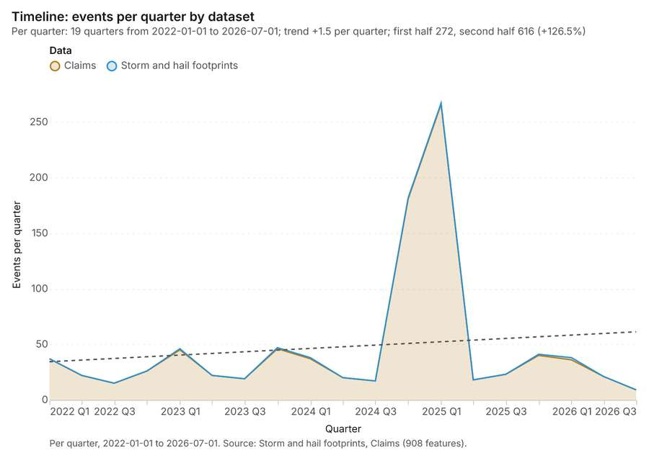
Figure 1. Timeline: events per quarter by dataset [1]. Per quarter, 2022-01-01 to 2026-07-01. Source: Storm and hail footprints, Claims (908 features). The data is in the appendix.
The timeline counts 908 dated events in Storm and hail footprints, Claims per quarter, from Q1 2022 to Q3 2026 [1][2][3]. By dataset: Claims 900; Storm and hail footprints 8 [1]. The trend is +1.5 events per quarter; the second half of the quarters has 616 against 272 in the first (+126.5%) [1].
Busiest quarters
- Q1 2025: 267 events [1]
- Q4 2024: 182 events [1]
- Q4 2023: 47 events [1]
Quietest quarters
- Q3 2026: 9 events [1]
- Q3 2022: 15 events [1]
- Q3 2024: 17 events [1]

Summarize within
What this analysis is. Summarize within: Count and aggregate the features inside each polygon (or bin), proportionally for lines and polygons [4]. In ArcGIS it is Summarize Within or Aggregate Points; in QGIS, native:countpointsinpolygon or native:sumlinelengths [4].
Why it was run on this data. Count Claims inside each feature of Storm and hail footprints by peril; the counts map as a choropleth (natural breaks, sequential colors) [5].
What it found. The analysis utilized the `gp_summarize_within` tool [6]. This process required the inputs Claims [7] and Storm and hail footprints [8].
Result | Value
result, count | 8
result, elapsed ms | 2
billing, cost | 0.02818
billing, list price | 0.02818
billing, upstream cost | 0

Findings
- Evidenced: Summarize within on Claims, Storm and hail footprints: Summarize within: 1 layer saved: Summarize within: Storm and hail footprints (8 features) [6][7][8].
- Evidenced: It reported result, count 8; result, elapsed ms 2; billing, cost 0.02818; billing, list price 0.02818; billing, upstream cost 0 [6].
Tool gp_summarize_within; parameters {"stats": [{"stat": "sum", "field": "paid_aud"}], "project": "45adc477-2b11-425a-ada1-ef48522eb87e", "features": {"layer": "Claims (1572e189)"}, "group_by": "peril", "polygons": {"layer": "Storm and hail footprints (2681856b)"}}

Summarize within
What this analysis is. Summarize within: Count and aggregate the features inside each polygon (or bin), proportionally for lines and polygons [4]. In ArcGIS it is Summarize Within or Aggregate Points; in QGIS, native:countpointsinpolygon or native:sumlinelengths [4].
Why it was run on this data. Count Claims inside each feature of Storm and hail footprints by peril; the counts map as a choropleth (natural breaks, sequential colors) [5].
What it found. Summarize within on River gauges, Storm and hail footprints: Summarize within: 1 layer saved: Summarize within: Storm and hail footprints (8 features) [8][9][10]. It reported result, count 8; result, elapsed ms 0; billing, cost 0.01034; billing, list price 0.01034; billing, upstream cost 0 [9].
Result | Value
result, count | 8
result, elapsed ms | 0
billing, cost | 0.01034
billing, list price | 0.01034
billing, upstream cost | 0

Findings
- Evidenced: Summarize within on River gauges, Storm and hail footprints: Summarize within: 1 layer saved: Summarize within: Storm and hail footprints (8 features) [8][9][10].
- Evidenced: It reported result, count 8; result, elapsed ms 0; billing, cost 0.01034; billing, list price 0.01034; billing, upstream cost 0 [9].
Tool gp_summarize_within; parameters {"stats": [{"stat": "sum", "field": "minor_flood_m"}], "project": "45adc477-2b11-425a-ada1-ef48522eb87e", "features": {"layer": "River gauges (af5a84eb)"}, "polygons": {"layer": "Storm and hail footprints (2681856b)"}}

Hot spots
What this analysis is. Hot spot analysis: Getis-Ord Gi* hot and cold spots with z-scores, p-values and confidence bins [11]. In ArcGIS it is Find Hot Spots or Hot Spot Analysis (Getis-Ord Gi*); in QGIS, qgis:hotspot (plugin) [11].
Why it was run on this data. 900 points: Getis-Ord Gi* tests whether the concentrations in Claims are statistically significant [12].
What it found. The hot spot analysis was executed using Claims data as the input [7]. The tool saved one layer containing 207 features as results [13]. The analysis was run using a distance band of 500 m and utilized 900 incidents [13].
Result | Value
result, bins | 207
result, count | 207
result, elapsed ms | 13
result, cell size m | 500
result, incidents used | 900
result, distance band m | 500
billing, cost | 0.068
billing, list price | 0.068
billing, upstream cost | 0

Findings
- Evidenced: Hot spots on Claims: Hot spot analysis: 1 layer saved: Hot spot analysis: Claims (207 features) [7][13].
- Evidenced: It reported result, bins 207; result, count 207; result, elapsed ms 13; result, cell size m 500; result, incidents used 900; result, distance band m 500 [13].
Tool gp_hot_spots; parameters {"project": "45adc477-2b11-425a-ada1-ef48522eb87e", "features": {"layer": "Claims (1572e189)"}, "aggregation": "hexagon", "cell_size_m": 500.0, "distance_band_m": 500.0}

Hot spots
What this analysis is. Hot spot analysis: Getis-Ord Gi* hot and cold spots with z-scores, p-values and confidence bins [11]. In ArcGIS it is Find Hot Spots or Hot Spot Analysis (Getis-Ord Gi*); in QGIS, qgis:hotspot (plugin) [11].
Why it was run on this data. 1400 points: Getis-Ord Gi* tests whether the concentrations in Insured properties are statistically significant [14].
What it found. Hot spots on Insured properties: Hot spot analysis: 1 layer saved: Hot spot analysis: Insured properties (208 features) [15][16]. It reported result, bins 208; result, count 208; result, elapsed ms 14; result, cell size m 500; result, incidents used 1,400; result, distance band m 500 [15].
Result | Value
result, bins | 208
result, count | 208
result, elapsed ms | 14
result, cell size m | 500
result, incidents used | 1,400
result, distance band m | 500
billing, cost | 0.078
billing, list price | 0.078
billing, upstream cost | 0

Findings
- Evidenced: Hot spots on Insured properties: Hot spot analysis: 1 layer saved: Hot spot analysis: Insured properties (208 features) [15][16].
- Evidenced: It reported result, bins 208; result, count 208; result, elapsed ms 14; result, cell size m 500; result, incidents used 1,400; result, distance band m 500 [15].
Tool gp_hot_spots; parameters {"project": "45adc477-2b11-425a-ada1-ef48522eb87e", "features": {"layer": "Insured properties (7fe53ce9)"}, "aggregation": "hexagon", "cell_size_m": 500.0, "distance_band_m": 500.0}

Hot spots
What this analysis is. Hot spot analysis: Getis-Ord Gi* hot and cold spots with z-scores, p-values and confidence bins [11]. In ArcGIS it is Find Hot Spots or Hot Spot Analysis (Getis-Ord Gi*); in QGIS, qgis:hotspot (plugin) [11].
Why it was run on this data. Gi* hot spots of 'max_hail_mm' across the areas [17].
What it found. The hot spot analysis tool was applied using the Storm and hail footprints layer as input [18]. The process saved one layer, titled Hot spot analysis: Storm and hail footprints [18]. This analysis yielded a total of 8 features [18], completing the task in 1 elapsed ms [18].
Result | Value
result, count | 8
result, elapsed ms | 1
result, excluded null | 0
result, distance band m | 2,528
billing, cost | 0.05016
billing, list price | 0.05016
billing, upstream cost | 0

Findings
- Evidenced: Hot spots on Storm and hail footprints: Hot spot analysis: 1 layer saved: Hot spot analysis: Storm and hail footprints (8 features) [8][18].
- Evidenced: It reported result, count 8; result, elapsed ms 1; result, excluded null 0; result, distance band m 2,528; billing, cost 0.05016; billing, list price 0.05016 [18].
Tool gp_hot_spots; parameters {"field": "max_hail_mm", "project": "45adc477-2b11-425a-ada1-ef48522eb87e", "features": {"layer": "Storm and hail footprints (2681856b)"}}

Space time hot spots
What this analysis is. Emerging hot spots: Where hot spots are new, consecutive, intensifying, persistent, diminishing, sporadic, oscillating or historical over time [19]. In ArcGIS it is Emerging Hot Spot Analysis or Create Space Time Cube [19].
Why it was run on this data. Claims carry dates in 'reported_at': emerging hot spot analysis finds new, intensifying and fading hot spots per month [20].
What it found. The analysis used the Claims layer as its input [7]. The `gp_space_time_hot_spots` tool successfully saved 68 features into the Emerging hot spots: Claims layer [21]. This operation processed 900 features and was completed in 15 milliseconds [21]. Furthermore, the resulting cost for this analysis was 0.145, which matched the list price [21].
Result | Value
result, count | 68
result, elapsed ms | 15
result, resolution | 8
result, features used | 900
result, time neighbors | 0
billing, cost | 0.145
billing, list price | 0.145
billing, upstream cost | 0

Findings
- Evidenced: Space time hot spots on Claims: Emerging hot spots: 1 layer saved: Emerging hot spots: Claims (68 features) [7][21].
- Evidenced: It reported result, count 68; result, elapsed ms 15; result, resolution 8; result, features used 900; result, time neighbors 0; billing, cost 0.145 [21].
Tool gp_space_time_hot_spots; parameters {"project": "45adc477-2b11-425a-ada1-ef48522eb87e", "features": {"layer": "Claims (1572e189)"}, "interval": "month", "bin_shape": "h3", "resolution": 8, "time_field": "reported_at"}

Near repeat
What this analysis is. Repeat and near repeat classification: Classify incidents as originators, repeats (same place) or near repeats within a distance and time window, with a Knox test table [22]. In ArcGIS it is Repeat and Near Repeat Classification or Near Repeat Calculator [22].
Why it was run on this data. Near repeat analysis tests whether Claims close in space also follow each other within 30 days [23].
What it found. Near repeat on Claims: Repeat and near repeat classification: 1 layer saved: Repeat and near repeat classification: Claims (900 features) [7][24]. It reported result, days 30; result, count 900; result, chains 83; result, distance m 200; result, elapsed ms 22; result, pairs linked 1,571 [24].
Result | Value
result, days | 30
result, count | 900
result, chains | 83
result, distance m | 200
result, elapsed ms | 22
result, pairs linked | 1,571
billing, cost | 0.077
billing, list price | 0.077
billing, upstream cost | 0

Findings
- Evidenced: Near repeat on Claims: Repeat and near repeat classification: 1 layer saved: Repeat and near repeat classification: Claims (900 features) [7][24].
- Evidenced: It reported result, days 30; result, count 900; result, chains 83; result, distance m 200; result, elapsed ms 22; result, pairs linked 1,571 [24].
Tool gp_near_repeat; parameters {"days": 30, "project": "45adc477-2b11-425a-ada1-ef48522eb87e", "features": {"layer": "Claims (1572e189)"}, "distance_m": 200.0, "time_field": "reported_at"}

Calculate density
What this analysis is. Calculate density: Kernel density per square kilometer on a grid [25]. In ArcGIS it is Calculate Density or Kernel Density; in QGIS, native:heatmapkerneldensityestimation [25].
Why it was run on this data. 900 points in Claims: a density surface shows where they concentrate [26].
What it found. Calculate density on Claims: Calculate density: 1 layer saved: Calculate density: Claims (1334 features) [7][27]. It reported result, count 1,334; result, elapsed ms 36; result, bandwidth m 500; result, cell size m 200; result, excluded null 0; result, max density per km2 303.9 [27].
Result | Value
result, count | 1,334
result, elapsed ms | 36
result, bandwidth m | 500
result, cell size m | 200
result, excluded null | 0
result, max density per km2 | 303.9
billing, cost | 0.068
billing, list price | 0.068
billing, upstream cost | 0

Findings
- Evidenced: Calculate density on Claims: Calculate density: 1 layer saved: Calculate density: Claims (1334 features) [7][27].
- Evidenced: It reported result, count 1,334; result, elapsed ms 36; result, bandwidth m 500; result, cell size m 200; result, excluded null 0; result, max density per km2 303.9 [27].
Tool gp_calculate_density; parameters {"kernel": "quartic", "project": "45adc477-2b11-425a-ada1-ef48522eb87e", "features": {"layer": "Claims (1572e189)"}, "bandwidth_m": 500.0, "cell_size_m": 200.0}

Calculate density
What this analysis is. Calculate density: Kernel density per square kilometer on a grid [25]. In ArcGIS it is Calculate Density or Kernel Density; in QGIS, native:heatmapkerneldensityestimation [25].
Why it was run on this data. 1400 points in Insured properties: a density surface shows where they concentrate [28].
What it found. Calculate density on Insured properties: Calculate density: 1 layer saved: Calculate density: Insured properties (1421 features) [16][29]. It reported result, count 1,421; result, elapsed ms 40; result, bandwidth m 500; result, cell size m 200; result, excluded null 0; result, max density per km2 383.9 [29].
Result | Value
result, count | 1,421
result, elapsed ms | 40
result, bandwidth m | 500
result, cell size m | 200
result, excluded null | 0
result, max density per km2 | 383.9
billing, cost | 0.078
billing, list price | 0.078
billing, upstream cost | 0

Findings
- Evidenced: Calculate density on Insured properties: Calculate density: 1 layer saved: Calculate density: Insured properties (1421 features) [16][29].
- Evidenced: It reported result, count 1,421; result, elapsed ms 40; result, bandwidth m 500; result, cell size m 200; result, excluded null 0; result, max density per km2 383.9 [29].
Tool gp_calculate_density; parameters {"kernel": "quartic", "project": "45adc477-2b11-425a-ada1-ef48522eb87e", "features": {"layer": "Insured properties (7fe53ce9)"}, "bandwidth_m": 500.0, "cell_size_m": 200.0}

Find point clusters
What this analysis is. Find point clusters: Density-based clusters (DBSCAN, HDBSCAN or OPTICS, optionally space-time) with hulls and noise [30]. In ArcGIS it is Find Point Clusters or Density-based Clustering; in QGIS, native:dbscanclustering or native:stdbscanclustering [30].
Why it was run on this data. DBSCAN finds dense groups of Claims and separates noise [31].
What it found. Find point clusters on Claims: Find point clusters: 2 layers saved: Find point clusters: Claims (900 features); Find point clusters: cluster hulls (2 features) [7][32]. It reported result, count 900; result, noise 659; result, distance m 200; result, elapsed ms 15; result, min points 20; billing, cost 0.068 [32].
Result | Value
result, count | 900
result, noise | 659
result, distance m | 200
result, elapsed ms | 15
result, min points | 20
billing, cost | 0.068
billing, list price | 0.068
billing, upstream cost | 0

Findings
- Evidenced: Find point clusters on Claims: Find point clusters: 2 layers saved: Find point clusters: Claims (900 features); Find point clusters: cluster hulls (2 features) [7][32].
- Evidenced: It reported result, count 900; result, noise 659; result, distance m 200; result, elapsed ms 15; result, min points 20; billing, cost 0.068 [32].
Tool gp_find_point_clusters; parameters {"method": "dbscan", "project": "45adc477-2b11-425a-ada1-ef48522eb87e", "features": {"layer": "Claims (1572e189)"}, "distance_m": 200.0, "min_points": 20}

Find point clusters
What this analysis is. Find point clusters: Density-based clusters (DBSCAN, HDBSCAN or OPTICS, optionally space-time) with hulls and noise [30]. In ArcGIS it is Find Point Clusters or Density-based Clustering; in QGIS, native:dbscanclustering or native:stdbscanclustering [30].
Why it was run on this data. DBSCAN finds dense groups of Insured properties and separates noise [33].
What it found. Find point clusters on Insured properties: Find point clusters: 2 layers saved: Find point clusters: Insured properties (1400 features); Find point clusters: cluster hulls (1 feature) [16][34]. It reported result, count 1,400; result, noise 1,134; result, distance m 200; result, elapsed ms 17; result, min points 20; billing, cost 0.078 [34].
Result | Value
result, count | 1,400
result, noise | 1,134
result, distance m | 200
result, elapsed ms | 17
result, min points | 20
billing, cost | 0.078
billing, list price | 0.078
billing, upstream cost | 0

Findings
- Evidenced: Find point clusters on Insured properties: Find point clusters: 2 layers saved: Find point clusters: Insured properties (1400 features); Find point clusters: cluster hulls (1 feature) [16][34].
- Evidenced: It reported result, count 1,400; result, noise 1,134; result, distance m 200; result, elapsed ms 17; result, min points 20; billing, cost 0.078 [34].
Tool gp_find_point_clusters; parameters {"method": "dbscan", "project": "45adc477-2b11-425a-ada1-ef48522eb87e", "features": {"layer": "Insured properties (7fe53ce9)"}, "distance_m": 200.0, "min_points": 20}

Outliers
What this analysis is. Find outliers: Anselin local Moran’s I: HH, LL clusters and HL, LH outliers [35]. In ArcGIS it is Find Outliers or Cluster and Outlier Analysis (Anselin Local Moran’s I) [35].
Why it was run on this data. Local Moran's I maps clusters and outliers of 'max_hail_mm' [36].
What it found. Outliers on Storm and hail footprints: Find outliers: 1 layer saved: Find outliers: Storm and hail footprints (8 features) [8][37]. It reported result, count 8; result, elapsed ms 4; result, permutations 199; result, excluded null 0; result, distance band m 2,528; billing, cost 0.05024 [37].
Result | Value
result, count | 8
result, elapsed ms | 4
result, permutations | 199
result, excluded null | 0
result, distance band m | 2,528
billing, cost | 0.05024
billing, list price | 0.05024
billing, upstream cost | 0

Findings
- Evidenced: Outliers on Storm and hail footprints: Find outliers: 1 layer saved: Find outliers: Storm and hail footprints (8 features) [8][37].
- Evidenced: It reported result, count 8; result, elapsed ms 4; result, permutations 199; result, excluded null 0; result, distance band m 2,528; billing, cost 0.05024 [37].
Tool gp_outliers; parameters {"field": "max_hail_mm", "project": "45adc477-2b11-425a-ada1-ef48522eb87e", "features": {"layer": "Storm and hail footprints (2681856b)"}, "aggregation": "hexagon"}

Outliers
What this analysis is. Find outliers: Anselin local Moran’s I: HH, LL clusters and HL, LH outliers [35]. In ArcGIS it is Find Outliers or Cluster and Outlier Analysis (Anselin Local Moran’s I) [35].
Why it was run on this data. Local Moran's I maps clusters and outliers of 'households' [38].
What it found. Outliers on Suburbs: Find outliers: 1 layer saved: Find outliers: Suburbs (14 features) [39][40]. It reported result, count 14; result, elapsed ms 1; result, permutations 199; result, excluded null 0; result, distance band m 1,936; billing, cost 0.05042 [39].
Result | Value
result, count | 14
result, elapsed ms | 1
result, permutations | 199
result, excluded null | 0
result, distance band m | 1,936
billing, cost | 0.05042
billing, list price | 0.05042
billing, upstream cost | 0

Findings
- Evidenced: Outliers on Suburbs: Find outliers: 1 layer saved: Find outliers: Suburbs (14 features) [39][40].
- Evidenced: It reported result, count 14; result, elapsed ms 1; result, permutations 199; result, excluded null 0; result, distance band m 1,936; billing, cost 0.05042 [39].
Tool gp_outliers; parameters {"field": "households", "project": "45adc477-2b11-425a-ada1-ef48522eb87e", "features": {"layer": "Suburbs (fb82f048)"}, "aggregation": "hexagon"}

Summarize within
What this analysis is. Summarize within: Count and aggregate the features inside each polygon (or bin), proportionally for lines and polygons [4]. In ArcGIS it is Summarize Within or Aggregate Points; in QGIS, native:countpointsinpolygon or native:sumlinelengths [4].
Why it was run on this data. Count Insured properties inside each feature of Storm and hail footprints by occupancy; the counts map as a choropleth (natural breaks, sequential colors) [41].
What it found. Summarize within on Insured properties, Storm and hail footprints: Summarize within: 1 layer saved: Summarize within: Storm and hail footprints (8 features) [8][16][42]. It reported result, count 8; result, elapsed ms 2; billing, cost 0.03818; billing, list price 0.03818; billing, upstream cost 0 [42].
Result | Value
result, count | 8
result, elapsed ms | 2
billing, cost | 0.03818
billing, list price | 0.03818
billing, upstream cost | 0

Findings
- Evidenced: Summarize within on Insured properties, Storm and hail footprints: Summarize within: 1 layer saved: Summarize within: Storm and hail footprints (8 features) [8][16][42].
- Evidenced: It reported result, count 8; result, elapsed ms 2; billing, cost 0.03818; billing, list price 0.03818; billing, upstream cost 0 [42].
Tool gp_summarize_within; parameters {"stats": [{"stat": "sum", "field": "sum_insured_aud"}], "project": "45adc477-2b11-425a-ada1-ef48522eb87e", "features": {"layer": "Insured properties (7fe53ce9)"}, "group_by": "occupancy", "polygons": {"layer": "Storm and hail footprints (2681856b)"}}

Maps and charts
The run also made 19 map image(s) [43][44][45][46][47][48][49][50][51][52][53][54][55][56][57][58][59][60][61] and 27 chart(s) [62][63][64][65][66][67][68][69][70][71][72][73][74][75][76][77][78][79][80][81][82][83][84][85][86][87][88].
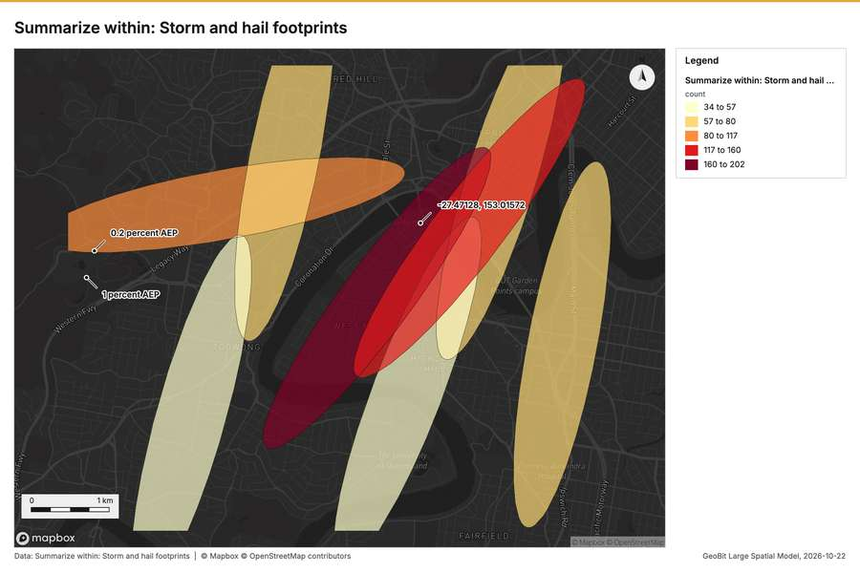
Figure 2. Summarize within: Storm and hail footprints [43]
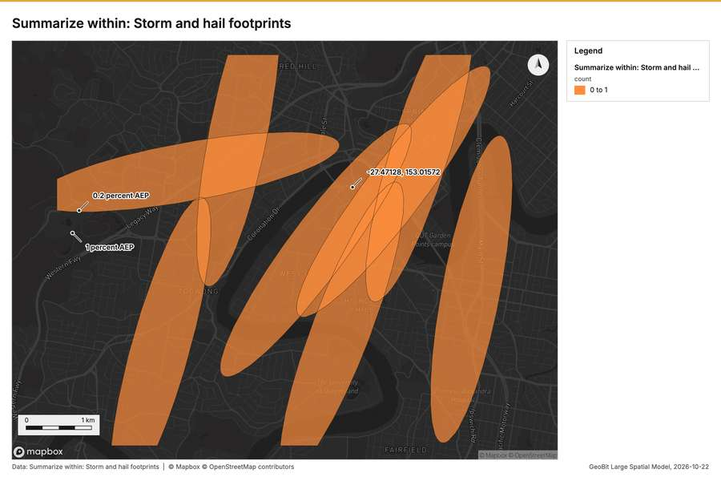
Figure 3. Summarize within: Storm and hail footprints [44]
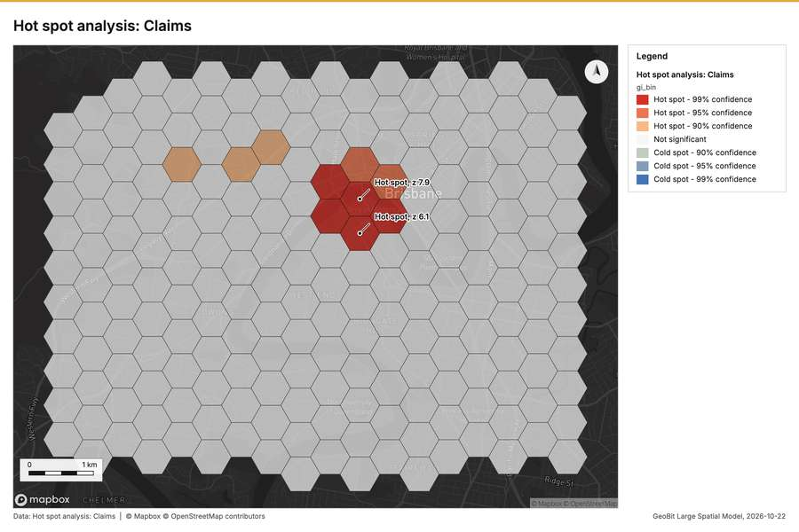
Figure 4. Hot spot analysis: Claims [45]
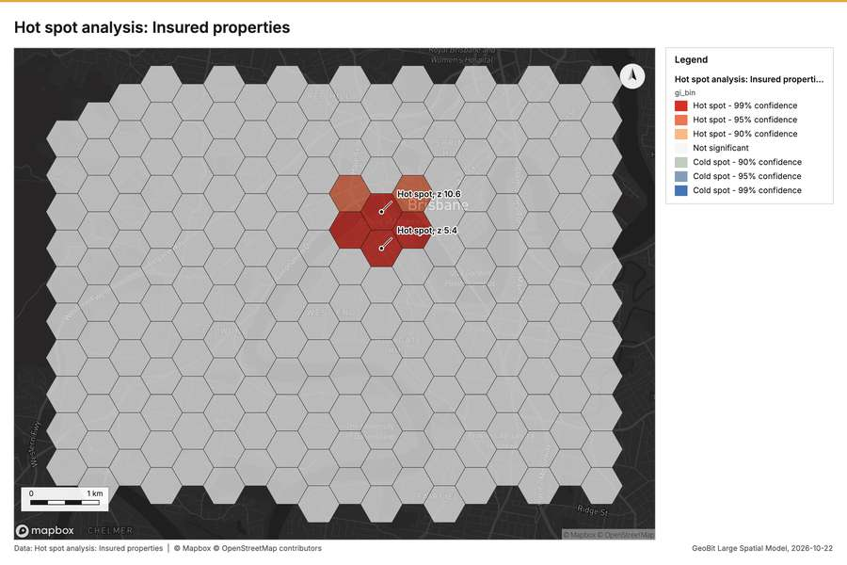
Figure 5. Hot spot analysis: Insured properties [46]
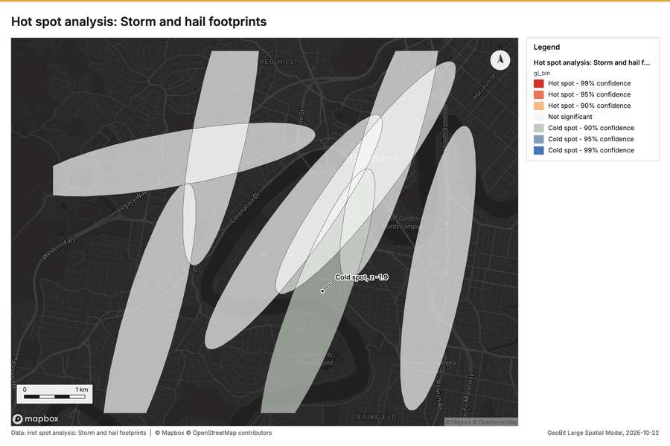
Figure 6. Hot spot analysis: Storm and hail footprints [47]
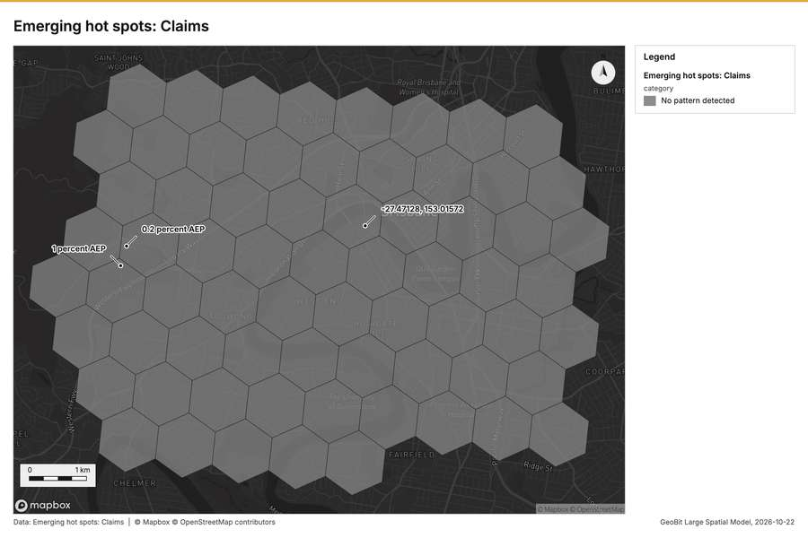
Figure 7. Emerging hot spots: Claims [48]
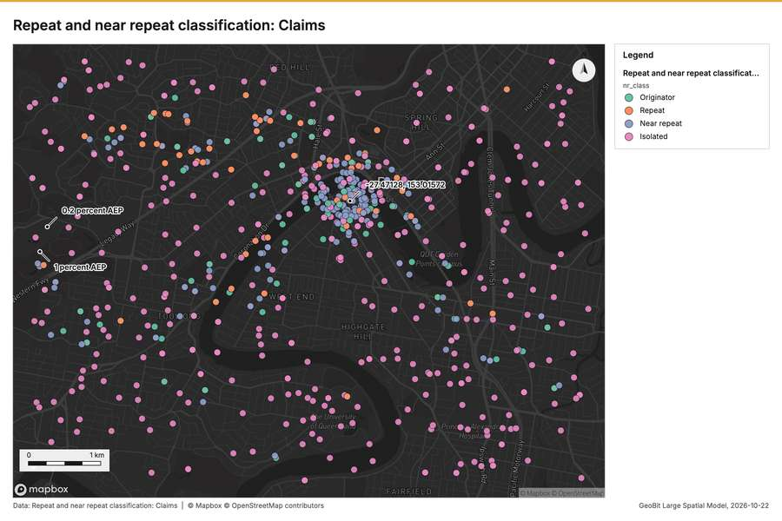
Figure 8. Repeat and near repeat classification: Claims [49]
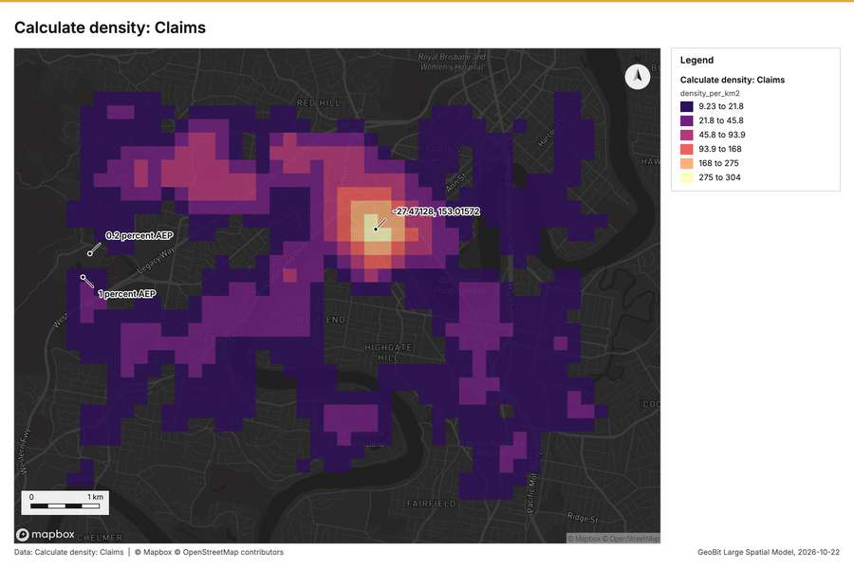
Figure 9. Calculate density: Claims [50]
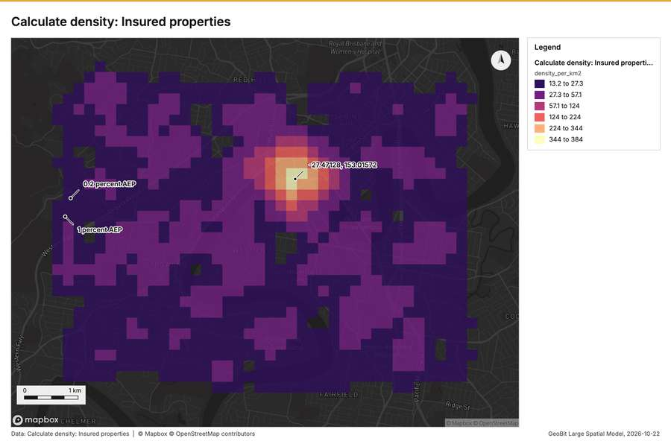
Figure 10. Calculate density: Insured properties [51]
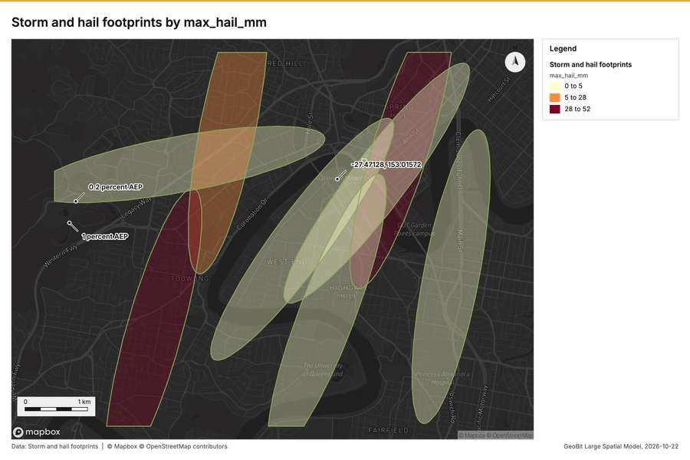
Figure 11. Storm and hail footprints by max_hail_mm [52]
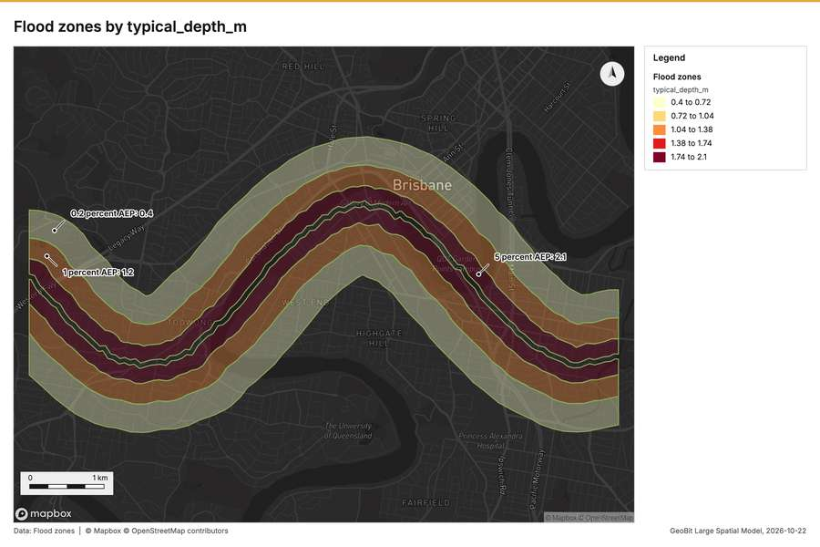
Figure 12. Flood zones by typical_depth_m [53]
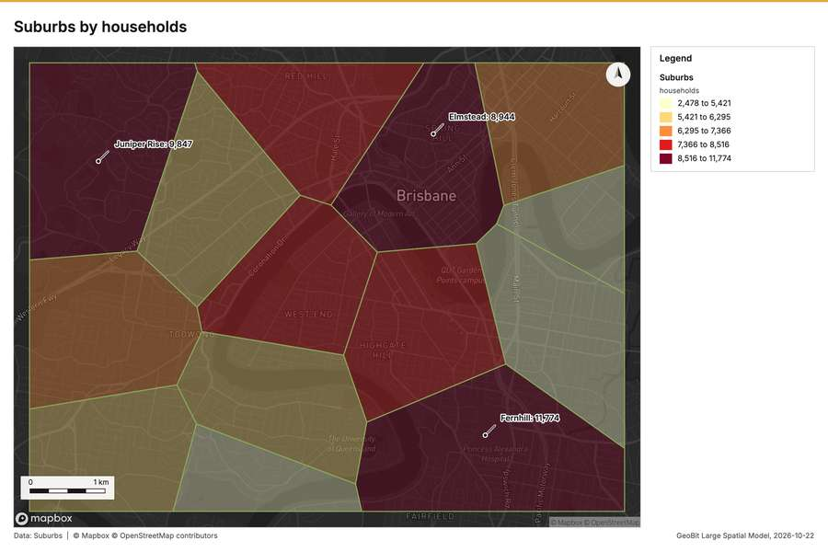
Figure 13. Suburbs by households [54]
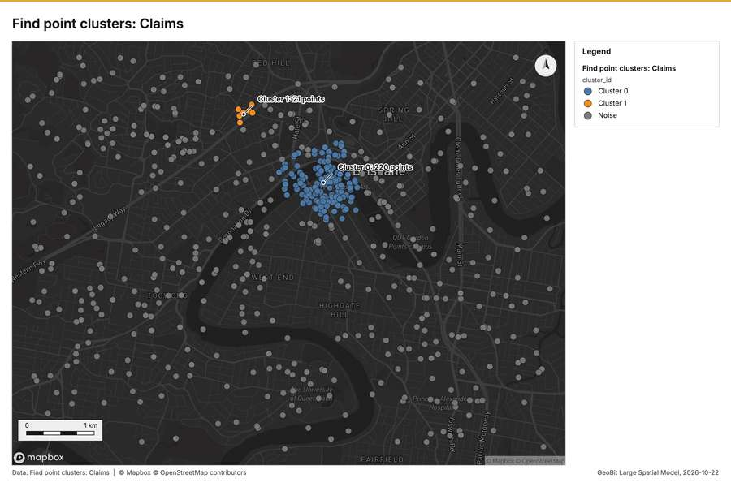
Figure 14. Find point clusters: Claims [55]
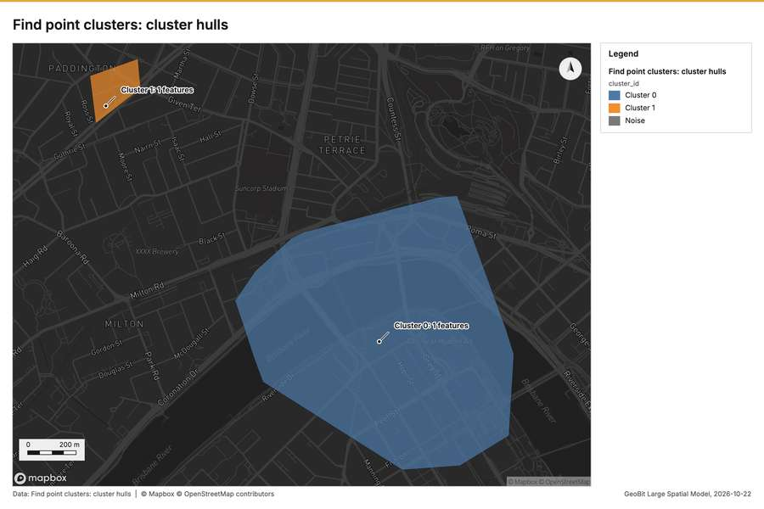
Figure 15. Find point clusters: cluster hulls [56]
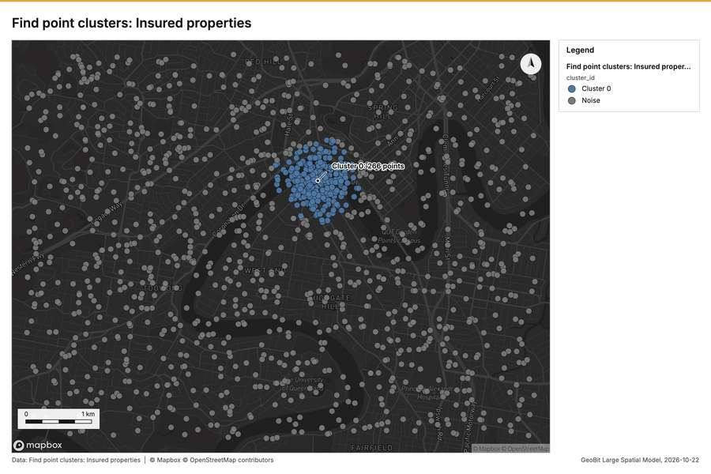
Figure 16. Find point clusters: Insured properties [57]
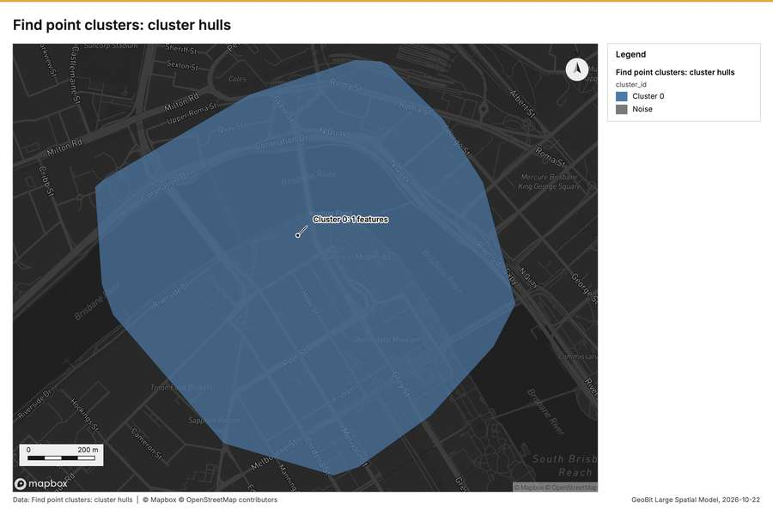
Figure 17. Find point clusters: cluster hulls [58]
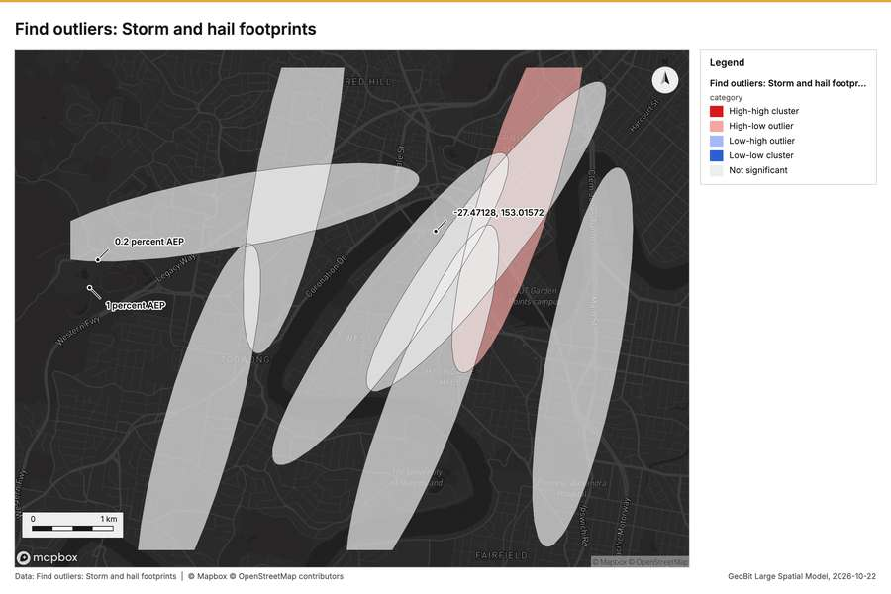
Figure 18. Find outliers: Storm and hail footprints [59]
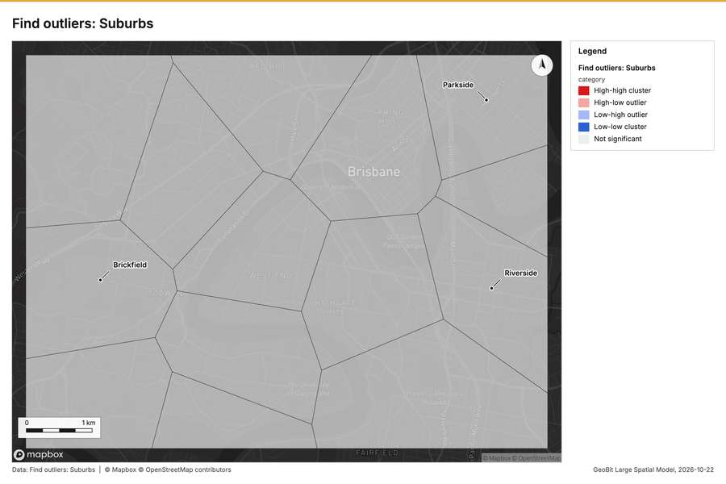
Figure 19. Find outliers: Suburbs [60]
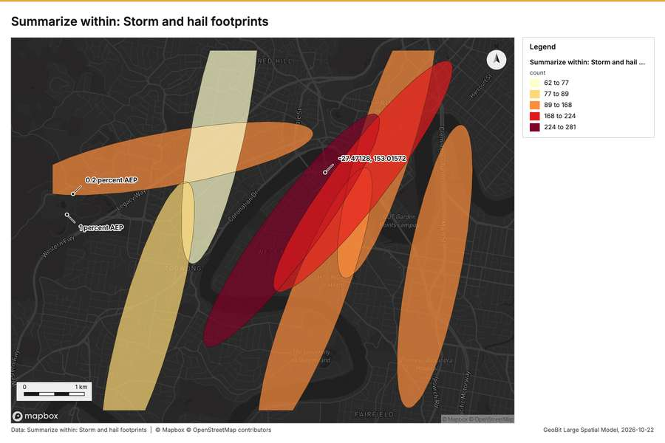
Figure 20. Summarize within: Storm and hail footprints [61]
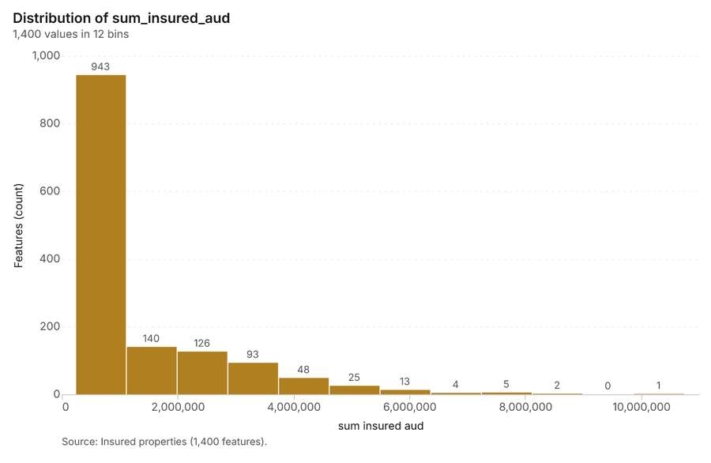
Figure 21. Insured properties over time (year_built) [62]. Source: Insured properties (1,400 features). The data is in the appendix.
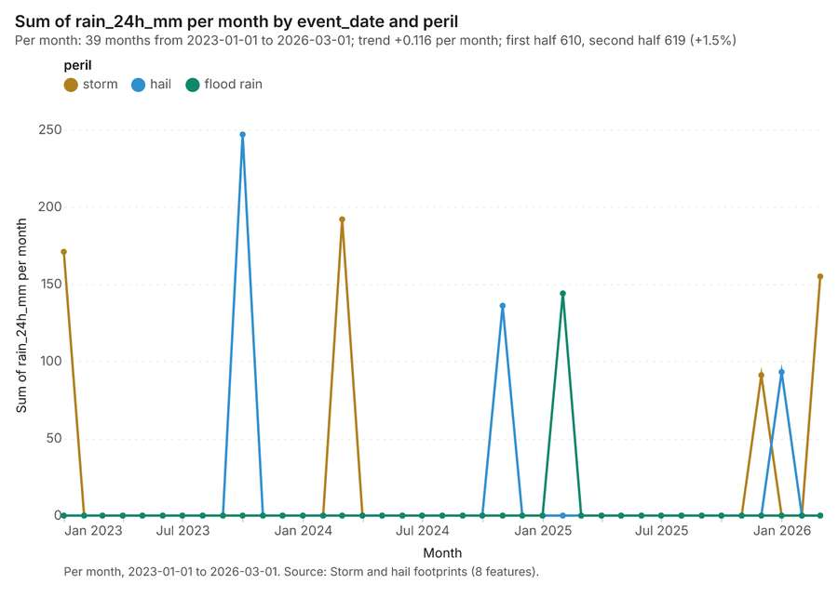
Figure 22. Storm and hail footprints over time (event_date) [63]. Per month, 2023-01-01 to 2026-03-01. Source: Storm and hail footprints (8 features). The data is in the appendix.
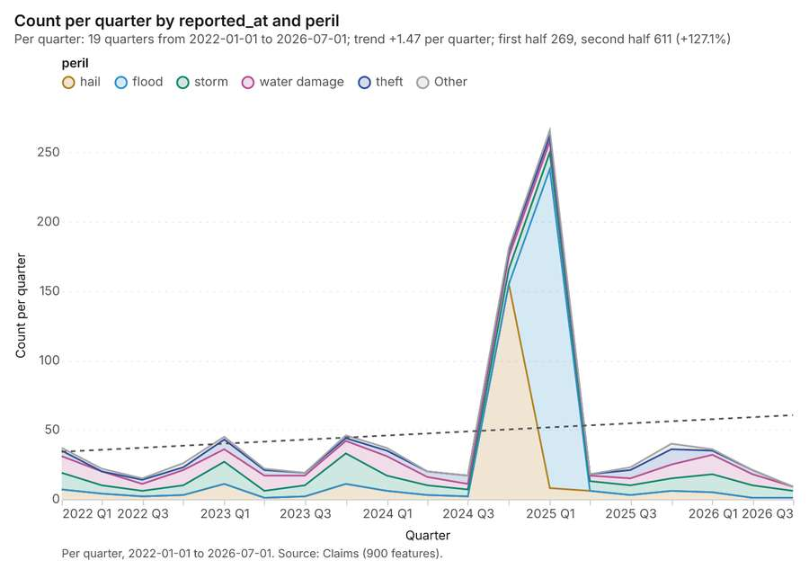
Figure 23. Claims over time (reported_at) [64]. Per quarter, 2022-01-01 to 2026-07-01. Source: Claims (900 features). The data is in the appendix.
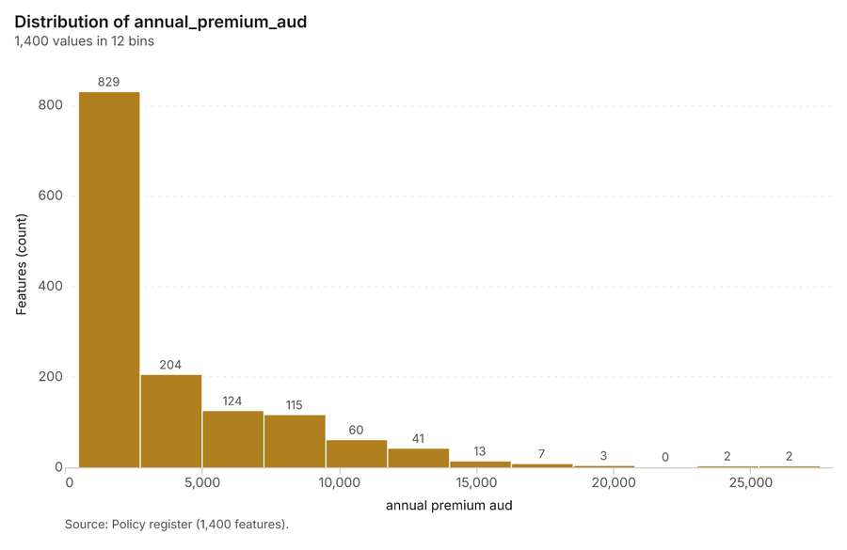
Figure 24. Policy register over time (renewal_month) [65]. Source: Policy register (1,400 features). The data is in the appendix.
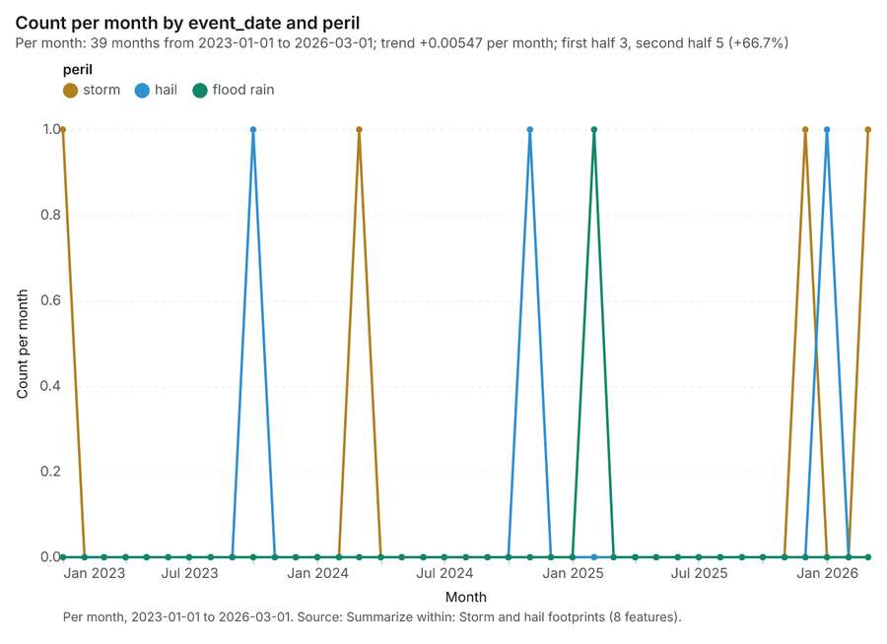
Figure 25. Summarize within: Storm and hail footprints [66]. Per month, 2023-01-01 to 2026-03-01. Source: Summarize within: Storm and hail footprints (8 features). The data is in the appendix.
Figure 26. Summarize within: Storm and hail footprints [67]. Per month, 2023-01-01 to 2026-03-01. Source: Summarize within: Storm and hail footprints (8 features). The data is in the appendix.
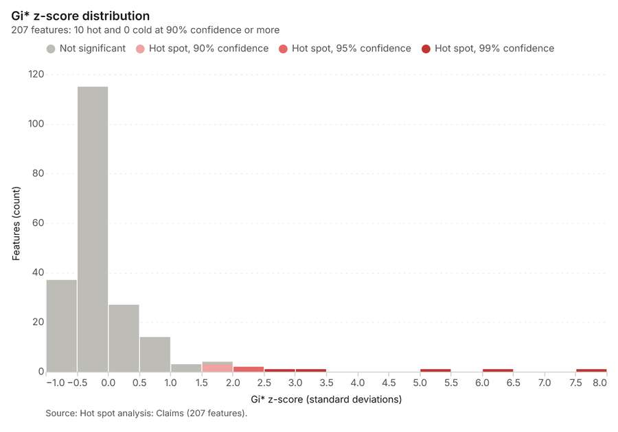
Figure 27. Hot spot analysis: Claims [68]. Source: Hot spot analysis: Claims (207 features). The data is in the appendix.
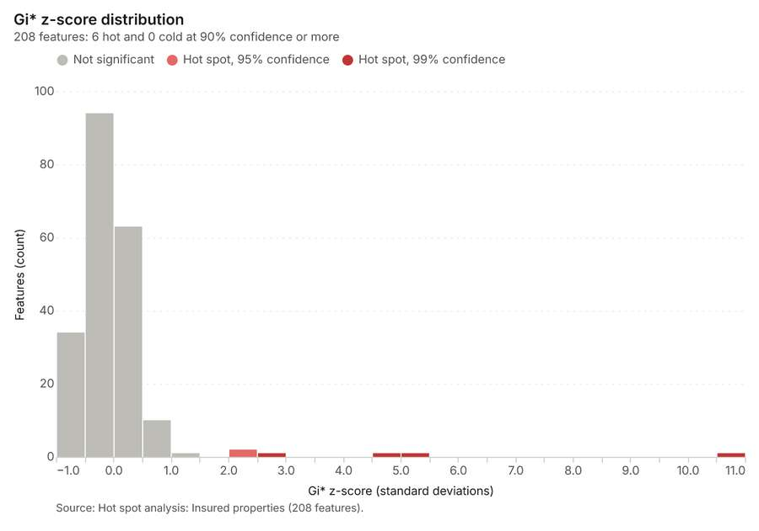
Figure 28. Hot spot analysis: Insured properties [69]. Source: Hot spot analysis: Insured properties (208 features). The data is in the appendix.
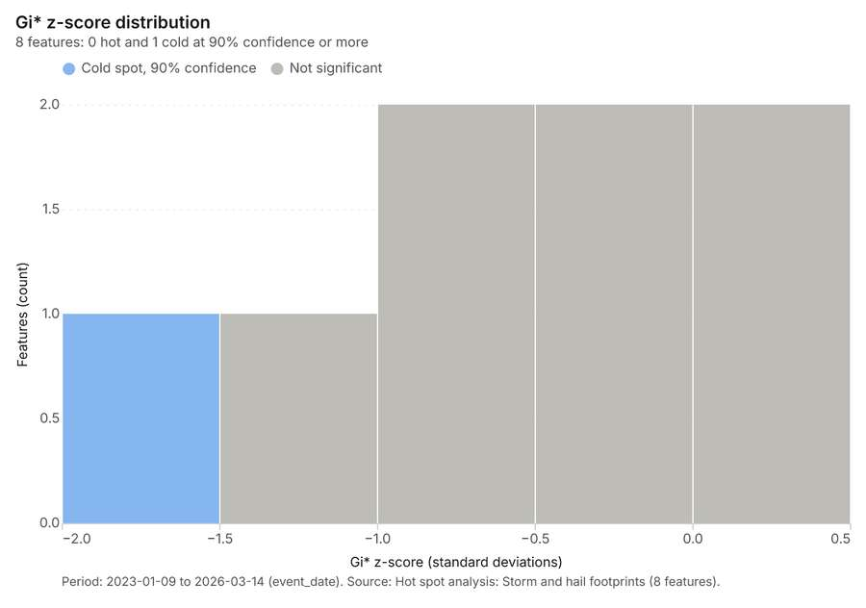
Figure 29. Hot spot analysis: Storm and hail footprints [70]. Period: 2023-01-09 to 2026-03-14 (event_date). Source: Hot spot analysis: Storm and hail footprints (8 features). The data is in the appendix.
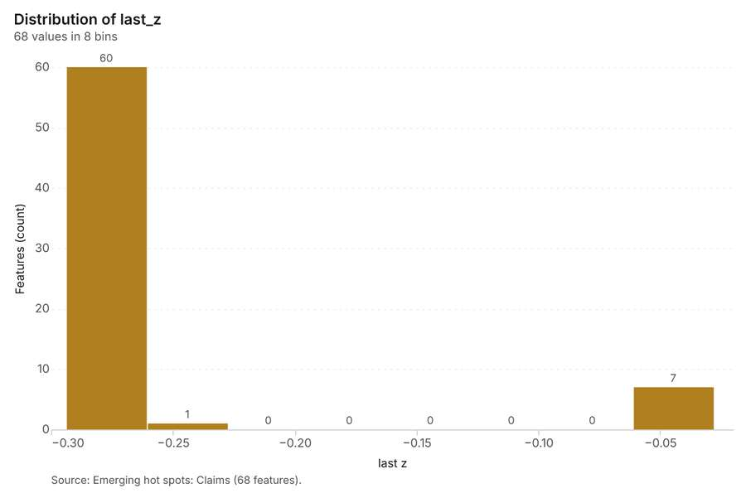
Figure 30. Emerging hot spots: Claims [71]. Source: Emerging hot spots: Claims (68 features). The data is in the appendix.
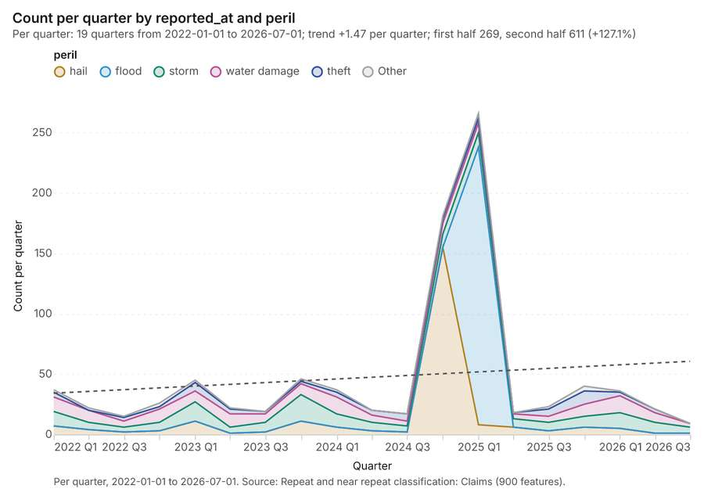
Figure 31. Repeat and near repeat classification: Claims [72]. Per quarter, 2022-01-01 to 2026-07-01. Source: Repeat and near repeat classification: Claims (900 features). The data is in the appendix.
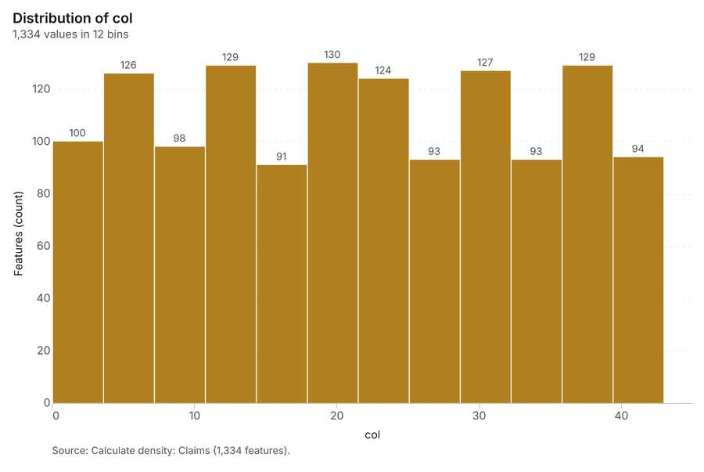
Figure 32. Calculate density: Claims [73]. Source: Calculate density: Claims (1,334 features). The data is in the appendix.
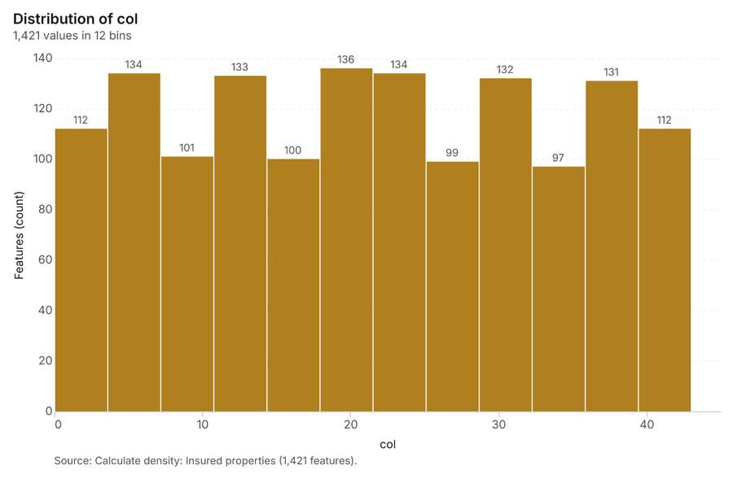
Figure 33. Calculate density: Insured properties [74]. Source: Calculate density: Insured properties (1,421 features). The data is in the appendix.
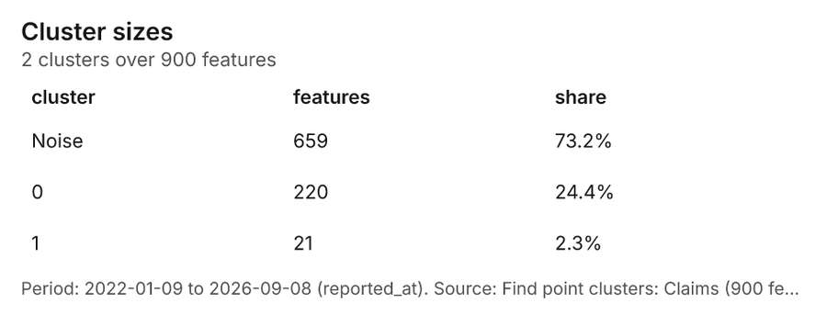
Figure 34. Find point clusters: Claims [75]. Period: 2022-01-09 to 2026-09-08 (reported_at). Source: Find point clusters: Claims (900 features). The data is in the appendix.
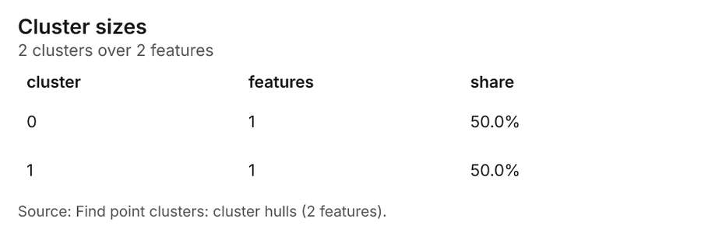
Figure 35. Find point clusters: cluster hulls [76]. Source: Find point clusters: cluster hulls (2 features). The data is in the appendix.
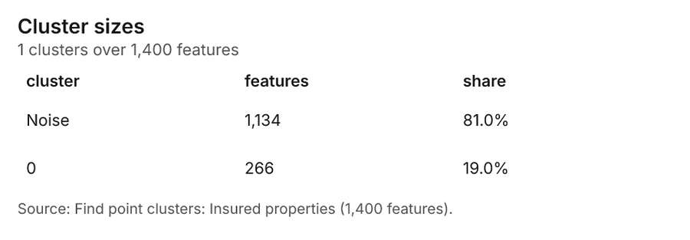
Figure 36. Find point clusters: Insured properties [77]. Source: Find point clusters: Insured properties (1,400 features). The data is in the appendix.
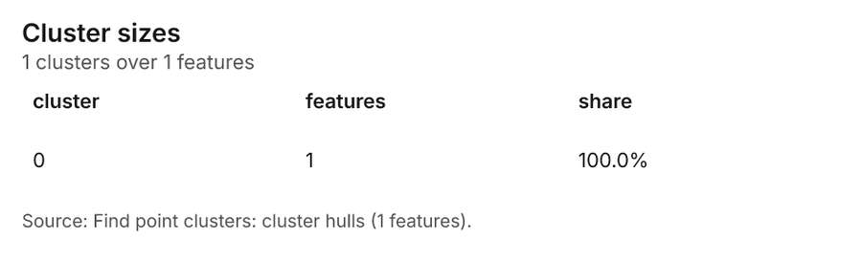
Figure 37. Find point clusters: cluster hulls [78]. Source: Find point clusters: cluster hulls (1 features). The data is in the appendix.
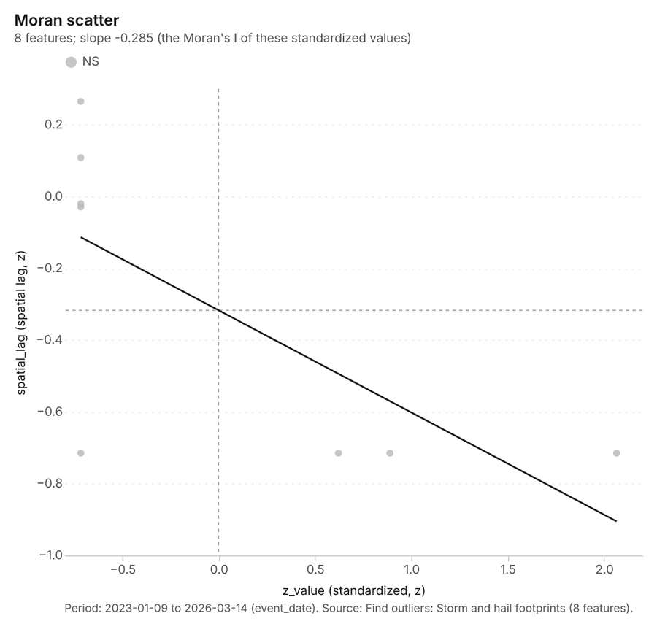
Figure 38. Find outliers: Storm and hail footprints [79]. Period: 2023-01-09 to 2026-03-14 (event_date). Source: Find outliers: Storm and hail footprints (8 features). The data is in the appendix.
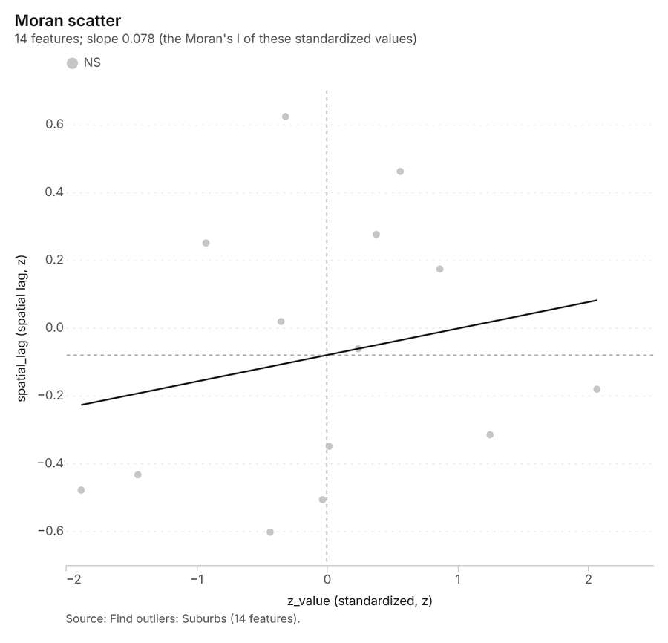
Figure 39. Find outliers: Suburbs [80]. Source: Find outliers: Suburbs (14 features). The data is in the appendix.
Figure 40. Summarize within: Storm and hail footprints [81]. Per month, 2023-01-01 to 2026-03-01. Source: Summarize within: Storm and hail footprints (8 features). The data is in the appendix.
Figure 41. Summarize within: Storm and hail footprints over time [82]. Per month, 2023-01-01 to 2026-03-01. Source: Summarize within: Storm and hail footprints (8 features). The data is in the appendix.
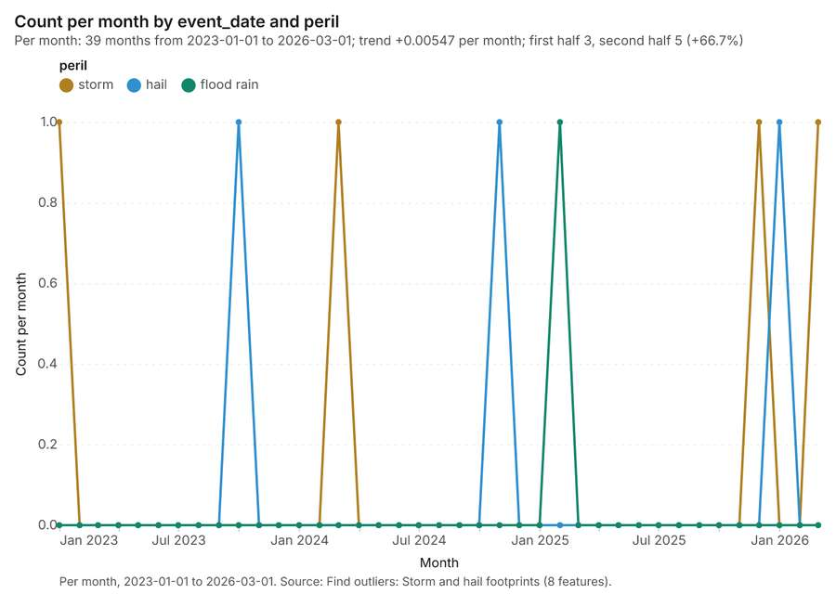
Figure 42. Find outliers: Storm and hail footprints over time [83]. Per month, 2023-01-01 to 2026-03-01. Source: Find outliers: Storm and hail footprints (8 features). The data is in the appendix.
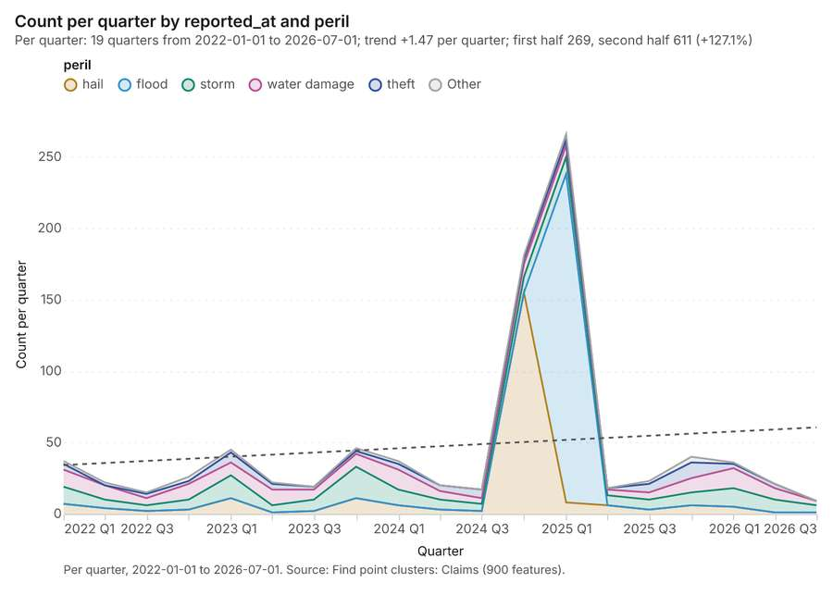
Figure 43. Find point clusters: Claims over time [84]. Per quarter, 2022-01-01 to 2026-07-01. Source: Find point clusters: Claims (900 features). The data is in the appendix.
Figure 44. Repeat and near repeat classification: Claims over time [85]. Per quarter, 2022-01-01 to 2026-07-01. Source: Repeat and near repeat classification: Claims (900 features). The data is in the appendix.
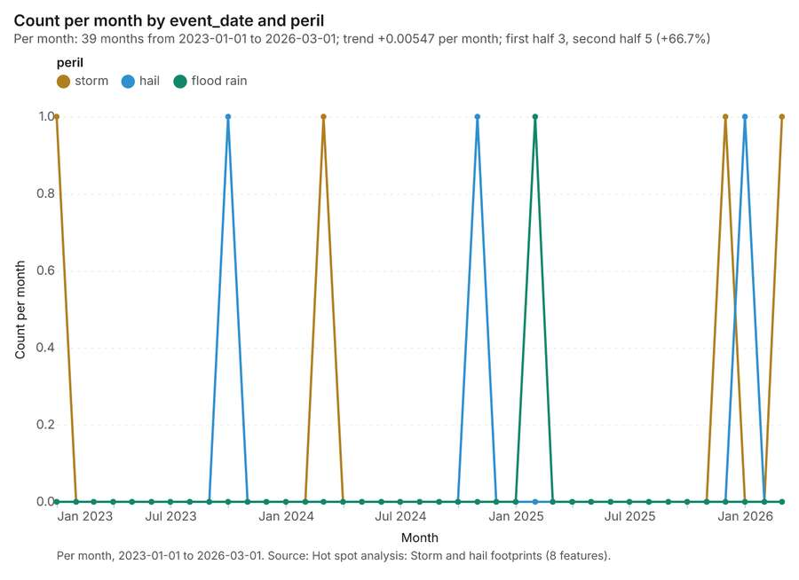
Figure 45. Hot spot analysis: Storm and hail footprints over time [86]. Per month, 2023-01-01 to 2026-03-01. Source: Hot spot analysis: Storm and hail footprints (8 features). The data is in the appendix.
Figure 46. Summarize within: Storm and hail footprints over time [87]. Per month, 2023-01-01 to 2026-03-01. Source: Summarize within: Storm and hail footprints (8 features). The data is in the appendix.
Figure 47. Summarize within: Storm and hail footprints over time [88]. Per month, 2023-01-01 to 2026-03-01. Source: Summarize within: Storm and hail footprints (8 features). The data is in the appendix.

Changes since the last run
This is the first report of this project.

Sources
[1] Rendering: Chart: Timeline: events per quarter by dataset. 38 rows (id 5eff943c-4f40-4974-826f-340c196a25f8)
[2] Dataset: Storm and hail footprints. vector, 8 rows (id 677fcb18-5109-46eb-a1ee-fa3ad15dd34f)
[3] Dataset: Claims. vector, 900 rows (id 6588dd91-5576-4a92-8d10-39bd636340c7)
[4] Catalog: Summarize within (operation catalog, gp_summarize_within). Count and aggregate the features inside each polygon (or bin), proportionally for lines and polygons. ArcGIS: Summarize Within, Aggregate Points. QGIS: native:countpointsinpolygon, native:sumlinelengths. (id gp_summarize_within)
[5] Plan: Claims per feature of Storm and hail footprints (the Start plan's candidate c_3ce931de86b1). Count Claims inside each feature of Storm and hail footprints by peril; the counts map as a choropleth (natural breaks, sequential colors). (id 06d8dbec-fb93-4c0a-9be6-0a9d1ccc71be:c_3ce931de86b1)
[6] Tool result: gp_summarize_within, step 0. Summarize within: 1 layer saved: Summarize within: Storm and hail footprints (8 features). (id a0114b7b-51fd-42f8-9f06-c527e020edfd:0)
[7] Layer: Claims. 900 features (id 1572e189-e7b2-4e6f-a830-ed552da56575)
[8] Layer: Storm and hail footprints. 8 features (id 2681856b-be9b-4f63-8284-615f870c0be2)
[9] Tool result: gp_summarize_within, step 1. Summarize within: 1 layer saved: Summarize within: Storm and hail footprints (8 features). (id a0114b7b-51fd-42f8-9f06-c527e020edfd:1)
[10] Layer: River gauges. 8 features (id af5a84eb-6d2b-423b-bb0a-445cd0c09e95)
[11] Catalog: Hot spot analysis (operation catalog, gp_hot_spots). Getis-Ord Gi* hot and cold spots with z-scores, p-values and confidence bins. ArcGIS: Find Hot Spots, Hot Spot Analysis (Getis-Ord Gi*). QGIS: qgis:hotspot (plugin). (id gp_hot_spots)
[12] Plan: Hot spots of Claims (the Start plan's candidate c_9ab60fc1c203). 900 points: Getis-Ord Gi* tests whether the concentrations in Claims are statistically significant. (id 06d8dbec-fb93-4c0a-9be6-0a9d1ccc71be:c_9ab60fc1c203)
[13] Tool result: gp_hot_spots, step 0. Hot spot analysis: 1 layer saved: Hot spot analysis: Claims (207 features). (id 316325ff-a684-43d3-bbf3-652ebc37b3e4:0)
[14] Plan: Hot spots of Insured properties (the Start plan's candidate c_69adcd5be75e). 1400 points: Getis-Ord Gi* tests whether the concentrations in Insured properties are statistically significant. (id 06d8dbec-fb93-4c0a-9be6-0a9d1ccc71be:c_69adcd5be75e)
[15] Tool result: gp_hot_spots, step 1. Hot spot analysis: 1 layer saved: Hot spot analysis: Insured properties (208 features). (id 316325ff-a684-43d3-bbf3-652ebc37b3e4:1)
[16] Layer: Insured properties. 1,400 features (id 7fe53ce9-7e3f-4c5c-9f52-a8f6ec7fe611)
[17] Plan: Hot spots of Storm and hail footprints (the Start plan's candidate c_f4c86eb32d2b). Gi* hot spots of 'max_hail_mm' across the areas. (id 06d8dbec-fb93-4c0a-9be6-0a9d1ccc71be:c_f4c86eb32d2b)
[18] Tool result: gp_hot_spots, step 2. Hot spot analysis: 1 layer saved: Hot spot analysis: Storm and hail footprints (8 features). (id 316325ff-a684-43d3-bbf3-652ebc37b3e4:2)
[19] Catalog: Emerging hot spots (operation catalog, gp_space_time_hot_spots). Where hot spots are new, consecutive, intensifying, persistent, diminishing, sporadic, oscillating or historical over time. ArcGIS: Emerging Hot Spot Analysis, Create Space Time Cube. (id gp_space_time_hot_spots)
[20] Plan: Space time hot spots of Claims (the Start plan's candidate c_40588a07718a). Claims carry dates in 'reported_at': emerging hot spot analysis finds new, intensifying and fading hot spots per month. (id 06d8dbec-fb93-4c0a-9be6-0a9d1ccc71be:c_40588a07718a)
[21] Tool result: gp_space_time_hot_spots, step 0. Emerging hot spots: 1 layer saved: Emerging hot spots: Claims (68 features). (id d0e51480-2493-4ab8-a463-1c97e8e32710:0)
[22] Catalog: Repeat and near repeat classification (operation catalog, gp_near_repeat). Classify incidents as originators, repeats (same place) or near repeats within a distance and time window, with a Knox test table. ArcGIS: Repeat and Near Repeat Classification, Near Repeat Calculator. (id gp_near_repeat)
[23] Plan: Near repeat of Claims (the Start plan's candidate c_f4deb424175b). Near repeat analysis tests whether Claims close in space also follow each other within 30 days. (id 06d8dbec-fb93-4c0a-9be6-0a9d1ccc71be:c_f4deb424175b)
[24] Tool result: gp_near_repeat, step 1. Repeat and near repeat classification: 1 layer saved: Repeat and near repeat classification: Claims (900 features). (id d0e51480-2493-4ab8-a463-1c97e8e32710:1)
[25] Catalog: Calculate density (operation catalog, gp_calculate_density). Kernel density per square kilometer on a grid. ArcGIS: Calculate Density, Kernel Density. QGIS: native:heatmapkerneldensityestimation. (id gp_calculate_density)
[26] Plan: Kernel density of Claims (the Start plan's candidate c_26d4d74b1df1). 900 points in Claims: a density surface shows where they concentrate. (id 06d8dbec-fb93-4c0a-9be6-0a9d1ccc71be:c_26d4d74b1df1)
[27] Tool result: gp_calculate_density, step 0. Calculate density: 1 layer saved: Calculate density: Claims (1334 features). (id 9884c7e7-d853-4005-bf7a-999f5bc9cc52:0)
[28] Plan: Kernel density of Insured properties (the Start plan's candidate c_0ea6c9ca57d7). 1400 points in Insured properties: a density surface shows where they concentrate. (id 06d8dbec-fb93-4c0a-9be6-0a9d1ccc71be:c_0ea6c9ca57d7)
[29] Tool result: gp_calculate_density, step 1. Calculate density: 1 layer saved: Calculate density: Insured properties (1421 features). (id 9884c7e7-d853-4005-bf7a-999f5bc9cc52:1)
[30] Catalog: Find point clusters (operation catalog, gp_find_point_clusters). Density-based clusters (DBSCAN, HDBSCAN or OPTICS, optionally space-time) with hulls and noise. ArcGIS: Find Point Clusters, Density-based Clustering. QGIS: native:dbscanclustering, native:stdbscanclustering. (id gp_find_point_clusters)
[31] Plan: Cluster points of Claims (the Start plan's candidate c_ce029e1407c2). DBSCAN finds dense groups of Claims and separates noise. (id 06d8dbec-fb93-4c0a-9be6-0a9d1ccc71be:c_ce029e1407c2)
[32] Tool result: gp_find_point_clusters, step 0. Find point clusters: 2 layers saved: Find point clusters: Claims (900 features); Find point clusters: cluster hulls (2 features). (id 7a8de26e-4331-45f4-a997-64ea2b53e411:0)
[33] Plan: Cluster points of Insured properties (the Start plan's candidate c_33558a731f2d). DBSCAN finds dense groups of Insured properties and separates noise. (id 06d8dbec-fb93-4c0a-9be6-0a9d1ccc71be:c_33558a731f2d)
[34] Tool result: gp_find_point_clusters, step 1. Find point clusters: 2 layers saved: Find point clusters: Insured properties (1400 features); Find point clusters: cluster hulls (1 feature). (id 7a8de26e-4331-45f4-a997-64ea2b53e411:1)
[35] Catalog: Find outliers (operation catalog, gp_outliers). Anselin local Moran’s I: HH, LL clusters and HL, LH outliers. ArcGIS: Find Outliers, Cluster and Outlier Analysis (Anselin Local Moran’s I). (id gp_outliers)
[36] Plan: Local morans i of Storm and hail footprints (the Start plan's candidate c_4980425ab5ac). Local Moran's I maps clusters and outliers of 'max_hail_mm'. (id 06d8dbec-fb93-4c0a-9be6-0a9d1ccc71be:c_4980425ab5ac)
[37] Tool result: gp_outliers, step 0. Find outliers: 1 layer saved: Find outliers: Storm and hail footprints (8 features). (id 98ffd9d7-e22c-464f-acd6-d17bdd616b2d:0)
[38] Plan: Local morans i of Suburbs (the Start plan's candidate c_fe84d27234ac). Local Moran's I maps clusters and outliers of 'households'. (id 06d8dbec-fb93-4c0a-9be6-0a9d1ccc71be:c_fe84d27234ac)
[39] Tool result: gp_outliers, step 1. Find outliers: 1 layer saved: Find outliers: Suburbs (14 features). (id 98ffd9d7-e22c-464f-acd6-d17bdd616b2d:1)
[40] Layer: Suburbs. 14 features (id fb82f048-f105-416a-bf03-e2acaab297e7)
[41] Plan: Insured properties per feature of Storm and hail footprints (the Start plan's candidate c_94f8ecf5d95d). Count Insured properties inside each feature of Storm and hail footprints by occupancy; the counts map as a choropleth (natural breaks, sequential colors). (id 06d8dbec-fb93-4c0a-9be6-0a9d1ccc71be:c_94f8ecf5d95d)
[42] Tool result: gp_summarize_within, step 0. Summarize within: 1 layer saved: Summarize within: Storm and hail footprints (8 features). (id 87fb30a5-7def-44b9-b558-2525d31918b0:0)
[43] Rendering: Map: Summarize within: Storm and hail footprints (id 2a1aaf16-223e-4075-bceb-302fef50736e)
[44] Rendering: Map: Summarize within: Storm and hail footprints (id a7e144f5-0b71-48f6-ac87-e92dd74fcb2a)
[45] Rendering: Map: Hot spot analysis: Claims (id 7982e9a2-c0e5-45be-a5c5-31b9b945fc19)
[46] Rendering: Map: Hot spot analysis: Insured properties (id e409fec4-375a-4521-bc6c-9e9ba19cdee1)
[47] Rendering: Map: Hot spot analysis: Storm and hail footprints (id 4157c216-416d-4e7b-9591-e76aa734122a)
[48] Rendering: Map: Emerging hot spots: Claims (id a2572cd7-31cf-49d7-8590-9c9188958738)
[49] Rendering: Map: Repeat and near repeat classification: Claims (id ad4d31e6-edd2-4091-ae9e-986c5980635d)
[50] Rendering: Map: Calculate density: Claims (id e90e2e84-8ae2-4ddf-89c1-8e9cb99846f5)
[51] Rendering: Map: Calculate density: Insured properties (id aca6ffec-56b4-437a-9237-8042f2451842)
[52] Rendering: Map: Storm and hail footprints by max_hail_mm (id 542c2970-4f8f-4518-9047-759e443972dc)
[53] Rendering: Map: Flood zones by typical_depth_m (id c2b90df1-67a4-4858-8e9d-46309defb94d)
[54] Rendering: Map: Suburbs by households (id 47988ada-460b-44ad-8fbf-b6caf5890b21)
[55] Rendering: Map: Find point clusters: Claims (id 65781e45-6d77-4466-abc1-ccf65b978fd5)
[56] Rendering: Map: Find point clusters: cluster hulls (id 13ddfb40-5c9a-46c0-9af5-ae2bbe72be38)
[57] Rendering: Map: Find point clusters: Insured properties (id a28a92fa-f6da-4952-95bd-bcd717ae80e5)
[58] Rendering: Map: Find point clusters: cluster hulls (id 93578793-0a4a-409b-917d-f245b87c7c0a)
[59] Rendering: Map: Find outliers: Storm and hail footprints (id 21b81e4b-9076-4527-acfc-0ac44c04a562)
[60] Rendering: Map: Find outliers: Suburbs (id 83af531c-9820-486f-b04f-30b70b9056df)
[61] Rendering: Map: Summarize within: Storm and hail footprints (id 1d135757-0516-446f-a7c6-b6db7e98747b)
[62] Rendering: Chart: Insured properties over time (year_built). 12 rows (id 8d4e2d79-aac5-4c6e-abac-e21331c131b5)
[63] Rendering: Chart: Storm and hail footprints over time (event_date). 117 rows (id 64775539-9daf-497b-9274-e7024b9b7580)
[64] Rendering: Chart: Claims over time (reported_at). 114 rows (id 3e7bf944-1b18-4cfd-92e7-02084d4ad6af)
[65] Rendering: Chart: Policy register over time (renewal_month). 12 rows (id bb394e48-05d5-45c8-8e10-e9c6cd1c1e22)
[66] Rendering: Chart: Summarize within: Storm and hail footprints. 117 rows (id 8d611e4f-5e30-41e5-a17b-8fd774fbb333)
[67] Rendering: Chart: Summarize within: Storm and hail footprints. 117 rows (id 2921949c-cc8b-49e8-8f36-372708ec0ec9)
[68] Rendering: Chart: Hot spot analysis: Claims. 13 rows (id 1c547987-63a6-4225-9fc5-f8a1f4f40bc9)
[69] Rendering: Chart: Hot spot analysis: Insured properties. 10 rows (id c688d50d-41b5-4273-bee3-14304883a86e)
[70] Rendering: Chart: Hot spot analysis: Storm and hail footprints. 5 rows (id 7a11d17b-e742-4289-80a4-56c828ed814a)
[71] Rendering: Chart: Emerging hot spots: Claims. 8 rows (id ac19af8e-92fa-4354-8343-6fe31255a078)
[72] Rendering: Chart: Repeat and near repeat classification: Claims. 114 rows (id bb30ce9a-b6c1-4c0a-8492-1403ee006f23)
[73] Rendering: Chart: Calculate density: Claims. 12 rows (id b980344c-c078-4dbe-a95f-0ae8eebe3ff6)
[74] Rendering: Chart: Calculate density: Insured properties. 12 rows (id 025d939a-b4ae-4c9a-aa35-a12ef8a45586)
[75] Rendering: Chart: Find point clusters: Claims. 3 rows (id 8728ce25-5e56-459f-92e6-de81f519a61c)
[76] Rendering: Chart: Find point clusters: cluster hulls. 2 rows (id d2463227-185a-4d40-b5b3-e7812cc679e9)
[77] Rendering: Chart: Find point clusters: Insured properties. 2 rows (id 5404c19d-8b94-4d9a-b40f-9912eb859cbb)
[78] Rendering: Chart: Find point clusters: cluster hulls. 1 rows (id 1c25a4c8-6c19-45d4-aba5-9a3129c05f70)
[79] Rendering: Chart: Find outliers: Storm and hail footprints. 8 rows (id e6de1baa-beb2-418f-8153-8793e70fc2ad)
[80] Rendering: Chart: Find outliers: Suburbs. 14 rows (id 1f04f579-5f9b-414c-8ce1-17a7102c48dd)
[81] Rendering: Chart: Summarize within: Storm and hail footprints. 117 rows (id 39560fea-7fad-479f-b618-a0c0204e7345)
[82] Rendering: Chart: Summarize within: Storm and hail footprints over time. 117 rows (id 6920192b-c42f-45e7-b970-d477640fcdd8)
[83] Rendering: Chart: Find outliers: Storm and hail footprints over time. 117 rows (id 942d51e3-f098-4b37-9152-999b3cbea4c1)
[84] Rendering: Chart: Find point clusters: Claims over time. 114 rows (id 9e4c70ff-e34e-4809-b15a-f0dc8cc60f38)
[85] Rendering: Chart: Repeat and near repeat classification: Claims over time. 114 rows (id d8be7ef1-a24d-4ad4-8527-372f6fa7abd4)
[86] Rendering: Chart: Hot spot analysis: Storm and hail footprints over time. 117 rows (id 7d410c0b-09b1-4ad6-bdac-9d8ac60bd780)
[87] Rendering: Chart: Summarize within: Storm and hail footprints over time. 117 rows (id 90935ae0-56d1-432d-a4c4-0c237d27fc7e)
[88] Rendering: Chart: Summarize within: Storm and hail footprints over time. 117 rows (id d5a96672-ab36-47b6-9af9-6ecb9aa53ed8)
[89] Dataset: Flood zones. vector, 3 rows (id 9ff7cd07-9707-4139-9501-699d367ac589)
[90] Dataset: River. vector, 1 rows (id 2ae3f47a-cb7b-4a6f-8f11-4fad2d865c48)
[91] Dataset: Suburbs. vector, 14 rows (id f84efb12-ec44-4ffb-9a4b-731fc92b0ff4)
[92] Dataset: Insured properties. vector, 1400 rows (id db8fb622-dcb0-450a-b376-1f30939b1f04)
[93] Dataset: River gauges. vector, 8 rows (id bc462c44-e561-4f0b-85e5-e1ed939da508)
[94] Dataset: Levees. vector, 6 rows (id d0e2941b-d2d3-4587-bca1-8ad0d6046a7a)
[95] Dataset: Policy register. table, 1400 rows (id 270b5574-288d-4ef6-b58a-64621756f91c)
[96] Dataset: Depth-damage curves. table, 28 rows (id a51443ce-2e0b-48b7-b869-93eb5bf70044)
[97] Dataset: Portfolio exposure memo. document, ? rows (id 705c2955-c1f1-464c-b094-d1aea428e6cb)
[98] Dataset: Underwriting guidelines for flood zones. document, ? rows (id d7e25805-fa99-4630-adf1-bd51214bd5d6)
[99] Record: Sample: Insurance, Brisbane (id 45adc477-2b11-425a-ada1-ef48522eb87e)
[100] Layer: Summarize within: Storm and hail footprints. 8 features (id f96865cb-7df1-42b5-9e46-55d014c12fe3)
[101] Layer: Summarize within: Storm and hail footprints. 8 features (id 96c5a7ae-3002-43b2-822a-d548a052a0a8)
[102] Layer: Hot spot analysis: Claims. 207 features (id 4e47f295-19b9-4c46-9b06-9f9dbfb63d94)
[103] Layer: Hot spot analysis: Insured properties. 208 features (id b322b158-2dd7-4092-9c87-b4df7b23c40a)
[104] Layer: Hot spot analysis: Storm and hail footprints. 8 features (id 8c364057-1ad8-4de9-9bee-e32bb6309d1b)
[105] Layer: Emerging hot spots: Claims. 68 features (id b605aa48-02fd-4f66-a10c-4cd4828bb0a3)
[106] Layer: Repeat and near repeat classification: Claims. 900 features (id 91fe9915-8c82-43f0-8a58-c4662a7ed370)
[107] Layer: Calculate density: Claims. 1,334 features (id d9529f47-12c6-44d1-a1ff-7650822864bb)
[108] Layer: Calculate density: Insured properties. 1,421 features (id 22892878-2807-40a9-8985-4a9271df26df)
[109] Layer: Find point clusters: Claims. 900 features (id c9572018-f633-4939-be7b-87082a048abb)
[110] Layer: Find point clusters: cluster hulls. 2 features (id 38d533f5-098f-4de2-b2fa-2ed589169af1)
[111] Layer: Find point clusters: Insured properties. 1,400 features (id dfd881e3-2b48-4be4-96e0-5ec3d592c5e9)
[112] Layer: Find point clusters: cluster hulls. 1 features (id 8d98e96a-9a2f-4616-8164-1bac0df14ad3)
[113] Layer: Find outliers: Storm and hail footprints. 8 features (id d4fe68e2-fd83-4c6f-8e98-04be0d55904b)
[114] Layer: Find outliers: Suburbs. 14 features (id f8ed8015-1aa6-4628-b2cf-2994274f3295)
[115] Layer: Summarize within: Storm and hail footprints. 8 features (id 5cc6baeb-9e4e-4539-8c3d-f2e3bb4355db)

Appendix: the data behind the charts

Figure 1. Timeline: events per quarter by dataset [1]
period | series | value
2022-01-01 | Claims | 37
2022-01-01 | Storm and hail footprints | 0
2022-04-01 | Claims | 22
2022-04-01 | Storm and hail footprints | 0
2022-07-01 | Claims | 15
2022-07-01 | Storm and hail footprints | 0
2022-10-01 | Claims | 26
2022-10-01 | Storm and hail footprints | 0
2023-01-01 | Claims | 45
2023-01-01 | Storm and hail footprints | 1
2023-04-01 | Claims | 22
2023-04-01 | Storm and hail footprints | 0
2023-07-01 | Claims | 19
2023-07-01 | Storm and hail footprints | 0
2023-10-01 | Claims | 46
2023-10-01 | Storm and hail footprints | 1
2024-01-01 | Claims | 37
2024-01-01 | Storm and hail footprints | 1
2024-04-01 | Claims | 20
2024-04-01 | Storm and hail footprints | 0
2024-07-01 | Claims | 17
2024-07-01 | Storm and hail footprints | 0
2024-10-01 | Claims | 181
2024-10-01 | Storm and hail footprints | 1
2025-01-01 | Claims | 266
2025-01-01 | Storm and hail footprints | 1
2025-04-01 | Claims | 18
2025-04-01 | Storm and hail footprints | 0
2025-07-01 | Claims | 23
2025-07-01 | Storm and hail footprints | 0
2025-10-01 | Claims | 40
2025-10-01 | Storm and hail footprints | 1
2026-01-01 | Claims | 36
2026-01-01 | Storm and hail footprints | 2
2026-04-01 | Claims | 21
2026-04-01 | Storm and hail footprints | 0
2026-07-01 | Claims | 9
2026-07-01 | Storm and hail footprints | 0

Figure 21. Insured properties over time (year_built) [62]
bin_start | bin_end | count
2.312e+05 | 1,106,837 | 943
1,106,837 | 1,982,438 | 140
1,982,438 | 2,858,040 | 126
2,858,040 | 3,733,642 | 93
3,733,642 | 4,609,244 | 48
4,609,244 | 5,484,846 | 25
5,484,846 | 6,360,447 | 13
6,360,447 | 7,236,049 | 4
7,236,049 | 8,111,651 | 5
8,111,651 | 8,987,252 | 2
8,987,252 | 9,862,854 | 0
9,862,854 | 10,738,456 | 1

Figure 22. Storm and hail footprints over time (event_date) [63]
period | series | value
2023-01-01 | storm | 171
2023-01-01 | hail | 0
2023-01-01 | flood rain | 0
2023-02-01 | storm | 0
2023-02-01 | hail | 0
2023-02-01 | flood rain | 0
2023-03-01 | storm | 0
2023-03-01 | hail | 0
2023-03-01 | flood rain | 0
2023-04-01 | storm | 0
2023-04-01 | hail | 0
2023-04-01 | flood rain | 0
2023-05-01 | storm | 0
2023-05-01 | hail | 0
2023-05-01 | flood rain | 0
2023-06-01 | storm | 0
2023-06-01 | hail | 0
2023-06-01 | flood rain | 0
2023-07-01 | storm | 0
2023-07-01 | hail | 0
2023-07-01 | flood rain | 0
2023-08-01 | storm | 0
2023-08-01 | hail | 0
2023-08-01 | flood rain | 0
2023-09-01 | storm | 0
2023-09-01 | hail | 0
2023-09-01 | flood rain | 0
2023-10-01 | storm | 0
2023-10-01 | hail | 247
2023-10-01 | flood rain | 0
2023-11-01 | storm | 0
2023-11-01 | hail | 0
2023-11-01 | flood rain | 0
2023-12-01 | storm | 0
2023-12-01 | hail | 0
2023-12-01 | flood rain | 0
2024-01-01 | storm | 0
2024-01-01 | hail | 0
2024-01-01 | flood rain | 0
2024-02-01 | storm | 0
2024-02-01 | hail | 0
2024-02-01 | flood rain | 0
2024-03-01 | storm | 192
2024-03-01 | hail | 0
2024-03-01 | flood rain | 0
2024-04-01 | storm | 0
2024-04-01 | hail | 0
2024-04-01 | flood rain | 0
2024-05-01 | storm | 0
2024-05-01 | hail | 0
2024-05-01 | flood rain | 0
2024-06-01 | storm | 0
2024-06-01 | hail | 0
2024-06-01 | flood rain | 0
2024-07-01 | storm | 0
2024-07-01 | hail | 0
2024-07-01 | flood rain | 0
2024-08-01 | storm | 0
2024-08-01 | hail | 0
2024-08-01 | flood rain | 0
2024-09-01 | storm | 0
2024-09-01 | hail | 0
2024-09-01 | flood rain | 0
2024-10-01 | storm | 0
2024-10-01 | hail | 0
2024-10-01 | flood rain | 0
2024-11-01 | storm | 0
2024-11-01 | hail | 136
2024-11-01 | flood rain | 0
2024-12-01 | storm | 0
2024-12-01 | hail | 0
2024-12-01 | flood rain | 0
2025-01-01 | storm | 0
2025-01-01 | hail | 0
2025-01-01 | flood rain | 0
2025-02-01 | storm | 0
2025-02-01 | hail | 0
2025-02-01 | flood rain | 144
2025-03-01 | storm | 0
2025-03-01 | hail | 0
2025-03-01 | flood rain | 0
2025-04-01 | storm | 0
2025-04-01 | hail | 0
2025-04-01 | flood rain | 0
2025-05-01 | storm | 0
2025-05-01 | hail | 0
2025-05-01 | flood rain | 0
2025-06-01 | storm | 0
2025-06-01 | hail | 0
2025-06-01 | flood rain | 0
2025-07-01 | storm | 0
2025-07-01 | hail | 0
2025-07-01 | flood rain | 0
2025-08-01 | storm | 0
2025-08-01 | hail | 0
2025-08-01 | flood rain | 0
2025-09-01 | storm | 0
2025-09-01 | hail | 0
2025-09-01 | flood rain | 0
2025-10-01 | storm | 0
2025-10-01 | hail | 0
2025-10-01 | flood rain | 0
2025-11-01 | storm | 0
2025-11-01 | hail | 0
2025-11-01 | flood rain | 0
2025-12-01 | storm | 91
2025-12-01 | hail | 0
2025-12-01 | flood rain | 0
2026-01-01 | storm | 0
2026-01-01 | hail | 93
2026-01-01 | flood rain | 0
2026-02-01 | storm | 0
2026-02-01 | hail | 0
2026-02-01 | flood rain | 0
2026-03-01 | storm | 155
2026-03-01 | hail | 0
2026-03-01 | flood rain | 0

Figure 23. Claims over time (reported_at) [64]
period | series | value
2022-01-01 | hail | 7
2022-01-01 | flood | 0
2022-01-01 | storm | 12
2022-01-01 | water damage | 12
2022-01-01 | theft | 4
2022-01-01 | Other | 2
2022-04-01 | hail | 4
2022-04-01 | flood | 0
2022-04-01 | storm | 6
2022-04-01 | water damage | 10
2022-04-01 | theft | 0
2022-04-01 | Other | 2
2022-07-01 | hail | 2
2022-07-01 | flood | 0
2022-07-01 | storm | 4
2022-07-01 | water damage | 5
2022-07-01 | theft | 3
2022-07-01 | Other | 1
2022-10-01 | hail | 3
2022-10-01 | flood | 0
2022-10-01 | storm | 7
2022-10-01 | water damage | 11
2022-10-01 | theft | 2
2022-10-01 | Other | 3
2023-01-01 | hail | 11
2023-01-01 | flood | 0
2023-01-01 | storm | 16
2023-01-01 | water damage | 9
2023-01-01 | theft | 7
2023-01-01 | Other | 2
2023-04-01 | hail | 1
2023-04-01 | flood | 0
2023-04-01 | storm | 5
2023-04-01 | water damage | 11
2023-04-01 | theft | 4
2023-04-01 | Other | 1
2023-07-01 | hail | 2
2023-07-01 | flood | 0
2023-07-01 | storm | 8
2023-07-01 | water damage | 7
2023-07-01 | theft | 2
2023-07-01 | Other | 0
2023-10-01 | hail | 11
2023-10-01 | flood | 0
2023-10-01 | storm | 22
2023-10-01 | water damage | 9
2023-10-01 | theft | 2
2023-10-01 | Other | 2
2024-01-01 | hail | 6
2024-01-01 | flood | 0
2024-01-01 | storm | 11
2024-01-01 | water damage | 14
2024-01-01 | theft | 4
2024-01-01 | Other | 2
2024-04-01 | hail | 3
2024-04-01 | flood | 0
2024-04-01 | storm | 7
2024-04-01 | water damage | 6
2024-04-01 | theft | 4
2024-04-01 | Other | 0
2024-07-01 | hail | 2
2024-07-01 | flood | 0
2024-07-01 | storm | 5
2024-07-01 | water damage | 4
2024-07-01 | theft | 6
2024-07-01 | Other | 0
2024-10-01 | hail | 155
2024-10-01 | flood | 0
2024-10-01 | storm | 11
2024-10-01 | water damage | 9
2024-10-01 | theft | 4
2024-10-01 | Other | 2
2025-01-01 | hail | 8
2025-01-01 | flood | 230
2025-01-01 | storm | 12
2025-01-01 | water damage | 8
2025-01-01 | theft | 4
2025-01-01 | Other | 4
2025-04-01 | hail | 6
2025-04-01 | flood | 0
2025-04-01 | storm | 7
2025-04-01 | water damage | 4
2025-04-01 | theft | 1
2025-04-01 | Other | 0
2025-07-01 | hail | 3
2025-07-01 | flood | 0
2025-07-01 | storm | 7
2025-07-01 | water damage | 5
2025-07-01 | theft | 6
2025-07-01 | Other | 2
2025-10-01 | hail | 6
2025-10-01 | flood | 0
2025-10-01 | storm | 9
2025-10-01 | water damage | 10
2025-10-01 | theft | 11
2025-10-01 | Other | 4
2026-01-01 | hail | 5
2026-01-01 | flood | 0
2026-01-01 | storm | 13
2026-01-01 | water damage | 14
2026-01-01 | theft | 3
2026-01-01 | Other | 1
2026-04-01 | hail | 1
2026-04-01 | flood | 0
2026-04-01 | storm | 9
2026-04-01 | water damage | 8
2026-04-01 | theft | 3
2026-04-01 | Other | 0
2026-07-01 | hail | 1
2026-07-01 | flood | 0
2026-07-01 | storm | 5
2026-07-01 | water damage | 3
2026-07-01 | theft | 0
2026-07-01 | Other | 0

Figure 24. Policy register over time (renewal_month) [65]
bin_start | bin_end | count
474 | 2,730 | 829
2,730 | 4,986 | 204
4,986 | 7,241 | 124
7,241 | 9,497 | 115
9,497 | 1.175e+04 | 60
1.175e+04 | 1.401e+04 | 41
1.401e+04 | 1.626e+04 | 13
1.626e+04 | 1.852e+04 | 7
1.852e+04 | 2.078e+04 | 3
2.078e+04 | 2.303e+04 | 0
2.303e+04 | 2.529e+04 | 2
2.529e+04 | 2.754e+04 | 2

Figure 25. Summarize within: Storm and hail footprints [66]
period | series | value
2023-01-01 | storm | 1
2023-01-01 | hail | 0
2023-01-01 | flood rain | 0
2023-02-01 | storm | 0
2023-02-01 | hail | 0
2023-02-01 | flood rain | 0
2023-03-01 | storm | 0
2023-03-01 | hail | 0
2023-03-01 | flood rain | 0
2023-04-01 | storm | 0
2023-04-01 | hail | 0
2023-04-01 | flood rain | 0
2023-05-01 | storm | 0
2023-05-01 | hail | 0
2023-05-01 | flood rain | 0
2023-06-01 | storm | 0
2023-06-01 | hail | 0
2023-06-01 | flood rain | 0
2023-07-01 | storm | 0
2023-07-01 | hail | 0
2023-07-01 | flood rain | 0
2023-08-01 | storm | 0
2023-08-01 | hail | 0
2023-08-01 | flood rain | 0
2023-09-01 | storm | 0
2023-09-01 | hail | 0
2023-09-01 | flood rain | 0
2023-10-01 | storm | 0
2023-10-01 | hail | 1
2023-10-01 | flood rain | 0
2023-11-01 | storm | 0
2023-11-01 | hail | 0
2023-11-01 | flood rain | 0
2023-12-01 | storm | 0
2023-12-01 | hail | 0
2023-12-01 | flood rain | 0
2024-01-01 | storm | 0
2024-01-01 | hail | 0
2024-01-01 | flood rain | 0
2024-02-01 | storm | 0
2024-02-01 | hail | 0
2024-02-01 | flood rain | 0
2024-03-01 | storm | 1
2024-03-01 | hail | 0
2024-03-01 | flood rain | 0
2024-04-01 | storm | 0
2024-04-01 | hail | 0
2024-04-01 | flood rain | 0
2024-05-01 | storm | 0
2024-05-01 | hail | 0
2024-05-01 | flood rain | 0
2024-06-01 | storm | 0
2024-06-01 | hail | 0
2024-06-01 | flood rain | 0
2024-07-01 | storm | 0
2024-07-01 | hail | 0
2024-07-01 | flood rain | 0
2024-08-01 | storm | 0
2024-08-01 | hail | 0
2024-08-01 | flood rain | 0
2024-09-01 | storm | 0
2024-09-01 | hail | 0
2024-09-01 | flood rain | 0
2024-10-01 | storm | 0
2024-10-01 | hail | 0
2024-10-01 | flood rain | 0
2024-11-01 | storm | 0
2024-11-01 | hail | 1
2024-11-01 | flood rain | 0
2024-12-01 | storm | 0
2024-12-01 | hail | 0
2024-12-01 | flood rain | 0
2025-01-01 | storm | 0
2025-01-01 | hail | 0
2025-01-01 | flood rain | 0
2025-02-01 | storm | 0
2025-02-01 | hail | 0
2025-02-01 | flood rain | 1
2025-03-01 | storm | 0
2025-03-01 | hail | 0
2025-03-01 | flood rain | 0
2025-04-01 | storm | 0
2025-04-01 | hail | 0
2025-04-01 | flood rain | 0
2025-05-01 | storm | 0
2025-05-01 | hail | 0
2025-05-01 | flood rain | 0
2025-06-01 | storm | 0
2025-06-01 | hail | 0
2025-06-01 | flood rain | 0
2025-07-01 | storm | 0
2025-07-01 | hail | 0
2025-07-01 | flood rain | 0
2025-08-01 | storm | 0
2025-08-01 | hail | 0
2025-08-01 | flood rain | 0
2025-09-01 | storm | 0
2025-09-01 | hail | 0
2025-09-01 | flood rain | 0
2025-10-01 | storm | 0
2025-10-01 | hail | 0
2025-10-01 | flood rain | 0
2025-11-01 | storm | 0
2025-11-01 | hail | 0
2025-11-01 | flood rain | 0
2025-12-01 | storm | 1
2025-12-01 | hail | 0
2025-12-01 | flood rain | 0
2026-01-01 | storm | 0
2026-01-01 | hail | 1
2026-01-01 | flood rain | 0
2026-02-01 | storm | 0
2026-02-01 | hail | 0
2026-02-01 | flood rain | 0
2026-03-01 | storm | 1
2026-03-01 | hail | 0
2026-03-01 | flood rain | 0

Figure 26. Summarize within: Storm and hail footprints [67]
period | series | value
2023-01-01 | storm | 1
2023-01-01 | hail | 0
2023-01-01 | flood rain | 0
2023-02-01 | storm | 0
2023-02-01 | hail | 0
2023-02-01 | flood rain | 0
2023-03-01 | storm | 0
2023-03-01 | hail | 0
2023-03-01 | flood rain | 0
2023-04-01 | storm | 0
2023-04-01 | hail | 0
2023-04-01 | flood rain | 0
2023-05-01 | storm | 0
2023-05-01 | hail | 0
2023-05-01 | flood rain | 0
2023-06-01 | storm | 0
2023-06-01 | hail | 0
2023-06-01 | flood rain | 0
2023-07-01 | storm | 0
2023-07-01 | hail | 0
2023-07-01 | flood rain | 0
2023-08-01 | storm | 0
2023-08-01 | hail | 0
2023-08-01 | flood rain | 0
2023-09-01 | storm | 0
2023-09-01 | hail | 0
2023-09-01 | flood rain | 0
2023-10-01 | storm | 0
2023-10-01 | hail | 1
2023-10-01 | flood rain | 0
2023-11-01 | storm | 0
2023-11-01 | hail | 0
2023-11-01 | flood rain | 0
2023-12-01 | storm | 0
2023-12-01 | hail | 0
2023-12-01 | flood rain | 0
2024-01-01 | storm | 0
2024-01-01 | hail | 0
2024-01-01 | flood rain | 0
2024-02-01 | storm | 0
2024-02-01 | hail | 0
2024-02-01 | flood rain | 0
2024-03-01 | storm | 1
2024-03-01 | hail | 0
2024-03-01 | flood rain | 0
2024-04-01 | storm | 0
2024-04-01 | hail | 0
2024-04-01 | flood rain | 0
2024-05-01 | storm | 0
2024-05-01 | hail | 0
2024-05-01 | flood rain | 0
2024-06-01 | storm | 0
2024-06-01 | hail | 0
2024-06-01 | flood rain | 0
2024-07-01 | storm | 0
2024-07-01 | hail | 0
2024-07-01 | flood rain | 0
2024-08-01 | storm | 0
2024-08-01 | hail | 0
2024-08-01 | flood rain | 0
2024-09-01 | storm | 0
2024-09-01 | hail | 0
2024-09-01 | flood rain | 0
2024-10-01 | storm | 0
2024-10-01 | hail | 0
2024-10-01 | flood rain | 0
2024-11-01 | storm | 0
2024-11-01 | hail | 1
2024-11-01 | flood rain | 0
2024-12-01 | storm | 0
2024-12-01 | hail | 0
2024-12-01 | flood rain | 0
2025-01-01 | storm | 0
2025-01-01 | hail | 0
2025-01-01 | flood rain | 0
2025-02-01 | storm | 0
2025-02-01 | hail | 0
2025-02-01 | flood rain | 1
2025-03-01 | storm | 0
2025-03-01 | hail | 0
2025-03-01 | flood rain | 0
2025-04-01 | storm | 0
2025-04-01 | hail | 0
2025-04-01 | flood rain | 0
2025-05-01 | storm | 0
2025-05-01 | hail | 0
2025-05-01 | flood rain | 0
2025-06-01 | storm | 0
2025-06-01 | hail | 0
2025-06-01 | flood rain | 0
2025-07-01 | storm | 0
2025-07-01 | hail | 0
2025-07-01 | flood rain | 0
2025-08-01 | storm | 0
2025-08-01 | hail | 0
2025-08-01 | flood rain | 0
2025-09-01 | storm | 0
2025-09-01 | hail | 0
2025-09-01 | flood rain | 0
2025-10-01 | storm | 0
2025-10-01 | hail | 0
2025-10-01 | flood rain | 0
2025-11-01 | storm | 0
2025-11-01 | hail | 0
2025-11-01 | flood rain | 0
2025-12-01 | storm | 1
2025-12-01 | hail | 0
2025-12-01 | flood rain | 0
2026-01-01 | storm | 0
2026-01-01 | hail | 1
2026-01-01 | flood rain | 0
2026-02-01 | storm | 0
2026-02-01 | hail | 0
2026-02-01 | flood rain | 0
2026-03-01 | storm | 1
2026-03-01 | hail | 0
2026-03-01 | flood rain | 0

Figure 27. Hot spot analysis: Claims [68]
bin_start | bin_end | band | band_label | count
-1 | -0.5 | not_significant | Not significant | 37
-0.5 | 0 | not_significant | Not significant | 115
0 | 0.5 | not_significant | Not significant | 27
0.5 | 1 | not_significant | Not significant | 14
1 | 1.5 | not_significant | Not significant | 3
1.5 | 2 | hot_90 | Hot spot, 90% confidence | 3
1.5 | 2 | not_significant | Not significant | 1
2 | 2.5 | hot_95 | Hot spot, 95% confidence | 2
2.5 | 3 | hot_99 | Hot spot, 99% confidence | 1
3 | 3.5 | hot_99 | Hot spot, 99% confidence | 1
5 | 5.5 | hot_99 | Hot spot, 99% confidence | 1
6 | 6.5 | hot_99 | Hot spot, 99% confidence | 1
7.5 | 8 | hot_99 | Hot spot, 99% confidence | 1

Figure 28. Hot spot analysis: Insured properties [69]
bin_start | bin_end | band | band_label | count
-1 | -0.5 | not_significant | Not significant | 34
-0.5 | 0 | not_significant | Not significant | 94
0 | 0.5 | not_significant | Not significant | 63
0.5 | 1 | not_significant | Not significant | 10
1 | 1.5 | not_significant | Not significant | 1
2 | 2.5 | hot_95 | Hot spot, 95% confidence | 2
2.5 | 3 | hot_99 | Hot spot, 99% confidence | 1
4.5 | 5 | hot_99 | Hot spot, 99% confidence | 1
5 | 5.5 | hot_99 | Hot spot, 99% confidence | 1
10.5 | 11 | hot_99 | Hot spot, 99% confidence | 1

Figure 29. Hot spot analysis: Storm and hail footprints [70]
bin_start | bin_end | band | band_label | count
-2 | -1.5 | cold_90 | Cold spot, 90% confidence | 1
-1.5 | -1 | not_significant | Not significant | 1
-1 | -0.5 | not_significant | Not significant | 2
-0.5 | 0 | not_significant | Not significant | 2
0 | 0.5 | not_significant | Not significant | 2

Figure 30. Emerging hot spots: Claims [71]
bin_start | bin_end | count
-0.294 | -0.2607 | 60
-0.2607 | -0.2275 | 1
-0.2275 | -0.1943 | 0
-0.1943 | -0.161 | 0
-0.161 | -0.1278 | 0
-0.1278 | -0.0945 | 0
-0.0945 | -0.06125 | 0
-0.06125 | -0.028 | 7

Figure 31. Repeat and near repeat classification: Claims [72]
period | series | value
2022-01-01 | hail | 7
2022-01-01 | flood | 0
2022-01-01 | storm | 12
2022-01-01 | water damage | 12
2022-01-01 | theft | 4
2022-01-01 | Other | 2
2022-04-01 | hail | 4
2022-04-01 | flood | 0
2022-04-01 | storm | 6
2022-04-01 | water damage | 10
2022-04-01 | theft | 0
2022-04-01 | Other | 2
2022-07-01 | hail | 2
2022-07-01 | flood | 0
2022-07-01 | storm | 4
2022-07-01 | water damage | 5
2022-07-01 | theft | 3
2022-07-01 | Other | 1
2022-10-01 | hail | 3
2022-10-01 | flood | 0
2022-10-01 | storm | 7
2022-10-01 | water damage | 11
2022-10-01 | theft | 2
2022-10-01 | Other | 3
2023-01-01 | hail | 11
2023-01-01 | flood | 0
2023-01-01 | storm | 16
2023-01-01 | water damage | 9
2023-01-01 | theft | 7
2023-01-01 | Other | 2
2023-04-01 | hail | 1
2023-04-01 | flood | 0
2023-04-01 | storm | 5
2023-04-01 | water damage | 11
2023-04-01 | theft | 4
2023-04-01 | Other | 1
2023-07-01 | hail | 2
2023-07-01 | flood | 0
2023-07-01 | storm | 8
2023-07-01 | water damage | 7
2023-07-01 | theft | 2
2023-07-01 | Other | 0
2023-10-01 | hail | 11
2023-10-01 | flood | 0
2023-10-01 | storm | 22
2023-10-01 | water damage | 9
2023-10-01 | theft | 2
2023-10-01 | Other | 2
2024-01-01 | hail | 6
2024-01-01 | flood | 0
2024-01-01 | storm | 11
2024-01-01 | water damage | 14
2024-01-01 | theft | 4
2024-01-01 | Other | 2
2024-04-01 | hail | 3
2024-04-01 | flood | 0
2024-04-01 | storm | 7
2024-04-01 | water damage | 6
2024-04-01 | theft | 4
2024-04-01 | Other | 0
2024-07-01 | hail | 2
2024-07-01 | flood | 0
2024-07-01 | storm | 5
2024-07-01 | water damage | 4
2024-07-01 | theft | 6
2024-07-01 | Other | 0
2024-10-01 | hail | 155
2024-10-01 | flood | 0
2024-10-01 | storm | 11
2024-10-01 | water damage | 9
2024-10-01 | theft | 4
2024-10-01 | Other | 2
2025-01-01 | hail | 8
2025-01-01 | flood | 230
2025-01-01 | storm | 12
2025-01-01 | water damage | 8
2025-01-01 | theft | 4
2025-01-01 | Other | 4
2025-04-01 | hail | 6
2025-04-01 | flood | 0
2025-04-01 | storm | 7
2025-04-01 | water damage | 4
2025-04-01 | theft | 1
2025-04-01 | Other | 0
2025-07-01 | hail | 3
2025-07-01 | flood | 0
2025-07-01 | storm | 7
2025-07-01 | water damage | 5
2025-07-01 | theft | 6
2025-07-01 | Other | 2
2025-10-01 | hail | 6
2025-10-01 | flood | 0
2025-10-01 | storm | 9
2025-10-01 | water damage | 10
2025-10-01 | theft | 11
2025-10-01 | Other | 4
2026-01-01 | hail | 5
2026-01-01 | flood | 0
2026-01-01 | storm | 13
2026-01-01 | water damage | 14
2026-01-01 | theft | 3
2026-01-01 | Other | 1
2026-04-01 | hail | 1
2026-04-01 | flood | 0
2026-04-01 | storm | 9
2026-04-01 | water damage | 8
2026-04-01 | theft | 3
2026-04-01 | Other | 0
2026-07-01 | hail | 1
2026-07-01 | flood | 0
2026-07-01 | storm | 5
2026-07-01 | water damage | 3
2026-07-01 | theft | 0
2026-07-01 | Other | 0

Figure 32. Calculate density: Claims [73]
bin_start | bin_end | count
0 | 3.583 | 100
3.583 | 7.167 | 126
7.167 | 10.75 | 98
10.75 | 14.33 | 129
14.33 | 17.92 | 91
17.92 | 21.5 | 130
21.5 | 25.08 | 124
25.08 | 28.67 | 93
28.67 | 32.25 | 127
32.25 | 35.83 | 93
35.83 | 39.42 | 129
39.42 | 43 | 94

Figure 33. Calculate density: Insured properties [74]
bin_start | bin_end | count
0 | 3.583 | 112
3.583 | 7.167 | 134
7.167 | 10.75 | 101
10.75 | 14.33 | 133
14.33 | 17.92 | 100
17.92 | 21.5 | 136
21.5 | 25.08 | 134
25.08 | 28.67 | 99
28.67 | 32.25 | 132
32.25 | 35.83 | 97
35.83 | 39.42 | 131
39.42 | 43 | 112

Figure 34. Find point clusters: Claims [75]
cluster | features | fraction | share
Noise | 659 | 0.7322 | 73.2%
0 | 220 | 0.2444 | 24.4%
1 | 21 | 0.02333 | 2.3%

Figure 35. Find point clusters: cluster hulls [76]
cluster | features | fraction | share
0 | 1 | 0.5 | 50.0%
1 | 1 | 0.5 | 50.0%

Figure 36. Find point clusters: Insured properties [77]
cluster | features | fraction | share
Noise | 1,134 | 0.81 | 81.0%
0 | 266 | 0.19 | 19.0%

Figure 37. Find point clusters: cluster hulls [78]
cluster | features | fraction | share
0 | 1 | 1 | 100.0%

Figure 38. Find outliers: Storm and hail footprints [79]
value | lag | type
-0.7152 | 0.2651 | NS
2.065 | -0.7152 | NS
-0.7152 | -0.7152 | NS
0.6216 | -0.7152 | NS
-0.7152 | -0.029 | NS
-0.7152 | -0.0201 | NS
0.889 | -0.7152 | NS
-0.7152 | 0.1083 | NS

Figure 39. Find outliers: Suburbs [80]
value | lag | type
-0.0327 | -0.5072 | NS
-0.9251 | 0.2501 | NS
0.0182 | -0.35 | NS
0.24 | -0.0622 | NS
-0.35 | 0.0182 | NS
-0.3156 | 0.6228 | NS
-0.4337 | -0.603 | NS
0.866 | 0.1731 | NS
2.068 | -0.1812 | NS
-1.88 | -0.4789 | NS
0.5628 | 0.461 | NS
-1.446 | -0.4337 | NS
1.25 | -0.3156 | NS
0.3788 | 0.2752 | NS

Figure 40. Summarize within: Storm and hail footprints [81]
period | series | value
2023-01-01 | storm | 1
2023-01-01 | hail | 0
2023-01-01 | flood rain | 0
2023-02-01 | storm | 0
2023-02-01 | hail | 0
2023-02-01 | flood rain | 0
2023-03-01 | storm | 0
2023-03-01 | hail | 0
2023-03-01 | flood rain | 0
2023-04-01 | storm | 0
2023-04-01 | hail | 0
2023-04-01 | flood rain | 0
2023-05-01 | storm | 0
2023-05-01 | hail | 0
2023-05-01 | flood rain | 0
2023-06-01 | storm | 0
2023-06-01 | hail | 0
2023-06-01 | flood rain | 0
2023-07-01 | storm | 0
2023-07-01 | hail | 0
2023-07-01 | flood rain | 0
2023-08-01 | storm | 0
2023-08-01 | hail | 0
2023-08-01 | flood rain | 0
2023-09-01 | storm | 0
2023-09-01 | hail | 0
2023-09-01 | flood rain | 0
2023-10-01 | storm | 0
2023-10-01 | hail | 1
2023-10-01 | flood rain | 0
2023-11-01 | storm | 0
2023-11-01 | hail | 0
2023-11-01 | flood rain | 0
2023-12-01 | storm | 0
2023-12-01 | hail | 0
2023-12-01 | flood rain | 0
2024-01-01 | storm | 0
2024-01-01 | hail | 0
2024-01-01 | flood rain | 0
2024-02-01 | storm | 0
2024-02-01 | hail | 0
2024-02-01 | flood rain | 0
2024-03-01 | storm | 1
2024-03-01 | hail | 0
2024-03-01 | flood rain | 0
2024-04-01 | storm | 0
2024-04-01 | hail | 0
2024-04-01 | flood rain | 0
2024-05-01 | storm | 0
2024-05-01 | hail | 0
2024-05-01 | flood rain | 0
2024-06-01 | storm | 0
2024-06-01 | hail | 0
2024-06-01 | flood rain | 0
2024-07-01 | storm | 0
2024-07-01 | hail | 0
2024-07-01 | flood rain | 0
2024-08-01 | storm | 0
2024-08-01 | hail | 0
2024-08-01 | flood rain | 0
2024-09-01 | storm | 0
2024-09-01 | hail | 0
2024-09-01 | flood rain | 0
2024-10-01 | storm | 0
2024-10-01 | hail | 0
2024-10-01 | flood rain | 0
2024-11-01 | storm | 0
2024-11-01 | hail | 1
2024-11-01 | flood rain | 0
2024-12-01 | storm | 0
2024-12-01 | hail | 0
2024-12-01 | flood rain | 0
2025-01-01 | storm | 0
2025-01-01 | hail | 0
2025-01-01 | flood rain | 0
2025-02-01 | storm | 0
2025-02-01 | hail | 0
2025-02-01 | flood rain | 1
2025-03-01 | storm | 0
2025-03-01 | hail | 0
2025-03-01 | flood rain | 0
2025-04-01 | storm | 0
2025-04-01 | hail | 0
2025-04-01 | flood rain | 0
2025-05-01 | storm | 0
2025-05-01 | hail | 0
2025-05-01 | flood rain | 0
2025-06-01 | storm | 0
2025-06-01 | hail | 0
2025-06-01 | flood rain | 0
2025-07-01 | storm | 0
2025-07-01 | hail | 0
2025-07-01 | flood rain | 0
2025-08-01 | storm | 0
2025-08-01 | hail | 0
2025-08-01 | flood rain | 0
2025-09-01 | storm | 0
2025-09-01 | hail | 0
2025-09-01 | flood rain | 0
2025-10-01 | storm | 0
2025-10-01 | hail | 0
2025-10-01 | flood rain | 0
2025-11-01 | storm | 0
2025-11-01 | hail | 0
2025-11-01 | flood rain | 0
2025-12-01 | storm | 1
2025-12-01 | hail | 0
2025-12-01 | flood rain | 0
2026-01-01 | storm | 0
2026-01-01 | hail | 1
2026-01-01 | flood rain | 0
2026-02-01 | storm | 0
2026-02-01 | hail | 0
2026-02-01 | flood rain | 0
2026-03-01 | storm | 1
2026-03-01 | hail | 0
2026-03-01 | flood rain | 0

Figure 41. Summarize within: Storm and hail footprints over time [82]
period | series | value
2023-01-01 | storm | 1
2023-01-01 | hail | 0
2023-01-01 | flood rain | 0
2023-02-01 | storm | 0
2023-02-01 | hail | 0
2023-02-01 | flood rain | 0
2023-03-01 | storm | 0
2023-03-01 | hail | 0
2023-03-01 | flood rain | 0
2023-04-01 | storm | 0
2023-04-01 | hail | 0
2023-04-01 | flood rain | 0
2023-05-01 | storm | 0
2023-05-01 | hail | 0
2023-05-01 | flood rain | 0
2023-06-01 | storm | 0
2023-06-01 | hail | 0
2023-06-01 | flood rain | 0
2023-07-01 | storm | 0
2023-07-01 | hail | 0
2023-07-01 | flood rain | 0
2023-08-01 | storm | 0
2023-08-01 | hail | 0
2023-08-01 | flood rain | 0
2023-09-01 | storm | 0
2023-09-01 | hail | 0
2023-09-01 | flood rain | 0
2023-10-01 | storm | 0
2023-10-01 | hail | 1
2023-10-01 | flood rain | 0
2023-11-01 | storm | 0
2023-11-01 | hail | 0
2023-11-01 | flood rain | 0
2023-12-01 | storm | 0
2023-12-01 | hail | 0
2023-12-01 | flood rain | 0
2024-01-01 | storm | 0
2024-01-01 | hail | 0
2024-01-01 | flood rain | 0
2024-02-01 | storm | 0
2024-02-01 | hail | 0
2024-02-01 | flood rain | 0
2024-03-01 | storm | 1
2024-03-01 | hail | 0
2024-03-01 | flood rain | 0
2024-04-01 | storm | 0
2024-04-01 | hail | 0
2024-04-01 | flood rain | 0
2024-05-01 | storm | 0
2024-05-01 | hail | 0
2024-05-01 | flood rain | 0
2024-06-01 | storm | 0
2024-06-01 | hail | 0
2024-06-01 | flood rain | 0
2024-07-01 | storm | 0
2024-07-01 | hail | 0
2024-07-01 | flood rain | 0
2024-08-01 | storm | 0
2024-08-01 | hail | 0
2024-08-01 | flood rain | 0
2024-09-01 | storm | 0
2024-09-01 | hail | 0
2024-09-01 | flood rain | 0
2024-10-01 | storm | 0
2024-10-01 | hail | 0
2024-10-01 | flood rain | 0
2024-11-01 | storm | 0
2024-11-01 | hail | 1
2024-11-01 | flood rain | 0
2024-12-01 | storm | 0
2024-12-01 | hail | 0
2024-12-01 | flood rain | 0
2025-01-01 | storm | 0
2025-01-01 | hail | 0
2025-01-01 | flood rain | 0
2025-02-01 | storm | 0
2025-02-01 | hail | 0
2025-02-01 | flood rain | 1
2025-03-01 | storm | 0
2025-03-01 | hail | 0
2025-03-01 | flood rain | 0
2025-04-01 | storm | 0
2025-04-01 | hail | 0
2025-04-01 | flood rain | 0
2025-05-01 | storm | 0
2025-05-01 | hail | 0
2025-05-01 | flood rain | 0
2025-06-01 | storm | 0
2025-06-01 | hail | 0
2025-06-01 | flood rain | 0
2025-07-01 | storm | 0
2025-07-01 | hail | 0
2025-07-01 | flood rain | 0
2025-08-01 | storm | 0
2025-08-01 | hail | 0
2025-08-01 | flood rain | 0
2025-09-01 | storm | 0
2025-09-01 | hail | 0
2025-09-01 | flood rain | 0
2025-10-01 | storm | 0
2025-10-01 | hail | 0
2025-10-01 | flood rain | 0
2025-11-01 | storm | 0
2025-11-01 | hail | 0
2025-11-01 | flood rain | 0
2025-12-01 | storm | 1
2025-12-01 | hail | 0
2025-12-01 | flood rain | 0
2026-01-01 | storm | 0
2026-01-01 | hail | 1
2026-01-01 | flood rain | 0
2026-02-01 | storm | 0
2026-02-01 | hail | 0
2026-02-01 | flood rain | 0
2026-03-01 | storm | 1
2026-03-01 | hail | 0
2026-03-01 | flood rain | 0

Figure 42. Find outliers: Storm and hail footprints over time [83]
period | series | value
2023-01-01 | storm | 1
2023-01-01 | hail | 0
2023-01-01 | flood rain | 0
2023-02-01 | storm | 0
2023-02-01 | hail | 0
2023-02-01 | flood rain | 0
2023-03-01 | storm | 0
2023-03-01 | hail | 0
2023-03-01 | flood rain | 0
2023-04-01 | storm | 0
2023-04-01 | hail | 0
2023-04-01 | flood rain | 0
2023-05-01 | storm | 0
2023-05-01 | hail | 0
2023-05-01 | flood rain | 0
2023-06-01 | storm | 0
2023-06-01 | hail | 0
2023-06-01 | flood rain | 0
2023-07-01 | storm | 0
2023-07-01 | hail | 0
2023-07-01 | flood rain | 0
2023-08-01 | storm | 0
2023-08-01 | hail | 0
2023-08-01 | flood rain | 0
2023-09-01 | storm | 0
2023-09-01 | hail | 0
2023-09-01 | flood rain | 0
2023-10-01 | storm | 0
2023-10-01 | hail | 1
2023-10-01 | flood rain | 0
2023-11-01 | storm | 0
2023-11-01 | hail | 0
2023-11-01 | flood rain | 0
2023-12-01 | storm | 0
2023-12-01 | hail | 0
2023-12-01 | flood rain | 0
2024-01-01 | storm | 0
2024-01-01 | hail | 0
2024-01-01 | flood rain | 0
2024-02-01 | storm | 0
2024-02-01 | hail | 0
2024-02-01 | flood rain | 0
2024-03-01 | storm | 1
2024-03-01 | hail | 0
2024-03-01 | flood rain | 0
2024-04-01 | storm | 0
2024-04-01 | hail | 0
2024-04-01 | flood rain | 0
2024-05-01 | storm | 0
2024-05-01 | hail | 0
2024-05-01 | flood rain | 0
2024-06-01 | storm | 0
2024-06-01 | hail | 0
2024-06-01 | flood rain | 0
2024-07-01 | storm | 0
2024-07-01 | hail | 0
2024-07-01 | flood rain | 0
2024-08-01 | storm | 0
2024-08-01 | hail | 0
2024-08-01 | flood rain | 0
2024-09-01 | storm | 0
2024-09-01 | hail | 0
2024-09-01 | flood rain | 0
2024-10-01 | storm | 0
2024-10-01 | hail | 0
2024-10-01 | flood rain | 0
2024-11-01 | storm | 0
2024-11-01 | hail | 1
2024-11-01 | flood rain | 0
2024-12-01 | storm | 0
2024-12-01 | hail | 0
2024-12-01 | flood rain | 0
2025-01-01 | storm | 0
2025-01-01 | hail | 0
2025-01-01 | flood rain | 0
2025-02-01 | storm | 0
2025-02-01 | hail | 0
2025-02-01 | flood rain | 1
2025-03-01 | storm | 0
2025-03-01 | hail | 0
2025-03-01 | flood rain | 0
2025-04-01 | storm | 0
2025-04-01 | hail | 0
2025-04-01 | flood rain | 0
2025-05-01 | storm | 0
2025-05-01 | hail | 0
2025-05-01 | flood rain | 0
2025-06-01 | storm | 0
2025-06-01 | hail | 0
2025-06-01 | flood rain | 0
2025-07-01 | storm | 0
2025-07-01 | hail | 0
2025-07-01 | flood rain | 0
2025-08-01 | storm | 0
2025-08-01 | hail | 0
2025-08-01 | flood rain | 0
2025-09-01 | storm | 0
2025-09-01 | hail | 0
2025-09-01 | flood rain | 0
2025-10-01 | storm | 0
2025-10-01 | hail | 0
2025-10-01 | flood rain | 0
2025-11-01 | storm | 0
2025-11-01 | hail | 0
2025-11-01 | flood rain | 0
2025-12-01 | storm | 1
2025-12-01 | hail | 0
2025-12-01 | flood rain | 0
2026-01-01 | storm | 0
2026-01-01 | hail | 1
2026-01-01 | flood rain | 0
2026-02-01 | storm | 0
2026-02-01 | hail | 0
2026-02-01 | flood rain | 0
2026-03-01 | storm | 1
2026-03-01 | hail | 0
2026-03-01 | flood rain | 0

Figure 43. Find point clusters: Claims over time [84]
period | series | value
2022-01-01 | hail | 7
2022-01-01 | flood | 0
2022-01-01 | storm | 12
2022-01-01 | water damage | 12
2022-01-01 | theft | 4
2022-01-01 | Other | 2
2022-04-01 | hail | 4
2022-04-01 | flood | 0
2022-04-01 | storm | 6
2022-04-01 | water damage | 10
2022-04-01 | theft | 0
2022-04-01 | Other | 2
2022-07-01 | hail | 2
2022-07-01 | flood | 0
2022-07-01 | storm | 4
2022-07-01 | water damage | 5
2022-07-01 | theft | 3
2022-07-01 | Other | 1
2022-10-01 | hail | 3
2022-10-01 | flood | 0
2022-10-01 | storm | 7
2022-10-01 | water damage | 11
2022-10-01 | theft | 2
2022-10-01 | Other | 3
2023-01-01 | hail | 11
2023-01-01 | flood | 0
2023-01-01 | storm | 16
2023-01-01 | water damage | 9
2023-01-01 | theft | 7
2023-01-01 | Other | 2
2023-04-01 | hail | 1
2023-04-01 | flood | 0
2023-04-01 | storm | 5
2023-04-01 | water damage | 11
2023-04-01 | theft | 4
2023-04-01 | Other | 1
2023-07-01 | hail | 2
2023-07-01 | flood | 0
2023-07-01 | storm | 8
2023-07-01 | water damage | 7
2023-07-01 | theft | 2
2023-07-01 | Other | 0
2023-10-01 | hail | 11
2023-10-01 | flood | 0
2023-10-01 | storm | 22
2023-10-01 | water damage | 9
2023-10-01 | theft | 2
2023-10-01 | Other | 2
2024-01-01 | hail | 6
2024-01-01 | flood | 0
2024-01-01 | storm | 11
2024-01-01 | water damage | 14
2024-01-01 | theft | 4
2024-01-01 | Other | 2
2024-04-01 | hail | 3
2024-04-01 | flood | 0
2024-04-01 | storm | 7
2024-04-01 | water damage | 6
2024-04-01 | theft | 4
2024-04-01 | Other | 0
2024-07-01 | hail | 2
2024-07-01 | flood | 0
2024-07-01 | storm | 5
2024-07-01 | water damage | 4
2024-07-01 | theft | 6
2024-07-01 | Other | 0
2024-10-01 | hail | 155
2024-10-01 | flood | 0
2024-10-01 | storm | 11
2024-10-01 | water damage | 9
2024-10-01 | theft | 4
2024-10-01 | Other | 2
2025-01-01 | hail | 8
2025-01-01 | flood | 230
2025-01-01 | storm | 12
2025-01-01 | water damage | 8
2025-01-01 | theft | 4
2025-01-01 | Other | 4
2025-04-01 | hail | 6
2025-04-01 | flood | 0
2025-04-01 | storm | 7
2025-04-01 | water damage | 4
2025-04-01 | theft | 1
2025-04-01 | Other | 0
2025-07-01 | hail | 3
2025-07-01 | flood | 0
2025-07-01 | storm | 7
2025-07-01 | water damage | 5
2025-07-01 | theft | 6
2025-07-01 | Other | 2
2025-10-01 | hail | 6
2025-10-01 | flood | 0
2025-10-01 | storm | 9
2025-10-01 | water damage | 10
2025-10-01 | theft | 11
2025-10-01 | Other | 4
2026-01-01 | hail | 5
2026-01-01 | flood | 0
2026-01-01 | storm | 13
2026-01-01 | water damage | 14
2026-01-01 | theft | 3
2026-01-01 | Other | 1
2026-04-01 | hail | 1
2026-04-01 | flood | 0
2026-04-01 | storm | 9
2026-04-01 | water damage | 8
2026-04-01 | theft | 3
2026-04-01 | Other | 0
2026-07-01 | hail | 1
2026-07-01 | flood | 0
2026-07-01 | storm | 5
2026-07-01 | water damage | 3
2026-07-01 | theft | 0
2026-07-01 | Other | 0

Figure 44. Repeat and near repeat classification: Claims over time [85]
period | series | value
2022-01-01 | hail | 7
2022-01-01 | flood | 0
2022-01-01 | storm | 12
2022-01-01 | water damage | 12
2022-01-01 | theft | 4
2022-01-01 | Other | 2
2022-04-01 | hail | 4
2022-04-01 | flood | 0
2022-04-01 | storm | 6
2022-04-01 | water damage | 10
2022-04-01 | theft | 0
2022-04-01 | Other | 2
2022-07-01 | hail | 2
2022-07-01 | flood | 0
2022-07-01 | storm | 4
2022-07-01 | water damage | 5
2022-07-01 | theft | 3
2022-07-01 | Other | 1
2022-10-01 | hail | 3
2022-10-01 | flood | 0
2022-10-01 | storm | 7
2022-10-01 | water damage | 11
2022-10-01 | theft | 2
2022-10-01 | Other | 3
2023-01-01 | hail | 11
2023-01-01 | flood | 0
2023-01-01 | storm | 16
2023-01-01 | water damage | 9
2023-01-01 | theft | 7
2023-01-01 | Other | 2
2023-04-01 | hail | 1
2023-04-01 | flood | 0
2023-04-01 | storm | 5
2023-04-01 | water damage | 11
2023-04-01 | theft | 4
2023-04-01 | Other | 1
2023-07-01 | hail | 2
2023-07-01 | flood | 0
2023-07-01 | storm | 8
2023-07-01 | water damage | 7
2023-07-01 | theft | 2
2023-07-01 | Other | 0
2023-10-01 | hail | 11
2023-10-01 | flood | 0
2023-10-01 | storm | 22
2023-10-01 | water damage | 9
2023-10-01 | theft | 2
2023-10-01 | Other | 2
2024-01-01 | hail | 6
2024-01-01 | flood | 0
2024-01-01 | storm | 11
2024-01-01 | water damage | 14
2024-01-01 | theft | 4
2024-01-01 | Other | 2
2024-04-01 | hail | 3
2024-04-01 | flood | 0
2024-04-01 | storm | 7
2024-04-01 | water damage | 6
2024-04-01 | theft | 4
2024-04-01 | Other | 0
2024-07-01 | hail | 2
2024-07-01 | flood | 0
2024-07-01 | storm | 5
2024-07-01 | water damage | 4
2024-07-01 | theft | 6
2024-07-01 | Other | 0
2024-10-01 | hail | 155
2024-10-01 | flood | 0
2024-10-01 | storm | 11
2024-10-01 | water damage | 9
2024-10-01 | theft | 4
2024-10-01 | Other | 2
2025-01-01 | hail | 8
2025-01-01 | flood | 230
2025-01-01 | storm | 12
2025-01-01 | water damage | 8
2025-01-01 | theft | 4
2025-01-01 | Other | 4
2025-04-01 | hail | 6
2025-04-01 | flood | 0
2025-04-01 | storm | 7
2025-04-01 | water damage | 4
2025-04-01 | theft | 1
2025-04-01 | Other | 0
2025-07-01 | hail | 3
2025-07-01 | flood | 0
2025-07-01 | storm | 7
2025-07-01 | water damage | 5
2025-07-01 | theft | 6
2025-07-01 | Other | 2
2025-10-01 | hail | 6
2025-10-01 | flood | 0
2025-10-01 | storm | 9
2025-10-01 | water damage | 10
2025-10-01 | theft | 11
2025-10-01 | Other | 4
2026-01-01 | hail | 5
2026-01-01 | flood | 0
2026-01-01 | storm | 13
2026-01-01 | water damage | 14
2026-01-01 | theft | 3
2026-01-01 | Other | 1
2026-04-01 | hail | 1
2026-04-01 | flood | 0
2026-04-01 | storm | 9
2026-04-01 | water damage | 8
2026-04-01 | theft | 3
2026-04-01 | Other | 0
2026-07-01 | hail | 1
2026-07-01 | flood | 0
2026-07-01 | storm | 5
2026-07-01 | water damage | 3
2026-07-01 | theft | 0
2026-07-01 | Other | 0

Figure 45. Hot spot analysis: Storm and hail footprints over time [86]
period | series | value
2023-01-01 | storm | 1
2023-01-01 | hail | 0
2023-01-01 | flood rain | 0
2023-02-01 | storm | 0
2023-02-01 | hail | 0
2023-02-01 | flood rain | 0
2023-03-01 | storm | 0
2023-03-01 | hail | 0
2023-03-01 | flood rain | 0
2023-04-01 | storm | 0
2023-04-01 | hail | 0
2023-04-01 | flood rain | 0
2023-05-01 | storm | 0
2023-05-01 | hail | 0
2023-05-01 | flood rain | 0
2023-06-01 | storm | 0
2023-06-01 | hail | 0
2023-06-01 | flood rain | 0
2023-07-01 | storm | 0
2023-07-01 | hail | 0
2023-07-01 | flood rain | 0
2023-08-01 | storm | 0
2023-08-01 | hail | 0
2023-08-01 | flood rain | 0
2023-09-01 | storm | 0
2023-09-01 | hail | 0
2023-09-01 | flood rain | 0
2023-10-01 | storm | 0
2023-10-01 | hail | 1
2023-10-01 | flood rain | 0
2023-11-01 | storm | 0
2023-11-01 | hail | 0
2023-11-01 | flood rain | 0
2023-12-01 | storm | 0
2023-12-01 | hail | 0
2023-12-01 | flood rain | 0
2024-01-01 | storm | 0
2024-01-01 | hail | 0
2024-01-01 | flood rain | 0
2024-02-01 | storm | 0
2024-02-01 | hail | 0
2024-02-01 | flood rain | 0
2024-03-01 | storm | 1
2024-03-01 | hail | 0
2024-03-01 | flood rain | 0
2024-04-01 | storm | 0
2024-04-01 | hail | 0
2024-04-01 | flood rain | 0
2024-05-01 | storm | 0
2024-05-01 | hail | 0
2024-05-01 | flood rain | 0
2024-06-01 | storm | 0
2024-06-01 | hail | 0
2024-06-01 | flood rain | 0
2024-07-01 | storm | 0
2024-07-01 | hail | 0
2024-07-01 | flood rain | 0
2024-08-01 | storm | 0
2024-08-01 | hail | 0
2024-08-01 | flood rain | 0
2024-09-01 | storm | 0
2024-09-01 | hail | 0
2024-09-01 | flood rain | 0
2024-10-01 | storm | 0
2024-10-01 | hail | 0
2024-10-01 | flood rain | 0
2024-11-01 | storm | 0
2024-11-01 | hail | 1
2024-11-01 | flood rain | 0
2024-12-01 | storm | 0
2024-12-01 | hail | 0
2024-12-01 | flood rain | 0
2025-01-01 | storm | 0
2025-01-01 | hail | 0
2025-01-01 | flood rain | 0
2025-02-01 | storm | 0
2025-02-01 | hail | 0
2025-02-01 | flood rain | 1
2025-03-01 | storm | 0
2025-03-01 | hail | 0
2025-03-01 | flood rain | 0
2025-04-01 | storm | 0
2025-04-01 | hail | 0
2025-04-01 | flood rain | 0
2025-05-01 | storm | 0
2025-05-01 | hail | 0
2025-05-01 | flood rain | 0
2025-06-01 | storm | 0
2025-06-01 | hail | 0
2025-06-01 | flood rain | 0
2025-07-01 | storm | 0
2025-07-01 | hail | 0
2025-07-01 | flood rain | 0
2025-08-01 | storm | 0
2025-08-01 | hail | 0
2025-08-01 | flood rain | 0
2025-09-01 | storm | 0
2025-09-01 | hail | 0
2025-09-01 | flood rain | 0
2025-10-01 | storm | 0
2025-10-01 | hail | 0
2025-10-01 | flood rain | 0
2025-11-01 | storm | 0
2025-11-01 | hail | 0
2025-11-01 | flood rain | 0
2025-12-01 | storm | 1
2025-12-01 | hail | 0
2025-12-01 | flood rain | 0
2026-01-01 | storm | 0
2026-01-01 | hail | 1
2026-01-01 | flood rain | 0
2026-02-01 | storm | 0
2026-02-01 | hail | 0
2026-02-01 | flood rain | 0
2026-03-01 | storm | 1
2026-03-01 | hail | 0
2026-03-01 | flood rain | 0

Figure 46. Summarize within: Storm and hail footprints over time [87]
period | series | value
2023-01-01 | storm | 1
2023-01-01 | hail | 0
2023-01-01 | flood rain | 0
2023-02-01 | storm | 0
2023-02-01 | hail | 0
2023-02-01 | flood rain | 0
2023-03-01 | storm | 0
2023-03-01 | hail | 0
2023-03-01 | flood rain | 0
2023-04-01 | storm | 0
2023-04-01 | hail | 0
2023-04-01 | flood rain | 0
2023-05-01 | storm | 0
2023-05-01 | hail | 0
2023-05-01 | flood rain | 0
2023-06-01 | storm | 0
2023-06-01 | hail | 0
2023-06-01 | flood rain | 0
2023-07-01 | storm | 0
2023-07-01 | hail | 0
2023-07-01 | flood rain | 0
2023-08-01 | storm | 0
2023-08-01 | hail | 0
2023-08-01 | flood rain | 0
2023-09-01 | storm | 0
2023-09-01 | hail | 0
2023-09-01 | flood rain | 0
2023-10-01 | storm | 0
2023-10-01 | hail | 1
2023-10-01 | flood rain | 0
2023-11-01 | storm | 0
2023-11-01 | hail | 0
2023-11-01 | flood rain | 0
2023-12-01 | storm | 0
2023-12-01 | hail | 0
2023-12-01 | flood rain | 0
2024-01-01 | storm | 0
2024-01-01 | hail | 0
2024-01-01 | flood rain | 0
2024-02-01 | storm | 0
2024-02-01 | hail | 0
2024-02-01 | flood rain | 0
2024-03-01 | storm | 1
2024-03-01 | hail | 0
2024-03-01 | flood rain | 0
2024-04-01 | storm | 0
2024-04-01 | hail | 0
2024-04-01 | flood rain | 0
2024-05-01 | storm | 0
2024-05-01 | hail | 0
2024-05-01 | flood rain | 0
2024-06-01 | storm | 0
2024-06-01 | hail | 0
2024-06-01 | flood rain | 0
2024-07-01 | storm | 0
2024-07-01 | hail | 0
2024-07-01 | flood rain | 0
2024-08-01 | storm | 0
2024-08-01 | hail | 0
2024-08-01 | flood rain | 0
2024-09-01 | storm | 0
2024-09-01 | hail | 0
2024-09-01 | flood rain | 0
2024-10-01 | storm | 0
2024-10-01 | hail | 0
2024-10-01 | flood rain | 0
2024-11-01 | storm | 0
2024-11-01 | hail | 1
2024-11-01 | flood rain | 0
2024-12-01 | storm | 0
2024-12-01 | hail | 0
2024-12-01 | flood rain | 0
2025-01-01 | storm | 0
2025-01-01 | hail | 0
2025-01-01 | flood rain | 0
2025-02-01 | storm | 0
2025-02-01 | hail | 0
2025-02-01 | flood rain | 1
2025-03-01 | storm | 0
2025-03-01 | hail | 0
2025-03-01 | flood rain | 0
2025-04-01 | storm | 0
2025-04-01 | hail | 0
2025-04-01 | flood rain | 0
2025-05-01 | storm | 0
2025-05-01 | hail | 0
2025-05-01 | flood rain | 0
2025-06-01 | storm | 0
2025-06-01 | hail | 0
2025-06-01 | flood rain | 0
2025-07-01 | storm | 0
2025-07-01 | hail | 0
2025-07-01 | flood rain | 0
2025-08-01 | storm | 0
2025-08-01 | hail | 0
2025-08-01 | flood rain | 0
2025-09-01 | storm | 0
2025-09-01 | hail | 0
2025-09-01 | flood rain | 0
2025-10-01 | storm | 0
2025-10-01 | hail | 0
2025-10-01 | flood rain | 0
2025-11-01 | storm | 0
2025-11-01 | hail | 0
2025-11-01 | flood rain | 0
2025-12-01 | storm | 1
2025-12-01 | hail | 0
2025-12-01 | flood rain | 0
2026-01-01 | storm | 0
2026-01-01 | hail | 1
2026-01-01 | flood rain | 0
2026-02-01 | storm | 0
2026-02-01 | hail | 0
2026-02-01 | flood rain | 0
2026-03-01 | storm | 1
2026-03-01 | hail | 0
2026-03-01 | flood rain | 0

Figure 47. Summarize within: Storm and hail footprints over time [88]
period | series | value
2023-01-01 | storm | 1
2023-01-01 | hail | 0
2023-01-01 | flood rain | 0
2023-02-01 | storm | 0
2023-02-01 | hail | 0
2023-02-01 | flood rain | 0
2023-03-01 | storm | 0
2023-03-01 | hail | 0
2023-03-01 | flood rain | 0
2023-04-01 | storm | 0
2023-04-01 | hail | 0
2023-04-01 | flood rain | 0
2023-05-01 | storm | 0
2023-05-01 | hail | 0
2023-05-01 | flood rain | 0
2023-06-01 | storm | 0
2023-06-01 | hail | 0
2023-06-01 | flood rain | 0
2023-07-01 | storm | 0
2023-07-01 | hail | 0
2023-07-01 | flood rain | 0
2023-08-01 | storm | 0
2023-08-01 | hail | 0
2023-08-01 | flood rain | 0
2023-09-01 | storm | 0
2023-09-01 | hail | 0
2023-09-01 | flood rain | 0
2023-10-01 | storm | 0
2023-10-01 | hail | 1
2023-10-01 | flood rain | 0
2023-11-01 | storm | 0
2023-11-01 | hail | 0
2023-11-01 | flood rain | 0
2023-12-01 | storm | 0
2023-12-01 | hail | 0
2023-12-01 | flood rain | 0
2024-01-01 | storm | 0
2024-01-01 | hail | 0
2024-01-01 | flood rain | 0
2024-02-01 | storm | 0
2024-02-01 | hail | 0
2024-02-01 | flood rain | 0
2024-03-01 | storm | 1
2024-03-01 | hail | 0
2024-03-01 | flood rain | 0
2024-04-01 | storm | 0
2024-04-01 | hail | 0
2024-04-01 | flood rain | 0
2024-05-01 | storm | 0
2024-05-01 | hail | 0
2024-05-01 | flood rain | 0
2024-06-01 | storm | 0
2024-06-01 | hail | 0
2024-06-01 | flood rain | 0
2024-07-01 | storm | 0
2024-07-01 | hail | 0
2024-07-01 | flood rain | 0
2024-08-01 | storm | 0
2024-08-01 | hail | 0
2024-08-01 | flood rain | 0
2024-09-01 | storm | 0
2024-09-01 | hail | 0
2024-09-01 | flood rain | 0
2024-10-01 | storm | 0
2024-10-01 | hail | 0
2024-10-01 | flood rain | 0
2024-11-01 | storm | 0
2024-11-01 | hail | 1
2024-11-01 | flood rain | 0
2024-12-01 | storm | 0
2024-12-01 | hail | 0
2024-12-01 | flood rain | 0
2025-01-01 | storm | 0
2025-01-01 | hail | 0
2025-01-01 | flood rain | 0
2025-02-01 | storm | 0
2025-02-01 | hail | 0
2025-02-01 | flood rain | 1
2025-03-01 | storm | 0
2025-03-01 | hail | 0
2025-03-01 | flood rain | 0
2025-04-01 | storm | 0
2025-04-01 | hail | 0
2025-04-01 | flood rain | 0
2025-05-01 | storm | 0
2025-05-01 | hail | 0
2025-05-01 | flood rain | 0
2025-06-01 | storm | 0
2025-06-01 | hail | 0
2025-06-01 | flood rain | 0
2025-07-01 | storm | 0
2025-07-01 | hail | 0
2025-07-01 | flood rain | 0
2025-08-01 | storm | 0
2025-08-01 | hail | 0
2025-08-01 | flood rain | 0
2025-09-01 | storm | 0
2025-09-01 | hail | 0
2025-09-01 | flood rain | 0
2025-10-01 | storm | 0
2025-10-01 | hail | 0
2025-10-01 | flood rain | 0
2025-11-01 | storm | 0
2025-11-01 | hail | 0
2025-11-01 | flood rain | 0
2025-12-01 | storm | 1
2025-12-01 | hail | 0
2025-12-01 | flood rain | 0
2026-01-01 | storm | 0
2026-01-01 | hail | 1
2026-01-01 | flood rain | 0
2026-02-01 | storm | 0
2026-02-01 | hail | 0
2026-02-01 | flood rain | 0
2026-03-01 | storm | 1
2026-03-01 | hail | 0
2026-03-01 | flood rain | 0

