GEOBIT LARGE SPATIAL MODEL

Sample: Logistics, Madrid: report
Project: Sample: Logistics, Madrid
Goal: Describe the project Sample: Logistics, Madrid: run the analyses that tell the most about its data, draw every result, and write a cited report.
Run: a282190f-59a4-4a74-8816-0f88c1c06122 (running, 11 agent run(s))
Generated: 2026-10-18T05:22:18Z, version 1
Model cost: USD 0.0000 over 0 model call(s)

Data used
Data | Kind | Rows | Time span | Summary | Source
Delivery zones | vector, Polygon | 10 |  | 10 polygon (area) features; 'parcels_per_day' 1,219 to 4,832 (mean 2062); 'households' 26,833 to 106,313 (mean 4.537e+04); named by 'name' (e.g. Barrio Norte, Las Flores, El Molino); total area 56.04 km2; extent -3.7513,40.3850 to -3.6564,40.4486. Areas (Delivery zones) with parcels_per_day to compare and map. | [110]
Depots | vector, Point | 3 |  | 3 point features; 'vans' 23 to 32 (mean 28.33); 'cargo_bikes' 4 to 14 (mean 8.333); 'dock_doors' 8 to 15 (mean 12.67); named by 'name' (e.g. Depot Norte, Depot Sur, Depot Este); extent -3.7276,40.3903 to -3.6643,40.4387. Point locations of Depots. | [111]
Routes | vector, LineString | 36 |  | 36 line features; 'vehicle' has 3 values (top: van 23, cargo bike 10, electric van 3); 'distance_km' 9.14 to 35.39 (mean 19.79); 'planned_min' 142 to 378 (mean 237.6); total length 712.7 km; extent -3.7501,40.3857 to -3.6573,40.4480. Lines (Routes) such as routes or networks. | [112]
Delivery stops | vector, Point | 2,000 | 2026-07-27 to 2026-09-19 | 2,000 point features; dated by 'delivered_at' from 2026-07-27 to 2026-09-19; 'status' has 2 values (top: delivered 1877, failed 123); 'delay_min' -10 to 59 (mean 10.29); 'parcels' 1 to 3 (mean 1.583); extent -3.7499,40.3856 to -3.6567,40.4475. Dated point events by status: where and when Delivery stops happen. | [2]
Parcel lockers | vector, Point | 45 |  | 45 point features; 'host' has 3 values (top: supermarket 16, metro 15, gas station 14); 'compartments' 40 to 90 (mean 60); 'utilization_pct' 35.3 to 97.3 (mean 60.95); extent -3.7492,40.3915 to -3.6578,40.4475. Point locations of Parcel lockers by host. | [113]
Loading bays | vector, Point | 60 |  | 60 point features; 'enforced' has 2 values (top: True 43, False 17); 'max_minutes' 15 to 30 (mean 21.83); extent -3.7497,40.3880 to -3.6596,40.4477. Point locations of Loading bays by enforced. | [114]
Roadworks | vector, LineString | 12 | 2026-06-27 to 2026-09-03 | 12 line features; dated by 'start_date' from 2026-06-27 to 2026-09-03; 'type' has 3 values (top: water main 6, resurfacing 3, metro 3); 'lanes_closed' 1 to 2 (mean 1.333); total length 4.26 km; extent -3.7212,40.3883 to -3.6585,40.4349. Lines (Roadworks) such as routes or networks. | [3]
Route performance by day | table | 1,728 | 2026-07-27 to 2026-09-19 | Table of 1,728 rows and 6 columns without geometry; dated by 'date' from 2026-07-27 to 2026-09-19; 'on_time_pct' 59.4 to 99.7 (mean 85.51); 'avg_delay_min' 0 to 24.5 (mean 8.212); 'failed_stops' 0 to 7 (mean 1.513). A table of Route performance by day without locations. | [4]
Vehicle fleet | table | 60 |  | Table of 60 rows and 6 columns without geometry; 'type' has 3 values (top: van 32, electric van 21, cargo bike 7); 'capacity_parcels' 35 to 160 (mean 104.4); 'range_km' 60 to 320 (mean 206.7); 'model_year' 2,017 to 2,026 (mean 2022). A table of Vehicle fleet without locations. | [115]
Operations review | document |  |  | 1-page md document 'Operations review: August and September 2026'; language en; mentions 5 place(s): Depot Este (2), El Molino (1), 40.41805, -3.70570 (1), Depot Sur (1), La Estacion (1). A document about Depot Este, El Molino, 40.41805, -3.70570. | [116]
Sample: Logistics, Madrid | record |  |  |  | [117]
Emerging hot spots: Delivery stops | layer, Polygon | 88 |  |  | [118]
Repeat and near repeat classification: Delivery stops | layer, Point | 2,000 |  |  | [119]
Summarize within: Delivery zones | layer, Polygon | 10 |  |  | [120]
Summarize within: Delivery zones | layer, Polygon | 10 |  |  | [121]
Summarize within: Delivery zones | layer, Polygon | 10 |  |  | [122]
Hot spot analysis: Delivery stops | layer, Polygon | 254 |  |  | [123]
Hot spot analysis: Parcel lockers | layer, Polygon | 19 |  |  | [124]
Hot spot analysis: Loading bays | layer, Polygon | 19 |  |  | [125]
Calculate density: Delivery stops | layer, Polygon | 1,654 |  |  | [126]
Calculate density: Parcel lockers | layer, Polygon | 99 |  |  | [127]
Calculate density: Loading bays | layer, Polygon | 101 |  |  | [128]
Find point clusters: Delivery stops | layer, Point | 2,000 |  |  | [129]
Find point clusters: cluster hulls | layer, Polygon | 2 |  |  | [130]
Find point clusters: Parcel lockers | layer, Point | 45 |  |  | [131]
Find point clusters: cluster hulls | layer, Polygon | 1 |  |  | [132]
Find point clusters: Loading bays | layer, Point | 60 |  |  | [133]
Find point clusters: cluster hulls | layer, Polygon | 6 |  |  | [134]
Find outliers: Delivery zones | layer, Polygon | 10 |  |  | [135]
Areas and lengths: Routes | layer, LineString | 36 |  |  | [136]
Areas and lengths: Roadworks | layer, LineString | 12 |  |  | [137]
Line density: Routes | layer, Polygon | 480 |  |  | [138]

Timeline
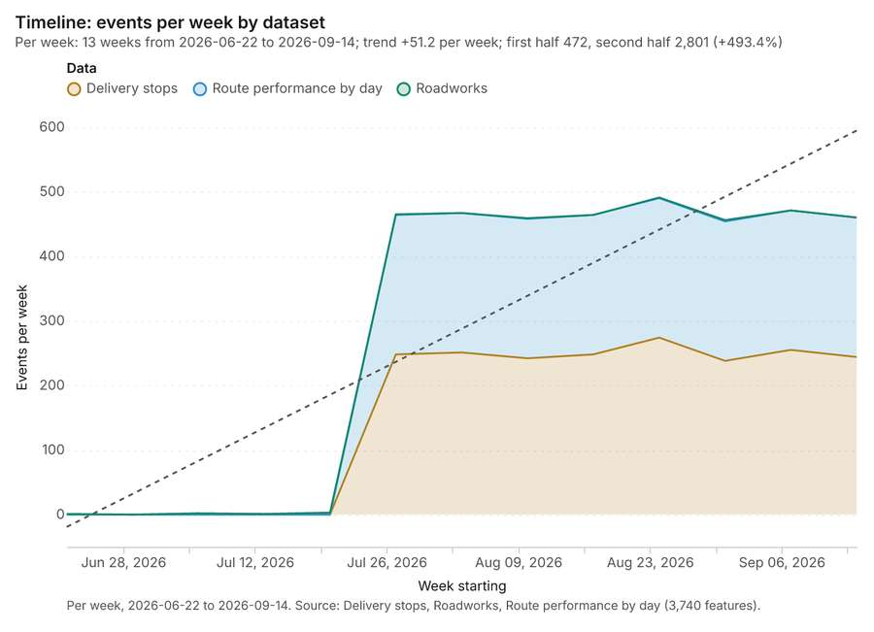
Figure 1. Timeline: events per week by dataset [1]. Per week, 2026-06-22 to 2026-09-14. Source: Delivery stops, Roadworks, Route performance by day (3,740 features). The data is in the appendix.
The timeline counts 3,740 dated events in Delivery stops, Roadworks, Route performance by day per week, from week of 2026-06-22 to week of 2026-09-14 [1][2][3][4]. By dataset: Delivery stops 2,000; Route performance by day 1,728; Roadworks 12 [1]. The trend is +51.2 events per week; the second half of the weeks has 2,801 against 472 in the first (+493.4%) [1]. 1 of the 13 weeks had no events [1]. Change point detection found no shift in the counts [5].
Busiest weeks
- week of 2026-08-24: 491 events [1]
- week of 2026-09-07: 471 events [1]
- week of 2026-08-03: 467 events [1]
Quietest weeks with events
- week of 2026-06-22: 1 event [1]
- week of 2026-07-13: 1 event [1]
- week of 2026-07-06: 2 events [1]

Space time hot spots
What this analysis is. Emerging hot spots: Where hot spots are new, consecutive, intensifying, persistent, diminishing, sporadic, oscillating or historical over time [6]. In ArcGIS it is Emerging Hot Spot Analysis or Create Space Time Cube [6].
Why it was run on this data. Delivery stops carry dates in 'delivered_at': emerging hot spot analysis finds new, intensifying and fading hot spots per week [7].
What it found. Space time hot spots on Delivery stops: Emerging hot spots: 1 layer saved: Emerging hot spots: Delivery stops (88 features) [8][9]. It reported result, count 88; result, elapsed ms 15; result, resolution 8; result, features used 2,000; result, time neighbors 0; billing, cost 0.2 [8].
Result | Value
result, count | 88
result, elapsed ms | 15
result, resolution | 8
result, features used | 2,000
result, time neighbors | 0
billing, cost | 0.2
billing, list price | 0.2
billing, upstream cost | 0

Findings
- Evidenced: Space time hot spots on Delivery stops: Emerging hot spots: 1 layer saved: Emerging hot spots: Delivery stops (88 features) [8][9].
- Evidenced: It reported result, count 88; result, elapsed ms 15; result, resolution 8; result, features used 2,000; result, time neighbors 0; billing, cost 0.2 [8].
Tool gp_space_time_hot_spots; parameters {"project": "55917da2-e619-41aa-b6a1-e521a75b705c", "features": {"layer": "Delivery stops (ba8073d9)"}, "interval": "week", "bin_shape": "h3", "resolution": 8, "time_field": "delivered_at"}

Near repeat
What this analysis is. Repeat and near repeat classification: Classify incidents as originators, repeats (same place) or near repeats within a distance and time window, with a Knox test table [10]. In ArcGIS it is Repeat and Near Repeat Classification or Near Repeat Calculator [10].
Why it was run on this data. Near repeat analysis tests whether Delivery stops close in space also follow each other within 5 days [11].
What it found. Near repeat on Delivery stops: Repeat and near repeat classification: 1 layer saved: Repeat and near repeat classification: Delivery stops (2000 features) [9][12]. It reported result, days 5; result, count 2,000; result, chains 276; result, distance m 200; result, elapsed ms 48; result, pairs linked 1,743 [12].
Result | Value
result, days | 5
result, count | 2,000
result, chains | 276
result, distance m | 200
result, elapsed ms | 48
result, pairs linked | 1,743
billing, cost | 0.11
billing, list price | 0.11
billing, upstream cost | 0

Findings
- Evidenced: Near repeat on Delivery stops: Repeat and near repeat classification: 1 layer saved: Repeat and near repeat classification: Delivery stops (2000 features) [9][12].
- Evidenced: It reported result, days 5; result, count 2,000; result, chains 276; result, distance m 200; result, elapsed ms 48; result, pairs linked 1,743 [12].
Tool gp_near_repeat; parameters {"days": 5, "project": "55917da2-e619-41aa-b6a1-e521a75b705c", "features": {"layer": "Delivery stops (ba8073d9)"}, "distance_m": 200.0, "time_field": "delivered_at"}

Change point detection
What this analysis is. Change point detection: When did the level, count, trend or variability change [13]? For the whole study area or for every bin [13]. In ArcGIS it is Change Point Detection [13].
Why it was run on this data. Change point detection finds when the weekly count of Delivery stops shifted [14].
What it found. Change point detection on Delivery stops: Change point detection: done; no map output [5][9]. It reported result, n changes 0; result, elapsed ms 4; result, events used 2,000; billing, cost 0.11; billing, list price 0.11; billing, upstream cost 0 [5].
Result | Value
result, n changes | 0
result, elapsed ms | 4
result, events used | 2,000
billing, cost | 0.11
billing, list price | 0.11
billing, upstream cost | 0

Findings
- Evidenced: Change point detection on Delivery stops: Change point detection: done; no map output [5][9].
- Evidenced: It reported result, n changes 0; result, elapsed ms 4; result, events used 2,000; billing, cost 0.11; billing, list price 0.11; billing, upstream cost 0 [5].
Tool gp_change_point_detection; parameters {"method": "count", "project": "55917da2-e619-41aa-b6a1-e521a75b705c", "features": {"layer": "Delivery stops (ba8073d9)"}, "interval": "week", "time_field": "delivered_at"}

Summarize within
What this analysis is. Summarize within: Count and aggregate the features inside each polygon (or bin), proportionally for lines and polygons [15]. In ArcGIS it is Summarize Within or Aggregate Points; in QGIS, native:countpointsinpolygon or native:sumlinelengths [15].
Why it was run on this data. Count Depots inside each feature of Delivery zones; the counts map as a choropleth (natural breaks, sequential colors) [16].
What it found. Summarize within on Depots, Delivery zones: Summarize within: 1 layer saved: Summarize within: Delivery zones (10 features) [17][18][19]. It reported result, count 10; result, elapsed ms 0; billing, cost 0.01028; billing, list price 0.01028; billing, upstream cost 0 [17].
Result | Value
result, count | 10
result, elapsed ms | 0
billing, cost | 0.01028
billing, list price | 0.01028
billing, upstream cost | 0

Findings
- Evidenced: Summarize within on Depots, Delivery zones: Summarize within: 1 layer saved: Summarize within: Delivery zones (10 features) [17][18][19].
- Evidenced: It reported result, count 10; result, elapsed ms 0; billing, cost 0.01028; billing, list price 0.01028; billing, upstream cost 0 [17].
Tool gp_summarize_within; parameters {"stats": [{"stat": "sum", "field": "vans"}], "project": "55917da2-e619-41aa-b6a1-e521a75b705c", "features": {"layer": "Depots (84d3272c)"}, "polygons": {"layer": "Delivery zones (bfcf8b53)"}}

Summarize within
What this analysis is. Summarize within: Count and aggregate the features inside each polygon (or bin), proportionally for lines and polygons [15]. In ArcGIS it is Summarize Within or Aggregate Points; in QGIS, native:countpointsinpolygon or native:sumlinelengths [15].
Why it was run on this data. Count Depots inside each feature of Delivery zones; the counts map as a choropleth (natural breaks, sequential colors) [16].
What it found. Summarize within on Delivery stops, Delivery zones: Summarize within: 1 layer saved: Summarize within: Delivery zones (10 features) [9][19][20]. It reported result, count 10; result, elapsed ms 4; billing, cost 0.05022; billing, list price 0.05022; billing, upstream cost 0 [20].
Result | Value
result, count | 10
result, elapsed ms | 4
billing, cost | 0.05022
billing, list price | 0.05022
billing, upstream cost | 0

Findings
- Evidenced: Summarize within on Delivery stops, Delivery zones: Summarize within: 1 layer saved: Summarize within: Delivery zones (10 features) [9][19][20].
- Evidenced: It reported result, count 10; result, elapsed ms 4; billing, cost 0.05022; billing, list price 0.05022; billing, upstream cost 0 [20].
Tool gp_summarize_within; parameters {"stats": [{"stat": "sum", "field": "delay_min"}], "project": "55917da2-e619-41aa-b6a1-e521a75b705c", "features": {"layer": "Delivery stops (ba8073d9)"}, "group_by": "status", "polygons": {"layer": "Delivery zones (bfcf8b53)"}}

Summarize within
What this analysis is. Summarize within: Count and aggregate the features inside each polygon (or bin), proportionally for lines and polygons [15]. In ArcGIS it is Summarize Within or Aggregate Points; in QGIS, native:countpointsinpolygon or native:sumlinelengths [15].
Why it was run on this data. Count Depots inside each feature of Delivery zones; the counts map as a choropleth (natural breaks, sequential colors) [16].
What it found. Summarize within on Parcel lockers, Delivery zones: Summarize within: 1 layer saved: Summarize within: Delivery zones (10 features) [19][21][22]. It reported result, count 10; result, elapsed ms 0; billing, cost 0.01112; billing, list price 0.01112; billing, upstream cost 0 [21].
Result | Value
result, count | 10
result, elapsed ms | 0
billing, cost | 0.01112
billing, list price | 0.01112
billing, upstream cost | 0

Findings
- Evidenced: Summarize within on Parcel lockers, Delivery zones: Summarize within: 1 layer saved: Summarize within: Delivery zones (10 features) [19][21][22].
- Evidenced: It reported result, count 10; result, elapsed ms 0; billing, cost 0.01112; billing, list price 0.01112; billing, upstream cost 0 [21].
Tool gp_summarize_within; parameters {"stats": [{"stat": "sum", "field": "compartments"}], "project": "55917da2-e619-41aa-b6a1-e521a75b705c", "features": {"layer": "Parcel lockers (4e9e11a9)"}, "group_by": "host", "polygons": {"layer": "Delivery zones (bfcf8b53)"}}

Hot spots
What this analysis is. Hot spot analysis: Getis-Ord Gi* hot and cold spots with z-scores, p-values and confidence bins [23]. In ArcGIS it is Find Hot Spots or Hot Spot Analysis (Getis-Ord Gi*); in QGIS, qgis:hotspot (plugin) [23].
Why it was run on this data. 2000 points: Getis-Ord Gi* tests whether the concentrations in Delivery stops are statistically significant [24].
What it found. The hot spot analysis was conducted using the Delivery stops layer [9] and the gp_hot_spots tool [25]. The process produced 254 features and calculated a count of 254 results [25]. For this analysis, 2,000 incidents were utilized, and the resulting cell size was 500 m [25]. The total billing cost for the analysis was 0.09 [25].
Result | Value
result, bins | 254
result, count | 254
result, elapsed ms | 23
result, cell size m | 500
result, incidents used | 2,000
result, distance band m | 500
billing, cost | 0.09
billing, list price | 0.09
billing, upstream cost | 0

Findings
- Evidenced: Hot spots on Delivery stops: Hot spot analysis: 1 layer saved: Hot spot analysis: Delivery stops (254 features) [9][25].
- Evidenced: It reported result, bins 254; result, count 254; result, elapsed ms 23; result, cell size m 500; result, incidents used 2,000; result, distance band m 500 [25].
Tool gp_hot_spots; parameters {"project": "55917da2-e619-41aa-b6a1-e521a75b705c", "features": {"layer": "Delivery stops (ba8073d9)"}, "aggregation": "hexagon", "cell_size_m": 500.0, "distance_band_m": 500.0}

Hot spots
What this analysis is. Hot spot analysis: Getis-Ord Gi* hot and cold spots with z-scores, p-values and confidence bins [23]. In ArcGIS it is Find Hot Spots or Hot Spot Analysis (Getis-Ord Gi*); in QGIS, qgis:hotspot (plugin) [23].
Why it was run on this data. 45 points: Getis-Ord Gi* tests whether the concentrations in Parcel lockers are statistically significant [26].
What it found. The hot spot analysis was conducted using the Parcel lockers layer [22]. The analysis produced 1 layer, titled "Hot spot analysis: Parcel lockers (19 features)" [27]. Key results showed the analysis generated 19 bins containing 19 features [27]. The operation took 2 milliseconds to complete, and the resulting cell size and distance band were both 2,000 meters [27].
Result | Value
result, bins | 19
result, count | 19
result, elapsed ms | 2
result, cell size m | 2,000
result, incidents used | 45
result, distance band m | 2,000
billing, cost | 0.0509
billing, list price | 0.0509
billing, upstream cost | 0

Findings
- Evidenced: Hot spots on Parcel lockers: Hot spot analysis: 1 layer saved: Hot spot analysis: Parcel lockers (19 features) [22][27].
- Evidenced: It reported result, bins 19; result, count 19; result, elapsed ms 2; result, cell size m 2,000; result, incidents used 45; result, distance band m 2,000 [27].
Tool gp_hot_spots; parameters {"project": "55917da2-e619-41aa-b6a1-e521a75b705c", "features": {"layer": "Parcel lockers (4e9e11a9)"}, "aggregation": "hexagon", "cell_size_m": 2000.0, "distance_band_m": 2000.0}

Hot spots
What this analysis is. Hot spot analysis: Getis-Ord Gi* hot and cold spots with z-scores, p-values and confidence bins [23]. In ArcGIS it is Find Hot Spots or Hot Spot Analysis (Getis-Ord Gi*); in QGIS, qgis:hotspot (plugin) [23].
Why it was run on this data. 60 points: Getis-Ord Gi* tests whether the concentrations in Loading bays are statistically significant [28].
What it found. Hot spots on Loading bays: Hot spot analysis: 1 layer saved: Hot spot analysis: Loading bays (19 features) [29][30]. It reported result, bins 19; result, count 19; result, elapsed ms 2; result, cell size m 2,000; result, incidents used 60; result, distance band m 2,000 [29].
Result | Value
result, bins | 19
result, count | 19
result, elapsed ms | 2
result, cell size m | 2,000
result, incidents used | 60
result, distance band m | 2,000
billing, cost | 0.0512
billing, list price | 0.0512
billing, upstream cost | 0

Findings
- Evidenced: Hot spots on Loading bays: Hot spot analysis: 1 layer saved: Hot spot analysis: Loading bays (19 features) [29][30].
- Evidenced: It reported result, bins 19; result, count 19; result, elapsed ms 2; result, cell size m 2,000; result, incidents used 60; result, distance band m 2,000 [29].
Tool gp_hot_spots; parameters {"project": "55917da2-e619-41aa-b6a1-e521a75b705c", "features": {"layer": "Loading bays (16574f8d)"}, "aggregation": "hexagon", "cell_size_m": 2000.0, "distance_band_m": 2000.0}

Calculate density
What this analysis is. Calculate density: Kernel density per square kilometer on a grid [31]. In ArcGIS it is Calculate Density or Kernel Density; in QGIS, native:heatmapkerneldensityestimation [31].
Why it was run on this data. 2000 points in Delivery stops: a density surface shows where they concentrate [32].
What it found. Calculate density on Delivery stops: Calculate density: 1 layer saved: Calculate density: Delivery stops (1654 features) [9][33]. It reported result, count 1,654; result, elapsed ms 74; result, bandwidth m 500; result, cell size m 200; result, excluded null 0; result, max density per km2 396 [33].
Result | Value
result, count | 1,654
result, elapsed ms | 74
result, bandwidth m | 500
result, cell size m | 200
result, excluded null | 0
result, max density per km2 | 396
billing, cost | 0.09
billing, list price | 0.09
billing, upstream cost | 0

Findings
- Evidenced: Calculate density on Delivery stops: Calculate density: 1 layer saved: Calculate density: Delivery stops (1654 features) [9][33].
- Evidenced: It reported result, count 1,654; result, elapsed ms 74; result, bandwidth m 500; result, cell size m 200; result, excluded null 0; result, max density per km2 396 [33].
Tool gp_calculate_density; parameters {"kernel": "quartic", "project": "55917da2-e619-41aa-b6a1-e521a75b705c", "features": {"layer": "Delivery stops (ba8073d9)"}, "bandwidth_m": 500.0, "cell_size_m": 200.0}

Calculate density
What this analysis is. Calculate density: Kernel density per square kilometer on a grid [31]. In ArcGIS it is Calculate Density or Kernel Density; in QGIS, native:heatmapkerneldensityestimation [31].
Why it was run on this data. 45 points in Parcel lockers: a density surface shows where they concentrate [34].
What it found. The calculation of density using the `gp_calculate_density` tool analyzed the Parcel lockers layer [22] and processed 99 features [35]. The process required an elapsed time of 5 ms [35], identifying a maximum density of 1.381 per km² [35].
Result | Value
result, count | 99
result, elapsed ms | 5
result, bandwidth m | 2,000
result, cell size m | 1,000
result, excluded null | 0
result, max density per km2 | 1.381
billing, cost | 0.0509
billing, list price | 0.0509
billing, upstream cost | 0

Findings
- Evidenced: Calculate density on Parcel lockers: Calculate density: 1 layer saved: Calculate density: Parcel lockers (99 features) [22][35].
- Evidenced: It reported result, count 99; result, elapsed ms 5; result, bandwidth m 2,000; result, cell size m 1,000; result, excluded null 0; result, max density per km2 1.381 [35].
Tool gp_calculate_density; parameters {"kernel": "quartic", "project": "55917da2-e619-41aa-b6a1-e521a75b705c", "features": {"layer": "Parcel lockers (4e9e11a9)"}, "bandwidth_m": 2000.0, "cell_size_m": 1000.0}

Calculate density
What this analysis is. Calculate density: Kernel density per square kilometer on a grid [31]. In ArcGIS it is Calculate Density or Kernel Density; in QGIS, native:heatmapkerneldensityestimation [31].
Why it was run on this data. 60 points in Loading bays: a density surface shows where they concentrate [36].
What it found. The density calculation used the Loading bays dataset [30]. This process analyzed 101 features and reported a total bandwidth of 2,000 meters [37]. The maximum density calculated across the layers was 1.929 per km² [37].
Result | Value
result, count | 101
result, elapsed ms | 5
result, bandwidth m | 2,000
result, cell size m | 1,000
result, excluded null | 0
result, max density per km2 | 1.929
billing, cost | 0.0512
billing, list price | 0.0512
billing, upstream cost | 0

Findings
- Evidenced: Calculate density on Loading bays: Calculate density: 1 layer saved: Calculate density: Loading bays (101 features) [30][37].
- Evidenced: It reported result, count 101; result, elapsed ms 5; result, bandwidth m 2,000; result, cell size m 1,000; result, excluded null 0; result, max density per km2 1.929 [37].
Tool gp_calculate_density; parameters {"kernel": "quartic", "project": "55917da2-e619-41aa-b6a1-e521a75b705c", "features": {"layer": "Loading bays (16574f8d)"}, "bandwidth_m": 2000.0, "cell_size_m": 1000.0}

Find point clusters
What this analysis is. Find point clusters: Density-based clusters (DBSCAN, HDBSCAN or OPTICS, optionally space-time) with hulls and noise [38]. In ArcGIS it is Find Point Clusters or Density-based Clustering; in QGIS, native:dbscanclustering or native:stdbscanclustering [38].
Why it was run on this data. DBSCAN finds dense groups of Delivery stops and separates noise [39].
What it found. Find point clusters on Delivery stops: Find point clusters: 2 layers saved: Find point clusters: Delivery stops (2000 features); Find point clusters: cluster hulls (2 features) [9][40]. It reported result, count 2,000; result, noise 1,570; result, distance m 200; result, elapsed ms 214; result, min points 20; billing, cost 0.09 [40].
Result | Value
result, count | 2,000
result, noise | 1,570
result, distance m | 200
result, elapsed ms | 214
result, min points | 20
billing, cost | 0.09
billing, list price | 0.09
billing, upstream cost | 0

Findings
- Evidenced: Find point clusters on Delivery stops: Find point clusters: 2 layers saved: Find point clusters: Delivery stops (2000 features); Find point clusters: cluster hulls (2 features) [9][40].
- Evidenced: It reported result, count 2,000; result, noise 1,570; result, distance m 200; result, elapsed ms 214; result, min points 20; billing, cost 0.09 [40].
Tool gp_find_point_clusters; parameters {"method": "dbscan", "project": "55917da2-e619-41aa-b6a1-e521a75b705c", "features": {"layer": "Delivery stops (ba8073d9)"}, "distance_m": 200.0, "min_points": 20}

Find point clusters
What this analysis is. Find point clusters: Density-based clusters (DBSCAN, HDBSCAN or OPTICS, optionally space-time) with hulls and noise [38]. In ArcGIS it is Find Point Clusters or Density-based Clustering; in QGIS, native:dbscanclustering or native:stdbscanclustering [38].
Why it was run on this data. DBSCAN finds dense groups of Parcel lockers and separates noise [41].
What it found. Find point clusters on Parcel lockers: Find point clusters: 2 layers saved: Find point clusters: Parcel lockers (45 features); Find point clusters: cluster hulls (1 feature) [22][42]. It reported result, count 45; result, noise 1; result, distance m 2,000; result, elapsed ms 2; result, min points 3; billing, cost 0.0509 [42].
Result | Value
result, count | 45
result, noise | 1
result, distance m | 2,000
result, elapsed ms | 2
result, min points | 3
billing, cost | 0.0509
billing, list price | 0.0509
billing, upstream cost | 0

Findings
- Evidenced: Find point clusters on Parcel lockers: Find point clusters: 2 layers saved: Find point clusters: Parcel lockers (45 features); Find point clusters: cluster hulls (1 feature) [22][42].
- Evidenced: It reported result, count 45; result, noise 1; result, distance m 2,000; result, elapsed ms 2; result, min points 3; billing, cost 0.0509 [42].
Tool gp_find_point_clusters; parameters {"method": "dbscan", "project": "55917da2-e619-41aa-b6a1-e521a75b705c", "features": {"layer": "Parcel lockers (4e9e11a9)"}, "distance_m": 2000.0, "min_points": 3}

Find point clusters
What this analysis is. Find point clusters: Density-based clusters (DBSCAN, HDBSCAN or OPTICS, optionally space-time) with hulls and noise [38]. In ArcGIS it is Find Point Clusters or Density-based Clustering; in QGIS, native:dbscanclustering or native:stdbscanclustering [38].
Why it was run on this data. DBSCAN finds dense groups of Loading bays and separates noise [43].
What it found. Find point clusters on Loading bays: Find point clusters: 2 layers saved: Find point clusters: Loading bays (60 features); Find point clusters: cluster hulls (6 features) [30][44]. It reported result, count 60; result, noise 7; result, distance m 1,000; result, elapsed ms 4; result, min points 3; billing, cost 0.0512 [44].
Result | Value
result, count | 60
result, noise | 7
result, distance m | 1,000
result, elapsed ms | 4
result, min points | 3
billing, cost | 0.0512
billing, list price | 0.0512
billing, upstream cost | 0

Findings
- Evidenced: Find point clusters on Loading bays: Find point clusters: 2 layers saved: Find point clusters: Loading bays (60 features); Find point clusters: cluster hulls (6 features) [30][44].
- Evidenced: It reported result, count 60; result, noise 7; result, distance m 1,000; result, elapsed ms 4; result, min points 3; billing, cost 0.0512 [44].
Tool gp_find_point_clusters; parameters {"method": "dbscan", "project": "55917da2-e619-41aa-b6a1-e521a75b705c", "features": {"layer": "Loading bays (16574f8d)"}, "distance_m": 1000.0, "min_points": 3}

Outliers
What this analysis is. Find outliers: Anselin local Moran’s I: HH, LL clusters and HL, LH outliers [45]. In ArcGIS it is Find Outliers or Cluster and Outlier Analysis (Anselin Local Moran’s I) [45].
Why it was run on this data. Local Moran's I maps clusters and outliers of 'parcels_per_day' [46].
What it found. Outliers on Delivery zones: Find outliers: 1 layer saved: Find outliers: Delivery zones (10 features) [19][47]. It reported result, count 10; result, elapsed ms 4; result, permutations 199; result, excluded null 0; result, distance band m 2,661; billing, cost 0.0503 [47].
Result | Value
result, count | 10
result, elapsed ms | 4
result, permutations | 199
result, excluded null | 0
result, distance band m | 2,661
billing, cost | 0.0503
billing, list price | 0.0503
billing, upstream cost | 0

Findings
- Evidenced: Outliers on Delivery zones: Find outliers: 1 layer saved: Find outliers: Delivery zones (10 features) [19][47].
- Evidenced: It reported result, count 10; result, elapsed ms 4; result, permutations 199; result, excluded null 0; result, distance band m 2,661; billing, cost 0.0503 [47].
Tool gp_outliers; parameters {"field": "parcels_per_day", "project": "55917da2-e619-41aa-b6a1-e521a75b705c", "features": {"layer": "Delivery zones (bfcf8b53)"}, "aggregation": "hexagon"}

Spatial autocorrelation
What this analysis is. Spatial autocorrelation: Global Moran’s I: is the pattern clustered, dispersed or random [48]. In ArcGIS it is Spatial Autocorrelation (Global Moran’s I) [48].
Why it was run on this data. Global Moran's I says whether similar values of 'parcels_per_day' sit next to each other [49].
What it found. Spatial autocorrelation on Delivery zones: Spatial autocorrelation: done; no map output [19][50]. It reported result, n 10; result, p value 0.1412; result, z score 1.471; result, morans i 0.09356; result, variance 0.01935; result, elapsed ms 2 [50].
Result | Value
result, n | 10
result, p value | 0.1412
result, z score | 1.471
result, morans i | 0.09356
result, variance | 0.01935
result, elapsed ms | 2
result, expected i | -0.1111
result, excluded null | 0
result, distance band m | 2,661
result, p value normality | 0.421
result, z score normality | 0.8046
result, variance normality | 0.06471
billing, cost | 0.02
billing, list price | 0.02
billing, upstream cost | 0

Findings
- Evidenced: Spatial autocorrelation on Delivery zones: Spatial autocorrelation: done; no map output [19][50].
- Evidenced: It reported result, n 10; result, p value 0.1412; result, z score 1.471; result, morans i 0.09356; result, variance 0.01935; result, elapsed ms 2 [50].
Tool gp_spatial_autocorrelation; parameters {"field": "parcels_per_day", "project": "55917da2-e619-41aa-b6a1-e521a75b705c", "features": {"layer": "Delivery zones (bfcf8b53)"}}

Measure
What this analysis is. Areas and lengths: Geodesic area, perimeter and length of each feature [51]. In ArcGIS it is Areas And Lengths or Calculate Geometry; in QGIS, qgis:exportaddgeometrycolumns [51].
Why it was run on this data. Lengths of the 36 lines of Routes (total and per feature) [52].
What it found. Measure on Routes: Areas and lengths: 1 layer saved: Areas and lengths: Routes (36 features) [53][54]. It reported result, count 36; result, elapsed ms 7; billing, cost 0.01; billing, list price 0.01; billing, upstream cost 0 [53].
Result | Value
result, count | 36
result, elapsed ms | 7
billing, cost | 0.01
billing, list price | 0.01
billing, upstream cost | 0

Findings
- Evidenced: Measure on Routes: Areas and lengths: 1 layer saved: Areas and lengths: Routes (36 features) [53][54].
- Evidenced: It reported result, count 36; result, elapsed ms 7; billing, cost 0.01; billing, list price 0.01; billing, upstream cost 0 [53].
Tool gp_measure; parameters {"units": "metric", "project": "55917da2-e619-41aa-b6a1-e521a75b705c", "features": {"layer": "Routes (93de6e09)"}}

Measure
What this analysis is. Areas and lengths: Geodesic area, perimeter and length of each feature [51]. In ArcGIS it is Areas And Lengths or Calculate Geometry; in QGIS, qgis:exportaddgeometrycolumns [51].
Why it was run on this data. Lengths of the 12 lines of Roadworks (total and per feature) [55].
What it found. The `gp_measure` tool was utilized with the Roadworks layer as input [57]. The tool saved the areas and lengths for Roadworks, which contained 12 features [56]. The process resulted in a count of 12 features and took 0 elapsed ms [56].
Result | Value
result, count | 12
result, elapsed ms | 0
billing, cost | 0.01
billing, list price | 0.01
billing, upstream cost | 0

Findings
- Evidenced: Measure on Roadworks: Areas and lengths: 1 layer saved: Areas and lengths: Roadworks (12 features) [56][57].
- Evidenced: It reported result, count 12; result, elapsed ms 0; billing, cost 0.01; billing, list price 0.01; billing, upstream cost 0 [56].
Tool gp_measure; parameters {"units": "metric", "project": "55917da2-e619-41aa-b6a1-e521a75b705c", "features": {"layer": "Roadworks (50ecfc27)"}}

Line density
What this analysis is. Line density: Length of lines per unit area around each cell (km per square km), optionally weighted by a field [58]. In ArcGIS it is Line Density; in QGIS, qgis:linedensity [58].
Why it was run on this data. Line density shows where Routes are densest [59].
What it found. Line density on Routes: Line density: 1 layer saved: Line density: Routes (480 features) [54][60]. It reported result, count 480; result, radius m 2,000; result, elapsed ms 69; result, cell size m 500; result, total length km 712.7; result, max density km per km2 20.21 [60].
Result | Value
result, count | 480
result, radius m | 2,000
result, elapsed ms | 69
result, cell size m | 500
result, total length km | 712.7
result, max density km per km2 | 20.21
billing, cost | 0.05072
billing, list price | 0.05072
billing, upstream cost | 0

Findings
- Evidenced: Line density on Routes: Line density: 1 layer saved: Line density: Routes (480 features) [54][60].
- Evidenced: It reported result, count 480; result, radius m 2,000; result, elapsed ms 69; result, cell size m 500; result, total length km 712.7; result, max density km per km2 20.21 [60].
A model draft was discarded because a sentence did not cite a source of this section.
Tool gp_line_density; parameters {"project": "55917da2-e619-41aa-b6a1-e521a75b705c", "features": {"layer": "Routes (93de6e09)"}, "radius_m": 2000.0, "cell_size_m": 500.0}

Maps and charts
The run also made 22 map image(s) [61][62][63][64][65][66][67][68][69][70][71][72][73][74][75][76][77][78][79][80][81][82] and 27 chart(s) [83][84][85][86][87][88][89][90][91][92][93][94][95][96][97][98][99][100][101][102][103][104][105][106][107][108][109].
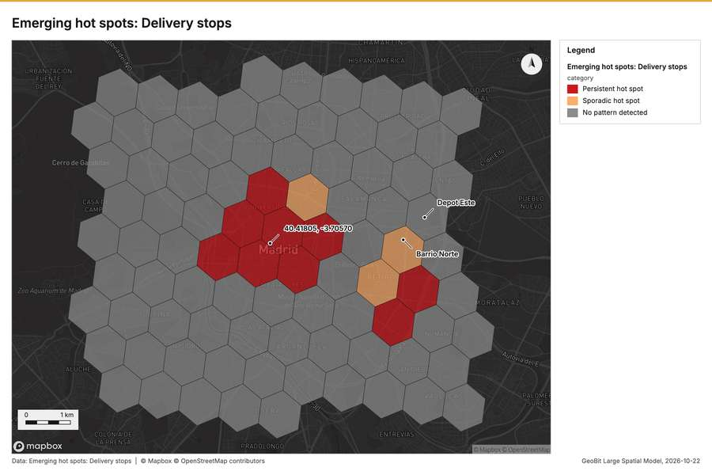
Figure 2. Emerging hot spots: Delivery stops [61]
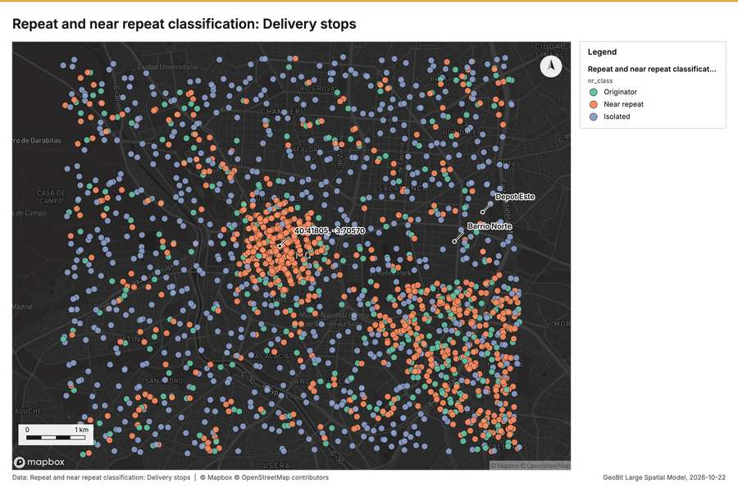
Figure 3. Repeat and near repeat classification: Delivery stops [62]
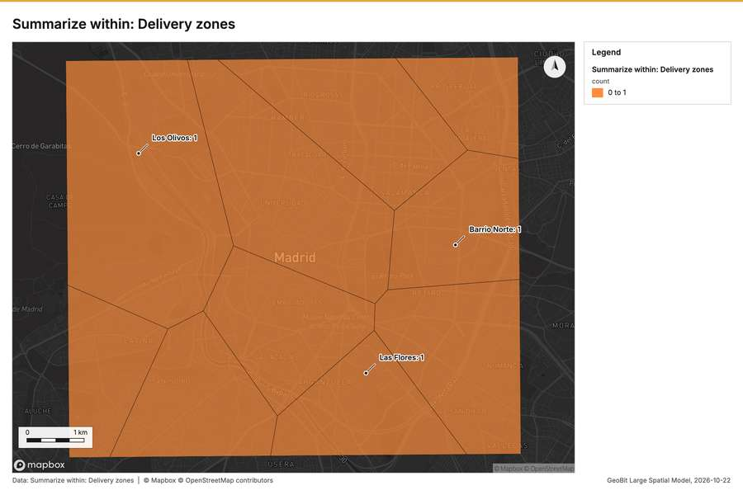
Figure 4. Summarize within: Delivery zones [63]
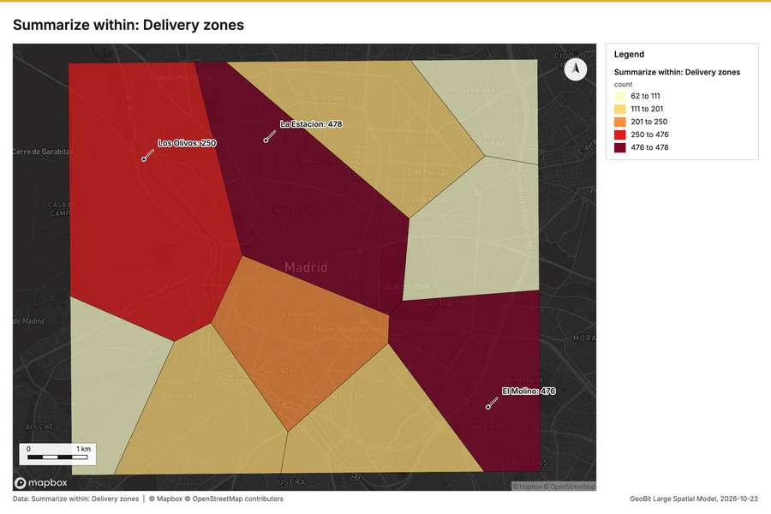
Figure 5. Summarize within: Delivery zones [64]
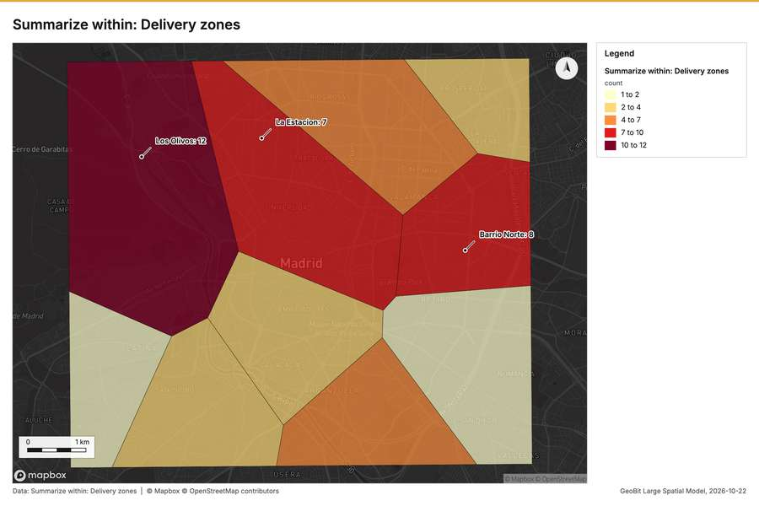
Figure 6. Summarize within: Delivery zones [65]
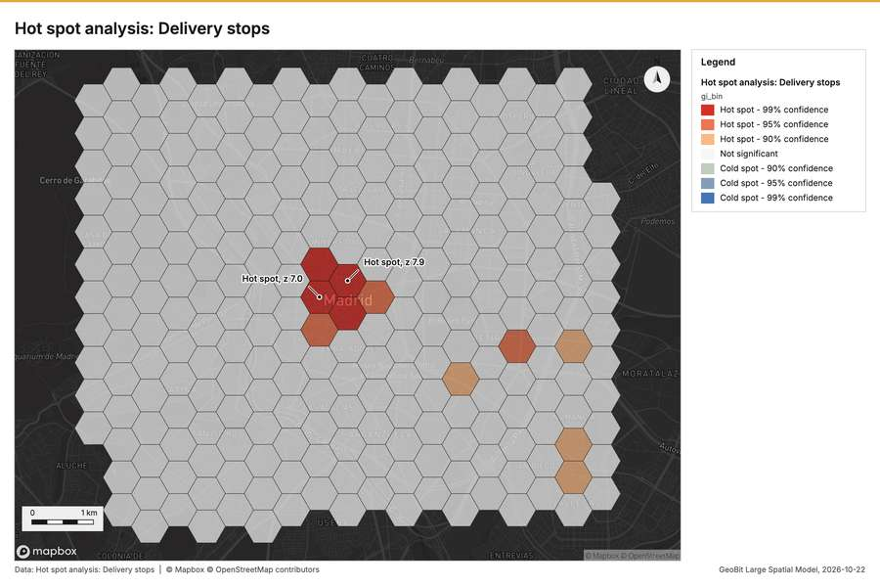
Figure 7. Hot spot analysis: Delivery stops [66]
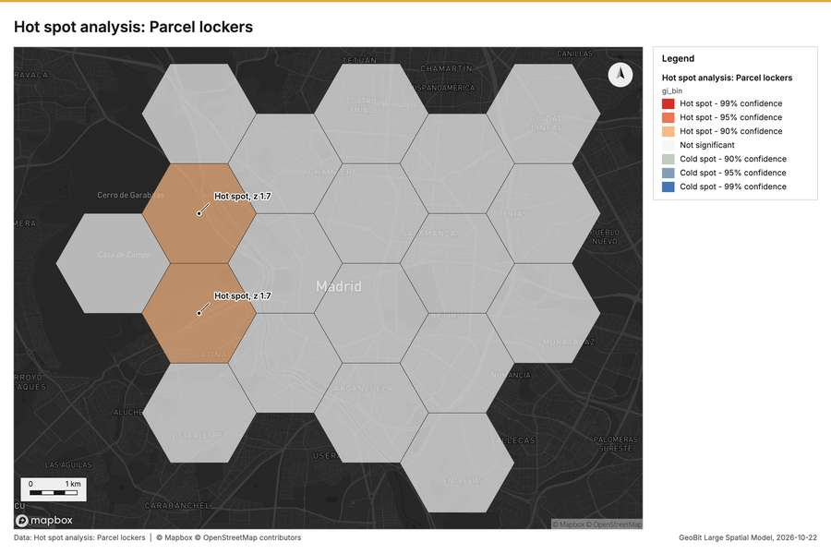
Figure 8. Hot spot analysis: Parcel lockers [67]
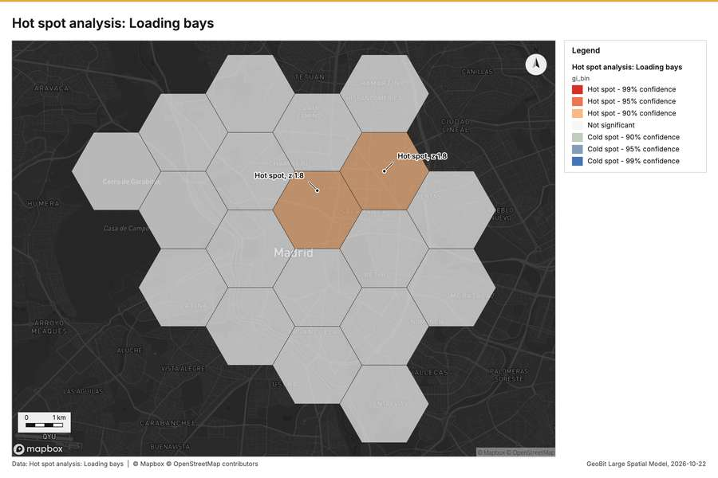
Figure 9. Hot spot analysis: Loading bays [68]
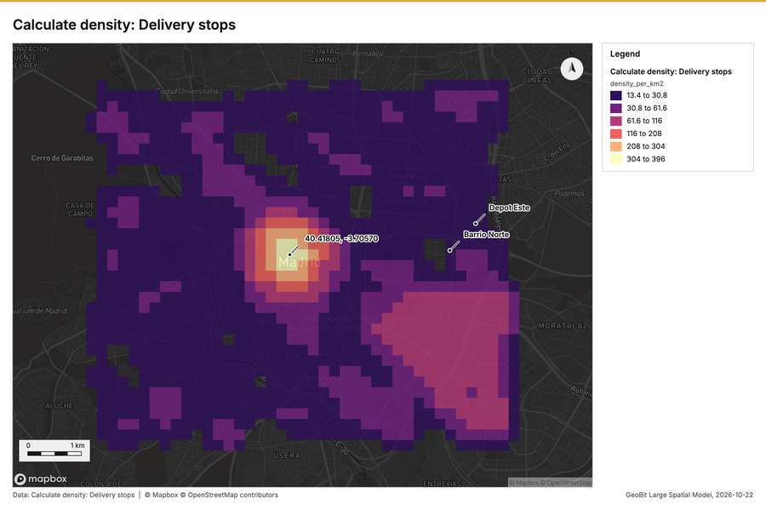
Figure 10. Calculate density: Delivery stops [69]
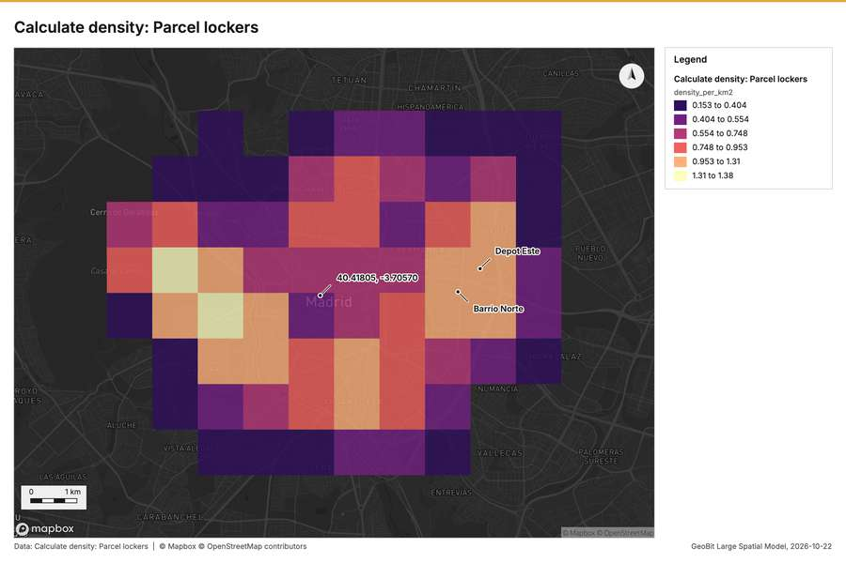
Figure 11. Calculate density: Parcel lockers [70]
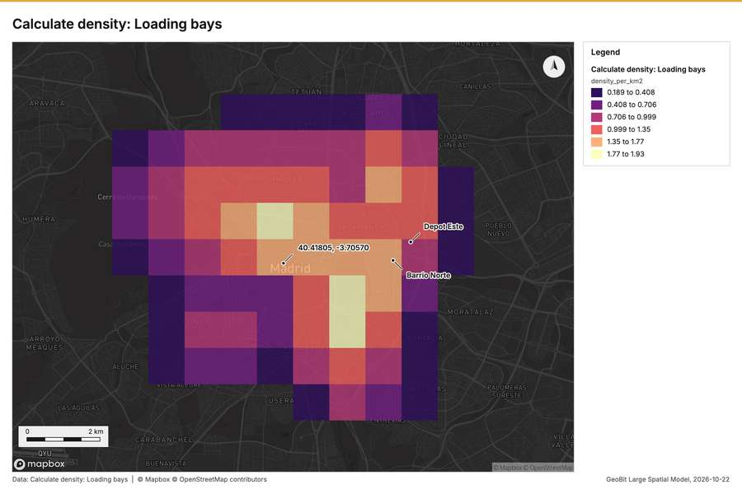
Figure 12. Calculate density: Loading bays [71]
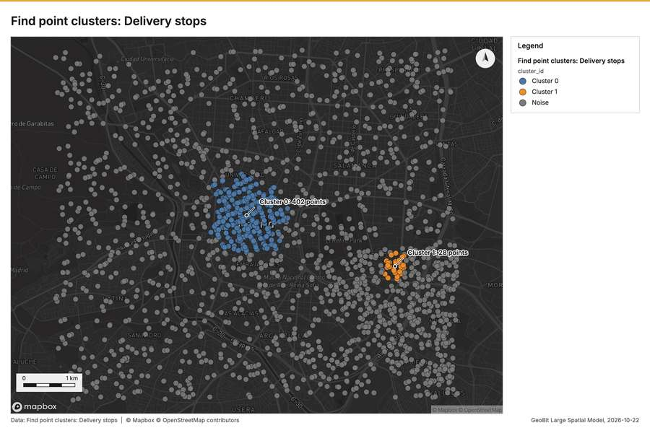
Figure 13. Find point clusters: Delivery stops [72]
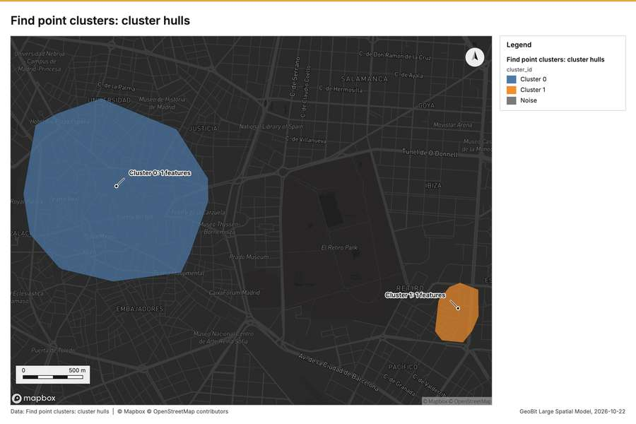
Figure 14. Find point clusters: cluster hulls [73]
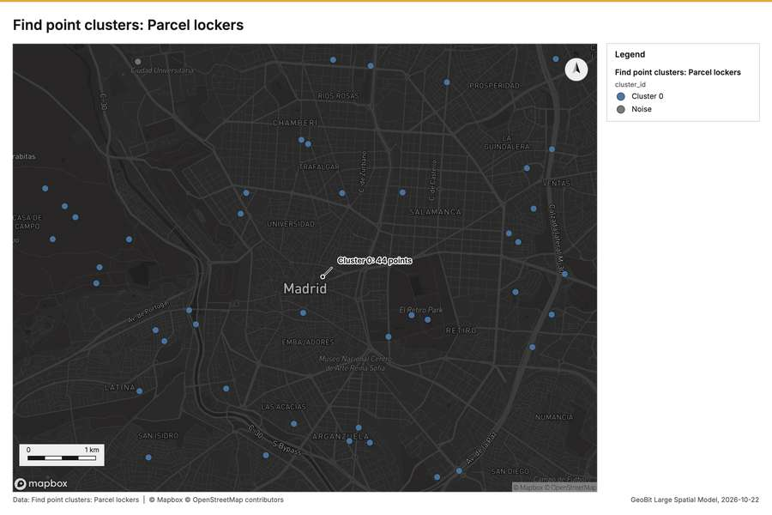
Figure 15. Find point clusters: Parcel lockers [74]
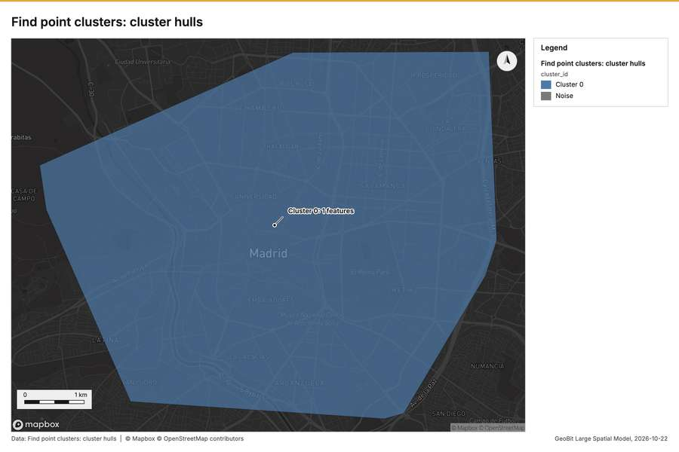
Figure 16. Find point clusters: cluster hulls [75]
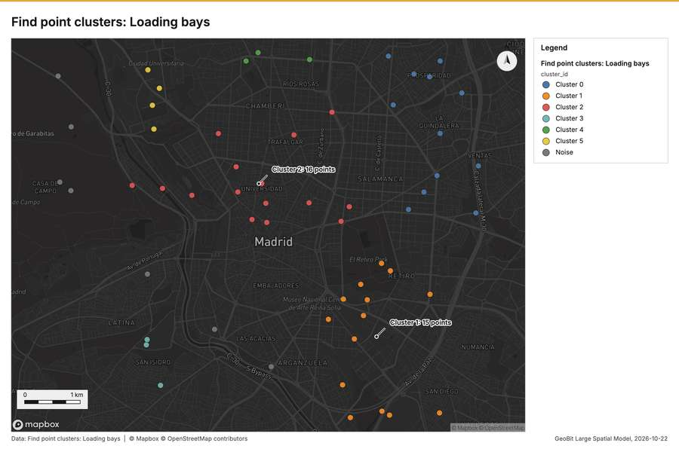
Figure 17. Find point clusters: Loading bays [76]
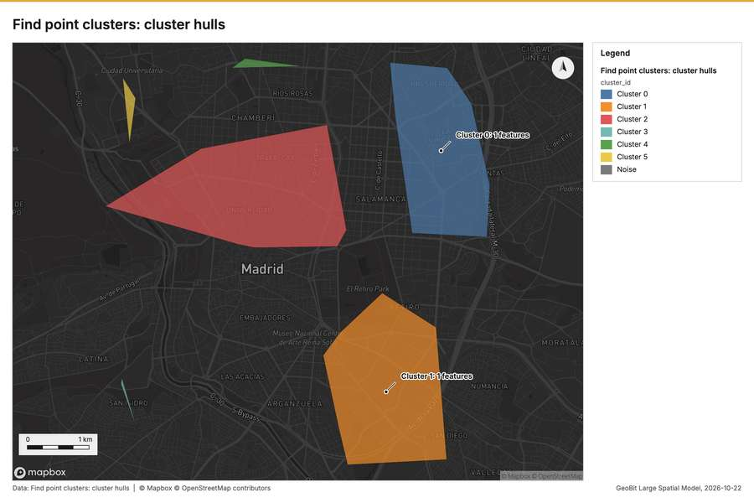
Figure 18. Find point clusters: cluster hulls [77]
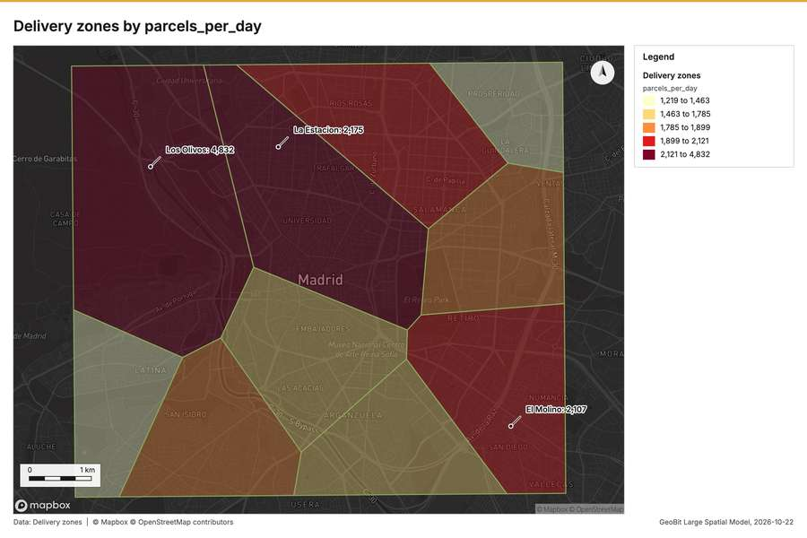
Figure 19. Delivery zones by parcels_per_day [78]
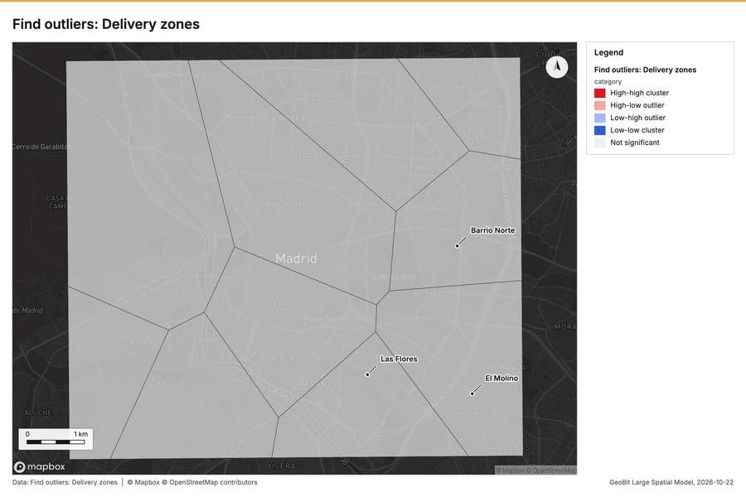
Figure 20. Find outliers: Delivery zones [79]
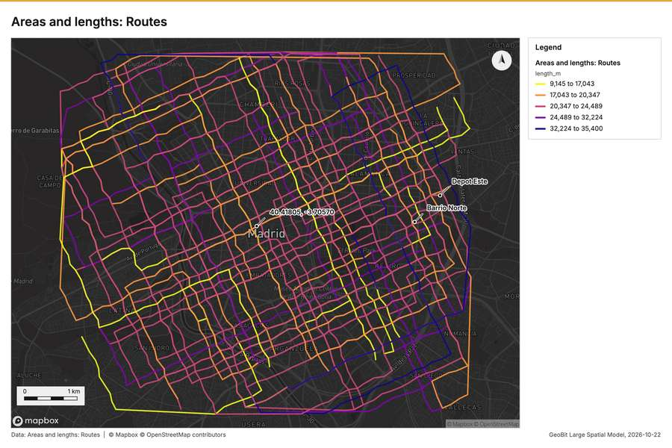
Figure 21. Areas and lengths: Routes [80]
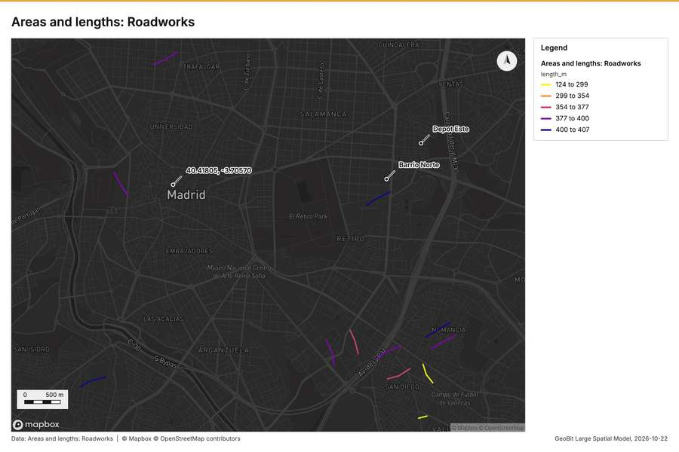
Figure 22. Areas and lengths: Roadworks [81]
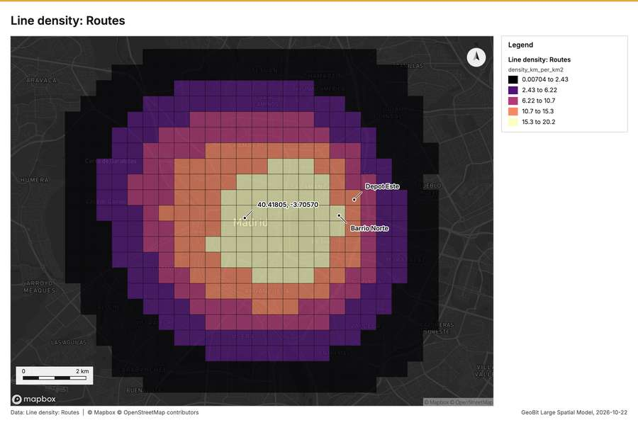
Figure 23. Line density: Routes [82]
What the map shows. The map shows the emerging hot spots for delivery stops, categorizing intensity [61]
Inferred: read from the image by gemma4:e4b, not evidence.
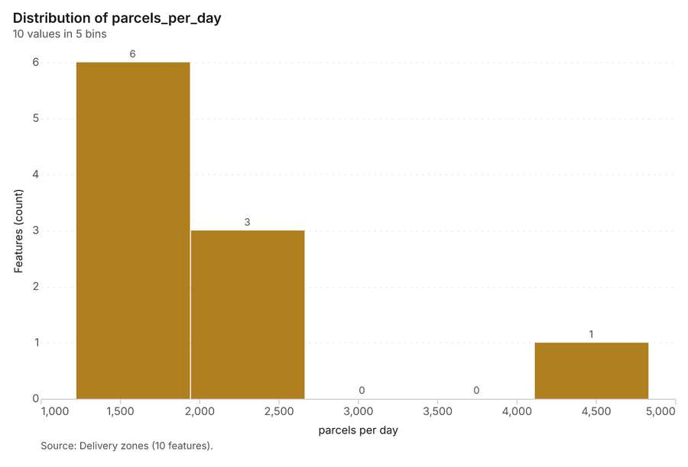
Figure 24. Delivery zones over time (parcels_per_day) [83]. Source: Delivery zones (10 features). The data is in the appendix.
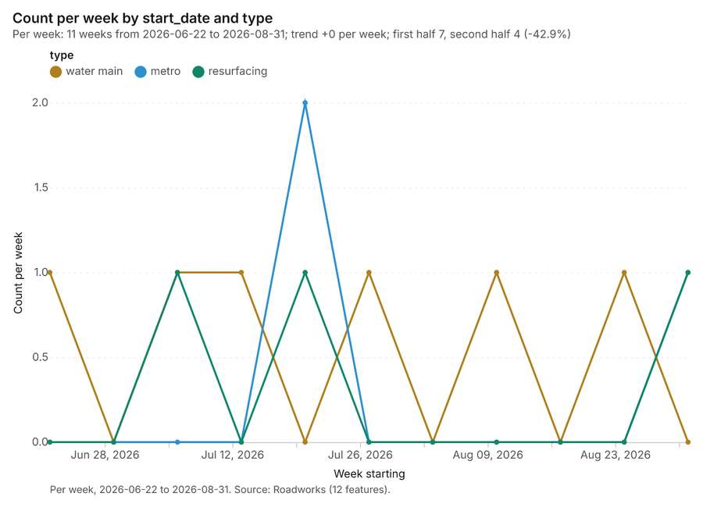
Figure 25. Roadworks over time (start_date) [84]. Per week, 2026-06-22 to 2026-08-31. Source: Roadworks (12 features). The data is in the appendix.
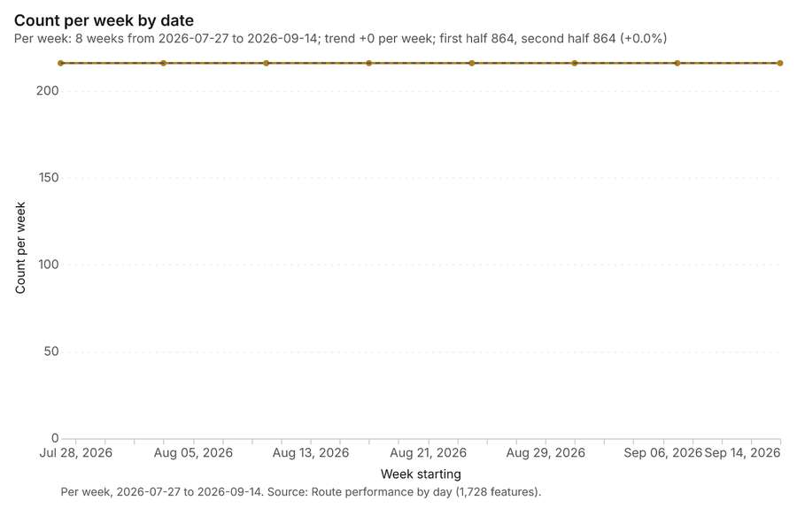
Figure 26. Route performance by day over time (date) [85]. Per week, 2026-07-27 to 2026-09-14. Source: Route performance by day (1,728 features). The data is in the appendix.
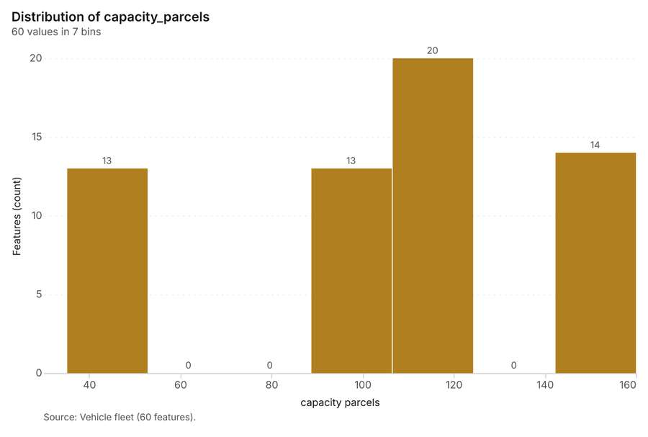
Figure 27. Vehicle fleet over time (model_year) [86]. Source: Vehicle fleet (60 features). The data is in the appendix.
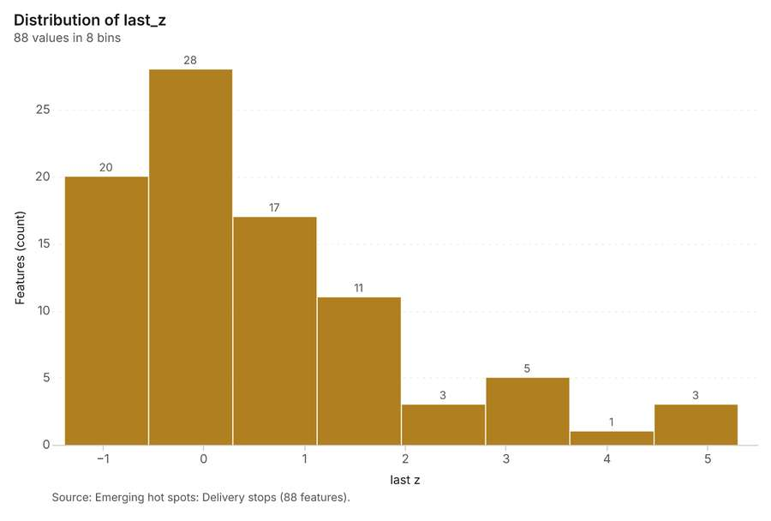
Figure 28. Emerging hot spots: Delivery stops [87]. Source: Emerging hot spots: Delivery stops (88 features). The data is in the appendix.
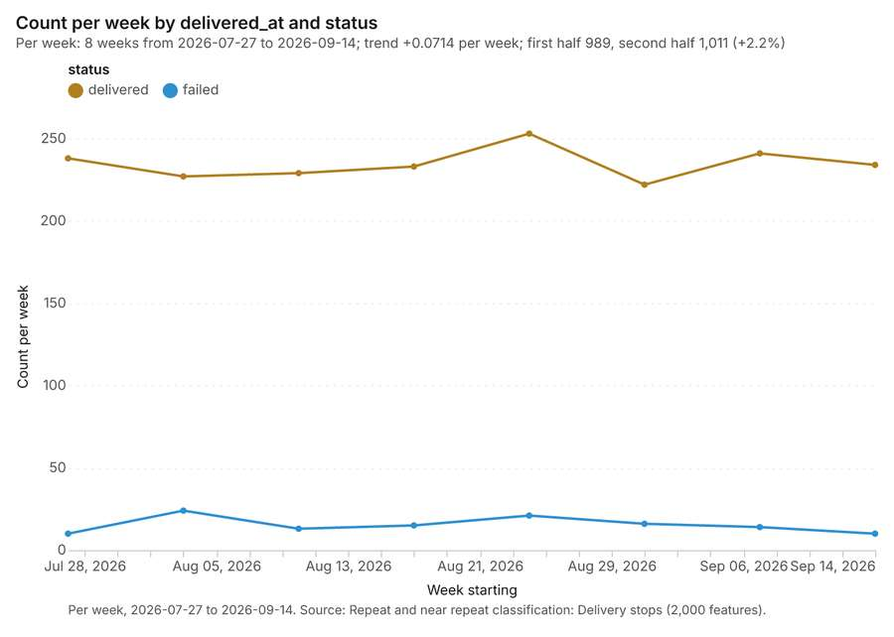
Figure 29. Repeat and near repeat classification: Delivery stops [88]. Per week, 2026-07-27 to 2026-09-14. Source: Repeat and near repeat classification: Delivery stops (2,000 features). The data is in the appendix.
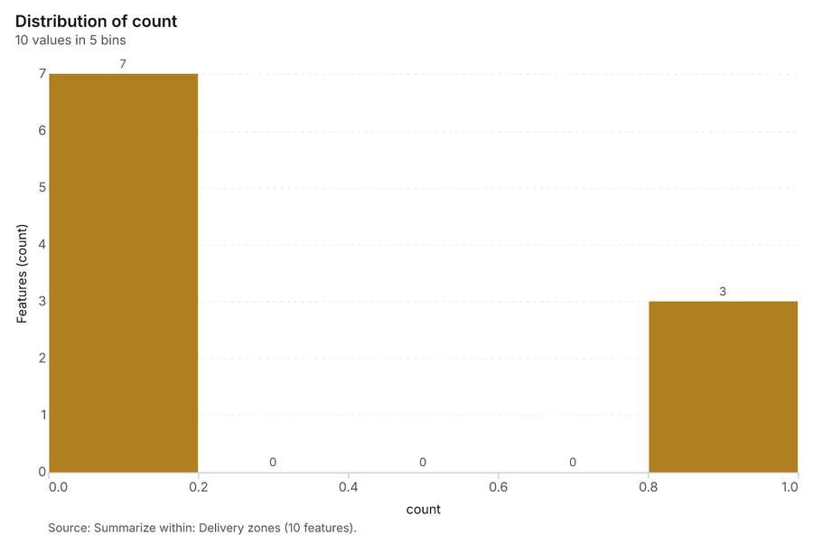
Figure 30. Summarize within: Delivery zones [89]. Source: Summarize within: Delivery zones (10 features). The data is in the appendix.
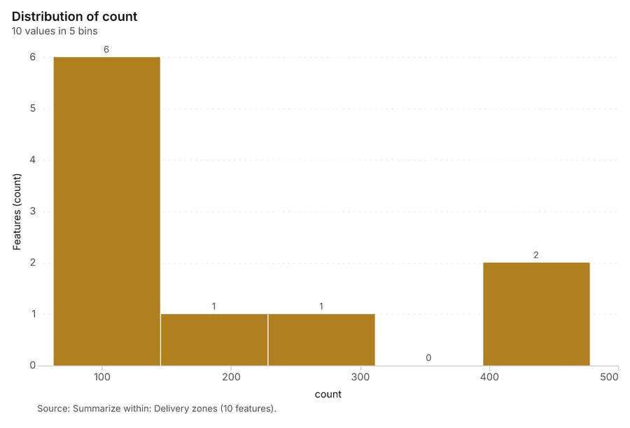
Figure 31. Summarize within: Delivery zones [90]. Source: Summarize within: Delivery zones (10 features). The data is in the appendix.
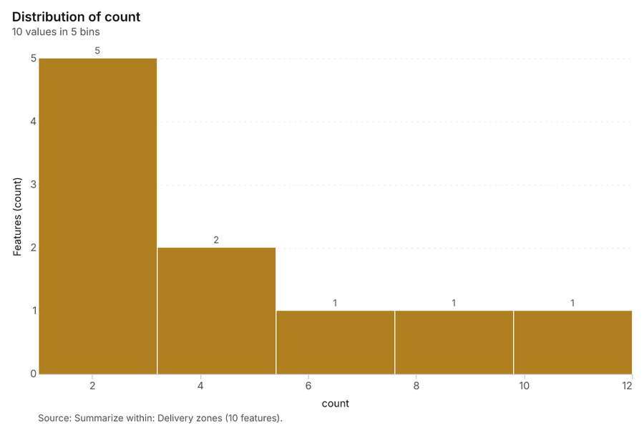
Figure 32. Summarize within: Delivery zones [91]. Source: Summarize within: Delivery zones (10 features). The data is in the appendix.
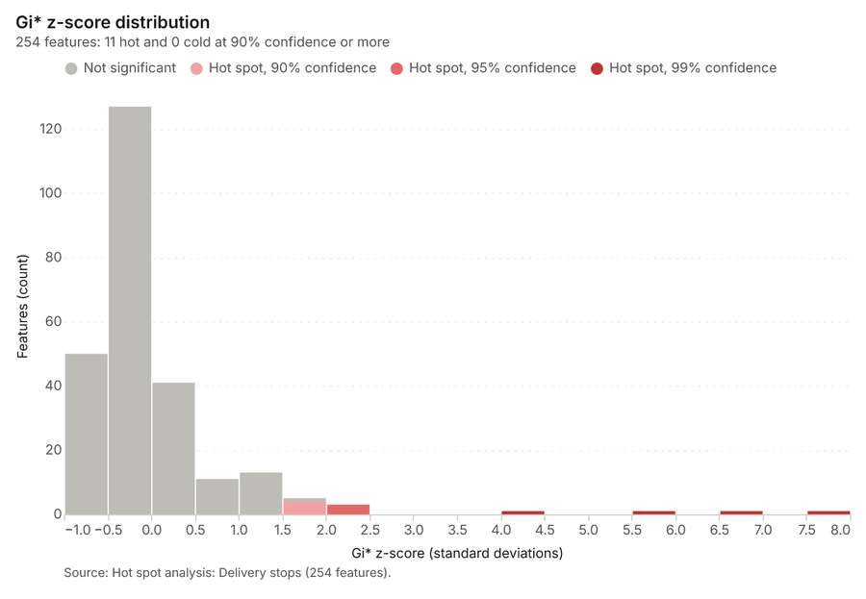
Figure 33. Hot spot analysis: Delivery stops [92]. Source: Hot spot analysis: Delivery stops (254 features). The data is in the appendix.
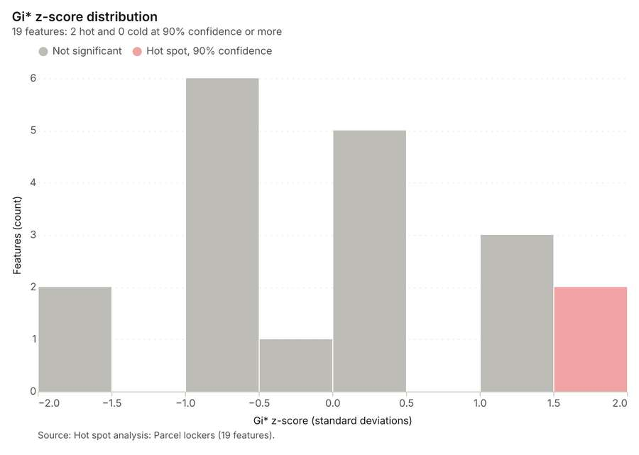
Figure 34. Hot spot analysis: Parcel lockers [93]. Source: Hot spot analysis: Parcel lockers (19 features). The data is in the appendix.
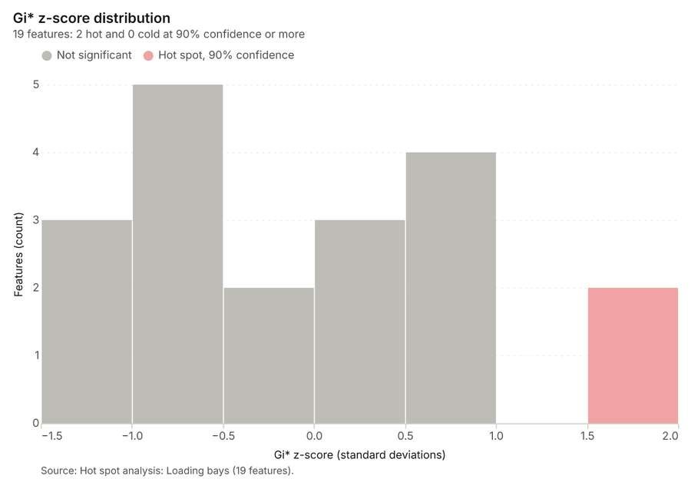
Figure 35. Hot spot analysis: Loading bays [94]. Source: Hot spot analysis: Loading bays (19 features). The data is in the appendix.
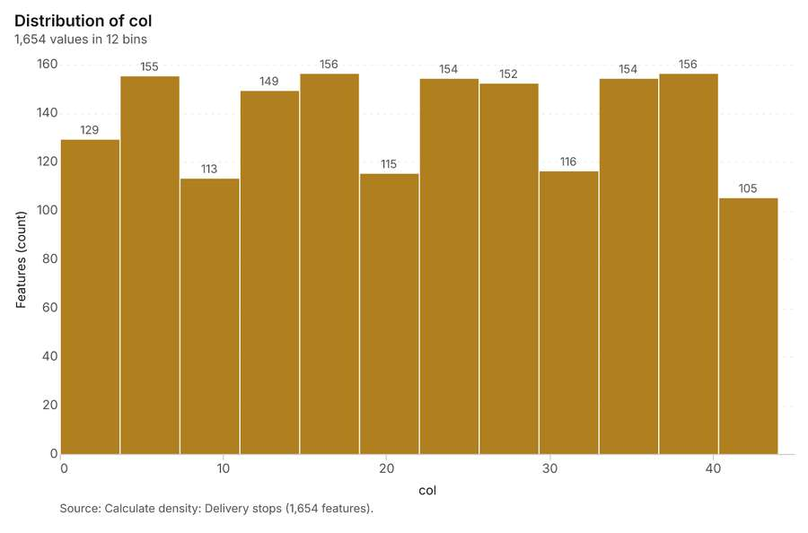
Figure 36. Calculate density: Delivery stops [95]. Source: Calculate density: Delivery stops (1,654 features). The data is in the appendix.
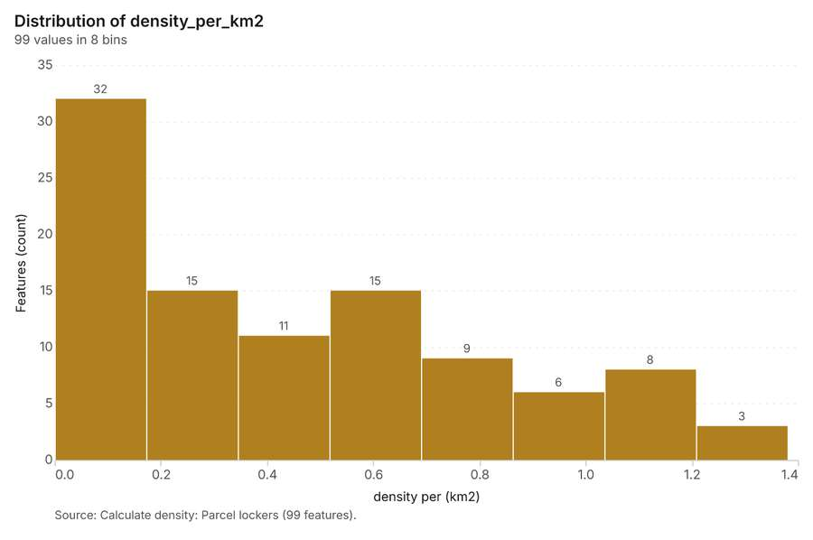
Figure 37. Calculate density: Parcel lockers [96]. Source: Calculate density: Parcel lockers (99 features). The data is in the appendix.
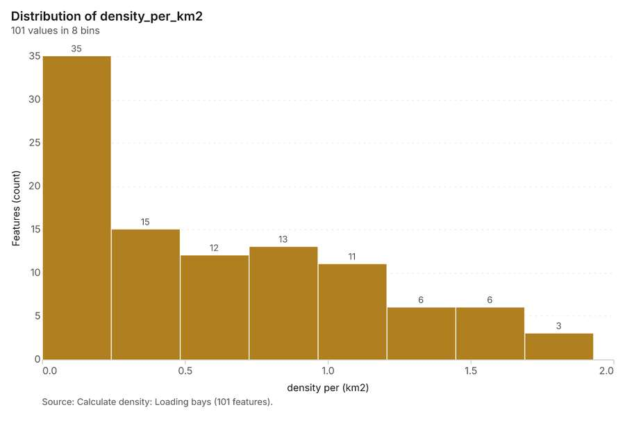
Figure 38. Calculate density: Loading bays [97]. Source: Calculate density: Loading bays (101 features). The data is in the appendix.
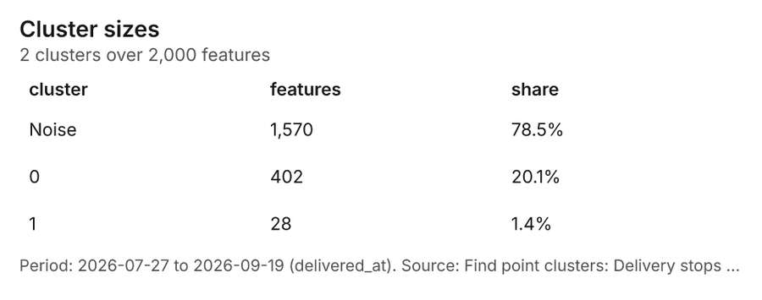
Figure 39. Find point clusters: Delivery stops [98]. Period: 2026-07-27 to 2026-09-19 (delivered_at). Source: Find point clusters: Delivery stops (2,000 features). The data is in the appendix.
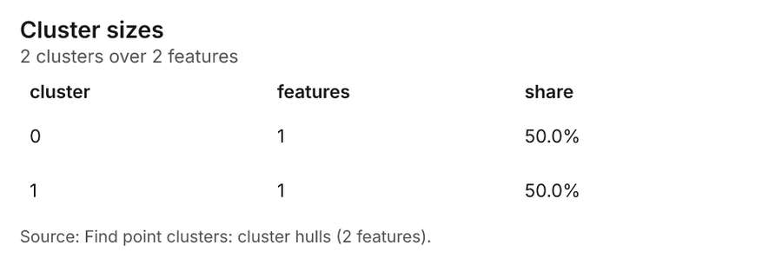
Figure 40. Find point clusters: cluster hulls [99]. Source: Find point clusters: cluster hulls (2 features). The data is in the appendix.
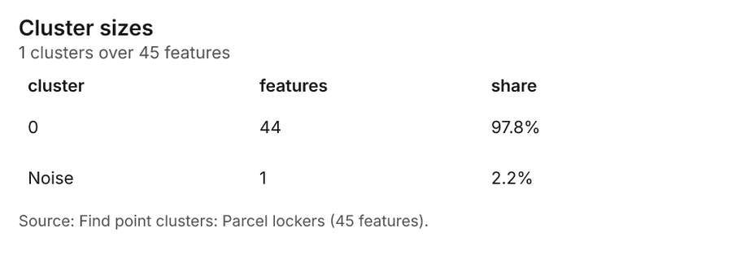
Figure 41. Find point clusters: Parcel lockers [100]. Source: Find point clusters: Parcel lockers (45 features). The data is in the appendix.
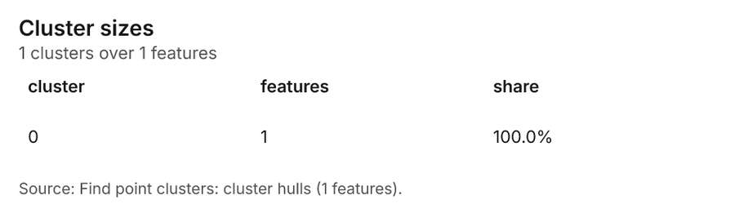
Figure 42. Find point clusters: cluster hulls [101]. Source: Find point clusters: cluster hulls (1 features). The data is in the appendix.
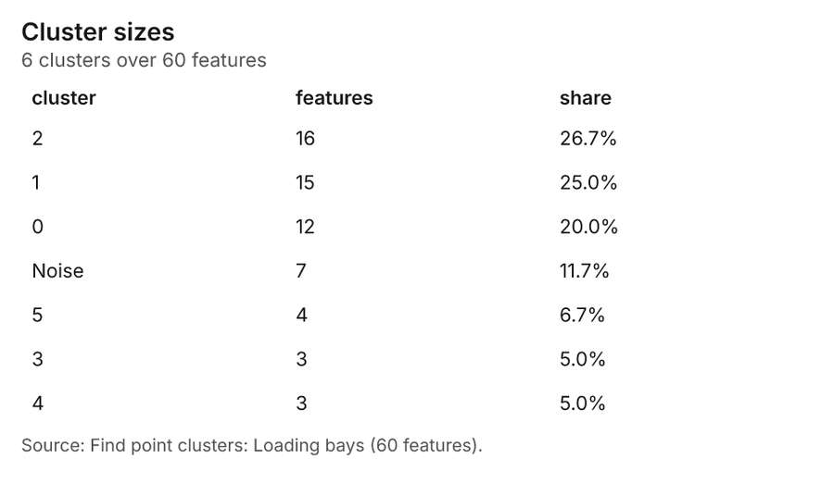
Figure 43. Find point clusters: Loading bays [102]. Source: Find point clusters: Loading bays (60 features). The data is in the appendix.
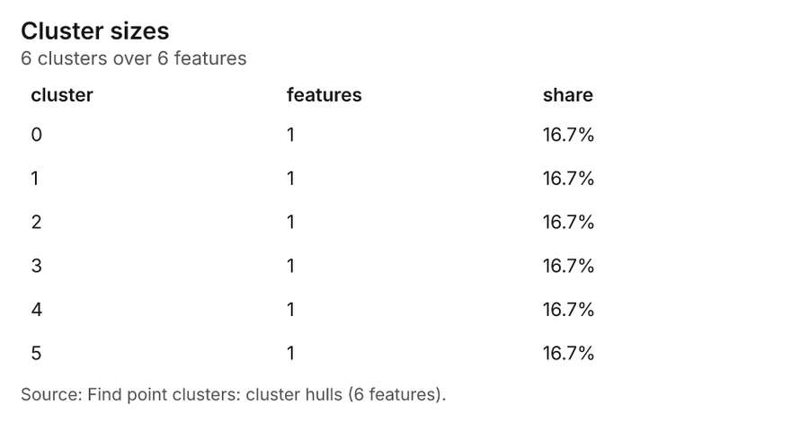
Figure 44. Find point clusters: cluster hulls [103]. Source: Find point clusters: cluster hulls (6 features). The data is in the appendix.
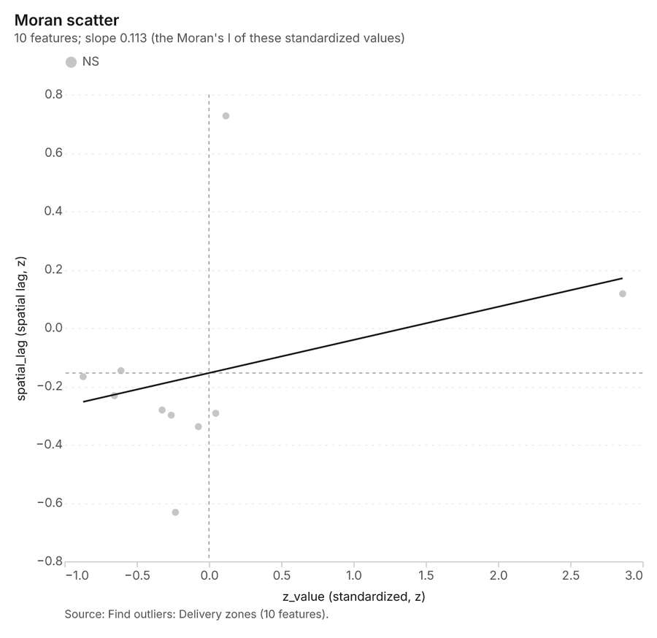
Figure 45. Find outliers: Delivery zones [104]. Source: Find outliers: Delivery zones (10 features). The data is in the appendix.
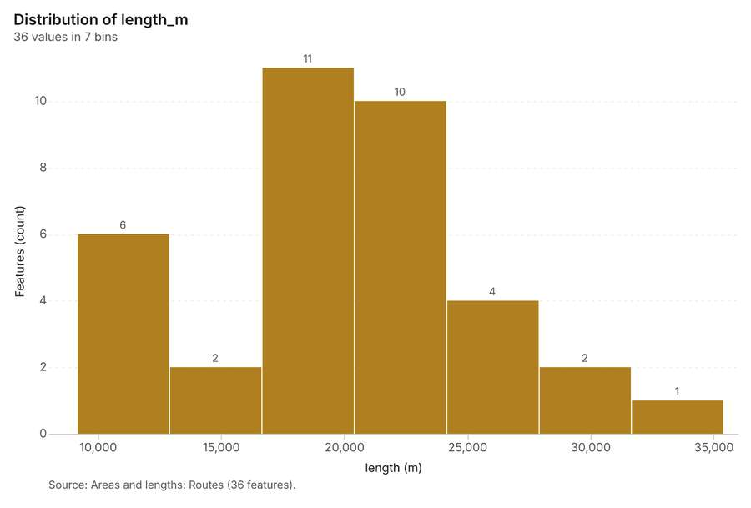
Figure 46. Areas and lengths: Routes [105]. Source: Areas and lengths: Routes (36 features). The data is in the appendix.
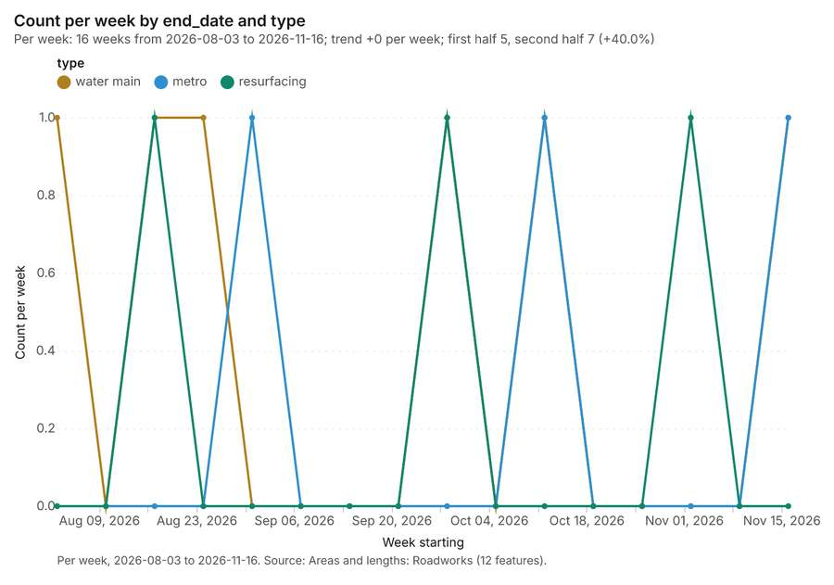
Figure 47. Areas and lengths: Roadworks [106]. Per week, 2026-08-03 to 2026-11-16. Source: Areas and lengths: Roadworks (12 features). The data is in the appendix.
Figure 48. Areas and lengths: Roadworks over time [107]. Per week, 2026-08-03 to 2026-11-16. Source: Areas and lengths: Roadworks (12 features). The data is in the appendix.
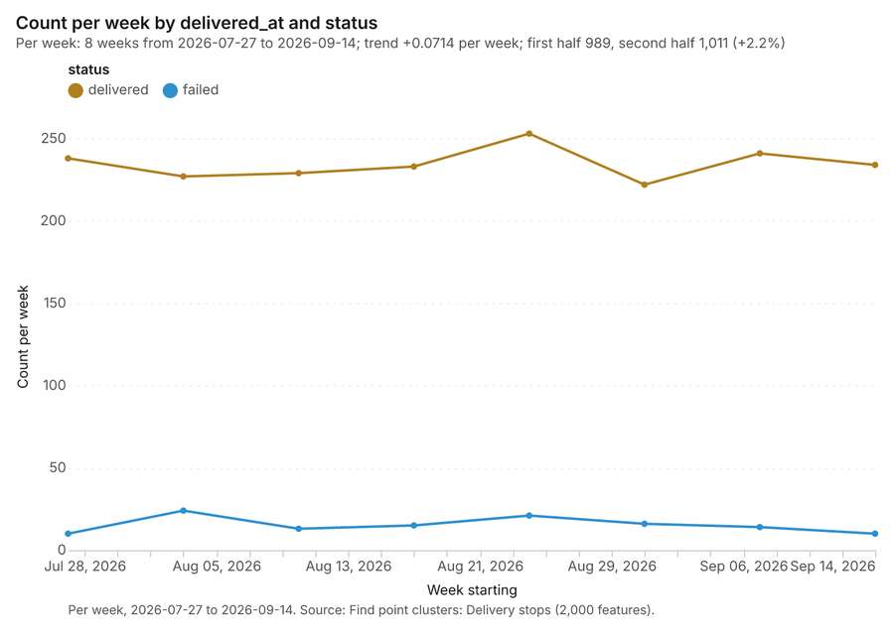
Figure 49. Find point clusters: Delivery stops over time [108]. Per week, 2026-07-27 to 2026-09-14. Source: Find point clusters: Delivery stops (2,000 features). The data is in the appendix.
Figure 50. Repeat and near repeat classification: Delivery stops over time [109]. Per week, 2026-07-27 to 2026-09-14. Source: Repeat and near repeat classification: Delivery stops (2,000 features). The data is in the appendix.

Changes since the last run
This is the first report of this project.

Sources
[1] Rendering: Chart: Timeline: events per week by dataset. 39 rows (id 1521b52f-2ba2-4bbc-a8f6-ccfe5e7fdf7f)
[2] Dataset: Delivery stops. vector, 2000 rows (id b701b76f-6822-4c92-82fe-b4acdce6c331)
[3] Dataset: Roadworks. vector, 12 rows (id 6fda682d-6a14-4d92-9cdd-cdcabec36863)
[4] Dataset: Route performance by day. table, 1728 rows (id 93163425-d292-4c3d-9bd8-2e8681a816c2)
[5] Tool result: gp_change_point_detection, step 2. Change point detection: done; no map output. (id 0bc1c879-b643-4a1a-9035-72f62d929ae4:2)
[6] Catalog: Emerging hot spots (operation catalog, gp_space_time_hot_spots). Where hot spots are new, consecutive, intensifying, persistent, diminishing, sporadic, oscillating or historical over time. ArcGIS: Emerging Hot Spot Analysis, Create Space Time Cube. (id gp_space_time_hot_spots)
[7] Plan: Space time hot spots of Delivery stops (the Start plan's candidate c_24901805ebc9). Delivery stops carry dates in 'delivered_at': emerging hot spot analysis finds new, intensifying and fading hot spots per week. (id 99a0ba18-4245-45ac-a729-8f0ed736c8b0:c_24901805ebc9)
[8] Tool result: gp_space_time_hot_spots, step 0. Emerging hot spots: 1 layer saved: Emerging hot spots: Delivery stops (88 features). (id 0bc1c879-b643-4a1a-9035-72f62d929ae4:0)
[9] Layer: Delivery stops. 2,000 features (id ba8073d9-f217-4175-acc5-437aabf37b16)
[10] Catalog: Repeat and near repeat classification (operation catalog, gp_near_repeat). Classify incidents as originators, repeats (same place) or near repeats within a distance and time window, with a Knox test table. ArcGIS: Repeat and Near Repeat Classification, Near Repeat Calculator. (id gp_near_repeat)
[11] Plan: Near repeat of Delivery stops (the Start plan's candidate c_07c2356dde76). Near repeat analysis tests whether Delivery stops close in space also follow each other within 5 days. (id 99a0ba18-4245-45ac-a729-8f0ed736c8b0:c_07c2356dde76)
[12] Tool result: gp_near_repeat, step 1. Repeat and near repeat classification: 1 layer saved: Repeat and near repeat classification: Delivery stops (2000 features). (id 0bc1c879-b643-4a1a-9035-72f62d929ae4:1)
[13] Catalog: Change point detection (operation catalog, gp_change_point_detection). When did the level, count, trend or variability change? For the whole study area or for every bin. ArcGIS: Change Point Detection. (id gp_change_point_detection)
[14] Plan: Change points of Delivery stops (the Start plan's candidate c_e6c80aa728e2). Change point detection finds when the weekly count of Delivery stops shifted. (id 99a0ba18-4245-45ac-a729-8f0ed736c8b0:c_e6c80aa728e2)
[15] Catalog: Summarize within (operation catalog, gp_summarize_within). Count and aggregate the features inside each polygon (or bin), proportionally for lines and polygons. ArcGIS: Summarize Within, Aggregate Points. QGIS: native:countpointsinpolygon, native:sumlinelengths. (id gp_summarize_within)
[16] Plan: Depots per feature of Delivery zones (the Start plan's candidate c_63970c31d3b8). Count Depots inside each feature of Delivery zones; the counts map as a choropleth (natural breaks, sequential colors). (id 99a0ba18-4245-45ac-a729-8f0ed736c8b0:c_63970c31d3b8)
[17] Tool result: gp_summarize_within, step 0. Summarize within: 1 layer saved: Summarize within: Delivery zones (10 features). (id 06830d85-af54-42ad-b4e3-68502ee43e45:0)
[18] Layer: Depots. 3 features (id 84d3272c-9902-4e4b-a3a0-899c3b10edb7)
[19] Layer: Delivery zones. 10 features (id bfcf8b53-48d2-44c7-b00e-a89315aee1b5)
[20] Tool result: gp_summarize_within, step 1. Summarize within: 1 layer saved: Summarize within: Delivery zones (10 features). (id 06830d85-af54-42ad-b4e3-68502ee43e45:1)
[21] Tool result: gp_summarize_within, step 2. Summarize within: 1 layer saved: Summarize within: Delivery zones (10 features). (id 06830d85-af54-42ad-b4e3-68502ee43e45:2)
[22] Layer: Parcel lockers. 45 features (id 4e9e11a9-8154-47b8-a5ce-2ba3dbf5f3e6)
[23] Catalog: Hot spot analysis (operation catalog, gp_hot_spots). Getis-Ord Gi* hot and cold spots with z-scores, p-values and confidence bins. ArcGIS: Find Hot Spots, Hot Spot Analysis (Getis-Ord Gi*). QGIS: qgis:hotspot (plugin). (id gp_hot_spots)
[24] Plan: Hot spots of Delivery stops (the Start plan's candidate c_90d2c6f9911f). 2000 points: Getis-Ord Gi* tests whether the concentrations in Delivery stops are statistically significant. (id 99a0ba18-4245-45ac-a729-8f0ed736c8b0:c_90d2c6f9911f)
[25] Tool result: gp_hot_spots, step 0. Hot spot analysis: 1 layer saved: Hot spot analysis: Delivery stops (254 features). (id baba02b7-1f72-470f-802a-5d9cf0a96e0e:0)
[26] Plan: Hot spots of Parcel lockers (the Start plan's candidate c_7f159ca7fe80). 45 points: Getis-Ord Gi* tests whether the concentrations in Parcel lockers are statistically significant. (id 99a0ba18-4245-45ac-a729-8f0ed736c8b0:c_7f159ca7fe80)
[27] Tool result: gp_hot_spots, step 1. Hot spot analysis: 1 layer saved: Hot spot analysis: Parcel lockers (19 features). (id baba02b7-1f72-470f-802a-5d9cf0a96e0e:1)
[28] Plan: Hot spots of Loading bays (the Start plan's candidate c_be4560f0ca20). 60 points: Getis-Ord Gi* tests whether the concentrations in Loading bays are statistically significant. (id 99a0ba18-4245-45ac-a729-8f0ed736c8b0:c_be4560f0ca20)
[29] Tool result: gp_hot_spots, step 2. Hot spot analysis: 1 layer saved: Hot spot analysis: Loading bays (19 features). (id baba02b7-1f72-470f-802a-5d9cf0a96e0e:2)
[30] Layer: Loading bays. 60 features (id 16574f8d-1ab3-403e-bf7c-ef2918a3168a)
[31] Catalog: Calculate density (operation catalog, gp_calculate_density). Kernel density per square kilometer on a grid. ArcGIS: Calculate Density, Kernel Density. QGIS: native:heatmapkerneldensityestimation. (id gp_calculate_density)
[32] Plan: Kernel density of Delivery stops (the Start plan's candidate c_b00e122abf70). 2000 points in Delivery stops: a density surface shows where they concentrate. (id 99a0ba18-4245-45ac-a729-8f0ed736c8b0:c_b00e122abf70)
[33] Tool result: gp_calculate_density, step 0. Calculate density: 1 layer saved: Calculate density: Delivery stops (1654 features). (id 5426b1e3-5d44-4200-ad65-fcd6b9219354:0)
[34] Plan: Kernel density of Parcel lockers (the Start plan's candidate c_d0abfcdb6ebd). 45 points in Parcel lockers: a density surface shows where they concentrate. (id 99a0ba18-4245-45ac-a729-8f0ed736c8b0:c_d0abfcdb6ebd)
[35] Tool result: gp_calculate_density, step 1. Calculate density: 1 layer saved: Calculate density: Parcel lockers (99 features). (id 5426b1e3-5d44-4200-ad65-fcd6b9219354:1)
[36] Plan: Kernel density of Loading bays (the Start plan's candidate c_f4d285023245). 60 points in Loading bays: a density surface shows where they concentrate. (id 99a0ba18-4245-45ac-a729-8f0ed736c8b0:c_f4d285023245)
[37] Tool result: gp_calculate_density, step 2. Calculate density: 1 layer saved: Calculate density: Loading bays (101 features). (id 5426b1e3-5d44-4200-ad65-fcd6b9219354:2)
[38] Catalog: Find point clusters (operation catalog, gp_find_point_clusters). Density-based clusters (DBSCAN, HDBSCAN or OPTICS, optionally space-time) with hulls and noise. ArcGIS: Find Point Clusters, Density-based Clustering. QGIS: native:dbscanclustering, native:stdbscanclustering. (id gp_find_point_clusters)
[39] Plan: Cluster points of Delivery stops (the Start plan's candidate c_ecc06546584b). DBSCAN finds dense groups of Delivery stops and separates noise. (id 99a0ba18-4245-45ac-a729-8f0ed736c8b0:c_ecc06546584b)
[40] Tool result: gp_find_point_clusters, step 0. Find point clusters: 2 layers saved: Find point clusters: Delivery stops (2000 features); Find point clusters: cluster hulls (2 features). (id 95a73131-a24c-4f4f-9468-8e9fb0e8dd34:0)
[41] Plan: Cluster points of Parcel lockers (the Start plan's candidate c_ea1cd80d3915). DBSCAN finds dense groups of Parcel lockers and separates noise. (id 99a0ba18-4245-45ac-a729-8f0ed736c8b0:c_ea1cd80d3915)
[42] Tool result: gp_find_point_clusters, step 1. Find point clusters: 2 layers saved: Find point clusters: Parcel lockers (45 features); Find point clusters: cluster hulls (1 feature). (id 95a73131-a24c-4f4f-9468-8e9fb0e8dd34:1)
[43] Plan: Cluster points of Loading bays (the Start plan's candidate c_d272c4a82a27). DBSCAN finds dense groups of Loading bays and separates noise. (id 99a0ba18-4245-45ac-a729-8f0ed736c8b0:c_d272c4a82a27)
[44] Tool result: gp_find_point_clusters, step 2. Find point clusters: 2 layers saved: Find point clusters: Loading bays (60 features); Find point clusters: cluster hulls (6 features). (id 95a73131-a24c-4f4f-9468-8e9fb0e8dd34:2)
[45] Catalog: Find outliers (operation catalog, gp_outliers). Anselin local Moran’s I: HH, LL clusters and HL, LH outliers. ArcGIS: Find Outliers, Cluster and Outlier Analysis (Anselin Local Moran’s I). (id gp_outliers)
[46] Plan: Local morans i of Delivery zones (the Start plan's candidate c_0bac5b3b8830). Local Moran's I maps clusters and outliers of 'parcels_per_day'. (id 99a0ba18-4245-45ac-a729-8f0ed736c8b0:c_0bac5b3b8830)
[47] Tool result: gp_outliers, step 0. Find outliers: 1 layer saved: Find outliers: Delivery zones (10 features). (id 4c008862-b527-4c01-a253-53d590dcfc30:0)
[48] Catalog: Spatial autocorrelation (operation catalog, gp_spatial_autocorrelation). Global Moran’s I: is the pattern clustered, dispersed or random. ArcGIS: Spatial Autocorrelation (Global Moran’s I). (id gp_spatial_autocorrelation)
[49] Plan: Global morans i of Delivery zones (the Start plan's candidate c_49e20ce52312). Global Moran's I says whether similar values of 'parcels_per_day' sit next to each other. (id 99a0ba18-4245-45ac-a729-8f0ed736c8b0:c_49e20ce52312)
[50] Tool result: gp_spatial_autocorrelation, step 1. Spatial autocorrelation: done; no map output. (id 4c008862-b527-4c01-a253-53d590dcfc30:1)
[51] Catalog: Areas and lengths (operation catalog, gp_measure). Geodesic area, perimeter and length of each feature. ArcGIS: Areas And Lengths, Calculate Geometry. QGIS: qgis:exportaddgeometrycolumns. (id gp_measure)
[52] Plan: Length stats of Routes (the Start plan's candidate c_85d40397c2bc). Lengths of the 36 lines of Routes (total and per feature). (id 99a0ba18-4245-45ac-a729-8f0ed736c8b0:c_85d40397c2bc)
[53] Tool result: gp_measure, step 0. Areas and lengths: 1 layer saved: Areas and lengths: Routes (36 features). (id 91b1b73d-cdc4-44e3-a35d-b8f649d4d58d:0)
[54] Layer: Routes. 36 features (id 93de6e09-79b3-40e9-8b57-4b7906bd7eef)
[55] Plan: Length stats of Roadworks (the Start plan's candidate c_a7200769644e). Lengths of the 12 lines of Roadworks (total and per feature). (id 99a0ba18-4245-45ac-a729-8f0ed736c8b0:c_a7200769644e)
[56] Tool result: gp_measure, step 1. Areas and lengths: 1 layer saved: Areas and lengths: Roadworks (12 features). (id 91b1b73d-cdc4-44e3-a35d-b8f649d4d58d:1)
[57] Layer: Roadworks. 12 features (id 50ecfc27-2fb7-43a7-a97c-62847d89632e)
[58] Catalog: Line density (operation catalog, gp_line_density). Length of lines per unit area around each cell (km per square km), optionally weighted by a field. ArcGIS: Line Density. QGIS: qgis:linedensity. (id gp_line_density)
[59] Plan: Line density of Routes (the Start plan's candidate c_42f6ef8679a2). Line density shows where Routes are densest. (id 99a0ba18-4245-45ac-a729-8f0ed736c8b0:c_42f6ef8679a2)
[60] Tool result: gp_line_density, step 2. Line density: 1 layer saved: Line density: Routes (480 features). (id 91b1b73d-cdc4-44e3-a35d-b8f649d4d58d:2)
[61] Rendering: Map: Emerging hot spots: Delivery stops (id f1d06252-1aff-40b3-8003-f6b25228a418)
[62] Rendering: Map: Repeat and near repeat classification: Delivery stops (id 56dbe991-5135-48c1-bc6c-7d3b6a07d808)
[63] Rendering: Map: Summarize within: Delivery zones (id 858fe721-2926-4049-9403-b702f7c1d708)
[64] Rendering: Map: Summarize within: Delivery zones (id 2824f9fd-2587-4fb5-a77e-a3aa3900d97b)
[65] Rendering: Map: Summarize within: Delivery zones (id 27fa5b0d-6371-4492-98c5-31025c68e575)
[66] Rendering: Map: Hot spot analysis: Delivery stops (id 2bacb0be-de03-4c38-bf8f-0ae5de932ab2)
[67] Rendering: Map: Hot spot analysis: Parcel lockers (id 518d4c2b-80c3-42d9-bc31-0561cedde38a)
[68] Rendering: Map: Hot spot analysis: Loading bays (id 3bd8a3a6-8e83-4ea2-b732-5258f2917d5b)
[69] Rendering: Map: Calculate density: Delivery stops (id e5664686-25ef-412b-ba05-b9ff052753ba)
[70] Rendering: Map: Calculate density: Parcel lockers (id 9153e49e-e4a6-473d-9b9a-0c99aa981559)
[71] Rendering: Map: Calculate density: Loading bays (id 089aef48-4d04-4e2b-adf3-1b5f5ba6339b)
[72] Rendering: Map: Find point clusters: Delivery stops (id 7e2737d2-52c9-41a9-ba06-a22cd7165f20)
[73] Rendering: Map: Find point clusters: cluster hulls (id 4f3cc889-cd88-4ebf-a131-f8a38db74f3a)
[74] Rendering: Map: Find point clusters: Parcel lockers (id 980074f9-34f5-41ca-b730-bf16feeff400)
[75] Rendering: Map: Find point clusters: cluster hulls (id 7a66f851-f7b6-4f69-9d38-1eabeffea2a6)
[76] Rendering: Map: Find point clusters: Loading bays (id ce8ded9c-4170-4c0f-89c3-9e2f0139076b)
[77] Rendering: Map: Find point clusters: cluster hulls (id 3a1bb395-8af7-4e6b-92e6-5049fe664a97)
[78] Rendering: Map: Delivery zones by parcels_per_day (id 69ec72f2-551e-4c36-9de4-64b8694296ea)
[79] Rendering: Map: Find outliers: Delivery zones (id 784a0e29-5811-4741-945d-714d4fcd467c)
[80] Rendering: Map: Areas and lengths: Routes (id 79d6c4d8-5815-4392-acf3-1f691e6cd92c)
[81] Rendering: Map: Areas and lengths: Roadworks (id 639ec0fd-16fb-4b55-80ad-9ccaac010750)
[82] Rendering: Map: Line density: Routes (id c697b1c6-e2a2-4247-a4b7-0e7df7e97f00)
[83] Rendering: Chart: Delivery zones over time (parcels_per_day). 5 rows (id 3c505c95-3e52-4c5e-b196-a568f2171052)
[84] Rendering: Chart: Roadworks over time (start_date). 33 rows (id b39779d1-1e2b-44ac-aabb-76eb01c77d35)
[85] Rendering: Chart: Route performance by day over time (date). 8 rows (id b65bccae-a1a1-4e72-ad21-f8677654af9e)
[86] Rendering: Chart: Vehicle fleet over time (model_year). 7 rows (id 931218d3-0ce6-4d63-b966-4d7ecca4f72b)
[87] Rendering: Chart: Emerging hot spots: Delivery stops. 8 rows (id 001edf48-ce03-4110-b451-7e47cefb2ce2)
[88] Rendering: Chart: Repeat and near repeat classification: Delivery stops. 16 rows (id 2613f13d-0205-403c-968f-467d6b8f18f2)
[89] Rendering: Chart: Summarize within: Delivery zones. 5 rows (id 40091302-ced6-4853-a28e-c0ab84bba36e)
[90] Rendering: Chart: Summarize within: Delivery zones. 5 rows (id c26a03d2-ecac-406f-b1c6-cb323c8972c6)
[91] Rendering: Chart: Summarize within: Delivery zones. 5 rows (id 2e9694e1-5c83-4efa-9ca3-1f148701edd0)
[92] Rendering: Chart: Hot spot analysis: Delivery stops. 12 rows (id 6f99017b-7c08-476b-b981-9fa925479410)
[93] Rendering: Chart: Hot spot analysis: Parcel lockers. 6 rows (id 20343f2f-b6eb-4043-a48d-0151b407e909)
[94] Rendering: Chart: Hot spot analysis: Loading bays. 6 rows (id c1c9a919-b186-4232-8d8b-b7389924e9cd)
[95] Rendering: Chart: Calculate density: Delivery stops. 12 rows (id 0ba97a70-8aad-48cf-87c2-76cf7c7397ac)
[96] Rendering: Chart: Calculate density: Parcel lockers. 8 rows (id 497850ae-e8d8-417c-a07d-29a5ca46284e)
[97] Rendering: Chart: Calculate density: Loading bays. 8 rows (id 35ec39ed-b26e-42b1-bc59-ed94b99f9552)
[98] Rendering: Chart: Find point clusters: Delivery stops. 3 rows (id 38539886-bc2b-42a5-a72d-5568be187825)
[99] Rendering: Chart: Find point clusters: cluster hulls. 2 rows (id 338c3b9e-35ed-4db2-8bc0-a3a861c4c0a5)
[100] Rendering: Chart: Find point clusters: Parcel lockers. 2 rows (id 07017722-d2cb-4819-a0c1-8678ecaa6069)
[101] Rendering: Chart: Find point clusters: cluster hulls. 1 rows (id df1f8b27-67ba-452d-9903-5fb39e94536e)
[102] Rendering: Chart: Find point clusters: Loading bays. 7 rows (id 55877d31-670a-4414-b3d9-a5a94c031ea2)
[103] Rendering: Chart: Find point clusters: cluster hulls. 6 rows (id e2598c9e-3c2b-436e-aee2-463caf5d80d5)
[104] Rendering: Chart: Find outliers: Delivery zones. 10 rows (id 91935639-db85-4e93-abb1-ebacc5cbe28f)
[105] Rendering: Chart: Areas and lengths: Routes. 7 rows (id 35bb3975-be91-41d8-b635-b9396a602106)
[106] Rendering: Chart: Areas and lengths: Roadworks. 48 rows (id 0a975f43-6acf-4887-afda-2a66d1ef8d59)
[107] Rendering: Chart: Areas and lengths: Roadworks over time. 48 rows (id 9f61cad0-7d51-4311-a916-62ea61f27aa8)
[108] Rendering: Chart: Find point clusters: Delivery stops over time. 16 rows (id 71c46175-748d-4398-9f7d-e07e43524c4c)
[109] Rendering: Chart: Repeat and near repeat classification: Delivery stops over time. 16 rows (id 7f6f8dcd-9739-475e-8a73-e687a2eed73e)
[110] Dataset: Delivery zones. vector, 10 rows (id ad6ace2b-b87b-4426-b59c-fe04636a404c)
[111] Dataset: Depots. vector, 3 rows (id 01a5d86e-7877-46c0-b8d7-c7125ff945d6)
[112] Dataset: Routes. vector, 36 rows (id 6b02543e-134e-4798-8c55-7433740f3a99)
[113] Dataset: Parcel lockers. vector, 45 rows (id bec44bb9-e98a-4cba-ad40-4738c680b667)
[114] Dataset: Loading bays. vector, 60 rows (id c8f85255-787a-4380-8e60-7b2d51723499)
[115] Dataset: Vehicle fleet. table, 60 rows (id 247c930d-b071-44b8-abcc-a946270b0521)
[116] Dataset: Operations review. document, ? rows (id db8eab40-ac85-4720-ba18-144f3cb5e953)
[117] Record: Sample: Logistics, Madrid (id 55917da2-e619-41aa-b6a1-e521a75b705c)
[118] Layer: Emerging hot spots: Delivery stops. 88 features (id 3eda3d63-4109-4ada-a0a5-a28cb0adffff)
[119] Layer: Repeat and near repeat classification: Delivery stops. 2,000 features (id 16311f39-dfc9-4fec-9ba4-5ab359b9d89b)
[120] Layer: Summarize within: Delivery zones. 10 features (id eaca5331-e8c9-435a-bd13-b434e2db618e)
[121] Layer: Summarize within: Delivery zones. 10 features (id ddf33542-ad9c-48ca-92aa-bb183fc2175b)
[122] Layer: Summarize within: Delivery zones. 10 features (id 7f9be9fb-5f32-4d00-b86c-2ccbc578ecc5)
[123] Layer: Hot spot analysis: Delivery stops. 254 features (id 277a1b72-5c43-4bb2-8a19-af8ab6d8cc80)
[124] Layer: Hot spot analysis: Parcel lockers. 19 features (id 169714e0-714b-4884-8a02-53783c9c7f03)
[125] Layer: Hot spot analysis: Loading bays. 19 features (id 4caff2b6-ee3f-4415-bdc9-5fa9437fd063)
[126] Layer: Calculate density: Delivery stops. 1,654 features (id 99dbaab0-d5d0-4b45-987b-d2c43d1d09c8)
[127] Layer: Calculate density: Parcel lockers. 99 features (id 472257d0-327b-4c9e-a4a8-480595dc3856)
[128] Layer: Calculate density: Loading bays. 101 features (id b6afbc2f-7942-4c9b-94f7-38c291b44345)
[129] Layer: Find point clusters: Delivery stops. 2,000 features (id cc731b64-afbe-4a38-943f-995b6107d190)
[130] Layer: Find point clusters: cluster hulls. 2 features (id 436a36cd-df6c-4e32-a0cc-26d50a8c6585)
[131] Layer: Find point clusters: Parcel lockers. 45 features (id 5e40b4a8-a526-40ac-b338-c5f4ebf27f56)
[132] Layer: Find point clusters: cluster hulls. 1 features (id 5ab85912-f47a-4fb3-b798-991d03f36a1b)
[133] Layer: Find point clusters: Loading bays. 60 features (id 90a837e8-38e5-46ee-a786-10b7fcae3bc0)
[134] Layer: Find point clusters: cluster hulls. 6 features (id 4e2df776-301c-492e-bb6b-6813e216076d)
[135] Layer: Find outliers: Delivery zones. 10 features (id 5e638f0b-04fd-4df9-a5c9-b3d338aebaea)
[136] Layer: Areas and lengths: Routes. 36 features (id 8b07f80e-053c-4638-867e-d4f875f2ab43)
[137] Layer: Areas and lengths: Roadworks. 12 features (id 2ce6988d-7414-430d-b0b9-ede487fe0343)
[138] Layer: Line density: Routes. 480 features (id 90fa509b-1446-4abc-b818-41008be35963)

Appendix: the data behind the charts

Figure 1. Timeline: events per week by dataset [1]
period | series | value
2026-06-22 | Delivery stops | 0
2026-06-22 | Route performance by day | 0
2026-06-22 | Roadworks | 1
2026-06-29 | Delivery stops | 0
2026-06-29 | Route performance by day | 0
2026-06-29 | Roadworks | 0
2026-07-06 | Delivery stops | 0
2026-07-06 | Route performance by day | 0
2026-07-06 | Roadworks | 2
2026-07-13 | Delivery stops | 0
2026-07-13 | Route performance by day | 0
2026-07-13 | Roadworks | 1
2026-07-20 | Delivery stops | 0
2026-07-20 | Route performance by day | 0
2026-07-20 | Roadworks | 3
2026-07-27 | Delivery stops | 248
2026-07-27 | Route performance by day | 216
2026-07-27 | Roadworks | 1
2026-08-03 | Delivery stops | 251
2026-08-03 | Route performance by day | 216
2026-08-03 | Roadworks | 0
2026-08-10 | Delivery stops | 242
2026-08-10 | Route performance by day | 216
2026-08-10 | Roadworks | 1
2026-08-17 | Delivery stops | 248
2026-08-17 | Route performance by day | 216
2026-08-17 | Roadworks | 0
2026-08-24 | Delivery stops | 274
2026-08-24 | Route performance by day | 216
2026-08-24 | Roadworks | 1
2026-08-31 | Delivery stops | 238
2026-08-31 | Route performance by day | 216
2026-08-31 | Roadworks | 2
2026-09-07 | Delivery stops | 255
2026-09-07 | Route performance by day | 216
2026-09-07 | Roadworks | 0
2026-09-14 | Delivery stops | 244
2026-09-14 | Route performance by day | 216
2026-09-14 | Roadworks | 0

Figure 24. Delivery zones over time (parcels_per_day) [83]
bin_start | bin_end | count
1,219 | 1,942 | 6
1,942 | 2,664 | 3
2,664 | 3,387 | 0
3,387 | 4,109 | 0
4,109 | 4,832 | 1

Figure 25. Roadworks over time (start_date) [84]
period | series | value
2026-06-22 | water main | 1
2026-06-22 | metro | 0
2026-06-22 | resurfacing | 0
2026-06-29 | water main | 0
2026-06-29 | metro | 0
2026-06-29 | resurfacing | 0
2026-07-06 | water main | 1
2026-07-06 | metro | 0
2026-07-06 | resurfacing | 1
2026-07-13 | water main | 1
2026-07-13 | metro | 0
2026-07-13 | resurfacing | 0
2026-07-20 | water main | 0
2026-07-20 | metro | 2
2026-07-20 | resurfacing | 1
2026-07-27 | water main | 1
2026-07-27 | metro | 0
2026-07-27 | resurfacing | 0
2026-08-03 | water main | 0
2026-08-03 | metro | 0
2026-08-03 | resurfacing | 0
2026-08-10 | water main | 1
2026-08-10 | metro | 0
2026-08-10 | resurfacing | 0
2026-08-17 | water main | 0
2026-08-17 | metro | 0
2026-08-17 | resurfacing | 0
2026-08-24 | water main | 1
2026-08-24 | metro | 0
2026-08-24 | resurfacing | 0
2026-08-31 | water main | 0
2026-08-31 | metro | 1
2026-08-31 | resurfacing | 1

Figure 26. Route performance by day over time (date) [85]
period | value
2026-07-27 | 216
2026-08-03 | 216
2026-08-10 | 216
2026-08-17 | 216
2026-08-24 | 216
2026-08-31 | 216
2026-09-07 | 216
2026-09-14 | 216

Figure 27. Vehicle fleet over time (model_year) [86]
bin_start | bin_end | count
35 | 52.86 | 13
52.86 | 70.71 | 0
70.71 | 88.57 | 0
88.57 | 106.4 | 13
106.4 | 124.3 | 20
124.3 | 142.1 | 0
142.1 | 160 | 14

Figure 28. Emerging hot spots: Delivery stops [87]
bin_start | bin_end | count
-1.381 | -0.5457 | 20
-0.5457 | 0.2895 | 28
0.2895 | 1.125 | 17
1.125 | 1.96 | 11
1.96 | 2.795 | 3
2.795 | 3.631 | 5
3.631 | 4.466 | 1
4.466 | 5.301 | 3

Figure 29. Repeat and near repeat classification: Delivery stops [88]
period | series | value
2026-07-27 | delivered | 238
2026-07-27 | failed | 10
2026-08-03 | delivered | 227
2026-08-03 | failed | 24
2026-08-10 | delivered | 229
2026-08-10 | failed | 13
2026-08-17 | delivered | 233
2026-08-17 | failed | 15
2026-08-24 | delivered | 253
2026-08-24 | failed | 21
2026-08-31 | delivered | 222
2026-08-31 | failed | 16
2026-09-07 | delivered | 241
2026-09-07 | failed | 14
2026-09-14 | delivered | 234
2026-09-14 | failed | 10

Figure 30. Summarize within: Delivery zones [89]
bin_start | bin_end | count
0 | 0.2 | 7
0.2 | 0.4 | 0
0.4 | 0.6 | 0
0.6 | 0.8 | 0
0.8 | 1 | 3

Figure 31. Summarize within: Delivery zones [90]
bin_start | bin_end | count
62 | 145.2 | 6
145.2 | 228.4 | 1
228.4 | 311.6 | 1
311.6 | 394.8 | 0
394.8 | 478 | 2

Figure 32. Summarize within: Delivery zones [91]
bin_start | bin_end | count
1 | 3.2 | 5
3.2 | 5.4 | 2
5.4 | 7.6 | 1
7.6 | 9.8 | 1
9.8 | 12 | 1

Figure 33. Hot spot analysis: Delivery stops [92]
bin_start | bin_end | band | band_label | count
-1 | -0.5 | not_significant | Not significant | 50
-0.5 | 0 | not_significant | Not significant | 127
0 | 0.5 | not_significant | Not significant | 41
0.5 | 1 | not_significant | Not significant | 11
1 | 1.5 | not_significant | Not significant | 13
1.5 | 2 | hot_90 | Hot spot, 90% confidence | 4
1.5 | 2 | not_significant | Not significant | 1
2 | 2.5 | hot_95 | Hot spot, 95% confidence | 3
4 | 4.5 | hot_99 | Hot spot, 99% confidence | 1
5.5 | 6 | hot_99 | Hot spot, 99% confidence | 1
6.5 | 7 | hot_99 | Hot spot, 99% confidence | 1
7.5 | 8 | hot_99 | Hot spot, 99% confidence | 1

Figure 34. Hot spot analysis: Parcel lockers [93]
bin_start | bin_end | band | band_label | count
-2 | -1.5 | not_significant | Not significant | 2
-1 | -0.5 | not_significant | Not significant | 6
-0.5 | 0 | not_significant | Not significant | 1
0 | 0.5 | not_significant | Not significant | 5
1 | 1.5 | not_significant | Not significant | 3
1.5 | 2 | hot_90 | Hot spot, 90% confidence | 2

Figure 35. Hot spot analysis: Loading bays [94]
bin_start | bin_end | band | band_label | count
-1.5 | -1 | not_significant | Not significant | 3
-1 | -0.5 | not_significant | Not significant | 5
-0.5 | 0 | not_significant | Not significant | 2
0 | 0.5 | not_significant | Not significant | 3
0.5 | 1 | not_significant | Not significant | 4
1.5 | 2 | hot_90 | Hot spot, 90% confidence | 2

Figure 36. Calculate density: Delivery stops [95]
bin_start | bin_end | count
0 | 3.667 | 129
3.667 | 7.333 | 155
7.333 | 11 | 113
11 | 14.67 | 149
14.67 | 18.33 | 156
18.33 | 22 | 115
22 | 25.67 | 154
25.67 | 29.33 | 152
29.33 | 33 | 116
33 | 36.67 | 154
36.67 | 40.33 | 156
40.33 | 44 | 105

Figure 37. Calculate density: Parcel lockers [96]
bin_start | bin_end | count
2.197e-05 | 0.1726 | 32
0.1726 | 0.3451 | 15
0.3451 | 0.5177 | 11
0.5177 | 0.6903 | 15
0.6903 | 0.8628 | 9
0.8628 | 1.035 | 6
1.035 | 1.208 | 8
1.208 | 1.381 | 3

Figure 38. Calculate density: Loading bays [97]
bin_start | bin_end | count
3.822e-07 | 0.2412 | 35
0.2412 | 0.4823 | 15
0.4823 | 0.7235 | 12
0.7235 | 0.9647 | 13
0.9647 | 1.206 | 11
1.206 | 1.447 | 6
1.447 | 1.688 | 6
1.688 | 1.929 | 3

Figure 39. Find point clusters: Delivery stops [98]
cluster | features | fraction | share
Noise | 1,570 | 0.785 | 78.5%
0 | 402 | 0.201 | 20.1%
1 | 28 | 0.014 | 1.4%

Figure 40. Find point clusters: cluster hulls [99]
cluster | features | fraction | share
0 | 1 | 0.5 | 50.0%
1 | 1 | 0.5 | 50.0%

Figure 41. Find point clusters: Parcel lockers [100]
cluster | features | fraction | share
0 | 44 | 0.9778 | 97.8%
Noise | 1 | 0.02222 | 2.2%

Figure 42. Find point clusters: cluster hulls [101]
cluster | features | fraction | share
0 | 1 | 1 | 100.0%

Figure 43. Find point clusters: Loading bays [102]
cluster | features | fraction | share
2 | 16 | 0.2667 | 26.7%
1 | 15 | 0.25 | 25.0%
0 | 12 | 0.2 | 20.0%
Noise | 7 | 0.1167 | 11.7%
5 | 4 | 0.06667 | 6.7%
3 | 3 | 0.05 | 5.0%
4 | 3 | 0.05 | 5.0%

Figure 44. Find point clusters: cluster hulls [103]
cluster | features | fraction | share
0 | 1 | 0.1667 | 16.7%
1 | 1 | 0.1667 | 16.7%
2 | 1 | 0.1667 | 16.7%
3 | 1 | 0.1667 | 16.7%
4 | 1 | 0.1667 | 16.7%
5 | 1 | 0.1667 | 16.7%

Figure 45. Find outliers: Delivery zones [104]
value | lag | type
-0.2612 | -0.2991 | NS
-0.3242 | -0.2814 | NS
0.0467 | -0.2927 | NS
0.117 | 0.7266 | NS
2.862 | 0.117 | NS
-0.8708 | -0.1672 | NS
-0.0732 | -0.3384 | NS
-0.6094 | -0.1465 | NS
-0.2323 | -0.6321 | NS
-0.6549 | -0.2323 | NS

Figure 46. Areas and lengths: Routes [105]
bin_start | bin_end | count
9,145 | 1.29e+04 | 6
1.29e+04 | 1.665e+04 | 2
1.665e+04 | 2.04e+04 | 11
2.04e+04 | 2.415e+04 | 10
2.415e+04 | 2.79e+04 | 4
2.79e+04 | 3.165e+04 | 2
3.165e+04 | 3.54e+04 | 1

Figure 47. Areas and lengths: Roadworks [106]
period | series | value
2026-08-03 | water main | 1
2026-08-03 | metro | 0
2026-08-03 | resurfacing | 0
2026-08-10 | water main | 0
2026-08-10 | metro | 0
2026-08-10 | resurfacing | 0
2026-08-17 | water main | 1
2026-08-17 | metro | 0
2026-08-17 | resurfacing | 1
2026-08-24 | water main | 1
2026-08-24 | metro | 0
2026-08-24 | resurfacing | 0
2026-08-31 | water main | 0
2026-08-31 | metro | 1
2026-08-31 | resurfacing | 0
2026-09-07 | water main | 0
2026-09-07 | metro | 0
2026-09-07 | resurfacing | 0
2026-09-14 | water main | 0
2026-09-14 | metro | 0
2026-09-14 | resurfacing | 0
2026-09-21 | water main | 0
2026-09-21 | metro | 0
2026-09-21 | resurfacing | 0
2026-09-28 | water main | 1
2026-09-28 | metro | 0
2026-09-28 | resurfacing | 1
2026-10-05 | water main | 0
2026-10-05 | metro | 0
2026-10-05 | resurfacing | 0
2026-10-12 | water main | 1
2026-10-12 | metro | 1
2026-10-12 | resurfacing | 0
2026-10-19 | water main | 0
2026-10-19 | metro | 0
2026-10-19 | resurfacing | 0
2026-10-26 | water main | 0
2026-10-26 | metro | 0
2026-10-26 | resurfacing | 0
2026-11-02 | water main | 0
2026-11-02 | metro | 0
2026-11-02 | resurfacing | 1
2026-11-09 | water main | 0
2026-11-09 | metro | 0
2026-11-09 | resurfacing | 0
2026-11-16 | water main | 1
2026-11-16 | metro | 1
2026-11-16 | resurfacing | 0

Figure 48. Areas and lengths: Roadworks over time [107]
period | series | value
2026-08-03 | water main | 1
2026-08-03 | metro | 0
2026-08-03 | resurfacing | 0
2026-08-10 | water main | 0
2026-08-10 | metro | 0
2026-08-10 | resurfacing | 0
2026-08-17 | water main | 1
2026-08-17 | metro | 0
2026-08-17 | resurfacing | 1
2026-08-24 | water main | 1
2026-08-24 | metro | 0
2026-08-24 | resurfacing | 0
2026-08-31 | water main | 0
2026-08-31 | metro | 1
2026-08-31 | resurfacing | 0
2026-09-07 | water main | 0
2026-09-07 | metro | 0
2026-09-07 | resurfacing | 0
2026-09-14 | water main | 0
2026-09-14 | metro | 0
2026-09-14 | resurfacing | 0
2026-09-21 | water main | 0
2026-09-21 | metro | 0
2026-09-21 | resurfacing | 0
2026-09-28 | water main | 1
2026-09-28 | metro | 0
2026-09-28 | resurfacing | 1
2026-10-05 | water main | 0
2026-10-05 | metro | 0
2026-10-05 | resurfacing | 0
2026-10-12 | water main | 1
2026-10-12 | metro | 1
2026-10-12 | resurfacing | 0
2026-10-19 | water main | 0
2026-10-19 | metro | 0
2026-10-19 | resurfacing | 0
2026-10-26 | water main | 0
2026-10-26 | metro | 0
2026-10-26 | resurfacing | 0
2026-11-02 | water main | 0
2026-11-02 | metro | 0
2026-11-02 | resurfacing | 1
2026-11-09 | water main | 0
2026-11-09 | metro | 0
2026-11-09 | resurfacing | 0
2026-11-16 | water main | 1
2026-11-16 | metro | 1
2026-11-16 | resurfacing | 0

Figure 49. Find point clusters: Delivery stops over time [108]
period | series | value
2026-07-27 | delivered | 238
2026-07-27 | failed | 10
2026-08-03 | delivered | 227
2026-08-03 | failed | 24
2026-08-10 | delivered | 229
2026-08-10 | failed | 13
2026-08-17 | delivered | 233
2026-08-17 | failed | 15
2026-08-24 | delivered | 253
2026-08-24 | failed | 21
2026-08-31 | delivered | 222
2026-08-31 | failed | 16
2026-09-07 | delivered | 241
2026-09-07 | failed | 14
2026-09-14 | delivered | 234
2026-09-14 | failed | 10

Figure 50. Repeat and near repeat classification: Delivery stops over time [109]
period | series | value
2026-07-27 | delivered | 238
2026-07-27 | failed | 10
2026-08-03 | delivered | 227
2026-08-03 | failed | 24
2026-08-10 | delivered | 229
2026-08-10 | failed | 13
2026-08-17 | delivered | 233
2026-08-17 | failed | 15
2026-08-24 | delivered | 253
2026-08-24 | failed | 21
2026-08-31 | delivered | 222
2026-08-31 | failed | 16
2026-09-07 | delivered | 241
2026-09-07 | failed | 14
2026-09-14 | delivered | 234
2026-09-14 | failed | 10

