GEOBIT LARGE SPATIAL MODEL

Sample: Mining, Newman: report
Project: Sample: Mining, Newman
Goal: Describe the project Sample: Mining, Newman: run the analyses that tell the most about its data, draw every result, and write a cited report.
Run: e02f959c-4f5a-4566-a3dc-239b3095beaa (running, 11 agent run(s))
Generated: 2026-10-18T05:51:00Z, version 1
Model cost: USD 0.0000 over 0 model call(s)

Data used
Data | Kind | Rows | Time span | Summary | Source
Mine areas | vector, Polygon | 7 |  | 7 polygon (area) features; 'kind' has 4 values (top: waste dump 3, pit 2, ROM pad 1); 'status' has 2 values (top: active 4, rehabilitating 3); 'depth_m' -60 to 260 (mean 33.14); 'ore_reserve_mt' 0 to 151.5 (mean 38.09); named by 'name' (e.g. Main Pit A, East Pit B, North Waste Dump); total area 6.68 km2; extent 119.6814,-23.3942 to 119.7444,-23.3460. Areas (Mine areas) with depth_m to compare and map. | [94]
Haul roads | vector, LineString | 38 |  | 38 line features; 'from' has 4 values (top: PIT-B 14, PIT-A 13, ROM 7); 'to' has 6 values (top: ROM 13, SP-1 6, WD-2 5); 'grade_pct' 0 to 33.3 (mean 6.558); 'width_m' 25 to 35 (mean 28.82); 'trucks_per_hour' 6 to 40 (mean 21.89); total length 20.47 km; extent 119.6885,-23.3893 to 119.7424,-23.3467. Lines (Haul roads) such as routes or networks. | [95]
Monitoring prisms | vector, Point | 60 |  | 60 point features; 'wall' has 4 values (top: north 19, west 17, south 17); 'elevation_m' 444.2 to 559.6 (mean 499.8); extent 119.6927,-23.3753 to 119.7116,-23.3626. Point locations of Monitoring prisms by wall. | [96]
Prism readings | vector, Point | 1,200 | 2026-05-04 to 2026-09-14 | 1,200 point features; dated by 'observed_at' from 2026-05-04 to 2026-09-14; 'displacement_mm' 0.1 to 74.8 (mean 7.96); 'velocity_mm_day' 0.02 to 2.99 (mean 0.2121); extent 119.6927,-23.3753 to 119.7116,-23.3626. Dated point events: where and when Prism readings happen. | [2]
Drill holes | vector, Point | 320 | 2024-01-01 to 2026-08-19 | 320 point features; dated by 'drilled_on' from 2024-01-01 to 2026-08-19; 'type' has 2 values (top: RC 221, diamond 99); 'depth_m' 60 to 319 (mean 187.9); 'fe_pct' 33.6 to 66 (mean 52.77); 'sio2_pct' 1 to 9.6 (mean 5.066); extent 119.6888,-23.3822 to 119.7396,-23.3598. Dated point events by type: where and when Drill holes happen. | [3]
Equipment | vector, Point | 40 |  | 40 point features; 'type' has 5 values (top: haul truck 16, excavator 8, dozer 6); 'status' has 3 values (top: operating 16, down 12, standby 12); 'payload_t' 0 to 220 (mean 88); extent 119.6909,-23.3864 to 119.7392,-23.3483. Point locations of Equipment by type. | [97]
Geotechnical domains | vector, Polygon | 6 |  | 6 polygon (area) features; 'rock_type' has 4 values (top: shale 3, dolerite 1, BIF 1); 'rmr' 43 to 74 (mean 54.83); 'design_angle_deg' 38 to 48 (mean 44.17); total area 10.37 km2; extent 119.6826,-23.3842 to 119.7217,-23.3540. Areas (Geotechnical domains) with rmr to compare and map. | [98]
Mine terrain model (DEM) | raster |  |  | 1-band float32 raster (dem), 400 x 300 cells; resolution 20; band 1 309.4 to 630.1; extent 119.6704,-23.3977 to 119.7496,-23.3423. An elevation surface for terrain analysis. | [99]
Production by pit and week | table | 76 | 2026-01-05 to 2026-09-21 | Table of 76 rows and 6 columns without geometry; dated by 'week_start' from 2026-01-05 to 2026-09-21; 'ore_t' 124,041 to 577,138 (mean 2.998e+05); 'waste_t' 238,570 to 1,500,239 (mean 7.316e+05); 'truck_hours' 664 to 3,679 (mean 1875). A table of Production by pit and week without locations. | [4]
Bench design by domain | table | 6 |  | Table of 6 rows and 5 columns without geometry; 'bench_height_m' 10 to 15 (mean 13.33); 'berm_width_m' 6.4 to 8.8 (mean 7.833); 'face_angle_deg' 65 to 75 (mean 69.17). A table of Bench design by domain without locations. | [100]
Geotechnical inspection report | document |  |  | 1-page pdf document 'Geotechnical inspection report'; language en; mentions 6 place(s): Main Pit A (3), -23.36400, 119.70205 (1), ROM Pad and Crusher (1), Main Pit (1), East Pit B (1). A document about Main Pit A, -23.36400, 119.70205, ROM Pad and Crusher. | [101]
Sample: Mining, Newman | record |  |  |  | [102]
Hot spot analysis: Drill holes | layer, Polygon | 50 |  |  | [103]
Hot spot analysis: Prism readings | layer, Polygon | 227 |  |  | [104]
Emerging hot spots: Drill holes | layer, Polygon | 30 |  |  | [105]
Emerging hot spots: Prism readings | layer, Polygon | 29 |  |  | [106]
Repeat and near repeat classification: Drill holes | layer, Point | 320 |  |  | [107]
Summarize within: Geotechnical domains | layer, Polygon | 6 |  |  | [108]
Summarize within: Geotechnical domains | layer, Polygon | 6 |  |  | [109]
Summarize within: Geotechnical domains | layer, Polygon | 6 |  |  | [110]
Find point clusters: Drill holes | layer, Point | 320 |  |  | [111]
Find point clusters: cluster hulls | layer, Polygon | 10 |  |  | [112]
Find point clusters: Prism readings | layer, Point | 1,200 |  |  | [113]
Find point clusters: cluster hulls | layer, Polygon | 60 |  |  | [114]
Find point clusters: Monitoring prisms | layer, Point | 60 |  |  | [115]
Find point clusters: cluster hulls | layer, Polygon | 4 |  |  | [116]
Slope (degrees) | layer | 0 |  |  | [117]
Calculate density: Drill holes | layer, Polygon | 328 |  |  | [118]
Calculate density: Prism readings | layer, Polygon | 545 |  |  | [119]
Calculate density: Monitoring prisms | layer, Polygon | 134 |  |  | [120]
Hot spot analysis: Monitoring prisms | layer, Polygon | 16 |  |  | [121]

Timeline
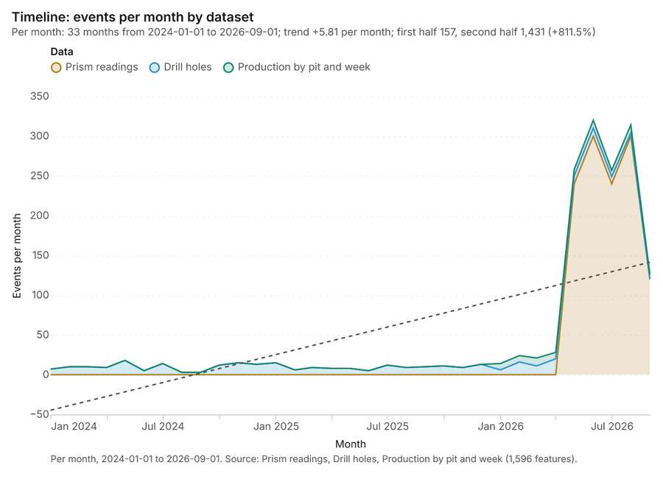
Figure 1. Timeline: events per month by dataset [1]. Per month, 2024-01-01 to 2026-09-01. Source: Prism readings, Drill holes, Production by pit and week (1,596 features). The data is in the appendix.
The timeline counts 1,596 dated events in Prism readings, Drill holes, Production by pit and week per month, from January 2024 to September 2026 [1][2][3][4]. By dataset: Prism readings 1,200; Drill holes 320; Production by pit and week 76 [1]. The trend is +5.81 events per month; the second half of the months has 1,431 against 157 in the first (+811.5%) [1].
Busiest months
- June 2026: 320 events [1]
- August 2026: 314 events [1]
- May 2026: 258 events [1]
Quietest months
- August 2024: 3 events [1]
- September 2024: 3 events [1]
- June 2024: 5 events [1]

Hot spots
What this analysis is. Hot spot analysis: Getis-Ord Gi* hot and cold spots with z-scores, p-values and confidence bins [5]. In ArcGIS it is Find Hot Spots or Hot Spot Analysis (Getis-Ord Gi*); in QGIS, qgis:hotspot (plugin) [5].
Why it was run on this data. 320 points: Getis-Ord Gi* tests whether the concentrations in Drill holes are statistically significant [6].
What it found. Hot spots on Drill holes: Hot spot analysis: 1 layer saved: Hot spot analysis: Drill holes (50 features) [7][8]. It reported result, bins 50; result, count 50; result, elapsed ms 6; result, cell size m 500; result, incidents used 320; result, distance band m 500 [7].
Result | Value
result, bins | 50
result, count | 50
result, elapsed ms | 6
result, cell size m | 500
result, incidents used | 320
result, distance band m | 500
billing, cost | 0.0564
billing, list price | 0.0564
billing, upstream cost | 0

Findings
- Evidenced: Hot spots on Drill holes: Hot spot analysis: 1 layer saved: Hot spot analysis: Drill holes (50 features) [7][8].
- Evidenced: It reported result, bins 50; result, count 50; result, elapsed ms 6; result, cell size m 500; result, incidents used 320; result, distance band m 500 [7].
Tool gp_hot_spots; parameters {"project": "11fd3b70-5f29-4895-b87f-807f2ec1e52e", "features": {"layer": "Drill holes (3fc6780a)"}, "aggregation": "hexagon", "cell_size_m": 500.0, "distance_band_m": 500.0}

Hot spots
What this analysis is. Hot spot analysis: Getis-Ord Gi* hot and cold spots with z-scores, p-values and confidence bins [5]. In ArcGIS it is Find Hot Spots or Hot Spot Analysis (Getis-Ord Gi*); in QGIS, qgis:hotspot (plugin) [5].
Why it was run on this data. 1200 points: Getis-Ord Gi* tests whether the concentrations in Prism readings are statistically significant [9].
What it found. Hot spots on Prism readings: Hot spot analysis: 1 layer saved: Hot spot analysis: Prism readings (227 features) [10][11]. It reported result, bins 227; result, count 227; result, elapsed ms 15; result, cell size m 100; result, incidents used 1,200; result, distance band m 100 [10].
Result | Value
result, bins | 227
result, count | 227
result, elapsed ms | 15
result, cell size m | 100
result, incidents used | 1,200
result, distance band m | 100
billing, cost | 0.074
billing, list price | 0.074
billing, upstream cost | 0

Findings
- Evidenced: Hot spots on Prism readings: Hot spot analysis: 1 layer saved: Hot spot analysis: Prism readings (227 features) [10][11].
- Evidenced: It reported result, bins 227; result, count 227; result, elapsed ms 15; result, cell size m 100; result, incidents used 1,200; result, distance band m 100 [10].
Tool gp_hot_spots; parameters {"project": "11fd3b70-5f29-4895-b87f-807f2ec1e52e", "features": {"layer": "Prism readings (920e4ae7)"}, "aggregation": "hexagon", "cell_size_m": 100.0, "distance_band_m": 100.0}

Space time hot spots
What this analysis is. Emerging hot spots: Where hot spots are new, consecutive, intensifying, persistent, diminishing, sporadic, oscillating or historical over time [12]. In ArcGIS it is Emerging Hot Spot Analysis or Create Space Time Cube [12].
Why it was run on this data. Drill holes carry dates in 'drilled_on': emerging hot spot analysis finds new, intensifying and fading hot spots per month [13].
What it found. Space time hot spots on Drill holes: Emerging hot spots: 1 layer saved: Emerging hot spots: Drill holes (30 features) [8][14]. It reported result, count 30; result, elapsed ms 5; result, resolution 8; result, features used 320; result, time neighbors 0; billing, cost 0.116 [14].
Result | Value
result, count | 30
result, elapsed ms | 5
result, resolution | 8
result, features used | 320
result, time neighbors | 0
billing, cost | 0.116
billing, list price | 0.116
billing, upstream cost | 0

Findings
- Evidenced: Space time hot spots on Drill holes: Emerging hot spots: 1 layer saved: Emerging hot spots: Drill holes (30 features) [8][14].
- Evidenced: It reported result, count 30; result, elapsed ms 5; result, resolution 8; result, features used 320; result, time neighbors 0; billing, cost 0.116 [14].
A model draft was discarded because a sentence did not cite a source of this section.
Tool gp_space_time_hot_spots; parameters {"project": "11fd3b70-5f29-4895-b87f-807f2ec1e52e", "features": {"layer": "Drill holes (3fc6780a)"}, "interval": "month", "bin_shape": "h3", "resolution": 8, "time_field": "drilled_on"}

Space time hot spots
What this analysis is. Emerging hot spots: Where hot spots are new, consecutive, intensifying, persistent, diminishing, sporadic, oscillating or historical over time [12]. In ArcGIS it is Emerging Hot Spot Analysis or Create Space Time Cube [12].
Why it was run on this data. Prism readings carry dates in 'observed_at': emerging hot spot analysis finds new, intensifying and fading hot spots per week [15].
What it found. Space time hot spots on Prism readings: Emerging hot spots: 1 layer saved: Emerging hot spots: Prism readings (29 features) [11][16]. It reported result, count 29; result, elapsed ms 5; result, resolution 9; result, features used 1,200; result, time neighbors 0; billing, cost 0.16 [16].
Result | Value
result, count | 29
result, elapsed ms | 5
result, resolution | 9
result, features used | 1,200
result, time neighbors | 0
billing, cost | 0.16
billing, list price | 0.16
billing, upstream cost | 0

Findings
- Evidenced: Space time hot spots on Prism readings: Emerging hot spots: 1 layer saved: Emerging hot spots: Prism readings (29 features) [11][16].
- Evidenced: It reported result, count 29; result, elapsed ms 5; result, resolution 9; result, features used 1,200; result, time neighbors 0; billing, cost 0.16 [16].
Tool gp_space_time_hot_spots; parameters {"project": "11fd3b70-5f29-4895-b87f-807f2ec1e52e", "features": {"layer": "Prism readings (920e4ae7)"}, "interval": "week", "bin_shape": "h3", "resolution": 9, "time_field": "observed_at"}

Near repeat
What this analysis is. Repeat and near repeat classification: Classify incidents as originators, repeats (same place) or near repeats within a distance and time window, with a Knox test table [17]. In ArcGIS it is Repeat and Near Repeat Classification or Near Repeat Calculator [17].
Why it was run on this data. Near repeat analysis tests whether Drill holes close in space also follow each other within 30 days [18].
What it found. The analysis used an input of Drill holes [8] to classify
Result | Value
result, days | 30
result, count | 320
result, chains | 41
result, distance m | 200
result, elapsed ms | 8
result, pairs linked | 61
billing, cost | 0.0596
billing, list price | 0.0596
billing, upstream cost | 0

Findings
- Evidenced: Near repeat on Drill holes: Repeat and near repeat classification: 1 layer saved: Repeat and near repeat classification: Drill holes (320 features) [8][19].
- Evidenced: It reported result, days 30; result, count 320; result, chains 41; result, distance m 200; result, elapsed ms 8; result, pairs linked 61 [19].
Tool gp_near_repeat; parameters {"days": 30, "project": "11fd3b70-5f29-4895-b87f-807f2ec1e52e", "features": {"layer": "Drill holes (3fc6780a)"}, "distance_m": 200.0, "time_field": "drilled_on"}

Summarize within
What this analysis is. Summarize within: Count and aggregate the features inside each polygon (or bin), proportionally for lines and polygons [20]. In ArcGIS it is Summarize Within or Aggregate Points; in QGIS, native:countpointsinpolygon or native:sumlinelengths [20].
Why it was run on this data. Count Drill holes inside each feature of Geotechnical domains by type; the counts map as a choropleth (natural breaks, sequential colors) [21].
What it found. Summarize within on Drill holes, Geotechnical domains: Summarize within: 1 layer saved: Summarize within: Geotechnical domains (6 features) [8][22][23]. It reported result, count 6; result, elapsed ms 1; billing, cost 0.01654; billing, list price 0.01654; billing, upstream cost 0 [22].
Result | Value
result, count | 6
result, elapsed ms | 1
billing, cost | 0.01654
billing, list price | 0.01654
billing, upstream cost | 0

Findings
- Evidenced: Summarize within on Drill holes, Geotechnical domains: Summarize within: 1 layer saved: Summarize within: Geotechnical domains (6 features) [8][22][23].
- Evidenced: It reported result, count 6; result, elapsed ms 1; billing, cost 0.01654; billing, list price 0.01654; billing, upstream cost 0 [22].
Tool gp_summarize_within; parameters {"stats": [{"stat": "sum", "field": "depth_m"}], "project": "11fd3b70-5f29-4895-b87f-807f2ec1e52e", "features": {"layer": "Drill holes (3fc6780a)"}, "group_by": "type", "polygons": {"layer": "Geotechnical domains (7e9e4801)"}}

Summarize within
What this analysis is. Summarize within: Count and aggregate the features inside each polygon (or bin), proportionally for lines and polygons [20]. In ArcGIS it is Summarize Within or Aggregate Points; in QGIS, native:countpointsinpolygon or native:sumlinelengths [20].
Why it was run on this data. Count Drill holes inside each feature of Geotechnical domains by type; the counts map as a choropleth (natural breaks, sequential colors) [21].
What it found. Summarize within on Prism readings, Geotechnical domains: Summarize within: 1 layer saved: Summarize within: Geotechnical domains (6 features) [11][23][24]. It reported result, count 6; result, elapsed ms 3; billing, cost 0.03414; billing, list price 0.03414; billing, upstream cost 0 [24].
Result | Value
result, count | 6
result, elapsed ms | 3
billing, cost | 0.03414
billing, list price | 0.03414
billing, upstream cost | 0

Findings
- Evidenced: Summarize within on Prism readings, Geotechnical domains: Summarize within: 1 layer saved: Summarize within: Geotechnical domains (6 features) [11][23][24].
- Evidenced: It reported result, count 6; result, elapsed ms 3; billing, cost 0.03414; billing, list price 0.03414; billing, upstream cost 0 [24].
Tool gp_summarize_within; parameters {"stats": [{"stat": "sum", "field": "displacement_mm"}], "project": "11fd3b70-5f29-4895-b87f-807f2ec1e52e", "features": {"layer": "Prism readings (920e4ae7)"}, "polygons": {"layer": "Geotechnical domains (7e9e4801)"}}

Summarize within
What this analysis is. Summarize within: Count and aggregate the features inside each polygon (or bin), proportionally for lines and polygons [20]. In ArcGIS it is Summarize Within or Aggregate Points; in QGIS, native:countpointsinpolygon or native:sumlinelengths [20].
Why it was run on this data. Count Drill holes inside each feature of Geotechnical domains by type; the counts map as a choropleth (natural breaks, sequential colors) [21].
What it found. Summarize within on Monitoring prisms, Geotechnical domains: Summarize within: 1 layer saved: Summarize within: Geotechnical domains (6 features) [23][25][26]. It reported result, count 6; result, elapsed ms 1; billing, cost 0.01134; billing, list price 0.01134; billing, upstream cost 0 [25].
Result | Value
result, count | 6
result, elapsed ms | 1
billing, cost | 0.01134
billing, list price | 0.01134
billing, upstream cost | 0

Findings
- Evidenced: Summarize within on Monitoring prisms, Geotechnical domains: Summarize within: 1 layer saved: Summarize within: Geotechnical domains (6 features) [23][25][26].
- Evidenced: It reported result, count 6; result, elapsed ms 1; billing, cost 0.01134; billing, list price 0.01134; billing, upstream cost 0 [25].
A model draft was discarded because a sentence did not cite a source of this section.
Tool gp_summarize_within; parameters {"stats": [{"stat": "sum", "field": "elevation_m"}], "project": "11fd3b70-5f29-4895-b87f-807f2ec1e52e", "features": {"layer": "Monitoring prisms (6e51a43e)"}, "group_by": "wall", "polygons": {"layer": "Geotechnical domains (7e9e4801)"}}

Find point clusters
What this analysis is. Find point clusters: Density-based clusters (DBSCAN, HDBSCAN or OPTICS, optionally space-time) with hulls and noise [27]. In ArcGIS it is Find Point Clusters or Density-based Clustering; in QGIS, native:dbscanclustering or native:stdbscanclustering [27].
Why it was run on this data. DBSCAN finds dense groups of Drill holes and separates noise [28].
What it found. Find point clusters on Drill holes: Find point clusters: 2 layers saved: Find point clusters: Drill holes (320 features); Find point clusters: cluster hulls (10 features) [8][29]. It reported result, count 320; result, noise 93; result, distance m 200; result, elapsed ms 9; result, min points 8; billing, cost 0.0564 [29].
Result | Value
result, count | 320
result, noise | 93
result, distance m | 200
result, elapsed ms | 9
result, min points | 8
billing, cost | 0.0564
billing, list price | 0.0564
billing, upstream cost | 0

Findings
- Evidenced: Find point clusters on Drill holes: Find point clusters: 2 layers saved: Find point clusters: Drill holes (320 features); Find point clusters: cluster hulls (10 features) [8][29].
- Evidenced: It reported result, count 320; result, noise 93; result, distance m 200; result, elapsed ms 9; result, min points 8; billing, cost 0.0564 [29].
Tool gp_find_point_clusters; parameters {"method": "dbscan", "project": "11fd3b70-5f29-4895-b87f-807f2ec1e52e", "features": {"layer": "Drill holes (3fc6780a)"}, "distance_m": 200.0, "min_points": 8}

Find point clusters
What this analysis is. Find point clusters: Density-based clusters (DBSCAN, HDBSCAN or OPTICS, optionally space-time) with hulls and noise [27]. In ArcGIS it is Find Point Clusters or Density-based Clustering; in QGIS, native:dbscanclustering or native:stdbscanclustering [27].
Why it was run on this data. DBSCAN finds dense groups of Prism readings and separates noise [30].
What it found. The cluster finding process began using the Prism readings as input [11]. The `gp_find_point_clusters` tool was executed, which saved a total of 2 layers [31].
Findings
- Evidenced: Find point clusters on Prism readings: Find point clusters: 2 layers saved: Find point clusters: Prism readings (1200 features); Find point clusters: cluster hulls (60 features) [11][31].
Tool gp_find_point_clusters; parameters {"method": "dbscan", "project": "11fd3b70-5f29-4895-b87f-807f2ec1e52e", "features": {"layer": "Prism readings (920e4ae7)"}, "distance_m": 50.0, "min_points": 20}

Find point clusters
What this analysis is. Find point clusters: Density-based clusters (DBSCAN, HDBSCAN or OPTICS, optionally space-time) with hulls and noise [27]. In ArcGIS it is Find Point Clusters or Density-based Clustering; in QGIS, native:dbscanclustering or native:stdbscanclustering [27].
Why it was run on this data. DBSCAN finds dense groups of Monitoring prisms and separates noise [32].
What it found. Find point clusters on Monitoring prisms: Find point clusters: 2 layers saved: Find point clusters: Monitoring prisms (60 features); Find point clusters: cluster hulls (4 features) [26][33]. It reported result, count 60; result, noise 5; result, distance m 200; result, elapsed ms 2; result, min points 3; billing, cost 0.0512 [33].
Result | Value
result, count | 60
result, noise | 5
result, distance m | 200
result, elapsed ms | 2
result, min points | 3
billing, cost | 0.0512
billing, list price | 0.0512
billing, upstream cost | 0

Findings
- Evidenced: Find point clusters on Monitoring prisms: Find point clusters: 2 layers saved: Find point clusters: Monitoring prisms (60 features); Find point clusters: cluster hulls (4 features) [26][33].
- Evidenced: It reported result, count 60; result, noise 5; result, distance m 200; result, elapsed ms 2; result, min points 3; billing, cost 0.0512 [33].
Tool gp_find_point_clusters; parameters {"method": "dbscan", "project": "11fd3b70-5f29-4895-b87f-807f2ec1e52e", "features": {"layer": "Monitoring prisms (6e51a43e)"}, "distance_m": 200.0, "min_points": 3}

Zonal statistics
What this analysis is. Zonal statistics: count/min/max/mean/std/sum/median/majority per polygon as a table and as GeoJSON [34]. In ArcGIS it is Zonal Statistics as Table (polygons) [34].
Why it was run on this data. Statistics of Mine terrain model (DEM) inside each feature of Geotechnical domains [35].
What it found. The analysis involved Zonal statistics using the rs_zonal_statistics tool [36]. The tool summary reports the generation of 6 row(s) [36]. It is noted that the analysis involved 6 zones [36].
Findings
- Evidenced: Zonal statistics: Zonal statistics: 6 row(s) [36].
- Evidenced: zones 6 [36].
Tool rs_zonal_statistics; parameters {"stats": ["mean", "min", "max", "std"], "zones": "Geotechnical domains (7e9e4801)", "raster_id": "Mine terrain model (DEM) (d3bacd4c)"}

Zonal statistics
What this analysis is. Zonal statistics: count/min/max/mean/std/sum/median/majority per polygon as a table and as GeoJSON [34]. In ArcGIS it is Zonal Statistics as Table (polygons) [34].
Why it was run on this data. Statistics of Mine terrain model (DEM) inside each feature of Geotechnical domains [35].
What it found. The analysis utilized the Zonal statistics tool, which is also referenced as rs_zonal_statistics [37]. This process yielded 7 row(s) [37]. The resulting data analyzed 7 zones [37].
Findings
- Evidenced: Zonal statistics: Zonal statistics: 7 row(s) [37].
- Evidenced: zones 7 [37].
Tool rs_zonal_statistics; parameters {"stats": ["mean", "min", "max", "std"], "zones": "Mine areas (e1015218)", "raster_id": "Mine terrain model (DEM) (d3bacd4c)"}

Slope
What this analysis is. Slope: Horn slope in degrees or percent, with the share of ground in six grade classes [38]. In ArcGIS it is Slope (Spatial Analyst); in QGIS, Slope (GDAL DEM) [38].
Why it was run on this data. Slope of the Mine terrain model (DEM) surface [39].
What it found. The slope analysis was conducted over an area of 48.00 km² [40].
Result | Value
dem, cols | 400
dem, rows | 300
dem, cell m | 20
dem, relief m | 320.7
dem, elev max m | 630.1
dem, elev min m | 309.4
dem, elev mean m | 570.3
dem, missing frac | 0
cost, usd | 0
grid, cols | 400
grid, rows | 300
grid, cell m | 20
stats, max | 36.74
stats, min | 0
stats, mean | 2.68
stats, median | 0.99
stats, steeper than 15pct | 8.62
rows left out | 0

Findings
- Evidenced: Slope on Mine terrain model (DEM): Slope over 48.00 km2: mean 2.68 degrees, max 36.74 degrees; 9% of the ground is steeper than 15% [40][41].
- Evidenced: DEM: Mine terrain model (DEM) [40][41].
- Evidenced: Verified: 2 checks passed [40][41].
- Evidenced: It reported dem, cols 400; dem, rows 300; dem, cell m 20; dem, relief m 320.7; dem, elev max m 630.1; dem, elev min m 309.4 [40].
Tool tr_slope; parameters {"dem": {"layer": "Mine terrain model (DEM) (d3bacd4c)"}, "project": "11fd3b70-5f29-4895-b87f-807f2ec1e52e"}

Calculate density
What this analysis is. Calculate density: Kernel density per square kilometer on a grid [42]. In ArcGIS it is Calculate Density or Kernel Density; in QGIS, native:heatmapkerneldensityestimation [42].
Why it was run on this data. 320 points in Drill holes: a density surface shows where they concentrate [43].
What it found. The density calculation was performed on 328 drill holes [44]. The resulting maximum density recorded was 81.67 per km2 [44]. The total elapsed time for the calculation was 11 ms [44]. Furthermore, the billing cost associated with this service was 0.0564 [44].
Result | Value
result, count | 328
result, elapsed ms | 11
result, bandwidth m | 500
result, cell size m | 200
result, excluded null | 0
result, max density per km2 | 81.67
billing, cost | 0.0564
billing, list price | 0.0564
billing, upstream cost | 0

Findings
- Evidenced: Calculate density on Drill holes: Calculate density: 1 layer saved: Calculate density: Drill holes (328 features) [8][44].
- Evidenced: It reported result, count 328; result, elapsed ms 11; result, bandwidth m 500; result, cell size m 200; result, excluded null 0; result, max density per km2 81.67 [44].
Tool gp_calculate_density; parameters {"kernel": "quartic", "project": "11fd3b70-5f29-4895-b87f-807f2ec1e52e", "features": {"layer": "Drill holes (3fc6780a)"}, "bandwidth_m": 500.0, "cell_size_m": 200.0}

Calculate density
What this analysis is. Calculate density: Kernel density per square kilometer on a grid [42]. In ArcGIS it is Calculate Density or Kernel Density; in QGIS, native:heatmapkerneldensityestimation [42].
Why it was run on this data. 1200 points in Prism readings: a density surface shows where they concentrate [45].
What it found. Calculate density on Prism readings: Calculate density: 1 layer saved: Calculate density: Prism readings (545 features) [11][46]. It reported result, count 545; result, elapsed ms 18; result, bandwidth m 100; result, cell size m 50; result, excluded null 0; result, max density per km2 2,781 [46].
Result | Value
result, count | 545
result, elapsed ms | 18
result, bandwidth m | 100
result, cell size m | 50
result, excluded null | 0
result, max density per km2 | 2,781
billing, cost | 0.074
billing, list price | 0.074
billing, upstream cost | 0

Findings
- Evidenced: Calculate density on Prism readings: Calculate density: 1 layer saved: Calculate density: Prism readings (545 features) [11][46].
- Evidenced: It reported result, count 545; result, elapsed ms 18; result, bandwidth m 100; result, cell size m 50; result, excluded null 0; result, max density per km2 2,781 [46].
Tool gp_calculate_density; parameters {"kernel": "quartic", "project": "11fd3b70-5f29-4895-b87f-807f2ec1e52e", "features": {"layer": "Prism readings (920e4ae7)"}, "bandwidth_m": 100.0, "cell_size_m": 50.0}

Calculate density
What this analysis is. Calculate density: Kernel density per square kilometer on a grid [42]. In ArcGIS it is Calculate Density or Kernel Density; in QGIS, native:heatmapkerneldensityestimation [42].
Why it was run on this data. 60 points in Monitoring prisms: a density surface shows where they concentrate [47].
What it found. The `gp_calculate_density` tool analyzed 134 features from the "Monitoring prisms" layer [48]. Key results from this analysis include a maximum density of 32.75 per km² [48]. Furthermore, the process utilized a bandwidth of 500 m [48] and completed within 4 elapsed ms [48].
Result | Value
result, count | 134
result, elapsed ms | 4
result, bandwidth m | 500
result, cell size m | 200
result, excluded null | 0
result, max density per km2 | 32.75
billing, cost | 0.0512
billing, list price | 0.0512
billing, upstream cost | 0

Findings
- Evidenced: Calculate density on Monitoring prisms: Calculate density: 1 layer saved: Calculate density: Monitoring prisms (134 features) [26][48].
- Evidenced: It reported result, count 134; result, elapsed ms 4; result, bandwidth m 500; result, cell size m 200; result, excluded null 0; result, max density per km2 32.75 [48].
Tool gp_calculate_density; parameters {"kernel": "quartic", "project": "11fd3b70-5f29-4895-b87f-807f2ec1e52e", "features": {"layer": "Monitoring prisms (6e51a43e)"}, "bandwidth_m": 500.0, "cell_size_m": 200.0}

Hot spots
What this analysis is. Hot spot analysis: Getis-Ord Gi* hot and cold spots with z-scores, p-values and confidence bins [5]. In ArcGIS it is Find Hot Spots or Hot Spot Analysis (Getis-Ord Gi*); in QGIS, qgis:hotspot (plugin) [5].
Why it was run on this data. 60 points: Getis-Ord Gi* tests whether the concentrations in Monitoring prisms are statistically significant [49].
What it found. Hot spots on Monitoring prisms: Hot spot analysis: 1 layer saved: Hot spot analysis: Monitoring prisms (16 features) [26][50]. It reported result, bins 16; result, count 16; result, elapsed ms 3; result, cell size m 500; result, incidents used 60; result, distance band m 500 [50].
Result | Value
result, bins | 16
result, count | 16
result, elapsed ms | 3
result, cell size m | 500
result, incidents used | 60
result, distance band m | 500
billing, cost | 0.0512
billing, list price | 0.0512
billing, upstream cost | 0

Findings
- Evidenced: Hot spots on Monitoring prisms: Hot spot analysis: 1 layer saved: Hot spot analysis: Monitoring prisms (16 features) [26][50].
- Evidenced: It reported result, bins 16; result, count 16; result, elapsed ms 3; result, cell size m 500; result, incidents used 60; result, distance band m 500 [50].
Tool gp_hot_spots; parameters {"project": "11fd3b70-5f29-4895-b87f-807f2ec1e52e", "features": {"layer": "Monitoring prisms (6e51a43e)"}, "aggregation": "hexagon", "cell_size_m": 500.0, "distance_band_m": 500.0}

Maps and charts
The run also made 21 map image(s) [51][52][53][54][55][56][57][58][59][60][61][62][63][64][65][66][67][68][69][70][71] and 22 chart(s) [72][73][74][75][76][77][78][79][80][81][82][83][84][85][86][87][88][89][90][91][92][93].
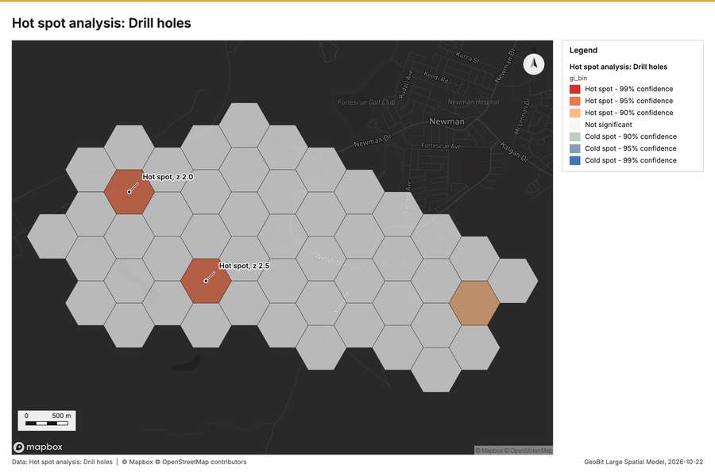
Figure 2. Hot spot analysis: Drill holes [51]
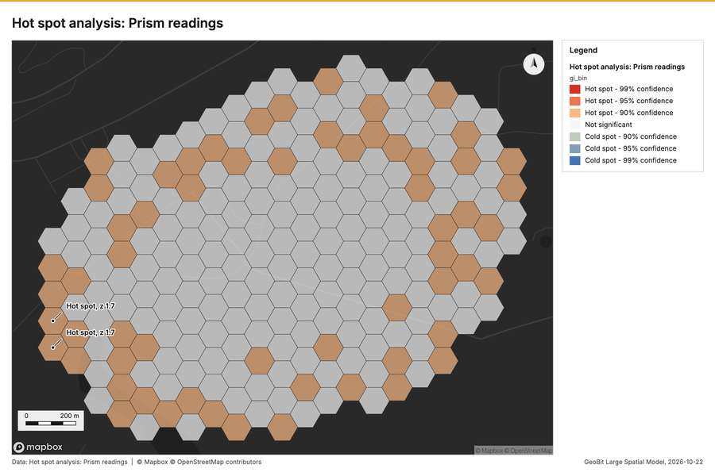
Figure 3. Hot spot analysis: Prism readings [52]
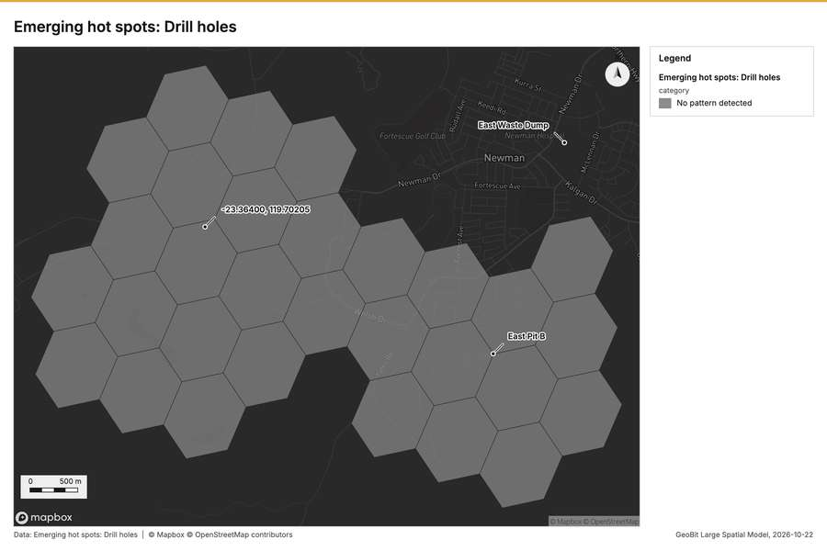
Figure 4. Emerging hot spots: Drill holes [53]
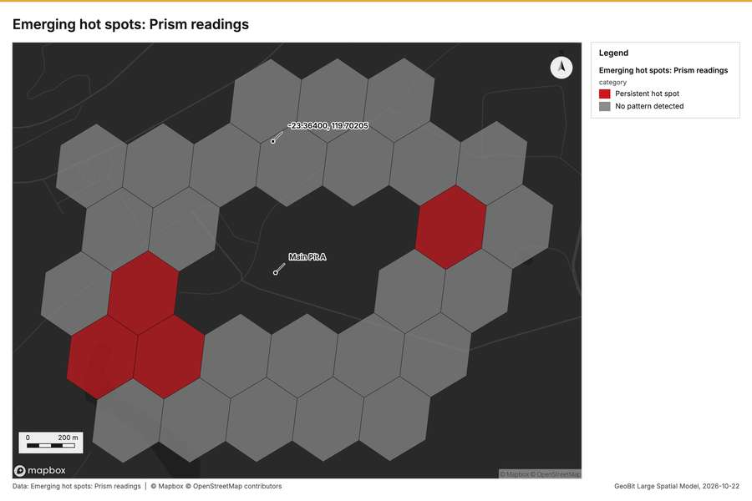
Figure 5. Emerging hot spots: Prism readings [54]
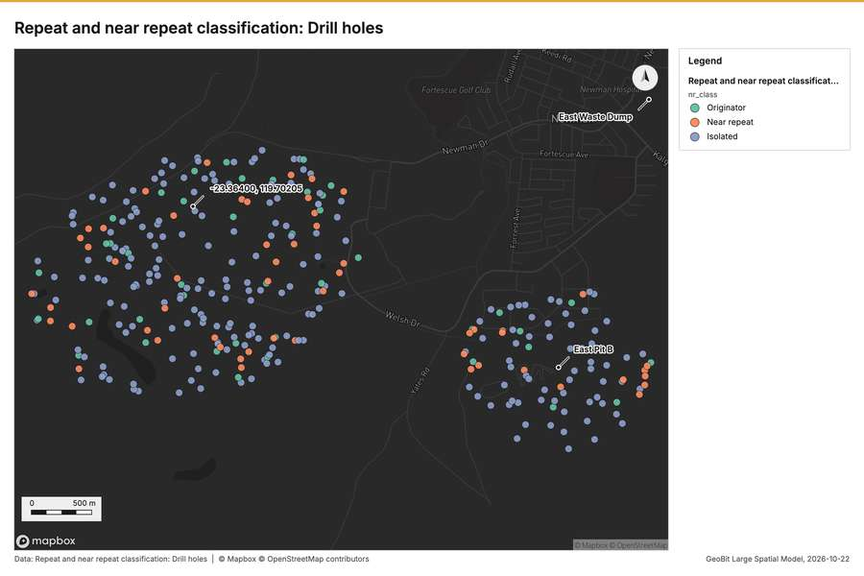
Figure 6. Repeat and near repeat classification: Drill holes [55]
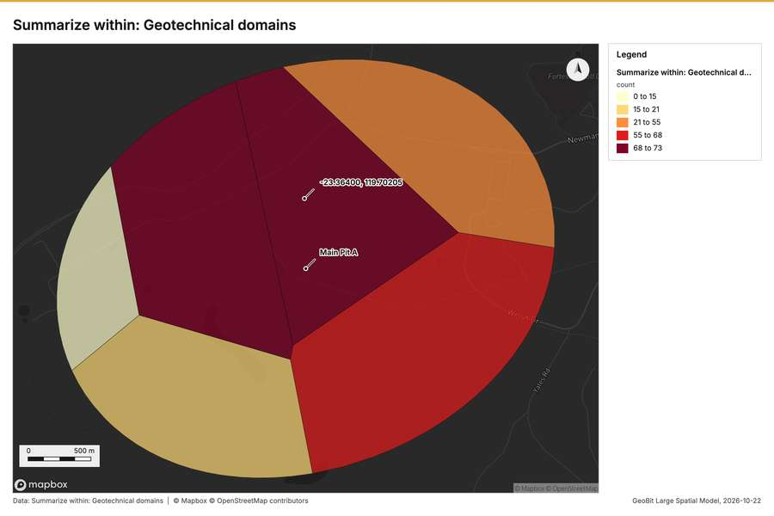
Figure 7. Summarize within: Geotechnical domains [56]
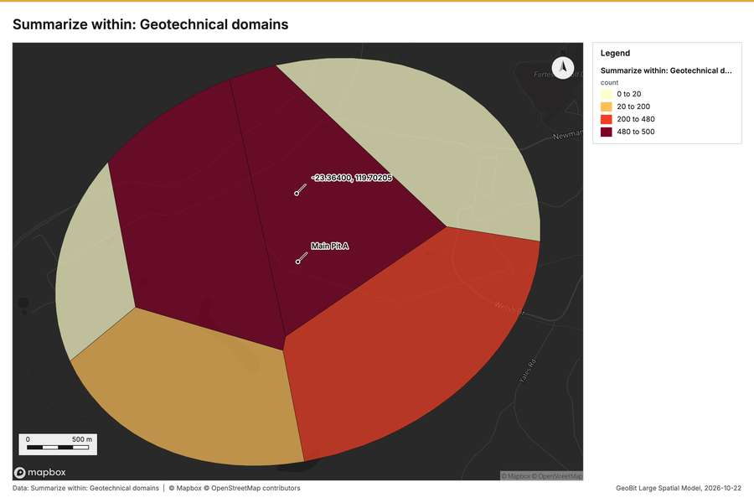
Figure 8. Summarize within: Geotechnical domains [57]
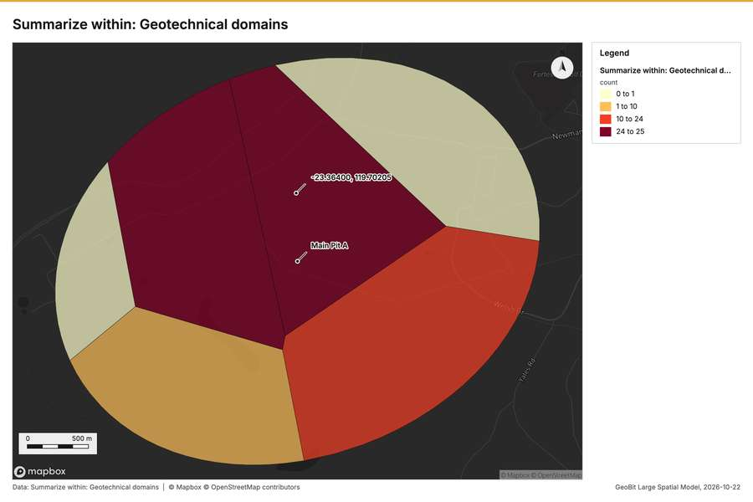
Figure 9. Summarize within: Geotechnical domains [58]
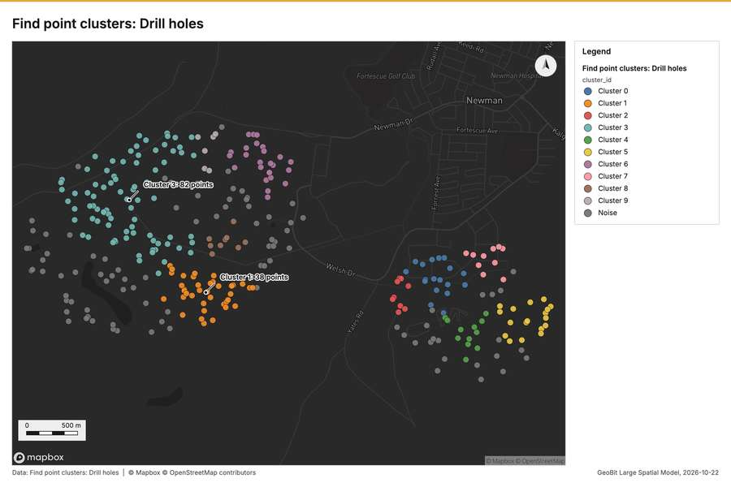
Figure 10. Find point clusters: Drill holes [59]
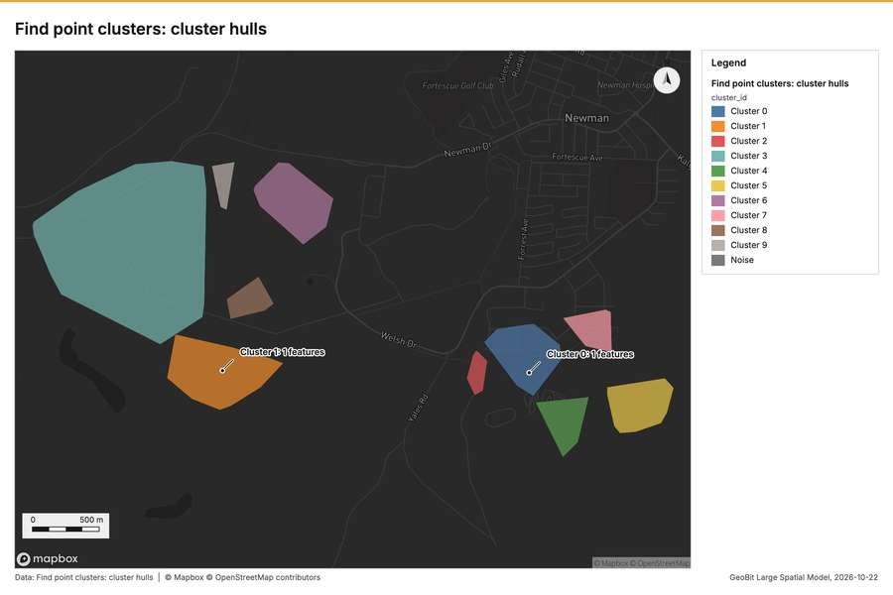
Figure 11. Find point clusters: cluster hulls [60]
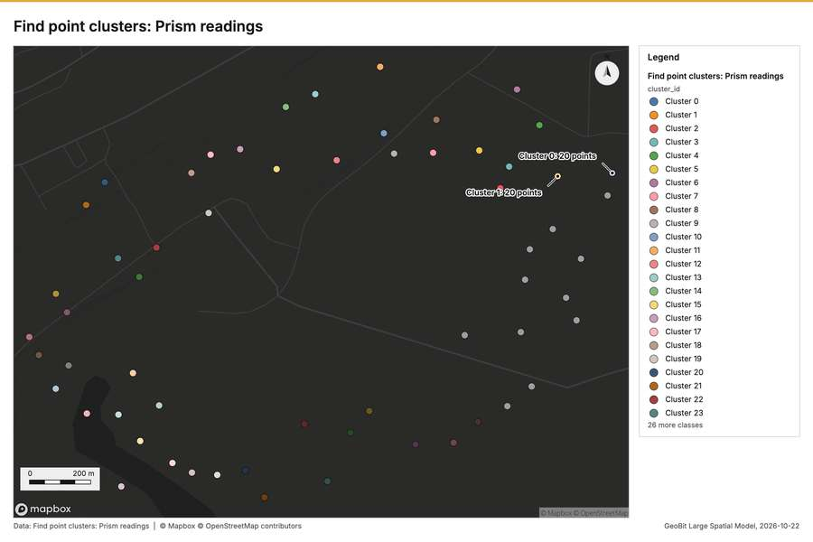
Figure 12. Find point clusters: Prism readings [61]
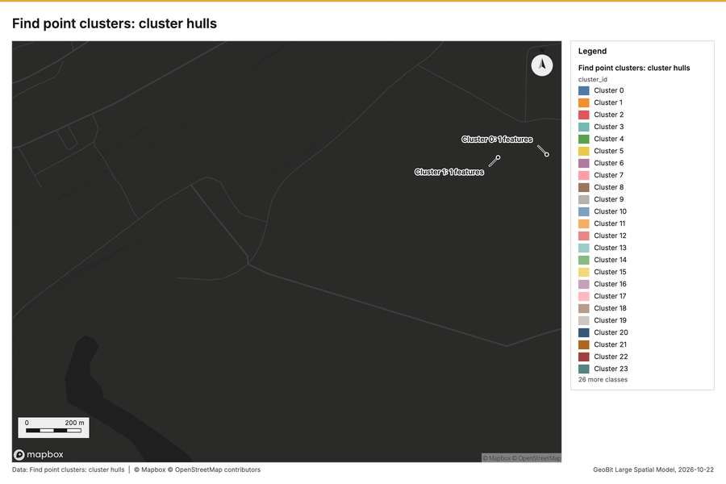
Figure 13. Find point clusters: cluster hulls [62]
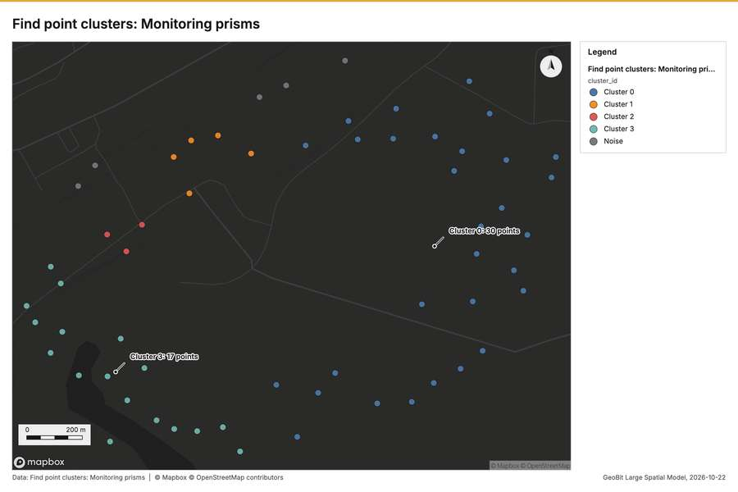
Figure 14. Find point clusters: Monitoring prisms [63]
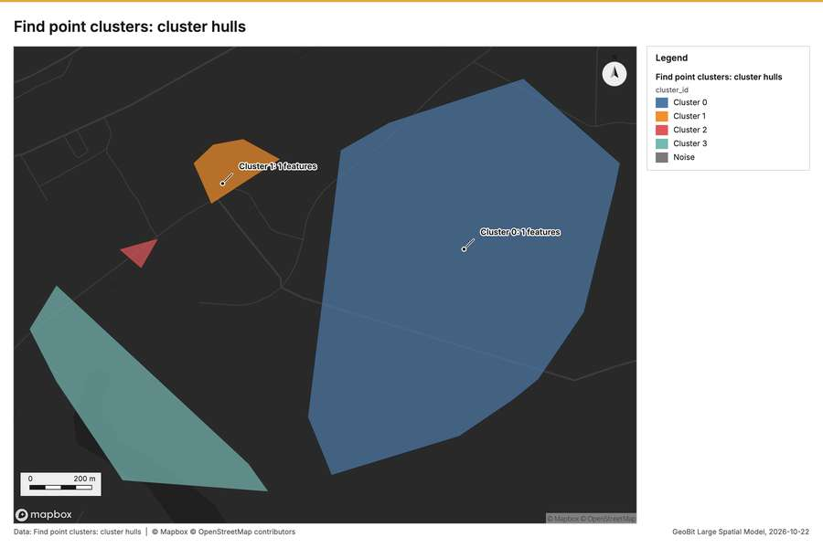
Figure 15. Find point clusters: cluster hulls [64]
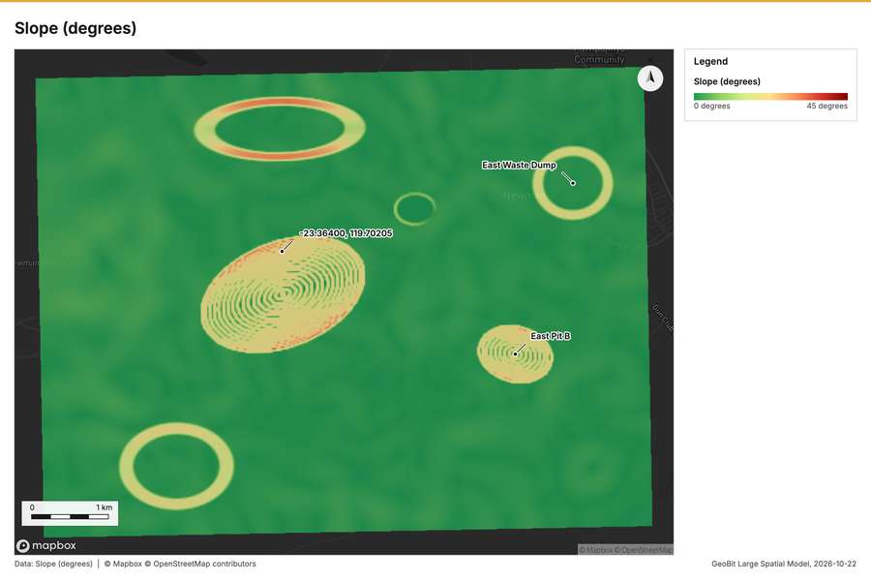
Figure 16. Slope (degrees) [65]
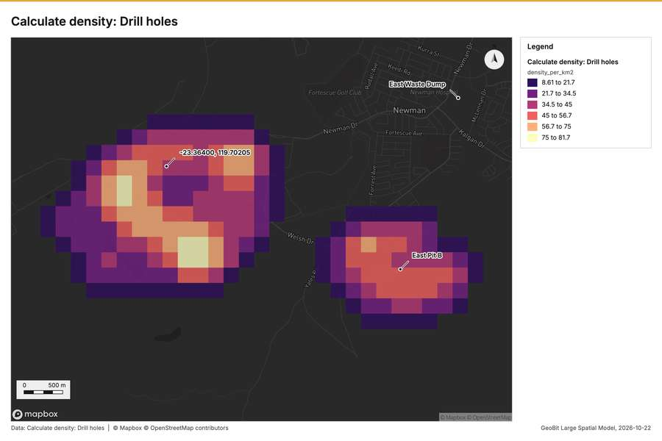
Figure 17. Calculate density: Drill holes [66]
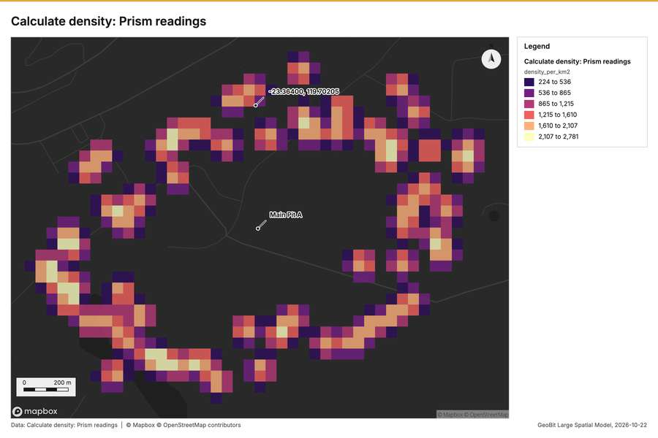
Figure 18. Calculate density: Prism readings [67]
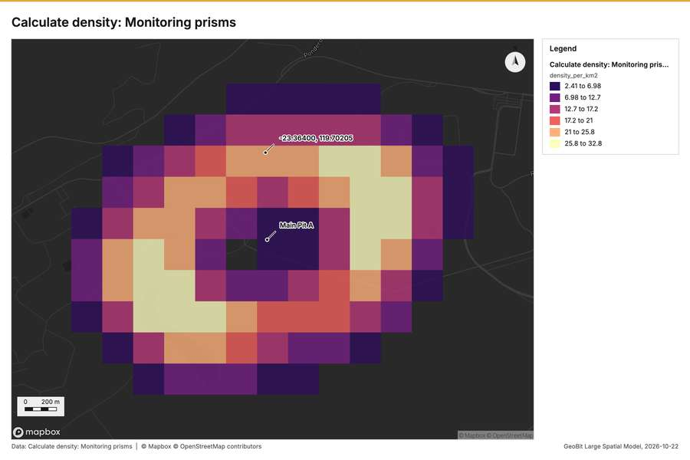
Figure 19. Calculate density: Monitoring prisms [68]
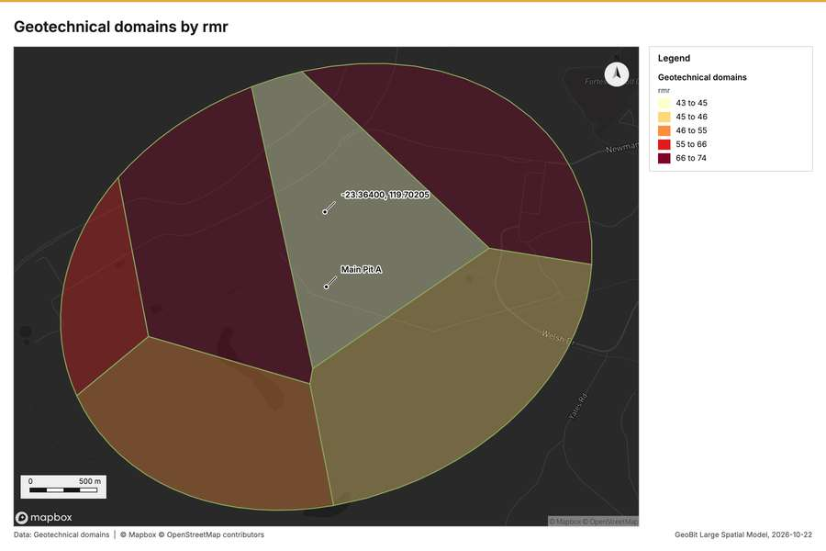
Figure 20. Geotechnical domains by rmr [69]
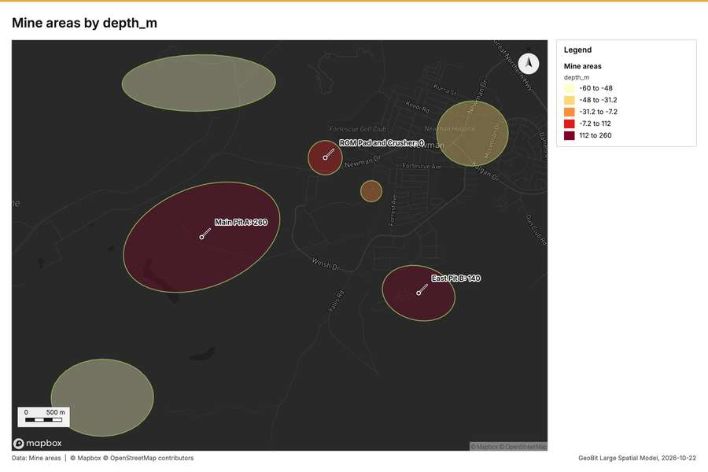
Figure 21. Mine areas by depth_m [70]
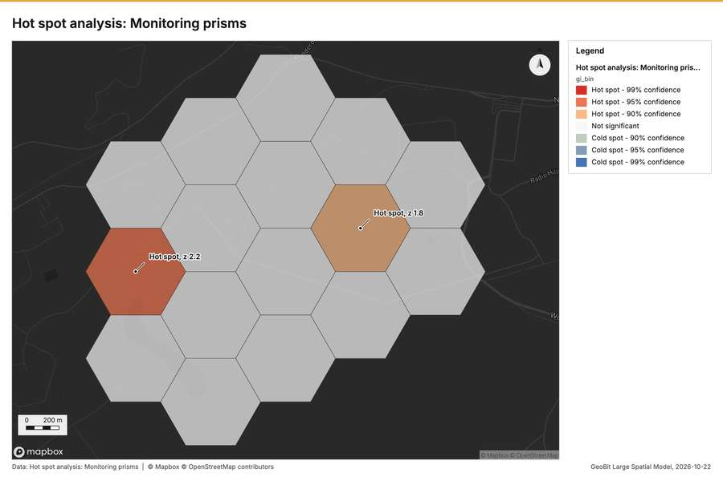
Figure 22. Hot spot analysis: Monitoring prisms [71]
What the map shows. The map titled "Emerging hot spots: Drill holes" displays the spatial analysis of drill hole activity over a defined geographical area. According to the legend provided, the analysis concluded that there is "No pattern detected" for the emerging hot spots of drill holes across the mapped region. Visually, the entire area is covered in a continuous network of uniformly shaded polygons, reflecting the absence of a discernible spatial cluster or gradient. Consequently, the image indicates a lack of significant aggregation or concentration of drill hole activity at any specific point. [53]
Inferred: read from the image by gemma4:e4b, not evidence.
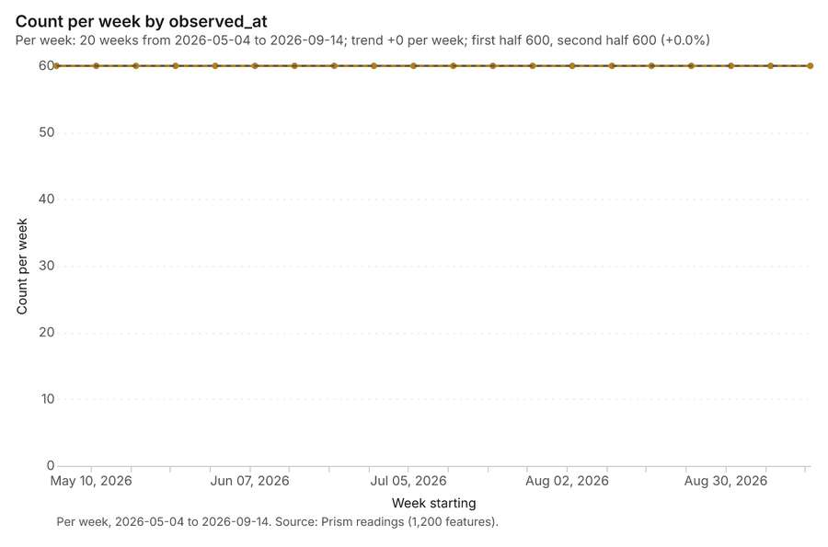
Figure 23. Prism readings over time (velocity_mm_day) [72]. Per week, 2026-05-04 to 2026-09-14. Source: Prism readings (1,200 features). The data is in the appendix.
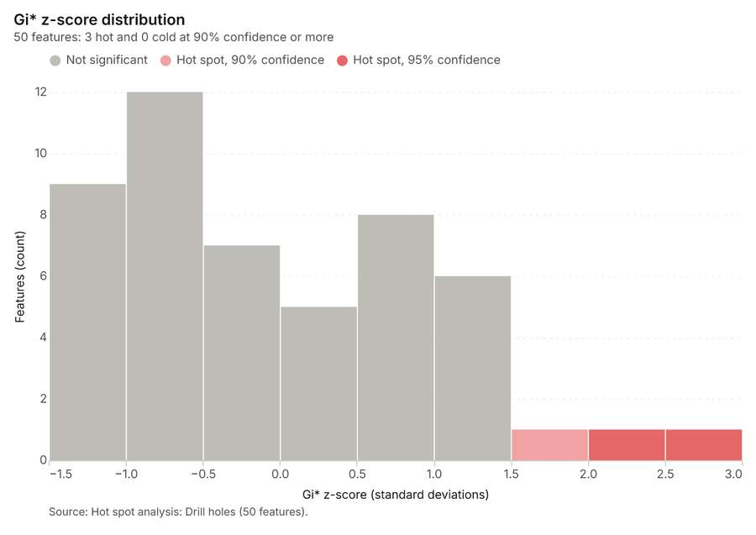
Figure 24. Hot spot analysis: Drill holes [73]. Source: Hot spot analysis: Drill holes (50 features). The data is in the appendix.
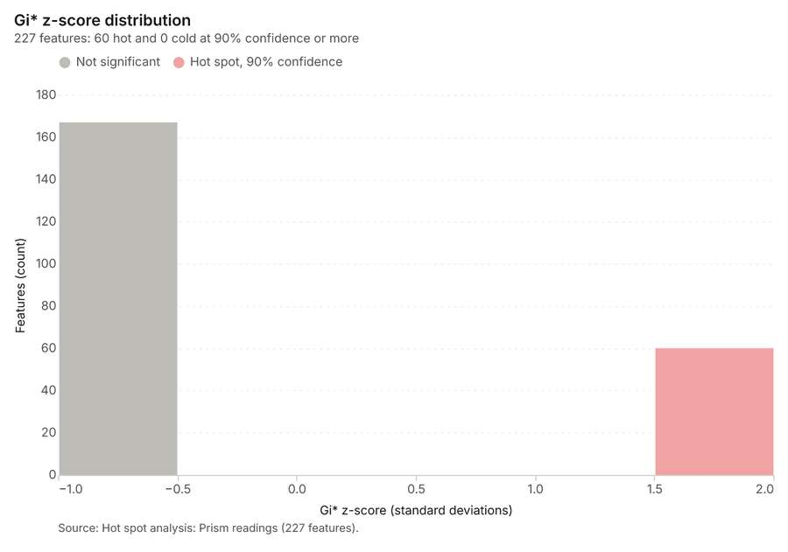
Figure 25. Hot spot analysis: Prism readings [74]. Source: Hot spot analysis: Prism readings (227 features). The data is in the appendix.
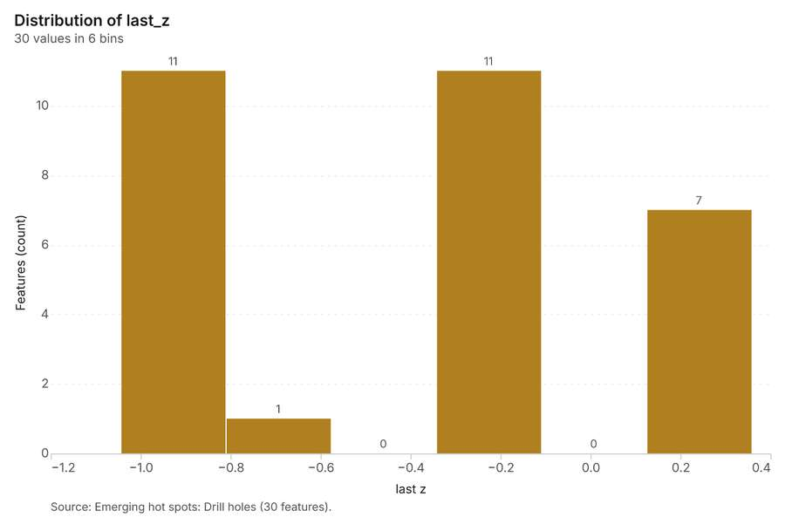
Figure 26. Emerging hot spots: Drill holes [75]. Source: Emerging hot spots: Drill holes (30 features). The data is in the appendix.
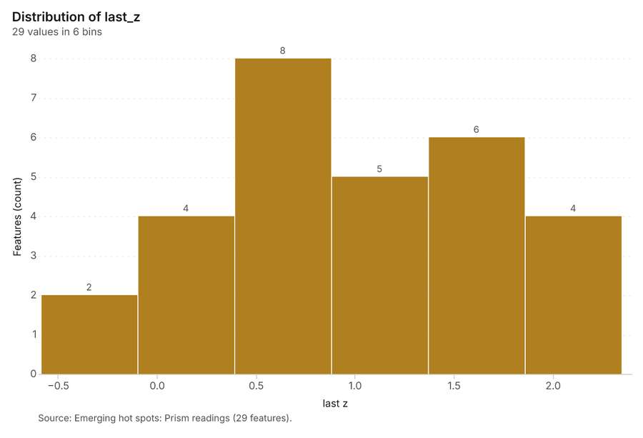
Figure 27. Emerging hot spots: Prism readings [76]. Source: Emerging hot spots: Prism readings (29 features). The data is in the appendix.
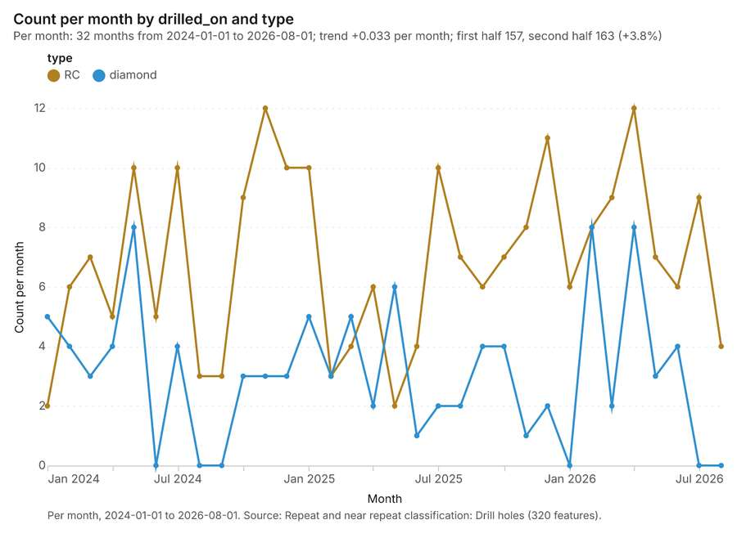
Figure 28. Repeat and near repeat classification: Drill holes [77]. Per month, 2024-01-01 to 2026-08-01. Source: Repeat and near repeat classification: Drill holes (320 features). The data is in the appendix.
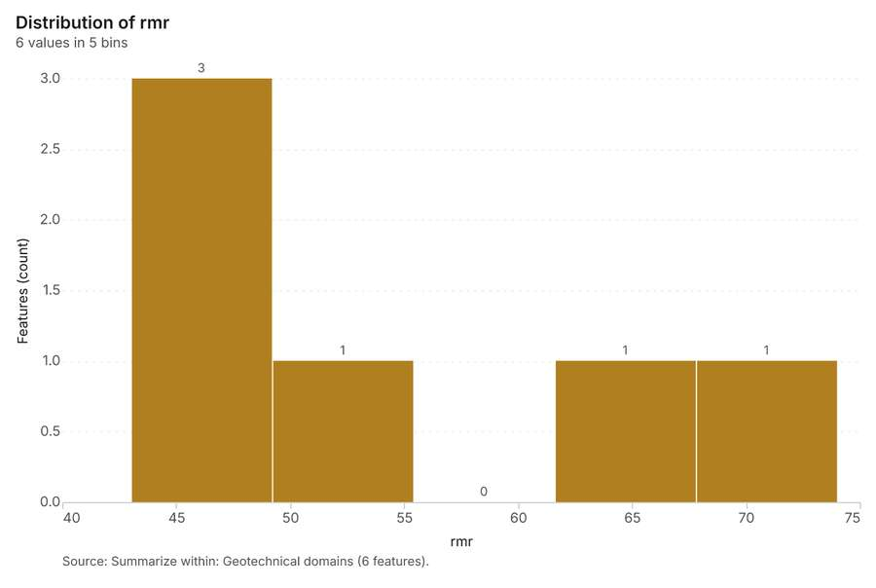
Figure 29. Summarize within: Geotechnical domains [78]. Source: Summarize within: Geotechnical domains (6 features). The data is in the appendix.
Figure 30. Summarize within: Geotechnical domains [79]. Source: Summarize within: Geotechnical domains (6 features). The data is in the appendix.
Figure 31. Summarize within: Geotechnical domains [80]. Source: Summarize within: Geotechnical domains (6 features). The data is in the appendix.
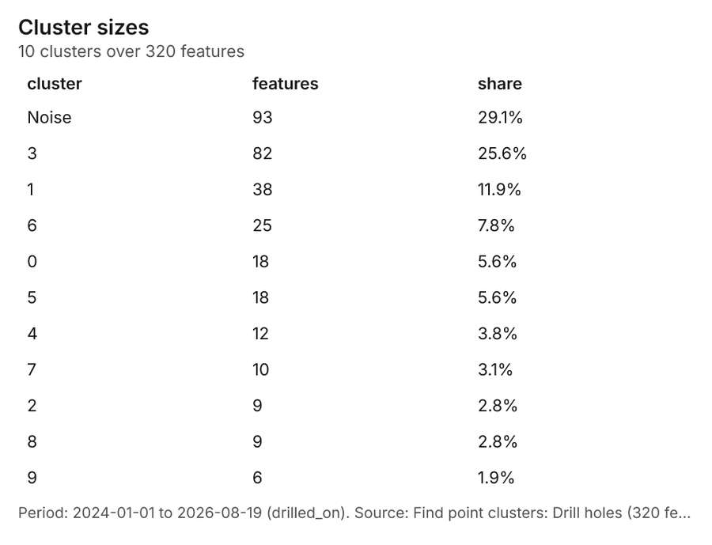
Figure 32. Find point clusters: Drill holes [81]. Period: 2024-01-01 to 2026-08-19 (drilled_on). Source: Find point clusters: Drill holes (320 features). The data is in the appendix.
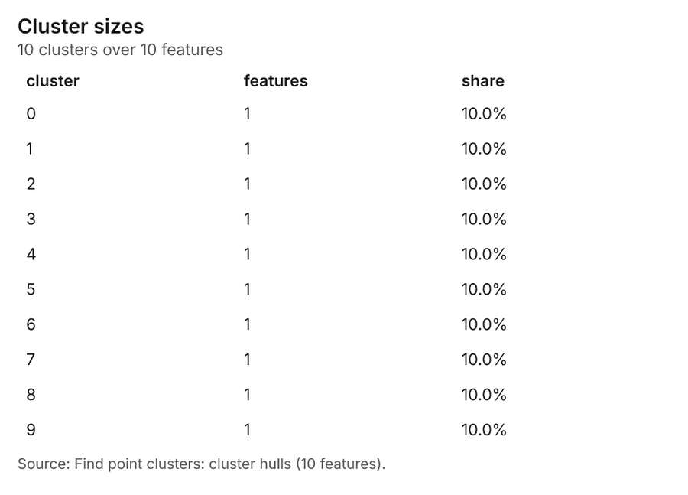
Figure 33. Find point clusters: cluster hulls [82]. Source: Find point clusters: cluster hulls (10 features). The data is in the appendix.
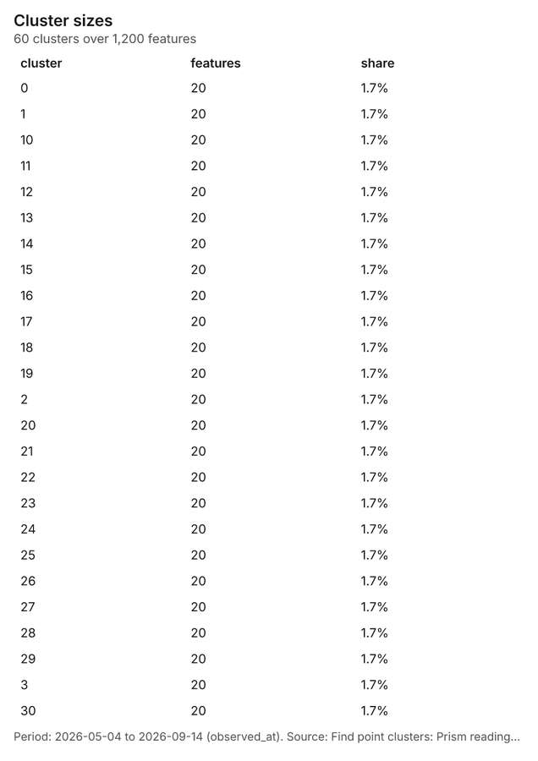
Figure 34. Find point clusters: Prism readings [83]. Period: 2026-05-04 to 2026-09-14 (observed_at). Source: Find point clusters: Prism readings (1,200 features). The data is in the appendix.
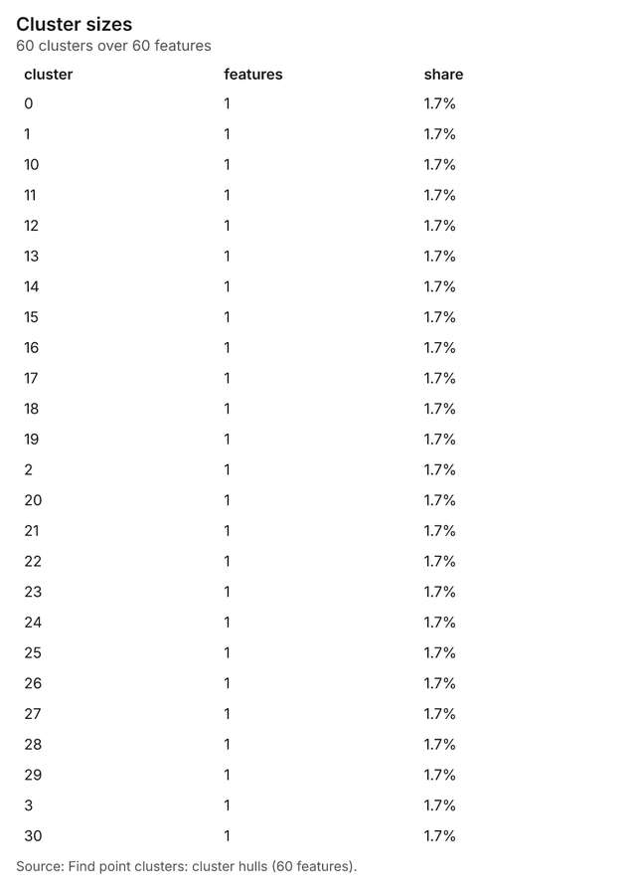
Figure 35. Find point clusters: cluster hulls [84]. Source: Find point clusters: cluster hulls (60 features). The data is in the appendix.
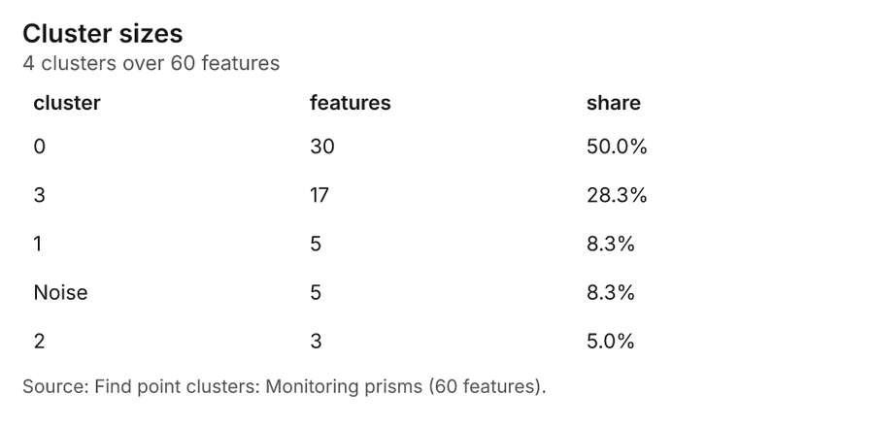
Figure 36. Find point clusters: Monitoring prisms [85]. Source: Find point clusters: Monitoring prisms (60 features). The data is in the appendix.
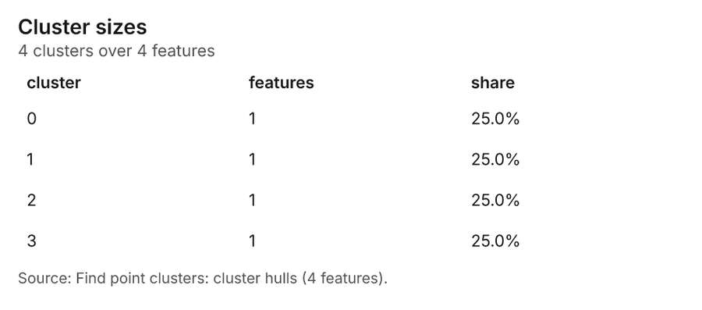
Figure 37. Find point clusters: cluster hulls [86]. Source: Find point clusters: cluster hulls (4 features). The data is in the appendix.
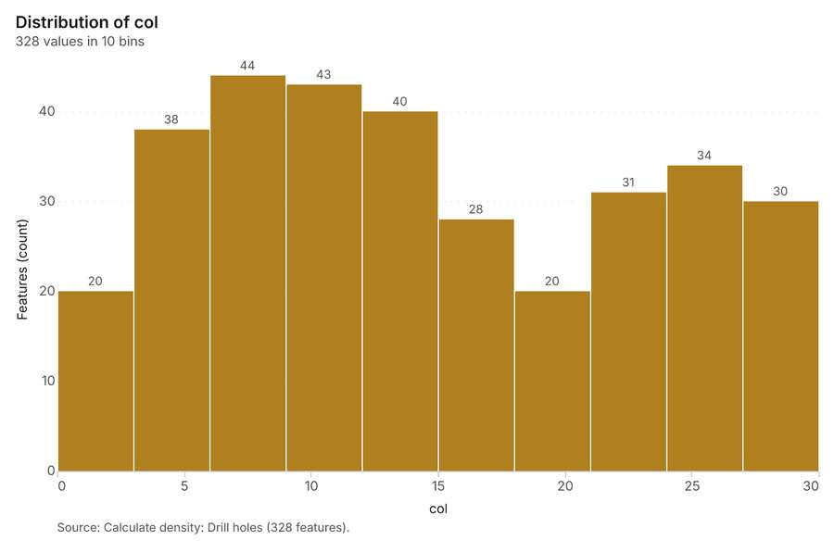
Figure 38. Calculate density: Drill holes [87]. Source: Calculate density: Drill holes (328 features). The data is in the appendix.
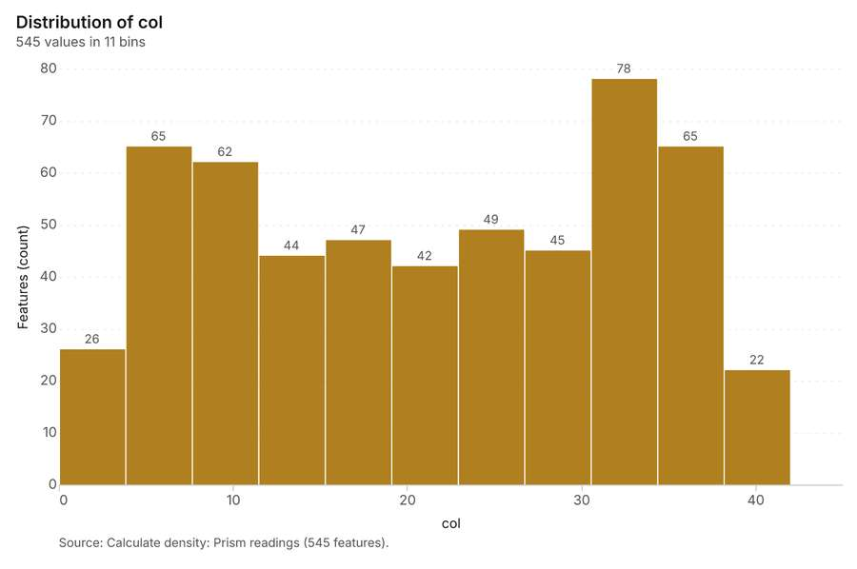
Figure 39. Calculate density: Prism readings [88]. Source: Calculate density: Prism readings (545 features). The data is in the appendix.
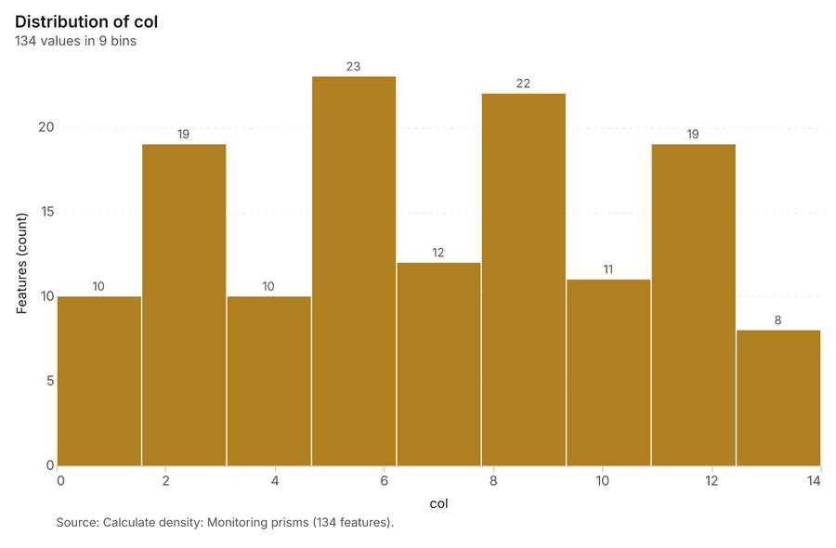
Figure 40. Calculate density: Monitoring prisms [89]. Source: Calculate density: Monitoring prisms (134 features). The data is in the appendix.
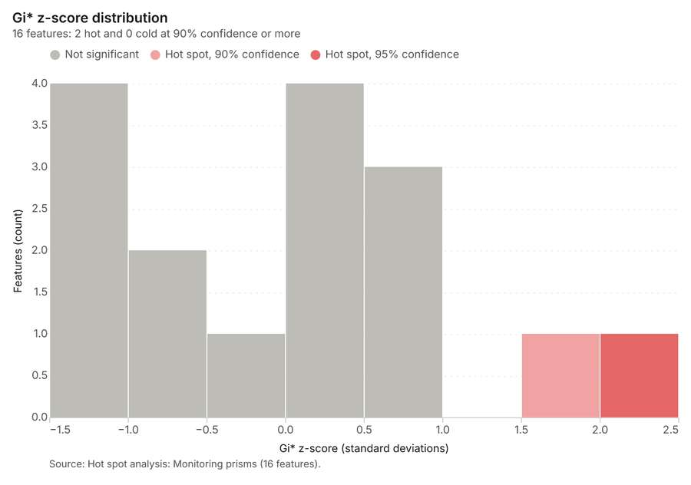
Figure 41. Hot spot analysis: Monitoring prisms [90]. Source: Hot spot analysis: Monitoring prisms (16 features). The data is in the appendix.
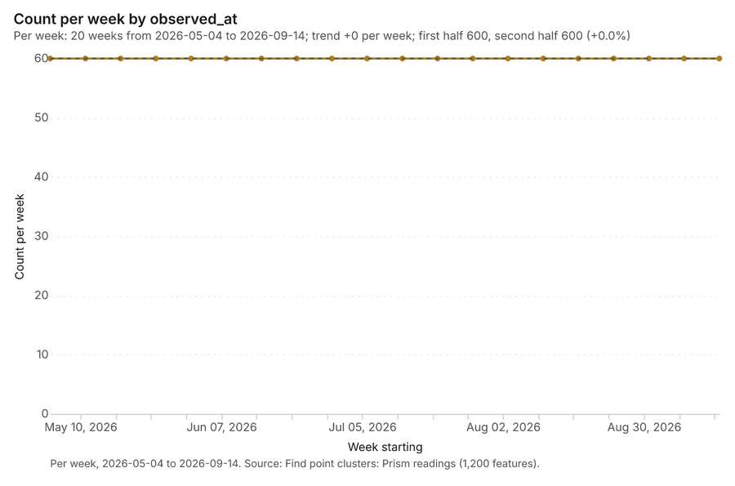
Figure 42. Find point clusters: Prism readings over time [91]. Per week, 2026-05-04 to 2026-09-14. Source: Find point clusters: Prism readings (1,200 features). The data is in the appendix.
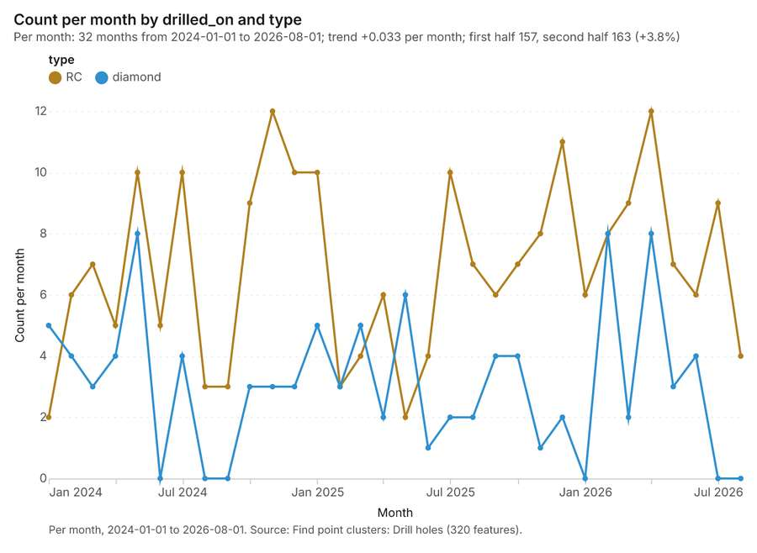
Figure 43. Find point clusters: Drill holes over time [92]. Per month, 2024-01-01 to 2026-08-01. Source: Find point clusters: Drill holes (320 features). The data is in the appendix.
Figure 44. Repeat and near repeat classification: Drill holes over time [93]. Per month, 2024-01-01 to 2026-08-01. Source: Repeat and near repeat classification: Drill holes (320 features). The data is in the appendix.

Changes since the last run
This is the first report of this project.

Sources
[1] Rendering: Chart: Timeline: events per month by dataset. 99 rows (id d5063e0d-383f-46d6-a583-b42ef86dcb50)
[2] Dataset: Prism readings. vector, 1200 rows (id 60f18997-7538-4981-ab32-a2378dbc2332)
[3] Dataset: Drill holes. vector, 320 rows (id 2a2433a0-611a-44a4-9f0d-081ef95736f5)
[4] Dataset: Production by pit and week. table, 76 rows (id b8016ccc-7a32-41af-83a8-3d85487ce025)
[5] Catalog: Hot spot analysis (operation catalog, gp_hot_spots). Getis-Ord Gi* hot and cold spots with z-scores, p-values and confidence bins. ArcGIS: Find Hot Spots, Hot Spot Analysis (Getis-Ord Gi*). QGIS: qgis:hotspot (plugin). (id gp_hot_spots)
[6] Plan: Hot spots of Drill holes (the Start plan's candidate c_89364af0f3f2). 320 points: Getis-Ord Gi* tests whether the concentrations in Drill holes are statistically significant. (id 7bc56161-0d78-4299-bc71-0dcafaee2734:c_89364af0f3f2)
[7] Tool result: gp_hot_spots, step 0. Hot spot analysis: 1 layer saved: Hot spot analysis: Drill holes (50 features). (id 6d176ba7-ebd6-4f95-82dc-d0c9a4e4146b:0)
[8] Layer: Drill holes. 320 features (id 3fc6780a-f84b-41cc-a091-beff7f8fa0d0)
[9] Plan: Hot spots of Prism readings (the Start plan's candidate c_50324c88a44c). 1200 points: Getis-Ord Gi* tests whether the concentrations in Prism readings are statistically significant. (id 7bc56161-0d78-4299-bc71-0dcafaee2734:c_50324c88a44c)
[10] Tool result: gp_hot_spots, step 1. Hot spot analysis: 1 layer saved: Hot spot analysis: Prism readings (227 features). (id 6d176ba7-ebd6-4f95-82dc-d0c9a4e4146b:1)
[11] Layer: Prism readings. 1,200 features (id 920e4ae7-03de-45d8-8b1f-df8f2afca685)
[12] Catalog: Emerging hot spots (operation catalog, gp_space_time_hot_spots). Where hot spots are new, consecutive, intensifying, persistent, diminishing, sporadic, oscillating or historical over time. ArcGIS: Emerging Hot Spot Analysis, Create Space Time Cube. (id gp_space_time_hot_spots)
[13] Plan: Space time hot spots of Drill holes (the Start plan's candidate c_0ea6ff5db7ae). Drill holes carry dates in 'drilled_on': emerging hot spot analysis finds new, intensifying and fading hot spots per month. (id 7bc56161-0d78-4299-bc71-0dcafaee2734:c_0ea6ff5db7ae)
[14] Tool result: gp_space_time_hot_spots, step 0. Emerging hot spots: 1 layer saved: Emerging hot spots: Drill holes (30 features). (id d6b96f46-054d-4ebc-b6ed-8ea1f8115bfb:0)
[15] Plan: Space time hot spots of Prism readings (the Start plan's candidate c_52d4ce8ea935). Prism readings carry dates in 'observed_at': emerging hot spot analysis finds new, intensifying and fading hot spots per week. (id 7bc56161-0d78-4299-bc71-0dcafaee2734:c_52d4ce8ea935)
[16] Tool result: gp_space_time_hot_spots, step 1. Emerging hot spots: 1 layer saved: Emerging hot spots: Prism readings (29 features). (id d6b96f46-054d-4ebc-b6ed-8ea1f8115bfb:1)
[17] Catalog: Repeat and near repeat classification (operation catalog, gp_near_repeat). Classify incidents as originators, repeats (same place) or near repeats within a distance and time window, with a Knox test table. ArcGIS: Repeat and Near Repeat Classification, Near Repeat Calculator. (id gp_near_repeat)
[18] Plan: Near repeat of Drill holes (the Start plan's candidate c_817106996954). Near repeat analysis tests whether Drill holes close in space also follow each other within 30 days. (id 7bc56161-0d78-4299-bc71-0dcafaee2734:c_817106996954)
[19] Tool result: gp_near_repeat, step 2. Repeat and near repeat classification: 1 layer saved: Repeat and near repeat classification: Drill holes (320 features). (id d6b96f46-054d-4ebc-b6ed-8ea1f8115bfb:2)
[20] Catalog: Summarize within (operation catalog, gp_summarize_within). Count and aggregate the features inside each polygon (or bin), proportionally for lines and polygons. ArcGIS: Summarize Within, Aggregate Points. QGIS: native:countpointsinpolygon, native:sumlinelengths. (id gp_summarize_within)
[21] Plan: Drill holes per feature of Geotechnical domains (the Start plan's candidate c_755f3a7cd2f9). Count Drill holes inside each feature of Geotechnical domains by type; the counts map as a choropleth (natural breaks, sequential colors). (id 7bc56161-0d78-4299-bc71-0dcafaee2734:c_755f3a7cd2f9)
[22] Tool result: gp_summarize_within, step 0. Summarize within: 1 layer saved: Summarize within: Geotechnical domains (6 features). (id e68cc066-c112-488f-8008-428c4110a545:0)
[23] Layer: Geotechnical domains. 6 features (id 7e9e4801-2390-459b-a556-ee9f4ecc9967)
[24] Tool result: gp_summarize_within, step 1. Summarize within: 1 layer saved: Summarize within: Geotechnical domains (6 features). (id e68cc066-c112-488f-8008-428c4110a545:1)
[25] Tool result: gp_summarize_within, step 2. Summarize within: 1 layer saved: Summarize within: Geotechnical domains (6 features). (id e68cc066-c112-488f-8008-428c4110a545:2)
[26] Layer: Monitoring prisms. 60 features (id 6e51a43e-4dfd-41b4-8730-56c9ba793475)
[27] Catalog: Find point clusters (operation catalog, gp_find_point_clusters). Density-based clusters (DBSCAN, HDBSCAN or OPTICS, optionally space-time) with hulls and noise. ArcGIS: Find Point Clusters, Density-based Clustering. QGIS: native:dbscanclustering, native:stdbscanclustering. (id gp_find_point_clusters)
[28] Plan: Cluster points of Drill holes (the Start plan's candidate c_6300f2dcb36d). DBSCAN finds dense groups of Drill holes and separates noise. (id 7bc56161-0d78-4299-bc71-0dcafaee2734:c_6300f2dcb36d)
[29] Tool result: gp_find_point_clusters, step 0. Find point clusters: 2 layers saved: Find point clusters: Drill holes (320 features); Find point clusters: cluster hulls (10 features). (id 5ac0b253-366a-4046-9261-fd5bdc8cf6f3:0)
[30] Plan: Cluster points of Prism readings (the Start plan's candidate c_04a216785510). DBSCAN finds dense groups of Prism readings and separates noise. (id 7bc56161-0d78-4299-bc71-0dcafaee2734:c_04a216785510)
[31] Tool result: gp_find_point_clusters, step 1. Find point clusters: 2 layers saved: Find point clusters: Prism readings (1200 features); Find point clusters: cluster hulls (60 features). (id 5ac0b253-366a-4046-9261-fd5bdc8cf6f3:1)
[32] Plan: Cluster points of Monitoring prisms (the Start plan's candidate c_9c591df40051). DBSCAN finds dense groups of Monitoring prisms and separates noise. (id 7bc56161-0d78-4299-bc71-0dcafaee2734:c_9c591df40051)
[33] Tool result: gp_find_point_clusters, step 2. Find point clusters: 2 layers saved: Find point clusters: Monitoring prisms (60 features); Find point clusters: cluster hulls (4 features). (id 5ac0b253-366a-4046-9261-fd5bdc8cf6f3:2)
[34] Catalog: Zonal statistics (analysis catalog, rs_zonal_statistics). count/min/max/mean/std/sum/median/majority per polygon as a table and as GeoJSON. ArcGIS: Zonal Statistics as Table (polygons). (id rs_zonal_statistics)
[35] Plan: Zonal statistics of Mine terrain model (DEM) and Geotechnical domains (the Start plan's candidate c_4a873859298f). Statistics of Mine terrain model (DEM) inside each feature of Geotechnical domains. (id 7bc56161-0d78-4299-bc71-0dcafaee2734:c_4a873859298f)
[36] Tool result: rs_zonal_statistics, step 0. Zonal statistics: 6 row(s). zones 6. (id 30c7009a-f86b-4e23-ad74-b8942eb98ecd:0)
[37] Tool result: rs_zonal_statistics, step 1. Zonal statistics: 7 row(s). zones 7. (id 30c7009a-f86b-4e23-ad74-b8942eb98ecd:1)
[38] Catalog: Slope (analysis catalog, tr_slope). Horn slope in degrees or percent, with the share of ground in six grade classes. ArcGIS: Slope (Spatial Analyst). QGIS: Slope (GDAL DEM). (id tr_slope)
[39] Plan: Slope of Mine terrain model (DEM) (the Start plan's candidate c_c4670a6804ed). Slope of the Mine terrain model (DEM) surface. (id 7bc56161-0d78-4299-bc71-0dcafaee2734:c_c4670a6804ed)
[40] Tool result: tr_slope, step 2. Slope over 48.00 km2: mean 2.68 degrees, max 36.74 degrees; 9% of the ground is steeper than 15%. DEM: Mine terrain model (DEM). Verified: 2 checks passed. (id 30c7009a-f86b-4e23-ad74-b8942eb98ecd:2)
[41] Layer: Mine terrain model (DEM). 0 features (id d3bacd4c-de66-4724-8a10-a3ec4d2f4cd4)
[42] Catalog: Calculate density (operation catalog, gp_calculate_density). Kernel density per square kilometer on a grid. ArcGIS: Calculate Density, Kernel Density. QGIS: native:heatmapkerneldensityestimation. (id gp_calculate_density)
[43] Plan: Kernel density of Drill holes (the Start plan's candidate c_2e2e29bf0e3a). 320 points in Drill holes: a density surface shows where they concentrate. (id 7bc56161-0d78-4299-bc71-0dcafaee2734:c_2e2e29bf0e3a)
[44] Tool result: gp_calculate_density, step 0. Calculate density: 1 layer saved: Calculate density: Drill holes (328 features). (id 48907d44-ee48-4d56-88b9-782734e7cb9e:0)
[45] Plan: Kernel density of Prism readings (the Start plan's candidate c_aacfc43e5746). 1200 points in Prism readings: a density surface shows where they concentrate. (id 7bc56161-0d78-4299-bc71-0dcafaee2734:c_aacfc43e5746)
[46] Tool result: gp_calculate_density, step 1. Calculate density: 1 layer saved: Calculate density: Prism readings (545 features). (id 48907d44-ee48-4d56-88b9-782734e7cb9e:1)
[47] Plan: Kernel density of Monitoring prisms (the Start plan's candidate c_f6f8e0a3b55f). 60 points in Monitoring prisms: a density surface shows where they concentrate. (id 7bc56161-0d78-4299-bc71-0dcafaee2734:c_f6f8e0a3b55f)
[48] Tool result: gp_calculate_density, step 2. Calculate density: 1 layer saved: Calculate density: Monitoring prisms (134 features). (id 48907d44-ee48-4d56-88b9-782734e7cb9e:2)
[49] Plan: Hot spots of Monitoring prisms (the Start plan's candidate c_37960faa4114). 60 points: Getis-Ord Gi* tests whether the concentrations in Monitoring prisms are statistically significant. (id 7bc56161-0d78-4299-bc71-0dcafaee2734:c_37960faa4114)
[50] Tool result: gp_hot_spots, step 0. Hot spot analysis: 1 layer saved: Hot spot analysis: Monitoring prisms (16 features). (id 85672774-a9a1-438b-b198-fb69481775dd:0)
[51] Rendering: Map: Hot spot analysis: Drill holes (id 7aba71c8-1496-40d8-b8eb-42666243d92b)
[52] Rendering: Map: Hot spot analysis: Prism readings (id 26ff0f7f-3d97-4039-93a6-123c8eafa5da)
[53] Rendering: Map: Emerging hot spots: Drill holes (id e03597b1-0956-4005-94ae-c579b88dc145)
[54] Rendering: Map: Emerging hot spots: Prism readings (id c7fd6550-a8b0-43c2-b53f-25a96057ad1f)
[55] Rendering: Map: Repeat and near repeat classification: Drill holes (id 64c3b80d-fd24-488e-857c-348e16eef2b7)
[56] Rendering: Map: Summarize within: Geotechnical domains (id 46826436-d7ec-40c3-bd26-6442c1f5bce0)
[57] Rendering: Map: Summarize within: Geotechnical domains (id a0355267-d17c-48fb-8009-9201561699e5)
[58] Rendering: Map: Summarize within: Geotechnical domains (id b5636e87-7844-4fb0-8ed5-f8f518396c87)
[59] Rendering: Map: Find point clusters: Drill holes (id db466f95-f4c8-4cd9-af9d-6d9cfcf6d915)
[60] Rendering: Map: Find point clusters: cluster hulls (id 6c0777df-5751-4f2a-b90f-28f799dfed17)
[61] Rendering: Map: Find point clusters: Prism readings (id 24577f88-171d-4b0e-b865-3e11993d2f9f)
[62] Rendering: Map: Find point clusters: cluster hulls (id f6f2da46-1368-4eda-bec6-17e32c7181f8)
[63] Rendering: Map: Find point clusters: Monitoring prisms (id a07906f9-8500-4b6c-9113-39a85ad19144)
[64] Rendering: Map: Find point clusters: cluster hulls (id 46445a69-778d-4e67-b2ee-b6df575e5ec0)
[65] Rendering: Map: Slope (degrees) (id 6e1a5363-e4c6-449d-8033-bd5fd8b184f2)
[66] Rendering: Map: Calculate density: Drill holes (id cc413631-8b22-482c-a490-bb94d5d9fcab)
[67] Rendering: Map: Calculate density: Prism readings (id 580f357c-fb0a-4e14-adc1-65a8045b73a3)
[68] Rendering: Map: Calculate density: Monitoring prisms (id cad3aba8-d7e0-4de8-8c67-d9f79050feae)
[69] Rendering: Map: Geotechnical domains by rmr (id c85125a0-4390-476f-8f95-a7f7b2b1772c)
[70] Rendering: Map: Mine areas by depth_m (id 7bf2ced2-c815-4869-902d-5189c7dbcbb3)
[71] Rendering: Map: Hot spot analysis: Monitoring prisms (id e47105cc-ae94-4c8a-ac4c-801c44b57ad6)
[72] Rendering: Chart: Prism readings over time (velocity_mm_day). 20 rows (id f72a208b-643e-404c-b35c-deb12248f756)
[73] Rendering: Chart: Hot spot analysis: Drill holes. 9 rows (id 2232e923-0f0f-40a7-bcec-b33f32691a12)
[74] Rendering: Chart: Hot spot analysis: Prism readings. 2 rows (id bcc45631-4c2b-4328-b12f-0742986292e6)
[75] Rendering: Chart: Emerging hot spots: Drill holes. 6 rows (id 83db89a9-e5f1-43ee-bef4-9607147169ef)
[76] Rendering: Chart: Emerging hot spots: Prism readings. 6 rows (id e64dd055-c0fb-427f-a4c1-b3365102d997)
[77] Rendering: Chart: Repeat and near repeat classification: Drill holes. 64 rows (id 0487f31b-380e-42f5-8a05-5afcc2dd8033)
[78] Rendering: Chart: Summarize within: Geotechnical domains. 5 rows (id 52ed6781-1621-4935-86e6-a4335fb92e26)
[79] Rendering: Chart: Summarize within: Geotechnical domains. 5 rows (id 60644b50-b68a-4746-97d0-81795a71efe5)
[80] Rendering: Chart: Summarize within: Geotechnical domains. 5 rows (id dc5eabf8-66d5-4b52-ab80-f8fd8a8eb98a)
[81] Rendering: Chart: Find point clusters: Drill holes. 11 rows (id c2c8d93a-1510-4b4c-8ceb-eb117952bdd5)
[82] Rendering: Chart: Find point clusters: cluster hulls. 10 rows (id 520eb33c-5a35-4111-bf80-cb207542d8d7)
[83] Rendering: Chart: Find point clusters: Prism readings. 60 rows (id 23efb700-58b6-48a0-8b27-5d330ea8f265)
[84] Rendering: Chart: Find point clusters: cluster hulls. 60 rows (id 471bb2b8-d0f5-4095-8b5a-dc94ede849ca)
[85] Rendering: Chart: Find point clusters: Monitoring prisms. 5 rows (id 19c67bbc-96ea-464f-98d9-b8049e398cd2)
[86] Rendering: Chart: Find point clusters: cluster hulls. 4 rows (id b959d2a0-9626-4d42-adca-b8bd867773e1)
[87] Rendering: Chart: Calculate density: Drill holes. 10 rows (id b2f5fe27-ce96-4a92-b076-cbd54e45c371)
[88] Rendering: Chart: Calculate density: Prism readings. 11 rows (id 141cbaa1-7ea2-44fe-a5b7-1bd4079d6a01)
[89] Rendering: Chart: Calculate density: Monitoring prisms. 9 rows (id 0f1f5fd1-f50c-4016-ac53-5ae0ec095be2)
[90] Rendering: Chart: Hot spot analysis: Monitoring prisms. 7 rows (id 0bacfb00-e39e-4890-93a0-bbdf0d8d797f)
[91] Rendering: Chart: Find point clusters: Prism readings over time. 20 rows (id e052e5c9-141f-425d-87c0-88027cefb9e8)
[92] Rendering: Chart: Find point clusters: Drill holes over time. 64 rows (id 0501233f-ce86-469a-adb7-88f810d5c2bf)
[93] Rendering: Chart: Repeat and near repeat classification: Drill holes over time. 64 rows (id a1201925-0565-4158-a599-5097c6e018b7)
[94] Dataset: Mine areas. vector, 7 rows (id 796bc23c-1c01-471f-a816-e4b92b4ad5d2)
[95] Dataset: Haul roads. vector, 38 rows (id 98271253-f396-48d5-89e3-e5ec77dd5592)
[96] Dataset: Monitoring prisms. vector, 60 rows (id 931b37bf-74ac-40a6-bf1e-5aa284c78b21)
[97] Dataset: Equipment. vector, 40 rows (id eb207db2-da08-4413-ab19-e6b7a998dbd4)
[98] Dataset: Geotechnical domains. vector, 6 rows (id 767dcbe8-71b3-4319-9ad0-09d448c619f8)
[99] Dataset: Mine terrain model (DEM). raster, ? rows (id 963146d0-3d3d-4cbb-a20f-e9c9ef5589ac)
[100] Dataset: Bench design by domain. table, 6 rows (id b5190874-406c-48c8-aebb-c9874f6882f0)
[101] Dataset: Geotechnical inspection report. document, ? rows (id 80e8ec2d-81ee-46d6-8c45-60a1c26b1f30)
[102] Record: Sample: Mining, Newman (id 11fd3b70-5f29-4895-b87f-807f2ec1e52e)
[103] Layer: Hot spot analysis: Drill holes. 50 features (id 36abf980-d699-4391-b457-180766c099c0)
[104] Layer: Hot spot analysis: Prism readings. 227 features (id 8d411a35-93ea-41e6-ac52-18fa06883b1c)
[105] Layer: Emerging hot spots: Drill holes. 30 features (id cc05cc11-2ba3-49cc-afaf-96e5b6d84ea6)
[106] Layer: Emerging hot spots: Prism readings. 29 features (id e8e5a0b5-cdd5-4009-9d71-f4cf0a3f9f18)
[107] Layer: Repeat and near repeat classification: Drill holes. 320 features (id 8bddb8ce-b2f8-42a4-ab09-fb8113d0c801)
[108] Layer: Summarize within: Geotechnical domains. 6 features (id 989fcb0a-59fe-4c99-8349-b5beb2aa041b)
[109] Layer: Summarize within: Geotechnical domains. 6 features (id 3a8b71e4-f3a7-48ff-b334-a801a6580ef1)
[110] Layer: Summarize within: Geotechnical domains. 6 features (id 6c0a971c-88cb-42dd-b61a-1f207187a16a)
[111] Layer: Find point clusters: Drill holes. 320 features (id be76cc0a-2088-45ad-bf48-2d3888e3db73)
[112] Layer: Find point clusters: cluster hulls. 10 features (id 2d5bb0ec-3aff-4ae5-8c07-a363aa90d7c0)
[113] Layer: Find point clusters: Prism readings. 1,200 features (id 3ed015a7-54f2-48f5-8d53-18be5b1e296f)
[114] Layer: Find point clusters: cluster hulls. 60 features (id 879a04ad-6994-4706-b490-5ae1b265ce0c)
[115] Layer: Find point clusters: Monitoring prisms. 60 features (id 071cb991-6662-4709-864a-6640d55e879e)
[116] Layer: Find point clusters: cluster hulls. 4 features (id e55673cb-1d02-42f4-93f6-1a75d767eade)
[117] Layer: Slope (degrees). 0 features (id c5b5f107-7b36-4783-b7a6-737f8f3a02cc)
[118] Layer: Calculate density: Drill holes. 328 features (id dd247b38-56c5-4294-964c-b7f44ab1d084)
[119] Layer: Calculate density: Prism readings. 545 features (id f30d3b65-9ba2-4542-8fe4-bf9d001bdfdb)
[120] Layer: Calculate density: Monitoring prisms. 134 features (id 8f7a5a35-13b6-4d43-bf2b-da32f59529b4)
[121] Layer: Hot spot analysis: Monitoring prisms. 16 features (id 4b0bd69c-b2aa-4d02-9ce9-80b98cc051ab)

Appendix: the data behind the charts

Figure 1. Timeline: events per month by dataset [1]
period | series | value
2024-01-01 | Prism readings | 0
2024-01-01 | Drill holes | 7
2024-01-01 | Production by pit and week | 0
2024-02-01 | Prism readings | 0
2024-02-01 | Drill holes | 10
2024-02-01 | Production by pit and week | 0
2024-03-01 | Prism readings | 0
2024-03-01 | Drill holes | 10
2024-03-01 | Production by pit and week | 0
2024-04-01 | Prism readings | 0
2024-04-01 | Drill holes | 9
2024-04-01 | Production by pit and week | 0
2024-05-01 | Prism readings | 0
2024-05-01 | Drill holes | 18
2024-05-01 | Production by pit and week | 0
2024-06-01 | Prism readings | 0
2024-06-01 | Drill holes | 5
2024-06-01 | Production by pit and week | 0
2024-07-01 | Prism readings | 0
2024-07-01 | Drill holes | 14
2024-07-01 | Production by pit and week | 0
2024-08-01 | Prism readings | 0
2024-08-01 | Drill holes | 3
2024-08-01 | Production by pit and week | 0
2024-09-01 | Prism readings | 0
2024-09-01 | Drill holes | 3
2024-09-01 | Production by pit and week | 0
2024-10-01 | Prism readings | 0
2024-10-01 | Drill holes | 12
2024-10-01 | Production by pit and week | 0
2024-11-01 | Prism readings | 0
2024-11-01 | Drill holes | 15
2024-11-01 | Production by pit and week | 0
2024-12-01 | Prism readings | 0
2024-12-01 | Drill holes | 13
2024-12-01 | Production by pit and week | 0
2025-01-01 | Prism readings | 0
2025-01-01 | Drill holes | 15
2025-01-01 | Production by pit and week | 0
2025-02-01 | Prism readings | 0
2025-02-01 | Drill holes | 6
2025-02-01 | Production by pit and week | 0
2025-03-01 | Prism readings | 0
2025-03-01 | Drill holes | 9
2025-03-01 | Production by pit and week | 0
2025-04-01 | Prism readings | 0
2025-04-01 | Drill holes | 8
2025-04-01 | Production by pit and week | 0
2025-05-01 | Prism readings | 0
2025-05-01 | Drill holes | 8
2025-05-01 | Production by pit and week | 0
2025-06-01 | Prism readings | 0
2025-06-01 | Drill holes | 5
2025-06-01 | Production by pit and week | 0
2025-07-01 | Prism readings | 0
2025-07-01 | Drill holes | 12
2025-07-01 | Production by pit and week | 0
2025-08-01 | Prism readings | 0
2025-08-01 | Drill holes | 9
2025-08-01 | Production by pit and week | 0
2025-09-01 | Prism readings | 0
2025-09-01 | Drill holes | 10
2025-09-01 | Production by pit and week | 0
2025-10-01 | Prism readings | 0
2025-10-01 | Drill holes | 11
2025-10-01 | Production by pit and week | 0
2025-11-01 | Prism readings | 0
2025-11-01 | Drill holes | 9
2025-11-01 | Production by pit and week | 0
2025-12-01 | Prism readings | 0
2025-12-01 | Drill holes | 13
2025-12-01 | Production by pit and week | 0
2026-01-01 | Prism readings | 0
2026-01-01 | Drill holes | 6
2026-01-01 | Production by pit and week | 8
2026-02-01 | Prism readings | 0
2026-02-01 | Drill holes | 16
2026-02-01 | Production by pit and week | 8
2026-03-01 | Prism readings | 0
2026-03-01 | Drill holes | 11
2026-03-01 | Production by pit and week | 10
2026-04-01 | Prism readings | 0
2026-04-01 | Drill holes | 20
2026-04-01 | Production by pit and week | 8
2026-05-01 | Prism readings | 240
2026-05-01 | Drill holes | 10
2026-05-01 | Production by pit and week | 8
2026-06-01 | Prism readings | 300
2026-06-01 | Drill holes | 10
2026-06-01 | Production by pit and week | 10
2026-07-01 | Prism readings | 240
2026-07-01 | Drill holes | 9
2026-07-01 | Production by pit and week | 8
2026-08-01 | Prism readings | 300
2026-08-01 | Drill holes | 4
2026-08-01 | Production by pit and week | 10
2026-09-01 | Prism readings | 120
2026-09-01 | Drill holes | 0
2026-09-01 | Production by pit and week | 6

Figure 23. Prism readings over time (velocity_mm_day) [72]
period | value
2026-05-04 | 60
2026-05-11 | 60
2026-05-18 | 60
2026-05-25 | 60
2026-06-01 | 60
2026-06-08 | 60
2026-06-15 | 60
2026-06-22 | 60
2026-06-29 | 60
2026-07-06 | 60
2026-07-13 | 60
2026-07-20 | 60
2026-07-27 | 60
2026-08-03 | 60
2026-08-10 | 60
2026-08-17 | 60
2026-08-24 | 60
2026-08-31 | 60
2026-09-07 | 60
2026-09-14 | 60

Figure 24. Hot spot analysis: Drill holes [73]
bin_start | bin_end | band | band_label | count
-1.5 | -1 | not_significant | Not significant | 9
-1 | -0.5 | not_significant | Not significant | 12
-0.5 | 0 | not_significant | Not significant | 7
0 | 0.5 | not_significant | Not significant | 5
0.5 | 1 | not_significant | Not significant | 8
1 | 1.5 | not_significant | Not significant | 6
1.5 | 2 | hot_90 | Hot spot, 90% confidence | 1
2 | 2.5 | hot_95 | Hot spot, 95% confidence | 1
2.5 | 3 | hot_95 | Hot spot, 95% confidence | 1

Figure 25. Hot spot analysis: Prism readings [74]
bin_start | bin_end | band | band_label | count
-1 | -0.5 | not_significant | Not significant | 167
1.5 | 2 | hot_90 | Hot spot, 90% confidence | 60

Figure 26. Emerging hot spots: Drill holes [75]
bin_start | bin_end | count
-1.045 | -0.8112 | 11
-0.8112 | -0.5773 | 1
-0.5773 | -0.3435 | 0
-0.3435 | -0.1097 | 11
-0.1097 | 0.1242 | 0
0.1242 | 0.358 | 7

Figure 27. Emerging hot spots: Prism readings [76]
bin_start | bin_end | count
-0.587 | -0.09783 | 2
-0.09783 | 0.3913 | 4
0.3913 | 0.8805 | 8
0.8805 | 1.37 | 5
1.37 | 1.859 | 6
1.859 | 2.348 | 4

Figure 28. Repeat and near repeat classification: Drill holes [77]
period | series | value
2024-01-01 | RC | 2
2024-01-01 | diamond | 5
2024-02-01 | RC | 6
2024-02-01 | diamond | 4
2024-03-01 | RC | 7
2024-03-01 | diamond | 3
2024-04-01 | RC | 5
2024-04-01 | diamond | 4
2024-05-01 | RC | 10
2024-05-01 | diamond | 8
2024-06-01 | RC | 5
2024-06-01 | diamond | 0
2024-07-01 | RC | 10
2024-07-01 | diamond | 4
2024-08-01 | RC | 3
2024-08-01 | diamond | 0
2024-09-01 | RC | 3
2024-09-01 | diamond | 0
2024-10-01 | RC | 9
2024-10-01 | diamond | 3
2024-11-01 | RC | 12
2024-11-01 | diamond | 3
2024-12-01 | RC | 10
2024-12-01 | diamond | 3
2025-01-01 | RC | 10
2025-01-01 | diamond | 5
2025-02-01 | RC | 3
2025-02-01 | diamond | 3
2025-03-01 | RC | 4
2025-03-01 | diamond | 5
2025-04-01 | RC | 6
2025-04-01 | diamond | 2
2025-05-01 | RC | 2
2025-05-01 | diamond | 6
2025-06-01 | RC | 4
2025-06-01 | diamond | 1
2025-07-01 | RC | 10
2025-07-01 | diamond | 2
2025-08-01 | RC | 7
2025-08-01 | diamond | 2
2025-09-01 | RC | 6
2025-09-01 | diamond | 4
2025-10-01 | RC | 7
2025-10-01 | diamond | 4
2025-11-01 | RC | 8
2025-11-01 | diamond | 1
2025-12-01 | RC | 11
2025-12-01 | diamond | 2
2026-01-01 | RC | 6
2026-01-01 | diamond | 0
2026-02-01 | RC | 8
2026-02-01 | diamond | 8
2026-03-01 | RC | 9
2026-03-01 | diamond | 2
2026-04-01 | RC | 12
2026-04-01 | diamond | 8
2026-05-01 | RC | 7
2026-05-01 | diamond | 3
2026-06-01 | RC | 6
2026-06-01 | diamond | 4
2026-07-01 | RC | 9
2026-07-01 | diamond | 0
2026-08-01 | RC | 4
2026-08-01 | diamond | 0

Figure 29. Summarize within: Geotechnical domains [78]
bin_start | bin_end | count
43 | 49.2 | 3
49.2 | 55.4 | 1
55.4 | 61.6 | 0
61.6 | 67.8 | 1
67.8 | 74 | 1

Figure 30. Summarize within: Geotechnical domains [79]
bin_start | bin_end | count
43 | 49.2 | 3
49.2 | 55.4 | 1
55.4 | 61.6 | 0
61.6 | 67.8 | 1
67.8 | 74 | 1

Figure 31. Summarize within: Geotechnical domains [80]
bin_start | bin_end | count
43 | 49.2 | 3
49.2 | 55.4 | 1
55.4 | 61.6 | 0
61.6 | 67.8 | 1
67.8 | 74 | 1

Figure 32. Find point clusters: Drill holes [81]
cluster | features | fraction | share
Noise | 93 | 0.2906 | 29.1%
3 | 82 | 0.2562 | 25.6%
1 | 38 | 0.1187 | 11.9%
6 | 25 | 0.07812 | 7.8%
0 | 18 | 0.05625 | 5.6%
5 | 18 | 0.05625 | 5.6%
4 | 12 | 0.0375 | 3.8%
7 | 10 | 0.03125 | 3.1%
2 | 9 | 0.02813 | 2.8%
8 | 9 | 0.02813 | 2.8%
9 | 6 | 0.01875 | 1.9%

Figure 33. Find point clusters: cluster hulls [82]
cluster | features | fraction | share
0 | 1 | 0.1 | 10.0%
1 | 1 | 0.1 | 10.0%
2 | 1 | 0.1 | 10.0%
3 | 1 | 0.1 | 10.0%
4 | 1 | 0.1 | 10.0%
5 | 1 | 0.1 | 10.0%
6 | 1 | 0.1 | 10.0%
7 | 1 | 0.1 | 10.0%
8 | 1 | 0.1 | 10.0%
9 | 1 | 0.1 | 10.0%

Figure 34. Find point clusters: Prism readings [83]
cluster | features | fraction | share
0 | 20 | 0.01667 | 1.7%
1 | 20 | 0.01667 | 1.7%
10 | 20 | 0.01667 | 1.7%
11 | 20 | 0.01667 | 1.7%
12 | 20 | 0.01667 | 1.7%
13 | 20 | 0.01667 | 1.7%
14 | 20 | 0.01667 | 1.7%
15 | 20 | 0.01667 | 1.7%
16 | 20 | 0.01667 | 1.7%
17 | 20 | 0.01667 | 1.7%
18 | 20 | 0.01667 | 1.7%
19 | 20 | 0.01667 | 1.7%
2 | 20 | 0.01667 | 1.7%
20 | 20 | 0.01667 | 1.7%
21 | 20 | 0.01667 | 1.7%
22 | 20 | 0.01667 | 1.7%
23 | 20 | 0.01667 | 1.7%
24 | 20 | 0.01667 | 1.7%
25 | 20 | 0.01667 | 1.7%
26 | 20 | 0.01667 | 1.7%
27 | 20 | 0.01667 | 1.7%
28 | 20 | 0.01667 | 1.7%
29 | 20 | 0.01667 | 1.7%
3 | 20 | 0.01667 | 1.7%
30 | 20 | 0.01667 | 1.7%
31 | 20 | 0.01667 | 1.7%
32 | 20 | 0.01667 | 1.7%
33 | 20 | 0.01667 | 1.7%
34 | 20 | 0.01667 | 1.7%
35 | 20 | 0.01667 | 1.7%
36 | 20 | 0.01667 | 1.7%
37 | 20 | 0.01667 | 1.7%
38 | 20 | 0.01667 | 1.7%
39 | 20 | 0.01667 | 1.7%
4 | 20 | 0.01667 | 1.7%
40 | 20 | 0.01667 | 1.7%
41 | 20 | 0.01667 | 1.7%
42 | 20 | 0.01667 | 1.7%
43 | 20 | 0.01667 | 1.7%
44 | 20 | 0.01667 | 1.7%
45 | 20 | 0.01667 | 1.7%
46 | 20 | 0.01667 | 1.7%
47 | 20 | 0.01667 | 1.7%
48 | 20 | 0.01667 | 1.7%
49 | 20 | 0.01667 | 1.7%
5 | 20 | 0.01667 | 1.7%
50 | 20 | 0.01667 | 1.7%
51 | 20 | 0.01667 | 1.7%
52 | 20 | 0.01667 | 1.7%
53 | 20 | 0.01667 | 1.7%
54 | 20 | 0.01667 | 1.7%
55 | 20 | 0.01667 | 1.7%
56 | 20 | 0.01667 | 1.7%
57 | 20 | 0.01667 | 1.7%
58 | 20 | 0.01667 | 1.7%
59 | 20 | 0.01667 | 1.7%
6 | 20 | 0.01667 | 1.7%
7 | 20 | 0.01667 | 1.7%
8 | 20 | 0.01667 | 1.7%
9 | 20 | 0.01667 | 1.7%

Figure 35. Find point clusters: cluster hulls [84]
cluster | features | fraction | share
0 | 1 | 0.01667 | 1.7%
1 | 1 | 0.01667 | 1.7%
10 | 1 | 0.01667 | 1.7%
11 | 1 | 0.01667 | 1.7%
12 | 1 | 0.01667 | 1.7%
13 | 1 | 0.01667 | 1.7%
14 | 1 | 0.01667 | 1.7%
15 | 1 | 0.01667 | 1.7%
16 | 1 | 0.01667 | 1.7%
17 | 1 | 0.01667 | 1.7%
18 | 1 | 0.01667 | 1.7%
19 | 1 | 0.01667 | 1.7%
2 | 1 | 0.01667 | 1.7%
20 | 1 | 0.01667 | 1.7%
21 | 1 | 0.01667 | 1.7%
22 | 1 | 0.01667 | 1.7%
23 | 1 | 0.01667 | 1.7%
24 | 1 | 0.01667 | 1.7%
25 | 1 | 0.01667 | 1.7%
26 | 1 | 0.01667 | 1.7%
27 | 1 | 0.01667 | 1.7%
28 | 1 | 0.01667 | 1.7%
29 | 1 | 0.01667 | 1.7%
3 | 1 | 0.01667 | 1.7%
30 | 1 | 0.01667 | 1.7%
31 | 1 | 0.01667 | 1.7%
32 | 1 | 0.01667 | 1.7%
33 | 1 | 0.01667 | 1.7%
34 | 1 | 0.01667 | 1.7%
35 | 1 | 0.01667 | 1.7%
36 | 1 | 0.01667 | 1.7%
37 | 1 | 0.01667 | 1.7%
38 | 1 | 0.01667 | 1.7%
39 | 1 | 0.01667 | 1.7%
4 | 1 | 0.01667 | 1.7%
40 | 1 | 0.01667 | 1.7%
41 | 1 | 0.01667 | 1.7%
42 | 1 | 0.01667 | 1.7%
43 | 1 | 0.01667 | 1.7%
44 | 1 | 0.01667 | 1.7%
45 | 1 | 0.01667 | 1.7%
46 | 1 | 0.01667 | 1.7%
47 | 1 | 0.01667 | 1.7%
48 | 1 | 0.01667 | 1.7%
49 | 1 | 0.01667 | 1.7%
5 | 1 | 0.01667 | 1.7%
50 | 1 | 0.01667 | 1.7%
51 | 1 | 0.01667 | 1.7%
52 | 1 | 0.01667 | 1.7%
53 | 1 | 0.01667 | 1.7%
54 | 1 | 0.01667 | 1.7%
55 | 1 | 0.01667 | 1.7%
56 | 1 | 0.01667 | 1.7%
57 | 1 | 0.01667 | 1.7%
58 | 1 | 0.01667 | 1.7%
59 | 1 | 0.01667 | 1.7%
6 | 1 | 0.01667 | 1.7%
7 | 1 | 0.01667 | 1.7%
8 | 1 | 0.01667 | 1.7%
9 | 1 | 0.01667 | 1.7%

Figure 36. Find point clusters: Monitoring prisms [85]
cluster | features | fraction | share
0 | 30 | 0.5 | 50.0%
3 | 17 | 0.2833 | 28.3%
1 | 5 | 0.08333 | 8.3%
Noise | 5 | 0.08333 | 8.3%
2 | 3 | 0.05 | 5.0%

Figure 37. Find point clusters: cluster hulls [86]
cluster | features | fraction | share
0 | 1 | 0.25 | 25.0%
1 | 1 | 0.25 | 25.0%
2 | 1 | 0.25 | 25.0%
3 | 1 | 0.25 | 25.0%

Figure 38. Calculate density: Drill holes [87]
bin_start | bin_end | count
0 | 3 | 20
3 | 6 | 38
6 | 9 | 44
9 | 12 | 43
12 | 15 | 40
15 | 18 | 28
18 | 21 | 20
21 | 24 | 31
24 | 27 | 34
27 | 30 | 30

Figure 39. Calculate density: Prism readings [88]
bin_start | bin_end | count
0 | 3.818 | 26
3.818 | 7.636 | 65
7.636 | 11.45 | 62
11.45 | 15.27 | 44
15.27 | 19.09 | 47
19.09 | 22.91 | 42
22.91 | 26.73 | 49
26.73 | 30.55 | 45
30.55 | 34.36 | 78
34.36 | 38.18 | 65
38.18 | 42 | 22

Figure 40. Calculate density: Monitoring prisms [89]
bin_start | bin_end | count
0 | 1.556 | 10
1.556 | 3.111 | 19
3.111 | 4.667 | 10
4.667 | 6.222 | 23
6.222 | 7.778 | 12
7.778 | 9.333 | 22
9.333 | 10.89 | 11
10.89 | 12.44 | 19
12.44 | 14 | 8

Figure 41. Hot spot analysis: Monitoring prisms [90]
bin_start | bin_end | band | band_label | count
-1.5 | -1 | not_significant | Not significant | 4
-1 | -0.5 | not_significant | Not significant | 2
-0.5 | 0 | not_significant | Not significant | 1
0 | 0.5 | not_significant | Not significant | 4
0.5 | 1 | not_significant | Not significant | 3
1.5 | 2 | hot_90 | Hot spot, 90% confidence | 1
2 | 2.5 | hot_95 | Hot spot, 95% confidence | 1

Figure 42. Find point clusters: Prism readings over time [91]
period | value
2026-05-04 | 60
2026-05-11 | 60
2026-05-18 | 60
2026-05-25 | 60
2026-06-01 | 60
2026-06-08 | 60
2026-06-15 | 60
2026-06-22 | 60
2026-06-29 | 60
2026-07-06 | 60
2026-07-13 | 60
2026-07-20 | 60
2026-07-27 | 60
2026-08-03 | 60
2026-08-10 | 60
2026-08-17 | 60
2026-08-24 | 60
2026-08-31 | 60
2026-09-07 | 60
2026-09-14 | 60

Figure 43. Find point clusters: Drill holes over time [92]
period | series | value
2024-01-01 | RC | 2
2024-01-01 | diamond | 5
2024-02-01 | RC | 6
2024-02-01 | diamond | 4
2024-03-01 | RC | 7
2024-03-01 | diamond | 3
2024-04-01 | RC | 5
2024-04-01 | diamond | 4
2024-05-01 | RC | 10
2024-05-01 | diamond | 8
2024-06-01 | RC | 5
2024-06-01 | diamond | 0
2024-07-01 | RC | 10
2024-07-01 | diamond | 4
2024-08-01 | RC | 3
2024-08-01 | diamond | 0
2024-09-01 | RC | 3
2024-09-01 | diamond | 0
2024-10-01 | RC | 9
2024-10-01 | diamond | 3
2024-11-01 | RC | 12
2024-11-01 | diamond | 3
2024-12-01 | RC | 10
2024-12-01 | diamond | 3
2025-01-01 | RC | 10
2025-01-01 | diamond | 5
2025-02-01 | RC | 3
2025-02-01 | diamond | 3
2025-03-01 | RC | 4
2025-03-01 | diamond | 5
2025-04-01 | RC | 6
2025-04-01 | diamond | 2
2025-05-01 | RC | 2
2025-05-01 | diamond | 6
2025-06-01 | RC | 4
2025-06-01 | diamond | 1
2025-07-01 | RC | 10
2025-07-01 | diamond | 2
2025-08-01 | RC | 7
2025-08-01 | diamond | 2
2025-09-01 | RC | 6
2025-09-01 | diamond | 4
2025-10-01 | RC | 7
2025-10-01 | diamond | 4
2025-11-01 | RC | 8
2025-11-01 | diamond | 1
2025-12-01 | RC | 11
2025-12-01 | diamond | 2
2026-01-01 | RC | 6
2026-01-01 | diamond | 0
2026-02-01 | RC | 8
2026-02-01 | diamond | 8
2026-03-01 | RC | 9
2026-03-01 | diamond | 2
2026-04-01 | RC | 12
2026-04-01 | diamond | 8
2026-05-01 | RC | 7
2026-05-01 | diamond | 3
2026-06-01 | RC | 6
2026-06-01 | diamond | 4
2026-07-01 | RC | 9
2026-07-01 | diamond | 0
2026-08-01 | RC | 4
2026-08-01 | diamond | 0

Figure 44. Repeat and near repeat classification: Drill holes over time [93]
period | series | value
2024-01-01 | RC | 2
2024-01-01 | diamond | 5
2024-02-01 | RC | 6
2024-02-01 | diamond | 4
2024-03-01 | RC | 7
2024-03-01 | diamond | 3
2024-04-01 | RC | 5
2024-04-01 | diamond | 4
2024-05-01 | RC | 10
2024-05-01 | diamond | 8
2024-06-01 | RC | 5
2024-06-01 | diamond | 0
2024-07-01 | RC | 10
2024-07-01 | diamond | 4
2024-08-01 | RC | 3
2024-08-01 | diamond | 0
2024-09-01 | RC | 3
2024-09-01 | diamond | 0
2024-10-01 | RC | 9
2024-10-01 | diamond | 3
2024-11-01 | RC | 12
2024-11-01 | diamond | 3
2024-12-01 | RC | 10
2024-12-01 | diamond | 3
2025-01-01 | RC | 10
2025-01-01 | diamond | 5
2025-02-01 | RC | 3
2025-02-01 | diamond | 3
2025-03-01 | RC | 4
2025-03-01 | diamond | 5
2025-04-01 | RC | 6
2025-04-01 | diamond | 2
2025-05-01 | RC | 2
2025-05-01 | diamond | 6
2025-06-01 | RC | 4
2025-06-01 | diamond | 1
2025-07-01 | RC | 10
2025-07-01 | diamond | 2
2025-08-01 | RC | 7
2025-08-01 | diamond | 2
2025-09-01 | RC | 6
2025-09-01 | diamond | 4
2025-10-01 | RC | 7
2025-10-01 | diamond | 4
2025-11-01 | RC | 8
2025-11-01 | diamond | 1
2025-12-01 | RC | 11
2025-12-01 | diamond | 2
2026-01-01 | RC | 6
2026-01-01 | diamond | 0
2026-02-01 | RC | 8
2026-02-01 | diamond | 8
2026-03-01 | RC | 9
2026-03-01 | diamond | 2
2026-04-01 | RC | 12
2026-04-01 | diamond | 8
2026-05-01 | RC | 7
2026-05-01 | diamond | 3
2026-06-01 | RC | 6
2026-06-01 | diamond | 4
2026-07-01 | RC | 9
2026-07-01 | diamond | 0
2026-08-01 | RC | 4
2026-08-01 | diamond | 0

