GEOBIT LARGE SPATIAL MODEL

Sample: Oil and gas pipelines, Midland: report
Project: Sample: Oil and gas pipelines, Midland
Goal: Describe the project Sample: Oil and gas pipelines, Midland: run the analyses that tell the most about its data, draw every result, and write a cited report.
Run: debf2e20-caf9-45f0-b26f-597c66cae39f (running, 11 agent run(s))
Generated: 2026-10-18T05:56:24Z, version 1
Model cost: USD 0.0000 over 0 model call(s)

Data used
Data | Kind | Rows | Time span | Summary | Source
Pipeline segments | vector, LineString | 99 |  | 99 line features; 'coating' has 3 values (top: FBE 54, tape 23, coal tar 22); 'station_from_m' 0 to 28,000 (mean 1.302e+04); 'station_to_m' 800 to 28,785 (mean 1.381e+04); 'diameter_in' 12 to 24 (mean 17.82); total length 78.44 km; extent -102.2108,31.9243 to -101.9449,32.0740. Lines (Pipeline segments) such as routes or networks. | [94]
In-line inspection anomalies | vector, Point | 1,118 | 2021-06-14 to 2025-06-09 | 1,118 point features; dated by 'inspected_on' from 2021-06-14 to 2025-06-09; 'feature' has 4 values (top: metal loss 454, crack-like 233, dent 220); 'clock' has 12 values (top: 4:00 105, 11:00 101, 7:00 100); 'depth_pct' 3 to 41.1 (mean 15.7); 'length_mm' 15 to 472 (mean 68.66); 'station_m' 157 to 28,769 (mean 1.203e+04); extent -102.2093,31.9267 to -101.9451,32.0732. Dated point events by feature: where and when In-line inspection anomalies happen. | [2]
Incidents | vector, Point | 70 | 2016-04-07 to 2026-06-14 | 70 point features; dated by 'date' from 2016-04-07 to 2026-06-14; 'cause' has 5 values (top: external corrosion 28, third-party damage 14, equipment 11); 'release_bbl' 0.5 to 157.2 (mean 12.33); 'station_m' 216 to 27,926 (mean 1.288e+04); extent -102.2063,31.9262 to -101.9486,32.0725. Dated point events by cause: where and when Incidents happen. | [3]
Valves and stations | vector, Point | 25 |  | 25 point features; 'type' has 3 values (top: test station 14, block valve 8, pump station 3); 'station_m' 0 to 25,600 (mean 1.19e+04); named by 'name' (e.g. L100 pump station 1, L100 test station 2, L100 block valve 3); extent -102.2109,31.9243 to -101.9659,32.0570. Point locations of Valves and stations by type. | [95]
High consequence areas | vector, Polygon | 6 |  | 6 polygon (area) features; 'type' has 2 values (top: populated area 5, water body 1); 'population' 0 to 2,400 (mean 728.3); named by 'name' (e.g. Mesa Verde colonia, Ranch Road 12 homes, County school campus); total area 19.01 km2; extent -102.1694,31.9544 to -101.9683,32.0709. Areas (High consequence areas) with population to compare and map. | [96]
Crossings | vector, Point | 14 |  | 14 point features; 'type' has 2 values (top: road 10, draw 4); 'cased' has 2 values (top: True 7, False 7); 'station_m' 186 to 23,139 (mean 1.149e+04); extent -102.1577,31.9259 to -101.9846,32.0445. Point locations of Crossings by type. | [97]
Right of way | vector, Polygon | 3 |  | 3 polygon (area) features; 'width_m' 30 to 30 (mean 30); named by 'name' (e.g. Line 100 crude right of way, Line 200 gas right of way, Line 300 NGL lateral right of way); total area 2.353 km2; extent -102.2110,31.9242 to -101.9447,32.0742. Areas (Right of way) with width_m to compare and map. | [98]
Cathodic protection readings | table | 168 | 2023-10-01 to 2026-06-28 | Table of 168 rows and 4 columns without geometry; dated by 'date' from 2023-10-01 to 2026-06-28; 'pipe_to_soil_on_mv' -1,031 to -863 (mean -948.8); 'pipe_to_soil_off_mv' -1,172 to -974 (mean -1065). A table of Cathodic protection readings without locations. | [4]
Segment operating limits | table | 99 |  | Table of 99 rows and 4 columns without geometry; 'maop_psi' 1,100 to 1,440 (mean 1247); 'class_location' 1 to 3 (mean 1.626); 'last_hydrotest_year' 2,008 to 2,022 (mean 2015). A table of Segment operating limits without locations. | [99]
Integrity management summary | document |  |  | 1-page pdf document 'Integrity management summary'; language en; mentions 5 place(s): 31.97837, -102.14691 (1), Highway rest area (1), Highway (1), Mesa Verde colonia (1), County school campus (1). A document about 31.97837, -102.14691, Highway rest area, Highway. | [100]
Sample: Oil and gas pipelines, Midland | record |  |  |  | [101]
Emerging hot spots: Incidents | layer, Polygon | 13 |  |  | [102]
Emerging hot spots: In-line inspection anomalies | layer, Polygon | 56 |  |  | [103]
Hot spot analysis: Incidents | layer, Point | 70 |  |  | [104]
Hot spot analysis: In-line inspection anomalies | layer, Point | 1,118 |  |  | [105]
Calculate density: Valves and stations | layer, Polygon | 41 |  |  | [106]
Calculate density: Incidents | layer, Polygon | 144 |  |  | [107]
Calculate density: In-line inspection anomalies | layer, Polygon | 1,039 |  |  | [108]
Summarize within: Right of way | layer, Polygon | 3 |  |  | [109]
Summarize within: Right of way | layer, Polygon | 3 |  |  | [110]
Summarize within: Right of way | layer, Polygon | 3 |  |  | [111]
Find point clusters: Valves and stations | layer, Point | 25 |  |  | [112]
Find point clusters: cluster hulls | layer, Polygon | 1 |  |  | [113]
Find point clusters: Incidents | layer, Point | 70 |  |  | [114]
Find point clusters: cluster hulls | layer, Polygon | 1 |  |  | [115]
Find point clusters: Crossings | layer, Point | 14 |  |  | [116]
Find point clusters: cluster hulls | layer, Polygon | 1 |  |  | [117]
Find nearest: Valves and stations | layer, Point | 24 |  |  | [118]
Find nearest: Valves and stations | layer, Point | 25 |  |  | [119]
Repeat and near repeat classification: Incidents | layer, Point | 70 |  |  | [120]

Timeline
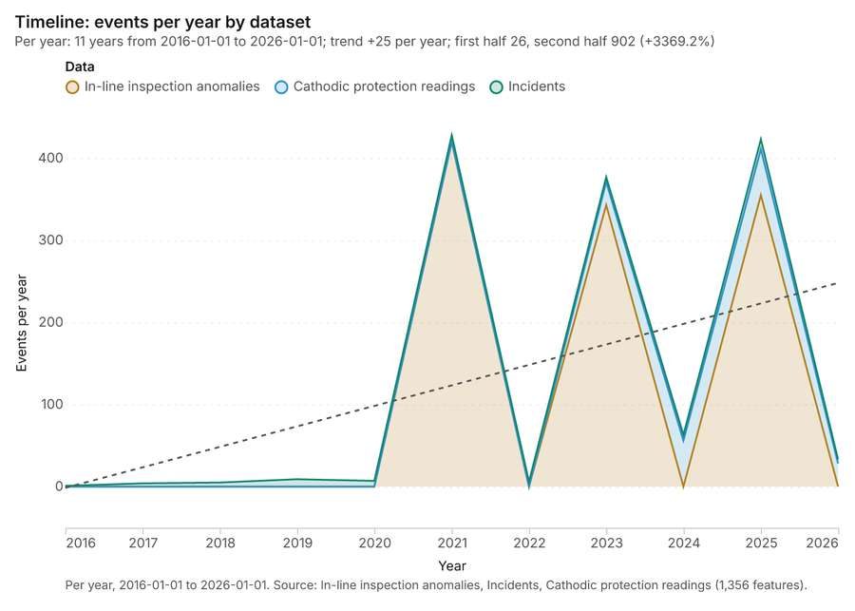
Figure 1. Timeline: events per year by dataset [1]. Per year, 2016-01-01 to 2026-01-01. Source: In-line inspection anomalies, Incidents, Cathodic protection readings (1,356 features). The data is in the appendix.
The timeline counts 1,356 dated events in In-line inspection anomalies, Incidents, Cathodic protection readings per year, from 2016 to 2026 [1][2][3][4]. By dataset: In-line inspection anomalies 1,118; Cathodic protection readings 168; Incidents 70 [1]. The trend is +25 events per year; the second half of the years has 902 against 26 in the first (+3369.2%) [1].
Busiest years
- 2021: 428 events [1]
- 2025: 423 events [1]
- 2023: 377 events [1]
Quietest years
- 2016: 1 event [1]
- 2017: 4 events [1]
- 2018: 5 events [1]

Space time hot spots
What this analysis is. Emerging hot spots: Where hot spots are new, consecutive, intensifying, persistent, diminishing, sporadic, oscillating or historical over time [5]. In ArcGIS it is Emerging Hot Spot Analysis or Create Space Time Cube [5].
Why it was run on this data. Incidents carry dates in 'date': emerging hot spot analysis finds new, intensifying and fading hot spots per year [6].
What it found. The analysis generated an output layer titled "Emerging hot spots: Incidents" which contained 13 features [7]. The input data for this analysis was the `Incidents` layer [8]. The process completed quickly, generating the result in 3 milliseconds [7].
Result | Value
result, count | 13
result, elapsed ms | 3
result, resolution | 6
result, features used | 70
result, time neighbors | 0
billing, cost | 0.1035
billing, list price | 0.1035
billing, upstream cost | 0

Findings
- Evidenced: Space time hot spots on Incidents: Emerging hot spots: 1 layer saved: Emerging hot spots: Incidents (13 features) [7][8].
- Evidenced: It reported result, count 13; result, elapsed ms 3; result, resolution 6; result, features used 70; result, time neighbors 0; billing, cost 0.1035 [7].
Tool gp_space_time_hot_spots; parameters {"agg": "sum", "project": "814309a7-f84e-4437-a8ec-209438a3f0a6", "features": {"layer": "Incidents (f9c94228)"}, "interval": "year", "bin_shape": "h3", "resolution": 6, "time_field": "date", "value_field": "station_m"}

Space time hot spots
What this analysis is. Emerging hot spots: Where hot spots are new, consecutive, intensifying, persistent, diminishing, sporadic, oscillating or historical over time [5]. In ArcGIS it is Emerging Hot Spot Analysis or Create Space Time Cube [5].
Why it was run on this data. In-line inspection anomalies carry dates in 'inspected_on': emerging hot spot analysis finds new, intensifying and fading hot spots per month [9].
What it found. The tool utilized the In-line inspection anomalies data as input [11]. The analysis identified 56 features for emerging hot spots, saving a layer named Emerging hot spots: In-line inspection anomalies [10].
Result | Value
result, count | 56
result, elapsed ms | 13
result, resolution | 7
result, features used | 1,118
result, time neighbors | 0
billing, cost | 0.1559
billing, list price | 0.1559
billing, upstream cost | 0

Findings
- Evidenced: Space time hot spots on In-line inspection anomalies: Emerging hot spots: 1 layer saved: Emerging hot spots: In-line inspection anomalies (56 features) [10][11].
- Evidenced: It reported result, count 56; result, elapsed ms 13; result, resolution 7; result, features used 1,118; result, time neighbors 0; billing, cost 0.1559 [10].
Tool gp_space_time_hot_spots; parameters {"agg": "sum", "project": "814309a7-f84e-4437-a8ec-209438a3f0a6", "features": {"layer": "In-line inspection anomalies (47cf738b)"}, "interval": "month", "bin_shape": "h3", "resolution": 7, "time_field": "inspected_on", "value_field": "station_m"}

Hot spots
What this analysis is. Hot spot analysis: Getis-Ord Gi* hot and cold spots with z-scores, p-values and confidence bins [12]. In ArcGIS it is Find Hot Spots or Hot Spot Analysis (Getis-Ord Gi*); in QGIS, qgis:hotspot (plugin) [12].
Why it was run on this data. 70 points: Getis-Ord Gi* tests whether the concentrations in Incidents are statistically significant [13].
What it found. Hot spots on Incidents: Hot spot analysis: 1 layer saved: Hot spot analysis: Incidents (70 features) [8][14]. It reported result, count 70; result, elapsed ms 2; result, excluded null 0; result, distance band m 5,000; billing, cost 0.0514; billing, list price 0.0514 [14].
Result | Value
result, count | 70
result, elapsed ms | 2
result, excluded null | 0
result, distance band m | 5,000
billing, cost | 0.0514
billing, list price | 0.0514
billing, upstream cost | 0

Findings
- Evidenced: Hot spots on Incidents: Hot spot analysis: 1 layer saved: Hot spot analysis: Incidents (70 features) [8][14].
- Evidenced: It reported result, count 70; result, elapsed ms 2; result, excluded null 0; result, distance band m 5,000; billing, cost 0.0514; billing, list price 0.0514 [14].
Tool gp_hot_spots; parameters {"field": "station_m", "project": "814309a7-f84e-4437-a8ec-209438a3f0a6", "features": {"layer": "Incidents (f9c94228)"}, "aggregation": "hexagon", "cell_size_m": 5000.0, "distance_band_m": 5000.0}

Hot spots
What this analysis is. Hot spot analysis: Getis-Ord Gi* hot and cold spots with z-scores, p-values and confidence bins [12]. In ArcGIS it is Find Hot Spots or Hot Spot Analysis (Getis-Ord Gi*); in QGIS, qgis:hotspot (plugin) [12].
Why it was run on this data. 1118 points: Getis-Ord Gi* tests whether the concentrations in In-line inspection anomalies are statistically significant [15].
What it found. The hot spot analysis was performed using the In-line inspection anomalies data [11].
Result | Value
result, count | 1,118
result, elapsed ms | 22
result, excluded null | 0
result, distance band m | 2,000
billing, cost | 0.07236
billing, list price | 0.07236
billing, upstream cost | 0

Findings
- Evidenced: Hot spots on In-line inspection anomalies: Hot spot analysis: 1 layer saved: Hot spot analysis: In-line inspection anomalies (1118 features) [11][16].
- Evidenced: It reported result, count 1,118; result, elapsed ms 22; result, excluded null 0; result, distance band m 2,000; billing, cost 0.07236; billing, list price 0.07236 [16].
Tool gp_hot_spots; parameters {"field": "station_m", "project": "814309a7-f84e-4437-a8ec-209438a3f0a6", "features": {"layer": "In-line inspection anomalies (47cf738b)"}, "aggregation": "hexagon", "cell_size_m": 1000.0, "distance_band_m": 2000.0}

Calculate density
What this analysis is. Calculate density: Kernel density per square kilometer on a grid [17]. In ArcGIS it is Calculate Density or Kernel Density; in QGIS, native:heatmapkerneldensityestimation [17].
Why it was run on this data. 25 points in Valves and stations: a density surface shows where they concentrate [18].
What it found. Calculate density on Valves and stations: Calculate density: 1 layer saved: Calculate density: Valves and stations (41 features) [19][20]. It reported result, count 41; result, elapsed ms 2; result, bandwidth m 10,000; result, cell size m 5,000; result, excluded null 0; result, max density per km2 1,474 [19].
Result | Value
result, count | 41
result, elapsed ms | 2
result, bandwidth m | 1e+04
result, cell size m | 5,000
result, excluded null | 0
result, max density per km2 | 1,474
billing, cost | 0.0505
billing, list price | 0.0505
billing, upstream cost | 0

Findings
- Evidenced: Calculate density on Valves and stations: Calculate density: 1 layer saved: Calculate density: Valves and stations (41 features) [19][20].
- Evidenced: It reported result, count 41; result, elapsed ms 2; result, bandwidth m 10,000; result, cell size m 5,000; result, excluded null 0; result, max density per km2 1,474 [19].
Tool gp_calculate_density; parameters {"kernel": "quartic", "project": "814309a7-f84e-4437-a8ec-209438a3f0a6", "features": {"layer": "Valves and stations (db114367)"}, "bandwidth_m": 10000.0, "cell_size_m": 5000.0, "weight_field": "station_m"}

Calculate density
What this analysis is. Calculate density: Kernel density per square kilometer on a grid [17]. In ArcGIS it is Calculate Density or Kernel Density; in QGIS, native:heatmapkerneldensityestimation [17].
Why it was run on this data. 70 points in Incidents: a density surface shows where they concentrate [21].
What it found. Calculate density on Incidents: Calculate density: 1 layer saved: Calculate density: Incidents (144 features) [8][22]. It reported result, count 144; result, elapsed ms 4; result, bandwidth m 5,000; result, cell size m 2,000; result, excluded null 0; result, max density per km2 1.124e+04 [22].
Result | Value
result, count | 144
result, elapsed ms | 4
result, bandwidth m | 5,000
result, cell size m | 2,000
result, excluded null | 0
result, max density per km2 | 1.124e+04
billing, cost | 0.0514
billing, list price | 0.0514
billing, upstream cost | 0

Findings
- Evidenced: Calculate density on Incidents: Calculate density: 1 layer saved: Calculate density: Incidents (144 features) [8][22].
- Evidenced: It reported result, count 144; result, elapsed ms 4; result, bandwidth m 5,000; result, cell size m 2,000; result, excluded null 0; result, max density per km2 1.124e+04 [22].
Tool gp_calculate_density; parameters {"kernel": "quartic", "project": "814309a7-f84e-4437-a8ec-209438a3f0a6", "features": {"layer": "Incidents (f9c94228)"}, "bandwidth_m": 5000.0, "cell_size_m": 2000.0, "weight_field": "station_m"}

Calculate density
What this analysis is. Calculate density: Kernel density per square kilometer on a grid [17]. In ArcGIS it is Calculate Density or Kernel Density; in QGIS, native:heatmapkerneldensityestimation [17].
Why it was run on this data. 1118 points in In-line inspection anomalies: a density surface shows where they concentrate [23].
What it found. The density calculation processed 1,039 features from the in-line inspection anomalies data [24]. The resulting maximum density per km2 was 2.813e+05 [24]. This analysis took an elapsed time of 35 ms [24]. Furthermore, the associated billing cost for this tool was 0.07236 [24].
Result | Value
result, count | 1,039
result, elapsed ms | 35
result, bandwidth m | 2,000
result, cell size m | 500
result, excluded null | 0
result, max density per km2 | 2.813e+05
billing, cost | 0.07236
billing, list price | 0.07236
billing, upstream cost | 0

Findings
- Evidenced: Calculate density on In-line inspection anomalies: Calculate density: 1 layer saved: Calculate density: In-line inspection anomalies (1039 features) [11][24].
- Evidenced: It reported result, count 1,039; result, elapsed ms 35; result, bandwidth m 2,000; result, cell size m 500; result, excluded null 0; result, max density per km2 2.813e+05 [24].
Tool gp_calculate_density; parameters {"kernel": "quartic", "project": "814309a7-f84e-4437-a8ec-209438a3f0a6", "features": {"layer": "In-line inspection anomalies (47cf738b)"}, "bandwidth_m": 2000.0, "cell_size_m": 500.0, "weight_field": "station_m"}

Summarize within
What this analysis is. Summarize within: Count and aggregate the features inside each polygon (or bin), proportionally for lines and polygons [25]. In ArcGIS it is Summarize Within or Aggregate Points; in QGIS, native:countpointsinpolygon or native:sumlinelengths [25].
Why it was run on this data. Count Valves and stations inside each feature of Right of way by type; the counts map as a choropleth (natural breaks, sequential colors) [26].
What it found. Summarize within on Valves and stations, Right of way: Summarize within: 1 layer saved: Summarize within: Right of way (3 features) [20][27][28]. It reported result, count 3; result, elapsed ms 2; billing, cost 0.01058; billing, list price 0.01058; billing, upstream cost 0 [27].
Result | Value
result, count | 3
result, elapsed ms | 2
billing, cost | 0.01058
billing, list price | 0.01058
billing, upstream cost | 0

Findings
- Evidenced: Summarize within on Valves and stations, Right of way: Summarize within: 1 layer saved: Summarize within: Right of way (3 features) [20][27][28].
- Evidenced: It reported result, count 3; result, elapsed ms 2; billing, cost 0.01058; billing, list price 0.01058; billing, upstream cost 0 [27].
Tool gp_summarize_within; parameters {"stats": [{"stat": "sum", "field": "station_m"}], "project": "814309a7-f84e-4437-a8ec-209438a3f0a6", "features": {"layer": "Valves and stations (db114367)"}, "group_by": "type", "polygons": {"layer": "Right of way (73b1c8fe)"}}

Summarize within
What this analysis is. Summarize within: Count and aggregate the features inside each polygon (or bin), proportionally for lines and polygons [25]. In ArcGIS it is Summarize Within or Aggregate Points; in QGIS, native:countpointsinpolygon or native:sumlinelengths [25].
Why it was run on this data. Count Valves and stations inside each feature of Right of way by type; the counts map as a choropleth (natural breaks, sequential colors) [26].
What it found. A summary within of right of way was generated using the gp_summarize_within tool [29]. The inputs for this process included incidents [8] and right of way data [28] [29]. The result produced contained 3 entries [29], and the process required 2 elapsed milliseconds [29].
Result | Value
result, count | 3
result, elapsed ms | 2
billing, cost | 0.01148
billing, list price | 0.01148
billing, upstream cost | 0

Findings
- Evidenced: Summarize within on Incidents, Right of way: Summarize within: 1 layer saved: Summarize within: Right of way (3 features) [8][28][29].
- Evidenced: It reported result, count 3; result, elapsed ms 2; billing, cost 0.01148; billing, list price 0.01148; billing, upstream cost 0 [29].
Tool gp_summarize_within; parameters {"stats": [{"stat": "sum", "field": "station_m"}], "project": "814309a7-f84e-4437-a8ec-209438a3f0a6", "features": {"layer": "Incidents (f9c94228)"}, "group_by": "cause", "polygons": {"layer": "Right of way (73b1c8fe)"}}

Summarize within
What this analysis is. Summarize within: Count and aggregate the features inside each polygon (or bin), proportionally for lines and polygons [25]. In ArcGIS it is Summarize Within or Aggregate Points; in QGIS, native:countpointsinpolygon or native:sumlinelengths [25].
Why it was run on this data. Count Valves and stations inside each feature of Right of way by type; the counts map as a choropleth (natural breaks, sequential colors) [26].
What it found. Summarize within on Crossings, Right of way: Summarize within: 1 layer saved: Summarize within: Right of way (3 features) [28][30][31]. It reported result, count 3; result, elapsed ms 2; billing, cost 0.01036; billing, list price 0.01036; billing, upstream cost 0 [30].
Result | Value
result, count | 3
result, elapsed ms | 2
billing, cost | 0.01036
billing, list price | 0.01036
billing, upstream cost | 0

Findings
- Evidenced: Summarize within on Crossings, Right of way: Summarize within: 1 layer saved: Summarize within: Right of way (3 features) [28][30][31].
- Evidenced: It reported result, count 3; result, elapsed ms 2; billing, cost 0.01036; billing, list price 0.01036; billing, upstream cost 0 [30].
Tool gp_summarize_within; parameters {"stats": [{"stat": "sum", "field": "station_m"}], "project": "814309a7-f84e-4437-a8ec-209438a3f0a6", "features": {"layer": "Crossings (d8fae91e)"}, "group_by": "type", "polygons": {"layer": "Right of way (73b1c8fe)"}}

Find point clusters
What this analysis is. Find point clusters: Density-based clusters (DBSCAN, HDBSCAN or OPTICS, optionally space-time) with hulls and noise [32]. In ArcGIS it is Find Point Clusters or Density-based Clustering; in QGIS, native:dbscanclustering or native:stdbscanclustering [32].
Why it was run on this data. DBSCAN finds dense groups of Valves and stations and separates noise [33].
What it found. Find point clusters on Valves and stations: Find point clusters: 2 layers saved: Find point clusters: Valves and stations (25 features); Find point clusters: cluster hulls (1 feature) [20][34]. It reported result, count 25; result, noise 0; result, distance m 5,000; result, elapsed ms 2; result, min points 3; billing, cost 0.0505 [34].
Result | Value
result, count | 25
result, noise | 0
result, distance m | 5,000
result, elapsed ms | 2
result, min points | 3
billing, cost | 0.0505
billing, list price | 0.0505
billing, upstream cost | 0

Findings
- Evidenced: Find point clusters on Valves and stations: Find point clusters: 2 layers saved: Find point clusters: Valves and stations (25 features); Find point clusters: cluster hulls (1 feature) [20][34].
- Evidenced: It reported result, count 25; result, noise 0; result, distance m 5,000; result, elapsed ms 2; result, min points 3; billing, cost 0.0505 [34].
Tool gp_find_point_clusters; parameters {"method": "dbscan", "project": "814309a7-f84e-4437-a8ec-209438a3f0a6", "features": {"layer": "Valves and stations (db114367)"}, "distance_m": 5000.0, "min_points": 3}

Find point clusters
What this analysis is. Find point clusters: Density-based clusters (DBSCAN, HDBSCAN or OPTICS, optionally space-time) with hulls and noise [32]. In ArcGIS it is Find Point Clusters or Density-based Clustering; in QGIS, native:dbscanclustering or native:stdbscanclustering [32].
Why it was run on this data. DBSCAN finds dense groups of Incidents and separates noise [35].
What it found. Find point clusters on Incidents: Find point clusters: 2 layers saved: Find point clusters: Incidents (70 features); Find point clusters: cluster hulls (1 feature) [8][36]. It reported result, count 70; result, noise 2; result, distance m 5,000; result, elapsed ms 2; result, min points 3; billing, cost 0.0514 [36].
Result | Value
result, count | 70
result, noise | 2
result, distance m | 5,000
result, elapsed ms | 2
result, min points | 3
billing, cost | 0.0514
billing, list price | 0.0514
billing, upstream cost | 0

Findings
- Evidenced: Find point clusters on Incidents: Find point clusters: 2 layers saved: Find point clusters: Incidents (70 features); Find point clusters: cluster hulls (1 feature) [8][36].
- Evidenced: It reported result, count 70; result, noise 2; result, distance m 5,000; result, elapsed ms 2; result, min points 3; billing, cost 0.0514 [36].
Tool gp_find_point_clusters; parameters {"method": "dbscan", "project": "814309a7-f84e-4437-a8ec-209438a3f0a6", "features": {"layer": "Incidents (f9c94228)"}, "distance_m": 5000.0, "min_points": 3}

Find point clusters
What this analysis is. Find point clusters: Density-based clusters (DBSCAN, HDBSCAN or OPTICS, optionally space-time) with hulls and noise [32]. In ArcGIS it is Find Point Clusters or Density-based Clustering; in QGIS, native:dbscanclustering or native:stdbscanclustering [32].
Why it was run on this data. DBSCAN finds dense groups of Crossings and separates noise [37].
What it found. Find point clusters on Crossings: Find point clusters: 2 layers saved: Find point clusters: Crossings (14 features); Find point clusters: cluster hulls (1 feature) [31][38]. It reported result, count 14; result, noise 4; result, distance m 5,000; result, elapsed ms 1; result, min points 3; billing, cost 0.05028 [38].
Result | Value
result, count | 14
result, noise | 4
result, distance m | 5,000
result, elapsed ms | 1
result, min points | 3
billing, cost | 0.05028
billing, list price | 0.05028
billing, upstream cost | 0

Findings
- Evidenced: Find point clusters on Crossings: Find point clusters: 2 layers saved: Find point clusters: Crossings (14 features); Find point clusters: cluster hulls (1 feature) [31][38].
- Evidenced: It reported result, count 14; result, noise 4; result, distance m 5,000; result, elapsed ms 1; result, min points 3; billing, cost 0.05028 [38].
Tool gp_find_point_clusters; parameters {"method": "dbscan", "project": "814309a7-f84e-4437-a8ec-209438a3f0a6", "features": {"layer": "Crossings (d8fae91e)"}, "distance_m": 5000.0, "min_points": 3}

Find nearest
What this analysis is. Find nearest: The k nearest features for each input, with geodesic distance and bearing [39]. In ArcGIS it is Find Nearest or Near; in QGIS, native:joinbynearest or native:nearestneighbouranalysis [39].
Why it was run on this data. The nearest of Crossings to each of Valves and stations, with distances [40].
What it found. Find nearest on Crossings, Valves and stations: Find nearest: 1 layer saved: Find nearest: Valves and stations (24 features) [20][31][41]. It reported result, count 24; result, elapsed ms 2; billing, cost 0.01078; billing, list price 0.01078; billing, upstream cost 0 [41].
Result | Value
result, count | 24
result, elapsed ms | 2
billing, cost | 0.01078
billing, list price | 0.01078
billing, upstream cost | 0

Findings
- Evidenced: Find nearest on Crossings, Valves and stations: Find nearest: 1 layer saved: Find nearest: Valves and stations (24 features) [20][31][41].
- Evidenced: It reported result, count 24; result, elapsed ms 2; billing, cost 0.01078; billing, list price 0.01078; billing, upstream cost 0 [41].
Tool gp_find_nearest; parameters {"k": 1, "to": {"layer": "Crossings (d8fae91e)"}, "from": {"layer": "Valves and stations (db114367)"}, "project": "814309a7-f84e-4437-a8ec-209438a3f0a6", "max_distance_m": 5000.0}

Find nearest
What this analysis is. Find nearest: The k nearest features for each input, with geodesic distance and bearing [39]. In ArcGIS it is Find Nearest or Near; in QGIS, native:joinbynearest or native:nearestneighbouranalysis [39].
Why it was run on this data. The nearest of Crossings to each of Valves and stations, with distances [40].
What it found. The `gp_find_nearest` tool was utilized, taking Valves and stations [20] and Pipeline segments [43] as input [42]. The function successfully returned 25 results [42]. The operation completed with an elapsed time of 12 ms [42], and the associated costs were reported as 0.01248 [42].
Result | Value
result, count | 25
result, elapsed ms | 12
billing, cost | 0.01248
billing, list price | 0.01248
billing, upstream cost | 0

Findings
- Evidenced: Find nearest on Pipeline segments, Valves and stations: Find nearest: 1 layer saved: Find nearest: Valves and stations (25 features) [20][42][43].
- Evidenced: It reported result, count 25; result, elapsed ms 12; billing, cost 0.01248; billing, list price 0.01248; billing, upstream cost 0 [42].
Tool gp_find_nearest; parameters {"k": 1, "to": {"layer": "Pipeline segments (07d2778e)"}, "from": {"layer": "Valves and stations (db114367)"}, "project": "814309a7-f84e-4437-a8ec-209438a3f0a6", "max_distance_m": 5000.0}

Near repeat
What this analysis is. Repeat and near repeat classification: Classify incidents as originators, repeats (same place) or near repeats within a distance and time window, with a Knox test table [44]. In ArcGIS it is Repeat and Near Repeat Classification or Near Repeat Calculator [44].
Why it was run on this data. Near repeat analysis tests whether Incidents close in space also follow each other within 30 days [45].
What it found. The Near repeat classification tool was run using Incidents data [8] and generated a layer containing 70
Result | Value
result, days | 30
result, count | 70
result, chains | 3
result, distance m | 2,000
result, elapsed ms | 4
result, pairs linked | 3
billing, cost | 0.0521
billing, list price | 0.0521
billing, upstream cost | 0

Findings
- Evidenced: Near repeat on Incidents: Repeat and near repeat classification: 1 layer saved: Repeat and near repeat classification: Incidents (70 features) [8][46].
- Evidenced: It reported result, days 30; result, count 70; result, chains 3; result, distance m 2,000; result, elapsed ms 4; result, pairs linked 3 [46].
Tool gp_near_repeat; parameters {"days": 30, "project": "814309a7-f84e-4437-a8ec-209438a3f0a6", "features": {"layer": "Incidents (f9c94228)"}, "distance_m": 2000.0, "time_field": "date"}

Maps and charts
The run also made 20 map image(s) [47][48][49][50][51][52][53][54][55][56][57][58][59][60][61][62][63][64][65][66] and 27 chart(s) [67][68][69][70][71][72][73][74][75][76][77][78][79][80][81][82][83][84][85][86][87][88][89][90][91][92][93].
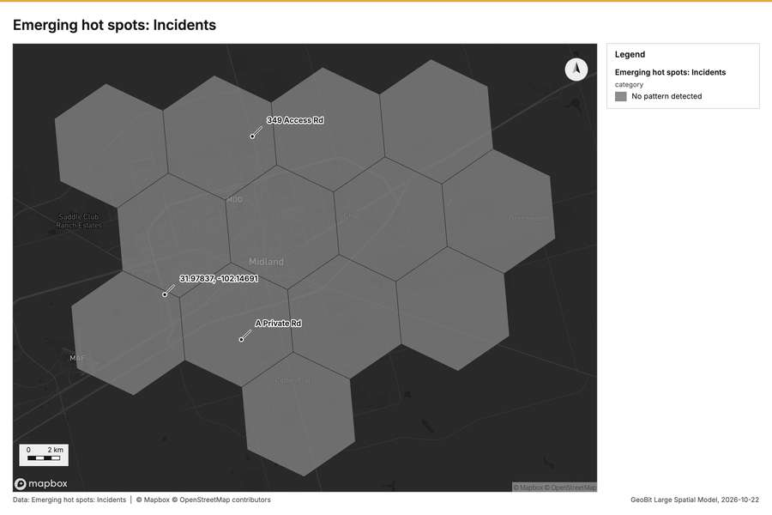
Figure 2. Emerging hot spots: Incidents [47]
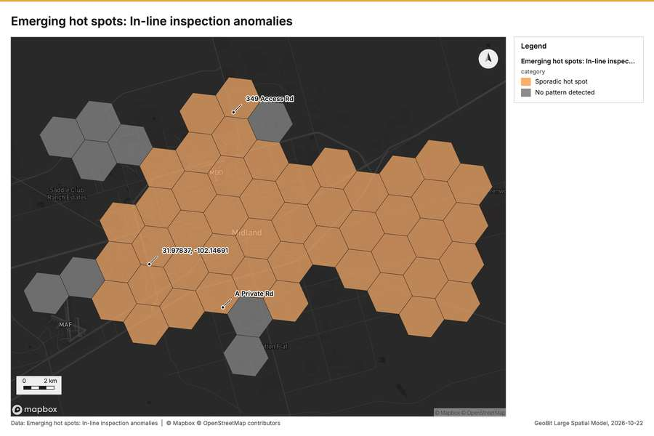
Figure 3. Emerging hot spots: In-line inspection anomalies [48]
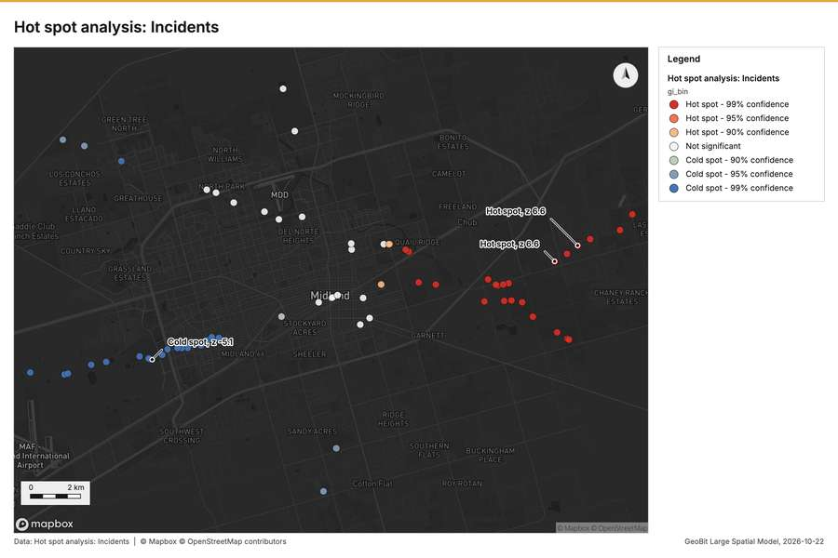
Figure 4. Hot spot analysis: Incidents [49]
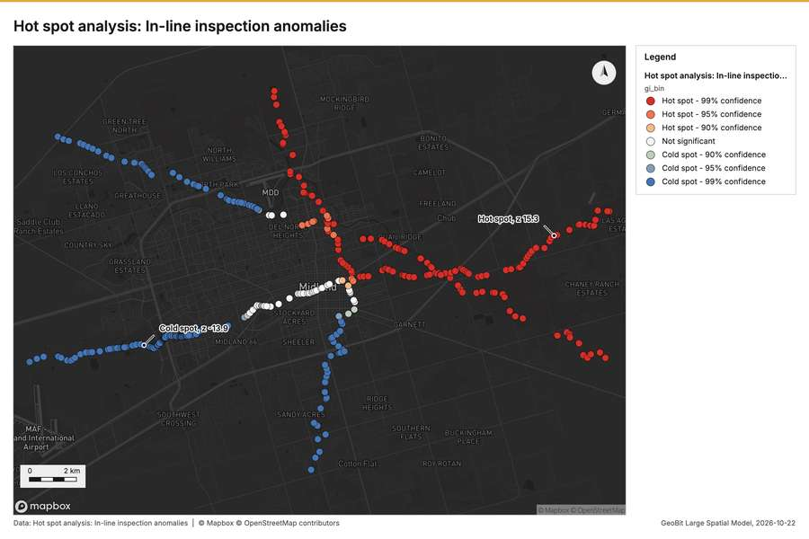
Figure 5. Hot spot analysis: In-line inspection anomalies [50]
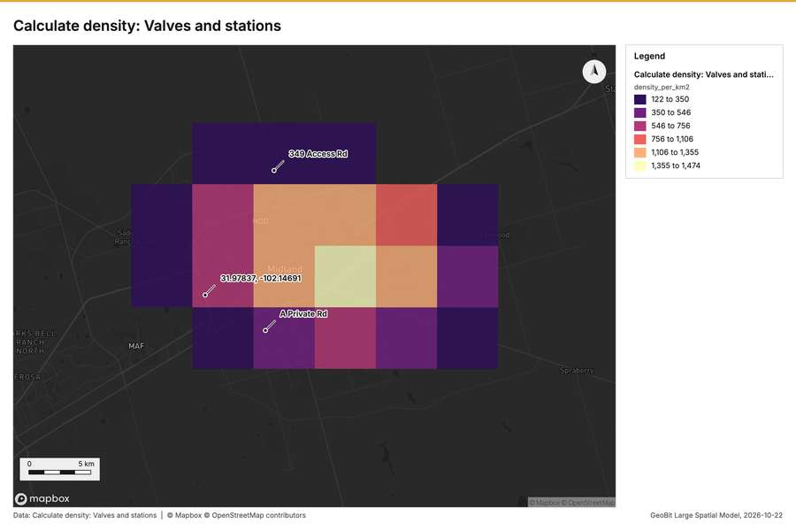
Figure 6. Calculate density: Valves and stations [51]
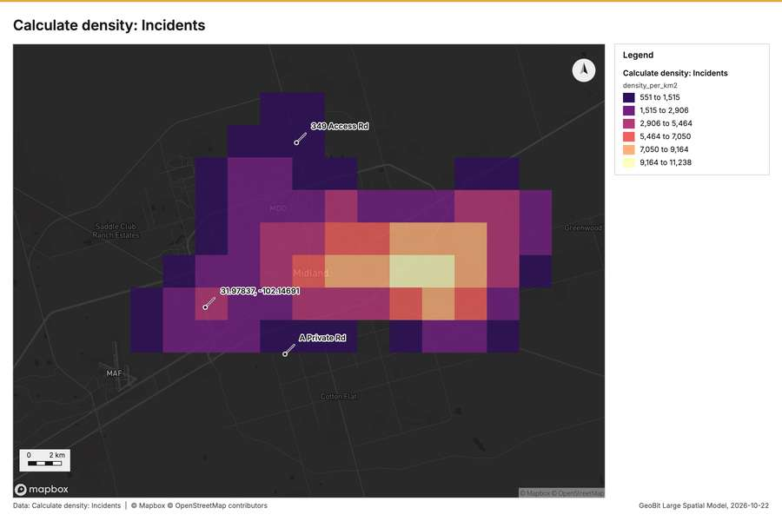
Figure 7. Calculate density: Incidents [52]
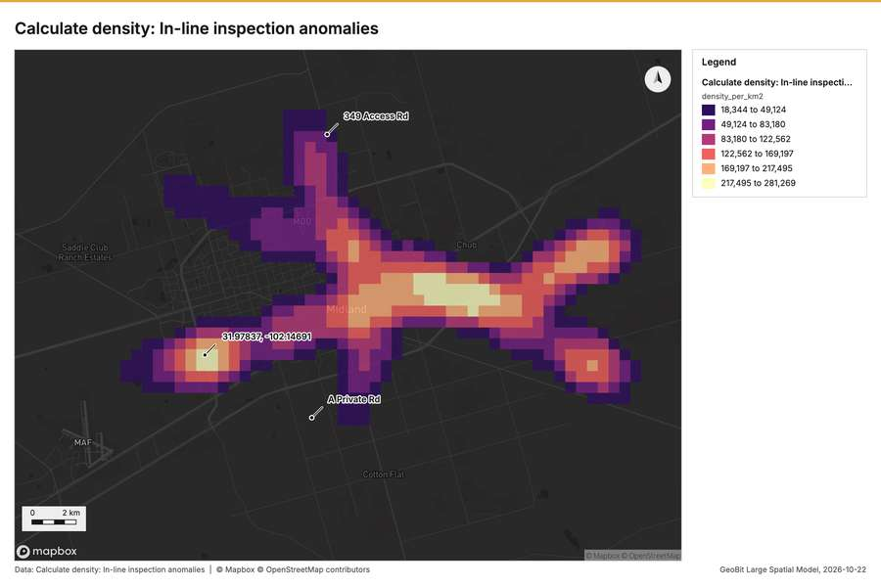
Figure 8. Calculate density: In-line inspection anomalies [53]
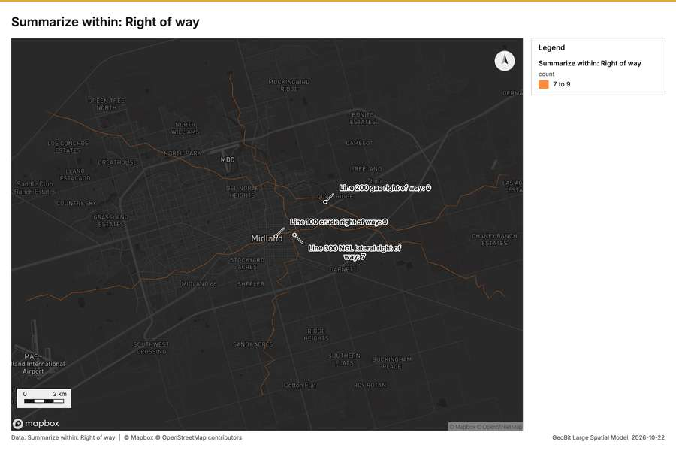
Figure 9. Summarize within: Right of way [54]
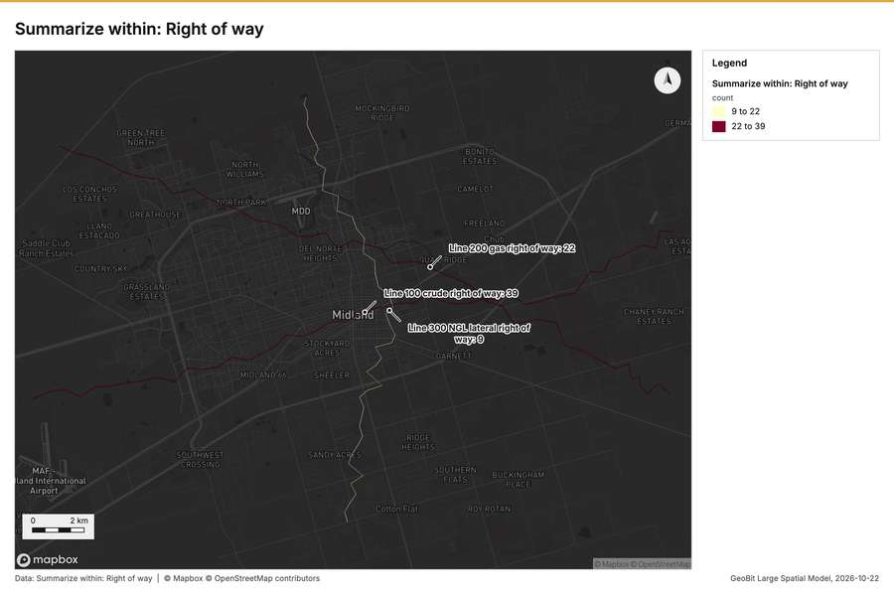
Figure 10. Summarize within: Right of way [55]
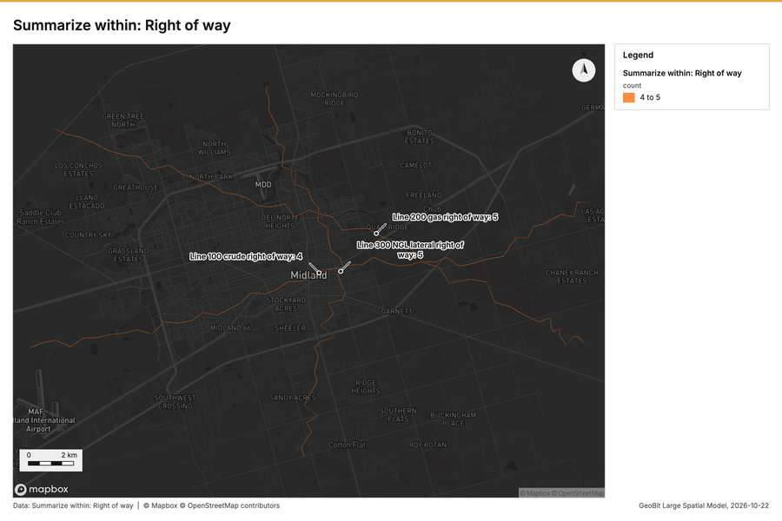
Figure 11. Summarize within: Right of way [56]
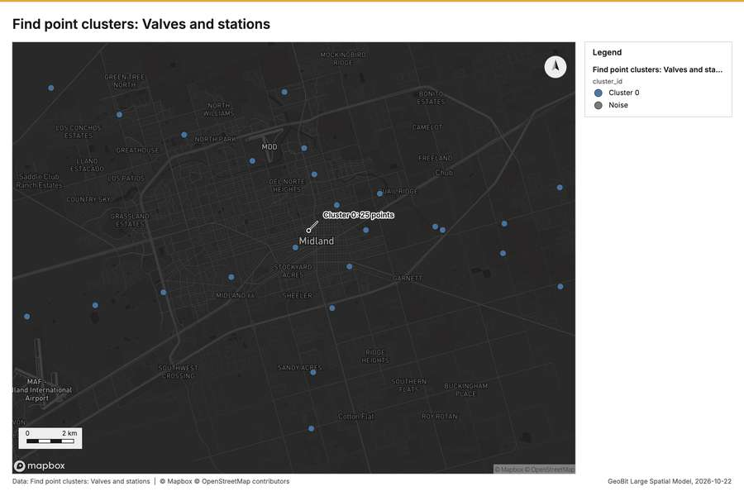
Figure 12. Find point clusters: Valves and stations [57]
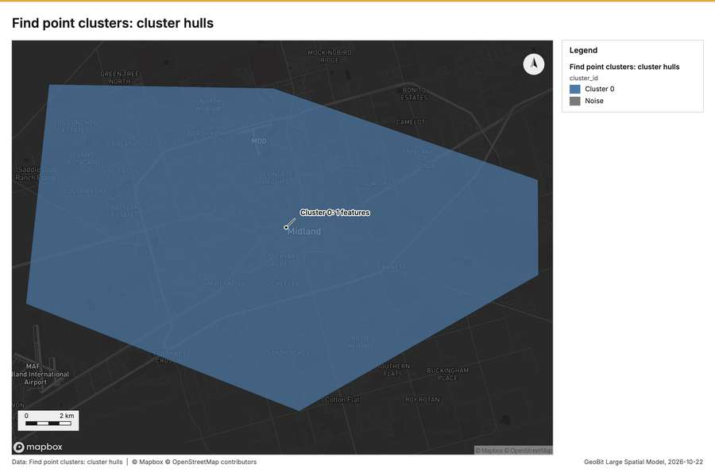
Figure 13. Find point clusters: cluster hulls [58]
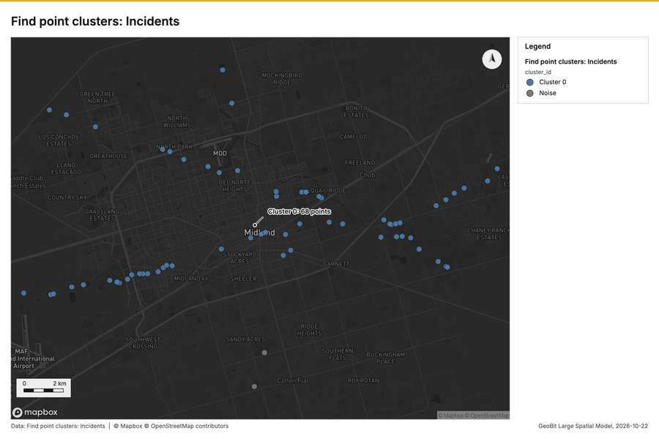
Figure 14. Find point clusters: Incidents [59]
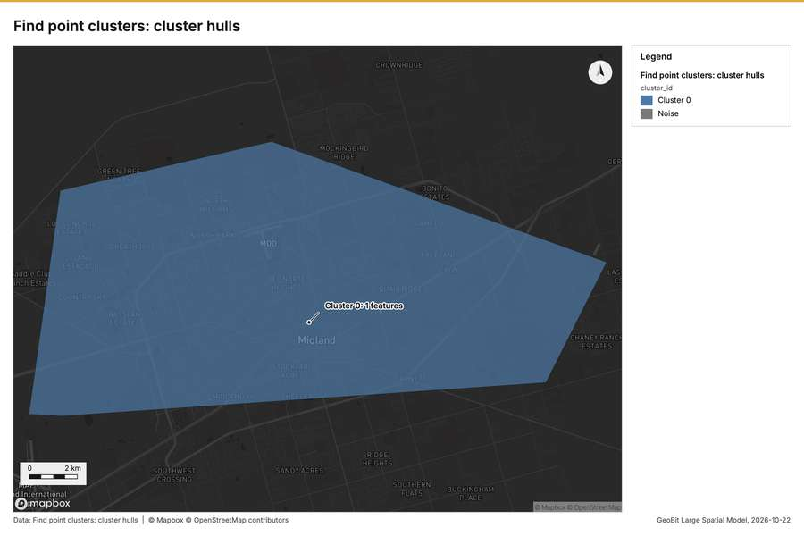
Figure 15. Find point clusters: cluster hulls [60]
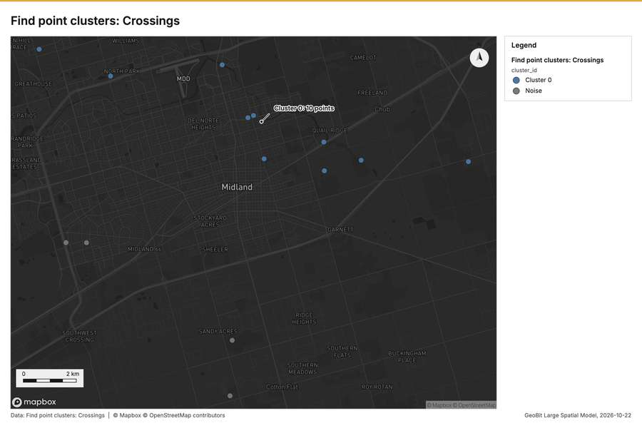
Figure 16. Find point clusters: Crossings [61]
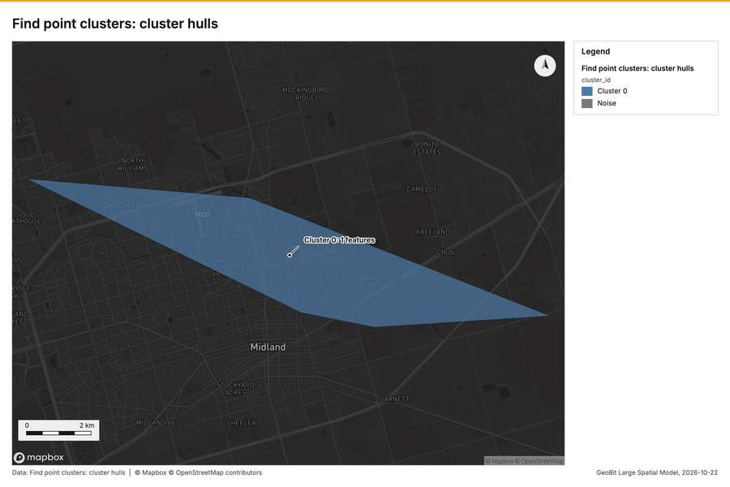
Figure 17. Find point clusters: cluster hulls [62]
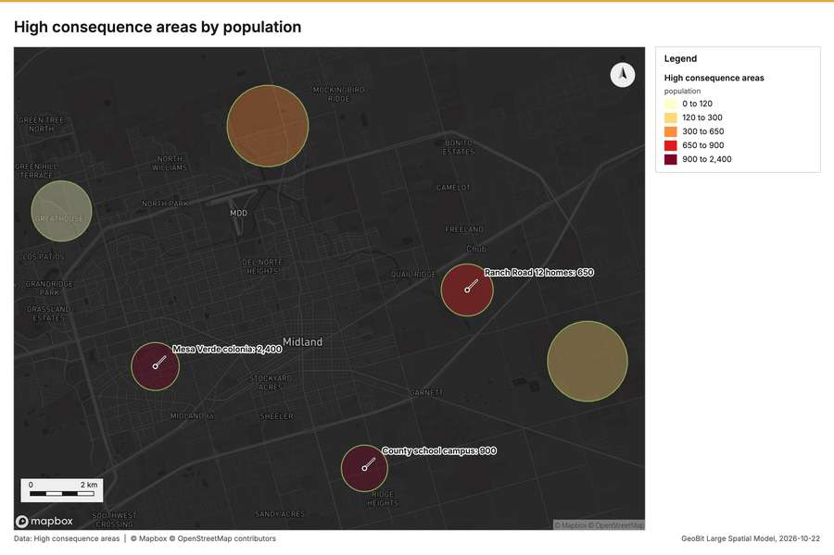
Figure 18. High consequence areas by population [63]
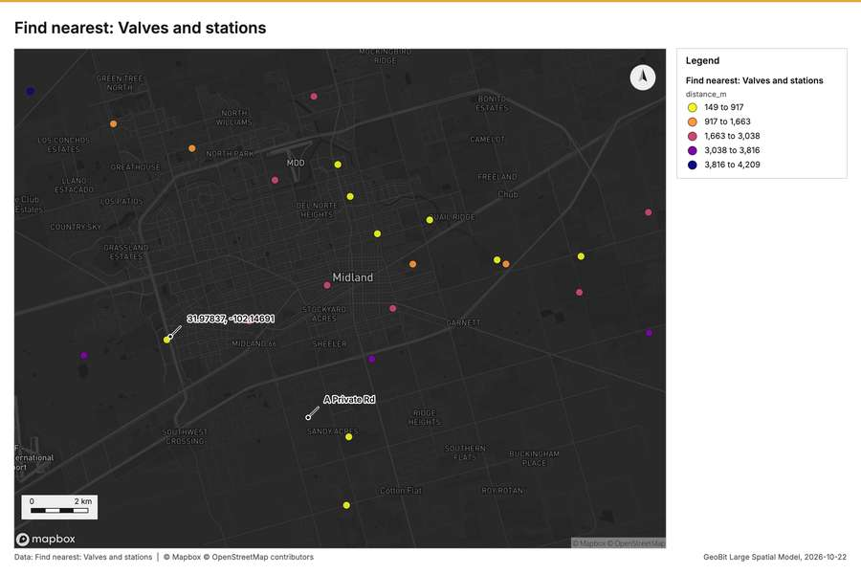
Figure 19. Find nearest: Valves and stations [64]
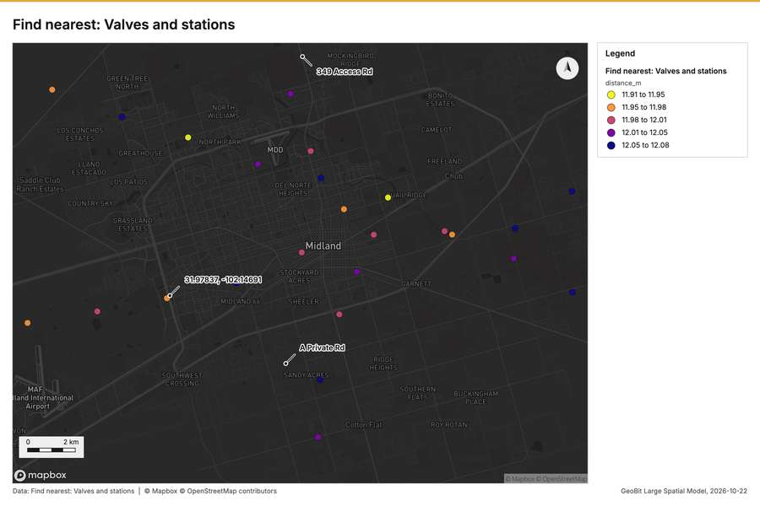
Figure 20. Find nearest: Valves and stations [65]
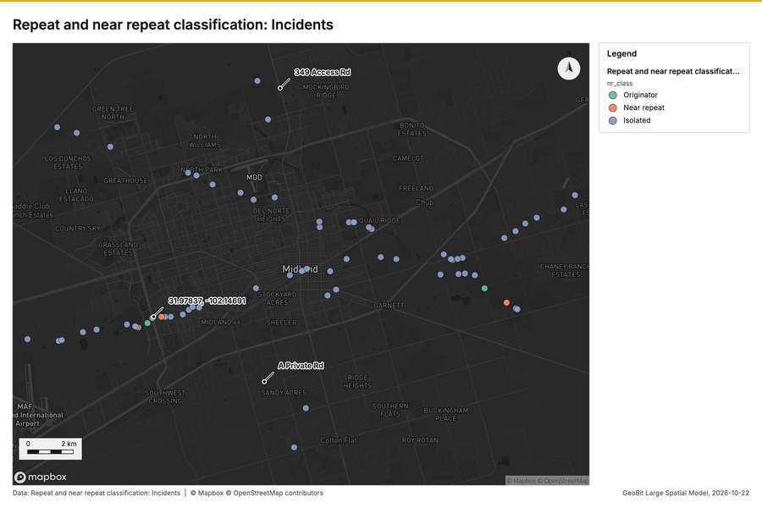
Figure 21. Repeat and near repeat classification: Incidents [66]
What the map shows. This map visualizes the analysis of emerging hot spots for incidents across the mapped area. The legend explicitly states that no pattern was detected for this category of incidents. Graphically, the map is drawn using a tessellation of hexagonal polygons, all of which are uniformly filled with a solid grey shade. Because no pattern was detected, the map does not display any visible clusters, significant gradients, or distinguishable high or low activity areas. [47]
Inferred: read from the image by gemma4:e4b, not evidence.
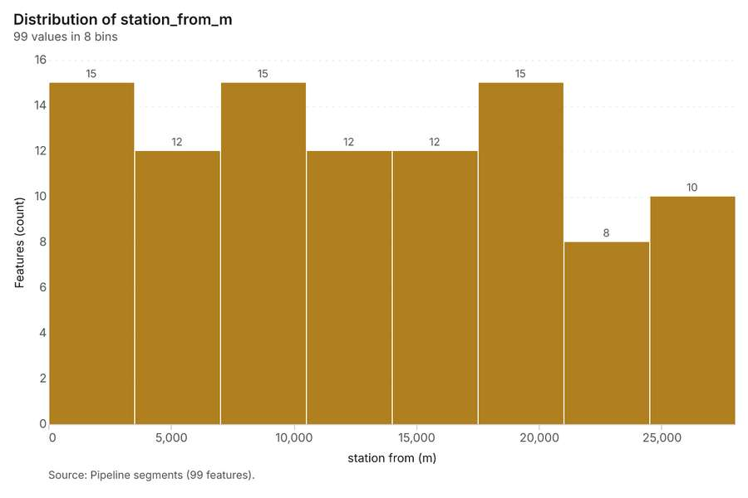
Figure 22. Pipeline segments over time (install_year) [67]. Source: Pipeline segments (99 features). The data is in the appendix.
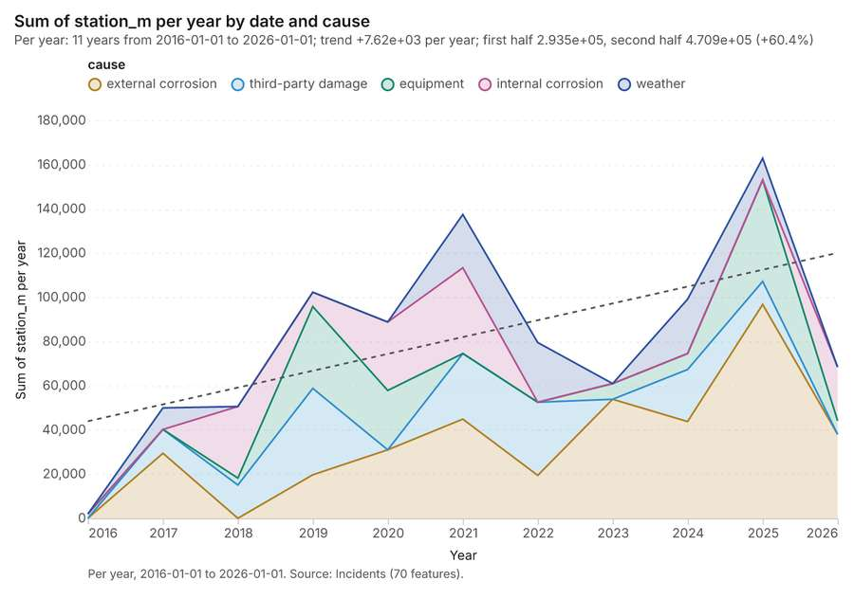
Figure 23. Incidents over time (date) [68]. Per year, 2016-01-01 to 2026-01-01. Source: Incidents (70 features). The data is in the appendix.
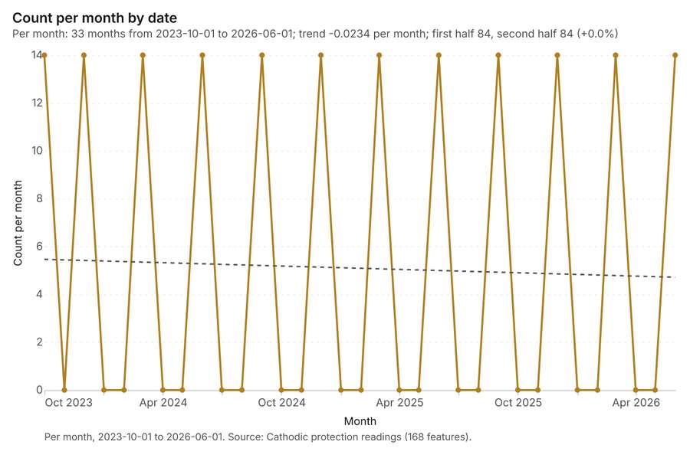
Figure 24. Cathodic protection readings over time (date) [69]. Per month, 2023-10-01 to 2026-06-01. Source: Cathodic protection readings (168 features). The data is in the appendix.
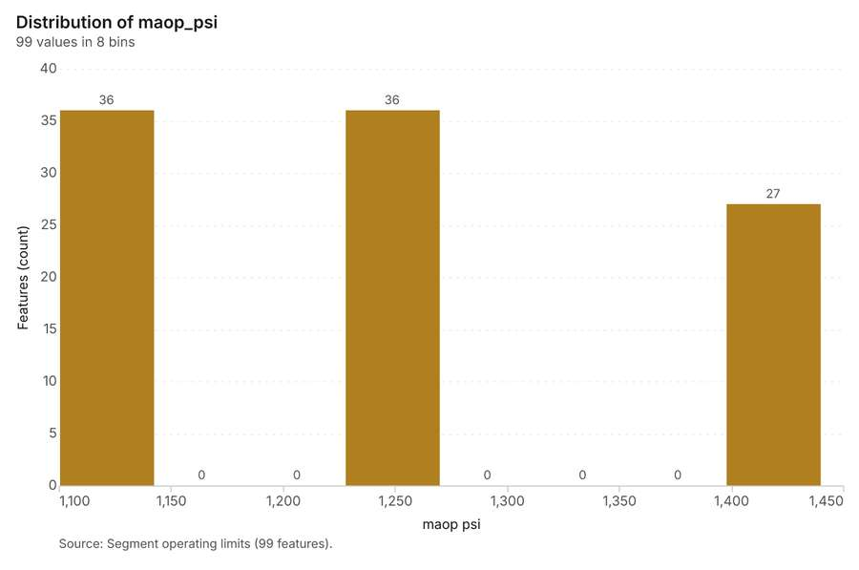
Figure 25. Segment operating limits over time (last_hydrotest_year) [70]. Source: Segment operating limits (99 features). The data is in the appendix.
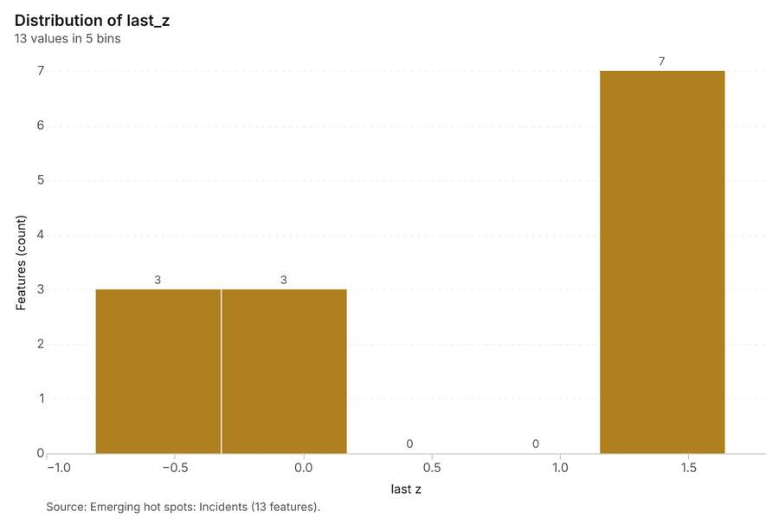
Figure 26. Emerging hot spots: Incidents [71]. Source: Emerging hot spots: Incidents (13 features). The data is in the appendix.
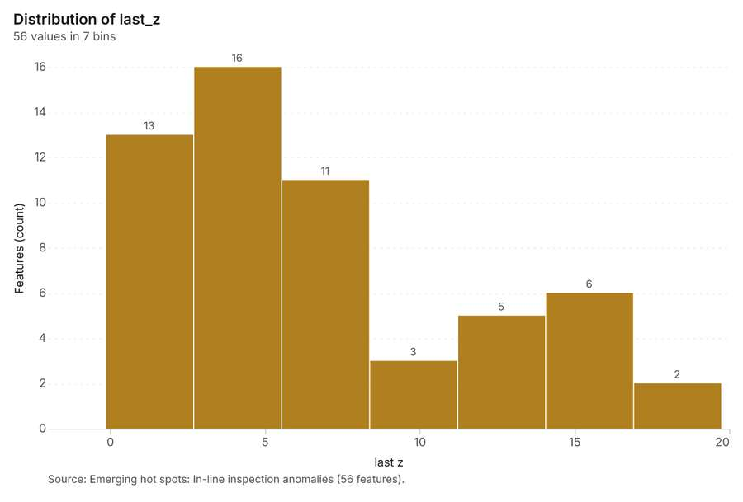
Figure 27. Emerging hot spots: In-line inspection anomalies [72]. Source: Emerging hot spots: In-line inspection anomalies (56 features). The data is in the appendix.
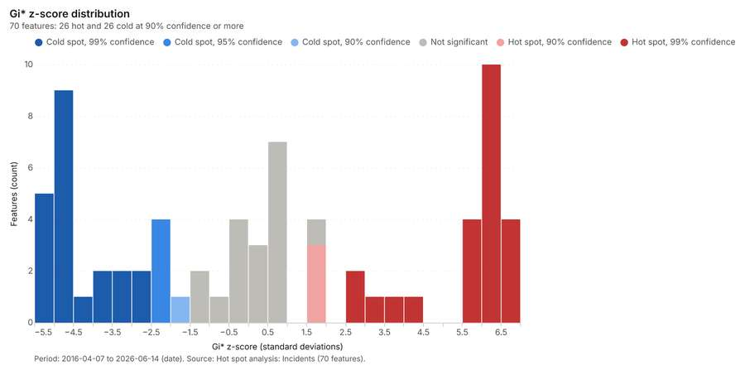
Figure 28. Hot spot analysis: Incidents [73]. Period: 2016-04-07 to 2026-06-14 (date). Source: Hot spot analysis: Incidents (70 features). The data is in the appendix.
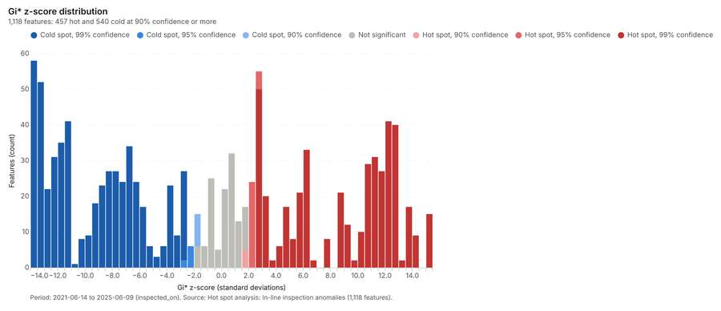
Figure 29. Hot spot analysis: In-line inspection anomalies [74]. Period: 2021-06-14 to 2025-06-09 (inspected_on). Source: Hot spot analysis: In-line inspection anomalies (1,118 features). The data is in the appendix.
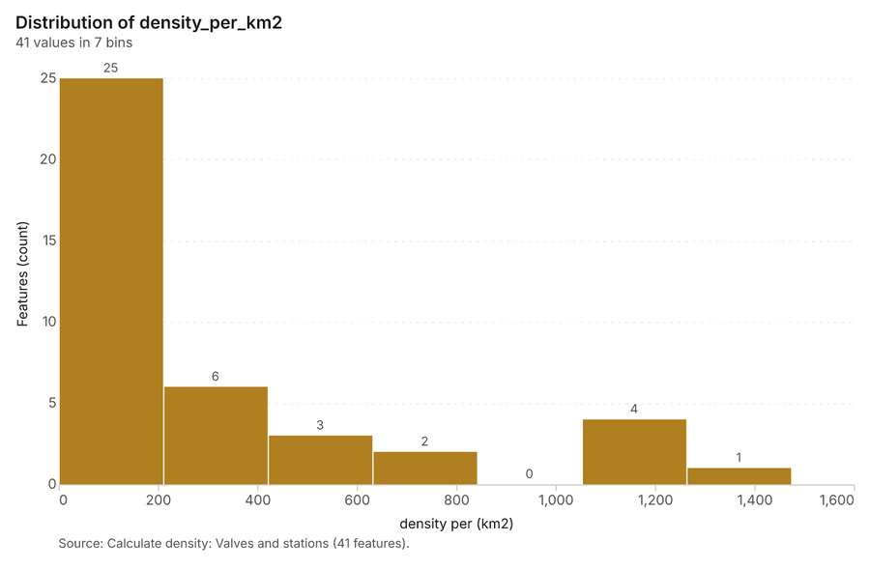
Figure 30. Calculate density: Valves and stations [75]. Source: Calculate density: Valves and stations (41 features). The data is in the appendix.
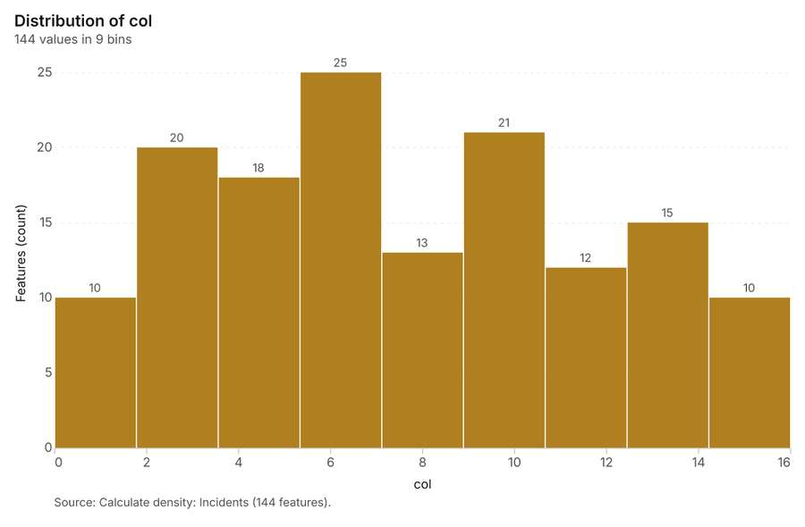
Figure 31. Calculate density: Incidents [76]. Source: Calculate density: Incidents (144 features). The data is in the appendix.
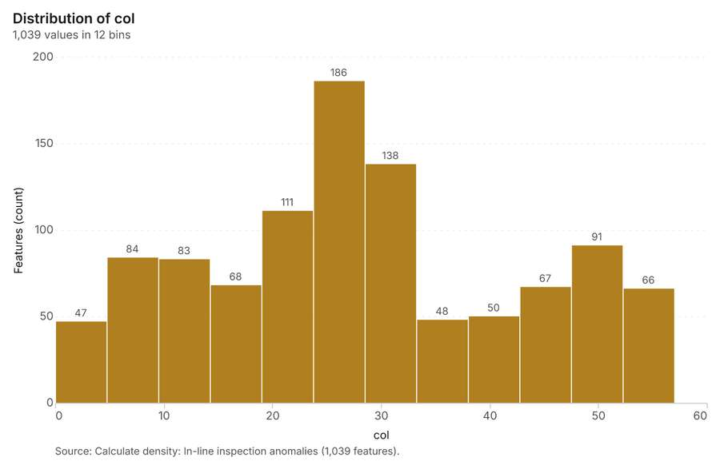
Figure 32. Calculate density: In-line inspection anomalies [77]. Source: Calculate density: In-line inspection anomalies (1,039 features). The data is in the appendix.
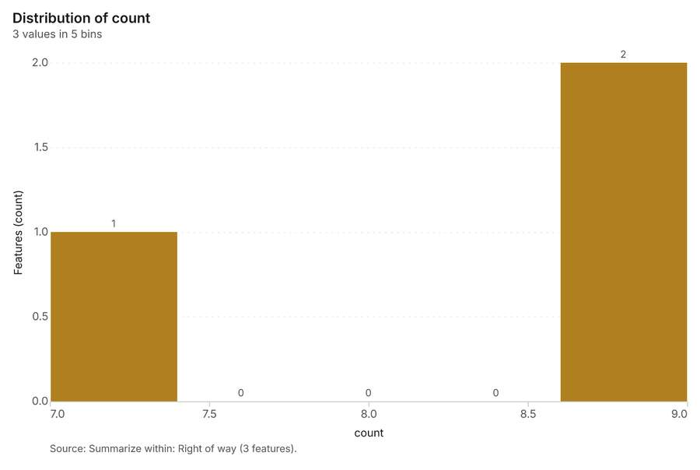
Figure 33. Summarize within: Right of way [78]. Source: Summarize within: Right of way (3 features). The data is in the appendix.
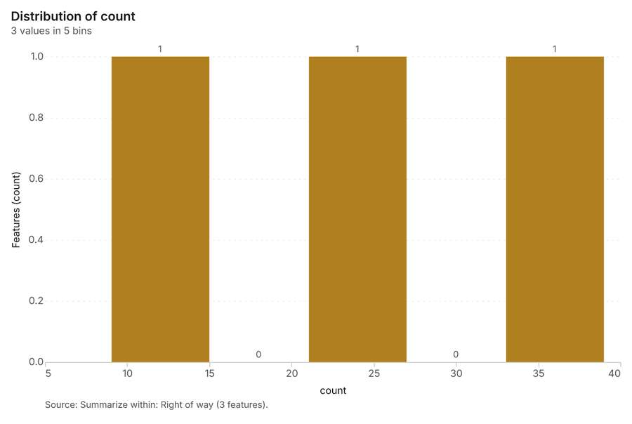
Figure 34. Summarize within: Right of way [79]. Source: Summarize within: Right of way (3 features). The data is in the appendix.
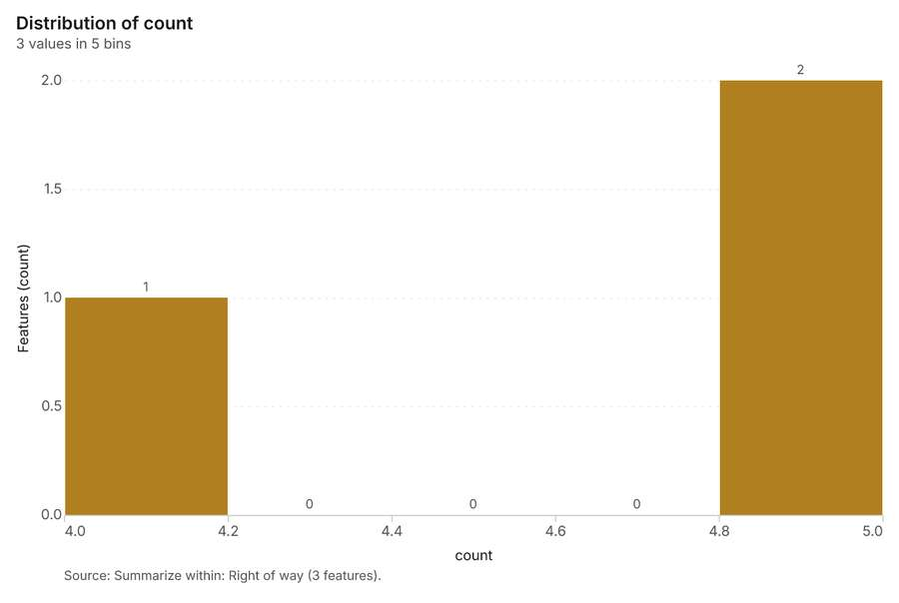
Figure 35. Summarize within: Right of way [80]. Source: Summarize within: Right of way (3 features). The data is in the appendix.
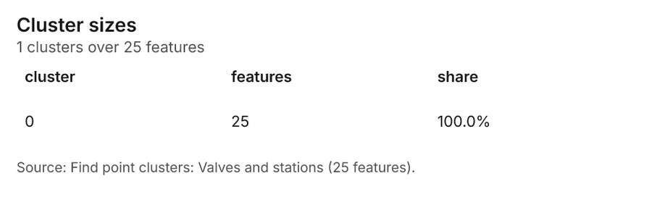
Figure 36. Find point clusters: Valves and stations [81]. Source: Find point clusters: Valves and stations (25 features). The data is in the appendix.
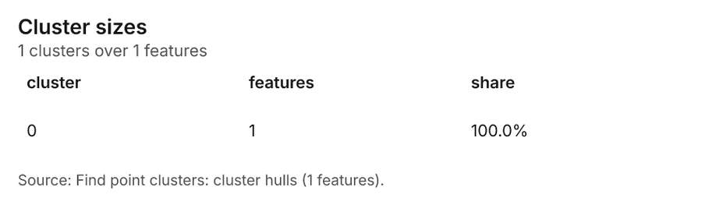
Figure 37. Find point clusters: cluster hulls [82]. Source: Find point clusters: cluster hulls (1 features). The data is in the appendix.
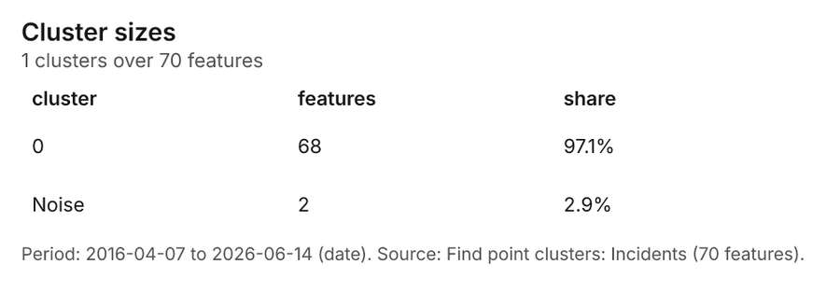
Figure 38. Find point clusters: Incidents [83]. Period: 2016-04-07 to 2026-06-14 (date). Source: Find point clusters: Incidents (70 features). The data is in the appendix.
Figure 39. Find point clusters: cluster hulls [84]. Source: Find point clusters: cluster hulls (1 features). The data is in the appendix.
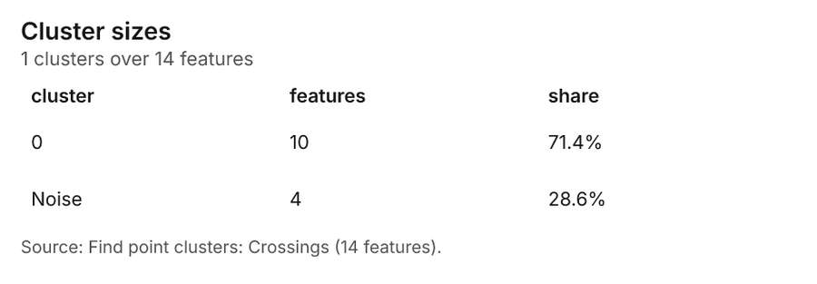
Figure 40. Find point clusters: Crossings [85]. Source: Find point clusters: Crossings (14 features). The data is in the appendix.
Figure 41. Find point clusters: cluster hulls [86]. Source: Find point clusters: cluster hulls (1 features). The data is in the appendix.
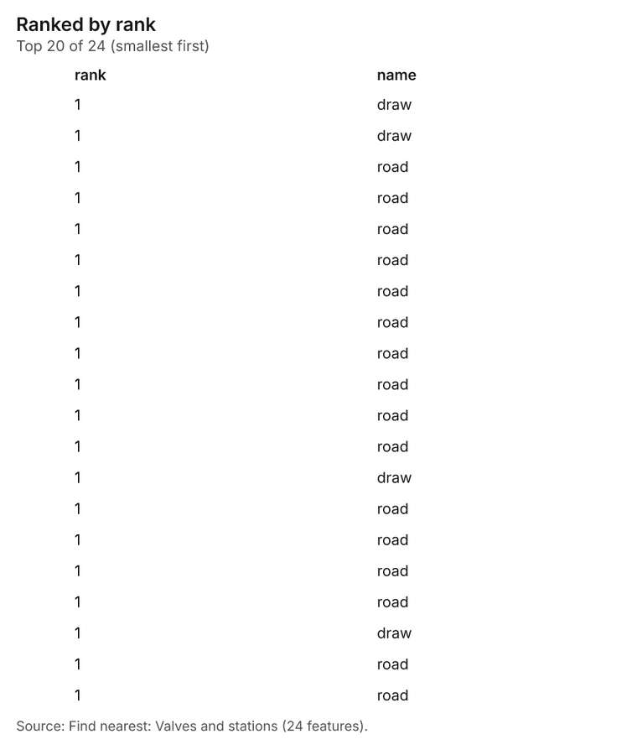
Figure 42. Find nearest: Valves and stations [87]. Source: Find nearest: Valves and stations (24 features). The data is in the appendix.
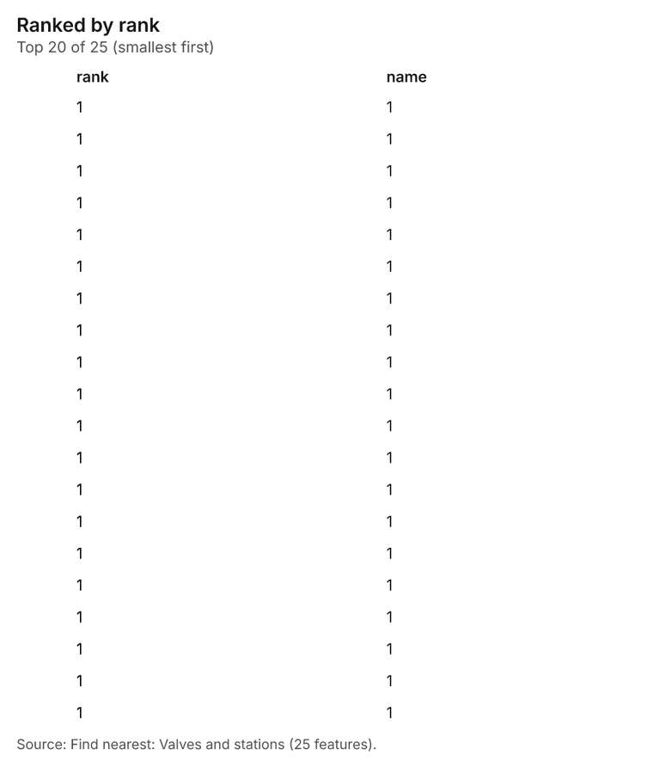
Figure 43. Find nearest: Valves and stations [88]. Source: Find nearest: Valves and stations (25 features). The data is in the appendix.
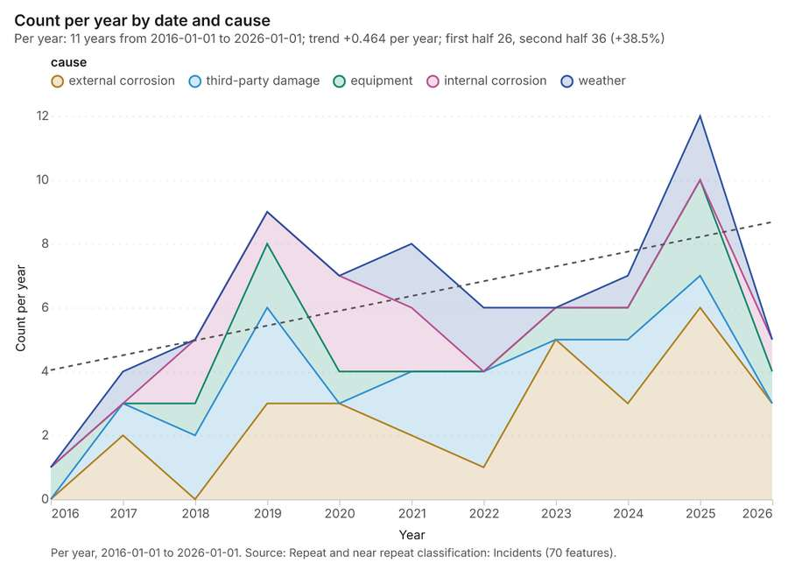
Figure 44. Repeat and near repeat classification: Incidents [89]. Per year, 2016-01-01 to 2026-01-01. Source: Repeat and near repeat classification: Incidents (70 features). The data is in the appendix.
Figure 45. Repeat and near repeat classification: Incidents over time [90]. Per year, 2016-01-01 to 2026-01-01. Source: Repeat and near repeat classification: Incidents (70 features). The data is in the appendix.
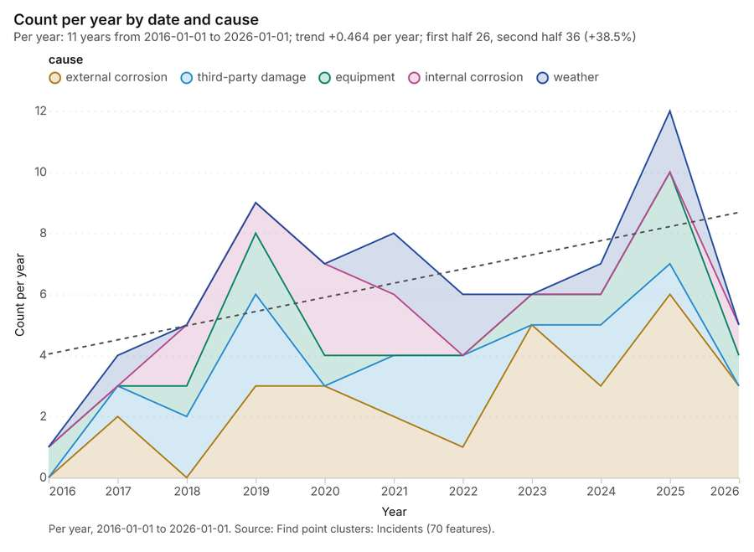
Figure 46. Find point clusters: Incidents over time [91]. Per year, 2016-01-01 to 2026-01-01. Source: Find point clusters: Incidents (70 features). The data is in the appendix.
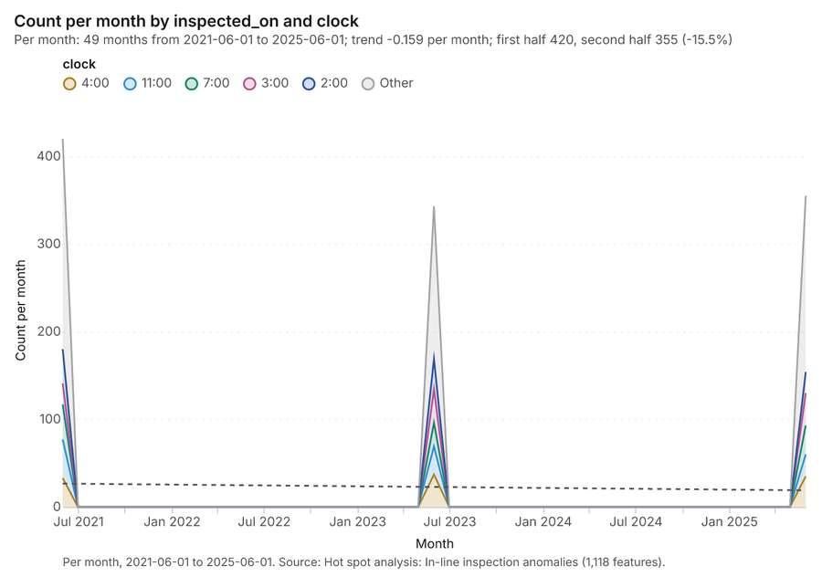
Figure 47. Hot spot analysis: In-line inspection anomalies over time [92]. Per month, 2021-06-01 to 2025-06-01. Source: Hot spot analysis: In-line inspection anomalies (1,118 features). The data is in the appendix.
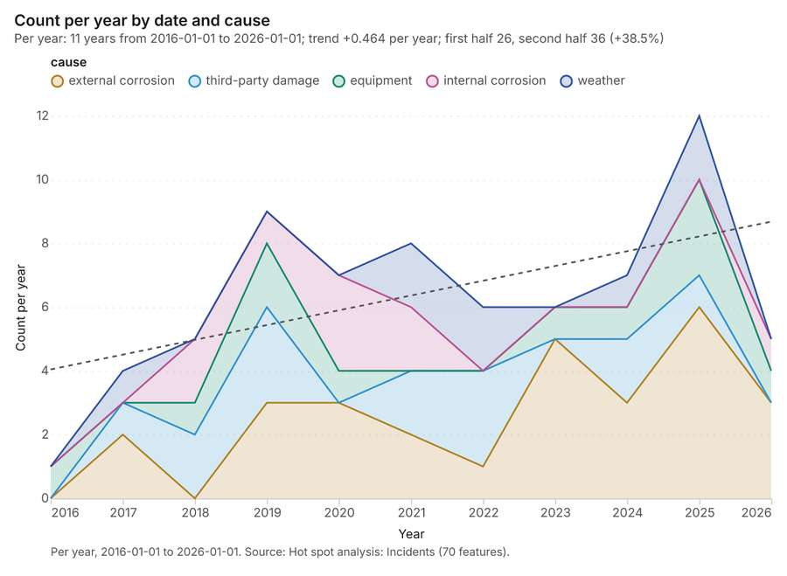
Figure 48. Hot spot analysis: Incidents over time [93]. Per year, 2016-01-01 to 2026-01-01. Source: Hot spot analysis: Incidents (70 features). The data is in the appendix.

Changes since the last run
This is the first report of this project.

Sources
[1] Rendering: Chart: Timeline: events per year by dataset. 33 rows (id 27fa3a89-f6f1-4b50-8932-e49cafec5ffa)
[2] Dataset: In-line inspection anomalies. vector, 1118 rows (id ab2540a1-9c20-423b-b653-0cf763c5cc8e)
[3] Dataset: Incidents. vector, 70 rows (id 663eca22-c04e-4522-8f28-ddc430b2a25c)
[4] Dataset: Cathodic protection readings. table, 168 rows (id aa287ab3-e04d-46e8-9c49-c47c5badeaec)
[5] Catalog: Emerging hot spots (operation catalog, gp_space_time_hot_spots). Where hot spots are new, consecutive, intensifying, persistent, diminishing, sporadic, oscillating or historical over time. ArcGIS: Emerging Hot Spot Analysis, Create Space Time Cube. (id gp_space_time_hot_spots)
[6] Plan: Space time hot spots of Incidents (the Start plan's candidate c_4bb802ff0ca3). Incidents carry dates in 'date': emerging hot spot analysis finds new, intensifying and fading hot spots per year. (id 448d8646-960a-4050-9835-47097cdccdec:c_4bb802ff0ca3)
[7] Tool result: gp_space_time_hot_spots, step 0. Emerging hot spots: 1 layer saved: Emerging hot spots: Incidents (13 features). (id 23f4a12e-8bc2-4bed-8142-0185e3507423:0)
[8] Layer: Incidents. 70 features (id f9c94228-f003-4199-ac8c-9f7c7ce6573e)
[9] Plan: Space time hot spots of In-line inspection anomalies (the Start plan's candidate c_ae37f1059eb0). In-line inspection anomalies carry dates in 'inspected_on': emerging hot spot analysis finds new, intensifying and fading hot spots per month. (id 448d8646-960a-4050-9835-47097cdccdec:c_ae37f1059eb0)
[10] Tool result: gp_space_time_hot_spots, step 1. Emerging hot spots: 1 layer saved: Emerging hot spots: In-line inspection anomalies (56 features). (id 23f4a12e-8bc2-4bed-8142-0185e3507423:1)
[11] Layer: In-line inspection anomalies. 1,118 features (id 47cf738b-1c03-4bc9-bfb4-57cf3a587582)
[12] Catalog: Hot spot analysis (operation catalog, gp_hot_spots). Getis-Ord Gi* hot and cold spots with z-scores, p-values and confidence bins. ArcGIS: Find Hot Spots, Hot Spot Analysis (Getis-Ord Gi*). QGIS: qgis:hotspot (plugin). (id gp_hot_spots)
[13] Plan: Hot spots of Incidents (the Start plan's candidate c_08af186146f2). 70 points: Getis-Ord Gi* tests whether the concentrations in Incidents are statistically significant. (id 448d8646-960a-4050-9835-47097cdccdec:c_08af186146f2)
[14] Tool result: gp_hot_spots, step 0. Hot spot analysis: 1 layer saved: Hot spot analysis: Incidents (70 features). (id 20eab220-57ff-40eb-9e8f-f1ba9a425785:0)
[15] Plan: Hot spots of In-line inspection anomalies (the Start plan's candidate c_5c37a51e83ac). 1118 points: Getis-Ord Gi* tests whether the concentrations in In-line inspection anomalies are statistically significant. (id 448d8646-960a-4050-9835-47097cdccdec:c_5c37a51e83ac)
[16] Tool result: gp_hot_spots, step 1. Hot spot analysis: 1 layer saved: Hot spot analysis: In-line inspection anomalies (1118 features). (id 20eab220-57ff-40eb-9e8f-f1ba9a425785:1)
[17] Catalog: Calculate density (operation catalog, gp_calculate_density). Kernel density per square kilometer on a grid. ArcGIS: Calculate Density, Kernel Density. QGIS: native:heatmapkerneldensityestimation. (id gp_calculate_density)
[18] Plan: Kernel density of Valves and stations (the Start plan's candidate c_43c88752b5a9). 25 points in Valves and stations: a density surface shows where they concentrate. (id 448d8646-960a-4050-9835-47097cdccdec:c_43c88752b5a9)
[19] Tool result: gp_calculate_density, step 0. Calculate density: 1 layer saved: Calculate density: Valves and stations (41 features). (id b394d06b-54ec-4401-9565-ef318584fd16:0)
[20] Layer: Valves and stations. 25 features (id db114367-2f18-40d1-b793-29e91297403d)
[21] Plan: Kernel density of Incidents (the Start plan's candidate c_d907267d52f7). 70 points in Incidents: a density surface shows where they concentrate. (id 448d8646-960a-4050-9835-47097cdccdec:c_d907267d52f7)
[22] Tool result: gp_calculate_density, step 1. Calculate density: 1 layer saved: Calculate density: Incidents (144 features). (id b394d06b-54ec-4401-9565-ef318584fd16:1)
[23] Plan: Kernel density of In-line inspection anomalies (the Start plan's candidate c_61f2c99818e2). 1118 points in In-line inspection anomalies: a density surface shows where they concentrate. (id 448d8646-960a-4050-9835-47097cdccdec:c_61f2c99818e2)
[24] Tool result: gp_calculate_density, step 2. Calculate density: 1 layer saved: Calculate density: In-line inspection anomalies (1039 features). (id b394d06b-54ec-4401-9565-ef318584fd16:2)
[25] Catalog: Summarize within (operation catalog, gp_summarize_within). Count and aggregate the features inside each polygon (or bin), proportionally for lines and polygons. ArcGIS: Summarize Within, Aggregate Points. QGIS: native:countpointsinpolygon, native:sumlinelengths. (id gp_summarize_within)
[26] Plan: Valves and stations per feature of Right of way (the Start plan's candidate c_b6eafe06ef22). Count Valves and stations inside each feature of Right of way by type; the counts map as a choropleth (natural breaks, sequential colors). (id 448d8646-960a-4050-9835-47097cdccdec:c_b6eafe06ef22)
[27] Tool result: gp_summarize_within, step 0. Summarize within: 1 layer saved: Summarize within: Right of way (3 features). (id ea2f3752-846d-448f-8548-5b0a1c92e970:0)
[28] Layer: Right of way. 3 features (id 73b1c8fe-ccbe-4a85-be57-8b42d4cb2f98)
[29] Tool result: gp_summarize_within, step 1. Summarize within: 1 layer saved: Summarize within: Right of way (3 features). (id ea2f3752-846d-448f-8548-5b0a1c92e970:1)
[30] Tool result: gp_summarize_within, step 2. Summarize within: 1 layer saved: Summarize within: Right of way (3 features). (id ea2f3752-846d-448f-8548-5b0a1c92e970:2)
[31] Layer: Crossings. 14 features (id d8fae91e-ebf5-4f86-914b-576c03ec8036)
[32] Catalog: Find point clusters (operation catalog, gp_find_point_clusters). Density-based clusters (DBSCAN, HDBSCAN or OPTICS, optionally space-time) with hulls and noise. ArcGIS: Find Point Clusters, Density-based Clustering. QGIS: native:dbscanclustering, native:stdbscanclustering. (id gp_find_point_clusters)
[33] Plan: Cluster points of Valves and stations (the Start plan's candidate c_7d2ecc0e9b43). DBSCAN finds dense groups of Valves and stations and separates noise. (id 448d8646-960a-4050-9835-47097cdccdec:c_7d2ecc0e9b43)
[34] Tool result: gp_find_point_clusters, step 0. Find point clusters: 2 layers saved: Find point clusters: Valves and stations (25 features); Find point clusters: cluster hulls (1 feature). (id 507d8dab-fdbf-4108-a054-5cc8d7218340:0)
[35] Plan: Cluster points of Incidents (the Start plan's candidate c_4583222e078a). DBSCAN finds dense groups of Incidents and separates noise. (id 448d8646-960a-4050-9835-47097cdccdec:c_4583222e078a)
[36] Tool result: gp_find_point_clusters, step 1. Find point clusters: 2 layers saved: Find point clusters: Incidents (70 features); Find point clusters: cluster hulls (1 feature). (id 507d8dab-fdbf-4108-a054-5cc8d7218340:1)
[37] Plan: Cluster points of Crossings (the Start plan's candidate c_8f718b3a3142). DBSCAN finds dense groups of Crossings and separates noise. (id 448d8646-960a-4050-9835-47097cdccdec:c_8f718b3a3142)
[38] Tool result: gp_find_point_clusters, step 2. Find point clusters: 2 layers saved: Find point clusters: Crossings (14 features); Find point clusters: cluster hulls (1 feature). (id 507d8dab-fdbf-4108-a054-5cc8d7218340:2)
[39] Catalog: Find nearest (operation catalog, gp_find_nearest). The k nearest features for each input, with geodesic distance and bearing. ArcGIS: Find Nearest, Near, Generate Near Table. QGIS: native:joinbynearest, native:nearestneighbouranalysis. (id gp_find_nearest)
[40] Plan: Find nearest of Valves and stations and Crossings (the Start plan's candidate c_e87a78f2fa16). The nearest of Crossings to each of Valves and stations, with distances. (id 448d8646-960a-4050-9835-47097cdccdec:c_e87a78f2fa16)
[41] Tool result: gp_find_nearest, step 0. Find nearest: 1 layer saved: Find nearest: Valves and stations (24 features). (id 98d845c3-a74a-4d63-8fbd-35eec3976f40:0)
[42] Tool result: gp_find_nearest, step 1. Find nearest: 1 layer saved: Find nearest: Valves and stations (25 features). (id 98d845c3-a74a-4d63-8fbd-35eec3976f40:1)
[43] Layer: Pipeline segments. 99 features (id 07d2778e-6a97-4ea5-9c49-141bc281a75e)
[44] Catalog: Repeat and near repeat classification (operation catalog, gp_near_repeat). Classify incidents as originators, repeats (same place) or near repeats within a distance and time window, with a Knox test table. ArcGIS: Repeat and Near Repeat Classification, Near Repeat Calculator. (id gp_near_repeat)
[45] Plan: Near repeat of Incidents (the Start plan's candidate c_4d0990e5511d). Near repeat analysis tests whether Incidents close in space also follow each other within 30 days. (id 448d8646-960a-4050-9835-47097cdccdec:c_4d0990e5511d)
[46] Tool result: gp_near_repeat, step 0. Repeat and near repeat classification: 1 layer saved: Repeat and near repeat classification: Incidents (70 features). (id 17f2580a-7f80-4b8b-8777-ba9b5e830194:0)
[47] Rendering: Map: Emerging hot spots: Incidents (id 9d77b25c-7721-4e11-a5b8-69e26ace1947)
[48] Rendering: Map: Emerging hot spots: In-line inspection anomalies (id 90c2582b-d73c-4982-b407-80c5f9808033)
[49] Rendering: Map: Hot spot analysis: Incidents (id 0b24f3d0-b06f-47f1-b372-43fc67cd8551)
[50] Rendering: Map: Hot spot analysis: In-line inspection anomalies (id 646edb97-f9c0-4bb5-8f51-a08c09d511e1)
[51] Rendering: Map: Calculate density: Valves and stations (id fa84664f-57a4-4a31-9378-cdfa74fa2ba5)
[52] Rendering: Map: Calculate density: Incidents (id b5fc9dfb-5cc7-4f8a-949d-ff6deb264068)
[53] Rendering: Map: Calculate density: In-line inspection anomalies (id 91e61349-3f8f-4df0-b85a-43246e0fba55)
[54] Rendering: Map: Summarize within: Right of way (id 43517d52-4c91-4a8a-b917-7c411a38d5ca)
[55] Rendering: Map: Summarize within: Right of way (id df7b3a24-22a5-4690-8eb3-f3af1d42b294)
[56] Rendering: Map: Summarize within: Right of way (id 6a8fcbbf-760e-42ab-86f6-975c6006fbff)
[57] Rendering: Map: Find point clusters: Valves and stations (id 39caaf58-743b-4be4-920b-cf81ce83ab6f)
[58] Rendering: Map: Find point clusters: cluster hulls (id 1c7d602b-58b5-4916-ae6b-1c8f781c42bc)
[59] Rendering: Map: Find point clusters: Incidents (id 23a515ac-6326-42d9-9b84-da366f111f0e)
[60] Rendering: Map: Find point clusters: cluster hulls (id 747a058e-9c8c-4dba-b805-099266717c23)
[61] Rendering: Map: Find point clusters: Crossings (id 880dba8e-22b4-42a1-bc63-5b6f17eba956)
[62] Rendering: Map: Find point clusters: cluster hulls (id 98f83533-fdad-4c1e-acfc-495e89277355)
[63] Rendering: Map: High consequence areas by population (id be0e9735-069a-4144-bcc3-4a5076868b7c)
[64] Rendering: Map: Find nearest: Valves and stations (id bc01fc55-62d8-4244-a6d8-2793a3a96a49)
[65] Rendering: Map: Find nearest: Valves and stations (id 389dedf9-c64f-4e07-bdee-1671f0aac289)
[66] Rendering: Map: Repeat and near repeat classification: Incidents (id 406a8b02-086d-430d-8e92-300ea2f58ebd)
[67] Rendering: Chart: Pipeline segments over time (install_year). 8 rows (id deca339b-546d-42f4-b999-c2fdb81c2551)
[68] Rendering: Chart: Incidents over time (date). 55 rows (id 28e9d8db-0969-4b8d-83d8-bd378ada30cc)
[69] Rendering: Chart: Cathodic protection readings over time (date). 33 rows (id 725b8aba-f6b3-4275-a079-6901dd4884a9)
[70] Rendering: Chart: Segment operating limits over time (last_hydrotest_year). 8 rows (id e6a700bd-e844-4aab-9f11-fb5d6ff8d9ac)
[71] Rendering: Chart: Emerging hot spots: Incidents. 5 rows (id ed2a12a0-1331-4e78-9b34-65bbc3466482)
[72] Rendering: Chart: Emerging hot spots: In-line inspection anomalies. 7 rows (id 568b890a-b0be-491f-b8c3-f5baca0de437)
[73] Rendering: Chart: Hot spot analysis: Incidents. 22 rows (id d61118a9-f614-4df7-96ea-d1853818f5cf)
[74] Rendering: Chart: Hot spot analysis: In-line inspection anomalies. 60 rows (id 8cecacc9-055e-4d3f-9f80-ad5581542518)
[75] Rendering: Chart: Calculate density: Valves and stations. 7 rows (id bbe9d65a-31d2-4828-a906-2d7744159241)
[76] Rendering: Chart: Calculate density: Incidents. 9 rows (id 648c7e0d-4975-4e6e-a88d-8be424d7ce73)
[77] Rendering: Chart: Calculate density: In-line inspection anomalies. 12 rows (id 45573bae-3b31-4aab-9b04-e8beccc02c66)
[78] Rendering: Chart: Summarize within: Right of way. 5 rows (id 80a42914-05e4-4d36-8d7a-4764e8358c4f)
[79] Rendering: Chart: Summarize within: Right of way. 5 rows (id 3fdf97cb-7ffa-42e4-a600-ff2a1546d530)
[80] Rendering: Chart: Summarize within: Right of way. 5 rows (id a91d845a-309d-4fb0-b09d-704693b7a33b)
[81] Rendering: Chart: Find point clusters: Valves and stations. 1 rows (id d116571e-86a6-4d39-89f0-a9b3ba40672e)
[82] Rendering: Chart: Find point clusters: cluster hulls. 1 rows (id a9ae9300-1702-49d4-bd47-7cc40008cadb)
[83] Rendering: Chart: Find point clusters: Incidents. 2 rows (id 6038f799-99b3-4a72-971a-4641713d3bc3)
[84] Rendering: Chart: Find point clusters: cluster hulls. 1 rows (id 01936942-9161-4210-a318-1e6ed3863d39)
[85] Rendering: Chart: Find point clusters: Crossings. 2 rows (id 708723bf-3747-4536-aa03-97d38d05bdf3)
[86] Rendering: Chart: Find point clusters: cluster hulls. 1 rows (id 0f980414-a050-4d48-9c30-1718d1a53d68)
[87] Rendering: Chart: Find nearest: Valves and stations. 20 rows (id ab68370c-1fcf-4a5a-bbf1-95daec887c63)
[88] Rendering: Chart: Find nearest: Valves and stations. 20 rows (id 03a124ee-3f3c-47e6-8427-457bea343092)
[89] Rendering: Chart: Repeat and near repeat classification: Incidents. 55 rows (id e0888086-d628-40b1-8e42-a28e2ad03314)
[90] Rendering: Chart: Repeat and near repeat classification: Incidents over time. 55 rows (id f7464338-c561-4ab3-8d45-b9664fa68c68)
[91] Rendering: Chart: Find point clusters: Incidents over time. 55 rows (id 3f3f2588-8f02-47f7-8ee8-b3b05074a4c0)
[92] Rendering: Chart: Hot spot analysis: In-line inspection anomalies over time. 294 rows (id 9615d7aa-ad69-493e-bcb4-301f153345a1)
[93] Rendering: Chart: Hot spot analysis: Incidents over time. 55 rows (id 5ed77f86-ae16-45fc-a707-ffe729229767)
[94] Dataset: Pipeline segments. vector, 99 rows (id aa24fa37-25a4-401a-aa0f-50268903f48d)
[95] Dataset: Valves and stations. vector, 25 rows (id 3d5c604b-238e-40fa-bcba-7a9411f150fb)
[96] Dataset: High consequence areas. vector, 6 rows (id c293e365-7a24-403b-9a39-f76e3b3326f1)
[97] Dataset: Crossings. vector, 14 rows (id 782618e2-11ce-41b2-b4fd-45a0e8fece3e)
[98] Dataset: Right of way. vector, 3 rows (id bb3c91ac-eea5-46a8-8560-01a305ee1a0d)
[99] Dataset: Segment operating limits. table, 99 rows (id 09899115-5eca-4e48-a25a-e02a48f1f415)
[100] Dataset: Integrity management summary. document, ? rows (id e4123571-4649-4ac8-85d6-bae9373cef36)
[101] Record: Sample: Oil and gas pipelines, Midland (id 814309a7-f84e-4437-a8ec-209438a3f0a6)
[102] Layer: Emerging hot spots: Incidents. 13 features (id 5ccafcff-cff1-4e9d-b2e3-765c77156339)
[103] Layer: Emerging hot spots: In-line inspection anomalies. 56 features (id 353953a9-5c13-479e-8f1b-6501da1582af)
[104] Layer: Hot spot analysis: Incidents. 70 features (id ec8a6c4b-e103-4cfc-9121-a54f3cec6e6e)
[105] Layer: Hot spot analysis: In-line inspection anomalies. 1,118 features (id bacc7686-f7e9-4955-a0cf-9db64aa4870e)
[106] Layer: Calculate density: Valves and stations. 41 features (id cc1d20be-5dca-4029-8f6b-33c27e79db1c)
[107] Layer: Calculate density: Incidents. 144 features (id 2e0cc790-5fb1-484a-9922-bc678772fb7d)
[108] Layer: Calculate density: In-line inspection anomalies. 1,039 features (id 6b4b4463-7e80-40f9-93a0-0cb62e92dcba)
[109] Layer: Summarize within: Right of way. 3 features (id 13538db0-7d38-497b-94d1-40cf60ad245d)
[110] Layer: Summarize within: Right of way. 3 features (id 227062b6-aa48-4440-a0f6-277e670c7170)
[111] Layer: Summarize within: Right of way. 3 features (id 06a7dd75-70ab-43d0-8420-66697a994dcc)
[112] Layer: Find point clusters: Valves and stations. 25 features (id 3110df92-7371-4f5e-8e6c-b97b894bb024)
[113] Layer: Find point clusters: cluster hulls. 1 features (id 060ccd5c-fd41-45f5-a05f-e6acaf40d13a)
[114] Layer: Find point clusters: Incidents. 70 features (id 6114c590-c23e-4ea0-a8b5-64c271fd3ab1)
[115] Layer: Find point clusters: cluster hulls. 1 features (id 3b9663d6-98db-48e7-91e9-6c73f7269773)
[116] Layer: Find point clusters: Crossings. 14 features (id d6bec857-d779-4b62-a669-ed072d7ff82e)
[117] Layer: Find point clusters: cluster hulls. 1 features (id 97d9231b-03fd-4842-802d-d3268005cde9)
[118] Layer: Find nearest: Valves and stations. 24 features (id 93cedf1e-ed61-4ee9-81a7-acea61799ce3)
[119] Layer: Find nearest: Valves and stations. 25 features (id 07d06af9-ca9c-459d-905a-591ff5b8a7b4)
[120] Layer: Repeat and near repeat classification: Incidents. 70 features (id 190a3e17-cf0e-4dd6-b885-45720a8e06f1)

Appendix: the data behind the charts

Figure 1. Timeline: events per year by dataset [1]
period | series | value
2016-01-01 | In-line inspection anomalies | 0
2016-01-01 | Cathodic protection readings | 0
2016-01-01 | Incidents | 1
2017-01-01 | In-line inspection anomalies | 0
2017-01-01 | Cathodic protection readings | 0
2017-01-01 | Incidents | 4
2018-01-01 | In-line inspection anomalies | 0
2018-01-01 | Cathodic protection readings | 0
2018-01-01 | Incidents | 5
2019-01-01 | In-line inspection anomalies | 0
2019-01-01 | Cathodic protection readings | 0
2019-01-01 | Incidents | 9
2020-01-01 | In-line inspection anomalies | 0
2020-01-01 | Cathodic protection readings | 0
2020-01-01 | Incidents | 7
2021-01-01 | In-line inspection anomalies | 420
2021-01-01 | Cathodic protection readings | 0
2021-01-01 | Incidents | 8
2022-01-01 | In-line inspection anomalies | 0
2022-01-01 | Cathodic protection readings | 0
2022-01-01 | Incidents | 6
2023-01-01 | In-line inspection anomalies | 343
2023-01-01 | Cathodic protection readings | 28
2023-01-01 | Incidents | 6
2024-01-01 | In-line inspection anomalies | 0
2024-01-01 | Cathodic protection readings | 56
2024-01-01 | Incidents | 7
2025-01-01 | In-line inspection anomalies | 355
2025-01-01 | Cathodic protection readings | 56
2025-01-01 | Incidents | 12
2026-01-01 | In-line inspection anomalies | 0
2026-01-01 | Cathodic protection readings | 28
2026-01-01 | Incidents | 5

Figure 22. Pipeline segments over time (install_year) [67]
bin_start | bin_end | count
0 | 3,500 | 15
3,500 | 7,000 | 12
7,000 | 1.05e+04 | 15
1.05e+04 | 1.4e+04 | 12
1.4e+04 | 1.75e+04 | 12
1.75e+04 | 2.1e+04 | 15
2.1e+04 | 2.45e+04 | 8
2.45e+04 | 2.8e+04 | 10

Figure 23. Incidents over time (date) [68]
period | series | value
2016-01-01 | external corrosion | 0
2016-01-01 | third-party damage | 0
2016-01-01 | equipment | 1,913
2016-01-01 | internal corrosion | 0
2016-01-01 | weather | 0
2017-01-01 | external corrosion | 2.942e+04
2017-01-01 | third-party damage | 1.078e+04
2017-01-01 | equipment | 0
2017-01-01 | internal corrosion | 0
2017-01-01 | weather | 9,750
2018-01-01 | external corrosion | 0
2018-01-01 | third-party damage | 1.504e+04
2018-01-01 | equipment | 3,140
2018-01-01 | internal corrosion | 3.239e+04
2018-01-01 | weather | 0
2019-01-01 | external corrosion | 1.968e+04
2019-01-01 | third-party damage | 3.909e+04
2019-01-01 | equipment | 3.703e+04
2019-01-01 | internal corrosion | 6,487
2019-01-01 | weather | 0
2020-01-01 | external corrosion | 3.097e+04
2020-01-01 | third-party damage | 0
2020-01-01 | equipment | 2.688e+04
2020-01-01 | internal corrosion | 3.096e+04
2020-01-01 | weather | 0
2021-01-01 | external corrosion | 4.487e+04
2021-01-01 | third-party damage | 2.968e+04
2021-01-01 | equipment | 0
2021-01-01 | internal corrosion | 3.876e+04
2021-01-01 | weather | 2.415e+04
2022-01-01 | external corrosion | 1.941e+04
2022-01-01 | third-party damage | 3.309e+04
2022-01-01 | equipment | 0
2022-01-01 | internal corrosion | 0
2022-01-01 | weather | 2.702e+04
2023-01-01 | external corrosion | 5.385e+04
2023-01-01 | third-party damage | 0
2023-01-01 | equipment | 7,096
2023-01-01 | internal corrosion | 0
2023-01-01 | weather | 0
2024-01-01 | external corrosion | 4.377e+04
2024-01-01 | third-party damage | 2.353e+04
2024-01-01 | equipment | 7,225
2024-01-01 | internal corrosion | 0
2024-01-01 | weather | 2.458e+04
2025-01-01 | external corrosion | 9.675e+04
2025-01-01 | third-party damage | 1.043e+04
2025-01-01 | equipment | 4.588e+04
2025-01-01 | internal corrosion | 0
2025-01-01 | weather | 9,842
2026-01-01 | external corrosion | 3.798e+04
2026-01-01 | third-party damage | 0
2026-01-01 | equipment | 6,176
2026-01-01 | internal corrosion | 2.427e+04
2026-01-01 | weather | 0

Figure 24. Cathodic protection readings over time (date) [69]
period | value
2023-10-01 | 14
2023-11-01 | 0
2023-12-01 | 14
2024-01-01 | 0
2024-02-01 | 0
2024-03-01 | 14
2024-04-01 | 0
2024-05-01 | 0
2024-06-01 | 14
2024-07-01 | 0
2024-08-01 | 0
2024-09-01 | 14
2024-10-01 | 0
2024-11-01 | 0
2024-12-01 | 14
2025-01-01 | 0
2025-02-01 | 0
2025-03-01 | 14
2025-04-01 | 0
2025-05-01 | 0
2025-06-01 | 14
2025-07-01 | 0
2025-08-01 | 0
2025-09-01 | 14
2025-10-01 | 0
2025-11-01 | 0
2025-12-01 | 14
2026-01-01 | 0
2026-02-01 | 0
2026-03-01 | 14
2026-04-01 | 0
2026-05-01 | 0
2026-06-01 | 14

Figure 25. Segment operating limits over time (last_hydrotest_year) [70]
bin_start | bin_end | count
1,100 | 1,142 | 36
1,142 | 1,185 | 0
1,185 | 1,228 | 0
1,228 | 1,270 | 36
1,270 | 1,312 | 0
1,312 | 1,355 | 0
1,355 | 1,398 | 0
1,398 | 1,440 | 27

Figure 26. Emerging hot spots: Incidents [71]
bin_start | bin_end | count
-0.811 | -0.3204 | 3
-0.3204 | 0.1702 | 3
0.1702 | 0.6608 | 0
0.6608 | 1.151 | 0
1.151 | 1.642 | 7

Figure 27. Emerging hot spots: In-line inspection anomalies [72]
bin_start | bin_end | count
-0.151 | 2.691 | 13
2.691 | 5.532 | 16
5.532 | 8.374 | 11
8.374 | 11.22 | 3
11.22 | 14.06 | 5
14.06 | 16.9 | 6
16.9 | 19.74 | 2

Figure 28. Hot spot analysis: Incidents [73]
bin_start | bin_end | band | band_label | count
-5.5 | -5 | cold_99 | Cold spot, 99% confidence | 5
-5 | -4.5 | cold_99 | Cold spot, 99% confidence | 9
-4.5 | -4 | cold_99 | Cold spot, 99% confidence | 1
-4 | -3.5 | cold_99 | Cold spot, 99% confidence | 2
-3.5 | -3 | cold_99 | Cold spot, 99% confidence | 2
-3 | -2.5 | cold_99 | Cold spot, 99% confidence | 2
-2.5 | -2 | cold_95 | Cold spot, 95% confidence | 4
-2 | -1.5 | cold_90 | Cold spot, 90% confidence | 1
-1.5 | -1 | not_significant | Not significant | 2
-1 | -0.5 | not_significant | Not significant | 1
-0.5 | 0 | not_significant | Not significant | 4
0 | 0.5 | not_significant | Not significant | 3
0.5 | 1 | not_significant | Not significant | 7
1.5 | 2 | hot_90 | Hot spot, 90% confidence | 3
1.5 | 2 | not_significant | Not significant | 1
2.5 | 3 | hot_99 | Hot spot, 99% confidence | 2
3 | 3.5 | hot_99 | Hot spot, 99% confidence | 1
3.5 | 4 | hot_99 | Hot spot, 99% confidence | 1
4 | 4.5 | hot_99 | Hot spot, 99% confidence | 1
5.5 | 6 | hot_99 | Hot spot, 99% confidence | 4
6 | 6.5 | hot_99 | Hot spot, 99% confidence | 10
6.5 | 7 | hot_99 | Hot spot, 99% confidence | 4

Figure 29. Hot spot analysis: In-line inspection anomalies [74]
bin_start | bin_end | band | band_label | count
-14 | -13.5 | cold_99 | Cold spot, 99% confidence | 58
-13.5 | -13 | cold_99 | Cold spot, 99% confidence | 52
-13 | -12.5 | cold_99 | Cold spot, 99% confidence | 22
-12.5 | -12 | cold_99 | Cold spot, 99% confidence | 31
-12 | -11.5 | cold_99 | Cold spot, 99% confidence | 35
-11.5 | -11 | cold_99 | Cold spot, 99% confidence | 41
-11 | -10.5 | cold_99 | Cold spot, 99% confidence | 1
-10.5 | -10 | cold_99 | Cold spot, 99% confidence | 8
-10 | -9.5 | cold_99 | Cold spot, 99% confidence | 9
-9.5 | -9 | cold_99 | Cold spot, 99% confidence | 18
-9 | -8.5 | cold_99 | Cold spot, 99% confidence | 23
-8.5 | -8 | cold_99 | Cold spot, 99% confidence | 27
-8 | -7.5 | cold_99 | Cold spot, 99% confidence | 27
-7.5 | -7 | cold_99 | Cold spot, 99% confidence | 24
-7 | -6.5 | cold_99 | Cold spot, 99% confidence | 34
-6.5 | -6 | cold_99 | Cold spot, 99% confidence | 24
-6 | -5.5 | cold_99 | Cold spot, 99% confidence | 17
-5.5 | -5 | cold_99 | Cold spot, 99% confidence | 6
-5 | -4.5 | cold_99 | Cold spot, 99% confidence | 3
-4.5 | -4 | cold_99 | Cold spot, 99% confidence | 6
-4 | -3.5 | cold_99 | Cold spot, 99% confidence | 23
-3.5 | -3 | cold_99 | Cold spot, 99% confidence | 9
-3 | -2.5 | cold_95 | Cold spot, 95% confidence | 2
-3 | -2.5 | cold_99 | Cold spot, 99% confidence | 25
-2.5 | -2 | cold_95 | Cold spot, 95% confidence | 6
-2 | -1.5 | cold_90 | Cold spot, 90% confidence | 9
-2 | -1.5 | not_significant | Not significant | 6
-1.5 | -1 | not_significant | Not significant | 6
-1 | -0.5 | not_significant | Not significant | 25
-0.5 | 0 | not_significant | Not significant | 5
0 | 0.5 | not_significant | Not significant | 22
0.5 | 1 | not_significant | Not significant | 32
1 | 1.5 | not_significant | Not significant | 13
1.5 | 2 | hot_90 | Hot spot, 90% confidence | 5
1.5 | 2 | not_significant | Not significant | 12
2 | 2.5 | hot_95 | Hot spot, 95% confidence | 24
2.5 | 3 | hot_95 | Hot spot, 95% confidence | 5
2.5 | 3 | hot_99 | Hot spot, 99% confidence | 50
3 | 3.5 | hot_99 | Hot spot, 99% confidence | 20
3.5 | 4 | hot_99 | Hot spot, 99% confidence | 2
4 | 4.5 | hot_99 | Hot spot, 99% confidence | 6
4.5 | 5 | hot_99 | Hot spot, 99% confidence | 17
5 | 5.5 | hot_99 | Hot spot, 99% confidence | 8
5.5 | 6 | hot_99 | Hot spot, 99% confidence | 21
6 | 6.5 | hot_99 | Hot spot, 99% confidence | 33
6.5 | 7 | hot_99 | Hot spot, 99% confidence | 2
7.5 | 8 | hot_99 | Hot spot, 99% confidence | 8
8.5 | 9 | hot_99 | Hot spot, 99% confidence | 21
9 | 9.5 | hot_99 | Hot spot, 99% confidence | 12
9.5 | 10 | hot_99 | Hot spot, 99% confidence | 2
10 | 10.5 | hot_99 | Hot spot, 99% confidence | 10
10.5 | 11 | hot_99 | Hot spot, 99% confidence | 29
11 | 11.5 | hot_99 | Hot spot, 99% confidence | 31
11.5 | 12 | hot_99 | Hot spot, 99% confidence | 27
12 | 12.5 | hot_99 | Hot spot, 99% confidence | 41
12.5 | 13 | hot_99 | Hot spot, 99% confidence | 40
13 | 13.5 | hot_99 | Hot spot, 99% confidence | 2
13.5 | 14 | hot_99 | Hot spot, 99% confidence | 17
14 | 14.5 | hot_99 | Hot spot, 99% confidence | 9
15 | 15.5 | hot_99 | Hot spot, 99% confidence | 15

Figure 30. Calculate density: Valves and stations [75]
bin_start | bin_end | count
0.005559 | 210.5 | 25
210.5 | 421.1 | 6
421.1 | 631.6 | 3
631.6 | 842.1 | 2
842.1 | 1,053 | 0
1,053 | 1,263 | 4
1,263 | 1,474 | 1

Figure 31. Calculate density: Incidents [76]
bin_start | bin_end | count
0 | 1.778 | 10
1.778 | 3.556 | 20
3.556 | 5.333 | 18
5.333 | 7.111 | 25
7.111 | 8.889 | 13
8.889 | 10.67 | 21
10.67 | 12.44 | 12
12.44 | 14.22 | 15
14.22 | 16 | 10

Figure 32. Calculate density: In-line inspection anomalies [77]
bin_start | bin_end | count
0 | 4.75 | 47
4.75 | 9.5 | 84
9.5 | 14.25 | 83
14.25 | 19 | 68
19 | 23.75 | 111
23.75 | 28.5 | 186
28.5 | 33.25 | 138
33.25 | 38 | 48
38 | 42.75 | 50
42.75 | 47.5 | 67
47.5 | 52.25 | 91
52.25 | 57 | 66

Figure 33. Summarize within: Right of way [78]
bin_start | bin_end | count
7 | 7.4 | 1
7.4 | 7.8 | 0
7.8 | 8.2 | 0
8.2 | 8.6 | 0
8.6 | 9 | 2

Figure 34. Summarize within: Right of way [79]
bin_start | bin_end | count
9 | 15 | 1
15 | 21 | 0
21 | 27 | 1
27 | 33 | 0
33 | 39 | 1

Figure 35. Summarize within: Right of way [80]
bin_start | bin_end | count
4 | 4.2 | 1
4.2 | 4.4 | 0
4.4 | 4.6 | 0
4.6 | 4.8 | 0
4.8 | 5 | 2

Figure 36. Find point clusters: Valves and stations [81]
cluster | features | fraction | share
0 | 25 | 1 | 100.0%

Figure 37. Find point clusters: cluster hulls [82]
cluster | features | fraction | share
0 | 1 | 1 | 100.0%

Figure 38. Find point clusters: Incidents [83]
cluster | features | fraction | share
0 | 68 | 0.9714 | 97.1%
Noise | 2 | 0.02857 | 2.9%

Figure 39. Find point clusters: cluster hulls [84]
cluster | features | fraction | share
0 | 1 | 1 | 100.0%

Figure 40. Find point clusters: Crossings [85]
cluster | features | fraction | share
0 | 10 | 0.7143 | 71.4%
Noise | 4 | 0.2857 | 28.6%

Figure 41. Find point clusters: cluster hulls [86]
cluster | features | fraction | share
0 | 1 | 1 | 100.0%

Figure 42. Find nearest: Valves and stations [87]
rank | name
1 | draw
1 | draw
1 | road
1 | road
1 | road
1 | road
1 | road
1 | road
1 | road
1 | road
1 | road
1 | road
1 | draw
1 | road
1 | road
1 | road
1 | road
1 | draw
1 | road
1 | road

Figure 43. Find nearest: Valves and stations [88]
rank | name
1 | 1
1 | 1
1 | 1
1 | 1
1 | 1
1 | 1
1 | 1
1 | 1
1 | 1
1 | 1
1 | 1
1 | 1
1 | 1
1 | 1
1 | 1
1 | 1
1 | 1
1 | 1
1 | 1
1 | 1

Figure 44. Repeat and near repeat classification: Incidents [89]
period | series | value
2016-01-01 | external corrosion | 0
2016-01-01 | third-party damage | 0
2016-01-01 | equipment | 1
2016-01-01 | internal corrosion | 0
2016-01-01 | weather | 0
2017-01-01 | external corrosion | 2
2017-01-01 | third-party damage | 1
2017-01-01 | equipment | 0
2017-01-01 | internal corrosion | 0
2017-01-01 | weather | 1
2018-01-01 | external corrosion | 0
2018-01-01 | third-party damage | 2
2018-01-01 | equipment | 1
2018-01-01 | internal corrosion | 2
2018-01-01 | weather | 0
2019-01-01 | external corrosion | 3
2019-01-01 | third-party damage | 3
2019-01-01 | equipment | 2
2019-01-01 | internal corrosion | 1
2019-01-01 | weather | 0
2020-01-01 | external corrosion | 3
2020-01-01 | third-party damage | 0
2020-01-01 | equipment | 1
2020-01-01 | internal corrosion | 3
2020-01-01 | weather | 0
2021-01-01 | external corrosion | 2
2021-01-01 | third-party damage | 2
2021-01-01 | equipment | 0
2021-01-01 | internal corrosion | 2
2021-01-01 | weather | 2
2022-01-01 | external corrosion | 1
2022-01-01 | third-party damage | 3
2022-01-01 | equipment | 0
2022-01-01 | internal corrosion | 0
2022-01-01 | weather | 2
2023-01-01 | external corrosion | 5
2023-01-01 | third-party damage | 0
2023-01-01 | equipment | 1
2023-01-01 | internal corrosion | 0
2023-01-01 | weather | 0
2024-01-01 | external corrosion | 3
2024-01-01 | third-party damage | 2
2024-01-01 | equipment | 1
2024-01-01 | internal corrosion | 0
2024-01-01 | weather | 1
2025-01-01 | external corrosion | 6
2025-01-01 | third-party damage | 1
2025-01-01 | equipment | 3
2025-01-01 | internal corrosion | 0
2025-01-01 | weather | 2
2026-01-01 | external corrosion | 3
2026-01-01 | third-party damage | 0
2026-01-01 | equipment | 1
2026-01-01 | internal corrosion | 1
2026-01-01 | weather | 0

Figure 45. Repeat and near repeat classification: Incidents over time [90]
period | series | value
2016-01-01 | external corrosion | 0
2016-01-01 | third-party damage | 0
2016-01-01 | equipment | 1
2016-01-01 | internal corrosion | 0
2016-01-01 | weather | 0
2017-01-01 | external corrosion | 2
2017-01-01 | third-party damage | 1
2017-01-01 | equipment | 0
2017-01-01 | internal corrosion | 0
2017-01-01 | weather | 1
2018-01-01 | external corrosion | 0
2018-01-01 | third-party damage | 2
2018-01-01 | equipment | 1
2018-01-01 | internal corrosion | 2
2018-01-01 | weather | 0
2019-01-01 | external corrosion | 3
2019-01-01 | third-party damage | 3
2019-01-01 | equipment | 2
2019-01-01 | internal corrosion | 1
2019-01-01 | weather | 0
2020-01-01 | external corrosion | 3
2020-01-01 | third-party damage | 0
2020-01-01 | equipment | 1
2020-01-01 | internal corrosion | 3
2020-01-01 | weather | 0
2021-01-01 | external corrosion | 2
2021-01-01 | third-party damage | 2
2021-01-01 | equipment | 0
2021-01-01 | internal corrosion | 2
2021-01-01 | weather | 2
2022-01-01 | external corrosion | 1
2022-01-01 | third-party damage | 3
2022-01-01 | equipment | 0
2022-01-01 | internal corrosion | 0
2022-01-01 | weather | 2
2023-01-01 | external corrosion | 5
2023-01-01 | third-party damage | 0
2023-01-01 | equipment | 1
2023-01-01 | internal corrosion | 0
2023-01-01 | weather | 0
2024-01-01 | external corrosion | 3
2024-01-01 | third-party damage | 2
2024-01-01 | equipment | 1
2024-01-01 | internal corrosion | 0
2024-01-01 | weather | 1
2025-01-01 | external corrosion | 6
2025-01-01 | third-party damage | 1
2025-01-01 | equipment | 3
2025-01-01 | internal corrosion | 0
2025-01-01 | weather | 2
2026-01-01 | external corrosion | 3
2026-01-01 | third-party damage | 0
2026-01-01 | equipment | 1
2026-01-01 | internal corrosion | 1
2026-01-01 | weather | 0

Figure 46. Find point clusters: Incidents over time [91]
period | series | value
2016-01-01 | external corrosion | 0
2016-01-01 | third-party damage | 0
2016-01-01 | equipment | 1
2016-01-01 | internal corrosion | 0
2016-01-01 | weather | 0
2017-01-01 | external corrosion | 2
2017-01-01 | third-party damage | 1
2017-01-01 | equipment | 0
2017-01-01 | internal corrosion | 0
2017-01-01 | weather | 1
2018-01-01 | external corrosion | 0
2018-01-01 | third-party damage | 2
2018-01-01 | equipment | 1
2018-01-01 | internal corrosion | 2
2018-01-01 | weather | 0
2019-01-01 | external corrosion | 3
2019-01-01 | third-party damage | 3
2019-01-01 | equipment | 2
2019-01-01 | internal corrosion | 1
2019-01-01 | weather | 0
2020-01-01 | external corrosion | 3
2020-01-01 | third-party damage | 0
2020-01-01 | equipment | 1
2020-01-01 | internal corrosion | 3
2020-01-01 | weather | 0
2021-01-01 | external corrosion | 2
2021-01-01 | third-party damage | 2
2021-01-01 | equipment | 0
2021-01-01 | internal corrosion | 2
2021-01-01 | weather | 2
2022-01-01 | external corrosion | 1
2022-01-01 | third-party damage | 3
2022-01-01 | equipment | 0
2022-01-01 | internal corrosion | 0
2022-01-01 | weather | 2
2023-01-01 | external corrosion | 5
2023-01-01 | third-party damage | 0
2023-01-01 | equipment | 1
2023-01-01 | internal corrosion | 0
2023-01-01 | weather | 0
2024-01-01 | external corrosion | 3
2024-01-01 | third-party damage | 2
2024-01-01 | equipment | 1
2024-01-01 | internal corrosion | 0
2024-01-01 | weather | 1
2025-01-01 | external corrosion | 6
2025-01-01 | third-party damage | 1
2025-01-01 | equipment | 3
2025-01-01 | internal corrosion | 0
2025-01-01 | weather | 2
2026-01-01 | external corrosion | 3
2026-01-01 | third-party damage | 0
2026-01-01 | equipment | 1
2026-01-01 | internal corrosion | 1
2026-01-01 | weather | 0

Figure 47. Hot spot analysis: In-line inspection anomalies over time [92]
period | series | value
2021-06-01 | 4:00 | 33
2021-06-01 | 11:00 | 44
2021-06-01 | 7:00 | 40
2021-06-01 | 3:00 | 24
2021-06-01 | 2:00 | 39
2021-06-01 | Other | 240
2021-07-01 | 4:00 | 0
2021-07-01 | 11:00 | 0
2021-07-01 | 7:00 | 0
2021-07-01 | 3:00 | 0
2021-07-01 | 2:00 | 0
2021-07-01 | Other | 0
2021-08-01 | 4:00 | 0
2021-08-01 | 11:00 | 0
2021-08-01 | 7:00 | 0
2021-08-01 | 3:00 | 0
2021-08-01 | 2:00 | 0
2021-08-01 | Other | 0
2021-09-01 | 4:00 | 0
2021-09-01 | 11:00 | 0
2021-09-01 | 7:00 | 0
2021-09-01 | 3:00 | 0
2021-09-01 | 2:00 | 0
2021-09-01 | Other | 0
2021-10-01 | 4:00 | 0
2021-10-01 | 11:00 | 0
2021-10-01 | 7:00 | 0
2021-10-01 | 3:00 | 0
2021-10-01 | 2:00 | 0
2021-10-01 | Other | 0
2021-11-01 | 4:00 | 0
2021-11-01 | 11:00 | 0
2021-11-01 | 7:00 | 0
2021-11-01 | 3:00 | 0
2021-11-01 | 2:00 | 0
2021-11-01 | Other | 0
2021-12-01 | 4:00 | 0
2021-12-01 | 11:00 | 0
2021-12-01 | 7:00 | 0
2021-12-01 | 3:00 | 0
2021-12-01 | 2:00 | 0
2021-12-01 | Other | 0
2022-01-01 | 4:00 | 0
2022-01-01 | 11:00 | 0
2022-01-01 | 7:00 | 0
2022-01-01 | 3:00 | 0
2022-01-01 | 2:00 | 0
2022-01-01 | Other | 0
2022-02-01 | 4:00 | 0
2022-02-01 | 11:00 | 0
2022-02-01 | 7:00 | 0
2022-02-01 | 3:00 | 0
2022-02-01 | 2:00 | 0
2022-02-01 | Other | 0
2022-03-01 | 4:00 | 0
2022-03-01 | 11:00 | 0
2022-03-01 | 7:00 | 0
2022-03-01 | 3:00 | 0
2022-03-01 | 2:00 | 0
2022-03-01 | Other | 0
2022-04-01 | 4:00 | 0
2022-04-01 | 11:00 | 0
2022-04-01 | 7:00 | 0
2022-04-01 | 3:00 | 0
2022-04-01 | 2:00 | 0
2022-04-01 | Other | 0
2022-05-01 | 4:00 | 0
2022-05-01 | 11:00 | 0
2022-05-01 | 7:00 | 0
2022-05-01 | 3:00 | 0
2022-05-01 | 2:00 | 0
2022-05-01 | Other | 0
2022-06-01 | 4:00 | 0
2022-06-01 | 11:00 | 0
2022-06-01 | 7:00 | 0
2022-06-01 | 3:00 | 0
2022-06-01 | 2:00 | 0
2022-06-01 | Other | 0
2022-07-01 | 4:00 | 0
2022-07-01 | 11:00 | 0
2022-07-01 | 7:00 | 0
2022-07-01 | 3:00 | 0
2022-07-01 | 2:00 | 0
2022-07-01 | Other | 0
2022-08-01 | 4:00 | 0
2022-08-01 | 11:00 | 0
2022-08-01 | 7:00 | 0
2022-08-01 | 3:00 | 0
2022-08-01 | 2:00 | 0
2022-08-01 | Other | 0
2022-09-01 | 4:00 | 0
2022-09-01 | 11:00 | 0
2022-09-01 | 7:00 | 0
2022-09-01 | 3:00 | 0
2022-09-01 | 2:00 | 0
2022-09-01 | Other | 0
2022-10-01 | 4:00 | 0
2022-10-01 | 11:00 | 0
2022-10-01 | 7:00 | 0
2022-10-01 | 3:00 | 0
2022-10-01 | 2:00 | 0
2022-10-01 | Other | 0
2022-11-01 | 4:00 | 0
2022-11-01 | 11:00 | 0
2022-11-01 | 7:00 | 0
2022-11-01 | 3:00 | 0
2022-11-01 | 2:00 | 0
2022-11-01 | Other | 0
2022-12-01 | 4:00 | 0
2022-12-01 | 11:00 | 0
2022-12-01 | 7:00 | 0
2022-12-01 | 3:00 | 0
2022-12-01 | 2:00 | 0
2022-12-01 | Other | 0
2023-01-01 | 4:00 | 0
2023-01-01 | 11:00 | 0
2023-01-01 | 7:00 | 0
2023-01-01 | 3:00 | 0
2023-01-01 | 2:00 | 0
2023-01-01 | Other | 0
2023-02-01 | 4:00 | 0
2023-02-01 | 11:00 | 0
2023-02-01 | 7:00 | 0
2023-02-01 | 3:00 | 0
2023-02-01 | 2:00 | 0
2023-02-01 | Other | 0
2023-03-01 | 4:00 | 0
2023-03-01 | 11:00 | 0
2023-03-01 | 7:00 | 0
2023-03-01 | 3:00 | 0
2023-03-01 | 2:00 | 0
2023-03-01 | Other | 0
2023-04-01 | 4:00 | 0
2023-04-01 | 11:00 | 0
2023-04-01 | 7:00 | 0
2023-04-01 | 3:00 | 0
2023-04-01 | 2:00 | 0
2023-04-01 | Other | 0
2023-05-01 | 4:00 | 0
2023-05-01 | 11:00 | 0
2023-05-01 | 7:00 | 0
2023-05-01 | 3:00 | 0
2023-05-01 | 2:00 | 0
2023-05-01 | Other | 0
2023-06-01 | 4:00 | 37
2023-06-01 | 11:00 | 32
2023-06-01 | 7:00 | 27
2023-06-01 | 3:00 | 38
2023-06-01 | 2:00 | 35
2023-06-01 | Other | 174
2023-07-01 | 4:00 | 0
2023-07-01 | 11:00 | 0
2023-07-01 | 7:00 | 0
2023-07-01 | 3:00 | 0
2023-07-01 | 2:00 | 0
2023-07-01 | Other | 0
2023-08-01 | 4:00 | 0
2023-08-01 | 11:00 | 0
2023-08-01 | 7:00 | 0
2023-08-01 | 3:00 | 0
2023-08-01 | 2:00 | 0
2023-08-01 | Other | 0
2023-09-01 | 4:00 | 0
2023-09-01 | 11:00 | 0
2023-09-01 | 7:00 | 0
2023-09-01 | 3:00 | 0
2023-09-01 | 2:00 | 0
2023-09-01 | Other | 0
2023-10-01 | 4:00 | 0
2023-10-01 | 11:00 | 0
2023-10-01 | 7:00 | 0
2023-10-01 | 3:00 | 0
2023-10-01 | 2:00 | 0
2023-10-01 | Other | 0
2023-11-01 | 4:00 | 0
2023-11-01 | 11:00 | 0
2023-11-01 | 7:00 | 0
2023-11-01 | 3:00 | 0
2023-11-01 | 2:00 | 0
2023-11-01 | Other | 0
2023-12-01 | 4:00 | 0
2023-12-01 | 11:00 | 0
2023-12-01 | 7:00 | 0
2023-12-01 | 3:00 | 0
2023-12-01 | 2:00 | 0
2023-12-01 | Other | 0
2024-01-01 | 4:00 | 0
2024-01-01 | 11:00 | 0
2024-01-01 | 7:00 | 0
2024-01-01 | 3:00 | 0
2024-01-01 | 2:00 | 0
2024-01-01 | Other | 0
2024-02-01 | 4:00 | 0
2024-02-01 | 11:00 | 0
2024-02-01 | 7:00 | 0
2024-02-01 | 3:00 | 0
2024-02-01 | 2:00 | 0
2024-02-01 | Other | 0
2024-03-01 | 4:00 | 0
2024-03-01 | 11:00 | 0
2024-03-01 | 7:00 | 0
2024-03-01 | 3:00 | 0
2024-03-01 | 2:00 | 0
2024-03-01 | Other | 0
2024-04-01 | 4:00 | 0
2024-04-01 | 11:00 | 0
2024-04-01 | 7:00 | 0
2024-04-01 | 3:00 | 0
2024-04-01 | 2:00 | 0
2024-04-01 | Other | 0
2024-05-01 | 4:00 | 0
2024-05-01 | 11:00 | 0
2024-05-01 | 7:00 | 0
2024-05-01 | 3:00 | 0
2024-05-01 | 2:00 | 0
2024-05-01 | Other | 0
2024-06-01 | 4:00 | 0
2024-06-01 | 11:00 | 0
2024-06-01 | 7:00 | 0
2024-06-01 | 3:00 | 0
2024-06-01 | 2:00 | 0
2024-06-01 | Other | 0
2024-07-01 | 4:00 | 0
2024-07-01 | 11:00 | 0
2024-07-01 | 7:00 | 0
2024-07-01 | 3:00 | 0
2024-07-01 | 2:00 | 0
2024-07-01 | Other | 0
2024-08-01 | 4:00 | 0
2024-08-01 | 11:00 | 0
2024-08-01 | 7:00 | 0
2024-08-01 | 3:00 | 0
2024-08-01 | 2:00 | 0
2024-08-01 | Other | 0
2024-09-01 | 4:00 | 0
2024-09-01 | 11:00 | 0
2024-09-01 | 7:00 | 0
2024-09-01 | 3:00 | 0
2024-09-01 | 2:00 | 0
2024-09-01 | Other | 0
2024-10-01 | 4:00 | 0
2024-10-01 | 11:00 | 0
2024-10-01 | 7:00 | 0
2024-10-01 | 3:00 | 0
2024-10-01 | 2:00 | 0
2024-10-01 | Other | 0
2024-11-01 | 4:00 | 0
2024-11-01 | 11:00 | 0
2024-11-01 | 7:00 | 0
2024-11-01 | 3:00 | 0
2024-11-01 | 2:00 | 0
2024-11-01 | Other | 0
2024-12-01 | 4:00 | 0
2024-12-01 | 11:00 | 0
2024-12-01 | 7:00 | 0
2024-12-01 | 3:00 | 0
2024-12-01 | 2:00 | 0
2024-12-01 | Other | 0
2025-01-01 | 4:00 | 0
2025-01-01 | 11:00 | 0
2025-01-01 | 7:00 | 0
2025-01-01 | 3:00 | 0
2025-01-01 | 2:00 | 0
2025-01-01 | Other | 0
2025-02-01 | 4:00 | 0
2025-02-01 | 11:00 | 0
2025-02-01 | 7:00 | 0
2025-02-01 | 3:00 | 0
2025-02-01 | 2:00 | 0
2025-02-01 | Other | 0
2025-03-01 | 4:00 | 0
2025-03-01 | 11:00 | 0
2025-03-01 | 7:00 | 0
2025-03-01 | 3:00 | 0
2025-03-01 | 2:00 | 0
2025-03-01 | Other | 0
2025-04-01 | 4:00 | 0
2025-04-01 | 11:00 | 0
2025-04-01 | 7:00 | 0
2025-04-01 | 3:00 | 0
2025-04-01 | 2:00 | 0
2025-04-01 | Other | 0
2025-05-01 | 4:00 | 0
2025-05-01 | 11:00 | 0
2025-05-01 | 7:00 | 0
2025-05-01 | 3:00 | 0
2025-05-01 | 2:00 | 0
2025-05-01 | Other | 0
2025-06-01 | 4:00 | 35
2025-06-01 | 11:00 | 25
2025-06-01 | 7:00 | 33
2025-06-01 | 3:00 | 37
2025-06-01 | 2:00 | 24
2025-06-01 | Other | 201

Figure 48. Hot spot analysis: Incidents over time [93]
period | series | value
2016-01-01 | external corrosion | 0
2016-01-01 | third-party damage | 0
2016-01-01 | equipment | 1
2016-01-01 | internal corrosion | 0
2016-01-01 | weather | 0
2017-01-01 | external corrosion | 2
2017-01-01 | third-party damage | 1
2017-01-01 | equipment | 0
2017-01-01 | internal corrosion | 0
2017-01-01 | weather | 1
2018-01-01 | external corrosion | 0
2018-01-01 | third-party damage | 2
2018-01-01 | equipment | 1
2018-01-01 | internal corrosion | 2
2018-01-01 | weather | 0
2019-01-01 | external corrosion | 3
2019-01-01 | third-party damage | 3
2019-01-01 | equipment | 2
2019-01-01 | internal corrosion | 1
2019-01-01 | weather | 0
2020-01-01 | external corrosion | 3
2020-01-01 | third-party damage | 0
2020-01-01 | equipment | 1
2020-01-01 | internal corrosion | 3
2020-01-01 | weather | 0
2021-01-01 | external corrosion | 2
2021-01-01 | third-party damage | 2
2021-01-01 | equipment | 0
2021-01-01 | internal corrosion | 2
2021-01-01 | weather | 2
2022-01-01 | external corrosion | 1
2022-01-01 | third-party damage | 3
2022-01-01 | equipment | 0
2022-01-01 | internal corrosion | 0
2022-01-01 | weather | 2
2023-01-01 | external corrosion | 5
2023-01-01 | third-party damage | 0
2023-01-01 | equipment | 1
2023-01-01 | internal corrosion | 0
2023-01-01 | weather | 0
2024-01-01 | external corrosion | 3
2024-01-01 | third-party damage | 2
2024-01-01 | equipment | 1
2024-01-01 | internal corrosion | 0
2024-01-01 | weather | 1
2025-01-01 | external corrosion | 6
2025-01-01 | third-party damage | 1
2025-01-01 | equipment | 3
2025-01-01 | internal corrosion | 0
2025-01-01 | weather | 2
2026-01-01 | external corrosion | 3
2026-01-01 | third-party damage | 0
2026-01-01 | equipment | 1
2026-01-01 | internal corrosion | 1
2026-01-01 | weather | 0

