GEOBIT LARGE SPATIAL MODEL

Sample: Ports and maritime operations, Rotterdam: report
Project: Sample: Ports and maritime operations, Rotterdam
Goal: Describe the project Sample: Ports and maritime operations, Rotterdam: run the analyses that tell the most about its data, draw every result, and write a cited report.
Run: cad465dd-123d-4ad9-bf15-16d738364e59 (running, 11 agent run(s))
Generated: 2026-10-18T05:44:00Z, version 1
Model cost: USD 0.0000 over 0 model call(s)

Data used
Data | Kind | Rows | Time span | Summary | Source
Berths | vector, LineString | 14 |  | 14 line features; 'depth_m' 11 to 18.5 (mean 15.24); 'length_m' 425 to 500 (mean 457.1); 'cranes' 2 to 6 (mean 4.714); named by 'name' (e.g. Berth 01 North quay, Berth 02 North quay, Berth 03 North quay); total length 6.402 km; extent 4.3883,51.8767 to 4.4506,51.8951. Lines (Berths) such as routes or networks. | [97]
Yard zones | vector, Polygon | 30 |  | 30 polygon (area) features; 'kind' has 4 values (top: import/export stack 24, empties 3, reefer 2); 'capacity_teu' 1,034 to 2,599 (mean 1869); 'utilization_pct' 55.3 to 98 (mean 78.84); total area 7.459 km2; extent 4.3872,51.8774 to 4.4527,51.8944. Areas (Yard zones) with capacity_teu to compare and map. | [98]
Gates | vector, Point | 4 |  | 4 point features; 'ocr' has 2 values (top: True 3, False 1); 'lanes' 5 to 12 (mean 7.75); named by 'name' (e.g. Gate A, Gate B, Gate C); extent 4.3864,51.8708 to 4.4195,51.8917. Point locations of Gates by ocr. | [99]
Truck gate transactions | vector, Point | 2,000 | 2026-08-31 to 2026-09-27 | 2,000 point features; dated by 'gate_in_at' from 2026-08-31 to 2026-09-27; 'move' has 3 values (top: drop-off 687, pick-up 666, dual 647); 'container' has 4 values (top: 20 ft 534, 40 ft high cube 531, reefer 40 ft 502); 'turn_time_min' 11 to 133 (mean 34.09); extent 4.3875,51.8776 to 4.4525,51.8944. Dated point events by move: where and when Truck gate transactions happen. | [2]
Cranes | vector, Point | 40 |  | 40 point features; 'type' has 2 values (top: ship to shore 28, yard gantry 12); 'moves_per_hour' 14.2 to 35.9 (mean 26.82); extent 4.3901,51.8770 to 4.4484,51.8949. Point locations of Cranes by type. | [100]
Reefer points | vector, Point | 100 |  | 100 point features; 'in_use' has 2 values (top: True 86, False 14); 'alarm' has 2 values (top: False 98, True 2); extent 4.4398,51.8829 to 4.4525,51.8881. Point locations of Reefer points by in_use. | [101]
Terminal roads | vector, LineString | 10 |  | 10 line features; 'one_way' has 2 values (top: False 5, True 5); 'speed_kmh' 30 to 30 (mean 30); total length 29.05 km; extent 4.3870,51.8773 to 4.4529,51.8946. Lines (Terminal roads) such as routes or networks. | [102]
Equipment faults | vector, Point | 260 | 2026-06-01 to 2026-09-30 | 260 point features; dated by 'date' from 2026-06-01 to 2026-09-30; 'system' has 4 values (top: hoist 74, electrical 68, spreader 61); 'downtime_h' 0.4 to 14 (mean 3.164); extent 4.3901,51.8770 to 4.4484,51.8949. Dated point events by system: where and when Equipment faults happen. | [3]
Berth calls | table | 360 | 2026-04-01 to 2026-09-30 | Table of 360 rows and 7 columns without geometry; dated by 'arrival_date' from 2026-04-01 to 2026-09-30; 'moves' 232 to 4,435 (mean 1125); 'crane_hours' 7.9 to 147.4 (mean 39.05); 'berth_hours' 2.5 to 57.7 (mean 12.75). A table of Berth calls without locations. | [4]
Yard inventory by day | table | 840 | 2026-08-31 to 2026-09-27 | Table of 840 rows and 4 columns without geometry; dated by 'date' from 2026-08-31 to 2026-09-27; 'teu_on_hand' 733 to 2,530 (mean 1337); 'avg_dwell_days' 3 to 8.4 (mean 4.57). A table of Yard inventory by day without locations. | [5]
Terminal performance report | document |  |  | 1-page md document 'Terminal performance report, September 2026'; language en; mentions 5 place(s): Berth 01 North quay (1), Berth 08 North quay (1), Berth (1), Y207 on Monday (1), Gate C (1). A document about Berth 01 North quay, Berth 08 North quay, Berth. | [103]
Sample: Ports and maritime operations, Rotterdam | record |  |  |  | [104]
Emerging hot spots: Equipment faults | layer, Polygon | 22 |  |  | [105]
Emerging hot spots: Truck gate transactions | layer, Polygon | 111 |  |  | [106]
Repeat and near repeat classification: Equipment faults | layer, Point | 260 |  |  | [107]
Summarize within: Yard zones | layer, Polygon | 30 |  |  | [108]
Summarize within: Yard zones | layer, Polygon | 30 |  |  | [109]
Summarize within: Yard zones | layer, Polygon | 30 |  |  | [110]
Hot spot analysis: Equipment faults | layer, Polygon | 41 |  |  | [111]
Hot spot analysis: Reefer points | layer, Polygon | 62 |  |  | [112]
Hot spot analysis: Truck gate transactions | layer, Point | 2,000 |  |  | [113]
Calculate density: Equipment faults | layer, Polygon | 284 |  |  | [114]
Calculate density: Reefer points | layer, Polygon | 425 |  |  | [115]
Calculate density: Truck gate transactions | layer, Polygon | 4,119 |  |  | [116]
Find point clusters: Equipment faults | layer, Point | 260 |  |  | [117]
Find point clusters: cluster hulls | layer, Polygon | 21 |  |  | [118]
Find point clusters: Reefer points | layer, Point | 100 |  |  | [119]
Find point clusters: cluster hulls | layer, Polygon | 1 |  |  | [120]
Find point clusters: Truck gate transactions | layer, Point | 2,000 |  |  | [121]
Find point clusters: cluster hulls | layer, Polygon | 1 |  |  | [122]
Find outliers: Yard zones | layer, Polygon | 30 |  |  | [123]
Terminal performance report, September 2026 | document |  |  |  | [124]

Timeline
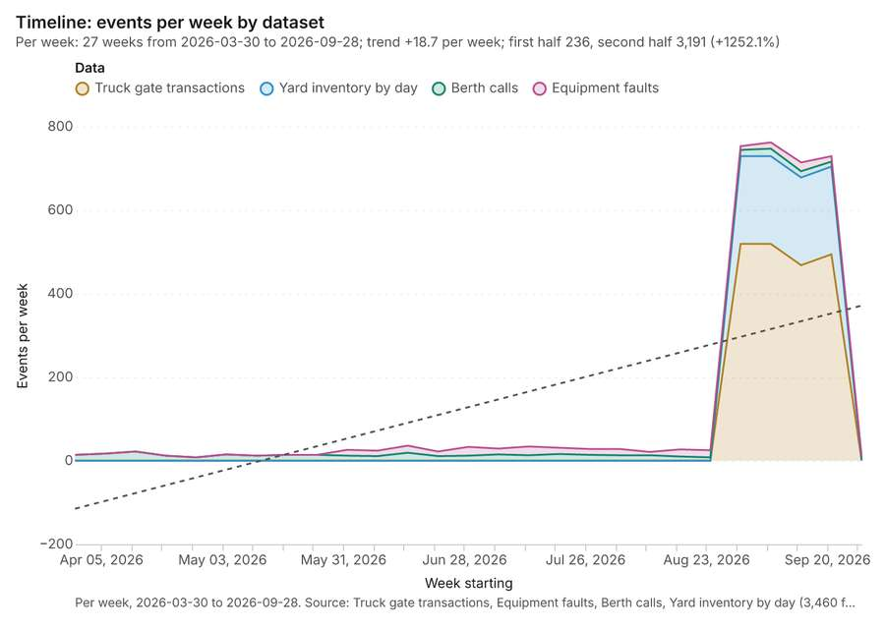
Figure 1. Timeline: events per week by dataset [1]. Per week, 2026-03-30 to 2026-09-28. Source: Truck gate transactions, Equipment faults, Berth calls, Yard inventory by day (3,460 features). The data is in the appendix.
The timeline counts 3,460 dated events in Truck gate transactions, Equipment faults, Berth calls and 1 more per week, from week of 2026-03-30 to week of 2026-09-28 [1][2][3][4][5]. By dataset: Truck gate transactions 2,000; Yard inventory by day 840; Berth calls 360; Equipment faults 260 [1]. The trend is +18.7 events per week; the second half of the weeks has 3,191 against 236 in the first (+1252.1%) [1].
Busiest weeks
- week of 2026-09-07: 762 events [1]
- week of 2026-08-31: 753 events [1]
- week of 2026-09-21: 729 events [1]
Quietest weeks
- week of 2026-04-27: 8 events [1]
- week of 2026-09-28: 10 events [1]
- week of 2026-04-20: 12 events [1]

Space time hot spots
What this analysis is. Emerging hot spots: Where hot spots are new, consecutive, intensifying, persistent, diminishing, sporadic, oscillating or historical over time [6]. In ArcGIS it is Emerging Hot Spot Analysis or Create Space Time Cube [6].
Why it was run on this data. Equipment faults carry dates in 'date': emerging hot spot analysis finds new, intensifying and fading hot spots per week [7].
What it found. The `gp_space_time_hot_spots` tool was executed using the Equipment faults data [9]. The analysis generated a result containing 22 features [8].
Result | Value
result, count | 22
result, elapsed ms | 4
result, resolution | 8
result, features used | 260
result, time neighbors | 0
billing, cost | 0.113
billing, list price | 0.113
billing, upstream cost | 0

Findings
- Evidenced: Space time hot spots on Equipment faults: Emerging hot spots: 1 layer saved: Emerging hot spots: Equipment faults (22 features) [8][9].
- Evidenced: It reported result, count 22; result, elapsed ms 4; result, resolution 8; result, features used 260; result, time neighbors 0; billing, cost 0.113 [8].
Tool gp_space_time_hot_spots; parameters {"project": "20fafc67-4c16-4f65-b17e-a469aa483b5a", "features": {"layer": "Equipment faults (790b76cb)"}, "interval": "week", "bin_shape": "h3", "resolution": 8, "time_field": "date"}

Space time hot spots
What this analysis is. Emerging hot spots: Where hot spots are new, consecutive, intensifying, persistent, diminishing, sporadic, oscillating or historical over time [6]. In ArcGIS it is Emerging Hot Spot Analysis or Create Space Time Cube [6].
Why it was run on this data. Truck gate transactions carry dates in 'gate_in_at': emerging hot spot analysis finds new, intensifying and fading hot spots per day [10].
What it found. The analysis utilized the `gp_space_time_hot_spots` tool on the `Truck gate transactions` data [12], successfully saving a layer titled "Emerging hot spots: Truck gate transactions
Result | Value
result, count | 111
result, elapsed ms | 21
result, resolution | 9
result, features used | 2,000
result, time neighbors | 0
billing, cost | 0.2
billing, list price | 0.2
billing, upstream cost | 0

Findings
- Evidenced: Space time hot spots on Truck gate transactions: Emerging hot spots: 1 layer saved: Emerging hot spots: Truck gate transactions (111 features) [11][12].
- Evidenced: It reported result, count 111; result, elapsed ms 21; result, resolution 9; result, features used 2,000; result, time neighbors 0; billing, cost 0.2 [11].
Tool gp_space_time_hot_spots; parameters {"agg": "sum", "project": "20fafc67-4c16-4f65-b17e-a469aa483b5a", "features": {"layer": "Truck gate transactions (b9f2750d)"}, "interval": "day", "bin_shape": "h3", "resolution": 9, "time_field": "gate_in_at", "value_field": "turn_time_min"}

Near repeat
What this analysis is. Repeat and near repeat classification: Classify incidents as originators, repeats (same place) or near repeats within a distance and time window, with a Knox test table [13]. In ArcGIS it is Repeat and Near Repeat Classification or Near Repeat Calculator [13].
Why it was run on this data. Near repeat analysis tests whether Equipment faults close in space also follow each other within 12 days [14].
What it found. Near repeat on Equipment faults: Repeat and near repeat classification: 1 layer saved: Repeat and near repeat classification: Equipment faults (260 features) [9][15]. It reported result, days 12; result, count 260; result, chains 51; result, distance m 200; result, elapsed ms 9; result, pairs linked 276 [15].
Result | Value
result, days | 12
result, count | 260
result, chains | 51
result, distance m | 200
result, elapsed ms | 9
result, pairs linked | 276
billing, cost | 0.0578
billing, list price | 0.0578
billing, upstream cost | 0

Findings
- Evidenced: Near repeat on Equipment faults: Repeat and near repeat classification: 1 layer saved: Repeat and near repeat classification: Equipment faults (260 features) [9][15].
- Evidenced: It reported result, days 12; result, count 260; result, chains 51; result, distance m 200; result, elapsed ms 9; result, pairs linked 276 [15].
Tool gp_near_repeat; parameters {"days": 12, "project": "20fafc67-4c16-4f65-b17e-a469aa483b5a", "features": {"layer": "Equipment faults (790b76cb)"}, "distance_m": 200.0, "time_field": "date"}

Summarize within
What this analysis is. Summarize within: Count and aggregate the features inside each polygon (or bin), proportionally for lines and polygons [16]. In ArcGIS it is Summarize Within or Aggregate Points; in QGIS, native:countpointsinpolygon or native:sumlinelengths [16].
Why it was run on this data. Count Equipment faults inside each feature of Yard zones by system; the counts map as a choropleth (natural breaks, sequential colors) [17].
What it found. Summarize within on Equipment faults, Yard zones: Summarize within: 1 layer saved: Summarize within: Yard zones (30 features) [9][18][19]. It reported result, count 30; result, elapsed ms 1; billing, cost 0.01582; billing, list price 0.01582; billing, upstream cost 0 [18].
Result | Value
result, count | 30
result, elapsed ms | 1
billing, cost | 0.01582
billing, list price | 0.01582
billing, upstream cost | 0

Findings
- Evidenced: Summarize within on Equipment faults, Yard zones: Summarize within: 1 layer saved: Summarize within: Yard zones (30 features) [9][18][19].
- Evidenced: It reported result, count 30; result, elapsed ms 1; billing, cost 0.01582; billing, list price 0.01582; billing, upstream cost 0 [18].
Tool gp_summarize_within; parameters {"stats": [{"stat": "sum", "field": "downtime_h"}], "project": "20fafc67-4c16-4f65-b17e-a469aa483b5a", "features": {"layer": "Equipment faults (790b76cb)"}, "group_by": "system", "polygons": {"layer": "Yard zones (0b9931a6)"}}

Summarize within
What this analysis is. Summarize within: Count and aggregate the features inside each polygon (or bin), proportionally for lines and polygons [16]. In ArcGIS it is Summarize Within or Aggregate Points; in QGIS, native:countpointsinpolygon or native:sumlinelengths [16].
Why it was run on this data. Count Equipment faults inside each feature of Yard zones by system; the counts map as a choropleth (natural breaks, sequential colors) [17].
What it found. Summarize within on Reefer points, Yard zones: Summarize within: 1 layer saved: Summarize within: Yard zones (30 features) [19][20][21]. It reported result, count 30; result, elapsed ms 1; billing, cost 0.0126; billing, list price 0.0126; billing, upstream cost 0 [20].
Result | Value
result, count | 30
result, elapsed ms | 1
billing, cost | 0.0126
billing, list price | 0.0126
billing, upstream cost | 0

Findings
- Evidenced: Summarize within on Reefer points, Yard zones: Summarize within: 1 layer saved: Summarize within: Yard zones (30 features) [19][20][21].
- Evidenced: It reported result, count 30; result, elapsed ms 1; billing, cost 0.0126; billing, list price 0.0126; billing, upstream cost 0 [20].
Tool gp_summarize_within; parameters {"stats": [], "project": "20fafc67-4c16-4f65-b17e-a469aa483b5a", "features": {"layer": "Reefer points (73835122)"}, "group_by": "in_use", "polygons": {"layer": "Yard zones (0b9931a6)"}}

Summarize within
What this analysis is. Summarize within: Count and aggregate the features inside each polygon (or bin), proportionally for lines and polygons [16]. In ArcGIS it is Summarize Within or Aggregate Points; in QGIS, native:countpointsinpolygon or native:sumlinelengths [16].
Why it was run on this data. Count Equipment faults inside each feature of Yard zones by system; the counts map as a choropleth (natural breaks, sequential colors) [17].
What it found. Summarize within on Truck gate transactions, Yard zones: Summarize within: 1 layer saved: Summarize within: Yard zones (30 features) [12][19][22]. It reported result, count 30; result, elapsed ms 4; billing, cost 0.05062; billing, list price 0.05062; billing, upstream cost 0 [22].
Result | Value
result, count | 30
result, elapsed ms | 4
billing, cost | 0.05062
billing, list price | 0.05062
billing, upstream cost | 0

Findings
- Evidenced: Summarize within on Truck gate transactions, Yard zones: Summarize within: 1 layer saved: Summarize within: Yard zones (30 features) [12][19][22].
- Evidenced: It reported result, count 30; result, elapsed ms 4; billing, cost 0.05062; billing, list price 0.05062; billing, upstream cost 0 [22].
Tool gp_summarize_within; parameters {"stats": [{"stat": "sum", "field": "turn_time_min"}], "project": "20fafc67-4c16-4f65-b17e-a469aa483b5a", "features": {"layer": "Truck gate transactions (b9f2750d)"}, "group_by": "move", "polygons": {"layer": "Yard zones (0b9931a6)"}}

Hot spots
What this analysis is. Hot spot analysis: Getis-Ord Gi* hot and cold spots with z-scores, p-values and confidence bins [23]. In ArcGIS it is Find Hot Spots or Hot Spot Analysis (Getis-Ord Gi*); in QGIS, qgis:hotspot (plugin) [23].
Why it was run on this data. 260 points: Getis-Ord Gi* tests whether the concentrations in Equipment faults are statistically significant [24].
What it found. Hot spot analysis was performed using the Equipment faults layer [9], resulting in 41 features saved [25].
Result | Value
result, bins | 41
result, count | 41
result, elapsed ms | 5
result, cell size m | 500
result, incidents used | 260
result, distance band m | 500
billing, cost | 0.0552
billing, list price | 0.0552
billing, upstream cost | 0

Findings
- Evidenced: Hot spots on Equipment faults: Hot spot analysis: 1 layer saved: Hot spot analysis: Equipment faults (41 features) [9][25].
- Evidenced: It reported result, bins 41; result, count 41; result, elapsed ms 5; result, cell size m 500; result, incidents used 260; result, distance band m 500 [25].
Tool gp_hot_spots; parameters {"project": "20fafc67-4c16-4f65-b17e-a469aa483b5a", "features": {"layer": "Equipment faults (790b76cb)"}, "aggregation": "hexagon", "cell_size_m": 500.0, "distance_band_m": 500.0}

Hot spots
What this analysis is. Hot spot analysis: Getis-Ord Gi* hot and cold spots with z-scores, p-values and confidence bins [23]. In ArcGIS it is Find Hot Spots or Hot Spot Analysis (Getis-Ord Gi*); in QGIS, qgis:hotspot (plugin) [23].
Why it was run on this data. 100 points: Getis-Ord Gi* tests whether the concentrations in Reefer points are statistically significant [26].
What it found. Hot spots on Reefer points: Hot spot analysis: 1 layer saved: Hot spot analysis: Reefer points (62 features) [21][27]. It reported result, bins 62; result, count 62; result, elapsed ms 4; result, cell size m 100; result, incidents used 100; result, distance band m 200 [27].
Result | Value
result, bins | 62
result, count | 62
result, elapsed ms | 4
result, cell size m | 100
result, incidents used | 100
result, distance band m | 200
billing, cost | 0.052
billing, list price | 0.052
billing, upstream cost | 0

Findings
- Evidenced: Hot spots on Reefer points: Hot spot analysis: 1 layer saved: Hot spot analysis: Reefer points (62 features) [21][27].
- Evidenced: It reported result, bins 62; result, count 62; result, elapsed ms 4; result, cell size m 100; result, incidents used 100; result, distance band m 200 [27].
Tool gp_hot_spots; parameters {"project": "20fafc67-4c16-4f65-b17e-a469aa483b5a", "features": {"layer": "Reefer points (73835122)"}, "aggregation": "hexagon", "cell_size_m": 100.0, "distance_band_m": 200.0}

Hot spots
What this analysis is. Hot spot analysis: Getis-Ord Gi* hot and cold spots with z-scores, p-values and confidence bins [23]. In ArcGIS it is Find Hot Spots or Hot Spot Analysis (Getis-Ord Gi*); in QGIS, qgis:hotspot (plugin) [23].
Why it was run on this data. 2000 points: Getis-Ord Gi* tests whether the concentrations in Truck gate transactions are statistically significant [28].
What it found. The hot spot analysis utilized the Truck gate transactions dataset [12] and was run using the gp_hot_spots tool [29].
Result | Value
result, count | 2,000
result, elapsed ms | 37
result, excluded null | 0
result, distance band m | 200
billing, cost | 0.09
billing, list price | 0.09
billing, upstream cost | 0

Findings
- Evidenced: Hot spots on Truck gate transactions: Hot spot analysis: 1 layer saved: Hot spot analysis: Truck gate transactions (2000 features) [12][29].
- Evidenced: It reported result, count 2,000; result, elapsed ms 37; result, excluded null 0; result, distance band m 200; billing, cost 0.09; billing, list price 0.09 [29].
Tool gp_hot_spots; parameters {"field": "turn_time_min", "project": "20fafc67-4c16-4f65-b17e-a469aa483b5a", "features": {"layer": "Truck gate transactions (b9f2750d)"}, "aggregation": "hexagon", "cell_size_m": 100.0, "distance_band_m": 200.0}

Calculate density
What this analysis is. Calculate density: Kernel density per square kilometer on a grid [30]. In ArcGIS it is Calculate Density or Kernel Density; in QGIS, native:heatmapkerneldensityestimation [30].
Why it was run on this data. 260 points in Equipment faults: a density surface shows where they concentrate [31].
What it found. Density was calculated utilizing the Equipment faults data [9]. The results indicated a total count of 284 features [32]. During this analysis, the maximum density recorded was 79.93 per km² [32].
Result | Value
result, count | 284
result, elapsed ms | 11
result, bandwidth m | 500
result, cell size m | 200
result, excluded null | 0
result, max density per km2 | 79.93
billing, cost | 0.0552
billing, list price | 0.0552
billing, upstream cost | 0

Findings
- Evidenced: Calculate density on Equipment faults: Calculate density: 1 layer saved: Calculate density: Equipment faults (284 features) [9][32].
- Evidenced: It reported result, count 284; result, elapsed ms 11; result, bandwidth m 500; result, cell size m 200; result, excluded null 0; result, max density per km2 79.93 [32].
Tool gp_calculate_density; parameters {"kernel": "quartic", "project": "20fafc67-4c16-4f65-b17e-a469aa483b5a", "features": {"layer": "Equipment faults (790b76cb)"}, "bandwidth_m": 500.0, "cell_size_m": 200.0}

Calculate density
What this analysis is. Calculate density: Kernel density per square kilometer on a grid [30]. In ArcGIS it is Calculate Density or Kernel Density; in QGIS, native:heatmapkerneldensityestimation [30].
Why it was run on this data. 100 points in Reefer points: a density surface shows where they concentrate [33].
What it found. Calculate density on Reefer points: Calculate density: 1 layer saved: Calculate density: Reefer points (425 features) [21][34]. It reported result, count 425; result, elapsed ms 17; result, bandwidth m 200; result, cell size m 50; result, excluded null 0; result, max density per km2 270.1 [34].
Result | Value
result, count | 425
result, elapsed ms | 17
result, bandwidth m | 200
result, cell size m | 50
result, excluded null | 0
result, max density per km2 | 270.1
billing, cost | 0.052
billing, list price | 0.052
billing, upstream cost | 0

Findings
- Evidenced: Calculate density on Reefer points: Calculate density: 1 layer saved: Calculate density: Reefer points (425 features) [21][34].
- Evidenced: It reported result, count 425; result, elapsed ms 17; result, bandwidth m 200; result, cell size m 50; result, excluded null 0; result, max density per km2 270.1 [34].
Tool gp_calculate_density; parameters {"kernel": "quartic", "project": "20fafc67-4c16-4f65-b17e-a469aa483b5a", "features": {"layer": "Reefer points (73835122)"}, "bandwidth_m": 200.0, "cell_size_m": 50.0}

Calculate density
What this analysis is. Calculate density: Kernel density per square kilometer on a grid [30]. In ArcGIS it is Calculate Density or Kernel Density; in QGIS, native:heatmapkerneldensityestimation [30].
Why it was run on this data. 2000 points in Truck gate transactions: a density surface shows where they concentrate [35].
What it found. The density calculation was executed using the Truck gate transactions data [12] via the `gp_calculate_density` tool [36].
Result | Value
result, count | 4,119
result, elapsed ms | 116
result, bandwidth m | 200
result, cell size m | 50
result, excluded null | 0
result, max density per km2 | 7.9e+04
billing, cost | 0.09
billing, list price | 0.09
billing, upstream cost | 0

Findings
- Evidenced: Calculate density on Truck gate transactions: Calculate density: 1 layer saved: Calculate density: Truck gate transactions (4119 features) [12][36].
- Evidenced: It reported result, count 4,119; result, elapsed ms 116; result, bandwidth m 200; result, cell size m 50; result, excluded null 0; result, max density per km2 7.9e+04 [36].
Tool gp_calculate_density; parameters {"kernel": "quartic", "project": "20fafc67-4c16-4f65-b17e-a469aa483b5a", "features": {"layer": "Truck gate transactions (b9f2750d)"}, "bandwidth_m": 200.0, "cell_size_m": 50.0, "weight_field": "turn_time_min"}

Find point clusters
What this analysis is. Find point clusters: Density-based clusters (DBSCAN, HDBSCAN or OPTICS, optionally space-time) with hulls and noise [37]. In ArcGIS it is Find Point Clusters or Density-based Clustering; in QGIS, native:dbscanclustering or native:stdbscanclustering [37].
Why it was run on this data. DBSCAN finds dense groups of Equipment faults and separates noise [38].
What it found. The cluster analysis produced two layers: Equipment faults with 260 features and cluster hulls with 21 features [39]. Using the input Equipment faults layer [9], the process yielded a result count of 260 and a noise count of 36 [39]. The analysis was completed in 10 ms, with a minimum point requirement of 6 [39]. The total cost of the operation was 0.0552, matching the list price [39].
Result | Value
result, count | 260
result, noise | 36
result, distance m | 200
result, elapsed ms | 10
result, min points | 6
billing, cost | 0.0552
billing, list price | 0.0552
billing, upstream cost | 0

Findings
- Evidenced: Find point clusters on Equipment faults: Find point clusters: 2 layers saved: Find point clusters: Equipment faults (260 features); Find point clusters: cluster hulls (21 features) [9][39].
- Evidenced: It reported result, count 260; result, noise 36; result, distance m 200; result, elapsed ms 10; result, min points 6; billing, cost 0.0552 [39].
Tool gp_find_point_clusters; parameters {"method": "dbscan", "project": "20fafc67-4c16-4f65-b17e-a469aa483b5a", "features": {"layer": "Equipment faults (790b76cb)"}, "distance_m": 200.0, "min_points": 6}

Find point clusters
What this analysis is. Find point clusters: Density-based clusters (DBSCAN, HDBSCAN or OPTICS, optionally space-time) with hulls and noise [37]. In ArcGIS it is Find Point Clusters or Density-based Clustering; in QGIS, native:dbscanclustering or native:stdbscanclustering [37].
Why it was run on this data. DBSCAN finds dense groups of Reefer points and separates noise [40].
What it found. Find point clusters on Reefer points: Find point clusters: 2 layers saved: Find point clusters: Reefer points (100 features); Find point clusters: cluster hulls (1 feature) [21][41]. It reported result, count 100; result, noise 4; result, distance m 100; result, elapsed ms 2; result, min points 3; billing, cost 0.052 [41].
Result | Value
result, count | 100
result, noise | 4
result, distance m | 100
result, elapsed ms | 2
result, min points | 3
billing, cost | 0.052
billing, list price | 0.052
billing, upstream cost | 0

Findings
- Evidenced: Find point clusters on Reefer points: Find point clusters: 2 layers saved: Find point clusters: Reefer points (100 features); Find point clusters: cluster hulls (1 feature) [21][41].
- Evidenced: It reported result, count 100; result, noise 4; result, distance m 100; result, elapsed ms 2; result, min points 3; billing, cost 0.052 [41].
Tool gp_find_point_clusters; parameters {"method": "dbscan", "project": "20fafc67-4c16-4f65-b17e-a469aa483b5a", "features": {"layer": "Reefer points (73835122)"}, "distance_m": 100.0, "min_points": 3}

Find point clusters
What this analysis is. Find point clusters: Density-based clusters (DBSCAN, HDBSCAN or OPTICS, optionally space-time) with hulls and noise [37]. In ArcGIS it is Find Point Clusters or Density-based Clustering; in QGIS, native:dbscanclustering or native:stdbscanclustering [37].
Why it was run on this data. DBSCAN finds dense groups of Truck gate transactions and separates noise [42].
What it found. Find point clusters on Truck gate transactions: Find point clusters: 2 layers saved: Find point clusters: Truck gate transactions (2000 features); Find point clusters: cluster hulls (1 feature) [12][43]. It reported result, count 2,000; result, noise 1,549; result, distance m 100; result, elapsed ms 163; result, min points 20; billing, cost 0.09 [43].
Result | Value
result, count | 2,000
result, noise | 1,549
result, distance m | 100
result, elapsed ms | 163
result, min points | 20
billing, cost | 0.09
billing, list price | 0.09
billing, upstream cost | 0

Findings
- Evidenced: Find point clusters on Truck gate transactions: Find point clusters: 2 layers saved: Find point clusters: Truck gate transactions (2000 features); Find point clusters: cluster hulls (1 feature) [12][43].
- Evidenced: It reported result, count 2,000; result, noise 1,549; result, distance m 100; result, elapsed ms 163; result, min points 20; billing, cost 0.09 [43].
Tool gp_find_point_clusters; parameters {"method": "dbscan", "project": "20fafc67-4c16-4f65-b17e-a469aa483b5a", "features": {"layer": "Truck gate transactions (b9f2750d)"}, "distance_m": 100.0, "min_points": 20}

Outliers
What this analysis is. Find outliers: Anselin local Moran’s I: HH, LL clusters and HL, LH outliers [44]. In ArcGIS it is Find Outliers or Cluster and Outlier Analysis (Anselin Local Moran’s I) [44].
Why it was run on this data. Local Moran's I maps clusters and outliers of 'capacity_teu' [45].
What it found. Outliers on Yard zones: Find outliers: 1 layer saved: Find outliers: Yard zones (30 features) [19][46]. It reported result, count 30; result, elapsed ms 4; result, permutations 199; result, excluded null 0; result, distance band m 454.7; billing, cost 0.0509 [46].
Result | Value
result, count | 30
result, elapsed ms | 4
result, permutations | 199
result, excluded null | 0
result, distance band m | 454.7
billing, cost | 0.0509
billing, list price | 0.0509
billing, upstream cost | 0

Findings
- Evidenced: Outliers on Yard zones: Find outliers: 1 layer saved: Find outliers: Yard zones (30 features) [19][46].
- Evidenced: It reported result, count 30; result, elapsed ms 4; result, permutations 199; result, excluded null 0; result, distance band m 454.7; billing, cost 0.0509 [46].
Tool gp_outliers; parameters {"field": "capacity_teu", "project": "20fafc67-4c16-4f65-b17e-a469aa483b5a", "features": {"layer": "Yard zones (0b9931a6)"}, "aggregation": "hexagon"}

Spatial autocorrelation
What this analysis is. Spatial autocorrelation: Global Moran’s I: is the pattern clustered, dispersed or random [47]. In ArcGIS it is Spatial Autocorrelation (Global Moran’s I) [47].
Why it was run on this data. Global Moran's I says whether similar values of 'capacity_teu' sit next to each other [48].
What it found. The spatial autocorrelation analysis was performed on the Yard zones input [19]. The analysis used a distance band set at 454.7 meters [49].
Result | Value
result, n | 30
result, p value | 0.515
result, z score | -0.6511
result, morans i | -0.1587
result, variance | 0.03637
result, elapsed ms | 2
result, expected i | -0.03448
result, excluded null | 0
result, distance band m | 454.7
result, p value normality | 0.5042
result, z score normality | -0.668
result, variance normality | 0.03456
billing, cost | 0.02
billing, list price | 0.02
billing, upstream cost | 0

Findings
- Evidenced: Spatial autocorrelation on Yard zones: Spatial autocorrelation: done; no map output [19][49].
- Evidenced: It reported result, n 30; result, p value 0.515; result, z score -0.6511; result, morans i -0.1587; result, variance 0.03637; result, elapsed ms 2 [49].
Tool gp_spatial_autocorrelation; parameters {"field": "capacity_teu", "project": "20fafc67-4c16-4f65-b17e-a469aa483b5a", "features": {"layer": "Yard zones (0b9931a6)"}}

Maps and charts
The run also made 20 map image(s) [50][51][52][53][54][55][56][57][58][59][60][61][62][63][64][65][66][67][68][69] and 27 chart(s) [70][71][72][73][74][75][76][77][78][79][80][81][82][83][84][85][86][87][88][89][90][91][92][93][94][95][96].
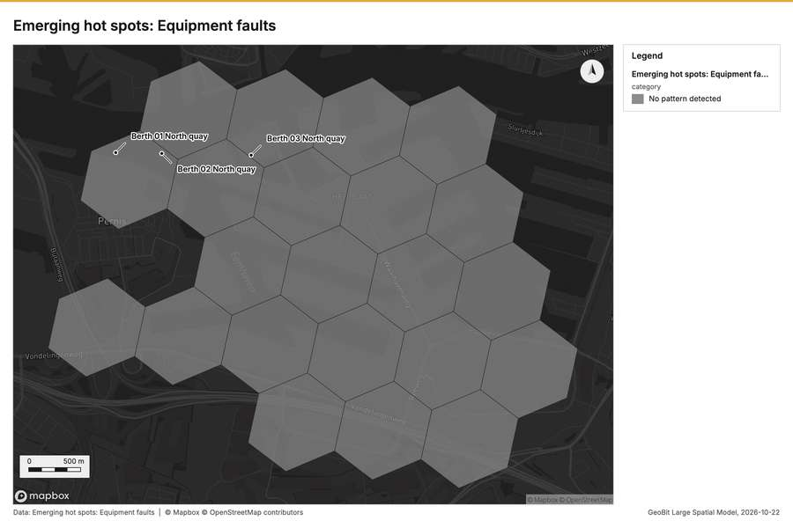
Figure 2. Emerging hot spots: Equipment faults [50]
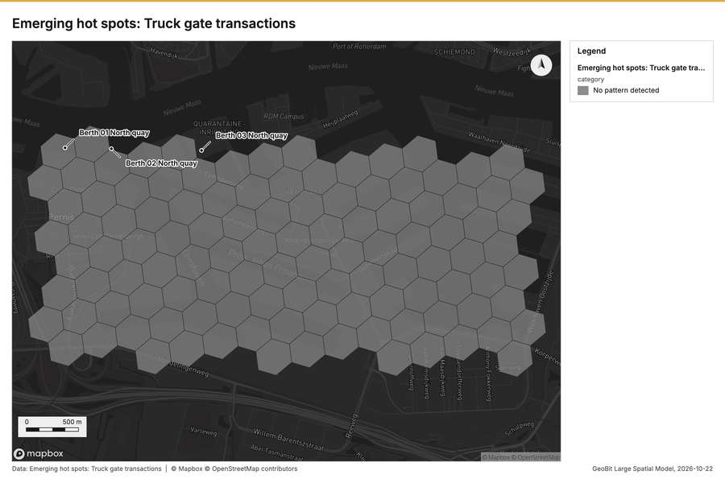
Figure 3. Emerging hot spots: Truck gate transactions [51]
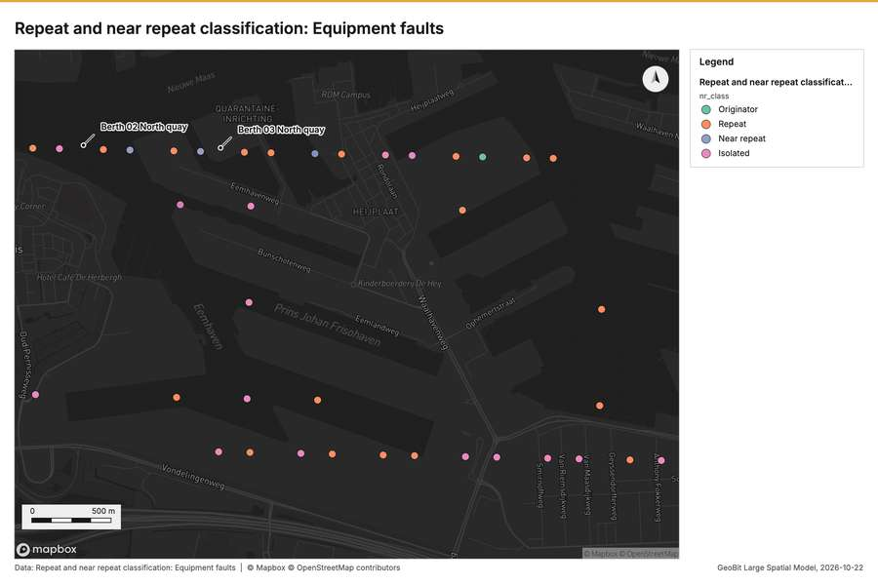
Figure 4. Repeat and near repeat classification: Equipment faults [52]
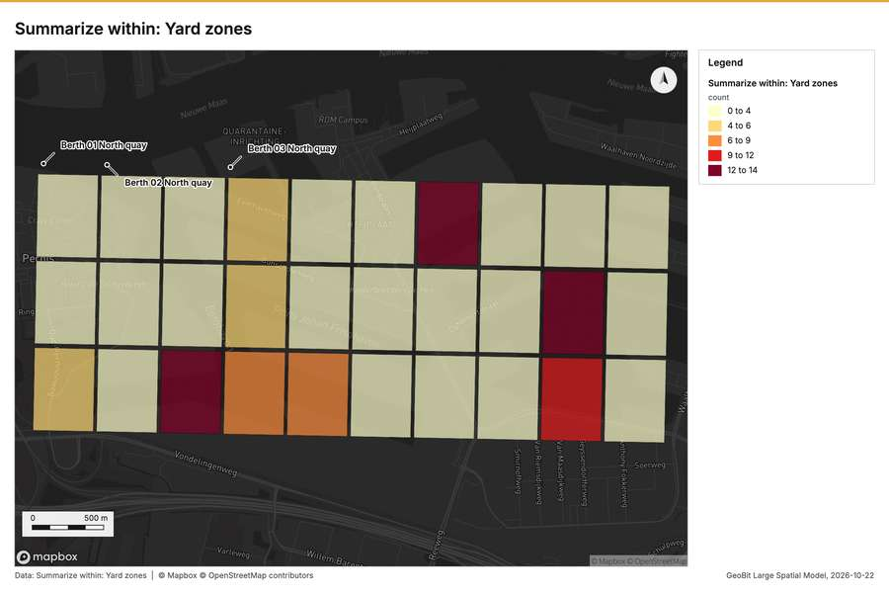
Figure 5. Summarize within: Yard zones [53]
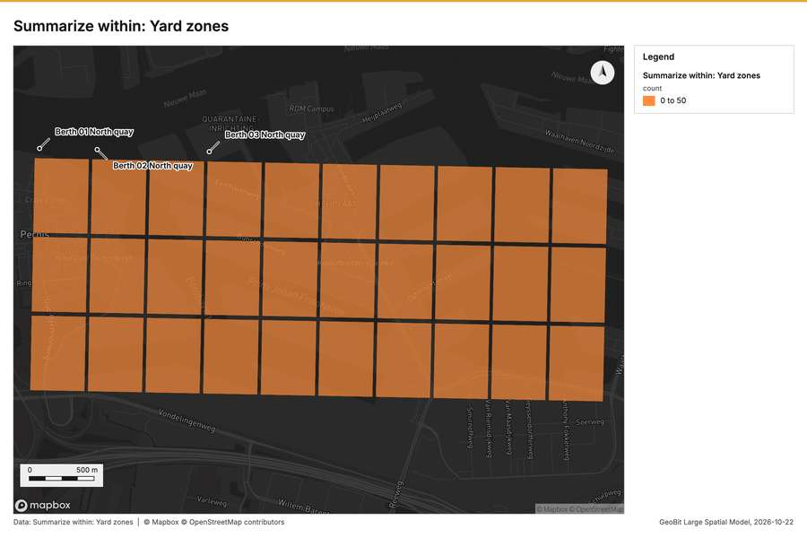
Figure 6. Summarize within: Yard zones [54]
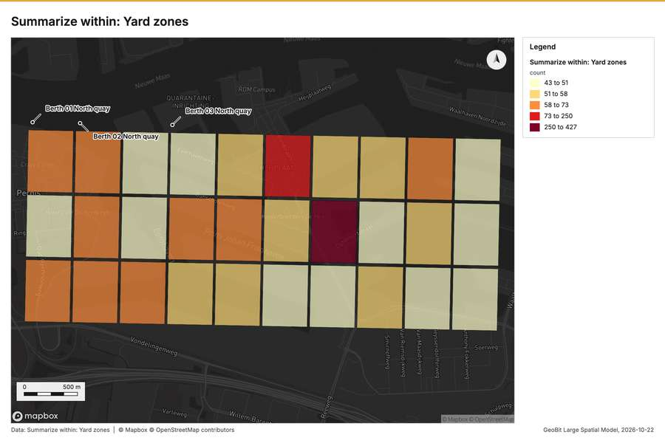
Figure 7. Summarize within: Yard zones [55]
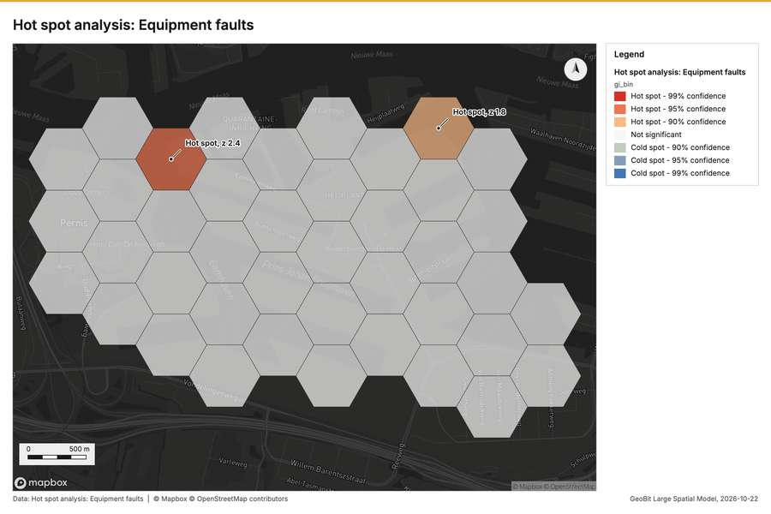
Figure 8. Hot spot analysis: Equipment faults [56]
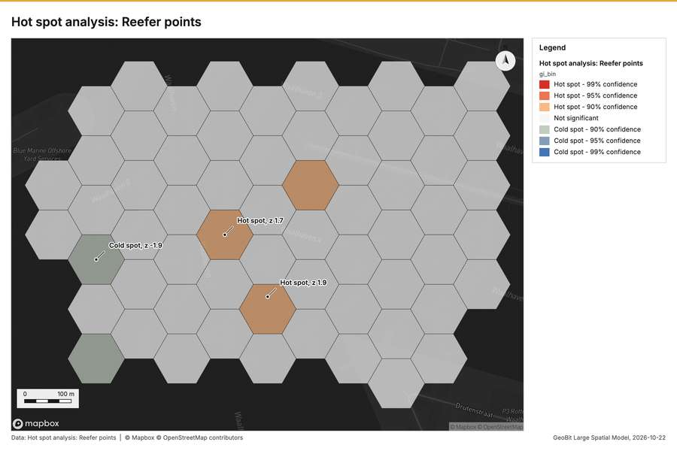
Figure 9. Hot spot analysis: Reefer points [57]
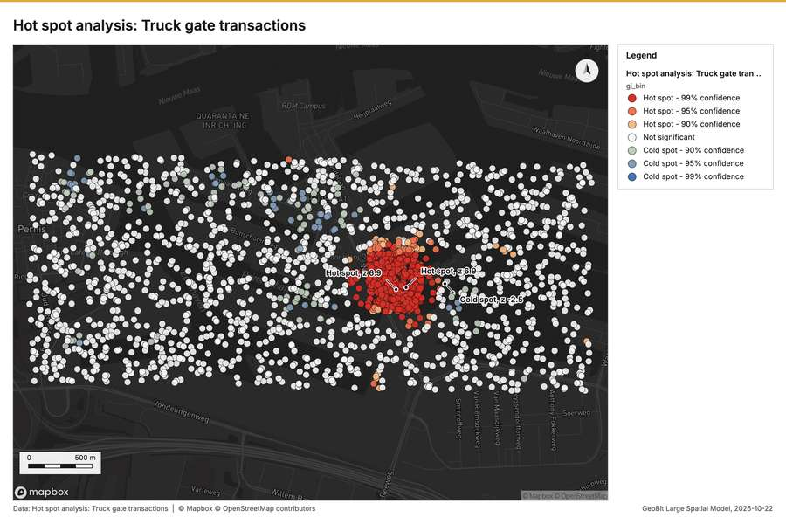
Figure 10. Hot spot analysis: Truck gate transactions [58]
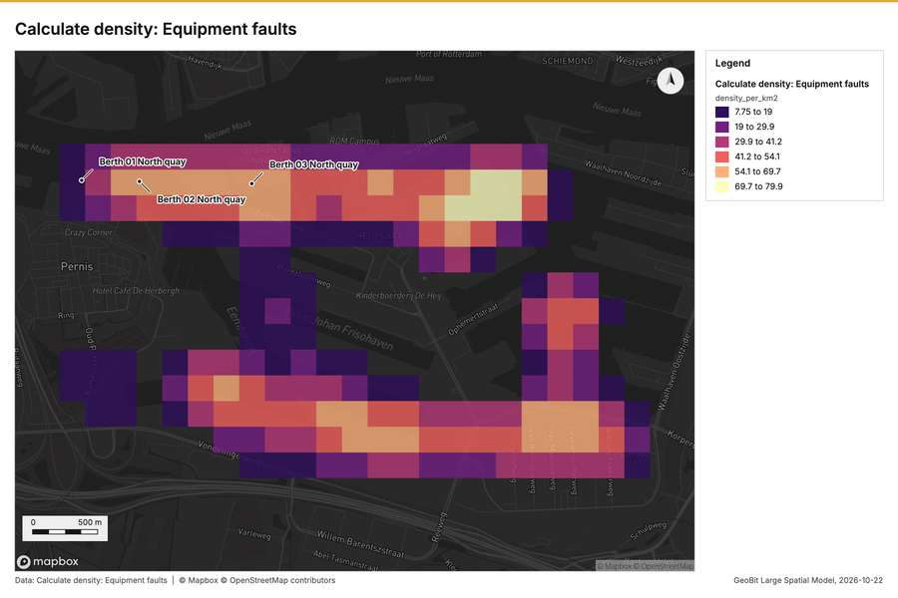
Figure 11. Calculate density: Equipment faults [59]
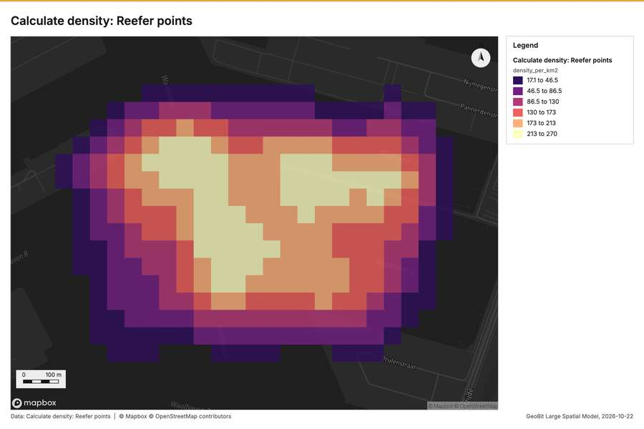
Figure 12. Calculate density: Reefer points [60]
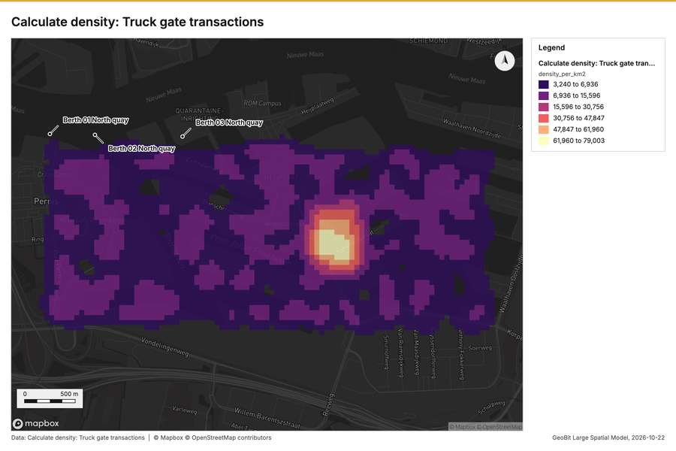
Figure 13. Calculate density: Truck gate transactions [61]
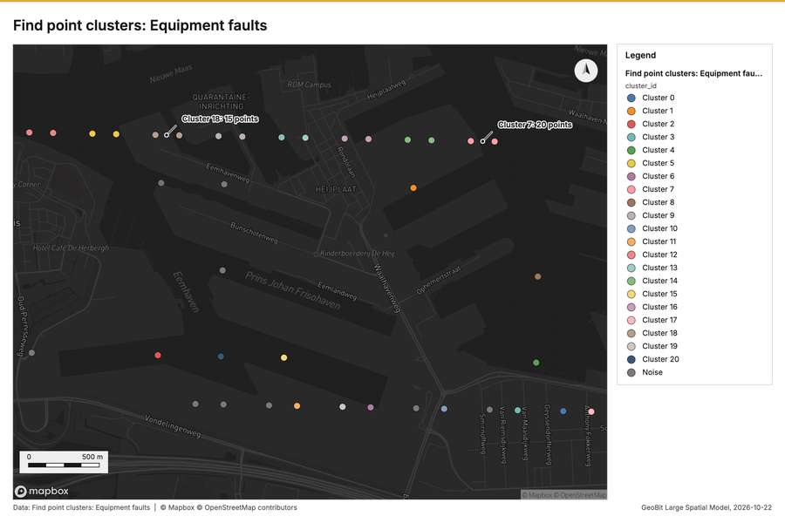
Figure 14. Find point clusters: Equipment faults [62]
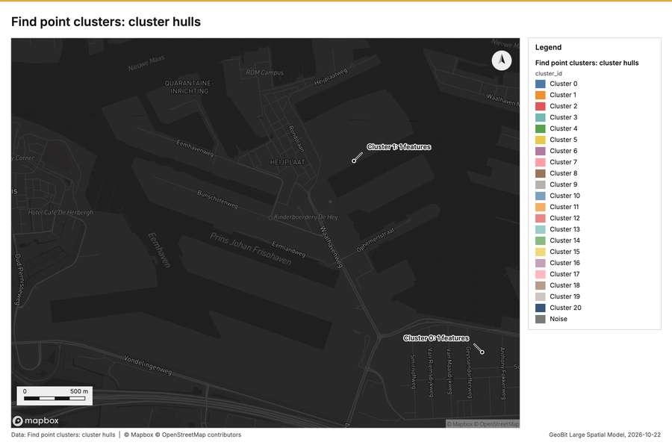
Figure 15. Find point clusters: cluster hulls [63]
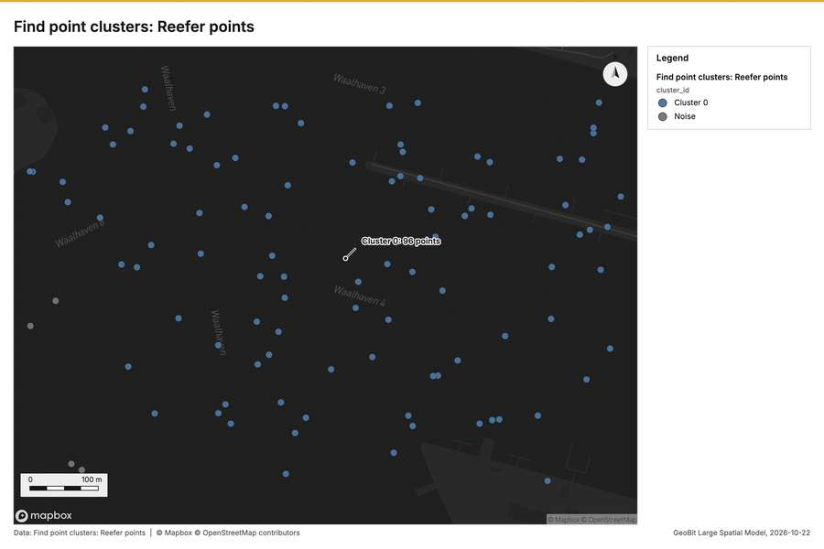
Figure 16. Find point clusters: Reefer points [64]
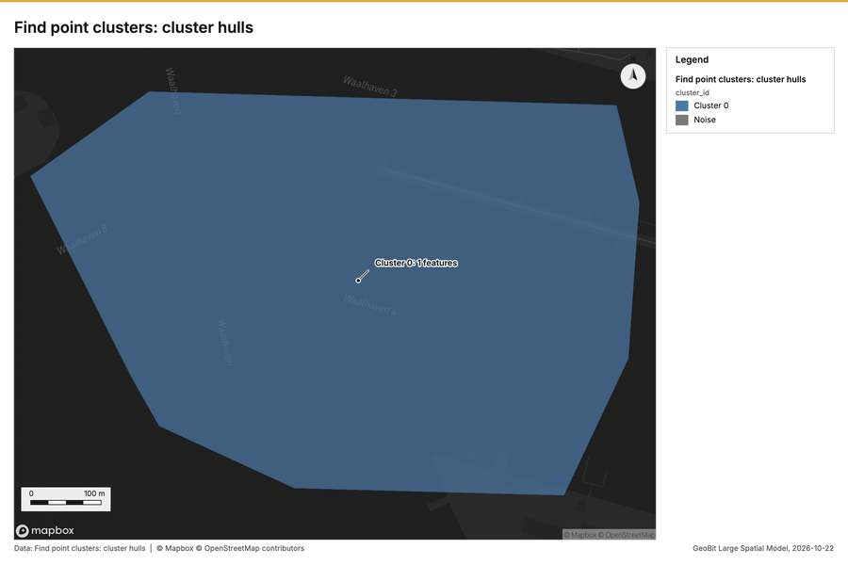
Figure 17. Find point clusters: cluster hulls [65]
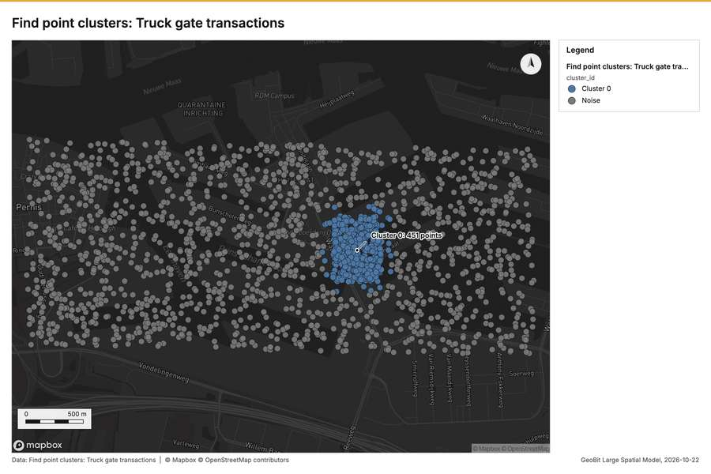
Figure 18. Find point clusters: Truck gate transactions [66]
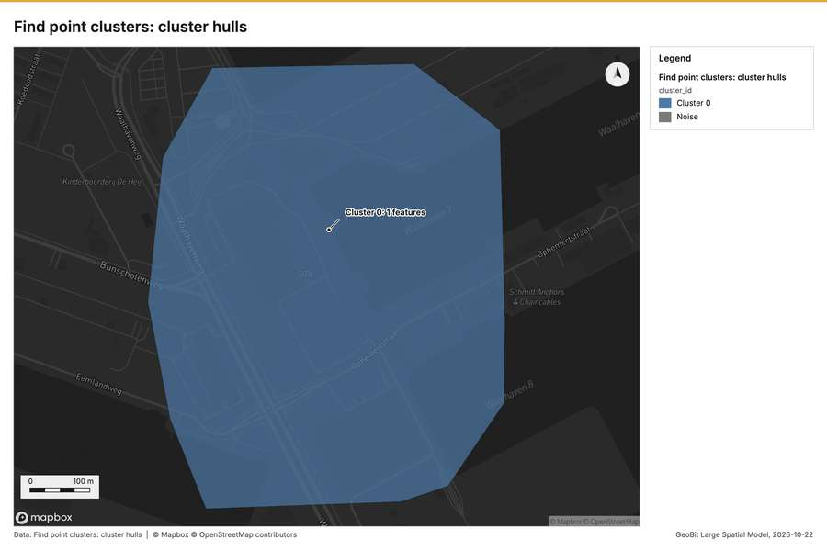
Figure 19. Find point clusters: cluster hulls [67]
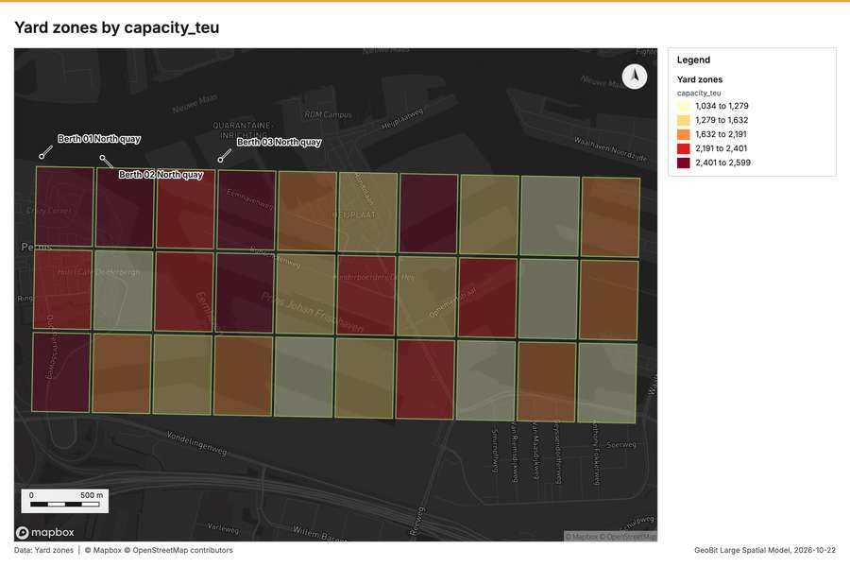
Figure 20. Yard zones by capacity_teu [68]
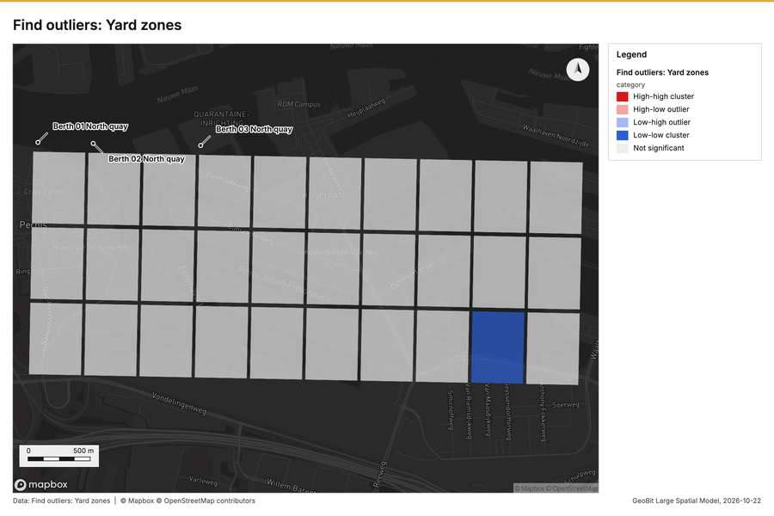
Figure 21. Find outliers: Yard zones [69]
What the map shows. The map displays the results of an emerging hot spots analysis concerning Equipment faults. According to the legend provided, the area is categorized as "No pattern detected." Across the entire mapped region, every grid cell is filled with the uniform gray color, indicating no emerging hot spot was identified. There are no visible clusters, gradients, or localized high-concentration areas of fault occurrences. The analysis suggests that, based on the displayed data, the equipment faults are distributed without a statistically significant pattern. [50]
Inferred: read from the image by gemma4:e4b, not evidence.
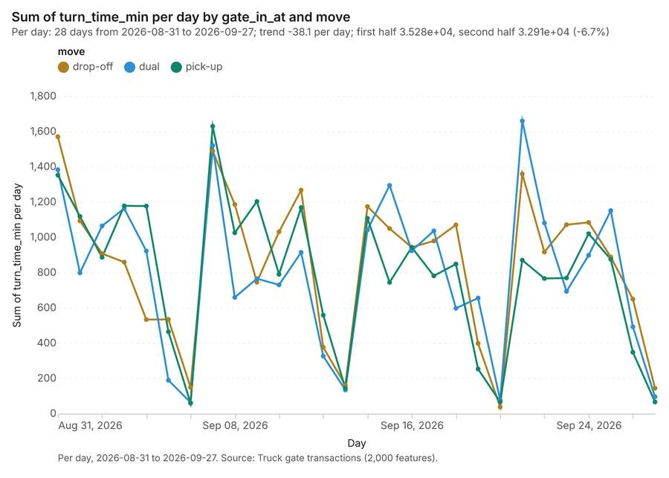
Figure 22. Truck gate transactions over time (turn_time_min) [70]. Per day, 2026-08-31 to 2026-09-27. Source: Truck gate transactions (2,000 features). The data is in the appendix.
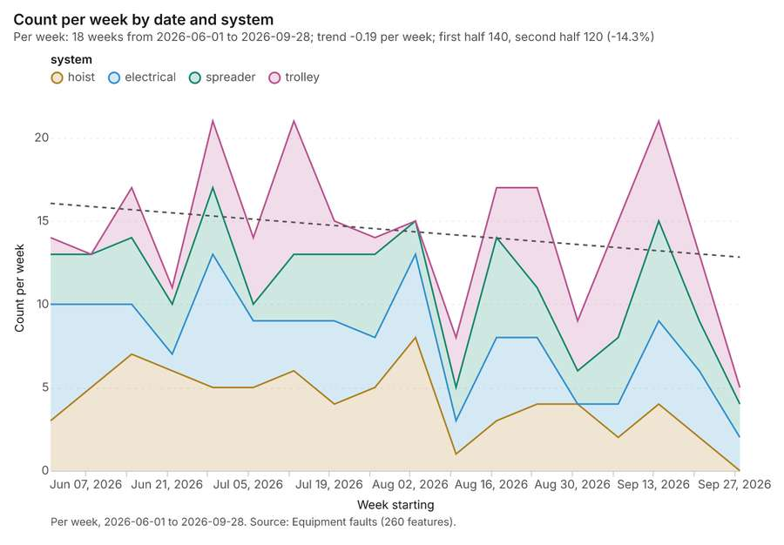
Figure 23. Equipment faults over time (date) [71]. Per week, 2026-06-01 to 2026-09-28. Source: Equipment faults (260 features). The data is in the appendix.
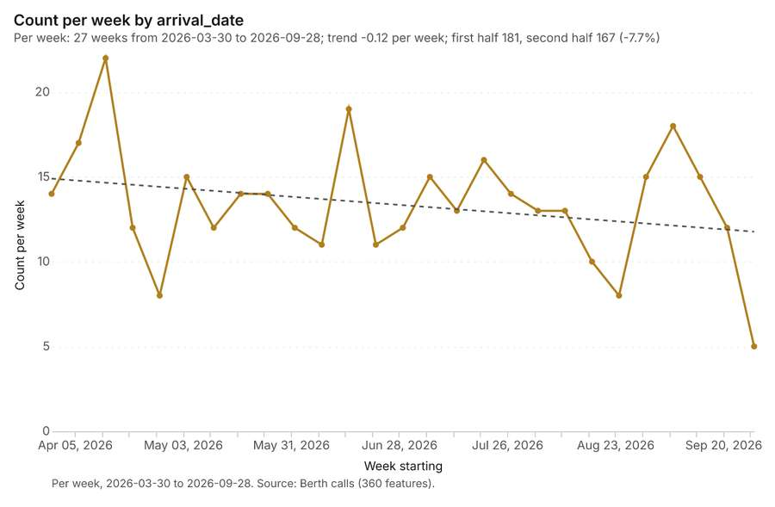
Figure 24. Berth calls over time (arrival_date) [72]. Per week, 2026-03-30 to 2026-09-28. Source: Berth calls (360 features). The data is in the appendix.
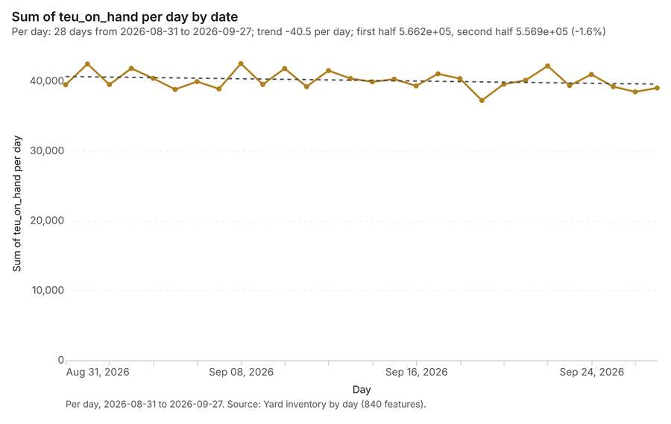
Figure 25. Yard inventory by day over time (date) [73]. Per day, 2026-08-31 to 2026-09-27. Source: Yard inventory by day (840 features). The data is in the appendix.
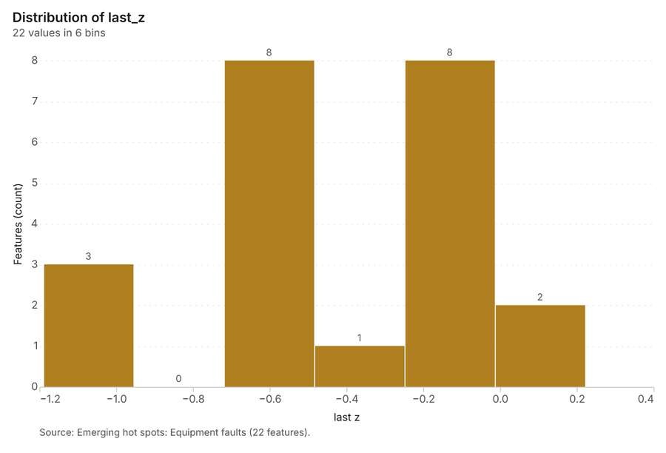
Figure 26. Emerging hot spots: Equipment faults [74]. Source: Emerging hot spots: Equipment faults (22 features). The data is in the appendix.
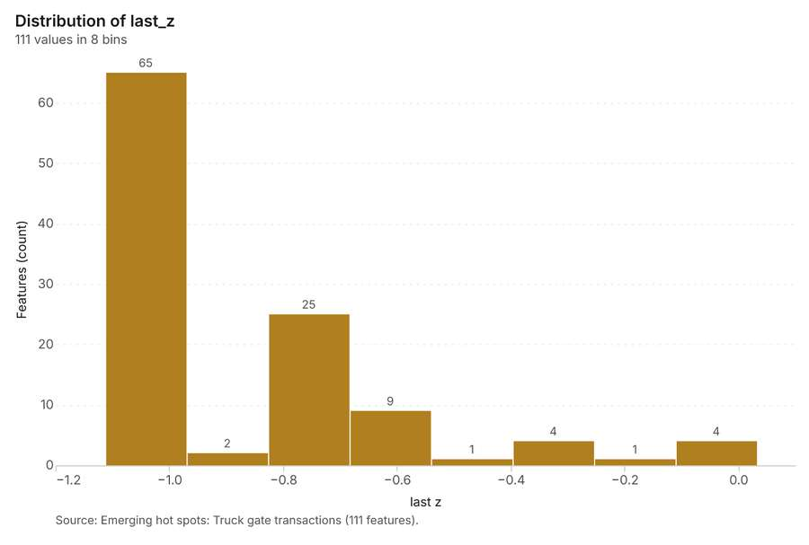
Figure 27. Emerging hot spots: Truck gate transactions [75]. Source: Emerging hot spots: Truck gate transactions (111 features). The data is in the appendix.
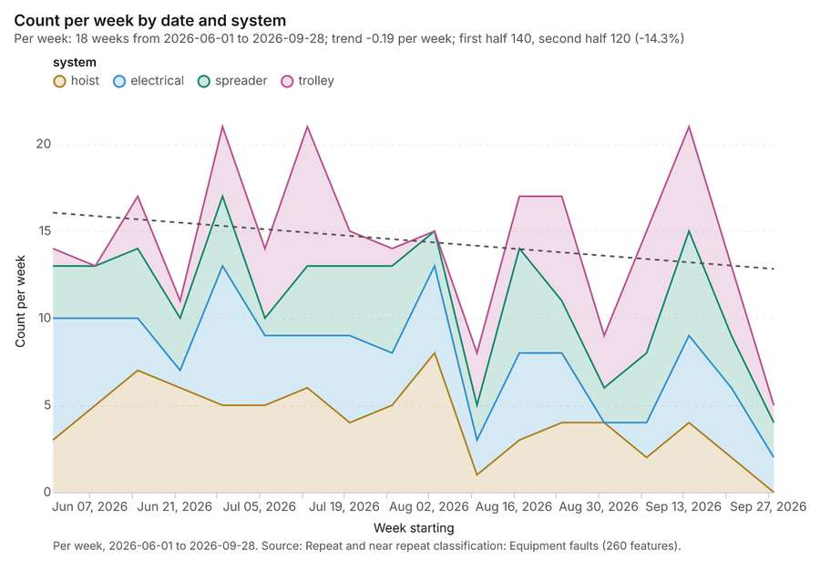
Figure 28. Repeat and near repeat classification: Equipment faults [76]. Per week, 2026-06-01 to 2026-09-28. Source: Repeat and near repeat classification: Equipment faults (260 features). The data is in the appendix.
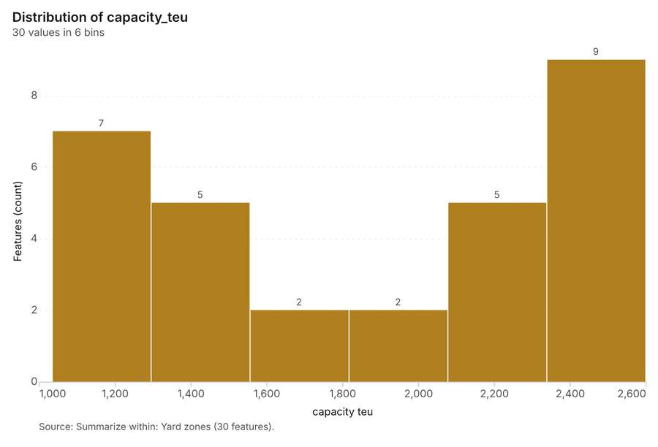
Figure 29. Summarize within: Yard zones [77]. Source: Summarize within: Yard zones (30 features). The data is in the appendix.
Figure 30. Summarize within: Yard zones [78]. Source: Summarize within: Yard zones (30 features). The data is in the appendix.
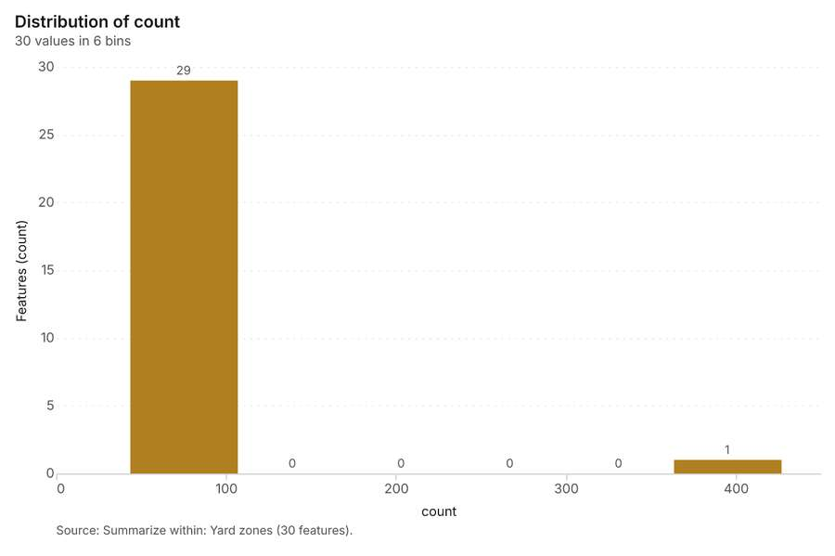
Figure 31. Summarize within: Yard zones [79]. Source: Summarize within: Yard zones (30 features). The data is in the appendix.
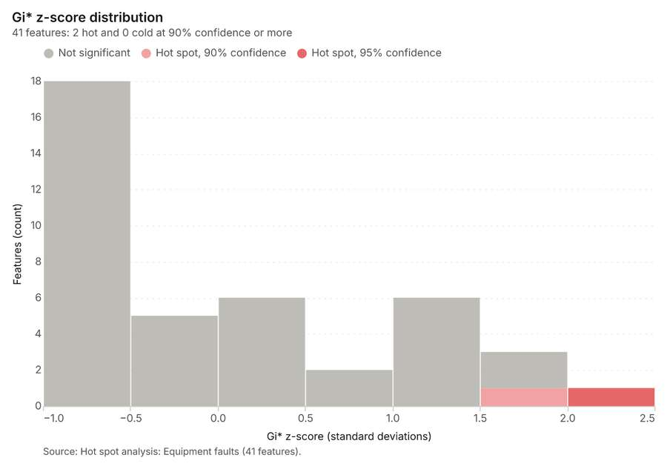
Figure 32. Hot spot analysis: Equipment faults [80]. Source: Hot spot analysis: Equipment faults (41 features). The data is in the appendix.
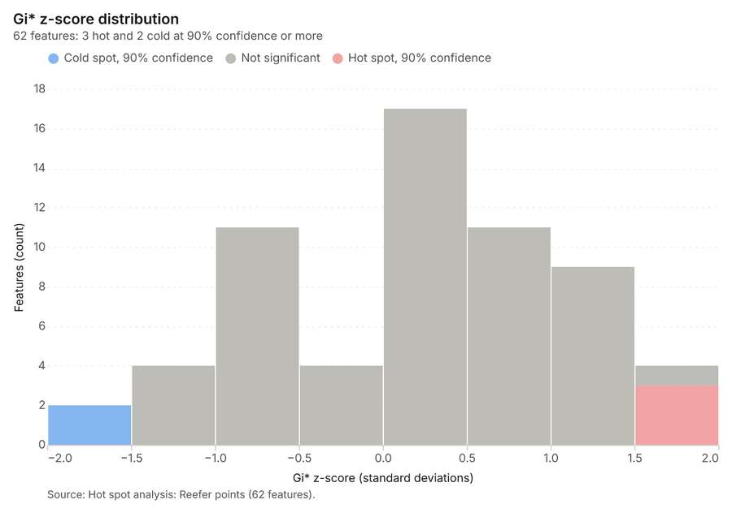
Figure 33. Hot spot analysis: Reefer points [81]. Source: Hot spot analysis: Reefer points (62 features). The data is in the appendix.
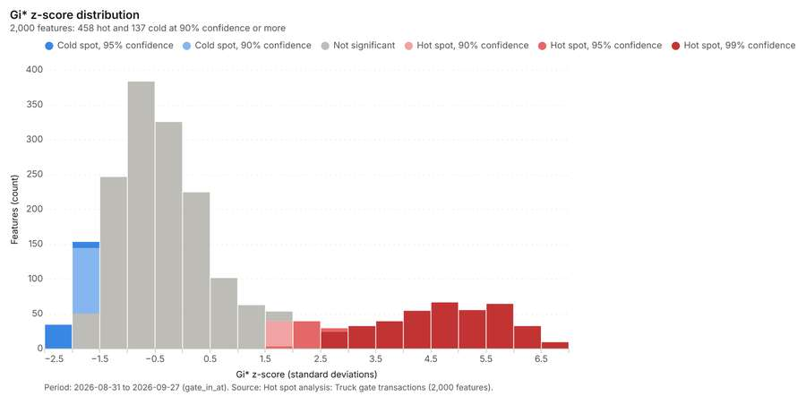
Figure 34. Hot spot analysis: Truck gate transactions [82]. Period: 2026-08-31 to 2026-09-27 (gate_in_at). Source: Hot spot analysis: Truck gate transactions (2,000 features). The data is in the appendix.
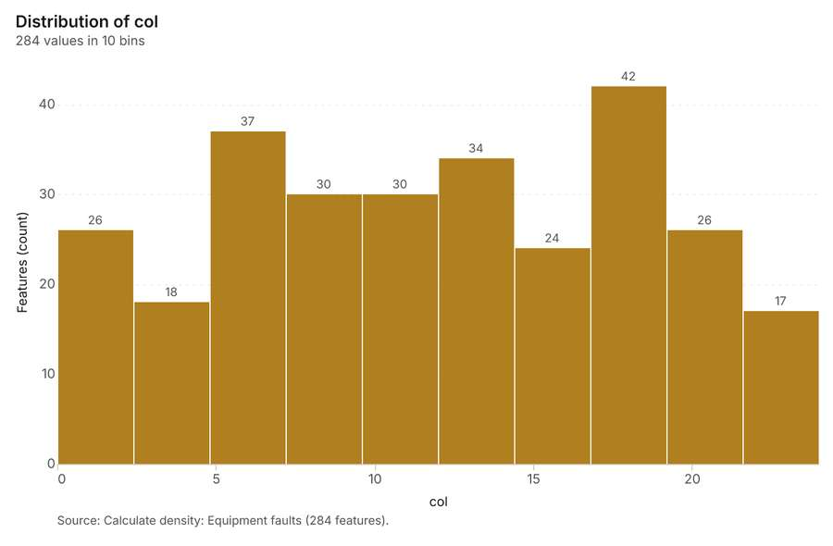
Figure 35. Calculate density: Equipment faults [83]. Source: Calculate density: Equipment faults (284 features). The data is in the appendix.
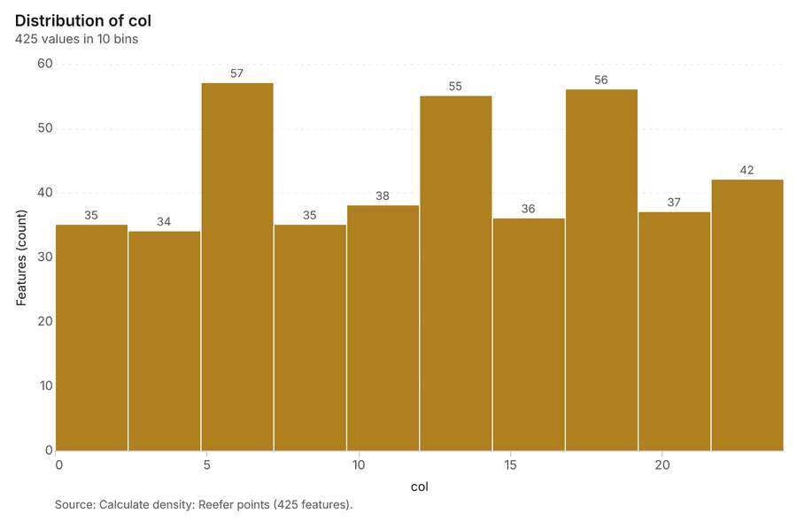
Figure 36. Calculate density: Reefer points [84]. Source: Calculate density: Reefer points (425 features). The data is in the appendix.
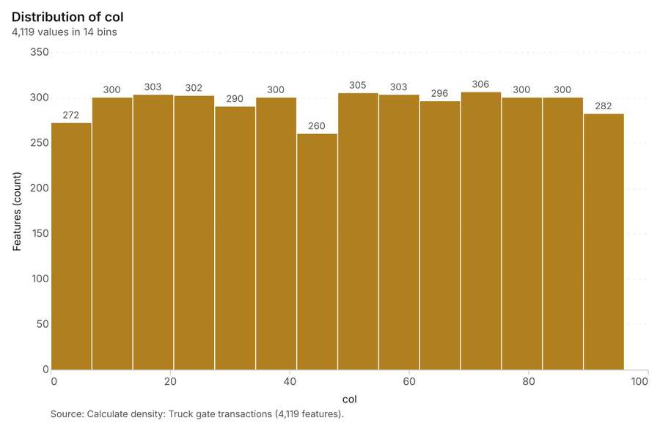
Figure 37. Calculate density: Truck gate transactions [85]. Source: Calculate density: Truck gate transactions (4,119 features). The data is in the appendix.
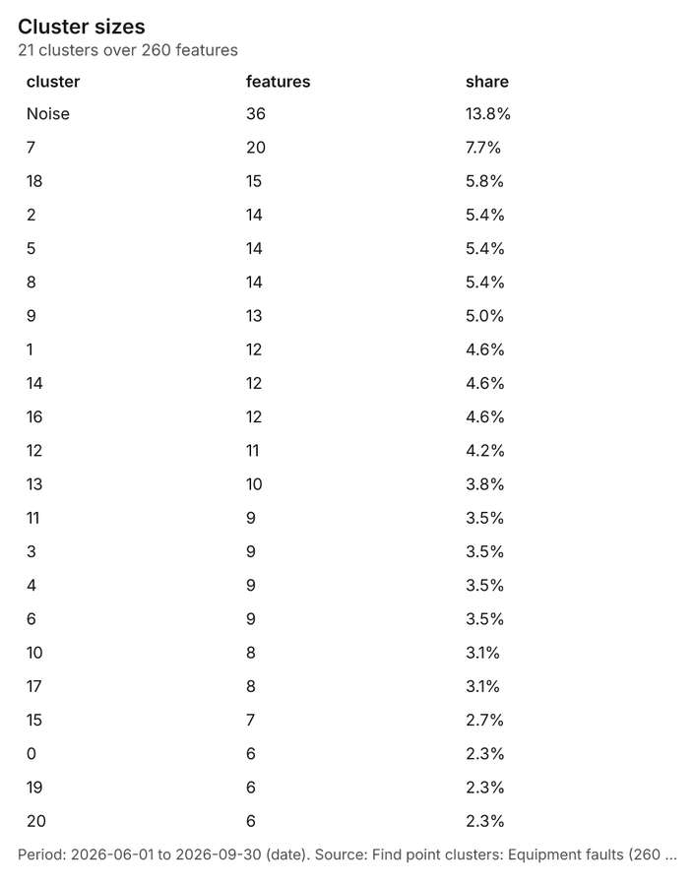
Figure 38. Find point clusters: Equipment faults [86]. Period: 2026-06-01 to 2026-09-30 (date). Source: Find point clusters: Equipment faults (260 features). The data is in the appendix.
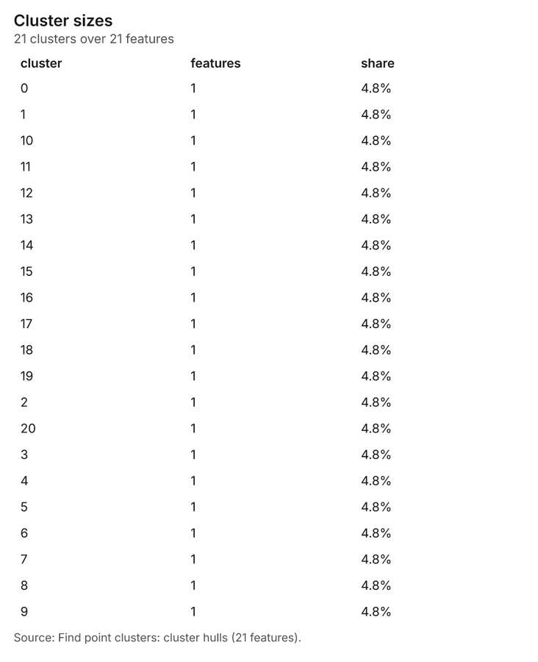
Figure 39. Find point clusters: cluster hulls [87]. Source: Find point clusters: cluster hulls (21 features). The data is in the appendix.
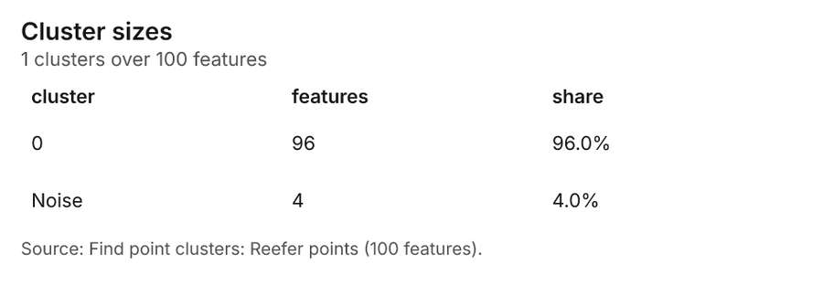
Figure 40. Find point clusters: Reefer points [88]. Source: Find point clusters: Reefer points (100 features). The data is in the appendix.
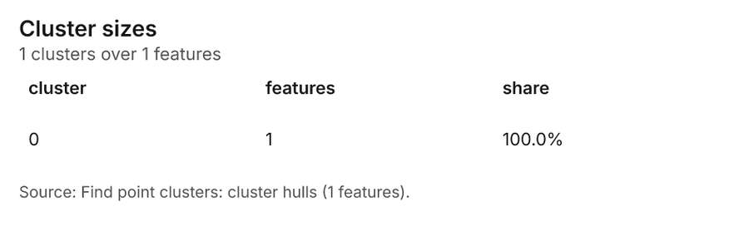
Figure 41. Find point clusters: cluster hulls [89]. Source: Find point clusters: cluster hulls (1 features). The data is in the appendix.
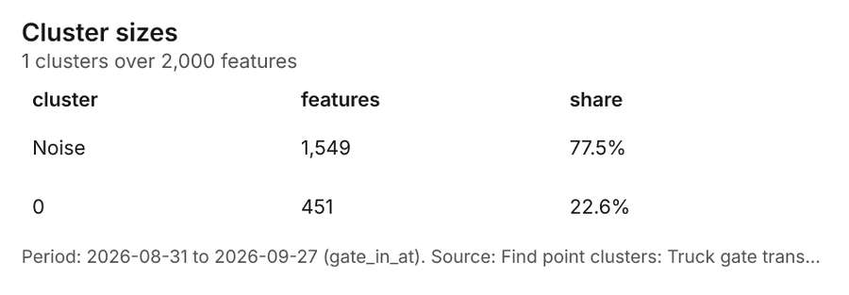
Figure 42. Find point clusters: Truck gate transactions [90]. Period: 2026-08-31 to 2026-09-27 (gate_in_at). Source: Find point clusters: Truck gate transactions (2,000 features). The data is in the appendix.
Figure 43. Find point clusters: cluster hulls [91]. Source: Find point clusters: cluster hulls (1 features). The data is in the appendix.
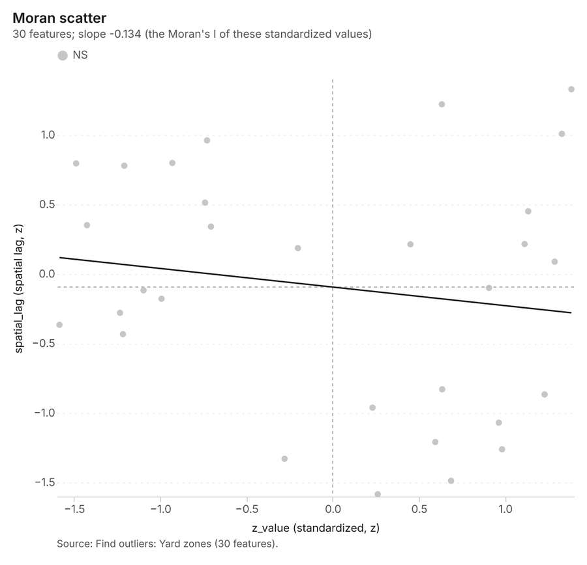
Figure 44. Find outliers: Yard zones [92]. Source: Find outliers: Yard zones (30 features). The data is in the appendix.
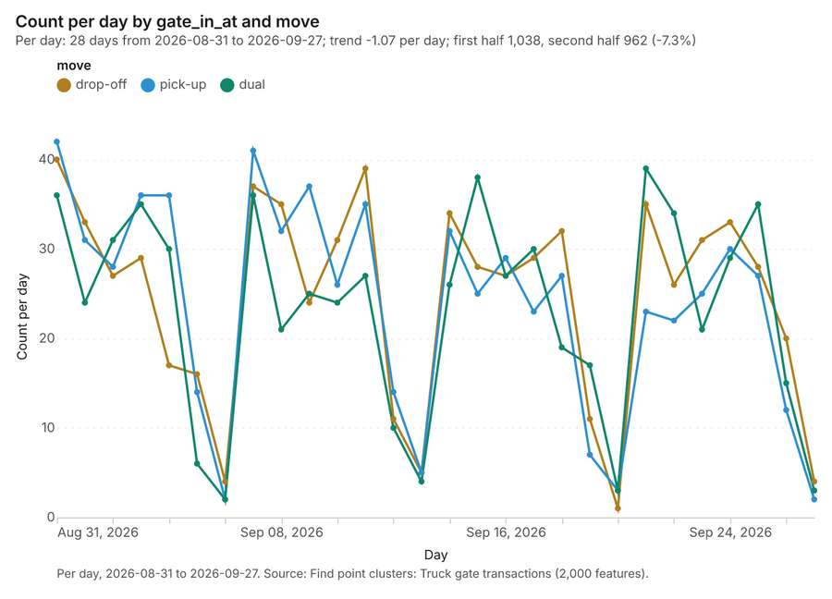
Figure 45. Find point clusters: Truck gate transactions over time [93]. Per day, 2026-08-31 to 2026-09-27. Source: Find point clusters: Truck gate transactions (2,000 features). The data is in the appendix.
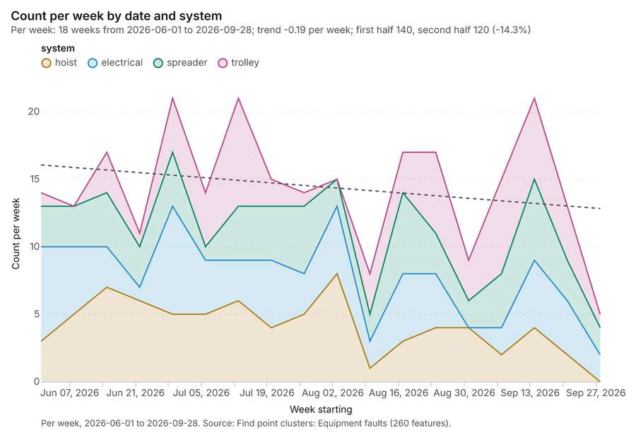
Figure 46. Find point clusters: Equipment faults over time [94]. Per week, 2026-06-01 to 2026-09-28. Source: Find point clusters: Equipment faults (260 features). The data is in the appendix.
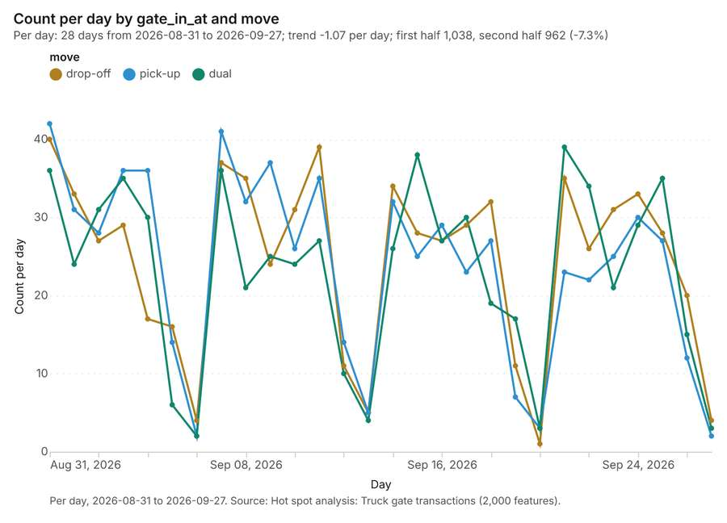
Figure 47. Hot spot analysis: Truck gate transactions over time [95]. Per day, 2026-08-31 to 2026-09-27. Source: Hot spot analysis: Truck gate transactions (2,000 features). The data is in the appendix.
Figure 48. Repeat and near repeat classification: Equipment faults over time [96]. Per week, 2026-06-01 to 2026-09-28. Source: Repeat and near repeat classification: Equipment faults (260 features). The data is in the appendix.

Changes since the last run
This is the first report of this project.

Sources
[1] Rendering: Chart: Timeline: events per week by dataset. 108 rows (id 11047c75-2b19-47cd-a59a-f0cbb048b5c8)
[2] Dataset: Truck gate transactions. vector, 2000 rows (id 9df2b234-4fbe-485c-b46c-b4c3ecee1bca)
[3] Dataset: Equipment faults. vector, 260 rows (id 2ac95106-0af7-4a53-9a75-a8bae7f1278e)
[4] Dataset: Berth calls. table, 360 rows (id 40ffa1b1-7e33-45bd-b8ea-a135c7f8a900)
[5] Dataset: Yard inventory by day. table, 840 rows (id 708007f4-4b4d-43d1-ac33-89c5e52f4d38)
[6] Catalog: Emerging hot spots (operation catalog, gp_space_time_hot_spots). Where hot spots are new, consecutive, intensifying, persistent, diminishing, sporadic, oscillating or historical over time. ArcGIS: Emerging Hot Spot Analysis, Create Space Time Cube. (id gp_space_time_hot_spots)
[7] Plan: Space time hot spots of Equipment faults (the Start plan's candidate c_b58984834921). Equipment faults carry dates in 'date': emerging hot spot analysis finds new, intensifying and fading hot spots per week. (id d9ee6452-a1f6-426a-aaab-e0d1b69d7593:c_b58984834921)
[8] Tool result: gp_space_time_hot_spots, step 0. Emerging hot spots: 1 layer saved: Emerging hot spots: Equipment faults (22 features). (id e40e3bed-16aa-4055-8346-9c7ae3dd0e1c:0)
[9] Layer: Equipment faults. 260 features (id 790b76cb-eb78-4e79-8c01-68b3710ce26d)
[10] Plan: Space time hot spots of Truck gate transactions (the Start plan's candidate c_eca8ebc5b6ec). Truck gate transactions carry dates in 'gate_in_at': emerging hot spot analysis finds new, intensifying and fading hot spots per day. (id d9ee6452-a1f6-426a-aaab-e0d1b69d7593:c_eca8ebc5b6ec)
[11] Tool result: gp_space_time_hot_spots, step 1. Emerging hot spots: 1 layer saved: Emerging hot spots: Truck gate transactions (111 features). (id e40e3bed-16aa-4055-8346-9c7ae3dd0e1c:1)
[12] Layer: Truck gate transactions. 2,000 features (id b9f2750d-cff0-415b-a399-c427801b3164)
[13] Catalog: Repeat and near repeat classification (operation catalog, gp_near_repeat). Classify incidents as originators, repeats (same place) or near repeats within a distance and time window, with a Knox test table. ArcGIS: Repeat and Near Repeat Classification, Near Repeat Calculator. (id gp_near_repeat)
[14] Plan: Near repeat of Equipment faults (the Start plan's candidate c_76cc00de2abd). Near repeat analysis tests whether Equipment faults close in space also follow each other within 12 days. (id d9ee6452-a1f6-426a-aaab-e0d1b69d7593:c_76cc00de2abd)
[15] Tool result: gp_near_repeat, step 2. Repeat and near repeat classification: 1 layer saved: Repeat and near repeat classification: Equipment faults (260 features). (id e40e3bed-16aa-4055-8346-9c7ae3dd0e1c:2)
[16] Catalog: Summarize within (operation catalog, gp_summarize_within). Count and aggregate the features inside each polygon (or bin), proportionally for lines and polygons. ArcGIS: Summarize Within, Aggregate Points. QGIS: native:countpointsinpolygon, native:sumlinelengths. (id gp_summarize_within)
[17] Plan: Equipment faults per feature of Yard zones (the Start plan's candidate c_aa826c0e2c95). Count Equipment faults inside each feature of Yard zones by system; the counts map as a choropleth (natural breaks, sequential colors). (id d9ee6452-a1f6-426a-aaab-e0d1b69d7593:c_aa826c0e2c95)
[18] Tool result: gp_summarize_within, step 0. Summarize within: 1 layer saved: Summarize within: Yard zones (30 features). (id b81a9a7d-e780-4bbd-a071-25593dafe30b:0)
[19] Layer: Yard zones. 30 features (id 0b9931a6-3451-4c38-97e1-e2d0b0d2e6c0)
[20] Tool result: gp_summarize_within, step 1. Summarize within: 1 layer saved: Summarize within: Yard zones (30 features). (id b81a9a7d-e780-4bbd-a071-25593dafe30b:1)
[21] Layer: Reefer points. 100 features (id 73835122-ec06-4a26-a127-ab201cf379e6)
[22] Tool result: gp_summarize_within, step 2. Summarize within: 1 layer saved: Summarize within: Yard zones (30 features). (id b81a9a7d-e780-4bbd-a071-25593dafe30b:2)
[23] Catalog: Hot spot analysis (operation catalog, gp_hot_spots). Getis-Ord Gi* hot and cold spots with z-scores, p-values and confidence bins. ArcGIS: Find Hot Spots, Hot Spot Analysis (Getis-Ord Gi*). QGIS: qgis:hotspot (plugin). (id gp_hot_spots)
[24] Plan: Hot spots of Equipment faults (the Start plan's candidate c_0641eeca6054). 260 points: Getis-Ord Gi* tests whether the concentrations in Equipment faults are statistically significant. (id d9ee6452-a1f6-426a-aaab-e0d1b69d7593:c_0641eeca6054)
[25] Tool result: gp_hot_spots, step 0. Hot spot analysis: 1 layer saved: Hot spot analysis: Equipment faults (41 features). (id d0ec0f48-d207-4e62-856c-316d57d7454a:0)
[26] Plan: Hot spots of Reefer points (the Start plan's candidate c_810f1d99b7e9). 100 points: Getis-Ord Gi* tests whether the concentrations in Reefer points are statistically significant. (id d9ee6452-a1f6-426a-aaab-e0d1b69d7593:c_810f1d99b7e9)
[27] Tool result: gp_hot_spots, step 1. Hot spot analysis: 1 layer saved: Hot spot analysis: Reefer points (62 features). (id d0ec0f48-d207-4e62-856c-316d57d7454a:1)
[28] Plan: Hot spots of Truck gate transactions (the Start plan's candidate c_e8db5dd726f1). 2000 points: Getis-Ord Gi* tests whether the concentrations in Truck gate transactions are statistically significant. (id d9ee6452-a1f6-426a-aaab-e0d1b69d7593:c_e8db5dd726f1)
[29] Tool result: gp_hot_spots, step 2. Hot spot analysis: 1 layer saved: Hot spot analysis: Truck gate transactions (2000 features). (id d0ec0f48-d207-4e62-856c-316d57d7454a:2)
[30] Catalog: Calculate density (operation catalog, gp_calculate_density). Kernel density per square kilometer on a grid. ArcGIS: Calculate Density, Kernel Density. QGIS: native:heatmapkerneldensityestimation. (id gp_calculate_density)
[31] Plan: Kernel density of Equipment faults (the Start plan's candidate c_0a821ea91d7a). 260 points in Equipment faults: a density surface shows where they concentrate. (id d9ee6452-a1f6-426a-aaab-e0d1b69d7593:c_0a821ea91d7a)
[32] Tool result: gp_calculate_density, step 0. Calculate density: 1 layer saved: Calculate density: Equipment faults (284 features). (id 3f35f607-29ba-44fe-827e-7ba7fd8f461d:0)
[33] Plan: Kernel density of Reefer points (the Start plan's candidate c_33d00d793c5e). 100 points in Reefer points: a density surface shows where they concentrate. (id d9ee6452-a1f6-426a-aaab-e0d1b69d7593:c_33d00d793c5e)
[34] Tool result: gp_calculate_density, step 1. Calculate density: 1 layer saved: Calculate density: Reefer points (425 features). (id 3f35f607-29ba-44fe-827e-7ba7fd8f461d:1)
[35] Plan: Kernel density of Truck gate transactions (the Start plan's candidate c_95387e3fbe3a). 2000 points in Truck gate transactions: a density surface shows where they concentrate. (id d9ee6452-a1f6-426a-aaab-e0d1b69d7593:c_95387e3fbe3a)
[36] Tool result: gp_calculate_density, step 2. Calculate density: 1 layer saved: Calculate density: Truck gate transactions (4119 features). (id 3f35f607-29ba-44fe-827e-7ba7fd8f461d:2)
[37] Catalog: Find point clusters (operation catalog, gp_find_point_clusters). Density-based clusters (DBSCAN, HDBSCAN or OPTICS, optionally space-time) with hulls and noise. ArcGIS: Find Point Clusters, Density-based Clustering. QGIS: native:dbscanclustering, native:stdbscanclustering. (id gp_find_point_clusters)
[38] Plan: Cluster points of Equipment faults (the Start plan's candidate c_cd3c95b593b8). DBSCAN finds dense groups of Equipment faults and separates noise. (id d9ee6452-a1f6-426a-aaab-e0d1b69d7593:c_cd3c95b593b8)
[39] Tool result: gp_find_point_clusters, step 0. Find point clusters: 2 layers saved: Find point clusters: Equipment faults (260 features); Find point clusters: cluster hulls (21 features). (id b0f8aa2c-db45-4d83-9fff-4f2b75bd614c:0)
[40] Plan: Cluster points of Reefer points (the Start plan's candidate c_17c598621b07). DBSCAN finds dense groups of Reefer points and separates noise. (id d9ee6452-a1f6-426a-aaab-e0d1b69d7593:c_17c598621b07)
[41] Tool result: gp_find_point_clusters, step 1. Find point clusters: 2 layers saved: Find point clusters: Reefer points (100 features); Find point clusters: cluster hulls (1 feature). (id b0f8aa2c-db45-4d83-9fff-4f2b75bd614c:1)
[42] Plan: Cluster points of Truck gate transactions (the Start plan's candidate c_57a67cafe160). DBSCAN finds dense groups of Truck gate transactions and separates noise. (id d9ee6452-a1f6-426a-aaab-e0d1b69d7593:c_57a67cafe160)
[43] Tool result: gp_find_point_clusters, step 2. Find point clusters: 2 layers saved: Find point clusters: Truck gate transactions (2000 features); Find point clusters: cluster hulls (1 feature). (id b0f8aa2c-db45-4d83-9fff-4f2b75bd614c:2)
[44] Catalog: Find outliers (operation catalog, gp_outliers). Anselin local Moran’s I: HH, LL clusters and HL, LH outliers. ArcGIS: Find Outliers, Cluster and Outlier Analysis (Anselin Local Moran’s I). (id gp_outliers)
[45] Plan: Local morans i of Yard zones (the Start plan's candidate c_429379204dba). Local Moran's I maps clusters and outliers of 'capacity_teu'. (id d9ee6452-a1f6-426a-aaab-e0d1b69d7593:c_429379204dba)
[46] Tool result: gp_outliers, step 0. Find outliers: 1 layer saved: Find outliers: Yard zones (30 features). (id 03a62e3e-7c33-480d-b1a9-3e5ac2c09cdb:0)
[47] Catalog: Spatial autocorrelation (operation catalog, gp_spatial_autocorrelation). Global Moran’s I: is the pattern clustered, dispersed or random. ArcGIS: Spatial Autocorrelation (Global Moran’s I). (id gp_spatial_autocorrelation)
[48] Plan: Global morans i of Yard zones (the Start plan's candidate c_085f774564d9). Global Moran's I says whether similar values of 'capacity_teu' sit next to each other. (id d9ee6452-a1f6-426a-aaab-e0d1b69d7593:c_085f774564d9)
[49] Tool result: gp_spatial_autocorrelation, step 1. Spatial autocorrelation: done; no map output. (id 03a62e3e-7c33-480d-b1a9-3e5ac2c09cdb:1)
[50] Rendering: Map: Emerging hot spots: Equipment faults (id e6910ca0-d50c-43b0-b7d9-8c5c1f050783)
[51] Rendering: Map: Emerging hot spots: Truck gate transactions (id 515cea9c-9877-46aa-a13c-4113ce12e73d)
[52] Rendering: Map: Repeat and near repeat classification: Equipment faults (id fa0dc608-c857-44d6-8678-d5b17e2f6b79)
[53] Rendering: Map: Summarize within: Yard zones (id af07b588-53b5-4b85-84cb-691b540af342)
[54] Rendering: Map: Summarize within: Yard zones (id 93c17116-d3e1-468f-b008-1e898a6cce2e)
[55] Rendering: Map: Summarize within: Yard zones (id 6f8ebf81-81b3-4228-9405-9cc9c04851e0)
[56] Rendering: Map: Hot spot analysis: Equipment faults (id 4ecf65c6-4ad6-40cb-9995-dcc289441572)
[57] Rendering: Map: Hot spot analysis: Reefer points (id 302ee063-bdd1-4516-9cf6-ebabd602feb1)
[58] Rendering: Map: Hot spot analysis: Truck gate transactions (id e879a4aa-940c-43ca-a32a-c85ce2668301)
[59] Rendering: Map: Calculate density: Equipment faults (id 693d7472-34c3-42d3-ace7-ac7eba5ff23b)
[60] Rendering: Map: Calculate density: Reefer points (id 757bdb8e-7a55-4deb-8f0a-91f5bd8ff881)
[61] Rendering: Map: Calculate density: Truck gate transactions (id 19c9a9f7-d4a7-4429-8aa7-9f0a2d99f3e4)
[62] Rendering: Map: Find point clusters: Equipment faults (id 52740046-11ec-462f-a421-aa7e94c61f6e)
[63] Rendering: Map: Find point clusters: cluster hulls (id fa3507ae-0db5-4cf6-9c5e-bc2137650c75)
[64] Rendering: Map: Find point clusters: Reefer points (id 65dc036f-0f6e-487d-9375-a24401305aca)
[65] Rendering: Map: Find point clusters: cluster hulls (id 3454a201-f985-451b-a1fd-c07dbe2e9fc9)
[66] Rendering: Map: Find point clusters: Truck gate transactions (id b09daf9c-0715-4cfb-821c-93920274d482)
[67] Rendering: Map: Find point clusters: cluster hulls (id 834cca38-8129-4ee1-b3fe-8a727e0445f9)
[68] Rendering: Map: Yard zones by capacity_teu (id ba095b6b-b3ec-4964-8628-46249c0ee3e3)
[69] Rendering: Map: Find outliers: Yard zones (id a557a74c-a519-4164-b6e1-928a88256d84)
[70] Rendering: Chart: Truck gate transactions over time (turn_time_min). 84 rows (id 39e5653c-2a28-47d2-b9de-18cc494cf9cf)
[71] Rendering: Chart: Equipment faults over time (date). 72 rows (id 276d16c9-87e8-4c05-93cf-d80429cf89e5)
[72] Rendering: Chart: Berth calls over time (arrival_date). 27 rows (id 596dd570-090f-45dc-b0ed-e076304cc527)
[73] Rendering: Chart: Yard inventory by day over time (date). 28 rows (id 0eda9598-8313-4475-84f5-17eb7bcf7426)
[74] Rendering: Chart: Emerging hot spots: Equipment faults. 6 rows (id da7da906-ad4c-461a-99be-03b42f884fc5)
[75] Rendering: Chart: Emerging hot spots: Truck gate transactions. 8 rows (id 3f8f08a0-4024-4c2c-a938-81749cfce26c)
[76] Rendering: Chart: Repeat and near repeat classification: Equipment faults. 72 rows (id 0d472ba0-f679-4732-98be-c1002dce9ad6)
[77] Rendering: Chart: Summarize within: Yard zones. 6 rows (id 0d1bd326-7967-4498-8e1d-36b4aea6639f)
[78] Rendering: Chart: Summarize within: Yard zones. 6 rows (id ffaaddda-e02a-4652-828f-be9cdc5c18a2)
[79] Rendering: Chart: Summarize within: Yard zones. 6 rows (id 51468063-34ec-4f8c-8b85-da250b575e2c)
[80] Rendering: Chart: Hot spot analysis: Equipment faults. 8 rows (id e7ce3e63-0873-4cba-a376-1db2b0fa4455)
[81] Rendering: Chart: Hot spot analysis: Reefer points. 9 rows (id c4cbac5f-1381-44df-a3b8-7d19a8d8d3d5)
[82] Rendering: Chart: Hot spot analysis: Truck gate transactions. 24 rows (id d4e4896e-0c4a-45d0-ad29-4aa177fac4cc)
[83] Rendering: Chart: Calculate density: Equipment faults. 10 rows (id ec8258c8-3b83-40cb-8cd4-83e84b2ebd4e)
[84] Rendering: Chart: Calculate density: Reefer points. 10 rows (id ab819465-a3dc-4df7-8d67-46b82daa5de5)
[85] Rendering: Chart: Calculate density: Truck gate transactions. 14 rows (id b736ba6f-071f-4510-96b4-0d2855e22868)
[86] Rendering: Chart: Find point clusters: Equipment faults. 22 rows (id 7aa48a3e-a3df-4cf5-93bb-857225aa546e)
[87] Rendering: Chart: Find point clusters: cluster hulls. 21 rows (id b0838907-a5b3-4291-a133-b10070ed11e2)
[88] Rendering: Chart: Find point clusters: Reefer points. 2 rows (id 48f1af69-f4c6-47e6-8abc-8446516aa1d4)
[89] Rendering: Chart: Find point clusters: cluster hulls. 1 rows (id af3b81f5-c016-4188-b386-92ea2a114c05)
[90] Rendering: Chart: Find point clusters: Truck gate transactions. 2 rows (id 02ef40c4-d23f-469d-9642-cd2ce224ab92)
[91] Rendering: Chart: Find point clusters: cluster hulls. 1 rows (id a98e736d-3cef-4702-b752-a48fbdb6aae0)
[92] Rendering: Chart: Find outliers: Yard zones. 30 rows (id 541a4d8b-35b0-4173-bcb5-dc8e44799584)
[93] Rendering: Chart: Find point clusters: Truck gate transactions over time. 84 rows (id 0d7f5f66-2a85-42ef-afd5-8e2199b7ce13)
[94] Rendering: Chart: Find point clusters: Equipment faults over time. 72 rows (id 20cbdbcd-ad36-425d-bf0b-882a13e227c1)
[95] Rendering: Chart: Hot spot analysis: Truck gate transactions over time. 84 rows (id ec4ea6d1-51eb-4752-a16b-09089bacdbc1)
[96] Rendering: Chart: Repeat and near repeat classification: Equipment faults over time. 72 rows (id 68dec16f-9994-47b6-adc7-092e4a8fd561)
[97] Dataset: Berths. vector, 14 rows (id b0a0ad32-bfd0-4c8e-9ddc-69c28f08c5fc)
[98] Dataset: Yard zones. vector, 30 rows (id 027eb1a0-c68d-4feb-9829-95445b227889)
[99] Dataset: Gates. vector, 4 rows (id 90230a02-a91e-47db-a1a6-07158b5ac6ff)
[100] Dataset: Cranes. vector, 40 rows (id 9f1702b0-8b5f-42d9-906b-ccfcb711f325)
[101] Dataset: Reefer points. vector, 100 rows (id 919ddf4e-8fe1-45fa-8f67-e26838b7ad21)
[102] Dataset: Terminal roads. vector, 10 rows (id a3a782c1-8c1e-45a2-a7f8-567f739ed72e)
[103] Dataset: Terminal performance report. document, ? rows (id 472b5c54-0433-4a12-b317-9330dcea7237)
[104] Record: Sample: Ports and maritime operations, Rotterdam (id 20fafc67-4c16-4f65-b17e-a469aa483b5a)
[105] Layer: Emerging hot spots: Equipment faults. 22 features (id 9e848a96-211c-42c6-8111-c36d32d9b5ba)
[106] Layer: Emerging hot spots: Truck gate transactions. 111 features (id a25ac4ad-fb45-40ac-b4b0-8549519e388c)
[107] Layer: Repeat and near repeat classification: Equipment faults. 260 features (id 05d505e6-94c9-4f7f-a8bd-d670658aae52)
[108] Layer: Summarize within: Yard zones. 30 features (id 1ab59bc5-6bfa-4c26-a4b5-f2b4101e7e3c)
[109] Layer: Summarize within: Yard zones. 30 features (id f570abd5-8269-4ef5-997b-152e35b6a60c)
[110] Layer: Summarize within: Yard zones. 30 features (id 010c891b-7159-4cac-8e7d-1b1db568f2c2)
[111] Layer: Hot spot analysis: Equipment faults. 41 features (id 4be3ee60-4d27-44b9-84ca-a6ab6f7c118c)
[112] Layer: Hot spot analysis: Reefer points. 62 features (id ecbf7402-7f8f-4356-841c-ec83c0107fbd)
[113] Layer: Hot spot analysis: Truck gate transactions. 2,000 features (id 63163d00-359d-492c-ad25-47d7fc65b7fa)
[114] Layer: Calculate density: Equipment faults. 284 features (id 6bd3f696-e942-4dd9-82b7-890891595182)
[115] Layer: Calculate density: Reefer points. 425 features (id d1114715-a70e-4df2-9ada-9f59d71f2f47)
[116] Layer: Calculate density: Truck gate transactions. 4,119 features (id 42c683d3-2380-4817-9147-97b54c2e9c09)
[117] Layer: Find point clusters: Equipment faults. 260 features (id c93af5f3-3198-4b3f-a55d-c6481bf8bca7)
[118] Layer: Find point clusters: cluster hulls. 21 features (id 4ad1b5b1-c112-4fa3-a32e-c1b8566e5741)
[119] Layer: Find point clusters: Reefer points. 100 features (id 4805f4c5-7373-4344-8545-8096d0c57dfc)
[120] Layer: Find point clusters: cluster hulls. 1 features (id 7547f64d-c473-4777-a154-a4bbd5da8e55)
[121] Layer: Find point clusters: Truck gate transactions. 2,000 features (id 7942997a-54cb-4243-a85b-1f52e888ea1f)
[122] Layer: Find point clusters: cluster hulls. 1 features (id a6e216aa-3fe3-415f-8203-97d68a4d585e)
[123] Layer: Find outliers: Yard zones. 30 features (id 9c813e1c-474b-49f0-b77b-2da7ee92ad72)
[124] Document: Terminal performance report, September 2026 (id 19bbd774-bf04-4db6-8cef-b792a24d56f8)

Appendix: the data behind the charts

Figure 1. Timeline: events per week by dataset [1]
period | series | value
2026-03-30 | Truck gate transactions | 0
2026-03-30 | Yard inventory by day | 0
2026-03-30 | Berth calls | 14
2026-03-30 | Equipment faults | 0
2026-04-06 | Truck gate transactions | 0
2026-04-06 | Yard inventory by day | 0
2026-04-06 | Berth calls | 17
2026-04-06 | Equipment faults | 0
2026-04-13 | Truck gate transactions | 0
2026-04-13 | Yard inventory by day | 0
2026-04-13 | Berth calls | 22
2026-04-13 | Equipment faults | 0
2026-04-20 | Truck gate transactions | 0
2026-04-20 | Yard inventory by day | 0
2026-04-20 | Berth calls | 12
2026-04-20 | Equipment faults | 0
2026-04-27 | Truck gate transactions | 0
2026-04-27 | Yard inventory by day | 0
2026-04-27 | Berth calls | 8
2026-04-27 | Equipment faults | 0
2026-05-04 | Truck gate transactions | 0
2026-05-04 | Yard inventory by day | 0
2026-05-04 | Berth calls | 15
2026-05-04 | Equipment faults | 0
2026-05-11 | Truck gate transactions | 0
2026-05-11 | Yard inventory by day | 0
2026-05-11 | Berth calls | 12
2026-05-11 | Equipment faults | 0
2026-05-18 | Truck gate transactions | 0
2026-05-18 | Yard inventory by day | 0
2026-05-18 | Berth calls | 14
2026-05-18 | Equipment faults | 0
2026-05-25 | Truck gate transactions | 0
2026-05-25 | Yard inventory by day | 0
2026-05-25 | Berth calls | 14
2026-05-25 | Equipment faults | 0
2026-06-01 | Truck gate transactions | 0
2026-06-01 | Yard inventory by day | 0
2026-06-01 | Berth calls | 12
2026-06-01 | Equipment faults | 14
2026-06-08 | Truck gate transactions | 0
2026-06-08 | Yard inventory by day | 0
2026-06-08 | Berth calls | 11
2026-06-08 | Equipment faults | 13
2026-06-15 | Truck gate transactions | 0
2026-06-15 | Yard inventory by day | 0
2026-06-15 | Berth calls | 19
2026-06-15 | Equipment faults | 17
2026-06-22 | Truck gate transactions | 0
2026-06-22 | Yard inventory by day | 0
2026-06-22 | Berth calls | 11
2026-06-22 | Equipment faults | 11
2026-06-29 | Truck gate transactions | 0
2026-06-29 | Yard inventory by day | 0
2026-06-29 | Berth calls | 12
2026-06-29 | Equipment faults | 21
2026-07-06 | Truck gate transactions | 0
2026-07-06 | Yard inventory by day | 0
2026-07-06 | Berth calls | 15
2026-07-06 | Equipment faults | 14
2026-07-13 | Truck gate transactions | 0
2026-07-13 | Yard inventory by day | 0
2026-07-13 | Berth calls | 13
2026-07-13 | Equipment faults | 21
2026-07-20 | Truck gate transactions | 0
2026-07-20 | Yard inventory by day | 0
2026-07-20 | Berth calls | 16
2026-07-20 | Equipment faults | 15
2026-07-27 | Truck gate transactions | 0
2026-07-27 | Yard inventory by day | 0
2026-07-27 | Berth calls | 14
2026-07-27 | Equipment faults | 14
2026-08-03 | Truck gate transactions | 0
2026-08-03 | Yard inventory by day | 0
2026-08-03 | Berth calls | 13
2026-08-03 | Equipment faults | 15
2026-08-10 | Truck gate transactions | 0
2026-08-10 | Yard inventory by day | 0
2026-08-10 | Berth calls | 13
2026-08-10 | Equipment faults | 8
2026-08-17 | Truck gate transactions | 0
2026-08-17 | Yard inventory by day | 0
2026-08-17 | Berth calls | 10
2026-08-17 | Equipment faults | 17
2026-08-24 | Truck gate transactions | 0
2026-08-24 | Yard inventory by day | 0
2026-08-24 | Berth calls | 8
2026-08-24 | Equipment faults | 17
2026-08-31 | Truck gate transactions | 519
2026-08-31 | Yard inventory by day | 210
2026-08-31 | Berth calls | 15
2026-08-31 | Equipment faults | 9
2026-09-07 | Truck gate transactions | 519
2026-09-07 | Yard inventory by day | 210
2026-09-07 | Berth calls | 18
2026-09-07 | Equipment faults | 15
2026-09-14 | Truck gate transactions | 468
2026-09-14 | Yard inventory by day | 210
2026-09-14 | Berth calls | 15
2026-09-14 | Equipment faults | 21
2026-09-21 | Truck gate transactions | 494
2026-09-21 | Yard inventory by day | 210
2026-09-21 | Berth calls | 12
2026-09-21 | Equipment faults | 13
2026-09-28 | Truck gate transactions | 0
2026-09-28 | Yard inventory by day | 0
2026-09-28 | Berth calls | 5
2026-09-28 | Equipment faults | 5

Figure 22. Truck gate transactions over time (turn_time_min) [70]
period | series | value
2026-08-31 | drop-off | 1,570
2026-08-31 | dual | 1,383
2026-08-31 | pick-up | 1,352
2026-09-01 | drop-off | 1,093
2026-09-01 | dual | 798
2026-09-01 | pick-up | 1,118
2026-09-02 | drop-off | 907
2026-09-02 | dual | 1,064
2026-09-02 | pick-up | 886
2026-09-03 | drop-off | 859
2026-09-03 | dual | 1,163
2026-09-03 | pick-up | 1,178
2026-09-04 | drop-off | 533
2026-09-04 | dual | 922
2026-09-04 | pick-up | 1,177
2026-09-05 | drop-off | 534
2026-09-05 | dual | 189
2026-09-05 | pick-up | 464
2026-09-06 | drop-off | 149
2026-09-06 | dual | 63
2026-09-06 | pick-up | 59
2026-09-07 | drop-off | 1,489
2026-09-07 | dual | 1,520
2026-09-07 | pick-up | 1,629
2026-09-08 | drop-off | 1,186
2026-09-08 | dual | 659
2026-09-08 | pick-up | 1,025
2026-09-09 | drop-off | 745
2026-09-09 | dual | 765
2026-09-09 | pick-up | 1,203
2026-09-10 | drop-off | 1,031
2026-09-10 | dual | 730
2026-09-10 | pick-up | 790
2026-09-11 | drop-off | 1,267
2026-09-11 | dual | 914
2026-09-11 | pick-up | 1,168
2026-09-12 | drop-off | 376
2026-09-12 | dual | 326
2026-09-12 | pick-up | 558
2026-09-13 | drop-off | 161
2026-09-13 | dual | 134
2026-09-13 | pick-up | 144
2026-09-14 | drop-off | 1,174
2026-09-14 | dual | 1,042
2026-09-14 | pick-up | 1,107
2026-09-15 | drop-off | 1,049
2026-09-15 | dual | 1,294
2026-09-15 | pick-up | 744
2026-09-16 | drop-off | 943
2026-09-16 | dual | 923
2026-09-16 | pick-up | 943
2026-09-17 | drop-off | 979
2026-09-17 | dual | 1,036
2026-09-17 | pick-up | 781
2026-09-18 | drop-off | 1,070
2026-09-18 | dual | 597
2026-09-18 | pick-up | 848
2026-09-19 | drop-off | 398
2026-09-19 | dual | 655
2026-09-19 | pick-up | 253
2026-09-20 | drop-off | 37
2026-09-20 | dual | 76
2026-09-20 | pick-up | 66
2026-09-21 | drop-off | 1,359
2026-09-21 | dual | 1,659
2026-09-21 | pick-up | 870
2026-09-22 | drop-off | 916
2026-09-22 | dual | 1,081
2026-09-22 | pick-up | 766
2026-09-23 | drop-off | 1,071
2026-09-23 | dual | 693
2026-09-23 | pick-up | 769
2026-09-24 | drop-off | 1,084
2026-09-24 | dual | 898
2026-09-24 | pick-up | 1,020
2026-09-25 | drop-off | 888
2026-09-25 | dual | 1,151
2026-09-25 | pick-up | 875
2026-09-26 | drop-off | 649
2026-09-26 | dual | 492
2026-09-26 | pick-up | 348
2026-09-27 | drop-off | 144
2026-09-27 | dual | 95
2026-09-27 | pick-up | 66

Figure 23. Equipment faults over time (date) [71]
period | series | value
2026-06-01 | hoist | 3
2026-06-01 | electrical | 7
2026-06-01 | spreader | 3
2026-06-01 | trolley | 1
2026-06-08 | hoist | 5
2026-06-08 | electrical | 5
2026-06-08 | spreader | 3
2026-06-08 | trolley | 0
2026-06-15 | hoist | 7
2026-06-15 | electrical | 3
2026-06-15 | spreader | 4
2026-06-15 | trolley | 3
2026-06-22 | hoist | 6
2026-06-22 | electrical | 1
2026-06-22 | spreader | 3
2026-06-22 | trolley | 1
2026-06-29 | hoist | 5
2026-06-29 | electrical | 8
2026-06-29 | spreader | 4
2026-06-29 | trolley | 4
2026-07-06 | hoist | 5
2026-07-06 | electrical | 4
2026-07-06 | spreader | 1
2026-07-06 | trolley | 4
2026-07-13 | hoist | 6
2026-07-13 | electrical | 3
2026-07-13 | spreader | 4
2026-07-13 | trolley | 8
2026-07-20 | hoist | 4
2026-07-20 | electrical | 5
2026-07-20 | spreader | 4
2026-07-20 | trolley | 2
2026-07-27 | hoist | 5
2026-07-27 | electrical | 3
2026-07-27 | spreader | 5
2026-07-27 | trolley | 1
2026-08-03 | hoist | 8
2026-08-03 | electrical | 5
2026-08-03 | spreader | 2
2026-08-03 | trolley | 0
2026-08-10 | hoist | 1
2026-08-10 | electrical | 2
2026-08-10 | spreader | 2
2026-08-10 | trolley | 3
2026-08-17 | hoist | 3
2026-08-17 | electrical | 5
2026-08-17 | spreader | 6
2026-08-17 | trolley | 3
2026-08-24 | hoist | 4
2026-08-24 | electrical | 4
2026-08-24 | spreader | 3
2026-08-24 | trolley | 6
2026-08-31 | hoist | 4
2026-08-31 | electrical | 0
2026-08-31 | spreader | 2
2026-08-31 | trolley | 3
2026-09-07 | hoist | 2
2026-09-07 | electrical | 2
2026-09-07 | spreader | 4
2026-09-07 | trolley | 7
2026-09-14 | hoist | 4
2026-09-14 | electrical | 5
2026-09-14 | spreader | 6
2026-09-14 | trolley | 6
2026-09-21 | hoist | 2
2026-09-21 | electrical | 4
2026-09-21 | spreader | 3
2026-09-21 | trolley | 4
2026-09-28 | hoist | 0
2026-09-28 | electrical | 2
2026-09-28 | spreader | 2
2026-09-28 | trolley | 1

Figure 24. Berth calls over time (arrival_date) [72]
period | value
2026-03-30 | 14
2026-04-06 | 17
2026-04-13 | 22
2026-04-20 | 12
2026-04-27 | 8
2026-05-04 | 15
2026-05-11 | 12
2026-05-18 | 14
2026-05-25 | 14
2026-06-01 | 12
2026-06-08 | 11
2026-06-15 | 19
2026-06-22 | 11
2026-06-29 | 12
2026-07-06 | 15
2026-07-13 | 13
2026-07-20 | 16
2026-07-27 | 14
2026-08-03 | 13
2026-08-10 | 13
2026-08-17 | 10
2026-08-24 | 8
2026-08-31 | 15
2026-09-07 | 18
2026-09-14 | 15
2026-09-21 | 12
2026-09-28 | 5

Figure 25. Yard inventory by day over time (date) [73]
period | value
2026-08-31 | 3.947e+04
2026-09-01 | 4.246e+04
2026-09-02 | 3.95e+04
2026-09-03 | 4.182e+04
2026-09-04 | 4.039e+04
2026-09-05 | 3.88e+04
2026-09-06 | 3.993e+04
2026-09-07 | 3.888e+04
2026-09-08 | 4.25e+04
2026-09-09 | 3.952e+04
2026-09-10 | 4.18e+04
2026-09-11 | 3.92e+04
2026-09-12 | 4.15e+04
2026-09-13 | 4.037e+04
2026-09-14 | 3.989e+04
2026-09-15 | 4.028e+04
2026-09-16 | 3.931e+04
2026-09-17 | 4.104e+04
2026-09-18 | 4.035e+04
2026-09-19 | 3.723e+04
2026-09-20 | 3.956e+04
2026-09-21 | 4.011e+04
2026-09-22 | 4.217e+04
2026-09-23 | 3.935e+04
2026-09-24 | 4.095e+04
2026-09-25 | 3.92e+04
2026-09-26 | 3.846e+04
2026-09-27 | 3.901e+04

Figure 26. Emerging hot spots: Equipment faults [74]
bin_start | bin_end | count
-1.19 | -0.9547 | 3
-0.9547 | -0.7193 | 0
-0.7193 | -0.484 | 8
-0.484 | -0.2487 | 1
-0.2487 | -0.01333 | 8
-0.01333 | 0.222 | 2

Figure 27. Emerging hot spots: Truck gate transactions [75]
bin_start | bin_end | count
-1.113 | -0.9698 | 65
-0.9698 | -0.8265 | 2
-0.8265 | -0.6833 | 25
-0.6833 | -0.54 | 9
-0.54 | -0.3967 | 1
-0.3967 | -0.2535 | 4
-0.2535 | -0.1103 | 1
-0.1103 | 0.033 | 4

Figure 28. Repeat and near repeat classification: Equipment faults [76]
period | series | value
2026-06-01 | hoist | 3
2026-06-01 | electrical | 7
2026-06-01 | spreader | 3
2026-06-01 | trolley | 1
2026-06-08 | hoist | 5
2026-06-08 | electrical | 5
2026-06-08 | spreader | 3
2026-06-08 | trolley | 0
2026-06-15 | hoist | 7
2026-06-15 | electrical | 3
2026-06-15 | spreader | 4
2026-06-15 | trolley | 3
2026-06-22 | hoist | 6
2026-06-22 | electrical | 1
2026-06-22 | spreader | 3
2026-06-22 | trolley | 1
2026-06-29 | hoist | 5
2026-06-29 | electrical | 8
2026-06-29 | spreader | 4
2026-06-29 | trolley | 4
2026-07-06 | hoist | 5
2026-07-06 | electrical | 4
2026-07-06 | spreader | 1
2026-07-06 | trolley | 4
2026-07-13 | hoist | 6
2026-07-13 | electrical | 3
2026-07-13 | spreader | 4
2026-07-13 | trolley | 8
2026-07-20 | hoist | 4
2026-07-20 | electrical | 5
2026-07-20 | spreader | 4
2026-07-20 | trolley | 2
2026-07-27 | hoist | 5
2026-07-27 | electrical | 3
2026-07-27 | spreader | 5
2026-07-27 | trolley | 1
2026-08-03 | hoist | 8
2026-08-03 | electrical | 5
2026-08-03 | spreader | 2
2026-08-03 | trolley | 0
2026-08-10 | hoist | 1
2026-08-10 | electrical | 2
2026-08-10 | spreader | 2
2026-08-10 | trolley | 3
2026-08-17 | hoist | 3
2026-08-17 | electrical | 5
2026-08-17 | spreader | 6
2026-08-17 | trolley | 3
2026-08-24 | hoist | 4
2026-08-24 | electrical | 4
2026-08-24 | spreader | 3
2026-08-24 | trolley | 6
2026-08-31 | hoist | 4
2026-08-31 | electrical | 0
2026-08-31 | spreader | 2
2026-08-31 | trolley | 3
2026-09-07 | hoist | 2
2026-09-07 | electrical | 2
2026-09-07 | spreader | 4
2026-09-07 | trolley | 7
2026-09-14 | hoist | 4
2026-09-14 | electrical | 5
2026-09-14 | spreader | 6
2026-09-14 | trolley | 6
2026-09-21 | hoist | 2
2026-09-21 | electrical | 4
2026-09-21 | spreader | 3
2026-09-21 | trolley | 4
2026-09-28 | hoist | 0
2026-09-28 | electrical | 2
2026-09-28 | spreader | 2
2026-09-28 | trolley | 1

Figure 29. Summarize within: Yard zones [77]
bin_start | bin_end | count
1,034 | 1,295 | 7
1,295 | 1,556 | 5
1,556 | 1,816 | 2
1,816 | 2,077 | 2
2,077 | 2,338 | 5
2,338 | 2,599 | 9

Figure 30. Summarize within: Yard zones [78]
bin_start | bin_end | count
1,034 | 1,295 | 7
1,295 | 1,556 | 5
1,556 | 1,816 | 2
1,816 | 2,077 | 2
2,077 | 2,338 | 5
2,338 | 2,599 | 9

Figure 31. Summarize within: Yard zones [79]
bin_start | bin_end | count
43 | 107 | 29
107 | 171 | 0
171 | 235 | 0
235 | 299 | 0
299 | 363 | 0
363 | 427 | 1

Figure 32. Hot spot analysis: Equipment faults [80]
bin_start | bin_end | band | band_label | count
-1 | -0.5 | not_significant | Not significant | 18
-0.5 | 0 | not_significant | Not significant | 5
0 | 0.5 | not_significant | Not significant | 6
0.5 | 1 | not_significant | Not significant | 2
1 | 1.5 | not_significant | Not significant | 6
1.5 | 2 | hot_90 | Hot spot, 90% confidence | 1
1.5 | 2 | not_significant | Not significant | 2
2 | 2.5 | hot_95 | Hot spot, 95% confidence | 1

Figure 33. Hot spot analysis: Reefer points [81]
bin_start | bin_end | band | band_label | count
-2 | -1.5 | cold_90 | Cold spot, 90% confidence | 2
-1.5 | -1 | not_significant | Not significant | 4
-1 | -0.5 | not_significant | Not significant | 11
-0.5 | 0 | not_significant | Not significant | 4
0 | 0.5 | not_significant | Not significant | 17
0.5 | 1 | not_significant | Not significant | 11
1 | 1.5 | not_significant | Not significant | 9
1.5 | 2 | hot_90 | Hot spot, 90% confidence | 3
1.5 | 2 | not_significant | Not significant | 1

Figure 34. Hot spot analysis: Truck gate transactions [82]
bin_start | bin_end | band | band_label | count
-2.5 | -2 | cold_95 | Cold spot, 95% confidence | 34
-2 | -1.5 | cold_90 | Cold spot, 90% confidence | 94
-2 | -1.5 | cold_95 | Cold spot, 95% confidence | 9
-2 | -1.5 | not_significant | Not significant | 50
-1.5 | -1 | not_significant | Not significant | 246
-1 | -0.5 | not_significant | Not significant | 383
-0.5 | 0 | not_significant | Not significant | 325
0 | 0.5 | not_significant | Not significant | 224
0.5 | 1 | not_significant | Not significant | 101
1 | 1.5 | not_significant | Not significant | 62
1.5 | 2 | hot_90 | Hot spot, 90% confidence | 36
1.5 | 2 | hot_95 | Hot spot, 95% confidence | 3
1.5 | 2 | not_significant | Not significant | 14
2 | 2.5 | hot_95 | Hot spot, 95% confidence | 39
2.5 | 3 | hot_95 | Hot spot, 95% confidence | 5
2.5 | 3 | hot_99 | Hot spot, 99% confidence | 24
3 | 3.5 | hot_99 | Hot spot, 99% confidence | 32
3.5 | 4 | hot_99 | Hot spot, 99% confidence | 39
4 | 4.5 | hot_99 | Hot spot, 99% confidence | 54
4.5 | 5 | hot_99 | Hot spot, 99% confidence | 66
5 | 5.5 | hot_99 | Hot spot, 99% confidence | 55
5.5 | 6 | hot_99 | Hot spot, 99% confidence | 64
6 | 6.5 | hot_99 | Hot spot, 99% confidence | 32
6.5 | 7 | hot_99 | Hot spot, 99% confidence | 9

Figure 35. Calculate density: Equipment faults [83]
bin_start | bin_end | count
0 | 2.4 | 26
2.4 | 4.8 | 18
4.8 | 7.2 | 37
7.2 | 9.6 | 30
9.6 | 12 | 30
12 | 14.4 | 34
14.4 | 16.8 | 24
16.8 | 19.2 | 42
19.2 | 21.6 | 26
21.6 | 24 | 17

Figure 36. Calculate density: Reefer points [84]
bin_start | bin_end | count
0 | 2.4 | 35
2.4 | 4.8 | 34
4.8 | 7.2 | 57
7.2 | 9.6 | 35
9.6 | 12 | 38
12 | 14.4 | 55
14.4 | 16.8 | 36
16.8 | 19.2 | 56
19.2 | 21.6 | 37
21.6 | 24 | 42

Figure 37. Calculate density: Truck gate transactions [85]
bin_start | bin_end | count
0 | 6.857 | 272
6.857 | 13.71 | 300
13.71 | 20.57 | 303
20.57 | 27.43 | 302
27.43 | 34.29 | 290
34.29 | 41.14 | 300
41.14 | 48 | 260
48 | 54.86 | 305
54.86 | 61.71 | 303
61.71 | 68.57 | 296
68.57 | 75.43 | 306
75.43 | 82.29 | 300
82.29 | 89.14 | 300
89.14 | 96 | 282

Figure 38. Find point clusters: Equipment faults [86]
cluster | features | fraction | share
Noise | 36 | 0.1385 | 13.8%
7 | 20 | 0.07692 | 7.7%
18 | 15 | 0.05769 | 5.8%
2 | 14 | 0.05385 | 5.4%
5 | 14 | 0.05385 | 5.4%
8 | 14 | 0.05385 | 5.4%
9 | 13 | 0.05 | 5.0%
1 | 12 | 0.04615 | 4.6%
14 | 12 | 0.04615 | 4.6%
16 | 12 | 0.04615 | 4.6%
12 | 11 | 0.04231 | 4.2%
13 | 10 | 0.03846 | 3.8%
11 | 9 | 0.03461 | 3.5%
3 | 9 | 0.03461 | 3.5%
4 | 9 | 0.03461 | 3.5%
6 | 9 | 0.03461 | 3.5%
10 | 8 | 0.03077 | 3.1%
17 | 8 | 0.03077 | 3.1%
15 | 7 | 0.02692 | 2.7%
0 | 6 | 0.02308 | 2.3%
19 | 6 | 0.02308 | 2.3%
20 | 6 | 0.02308 | 2.3%

Figure 39. Find point clusters: cluster hulls [87]
cluster | features | fraction | share
0 | 1 | 0.04762 | 4.8%
1 | 1 | 0.04762 | 4.8%
10 | 1 | 0.04762 | 4.8%
11 | 1 | 0.04762 | 4.8%
12 | 1 | 0.04762 | 4.8%
13 | 1 | 0.04762 | 4.8%
14 | 1 | 0.04762 | 4.8%
15 | 1 | 0.04762 | 4.8%
16 | 1 | 0.04762 | 4.8%
17 | 1 | 0.04762 | 4.8%
18 | 1 | 0.04762 | 4.8%
19 | 1 | 0.04762 | 4.8%
2 | 1 | 0.04762 | 4.8%
20 | 1 | 0.04762 | 4.8%
3 | 1 | 0.04762 | 4.8%
4 | 1 | 0.04762 | 4.8%
5 | 1 | 0.04762 | 4.8%
6 | 1 | 0.04762 | 4.8%
7 | 1 | 0.04762 | 4.8%
8 | 1 | 0.04762 | 4.8%
9 | 1 | 0.04762 | 4.8%

Figure 40. Find point clusters: Reefer points [88]
cluster | features | fraction | share
0 | 96 | 0.96 | 96.0%
Noise | 4 | 0.04 | 4.0%

Figure 41. Find point clusters: cluster hulls [89]
cluster | features | fraction | share
0 | 1 | 1 | 100.0%

Figure 42. Find point clusters: Truck gate transactions [90]
cluster | features | fraction | share
Noise | 1,549 | 0.7745 | 77.5%
0 | 451 | 0.2255 | 22.6%

Figure 43. Find point clusters: cluster hulls [91]
cluster | features | fraction | share
0 | 1 | 1 | 100.0%

Figure 44. Find outliers: Yard zones [92]
value | lag | type
1.134 | 0.4513 | NS
0.4513 | 0.2142 | NS
-0.7057 | 0.3413 | NS
0.2313 | -0.9608 | NS
-1.216 | -0.4326 | NS
-1.096 | -0.1168 | NS
0.9823 | -1.26 | NS
-1.425 | 0.3517 | NS
-0.2789 | -1.329 | NS
-1.233 | -0.2789 | NS
0.6865 | -1.487 | NS
-1.487 | 0.7965 | NS
0.9065 | -0.0997 | NS
1.288 | 0.089 | NS
-0.7284 | 0.9615 | NS
0.6352 | -0.829 | NS
-0.9295 | 0.7993 | NS
0.9634 | -1.069 | NS
-1.208 | 0.7794 | NS
0.5954 | -1.208 | NS
1.384 | 1.329 | NS
1.329 | 1.009 | NS
0.6333 | 1.221 | NS
1.113 | 0.2161 | NS
-0.2012 | 0.1867 | NS
-0.7398 | 0.5139 | NS
1.229 | -0.8659 | NS
-0.9921 | -0.1775 | NS
-1.584 | -0.3652 | NS
0.2616 | -1.584 | NS

Figure 45. Find point clusters: Truck gate transactions over time [93]
period | series | value
2026-08-31 | drop-off | 40
2026-08-31 | pick-up | 42
2026-08-31 | dual | 36
2026-09-01 | drop-off | 33
2026-09-01 | pick-up | 31
2026-09-01 | dual | 24
2026-09-02 | drop-off | 27
2026-09-02 | pick-up | 28
2026-09-02 | dual | 31
2026-09-03 | drop-off | 29
2026-09-03 | pick-up | 36
2026-09-03 | dual | 35
2026-09-04 | drop-off | 17
2026-09-04 | pick-up | 36
2026-09-04 | dual | 30
2026-09-05 | drop-off | 16
2026-09-05 | pick-up | 14
2026-09-05 | dual | 6
2026-09-06 | drop-off | 4
2026-09-06 | pick-up | 2
2026-09-06 | dual | 2
2026-09-07 | drop-off | 37
2026-09-07 | pick-up | 41
2026-09-07 | dual | 36
2026-09-08 | drop-off | 35
2026-09-08 | pick-up | 32
2026-09-08 | dual | 21
2026-09-09 | drop-off | 24
2026-09-09 | pick-up | 37
2026-09-09 | dual | 25
2026-09-10 | drop-off | 31
2026-09-10 | pick-up | 26
2026-09-10 | dual | 24
2026-09-11 | drop-off | 39
2026-09-11 | pick-up | 35
2026-09-11 | dual | 27
2026-09-12 | drop-off | 11
2026-09-12 | pick-up | 14
2026-09-12 | dual | 10
2026-09-13 | drop-off | 5
2026-09-13 | pick-up | 5
2026-09-13 | dual | 4
2026-09-14 | drop-off | 34
2026-09-14 | pick-up | 32
2026-09-14 | dual | 26
2026-09-15 | drop-off | 28
2026-09-15 | pick-up | 25
2026-09-15 | dual | 38
2026-09-16 | drop-off | 27
2026-09-16 | pick-up | 29
2026-09-16 | dual | 27
2026-09-17 | drop-off | 29
2026-09-17 | pick-up | 23
2026-09-17 | dual | 30
2026-09-18 | drop-off | 32
2026-09-18 | pick-up | 27
2026-09-18 | dual | 19
2026-09-19 | drop-off | 11
2026-09-19 | pick-up | 7
2026-09-19 | dual | 17
2026-09-20 | drop-off | 1
2026-09-20 | pick-up | 3
2026-09-20 | dual | 3
2026-09-21 | drop-off | 35
2026-09-21 | pick-up | 23
2026-09-21 | dual | 39
2026-09-22 | drop-off | 26
2026-09-22 | pick-up | 22
2026-09-22 | dual | 34
2026-09-23 | drop-off | 31
2026-09-23 | pick-up | 25
2026-09-23 | dual | 21
2026-09-24 | drop-off | 33
2026-09-24 | pick-up | 30
2026-09-24 | dual | 29
2026-09-25 | drop-off | 28
2026-09-25 | pick-up | 27
2026-09-25 | dual | 35
2026-09-26 | drop-off | 20
2026-09-26 | pick-up | 12
2026-09-26 | dual | 15
2026-09-27 | drop-off | 4
2026-09-27 | pick-up | 2
2026-09-27 | dual | 3

Figure 46. Find point clusters: Equipment faults over time [94]
period | series | value
2026-06-01 | hoist | 3
2026-06-01 | electrical | 7
2026-06-01 | spreader | 3
2026-06-01 | trolley | 1
2026-06-08 | hoist | 5
2026-06-08 | electrical | 5
2026-06-08 | spreader | 3
2026-06-08 | trolley | 0
2026-06-15 | hoist | 7
2026-06-15 | electrical | 3
2026-06-15 | spreader | 4
2026-06-15 | trolley | 3
2026-06-22 | hoist | 6
2026-06-22 | electrical | 1
2026-06-22 | spreader | 3
2026-06-22 | trolley | 1
2026-06-29 | hoist | 5
2026-06-29 | electrical | 8
2026-06-29 | spreader | 4
2026-06-29 | trolley | 4
2026-07-06 | hoist | 5
2026-07-06 | electrical | 4
2026-07-06 | spreader | 1
2026-07-06 | trolley | 4
2026-07-13 | hoist | 6
2026-07-13 | electrical | 3
2026-07-13 | spreader | 4
2026-07-13 | trolley | 8
2026-07-20 | hoist | 4
2026-07-20 | electrical | 5
2026-07-20 | spreader | 4
2026-07-20 | trolley | 2
2026-07-27 | hoist | 5
2026-07-27 | electrical | 3
2026-07-27 | spreader | 5
2026-07-27 | trolley | 1
2026-08-03 | hoist | 8
2026-08-03 | electrical | 5
2026-08-03 | spreader | 2
2026-08-03 | trolley | 0
2026-08-10 | hoist | 1
2026-08-10 | electrical | 2
2026-08-10 | spreader | 2
2026-08-10 | trolley | 3
2026-08-17 | hoist | 3
2026-08-17 | electrical | 5
2026-08-17 | spreader | 6
2026-08-17 | trolley | 3
2026-08-24 | hoist | 4
2026-08-24 | electrical | 4
2026-08-24 | spreader | 3
2026-08-24 | trolley | 6
2026-08-31 | hoist | 4
2026-08-31 | electrical | 0
2026-08-31 | spreader | 2
2026-08-31 | trolley | 3
2026-09-07 | hoist | 2
2026-09-07 | electrical | 2
2026-09-07 | spreader | 4
2026-09-07 | trolley | 7
2026-09-14 | hoist | 4
2026-09-14 | electrical | 5
2026-09-14 | spreader | 6
2026-09-14 | trolley | 6
2026-09-21 | hoist | 2
2026-09-21 | electrical | 4
2026-09-21 | spreader | 3
2026-09-21 | trolley | 4
2026-09-28 | hoist | 0
2026-09-28 | electrical | 2
2026-09-28 | spreader | 2
2026-09-28 | trolley | 1

Figure 47. Hot spot analysis: Truck gate transactions over time [95]
period | series | value
2026-08-31 | drop-off | 40
2026-08-31 | pick-up | 42
2026-08-31 | dual | 36
2026-09-01 | drop-off | 33
2026-09-01 | pick-up | 31
2026-09-01 | dual | 24
2026-09-02 | drop-off | 27
2026-09-02 | pick-up | 28
2026-09-02 | dual | 31
2026-09-03 | drop-off | 29
2026-09-03 | pick-up | 36
2026-09-03 | dual | 35
2026-09-04 | drop-off | 17
2026-09-04 | pick-up | 36
2026-09-04 | dual | 30
2026-09-05 | drop-off | 16
2026-09-05 | pick-up | 14
2026-09-05 | dual | 6
2026-09-06 | drop-off | 4
2026-09-06 | pick-up | 2
2026-09-06 | dual | 2
2026-09-07 | drop-off | 37
2026-09-07 | pick-up | 41
2026-09-07 | dual | 36
2026-09-08 | drop-off | 35
2026-09-08 | pick-up | 32
2026-09-08 | dual | 21
2026-09-09 | drop-off | 24
2026-09-09 | pick-up | 37
2026-09-09 | dual | 25
2026-09-10 | drop-off | 31
2026-09-10 | pick-up | 26
2026-09-10 | dual | 24
2026-09-11 | drop-off | 39
2026-09-11 | pick-up | 35
2026-09-11 | dual | 27
2026-09-12 | drop-off | 11
2026-09-12 | pick-up | 14
2026-09-12 | dual | 10
2026-09-13 | drop-off | 5
2026-09-13 | pick-up | 5
2026-09-13 | dual | 4
2026-09-14 | drop-off | 34
2026-09-14 | pick-up | 32
2026-09-14 | dual | 26
2026-09-15 | drop-off | 28
2026-09-15 | pick-up | 25
2026-09-15 | dual | 38
2026-09-16 | drop-off | 27
2026-09-16 | pick-up | 29
2026-09-16 | dual | 27
2026-09-17 | drop-off | 29
2026-09-17 | pick-up | 23
2026-09-17 | dual | 30
2026-09-18 | drop-off | 32
2026-09-18 | pick-up | 27
2026-09-18 | dual | 19
2026-09-19 | drop-off | 11
2026-09-19 | pick-up | 7
2026-09-19 | dual | 17
2026-09-20 | drop-off | 1
2026-09-20 | pick-up | 3
2026-09-20 | dual | 3
2026-09-21 | drop-off | 35
2026-09-21 | pick-up | 23
2026-09-21 | dual | 39
2026-09-22 | drop-off | 26
2026-09-22 | pick-up | 22
2026-09-22 | dual | 34
2026-09-23 | drop-off | 31
2026-09-23 | pick-up | 25
2026-09-23 | dual | 21
2026-09-24 | drop-off | 33
2026-09-24 | pick-up | 30
2026-09-24 | dual | 29
2026-09-25 | drop-off | 28
2026-09-25 | pick-up | 27
2026-09-25 | dual | 35
2026-09-26 | drop-off | 20
2026-09-26 | pick-up | 12
2026-09-26 | dual | 15
2026-09-27 | drop-off | 4
2026-09-27 | pick-up | 2
2026-09-27 | dual | 3

Figure 48. Repeat and near repeat classification: Equipment faults over time [96]
period | series | value
2026-06-01 | hoist | 3
2026-06-01 | electrical | 7
2026-06-01 | spreader | 3
2026-06-01 | trolley | 1
2026-06-08 | hoist | 5
2026-06-08 | electrical | 5
2026-06-08 | spreader | 3
2026-06-08 | trolley | 0
2026-06-15 | hoist | 7
2026-06-15 | electrical | 3
2026-06-15 | spreader | 4
2026-06-15 | trolley | 3
2026-06-22 | hoist | 6
2026-06-22 | electrical | 1
2026-06-22 | spreader | 3
2026-06-22 | trolley | 1
2026-06-29 | hoist | 5
2026-06-29 | electrical | 8
2026-06-29 | spreader | 4
2026-06-29 | trolley | 4
2026-07-06 | hoist | 5
2026-07-06 | electrical | 4
2026-07-06 | spreader | 1
2026-07-06 | trolley | 4
2026-07-13 | hoist | 6
2026-07-13 | electrical | 3
2026-07-13 | spreader | 4
2026-07-13 | trolley | 8
2026-07-20 | hoist | 4
2026-07-20 | electrical | 5
2026-07-20 | spreader | 4
2026-07-20 | trolley | 2
2026-07-27 | hoist | 5
2026-07-27 | electrical | 3
2026-07-27 | spreader | 5
2026-07-27 | trolley | 1
2026-08-03 | hoist | 8
2026-08-03 | electrical | 5
2026-08-03 | spreader | 2
2026-08-03 | trolley | 0
2026-08-10 | hoist | 1
2026-08-10 | electrical | 2
2026-08-10 | spreader | 2
2026-08-10 | trolley | 3
2026-08-17 | hoist | 3
2026-08-17 | electrical | 5
2026-08-17 | spreader | 6
2026-08-17 | trolley | 3
2026-08-24 | hoist | 4
2026-08-24 | electrical | 4
2026-08-24 | spreader | 3
2026-08-24 | trolley | 6
2026-08-31 | hoist | 4
2026-08-31 | electrical | 0
2026-08-31 | spreader | 2
2026-08-31 | trolley | 3
2026-09-07 | hoist | 2
2026-09-07 | electrical | 2
2026-09-07 | spreader | 4
2026-09-07 | trolley | 7
2026-09-14 | hoist | 4
2026-09-14 | electrical | 5
2026-09-14 | spreader | 6
2026-09-14 | trolley | 6
2026-09-21 | hoist | 2
2026-09-21 | electrical | 4
2026-09-21 | spreader | 3
2026-09-21 | trolley | 4
2026-09-28 | hoist | 0
2026-09-28 | electrical | 2
2026-09-28 | spreader | 2
2026-09-28 | trolley | 1

