GEOBIT LARGE SPATIAL MODEL

Sample: Public health, Kampala: report
Project: Sample: Public health, Kampala
Goal: Describe the project Sample: Public health, Kampala: run the analyses that tell the most about its data, draw every result, and write a cited report.
Run: 12778c77-4c3f-4379-9aca-c9e85676282e (running, 19 agent run(s))
Generated: 2026-10-19T04:37:18Z, version 1
Model cost: USD 0.0000 over 0 model call(s)

Data used
Data | Kind | Rows | Time span | Summary | Source
Health sub-districts | vector, Polygon | 18 |  | 18 polygon (area) features; 'population' 18,870 to 128,117 (mean 4.538e+04); 'households' 4,102 to 27,851 (mean 9866); named by 'name' (e.g. Eastfield sub-district, Westbrook sub-district, Millbrook sub-district); total area 90.07 km2; extent 32.5362,0.2729 to 32.6260,0.3543. Areas (Health sub-districts) with population to compare and map. | [150]
Cases | vector, Point | 2,290 | 2025-10-01 to 2026-09-30 | 2,290 point features; dated by 'onset_date' from 2025-10-01 to 2026-09-30; 'disease' has 3 values (top: malaria 1700, cholera 330, typhoid 260); 'age_group' has 4 values (top: 15-49 797, 0-4 660, 5-14 580); extent 32.5366,0.2735 to 32.6255,0.3539. Dated point events by disease: where and when Cases happen. | [2]
Clinics | vector, Point | 35 |  | 35 point features; 'level' has 4 values (top: HC III 19, HC II 10, HC IV 5); 'beds' 1 to 120 (mean 17.37); 'staff' 6 to 113 (mean 56.8); named by 'name' (e.g. Canal Side HC III, Station Quarter HC III, Brickfield HC III); extent 32.5409,0.2790 to 32.6190,0.3514. Point locations of Clinics by level. | [151]
Water points | vector, Point | 150 |  | 150 point features; 'type' has 4 values (top: protected spring 43, unprotected well 39, borehole 35); 'functional' has 2 values (top: True 133, False 17); extent 32.5387,0.2747 to 32.6248,0.3534. Point locations of Water points by type. | [152]
Community health worker visits | vector, Point | 1,000 | 2026-04-01 to 2026-09-30 | 1,000 point features; dated by 'visited_at' from 2026-04-01 to 2026-09-30; 'purpose' has 4 values (top: bed net check 257, referral 256, case follow-up 244); 'fever_found' has 2 values (top: False 813, True 187); extent 32.5375,0.2740 to 32.6255,0.3539. Dated point events by purpose: where and when Community health worker visits happen. | [3]
Outbreak response teams | vector, Point | 6 |  | 6 point features; 'focus' has 2 values (top: cholera 4, malaria 2); 'members' 4 to 9 (mean 7.333); named by 'name' (e.g. Rapid response team 1, Rapid response team 2, Rapid response team 3); extent 32.5429,0.2770 to 32.6146,0.3071. Point locations of Outbreak response teams by focus. | [153]
Vaccination sessions | vector, Point | 200 | 2026-01-05 to 2026-09-29 | 200 point features; dated by 'held_on' from 2026-01-05 to 2026-09-29; 'vaccine' has 4 values (top: measles 61, polio 55, cholera OCV 43); 'district_code' has 18 values (top: HSD07 32, HSD15 23, HSD06 22); 'doses' 44 to 477 (mean 146.5); extent 32.5374,0.2745 to 32.6254,0.3530. Dated point events by vaccine: where and when Vaccination sessions happen. | [4]
Weekly cases by sub-district | table | 936 | 2025-10-06 to 2026-09-28 | Table of 936 rows and 5 columns without geometry; dated by 'week_start' from 2025-10-06 to 2026-09-28; 'area_code' has 18 values (top: HSD01 52, HSD02 52, HSD03 52); 'cases' 0 to 115 (mean 2.429); 'tests' 5 to 340 (mean 24.62); 'positivity_pct' 0 to 34.8 (mean 8.224). A table of Weekly cases by sub-district without locations. | [5]
Clinic stock by month | table | 315 | 2026-01-01 to 2026-09-01 | Table of 315 rows and 6 columns without geometry; dated by 'month' from 2026-01-01 to 2026-09-01; 'rdt_kits' 0 to 400 (mean 213.3); 'act_doses' 4 to 600 (mean 307.4); 'ors_sachets' 3 to 900 (mean 446.3). A table of Clinic stock by month without locations. | [6]
Epidemiological situation report | document |  |  | 1-page pdf document 'Epidemiological situation report'; language en; mentions 6 place(s): Parkside sub-district (2), 0.29731, 32.59548 (1), Parkside (1), Rapid response team 1 (1), Eastfield sub-district (1). A document about Parkside sub-district, 0.29731, 32.59548, Parkside; it names organizations Malaria; event terms cholera, outbreak. | [154]
Sample: Public health, Kampala | record |  |  |  | [155]
Emerging hot spots: Community health worker visits | layer, Polygon | 124 |  |  | [156]
Emerging hot spots: Vaccination sessions | layer, Polygon | 24 |  |  | [157]
Emerging hot spots: Cases | layer, Polygon | 125 |  |  | [158]
Hot spot analysis: Community health worker visits | layer, Polygon | 390 |  |  | [159]
Hot spot analysis: Cases | layer, Polygon | 2,259 |  |  | [98]
Hot spot analysis: Vaccination sessions | layer, Polygon | 99 |  |  | [160]
Summarize within: Health sub-districts | layer, Polygon | 18 |  |  | [161]
Summarize within: Health sub-districts | layer, Polygon | 18 |  |  | [88]
Summarize within: Health sub-districts | layer, Polygon | 18 |  |  | [162]
Period change: Community health worker visits (week of 2026-09-21 to week of 2026-09-28) | layer, Polygon | 14 |  |  | [10]
Period change: Vaccination sessions (week of 2026-06-29 to week of 2026-07-06) | layer, Polygon | 10 |  |  | [12]
Period change: Cases (week of 2026-05-18 to week of 2026-05-25) | layer, Polygon | 18 |  |  | [14]
Calculate density: Community health worker visits | layer, Polygon | 2,452 |  |  | [93]
Calculate density: Cases | layer, Polygon | 2,508 |  |  | [124]
Calculate density: Vaccination sessions | layer, Polygon | 616 |  |  | [163]
Find point clusters: Community health worker visits | layer, Point | 1,000 |  |  | [164]
Find point clusters: Cases | layer, Point | 2,290 |  |  | [165]
Find point clusters: cluster hulls | layer, Polygon | 1 |  |  | [104]
Find outliers: Health sub-districts | layer, Polygon | 18 |  |  | [166]
Change beside the counts per health sub-district | layer, Polygon | 18 |  |  | [89]
Dense areas of community health worker visits | layer, MultiPolygon | 5 |  |  | [111]
Change of vaccination sessions where density is high | layer, Polygon | 10 |  |  | [94]
Hot cells of cases per health sub-district | layer, Polygon | 18 |  |  | [99]
Nearest outbreak response team to each cluster of cases | layer, Polygon | 1 |  |  | [105]
Change of vaccination sessions per health sub-district | layer, Polygon | 18 |  |  | [114]
Outbreak response teams within 250 m of each cluster of cases | layer, Polygon | 1 |  |  | [119]
Density of community health worker visits and cases together | layer, Polygon | 4,960 |  |  | [125]

Timeline
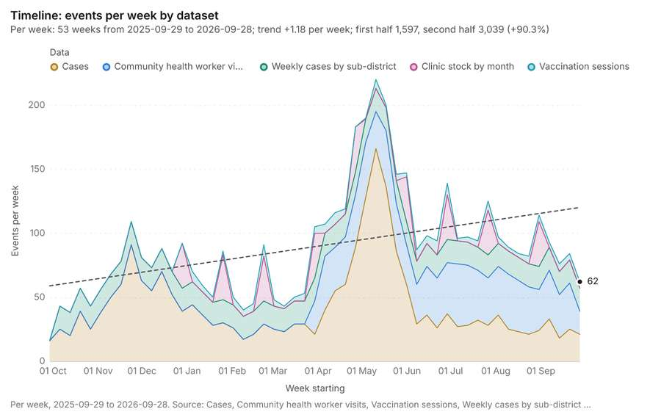
Figure 1. Timeline: events per week by dataset [1]. Per week, 2025-09-29 to 2026-09-28. Source: Cases, Community health worker visits, Vaccination sessions, Weekly cases by sub-district and 1 more (4,741 features). The data is in the appendix.
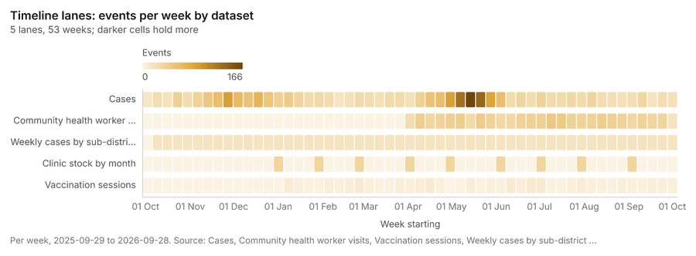
Figure 2. Timeline lanes: events per week by dataset [7]. Per week, 2025-09-29 to 2026-09-28. Source: Cases, Community health worker visits, Vaccination sessions, Weekly cases by sub-district and 1 more (4,741 features). The data is in the appendix.
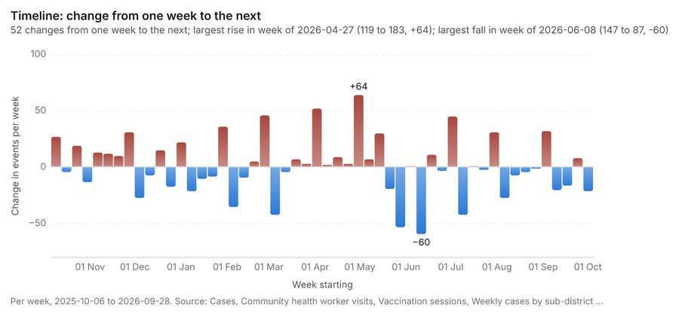
Figure 3. Timeline: change from one week to the next [8]. Per week, 2025-10-06 to 2026-09-28. Source: Cases, Community health worker visits, Vaccination sessions, Weekly cases by sub-district and 1 more (4,741 features). The data is in the appendix.
The timeline counts 4,741 dated events in Cases, Community health worker visits, Vaccination sessions and 2 more per week, from week of 2025-09-29 to week of 2026-09-28 [1][2][3][4][5][6]. By dataset: Cases 2,290; Community health worker visits 1,000; Weekly cases by sub-district 936; Clinic stock by month 315; Vaccination sessions 200 [1][7]. The trend is +1.18 events per week; the second half of the weeks has 3,039 against 1,597 in the first (+90.3%) [1]. Week over week, the largest rise was from week of 2026-04-20 to week of 2026-04-27 (119 to 183, +64) and the largest fall was from week of 2026-06-01 to week of 2026-06-08 (147 to 87, -60) [1][8]. The count fell from 36 in week of 2026-09-21 to 18 in week of 2026-09-28 (-50.0%), beyond what chance would give (p = 0.0198) [9][10]. Between the two, the largest rise was in Riverside sub-district (1 to 3, +2) and the largest fall in Canal Side sub-district (5 to 1, -4) [9][10]. The count fell from 9 in week of 2026-06-29 to 2 in week of 2026-07-06 (-77.8%), within what chance would give (p = 0.0654) [11][12]. Between the two, the largest rise was in Canal Side sub-district (0 to 1, +1) and the largest fall in Fernhill sub-district (2 to 0, -2) [11][12]. The count fell from 136 in week of 2026-05-18 to 86 in week of 2026-05-25 (-36.8%), beyond what chance would give (p = 0.000963) [13][14]. Between the two, the largest rise was in Foundry Row sub-district (5 to 8, +3) and the largest fall in Parkside sub-district (77 to 39, -38) [13][14].
Busiest weeks
- week of 2026-05-11: 220 events [1]
- week of 2026-05-18: 200 events [1]
- week of 2026-05-04: 190 events [1]
Quietest weeks
- week of 2025-09-29: 16 events [1]
- week of 2025-10-13: 38 events [1]
- week of 2026-02-09: 40 events [1]

Overview
Overview: the top 3 results in the report's order, each in one distinct color, over Health sub-districts as context [15].
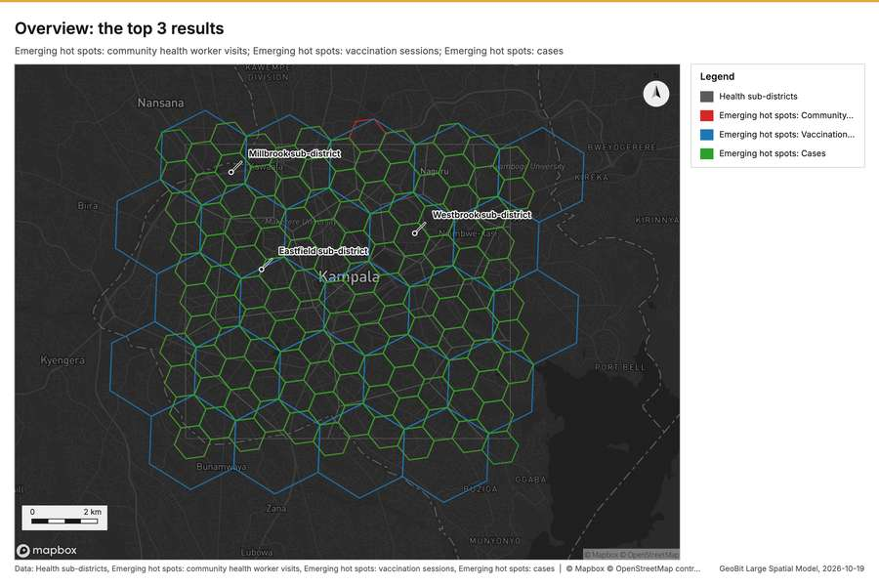
Figure 4. Overview: the top 3 results [15]

Spatial structure
Health sub-districts are 18 areas of 5.004 km2 on average, covering 100 percent of their extent, with no overlap [16]. Cases are clustered (nearest-neighbor ratio 0.90, z = -9.4; features lie 87.9 m apart on average against 98 m if random) [17]. Cases are dated by 'onset_date' from 2025-10-01 to 2026-09-30 at a week grain [17]. Over time the pattern changes: the earlier half is random (ratio 0.9714) and the later half clustered (ratio 0.8894); the center moved 783 m [17]. Clinics are evenly spread (dispersed) (nearest-neighbor ratio 1.58, z = +6.6; features lie 1.115 km apart on average against 705 m if random) [18]. Water points are spread at random (nearest-neighbor ratio 0.96, z = -0.9; features lie 359 m apart on average against 373 m if random) [19]. Community health worker visits are clustered (nearest-neighbor ratio 0.95, z = -3.3; features lie 139 m apart on average against 147 m if random) [20]. Outbreak response teams are evenly spread (dispersed) (nearest-neighbor ratio 1.55, z = +2.6; features lie 1.635 km apart on average against 1.052 km if random) [21]. Vaccination sessions are spread at random (nearest-neighbor ratio 1.00, z = +0.1; features lie 327 m apart on average against 326 m if random) [22]. Vaccination sessions are dated by 'held_on' from 2026-01-05 to 2026-09-29 at a week grain [22]. Over time the pattern changes: the earlier half is random (ratio 1.0941) and the later half dispersed (ratio 1.122); the center moved 259 m [22]. 100 percent of Cases lie inside Health sub-districts (2290 of 2290) [16][17]. 100 percent of Clinics lie inside Health sub-districts (35 of 35) [16][18]. 100 percent of Community health worker visits lie inside Health sub-districts (1000 of 1000) [16][20]. 100 percent of Outbreak response teams lie inside Health sub-districts (6 of 6) [16][21]. 100 percent of Vaccination sessions lie inside Health sub-districts (200 of 200) [16][22]. 100 percent of Water points lie inside Health sub-districts (150 of 150) [16][19]. Outbreak response teams lie 35.3 m from the nearest of Cases (median); 83 percent lie within 100 m [17][21]. Water points lie 71.9 m from the nearest of Cases (median); 71 percent lie within 100 m [17][19]. Community health worker visits lie 77.4 m from the nearest of Cases (median); 62 percent lie within 100 m [17][20]. Vaccination sessions lie 79.5 m from the nearest of Cases (median); 64 percent lie within 100 m [17][22].
Result | Value
layers profiled | 7
clustered point layers | 2
dispersed point layers | 2
random point layers | 2

Findings
- Evidenced: Health sub-districts are 18 areas of 5.004 km2 on average, covering 100 percent of their extent, with no overlap [16].
- Evidenced: Cases are clustered (nearest-neighbor ratio 0.90, z = -9.4; features lie 87.9 m apart on average against 98 m if random) [17].
- Evidenced: Cases are dated by 'onset_date' from 2025-10-01 to 2026-09-30 at a week grain [17].
- Evidenced: Over time the pattern changes: the earlier half is random (ratio 0.9714) and the later half clustered (ratio 0.8894); the center moved 783 m [17].
- Evidenced: Clinics are evenly spread (dispersed) (nearest-neighbor ratio 1.58, z = +6.6; features lie 1.115 km apart on average against 705 m if random) [18].
- Evidenced: Water points are spread at random (nearest-neighbor ratio 0.96, z = -0.9; features lie 359 m apart on average against 373 m if random) [19].
- Evidenced: Community health worker visits are clustered (nearest-neighbor ratio 0.95, z = -3.3; features lie 139 m apart on average against 147 m if random) [20].
- Evidenced: Outbreak response teams are evenly spread (dispersed) (nearest-neighbor ratio 1.55, z = +2.6; features lie 1.635 km apart on average against 1.052 km if random) [21].
- Evidenced: Vaccination sessions are spread at random (nearest-neighbor ratio 1.00, z = +0.1; features lie 327 m apart on average against 326 m if random) [22].
- Evidenced: Vaccination sessions are dated by 'held_on' from 2026-01-05 to 2026-09-29 at a week grain [22].
- Evidenced: Over time the pattern changes: the earlier half is random (ratio 1.0941) and the later half dispersed (ratio 1.122); the center moved 259 m [22].
- Evidenced: 100 percent of Cases lie inside Health sub-districts (2290 of 2290) [16][17].
- Evidenced: 100 percent of Clinics lie inside Health sub-districts (35 of 35) [16][18].
- Evidenced: 100 percent of Community health worker visits lie inside Health sub-districts (1000 of 1000) [16][20].
- Evidenced: 100 percent of Outbreak response teams lie inside Health sub-districts (6 of 6) [16][21].
- Evidenced: 100 percent of Vaccination sessions lie inside Health sub-districts (200 of 200) [16][22].
- Evidenced: 100 percent of Water points lie inside Health sub-districts (150 of 150) [16][19].
- Evidenced: Outbreak response teams lie 35.3 m from the nearest of Cases (median); 83 percent lie within 100 m [17][21].
- Evidenced: Water points lie 71.9 m from the nearest of Cases (median); 71 percent lie within 100 m [17][19].
- Evidenced: Community health worker visits lie 77.4 m from the nearest of Cases (median); 62 percent lie within 100 m [17][20].
- Evidenced: Vaccination sessions lie 79.5 m from the nearest of Cases (median); 64 percent lie within 100 m [17][22].

Space time hot spots
What this analysis is. Emerging hot spots: Where hot spots are new, consecutive, intensifying, persistent, diminishing, sporadic, oscillating or historical over time [23]. In ArcGIS it is Emerging Hot Spot Analysis or Create Space Time Cube [23].
Why it was run on this data. Community health worker visits carry dates in 'visited_at': emerging hot spot analysis finds new, intensifying and fading hot spots per week [24].
What it found. Space time hot spots on Community health worker visits: Emerging hot spots: 1 layer saved: Emerging hot spots: Community health worker visits (124 features) [20][25]. It reported result, count 124; result, elapsed ms 17; result, resolution 8; result, features used 1,000; result, time neighbors 0; billing, cost 0.15 [25].
Result | Value
result, count | 124
result, elapsed ms | 17
result, resolution | 8
result, features used | 1,000
result, time neighbors | 0
billing, cost | 0.15
billing, list price | 0.15
billing, upstream cost | 0

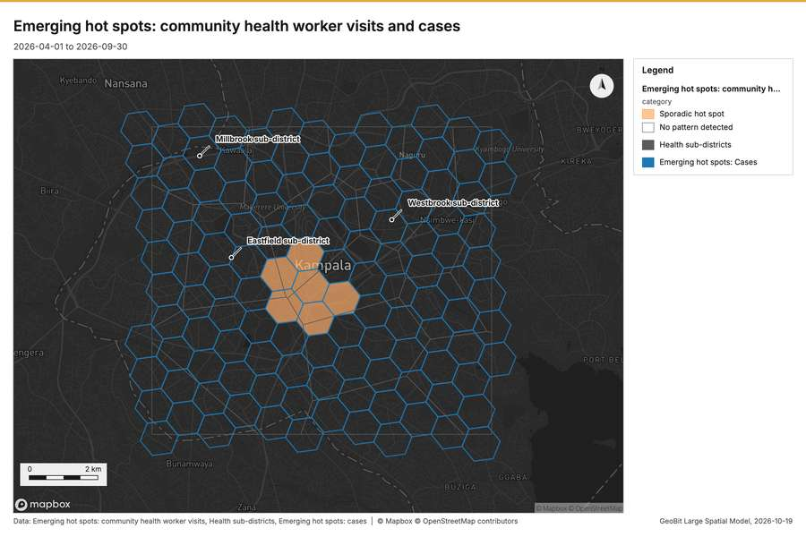
Figure 5. Emerging hot spots: community health worker visits and cases [26]
What the map shows. The map draws Emerging hot spots: community health worker visits by category in 2 classes: Sporadic hot spot, No pattern detected [26]. The map draws Health sub-districts with one symbol [26]. The map draws Emerging hot spots: cases with one symbol [26]. It draws 267 features [26]. It covers longitude 32.5 to 32.661 and latitude 0.252 to 0.372, at about 1:74,770 [26].
Findings
- Evidenced: Space time hot spots on Community health worker visits: Emerging hot spots: 1 layer saved: Emerging hot spots: Community health worker visits (124 features) [20][25].
- Evidenced: It reported result, count 124; result, elapsed ms 17; result, resolution 8; result, features used 1,000; result, time neighbors 0; billing, cost 0.15 [25].
Tool gp_space_time_hot_spots; parameters {"project": "2612067c-badd-4310-9678-8f580d5e3d32", "features": {"layer": "Community health worker visits (4d70d1ce)"}, "interval": "week", "bin_shape": "h3", "resolution": 8, "time_field": "visited_at"}

Space time hot spots
What this analysis is. Emerging hot spots: Where hot spots are new, consecutive, intensifying, persistent, diminishing, sporadic, oscillating or historical over time [23]. In ArcGIS it is Emerging Hot Spot Analysis or Create Space Time Cube [23].
Why it was run on this data. Vaccination sessions carry dates in 'held_on': emerging hot spot analysis finds new, intensifying and fading hot spots per week [27]. Measured: the pattern of Vaccination sessions changes over time (earlier half random, later half dispersed; the center moved 259 m) [27].
What it found. The analysis of vaccination sessions using the `gp_space_time_hot_spots` tool resulted in the generation of 24 features, saving the output as "Emerging hot spots: Vaccination sessions" [28]. This computation had an elapsed time of 5 milliseconds [28]. The process utilized 200 features and had a resolution of 7 [28]. The total cost incurred for this operation was 0.11 [28].
Result | Value
result, count | 24
result, elapsed ms | 5
result, resolution | 7
result, features used | 200
result, time neighbors | 0
billing, cost | 0.11
billing, list price | 0.11
billing, upstream cost | 0

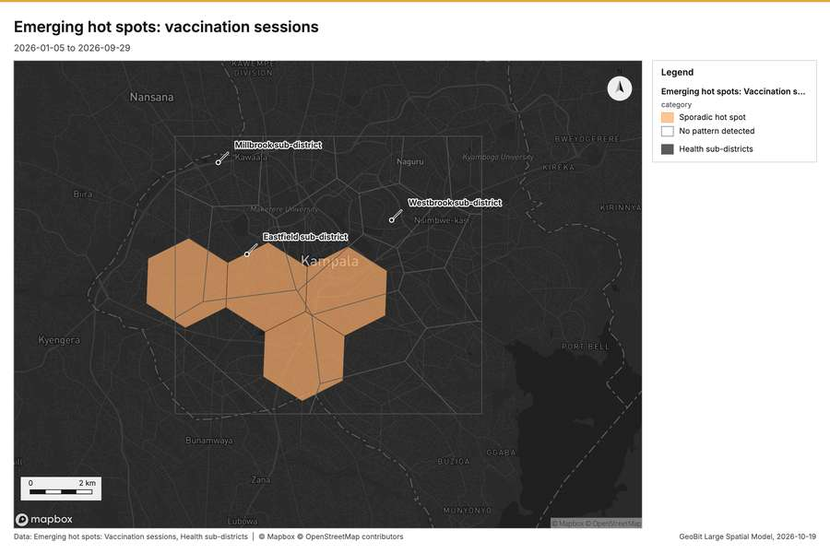
Figure 6. Emerging hot spots: vaccination sessions [29]
What the map shows. The map draws Emerging hot spots: Vaccination sessions by category in 2 classes: Sporadic hot spot, No pattern detected [29]. The map draws Health sub-districts with one symbol [29]. It draws 42 features [29]. It covers longitude 32.489 to 32.673 and latitude 0.239 to 0.376, at about 1:85,295 [29].
Findings
- Evidenced: Space time hot spots on Vaccination sessions: Emerging hot spots: 1 layer saved: Emerging hot spots: Vaccination sessions (24 features) [22][28].
- Evidenced: It reported result, count 24; result, elapsed ms 5; result, resolution 7; result, features used 200; result, time neighbors 0; billing, cost 0.11 [28].
Tool gp_space_time_hot_spots; parameters {"project": "2612067c-badd-4310-9678-8f580d5e3d32", "features": {"layer": "Vaccination sessions (6798c97c)"}, "interval": "week", "bin_shape": "h3", "resolution": 7, "time_field": "held_on"}

Space time hot spots
What this analysis is. Emerging hot spots: Where hot spots are new, consecutive, intensifying, persistent, diminishing, sporadic, oscillating or historical over time [23]. In ArcGIS it is Emerging Hot Spot Analysis or Create Space Time Cube [23].
Why it was run on this data. Cases carry dates in 'onset_date': emerging hot spot analysis finds new, intensifying and fading hot spots per week [30]. Measured: the pattern of Cases changes over time (earlier half random, later half clustered; the center moved 783 m) [30].
What it found. Space time hot spots on Cases: Emerging hot spots: 1 layer saved: Emerging hot spots: Cases (125 features) [17][31]. It reported result, count 125; result, elapsed ms 26; result, resolution 8; result, features used 2,290; result, time neighbors 0; billing, cost 0.2145 [31].
Result | Value
result, count | 125
result, elapsed ms | 26
result, resolution | 8
result, features used | 2,290
result, time neighbors | 0
billing, cost | 0.2145
billing, list price | 0.2145
billing, upstream cost | 0

What the map shows. Drawn with space time hot spots on the map Emerging hot spots: community health worker visits and cases [26].
Findings
- Evidenced: Space time hot spots on Cases: Emerging hot spots: 1 layer saved: Emerging hot spots: Cases (125 features) [17][31].
- Evidenced: It reported result, count 125; result, elapsed ms 26; result, resolution 8; result, features used 2,290; result, time neighbors 0; billing, cost 0.2145 [31].
Tool gp_space_time_hot_spots; parameters {"project": "2612067c-badd-4310-9678-8f580d5e3d32", "features": {"layer": "Cases (03c8f72b)"}, "interval": "week", "bin_shape": "h3", "resolution": 8, "time_field": "onset_date"}

Hot spots
What this analysis is. Hot spot analysis: Getis-Ord Gi* hot and cold spots with z-scores, p-values and confidence bins [32]. In ArcGIS it is Find Hot Spots or Hot Spot Analysis (Getis-Ord Gi*); in QGIS, qgis:hotspot (plugin) [32].
Why it was run on this data. 1000 points: Getis-Ord Gi* tests whether the concentrations in Community health worker visits are statistically significant [33]. Measured: Community health worker visits are clustered (nearest-neighbor ratio 0.95, z = -3.3), median spacing 124 m [33]. Cells of 500 m and a band of 1000 m from the measured spacing [33].
What it found. Hot spots on Community health worker visits: Hot spot analysis: 1 layer saved: Hot spot analysis: Community health worker visits (390 features) [20][34]. It reported result, bins 390; result, count 390; result, elapsed ms 17; result, cell size m 500; result, incidents used 1,000; result, distance band m 1,000 [34].
Result | Value
result, bins | 390
result, count | 390
result, elapsed ms | 17
result, cell size m | 500
result, incidents used | 1,000
result, distance band m | 1,000
billing, cost | 0.07
billing, list price | 0.07
billing, upstream cost | 0

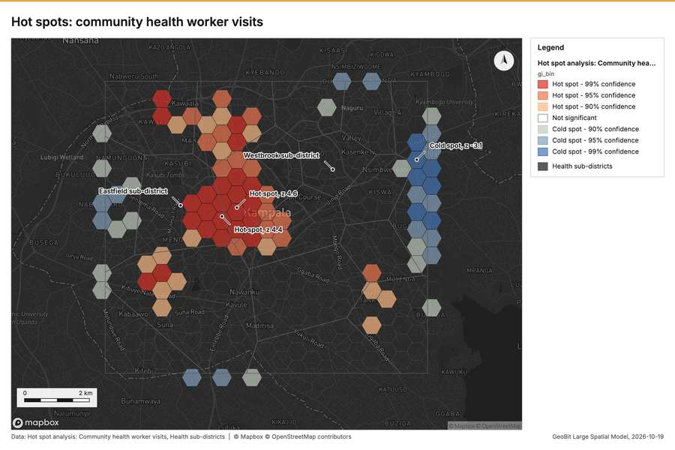
Figure 7. Hot spots: community health worker visits [35]
What the map shows. The map draws Hot spot analysis: Community health worker visits by gi_bin in 7 classes: Hot spot - 99% confidence, Hot spot - 95% confidence, Hot spot - 90% confidence, Not significant, Cold spot - 90% confidence, Cold spot - 95% confidence and 1 more [35]. The map draws Health sub-districts with one symbol [35]. It draws 408 features [35]. It covers longitude 32.51 to 32.652 and latitude 0.257 to 0.366, at about 1:66,000 [35].
Findings
- Evidenced: Hot spots on Community health worker visits: Hot spot analysis: 1 layer saved: Hot spot analysis: Community health worker visits (390 features) [20][34].
- Evidenced: It reported result, bins 390; result, count 390; result, elapsed ms 17; result, cell size m 500; result, incidents used 1,000; result, distance band m 1,000 [34].
Tool gp_hot_spots; parameters {"project": "2612067c-badd-4310-9678-8f580d5e3d32", "features": {"layer": "Community health worker visits (4d70d1ce)"}, "aggregation": "hexagon", "cell_size_m": 500.0, "distance_band_m": 1000.0}

Hot spots
What this analysis is. Hot spot analysis: Getis-Ord Gi* hot and cold spots with z-scores, p-values and confidence bins [32]. In ArcGIS it is Find Hot Spots or Hot Spot Analysis (Getis-Ord Gi*); in QGIS, qgis:hotspot (plugin) [32].
Why it was run on this data. 2290 points: Getis-Ord Gi* tests whether the concentrations in Cases are statistically significant [36]. Measured: Cases are clustered (nearest-neighbor ratio 0.90, z = -9.4), median spacing 75.6 m [36]. Cells of 200 m and a band of 500 m from the measured spacing [36].
What it found. Hot spots on Cases: Hot spot analysis: 1 layer saved: Hot spot analysis: Cases (2259 features) [17][37]. It reported result, bins 2,259; result, count 2,259; result, elapsed ms 75; result, cell size m 200; result, incidents used 2,290; result, distance band m 500 [37].
Result | Value
result, bins | 2,259
result, count | 2,259
result, elapsed ms | 75
result, cell size m | 200
result, incidents used | 2,290
result, distance band m | 500
billing, cost | 0.0958
billing, list price | 0.0958
billing, upstream cost | 0

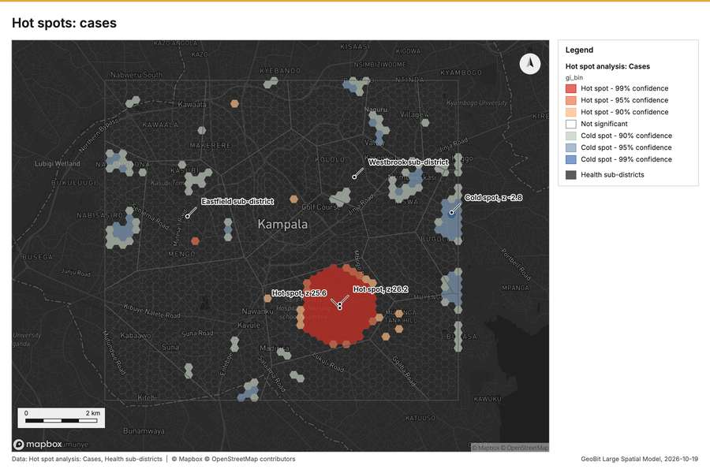
Figure 8. Hot spots: cases [38]
What the map shows. The map draws Hot spot analysis: Cases by gi_bin in 7 classes: Hot spot - 99% confidence, Hot spot - 95% confidence, Hot spot - 90% confidence, Not significant, Cold spot - 90% confidence, Cold spot - 95% confidence and 1 more [38]. The map draws Health sub-districts with one symbol [38]. It draws 2,277 features [38]. It covers longitude 32.512 to 32.649 and latitude 0.26 to 0.365, at about 1:63,311 [38].
Findings
- Evidenced: Hot spots on Cases: Hot spot analysis: 1 layer saved: Hot spot analysis: Cases (2259 features) [17][37].
- Evidenced: It reported result, bins 2,259; result, count 2,259; result, elapsed ms 75; result, cell size m 200; result, incidents used 2,290; result, distance band m 500 [37].
Tool gp_hot_spots; parameters {"project": "2612067c-badd-4310-9678-8f580d5e3d32", "features": {"layer": "Cases (03c8f72b)"}, "aggregation": "hexagon", "cell_size_m": 200.0, "distance_band_m": 500.0}

Hot spots
What this analysis is. Hot spot analysis: Getis-Ord Gi* hot and cold spots with z-scores, p-values and confidence bins [32]. In ArcGIS it is Find Hot Spots or Hot Spot Analysis (Getis-Ord Gi*); in QGIS, qgis:hotspot (plugin) [32].
Why it was run on this data. 200 points: Getis-Ord Gi* tests whether the concentrations in Vaccination sessions are statistically significant [39].
What it found. Hot spots on Vaccination sessions: Hot spot analysis: 1 layer saved: Hot spot analysis: Vaccination sessions (99 features) [22][40]. It reported result, bins 99; result, count 99; result, elapsed ms 5; result, cell size m 1,000; result, incidents used 200; result, distance band m 2,000 [40].
Result | Value
result, bins | 99
result, count | 99
result, elapsed ms | 5
result, cell size m | 1,000
result, incidents used | 200
result, distance band m | 2,000
billing, cost | 0.054
billing, list price | 0.054
billing, upstream cost | 0

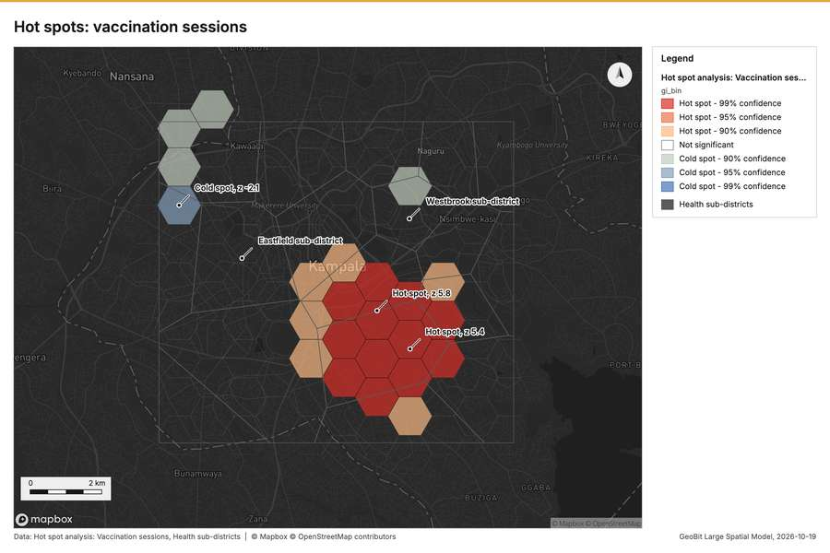
Figure 9. Hot spots: vaccination sessions [41]
What the map shows. The map draws Hot spot analysis: Vaccination sessions by gi_bin in 7 classes: Hot spot - 99% confidence, Hot spot - 95% confidence, Hot spot - 90% confidence, Not significant, Cold spot - 90% confidence, Cold spot - 95% confidence and 1 more [41]. The map draws Health sub-districts with one symbol [41]. It draws 117 features [41]. It covers longitude 32.499 to 32.659 and latitude 0.251 to 0.373, at about 1:73,740 [41].
Findings
- Evidenced: Hot spots on Vaccination sessions: Hot spot analysis: 1 layer saved: Hot spot analysis: Vaccination sessions (99 features) [22][40].
- Evidenced: It reported result, bins 99; result, count 99; result, elapsed ms 5; result, cell size m 1,000; result, incidents used 200; result, distance band m 2,000 [40].
Tool gp_hot_spots; parameters {"project": "2612067c-badd-4310-9678-8f580d5e3d32", "features": {"layer": "Vaccination sessions (6798c97c)"}, "aggregation": "hexagon", "cell_size_m": 1000.0, "distance_band_m": 2000.0}

Summarize within
What this analysis is. Summarize within: Count and aggregate the features inside each polygon (or bin), proportionally for lines and polygons [42]. In ArcGIS it is Summarize Within or Aggregate Points; in QGIS, native:countpointsinpolygon or native:sumlinelengths [42].
Why it was run on this data. Count Community health worker visits inside each feature of Health sub-districts by purpose; the counts map as a choropleth (natural breaks, sequential colors) [43].
What it found. Summarize within on Community health worker visits, Health sub-districts: Summarize within: 1 layer saved: Summarize within: Health sub-districts (18 features) [16][20][44]. It reported result, count 18; result, elapsed ms 2; billing, cost 0.03036; billing, list price 0.03036; billing, upstream cost 0 [44].
Result | Value
result, count | 18
result, elapsed ms | 2
billing, cost | 0.03036
billing, list price | 0.03036
billing, upstream cost | 0

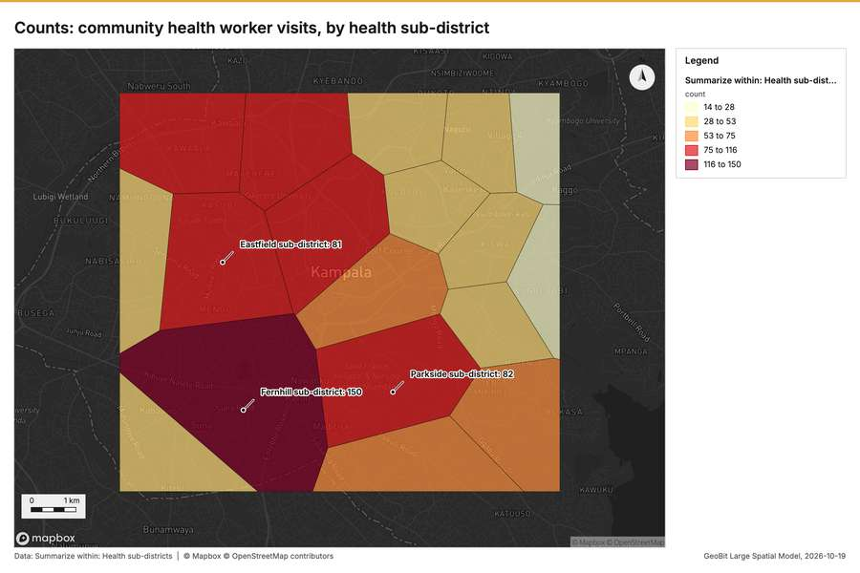
Figure 10. Counts: community health worker visits, by health sub-district [45]
What the map shows. The map draws Summarize within: Health sub-districts by count in 5 classes: 14 to 28, 28 to 53, 53 to 75, 75 to 116, 116 to 150 [45]. It draws 18 features [45]. It covers longitude 32.515 to 32.648 and latitude 0.261 to 0.363, at about 1:61,580 [45].
Findings
- Evidenced: Summarize within on Community health worker visits, Health sub-districts: Summarize within: 1 layer saved: Summarize within: Health sub-districts (18 features) [16][20][44].
- Evidenced: It reported result, count 18; result, elapsed ms 2; billing, cost 0.03036; billing, list price 0.03036; billing, upstream cost 0 [44].
Tool gp_summarize_within; parameters {"stats": [], "project": "2612067c-badd-4310-9678-8f580d5e3d32", "features": {"layer": "Community health worker visits (4d70d1ce)"}, "group_by": "purpose", "polygons": {"layer": "Health sub-districts (433b88cc)"}}

Summarize within
What this analysis is. Summarize within: Count and aggregate the features inside each polygon (or bin), proportionally for lines and polygons [42]. In ArcGIS it is Summarize Within or Aggregate Points; in QGIS, native:countpointsinpolygon or native:sumlinelengths [42].
Why it was run on this data. Count Community health worker visits inside each feature of Health sub-districts by purpose; the counts map as a choropleth (natural breaks, sequential colors) [43].
What it found. Summarize within on Vaccination sessions, Health sub-districts: Summarize within: 1 layer saved: Summarize within: Health sub-districts (18 features) [16][22][46]. It reported result, count 18; result, elapsed ms 0; billing, cost 0.01438; billing, list price 0.01438; billing, upstream cost 0 [46].
Result | Value
result, count | 18
result, elapsed ms | 0
billing, cost | 0.01438
billing, list price | 0.01438
billing, upstream cost | 0

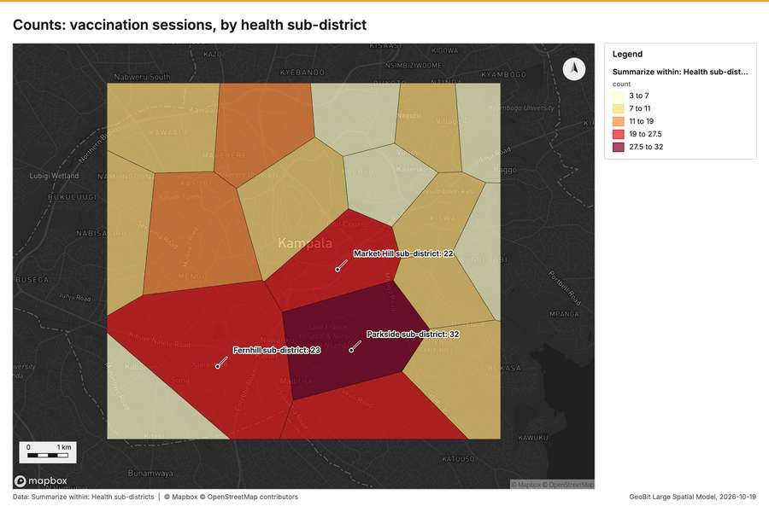
Figure 11. Counts: vaccination sessions, by health sub-district [47]
What the map shows. The map draws Summarize within: Health sub-districts by count in 5 classes: 3 to 7, 7 to 11, 11 to 19, 19 to 27.5, 27.5 to 32 [47]. It draws 18 features [47]. It covers longitude 32.515 to 32.648 and latitude 0.261 to 0.363, at about 1:61,580 [47].
Findings
- Evidenced: Summarize within on Vaccination sessions, Health sub-districts: Summarize within: 1 layer saved: Summarize within: Health sub-districts (18 features) [16][22][46].
- Evidenced: It reported result, count 18; result, elapsed ms 0; billing, cost 0.01438; billing, list price 0.01438; billing, upstream cost 0 [46].
Tool gp_summarize_within; parameters {"stats": [{"stat": "sum", "field": "doses"}], "project": "2612067c-badd-4310-9678-8f580d5e3d32", "features": {"layer": "Vaccination sessions (6798c97c)"}, "group_by": "vaccine", "polygons": {"layer": "Health sub-districts (433b88cc)"}}

Summarize within
What this analysis is. Summarize within: Count and aggregate the features inside each polygon (or bin), proportionally for lines and polygons [42]. In ArcGIS it is Summarize Within or Aggregate Points; in QGIS, native:countpointsinpolygon or native:sumlinelengths [42].
Why it was run on this data. Count Community health worker visits inside each feature of Health sub-districts by purpose; the counts map as a choropleth (natural breaks, sequential colors) [43].
What it found. The `gp_summarize_within` function summarized Health sub-districts, which contained 18 features [48].
Result | Value
result, count | 18
result, elapsed ms | 3
billing, cost | 0.05616
billing, list price | 0.05616
billing, upstream cost | 0

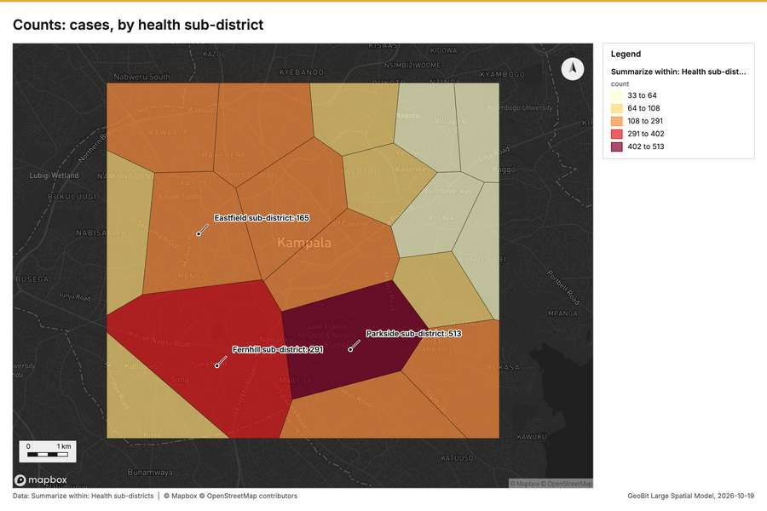
Figure 12. Counts: cases, by health sub-district [49]
What the map shows. The map draws Summarize within: Health sub-districts by count in 5 classes: 33 to 64, 64 to 108, 108 to 291, 291 to 402, 402 to 513 [49]. It draws 18 features [49]. It covers longitude 32.515 to 32.648 and latitude 0.261 to 0.363, at about 1:61,580 [49].
Findings
- Evidenced: Summarize within on Cases, Health sub-districts: Summarize within: 1 layer saved: Summarize within: Health sub-districts (18 features) [16][17][48].
- Evidenced: It reported result, count 18; result, elapsed ms 3; billing, cost 0.05616; billing, list price 0.05616; billing, upstream cost 0 [48].
Tool gp_summarize_within; parameters {"stats": [], "project": "2612067c-badd-4310-9678-8f580d5e3d32", "features": {"layer": "Cases (03c8f72b)"}, "group_by": "disease", "polygons": {"layer": "Health sub-districts (433b88cc)"}}

Period change
What this analysis is. Period change: Counts or sums per period (week over week, month over month, any two periods, or before and after a date), per area, per H3 cell or in total, with the places of largest rise and fall and a significance note [50]. In ArcGIS it is Summarize Percent Change (Crime Analysis) or Change Point Detection [50].
Why it was run on this data. Community health worker visits carry dates in 'visited_at' over 26 weeks: the count per week, week over week, with the places of largest rise and fall per feature of Health sub-districts and whether the change is beyond chance [51].
What it found. Period change on Health sub-districts, Community health worker visits produced Period change: Community health worker visits (week of 2026-09-21 to week of 2026-09-28) (14 features) [9][10][16][20]. Community health worker visits: count per week shows a trend of -0.0873 per week; the second half of its weeks has 488 against 472 in the first (+3.4%) [53]. The chart Community health worker visits: week of 2026-09-21 to week of 2026-09-28 by place is drawn from 28 rows [54]. The chart Period change: Community health worker visits (week of 2026-09-21 to week of 2026-09-28) is drawn from 5 rows [55].
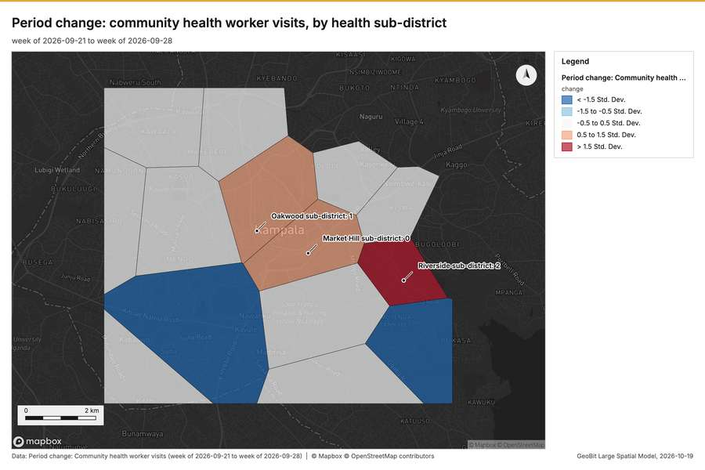
Figure 13. Period change: community health worker visits, by health sub-district [52]
What the map shows. The map draws Period change: Community health worker visits (week of 2026-09-21 to week of 2026-09-28) by change in 5 classes: < -1.5 Std; Dev, -1.5 to -0.5 Std; Dev, -0.5 to 0.5 Std; Dev, 0.5 to 1.5 Std; Dev, > 1.5 Std; Dev [52]. It draws 14 features [52]. It covers longitude 32.512 to 32.65 and latitude 0.261 to 0.364, at about 1:63,751 [52].
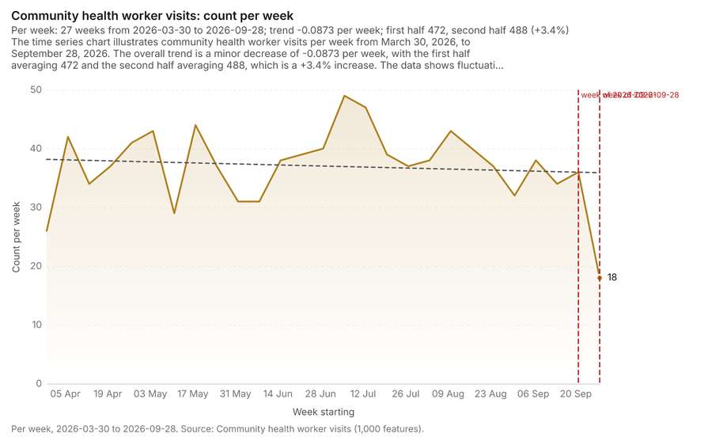
Figure 14. Community health worker visits: count per week [53]. Per week, 2026-03-30 to 2026-09-28. Source: Community health worker visits (1,000 features). The data is in the appendix.
What the chart shows. The time series chart illustrates community health worker visits per week from March 30, 2026, to September 28, 2026 [53]. The overall trend is a minor decrease of -0.0873 per week, with the first half averaging 472 and the second half averaging 488, which is a +3.4% increase [53]. The data shows fluctuations throughout the period, with the count reaching a peak of approximately 48 around the week of July 6 and a noticeable drop to 18 in the final week of September 28 [53]. The analysis highlights a specific fall from 36 in the week of September 21 to 18 in the week of September 28 (a -50.0% change), which is stated as unlikely to be chance (p = 0.0198) [53].
Inferred: read from the image by gemma4:e4b, not evidence.
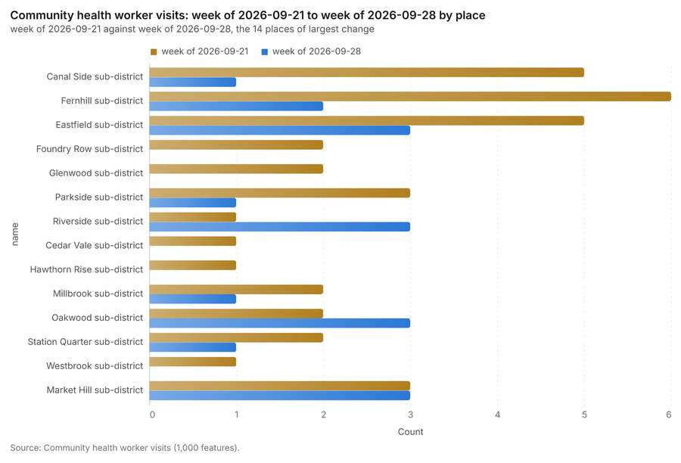
Figure 15. Community health worker visits: week of 2026-09-21 to week of 2026-09-28 by place [54]. Source: Community health worker visits (1,000 features). The data is in the appendix.
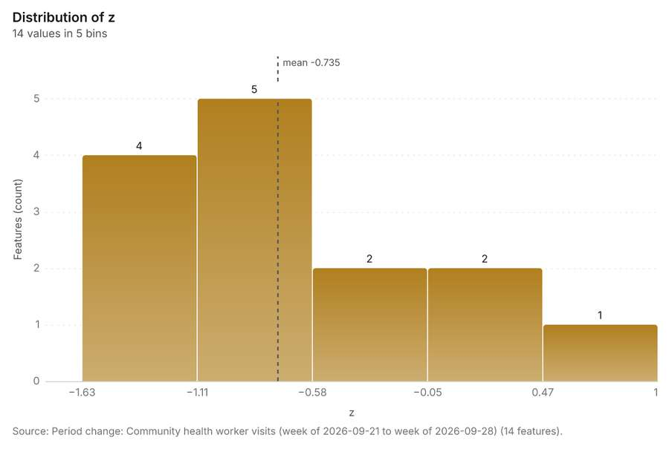
Figure 16. Period change: Community health worker visits (week of 2026-09-21 to week of 2026-09-28) [55]. Source: Period change: Community health worker visits (week of 2026-09-21 to week of 2026-09-28) (14 features). The data is in the appendix.
Findings
- Evidenced: Period change on Health sub-districts, Community health worker visits produced Period change: Community health worker visits (week of 2026-09-21 to week of 2026-09-28) (14 features) [9][10][16][20].
- Evidenced: Community health worker visits: count per week shows a trend of -0.0873 per week; the second half of its weeks has 488 against 472 in the first (+3.4%) [53].
- Evidenced: The chart Community health worker visits: week of 2026-09-21 to week of 2026-09-28 by place is drawn from 28 rows [54].
- Evidenced: The chart Period change: Community health worker visits (week of 2026-09-21 to week of 2026-09-28) is drawn from 5 rows [55].
Tool gp_period_change; parameters {"by": "area", "areas": {"layer": "Health sub-districts (433b88cc)"}, "period": "week", "project": "2612067c-badd-4310-9678-8f580d5e3d32", "features": {"layer": "Community health worker visits (4d70d1ce)"}, "area_field": "name", "time_field": "visited_at"}

Period change
What this analysis is. Period change: Counts or sums per period (week over week, month over month, any two periods, or before and after a date), per area, per H3 cell or in total, with the places of largest rise and fall and a significance note [50]. In ArcGIS it is Summarize Percent Change (Crime Analysis) or Change Point Detection [50].
Why it was run on this data. Community health worker visits carry dates in 'visited_at' over 26 weeks: the count per week, week over week, with the places of largest rise and fall per feature of Health sub-districts and whether the change is beyond chance [51].
What it found. Period change on Health sub-districts, Vaccination sessions produced Period change: Vaccination sessions (week of 2026-06-29 to week of 2026-07-06) (10 features) [11][12][16][22]. Vaccination sessions: count per week shows a trend of -0.00587 per week; the second half of its weeks has 103 against 95 in the first (+8.4%) [57]. The chart Vaccination sessions: week of 2026-06-29 to week of 2026-07-06 by place is drawn from 20 rows [58]. The chart Period change: Vaccination sessions (week of 2026-06-29 to week of 2026-07-06) is drawn from 5 rows [59].
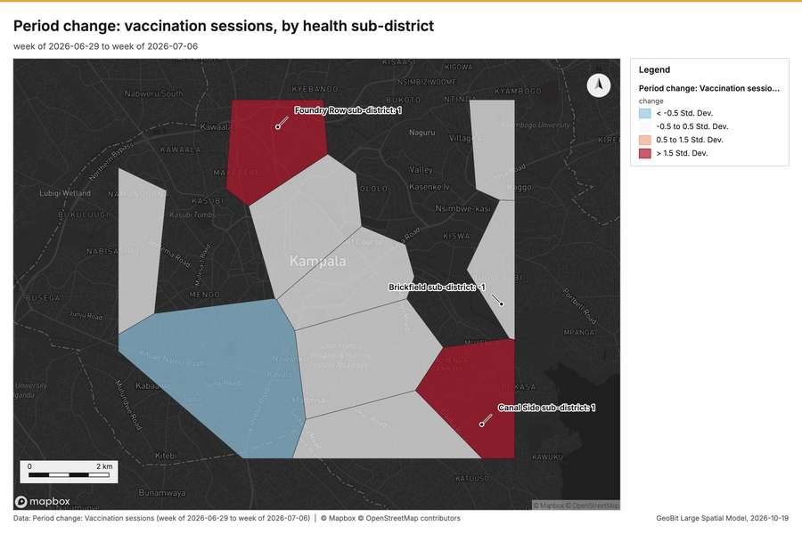
Figure 17. Period change: vaccination sessions, by health sub-district [56]
What the map shows. The map draws Period change: Vaccination sessions (week of 2026-06-29 to week of 2026-07-06) by change in 4 classes: < -0.5 Std; Dev, -0.5 to 0.5 Std; Dev, 0.5 to 1.5 Std; Dev, > 1.5 Std; Dev [56]. It draws 10 features [56]. It covers longitude 32.512 to 32.65 and latitude 0.261 to 0.364, at about 1:63,751 [56].
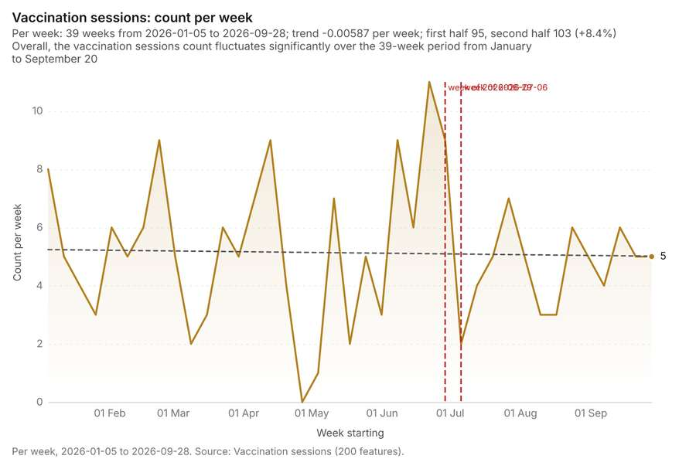
Figure 18. Vaccination sessions: count per week [57]. Per week, 2026-01-05 to 2026-09-28. Source: Vaccination sessions (200 features). The data is in the appendix.
What the chart shows. Overall, the vaccination sessions count fluctuates significantly over the 39-week period from January to September 20 [57].
Inferred: read from the image by gemma4:e4b, not evidence.
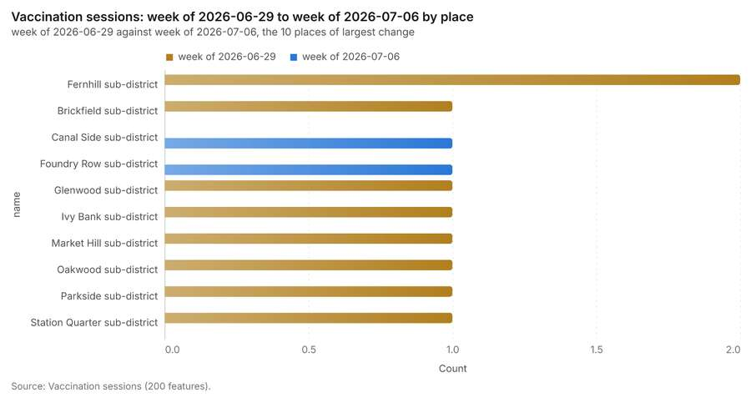
Figure 19. Vaccination sessions: week of 2026-06-29 to week of 2026-07-06 by place [58]. Source: Vaccination sessions (200 features). The data is in the appendix.
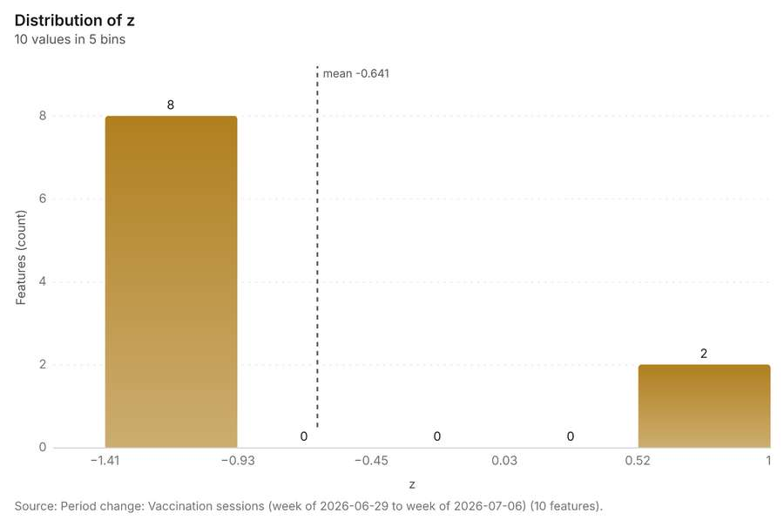
Figure 20. Period change: Vaccination sessions (week of 2026-06-29 to week of 2026-07-06) [59]. Source: Period change: Vaccination sessions (week of 2026-06-29 to week of 2026-07-06) (10 features). The data is in the appendix.
Findings
- Evidenced: Period change on Health sub-districts, Vaccination sessions produced Period change: Vaccination sessions (week of 2026-06-29 to week of 2026-07-06) (10 features) [11][12][16][22].
- Evidenced: Vaccination sessions: count per week shows a trend of -0.00587 per week; the second half of its weeks has 103 against 95 in the first (+8.4%) [57].
- Evidenced: The chart Vaccination sessions: week of 2026-06-29 to week of 2026-07-06 by place is drawn from 20 rows [58].
- Evidenced: The chart Period change: Vaccination sessions (week of 2026-06-29 to week of 2026-07-06) is drawn from 5 rows [59].
Tool gp_period_change; parameters {"by": "area", "areas": {"layer": "Health sub-districts (433b88cc)"}, "period": "week", "project": "2612067c-badd-4310-9678-8f580d5e3d32", "features": {"layer": "Vaccination sessions (6798c97c)"}, "area_field": "name", "time_field": "held_on"}

Period change
What this analysis is. Period change: Counts or sums per period (week over week, month over month, any two periods, or before and after a date), per area, per H3 cell or in total, with the places of largest rise and fall and a significance note [50]. In ArcGIS it is Summarize Percent Change (Crime Analysis) or Change Point Detection [50].
Why it was run on this data. Community health worker visits carry dates in 'visited_at' over 26 weeks: the count per week, week over week, with the places of largest rise and fall per feature of Health sub-districts and whether the change is beyond chance [51].
What it found. Period change on Health sub-districts, Cases produced Period change: Cases (week of 2026-05-18 to week of 2026-05-25) (18 features) [13][14][16][17]. Cases: count per week shows a trend of -0.115 per week; the second half of its weeks has 1,289 against 980 in the first (+31.5%) [61]. The chart Cases: week of 2026-05-18 to week of 2026-05-25 by place is drawn from 30 rows [62]. The chart Period change: Cases (week of 2026-05-18 to week of 2026-05-25) is drawn from 6 rows [63].
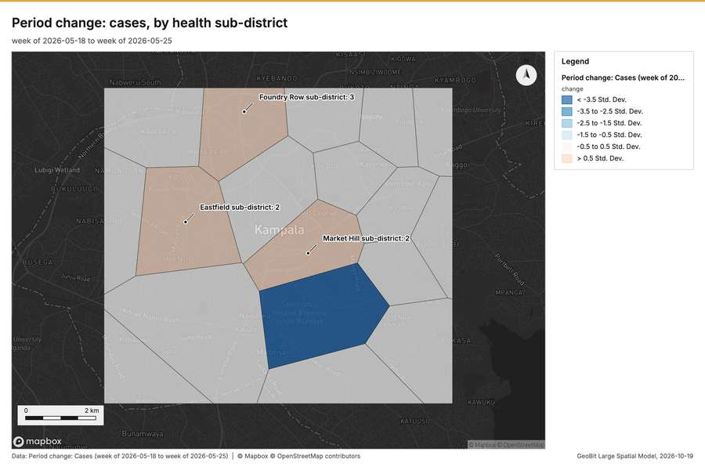
Figure 21. Period change: cases, by health sub-district [60]
What the map shows. The map draws Period change: Cases (week of 2026-05-18 to week of 2026-05-25) by change in 6 classes: < -3.5 Std; Dev, -3.5 to -2.5 Std; Dev, -2.5 to -1.5 Std; Dev, -1.5 to -0.5 Std; Dev, -0.5 to 0.5 Std; Dev, > 0.5 Std; Dev [60]. It draws 18 features [60]. It covers longitude 32.512 to 32.65 and latitude 0.261 to 0.364, at about 1:63,751 [60].
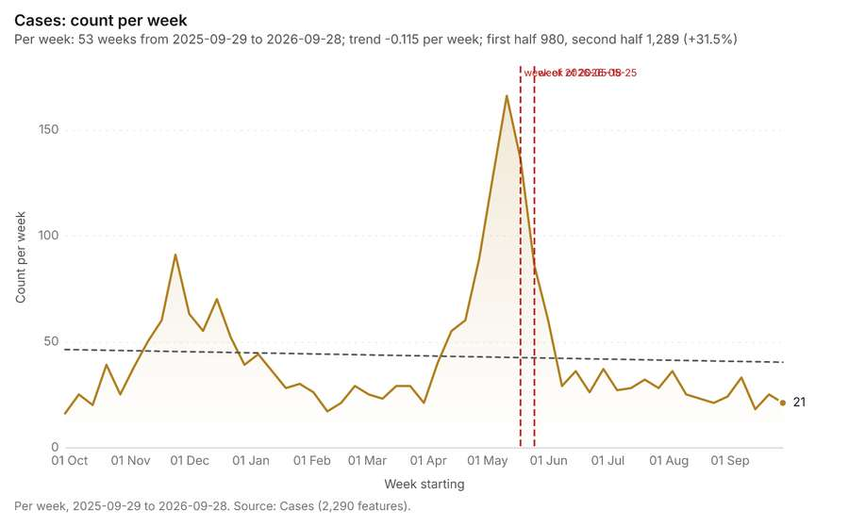
Figure 22. Cases: count per week [61]. Per week, 2025-09-29 to 2026-09-28. Source: Cases (2,290 features). The data is in the appendix.
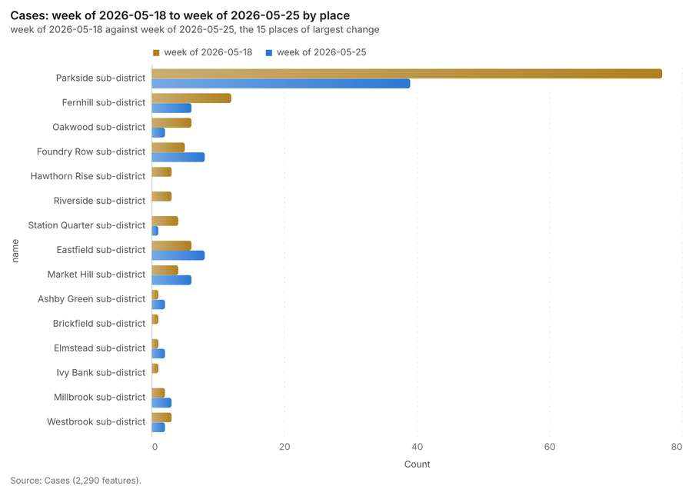
Figure 23. Cases: week of 2026-05-18 to week of 2026-05-25 by place [62]. Source: Cases (2,290 features). The data is in the appendix.
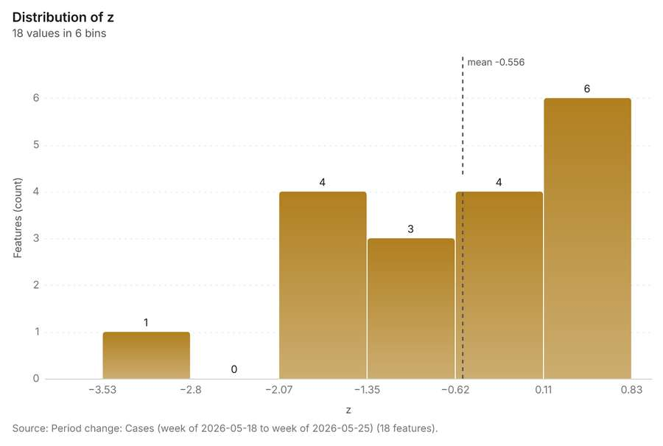
Figure 24. Period change: Cases (week of 2026-05-18 to week of 2026-05-25) [63]. Source: Period change: Cases (week of 2026-05-18 to week of 2026-05-25) (18 features). The data is in the appendix.
Findings
- Evidenced: Period change on Health sub-districts, Cases produced Period change: Cases (week of 2026-05-18 to week of 2026-05-25) (18 features) [13][14][16][17].
- Evidenced: Cases: count per week shows a trend of -0.115 per week; the second half of its weeks has 1,289 against 980 in the first (+31.5%) [61].
- Evidenced: The chart Cases: week of 2026-05-18 to week of 2026-05-25 by place is drawn from 30 rows [62].
- Evidenced: The chart Period change: Cases (week of 2026-05-18 to week of 2026-05-25) is drawn from 6 rows [63].
Tool gp_period_change; parameters {"by": "area", "areas": {"layer": "Health sub-districts (433b88cc)"}, "period": "week", "project": "2612067c-badd-4310-9678-8f580d5e3d32", "features": {"layer": "Cases (03c8f72b)"}, "area_field": "name", "time_field": "onset_date"}

Calculate density
What this analysis is. Calculate density: Kernel density per square kilometer on a grid [64]. In ArcGIS it is Calculate Density or Kernel Density; in QGIS, native:heatmapkerneldensityestimation [64].
Why it was run on this data. 1000 points in Community health worker visits: a density surface shows where they concentrate [65]. Measured: Community health worker visits are clustered (nearest-neighbor ratio 0.95, z = -3.3), median spacing 124 m [65].
What it found. Calculate density on Community health worker visits: Calculate density: 1 layer saved: Calculate density: Community health worker visits (2452 features) [20][66]. It reported result, count 2,452; result, elapsed ms 43; result, bandwidth m 500; result, cell size m 200; result, excluded null 0; result, max density per km2 34.43 [66].
Result | Value
result, count | 2,452
result, elapsed ms | 43
result, bandwidth m | 500
result, cell size m | 200
result, excluded null | 0
result, max density per km2 | 34.43
billing, cost | 0.07
billing, list price | 0.07
billing, upstream cost | 0

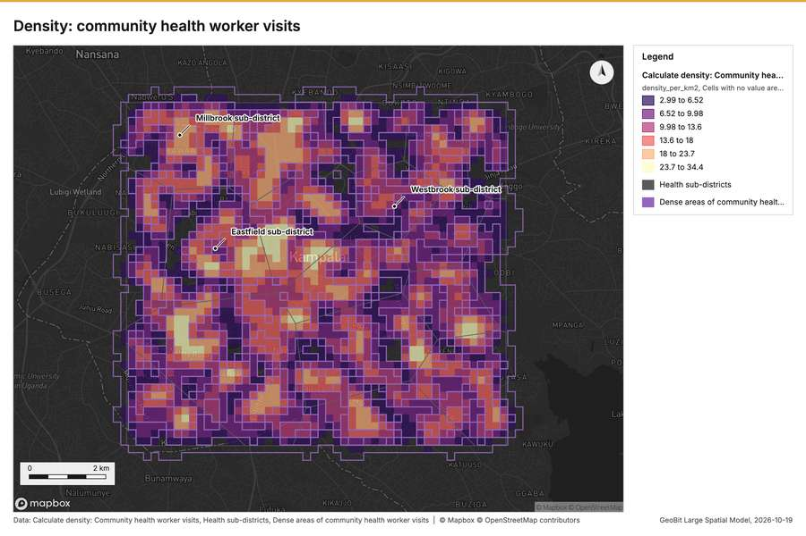
Figure 25. Density: community health worker visits [67]
What the map shows. The map draws Calculate density: Community health worker visits by density_per_km2 in 6 classes: 2.99 to 6.52, 6.52 to 9.98, 9.98 to 13.6, 13.6 to 18, 18 to 23.7, 23.7 to 34.4 [67]. The map draws Health sub-districts with one symbol [67]. The map draws Dense areas of community health worker visits with one symbol [67]. It draws 2,475 features [67]. It covers longitude 32.509 to 32.654 and latitude 0.257 to 0.368, at about 1:66,921 [67].
Findings
- Evidenced: Calculate density on Community health worker visits: Calculate density: 1 layer saved: Calculate density: Community health worker visits (2452 features) [20][66].
- Evidenced: It reported result, count 2,452; result, elapsed ms 43; result, bandwidth m 500; result, cell size m 200; result, excluded null 0; result, max density per km2 34.43 [66].
A model draft was discarded because a sentence did not cite a source of this section.
Tool gp_calculate_density; parameters {"kernel": "quartic", "project": "2612067c-badd-4310-9678-8f580d5e3d32", "features": {"layer": "Community health worker visits (4d70d1ce)"}, "bandwidth_m": 500.0, "cell_size_m": 200.0}

Calculate density
What this analysis is. Calculate density: Kernel density per square kilometer on a grid [64]. In ArcGIS it is Calculate Density or Kernel Density; in QGIS, native:heatmapkerneldensityestimation [64].
Why it was run on this data. 2290 points in Cases: a density surface shows where they concentrate [68]. Measured: Cases are clustered (nearest-neighbor ratio 0.90, z = -9.4), median spacing 75.6 m [68].
What it found. The density was calculated using the Cases input [17] and processed 2,508 features [69].
Result | Value
result, count | 2,508
result, elapsed ms | 49
result, bandwidth m | 500
result, cell size m | 200
result, excluded null | 0
result, max density per km2 | 282
billing, cost | 0.0958
billing, list price | 0.0958
billing, upstream cost | 0

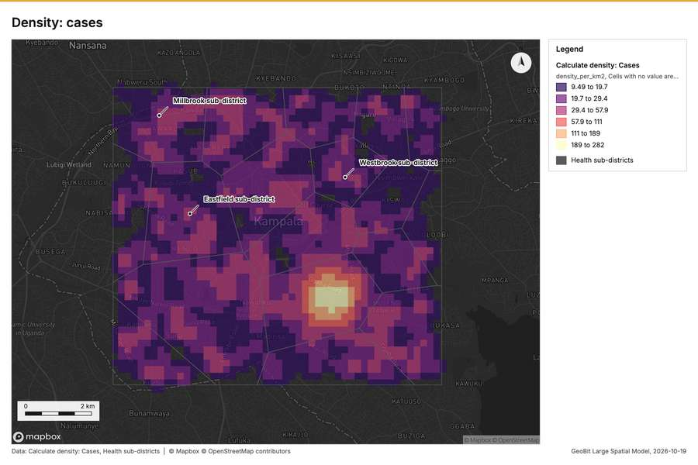
Figure 26. Density: cases [70]
What the map shows. The map draws Calculate density: Cases by density_per_km2 in 6 classes: 9.49 to 19.7, 19.7 to 29.4, 29.4 to 57.9, 57.9 to 111, 111 to 189, 189 to 282 [70]. The map draws Health sub-districts with one symbol [70]. It draws 2,526 features [70]. It covers longitude 32.508 to 32.653 and latitude 0.257 to 0.367, at about 1:66,921 [70].
Findings
- Evidenced: Calculate density on Cases: Calculate density: 1 layer saved: Calculate density: Cases (2508 features) [17][69].
- Evidenced: It reported result, count 2,508; result, elapsed ms 49; result, bandwidth m 500; result, cell size m 200; result, excluded null 0; result, max density per km2 282 [69].
Tool gp_calculate_density; parameters {"kernel": "quartic", "project": "2612067c-badd-4310-9678-8f580d5e3d32", "features": {"layer": "Cases (03c8f72b)"}, "bandwidth_m": 500.0, "cell_size_m": 200.0}

Calculate density
What this analysis is. Calculate density: Kernel density per square kilometer on a grid [64]. In ArcGIS it is Calculate Density or Kernel Density; in QGIS, native:heatmapkerneldensityestimation [64].
Why it was run on this data. 200 points in Vaccination sessions: a density surface shows where they concentrate [71].
What it found. Calculate density on Vaccination sessions: Calculate density: 1 layer saved: Calculate density: Vaccination sessions (616 features) [22][72]. It reported result, count 616; result, elapsed ms 105; result, bandwidth m 2,000; result, cell size m 500; result, excluded null 0; result, max density per km2 5.525 [72].
Result | Value
result, count | 616
result, elapsed ms | 105
result, bandwidth m | 2,000
result, cell size m | 500
result, excluded null | 0
result, max density per km2 | 5.525
billing, cost | 0.054
billing, list price | 0.054
billing, upstream cost | 0

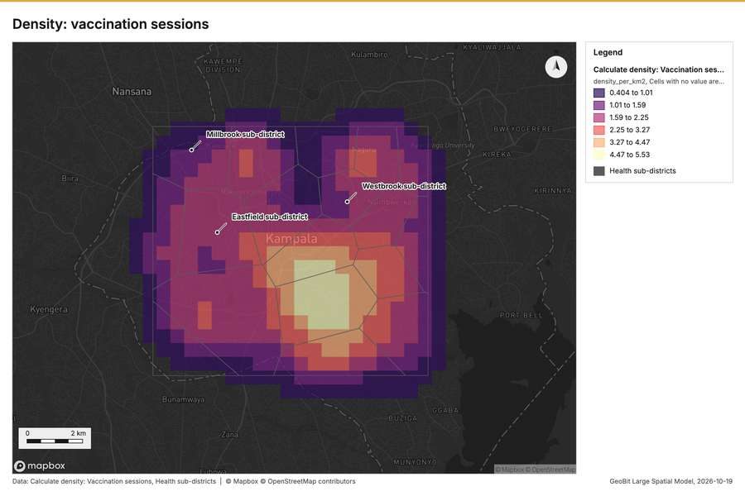
Figure 27. Density: vaccination sessions [73]
What the map shows. The map draws Calculate density: Vaccination sessions by density_per_km2 in 6 classes: 0.404 to 1.01, 1.01 to 1.59, 1.59 to 2.25, 2.25 to 3.27, 3.27 to 4.47, 4.47 to 5.53 [73]. The map draws Health sub-districts with one symbol [73]. It draws 634 features [73]. It covers longitude 32.49 to 32.674 and latitude 0.241 to 0.382, at about 1:85,295 [73].
Findings
- Evidenced: Calculate density on Vaccination sessions: Calculate density: 1 layer saved: Calculate density: Vaccination sessions (616 features) [22][72].
- Evidenced: It reported result, count 616; result, elapsed ms 105; result, bandwidth m 2,000; result, cell size m 500; result, excluded null 0; result, max density per km2 5.525 [72].
Tool gp_calculate_density; parameters {"kernel": "quartic", "project": "2612067c-badd-4310-9678-8f580d5e3d32", "features": {"layer": "Vaccination sessions (6798c97c)"}, "bandwidth_m": 2000.0, "cell_size_m": 500.0}

Find point clusters
What this analysis is. Find point clusters: Density-based clusters (DBSCAN, HDBSCAN or OPTICS, optionally space-time) with hulls and noise [74]. In ArcGIS it is Find Point Clusters or Density-based Clustering; in QGIS, native:dbscanclustering or native:stdbscanclustering [74].
Why it was run on this data. DBSCAN finds dense groups of Community health worker visits and separates noise [75]. Measured: Community health worker visits are clustered (nearest-neighbor ratio 0.95, z = -3.3), median spacing 124 m [75]. DBSCAN at 200 m (twice the measured spacing) [75].
What it found. Find point clusters on Community health worker visits: Find point clusters: 1 layer saved: Find point clusters: Community health worker visits (1000 features) [20][76]. It reported result, count 1,000; result, noise 1,000; result, distance m 200; result, elapsed ms 576; result, min points 20; billing, cost 0.07 [76].
Result | Value
result, count | 1,000
result, noise | 1,000
result, distance m | 200
result, elapsed ms | 576
result, min points | 20
billing, cost | 0.07
billing, list price | 0.07
billing, upstream cost | 0

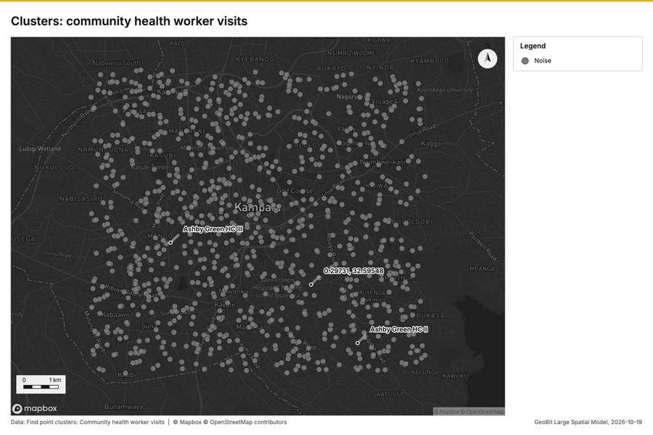
Figure 28. Clusters: community health worker visits [77]
What the map shows. The map draws Find point clusters: Community health worker visits with one symbol [77]. It draws 1,000 features [77]. It covers longitude 32.516 to 32.647 and latitude 0.263 to 0.363, at about 1:60,312 [77].
Findings
- Evidenced: Find point clusters on Community health worker visits: Find point clusters: 1 layer saved: Find point clusters: Community health worker visits (1000 features) [20][76].
- Evidenced: It reported result, count 1,000; result, noise 1,000; result, distance m 200; result, elapsed ms 576; result, min points 20; billing, cost 0.07 [76].
Tool gp_find_point_clusters; parameters {"method": "dbscan", "project": "2612067c-badd-4310-9678-8f580d5e3d32", "features": {"layer": "Community health worker visits (4d70d1ce)"}, "distance_m": 200.0, "min_points": 20}

Find point clusters
What this analysis is. Find point clusters: Density-based clusters (DBSCAN, HDBSCAN or OPTICS, optionally space-time) with hulls and noise [74]. In ArcGIS it is Find Point Clusters or Density-based Clustering; in QGIS, native:dbscanclustering or native:stdbscanclustering [74].
Why it was run on this data. DBSCAN finds dense groups of Cases and separates noise [78]. Measured: Cases are clustered (nearest-neighbor ratio 0.90, z = -9.4), median spacing 75.6 m [78]. DBSCAN at 200 m (twice the measured spacing) [78].
What it found. Find point clusters on Cases: Find point clusters: 2 layers saved: Find point clusters: Cases (2290 features); Find point clusters: cluster hulls (1 feature) [17][79]. It reported result, count 2,290; result, noise 1,961; result, distance m 200; result, elapsed ms 24; result, min points 20; billing, cost 0.0958 [79].
Result | Value
result, count | 2,290
result, noise | 1,961
result, distance m | 200
result, elapsed ms | 24
result, min points | 20
billing, cost | 0.0958
billing, list price | 0.0958
billing, upstream cost | 0

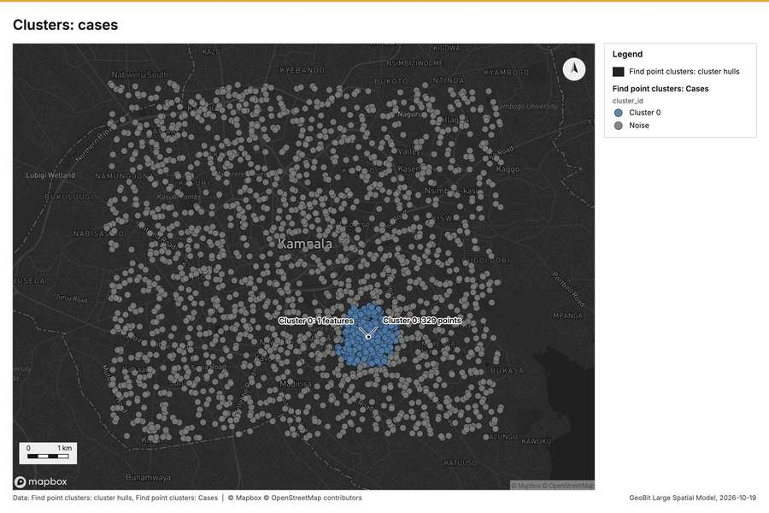
Figure 29. Clusters: cases [80]
What the map shows. The map draws Find point clusters: cluster hulls with one symbol [80]. The map draws Find point clusters: Cases by cluster_id in 2 classes: Cluster 0, Noise [80]. It draws 2,291 features [80]. It covers longitude 32.516 to 32.647 and latitude 0.262 to 0.363, at about 1:60,732 [80].
Findings
- Evidenced: Find point clusters on Cases: Find point clusters: 2 layers saved: Find point clusters: Cases (2290 features); Find point clusters: cluster hulls (1 feature) [17][79].
- Evidenced: It reported result, count 2,290; result, noise 1,961; result, distance m 200; result, elapsed ms 24; result, min points 20; billing, cost 0.0958 [79].
Tool gp_find_point_clusters; parameters {"method": "dbscan", "project": "2612067c-badd-4310-9678-8f580d5e3d32", "features": {"layer": "Cases (03c8f72b)"}, "distance_m": 200.0, "min_points": 20}

Outliers
What this analysis is. Find outliers: Anselin local Moran’s I: HH, LL clusters and HL, LH outliers [81]. In ArcGIS it is Find Outliers or Cluster and Outlier Analysis (Anselin Local Moran’s I) [81].
Why it was run on this data. Local Moran's I maps clusters and outliers of 'population' [82]. Measured: Health sub-districts have 39 neighboring pairs (4.33 neighbors per area, 0 isolated), so neighbors can be compared [82].
What it found. The outlier analysis process used Health sub-districts as input data [16]. The operation, which saved 1 layer for Health sub-districts, successfully analyzed 18 features [83].
Result | Value
result, count | 18
result, elapsed ms | 2
result, permutations | 199
result, excluded null | 0
result, distance band m | 2,467
billing, cost | 0.05054
billing, list price | 0.05054
billing, upstream cost | 0

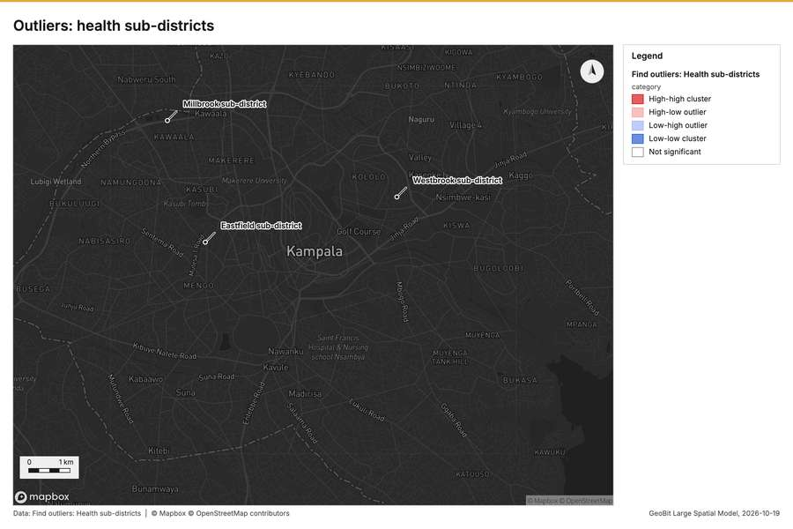
Figure 30. Outliers: health sub-districts [84]
What the map shows. The map draws Find outliers: Health sub-districts by category in 5 classes: High-high cluster, High-low outlier, Low-high outlier, Low-low cluster, Not significant [84]. It draws 18 features [84]. It covers longitude 32.515 to 32.648 and latitude 0.261 to 0.363, at about 1:61,580 [84].
Findings
- Evidenced: Outliers on Health sub-districts: Find outliers: 1 layer saved: Find outliers: Health sub-districts (18 features) [16][83].
- Evidenced: It reported result, count 18; result, elapsed ms 2; result, permutations 199; result, excluded null 0; result, distance band m 2,467; billing, cost 0.05054 [83].
Tool gp_outliers; parameters {"field": "population", "project": "2612067c-badd-4310-9678-8f580d5e3d32", "features": {"layer": "Health sub-districts (433b88cc)"}, "aggregation": "hexagon"}

What follows from the results
Change beside the counts per health sub-district, from Period change: Cases (week of 2026-05-18 to week of 2026-05-25) and Summarize within: Health sub-districts: the busiest area, Parkside sub-district (32 in all), changed by -38 [87][13][46]. Change of vaccination sessions where density is high, from Period change: Vaccination sessions (week of 2026-06-29 to week of 2026-07-06) and Calculate density: Community health worker visits: the largest rise (+1, Canal Side sub-district) is where density averages 10.88 per square kilometer [92][11][66]. Hot cells of cases per health sub-district, from Hot spot analysis: Cases: 8 of 18 areas hold hot spot cells; Parkside sub-district holds the most (103) [97][37]. Nearest outbreak response team to each cluster of cases, from Find point clusters: cluster hulls: the 1 clusters lie 0 to 0 m from the nearest facility (Rapid response team 1 and others) [103][79]. Dense areas of community health worker visits, from Calculate density: Community health worker visits: the densest of five classes joins 491 cells into one area [110][66]. Change of vaccination sessions per health sub-district, from Period change: Vaccination sessions (week of 2026-06-29 to week of 2026-07-06): Canal Side sub-district rose the most (+1) and Fernhill sub-district fell the most (-2) [113][11]. Outbreak response teams within 250 m of each cluster of cases, from Find point clusters: cluster hulls: 1 of 1 clusters have one within 250 m [118][79]. Density of community health worker visits and cases together, from Calculate density: Community health worker visits and Calculate density: Cases: 4960 features from 2 sources [123][66][69].
Findings
- Evidenced: Change beside the counts per health sub-district, from Period change: Cases (week of 2026-05-18 to week of 2026-05-25) and Summarize within: Health sub-districts: the busiest area, Parkside sub-district (32 in all), changed by -38 [87][13][46].
- Evidenced: Change of vaccination sessions where density is high, from Period change: Vaccination sessions (week of 2026-06-29 to week of 2026-07-06) and Calculate density: Community health worker visits: the largest rise (+1, Canal Side sub-district) is where density averages 10.88 per square kilometer [92][11][66].
- Evidenced: Hot cells of cases per health sub-district, from Hot spot analysis: Cases: 8 of 18 areas hold hot spot cells; Parkside sub-district holds the most (103) [97][37].
- Evidenced: Nearest outbreak response team to each cluster of cases, from Find point clusters: cluster hulls: the 1 clusters lie 0 to 0 m from the nearest facility (Rapid response team 1 and others) [103][79].
- Evidenced: Dense areas of community health worker visits, from Calculate density: Community health worker visits: the densest of five classes joins 491 cells into one area [110][66].
- Evidenced: Change of vaccination sessions per health sub-district, from Period change: Vaccination sessions (week of 2026-06-29 to week of 2026-07-06): Canal Side sub-district rose the most (+1) and Fernhill sub-district fell the most (-2) [113][11].
- Evidenced: Outbreak response teams within 250 m of each cluster of cases, from Find point clusters: cluster hulls: 1 of 1 clusters have one within 250 m [118][79].
- Evidenced: Density of community health worker visits and cases together, from Calculate density: Community health worker visits and Calculate density: Cases: 4960 features from 2 sources [123][66][69].

Change beside the counts per health sub-district
What this analysis is. Spatial join: Attach attributes (or aggregates) of matching features from another layer, by location, distance, time and attributes [85]. In ArcGIS it is Join Features or Spatial Join; in QGIS, native:joinattributesbylocation or native:joinbylocationsummary [85].
Why it was run on this data. It was run toward the goal "Describe the project Sample: Public health, Kampala: run the analyses that tell the most about its data, draw every result, and write a cited report" [86].
What it found. Spatial join on Summarize within: Health sub-districts, Period change: Cases (week of 2026-05-18 to week of 2026-05-25) produced Change beside the counts per health sub-district (18 features) [14][87][88][89]. It reported result, count 18; result, elapsed ms 1; billing, cost 0.01074; billing, list price 0.01074; billing, upstream cost 0 [87]. The chart Change beside the counts per health sub-district is drawn from 6 rows [91].
Result | Value
result, count | 18
result, elapsed ms | 1
billing, cost | 0.01074
billing, list price | 0.01074
billing, upstream cost | 0

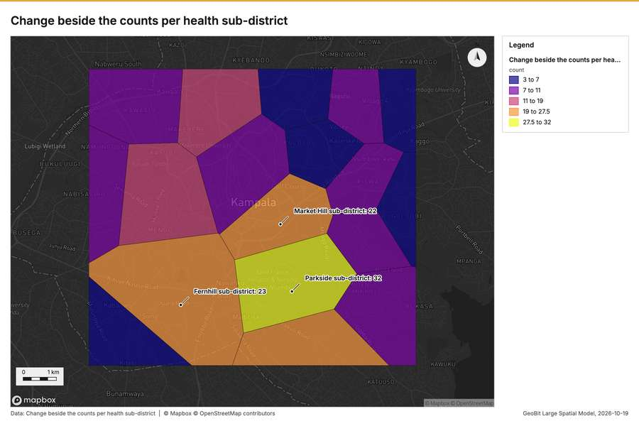
Figure 31. Change beside the counts per health sub-district [90]
What the map shows. The map draws Change beside the counts per health sub-district by count in 5 classes: 3 to 7, 7 to 11, 11 to 19, 19 to 27.5, 27.5 to 32 [90]. It draws 18 features [90]. It covers longitude 32.515 to 32.648 and latitude 0.261 to 0.363, at about 1:61,580 [90].
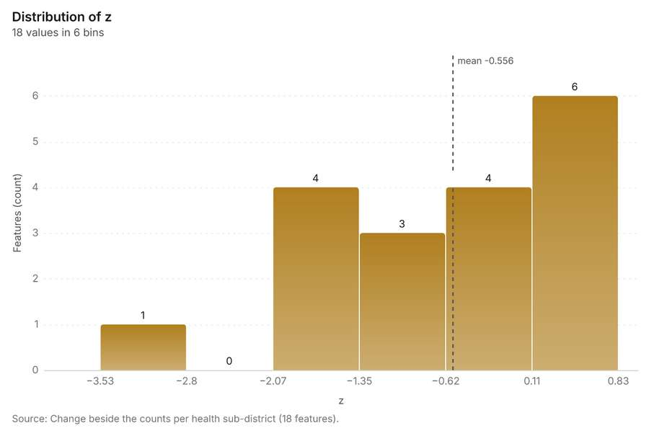
Figure 32. Change beside the counts per health sub-district [91]. Source: Change beside the counts per health sub-district (18 features). The data is in the appendix.
Findings
- Evidenced: Spatial join on Summarize within: Health sub-districts, Period change: Cases (week of 2026-05-18 to week of 2026-05-25) produced Change beside the counts per health sub-district (18 features) [14][87][88][89].
- Evidenced: It reported result, count 18; result, elapsed ms 1; billing, cost 0.01074; billing, list price 0.01074; billing, upstream cost 0 [87].
- Evidenced: The chart Change beside the counts per health sub-district is drawn from 6 rows [91].
Tool gp_spatial_join; parameters {"join": {"layer": "Summarize within: Health sub-districts (9220b574)"}, "fields": ["count"], "target": {"layer": "Period change: Cases (week of 2026-05-18 to week of 2026-05-25) (66f934f7)"}, "project": "2612067c-badd-4310-9678-8f580d5e3d32", "predicate": "largest_overlap", "output_name": "Change beside the counts per health sub-district"}

Change of vaccination sessions where density is high
What this analysis is. Spatial join: Attach attributes (or aggregates) of matching features from another layer, by location, distance, time and attributes [85]. In ArcGIS it is Join Features or Spatial Join; in QGIS, native:joinattributesbylocation or native:joinbylocationsummary [85].
Why it was run on this data. It was run toward the goal "Describe the project Sample: Public health, Kampala: run the analyses that tell the most about its data, draw every result, and write a cited report" [86].
What it found. The analysis utilized a spatial join [92], integrating data derived from Calculate density: Community health worker visits [93] and the specific period change for Vaccination sessions (week of 2026-06-
Result | Value
result, count | 10
result, elapsed ms | 3
billing, cost | 0.05926
billing, list price | 0.05926
billing, upstream cost | 0

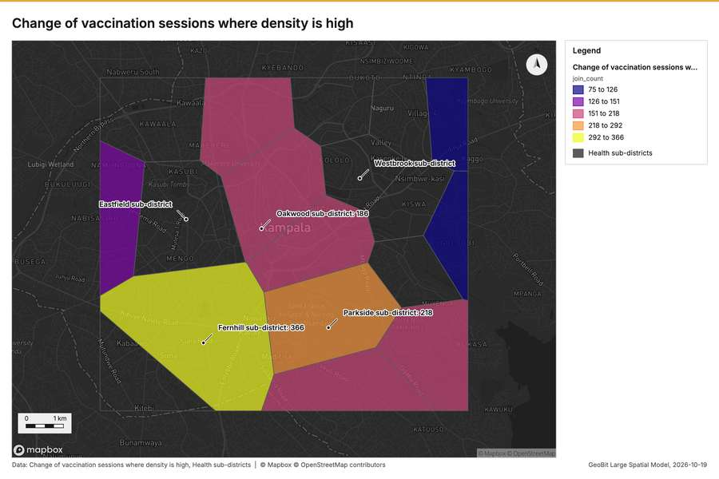
Figure 33. Change of vaccination sessions where density is high [95]
What the map shows. The map draws Change of vaccination sessions where density is high by join_count in 5 classes: 75 to 126, 126 to 151, 151 to 218, 218 to 292, 292 to 366 [95]. The map draws Health sub-districts with one symbol [95]. It draws 28 features [95]. It covers longitude 32.515 to 32.648 and latitude 0.261 to 0.363, at about 1:61,580 [95].
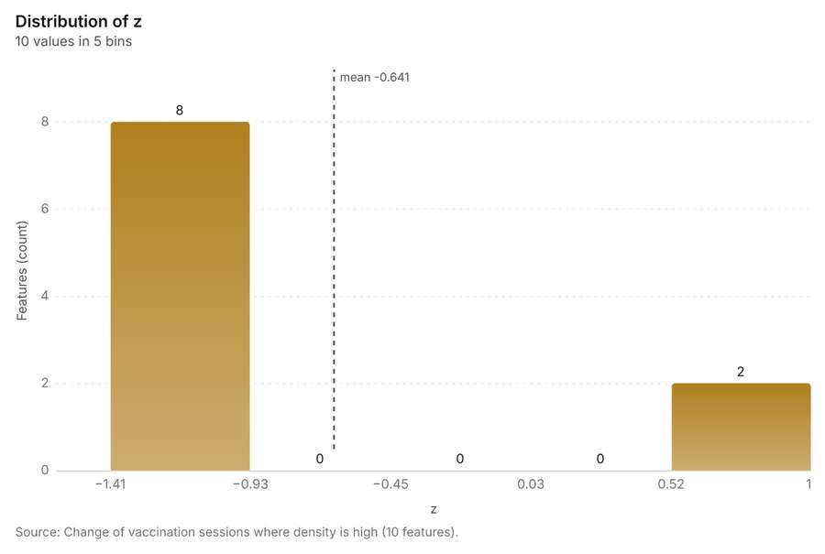
Figure 34. Change of vaccination sessions where density is high [96]. Source: Change of vaccination sessions where density is high (10 features). The data is in the appendix.
Findings
- Evidenced: Spatial join on Calculate density: Community health worker visits, Period change: Vaccination sessions (week of 2026-06-29 to week of 2026-07-06) produced Change of vaccination sessions where density is high (10 features) [12][92][93][94].
- Evidenced: It reported result, count 10; result, elapsed ms 3; billing, cost 0.05926; billing, list price 0.05926; billing, upstream cost 0 [92].
- Evidenced: The chart Change of vaccination sessions where density is high is drawn from 5 rows [96].
Tool gp_spatial_join; parameters {"join": {"layer": "Calculate density: Community health worker visits (3aeb4280)"}, "stats": [{"agg": "mean", "field": "density_per_km2"}], "target": {"layer": "Period change: Vaccination sessions (week of 2026-06-29 to week of 2026-07-06) (3345972d)"}, "project": "2612067c-badd-4310-9678-8f580d5e3d32", "predicate": "intersects", "output_name": "Change of vaccination sessions where density is high

Hot cells of cases per health sub-district
What this analysis is. Summarize within: Count and aggregate the features inside each polygon (or bin), proportionally for lines and polygons [42]. In ArcGIS it is Summarize Within or Aggregate Points; in QGIS, native:countpointsinpolygon or native:sumlinelengths [42].
Why it was run on this data. Count Community health worker visits inside each feature of Health sub-districts by purpose; the counts map as a choropleth (natural breaks, sequential colors) [43].
What it found. Summarize within on Hot spot analysis: Cases, Health sub-districts produced Hot cells of cases per health sub-district (18 features) [16][97][98][99]. It reported result, count 18; result, elapsed ms 38; billing, cost 0.05554; billing, list price 0.05554; billing, upstream cost 0 [97]. The chart Hot cells of cases per health sub-district is drawn from 6 rows [101].
Result | Value
result, count | 18
result, elapsed ms | 38
billing, cost | 0.05554
billing, list price | 0.05554
billing, upstream cost | 0

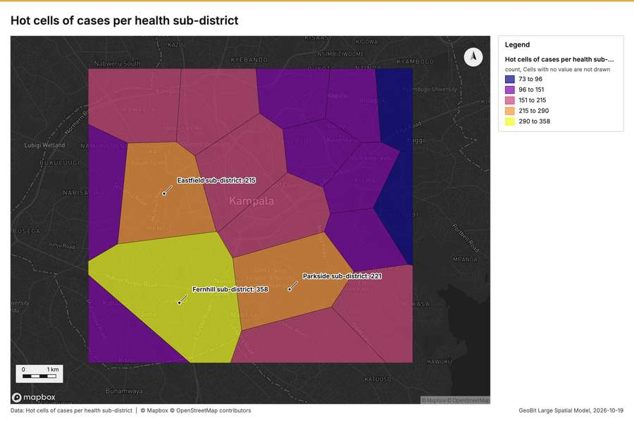
Figure 35. Hot cells of cases per health sub-district [100]
What the map shows. The map draws Hot cells of cases per health sub-district by count in 5 classes: 73 to 96, 96 to 151, 151 to 215, 215 to 290, 290 to 358 [100]. It draws 18 features [100]. It covers longitude 32.515 to 32.648 and latitude 0.261 to 0.363, at about 1:61,580 [100].
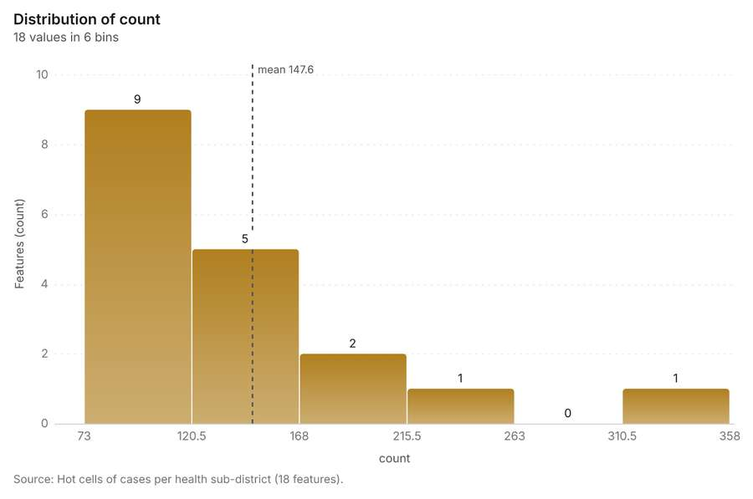
Figure 36. Hot cells of cases per health sub-district [101]. Source: Hot cells of cases per health sub-district (18 features). The data is in the appendix.
Findings
- Evidenced: Summarize within on Hot spot analysis: Cases, Health sub-districts produced Hot cells of cases per health sub-district (18 features) [16][97][98][99].
- Evidenced: It reported result, count 18; result, elapsed ms 38; billing, cost 0.05554; billing, list price 0.05554; billing, upstream cost 0 [97].
- Evidenced: The chart Hot cells of cases per health sub-district is drawn from 6 rows [101].
Tool gp_summarize_within; parameters {"project": "2612067c-badd-4310-9678-8f580d5e3d32", "features": {"layer": "Hot spot analysis: Cases (7dc9eb55)"}, "group_by": "gi_bin", "polygons": {"layer": "Health sub-districts (433b88cc)"}, "output_name": "Hot cells of cases per health sub-district"}

Nearest outbreak response team to each cluster of cases
What this analysis is. Find nearest: The k nearest features for each input, with geodesic distance and bearing [102]. In ArcGIS it is Find Nearest or Near; in QGIS, native:joinbynearest or native:nearestneighbouranalysis [102].
Why it was run on this data. It was run toward the goal "Describe the project Sample: Public health, Kampala: run the analyses that tell the most about its data, draw every result, and write a cited report" [86].
What it found. The `gp_find_nearest` tool was executed using the Outbreak response teams input data [21]. This analysis used the cluster hulls from [104] to determine the nearest outbreak response team to each cluster of cases [105]. The operation generated one result, completing in 2 [103] milliseconds and incurring a cost of 0.01014 [103]. A chart detailing the nearest outbreak response team to each cluster of cases was generated, containing 1 row [107].
Result | Value
result, count | 1
result, elapsed ms | 2
billing, cost | 0.01014
billing, list price | 0.01014
billing, upstream cost | 0

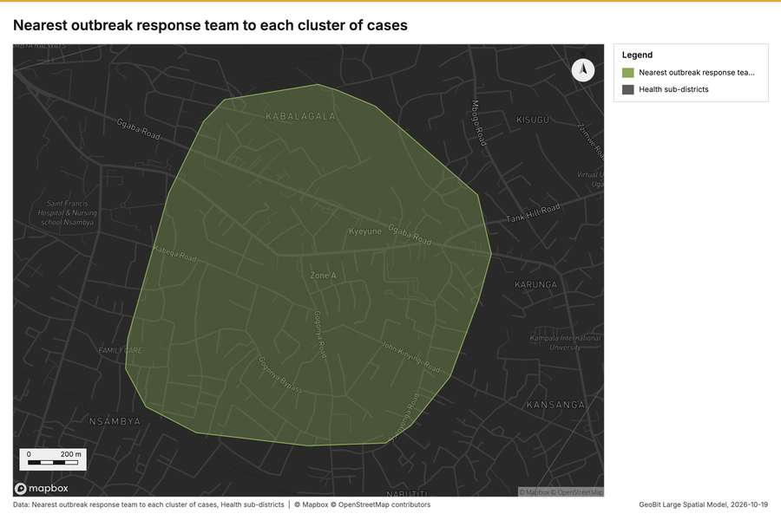
Figure 37. Nearest outbreak response team to each cluster of cases [106]
What the map shows. The map draws Nearest outbreak response team to each cluster of cases with one symbol [106]. The map draws Health sub-districts with one symbol [106]. It draws 19 features [106]. It covers longitude 32.585 to 32.606 and latitude 0.289 to 0.305, at about 1:10,087 [106].
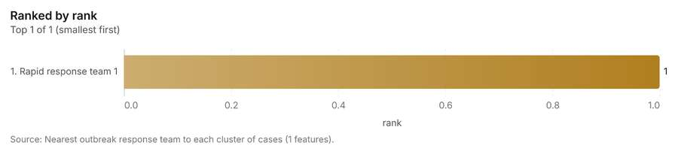
Figure 38. Nearest outbreak response team to each cluster of cases [107]. Source: Nearest outbreak response team to each cluster of cases (1 features). The data is in the appendix.
Findings
- Evidenced: Find nearest on Outbreak response teams, Find point clusters: cluster hulls produced Nearest outbreak response team to each cluster of cases (1 features) [21][103][104][105].
- Evidenced: It reported result, count 1; result, elapsed ms 2; billing, cost 0.01014; billing, list price 0.01014; billing, upstream cost 0 [103].
- Evidenced: The chart Nearest outbreak response team to each cluster of cases is drawn from 1 rows [107].
Tool gp_find_nearest; parameters {"k": 1, "to": {"layer": "Outbreak response teams (1b8f0e74)"}, "from": {"layer": "Find point clusters: cluster hulls (53d9a3e2)"}, "project": "2612067c-badd-4310-9678-8f580d5e3d32", "output_name": "Nearest outbreak response team to each cluster of cases"}

Dense areas of community health worker visits
What this analysis is. Pipeline: Run up to 20 GIS operations in one engine call; a step's params may use "$id" (an earlier step's result) or "$id.key", and layer references [108]. Every step's map outputs are saved as styled layers [108].
Why it was run on this data. Health sub-districts holds population in 'population': Community health worker visits per 10,000 people in each feature compares features of different size; mapped as a choropleth (natural breaks, sequential colors) [109].
What it found. A pipeline of 2 steps (classify_field > dissolve) was executed, saving 1 layer [110].
Result | Value
result, count | 5
result, elapsed ms | 46
billing, cost | 0.06905
billing, list price | 0.06905
billing, upstream cost | 0
list price | 0.06905

What the map shows. Drawn with calculate density on the map Density: community health worker visits [67].
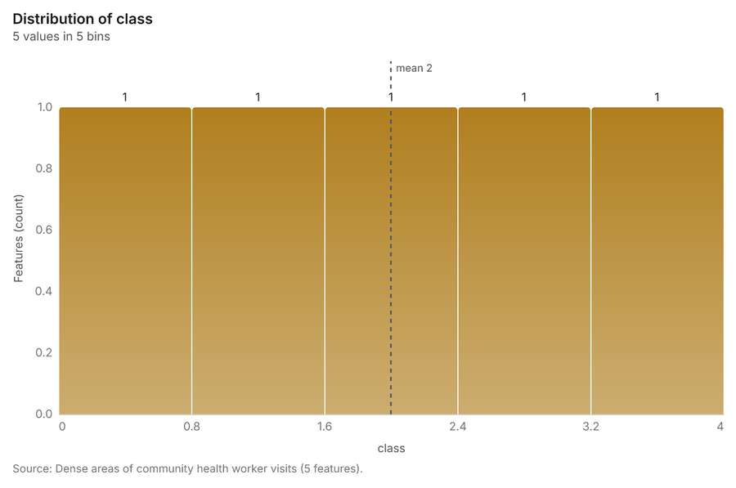
Figure 39. Dense areas of community health worker visits [112]. Source: Dense areas of community health worker visits (5 features). The data is in the appendix.
Findings
- Evidenced: Pipeline on Calculate density: Community health worker visits produced Dense areas of community health worker visits (5 features) [93][110][111].
- Evidenced: It reported result, count 5; result, elapsed ms 46; billing, cost 0.06905; billing, list price 0.06905; billing, upstream cost 0; list price 0.06905 [110].
- Evidenced: The chart Dense areas of community health worker visits is drawn from 5 rows [112].
Tool gp_pipeline; parameters {"save": "final", "steps": [{"id": "classes", "params": {"field": "density_per_km2", "method": "quantile", "classes": 5, "features": {"layer": "Calculate density: Community health worker visits (3aeb4280)"}}, "operation": "classify_field"}, {"id": "areas", "params": {"by": ["class"], "features": "$classes"}, "operation": "dissolve"}], "project": "2612067c-badd-4310-9678-8f580d5e3d32", "output_name

Change of vaccination sessions per health sub-district
What this analysis is. Summarize within: Count and aggregate the features inside each polygon (or bin), proportionally for lines and polygons [42]. In ArcGIS it is Summarize Within or Aggregate Points; in QGIS, native:countpointsinpolygon or native:sumlinelengths [42].
Why it was run on this data. Count Community health worker visits inside each feature of Health sub-districts by purpose; the counts map as a choropleth (natural breaks, sequential colors) [43].
What it found. The analysis utilized the input of 'Health sub-districts' [16] and a 'Period change: Vaccination sessions (week of 2026-06-29 to week of 2026-07-06)' [12] to generate the 'Change of vaccination sessions per health sub-district' [114] using the `gp_summarize_within` tool [113]. This resulted in a count of 18 features for the layer [113]. Furthermore, the chart displaying the change in vaccination sessions is drawn from 6 rows [116].
Result | Value
result, count | 18
result, elapsed ms | 1
billing, cost | 0.01058
billing, list price | 0.01058
billing, upstream cost | 0

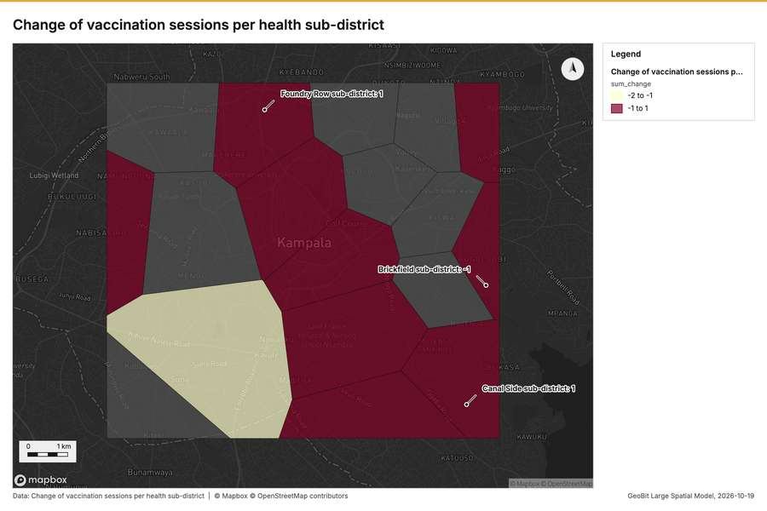
Figure 40. Change of vaccination sessions per health sub-district [115]
What the map shows. The map draws Change of vaccination sessions per health sub-district by sum_change in 2 classes: -2 to -1, -1 to 1 [115]. It draws 18 features [115]. It covers longitude 32.515 to 32.648 and latitude 0.261 to 0.363, at about 1:61,580 [115].
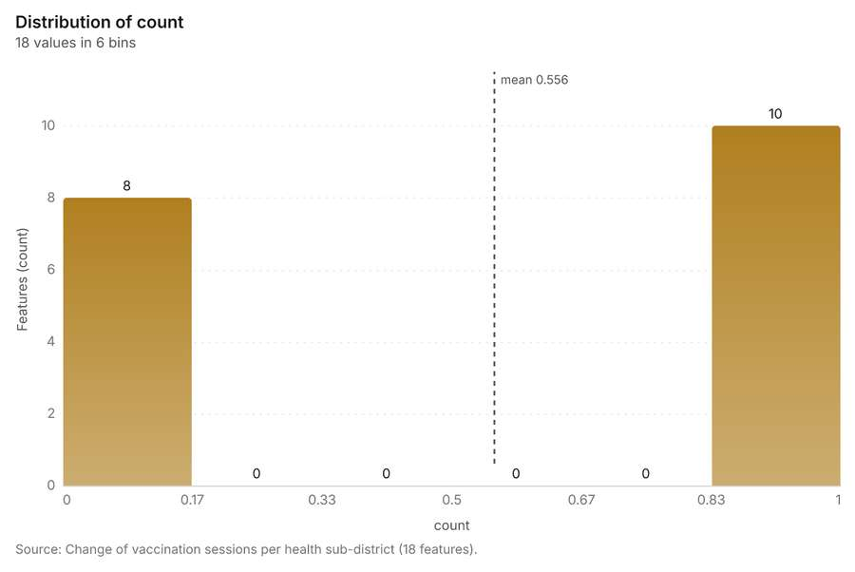
Figure 41. Change of vaccination sessions per health sub-district [116]. Source: Change of vaccination sessions per health sub-district (18 features). The data is in the appendix.
Findings
- Evidenced: Summarize within on Period change: Vaccination sessions (week of 2026-06-29 to week of 2026-07-06), Health sub-districts produced Change of vaccination sessions per health sub-district (18 features) [12][16][113][114].
- Evidenced: It reported result, count 18; result, elapsed ms 1; billing, cost 0.01058; billing, list price 0.01058; billing, upstream cost 0 [113].
- Evidenced: The chart Change of vaccination sessions per health sub-district is drawn from 6 rows [116].
Tool gp_summarize_within; parameters {"stats": [{"agg": "sum", "field": "change"}], "project": "2612067c-badd-4310-9678-8f580d5e3d32", "features": {"layer": "Period change: Vaccination sessions (week of 2026-06-29 to week of 2026-07-06) (3345972d)"}, "polygons": {"layer": "Health sub-districts (433b88cc)"}, "output_name": "Change of vaccination sessions per health sub-district"}

Outbreak response teams within 250 m of each cluster of cases
What this analysis is. Pipeline: Run up to 20 GIS operations in one engine call; a step's params may use "$id" (an earlier step's result) or "$id.key", and layer references [108]. Every step's map outputs are saved as styled layers [108].
Why it was run on this data. Health sub-districts holds population in 'population': Outbreak response teams per 10,000 people in each feature compares features of different size; mapped as a choropleth (natural breaks, sequential colors) [117].
What it found. Pipeline on Find point clusters: cluster hulls, Outbreak response teams produced Outbreak response teams within 250 m of each cluster of cases (1 features) [21][104][118][119]. It reported result, count 1; result, elapsed ms 0; billing, cost 0.02015; billing, list price 0.02015; billing, upstream cost 0; list price 0.02015 [118]. The chart Outbreak response teams within 250 m of each cluster of cases is drawn from 1 rows [121].
Result | Value
result, count | 1
result, elapsed ms | 0
billing, cost | 0.02015
billing, list price | 0.02015
billing, upstream cost | 0
list price | 0.02015

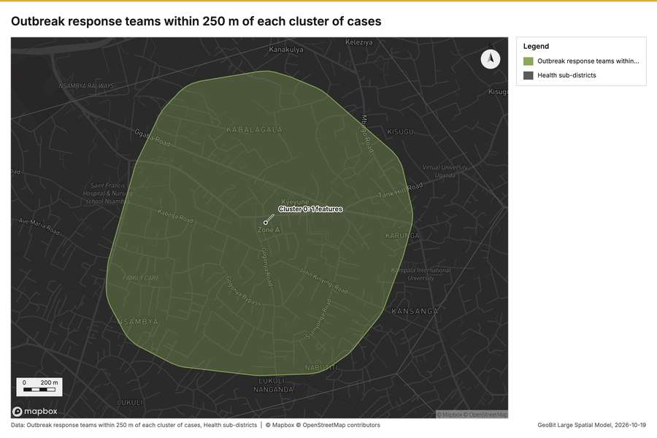
Figure 42. Outbreak response teams within 250 m of each cluster of cases [120]
What the map shows. The map draws Outbreak response teams within 250 m of each cluster of cases with one symbol [120]. The map draws Health sub-districts with one symbol [120]. It draws 19 features [120]. It covers longitude 32.581 to 32.61 and latitude 0.286 to 0.308, at about 1:13,495 [120].
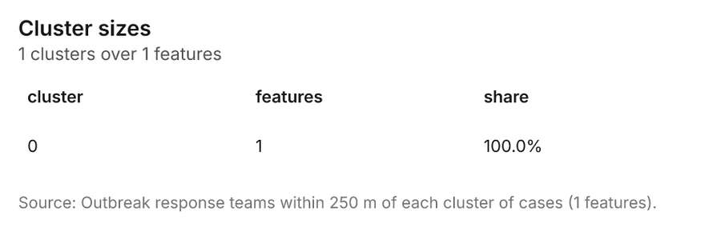
Figure 43. Outbreak response teams within 250 m of each cluster of cases [121]. Source: Outbreak response teams within 250 m of each cluster of cases (1 features). The data is in the appendix.
Findings
- Evidenced: Pipeline on Find point clusters: cluster hulls, Outbreak response teams produced Outbreak response teams within 250 m of each cluster of cases (1 features) [21][104][118][119].
- Evidenced: It reported result, count 1; result, elapsed ms 0; billing, cost 0.02015; billing, list price 0.02015; billing, upstream cost 0; list price 0.02015 [118].
- Evidenced: The chart Outbreak response teams within 250 m of each cluster of cases is drawn from 1 rows [121].
Tool gp_pipeline; parameters {"save": "final", "steps": [{"id": "buffer", "params": {"features": {"layer": "Find point clusters: cluster hulls (53d9a3e2)"}, "distance_m": 250}, "operation": "buffer"}, {"id": "count", "params": {"features": {"layer": "Outbreak response teams (1b8f0e74)"}, "polygons": "$buffer"}, "operation": "summarize_within"}], "project": "2612067c-badd-4310-9678-8f580d5e3d32", "output_name": "Outbreak respo

Density of community health worker visits and cases together
What this analysis is. Merge layers: Append several layers into one [122]. In ArcGIS it is Merge Layers or Merge; in QGIS, native:mergevectorlayers [122].
Why it was run on this data. It was run toward the goal "Describe the project Sample: Public health, Kampala: run the analyses that tell the most about its data, draw every result, and write a cited report" [86].
What it found. The `gp_merge_layers` tool combined inputs for Community health worker visits [93] and Cases [124] to create the merged layer [123].
Result | Value
result, count | 4,960
result, elapsed ms | 109
billing, cost | 0.01
billing, list price | 0.01
billing, upstream cost | 0

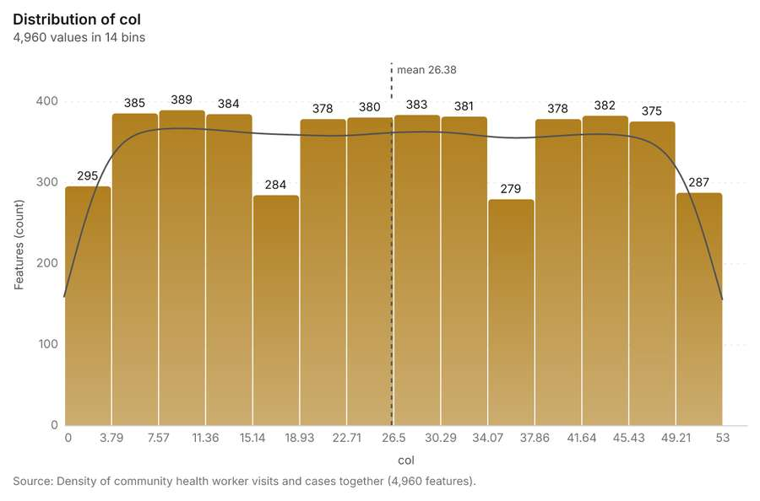
Figure 44. Density of community health worker visits and cases together [126]. Source: Density of community health worker visits and cases together (4,960 features). The data is in the appendix.
Findings
- Evidenced: Merge layers on Calculate density: Community health worker visits, Calculate density: Cases produced Density of community health worker visits and cases together (4,960 features) [93][123][124][125].
- Evidenced: It reported result, count 4,960; result, elapsed ms 109; billing, cost 0.01; billing, list price 0.01; billing, upstream cost 0 [123].
- Evidenced: The chart Density of community health worker visits and cases together is drawn from 14 rows [126].
Tool gp_merge_layers; parameters {"layers": [{"layer": "Calculate density: Community health worker visits (3aeb4280)"}, {"layer": "Calculate density: Cases (b48a2b54)"}], "project": "2612067c-badd-4310-9678-8f580d5e3d32", "output_name": "Density of community health worker visits and cases together", "source_field": "source"}

Maps and charts
The run also made 1 map image(s) [127] and 19 chart(s) [128][129][130][131][132][133][134][135][136][137][138][139][140][141][142][143][144][145][146].
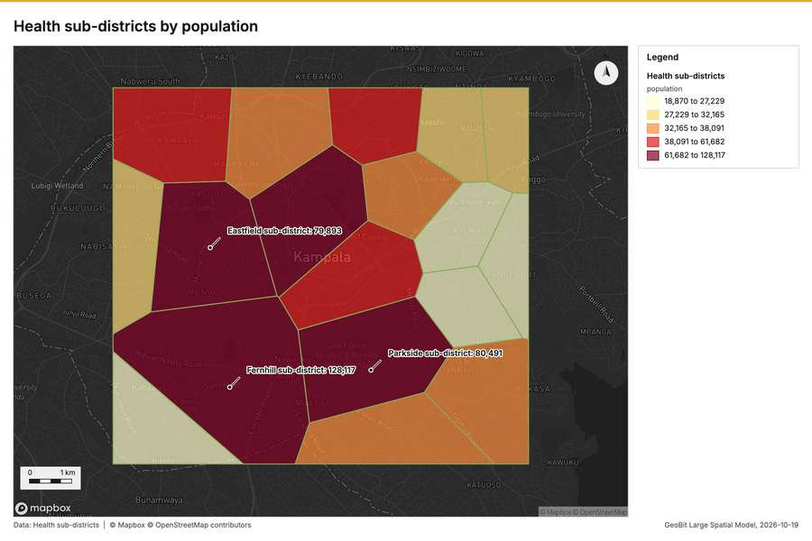
Figure 45. Health sub-districts by population [127]
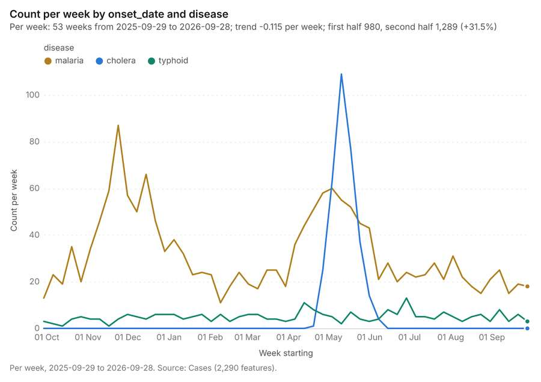
Figure 46. Cases over time (onset_date) [128]. Per week, 2025-09-29 to 2026-09-28. Source: Cases (2,290 features). The data is in the appendix.
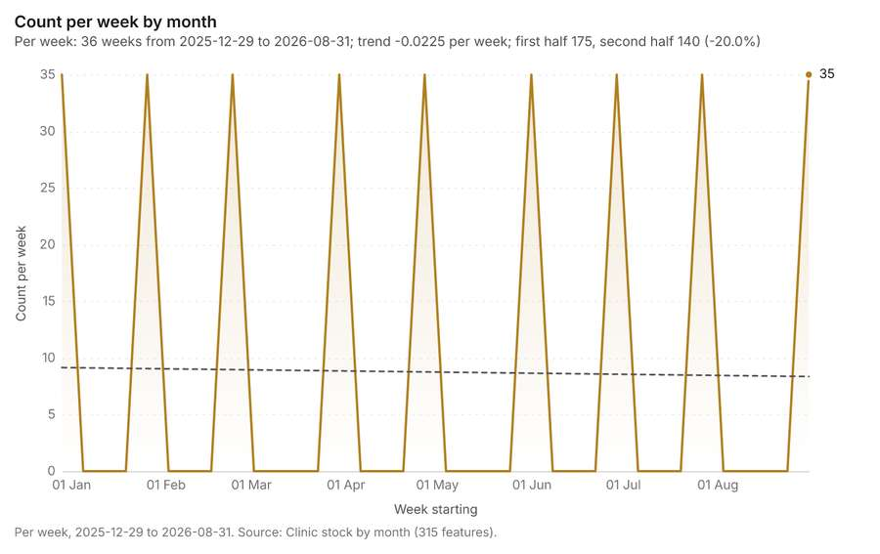
Figure 47. Clinic stock by month over time (month) [129]. Per week, 2025-12-29 to 2026-08-31. Source: Clinic stock by month (315 features). The data is in the appendix.
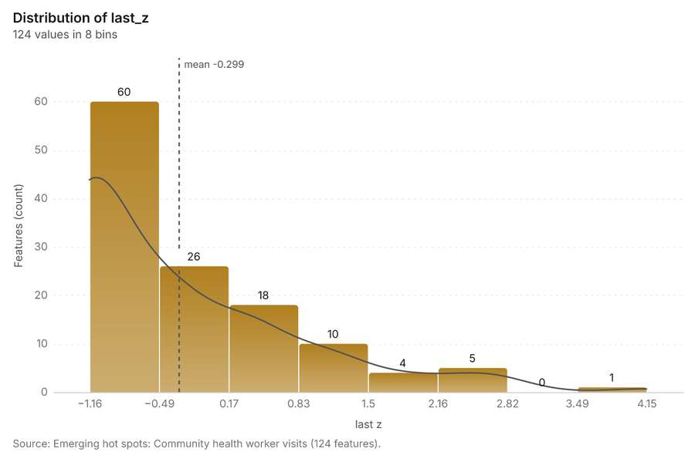
Figure 48. Emerging hot spots: Community health worker visits [130]. Source: Emerging hot spots: Community health worker visits (124 features). The data is in the appendix.
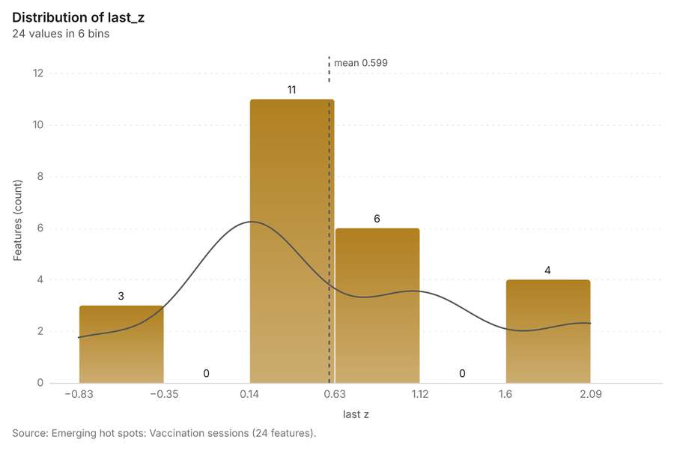
Figure 49. Emerging hot spots: Vaccination sessions [131]. Source: Emerging hot spots: Vaccination sessions (24 features). The data is in the appendix.
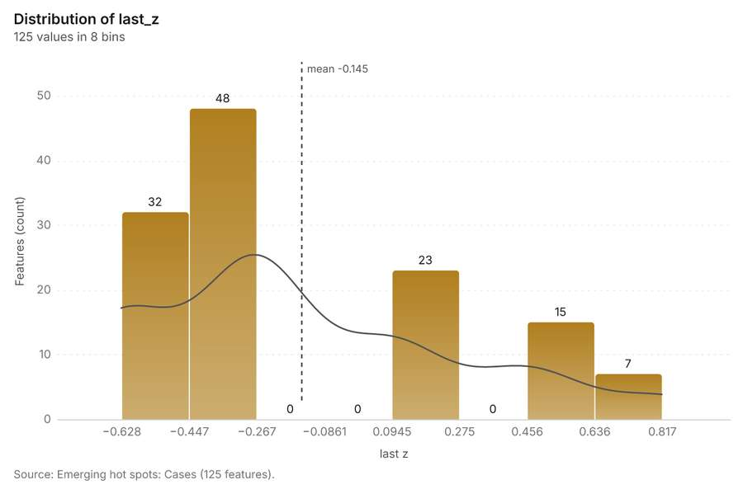
Figure 50. Emerging hot spots: Cases [132]. Source: Emerging hot spots: Cases (125 features). The data is in the appendix.
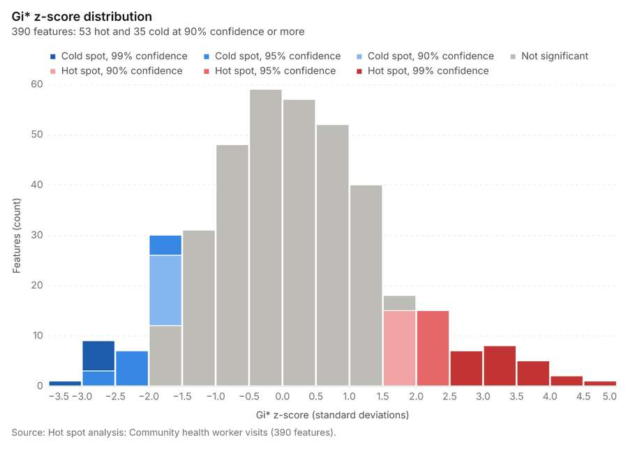
Figure 51. Hot spot analysis: Community health worker visits [133]. Source: Hot spot analysis: Community health worker visits (390 features). The data is in the appendix.
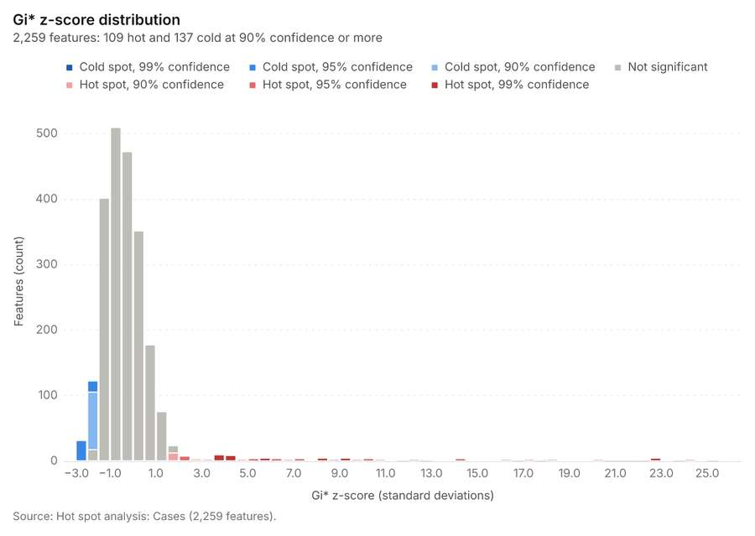
Figure 52. Hot spot analysis: Cases [134]. Source: Hot spot analysis: Cases (2,259 features). The data is in the appendix.
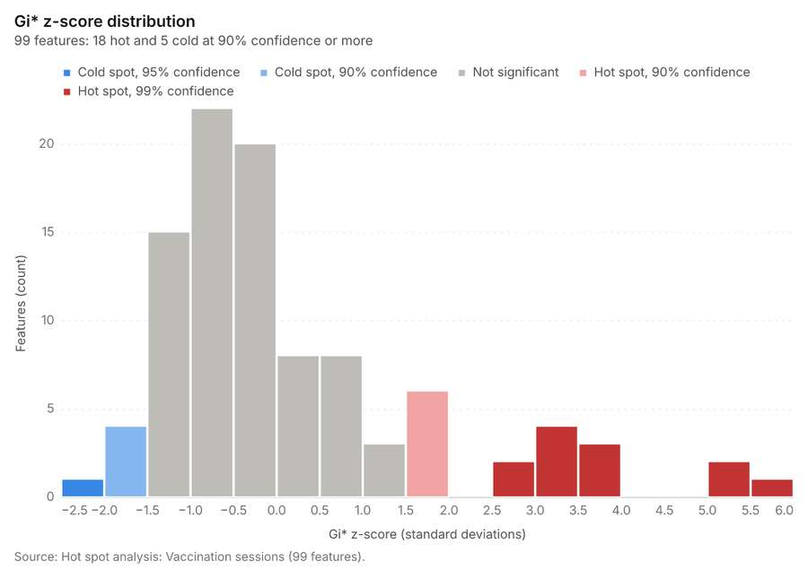
Figure 53. Hot spot analysis: Vaccination sessions [135]. Source: Hot spot analysis: Vaccination sessions (99 features). The data is in the appendix.
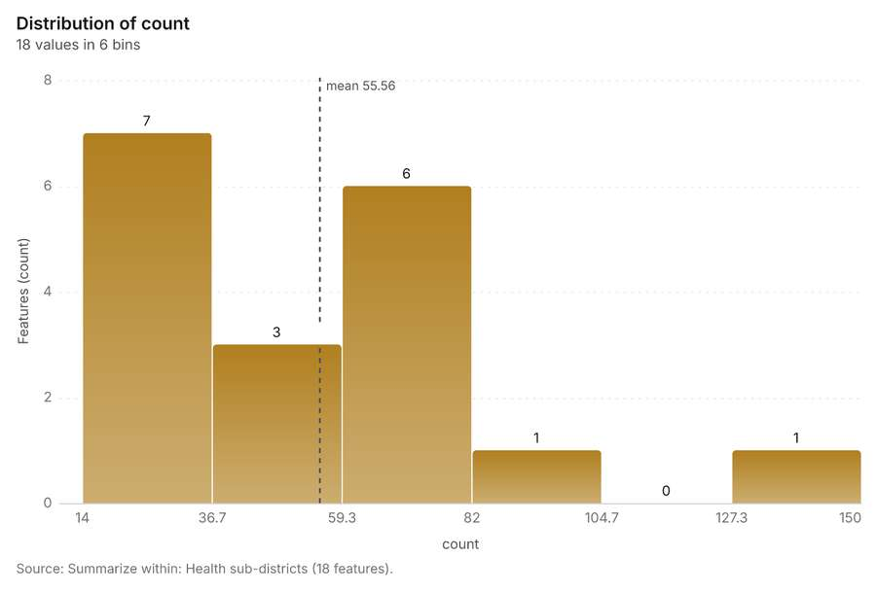
Figure 54. Summarize within: Health sub-districts [136]. Source: Summarize within: Health sub-districts (18 features). The data is in the appendix.
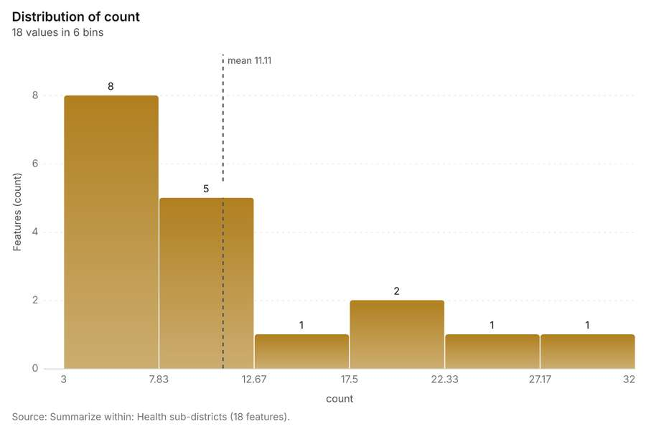
Figure 55. Summarize within: Health sub-districts [137]. Source: Summarize within: Health sub-districts (18 features). The data is in the appendix.
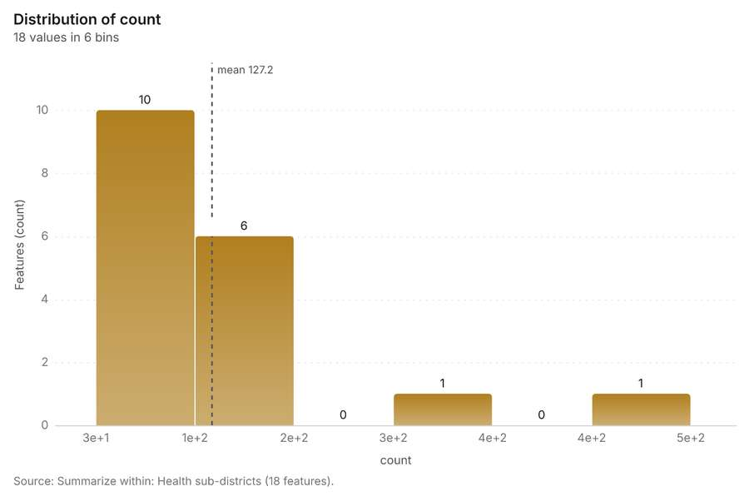
Figure 56. Summarize within: Health sub-districts [138]. Source: Summarize within: Health sub-districts (18 features). The data is in the appendix.
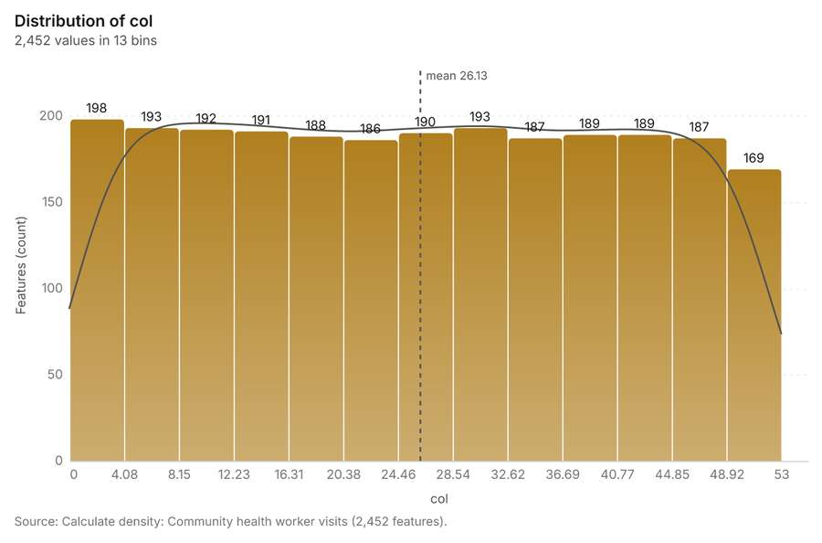
Figure 57. Calculate density: Community health worker visits [139]. Source: Calculate density: Community health worker visits (2,452 features). The data is in the appendix.
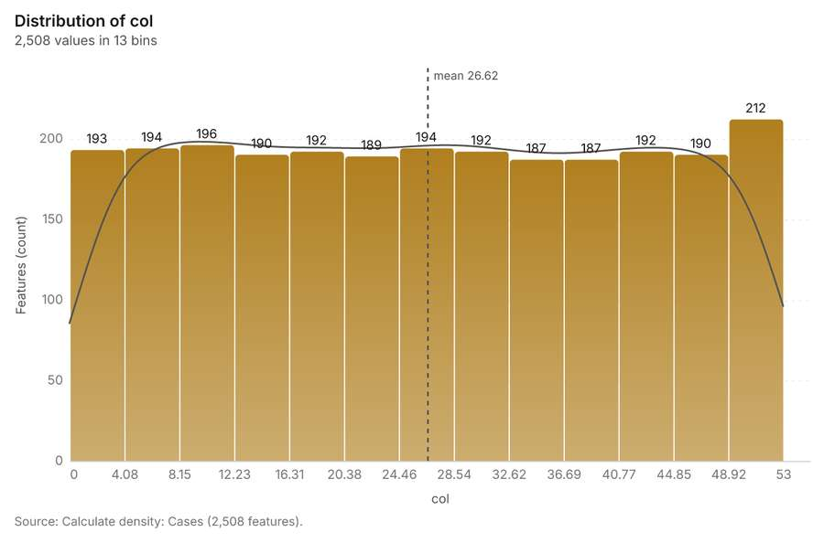
Figure 58. Calculate density: Cases [140]. Source: Calculate density: Cases (2,508 features). The data is in the appendix.
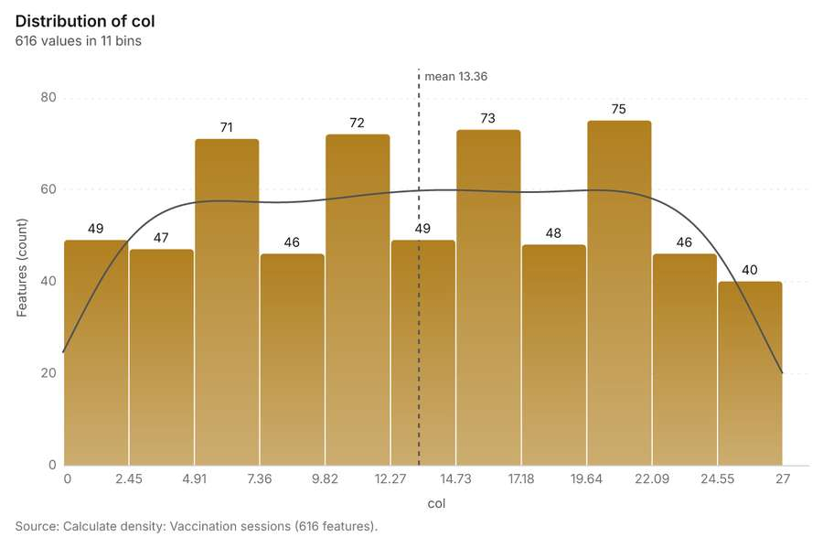
Figure 59. Calculate density: Vaccination sessions [141]. Source: Calculate density: Vaccination sessions (616 features). The data is in the appendix.
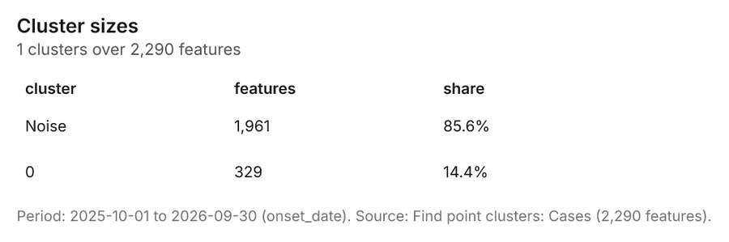
Figure 60. Find point clusters: Cases [142]. Period: 2025-10-01 to 2026-09-30 (onset_date). Source: Find point clusters: Cases (2,290 features). The data is in the appendix.
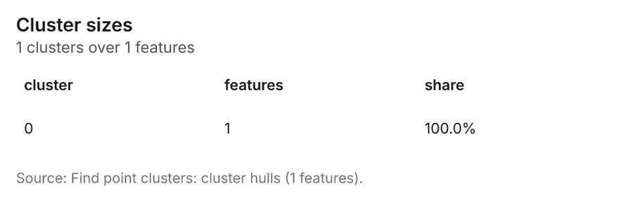
Figure 61. Find point clusters: cluster hulls [143]. Source: Find point clusters: cluster hulls (1 features). The data is in the appendix.
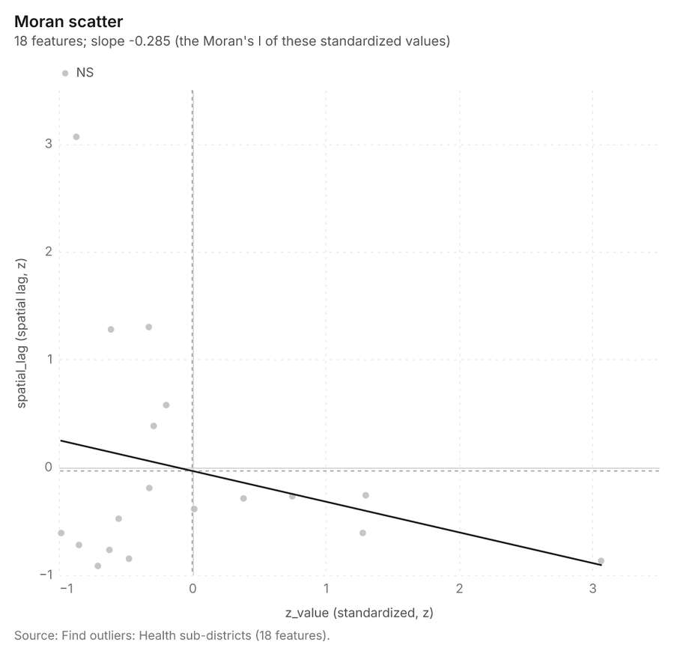
Figure 62. Find outliers: Health sub-districts [144]. Source: Find outliers: Health sub-districts (18 features). The data is in the appendix.
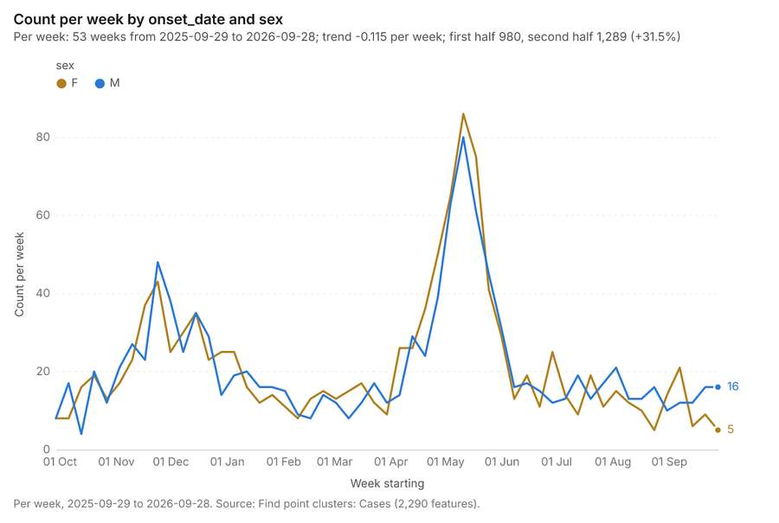
Figure 63. Find point clusters: Cases over time [145]. Per week, 2025-09-29 to 2026-09-28. Source: Find point clusters: Cases (2,290 features). The data is in the appendix.
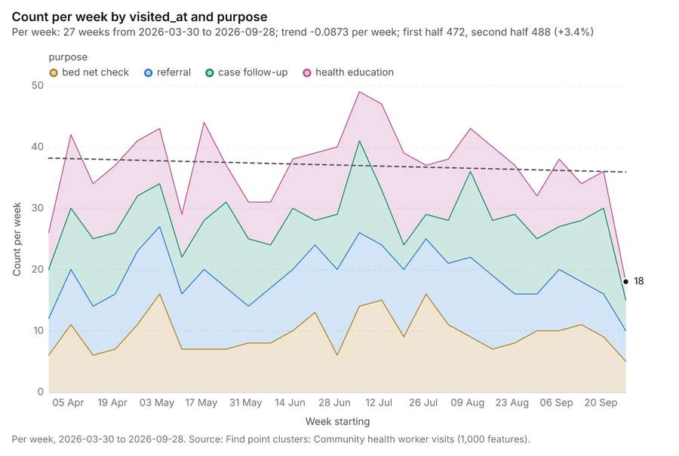
Figure 64. Find point clusters: Community health worker visits over time [146]. Per week, 2026-03-30 to 2026-09-28. Source: Find point clusters: Community health worker visits (1,000 features). The data is in the appendix.

More maps
1 more map(s), beyond the 24 the report body holds, in the composer's order: Density of community health worker visits and cases together [147].
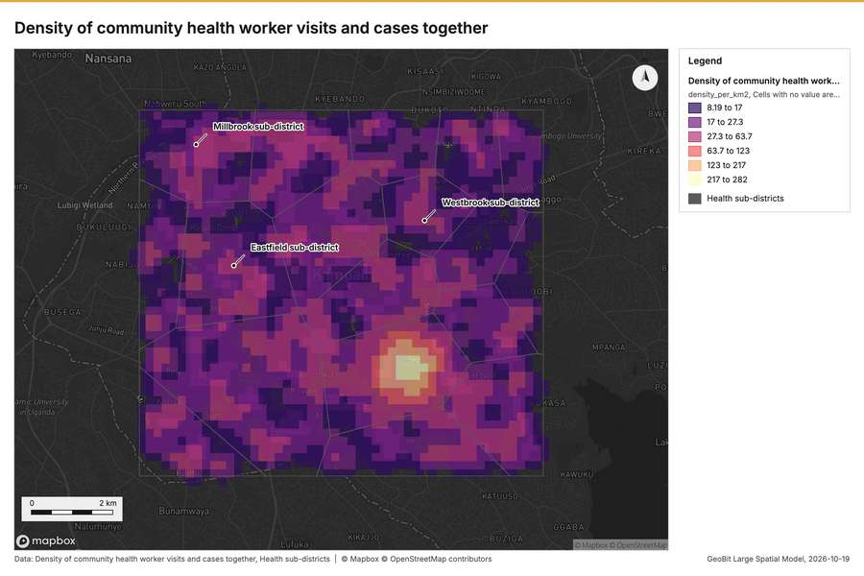
Figure 65. Density of community health worker visits and cases together [147]

Documents
What the documents name. Epidemiological situation report (1 page, 1 page(s) from the text layer) names 1 organization, 4 event terms, 6 places and 1 quantity [148]. Organizations named in Epidemiological situation report: Malaria (page 1, line 5) [149]. Event terms in Epidemiological situation report: cholera (page 1, line 3, 2 mentions), outbreak (page 1, line 3, 2 mentions) [149]. Places named in Epidemiological situation report: Parkside sub-district (page 1, line 3, 2 mentions), 029731, 3259548 (page 1, line 3), Rapid response team 1 (page 1, line 11), Eastfield sub-district (page 1, line 12) [149].
Result | Value
Documents | 1
Entities | 12
Organizations | 1
Event terms | 4
Places | 6
Quantities | 1

Findings
- Evidenced: Epidemiological situation report (1 page, 1 page(s) from the text layer) names 1 organization, 4 event terms, 6 places and 1 quantity.
- Evidenced: Organizations named in Epidemiological situation report: Malaria (page 1, line 5).
- Evidenced: Event terms in Epidemiological situation report: cholera (page 1, line 3, 2 mentions), outbreak (page 1, line 3, 2 mentions).
- Evidenced: Places named in Epidemiological situation report: Parkside sub-district (page 1, line 3, 2 mentions), 029731, 3259548 (page 1, line 3), Rapid response team 1 (page 1, line 11), Eastfield sub-district (page 1, line 12).

Changes since the last run
89 number(s) changed since the report of 2026-10-19T04:03:52Z.
Analysis | Measure | Before | After | Change
Space time hot spots | result, count | 24 | 124 | 100
Space time hot spots | result, elapsed ms | 4 | 17 | 13
Space time hot spots | result, resolution | 7 | 8 | 1
Space time hot spots | result, features used | 200 | 1,000 | 800
Space time hot spots | billing, cost | 0.11 | 0.15 | 0.04
Space time hot spots | billing, list price | 0.11 | 0.15 | 0.04
Space time hot spots | result, elapsed ms | 4 | 5 | 1
Space time hot spots | result, count | 24 | 125 | 101
Space time hot spots | result, elapsed ms | 4 | 26 | 22
Space time hot spots | result, resolution | 7 | 8 | 1
Space time hot spots | result, features used | 200 | 2,290 | 2,090
Space time hot spots | billing, cost | 0.11 | 0.2145 | 0.1045
Space time hot spots | billing, list price | 0.11 | 0.2145 | 0.1045
Hot spots | result, bins | 93 | 390 | 297
Hot spots | result, count | 93 | 390 | 297
Hot spots | result, elapsed ms | 4 | 17 | 13
Hot spots | result, cell size m | 1,000 | 500 | -500
Hot spots | result, incidents used | 150 | 1,000 | 850
Hot spots | result, distance band m | 2,000 | 1,000 | -1,000
Hot spots | billing, cost | 0.053 | 0.07 | 0.017
Hot spots | billing, list price | 0.053 | 0.07 | 0.017
Hot spots | result, bins | 93 | 2,259 | 2,166
Hot spots | result, count | 93 | 2,259 | 2,166
Hot spots | result, elapsed ms | 4 | 75 | 71
Hot spots | result, cell size m | 1,000 | 200 | -800
Hot spots | result, incidents used | 150 | 2,290 | 2,140
Hot spots | result, distance band m | 2,000 | 500 | -1,500
Hot spots | billing, cost | 0.053 | 0.0958 | 0.0428
Hot spots | billing, list price | 0.053 | 0.0958 | 0.0428
Hot spots | result, bins | 93 | 99 | 6
Hot spots | result, count | 93 | 99 | 6
Hot spots | result, elapsed ms | 4 | 5 | 1
Hot spots | result, incidents used | 150 | 200 | 50
Hot spots | billing, cost | 0.053 | 0.054 | 0.001
Hot spots | billing, list price | 0.053 | 0.054 | 0.001
Summarize within | result, elapsed ms | 1 | 2 | 1
Summarize within | billing, cost | 0.01058 | 0.03036 | 0.01978
Summarize within | billing, list price | 0.01058 | 0.03036 | 0.01978
Summarize within | result, elapsed ms | 1 | 0 | -1
Summarize within | billing, cost | 0.01058 | 0.01438 | 0.0038
Summarize within | billing, list price | 0.01058 | 0.01438 | 0.0038
Summarize within | result, elapsed ms | 1 | 3 | 2
Summarize within | billing, cost | 0.01058 | 0.05616 | 0.04558
Summarize within | billing, list price | 0.01058 | 0.05616 | 0.04558
Calculate density | result, count | 558 | 2,452 | 1,894
Calculate density | result, elapsed ms | 11 | 43 | 32
Calculate density | result, bandwidth m | 2,000 | 500 | -1,500
Calculate density | result, cell size m | 500 | 200 | -300
Calculate density | result, max density per km2 | 6.956 | 34.43 | 27.47
Calculate density | billing, cost | 0.053 | 0.07 | 0.017
Calculate density | billing, list price | 0.053 | 0.07 | 0.017
Calculate density | result, count | 558 | 2,508 | 1,950
Calculate density | result, elapsed ms | 11 | 49 | 38
Calculate density | result, bandwidth m | 2,000 | 500 | -1,500
Calculate density | result, cell size m | 500 | 200 | -300
Calculate density | result, max density per km2 | 6.956 | 282 | 275.1
Calculate density | billing, cost | 0.053 | 0.0958 | 0.0428
Calculate density | billing, list price | 0.053 | 0.0958 | 0.0428
Calculate density | result, count | 558 | 616 | 58
Calculate density | result, elapsed ms | 11 | 105 | 94
Calculate density | result, max density per km2 | 6.956 | 5.525 | -1.431
Calculate density | billing, cost | 0.053 | 0.054 | 0.001
Calculate density | billing, list price | 0.053 | 0.054 | 0.001
Find point clusters | result, count | 2,290 | 1,000 | -1,290
Find point clusters | result, noise | 1,961 | 1,000 | -961
Find point clusters | result, elapsed ms | 23 | 576 | 553
Find point clusters | billing, cost | 0.0958 | 0.07 | -0.0258
Find point clusters | billing, list price | 0.0958 | 0.07 | -0.0258
Find point clusters | result, elapsed ms | 23 | 24 | 1
Change beside the counts per health sub-district | result, count | 10 | 18 | 8
Change beside the counts per health sub-district | result, elapsed ms | 2 | 1 | -1
Change beside the counts per health sub-district | billing, cost | 0.06038 | 0.01074 | -0.04964
Change beside the counts per health sub-district | billing, list price | 0.06038 | 0.01074 | -0.04964
Change of vaccination sessions where density is high | result, elapsed ms | 2 | 3 | 1
Change of vaccination sessions where density is high | billing, cost | 0.06038 | 0.05926 | -0.00112
Change of vaccination sessions where density is high | billing, list price | 0.06038 | 0.05926 | -0.00112
Hot cells of cases per health sub-district | result, elapsed ms | 1 | 38 | 37
Hot cells of cases per health sub-district | billing, cost | 0.01058 | 0.05554 | 0.04496
Hot cells of cases per health sub-district | billing, list price | 0.01058 | 0.05554 | 0.04496
Dense areas of community health worker visits | result, count | 1 | 5 | 4
Dense areas of community health worker visits | result, elapsed ms | 0 | 46 | 46
Dense areas of community health worker visits | billing, cost | 0.02015 | 0.06905 | 0.0489
Dense areas of community health worker visits | billing, list price | 0.02015 | 0.06905 | 0.0489
Dense areas of community health worker visits | list price | 0.02015 | 0.06905 | 0.0489
Density of community health worker visits and cases together | result, count | 2,352 | 4,960 | 2,608
Density of community health worker visits and cases together | result, elapsed ms | 58 | 109 | 51
Documents | Entities | 1 | 12 | 11
Documents | Event terms | 1 | 4 | 3
Documents | Places | 1 | 6 | 5

Sources
[1] Rendering: Chart: Timeline: events per week by dataset. 265 rows (id 9ed316de-c13f-4c96-9941-d0ab254813c6)
[2] Dataset: Cases. vector, 2290 rows (id 59cb2ed5-709d-4ca6-94aa-fd8eb621eb37)
[3] Dataset: Community health worker visits. vector, 1000 rows (id 44c21bd2-0729-457b-ba05-d7a36b9885ed)
[4] Dataset: Vaccination sessions. vector, 200 rows (id 46c023c6-ea3b-4a1d-9a6c-130a334b6790)
[5] Dataset: Weekly cases by sub-district. table, 936 rows (id 1ce22bbc-4659-446b-a2ab-9d6f1bfe6418)
[6] Dataset: Clinic stock by month. table, 315 rows (id 930b3eee-3ebe-4aff-8fa0-a2c38a029a36)
[7] Rendering: Chart: Timeline lanes: events per week by dataset. 265 rows (id dc67edf4-bf01-4d54-a054-9cccf4719256)
[8] Rendering: Chart: Timeline: change from one week to the next. 52 rows (id b08e07a6-2857-423d-9faf-2edf4b6db093)
[9] Tool result: gp_period_change, step 0. The count fell from 36 in week of 2026-09-21 to 18 in week of 2026-09-28 (-50.0%); a change this large is unlikely to be chance (p = 0.0198). (id da0d02de-5858-490e-a2a5-d4daf11b4a77:0)
[10] Layer: Period change: Community health worker visits (week of 2026-09-21 to week of 2026-09-28) (id 3bec1b01-80c0-4802-8f6f-e05ccd607485)
[11] Tool result: gp_period_change, step 1. The count fell from 9 in week of 2026-06-29 to 2 in week of 2026-07-06 (-77.8%); a change this small is within what chance would give (p = 0.0654). (id da0d02de-5858-490e-a2a5-d4daf11b4a77:1)
[12] Layer: Period change: Vaccination sessions (week of 2026-06-29 to week of 2026-07-06) (id 3345972d-58bd-4b02-b103-633f6c7a1c21)
[13] Tool result: gp_period_change, step 2. The count fell from 136 in week of 2026-05-18 to 86 in week of 2026-05-25 (-36.8%); a change this large is unlikely to be chance (p = 0.000963). (id da0d02de-5858-490e-a2a5-d4daf11b4a77:2)
[14] Layer: Period change: Cases (week of 2026-05-18 to week of 2026-05-25) (id 66f934f7-4d7f-4b71-bfe5-db9cf372b64d)
[15] Rendering: Map: Overview: the top 3 results. view longitude 32.48887 to 32.67295, latitude 0.23939 to 0.37643 (id 56c16576-ebcf-441b-9376-fc19268f64e4)
[16] Layer: Health sub-districts. spatial profile (id 433b88cc-cf57-4d48-b158-220cc8b77697)
[17] Layer: Cases. spatial profile (id 03c8f72b-99c1-4176-8f56-aabff1d062b7)
[18] Layer: Clinics. spatial profile (id ac5b28b9-59c1-40e0-b7bd-1b0014ea13e0)
[19] Layer: Water points. spatial profile (id c63bde31-7c18-420e-894d-3e824a409c2d)
[20] Layer: Community health worker visits. spatial profile (id 4d70d1ce-8162-42eb-b3d7-d864edf2721e)
[21] Layer: Outbreak response teams. spatial profile (id 1b8f0e74-8ce3-4ca6-bbf8-e76348e17d6e)
[22] Layer: Vaccination sessions. spatial profile (id 6798c97c-ff1d-462f-b9b0-5baab95708a5)
[23] Catalog: Emerging hot spots (operation catalog, gp_space_time_hot_spots). Where hot spots are new, consecutive, intensifying, persistent, diminishing, sporadic, oscillating or historical over time. ArcGIS: Emerging Hot Spot Analysis, Create Space Time Cube. (id gp_space_time_hot_spots)
[24] Plan: Space time hot spots of Community health worker visits (the Start plan's candidate c_70590e6d2eeb). Community health worker visits carry dates in 'visited_at': emerging hot spot analysis finds new, intensifying and fading hot spots per week. (id 502cfe77-e27d-4781-888d-59ecc8241e24:c_70590e6d2eeb)
[25] Tool result: gp_space_time_hot_spots, step 0. Emerging hot spots: 1 layer saved: Emerging hot spots: Community health worker visits (124 features). (id ca57d695-3247-4efe-bf1e-0e4a458c66f4:0)
[26] Rendering: Map: Emerging hot spots: community health worker visits and cases. view longitude 32.49952 to 32.66088, latitude 0.25211 to 0.37225 (id 7e95523d-3393-400e-8c04-5e9bb1751ad0)
[27] Plan: Space time hot spots of Vaccination sessions (the Start plan's candidate c_136a5b017678). Vaccination sessions carry dates in 'held_on': emerging hot spot analysis finds new, intensifying and fading hot spots per week. Measured: the pattern of Vaccination sessions changes over time (earlier half random, later half dispersed; the center moved 259 m). (id 502cfe77-e27d-4781-888d-59ecc8241e24:c_136a5b017678)
[28] Tool result: gp_space_time_hot_spots, step 1. Emerging hot spots: 1 layer saved: Emerging hot spots: Vaccination sessions (24 features). (id ca57d695-3247-4efe-bf1e-0e4a458c66f4:1)
[29] Rendering: Map: Emerging hot spots: vaccination sessions. view longitude 32.48887 to 32.67295, latitude 0.23939 to 0.37643 (id 56aebece-6125-4fb6-b449-86d97ba94702)
[30] Plan: Space time hot spots of Cases (the Start plan's candidate c_24319662e98f). Cases carry dates in 'onset_date': emerging hot spot analysis finds new, intensifying and fading hot spots per week. Measured: the pattern of Cases changes over time (earlier half random, later half clustered; the center moved 783 m). (id 502cfe77-e27d-4781-888d-59ecc8241e24:c_24319662e98f)
[31] Tool result: gp_space_time_hot_spots, step 2. Emerging hot spots: 1 layer saved: Emerging hot spots: Cases (125 features). (id ca57d695-3247-4efe-bf1e-0e4a458c66f4:2)
[32] Catalog: Hot spot analysis (operation catalog, gp_hot_spots). Getis-Ord Gi* hot and cold spots with z-scores, p-values and confidence bins. ArcGIS: Find Hot Spots, Hot Spot Analysis (Getis-Ord Gi*). QGIS: qgis:hotspot (plugin). (id gp_hot_spots)
[33] Plan: Hot spots of Community health worker visits (the Start plan's candidate c_6211f60c8ad6). 1000 points: Getis-Ord Gi* tests whether the concentrations in Community health worker visits are statistically significant. Measured: Community health worker visits are clustered (nearest-neighbor ratio 0.95, z = -3.3), median spacing 124 m. Cells of 500 m and a band of 1000 m from the measured spacing. (id 502cfe77-e27d-4781-888d-59ecc8241e24:c_6211f60c8ad6)
[34] Tool result: gp_hot_spots, step 0. Hot spot analysis: 1 layer saved: Hot spot analysis: Community health worker visits (390 features). (id c2d5c745-9aa1-4cd9-a0a8-2ff3ab77a62a:0)
[35] Rendering: Map: Hot spots: community health worker visits. view longitude 32.50994 to 32.65238, latitude 0.25713 to 0.36631 (id 98052aef-9d4d-4f54-ba5f-c8b6a1168787)
[36] Plan: Hot spots of Cases (the Start plan's candidate c_9fb20ef66d1e). 2290 points: Getis-Ord Gi* tests whether the concentrations in Cases are statistically significant. Measured: Cases are clustered (nearest-neighbor ratio 0.90, z = -9.4), median spacing 75.6 m. Cells of 200 m and a band of 500 m from the measured spacing. (id 502cfe77-e27d-4781-888d-59ecc8241e24:c_9fb20ef66d1e)
[37] Tool result: gp_hot_spots, step 1. Hot spot analysis: 1 layer saved: Hot spot analysis: Cases (2259 features). (id c2d5c745-9aa1-4cd9-a0a8-2ff3ab77a62a:1)
[38] Rendering: Map: Hot spots: cases. view longitude 32.5125 to 32.64913, latitude 0.25979 to 0.36453 (id a56eeb41-2edc-432a-88c7-a24c0f5a72b3)
[39] Plan: Hot spots of Vaccination sessions (the Start plan's candidate c_e1e27b62d2c9). 200 points: Getis-Ord Gi* tests whether the concentrations in Vaccination sessions are statistically significant. (id 502cfe77-e27d-4781-888d-59ecc8241e24:c_e1e27b62d2c9)
[40] Tool result: gp_hot_spots, step 2. Hot spot analysis: 1 layer saved: Hot spot analysis: Vaccination sessions (99 features). (id c2d5c745-9aa1-4cd9-a0a8-2ff3ab77a62a:2)
[41] Rendering: Map: Hot spots: vaccination sessions. view longitude 32.49938 to 32.65852, latitude 0.25127 to 0.37325 (id 68ed8d3d-fda0-438d-87ed-17c5d6d517d1)
[42] Catalog: Summarize within (operation catalog, gp_summarize_within). Count and aggregate the features inside each polygon (or bin), proportionally for lines and polygons. ArcGIS: Summarize Within, Aggregate Points. QGIS: native:countpointsinpolygon, native:sumlinelengths. (id gp_summarize_within)
[43] Plan: Community health worker visits per feature of Health sub-districts (the Start plan's candidate c_f0b17dbbc715). Count Community health worker visits inside each feature of Health sub-districts by purpose; the counts map as a choropleth (natural breaks, sequential colors). (id 502cfe77-e27d-4781-888d-59ecc8241e24:c_f0b17dbbc715)
[44] Tool result: gp_summarize_within, step 0. Summarize within: 1 layer saved: Summarize within: Health sub-districts (18 features). (id a98160db-9f77-4a98-acfd-a879b8f97de9:0)
[45] Rendering: Map: Counts: community health worker visits, by health sub-district. view longitude 32.51464 to 32.64754, latitude 0.26149 to 0.36336 (id 3b9b93aa-6cb9-420c-beb3-f36bcbea491e)
[46] Tool result: gp_summarize_within, step 1. Summarize within: 1 layer saved: Summarize within: Health sub-districts (18 features). (id a98160db-9f77-4a98-acfd-a879b8f97de9:1)
[47] Rendering: Map: Counts: vaccination sessions, by health sub-district. view longitude 32.51464 to 32.64754, latitude 0.26149 to 0.36336 (id 72daafcb-45d3-43a7-bc54-d22b2cc6e843)
[48] Tool result: gp_summarize_within, step 2. Summarize within: 1 layer saved: Summarize within: Health sub-districts (18 features). (id a98160db-9f77-4a98-acfd-a879b8f97de9:2)
[49] Rendering: Map: Counts: cases, by health sub-district. view longitude 32.51464 to 32.64754, latitude 0.26149 to 0.36336 (id 2135f78f-d2ac-433f-9d8a-6e3d45ba6e33)
[50] Catalog: Period change (analysis catalog, gp_period_change). Counts or sums per period (week over week, month over month, any two periods, or before and after a date), per area, per H3 cell or in total, with the places of largest rise and fall and a significance note. ArcGIS: Summarize Percent Change (Crime Analysis), Change Point Detection. (id gp_period_change)
[51] Plan: Community health worker visits: change per week per feature of Health sub-districts (the Start plan's candidate c_a2fcbe1fcdab). Community health worker visits carry dates in 'visited_at' over 26 weeks: the count per week, week over week, with the places of largest rise and fall per feature of Health sub-districts and whether the change is beyond chance. (id 502cfe77-e27d-4781-888d-59ecc8241e24:c_a2fcbe1fcdab)
[52] Rendering: Map: Period change: community health worker visits, by health sub-district. view longitude 32.51235 to 32.64994, latitude 0.26121 to 0.36364 (id 1ba857b6-25f9-4a1e-9809-7dabd1dba73f)
[53] Rendering: Chart: Community health worker visits: count per week. 27 rows (id 38a7f1b5-f586-4a93-acb8-4706829d7084)
[54] Rendering: Chart: Community health worker visits: week of 2026-09-21 to week of 2026-09-28 by place. 28 rows (id cc02c36d-d7ba-4b30-b17f-b4d59c59a182)
[55] Rendering: Chart: Period change: Community health worker visits (week of 2026-09-21 to week of 2026-09-28). 5 rows (id 5a1e5aac-b54b-49dd-82a1-6de54c6f280a)
[56] Rendering: Map: Period change: vaccination sessions, by health sub-district. view longitude 32.51235 to 32.64994, latitude 0.26121 to 0.36364 (id 4021c7ee-ffb3-49da-9404-41221d96a7a2)
[57] Rendering: Chart: Vaccination sessions: count per week. 39 rows (id f56fc17e-709a-4ed7-a297-d2fd6e33d067)
[58] Rendering: Chart: Vaccination sessions: week of 2026-06-29 to week of 2026-07-06 by place. 20 rows (id 293fe134-01c3-4c24-b991-e34d182657c7)
[59] Rendering: Chart: Period change: Vaccination sessions (week of 2026-06-29 to week of 2026-07-06). 5 rows (id a076831a-6ae4-47aa-8be1-9a5d36f509fa)
[60] Rendering: Map: Period change: cases, by health sub-district. view longitude 32.51235 to 32.64994, latitude 0.26121 to 0.36364 (id c02c2da5-7128-4cbe-bc4c-1af8118de764)
[61] Rendering: Chart: Cases: count per week. 53 rows (id a232e499-3702-4315-b7d3-da9d00e71897)
[62] Rendering: Chart: Cases: week of 2026-05-18 to week of 2026-05-25 by place. 30 rows (id c86a0c4a-b1af-4354-b292-8496363ee353)
[63] Rendering: Chart: Period change: Cases (week of 2026-05-18 to week of 2026-05-25). 6 rows (id 916d1401-e116-42e0-b939-a730c5fff396)
[64] Catalog: Calculate density (operation catalog, gp_calculate_density). Kernel density per square kilometer on a grid. ArcGIS: Calculate Density, Kernel Density. QGIS: native:heatmapkerneldensityestimation. (id gp_calculate_density)
[65] Plan: Kernel density of Community health worker visits (the Start plan's candidate c_224143430356). 1000 points in Community health worker visits: a density surface shows where they concentrate. Measured: Community health worker visits are clustered (nearest-neighbor ratio 0.95, z = -3.3), median spacing 124 m. (id 502cfe77-e27d-4781-888d-59ecc8241e24:c_224143430356)
[66] Tool result: gp_calculate_density, step 0. Calculate density: 1 layer saved: Calculate density: Community health worker visits (2452 features). (id 12155ea1-761a-4dfb-bea9-c367f910d998:0)
[67] Rendering: Map: Density: community health worker visits. view longitude 32.50938 to 32.65381, latitude 0.25717 to 0.36787 (id c4802079-26fd-4077-ab26-93b7925b6482)
[68] Plan: Kernel density of Cases (the Start plan's candidate c_070749f5aead). 2290 points in Cases: a density surface shows where they concentrate. Measured: Cases are clustered (nearest-neighbor ratio 0.90, z = -9.4), median spacing 75.6 m. (id 502cfe77-e27d-4781-888d-59ecc8241e24:c_070749f5aead)
[69] Tool result: gp_calculate_density, step 1. Calculate density: 1 layer saved: Calculate density: Cases (2508 features). (id 12155ea1-761a-4dfb-bea9-c367f910d998:1)
[70] Rendering: Map: Density: cases. view longitude 32.50843 to 32.65285, latitude 0.25669 to 0.3674 (id 06af517c-f53b-4797-a57c-3a39a0f27a0d)
[71] Plan: Kernel density of Vaccination sessions (the Start plan's candidate c_e0476445813b). 200 points in Vaccination sessions: a density surface shows where they concentrate. (id 502cfe77-e27d-4781-888d-59ecc8241e24:c_e0476445813b)
[72] Tool result: gp_calculate_density, step 2. Calculate density: 1 layer saved: Calculate density: Vaccination sessions (616 features). (id 12155ea1-761a-4dfb-bea9-c367f910d998:2)
[73] Rendering: Map: Density: vaccination sessions. view longitude 32.49029 to 32.67437, latitude 0.24081 to 0.3819 (id 8e8a277d-768e-4e3d-b59e-c64d53beeb67)
[74] Catalog: Find point clusters (operation catalog, gp_find_point_clusters). Density-based clusters (DBSCAN, HDBSCAN or OPTICS, optionally space-time) with hulls and noise. ArcGIS: Find Point Clusters, Density-based Clustering. QGIS: native:dbscanclustering, native:stdbscanclustering. (id gp_find_point_clusters)
[75] Plan: Cluster points of Community health worker visits (the Start plan's candidate c_b85a20a2f1a4). DBSCAN finds dense groups of Community health worker visits and separates noise. Measured: Community health worker visits are clustered (nearest-neighbor ratio 0.95, z = -3.3), median spacing 124 m. DBSCAN at 200 m (twice the measured spacing). (id 502cfe77-e27d-4781-888d-59ecc8241e24:c_b85a20a2f1a4)
[76] Tool result: gp_find_point_clusters, step 0. Find point clusters: 1 layer saved: Find point clusters: Community health worker visits (1000 features). (id 77bbbd8a-81ae-4bc9-b0c3-23aaf5f1fa0f:0)
[77] Rendering: Map: Clusters: community health worker visits. view longitude 32.51641 to 32.64657, latitude 0.26283 to 0.3626 (id 8bb4310d-659d-4524-a471-aaae6fdb36c0)
[78] Plan: Cluster points of Cases (the Start plan's candidate c_c6803ff2f7da). DBSCAN finds dense groups of Cases and separates noise. Measured: Cases are clustered (nearest-neighbor ratio 0.90, z = -9.4), median spacing 75.6 m. DBSCAN at 200 m (twice the measured spacing). (id 502cfe77-e27d-4781-888d-59ecc8241e24:c_c6803ff2f7da)
[79] Tool result: gp_find_point_clusters, step 1. Find point clusters: 2 layers saved: Find point clusters: Cases (2290 features); Find point clusters: cluster hulls (1 feature). (id 77bbbd8a-81ae-4bc9-b0c3-23aaf5f1fa0f:1)
[80] Rendering: Map: Clusters: cases. view longitude 32.51557 to 32.64664, latitude 0.26229 to 0.36275 (id 48c33ecb-0323-4a65-a670-4a31e60946af)
[81] Catalog: Find outliers (operation catalog, gp_outliers). Anselin local Moran’s I: HH, LL clusters and HL, LH outliers. ArcGIS: Find Outliers, Cluster and Outlier Analysis (Anselin Local Moran’s I). (id gp_outliers)
[82] Plan: Local morans i of Health sub-districts (the Start plan's candidate c_39aa394b7122). Local Moran's I maps clusters and outliers of 'population'. Measured: Health sub-districts have 39 neighboring pairs (4.33 neighbors per area, 0 isolated), so neighbors can be compared. (id 502cfe77-e27d-4781-888d-59ecc8241e24:c_39aa394b7122)
[83] Tool result: gp_outliers, step 0. Find outliers: 1 layer saved: Find outliers: Health sub-districts (18 features). (id 97423338-c177-4702-bebb-f1beb57bfaff:0)
[84] Rendering: Map: Outliers: health sub-districts. view longitude 32.51464 to 32.64754, latitude 0.26149 to 0.36336 (id b07c4b22-dbfb-4024-b401-a4a40ee5d0c0)
[85] Catalog: Spatial join (operation catalog, gp_spatial_join). Attach attributes (or aggregates) of matching features from another layer, by location, distance, time and attributes. ArcGIS: Join Features, Spatial Join. QGIS: native:joinattributesbylocation, native:joinbylocationsummary, native:joinbynearest. (id gp_spatial_join)
[86] Plan: The run's goal. Describe the project Sample: Public health, Kampala: run the analyses that tell the most about its data, draw every result, and write a cited report. (id 12778c77-4c3f-4379-9aca-c9e85676282e:goal)
[87] Tool result: gp_spatial_join, step 0. Spatial join: 1 layer saved: Change beside the counts per health sub-district (18 features). (id a1498fe0-e6b0-47ea-b178-eea9d9489b4e:0)
[88] Layer: Summarize within: Health sub-districts. 18 features (id 9220b574-337c-44ac-8245-9bddea6ca9e7)
[89] Layer: Change beside the counts per health sub-district. 18 features (id 329bcab2-5a7e-47ff-9e3a-70ab2bfb87e9)
[90] Rendering: Map: Change beside the counts per health sub-district. view longitude 32.51464 to 32.64754, latitude 0.26149 to 0.36336 (id 1a975715-964d-4cea-a9d4-e1f36f7402f9)
[91] Rendering: Chart: Change beside the counts per health sub-district. 6 rows (id d8232fd5-0620-44d0-a014-35f7ff7c1ccb)
[92] Tool result: gp_spatial_join, step 0. Spatial join: 1 layer saved: Change of vaccination sessions where density is high (10 features). (id dcf7086a-4b87-4442-bf12-c3721d1867e7:0)
[93] Layer: Calculate density: Community health worker visits. 2,452 features (id 3aeb4280-7dc5-445b-bbe5-0f612cf31e62)
[94] Layer: Change of vaccination sessions where density is high. 10 features (id 9cf2f4e1-0c98-47a0-8eda-017184bee6f6)
[95] Rendering: Map: Change of vaccination sessions where density is high. view longitude 32.51464 to 32.64754, latitude 0.26149 to 0.36336 (id 2e0eef15-a319-4b25-8746-f0ab62d6c9ad)
[96] Rendering: Chart: Change of vaccination sessions where density is high. 5 rows (id 339db613-2509-4201-bb54-b9cf3018c42e)
[97] Tool result: gp_summarize_within, step 0. Summarize within: 1 layer saved: Hot cells of cases per health sub-district (18 features). (id cbaa2d66-7e86-4062-a268-8ceebb34226f:0)
[98] Layer: Hot spot analysis: Cases. 2,259 features (id 7dc9eb55-076a-4811-89ea-633c6eba1ad4)
[99] Layer: Hot cells of cases per health sub-district. 18 features (id c90fa521-67fb-47d1-b4be-789822f3c247)
[100] Rendering: Map: Hot cells of cases per health sub-district. view longitude 32.51464 to 32.64754, latitude 0.26149 to 0.36336 (id c1fd9863-16f7-454b-b2e4-46156c47d93d)
[101] Rendering: Chart: Hot cells of cases per health sub-district. 6 rows (id d428d2a4-23ca-4584-9e0e-18e6da6305ec)
[102] Catalog: Find nearest (operation catalog, gp_find_nearest). The k nearest features for each input, with geodesic distance and bearing. ArcGIS: Find Nearest, Near, Generate Near Table. QGIS: native:joinbynearest, native:nearestneighbouranalysis. (id gp_find_nearest)
[103] Tool result: gp_find_nearest, step 0. Find nearest: 1 layer saved: Nearest outbreak response team to each cluster of cases (1 feature). (id bf6d2133-da41-4a20-84bf-87e492f1da5b:0)
[104] Layer: Find point clusters: cluster hulls. 1 features (id 53d9a3e2-2347-4fc0-bb22-fd75844c6cc8)
[105] Layer: Nearest outbreak response team to each cluster of cases. 1 features (id b7c1c4f9-ecec-44aa-bf5a-a330316e549f)
[106] Rendering: Map: Nearest outbreak response team to each cluster of cases. view longitude 32.5846 to 32.60637, latitude 0.28861 to 0.3053 (id 561b2c9d-1c47-4350-a8f1-2ace1078c213)
[107] Rendering: Chart: Nearest outbreak response team to each cluster of cases. 1 rows (id 3762f5c3-d6af-4f5c-847a-dcb0fcf4fbe1)
[108] Catalog: Pipeline (tool description, gp_pipeline). Run up to 20 GIS operations in one engine call; a step's params may use "$id" (an earlier step's result) or "$id.key", and layer references. Every step's map outputs are saved as styled layers. Never calls Mapbox. (id gp_pipeline)
[109] Plan: Community health worker visits per 10,000 people per feature of Health sub-districts (the Start plan's candidate c_9273635ebf24). Health sub-districts holds population in 'population': Community health worker visits per 10,000 people in each feature compares features of different size; mapped as a choropleth (natural breaks, sequential colors). (id 502cfe77-e27d-4781-888d-59ecc8241e24:c_9273635ebf24)
[110] Tool result: gp_pipeline, step 0. Pipeline of 2 steps (classify_field > dissolve): 1 layer saved. (id 228e478a-4ba9-4d74-976e-e45efd5229c7:0)
[111] Layer: Dense areas of community health worker visits. 5 features (id 3c9ccc18-20ed-47f2-ac66-234751a0679d)
[112] Rendering: Chart: Dense areas of community health worker visits. 5 rows (id 42cf1971-6f22-441e-aa1a-a1326ec273d8)
[113] Tool result: gp_summarize_within, step 0. Summarize within: 1 layer saved: Change of vaccination sessions per health sub-district (18 features). (id 17676f2a-994e-4660-9745-0a3db803f8a8:0)
[114] Layer: Change of vaccination sessions per health sub-district. 18 features (id f4ad8c88-5019-4a59-a2a0-054c153f32be)
[115] Rendering: Map: Change of vaccination sessions per health sub-district. view longitude 32.51464 to 32.64754, latitude 0.26149 to 0.36336 (id 5b65b748-4632-4299-9ce1-4f8eb9a0301e)
[116] Rendering: Chart: Change of vaccination sessions per health sub-district. 6 rows (id 7d5f7fc8-f8d9-41e4-be37-e2cea1f883b7)
[117] Plan: Outbreak response teams per 10,000 people per feature of Health sub-districts (the Start plan's candidate c_9a76ebe60c76). Health sub-districts holds population in 'population': Outbreak response teams per 10,000 people in each feature compares features of different size; mapped as a choropleth (natural breaks, sequential colors). (id 502cfe77-e27d-4781-888d-59ecc8241e24:c_9a76ebe60c76)
[118] Tool result: gp_pipeline, step 0. Pipeline of 2 steps (buffer > summarize_within): 1 layer saved. (id 8ab3e530-5833-406a-81af-1fb4eae27c2f:0)
[119] Layer: Outbreak response teams within 250 m of each cluster of cases. 1 features (id b7e12b85-5a4c-4d51-b141-8bb6248100da)
[120] Rendering: Map: Outbreak response teams within 250 m of each cluster of cases. view longitude 32.58093 to 32.61005, latitude 0.28573 to 0.30805 (id 2a7e6b94-090d-4ceb-9543-bf0e2eaad33c)
[121] Rendering: Chart: Outbreak response teams within 250 m of each cluster of cases. 1 rows (id 8d19bda1-77d2-4fd7-9777-e6693a0dd643)
[122] Catalog: Merge layers (operation catalog, gp_merge_layers). Append several layers into one. ArcGIS: Merge Layers, Merge. QGIS: native:mergevectorlayers. (id gp_merge_layers)
[123] Tool result: gp_merge_layers, step 0. Merge layers: 1 layer saved: Density of community health worker visits and cases together (4960 features). (id 1e12b18a-4e3f-4064-82dd-a2dfd4e27abc:0)
[124] Layer: Calculate density: Cases. 2,508 features (id b48a2b54-e6f8-464b-bc6d-b3f70448006d)
[125] Layer: Density of community health worker visits and cases together. 4,960 features (id 39d58f96-c415-42fe-bd1d-212d8c37be6e)
[126] Rendering: Chart: Density of community health worker visits and cases together. 14 rows (id 2adbb49c-d53c-48e7-a48f-ad1f6f209cf5)
[127] Rendering: Map: Health sub-districts by population (id 5ef70e51-0bfd-4073-a856-905f5169fec3)
[128] Rendering: Chart: Cases over time (onset_date). 159 rows (id 2767bc98-56c4-42c3-b1d6-bd12a2987bec)
[129] Rendering: Chart: Clinic stock by month over time (month). 36 rows (id f8cfe58c-5392-477f-95a8-16f1c3223752)
[130] Rendering: Chart: Emerging hot spots: Community health worker visits. 8 rows (id d847a912-2ac6-45dd-9ff7-e69e54f5091b)
[131] Rendering: Chart: Emerging hot spots: Vaccination sessions. 6 rows (id e41e6ccc-7233-4910-b880-fa8e491bc99b)
[132] Rendering: Chart: Emerging hot spots: Cases. 8 rows (id 8d0dd7bd-fa8d-46d4-a605-510c07477368)
[133] Rendering: Chart: Hot spot analysis: Community health worker visits. 21 rows (id 2f9efce8-7875-4dac-b005-38853d079029)
[134] Rendering: Chart: Hot spot analysis: Cases. 53 rows (id fa55dd0e-666e-4751-b2b2-9e1f0b859733)
[135] Rendering: Chart: Hot spot analysis: Vaccination sessions. 14 rows (id b1e62dd9-e001-4d7a-b5e6-ab1dc1f840cc)
[136] Rendering: Chart: Summarize within: Health sub-districts. 6 rows (id 9f7e951b-937a-4c91-a27e-78f52dcc8881)
[137] Rendering: Chart: Summarize within: Health sub-districts. 6 rows (id c229b3e5-c6e5-4952-a2f7-694aa2209b3f)
[138] Rendering: Chart: Summarize within: Health sub-districts. 6 rows (id 5e8cdc54-af5b-4a64-8630-d8cc680b09a0)
[139] Rendering: Chart: Calculate density: Community health worker visits. 13 rows (id fde12f1f-a5aa-4aeb-bf82-9263e56dca6f)
[140] Rendering: Chart: Calculate density: Cases. 13 rows (id d3819a7e-df6e-410c-a08e-5dc99421b7b4)
[141] Rendering: Chart: Calculate density: Vaccination sessions. 11 rows (id e67f7ebe-6edb-44cb-992b-568211369e6d)
[142] Rendering: Chart: Find point clusters: Cases. 2 rows (id 9446f731-3ec5-4204-a55f-680b73096a9b)
[143] Rendering: Chart: Find point clusters: cluster hulls. 1 rows (id 47f73bfc-cea9-49b5-a8c8-0daf229197af)
[144] Rendering: Chart: Find outliers: Health sub-districts. 18 rows (id 80bc5037-fe96-47f6-9f2d-09b7e0b01cee)
[145] Rendering: Chart: Find point clusters: Cases over time. 106 rows (id eda4bec9-eaa5-497f-855f-0e9893628d6b)
[146] Rendering: Chart: Find point clusters: Community health worker visits over time. 108 rows (id b48c3ed5-295d-4fff-a7f2-8068c4ce4536)
[147] Rendering: Map: Density of community health worker visits and cases together. view longitude 32.50837 to 32.6538, latitude 0.25641 to 0.36789 (id 88c9d95c-3e1b-4a51-8f51-669e638423ad)
[148] Document: Epidemiological situation report. 1 page(s), 1 page(s) from the text layer (id cb6fd9c4-f91e-4a89-a40d-68bf28554744)
[149] Document page: Epidemiological situation report, page 1. Malaria cases rose after both rainy seasons, three weeks after the rain peaks. (id cb6fd9c4-f91e-4a89-a40d-68bf28554744:1)
[150] Dataset: Health sub-districts. vector, 18 rows (id 9bb4e797-2cc2-4974-b5ec-02ddc0a96670)
[151] Dataset: Clinics. vector, 35 rows (id 668e992e-3b51-4493-9704-d33893bb3dfc)
[152] Dataset: Water points. vector, 150 rows (id 899479cd-15fb-482f-8652-6656bfa10bfb)
[153] Dataset: Outbreak response teams. vector, 6 rows (id af26ec39-903c-46e8-8314-2dea85af0098)
[154] Dataset: Epidemiological situation report. document, ? rows (id 33a668e1-f7f4-454b-ac70-576cd982e98f)
[155] Record: Sample: Public health, Kampala (id 2612067c-badd-4310-9678-8f580d5e3d32)
[156] Layer: Emerging hot spots: Community health worker visits. 124 features (id 32cd91ad-60ea-4d7e-a96f-48417549e7e1)
[157] Layer: Emerging hot spots: Vaccination sessions. 24 features (id 99a03e93-7113-48b6-b8ad-aa357667356c)
[158] Layer: Emerging hot spots: Cases. 125 features (id fd743779-7b6c-495f-9c0d-b1ac9a8dafa4)
[159] Layer: Hot spot analysis: Community health worker visits. 390 features (id e0bdc602-6847-43ba-83b2-d2832f74b413)
[160] Layer: Hot spot analysis: Vaccination sessions. 99 features (id dc4def90-dea3-4ca0-88dd-5778b14b932b)
[161] Layer: Summarize within: Health sub-districts. 18 features (id def8ac79-eb53-495e-af55-828f67a5b5a2)
[162] Layer: Summarize within: Health sub-districts. 18 features (id f4259241-f5e4-42fa-9481-0cf7434aa6d5)
[163] Layer: Calculate density: Vaccination sessions. 616 features (id c49f160e-369f-44fa-b91b-296dc8ea18ee)
[164] Layer: Find point clusters: Community health worker visits. 1,000 features (id 97d77c9e-c58d-4c5a-af88-3874d12ef032)
[165] Layer: Find point clusters: Cases. 2,290 features (id f97a47bc-a875-42e7-891d-ba3d7809245f)
[166] Layer: Find outliers: Health sub-districts. 18 features (id 2d5379dc-e698-4b04-b2db-6504a49d353d)

Appendix: the data behind the charts

Figure 1. Timeline: events per week by dataset [1]
period | series | value
2025-09-29 | Cases | 16
2025-09-29 | Community health worker visits | 0
2025-09-29 | Weekly cases by sub-district | 0
2025-09-29 | Clinic stock by month | 0
2025-09-29 | Vaccination sessions | 0
2025-10-06 | Cases | 25
2025-10-06 | Community health worker visits | 0
2025-10-06 | Weekly cases by sub-district | 18
2025-10-06 | Clinic stock by month | 0
2025-10-06 | Vaccination sessions | 0
2025-10-13 | Cases | 20
2025-10-13 | Community health worker visits | 0
2025-10-13 | Weekly cases by sub-district | 18
2025-10-13 | Clinic stock by month | 0
2025-10-13 | Vaccination sessions | 0
2025-10-20 | Cases | 39
2025-10-20 | Community health worker visits | 0
2025-10-20 | Weekly cases by sub-district | 18
2025-10-20 | Clinic stock by month | 0
2025-10-20 | Vaccination sessions | 0
2025-10-27 | Cases | 25
2025-10-27 | Community health worker visits | 0
2025-10-27 | Weekly cases by sub-district | 18
2025-10-27 | Clinic stock by month | 0
2025-10-27 | Vaccination sessions | 0
2025-11-03 | Cases | 38
2025-11-03 | Community health worker visits | 0
2025-11-03 | Weekly cases by sub-district | 18
2025-11-03 | Clinic stock by month | 0
2025-11-03 | Vaccination sessions | 0
2025-11-10 | Cases | 50
2025-11-10 | Community health worker visits | 0
2025-11-10 | Weekly cases by sub-district | 18
2025-11-10 | Clinic stock by month | 0
2025-11-10 | Vaccination sessions | 0
2025-11-17 | Cases | 60
2025-11-17 | Community health worker visits | 0
2025-11-17 | Weekly cases by sub-district | 18
2025-11-17 | Clinic stock by month | 0
2025-11-17 | Vaccination sessions | 0
2025-11-24 | Cases | 91
2025-11-24 | Community health worker visits | 0
2025-11-24 | Weekly cases by sub-district | 18
2025-11-24 | Clinic stock by month | 0
2025-11-24 | Vaccination sessions | 0
2025-12-01 | Cases | 63
2025-12-01 | Community health worker visits | 0
2025-12-01 | Weekly cases by sub-district | 18
2025-12-01 | Clinic stock by month | 0
2025-12-01 | Vaccination sessions | 0
2025-12-08 | Cases | 55
2025-12-08 | Community health worker visits | 0
2025-12-08 | Weekly cases by sub-district | 18
2025-12-08 | Clinic stock by month | 0
2025-12-08 | Vaccination sessions | 0
2025-12-15 | Cases | 70
2025-12-15 | Community health worker visits | 0
2025-12-15 | Weekly cases by sub-district | 18
2025-12-15 | Clinic stock by month | 0
2025-12-15 | Vaccination sessions | 0
2025-12-22 | Cases | 52
2025-12-22 | Community health worker visits | 0
2025-12-22 | Weekly cases by sub-district | 18
2025-12-22 | Clinic stock by month | 0
2025-12-22 | Vaccination sessions | 0
2025-12-29 | Cases | 39
2025-12-29 | Community health worker visits | 0
2025-12-29 | Weekly cases by sub-district | 18
2025-12-29 | Clinic stock by month | 35
2025-12-29 | Vaccination sessions | 0
2026-01-05 | Cases | 44
2026-01-05 | Community health worker visits | 0
2026-01-05 | Weekly cases by sub-district | 18
2026-01-05 | Clinic stock by month | 0
2026-01-05 | Vaccination sessions | 8
2026-01-12 | Cases | 36
2026-01-12 | Community health worker visits | 0
2026-01-12 | Weekly cases by sub-district | 18
2026-01-12 | Clinic stock by month | 0
2026-01-12 | Vaccination sessions | 5
2026-01-19 | Cases | 28
2026-01-19 | Community health worker visits | 0
2026-01-19 | Weekly cases by sub-district | 18
2026-01-19 | Clinic stock by month | 0
2026-01-19 | Vaccination sessions | 4
2026-01-26 | Cases | 30
2026-01-26 | Community health worker visits | 0
2026-01-26 | Weekly cases by sub-district | 18
2026-01-26 | Clinic stock by month | 35
2026-01-26 | Vaccination sessions | 3
2026-02-02 | Cases | 26
2026-02-02 | Community health worker visits | 0
2026-02-02 | Weekly cases by sub-district | 18
2026-02-02 | Clinic stock by month | 0
2026-02-02 | Vaccination sessions | 6
2026-02-09 | Cases | 17
2026-02-09 | Community health worker visits | 0
2026-02-09 | Weekly cases by sub-district | 18
2026-02-09 | Clinic stock by month | 0
2026-02-09 | Vaccination sessions | 5
2026-02-16 | Cases | 21
2026-02-16 | Community health worker visits | 0
2026-02-16 | Weekly cases by sub-district | 18
2026-02-16 | Clinic stock by month | 0
2026-02-16 | Vaccination sessions | 6
2026-02-23 | Cases | 29
2026-02-23 | Community health worker visits | 0
2026-02-23 | Weekly cases by sub-district | 18
2026-02-23 | Clinic stock by month | 35
2026-02-23 | Vaccination sessions | 9
2026-03-02 | Cases | 25
2026-03-02 | Community health worker visits | 0
2026-03-02 | Weekly cases by sub-district | 18
2026-03-02 | Clinic stock by month | 0
2026-03-02 | Vaccination sessions | 5
2026-03-09 | Cases | 23
2026-03-09 | Community health worker visits | 0
2026-03-09 | Weekly cases by sub-district | 18
2026-03-09 | Clinic stock by month | 0
2026-03-09 | Vaccination sessions | 2
2026-03-16 | Cases | 29
2026-03-16 | Community health worker visits | 0
2026-03-16 | Weekly cases by sub-district | 18
2026-03-16 | Clinic stock by month | 0
2026-03-16 | Vaccination sessions | 3
2026-03-23 | Cases | 29
2026-03-23 | Community health worker visits | 0
2026-03-23 | Weekly cases by sub-district | 18
2026-03-23 | Clinic stock by month | 0
2026-03-23 | Vaccination sessions | 6
2026-03-30 | Cases | 21
2026-03-30 | Community health worker visits | 26
2026-03-30 | Weekly cases by sub-district | 18
2026-03-30 | Clinic stock by month | 35
2026-03-30 | Vaccination sessions | 5
2026-04-06 | Cases | 40
2026-04-06 | Community health worker visits | 42
2026-04-06 | Weekly cases by sub-district | 18
2026-04-06 | Clinic stock by month | 0
2026-04-06 | Vaccination sessions | 7
2026-04-13 | Cases | 55
2026-04-13 | Community health worker visits | 34
2026-04-13 | Weekly cases by sub-district | 18
2026-04-13 | Clinic stock by month | 0
2026-04-13 | Vaccination sessions | 9
2026-04-20 | Cases | 60
2026-04-20 | Community health worker visits | 37
2026-04-20 | Weekly cases by sub-district | 18
2026-04-20 | Clinic stock by month | 0
2026-04-20 | Vaccination sessions | 4
2026-04-27 | Cases | 89
2026-04-27 | Community health worker visits | 41
2026-04-27 | Weekly cases by sub-district | 18
2026-04-27 | Clinic stock by month | 35
2026-04-27 | Vaccination sessions | 0
2026-05-04 | Cases | 128
2026-05-04 | Community health worker visits | 43
2026-05-04 | Weekly cases by sub-district | 18
2026-05-04 | Clinic stock by month | 0
2026-05-04 | Vaccination sessions | 1
2026-05-11 | Cases | 166
2026-05-11 | Community health worker visits | 29
2026-05-11 | Weekly cases by sub-district | 18
2026-05-11 | Clinic stock by month | 0
2026-05-11 | Vaccination sessions | 7
2026-05-18 | Cases | 136
2026-05-18 | Community health worker visits | 44
2026-05-18 | Weekly cases by sub-district | 18
2026-05-18 | Clinic stock by month | 0
2026-05-18 | Vaccination sessions | 2
2026-05-25 | Cases | 86
2026-05-25 | Community health worker visits | 37
2026-05-25 | Weekly cases by sub-district | 18
2026-05-25 | Clinic stock by month | 0
2026-05-25 | Vaccination sessions | 5
2026-06-01 | Cases | 60
2026-06-01 | Community health worker visits | 31
2026-06-01 | Weekly cases by sub-district | 18
2026-06-01 | Clinic stock by month | 35
2026-06-01 | Vaccination sessions | 3
2026-06-08 | Cases | 29
2026-06-08 | Community health worker visits | 31
2026-06-08 | Weekly cases by sub-district | 18
2026-06-08 | Clinic stock by month | 0
2026-06-08 | Vaccination sessions | 9
2026-06-15 | Cases | 36
2026-06-15 | Community health worker visits | 38
2026-06-15 | Weekly cases by sub-district | 18
2026-06-15 | Clinic stock by month | 0
2026-06-15 | Vaccination sessions | 6
2026-06-22 | Cases | 26
2026-06-22 | Community health worker visits | 39
2026-06-22 | Weekly cases by sub-district | 18
2026-06-22 | Clinic stock by month | 0
2026-06-22 | Vaccination sessions | 11
2026-06-29 | Cases | 37
2026-06-29 | Community health worker visits | 40
2026-06-29 | Weekly cases by sub-district | 18
2026-06-29 | Clinic stock by month | 35
2026-06-29 | Vaccination sessions | 9
2026-07-06 | Cases | 27
2026-07-06 | Community health worker visits | 49
2026-07-06 | Weekly cases by sub-district | 18
2026-07-06 | Clinic stock by month | 0
2026-07-06 | Vaccination sessions | 2
2026-07-13 | Cases | 28
2026-07-13 | Community health worker visits | 47
2026-07-13 | Weekly cases by sub-district | 18
2026-07-13 | Clinic stock by month | 0
2026-07-13 | Vaccination sessions | 4
2026-07-20 | Cases | 32
2026-07-20 | Community health worker visits | 39
2026-07-20 | Weekly cases by sub-district | 18
2026-07-20 | Clinic stock by month | 0
2026-07-20 | Vaccination sessions | 5
2026-07-27 | Cases | 28
2026-07-27 | Community health worker visits | 37
2026-07-27 | Weekly cases by sub-district | 18
2026-07-27 | Clinic stock by month | 35
2026-07-27 | Vaccination sessions | 7
2026-08-03 | Cases | 36
2026-08-03 | Community health worker visits | 38
2026-08-03 | Weekly cases by sub-district | 18
2026-08-03 | Clinic stock by month | 0
2026-08-03 | Vaccination sessions | 5
2026-08-10 | Cases | 25
2026-08-10 | Community health worker visits | 43
2026-08-10 | Weekly cases by sub-district | 18
2026-08-10 | Clinic stock by month | 0
2026-08-10 | Vaccination sessions | 3
2026-08-17 | Cases | 23
2026-08-17 | Community health worker visits | 40
2026-08-17 | Weekly cases by sub-district | 18
2026-08-17 | Clinic stock by month | 0
2026-08-17 | Vaccination sessions | 3
2026-08-24 | Cases | 21
2026-08-24 | Community health worker visits | 37
2026-08-24 | Weekly cases by sub-district | 18
2026-08-24 | Clinic stock by month | 0
2026-08-24 | Vaccination sessions | 6
2026-08-31 | Cases | 24
2026-08-31 | Community health worker visits | 32
2026-08-31 | Weekly cases by sub-district | 18
2026-08-31 | Clinic stock by month | 35
2026-08-31 | Vaccination sessions | 5
2026-09-07 | Cases | 33
2026-09-07 | Community health worker visits | 38
2026-09-07 | Weekly cases by sub-district | 18
2026-09-07 | Clinic stock by month | 0
2026-09-07 | Vaccination sessions | 4
2026-09-14 | Cases | 18
2026-09-14 | Community health worker visits | 34
2026-09-14 | Weekly cases by sub-district | 18
2026-09-14 | Clinic stock by month | 0
2026-09-14 | Vaccination sessions | 6
2026-09-21 | Cases | 25
2026-09-21 | Community health worker visits | 36
2026-09-21 | Weekly cases by sub-district | 18
2026-09-21 | Clinic stock by month | 0
2026-09-21 | Vaccination sessions | 5
2026-09-28 | Cases | 21
2026-09-28 | Community health worker visits | 18
2026-09-28 | Weekly cases by sub-district | 18
2026-09-28 | Clinic stock by month | 0
2026-09-28 | Vaccination sessions | 5

Figure 2. Timeline lanes: events per week by dataset [7]
lane | period | period_end | value
Cases | 2025-09-29 | 2025-10-06 | 16
Cases | 2025-10-06 | 2025-10-13 | 25
Cases | 2025-10-13 | 2025-10-20 | 20
Cases | 2025-10-20 | 2025-10-27 | 39
Cases | 2025-10-27 | 2025-11-03 | 25
Cases | 2025-11-03 | 2025-11-10 | 38
Cases | 2025-11-10 | 2025-11-17 | 50
Cases | 2025-11-17 | 2025-11-24 | 60
Cases | 2025-11-24 | 2025-12-01 | 91
Cases | 2025-12-01 | 2025-12-08 | 63
Cases | 2025-12-08 | 2025-12-15 | 55
Cases | 2025-12-15 | 2025-12-22 | 70
Cases | 2025-12-22 | 2025-12-29 | 52
Cases | 2025-12-29 | 2026-01-05 | 39
Cases | 2026-01-05 | 2026-01-12 | 44
Cases | 2026-01-12 | 2026-01-19 | 36
Cases | 2026-01-19 | 2026-01-26 | 28
Cases | 2026-01-26 | 2026-02-02 | 30
Cases | 2026-02-02 | 2026-02-09 | 26
Cases | 2026-02-09 | 2026-02-16 | 17
Cases | 2026-02-16 | 2026-02-23 | 21
Cases | 2026-02-23 | 2026-03-02 | 29
Cases | 2026-03-02 | 2026-03-09 | 25
Cases | 2026-03-09 | 2026-03-16 | 23
Cases | 2026-03-16 | 2026-03-23 | 29
Cases | 2026-03-23 | 2026-03-30 | 29
Cases | 2026-03-30 | 2026-04-06 | 21
Cases | 2026-04-06 | 2026-04-13 | 40
Cases | 2026-04-13 | 2026-04-20 | 55
Cases | 2026-04-20 | 2026-04-27 | 60
Cases | 2026-04-27 | 2026-05-04 | 89
Cases | 2026-05-04 | 2026-05-11 | 128
Cases | 2026-05-11 | 2026-05-18 | 166
Cases | 2026-05-18 | 2026-05-25 | 136
Cases | 2026-05-25 | 2026-06-01 | 86
Cases | 2026-06-01 | 2026-06-08 | 60
Cases | 2026-06-08 | 2026-06-15 | 29
Cases | 2026-06-15 | 2026-06-22 | 36
Cases | 2026-06-22 | 2026-06-29 | 26
Cases | 2026-06-29 | 2026-07-06 | 37
Cases | 2026-07-06 | 2026-07-13 | 27
Cases | 2026-07-13 | 2026-07-20 | 28
Cases | 2026-07-20 | 2026-07-27 | 32
Cases | 2026-07-27 | 2026-08-03 | 28
Cases | 2026-08-03 | 2026-08-10 | 36
Cases | 2026-08-10 | 2026-08-17 | 25
Cases | 2026-08-17 | 2026-08-24 | 23
Cases | 2026-08-24 | 2026-08-31 | 21
Cases | 2026-08-31 | 2026-09-07 | 24
Cases | 2026-09-07 | 2026-09-14 | 33
Cases | 2026-09-14 | 2026-09-21 | 18
Cases | 2026-09-21 | 2026-09-28 | 25
Cases | 2026-09-28 | 2026-10-05 | 21
Community health worker visits | 2025-09-29 | 2025-10-06 | 0
Community health worker visits | 2025-10-06 | 2025-10-13 | 0
Community health worker visits | 2025-10-13 | 2025-10-20 | 0
Community health worker visits | 2025-10-20 | 2025-10-27 | 0
Community health worker visits | 2025-10-27 | 2025-11-03 | 0
Community health worker visits | 2025-11-03 | 2025-11-10 | 0
Community health worker visits | 2025-11-10 | 2025-11-17 | 0
Community health worker visits | 2025-11-17 | 2025-11-24 | 0
Community health worker visits | 2025-11-24 | 2025-12-01 | 0
Community health worker visits | 2025-12-01 | 2025-12-08 | 0
Community health worker visits | 2025-12-08 | 2025-12-15 | 0
Community health worker visits | 2025-12-15 | 2025-12-22 | 0
Community health worker visits | 2025-12-22 | 2025-12-29 | 0
Community health worker visits | 2025-12-29 | 2026-01-05 | 0
Community health worker visits | 2026-01-05 | 2026-01-12 | 0
Community health worker visits | 2026-01-12 | 2026-01-19 | 0
Community health worker visits | 2026-01-19 | 2026-01-26 | 0
Community health worker visits | 2026-01-26 | 2026-02-02 | 0
Community health worker visits | 2026-02-02 | 2026-02-09 | 0
Community health worker visits | 2026-02-09 | 2026-02-16 | 0
Community health worker visits | 2026-02-16 | 2026-02-23 | 0
Community health worker visits | 2026-02-23 | 2026-03-02 | 0
Community health worker visits | 2026-03-02 | 2026-03-09 | 0
Community health worker visits | 2026-03-09 | 2026-03-16 | 0
Community health worker visits | 2026-03-16 | 2026-03-23 | 0
Community health worker visits | 2026-03-23 | 2026-03-30 | 0
Community health worker visits | 2026-03-30 | 2026-04-06 | 26
Community health worker visits | 2026-04-06 | 2026-04-13 | 42
Community health worker visits | 2026-04-13 | 2026-04-20 | 34
Community health worker visits | 2026-04-20 | 2026-04-27 | 37
Community health worker visits | 2026-04-27 | 2026-05-04 | 41
Community health worker visits | 2026-05-04 | 2026-05-11 | 43
Community health worker visits | 2026-05-11 | 2026-05-18 | 29
Community health worker visits | 2026-05-18 | 2026-05-25 | 44
Community health worker visits | 2026-05-25 | 2026-06-01 | 37
Community health worker visits | 2026-06-01 | 2026-06-08 | 31
Community health worker visits | 2026-06-08 | 2026-06-15 | 31
Community health worker visits | 2026-06-15 | 2026-06-22 | 38
Community health worker visits | 2026-06-22 | 2026-06-29 | 39
Community health worker visits | 2026-06-29 | 2026-07-06 | 40
Community health worker visits | 2026-07-06 | 2026-07-13 | 49
Community health worker visits | 2026-07-13 | 2026-07-20 | 47
Community health worker visits | 2026-07-20 | 2026-07-27 | 39
Community health worker visits | 2026-07-27 | 2026-08-03 | 37
Community health worker visits | 2026-08-03 | 2026-08-10 | 38
Community health worker visits | 2026-08-10 | 2026-08-17 | 43
Community health worker visits | 2026-08-17 | 2026-08-24 | 40
Community health worker visits | 2026-08-24 | 2026-08-31 | 37
Community health worker visits | 2026-08-31 | 2026-09-07 | 32
Community health worker visits | 2026-09-07 | 2026-09-14 | 38
Community health worker visits | 2026-09-14 | 2026-09-21 | 34
Community health worker visits | 2026-09-21 | 2026-09-28 | 36
Community health worker visits | 2026-09-28 | 2026-10-05 | 18
Weekly cases by sub-district | 2025-09-29 | 2025-10-06 | 0
Weekly cases by sub-district | 2025-10-06 | 2025-10-13 | 18
Weekly cases by sub-district | 2025-10-13 | 2025-10-20 | 18
Weekly cases by sub-district | 2025-10-20 | 2025-10-27 | 18
Weekly cases by sub-district | 2025-10-27 | 2025-11-03 | 18
Weekly cases by sub-district | 2025-11-03 | 2025-11-10 | 18
Weekly cases by sub-district | 2025-11-10 | 2025-11-17 | 18
Weekly cases by sub-district | 2025-11-17 | 2025-11-24 | 18
Weekly cases by sub-district | 2025-11-24 | 2025-12-01 | 18
Weekly cases by sub-district | 2025-12-01 | 2025-12-08 | 18
Weekly cases by sub-district | 2025-12-08 | 2025-12-15 | 18
Weekly cases by sub-district | 2025-12-15 | 2025-12-22 | 18
Weekly cases by sub-district | 2025-12-22 | 2025-12-29 | 18
Weekly cases by sub-district | 2025-12-29 | 2026-01-05 | 18
Weekly cases by sub-district | 2026-01-05 | 2026-01-12 | 18
Weekly cases by sub-district | 2026-01-12 | 2026-01-19 | 18
Weekly cases by sub-district | 2026-01-19 | 2026-01-26 | 18
Weekly cases by sub-district | 2026-01-26 | 2026-02-02 | 18
Weekly cases by sub-district | 2026-02-02 | 2026-02-09 | 18
Weekly cases by sub-district | 2026-02-09 | 2026-02-16 | 18
Weekly cases by sub-district | 2026-02-16 | 2026-02-23 | 18
Weekly cases by sub-district | 2026-02-23 | 2026-03-02 | 18
Weekly cases by sub-district | 2026-03-02 | 2026-03-09 | 18
Weekly cases by sub-district | 2026-03-09 | 2026-03-16 | 18
Weekly cases by sub-district | 2026-03-16 | 2026-03-23 | 18
Weekly cases by sub-district | 2026-03-23 | 2026-03-30 | 18
Weekly cases by sub-district | 2026-03-30 | 2026-04-06 | 18
Weekly cases by sub-district | 2026-04-06 | 2026-04-13 | 18
Weekly cases by sub-district | 2026-04-13 | 2026-04-20 | 18
Weekly cases by sub-district | 2026-04-20 | 2026-04-27 | 18
Weekly cases by sub-district | 2026-04-27 | 2026-05-04 | 18
Weekly cases by sub-district | 2026-05-04 | 2026-05-11 | 18
Weekly cases by sub-district | 2026-05-11 | 2026-05-18 | 18
Weekly cases by sub-district | 2026-05-18 | 2026-05-25 | 18
Weekly cases by sub-district | 2026-05-25 | 2026-06-01 | 18
Weekly cases by sub-district | 2026-06-01 | 2026-06-08 | 18
Weekly cases by sub-district | 2026-06-08 | 2026-06-15 | 18
Weekly cases by sub-district | 2026-06-15 | 2026-06-22 | 18
Weekly cases by sub-district | 2026-06-22 | 2026-06-29 | 18
Weekly cases by sub-district | 2026-06-29 | 2026-07-06 | 18
Weekly cases by sub-district | 2026-07-06 | 2026-07-13 | 18
Weekly cases by sub-district | 2026-07-13 | 2026-07-20 | 18
Weekly cases by sub-district | 2026-07-20 | 2026-07-27 | 18
Weekly cases by sub-district | 2026-07-27 | 2026-08-03 | 18
Weekly cases by sub-district | 2026-08-03 | 2026-08-10 | 18
Weekly cases by sub-district | 2026-08-10 | 2026-08-17 | 18
Weekly cases by sub-district | 2026-08-17 | 2026-08-24 | 18
Weekly cases by sub-district | 2026-08-24 | 2026-08-31 | 18
Weekly cases by sub-district | 2026-08-31 | 2026-09-07 | 18
Weekly cases by sub-district | 2026-09-07 | 2026-09-14 | 18
Weekly cases by sub-district | 2026-09-14 | 2026-09-21 | 18
Weekly cases by sub-district | 2026-09-21 | 2026-09-28 | 18
Weekly cases by sub-district | 2026-09-28 | 2026-10-05 | 18
Clinic stock by month | 2025-09-29 | 2025-10-06 | 0
Clinic stock by month | 2025-10-06 | 2025-10-13 | 0
Clinic stock by month | 2025-10-13 | 2025-10-20 | 0
Clinic stock by month | 2025-10-20 | 2025-10-27 | 0
Clinic stock by month | 2025-10-27 | 2025-11-03 | 0
Clinic stock by month | 2025-11-03 | 2025-11-10 | 0
Clinic stock by month | 2025-11-10 | 2025-11-17 | 0
Clinic stock by month | 2025-11-17 | 2025-11-24 | 0
Clinic stock by month | 2025-11-24 | 2025-12-01 | 0
Clinic stock by month | 2025-12-01 | 2025-12-08 | 0
Clinic stock by month | 2025-12-08 | 2025-12-15 | 0
Clinic stock by month | 2025-12-15 | 2025-12-22 | 0
Clinic stock by month | 2025-12-22 | 2025-12-29 | 0
Clinic stock by month | 2025-12-29 | 2026-01-05 | 35
Clinic stock by month | 2026-01-05 | 2026-01-12 | 0
Clinic stock by month | 2026-01-12 | 2026-01-19 | 0
Clinic stock by month | 2026-01-19 | 2026-01-26 | 0
Clinic stock by month | 2026-01-26 | 2026-02-02 | 35
Clinic stock by month | 2026-02-02 | 2026-02-09 | 0
Clinic stock by month | 2026-02-09 | 2026-02-16 | 0
Clinic stock by month | 2026-02-16 | 2026-02-23 | 0
Clinic stock by month | 2026-02-23 | 2026-03-02 | 35
Clinic stock by month | 2026-03-02 | 2026-03-09 | 0
Clinic stock by month | 2026-03-09 | 2026-03-16 | 0
Clinic stock by month | 2026-03-16 | 2026-03-23 | 0
Clinic stock by month | 2026-03-23 | 2026-03-30 | 0
Clinic stock by month | 2026-03-30 | 2026-04-06 | 35
Clinic stock by month | 2026-04-06 | 2026-04-13 | 0
Clinic stock by month | 2026-04-13 | 2026-04-20 | 0
Clinic stock by month | 2026-04-20 | 2026-04-27 | 0
Clinic stock by month | 2026-04-27 | 2026-05-04 | 35
Clinic stock by month | 2026-05-04 | 2026-05-11 | 0
Clinic stock by month | 2026-05-11 | 2026-05-18 | 0
Clinic stock by month | 2026-05-18 | 2026-05-25 | 0
Clinic stock by month | 2026-05-25 | 2026-06-01 | 0
Clinic stock by month | 2026-06-01 | 2026-06-08 | 35
Clinic stock by month | 2026-06-08 | 2026-06-15 | 0
Clinic stock by month | 2026-06-15 | 2026-06-22 | 0
Clinic stock by month | 2026-06-22 | 2026-06-29 | 0
Clinic stock by month | 2026-06-29 | 2026-07-06 | 35
Clinic stock by month | 2026-07-06 | 2026-07-13 | 0
Clinic stock by month | 2026-07-13 | 2026-07-20 | 0
Clinic stock by month | 2026-07-20 | 2026-07-27 | 0
Clinic stock by month | 2026-07-27 | 2026-08-03 | 35
Clinic stock by month | 2026-08-03 | 2026-08-10 | 0
Clinic stock by month | 2026-08-10 | 2026-08-17 | 0
Clinic stock by month | 2026-08-17 | 2026-08-24 | 0
Clinic stock by month | 2026-08-24 | 2026-08-31 | 0
Clinic stock by month | 2026-08-31 | 2026-09-07 | 35
Clinic stock by month | 2026-09-07 | 2026-09-14 | 0
Clinic stock by month | 2026-09-14 | 2026-09-21 | 0
Clinic stock by month | 2026-09-21 | 2026-09-28 | 0
Clinic stock by month | 2026-09-28 | 2026-10-05 | 0
Vaccination sessions | 2025-09-29 | 2025-10-06 | 0
Vaccination sessions | 2025-10-06 | 2025-10-13 | 0
Vaccination sessions | 2025-10-13 | 2025-10-20 | 0
Vaccination sessions | 2025-10-20 | 2025-10-27 | 0
Vaccination sessions | 2025-10-27 | 2025-11-03 | 0
Vaccination sessions | 2025-11-03 | 2025-11-10 | 0
Vaccination sessions | 2025-11-10 | 2025-11-17 | 0
Vaccination sessions | 2025-11-17 | 2025-11-24 | 0
Vaccination sessions | 2025-11-24 | 2025-12-01 | 0
Vaccination sessions | 2025-12-01 | 2025-12-08 | 0
Vaccination sessions | 2025-12-08 | 2025-12-15 | 0
Vaccination sessions | 2025-12-15 | 2025-12-22 | 0
Vaccination sessions | 2025-12-22 | 2025-12-29 | 0
Vaccination sessions | 2025-12-29 | 2026-01-05 | 0
Vaccination sessions | 2026-01-05 | 2026-01-12 | 8
Vaccination sessions | 2026-01-12 | 2026-01-19 | 5
Vaccination sessions | 2026-01-19 | 2026-01-26 | 4
Vaccination sessions | 2026-01-26 | 2026-02-02 | 3
Vaccination sessions | 2026-02-02 | 2026-02-09 | 6
Vaccination sessions | 2026-02-09 | 2026-02-16 | 5
Vaccination sessions | 2026-02-16 | 2026-02-23 | 6
Vaccination sessions | 2026-02-23 | 2026-03-02 | 9
Vaccination sessions | 2026-03-02 | 2026-03-09 | 5
Vaccination sessions | 2026-03-09 | 2026-03-16 | 2
Vaccination sessions | 2026-03-16 | 2026-03-23 | 3
Vaccination sessions | 2026-03-23 | 2026-03-30 | 6
Vaccination sessions | 2026-03-30 | 2026-04-06 | 5
Vaccination sessions | 2026-04-06 | 2026-04-13 | 7
Vaccination sessions | 2026-04-13 | 2026-04-20 | 9
Vaccination sessions | 2026-04-20 | 2026-04-27 | 4
Vaccination sessions | 2026-04-27 | 2026-05-04 | 0
Vaccination sessions | 2026-05-04 | 2026-05-11 | 1
Vaccination sessions | 2026-05-11 | 2026-05-18 | 7
Vaccination sessions | 2026-05-18 | 2026-05-25 | 2
Vaccination sessions | 2026-05-25 | 2026-06-01 | 5
Vaccination sessions | 2026-06-01 | 2026-06-08 | 3
Vaccination sessions | 2026-06-08 | 2026-06-15 | 9
Vaccination sessions | 2026-06-15 | 2026-06-22 | 6
Vaccination sessions | 2026-06-22 | 2026-06-29 | 11
Vaccination sessions | 2026-06-29 | 2026-07-06 | 9
Vaccination sessions | 2026-07-06 | 2026-07-13 | 2
Vaccination sessions | 2026-07-13 | 2026-07-20 | 4
Vaccination sessions | 2026-07-20 | 2026-07-27 | 5
Vaccination sessions | 2026-07-27 | 2026-08-03 | 7
Vaccination sessions | 2026-08-03 | 2026-08-10 | 5
Vaccination sessions | 2026-08-10 | 2026-08-17 | 3
Vaccination sessions | 2026-08-17 | 2026-08-24 | 3
Vaccination sessions | 2026-08-24 | 2026-08-31 | 6
Vaccination sessions | 2026-08-31 | 2026-09-07 | 5
Vaccination sessions | 2026-09-07 | 2026-09-14 | 4
Vaccination sessions | 2026-09-14 | 2026-09-21 | 6
Vaccination sessions | 2026-09-21 | 2026-09-28 | 5
Vaccination sessions | 2026-09-28 | 2026-10-05 | 5

Figure 3. Timeline: change from one week to the next [8]
period | period_end | value | previous | change
2025-10-06 | 2025-10-13 | 43 | 16 | 27
2025-10-13 | 2025-10-20 | 38 | 43 | -5
2025-10-20 | 2025-10-27 | 57 | 38 | 19
2025-10-27 | 2025-11-03 | 43 | 57 | -14
2025-11-03 | 2025-11-10 | 56 | 43 | 13
2025-11-10 | 2025-11-17 | 68 | 56 | 12
2025-11-17 | 2025-11-24 | 78 | 68 | 10
2025-11-24 | 2025-12-01 | 109 | 78 | 31
2025-12-01 | 2025-12-08 | 81 | 109 | -28
2025-12-08 | 2025-12-15 | 73 | 81 | -8
2025-12-15 | 2025-12-22 | 88 | 73 | 15
2025-12-22 | 2025-12-29 | 70 | 88 | -18
2025-12-29 | 2026-01-05 | 92 | 70 | 22
2026-01-05 | 2026-01-12 | 70 | 92 | -22
2026-01-12 | 2026-01-19 | 59 | 70 | -11
2026-01-19 | 2026-01-26 | 50 | 59 | -9
2026-01-26 | 2026-02-02 | 86 | 50 | 36
2026-02-02 | 2026-02-09 | 50 | 86 | -36
2026-02-09 | 2026-02-16 | 40 | 50 | -10
2026-02-16 | 2026-02-23 | 45 | 40 | 5
2026-02-23 | 2026-03-02 | 91 | 45 | 46
2026-03-02 | 2026-03-09 | 48 | 91 | -43
2026-03-09 | 2026-03-16 | 43 | 48 | -5
2026-03-16 | 2026-03-23 | 50 | 43 | 7
2026-03-23 | 2026-03-30 | 53 | 50 | 3
2026-03-30 | 2026-04-06 | 105 | 53 | 52
2026-04-06 | 2026-04-13 | 107 | 105 | 2
2026-04-13 | 2026-04-20 | 116 | 107 | 9
2026-04-20 | 2026-04-27 | 119 | 116 | 3
2026-04-27 | 2026-05-04 | 183 | 119 | 64
2026-05-04 | 2026-05-11 | 190 | 183 | 7
2026-05-11 | 2026-05-18 | 220 | 190 | 30
2026-05-18 | 2026-05-25 | 200 | 220 | -20
2026-05-25 | 2026-06-01 | 146 | 200 | -54
2026-06-01 | 2026-06-08 | 147 | 146 | 1
2026-06-08 | 2026-06-15 | 87 | 147 | -60
2026-06-15 | 2026-06-22 | 98 | 87 | 11
2026-06-22 | 2026-06-29 | 94 | 98 | -4
2026-06-29 | 2026-07-06 | 139 | 94 | 45
2026-07-06 | 2026-07-13 | 96 | 139 | -43
2026-07-13 | 2026-07-20 | 97 | 96 | 1
2026-07-20 | 2026-07-27 | 94 | 97 | -3
2026-07-27 | 2026-08-03 | 125 | 94 | 31
2026-08-03 | 2026-08-10 | 97 | 125 | -28
2026-08-10 | 2026-08-17 | 89 | 97 | -8
2026-08-17 | 2026-08-24 | 84 | 89 | -5
2026-08-24 | 2026-08-31 | 82 | 84 | -2
2026-08-31 | 2026-09-07 | 114 | 82 | 32
2026-09-07 | 2026-09-14 | 93 | 114 | -21
2026-09-14 | 2026-09-21 | 76 | 93 | -17
2026-09-21 | 2026-09-28 | 84 | 76 | 8
2026-09-28 | 2026-10-05 | 62 | 84 | -22

Figure 14. Community health worker visits: count per week [53]
period | value
2026-03-30 | 26
2026-04-06 | 42
2026-04-13 | 34
2026-04-20 | 37
2026-04-27 | 41
2026-05-04 | 43
2026-05-11 | 29
2026-05-18 | 44
2026-05-25 | 37
2026-06-01 | 31
2026-06-08 | 31
2026-06-15 | 38
2026-06-22 | 39
2026-06-29 | 40
2026-07-06 | 49
2026-07-13 | 47
2026-07-20 | 39
2026-07-27 | 37
2026-08-03 | 38
2026-08-10 | 43
2026-08-17 | 40
2026-08-24 | 37
2026-08-31 | 32
2026-09-07 | 38
2026-09-14 | 34
2026-09-21 | 36
2026-09-28 | 18

Figure 15. Community health worker visits: week of 2026-09-21 to week of 2026-09-28 by place [54]
group | period | value
Canal Side sub-district | week of 2026-09-21 | 5
Canal Side sub-district | week of 2026-09-28 | 1
Fernhill sub-district | week of 2026-09-21 | 6
Fernhill sub-district | week of 2026-09-28 | 2
Eastfield sub-district | week of 2026-09-21 | 5
Eastfield sub-district | week of 2026-09-28 | 3
Foundry Row sub-district | week of 2026-09-21 | 2
Foundry Row sub-district | week of 2026-09-28 | 0
Glenwood sub-district | week of 2026-09-21 | 2
Glenwood sub-district | week of 2026-09-28 | 0
Parkside sub-district | week of 2026-09-21 | 3
Parkside sub-district | week of 2026-09-28 | 1
Riverside sub-district | week of 2026-09-21 | 1
Riverside sub-district | week of 2026-09-28 | 3
Cedar Vale sub-district | week of 2026-09-21 | 1
Cedar Vale sub-district | week of 2026-09-28 | 0
Hawthorn Rise sub-district | week of 2026-09-21 | 1
Hawthorn Rise sub-district | week of 2026-09-28 | 0
Millbrook sub-district | week of 2026-09-21 | 2
Millbrook sub-district | week of 2026-09-28 | 1
Oakwood sub-district | week of 2026-09-21 | 2
Oakwood sub-district | week of 2026-09-28 | 3
Station Quarter sub-district | week of 2026-09-21 | 2
Station Quarter sub-district | week of 2026-09-28 | 1
Westbrook sub-district | week of 2026-09-21 | 1
Westbrook sub-district | week of 2026-09-28 | 0
Market Hill sub-district | week of 2026-09-21 | 3
Market Hill sub-district | week of 2026-09-28 | 3

Figure 16. Period change: Community health worker visits (week of 2026-09-21 to week of 2026-09-28) [55]
bin_start | bin_end | count
-1.633 | -1.106 | 4
-1.106 | -0.5798 | 5
-0.5798 | -0.0532 | 2
-0.0532 | 0.4734 | 2
0.4734 | 1 | 1

Figure 18. Vaccination sessions: count per week [57]
period | value
2026-01-05 | 8
2026-01-12 | 5
2026-01-19 | 4
2026-01-26 | 3
2026-02-02 | 6
2026-02-09 | 5
2026-02-16 | 6
2026-02-23 | 9
2026-03-02 | 5
2026-03-09 | 2
2026-03-16 | 3
2026-03-23 | 6
2026-03-30 | 5
2026-04-06 | 7
2026-04-13 | 9
2026-04-20 | 4
2026-04-27 | 0
2026-05-04 | 1
2026-05-11 | 7
2026-05-18 | 2
2026-05-25 | 5
2026-06-01 | 3
2026-06-08 | 9
2026-06-15 | 6
2026-06-22 | 11
2026-06-29 | 9
2026-07-06 | 2
2026-07-13 | 4
2026-07-20 | 5
2026-07-27 | 7
2026-08-03 | 5
2026-08-10 | 3
2026-08-17 | 3
2026-08-24 | 6
2026-08-31 | 5
2026-09-07 | 4
2026-09-14 | 6
2026-09-21 | 5
2026-09-28 | 5

Figure 19. Vaccination sessions: week of 2026-06-29 to week of 2026-07-06 by place [58]
group | period | value
Fernhill sub-district | week of 2026-06-29 | 2
Fernhill sub-district | week of 2026-07-06 | 0
Brickfield sub-district | week of 2026-06-29 | 1
Brickfield sub-district | week of 2026-07-06 | 0
Canal Side sub-district | week of 2026-06-29 | 0
Canal Side sub-district | week of 2026-07-06 | 1
Foundry Row sub-district | week of 2026-06-29 | 0
Foundry Row sub-district | week of 2026-07-06 | 1
Glenwood sub-district | week of 2026-06-29 | 1
Glenwood sub-district | week of 2026-07-06 | 0
Ivy Bank sub-district | week of 2026-06-29 | 1
Ivy Bank sub-district | week of 2026-07-06 | 0
Market Hill sub-district | week of 2026-06-29 | 1
Market Hill sub-district | week of 2026-07-06 | 0
Oakwood sub-district | week of 2026-06-29 | 1
Oakwood sub-district | week of 2026-07-06 | 0
Parkside sub-district | week of 2026-06-29 | 1
Parkside sub-district | week of 2026-07-06 | 0
Station Quarter sub-district | week of 2026-06-29 | 1
Station Quarter sub-district | week of 2026-07-06 | 0

Figure 20. Period change: Vaccination sessions (week of 2026-06-29 to week of 2026-07-06) [59]
bin_start | bin_end | count
-1.414 | -0.9314 | 8
-0.9314 | -0.4485 | 0
-0.4485 | 0.03432 | 0
0.03432 | 0.5172 | 0
0.5172 | 1 | 2

Figure 22. Cases: count per week [61]
period | value
2025-09-29 | 16
2025-10-06 | 25
2025-10-13 | 20
2025-10-20 | 39
2025-10-27 | 25
2025-11-03 | 38
2025-11-10 | 50
2025-11-17 | 60
2025-11-24 | 91
2025-12-01 | 63
2025-12-08 | 55
2025-12-15 | 70
2025-12-22 | 52
2025-12-29 | 39
2026-01-05 | 44
2026-01-12 | 36
2026-01-19 | 28
2026-01-26 | 30
2026-02-02 | 26
2026-02-09 | 17
2026-02-16 | 21
2026-02-23 | 29
2026-03-02 | 25
2026-03-09 | 23
2026-03-16 | 29
2026-03-23 | 29
2026-03-30 | 21
2026-04-06 | 40
2026-04-13 | 55
2026-04-20 | 60
2026-04-27 | 89
2026-05-04 | 128
2026-05-11 | 166
2026-05-18 | 136
2026-05-25 | 86
2026-06-01 | 60
2026-06-08 | 29
2026-06-15 | 36
2026-06-22 | 26
2026-06-29 | 37
2026-07-06 | 27
2026-07-13 | 28
2026-07-20 | 32
2026-07-27 | 28
2026-08-03 | 36
2026-08-10 | 25
2026-08-17 | 23
2026-08-24 | 21
2026-08-31 | 24
2026-09-07 | 33
2026-09-14 | 18
2026-09-21 | 25
2026-09-28 | 21

Figure 23. Cases: week of 2026-05-18 to week of 2026-05-25 by place [62]
group | period | value
Parkside sub-district | week of 2026-05-18 | 77
Parkside sub-district | week of 2026-05-25 | 39
Fernhill sub-district | week of 2026-05-18 | 12
Fernhill sub-district | week of 2026-05-25 | 6
Oakwood sub-district | week of 2026-05-18 | 6
Oakwood sub-district | week of 2026-05-25 | 2
Foundry Row sub-district | week of 2026-05-18 | 5
Foundry Row sub-district | week of 2026-05-25 | 8
Hawthorn Rise sub-district | week of 2026-05-18 | 3
Hawthorn Rise sub-district | week of 2026-05-25 | 0
Riverside sub-district | week of 2026-05-18 | 3
Riverside sub-district | week of 2026-05-25 | 0
Station Quarter sub-district | week of 2026-05-18 | 4
Station Quarter sub-district | week of 2026-05-25 | 1
Eastfield sub-district | week of 2026-05-18 | 6
Eastfield sub-district | week of 2026-05-25 | 8
Market Hill sub-district | week of 2026-05-18 | 4
Market Hill sub-district | week of 2026-05-25 | 6
Ashby Green sub-district | week of 2026-05-18 | 1
Ashby Green sub-district | week of 2026-05-25 | 2
Brickfield sub-district | week of 2026-05-18 | 1
Brickfield sub-district | week of 2026-05-25 | 0
Elmstead sub-district | week of 2026-05-18 | 1
Elmstead sub-district | week of 2026-05-25 | 2
Ivy Bank sub-district | week of 2026-05-18 | 1
Ivy Bank sub-district | week of 2026-05-25 | 0
Millbrook sub-district | week of 2026-05-18 | 2
Millbrook sub-district | week of 2026-05-25 | 3
Westbrook sub-district | week of 2026-05-18 | 3
Westbrook sub-district | week of 2026-05-25 | 2

Figure 24. Period change: Cases (week of 2026-05-18 to week of 2026-05-25) [63]
bin_start | bin_end | count
-3.528 | -2.801 | 1
-2.801 | -2.075 | 0
-2.075 | -1.348 | 4
-1.348 | -0.6213 | 3
-0.6213 | 0.1054 | 4
0.1054 | 0.8321 | 6

Figure 32. Change beside the counts per health sub-district [91]
bin_start | bin_end | count
-3.528 | -2.801 | 1
-2.801 | -2.075 | 0
-2.075 | -1.348 | 4
-1.348 | -0.6213 | 3
-0.6213 | 0.1054 | 4
0.1054 | 0.8321 | 6

Figure 34. Change of vaccination sessions where density is high [96]
bin_start | bin_end | count
-1.414 | -0.9314 | 8
-0.9314 | -0.4485 | 0
-0.4485 | 0.03432 | 0
0.03432 | 0.5172 | 0
0.5172 | 1 | 2

Figure 36. Hot cells of cases per health sub-district [101]
bin_start | bin_end | count
73 | 120.5 | 9
120.5 | 168 | 5
168 | 215.5 | 2
215.5 | 263 | 1
263 | 310.5 | 0
310.5 | 358 | 1

Figure 38. Nearest outbreak response team to each cluster of cases [107]
rank | name
1 | Rapid response team 1

Figure 39. Dense areas of community health worker visits [112]
bin_start | bin_end | count
0 | 0.8 | 1
0.8 | 1.6 | 1
1.6 | 2.4 | 1
2.4 | 3.2 | 1
3.2 | 4 | 1

Figure 41. Change of vaccination sessions per health sub-district [116]
bin_start | bin_end | count
0 | 0.1667 | 8
0.1667 | 0.3333 | 0
0.3333 | 0.5 | 0
0.5 | 0.6667 | 0
0.6667 | 0.8333 | 0
0.8333 | 1 | 10

Figure 43. Outbreak response teams within 250 m of each cluster of cases [121]
cluster | features | fraction | share
0 | 1 | 1 | 100.0%

Figure 44. Density of community health worker visits and cases together [126]
bin_start | bin_end | count
0 | 3.786 | 295
3.786 | 7.571 | 385
7.571 | 11.36 | 389
11.36 | 15.14 | 384
15.14 | 18.93 | 284
18.93 | 22.71 | 378
22.71 | 26.5 | 380
26.5 | 30.29 | 383
30.29 | 34.07 | 381
34.07 | 37.86 | 279
37.86 | 41.64 | 378
41.64 | 45.43 | 382
45.43 | 49.21 | 375
49.21 | 53 | 287

Figure 46. Cases over time (onset_date) [128]
period | series | value
2025-09-29 | malaria | 13
2025-09-29 | cholera | 0
2025-09-29 | typhoid | 3
2025-10-06 | malaria | 23
2025-10-06 | cholera | 0
2025-10-06 | typhoid | 2
2025-10-13 | malaria | 19
2025-10-13 | cholera | 0
2025-10-13 | typhoid | 1
2025-10-20 | malaria | 35
2025-10-20 | cholera | 0
2025-10-20 | typhoid | 4
2025-10-27 | malaria | 20
2025-10-27 | cholera | 0
2025-10-27 | typhoid | 5
2025-11-03 | malaria | 34
2025-11-03 | cholera | 0
2025-11-03 | typhoid | 4
2025-11-10 | malaria | 46
2025-11-10 | cholera | 0
2025-11-10 | typhoid | 4
2025-11-17 | malaria | 59
2025-11-17 | cholera | 0
2025-11-17 | typhoid | 1
2025-11-24 | malaria | 87
2025-11-24 | cholera | 0
2025-11-24 | typhoid | 4
2025-12-01 | malaria | 57
2025-12-01 | cholera | 0
2025-12-01 | typhoid | 6
2025-12-08 | malaria | 50
2025-12-08 | cholera | 0
2025-12-08 | typhoid | 5
2025-12-15 | malaria | 66
2025-12-15 | cholera | 0
2025-12-15 | typhoid | 4
2025-12-22 | malaria | 46
2025-12-22 | cholera | 0
2025-12-22 | typhoid | 6
2025-12-29 | malaria | 33
2025-12-29 | cholera | 0
2025-12-29 | typhoid | 6
2026-01-05 | malaria | 38
2026-01-05 | cholera | 0
2026-01-05 | typhoid | 6
2026-01-12 | malaria | 32
2026-01-12 | cholera | 0
2026-01-12 | typhoid | 4
2026-01-19 | malaria | 23
2026-01-19 | cholera | 0
2026-01-19 | typhoid | 5
2026-01-26 | malaria | 24
2026-01-26 | cholera | 0
2026-01-26 | typhoid | 6
2026-02-02 | malaria | 23
2026-02-02 | cholera | 0
2026-02-02 | typhoid | 3
2026-02-09 | malaria | 11
2026-02-09 | cholera | 0
2026-02-09 | typhoid | 6
2026-02-16 | malaria | 18
2026-02-16 | cholera | 0
2026-02-16 | typhoid | 3
2026-02-23 | malaria | 24
2026-02-23 | cholera | 0
2026-02-23 | typhoid | 5
2026-03-02 | malaria | 19
2026-03-02 | cholera | 0
2026-03-02 | typhoid | 6
2026-03-09 | malaria | 17
2026-03-09 | cholera | 0
2026-03-09 | typhoid | 6
2026-03-16 | malaria | 25
2026-03-16 | cholera | 0
2026-03-16 | typhoid | 4
2026-03-23 | malaria | 25
2026-03-23 | cholera | 0
2026-03-23 | typhoid | 4
2026-03-30 | malaria | 18
2026-03-30 | cholera | 0
2026-03-30 | typhoid | 3
2026-04-06 | malaria | 36
2026-04-06 | cholera | 0
2026-04-06 | typhoid | 4
2026-04-13 | malaria | 44
2026-04-13 | cholera | 0
2026-04-13 | typhoid | 11
2026-04-20 | malaria | 51
2026-04-20 | cholera | 1
2026-04-20 | typhoid | 8
2026-04-27 | malaria | 58
2026-04-27 | cholera | 25
2026-04-27 | typhoid | 6
2026-05-04 | malaria | 60
2026-05-04 | cholera | 63
2026-05-04 | typhoid | 5
2026-05-11 | malaria | 55
2026-05-11 | cholera | 109
2026-05-11 | typhoid | 2
2026-05-18 | malaria | 52
2026-05-18 | cholera | 77
2026-05-18 | typhoid | 7
2026-05-25 | malaria | 45
2026-05-25 | cholera | 37
2026-05-25 | typhoid | 4
2026-06-01 | malaria | 43
2026-06-01 | cholera | 14
2026-06-01 | typhoid | 3
2026-06-08 | malaria | 21
2026-06-08 | cholera | 4
2026-06-08 | typhoid | 4
2026-06-15 | malaria | 28
2026-06-15 | cholera | 0
2026-06-15 | typhoid | 8
2026-06-22 | malaria | 20
2026-06-22 | cholera | 0
2026-06-22 | typhoid | 6
2026-06-29 | malaria | 24
2026-06-29 | cholera | 0
2026-06-29 | typhoid | 13
2026-07-06 | malaria | 22
2026-07-06 | cholera | 0
2026-07-06 | typhoid | 5
2026-07-13 | malaria | 23
2026-07-13 | cholera | 0
2026-07-13 | typhoid | 5
2026-07-20 | malaria | 28
2026-07-20 | cholera | 0
2026-07-20 | typhoid | 4
2026-07-27 | malaria | 21
2026-07-27 | cholera | 0
2026-07-27 | typhoid | 7
2026-08-03 | malaria | 31
2026-08-03 | cholera | 0
2026-08-03 | typhoid | 5
2026-08-10 | malaria | 22
2026-08-10 | cholera | 0
2026-08-10 | typhoid | 3
2026-08-17 | malaria | 18
2026-08-17 | cholera | 0
2026-08-17 | typhoid | 5
2026-08-24 | malaria | 15
2026-08-24 | cholera | 0
2026-08-24 | typhoid | 6
2026-08-31 | malaria | 21
2026-08-31 | cholera | 0
2026-08-31 | typhoid | 3
2026-09-07 | malaria | 25
2026-09-07 | cholera | 0
2026-09-07 | typhoid | 8
2026-09-14 | malaria | 15
2026-09-14 | cholera | 0
2026-09-14 | typhoid | 3
2026-09-21 | malaria | 19
2026-09-21 | cholera | 0
2026-09-21 | typhoid | 6
2026-09-28 | malaria | 18
2026-09-28 | cholera | 0
2026-09-28 | typhoid | 3

Figure 47. Clinic stock by month over time (month) [129]
period | value
2025-12-29 | 35
2026-01-05 | 0
2026-01-12 | 0
2026-01-19 | 0
2026-01-26 | 35
2026-02-02 | 0
2026-02-09 | 0
2026-02-16 | 0
2026-02-23 | 35
2026-03-02 | 0
2026-03-09 | 0
2026-03-16 | 0
2026-03-23 | 0
2026-03-30 | 35
2026-04-06 | 0
2026-04-13 | 0
2026-04-20 | 0
2026-04-27 | 35
2026-05-04 | 0
2026-05-11 | 0
2026-05-18 | 0
2026-05-25 | 0
2026-06-01 | 35
2026-06-08 | 0
2026-06-15 | 0
2026-06-22 | 0
2026-06-29 | 35
2026-07-06 | 0
2026-07-13 | 0
2026-07-20 | 0
2026-07-27 | 35
2026-08-03 | 0
2026-08-10 | 0
2026-08-17 | 0
2026-08-24 | 0
2026-08-31 | 35

Figure 48. Emerging hot spots: Community health worker visits [130]
bin_start | bin_end | count
-1.156 | -0.4926 | 60
-0.4926 | 0.1708 | 26
0.1708 | 0.8341 | 18
0.8341 | 1.498 | 10
1.498 | 2.161 | 4
2.161 | 2.824 | 5
2.824 | 3.488 | 0
3.488 | 4.151 | 1

Figure 49. Emerging hot spots: Vaccination sessions [131]
bin_start | bin_end | count
-0.832 | -0.3452 | 3
-0.3452 | 0.1417 | 0
0.1417 | 0.6285 | 11
0.6285 | 1.115 | 6
1.115 | 1.602 | 0
1.602 | 2.089 | 4

Figure 50. Emerging hot spots: Cases [132]
bin_start | bin_end | count
-0.628 | -0.4474 | 32
-0.4474 | -0.2667 | 48
-0.2667 | -0.08612 | 0
-0.08612 | 0.0945 | 0
0.0945 | 0.2751 | 23
0.2751 | 0.4557 | 0
0.4557 | 0.6364 | 15
0.6364 | 0.817 | 7

Figure 51. Hot spot analysis: Community health worker visits [133]
bin_start | bin_end | band | band_label | count
-3.5 | -3 | cold_99 | Cold spot, 99% confidence | 1
-3 | -2.5 | cold_95 | Cold spot, 95% confidence | 3
-3 | -2.5 | cold_99 | Cold spot, 99% confidence | 6
-2.5 | -2 | cold_95 | Cold spot, 95% confidence | 7
-2 | -1.5 | cold_90 | Cold spot, 90% confidence | 14
-2 | -1.5 | cold_95 | Cold spot, 95% confidence | 4
-2 | -1.5 | not_significant | Not significant | 12
-1.5 | -1 | not_significant | Not significant | 31
-1 | -0.5 | not_significant | Not significant | 48
-0.5 | 0 | not_significant | Not significant | 59
0 | 0.5 | not_significant | Not significant | 57
0.5 | 1 | not_significant | Not significant | 52
1 | 1.5 | not_significant | Not significant | 40
1.5 | 2 | hot_90 | Hot spot, 90% confidence | 15
1.5 | 2 | not_significant | Not significant | 3
2 | 2.5 | hot_95 | Hot spot, 95% confidence | 15
2.5 | 3 | hot_99 | Hot spot, 99% confidence | 7
3 | 3.5 | hot_99 | Hot spot, 99% confidence | 8
3.5 | 4 | hot_99 | Hot spot, 99% confidence | 5
4 | 4.5 | hot_99 | Hot spot, 99% confidence | 2
4.5 | 5 | hot_99 | Hot spot, 99% confidence | 1

Figure 52. Hot spot analysis: Cases [134]
bin_start | bin_end | band | band_label | count
-3 | -2.5 | cold_99 | Cold spot, 99% confidence | 1
-2.5 | -2 | cold_95 | Cold spot, 95% confidence | 31
-2 | -1.5 | cold_90 | Cold spot, 90% confidence | 88
-2 | -1.5 | cold_95 | Cold spot, 95% confidence | 17
-2 | -1.5 | not_significant | Not significant | 17
-1.5 | -1 | not_significant | Not significant | 401
-1 | -0.5 | not_significant | Not significant | 509
-0.5 | 0 | not_significant | Not significant | 472
0 | 0.5 | not_significant | Not significant | 351
0.5 | 1 | not_significant | Not significant | 177
1 | 1.5 | not_significant | Not significant | 75
1.5 | 2 | hot_90 | Hot spot, 90% confidence | 12
1.5 | 2 | not_significant | Not significant | 11
2 | 2.5 | hot_95 | Hot spot, 95% confidence | 7
2.5 | 3 | hot_95 | Hot spot, 95% confidence | 2
2.5 | 3 | hot_99 | Hot spot, 99% confidence | 2
3 | 3.5 | hot_99 | Hot spot, 99% confidence | 2
3.5 | 4 | hot_99 | Hot spot, 99% confidence | 9
4 | 4.5 | hot_99 | Hot spot, 99% confidence | 8
4.5 | 5 | hot_99 | Hot spot, 99% confidence | 2
5 | 5.5 | hot_99 | Hot spot, 99% confidence | 3
5.5 | 6 | hot_99 | Hot spot, 99% confidence | 4
6 | 6.5 | hot_99 | Hot spot, 99% confidence | 3
6.5 | 7 | hot_99 | Hot spot, 99% confidence | 2
7 | 7.5 | hot_99 | Hot spot, 99% confidence | 3
7.5 | 8 | hot_99 | Hot spot, 99% confidence | 1
8 | 8.5 | hot_99 | Hot spot, 99% confidence | 4
8.5 | 9 | hot_99 | Hot spot, 99% confidence | 2
9 | 9.5 | hot_99 | Hot spot, 99% confidence | 4
9.5 | 10 | hot_99 | Hot spot, 99% confidence | 2
10 | 10.5 | hot_99 | Hot spot, 99% confidence | 3
10.5 | 11 | hot_99 | Hot spot, 99% confidence | 2
11 | 11.5 | hot_99 | Hot spot, 99% confidence | 1
12 | 12.5 | hot_99 | Hot spot, 99% confidence | 2
13 | 13.5 | hot_99 | Hot spot, 99% confidence | 1
13.5 | 14 | hot_99 | Hot spot, 99% confidence | 1
14 | 14.5 | hot_99 | Hot spot, 99% confidence | 3
14.5 | 15 | hot_99 | Hot spot, 99% confidence | 1
15 | 15.5 | hot_99 | Hot spot, 99% confidence | 1
15.5 | 16 | hot_99 | Hot spot, 99% confidence | 1
16 | 16.5 | hot_99 | Hot spot, 99% confidence | 2
17 | 17.5 | hot_99 | Hot spot, 99% confidence | 2
18 | 18.5 | hot_99 | Hot spot, 99% confidence | 2
18.5 | 19 | hot_99 | Hot spot, 99% confidence | 1
19 | 19.5 | hot_99 | Hot spot, 99% confidence | 1
19.5 | 20 | hot_99 | Hot spot, 99% confidence | 1
20 | 20.5 | hot_99 | Hot spot, 99% confidence | 2
22.5 | 23 | hot_99 | Hot spot, 99% confidence | 4
23 | 23.5 | hot_99 | Hot spot, 99% confidence | 1
24 | 24.5 | hot_99 | Hot spot, 99% confidence | 2
24.5 | 25 | hot_99 | Hot spot, 99% confidence | 1
25.5 | 26 | hot_99 | Hot spot, 99% confidence | 1
26 | 26.5 | hot_99 | Hot spot, 99% confidence | 1

Figure 53. Hot spot analysis: Vaccination sessions [135]
bin_start | bin_end | band | band_label | count
-2.5 | -2 | cold_95 | Cold spot, 95% confidence | 1
-2 | -1.5 | cold_90 | Cold spot, 90% confidence | 4
-1.5 | -1 | not_significant | Not significant | 15
-1 | -0.5 | not_significant | Not significant | 22
-0.5 | 0 | not_significant | Not significant | 20
0 | 0.5 | not_significant | Not significant | 8
0.5 | 1 | not_significant | Not significant | 8
1 | 1.5 | not_significant | Not significant | 3
1.5 | 2 | hot_90 | Hot spot, 90% confidence | 6
2.5 | 3 | hot_99 | Hot spot, 99% confidence | 2
3 | 3.5 | hot_99 | Hot spot, 99% confidence | 4
3.5 | 4 | hot_99 | Hot spot, 99% confidence | 3
5 | 5.5 | hot_99 | Hot spot, 99% confidence | 2
5.5 | 6 | hot_99 | Hot spot, 99% confidence | 1

Figure 54. Summarize within: Health sub-districts [136]
bin_start | bin_end | count
14 | 36.67 | 7
36.67 | 59.33 | 3
59.33 | 82 | 6
82 | 104.7 | 1
104.7 | 127.3 | 0
127.3 | 150 | 1

Figure 55. Summarize within: Health sub-districts [137]
bin_start | bin_end | count
3 | 7.833 | 8
7.833 | 12.67 | 5
12.67 | 17.5 | 1
17.5 | 22.33 | 2
22.33 | 27.17 | 1
27.17 | 32 | 1

Figure 56. Summarize within: Health sub-districts [138]
bin_start | bin_end | count
33 | 113 | 10
113 | 193 | 6
193 | 273 | 0
273 | 353 | 1
353 | 433 | 0
433 | 513 | 1

Figure 57. Calculate density: Community health worker visits [139]
bin_start | bin_end | count
0 | 4.077 | 198
4.077 | 8.154 | 193
8.154 | 12.23 | 192
12.23 | 16.31 | 191
16.31 | 20.38 | 188
20.38 | 24.46 | 186
24.46 | 28.54 | 190
28.54 | 32.62 | 193
32.62 | 36.69 | 187
36.69 | 40.77 | 189
40.77 | 44.85 | 189
44.85 | 48.92 | 187
48.92 | 53 | 169

Figure 58. Calculate density: Cases [140]
bin_start | bin_end | count
0 | 4.077 | 193
4.077 | 8.154 | 194
8.154 | 12.23 | 196
12.23 | 16.31 | 190
16.31 | 20.38 | 192
20.38 | 24.46 | 189
24.46 | 28.54 | 194
28.54 | 32.62 | 192
32.62 | 36.69 | 187
36.69 | 40.77 | 187
40.77 | 44.85 | 192
44.85 | 48.92 | 190
48.92 | 53 | 212

Figure 59. Calculate density: Vaccination sessions [141]
bin_start | bin_end | count
0 | 2.455 | 49
2.455 | 4.909 | 47
4.909 | 7.364 | 71
7.364 | 9.818 | 46
9.818 | 12.27 | 72
12.27 | 14.73 | 49
14.73 | 17.18 | 73
17.18 | 19.64 | 48
19.64 | 22.09 | 75
22.09 | 24.55 | 46
24.55 | 27 | 40

Figure 60. Find point clusters: Cases [142]
cluster | features | fraction | share
Noise | 1,961 | 0.8563 | 85.6%
0 | 329 | 0.1437 | 14.4%

Figure 61. Find point clusters: cluster hulls [143]
cluster | features | fraction | share
0 | 1 | 1 | 100.0%

Figure 62. Find outliers: Health sub-districts [144]
value | lag | type
1.279 | -0.6096 | NS
-0.322 | -0.1926 | NS
0.3843 | -0.2891 | NS
-0.4745 | -0.8491 | NS
-0.3255 | 1.301 | NS
-0.1949 | 0.5765 | NS
1.301 | -0.2602 | NS
-0.8491 | -0.7215 | NS
-0.7074 | -0.9158 | NS
-0.2891 | 0.3834 | NS
0.7505 | -0.2687 | NS
0.0154 | -0.3876 | NS
-0.9826 | -0.6102 | NS
-0.5515 | -0.4775 | NS
3.066 | -0.8691 | NS
-0.6096 | 1.279 | NS
-0.8691 | 3.066 | NS
-0.6209 | -0.7671 | NS

Figure 63. Find point clusters: Cases over time [145]
period | series | value
2025-09-29 | F | 8
2025-09-29 | M | 8
2025-10-06 | F | 8
2025-10-06 | M | 17
2025-10-13 | F | 16
2025-10-13 | M | 4
2025-10-20 | F | 19
2025-10-20 | M | 20
2025-10-27 | F | 13
2025-10-27 | M | 12
2025-11-03 | F | 17
2025-11-03 | M | 21
2025-11-10 | F | 23
2025-11-10 | M | 27
2025-11-17 | F | 37
2025-11-17 | M | 23
2025-11-24 | F | 43
2025-11-24 | M | 48
2025-12-01 | F | 25
2025-12-01 | M | 38
2025-12-08 | F | 30
2025-12-08 | M | 25
2025-12-15 | F | 35
2025-12-15 | M | 35
2025-12-22 | F | 23
2025-12-22 | M | 29
2025-12-29 | F | 25
2025-12-29 | M | 14
2026-01-05 | F | 25
2026-01-05 | M | 19
2026-01-12 | F | 16
2026-01-12 | M | 20
2026-01-19 | F | 12
2026-01-19 | M | 16
2026-01-26 | F | 14
2026-01-26 | M | 16
2026-02-02 | F | 11
2026-02-02 | M | 15
2026-02-09 | F | 8
2026-02-09 | M | 9
2026-02-16 | F | 13
2026-02-16 | M | 8
2026-02-23 | F | 15
2026-02-23 | M | 14
2026-03-02 | F | 13
2026-03-02 | M | 12
2026-03-09 | F | 15
2026-03-09 | M | 8
2026-03-16 | F | 17
2026-03-16 | M | 12
2026-03-23 | F | 12
2026-03-23 | M | 17
2026-03-30 | F | 9
2026-03-30 | M | 12
2026-04-06 | F | 26
2026-04-06 | M | 14
2026-04-13 | F | 26
2026-04-13 | M | 29
2026-04-20 | F | 36
2026-04-20 | M | 24
2026-04-27 | F | 50
2026-04-27 | M | 39
2026-05-04 | F | 65
2026-05-04 | M | 63
2026-05-11 | F | 86
2026-05-11 | M | 80
2026-05-18 | F | 75
2026-05-18 | M | 61
2026-05-25 | F | 41
2026-05-25 | M | 45
2026-06-01 | F | 29
2026-06-01 | M | 31
2026-06-08 | F | 13
2026-06-08 | M | 16
2026-06-15 | F | 19
2026-06-15 | M | 17
2026-06-22 | F | 11
2026-06-22 | M | 15
2026-06-29 | F | 25
2026-06-29 | M | 12
2026-07-06 | F | 14
2026-07-06 | M | 13
2026-07-13 | F | 9
2026-07-13 | M | 19
2026-07-20 | F | 19
2026-07-20 | M | 13
2026-07-27 | F | 11
2026-07-27 | M | 17
2026-08-03 | F | 15
2026-08-03 | M | 21
2026-08-10 | F | 12
2026-08-10 | M | 13
2026-08-17 | F | 10
2026-08-17 | M | 13
2026-08-24 | F | 5
2026-08-24 | M | 16
2026-08-31 | F | 14
2026-08-31 | M | 10
2026-09-07 | F | 21
2026-09-07 | M | 12
2026-09-14 | F | 6
2026-09-14 | M | 12
2026-09-21 | F | 9
2026-09-21 | M | 16
2026-09-28 | F | 5
2026-09-28 | M | 16

Figure 64. Find point clusters: Community health worker visits over time [146]
period | series | value
2026-03-30 | bed net check | 6
2026-03-30 | referral | 6
2026-03-30 | case follow-up | 8
2026-03-30 | health education | 6
2026-04-06 | bed net check | 11
2026-04-06 | referral | 9
2026-04-06 | case follow-up | 10
2026-04-06 | health education | 12
2026-04-13 | bed net check | 6
2026-04-13 | referral | 8
2026-04-13 | case follow-up | 11
2026-04-13 | health education | 9
2026-04-20 | bed net check | 7
2026-04-20 | referral | 9
2026-04-20 | case follow-up | 10
2026-04-20 | health education | 11
2026-04-27 | bed net check | 11
2026-04-27 | referral | 12
2026-04-27 | case follow-up | 9
2026-04-27 | health education | 9
2026-05-04 | bed net check | 16
2026-05-04 | referral | 11
2026-05-04 | case follow-up | 7
2026-05-04 | health education | 9
2026-05-11 | bed net check | 7
2026-05-11 | referral | 9
2026-05-11 | case follow-up | 6
2026-05-11 | health education | 7
2026-05-18 | bed net check | 7
2026-05-18 | referral | 13
2026-05-18 | case follow-up | 8
2026-05-18 | health education | 16
2026-05-25 | bed net check | 7
2026-05-25 | referral | 10
2026-05-25 | case follow-up | 14
2026-05-25 | health education | 6
2026-06-01 | bed net check | 8
2026-06-01 | referral | 6
2026-06-01 | case follow-up | 11
2026-06-01 | health education | 6
2026-06-08 | bed net check | 8
2026-06-08 | referral | 9
2026-06-08 | case follow-up | 7
2026-06-08 | health education | 7
2026-06-15 | bed net check | 10
2026-06-15 | referral | 10
2026-06-15 | case follow-up | 10
2026-06-15 | health education | 8
2026-06-22 | bed net check | 13
2026-06-22 | referral | 11
2026-06-22 | case follow-up | 4
2026-06-22 | health education | 11
2026-06-29 | bed net check | 6
2026-06-29 | referral | 14
2026-06-29 | case follow-up | 9
2026-06-29 | health education | 11
2026-07-06 | bed net check | 14
2026-07-06 | referral | 12
2026-07-06 | case follow-up | 15
2026-07-06 | health education | 8
2026-07-13 | bed net check | 15
2026-07-13 | referral | 9
2026-07-13 | case follow-up | 9
2026-07-13 | health education | 14
2026-07-20 | bed net check | 9
2026-07-20 | referral | 11
2026-07-20 | case follow-up | 4
2026-07-20 | health education | 15
2026-07-27 | bed net check | 16
2026-07-27 | referral | 9
2026-07-27 | case follow-up | 4
2026-07-27 | health education | 8
2026-08-03 | bed net check | 11
2026-08-03 | referral | 10
2026-08-03 | case follow-up | 7
2026-08-03 | health education | 10
2026-08-10 | bed net check | 9
2026-08-10 | referral | 13
2026-08-10 | case follow-up | 14
2026-08-10 | health education | 7
2026-08-17 | bed net check | 7
2026-08-17 | referral | 12
2026-08-17 | case follow-up | 9
2026-08-17 | health education | 12
2026-08-24 | bed net check | 8
2026-08-24 | referral | 8
2026-08-24 | case follow-up | 13
2026-08-24 | health education | 8
2026-08-31 | bed net check | 10
2026-08-31 | referral | 6
2026-08-31 | case follow-up | 9
2026-08-31 | health education | 7
2026-09-07 | bed net check | 10
2026-09-07 | referral | 10
2026-09-07 | case follow-up | 7
2026-09-07 | health education | 11
2026-09-14 | bed net check | 11
2026-09-14 | referral | 7
2026-09-14 | case follow-up | 10
2026-09-14 | health education | 6
2026-09-21 | bed net check | 9
2026-09-21 | referral | 7
2026-09-21 | case follow-up | 14
2026-09-21 | health education | 6
2026-09-28 | bed net check | 5
2026-09-28 | referral | 5
2026-09-28 | case follow-up | 5
2026-09-28 | health education | 3

