GEOBIT LARGE SPATIAL MODEL

Sample: Public safety, Chicago: report
Project: Sample: Public safety, Chicago
Goal: Describe the project Sample: Public safety, Chicago: run the analyses that tell the most about its data, draw every result, and write a cited report.
Run: 2e6054ca-62f3-479f-b398-915fe26200ce (running, 19 agent run(s))
Generated: 2026-10-19T04:36:58Z, version 1
Model cost: USD 0.0000 over 0 model call(s)

Data used
Data | Kind | Rows | Time span | Summary | Source
Incidents | vector, Point | 1,680 | 2025-10-01 to 2026-09-30 | 1,680 point features; dated by 'reported_at' from 2025-10-01 to 2026-09-30; 'category' has 7 values (top: theft 539, battery 286, criminal damage 207); 'location_type' has 6 values (top: street 626, residence 351, business 274); 'severity' 1 to 5 (mean 2.587); extent -87.6800,41.8566 to -87.6078,41.9016. Dated point events by category: where and when Incidents happen. | [2]
Street light outages | vector, Point | 420 | 2025-10-01 to 2026-09-30 | 420 point features; dated by 'reported_at' from 2025-10-01 to 2026-09-30; 'cause' has 4 values (top: lamp failure 209, cable fault 100, vandalism 64); 'days_out' 1 to 60 (mean 6.95); extent -87.6803,41.8565 to -87.6125,41.9013. Dated point events by cause: where and when Street light outages happen. | [3]
Patrol beats | vector, Polygon | 16 |  | 16 polygon (area) features; 'district' has 1 values (top: District 12 16); 'population' 11,440 to 33,436 (mean 2.514e+04); 'officers_assigned' 6 to 12 (mean 9.75); named by 'name' (e.g. North River Beat, Market West Beat, Station Quarter Beat); total area 30.02 km2; extent -87.6804,41.8563 to -87.6076,41.9017. Areas (Patrol beats) with population to compare and map. | [145]
Police stations | vector, Point | 3 |  | 3 point features; 'open_24h' has 2 values (top: False 2, True 1); 'officers' 97 to 139 (mean 124.7); named by 'name' (e.g. Central District Station, Westside Station, Riverside Station); extent -87.6671,41.8744 to -87.6210,41.8881. Point locations of Police stations by open_24h. | [146]
CCTV cameras | vector, Point | 60 |  | 60 point features; 'ptz' has 2 values (top: False 41, True 19); 'status' has 2 values (top: live 45, fault 15); 'installed_year' 2,012 to 2,025 (mean 2018); extent -87.6796,41.8566 to -87.6139,41.9010. Point locations of CCTV cameras by ptz. | [147]
Transit stops | vector, Point | 80 |  | 80 point features; 'mode' has 2 values (top: bus 74, rail 6); 'daily_boardings' 48 to 4,542 (mean 311.9); named by 'name' (e.g. Central Transit Center, Stop 002, Stop 003); extent -87.6794,41.8569 to -87.6138,41.9013. Point locations of Transit stops by mode. | [148]
Licensed premises | vector, Point | 120 |  | 120 point features; 'type' has 4 values (top: restaurant 57, bar 38, liquor store 13); 'closing_hour' 0 to 23 (mean 5.775); 'capacity' 32 to 350 (mean 124.8); extent -87.6794,41.8569 to -87.6140,41.9008. Point locations of Licensed premises by type. | [149]
Roads | vector, LineString | 1,033 |  | 1,033 line features; 'class' has 4 values (top: local 814, other 181, motorway 25); 'speed_limit_mph' 25 to 35 (mean 25.37); 'lanes' 2 to 4 (mean 2.074); named by 'name' (e.g. Randolph St, W Arcade Pl, Harrison St); total length 509.7 km; extent -87.6804,41.8563 to -87.6077,41.9016. Lines (Roads) such as routes or networks. | [150]
Calls for service by beat and month | table | 384 | 2024-10-01 to 2026-09-01 | Table of 384 rows and 6 columns without geometry; dated by 'month' from 2024-10-01 to 2026-09-01; 'calls' 61 to 814 (mean 226.5); 'priority_1_calls' 9 to 139 (mean 35.84); 'median_response_min' 5.7 to 13.9 (mean 9.779). A table of Calls for service by beat and month without locations. | [4]
Beat staffing by shift | table | 48 |  | Table of 48 rows and 5 columns without geometry; 'shift' has 3 values (top: day 16, evening 16, night 16); 'officers' 2 to 6 (mean 3.75); 'vehicles' 1 to 3 (mean 1.979); 'overtime_hours' 0 to 59 (mean 28.85). A table of Beat staffing by shift without locations. | [151]
Quarterly crime and safety briefing | document |  |  | 1-page md document 'Quarterly crime and safety briefing, third quarter 2026'; language en; mentions 7 place(s): Central Transit Center (2), Market West Beat (2), N Elizabeth St (2), Kingsway Beat (2), 41.87815, -87.63532 (1). A document about Central Transit Center, Market West Beat, N Elizabeth St; it names event terms Thefts, Transit, street. | [152]
Hot spot patrol plan | document |  |  | 1-page pdf document 'Hot spot patrol plan'; language en; mentions 6 place(s): Central District Station (1), Westside Station (1), Riverside Station (1), Central Transit Center (1), Market West Beat (1). A document about Central District Station, Westside Station, Riverside Station; it names organizations Focus; event terms theft, Patrols, Transit. | [153]
Sample: Public safety, Chicago | record |  |  |  | [154]
Hot spot analysis: CCTV cameras | layer, Polygon | 36 |  |  | [98]
Hot spot analysis: Licensed premises | layer, Polygon | 112 |  |  | [155]
Emerging hot spots: Incidents | layer, Polygon | 270 |  |  | [156]
Emerging hot spots: Street light outages | layer, Polygon | 47 |  |  | [157]
Find point clusters: Licensed premises | layer, Point | 120 |  |  | [158]
Find point clusters: cluster hulls | layer, Polygon | 3 |  |  | [81]
Find point clusters: Incidents | layer, Point | 1,680 |  |  | [159]
Find point clusters: cluster hulls | layer, Polygon | 3 |  |  | [160]
Find point clusters: Street light outages | layer, Point | 420 |  |  | [161]
Find point clusters: cluster hulls | layer, Polygon | 1 |  |  | [162]
Summarize within: Patrol beats | layer, Polygon | 16 |  |  | [163]
Summarize within: Patrol beats | layer, Polygon | 16 |  |  | [164]
Summarize within: Patrol beats | layer, Polygon | 16 |  |  | [88]
Period change: Incidents (week of 2026-06-22 to week of 2026-06-29) | layer, Polygon | 16 |  |  | [8]
Period change: Street light outages (week of 2026-02-02 to week of 2026-02-09) | layer, Polygon | 7 |  |  | [10]
Calculate density: Licensed premises | layer, Polygon | 164 |  |  | [165]
Calculate density: Incidents | layer, Polygon | 2,874 |  |  | [166]
Calculate density: Street light outages | layer, Polygon | 848 |  |  | [93]
Hot spot analysis: Incidents | layer, Polygon | 2,912 |  |  | [80]
Repeat and near repeat classification: Incidents | layer, Point | 1,680 |  |  | [167]
Dense areas of street light outages | layer, MultiPolygon | 5 |  |  | [110]
Hot cells inside each cluster of licensed premises | layer, Polygon | 3 |  |  | [82]
Change beside the counts per patrol beat | layer, Polygon | 16 |  |  | [89]
Change of incidents where density is high | layer, Polygon | 16 |  |  | [94]
Hot cells of CCTV cameras per patrol beat | layer, Polygon | 16 |  |  | [99]
Nearest police station to each cluster of licensed premises | layer, Polygon | 3 |  |  | [104]
Change of street light outages per patrol beat | layer, Polygon | 16 |  |  | [113]

Timeline
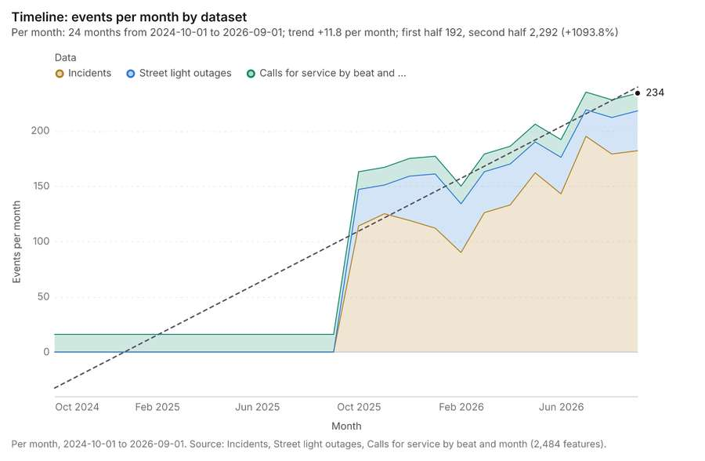
Figure 1. Timeline: events per month by dataset [1]. Per month, 2024-10-01 to 2026-09-01. Source: Incidents, Street light outages, Calls for service by beat and month (2,484 features). The data is in the appendix.
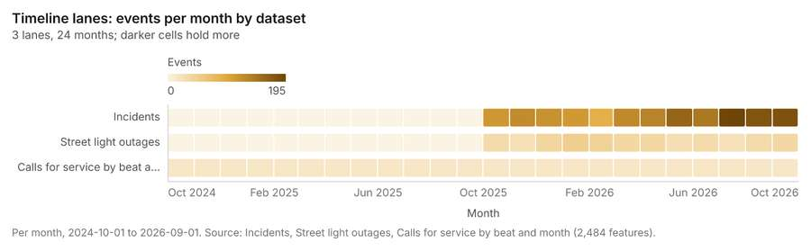
Figure 2. Timeline lanes: events per month by dataset [5]. Per month, 2024-10-01 to 2026-09-01. Source: Incidents, Street light outages, Calls for service by beat and month (2,484 features). The data is in the appendix.
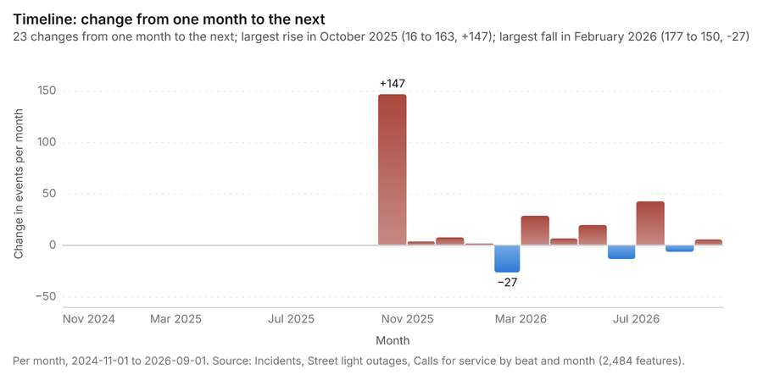
Figure 3. Timeline: change from one month to the next [6]. Per month, 2024-11-01 to 2026-09-01. Source: Incidents, Street light outages, Calls for service by beat and month (2,484 features). The data is in the appendix.
The timeline counts 2,484 dated events in Incidents, Street light outages, Calls for service by beat and month per month, from October 2024 to September 2026 [1][2][3][4]. By dataset: Incidents 1,680; Street light outages 420; Calls for service by beat and month 384 [1][5]. The trend is +11.8 events per month; the second half of the months has 2,292 against 192 in the first (+1093.8%) [1]. Month over month, the largest rise was from September 2025 to October 2025 (16 to 163, +147) and the largest fall was from January 2026 to February 2026 (177 to 150, -27) [1][6]. The count rose from 33 in week of 2026-06-22 to 72 in week of 2026-06-29 (+118.2%), beyond what chance would give (p = 0.000178) [7][8]. Between the two, the largest rise was in Market West Beat (7 to 16, +9) and the largest fall in Granary Beat (2 to 0, -2) [7][8]. The count fell from 17 in week of 2026-02-02 to 4 in week of 2026-02-09 (-76.5%), beyond what chance would give (p = 0.0072) [9][10]. Between the two, the largest rise was in Parkview Beat (0 to 2, +2) and the largest fall in Market West Beat (9 to 2, -7) [9][10].
Busiest months
- July 2026: 235 events [1]
- September 2026: 234 events [1]
- August 2026: 228 events [1]
Quietest months
- October 2024: 16 events [1]
- November 2024: 16 events [1]
- December 2024: 16 events [1]

Overview
Overview: the top 3 results in the report's order, each in one distinct color, over Patrol beats as context [11].
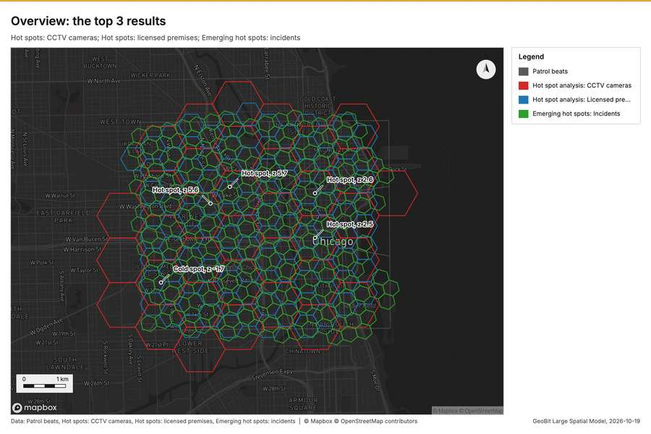
Figure 4. Overview: the top 3 results [11]

Spatial structure
Incidents are clustered (nearest-neighbor ratio 0.73, z = -21.0; features lie 48.8 m apart on average against 66.5 m if random) [12]. Incidents are dated by 'reported_at' from 2025-10-01 to 2026-09-30 at a week grain [12]. Over time the pattern changes: the earlier half is clustered (ratio 0.7893) and the later half clustered (ratio 0.7746); the center moved 132 m [12]. Street light outages are clustered (nearest-neighbor ratio 0.88, z = -4.9; features lie 113 m apart on average against 129 m if random) [13]. Street light outages are dated by 'reported_at' from 2025-10-01 to 2026-09-30 at a week grain [13]. Over time the pattern changes: the earlier half is clustered (ratio 0.8542) and the later half clustered (ratio 0.8877); the center moved 263 m [13]. Patrol beats are 16 areas of 1.876 km2 on average, covering 99 percent of their extent, with no overlap [14]. CCTV cameras are spread at random (nearest-neighbor ratio 0.93, z = -1.0; features lie 311 m apart on average against 334 m if random) [15]. Transit stops are spread at random (nearest-neighbor ratio 0.93, z = -1.2; features lie 268 m apart on average against 289 m if random) [16]. Licensed premises are clustered (nearest-neighbor ratio 0.85, z = -3.2; features lie 199 m apart on average against 234 m if random) [17]. Roads form a connected network: 1033 lines with 120 junctions and 2864 crossings in 98 connected parts, 509.7 km in all [18]. 100 percent of CCTV cameras lie inside Patrol beats (60 of 60) [14][15]. 100 percent of Incidents lie inside Patrol beats (1680 of 1680) [12][14]. 100 percent of Licensed premises lie inside Patrol beats (120 of 120) [14][17]. 100 percent of Police stations lie inside Patrol beats (3 of 3) [14][19]. 100 percent of Street light outages lie inside Patrol beats (420 of 420) [13][14]. 100 percent of Transit stops lie inside Patrol beats (80 of 80) [14][16]. 99 percent of Roads lie inside Patrol beats (1019 of 1033) [14][18]. CCTV cameras lie 2.33 m from the nearest of Roads (median); 100 percent lie within 100 m [15][18]. Street light outages lie 3.89 m from the nearest of Roads (median); 96 percent lie within 100 m [13][18]. Transit stops lie 4.41 m from the nearest of Roads (median); 100 percent lie within 100 m [16][18].
Result | Value
layers profiled | 8
clustered point layers | 3
random point layers | 2

Findings
- Evidenced: Incidents are clustered (nearest-neighbor ratio 0.73, z = -21.0; features lie 48.8 m apart on average against 66.5 m if random) [12].
- Evidenced: Incidents are dated by 'reported_at' from 2025-10-01 to 2026-09-30 at a week grain [12].
- Evidenced: Over time the pattern changes: the earlier half is clustered (ratio 0.7893) and the later half clustered (ratio 0.7746); the center moved 132 m [12].
- Evidenced: Street light outages are clustered (nearest-neighbor ratio 0.88, z = -4.9; features lie 113 m apart on average against 129 m if random) [13].
- Evidenced: Street light outages are dated by 'reported_at' from 2025-10-01 to 2026-09-30 at a week grain [13].
- Evidenced: Over time the pattern changes: the earlier half is clustered (ratio 0.8542) and the later half clustered (ratio 0.8877); the center moved 263 m [13].
- Evidenced: Patrol beats are 16 areas of 1.876 km2 on average, covering 99 percent of their extent, with no overlap [14].
- Evidenced: CCTV cameras are spread at random (nearest-neighbor ratio 0.93, z = -1.0; features lie 311 m apart on average against 334 m if random) [15].
- Evidenced: Transit stops are spread at random (nearest-neighbor ratio 0.93, z = -1.2; features lie 268 m apart on average against 289 m if random) [16].
- Evidenced: Licensed premises are clustered (nearest-neighbor ratio 0.85, z = -3.2; features lie 199 m apart on average against 234 m if random) [17].
- Evidenced: Roads form a connected network: 1033 lines with 120 junctions and 2864 crossings in 98 connected parts, 509.7 km in all [18].
- Evidenced: 100 percent of CCTV cameras lie inside Patrol beats (60 of 60) [14][15].
- Evidenced: 100 percent of Incidents lie inside Patrol beats (1680 of 1680) [12][14].
- Evidenced: 100 percent of Licensed premises lie inside Patrol beats (120 of 120) [14][17].
- Evidenced: 100 percent of Police stations lie inside Patrol beats (3 of 3) [14][19].
- Evidenced: 100 percent of Street light outages lie inside Patrol beats (420 of 420) [13][14].
- Evidenced: 100 percent of Transit stops lie inside Patrol beats (80 of 80) [14][16].
- Evidenced: 99 percent of Roads lie inside Patrol beats (1019 of 1033) [14][18].
- Evidenced: CCTV cameras lie 2.33 m from the nearest of Roads (median); 100 percent lie within 100 m [15][18].
- Evidenced: Street light outages lie 3.89 m from the nearest of Roads (median); 96 percent lie within 100 m [13][18].
- Evidenced: Transit stops lie 4.41 m from the nearest of Roads (median); 100 percent lie within 100 m [16][18].

Hot spots
What this analysis is. Hot spot analysis: Getis-Ord Gi* hot and cold spots with z-scores, p-values and confidence bins [20]. In ArcGIS it is Find Hot Spots or Hot Spot Analysis (Getis-Ord Gi*); in QGIS, qgis:hotspot (plugin) [20].
Why it was run on this data. 60 points: Getis-Ord Gi* tests whether the concentrations in CCTV cameras are statistically significant [21].
What it found. The hot spot analysis tool, `gp_hot_spots`, utilized the CCTV cameras layer [15] and returned a result containing 36 features [22].
Result | Value
result, bins | 36
result, count | 36
result, elapsed ms | 3
result, cell size m | 1,000
result, incidents used | 60
result, distance band m | 2,000
billing, cost | 0.0512
billing, list price | 0.0512
billing, upstream cost | 0

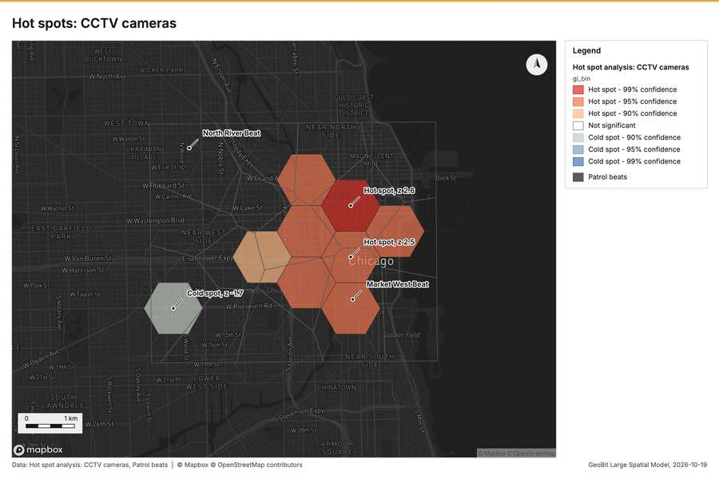
Figure 5. Hot spots: CCTV cameras [23]
What the map shows. The map draws Hot spot analysis: CCTV cameras by gi_bin in 7 classes: Hot spot - 99% confidence, Hot spot - 95% confidence, Hot spot - 90% confidence, Not significant, Cold spot - 90% confidence, Cold spot - 95% confidence and 1 more [23]. The map draws Patrol beats with one symbol [23]. It draws 52 features [23]. It covers longitude -87.715 to -87.578 and latitude 41.838 to 41.917, at about 1:47,468 [23].
Findings
- Evidenced: Hot spots on CCTV cameras: Hot spot analysis: 1 layer saved: Hot spot analysis: CCTV cameras (36 features) [15][22].
- Evidenced: It reported result, bins 36; result, count 36; result, elapsed ms 3; result, cell size m 1,000; result, incidents used 60; result, distance band m 2,000 [22].
Tool gp_hot_spots; parameters {"project": "fe9df6b9-8a15-4264-946b-4b37b8dbb89d", "features": {"layer": "CCTV cameras (ad88aaeb)"}, "aggregation": "hexagon", "cell_size_m": 1000.0, "distance_band_m": 2000.0}

Hot spots
What this analysis is. Hot spot analysis: Getis-Ord Gi* hot and cold spots with z-scores, p-values and confidence bins [20]. In ArcGIS it is Find Hot Spots or Hot Spot Analysis (Getis-Ord Gi*); in QGIS, qgis:hotspot (plugin) [20].
Why it was run on this data. 120 points: Getis-Ord Gi* tests whether the concentrations in Licensed premises are statistically significant [24]. Measured: Licensed premises are clustered (nearest-neighbor ratio 0.85, z = -3.2), median spacing 121 m [24]. Cells of 500 m and a band of 1000 m from the measured spacing [24].
What it found. Hot spots on Licensed premises: Hot spot analysis: 1 layer saved: Hot spot analysis: Licensed premises (112 features) [17][25]. It reported result, bins 112; result, count 112; result, elapsed ms 5; result, cell size m 500; result, incidents used 120; result, distance band m 1,000 [25].
Result | Value
result, bins | 112
result, count | 112
result, elapsed ms | 5
result, cell size m | 500
result, incidents used | 120
result, distance band m | 1,000
billing, cost | 0.0524
billing, list price | 0.0524
billing, upstream cost | 0

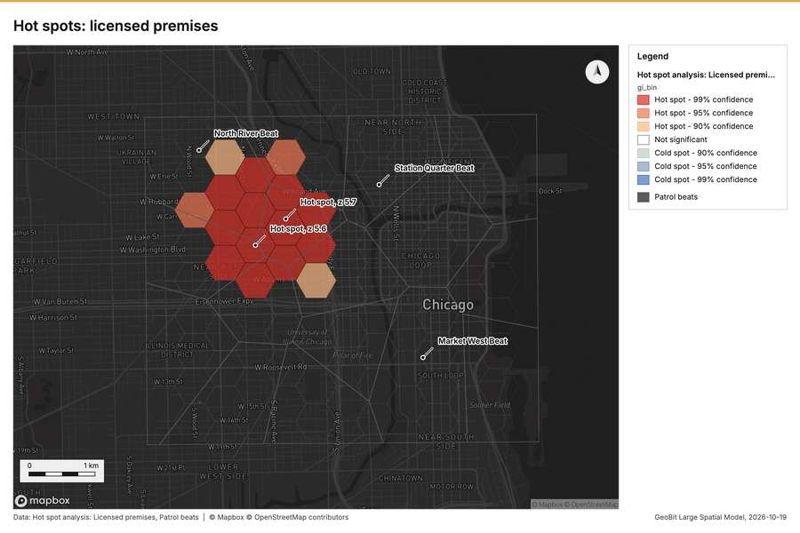
Figure 6. Hot spots: licensed premises [26]
What the map shows. The map draws Hot spot analysis: Licensed premises by gi_bin in 7 classes: Hot spot - 99% confidence, Hot spot - 95% confidence, Hot spot - 90% confidence, Not significant, Cold spot - 90% confidence, Cold spot - 95% confidence and 1 more [26]. The map draws Patrol beats with one symbol [26]. It draws 128 features [26]. It covers longitude -87.705 to -87.593 and latitude 41.847 to 41.911, at about 1:38,555 [26].
Findings
- Evidenced: Hot spots on Licensed premises: Hot spot analysis: 1 layer saved: Hot spot analysis: Licensed premises (112 features) [17][25].
- Evidenced: It reported result, bins 112; result, count 112; result, elapsed ms 5; result, cell size m 500; result, incidents used 120; result, distance band m 1,000 [25].
A model draft was discarded because a sentence did not cite a source of this section.
Tool gp_hot_spots; parameters {"project": "fe9df6b9-8a15-4264-946b-4b37b8dbb89d", "features": {"layer": "Licensed premises (055b5c2c)"}, "aggregation": "hexagon", "cell_size_m": 500.0, "distance_band_m": 1000.0}

Space time hot spots
What this analysis is. Emerging hot spots: Where hot spots are new, consecutive, intensifying, persistent, diminishing, sporadic, oscillating or historical over time [27]. In ArcGIS it is Emerging Hot Spot Analysis or Create Space Time Cube [27].
Why it was run on this data. Incidents carry dates in 'reported_at': emerging hot spot analysis finds new, intensifying and fading hot spots per week [28]. Measured: the pattern of Incidents changes over time (earlier half clustered, later half clustered; the center moved 132 m) [28].
What it found. The space time hot spots analysis was executed using the Incidents layer [12] and resulted in 270 features saved as "Emerging hot spots: Incidents" [29]. The process was efficient, concluding in an elapsed time of 46 milliseconds [29]. Furthermore, the analysis utilized 1,680 features and incurred a total cost of 0.184 [29].
Result | Value
result, count | 270
result, elapsed ms | 46
result, resolution | 9
result, features used | 1,680
result, time neighbors | 0
billing, cost | 0.184
billing, list price | 0.184
billing, upstream cost | 0

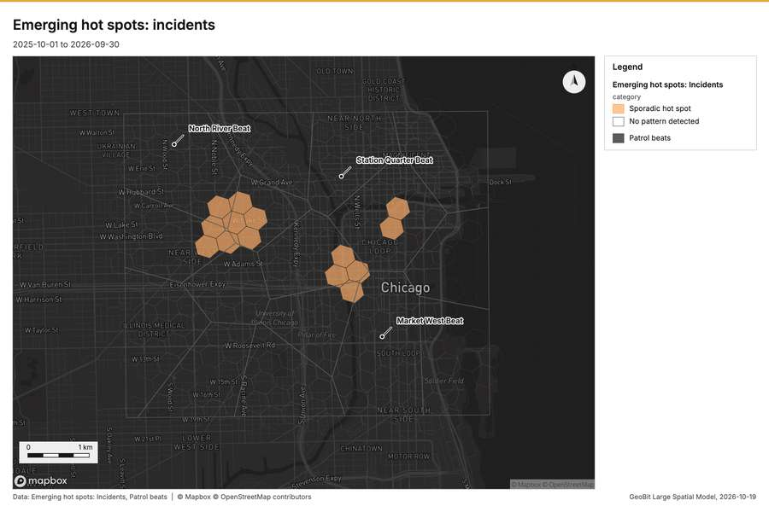
Figure 7. Emerging hot spots: incidents [30]
What the map shows. The map draws Emerging hot spots: Incidents by category in 2 classes: Sporadic hot spot, No pattern detected [30]. The map draws Patrol beats with one symbol [30]. It draws 286 features [30]. It covers longitude -87.702 to -87.587 and latitude 41.846 to 41.91, at about 1:39,916 [30].
Findings
- Evidenced: Space time hot spots on Incidents: Emerging hot spots: 1 layer saved: Emerging hot spots: Incidents (270 features) [12][29].
- Evidenced: It reported result, count 270; result, elapsed ms 46; result, resolution 9; result, features used 1,680; result, time neighbors 0; billing, cost 0.184 [29].
Tool gp_space_time_hot_spots; parameters {"project": "fe9df6b9-8a15-4264-946b-4b37b8dbb89d", "features": {"layer": "Incidents (36ad5f7c)"}, "interval": "week", "bin_shape": "h3", "resolution": 9, "time_field": "reported_at"}

Space time hot spots
What this analysis is. Emerging hot spots: Where hot spots are new, consecutive, intensifying, persistent, diminishing, sporadic, oscillating or historical over time [27]. In ArcGIS it is Emerging Hot Spot Analysis or Create Space Time Cube [27].
Why it was run on this data. Street light outages carry dates in 'reported_at': emerging hot spot analysis finds new, intensifying and fading hot spots per week [31]. Measured: the pattern of Street light outages changes over time (earlier half clustered, later half clustered; the center moved 263 m) [31].
What it found. Space time hot spots on Street light outages: Emerging hot spots: 1 layer saved: Emerging hot spots: Street light outages (47 features) [13][32]. It reported result, count 47; result, elapsed ms 10; result, resolution 8; result, features used 420; result, time neighbors 0; billing, cost 0.121 [32].
Result | Value
result, count | 47
result, elapsed ms | 10
result, resolution | 8
result, features used | 420
result, time neighbors | 0
billing, cost | 0.121
billing, list price | 0.121
billing, upstream cost | 0

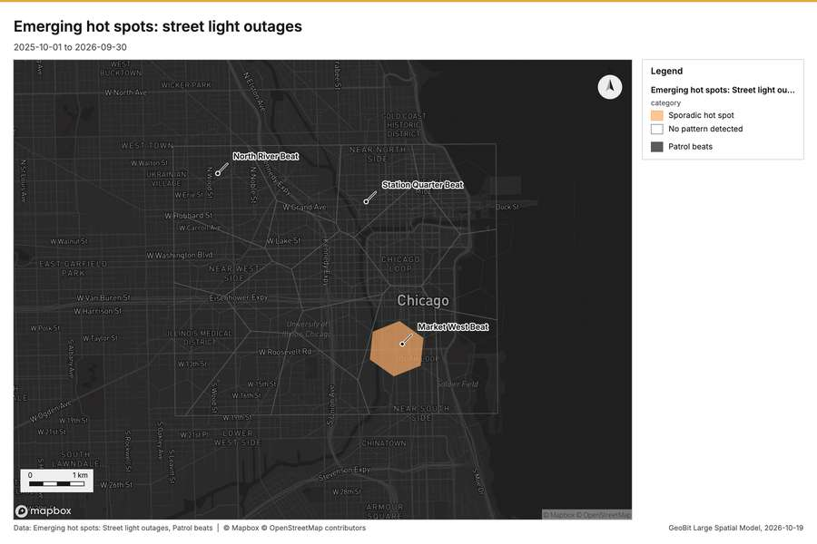
Figure 8. Emerging hot spots: street light outages [33]
What the map shows. The map draws Emerging hot spots: Street light outages by category in 2 classes: Sporadic hot spot, No pattern detected [33]. The map draws Patrol beats with one symbol [33]. It draws 63 features [33]. It covers longitude -87.716 to -87.578 and latitude 41.839 to 41.916, at about 1:47,799 [33].
Findings
- Evidenced: Space time hot spots on Street light outages: Emerging hot spots: 1 layer saved: Emerging hot spots: Street light outages (47 features) [13][32].
- Evidenced: It reported result, count 47; result, elapsed ms 10; result, resolution 8; result, features used 420; result, time neighbors 0; billing, cost 0.121 [32].
Tool gp_space_time_hot_spots; parameters {"project": "fe9df6b9-8a15-4264-946b-4b37b8dbb89d", "features": {"layer": "Street light outages (a7218535)"}, "interval": "week", "bin_shape": "h3", "resolution": 8, "time_field": "reported_at"}

Find point clusters
What this analysis is. Find point clusters: Density-based clusters (DBSCAN, HDBSCAN or OPTICS, optionally space-time) with hulls and noise [34]. In ArcGIS it is Find Point Clusters or Density-based Clustering; in QGIS, native:dbscanclustering or native:stdbscanclustering [34].
Why it was run on this data. DBSCAN finds dense groups of Licensed premises and separates noise [35]. Measured: Licensed premises are clustered (nearest-neighbor ratio 0.85, z = -3.2), median spacing 121 m [35]. DBSCAN at 200 m (twice the measured spacing) [35].
What it found. Find point clusters on Licensed premises: Find point clusters: 2 layers saved: Find point clusters: Licensed premises (120 features); Find point clusters: cluster hulls (3 features) [17][36]. It reported result, count 120; result, noise 61; result, distance m 200; result, elapsed ms 499; result, min points 3; billing, cost 0.0524 [36].
Result | Value
result, count | 120
result, noise | 61
result, distance m | 200
result, elapsed ms | 499
result, min points | 3
billing, cost | 0.0524
billing, list price | 0.0524
billing, upstream cost | 0

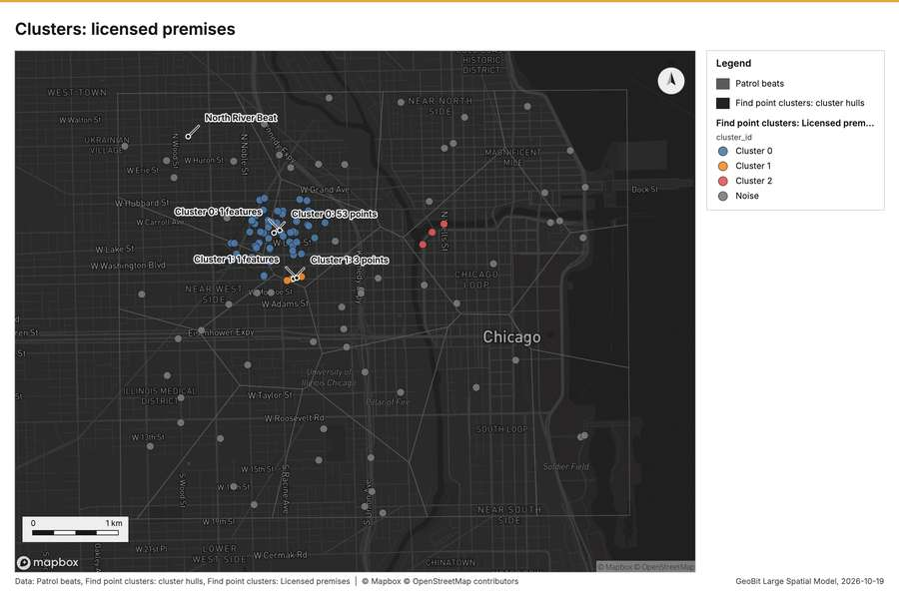
Figure 9. Clusters: licensed premises [37]
What the map shows. The map draws Patrol beats with one symbol [37]. The map draws Find point clusters: cluster hulls with one symbol [37]. The map draws Find point clusters: Licensed premises by cluster_id in 4 classes: Cluster 0, Cluster 1, Cluster 2, Noise [37]. It draws 139 features [37]. It covers longitude -87.695 to -87.598 and latitude 41.851 to 41.906, at about 1:33,333 [37].
Findings
- Evidenced: Find point clusters on Licensed premises: Find point clusters: 2 layers saved: Find point clusters: Licensed premises (120 features); Find point clusters: cluster hulls (3 features) [17][36].
- Evidenced: It reported result, count 120; result, noise 61; result, distance m 200; result, elapsed ms 499; result, min points 3; billing, cost 0.0524 [36].
Tool gp_find_point_clusters; parameters {"method": "dbscan", "project": "fe9df6b9-8a15-4264-946b-4b37b8dbb89d", "features": {"layer": "Licensed premises (055b5c2c)"}, "distance_m": 200.0, "min_points": 3}

Find point clusters
What this analysis is. Find point clusters: Density-based clusters (DBSCAN, HDBSCAN or OPTICS, optionally space-time) with hulls and noise [34]. In ArcGIS it is Find Point Clusters or Density-based Clustering; in QGIS, native:dbscanclustering or native:stdbscanclustering [34].
Why it was run on this data. DBSCAN finds dense groups of Incidents and separates noise [38]. Measured: Incidents are clustered (nearest-neighbor ratio 0.73, z = -21.0), median spacing 34.3 m [38]. DBSCAN at 50 m (twice the measured spacing) [38].
What it found. Find point clusters on Incidents: Find point clusters: 2 layers saved: Find point clusters: Incidents (1680 features); Find point clusters: cluster hulls (3 features) [12][39]. It reported result, count 1,680; result, noise 1,609; result, distance m 50; result, elapsed ms 19; result, min points 20; billing, cost 0.0836 [39].
Result | Value
result, count | 1,680
result, noise | 1,609
result, distance m | 50
result, elapsed ms | 19
result, min points | 20
billing, cost | 0.0836
billing, list price | 0.0836
billing, upstream cost | 0

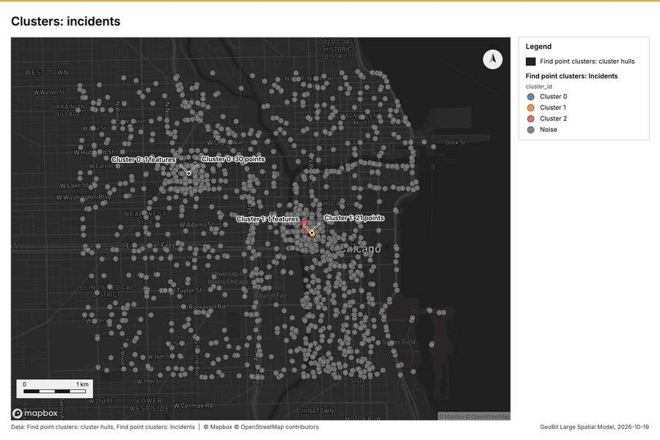
Figure 10. Clusters: incidents [40]
What the map shows. The map draws Find point clusters: cluster hulls with one symbol [40]. The map draws Find point clusters: Incidents by cluster_id in 4 classes: Cluster 0, Cluster 1, Cluster 2, Noise [40]. It draws 1,683 features [40]. It covers longitude -87.693 to -87.595 and latitude 41.85 to 41.907, at about 1:34,033 [40].
Findings
- Evidenced: Find point clusters on Incidents: Find point clusters: 2 layers saved: Find point clusters: Incidents (1680 features); Find point clusters: cluster hulls (3 features) [12][39].
- Evidenced: It reported result, count 1,680; result, noise 1,609; result, distance m 50; result, elapsed ms 19; result, min points 20; billing, cost 0.0836 [39].
Tool gp_find_point_clusters; parameters {"method": "dbscan", "project": "fe9df6b9-8a15-4264-946b-4b37b8dbb89d", "features": {"layer": "Incidents (36ad5f7c)"}, "distance_m": 50.0, "min_points": 20}

Find point clusters
What this analysis is. Find point clusters: Density-based clusters (DBSCAN, HDBSCAN or OPTICS, optionally space-time) with hulls and noise [34]. In ArcGIS it is Find Point Clusters or Density-based Clustering; in QGIS, native:dbscanclustering or native:stdbscanclustering [34].
Why it was run on this data. DBSCAN finds dense groups of Street light outages and separates noise [41]. Measured: Street light outages are clustered (nearest-neighbor ratio 0.88, z = -4.9), median spacing 74.9 m [41]. DBSCAN at 100 m (twice the measured spacing) [41].
What it found. The `gp_find_point_clusters` tool was utilized against the Street light outages layer [13]. This analysis successfully identified 420 features [42], classifying 410 of the input data as noise [42]. The cluster process was configured with a distance threshold of 100 meters and required a minimum of 10 points [42].
Result | Value
result, count | 420
result, noise | 410
result, distance m | 100
result, elapsed ms | 5
result, min points | 10
billing, cost | 0.0584
billing, list price | 0.0584
billing, upstream cost | 0

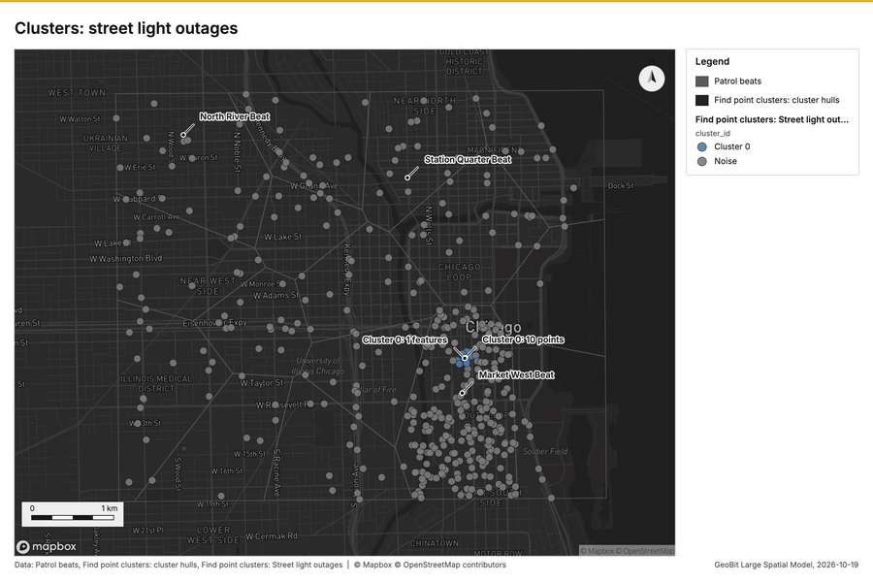
Figure 11. Clusters: street light outages [43]
What the map shows. The map draws Patrol beats with one symbol [43]. The map draws Find point clusters: cluster hulls with one symbol [43]. The map draws Find point clusters: Street light outages by cluster_id in 2 classes: Cluster 0, Noise [43]. It draws 437 features [43]. It covers longitude -87.695 to -87.597 and latitude 41.85 to 41.906, at about 1:33,798 [43].
Findings
- Evidenced: Find point clusters on Street light outages: Find point clusters: 2 layers saved: Find point clusters: Street light outages (420 features); Find point clusters: cluster hulls (1 feature) [13][42].
- Evidenced: It reported result, count 420; result, noise 410; result, distance m 100; result, elapsed ms 5; result, min points 10; billing, cost 0.0584 [42].
Tool gp_find_point_clusters; parameters {"method": "dbscan", "project": "fe9df6b9-8a15-4264-946b-4b37b8dbb89d", "features": {"layer": "Street light outages (a7218535)"}, "distance_m": 100.0, "min_points": 10}

Summarize within
What this analysis is. Summarize within: Count and aggregate the features inside each polygon (or bin), proportionally for lines and polygons [44]. In ArcGIS it is Summarize Within or Aggregate Points; in QGIS, native:countpointsinpolygon or native:sumlinelengths [44].
Why it was run on this data. Count CCTV cameras inside each feature of Patrol beats by ptz; the counts map as a choropleth (natural breaks, sequential colors) [45].
What it found. Summarize within on CCTV cameras, Patrol beats: Summarize within: 1 layer saved: Summarize within: Patrol beats (16 features) [14][15][46]. It reported result, count 16; result, elapsed ms 0; billing, cost 0.01154; billing, list price 0.01154; billing, upstream cost 0 [46].
Result | Value
result, count | 16
result, elapsed ms | 0
billing, cost | 0.01154
billing, list price | 0.01154
billing, upstream cost | 0

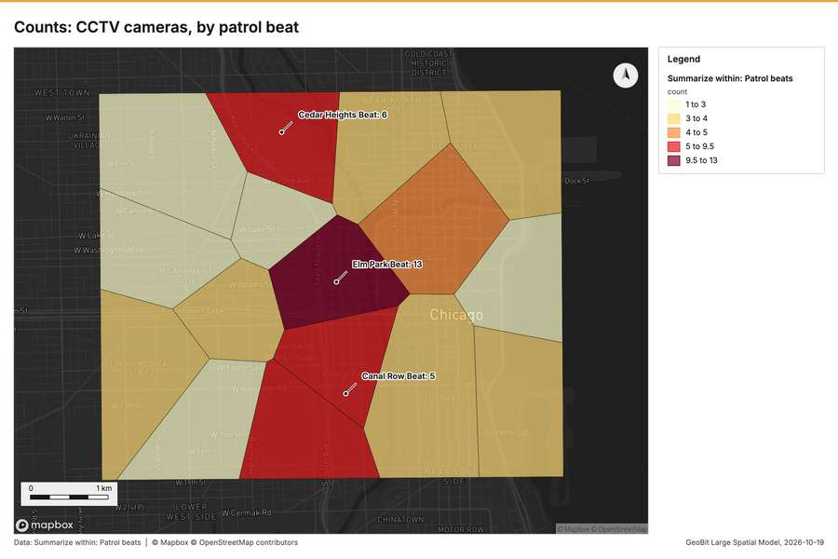
Figure 12. Counts: CCTV cameras, by patrol beat [47]
What the map shows. The map draws Summarize within: Patrol beats by count in 5 classes: 1 to 3, 3 to 4, 4 to 5, 5 to 9.5, 9.5 to 13 [47]. It draws 16 features [47]. It covers longitude -87.694 to -87.594 and latitude 41.85 to 41.907, at about 1:34,270 [47].
Findings
- Evidenced: Summarize within on CCTV cameras, Patrol beats: Summarize within: 1 layer saved: Summarize within: Patrol beats (16 features) [14][15][46].
- Evidenced: It reported result, count 16; result, elapsed ms 0; billing, cost 0.01154; billing, list price 0.01154; billing, upstream cost 0 [46].
Tool gp_summarize_within; parameters {"stats": [{"stat": "sum", "field": "installed_year"}], "project": "fe9df6b9-8a15-4264-946b-4b37b8dbb89d", "features": {"layer": "CCTV cameras (ad88aaeb)"}, "group_by": "ptz", "polygons": {"layer": "Patrol beats (8c67e28f)"}}

Summarize within
What this analysis is. Summarize within: Count and aggregate the features inside each polygon (or bin), proportionally for lines and polygons [44]. In ArcGIS it is Summarize Within or Aggregate Points; in QGIS, native:countpointsinpolygon or native:sumlinelengths [44].
Why it was run on this data. Count CCTV cameras inside each feature of Patrol beats by ptz; the counts map as a choropleth (natural breaks, sequential colors) [45].
What it found. The analysis used the "Summarize within: Patrol beats" function, which processed 16 features [48].
Result | Value
result, count | 16
result, elapsed ms | 0
billing, cost | 0.01274
billing, list price | 0.01274
billing, upstream cost | 0

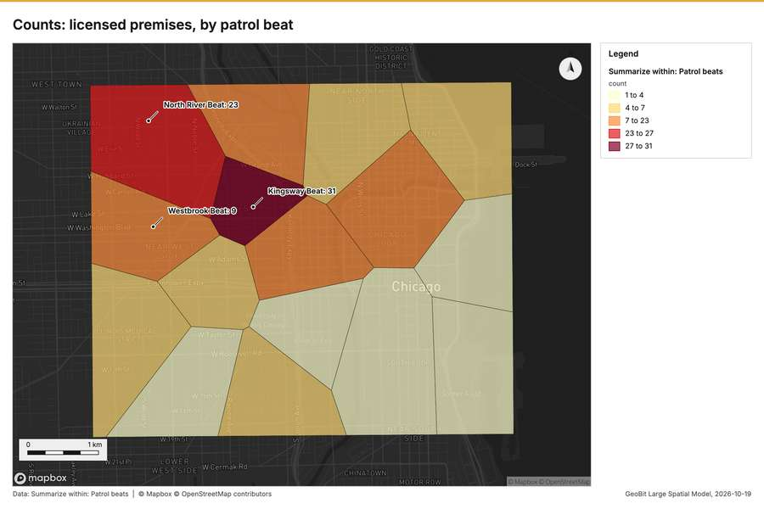
Figure 13. Counts: licensed premises, by patrol beat [49]
What the map shows. The map draws Summarize within: Patrol beats by count in 5 classes: 1 to 4, 4 to 7, 7 to 23, 23 to 27, 27 to 31 [49]. It draws 16 features [49]. It covers longitude -87.694 to -87.594 and latitude 41.85 to 41.907, at about 1:34,270 [49].
Findings
- Evidenced: Summarize within on Licensed premises, Patrol beats: Summarize within: 1 layer saved: Summarize within: Patrol beats (16 features) [14][17][48].
- Evidenced: It reported result, count 16; result, elapsed ms 0; billing, cost 0.01274; billing, list price 0.01274; billing, upstream cost 0 [48].
Tool gp_summarize_within; parameters {"stats": [{"stat": "sum", "field": "closing_hour"}], "project": "fe9df6b9-8a15-4264-946b-4b37b8dbb89d", "features": {"layer": "Licensed premises (055b5c2c)"}, "group_by": "type", "polygons": {"layer": "Patrol beats (8c67e28f)"}}

Summarize within
What this analysis is. Summarize within: Count and aggregate the features inside each polygon (or bin), proportionally for lines and polygons [44]. In ArcGIS it is Summarize Within or Aggregate Points; in QGIS, native:countpointsinpolygon or native:sumlinelengths [44].
Why it was run on this data. Count CCTV cameras inside each feature of Patrol beats by ptz; the counts map as a choropleth (natural breaks, sequential colors) [45].
What it found. Summarize within on Incidents, Patrol beats: Summarize within: 1 layer saved: Summarize within: Patrol beats (16 features) [12][14][50]. It reported result, count 16; result, elapsed ms 2; billing, cost 0.04394; billing, list price 0.04394; billing, upstream cost 0 [50].
Result | Value
result, count | 16
result, elapsed ms | 2
billing, cost | 0.04394
billing, list price | 0.04394
billing, upstream cost | 0

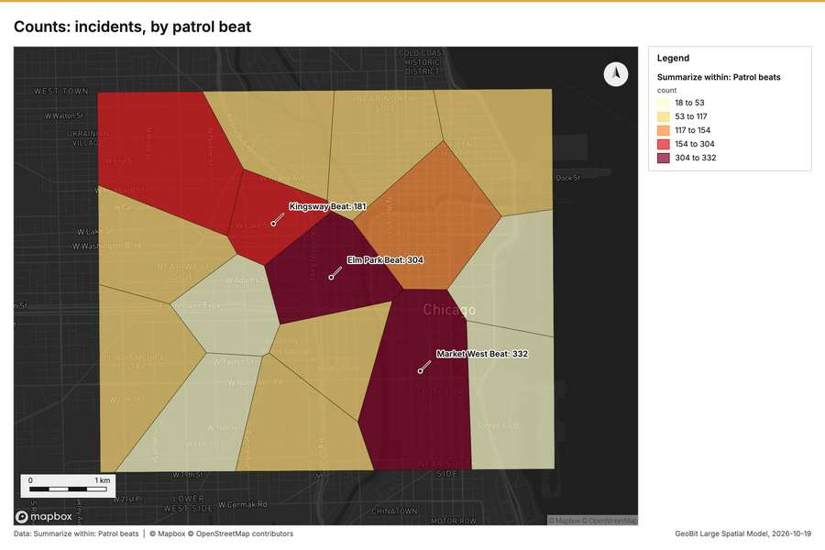
Figure 14. Counts: incidents, by patrol beat [51]
What the map shows. The map draws Summarize within: Patrol beats by count in 5 classes: 18 to 53, 53 to 117, 117 to 154, 154 to 304, 304 to 332 [51]. It draws 16 features [51]. It covers longitude -87.694 to -87.594 and latitude 41.85 to 41.907, at about 1:34,270 [51].
Findings
- Evidenced: Summarize within on Incidents, Patrol beats: Summarize within: 1 layer saved: Summarize within: Patrol beats (16 features) [12][14][50].
- Evidenced: It reported result, count 16; result, elapsed ms 2; billing, cost 0.04394; billing, list price 0.04394; billing, upstream cost 0 [50].
Tool gp_summarize_within; parameters {"stats": [{"stat": "sum", "field": "severity"}], "project": "fe9df6b9-8a15-4264-946b-4b37b8dbb89d", "features": {"layer": "Incidents (36ad5f7c)"}, "group_by": "category", "polygons": {"layer": "Patrol beats (8c67e28f)"}}

Period change
What this analysis is. Period change: Counts or sums per period (week over week, month over month, any two periods, or before and after a date), per area, per H3 cell or in total, with the places of largest rise and fall and a significance note [52]. In ArcGIS it is Summarize Percent Change (Crime Analysis) or Change Point Detection [52].
Why it was run on this data. Incidents carry dates in 'reported_at' over 52 weeks: the count per week, week over week, with the places of largest rise and fall per feature of Patrol beats and whether the change is beyond chance [53].
What it found. Period change on Patrol beats, Incidents produced Period change: Incidents (week of 2026-06-22 to week of 2026-06-29) (16 features) [7][8][12][14]. Incidents: count per week shows a trend of +0.36 per week; the second half of its weeks has 979 against 676 in the first (+44.8%) [55]. The chart Incidents: week of 2026-06-22 to week of 2026-06-29 by place is drawn from 30 rows [56]. The chart Period change: Incidents (week of 2026-06-22 to week of 2026-06-29) is drawn from 5 rows [57].
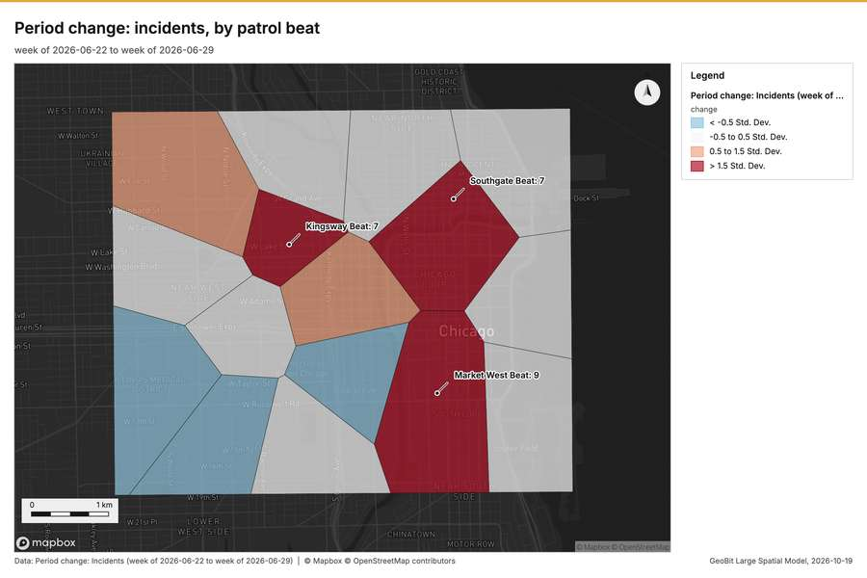
Figure 15. Period change: incidents, by patrol beat [54]
What the map shows. The map draws Period change: Incidents (week of 2026-06-22 to week of 2026-06-29) by change in 4 classes: < -0.5 Std; Dev, -0.5 to 0.5 Std; Dev, 0.5 to 1.5 Std; Dev, > 1.5 Std; Dev [54]. It draws 16 features [54]. It covers longitude -87.696 to -87.592 and latitude 41.85 to 41.907, at about 1:35,725 [54].
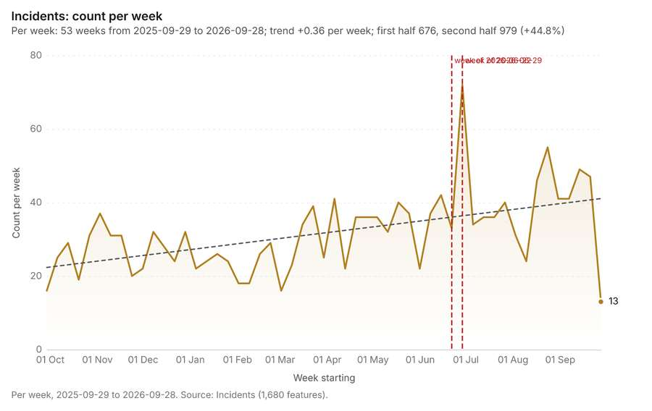
Figure 16. Incidents: count per week [55]. Per week, 2025-09-29 to 2026-09-28. Source: Incidents (1,680 features). The data is in the appendix.
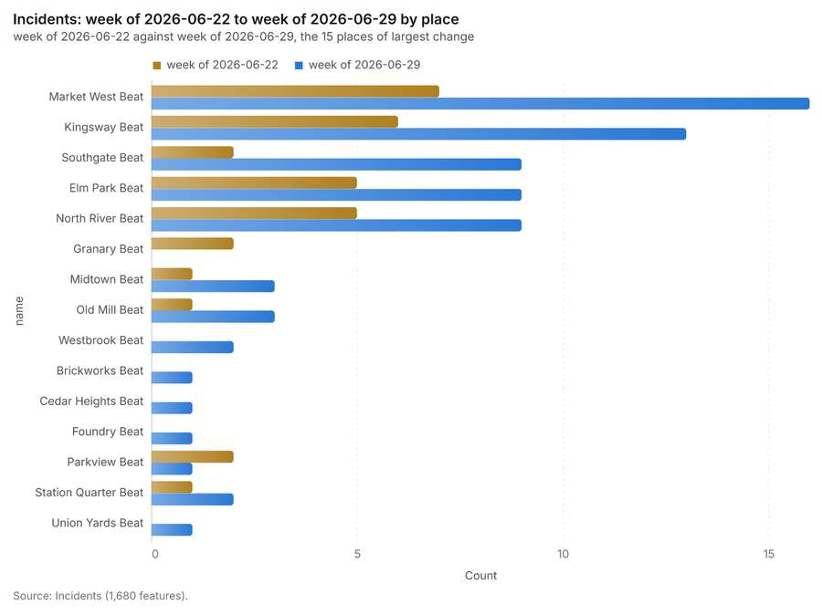
Figure 17. Incidents: week of 2026-06-22 to week of 2026-06-29 by place [56]. Source: Incidents (1,680 features). The data is in the appendix.
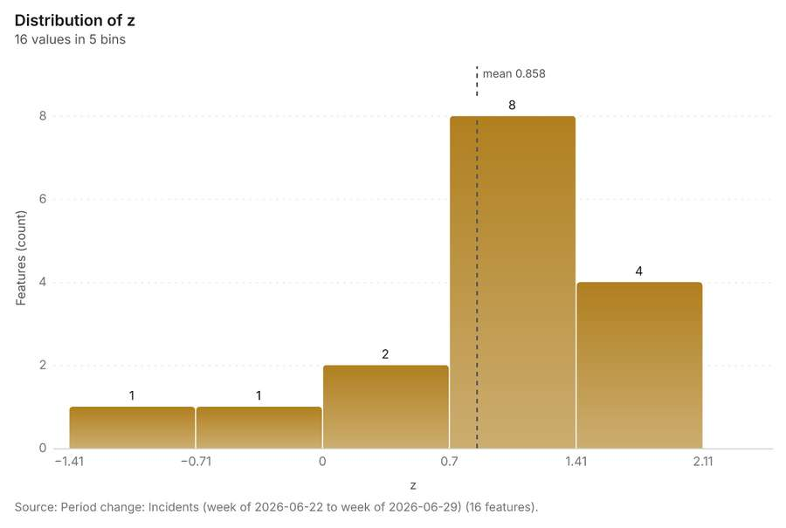
Figure 18. Period change: Incidents (week of 2026-06-22 to week of 2026-06-29) [57]. Source: Period change: Incidents (week of 2026-06-22 to week of 2026-06-29) (16 features). The data is in the appendix.
Findings
- Evidenced: Period change on Patrol beats, Incidents produced Period change: Incidents (week of 2026-06-22 to week of 2026-06-29) (16 features) [7][8][12][14].
- Evidenced: Incidents: count per week shows a trend of +0.36 per week; the second half of its weeks has 979 against 676 in the first (+44.8%) [55].
- Evidenced: The chart Incidents: week of 2026-06-22 to week of 2026-06-29 by place is drawn from 30 rows [56].
- Evidenced: The chart Period change: Incidents (week of 2026-06-22 to week of 2026-06-29) is drawn from 5 rows [57].
Tool gp_period_change; parameters {"by": "area", "areas": {"layer": "Patrol beats (8c67e28f)"}, "period": "week", "project": "fe9df6b9-8a15-4264-946b-4b37b8dbb89d", "features": {"layer": "Incidents (36ad5f7c)"}, "area_field": "name", "time_field": "reported_at"}

Period change
What this analysis is. Period change: Counts or sums per period (week over week, month over month, any two periods, or before and after a date), per area, per H3 cell or in total, with the places of largest rise and fall and a significance note [52]. In ArcGIS it is Summarize Percent Change (Crime Analysis) or Change Point Detection [52].
Why it was run on this data. Incidents carry dates in 'reported_at' over 52 weeks: the count per week, week over week, with the places of largest rise and fall per feature of Patrol beats and whether the change is beyond chance [53].
What it found. Period change on Patrol beats, Street light outages produced Period change: Street light outages (week of 2026-02-02 to week of 2026-02-09) (7 features) [9][10][13][14]. Street light outages: count per week shows a trend of -0.0337 per week; the second half of its weeks has 183 against 224 in the first (-18.3%) [59]. The chart Street light outages: week of 2026-02-02 to week of 2026-02-09 by place is drawn from 14 rows [60]. The chart Period change: Street light outages (week of 2026-02-02 to week of 2026-02-09) is drawn from 5 rows [61].
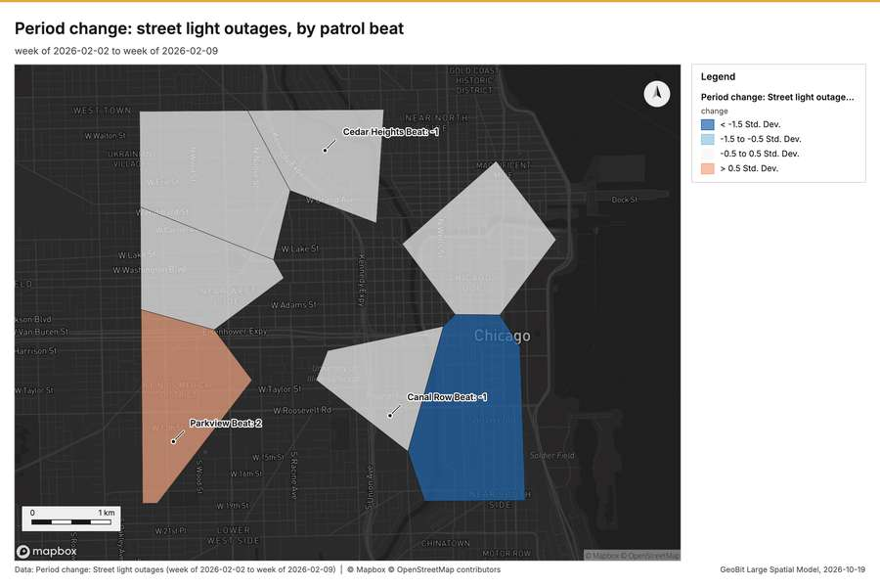
Figure 19. Period change: street light outages, by patrol beat [58]
What the map shows. The map draws Period change: Street light outages (week of 2026-02-02 to week of 2026-02-09) by change in 4 classes: < -1.5 Std; Dev, -1.5 to -0.5 Std; Dev, -0.5 to 0.5 Std; Dev, > 0.5 Std; Dev [58]. It draws 7 features [58]. It covers longitude -87.7 to -87.597 and latitude 41.85 to 41.907, at about 1:35,479 [58].
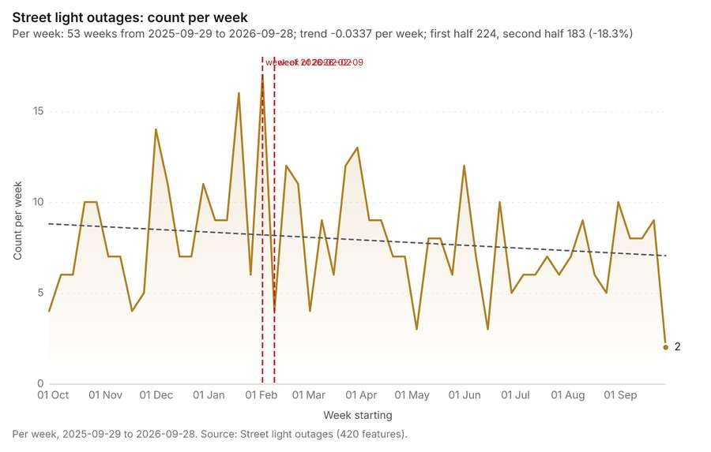
Figure 20. Street light outages: count per week [59]. Per week, 2025-09-29 to 2026-09-28. Source: Street light outages (420 features). The data is in the appendix.
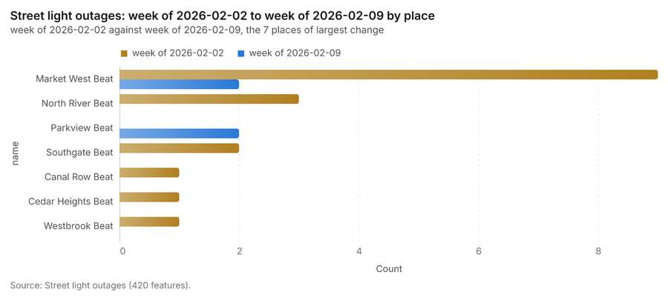
Figure 21. Street light outages: week of 2026-02-02 to week of 2026-02-09 by place [60]. Source: Street light outages (420 features). The data is in the appendix.
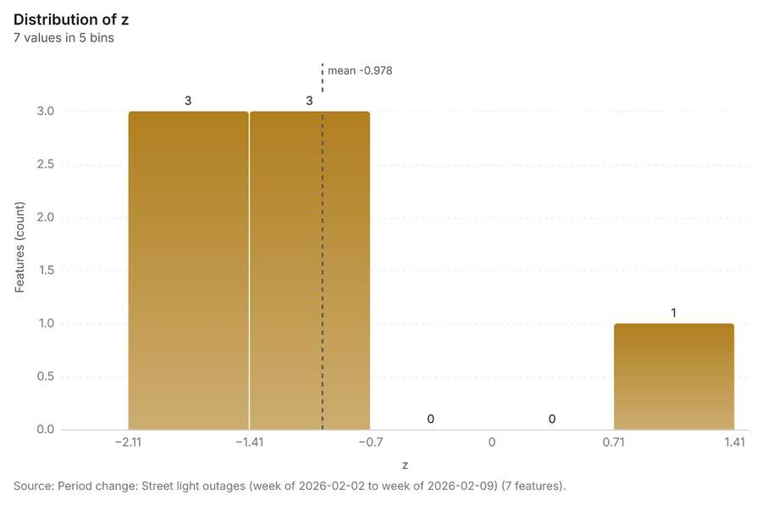
Figure 22. Period change: Street light outages (week of 2026-02-02 to week of 2026-02-09) [61]. Source: Period change: Street light outages (week of 2026-02-02 to week of 2026-02-09) (7 features). The data is in the appendix.
Findings
- Evidenced: Period change on Patrol beats, Street light outages produced Period change: Street light outages (week of 2026-02-02 to week of 2026-02-09) (7 features) [9][10][13][14].
- Evidenced: Street light outages: count per week shows a trend of -0.0337 per week; the second half of its weeks has 183 against 224 in the first (-18.3%) [59].
- Evidenced: The chart Street light outages: week of 2026-02-02 to week of 2026-02-09 by place is drawn from 14 rows [60].
- Evidenced: The chart Period change: Street light outages (week of 2026-02-02 to week of 2026-02-09) is drawn from 5 rows [61].
Tool gp_period_change; parameters {"by": "area", "areas": {"layer": "Patrol beats (8c67e28f)"}, "period": "week", "project": "fe9df6b9-8a15-4264-946b-4b37b8dbb89d", "features": {"layer": "Street light outages (a7218535)"}, "area_field": "name", "time_field": "reported_at"}

Calculate density
What this analysis is. Calculate density: Kernel density per square kilometer on a grid [62]. In ArcGIS it is Calculate Density or Kernel Density; in QGIS, native:heatmapkerneldensityestimation [62].
Why it was run on this data. 120 points in Licensed premises: a density surface shows where they concentrate [63]. Measured: Licensed premises are clustered (nearest-neighbor ratio 0.85, z = -3.2), median spacing 121 m [63].
What it found. Calculate density on Licensed premises: Calculate density: 1 layer saved: Calculate density: Licensed premises (164 features) [17][64]. It reported result, count 164; result, elapsed ms 4; result, bandwidth m 1,000; result, cell size m 500; result, excluded null 0; result, max density per km2 42.62 [64].
Result | Value
result, count | 164
result, elapsed ms | 4
result, bandwidth m | 1,000
result, cell size m | 500
result, excluded null | 0
result, max density per km2 | 42.62
billing, cost | 0.0524
billing, list price | 0.0524
billing, upstream cost | 0

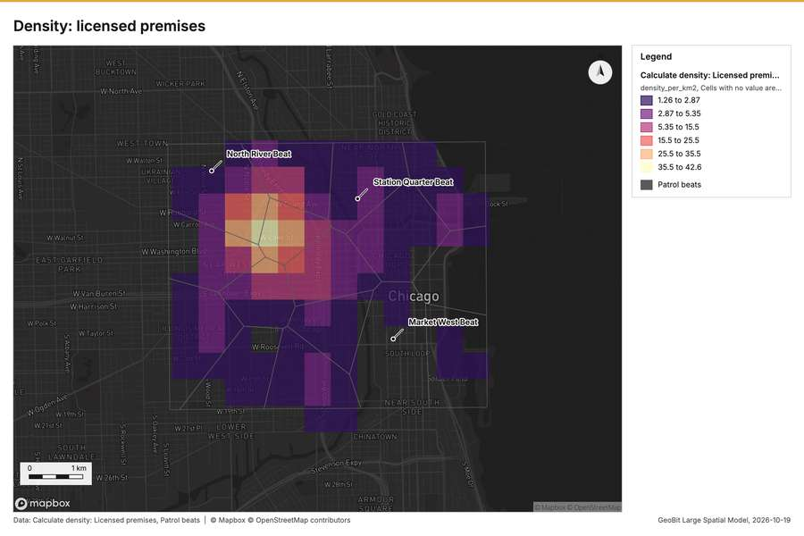
Figure 23. Density: licensed premises [65]
What the map shows. The map draws Calculate density: Licensed premises by density_per_km2 in 6 classes: 1.26 to 2.87, 2.87 to 5.35, 5.35 to 15.5, 15.5 to 25.5, 25.5 to 35.5, 35.5 to 42.6 [65]. The map draws Patrol beats with one symbol [65]. It draws 180 features [65]. It covers longitude -87.716 to -87.577 and latitude 41.839 to 41.918, at about 1:47,798 [65].
Findings
- Evidenced: Calculate density on Licensed premises: Calculate density: 1 layer saved: Calculate density: Licensed premises (164 features) [17][64].
- Evidenced: It reported result, count 164; result, elapsed ms 4; result, bandwidth m 1,000; result, cell size m 500; result, excluded null 0; result, max density per km2 42.62 [64].
Tool gp_calculate_density; parameters {"kernel": "quartic", "project": "fe9df6b9-8a15-4264-946b-4b37b8dbb89d", "features": {"layer": "Licensed premises (055b5c2c)"}, "bandwidth_m": 1000.0, "cell_size_m": 500.0}

Calculate density
What this analysis is. Calculate density: Kernel density per square kilometer on a grid [62]. In ArcGIS it is Calculate Density or Kernel Density; in QGIS, native:heatmapkerneldensityestimation [62].
Why it was run on this data. 1680 points in Incidents: a density surface shows where they concentrate [66]. Measured: Incidents are clustered (nearest-neighbor ratio 0.73, z = -21.0), median spacing 34.3 m [66].
What it found. Calculate density on Incidents: Calculate density: 1 layer saved: Calculate density: Incidents (2874 features) [12][67]. It reported result, count 2,874; result, elapsed ms 50; result, bandwidth m 200; result, cell size m 100; result, excluded null 0; result, max density per km2 1,347 [67].
Result | Value
result, count | 2,874
result, elapsed ms | 50
result, bandwidth m | 200
result, cell size m | 100
result, excluded null | 0
result, max density per km2 | 1,347
billing, cost | 0.0836
billing, list price | 0.0836
billing, upstream cost | 0

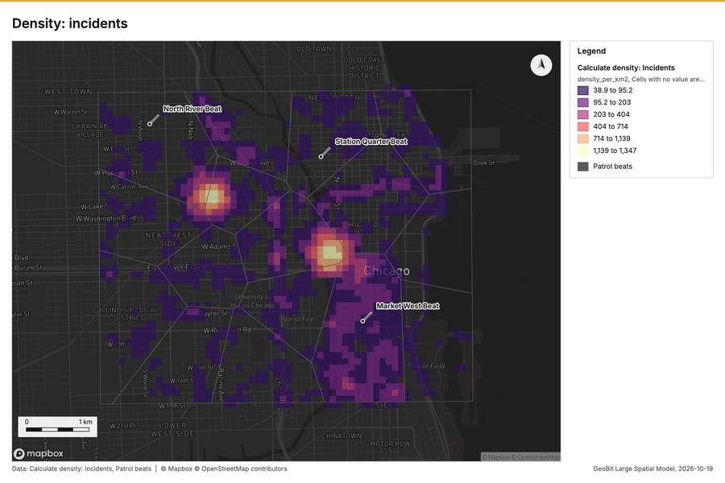
Figure 24. Density: incidents [68]
What the map shows. The map draws Calculate density: Incidents by density_per_km2 in 6 classes: 38.9 to 95.2, 95.2 to 203, 203 to 404, 404 to 714, 714 to 1,139, 1,139 to 1,347 [68]. The map draws Patrol beats with one symbol [68]. It draws 2,890 features [68]. It covers longitude -87.697 to -87.591 and latitude 41.848 to 41.909, at about 1:36,730 [68].
Findings
- Evidenced: Calculate density on Incidents: Calculate density: 1 layer saved: Calculate density: Incidents (2874 features) [12][67].
- Evidenced: It reported result, count 2,874; result, elapsed ms 50; result, bandwidth m 200; result, cell size m 100; result, excluded null 0; result, max density per km2 1,347 [67].
Tool gp_calculate_density; parameters {"kernel": "quartic", "project": "fe9df6b9-8a15-4264-946b-4b37b8dbb89d", "features": {"layer": "Incidents (36ad5f7c)"}, "bandwidth_m": 200.0, "cell_size_m": 100.0}

Calculate density
What this analysis is. Calculate density: Kernel density per square kilometer on a grid [62]. In ArcGIS it is Calculate Density or Kernel Density; in QGIS, native:heatmapkerneldensityestimation [62].
Why it was run on this data. 420 points in Street light outages: a density surface shows where they concentrate [69]. Measured: Street light outages are clustered (nearest-neighbor ratio 0.88, z = -4.9), median spacing 74.9 m [69].
What it found. Calculate density on Street light outages: Calculate density: 1 layer saved: Calculate density: Street light outages (848 features) [13][70]. It reported result, count 848; result, elapsed ms 15; result, bandwidth m 500; result, cell size m 200; result, excluded null 0; result, max density per km2 107.5 [70].
Result | Value
result, count | 848
result, elapsed ms | 15
result, bandwidth m | 500
result, cell size m | 200
result, excluded null | 0
result, max density per km2 | 107.5
billing, cost | 0.0584
billing, list price | 0.0584
billing, upstream cost | 0

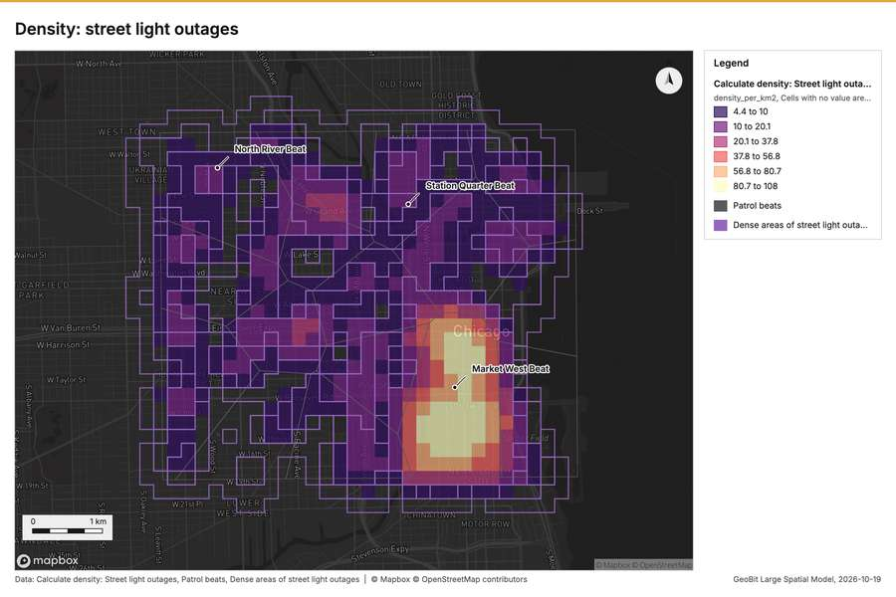
Figure 25. Density: street light outages [71]
What the map shows. The map draws Calculate density: Street light outages by density_per_km2 in 6 classes: 4.4 to 10, 10 to 20.1, 20.1 to 37.8, 37.8 to 56.8, 56.8 to 80.7, 80.7 to 108 [71]. The map draws Patrol beats with one symbol [71]. The map draws Dense areas of street light outages with one symbol [71]. It draws 869 features [71]. It covers longitude -87.706 to -87.588 and latitude 41.845 to 41.912, at about 1:40,754 [71].
Findings
- Evidenced: Calculate density on Street light outages: Calculate density: 1 layer saved: Calculate density: Street light outages (848 features) [13][70].
- Evidenced: It reported result, count 848; result, elapsed ms 15; result, bandwidth m 500; result, cell size m 200; result, excluded null 0; result, max density per km2 107.5 [70].
Tool gp_calculate_density; parameters {"kernel": "quartic", "project": "fe9df6b9-8a15-4264-946b-4b37b8dbb89d", "features": {"layer": "Street light outages (a7218535)"}, "bandwidth_m": 500.0, "cell_size_m": 200.0}

Hot spots
What this analysis is. Hot spot analysis: Getis-Ord Gi* hot and cold spots with z-scores, p-values and confidence bins [20]. In ArcGIS it is Find Hot Spots or Hot Spot Analysis (Getis-Ord Gi*); in QGIS, qgis:hotspot (plugin) [20].
Why it was run on this data. 1680 points: Getis-Ord Gi* tests whether the concentrations in Incidents are statistically significant [72]. Measured: Incidents are clustered (nearest-neighbor ratio 0.73, z = -21.0), median spacing 34.3 m [72]. Cells of 100 m and a band of 200 m from the measured spacing [72].
What it found. Hot spots on Incidents: Hot spot analysis: 1 layer saved: Hot spot analysis: Incidents (2912 features) [12][73]. It reported result, bins 2,912; result, count 2,912; result, elapsed ms 100; result, cell size m 100; result, incidents used 1,680; result, distance band m 200 [73].
Result | Value
result, bins | 2,912
result, count | 2,912
result, elapsed ms | 100
result, cell size m | 100
result, incidents used | 1,680
result, distance band m | 200
billing, cost | 0.0836
billing, list price | 0.0836
billing, upstream cost | 0

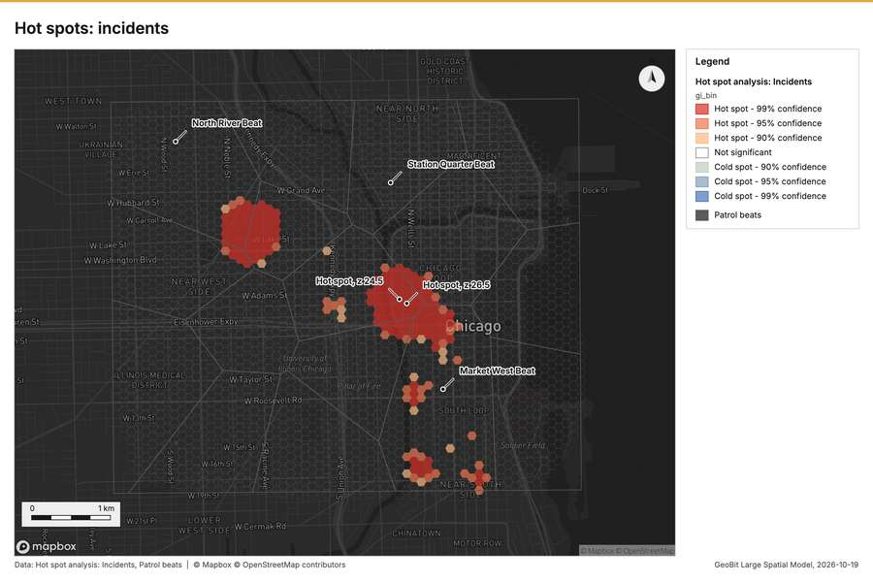
Figure 26. Hot spots: incidents [74]
What the map shows. The map draws Hot spot analysis: Incidents by gi_bin in 7 classes: Hot spot - 99% confidence, Hot spot - 95% confidence, Hot spot - 90% confidence, Not significant, Cold spot - 90% confidence, Cold spot - 95% confidence and 1 more [74]. The map draws Patrol beats with one symbol [74]. It draws 2,928 features [74]. It covers longitude -87.695 to -87.593 and latitude 41.849 to 41.907, at about 1:35,233 [74].
Findings
- Evidenced: Hot spots on Incidents: Hot spot analysis: 1 layer saved: Hot spot analysis: Incidents (2912 features) [12][73].
- Evidenced: It reported result, bins 2,912; result, count 2,912; result, elapsed ms 100; result, cell size m 100; result, incidents used 1,680; result, distance band m 200 [73].
Tool gp_hot_spots; parameters {"project": "fe9df6b9-8a15-4264-946b-4b37b8dbb89d", "features": {"layer": "Incidents (36ad5f7c)"}, "aggregation": "hexagon", "cell_size_m": 100.0, "distance_band_m": 200.0}

Near repeat
What this analysis is. Repeat and near repeat classification: Classify incidents as originators, repeats (same place) or near repeats within a distance and time window, with a Knox test table [75]. In ArcGIS it is Repeat and Near Repeat Classification or Near Repeat Calculator [75].
Why it was run on this data. Near repeat analysis tests whether Incidents close in space also follow each other within 30 days [76].
What it found. The gp\_near\_repeat tool processed the Incidents data [12] and generated results covering 30 days [77]. The tool identified 1,680 results [77], involving 152 chains [77]. This analysis calculated pairs linked involving 1,357 pairs [77] over a distance of 100 m [77]. The total cost for this process was 0.1004 [77].
Result | Value
result, days | 30
result, count | 1,680
result, chains | 152
result, distance m | 100
result, elapsed ms | 39
result, pairs linked | 1,357
billing, cost | 0.1004
billing, list price | 0.1004
billing, upstream cost | 0

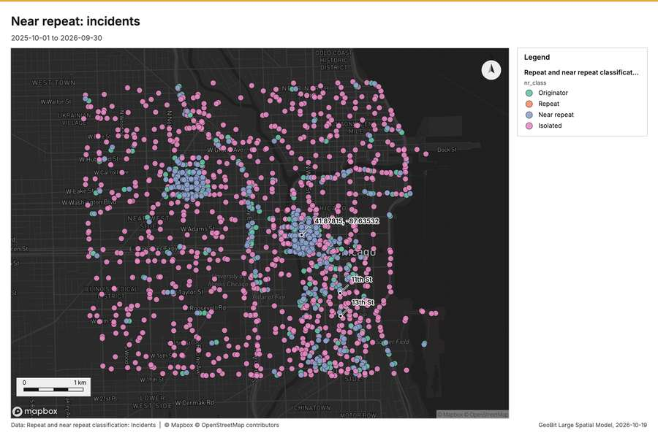
Figure 27. Near repeat: incidents [78]
What the map shows. The map draws Repeat and near repeat classification: Incidents by nr_class in 4 classes: Originator, Repeat, Near repeat, Isolated [78]. It draws 1,680 features [78]. It covers longitude -87.695 to -87.593 and latitude 41.85 to 41.907, at about 1:35,233 [78].
Findings
- Evidenced: Near repeat on Incidents: Repeat and near repeat classification: 1 layer saved: Repeat and near repeat classification: Incidents (1680 features) [12][77].
- Evidenced: It reported result, days 30; result, count 1,680; result, chains 152; result, distance m 100; result, elapsed ms 39; result, pairs linked 1,357 [77].
Tool gp_near_repeat; parameters {"days": 30, "project": "fe9df6b9-8a15-4264-946b-4b37b8dbb89d", "features": {"layer": "Incidents (36ad5f7c)"}, "distance_m": 100.0, "time_field": "reported_at"}

What follows from the results
Hot cells inside each cluster of licensed premises, from Hot spot analysis: Incidents and Find point clusters: cluster hulls: 1 of 3 clusters hold hot spot cells; cluster 0 holds the most (53) [79][73][36]. Change beside the counts per patrol beat, from Period change: Incidents (week of 2026-06-22 to week of 2026-06-29) and Summarize within: Patrol beats: the busiest area, Market West Beat (332 in all), changed by +9 [87][7][50]. Change of incidents where density is high, from Period change: Incidents (week of 2026-06-22 to week of 2026-06-29) and Calculate density: Street light outages: the largest rise (+9, Market West Beat) is where density averages 58.82 per square kilometer [92][7][70]. Hot cells of CCTV cameras per patrol beat, from Hot spot analysis: CCTV cameras: 9 of 16 areas hold hot spot cells; Southgate Beat holds the most (5) [97][22]. Nearest police station to each cluster of licensed premises, from Find point clusters: cluster hulls: the 3 clusters lie 836 to 972 m from the nearest facility (Central District Station and others) [103][36]. Dense areas of street light outages, from Calculate density: Street light outages: the densest of five classes joins 170 cells into one area [109][70]. Change of street light outages per patrol beat, from Period change: Street light outages (week of 2026-02-02 to week of 2026-02-09): Parkview Beat rose the most (+2) and Market West Beat fell the most (-7) [112][9].
Findings
- Evidenced: Hot cells inside each cluster of licensed premises, from Hot spot analysis: Incidents and Find point clusters: cluster hulls: 1 of 3 clusters hold hot spot cells; cluster 0 holds the most (53) [79][73][36].
- Evidenced: Change beside the counts per patrol beat, from Period change: Incidents (week of 2026-06-22 to week of 2026-06-29) and Summarize within: Patrol beats: the busiest area, Market West Beat (332 in all), changed by +9 [87][7][50].
- Evidenced: Change of incidents where density is high, from Period change: Incidents (week of 2026-06-22 to week of 2026-06-29) and Calculate density: Street light outages: the largest rise (+9, Market West Beat) is where density averages 58.82 per square kilometer [92][7][70].
- Evidenced: Hot cells of CCTV cameras per patrol beat, from Hot spot analysis: CCTV cameras: 9 of 16 areas hold hot spot cells; Southgate Beat holds the most (5) [97][22].
- Evidenced: Nearest police station to each cluster of licensed premises, from Find point clusters: cluster hulls: the 3 clusters lie 836 to 972 m from the nearest facility (Central District Station and others) [103][36].
- Evidenced: Dense areas of street light outages, from Calculate density: Street light outages: the densest of five classes joins 170 cells into one area [109][70].
- Evidenced: Change of street light outages per patrol beat, from Period change: Street light outages (week of 2026-02-02 to week of 2026-02-09): Parkview Beat rose the most (+2) and Market West Beat fell the most (-7) [112][9].

Hot cells inside each cluster of licensed premises
What this analysis is. Summarize within: Count and aggregate the features inside each polygon (or bin), proportionally for lines and polygons [44]. In ArcGIS it is Summarize Within or Aggregate Points; in QGIS, native:countpointsinpolygon or native:sumlinelengths [44].
Why it was run on this data. Count CCTV cameras inside each feature of Patrol beats by ptz; the counts map as a choropleth (natural breaks, sequential colors) [45].
What it found. The `gp_summarize_within` analysis saved one layer called Hot cells inside each cluster of licensed premises with 3 features [79].
Result | Value
result, count | 3
result, elapsed ms | 6
billing, cost | 0.0683
billing, list price | 0.0683
billing, upstream cost | 0

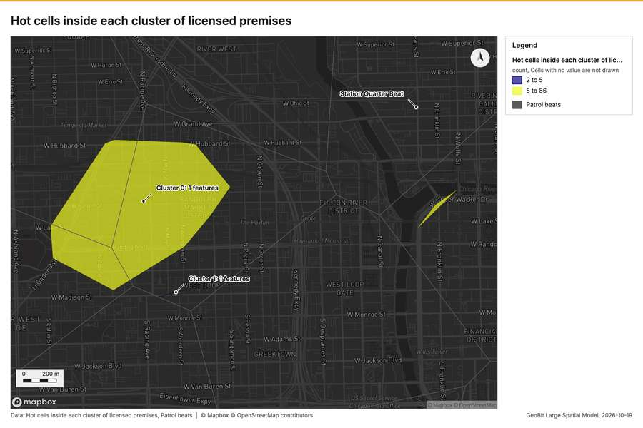
Figure 28. Hot cells inside each cluster of licensed premises [83]
What the map shows. The map draws Hot cells inside each cluster of licensed premises by count in 2 classes: 2 to 5, 5 to 86 [83]. The map draws Patrol beats with one symbol [83]. It draws 19 features [83]. It covers longitude -87.667 to -87.631 and latitude 41.875 to 41.896, at about 1:12,455 [83].
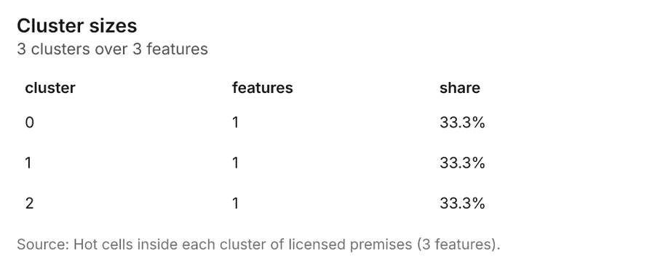
Figure 29. Hot cells inside each cluster of licensed premises [84]. Source: Hot cells inside each cluster of licensed premises (3 features). The data is in the appendix.
Findings
- Evidenced: Summarize within on Hot spot analysis: Incidents, Find point clusters: cluster hulls produced Hot cells inside each cluster of licensed premises (3 features) [79][80][81][82].
- Evidenced: It reported result, count 3; result, elapsed ms 6; billing, cost 0.0683; billing, list price 0.0683; billing, upstream cost 0 [79].
- Evidenced: The chart Hot cells inside each cluster of licensed premises is drawn from 3 rows [84].
Tool gp_summarize_within; parameters {"project": "fe9df6b9-8a15-4264-946b-4b37b8dbb89d", "features": {"layer": "Hot spot analysis: Incidents (8382f930)"}, "group_by": "gi_bin", "polygons": {"layer": "Find point clusters: cluster hulls (4dfef6fb)"}, "output_name": "Hot cells inside each cluster of licensed premises"}

Change beside the counts per patrol beat
What this analysis is. Spatial join: Attach attributes (or aggregates) of matching features from another layer, by location, distance, time and attributes [85]. In ArcGIS it is Join Features or Spatial Join; in QGIS, native:joinattributesbylocation or native:joinbylocationsummary [85].
Why it was run on this data. It was run toward the goal "Describe the project Sample: Public safety, Chicago: run the analyses that tell the most about its data, draw every result, and write a cited report" [86].
What it found. Spatial join on Summarize within: Patrol beats, Period change: Incidents (week of 2026-06-22 to week of 2026-06-29) produced Change beside the counts per patrol beat (16 features) [8][87][88][89]. It reported result, count 16; result, elapsed ms 1; billing, cost 0.01066; billing, list price 0.01066; billing, upstream cost 0 [87]. The chart Change beside the counts per patrol beat is drawn from 5 rows [91].
Result | Value
result, count | 16
result, elapsed ms | 1
billing, cost | 0.01066
billing, list price | 0.01066
billing, upstream cost | 0

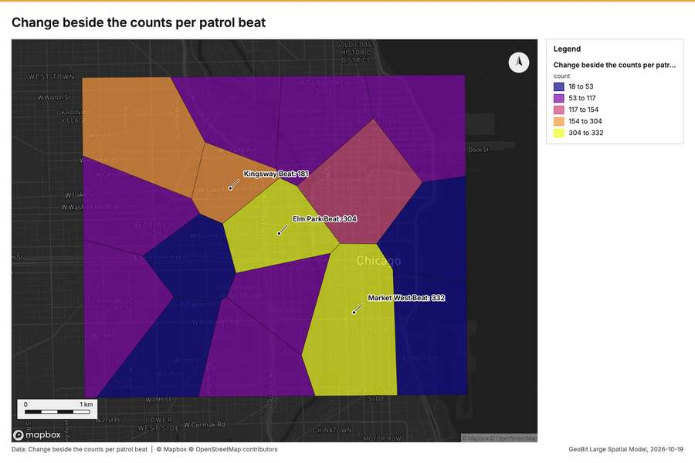
Figure 30. Change beside the counts per patrol beat [90]
What the map shows. The map draws Change beside the counts per patrol beat by count in 5 classes: 18 to 53, 53 to 117, 117 to 154, 154 to 304, 304 to 332 [90]. It draws 16 features [90]. It covers longitude -87.694 to -87.594 and latitude 41.85 to 41.907, at about 1:34,270 [90].
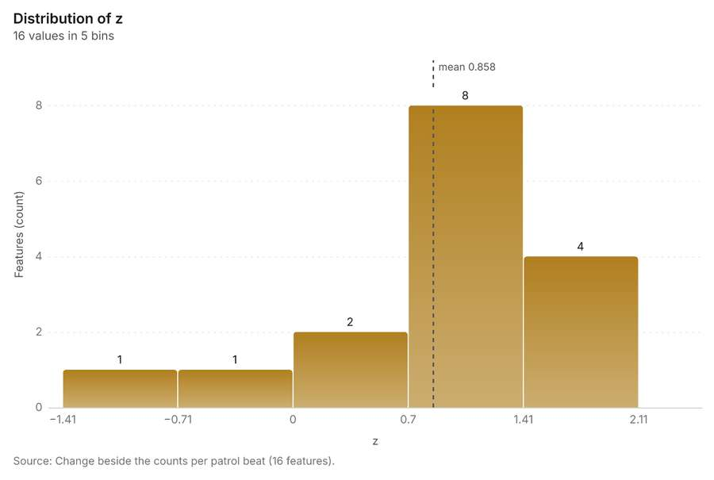
Figure 31. Change beside the counts per patrol beat [91]. Source: Change beside the counts per patrol beat (16 features). The data is in the appendix.
Findings
- Evidenced: Spatial join on Summarize within: Patrol beats, Period change: Incidents (week of 2026-06-22 to week of 2026-06-29) produced Change beside the counts per patrol beat (16 features) [8][87][88][89].
- Evidenced: It reported result, count 16; result, elapsed ms 1; billing, cost 0.01066; billing, list price 0.01066; billing, upstream cost 0 [87].
- Evidenced: The chart Change beside the counts per patrol beat is drawn from 5 rows [91].
Tool gp_spatial_join; parameters {"join": {"layer": "Summarize within: Patrol beats (31bedf68)"}, "fields": ["count"], "target": {"layer": "Period change: Incidents (week of 2026-06-22 to week of 2026-06-29) (1e0726ac)"}, "project": "fe9df6b9-8a15-4264-946b-4b37b8dbb89d", "predicate": "largest_overlap", "output_name": "Change beside the counts per patrol beat"}

Change of incidents where density is high
What this analysis is. Spatial join: Attach attributes (or aggregates) of matching features from another layer, by location, distance, time and attributes [85]. In ArcGIS it is Join Features or Spatial Join; in QGIS, native:joinattributesbylocation or native:joinbylocationsummary [85].
Why it was run on this data. It was run toward the goal "Describe the project Sample: Public safety, Chicago: run the analyses that tell the most about its data, draw every result, and write a cited report" [86].
What it found. The spatial join utilized the Period change: Incidents data [8] and calculated density data from Street light outages [93].
Result | Value
result, count | 16
result, elapsed ms | 1
billing, cost | 0.0273
billing, list price | 0.0273
billing, upstream cost | 0

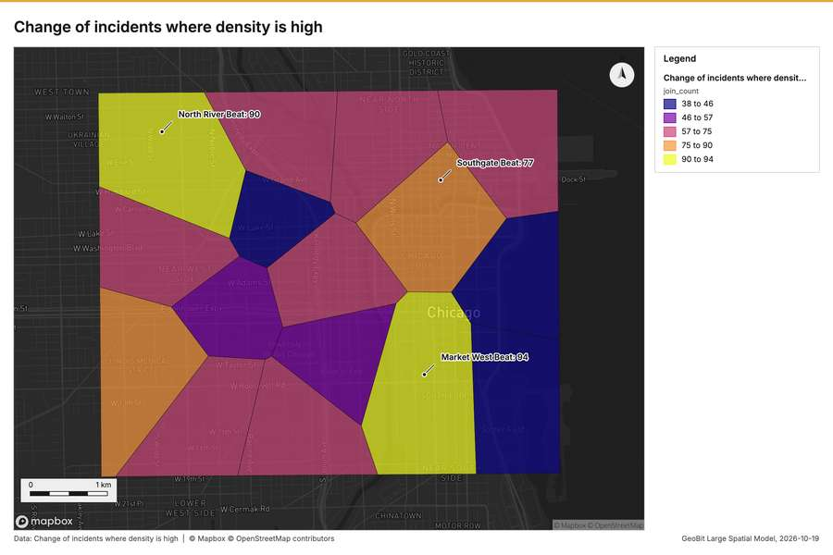
Figure 32. Change of incidents where density is high [95]
What the map shows. The map draws Change of incidents where density is high by join_count in 5 classes: 38 to 46, 46 to 57, 57 to 75, 75 to 90, 90 to 94 [95]. It draws 16 features [95]. It covers longitude -87.694 to -87.594 and latitude 41.85 to 41.907, at about 1:34,270 [95].
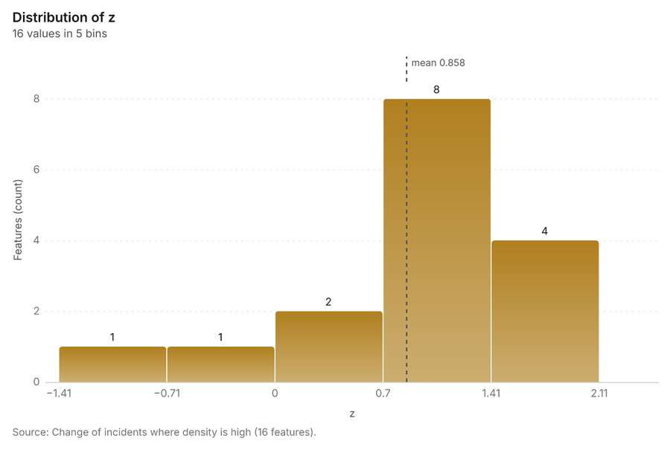
Figure 33. Change of incidents where density is high [96]. Source: Change of incidents where density is high (16 features). The data is in the appendix.
Findings
- Evidenced: Spatial join on Calculate density: Street light outages, Period change: Incidents (week of 2026-06-22 to week of 2026-06-29) produced Change of incidents where density is high (16 features) [8][92][93][94].
- Evidenced: It reported result, count 16; result, elapsed ms 1; billing, cost 0.0273; billing, list price 0.0273; billing, upstream cost 0 [92].
- Evidenced: The chart Change of incidents where density is high is drawn from 5 rows [96].
Tool gp_spatial_join; parameters {"join": {"layer": "Calculate density: Street light outages (22316e02)"}, "stats": [{"agg": "mean", "field": "density_per_km2"}], "target": {"layer": "Period change: Incidents (week of 2026-06-22 to week of 2026-06-29) (1e0726ac)"}, "project": "fe9df6b9-8a15-4264-946b-4b37b8dbb89d", "predicate": "intersects", "output_name": "Change of incidents where density is high"}

Hot cells of CCTV cameras per patrol beat
What this analysis is. Summarize within: Count and aggregate the features inside each polygon (or bin), proportionally for lines and polygons [44]. In ArcGIS it is Summarize Within or Aggregate Points; in QGIS, native:countpointsinpolygon or native:sumlinelengths [44].
Why it was run on this data. Count CCTV cameras inside each feature of Patrol beats by ptz; the counts map as a choropleth (natural breaks, sequential colors) [45].
What it found. Summarize within on Hot spot analysis: CCTV cameras, Patrol beats produced Hot cells of CCTV cameras per patrol beat (16 features) [14][97][98][99]. It reported result, count 16; result, elapsed ms 2; billing, cost 0.01104; billing, list price 0.01104; billing, upstream cost 0 [97]. The chart Hot cells of CCTV cameras per patrol beat is drawn from 5 rows [101].
Result | Value
result, count | 16
result, elapsed ms | 2
billing, cost | 0.01104
billing, list price | 0.01104
billing, upstream cost | 0

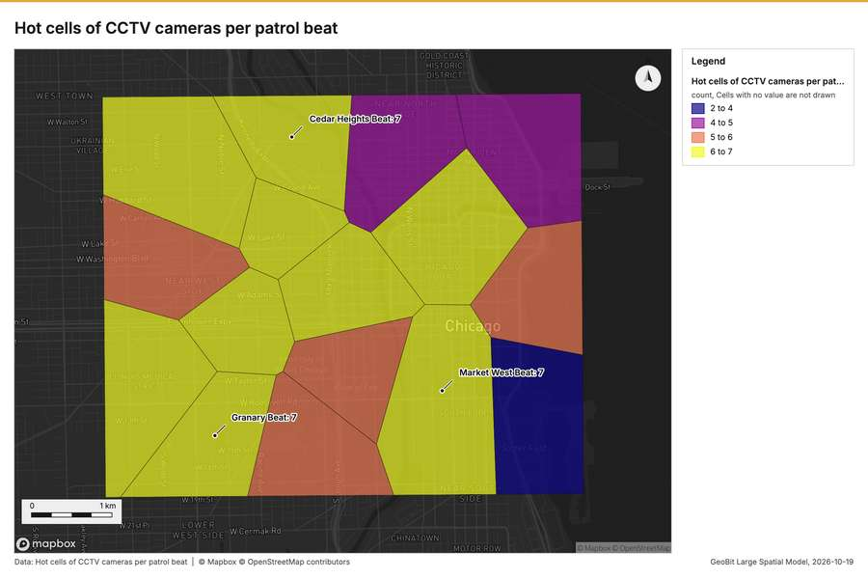
Figure 34. Hot cells of CCTV cameras per patrol beat [100]
What the map shows. The map draws Hot cells of CCTV cameras per patrol beat by count in 4 classes: 2 to 4, 4 to 5, 5 to 6, 6 to 7 [100]. It draws 16 features [100]. It covers longitude -87.694 to -87.594 and latitude 41.85 to 41.907, at about 1:34,270 [100].
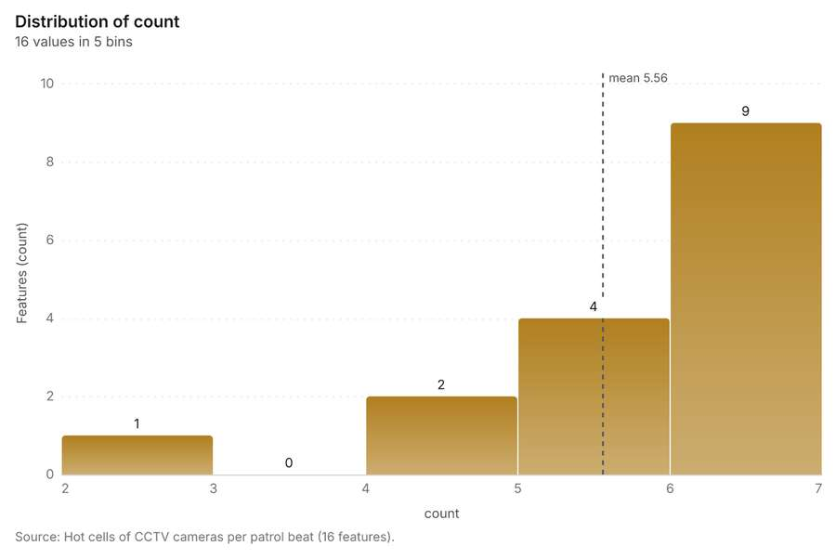
Figure 35. Hot cells of CCTV cameras per patrol beat [101]. Source: Hot cells of CCTV cameras per patrol beat (16 features). The data is in the appendix.
Findings
- Evidenced: Summarize within on Hot spot analysis: CCTV cameras, Patrol beats produced Hot cells of CCTV cameras per patrol beat (16 features) [14][97][98][99].
- Evidenced: It reported result, count 16; result, elapsed ms 2; billing, cost 0.01104; billing, list price 0.01104; billing, upstream cost 0 [97].
- Evidenced: The chart Hot cells of CCTV cameras per patrol beat is drawn from 5 rows [101].
Tool gp_summarize_within; parameters {"project": "fe9df6b9-8a15-4264-946b-4b37b8dbb89d", "features": {"layer": "Hot spot analysis: CCTV cameras (2cc32b98)"}, "group_by": "gi_bin", "polygons": {"layer": "Patrol beats (8c67e28f)"}, "output_name": "Hot cells of CCTV cameras per patrol beat"}

Nearest police station to each cluster of licensed premises
What this analysis is. Find nearest: The k nearest features for each input, with geodesic distance and bearing [102]. In ArcGIS it is Find Nearest or Near; in QGIS, native:joinbynearest or native:nearestneighbouranalysis [102].
Why it was run on this data. It was run toward the goal "Describe the project Sample: Public safety, Chicago: run the analyses that tell the most about its data, draw every result, and write a cited report" [86].
What it found. Find nearest on Police stations, Find point clusters: cluster hulls produced Nearest police station to each cluster of licensed premises (3 features) [19][81][103][104]. It reported result, count 3; result, elapsed ms 3; billing, cost 0.01012; billing, list price 0.01012; billing, upstream cost 0 [103]. The chart Nearest police station to each cluster of licensed premises is drawn from 3 rows [106].
Result | Value
result, count | 3
result, elapsed ms | 3
billing, cost | 0.01012
billing, list price | 0.01012
billing, upstream cost | 0

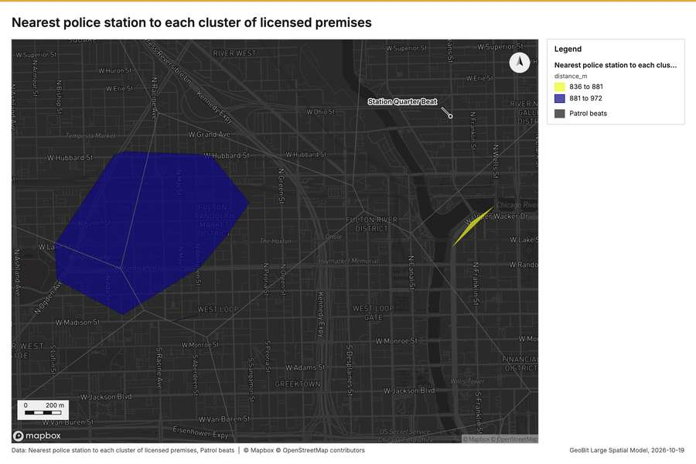
Figure 36. Nearest police station to each cluster of licensed premises [105]
What the map shows. The map draws Nearest police station to each cluster of licensed premises by distance_m in 2 classes: 836 to 881, 881 to 972 [105]. The map draws Patrol beats with one symbol [105]. It draws 19 features [105]. It covers longitude -87.667 to -87.631 and latitude 41.875 to 41.896, at about 1:12,455 [105].
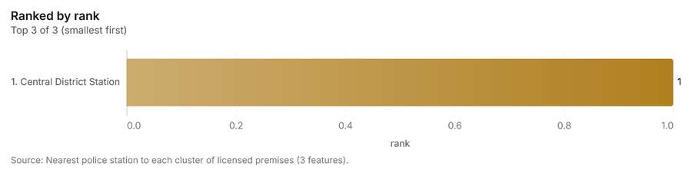
Figure 37. Nearest police station to each cluster of licensed premises [106]. Source: Nearest police station to each cluster of licensed premises (3 features). The data is in the appendix.
Findings
- Evidenced: Find nearest on Police stations, Find point clusters: cluster hulls produced Nearest police station to each cluster of licensed premises (3 features) [19][81][103][104].
- Evidenced: It reported result, count 3; result, elapsed ms 3; billing, cost 0.01012; billing, list price 0.01012; billing, upstream cost 0 [103].
- Evidenced: The chart Nearest police station to each cluster of licensed premises is drawn from 3 rows [106].
Tool gp_find_nearest; parameters {"k": 1, "to": {"layer": "Police stations (6b7fdf5e)"}, "from": {"layer": "Find point clusters: cluster hulls (4dfef6fb)"}, "project": "fe9df6b9-8a15-4264-946b-4b37b8dbb89d", "output_name": "Nearest police station to each cluster of licensed premises"}

Dense areas of street light outages
What this analysis is. Pipeline: Run up to 20 GIS operations in one engine call; a step's params may use "$id" (an earlier step's result) or "$id.key", and layer references [107]. Every step's map outputs are saved as styled layers [107].
Why it was run on this data. Patrol beats holds population in 'population': CCTV cameras per 10,000 people in each feature compares features of different size; mapped as a choropleth (natural breaks, sequential colors) [108].
What it found. Pipeline on Calculate density: Street light outages produced Dense areas of street light outages (5 features) [93][109][110]. It reported result, count 5; result, elapsed ms 13; billing, cost 0.03697; billing, list price 0.03697; billing, upstream cost 0; list price 0.03697 [109]. The chart Dense areas of street light outages is drawn from 5 rows [111].
Result | Value
result, count | 5
result, elapsed ms | 13
billing, cost | 0.03697
billing, list price | 0.03697
billing, upstream cost | 0
list price | 0.03697

What the map shows. Drawn with calculate density on the map Density: street light outages [71].
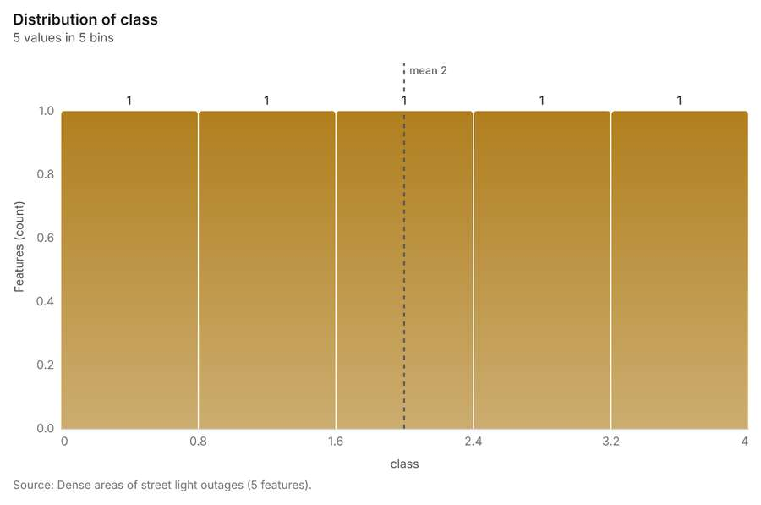
Figure 38. Dense areas of street light outages [111]. Source: Dense areas of street light outages (5 features). The data is in the appendix.
Findings
- Evidenced: Pipeline on Calculate density: Street light outages produced Dense areas of street light outages (5 features) [93][109][110].
- Evidenced: It reported result, count 5; result, elapsed ms 13; billing, cost 0.03697; billing, list price 0.03697; billing, upstream cost 0; list price 0.03697 [109].
- Evidenced: The chart Dense areas of street light outages is drawn from 5 rows [111].
Tool gp_pipeline; parameters {"save": "final", "steps": [{"id": "classes", "params": {"field": "density_per_km2", "method": "quantile", "classes": 5, "features": {"layer": "Calculate density: Street light outages (22316e02)"}}, "operation": "classify_field"}, {"id": "areas", "params": {"by": ["class"], "features": "$classes"}, "operation": "dissolve"}], "project": "fe9df6b9-8a15-4264-946b-4b37b8dbb89d", "output_name": "Dense

Change of street light outages per patrol beat
What this analysis is. Summarize within: Count and aggregate the features inside each polygon (or bin), proportionally for lines and polygons [44]. In ArcGIS it is Summarize Within or Aggregate Points; in QGIS, native:countpointsinpolygon or native:sumlinelengths [44].
Why it was run on this data. Count CCTV cameras inside each feature of Patrol beats by ptz; the counts map as a choropleth (natural breaks, sequential colors) [45].
What it found. Summarize within on Period change: Street light outages (week of 2026-02-02 to week of 2026-02-09), Patrol beats produced Change of street light outages per patrol beat (16 features) [10][14][112][113]. It reported result, count 16; result, elapsed ms 1; billing, cost 0.01048; billing, list price 0.01048; billing, upstream cost 0 [112]. The chart Change of street light outages per patrol beat is drawn from 5 rows [115].
Result | Value
result, count | 16
result, elapsed ms | 1
billing, cost | 0.01048
billing, list price | 0.01048
billing, upstream cost | 0

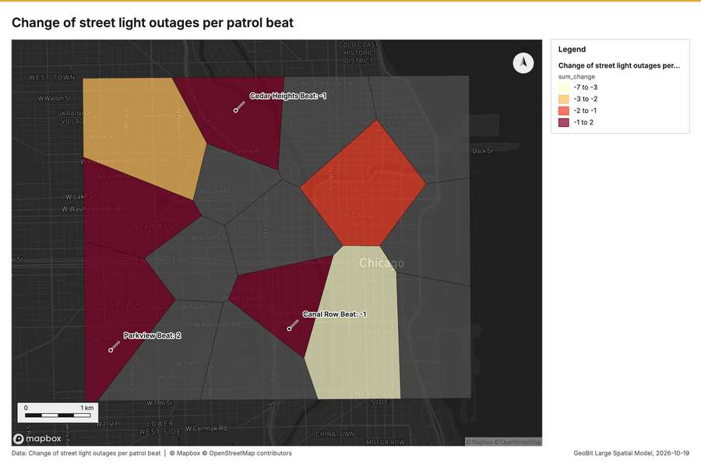
Figure 39. Change of street light outages per patrol beat [114]
What the map shows. The map draws Change of street light outages per patrol beat by sum_change in 4 classes: -7 to -3, -3 to -2, -2 to -1, -1 to 2 [114]. It draws 16 features [114]. It covers longitude -87.694 to -87.594 and latitude 41.85 to 41.907, at about 1:34,270 [114].
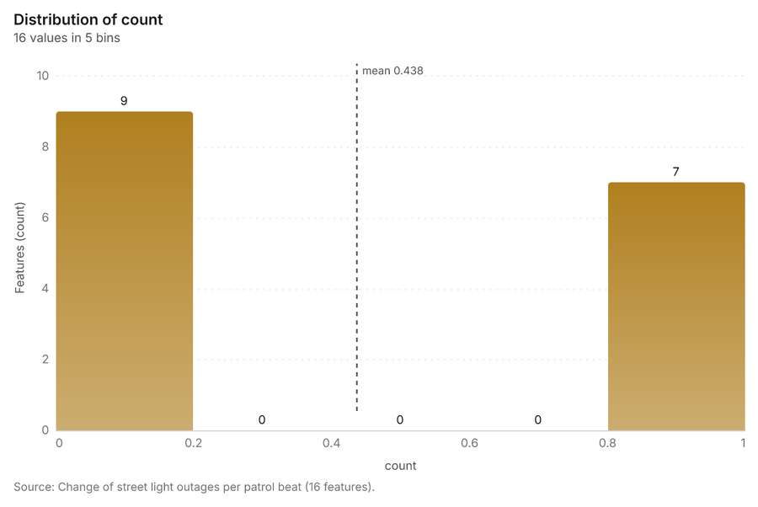
Figure 40. Change of street light outages per patrol beat [115]. Source: Change of street light outages per patrol beat (16 features). The data is in the appendix.
Findings
- Evidenced: Summarize within on Period change: Street light outages (week of 2026-02-02 to week of 2026-02-09), Patrol beats produced Change of street light outages per patrol beat (16 features) [10][14][112][113].
- Evidenced: It reported result, count 16; result, elapsed ms 1; billing, cost 0.01048; billing, list price 0.01048; billing, upstream cost 0 [112].
- Evidenced: The chart Change of street light outages per patrol beat is drawn from 5 rows [115].
Tool gp_summarize_within; parameters {"stats": [{"agg": "sum", "field": "change"}], "project": "fe9df6b9-8a15-4264-946b-4b37b8dbb89d", "features": {"layer": "Period change: Street light outages (week of 2026-02-02 to week of 2026-02-09) (b942fd09)"}, "polygons": {"layer": "Patrol beats (8c67e28f)"}, "output_name": "Change of street light outages per patrol beat"}

Maps and charts
The run also made 25 chart(s) [116][117][118][119][120][121][122][123][124][125][126][127][128][129][130][131][132][133][134][135][136][137][138][139][140].
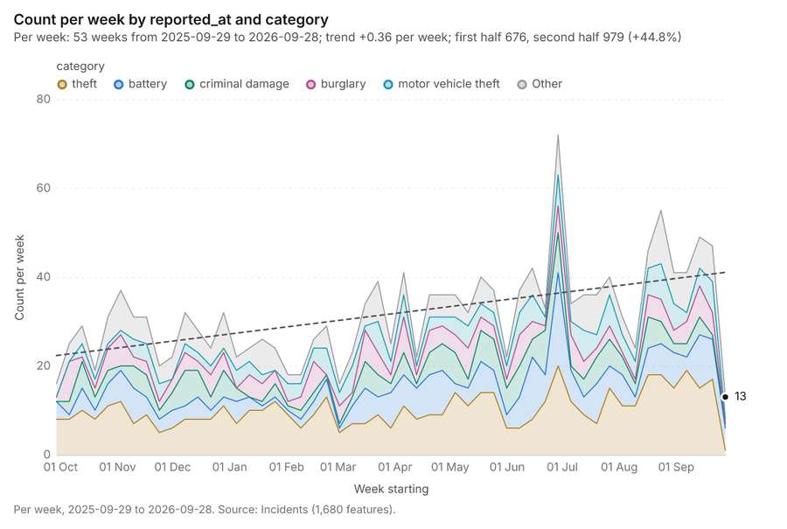
Figure 41. Incidents over time (reported_at) [116]. Per week, 2025-09-29 to 2026-09-28. Source: Incidents (1,680 features). The data is in the appendix.
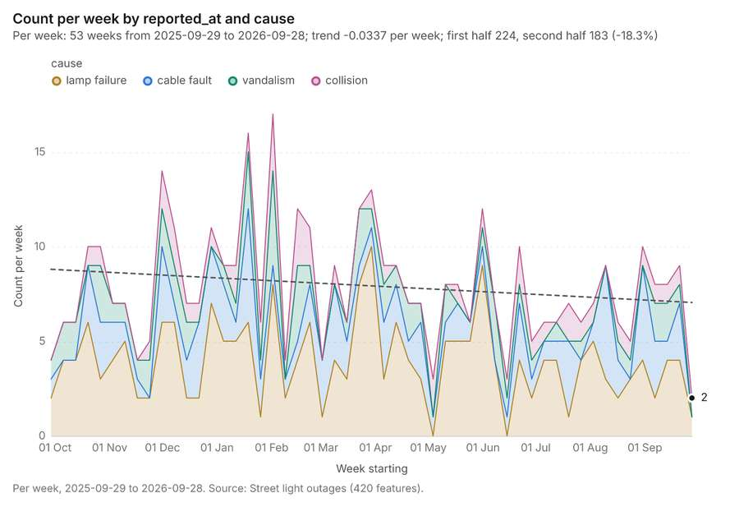
Figure 42. Street light outages over time (reported_at) [117]. Per week, 2025-09-29 to 2026-09-28. Source: Street light outages (420 features). The data is in the appendix.
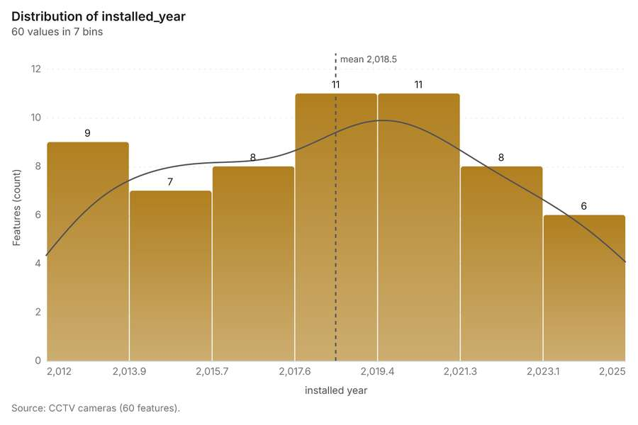
Figure 43. CCTV cameras over time (installed_year) [118]. Source: CCTV cameras (60 features). The data is in the appendix.
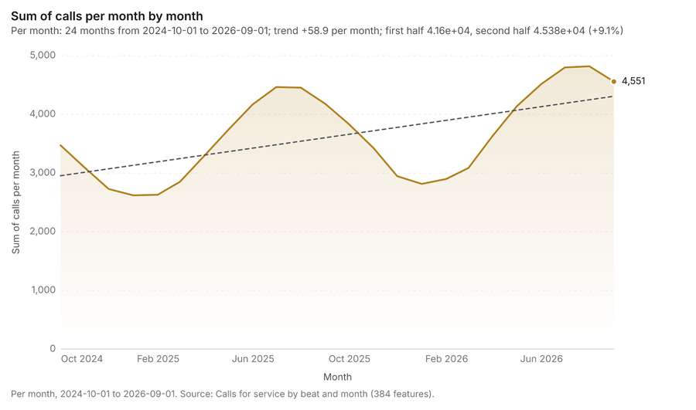
Figure 44. Calls for service by beat and month over time (month) [119]. Per month, 2024-10-01 to 2026-09-01. Source: Calls for service by beat and month (384 features). The data is in the appendix.
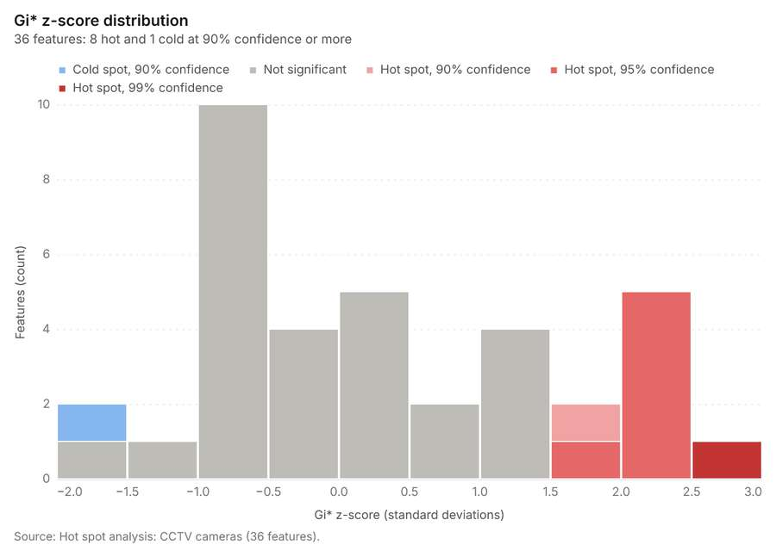
Figure 45. Hot spot analysis: CCTV cameras [120]. Source: Hot spot analysis: CCTV cameras (36 features). The data is in the appendix.
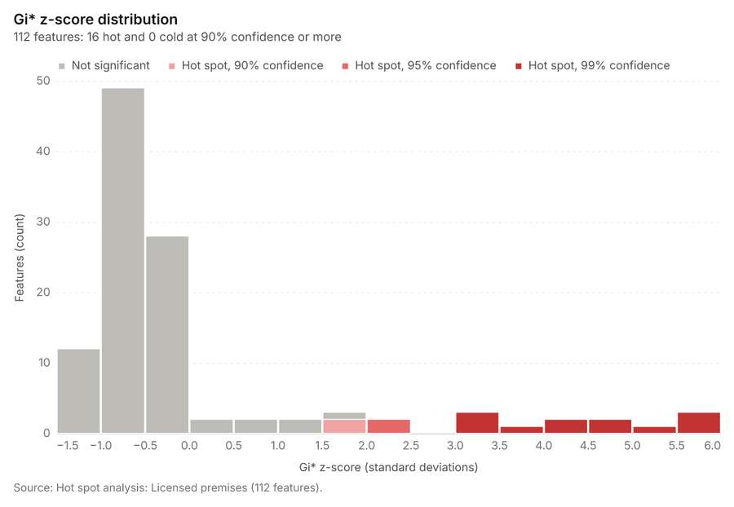
Figure 46. Hot spot analysis: Licensed premises [121]. Source: Hot spot analysis: Licensed premises (112 features). The data is in the appendix.
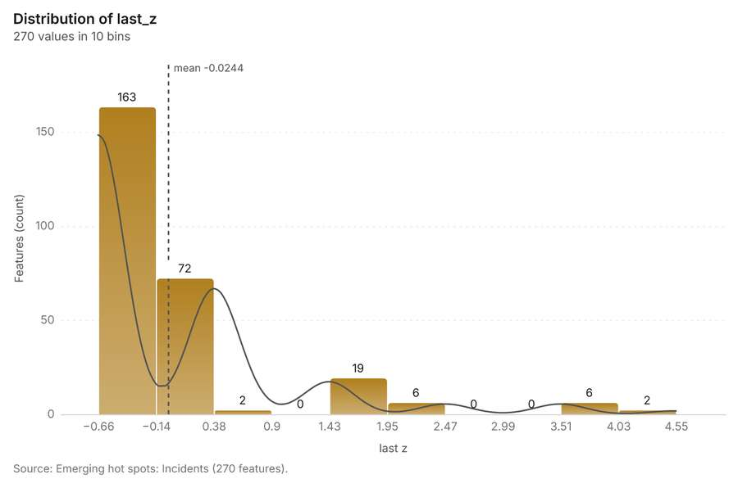
Figure 47. Emerging hot spots: Incidents [122]. Source: Emerging hot spots: Incidents (270 features). The data is in the appendix.
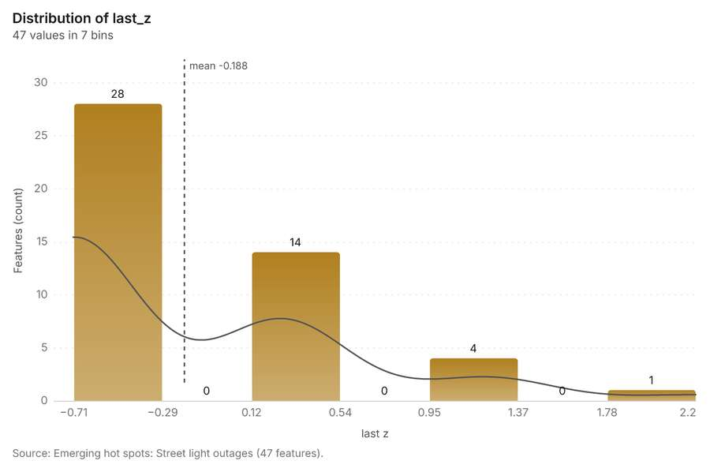
Figure 48. Emerging hot spots: Street light outages [123]. Source: Emerging hot spots: Street light outages (47 features). The data is in the appendix.
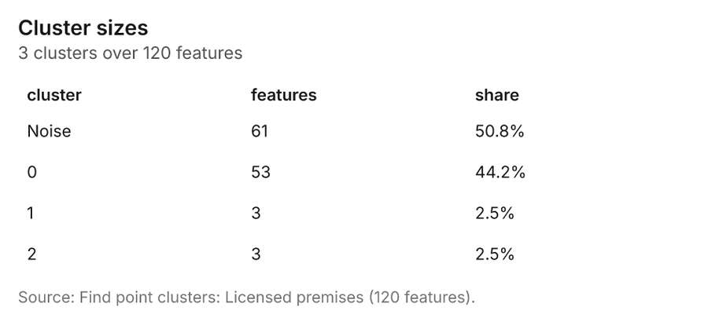
Figure 49. Find point clusters: Licensed premises [124]. Source: Find point clusters: Licensed premises (120 features). The data is in the appendix.
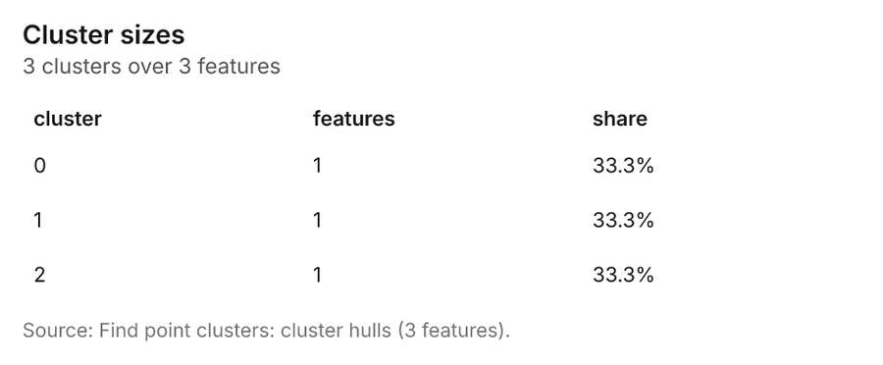
Figure 50. Find point clusters: cluster hulls [125]. Source: Find point clusters: cluster hulls (3 features). The data is in the appendix.
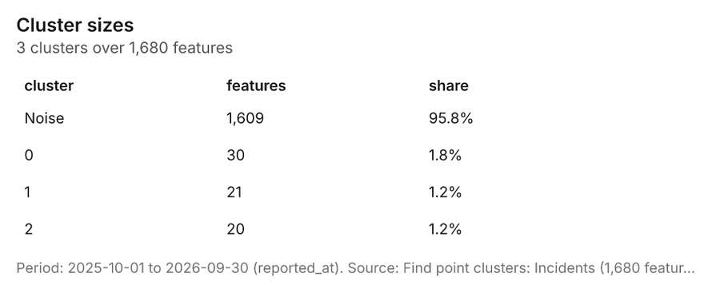
Figure 51. Find point clusters: Incidents [126]. Period: 2025-10-01 to 2026-09-30 (reported_at). Source: Find point clusters: Incidents (1,680 features). The data is in the appendix.
Figure 52. Find point clusters: cluster hulls [127]. Source: Find point clusters: cluster hulls (3 features). The data is in the appendix.
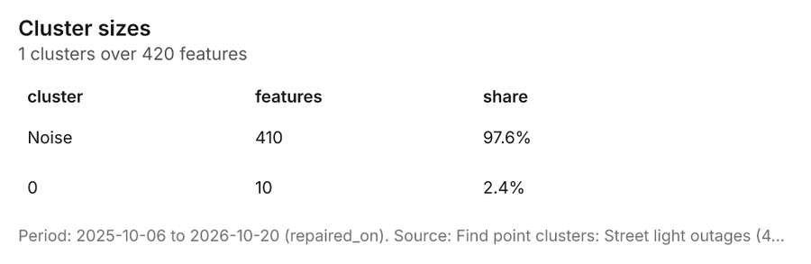
Figure 53. Find point clusters: Street light outages [128]. Period: 2025-10-06 to 2026-10-20 (repaired_on). Source: Find point clusters: Street light outages (420 features). The data is in the appendix.
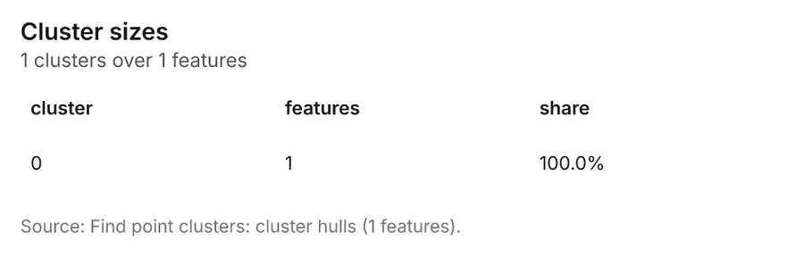
Figure 54. Find point clusters: cluster hulls [129]. Source: Find point clusters: cluster hulls (1 features). The data is in the appendix.
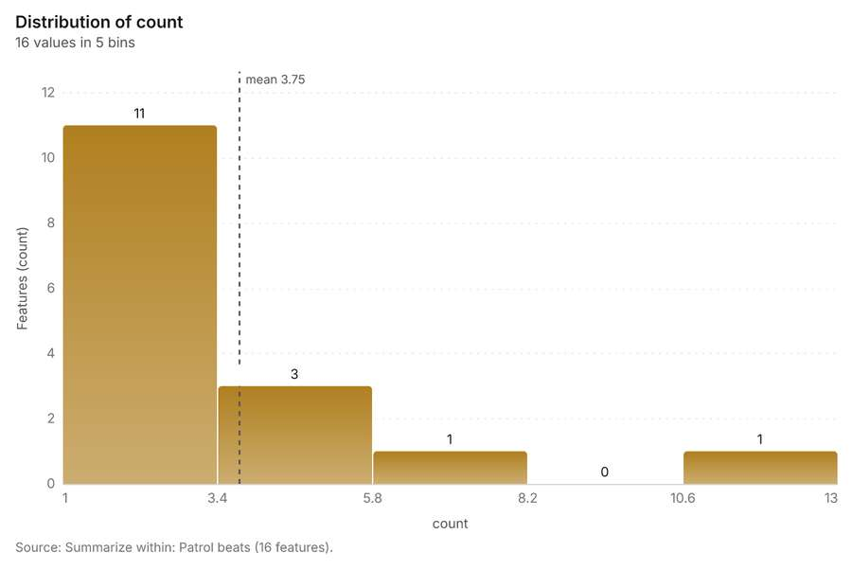
Figure 55. Summarize within: Patrol beats [130]. Source: Summarize within: Patrol beats (16 features). The data is in the appendix.
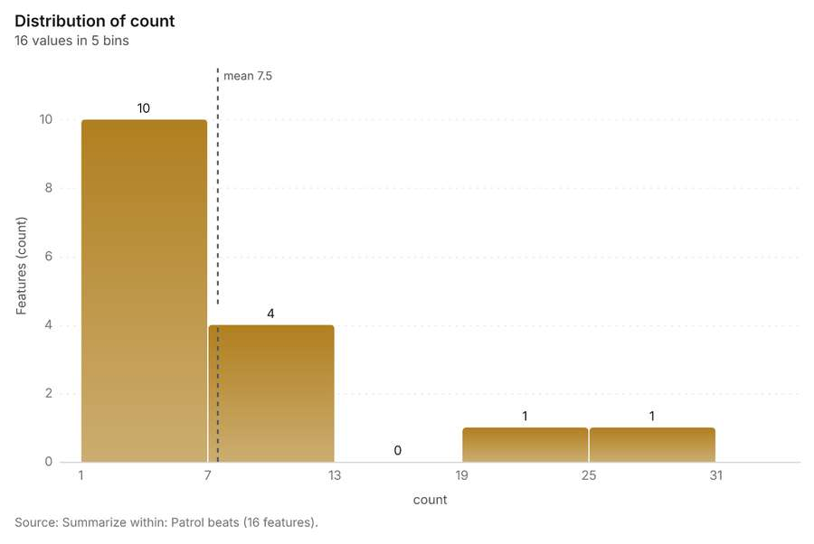
Figure 56. Summarize within: Patrol beats [131]. Source: Summarize within: Patrol beats (16 features). The data is in the appendix.
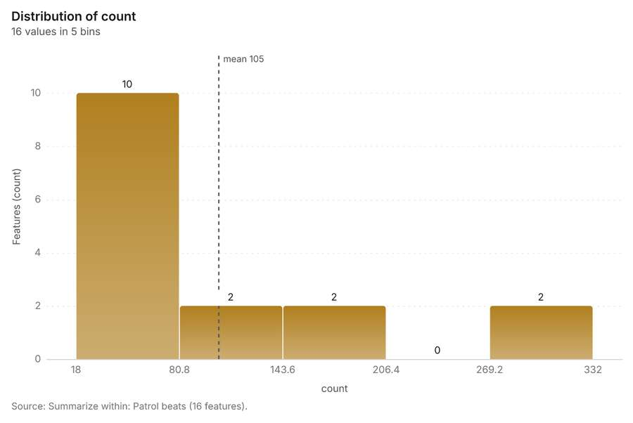
Figure 57. Summarize within: Patrol beats [132]. Source: Summarize within: Patrol beats (16 features). The data is in the appendix.
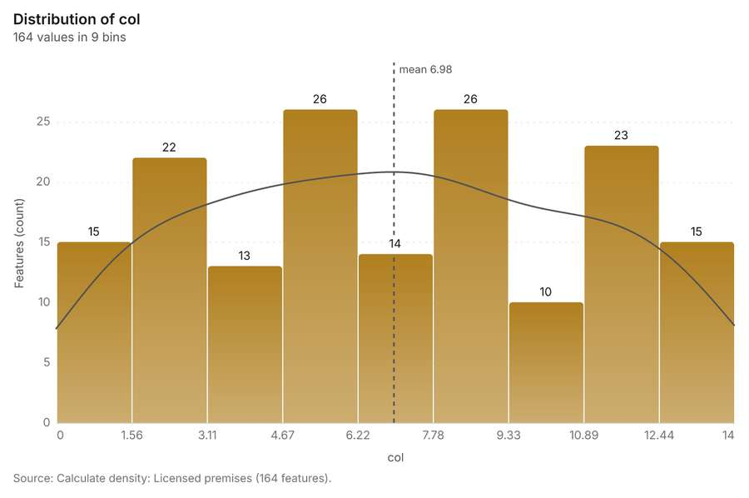
Figure 58. Calculate density: Licensed premises [133]. Source: Calculate density: Licensed premises (164 features). The data is in the appendix.
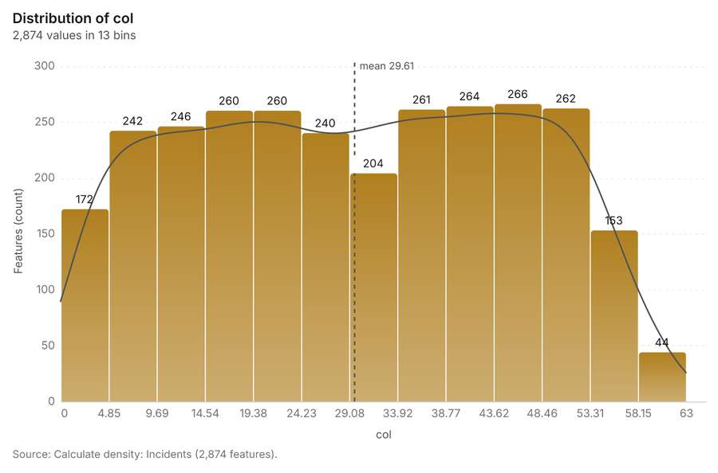
Figure 59. Calculate density: Incidents [134]. Source: Calculate density: Incidents (2,874 features). The data is in the appendix.
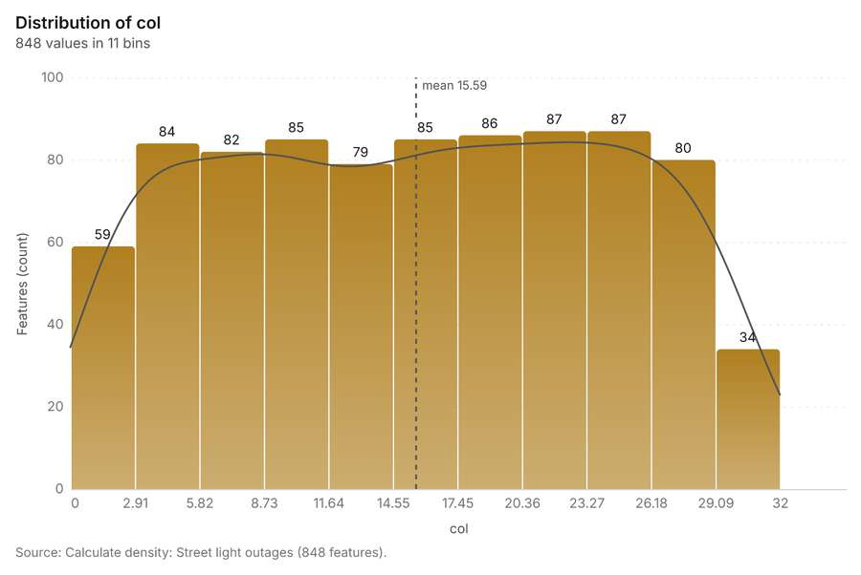
Figure 60. Calculate density: Street light outages [135]. Source: Calculate density: Street light outages (848 features). The data is in the appendix.
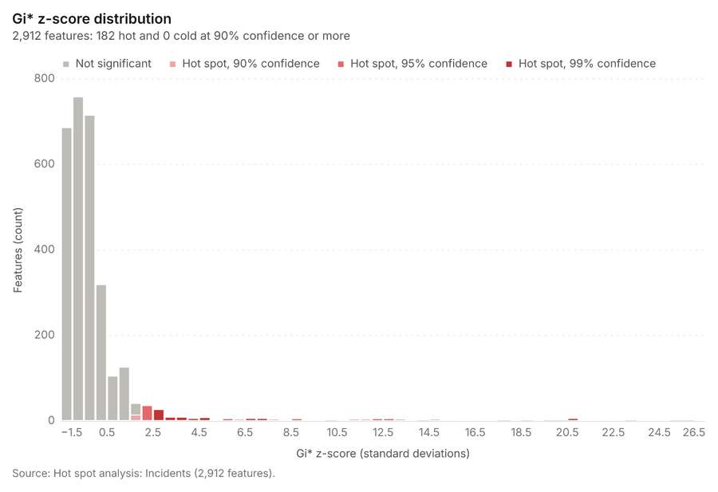
Figure 61. Hot spot analysis: Incidents [136]. Source: Hot spot analysis: Incidents (2,912 features). The data is in the appendix.
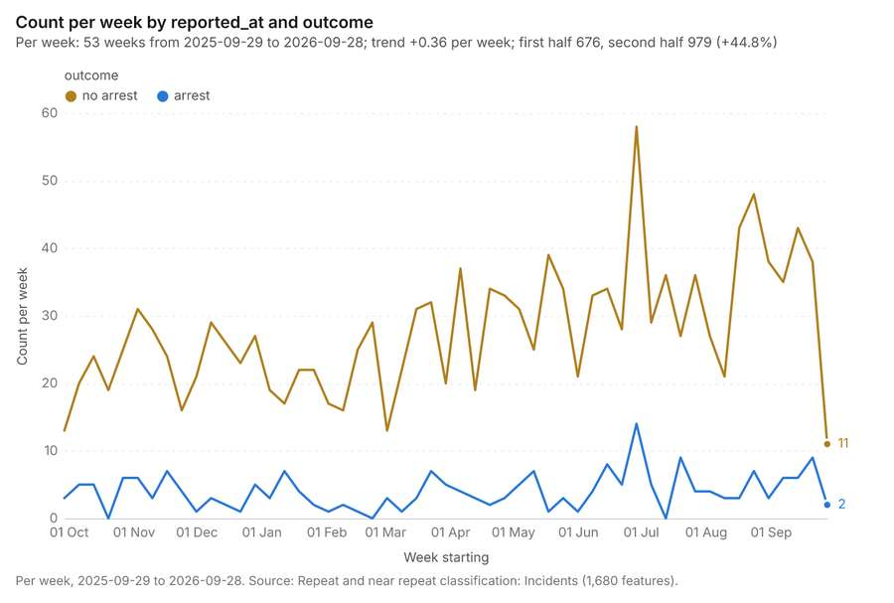
Figure 62. Repeat and near repeat classification: Incidents [137]. Per week, 2025-09-29 to 2026-09-28. Source: Repeat and near repeat classification: Incidents (1,680 features). The data is in the appendix.
Figure 63. Repeat and near repeat classification: Incidents over time [138]. Per week, 2025-09-29 to 2026-09-28. Source: Repeat and near repeat classification: Incidents (1,680 features). The data is in the appendix.
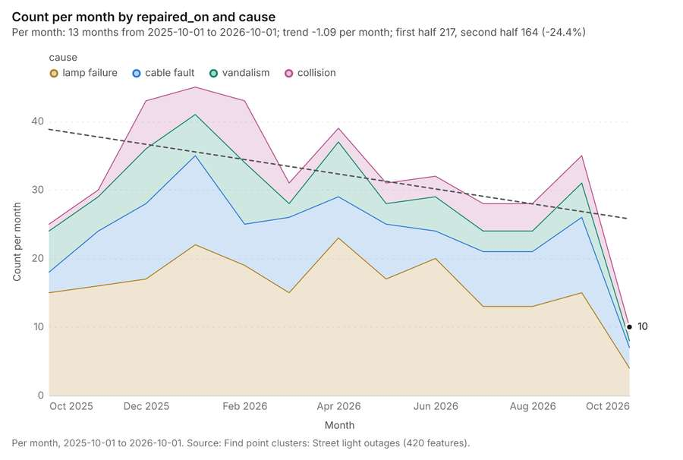
Figure 64. Find point clusters: Street light outages over time [139]. Per month, 2025-10-01 to 2026-10-01. Source: Find point clusters: Street light outages (420 features). The data is in the appendix.
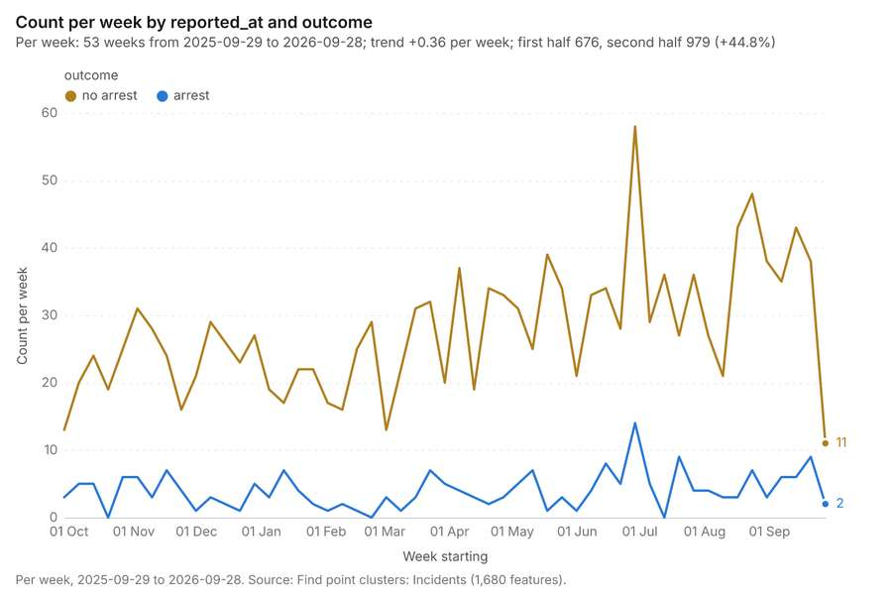
Figure 65. Find point clusters: Incidents over time [140]. Per week, 2025-09-29 to 2026-09-28. Source: Find point clusters: Incidents (1,680 features). The data is in the appendix.

Documents
What the documents name. Quarterly crime and safety briefing, third quarter 2026 (1 page, 1 page(s) from the text layer) names 12 event terms and 11 places [141]. Event terms in Quarterly crime and safety briefing, third quarter 2026: Thefts (page 1, line 7, 2 mentions), Transit (page 1, line 7, 2 mentions), street (page 1, line 9, 2 mentions), demonstration (page 1, line 3) [142]. Places named in Quarterly crime and safety briefing, third quarter 2026: Central Transit Center (page 1, line 7, 2 mentions), Market West Beat (page 1, line 9, 2 mentions), N Elizabeth St (page 1, line 11, 2 mentions), Kingsway Beat (page 1, line 11, 2 mentions) [142]. Hot spot patrol plan (1 page, 1 page(s) from the text layer) names 1 organization, 8 event terms and 6 places [143]. Organizations named in Hot spot patrol plan: Focus (page 1, line 7) [144]. Event terms in Hot spot patrol plan: theft (page 1, line 11, 2 mentions), patrol (page 1, line 1), Patrols (page 1, line 3), Transit (page 1, line 8) [144]. Places named in Hot spot patrol plan: Central District Station (page 1, line 3), Westside Station (page 1, line 3), Riverside Station (page 1, line 3), Central Transit Center (page 1, line 8) [144].
Result | Value
Documents | 2
Entities | 38
Organizations | 1
Event terms | 20
Places | 17

Findings
- Evidenced: Quarterly crime and safety briefing, third quarter 2026 (1 page, 1 page(s) from the text layer) names 12 event terms and 11 places.
- Evidenced: Event terms in Quarterly crime and safety briefing, third quarter 2026: Thefts (page 1, line 7, 2 mentions), Transit (page 1, line 7, 2 mentions), street (page 1, line 9, 2 mentions), demonstration (page 1, line 3).
- Evidenced: Places named in Quarterly crime and safety briefing, third quarter 2026: Central Transit Center (page 1, line 7, 2 mentions), Market West Beat (page 1, line 9, 2 mentions), N Elizabeth St (page 1, line 11, 2 mentions), Kingsway Beat (page 1, line 11, 2 mentions).
- Evidenced: Hot spot patrol plan (1 page, 1 page(s) from the text layer) names 1 organization, 8 event terms and 6 places.
- Evidenced: Organizations named in Hot spot patrol plan: Focus (page 1, line 7).
- Evidenced: Event terms in Hot spot patrol plan: theft (page 1, line 11, 2 mentions), patrol (page 1, line 1), Patrols (page 1, line 3), Transit (page 1, line 8).
- Evidenced: Places named in Hot spot patrol plan: Central District Station (page 1, line 3), Westside Station (page 1, line 3), Riverside Station (page 1, line 3), Central Transit Center (page 1, line 8).

Changes since the last run
94 number(s) changed since the report of 2026-10-19T04:03:32Z.
Analysis | Measure | Before | After | Change
Hot spots | result, bins | 35 | 36 | 1
Hot spots | result, count | 35 | 36 | 1
Hot spots | result, elapsed ms | 2 | 3 | 1
Hot spots | result, incidents used | 80 | 60 | -20
Hot spots | result, distance band m | 1,000 | 2,000 | 1,000
Hot spots | billing, cost | 0.0516 | 0.0512 | -0.0004
Hot spots | billing, list price | 0.0516 | 0.0512 | -0.0004
Hot spots | result, bins | 35 | 112 | 77
Hot spots | result, count | 35 | 112 | 77
Hot spots | result, elapsed ms | 2 | 5 | 3
Hot spots | result, cell size m | 1,000 | 500 | -500
Hot spots | result, incidents used | 80 | 120 | 40
Hot spots | billing, cost | 0.0516 | 0.0524 | 0.0008
Hot spots | billing, list price | 0.0516 | 0.0524 | 0.0008
Space time hot spots | result, elapsed ms | 44 | 46 | 2
Space time hot spots | result, count | 270 | 47 | -223
Space time hot spots | result, elapsed ms | 44 | 10 | -34
Space time hot spots | result, resolution | 9 | 8 | -1
Space time hot spots | result, features used | 1,680 | 420 | -1,260
Space time hot spots | billing, cost | 0.184 | 0.121 | -0.063
Space time hot spots | billing, list price | 0.184 | 0.121 | -0.063
Find point clusters | result, count | 1,680 | 120 | -1,560
Find point clusters | result, noise | 1,609 | 61 | -1,548
Find point clusters | result, distance m | 50 | 200 | 150
Find point clusters | result, elapsed ms | 118 | 499 | 381
Find point clusters | result, min points | 20 | 3 | -17
Find point clusters | billing, cost | 0.0836 | 0.0524 | -0.0312
Find point clusters | billing, list price | 0.0836 | 0.0524 | -0.0312
Find point clusters | result, elapsed ms | 118 | 19 | -99
Find point clusters | result, count | 1,680 | 420 | -1,260
Find point clusters | result, noise | 1,609 | 410 | -1,199
Find point clusters | result, distance m | 50 | 100 | 50
Find point clusters | result, elapsed ms | 118 | 5 | -113
Find point clusters | result, min points | 20 | 10 | -10
Find point clusters | billing, cost | 0.0836 | 0.0584 | -0.0252
Find point clusters | billing, list price | 0.0836 | 0.0584 | -0.0252
Summarize within | result, elapsed ms | 1 | 0 | -1
Summarize within | billing, cost | 0.01048 | 0.01154 | 0.00106
Summarize within | billing, list price | 0.01048 | 0.01154 | 0.00106
Summarize within | result, elapsed ms | 1 | 0 | -1
Summarize within | billing, cost | 0.01048 | 0.01274 | 0.00226
Summarize within | billing, list price | 0.01048 | 0.01274 | 0.00226
Summarize within | result, elapsed ms | 1 | 2 | 1
Summarize within | billing, cost | 0.01048 | 0.04394 | 0.03346
Summarize within | billing, list price | 0.01048 | 0.04394 | 0.03346
Calculate density | result, count | 2,874 | 164 | -2,710
Calculate density | result, elapsed ms | 162 | 4 | -158
Calculate density | result, bandwidth m | 200 | 1,000 | 800
Calculate density | result, cell size m | 100 | 500 | 400
Calculate density | result, max density per km2 | 1,347 | 42.62 | -1,305
Calculate density | billing, cost | 0.0836 | 0.0524 | -0.0312
Calculate density | billing, list price | 0.0836 | 0.0524 | -0.0312
Calculate density | result, elapsed ms | 162 | 50 | -112
Calculate density | result, count | 2,874 | 848 | -2,026
Calculate density | result, elapsed ms | 162 | 15 | -147
Calculate density | result, bandwidth m | 200 | 500 | 300
Calculate density | result, cell size m | 100 | 200 | 100
Calculate density | result, max density per km2 | 1,347 | 107.5 | -1,240
Calculate density | billing, cost | 0.0836 | 0.0584 | -0.0252
Calculate density | billing, list price | 0.0836 | 0.0584 | -0.0252
Hot spots | result, bins | 35 | 2,912 | 2,877
Hot spots | result, count | 35 | 2,912 | 2,877
Hot spots | result, elapsed ms | 2 | 100 | 98
Hot spots | result, cell size m | 1,000 | 100 | -900
Hot spots | result, incidents used | 80 | 1,680 | 1,600
Hot spots | result, distance band m | 1,000 | 200 | -800
Hot spots | billing, cost | 0.0516 | 0.0836 | 0.032
Hot spots | billing, list price | 0.0516 | 0.0836 | 0.032
Near repeat | result, count | 420 | 1,680 | 1,260
Near repeat | result, chains | 53 | 152 | 99
Near repeat | result, distance m | 200 | 100 | -100
Near repeat | result, elapsed ms | 10 | 39 | 29
Near repeat | result, pairs linked | 185 | 1,357 | 1,172
Near repeat | billing, cost | 0.0626 | 0.1004 | 0.0378
Near repeat | billing, list price | 0.0626 | 0.1004 | 0.0378
Hot cells inside each cluster of licensed premises | result, count | 16 | 3 | -13
Hot cells inside each cluster of licensed premises | result, elapsed ms | 1 | 6 | 5
Hot cells inside each cluster of licensed premises | billing, cost | 0.01048 | 0.0683 | 0.05782
Hot cells inside each cluster of licensed premises | billing, list price | 0.01048 | 0.0683 | 0.05782
Change beside the counts per patrol beat | billing, cost | 0.0273 | 0.01066 | -0.01664
Change beside the counts per patrol beat | billing, list price | 0.0273 | 0.01066 | -0.01664
Hot cells of CCTV cameras per patrol beat | result, elapsed ms | 1 | 2 | 1
Hot cells of CCTV cameras per patrol beat | billing, cost | 0.01048 | 0.01104 | 0.00056
Hot cells of CCTV cameras per patrol beat | billing, list price | 0.01048 | 0.01104 | 0.00056
Nearest police station to each cluster of licensed premises | result, elapsed ms | 2 | 3 | 1
Dense areas of street light outages | result, count | 936 | 5 | -931
Dense areas of street light outages | result, elapsed ms | 22 | 13 | -9
Dense areas of street light outages | billing, cost | 0.102 | 0.03697 | -0.06503
Dense areas of street light outages | billing, list price | 0.102 | 0.03697 | -0.06503
Dense areas of street light outages | list price | 0.102 | 0.03697 | -0.06503
Documents | Documents | 17 | 2 | -15
Documents | Entities | 17 | 38 | 21
Documents | Organizations | 17 | 1 | -16
Documents | Event terms | 17 | 20 | 3

Sources
[1] Rendering: Chart: Timeline: events per month by dataset. 72 rows (id d013059e-6933-47a5-bb09-9a0dc42d4902)
[2] Dataset: Incidents. vector, 1680 rows (id 8e5ad24c-d6a6-4a58-8281-8b363a095f60)
[3] Dataset: Street light outages. vector, 420 rows (id abe096b9-4f2d-4a2c-8093-abb51b141f33)
[4] Dataset: Calls for service by beat and month. table, 384 rows (id 924696a2-7623-45fc-aa81-6181d9eba827)
[5] Rendering: Chart: Timeline lanes: events per month by dataset. 72 rows (id fb1cdee2-f533-45f4-983f-0cd951892613)
[6] Rendering: Chart: Timeline: change from one month to the next. 23 rows (id 2d043b97-3b7e-4081-a3cc-a2d4f2bb2246)
[7] Tool result: gp_period_change, step 0. The count rose from 33 in week of 2026-06-22 to 72 in week of 2026-06-29 (+118.2%); a change this large is unlikely to be chance (p = 0.000178). (id 2042e52a-03d6-42f1-8365-22ab6777dc1e:0)
[8] Layer: Period change: Incidents (week of 2026-06-22 to week of 2026-06-29) (id 1e0726ac-a223-423b-b680-55434fcfa5e6)
[9] Tool result: gp_period_change, step 1. The count fell from 17 in week of 2026-02-02 to 4 in week of 2026-02-09 (-76.5%); a change this large is unlikely to be chance (p = 0.0072). (id 2042e52a-03d6-42f1-8365-22ab6777dc1e:1)
[10] Layer: Period change: Street light outages (week of 2026-02-02 to week of 2026-02-09) (id b942fd09-4b01-4ffe-a2ab-c88503e90ef1)
[11] Rendering: Map: Overview: the top 3 results. view longitude -87.71811 to -87.57468, latitude 41.83798 to 41.91748 (id 79e66837-1f85-4f45-956b-0a34bfd5fe00)
[12] Layer: Incidents. spatial profile (id 36ad5f7c-eab7-4ac7-8256-9737c4a1b044)
[13] Layer: Street light outages. spatial profile (id a7218535-327c-4a76-b5d4-8caa09f44155)
[14] Layer: Patrol beats. spatial profile (id 8c67e28f-6678-462f-a450-e83d278138e8)
[15] Layer: CCTV cameras. spatial profile (id ad88aaeb-e7ac-4b9c-aa1c-c4626ae498b8)
[16] Layer: Transit stops. spatial profile (id 313ae694-78aa-4830-955c-22be11a8a8a3)
[17] Layer: Licensed premises. spatial profile (id 055b5c2c-2a86-4379-95be-6f38f708b65b)
[18] Layer: Roads. spatial profile (id f63e5a45-031b-44a5-bf1e-7b9d17cb2378)
[19] Layer: Police stations. spatial profile (id 6b7fdf5e-7de9-4f14-995d-0c918b2e91ec)
[20] Catalog: Hot spot analysis (operation catalog, gp_hot_spots). Getis-Ord Gi* hot and cold spots with z-scores, p-values and confidence bins. ArcGIS: Find Hot Spots, Hot Spot Analysis (Getis-Ord Gi*). QGIS: qgis:hotspot (plugin). (id gp_hot_spots)
[21] Plan: Hot spots of CCTV cameras (the Start plan's candidate c_f0a51c3ce192). 60 points: Getis-Ord Gi* tests whether the concentrations in CCTV cameras are statistically significant. (id f922208b-bbd9-4f8c-a605-3fb31853d7fd:c_f0a51c3ce192)
[22] Tool result: gp_hot_spots, step 0. Hot spot analysis: 1 layer saved: Hot spot analysis: CCTV cameras (36 features). (id 321ba186-8b6e-4c4b-bb58-94f915d8b6aa:0)
[23] Rendering: Map: Hot spots: CCTV cameras. view longitude -87.7152 to -87.57762, latitude 41.83848 to 41.91701 (id a5a339e4-5577-4333-9b86-911f2f84f49a)
[24] Plan: Hot spots of Licensed premises (the Start plan's candidate c_91bb663e526f). 120 points: Getis-Ord Gi* tests whether the concentrations in Licensed premises are statistically significant. Measured: Licensed premises are clustered (nearest-neighbor ratio 0.85, z = -3.2), median spacing 121 m. Cells of 500 m and a band of 1000 m from the measured spacing. (id f922208b-bbd9-4f8c-a605-3fb31853d7fd:c_91bb663e526f)
[25] Tool result: gp_hot_spots, step 1. Hot spot analysis: 1 layer saved: Hot spot analysis: Licensed premises (112 features). (id 321ba186-8b6e-4c4b-bb58-94f915d8b6aa:1)
[26] Rendering: Map: Hot spots: licensed premises. view longitude -87.70465 to -87.5929, latitude 41.84743 to 41.91121 (id 2145f368-15a9-49e0-ad22-77165edbf2be)
[27] Catalog: Emerging hot spots (operation catalog, gp_space_time_hot_spots). Where hot spots are new, consecutive, intensifying, persistent, diminishing, sporadic, oscillating or historical over time. ArcGIS: Emerging Hot Spot Analysis, Create Space Time Cube. (id gp_space_time_hot_spots)
[28] Plan: Space time hot spots of Incidents (the Start plan's candidate c_1c60b58dbb29). Incidents carry dates in 'reported_at': emerging hot spot analysis finds new, intensifying and fading hot spots per week. Measured: the pattern of Incidents changes over time (earlier half clustered, later half clustered; the center moved 132 m). (id f922208b-bbd9-4f8c-a605-3fb31853d7fd:c_1c60b58dbb29)
[29] Tool result: gp_space_time_hot_spots, step 0. Emerging hot spots: 1 layer saved: Emerging hot spots: Incidents (270 features). (id 961133c9-b424-4eba-880c-76b21b589fcb:0)
[30] Rendering: Map: Emerging hot spots: incidents. view longitude -87.70246 to -87.58676, latitude 41.84569 to 41.90983 (id 6f2b1b3c-6588-4aa1-b6cf-4e9a3a111f44)
[31] Plan: Space time hot spots of Street light outages (the Start plan's candidate c_2469aa67bba0). Street light outages carry dates in 'reported_at': emerging hot spot analysis finds new, intensifying and fading hot spots per week. Measured: the pattern of Street light outages changes over time (earlier half clustered, later half clustered; the center moved 263 m). (id f922208b-bbd9-4f8c-a605-3fb31853d7fd:c_2469aa67bba0)
[32] Tool result: gp_space_time_hot_spots, step 1. Emerging hot spots: 1 layer saved: Emerging hot spots: Street light outages (47 features). (id 961133c9-b424-4eba-880c-76b21b589fcb:1)
[33] Rendering: Map: Emerging hot spots: street light outages. view longitude -87.71613 to -87.57759, latitude 41.83894 to 41.91574 (id 91191d14-e6a0-40e1-a6fa-dd44826aaf6e)
[34] Catalog: Find point clusters (operation catalog, gp_find_point_clusters). Density-based clusters (DBSCAN, HDBSCAN or OPTICS, optionally space-time) with hulls and noise. ArcGIS: Find Point Clusters, Density-based Clustering. QGIS: native:dbscanclustering, native:stdbscanclustering. (id gp_find_point_clusters)
[35] Plan: Cluster points of Licensed premises (the Start plan's candidate c_bca1140666e1). DBSCAN finds dense groups of Licensed premises and separates noise. Measured: Licensed premises are clustered (nearest-neighbor ratio 0.85, z = -3.2), median spacing 121 m. DBSCAN at 200 m (twice the measured spacing). (id f922208b-bbd9-4f8c-a605-3fb31853d7fd:c_bca1140666e1)
[36] Tool result: gp_find_point_clusters, step 0. Find point clusters: 2 layers saved: Find point clusters: Licensed premises (120 features); Find point clusters: cluster hulls (3 features). (id 215b8c93-8d01-4390-b188-f5c767207b46:0)
[37] Rendering: Map: Clusters: licensed premises. view longitude -87.69497 to -87.59835, latitude 41.85068 to 41.90582 (id 2605dc65-0adc-4643-9694-8530ea34521a)
[38] Plan: Cluster points of Incidents (the Start plan's candidate c_0aed3f12db5c). DBSCAN finds dense groups of Incidents and separates noise. Measured: Incidents are clustered (nearest-neighbor ratio 0.73, z = -21.0), median spacing 34.3 m. DBSCAN at 50 m (twice the measured spacing). (id f922208b-bbd9-4f8c-a605-3fb31853d7fd:c_0aed3f12db5c)
[39] Tool result: gp_find_point_clusters, step 1. Find point clusters: 2 layers saved: Find point clusters: Incidents (1680 features); Find point clusters: cluster hulls (3 features). (id 215b8c93-8d01-4390-b188-f5c767207b46:1)
[40] Rendering: Map: Clusters: incidents. view longitude -87.69327 to -87.59462, latitude 41.8503 to 41.9066 (id d9cb38e3-2bbf-4bd6-8736-3a3f54e2766c)
[41] Plan: Cluster points of Street light outages (the Start plan's candidate c_eac5e908317b). DBSCAN finds dense groups of Street light outages and separates noise. Measured: Street light outages are clustered (nearest-neighbor ratio 0.88, z = -4.9), median spacing 74.9 m. DBSCAN at 100 m (twice the measured spacing). (id f922208b-bbd9-4f8c-a605-3fb31853d7fd:c_eac5e908317b)
[42] Tool result: gp_find_point_clusters, step 2. Find point clusters: 2 layers saved: Find point clusters: Street light outages (420 features); Find point clusters: cluster hulls (1 feature). (id 215b8c93-8d01-4390-b188-f5c767207b46:2)
[43] Rendering: Map: Clusters: street light outages. view longitude -87.6954 to -87.59744, latitude 41.85029 to 41.9062 (id e91b963b-96c8-45a2-9a13-6a160f41445f)
[44] Catalog: Summarize within (operation catalog, gp_summarize_within). Count and aggregate the features inside each polygon (or bin), proportionally for lines and polygons. ArcGIS: Summarize Within, Aggregate Points. QGIS: native:countpointsinpolygon, native:sumlinelengths. (id gp_summarize_within)
[45] Plan: CCTV cameras per feature of Patrol beats (the Start plan's candidate c_c58f45b29b6e). Count CCTV cameras inside each feature of Patrol beats by ptz; the counts map as a choropleth (natural breaks, sequential colors). (id f922208b-bbd9-4f8c-a605-3fb31853d7fd:c_c58f45b29b6e)
[46] Tool result: gp_summarize_within, step 0. Summarize within: 1 layer saved: Summarize within: Patrol beats (16 features). (id 5e359a15-f5e2-429c-a252-d2486c76e559:0)
[47] Rendering: Map: Counts: CCTV cameras, by patrol beat. view longitude -87.69371 to -87.59438, latitude 41.85001 to 41.9067 (id 1d6099da-be90-4b9c-9991-ddaea0c2a814)
[48] Tool result: gp_summarize_within, step 1. Summarize within: 1 layer saved: Summarize within: Patrol beats (16 features). (id 5e359a15-f5e2-429c-a252-d2486c76e559:1)
[49] Rendering: Map: Counts: licensed premises, by patrol beat. view longitude -87.69371 to -87.59438, latitude 41.85001 to 41.9067 (id f3ebc560-673b-4e0e-bfeb-f244b6e425c8)
[50] Tool result: gp_summarize_within, step 2. Summarize within: 1 layer saved: Summarize within: Patrol beats (16 features). (id 5e359a15-f5e2-429c-a252-d2486c76e559:2)
[51] Rendering: Map: Counts: incidents, by patrol beat. view longitude -87.69371 to -87.59438, latitude 41.85001 to 41.9067 (id f6217787-f7ba-4030-aa6d-63161fb23a9e)
[52] Catalog: Period change (analysis catalog, gp_period_change). Counts or sums per period (week over week, month over month, any two periods, or before and after a date), per area, per H3 cell or in total, with the places of largest rise and fall and a significance note. ArcGIS: Summarize Percent Change (Crime Analysis), Change Point Detection. (id gp_period_change)
[53] Plan: Incidents: change per week per feature of Patrol beats (the Start plan's candidate c_55dcc49526ff). Incidents carry dates in 'reported_at' over 52 weeks: the count per week, week over week, with the places of largest rise and fall per feature of Patrol beats and whether the change is beyond chance. (id f922208b-bbd9-4f8c-a605-3fb31853d7fd:c_55dcc49526ff)
[54] Rendering: Map: Period change: incidents, by patrol beat. view longitude -87.69576 to -87.59221, latitude 41.8496 to 41.907 (id f8fa38e0-6b2b-4027-9d48-4238d9d56b8b)
[55] Rendering: Chart: Incidents: count per week. 53 rows (id 669d11fe-6a6b-4977-827a-e6583fbb9ec8)
[56] Rendering: Chart: Incidents: week of 2026-06-22 to week of 2026-06-29 by place. 30 rows (id d57784f7-9e7d-4cb3-a1b4-5c224a8d2ffd)
[57] Rendering: Chart: Period change: Incidents (week of 2026-06-22 to week of 2026-06-29). 5 rows (id 8f97238b-666e-416b-87f0-c34f89646566)
[58] Rendering: Map: Period change: street light outages, by patrol beat. view longitude -87.69969 to -87.59686, latitude 41.84969 to 41.90669 (id 064b0349-aa03-4072-ac98-9eb86c884bd9)
[59] Rendering: Chart: Street light outages: count per week. 53 rows (id 73202d54-d8bb-4119-8b31-815538262a83)
[60] Rendering: Chart: Street light outages: week of 2026-02-02 to week of 2026-02-09 by place. 14 rows (id 56c46fab-d5ad-44bb-b563-5bba1cc24883)
[61] Rendering: Chart: Period change: Street light outages (week of 2026-02-02 to week of 2026-02-09). 5 rows (id d58ef4fc-c705-4cc6-bbc5-aca3bf3f48b6)
[62] Catalog: Calculate density (operation catalog, gp_calculate_density). Kernel density per square kilometer on a grid. ArcGIS: Calculate Density, Kernel Density. QGIS: native:heatmapkerneldensityestimation. (id gp_calculate_density)
[63] Plan: Kernel density of Licensed premises (the Start plan's candidate c_2b247b24a505). 120 points in Licensed premises: a density surface shows where they concentrate. Measured: Licensed premises are clustered (nearest-neighbor ratio 0.85, z = -3.2), median spacing 121 m. (id f922208b-bbd9-4f8c-a605-3fb31853d7fd:c_2b247b24a505)
[64] Tool result: gp_calculate_density, step 0. Calculate density: 1 layer saved: Calculate density: Licensed premises (164 features). (id 8475a7ee-691d-4552-8a24-41bb69bf46a4:0)
[65] Rendering: Map: Density: licensed premises. view longitude -87.71552 to -87.57698, latitude 41.83894 to 41.91801 (id 2d0ffd6b-492c-46b6-9708-edf0e8f348fa)
[66] Plan: Kernel density of Incidents (the Start plan's candidate c_9007d02c4a41). 1680 points in Incidents: a density surface shows where they concentrate. Measured: Incidents are clustered (nearest-neighbor ratio 0.73, z = -21.0), median spacing 34.3 m. (id f922208b-bbd9-4f8c-a605-3fb31853d7fd:c_9007d02c4a41)
[67] Tool result: gp_calculate_density, step 1. Calculate density: 1 layer saved: Calculate density: Incidents (2874 features). (id 8475a7ee-691d-4552-8a24-41bb69bf46a4:1)
[68] Rendering: Map: Density: incidents. view longitude -87.69708 to -87.59062, latitude 41.848 to 41.90876 (id 0aa6b6e6-e52d-4399-b08c-8e798eb73c93)
[69] Plan: Kernel density of Street light outages (the Start plan's candidate c_bd626b9123bb). 420 points in Street light outages: a density surface shows where they concentrate. Measured: Street light outages are clustered (nearest-neighbor ratio 0.88, z = -4.9), median spacing 74.9 m. (id f922208b-bbd9-4f8c-a605-3fb31853d7fd:c_bd626b9123bb)
[70] Tool result: gp_calculate_density, step 2. Calculate density: 1 layer saved: Calculate density: Street light outages (848 features). (id 8475a7ee-691d-4552-8a24-41bb69bf46a4:2)
[71] Rendering: Map: Density: street light outages. view longitude -87.70567 to -87.58754, latitude 41.84454 to 41.91196 (id 27e532e4-8298-4330-ad1a-0d9375f48b07)
[72] Plan: Hot spots of Incidents (the Start plan's candidate c_c312b5d076a7). 1680 points: Getis-Ord Gi* tests whether the concentrations in Incidents are statistically significant. Measured: Incidents are clustered (nearest-neighbor ratio 0.73, z = -21.0), median spacing 34.3 m. Cells of 100 m and a band of 200 m from the measured spacing. (id f922208b-bbd9-4f8c-a605-3fb31853d7fd:c_c312b5d076a7)
[73] Tool result: gp_hot_spots, step 0. Hot spot analysis: 1 layer saved: Hot spot analysis: Incidents (2912 features). (id bc2d155b-8245-44bd-bc02-ae3dd8ce99bd:0)
[74] Rendering: Map: Hot spots: incidents. view longitude -87.69527 to -87.59314, latitude 41.84909 to 41.90737 (id 207cb3df-c55c-401c-8124-cbf80367ad53)
[75] Catalog: Repeat and near repeat classification (operation catalog, gp_near_repeat). Classify incidents as originators, repeats (same place) or near repeats within a distance and time window, with a Knox test table. ArcGIS: Repeat and Near Repeat Classification, Near Repeat Calculator. (id gp_near_repeat)
[76] Plan: Near repeat of Incidents (the Start plan's candidate c_cabb2c797127). Near repeat analysis tests whether Incidents close in space also follow each other within 30 days. (id f922208b-bbd9-4f8c-a605-3fb31853d7fd:c_cabb2c797127)
[77] Tool result: gp_near_repeat, step 0. Repeat and near repeat classification: 1 layer saved: Repeat and near repeat classification: Incidents (1680 features). (id e703fd06-1a0c-47e1-8d41-9a7f7ca7a096:0)
[78] Rendering: Map: Near repeat: incidents. view longitude -87.69493 to -87.59281, latitude 41.85009 to 41.9067 (id 28e59ede-c587-4b24-bb28-3230a99a4d59)
[79] Tool result: gp_summarize_within, step 0. Summarize within: 1 layer saved: Hot cells inside each cluster of licensed premises (3 features). (id 47c5f0de-dfdf-494b-911d-90b10a714d4d:0)
[80] Layer: Hot spot analysis: Incidents. 2,912 features (id 8382f930-c9d0-432b-82b7-fabc618137e9)
[81] Layer: Find point clusters: cluster hulls. 3 features (id 4dfef6fb-4663-43a7-86b3-cb7ca742b344)
[82] Layer: Hot cells inside each cluster of licensed premises. 3 features (id ca4b4f64-91e3-4c8b-b95e-1027e417c18a)
[83] Rendering: Map: Hot cells inside each cluster of licensed premises. view longitude -87.66722 to -87.63111, latitude 41.87536 to 41.89597 (id 1f5b237f-456e-4271-ac5a-8b7c49ea1203)
[84] Rendering: Chart: Hot cells inside each cluster of licensed premises. 3 rows (id dc8f6491-2889-4c96-8892-a5a92ddccff9)
[85] Catalog: Spatial join (operation catalog, gp_spatial_join). Attach attributes (or aggregates) of matching features from another layer, by location, distance, time and attributes. ArcGIS: Join Features, Spatial Join. QGIS: native:joinattributesbylocation, native:joinbylocationsummary, native:joinbynearest. (id gp_spatial_join)
[86] Plan: The run's goal. Describe the project Sample: Public safety, Chicago: run the analyses that tell the most about its data, draw every result, and write a cited report. (id 2e6054ca-62f3-479f-b398-915fe26200ce:goal)
[87] Tool result: gp_spatial_join, step 0. Spatial join: 1 layer saved: Change beside the counts per patrol beat (16 features). (id b47bd286-7bf7-47ee-8462-aba2f7f03009:0)
[88] Layer: Summarize within: Patrol beats. 16 features (id 31bedf68-b7b3-41b2-abda-6a464b2f0776)
[89] Layer: Change beside the counts per patrol beat. 16 features (id a982a2d6-956f-4dfe-b821-16eefe49fc59)
[90] Rendering: Map: Change beside the counts per patrol beat. view longitude -87.69371 to -87.59438, latitude 41.85001 to 41.9067 (id 72abfc34-1aa3-41c0-918f-e1038e14d6e4)
[91] Rendering: Chart: Change beside the counts per patrol beat. 5 rows (id 0db6652b-8019-4841-a5c5-bb77cb37c605)
[92] Tool result: gp_spatial_join, step 0. Spatial join: 1 layer saved: Change of incidents where density is high (16 features). (id a507fc16-21fd-45b9-aeb6-d8c679c59bfa:0)
[93] Layer: Calculate density: Street light outages. 848 features (id 22316e02-9759-4f61-b1eb-206b935b14bb)
[94] Layer: Change of incidents where density is high. 16 features (id b18abe82-9e7c-4939-aba0-31147b337e8d)
[95] Rendering: Map: Change of incidents where density is high. view longitude -87.69371 to -87.59438, latitude 41.85001 to 41.9067 (id 4c6d9fb2-ffd0-4f64-8535-c3988767f184)
[96] Rendering: Chart: Change of incidents where density is high. 5 rows (id 92ea2477-a522-47ee-89b1-746ee6856ca5)
[97] Tool result: gp_summarize_within, step 0. Summarize within: 1 layer saved: Hot cells of CCTV cameras per patrol beat (16 features). (id 614dc9e6-1702-4222-aaee-d9710ae1d2fa:0)
[98] Layer: Hot spot analysis: CCTV cameras. 36 features (id 2cc32b98-9097-49ba-8818-944110cdf58f)
[99] Layer: Hot cells of CCTV cameras per patrol beat. 16 features (id d17a96b4-151e-4595-be18-86aaab10e46f)
[100] Rendering: Map: Hot cells of CCTV cameras per patrol beat. view longitude -87.69371 to -87.59438, latitude 41.85001 to 41.9067 (id b8be83a4-10bf-4533-a453-099468da0894)
[101] Rendering: Chart: Hot cells of CCTV cameras per patrol beat. 5 rows (id 35fadd76-8342-4832-bb6b-54b406cc2355)
[102] Catalog: Find nearest (operation catalog, gp_find_nearest). The k nearest features for each input, with geodesic distance and bearing. ArcGIS: Find Nearest, Near, Generate Near Table. QGIS: native:joinbynearest, native:nearestneighbouranalysis. (id gp_find_nearest)
[103] Tool result: gp_find_nearest, step 0. Find nearest: 1 layer saved: Nearest police station to each cluster of licensed premises (3 features). (id c991d762-1f84-44c6-96ae-3710f29ec64c:0)
[104] Layer: Nearest police station to each cluster of licensed premises. 3 features (id e1507503-e9d4-495b-92ae-125ebdaa2cf0)
[105] Rendering: Map: Nearest police station to each cluster of licensed premises. view longitude -87.66722 to -87.63111, latitude 41.87536 to 41.89597 (id 85be50e0-3982-4731-8c0e-823fa9294a88)
[106] Rendering: Chart: Nearest police station to each cluster of licensed premises. 3 rows (id 2dec7314-090d-4c50-abac-7f19aa87b8c3)
[107] Catalog: Pipeline (tool description, gp_pipeline). Run up to 20 GIS operations in one engine call; a step's params may use "$id" (an earlier step's result) or "$id.key", and layer references. Every step's map outputs are saved as styled layers. Never calls Mapbox. (id gp_pipeline)
[108] Plan: CCTV cameras per 10,000 people per feature of Patrol beats (the Start plan's candidate c_c2ae8a2714b2). Patrol beats holds population in 'population': CCTV cameras per 10,000 people in each feature compares features of different size; mapped as a choropleth (natural breaks, sequential colors). (id f922208b-bbd9-4f8c-a605-3fb31853d7fd:c_c2ae8a2714b2)
[109] Tool result: gp_pipeline, step 0. Pipeline of 2 steps (classify_field > dissolve): 1 layer saved. (id 6ca7bfd5-79a6-41c1-bf7d-8e6d94107d57:0)
[110] Layer: Dense areas of street light outages. 5 features (id ac9b6845-0f71-4373-bd6d-610425383c47)
[111] Rendering: Chart: Dense areas of street light outages. 5 rows (id eb14b23d-e657-47db-bbb9-6dc855c8b8cc)
[112] Tool result: gp_summarize_within, step 0. Summarize within: 1 layer saved: Change of street light outages per patrol beat (16 features). (id cc3dd633-eef0-4eb3-8158-2f9fd13fb200:0)
[113] Layer: Change of street light outages per patrol beat. 16 features (id 3aa058c3-6af3-4495-9b14-12531d1ab9a2)
[114] Rendering: Map: Change of street light outages per patrol beat. view longitude -87.69371 to -87.59438, latitude 41.85001 to 41.9067 (id 8c09d493-6848-4496-8154-9e4918bed43f)
[115] Rendering: Chart: Change of street light outages per patrol beat. 5 rows (id f5280b27-6c71-4ddf-ba62-2c3527a68ab7)
[116] Rendering: Chart: Incidents over time (reported_at). 318 rows (id 77127ac6-8e99-4791-97cd-fae719d89262)
[117] Rendering: Chart: Street light outages over time (reported_at). 212 rows (id f9621103-3d0a-49ab-b90b-f7b40f93745b)
[118] Rendering: Chart: CCTV cameras over time (installed_year). 7 rows (id d430a879-effd-4bd0-81f7-baa28a4e5360)
[119] Rendering: Chart: Calls for service by beat and month over time (month). 24 rows (id 7c56f65f-9b6b-4cdd-a312-17f1982d8de0)
[120] Rendering: Chart: Hot spot analysis: CCTV cameras. 12 rows (id 64aa9539-922f-4609-8b9a-6ef06a308a05)
[121] Rendering: Chart: Hot spot analysis: Licensed premises. 15 rows (id 4a5bc439-21a2-432b-9b8c-8615b719b8f0)
[122] Rendering: Chart: Emerging hot spots: Incidents. 10 rows (id 07721714-421e-4a56-9250-c62be37e8e3e)
[123] Rendering: Chart: Emerging hot spots: Street light outages. 7 rows (id 890e75d2-c676-4d56-aa47-5dc8fc6b1f37)
[124] Rendering: Chart: Find point clusters: Licensed premises. 4 rows (id eab8321b-459d-4b21-8ac3-03b4c9716a0b)
[125] Rendering: Chart: Find point clusters: cluster hulls. 3 rows (id 597c1cc7-6d4d-45ea-805f-e76406a7301d)
[126] Rendering: Chart: Find point clusters: Incidents. 4 rows (id 834a7e88-1f92-40c3-876e-07b230849ef1)
[127] Rendering: Chart: Find point clusters: cluster hulls. 3 rows (id b1d73a1a-bd54-4f9a-829e-a64da853e8b8)
[128] Rendering: Chart: Find point clusters: Street light outages. 2 rows (id da93f938-3c5c-4e4b-a1e9-332a9c4d97c4)
[129] Rendering: Chart: Find point clusters: cluster hulls. 1 rows (id d0a69a7c-4f2e-46e8-8fbb-3db7d1804d97)
[130] Rendering: Chart: Summarize within: Patrol beats. 5 rows (id cf0bb795-0579-4a40-a979-e2f725bdfd8a)
[131] Rendering: Chart: Summarize within: Patrol beats. 5 rows (id cf1142c2-7076-48aa-b438-d97d2f7f83d6)
[132] Rendering: Chart: Summarize within: Patrol beats. 5 rows (id 85f26d21-089a-4d33-bb0c-b985b8e6ddae)
[133] Rendering: Chart: Calculate density: Licensed premises. 9 rows (id 3365b9ed-e2bc-4612-b00e-b147032aaa0b)
[134] Rendering: Chart: Calculate density: Incidents. 13 rows (id 130ec3b4-ddc0-4f62-8c53-493253574a12)
[135] Rendering: Chart: Calculate density: Street light outages. 11 rows (id 5d19b0ed-c618-4e8e-9536-3f3a0821dcd8)
[136] Rendering: Chart: Hot spot analysis: Incidents. 48 rows (id dc40d842-a071-4cf4-87b5-9dbd4aff8223)
[137] Rendering: Chart: Repeat and near repeat classification: Incidents. 106 rows (id 2774b60c-5a11-46d6-a8e1-f56f2a252051)
[138] Rendering: Chart: Repeat and near repeat classification: Incidents over time. 106 rows (id d3456b40-f8d2-4674-9fe4-b420ca81087b)
[139] Rendering: Chart: Find point clusters: Street light outages over time. 52 rows (id b7008422-a117-4748-8bb2-7dd55cd29bdd)
[140] Rendering: Chart: Find point clusters: Incidents over time. 106 rows (id fcaf3d1b-6848-404c-9e97-b57b023c1cbd)
[141] Document: Quarterly crime and safety briefing, third quarter 2026. 1 page(s), 1 page(s) from the text layer (id 7f7de84b-c518-4d25-b279-e98be530690e)
[142] Document page: Quarterly crime and safety briefing, third quarter 2026, page 1. Thefts and robberies remain concentrated around the Central Transit Center at 41.87815, -87.63532, mostly on weekday commuting hours. (id 7f7de84b-c518-4d25-b279-e98be530690e:1)
[143] Document: Hot spot patrol plan. 1 page(s), 1 page(s) from the text layer (id 0bf0414d-d633-4517-a876-66ca320180f3)
[144] Document page: Hot spot patrol plan, page 1. Focus (id 0bf0414d-d633-4517-a876-66ca320180f3:1)
[145] Dataset: Patrol beats. vector, 16 rows (id ba848777-0930-4af3-b069-03edd17a2c3a)
[146] Dataset: Police stations. vector, 3 rows (id d3ceed49-4119-4de8-9218-65b32992e120)
[147] Dataset: CCTV cameras. vector, 60 rows (id 13e9e089-c520-4be6-9034-c0ecaf7790ab)
[148] Dataset: Transit stops. vector, 80 rows (id cc2e635f-1052-402a-82aa-95b2db052e76)
[149] Dataset: Licensed premises. vector, 120 rows (id 1a088947-ca4e-4632-b13d-975d48c05e97)
[150] Dataset: Roads. vector, 1033 rows (id e72c7c55-1cdd-49b2-b75d-3d2ec18b9c1e)
[151] Dataset: Beat staffing by shift. table, 48 rows (id 6abb3c2e-68b3-4a9c-b2a7-ce316203ebe8)
[152] Dataset: Quarterly crime and safety briefing. document, ? rows (id 535a8782-a933-42ff-af25-92ec818afdd6)
[153] Dataset: Hot spot patrol plan. document, ? rows (id 70e64e98-d266-4079-a9a1-7d54ac2c3e96)
[154] Record: Sample: Public safety, Chicago (id fe9df6b9-8a15-4264-946b-4b37b8dbb89d)
[155] Layer: Hot spot analysis: Licensed premises. 112 features (id 90322b1c-a218-4ac5-8478-7f0de2a327dd)
[156] Layer: Emerging hot spots: Incidents. 270 features (id ddbdee29-f892-4397-9f92-4fb6062a0a16)
[157] Layer: Emerging hot spots: Street light outages. 47 features (id 377fb9d7-1ae0-4b9d-b202-467adca71899)
[158] Layer: Find point clusters: Licensed premises. 120 features (id 0f39a418-fa9c-4906-bbe4-7afb6c00ba8c)
[159] Layer: Find point clusters: Incidents. 1,680 features (id 75dd415e-0b2c-4a18-b79c-cc2338385dd5)
[160] Layer: Find point clusters: cluster hulls. 3 features (id 99ba9a84-3453-4bca-a43e-5861ef41c540)
[161] Layer: Find point clusters: Street light outages. 420 features (id 4ac9e9ca-a714-4ec7-9df8-4e3869dbcc58)
[162] Layer: Find point clusters: cluster hulls. 1 features (id 6d783f7e-8f24-4458-8abc-6e3126e9630a)
[163] Layer: Summarize within: Patrol beats. 16 features (id 430dcae6-3721-44c7-9264-40595ff75b4e)
[164] Layer: Summarize within: Patrol beats. 16 features (id fabe7842-f3f5-4d5e-a46f-c3232381dc5f)
[165] Layer: Calculate density: Licensed premises. 164 features (id 76319405-6afb-4505-946b-c33b783be8eb)
[166] Layer: Calculate density: Incidents. 2,874 features (id 8d228b68-9a3d-43fd-96a3-e37297b29f9a)
[167] Layer: Repeat and near repeat classification: Incidents. 1,680 features (id aa6cf905-4fec-4559-9917-c9810ef2a94b)

Appendix: the data behind the charts

Figure 1. Timeline: events per month by dataset [1]
period | series | value
2024-10-01 | Incidents | 0
2024-10-01 | Street light outages | 0
2024-10-01 | Calls for service by beat and month | 16
2024-11-01 | Incidents | 0
2024-11-01 | Street light outages | 0
2024-11-01 | Calls for service by beat and month | 16
2024-12-01 | Incidents | 0
2024-12-01 | Street light outages | 0
2024-12-01 | Calls for service by beat and month | 16
2025-01-01 | Incidents | 0
2025-01-01 | Street light outages | 0
2025-01-01 | Calls for service by beat and month | 16
2025-02-01 | Incidents | 0
2025-02-01 | Street light outages | 0
2025-02-01 | Calls for service by beat and month | 16
2025-03-01 | Incidents | 0
2025-03-01 | Street light outages | 0
2025-03-01 | Calls for service by beat and month | 16
2025-04-01 | Incidents | 0
2025-04-01 | Street light outages | 0
2025-04-01 | Calls for service by beat and month | 16
2025-05-01 | Incidents | 0
2025-05-01 | Street light outages | 0
2025-05-01 | Calls for service by beat and month | 16
2025-06-01 | Incidents | 0
2025-06-01 | Street light outages | 0
2025-06-01 | Calls for service by beat and month | 16
2025-07-01 | Incidents | 0
2025-07-01 | Street light outages | 0
2025-07-01 | Calls for service by beat and month | 16
2025-08-01 | Incidents | 0
2025-08-01 | Street light outages | 0
2025-08-01 | Calls for service by beat and month | 16
2025-09-01 | Incidents | 0
2025-09-01 | Street light outages | 0
2025-09-01 | Calls for service by beat and month | 16
2025-10-01 | Incidents | 114
2025-10-01 | Street light outages | 33
2025-10-01 | Calls for service by beat and month | 16
2025-11-01 | Incidents | 125
2025-11-01 | Street light outages | 26
2025-11-01 | Calls for service by beat and month | 16
2025-12-01 | Incidents | 119
2025-12-01 | Street light outages | 40
2025-12-01 | Calls for service by beat and month | 16
2026-01-01 | Incidents | 112
2026-01-01 | Street light outages | 49
2026-01-01 | Calls for service by beat and month | 16
2026-02-01 | Incidents | 90
2026-02-01 | Street light outages | 44
2026-02-01 | Calls for service by beat and month | 16
2026-03-01 | Incidents | 126
2026-03-01 | Street light outages | 37
2026-03-01 | Calls for service by beat and month | 16
2026-04-01 | Incidents | 133
2026-04-01 | Street light outages | 37
2026-04-01 | Calls for service by beat and month | 16
2026-05-01 | Incidents | 162
2026-05-01 | Street light outages | 28
2026-05-01 | Calls for service by beat and month | 16
2026-06-01 | Incidents | 143
2026-06-01 | Street light outages | 33
2026-06-01 | Calls for service by beat and month | 16
2026-07-01 | Incidents | 195
2026-07-01 | Street light outages | 24
2026-07-01 | Calls for service by beat and month | 16
2026-08-01 | Incidents | 179
2026-08-01 | Street light outages | 33
2026-08-01 | Calls for service by beat and month | 16
2026-09-01 | Incidents | 182
2026-09-01 | Street light outages | 36
2026-09-01 | Calls for service by beat and month | 16

Figure 2. Timeline lanes: events per month by dataset [5]
lane | period | period_end | value
Incidents | 2024-10-01 | 2024-11-01 | 0
Incidents | 2024-11-01 | 2024-12-01 | 0
Incidents | 2024-12-01 | 2025-01-01 | 0
Incidents | 2025-01-01 | 2025-02-01 | 0
Incidents | 2025-02-01 | 2025-03-01 | 0
Incidents | 2025-03-01 | 2025-04-01 | 0
Incidents | 2025-04-01 | 2025-05-01 | 0
Incidents | 2025-05-01 | 2025-06-01 | 0
Incidents | 2025-06-01 | 2025-07-01 | 0
Incidents | 2025-07-01 | 2025-08-01 | 0
Incidents | 2025-08-01 | 2025-09-01 | 0
Incidents | 2025-09-01 | 2025-10-01 | 0
Incidents | 2025-10-01 | 2025-11-01 | 114
Incidents | 2025-11-01 | 2025-12-01 | 125
Incidents | 2025-12-01 | 2026-01-01 | 119
Incidents | 2026-01-01 | 2026-02-01 | 112
Incidents | 2026-02-01 | 2026-03-01 | 90
Incidents | 2026-03-01 | 2026-04-01 | 126
Incidents | 2026-04-01 | 2026-05-01 | 133
Incidents | 2026-05-01 | 2026-06-01 | 162
Incidents | 2026-06-01 | 2026-07-01 | 143
Incidents | 2026-07-01 | 2026-08-01 | 195
Incidents | 2026-08-01 | 2026-09-01 | 179
Incidents | 2026-09-01 | 2026-10-01 | 182
Street light outages | 2024-10-01 | 2024-11-01 | 0
Street light outages | 2024-11-01 | 2024-12-01 | 0
Street light outages | 2024-12-01 | 2025-01-01 | 0
Street light outages | 2025-01-01 | 2025-02-01 | 0
Street light outages | 2025-02-01 | 2025-03-01 | 0
Street light outages | 2025-03-01 | 2025-04-01 | 0
Street light outages | 2025-04-01 | 2025-05-01 | 0
Street light outages | 2025-05-01 | 2025-06-01 | 0
Street light outages | 2025-06-01 | 2025-07-01 | 0
Street light outages | 2025-07-01 | 2025-08-01 | 0
Street light outages | 2025-08-01 | 2025-09-01 | 0
Street light outages | 2025-09-01 | 2025-10-01 | 0
Street light outages | 2025-10-01 | 2025-11-01 | 33
Street light outages | 2025-11-01 | 2025-12-01 | 26
Street light outages | 2025-12-01 | 2026-01-01 | 40
Street light outages | 2026-01-01 | 2026-02-01 | 49
Street light outages | 2026-02-01 | 2026-03-01 | 44
Street light outages | 2026-03-01 | 2026-04-01 | 37
Street light outages | 2026-04-01 | 2026-05-01 | 37
Street light outages | 2026-05-01 | 2026-06-01 | 28
Street light outages | 2026-06-01 | 2026-07-01 | 33
Street light outages | 2026-07-01 | 2026-08-01 | 24
Street light outages | 2026-08-01 | 2026-09-01 | 33
Street light outages | 2026-09-01 | 2026-10-01 | 36
Calls for service by beat and month | 2024-10-01 | 2024-11-01 | 16
Calls for service by beat and month | 2024-11-01 | 2024-12-01 | 16
Calls for service by beat and month | 2024-12-01 | 2025-01-01 | 16
Calls for service by beat and month | 2025-01-01 | 2025-02-01 | 16
Calls for service by beat and month | 2025-02-01 | 2025-03-01 | 16
Calls for service by beat and month | 2025-03-01 | 2025-04-01 | 16
Calls for service by beat and month | 2025-04-01 | 2025-05-01 | 16
Calls for service by beat and month | 2025-05-01 | 2025-06-01 | 16
Calls for service by beat and month | 2025-06-01 | 2025-07-01 | 16
Calls for service by beat and month | 2025-07-01 | 2025-08-01 | 16
Calls for service by beat and month | 2025-08-01 | 2025-09-01 | 16
Calls for service by beat and month | 2025-09-01 | 2025-10-01 | 16
Calls for service by beat and month | 2025-10-01 | 2025-11-01 | 16
Calls for service by beat and month | 2025-11-01 | 2025-12-01 | 16
Calls for service by beat and month | 2025-12-01 | 2026-01-01 | 16
Calls for service by beat and month | 2026-01-01 | 2026-02-01 | 16
Calls for service by beat and month | 2026-02-01 | 2026-03-01 | 16
Calls for service by beat and month | 2026-03-01 | 2026-04-01 | 16
Calls for service by beat and month | 2026-04-01 | 2026-05-01 | 16
Calls for service by beat and month | 2026-05-01 | 2026-06-01 | 16
Calls for service by beat and month | 2026-06-01 | 2026-07-01 | 16
Calls for service by beat and month | 2026-07-01 | 2026-08-01 | 16
Calls for service by beat and month | 2026-08-01 | 2026-09-01 | 16
Calls for service by beat and month | 2026-09-01 | 2026-10-01 | 16

Figure 3. Timeline: change from one month to the next [6]
period | period_end | value | previous | change
2024-11-01 | 2024-12-01 | 16 | 16 | 0
2024-12-01 | 2025-01-01 | 16 | 16 | 0
2025-01-01 | 2025-02-01 | 16 | 16 | 0
2025-02-01 | 2025-03-01 | 16 | 16 | 0
2025-03-01 | 2025-04-01 | 16 | 16 | 0
2025-04-01 | 2025-05-01 | 16 | 16 | 0
2025-05-01 | 2025-06-01 | 16 | 16 | 0
2025-06-01 | 2025-07-01 | 16 | 16 | 0
2025-07-01 | 2025-08-01 | 16 | 16 | 0
2025-08-01 | 2025-09-01 | 16 | 16 | 0
2025-09-01 | 2025-10-01 | 16 | 16 | 0
2025-10-01 | 2025-11-01 | 163 | 16 | 147
2025-11-01 | 2025-12-01 | 167 | 163 | 4
2025-12-01 | 2026-01-01 | 175 | 167 | 8
2026-01-01 | 2026-02-01 | 177 | 175 | 2
2026-02-01 | 2026-03-01 | 150 | 177 | -27
2026-03-01 | 2026-04-01 | 179 | 150 | 29
2026-04-01 | 2026-05-01 | 186 | 179 | 7
2026-05-01 | 2026-06-01 | 206 | 186 | 20
2026-06-01 | 2026-07-01 | 192 | 206 | -14
2026-07-01 | 2026-08-01 | 235 | 192 | 43
2026-08-01 | 2026-09-01 | 228 | 235 | -7
2026-09-01 | 2026-10-01 | 234 | 228 | 6

Figure 16. Incidents: count per week [55]
period | value
2025-09-29 | 16
2025-10-06 | 25
2025-10-13 | 29
2025-10-20 | 19
2025-10-27 | 31
2025-11-03 | 37
2025-11-10 | 31
2025-11-17 | 31
2025-11-24 | 20
2025-12-01 | 22
2025-12-08 | 32
2025-12-15 | 28
2025-12-22 | 24
2025-12-29 | 32
2026-01-05 | 22
2026-01-12 | 24
2026-01-19 | 26
2026-01-26 | 24
2026-02-02 | 18
2026-02-09 | 18
2026-02-16 | 26
2026-02-23 | 29
2026-03-02 | 16
2026-03-09 | 23
2026-03-16 | 34
2026-03-23 | 39
2026-03-30 | 25
2026-04-06 | 41
2026-04-13 | 22
2026-04-20 | 36
2026-04-27 | 36
2026-05-04 | 36
2026-05-11 | 32
2026-05-18 | 40
2026-05-25 | 37
2026-06-01 | 22
2026-06-08 | 37
2026-06-15 | 42
2026-06-22 | 33
2026-06-29 | 72
2026-07-06 | 34
2026-07-13 | 36
2026-07-20 | 36
2026-07-27 | 40
2026-08-03 | 31
2026-08-10 | 24
2026-08-17 | 46
2026-08-24 | 55
2026-08-31 | 41
2026-09-07 | 41
2026-09-14 | 49
2026-09-21 | 47
2026-09-28 | 13

Figure 17. Incidents: week of 2026-06-22 to week of 2026-06-29 by place [56]
group | period | value
Market West Beat | week of 2026-06-22 | 7
Market West Beat | week of 2026-06-29 | 16
Kingsway Beat | week of 2026-06-22 | 6
Kingsway Beat | week of 2026-06-29 | 13
Southgate Beat | week of 2026-06-22 | 2
Southgate Beat | week of 2026-06-29 | 9
Elm Park Beat | week of 2026-06-22 | 5
Elm Park Beat | week of 2026-06-29 | 9
North River Beat | week of 2026-06-22 | 5
North River Beat | week of 2026-06-29 | 9
Granary Beat | week of 2026-06-22 | 2
Granary Beat | week of 2026-06-29 | 0
Midtown Beat | week of 2026-06-22 | 1
Midtown Beat | week of 2026-06-29 | 3
Old Mill Beat | week of 2026-06-22 | 1
Old Mill Beat | week of 2026-06-29 | 3
Westbrook Beat | week of 2026-06-22 | 0
Westbrook Beat | week of 2026-06-29 | 2
Brickworks Beat | week of 2026-06-22 | 0
Brickworks Beat | week of 2026-06-29 | 1
Cedar Heights Beat | week of 2026-06-22 | 0
Cedar Heights Beat | week of 2026-06-29 | 1
Foundry Beat | week of 2026-06-22 | 0
Foundry Beat | week of 2026-06-29 | 1
Parkview Beat | week of 2026-06-22 | 2
Parkview Beat | week of 2026-06-29 | 1
Station Quarter Beat | week of 2026-06-22 | 1
Station Quarter Beat | week of 2026-06-29 | 2
Union Yards Beat | week of 2026-06-22 | 0
Union Yards Beat | week of 2026-06-29 | 1

Figure 18. Period change: Incidents (week of 2026-06-22 to week of 2026-06-29) [57]
bin_start | bin_end | count
-1.414 | -0.7092 | 1
-0.7092 | -0.00428 | 1
-0.00428 | 0.7007 | 2
0.7007 | 1.406 | 8
1.406 | 2.111 | 4

Figure 20. Street light outages: count per week [59]
period | value
2025-09-29 | 4
2025-10-06 | 6
2025-10-13 | 6
2025-10-20 | 10
2025-10-27 | 10
2025-11-03 | 7
2025-11-10 | 7
2025-11-17 | 4
2025-11-24 | 5
2025-12-01 | 14
2025-12-08 | 11
2025-12-15 | 7
2025-12-22 | 7
2025-12-29 | 11
2026-01-05 | 9
2026-01-12 | 9
2026-01-19 | 16
2026-01-26 | 6
2026-02-02 | 17
2026-02-09 | 4
2026-02-16 | 12
2026-02-23 | 11
2026-03-02 | 4
2026-03-09 | 9
2026-03-16 | 6
2026-03-23 | 12
2026-03-30 | 13
2026-04-06 | 9
2026-04-13 | 9
2026-04-20 | 7
2026-04-27 | 7
2026-05-04 | 3
2026-05-11 | 8
2026-05-18 | 8
2026-05-25 | 6
2026-06-01 | 12
2026-06-08 | 7
2026-06-15 | 3
2026-06-22 | 10
2026-06-29 | 5
2026-07-06 | 6
2026-07-13 | 6
2026-07-20 | 7
2026-07-27 | 6
2026-08-03 | 7
2026-08-10 | 9
2026-08-17 | 6
2026-08-24 | 5
2026-08-31 | 10
2026-09-07 | 8
2026-09-14 | 8
2026-09-21 | 9
2026-09-28 | 2

Figure 21. Street light outages: week of 2026-02-02 to week of 2026-02-09 by place [60]
group | period | value
Market West Beat | week of 2026-02-02 | 9
Market West Beat | week of 2026-02-09 | 2
North River Beat | week of 2026-02-02 | 3
North River Beat | week of 2026-02-09 | 0
Parkview Beat | week of 2026-02-02 | 0
Parkview Beat | week of 2026-02-09 | 2
Southgate Beat | week of 2026-02-02 | 2
Southgate Beat | week of 2026-02-09 | 0
Canal Row Beat | week of 2026-02-02 | 1
Canal Row Beat | week of 2026-02-09 | 0
Cedar Heights Beat | week of 2026-02-02 | 1
Cedar Heights Beat | week of 2026-02-09 | 0
Westbrook Beat | week of 2026-02-02 | 1
Westbrook Beat | week of 2026-02-09 | 0

Figure 22. Period change: Street light outages (week of 2026-02-02 to week of 2026-02-09) [61]
bin_start | bin_end | count
-2.111 | -1.406 | 3
-1.406 | -0.7007 | 3
-0.7007 | 0.00428 | 0
0.00428 | 0.7092 | 0
0.7092 | 1.414 | 1

Figure 29. Hot cells inside each cluster of licensed premises [84]
cluster | features | fraction | share
0 | 1 | 0.3333 | 33.3%
1 | 1 | 0.3333 | 33.3%
2 | 1 | 0.3333 | 33.3%

Figure 31. Change beside the counts per patrol beat [91]
bin_start | bin_end | count
-1.414 | -0.7092 | 1
-0.7092 | -0.00428 | 1
-0.00428 | 0.7007 | 2
0.7007 | 1.406 | 8
1.406 | 2.111 | 4

Figure 33. Change of incidents where density is high [96]
bin_start | bin_end | count
-1.414 | -0.7092 | 1
-0.7092 | -0.00428 | 1
-0.00428 | 0.7007 | 2
0.7007 | 1.406 | 8
1.406 | 2.111 | 4

Figure 35. Hot cells of CCTV cameras per patrol beat [101]
bin_start | bin_end | count
2 | 3 | 1
3 | 4 | 0
4 | 5 | 2
5 | 6 | 4
6 | 7 | 9

Figure 37. Nearest police station to each cluster of licensed premises [106]
rank | name
1 | Central District Station
1 | Central District Station
1 | Central District Station

Figure 38. Dense areas of street light outages [111]
bin_start | bin_end | count
0 | 0.8 | 1
0.8 | 1.6 | 1
1.6 | 2.4 | 1
2.4 | 3.2 | 1
3.2 | 4 | 1

Figure 40. Change of street light outages per patrol beat [115]
bin_start | bin_end | count
0 | 0.2 | 9
0.2 | 0.4 | 0
0.4 | 0.6 | 0
0.6 | 0.8 | 0
0.8 | 1 | 7

Figure 41. Incidents over time (reported_at) [116]
period | series | value
2025-09-29 | theft | 8
2025-09-29 | battery | 4
2025-09-29 | criminal damage | 0
2025-09-29 | burglary | 1
2025-09-29 | motor vehicle theft | 0
2025-09-29 | Other | 3
2025-10-06 | theft | 8
2025-10-06 | battery | 1
2025-10-06 | criminal damage | 3
2025-10-06 | burglary | 9
2025-10-06 | motor vehicle theft | 0
2025-10-06 | Other | 4
2025-10-13 | theft | 10
2025-10-13 | battery | 5
2025-10-13 | criminal damage | 6
2025-10-13 | burglary | 1
2025-10-13 | motor vehicle theft | 3
2025-10-13 | Other | 4
2025-10-20 | theft | 8
2025-10-20 | battery | 2
2025-10-20 | criminal damage | 3
2025-10-20 | burglary | 2
2025-10-20 | motor vehicle theft | 2
2025-10-20 | Other | 2
2025-10-27 | theft | 11
2025-10-27 | battery | 5
2025-10-27 | criminal damage | 3
2025-10-27 | burglary | 5
2025-10-27 | motor vehicle theft | 1
2025-10-27 | Other | 6
2025-11-03 | theft | 12
2025-11-03 | battery | 7
2025-11-03 | criminal damage | 1
2025-11-03 | burglary | 7
2025-11-03 | motor vehicle theft | 1
2025-11-03 | Other | 9
2025-11-10 | theft | 7
2025-11-10 | battery | 8
2025-11-10 | criminal damage | 5
2025-11-10 | burglary | 2
2025-11-10 | motor vehicle theft | 4
2025-11-10 | Other | 5
2025-11-17 | theft | 9
2025-11-17 | battery | 4
2025-11-17 | criminal damage | 5
2025-11-17 | burglary | 3
2025-11-17 | motor vehicle theft | 4
2025-11-17 | Other | 6
2025-11-24 | theft | 5
2025-11-24 | battery | 3
2025-11-24 | criminal damage | 2
2025-11-24 | burglary | 2
2025-11-24 | motor vehicle theft | 4
2025-11-24 | Other | 4
2025-12-01 | theft | 6
2025-12-01 | battery | 4
2025-12-01 | criminal damage | 4
2025-12-01 | burglary | 3
2025-12-01 | motor vehicle theft | 0
2025-12-01 | Other | 5
2025-12-08 | theft | 8
2025-12-08 | battery | 3
2025-12-08 | criminal damage | 8
2025-12-08 | burglary | 4
2025-12-08 | motor vehicle theft | 2
2025-12-08 | Other | 7
2025-12-15 | theft | 8
2025-12-15 | battery | 5
2025-12-15 | criminal damage | 6
2025-12-15 | burglary | 2
2025-12-15 | motor vehicle theft | 2
2025-12-15 | Other | 5
2025-12-22 | theft | 8
2025-12-22 | battery | 2
2025-12-22 | criminal damage | 3
2025-12-22 | burglary | 5
2025-12-22 | motor vehicle theft | 2
2025-12-22 | Other | 4
2025-12-29 | theft | 11
2025-12-29 | battery | 2
2025-12-29 | criminal damage | 6
2025-12-29 | burglary | 4
2025-12-29 | motor vehicle theft | 1
2025-12-29 | Other | 8
2026-01-05 | theft | 7
2026-01-05 | battery | 5
2026-01-05 | criminal damage | 3
2026-01-05 | burglary | 0
2026-01-05 | motor vehicle theft | 4
2026-01-05 | Other | 3
2026-01-12 | theft | 10
2026-01-12 | battery | 3
2026-01-12 | criminal damage | 0
2026-01-12 | burglary | 5
2026-01-12 | motor vehicle theft | 3
2026-01-12 | Other | 3
2026-01-19 | theft | 10
2026-01-19 | battery | 1
2026-01-19 | criminal damage | 1
2026-01-19 | burglary | 4
2026-01-19 | motor vehicle theft | 2
2026-01-19 | Other | 8
2026-01-26 | theft | 12
2026-01-26 | battery | 1
2026-01-26 | criminal damage | 3
2026-01-26 | burglary | 3
2026-01-26 | motor vehicle theft | 0
2026-01-26 | Other | 5
2026-02-02 | theft | 9
2026-02-02 | battery | 1
2026-02-02 | criminal damage | 1
2026-02-02 | burglary | 1
2026-02-02 | motor vehicle theft | 4
2026-02-02 | Other | 2
2026-02-09 | theft | 6
2026-02-09 | battery | 2
2026-02-09 | criminal damage | 2
2026-02-09 | burglary | 3
2026-02-09 | motor vehicle theft | 3
2026-02-09 | Other | 2
2026-02-16 | theft | 9
2026-02-16 | battery | 3
2026-02-16 | criminal damage | 2
2026-02-16 | burglary | 7
2026-02-16 | motor vehicle theft | 3
2026-02-16 | Other | 2
2026-02-23 | theft | 13
2026-02-23 | battery | 4
2026-02-23 | criminal damage | 1
2026-02-23 | burglary | 0
2026-02-23 | motor vehicle theft | 6
2026-02-23 | Other | 5
2026-03-02 | theft | 5
2026-03-02 | battery | 1
2026-03-02 | criminal damage | 1
2026-03-02 | burglary | 4
2026-03-02 | motor vehicle theft | 3
2026-03-02 | Other | 2
2026-03-09 | theft | 7
2026-03-09 | battery | 4
2026-03-09 | criminal damage | 2
2026-03-09 | burglary | 1
2026-03-09 | motor vehicle theft | 6
2026-03-09 | Other | 3
2026-03-16 | theft | 7
2026-03-16 | battery | 8
2026-03-16 | criminal damage | 6
2026-03-16 | burglary | 7
2026-03-16 | motor vehicle theft | 1
2026-03-16 | Other | 5
2026-03-23 | theft | 9
2026-03-23 | battery | 4
2026-03-23 | criminal damage | 5
2026-03-23 | burglary | 5
2026-03-23 | motor vehicle theft | 7
2026-03-23 | Other | 9
2026-03-30 | theft | 6
2026-03-30 | battery | 8
2026-03-30 | criminal damage | 2
2026-03-30 | burglary | 2
2026-03-30 | motor vehicle theft | 3
2026-03-30 | Other | 4
2026-04-06 | theft | 11
2026-04-06 | battery | 7
2026-04-06 | criminal damage | 5
2026-04-06 | burglary | 8
2026-04-06 | motor vehicle theft | 5
2026-04-06 | Other | 5
2026-04-13 | theft | 8
2026-04-13 | battery | 7
2026-04-13 | criminal damage | 1
2026-04-13 | burglary | 2
2026-04-13 | motor vehicle theft | 2
2026-04-13 | Other | 2
2026-04-20 | theft | 9
2026-04-20 | battery | 9
2026-04-20 | criminal damage | 5
2026-04-20 | burglary | 5
2026-04-20 | motor vehicle theft | 3
2026-04-20 | Other | 5
2026-04-27 | theft | 9
2026-04-27 | battery | 10
2026-04-27 | criminal damage | 6
2026-04-27 | burglary | 4
2026-04-27 | motor vehicle theft | 2
2026-04-27 | Other | 5
2026-05-04 | theft | 14
2026-05-04 | battery | 2
2026-05-04 | criminal damage | 7
2026-05-04 | burglary | 4
2026-05-04 | motor vehicle theft | 4
2026-05-04 | Other | 5
2026-05-11 | theft | 11
2026-05-11 | battery | 4
2026-05-11 | criminal damage | 2
2026-05-11 | burglary | 7
2026-05-11 | motor vehicle theft | 5
2026-05-11 | Other | 3
2026-05-18 | theft | 14
2026-05-18 | battery | 7
2026-05-18 | criminal damage | 7
2026-05-18 | burglary | 3
2026-05-18 | motor vehicle theft | 3
2026-05-18 | Other | 6
2026-05-25 | theft | 14
2026-05-25 | battery | 5
2026-05-25 | criminal damage | 7
2026-05-25 | burglary | 3
2026-05-25 | motor vehicle theft | 3
2026-05-25 | Other | 5
2026-06-01 | theft | 6
2026-06-01 | battery | 3
2026-06-01 | criminal damage | 6
2026-06-01 | burglary | 2
2026-06-01 | motor vehicle theft | 3
2026-06-01 | Other | 2
2026-06-08 | theft | 6
2026-06-08 | battery | 7
2026-06-08 | criminal damage | 7
2026-06-08 | burglary | 7
2026-06-08 | motor vehicle theft | 5
2026-06-08 | Other | 5
2026-06-15 | theft | 8
2026-06-15 | battery | 14
2026-06-15 | criminal damage | 4
2026-06-15 | burglary | 4
2026-06-15 | motor vehicle theft | 6
2026-06-15 | Other | 6
2026-06-22 | theft | 12
2026-06-22 | battery | 6
2026-06-22 | criminal damage | 10
2026-06-22 | burglary | 1
2026-06-22 | motor vehicle theft | 2
2026-06-22 | Other | 2
2026-06-29 | theft | 20
2026-06-29 | battery | 21
2026-06-29 | criminal damage | 9
2026-06-29 | burglary | 6
2026-06-29 | motor vehicle theft | 7
2026-06-29 | Other | 9
2026-07-06 | theft | 12
2026-07-06 | battery | 7
2026-07-06 | criminal damage | 1
2026-07-06 | burglary | 7
2026-07-06 | motor vehicle theft | 3
2026-07-06 | Other | 4
2026-07-13 | theft | 9
2026-07-13 | battery | 4
2026-07-13 | criminal damage | 4
2026-07-13 | burglary | 4
2026-07-13 | motor vehicle theft | 7
2026-07-13 | Other | 8
2026-07-20 | theft | 7
2026-07-20 | battery | 9
2026-07-20 | criminal damage | 6
2026-07-20 | burglary | 2
2026-07-20 | motor vehicle theft | 3
2026-07-20 | Other | 9
2026-07-27 | theft | 15
2026-07-27 | battery | 5
2026-07-27 | criminal damage | 6
2026-07-27 | burglary | 3
2026-07-27 | motor vehicle theft | 7
2026-07-27 | Other | 4
2026-08-03 | theft | 11
2026-08-03 | battery | 7
2026-08-03 | criminal damage | 4
2026-08-03 | burglary | 1
2026-08-03 | motor vehicle theft | 4
2026-08-03 | Other | 4
2026-08-10 | theft | 11
2026-08-10 | battery | 2
2026-08-10 | criminal damage | 3
2026-08-10 | burglary | 1
2026-08-10 | motor vehicle theft | 4
2026-08-10 | Other | 3
2026-08-17 | theft | 18
2026-08-17 | battery | 6
2026-08-17 | criminal damage | 7
2026-08-17 | burglary | 5
2026-08-17 | motor vehicle theft | 6
2026-08-17 | Other | 4
2026-08-24 | theft | 18
2026-08-24 | battery | 7
2026-08-24 | criminal damage | 5
2026-08-24 | burglary | 5
2026-08-24 | motor vehicle theft | 8
2026-08-24 | Other | 12
2026-08-31 | theft | 15
2026-08-31 | battery | 8
2026-08-31 | criminal damage | 2
2026-08-31 | burglary | 3
2026-08-31 | motor vehicle theft | 6
2026-08-31 | Other | 7
2026-09-07 | theft | 19
2026-09-07 | battery | 3
2026-09-07 | criminal damage | 3
2026-09-07 | burglary | 5
2026-09-07 | motor vehicle theft | 2
2026-09-07 | Other | 9
2026-09-14 | theft | 15
2026-09-14 | battery | 12
2026-09-14 | criminal damage | 4
2026-09-14 | burglary | 7
2026-09-14 | motor vehicle theft | 4
2026-09-14 | Other | 7
2026-09-21 | theft | 17
2026-09-21 | battery | 9
2026-09-21 | criminal damage | 1
2026-09-21 | burglary | 5
2026-09-21 | motor vehicle theft | 7
2026-09-21 | Other | 8
2026-09-28 | theft | 1
2026-09-28 | battery | 5
2026-09-28 | criminal damage | 1
2026-09-28 | burglary | 0
2026-09-28 | motor vehicle theft | 1
2026-09-28 | Other | 5

Figure 42. Street light outages over time (reported_at) [117]
period | series | value
2025-09-29 | lamp failure | 2
2025-09-29 | cable fault | 1
2025-09-29 | vandalism | 1
2025-09-29 | collision | 0
2025-10-06 | lamp failure | 4
2025-10-06 | cable fault | 0
2025-10-06 | vandalism | 2
2025-10-06 | collision | 0
2025-10-13 | lamp failure | 4
2025-10-13 | cable fault | 0
2025-10-13 | vandalism | 2
2025-10-13 | collision | 0
2025-10-20 | lamp failure | 6
2025-10-20 | cable fault | 3
2025-10-20 | vandalism | 0
2025-10-20 | collision | 1
2025-10-27 | lamp failure | 3
2025-10-27 | cable fault | 3
2025-10-27 | vandalism | 3
2025-10-27 | collision | 1
2025-11-03 | lamp failure | 4
2025-11-03 | cable fault | 2
2025-11-03 | vandalism | 1
2025-11-03 | collision | 0
2025-11-10 | lamp failure | 5
2025-11-10 | cable fault | 1
2025-11-10 | vandalism | 1
2025-11-10 | collision | 0
2025-11-17 | lamp failure | 2
2025-11-17 | cable fault | 1
2025-11-17 | vandalism | 1
2025-11-17 | collision | 0
2025-11-24 | lamp failure | 2
2025-11-24 | cable fault | 0
2025-11-24 | vandalism | 2
2025-11-24 | collision | 1
2025-12-01 | lamp failure | 6
2025-12-01 | cable fault | 4
2025-12-01 | vandalism | 2
2025-12-01 | collision | 2
2025-12-08 | lamp failure | 6
2025-12-08 | cable fault | 1
2025-12-08 | vandalism | 2
2025-12-08 | collision | 2
2025-12-15 | lamp failure | 2
2025-12-15 | cable fault | 2
2025-12-15 | vandalism | 2
2025-12-15 | collision | 1
2025-12-22 | lamp failure | 2
2025-12-22 | cable fault | 4
2025-12-22 | vandalism | 0
2025-12-22 | collision | 1
2025-12-29 | lamp failure | 7
2025-12-29 | cable fault | 3
2025-12-29 | vandalism | 0
2025-12-29 | collision | 1
2026-01-05 | lamp failure | 5
2026-01-05 | cable fault | 3
2026-01-05 | vandalism | 1
2026-01-05 | collision | 0
2026-01-12 | lamp failure | 5
2026-01-12 | cable fault | 1
2026-01-12 | vandalism | 1
2026-01-12 | collision | 2
2026-01-19 | lamp failure | 6
2026-01-19 | cable fault | 6
2026-01-19 | vandalism | 3
2026-01-19 | collision | 1
2026-01-26 | lamp failure | 1
2026-01-26 | cable fault | 2
2026-01-26 | vandalism | 1
2026-01-26 | collision | 2
2026-02-02 | lamp failure | 8
2026-02-02 | cable fault | 1
2026-02-02 | vandalism | 5
2026-02-02 | collision | 3
2026-02-09 | lamp failure | 2
2026-02-09 | cable fault | 1
2026-02-09 | vandalism | 0
2026-02-09 | collision | 1
2026-02-16 | lamp failure | 4
2026-02-16 | cable fault | 1
2026-02-16 | vandalism | 4
2026-02-16 | collision | 3
2026-02-23 | lamp failure | 6
2026-02-23 | cable fault | 2
2026-02-23 | vandalism | 1
2026-02-23 | collision | 2
2026-03-02 | lamp failure | 1
2026-03-02 | cable fault | 3
2026-03-02 | vandalism | 0
2026-03-02 | collision | 0
2026-03-09 | lamp failure | 4
2026-03-09 | cable fault | 4
2026-03-09 | vandalism | 0
2026-03-09 | collision | 1
2026-03-16 | lamp failure | 3
2026-03-16 | cable fault | 2
2026-03-16 | vandalism | 1
2026-03-16 | collision | 0
2026-03-23 | lamp failure | 8
2026-03-23 | cable fault | 1
2026-03-23 | vandalism | 3
2026-03-23 | collision | 0
2026-03-30 | lamp failure | 10
2026-03-30 | cable fault | 1
2026-03-30 | vandalism | 1
2026-03-30 | collision | 1
2026-04-06 | lamp failure | 3
2026-04-06 | cable fault | 3
2026-04-06 | vandalism | 2
2026-04-06 | collision | 1
2026-04-13 | lamp failure | 6
2026-04-13 | cable fault | 2
2026-04-13 | vandalism | 1
2026-04-13 | collision | 0
2026-04-20 | lamp failure | 4
2026-04-20 | cable fault | 1
2026-04-20 | vandalism | 2
2026-04-20 | collision | 0
2026-04-27 | lamp failure | 3
2026-04-27 | cable fault | 3
2026-04-27 | vandalism | 1
2026-04-27 | collision | 0
2026-05-04 | lamp failure | 0
2026-05-04 | cable fault | 1
2026-05-04 | vandalism | 0
2026-05-04 | collision | 2
2026-05-11 | lamp failure | 5
2026-05-11 | cable fault | 1
2026-05-11 | vandalism | 2
2026-05-11 | collision | 0
2026-05-18 | lamp failure | 5
2026-05-18 | cable fault | 2
2026-05-18 | vandalism | 0
2026-05-18 | collision | 1
2026-05-25 | lamp failure | 5
2026-05-25 | cable fault | 1
2026-05-25 | vandalism | 0
2026-05-25 | collision | 0
2026-06-01 | lamp failure | 9
2026-06-01 | cable fault | 1
2026-06-01 | vandalism | 1
2026-06-01 | collision | 1
2026-06-08 | lamp failure | 4
2026-06-08 | cable fault | 0
2026-06-08 | vandalism | 3
2026-06-08 | collision | 0
2026-06-15 | lamp failure | 0
2026-06-15 | cable fault | 1
2026-06-15 | vandalism | 1
2026-06-15 | collision | 1
2026-06-22 | lamp failure | 4
2026-06-22 | cable fault | 3
2026-06-22 | vandalism | 1
2026-06-22 | collision | 2
2026-06-29 | lamp failure | 2
2026-06-29 | cable fault | 1
2026-06-29 | vandalism | 1
2026-06-29 | collision | 1
2026-07-06 | lamp failure | 4
2026-07-06 | cable fault | 1
2026-07-06 | vandalism | 0
2026-07-06 | collision | 1
2026-07-13 | lamp failure | 4
2026-07-13 | cable fault | 1
2026-07-13 | vandalism | 1
2026-07-13 | collision | 0
2026-07-20 | lamp failure | 1
2026-07-20 | cable fault | 4
2026-07-20 | vandalism | 0
2026-07-20 | collision | 2
2026-07-27 | lamp failure | 4
2026-07-27 | cable fault | 0
2026-07-27 | vandalism | 1
2026-07-27 | collision | 1
2026-08-03 | lamp failure | 5
2026-08-03 | cable fault | 1
2026-08-03 | vandalism | 0
2026-08-03 | collision | 1
2026-08-10 | lamp failure | 3
2026-08-10 | cable fault | 6
2026-08-10 | vandalism | 0
2026-08-10 | collision | 0
2026-08-17 | lamp failure | 2
2026-08-17 | cable fault | 2
2026-08-17 | vandalism | 1
2026-08-17 | collision | 1
2026-08-24 | lamp failure | 3
2026-08-24 | cable fault | 0
2026-08-24 | vandalism | 1
2026-08-24 | collision | 1
2026-08-31 | lamp failure | 4
2026-08-31 | cable fault | 5
2026-08-31 | vandalism | 0
2026-08-31 | collision | 1
2026-09-07 | lamp failure | 2
2026-09-07 | cable fault | 3
2026-09-07 | vandalism | 2
2026-09-07 | collision | 1
2026-09-14 | lamp failure | 4
2026-09-14 | cable fault | 1
2026-09-14 | vandalism | 2
2026-09-14 | collision | 1
2026-09-21 | lamp failure | 4
2026-09-21 | cable fault | 3
2026-09-21 | vandalism | 1
2026-09-21 | collision | 1
2026-09-28 | lamp failure | 1
2026-09-28 | cable fault | 0
2026-09-28 | vandalism | 0
2026-09-28 | collision | 1

Figure 43. CCTV cameras over time (installed_year) [118]
bin_start | bin_end | count
2,012 | 2,014 | 9
2,014 | 2,016 | 7
2,016 | 2,018 | 8
2,018 | 2,019 | 11
2,019 | 2,021 | 11
2,021 | 2,023 | 8
2,023 | 2,025 | 6

Figure 44. Calls for service by beat and month over time (month) [119]
period | value
2024-10-01 | 3,466
2024-11-01 | 3,080
2024-12-01 | 2,721
2025-01-01 | 2,613
2025-02-01 | 2,623
2025-03-01 | 2,843
2025-04-01 | 3,288
2025-05-01 | 3,726
2025-06-01 | 4,161
2025-07-01 | 4,458
2025-08-01 | 4,448
2025-09-01 | 4,171
2025-10-01 | 3,824
2025-11-01 | 3,418
2025-12-01 | 2,939
2026-01-01 | 2,808
2026-02-01 | 2,892
2026-03-01 | 3,079
2026-04-01 | 3,632
2026-05-01 | 4,128
2026-06-01 | 4,507
2026-07-01 | 4,792
2026-08-01 | 4,812
2026-09-01 | 4,551

Figure 45. Hot spot analysis: CCTV cameras [120]
bin_start | bin_end | band | band_label | count
-2 | -1.5 | cold_90 | Cold spot, 90% confidence | 1
-2 | -1.5 | not_significant | Not significant | 1
-1.5 | -1 | not_significant | Not significant | 1
-1 | -0.5 | not_significant | Not significant | 10
-0.5 | 0 | not_significant | Not significant | 4
0 | 0.5 | not_significant | Not significant | 5
0.5 | 1 | not_significant | Not significant | 2
1 | 1.5 | not_significant | Not significant | 4
1.5 | 2 | hot_90 | Hot spot, 90% confidence | 1
1.5 | 2 | hot_95 | Hot spot, 95% confidence | 1
2 | 2.5 | hot_95 | Hot spot, 95% confidence | 5
2.5 | 3 | hot_99 | Hot spot, 99% confidence | 1

Figure 46. Hot spot analysis: Licensed premises [121]
bin_start | bin_end | band | band_label | count
-1.5 | -1 | not_significant | Not significant | 12
-1 | -0.5 | not_significant | Not significant | 49
-0.5 | 0 | not_significant | Not significant | 28
0 | 0.5 | not_significant | Not significant | 2
0.5 | 1 | not_significant | Not significant | 2
1 | 1.5 | not_significant | Not significant | 2
1.5 | 2 | hot_90 | Hot spot, 90% confidence | 2
1.5 | 2 | not_significant | Not significant | 1
2 | 2.5 | hot_95 | Hot spot, 95% confidence | 2
3 | 3.5 | hot_99 | Hot spot, 99% confidence | 3
3.5 | 4 | hot_99 | Hot spot, 99% confidence | 1
4 | 4.5 | hot_99 | Hot spot, 99% confidence | 2
4.5 | 5 | hot_99 | Hot spot, 99% confidence | 2
5 | 5.5 | hot_99 | Hot spot, 99% confidence | 1
5.5 | 6 | hot_99 | Hot spot, 99% confidence | 3

Figure 47. Emerging hot spots: Incidents [122]
bin_start | bin_end | count
-0.659 | -0.1378 | 163
-0.1378 | 0.3834 | 72
0.3834 | 0.9046 | 2
0.9046 | 1.426 | 0
1.426 | 1.947 | 19
1.947 | 2.468 | 6
2.468 | 2.989 | 0
2.989 | 3.511 | 0
3.511 | 4.032 | 6
4.032 | 4.553 | 2

Figure 48. Emerging hot spots: Street light outages [123]
bin_start | bin_end | count
-0.707 | -0.2919 | 28
-0.2919 | 0.1233 | 0
0.1233 | 0.5384 | 14
0.5384 | 0.9536 | 0
0.9536 | 1.369 | 4
1.369 | 1.784 | 0
1.784 | 2.199 | 1

Figure 49. Find point clusters: Licensed premises [124]
cluster | features | fraction | share
Noise | 61 | 0.5083 | 50.8%
0 | 53 | 0.4417 | 44.2%
1 | 3 | 0.025 | 2.5%
2 | 3 | 0.025 | 2.5%

Figure 50. Find point clusters: cluster hulls [125]
cluster | features | fraction | share
0 | 1 | 0.3333 | 33.3%
1 | 1 | 0.3333 | 33.3%
2 | 1 | 0.3333 | 33.3%

Figure 51. Find point clusters: Incidents [126]
cluster | features | fraction | share
Noise | 1,609 | 0.9577 | 95.8%
0 | 30 | 0.01786 | 1.8%
1 | 21 | 0.0125 | 1.2%
2 | 20 | 0.01191 | 1.2%

Figure 52. Find point clusters: cluster hulls [127]
cluster | features | fraction | share
0 | 1 | 0.3333 | 33.3%
1 | 1 | 0.3333 | 33.3%
2 | 1 | 0.3333 | 33.3%

Figure 53. Find point clusters: Street light outages [128]
cluster | features | fraction | share
Noise | 410 | 0.9762 | 97.6%
0 | 10 | 0.02381 | 2.4%

Figure 54. Find point clusters: cluster hulls [129]
cluster | features | fraction | share
0 | 1 | 1 | 100.0%

Figure 55. Summarize within: Patrol beats [130]
bin_start | bin_end | count
1 | 3.4 | 11
3.4 | 5.8 | 3
5.8 | 8.2 | 1
8.2 | 10.6 | 0
10.6 | 13 | 1

Figure 56. Summarize within: Patrol beats [131]
bin_start | bin_end | count
1 | 7 | 10
7 | 13 | 4
13 | 19 | 0
19 | 25 | 1
25 | 31 | 1

Figure 57. Summarize within: Patrol beats [132]
bin_start | bin_end | count
18 | 80.8 | 10
80.8 | 143.6 | 2
143.6 | 206.4 | 2
206.4 | 269.2 | 0
269.2 | 332 | 2

Figure 58. Calculate density: Licensed premises [133]
bin_start | bin_end | count
0 | 1.556 | 15
1.556 | 3.111 | 22
3.111 | 4.667 | 13
4.667 | 6.222 | 26
6.222 | 7.778 | 14
7.778 | 9.333 | 26
9.333 | 10.89 | 10
10.89 | 12.44 | 23
12.44 | 14 | 15

Figure 59. Calculate density: Incidents [134]
bin_start | bin_end | count
0 | 4.846 | 172
4.846 | 9.692 | 242
9.692 | 14.54 | 246
14.54 | 19.38 | 260
19.38 | 24.23 | 260
24.23 | 29.08 | 240
29.08 | 33.92 | 204
33.92 | 38.77 | 261
38.77 | 43.62 | 264
43.62 | 48.46 | 266
48.46 | 53.31 | 262
53.31 | 58.15 | 153
58.15 | 63 | 44

Figure 60. Calculate density: Street light outages [135]
bin_start | bin_end | count
0 | 2.909 | 59
2.909 | 5.818 | 84
5.818 | 8.727 | 82
8.727 | 11.64 | 85
11.64 | 14.55 | 79
14.55 | 17.45 | 85
17.45 | 20.36 | 86
20.36 | 23.27 | 87
23.27 | 26.18 | 87
26.18 | 29.09 | 80
29.09 | 32 | 34

Figure 61. Hot spot analysis: Incidents [136]
bin_start | bin_end | band | band_label | count
-1.5 | -1 | not_significant | Not significant | 685
-1 | -0.5 | not_significant | Not significant | 757
-0.5 | 0 | not_significant | Not significant | 714
0 | 0.5 | not_significant | Not significant | 318
0.5 | 1 | not_significant | Not significant | 104
1 | 1.5 | not_significant | Not significant | 125
1.5 | 2 | hot_90 | Hot spot, 90% confidence | 13
1.5 | 2 | not_significant | Not significant | 27
2 | 2.5 | hot_95 | Hot spot, 95% confidence | 35
2.5 | 3 | hot_99 | Hot spot, 99% confidence | 26
3 | 3.5 | hot_99 | Hot spot, 99% confidence | 8
3.5 | 4 | hot_99 | Hot spot, 99% confidence | 8
4 | 4.5 | hot_99 | Hot spot, 99% confidence | 5
4.5 | 5 | hot_99 | Hot spot, 99% confidence | 7
5 | 5.5 | hot_99 | Hot spot, 99% confidence | 2
5.5 | 6 | hot_99 | Hot spot, 99% confidence | 4
6 | 6.5 | hot_99 | Hot spot, 99% confidence | 3
6.5 | 7 | hot_99 | Hot spot, 99% confidence | 5
7 | 7.5 | hot_99 | Hot spot, 99% confidence | 5
7.5 | 8 | hot_99 | Hot spot, 99% confidence | 3
8 | 8.5 | hot_99 | Hot spot, 99% confidence | 2
8.5 | 9 | hot_99 | Hot spot, 99% confidence | 4
9 | 9.5 | hot_99 | Hot spot, 99% confidence | 2
9.5 | 10 | hot_99 | Hot spot, 99% confidence | 2
10.5 | 11 | hot_99 | Hot spot, 99% confidence | 1
11 | 11.5 | hot_99 | Hot spot, 99% confidence | 3
11.5 | 12 | hot_99 | Hot spot, 99% confidence | 3
12 | 12.5 | hot_99 | Hot spot, 99% confidence | 4
12.5 | 13 | hot_99 | Hot spot, 99% confidence | 4
13 | 13.5 | hot_99 | Hot spot, 99% confidence | 3
13.5 | 14 | hot_99 | Hot spot, 99% confidence | 2
14.5 | 15 | hot_99 | Hot spot, 99% confidence | 3
15 | 15.5 | hot_99 | Hot spot, 99% confidence | 2
15.5 | 16 | hot_99 | Hot spot, 99% confidence | 1
16 | 16.5 | hot_99 | Hot spot, 99% confidence | 1
16.5 | 17 | hot_99 | Hot spot, 99% confidence | 2
17 | 17.5 | hot_99 | Hot spot, 99% confidence | 1
18 | 18.5 | hot_99 | Hot spot, 99% confidence | 1
19 | 19.5 | hot_99 | Hot spot, 99% confidence | 1
20.5 | 21 | hot_99 | Hot spot, 99% confidence | 5
21 | 21.5 | hot_99 | Hot spot, 99% confidence | 2
21.5 | 22 | hot_99 | Hot spot, 99% confidence | 2
22 | 22.5 | hot_99 | Hot spot, 99% confidence | 2
22.5 | 23 | hot_99 | Hot spot, 99% confidence | 1
23.5 | 24 | hot_99 | Hot spot, 99% confidence | 1
24 | 24.5 | hot_99 | Hot spot, 99% confidence | 1
24.5 | 25 | hot_99 | Hot spot, 99% confidence | 1
26 | 26.5 | hot_99 | Hot spot, 99% confidence | 1

Figure 62. Repeat and near repeat classification: Incidents [137]
period | series | value
2025-09-29 | no arrest | 13
2025-09-29 | arrest | 3
2025-10-06 | no arrest | 20
2025-10-06 | arrest | 5
2025-10-13 | no arrest | 24
2025-10-13 | arrest | 5
2025-10-20 | no arrest | 19
2025-10-20 | arrest | 0
2025-10-27 | no arrest | 25
2025-10-27 | arrest | 6
2025-11-03 | no arrest | 31
2025-11-03 | arrest | 6
2025-11-10 | no arrest | 28
2025-11-10 | arrest | 3
2025-11-17 | no arrest | 24
2025-11-17 | arrest | 7
2025-11-24 | no arrest | 16
2025-11-24 | arrest | 4
2025-12-01 | no arrest | 21
2025-12-01 | arrest | 1
2025-12-08 | no arrest | 29
2025-12-08 | arrest | 3
2025-12-15 | no arrest | 26
2025-12-15 | arrest | 2
2025-12-22 | no arrest | 23
2025-12-22 | arrest | 1
2025-12-29 | no arrest | 27
2025-12-29 | arrest | 5
2026-01-05 | no arrest | 19
2026-01-05 | arrest | 3
2026-01-12 | no arrest | 17
2026-01-12 | arrest | 7
2026-01-19 | no arrest | 22
2026-01-19 | arrest | 4
2026-01-26 | no arrest | 22
2026-01-26 | arrest | 2
2026-02-02 | no arrest | 17
2026-02-02 | arrest | 1
2026-02-09 | no arrest | 16
2026-02-09 | arrest | 2
2026-02-16 | no arrest | 25
2026-02-16 | arrest | 1
2026-02-23 | no arrest | 29
2026-02-23 | arrest | 0
2026-03-02 | no arrest | 13
2026-03-02 | arrest | 3
2026-03-09 | no arrest | 22
2026-03-09 | arrest | 1
2026-03-16 | no arrest | 31
2026-03-16 | arrest | 3
2026-03-23 | no arrest | 32
2026-03-23 | arrest | 7
2026-03-30 | no arrest | 20
2026-03-30 | arrest | 5
2026-04-06 | no arrest | 37
2026-04-06 | arrest | 4
2026-04-13 | no arrest | 19
2026-04-13 | arrest | 3
2026-04-20 | no arrest | 34
2026-04-20 | arrest | 2
2026-04-27 | no arrest | 33
2026-04-27 | arrest | 3
2026-05-04 | no arrest | 31
2026-05-04 | arrest | 5
2026-05-11 | no arrest | 25
2026-05-11 | arrest | 7
2026-05-18 | no arrest | 39
2026-05-18 | arrest | 1
2026-05-25 | no arrest | 34
2026-05-25 | arrest | 3
2026-06-01 | no arrest | 21
2026-06-01 | arrest | 1
2026-06-08 | no arrest | 33
2026-06-08 | arrest | 4
2026-06-15 | no arrest | 34
2026-06-15 | arrest | 8
2026-06-22 | no arrest | 28
2026-06-22 | arrest | 5
2026-06-29 | no arrest | 58
2026-06-29 | arrest | 14
2026-07-06 | no arrest | 29
2026-07-06 | arrest | 5
2026-07-13 | no arrest | 36
2026-07-13 | arrest | 0
2026-07-20 | no arrest | 27
2026-07-20 | arrest | 9
2026-07-27 | no arrest | 36
2026-07-27 | arrest | 4
2026-08-03 | no arrest | 27
2026-08-03 | arrest | 4
2026-08-10 | no arrest | 21
2026-08-10 | arrest | 3
2026-08-17 | no arrest | 43
2026-08-17 | arrest | 3
2026-08-24 | no arrest | 48
2026-08-24 | arrest | 7
2026-08-31 | no arrest | 38
2026-08-31 | arrest | 3
2026-09-07 | no arrest | 35
2026-09-07 | arrest | 6
2026-09-14 | no arrest | 43
2026-09-14 | arrest | 6
2026-09-21 | no arrest | 38
2026-09-21 | arrest | 9
2026-09-28 | no arrest | 11
2026-09-28 | arrest | 2

Figure 63. Repeat and near repeat classification: Incidents over time [138]
period | series | value
2025-09-29 | no arrest | 13
2025-09-29 | arrest | 3
2025-10-06 | no arrest | 20
2025-10-06 | arrest | 5
2025-10-13 | no arrest | 24
2025-10-13 | arrest | 5
2025-10-20 | no arrest | 19
2025-10-20 | arrest | 0
2025-10-27 | no arrest | 25
2025-10-27 | arrest | 6
2025-11-03 | no arrest | 31
2025-11-03 | arrest | 6
2025-11-10 | no arrest | 28
2025-11-10 | arrest | 3
2025-11-17 | no arrest | 24
2025-11-17 | arrest | 7
2025-11-24 | no arrest | 16
2025-11-24 | arrest | 4
2025-12-01 | no arrest | 21
2025-12-01 | arrest | 1
2025-12-08 | no arrest | 29
2025-12-08 | arrest | 3
2025-12-15 | no arrest | 26
2025-12-15 | arrest | 2
2025-12-22 | no arrest | 23
2025-12-22 | arrest | 1
2025-12-29 | no arrest | 27
2025-12-29 | arrest | 5
2026-01-05 | no arrest | 19
2026-01-05 | arrest | 3
2026-01-12 | no arrest | 17
2026-01-12 | arrest | 7
2026-01-19 | no arrest | 22
2026-01-19 | arrest | 4
2026-01-26 | no arrest | 22
2026-01-26 | arrest | 2
2026-02-02 | no arrest | 17
2026-02-02 | arrest | 1
2026-02-09 | no arrest | 16
2026-02-09 | arrest | 2
2026-02-16 | no arrest | 25
2026-02-16 | arrest | 1
2026-02-23 | no arrest | 29
2026-02-23 | arrest | 0
2026-03-02 | no arrest | 13
2026-03-02 | arrest | 3
2026-03-09 | no arrest | 22
2026-03-09 | arrest | 1
2026-03-16 | no arrest | 31
2026-03-16 | arrest | 3
2026-03-23 | no arrest | 32
2026-03-23 | arrest | 7
2026-03-30 | no arrest | 20
2026-03-30 | arrest | 5
2026-04-06 | no arrest | 37
2026-04-06 | arrest | 4
2026-04-13 | no arrest | 19
2026-04-13 | arrest | 3
2026-04-20 | no arrest | 34
2026-04-20 | arrest | 2
2026-04-27 | no arrest | 33
2026-04-27 | arrest | 3
2026-05-04 | no arrest | 31
2026-05-04 | arrest | 5
2026-05-11 | no arrest | 25
2026-05-11 | arrest | 7
2026-05-18 | no arrest | 39
2026-05-18 | arrest | 1
2026-05-25 | no arrest | 34
2026-05-25 | arrest | 3
2026-06-01 | no arrest | 21
2026-06-01 | arrest | 1
2026-06-08 | no arrest | 33
2026-06-08 | arrest | 4
2026-06-15 | no arrest | 34
2026-06-15 | arrest | 8
2026-06-22 | no arrest | 28
2026-06-22 | arrest | 5
2026-06-29 | no arrest | 58
2026-06-29 | arrest | 14
2026-07-06 | no arrest | 29
2026-07-06 | arrest | 5
2026-07-13 | no arrest | 36
2026-07-13 | arrest | 0
2026-07-20 | no arrest | 27
2026-07-20 | arrest | 9
2026-07-27 | no arrest | 36
2026-07-27 | arrest | 4
2026-08-03 | no arrest | 27
2026-08-03 | arrest | 4
2026-08-10 | no arrest | 21
2026-08-10 | arrest | 3
2026-08-17 | no arrest | 43
2026-08-17 | arrest | 3
2026-08-24 | no arrest | 48
2026-08-24 | arrest | 7
2026-08-31 | no arrest | 38
2026-08-31 | arrest | 3
2026-09-07 | no arrest | 35
2026-09-07 | arrest | 6
2026-09-14 | no arrest | 43
2026-09-14 | arrest | 6
2026-09-21 | no arrest | 38
2026-09-21 | arrest | 9
2026-09-28 | no arrest | 11
2026-09-28 | arrest | 2

Figure 64. Find point clusters: Street light outages over time [139]
period | series | value
2025-10-01 | lamp failure | 15
2025-10-01 | cable fault | 3
2025-10-01 | vandalism | 6
2025-10-01 | collision | 1
2025-11-01 | lamp failure | 16
2025-11-01 | cable fault | 8
2025-11-01 | vandalism | 5
2025-11-01 | collision | 1
2025-12-01 | lamp failure | 17
2025-12-01 | cable fault | 11
2025-12-01 | vandalism | 8
2025-12-01 | collision | 7
2026-01-01 | lamp failure | 22
2026-01-01 | cable fault | 13
2026-01-01 | vandalism | 6
2026-01-01 | collision | 4
2026-02-01 | lamp failure | 19
2026-02-01 | cable fault | 6
2026-02-01 | vandalism | 9
2026-02-01 | collision | 9
2026-03-01 | lamp failure | 15
2026-03-01 | cable fault | 11
2026-03-01 | vandalism | 2
2026-03-01 | collision | 3
2026-04-01 | lamp failure | 23
2026-04-01 | cable fault | 6
2026-04-01 | vandalism | 8
2026-04-01 | collision | 2
2026-05-01 | lamp failure | 17
2026-05-01 | cable fault | 8
2026-05-01 | vandalism | 3
2026-05-01 | collision | 3
2026-06-01 | lamp failure | 20
2026-06-01 | cable fault | 4
2026-06-01 | vandalism | 5
2026-06-01 | collision | 3
2026-07-01 | lamp failure | 13
2026-07-01 | cable fault | 8
2026-07-01 | vandalism | 3
2026-07-01 | collision | 4
2026-08-01 | lamp failure | 13
2026-08-01 | cable fault | 8
2026-08-01 | vandalism | 3
2026-08-01 | collision | 4
2026-09-01 | lamp failure | 15
2026-09-01 | cable fault | 11
2026-09-01 | vandalism | 5
2026-09-01 | collision | 4
2026-10-01 | lamp failure | 4
2026-10-01 | cable fault | 3
2026-10-01 | vandalism | 1
2026-10-01 | collision | 2

Figure 65. Find point clusters: Incidents over time [140]
period | series | value
2025-09-29 | no arrest | 13
2025-09-29 | arrest | 3
2025-10-06 | no arrest | 20
2025-10-06 | arrest | 5
2025-10-13 | no arrest | 24
2025-10-13 | arrest | 5
2025-10-20 | no arrest | 19
2025-10-20 | arrest | 0
2025-10-27 | no arrest | 25
2025-10-27 | arrest | 6
2025-11-03 | no arrest | 31
2025-11-03 | arrest | 6
2025-11-10 | no arrest | 28
2025-11-10 | arrest | 3
2025-11-17 | no arrest | 24
2025-11-17 | arrest | 7
2025-11-24 | no arrest | 16
2025-11-24 | arrest | 4
2025-12-01 | no arrest | 21
2025-12-01 | arrest | 1
2025-12-08 | no arrest | 29
2025-12-08 | arrest | 3
2025-12-15 | no arrest | 26
2025-12-15 | arrest | 2
2025-12-22 | no arrest | 23
2025-12-22 | arrest | 1
2025-12-29 | no arrest | 27
2025-12-29 | arrest | 5
2026-01-05 | no arrest | 19
2026-01-05 | arrest | 3
2026-01-12 | no arrest | 17
2026-01-12 | arrest | 7
2026-01-19 | no arrest | 22
2026-01-19 | arrest | 4
2026-01-26 | no arrest | 22
2026-01-26 | arrest | 2
2026-02-02 | no arrest | 17
2026-02-02 | arrest | 1
2026-02-09 | no arrest | 16
2026-02-09 | arrest | 2
2026-02-16 | no arrest | 25
2026-02-16 | arrest | 1
2026-02-23 | no arrest | 29
2026-02-23 | arrest | 0
2026-03-02 | no arrest | 13
2026-03-02 | arrest | 3
2026-03-09 | no arrest | 22
2026-03-09 | arrest | 1
2026-03-16 | no arrest | 31
2026-03-16 | arrest | 3
2026-03-23 | no arrest | 32
2026-03-23 | arrest | 7
2026-03-30 | no arrest | 20
2026-03-30 | arrest | 5
2026-04-06 | no arrest | 37
2026-04-06 | arrest | 4
2026-04-13 | no arrest | 19
2026-04-13 | arrest | 3
2026-04-20 | no arrest | 34
2026-04-20 | arrest | 2
2026-04-27 | no arrest | 33
2026-04-27 | arrest | 3
2026-05-04 | no arrest | 31
2026-05-04 | arrest | 5
2026-05-11 | no arrest | 25
2026-05-11 | arrest | 7
2026-05-18 | no arrest | 39
2026-05-18 | arrest | 1
2026-05-25 | no arrest | 34
2026-05-25 | arrest | 3
2026-06-01 | no arrest | 21
2026-06-01 | arrest | 1
2026-06-08 | no arrest | 33
2026-06-08 | arrest | 4
2026-06-15 | no arrest | 34
2026-06-15 | arrest | 8
2026-06-22 | no arrest | 28
2026-06-22 | arrest | 5
2026-06-29 | no arrest | 58
2026-06-29 | arrest | 14
2026-07-06 | no arrest | 29
2026-07-06 | arrest | 5
2026-07-13 | no arrest | 36
2026-07-13 | arrest | 0
2026-07-20 | no arrest | 27
2026-07-20 | arrest | 9
2026-07-27 | no arrest | 36
2026-07-27 | arrest | 4
2026-08-03 | no arrest | 27
2026-08-03 | arrest | 4
2026-08-10 | no arrest | 21
2026-08-10 | arrest | 3
2026-08-17 | no arrest | 43
2026-08-17 | arrest | 3
2026-08-24 | no arrest | 48
2026-08-24 | arrest | 7
2026-08-31 | no arrest | 38
2026-08-31 | arrest | 3
2026-09-07 | no arrest | 35
2026-09-07 | arrest | 6
2026-09-14 | no arrest | 43
2026-09-14 | arrest | 6
2026-09-21 | no arrest | 38
2026-09-21 | arrest | 9
2026-09-28 | no arrest | 11
2026-09-28 | arrest | 2

