GEOBIT LARGE SPATIAL MODEL

Sample: Renewable energy, Ouarzazate: report
Project: Sample: Renewable energy, Ouarzazate
Goal: Describe the project Sample: Renewable energy, Ouarzazate: run the analyses that tell the most about its data, draw every result, and write a cited report.
Run: 895bf965-1c68-4de6-be27-d405f321db83 (running, 11 agent run(s))
Generated: 2026-10-18T05:22:03Z, version 1
Model cost: USD 0.0000 over 0 model call(s)

Data used
Data | Kind | Rows | Time span | Summary | Source
Transmission lines | vector, LineString | 2 |  | 2 line features; 'voltage_kv' 60 to 225 (mean 142.5); 'spare_capacity_mw' 35 to 180 (mean 107.5); total length 18.77 km; extent -6.9733,30.8748 to -6.8270,30.9182. Lines (Transmission lines) such as routes or networks. | [76]
Substations | vector, Point | 5 |  | 5 point features; 'voltage_kv' 60 to 225 (mean 93); 'spare_capacity_mw' 21 to 152 (mean 107.4); named by 'name' (e.g. Plateau 225 kV substation, East 60 kV substation, South 60 kV substation); extent -6.9659,30.8775 to -6.8414,30.9250. Point locations of Substations. | [77]
Exclusion zones | vector, Polygon | 8 |  | 8 polygon (area) features; 'buffer_m' 100 to 250 (mean 156.2); named by 'reason' (e.g. Wadi flood zone north, Wadi flood zone south, Village and buffer); total area 44.58 km2; extent -6.9737,30.8811 to -6.8264,30.9624. Areas (Exclusion zones) with buffer_m to compare and map. | [78]
Candidate sites | vector, Polygon | 30 |  | 30 polygon (area) features; 'owner' has 3 values (top: state 13, communal 9, private 8); 'ghi_kwh_m2_yr' 2,256 to 2,432 (mean 2333); 'area_ha' 46.6 to 122.9 (mean 76.6); 'grid_km' 0 to 4.4 (mean 1.907); named by 'name' (e.g. Site S01, Site S02, Site S03); total area 22.98 km2; extent -6.9638,30.8781 to -6.8324,30.9643. Areas (Candidate sites) with ghi_kwh_m2_yr to compare and map. | [79]
Met masts | vector, Point | 4 |  | 4 point features; 'height_m' 80 to 80 (mean 80); 'installed_year' 2,024 to 2,024 (mean 2024); named by 'name' (e.g. Met mast 1, Met mast 2, Met mast 3); extent -6.9434,30.8923 to -6.8640,30.9432. Point locations of Met masts. | [80]
Bird surveys | vector, Point | 650 | 2025-03-01 to 2026-05-31 | 650 point features; dated by 'observed_at' from 2025-03-01 to 2026-05-31; 'species' has 5 values (top: lanner falcon 140, houbara bustard 137, booted eagle 129); 'count' 1 to 9 (mean 2.923); 'flight_height_m' 4 to 553 (mean 56.87); extent -6.9724,30.8746 to -6.8270,30.9658. Dated point events by species: where and when Bird surveys happen. | [2]
Dust storms | vector, Polygon | 14 | 2024-02-01 to 2025-06-28 | 14 polygon (area) features; dated by 'date' from 2024-02-01 to 2025-06-28; 'pm10_peak' 524 to 1,684 (mean 989.1); 'visibility_m' 726 to 2,922 (mean 1712); total area 246.4 km2; extent -6.9742,30.8738 to -6.8259,30.9658. Areas (Dust storms) with pm10_peak to compare and map. | [3]
Access roads | vector, LineString | 11 |  | 11 line features; 'surface' has 2 values (top: track 10, paved 1); total length 57.28 km; extent -6.9740,30.8791 to -6.8277,30.9572. Lines (Access roads) such as routes or networks. | [81]
Plateau terrain model (DEM) | raster |  |  | 1-band float32 raster (dem), 467 x 333 cells; resolution 30; band 1 1056 to 1409; extent -6.9742,30.8738 to -6.8257,30.9663. An elevation surface for terrain analysis. | [82]
Site irradiance by month | table | 360 | 2025-01-01 to 2025-12-01 | Table of 360 rows and 4 columns without geometry; dated by 'month' from 2025-01-01 to 2025-12-01; 'ghi_kwh_m2_day' 4.61 to 8.31 (mean 6.397); 'soiling_loss_pct' 0 to 9.3 (mean 3.562). A table of Site irradiance by month without locations. | [4]
Land status of sites | table | 30 |  | Table of 30 rows and 4 columns without geometry; 'owner_type' has 3 values (top: private 14, state 12, communal 4); 'lease_status' has 4 values (top: available 12, negotiating 10, disputed 4); 'price_mad_ha_yr' 5,575 to 18,710 (mean 9426). A table of Land status of sites without locations. | [83]
Site screening memo | document |  |  | 1-page md document 'Site screening memo'; language en; mentions 9 place(s): Site S01 (1), Site S13 (1), Site S16 (1), Plateau 225 kV substation (1), Bird corridor (1). A document about Site S01, Site S13, Site S16. | [84]
Sample: Renewable energy, Ouarzazate | record |  |  |  | [85]
Summarize within: Exclusion zones | layer, Polygon | 8 |  |  | [86]
Summarize within: Exclusion zones | layer, Polygon | 8 |  |  | [87]
Summarize within: Exclusion zones | layer, Polygon | 8 |  |  | [88]
Emerging hot spots: Bird surveys | layer, Polygon | 156 |  |  | [89]
Hot spot analysis: Bird surveys | layer, Point | 650 |  |  | [90]
Calculate density: Bird surveys | layer, Polygon | 699 |  |  | [91]
Find point clusters: Bird surveys | layer, Point | 650 |  |  | [92]
Find point clusters: cluster hulls | layer, Polygon | 1 |  |  | [93]
Find outliers: Exclusion zones | layer, Polygon | 8 |  |  | [94]
Find outliers: Dust storms | layer, Polygon | 14 |  |  | [95]
Find outliers: Candidate sites | layer, Polygon | 30 |  |  | [96]

Timeline
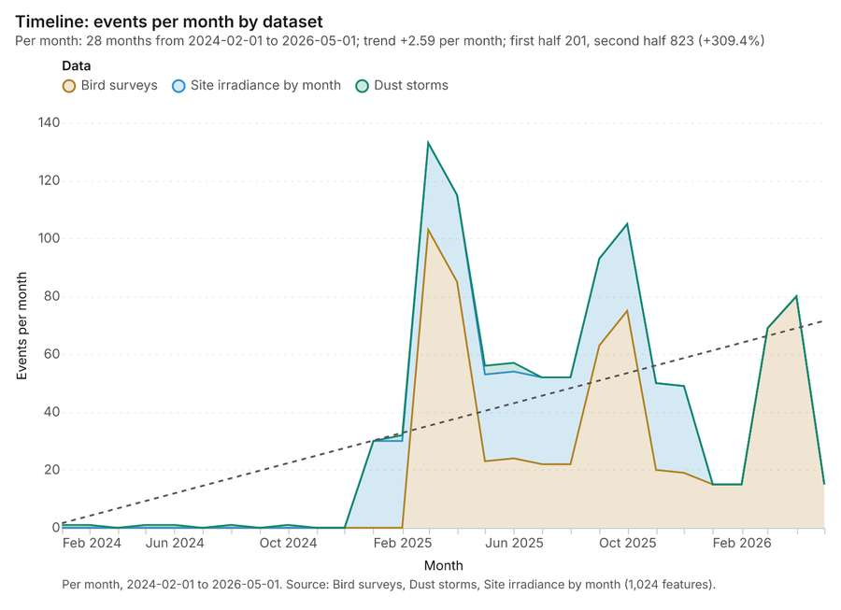
Figure 1. Timeline: events per month by dataset [1]. Per month, 2024-02-01 to 2026-05-01. Source: Bird surveys, Dust storms, Site irradiance by month (1,024 features). The data is in the appendix.
The timeline counts 1,024 dated events in Bird surveys, Dust storms, Site irradiance by month per month, from February 2024 to May 2026 [1][2][3][4]. By dataset: Bird surveys 650; Site irradiance by month 360; Dust storms 14 [1]. The trend is +2.59 events per month; the second half of the months has 823 against 201 in the first (+309.4%) [1]. 5 of the 28 months had no events [1].
Busiest months
- March 2025: 133 events [1]
- April 2025: 115 events [1]
- October 2025: 105 events [1]
Quietest months with events
- February 2024: 1 event [1]
- March 2024: 1 event [1]
- May 2024: 1 event [1]

Summarize within
What this analysis is. Summarize within: Count and aggregate the features inside each polygon (or bin), proportionally for lines and polygons [5]. In ArcGIS it is Summarize Within or Aggregate Points; in QGIS, native:countpointsinpolygon or native:sumlinelengths [5].
Why it was run on this data. Count Met masts inside each feature of Exclusion zones; the counts map as a choropleth (natural breaks, sequential colors) [6].
What it found. Summarize within on Met masts, Exclusion zones: Summarize within: 1 layer saved: Summarize within: Exclusion zones (8 features) [7][8][9]. It reported result, count 8; result, elapsed ms 3; billing, cost 0.01024; billing, list price 0.01024; billing, upstream cost 0 [7].
Result | Value
result, count | 8
result, elapsed ms | 3
billing, cost | 0.01024
billing, list price | 0.01024
billing, upstream cost | 0

Findings
- Evidenced: Summarize within on Met masts, Exclusion zones: Summarize within: 1 layer saved: Summarize within: Exclusion zones (8 features) [7][8][9].
- Evidenced: It reported result, count 8; result, elapsed ms 3; billing, cost 0.01024; billing, list price 0.01024; billing, upstream cost 0 [7].
Tool gp_summarize_within; parameters {"stats": [], "project": "8e181d65-6b3c-4526-9cff-cfc25a7f3e07", "features": {"layer": "Met masts (46ca6de8)"}, "polygons": {"layer": "Exclusion zones (f76641f5)"}}

Summarize within
What this analysis is. Summarize within: Count and aggregate the features inside each polygon (or bin), proportionally for lines and polygons [5]. In ArcGIS it is Summarize Within or Aggregate Points; in QGIS, native:countpointsinpolygon or native:sumlinelengths [5].
Why it was run on this data. Count Met masts inside each feature of Exclusion zones; the counts map as a choropleth (natural breaks, sequential colors) [6].
What it found. Summarize within on Substations, Exclusion zones: Summarize within: 1 layer saved: Summarize within: Exclusion zones (8 features) [9][10][11]. It reported result, count 8; result, elapsed ms 3; billing, cost 0.01028; billing, list price 0.01028; billing, upstream cost 0 [10].
Result | Value
result, count | 8
result, elapsed ms | 3
billing, cost | 0.01028
billing, list price | 0.01028
billing, upstream cost | 0

Findings
- Evidenced: Summarize within on Substations, Exclusion zones: Summarize within: 1 layer saved: Summarize within: Exclusion zones (8 features) [9][10][11].
- Evidenced: It reported result, count 8; result, elapsed ms 3; billing, cost 0.01028; billing, list price 0.01028; billing, upstream cost 0 [10].
A model draft was discarded because a sentence did not cite a source of this section.
Tool gp_summarize_within; parameters {"stats": [{"stat": "sum", "field": "voltage_kv"}], "project": "8e181d65-6b3c-4526-9cff-cfc25a7f3e07", "features": {"layer": "Substations (9024da37)"}, "polygons": {"layer": "Exclusion zones (f76641f5)"}}

Summarize within
What this analysis is. Summarize within: Count and aggregate the features inside each polygon (or bin), proportionally for lines and polygons [5]. In ArcGIS it is Summarize Within or Aggregate Points; in QGIS, native:countpointsinpolygon or native:sumlinelengths [5].
Why it was run on this data. Count Met masts inside each feature of Exclusion zones; the counts map as a choropleth (natural breaks, sequential colors) [6].
What it found. Summarize within on Bird surveys, Exclusion zones: Summarize within: 1 layer saved: Summarize within: Exclusion zones (8 features) [9][12][13]. It reported result, count 8; result, elapsed ms 5; billing, cost 0.02318; billing, list price 0.02318; billing, upstream cost 0 [12].
Result | Value
result, count | 8
result, elapsed ms | 5
billing, cost | 0.02318
billing, list price | 0.02318
billing, upstream cost | 0

Findings
- Evidenced: Summarize within on Bird surveys, Exclusion zones: Summarize within: 1 layer saved: Summarize within: Exclusion zones (8 features) [9][12][13].
- Evidenced: It reported result, count 8; result, elapsed ms 5; billing, cost 0.02318; billing, list price 0.02318; billing, upstream cost 0 [12].
Tool gp_summarize_within; parameters {"stats": [{"stat": "sum", "field": "count"}], "project": "8e181d65-6b3c-4526-9cff-cfc25a7f3e07", "features": {"layer": "Bird surveys (a5b49489)"}, "group_by": "species", "polygons": {"layer": "Exclusion zones (f76641f5)"}}

Zonal statistics
What this analysis is. Zonal statistics: count/min/max/mean/std/sum/median/majority per polygon as a table and as GeoJSON [14]. In ArcGIS it is Zonal Statistics as Table (polygons) [14].
Why it was run on this data. Statistics of Plateau terrain model (DEM) inside each feature of Exclusion zones [15].
What it found. The zonal statistics analysis was performed using the tool rs_zonal_statistics [16]. The tool summary indicated that Zonal statistics produced 8 row(s) [16]. Additionally, the process analyzed 8 zones [16].
Findings
- Evidenced: Zonal statistics: Zonal statistics: 8 row(s) [16].
- Evidenced: zones 8 [16].
Tool rs_zonal_statistics; parameters {"stats": ["mean", "min", "max", "std"], "zones": "Exclusion zones (f76641f5)", "raster_id": "Plateau terrain model (DEM) (918994c5)"}

Zonal statistics
What this analysis is. Zonal statistics: count/min/max/mean/std/sum/median/majority per polygon as a table and as GeoJSON [14]. In ArcGIS it is Zonal Statistics as Table (polygons) [14].
Why it was run on this data. Statistics of Plateau terrain model (DEM) inside each feature of Exclusion zones [15].
What it found. The tool rs_zonal_statistics processed 14 row(s) [17]. This tool involved 14 zones [17].
Findings
- Evidenced: Zonal statistics: Zonal statistics: 14 row(s) [17].
- Evidenced: zones 14 [17].
Tool rs_zonal_statistics; parameters {"stats": ["mean", "min", "max", "std"], "zones": "Dust storms (aeb5849f)", "raster_id": "Plateau terrain model (DEM) (918994c5)"}

Zonal statistics
What this analysis is. Zonal statistics: count/min/max/mean/std/sum/median/majority per polygon as a table and as GeoJSON [14]. In ArcGIS it is Zonal Statistics as Table (polygons) [14].
Why it was run on this data. Statistics of Plateau terrain model (DEM) inside each feature of Exclusion zones [15].
What it found. The Zonal statistics analysis used the tool rs_zonal_statistics [18]. The resulting data structure contains 30 row(s) spanning 30 zones [18].
Findings
- Evidenced: Zonal statistics: Zonal statistics: 30 row(s) [18].
- Evidenced: zones 30 [18].
Tool rs_zonal_statistics; parameters {"stats": ["mean", "min", "max", "std"], "zones": "Candidate sites (d70250d1)", "raster_id": "Plateau terrain model (DEM) (918994c5)"}

Space time hot spots
What this analysis is. Emerging hot spots: Where hot spots are new, consecutive, intensifying, persistent, diminishing, sporadic, oscillating or historical over time [19]. In ArcGIS it is Emerging Hot Spot Analysis or Create Space Time Cube [19].
Why it was run on this data. Bird surveys carry dates in 'observed_at': emerging hot spot analysis finds new, intensifying and fading hot spots per month [20].
What it found. Space time hot spots on Bird surveys: Emerging hot spots: 1 layer saved: Emerging hot spots: Bird surveys (156 features) [13][21]. It reported result, count 156; result, elapsed ms 22; result, resolution 8; result, features used 650; result, time neighbors 0; billing, cost 0.1325 [21].
Result | Value
result, count | 156
result, elapsed ms | 22
result, resolution | 8
result, features used | 650
result, time neighbors | 0
billing, cost | 0.1325
billing, list price | 0.1325
billing, upstream cost | 0

Findings
- Evidenced: Space time hot spots on Bird surveys: Emerging hot spots: 1 layer saved: Emerging hot spots: Bird surveys (156 features) [13][21].
- Evidenced: It reported result, count 156; result, elapsed ms 22; result, resolution 8; result, features used 650; result, time neighbors 0; billing, cost 0.1325 [21].
A model draft was discarded because a sentence did not cite a source of this section.
Tool gp_space_time_hot_spots; parameters {"agg": "sum", "project": "8e181d65-6b3c-4526-9cff-cfc25a7f3e07", "features": {"layer": "Bird surveys (a5b49489)"}, "interval": "month", "bin_shape": "h3", "resolution": 8, "time_field": "observed_at", "value_field": "count"}

Hot spots
What this analysis is. Hot spot analysis: Getis-Ord Gi* hot and cold spots with z-scores, p-values and confidence bins [22]. In ArcGIS it is Find Hot Spots or Hot Spot Analysis (Getis-Ord Gi*); in QGIS, qgis:hotspot (plugin) [22].
Why it was run on this data. 650 points: Getis-Ord Gi* tests whether the concentrations in Bird surveys are statistically significant [23].
What it found. The hot spot analysis utilized the Bird surveys layer [13] and resulted in 650 features [
Result | Value
result, count | 650
result, elapsed ms | 13
result, excluded null | 0
result, distance band m | 1,000
billing, cost | 0.063
billing, list price | 0.063
billing, upstream cost | 0

Findings
- Evidenced: Hot spots on Bird surveys: Hot spot analysis: 1 layer saved: Hot spot analysis: Bird surveys (650 features) [13][24].
- Evidenced: It reported result, count 650; result, elapsed ms 13; result, excluded null 0; result, distance band m 1,000; billing, cost 0.063; billing, list price 0.063 [24].
Tool gp_hot_spots; parameters {"field": "count", "project": "8e181d65-6b3c-4526-9cff-cfc25a7f3e07", "features": {"layer": "Bird surveys (a5b49489)"}, "aggregation": "hexagon", "cell_size_m": 1000.0, "distance_band_m": 1000.0}

Calculate density
What this analysis is. Calculate density: Kernel density per square kilometer on a grid [25]. In ArcGIS it is Calculate Density or Kernel Density; in QGIS, native:heatmapkerneldensityestimation [25].
Why it was run on this data. 650 points in Bird surveys: a density surface shows where they concentrate [26].
What it found. The density calculation tool was run on the Bird surveys layer [27], yielding 699 features [27]. The resulting density data showed a maximum of 194.2 per km² [27]. Key parameters for the calculation included a bandwidth of 1,000 m and a cell size of 500 m [27]. The cost associated with this operation was 0.063 [27].
Result | Value
result, count | 699
result, elapsed ms | 21
result, bandwidth m | 1,000
result, cell size m | 500
result, excluded null | 0
result, max density per km2 | 194.2
billing, cost | 0.063
billing, list price | 0.063
billing, upstream cost | 0

Findings
- Evidenced: Calculate density on Bird surveys: Calculate density: 1 layer saved: Calculate density: Bird surveys (699 features) [13][27].
- Evidenced: It reported result, count 699; result, elapsed ms 21; result, bandwidth m 1,000; result, cell size m 500; result, excluded null 0; result, max density per km2 194.2 [27].
Tool gp_calculate_density; parameters {"kernel": "quartic", "project": "8e181d65-6b3c-4526-9cff-cfc25a7f3e07", "features": {"layer": "Bird surveys (a5b49489)"}, "bandwidth_m": 1000.0, "cell_size_m": 500.0, "weight_field": "count"}

Find point clusters
What this analysis is. Find point clusters: Density-based clusters (DBSCAN, HDBSCAN or OPTICS, optionally space-time) with hulls and noise [28]. In ArcGIS it is Find Point Clusters or Density-based Clustering; in QGIS, native:dbscanclustering or native:stdbscanclustering [28].
Why it was run on this data. DBSCAN finds dense groups of Bird surveys and separates noise [29].
What it found. Find point clusters on Bird surveys: Find point clusters: 2 layers saved: Find point clusters: Bird surveys (650 features); Find point clusters: cluster hulls (1 feature) [13][30]. It reported result, count 650; result, noise 261; result, distance m 500; result, elapsed ms 11; result, min points 16; billing, cost 0.063 [30].
Result | Value
result, count | 650
result, noise | 261
result, distance m | 500
result, elapsed ms | 11
result, min points | 16
billing, cost | 0.063
billing, list price | 0.063
billing, upstream cost | 0

Findings
- Evidenced: Find point clusters on Bird surveys: Find point clusters: 2 layers saved: Find point clusters: Bird surveys (650 features); Find point clusters: cluster hulls (1 feature) [13][30].
- Evidenced: It reported result, count 650; result, noise 261; result, distance m 500; result, elapsed ms 11; result, min points 16; billing, cost 0.063 [30].
Tool gp_find_point_clusters; parameters {"method": "dbscan", "project": "8e181d65-6b3c-4526-9cff-cfc25a7f3e07", "features": {"layer": "Bird surveys (a5b49489)"}, "distance_m": 500.0, "min_points": 16}

Nearest neighbor index
What this analysis is. Average nearest neighbor: Clark-Evans ratio: clustered, dispersed or random [31]. In ArcGIS it is Average Nearest Neighbor; in QGIS, native:nearestneighbouranalysis [31].
Why it was run on this data. The average nearest neighbor ratio says whether Substations are clustered, random or dispersed [32].
What it found. Nearest neighbor index on Substations: Average nearest neighbor: done; no map output [11][33]. It reported result, n 5; result, p value 0; result, z score 8.856; result, elapsed ms 0; result, study area m2 30,876,054; result, nearest neighbor ratio 3.07 [33].
Result | Value
result, n | 5
result, p value | 0
result, z score | 8.856
result, elapsed ms | 0
result, study area m2 | 30,876,054
result, nearest neighbor ratio | 3.07
result, expected mean distance m | 1,242
result, observed mean distance m | 3,815
billing, cost | 0.02
billing, list price | 0.02
billing, upstream cost | 0

Findings
- Evidenced: Nearest neighbor index on Substations: Average nearest neighbor: done; no map output [11][33].
- Evidenced: It reported result, n 5; result, p value 0; result, z score 8.856; result, elapsed ms 0; result, study area m2 30,876,054; result, nearest neighbor ratio 3.07 [33].
Tool gp_nearest_neighbor_index; parameters {"project": "8e181d65-6b3c-4526-9cff-cfc25a7f3e07", "features": {"layer": "Substations (9024da37)"}}

Nearest neighbor index
What this analysis is. Average nearest neighbor: Clark-Evans ratio: clustered, dispersed or random [31]. In ArcGIS it is Average Nearest Neighbor; in QGIS, native:nearestneighbouranalysis [31].
Why it was run on this data. The average nearest neighbor ratio says whether Bird surveys are clustered, random or dispersed [34].
What it found. Nearest neighbor index on Bird surveys: Average nearest neighbor: done; no map output [13][35]. It reported result, n 650; result, p value 0; result, z score -9.837; result, elapsed ms 3; result, study area m2 134,387,893; result, nearest neighbor ratio 0.7983 [35].
Result | Value
result, n | 650
result, p value | 0
result, z score | -9.837
result, elapsed ms | 3
result, study area m2 | 134,387,893
result, nearest neighbor ratio | 0.7983
result, expected mean distance m | 227.3
result, observed mean distance m | 181.5
billing, cost | 0.02
billing, list price | 0.02
billing, upstream cost | 0

Findings
- Evidenced: Nearest neighbor index on Bird surveys: Average nearest neighbor: done; no map output [13][35].
- Evidenced: It reported result, n 650; result, p value 0; result, z score -9.837; result, elapsed ms 3; result, study area m2 134,387,893; result, nearest neighbor ratio 0.7983 [35].
Tool gp_nearest_neighbor_index; parameters {"project": "8e181d65-6b3c-4526-9cff-cfc25a7f3e07", "features": {"layer": "Bird surveys (a5b49489)"}}

Outliers
What this analysis is. Find outliers: Anselin local Moran’s I: HH, LL clusters and HL, LH outliers [36]. In ArcGIS it is Find Outliers or Cluster and Outlier Analysis (Anselin Local Moran’s I) [36].
Why it was run on this data. Local Moran's I maps clusters and outliers of 'buffer_m' [37].
What it found. The `gp_outliers` tool identified outliers and processed the Exclusion zones [38, 9]. The execution found 1 layer saved and reported a total count of 8 results [38].
Result | Value
result, count | 8
result, elapsed ms | 10
result, permutations | 199
result, excluded null | 0
result, distance band m | 4,662
billing, cost | 0.05024
billing, list price | 0.05024
billing, upstream cost | 0

Findings
- Evidenced: Outliers on Exclusion zones: Find outliers: 1 layer saved: Find outliers: Exclusion zones (8 features) [9][38].
- Evidenced: It reported result, count 8; result, elapsed ms 10; result, permutations 199; result, excluded null 0; result, distance band m 4,662; billing, cost 0.05024 [38].
Tool gp_outliers; parameters {"field": "buffer_m", "project": "8e181d65-6b3c-4526-9cff-cfc25a7f3e07", "features": {"layer": "Exclusion zones (f76641f5)"}, "aggregation": "hexagon"}

Outliers
What this analysis is. Find outliers: Anselin local Moran’s I: HH, LL clusters and HL, LH outliers [36]. In ArcGIS it is Find Outliers or Cluster and Outlier Analysis (Anselin Local Moran’s I) [36].
Why it was run on this data. Local Moran's I maps clusters and outliers of 'pm10_peak' [39].
What it found. The analysis utilized the `gp_outliers` tool [40] on the `Dust storms` layer [41]. The function identified a count of 14 results [40], and the entire operation took 5 ms to complete [40]. Billing details indicated a list price of 0.05042 [40] for processing the 14 features [40].
Result | Value
result, count | 14
result, elapsed ms | 5
result, permutations | 199
result, excluded null | 0
result, distance band m | 4,561
billing, cost | 0.05042
billing, list price | 0.05042
billing, upstream cost | 0

Findings
- Evidenced: Outliers on Dust storms: Find outliers: 1 layer saved: Find outliers: Dust storms (14 features) [40][41].
- Evidenced: It reported result, count 14; result, elapsed ms 5; result, permutations 199; result, excluded null 0; result, distance band m 4,561; billing, cost 0.05042 [40].
Tool gp_outliers; parameters {"field": "pm10_peak", "project": "8e181d65-6b3c-4526-9cff-cfc25a7f3e07", "features": {"layer": "Dust storms (aeb5849f)"}, "aggregation": "hexagon"}

Outliers
What this analysis is. Find outliers: Anselin local Moran’s I: HH, LL clusters and HL, LH outliers [36]. In ArcGIS it is Find Outliers or Cluster and Outlier Analysis (Anselin Local Moran’s I) [36].
Why it was run on this data. Local Moran's I maps clusters and outliers of 'ghi_kwh_m2_yr' [42].
What it found. Outliers on Candidate sites: Find outliers: 1 layer saved: Find outliers: Candidate sites (30 features) [43][44]. It reported result, count 30; result, elapsed ms 8; result, permutations 199; result, excluded null 0; result, distance band m 3,255; billing, cost 0.0509 [43].
Result | Value
result, count | 30
result, elapsed ms | 8
result, permutations | 199
result, excluded null | 0
result, distance band m | 3,255
billing, cost | 0.0509
billing, list price | 0.0509
billing, upstream cost | 0

Findings
- Evidenced: Outliers on Candidate sites: Find outliers: 1 layer saved: Find outliers: Candidate sites (30 features) [43][44].
- Evidenced: It reported result, count 30; result, elapsed ms 8; result, permutations 199; result, excluded null 0; result, distance band m 3,255; billing, cost 0.0509 [43].
Tool gp_outliers; parameters {"field": "ghi_kwh_m2_yr", "project": "8e181d65-6b3c-4526-9cff-cfc25a7f3e07", "features": {"layer": "Candidate sites (d70250d1)"}, "aggregation": "hexagon"}

Maps and charts
The run also made 14 map image(s) [45][46][47][48][49][50][51][52][53][54][55][56][57][58] and 17 chart(s) [59][60][61][62][63][64][65][66][67][68][69][70][71][72][73][74][75].
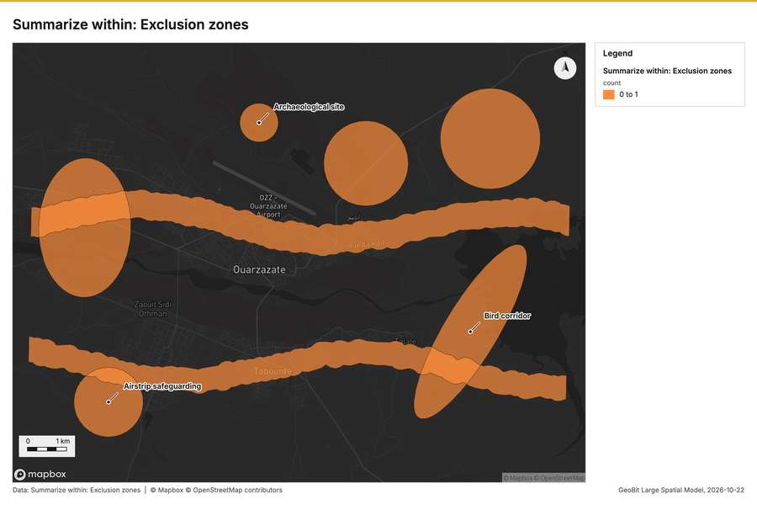
Figure 2. Summarize within: Exclusion zones [45]
Figure 3. Summarize within: Exclusion zones [46]
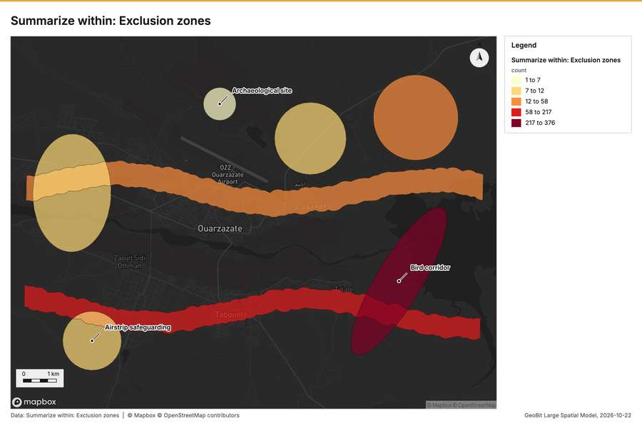
Figure 4. Summarize within: Exclusion zones [47]
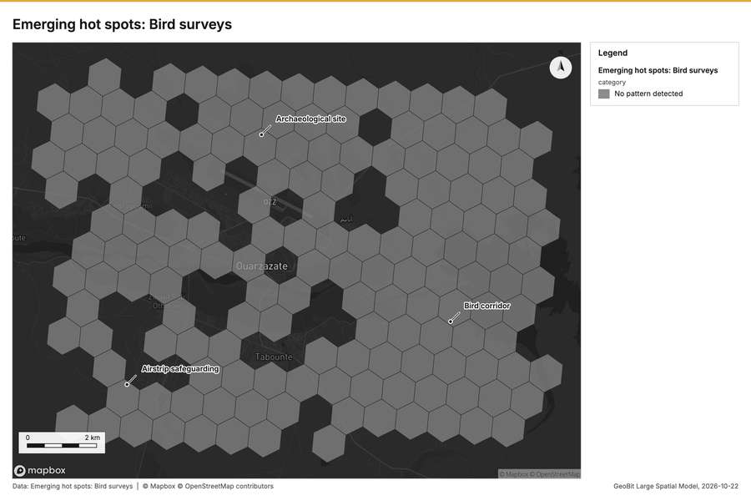
Figure 5. Emerging hot spots: Bird surveys [48]
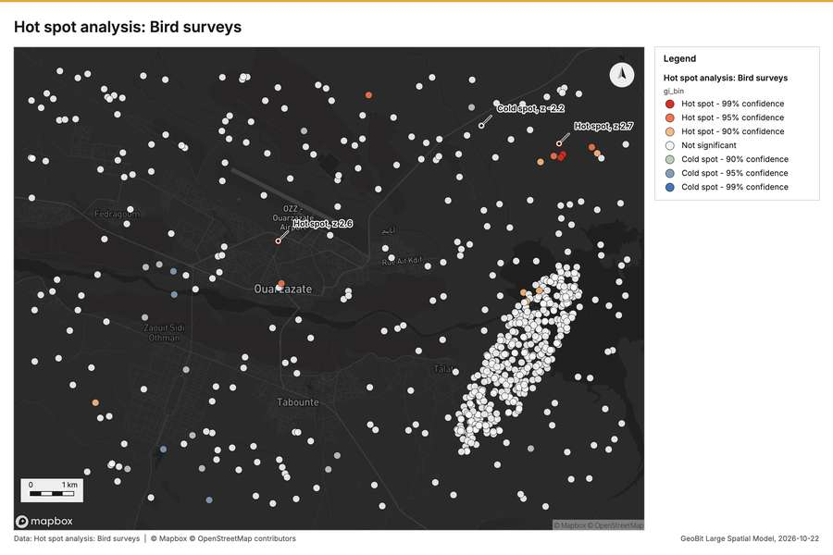
Figure 6. Hot spot analysis: Bird surveys [49]
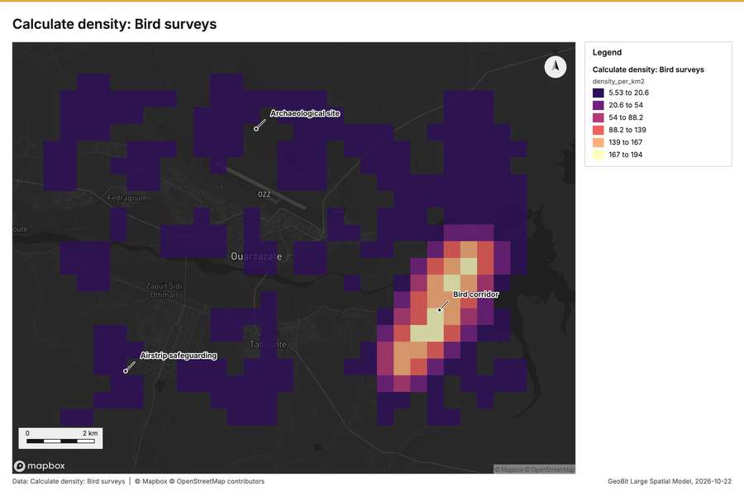
Figure 7. Calculate density: Bird surveys [50]
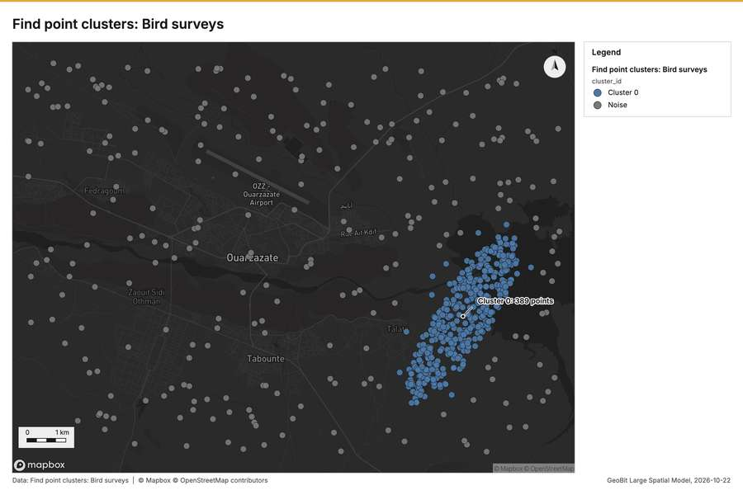
Figure 8. Find point clusters: Bird surveys [51]
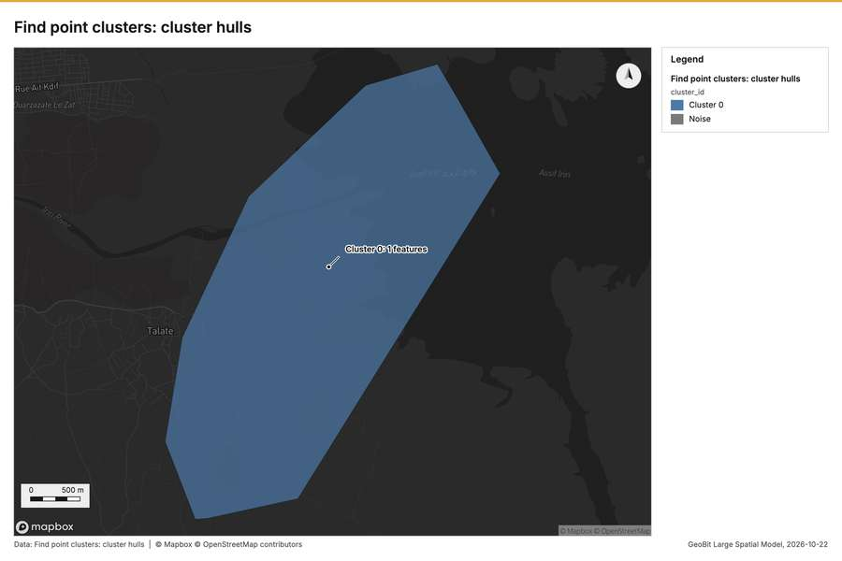
Figure 9. Find point clusters: cluster hulls [52]
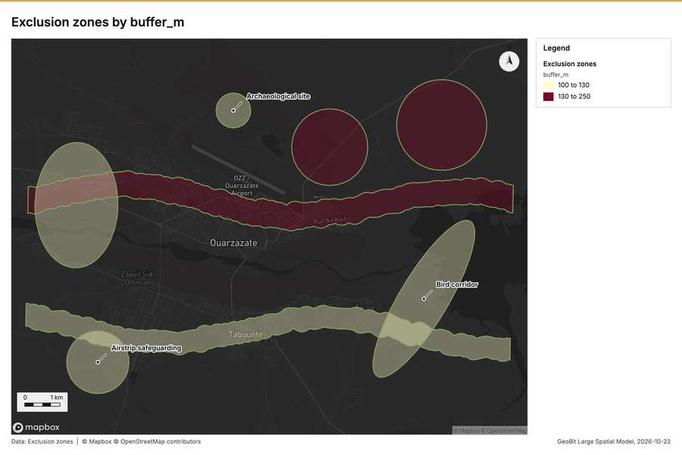
Figure 10. Exclusion zones by buffer_m [53]
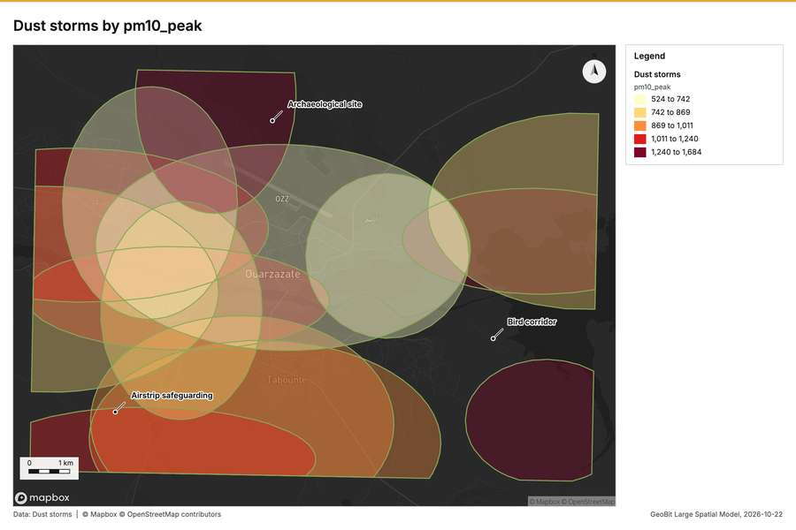
Figure 11. Dust storms by pm10_peak [54]
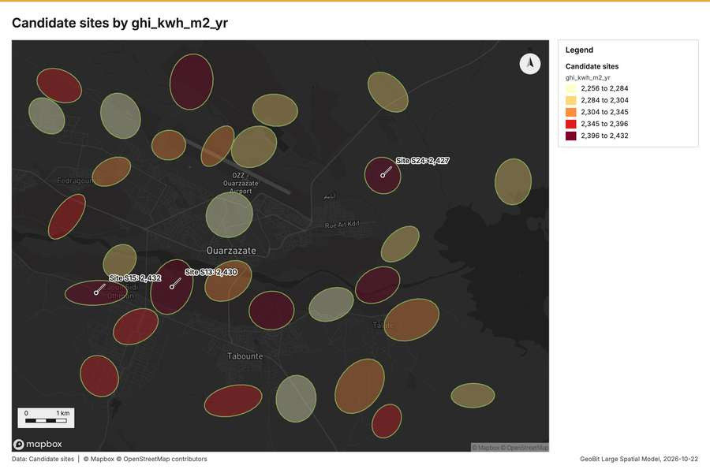
Figure 12. Candidate sites by ghi_kwh_m2_yr [55]
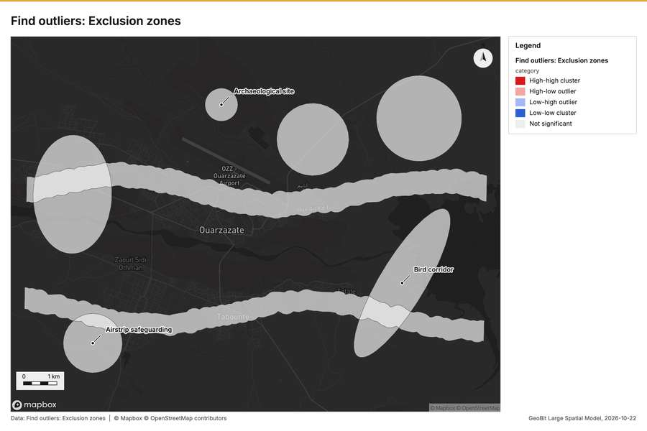
Figure 13. Find outliers: Exclusion zones [56]
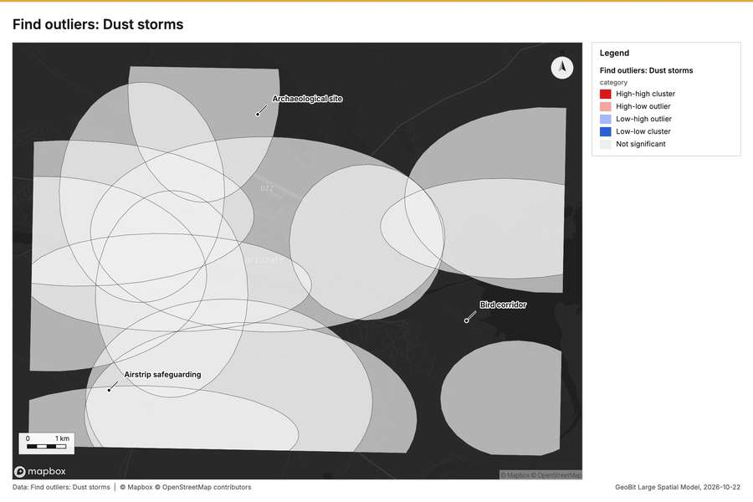
Figure 14. Find outliers: Dust storms [57]
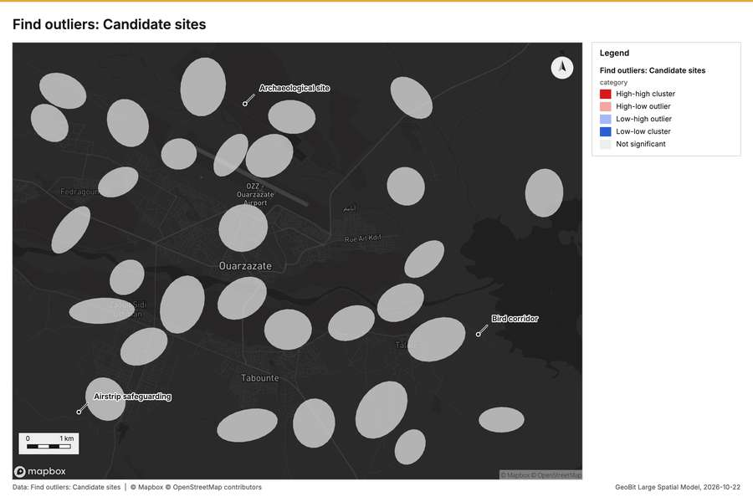
Figure 15. Find outliers: Candidate sites [58]
What the map shows. The map displays the summarized count of "Exclusion zones" within the area, using 0 to 1 as indicated in the legend. High counts, represented by darker orange, are clustered in several prominent, sinuous bands running horizontally across the mapped view. Additionally, distinct areas of high counts are visible as larger, circular patches that are scattered across [46]
Inferred: read from the image by gemma4:e4b, not evidence.
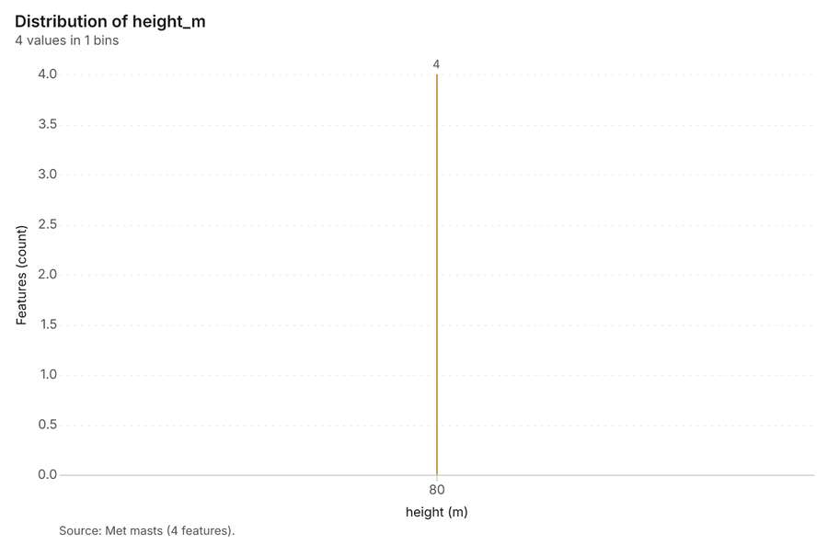
Figure 16. Met masts over time (installed_year) [59]. Source: Met masts (4 features). The data is in the appendix.
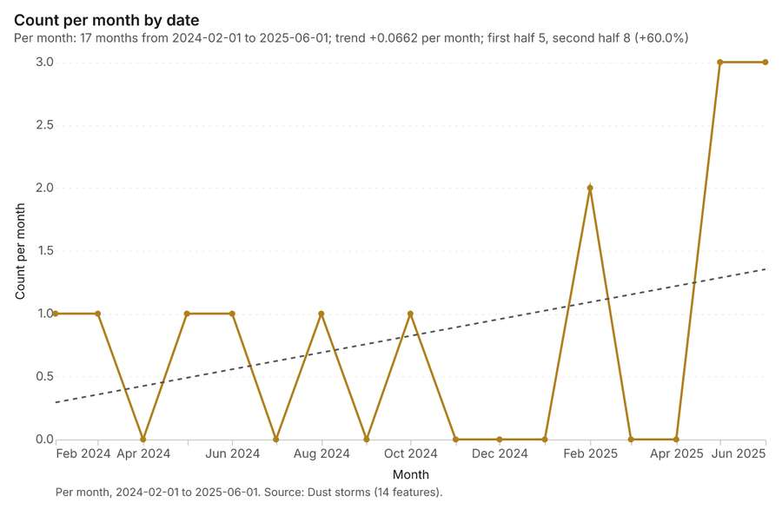
Figure 17. Dust storms over time (date) [60]. Per month, 2024-02-01 to 2025-06-01. Source: Dust storms (14 features). The data is in the appendix.
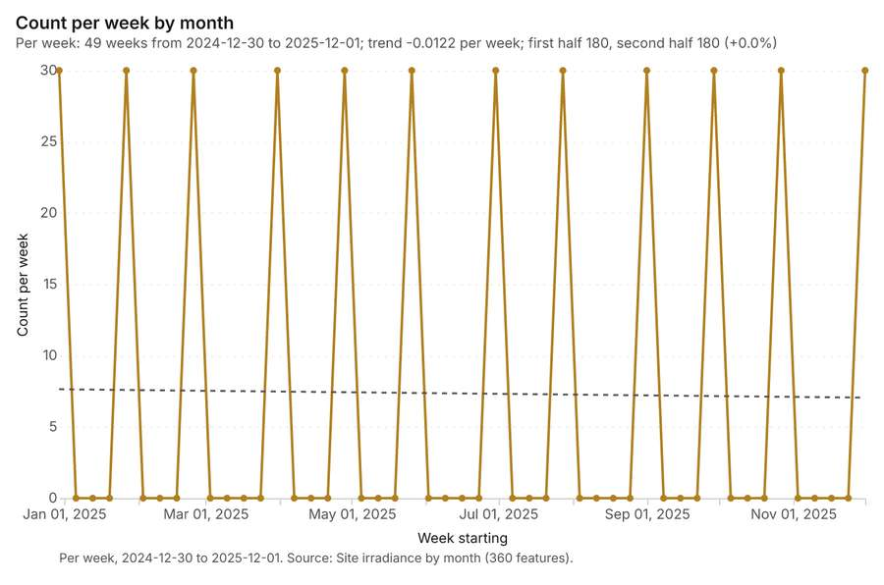
Figure 18. Site irradiance by month over time (month) [61]. Per week, 2024-12-30 to 2025-12-01. Source: Site irradiance by month (360 features). The data is in the appendix.
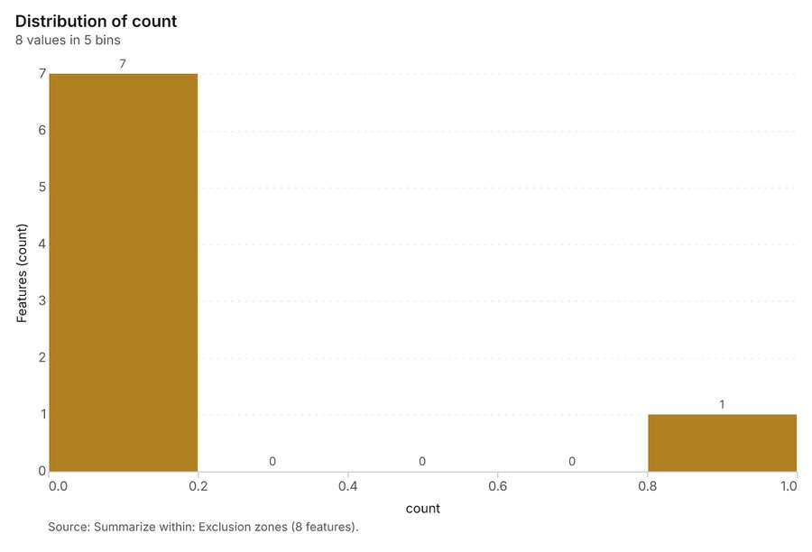
Figure 19. Summarize within: Exclusion zones [62]. Source: Summarize within: Exclusion zones (8 features). The data is in the appendix.
Figure 20. Summarize within: Exclusion zones [63]. Source: Summarize within: Exclusion zones (8 features). The data is in the appendix.
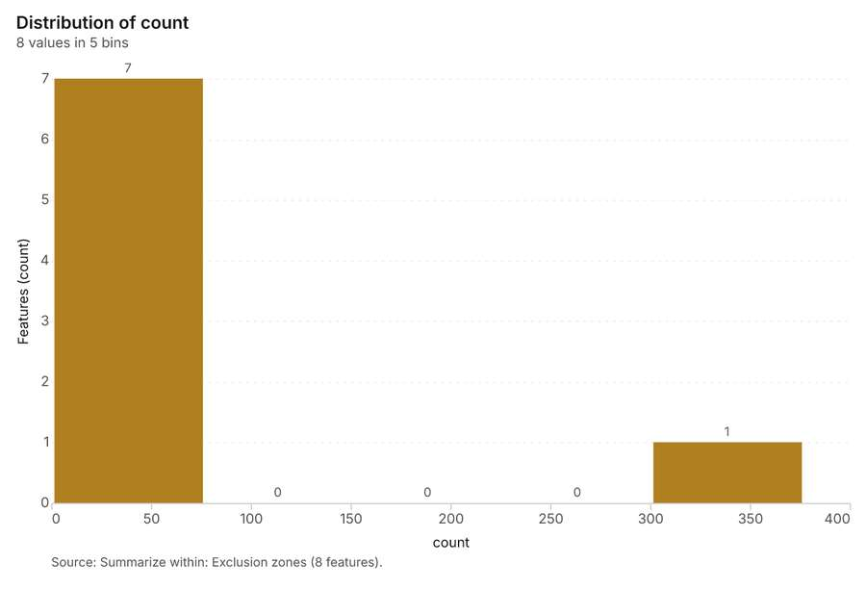
Figure 21. Summarize within: Exclusion zones [64]. Source: Summarize within: Exclusion zones (8 features). The data is in the appendix.
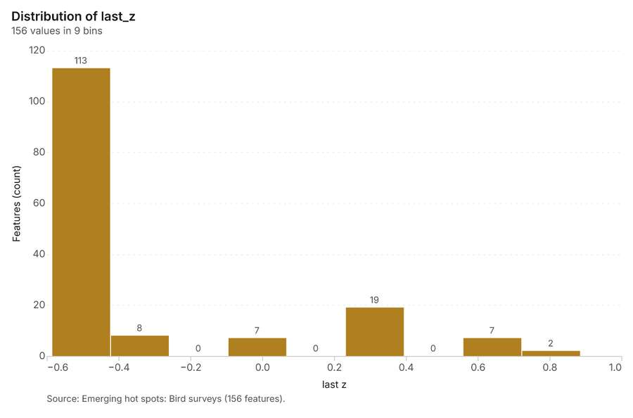
Figure 22. Emerging hot spots: Bird surveys [65]. Source: Emerging hot spots: Bird surveys (156 features). The data is in the appendix.
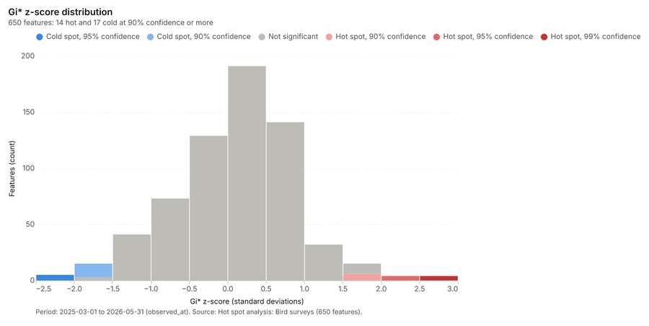
Figure 23. Hot spot analysis: Bird surveys [66]. Period: 2025-03-01 to 2026-05-31 (observed_at). Source: Hot spot analysis: Bird surveys (650 features). The data is in the appendix.
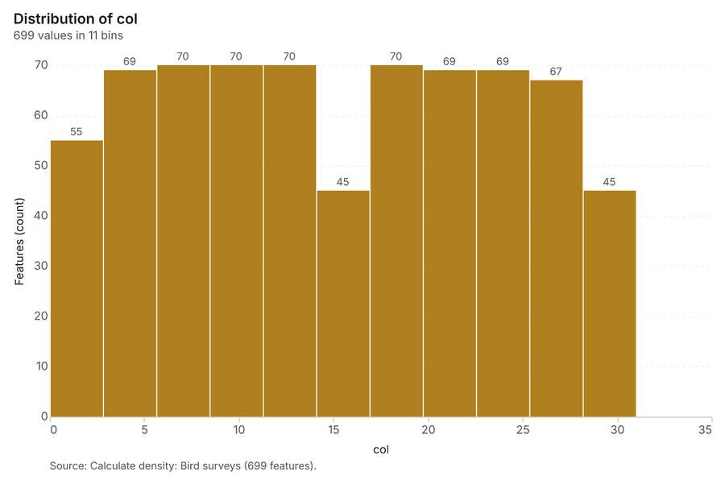
Figure 24. Calculate density: Bird surveys [67]. Source: Calculate density: Bird surveys (699 features). The data is in the appendix.
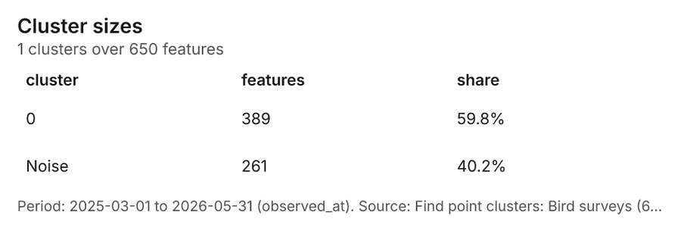
Figure 25. Find point clusters: Bird surveys [68]. Period: 2025-03-01 to 2026-05-31 (observed_at). Source: Find point clusters: Bird surveys (650 features). The data is in the appendix.
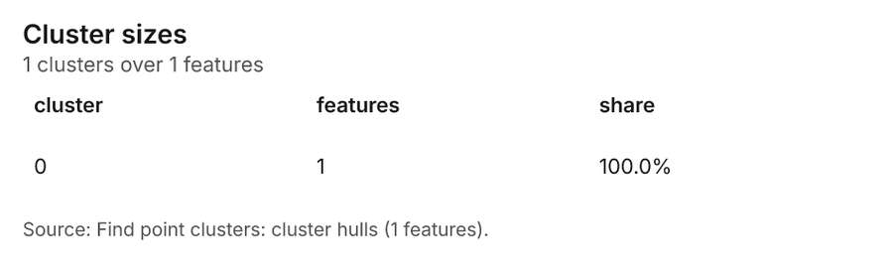
Figure 26. Find point clusters: cluster hulls [69]. Source: Find point clusters: cluster hulls (1 features). The data is in the appendix.
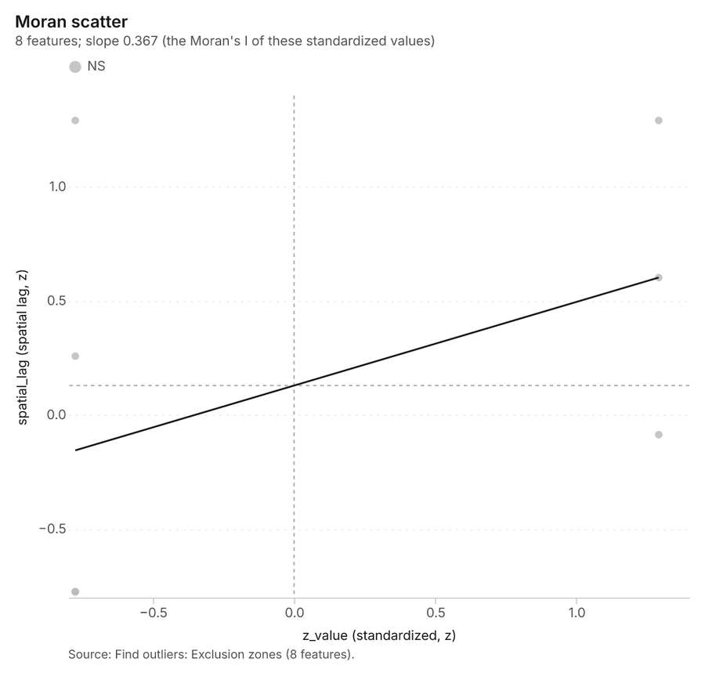
Figure 27. Find outliers: Exclusion zones [70]. Source: Find outliers: Exclusion zones (8 features). The data is in the appendix.
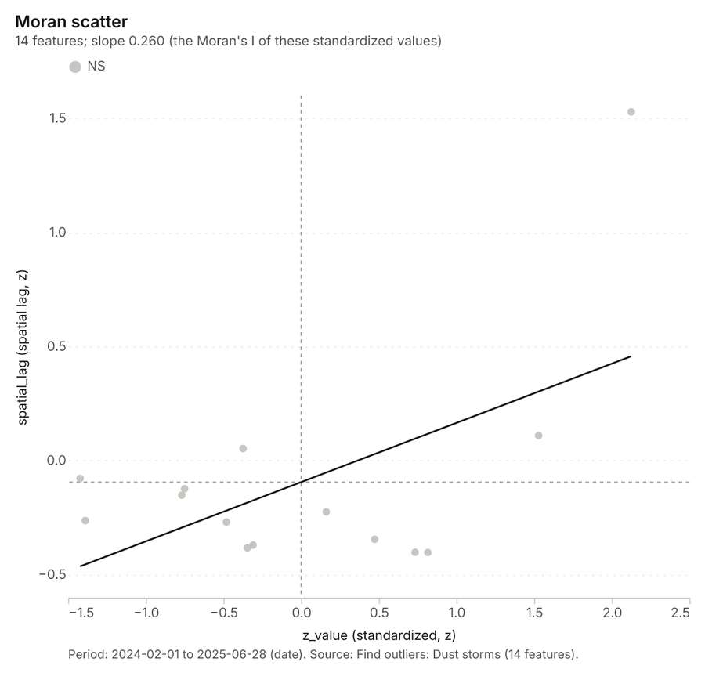
Figure 28. Find outliers: Dust storms [71]. Period: 2024-02-01 to 2025-06-28 (date). Source: Find outliers: Dust storms (14 features). The data is in the appendix.
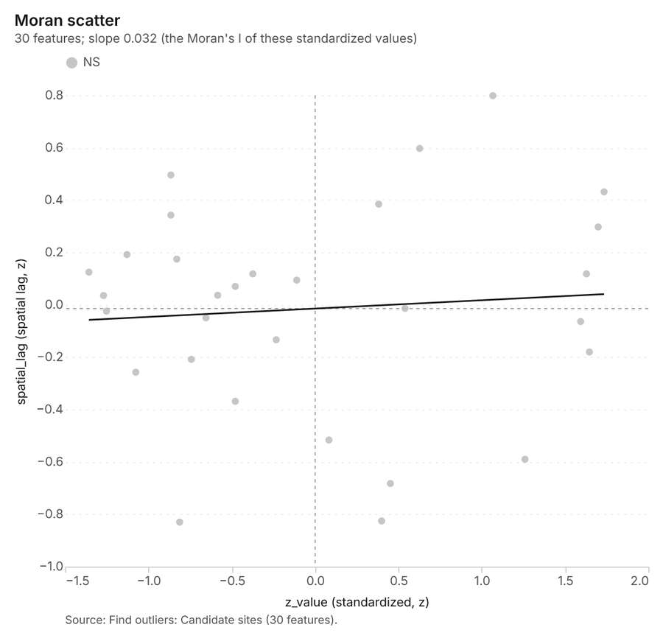
Figure 29. Find outliers: Candidate sites [72]. Source: Find outliers: Candidate sites (30 features). The data is in the appendix.
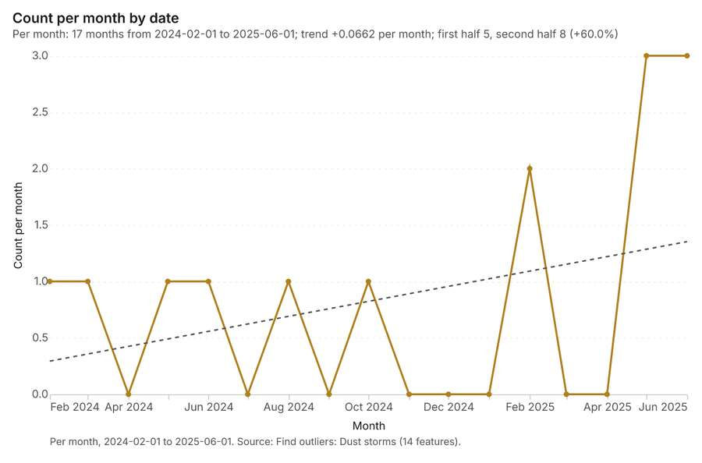
Figure 30. Find outliers: Dust storms over time [73]. Per month, 2024-02-01 to 2025-06-01. Source: Find outliers: Dust storms (14 features). The data is in the appendix.
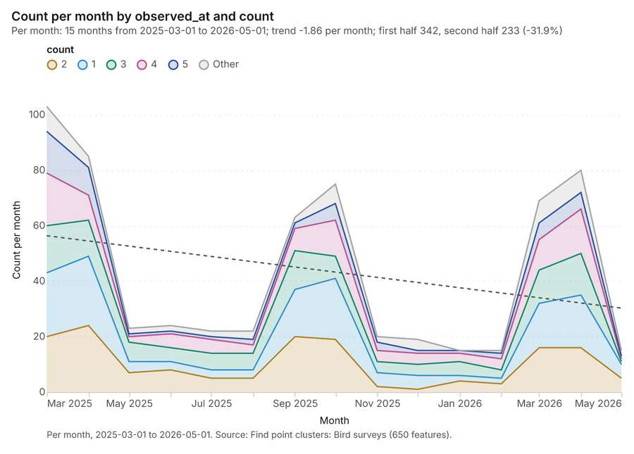
Figure 31. Find point clusters: Bird surveys over time [74]. Per month, 2025-03-01 to 2026-05-01. Source: Find point clusters: Bird surveys (650 features). The data is in the appendix.
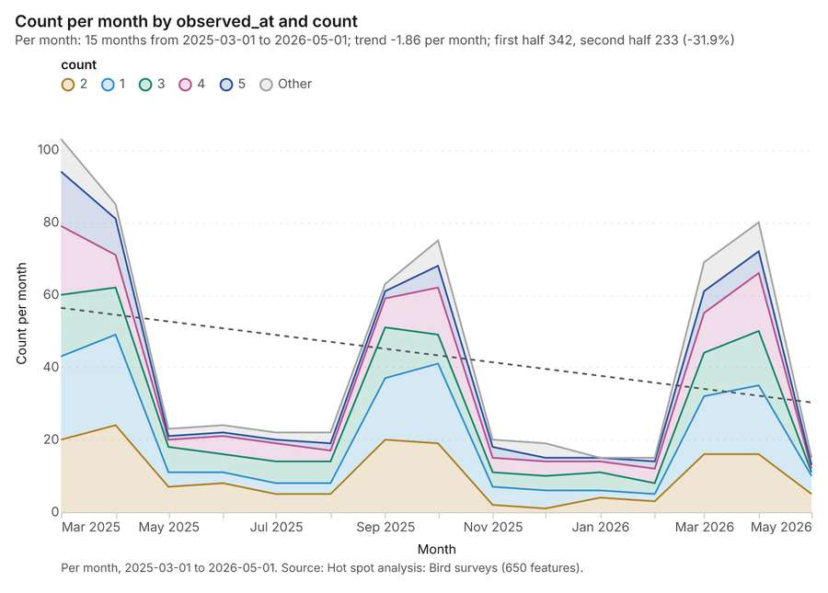
Figure 32. Hot spot analysis: Bird surveys over time [75]. Per month, 2025-03-01 to 2026-05-01. Source: Hot spot analysis: Bird surveys (650 features). The data is in the appendix.

Changes since the last run
This is the first report of this project.

Sources
[1] Rendering: Chart: Timeline: events per month by dataset. 84 rows (id 241ff431-2463-4d2b-9969-bfa5a0f6ce84)
[2] Dataset: Bird surveys. vector, 650 rows (id 7a5a9074-3838-427a-8c24-d286446838ad)
[3] Dataset: Dust storms. vector, 14 rows (id 8ead6725-8b61-44df-a3b4-cdb7f223347a)
[4] Dataset: Site irradiance by month. table, 360 rows (id c78442cd-f73b-403e-8ff1-86fb1c7bc591)
[5] Catalog: Summarize within (operation catalog, gp_summarize_within). Count and aggregate the features inside each polygon (or bin), proportionally for lines and polygons. ArcGIS: Summarize Within, Aggregate Points. QGIS: native:countpointsinpolygon, native:sumlinelengths. (id gp_summarize_within)
[6] Plan: Met masts per feature of Exclusion zones (the Start plan's candidate c_41c08b6712ff). Count Met masts inside each feature of Exclusion zones; the counts map as a choropleth (natural breaks, sequential colors). (id 4467f0bd-c718-4e32-858e-fdc23c1206ed:c_41c08b6712ff)
[7] Tool result: gp_summarize_within, step 0. Summarize within: 1 layer saved: Summarize within: Exclusion zones (8 features). (id 94fd8ddf-f2f8-40c7-9baa-40dbb152522d:0)
[8] Layer: Met masts. 4 features (id 46ca6de8-1f52-4cae-8a9c-aa89cdfb58ed)
[9] Layer: Exclusion zones. 8 features (id f76641f5-146c-4958-8885-d9250aa67fc6)
[10] Tool result: gp_summarize_within, step 1. Summarize within: 1 layer saved: Summarize within: Exclusion zones (8 features). (id 94fd8ddf-f2f8-40c7-9baa-40dbb152522d:1)
[11] Layer: Substations. 5 features (id 9024da37-5b4c-4500-b90a-7838a0cefe33)
[12] Tool result: gp_summarize_within, step 2. Summarize within: 1 layer saved: Summarize within: Exclusion zones (8 features). (id 94fd8ddf-f2f8-40c7-9baa-40dbb152522d:2)
[13] Layer: Bird surveys. 650 features (id a5b49489-c432-4eb3-aa5e-37524f1a4db9)
[14] Catalog: Zonal statistics (analysis catalog, rs_zonal_statistics). count/min/max/mean/std/sum/median/majority per polygon as a table and as GeoJSON. ArcGIS: Zonal Statistics as Table (polygons). (id rs_zonal_statistics)
[15] Plan: Zonal statistics of Plateau terrain model (DEM) and Exclusion zones (the Start plan's candidate c_66d31df1c394). Statistics of Plateau terrain model (DEM) inside each feature of Exclusion zones. (id 4467f0bd-c718-4e32-858e-fdc23c1206ed:c_66d31df1c394)
[16] Tool result: rs_zonal_statistics, step 0. Zonal statistics: 8 row(s). zones 8. (id f33d2406-6d8e-4b9d-ac3e-7cda4a6fb94a:0)
[17] Tool result: rs_zonal_statistics, step 1. Zonal statistics: 14 row(s). zones 14. (id f33d2406-6d8e-4b9d-ac3e-7cda4a6fb94a:1)
[18] Tool result: rs_zonal_statistics, step 2. Zonal statistics: 30 row(s). zones 30. (id f33d2406-6d8e-4b9d-ac3e-7cda4a6fb94a:2)
[19] Catalog: Emerging hot spots (operation catalog, gp_space_time_hot_spots). Where hot spots are new, consecutive, intensifying, persistent, diminishing, sporadic, oscillating or historical over time. ArcGIS: Emerging Hot Spot Analysis, Create Space Time Cube. (id gp_space_time_hot_spots)
[20] Plan: Space time hot spots of Bird surveys (the Start plan's candidate c_0a376e0f7bee). Bird surveys carry dates in 'observed_at': emerging hot spot analysis finds new, intensifying and fading hot spots per month. (id 4467f0bd-c718-4e32-858e-fdc23c1206ed:c_0a376e0f7bee)
[21] Tool result: gp_space_time_hot_spots, step 0. Emerging hot spots: 1 layer saved: Emerging hot spots: Bird surveys (156 features). (id 57aa9228-065c-4727-b2e2-360559185796:0)
[22] Catalog: Hot spot analysis (operation catalog, gp_hot_spots). Getis-Ord Gi* hot and cold spots with z-scores, p-values and confidence bins. ArcGIS: Find Hot Spots, Hot Spot Analysis (Getis-Ord Gi*). QGIS: qgis:hotspot (plugin). (id gp_hot_spots)
[23] Plan: Hot spots of Bird surveys (the Start plan's candidate c_c119c8fa5c0a). 650 points: Getis-Ord Gi* tests whether the concentrations in Bird surveys are statistically significant. (id 4467f0bd-c718-4e32-858e-fdc23c1206ed:c_c119c8fa5c0a)
[24] Tool result: gp_hot_spots, step 0. Hot spot analysis: 1 layer saved: Hot spot analysis: Bird surveys (650 features). (id 1a6fb48c-a16d-4ea8-b7b2-c8198bec40da:0)
[25] Catalog: Calculate density (operation catalog, gp_calculate_density). Kernel density per square kilometer on a grid. ArcGIS: Calculate Density, Kernel Density. QGIS: native:heatmapkerneldensityestimation. (id gp_calculate_density)
[26] Plan: Kernel density of Bird surveys (the Start plan's candidate c_d8957b1a8e52). 650 points in Bird surveys: a density surface shows where they concentrate. (id 4467f0bd-c718-4e32-858e-fdc23c1206ed:c_d8957b1a8e52)
[27] Tool result: gp_calculate_density, step 0. Calculate density: 1 layer saved: Calculate density: Bird surveys (699 features). (id 36d3dffd-9398-4987-9589-70b885baa263:0)
[28] Catalog: Find point clusters (operation catalog, gp_find_point_clusters). Density-based clusters (DBSCAN, HDBSCAN or OPTICS, optionally space-time) with hulls and noise. ArcGIS: Find Point Clusters, Density-based Clustering. QGIS: native:dbscanclustering, native:stdbscanclustering. (id gp_find_point_clusters)
[29] Plan: Cluster points of Bird surveys (the Start plan's candidate c_c55469a968f2). DBSCAN finds dense groups of Bird surveys and separates noise. (id 4467f0bd-c718-4e32-858e-fdc23c1206ed:c_c55469a968f2)
[30] Tool result: gp_find_point_clusters, step 0. Find point clusters: 2 layers saved: Find point clusters: Bird surveys (650 features); Find point clusters: cluster hulls (1 feature). (id 739720b8-96fb-4b1d-aada-de004de8b3a1:0)
[31] Catalog: Average nearest neighbor (operation catalog, gp_nearest_neighbor_index). Clark-Evans ratio: clustered, dispersed or random. ArcGIS: Average Nearest Neighbor. QGIS: native:nearestneighbouranalysis. (id gp_nearest_neighbor_index)
[32] Plan: Nearest neighbor index of Substations (the Start plan's candidate c_dca4b687a126). The average nearest neighbor ratio says whether Substations are clustered, random or dispersed. (id 4467f0bd-c718-4e32-858e-fdc23c1206ed:c_dca4b687a126)
[33] Tool result: gp_nearest_neighbor_index, step 1. Average nearest neighbor: done; no map output. (id 739720b8-96fb-4b1d-aada-de004de8b3a1:1)
[34] Plan: Nearest neighbor index of Bird surveys (the Start plan's candidate c_de3169143bcf). The average nearest neighbor ratio says whether Bird surveys are clustered, random or dispersed. (id 4467f0bd-c718-4e32-858e-fdc23c1206ed:c_de3169143bcf)
[35] Tool result: gp_nearest_neighbor_index, step 2. Average nearest neighbor: done; no map output. (id 739720b8-96fb-4b1d-aada-de004de8b3a1:2)
[36] Catalog: Find outliers (operation catalog, gp_outliers). Anselin local Moran’s I: HH, LL clusters and HL, LH outliers. ArcGIS: Find Outliers, Cluster and Outlier Analysis (Anselin Local Moran’s I). (id gp_outliers)
[37] Plan: Local morans i of Exclusion zones (the Start plan's candidate c_dacb1f86eb85). Local Moran's I maps clusters and outliers of 'buffer_m'. (id 4467f0bd-c718-4e32-858e-fdc23c1206ed:c_dacb1f86eb85)
[38] Tool result: gp_outliers, step 0. Find outliers: 1 layer saved: Find outliers: Exclusion zones (8 features). (id 7c480adb-51cb-4581-babf-bcb4de29270c:0)
[39] Plan: Local morans i of Dust storms (the Start plan's candidate c_263cf93eb691). Local Moran's I maps clusters and outliers of 'pm10_peak'. (id 4467f0bd-c718-4e32-858e-fdc23c1206ed:c_263cf93eb691)
[40] Tool result: gp_outliers, step 1. Find outliers: 1 layer saved: Find outliers: Dust storms (14 features). (id 7c480adb-51cb-4581-babf-bcb4de29270c:1)
[41] Layer: Dust storms. 14 features (id aeb5849f-590f-4591-8605-6f335d2d6985)
[42] Plan: Local morans i of Candidate sites (the Start plan's candidate c_d8df894e1c0f). Local Moran's I maps clusters and outliers of 'ghi_kwh_m2_yr'. (id 4467f0bd-c718-4e32-858e-fdc23c1206ed:c_d8df894e1c0f)
[43] Tool result: gp_outliers, step 2. Find outliers: 1 layer saved: Find outliers: Candidate sites (30 features). (id 7c480adb-51cb-4581-babf-bcb4de29270c:2)
[44] Layer: Candidate sites. 30 features (id d70250d1-ef9b-4ddd-affc-598a99acfac1)
[45] Rendering: Map: Summarize within: Exclusion zones (id a6518854-804b-4606-8c78-3199b664ea13)
[46] Rendering: Map: Summarize within: Exclusion zones (id b8f965ce-a6f5-4252-b925-2dbd5333312e)
[47] Rendering: Map: Summarize within: Exclusion zones (id 742ea1fc-81db-4b13-b650-6578d5c142d3)
[48] Rendering: Map: Emerging hot spots: Bird surveys (id f6e21899-5e59-44b5-ab88-0cf929b7c84a)
[49] Rendering: Map: Hot spot analysis: Bird surveys (id e2916412-7427-4ec7-92e5-508880e59378)
[50] Rendering: Map: Calculate density: Bird surveys (id 2f7731ce-3173-4b98-9998-48d6cc94da15)
[51] Rendering: Map: Find point clusters: Bird surveys (id fbf99427-4ce6-4f52-85a1-e32846f89b0c)
[52] Rendering: Map: Find point clusters: cluster hulls (id 619927ad-be3e-49a4-aa08-fba883794bd1)
[53] Rendering: Map: Exclusion zones by buffer_m (id 8ce2fa47-92bc-4870-bcc6-b08df1d28697)
[54] Rendering: Map: Dust storms by pm10_peak (id 61c52e96-09d1-4502-95f4-8391fe90a3bc)
[55] Rendering: Map: Candidate sites by ghi_kwh_m2_yr (id 51ce9254-115e-470f-b51a-065a90143ec1)
[56] Rendering: Map: Find outliers: Exclusion zones (id 8aa42480-628b-456e-8317-a63ecb0a3405)
[57] Rendering: Map: Find outliers: Dust storms (id 819c4713-4920-4e42-8580-4a2e18d6730f)
[58] Rendering: Map: Find outliers: Candidate sites (id c0057f5e-4079-4e34-9de6-ea0fbb863445)
[59] Rendering: Chart: Met masts over time (installed_year). 1 rows (id e00e30b9-644b-46ca-b655-11a6de9b9737)
[60] Rendering: Chart: Dust storms over time (date). 17 rows (id 6f802689-3e28-49da-ae1e-e7352a53f3df)
[61] Rendering: Chart: Site irradiance by month over time (month). 49 rows (id 1b214c3b-e27f-45d7-b3e9-37007a7bbfe8)
[62] Rendering: Chart: Summarize within: Exclusion zones. 5 rows (id 4cc2f224-b101-495c-a15a-534e73cf325f)
[63] Rendering: Chart: Summarize within: Exclusion zones. 5 rows (id 606dca1a-e6b3-4dad-9d26-a3ad7f095ac1)
[64] Rendering: Chart: Summarize within: Exclusion zones. 5 rows (id d5e79060-d2fb-47a5-9f50-9cb8841d67ab)
[65] Rendering: Chart: Emerging hot spots: Bird surveys. 9 rows (id fecf206e-e20a-4599-95cf-bda738a0cfae)
[66] Rendering: Chart: Hot spot analysis: Bird surveys. 13 rows (id f43915bf-27f4-479b-93aa-2d0c28bacc51)
[67] Rendering: Chart: Calculate density: Bird surveys. 11 rows (id 5f555a81-736e-4cef-810b-a5130a1af5c7)
[68] Rendering: Chart: Find point clusters: Bird surveys. 2 rows (id 6c497926-d4b4-4ef7-91e9-b21976c56e1a)
[69] Rendering: Chart: Find point clusters: cluster hulls. 1 rows (id 984b2fed-7ac4-4992-977a-54a6579cc974)
[70] Rendering: Chart: Find outliers: Exclusion zones. 8 rows (id 3f91f867-567e-4007-a379-87ff1c2ec1f5)
[71] Rendering: Chart: Find outliers: Dust storms. 14 rows (id e873d7a4-2ae8-4b97-92b4-45515b61c9e7)
[72] Rendering: Chart: Find outliers: Candidate sites. 30 rows (id 78f7a5da-e0e2-4a91-9914-a69b6ea9d7a2)
[73] Rendering: Chart: Find outliers: Dust storms over time. 17 rows (id 4568b65f-edd9-4f11-8d2b-857d4a5222a3)
[74] Rendering: Chart: Find point clusters: Bird surveys over time. 90 rows (id 62e514e8-affd-48d5-ae06-637bb1e12776)
[75] Rendering: Chart: Hot spot analysis: Bird surveys over time. 90 rows (id 3ad09906-2ab7-474e-9978-693d44d049e9)
[76] Dataset: Transmission lines. vector, 2 rows (id 81e40578-e11f-4cb0-864c-1046f98bd22f)
[77] Dataset: Substations. vector, 5 rows (id 72dd1bf3-452e-470d-be4e-83dcb0b85cab)
[78] Dataset: Exclusion zones. vector, 8 rows (id 6cafb793-ef1d-4f2e-bff7-5825f0e576c7)
[79] Dataset: Candidate sites. vector, 30 rows (id e6ff1e61-6ff4-4123-91b0-a52d86d2f216)
[80] Dataset: Met masts. vector, 4 rows (id 091a72d3-dd86-4a99-a88e-e5d49ad70868)
[81] Dataset: Access roads. vector, 11 rows (id 3294b702-ed92-4c49-96ee-c739d04c98f7)
[82] Dataset: Plateau terrain model (DEM). raster, ? rows (id 4f619ad8-009f-4070-940a-dc92f2424eda)
[83] Dataset: Land status of sites. table, 30 rows (id 8d37fb84-9a33-4798-a0da-2027e38ee102)
[84] Dataset: Site screening memo. document, ? rows (id 7f171779-1185-43a2-ac02-a1442e6426c2)
[85] Record: Sample: Renewable energy, Ouarzazate (id 8e181d65-6b3c-4526-9cff-cfc25a7f3e07)
[86] Layer: Summarize within: Exclusion zones. 8 features (id c30aa790-7338-4207-a249-4ce0e2af6afe)
[87] Layer: Summarize within: Exclusion zones. 8 features (id f3d21de8-7328-4a27-aca4-768ddfaee0c5)
[88] Layer: Summarize within: Exclusion zones. 8 features (id e4d609b6-cd02-4a55-b91b-7453cea46f48)
[89] Layer: Emerging hot spots: Bird surveys. 156 features (id d5d16299-e985-46e4-8b02-95e30d5f391d)
[90] Layer: Hot spot analysis: Bird surveys. 650 features (id 40e70c81-7b21-4bc1-95c1-f82d27de5cb5)
[91] Layer: Calculate density: Bird surveys. 699 features (id ffc41d66-b6e8-4e66-874f-7f196e443401)
[92] Layer: Find point clusters: Bird surveys. 650 features (id 595715b9-59fc-4d3b-9302-d6088eb0b54e)
[93] Layer: Find point clusters: cluster hulls. 1 features (id 9d1168bd-46a8-44f2-9151-b8f90e9969ce)
[94] Layer: Find outliers: Exclusion zones. 8 features (id 51682486-1e75-4431-9877-84e23905da06)
[95] Layer: Find outliers: Dust storms. 14 features (id 30d0b0fa-9659-4bb8-9bc1-dde109be98eb)
[96] Layer: Find outliers: Candidate sites. 30 features (id fdc1035f-c5c6-4b5a-9a27-a2211ccf6ee1)

Appendix: the data behind the charts

Figure 1. Timeline: events per month by dataset [1]
period | series | value
2024-02-01 | Bird surveys | 0
2024-02-01 | Site irradiance by month | 0
2024-02-01 | Dust storms | 1
2024-03-01 | Bird surveys | 0
2024-03-01 | Site irradiance by month | 0
2024-03-01 | Dust storms | 1
2024-04-01 | Bird surveys | 0
2024-04-01 | Site irradiance by month | 0
2024-04-01 | Dust storms | 0
2024-05-01 | Bird surveys | 0
2024-05-01 | Site irradiance by month | 0
2024-05-01 | Dust storms | 1
2024-06-01 | Bird surveys | 0
2024-06-01 | Site irradiance by month | 0
2024-06-01 | Dust storms | 1
2024-07-01 | Bird surveys | 0
2024-07-01 | Site irradiance by month | 0
2024-07-01 | Dust storms | 0
2024-08-01 | Bird surveys | 0
2024-08-01 | Site irradiance by month | 0
2024-08-01 | Dust storms | 1
2024-09-01 | Bird surveys | 0
2024-09-01 | Site irradiance by month | 0
2024-09-01 | Dust storms | 0
2024-10-01 | Bird surveys | 0
2024-10-01 | Site irradiance by month | 0
2024-10-01 | Dust storms | 1
2024-11-01 | Bird surveys | 0
2024-11-01 | Site irradiance by month | 0
2024-11-01 | Dust storms | 0
2024-12-01 | Bird surveys | 0
2024-12-01 | Site irradiance by month | 0
2024-12-01 | Dust storms | 0
2025-01-01 | Bird surveys | 0
2025-01-01 | Site irradiance by month | 30
2025-01-01 | Dust storms | 0
2025-02-01 | Bird surveys | 0
2025-02-01 | Site irradiance by month | 30
2025-02-01 | Dust storms | 2
2025-03-01 | Bird surveys | 103
2025-03-01 | Site irradiance by month | 30
2025-03-01 | Dust storms | 0
2025-04-01 | Bird surveys | 85
2025-04-01 | Site irradiance by month | 30
2025-04-01 | Dust storms | 0
2025-05-01 | Bird surveys | 23
2025-05-01 | Site irradiance by month | 30
2025-05-01 | Dust storms | 3
2025-06-01 | Bird surveys | 24
2025-06-01 | Site irradiance by month | 30
2025-06-01 | Dust storms | 3
2025-07-01 | Bird surveys | 22
2025-07-01 | Site irradiance by month | 30
2025-07-01 | Dust storms | 0
2025-08-01 | Bird surveys | 22
2025-08-01 | Site irradiance by month | 30
2025-08-01 | Dust storms | 0
2025-09-01 | Bird surveys | 63
2025-09-01 | Site irradiance by month | 30
2025-09-01 | Dust storms | 0
2025-10-01 | Bird surveys | 75
2025-10-01 | Site irradiance by month | 30
2025-10-01 | Dust storms | 0
2025-11-01 | Bird surveys | 20
2025-11-01 | Site irradiance by month | 30
2025-11-01 | Dust storms | 0
2025-12-01 | Bird surveys | 19
2025-12-01 | Site irradiance by month | 30
2025-12-01 | Dust storms | 0
2026-01-01 | Bird surveys | 15
2026-01-01 | Site irradiance by month | 0
2026-01-01 | Dust storms | 0
2026-02-01 | Bird surveys | 15
2026-02-01 | Site irradiance by month | 0
2026-02-01 | Dust storms | 0
2026-03-01 | Bird surveys | 69
2026-03-01 | Site irradiance by month | 0
2026-03-01 | Dust storms | 0
2026-04-01 | Bird surveys | 80
2026-04-01 | Site irradiance by month | 0
2026-04-01 | Dust storms | 0
2026-05-01 | Bird surveys | 15
2026-05-01 | Site irradiance by month | 0
2026-05-01 | Dust storms | 0

Figure 16. Met masts over time (installed_year) [59]
bin_start | bin_end | count
80 | 80 | 4

Figure 17. Dust storms over time (date) [60]
period | value
2024-02-01 | 1
2024-03-01 | 1
2024-04-01 | 0
2024-05-01 | 1
2024-06-01 | 1
2024-07-01 | 0
2024-08-01 | 1
2024-09-01 | 0
2024-10-01 | 1
2024-11-01 | 0
2024-12-01 | 0
2025-01-01 | 0
2025-02-01 | 2
2025-03-01 | 0
2025-04-01 | 0
2025-05-01 | 3
2025-06-01 | 3

Figure 18. Site irradiance by month over time (month) [61]
period | value
2024-12-30 | 30
2025-01-06 | 0
2025-01-13 | 0
2025-01-20 | 0
2025-01-27 | 30
2025-02-03 | 0
2025-02-10 | 0
2025-02-17 | 0
2025-02-24 | 30
2025-03-03 | 0
2025-03-10 | 0
2025-03-17 | 0
2025-03-24 | 0
2025-03-31 | 30
2025-04-07 | 0
2025-04-14 | 0
2025-04-21 | 0
2025-04-28 | 30
2025-05-05 | 0
2025-05-12 | 0
2025-05-19 | 0
2025-05-26 | 30
2025-06-02 | 0
2025-06-09 | 0
2025-06-16 | 0
2025-06-23 | 0
2025-06-30 | 30
2025-07-07 | 0
2025-07-14 | 0
2025-07-21 | 0
2025-07-28 | 30
2025-08-04 | 0
2025-08-11 | 0
2025-08-18 | 0
2025-08-25 | 0
2025-09-01 | 30
2025-09-08 | 0
2025-09-15 | 0
2025-09-22 | 0
2025-09-29 | 30
2025-10-06 | 0
2025-10-13 | 0
2025-10-20 | 0
2025-10-27 | 30
2025-11-03 | 0
2025-11-10 | 0
2025-11-17 | 0
2025-11-24 | 0
2025-12-01 | 30

Figure 19. Summarize within: Exclusion zones [62]
bin_start | bin_end | count
0 | 0.2 | 7
0.2 | 0.4 | 0
0.4 | 0.6 | 0
0.6 | 0.8 | 0
0.8 | 1 | 1

Figure 20. Summarize within: Exclusion zones [63]
bin_start | bin_end | count
0 | 0.2 | 7
0.2 | 0.4 | 0
0.4 | 0.6 | 0
0.6 | 0.8 | 0
0.8 | 1 | 1

Figure 21. Summarize within: Exclusion zones [64]
bin_start | bin_end | count
1 | 76 | 7
76 | 151 | 0
151 | 226 | 0
226 | 301 | 0
301 | 376 | 1

Figure 22. Emerging hot spots: Bird surveys [65]
bin_start | bin_end | count
-0.587 | -0.4234 | 113
-0.4234 | -0.2599 | 8
-0.2599 | -0.09633 | 0
-0.09633 | 0.06722 | 7
0.06722 | 0.2308 | 0
0.2308 | 0.3943 | 19
0.3943 | 0.5579 | 0
0.5579 | 0.7214 | 7
0.7214 | 0.885 | 2

Figure 23. Hot spot analysis: Bird surveys [66]
bin_start | bin_end | band | band_label | count
-2.5 | -2 | cold_95 | Cold spot, 95% confidence | 5
-2 | -1.5 | cold_90 | Cold spot, 90% confidence | 12
-2 | -1.5 | not_significant | Not significant | 3
-1.5 | -1 | not_significant | Not significant | 41
-1 | -0.5 | not_significant | Not significant | 73
-0.5 | 0 | not_significant | Not significant | 129
0 | 0.5 | not_significant | Not significant | 191
0.5 | 1 | not_significant | Not significant | 141
1 | 1.5 | not_significant | Not significant | 32
1.5 | 2 | hot_90 | Hot spot, 90% confidence | 6
1.5 | 2 | not_significant | Not significant | 9
2 | 2.5 | hot_95 | Hot spot, 95% confidence | 4
2.5 | 3 | hot_99 | Hot spot, 99% confidence | 4

Figure 24. Calculate density: Bird surveys [67]
bin_start | bin_end | count
0 | 2.818 | 55
2.818 | 5.636 | 69
5.636 | 8.455 | 70
8.455 | 11.27 | 70
11.27 | 14.09 | 70
14.09 | 16.91 | 45
16.91 | 19.73 | 70
19.73 | 22.55 | 69
22.55 | 25.36 | 69
25.36 | 28.18 | 67
28.18 | 31 | 45

Figure 25. Find point clusters: Bird surveys [68]
cluster | features | fraction | share
0 | 389 | 0.5985 | 59.8%
Noise | 261 | 0.4015 | 40.2%

Figure 26. Find point clusters: cluster hulls [69]
cluster | features | fraction | share
0 | 1 | 1 | 100.0%

Figure 27. Find outliers: Exclusion zones [70]
value | lag | type
1.291 | -0.0861 | NS
-0.7746 | 0.2582 | NS
1.291 | 0.6025 | NS
-0.7746 | -0.7746 | NS
-0.7746 | -0.7746 | NS
-0.7746 | 1.291 | NS
1.291 | 1.291 | NS
-0.7746 | -0.7746 | NS

Figure 28. Find outliers: Dust storms [71]
value | lag | type
0.1617 | -0.2244 | NS
2.125 | 1.529 | NS
1.529 | 0.1097 | NS
-0.346 | -0.3822 | NS
-0.4806 | -0.2691 | NS
0.7336 | -0.4016 | NS
-0.3093 | -0.3699 | NS
-0.7681 | -0.1513 | NS
0.4736 | -0.3448 | NS
-0.7498 | -0.1231 | NS
-0.3736 | 0.0531 | NS
-1.423 | -0.0779 | NS
-1.389 | -0.2628 | NS
0.8162 | -0.4023 | NS

Figure 29. Find outliers: Candidate sites [72]
value | lag | type
-0.3735 | 0.1182 | NS
-1.269 | 0.0355 | NS
-0.4788 | -0.3687 | NS
-1.357 | 0.1248 | NS
-0.8652 | 0.3426 | NS
0.3992 | -0.8257 | NS
0.4519 | -0.6826 | NS
1.629 | 0.1182 | NS
-0.8652 | 0.4958 | NS
0.3817 | 0.3846 | NS
0.6275 | 0.5974 | NS
1.26 | -0.5901 | NS
1.699 | 0.2974 | NS
-1.129 | 0.192 | NS
1.734 | 0.4314 | NS
-0.8301 | 0.1744 | NS
-0.1101 | 0.0941 | NS
-0.6545 | -0.0498 | NS
0.0831 | -0.5165 | NS
-1.076 | -0.2576 | NS
1.593 | -0.064 | NS
-0.5842 | 0.0363 | NS
-1.252 | -0.0242 | NS
1.646 | -0.1803 | NS
-0.7423 | -0.2084 | NS
0.5397 | -0.0135 | NS
1.067 | 0.7988 | NS
-0.8125 | -0.8301 | NS
-0.233 | -0.1335 | NS
-0.4788 | 0.0704 | NS

Figure 30. Find outliers: Dust storms over time [73]
period | value
2024-02-01 | 1
2024-03-01 | 1
2024-04-01 | 0
2024-05-01 | 1
2024-06-01 | 1
2024-07-01 | 0
2024-08-01 | 1
2024-09-01 | 0
2024-10-01 | 1
2024-11-01 | 0
2024-12-01 | 0
2025-01-01 | 0
2025-02-01 | 2
2025-03-01 | 0
2025-04-01 | 0
2025-05-01 | 3
2025-06-01 | 3

Figure 31. Find point clusters: Bird surveys over time [74]
period | series | value
2025-03-01 | 2 | 20
2025-03-01 | 1 | 23
2025-03-01 | 3 | 17
2025-03-01 | 4 | 19
2025-03-01 | 5 | 15
2025-03-01 | Other | 9
2025-04-01 | 2 | 24
2025-04-01 | 1 | 25
2025-04-01 | 3 | 13
2025-04-01 | 4 | 9
2025-04-01 | 5 | 10
2025-04-01 | Other | 4
2025-05-01 | 2 | 7
2025-05-01 | 1 | 4
2025-05-01 | 3 | 7
2025-05-01 | 4 | 2
2025-05-01 | 5 | 1
2025-05-01 | Other | 2
2025-06-01 | 2 | 8
2025-06-01 | 1 | 3
2025-06-01 | 3 | 5
2025-06-01 | 4 | 5
2025-06-01 | 5 | 1
2025-06-01 | Other | 2
2025-07-01 | 2 | 5
2025-07-01 | 1 | 3
2025-07-01 | 3 | 6
2025-07-01 | 4 | 5
2025-07-01 | 5 | 1
2025-07-01 | Other | 2
2025-08-01 | 2 | 5
2025-08-01 | 1 | 3
2025-08-01 | 3 | 6
2025-08-01 | 4 | 3
2025-08-01 | 5 | 2
2025-08-01 | Other | 3
2025-09-01 | 2 | 20
2025-09-01 | 1 | 17
2025-09-01 | 3 | 14
2025-09-01 | 4 | 8
2025-09-01 | 5 | 2
2025-09-01 | Other | 2
2025-10-01 | 2 | 19
2025-10-01 | 1 | 22
2025-10-01 | 3 | 8
2025-10-01 | 4 | 13
2025-10-01 | 5 | 6
2025-10-01 | Other | 7
2025-11-01 | 2 | 2
2025-11-01 | 1 | 5
2025-11-01 | 3 | 4
2025-11-01 | 4 | 4
2025-11-01 | 5 | 3
2025-11-01 | Other | 2
2025-12-01 | 2 | 1
2025-12-01 | 1 | 5
2025-12-01 | 3 | 4
2025-12-01 | 4 | 4
2025-12-01 | 5 | 1
2025-12-01 | Other | 4
2026-01-01 | 2 | 4
2026-01-01 | 1 | 2
2026-01-01 | 3 | 5
2026-01-01 | 4 | 3
2026-01-01 | 5 | 1
2026-01-01 | Other | 0
2026-02-01 | 2 | 3
2026-02-01 | 1 | 2
2026-02-01 | 3 | 3
2026-02-01 | 4 | 4
2026-02-01 | 5 | 2
2026-02-01 | Other | 1
2026-03-01 | 2 | 16
2026-03-01 | 1 | 16
2026-03-01 | 3 | 12
2026-03-01 | 4 | 11
2026-03-01 | 5 | 6
2026-03-01 | Other | 8
2026-04-01 | 2 | 16
2026-04-01 | 1 | 19
2026-04-01 | 3 | 15
2026-04-01 | 4 | 16
2026-04-01 | 5 | 6
2026-04-01 | Other | 8
2026-05-01 | 2 | 5
2026-05-01 | 1 | 5
2026-05-01 | 3 | 1
2026-05-01 | 4 | 1
2026-05-01 | 5 | 1
2026-05-01 | Other | 2

Figure 32. Hot spot analysis: Bird surveys over time [75]
period | series | value
2025-03-01 | 2 | 20
2025-03-01 | 1 | 23
2025-03-01 | 3 | 17
2025-03-01 | 4 | 19
2025-03-01 | 5 | 15
2025-03-01 | Other | 9
2025-04-01 | 2 | 24
2025-04-01 | 1 | 25
2025-04-01 | 3 | 13
2025-04-01 | 4 | 9
2025-04-01 | 5 | 10
2025-04-01 | Other | 4
2025-05-01 | 2 | 7
2025-05-01 | 1 | 4
2025-05-01 | 3 | 7
2025-05-01 | 4 | 2
2025-05-01 | 5 | 1
2025-05-01 | Other | 2
2025-06-01 | 2 | 8
2025-06-01 | 1 | 3
2025-06-01 | 3 | 5
2025-06-01 | 4 | 5
2025-06-01 | 5 | 1
2025-06-01 | Other | 2
2025-07-01 | 2 | 5
2025-07-01 | 1 | 3
2025-07-01 | 3 | 6
2025-07-01 | 4 | 5
2025-07-01 | 5 | 1
2025-07-01 | Other | 2
2025-08-01 | 2 | 5
2025-08-01 | 1 | 3
2025-08-01 | 3 | 6
2025-08-01 | 4 | 3
2025-08-01 | 5 | 2
2025-08-01 | Other | 3
2025-09-01 | 2 | 20
2025-09-01 | 1 | 17
2025-09-01 | 3 | 14
2025-09-01 | 4 | 8
2025-09-01 | 5 | 2
2025-09-01 | Other | 2
2025-10-01 | 2 | 19
2025-10-01 | 1 | 22
2025-10-01 | 3 | 8
2025-10-01 | 4 | 13
2025-10-01 | 5 | 6
2025-10-01 | Other | 7
2025-11-01 | 2 | 2
2025-11-01 | 1 | 5
2025-11-01 | 3 | 4
2025-11-01 | 4 | 4
2025-11-01 | 5 | 3
2025-11-01 | Other | 2
2025-12-01 | 2 | 1
2025-12-01 | 1 | 5
2025-12-01 | 3 | 4
2025-12-01 | 4 | 4
2025-12-01 | 5 | 1
2025-12-01 | Other | 4
2026-01-01 | 2 | 4
2026-01-01 | 1 | 2
2026-01-01 | 3 | 5
2026-01-01 | 4 | 3
2026-01-01 | 5 | 1
2026-01-01 | Other | 0
2026-02-01 | 2 | 3
2026-02-01 | 1 | 2
2026-02-01 | 3 | 3
2026-02-01 | 4 | 4
2026-02-01 | 5 | 2
2026-02-01 | Other | 1
2026-03-01 | 2 | 16
2026-03-01 | 1 | 16
2026-03-01 | 3 | 12
2026-03-01 | 4 | 11
2026-03-01 | 5 | 6
2026-03-01 | Other | 8
2026-04-01 | 2 | 16
2026-04-01 | 1 | 19
2026-04-01 | 3 | 15
2026-04-01 | 4 | 16
2026-04-01 | 5 | 6
2026-04-01 | Other | 8
2026-05-01 | 2 | 5
2026-05-01 | 1 | 5
2026-05-01 | 3 | 1
2026-05-01 | 4 | 1
2026-05-01 | 5 | 1
2026-05-01 | Other | 2

