GEOBIT LARGE SPATIAL MODEL

Sample: Retail, Manchester: report
Project: Sample: Retail, Manchester
Goal: Describe the project Sample: Retail, Manchester: run the analyses that tell the most about its data, draw every result, and write a cited report.
Run: fc8e4ab3-4293-4a39-95aa-e6a952c9b855 (running, 11 agent run(s))
Generated: 2026-10-18T05:14:40Z, version 1
Model cost: USD 0.0000 over 0 model call(s)

Data used
Data | Kind | Rows | Time span | Summary | Source
Neighborhoods | vector, Polygon | 32 |  | 32 polygon (area) features; 'population' 3,781 to 26,441 (mean 9305); 'households' 1,591 to 11,295 (mean 3926); named by 'name' (e.g. Northgate, Southgate, Eastfield); total area 42.03 km2; extent -2.2952,53.4527 to -2.1888,53.5073. Areas (Neighborhoods) with population to compare and map. | [86]
Stores | vector, Point | 14 |  | 14 point features; 'format' has 3 values (top: express 8, superstore 3, metro 3); 'sales_gbp_week' 51,784 to 524,305 (mean 1.759e+05); 'floor_area_m2' 445 to 4,768 (mean 1625); 'opened_year' 1,996 to 2,024 (mean 2009); named by 'name' (e.g. Eastfield Superstore, Millbrook Superstore, Station Quarter Express); extent -2.2796,53.4607 to -2.2011,53.5019. Point locations of Stores by format. | [87]
Competitor stores | vector, Point | 70 |  | 70 point features; 'brand' has 5 values (top: Brand A 16, Brand E 15, Brand D 14); 'format' has 3 values (top: convenience 40, discount 21, supermarket 9); 'est_sales_gbp_week' 33,094 to 394,645 (mean 1.278e+05); extent -2.2910,53.4547 to -2.1909,53.5016. Point locations of Competitor stores by brand. | [88]
Trade areas | vector, Polygon | 14 |  | 14 polygon (area) features; 'households' 3,766 to 11,828 (mean 7821); 'spend_potential_gbp_week' 194,055 to 511,896 (mean 3.537e+05); named by 'name' (e.g. Eastfield Superstore trade area, Millbrook Superstore trade area, Station Quarter Express trade area); total area 42.03 km2; extent -2.2952,53.4527 to -2.1888,53.5073. Areas (Trade areas) with households to compare and map. | [89]
Loyalty transactions | vector, Point | 2,200 | 2026-04-01 to 2026-09-30 | 2,200 point features; dated by 'purchased_at' from 2026-04-01 to 2026-09-30; 'segment' has 4 values (top: family 786, professional 532, student 464); 'channel' has 3 values (top: in store 1531, click and collect 443, delivery 226); 'basket_gbp' 4.02 to 224.7 (mean 33.82); extent -2.2938,53.4534 to -2.1901,53.5066. Dated point events by segment: where and when Loyalty transactions happen. | [2]
Footfall counts by week | vector, Point | 780 | 2026-04-06 to 2026-09-28 | 780 point features; dated by 'date' from 2026-04-06 to 2026-09-28; 'visitors' 2,579 to 23,787 (mean 8873); extent -2.2893,53.4537 to -2.1929,53.5030. Dated point events: where and when Footfall counts by week happen. | [3]
Parking lots | vector, Point | 25 |  | 25 point features; 'type' has 2 values (top: multi-story 13, surface 12); 'spaces' 64 to 858 (mean 463.1); 'tariff_gbp_hour' 1.35 to 4.23 (mean 2.639); extent -2.2858,53.4557 to -2.1915,53.5046. Point locations of Parking lots by type. | [90]
Main roads | vector, LineString | 18 |  | 18 line features; 'class' has 1 values (top: A road 18); 'aadt' 13,250 to 31,246 (mean 1.988e+04); named by 'name' (e.g. Bury Road, Hyde Road, Bridge Street); total length 98.34 km; extent -2.2939,53.4535 to -2.1904,53.5064. Lines (Main roads) such as routes or networks. | [91]
Neighborhood demographics | table | 32 |  | Table of 32 rows and 6 columns without geometry; 'median_income_gbp' 20,009 to 46,150 (mean 3.21e+04); 'pct_age_65_plus' 8.1 to 23.4 (mean 16); 'pct_students' 2.1 to 36.8 (mean 20.3). A table of Neighborhood demographics without locations. | [92]
Weekly store sales | table | 364 | 2026-04-06 to 2026-09-28 | Table of 364 rows and 5 columns without geometry; dated by 'week_start' from 2026-04-06 to 2026-09-28; 'sales_gbp' 47,580 to 616,246 (mean 1.887e+05); 'transactions' 1,412 to 23,295 (mean 6598); 'avg_basket_gbp' 24.07 to 34 (mean 28.99). A table of Weekly store sales without locations. | [4]
Store network expansion memo | document |  |  | 1-page md document 'Store network expansion memo'; language en; mentions 5 place(s): Eastfield Superstore (1), Millbrook Superstore (1), Orchard Park (1), 53.46088, -2.20544 (1), Oakwood Superstore trade area (1). A document about Eastfield Superstore, Millbrook Superstore, Orchard Park. | [93]
Sample: Retail, Manchester | record |  |  |  | [94]
Hot spot analysis: Competitor stores | layer, Polygon | 43 |  |  | [95]
Hot spot analysis: Footfall counts by week | layer, Polygon | 130 |  |  | [96]
Emerging hot spots: Footfall counts by week | layer, Polygon | 25 |  |  | [97]
Emerging hot spots: Loyalty transactions | layer, Polygon | 395 |  |  | [98]
Calculate density: Competitor stores | layer, Polygon | 322 |  |  | [99]
Calculate density: Footfall counts by week | layer, Polygon | 428 |  |  | [100]
Calculate density: Loyalty transactions | layer, Polygon | 3,864 |  |  | [101]
Summarize within: Trade areas | layer, Polygon | 14 |  |  | [102]
Summarize within: Trade areas | layer, Polygon | 14 |  |  | [103]
Summarize within: Trade areas | layer, Polygon | 14 |  |  | [104]
Find point clusters: Stores | layer, Point | 14 |  |  | [105]
Find point clusters: cluster hulls | layer, Polygon | 1 |  |  | [106]
Find point clusters: Competitor stores | layer, Point | 70 |  |  | [107]
Find point clusters: cluster hulls | layer, Polygon | 2 |  |  | [108]
Find point clusters: Footfall counts by week | layer, Point | 780 |  |  | [109]
Find point clusters: cluster hulls | layer, Polygon | 30 |  |  | [110]
Hot spot analysis: Loyalty transactions | layer, Polygon | 1,071 |  |  | [111]
Repeat and near repeat classification: Footfall counts by week | layer, Point | 780 |  |  | [112]

Timeline
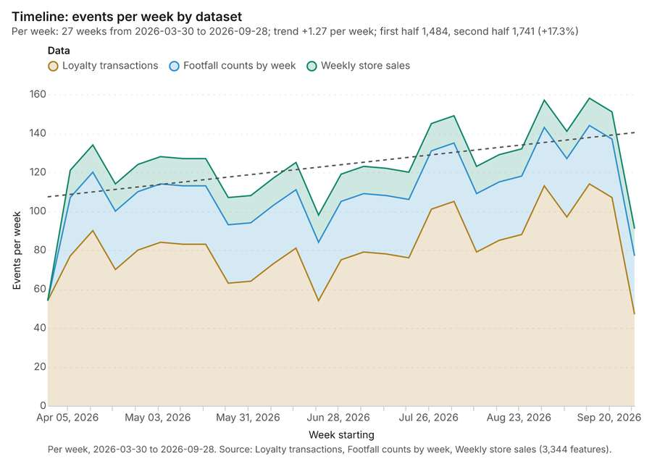
Figure 1. Timeline: events per week by dataset [1]. Per week, 2026-03-30 to 2026-09-28. Source: Loyalty transactions, Footfall counts by week, Weekly store sales (3,344 features). The data is in the appendix.
The timeline counts 3,344 dated events in Loyalty transactions, Footfall counts by week, Weekly store sales per week, from week of 2026-03-30 to week of 2026-09-28 [1][2][3][4]. By dataset: Loyalty transactions 2,200; Footfall counts by week 780; Weekly store sales 364 [1]. The trend is +1.27 events per week; the second half of the weeks has 1,741 against 1,484 in the first (+17.3%) [1].
Busiest weeks
- week of 2026-09-14: 158 events [1]
- week of 2026-08-31: 157 events [1]
- week of 2026-09-21: 151 events [1]
Quietest weeks
- week of 2026-03-30: 54 events [1]
- week of 2026-09-28: 91 events [1]
- week of 2026-06-22: 98 events [1]

Hot spots
What this analysis is. Hot spot analysis: Getis-Ord Gi* hot and cold spots with z-scores, p-values and confidence bins [5]. In ArcGIS it is Find Hot Spots or Hot Spot Analysis (Getis-Ord Gi*); in QGIS, qgis:hotspot (plugin) [5].
Why it was run on this data. 70 points: Getis-Ord Gi* tests whether the concentrations in Competitor stores are statistically significant [6].
What it found. Hot spot analysis was conducted using the Competitor stores layer [8]. The resulting dataset contained 43 features and 43 counts [7].
Result | Value
result, bins | 43
result, count | 43
result, elapsed ms | 5
result, cell size m | 1,000
result, incidents used | 70
result, distance band m | 2,000
billing, cost | 0.0514
billing, list price | 0.0514
billing, upstream cost | 0

Findings
- Evidenced: Hot spots on Competitor stores: Hot spot analysis: 1 layer saved: Hot spot analysis: Competitor stores (43 features) [7][8].
- Evidenced: It reported result, bins 43; result, count 43; result, elapsed ms 5; result, cell size m 1,000; result, incidents used 70; result, distance band m 2,000 [7].
Tool gp_hot_spots; parameters {"project": "e415669e-4f91-46e1-8afb-4604f1d21ffb", "features": {"layer": "Competitor stores (4c436f86)"}, "aggregation": "hexagon", "cell_size_m": 1000.0, "distance_band_m": 2000.0}

Hot spots
What this analysis is. Hot spot analysis: Getis-Ord Gi* hot and cold spots with z-scores, p-values and confidence bins [5]. In ArcGIS it is Find Hot Spots or Hot Spot Analysis (Getis-Ord Gi*); in QGIS, qgis:hotspot (plugin) [5].
Why it was run on this data. 780 points: Getis-Ord Gi* tests whether the concentrations in Footfall counts by week are statistically significant [9].
What it found. Hot spots on Footfall counts by week: Hot spot analysis: 1 layer saved: Hot spot analysis: Footfall counts by week (130 features) [10][11]. It reported result, bins 130; result, count 130; result, elapsed ms 14; result, cell size m 500; result, incidents used 780; result, distance band m 500 [10].
Result | Value
result, bins | 130
result, count | 130
result, elapsed ms | 14
result, cell size m | 500
result, incidents used | 780
result, distance band m | 500
billing, cost | 0.0656
billing, list price | 0.0656
billing, upstream cost | 0

Findings
- Evidenced: Hot spots on Footfall counts by week: Hot spot analysis: 1 layer saved: Hot spot analysis: Footfall counts by week (130 features) [10][11].
- Evidenced: It reported result, bins 130; result, count 130; result, elapsed ms 14; result, cell size m 500; result, incidents used 780; result, distance band m 500 [10].
Tool gp_hot_spots; parameters {"project": "e415669e-4f91-46e1-8afb-4604f1d21ffb", "features": {"layer": "Footfall counts by week (f2397865)"}, "aggregation": "hexagon", "cell_size_m": 500.0, "distance_band_m": 500.0}

Space time hot spots
What this analysis is. Emerging hot spots: Where hot spots are new, consecutive, intensifying, persistent, diminishing, sporadic, oscillating or historical over time [12]. In ArcGIS it is Emerging Hot Spot Analysis or Create Space Time Cube [12].
Why it was run on this data. Footfall counts by week carry dates in 'date': emerging hot spot analysis finds new, intensifying and fading hot spots per week [13].
What it found. Space time hot spots on Footfall counts by week: Emerging hot spots: 1 layer saved: Emerging hot spots: Footfall counts by week (25 features) [11][14]. It reported result, count 25; result, elapsed ms 11; result, resolution 8; result, features used 780; result, time neighbors 0; billing, cost 0.139 [14].
Result | Value
result, count | 25
result, elapsed ms | 11
result, resolution | 8
result, features used | 780
result, time neighbors | 0
billing, cost | 0.139
billing, list price | 0.139
billing, upstream cost | 0

Findings
- Evidenced: Space time hot spots on Footfall counts by week: Emerging hot spots: 1 layer saved: Emerging hot spots: Footfall counts by week (25 features) [11][14].
- Evidenced: It reported result, count 25; result, elapsed ms 11; result, resolution 8; result, features used 780; result, time neighbors 0; billing, cost 0.139 [14].
Tool gp_space_time_hot_spots; parameters {"project": "e415669e-4f91-46e1-8afb-4604f1d21ffb", "features": {"layer": "Footfall counts by week (f2397865)"}, "interval": "week", "bin_shape": "h3", "resolution": 8, "time_field": "date"}

Space time hot spots
What this analysis is. Emerging hot spots: Where hot spots are new, consecutive, intensifying, persistent, diminishing, sporadic, oscillating or historical over time [12]. In ArcGIS it is Emerging Hot Spot Analysis or Create Space Time Cube [12].
Why it was run on this data. Loyalty transactions carry dates in 'purchased_at': emerging hot spot analysis finds new, intensifying and fading hot spots per week [15].
What it found. The analysis utilized the Loyalty transactions data [17] to identify emerging hot spots [16].
Result | Value
result, count | 395
result, elapsed ms | 66
result, resolution | 9
result, features used | 2,200
result, time neighbors | 0
billing, cost | 0.21
billing, list price | 0.21
billing, upstream cost | 0

Findings
- Evidenced: Space time hot spots on Loyalty transactions: Emerging hot spots: 1 layer saved: Emerging hot spots: Loyalty transactions (395 features) [16][17].
- Evidenced: It reported result, count 395; result, elapsed ms 66; result, resolution 9; result, features used 2,200; result, time neighbors 0; billing, cost 0.21 [16].
Tool gp_space_time_hot_spots; parameters {"project": "e415669e-4f91-46e1-8afb-4604f1d21ffb", "features": {"layer": "Loyalty transactions (aa524a0b)"}, "interval": "week", "bin_shape": "h3", "resolution": 9, "time_field": "purchased_at"}

Calculate density
What this analysis is. Calculate density: Kernel density per square kilometer on a grid [18]. In ArcGIS it is Calculate Density or Kernel Density; in QGIS, native:heatmapkerneldensityestimation [18].
Why it was run on this data. 70 points in Competitor stores: a density surface shows where they concentrate [19].
What it found. Calculate density on Competitor stores: Calculate density: 1 layer saved: Calculate density: Competitor stores (322 features) [8][20]. It reported result, count 322; result, elapsed ms 15; result, bandwidth m 2,000; result, cell size m 500; result, excluded null 0; result, max density per km2 2.995 [20].
Result | Value
result, count | 322
result, elapsed ms | 15
result, bandwidth m | 2,000
result, cell size m | 500
result, excluded null | 0
result, max density per km2 | 2.995
billing, cost | 0.0514
billing, list price | 0.0514
billing, upstream cost | 0

Findings
- Evidenced: Calculate density on Competitor stores: Calculate density: 1 layer saved: Calculate density: Competitor stores (322 features) [8][20].
- Evidenced: It reported result, count 322; result, elapsed ms 15; result, bandwidth m 2,000; result, cell size m 500; result, excluded null 0; result, max density per km2 2.995 [20].
A model draft was discarded because a sentence did not cite a source of this section.
Tool gp_calculate_density; parameters {"kernel": "quartic", "project": "e415669e-4f91-46e1-8afb-4604f1d21ffb", "features": {"layer": "Competitor stores (4c436f86)"}, "bandwidth_m": 2000.0, "cell_size_m": 500.0}

Calculate density
What this analysis is. Calculate density: Kernel density per square kilometer on a grid [18]. In ArcGIS it is Calculate Density or Kernel Density; in QGIS, native:heatmapkerneldensityestimation [18].
Why it was run on this data. 780 points in Footfall counts by week: a density surface shows where they concentrate [21].
What it found. Calculate density on Footfall counts by week: Calculate density: 1 layer saved: Calculate density: Footfall counts by week (428 features) [11][22]. It reported result, count 428; result, elapsed ms 19; result, bandwidth m 500; result, cell size m 200; result, excluded null 0; result, max density per km2 195.5 [22].
Result | Value
result, count | 428
result, elapsed ms | 19
result, bandwidth m | 500
result, cell size m | 200
result, excluded null | 0
result, max density per km2 | 195.5
billing, cost | 0.0656
billing, list price | 0.0656
billing, upstream cost | 0

Findings
- Evidenced: Calculate density on Footfall counts by week: Calculate density: 1 layer saved: Calculate density: Footfall counts by week (428 features) [11][22].
- Evidenced: It reported result, count 428; result, elapsed ms 19; result, bandwidth m 500; result, cell size m 200; result, excluded null 0; result, max density per km2 195.5 [22].
A model draft was discarded because a sentence did not cite a source of this section.
Tool gp_calculate_density; parameters {"kernel": "quartic", "project": "e415669e-4f91-46e1-8afb-4604f1d21ffb", "features": {"layer": "Footfall counts by week (f2397865)"}, "bandwidth_m": 500.0, "cell_size_m": 200.0}

Calculate density
What this analysis is. Calculate density: Kernel density per square kilometer on a grid [18]. In ArcGIS it is Calculate Density or Kernel Density; in QGIS, native:heatmapkerneldensityestimation [18].
Why it was run on this data. 2200 points in Loyalty transactions: a density surface shows where they concentrate [23].
What it found. Calculate density on Loyalty transactions: Calculate density: 1 layer saved: Calculate density: Loyalty transactions (3864 features) [17][24]. It reported result, count 3,864; result, elapsed ms 134; result, bandwidth m 200; result, cell size m 100; result, excluded null 0; result, max density per km2 386.8 [24].
Result | Value
result, count | 3,864
result, elapsed ms | 134
result, bandwidth m | 200
result, cell size m | 100
result, excluded null | 0
result, max density per km2 | 386.8
billing, cost | 0.094
billing, list price | 0.094
billing, upstream cost | 0

Findings
- Evidenced: Calculate density on Loyalty transactions: Calculate density: 1 layer saved: Calculate density: Loyalty transactions (3864 features) [17][24].
- Evidenced: It reported result, count 3,864; result, elapsed ms 134; result, bandwidth m 200; result, cell size m 100; result, excluded null 0; result, max density per km2 386.8 [24].
Tool gp_calculate_density; parameters {"kernel": "quartic", "project": "e415669e-4f91-46e1-8afb-4604f1d21ffb", "features": {"layer": "Loyalty transactions (aa524a0b)"}, "bandwidth_m": 200.0, "cell_size_m": 100.0}

Summarize within
What this analysis is. Summarize within: Count and aggregate the features inside each polygon (or bin), proportionally for lines and polygons [25]. In ArcGIS it is Summarize Within or Aggregate Points; in QGIS, native:countpointsinpolygon or native:sumlinelengths [25].
Why it was run on this data. Count Stores inside each feature of Trade areas by format; the counts map as a choropleth (natural breaks, sequential colors) [26].
What it found. Summarize within on Stores, Trade areas: Summarize within: 1 layer saved: Summarize within: Trade areas (14 features) [27][28][29]. It reported result, count 14; result, elapsed ms 1; billing, cost 0.01058; billing, list price 0.01058; billing, upstream cost 0 [27].
Result | Value
result, count | 14
result, elapsed ms | 1
billing, cost | 0.01058
billing, list price | 0.01058
billing, upstream cost | 0

Findings
- Evidenced: Summarize within on Stores, Trade areas: Summarize within: 1 layer saved: Summarize within: Trade areas (14 features) [27][28][29].
- Evidenced: It reported result, count 14; result, elapsed ms 1; billing, cost 0.01058; billing, list price 0.01058; billing, upstream cost 0 [27].
Tool gp_summarize_within; parameters {"stats": [{"stat": "sum", "field": "sales_gbp_week"}], "project": "e415669e-4f91-46e1-8afb-4604f1d21ffb", "features": {"layer": "Stores (18363c3a)"}, "group_by": "format", "polygons": {"layer": "Trade areas (e712834d)"}}

Summarize within
What this analysis is. Summarize within: Count and aggregate the features inside each polygon (or bin), proportionally for lines and polygons [25]. In ArcGIS it is Summarize Within or Aggregate Points; in QGIS, native:countpointsinpolygon or native:sumlinelengths [25].
Why it was run on this data. Count Stores inside each feature of Trade areas by format; the counts map as a choropleth (natural breaks, sequential colors) [26].
What it found. Summarize within on Competitor stores, Trade areas: Summarize within: 1 layer saved: Summarize within: Trade areas (14 features) [8][29][30]. It reported result, count 14; result, elapsed ms 0; billing, cost 0.0117; billing, list price 0.0117; billing, upstream cost 0 [30].
Result | Value
result, count | 14
result, elapsed ms | 0
billing, cost | 0.0117
billing, list price | 0.0117
billing, upstream cost | 0

Findings
- Evidenced: Summarize within on Competitor stores, Trade areas: Summarize within: 1 layer saved: Summarize within: Trade areas (14 features) [8][29][30].
- Evidenced: It reported result, count 14; result, elapsed ms 0; billing, cost 0.0117; billing, list price 0.0117; billing, upstream cost 0 [30].
Tool gp_summarize_within; parameters {"stats": [{"stat": "sum", "field": "est_sales_gbp_week"}], "project": "e415669e-4f91-46e1-8afb-4604f1d21ffb", "features": {"layer": "Competitor stores (4c436f86)"}, "group_by": "brand", "polygons": {"layer": "Trade areas (e712834d)"}}

Summarize within
What this analysis is. Summarize within: Count and aggregate the features inside each polygon (or bin), proportionally for lines and polygons [25]. In ArcGIS it is Summarize Within or Aggregate Points; in QGIS, native:countpointsinpolygon or native:sumlinelengths [25].
Why it was run on this data. Count Stores inside each feature of Trade areas by format; the counts map as a choropleth (natural breaks, sequential colors) [26].
What it found. Summarize within on Footfall counts by week, Trade areas: Summarize within: 1 layer saved: Summarize within: Trade areas (14 features) [11][29][31]. It reported result, count 14; result, elapsed ms 2; billing, cost 0.0259; billing, list price 0.0259; billing, upstream cost 0 [31].
Result | Value
result, count | 14
result, elapsed ms | 2
billing, cost | 0.0259
billing, list price | 0.0259
billing, upstream cost | 0

Findings
- Evidenced: Summarize within on Footfall counts by week, Trade areas: Summarize within: 1 layer saved: Summarize within: Trade areas (14 features) [11][29][31].
- Evidenced: It reported result, count 14; result, elapsed ms 2; billing, cost 0.0259; billing, list price 0.0259; billing, upstream cost 0 [31].
Tool gp_summarize_within; parameters {"stats": [{"stat": "sum", "field": "visitors"}], "project": "e415669e-4f91-46e1-8afb-4604f1d21ffb", "features": {"layer": "Footfall counts by week (f2397865)"}, "polygons": {"layer": "Trade areas (e712834d)"}}

Find point clusters
What this analysis is. Find point clusters: Density-based clusters (DBSCAN, HDBSCAN or OPTICS, optionally space-time) with hulls and noise [32]. In ArcGIS it is Find Point Clusters or Density-based Clustering; in QGIS, native:dbscanclustering or native:stdbscanclustering [32].
Why it was run on this data. DBSCAN finds dense groups of Stores and separates noise [33].
What it found. Find point clusters on Stores: Find point clusters: 2 layers saved: Find point clusters: Stores (14 features); Find point clusters: cluster hulls (1 feature) [28][34]. It reported result, count 14; result, noise 0; result, distance m 2,000; result, elapsed ms 5; result, min points 3; billing, cost 0.05028 [34].
Result | Value
result, count | 14
result, noise | 0
result, distance m | 2,000
result, elapsed ms | 5
result, min points | 3
billing, cost | 0.05028
billing, list price | 0.05028
billing, upstream cost | 0

Findings
- Evidenced: Find point clusters on Stores: Find point clusters: 2 layers saved: Find point clusters: Stores (14 features); Find point clusters: cluster hulls (1 feature) [28][34].
- Evidenced: It reported result, count 14; result, noise 0; result, distance m 2,000; result, elapsed ms 5; result, min points 3; billing, cost 0.05028 [34].
Tool gp_find_point_clusters; parameters {"method": "dbscan", "project": "e415669e-4f91-46e1-8afb-4604f1d21ffb", "features": {"layer": "Stores (18363c3a)"}, "distance_m": 2000.0, "min_points": 3}

Find point clusters
What this analysis is. Find point clusters: Density-based clusters (DBSCAN, HDBSCAN or OPTICS, optionally space-time) with hulls and noise [32]. In ArcGIS it is Find Point Clusters or Density-based Clustering; in QGIS, native:dbscanclustering or native:stdbscanclustering [32].
Why it was run on this data. DBSCAN finds dense groups of Competitor stores and separates noise [35].
What it found. The `gp_find_point_clusters` tool was executed using the Competitor stores dataset [8]. This analysis saved two layers, including Competitor stores with 70 features and cluster hulls with 2 features [36]. The tool returned 70 results and 2 noise points [36]. The entire process completed with an elapsed time of 3 milliseconds [36], and the associated billing cost was 0.0514 [36].
Result | Value
result, count | 70
result, noise | 2
result, distance m | 1,000
result, elapsed ms | 3
result, min points | 3
billing, cost | 0.0514
billing, list price | 0.0514
billing, upstream cost | 0

Findings
- Evidenced: Find point clusters on Competitor stores: Find point clusters: 2 layers saved: Find point clusters: Competitor stores (70 features); Find point clusters: cluster hulls (2 features) [8][36].
- Evidenced: It reported result, count 70; result, noise 2; result, distance m 1,000; result, elapsed ms 3; result, min points 3; billing, cost 0.0514 [36].
Tool gp_find_point_clusters; parameters {"method": "dbscan", "project": "e415669e-4f91-46e1-8afb-4604f1d21ffb", "features": {"layer": "Competitor stores (4c436f86)"}, "distance_m": 1000.0, "min_points": 3}

Find point clusters
What this analysis is. Find point clusters: Density-based clusters (DBSCAN, HDBSCAN or OPTICS, optionally space-time) with hulls and noise [32]. In ArcGIS it is Find Point Clusters or Density-based Clustering; in QGIS, native:dbscanclustering or native:stdbscanclustering [32].
Why it was run on this data. DBSCAN finds dense groups of Footfall counts by week and separates noise [37].
What it found. Find point clusters on Footfall counts by week: Find point clusters: 2 layers saved: Find point clusters: Footfall counts by week (780 features); Find point clusters: cluster hulls (30 features) [11][38]. It reported result, count 780; result, noise 0; result, distance m 200; result, elapsed ms 29; result, min points 20; billing, cost 0.0656 [38].
Result | Value
result, count | 780
result, noise | 0
result, distance m | 200
result, elapsed ms | 29
result, min points | 20
billing, cost | 0.0656
billing, list price | 0.0656
billing, upstream cost | 0

Findings
- Evidenced: Find point clusters on Footfall counts by week: Find point clusters: 2 layers saved: Find point clusters: Footfall counts by week (780 features); Find point clusters: cluster hulls (30 features) [11][38].
- Evidenced: It reported result, count 780; result, noise 0; result, distance m 200; result, elapsed ms 29; result, min points 20; billing, cost 0.0656 [38].
Tool gp_find_point_clusters; parameters {"method": "dbscan", "project": "e415669e-4f91-46e1-8afb-4604f1d21ffb", "features": {"layer": "Footfall counts by week (f2397865)"}, "distance_m": 200.0, "min_points": 20}

Hot spots
What this analysis is. Hot spot analysis: Getis-Ord Gi* hot and cold spots with z-scores, p-values and confidence bins [5]. In ArcGIS it is Find Hot Spots or Hot Spot Analysis (Getis-Ord Gi*); in QGIS, qgis:hotspot (plugin) [5].
Why it was run on this data. 2200 points: Getis-Ord Gi* tests whether the concentrations in Loyalty transactions are statistically significant [39].
What it found. Hot spots on Loyalty transactions: Hot spot analysis: 1 layer saved: Hot spot analysis: Loyalty transactions (1071 features) [17][40]. It reported result, bins 1,071; result, count 1,071; result, elapsed ms 59; result, cell size m 200; result, incidents used 2,200; result, distance band m 200 [40].
Result | Value
result, bins | 1,071
result, count | 1,071
result, elapsed ms | 59
result, cell size m | 200
result, incidents used | 2,200
result, distance band m | 200
billing, cost | 0.094
billing, list price | 0.094
billing, upstream cost | 0

Findings
- Evidenced: Hot spots on Loyalty transactions: Hot spot analysis: 1 layer saved: Hot spot analysis: Loyalty transactions (1071 features) [17][40].
- Evidenced: It reported result, bins 1,071; result, count 1,071; result, elapsed ms 59; result, cell size m 200; result, incidents used 2,200; result, distance band m 200 [40].
Tool gp_hot_spots; parameters {"project": "e415669e-4f91-46e1-8afb-4604f1d21ffb", "features": {"layer": "Loyalty transactions (aa524a0b)"}, "aggregation": "hexagon", "cell_size_m": 200.0, "distance_band_m": 200.0}

Near repeat
What this analysis is. Repeat and near repeat classification: Classify incidents as originators, repeats (same place) or near repeats within a distance and time window, with a Knox test table [41]. In ArcGIS it is Repeat and Near Repeat Classification or Near Repeat Calculator [41].
Why it was run on this data. Near repeat analysis tests whether Footfall counts by week close in space also follow each other within 18 days [42].
What it found. Near repeat on Footfall counts by week: Repeat and near repeat classification: 1 layer saved: Repeat and near repeat classification: Footfall counts by week (780 features) [11][43]. It reported result, days 18; result, count 780; result, chains 30; result, distance m 200; result, elapsed ms 40; result, pairs linked 1,470 [43].
Result | Value
result, days | 18
result, count | 780
result, chains | 30
result, distance m | 200
result, elapsed ms | 40
result, pairs linked | 1,470
billing, cost | 0.0734
billing, list price | 0.0734
billing, upstream cost | 0

Findings
- Evidenced: Near repeat on Footfall counts by week: Repeat and near repeat classification: 1 layer saved: Repeat and near repeat classification: Footfall counts by week (780 features) [11][43].
- Evidenced: It reported result, days 18; result, count 780; result, chains 30; result, distance m 200; result, elapsed ms 40; result, pairs linked 1,470 [43].
Tool gp_near_repeat; parameters {"days": 18, "project": "e415669e-4f91-46e1-8afb-4604f1d21ffb", "features": {"layer": "Footfall counts by week (f2397865)"}, "distance_m": 200.0, "time_field": "date"}

Maps and charts
The run also made 20 map image(s) [44][45][46][47][48][49][50][51][52][53][54][55][56][57][58][59][60][61][62][63] and 22 chart(s) [64][65][66][67][68][69][70][71][72][73][74][75][76][77][78][79][80][81][82][83][84][85].
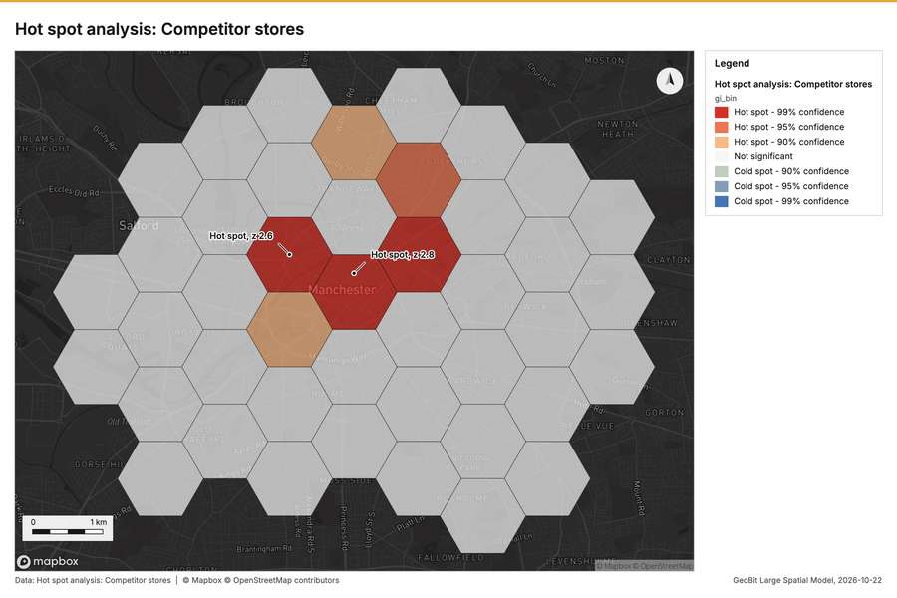
Figure 2. Hot spot analysis: Competitor stores [44]
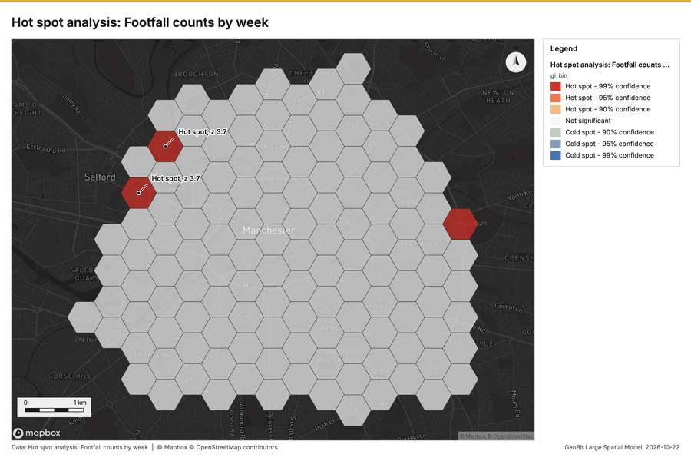
Figure 3. Hot spot analysis: Footfall counts by week [45]
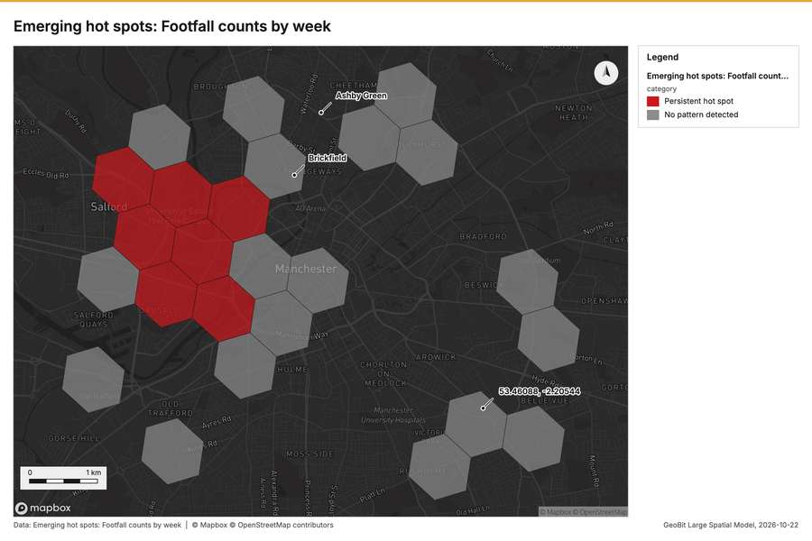
Figure 4. Emerging hot spots: Footfall counts by week [46]
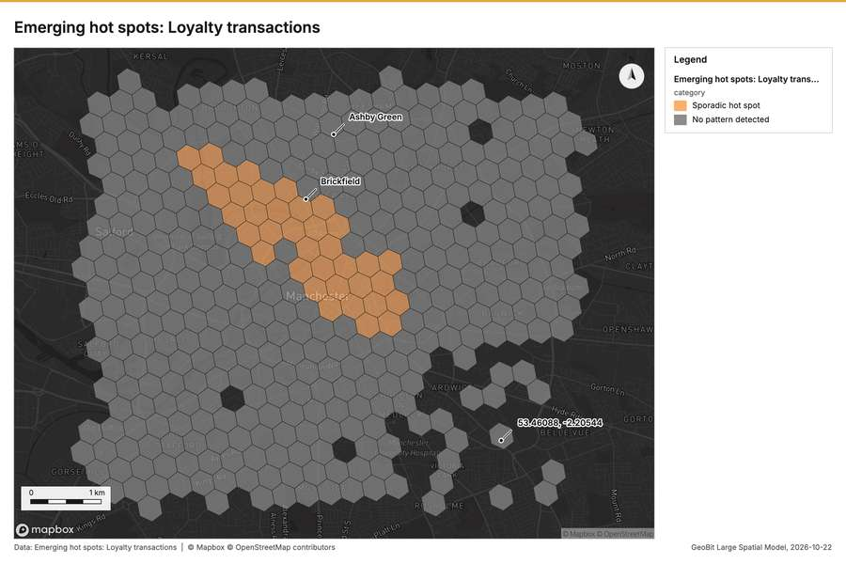
Figure 5. Emerging hot spots: Loyalty transactions [47]
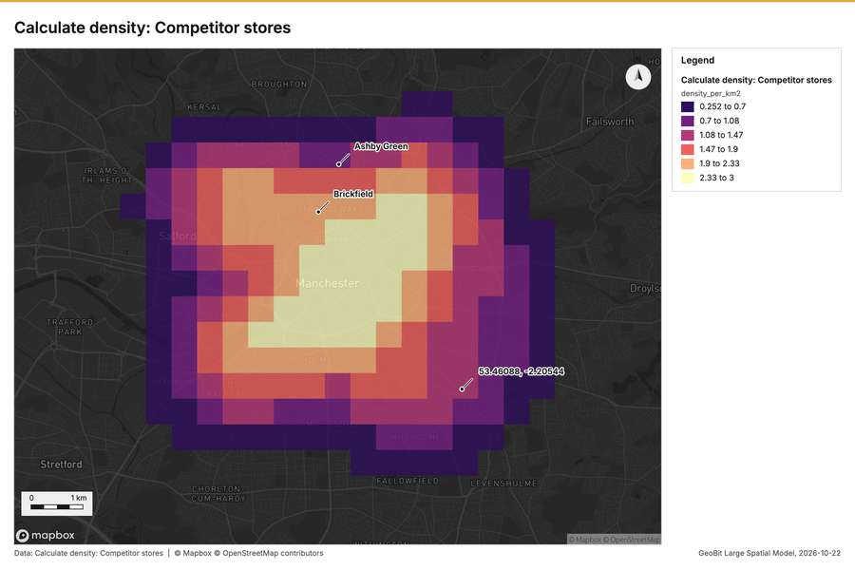
Figure 6. Calculate density: Competitor stores [48]
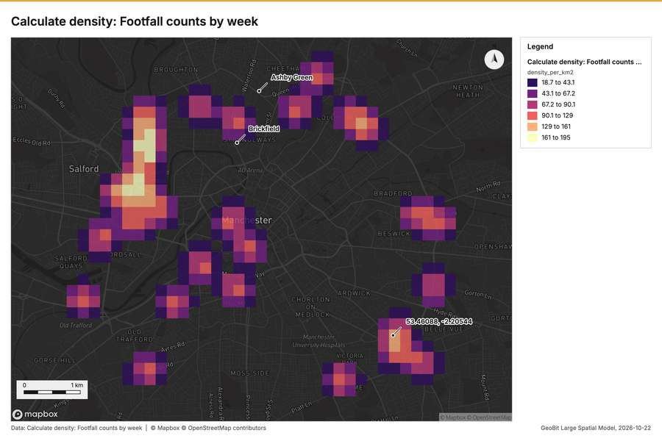
Figure 7. Calculate density: Footfall counts by week [49]
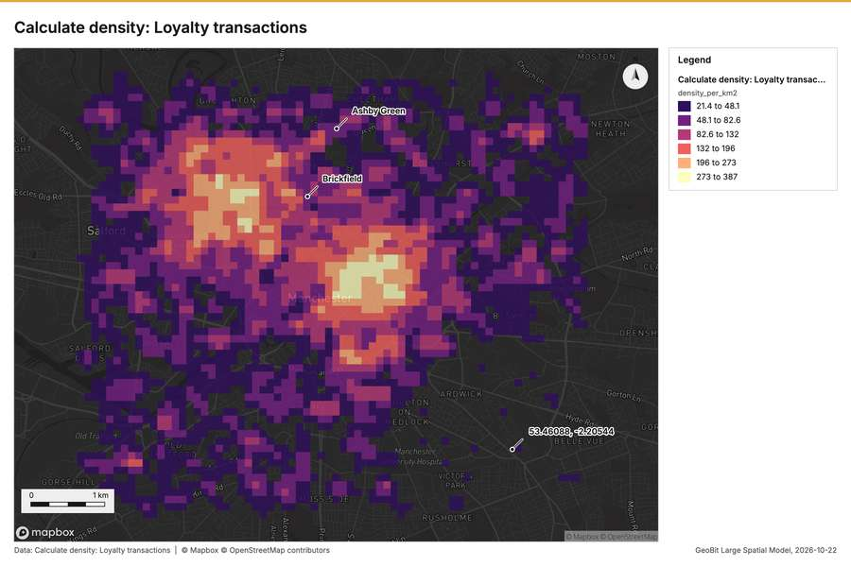
Figure 8. Calculate density: Loyalty transactions [50]
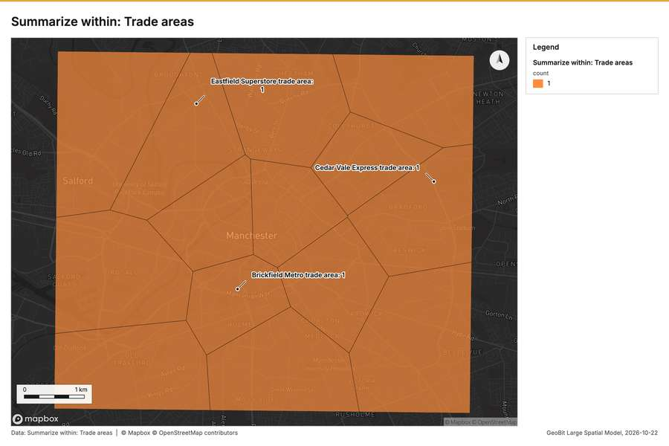
Figure 9. Summarize within: Trade areas [51]
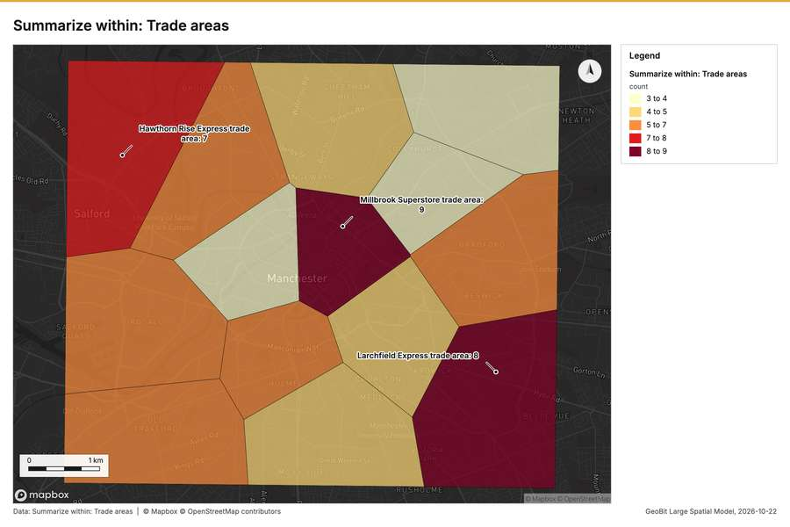
Figure 10. Summarize within: Trade areas [52]
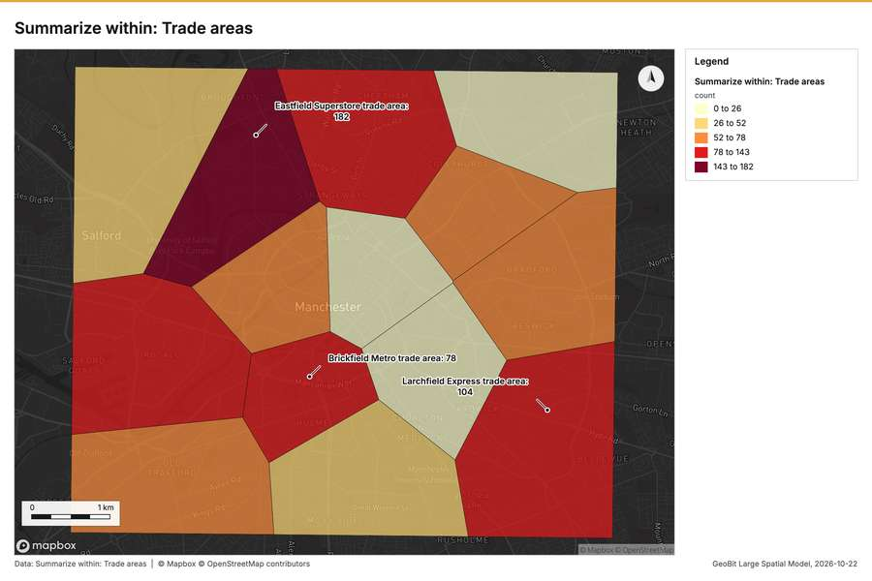
Figure 11. Summarize within: Trade areas [53]
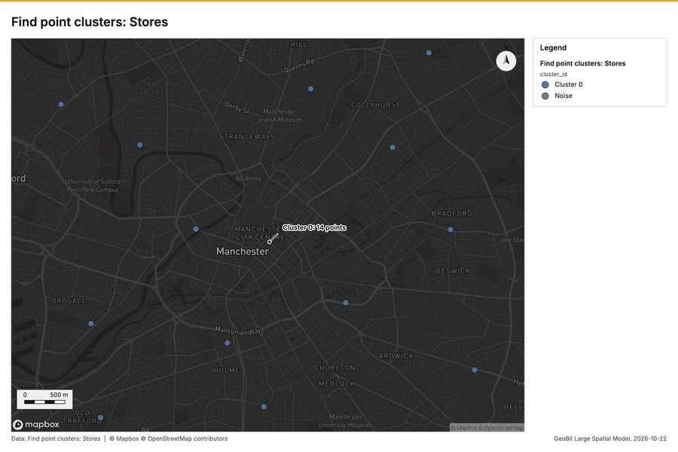
Figure 12. Find point clusters: Stores [54]
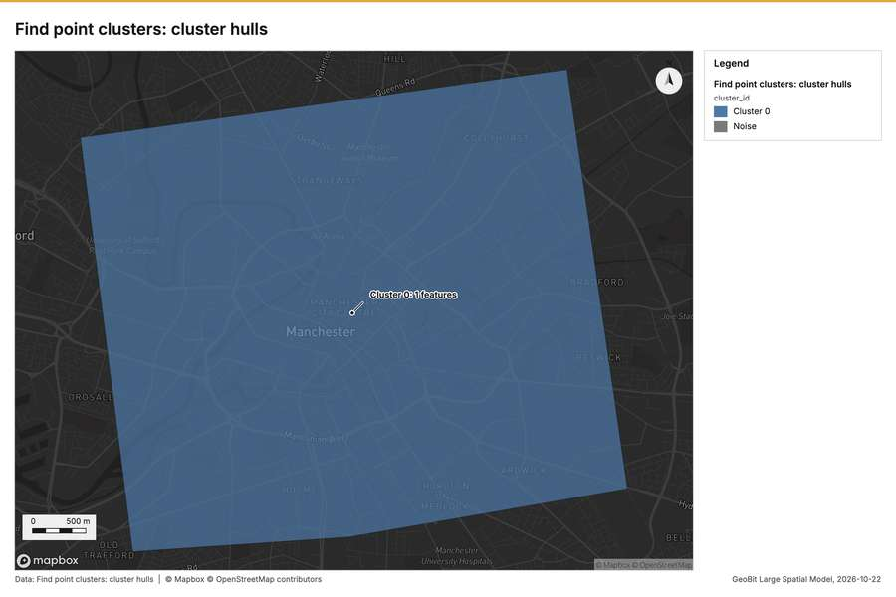
Figure 13. Find point clusters: cluster hulls [55]
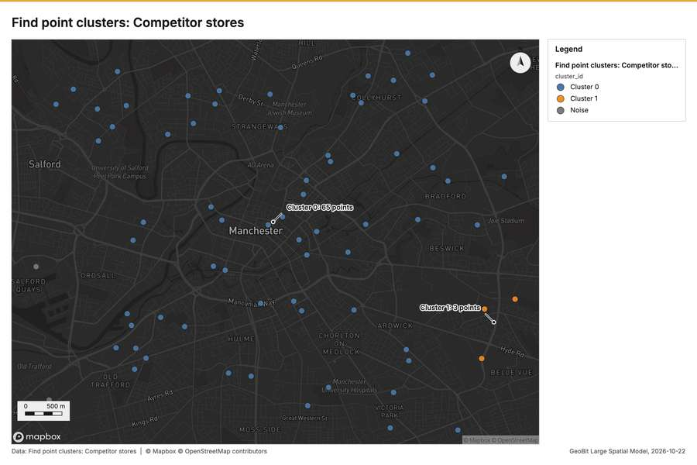
Figure 14. Find point clusters: Competitor stores [56]
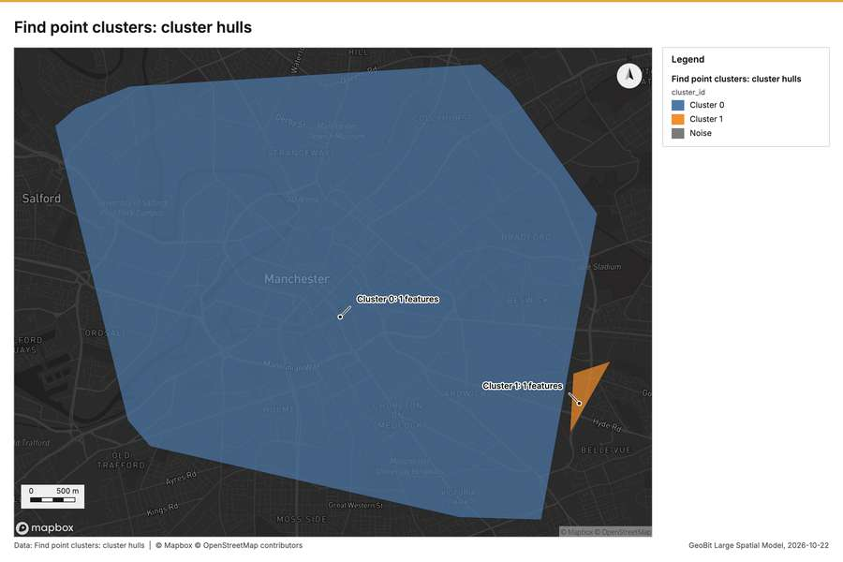
Figure 15. Find point clusters: cluster hulls [57]
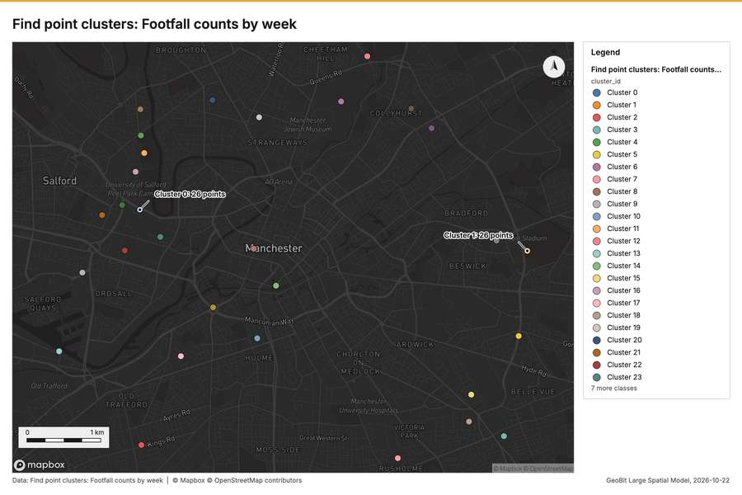
Figure 16. Find point clusters: Footfall counts by week [58]
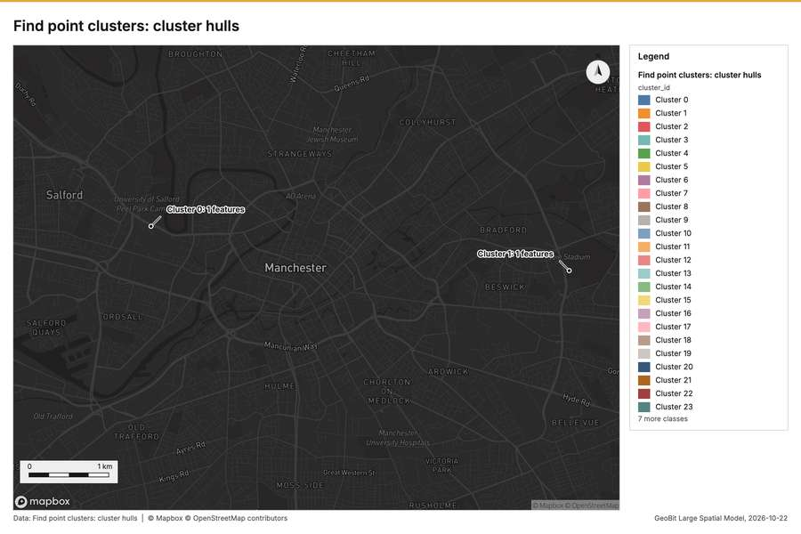
Figure 17. Find point clusters: cluster hulls [59]
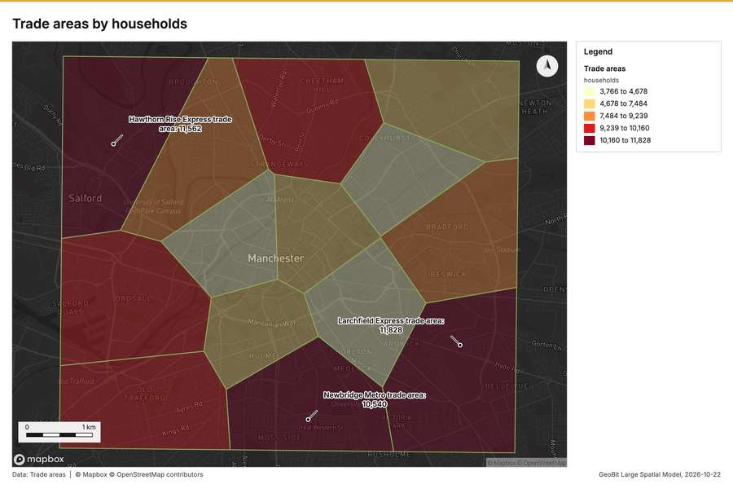
Figure 18. Trade areas by households [60]
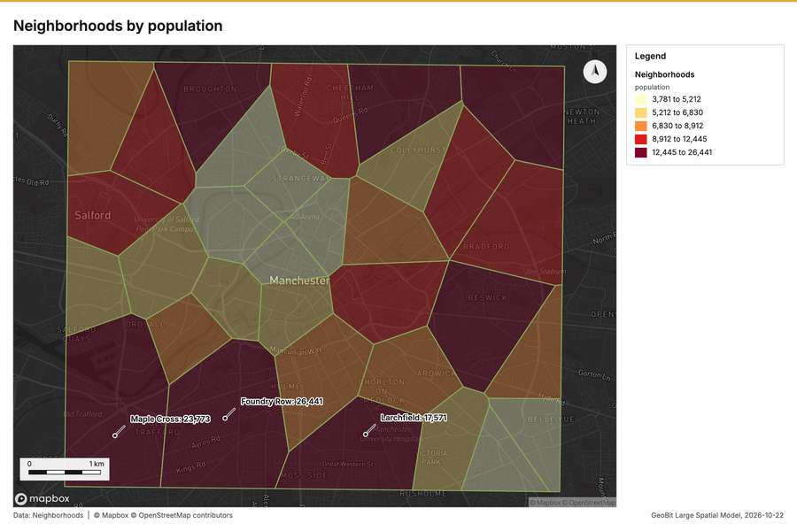
Figure 19. Neighborhoods by population [61]
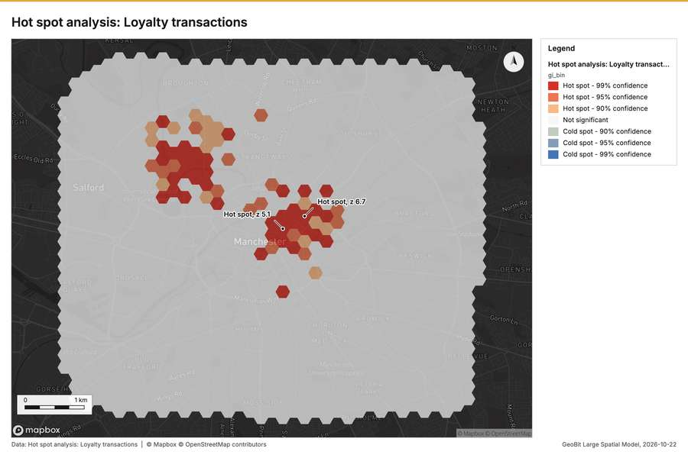
Figure 20. Hot spot analysis: Loyalty transactions [62]
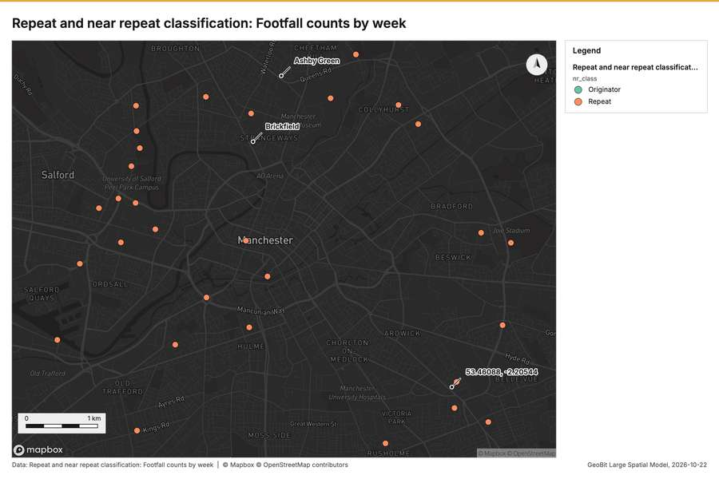
Figure 21. Repeat and near repeat classification: Footfall counts by week [63]
What the map shows. The "Hot spot analysis: Competitor stores" shows a noticeable cluster of high activity located in the [44]
Inferred: read from the image by gemma4:e4b, not evidence.
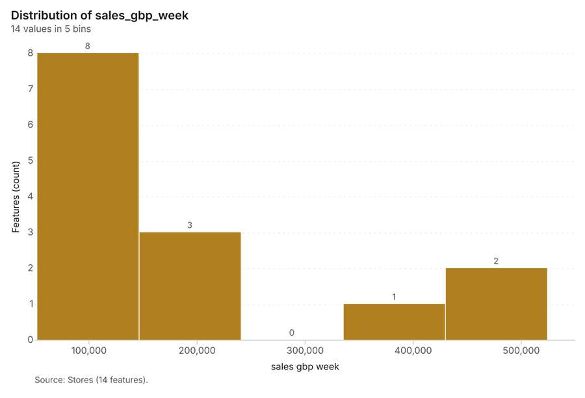
Figure 22. Stores over time (opened_year) [64]. Source: Stores (14 features). The data is in the appendix.
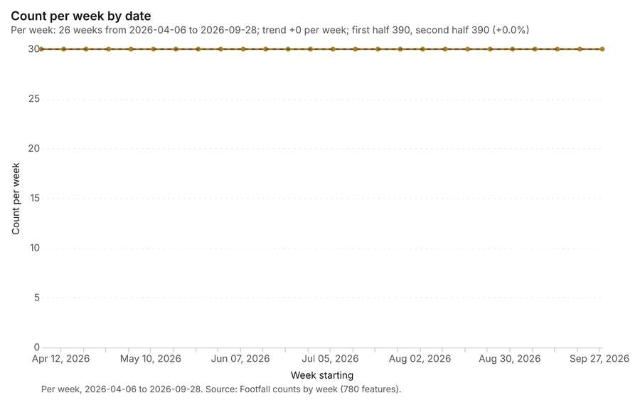
Figure 23. Footfall counts by week over time (date) [65]. Per week, 2026-04-06 to 2026-09-28. Source: Footfall counts by week (780 features). The data is in the appendix.
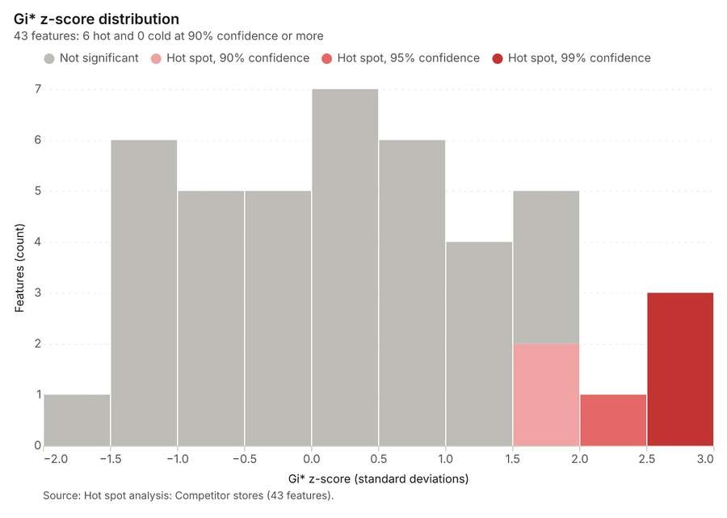
Figure 24. Hot spot analysis: Competitor stores [66]. Source: Hot spot analysis: Competitor stores (43 features). The data is in the appendix.
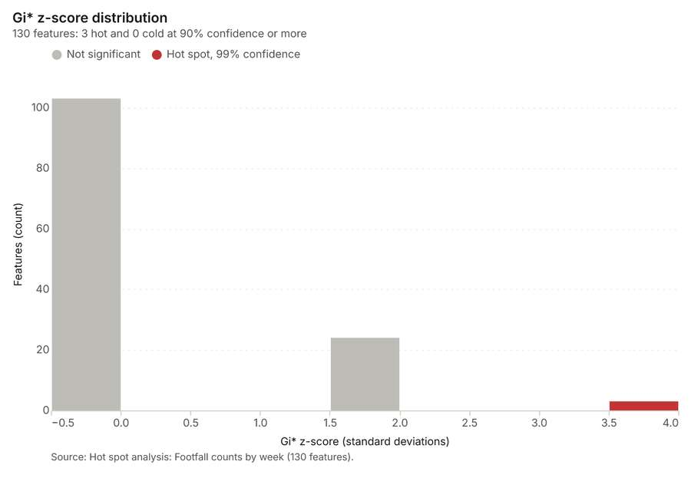
Figure 25. Hot spot analysis: Footfall counts by week [67]. Source: Hot spot analysis: Footfall counts by week (130 features). The data is in the appendix.
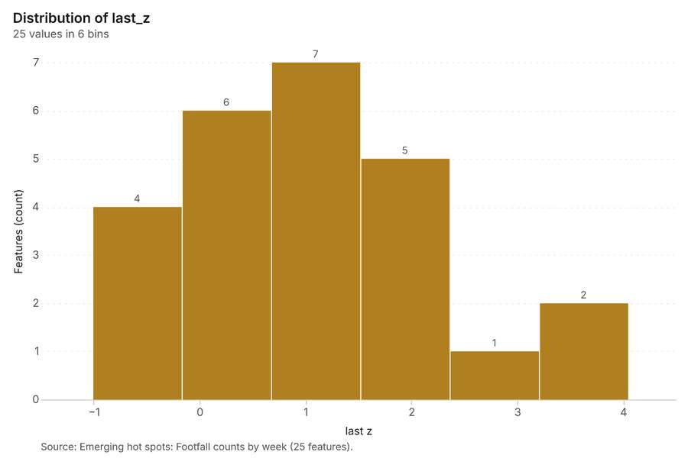
Figure 26. Emerging hot spots: Footfall counts by week [68]. Source: Emerging hot spots: Footfall counts by week (25 features). The data is in the appendix.
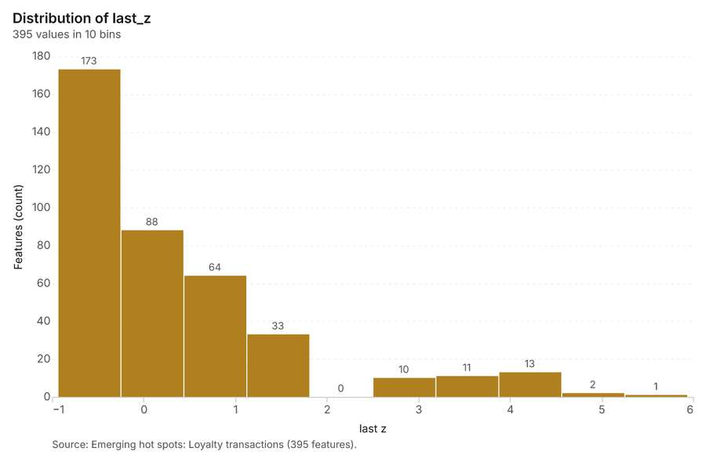
Figure 27. Emerging hot spots: Loyalty transactions [69]. Source: Emerging hot spots: Loyalty transactions (395 features). The data is in the appendix.
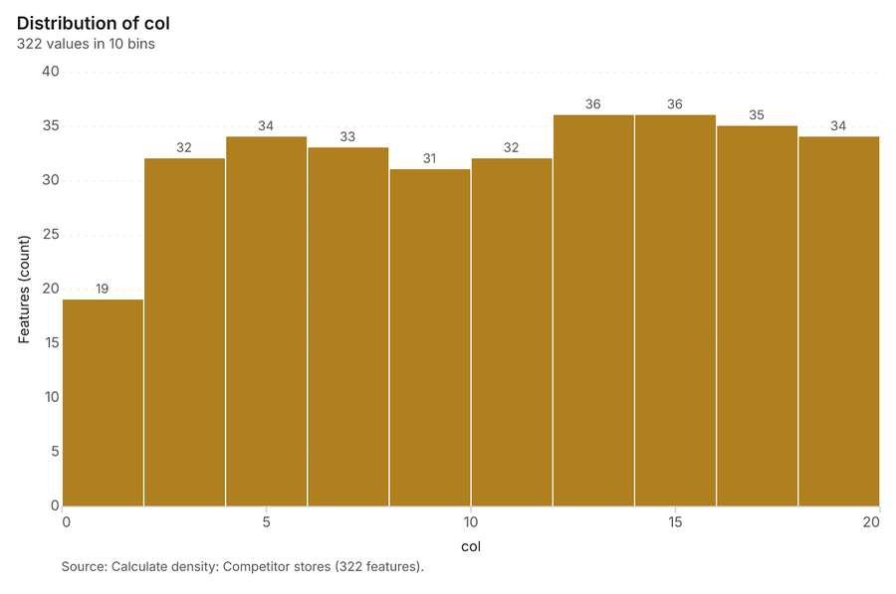
Figure 28. Calculate density: Competitor stores [70]. Source: Calculate density: Competitor stores (322 features). The data is in the appendix.
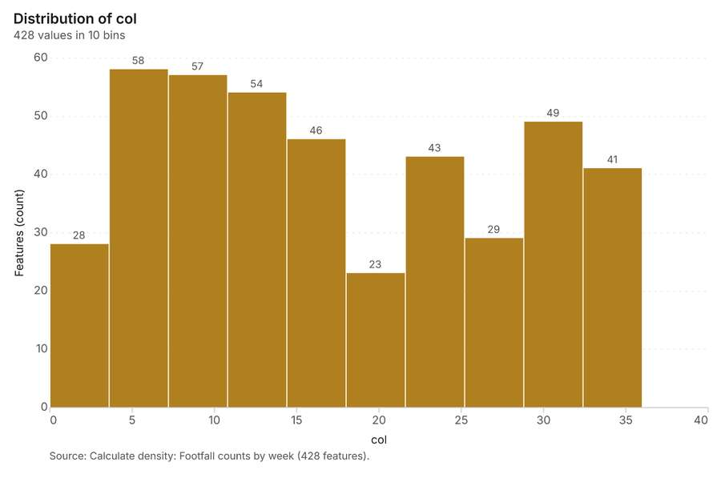
Figure 29. Calculate density: Footfall counts by week [71]. Source: Calculate density: Footfall counts by week (428 features). The data is in the appendix.
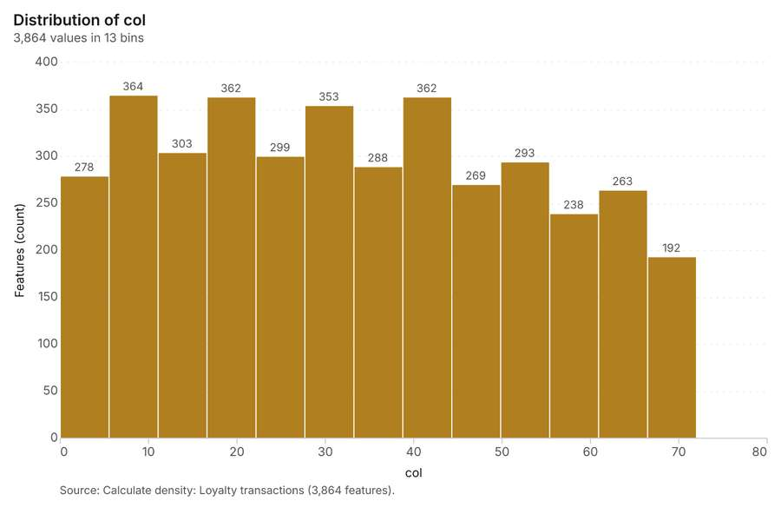
Figure 30. Calculate density: Loyalty transactions [72]. Source: Calculate density: Loyalty transactions (3,864 features). The data is in the appendix.
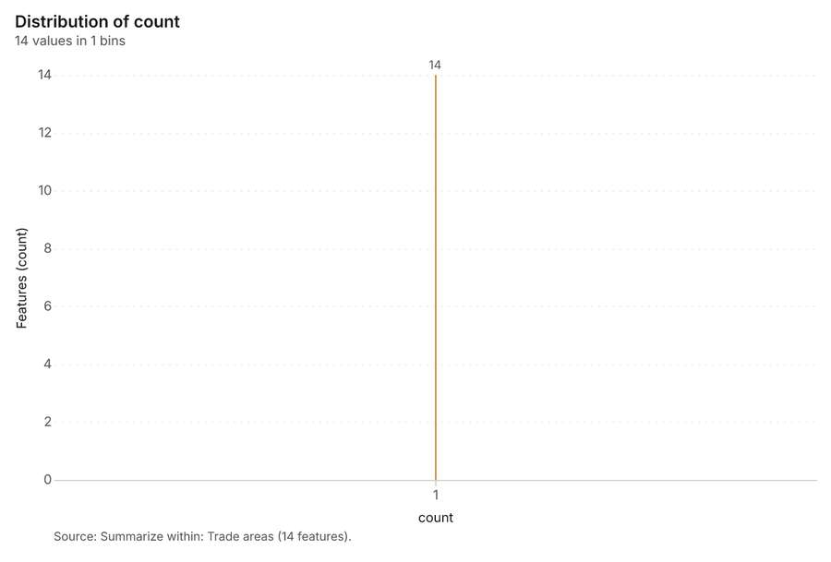
Figure 31. Summarize within: Trade areas [73]. Source: Summarize within: Trade areas (14 features). The data is in the appendix.
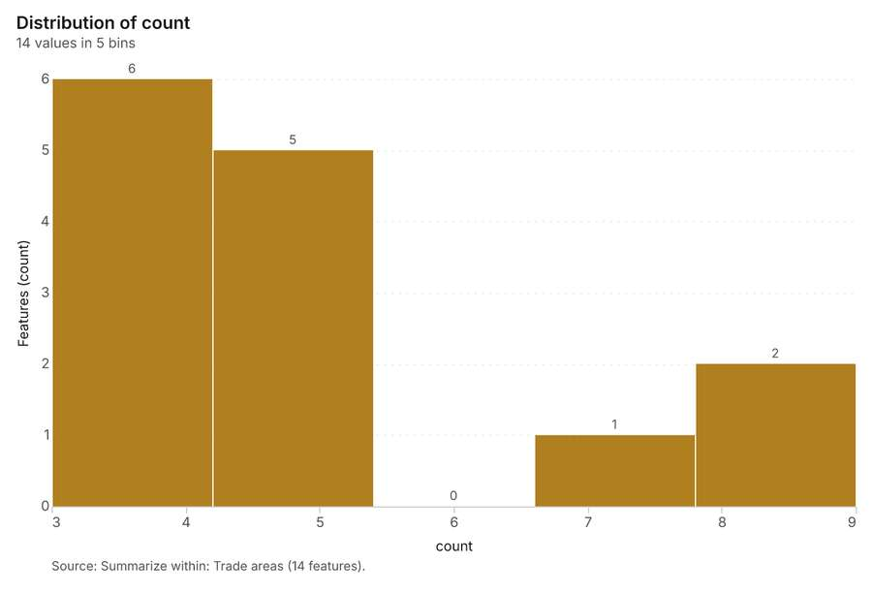
Figure 32. Summarize within: Trade areas [74]. Source: Summarize within: Trade areas (14 features). The data is in the appendix.
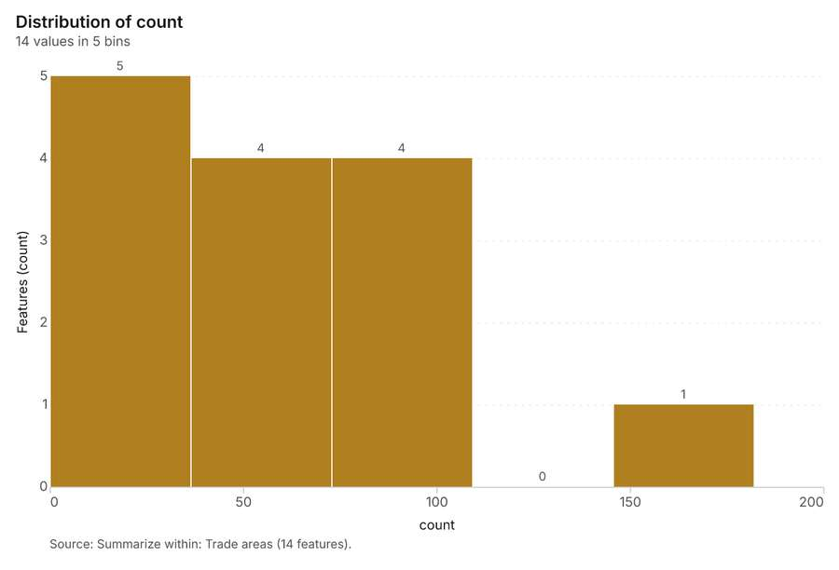
Figure 33. Summarize within: Trade areas [75]. Source: Summarize within: Trade areas (14 features). The data is in the appendix.
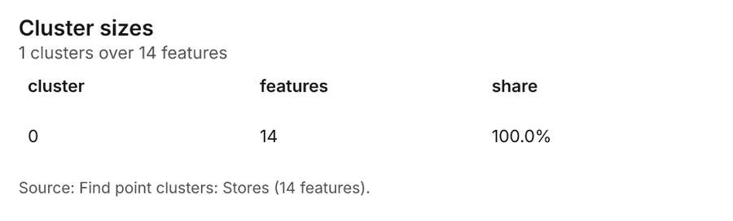
Figure 34. Find point clusters: Stores [76]. Source: Find point clusters: Stores (14 features). The data is in the appendix.
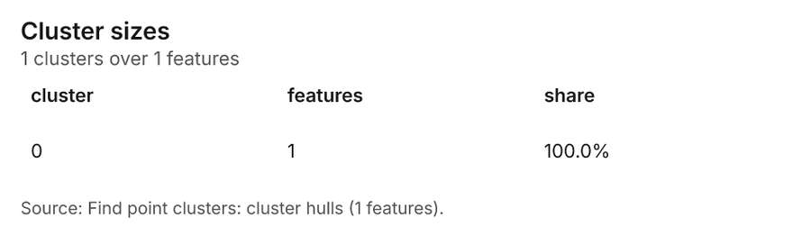
Figure 35. Find point clusters: cluster hulls [77]. Source: Find point clusters: cluster hulls (1 features). The data is in the appendix.
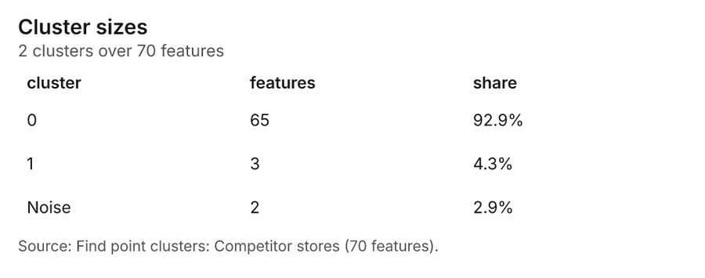
Figure 36. Find point clusters: Competitor stores [78]. Source: Find point clusters: Competitor stores (70 features). The data is in the appendix.
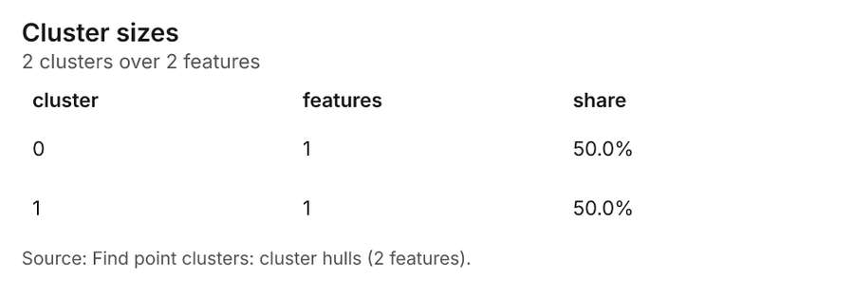
Figure 37. Find point clusters: cluster hulls [79]. Source: Find point clusters: cluster hulls (2 features). The data is in the appendix.
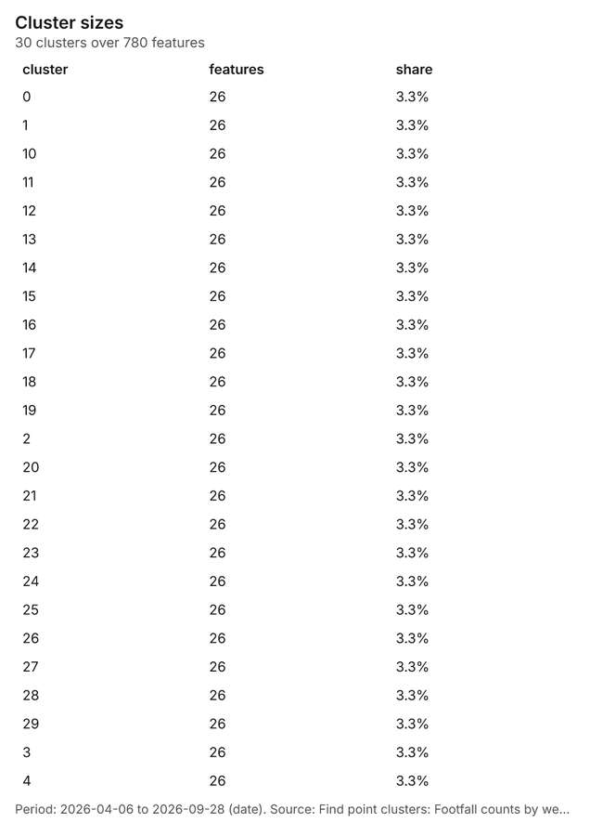
Figure 38. Find point clusters: Footfall counts by week [80]. Period: 2026-04-06 to 2026-09-28 (date). Source: Find point clusters: Footfall counts by week (780 features). The data is in the appendix.
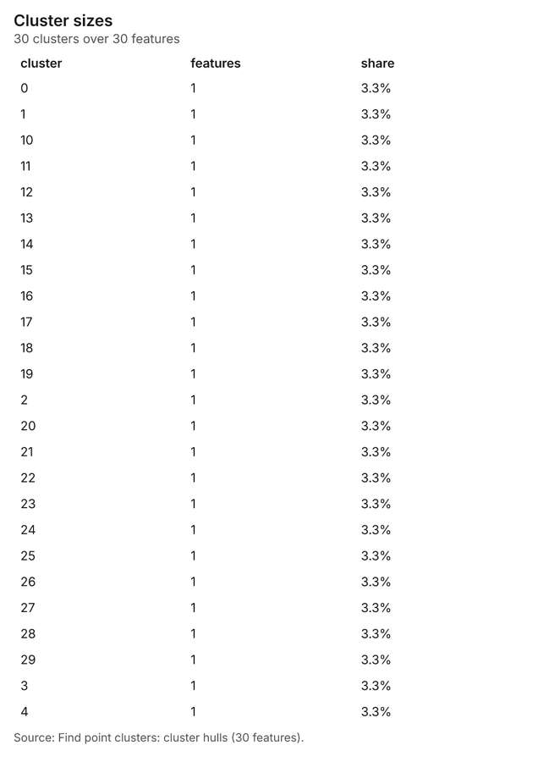
Figure 39. Find point clusters: cluster hulls [81]. Source: Find point clusters: cluster hulls (30 features). The data is in the appendix.
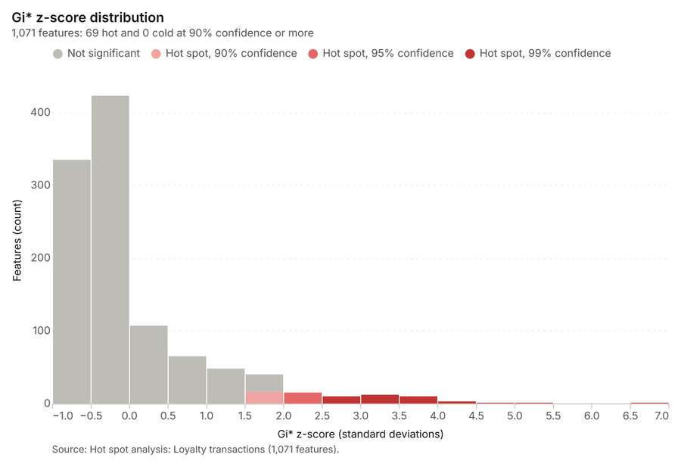
Figure 40. Hot spot analysis: Loyalty transactions [82]. Source: Hot spot analysis: Loyalty transactions (1,071 features). The data is in the appendix.
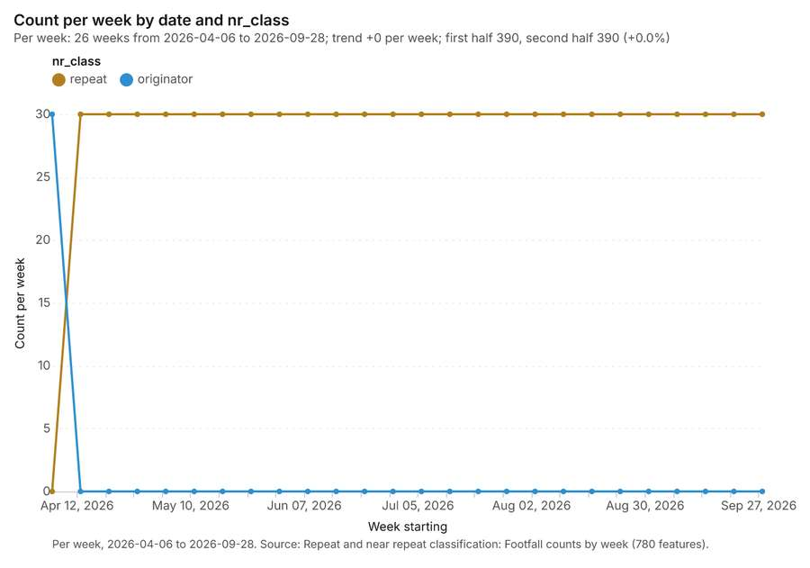
Figure 41. Repeat and near repeat classification: Footfall counts by week [83]. Per week, 2026-04-06 to 2026-09-28. Source: Repeat and near repeat classification: Footfall counts by week (780 features). The data is in the appendix.
Figure 42. Repeat and near repeat classification: Footfall counts by week over time [84]. Per week, 2026-04-06 to 2026-09-28. Source: Repeat and near repeat classification: Footfall counts by week (780 features). The data is in the appendix.
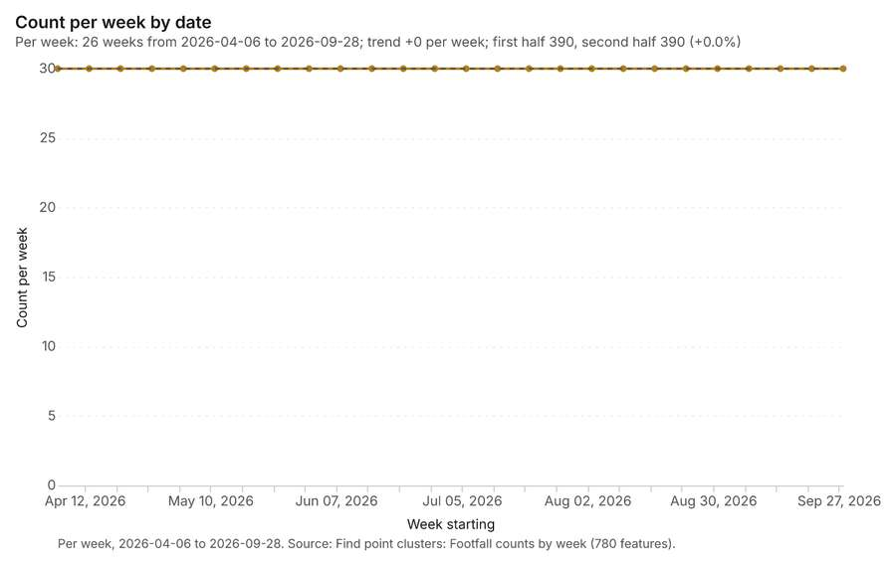
Figure 43. Find point clusters: Footfall counts by week over time [85]. Per week, 2026-04-06 to 2026-09-28. Source: Find point clusters: Footfall counts by week (780 features). The data is in the appendix.

Changes since the last run
This is the first report of this project.

Sources
[1] Rendering: Chart: Timeline: events per week by dataset. 81 rows (id b6ec7ced-8908-403a-82e8-b707067abf11)
[2] Dataset: Loyalty transactions. vector, 2200 rows (id c92f0326-813e-48e4-b969-2af33dd6f105)
[3] Dataset: Footfall counts by week. vector, 780 rows (id b8b278cf-9521-499e-b4b7-e6f243cb9269)
[4] Dataset: Weekly store sales. table, 364 rows (id 0fd06209-c790-4dc2-9c7b-6ef4117b8bf2)
[5] Catalog: Hot spot analysis (operation catalog, gp_hot_spots). Getis-Ord Gi* hot and cold spots with z-scores, p-values and confidence bins. ArcGIS: Find Hot Spots, Hot Spot Analysis (Getis-Ord Gi*). QGIS: qgis:hotspot (plugin). (id gp_hot_spots)
[6] Plan: Hot spots of Competitor stores (the Start plan's candidate c_768477a30749). 70 points: Getis-Ord Gi* tests whether the concentrations in Competitor stores are statistically significant. (id 0b0bb769-454c-448a-a67b-f44e5a60fefc:c_768477a30749)
[7] Tool result: gp_hot_spots, step 0. Hot spot analysis: 1 layer saved: Hot spot analysis: Competitor stores (43 features). (id b507865e-e41b-4810-90c3-5f92db83053c:0)
[8] Layer: Competitor stores. 70 features (id 4c436f86-a921-4bc7-ab04-ec1160edd973)
[9] Plan: Hot spots of Footfall counts by week (the Start plan's candidate c_e591398dec9c). 780 points: Getis-Ord Gi* tests whether the concentrations in Footfall counts by week are statistically significant. (id 0b0bb769-454c-448a-a67b-f44e5a60fefc:c_e591398dec9c)
[10] Tool result: gp_hot_spots, step 1. Hot spot analysis: 1 layer saved: Hot spot analysis: Footfall counts by week (130 features). (id b507865e-e41b-4810-90c3-5f92db83053c:1)
[11] Layer: Footfall counts by week. 780 features (id f2397865-1eae-4be9-8276-1cefdc53f340)
[12] Catalog: Emerging hot spots (operation catalog, gp_space_time_hot_spots). Where hot spots are new, consecutive, intensifying, persistent, diminishing, sporadic, oscillating or historical over time. ArcGIS: Emerging Hot Spot Analysis, Create Space Time Cube. (id gp_space_time_hot_spots)
[13] Plan: Space time hot spots of Footfall counts by week (the Start plan's candidate c_1fdb05aba998). Footfall counts by week carry dates in 'date': emerging hot spot analysis finds new, intensifying and fading hot spots per week. (id 0b0bb769-454c-448a-a67b-f44e5a60fefc:c_1fdb05aba998)
[14] Tool result: gp_space_time_hot_spots, step 0. Emerging hot spots: 1 layer saved: Emerging hot spots: Footfall counts by week (25 features). (id 21998efd-79ff-497c-8ea5-61d8a01f2b62:0)
[15] Plan: Space time hot spots of Loyalty transactions (the Start plan's candidate c_a7d38c7e2909). Loyalty transactions carry dates in 'purchased_at': emerging hot spot analysis finds new, intensifying and fading hot spots per week. (id 0b0bb769-454c-448a-a67b-f44e5a60fefc:c_a7d38c7e2909)
[16] Tool result: gp_space_time_hot_spots, step 1. Emerging hot spots: 1 layer saved: Emerging hot spots: Loyalty transactions (395 features). (id 21998efd-79ff-497c-8ea5-61d8a01f2b62:1)
[17] Layer: Loyalty transactions. 2,200 features (id aa524a0b-a973-4a26-9744-54d5e4cfc549)
[18] Catalog: Calculate density (operation catalog, gp_calculate_density). Kernel density per square kilometer on a grid. ArcGIS: Calculate Density, Kernel Density. QGIS: native:heatmapkerneldensityestimation. (id gp_calculate_density)
[19] Plan: Kernel density of Competitor stores (the Start plan's candidate c_395aeab7e765). 70 points in Competitor stores: a density surface shows where they concentrate. (id 0b0bb769-454c-448a-a67b-f44e5a60fefc:c_395aeab7e765)
[20] Tool result: gp_calculate_density, step 0. Calculate density: 1 layer saved: Calculate density: Competitor stores (322 features). (id 430ebe02-9fb6-4905-a3f4-d3f833474337:0)
[21] Plan: Kernel density of Footfall counts by week (the Start plan's candidate c_af8a7417d64e). 780 points in Footfall counts by week: a density surface shows where they concentrate. (id 0b0bb769-454c-448a-a67b-f44e5a60fefc:c_af8a7417d64e)
[22] Tool result: gp_calculate_density, step 1. Calculate density: 1 layer saved: Calculate density: Footfall counts by week (428 features). (id 430ebe02-9fb6-4905-a3f4-d3f833474337:1)
[23] Plan: Kernel density of Loyalty transactions (the Start plan's candidate c_17cb4893e203). 2200 points in Loyalty transactions: a density surface shows where they concentrate. (id 0b0bb769-454c-448a-a67b-f44e5a60fefc:c_17cb4893e203)
[24] Tool result: gp_calculate_density, step 2. Calculate density: 1 layer saved: Calculate density: Loyalty transactions (3864 features). (id 430ebe02-9fb6-4905-a3f4-d3f833474337:2)
[25] Catalog: Summarize within (operation catalog, gp_summarize_within). Count and aggregate the features inside each polygon (or bin), proportionally for lines and polygons. ArcGIS: Summarize Within, Aggregate Points. QGIS: native:countpointsinpolygon, native:sumlinelengths. (id gp_summarize_within)
[26] Plan: Stores per feature of Trade areas (the Start plan's candidate c_2c5b6056dd2b). Count Stores inside each feature of Trade areas by format; the counts map as a choropleth (natural breaks, sequential colors). (id 0b0bb769-454c-448a-a67b-f44e5a60fefc:c_2c5b6056dd2b)
[27] Tool result: gp_summarize_within, step 0. Summarize within: 1 layer saved: Summarize within: Trade areas (14 features). (id 19ff26ef-a2c9-471b-a599-9000ca42c12a:0)
[28] Layer: Stores. 14 features (id 18363c3a-9918-4ce0-ab48-033ac000c916)
[29] Layer: Trade areas. 14 features (id e712834d-448e-41b7-b460-06c5bedc46af)
[30] Tool result: gp_summarize_within, step 1. Summarize within: 1 layer saved: Summarize within: Trade areas (14 features). (id 19ff26ef-a2c9-471b-a599-9000ca42c12a:1)
[31] Tool result: gp_summarize_within, step 2. Summarize within: 1 layer saved: Summarize within: Trade areas (14 features). (id 19ff26ef-a2c9-471b-a599-9000ca42c12a:2)
[32] Catalog: Find point clusters (operation catalog, gp_find_point_clusters). Density-based clusters (DBSCAN, HDBSCAN or OPTICS, optionally space-time) with hulls and noise. ArcGIS: Find Point Clusters, Density-based Clustering. QGIS: native:dbscanclustering, native:stdbscanclustering. (id gp_find_point_clusters)
[33] Plan: Cluster points of Stores (the Start plan's candidate c_6507de56c2a3). DBSCAN finds dense groups of Stores and separates noise. (id 0b0bb769-454c-448a-a67b-f44e5a60fefc:c_6507de56c2a3)
[34] Tool result: gp_find_point_clusters, step 0. Find point clusters: 2 layers saved: Find point clusters: Stores (14 features); Find point clusters: cluster hulls (1 feature). (id ca920f5a-83d3-4ecf-82d9-45a80921c7b9:0)
[35] Plan: Cluster points of Competitor stores (the Start plan's candidate c_53b613e74a4d). DBSCAN finds dense groups of Competitor stores and separates noise. (id 0b0bb769-454c-448a-a67b-f44e5a60fefc:c_53b613e74a4d)
[36] Tool result: gp_find_point_clusters, step 1. Find point clusters: 2 layers saved: Find point clusters: Competitor stores (70 features); Find point clusters: cluster hulls (2 features). (id ca920f5a-83d3-4ecf-82d9-45a80921c7b9:1)
[37] Plan: Cluster points of Footfall counts by week (the Start plan's candidate c_d5d62e4a81d6). DBSCAN finds dense groups of Footfall counts by week and separates noise. (id 0b0bb769-454c-448a-a67b-f44e5a60fefc:c_d5d62e4a81d6)
[38] Tool result: gp_find_point_clusters, step 2. Find point clusters: 2 layers saved: Find point clusters: Footfall counts by week (780 features); Find point clusters: cluster hulls (30 features). (id ca920f5a-83d3-4ecf-82d9-45a80921c7b9:2)
[39] Plan: Hot spots of Loyalty transactions (the Start plan's candidate c_47bf1f0a2ecf). 2200 points: Getis-Ord Gi* tests whether the concentrations in Loyalty transactions are statistically significant. (id 0b0bb769-454c-448a-a67b-f44e5a60fefc:c_47bf1f0a2ecf)
[40] Tool result: gp_hot_spots, step 0. Hot spot analysis: 1 layer saved: Hot spot analysis: Loyalty transactions (1071 features). (id 5a6f1c3e-75be-4e48-a441-9e9439c69a91:0)
[41] Catalog: Repeat and near repeat classification (operation catalog, gp_near_repeat). Classify incidents as originators, repeats (same place) or near repeats within a distance and time window, with a Knox test table. ArcGIS: Repeat and Near Repeat Classification, Near Repeat Calculator. (id gp_near_repeat)
[42] Plan: Near repeat of Footfall counts by week (the Start plan's candidate c_73acbbcef86d). Near repeat analysis tests whether Footfall counts by week close in space also follow each other within 18 days. (id 0b0bb769-454c-448a-a67b-f44e5a60fefc:c_73acbbcef86d)
[43] Tool result: gp_near_repeat, step 0. Repeat and near repeat classification: 1 layer saved: Repeat and near repeat classification: Footfall counts by week (780 features). (id 1f9ce8d2-9c80-423d-af47-a65148d65bf2:0)
[44] Rendering: Map: Hot spot analysis: Competitor stores (id 41888450-f89e-4987-b1c8-dd5bf46def36)
[45] Rendering: Map: Hot spot analysis: Footfall counts by week (id f93b9c24-c668-48a3-bbb7-19c453deff48)
[46] Rendering: Map: Emerging hot spots: Footfall counts by week (id cb7f1de8-6f92-4f7b-851f-d1e165a7b7cc)
[47] Rendering: Map: Emerging hot spots: Loyalty transactions (id 4b865cd2-b745-4c5f-8633-9afed6258161)
[48] Rendering: Map: Calculate density: Competitor stores (id e400313e-2c8f-4e48-a9f7-25769b8d11a0)
[49] Rendering: Map: Calculate density: Footfall counts by week (id f2d8ba2d-fb20-4c4c-a479-297dc0b8b234)
[50] Rendering: Map: Calculate density: Loyalty transactions (id 3e01b21f-9a4f-4179-9e11-68a06635b4a7)
[51] Rendering: Map: Summarize within: Trade areas (id d11fb076-b43e-46f5-90e6-45ae509035e4)
[52] Rendering: Map: Summarize within: Trade areas (id 73cc3108-93e2-4779-b12c-3b92ec9c25a2)
[53] Rendering: Map: Summarize within: Trade areas (id 924e39d5-2308-4dff-b4e4-f47f5728463f)
[54] Rendering: Map: Find point clusters: Stores (id 78c40d3d-dee7-49cb-be7d-ef0ed8325367)
[55] Rendering: Map: Find point clusters: cluster hulls (id e9a1e8eb-0435-4209-9bd4-f5dbf7b51be9)
[56] Rendering: Map: Find point clusters: Competitor stores (id d3819598-0281-437f-992f-f0f54e12724e)
[57] Rendering: Map: Find point clusters: cluster hulls (id 70d2c2da-7629-473a-9f6f-106e6d23bab1)
[58] Rendering: Map: Find point clusters: Footfall counts by week (id 7112a329-ab18-44fb-a596-e82e1bee032d)
[59] Rendering: Map: Find point clusters: cluster hulls (id bf8ff644-7688-4db7-8bb6-f3cc36fe7901)
[60] Rendering: Map: Trade areas by households (id 33981aa9-656c-4956-b45f-c22bca1b6eeb)
[61] Rendering: Map: Neighborhoods by population (id a8598722-b6b3-4fc1-93e3-d3453c8c18d7)
[62] Rendering: Map: Hot spot analysis: Loyalty transactions (id fce9171a-60ec-4705-a035-aaccbcaba8e8)
[63] Rendering: Map: Repeat and near repeat classification: Footfall counts by week (id e70b2db0-fea4-47cf-8ec3-7183fee9e834)
[64] Rendering: Chart: Stores over time (opened_year). 5 rows (id 88a4e6a1-e252-4fad-bb98-135337862108)
[65] Rendering: Chart: Footfall counts by week over time (date). 26 rows (id 6e13d856-d944-439a-8903-ae33a8ab0da3)
[66] Rendering: Chart: Hot spot analysis: Competitor stores. 11 rows (id 9c3ad16e-b912-4594-a05a-87cded10ab78)
[67] Rendering: Chart: Hot spot analysis: Footfall counts by week. 3 rows (id 0b831a4b-dee4-45be-b7d7-e986b73d50bc)
[68] Rendering: Chart: Emerging hot spots: Footfall counts by week. 6 rows (id 789e8923-f0a6-4857-9ab7-b66bc1cd1c3f)
[69] Rendering: Chart: Emerging hot spots: Loyalty transactions. 10 rows (id 813722a9-1e8c-4450-aec2-7394e0775dba)
[70] Rendering: Chart: Calculate density: Competitor stores. 10 rows (id 7d20b087-1407-433c-8dc8-d356ce1f082e)
[71] Rendering: Chart: Calculate density: Footfall counts by week. 10 rows (id 17d4ba42-821c-40ae-b3d1-7b35ca038652)
[72] Rendering: Chart: Calculate density: Loyalty transactions. 13 rows (id f692141a-e0e4-42c1-ac87-80825e412def)
[73] Rendering: Chart: Summarize within: Trade areas. 1 rows (id 8f97ef4e-3866-4c95-a751-112dfd457eef)
[74] Rendering: Chart: Summarize within: Trade areas. 5 rows (id 35a513b9-93bb-465d-b882-5d348e39b6dc)
[75] Rendering: Chart: Summarize within: Trade areas. 5 rows (id 8e3c214d-56fd-4e64-929e-30c9c09c29f5)
[76] Rendering: Chart: Find point clusters: Stores. 1 rows (id b9c77e7c-1f5c-400c-bf75-b3aca56b70e7)
[77] Rendering: Chart: Find point clusters: cluster hulls. 1 rows (id 467acba3-533e-407d-9fbd-23f5820d4419)
[78] Rendering: Chart: Find point clusters: Competitor stores. 3 rows (id 6d7a778d-7a18-45e4-adf0-4bd41485ad7e)
[79] Rendering: Chart: Find point clusters: cluster hulls. 2 rows (id eb67f5bb-ba8e-4094-b82d-ec0756a3a23a)
[80] Rendering: Chart: Find point clusters: Footfall counts by week. 30 rows (id 45f91f53-c509-412f-a771-62cba1d96b4f)
[81] Rendering: Chart: Find point clusters: cluster hulls. 30 rows (id 7541ae38-9abb-4836-9e35-aa37edae4d9e)
[82] Rendering: Chart: Hot spot analysis: Loyalty transactions. 15 rows (id b9623d33-4a1f-466f-887c-2aecc180a640)
[83] Rendering: Chart: Repeat and near repeat classification: Footfall counts by week. 52 rows (id 693cb1b3-8254-4cfb-8525-f6aab230d985)
[84] Rendering: Chart: Repeat and near repeat classification: Footfall counts by week over time. 52 rows (id da2c2ad8-5c02-46ad-be96-5afb7abf90a7)
[85] Rendering: Chart: Find point clusters: Footfall counts by week over time. 26 rows (id 43bccbb2-c646-4616-8780-2bd48f81912e)
[86] Dataset: Neighborhoods. vector, 32 rows (id fa0b8017-5ddc-4e1f-a444-31fd07e52b97)
[87] Dataset: Stores. vector, 14 rows (id 82660798-29d0-4c66-a9c0-444823fa0479)
[88] Dataset: Competitor stores. vector, 70 rows (id 9c4d2224-f1d8-4fc0-8667-d94268e2460a)
[89] Dataset: Trade areas. vector, 14 rows (id 5172e6d7-515f-4a32-89d2-408d49039a96)
[90] Dataset: Parking lots. vector, 25 rows (id ef40dd81-eb91-41ff-a8ce-d61b98dfa2bc)
[91] Dataset: Main roads. vector, 18 rows (id 1d4e054d-0664-4e98-9a81-0645bcbb69a7)
[92] Dataset: Neighborhood demographics. table, 32 rows (id e76e880f-2f9b-4745-8cb1-c1977effb3ab)
[93] Dataset: Store network expansion memo. document, ? rows (id 8f7f2a26-905f-48fc-8056-46e9aaa7cd21)
[94] Record: Sample: Retail, Manchester (id e415669e-4f91-46e1-8afb-4604f1d21ffb)
[95] Layer: Hot spot analysis: Competitor stores. 43 features (id b80aa42a-d8ea-4e32-8d49-6e5773e54e39)
[96] Layer: Hot spot analysis: Footfall counts by week. 130 features (id f0b07952-61d1-4329-8f15-30737eeffd7b)
[97] Layer: Emerging hot spots: Footfall counts by week. 25 features (id 0e4e31f2-68f4-4616-9467-013b9d001713)
[98] Layer: Emerging hot spots: Loyalty transactions. 395 features (id a138b441-1405-4566-b2be-a105c298c8bc)
[99] Layer: Calculate density: Competitor stores. 322 features (id 66cc8107-cef3-4817-88bc-3d844fef8c5d)
[100] Layer: Calculate density: Footfall counts by week. 428 features (id 127e81c4-1813-4a14-bf8a-e02c15922197)
[101] Layer: Calculate density: Loyalty transactions. 3,864 features (id c60805b0-dabf-417a-9c74-56991faf551d)
[102] Layer: Summarize within: Trade areas. 14 features (id 7c9a641f-d6ec-4516-94be-bf77837866f9)
[103] Layer: Summarize within: Trade areas. 14 features (id 18fcae7b-5cd3-43b0-8df8-db89ccdf1ce1)
[104] Layer: Summarize within: Trade areas. 14 features (id aa777707-952c-4358-950b-2b0b19102664)
[105] Layer: Find point clusters: Stores. 14 features (id 99f04d61-5c35-4915-81c3-07e1c20e77a9)
[106] Layer: Find point clusters: cluster hulls. 1 features (id 307f2beb-8d40-4d28-80e7-f41546cea1f1)
[107] Layer: Find point clusters: Competitor stores. 70 features (id b588c0ef-eaf1-43aa-9e46-eb574ee308cd)
[108] Layer: Find point clusters: cluster hulls. 2 features (id 937090ee-0478-421a-b9ea-436ec735517e)
[109] Layer: Find point clusters: Footfall counts by week. 780 features (id 9185731c-b554-4959-be37-e8b614083c36)
[110] Layer: Find point clusters: cluster hulls. 30 features (id 589e2574-90d1-40c4-9a13-7a72b83fb52f)
[111] Layer: Hot spot analysis: Loyalty transactions. 1,071 features (id e5715bae-7cde-4109-98c9-68e36ec45e14)
[112] Layer: Repeat and near repeat classification: Footfall counts by week. 780 features (id e233d1b4-20ea-4a50-8578-dd34d19532fc)

Appendix: the data behind the charts

Figure 1. Timeline: events per week by dataset [1]
period | series | value
2026-03-30 | Loyalty transactions | 54
2026-03-30 | Footfall counts by week | 0
2026-03-30 | Weekly store sales | 0
2026-04-06 | Loyalty transactions | 77
2026-04-06 | Footfall counts by week | 30
2026-04-06 | Weekly store sales | 14
2026-04-13 | Loyalty transactions | 90
2026-04-13 | Footfall counts by week | 30
2026-04-13 | Weekly store sales | 14
2026-04-20 | Loyalty transactions | 70
2026-04-20 | Footfall counts by week | 30
2026-04-20 | Weekly store sales | 14
2026-04-27 | Loyalty transactions | 80
2026-04-27 | Footfall counts by week | 30
2026-04-27 | Weekly store sales | 14
2026-05-04 | Loyalty transactions | 84
2026-05-04 | Footfall counts by week | 30
2026-05-04 | Weekly store sales | 14
2026-05-11 | Loyalty transactions | 83
2026-05-11 | Footfall counts by week | 30
2026-05-11 | Weekly store sales | 14
2026-05-18 | Loyalty transactions | 83
2026-05-18 | Footfall counts by week | 30
2026-05-18 | Weekly store sales | 14
2026-05-25 | Loyalty transactions | 63
2026-05-25 | Footfall counts by week | 30
2026-05-25 | Weekly store sales | 14
2026-06-01 | Loyalty transactions | 64
2026-06-01 | Footfall counts by week | 30
2026-06-01 | Weekly store sales | 14
2026-06-08 | Loyalty transactions | 73
2026-06-08 | Footfall counts by week | 30
2026-06-08 | Weekly store sales | 14
2026-06-15 | Loyalty transactions | 81
2026-06-15 | Footfall counts by week | 30
2026-06-15 | Weekly store sales | 14
2026-06-22 | Loyalty transactions | 54
2026-06-22 | Footfall counts by week | 30
2026-06-22 | Weekly store sales | 14
2026-06-29 | Loyalty transactions | 75
2026-06-29 | Footfall counts by week | 30
2026-06-29 | Weekly store sales | 14
2026-07-06 | Loyalty transactions | 79
2026-07-06 | Footfall counts by week | 30
2026-07-06 | Weekly store sales | 14
2026-07-13 | Loyalty transactions | 78
2026-07-13 | Footfall counts by week | 30
2026-07-13 | Weekly store sales | 14
2026-07-20 | Loyalty transactions | 76
2026-07-20 | Footfall counts by week | 30
2026-07-20 | Weekly store sales | 14
2026-07-27 | Loyalty transactions | 101
2026-07-27 | Footfall counts by week | 30
2026-07-27 | Weekly store sales | 14
2026-08-03 | Loyalty transactions | 105
2026-08-03 | Footfall counts by week | 30
2026-08-03 | Weekly store sales | 14
2026-08-10 | Loyalty transactions | 79
2026-08-10 | Footfall counts by week | 30
2026-08-10 | Weekly store sales | 14
2026-08-17 | Loyalty transactions | 85
2026-08-17 | Footfall counts by week | 30
2026-08-17 | Weekly store sales | 14
2026-08-24 | Loyalty transactions | 88
2026-08-24 | Footfall counts by week | 30
2026-08-24 | Weekly store sales | 14
2026-08-31 | Loyalty transactions | 113
2026-08-31 | Footfall counts by week | 30
2026-08-31 | Weekly store sales | 14
2026-09-07 | Loyalty transactions | 97
2026-09-07 | Footfall counts by week | 30
2026-09-07 | Weekly store sales | 14
2026-09-14 | Loyalty transactions | 114
2026-09-14 | Footfall counts by week | 30
2026-09-14 | Weekly store sales | 14
2026-09-21 | Loyalty transactions | 107
2026-09-21 | Footfall counts by week | 30
2026-09-21 | Weekly store sales | 14
2026-09-28 | Loyalty transactions | 47
2026-09-28 | Footfall counts by week | 30
2026-09-28 | Weekly store sales | 14

Figure 22. Stores over time (opened_year) [64]
bin_start | bin_end | count
5.178e+04 | 1.463e+05 | 8
1.463e+05 | 2.408e+05 | 3
2.408e+05 | 3.353e+05 | 0
3.353e+05 | 4.298e+05 | 1
4.298e+05 | 5.243e+05 | 2

Figure 23. Footfall counts by week over time (date) [65]
period | value
2026-04-06 | 30
2026-04-13 | 30
2026-04-20 | 30
2026-04-27 | 30
2026-05-04 | 30
2026-05-11 | 30
2026-05-18 | 30
2026-05-25 | 30
2026-06-01 | 30
2026-06-08 | 30
2026-06-15 | 30
2026-06-22 | 30
2026-06-29 | 30
2026-07-06 | 30
2026-07-13 | 30
2026-07-20 | 30
2026-07-27 | 30
2026-08-03 | 30
2026-08-10 | 30
2026-08-17 | 30
2026-08-24 | 30
2026-08-31 | 30
2026-09-07 | 30
2026-09-14 | 30
2026-09-21 | 30
2026-09-28 | 30

Figure 24. Hot spot analysis: Competitor stores [66]
bin_start | bin_end | band | band_label | count
-2 | -1.5 | not_significant | Not significant | 1
-1.5 | -1 | not_significant | Not significant | 6
-1 | -0.5 | not_significant | Not significant | 5
-0.5 | 0 | not_significant | Not significant | 5
0 | 0.5 | not_significant | Not significant | 7
0.5 | 1 | not_significant | Not significant | 6
1 | 1.5 | not_significant | Not significant | 4
1.5 | 2 | hot_90 | Hot spot, 90% confidence | 2
1.5 | 2 | not_significant | Not significant | 3
2 | 2.5 | hot_95 | Hot spot, 95% confidence | 1
2.5 | 3 | hot_99 | Hot spot, 99% confidence | 3

Figure 25. Hot spot analysis: Footfall counts by week [67]
bin_start | bin_end | band | band_label | count
-0.5 | 0 | not_significant | Not significant | 103
1.5 | 2 | not_significant | Not significant | 24
3.5 | 4 | hot_99 | Hot spot, 99% confidence | 3

Figure 26. Emerging hot spots: Footfall counts by week [68]
bin_start | bin_end | count
-1.012 | -0.1687 | 4
-0.1687 | 0.6747 | 6
0.6747 | 1.518 | 7
1.518 | 2.361 | 5
2.361 | 3.205 | 1
3.205 | 4.048 | 2

Figure 27. Emerging hot spots: Loyalty transactions [69]
bin_start | bin_end | count
-0.941 | -0.2532 | 173
-0.2532 | 0.4346 | 88
0.4346 | 1.122 | 64
1.122 | 1.81 | 33
1.81 | 2.498 | 0
2.498 | 3.186 | 10
3.186 | 3.874 | 11
3.874 | 4.561 | 13
4.561 | 5.249 | 2
5.249 | 5.937 | 1

Figure 28. Calculate density: Competitor stores [70]
bin_start | bin_end | count
0 | 2 | 19
2 | 4 | 32
4 | 6 | 34
6 | 8 | 33
8 | 10 | 31
10 | 12 | 32
12 | 14 | 36
14 | 16 | 36
16 | 18 | 35
18 | 20 | 34

Figure 29. Calculate density: Footfall counts by week [71]
bin_start | bin_end | count
0 | 3.6 | 28
3.6 | 7.2 | 58
7.2 | 10.8 | 57
10.8 | 14.4 | 54
14.4 | 18 | 46
18 | 21.6 | 23
21.6 | 25.2 | 43
25.2 | 28.8 | 29
28.8 | 32.4 | 49
32.4 | 36 | 41

Figure 30. Calculate density: Loyalty transactions [72]
bin_start | bin_end | count
0 | 5.538 | 278
5.538 | 11.08 | 364
11.08 | 16.62 | 303
16.62 | 22.15 | 362
22.15 | 27.69 | 299
27.69 | 33.23 | 353
33.23 | 38.77 | 288
38.77 | 44.31 | 362
44.31 | 49.85 | 269
49.85 | 55.38 | 293
55.38 | 60.92 | 238
60.92 | 66.46 | 263
66.46 | 72 | 192

Figure 31. Summarize within: Trade areas [73]
bin_start | bin_end | count
1 | 1 | 14

Figure 32. Summarize within: Trade areas [74]
bin_start | bin_end | count
3 | 4.2 | 6
4.2 | 5.4 | 5
5.4 | 6.6 | 0
6.6 | 7.8 | 1
7.8 | 9 | 2

Figure 33. Summarize within: Trade areas [75]
bin_start | bin_end | count
0 | 36.4 | 5
36.4 | 72.8 | 4
72.8 | 109.2 | 4
109.2 | 145.6 | 0
145.6 | 182 | 1

Figure 34. Find point clusters: Stores [76]
cluster | features | fraction | share
0 | 14 | 1 | 100.0%

Figure 35. Find point clusters: cluster hulls [77]
cluster | features | fraction | share
0 | 1 | 1 | 100.0%

Figure 36. Find point clusters: Competitor stores [78]
cluster | features | fraction | share
0 | 65 | 0.9286 | 92.9%
1 | 3 | 0.04286 | 4.3%
Noise | 2 | 0.02857 | 2.9%

Figure 37. Find point clusters: cluster hulls [79]
cluster | features | fraction | share
0 | 1 | 0.5 | 50.0%
1 | 1 | 0.5 | 50.0%

Figure 38. Find point clusters: Footfall counts by week [80]
cluster | features | fraction | share
0 | 26 | 0.03333 | 3.3%
1 | 26 | 0.03333 | 3.3%
10 | 26 | 0.03333 | 3.3%
11 | 26 | 0.03333 | 3.3%
12 | 26 | 0.03333 | 3.3%
13 | 26 | 0.03333 | 3.3%
14 | 26 | 0.03333 | 3.3%
15 | 26 | 0.03333 | 3.3%
16 | 26 | 0.03333 | 3.3%
17 | 26 | 0.03333 | 3.3%
18 | 26 | 0.03333 | 3.3%
19 | 26 | 0.03333 | 3.3%
2 | 26 | 0.03333 | 3.3%
20 | 26 | 0.03333 | 3.3%
21 | 26 | 0.03333 | 3.3%
22 | 26 | 0.03333 | 3.3%
23 | 26 | 0.03333 | 3.3%
24 | 26 | 0.03333 | 3.3%
25 | 26 | 0.03333 | 3.3%
26 | 26 | 0.03333 | 3.3%
27 | 26 | 0.03333 | 3.3%
28 | 26 | 0.03333 | 3.3%
29 | 26 | 0.03333 | 3.3%
3 | 26 | 0.03333 | 3.3%
4 | 26 | 0.03333 | 3.3%
5 | 26 | 0.03333 | 3.3%
6 | 26 | 0.03333 | 3.3%
7 | 26 | 0.03333 | 3.3%
8 | 26 | 0.03333 | 3.3%
9 | 26 | 0.03333 | 3.3%

Figure 39. Find point clusters: cluster hulls [81]
cluster | features | fraction | share
0 | 1 | 0.03333 | 3.3%
1 | 1 | 0.03333 | 3.3%
10 | 1 | 0.03333 | 3.3%
11 | 1 | 0.03333 | 3.3%
12 | 1 | 0.03333 | 3.3%
13 | 1 | 0.03333 | 3.3%
14 | 1 | 0.03333 | 3.3%
15 | 1 | 0.03333 | 3.3%
16 | 1 | 0.03333 | 3.3%
17 | 1 | 0.03333 | 3.3%
18 | 1 | 0.03333 | 3.3%
19 | 1 | 0.03333 | 3.3%
2 | 1 | 0.03333 | 3.3%
20 | 1 | 0.03333 | 3.3%
21 | 1 | 0.03333 | 3.3%
22 | 1 | 0.03333 | 3.3%
23 | 1 | 0.03333 | 3.3%
24 | 1 | 0.03333 | 3.3%
25 | 1 | 0.03333 | 3.3%
26 | 1 | 0.03333 | 3.3%
27 | 1 | 0.03333 | 3.3%
28 | 1 | 0.03333 | 3.3%
29 | 1 | 0.03333 | 3.3%
3 | 1 | 0.03333 | 3.3%
4 | 1 | 0.03333 | 3.3%
5 | 1 | 0.03333 | 3.3%
6 | 1 | 0.03333 | 3.3%
7 | 1 | 0.03333 | 3.3%
8 | 1 | 0.03333 | 3.3%
9 | 1 | 0.03333 | 3.3%

Figure 40. Hot spot analysis: Loyalty transactions [82]
bin_start | bin_end | band | band_label | count
-1 | -0.5 | not_significant | Not significant | 335
-0.5 | 0 | not_significant | Not significant | 423
0 | 0.5 | not_significant | Not significant | 107
0.5 | 1 | not_significant | Not significant | 65
1 | 1.5 | not_significant | Not significant | 48
1.5 | 2 | hot_90 | Hot spot, 90% confidence | 16
1.5 | 2 | not_significant | Not significant | 24
2 | 2.5 | hot_95 | Hot spot, 95% confidence | 15
2.5 | 3 | hot_99 | Hot spot, 99% confidence | 10
3 | 3.5 | hot_99 | Hot spot, 99% confidence | 12
3.5 | 4 | hot_99 | Hot spot, 99% confidence | 10
4 | 4.5 | hot_99 | Hot spot, 99% confidence | 3
4.5 | 5 | hot_99 | Hot spot, 99% confidence | 1
5 | 5.5 | hot_99 | Hot spot, 99% confidence | 1
6.5 | 7 | hot_99 | Hot spot, 99% confidence | 1

Figure 41. Repeat and near repeat classification: Footfall counts by week [83]
period | series | value
2026-04-06 | repeat | 0
2026-04-06 | originator | 30
2026-04-13 | repeat | 30
2026-04-13 | originator | 0
2026-04-20 | repeat | 30
2026-04-20 | originator | 0
2026-04-27 | repeat | 30
2026-04-27 | originator | 0
2026-05-04 | repeat | 30
2026-05-04 | originator | 0
2026-05-11 | repeat | 30
2026-05-11 | originator | 0
2026-05-18 | repeat | 30
2026-05-18 | originator | 0
2026-05-25 | repeat | 30
2026-05-25 | originator | 0
2026-06-01 | repeat | 30
2026-06-01 | originator | 0
2026-06-08 | repeat | 30
2026-06-08 | originator | 0
2026-06-15 | repeat | 30
2026-06-15 | originator | 0
2026-06-22 | repeat | 30
2026-06-22 | originator | 0
2026-06-29 | repeat | 30
2026-06-29 | originator | 0
2026-07-06 | repeat | 30
2026-07-06 | originator | 0
2026-07-13 | repeat | 30
2026-07-13 | originator | 0
2026-07-20 | repeat | 30
2026-07-20 | originator | 0
2026-07-27 | repeat | 30
2026-07-27 | originator | 0
2026-08-03 | repeat | 30
2026-08-03 | originator | 0
2026-08-10 | repeat | 30
2026-08-10 | originator | 0
2026-08-17 | repeat | 30
2026-08-17 | originator | 0
2026-08-24 | repeat | 30
2026-08-24 | originator | 0
2026-08-31 | repeat | 30
2026-08-31 | originator | 0
2026-09-07 | repeat | 30
2026-09-07 | originator | 0
2026-09-14 | repeat | 30
2026-09-14 | originator | 0
2026-09-21 | repeat | 30
2026-09-21 | originator | 0
2026-09-28 | repeat | 30
2026-09-28 | originator | 0

Figure 42. Repeat and near repeat classification: Footfall counts by week over time [84]
period | series | value
2026-04-06 | repeat | 0
2026-04-06 | originator | 30
2026-04-13 | repeat | 30
2026-04-13 | originator | 0
2026-04-20 | repeat | 30
2026-04-20 | originator | 0
2026-04-27 | repeat | 30
2026-04-27 | originator | 0
2026-05-04 | repeat | 30
2026-05-04 | originator | 0
2026-05-11 | repeat | 30
2026-05-11 | originator | 0
2026-05-18 | repeat | 30
2026-05-18 | originator | 0
2026-05-25 | repeat | 30
2026-05-25 | originator | 0
2026-06-01 | repeat | 30
2026-06-01 | originator | 0
2026-06-08 | repeat | 30
2026-06-08 | originator | 0
2026-06-15 | repeat | 30
2026-06-15 | originator | 0
2026-06-22 | repeat | 30
2026-06-22 | originator | 0
2026-06-29 | repeat | 30
2026-06-29 | originator | 0
2026-07-06 | repeat | 30
2026-07-06 | originator | 0
2026-07-13 | repeat | 30
2026-07-13 | originator | 0
2026-07-20 | repeat | 30
2026-07-20 | originator | 0
2026-07-27 | repeat | 30
2026-07-27 | originator | 0
2026-08-03 | repeat | 30
2026-08-03 | originator | 0
2026-08-10 | repeat | 30
2026-08-10 | originator | 0
2026-08-17 | repeat | 30
2026-08-17 | originator | 0
2026-08-24 | repeat | 30
2026-08-24 | originator | 0
2026-08-31 | repeat | 30
2026-08-31 | originator | 0
2026-09-07 | repeat | 30
2026-09-07 | originator | 0
2026-09-14 | repeat | 30
2026-09-14 | originator | 0
2026-09-21 | repeat | 30
2026-09-21 | originator | 0
2026-09-28 | repeat | 30
2026-09-28 | originator | 0

Figure 43. Find point clusters: Footfall counts by week over time [85]
period | value
2026-04-06 | 30
2026-04-13 | 30
2026-04-20 | 30
2026-04-27 | 30
2026-05-04 | 30
2026-05-11 | 30
2026-05-18 | 30
2026-05-25 | 30
2026-06-01 | 30
2026-06-08 | 30
2026-06-15 | 30
2026-06-22 | 30
2026-06-29 | 30
2026-07-06 | 30
2026-07-13 | 30
2026-07-20 | 30
2026-07-27 | 30
2026-08-03 | 30
2026-08-10 | 30
2026-08-17 | 30
2026-08-24 | 30
2026-08-31 | 30
2026-09-07 | 30
2026-09-14 | 30
2026-09-21 | 30
2026-09-28 | 30

