GEOBIT LARGE SPATIAL MODEL

Sample: Transportation safety, Sao Paulo: report
Project: Sample: Transportation safety, Sao Paulo
Goal: Describe the project Sample: Transportation safety, Sao Paulo: run the analyses that tell the most about its data, draw every result, and write a cited report.
Run: 35aef51a-0242-4655-8a7d-ba6fc31c344b (running, 11 agent run(s))
Generated: 2026-10-18T06:32:13Z, version 1
Model cost: USD 0.0000 over 0 model call(s)

Data used
Data | Kind | Rows | Time span | Summary | Source
Road segments | vector, LineString | 900 |  | 900 line features; 'class' has 2 values (top: local 663, arterial 237); 'speed_limit_kmh' 30 to 60 (mean 45.06); 'aadt' 1,727 to 99,346 (mean 1.553e+04); 'lanes' 1 to 4 (mean 2.173); named by 'name' (e.g. Avenida Sul, Avenida Norte, Avenida Rebouca); total length 200.3 km; extent -46.6897,-23.5880 to -46.6328,-23.5351. Lines (Road segments) such as routes or networks. | [89]
Traffic districts | vector, Polygon | 12 |  | 12 polygon (area) features; 'population' 13,386 to 103,619 (mean 4.944e+04); 'km_of_road' 19.5 to 61.8 (mean 42.02); named by 'name' (e.g. Ribeira Sul, Jardim dos Pinheiros, Morro Claro); total area 42 km2; extent -46.6905,-23.5888 to -46.6213,-23.5339. Areas (Traffic districts) with population to compare and map. | [90]
Crashes | vector, Point | 2,100 | 2024-10-01 to 2026-09-30 | 2,100 point features; dated by 'occurred_at' from 2024-10-01 to 2026-09-30; 'severity' has 4 values (top: slight 965, property damage 610, serious 442); 'mode' has 6 values (top: motorcycle 761, car 728, pedestrian 280); 'injured' 0 to 6 (mean 0.8281); extent -46.6895,-23.5878 to -46.6221,-23.5352. Dated point events by severity: where and when Crashes happen. | [2]
Speed cameras | vector, Point | 25 |  | 25 point features; 'limit_kmh' 60 to 60 (mean 60); 'installed_year' 2,015 to 2,025 (mean 2020); named by 'name' (e.g. Speed camera 01, Speed camera 02, Speed camera 03); extent -46.6879,-23.5867 to -46.6330,-23.5361. Point locations of Speed cameras. | [91]
Schools | vector, Point | 40 |  | 40 point features; 'level' has 2 values (top: medio 22, fundamental 18); 'students' 206 to 1,777 (mean 936.7); named by 'name' (e.g. Escola Vila Norte, Escola Jardim Primavera, Escola Alto do Moinho); extent -46.6894,-23.5866 to -46.6239,-23.5365. Point locations of Schools by level. | [92]
Bus stops | vector, Point | 120 |  | 120 point features; 'shelter' has 2 values (top: True 74, False 46); 'lines' 1 to 14 (mean 7.383); extent -46.6879,-23.5873 to -46.6236,-23.5357. Point locations of Bus stops by shelter. | [93]
Pedestrian crossings | vector, Point | 200 |  | 200 point features; 'type' has 3 values (top: signalized 74, zebra 64, raised 62); 'countdown' has 2 values (top: False 114, True 86); extent -46.6896,-23.5875 to -46.6226,-23.5348. Point locations of Pedestrian crossings by type. | [94]
Traffic calming | vector, Point | 70 | 2023-01-07 to 2026-06-13 | 70 point features; dated by 'date' from 2023-01-07 to 2026-06-13; 'type' has 4 values (top: chicane 21, lane narrowing 19, raised crossing 18); 'cost_brl' 13,814 to 135,708 (mean 5.279e+04); extent -46.6872,-23.5825 to -46.6351,-23.5364. Dated point events by type: where and when Traffic calming happen. | [3]
Segment speeds by month | table | 1,440 | 2025-10-01 to 2026-09-01 | Table of 1,440 rows and 5 columns without geometry; dated by 'month' from 2025-10-01 to 2026-09-01; 'mean_speed_kmh' 42 to 65.8 (mean 53.34); 'p85_speed_kmh' 52.9 to 79.3 (mean 65.81); 'volume' 15,817 to 81,760 (mean 3.765e+04). A table of Segment speeds by month without locations. | [4]
Camera citations by month | table | 300 | 2025-10-01 to 2026-09-01 | Table of 300 rows and 4 columns without geometry; dated by 'month' from 2025-10-01 to 2026-09-01; 'citations' 802 to 993 (mean 898.9); 'avg_excess_kmh' 8 to 19 (mean 13.36). A table of Camera citations by month without locations. | [5]
Vision Zero corridor review | document |  |  | 1-page md document 'Vision Zero corridor review'; language en; mentions 4 place(s): Avenida do Parque (2), -23.55479, -46.66610 (1), Speed camera 01 (1), Speed camera 02 (1). A document about Avenida do Parque, -23.55479, -46.66610, Speed camera 01. | [95]
Sample: Transportation safety, Sao Paulo | record |  |  |  | [96]
Hot spot analysis: Schools | layer, Point | 40 |  |  | [97]
Hot spot analysis: Crashes | layer, Polygon | 1,049 |  |  | [98]
Emerging hot spots: Crashes | layer, Polygon | 391 |  |  | [99]
Emerging hot spots: Traffic calming | layer, Polygon | 14 |  |  | [100]
Summarize within: Traffic districts | layer, Polygon | 12 |  |  | [101]
Summarize within: Traffic districts | layer, Polygon | 12 |  |  | [102]
Find point clusters: Schools | layer, Point | 40 |  |  | [103]
Find point clusters: cluster hulls | layer, Polygon | 3 |  |  | [104]
Find point clusters: Crashes | layer, Point | 2,100 |  |  | [105]
Find point clusters: cluster hulls | layer, Polygon | 2 |  |  | [106]
Find point clusters: Pedestrian crossings | layer, Point | 200 |  |  | [107]
Find point clusters: cluster hulls | layer, Polygon | 11 |  |  | [108]
Calculate density: Schools | layer, Polygon | 80 |  |  | [109]
Calculate density: Crashes | layer, Polygon | 4,112 |  |  | [110]
Calculate density: Pedestrian crossings | layer, Polygon | 251 |  |  | [111]
Hot spot analysis: Pedestrian crossings | layer, Polygon | 54 |  |  | [112]
Repeat and near repeat classification: Crashes | layer, Point | 2,100 |  |  | [113]
Summarize within: Traffic districts | layer, Polygon | 12 |  |  | [114]

Timeline
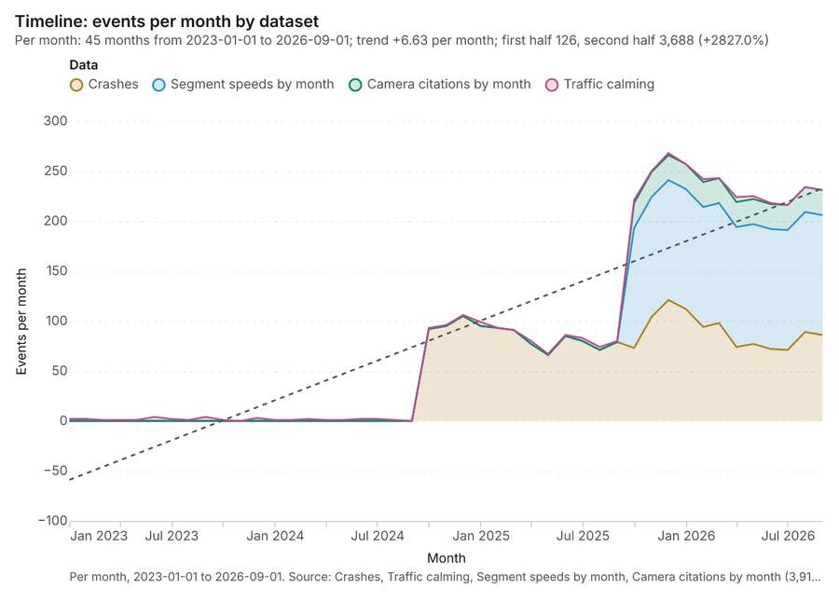
Figure 1. Timeline: events per month by dataset [1]. Per month, 2023-01-01 to 2026-09-01. Source: Crashes, Traffic calming, Segment speeds by month, Camera citations by month (3,910 features). The data is in the appendix.
The timeline counts 3,910 dated events in Crashes, Traffic calming, Segment speeds by month and 1 more per month, from January 2023 to September 2026 [1][2][3][4][5]. By dataset: Crashes 2,100; Segment speeds by month 1,440; Camera citations by month 300; Traffic calming 70 [1]. The trend is +6.63 events per month; the second half of the months has 3,688 against 126 in the first (+2827.0%) [1]. 2 of the 45 months had no events [1].
Busiest months
- December 2025: 268 events [1]
- January 2026: 257 events [1]
- November 2025: 250 events [1]
Quietest months with events
- March 2023: 1 event [1]
- April 2023: 1 event [1]
- May 2023: 1 event [1]

Hot spots
What this analysis is. Hot spot analysis: Getis-Ord Gi* hot and cold spots with z-scores, p-values and confidence bins [6]. In ArcGIS it is Find Hot Spots or Hot Spot Analysis (Getis-Ord Gi*); in QGIS, qgis:hotspot (plugin) [6].
Why it was run on this data. 40 points: Getis-Ord Gi* tests whether the concentrations in Schools are statistically significant [7].
What it found. Hot spot analysis was performed using the Schools input layer [9].
Result | Value
result, count | 40
result, elapsed ms | 3
result, excluded null | 0
result, distance band m | 2,000
billing, cost | 0.0508
billing, list price | 0.0508
billing, upstream cost | 0

Findings
- Evidenced: Hot spots on Schools: Hot spot analysis: 1 layer saved: Hot spot analysis: Schools (40 features) [8][9].
- Evidenced: It reported result, count 40; result, elapsed ms 3; result, excluded null 0; result, distance band m 2,000; billing, cost 0.0508; billing, list price 0.0508 [8].
Tool gp_hot_spots; parameters {"field": "students", "project": "220702b2-1327-4244-9cff-74cf9d501f98", "features": {"layer": "Schools (cb956034)"}, "aggregation": "hexagon", "cell_size_m": 2000.0, "distance_band_m": 2000.0}

Hot spots
What this analysis is. Hot spot analysis: Getis-Ord Gi* hot and cold spots with z-scores, p-values and confidence bins [6]. In ArcGIS it is Find Hot Spots or Hot Spot Analysis (Getis-Ord Gi*); in QGIS, qgis:hotspot (plugin) [6].
Why it was run on this data. 2100 points: Getis-Ord Gi* tests whether the concentrations in Crashes are statistically significant [10].
What it found. Hot spots on Crashes: Hot spot analysis: 1 layer saved: Hot spot analysis: Crashes (1049 features) [11][12]. It reported result, bins 1,049; result, count 1,049; result, elapsed ms 64; result, cell size m 200; result, incidents used 2,100; result, distance band m 200 [11].
Result | Value
result, bins | 1,049
result, count | 1,049
result, elapsed ms | 64
result, cell size m | 200
result, incidents used | 2,100
result, distance band m | 200
billing, cost | 0.092
billing, list price | 0.092
billing, upstream cost | 0

Findings
- Evidenced: Hot spots on Crashes: Hot spot analysis: 1 layer saved: Hot spot analysis: Crashes (1049 features) [11][12].
- Evidenced: It reported result, bins 1,049; result, count 1,049; result, elapsed ms 64; result, cell size m 200; result, incidents used 2,100; result, distance band m 200 [11].
Tool gp_hot_spots; parameters {"project": "220702b2-1327-4244-9cff-74cf9d501f98", "features": {"layer": "Crashes (9501bda5)"}, "aggregation": "hexagon", "cell_size_m": 200.0, "distance_band_m": 200.0}

Space time hot spots
What this analysis is. Emerging hot spots: Where hot spots are new, consecutive, intensifying, persistent, diminishing, sporadic, oscillating or historical over time [13]. In ArcGIS it is Emerging Hot Spot Analysis or Create Space Time Cube [13].
Why it was run on this data. Crashes carry dates in 'occurred_at': emerging hot spot analysis finds new, intensifying and fading hot spots per month [14].
What it found. Space time hot spots on Crashes: Emerging hot spots: 1 layer saved: Emerging hot spots: Crashes (391 features) [12][15]. It reported result, count 391; result, elapsed ms 57; result, resolution 9; result, features used 2,100; result, time neighbors 0; billing, cost 0.205 [15].
Result | Value
result, count | 391
result, elapsed ms | 57
result, resolution | 9
result, features used | 2,100
result, time neighbors | 0
billing, cost | 0.205
billing, list price | 0.205
billing, upstream cost | 0

Findings
- Evidenced: Space time hot spots on Crashes: Emerging hot spots: 1 layer saved: Emerging hot spots: Crashes (391 features) [12][15].
- Evidenced: It reported result, count 391; result, elapsed ms 57; result, resolution 9; result, features used 2,100; result, time neighbors 0; billing, cost 0.205 [15].
Tool gp_space_time_hot_spots; parameters {"project": "220702b2-1327-4244-9cff-74cf9d501f98", "features": {"layer": "Crashes (9501bda5)"}, "interval": "month", "bin_shape": "h3", "resolution": 9, "time_field": "occurred_at"}

Space time hot spots
What this analysis is. Emerging hot spots: Where hot spots are new, consecutive, intensifying, persistent, diminishing, sporadic, oscillating or historical over time [13]. In ArcGIS it is Emerging Hot Spot Analysis or Create Space Time Cube [13].
Why it was run on this data. Traffic calming carry dates in 'date': emerging hot spot analysis finds new, intensifying and fading hot spots per month [16].
What it found. Space time hot spots on Traffic calming: Emerging hot spots: 1 layer saved: Emerging hot spots: Traffic calming (14 features) [17][18]. It reported result, count 14; result, elapsed ms 4; result, resolution 7; result, features used 70; result, time neighbors 0; billing, cost 0.1035 [17].
Result | Value
result, count | 14
result, elapsed ms | 4
result, resolution | 7
result, features used | 70
result, time neighbors | 0
billing, cost | 0.1035
billing, list price | 0.1035
billing, upstream cost | 0

Findings
- Evidenced: Space time hot spots on Traffic calming: Emerging hot spots: 1 layer saved: Emerging hot spots: Traffic calming (14 features) [17][18].
- Evidenced: It reported result, count 14; result, elapsed ms 4; result, resolution 7; result, features used 70; result, time neighbors 0; billing, cost 0.1035 [17].
Tool gp_space_time_hot_spots; parameters {"project": "220702b2-1327-4244-9cff-74cf9d501f98", "features": {"layer": "Traffic calming (03fd1e3f)"}, "interval": "month", "bin_shape": "h3", "resolution": 7, "time_field": "date"}

Summarize within
What this analysis is. Summarize within: Count and aggregate the features inside each polygon (or bin), proportionally for lines and polygons [19]. In ArcGIS it is Summarize Within or Aggregate Points; in QGIS, native:countpointsinpolygon or native:sumlinelengths [19].
Why it was run on this data. Count Schools inside each feature of Traffic districts by level; the counts map as a choropleth (natural breaks, sequential colors) [20].
What it found. Summarize within on Schools, Traffic districts: Summarize within: 1 layer saved: Summarize within: Traffic districts (12 features) [9][21][22]. It reported result, count 12; result, elapsed ms 0; billing, cost 0.01106; billing, list price 0.01106; billing, upstream cost 0 [21].
Result | Value
result, count | 12
result, elapsed ms | 0
billing, cost | 0.01106
billing, list price | 0.01106
billing, upstream cost | 0

Findings
- Evidenced: Summarize within on Schools, Traffic districts: Summarize within: 1 layer saved: Summarize within: Traffic districts (12 features) [9][21][22].
- Evidenced: It reported result, count 12; result, elapsed ms 0; billing, cost 0.01106; billing, list price 0.01106; billing, upstream cost 0 [21].
Tool gp_summarize_within; parameters {"stats": [{"stat": "sum", "field": "students"}], "project": "220702b2-1327-4244-9cff-74cf9d501f98", "features": {"layer": "Schools (cb956034)"}, "group_by": "level", "polygons": {"layer": "Traffic districts (426e8d19)"}}

Summarize within
What this analysis is. Summarize within: Count and aggregate the features inside each polygon (or bin), proportionally for lines and polygons [19]. In ArcGIS it is Summarize Within or Aggregate Points; in QGIS, native:countpointsinpolygon or native:sumlinelengths [19].
Why it was run on this data. Count Schools inside each feature of Traffic districts by level; the counts map as a choropleth (natural breaks, sequential colors) [20].
What it found. Summarize within on Crashes, Traffic districts: Summarize within: 1 layer saved: Summarize within: Traffic districts (12 features) [12][22][23]. It reported result, count 12; result, elapsed ms 3; billing, cost 0.05226; billing, list price 0.05226; billing, upstream cost 0 [23].
Result | Value
result, count | 12
result, elapsed ms | 3
billing, cost | 0.05226
billing, list price | 0.05226
billing, upstream cost | 0

Findings
- Evidenced: Summarize within on Crashes, Traffic districts: Summarize within: 1 layer saved: Summarize within: Traffic districts (12 features) [12][22][23].
- Evidenced: It reported result, count 12; result, elapsed ms 3; billing, cost 0.05226; billing, list price 0.05226; billing, upstream cost 0 [23].
Tool gp_summarize_within; parameters {"stats": [{"stat": "sum", "field": "injured"}], "project": "220702b2-1327-4244-9cff-74cf9d501f98", "features": {"layer": "Crashes (9501bda5)"}, "group_by": "severity", "polygons": {"layer": "Traffic districts (426e8d19)"}}

Find point clusters
What this analysis is. Find point clusters: Density-based clusters (DBSCAN, HDBSCAN or OPTICS, optionally space-time) with hulls and noise [24]. In ArcGIS it is Find Point Clusters or Density-based Clustering; in QGIS, native:dbscanclustering or native:stdbscanclustering [24].
Why it was run on this data. DBSCAN finds dense groups of Schools and separates noise [25].
What it found. Find point clusters on Schools: Find point clusters: 2 layers saved: Find point clusters: Schools (40 features); Find point clusters: cluster hulls (3 features) [9][26]. It reported result, count 40; result, noise 3; result, distance m 1,000; result, elapsed ms 5; result, min points 3; billing, cost 0.0508 [26].
Result | Value
result, count | 40
result, noise | 3
result, distance m | 1,000
result, elapsed ms | 5
result, min points | 3
billing, cost | 0.0508
billing, list price | 0.0508
billing, upstream cost | 0

Findings
- Evidenced: Find point clusters on Schools: Find point clusters: 2 layers saved: Find point clusters: Schools (40 features); Find point clusters: cluster hulls (3 features) [9][26].
- Evidenced: It reported result, count 40; result, noise 3; result, distance m 1,000; result, elapsed ms 5; result, min points 3; billing, cost 0.0508 [26].
Tool gp_find_point_clusters; parameters {"method": "dbscan", "project": "220702b2-1327-4244-9cff-74cf9d501f98", "features": {"layer": "Schools (cb956034)"}, "distance_m": 1000.0, "min_points": 3}

Find point clusters
What this analysis is. Find point clusters: Density-based clusters (DBSCAN, HDBSCAN or OPTICS, optionally space-time) with hulls and noise [24]. In ArcGIS it is Find Point Clusters or Density-based Clustering; in QGIS, native:dbscanclustering or native:stdbscanclustering [24].
Why it was run on this data. DBSCAN finds dense groups of Crashes and separates noise [27].
What it found. Find point clusters on Crashes: Find point clusters: 2 layers saved: Find point clusters: Crashes (2100 features); Find point clusters: cluster hulls (2 features) [12][28]. It reported result, count 2,100; result, noise 1,422; result, distance m 200; result, elapsed ms 32; result, min points 20; billing, cost 0.092 [28].
Result | Value
result, count | 2,100
result, noise | 1,422
result, distance m | 200
result, elapsed ms | 32
result, min points | 20
billing, cost | 0.092
billing, list price | 0.092
billing, upstream cost | 0

Findings
- Evidenced: Find point clusters on Crashes: Find point clusters: 2 layers saved: Find point clusters: Crashes (2100 features); Find point clusters: cluster hulls (2 features) [12][28].
- Evidenced: It reported result, count 2,100; result, noise 1,422; result, distance m 200; result, elapsed ms 32; result, min points 20; billing, cost 0.092 [28].
Tool gp_find_point_clusters; parameters {"method": "dbscan", "project": "220702b2-1327-4244-9cff-74cf9d501f98", "features": {"layer": "Crashes (9501bda5)"}, "distance_m": 200.0, "min_points": 20}

Find point clusters
What this analysis is. Find point clusters: Density-based clusters (DBSCAN, HDBSCAN or OPTICS, optionally space-time) with hulls and noise [24]. In ArcGIS it is Find Point Clusters or Density-based Clustering; in QGIS, native:dbscanclustering or native:stdbscanclustering [24].
Why it was run on this data. DBSCAN finds dense groups of Pedestrian crossings and separates noise [29].
What it found. Find point clusters on Pedestrian crossings: Find point clusters: 2 layers saved: Find point clusters: Pedestrian crossings (200 features); Find point clusters: cluster hulls (11 features) [30][31]. It reported result, count 200; result, noise 53; result, distance m 500; result, elapsed ms 6; result, min points 5; billing, cost 0.054 [30].
Result | Value
result, count | 200
result, noise | 53
result, distance m | 500
result, elapsed ms | 6
result, min points | 5
billing, cost | 0.054
billing, list price | 0.054
billing, upstream cost | 0

Findings
- Evidenced: Find point clusters on Pedestrian crossings: Find point clusters: 2 layers saved: Find point clusters: Pedestrian crossings (200 features); Find point clusters: cluster hulls (11 features) [30][31].
- Evidenced: It reported result, count 200; result, noise 53; result, distance m 500; result, elapsed ms 6; result, min points 5; billing, cost 0.054 [30].
A model draft was discarded because a sentence did not cite a source of this section.
Tool gp_find_point_clusters; parameters {"method": "dbscan", "project": "220702b2-1327-4244-9cff-74cf9d501f98", "features": {"layer": "Pedestrian crossings (5a5fc524)"}, "distance_m": 500.0, "min_points": 5}

Calculate density
What this analysis is. Calculate density: Kernel density per square kilometer on a grid [32]. In ArcGIS it is Calculate Density or Kernel Density; in QGIS, native:heatmapkerneldensityestimation [32].
Why it was run on this data. 40 points in Schools: a density surface shows where they concentrate [33].
What it found. Calculate density on Schools: Calculate density: 1 layer saved: Calculate density: Schools (80 features) [9][34]. It reported result, count 80; result, elapsed ms 4; result, bandwidth m 2,000; result, cell size m 1,000; result, excluded null 0; result, max density per km2 1,488 [34].
Result | Value
result, count | 80
result, elapsed ms | 4
result, bandwidth m | 2,000
result, cell size m | 1,000
result, excluded null | 0
result, max density per km2 | 1,488
billing, cost | 0.0508
billing, list price | 0.0508
billing, upstream cost | 0

Findings
- Evidenced: Calculate density on Schools: Calculate density: 1 layer saved: Calculate density: Schools (80 features) [9][34].
- Evidenced: It reported result, count 80; result, elapsed ms 4; result, bandwidth m 2,000; result, cell size m 1,000; result, excluded null 0; result, max density per km2 1,488 [34].
A model draft was discarded because a sentence did not cite a source of this section.
Tool gp_calculate_density; parameters {"kernel": "quartic", "project": "220702b2-1327-4244-9cff-74cf9d501f98", "features": {"layer": "Schools (cb956034)"}, "bandwidth_m": 2000.0, "cell_size_m": 1000.0, "weight_field": "students"}

Calculate density
What this analysis is. Calculate density: Kernel density per square kilometer on a grid [32]. In ArcGIS it is Calculate Density or Kernel Density; in QGIS, native:heatmapkerneldensityestimation [32].
Why it was run on this data. 2100 points in Crashes: a density surface shows where they concentrate [35].
What it found. The density calculation used the Crashes layer as input [12]. The tool successfully processed the data, yielding 4,112 features [36].
Result | Value
result, count | 4,112
result, elapsed ms | 110
result, bandwidth m | 200
result, cell size m | 100
result, excluded null | 0
result, max density per km2 | 816.6
billing, cost | 0.092
billing, list price | 0.092
billing, upstream cost | 0

Findings
- Evidenced: Calculate density on Crashes: Calculate density: 1 layer saved: Calculate density: Crashes (4112 features) [12][36].
- Evidenced: It reported result, count 4,112; result, elapsed ms 110; result, bandwidth m 200; result, cell size m 100; result, excluded null 0; result, max density per km2 816.6 [36].
Tool gp_calculate_density; parameters {"kernel": "quartic", "project": "220702b2-1327-4244-9cff-74cf9d501f98", "features": {"layer": "Crashes (9501bda5)"}, "bandwidth_m": 200.0, "cell_size_m": 100.0}

Calculate density
What this analysis is. Calculate density: Kernel density per square kilometer on a grid [32]. In ArcGIS it is Calculate Density or Kernel Density; in QGIS, native:heatmapkerneldensityestimation [32].
Why it was run on this data. 200 points in Pedestrian crossings: a density surface shows where they concentrate [37].
What it found. The calculation of density was performed on the Pedestrian crossings layer [31] using the gp_calculate_density function [38]. This process yielded a count of 251 features [38], with an elapsed time of 7 milliseconds [38]. The resulting density calculation reported a maximum density per km2 of 9.062 [38].
Result | Value
result, count | 251
result, elapsed ms | 7
result, bandwidth m | 1,000
result, cell size m | 500
result, excluded null | 0
result, max density per km2 | 9.062
billing, cost | 0.054
billing, list price | 0.054
billing, upstream cost | 0

Findings
- Evidenced: Calculate density on Pedestrian crossings: Calculate density: 1 layer saved: Calculate density: Pedestrian crossings (251 features) [31][38].
- Evidenced: It reported result, count 251; result, elapsed ms 7; result, bandwidth m 1,000; result, cell size m 500; result, excluded null 0; result, max density per km2 9.062 [38].
Tool gp_calculate_density; parameters {"kernel": "quartic", "project": "220702b2-1327-4244-9cff-74cf9d501f98", "features": {"layer": "Pedestrian crossings (5a5fc524)"}, "bandwidth_m": 1000.0, "cell_size_m": 500.0}

Hot spots
What this analysis is. Hot spot analysis: Getis-Ord Gi* hot and cold spots with z-scores, p-values and confidence bins [6]. In ArcGIS it is Find Hot Spots or Hot Spot Analysis (Getis-Ord Gi*); in QGIS, qgis:hotspot (plugin) [6].
Why it was run on this data. 200 points: Getis-Ord Gi* tests whether the concentrations in Pedestrian crossings are statistically significant [39].
What it found. Hot spots on Pedestrian crossings: Hot spot analysis: 1 layer saved: Hot spot analysis: Pedestrian crossings (54 features) [31][40]. It reported result, bins 54; result, count 54; result, elapsed ms 5; result, cell size m 1,000; result, incidents used 200; result, distance band m 1,000 [40].
Result | Value
result, bins | 54
result, count | 54
result, elapsed ms | 5
result, cell size m | 1,000
result, incidents used | 200
result, distance band m | 1,000
billing, cost | 0.054
billing, list price | 0.054
billing, upstream cost | 0

Findings
- Evidenced: Hot spots on Pedestrian crossings: Hot spot analysis: 1 layer saved: Hot spot analysis: Pedestrian crossings (54 features) [31][40].
- Evidenced: It reported result, bins 54; result, count 54; result, elapsed ms 5; result, cell size m 1,000; result, incidents used 200; result, distance band m 1,000 [40].
Tool gp_hot_spots; parameters {"project": "220702b2-1327-4244-9cff-74cf9d501f98", "features": {"layer": "Pedestrian crossings (5a5fc524)"}, "aggregation": "hexagon", "cell_size_m": 1000.0, "distance_band_m": 1000.0}

Near repeat
What this analysis is. Repeat and near repeat classification: Classify incidents as originators, repeats (same place) or near repeats within a distance and time window, with a Knox test table [41]. In ArcGIS it is Repeat and Near Repeat Classification or Near Repeat Calculator [41].
Why it was run on this data. Near repeat analysis tests whether Crashes close in space also follow each other within 30 days [42].
What it found. Near repeat on Crashes: Repeat and near repeat classification: 1 layer saved: Repeat and near repeat classification: Crashes (2100 features) [12][43]. It reported result, days 30; result, count 2,100; result, chains 190; result, distance m 100; result, elapsed ms 41; result, pairs linked 506 [43].
Result | Value
result, days | 30
result, count | 2,100
result, chains | 190
result, distance m | 100
result, elapsed ms | 41
result, pairs linked | 506
billing, cost | 0.113
billing, list price | 0.113
billing, upstream cost | 0

Findings
- Evidenced: Near repeat on Crashes: Repeat and near repeat classification: 1 layer saved: Repeat and near repeat classification: Crashes (2100 features) [12][43].
- Evidenced: It reported result, days 30; result, count 2,100; result, chains 190; result, distance m 100; result, elapsed ms 41; result, pairs linked 506 [43].
Tool gp_near_repeat; parameters {"days": 30, "project": "220702b2-1327-4244-9cff-74cf9d501f98", "features": {"layer": "Crashes (9501bda5)"}, "distance_m": 100.0, "time_field": "occurred_at"}

Summarize within
What this analysis is. Summarize within: Count and aggregate the features inside each polygon (or bin), proportionally for lines and polygons [19]. In ArcGIS it is Summarize Within or Aggregate Points; in QGIS, native:countpointsinpolygon or native:sumlinelengths [19].
Why it was run on this data. Count Pedestrian crossings inside each feature of Traffic districts by type; the counts map as a choropleth (natural breaks, sequential colors) [44].
What it found. The analysis used Pedestrian crossings [31] and Traffic districts [22] as inputs for the geoprocessing summary [45]. The `gp_summarize_within` tool reported a result count of 12 [45].
Result | Value
result, count | 12
result, elapsed ms | 1
billing, cost | 0.01424
billing, list price | 0.01424
billing, upstream cost | 0

Findings
- Evidenced: Summarize within on Pedestrian crossings, Traffic districts: Summarize within: 1 layer saved: Summarize within: Traffic districts (12 features) [22][31][45].
- Evidenced: It reported result, count 12; result, elapsed ms 1; billing, cost 0.01424; billing, list price 0.01424; billing, upstream cost 0 [45].
Tool gp_summarize_within; parameters {"stats": [], "project": "220702b2-1327-4244-9cff-74cf9d501f98", "features": {"layer": "Pedestrian crossings (5a5fc524)"}, "group_by": "type", "polygons": {"layer": "Traffic districts (426e8d19)"}}

Maps and charts
The run also made 18 map image(s) [46][47][48][49][50][51][52][53][54][55][56][57][58][59][60][61][62][63] and 25 chart(s) [64][65][66][67][68][69][70][71][72][73][74][75][76][77][78][79][80][81][82][83][84][85][86][87][88].
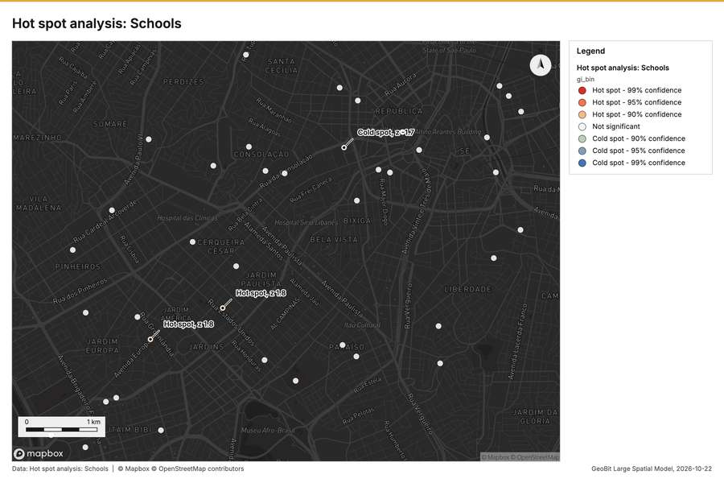
Figure 2. Hot spot analysis: Schools [46]
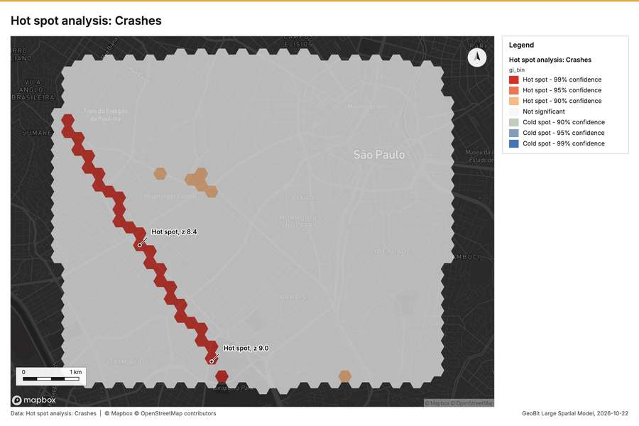
Figure 3. Hot spot analysis: Crashes [47]
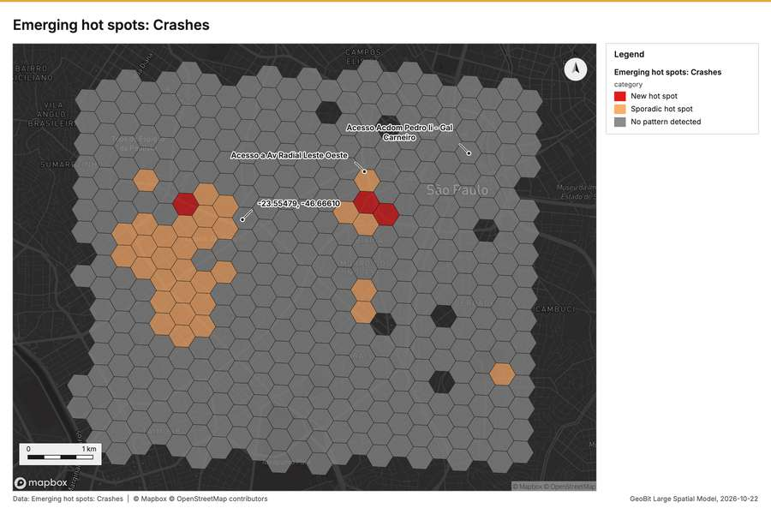
Figure 4. Emerging hot spots: Crashes [48]
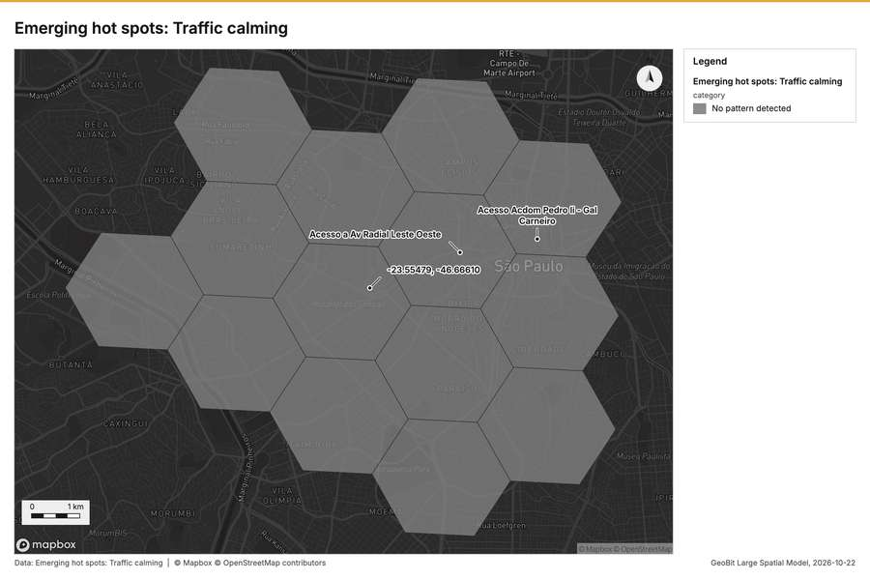
Figure 5. Emerging hot spots: Traffic calming [49]
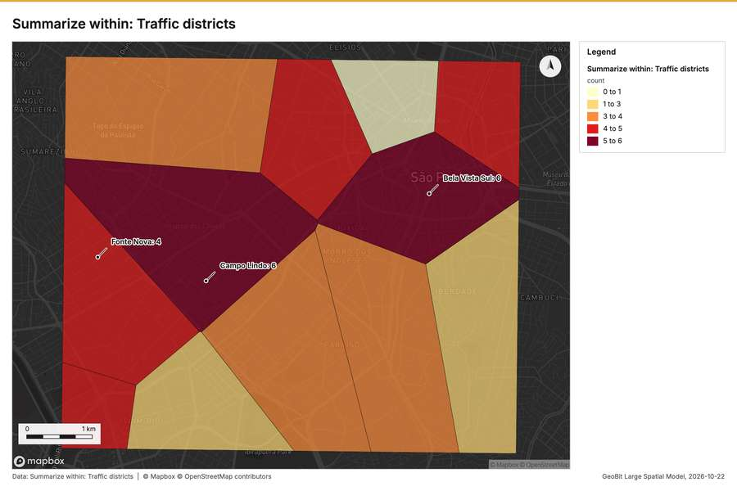
Figure 6. Summarize within: Traffic districts [50]
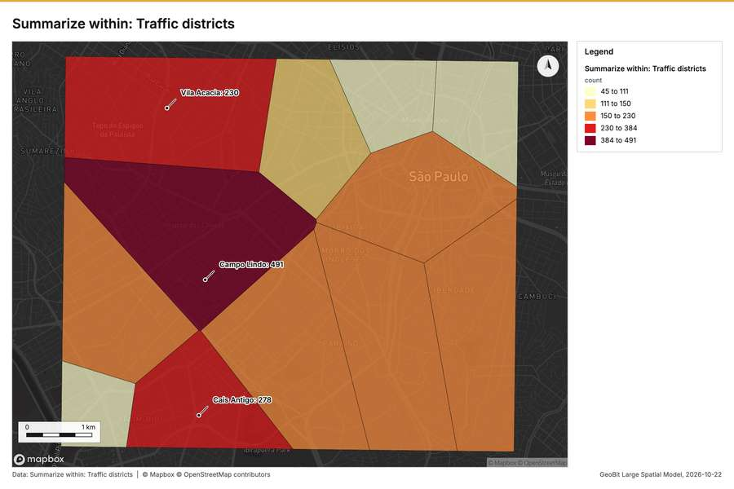
Figure 7. Summarize within: Traffic districts [51]
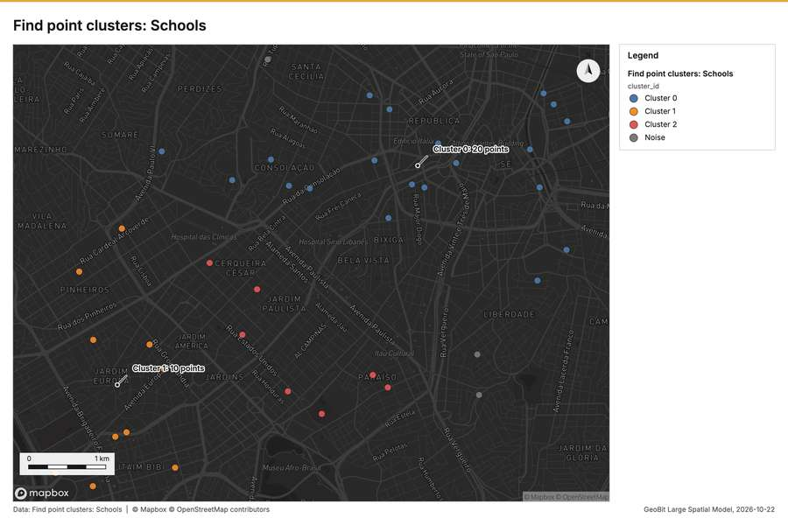
Figure 8. Find point clusters: Schools [52]
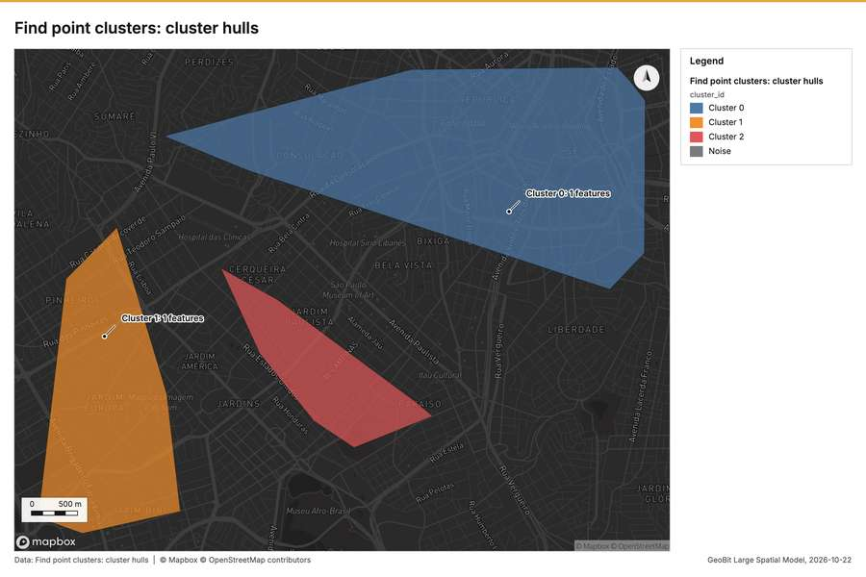
Figure 9. Find point clusters: cluster hulls [53]
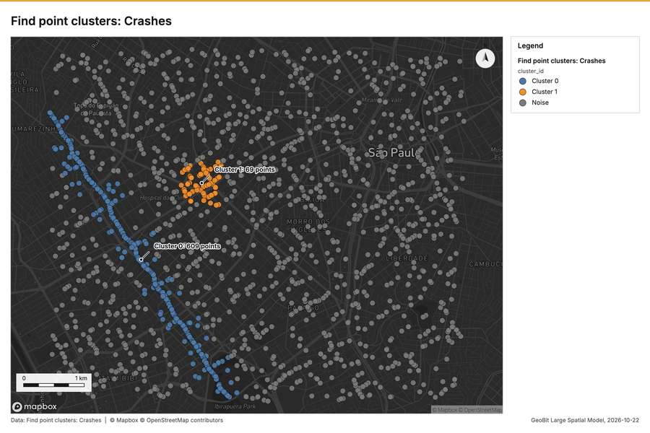
Figure 10. Find point clusters: Crashes [54]
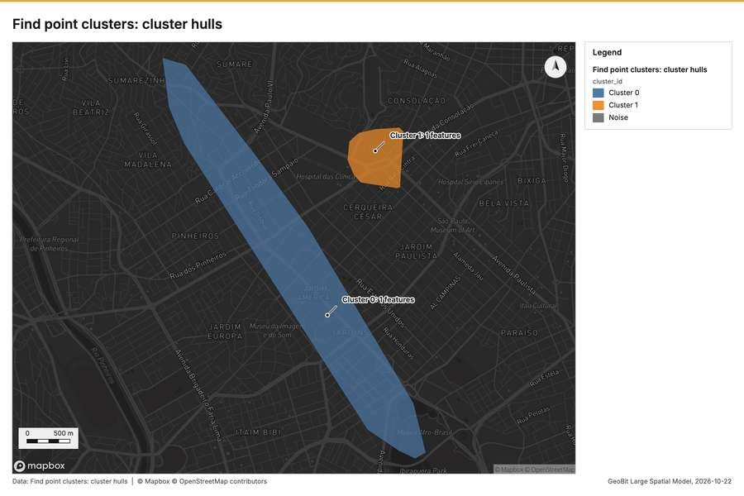
Figure 11. Find point clusters: cluster hulls [55]
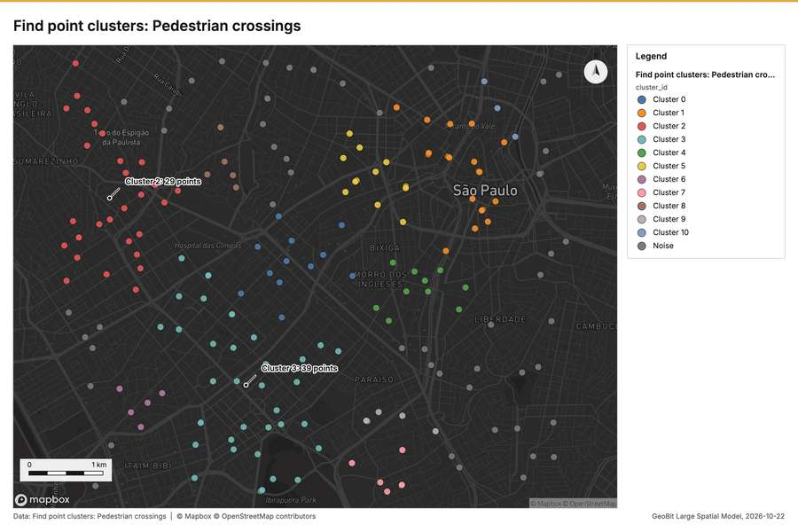
Figure 12. Find point clusters: Pedestrian crossings [56]
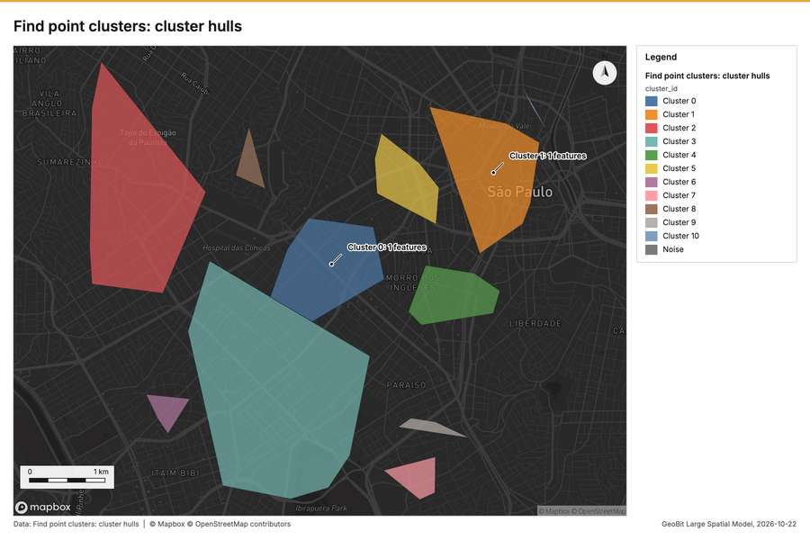
Figure 13. Find point clusters: cluster hulls [57]
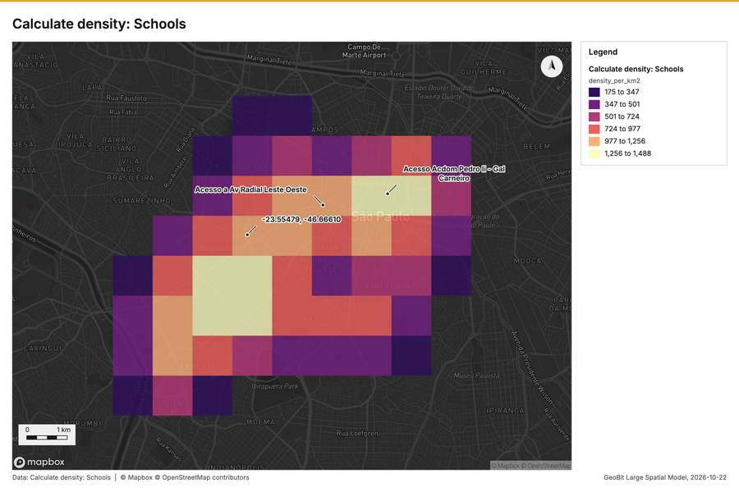
Figure 14. Calculate density: Schools [58]
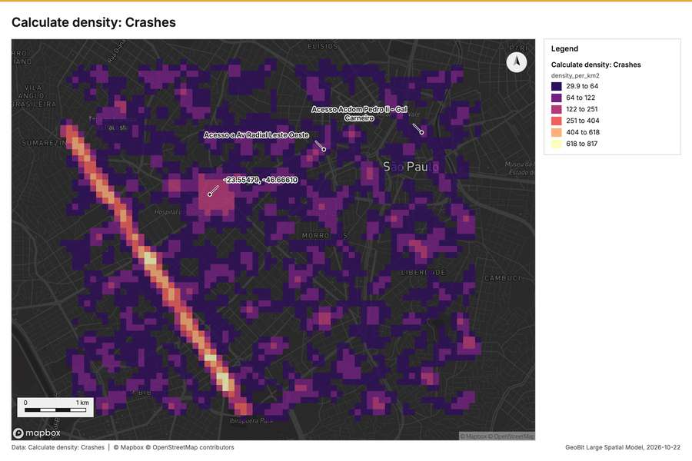
Figure 15. Calculate density: Crashes [59]
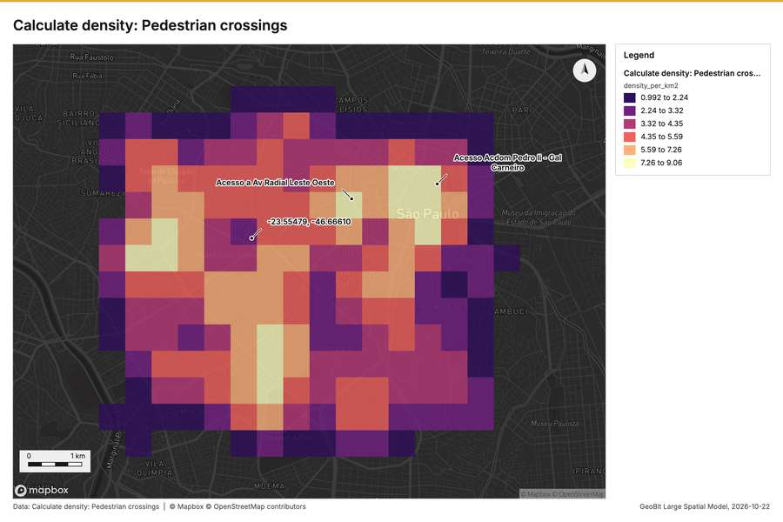
Figure 16. Calculate density: Pedestrian crossings [60]
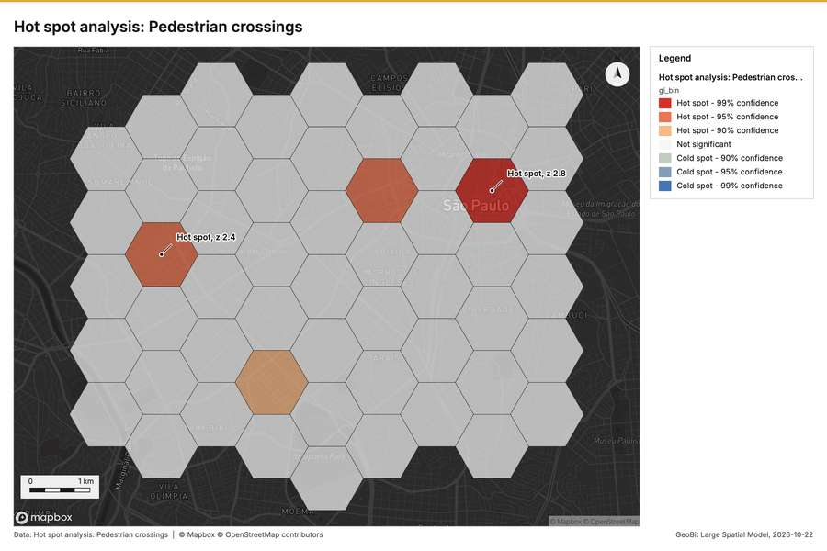
Figure 17. Hot spot analysis: Pedestrian crossings [61]
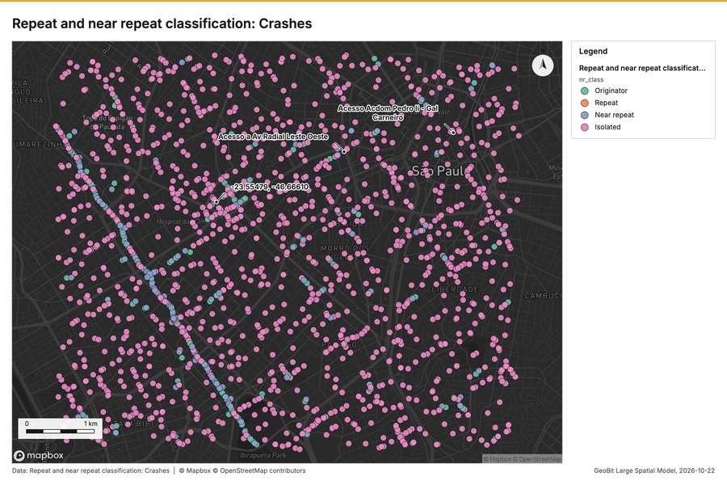
Figure 18. Repeat and near repeat classification: Crashes [62]
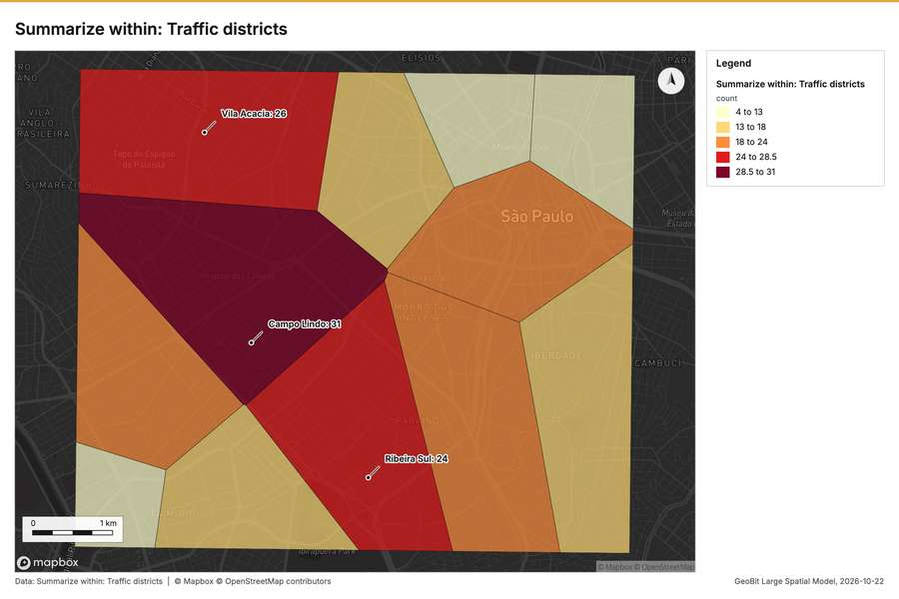
Figure 19. Summarize within: Traffic districts [63]
What the map shows. The map, titled "Emerging hot spots: Traffic calming," displays spatial analysis results across multiple hexagonal zones. According to the map's legend, every area is categorized under the "No pattern detected" status for this emerging hot spot analysis. The map does not display any visible clusters, gradients, or outliers of high or low traffic calming activity. The uniform [49]
Inferred: read from the image by gemma4:e4b, not evidence.
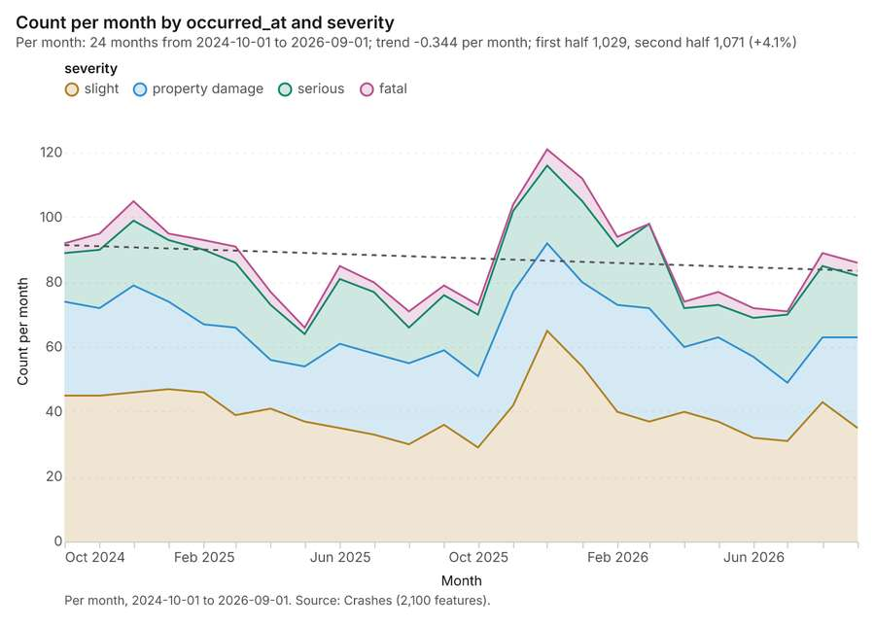
Figure 20. Crashes over time (occurred_at) [64]. Per month, 2024-10-01 to 2026-09-01. Source: Crashes (2,100 features). The data is in the appendix.
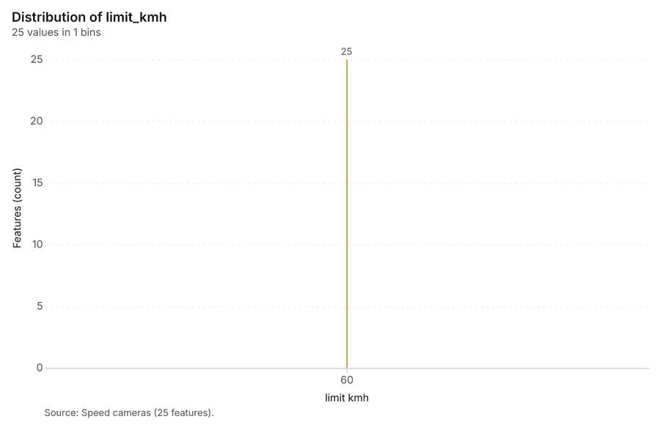
Figure 21. Speed cameras over time (installed_year) [65]. Source: Speed cameras (25 features). The data is in the appendix.
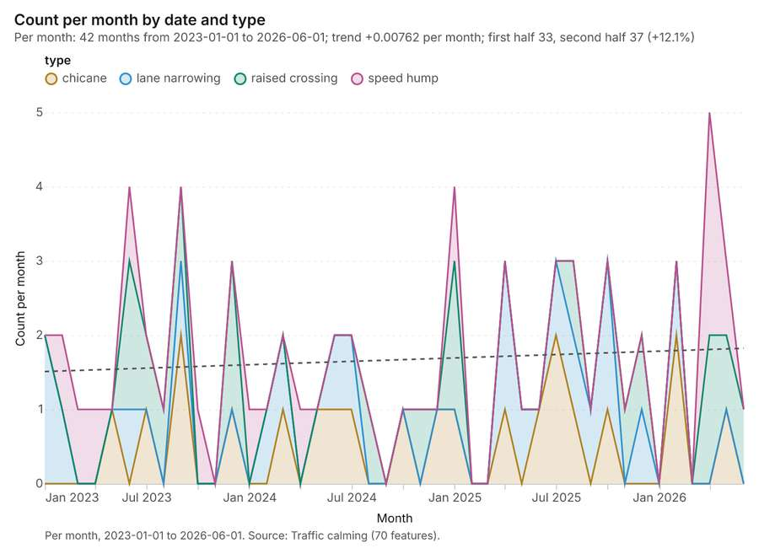
Figure 22. Traffic calming over time (date) [66]. Per month, 2023-01-01 to 2026-06-01. Source: Traffic calming (70 features). The data is in the appendix.
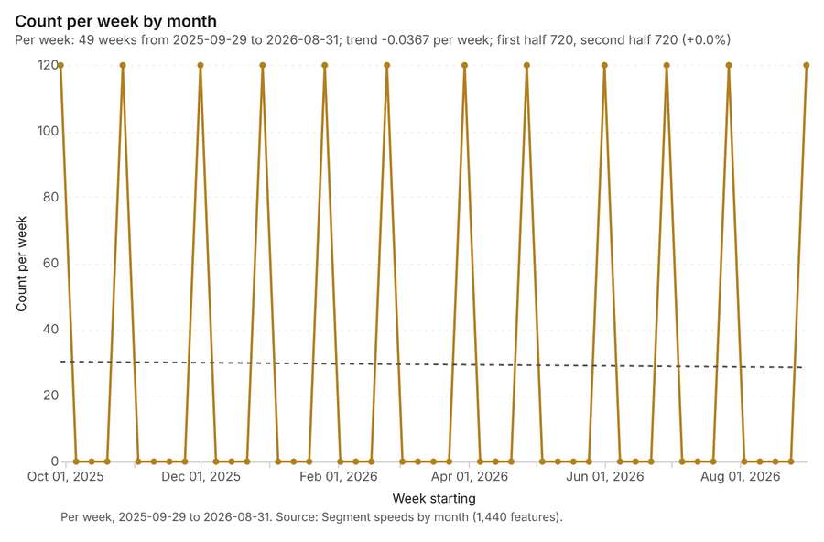
Figure 23. Segment speeds by month over time (month) [67]. Per week, 2025-09-29 to 2026-08-31. Source: Segment speeds by month (1,440 features). The data is in the appendix.
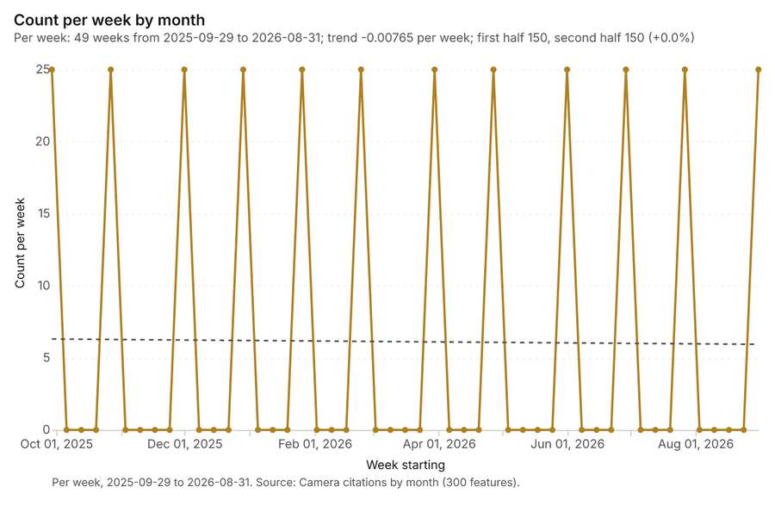
Figure 24. Camera citations by month over time (month) [68]. Per week, 2025-09-29 to 2026-08-31. Source: Camera citations by month (300 features). The data is in the appendix.
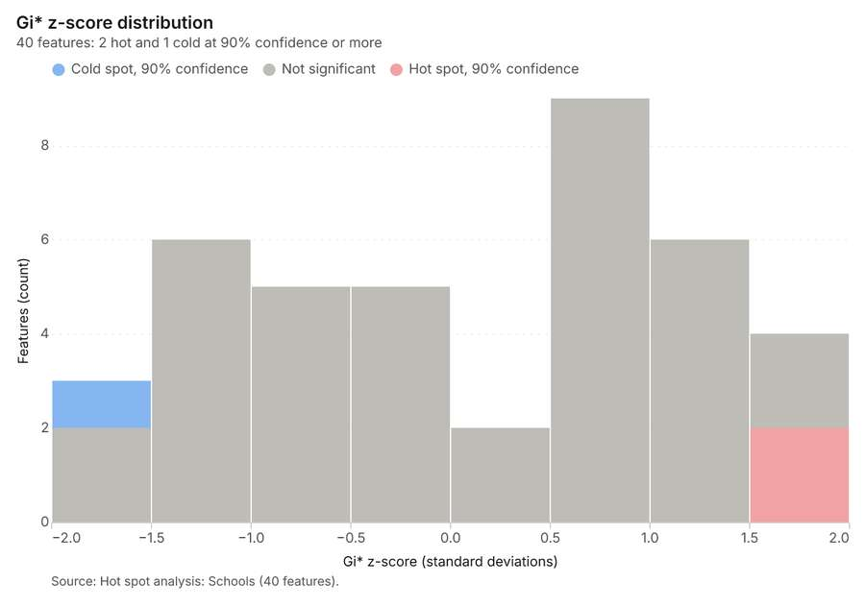
Figure 25. Hot spot analysis: Schools [69]. Source: Hot spot analysis: Schools (40 features). The data is in the appendix.
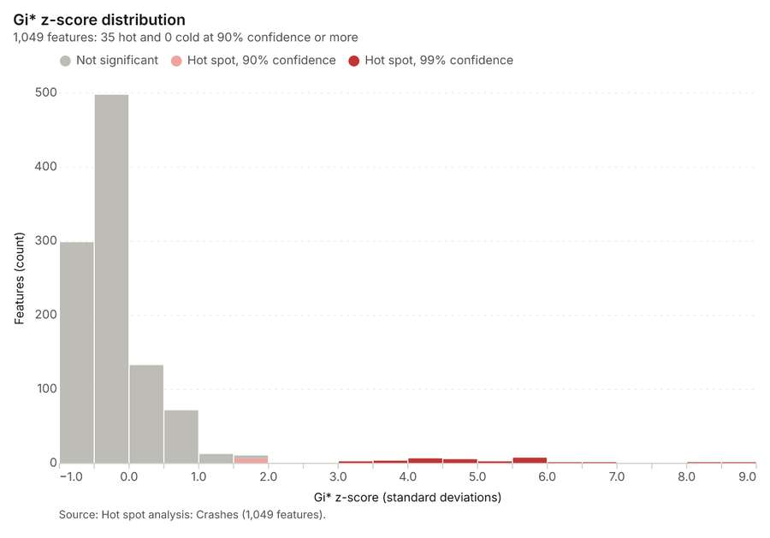
Figure 26. Hot spot analysis: Crashes [70]. Source: Hot spot analysis: Crashes (1,049 features). The data is in the appendix.
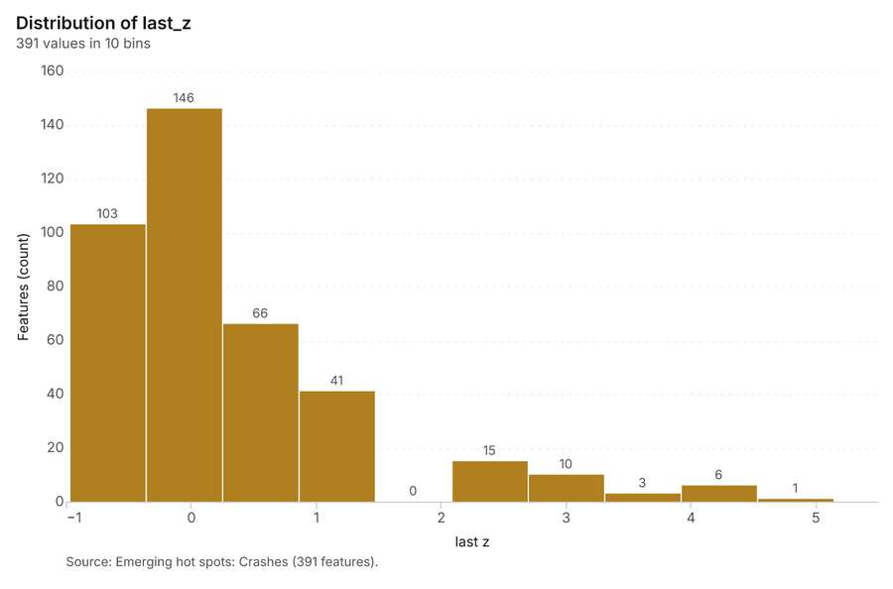
Figure 27. Emerging hot spots: Crashes [71]. Source: Emerging hot spots: Crashes (391 features). The data is in the appendix.
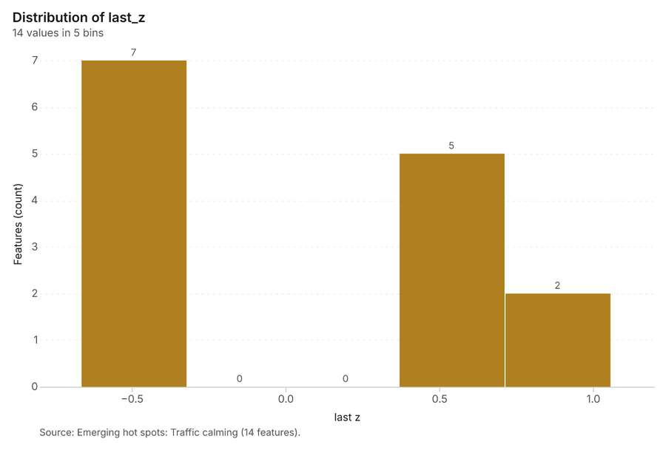
Figure 28. Emerging hot spots: Traffic calming [72]. Source: Emerging hot spots: Traffic calming (14 features). The data is in the appendix.
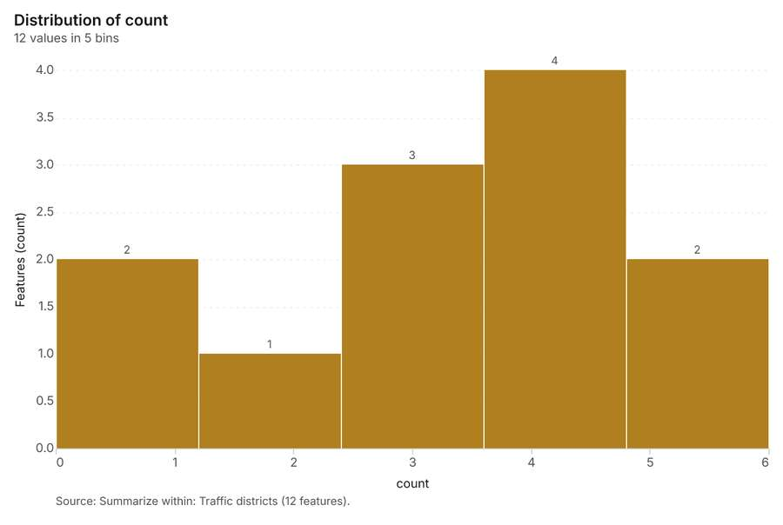
Figure 29. Summarize within: Traffic districts [73]. Source: Summarize within: Traffic districts (12 features). The data is in the appendix.
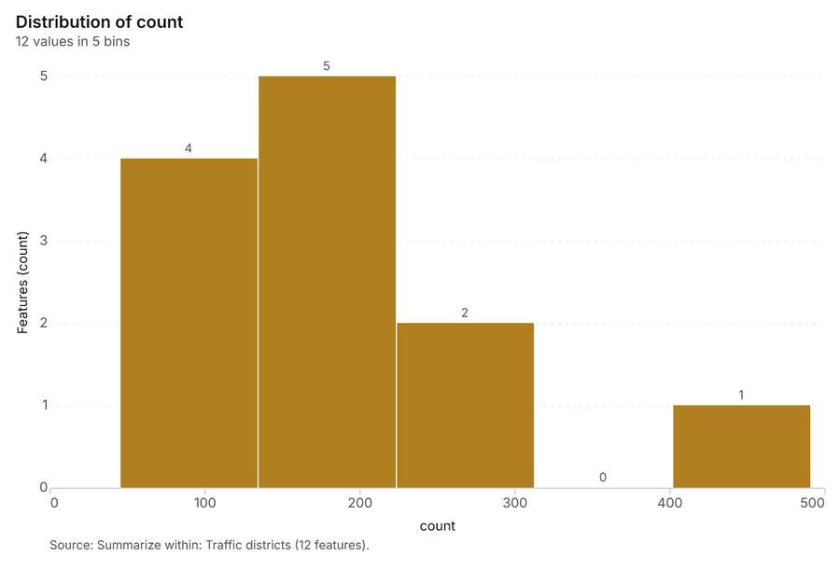
Figure 30. Summarize within: Traffic districts [74]. Source: Summarize within: Traffic districts (12 features). The data is in the appendix.
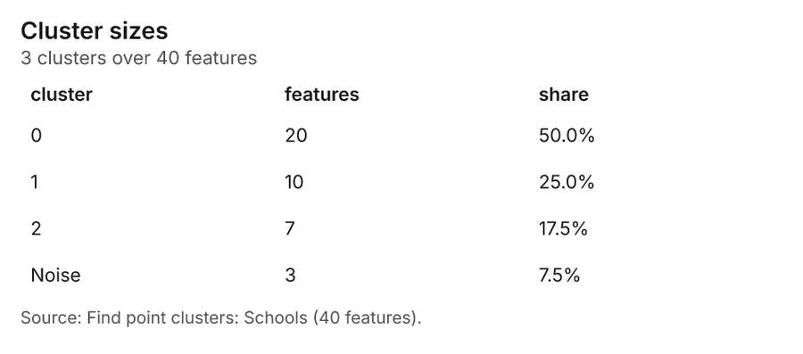
Figure 31. Find point clusters: Schools [75]. Source: Find point clusters: Schools (40 features). The data is in the appendix.
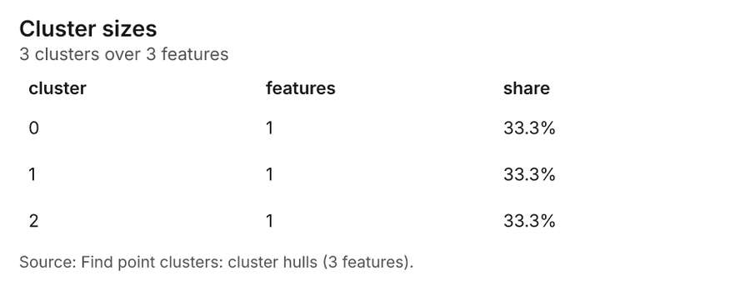
Figure 32. Find point clusters: cluster hulls [76]. Source: Find point clusters: cluster hulls (3 features). The data is in the appendix.
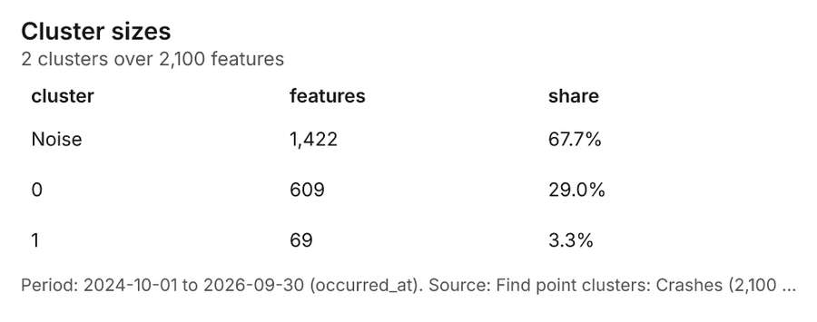
Figure 33. Find point clusters: Crashes [77]. Period: 2024-10-01 to 2026-09-30 (occurred_at). Source: Find point clusters: Crashes (2,100 features). The data is in the appendix.
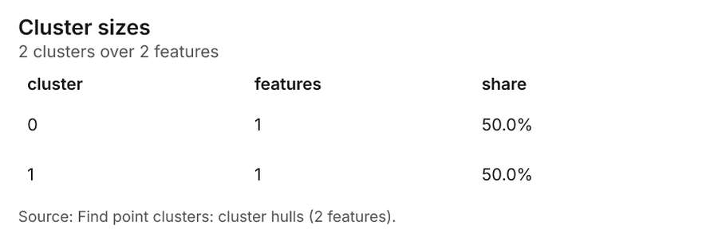
Figure 34. Find point clusters: cluster hulls [78]. Source: Find point clusters: cluster hulls (2 features). The data is in the appendix.
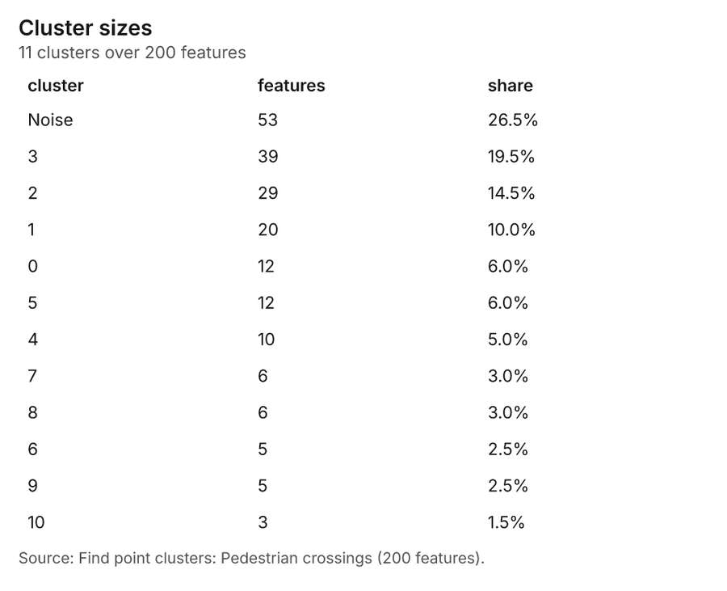
Figure 35. Find point clusters: Pedestrian crossings [79]. Source: Find point clusters: Pedestrian crossings (200 features). The data is in the appendix.
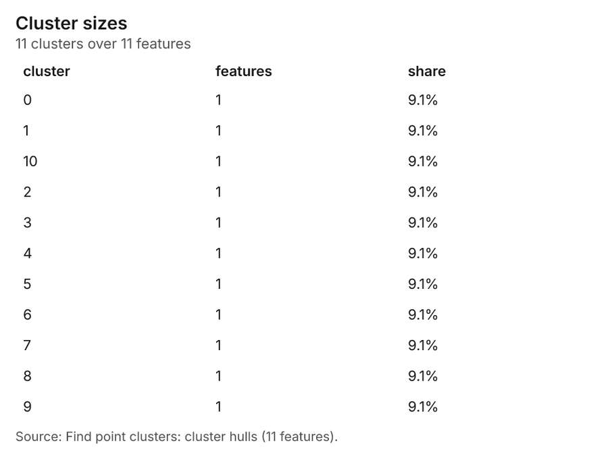
Figure 36. Find point clusters: cluster hulls [80]. Source: Find point clusters: cluster hulls (11 features). The data is in the appendix.
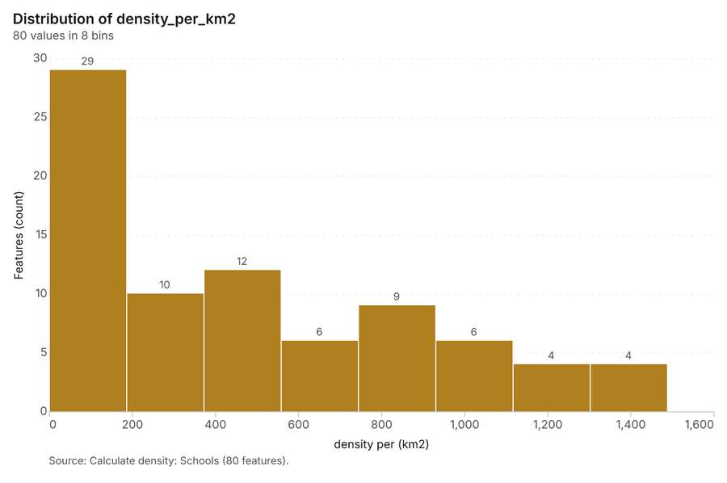
Figure 37. Calculate density: Schools [81]. Source: Calculate density: Schools (80 features). The data is in the appendix.
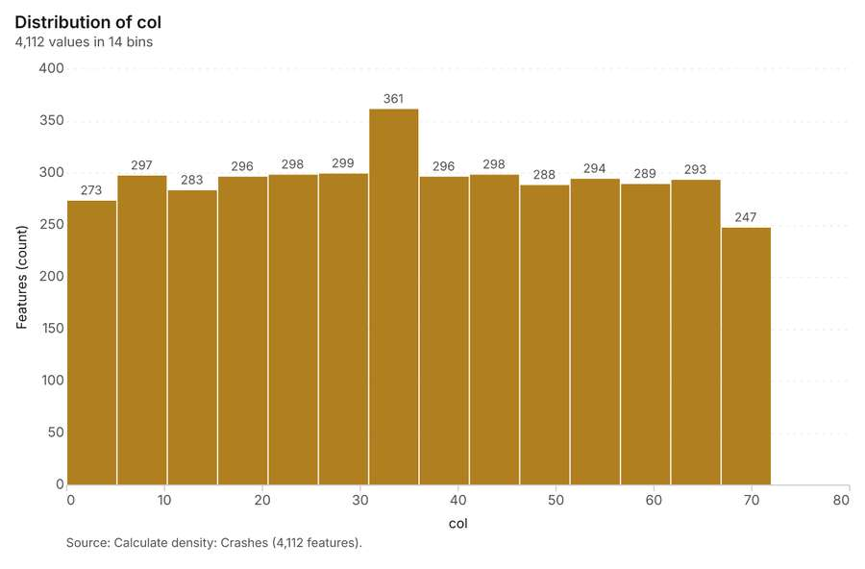
Figure 38. Calculate density: Crashes [82]. Source: Calculate density: Crashes (4,112 features). The data is in the appendix.
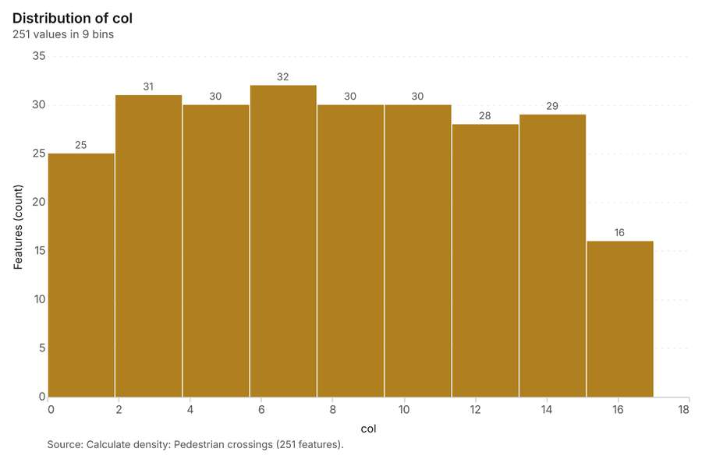
Figure 39. Calculate density: Pedestrian crossings [83]. Source: Calculate density: Pedestrian crossings (251 features). The data is in the appendix.
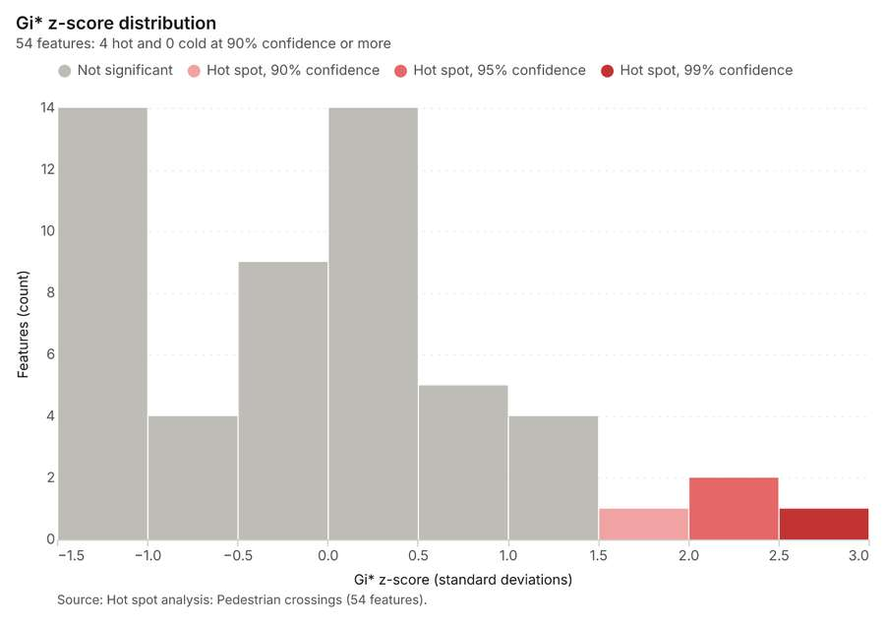
Figure 40. Hot spot analysis: Pedestrian crossings [84]. Source: Hot spot analysis: Pedestrian crossings (54 features). The data is in the appendix.
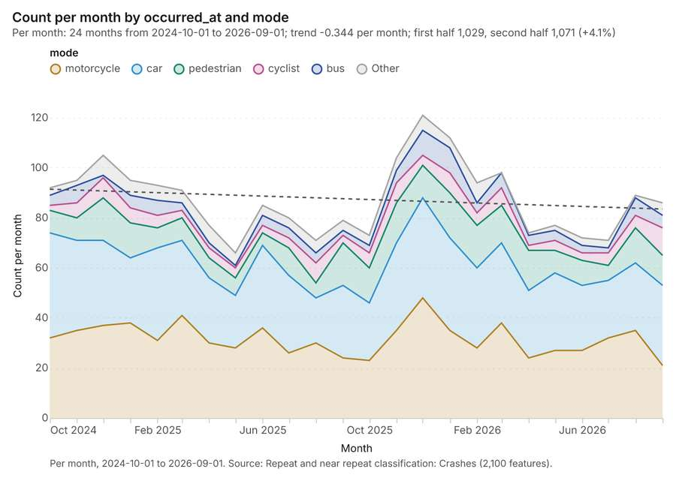
Figure 41. Repeat and near repeat classification: Crashes [85]. Per month, 2024-10-01 to 2026-09-01. Source: Repeat and near repeat classification: Crashes (2,100 features). The data is in the appendix.
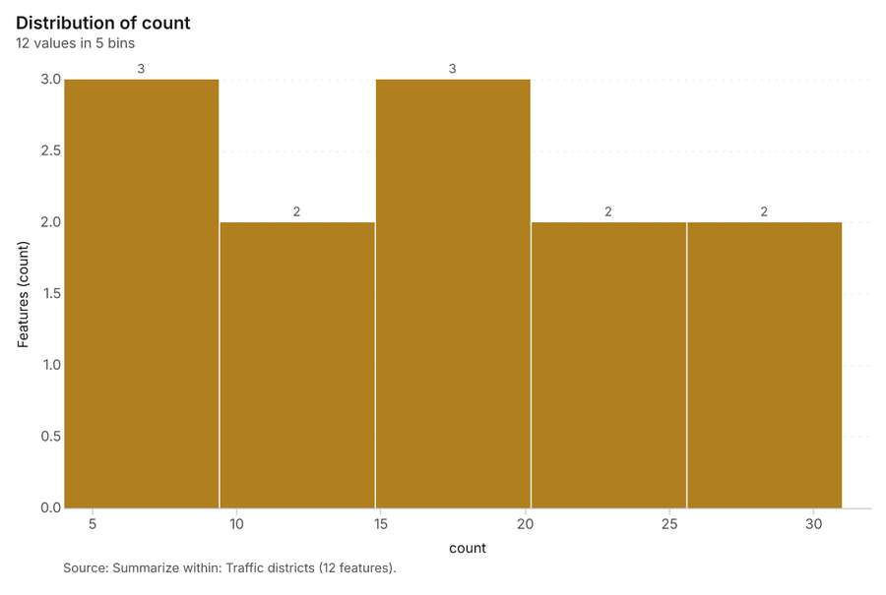
Figure 42. Summarize within: Traffic districts [86]. Source: Summarize within: Traffic districts (12 features). The data is in the appendix.
Figure 43. Repeat and near repeat classification: Crashes over time [87]. Per month, 2024-10-01 to 2026-09-01. Source: Repeat and near repeat classification: Crashes (2,100 features). The data is in the appendix.
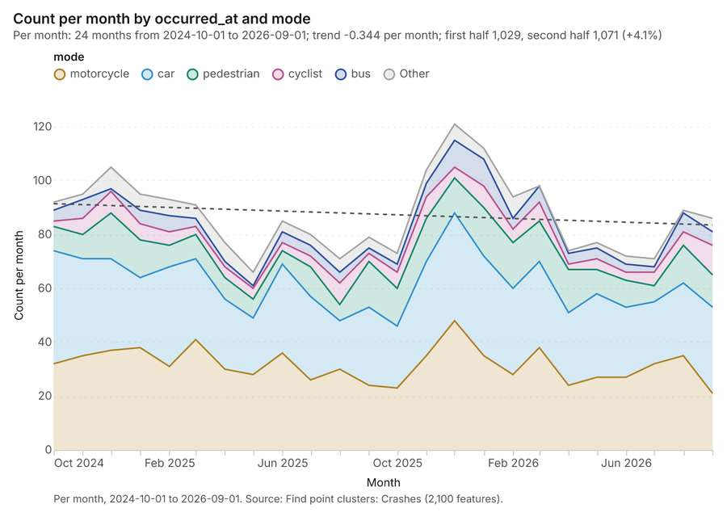
Figure 44. Find point clusters: Crashes over time [88]. Per month, 2024-10-01 to 2026-09-01. Source: Find point clusters: Crashes (2,100 features). The data is in the appendix.

Changes since the last run
This is the first report of this project.

Sources
[1] Rendering: Chart: Timeline: events per month by dataset. 180 rows (id 9a0c9c08-6710-43e7-925b-a5575fc6ff05)
[2] Dataset: Crashes. vector, 2100 rows (id 4c514909-5014-41d8-b00c-114927c21aa8)
[3] Dataset: Traffic calming. vector, 70 rows (id a3bcfa4c-92bd-4d42-84a1-8fa68b0ed82e)
[4] Dataset: Segment speeds by month. table, 1440 rows (id d8e69dfa-1f0d-4b89-a415-acb37422c879)
[5] Dataset: Camera citations by month. table, 300 rows (id 6dd2a5a7-473b-47ef-87b8-127a0fa9fe0d)
[6] Catalog: Hot spot analysis (operation catalog, gp_hot_spots). Getis-Ord Gi* hot and cold spots with z-scores, p-values and confidence bins. ArcGIS: Find Hot Spots, Hot Spot Analysis (Getis-Ord Gi*). QGIS: qgis:hotspot (plugin). (id gp_hot_spots)
[7] Plan: Hot spots of Schools (the Start plan's candidate c_6820fa8048aa). 40 points: Getis-Ord Gi* tests whether the concentrations in Schools are statistically significant. (id b084b0e6-acd2-4d38-bfd7-32a3ffa79c90:c_6820fa8048aa)
[8] Tool result: gp_hot_spots, step 0. Hot spot analysis: 1 layer saved: Hot spot analysis: Schools (40 features). (id b665fc95-b641-4093-9d22-956737a8fbfd:0)
[9] Layer: Schools. 40 features (id cb956034-2d9c-4a8b-b395-a35fdb983208)
[10] Plan: Hot spots of Crashes (the Start plan's candidate c_770e814da3da). 2100 points: Getis-Ord Gi* tests whether the concentrations in Crashes are statistically significant. (id b084b0e6-acd2-4d38-bfd7-32a3ffa79c90:c_770e814da3da)
[11] Tool result: gp_hot_spots, step 1. Hot spot analysis: 1 layer saved: Hot spot analysis: Crashes (1049 features). (id b665fc95-b641-4093-9d22-956737a8fbfd:1)
[12] Layer: Crashes. 2,100 features (id 9501bda5-835f-47e8-b486-e5fa594533df)
[13] Catalog: Emerging hot spots (operation catalog, gp_space_time_hot_spots). Where hot spots are new, consecutive, intensifying, persistent, diminishing, sporadic, oscillating or historical over time. ArcGIS: Emerging Hot Spot Analysis, Create Space Time Cube. (id gp_space_time_hot_spots)
[14] Plan: Space time hot spots of Crashes (the Start plan's candidate c_94b04cf53208). Crashes carry dates in 'occurred_at': emerging hot spot analysis finds new, intensifying and fading hot spots per month. (id b084b0e6-acd2-4d38-bfd7-32a3ffa79c90:c_94b04cf53208)
[15] Tool result: gp_space_time_hot_spots, step 0. Emerging hot spots: 1 layer saved: Emerging hot spots: Crashes (391 features). (id a02448cc-b477-4a6c-8ae7-3ac23d189640:0)
[16] Plan: Space time hot spots of Traffic calming (the Start plan's candidate c_b32d5bad7a33). Traffic calming carry dates in 'date': emerging hot spot analysis finds new, intensifying and fading hot spots per month. (id b084b0e6-acd2-4d38-bfd7-32a3ffa79c90:c_b32d5bad7a33)
[17] Tool result: gp_space_time_hot_spots, step 1. Emerging hot spots: 1 layer saved: Emerging hot spots: Traffic calming (14 features). (id a02448cc-b477-4a6c-8ae7-3ac23d189640:1)
[18] Layer: Traffic calming. 70 features (id 03fd1e3f-918a-4f9a-8ab9-945371297dc6)
[19] Catalog: Summarize within (operation catalog, gp_summarize_within). Count and aggregate the features inside each polygon (or bin), proportionally for lines and polygons. ArcGIS: Summarize Within, Aggregate Points. QGIS: native:countpointsinpolygon, native:sumlinelengths. (id gp_summarize_within)
[20] Plan: Schools per feature of Traffic districts (the Start plan's candidate c_8a3ffc7a90b1). Count Schools inside each feature of Traffic districts by level; the counts map as a choropleth (natural breaks, sequential colors). (id b084b0e6-acd2-4d38-bfd7-32a3ffa79c90:c_8a3ffc7a90b1)
[21] Tool result: gp_summarize_within, step 0. Summarize within: 1 layer saved: Summarize within: Traffic districts (12 features). (id 8387f3d4-ed0c-4186-a3ac-98f72f10cd75:0)
[22] Layer: Traffic districts. 12 features (id 426e8d19-80fb-4cf4-9a7a-1e47e48d31cc)
[23] Tool result: gp_summarize_within, step 1. Summarize within: 1 layer saved: Summarize within: Traffic districts (12 features). (id 8387f3d4-ed0c-4186-a3ac-98f72f10cd75:1)
[24] Catalog: Find point clusters (operation catalog, gp_find_point_clusters). Density-based clusters (DBSCAN, HDBSCAN or OPTICS, optionally space-time) with hulls and noise. ArcGIS: Find Point Clusters, Density-based Clustering. QGIS: native:dbscanclustering, native:stdbscanclustering. (id gp_find_point_clusters)
[25] Plan: Cluster points of Schools (the Start plan's candidate c_a5ebd65960a7). DBSCAN finds dense groups of Schools and separates noise. (id b084b0e6-acd2-4d38-bfd7-32a3ffa79c90:c_a5ebd65960a7)
[26] Tool result: gp_find_point_clusters, step 0. Find point clusters: 2 layers saved: Find point clusters: Schools (40 features); Find point clusters: cluster hulls (3 features). (id 54de2fc4-ad0a-412e-bf5d-e9653a15671f:0)
[27] Plan: Cluster points of Crashes (the Start plan's candidate c_2c9942f1fafe). DBSCAN finds dense groups of Crashes and separates noise. (id b084b0e6-acd2-4d38-bfd7-32a3ffa79c90:c_2c9942f1fafe)
[28] Tool result: gp_find_point_clusters, step 1. Find point clusters: 2 layers saved: Find point clusters: Crashes (2100 features); Find point clusters: cluster hulls (2 features). (id 54de2fc4-ad0a-412e-bf5d-e9653a15671f:1)
[29] Plan: Cluster points of Pedestrian crossings (the Start plan's candidate c_c18fe860314d). DBSCAN finds dense groups of Pedestrian crossings and separates noise. (id b084b0e6-acd2-4d38-bfd7-32a3ffa79c90:c_c18fe860314d)
[30] Tool result: gp_find_point_clusters, step 2. Find point clusters: 2 layers saved: Find point clusters: Pedestrian crossings (200 features); Find point clusters: cluster hulls (11 features). (id 54de2fc4-ad0a-412e-bf5d-e9653a15671f:2)
[31] Layer: Pedestrian crossings. 200 features (id 5a5fc524-5914-46f0-b637-120d3de1b01c)
[32] Catalog: Calculate density (operation catalog, gp_calculate_density). Kernel density per square kilometer on a grid. ArcGIS: Calculate Density, Kernel Density. QGIS: native:heatmapkerneldensityestimation. (id gp_calculate_density)
[33] Plan: Kernel density of Schools (the Start plan's candidate c_25e52236511e). 40 points in Schools: a density surface shows where they concentrate. (id b084b0e6-acd2-4d38-bfd7-32a3ffa79c90:c_25e52236511e)
[34] Tool result: gp_calculate_density, step 0. Calculate density: 1 layer saved: Calculate density: Schools (80 features). (id 002fb5f9-1af6-402f-b464-49edd32e3044:0)
[35] Plan: Kernel density of Crashes (the Start plan's candidate c_bfc2a7ecf90c). 2100 points in Crashes: a density surface shows where they concentrate. (id b084b0e6-acd2-4d38-bfd7-32a3ffa79c90:c_bfc2a7ecf90c)
[36] Tool result: gp_calculate_density, step 1. Calculate density: 1 layer saved: Calculate density: Crashes (4112 features). (id 002fb5f9-1af6-402f-b464-49edd32e3044:1)
[37] Plan: Kernel density of Pedestrian crossings (the Start plan's candidate c_9b962a31a776). 200 points in Pedestrian crossings: a density surface shows where they concentrate. (id b084b0e6-acd2-4d38-bfd7-32a3ffa79c90:c_9b962a31a776)
[38] Tool result: gp_calculate_density, step 2. Calculate density: 1 layer saved: Calculate density: Pedestrian crossings (251 features). (id 002fb5f9-1af6-402f-b464-49edd32e3044:2)
[39] Plan: Hot spots of Pedestrian crossings (the Start plan's candidate c_6f2484f162ad). 200 points: Getis-Ord Gi* tests whether the concentrations in Pedestrian crossings are statistically significant. (id b084b0e6-acd2-4d38-bfd7-32a3ffa79c90:c_6f2484f162ad)
[40] Tool result: gp_hot_spots, step 0. Hot spot analysis: 1 layer saved: Hot spot analysis: Pedestrian crossings (54 features). (id 20671da3-3c9f-4bfc-ab63-45789559bbaa:0)
[41] Catalog: Repeat and near repeat classification (operation catalog, gp_near_repeat). Classify incidents as originators, repeats (same place) or near repeats within a distance and time window, with a Knox test table. ArcGIS: Repeat and Near Repeat Classification, Near Repeat Calculator. (id gp_near_repeat)
[42] Plan: Near repeat of Crashes (the Start plan's candidate c_f79962c58bba). Near repeat analysis tests whether Crashes close in space also follow each other within 30 days. (id b084b0e6-acd2-4d38-bfd7-32a3ffa79c90:c_f79962c58bba)
[43] Tool result: gp_near_repeat, step 0. Repeat and near repeat classification: 1 layer saved: Repeat and near repeat classification: Crashes (2100 features). (id 9871ee2f-25cc-4833-b2ad-49666fe06c44:0)
[44] Plan: Pedestrian crossings per feature of Traffic districts (the Start plan's candidate c_c09d00b8db7e). Count Pedestrian crossings inside each feature of Traffic districts by type; the counts map as a choropleth (natural breaks, sequential colors). (id b084b0e6-acd2-4d38-bfd7-32a3ffa79c90:c_c09d00b8db7e)
[45] Tool result: gp_summarize_within, step 0. Summarize within: 1 layer saved: Summarize within: Traffic districts (12 features). (id 1ff731de-fa54-412a-90f2-45eb74c9277e:0)
[46] Rendering: Map: Hot spot analysis: Schools (id adeafe66-bb7e-41b6-a50a-d645d50e3878)
[47] Rendering: Map: Hot spot analysis: Crashes (id 233e2091-e0f2-486b-9e97-493528e7345f)
[48] Rendering: Map: Emerging hot spots: Crashes (id fbc0e5a3-a877-4a33-bf17-9ad55699796c)
[49] Rendering: Map: Emerging hot spots: Traffic calming (id a1894195-d446-4aa2-9f8e-d0c822d7fa9e)
[50] Rendering: Map: Summarize within: Traffic districts (id 30ea9d3d-11ed-4c02-a9da-973b648cdda5)
[51] Rendering: Map: Summarize within: Traffic districts (id 59917dcd-4eac-4bbc-9094-fa048d8e0a8b)
[52] Rendering: Map: Find point clusters: Schools (id b9530209-8153-4b70-81e4-d13d4126e118)
[53] Rendering: Map: Find point clusters: cluster hulls (id 330923f5-621d-43f6-9f98-83b237722c00)
[54] Rendering: Map: Find point clusters: Crashes (id e8b0af6b-ab8d-4188-83ae-a83a5a7c76b3)
[55] Rendering: Map: Find point clusters: cluster hulls (id e5080803-3fc0-47b7-95f7-4829eb6d3859)
[56] Rendering: Map: Find point clusters: Pedestrian crossings (id 5f216382-62b6-4351-86ff-4e5ae0af8125)
[57] Rendering: Map: Find point clusters: cluster hulls (id 58f6c7d6-f814-4b9e-a8c9-4dd6d9ef95d1)
[58] Rendering: Map: Calculate density: Schools (id f2b01dad-ebee-465f-9e27-d62097f4c268)
[59] Rendering: Map: Calculate density: Crashes (id 64a4981a-c955-42e7-b34b-254a98f25520)
[60] Rendering: Map: Calculate density: Pedestrian crossings (id 2756e5bb-abe5-4473-b915-78f831d3d5a4)
[61] Rendering: Map: Hot spot analysis: Pedestrian crossings (id 8f0a76db-4777-4ab7-9a9a-930da7a08925)
[62] Rendering: Map: Repeat and near repeat classification: Crashes (id 02ed79bd-4bdf-4842-93fe-2e184455d945)
[63] Rendering: Map: Summarize within: Traffic districts (id 6dfdb515-5e14-402d-871f-0ffa294530f7)
[64] Rendering: Chart: Crashes over time (occurred_at). 96 rows (id 8cda2c81-bd3a-4553-9c58-295ed795aff2)
[65] Rendering: Chart: Speed cameras over time (installed_year). 1 rows (id 7edbd055-674b-4ee4-97e5-347a866c2947)
[66] Rendering: Chart: Traffic calming over time (date). 168 rows (id 2d958f28-45c2-4b7a-87ed-c8ab49911031)
[67] Rendering: Chart: Segment speeds by month over time (month). 49 rows (id b7432eea-2c3a-477a-a1e8-2d36cd655803)
[68] Rendering: Chart: Camera citations by month over time (month). 49 rows (id 969fa530-28ba-4dd0-a75b-69aa84b54678)
[69] Rendering: Chart: Hot spot analysis: Schools. 10 rows (id 461534e0-1147-4c68-b696-ce72af84c87e)
[70] Rendering: Chart: Hot spot analysis: Crashes. 17 rows (id e0c0fd5a-fbcd-48a4-b737-5ec55e00e9b6)
[71] Rendering: Chart: Emerging hot spots: Crashes. 10 rows (id 733c92a3-ffad-470a-a9c0-f4d673d42289)
[72] Rendering: Chart: Emerging hot spots: Traffic calming. 5 rows (id 10c55d47-29c7-4734-a9fe-0a0b7975fbb8)
[73] Rendering: Chart: Summarize within: Traffic districts. 5 rows (id d2a4a3dc-7d76-4a0e-b041-b334e994f076)
[74] Rendering: Chart: Summarize within: Traffic districts. 5 rows (id 897d00dc-b8b3-4e8d-9d2a-a66ba81fa3a8)
[75] Rendering: Chart: Find point clusters: Schools. 4 rows (id 423c158c-d88d-476c-b3d7-399c0645179a)
[76] Rendering: Chart: Find point clusters: cluster hulls. 3 rows (id b7ed2b2a-82e2-47a7-b9fd-40ba7637b0fb)
[77] Rendering: Chart: Find point clusters: Crashes. 3 rows (id 7ea99118-9ea1-4440-a6b8-2787d996b886)
[78] Rendering: Chart: Find point clusters: cluster hulls. 2 rows (id 1f581a53-06c3-4e15-b1d5-c6d8810d5069)
[79] Rendering: Chart: Find point clusters: Pedestrian crossings. 12 rows (id 734ca768-921a-4688-b5a3-91e547b8132f)
[80] Rendering: Chart: Find point clusters: cluster hulls. 11 rows (id 644e98c9-2e62-4e6c-88cc-2bac7654aca8)
[81] Rendering: Chart: Calculate density: Schools. 8 rows (id 5185f166-2557-47d4-95a0-e09a9b9dffa6)
[82] Rendering: Chart: Calculate density: Crashes. 14 rows (id d1d3088c-9c82-4847-9ad2-937f125a2774)
[83] Rendering: Chart: Calculate density: Pedestrian crossings. 9 rows (id 2be0343e-08ed-45f8-b191-db1ac61f21d2)
[84] Rendering: Chart: Hot spot analysis: Pedestrian crossings. 9 rows (id 04bdc4d9-e0fe-477a-8403-b2f2881d948a)
[85] Rendering: Chart: Repeat and near repeat classification: Crashes. 144 rows (id 533c2ef2-04e7-4ec6-9dda-091526d4b60e)
[86] Rendering: Chart: Summarize within: Traffic districts. 5 rows (id f50135c9-a379-4056-b401-ddd84d655807)
[87] Rendering: Chart: Repeat and near repeat classification: Crashes over time. 144 rows (id aa71a552-c3d9-4aee-a82e-f6857fbc92a9)
[88] Rendering: Chart: Find point clusters: Crashes over time. 144 rows (id 1d507cb3-0287-4a28-9492-374091139b83)
[89] Dataset: Road segments. vector, 900 rows (id a1c0c341-b0b4-4540-8666-cc898710a5a2)
[90] Dataset: Traffic districts. vector, 12 rows (id 4ddf9694-9e59-443e-9e26-b99d63650843)
[91] Dataset: Speed cameras. vector, 25 rows (id d0346d0a-3495-47e2-bbaa-9bdebea63dae)
[92] Dataset: Schools. vector, 40 rows (id 47516658-bc03-4d11-a9a3-83d7b85272e7)
[93] Dataset: Bus stops. vector, 120 rows (id b69ec834-01b9-40fe-b4d7-048918f3ff66)
[94] Dataset: Pedestrian crossings. vector, 200 rows (id 9904012c-b65c-4579-bb44-535cd45f66ca)
[95] Dataset: Vision Zero corridor review. document, ? rows (id cef3f8f3-9628-4f98-b173-947dda8f30f3)
[96] Record: Sample: Transportation safety, Sao Paulo (id 220702b2-1327-4244-9cff-74cf9d501f98)
[97] Layer: Hot spot analysis: Schools. 40 features (id e24a725d-1226-4c6c-ac79-ddb0e0634c6c)
[98] Layer: Hot spot analysis: Crashes. 1,049 features (id becfaca3-5eea-4150-9c71-4a8a51769984)
[99] Layer: Emerging hot spots: Crashes. 391 features (id 9df86500-c0e4-4e6a-b523-dc729593eaa4)
[100] Layer: Emerging hot spots: Traffic calming. 14 features (id fd2099dc-7aac-4041-8f85-bb99a6553671)
[101] Layer: Summarize within: Traffic districts. 12 features (id 7dd3dbff-8946-47c0-9f8c-365a3f16b57f)
[102] Layer: Summarize within: Traffic districts. 12 features (id ab0320a0-7ff1-4268-8628-c5d500503744)
[103] Layer: Find point clusters: Schools. 40 features (id 62d9b779-75eb-44b3-af8e-6b11cb59257b)
[104] Layer: Find point clusters: cluster hulls. 3 features (id 9a336160-b53a-41a1-bdce-2ce51cd5a9fe)
[105] Layer: Find point clusters: Crashes. 2,100 features (id a3b9de76-4c1e-4b60-b686-346672b601ef)
[106] Layer: Find point clusters: cluster hulls. 2 features (id fb76f8c2-f8d9-4e00-9560-bec71fbe6696)
[107] Layer: Find point clusters: Pedestrian crossings. 200 features (id 177f4978-c15d-4e75-b5c7-7a917152e219)
[108] Layer: Find point clusters: cluster hulls. 11 features (id 42bb9ca8-0db1-4b9d-8ed3-e7c9337230cf)
[109] Layer: Calculate density: Schools. 80 features (id 41390c5d-5081-4052-9d4c-9ba56bf9b6f5)
[110] Layer: Calculate density: Crashes. 4,112 features (id b719c8e4-0a00-46f8-a1ac-dba4d26a9fcb)
[111] Layer: Calculate density: Pedestrian crossings. 251 features (id 59d27925-1f02-4b09-86f4-ada68a81d6fe)
[112] Layer: Hot spot analysis: Pedestrian crossings. 54 features (id a4ed9f7b-d1d3-42f8-a3e7-e16c31bbc302)
[113] Layer: Repeat and near repeat classification: Crashes. 2,100 features (id 983941e1-9046-42e6-a142-4a34d1f16e13)
[114] Layer: Summarize within: Traffic districts. 12 features (id 611b1b4c-39d3-405a-976d-57aca77ac14e)

Appendix: the data behind the charts

Figure 1. Timeline: events per month by dataset [1]
period | series | value
2023-01-01 | Crashes | 0
2023-01-01 | Segment speeds by month | 0
2023-01-01 | Camera citations by month | 0
2023-01-01 | Traffic calming | 2
2023-02-01 | Crashes | 0
2023-02-01 | Segment speeds by month | 0
2023-02-01 | Camera citations by month | 0
2023-02-01 | Traffic calming | 2
2023-03-01 | Crashes | 0
2023-03-01 | Segment speeds by month | 0
2023-03-01 | Camera citations by month | 0
2023-03-01 | Traffic calming | 1
2023-04-01 | Crashes | 0
2023-04-01 | Segment speeds by month | 0
2023-04-01 | Camera citations by month | 0
2023-04-01 | Traffic calming | 1
2023-05-01 | Crashes | 0
2023-05-01 | Segment speeds by month | 0
2023-05-01 | Camera citations by month | 0
2023-05-01 | Traffic calming | 1
2023-06-01 | Crashes | 0
2023-06-01 | Segment speeds by month | 0
2023-06-01 | Camera citations by month | 0
2023-06-01 | Traffic calming | 4
2023-07-01 | Crashes | 0
2023-07-01 | Segment speeds by month | 0
2023-07-01 | Camera citations by month | 0
2023-07-01 | Traffic calming | 2
2023-08-01 | Crashes | 0
2023-08-01 | Segment speeds by month | 0
2023-08-01 | Camera citations by month | 0
2023-08-01 | Traffic calming | 1
2023-09-01 | Crashes | 0
2023-09-01 | Segment speeds by month | 0
2023-09-01 | Camera citations by month | 0
2023-09-01 | Traffic calming | 4
2023-10-01 | Crashes | 0
2023-10-01 | Segment speeds by month | 0
2023-10-01 | Camera citations by month | 0
2023-10-01 | Traffic calming | 1
2023-11-01 | Crashes | 0
2023-11-01 | Segment speeds by month | 0
2023-11-01 | Camera citations by month | 0
2023-11-01 | Traffic calming | 0
2023-12-01 | Crashes | 0
2023-12-01 | Segment speeds by month | 0
2023-12-01 | Camera citations by month | 0
2023-12-01 | Traffic calming | 3
2024-01-01 | Crashes | 0
2024-01-01 | Segment speeds by month | 0
2024-01-01 | Camera citations by month | 0
2024-01-01 | Traffic calming | 1
2024-02-01 | Crashes | 0
2024-02-01 | Segment speeds by month | 0
2024-02-01 | Camera citations by month | 0
2024-02-01 | Traffic calming | 1
2024-03-01 | Crashes | 0
2024-03-01 | Segment speeds by month | 0
2024-03-01 | Camera citations by month | 0
2024-03-01 | Traffic calming | 2
2024-04-01 | Crashes | 0
2024-04-01 | Segment speeds by month | 0
2024-04-01 | Camera citations by month | 0
2024-04-01 | Traffic calming | 1
2024-05-01 | Crashes | 0
2024-05-01 | Segment speeds by month | 0
2024-05-01 | Camera citations by month | 0
2024-05-01 | Traffic calming | 1
2024-06-01 | Crashes | 0
2024-06-01 | Segment speeds by month | 0
2024-06-01 | Camera citations by month | 0
2024-06-01 | Traffic calming | 2
2024-07-01 | Crashes | 0
2024-07-01 | Segment speeds by month | 0
2024-07-01 | Camera citations by month | 0
2024-07-01 | Traffic calming | 2
2024-08-01 | Crashes | 0
2024-08-01 | Segment speeds by month | 0
2024-08-01 | Camera citations by month | 0
2024-08-01 | Traffic calming | 1
2024-09-01 | Crashes | 0
2024-09-01 | Segment speeds by month | 0
2024-09-01 | Camera citations by month | 0
2024-09-01 | Traffic calming | 0
2024-10-01 | Crashes | 92
2024-10-01 | Segment speeds by month | 0
2024-10-01 | Camera citations by month | 0
2024-10-01 | Traffic calming | 1
2024-11-01 | Crashes | 95
2024-11-01 | Segment speeds by month | 0
2024-11-01 | Camera citations by month | 0
2024-11-01 | Traffic calming | 1
2024-12-01 | Crashes | 105
2024-12-01 | Segment speeds by month | 0
2024-12-01 | Camera citations by month | 0
2024-12-01 | Traffic calming | 1
2025-01-01 | Crashes | 95
2025-01-01 | Segment speeds by month | 0
2025-01-01 | Camera citations by month | 0
2025-01-01 | Traffic calming | 4
2025-02-01 | Crashes | 93
2025-02-01 | Segment speeds by month | 0
2025-02-01 | Camera citations by month | 0
2025-02-01 | Traffic calming | 0
2025-03-01 | Crashes | 91
2025-03-01 | Segment speeds by month | 0
2025-03-01 | Camera citations by month | 0
2025-03-01 | Traffic calming | 0
2025-04-01 | Crashes | 77
2025-04-01 | Segment speeds by month | 0
2025-04-01 | Camera citations by month | 0
2025-04-01 | Traffic calming | 3
2025-05-01 | Crashes | 66
2025-05-01 | Segment speeds by month | 0
2025-05-01 | Camera citations by month | 0
2025-05-01 | Traffic calming | 1
2025-06-01 | Crashes | 85
2025-06-01 | Segment speeds by month | 0
2025-06-01 | Camera citations by month | 0
2025-06-01 | Traffic calming | 1
2025-07-01 | Crashes | 80
2025-07-01 | Segment speeds by month | 0
2025-07-01 | Camera citations by month | 0
2025-07-01 | Traffic calming | 3
2025-08-01 | Crashes | 71
2025-08-01 | Segment speeds by month | 0
2025-08-01 | Camera citations by month | 0
2025-08-01 | Traffic calming | 3
2025-09-01 | Crashes | 79
2025-09-01 | Segment speeds by month | 0
2025-09-01 | Camera citations by month | 0
2025-09-01 | Traffic calming | 1
2025-10-01 | Crashes | 73
2025-10-01 | Segment speeds by month | 120
2025-10-01 | Camera citations by month | 25
2025-10-01 | Traffic calming | 3
2025-11-01 | Crashes | 104
2025-11-01 | Segment speeds by month | 120
2025-11-01 | Camera citations by month | 25
2025-11-01 | Traffic calming | 1
2025-12-01 | Crashes | 121
2025-12-01 | Segment speeds by month | 120
2025-12-01 | Camera citations by month | 25
2025-12-01 | Traffic calming | 2
2026-01-01 | Crashes | 112
2026-01-01 | Segment speeds by month | 120
2026-01-01 | Camera citations by month | 25
2026-01-01 | Traffic calming | 0
2026-02-01 | Crashes | 94
2026-02-01 | Segment speeds by month | 120
2026-02-01 | Camera citations by month | 25
2026-02-01 | Traffic calming | 3
2026-03-01 | Crashes | 98
2026-03-01 | Segment speeds by month | 120
2026-03-01 | Camera citations by month | 25
2026-03-01 | Traffic calming | 0
2026-04-01 | Crashes | 74
2026-04-01 | Segment speeds by month | 120
2026-04-01 | Camera citations by month | 25
2026-04-01 | Traffic calming | 5
2026-05-01 | Crashes | 77
2026-05-01 | Segment speeds by month | 120
2026-05-01 | Camera citations by month | 25
2026-05-01 | Traffic calming | 3
2026-06-01 | Crashes | 72
2026-06-01 | Segment speeds by month | 120
2026-06-01 | Camera citations by month | 25
2026-06-01 | Traffic calming | 1
2026-07-01 | Crashes | 71
2026-07-01 | Segment speeds by month | 120
2026-07-01 | Camera citations by month | 25
2026-07-01 | Traffic calming | 0
2026-08-01 | Crashes | 89
2026-08-01 | Segment speeds by month | 120
2026-08-01 | Camera citations by month | 25
2026-08-01 | Traffic calming | 0
2026-09-01 | Crashes | 86
2026-09-01 | Segment speeds by month | 120
2026-09-01 | Camera citations by month | 25
2026-09-01 | Traffic calming | 0

Figure 20. Crashes over time (occurred_at) [64]
period | series | value
2024-10-01 | slight | 45
2024-10-01 | property damage | 29
2024-10-01 | serious | 15
2024-10-01 | fatal | 3
2024-11-01 | slight | 45
2024-11-01 | property damage | 27
2024-11-01 | serious | 18
2024-11-01 | fatal | 5
2024-12-01 | slight | 46
2024-12-01 | property damage | 33
2024-12-01 | serious | 20
2024-12-01 | fatal | 6
2025-01-01 | slight | 47
2025-01-01 | property damage | 27
2025-01-01 | serious | 19
2025-01-01 | fatal | 2
2025-02-01 | slight | 46
2025-02-01 | property damage | 21
2025-02-01 | serious | 23
2025-02-01 | fatal | 3
2025-03-01 | slight | 39
2025-03-01 | property damage | 27
2025-03-01 | serious | 20
2025-03-01 | fatal | 5
2025-04-01 | slight | 41
2025-04-01 | property damage | 15
2025-04-01 | serious | 17
2025-04-01 | fatal | 4
2025-05-01 | slight | 37
2025-05-01 | property damage | 17
2025-05-01 | serious | 10
2025-05-01 | fatal | 2
2025-06-01 | slight | 35
2025-06-01 | property damage | 26
2025-06-01 | serious | 20
2025-06-01 | fatal | 4
2025-07-01 | slight | 33
2025-07-01 | property damage | 25
2025-07-01 | serious | 19
2025-07-01 | fatal | 3
2025-08-01 | slight | 30
2025-08-01 | property damage | 25
2025-08-01 | serious | 11
2025-08-01 | fatal | 5
2025-09-01 | slight | 36
2025-09-01 | property damage | 23
2025-09-01 | serious | 17
2025-09-01 | fatal | 3
2025-10-01 | slight | 29
2025-10-01 | property damage | 22
2025-10-01 | serious | 19
2025-10-01 | fatal | 3
2025-11-01 | slight | 42
2025-11-01 | property damage | 35
2025-11-01 | serious | 25
2025-11-01 | fatal | 2
2025-12-01 | slight | 65
2025-12-01 | property damage | 27
2025-12-01 | serious | 24
2025-12-01 | fatal | 5
2026-01-01 | slight | 54
2026-01-01 | property damage | 26
2026-01-01 | serious | 25
2026-01-01 | fatal | 7
2026-02-01 | slight | 40
2026-02-01 | property damage | 33
2026-02-01 | serious | 18
2026-02-01 | fatal | 3
2026-03-01 | slight | 37
2026-03-01 | property damage | 35
2026-03-01 | serious | 26
2026-03-01 | fatal | 0
2026-04-01 | slight | 40
2026-04-01 | property damage | 20
2026-04-01 | serious | 12
2026-04-01 | fatal | 2
2026-05-01 | slight | 37
2026-05-01 | property damage | 26
2026-05-01 | serious | 10
2026-05-01 | fatal | 4
2026-06-01 | slight | 32
2026-06-01 | property damage | 25
2026-06-01 | serious | 12
2026-06-01 | fatal | 3
2026-07-01 | slight | 31
2026-07-01 | property damage | 18
2026-07-01 | serious | 21
2026-07-01 | fatal | 1
2026-08-01 | slight | 43
2026-08-01 | property damage | 20
2026-08-01 | serious | 22
2026-08-01 | fatal | 4
2026-09-01 | slight | 35
2026-09-01 | property damage | 28
2026-09-01 | serious | 19
2026-09-01 | fatal | 4

Figure 21. Speed cameras over time (installed_year) [65]
bin_start | bin_end | count
60 | 60 | 25

Figure 22. Traffic calming over time (date) [66]
period | series | value
2023-01-01 | chicane | 0
2023-01-01 | lane narrowing | 2
2023-01-01 | raised crossing | 0
2023-01-01 | speed hump | 0
2023-02-01 | chicane | 0
2023-02-01 | lane narrowing | 1
2023-02-01 | raised crossing | 0
2023-02-01 | speed hump | 1
2023-03-01 | chicane | 0
2023-03-01 | lane narrowing | 0
2023-03-01 | raised crossing | 0
2023-03-01 | speed hump | 1
2023-04-01 | chicane | 0
2023-04-01 | lane narrowing | 0
2023-04-01 | raised crossing | 0
2023-04-01 | speed hump | 1
2023-05-01 | chicane | 1
2023-05-01 | lane narrowing | 0
2023-05-01 | raised crossing | 0
2023-05-01 | speed hump | 0
2023-06-01 | chicane | 0
2023-06-01 | lane narrowing | 1
2023-06-01 | raised crossing | 2
2023-06-01 | speed hump | 1
2023-07-01 | chicane | 1
2023-07-01 | lane narrowing | 0
2023-07-01 | raised crossing | 1
2023-07-01 | speed hump | 0
2023-08-01 | chicane | 0
2023-08-01 | lane narrowing | 0
2023-08-01 | raised crossing | 1
2023-08-01 | speed hump | 0
2023-09-01 | chicane | 2
2023-09-01 | lane narrowing | 1
2023-09-01 | raised crossing | 1
2023-09-01 | speed hump | 0
2023-10-01 | chicane | 0
2023-10-01 | lane narrowing | 0
2023-10-01 | raised crossing | 0
2023-10-01 | speed hump | 1
2023-11-01 | chicane | 0
2023-11-01 | lane narrowing | 0
2023-11-01 | raised crossing | 0
2023-11-01 | speed hump | 0
2023-12-01 | chicane | 1
2023-12-01 | lane narrowing | 0
2023-12-01 | raised crossing | 2
2023-12-01 | speed hump | 0
2024-01-01 | chicane | 0
2024-01-01 | lane narrowing | 0
2024-01-01 | raised crossing | 0
2024-01-01 | speed hump | 1
2024-02-01 | chicane | 0
2024-02-01 | lane narrowing | 1
2024-02-01 | raised crossing | 0
2024-02-01 | speed hump | 0
2024-03-01 | chicane | 1
2024-03-01 | lane narrowing | 1
2024-03-01 | raised crossing | 0
2024-03-01 | speed hump | 0
2024-04-01 | chicane | 0
2024-04-01 | lane narrowing | 0
2024-04-01 | raised crossing | 0
2024-04-01 | speed hump | 1
2024-05-01 | chicane | 1
2024-05-01 | lane narrowing | 0
2024-05-01 | raised crossing | 0
2024-05-01 | speed hump | 0
2024-06-01 | chicane | 1
2024-06-01 | lane narrowing | 1
2024-06-01 | raised crossing | 0
2024-06-01 | speed hump | 0
2024-07-01 | chicane | 1
2024-07-01 | lane narrowing | 1
2024-07-01 | raised crossing | 0
2024-07-01 | speed hump | 0
2024-08-01 | chicane | 0
2024-08-01 | lane narrowing | 0
2024-08-01 | raised crossing | 1
2024-08-01 | speed hump | 0
2024-09-01 | chicane | 0
2024-09-01 | lane narrowing | 0
2024-09-01 | raised crossing | 0
2024-09-01 | speed hump | 0
2024-10-01 | chicane | 1
2024-10-01 | lane narrowing | 0
2024-10-01 | raised crossing | 0
2024-10-01 | speed hump | 0
2024-11-01 | chicane | 0
2024-11-01 | lane narrowing | 0
2024-11-01 | raised crossing | 1
2024-11-01 | speed hump | 0
2024-12-01 | chicane | 1
2024-12-01 | lane narrowing | 0
2024-12-01 | raised crossing | 0
2024-12-01 | speed hump | 0
2025-01-01 | chicane | 1
2025-01-01 | lane narrowing | 0
2025-01-01 | raised crossing | 2
2025-01-01 | speed hump | 1
2025-02-01 | chicane | 0
2025-02-01 | lane narrowing | 0
2025-02-01 | raised crossing | 0
2025-02-01 | speed hump | 0
2025-03-01 | chicane | 0
2025-03-01 | lane narrowing | 0
2025-03-01 | raised crossing | 0
2025-03-01 | speed hump | 0
2025-04-01 | chicane | 1
2025-04-01 | lane narrowing | 2
2025-04-01 | raised crossing | 0
2025-04-01 | speed hump | 0
2025-05-01 | chicane | 0
2025-05-01 | lane narrowing | 1
2025-05-01 | raised crossing | 0
2025-05-01 | speed hump | 0
2025-06-01 | chicane | 1
2025-06-01 | lane narrowing | 0
2025-06-01 | raised crossing | 0
2025-06-01 | speed hump | 0
2025-07-01 | chicane | 2
2025-07-01 | lane narrowing | 1
2025-07-01 | raised crossing | 0
2025-07-01 | speed hump | 0
2025-08-01 | chicane | 1
2025-08-01 | lane narrowing | 1
2025-08-01 | raised crossing | 1
2025-08-01 | speed hump | 0
2025-09-01 | chicane | 0
2025-09-01 | lane narrowing | 1
2025-09-01 | raised crossing | 0
2025-09-01 | speed hump | 0
2025-10-01 | chicane | 1
2025-10-01 | lane narrowing | 2
2025-10-01 | raised crossing | 0
2025-10-01 | speed hump | 0
2025-11-01 | chicane | 0
2025-11-01 | lane narrowing | 0
2025-11-01 | raised crossing | 1
2025-11-01 | speed hump | 0
2025-12-01 | chicane | 0
2025-12-01 | lane narrowing | 1
2025-12-01 | raised crossing | 1
2025-12-01 | speed hump | 0
2026-01-01 | chicane | 0
2026-01-01 | lane narrowing | 0
2026-01-01 | raised crossing | 0
2026-01-01 | speed hump | 0
2026-02-01 | chicane | 2
2026-02-01 | lane narrowing | 1
2026-02-01 | raised crossing | 0
2026-02-01 | speed hump | 0
2026-03-01 | chicane | 0
2026-03-01 | lane narrowing | 0
2026-03-01 | raised crossing | 0
2026-03-01 | speed hump | 0
2026-04-01 | chicane | 0
2026-04-01 | lane narrowing | 0
2026-04-01 | raised crossing | 2
2026-04-01 | speed hump | 3
2026-05-01 | chicane | 1
2026-05-01 | lane narrowing | 0
2026-05-01 | raised crossing | 1
2026-05-01 | speed hump | 1
2026-06-01 | chicane | 0
2026-06-01 | lane narrowing | 0
2026-06-01 | raised crossing | 1
2026-06-01 | speed hump | 0

Figure 23. Segment speeds by month over time (month) [67]
period | value
2025-09-29 | 120
2025-10-06 | 0
2025-10-13 | 0
2025-10-20 | 0
2025-10-27 | 120
2025-11-03 | 0
2025-11-10 | 0
2025-11-17 | 0
2025-11-24 | 0
2025-12-01 | 120
2025-12-08 | 0
2025-12-15 | 0
2025-12-22 | 0
2025-12-29 | 120
2026-01-05 | 0
2026-01-12 | 0
2026-01-19 | 0
2026-01-26 | 120
2026-02-02 | 0
2026-02-09 | 0
2026-02-16 | 0
2026-02-23 | 120
2026-03-02 | 0
2026-03-09 | 0
2026-03-16 | 0
2026-03-23 | 0
2026-03-30 | 120
2026-04-06 | 0
2026-04-13 | 0
2026-04-20 | 0
2026-04-27 | 120
2026-05-04 | 0
2026-05-11 | 0
2026-05-18 | 0
2026-05-25 | 0
2026-06-01 | 120
2026-06-08 | 0
2026-06-15 | 0
2026-06-22 | 0
2026-06-29 | 120
2026-07-06 | 0
2026-07-13 | 0
2026-07-20 | 0
2026-07-27 | 120
2026-08-03 | 0
2026-08-10 | 0
2026-08-17 | 0
2026-08-24 | 0
2026-08-31 | 120

Figure 24. Camera citations by month over time (month) [68]
period | value
2025-09-29 | 25
2025-10-06 | 0
2025-10-13 | 0
2025-10-20 | 0
2025-10-27 | 25
2025-11-03 | 0
2025-11-10 | 0
2025-11-17 | 0
2025-11-24 | 0
2025-12-01 | 25
2025-12-08 | 0
2025-12-15 | 0
2025-12-22 | 0
2025-12-29 | 25
2026-01-05 | 0
2026-01-12 | 0
2026-01-19 | 0
2026-01-26 | 25
2026-02-02 | 0
2026-02-09 | 0
2026-02-16 | 0
2026-02-23 | 25
2026-03-02 | 0
2026-03-09 | 0
2026-03-16 | 0
2026-03-23 | 0
2026-03-30 | 25
2026-04-06 | 0
2026-04-13 | 0
2026-04-20 | 0
2026-04-27 | 25
2026-05-04 | 0
2026-05-11 | 0
2026-05-18 | 0
2026-05-25 | 0
2026-06-01 | 25
2026-06-08 | 0
2026-06-15 | 0
2026-06-22 | 0
2026-06-29 | 25
2026-07-06 | 0
2026-07-13 | 0
2026-07-20 | 0
2026-07-27 | 25
2026-08-03 | 0
2026-08-10 | 0
2026-08-17 | 0
2026-08-24 | 0
2026-08-31 | 25

Figure 25. Hot spot analysis: Schools [69]
bin_start | bin_end | band | band_label | count
-2 | -1.5 | cold_90 | Cold spot, 90% confidence | 1
-2 | -1.5 | not_significant | Not significant | 2
-1.5 | -1 | not_significant | Not significant | 6
-1 | -0.5 | not_significant | Not significant | 5
-0.5 | 0 | not_significant | Not significant | 5
0 | 0.5 | not_significant | Not significant | 2
0.5 | 1 | not_significant | Not significant | 9
1 | 1.5 | not_significant | Not significant | 6
1.5 | 2 | hot_90 | Hot spot, 90% confidence | 2
1.5 | 2 | not_significant | Not significant | 2

Figure 26. Hot spot analysis: Crashes [70]
bin_start | bin_end | band | band_label | count
-1 | -0.5 | not_significant | Not significant | 298
-0.5 | 0 | not_significant | Not significant | 497
0 | 0.5 | not_significant | Not significant | 132
0.5 | 1 | not_significant | Not significant | 71
1 | 1.5 | not_significant | Not significant | 12
1.5 | 2 | hot_90 | Hot spot, 90% confidence | 6
1.5 | 2 | not_significant | Not significant | 4
3 | 3.5 | hot_99 | Hot spot, 99% confidence | 2
3.5 | 4 | hot_99 | Hot spot, 99% confidence | 3
4 | 4.5 | hot_99 | Hot spot, 99% confidence | 6
4.5 | 5 | hot_99 | Hot spot, 99% confidence | 5
5 | 5.5 | hot_99 | Hot spot, 99% confidence | 2
5.5 | 6 | hot_99 | Hot spot, 99% confidence | 7
6 | 6.5 | hot_99 | Hot spot, 99% confidence | 1
6.5 | 7 | hot_99 | Hot spot, 99% confidence | 1
8 | 8.5 | hot_99 | Hot spot, 99% confidence | 1
8.5 | 9 | hot_99 | Hot spot, 99% confidence | 1

Figure 27. Emerging hot spots: Crashes [71]
bin_start | bin_end | count
-0.974 | -0.3622 | 103
-0.3622 | 0.2496 | 146
0.2496 | 0.8614 | 66
0.8614 | 1.473 | 41
1.473 | 2.085 | 0
2.085 | 2.697 | 15
2.697 | 3.309 | 10
3.309 | 3.92 | 3
3.92 | 4.532 | 6
4.532 | 5.144 | 1

Figure 28. Emerging hot spots: Traffic calming [72]
bin_start | bin_end | count
-0.666 | -0.3214 | 7
-0.3214 | 0.0232 | 0
0.0232 | 0.3678 | 0
0.3678 | 0.7124 | 5
0.7124 | 1.057 | 2

Figure 29. Summarize within: Traffic districts [73]
bin_start | bin_end | count
0 | 1.2 | 2
1.2 | 2.4 | 1
2.4 | 3.6 | 3
3.6 | 4.8 | 4
4.8 | 6 | 2

Figure 30. Summarize within: Traffic districts [74]
bin_start | bin_end | count
45 | 134.2 | 4
134.2 | 223.4 | 5
223.4 | 312.6 | 2
312.6 | 401.8 | 0
401.8 | 491 | 1

Figure 31. Find point clusters: Schools [75]
cluster | features | fraction | share
0 | 20 | 0.5 | 50.0%
1 | 10 | 0.25 | 25.0%
2 | 7 | 0.175 | 17.5%
Noise | 3 | 0.075 | 7.5%

Figure 32. Find point clusters: cluster hulls [76]
cluster | features | fraction | share
0 | 1 | 0.3333 | 33.3%
1 | 1 | 0.3333 | 33.3%
2 | 1 | 0.3333 | 33.3%

Figure 33. Find point clusters: Crashes [77]
cluster | features | fraction | share
Noise | 1,422 | 0.6771 | 67.7%
0 | 609 | 0.29 | 29.0%
1 | 69 | 0.03286 | 3.3%

Figure 34. Find point clusters: cluster hulls [78]
cluster | features | fraction | share
0 | 1 | 0.5 | 50.0%
1 | 1 | 0.5 | 50.0%

Figure 35. Find point clusters: Pedestrian crossings [79]
cluster | features | fraction | share
Noise | 53 | 0.265 | 26.5%
3 | 39 | 0.195 | 19.5%
2 | 29 | 0.145 | 14.5%
1 | 20 | 0.1 | 10.0%
0 | 12 | 0.06 | 6.0%
5 | 12 | 0.06 | 6.0%
4 | 10 | 0.05 | 5.0%
7 | 6 | 0.03 | 3.0%
8 | 6 | 0.03 | 3.0%
6 | 5 | 0.025 | 2.5%
9 | 5 | 0.025 | 2.5%
10 | 3 | 0.015 | 1.5%

Figure 36. Find point clusters: cluster hulls [80]
cluster | features | fraction | share
0 | 1 | 0.09091 | 9.1%
1 | 1 | 0.09091 | 9.1%
10 | 1 | 0.09091 | 9.1%
2 | 1 | 0.09091 | 9.1%
3 | 1 | 0.09091 | 9.1%
4 | 1 | 0.09091 | 9.1%
5 | 1 | 0.09091 | 9.1%
6 | 1 | 0.09091 | 9.1%
7 | 1 | 0.09091 | 9.1%
8 | 1 | 0.09091 | 9.1%
9 | 1 | 0.09091 | 9.1%

Figure 37. Calculate density: Schools [81]
bin_start | bin_end | count
0.0812 | 186.1 | 29
186.1 | 372.1 | 10
372.1 | 558.1 | 12
558.1 | 744.2 | 6
744.2 | 930.2 | 9
930.2 | 1,116 | 6
1,116 | 1,302 | 4
1,302 | 1,488 | 4

Figure 38. Calculate density: Crashes [82]
bin_start | bin_end | count
0 | 5.143 | 273
5.143 | 10.29 | 297
10.29 | 15.43 | 283
15.43 | 20.57 | 296
20.57 | 25.71 | 298
25.71 | 30.86 | 299
30.86 | 36 | 361
36 | 41.14 | 296
41.14 | 46.29 | 298
46.29 | 51.43 | 288
51.43 | 56.57 | 294
56.57 | 61.71 | 289
61.71 | 66.86 | 293
66.86 | 72 | 247

Figure 39. Calculate density: Pedestrian crossings [83]
bin_start | bin_end | count
0 | 1.889 | 25
1.889 | 3.778 | 31
3.778 | 5.667 | 30
5.667 | 7.556 | 32
7.556 | 9.444 | 30
9.444 | 11.33 | 30
11.33 | 13.22 | 28
13.22 | 15.11 | 29
15.11 | 17 | 16

Figure 40. Hot spot analysis: Pedestrian crossings [84]
bin_start | bin_end | band | band_label | count
-1.5 | -1 | not_significant | Not significant | 14
-1 | -0.5 | not_significant | Not significant | 4
-0.5 | 0 | not_significant | Not significant | 9
0 | 0.5 | not_significant | Not significant | 14
0.5 | 1 | not_significant | Not significant | 5
1 | 1.5 | not_significant | Not significant | 4
1.5 | 2 | hot_90 | Hot spot, 90% confidence | 1
2 | 2.5 | hot_95 | Hot spot, 95% confidence | 2
2.5 | 3 | hot_99 | Hot spot, 99% confidence | 1

Figure 41. Repeat and near repeat classification: Crashes [85]
period | series | value
2024-10-01 | motorcycle | 32
2024-10-01 | car | 42
2024-10-01 | pedestrian | 9
2024-10-01 | cyclist | 2
2024-10-01 | bus | 4
2024-10-01 | Other | 3
2024-11-01 | motorcycle | 35
2024-11-01 | car | 36
2024-11-01 | pedestrian | 9
2024-11-01 | cyclist | 6
2024-11-01 | bus | 7
2024-11-01 | Other | 2
2024-12-01 | motorcycle | 37
2024-12-01 | car | 34
2024-12-01 | pedestrian | 17
2024-12-01 | cyclist | 8
2024-12-01 | bus | 1
2024-12-01 | Other | 8
2025-01-01 | motorcycle | 38
2025-01-01 | car | 26
2025-01-01 | pedestrian | 14
2025-01-01 | cyclist | 6
2025-01-01 | bus | 5
2025-01-01 | Other | 6
2025-02-01 | motorcycle | 31
2025-02-01 | car | 37
2025-02-01 | pedestrian | 8
2025-02-01 | cyclist | 5
2025-02-01 | bus | 6
2025-02-01 | Other | 6
2025-03-01 | motorcycle | 41
2025-03-01 | car | 30
2025-03-01 | pedestrian | 9
2025-03-01 | cyclist | 3
2025-03-01 | bus | 3
2025-03-01 | Other | 5
2025-04-01 | motorcycle | 30
2025-04-01 | car | 26
2025-04-01 | pedestrian | 8
2025-04-01 | cyclist | 4
2025-04-01 | bus | 2
2025-04-01 | Other | 7
2025-05-01 | motorcycle | 28
2025-05-01 | car | 21
2025-05-01 | pedestrian | 7
2025-05-01 | cyclist | 4
2025-05-01 | bus | 1
2025-05-01 | Other | 5
2025-06-01 | motorcycle | 36
2025-06-01 | car | 33
2025-06-01 | pedestrian | 5
2025-06-01 | cyclist | 3
2025-06-01 | bus | 4
2025-06-01 | Other | 4
2025-07-01 | motorcycle | 26
2025-07-01 | car | 31
2025-07-01 | pedestrian | 11
2025-07-01 | cyclist | 4
2025-07-01 | bus | 4
2025-07-01 | Other | 4
2025-08-01 | motorcycle | 30
2025-08-01 | car | 18
2025-08-01 | pedestrian | 6
2025-08-01 | cyclist | 8
2025-08-01 | bus | 4
2025-08-01 | Other | 5
2025-09-01 | motorcycle | 24
2025-09-01 | car | 29
2025-09-01 | pedestrian | 17
2025-09-01 | cyclist | 3
2025-09-01 | bus | 2
2025-09-01 | Other | 4
2025-10-01 | motorcycle | 23
2025-10-01 | car | 23
2025-10-01 | pedestrian | 14
2025-10-01 | cyclist | 6
2025-10-01 | bus | 3
2025-10-01 | Other | 4
2025-11-01 | motorcycle | 35
2025-11-01 | car | 35
2025-11-01 | pedestrian | 16
2025-11-01 | cyclist | 8
2025-11-01 | bus | 5
2025-11-01 | Other | 5
2025-12-01 | motorcycle | 48
2025-12-01 | car | 40
2025-12-01 | pedestrian | 13
2025-12-01 | cyclist | 4
2025-12-01 | bus | 10
2025-12-01 | Other | 6
2026-01-01 | motorcycle | 35
2026-01-01 | car | 37
2026-01-01 | pedestrian | 18
2026-01-01 | cyclist | 8
2026-01-01 | bus | 10
2026-01-01 | Other | 4
2026-02-01 | motorcycle | 28
2026-02-01 | car | 32
2026-02-01 | pedestrian | 17
2026-02-01 | cyclist | 5
2026-02-01 | bus | 4
2026-02-01 | Other | 8
2026-03-01 | motorcycle | 38
2026-03-01 | car | 32
2026-03-01 | pedestrian | 15
2026-03-01 | cyclist | 7
2026-03-01 | bus | 6
2026-03-01 | Other | 0
2026-04-01 | motorcycle | 24
2026-04-01 | car | 27
2026-04-01 | pedestrian | 16
2026-04-01 | cyclist | 2
2026-04-01 | bus | 4
2026-04-01 | Other | 1
2026-05-01 | motorcycle | 27
2026-05-01 | car | 31
2026-05-01 | pedestrian | 9
2026-05-01 | cyclist | 4
2026-05-01 | bus | 4
2026-05-01 | Other | 2
2026-06-01 | motorcycle | 27
2026-06-01 | car | 26
2026-06-01 | pedestrian | 10
2026-06-01 | cyclist | 3
2026-06-01 | bus | 3
2026-06-01 | Other | 3
2026-07-01 | motorcycle | 32
2026-07-01 | car | 23
2026-07-01 | pedestrian | 6
2026-07-01 | cyclist | 5
2026-07-01 | bus | 2
2026-07-01 | Other | 3
2026-08-01 | motorcycle | 35
2026-08-01 | car | 27
2026-08-01 | pedestrian | 14
2026-08-01 | cyclist | 5
2026-08-01 | bus | 7
2026-08-01 | Other | 1
2026-09-01 | motorcycle | 21
2026-09-01 | car | 32
2026-09-01 | pedestrian | 12
2026-09-01 | cyclist | 11
2026-09-01 | bus | 5
2026-09-01 | Other | 5

Figure 42. Summarize within: Traffic districts [86]
bin_start | bin_end | count
4 | 9.4 | 3
9.4 | 14.8 | 2
14.8 | 20.2 | 3
20.2 | 25.6 | 2
25.6 | 31 | 2

Figure 43. Repeat and near repeat classification: Crashes over time [87]
period | series | value
2024-10-01 | motorcycle | 32
2024-10-01 | car | 42
2024-10-01 | pedestrian | 9
2024-10-01 | cyclist | 2
2024-10-01 | bus | 4
2024-10-01 | Other | 3
2024-11-01 | motorcycle | 35
2024-11-01 | car | 36
2024-11-01 | pedestrian | 9
2024-11-01 | cyclist | 6
2024-11-01 | bus | 7
2024-11-01 | Other | 2
2024-12-01 | motorcycle | 37
2024-12-01 | car | 34
2024-12-01 | pedestrian | 17
2024-12-01 | cyclist | 8
2024-12-01 | bus | 1
2024-12-01 | Other | 8
2025-01-01 | motorcycle | 38
2025-01-01 | car | 26
2025-01-01 | pedestrian | 14
2025-01-01 | cyclist | 6
2025-01-01 | bus | 5
2025-01-01 | Other | 6
2025-02-01 | motorcycle | 31
2025-02-01 | car | 37
2025-02-01 | pedestrian | 8
2025-02-01 | cyclist | 5
2025-02-01 | bus | 6
2025-02-01 | Other | 6
2025-03-01 | motorcycle | 41
2025-03-01 | car | 30
2025-03-01 | pedestrian | 9
2025-03-01 | cyclist | 3
2025-03-01 | bus | 3
2025-03-01 | Other | 5
2025-04-01 | motorcycle | 30
2025-04-01 | car | 26
2025-04-01 | pedestrian | 8
2025-04-01 | cyclist | 4
2025-04-01 | bus | 2
2025-04-01 | Other | 7
2025-05-01 | motorcycle | 28
2025-05-01 | car | 21
2025-05-01 | pedestrian | 7
2025-05-01 | cyclist | 4
2025-05-01 | bus | 1
2025-05-01 | Other | 5
2025-06-01 | motorcycle | 36
2025-06-01 | car | 33
2025-06-01 | pedestrian | 5
2025-06-01 | cyclist | 3
2025-06-01 | bus | 4
2025-06-01 | Other | 4
2025-07-01 | motorcycle | 26
2025-07-01 | car | 31
2025-07-01 | pedestrian | 11
2025-07-01 | cyclist | 4
2025-07-01 | bus | 4
2025-07-01 | Other | 4
2025-08-01 | motorcycle | 30
2025-08-01 | car | 18
2025-08-01 | pedestrian | 6
2025-08-01 | cyclist | 8
2025-08-01 | bus | 4
2025-08-01 | Other | 5
2025-09-01 | motorcycle | 24
2025-09-01 | car | 29
2025-09-01 | pedestrian | 17
2025-09-01 | cyclist | 3
2025-09-01 | bus | 2
2025-09-01 | Other | 4
2025-10-01 | motorcycle | 23
2025-10-01 | car | 23
2025-10-01 | pedestrian | 14
2025-10-01 | cyclist | 6
2025-10-01 | bus | 3
2025-10-01 | Other | 4
2025-11-01 | motorcycle | 35
2025-11-01 | car | 35
2025-11-01 | pedestrian | 16
2025-11-01 | cyclist | 8
2025-11-01 | bus | 5
2025-11-01 | Other | 5
2025-12-01 | motorcycle | 48
2025-12-01 | car | 40
2025-12-01 | pedestrian | 13
2025-12-01 | cyclist | 4
2025-12-01 | bus | 10
2025-12-01 | Other | 6
2026-01-01 | motorcycle | 35
2026-01-01 | car | 37
2026-01-01 | pedestrian | 18
2026-01-01 | cyclist | 8
2026-01-01 | bus | 10
2026-01-01 | Other | 4
2026-02-01 | motorcycle | 28
2026-02-01 | car | 32
2026-02-01 | pedestrian | 17
2026-02-01 | cyclist | 5
2026-02-01 | bus | 4
2026-02-01 | Other | 8
2026-03-01 | motorcycle | 38
2026-03-01 | car | 32
2026-03-01 | pedestrian | 15
2026-03-01 | cyclist | 7
2026-03-01 | bus | 6
2026-03-01 | Other | 0
2026-04-01 | motorcycle | 24
2026-04-01 | car | 27
2026-04-01 | pedestrian | 16
2026-04-01 | cyclist | 2
2026-04-01 | bus | 4
2026-04-01 | Other | 1
2026-05-01 | motorcycle | 27
2026-05-01 | car | 31
2026-05-01 | pedestrian | 9
2026-05-01 | cyclist | 4
2026-05-01 | bus | 4
2026-05-01 | Other | 2
2026-06-01 | motorcycle | 27
2026-06-01 | car | 26
2026-06-01 | pedestrian | 10
2026-06-01 | cyclist | 3
2026-06-01 | bus | 3
2026-06-01 | Other | 3
2026-07-01 | motorcycle | 32
2026-07-01 | car | 23
2026-07-01 | pedestrian | 6
2026-07-01 | cyclist | 5
2026-07-01 | bus | 2
2026-07-01 | Other | 3
2026-08-01 | motorcycle | 35
2026-08-01 | car | 27
2026-08-01 | pedestrian | 14
2026-08-01 | cyclist | 5
2026-08-01 | bus | 7
2026-08-01 | Other | 1
2026-09-01 | motorcycle | 21
2026-09-01 | car | 32
2026-09-01 | pedestrian | 12
2026-09-01 | cyclist | 11
2026-09-01 | bus | 5
2026-09-01 | Other | 5

Figure 44. Find point clusters: Crashes over time [88]
period | series | value
2024-10-01 | motorcycle | 32
2024-10-01 | car | 42
2024-10-01 | pedestrian | 9
2024-10-01 | cyclist | 2
2024-10-01 | bus | 4
2024-10-01 | Other | 3
2024-11-01 | motorcycle | 35
2024-11-01 | car | 36
2024-11-01 | pedestrian | 9
2024-11-01 | cyclist | 6
2024-11-01 | bus | 7
2024-11-01 | Other | 2
2024-12-01 | motorcycle | 37
2024-12-01 | car | 34
2024-12-01 | pedestrian | 17
2024-12-01 | cyclist | 8
2024-12-01 | bus | 1
2024-12-01 | Other | 8
2025-01-01 | motorcycle | 38
2025-01-01 | car | 26
2025-01-01 | pedestrian | 14
2025-01-01 | cyclist | 6
2025-01-01 | bus | 5
2025-01-01 | Other | 6
2025-02-01 | motorcycle | 31
2025-02-01 | car | 37
2025-02-01 | pedestrian | 8
2025-02-01 | cyclist | 5
2025-02-01 | bus | 6
2025-02-01 | Other | 6
2025-03-01 | motorcycle | 41
2025-03-01 | car | 30
2025-03-01 | pedestrian | 9
2025-03-01 | cyclist | 3
2025-03-01 | bus | 3
2025-03-01 | Other | 5
2025-04-01 | motorcycle | 30
2025-04-01 | car | 26
2025-04-01 | pedestrian | 8
2025-04-01 | cyclist | 4
2025-04-01 | bus | 2
2025-04-01 | Other | 7
2025-05-01 | motorcycle | 28
2025-05-01 | car | 21
2025-05-01 | pedestrian | 7
2025-05-01 | cyclist | 4
2025-05-01 | bus | 1
2025-05-01 | Other | 5
2025-06-01 | motorcycle | 36
2025-06-01 | car | 33
2025-06-01 | pedestrian | 5
2025-06-01 | cyclist | 3
2025-06-01 | bus | 4
2025-06-01 | Other | 4
2025-07-01 | motorcycle | 26
2025-07-01 | car | 31
2025-07-01 | pedestrian | 11
2025-07-01 | cyclist | 4
2025-07-01 | bus | 4
2025-07-01 | Other | 4
2025-08-01 | motorcycle | 30
2025-08-01 | car | 18
2025-08-01 | pedestrian | 6
2025-08-01 | cyclist | 8
2025-08-01 | bus | 4
2025-08-01 | Other | 5
2025-09-01 | motorcycle | 24
2025-09-01 | car | 29
2025-09-01 | pedestrian | 17
2025-09-01 | cyclist | 3
2025-09-01 | bus | 2
2025-09-01 | Other | 4
2025-10-01 | motorcycle | 23
2025-10-01 | car | 23
2025-10-01 | pedestrian | 14
2025-10-01 | cyclist | 6
2025-10-01 | bus | 3
2025-10-01 | Other | 4
2025-11-01 | motorcycle | 35
2025-11-01 | car | 35
2025-11-01 | pedestrian | 16
2025-11-01 | cyclist | 8
2025-11-01 | bus | 5
2025-11-01 | Other | 5
2025-12-01 | motorcycle | 48
2025-12-01 | car | 40
2025-12-01 | pedestrian | 13
2025-12-01 | cyclist | 4
2025-12-01 | bus | 10
2025-12-01 | Other | 6
2026-01-01 | motorcycle | 35
2026-01-01 | car | 37
2026-01-01 | pedestrian | 18
2026-01-01 | cyclist | 8
2026-01-01 | bus | 10
2026-01-01 | Other | 4
2026-02-01 | motorcycle | 28
2026-02-01 | car | 32
2026-02-01 | pedestrian | 17
2026-02-01 | cyclist | 5
2026-02-01 | bus | 4
2026-02-01 | Other | 8
2026-03-01 | motorcycle | 38
2026-03-01 | car | 32
2026-03-01 | pedestrian | 15
2026-03-01 | cyclist | 7
2026-03-01 | bus | 6
2026-03-01 | Other | 0
2026-04-01 | motorcycle | 24
2026-04-01 | car | 27
2026-04-01 | pedestrian | 16
2026-04-01 | cyclist | 2
2026-04-01 | bus | 4
2026-04-01 | Other | 1
2026-05-01 | motorcycle | 27
2026-05-01 | car | 31
2026-05-01 | pedestrian | 9
2026-05-01 | cyclist | 4
2026-05-01 | bus | 4
2026-05-01 | Other | 2
2026-06-01 | motorcycle | 27
2026-06-01 | car | 26
2026-06-01 | pedestrian | 10
2026-06-01 | cyclist | 3
2026-06-01 | bus | 3
2026-06-01 | Other | 3
2026-07-01 | motorcycle | 32
2026-07-01 | car | 23
2026-07-01 | pedestrian | 6
2026-07-01 | cyclist | 5
2026-07-01 | bus | 2
2026-07-01 | Other | 3
2026-08-01 | motorcycle | 35
2026-08-01 | car | 27
2026-08-01 | pedestrian | 14
2026-08-01 | cyclist | 5
2026-08-01 | bus | 7
2026-08-01 | Other | 1
2026-09-01 | motorcycle | 21
2026-09-01 | car | 32
2026-09-01 | pedestrian | 12
2026-09-01 | cyclist | 11
2026-09-01 | bus | 5
2026-09-01 | Other | 5

