GEOBIT LARGE SPATIAL MODEL

Sample: Corporate security and travel risk, Mexico City: report
Project: Sample: Corporate security and travel risk, Mexico City
Goal: Describe the project Sample: Corporate security and travel risk, Mexico City: run the analyses that tell the most about its data, draw every result, and write a cited report.
Run: 294d550b-9eea-4398-b429-6280256992ba (running, 11 agent run(s))
Generated: 2026-10-18T05:29:33Z, version 1
Model cost: USD 0.0000 over 0 model call(s)

Data used
Data | Kind | Rows | Time span | Summary | Source
Company sites | vector, Point | 8 |  | 8 point features; 'type' has 4 values (top: office 3, warehouse 2, client 2); 'security_level' has 2 values (top: standard 6, enhanced 2); 'staff' 8 to 420 (mean 97.5); named by 'name' (e.g. Head office, Distribution center, Sales office Norte); extent -99.1652,19.4107 to -99.1046,19.4578. Point locations of Company sites by type. | [107]
Hotels | vector, Point | 30 |  | 30 point features; 'approved' has 2 values (top: True 17, False 13); 'stars' 3 to 5 (mean 4.067); named by 'name' (e.g. Hotel Los Pinos 1, Hotel El Cerro 2, Hotel La Fuente 3); extent -99.1728,19.4108 to -99.1024,19.4643. Point locations of Hotels by approved. | [108]
Travel routes | vector, LineString | 10 |  | 10 line features; 'mode' has 2 values (top: approved taxi 8, company car 2); 'typical_min' 19 to 44 (mean 30.2); named by 'name' (e.g. Airport to Head office, Airport to Hotel Los Pinos 1, Hotel Los Pinos 1 to Head office); total length 51.24 km; extent -99.1652,19.4105 to -99.0901,19.4643. Lines (Travel routes) such as routes or networks. | [109]
Security incidents | vector, Point | 1,700 | 2025-10-01 to 2026-09-30 | 1,700 point features; dated by 'occurred_at' from 2025-10-01 to 2026-09-30; 'type' has 8 values (top: robbery 456, theft 390, vandalism 252); 'severity' has 3 values (top: low 832, medium 610, high 258); extent -99.1802,19.3971 to -99.0859,19.4682. Dated point events by type: where and when Security incidents happen. | [2]
Risk zones | vector, Polygon | 14 |  | 14 polygon (area) features; 'night_travel' has 3 values (top: escort 5, allowed 5, avoid 4); 'risk_score' 1 to 10 (mean 6.143); named by 'name' (e.g. La Ribera, Los Pinos, El Cerro); total area 80.06 km2; extent -99.1809,19.3964 to -99.0856,19.4688. Areas (Risk zones) with risk_score to compare and map. | [110]
Hospitals | vector, Point | 15 |  | 15 point features; 'english_speaking' has 2 values (top: False 9, True 6); 'trauma_level' 1 to 3 (mean 1.6); named by 'name' (e.g. Hospital Las Acacias, Hospital El Puerto Viejo, Hospital La Alameda); extent -99.1691,19.4018 to -99.0923,19.4672. Point locations of Hospitals by english_speaking. | [111]
Safe havens | vector, Point | 12 |  | 12 point features; 'type' has 4 values (top: partner office 4, embassy 4, hotel 3); 'open_24h' has 2 values (top: True 6, False 6); extent -99.1732,19.4029 to -99.0999,19.4675. Point locations of Safe havens by type. | [112]
Protest events | vector, Point | 80 | 2026-01-05 to 2026-09-28 | 80 point features; dated by 'date' from 2026-01-05 to 2026-09-28; 'size' has 3 values (top: large 32, small 28, medium 20); 'theme' has 4 values (top: education 23, water 22, labor 21); extent -99.1465,19.4258 to -99.1195,19.4519. Dated point events by size: where and when Protest events happen. | [3]
Travel log | table | 400 | 2025-10-01 to 2026-09-30 | Table of 400 rows and 6 columns without geometry; dated by 'date' from 2025-10-01 to 2026-09-30; 'incident_reported' has 2 values (top: False 390, True 10); 'travellers' 1 to 4 (mean 2.56); 'delay_min' 0 to 24 (mean 6.668). A table of Travel log without locations. | [4]
Site guard roster | table | 16 |  | Table of 16 rows and 4 columns without geometry; 'shift' has 2 values (top: day 8, night 8); 'armed' has 2 values (top: False 15, True 1); 'guards' 1 to 6 (mean 4.188). A table of Site guard roster without locations. | [113]
Country security briefing | document |  |  | 1-page pdf document 'Country security briefing'; language en; mentions 7 place(s): Head office to Distribution center (1), Head of (1), Distribution (1), La Ribera (1), Head office (1). A document about Head office to Distribution center, Head of, Distribution. | [114]
Hotel security assessment | document |  |  | 1-page md document 'Hotel security assessment'; language en; mentions 4 place(s): Hotel Los Pinos 1 (1), Hotel El Cerro 2 (1), Head office (1), Hotel La Fuente 3 (1). A document about Hotel Los Pinos 1, Hotel El Cerro 2, Head office. | [115]
Sample: Corporate security and travel risk, Mexico City | record |  |  |  | [116]
Hot spot analysis: Protest events | layer, Polygon | 29 |  |  | [117]
Hot spot analysis: Hotels | layer, Polygon | 14 |  |  | [118]
Hot spot analysis: Security incidents | layer, Polygon | 353 |  |  | [119]
Emerging hot spots: Protest events | layer, Polygon | 14 |  |  | [120]
Emerging hot spots: Security incidents | layer, Polygon | 108 |  |  | [121]
Repeat and near repeat classification: Protest events | layer, Point | 80 |  |  | [122]
Summarize within: Risk zones | layer, Polygon | 14 |  |  | [123]
Summarize within: Risk zones | layer, Polygon | 14 |  |  | [124]
Summarize within: Risk zones | layer, Polygon | 14 |  |  | [125]
Find point clusters: Hospitals | layer, Point | 15 |  |  | [126]
Find point clusters: cluster hulls | layer, Polygon | 1 |  |  | [127]
Find point clusters: Safe havens | layer, Point | 12 |  |  | [128]
Find point clusters: cluster hulls | layer, Polygon | 2 |  |  | [129]
Find point clusters: Protest events | layer, Point | 80 |  |  | [130]
Find point clusters: cluster hulls | layer, Polygon | 1 |  |  | [131]
Calculate density: Protest events | layer, Polygon | 386 |  |  | [132]
Calculate density: Hotels | layer, Polygon | 82 |  |  | [133]
Calculate density: Security incidents | layer, Polygon | 2,240 |  |  | [134]
Find outliers: Risk zones | layer, Polygon | 14 |  |  | [135]
Find nearest: Hospitals | layer, Point | 14 |  |  | [136]
Find nearest: Hospitals | layer, Point | 14 |  |  | [137]
Find nearest: Hospitals | layer, Point | 6 |  |  | [138]

Timeline
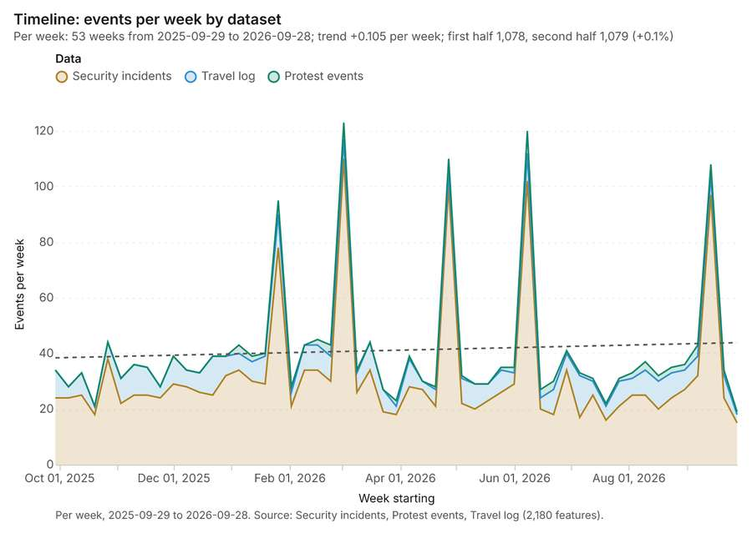
Figure 1. Timeline: events per week by dataset [1]. Per week, 2025-09-29 to 2026-09-28. Source: Security incidents, Protest events, Travel log (2,180 features). The data is in the appendix.
The timeline counts 2,180 dated events in Security incidents, Protest events, Travel log per week, from week of 2025-09-29 to week of 2026-09-28 [1][2][3][4]. By dataset: Security incidents 1,700; Travel log 400; Protest events 80 [1]. The trend is +0.105 events per week; the second half of the weeks has 1,079 against 1,078 in the first (+0.1%) [1].
Busiest weeks
- week of 2026-03-02: 123 events [1]
- week of 2026-06-08: 120 events [1]
- week of 2026-04-27: 110 events [1]
Quietest weeks
- week of 2026-09-28: 19 events [1]
- week of 2025-10-20: 21 events [1]
- week of 2026-07-20: 22 events [1]

Hot spots
What this analysis is. Hot spot analysis: Getis-Ord Gi* hot and cold spots with z-scores, p-values and confidence bins [5]. In ArcGIS it is Find Hot Spots or Hot Spot Analysis (Getis-Ord Gi*); in QGIS, qgis:hotspot (plugin) [5].
Why it was run on this data. 80 points: Getis-Ord Gi* tests whether the concentrations in Protest events are statistically significant [6].
What it found. Hot spots on Protest events: Hot spot analysis: 1 layer saved: Hot spot analysis: Protest events (29 features) [7][8]. It reported result, bins 29; result, count 29; result, elapsed ms 5; result, cell size m 500; result, incidents used 80; result, distance band m 1,000 [7].
Result | Value
result, bins | 29
result, count | 29
result, elapsed ms | 5
result, cell size m | 500
result, incidents used | 80
result, distance band m | 1,000
billing, cost | 0.0516
billing, list price | 0.0516
billing, upstream cost | 0

Findings
- Evidenced: Hot spots on Protest events: Hot spot analysis: 1 layer saved: Hot spot analysis: Protest events (29 features) [7][8].
- Evidenced: It reported result, bins 29; result, count 29; result, elapsed ms 5; result, cell size m 500; result, incidents used 80; result, distance band m 1,000 [7].
A model draft was discarded because a sentence did not cite a source of this section.
Tool gp_hot_spots; parameters {"project": "188436ed-c19a-4e7c-ab43-b58fe7291e56", "features": {"layer": "Protest events (cf75e6b1)"}, "aggregation": "hexagon", "cell_size_m": 500.0, "distance_band_m": 1000.0}

Hot spots
What this analysis is. Hot spot analysis: Getis-Ord Gi* hot and cold spots with z-scores, p-values and confidence bins [5]. In ArcGIS it is Find Hot Spots or Hot Spot Analysis (Getis-Ord Gi*); in QGIS, qgis:hotspot (plugin) [5].
Why it was run on this data. 30 points: Getis-Ord Gi* tests whether the concentrations in Hotels are statistically significant [9].
What it found. The hot spot analysis generated 14 features [10] after processing the Hotels layer [11]. The analysis used 30 incidents and set both the distance band and cell size to 2,000 m [10]. The process completed quickly, taking 2 ms [10]. The billing for this analysis was 0.0506 [10].
Result | Value
result, bins | 14
result, count | 14
result, elapsed ms | 2
result, cell size m | 2,000
result, incidents used | 30
result, distance band m | 2,000
billing, cost | 0.0506
billing, list price | 0.0506
billing, upstream cost | 0

Findings
- Evidenced: Hot spots on Hotels: Hot spot analysis: 1 layer saved: Hot spot analysis: Hotels (14 features) [10][11].
- Evidenced: It reported result, bins 14; result, count 14; result, elapsed ms 2; result, cell size m 2,000; result, incidents used 30; result, distance band m 2,000 [10].
Tool gp_hot_spots; parameters {"project": "188436ed-c19a-4e7c-ab43-b58fe7291e56", "features": {"layer": "Hotels (28842e9c)"}, "aggregation": "hexagon", "cell_size_m": 2000.0, "distance_band_m": 2000.0}

Hot spots
What this analysis is. Hot spot analysis: Getis-Ord Gi* hot and cold spots with z-scores, p-values and confidence bins [5]. In ArcGIS it is Find Hot Spots or Hot Spot Analysis (Getis-Ord Gi*); in QGIS, qgis:hotspot (plugin) [5].
Why it was run on this data. 1700 points: Getis-Ord Gi* tests whether the concentrations in Security incidents are statistically significant [12].
What it found. Hot spots on Security incidents: Hot spot analysis: 1 layer saved: Hot spot analysis: Security incidents (353 features) [13][14]. It reported result, bins 353; result, count 353; result, elapsed ms 18; result, cell size m 500; result, incidents used 1,700; result, distance band m 500 [13].
Result | Value
result, bins | 353
result, count | 353
result, elapsed ms | 18
result, cell size m | 500
result, incidents used | 1,700
result, distance band m | 500
billing, cost | 0.084
billing, list price | 0.084
billing, upstream cost | 0

Findings
- Evidenced: Hot spots on Security incidents: Hot spot analysis: 1 layer saved: Hot spot analysis: Security incidents (353 features) [13][14].
- Evidenced: It reported result, bins 353; result, count 353; result, elapsed ms 18; result, cell size m 500; result, incidents used 1,700; result, distance band m 500 [13].
Tool gp_hot_spots; parameters {"project": "188436ed-c19a-4e7c-ab43-b58fe7291e56", "features": {"layer": "Security incidents (afb5d90c)"}, "aggregation": "hexagon", "cell_size_m": 500.0, "distance_band_m": 500.0}

Space time hot spots
What this analysis is. Emerging hot spots: Where hot spots are new, consecutive, intensifying, persistent, diminishing, sporadic, oscillating or historical over time [15]. In ArcGIS it is Emerging Hot Spot Analysis or Create Space Time Cube [15].
Why it was run on this data. Protest events carry dates in 'date': emerging hot spot analysis finds new, intensifying and fading hot spots per week [16].
What it found. Space time hot spots on Protest events: Emerging hot spots: 1 layer saved: Emerging hot spots: Protest events (14 features) [8][17]. It reported result, count 14; result, elapsed ms 4; result, resolution 8; result, features used 80; result, time neighbors 0; billing, cost 0.104 [17].
Result | Value
result, count | 14
result, elapsed ms | 4
result, resolution | 8
result, features used | 80
result, time neighbors | 0
billing, cost | 0.104
billing, list price | 0.104
billing, upstream cost | 0

Findings
- Evidenced: Space time hot spots on Protest events: Emerging hot spots: 1 layer saved: Emerging hot spots: Protest events (14 features) [8][17].
- Evidenced: It reported result, count 14; result, elapsed ms 4; result, resolution 8; result, features used 80; result, time neighbors 0; billing, cost 0.104 [17].
A model draft was discarded because a sentence did not cite a source of this section.
Tool gp_space_time_hot_spots; parameters {"project": "188436ed-c19a-4e7c-ab43-b58fe7291e56", "features": {"layer": "Protest events (cf75e6b1)"}, "interval": "week", "bin_shape": "h3", "resolution": 8, "time_field": "date"}

Space time hot spots
What this analysis is. Emerging hot spots: Where hot spots are new, consecutive, intensifying, persistent, diminishing, sporadic, oscillating or historical over time [15]. In ArcGIS it is Emerging Hot Spot Analysis or Create Space Time Cube [15].
Why it was run on this data. Security incidents carry dates in 'occurred_at': emerging hot spot analysis finds new, intensifying and fading hot spots per week [18].
What it found. Space time hot spots on Security incidents: Emerging hot spots: 1 layer saved: Emerging hot spots: Security incidents (108 features) [14][19]. It reported result, count 108; result, elapsed ms 21; result, resolution 8; result, features used 1,700; result, time neighbors 0; billing, cost 0.185 [19].
Result | Value
result, count | 108
result, elapsed ms | 21
result, resolution | 8
result, features used | 1,700
result, time neighbors | 0
billing, cost | 0.185
billing, list price | 0.185
billing, upstream cost | 0

Findings
- Evidenced: Space time hot spots on Security incidents: Emerging hot spots: 1 layer saved: Emerging hot spots: Security incidents (108 features) [14][19].
- Evidenced: It reported result, count 108; result, elapsed ms 21; result, resolution 8; result, features used 1,700; result, time neighbors 0; billing, cost 0.185 [19].
Tool gp_space_time_hot_spots; parameters {"project": "188436ed-c19a-4e7c-ab43-b58fe7291e56", "features": {"layer": "Security incidents (afb5d90c)"}, "interval": "week", "bin_shape": "h3", "resolution": 8, "time_field": "occurred_at"}

Near repeat
What this analysis is. Repeat and near repeat classification: Classify incidents as originators, repeats (same place) or near repeats within a distance and time window, with a Knox test table [20]. In ArcGIS it is Repeat and Near Repeat Classification or Near Repeat Calculator [20].
Why it was run on this data. Near repeat analysis tests whether Protest events close in space also follow each other within 27 days [21].
What it found. The tool executed used the Protest events data [8] to classify near repeats [22]. The resulting dataset contained a count of 80 pairs [22], with 11 total chains identified [22]. Furthermore, 15 pairs were linked, and the average distance was reported as 200 m [22].
Result | Value
result, days | 27
result, count | 80
result, chains | 11
result, distance m | 200
result, elapsed ms | 4
result, pairs linked | 15
billing, cost | 0.0524
billing, list price | 0.0524
billing, upstream cost | 0

Findings
- Evidenced: Near repeat on Protest events: Repeat and near repeat classification: 1 layer saved: Repeat and near repeat classification: Protest events (80 features) [8][22].
- Evidenced: It reported result, days 27; result, count 80; result, chains 11; result, distance m 200; result, elapsed ms 4; result, pairs linked 15 [22].
Tool gp_near_repeat; parameters {"days": 27, "project": "188436ed-c19a-4e7c-ab43-b58fe7291e56", "features": {"layer": "Protest events (cf75e6b1)"}, "distance_m": 200.0, "time_field": "date"}

Summarize within
What this analysis is. Summarize within: Count and aggregate the features inside each polygon (or bin), proportionally for lines and polygons [23]. In ArcGIS it is Summarize Within or Aggregate Points; in QGIS, native:countpointsinpolygon or native:sumlinelengths [23].
Why it was run on this data. Count Hospitals inside each feature of Risk zones by english_speaking; the counts map as a choropleth (natural breaks, sequential colors) [24].
What it found. Summarize within on Hospitals, Risk zones: Summarize within: 1 layer saved: Summarize within: Risk zones (14 features) [25][26][27]. It reported result, count 14; result, elapsed ms 0; billing, cost 0.0106; billing, list price 0.0106; billing, upstream cost 0 [25].
Result | Value
result, count | 14
result, elapsed ms | 0
billing, cost | 0.0106
billing, list price | 0.0106
billing, upstream cost | 0

Findings
- Evidenced: Summarize within on Hospitals, Risk zones: Summarize within: 1 layer saved: Summarize within: Risk zones (14 features) [25][26][27].
- Evidenced: It reported result, count 14; result, elapsed ms 0; billing, cost 0.0106; billing, list price 0.0106; billing, upstream cost 0 [25].
Tool gp_summarize_within; parameters {"stats": [{"stat": "sum", "field": "trauma_level"}], "project": "188436ed-c19a-4e7c-ab43-b58fe7291e56", "features": {"layer": "Hospitals (8a96a3d4)"}, "group_by": "english_speaking", "polygons": {"layer": "Risk zones (a4d2e294)"}}

Summarize within
What this analysis is. Summarize within: Count and aggregate the features inside each polygon (or bin), proportionally for lines and polygons [23]. In ArcGIS it is Summarize Within or Aggregate Points; in QGIS, native:countpointsinpolygon or native:sumlinelengths [23].
Why it was run on this data. Count Hospitals inside each feature of Risk zones by english_speaking; the counts map as a choropleth (natural breaks, sequential colors) [24].
What it found. Summarize within on Safe havens, Risk zones: Summarize within: 1 layer saved: Summarize within: Risk zones (14 features) [27][28][29]. It reported result, count 14; result, elapsed ms 0; billing, cost 0.01052; billing, list price 0.01052; billing, upstream cost 0 [28].
Result | Value
result, count | 14
result, elapsed ms | 0
billing, cost | 0.01052
billing, list price | 0.01052
billing, upstream cost | 0

Findings
- Evidenced: Summarize within on Safe havens, Risk zones: Summarize within: 1 layer saved: Summarize within: Risk zones (14 features) [27][28][29].
- Evidenced: It reported result, count 14; result, elapsed ms 0; billing, cost 0.01052; billing, list price 0.01052; billing, upstream cost 0 [28].
Tool gp_summarize_within; parameters {"stats": [], "project": "188436ed-c19a-4e7c-ab43-b58fe7291e56", "features": {"layer": "Safe havens (d7ec6bb0)"}, "group_by": "type", "polygons": {"layer": "Risk zones (a4d2e294)"}}

Summarize within
What this analysis is. Summarize within: Count and aggregate the features inside each polygon (or bin), proportionally for lines and polygons [23]. In ArcGIS it is Summarize Within or Aggregate Points; in QGIS, native:countpointsinpolygon or native:sumlinelengths [23].
Why it was run on this data. Count Hospitals inside each feature of Risk zones by english_speaking; the counts map as a choropleth (natural breaks, sequential colors) [24].
What it found. The analysis employed the `gp_summarize_within` tool [30], accepting Protest events [8] and Risk zones [27] as inputs [30]. This process yielded a result count of 14 [30].
Result | Value
result, count | 14
result, elapsed ms | 0
billing, cost | 0.01188
billing, list price | 0.01188
billing, upstream cost | 0

Findings
- Evidenced: Summarize within on Protest events, Risk zones: Summarize within: 1 layer saved: Summarize within: Risk zones (14 features) [8][27][30].
- Evidenced: It reported result, count 14; result, elapsed ms 0; billing, cost 0.01188; billing, list price 0.01188; billing, upstream cost 0 [30].
Tool gp_summarize_within; parameters {"stats": [], "project": "188436ed-c19a-4e7c-ab43-b58fe7291e56", "features": {"layer": "Protest events (cf75e6b1)"}, "group_by": "size", "polygons": {"layer": "Risk zones (a4d2e294)"}}

Find point clusters
What this analysis is. Find point clusters: Density-based clusters (DBSCAN, HDBSCAN or OPTICS, optionally space-time) with hulls and noise [31]. In ArcGIS it is Find Point Clusters or Density-based Clustering; in QGIS, native:dbscanclustering or native:stdbscanclustering [31].
Why it was run on this data. DBSCAN finds dense groups of Hospitals and separates noise [32].
What it found. Find point clusters on Hospitals: Find point clusters: 2 layers saved: Find point clusters: Hospitals (15 features); Find point clusters: cluster hulls (1 feature) [26][33]. It reported result, count 15; result, noise 4; result, distance m 2,000; result, elapsed ms 2; result, min points 3; billing, cost 0.0503 [33].
Result | Value
result, count | 15
result, noise | 4
result, distance m | 2,000
result, elapsed ms | 2
result, min points | 3
billing, cost | 0.0503
billing, list price | 0.0503
billing, upstream cost | 0

Findings
- Evidenced: Find point clusters on Hospitals: Find point clusters: 2 layers saved: Find point clusters: Hospitals (15 features); Find point clusters: cluster hulls (1 feature) [26][33].
- Evidenced: It reported result, count 15; result, noise 4; result, distance m 2,000; result, elapsed ms 2; result, min points 3; billing, cost 0.0503 [33].
Tool gp_find_point_clusters; parameters {"method": "dbscan", "project": "188436ed-c19a-4e7c-ab43-b58fe7291e56", "features": {"layer": "Hospitals (8a96a3d4)"}, "distance_m": 2000.0, "min_points": 3}

Find point clusters
What this analysis is. Find point clusters: Density-based clusters (DBSCAN, HDBSCAN or OPTICS, optionally space-time) with hulls and noise [31]. In ArcGIS it is Find Point Clusters or Density-based Clustering; in QGIS, native:dbscanclustering or native:stdbscanclustering [31].
Why it was run on this data. DBSCAN finds dense groups of Safe havens and separates noise [34].
What it found. The tool saved 2 layers: Find point clusters: Safe havens found 12 features, and Find point clusters: cluster hulls found 2 features [35]. The process resulted in 12 points, with 4 points categorized as noise [35].
Result | Value
result, count | 12
result, noise | 4
result, distance m | 2,000
result, elapsed ms | 1
result, min points | 3
billing, cost | 0.05024
billing, list price | 0.05024
billing, upstream cost | 0

Findings
- Evidenced: Find point clusters on Safe havens: Find point clusters: 2 layers saved: Find point clusters: Safe havens (12 features); Find point clusters: cluster hulls (2 features) [29][35].
- Evidenced: It reported result, count 12; result, noise 4; result, distance m 2,000; result, elapsed ms 1; result, min points 3; billing, cost 0.05024 [35].
Tool gp_find_point_clusters; parameters {"method": "dbscan", "project": "188436ed-c19a-4e7c-ab43-b58fe7291e56", "features": {"layer": "Safe havens (d7ec6bb0)"}, "distance_m": 2000.0, "min_points": 3}

Find point clusters
What this analysis is. Find point clusters: Density-based clusters (DBSCAN, HDBSCAN or OPTICS, optionally space-time) with hulls and noise [31]. In ArcGIS it is Find Point Clusters or Density-based Clustering; in QGIS, native:dbscanclustering or native:stdbscanclustering [31].
Why it was run on this data. DBSCAN finds dense groups of Protest events and separates noise [36].
What it found. Find point clusters on Protest events: Find point clusters: 2 layers saved: Find point clusters: Protest events (80 features); Find point clusters: cluster hulls (1 feature) [8][37]. It reported result, count 80; result, noise 3; result, distance m 500; result, elapsed ms 2; result, min points 3; billing, cost 0.0516 [37].
Result | Value
result, count | 80
result, noise | 3
result, distance m | 500
result, elapsed ms | 2
result, min points | 3
billing, cost | 0.0516
billing, list price | 0.0516
billing, upstream cost | 0

Findings
- Evidenced: Find point clusters on Protest events: Find point clusters: 2 layers saved: Find point clusters: Protest events (80 features); Find point clusters: cluster hulls (1 feature) [8][37].
- Evidenced: It reported result, count 80; result, noise 3; result, distance m 500; result, elapsed ms 2; result, min points 3; billing, cost 0.0516 [37].
Tool gp_find_point_clusters; parameters {"method": "dbscan", "project": "188436ed-c19a-4e7c-ab43-b58fe7291e56", "features": {"layer": "Protest events (cf75e6b1)"}, "distance_m": 500.0, "min_points": 3}

Calculate density
What this analysis is. Calculate density: Kernel density per square kilometer on a grid [38]. In ArcGIS it is Calculate Density or Kernel Density; in QGIS, native:heatmapkerneldensityestimation [38].
Why it was run on this data. 80 points in Protest events: a density surface shows where they concentrate [39].
What it found. Calculate density on Protest events: Calculate density: 1 layer saved: Calculate density: Protest events (386 features) [8][40]. It reported result, count 386; result, elapsed ms 11; result, bandwidth m 1,000; result, cell size m 200; result, excluded null 0; result, max density per km2 29.94 [40].
Result | Value
result, count | 386
result, elapsed ms | 11
result, bandwidth m | 1,000
result, cell size m | 200
result, excluded null | 0
result, max density per km2 | 29.94
billing, cost | 0.0516
billing, list price | 0.0516
billing, upstream cost | 0

Findings
- Evidenced: Calculate density on Protest events: Calculate density: 1 layer saved: Calculate density: Protest events (386 features) [8][40].
- Evidenced: It reported result, count 386; result, elapsed ms 11; result, bandwidth m 1,000; result, cell size m 200; result, excluded null 0; result, max density per km2 29.94 [40].
Tool gp_calculate_density; parameters {"kernel": "quartic", "project": "188436ed-c19a-4e7c-ab43-b58fe7291e56", "features": {"layer": "Protest events (cf75e6b1)"}, "bandwidth_m": 1000.0, "cell_size_m": 200.0}

Calculate density
What this analysis is. Calculate density: Kernel density per square kilometer on a grid [38]. In ArcGIS it is Calculate Density or Kernel Density; in QGIS, native:heatmapkerneldensityestimation [38].
Why it was run on this data. 30 points in Hotels: a density surface shows where they concentrate [41].
What it found. The density calculation was run on the Hotels layer [11] by utilizing the `gp_calculate_density` tool [42].
Result | Value
result, count | 82
result, elapsed ms | 3
result, bandwidth m | 2,000
result, cell size m | 1,000
result, excluded null | 0
result, max density per km2 | 1.819
billing, cost | 0.0506
billing, list price | 0.0506
billing, upstream cost | 0

Findings
- Evidenced: Calculate density on Hotels: Calculate density: 1 layer saved: Calculate density: Hotels (82 features) [11][42].
- Evidenced: It reported result, count 82; result, elapsed ms 3; result, bandwidth m 2,000; result, cell size m 1,000; result, excluded null 0; result, max density per km2 1.819 [42].
Tool gp_calculate_density; parameters {"kernel": "quartic", "project": "188436ed-c19a-4e7c-ab43-b58fe7291e56", "features": {"layer": "Hotels (28842e9c)"}, "bandwidth_m": 2000.0, "cell_size_m": 1000.0}

Calculate density
What this analysis is. Calculate density: Kernel density per square kilometer on a grid [38]. In ArcGIS it is Calculate Density or Kernel Density; in QGIS, native:heatmapkerneldensityestimation [38].
Why it was run on this data. 1700 points in Security incidents: a density surface shows where they concentrate [43].
What it found. Calculate density on Security incidents: Calculate density: 1 layer saved: Calculate density: Security incidents (2240 features) [14][44]. It reported result, count 2,240; result, elapsed ms 60; result, bandwidth m 500; result, cell size m 200; result, excluded null 0; result, max density per km2 267.9 [44].
Result | Value
result, count | 2,240
result, elapsed ms | 60
result, bandwidth m | 500
result, cell size m | 200
result, excluded null | 0
result, max density per km2 | 267.9
billing, cost | 0.084
billing, list price | 0.084
billing, upstream cost | 0

Findings
- Evidenced: Calculate density on Security incidents: Calculate density: 1 layer saved: Calculate density: Security incidents (2240 features) [14][44].
- Evidenced: It reported result, count 2,240; result, elapsed ms 60; result, bandwidth m 500; result, cell size m 200; result, excluded null 0; result, max density per km2 267.9 [44].
Tool gp_calculate_density; parameters {"kernel": "quartic", "project": "188436ed-c19a-4e7c-ab43-b58fe7291e56", "features": {"layer": "Security incidents (afb5d90c)"}, "bandwidth_m": 500.0, "cell_size_m": 200.0}

Outliers
What this analysis is. Find outliers: Anselin local Moran’s I: HH, LL clusters and HL, LH outliers [45]. In ArcGIS it is Find Outliers or Cluster and Outlier Analysis (Anselin Local Moran’s I) [45].
Why it was run on this data. Local Moran's I maps clusters and outliers of 'risk_score' [46].
What it found. Outliers on Risk zones: Find outliers: 1 layer saved: Find outliers: Risk zones (14 features) [27][47]. It reported result, count 14; result, elapsed ms 2; result, permutations 199; result, excluded null 0; result, distance band m 2,548; billing, cost 0.05042 [47].
Result | Value
result, count | 14
result, elapsed ms | 2
result, permutations | 199
result, excluded null | 0
result, distance band m | 2,548
billing, cost | 0.05042
billing, list price | 0.05042
billing, upstream cost | 0

Findings
- Evidenced: Outliers on Risk zones: Find outliers: 1 layer saved: Find outliers: Risk zones (14 features) [27][47].
- Evidenced: It reported result, count 14; result, elapsed ms 2; result, permutations 199; result, excluded null 0; result, distance band m 2,548; billing, cost 0.05042 [47].
Tool gp_outliers; parameters {"field": "risk_score", "project": "188436ed-c19a-4e7c-ab43-b58fe7291e56", "features": {"layer": "Risk zones (a4d2e294)"}, "aggregation": "hexagon"}

Spatial autocorrelation
What this analysis is. Spatial autocorrelation: Global Moran’s I: is the pattern clustered, dispersed or random [48]. In ArcGIS it is Spatial Autocorrelation (Global Moran’s I) [48].
Why it was run on this data. Global Moran's I says whether similar values of 'risk_score' sit next to each other [49].
What it found. The spatial autocorrelation tool was run using the Risk zones input [27], completing without generating a map output [50].
Result | Value
result, n | 14
result, p value | 0.6185
result, z score | -0.498
result, morans i | -0.2235
result, variance | 0.08664
result, elapsed ms | 1
result, expected i | -0.07692
result, excluded null | 0
result, distance band m | 2,548
result, p value normality | 0.6003
result, z score normality | -0.5239
result, variance normality | 0.0783
billing, cost | 0.02
billing, list price | 0.02
billing, upstream cost | 0

Findings
- Evidenced: Spatial autocorrelation on Risk zones: Spatial autocorrelation: done; no map output [27][50].
- Evidenced: It reported result, n 14; result, p value 0.6185; result, z score -0.498; result, morans i -0.2235; result, variance 0.08664; result, elapsed ms 1 [50].
Tool gp_spatial_autocorrelation; parameters {"field": "risk_score", "project": "188436ed-c19a-4e7c-ab43-b58fe7291e56", "features": {"layer": "Risk zones (a4d2e294)"}}

Find nearest
What this analysis is. Find nearest: The k nearest features for each input, with geodesic distance and bearing [51]. In ArcGIS it is Find Nearest or Near; in QGIS, native:joinbynearest or native:nearestneighbouranalysis [51].
Why it was run on this data. The nearest of Travel routes to each of Hospitals, with distances [52].
What it found. Find nearest on Travel routes, Hospitals: Find nearest: 1 layer saved: Find nearest: Hospitals (14 features) [26][53][54]. It reported result, count 14; result, elapsed ms 10; billing, cost 0.0105; billing, list price 0.0105; billing, upstream cost 0 [53].
Result | Value
result, count | 14
result, elapsed ms | 10
billing, cost | 0.0105
billing, list price | 0.0105
billing, upstream cost | 0

Findings
- Evidenced: Find nearest on Travel routes, Hospitals: Find nearest: 1 layer saved: Find nearest: Hospitals (14 features) [26][53][54].
- Evidenced: It reported result, count 14; result, elapsed ms 10; billing, cost 0.0105; billing, list price 0.0105; billing, upstream cost 0 [53].
Tool gp_find_nearest; parameters {"k": 1, "to": {"layer": "Travel routes (17118d2e)"}, "from": {"layer": "Hospitals (8a96a3d4)"}, "project": "188436ed-c19a-4e7c-ab43-b58fe7291e56", "max_distance_m": 2000.0}

Find nearest
What this analysis is. Find nearest: The k nearest features for each input, with geodesic distance and bearing [51]. In ArcGIS it is Find Nearest or Near; in QGIS, native:joinbynearest or native:nearestneighbouranalysis [51].
Why it was run on this data. The nearest of Travel routes to each of Hospitals, with distances [52].
What it found. Find nearest on Safe havens, Hospitals: Find nearest: 1 layer saved: Find nearest: Hospitals (14 features) [26][29][55]. It reported result, count 14; result, elapsed ms 1; billing, cost 0.01054; billing, list price 0.01054; billing, upstream cost 0 [55].
Result | Value
result, count | 14
result, elapsed ms | 1
billing, cost | 0.01054
billing, list price | 0.01054
billing, upstream cost | 0

Findings
- Evidenced: Find nearest on Safe havens, Hospitals: Find nearest: 1 layer saved: Find nearest: Hospitals (14 features) [26][29][55].
- Evidenced: It reported result, count 14; result, elapsed ms 1; billing, cost 0.01054; billing, list price 0.01054; billing, upstream cost 0 [55].
Tool gp_find_nearest; parameters {"k": 1, "to": {"layer": "Safe havens (d7ec6bb0)"}, "from": {"layer": "Hospitals (8a96a3d4)"}, "project": "188436ed-c19a-4e7c-ab43-b58fe7291e56", "max_distance_m": 2000.0}

Find nearest
What this analysis is. Find nearest: The k nearest features for each input, with geodesic distance and bearing [51]. In ArcGIS it is Find Nearest or Near; in QGIS, native:joinbynearest or native:nearestneighbouranalysis [51].
Why it was run on this data. The nearest of Travel routes to each of Hospitals, with distances [52].
What it found. The `gp_find_nearest` tool was utilized with Protest events [8] and Hospitals [26] [56]. This process found 6 results [56]. The execution was quick, completing in 1 elapsed ms [56]. The billing cost associated with this operation was 0.0119 [56].
Result | Value
result, count | 6
result, elapsed ms | 1
billing, cost | 0.0119
billing, list price | 0.0119
billing, upstream cost | 0

Findings
- Evidenced: Find nearest on Protest events, Hospitals: Find nearest: 1 layer saved: Find nearest: Hospitals (6 features) [8][26][56].
- Evidenced: It reported result, count 6; result, elapsed ms 1; billing, cost 0.0119; billing, list price 0.0119; billing, upstream cost 0 [56].
Tool gp_find_nearest; parameters {"k": 1, "to": {"layer": "Protest events (cf75e6b1)"}, "from": {"layer": "Hospitals (8a96a3d4)"}, "project": "188436ed-c19a-4e7c-ab43-b58fe7291e56", "max_distance_m": 2000.0}

Maps and charts
The run also made 23 map image(s) [57][58][59][60][61][62][63][64][65][66][67][68][69][70][71][72][73][74][75][76][77][78][79] and 27 chart(s) [80][81][82][83][84][85][86][87][88][89][90][91][92][93][94][95][96][97][98][99][100][101][102][103][104][105][106].
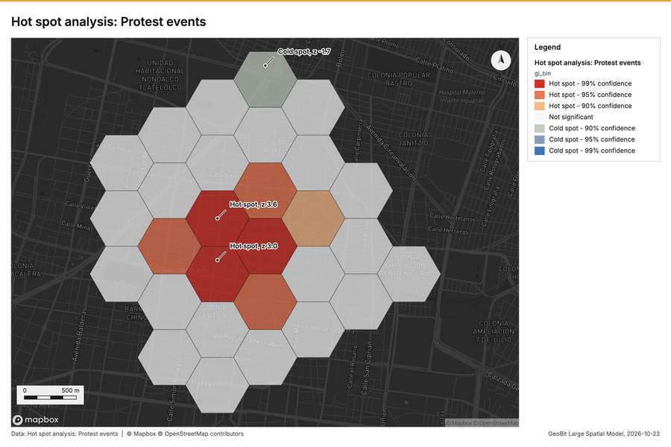
Figure 2. Hot spot analysis: Protest events [57]
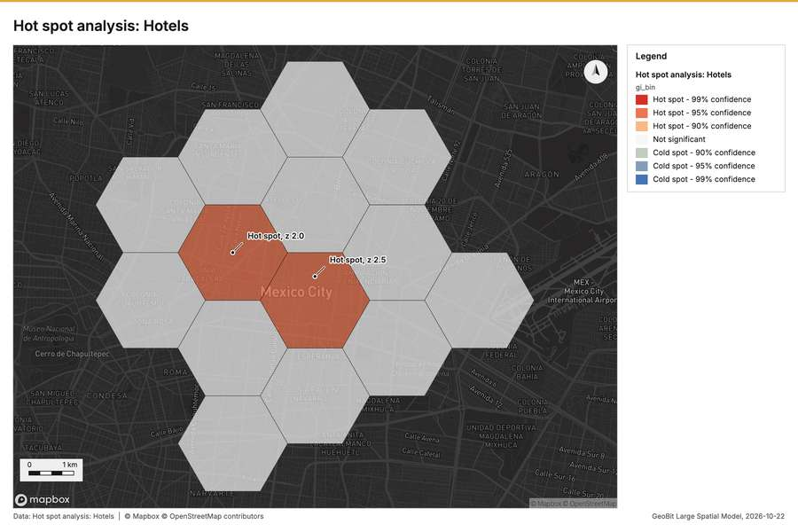
Figure 3. Hot spot analysis: Hotels [58]
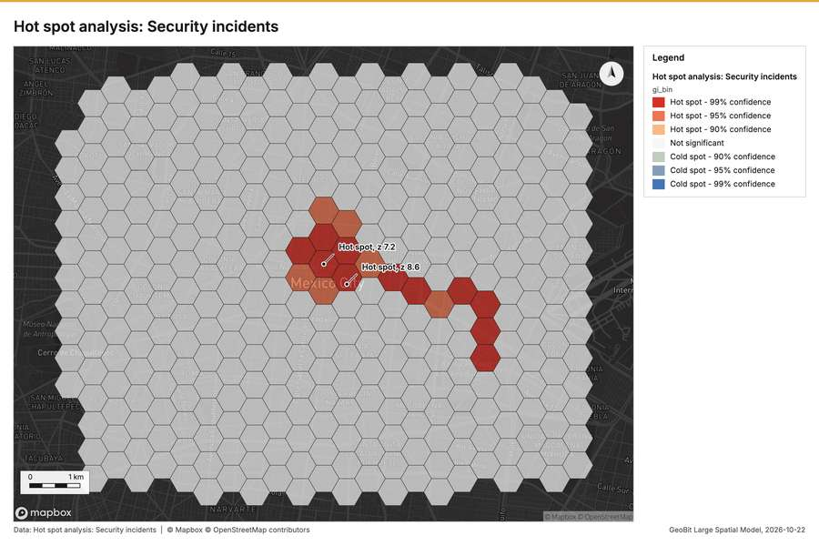
Figure 4. Hot spot analysis: Security incidents [59]
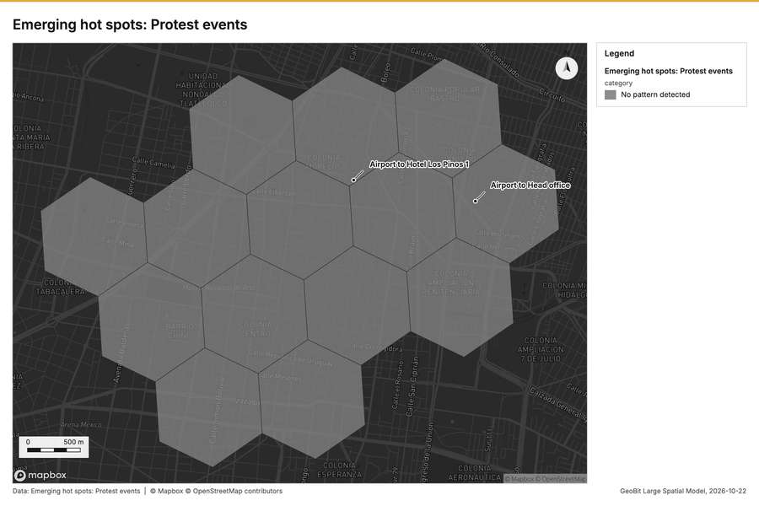
Figure 5. Emerging hot spots: Protest events [60]
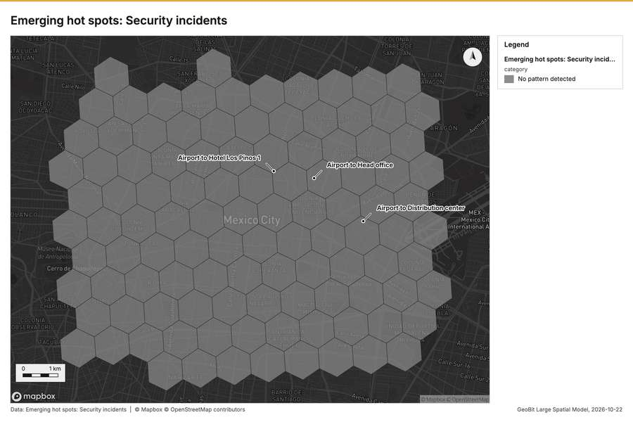
Figure 6. Emerging hot spots: Security incidents [61]
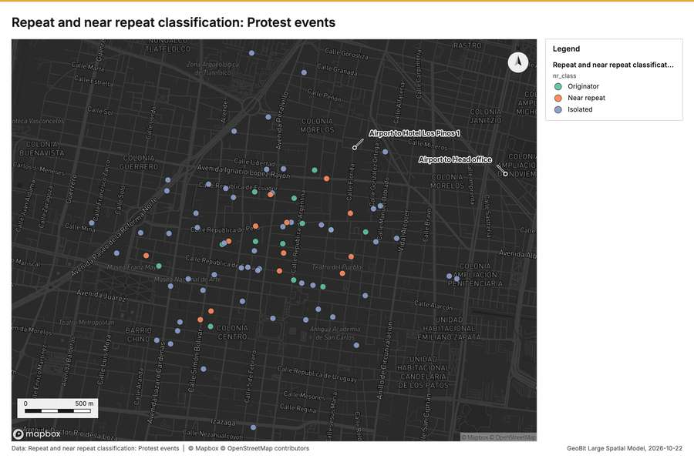
Figure 7. Repeat and near repeat classification: Protest events [62]
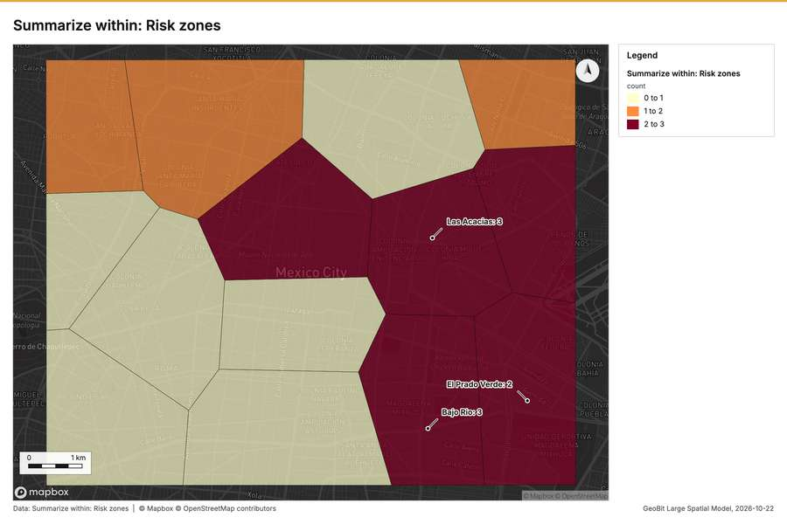
Figure 8. Summarize within: Risk zones [63]
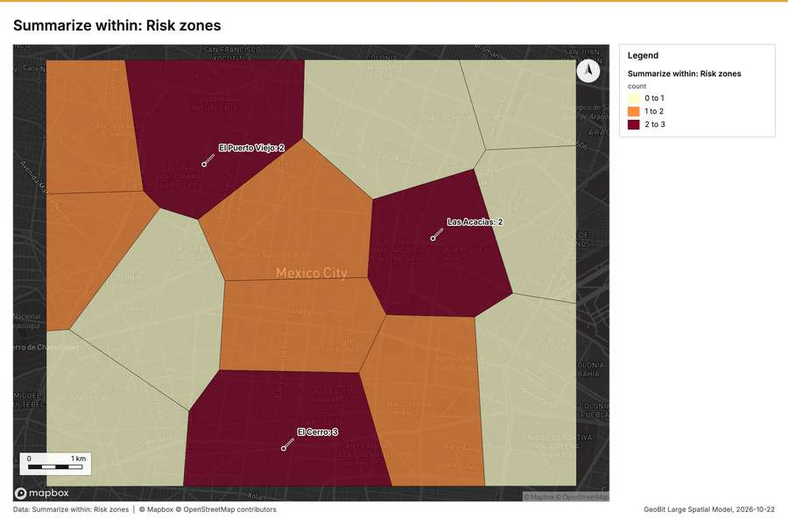
Figure 9. Summarize within: Risk zones [64]
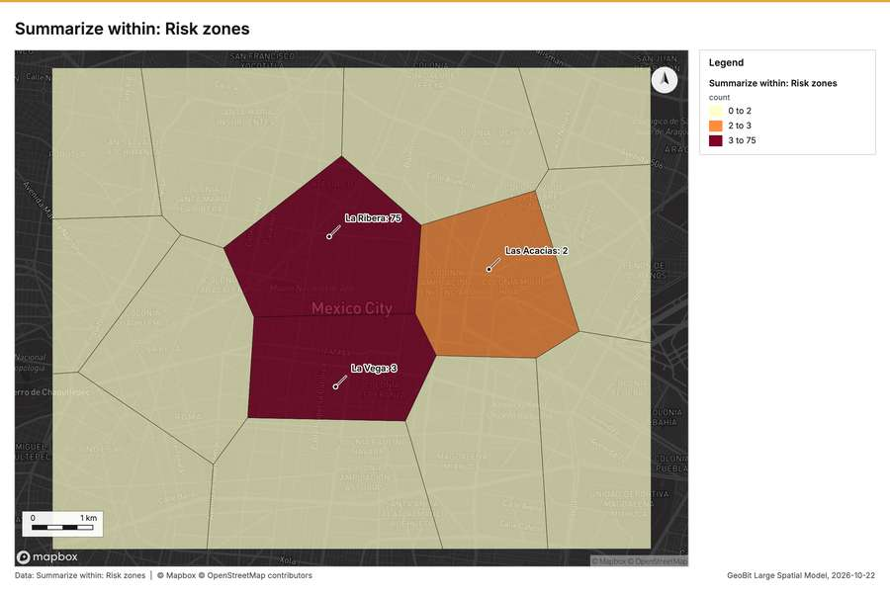
Figure 10. Summarize within: Risk zones [65]
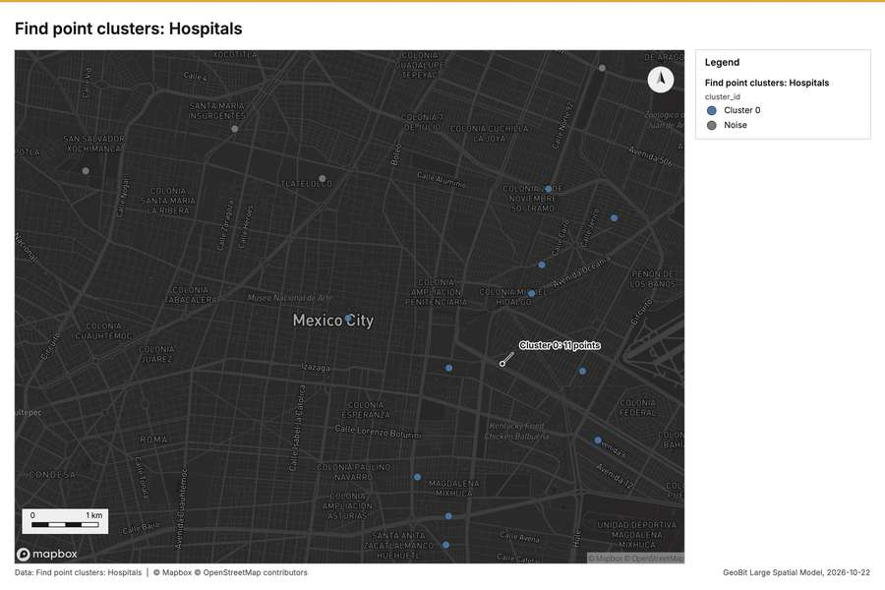
Figure 11. Find point clusters: Hospitals [66]
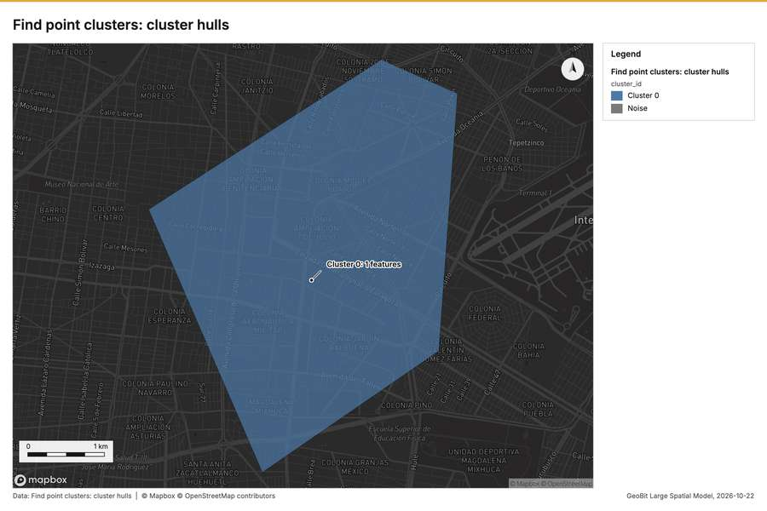
Figure 12. Find point clusters: cluster hulls [67]
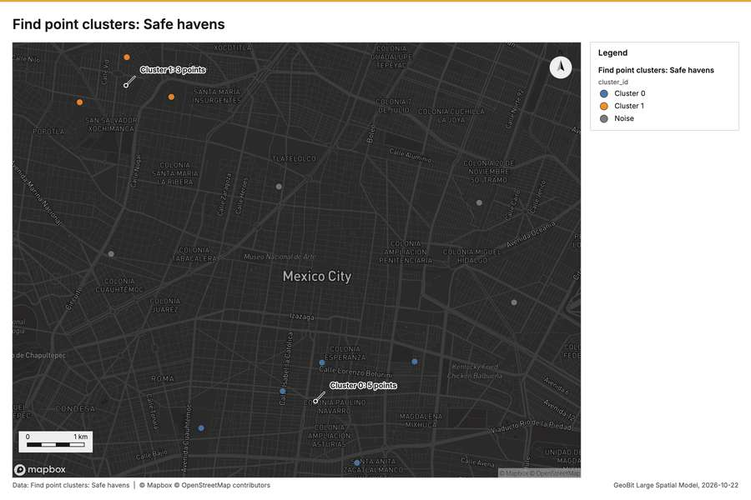
Figure 13. Find point clusters: Safe havens [68]
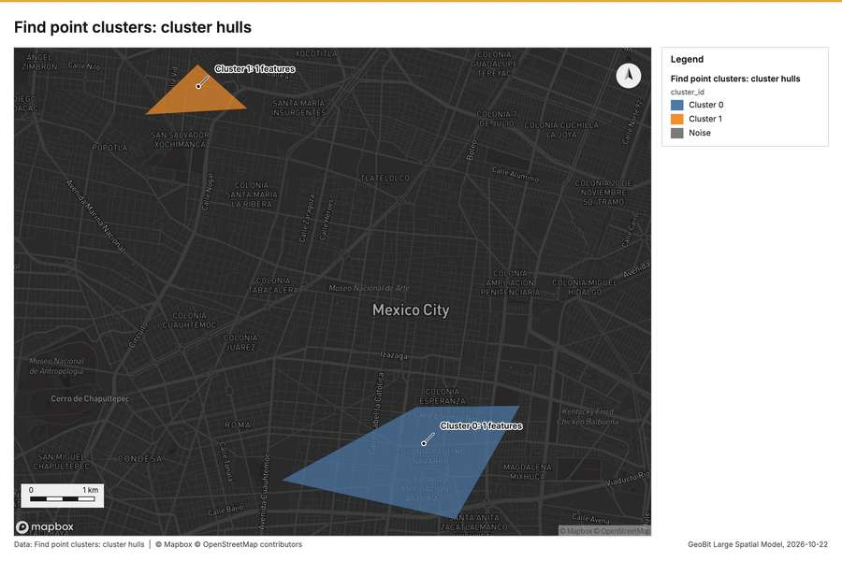
Figure 14. Find point clusters: cluster hulls [69]
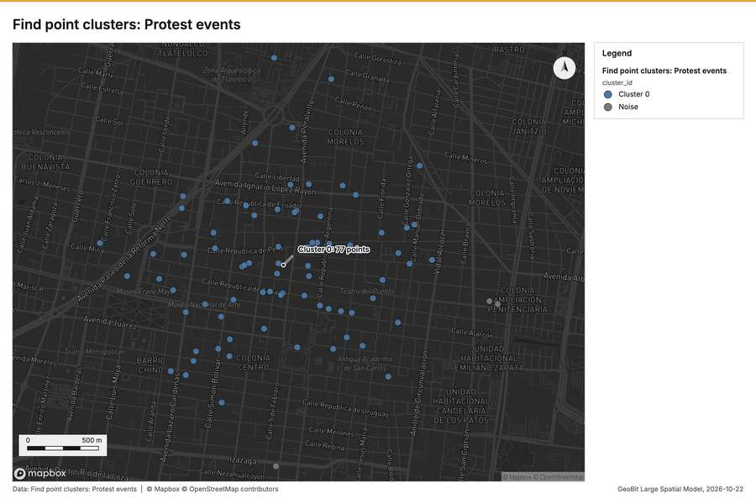
Figure 15. Find point clusters: Protest events [70]
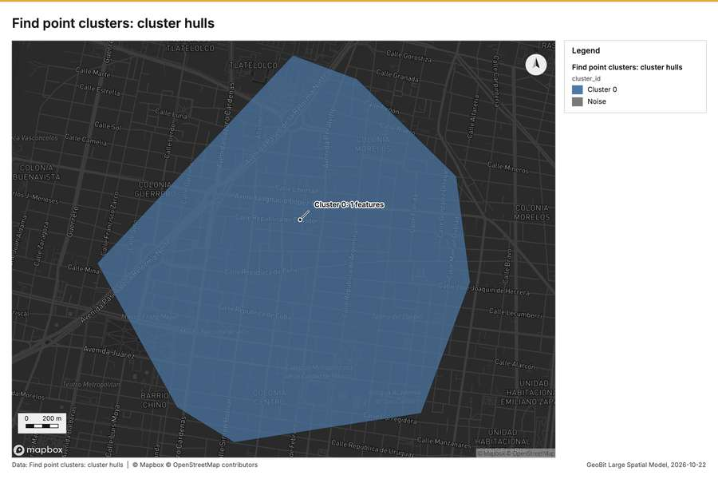
Figure 16. Find point clusters: cluster hulls [71]
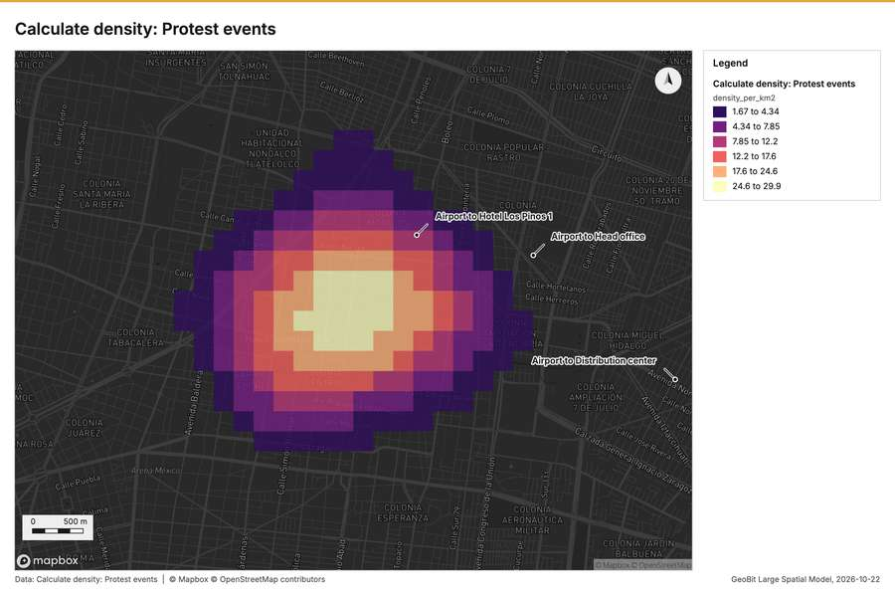
Figure 17. Calculate density: Protest events [72]
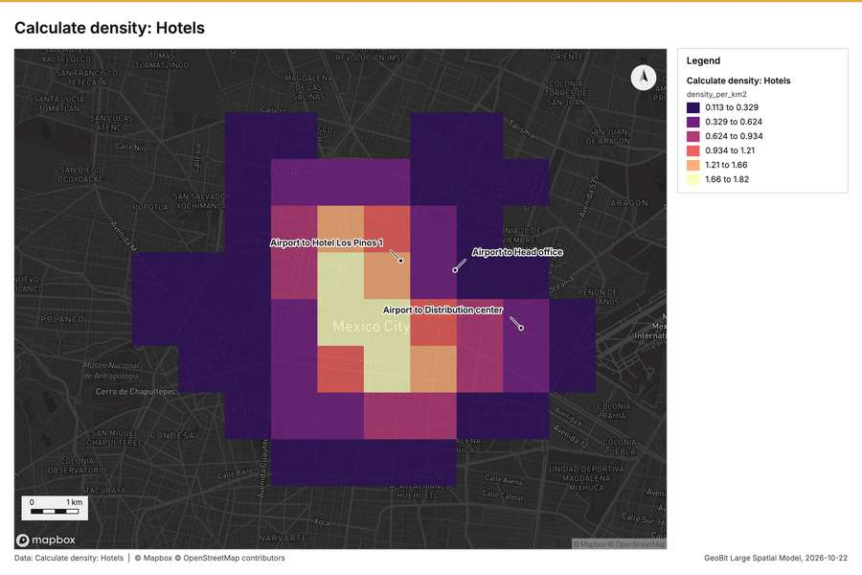
Figure 18. Calculate density: Hotels [73]
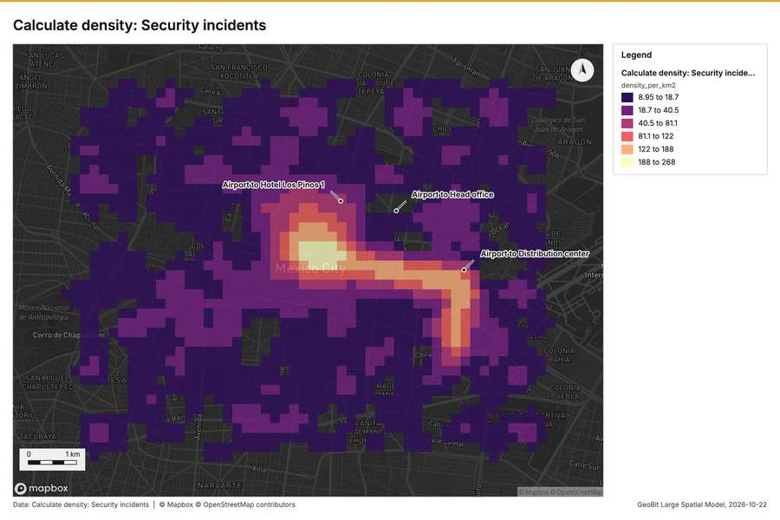
Figure 19. Calculate density: Security incidents [74]
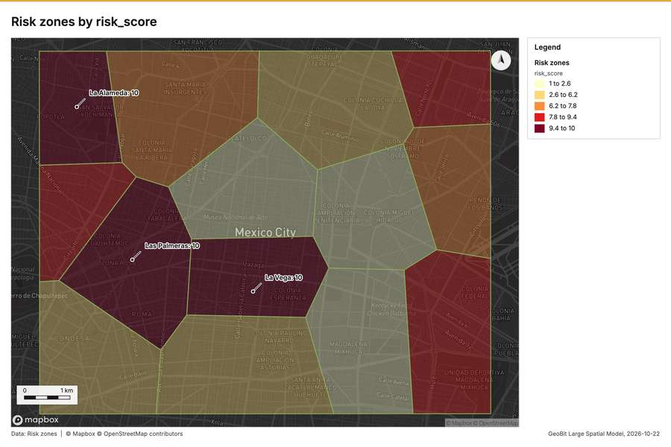
Figure 20. Risk zones by risk_score [75]
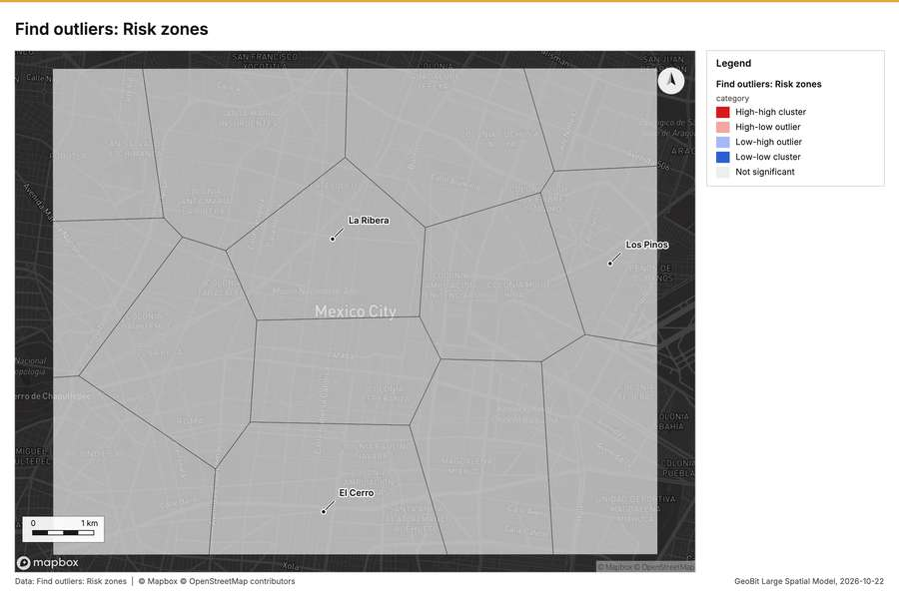
Figure 21. Find outliers: Risk zones [76]
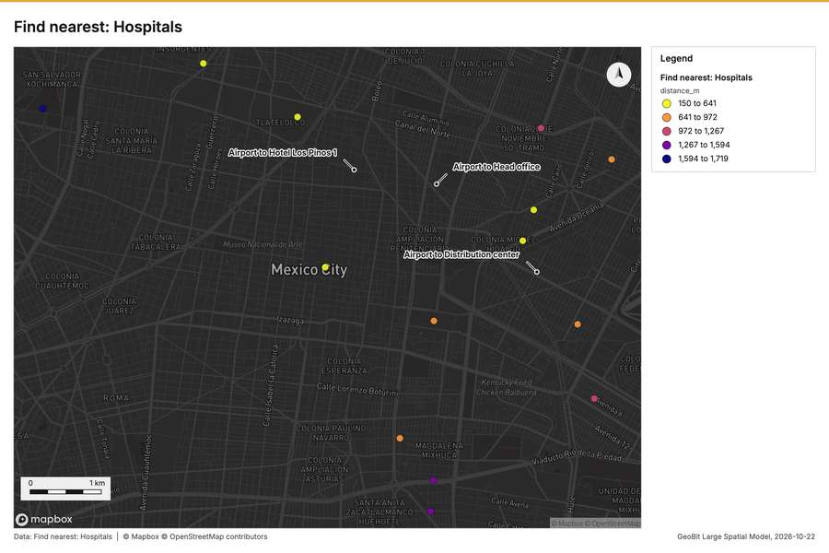
Figure 22. Find nearest: Hospitals [77]
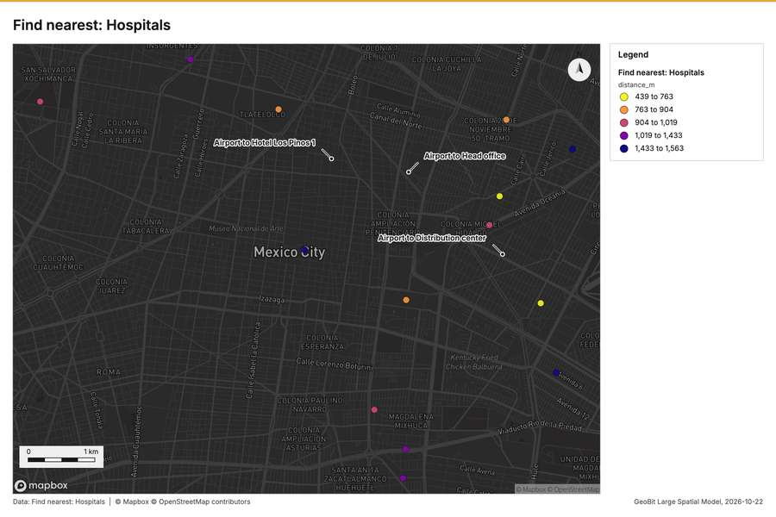
Figure 23. Find nearest: Hospitals [78]
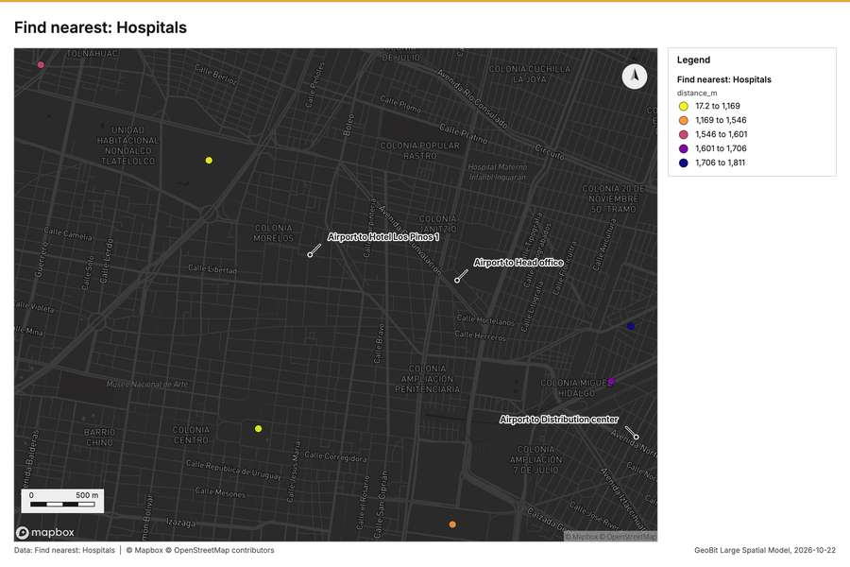
Figure 24. Find nearest: Hospitals [79]
What the map shows. This map, titled "Emerging hot spots: Protest events," analyzes a specific geographic area running from longitude -99.15818 to -99.10583 and latitude 19.41925 to 19.45709. The analysis indicates that there is no identifiable pattern of "Emerging [60]
Inferred: read from the image by gemma4:e4b, not evidence.
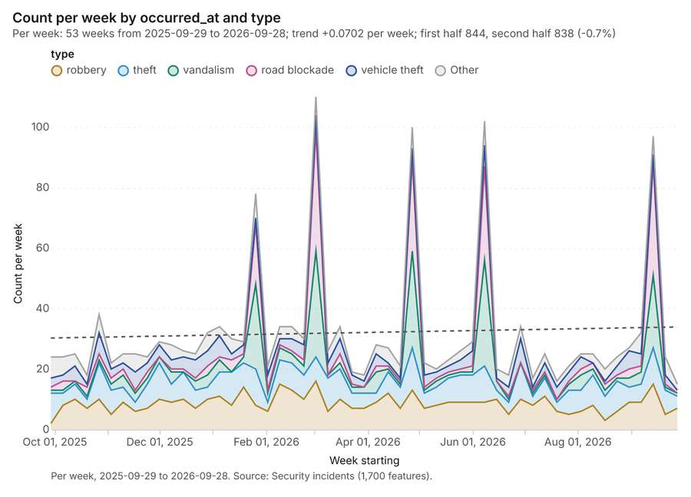
Figure 25. Security incidents over time (occurred_at) [80]. Per week, 2025-09-29 to 2026-09-28. Source: Security incidents (1,700 features). The data is in the appendix.
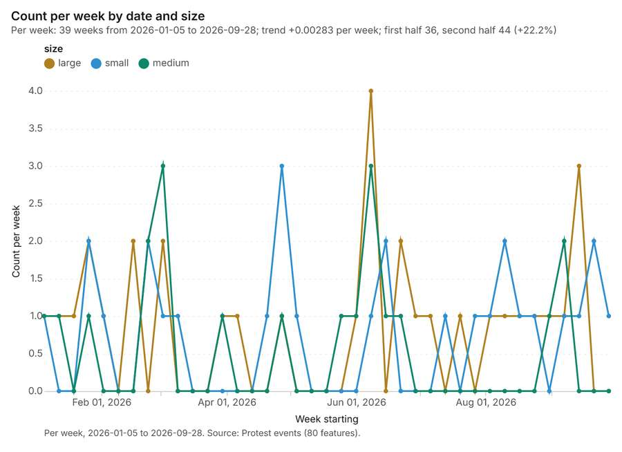
Figure 26. Protest events over time (date) [81]. Per week, 2026-01-05 to 2026-09-28. Source: Protest events (80 features). The data is in the appendix.
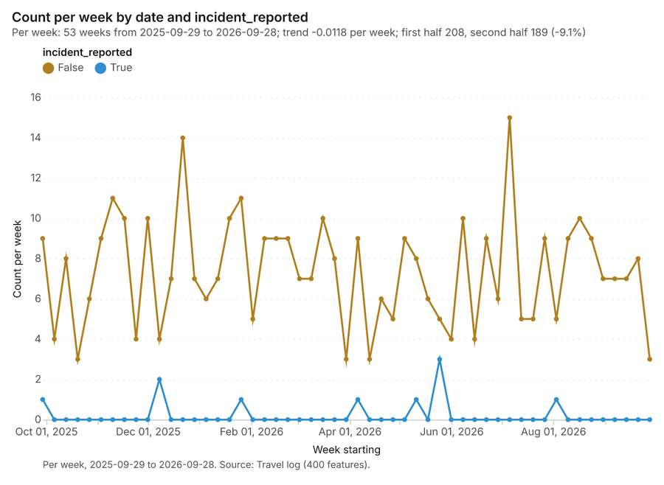
Figure 27. Travel log over time (date) [82]. Per week, 2025-09-29 to 2026-09-28. Source: Travel log (400 features). The data is in the appendix.
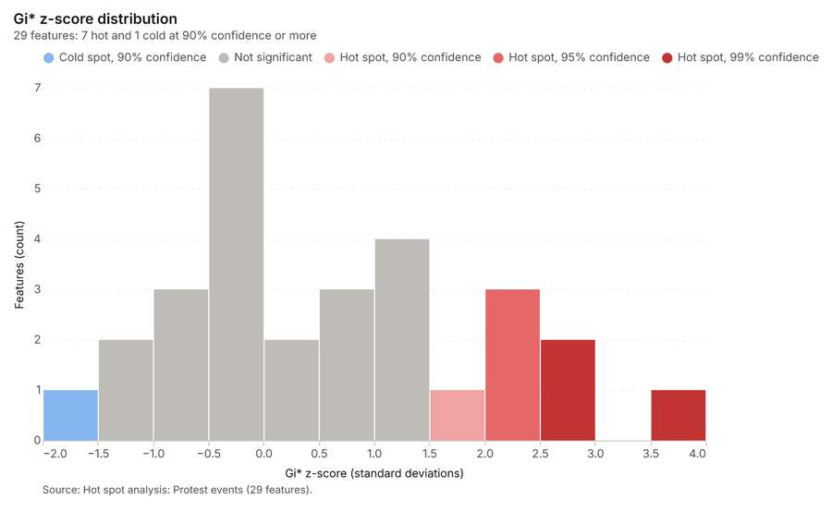
Figure 28. Hot spot analysis: Protest events [83]. Source: Hot spot analysis: Protest events (29 features). The data is in the appendix.
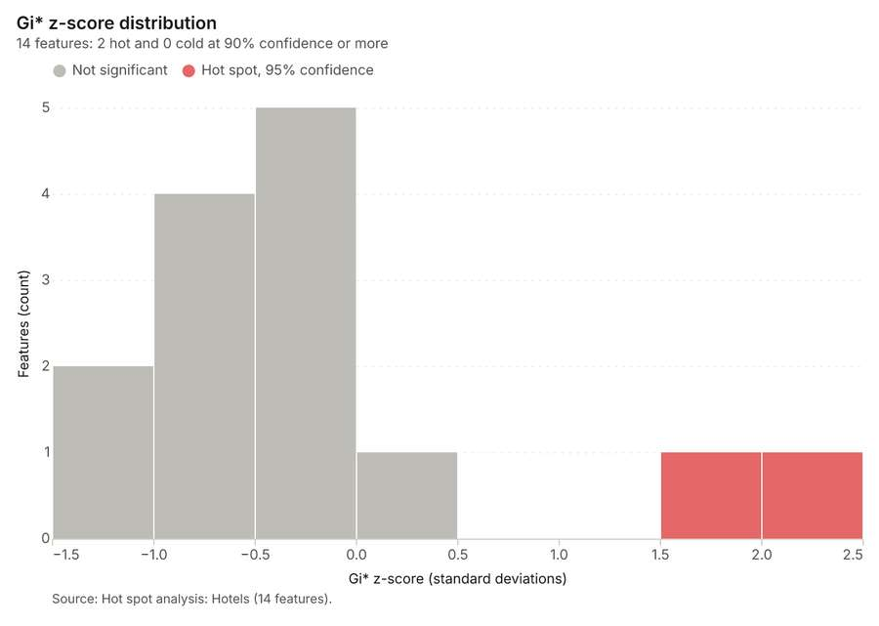
Figure 29. Hot spot analysis: Hotels [84]. Source: Hot spot analysis: Hotels (14 features). The data is in the appendix.
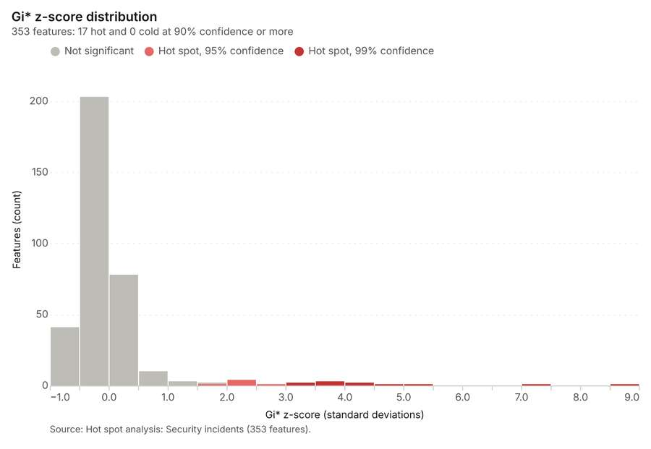
Figure 30. Hot spot analysis: Security incidents [85]. Source: Hot spot analysis: Security incidents (353 features). The data is in the appendix.
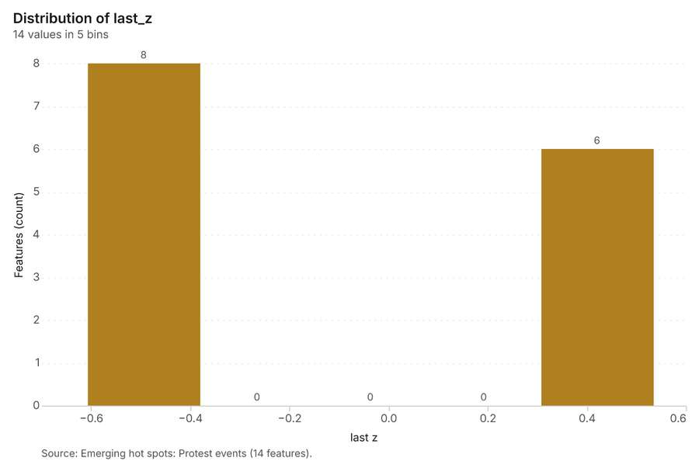
Figure 31. Emerging hot spots: Protest events [86]. Source: Emerging hot spots: Protest events (14 features). The data is in the appendix.
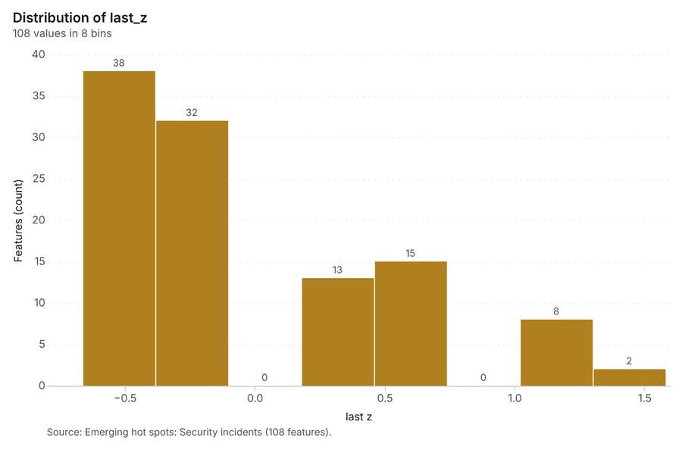
Figure 32. Emerging hot spots: Security incidents [87]. Source: Emerging hot spots: Security incidents (108 features). The data is in the appendix.
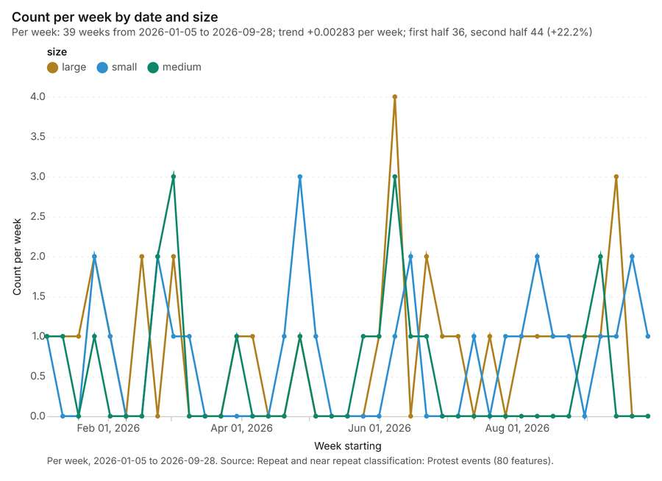
Figure 33. Repeat and near repeat classification: Protest events [88]. Per week, 2026-01-05 to 2026-09-28. Source: Repeat and near repeat classification: Protest events (80 features). The data is in the appendix.
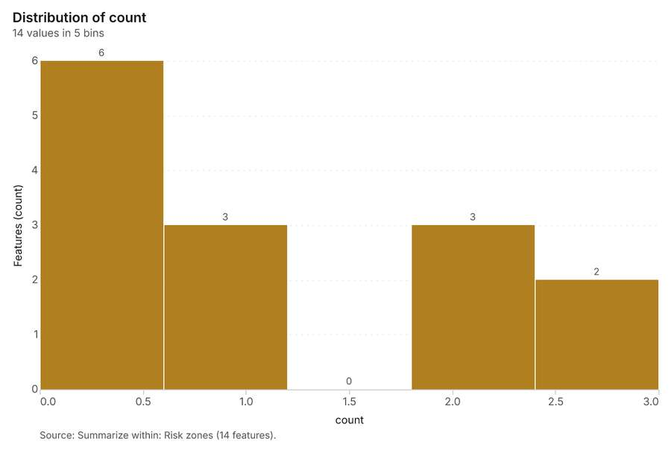
Figure 34. Summarize within: Risk zones [89]. Source: Summarize within: Risk zones (14 features). The data is in the appendix.
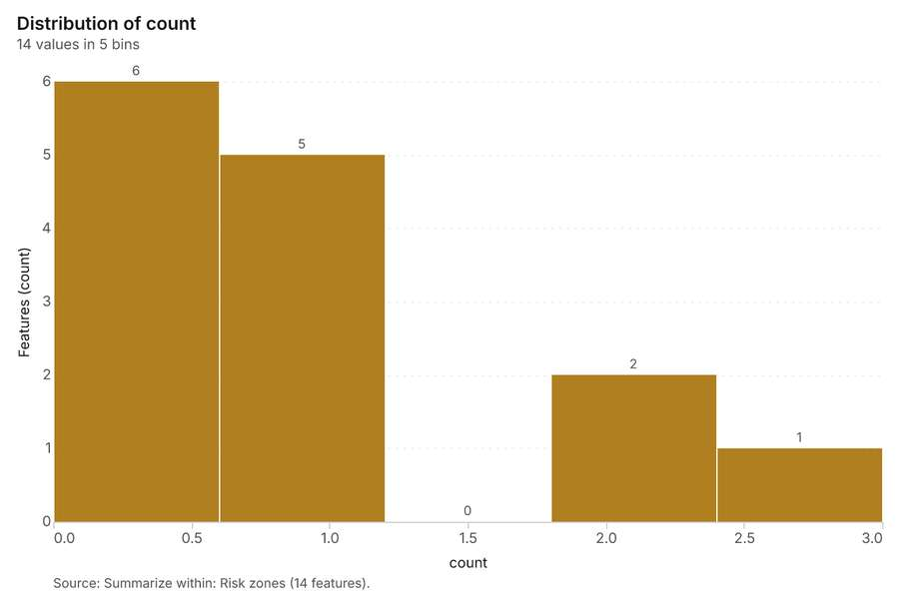
Figure 35. Summarize within: Risk zones [90]. Source: Summarize within: Risk zones (14 features). The data is in the appendix.
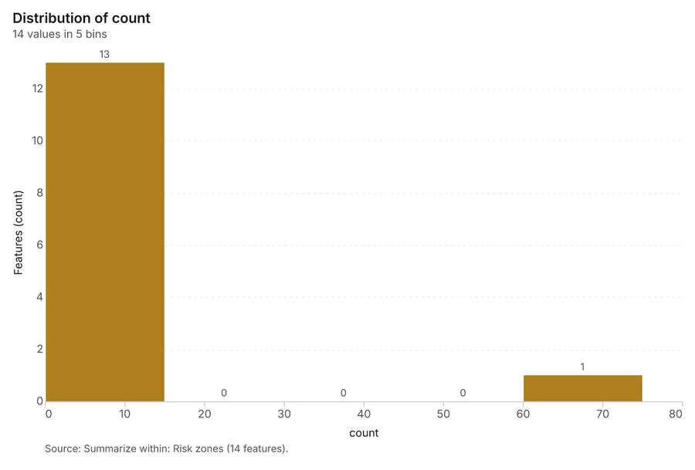
Figure 36. Summarize within: Risk zones [91]. Source: Summarize within: Risk zones (14 features). The data is in the appendix.
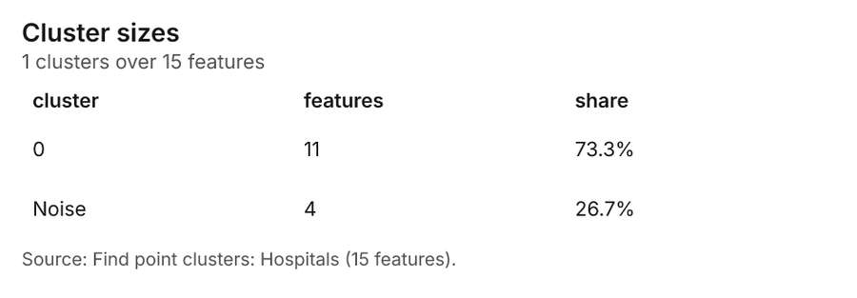
Figure 37. Find point clusters: Hospitals [92]. Source: Find point clusters: Hospitals (15 features). The data is in the appendix.
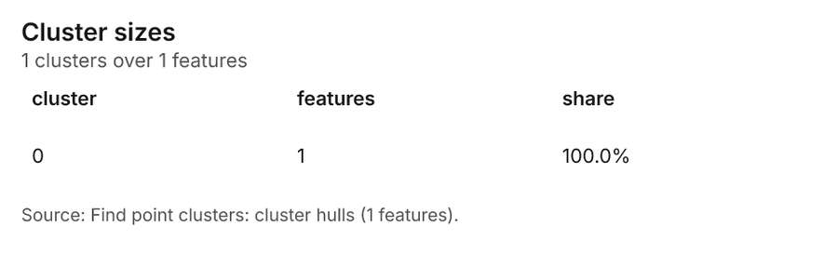
Figure 38. Find point clusters: cluster hulls [93]. Source: Find point clusters: cluster hulls (1 features). The data is in the appendix.
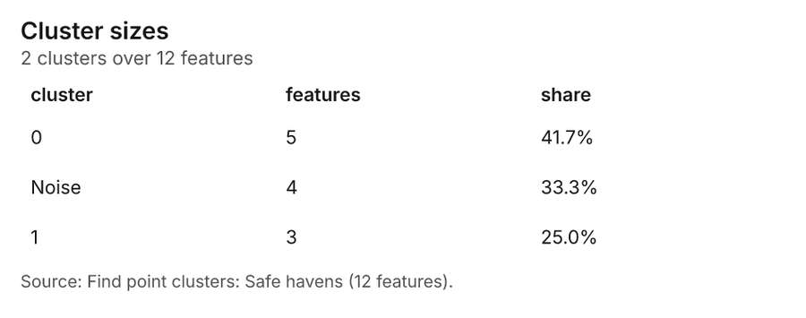
Figure 39. Find point clusters: Safe havens [94]. Source: Find point clusters: Safe havens (12 features). The data is in the appendix.
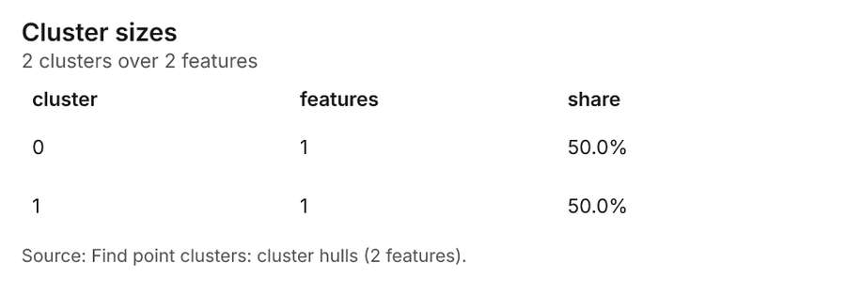
Figure 40. Find point clusters: cluster hulls [95]. Source: Find point clusters: cluster hulls (2 features). The data is in the appendix.
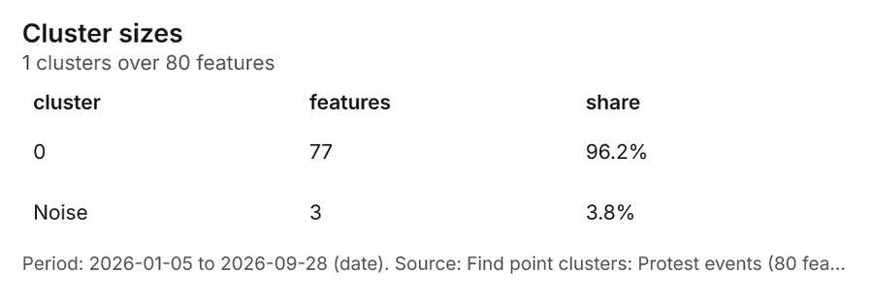
Figure 41. Find point clusters: Protest events [96]. Period: 2026-01-05 to 2026-09-28 (date). Source: Find point clusters: Protest events (80 features). The data is in the appendix.
Figure 42. Find point clusters: cluster hulls [97]. Source: Find point clusters: cluster hulls (1 features). The data is in the appendix.
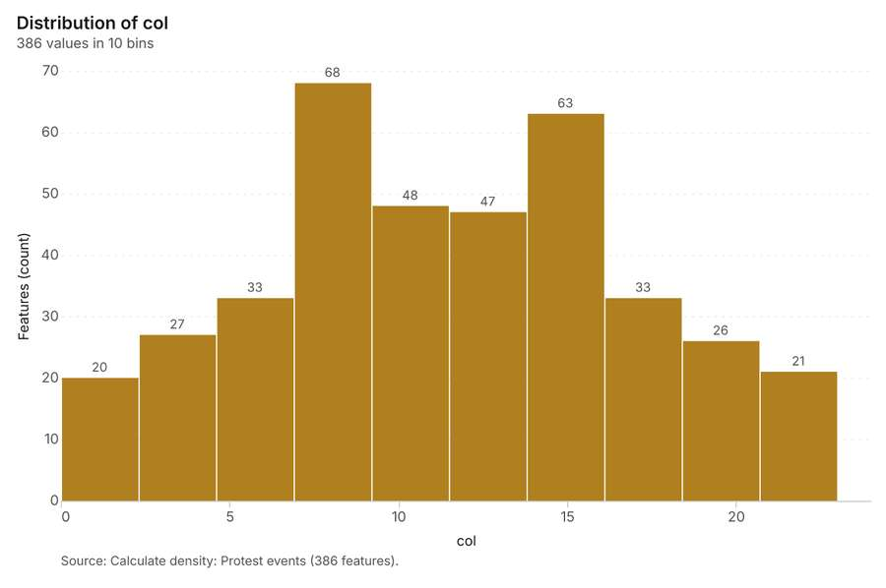
Figure 43. Calculate density: Protest events [98]. Source: Calculate density: Protest events (386 features). The data is in the appendix.
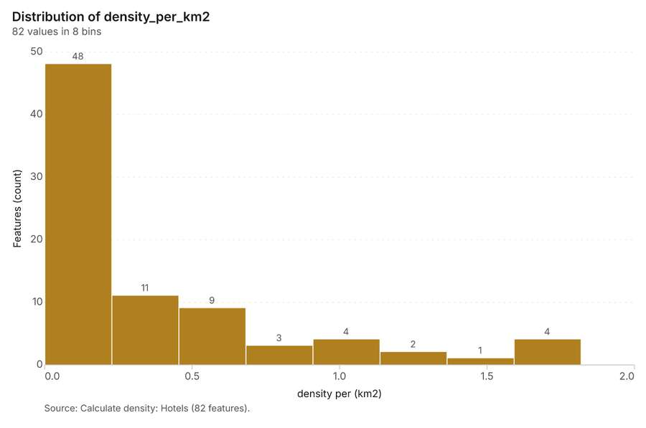
Figure 44. Calculate density: Hotels [99]. Source: Calculate density: Hotels (82 features). The data is in the appendix.
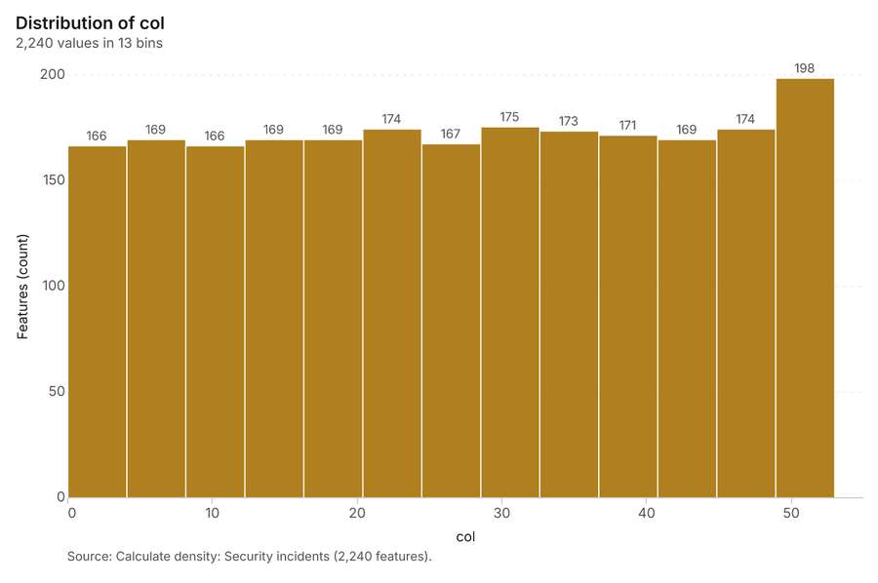
Figure 45. Calculate density: Security incidents [100]. Source: Calculate density: Security incidents (2,240 features). The data is in the appendix.
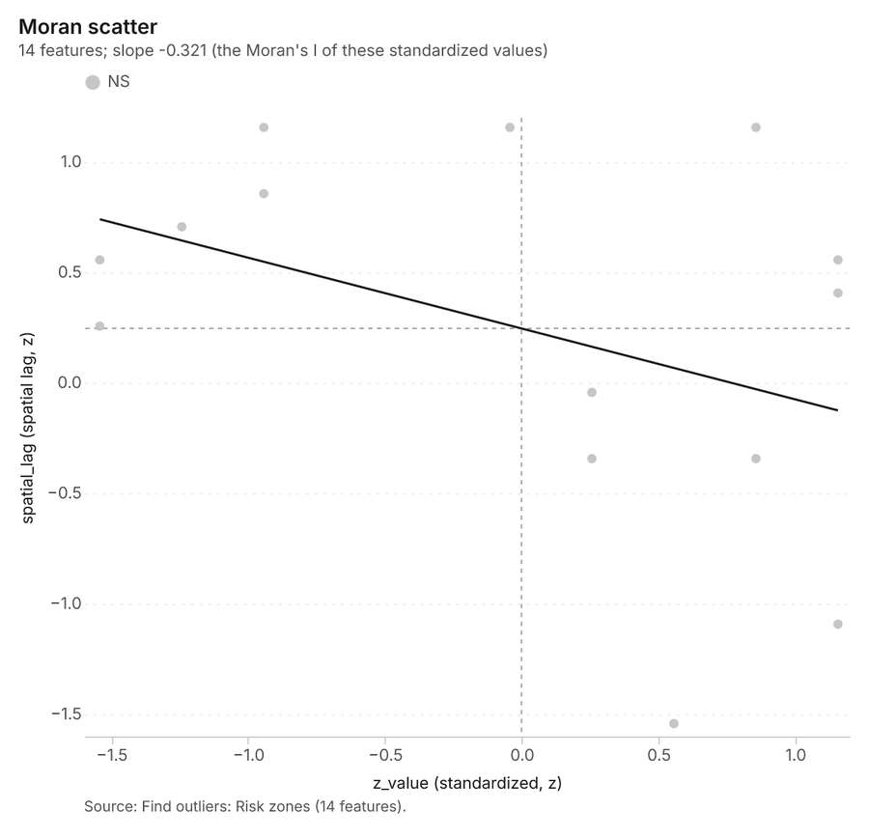
Figure 46. Find outliers: Risk zones [101]. Source: Find outliers: Risk zones (14 features). The data is in the appendix.
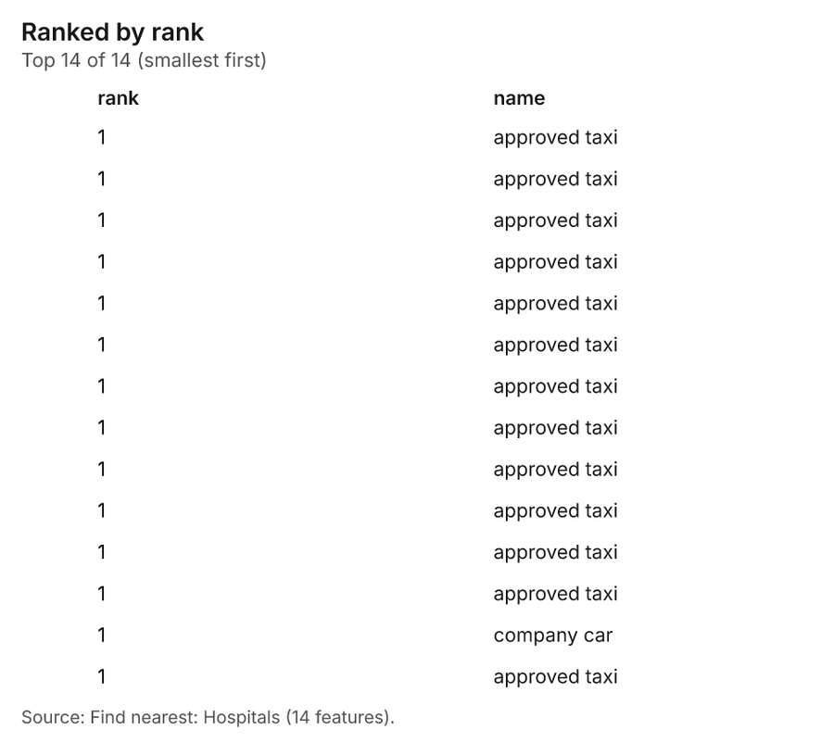
Figure 47. Find nearest: Hospitals [102]. Source: Find nearest: Hospitals (14 features). The data is in the appendix.
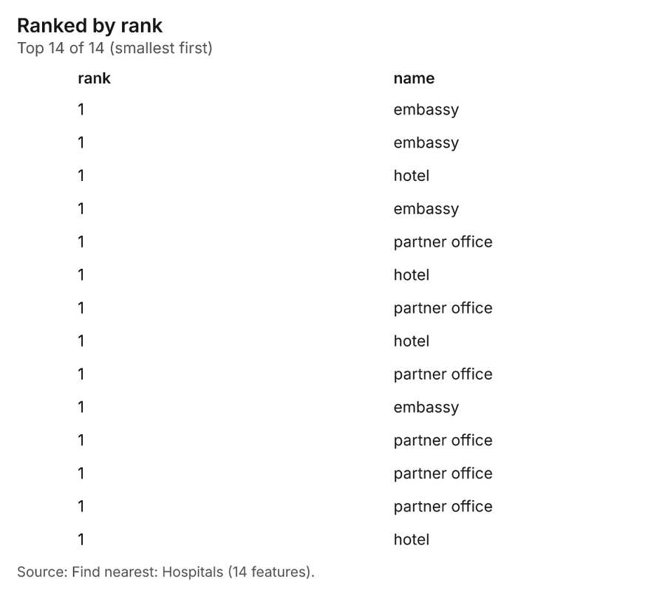
Figure 48. Find nearest: Hospitals [103]. Source: Find nearest: Hospitals (14 features). The data is in the appendix.
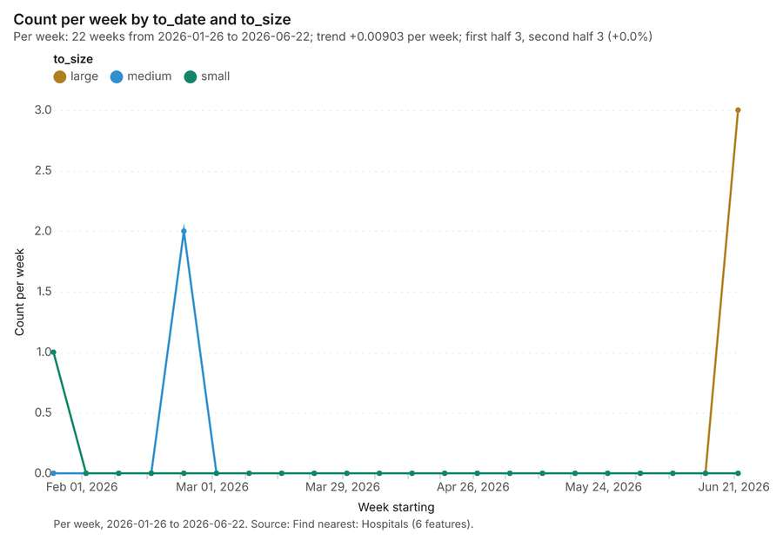
Figure 49. Find nearest: Hospitals over time [104]. Per week, 2026-01-26 to 2026-06-22. Source: Find nearest: Hospitals (6 features). The data is in the appendix.
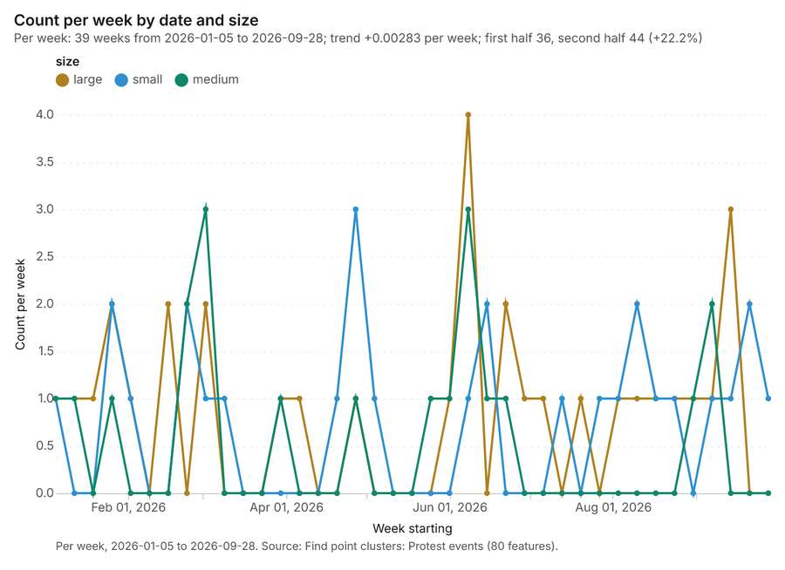
Figure 50. Find point clusters: Protest events over time [105]. Per week, 2026-01-05 to 2026-09-28. Source: Find point clusters: Protest events (80 features). The data is in the appendix.
Figure 51. Repeat and near repeat classification: Protest events over time [106]. Per week, 2026-01-05 to 2026-09-28. Source: Repeat and near repeat classification: Protest events (80 features). The data is in the appendix.

Changes since the last run
This is the first report of this project.

Sources
[1] Rendering: Chart: Timeline: events per week by dataset. 159 rows (id f07ed5b6-9486-4c24-a7ad-e2c1b9a45323)
[2] Dataset: Security incidents. vector, 1700 rows (id e157aa87-0056-48e2-affe-2abe8c8f035b)
[3] Dataset: Protest events. vector, 80 rows (id 61b11bf6-a94e-410d-bc75-a441daea9e2e)
[4] Dataset: Travel log. table, 400 rows (id 91769657-5256-4993-90ae-bea93e5d9277)
[5] Catalog: Hot spot analysis (operation catalog, gp_hot_spots). Getis-Ord Gi* hot and cold spots with z-scores, p-values and confidence bins. ArcGIS: Find Hot Spots, Hot Spot Analysis (Getis-Ord Gi*). QGIS: qgis:hotspot (plugin). (id gp_hot_spots)
[6] Plan: Hot spots of Protest events (the Start plan's candidate c_e4c60efa6297). 80 points: Getis-Ord Gi* tests whether the concentrations in Protest events are statistically significant. (id 2f94775f-544a-4c5f-9cbe-3a9e3ee974e2:c_e4c60efa6297)
[7] Tool result: gp_hot_spots, step 0. Hot spot analysis: 1 layer saved: Hot spot analysis: Protest events (29 features). (id cb954b77-a9f1-40f9-ba2a-8936e0981670:0)
[8] Layer: Protest events. 80 features (id cf75e6b1-838e-4795-85d8-20e39702882e)
[9] Plan: Hot spots of Hotels (the Start plan's candidate c_d9214e0b2e9c). 30 points: Getis-Ord Gi* tests whether the concentrations in Hotels are statistically significant. (id 2f94775f-544a-4c5f-9cbe-3a9e3ee974e2:c_d9214e0b2e9c)
[10] Tool result: gp_hot_spots, step 1. Hot spot analysis: 1 layer saved: Hot spot analysis: Hotels (14 features). (id cb954b77-a9f1-40f9-ba2a-8936e0981670:1)
[11] Layer: Hotels. 30 features (id 28842e9c-fa0f-4fa0-ab60-50616b38e2eb)
[12] Plan: Hot spots of Security incidents (the Start plan's candidate c_2cf7cb199846). 1700 points: Getis-Ord Gi* tests whether the concentrations in Security incidents are statistically significant. (id 2f94775f-544a-4c5f-9cbe-3a9e3ee974e2:c_2cf7cb199846)
[13] Tool result: gp_hot_spots, step 2. Hot spot analysis: 1 layer saved: Hot spot analysis: Security incidents (353 features). (id cb954b77-a9f1-40f9-ba2a-8936e0981670:2)
[14] Layer: Security incidents. 1,700 features (id afb5d90c-b04a-45b5-86de-02dd48a97b15)
[15] Catalog: Emerging hot spots (operation catalog, gp_space_time_hot_spots). Where hot spots are new, consecutive, intensifying, persistent, diminishing, sporadic, oscillating or historical over time. ArcGIS: Emerging Hot Spot Analysis, Create Space Time Cube. (id gp_space_time_hot_spots)
[16] Plan: Space time hot spots of Protest events (the Start plan's candidate c_7097f355a4d8). Protest events carry dates in 'date': emerging hot spot analysis finds new, intensifying and fading hot spots per week. (id 2f94775f-544a-4c5f-9cbe-3a9e3ee974e2:c_7097f355a4d8)
[17] Tool result: gp_space_time_hot_spots, step 0. Emerging hot spots: 1 layer saved: Emerging hot spots: Protest events (14 features). (id 4ce981f8-e618-4a52-ab5e-deb572cf8a18:0)
[18] Plan: Space time hot spots of Security incidents (the Start plan's candidate c_333ac7b0a6a6). Security incidents carry dates in 'occurred_at': emerging hot spot analysis finds new, intensifying and fading hot spots per week. (id 2f94775f-544a-4c5f-9cbe-3a9e3ee974e2:c_333ac7b0a6a6)
[19] Tool result: gp_space_time_hot_spots, step 1. Emerging hot spots: 1 layer saved: Emerging hot spots: Security incidents (108 features). (id 4ce981f8-e618-4a52-ab5e-deb572cf8a18:1)
[20] Catalog: Repeat and near repeat classification (operation catalog, gp_near_repeat). Classify incidents as originators, repeats (same place) or near repeats within a distance and time window, with a Knox test table. ArcGIS: Repeat and Near Repeat Classification, Near Repeat Calculator. (id gp_near_repeat)
[21] Plan: Near repeat of Protest events (the Start plan's candidate c_f95b4db5e496). Near repeat analysis tests whether Protest events close in space also follow each other within 27 days. (id 2f94775f-544a-4c5f-9cbe-3a9e3ee974e2:c_f95b4db5e496)
[22] Tool result: gp_near_repeat, step 2. Repeat and near repeat classification: 1 layer saved: Repeat and near repeat classification: Protest events (80 features). (id 4ce981f8-e618-4a52-ab5e-deb572cf8a18:2)
[23] Catalog: Summarize within (operation catalog, gp_summarize_within). Count and aggregate the features inside each polygon (or bin), proportionally for lines and polygons. ArcGIS: Summarize Within, Aggregate Points. QGIS: native:countpointsinpolygon, native:sumlinelengths. (id gp_summarize_within)
[24] Plan: Hospitals per feature of Risk zones (the Start plan's candidate c_6520524d187a). Count Hospitals inside each feature of Risk zones by english_speaking; the counts map as a choropleth (natural breaks, sequential colors). (id 2f94775f-544a-4c5f-9cbe-3a9e3ee974e2:c_6520524d187a)
[25] Tool result: gp_summarize_within, step 0. Summarize within: 1 layer saved: Summarize within: Risk zones (14 features). (id 4db35232-a32c-47e1-9154-89fbc3620126:0)
[26] Layer: Hospitals. 15 features (id 8a96a3d4-1867-4c29-8033-2a6817b92b2c)
[27] Layer: Risk zones. 14 features (id a4d2e294-c13c-4572-b6fc-2b8ef4e9c955)
[28] Tool result: gp_summarize_within, step 1. Summarize within: 1 layer saved: Summarize within: Risk zones (14 features). (id 4db35232-a32c-47e1-9154-89fbc3620126:1)
[29] Layer: Safe havens. 12 features (id d7ec6bb0-8b36-474d-8157-931bdc40122a)
[30] Tool result: gp_summarize_within, step 2. Summarize within: 1 layer saved: Summarize within: Risk zones (14 features). (id 4db35232-a32c-47e1-9154-89fbc3620126:2)
[31] Catalog: Find point clusters (operation catalog, gp_find_point_clusters). Density-based clusters (DBSCAN, HDBSCAN or OPTICS, optionally space-time) with hulls and noise. ArcGIS: Find Point Clusters, Density-based Clustering. QGIS: native:dbscanclustering, native:stdbscanclustering. (id gp_find_point_clusters)
[32] Plan: Cluster points of Hospitals (the Start plan's candidate c_65a1f33e9e5e). DBSCAN finds dense groups of Hospitals and separates noise. (id 2f94775f-544a-4c5f-9cbe-3a9e3ee974e2:c_65a1f33e9e5e)
[33] Tool result: gp_find_point_clusters, step 0. Find point clusters: 2 layers saved: Find point clusters: Hospitals (15 features); Find point clusters: cluster hulls (1 feature). (id 86c36cc2-95cb-4bfa-aac6-db9cc2913cc1:0)
[34] Plan: Cluster points of Safe havens (the Start plan's candidate c_5ba3c571cd04). DBSCAN finds dense groups of Safe havens and separates noise. (id 2f94775f-544a-4c5f-9cbe-3a9e3ee974e2:c_5ba3c571cd04)
[35] Tool result: gp_find_point_clusters, step 1. Find point clusters: 2 layers saved: Find point clusters: Safe havens (12 features); Find point clusters: cluster hulls (2 features). (id 86c36cc2-95cb-4bfa-aac6-db9cc2913cc1:1)
[36] Plan: Cluster points of Protest events (the Start plan's candidate c_ae60a45625a8). DBSCAN finds dense groups of Protest events and separates noise. (id 2f94775f-544a-4c5f-9cbe-3a9e3ee974e2:c_ae60a45625a8)
[37] Tool result: gp_find_point_clusters, step 2. Find point clusters: 2 layers saved: Find point clusters: Protest events (80 features); Find point clusters: cluster hulls (1 feature). (id 86c36cc2-95cb-4bfa-aac6-db9cc2913cc1:2)
[38] Catalog: Calculate density (operation catalog, gp_calculate_density). Kernel density per square kilometer on a grid. ArcGIS: Calculate Density, Kernel Density. QGIS: native:heatmapkerneldensityestimation. (id gp_calculate_density)
[39] Plan: Kernel density of Protest events (the Start plan's candidate c_7c8acce6dd51). 80 points in Protest events: a density surface shows where they concentrate. (id 2f94775f-544a-4c5f-9cbe-3a9e3ee974e2:c_7c8acce6dd51)
[40] Tool result: gp_calculate_density, step 0. Calculate density: 1 layer saved: Calculate density: Protest events (386 features). (id 72e7e894-08fe-429b-84d0-f973eac006a1:0)
[41] Plan: Kernel density of Hotels (the Start plan's candidate c_fb39ef5f9446). 30 points in Hotels: a density surface shows where they concentrate. (id 2f94775f-544a-4c5f-9cbe-3a9e3ee974e2:c_fb39ef5f9446)
[42] Tool result: gp_calculate_density, step 1. Calculate density: 1 layer saved: Calculate density: Hotels (82 features). (id 72e7e894-08fe-429b-84d0-f973eac006a1:1)
[43] Plan: Kernel density of Security incidents (the Start plan's candidate c_8b75d0e8f5bf). 1700 points in Security incidents: a density surface shows where they concentrate. (id 2f94775f-544a-4c5f-9cbe-3a9e3ee974e2:c_8b75d0e8f5bf)
[44] Tool result: gp_calculate_density, step 2. Calculate density: 1 layer saved: Calculate density: Security incidents (2240 features). (id 72e7e894-08fe-429b-84d0-f973eac006a1:2)
[45] Catalog: Find outliers (operation catalog, gp_outliers). Anselin local Moran’s I: HH, LL clusters and HL, LH outliers. ArcGIS: Find Outliers, Cluster and Outlier Analysis (Anselin Local Moran’s I). (id gp_outliers)
[46] Plan: Local morans i of Risk zones (the Start plan's candidate c_b57bb9ae247a). Local Moran's I maps clusters and outliers of 'risk_score'. (id 2f94775f-544a-4c5f-9cbe-3a9e3ee974e2:c_b57bb9ae247a)
[47] Tool result: gp_outliers, step 0. Find outliers: 1 layer saved: Find outliers: Risk zones (14 features). (id 8804c2f2-0669-4232-a6ea-33b246fdbe10:0)
[48] Catalog: Spatial autocorrelation (operation catalog, gp_spatial_autocorrelation). Global Moran’s I: is the pattern clustered, dispersed or random. ArcGIS: Spatial Autocorrelation (Global Moran’s I). (id gp_spatial_autocorrelation)
[49] Plan: Global morans i of Risk zones (the Start plan's candidate c_e8c49b66ee35). Global Moran's I says whether similar values of 'risk_score' sit next to each other. (id 2f94775f-544a-4c5f-9cbe-3a9e3ee974e2:c_e8c49b66ee35)
[50] Tool result: gp_spatial_autocorrelation, step 1. Spatial autocorrelation: done; no map output. (id 8804c2f2-0669-4232-a6ea-33b246fdbe10:1)
[51] Catalog: Find nearest (operation catalog, gp_find_nearest). The k nearest features for each input, with geodesic distance and bearing. ArcGIS: Find Nearest, Near, Generate Near Table. QGIS: native:joinbynearest, native:nearestneighbouranalysis. (id gp_find_nearest)
[52] Plan: Find nearest of Hospitals and Travel routes (the Start plan's candidate c_6c9de7d7d3b4). The nearest of Travel routes to each of Hospitals, with distances. (id 2f94775f-544a-4c5f-9cbe-3a9e3ee974e2:c_6c9de7d7d3b4)
[53] Tool result: gp_find_nearest, step 0. Find nearest: 1 layer saved: Find nearest: Hospitals (14 features). (id d72a65fe-570d-4b7e-bb1f-3397ddd3dff0:0)
[54] Layer: Travel routes. 10 features (id 17118d2e-4c8a-4e58-a365-56ed0dccddeb)
[55] Tool result: gp_find_nearest, step 1. Find nearest: 1 layer saved: Find nearest: Hospitals (14 features). (id d72a65fe-570d-4b7e-bb1f-3397ddd3dff0:1)
[56] Tool result: gp_find_nearest, step 2. Find nearest: 1 layer saved: Find nearest: Hospitals (6 features). (id d72a65fe-570d-4b7e-bb1f-3397ddd3dff0:2)
[57] Rendering: Map: Hot spot analysis: Protest events (id 500df2bf-0773-4df4-997b-e52faf1d7b86)
[58] Rendering: Map: Hot spot analysis: Hotels (id a9b20642-0e6f-4981-a664-da575f4c0f47)
[59] Rendering: Map: Hot spot analysis: Security incidents (id dfc0443f-8eec-4850-bcf5-b167e4b25bb2)
[60] Rendering: Map: Emerging hot spots: Protest events (id 0099fe22-7871-4a15-a0e8-1feae00a5bfe)
[61] Rendering: Map: Emerging hot spots: Security incidents (id ac12c726-afc7-4f73-bcad-180032253879)
[62] Rendering: Map: Repeat and near repeat classification: Protest events (id 88da8834-5528-4120-a9c9-c2d8f343794a)
[63] Rendering: Map: Summarize within: Risk zones (id 00bc1476-064e-4f9d-b9df-58b7176702f7)
[64] Rendering: Map: Summarize within: Risk zones (id 097e7003-7459-4810-8b27-5f7a0070cb99)
[65] Rendering: Map: Summarize within: Risk zones (id 0f0f8452-fff5-40e3-9da5-e4b1a4e0c9c3)
[66] Rendering: Map: Find point clusters: Hospitals (id 47eb8a01-1990-4474-b495-5bf2f8a9ea58)
[67] Rendering: Map: Find point clusters: cluster hulls (id 9199cde6-d3cd-466f-bbdb-c545c614f5d9)
[68] Rendering: Map: Find point clusters: Safe havens (id b7163651-cc15-45dd-85df-b9a1e1a0c2ab)
[69] Rendering: Map: Find point clusters: cluster hulls (id b07c64b4-3212-4751-b9fe-884c92e2af0b)
[70] Rendering: Map: Find point clusters: Protest events (id 09c181e5-fd50-4a4d-8fb9-c372f05b7087)
[71] Rendering: Map: Find point clusters: cluster hulls (id 837965dd-bd8f-4eda-8fc0-9ce4211449eb)
[72] Rendering: Map: Calculate density: Protest events (id 26c2dd95-9903-4e3a-9502-b9d59a00d91f)
[73] Rendering: Map: Calculate density: Hotels (id 87642b35-e16d-4168-a04d-24944d0ea7c8)
[74] Rendering: Map: Calculate density: Security incidents (id db714770-2476-4110-af9b-826c0fda7266)
[75] Rendering: Map: Risk zones by risk_score (id acd51039-768b-4034-9aa3-0fa9355f4884)
[76] Rendering: Map: Find outliers: Risk zones (id 5323e5c1-28e1-44b3-8f9c-44f34efbf17f)
[77] Rendering: Map: Find nearest: Hospitals (id a1567a83-3fb0-4dcf-8d6c-71ba8b4ed7d7)
[78] Rendering: Map: Find nearest: Hospitals (id b16977bf-56c6-43a5-bf88-4d5b01a2648c)
[79] Rendering: Map: Find nearest: Hospitals (id 11bfd2f1-7879-4693-a32a-915be104a231)
[80] Rendering: Chart: Security incidents over time (occurred_at). 318 rows (id e4bbd9ee-6938-4976-afea-98b10b22455f)
[81] Rendering: Chart: Protest events over time (date). 117 rows (id f828e7a2-d14d-4bc3-b257-85cd520ee1ef)
[82] Rendering: Chart: Travel log over time (date). 106 rows (id 66c88c61-6c69-4dc0-a55d-5c961369ab06)
[83] Rendering: Chart: Hot spot analysis: Protest events. 11 rows (id 66439a0c-ac69-4219-b24e-6f7ff88f70d2)
[84] Rendering: Chart: Hot spot analysis: Hotels. 6 rows (id c52e7b32-d25d-4aed-abe8-9ebb7f603bfd)
[85] Rendering: Chart: Hot spot analysis: Security incidents. 16 rows (id ca9f7204-df1a-4b6c-b63a-414bc07961a3)
[86] Rendering: Chart: Emerging hot spots: Protest events. 5 rows (id a0edbd15-0e36-4d00-9145-33631fafb0d4)
[87] Rendering: Chart: Emerging hot spots: Security incidents. 8 rows (id 0b5d890b-d25b-4e32-8200-951dc01149f7)
[88] Rendering: Chart: Repeat and near repeat classification: Protest events. 117 rows (id 2306aa49-d791-4cd3-8d4c-28e6660067db)
[89] Rendering: Chart: Summarize within: Risk zones. 5 rows (id c94ab553-318c-4a5e-bfe3-5ceb6088a6d2)
[90] Rendering: Chart: Summarize within: Risk zones. 5 rows (id 67037acd-9bb9-4174-b327-02e297418724)
[91] Rendering: Chart: Summarize within: Risk zones. 5 rows (id 923af0d1-ab6e-4ce5-b3d9-81d29ab8cc03)
[92] Rendering: Chart: Find point clusters: Hospitals. 2 rows (id 20d9b93a-9f38-4502-8832-0c3847923a24)
[93] Rendering: Chart: Find point clusters: cluster hulls. 1 rows (id f9da01d9-7689-4ba1-b714-0a48053eb1ae)
[94] Rendering: Chart: Find point clusters: Safe havens. 3 rows (id b1d7e3a3-1643-4aea-87c6-3d0616a865de)
[95] Rendering: Chart: Find point clusters: cluster hulls. 2 rows (id 4093c918-1c9f-481a-8b57-2adef8395ab8)
[96] Rendering: Chart: Find point clusters: Protest events. 2 rows (id 83853866-50d0-468b-8c71-7faa0aa71c50)
[97] Rendering: Chart: Find point clusters: cluster hulls. 1 rows (id e5bfd36e-59ac-4d44-805f-ba7f25c9358d)
[98] Rendering: Chart: Calculate density: Protest events. 10 rows (id 73671b82-b4a3-42c0-a8ae-b1d27cba0ec2)
[99] Rendering: Chart: Calculate density: Hotels. 8 rows (id c0aefbfb-9735-4f03-a2e6-d27fabd30313)
[100] Rendering: Chart: Calculate density: Security incidents. 13 rows (id a8231907-9048-4318-9575-1e7364e4238a)
[101] Rendering: Chart: Find outliers: Risk zones. 14 rows (id 491c699f-46c0-4622-98ad-1183374f76e1)
[102] Rendering: Chart: Find nearest: Hospitals. 14 rows (id 9cc7d0a7-efe8-4e46-9c45-e42681c0944f)
[103] Rendering: Chart: Find nearest: Hospitals. 14 rows (id e56bd3f0-499e-402f-a74a-cca2f35b3bc9)
[104] Rendering: Chart: Find nearest: Hospitals over time. 66 rows (id 51a6266c-78a0-4146-87ab-d79e4d6ba260)
[105] Rendering: Chart: Find point clusters: Protest events over time. 117 rows (id 86bdb528-cab1-4fff-aa57-5ee0311a2b43)
[106] Rendering: Chart: Repeat and near repeat classification: Protest events over time. 117 rows (id 4dfde3d2-01b3-45b2-90c2-09129de0912c)
[107] Dataset: Company sites. vector, 8 rows (id a57e5e2e-a25d-409d-9272-6ca1c1ae23ab)
[108] Dataset: Hotels. vector, 30 rows (id 960da6f9-a119-47d2-8c4c-73faa6425317)
[109] Dataset: Travel routes. vector, 10 rows (id 1008679c-3d12-45ea-a8ce-be53355c90d8)
[110] Dataset: Risk zones. vector, 14 rows (id a6555125-2ca1-45ce-8a48-57ce5705423b)
[111] Dataset: Hospitals. vector, 15 rows (id 03c9ffea-5a0a-4d80-8965-c0709759aff3)
[112] Dataset: Safe havens. vector, 12 rows (id 511f2fd6-d838-46cc-a47c-c29f431a83c0)
[113] Dataset: Site guard roster. table, 16 rows (id 19276383-dfed-4594-b706-1f9d7ba7b072)
[114] Dataset: Country security briefing. document, ? rows (id f20d3f16-9057-4bc4-a33a-b2d8b53657a0)
[115] Dataset: Hotel security assessment. document, ? rows (id e794bded-1be4-41a5-bbf2-086e1a0791f3)
[116] Record: Sample: Corporate security and travel risk, Mexico City (id 188436ed-c19a-4e7c-ab43-b58fe7291e56)
[117] Layer: Hot spot analysis: Protest events. 29 features (id db1e7e50-0b84-4c23-a7f1-70d712d84483)
[118] Layer: Hot spot analysis: Hotels. 14 features (id 236b49e6-718b-468e-9414-fec05e2fd046)
[119] Layer: Hot spot analysis: Security incidents. 353 features (id 354043da-a305-407a-bbe0-c2d077f68fed)
[120] Layer: Emerging hot spots: Protest events. 14 features (id d4e930d7-f5cc-45e0-b105-ee6ff35846d6)
[121] Layer: Emerging hot spots: Security incidents. 108 features (id 7d258e9e-7357-4428-8775-a97375d60dd3)
[122] Layer: Repeat and near repeat classification: Protest events. 80 features (id c15ea26d-f7bf-43bf-987f-05e0d75a4a76)
[123] Layer: Summarize within: Risk zones. 14 features (id 46424976-b4de-430a-93e8-53723336e3a7)
[124] Layer: Summarize within: Risk zones. 14 features (id 66d57619-49ef-4eb7-831b-bedc47b571d1)
[125] Layer: Summarize within: Risk zones. 14 features (id 705e651a-1e75-493d-a532-0c8927aa40cd)
[126] Layer: Find point clusters: Hospitals. 15 features (id 991c0297-f207-49c1-9361-29e0d01cd1f5)
[127] Layer: Find point clusters: cluster hulls. 1 features (id e06a131f-7989-4c9a-bad5-98f65d8d13ee)
[128] Layer: Find point clusters: Safe havens. 12 features (id 1da076c5-d608-4691-b2c6-0458f1989d7e)
[129] Layer: Find point clusters: cluster hulls. 2 features (id cb9419c5-0ee1-4dba-a62a-5b39176bab51)
[130] Layer: Find point clusters: Protest events. 80 features (id 84d6cdb7-cfe3-4875-8ab3-4c85027ca7be)
[131] Layer: Find point clusters: cluster hulls. 1 features (id baa8dcc7-143d-4f94-a316-947abdb534cf)
[132] Layer: Calculate density: Protest events. 386 features (id 54008367-d33a-4511-b5e1-8c4a55915ad0)
[133] Layer: Calculate density: Hotels. 82 features (id c4eba0a4-6712-445b-bc6c-cf0c26bb9cac)
[134] Layer: Calculate density: Security incidents. 2,240 features (id 57bb3eed-15a3-4c3d-b425-89ac6f7edeaf)
[135] Layer: Find outliers: Risk zones. 14 features (id e8ee4af5-2649-4990-8578-af9a7ca2a1e6)
[136] Layer: Find nearest: Hospitals. 14 features (id cc3abbbe-dedb-4bf4-a08f-10d4882a63d2)
[137] Layer: Find nearest: Hospitals. 14 features (id 39cac909-2a3f-47b4-9123-524c237e05eb)
[138] Layer: Find nearest: Hospitals. 6 features (id 5b28ce74-706d-460a-b867-4b1ce5f6ed98)

Appendix: the data behind the charts

Figure 1. Timeline: events per week by dataset [1]
period | series | value
2025-09-29 | Security incidents | 24
2025-09-29 | Travel log | 10
2025-09-29 | Protest events | 0
2025-10-06 | Security incidents | 24
2025-10-06 | Travel log | 4
2025-10-06 | Protest events | 0
2025-10-13 | Security incidents | 25
2025-10-13 | Travel log | 8
2025-10-13 | Protest events | 0
2025-10-20 | Security incidents | 18
2025-10-20 | Travel log | 3
2025-10-20 | Protest events | 0
2025-10-27 | Security incidents | 38
2025-10-27 | Travel log | 6
2025-10-27 | Protest events | 0
2025-11-03 | Security incidents | 22
2025-11-03 | Travel log | 9
2025-11-03 | Protest events | 0
2025-11-10 | Security incidents | 25
2025-11-10 | Travel log | 11
2025-11-10 | Protest events | 0
2025-11-17 | Security incidents | 25
2025-11-17 | Travel log | 10
2025-11-17 | Protest events | 0
2025-11-24 | Security incidents | 24
2025-11-24 | Travel log | 4
2025-11-24 | Protest events | 0
2025-12-01 | Security incidents | 29
2025-12-01 | Travel log | 10
2025-12-01 | Protest events | 0
2025-12-08 | Security incidents | 28
2025-12-08 | Travel log | 6
2025-12-08 | Protest events | 0
2025-12-15 | Security incidents | 26
2025-12-15 | Travel log | 7
2025-12-15 | Protest events | 0
2025-12-22 | Security incidents | 25
2025-12-22 | Travel log | 14
2025-12-22 | Protest events | 0
2025-12-29 | Security incidents | 32
2025-12-29 | Travel log | 7
2025-12-29 | Protest events | 0
2026-01-05 | Security incidents | 34
2026-01-05 | Travel log | 6
2026-01-05 | Protest events | 3
2026-01-12 | Security incidents | 30
2026-01-12 | Travel log | 7
2026-01-12 | Protest events | 2
2026-01-19 | Security incidents | 29
2026-01-19 | Travel log | 10
2026-01-19 | Protest events | 1
2026-01-26 | Security incidents | 78
2026-01-26 | Travel log | 12
2026-01-26 | Protest events | 5
2026-02-02 | Security incidents | 21
2026-02-02 | Travel log | 5
2026-02-02 | Protest events | 2
2026-02-09 | Security incidents | 34
2026-02-09 | Travel log | 9
2026-02-09 | Protest events | 0
2026-02-16 | Security incidents | 34
2026-02-16 | Travel log | 9
2026-02-16 | Protest events | 2
2026-02-23 | Security incidents | 30
2026-02-23 | Travel log | 9
2026-02-23 | Protest events | 4
2026-03-02 | Security incidents | 110
2026-03-02 | Travel log | 7
2026-03-02 | Protest events | 6
2026-03-09 | Security incidents | 26
2026-03-09 | Travel log | 7
2026-03-09 | Protest events | 1
2026-03-16 | Security incidents | 34
2026-03-16 | Travel log | 10
2026-03-16 | Protest events | 0
2026-03-23 | Security incidents | 19
2026-03-23 | Travel log | 8
2026-03-23 | Protest events | 0
2026-03-30 | Security incidents | 18
2026-03-30 | Travel log | 3
2026-03-30 | Protest events | 2
2026-04-06 | Security incidents | 28
2026-04-06 | Travel log | 10
2026-04-06 | Protest events | 1
2026-04-13 | Security incidents | 27
2026-04-13 | Travel log | 3
2026-04-13 | Protest events | 0
2026-04-20 | Security incidents | 21
2026-04-20 | Travel log | 6
2026-04-20 | Protest events | 1
2026-04-27 | Security incidents | 100
2026-04-27 | Travel log | 5
2026-04-27 | Protest events | 5
2026-05-04 | Security incidents | 22
2026-05-04 | Travel log | 9
2026-05-04 | Protest events | 1
2026-05-11 | Security incidents | 20
2026-05-11 | Travel log | 9
2026-05-11 | Protest events | 0
2026-05-18 | Security incidents | 23
2026-05-18 | Travel log | 6
2026-05-18 | Protest events | 0
2026-05-25 | Security incidents | 26
2026-05-25 | Travel log | 8
2026-05-25 | Protest events | 1
2026-06-01 | Security incidents | 29
2026-06-01 | Travel log | 4
2026-06-01 | Protest events | 2
2026-06-08 | Security incidents | 102
2026-06-08 | Travel log | 10
2026-06-08 | Protest events | 8
2026-06-15 | Security incidents | 20
2026-06-15 | Travel log | 4
2026-06-15 | Protest events | 3
2026-06-22 | Security incidents | 18
2026-06-22 | Travel log | 9
2026-06-22 | Protest events | 3
2026-06-29 | Security incidents | 34
2026-06-29 | Travel log | 6
2026-06-29 | Protest events | 1
2026-07-06 | Security incidents | 17
2026-07-06 | Travel log | 15
2026-07-06 | Protest events | 1
2026-07-13 | Security incidents | 25
2026-07-13 | Travel log | 5
2026-07-13 | Protest events | 1
2026-07-20 | Security incidents | 16
2026-07-20 | Travel log | 5
2026-07-20 | Protest events | 1
2026-07-27 | Security incidents | 21
2026-07-27 | Travel log | 9
2026-07-27 | Protest events | 1
2026-08-03 | Security incidents | 25
2026-08-03 | Travel log | 6
2026-08-03 | Protest events | 2
2026-08-10 | Security incidents | 25
2026-08-10 | Travel log | 9
2026-08-10 | Protest events | 3
2026-08-17 | Security incidents | 20
2026-08-17 | Travel log | 10
2026-08-17 | Protest events | 2
2026-08-24 | Security incidents | 24
2026-08-24 | Travel log | 9
2026-08-24 | Protest events | 2
2026-08-31 | Security incidents | 27
2026-08-31 | Travel log | 7
2026-08-31 | Protest events | 2
2026-09-07 | Security incidents | 32
2026-09-07 | Travel log | 7
2026-09-07 | Protest events | 4
2026-09-14 | Security incidents | 97
2026-09-14 | Travel log | 7
2026-09-14 | Protest events | 4
2026-09-21 | Security incidents | 24
2026-09-21 | Travel log | 8
2026-09-21 | Protest events | 2
2026-09-28 | Security incidents | 15
2026-09-28 | Travel log | 3
2026-09-28 | Protest events | 1

Figure 25. Security incidents over time (occurred_at) [80]
period | series | value
2025-09-29 | robbery | 2
2025-09-29 | theft | 10
2025-09-29 | vandalism | 1
2025-09-29 | road blockade | 1
2025-09-29 | vehicle theft | 3
2025-09-29 | Other | 7
2025-10-06 | robbery | 8
2025-10-06 | theft | 4
2025-10-06 | vandalism | 1
2025-10-06 | road blockade | 3
2025-10-06 | vehicle theft | 2
2025-10-06 | Other | 6
2025-10-13 | robbery | 10
2025-10-13 | theft | 5
2025-10-13 | vandalism | 1
2025-10-13 | road blockade | 0
2025-10-13 | vehicle theft | 5
2025-10-13 | Other | 4
2025-10-20 | robbery | 7
2025-10-20 | theft | 3
2025-10-20 | vandalism | 1
2025-10-20 | road blockade | 3
2025-10-20 | vehicle theft | 1
2025-10-20 | Other | 3
2025-10-27 | robbery | 10
2025-10-27 | theft | 12
2025-10-27 | vandalism | 1
2025-10-27 | road blockade | 2
2025-10-27 | vehicle theft | 7
2025-10-27 | Other | 6
2025-11-03 | robbery | 5
2025-11-03 | theft | 8
2025-11-03 | vandalism | 2
2025-11-03 | road blockade | 2
2025-11-03 | vehicle theft | 3
2025-11-03 | Other | 2
2025-11-10 | robbery | 9
2025-11-10 | theft | 5
2025-11-10 | vandalism | 4
2025-11-10 | road blockade | 2
2025-11-10 | vehicle theft | 2
2025-11-10 | Other | 3
2025-11-17 | robbery | 6
2025-11-17 | theft | 3
2025-11-17 | vandalism | 3
2025-11-17 | road blockade | 1
2025-11-17 | vehicle theft | 6
2025-11-17 | Other | 6
2025-11-24 | robbery | 7
2025-11-24 | theft | 8
2025-11-24 | vandalism | 2
2025-11-24 | road blockade | 2
2025-11-24 | vehicle theft | 3
2025-11-24 | Other | 2
2025-12-01 | robbery | 10
2025-12-01 | theft | 12
2025-12-01 | vandalism | 2
2025-12-01 | road blockade | 0
2025-12-01 | vehicle theft | 4
2025-12-01 | Other | 1
2025-12-08 | robbery | 9
2025-12-08 | theft | 6
2025-12-08 | vandalism | 4
2025-12-08 | road blockade | 1
2025-12-08 | vehicle theft | 3
2025-12-08 | Other | 5
2025-12-15 | robbery | 10
2025-12-15 | theft | 9
2025-12-15 | vandalism | 0
2025-12-15 | road blockade | 1
2025-12-15 | vehicle theft | 4
2025-12-15 | Other | 2
2025-12-22 | robbery | 7
2025-12-22 | theft | 6
2025-12-22 | vandalism | 3
2025-12-22 | road blockade | 1
2025-12-22 | vehicle theft | 6
2025-12-22 | Other | 2
2025-12-29 | robbery | 10
2025-12-29 | theft | 4
2025-12-29 | vandalism | 4
2025-12-29 | road blockade | 3
2025-12-29 | vehicle theft | 5
2025-12-29 | Other | 6
2026-01-05 | robbery | 11
2026-01-05 | theft | 8
2026-01-05 | vandalism | 4
2026-01-05 | road blockade | 1
2026-01-05 | vehicle theft | 7
2026-01-05 | Other | 3
2026-01-12 | robbery | 8
2026-01-12 | theft | 11
2026-01-12 | vandalism | 0
2026-01-12 | road blockade | 4
2026-01-12 | vehicle theft | 2
2026-01-12 | Other | 5
2026-01-19 | robbery | 14
2026-01-19 | theft | 8
2026-01-19 | vandalism | 2
2026-01-19 | road blockade | 1
2026-01-19 | vehicle theft | 3
2026-01-19 | Other | 1
2026-01-26 | robbery | 8
2026-01-26 | theft | 12
2026-01-26 | vandalism | 28
2026-01-26 | road blockade | 20
2026-01-26 | vehicle theft | 2
2026-01-26 | Other | 8
2026-02-02 | robbery | 6
2026-02-02 | theft | 3
2026-02-02 | vandalism | 3
2026-02-02 | road blockade | 1
2026-02-02 | vehicle theft | 5
2026-02-02 | Other | 3
2026-02-09 | robbery | 15
2026-02-09 | theft | 8
2026-02-09 | vandalism | 4
2026-02-09 | road blockade | 1
2026-02-09 | vehicle theft | 2
2026-02-09 | Other | 4
2026-02-16 | robbery | 13
2026-02-16 | theft | 9
2026-02-16 | vandalism | 3
2026-02-16 | road blockade | 1
2026-02-16 | vehicle theft | 4
2026-02-16 | Other | 4
2026-02-23 | robbery | 10
2026-02-23 | theft | 8
2026-02-23 | vandalism | 3
2026-02-23 | road blockade | 2
2026-02-23 | vehicle theft | 5
2026-02-23 | Other | 2
2026-03-02 | robbery | 16
2026-03-02 | theft | 8
2026-03-02 | vandalism | 35
2026-03-02 | road blockade | 40
2026-03-02 | vehicle theft | 5
2026-03-02 | Other | 6
2026-03-09 | robbery | 6
2026-03-09 | theft | 11
2026-03-09 | vandalism | 1
2026-03-09 | road blockade | 0
2026-03-09 | vehicle theft | 4
2026-03-09 | Other | 4
2026-03-16 | robbery | 10
2026-03-16 | theft | 10
2026-03-16 | vandalism | 2
2026-03-16 | road blockade | 3
2026-03-16 | vehicle theft | 5
2026-03-16 | Other | 4
2026-03-23 | robbery | 7
2026-03-23 | theft | 5
2026-03-23 | vandalism | 2
2026-03-23 | road blockade | 1
2026-03-23 | vehicle theft | 3
2026-03-23 | Other | 1
2026-03-30 | robbery | 7
2026-03-30 | theft | 5
2026-03-30 | vandalism | 2
2026-03-30 | road blockade | 0
2026-03-30 | vehicle theft | 2
2026-03-30 | Other | 2
2026-04-06 | robbery | 9
2026-04-06 | theft | 3
2026-04-06 | vandalism | 7
2026-04-06 | road blockade | 2
2026-04-06 | vehicle theft | 4
2026-04-06 | Other | 3
2026-04-13 | robbery | 12
2026-04-13 | theft | 7
2026-04-13 | vandalism | 1
2026-04-13 | road blockade | 1
2026-04-13 | vehicle theft | 1
2026-04-13 | Other | 5
2026-04-20 | robbery | 7
2026-04-20 | theft | 7
2026-04-20 | vandalism | 1
2026-04-20 | road blockade | 1
2026-04-20 | vehicle theft | 1
2026-04-20 | Other | 4
2026-04-27 | robbery | 13
2026-04-27 | theft | 14
2026-04-27 | vandalism | 32
2026-04-27 | road blockade | 30
2026-04-27 | vehicle theft | 4
2026-04-27 | Other | 7
2026-05-04 | robbery | 7
2026-05-04 | theft | 5
2026-05-04 | vandalism | 1
2026-05-04 | road blockade | 1
2026-05-04 | vehicle theft | 4
2026-05-04 | Other | 4
2026-05-11 | robbery | 8
2026-05-11 | theft | 6
2026-05-11 | vandalism | 2
2026-05-11 | road blockade | 1
2026-05-11 | vehicle theft | 2
2026-05-11 | Other | 1
2026-05-18 | robbery | 9
2026-05-18 | theft | 8
2026-05-18 | vandalism | 1
2026-05-18 | road blockade | 1
2026-05-18 | vehicle theft | 2
2026-05-18 | Other | 2
2026-05-25 | robbery | 9
2026-05-25 | theft | 9
2026-05-25 | vandalism | 1
2026-05-25 | road blockade | 1
2026-05-25 | vehicle theft | 3
2026-05-25 | Other | 3
2026-06-01 | robbery | 9
2026-06-01 | theft | 9
2026-06-01 | vandalism | 1
2026-06-01 | road blockade | 2
2026-06-01 | vehicle theft | 5
2026-06-01 | Other | 3
2026-06-08 | robbery | 9
2026-06-08 | theft | 12
2026-06-08 | vandalism | 35
2026-06-08 | road blockade | 31
2026-06-08 | vehicle theft | 7
2026-06-08 | Other | 8
2026-06-15 | robbery | 10
2026-06-15 | theft | 3
2026-06-15 | vandalism | 3
2026-06-15 | road blockade | 0
2026-06-15 | vehicle theft | 1
2026-06-15 | Other | 3
2026-06-22 | robbery | 5
2026-06-22 | theft | 4
2026-06-22 | vandalism | 1
2026-06-22 | road blockade | 1
2026-06-22 | vehicle theft | 3
2026-06-22 | Other | 4
2026-06-29 | robbery | 10
2026-06-29 | theft | 12
2026-06-29 | vandalism | 0
2026-06-29 | road blockade | 0
2026-06-29 | vehicle theft | 8
2026-06-29 | Other | 4
2026-07-06 | robbery | 8
2026-07-06 | theft | 3
2026-07-06 | vandalism | 1
2026-07-06 | road blockade | 1
2026-07-06 | vehicle theft | 1
2026-07-06 | Other | 3
2026-07-13 | robbery | 11
2026-07-13 | theft | 6
2026-07-13 | vandalism | 1
2026-07-13 | road blockade | 1
2026-07-13 | vehicle theft | 3
2026-07-13 | Other | 3
2026-07-20 | robbery | 6
2026-07-20 | theft | 3
2026-07-20 | vandalism | 1
2026-07-20 | road blockade | 0
2026-07-20 | vehicle theft | 4
2026-07-20 | Other | 2
2026-07-27 | robbery | 5
2026-07-27 | theft | 8
2026-07-27 | vandalism | 2
2026-07-27 | road blockade | 1
2026-07-27 | vehicle theft | 3
2026-07-27 | Other | 2
2026-08-03 | robbery | 6
2026-08-03 | theft | 7
2026-08-03 | vandalism | 5
2026-08-03 | road blockade | 2
2026-08-03 | vehicle theft | 4
2026-08-03 | Other | 1
2026-08-10 | robbery | 8
2026-08-10 | theft | 10
2026-08-10 | vandalism | 2
2026-08-10 | road blockade | 2
2026-08-10 | vehicle theft | 0
2026-08-10 | Other | 3
2026-08-17 | robbery | 3
2026-08-17 | theft | 8
2026-08-17 | vandalism | 2
2026-08-17 | road blockade | 2
2026-08-17 | vehicle theft | 1
2026-08-17 | Other | 4
2026-08-24 | robbery | 6
2026-08-24 | theft | 10
2026-08-24 | vandalism | 1
2026-08-24 | road blockade | 1
2026-08-24 | vehicle theft | 3
2026-08-24 | Other | 3
2026-08-31 | robbery | 9
2026-08-31 | theft | 5
2026-08-31 | vandalism | 3
2026-08-31 | road blockade | 3
2026-08-31 | vehicle theft | 6
2026-08-31 | Other | 1
2026-09-07 | robbery | 9
2026-09-07 | theft | 6
2026-09-07 | vandalism | 4
2026-09-07 | road blockade | 2
2026-09-07 | vehicle theft | 4
2026-09-07 | Other | 7
2026-09-14 | robbery | 15
2026-09-14 | theft | 12
2026-09-14 | vandalism | 24
2026-09-14 | road blockade | 37
2026-09-14 | vehicle theft | 3
2026-09-14 | Other | 6
2026-09-21 | robbery | 5
2026-09-21 | theft | 8
2026-09-21 | vandalism | 1
2026-09-21 | road blockade | 1
2026-09-21 | vehicle theft | 3
2026-09-21 | Other | 6
2026-09-28 | robbery | 7
2026-09-28 | theft | 4
2026-09-28 | vandalism | 1
2026-09-28 | road blockade | 0
2026-09-28 | vehicle theft | 1
2026-09-28 | Other | 2

Figure 26. Protest events over time (date) [81]
period | series | value
2026-01-05 | large | 1
2026-01-05 | small | 1
2026-01-05 | medium | 1
2026-01-12 | large | 1
2026-01-12 | small | 0
2026-01-12 | medium | 1
2026-01-19 | large | 1
2026-01-19 | small | 0
2026-01-19 | medium | 0
2026-01-26 | large | 2
2026-01-26 | small | 2
2026-01-26 | medium | 1
2026-02-02 | large | 1
2026-02-02 | small | 1
2026-02-02 | medium | 0
2026-02-09 | large | 0
2026-02-09 | small | 0
2026-02-09 | medium | 0
2026-02-16 | large | 2
2026-02-16 | small | 0
2026-02-16 | medium | 0
2026-02-23 | large | 0
2026-02-23 | small | 2
2026-02-23 | medium | 2
2026-03-02 | large | 2
2026-03-02 | small | 1
2026-03-02 | medium | 3
2026-03-09 | large | 0
2026-03-09 | small | 1
2026-03-09 | medium | 0
2026-03-16 | large | 0
2026-03-16 | small | 0
2026-03-16 | medium | 0
2026-03-23 | large | 0
2026-03-23 | small | 0
2026-03-23 | medium | 0
2026-03-30 | large | 1
2026-03-30 | small | 0
2026-03-30 | medium | 1
2026-04-06 | large | 1
2026-04-06 | small | 0
2026-04-06 | medium | 0
2026-04-13 | large | 0
2026-04-13 | small | 0
2026-04-13 | medium | 0
2026-04-20 | large | 0
2026-04-20 | small | 1
2026-04-20 | medium | 0
2026-04-27 | large | 1
2026-04-27 | small | 3
2026-04-27 | medium | 1
2026-05-04 | large | 0
2026-05-04 | small | 1
2026-05-04 | medium | 0
2026-05-11 | large | 0
2026-05-11 | small | 0
2026-05-11 | medium | 0
2026-05-18 | large | 0
2026-05-18 | small | 0
2026-05-18 | medium | 0
2026-05-25 | large | 0
2026-05-25 | small | 0
2026-05-25 | medium | 1
2026-06-01 | large | 1
2026-06-01 | small | 0
2026-06-01 | medium | 1
2026-06-08 | large | 4
2026-06-08 | small | 1
2026-06-08 | medium | 3
2026-06-15 | large | 0
2026-06-15 | small | 2
2026-06-15 | medium | 1
2026-06-22 | large | 2
2026-06-22 | small | 0
2026-06-22 | medium | 1
2026-06-29 | large | 1
2026-06-29 | small | 0
2026-06-29 | medium | 0
2026-07-06 | large | 1
2026-07-06 | small | 0
2026-07-06 | medium | 0
2026-07-13 | large | 0
2026-07-13 | small | 1
2026-07-13 | medium | 0
2026-07-20 | large | 1
2026-07-20 | small | 0
2026-07-20 | medium | 0
2026-07-27 | large | 0
2026-07-27 | small | 1
2026-07-27 | medium | 0
2026-08-03 | large | 1
2026-08-03 | small | 1
2026-08-03 | medium | 0
2026-08-10 | large | 1
2026-08-10 | small | 2
2026-08-10 | medium | 0
2026-08-17 | large | 1
2026-08-17 | small | 1
2026-08-17 | medium | 0
2026-08-24 | large | 1
2026-08-24 | small | 1
2026-08-24 | medium | 0
2026-08-31 | large | 1
2026-08-31 | small | 0
2026-08-31 | medium | 1
2026-09-07 | large | 1
2026-09-07 | small | 1
2026-09-07 | medium | 2
2026-09-14 | large | 3
2026-09-14 | small | 1
2026-09-14 | medium | 0
2026-09-21 | large | 0
2026-09-21 | small | 2
2026-09-21 | medium | 0
2026-09-28 | large | 0
2026-09-28 | small | 1
2026-09-28 | medium | 0

Figure 27. Travel log over time (date) [82]
period | series | value
2025-09-29 | False | 9
2025-09-29 | True | 1
2025-10-06 | False | 4
2025-10-06 | True | 0
2025-10-13 | False | 8
2025-10-13 | True | 0
2025-10-20 | False | 3
2025-10-20 | True | 0
2025-10-27 | False | 6
2025-10-27 | True | 0
2025-11-03 | False | 9
2025-11-03 | True | 0
2025-11-10 | False | 11
2025-11-10 | True | 0
2025-11-17 | False | 10
2025-11-17 | True | 0
2025-11-24 | False | 4
2025-11-24 | True | 0
2025-12-01 | False | 10
2025-12-01 | True | 0
2025-12-08 | False | 4
2025-12-08 | True | 2
2025-12-15 | False | 7
2025-12-15 | True | 0
2025-12-22 | False | 14
2025-12-22 | True | 0
2025-12-29 | False | 7
2025-12-29 | True | 0
2026-01-05 | False | 6
2026-01-05 | True | 0
2026-01-12 | False | 7
2026-01-12 | True | 0
2026-01-19 | False | 10
2026-01-19 | True | 0
2026-01-26 | False | 11
2026-01-26 | True | 1
2026-02-02 | False | 5
2026-02-02 | True | 0
2026-02-09 | False | 9
2026-02-09 | True | 0
2026-02-16 | False | 9
2026-02-16 | True | 0
2026-02-23 | False | 9
2026-02-23 | True | 0
2026-03-02 | False | 7
2026-03-02 | True | 0
2026-03-09 | False | 7
2026-03-09 | True | 0
2026-03-16 | False | 10
2026-03-16 | True | 0
2026-03-23 | False | 8
2026-03-23 | True | 0
2026-03-30 | False | 3
2026-03-30 | True | 0
2026-04-06 | False | 9
2026-04-06 | True | 1
2026-04-13 | False | 3
2026-04-13 | True | 0
2026-04-20 | False | 6
2026-04-20 | True | 0
2026-04-27 | False | 5
2026-04-27 | True | 0
2026-05-04 | False | 9
2026-05-04 | True | 0
2026-05-11 | False | 8
2026-05-11 | True | 1
2026-05-18 | False | 6
2026-05-18 | True | 0
2026-05-25 | False | 5
2026-05-25 | True | 3
2026-06-01 | False | 4
2026-06-01 | True | 0
2026-06-08 | False | 10
2026-06-08 | True | 0
2026-06-15 | False | 4
2026-06-15 | True | 0
2026-06-22 | False | 9
2026-06-22 | True | 0
2026-06-29 | False | 6
2026-06-29 | True | 0
2026-07-06 | False | 15
2026-07-06 | True | 0
2026-07-13 | False | 5
2026-07-13 | True | 0
2026-07-20 | False | 5
2026-07-20 | True | 0
2026-07-27 | False | 9
2026-07-27 | True | 0
2026-08-03 | False | 5
2026-08-03 | True | 1
2026-08-10 | False | 9
2026-08-10 | True | 0
2026-08-17 | False | 10
2026-08-17 | True | 0
2026-08-24 | False | 9
2026-08-24 | True | 0
2026-08-31 | False | 7
2026-08-31 | True | 0
2026-09-07 | False | 7
2026-09-07 | True | 0
2026-09-14 | False | 7
2026-09-14 | True | 0
2026-09-21 | False | 8
2026-09-21 | True | 0
2026-09-28 | False | 3
2026-09-28 | True | 0

Figure 28. Hot spot analysis: Protest events [83]
bin_start | bin_end | band | band_label | count
-2 | -1.5 | cold_90 | Cold spot, 90% confidence | 1
-1.5 | -1 | not_significant | Not significant | 2
-1 | -0.5 | not_significant | Not significant | 3
-0.5 | 0 | not_significant | Not significant | 7
0 | 0.5 | not_significant | Not significant | 2
0.5 | 1 | not_significant | Not significant | 3
1 | 1.5 | not_significant | Not significant | 4
1.5 | 2 | hot_90 | Hot spot, 90% confidence | 1
2 | 2.5 | hot_95 | Hot spot, 95% confidence | 3
2.5 | 3 | hot_99 | Hot spot, 99% confidence | 2
3.5 | 4 | hot_99 | Hot spot, 99% confidence | 1

Figure 29. Hot spot analysis: Hotels [84]
bin_start | bin_end | band | band_label | count
-1.5 | -1 | not_significant | Not significant | 2
-1 | -0.5 | not_significant | Not significant | 4
-0.5 | 0 | not_significant | Not significant | 5
0 | 0.5 | not_significant | Not significant | 1
1.5 | 2 | hot_95 | Hot spot, 95% confidence | 1
2 | 2.5 | hot_95 | Hot spot, 95% confidence | 1

Figure 30. Hot spot analysis: Security incidents [85]
bin_start | bin_end | band | band_label | count
-1 | -0.5 | not_significant | Not significant | 41
-0.5 | 0 | not_significant | Not significant | 203
0 | 0.5 | not_significant | Not significant | 78
0.5 | 1 | not_significant | Not significant | 10
1 | 1.5 | not_significant | Not significant | 3
1.5 | 2 | hot_95 | Hot spot, 95% confidence | 1
1.5 | 2 | not_significant | Not significant | 1
2 | 2.5 | hot_95 | Hot spot, 95% confidence | 4
2.5 | 3 | hot_95 | Hot spot, 95% confidence | 1
3 | 3.5 | hot_99 | Hot spot, 99% confidence | 2
3.5 | 4 | hot_99 | Hot spot, 99% confidence | 3
4 | 4.5 | hot_99 | Hot spot, 99% confidence | 2
4.5 | 5 | hot_99 | Hot spot, 99% confidence | 1
5 | 5.5 | hot_99 | Hot spot, 99% confidence | 1
7 | 7.5 | hot_99 | Hot spot, 99% confidence | 1
8.5 | 9 | hot_99 | Hot spot, 99% confidence | 1

Figure 31. Emerging hot spots: Protest events [86]
bin_start | bin_end | count
-0.608 | -0.3794 | 8
-0.3794 | -0.1508 | 0
-0.1508 | 0.0778 | 0
0.0778 | 0.3064 | 0
0.3064 | 0.535 | 6

Figure 32. Emerging hot spots: Security incidents [87]
bin_start | bin_end | count
-0.663 | -0.3824 | 38
-0.3824 | -0.1017 | 32
-0.1017 | 0.1789 | 0
0.1789 | 0.4595 | 13
0.4595 | 0.7401 | 15
0.7401 | 1.021 | 0
1.021 | 1.301 | 8
1.301 | 1.582 | 2

Figure 33. Repeat and near repeat classification: Protest events [88]
period | series | value
2026-01-05 | large | 1
2026-01-05 | small | 1
2026-01-05 | medium | 1
2026-01-12 | large | 1
2026-01-12 | small | 0
2026-01-12 | medium | 1
2026-01-19 | large | 1
2026-01-19 | small | 0
2026-01-19 | medium | 0
2026-01-26 | large | 2
2026-01-26 | small | 2
2026-01-26 | medium | 1
2026-02-02 | large | 1
2026-02-02 | small | 1
2026-02-02 | medium | 0
2026-02-09 | large | 0
2026-02-09 | small | 0
2026-02-09 | medium | 0
2026-02-16 | large | 2
2026-02-16 | small | 0
2026-02-16 | medium | 0
2026-02-23 | large | 0
2026-02-23 | small | 2
2026-02-23 | medium | 2
2026-03-02 | large | 2
2026-03-02 | small | 1
2026-03-02 | medium | 3
2026-03-09 | large | 0
2026-03-09 | small | 1
2026-03-09 | medium | 0
2026-03-16 | large | 0
2026-03-16 | small | 0
2026-03-16 | medium | 0
2026-03-23 | large | 0
2026-03-23 | small | 0
2026-03-23 | medium | 0
2026-03-30 | large | 1
2026-03-30 | small | 0
2026-03-30 | medium | 1
2026-04-06 | large | 1
2026-04-06 | small | 0
2026-04-06 | medium | 0
2026-04-13 | large | 0
2026-04-13 | small | 0
2026-04-13 | medium | 0
2026-04-20 | large | 0
2026-04-20 | small | 1
2026-04-20 | medium | 0
2026-04-27 | large | 1
2026-04-27 | small | 3
2026-04-27 | medium | 1
2026-05-04 | large | 0
2026-05-04 | small | 1
2026-05-04 | medium | 0
2026-05-11 | large | 0
2026-05-11 | small | 0
2026-05-11 | medium | 0
2026-05-18 | large | 0
2026-05-18 | small | 0
2026-05-18 | medium | 0
2026-05-25 | large | 0
2026-05-25 | small | 0
2026-05-25 | medium | 1
2026-06-01 | large | 1
2026-06-01 | small | 0
2026-06-01 | medium | 1
2026-06-08 | large | 4
2026-06-08 | small | 1
2026-06-08 | medium | 3
2026-06-15 | large | 0
2026-06-15 | small | 2
2026-06-15 | medium | 1
2026-06-22 | large | 2
2026-06-22 | small | 0
2026-06-22 | medium | 1
2026-06-29 | large | 1
2026-06-29 | small | 0
2026-06-29 | medium | 0
2026-07-06 | large | 1
2026-07-06 | small | 0
2026-07-06 | medium | 0
2026-07-13 | large | 0
2026-07-13 | small | 1
2026-07-13 | medium | 0
2026-07-20 | large | 1
2026-07-20 | small | 0
2026-07-20 | medium | 0
2026-07-27 | large | 0
2026-07-27 | small | 1
2026-07-27 | medium | 0
2026-08-03 | large | 1
2026-08-03 | small | 1
2026-08-03 | medium | 0
2026-08-10 | large | 1
2026-08-10 | small | 2
2026-08-10 | medium | 0
2026-08-17 | large | 1
2026-08-17 | small | 1
2026-08-17 | medium | 0
2026-08-24 | large | 1
2026-08-24 | small | 1
2026-08-24 | medium | 0
2026-08-31 | large | 1
2026-08-31 | small | 0
2026-08-31 | medium | 1
2026-09-07 | large | 1
2026-09-07 | small | 1
2026-09-07 | medium | 2
2026-09-14 | large | 3
2026-09-14 | small | 1
2026-09-14 | medium | 0
2026-09-21 | large | 0
2026-09-21 | small | 2
2026-09-21 | medium | 0
2026-09-28 | large | 0
2026-09-28 | small | 1
2026-09-28 | medium | 0

Figure 34. Summarize within: Risk zones [89]
bin_start | bin_end | count
0 | 0.6 | 6
0.6 | 1.2 | 3
1.2 | 1.8 | 0
1.8 | 2.4 | 3
2.4 | 3 | 2

Figure 35. Summarize within: Risk zones [90]
bin_start | bin_end | count
0 | 0.6 | 6
0.6 | 1.2 | 5
1.2 | 1.8 | 0
1.8 | 2.4 | 2
2.4 | 3 | 1

Figure 36. Summarize within: Risk zones [91]
bin_start | bin_end | count
0 | 15 | 13
15 | 30 | 0
30 | 45 | 0
45 | 60 | 0
60 | 75 | 1

Figure 37. Find point clusters: Hospitals [92]
cluster | features | fraction | share
0 | 11 | 0.7333 | 73.3%
Noise | 4 | 0.2667 | 26.7%

Figure 38. Find point clusters: cluster hulls [93]
cluster | features | fraction | share
0 | 1 | 1 | 100.0%

Figure 39. Find point clusters: Safe havens [94]
cluster | features | fraction | share
0 | 5 | 0.4167 | 41.7%
Noise | 4 | 0.3333 | 33.3%
1 | 3 | 0.25 | 25.0%

Figure 40. Find point clusters: cluster hulls [95]
cluster | features | fraction | share
0 | 1 | 0.5 | 50.0%
1 | 1 | 0.5 | 50.0%

Figure 41. Find point clusters: Protest events [96]
cluster | features | fraction | share
0 | 77 | 0.9625 | 96.2%
Noise | 3 | 0.0375 | 3.8%

Figure 42. Find point clusters: cluster hulls [97]
cluster | features | fraction | share
0 | 1 | 1 | 100.0%

Figure 43. Calculate density: Protest events [98]
bin_start | bin_end | count
0 | 2.3 | 20
2.3 | 4.6 | 27
4.6 | 6.9 | 33
6.9 | 9.2 | 68
9.2 | 11.5 | 48
11.5 | 13.8 | 47
13.8 | 16.1 | 63
16.1 | 18.4 | 33
18.4 | 20.7 | 26
20.7 | 23 | 21

Figure 44. Calculate density: Hotels [99]
bin_start | bin_end | count
0.0002631 | 0.2276 | 48
0.2276 | 0.455 | 11
0.455 | 0.6823 | 9
0.6823 | 0.9096 | 3
0.9096 | 1.137 | 4
1.137 | 1.364 | 2
1.364 | 1.592 | 1
1.592 | 1.819 | 4

Figure 45. Calculate density: Security incidents [100]
bin_start | bin_end | count
0 | 4.077 | 166
4.077 | 8.154 | 169
8.154 | 12.23 | 166
12.23 | 16.31 | 169
16.31 | 20.38 | 169
20.38 | 24.46 | 174
24.46 | 28.54 | 167
28.54 | 32.62 | 175
32.62 | 36.69 | 173
36.69 | 40.77 | 171
40.77 | 44.85 | 169
44.85 | 48.92 | 174
48.92 | 53 | 198

Figure 46. Find outliers: Risk zones [101]
value | lag | type
-1.242 | 0.7068 | NS
0.257 | -0.3427 | NS
-0.9424 | 1.157 | NS
0.8567 | 1.157 | NS
-1.542 | 0.257 | NS
0.257 | -0.0428 | NS
1.157 | 0.5569 | NS
-0.0428 | 1.157 | NS
0.8567 | -0.3427 | NS
1.157 | -1.092 | NS
-0.9424 | 0.8567 | NS
-1.542 | 0.5569 | NS
1.157 | 0.4069 | NS
0.5569 | -1.542 | NS

Figure 47. Find nearest: Hospitals [102]
rank | name
1 | approved taxi
1 | approved taxi
1 | approved taxi
1 | approved taxi
1 | approved taxi
1 | approved taxi
1 | approved taxi
1 | approved taxi
1 | approved taxi
1 | approved taxi
1 | approved taxi
1 | approved taxi
1 | company car
1 | approved taxi

Figure 48. Find nearest: Hospitals [103]
rank | name
1 | embassy
1 | embassy
1 | hotel
1 | embassy
1 | partner office
1 | hotel
1 | partner office
1 | hotel
1 | partner office
1 | embassy
1 | partner office
1 | partner office
1 | partner office
1 | hotel

Figure 49. Find nearest: Hospitals over time [104]
period | series | value
2026-01-26 | large | 0
2026-01-26 | medium | 0
2026-01-26 | small | 1
2026-02-02 | large | 0
2026-02-02 | medium | 0
2026-02-02 | small | 0
2026-02-09 | large | 0
2026-02-09 | medium | 0
2026-02-09 | small | 0
2026-02-16 | large | 0
2026-02-16 | medium | 0
2026-02-16 | small | 0
2026-02-23 | large | 0
2026-02-23 | medium | 2
2026-02-23 | small | 0
2026-03-02 | large | 0
2026-03-02 | medium | 0
2026-03-02 | small | 0
2026-03-09 | large | 0
2026-03-09 | medium | 0
2026-03-09 | small | 0
2026-03-16 | large | 0
2026-03-16 | medium | 0
2026-03-16 | small | 0
2026-03-23 | large | 0
2026-03-23 | medium | 0
2026-03-23 | small | 0
2026-03-30 | large | 0
2026-03-30 | medium | 0
2026-03-30 | small | 0
2026-04-06 | large | 0
2026-04-06 | medium | 0
2026-04-06 | small | 0
2026-04-13 | large | 0
2026-04-13 | medium | 0
2026-04-13 | small | 0
2026-04-20 | large | 0
2026-04-20 | medium | 0
2026-04-20 | small | 0
2026-04-27 | large | 0
2026-04-27 | medium | 0
2026-04-27 | small | 0
2026-05-04 | large | 0
2026-05-04 | medium | 0
2026-05-04 | small | 0
2026-05-11 | large | 0
2026-05-11 | medium | 0
2026-05-11 | small | 0
2026-05-18 | large | 0
2026-05-18 | medium | 0
2026-05-18 | small | 0
2026-05-25 | large | 0
2026-05-25 | medium | 0
2026-05-25 | small | 0
2026-06-01 | large | 0
2026-06-01 | medium | 0
2026-06-01 | small | 0
2026-06-08 | large | 0
2026-06-08 | medium | 0
2026-06-08 | small | 0
2026-06-15 | large | 0
2026-06-15 | medium | 0
2026-06-15 | small | 0
2026-06-22 | large | 3
2026-06-22 | medium | 0
2026-06-22 | small | 0

Figure 50. Find point clusters: Protest events over time [105]
period | series | value
2026-01-05 | large | 1
2026-01-05 | small | 1
2026-01-05 | medium | 1
2026-01-12 | large | 1
2026-01-12 | small | 0
2026-01-12 | medium | 1
2026-01-19 | large | 1
2026-01-19 | small | 0
2026-01-19 | medium | 0
2026-01-26 | large | 2
2026-01-26 | small | 2
2026-01-26 | medium | 1
2026-02-02 | large | 1
2026-02-02 | small | 1
2026-02-02 | medium | 0
2026-02-09 | large | 0
2026-02-09 | small | 0
2026-02-09 | medium | 0
2026-02-16 | large | 2
2026-02-16 | small | 0
2026-02-16 | medium | 0
2026-02-23 | large | 0
2026-02-23 | small | 2
2026-02-23 | medium | 2
2026-03-02 | large | 2
2026-03-02 | small | 1
2026-03-02 | medium | 3
2026-03-09 | large | 0
2026-03-09 | small | 1
2026-03-09 | medium | 0
2026-03-16 | large | 0
2026-03-16 | small | 0
2026-03-16 | medium | 0
2026-03-23 | large | 0
2026-03-23 | small | 0
2026-03-23 | medium | 0
2026-03-30 | large | 1
2026-03-30 | small | 0
2026-03-30 | medium | 1
2026-04-06 | large | 1
2026-04-06 | small | 0
2026-04-06 | medium | 0
2026-04-13 | large | 0
2026-04-13 | small | 0
2026-04-13 | medium | 0
2026-04-20 | large | 0
2026-04-20 | small | 1
2026-04-20 | medium | 0
2026-04-27 | large | 1
2026-04-27 | small | 3
2026-04-27 | medium | 1
2026-05-04 | large | 0
2026-05-04 | small | 1
2026-05-04 | medium | 0
2026-05-11 | large | 0
2026-05-11 | small | 0
2026-05-11 | medium | 0
2026-05-18 | large | 0
2026-05-18 | small | 0
2026-05-18 | medium | 0
2026-05-25 | large | 0
2026-05-25 | small | 0
2026-05-25 | medium | 1
2026-06-01 | large | 1
2026-06-01 | small | 0
2026-06-01 | medium | 1
2026-06-08 | large | 4
2026-06-08 | small | 1
2026-06-08 | medium | 3
2026-06-15 | large | 0
2026-06-15 | small | 2
2026-06-15 | medium | 1
2026-06-22 | large | 2
2026-06-22 | small | 0
2026-06-22 | medium | 1
2026-06-29 | large | 1
2026-06-29 | small | 0
2026-06-29 | medium | 0
2026-07-06 | large | 1
2026-07-06 | small | 0
2026-07-06 | medium | 0
2026-07-13 | large | 0
2026-07-13 | small | 1
2026-07-13 | medium | 0
2026-07-20 | large | 1
2026-07-20 | small | 0
2026-07-20 | medium | 0
2026-07-27 | large | 0
2026-07-27 | small | 1
2026-07-27 | medium | 0
2026-08-03 | large | 1
2026-08-03 | small | 1
2026-08-03 | medium | 0
2026-08-10 | large | 1
2026-08-10 | small | 2
2026-08-10 | medium | 0
2026-08-17 | large | 1
2026-08-17 | small | 1
2026-08-17 | medium | 0
2026-08-24 | large | 1
2026-08-24 | small | 1
2026-08-24 | medium | 0
2026-08-31 | large | 1
2026-08-31 | small | 0
2026-08-31 | medium | 1
2026-09-07 | large | 1
2026-09-07 | small | 1
2026-09-07 | medium | 2
2026-09-14 | large | 3
2026-09-14 | small | 1
2026-09-14 | medium | 0
2026-09-21 | large | 0
2026-09-21 | small | 2
2026-09-21 | medium | 0
2026-09-28 | large | 0
2026-09-28 | small | 1
2026-09-28 | medium | 0

Figure 51. Repeat and near repeat classification: Protest events over time [106]
period | series | value
2026-01-05 | large | 1
2026-01-05 | small | 1
2026-01-05 | medium | 1
2026-01-12 | large | 1
2026-01-12 | small | 0
2026-01-12 | medium | 1
2026-01-19 | large | 1
2026-01-19 | small | 0
2026-01-19 | medium | 0
2026-01-26 | large | 2
2026-01-26 | small | 2
2026-01-26 | medium | 1
2026-02-02 | large | 1
2026-02-02 | small | 1
2026-02-02 | medium | 0
2026-02-09 | large | 0
2026-02-09 | small | 0
2026-02-09 | medium | 0
2026-02-16 | large | 2
2026-02-16 | small | 0
2026-02-16 | medium | 0
2026-02-23 | large | 0
2026-02-23 | small | 2
2026-02-23 | medium | 2
2026-03-02 | large | 2
2026-03-02 | small | 1
2026-03-02 | medium | 3
2026-03-09 | large | 0
2026-03-09 | small | 1
2026-03-09 | medium | 0
2026-03-16 | large | 0
2026-03-16 | small | 0
2026-03-16 | medium | 0
2026-03-23 | large | 0
2026-03-23 | small | 0
2026-03-23 | medium | 0
2026-03-30 | large | 1
2026-03-30 | small | 0
2026-03-30 | medium | 1
2026-04-06 | large | 1
2026-04-06 | small | 0
2026-04-06 | medium | 0
2026-04-13 | large | 0
2026-04-13 | small | 0
2026-04-13 | medium | 0
2026-04-20 | large | 0
2026-04-20 | small | 1
2026-04-20 | medium | 0
2026-04-27 | large | 1
2026-04-27 | small | 3
2026-04-27 | medium | 1
2026-05-04 | large | 0
2026-05-04 | small | 1
2026-05-04 | medium | 0
2026-05-11 | large | 0
2026-05-11 | small | 0
2026-05-11 | medium | 0
2026-05-18 | large | 0
2026-05-18 | small | 0
2026-05-18 | medium | 0
2026-05-25 | large | 0
2026-05-25 | small | 0
2026-05-25 | medium | 1
2026-06-01 | large | 1
2026-06-01 | small | 0
2026-06-01 | medium | 1
2026-06-08 | large | 4
2026-06-08 | small | 1
2026-06-08 | medium | 3
2026-06-15 | large | 0
2026-06-15 | small | 2
2026-06-15 | medium | 1
2026-06-22 | large | 2
2026-06-22 | small | 0
2026-06-22 | medium | 1
2026-06-29 | large | 1
2026-06-29 | small | 0
2026-06-29 | medium | 0
2026-07-06 | large | 1
2026-07-06 | small | 0
2026-07-06 | medium | 0
2026-07-13 | large | 0
2026-07-13 | small | 1
2026-07-13 | medium | 0
2026-07-20 | large | 1
2026-07-20 | small | 0
2026-07-20 | medium | 0
2026-07-27 | large | 0
2026-07-27 | small | 1
2026-07-27 | medium | 0
2026-08-03 | large | 1
2026-08-03 | small | 1
2026-08-03 | medium | 0
2026-08-10 | large | 1
2026-08-10 | small | 2
2026-08-10 | medium | 0
2026-08-17 | large | 1
2026-08-17 | small | 1
2026-08-17 | medium | 0
2026-08-24 | large | 1
2026-08-24 | small | 1
2026-08-24 | medium | 0
2026-08-31 | large | 1
2026-08-31 | small | 0
2026-08-31 | medium | 1
2026-09-07 | large | 1
2026-09-07 | small | 1
2026-09-07 | medium | 2
2026-09-14 | large | 3
2026-09-14 | small | 1
2026-09-14 | medium | 0
2026-09-21 | large | 0
2026-09-21 | small | 2
2026-09-21 | medium | 0
2026-09-28 | large | 0
2026-09-28 | small | 1
2026-09-28 | medium | 0

