GEOBIT LARGE SPATIAL MODEL

Sample: Smart city sensors, Krakow: report
Project: Sample: Smart city sensors, Krakow
Goal: Describe the project Sample: Smart city sensors, Krakow: run the analyses that tell the most about its data, draw every result, and write a cited report.
Run: 036a3e58-f6a2-4c67-bf86-aaa45b6b5e6f (running, 11 agent run(s))
Generated: 2026-10-18T06:32:42Z, version 1
Model cost: USD 0.0000 over 0 model call(s)

Data used
Data | Kind | Rows | Time span | Summary | Source
Districts | vector, Polygon | 12 |  | 12 polygon (area) features; 'population' 15,889 to 73,746 (mean 3.707e+04); 'coal_heated_homes' 264 to 6,760 (mean 2035); named by 'name' (e.g. Polnoc, Poludnie, Wschod); total area 48.03 km2; extent 19.8885,50.0372 to 20.0014,50.0922. Areas (Districts) with population to compare and map. | [98]
Air quality sensors | vector, Point | 18 |  | 18 point features; 'model' has 2 values (top: optical PM 9, reference station 9); 'height_m' 3 to 6 (mean 4.5); named by 'name' (e.g. Air sensor 01 Zachod, Air sensor 02 Rynek Gorny, Air sensor 03 Parkowa); extent 19.8942,50.0421 to 19.9952,50.0874. Point locations of Air quality sensors by model. | [99]
Sensor readings every three hours | table | 3,024 | 2026-01-12 to 2026-02-01 | Table of 3,024 rows and 7 columns without geometry; dated by 'timestamp' from 2026-01-12 to 2026-02-01; 'pm25_ugm3' 17.6 to 211 (mean 52.75); 'pm10_ugm3' 23 to 326.5 (mean 76.56); 'no2_ugm3' 15 to 55 (mean 34.97). A table of Sensor readings every three hours without locations. | [2]
Major roads | vector, LineString | 20 |  | 20 line features; 'aadt' 8,775 to 60,655 (mean 2.965e+04); 'heavy_pct' 3.4 to 13.8 (mean 7.705); named by 'name' (e.g. ulica Dluga, ulica Ogrodowa, aleja Lipowa); total length 121.1 km; extent 19.8899,50.0380 to 20.0004,50.0913. Lines (Major roads) such as routes or networks. | [100]
Heating and smoke complaints | vector, Point | 1,000 | 2025-10-01 to 2026-03-31 | 1,000 point features; dated by 'reported_at' from 2025-10-01 to 2026-03-31; 'issue' has 4 values (top: dust 265, smell 261, smoke from chimney 239); 'channel' has 3 values (top: web 349, phone 326, app 325); extent 19.8915,50.0381 to 20.0005,50.0913. Dated point events by issue: where and when Heating and smoke complaints happen. | [3]
Traffic counters | vector, Point | 20 |  | 20 point features; 'lanes' 2 to 4 (mean 3.2); extent 19.8905,50.0388 to 19.9989,50.0888. Point locations of Traffic counters. | [101]
Traffic counts by day | table | 420 | 2026-01-12 to 2026-02-01 | Table of 420 rows and 4 columns without geometry; dated by 'date' from 2026-01-12 to 2026-02-01; 'vehicles' 4,398 to 46,448 (mean 2.016e+04); 'heavy_pct' 4 to 13 (mean 8.541). A table of Traffic counts by day without locations. | [4]
Schools | vector, Point | 50 |  | 50 point features; 'pupils' 154 to 890 (mean 561.8); named by 'name' (e.g. Szkola 1, Szkola 2, Szkola 3); extent 19.8911,50.0385 to 19.9994,50.0908. Point locations of Schools. | [102]
Green areas | vector, Polygon | 15 |  | 15 polygon (area) features; 'trees' 160 to 869 (mean 446.5); named by 'name' (e.g. Park Poludnie, Park Wschod, Park Zachod); total area 0.3318 km2; extent 19.8943,50.0418 to 19.9722,50.0881. Areas (Green areas) with trees to compare and map. | [103]
Smog alert areas | vector, Polygon | 5 | 2026-01-16 to 2026-01-25 | 5 polygon (area) features; dated by 'date' from 2026-01-16 to 2026-01-25; 'level' has 2 values (top: level 3 3, level 2 2); 'free_transit' has 1 values (top: True 5); total area 49.02 km2; extent 19.8966,50.0587 to 19.9482,50.0915. Areas (Smog alert areas) to compare and map. | [5]
Air quality bulletin | document |  |  | 1-page md document 'Air quality bulletin, January 2026'; language en; mentions 3 place(s): Poludnie (1), Air sensor 02 Rynek Gorny (1), Air sensor 06 Poludnie (1). A document about Poludnie, Air sensor 02 Rynek Gorny, Air sensor 06 Poludnie. | [104]
Sample: Smart city sensors, Krakow | record |  |  |  | [105]
Emerging hot spots: Heating and smoke complaints | layer, Polygon | 79 |  |  | [106]
Repeat and near repeat classification: Heating and smoke complaints | layer, Point | 1,000 |  |  | [107]
Summarize within: Smog alert areas | layer, Polygon | 5 |  |  | [108]
Summarize within: Smog alert areas | layer, Polygon | 5 |  |  | [109]
Hot spot analysis: Schools | layer, Polygon | 18 |  |  | [110]
Hot spot analysis: Heating and smoke complaints | layer, Polygon | 208 |  |  | [111]
Calculate density: Schools | layer, Polygon | 98 |  |  | [112]
Calculate density: Traffic counters | layer, Polygon | 208 |  |  | [113]
Calculate density: Heating and smoke complaints | layer, Polygon | 1,379 |  |  | [114]
Find point clusters: Schools | layer, Point | 50 |  |  | [115]
Find point clusters: cluster hulls | layer, Polygon | 7 |  |  | [116]
Find point clusters: Traffic counters | layer, Point | 20 |  |  | [117]
Find point clusters: cluster hulls | layer, Polygon | 1 |  |  | [118]
Find point clusters: Air quality sensors | layer, Point | 18 |  |  | [119]
Find point clusters: cluster hulls | layer, Polygon | 1 |  |  | [120]
Find outliers: Districts | layer, Polygon | 12 |  |  | [121]
Find outliers: Green areas | layer, Polygon | 15 |  |  | [122]
Summarize within: Smog alert areas | layer, Polygon | 5 |  |  | [123]

Timeline
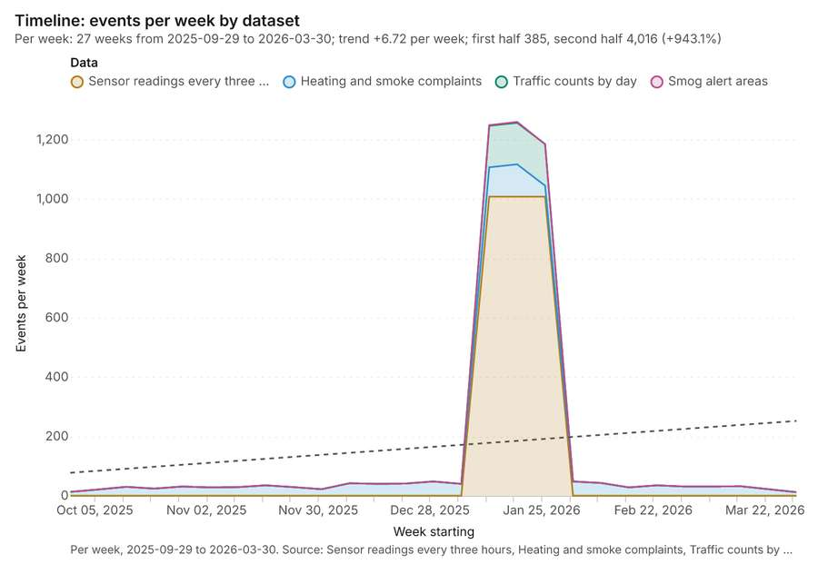
Figure 1. Timeline: events per week by dataset [1]. Per week, 2025-09-29 to 2026-03-30. Source: Sensor readings every three hours, Heating and smoke complaints, Traffic counts by day, Smog alert areas (4,449 features). The data is in the appendix.
The timeline counts 4,449 dated events in Sensor readings every three hours, Heating and smoke complaints, Traffic counts by day and 1 more per week, from week of 2025-09-29 to week of 2026-03-30 [1][2][3][4][5]. By dataset: Sensor readings every three hours 3,024; Heating and smoke complaints 1,000; Traffic counts by day 420; Smog alert areas 5 [1]. The trend is +6.72 events per week; the second half of the weeks has 4,016 against 385 in the first (+943.1%) [1].
Busiest weeks
- week of 2026-01-19: 1,260 events [1]
- week of 2026-01-12: 1,249 events [1]
- week of 2026-01-26: 1,185 events [1]
Quietest weeks
- week of 2026-03-30: 12 events [1]
- week of 2025-09-29: 13 events [1]
- week of 2025-10-06: 21 events [1]

Space time hot spots
What this analysis is. Emerging hot spots: Where hot spots are new, consecutive, intensifying, persistent, diminishing, sporadic, oscillating or historical over time [6]. In ArcGIS it is Emerging Hot Spot Analysis or Create Space Time Cube [6].
Why it was run on this data. Heating and smoke complaints carry dates in 'reported_at': emerging hot spot analysis finds new, intensifying and fading hot spots per week [7].
What it found. Space time hot spots on Heating and smoke complaints: Emerging hot spots: 1 layer saved: Emerging hot spots: Heating and smoke complaints (79 features) [8][9]. It reported result, count 79; result, elapsed ms 13; result, resolution 8; result, features used 1,000; result, time neighbors 0; billing, cost 0.15 [8].
Result | Value
result, count | 79
result, elapsed ms | 13
result, resolution | 8
result, features used | 1,000
result, time neighbors | 0
billing, cost | 0.15
billing, list price | 0.15
billing, upstream cost | 0

Findings
- Evidenced: Space time hot spots on Heating and smoke complaints: Emerging hot spots: 1 layer saved: Emerging hot spots: Heating and smoke complaints (79 features) [8][9].
- Evidenced: It reported result, count 79; result, elapsed ms 13; result, resolution 8; result, features used 1,000; result, time neighbors 0; billing, cost 0.15 [8].
A model draft was discarded because a sentence did not cite a source of this section.
Tool gp_space_time_hot_spots; parameters {"project": "941056ab-e59e-43ce-98fd-5b3678626f78", "features": {"layer": "Heating and smoke complaints (872e2359)"}, "interval": "week", "bin_shape": "h3", "resolution": 8, "time_field": "reported_at"}

Near repeat
What this analysis is. Repeat and near repeat classification: Classify incidents as originators, repeats (same place) or near repeats within a distance and time window, with a Knox test table [10]. In ArcGIS it is Repeat and Near Repeat Classification or Near Repeat Calculator [10].
Why it was run on this data. Near repeat analysis tests whether Heating and smoke complaints close in space also follow each other within 18 days [11].
What it found. Near repeat on Heating and smoke complaints: Repeat and near repeat classification: 1 layer saved: Repeat and near repeat classification: Heating and smoke complaints (1000 features) [9][12]. It reported result, days 18; result, count 1,000; result, chains 118; result, distance m 200; result, elapsed ms 21; result, pairs linked 557 [12].
Result | Value
result, days | 18
result, count | 1,000
result, chains | 118
result, distance m | 200
result, elapsed ms | 21
result, pairs linked | 557
billing, cost | 0.08
billing, list price | 0.08
billing, upstream cost | 0

Findings
- Evidenced: Near repeat on Heating and smoke complaints: Repeat and near repeat classification: 1 layer saved: Repeat and near repeat classification: Heating and smoke complaints (1000 features) [9][12].
- Evidenced: It reported result, days 18; result, count 1,000; result, chains 118; result, distance m 200; result, elapsed ms 21; result, pairs linked 557 [12].
Tool gp_near_repeat; parameters {"days": 18, "project": "941056ab-e59e-43ce-98fd-5b3678626f78", "features": {"layer": "Heating and smoke complaints (872e2359)"}, "distance_m": 200.0, "time_field": "reported_at"}

Summarize within
What this analysis is. Summarize within: Count and aggregate the features inside each polygon (or bin), proportionally for lines and polygons [13]. In ArcGIS it is Summarize Within or Aggregate Points; in QGIS, native:countpointsinpolygon or native:sumlinelengths [13].
Why it was run on this data. Count Schools inside each feature of Smog alert areas; the counts map as a choropleth (natural breaks, sequential colors) [14].
What it found. Summarize within on Schools, Smog alert areas: Summarize within: 1 layer saved: Summarize within: Smog alert areas (5 features) [15][16][17]. It reported result, count 5; result, elapsed ms 1; billing, cost 0.01112; billing, list price 0.01112; billing, upstream cost 0 [15].
Result | Value
result, count | 5
result, elapsed ms | 1
billing, cost | 0.01112
billing, list price | 0.01112
billing, upstream cost | 0

Findings
- Evidenced: Summarize within on Schools, Smog alert areas: Summarize within: 1 layer saved: Summarize within: Smog alert areas (5 features) [15][16][17].
- Evidenced: It reported result, count 5; result, elapsed ms 1; billing, cost 0.01112; billing, list price 0.01112; billing, upstream cost 0 [15].
Tool gp_summarize_within; parameters {"stats": [{"stat": "sum", "field": "pupils"}], "project": "941056ab-e59e-43ce-98fd-5b3678626f78", "features": {"layer": "Schools (04161d9b)"}, "polygons": {"layer": "Smog alert areas (cb491d16)"}}

Summarize within
What this analysis is. Summarize within: Count and aggregate the features inside each polygon (or bin), proportionally for lines and polygons [13]. In ArcGIS it is Summarize Within or Aggregate Points; in QGIS, native:countpointsinpolygon or native:sumlinelengths [13].
Why it was run on this data. Count Schools inside each feature of Smog alert areas; the counts map as a choropleth (natural breaks, sequential colors) [14].
What it found. The process involved using the `gp_summarize_within` tool [18] to summarize data using smog alert areas [17] and traffic counters [19].
Result | Value
result, count | 5
result, elapsed ms | 0
billing, cost | 0.01052
billing, list price | 0.01052
billing, upstream cost | 0

Findings
- Evidenced: Summarize within on Traffic counters, Smog alert areas: Summarize within: 1 layer saved: Summarize within: Smog alert areas (5 features) [17][18][19].
- Evidenced: It reported result, count 5; result, elapsed ms 0; billing, cost 0.01052; billing, list price 0.01052; billing, upstream cost 0 [18].
Tool gp_summarize_within; parameters {"stats": [{"stat": "sum", "field": "lanes"}], "project": "941056ab-e59e-43ce-98fd-5b3678626f78", "features": {"layer": "Traffic counters (2beeba9d)"}, "polygons": {"layer": "Smog alert areas (cb491d16)"}}

Hot spots
What this analysis is. Hot spot analysis: Getis-Ord Gi* hot and cold spots with z-scores, p-values and confidence bins [20]. In ArcGIS it is Find Hot Spots or Hot Spot Analysis (Getis-Ord Gi*); in QGIS, qgis:hotspot (plugin) [20].
Why it was run on this data. 50 points: Getis-Ord Gi* tests whether the concentrations in Schools are statistically significant [21].
What it found. Hot spot analysis was run using the Schools layer as input [16], saving 1 layer with 18 features [22].
Result | Value
result, bins | 18
result, count | 18
result, elapsed ms | 4
result, cell size m | 2,000
result, incidents used | 50
result, distance band m | 2,000
billing, cost | 0.051
billing, list price | 0.051
billing, upstream cost | 0

Findings
- Evidenced: Hot spots on Schools: Hot spot analysis: 1 layer saved: Hot spot analysis: Schools (18 features) [16][22].
- Evidenced: It reported result, bins 18; result, count 18; result, elapsed ms 4; result, cell size m 2,000; result, incidents used 50; result, distance band m 2,000 [22].
Tool gp_hot_spots; parameters {"project": "941056ab-e59e-43ce-98fd-5b3678626f78", "features": {"layer": "Schools (04161d9b)"}, "aggregation": "hexagon", "cell_size_m": 2000.0, "distance_band_m": 2000.0}

Hot spots
What this analysis is. Hot spot analysis: Getis-Ord Gi* hot and cold spots with z-scores, p-values and confidence bins [20]. In ArcGIS it is Find Hot Spots or Hot Spot Analysis (Getis-Ord Gi*); in QGIS, qgis:hotspot (plugin) [20].
Why it was run on this data. 1000 points: Getis-Ord Gi* tests whether the concentrations in Heating and smoke complaints are statistically significant [23].
What it found. The hot spot analysis was performed using the Heating and smoke complaints layer [9]. This process saved one layer titled Hot spot analysis: Heating and smoke complaints, containing 208 features [24]. The analysis utilized 1,000 incidents and generated 208 results [24].
Result | Value
result, bins | 208
result, count | 208
result, elapsed ms | 12
result, cell size m | 500
result, incidents used | 1,000
result, distance band m | 500
billing, cost | 0.07
billing, list price | 0.07
billing, upstream cost | 0

Findings
- Evidenced: Hot spots on Heating and smoke complaints: Hot spot analysis: 1 layer saved: Hot spot analysis: Heating and smoke complaints (208 features) [9][24].
- Evidenced: It reported result, bins 208; result, count 208; result, elapsed ms 12; result, cell size m 500; result, incidents used 1,000; result, distance band m 500 [24].
Tool gp_hot_spots; parameters {"project": "941056ab-e59e-43ce-98fd-5b3678626f78", "features": {"layer": "Heating and smoke complaints (872e2359)"}, "aggregation": "hexagon", "cell_size_m": 500.0, "distance_band_m": 500.0}

Calculate density
What this analysis is. Calculate density: Kernel density per square kilometer on a grid [25]. In ArcGIS it is Calculate Density or Kernel Density; in QGIS, native:heatmapkerneldensityestimation [25].
Why it was run on this data. 50 points in Schools: a density surface shows where they concentrate [26].
What it found. The calculation of density was performed using the Schools layer [16] and the gp_calculate_density tool [27]. This process successfully analyzed 98 features [27]. The maximum density detected over the area was 1.407 per km^2 [27]. Overall, the billing cost associated with this operation was 0.051 [27].
Result | Value
result, count | 98
result, elapsed ms | 5
result, bandwidth m | 2,000
result, cell size m | 1,000
result, excluded null | 0
result, max density per km2 | 1.407
billing, cost | 0.051
billing, list price | 0.051
billing, upstream cost | 0

Findings
- Evidenced: Calculate density on Schools: Calculate density: 1 layer saved: Calculate density: Schools (98 features) [16][27].
- Evidenced: It reported result, count 98; result, elapsed ms 5; result, bandwidth m 2,000; result, cell size m 1,000; result, excluded null 0; result, max density per km2 1.407 [27].
Tool gp_calculate_density; parameters {"kernel": "quartic", "project": "941056ab-e59e-43ce-98fd-5b3678626f78", "features": {"layer": "Schools (04161d9b)"}, "bandwidth_m": 2000.0, "cell_size_m": 1000.0}

Calculate density
What this analysis is. Calculate density: Kernel density per square kilometer on a grid [25]. In ArcGIS it is Calculate Density or Kernel Density; in QGIS, native:heatmapkerneldensityestimation [25].
Why it was run on this data. 20 points in Traffic counters: a density surface shows where they concentrate [28].
What it found. Calculate density on Traffic counters: Calculate density: 1 layer saved: Calculate density: Traffic counters (208 features) [19][29]. It reported result, count 208; result, elapsed ms 6; result, bandwidth m 5,000; result, cell size m 1,000; result, excluded null 0; result, max density per km2 0.4822 [29].
Result | Value
result, count | 208
result, elapsed ms | 6
result, bandwidth m | 5,000
result, cell size m | 1,000
result, excluded null | 0
result, max density per km2 | 0.4822
billing, cost | 0.0504
billing, list price | 0.0504
billing, upstream cost | 0

Findings
- Evidenced: Calculate density on Traffic counters: Calculate density: 1 layer saved: Calculate density: Traffic counters (208 features) [19][29].
- Evidenced: It reported result, count 208; result, elapsed ms 6; result, bandwidth m 5,000; result, cell size m 1,000; result, excluded null 0; result, max density per km2 0.4822 [29].
Tool gp_calculate_density; parameters {"kernel": "quartic", "project": "941056ab-e59e-43ce-98fd-5b3678626f78", "features": {"layer": "Traffic counters (2beeba9d)"}, "bandwidth_m": 5000.0, "cell_size_m": 1000.0}

Calculate density
What this analysis is. Calculate density: Kernel density per square kilometer on a grid [25]. In ArcGIS it is Calculate Density or Kernel Density; in QGIS, native:heatmapkerneldensityestimation [25].
Why it was run on this data. 1000 points in Heating and smoke complaints: a density surface shows where they concentrate [30].
What it found. The calculation of density for heating and smoke complaints generated 1,379 features [31]. This operation had a resulting elapsed time of 41 ms [31]. Key metrics provided include a cell size of 200 m and an excluded null count of 0 [31]. The maximum density recorded was 120.2 per km2 [31].
Result | Value
result, count | 1,379
result, elapsed ms | 41
result, bandwidth m | 500
result, cell size m | 200
result, excluded null | 0
result, max density per km2 | 120.2
billing, cost | 0.07
billing, list price | 0.07
billing, upstream cost | 0

Findings
- Evidenced: Calculate density on Heating and smoke complaints: Calculate density: 1 layer saved: Calculate density: Heating and smoke complaints (1379 features) [9][31].
- Evidenced: It reported result, count 1,379; result, elapsed ms 41; result, bandwidth m 500; result, cell size m 200; result, excluded null 0; result, max density per km2 120.2 [31].
Tool gp_calculate_density; parameters {"kernel": "quartic", "project": "941056ab-e59e-43ce-98fd-5b3678626f78", "features": {"layer": "Heating and smoke complaints (872e2359)"}, "bandwidth_m": 500.0, "cell_size_m": 200.0}

Find point clusters
What this analysis is. Find point clusters: Density-based clusters (DBSCAN, HDBSCAN or OPTICS, optionally space-time) with hulls and noise [32]. In ArcGIS it is Find Point Clusters or Density-based Clustering; in QGIS, native:dbscanclustering or native:stdbscanclustering [32].
Why it was run on this data. DBSCAN finds dense groups of Schools and separates noise [33].
What it found. Find point clusters on Schools: Find point clusters: 2 layers saved: Find point clusters: Schools (50 features); Find point clusters: cluster hulls (7 features) [16][34]. It reported result, count 50; result, noise 10; result, distance m 1,000; result, elapsed ms 4; result, min points 3; billing, cost 0.051 [34].
Result | Value
result, count | 50
result, noise | 10
result, distance m | 1,000
result, elapsed ms | 4
result, min points | 3
billing, cost | 0.051
billing, list price | 0.051
billing, upstream cost | 0

Findings
- Evidenced: Find point clusters on Schools: Find point clusters: 2 layers saved: Find point clusters: Schools (50 features); Find point clusters: cluster hulls (7 features) [16][34].
- Evidenced: It reported result, count 50; result, noise 10; result, distance m 1,000; result, elapsed ms 4; result, min points 3; billing, cost 0.051 [34].
Tool gp_find_point_clusters; parameters {"method": "dbscan", "project": "941056ab-e59e-43ce-98fd-5b3678626f78", "features": {"layer": "Schools (04161d9b)"}, "distance_m": 1000.0, "min_points": 3}

Find point clusters
What this analysis is. Find point clusters: Density-based clusters (DBSCAN, HDBSCAN or OPTICS, optionally space-time) with hulls and noise [32]. In ArcGIS it is Find Point Clusters or Density-based Clustering; in QGIS, native:dbscanclustering or native:stdbscanclustering [32].
Why it was run on this data. DBSCAN finds dense groups of Traffic counters and separates noise [35].
What it found. Find point clusters on Traffic counters: Find point clusters: 2 layers saved: Find point clusters: Traffic counters (20 features); Find point clusters: cluster hulls (1 feature) [19][36]. It reported result, count 20; result, noise 1; result, distance m 2,000; result, elapsed ms 1; result, min points 3; billing, cost 0.0504 [36].
Result | Value
result, count | 20
result, noise | 1
result, distance m | 2,000
result, elapsed ms | 1
result, min points | 3
billing, cost | 0.0504
billing, list price | 0.0504
billing, upstream cost | 0

Findings
- Evidenced: Find point clusters on Traffic counters: Find point clusters: 2 layers saved: Find point clusters: Traffic counters (20 features); Find point clusters: cluster hulls (1 feature) [19][36].
- Evidenced: It reported result, count 20; result, noise 1; result, distance m 2,000; result, elapsed ms 1; result, min points 3; billing, cost 0.0504 [36].
A model draft was discarded because a sentence did not cite a source of this section.
Tool gp_find_point_clusters; parameters {"method": "dbscan", "project": "941056ab-e59e-43ce-98fd-5b3678626f78", "features": {"layer": "Traffic counters (2beeba9d)"}, "distance_m": 2000.0, "min_points": 3}

Find point clusters
What this analysis is. Find point clusters: Density-based clusters (DBSCAN, HDBSCAN or OPTICS, optionally space-time) with hulls and noise [32]. In ArcGIS it is Find Point Clusters or Density-based Clustering; in QGIS, native:dbscanclustering or native:stdbscanclustering [32].
Why it was run on this data. DBSCAN finds dense groups of Air quality sensors and separates noise [37].
What it found. Find point clusters on Air quality sensors: Find point clusters: 2 layers saved: Find point clusters: Air quality sensors (18 features); Find point clusters: cluster hulls (1 feature) [38][39]. It reported result, count 18; result, noise 0; result, distance m 2,000; result, elapsed ms 1; result, min points 3; billing, cost 0.05036 [38].
Result | Value
result, count | 18
result, noise | 0
result, distance m | 2,000
result, elapsed ms | 1
result, min points | 3
billing, cost | 0.05036
billing, list price | 0.05036
billing, upstream cost | 0

Findings
- Evidenced: Find point clusters on Air quality sensors: Find point clusters: 2 layers saved: Find point clusters: Air quality sensors (18 features); Find point clusters: cluster hulls (1 feature) [38][39].
- Evidenced: It reported result, count 18; result, noise 0; result, distance m 2,000; result, elapsed ms 1; result, min points 3; billing, cost 0.05036 [38].
Tool gp_find_point_clusters; parameters {"method": "dbscan", "project": "941056ab-e59e-43ce-98fd-5b3678626f78", "features": {"layer": "Air quality sensors (b023a603)"}, "distance_m": 2000.0, "min_points": 3}

Outliers
What this analysis is. Find outliers: Anselin local Moran’s I: HH, LL clusters and HL, LH outliers [40]. In ArcGIS it is Find Outliers or Cluster and Outlier Analysis (Anselin Local Moran’s I) [40].
Why it was run on this data. Local Moran's I maps clusters and outliers of 'population' [41].
What it found. The outlier analysis utilized the Districts layer as input [43]. The process successfully located 12 features within the Districts dataset [42].
Result | Value
result, count | 12
result, elapsed ms | 4
result, permutations | 199
result, excluded null | 0
result, distance band m | 2,269
billing, cost | 0.05036
billing, list price | 0.05036
billing, upstream cost | 0

Findings
- Evidenced: Outliers on Districts: Find outliers: 1 layer saved: Find outliers: Districts (12 features) [42][43].
- Evidenced: It reported result, count 12; result, elapsed ms 4; result, permutations 199; result, excluded null 0; result, distance band m 2,269; billing, cost 0.05036 [42].
Tool gp_outliers; parameters {"field": "population", "project": "941056ab-e59e-43ce-98fd-5b3678626f78", "features": {"layer": "Districts (cf8657b3)"}, "aggregation": "hexagon"}

Outliers
What this analysis is. Find outliers: Anselin local Moran’s I: HH, LL clusters and HL, LH outliers [40]. In ArcGIS it is Find Outliers or Cluster and Outlier Analysis (Anselin Local Moran’s I) [40].
Why it was run on this data. Local Moran's I maps clusters and outliers of 'trees' [44].
What it found. Outliers on Green areas: Find outliers: 1 layer saved: Find outliers: Green areas (15 features) [45][46]. It reported result, count 15; result, elapsed ms 2; result, permutations 199; result, excluded null 0; result, distance band m 1,632; billing, cost 0.05045 [45].
Result | Value
result, count | 15
result, elapsed ms | 2
result, permutations | 199
result, excluded null | 0
result, distance band m | 1,632
billing, cost | 0.05045
billing, list price | 0.05045
billing, upstream cost | 0

Findings
- Evidenced: Outliers on Green areas: Find outliers: 1 layer saved: Find outliers: Green areas (15 features) [45][46].
- Evidenced: It reported result, count 15; result, elapsed ms 2; result, permutations 199; result, excluded null 0; result, distance band m 1,632; billing, cost 0.05045 [45].
Tool gp_outliers; parameters {"field": "trees", "project": "941056ab-e59e-43ce-98fd-5b3678626f78", "features": {"layer": "Green areas (3858215c)"}, "aggregation": "hexagon"}

Spatial autocorrelation
What this analysis is. Spatial autocorrelation: Global Moran’s I: is the pattern clustered, dispersed or random [47]. In ArcGIS it is Spatial Autocorrelation (Global Moran’s I) [47].
Why it was run on this data. Global Moran's I says whether similar values of 'population' sit next to each other [48].
What it found. Spatial autocorrelation on Districts: Spatial autocorrelation: done; no map output [43][49]. It reported result, n 12; result, p value 0.04188; result, z score 2.035; result, morans i 0.3603; result, variance 0.04918; result, elapsed ms 1 [49].
Result | Value
result, n | 12
result, p value | 0.04188
result, z score | 2.035
result, morans i | 0.3603
result, variance | 0.04918
result, elapsed ms | 1
result, expected i | -0.09091
result, excluded null | 0
result, distance band m | 2,269
result, p value normality | 0.03746
result, z score normality | 2.081
result, variance normality | 0.04703
billing, cost | 0.02
billing, list price | 0.02
billing, upstream cost | 0

Findings
- Evidenced: Spatial autocorrelation on Districts: Spatial autocorrelation: done; no map output [43][49].
- Evidenced: It reported result, n 12; result, p value 0.04188; result, z score 2.035; result, morans i 0.3603; result, variance 0.04918; result, elapsed ms 1 [49].
Tool gp_spatial_autocorrelation; parameters {"field": "population", "project": "941056ab-e59e-43ce-98fd-5b3678626f78", "features": {"layer": "Districts (cf8657b3)"}}

Summarize within
What this analysis is. Summarize within: Count and aggregate the features inside each polygon (or bin), proportionally for lines and polygons [13]. In ArcGIS it is Summarize Within or Aggregate Points; in QGIS, native:countpointsinpolygon or native:sumlinelengths [13].
Why it was run on this data. Count Air quality sensors inside each feature of Smog alert areas by model; the counts map as a choropleth (natural breaks, sequential colors) [50].
What it found. Summarize within on Air quality sensors, Smog alert areas: Summarize within: 1 layer saved: Summarize within: Smog alert areas (5 features) [17][39][51]. It reported result, count 5; result, elapsed ms 1; billing, cost 0.01048; billing, list price 0.01048; billing, upstream cost 0 [51].
Result | Value
result, count | 5
result, elapsed ms | 1
billing, cost | 0.01048
billing, list price | 0.01048
billing, upstream cost | 0

Findings
- Evidenced: Summarize within on Air quality sensors, Smog alert areas: Summarize within: 1 layer saved: Summarize within: Smog alert areas (5 features) [17][39][51].
- Evidenced: It reported result, count 5; result, elapsed ms 1; billing, cost 0.01048; billing, list price 0.01048; billing, upstream cost 0 [51].
Tool gp_summarize_within; parameters {"stats": [{"stat": "sum", "field": "height_m"}], "project": "941056ab-e59e-43ce-98fd-5b3678626f78", "features": {"layer": "Air quality sensors (b023a603)"}, "group_by": "model", "polygons": {"layer": "Smog alert areas (cb491d16)"}}

Maps and charts
The run also made 20 map image(s) [52][53][54][55][56][57][58][59][60][61][62][63][64][65][66][67][68][69][70][71] and 26 chart(s) [72][73][74][75][76][77][78][79][80][81][82][83][84][85][86][87][88][89][90][91][92][93][94][95][96][97].
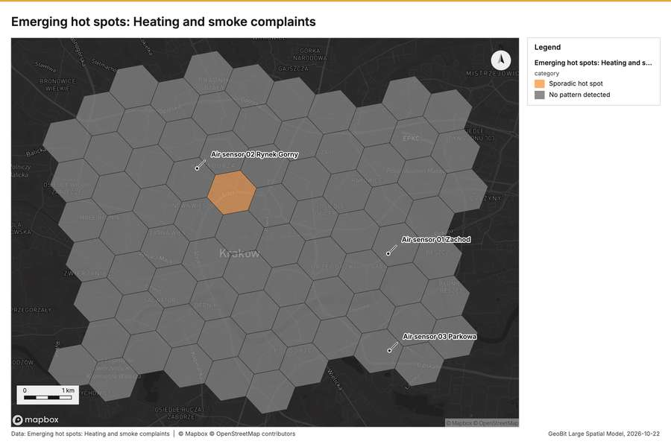
Figure 2. Emerging hot spots: Heating and smoke complaints [52]
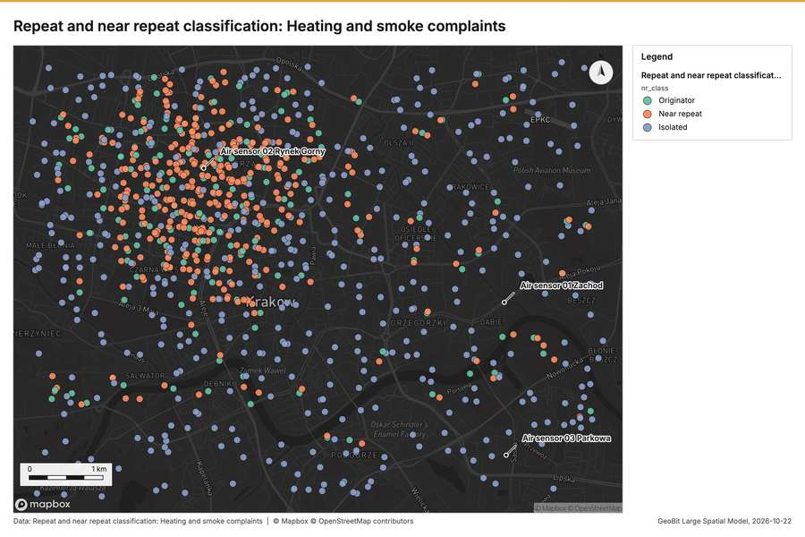
Figure 3. Repeat and near repeat classification: Heating and smoke complaints [53]
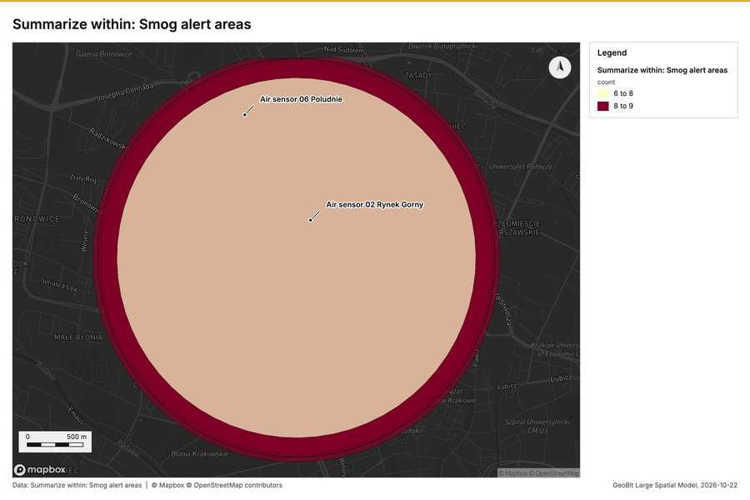
Figure 4. Summarize within: Smog alert areas [54]
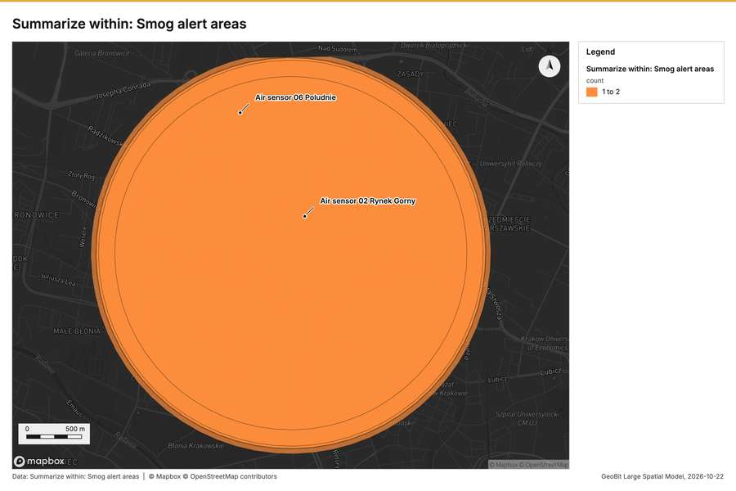
Figure 5. Summarize within: Smog alert areas [55]
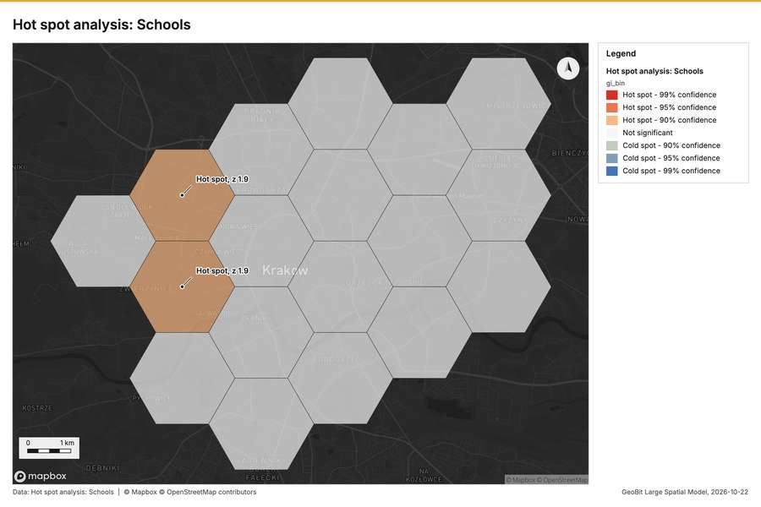
Figure 6. Hot spot analysis: Schools [56]
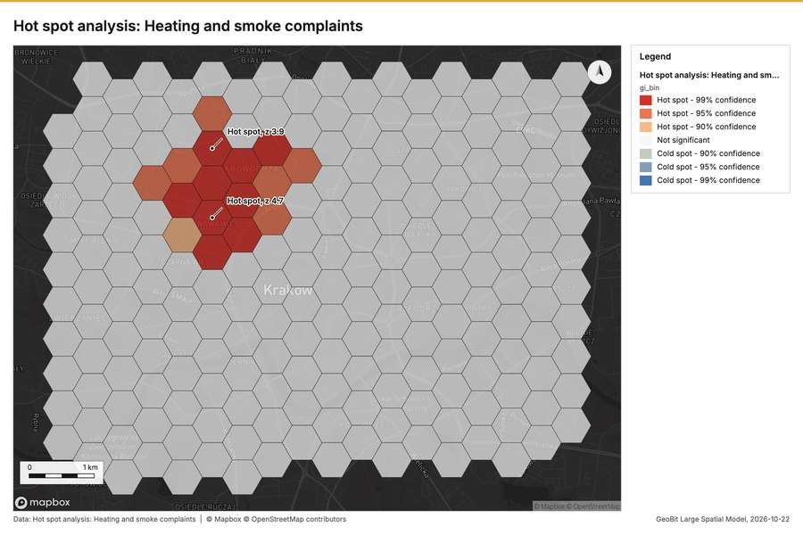
Figure 7. Hot spot analysis: Heating and smoke complaints [57]
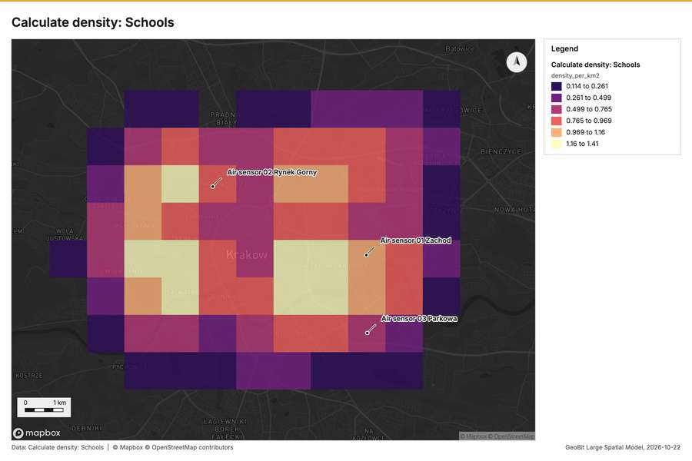
Figure 8. Calculate density: Schools [58]
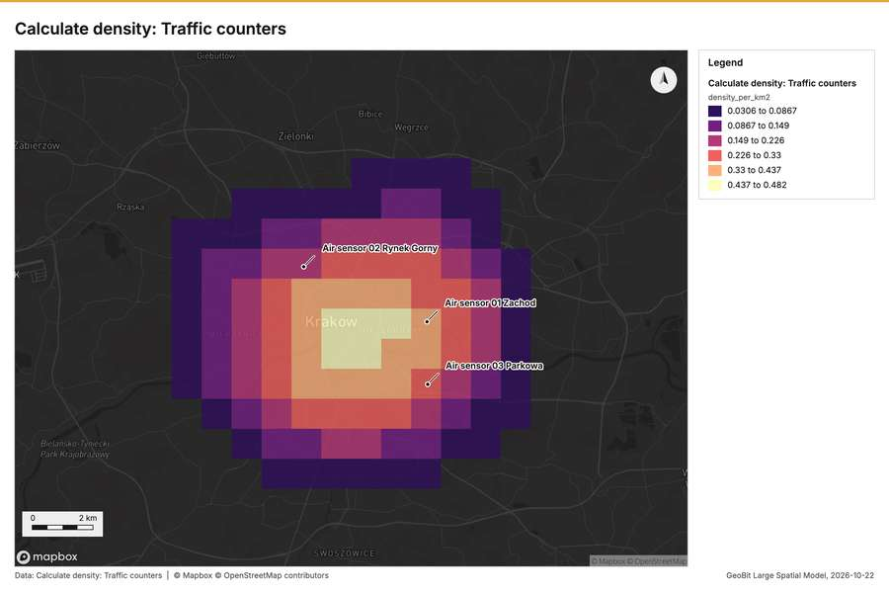
Figure 9. Calculate density: Traffic counters [59]
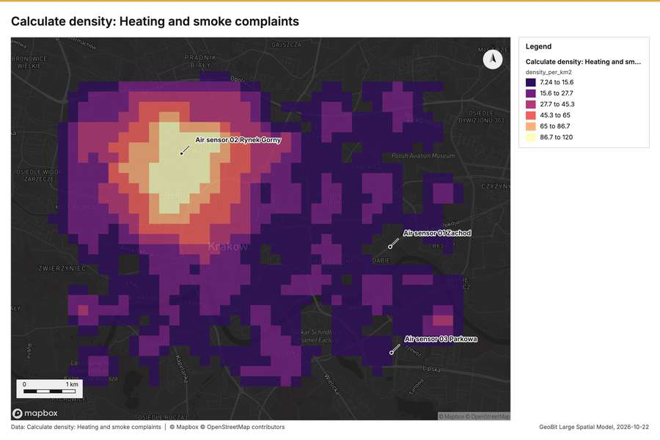
Figure 10. Calculate density: Heating and smoke complaints [60]
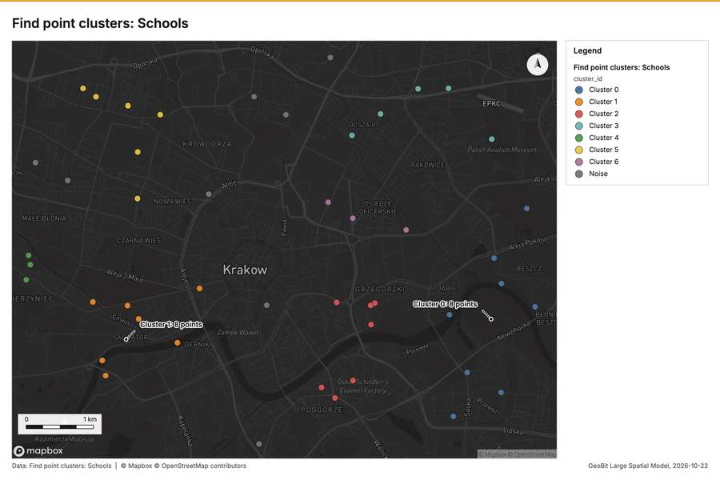
Figure 11. Find point clusters: Schools [61]
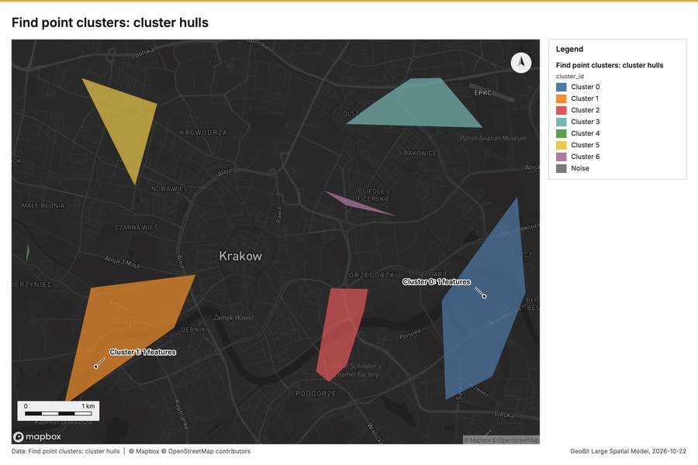
Figure 12. Find point clusters: cluster hulls [62]
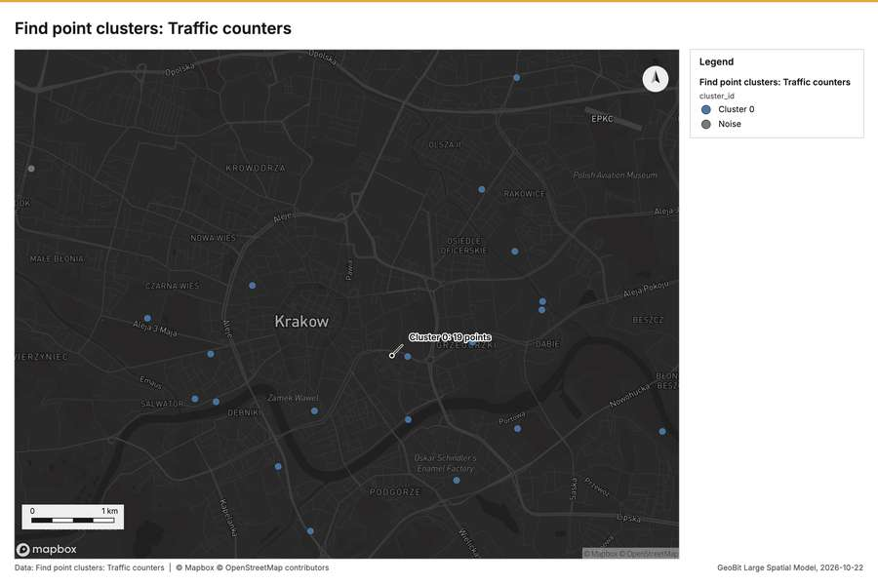
Figure 13. Find point clusters: Traffic counters [63]
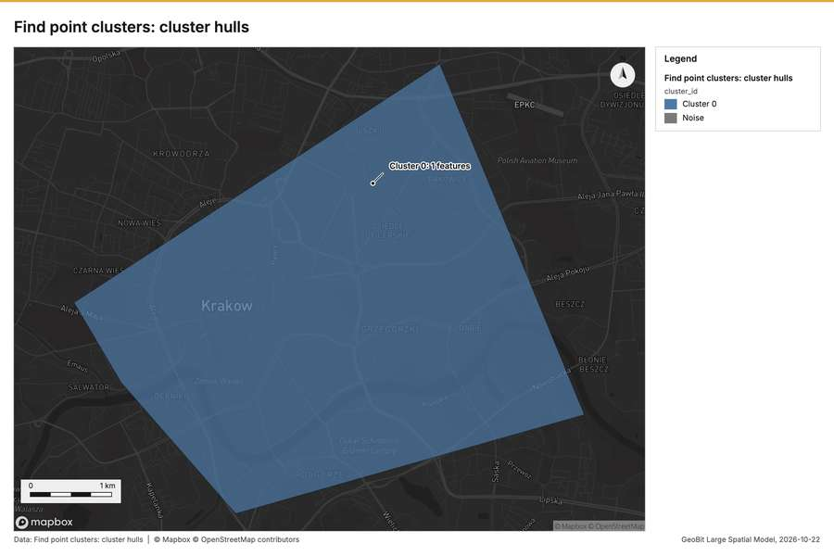
Figure 14. Find point clusters: cluster hulls [64]
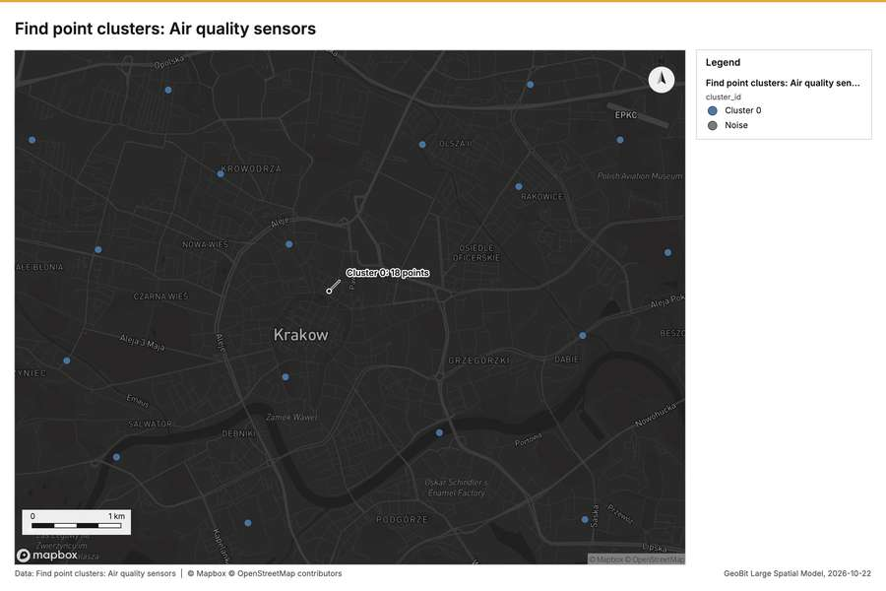
Figure 15. Find point clusters: Air quality sensors [65]
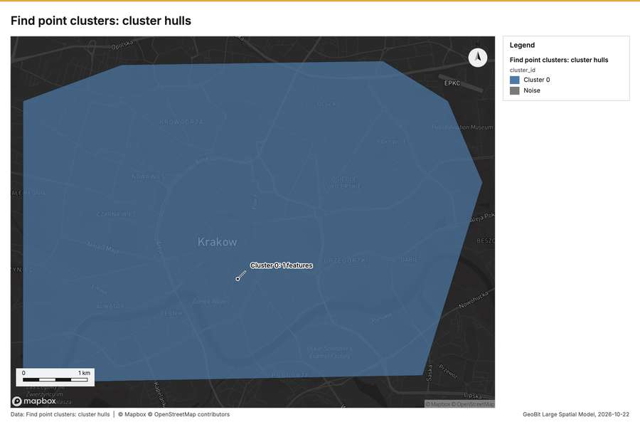
Figure 16. Find point clusters: cluster hulls [66]
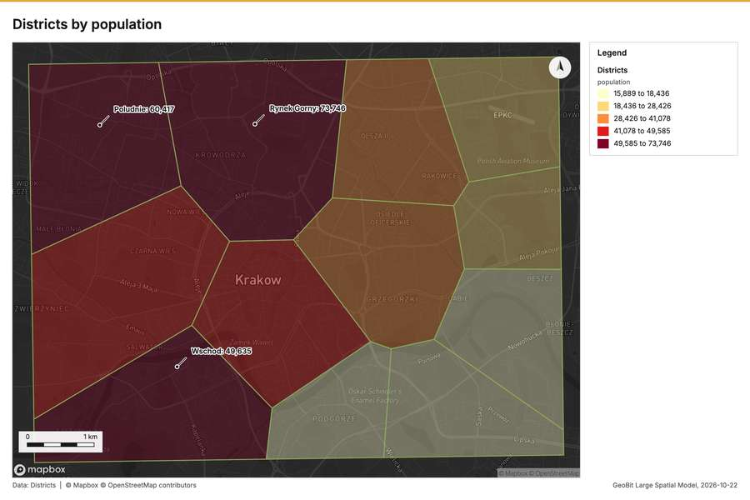
Figure 17. Districts by population [67]
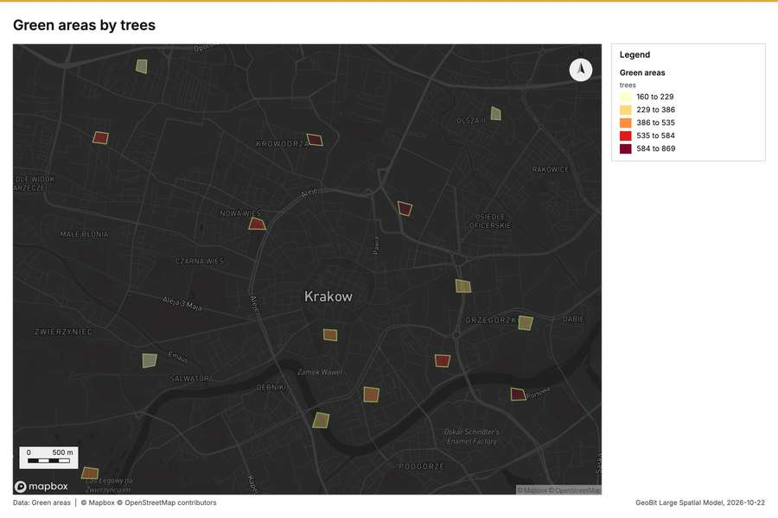
Figure 18. Green areas by trees [68]
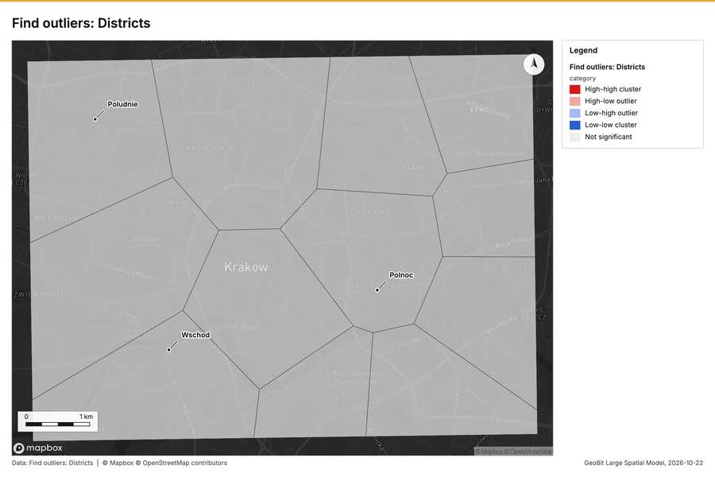
Figure 19. Find outliers: Districts [69]
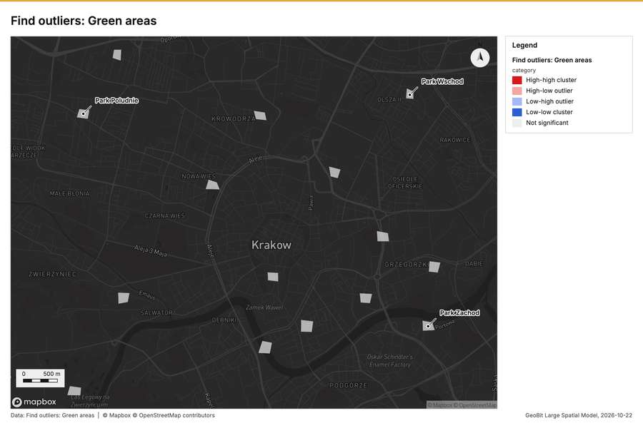
Figure 20. Find outliers: Green areas [70]
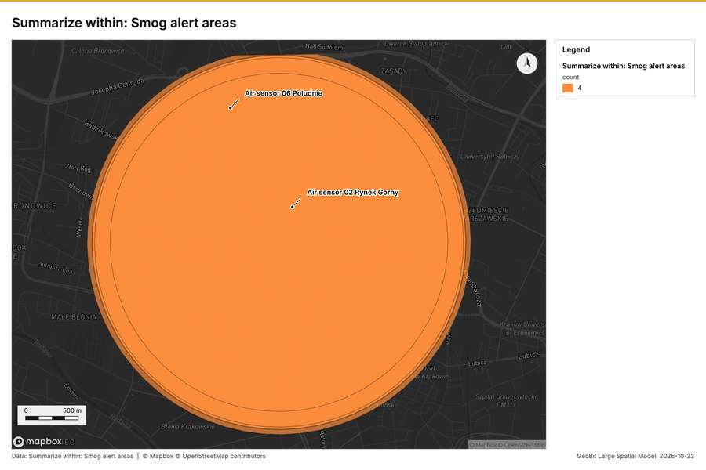
Figure 21. Summarize within: Smog alert areas [71]
What the map shows. The map displays the analysis of "Heating and smoke complaints" across a grid of cells, according to the provided legend. The overwhelming majority of the mapped area is coloured grey, indicating that "No pattern detected" was found in most locations. There is a small cluster of adjacent hexagonal cells near the center of the map that are coloured orange, signifying a "Sporadic hot spot." These few sporadic hot spots are tightly grouped together in a specific area, standing out against the wide expanse of areas showing no discernible pattern. [52]
Inferred: read from the image by gemma4:e4b, not evidence.
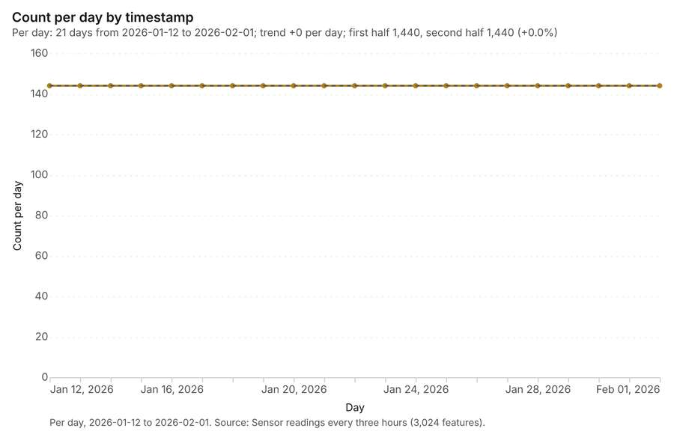
Figure 22. Sensor readings every three hours over time (timestamp) [72]. Per day, 2026-01-12 to 2026-02-01. Source: Sensor readings every three hours (3,024 features). The data is in the appendix.
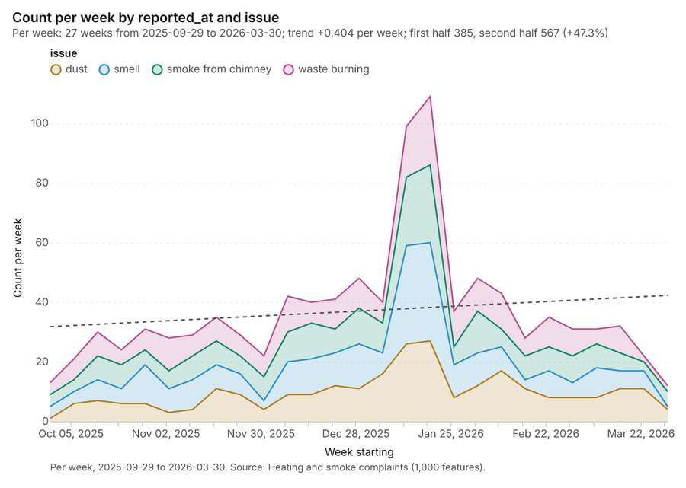
Figure 23. Heating and smoke complaints over time (reported_at) [73]. Per week, 2025-09-29 to 2026-03-30. Source: Heating and smoke complaints (1,000 features). The data is in the appendix.
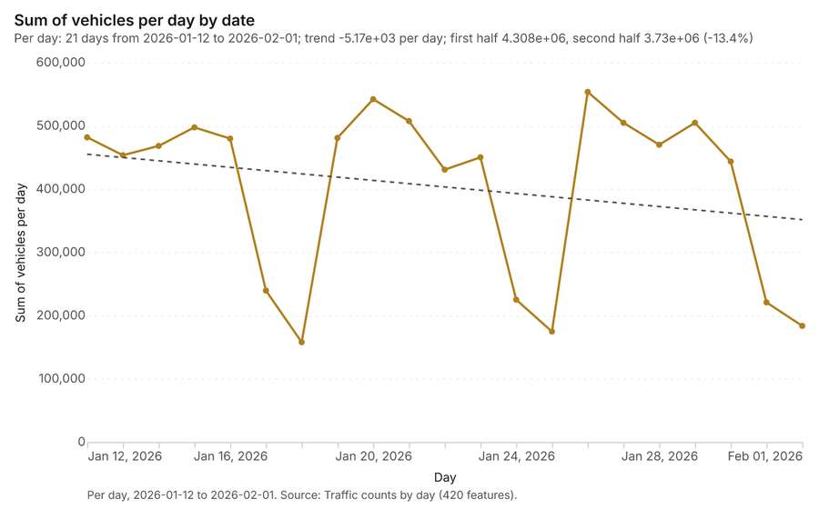
Figure 24. Traffic counts by day over time (date) [74]. Per day, 2026-01-12 to 2026-02-01. Source: Traffic counts by day (420 features). The data is in the appendix.
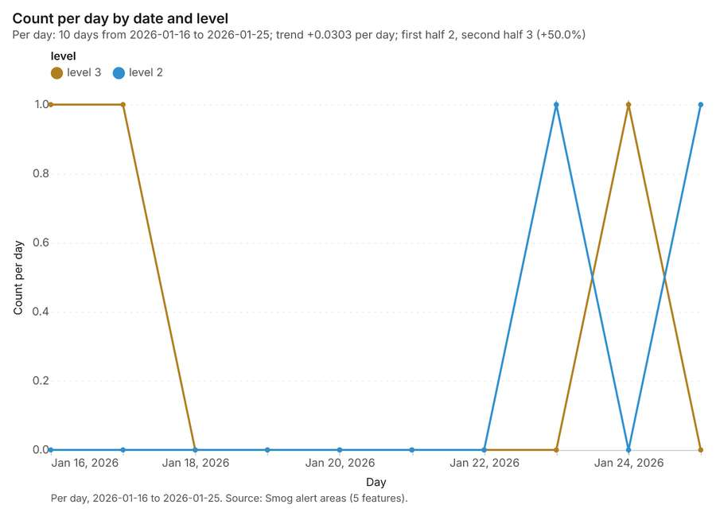
Figure 25. Smog alert areas over time (date) [75]. Per day, 2026-01-16 to 2026-01-25. Source: Smog alert areas (5 features). The data is in the appendix.
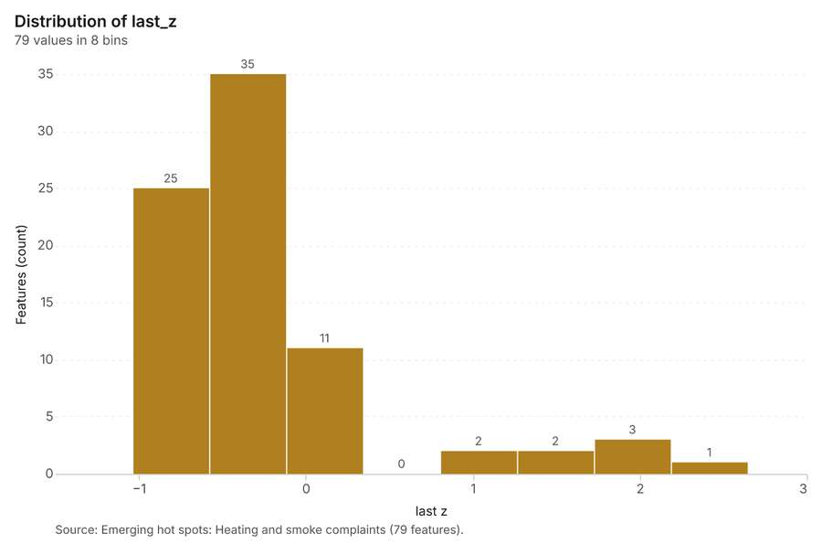
Figure 26. Emerging hot spots: Heating and smoke complaints [76]. Source: Emerging hot spots: Heating and smoke complaints (79 features). The data is in the appendix.
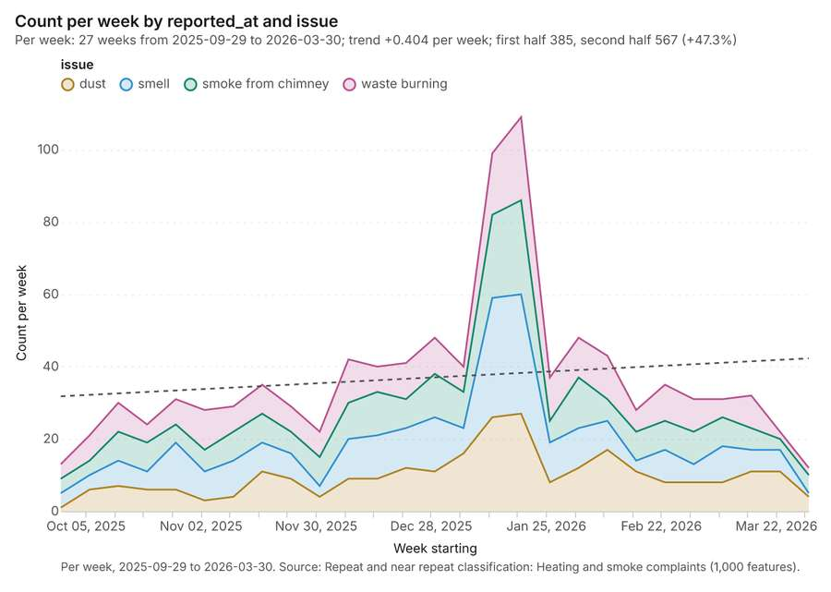
Figure 27. Repeat and near repeat classification: Heating and smoke complaints [77]. Per week, 2025-09-29 to 2026-03-30. Source: Repeat and near repeat classification: Heating and smoke complaints (1,000 features). The data is in the appendix.
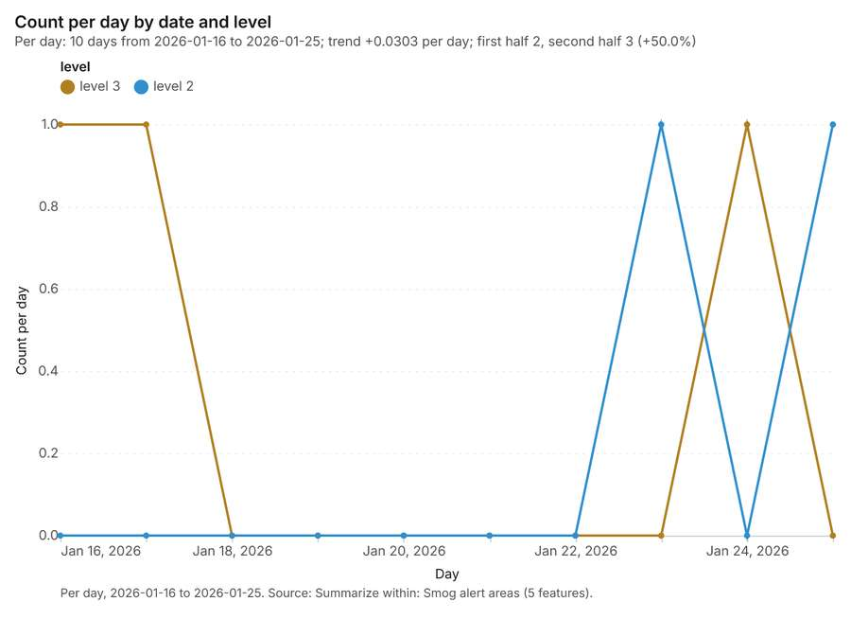
Figure 28. Summarize within: Smog alert areas [78]. Per day, 2026-01-16 to 2026-01-25. Source: Summarize within: Smog alert areas (5 features). The data is in the appendix.
Figure 29. Summarize within: Smog alert areas [79]. Per day, 2026-01-16 to 2026-01-25. Source: Summarize within: Smog alert areas (5 features). The data is in the appendix.
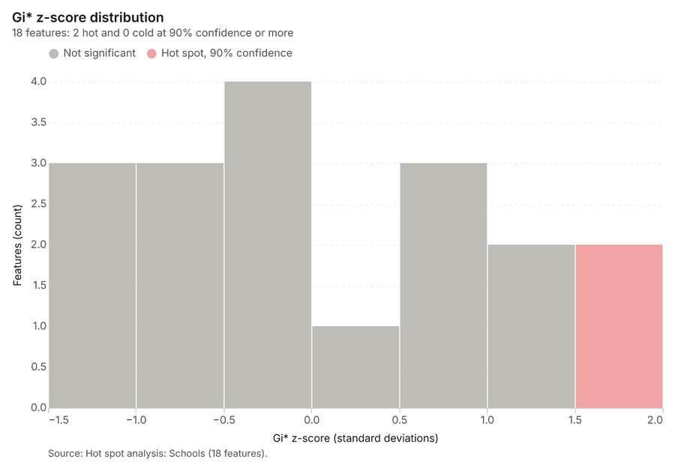
Figure 30. Hot spot analysis: Schools [80]. Source: Hot spot analysis: Schools (18 features). The data is in the appendix.
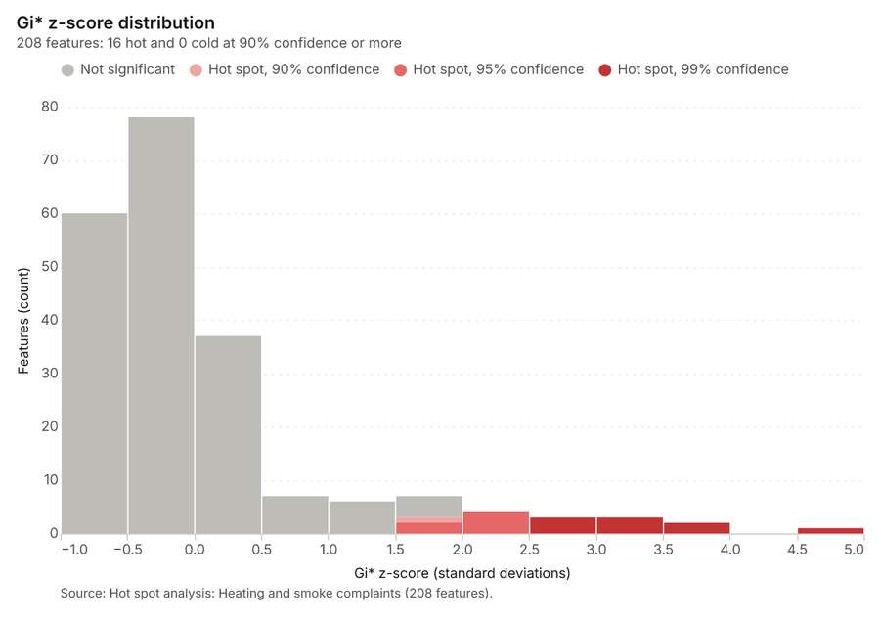
Figure 31. Hot spot analysis: Heating and smoke complaints [81]. Source: Hot spot analysis: Heating and smoke complaints (208 features). The data is in the appendix.
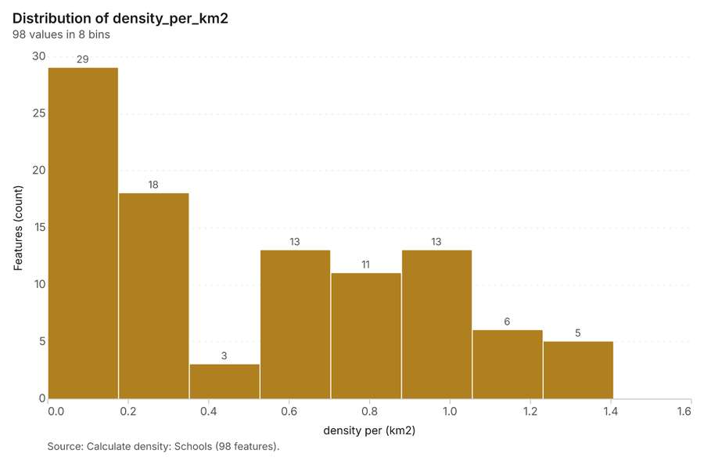
Figure 32. Calculate density: Schools [82]. Source: Calculate density: Schools (98 features). The data is in the appendix.
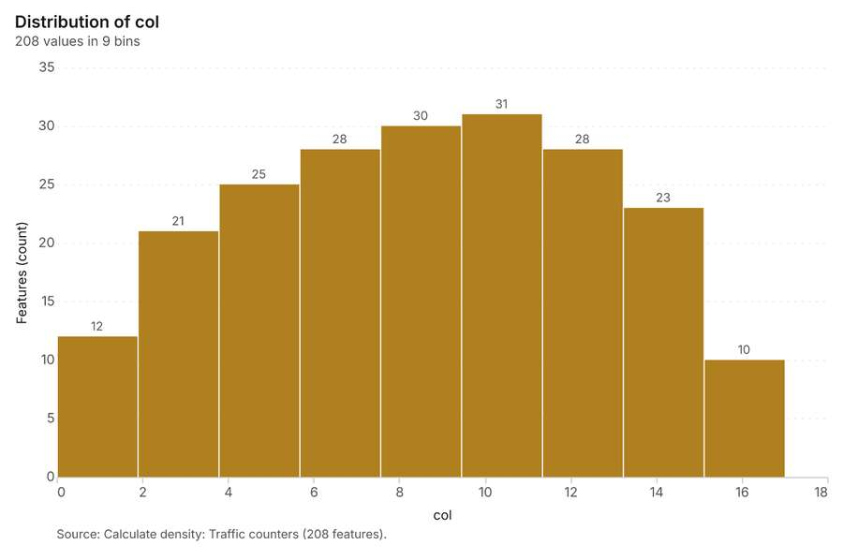
Figure 33. Calculate density: Traffic counters [83]. Source: Calculate density: Traffic counters (208 features). The data is in the appendix.
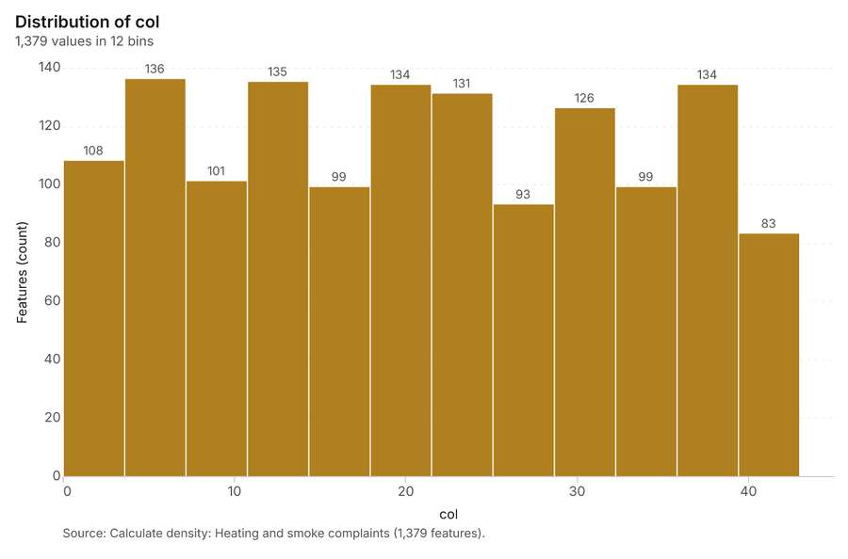
Figure 34. Calculate density: Heating and smoke complaints [84]. Source: Calculate density: Heating and smoke complaints (1,379 features). The data is in the appendix.
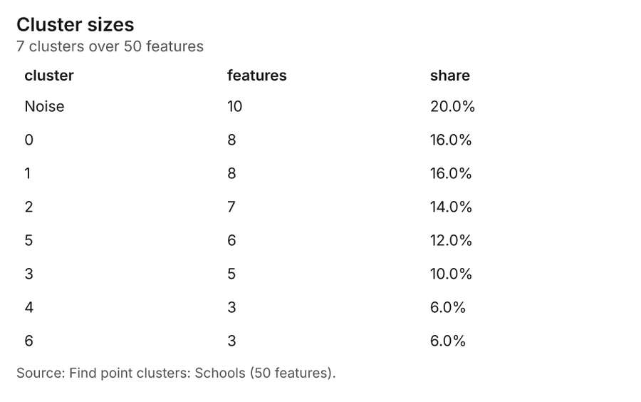
Figure 35. Find point clusters: Schools [85]. Source: Find point clusters: Schools (50 features). The data is in the appendix.
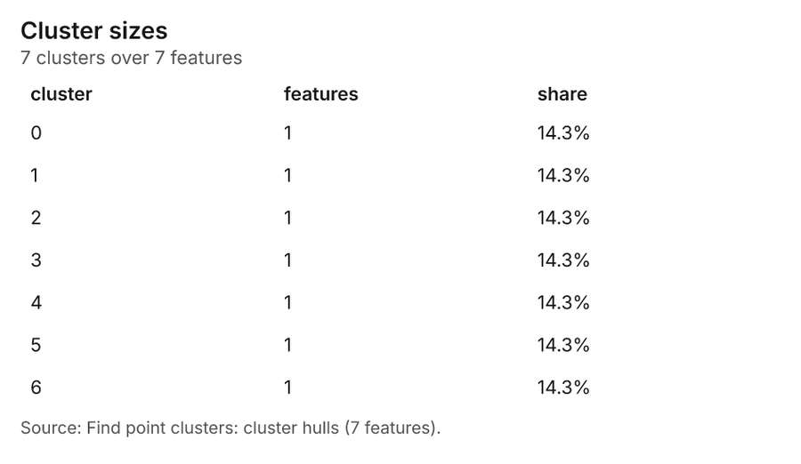
Figure 36. Find point clusters: cluster hulls [86]. Source: Find point clusters: cluster hulls (7 features). The data is in the appendix.
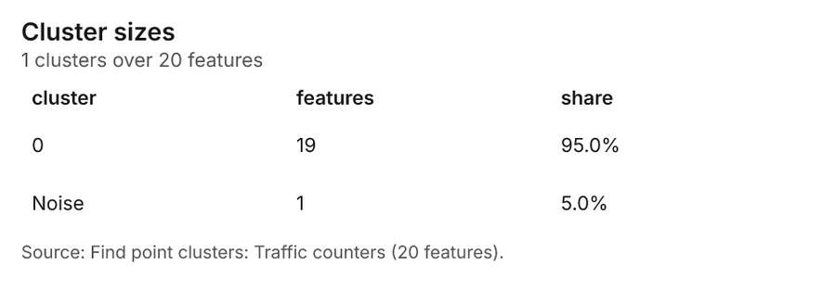
Figure 37. Find point clusters: Traffic counters [87]. Source: Find point clusters: Traffic counters (20 features). The data is in the appendix.
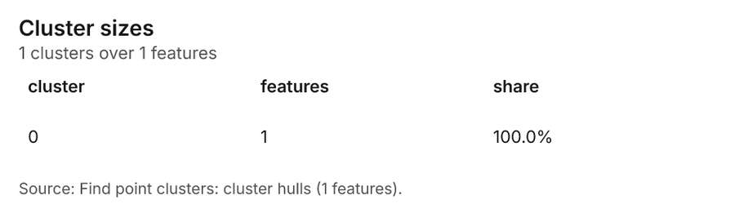
Figure 38. Find point clusters: cluster hulls [88]. Source: Find point clusters: cluster hulls (1 features). The data is in the appendix.
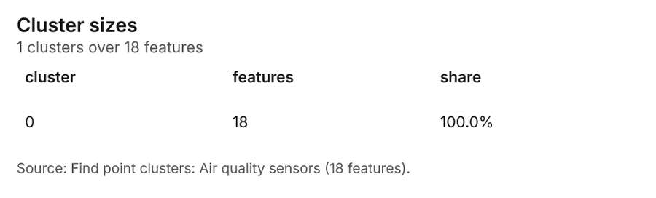
Figure 39. Find point clusters: Air quality sensors [89]. Source: Find point clusters: Air quality sensors (18 features). The data is in the appendix.
Figure 40. Find point clusters: cluster hulls [90]. Source: Find point clusters: cluster hulls (1 features). The data is in the appendix.
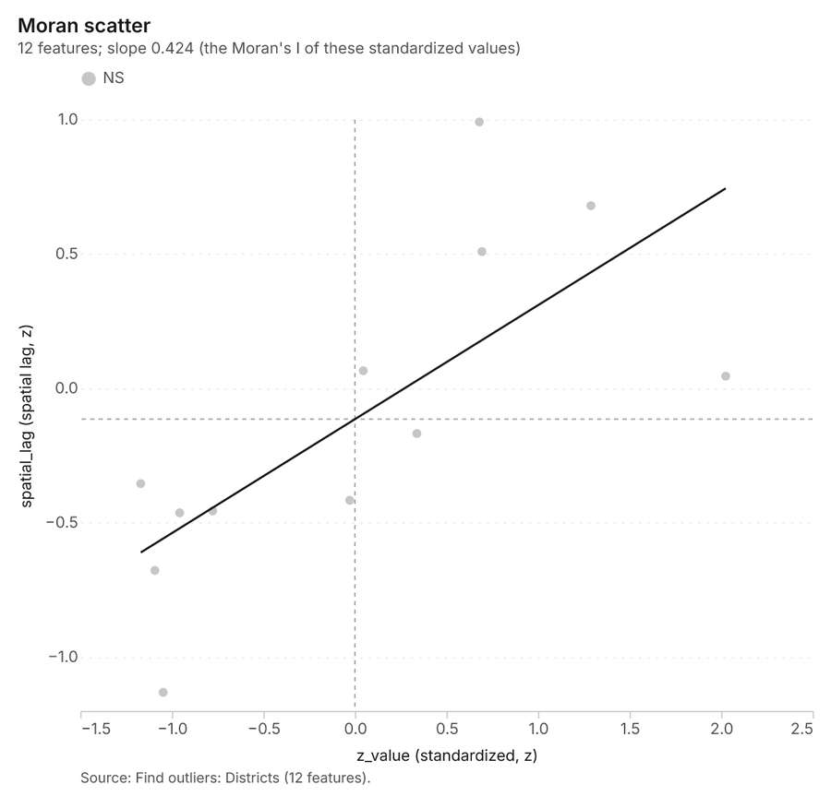
Figure 41. Find outliers: Districts [91]. Source: Find outliers: Districts (12 features). The data is in the appendix.
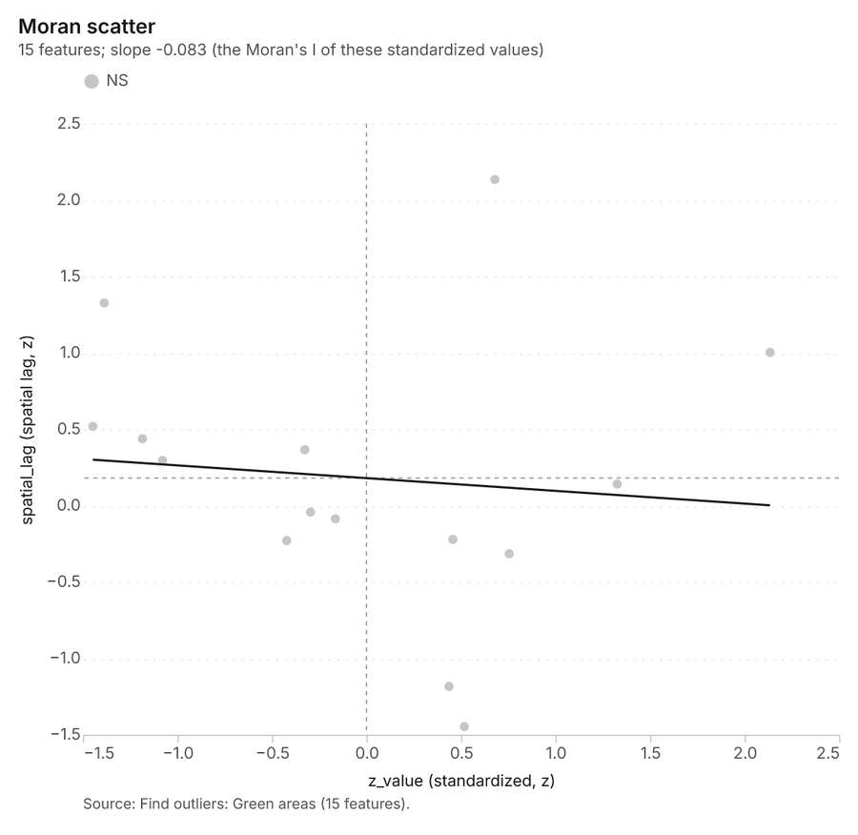
Figure 42. Find outliers: Green areas [92]. Source: Find outliers: Green areas (15 features). The data is in the appendix.
Figure 43. Summarize within: Smog alert areas [93]. Per day, 2026-01-16 to 2026-01-25. Source: Summarize within: Smog alert areas (5 features). The data is in the appendix.
Figure 44. Summarize within: Smog alert areas over time [94]. Per day, 2026-01-16 to 2026-01-25. Source: Summarize within: Smog alert areas (5 features). The data is in the appendix.
Figure 45. Summarize within: Smog alert areas over time [95]. Per day, 2026-01-16 to 2026-01-25. Source: Summarize within: Smog alert areas (5 features). The data is in the appendix.
Figure 46. Summarize within: Smog alert areas over time [96]. Per day, 2026-01-16 to 2026-01-25. Source: Summarize within: Smog alert areas (5 features). The data is in the appendix.
Figure 47. Repeat and near repeat classification: Heating and smoke complaints over time [97]. Per week, 2025-09-29 to 2026-03-30. Source: Repeat and near repeat classification: Heating and smoke complaints (1,000 features). The data is in the appendix.

Changes since the last run
This is the first report of this project.

Sources
[1] Rendering: Chart: Timeline: events per week by dataset. 108 rows (id a084bcb1-4ebb-4e02-a2b5-e0989f373da4)
[2] Dataset: Sensor readings every three hours. table, 3024 rows (id 0d15a1c1-4e15-46ed-8bc1-8aa3d29ccbcd)
[3] Dataset: Heating and smoke complaints. vector, 1000 rows (id f4580557-af68-44bb-8bac-c0ee2ee81164)
[4] Dataset: Traffic counts by day. table, 420 rows (id 4dddb911-3782-4522-b33f-66a0810f4308)
[5] Dataset: Smog alert areas. vector, 5 rows (id 1797fddc-1ecb-4d65-bb9d-8c24fbce0b84)
[6] Catalog: Emerging hot spots (operation catalog, gp_space_time_hot_spots). Where hot spots are new, consecutive, intensifying, persistent, diminishing, sporadic, oscillating or historical over time. ArcGIS: Emerging Hot Spot Analysis, Create Space Time Cube. (id gp_space_time_hot_spots)
[7] Plan: Space time hot spots of Heating and smoke complaints (the Start plan's candidate c_d98590d93cd6). Heating and smoke complaints carry dates in 'reported_at': emerging hot spot analysis finds new, intensifying and fading hot spots per week. (id 73000d9f-3676-479d-bf5e-7209c2669a39:c_d98590d93cd6)
[8] Tool result: gp_space_time_hot_spots, step 0. Emerging hot spots: 1 layer saved: Emerging hot spots: Heating and smoke complaints (79 features). (id e2bffa10-d83f-4078-a978-5b42d657bad7:0)
[9] Layer: Heating and smoke complaints. 1,000 features (id 872e2359-4c4f-4b1c-a353-f558b419ae1b)
[10] Catalog: Repeat and near repeat classification (operation catalog, gp_near_repeat). Classify incidents as originators, repeats (same place) or near repeats within a distance and time window, with a Knox test table. ArcGIS: Repeat and Near Repeat Classification, Near Repeat Calculator. (id gp_near_repeat)
[11] Plan: Near repeat of Heating and smoke complaints (the Start plan's candidate c_ba6e8fc6e4b1). Near repeat analysis tests whether Heating and smoke complaints close in space also follow each other within 18 days. (id 73000d9f-3676-479d-bf5e-7209c2669a39:c_ba6e8fc6e4b1)
[12] Tool result: gp_near_repeat, step 1. Repeat and near repeat classification: 1 layer saved: Repeat and near repeat classification: Heating and smoke complaints (1000 features). (id e2bffa10-d83f-4078-a978-5b42d657bad7:1)
[13] Catalog: Summarize within (operation catalog, gp_summarize_within). Count and aggregate the features inside each polygon (or bin), proportionally for lines and polygons. ArcGIS: Summarize Within, Aggregate Points. QGIS: native:countpointsinpolygon, native:sumlinelengths. (id gp_summarize_within)
[14] Plan: Schools per feature of Smog alert areas (the Start plan's candidate c_fe1717bec4eb). Count Schools inside each feature of Smog alert areas; the counts map as a choropleth (natural breaks, sequential colors). (id 73000d9f-3676-479d-bf5e-7209c2669a39:c_fe1717bec4eb)
[15] Tool result: gp_summarize_within, step 0. Summarize within: 1 layer saved: Summarize within: Smog alert areas (5 features). (id 11b23637-45df-4d60-b9d3-92ec6e1a9142:0)
[16] Layer: Schools. 50 features (id 04161d9b-b772-49f5-b451-f05a72c11340)
[17] Layer: Smog alert areas. 5 features (id cb491d16-8d66-4ca9-8a0c-b0cca331df73)
[18] Tool result: gp_summarize_within, step 1. Summarize within: 1 layer saved: Summarize within: Smog alert areas (5 features). (id 11b23637-45df-4d60-b9d3-92ec6e1a9142:1)
[19] Layer: Traffic counters. 20 features (id 2beeba9d-323f-4f1e-919a-5e066c70311f)
[20] Catalog: Hot spot analysis (operation catalog, gp_hot_spots). Getis-Ord Gi* hot and cold spots with z-scores, p-values and confidence bins. ArcGIS: Find Hot Spots, Hot Spot Analysis (Getis-Ord Gi*). QGIS: qgis:hotspot (plugin). (id gp_hot_spots)
[21] Plan: Hot spots of Schools (the Start plan's candidate c_b9bfdeef42df). 50 points: Getis-Ord Gi* tests whether the concentrations in Schools are statistically significant. (id 73000d9f-3676-479d-bf5e-7209c2669a39:c_b9bfdeef42df)
[22] Tool result: gp_hot_spots, step 0. Hot spot analysis: 1 layer saved: Hot spot analysis: Schools (18 features). (id ce105be5-3779-4e96-a7f2-284b760484a5:0)
[23] Plan: Hot spots of Heating and smoke complaints (the Start plan's candidate c_8ba28202f6a2). 1000 points: Getis-Ord Gi* tests whether the concentrations in Heating and smoke complaints are statistically significant. (id 73000d9f-3676-479d-bf5e-7209c2669a39:c_8ba28202f6a2)
[24] Tool result: gp_hot_spots, step 1. Hot spot analysis: 1 layer saved: Hot spot analysis: Heating and smoke complaints (208 features). (id ce105be5-3779-4e96-a7f2-284b760484a5:1)
[25] Catalog: Calculate density (operation catalog, gp_calculate_density). Kernel density per square kilometer on a grid. ArcGIS: Calculate Density, Kernel Density. QGIS: native:heatmapkerneldensityestimation. (id gp_calculate_density)
[26] Plan: Kernel density of Schools (the Start plan's candidate c_b5b20e7ef97c). 50 points in Schools: a density surface shows where they concentrate. (id 73000d9f-3676-479d-bf5e-7209c2669a39:c_b5b20e7ef97c)
[27] Tool result: gp_calculate_density, step 0. Calculate density: 1 layer saved: Calculate density: Schools (98 features). (id f7011d1b-ef58-4060-8cda-1a0a0ec3fb50:0)
[28] Plan: Kernel density of Traffic counters (the Start plan's candidate c_5380a4ae623b). 20 points in Traffic counters: a density surface shows where they concentrate. (id 73000d9f-3676-479d-bf5e-7209c2669a39:c_5380a4ae623b)
[29] Tool result: gp_calculate_density, step 1. Calculate density: 1 layer saved: Calculate density: Traffic counters (208 features). (id f7011d1b-ef58-4060-8cda-1a0a0ec3fb50:1)
[30] Plan: Kernel density of Heating and smoke complaints (the Start plan's candidate c_0cb7c2c39d34). 1000 points in Heating and smoke complaints: a density surface shows where they concentrate. (id 73000d9f-3676-479d-bf5e-7209c2669a39:c_0cb7c2c39d34)
[31] Tool result: gp_calculate_density, step 2. Calculate density: 1 layer saved: Calculate density: Heating and smoke complaints (1379 features). (id f7011d1b-ef58-4060-8cda-1a0a0ec3fb50:2)
[32] Catalog: Find point clusters (operation catalog, gp_find_point_clusters). Density-based clusters (DBSCAN, HDBSCAN or OPTICS, optionally space-time) with hulls and noise. ArcGIS: Find Point Clusters, Density-based Clustering. QGIS: native:dbscanclustering, native:stdbscanclustering. (id gp_find_point_clusters)
[33] Plan: Cluster points of Schools (the Start plan's candidate c_9dae65ce7c51). DBSCAN finds dense groups of Schools and separates noise. (id 73000d9f-3676-479d-bf5e-7209c2669a39:c_9dae65ce7c51)
[34] Tool result: gp_find_point_clusters, step 0. Find point clusters: 2 layers saved: Find point clusters: Schools (50 features); Find point clusters: cluster hulls (7 features). (id 17da64d0-c62f-4bc1-b36b-a20be986149f:0)
[35] Plan: Cluster points of Traffic counters (the Start plan's candidate c_5a43af034293). DBSCAN finds dense groups of Traffic counters and separates noise. (id 73000d9f-3676-479d-bf5e-7209c2669a39:c_5a43af034293)
[36] Tool result: gp_find_point_clusters, step 1. Find point clusters: 2 layers saved: Find point clusters: Traffic counters (20 features); Find point clusters: cluster hulls (1 feature). (id 17da64d0-c62f-4bc1-b36b-a20be986149f:1)
[37] Plan: Cluster points of Air quality sensors (the Start plan's candidate c_82728615a157). DBSCAN finds dense groups of Air quality sensors and separates noise. (id 73000d9f-3676-479d-bf5e-7209c2669a39:c_82728615a157)
[38] Tool result: gp_find_point_clusters, step 2. Find point clusters: 2 layers saved: Find point clusters: Air quality sensors (18 features); Find point clusters: cluster hulls (1 feature). (id 17da64d0-c62f-4bc1-b36b-a20be986149f:2)
[39] Layer: Air quality sensors. 18 features (id b023a603-7600-43b0-b1a5-263889cc78ec)
[40] Catalog: Find outliers (operation catalog, gp_outliers). Anselin local Moran’s I: HH, LL clusters and HL, LH outliers. ArcGIS: Find Outliers, Cluster and Outlier Analysis (Anselin Local Moran’s I). (id gp_outliers)
[41] Plan: Local morans i of Districts (the Start plan's candidate c_4dc818ee3a6e). Local Moran's I maps clusters and outliers of 'population'. (id 73000d9f-3676-479d-bf5e-7209c2669a39:c_4dc818ee3a6e)
[42] Tool result: gp_outliers, step 0. Find outliers: 1 layer saved: Find outliers: Districts (12 features). (id d6fde80f-96aa-463a-8668-577f95febf04:0)
[43] Layer: Districts. 12 features (id cf8657b3-2d43-4636-9390-17763a61ba4a)
[44] Plan: Local morans i of Green areas (the Start plan's candidate c_ade852c64875). Local Moran's I maps clusters and outliers of 'trees'. (id 73000d9f-3676-479d-bf5e-7209c2669a39:c_ade852c64875)
[45] Tool result: gp_outliers, step 1. Find outliers: 1 layer saved: Find outliers: Green areas (15 features). (id d6fde80f-96aa-463a-8668-577f95febf04:1)
[46] Layer: Green areas. 15 features (id 3858215c-dede-4b5d-bb9d-c7026b082281)
[47] Catalog: Spatial autocorrelation (operation catalog, gp_spatial_autocorrelation). Global Moran’s I: is the pattern clustered, dispersed or random. ArcGIS: Spatial Autocorrelation (Global Moran’s I). (id gp_spatial_autocorrelation)
[48] Plan: Global morans i of Districts (the Start plan's candidate c_e7dbd09fdbfe). Global Moran's I says whether similar values of 'population' sit next to each other. (id 73000d9f-3676-479d-bf5e-7209c2669a39:c_e7dbd09fdbfe)
[49] Tool result: gp_spatial_autocorrelation, step 2. Spatial autocorrelation: done; no map output. (id d6fde80f-96aa-463a-8668-577f95febf04:2)
[50] Plan: Air quality sensors per feature of Smog alert areas (the Start plan's candidate c_9e70122240f8). Count Air quality sensors inside each feature of Smog alert areas by model; the counts map as a choropleth (natural breaks, sequential colors). (id 73000d9f-3676-479d-bf5e-7209c2669a39:c_9e70122240f8)
[51] Tool result: gp_summarize_within, step 0. Summarize within: 1 layer saved: Summarize within: Smog alert areas (5 features). (id 9293aa84-ac7f-4f7b-98ff-5dd6fd0e80c3:0)
[52] Rendering: Map: Emerging hot spots: Heating and smoke complaints (id ef0fba2c-3dab-44c8-8d1b-37950e2aa09f)
[53] Rendering: Map: Repeat and near repeat classification: Heating and smoke complaints (id 93441096-27ae-4f30-aade-125dce56048f)
[54] Rendering: Map: Summarize within: Smog alert areas (id 407df334-25e6-42fe-8c40-03ead11b55fc)
[55] Rendering: Map: Summarize within: Smog alert areas (id 0034d9c7-6324-47a3-b594-1d24ebb1c534)
[56] Rendering: Map: Hot spot analysis: Schools (id fad1fd90-84ae-4c56-a7c8-c19968f56251)
[57] Rendering: Map: Hot spot analysis: Heating and smoke complaints (id e8903c1c-1976-4634-a49a-1eca16d457d8)
[58] Rendering: Map: Calculate density: Schools (id dd937085-125b-4245-b19d-4df13795ffac)
[59] Rendering: Map: Calculate density: Traffic counters (id e20a9973-68d1-4830-bbb5-9a780d6a9a33)
[60] Rendering: Map: Calculate density: Heating and smoke complaints (id 0160d7fb-b98e-47f4-ba56-8e97beecdc89)
[61] Rendering: Map: Find point clusters: Schools (id 2fe195f1-b867-4da5-80ca-f8476d6adc87)
[62] Rendering: Map: Find point clusters: cluster hulls (id 0419d3be-d8f9-490f-b1f7-42948c5a9737)
[63] Rendering: Map: Find point clusters: Traffic counters (id 0b85a9fc-34fd-43cb-84f9-2f5ffe2f143c)
[64] Rendering: Map: Find point clusters: cluster hulls (id d057adbc-5e7a-4438-8d07-3b943401c523)
[65] Rendering: Map: Find point clusters: Air quality sensors (id 2cb83ca5-0098-4a79-9790-1e43bfdf1db5)
[66] Rendering: Map: Find point clusters: cluster hulls (id a67a4f33-5986-463c-bc2c-acd3018fea50)
[67] Rendering: Map: Districts by population (id 2e54a251-6a26-402f-86e8-e6d15cab3ac3)
[68] Rendering: Map: Green areas by trees (id 7404178c-fa56-4278-a94d-180735127ec9)
[69] Rendering: Map: Find outliers: Districts (id 65c0124e-203f-4f91-873c-12b4b6960ae4)
[70] Rendering: Map: Find outliers: Green areas (id dc1a86e3-09d6-402a-a3b2-c3fdd0d3eab5)
[71] Rendering: Map: Summarize within: Smog alert areas (id a4d875cc-962b-4e3c-b64e-dd57deee34ed)
[72] Rendering: Chart: Sensor readings every three hours over time (timestamp). 21 rows (id 8be9f734-9fc2-4614-9c16-f319eb5bc297)
[73] Rendering: Chart: Heating and smoke complaints over time (reported_at). 108 rows (id bafb9708-0830-42a8-9dce-37a4690fb945)
[74] Rendering: Chart: Traffic counts by day over time (date). 21 rows (id 71f35ff8-083c-4035-b705-ccab22f7bdf8)
[75] Rendering: Chart: Smog alert areas over time (date). 20 rows (id 4033fc71-23c1-4ffa-ae99-ae32670ffd03)
[76] Rendering: Chart: Emerging hot spots: Heating and smoke complaints. 8 rows (id 988b5149-df22-4996-bf31-ac55354d51c4)
[77] Rendering: Chart: Repeat and near repeat classification: Heating and smoke complaints. 108 rows (id f41c1c14-81d1-4349-8443-09a4f4ba9eb6)
[78] Rendering: Chart: Summarize within: Smog alert areas. 20 rows (id 9227b7e1-e625-47f7-80b5-495de4ab4e0a)
[79] Rendering: Chart: Summarize within: Smog alert areas. 20 rows (id a7c52833-f238-4226-b84c-fb152e2c2eb1)
[80] Rendering: Chart: Hot spot analysis: Schools. 7 rows (id e9ad8aa0-adb4-490e-928f-6b45446a7f1f)
[81] Rendering: Chart: Hot spot analysis: Heating and smoke complaints. 13 rows (id d96b848c-1ca5-4e56-a8a0-bd5c1a5ae7d0)
[82] Rendering: Chart: Calculate density: Schools. 8 rows (id 063ac921-93d3-4e7d-ab62-58eb4e9b60e6)
[83] Rendering: Chart: Calculate density: Traffic counters. 9 rows (id 43c8bec3-da9f-4830-912a-49013656b2a0)
[84] Rendering: Chart: Calculate density: Heating and smoke complaints. 12 rows (id 55617b3d-063a-4f9c-a0dc-71b273d1c5c5)
[85] Rendering: Chart: Find point clusters: Schools. 8 rows (id 6776d720-700c-42c8-803c-ba17f7028e7e)
[86] Rendering: Chart: Find point clusters: cluster hulls. 7 rows (id 9bde57a2-00d0-4bd3-a720-f74fb52e323e)
[87] Rendering: Chart: Find point clusters: Traffic counters. 2 rows (id 7ca9a164-4408-4af2-8a82-d20106e3d63e)
[88] Rendering: Chart: Find point clusters: cluster hulls. 1 rows (id 468903ad-2588-4bd9-b8d4-6010b36560ca)
[89] Rendering: Chart: Find point clusters: Air quality sensors. 1 rows (id 781b4a70-d6e9-4e64-931e-192b47d86fd1)
[90] Rendering: Chart: Find point clusters: cluster hulls. 1 rows (id 138b31d8-fc4f-44f8-8117-aecb9b369d31)
[91] Rendering: Chart: Find outliers: Districts. 12 rows (id f6661716-8904-4181-817e-f4d3e782e217)
[92] Rendering: Chart: Find outliers: Green areas. 15 rows (id b3b4d6ea-4b5e-4cac-8fd3-fcda036bee5c)
[93] Rendering: Chart: Summarize within: Smog alert areas. 20 rows (id 1ceece26-9477-4f54-9fa4-1e2dbc1f96a5)
[94] Rendering: Chart: Summarize within: Smog alert areas over time. 20 rows (id 76c45baf-feca-4a2f-a3a8-a4aa1cb03271)
[95] Rendering: Chart: Summarize within: Smog alert areas over time. 20 rows (id fc1e8aa9-d730-49fa-9bbb-bbeacedfb972)
[96] Rendering: Chart: Summarize within: Smog alert areas over time. 20 rows (id f7309174-c972-4de9-853f-0c6929414c1f)
[97] Rendering: Chart: Repeat and near repeat classification: Heating and smoke complaints over time. 108 rows (id 5a51d5a0-e784-4a44-a4b6-258ad1f1e695)
[98] Dataset: Districts. vector, 12 rows (id 26db6cdc-8ed6-4018-8216-57b31d6b7b10)
[99] Dataset: Air quality sensors. vector, 18 rows (id 6baceea7-d2af-4370-8edd-b762c4503296)
[100] Dataset: Major roads. vector, 20 rows (id c02faba8-cbb0-4f5c-9b60-817e3cfb35fe)
[101] Dataset: Traffic counters. vector, 20 rows (id 3b29eef8-b3c6-476c-b293-75939220204d)
[102] Dataset: Schools. vector, 50 rows (id 30a2dc6f-9417-4701-b099-bcebc56bd124)
[103] Dataset: Green areas. vector, 15 rows (id 32303dbc-77ff-4931-9a5d-9590fbeb6497)
[104] Dataset: Air quality bulletin. document, ? rows (id acc3c65d-3cae-42d7-af0f-109b23544f46)
[105] Record: Sample: Smart city sensors, Krakow (id 941056ab-e59e-43ce-98fd-5b3678626f78)
[106] Layer: Emerging hot spots: Heating and smoke complaints. 79 features (id bf5f1710-3502-403a-8d6a-ffe2e546b9eb)
[107] Layer: Repeat and near repeat classification: Heating and smoke complaints. 1,000 features (id bb01a925-2b04-4941-9f49-710b9a99b0eb)
[108] Layer: Summarize within: Smog alert areas. 5 features (id acc65faa-4c2f-47ce-af45-9d9d172f8270)
[109] Layer: Summarize within: Smog alert areas. 5 features (id fd04402f-45d7-49e4-91f3-b84e26f37bd8)
[110] Layer: Hot spot analysis: Schools. 18 features (id 5228d4e7-3d39-443c-85cd-530e92371dbe)
[111] Layer: Hot spot analysis: Heating and smoke complaints. 208 features (id 16bc96b6-9c4f-4c62-b6e2-da0018f9338c)
[112] Layer: Calculate density: Schools. 98 features (id 1263d766-433f-4232-a64f-4c671f510b22)
[113] Layer: Calculate density: Traffic counters. 208 features (id bcbc8c7e-77b3-4bfb-882d-bad64d25f7f1)
[114] Layer: Calculate density: Heating and smoke complaints. 1,379 features (id 54d2c3ab-0779-4796-8ab6-f64429e25aa9)
[115] Layer: Find point clusters: Schools. 50 features (id cfc15b6a-1b6a-49f0-babb-0f62493f7ae8)
[116] Layer: Find point clusters: cluster hulls. 7 features (id ecce6173-f6a4-413b-95e9-b66d9b514f36)
[117] Layer: Find point clusters: Traffic counters. 20 features (id 5b1bb98f-a7b6-4e1d-9746-34bd0adff1d8)
[118] Layer: Find point clusters: cluster hulls. 1 features (id c5d42204-a8ab-452e-b226-45831682926b)
[119] Layer: Find point clusters: Air quality sensors. 18 features (id c7b1b5b6-45ea-4c4b-89fb-057b73041330)
[120] Layer: Find point clusters: cluster hulls. 1 features (id 77120389-d522-4f77-b502-a63eafc89c5d)
[121] Layer: Find outliers: Districts. 12 features (id cf03dea3-3fc9-4ee1-beb8-43ec21f5da69)
[122] Layer: Find outliers: Green areas. 15 features (id 3e0dd3e3-729e-40f0-80b8-2477238ce9d7)
[123] Layer: Summarize within: Smog alert areas. 5 features (id af0ec067-f4d0-4dfb-be36-930e255a6ef8)

Appendix: the data behind the charts

Figure 1. Timeline: events per week by dataset [1]
period | series | value
2025-09-29 | Sensor readings every three hours | 0
2025-09-29 | Heating and smoke complaints | 13
2025-09-29 | Traffic counts by day | 0
2025-09-29 | Smog alert areas | 0
2025-10-06 | Sensor readings every three hours | 0
2025-10-06 | Heating and smoke complaints | 21
2025-10-06 | Traffic counts by day | 0
2025-10-06 | Smog alert areas | 0
2025-10-13 | Sensor readings every three hours | 0
2025-10-13 | Heating and smoke complaints | 30
2025-10-13 | Traffic counts by day | 0
2025-10-13 | Smog alert areas | 0
2025-10-20 | Sensor readings every three hours | 0
2025-10-20 | Heating and smoke complaints | 24
2025-10-20 | Traffic counts by day | 0
2025-10-20 | Smog alert areas | 0
2025-10-27 | Sensor readings every three hours | 0
2025-10-27 | Heating and smoke complaints | 31
2025-10-27 | Traffic counts by day | 0
2025-10-27 | Smog alert areas | 0
2025-11-03 | Sensor readings every three hours | 0
2025-11-03 | Heating and smoke complaints | 28
2025-11-03 | Traffic counts by day | 0
2025-11-03 | Smog alert areas | 0
2025-11-10 | Sensor readings every three hours | 0
2025-11-10 | Heating and smoke complaints | 29
2025-11-10 | Traffic counts by day | 0
2025-11-10 | Smog alert areas | 0
2025-11-17 | Sensor readings every three hours | 0
2025-11-17 | Heating and smoke complaints | 35
2025-11-17 | Traffic counts by day | 0
2025-11-17 | Smog alert areas | 0
2025-11-24 | Sensor readings every three hours | 0
2025-11-24 | Heating and smoke complaints | 29
2025-11-24 | Traffic counts by day | 0
2025-11-24 | Smog alert areas | 0
2025-12-01 | Sensor readings every three hours | 0
2025-12-01 | Heating and smoke complaints | 22
2025-12-01 | Traffic counts by day | 0
2025-12-01 | Smog alert areas | 0
2025-12-08 | Sensor readings every three hours | 0
2025-12-08 | Heating and smoke complaints | 42
2025-12-08 | Traffic counts by day | 0
2025-12-08 | Smog alert areas | 0
2025-12-15 | Sensor readings every three hours | 0
2025-12-15 | Heating and smoke complaints | 40
2025-12-15 | Traffic counts by day | 0
2025-12-15 | Smog alert areas | 0
2025-12-22 | Sensor readings every three hours | 0
2025-12-22 | Heating and smoke complaints | 41
2025-12-22 | Traffic counts by day | 0
2025-12-22 | Smog alert areas | 0
2025-12-29 | Sensor readings every three hours | 0
2025-12-29 | Heating and smoke complaints | 48
2025-12-29 | Traffic counts by day | 0
2025-12-29 | Smog alert areas | 0
2026-01-05 | Sensor readings every three hours | 0
2026-01-05 | Heating and smoke complaints | 40
2026-01-05 | Traffic counts by day | 0
2026-01-05 | Smog alert areas | 0
2026-01-12 | Sensor readings every three hours | 1,008
2026-01-12 | Heating and smoke complaints | 99
2026-01-12 | Traffic counts by day | 140
2026-01-12 | Smog alert areas | 2
2026-01-19 | Sensor readings every three hours | 1,008
2026-01-19 | Heating and smoke complaints | 109
2026-01-19 | Traffic counts by day | 140
2026-01-19 | Smog alert areas | 3
2026-01-26 | Sensor readings every three hours | 1,008
2026-01-26 | Heating and smoke complaints | 37
2026-01-26 | Traffic counts by day | 140
2026-01-26 | Smog alert areas | 0
2026-02-02 | Sensor readings every three hours | 0
2026-02-02 | Heating and smoke complaints | 48
2026-02-02 | Traffic counts by day | 0
2026-02-02 | Smog alert areas | 0
2026-02-09 | Sensor readings every three hours | 0
2026-02-09 | Heating and smoke complaints | 43
2026-02-09 | Traffic counts by day | 0
2026-02-09 | Smog alert areas | 0
2026-02-16 | Sensor readings every three hours | 0
2026-02-16 | Heating and smoke complaints | 28
2026-02-16 | Traffic counts by day | 0
2026-02-16 | Smog alert areas | 0
2026-02-23 | Sensor readings every three hours | 0
2026-02-23 | Heating and smoke complaints | 35
2026-02-23 | Traffic counts by day | 0
2026-02-23 | Smog alert areas | 0
2026-03-02 | Sensor readings every three hours | 0
2026-03-02 | Heating and smoke complaints | 31
2026-03-02 | Traffic counts by day | 0
2026-03-02 | Smog alert areas | 0
2026-03-09 | Sensor readings every three hours | 0
2026-03-09 | Heating and smoke complaints | 31
2026-03-09 | Traffic counts by day | 0
2026-03-09 | Smog alert areas | 0
2026-03-16 | Sensor readings every three hours | 0
2026-03-16 | Heating and smoke complaints | 32
2026-03-16 | Traffic counts by day | 0
2026-03-16 | Smog alert areas | 0
2026-03-23 | Sensor readings every three hours | 0
2026-03-23 | Heating and smoke complaints | 22
2026-03-23 | Traffic counts by day | 0
2026-03-23 | Smog alert areas | 0
2026-03-30 | Sensor readings every three hours | 0
2026-03-30 | Heating and smoke complaints | 12
2026-03-30 | Traffic counts by day | 0
2026-03-30 | Smog alert areas | 0

Figure 22. Sensor readings every three hours over time (timestamp) [72]
period | value
2026-01-12 | 144
2026-01-13 | 144
2026-01-14 | 144
2026-01-15 | 144
2026-01-16 | 144
2026-01-17 | 144
2026-01-18 | 144
2026-01-19 | 144
2026-01-20 | 144
2026-01-21 | 144
2026-01-22 | 144
2026-01-23 | 144
2026-01-24 | 144
2026-01-25 | 144
2026-01-26 | 144
2026-01-27 | 144
2026-01-28 | 144
2026-01-29 | 144
2026-01-30 | 144
2026-01-31 | 144
2026-02-01 | 144

Figure 23. Heating and smoke complaints over time (reported_at) [73]
period | series | value
2025-09-29 | dust | 1
2025-09-29 | smell | 4
2025-09-29 | smoke from chimney | 4
2025-09-29 | waste burning | 4
2025-10-06 | dust | 6
2025-10-06 | smell | 4
2025-10-06 | smoke from chimney | 4
2025-10-06 | waste burning | 7
2025-10-13 | dust | 7
2025-10-13 | smell | 7
2025-10-13 | smoke from chimney | 8
2025-10-13 | waste burning | 8
2025-10-20 | dust | 6
2025-10-20 | smell | 5
2025-10-20 | smoke from chimney | 8
2025-10-20 | waste burning | 5
2025-10-27 | dust | 6
2025-10-27 | smell | 13
2025-10-27 | smoke from chimney | 5
2025-10-27 | waste burning | 7
2025-11-03 | dust | 3
2025-11-03 | smell | 8
2025-11-03 | smoke from chimney | 6
2025-11-03 | waste burning | 11
2025-11-10 | dust | 4
2025-11-10 | smell | 10
2025-11-10 | smoke from chimney | 8
2025-11-10 | waste burning | 7
2025-11-17 | dust | 11
2025-11-17 | smell | 8
2025-11-17 | smoke from chimney | 8
2025-11-17 | waste burning | 8
2025-11-24 | dust | 9
2025-11-24 | smell | 7
2025-11-24 | smoke from chimney | 6
2025-11-24 | waste burning | 7
2025-12-01 | dust | 4
2025-12-01 | smell | 3
2025-12-01 | smoke from chimney | 8
2025-12-01 | waste burning | 7
2025-12-08 | dust | 9
2025-12-08 | smell | 11
2025-12-08 | smoke from chimney | 10
2025-12-08 | waste burning | 12
2025-12-15 | dust | 9
2025-12-15 | smell | 12
2025-12-15 | smoke from chimney | 12
2025-12-15 | waste burning | 7
2025-12-22 | dust | 12
2025-12-22 | smell | 11
2025-12-22 | smoke from chimney | 8
2025-12-22 | waste burning | 10
2025-12-29 | dust | 11
2025-12-29 | smell | 15
2025-12-29 | smoke from chimney | 12
2025-12-29 | waste burning | 10
2026-01-05 | dust | 16
2026-01-05 | smell | 7
2026-01-05 | smoke from chimney | 10
2026-01-05 | waste burning | 7
2026-01-12 | dust | 26
2026-01-12 | smell | 33
2026-01-12 | smoke from chimney | 23
2026-01-12 | waste burning | 17
2026-01-19 | dust | 27
2026-01-19 | smell | 33
2026-01-19 | smoke from chimney | 26
2026-01-19 | waste burning | 23
2026-01-26 | dust | 8
2026-01-26 | smell | 11
2026-01-26 | smoke from chimney | 6
2026-01-26 | waste burning | 12
2026-02-02 | dust | 12
2026-02-02 | smell | 11
2026-02-02 | smoke from chimney | 14
2026-02-02 | waste burning | 11
2026-02-09 | dust | 17
2026-02-09 | smell | 8
2026-02-09 | smoke from chimney | 6
2026-02-09 | waste burning | 12
2026-02-16 | dust | 11
2026-02-16 | smell | 3
2026-02-16 | smoke from chimney | 8
2026-02-16 | waste burning | 6
2026-02-23 | dust | 8
2026-02-23 | smell | 9
2026-02-23 | smoke from chimney | 8
2026-02-23 | waste burning | 10
2026-03-02 | dust | 8
2026-03-02 | smell | 5
2026-03-02 | smoke from chimney | 9
2026-03-02 | waste burning | 9
2026-03-09 | dust | 8
2026-03-09 | smell | 10
2026-03-09 | smoke from chimney | 8
2026-03-09 | waste burning | 5
2026-03-16 | dust | 11
2026-03-16 | smell | 6
2026-03-16 | smoke from chimney | 6
2026-03-16 | waste burning | 9
2026-03-23 | dust | 11
2026-03-23 | smell | 6
2026-03-23 | smoke from chimney | 3
2026-03-23 | waste burning | 2
2026-03-30 | dust | 4
2026-03-30 | smell | 1
2026-03-30 | smoke from chimney | 5
2026-03-30 | waste burning | 2

Figure 24. Traffic counts by day over time (date) [74]
period | value
2026-01-12 | 4.817e+05
2026-01-13 | 4.534e+05
2026-01-14 | 4.68e+05
2026-01-15 | 4.975e+05
2026-01-16 | 4.796e+05
2026-01-17 | 2.394e+05
2026-01-18 | 1.577e+05
2026-01-19 | 4.808e+05
2026-01-20 | 5.42e+05
2026-01-21 | 5.074e+05
2026-01-22 | 4.305e+05
2026-01-23 | 4.501e+05
2026-01-24 | 2.25e+05
2026-01-25 | 1.746e+05
2026-01-26 | 5.535e+05
2026-01-27 | 5.047e+05
2026-01-28 | 4.7e+05
2026-01-29 | 5.047e+05
2026-01-30 | 4.434e+05
2026-01-31 | 2.208e+05
2026-02-01 | 1.835e+05

Figure 25. Smog alert areas over time (date) [75]
period | series | value
2026-01-16 | level 3 | 1
2026-01-16 | level 2 | 0
2026-01-17 | level 3 | 1
2026-01-17 | level 2 | 0
2026-01-18 | level 3 | 0
2026-01-18 | level 2 | 0
2026-01-19 | level 3 | 0
2026-01-19 | level 2 | 0
2026-01-20 | level 3 | 0
2026-01-20 | level 2 | 0
2026-01-21 | level 3 | 0
2026-01-21 | level 2 | 0
2026-01-22 | level 3 | 0
2026-01-22 | level 2 | 0
2026-01-23 | level 3 | 0
2026-01-23 | level 2 | 1
2026-01-24 | level 3 | 1
2026-01-24 | level 2 | 0
2026-01-25 | level 3 | 0
2026-01-25 | level 2 | 1

Figure 26. Emerging hot spots: Heating and smoke complaints [76]
bin_start | bin_end | count
-1.039 | -0.5783 | 25
-0.5783 | -0.1175 | 35
-0.1175 | 0.3432 | 11
0.3432 | 0.804 | 0
0.804 | 1.265 | 2
1.265 | 1.726 | 2
1.726 | 2.186 | 3
2.186 | 2.647 | 1

Figure 27. Repeat and near repeat classification: Heating and smoke complaints [77]
period | series | value
2025-09-29 | dust | 1
2025-09-29 | smell | 4
2025-09-29 | smoke from chimney | 4
2025-09-29 | waste burning | 4
2025-10-06 | dust | 6
2025-10-06 | smell | 4
2025-10-06 | smoke from chimney | 4
2025-10-06 | waste burning | 7
2025-10-13 | dust | 7
2025-10-13 | smell | 7
2025-10-13 | smoke from chimney | 8
2025-10-13 | waste burning | 8
2025-10-20 | dust | 6
2025-10-20 | smell | 5
2025-10-20 | smoke from chimney | 8
2025-10-20 | waste burning | 5
2025-10-27 | dust | 6
2025-10-27 | smell | 13
2025-10-27 | smoke from chimney | 5
2025-10-27 | waste burning | 7
2025-11-03 | dust | 3
2025-11-03 | smell | 8
2025-11-03 | smoke from chimney | 6
2025-11-03 | waste burning | 11
2025-11-10 | dust | 4
2025-11-10 | smell | 10
2025-11-10 | smoke from chimney | 8
2025-11-10 | waste burning | 7
2025-11-17 | dust | 11
2025-11-17 | smell | 8
2025-11-17 | smoke from chimney | 8
2025-11-17 | waste burning | 8
2025-11-24 | dust | 9
2025-11-24 | smell | 7
2025-11-24 | smoke from chimney | 6
2025-11-24 | waste burning | 7
2025-12-01 | dust | 4
2025-12-01 | smell | 3
2025-12-01 | smoke from chimney | 8
2025-12-01 | waste burning | 7
2025-12-08 | dust | 9
2025-12-08 | smell | 11
2025-12-08 | smoke from chimney | 10
2025-12-08 | waste burning | 12
2025-12-15 | dust | 9
2025-12-15 | smell | 12
2025-12-15 | smoke from chimney | 12
2025-12-15 | waste burning | 7
2025-12-22 | dust | 12
2025-12-22 | smell | 11
2025-12-22 | smoke from chimney | 8
2025-12-22 | waste burning | 10
2025-12-29 | dust | 11
2025-12-29 | smell | 15
2025-12-29 | smoke from chimney | 12
2025-12-29 | waste burning | 10
2026-01-05 | dust | 16
2026-01-05 | smell | 7
2026-01-05 | smoke from chimney | 10
2026-01-05 | waste burning | 7
2026-01-12 | dust | 26
2026-01-12 | smell | 33
2026-01-12 | smoke from chimney | 23
2026-01-12 | waste burning | 17
2026-01-19 | dust | 27
2026-01-19 | smell | 33
2026-01-19 | smoke from chimney | 26
2026-01-19 | waste burning | 23
2026-01-26 | dust | 8
2026-01-26 | smell | 11
2026-01-26 | smoke from chimney | 6
2026-01-26 | waste burning | 12
2026-02-02 | dust | 12
2026-02-02 | smell | 11
2026-02-02 | smoke from chimney | 14
2026-02-02 | waste burning | 11
2026-02-09 | dust | 17
2026-02-09 | smell | 8
2026-02-09 | smoke from chimney | 6
2026-02-09 | waste burning | 12
2026-02-16 | dust | 11
2026-02-16 | smell | 3
2026-02-16 | smoke from chimney | 8
2026-02-16 | waste burning | 6
2026-02-23 | dust | 8
2026-02-23 | smell | 9
2026-02-23 | smoke from chimney | 8
2026-02-23 | waste burning | 10
2026-03-02 | dust | 8
2026-03-02 | smell | 5
2026-03-02 | smoke from chimney | 9
2026-03-02 | waste burning | 9
2026-03-09 | dust | 8
2026-03-09 | smell | 10
2026-03-09 | smoke from chimney | 8
2026-03-09 | waste burning | 5
2026-03-16 | dust | 11
2026-03-16 | smell | 6
2026-03-16 | smoke from chimney | 6
2026-03-16 | waste burning | 9
2026-03-23 | dust | 11
2026-03-23 | smell | 6
2026-03-23 | smoke from chimney | 3
2026-03-23 | waste burning | 2
2026-03-30 | dust | 4
2026-03-30 | smell | 1
2026-03-30 | smoke from chimney | 5
2026-03-30 | waste burning | 2

Figure 28. Summarize within: Smog alert areas [78]
period | series | value
2026-01-16 | level 3 | 1
2026-01-16 | level 2 | 0
2026-01-17 | level 3 | 1
2026-01-17 | level 2 | 0
2026-01-18 | level 3 | 0
2026-01-18 | level 2 | 0
2026-01-19 | level 3 | 0
2026-01-19 | level 2 | 0
2026-01-20 | level 3 | 0
2026-01-20 | level 2 | 0
2026-01-21 | level 3 | 0
2026-01-21 | level 2 | 0
2026-01-22 | level 3 | 0
2026-01-22 | level 2 | 0
2026-01-23 | level 3 | 0
2026-01-23 | level 2 | 1
2026-01-24 | level 3 | 1
2026-01-24 | level 2 | 0
2026-01-25 | level 3 | 0
2026-01-25 | level 2 | 1

Figure 29. Summarize within: Smog alert areas [79]
period | series | value
2026-01-16 | level 3 | 1
2026-01-16 | level 2 | 0
2026-01-17 | level 3 | 1
2026-01-17 | level 2 | 0
2026-01-18 | level 3 | 0
2026-01-18 | level 2 | 0
2026-01-19 | level 3 | 0
2026-01-19 | level 2 | 0
2026-01-20 | level 3 | 0
2026-01-20 | level 2 | 0
2026-01-21 | level 3 | 0
2026-01-21 | level 2 | 0
2026-01-22 | level 3 | 0
2026-01-22 | level 2 | 0
2026-01-23 | level 3 | 0
2026-01-23 | level 2 | 1
2026-01-24 | level 3 | 1
2026-01-24 | level 2 | 0
2026-01-25 | level 3 | 0
2026-01-25 | level 2 | 1

Figure 30. Hot spot analysis: Schools [80]
bin_start | bin_end | band | band_label | count
-1.5 | -1 | not_significant | Not significant | 3
-1 | -0.5 | not_significant | Not significant | 3
-0.5 | 0 | not_significant | Not significant | 4
0 | 0.5 | not_significant | Not significant | 1
0.5 | 1 | not_significant | Not significant | 3
1 | 1.5 | not_significant | Not significant | 2
1.5 | 2 | hot_90 | Hot spot, 90% confidence | 2

Figure 31. Hot spot analysis: Heating and smoke complaints [81]
bin_start | bin_end | band | band_label | count
-1 | -0.5 | not_significant | Not significant | 60
-0.5 | 0 | not_significant | Not significant | 78
0 | 0.5 | not_significant | Not significant | 37
0.5 | 1 | not_significant | Not significant | 7
1 | 1.5 | not_significant | Not significant | 6
1.5 | 2 | hot_90 | Hot spot, 90% confidence | 1
1.5 | 2 | hot_95 | Hot spot, 95% confidence | 2
1.5 | 2 | not_significant | Not significant | 4
2 | 2.5 | hot_95 | Hot spot, 95% confidence | 4
2.5 | 3 | hot_99 | Hot spot, 99% confidence | 3
3 | 3.5 | hot_99 | Hot spot, 99% confidence | 3
3.5 | 4 | hot_99 | Hot spot, 99% confidence | 2
4.5 | 5 | hot_99 | Hot spot, 99% confidence | 1

Figure 32. Calculate density: Schools [82]
bin_start | bin_end | count
1.017e-05 | 0.1759 | 29
0.1759 | 0.3518 | 18
0.3518 | 0.5276 | 3
0.5276 | 0.7035 | 13
0.7035 | 0.8794 | 11
0.8794 | 1.055 | 13
1.055 | 1.231 | 6
1.231 | 1.407 | 5

Figure 33. Calculate density: Traffic counters [83]
bin_start | bin_end | count
0 | 1.889 | 12
1.889 | 3.778 | 21
3.778 | 5.667 | 25
5.667 | 7.556 | 28
7.556 | 9.444 | 30
9.444 | 11.33 | 31
11.33 | 13.22 | 28
13.22 | 15.11 | 23
15.11 | 17 | 10

Figure 34. Calculate density: Heating and smoke complaints [84]
bin_start | bin_end | count
0 | 3.583 | 108
3.583 | 7.167 | 136
7.167 | 10.75 | 101
10.75 | 14.33 | 135
14.33 | 17.92 | 99
17.92 | 21.5 | 134
21.5 | 25.08 | 131
25.08 | 28.67 | 93
28.67 | 32.25 | 126
32.25 | 35.83 | 99
35.83 | 39.42 | 134
39.42 | 43 | 83

Figure 35. Find point clusters: Schools [85]
cluster | features | fraction | share
Noise | 10 | 0.2 | 20.0%
0 | 8 | 0.16 | 16.0%
1 | 8 | 0.16 | 16.0%
2 | 7 | 0.14 | 14.0%
5 | 6 | 0.12 | 12.0%
3 | 5 | 0.1 | 10.0%
4 | 3 | 0.06 | 6.0%
6 | 3 | 0.06 | 6.0%

Figure 36. Find point clusters: cluster hulls [86]
cluster | features | fraction | share
0 | 1 | 0.1429 | 14.3%
1 | 1 | 0.1429 | 14.3%
2 | 1 | 0.1429 | 14.3%
3 | 1 | 0.1429 | 14.3%
4 | 1 | 0.1429 | 14.3%
5 | 1 | 0.1429 | 14.3%
6 | 1 | 0.1429 | 14.3%

Figure 37. Find point clusters: Traffic counters [87]
cluster | features | fraction | share
0 | 19 | 0.95 | 95.0%
Noise | 1 | 0.05 | 5.0%

Figure 38. Find point clusters: cluster hulls [88]
cluster | features | fraction | share
0 | 1 | 1 | 100.0%

Figure 39. Find point clusters: Air quality sensors [89]
cluster | features | fraction | share
0 | 18 | 1 | 100.0%

Figure 40. Find point clusters: cluster hulls [90]
cluster | features | fraction | share
0 | 1 | 1 | 100.0%

Figure 41. Find outliers: Districts [91]
value | lag | type
-0.0284 | -0.4164 | NS
1.289 | 0.6798 | NS
0.6937 | 0.509 | NS
-1.093 | -0.6775 | NS
0.0455 | 0.0657 | NS
-1.17 | -0.3544 | NS
2.025 | 0.0455 | NS
-1.047 | -1.131 | NS
0.3383 | -0.1681 | NS
-0.7767 | -0.4557 | NS
0.6798 | 0.9914 | NS
-0.9569 | -0.463 | NS

Figure 42. Find outliers: Green areas [92]
value | lag | type
0.5177 | -1.448 | NS
-1.387 | 1.326 | NS
0.7551 | -0.3159 | NS
-0.1644 | -0.0869 | NS
-1.079 | 0.2954 | NS
-0.422 | -0.23 | NS
2.134 | 1.003 | NS
0.4369 | -1.185 | NS
1.326 | 0.1405 | NS
0.4571 | -0.222 | NS
-1.448 | 0.5177 | NS
-1.185 | 0.4369 | NS
-0.2957 | -0.0431 | NS
0.6794 | 2.134 | NS
-0.326 | 0.3649 | NS

Figure 43. Summarize within: Smog alert areas [93]
period | series | value
2026-01-16 | level 3 | 1
2026-01-16 | level 2 | 0
2026-01-17 | level 3 | 1
2026-01-17 | level 2 | 0
2026-01-18 | level 3 | 0
2026-01-18 | level 2 | 0
2026-01-19 | level 3 | 0
2026-01-19 | level 2 | 0
2026-01-20 | level 3 | 0
2026-01-20 | level 2 | 0
2026-01-21 | level 3 | 0
2026-01-21 | level 2 | 0
2026-01-22 | level 3 | 0
2026-01-22 | level 2 | 0
2026-01-23 | level 3 | 0
2026-01-23 | level 2 | 1
2026-01-24 | level 3 | 1
2026-01-24 | level 2 | 0
2026-01-25 | level 3 | 0
2026-01-25 | level 2 | 1

Figure 44. Summarize within: Smog alert areas over time [94]
period | series | value
2026-01-16 | level 3 | 1
2026-01-16 | level 2 | 0
2026-01-17 | level 3 | 1
2026-01-17 | level 2 | 0
2026-01-18 | level 3 | 0
2026-01-18 | level 2 | 0
2026-01-19 | level 3 | 0
2026-01-19 | level 2 | 0
2026-01-20 | level 3 | 0
2026-01-20 | level 2 | 0
2026-01-21 | level 3 | 0
2026-01-21 | level 2 | 0
2026-01-22 | level 3 | 0
2026-01-22 | level 2 | 0
2026-01-23 | level 3 | 0
2026-01-23 | level 2 | 1
2026-01-24 | level 3 | 1
2026-01-24 | level 2 | 0
2026-01-25 | level 3 | 0
2026-01-25 | level 2 | 1

Figure 45. Summarize within: Smog alert areas over time [95]
period | series | value
2026-01-16 | level 3 | 1
2026-01-16 | level 2 | 0
2026-01-17 | level 3 | 1
2026-01-17 | level 2 | 0
2026-01-18 | level 3 | 0
2026-01-18 | level 2 | 0
2026-01-19 | level 3 | 0
2026-01-19 | level 2 | 0
2026-01-20 | level 3 | 0
2026-01-20 | level 2 | 0
2026-01-21 | level 3 | 0
2026-01-21 | level 2 | 0
2026-01-22 | level 3 | 0
2026-01-22 | level 2 | 0
2026-01-23 | level 3 | 0
2026-01-23 | level 2 | 1
2026-01-24 | level 3 | 1
2026-01-24 | level 2 | 0
2026-01-25 | level 3 | 0
2026-01-25 | level 2 | 1

Figure 46. Summarize within: Smog alert areas over time [96]
period | series | value
2026-01-16 | level 3 | 1
2026-01-16 | level 2 | 0
2026-01-17 | level 3 | 1
2026-01-17 | level 2 | 0
2026-01-18 | level 3 | 0
2026-01-18 | level 2 | 0
2026-01-19 | level 3 | 0
2026-01-19 | level 2 | 0
2026-01-20 | level 3 | 0
2026-01-20 | level 2 | 0
2026-01-21 | level 3 | 0
2026-01-21 | level 2 | 0
2026-01-22 | level 3 | 0
2026-01-22 | level 2 | 0
2026-01-23 | level 3 | 0
2026-01-23 | level 2 | 1
2026-01-24 | level 3 | 1
2026-01-24 | level 2 | 0
2026-01-25 | level 3 | 0
2026-01-25 | level 2 | 1

Figure 47. Repeat and near repeat classification: Heating and smoke complaints over time [97]
period | series | value
2025-09-29 | dust | 1
2025-09-29 | smell | 4
2025-09-29 | smoke from chimney | 4
2025-09-29 | waste burning | 4
2025-10-06 | dust | 6
2025-10-06 | smell | 4
2025-10-06 | smoke from chimney | 4
2025-10-06 | waste burning | 7
2025-10-13 | dust | 7
2025-10-13 | smell | 7
2025-10-13 | smoke from chimney | 8
2025-10-13 | waste burning | 8
2025-10-20 | dust | 6
2025-10-20 | smell | 5
2025-10-20 | smoke from chimney | 8
2025-10-20 | waste burning | 5
2025-10-27 | dust | 6
2025-10-27 | smell | 13
2025-10-27 | smoke from chimney | 5
2025-10-27 | waste burning | 7
2025-11-03 | dust | 3
2025-11-03 | smell | 8
2025-11-03 | smoke from chimney | 6
2025-11-03 | waste burning | 11
2025-11-10 | dust | 4
2025-11-10 | smell | 10
2025-11-10 | smoke from chimney | 8
2025-11-10 | waste burning | 7
2025-11-17 | dust | 11
2025-11-17 | smell | 8
2025-11-17 | smoke from chimney | 8
2025-11-17 | waste burning | 8
2025-11-24 | dust | 9
2025-11-24 | smell | 7
2025-11-24 | smoke from chimney | 6
2025-11-24 | waste burning | 7
2025-12-01 | dust | 4
2025-12-01 | smell | 3
2025-12-01 | smoke from chimney | 8
2025-12-01 | waste burning | 7
2025-12-08 | dust | 9
2025-12-08 | smell | 11
2025-12-08 | smoke from chimney | 10
2025-12-08 | waste burning | 12
2025-12-15 | dust | 9
2025-12-15 | smell | 12
2025-12-15 | smoke from chimney | 12
2025-12-15 | waste burning | 7
2025-12-22 | dust | 12
2025-12-22 | smell | 11
2025-12-22 | smoke from chimney | 8
2025-12-22 | waste burning | 10
2025-12-29 | dust | 11
2025-12-29 | smell | 15
2025-12-29 | smoke from chimney | 12
2025-12-29 | waste burning | 10
2026-01-05 | dust | 16
2026-01-05 | smell | 7
2026-01-05 | smoke from chimney | 10
2026-01-05 | waste burning | 7
2026-01-12 | dust | 26
2026-01-12 | smell | 33
2026-01-12 | smoke from chimney | 23
2026-01-12 | waste burning | 17
2026-01-19 | dust | 27
2026-01-19 | smell | 33
2026-01-19 | smoke from chimney | 26
2026-01-19 | waste burning | 23
2026-01-26 | dust | 8
2026-01-26 | smell | 11
2026-01-26 | smoke from chimney | 6
2026-01-26 | waste burning | 12
2026-02-02 | dust | 12
2026-02-02 | smell | 11
2026-02-02 | smoke from chimney | 14
2026-02-02 | waste burning | 11
2026-02-09 | dust | 17
2026-02-09 | smell | 8
2026-02-09 | smoke from chimney | 6
2026-02-09 | waste burning | 12
2026-02-16 | dust | 11
2026-02-16 | smell | 3
2026-02-16 | smoke from chimney | 8
2026-02-16 | waste burning | 6
2026-02-23 | dust | 8
2026-02-23 | smell | 9
2026-02-23 | smoke from chimney | 8
2026-02-23 | waste burning | 10
2026-03-02 | dust | 8
2026-03-02 | smell | 5
2026-03-02 | smoke from chimney | 9
2026-03-02 | waste burning | 9
2026-03-09 | dust | 8
2026-03-09 | smell | 10
2026-03-09 | smoke from chimney | 8
2026-03-09 | waste burning | 5
2026-03-16 | dust | 11
2026-03-16 | smell | 6
2026-03-16 | smoke from chimney | 6
2026-03-16 | waste burning | 9
2026-03-23 | dust | 11
2026-03-23 | smell | 6
2026-03-23 | smoke from chimney | 3
2026-03-23 | waste burning | 2
2026-03-30 | dust | 4
2026-03-30 | smell | 1
2026-03-30 | smoke from chimney | 5
2026-03-30 | waste burning | 2

