GEOBIT LARGE SPATIAL MODEL

Sample: Telecom, Medellin: report
Project: Sample: Telecom, Medellin
Goal: Describe the project Sample: Telecom, Medellin: run the analyses that tell the most about its data, draw every result, and write a cited report.
Run: de496ddc-3bd2-4d81-bcc0-e58d35927cfd (running, 19 agent run(s))
Generated: 2026-10-19T04:49:11Z, version 1
Model cost: USD 0.0000 over 0 model call(s)

Data used
Data | Kind | Rows | Time span | Summary | Source
Neighborhoods | vector, Polygon | 16 |  | 16 polygon (area) features; 'population' 27,852 to 74,163 (mean 4.98e+04); 'subscribers' 7,873 to 29,047 (mean 1.72e+04); named by 'name' (e.g. Barrio Norte, Las Flores, El Molino); total area 72.05 km2; extent -75.6219,6.2080 to -75.5405,6.2804. Areas (Neighborhoods) with population to compare and map. | [329]
Towers | vector, Point | 14 |  | 14 point features; 'technology' has 2 values (top: 4G/5G 7, 4G 7); 'height_m' 25 to 40 (mean 33.93); 'ground_m' 1490 to 2270 (mean 1768); 'sectors' 3 to 3 (mean 3); named by 'name' (e.g. Tower 01 La Estacion, Tower 02 La Ribera, Tower 03 La Fuente); extent -75.6097,6.2153 to -75.5641,6.2746. Point locations of Towers by technology. | [330]
Dropped calls | vector, Point | 1,800 | 2026-08-03 to 2026-09-27 | 1,800 point features; dated by 'occurred_at' from 2026-08-03 to 2026-09-27; 'cause' has 4 values (top: coverage 646, handover 617, congestion 341); 'technology' has 3 values (top: 4G 895, 5G 455, 3G 450); 'signal_dbm' -128.6 to -73 (mean -103.4); extent -75.6212,6.2088 to -75.5413,6.2798. Dated point events by cause: where and when Dropped calls happen. | [2]
Coverage complaints | vector, Point | 420 | 2026-03-01 to 2026-09-30 | 420 point features; dated by 'date' from 2026-03-01 to 2026-09-30; 'issue' has 3 values (top: slow data 154, calls drop 140, no signal indoors 126); 'plan' has 3 values (top: prepaid 147, postpaid 137, business 136); extent -75.6212,6.2087 to -75.5421,6.2796. Dated point events by issue: where and when Coverage complaints happen. | [3]
Fiber routes | vector, LineString | 19 |  | 19 line features; 'owner' has 2 values (top: leased 13, own 6); 'fibres' 24 to 96 (mean 72); total length 61.98 km; extent -75.6097,6.2153 to -75.5641,6.2746. Lines (Fiber routes) such as routes or networks. | [331]
Small cells | vector, Point | 40 |  | 40 point features; 'status' has 2 values (top: planned 30, live 10); 'band' has 2 values (top: n78 21, B7 19); extent -75.6198,6.2095 to -75.5410,6.2782. Point locations of Small cells by status. | [332]
Valley terrain model (DEM) | raster |  |  | 1-band float32 raster (dem), 300 x 267 cells; resolution 30; band 1 1475 to 2759; extent -75.6219,6.2079 to -75.5405,6.2804. An elevation surface for terrain analysis. | [333]
Cell KPIs by day | table | 784 | 2026-08-03 to 2026-09-27 | Table of 784 rows and 5 columns without geometry; dated by 'date' from 2026-08-03 to 2026-09-27; 'traffic_gb' 429.6 to 2612 (mean 1036); 'drop_rate_pct' 0.1 to 3.81 (mean 1.437); 'availability_pct' 98.43 to 100 (mean 99.57). A table of Cell KPIs by day without locations. | [4]
Site leases | table | 14 |  | Table of 14 rows and 4 columns without geometry; 'landlord_type' has 4 values (top: private 5, municipal 4, church 3); 'lease_end_year' 2,027 to 2,033 (mean 2030); 'monthly_rent_cop' 2,362,560 to 5,612,144 (mean 3,912,966). A table of Site leases without locations. | [334]
Network performance review | document |  |  | 1-page md document 'Network performance review, August and September 2026'; language en; mentions 7 place(s): Los Olivos (1), 6.24785, -75.55517 (1), Tower 03 La Fuente (1), Tower (1), Tower 13 Los Pinos (1). A document about Los Olivos, 6.24785, -75.55517, Tower 03 La Fuente; it names event terms congestion, coverage, live. | [335]
Sample: Telecom, Medellin | record |  |  |  | [336]
Terrain: Hillshade | layer | 0 |  |  | [97]
Terrain: Elevation (m) | layer | 0 |  |  | [23]
Terrain: Contours (100 m) | layer, LineString | 24 |  |  | [100]
Terrain: Dominant heights | layer, Point | 5 |  |  | [22]
Terrain: Slope (degrees) | layer | 0 |  |  | [99]
Terrain: Aspect (degrees from north) | layer | 0 |  |  | [98]
Terrain: Landforms (geomorphons) | layer | 0 |  |  | [93]
Terrain: Flow accumulation (upstream cells) | layer | 0 |  |  | [87]
Terrain: Watershed boundaries | layer, Polygon | 3 |  |  | [82]
Terrain: Flood-prone areas | layer, Polygon | 2 |  |  | [77]
Terrain: Streams (Strahler order) | layer, LineString | 9 |  |  | [85]
Terrain: MCOO going classes | layer | 0 |  |  | [67]
Terrain: Mobility corridors | layer, Polygon | 2 |  |  | [65]
Terrain: Avenues of approach | layer, LineString | 3 |  |  | [62]
Terrain: Corridor constrictions | layer, Point | 3 |  |  | [63]
Terrain heights: Visible area | layer, Polygon | 5 |  |  | [59]
Terrain: Open flat ground | layer, Polygon | 9 |  |  | [89]
Terrain: Key terrain candidates | layer, Point | 2 |  |  | [64]
Terrain: Total curvature | layer | 0 |  |  | [96]
Terrain: Terrain ruggedness (m) | layer | 0 |  |  | [95]
Terrain: Topographic position (m) | layer | 0 |  |  | [94]
Terrain: Ravines | layer, LineString | 5 |  |  | [92]
Terrain: Ridges | layer, LineString | 36 |  |  | [91]
Terrain: Observation points | layer, Point | 2 |  |  | [90]
Terrain: Terrain masking (cover) | layer, Polygon | 5 |  |  | [88]
Terrain: Flow direction (D8) | layer | 0 |  |  | [86]
Terrain: Pour points | layer, Point | 3 |  |  | [84]
Terrain: Watersheds | layer | 0 |  |  | [83]
Terrain: Pour points (snapped) | layer, Point | 3 |  |  | [81]
Slope (degrees) | layer | 0 |  |  | [179]
Hot spot analysis: Coverage complaints | layer, Polygon | 305 |  |  | [337]
Terrain: Streams (Strahler order) | layer, LineString | 9 |  |  | [78]
Terrain dismounted: Obstacles | layer, Polygon | 1 |  |  | [74]
Terrain wheeled: Obstacles | layer, Polygon | 10 |  |  | [71]
Terrain tracked: Obstacles | layer, Polygon | 1 |  |  | [68]
Terrain: Obstacles | layer, Polygon | 1 |  |  | [66]
Terrain DH-1 DH-2: Sightline | layer, LineString | 1 |  |  | [57]
Terrain DH-1 DH-3: Sightline | layer, LineString | 1 |  |  | [56]
Terrain heights: Observers | layer, Point | 5 |  |  | [58]
Terrain DH-1 DH-3: Ground visible from the observer | layer, LineString | 3 |  |  | [55]
Terrain DH-2 DH-3: Sightline | layer, LineString | 1 |  |  | [54]
Terrain axis: Least-cost routes | layer, LineString | 1 |  |  | [53]
Terrain: Best buildability areas | layer, Polygon | 88 |  |  | [37]
Terrain summits: Least-cost routes | layer, LineString | 1 |  |  | [52]
Terrain axis: Profile line | layer, LineString | 1 |  |  | [51]
Terrain: Height above the nearest stream (m) | layer | 0 |  |  | [80]
Terrain: Best mineability areas | layer, Polygon | 15 |  |  | [32]
Terrain summits: Profile line | layer, LineString | 1 |  |  | [50]
Terrain: Landing zone candidates | layer, Point | 6 |  |  | [29]
Terrain: Flood-prone ground (within 3 m of the stream) | layer | 0 |  |  | [79]
Terrain: Landing points | layer, Polygon | 6 |  |  | [28]
Terrain: Visible area | layer, Polygon | 1 |  |  | [25]
Terrain: Observers | layer, Point | 14 |  |  | [24]
Terrain dismounted: Going (dismounted) | layer | 0 |  |  | [76]
Terrain: Terrain findings | layer, Point | 9 |  |  | [21]
Terrain dismounted: Off-road speed (km/h) | layer | 0 |  |  | [75]
Terrain wheeled: Going (wheeled) | layer | 0 |  |  | [73]
Terrain wheeled: Off-road speed (km/h) | layer | 0 |  |  | [72]
Terrain tracked: Going (tracked) | layer | 0 |  |  | [70]
Terrain tracked: Off-road speed (km/h) | layer | 0 |  |  | [69]
Terrain heights: Viewshed | layer | 0 |  |  | [61]
Terrain heights: Observers that see each cell | layer | 0 |  |  | [60]
Terrain: Clear-sky insolation (kWh/m2/day) | layer | 0 |  |  | [49]
Terrain: Sky view factor | layer | 0 |  |  | [48]
Terrain: Solar siting class | layer | 0 |  |  | [47]
Terrain: Factor of safety (capped at 100) | layer | 0 |  |  | [46]
Terrain: Stability classes | layer | 0 |  |  | [45]
Terrain: Susceptibility index (0-1) | layer | 0 |  |  | [44]
Terrain: Susceptibility classes | layer | 0 |  |  | [43]
Terrain: Soil loss (t/ha/yr) | layer | 0 |  |  | [42]
Terrain: Erosion risk classes | layer | 0 |  |  | [41]
Terrain: LS factor | layer | 0 |  |  | [40]
Terrain: Buildability score (0-100) | layer | 0 |  |  | [39]
Terrain: Buildability classes | layer | 0 |  |  | [38]
Terrain: Site suitability score (0-100) | layer | 0 |  |  | [36]
Terrain: Site suitability classes | layer | 0 |  |  | [35]
Terrain: Mineability score (0-100) | layer | 0 |  |  | [34]
Terrain: Mineability classes | layer | 0 |  |  | [33]
Terrain: Landing ground | layer | 0 |  |  | [31]
Terrain: Clear ground radius (m) | layer | 0 |  |  | [30]
Terrain: Viewshed | layer | 0 |  |  | [27]
Terrain: Observers that see each cell | layer | 0 |  |  | [26]
Hot spot analysis: Dropped calls | layer, Polygon | 1,798 |  |  | [242]
Hot spot analysis: Small cells | layer, Polygon | 21 |  |  | [338]
Emerging hot spots: Coverage complaints | layer, Polygon | 94 |  |  | [339]
Emerging hot spots: Dropped calls | layer, Polygon | 109 |  |  | [340]
Summarize within: Neighborhoods | layer, Polygon | 16 |  |  | [341]
Summarize within: Neighborhoods | layer, Polygon | 16 |  |  | [342]
Summarize within: Neighborhoods | layer, Polygon | 16 |  |  | [236]
Period change: Dropped calls (week of 2026-08-24 to week of 2026-08-31) | layer, Polygon | 16 |  |  | [8]
Period change: Coverage complaints (week of 2026-08-10 to week of 2026-08-17) | layer, Polygon | 8 |  |  | [10]
Seasonality of Dropped calls | layer, Polygon | 16 |  |  | [208]
Calculate density: Dropped calls | layer, Polygon | 2,034 |  |  | [343]
Calculate density: Coverage complaints | layer, Polygon | 383 |  |  | [239]
Dense areas of coverage complaints | layer, MultiPolygon | 5 |  |  | [252]
Calculate density: Small cells | layer, Polygon | 117 |  |  | [344]
Find point clusters: cluster hulls | layer, Polygon | 2 |  |  | [247]
Find point clusters: Dropped calls | layer, Point | 1,800 |  |  | [345]
Find point clusters: cluster hulls | layer, Polygon | 1 |  |  | [346]
Find point clusters: Coverage complaints | layer, Point | 420 |  |  | [347]
Find outliers: Neighborhoods | layer, Polygon | 16 |  |  | [348]
Change beside the counts per neighborhood | layer, Polygon | 16 |  |  | [237]
Change of dropped calls where density is high | layer, Polygon | 16 |  |  | [240]
Hot cells of dropped calls per neighborhood | layer, Polygon | 16 |  |  | [243]
Nearest tower to each cluster of dropped calls | layer, Polygon | 2 |  |  | [248]
Change of coverage complaints per neighborhood | layer, Polygon | 16 |  |  | [254]
Find point clusters: cluster hulls | layer, Polygon | 3 |  |  | [257]
Clusters of all inputs together: dropped calls and coverage complaints | layer, Point | 2,220 |  |  | [258]
Towers within 250 m of each cluster of dropped calls | layer, Polygon | 2 |  |  | [261]

Timeline
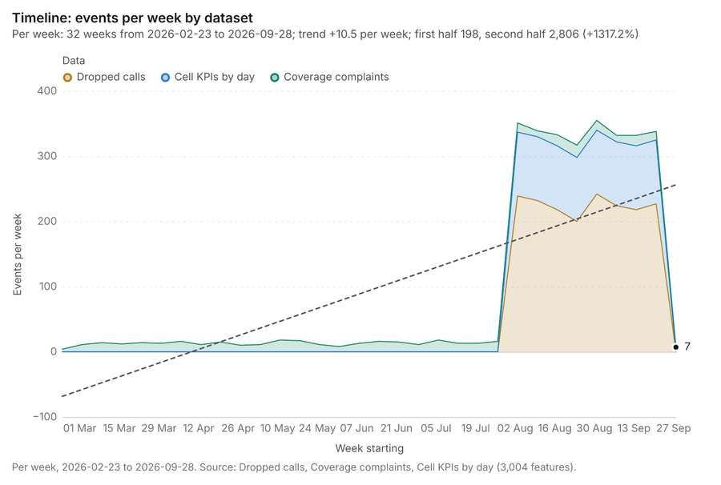
Figure 1. Timeline: events per week by dataset [1]. Per week, 2026-02-23 to 2026-09-28. Source: Dropped calls, Coverage complaints, Cell KPIs by day (3,004 features). The data is in the appendix.
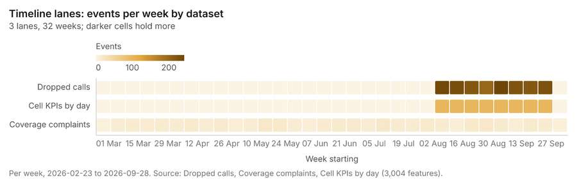
Figure 2. Timeline lanes: events per week by dataset [5]. Per week, 2026-02-23 to 2026-09-28. Source: Dropped calls, Coverage complaints, Cell KPIs by day (3,004 features). The data is in the appendix.
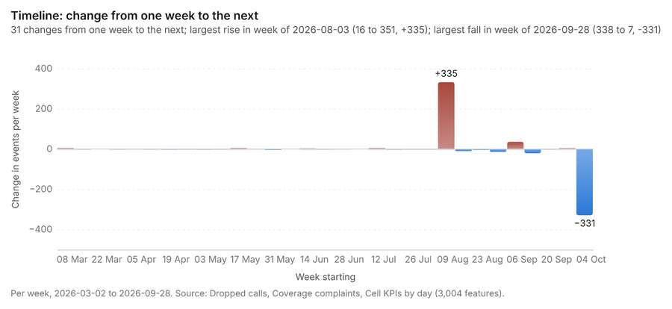
Figure 3. Timeline: change from one week to the next [6]. Per week, 2026-03-02 to 2026-09-28. Source: Dropped calls, Coverage complaints, Cell KPIs by day (3,004 features). The data is in the appendix.
The timeline counts 3,004 dated events in Dropped calls, Coverage complaints, Cell KPIs by day per week, from week of 2026-02-23 to week of 2026-09-28 [1][2][3][4]. By dataset: Dropped calls 1,800; Cell KPIs by day 784; Coverage complaints 420 [1][5]. The trend is +10.5 events per week; the second half of the weeks has 2,806 against 198 in the first (+1317.2%) [1]. Week over week, the largest rise was from week of 2026-07-27 to week of 2026-08-03 (16 to 351, +335) and the largest fall was from week of 2026-09-21 to week of 2026-09-28 (338 to 7, -331) [1][6]. The count rose from 200 in week of 2026-08-24 to 242 in week of 2026-08-31 (+21.0%), within what chance would give (p = 0.051) [7][8]. Between the two, the largest rise was in Los Olivos (28 to 41, +13) and the largest fall in Barrio Norte (12 to 5, -7) [7][8]. The count rose from 9 in week of 2026-08-10 to 17 in week of 2026-08-17 (+88.9%), within what chance would give (p = 0.169) [9][10]. Between the two, the largest rise was in El Puerto Viejo (0 to 3, +3) and the largest fall in La Ribera (2 to 1, -1) [9][10].
Busiest weeks
- week of 2026-08-31: 355 events [1]
- week of 2026-08-03: 351 events [1]
- week of 2026-08-10: 339 events [1]
Quietest weeks
- week of 2026-02-23: 4 events [1]
- week of 2026-09-28: 7 events [1]
- week of 2026-06-01: 8 events [1]

Overview
Overview: the top 3 results in the report's order, each in one distinct color, over Neighborhoods as context [11].
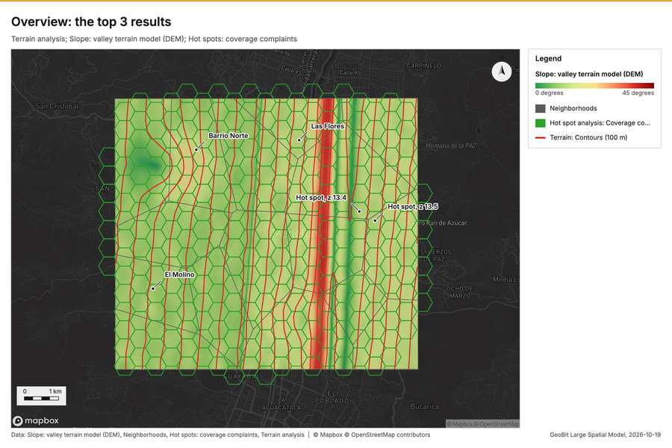
Figure 4. Overview: the top 3 results [11]

Spatial structure
Neighborhoods are 16 areas of 4.503 km2 on average, covering 100 percent of their extent, with no overlap [12]. Towers are evenly spread (dispersed) (nearest-neighbor ratio 1.82, z = +5.8; features lie 1.396 km apart on average against 768 m if random) [13]. Dropped calls are clustered (nearest-neighbor ratio 0.87, z = -10.7; features lie 85.2 m apart on average against 98.1 m if random) [14]. Coverage complaints are clustered (nearest-neighbor ratio 0.87, z = -5.0; features lie 177 m apart on average against 202 m if random) [15]. Coverage complaints are dated by 'date' from 2026-03-01 to 2026-09-30 at a week grain [15]. Over time the pattern changes: the earlier half is clustered (ratio 0.873) and the later half random (ratio 0.9552); the center moved 305 m [15]. Fiber routes form a connected network: 19 lines with 7 junctions and 84 crossings in 1 connected part, 61.98 km in all [16]. Small cells are spread at random (nearest-neighbor ratio 1.07, z = +0.8; features lie 686 m apart on average against 643 m if random) [17]. 100 percent of Coverage complaints lie inside Neighborhoods (420 of 420) [12][15]. 100 percent of Dropped calls lie inside Neighborhoods (1800 of 1800) [12][14]. 100 percent of Fiber routes lie inside Neighborhoods (19 of 19) [12][16]. 100 percent of Small cells lie inside Neighborhoods (40 of 40) [12][17]. 100 percent of Towers lie inside Neighborhoods (14 of 14) [12][13]. Towers lie 0 m from the nearest of Fiber routes (median); 86 percent lie within 100 m [13][16]. Coverage complaints lie 62.7 m from the nearest of Dropped calls (median); 64 percent lie within 100 m [14][15]. Small cells lie 91.5 m from the nearest of Dropped calls (median); 52 percent lie within 100 m [14][17]. Towers lie 134 m from the nearest of Dropped calls (median); 100 percent lie within 500 m [13][14]. Dropped calls lie 170 m from the nearest of Coverage complaints (median); 94 percent lie within 500 m [14][15].
Result | Value
layers profiled | 6
clustered point layers | 2
dispersed point layers | 1
random point layers | 1

Findings
- Evidenced: Neighborhoods are 16 areas of 4.503 km2 on average, covering 100 percent of their extent, with no overlap [12].
- Evidenced: Towers are evenly spread (dispersed) (nearest-neighbor ratio 1.82, z = +5.8; features lie 1.396 km apart on average against 768 m if random) [13].
- Evidenced: Dropped calls are clustered (nearest-neighbor ratio 0.87, z = -10.7; features lie 85.2 m apart on average against 98.1 m if random) [14].
- Evidenced: Coverage complaints are clustered (nearest-neighbor ratio 0.87, z = -5.0; features lie 177 m apart on average against 202 m if random) [15].
- Evidenced: Coverage complaints are dated by 'date' from 2026-03-01 to 2026-09-30 at a week grain [15].
- Evidenced: Over time the pattern changes: the earlier half is clustered (ratio 0.873) and the later half random (ratio 0.9552); the center moved 305 m [15].
- Evidenced: Fiber routes form a connected network: 19 lines with 7 junctions and 84 crossings in 1 connected part, 61.98 km in all [16].
- Evidenced: Small cells are spread at random (nearest-neighbor ratio 1.07, z = +0.8; features lie 686 m apart on average against 643 m if random) [17].
- Evidenced: 100 percent of Coverage complaints lie inside Neighborhoods (420 of 420) [12][15].
- Evidenced: 100 percent of Dropped calls lie inside Neighborhoods (1800 of 1800) [12][14].
- Evidenced: 100 percent of Fiber routes lie inside Neighborhoods (19 of 19) [12][16].
- Evidenced: 100 percent of Small cells lie inside Neighborhoods (40 of 40) [12][17].
- Evidenced: 100 percent of Towers lie inside Neighborhoods (14 of 14) [12][13].
- Evidenced: Towers lie 0 m from the nearest of Fiber routes (median); 86 percent lie within 100 m [13][16].
- Evidenced: Coverage complaints lie 62.7 m from the nearest of Dropped calls (median); 64 percent lie within 100 m [14][15].
- Evidenced: Small cells lie 91.5 m from the nearest of Dropped calls (median); 52 percent lie within 100 m [14][17].
- Evidenced: Towers lie 134 m from the nearest of Dropped calls (median); 100 percent lie within 500 m [13][14].
- Evidenced: Dropped calls lie 170 m from the nearest of Coverage complaints (median); 94 percent lie within 500 m [14][15].

Terrain analysis
What this analysis is. Terrain analysis: The automatic terrain analysis of an area, with no model call: by default every terrain tool (everything), or a subset (general, mobility, observation, hydrology, site), then the elevation layer, the hypsometric curve, slope distribution, aspect rose and route profiles, the dominant heights, the cited terrain findings (key terrain, chokepoints, corridors, flood-prone ground) and the terrain maps [18]. Large areas run coarser with the factor reported [18]. In ArcGIS it is No single tool (terrain analysis workflow: Surface Parameters, Viewshed, Hydrology, Distance Accumulation); in QGIS, No single tool (Processing model of GDAL DEM, r.viewshed, r.watershed and r.cost) [18].
Why it was run on this data. Automatic terrain analysis (everything) on the project's DEM Valley terrain model (DEM); observers from the 14 point(s) of Towers: every terrain tool: relief, slope, aspect, hillshade, curvature, roughness, landforms, ravines and ridges, strategic points, hydrology (flow, streams, pour points, watersheds, flood-prone ground), mobility for every mover, the MCOO, viewsheds and lines of sight from th [19].
What it found. Terrain analysis produced Terrain: Terrain findings (9 features), Terrain: Dominant heights (5 features), Terrain: Elevation (m) (0 features) [20][21][22][23]. It reported tokens, usd 0.737; tokens, tokens 737; tokens, tokens in 1; tokens, tokens out 184; numbers, maps 7; numbers, charts 4 [20]. The chart Hypsometric curve is drawn from 20 rows [131]. The chart Slope distribution is drawn from 6 rows [132]. The chart Aspect rose is drawn from 8 rows [133]. The chart Elevation along the routes is drawn from 320 rows [134]. The chart Terrain: Contours (100 m) is drawn from 6 rows [135]. The chart Terrain: Ravines is drawn from 5 rows [136]. The chart Terrain: Ridges is drawn from 7 rows [137]. The chart Terrain: Observation points is drawn from 5 rows [138]. The chart Terrain: Open flat ground is drawn from 5 rows [139]. The chart Terrain: Terrain masking (cover) is drawn from 5 rows [140]. The chart Terrain: Streams (Strahler order) is drawn from 5 rows [141]. The chart Terrain: Pour points is drawn from 5 rows [142]. The chart Terrain: Watershed boundaries is drawn from 5 rows [143]. The chart Terrain: Pour points (snapped) is drawn from 5 rows [144]. The chart Terrain: Streams (Strahler order) is drawn from 5 rows [145]. The chart Terrain: Flood-prone areas is drawn from 5 rows [146]. The chart Terrain dismounted: Obstacles is drawn from 1 rows [147]. The chart Terrain wheeled: Obstacles is drawn from 5 rows [148]. The chart Terrain tracked: Obstacles is drawn from 1 rows [149]. The chart Terrain: Obstacles is drawn from 1 rows [150]. The chart Terrain: Mobility corridors is drawn from 5 rows [151]. The chart Terrain: Key terrain candidates is drawn from 5 rows [152]. The chart Terrain: Corridor constrictions is drawn from 5 rows [153]. The chart Terrain: Avenues of approach is drawn from 5 rows [154]. The chart Terrain heights: Visible area is drawn from 5 rows [155]. The chart Terrain heights: Observers is drawn from 5 rows [156]. The chart Terrain DH-1 DH-2: Sightline is drawn from 1 rows [157]. The chart Terrain DH-1 DH-3: Sightline is drawn from 1 rows [158]. The chart Terrain DH-1 DH-3: Ground visible from the observer is drawn from 5 rows [159]. The chart Terrain DH-2 DH-3: Sightline is drawn from 1 rows [160]. The chart Terrain axis: Least-cost routes is drawn from 1 rows [161]. The chart Terrain summits: Least-cost routes is drawn from 1 rows [162]. The chart Terrain axis: Profile line is drawn from 1 rows [163]. The chart Terrain summits: Profile line is drawn from 1 rows [164]. The chart Terrain: Best buildability areas is drawn from 8 rows [165]. The chart Terrain: Best mineability areas is drawn from 5 rows [166]. The chart Terrain: Landing zone candidates is drawn from 5 rows [167]. The chart Terrain: Landing points is drawn from 1 rows [168]. The chart Terrain: Visible area is drawn from 1 rows [169]. The chart Terrain: Observers is drawn from 5 rows [170]. The chart Terrain: Dominant heights is drawn from 5 rows [171].
Result | Value
tokens, usd | 0.737
tokens, tokens | 737
tokens, tokens in | 1
tokens, tokens out | 184
numbers, maps | 7
numbers, charts | 4
numbers, layers | 80
numbers, area km2 | 72.09
numbers, findings | 55
numbers, flat pct | 0.273
numbers, relief m | 1,284
numbers, corridors | 2
numbers, steps run | 35
numbers, tools run | 28
numbers, chokepoints | 3
numbers, key terrain | 2
numbers, steps failed | 1
numbers, calls skipped | 0
numbers, mean slope deg | 13.16
numbers, elevation max m | 2,759

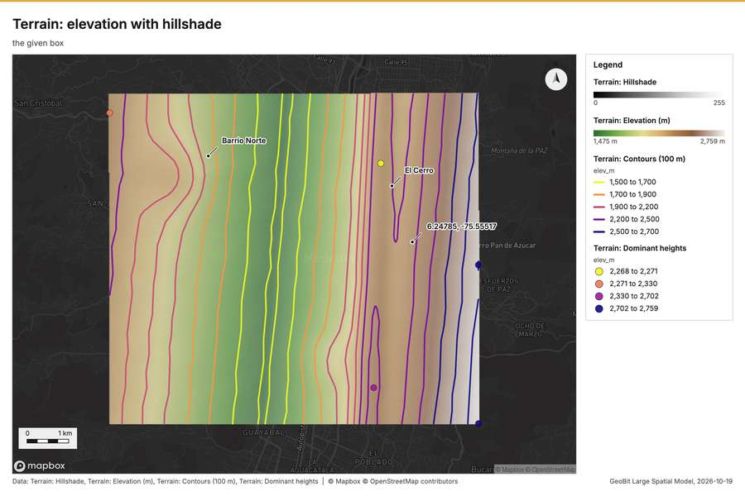
Figure 5. Terrain: elevation with hillshade [101]
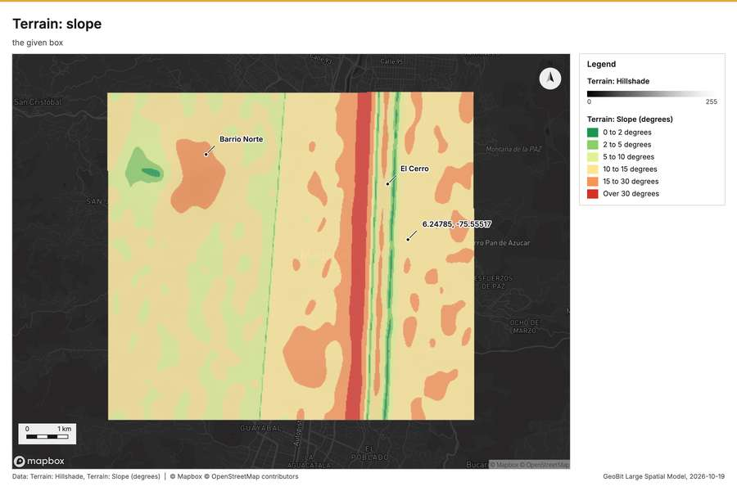
Figure 6. Terrain: slope [102]
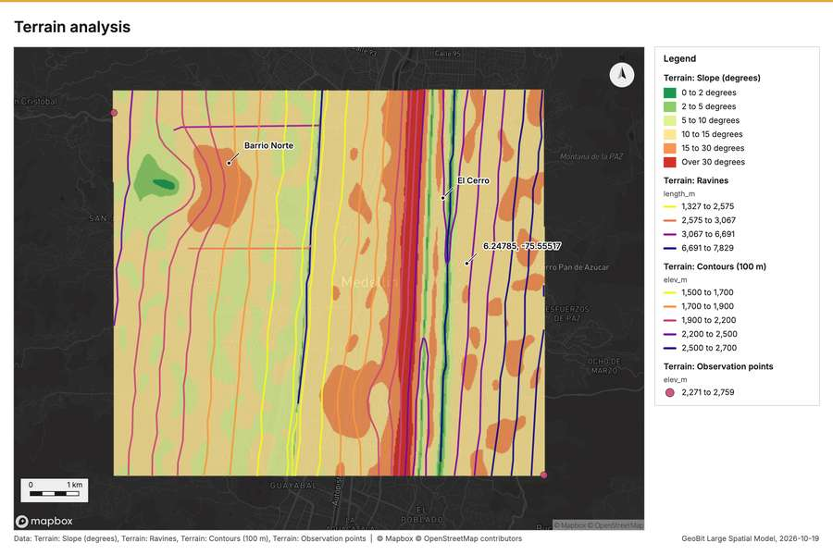
Figure 7. Terrain analysis [103]
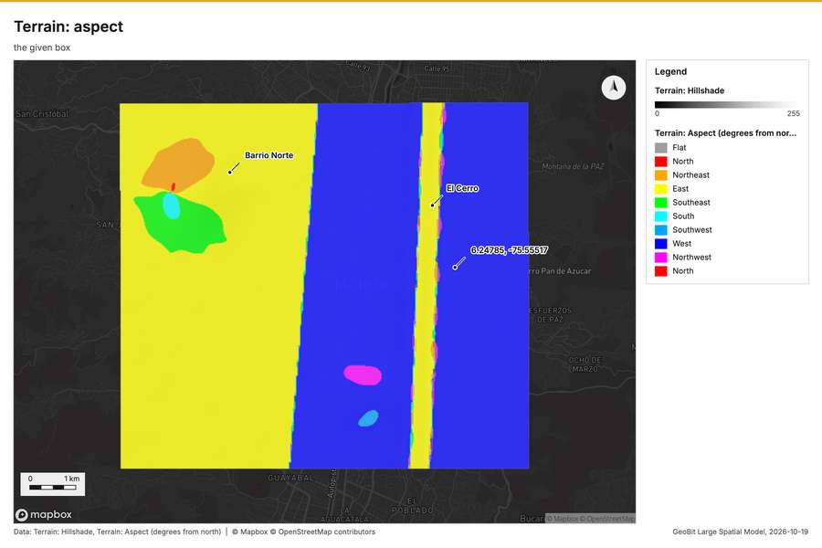
Figure 8. Terrain: aspect [104]
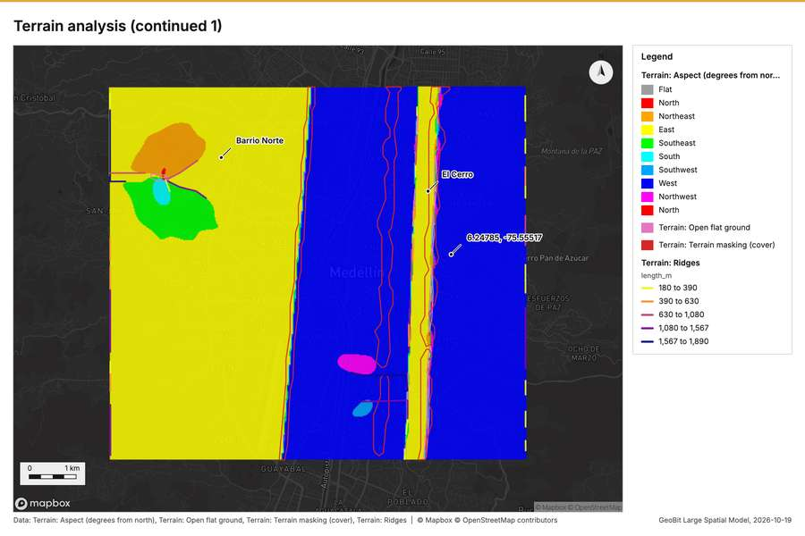
Figure 9. Terrain analysis (continued 1) [105]
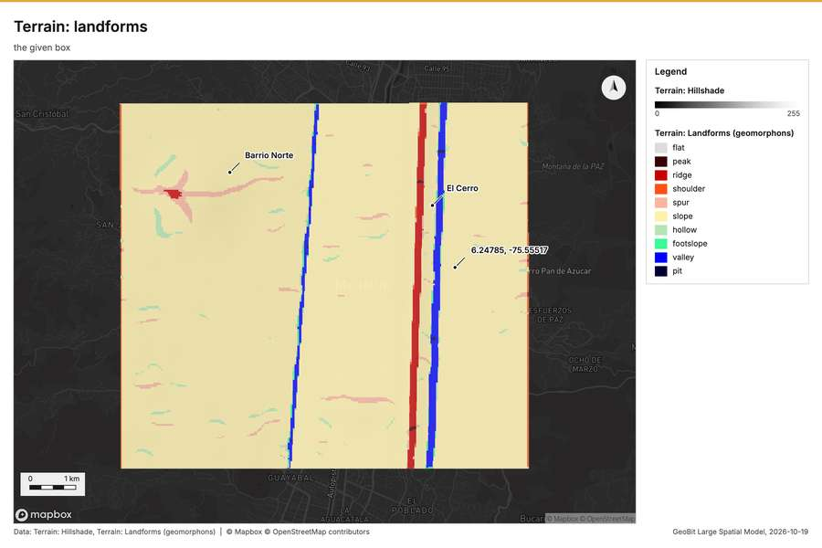
Figure 10. Terrain: landforms [106]
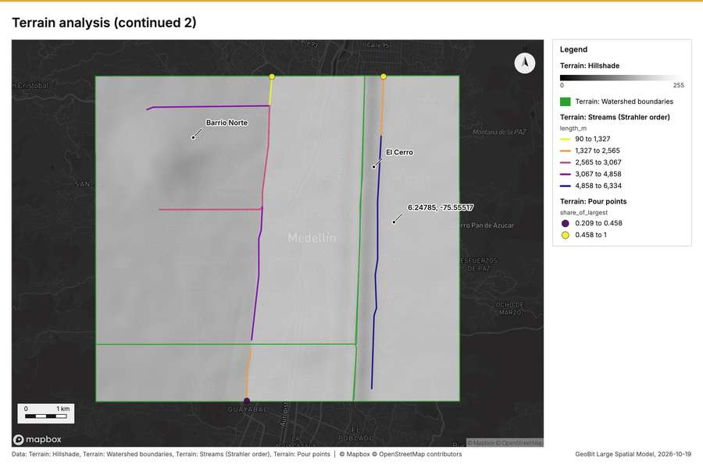
Figure 11. Terrain analysis (continued 2) [107]
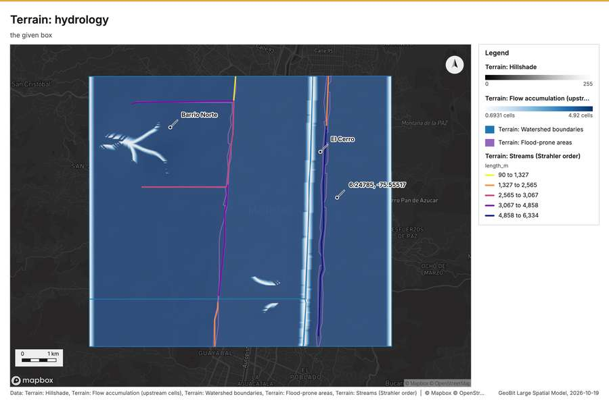
Figure 12. Terrain: hydrology [108]
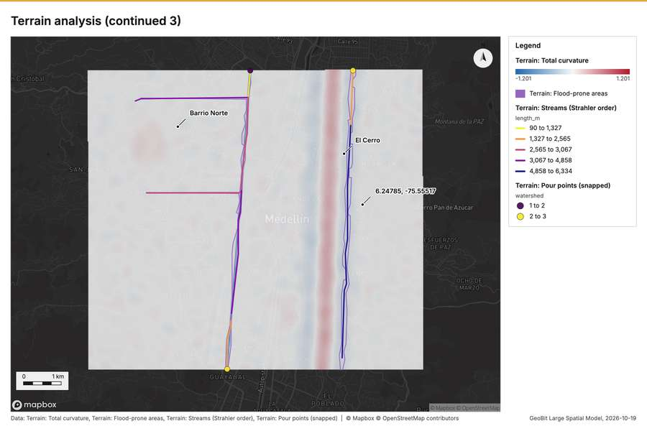
Figure 13. Terrain analysis (continued 3) [109]
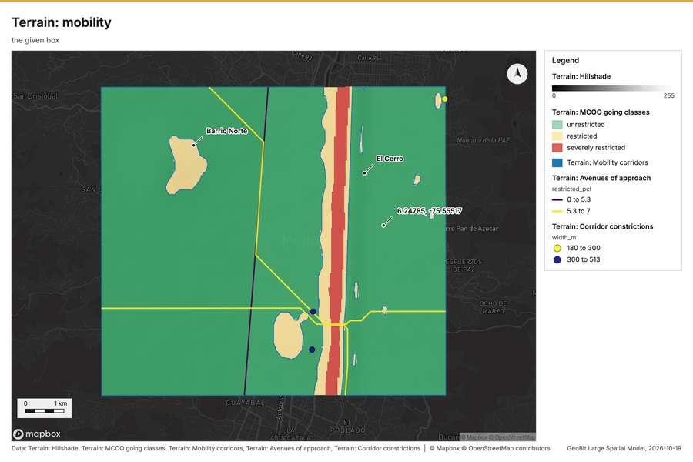
Figure 14. Terrain: mobility [110]
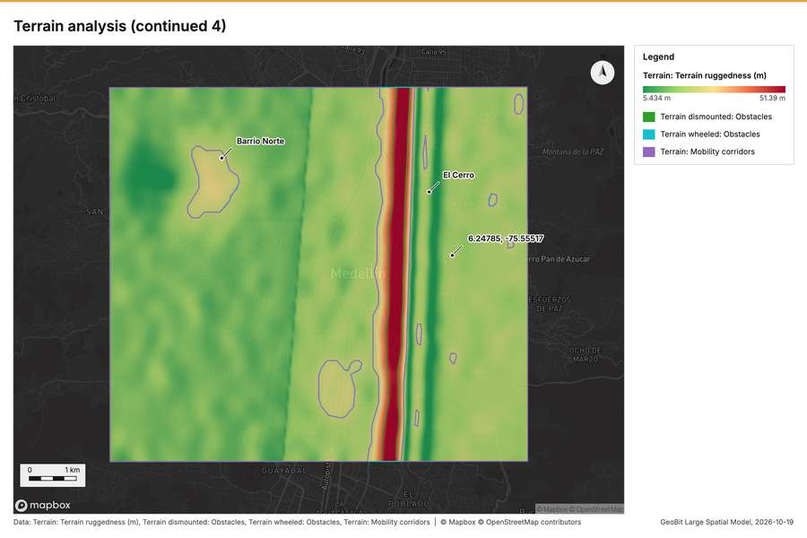
Figure 15. Terrain analysis (continued 4) [111]
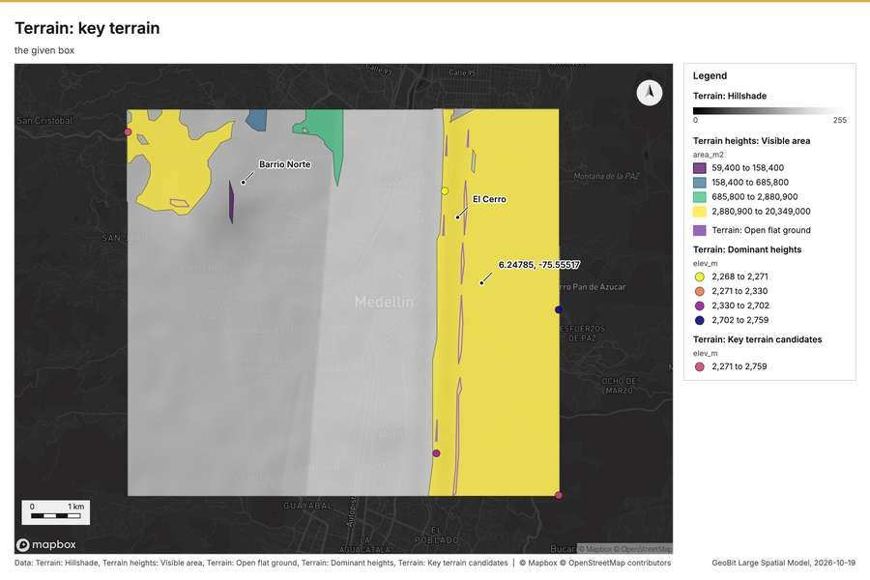
Figure 16. Terrain: key terrain [112]
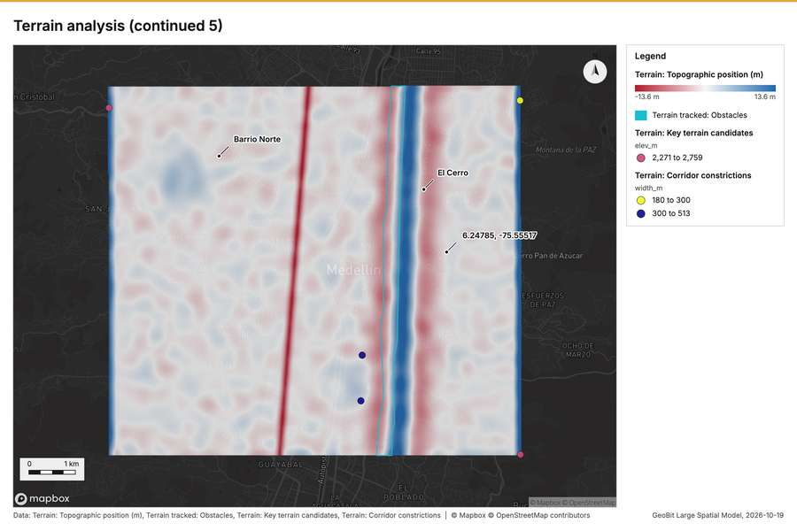
Figure 17. Terrain analysis (continued 5) [113]
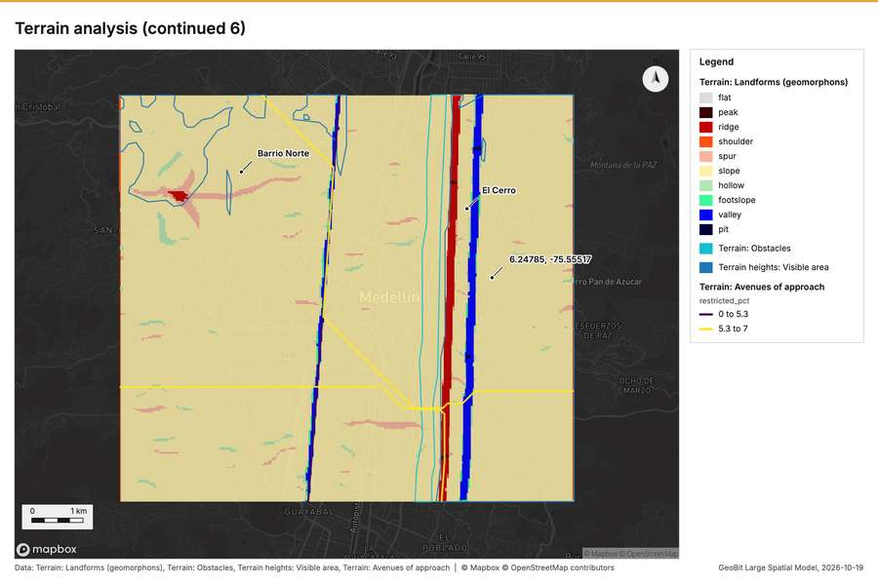
Figure 18. Terrain analysis (continued 6) [114]
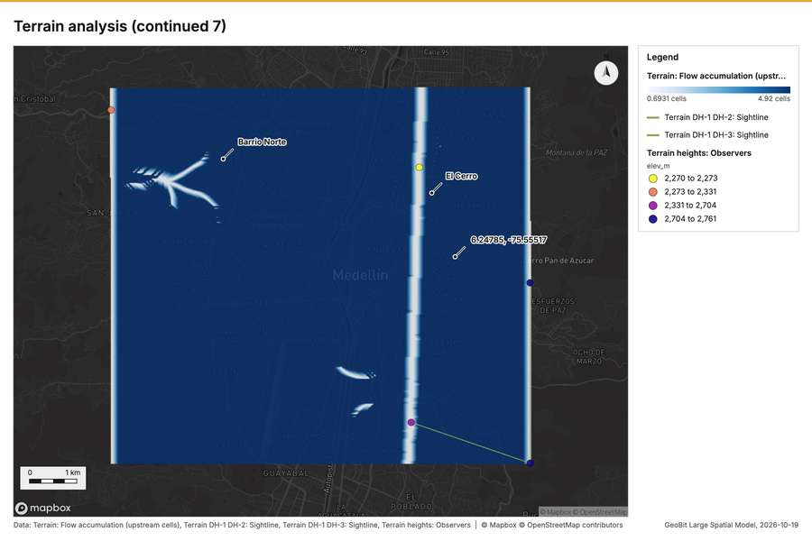
Figure 19. Terrain analysis (continued 7) [115]
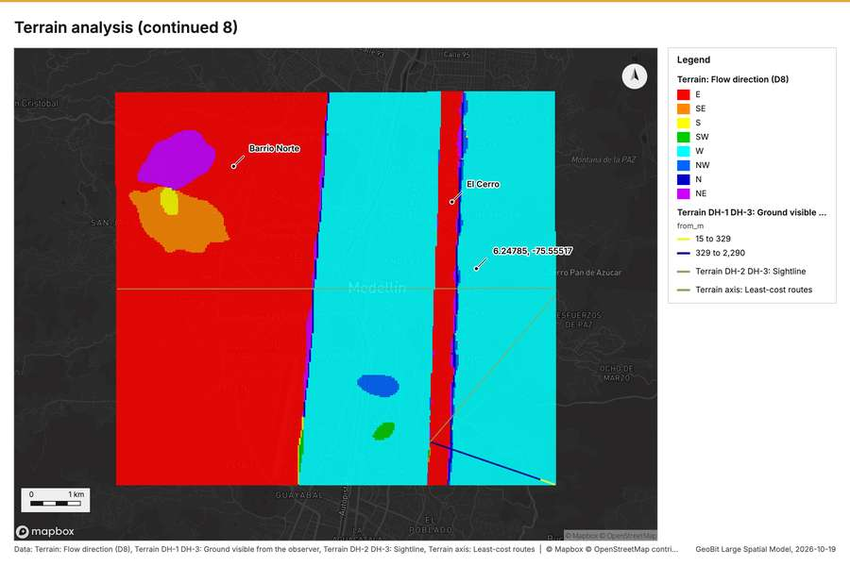
Figure 20. Terrain analysis (continued 8) [116]
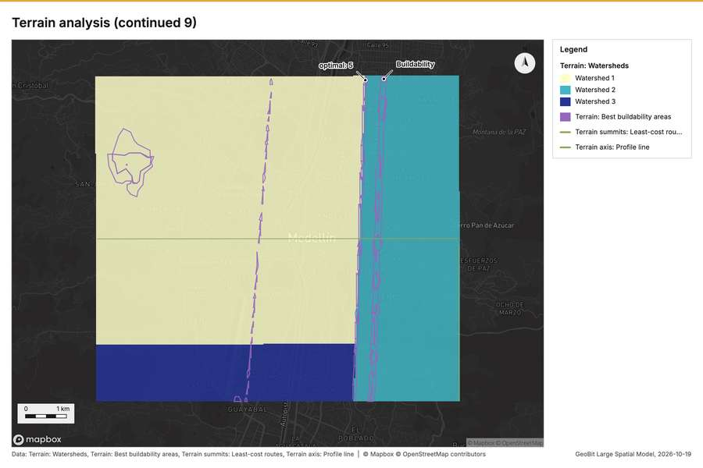
Figure 21. Terrain analysis (continued 9) [117]
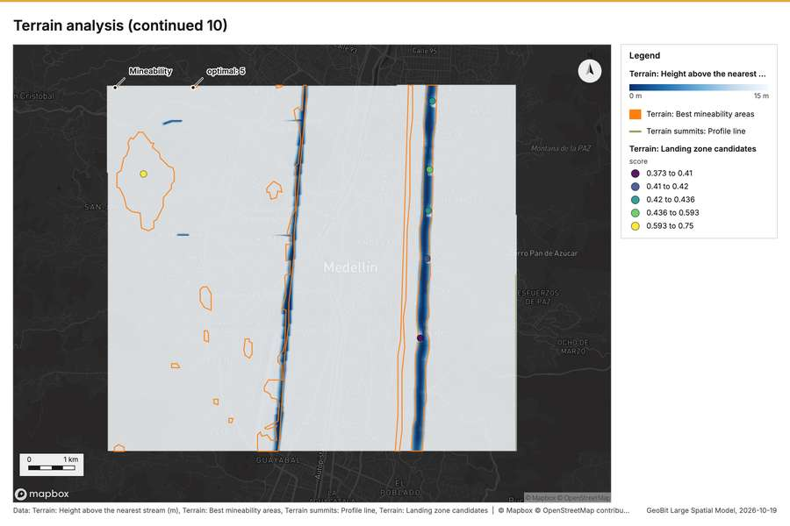
Figure 22. Terrain analysis (continued 10) [118]
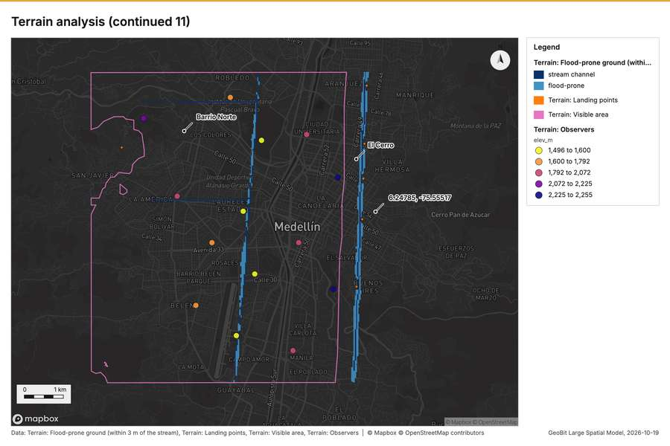
Figure 23. Terrain analysis (continued 11) [119]
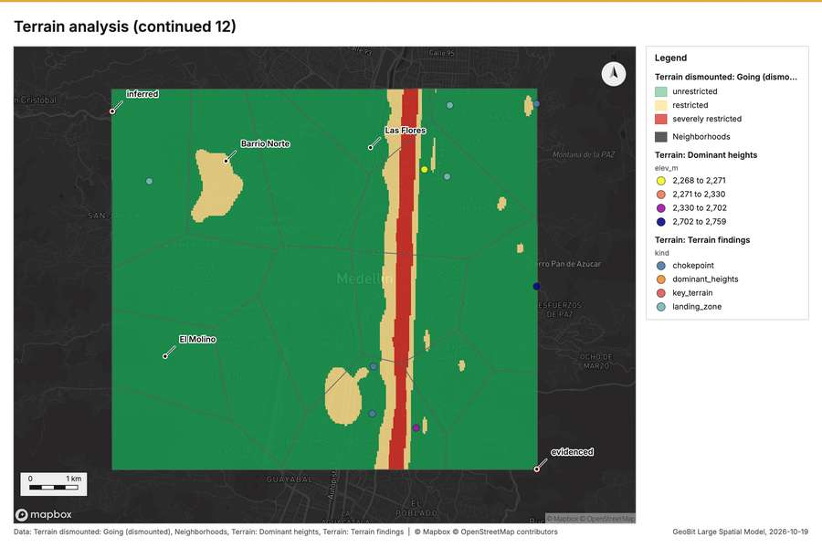
Figure 24. Terrain analysis (continued 12) [120]
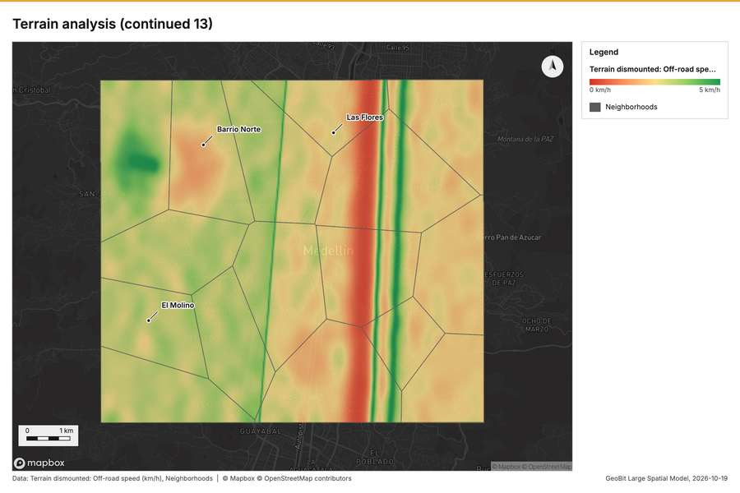
Figure 25. Terrain analysis (continued 13) [121]
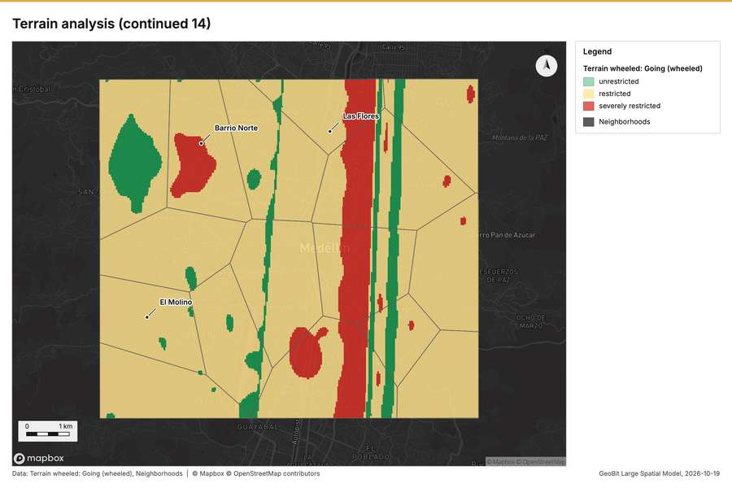
Figure 26. Terrain analysis (continued 14) [122]
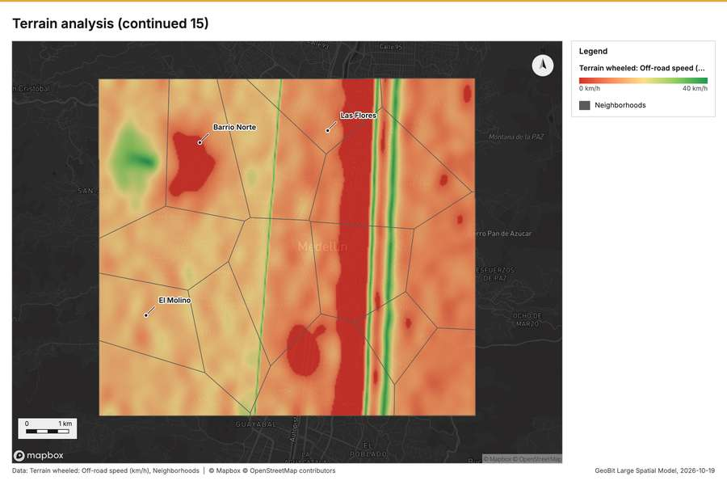
Figure 27. Terrain analysis (continued 15) [123]
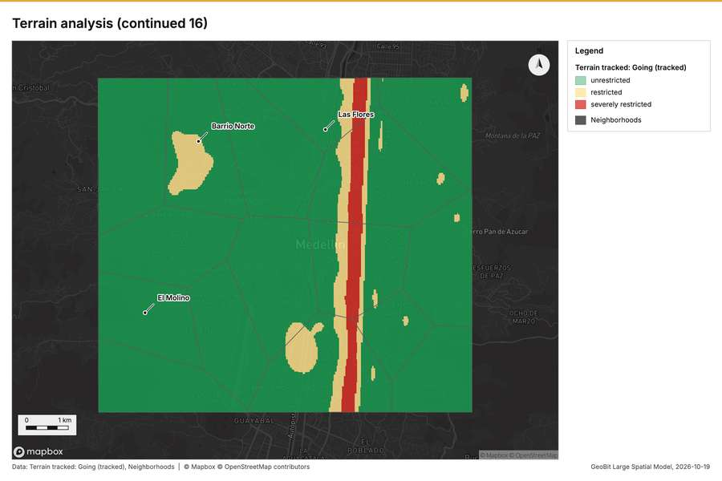
Figure 28. Terrain analysis (continued 16) [124]
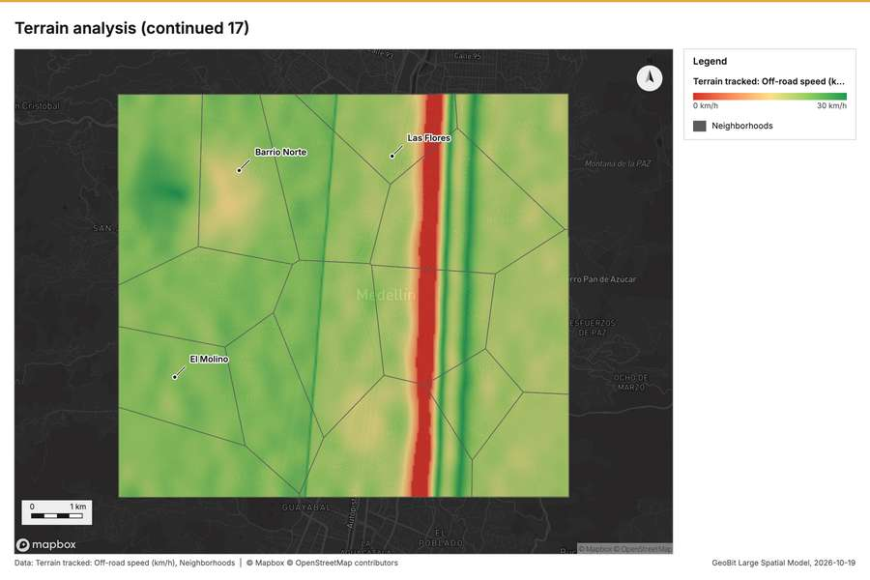
Figure 29. Terrain analysis (continued 17) [125]
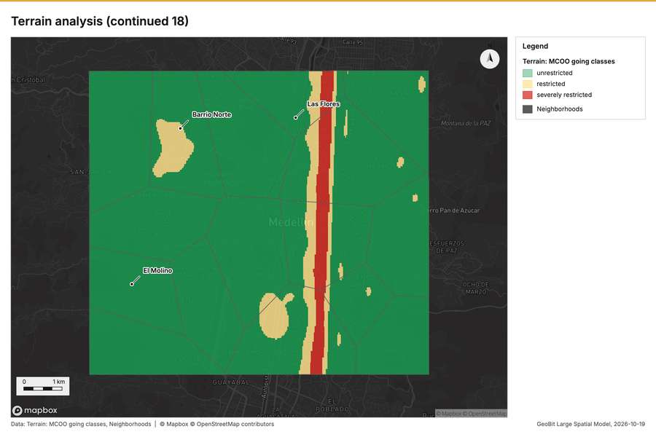
Figure 30. Terrain analysis (continued 18) [126]
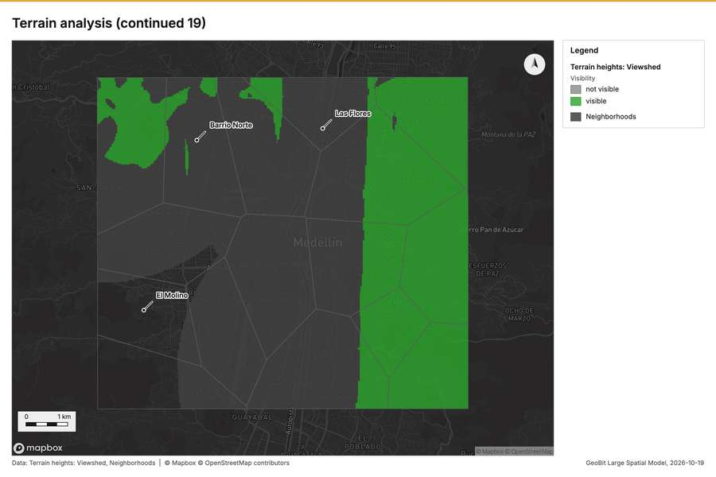
Figure 31. Terrain analysis (continued 19) [127]
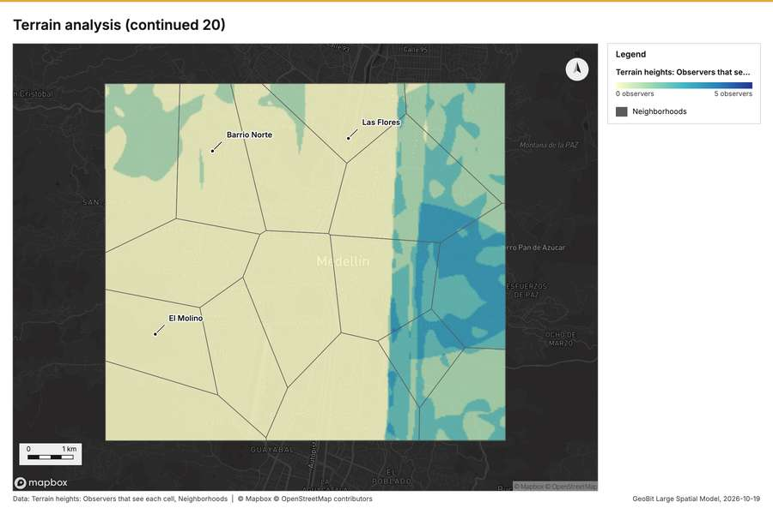
Figure 32. Terrain analysis (continued 20) [128]
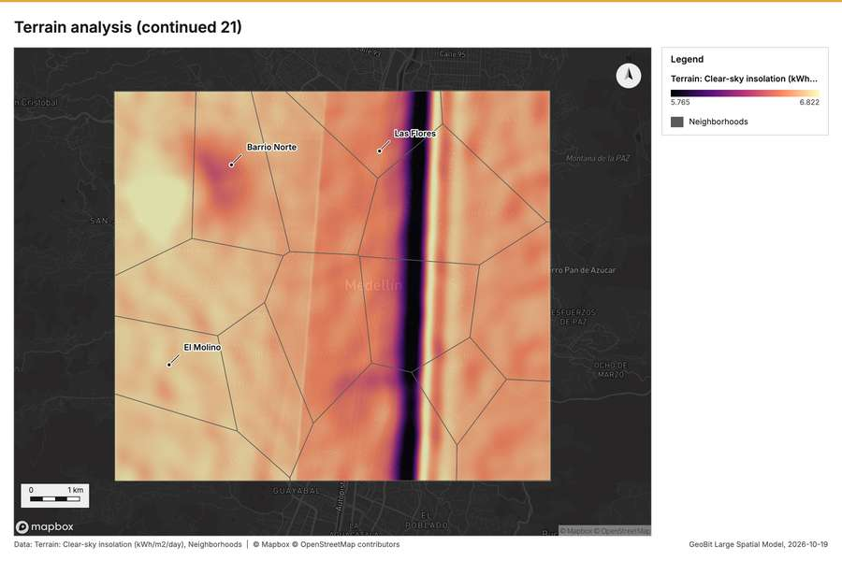
Figure 33. Terrain analysis (continued 21) [129]
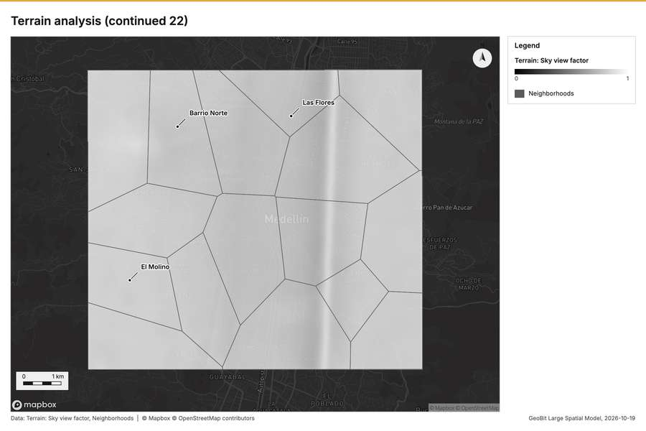
Figure 34. Terrain analysis (continued 22) [130]
What the map shows. The map shades Terrain: Hillshade on a continuous ramp from 0 to 255 [101]. The map shades Terrain: Elevation (m) on a continuous ramp from 1,475 m to 2,759 m [101]. The map draws Terrain: Contours (100 m) by elev_m in 5 classes: 1,500 to 1,700, 1,700 to 1,900, 1,900 to 2,200, 2,200 to 2,500, 2,500 to 2,700 [101]. The map draws Terrain: Dominant heights by elev_m in 4 classes: 2,268 to 2,271, 2,271 to 2,330, 2,330 to 2,702, 2,702 to 2,759 [101]. It draws 29 features [101]. It covers longitude -75.643 to -75.519 and latitude 6.197 to 6.289, at about 1:57,116 [101].
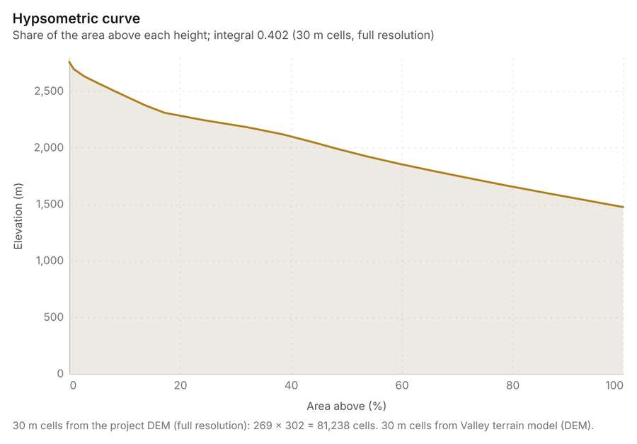
Figure 35. Hypsometric curve [131]. 30 m cells from the project DEM (full resolution): 269 x 302 = 81,238 cells. 30 m cells from Valley terrain model (DEM). The data is in the appendix.
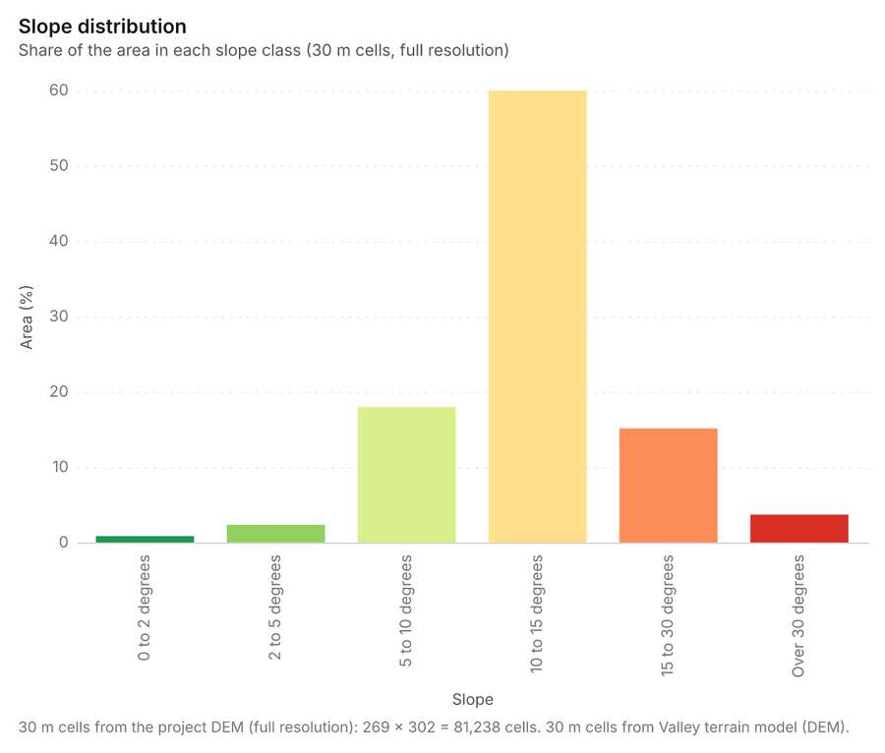
Figure 36. Slope distribution [132]. 30 m cells from the project DEM (full resolution): 269 x 302 = 81,238 cells. 30 m cells from Valley terrain model (DEM). The data is in the appendix.
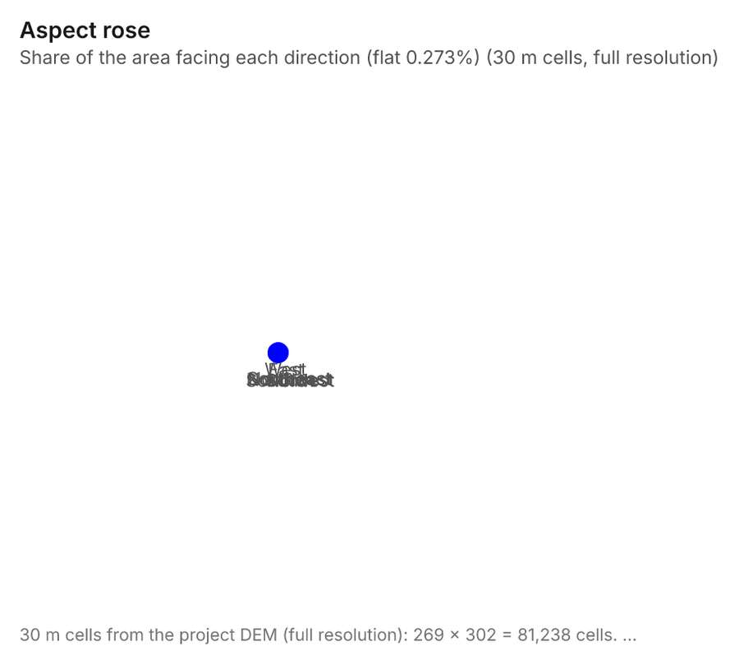
Figure 37. Aspect rose [133]. 30 m cells from the project DEM (full resolution): 269 x 302 = 81,238 cells. 30 m cells from Valley terrain model (DEM). The data is in the appendix.
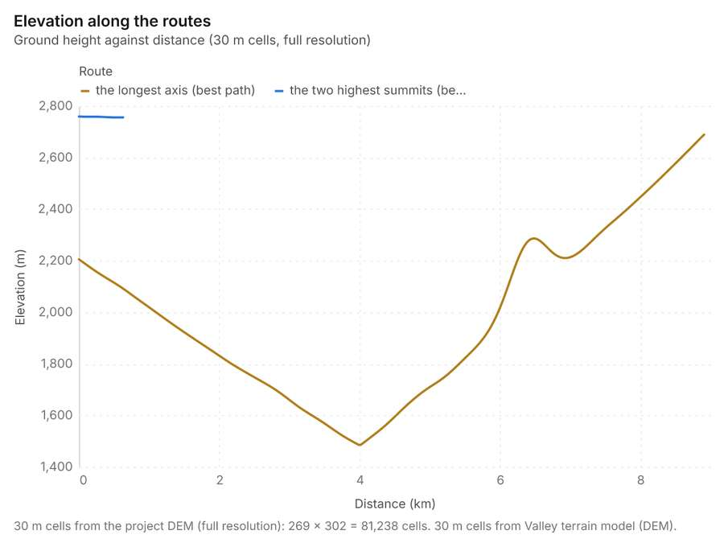
Figure 38. Elevation along the routes [134]. 30 m cells from the project DEM (full resolution): 269 x 302 = 81,238 cells. 30 m cells from Valley terrain model (DEM). The data is in the appendix.
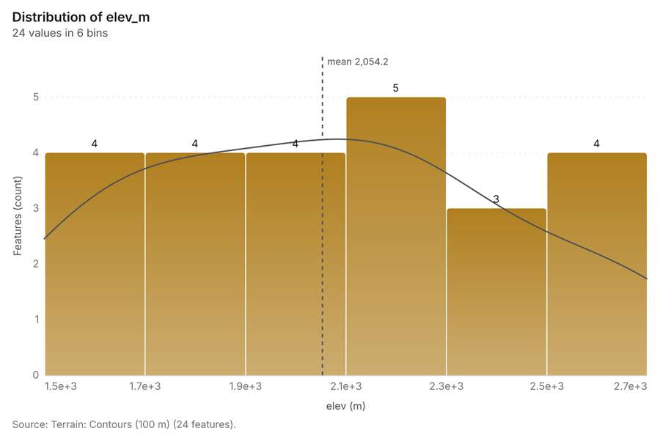
Figure 39. Terrain: Contours (100 m) [135]. Source: Terrain: Contours (100 m) (24 features). The data is in the appendix.
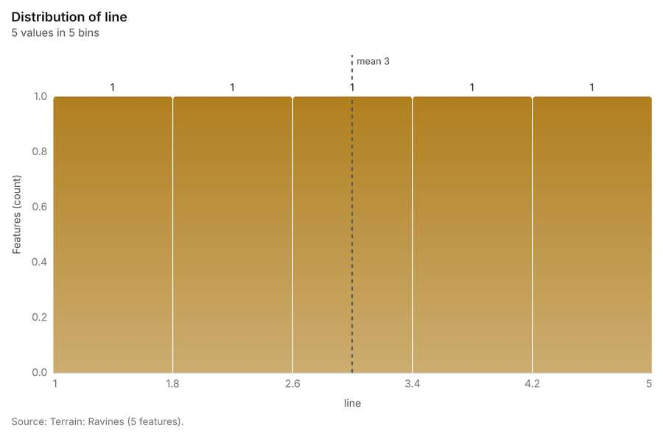
Figure 40. Terrain: Ravines [136]. Source: Terrain: Ravines (5 features). The data is in the appendix.
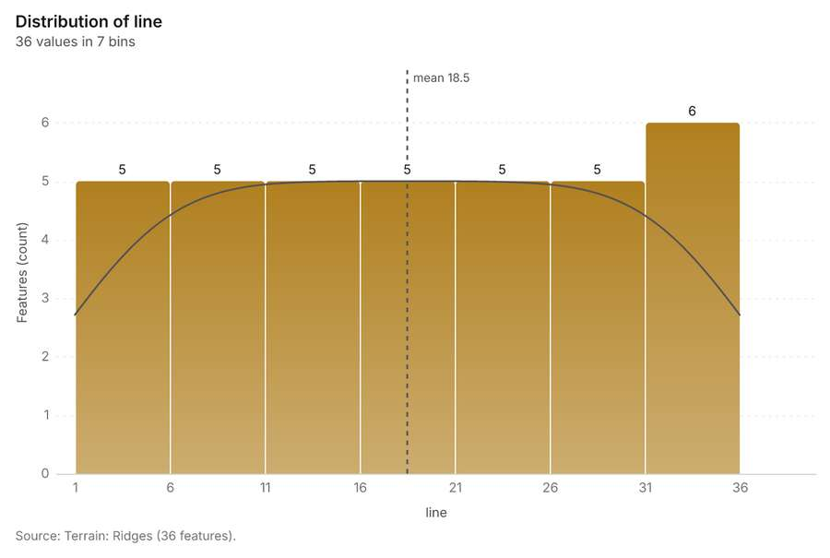
Figure 41. Terrain: Ridges [137]. Source: Terrain: Ridges (36 features). The data is in the appendix.
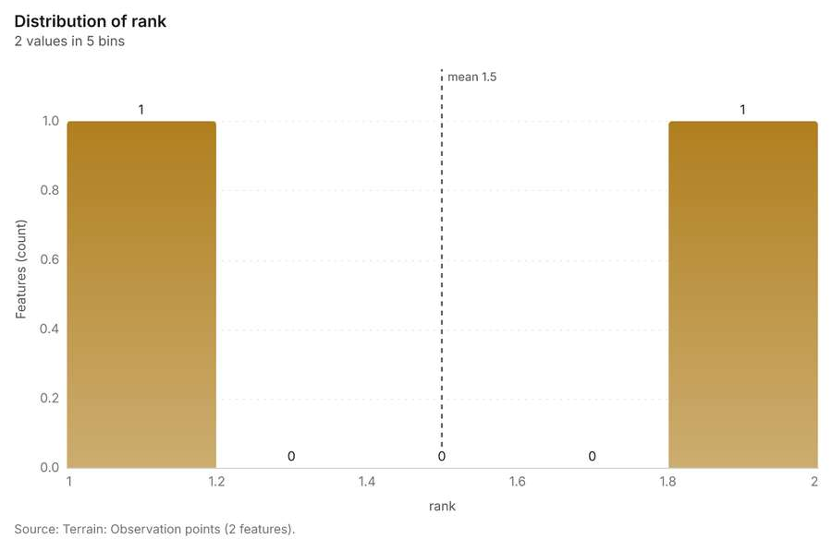
Figure 42. Terrain: Observation points [138]. Source: Terrain: Observation points (2 features). The data is in the appendix.
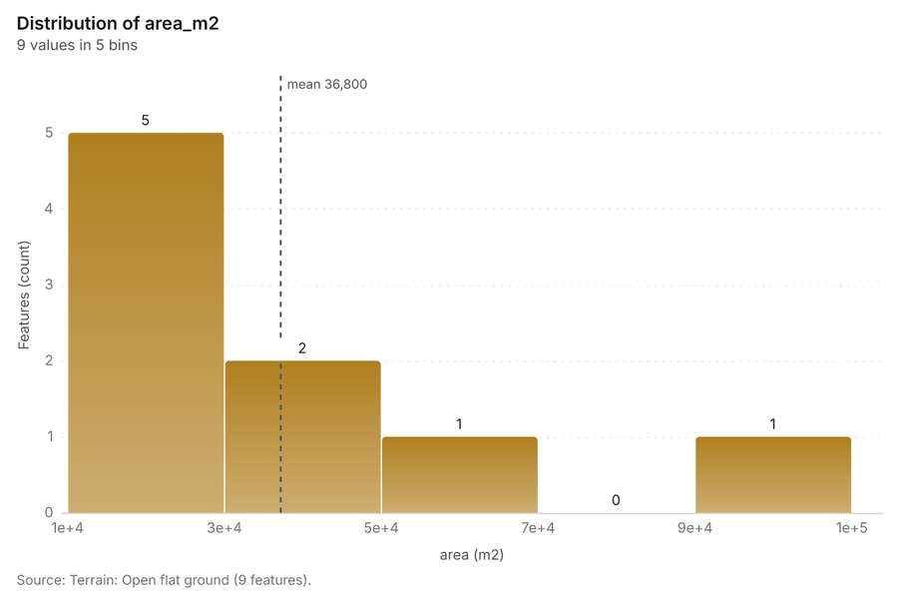
Figure 43. Terrain: Open flat ground [139]. Source: Terrain: Open flat ground (9 features). The data is in the appendix.
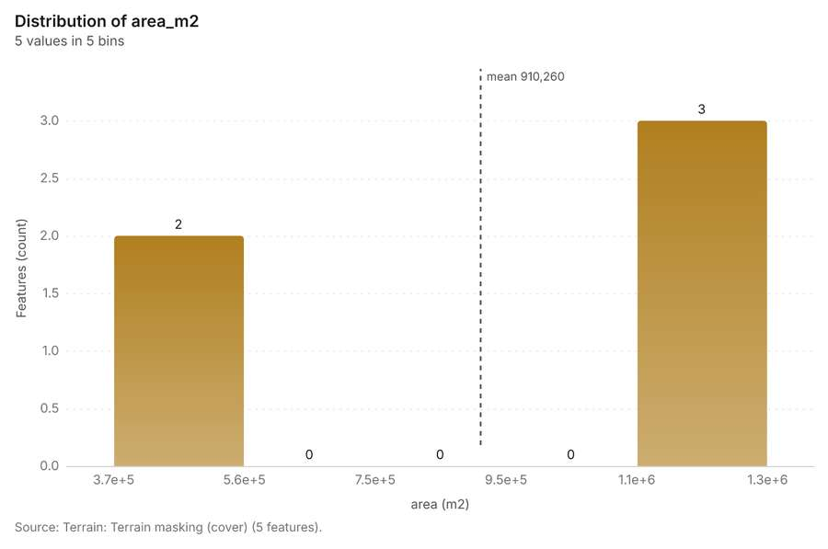
Figure 44. Terrain: Terrain masking (cover) [140]. Source: Terrain: Terrain masking (cover) (5 features). The data is in the appendix.
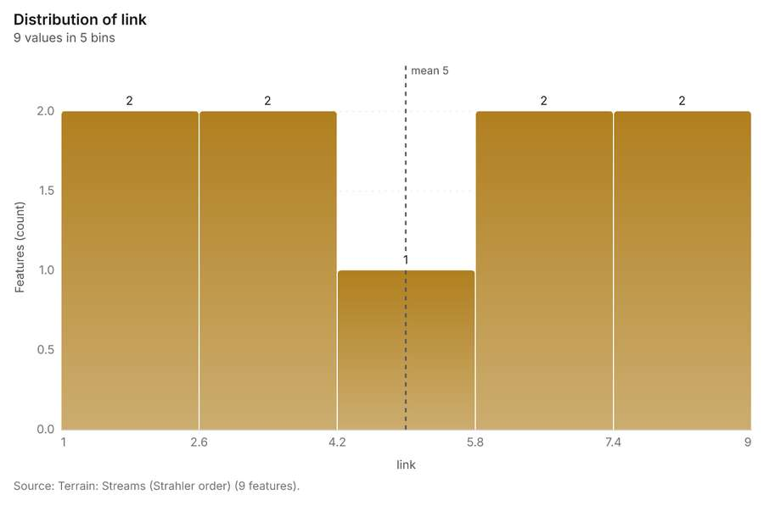
Figure 45. Terrain: Streams (Strahler order) [141]. Source: Terrain: Streams (Strahler order) (9 features). The data is in the appendix.
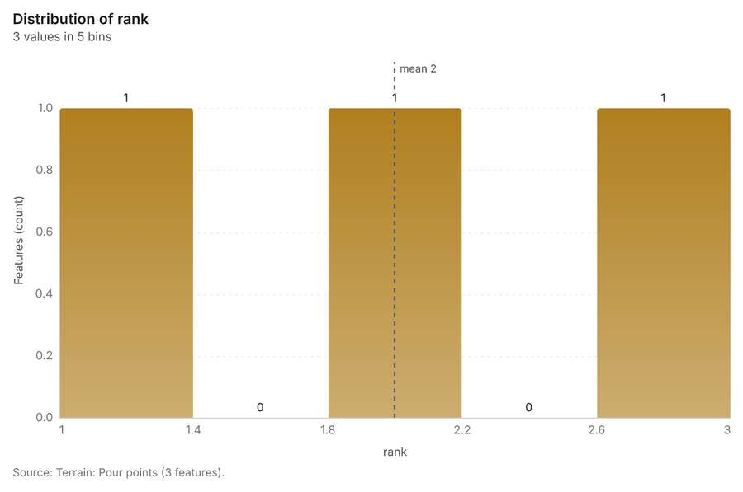
Figure 46. Terrain: Pour points [142]. Source: Terrain: Pour points (3 features). The data is in the appendix.
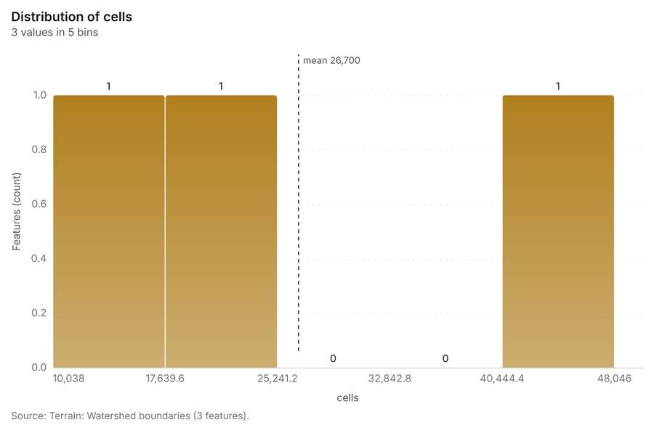
Figure 47. Terrain: Watershed boundaries [143]. Source: Terrain: Watershed boundaries (3 features). The data is in the appendix.
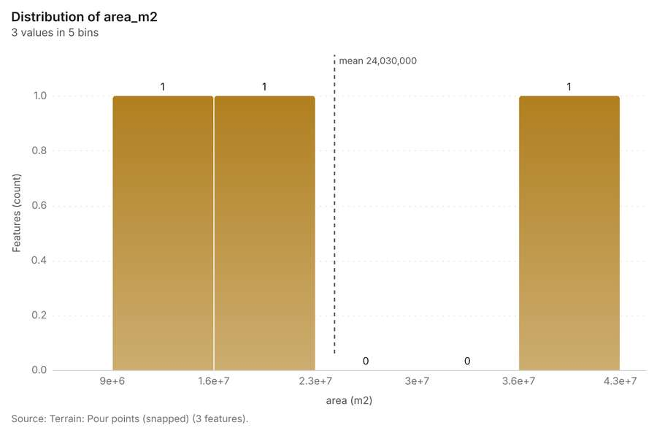
Figure 48. Terrain: Pour points (snapped) [144]. Source: Terrain: Pour points (snapped) (3 features). The data is in the appendix.
Figure 49. Terrain: Streams (Strahler order) [145]. Source: Terrain: Streams (Strahler order) (9 features). The data is in the appendix.
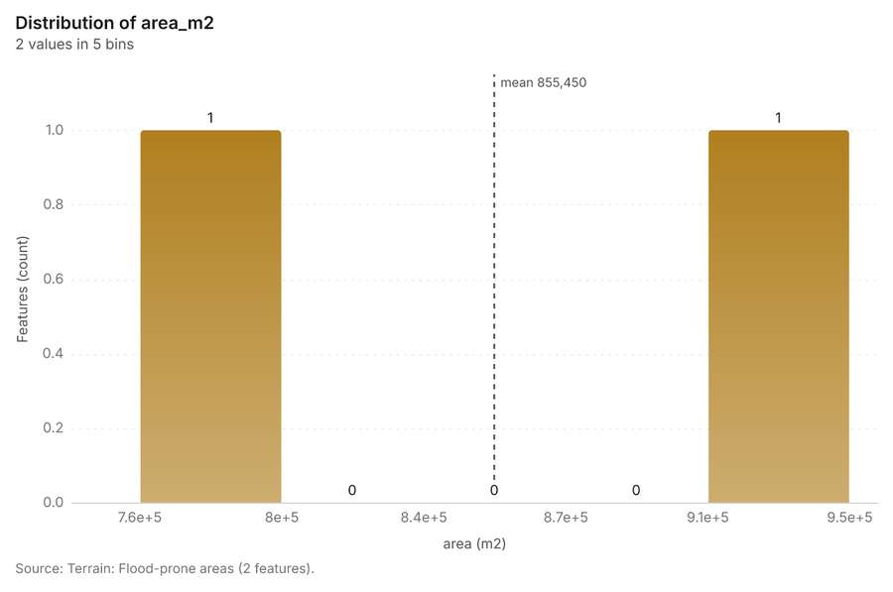
Figure 50. Terrain: Flood-prone areas [146]. Source: Terrain: Flood-prone areas (2 features). The data is in the appendix.
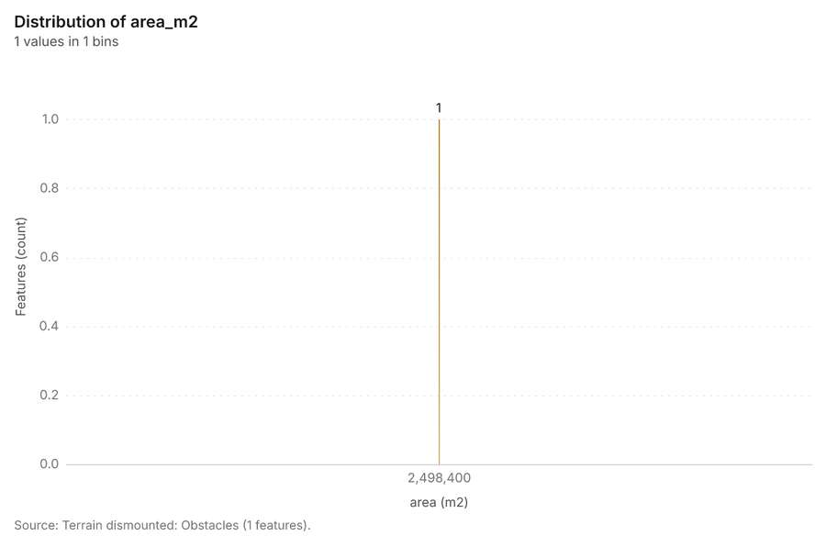
Figure 51. Terrain dismounted: Obstacles [147]. Source: Terrain dismounted: Obstacles (1 features). The data is in the appendix.
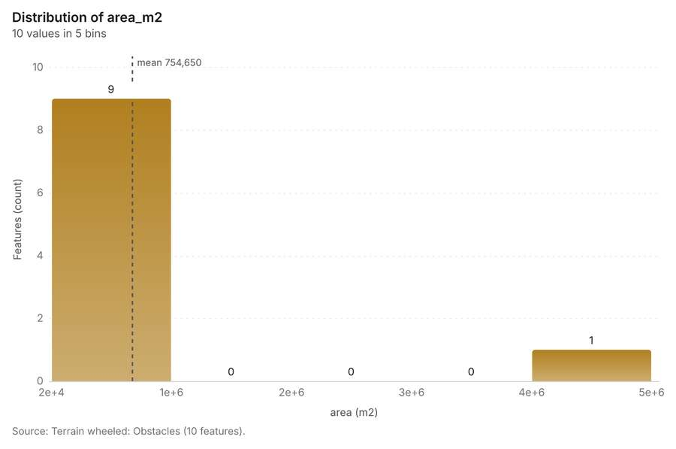
Figure 52. Terrain wheeled: Obstacles [148]. Source: Terrain wheeled: Obstacles (10 features). The data is in the appendix.
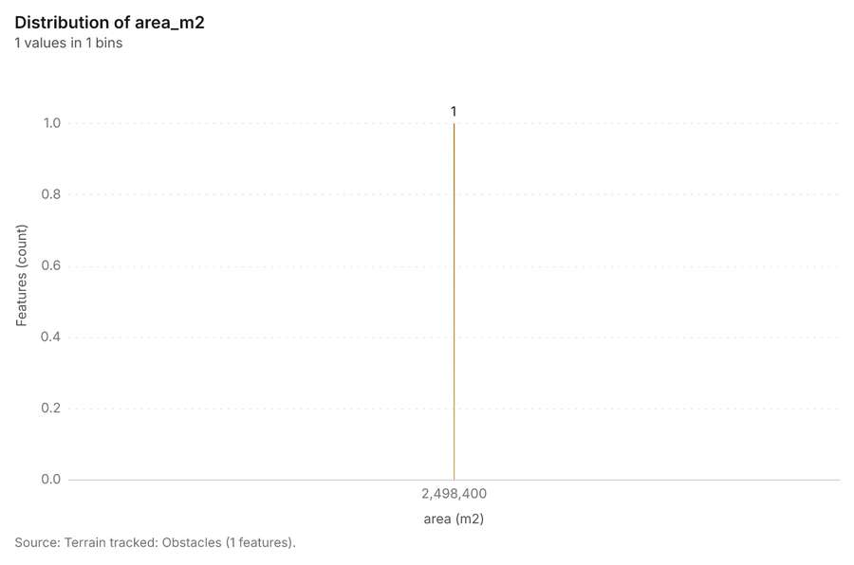
Figure 53. Terrain tracked: Obstacles [149]. Source: Terrain tracked: Obstacles (1 features). The data is in the appendix.
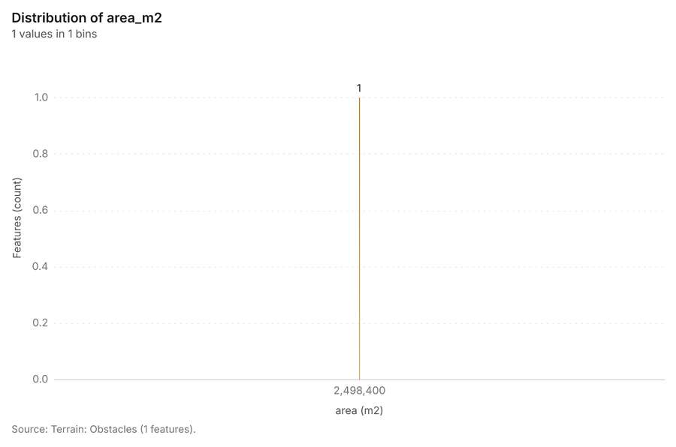
Figure 54. Terrain: Obstacles [150]. Source: Terrain: Obstacles (1 features). The data is in the appendix.
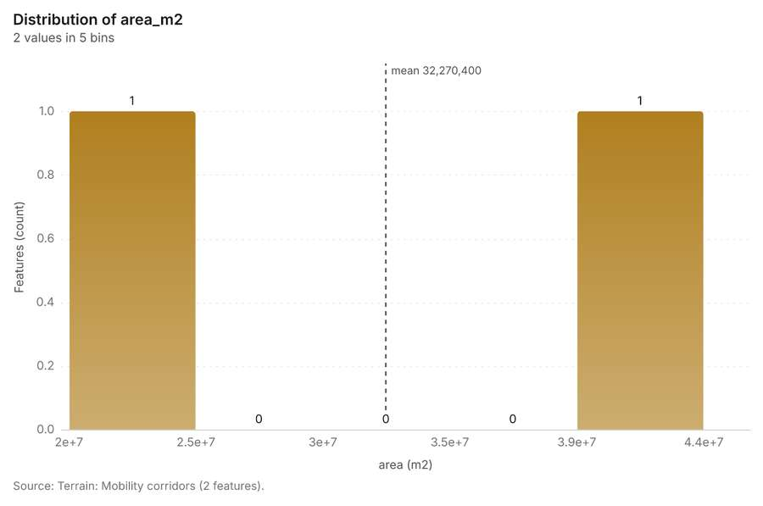
Figure 55. Terrain: Mobility corridors [151]. Source: Terrain: Mobility corridors (2 features). The data is in the appendix.
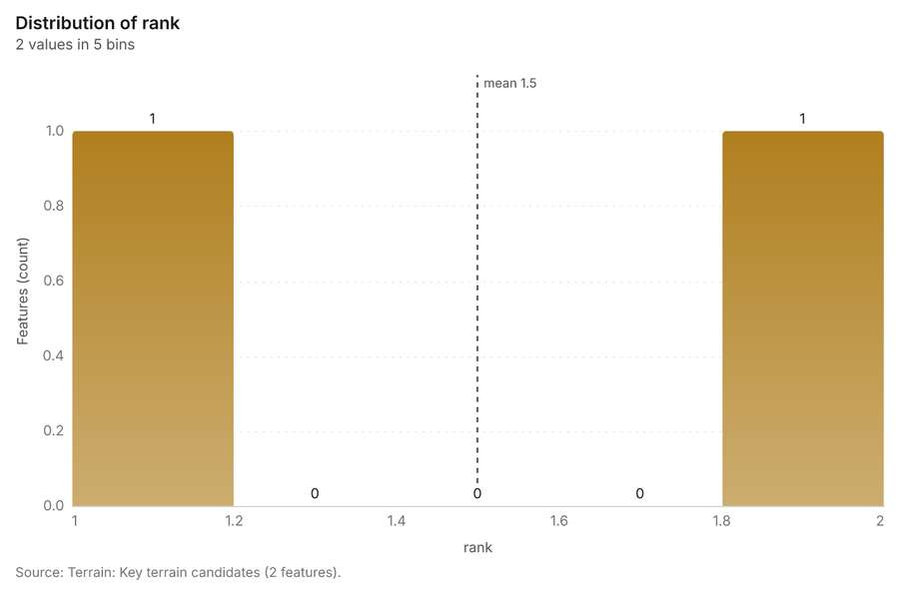
Figure 56. Terrain: Key terrain candidates [152]. Source: Terrain: Key terrain candidates (2 features). The data is in the appendix.
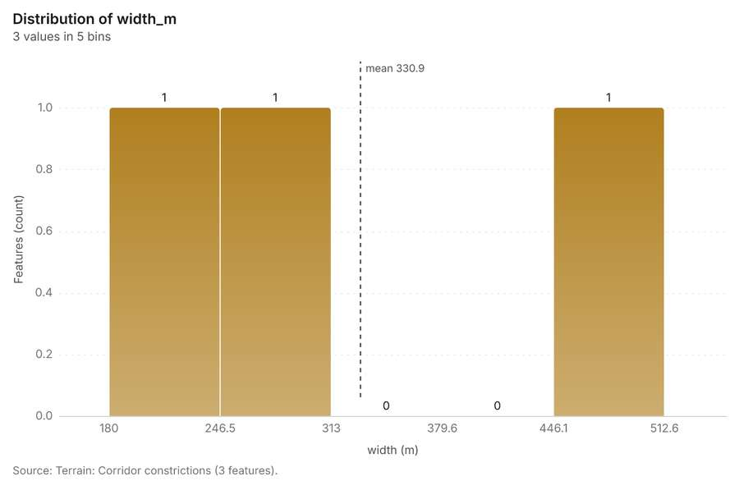
Figure 57. Terrain: Corridor constrictions [153]. Source: Terrain: Corridor constrictions (3 features). The data is in the appendix.
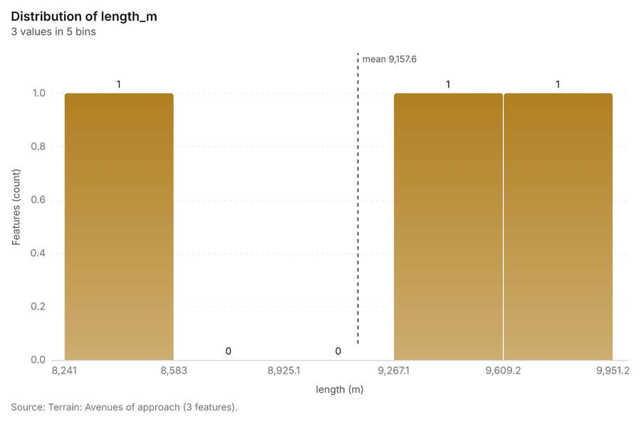
Figure 58. Terrain: Avenues of approach [154]. Source: Terrain: Avenues of approach (3 features). The data is in the appendix.
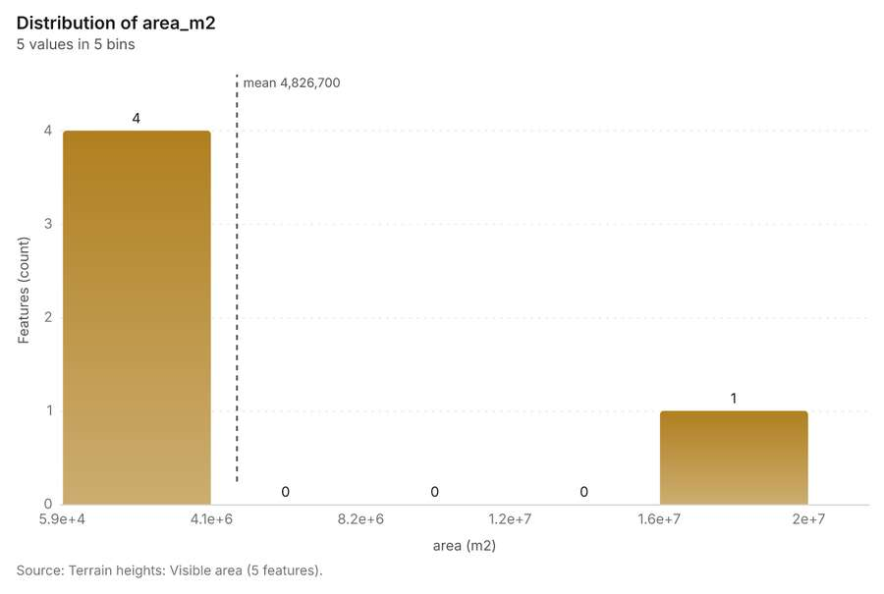
Figure 59. Terrain heights: Visible area [155]. Source: Terrain heights: Visible area (5 features). The data is in the appendix.
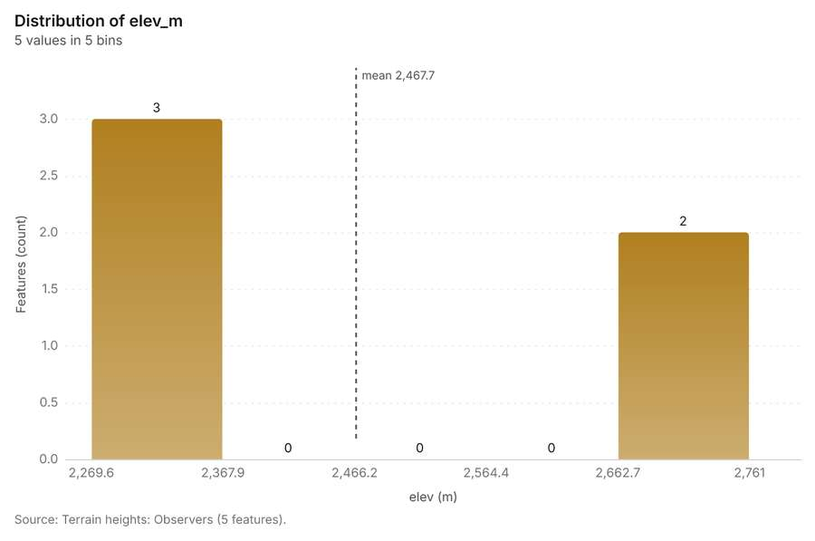
Figure 60. Terrain heights: Observers [156]. Source: Terrain heights: Observers (5 features). The data is in the appendix.
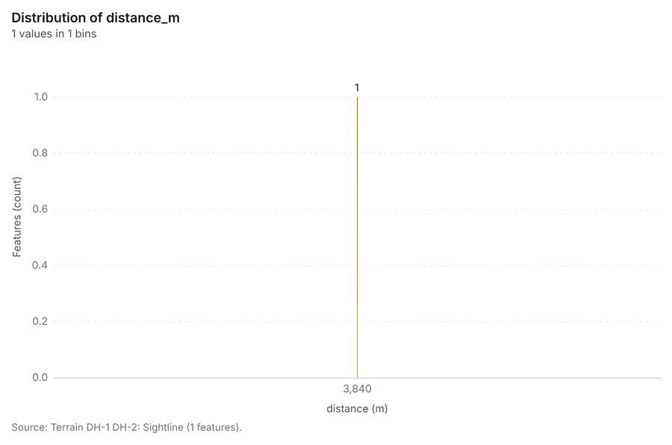
Figure 61. Terrain DH-1 DH-2: Sightline [157]. Source: Terrain DH-1 DH-2: Sightline (1 features). The data is in the appendix.
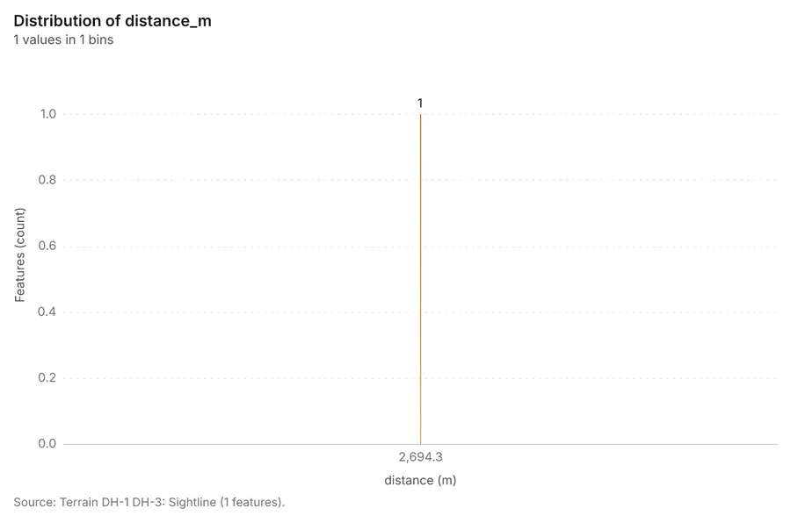
Figure 62. Terrain DH-1 DH-3: Sightline [158]. Source: Terrain DH-1 DH-3: Sightline (1 features). The data is in the appendix.
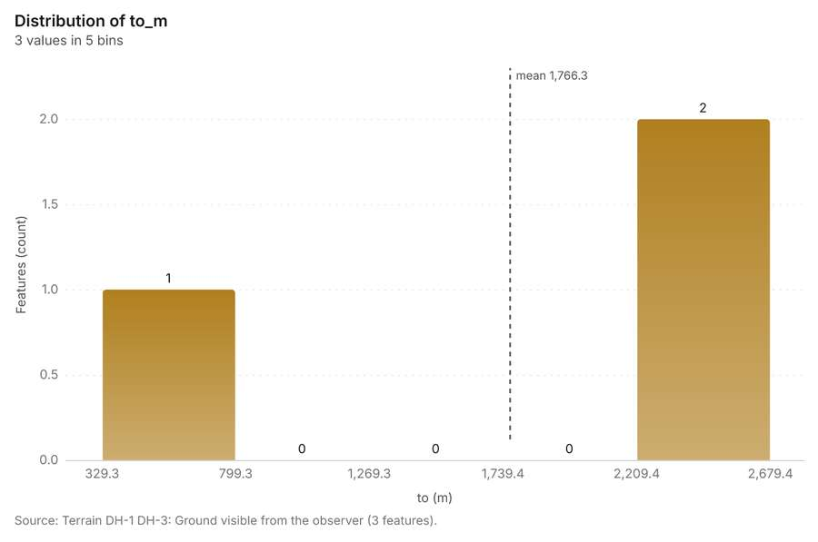
Figure 63. Terrain DH-1 DH-3: Ground visible from the observer [159]. Source: Terrain DH-1 DH-3: Ground visible from the observer (3 features). The data is in the appendix.
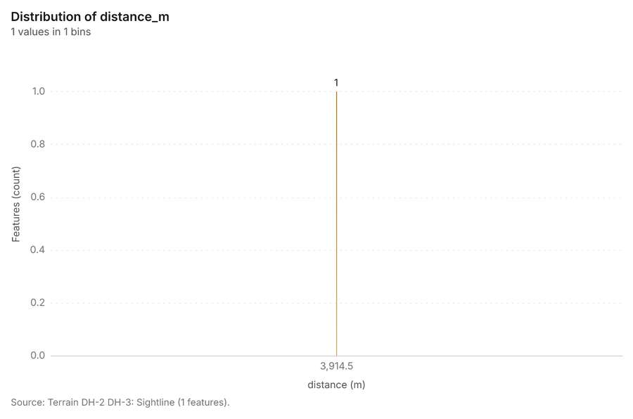
Figure 64. Terrain DH-2 DH-3: Sightline [160]. Source: Terrain DH-2 DH-3: Sightline (1 features). The data is in the appendix.
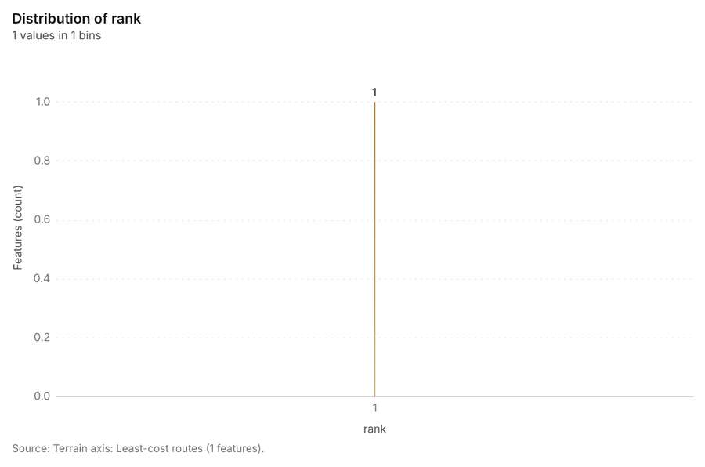
Figure 65. Terrain axis: Least-cost routes [161]. Source: Terrain axis: Least-cost routes (1 features). The data is in the appendix.
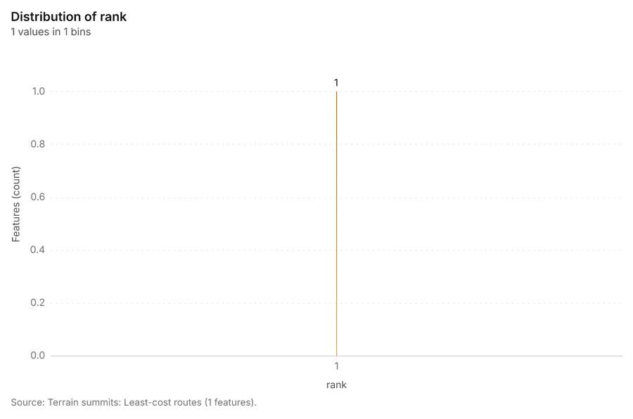
Figure 66. Terrain summits: Least-cost routes [162]. Source: Terrain summits: Least-cost routes (1 features). The data is in the appendix.
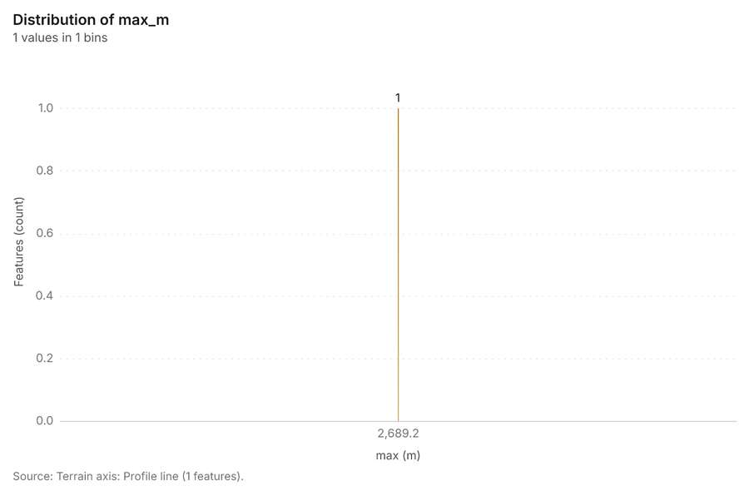
Figure 67. Terrain axis: Profile line [163]. Source: Terrain axis: Profile line (1 features). The data is in the appendix.
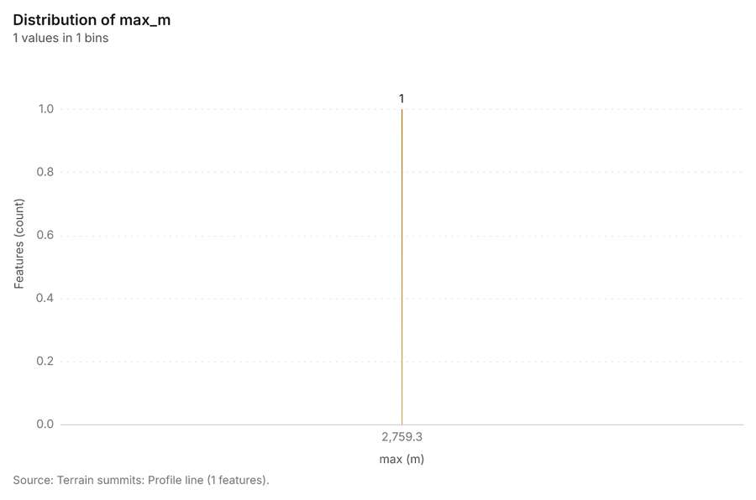
Figure 68. Terrain summits: Profile line [164]. Source: Terrain summits: Profile line (1 features). The data is in the appendix.
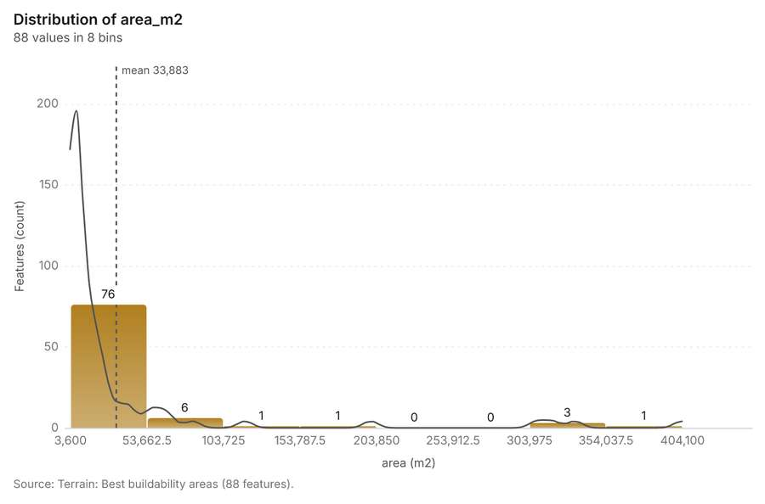
Figure 69. Terrain: Best buildability areas [165]. Source: Terrain: Best buildability areas (88 features). The data is in the appendix.
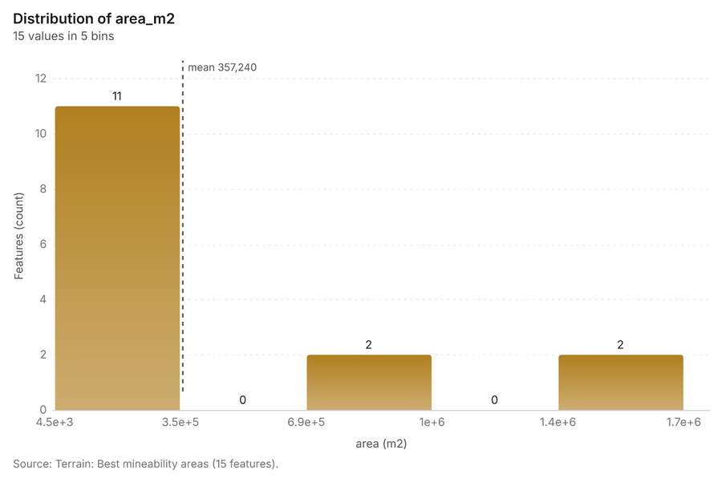
Figure 70. Terrain: Best mineability areas [166]. Source: Terrain: Best mineability areas (15 features). The data is in the appendix.
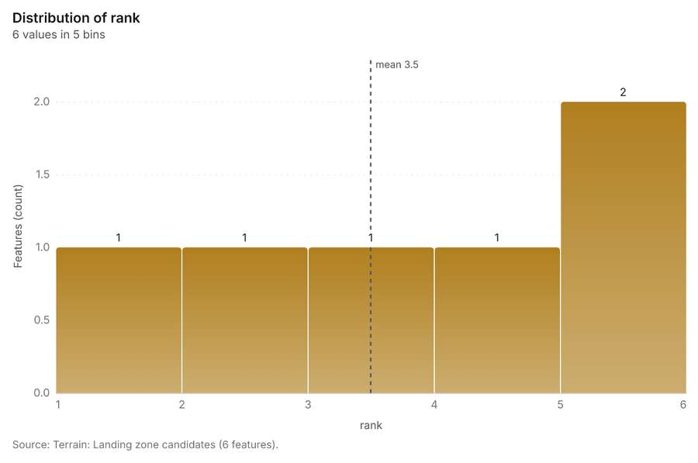
Figure 71. Terrain: Landing zone candidates [167]. Source: Terrain: Landing zone candidates (6 features). The data is in the appendix.
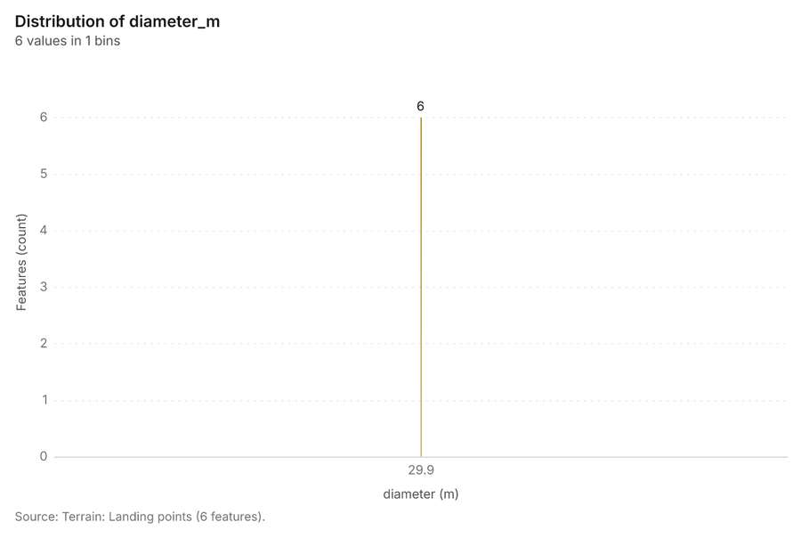
Figure 72. Terrain: Landing points [168]. Source: Terrain: Landing points (6 features). The data is in the appendix.
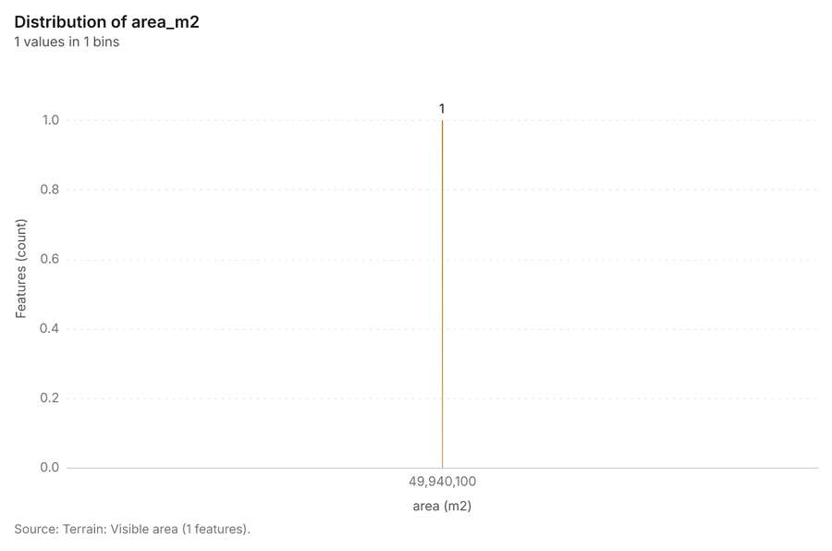
Figure 73. Terrain: Visible area [169]. Source: Terrain: Visible area (1 features). The data is in the appendix.
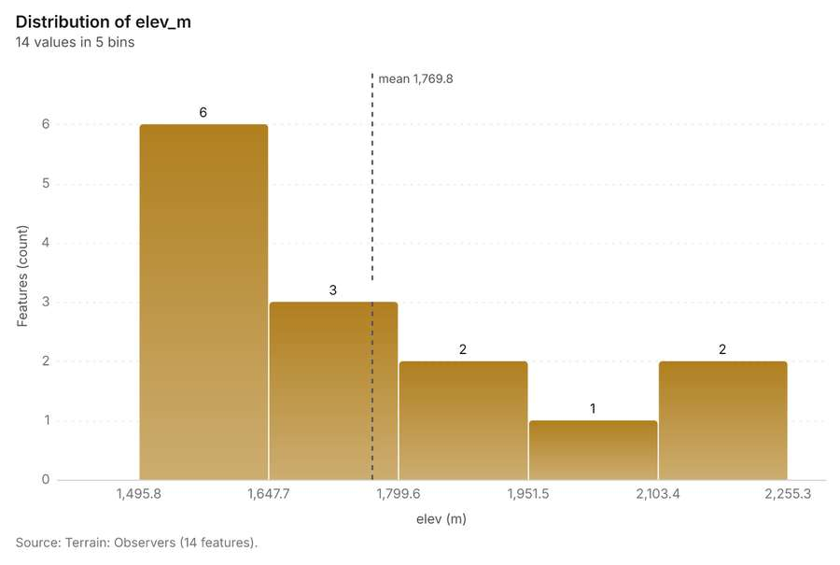
Figure 74. Terrain: Observers [170]. Source: Terrain: Observers (14 features). The data is in the appendix.
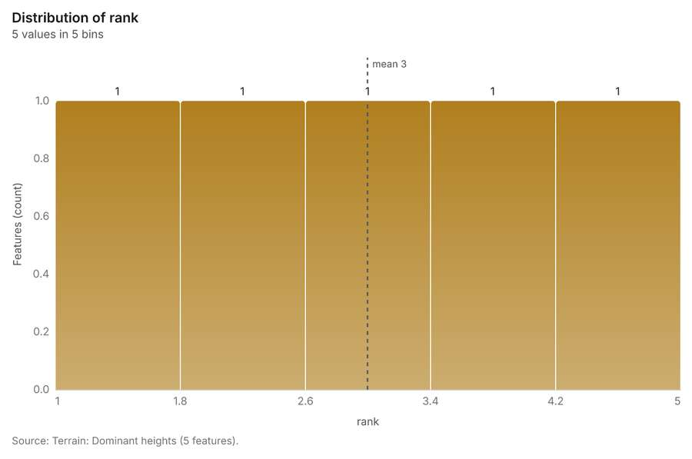
Figure 75. Terrain: Dominant heights [171]. Source: Terrain: Dominant heights (5 features). The data is in the appendix.
Findings
- Evidenced: Terrain analysis produced Terrain: Terrain findings (9 features), Terrain: Dominant heights (5 features), Terrain: Elevation (m) (0 features) [20][21][22][23].
- Evidenced: It reported tokens, usd 0.737; tokens, tokens 737; tokens, tokens in 1; tokens, tokens out 184; numbers, maps 7; numbers, charts 4 [20].
- Evidenced: The chart Hypsometric curve is drawn from 20 rows [131].
- Evidenced: The chart Slope distribution is drawn from 6 rows [132].
- Evidenced: The chart Aspect rose is drawn from 8 rows [133].
- Evidenced: The chart Elevation along the routes is drawn from 320 rows [134].
- Evidenced: The chart Terrain: Contours (100 m) is drawn from 6 rows [135].
- Evidenced: The chart Terrain: Ravines is drawn from 5 rows [136].
- Evidenced: The chart Terrain: Ridges is drawn from 7 rows [137].
- Evidenced: The chart Terrain: Observation points is drawn from 5 rows [138].
- Evidenced: The chart Terrain: Open flat ground is drawn from 5 rows [139].
- Evidenced: The chart Terrain: Terrain masking (cover) is drawn from 5 rows [140].
- Evidenced: The chart Terrain: Streams (Strahler order) is drawn from 5 rows [141].
- Evidenced: The chart Terrain: Pour points is drawn from 5 rows [142].
- Evidenced: The chart Terrain: Watershed boundaries is drawn from 5 rows [143].
- Evidenced: The chart Terrain: Pour points (snapped) is drawn from 5 rows [144].
- Evidenced: The chart Terrain: Streams (Strahler order) is drawn from 5 rows [145].
- Evidenced: The chart Terrain: Flood-prone areas is drawn from 5 rows [146].
- Evidenced: The chart Terrain dismounted: Obstacles is drawn from 1 rows [147].
- Evidenced: The chart Terrain wheeled: Obstacles is drawn from 5 rows [148].
- Evidenced: The chart Terrain tracked: Obstacles is drawn from 1 rows [149].
- Evidenced: The chart Terrain: Obstacles is drawn from 1 rows [150].
- Evidenced: The chart Terrain: Mobility corridors is drawn from 5 rows [151].
- Evidenced: The chart Terrain: Key terrain candidates is drawn from 5 rows [152].
- Evidenced: The chart Terrain: Corridor constrictions is drawn from 5 rows [153].
- Evidenced: The chart Terrain: Avenues of approach is drawn from 5 rows [154].
- Evidenced: The chart Terrain heights: Visible area is drawn from 5 rows [155].
- Evidenced: The chart Terrain heights: Observers is drawn from 5 rows [156].
- Evidenced: The chart Terrain DH-1 DH-2: Sightline is drawn from 1 rows [157].
- Evidenced: The chart Terrain DH-1 DH-3: Sightline is drawn from 1 rows [158].
- Evidenced: The chart Terrain DH-1 DH-3: Ground visible from the observer is drawn from 5 rows [159].
- Evidenced: The chart Terrain DH-2 DH-3: Sightline is drawn from 1 rows [160].
- Evidenced: The chart Terrain axis: Least-cost routes is drawn from 1 rows [161].
- Evidenced: The chart Terrain summits: Least-cost routes is drawn from 1 rows [162].
- Evidenced: The chart Terrain axis: Profile line is drawn from 1 rows [163].
- Evidenced: The chart Terrain summits: Profile line is drawn from 1 rows [164].
- Evidenced: The chart Terrain: Best buildability areas is drawn from 8 rows [165].
- Evidenced: The chart Terrain: Best mineability areas is drawn from 5 rows [166].
- Evidenced: The chart Terrain: Landing zone candidates is drawn from 5 rows [167].
- Evidenced: The chart Terrain: Landing points is drawn from 1 rows [168].
- Evidenced: The chart Terrain: Visible area is drawn from 1 rows [169].
- Evidenced: The chart Terrain: Observers is drawn from 5 rows [170].
- Evidenced: The chart Terrain: Dominant heights is drawn from 5 rows [171].
- Evidenced: The 72.1 km2 area spans 1,475 to 2,759 m (1,284 m of relief; median 1,969 m) at 30 m. Slopes average 13.2 degrees; 18.8% of the ground is steeper than 15 degrees and 3.7% steeper than 30 [20][23][178].
- Evidenced: The highest summit (DH-1) rises to 2,759 m, 192 m above the ground within 750 m; the next summits reach 2,702 m, 2,330 m, 2,271 m [20][22][178].
- Inferred: KT-1 is a key terrain candidate: highest ground within 1.0 km (2271 m); 189 m above the lowest ground around it; observes 21% of the ground within 4.5 km (3.81 km2); overlooks mobility corridor MC-1 [64][90][178]. A candidate, not a decision [64][90][178].
- Inferred: KT-2 is a key terrain candidate: highest ground within 1.0 km (2759 m); 270 m above the lowest ground around it; observes 13% of the ground within 4.5 km (2.01 km2); overlooks mobility corridor MC-2 [64][90][178]. A candidate, not a decision [64][90][178].
- Inferred: The widest mobility corridor (MC-1) is about 3.2 km wide and 8.4 km long on a 4 degree axis; 2 corridor(s) in all [20][65][178].
- Inferred: AA-1: cheapest way through the area from the N edge to the S edge: 8.2 km, about 103 min, 0% restricted going (no objective given) [20][62][178].
- Inferred: AA-2: cheapest way through the area from the SE edge to the NW edge: 10.0 km, about 201 min, 5% restricted going (no objective given) [20][62][178].
- Inferred: CP-1: MC-2 narrows to 180 m, at most 70% of its median width (300 m) [20][63][178].
- Inferred: CP-2: MC-1 narrows to 300 m, at most 70% of its median width (3.2 km) [20][63][178].
- Inferred: CP-3: MC-1 narrows to 513 m, at most 70% of its median width (3.2 km) [20][63][178].
- Inferred: 1.72 km2 (2.4% of the area) lies within 3 m of the height of the nearest stream, the ground that floods first when the streams rise; a terrain screen, not a flood model [20][79][178].
- Evidenced: Most ground faces west (49.0%); 0.3% is flat (under 1 degree) [20][23][178].
- Evidenced: From the dominant heights (1.7 m eye height) 37.1% of the ground within 4.5 km is visible (24.13 km2) [20][27][61][90][178].
- Evidenced: From OP-1, OP-2, OP-3, OP-4, OP-5, OP-6, OP-7, OP-8, OP-9, OP-10, OP-11, OP-12, OP-13, OP-14 (1.7 m eye height) 69.3% of the ground within 4.5 km is visible (49.94 km2) [20][27][61][90][178].
- Evidenced: From observation point KT-1 (1.7 m eye height) 21.1% of the ground within 4.5 km is visible (3.81 km2) [20][27][61][90][178].
- Evidenced: From observation point KT-2 (1.7 m eye height) 12.5% of the ground within 4.5 km is visible (2.01 km2) [20][27][61][90][178].
- Inferred: LZ-1 (score 0.75): a 29.9 m medium helicopter landing point fits: clear ground about 300 m across or more at 30 m cells; slope up to 2.3 degrees (limit 7); unobserved, 531 m from observed ground [29][178]. Map study: confirm on the ground [29][178].
- Inferred: LZ-2 (score 0.44): a 29.9 m medium helicopter landing point fits: clear ground about 90 m across at 30 m cells; slope up to 3.4 degrees (limit 7); unobserved, 540 m from observed ground [29][178]. Map study: confirm on the ground [29][178].
- Inferred: LZ-3 (score 0.43): a 29.9 m medium helicopter landing point fits: clear ground about 90 m across at 30 m cells; slope up to 4.3 degrees (limit 7); unobserved, 569 m from observed ground [29][178]. Map study: confirm on the ground [29][178].
- Evidenced: The best dismounted route the longest axis is 8.91 km long, about 245 min, climbing 1280 m [20][50][51][52][53][178].
- Evidenced: The best dismounted route the two highest summits is 3.84 km long, about 44 min, climbing 11 m [20][50][51][52][53][178].
- Evidenced: 24 contour line(s) at 100 m over 13 level(s) [20][100][178].
- Evidenced: Slope over 72.09 km2: mean 13.16 degrees, max 38.63 degrees; 92% of the ground is steeper than 15% [20][99][178].
- Evidenced: Aspect: most ground faces W (49%); 0% is flat (slope under 1 degrees) [20][98][178].
- Evidenced: Hillshade lit from 315 degrees at 45 degrees altitude (multidirectional) [20][97][178].
- Evidenced: Total curvature (1/100 m): mean -0.005, range -1.2011 to 0.3811 [20][96][178].
- Evidenced: Terrain suite over 72.09 km2 at 30 m: elevation 1475.15 to 2759.29 m; 2 raster(s) and 0 vector layer(s) [20][94][95][178].
- Evidenced: Landforms (geomorphons): slope 92%, valley 2%, ridge 2% (search 300 m, flat below 1 degrees) [20][93][178].
- Evidenced: 5 ravine line(s) and 36 ridge line(s); ravines drain at least 0.721 km2 [20][91][92][178].
- Evidenced: 2 observation point(s), 9 open flat area(s), 5 masked area(s) [20][88][89][90][178].
- Evidenced: Flow accumulation (pure): the largest catchment drains 43.241 km2 through one cell; 9 stream link(s), Strahler order up to 2 [20][85][86][87][178].
- Evidenced: Pour points: found 3 candidate outlets draining at least 0.721 km2 [20][84][178].
- Evidenced: Watersheds of the 3 largest outlet basin(s): 72.090 km2 in total; the largest drains 43.241 km2 [20][81][82][83][178].
- Evidenced: Flood-prone ground (HAND up to 3 m above streams that drain 0.72 km2 or more): 1.715 km2, 2.4% of the area; 9 stream link(s) [20][77][78][79][80][178].
- Inferred: Dismounted going: 90% unrestricted, 7% restricted, 3% severely restricted; 1 obstacle region(s) [20][74][75][76][178].
- Inferred: Wheeled going: 8% unrestricted, 81% restricted, 10% severely restricted; 10 obstacle region(s) [20][71][72][73][178].
- Inferred: Tracked going: 90% unrestricted, 7% restricted, 3% severely restricted; 1 obstacle region(s) [20][68][69][70][178].
- Inferred: MCOO (dismounted): 1 obstacle(s), 2 corridor(s), 2 key terrain candidate(s), 3 avenue(s) [20][62][63][64][65][66][67][178].
- Evidenced: Visible from 5 observer(s): 37.1% of the ground within 4500 m (24.134 km2); k = 0.13 [20][58][59][60][61][178].
- Evidenced: Target unknown over 3840 m: an endpoint lies on missing ground or outside the area [20][57][178].
- Evidenced: Target visible over 2694 m: clear: the lowest clearance is 2.9 m at 15 m from A [20][55][56][178].
- Evidenced: Target unknown over 3915 m: an endpoint lies on missing ground or outside the area [20][54][178].
- Inferred: Best dismounted route: 8.91 km in about 245 min (ascent 1280 m, 4% restricted); 0 alternate(s) [20][53][178].
- Inferred: Best dismounted route: 3.84 km in about 44 min (ascent 11 m, 0% restricted); 0 alternate(s) [20][52][178].
- Evidenced: Profile of 8910 m: 1485.4 to 2689.19 m, gain 1280 m, loss 796 m, steepest grade 77.5% [20][51][178].
- Evidenced: Profile of 3840 m: 2755.69 to 2759.29 m, gain 0 m, loss 4 m, steepest grade 1.4% [20][50][178].
- Inferred: Clear-sky insolation over 365 day(s): mean 6.607 kWh/m2/day (range 5.552 to 6.892); most energy on unsuitable ground [20][47][48][49][178].
- Inferred: Infinite-slope factor of safety: 2.1% unstable (FS < 1), 3.4% marginal; lowest FS 0.91 [20][45][46][178].
- Inferred: Landslide susceptibility (terrain index): 1.6% high or very high; weights {'slope': 0.5, 'wetness': 0.25, 'concavity': 0.15, 'relief': 0.1} [20][43][44][178].
- Inferred: Erosion (RUSLE form): mean soil loss 39.45 t/ha/yr; 96.8% of the ground is high or very high [20][40][41][42][178].
- Inferred: Buildability: 1.4% optimal, 2.8% suitable; mean score 5/100; 91.7% excluded by constraints [20][37][38][39][178].
- Inferred: Site suitability: 0.0% excellent, 0.0% good; mean score 38/100; 3.7% excluded by constraints [20][35][36][178].
- Inferred: Mineability: 7.4% optimal, 46.4% suitable; mean score 74/100; 0.0% excluded by constraints [20][32][33][34][178].
- Inferred: Landing zones for a 29.9 m medium helicopter landing point (slope up to 7 degrees): 6 candidate(s); 3.2% of the ground fits the landing point [20][28][29][30][31][178].
- Evidenced: Visible from 14 observer(s): 69.3% of the ground within 4500 m (49.940 km2); k = 0.13 [20][24][25][26][27][178].
Tool tr_terrain_analysis; parameters {"dem": {"dataset": "f309cad9-7065-421d-b65f-542f4ad825d1"}, "area": [-75.6219210590975, 6.207884234863717, -75.5404851734973, 6.280430663194416], "project": "bceeca13-52a5-4344-bf84-77a2f9f8e186", "purpose": "everything", "observers": [[-75.587681, 6.218869], [-75.583629, 6.233346], [-75.586086, 6.247817], [-75.582036, 6.264466], [-75.58937, 6.274589], [-75.597451, 6.226094], [-75.601548, 6.25141

Zonal statistics
What this analysis is. Zonal statistics: count/min/max/mean/std/sum/median/majority per polygon as a table and as GeoJSON [172]. In ArcGIS it is Zonal Statistics as Table (polygons) [172].
Why it was run on this data. Statistics of Valley terrain model (DEM) inside each feature of Neighborhoods [173].
What it found. The analysis involves Zonal statistics using the rs_zonal_statistics tool [174]. The tool summary reports processing 16 row(s) [174]. Additionally, the process analyzed 16 zones [174].
Findings
- Evidenced: Zonal statistics: Zonal statistics: 16 row(s) [174].
- Evidenced: zones 16 [174].
Tool rs_zonal_statistics; parameters {"stats": ["mean", "min", "max", "std"], "zones": "Neighborhoods (efbe8937)", "raster_id": "Valley terrain model (DEM) (51a68176)"}

Slope
What this analysis is. Slope: Horn slope in degrees or percent, with the share of ground in six grade classes [175]. In ArcGIS it is Slope (Spatial Analyst); in QGIS, Slope (GDAL DEM) [175].
Why it was run on this data. Slope of the Valley terrain model (DEM) surface [176].
What it found. Slope on Valley terrain model (DEM) produced Slope (degrees) (0 features) [177][178][179]. It reported dem, cols 300; dem, rows 267; dem, cell m 30; dem, native m 30; dem, relief m 1,284; dem, elev max m 2,759 [177].
Result | Value
dem, cols | 300
dem, rows | 267
dem, cell m | 30
dem, native m | 30
dem, relief m | 1,284
dem, elev max m | 2,759
dem, elev min m | 1,475
dem, elev mean m | 1,991
dem, missing frac | 0
grid, cols | 300
grid, rows | 267
grid, cell m | 30
stats, max | 38.63
stats, min | 0.02
stats, mean | 13.16
stats, median | 12.37
stats, steeper than 15pct | 91.71
tokens, usd | 0.017
tokens, tokens | 17
tokens, tokens in | 1

Findings
- Evidenced: Slope on Valley terrain model (DEM) produced Slope (degrees) (0 features) [177][178][179].
- Evidenced: It reported dem, cols 300; dem, rows 267; dem, cell m 30; dem, native m 30; dem, relief m 1,284; dem, elev max m 2,759 [177].
Tool tr_slope; parameters {"dem": {"layer": "Valley terrain model (DEM) (51a68176)"}, "project": "bceeca13-52a5-4344-bf84-77a2f9f8e186"}

Hot spots
What this analysis is. Hot spot analysis: Getis-Ord Gi* hot and cold spots with z-scores, p-values and confidence bins [180]. In ArcGIS it is Find Hot Spots or Hot Spot Analysis (Getis-Ord Gi*); in QGIS, qgis:hotspot (plugin) [180].
Why it was run on this data. 1800 points: Getis-Ord Gi* tests whether the concentrations in Dropped calls are statistically significant [181]. Measured: Dropped calls are clustered (nearest-neighbor ratio 0.87, z = -10.7), median spacing 63 m [181]. Cells of 200 m and a band of 500 m from the measured spacing [181].
What it found. Hot spots on Dropped calls: Hot spot analysis: 1 layer saved: Hot spot analysis: Dropped calls (1798 features) [14][182]. It reported result, bins 1,798; result, count 1,798; result, elapsed ms 64; result, cell size m 200; result, incidents used 1,800; result, distance band m 500 [182].
Result | Value
result, bins | 1,798
result, count | 1,798
result, elapsed ms | 64
result, cell size m | 200
result, incidents used | 1,800
result, distance band m | 500
billing, cost | 0.086
billing, list price | 0.086
billing, upstream cost | 0

Findings
- Evidenced: Hot spots on Dropped calls: Hot spot analysis: 1 layer saved: Hot spot analysis: Dropped calls (1798 features) [14][182].
- Evidenced: It reported result, bins 1,798; result, count 1,798; result, elapsed ms 64; result, cell size m 200; result, incidents used 1,800; result, distance band m 500 [182].
Tool gp_hot_spots; parameters {"project": "bceeca13-52a5-4344-bf84-77a2f9f8e186", "features": {"layer": "Dropped calls (e2f5ccec)"}, "aggregation": "hexagon", "cell_size_m": 200.0, "distance_band_m": 500.0}

Hot spots
What this analysis is. Hot spot analysis: Getis-Ord Gi* hot and cold spots with z-scores, p-values and confidence bins [180]. In ArcGIS it is Find Hot Spots or Hot Spot Analysis (Getis-Ord Gi*); in QGIS, qgis:hotspot (plugin) [180].
Why it was run on this data. 420 points: Getis-Ord Gi* tests whether the concentrations in Coverage complaints are statistically significant [183]. Measured: Coverage complaints are clustered (nearest-neighbor ratio 0.87, z = -5.0), median spacing 123 m [183]. Cells of 500 m and a band of 1000 m from the measured spacing [183].
What it found. Hot spots on Coverage complaints: Hot spot analysis: 1 layer saved: Hot spot analysis: Coverage complaints (305 features) [15][184]. It reported result, bins 305; result, count 305; result, elapsed ms 11; result, cell size m 500; result, incidents used 420; result, distance band m 1,000 [184].
Result | Value
result, bins | 305
result, count | 305
result, elapsed ms | 11
result, cell size m | 500
result, incidents used | 420
result, distance band m | 1,000
billing, cost | 0.0584
billing, list price | 0.0584
billing, upstream cost | 0

Findings
- Evidenced: Hot spots on Coverage complaints: Hot spot analysis: 1 layer saved: Hot spot analysis: Coverage complaints (305 features) [15][184].
- Evidenced: It reported result, bins 305; result, count 305; result, elapsed ms 11; result, cell size m 500; result, incidents used 420; result, distance band m 1,000 [184].
Tool gp_hot_spots; parameters {"project": "bceeca13-52a5-4344-bf84-77a2f9f8e186", "features": {"layer": "Coverage complaints (a0e6cf38)"}, "aggregation": "hexagon", "cell_size_m": 500.0, "distance_band_m": 1000.0}

Hot spots
What this analysis is. Hot spot analysis: Getis-Ord Gi* hot and cold spots with z-scores, p-values and confidence bins [180]. In ArcGIS it is Find Hot Spots or Hot Spot Analysis (Getis-Ord Gi*); in QGIS, qgis:hotspot (plugin) [180].
Why it was run on this data. 40 points: Getis-Ord Gi* tests whether the concentrations in Small cells are statistically significant [185].
What it found. The hot spot analysis processed 40 incidents using the Small cells layer [186]. The analysis identified 21 features, with the result showing a count of 21 [186]. These results were generated using a cell size of 2,000 m and a distance band of 2,000 m [186]. The total cost for the analysis was 0.0508 [186].
Result | Value
result, bins | 21
result, count | 21
result, elapsed ms | 2
result, cell size m | 2,000
result, incidents used | 40
result, distance band m | 2,000
billing, cost | 0.0508
billing, list price | 0.0508
billing, upstream cost | 0

Findings
- Evidenced: Hot spots on Small cells: Hot spot analysis: 1 layer saved: Hot spot analysis: Small cells (21 features) [17][186].
- Evidenced: It reported result, bins 21; result, count 21; result, elapsed ms 2; result, cell size m 2,000; result, incidents used 40; result, distance band m 2,000 [186].
Tool gp_hot_spots; parameters {"project": "bceeca13-52a5-4344-bf84-77a2f9f8e186", "features": {"layer": "Small cells (0b706ff2)"}, "aggregation": "hexagon", "cell_size_m": 2000.0, "distance_band_m": 2000.0}

Space time hot spots
What this analysis is. Emerging hot spots: Where hot spots are new, consecutive, intensifying, persistent, diminishing, sporadic, oscillating or historical over time [187]. In ArcGIS it is Emerging Hot Spot Analysis or Create Space Time Cube [187].
Why it was run on this data. Coverage complaints carry dates in 'date': emerging hot spot analysis finds new, intensifying and fading hot spots per week [188]. Measured: the pattern of Coverage complaints changes over time (earlier half clustered, later half random; the center moved 305 m) [188].
What it found. Space time hot spots on Coverage complaints: Emerging hot spots: 1 layer saved: Emerging hot spots: Coverage complaints (94 features) [15][189]. It reported result, count 94; result, elapsed ms 14; result, resolution 8; result, features used 420; result, time neighbors 0; billing, cost 0.121 [189].
Result | Value
result, count | 94
result, elapsed ms | 14
result, resolution | 8
result, features used | 420
result, time neighbors | 0
billing, cost | 0.121
billing, list price | 0.121
billing, upstream cost | 0

Findings
- Evidenced: Space time hot spots on Coverage complaints: Emerging hot spots: 1 layer saved: Emerging hot spots: Coverage complaints (94 features) [15][189].
- Evidenced: It reported result, count 94; result, elapsed ms 14; result, resolution 8; result, features used 420; result, time neighbors 0; billing, cost 0.121 [189].
Tool gp_space_time_hot_spots; parameters {"project": "bceeca13-52a5-4344-bf84-77a2f9f8e186", "features": {"layer": "Coverage complaints (a0e6cf38)"}, "interval": "week", "bin_shape": "h3", "resolution": 8, "time_field": "date"}

Space time hot spots
What this analysis is. Emerging hot spots: Where hot spots are new, consecutive, intensifying, persistent, diminishing, sporadic, oscillating or historical over time [187]. In ArcGIS it is Emerging Hot Spot Analysis or Create Space Time Cube [187].
Why it was run on this data. Dropped calls carry dates in 'occurred_at': emerging hot spot analysis finds new, intensifying and fading hot spots per week [190].
What it found. Space time hot spots on Dropped calls: Emerging hot spots: 1 layer saved: Emerging hot spots: Dropped calls (109 features) [14][191]. It reported result, count 109; result, elapsed ms 13; result, resolution 8; result, features used 1,800; result, time neighbors 0; billing, cost 0.19 [191].
Result | Value
result, count | 109
result, elapsed ms | 13
result, resolution | 8
result, features used | 1,800
result, time neighbors | 0
billing, cost | 0.19
billing, list price | 0.19
billing, upstream cost | 0

Findings
- Evidenced: Space time hot spots on Dropped calls: Emerging hot spots: 1 layer saved: Emerging hot spots: Dropped calls (109 features) [14][191].
- Evidenced: It reported result, count 109; result, elapsed ms 13; result, resolution 8; result, features used 1,800; result, time neighbors 0; billing, cost 0.19 [191].
Tool gp_space_time_hot_spots; parameters {"project": "bceeca13-52a5-4344-bf84-77a2f9f8e186", "features": {"layer": "Dropped calls (e2f5ccec)"}, "interval": "week", "bin_shape": "h3", "resolution": 8, "time_field": "occurred_at"}

Summarize within
What this analysis is. Summarize within: Count and aggregate the features inside each polygon (or bin), proportionally for lines and polygons [192]. In ArcGIS it is Summarize Within or Aggregate Points; in QGIS, native:countpointsinpolygon or native:sumlinelengths [192].
Why it was run on this data. Count Towers inside each feature of Neighborhoods by technology; the counts map as a choropleth (natural breaks, sequential colors) [193].
What it found. Summarize within on Towers, Neighborhoods: Summarize within: 1 layer saved: Summarize within: Neighborhoods (16 features) [12][13][194]. It reported result, count 16; result, elapsed ms 1; billing, cost 0.01062; billing, list price 0.01062; billing, upstream cost 0 [194].
Result | Value
result, count | 16
result, elapsed ms | 1
billing, cost | 0.01062
billing, list price | 0.01062
billing, upstream cost | 0

Findings
- Evidenced: Summarize within on Towers, Neighborhoods: Summarize within: 1 layer saved: Summarize within: Neighborhoods (16 features) [12][13][194].
- Evidenced: It reported result, count 16; result, elapsed ms 1; billing, cost 0.01062; billing, list price 0.01062; billing, upstream cost 0 [194].
Tool gp_summarize_within; parameters {"stats": [{"stat": "sum", "field": "height_m"}], "project": "bceeca13-52a5-4344-bf84-77a2f9f8e186", "features": {"layer": "Towers (f7206b9b)"}, "group_by": "technology", "polygons": {"layer": "Neighborhoods (efbe8937)"}}

Summarize within
What this analysis is. Summarize within: Count and aggregate the features inside each polygon (or bin), proportionally for lines and polygons [192]. In ArcGIS it is Summarize Within or Aggregate Points; in QGIS, native:countpointsinpolygon or native:sumlinelengths [192].
Why it was run on this data. Count Towers inside each feature of Neighborhoods by technology; the counts map as a choropleth (natural breaks, sequential colors) [193].
What it found. Summarize within on Small cells, Neighborhoods: Summarize within: 1 layer saved: Summarize within: Neighborhoods (16 features) [12][17][195]. It reported result, count 16; result, elapsed ms 0; billing, cost 0.01112; billing, list price 0.01112; billing, upstream cost 0 [195].
Result | Value
result, count | 16
result, elapsed ms | 0
billing, cost | 0.01112
billing, list price | 0.01112
billing, upstream cost | 0

Findings
- Evidenced: Summarize within on Small cells, Neighborhoods: Summarize within: 1 layer saved: Summarize within: Neighborhoods (16 features) [12][17][195].
- Evidenced: It reported result, count 16; result, elapsed ms 0; billing, cost 0.01112; billing, list price 0.01112; billing, upstream cost 0 [195].
Tool gp_summarize_within; parameters {"stats": [], "project": "bceeca13-52a5-4344-bf84-77a2f9f8e186", "features": {"layer": "Small cells (0b706ff2)"}, "group_by": "status", "polygons": {"layer": "Neighborhoods (efbe8937)"}}

Summarize within
What this analysis is. Summarize within: Count and aggregate the features inside each polygon (or bin), proportionally for lines and polygons [192]. In ArcGIS it is Summarize Within or Aggregate Points; in QGIS, native:countpointsinpolygon or native:sumlinelengths [192].
Why it was run on this data. Count Towers inside each feature of Neighborhoods by technology; the counts map as a choropleth (natural breaks, sequential colors) [193].
What it found. Summarize within on Dropped calls, Neighborhoods: Summarize within: 1 layer saved: Summarize within: Neighborhoods (16 features) [12][14][196]. It reported result, count 16; result, elapsed ms 3; billing, cost 0.04634; billing, list price 0.04634; billing, upstream cost 0 [196].
Result | Value
result, count | 16
result, elapsed ms | 3
billing, cost | 0.04634
billing, list price | 0.04634
billing, upstream cost | 0

Findings
- Evidenced: Summarize within on Dropped calls, Neighborhoods: Summarize within: 1 layer saved: Summarize within: Neighborhoods (16 features) [12][14][196].
- Evidenced: It reported result, count 16; result, elapsed ms 3; billing, cost 0.04634; billing, list price 0.04634; billing, upstream cost 0 [196].
Tool gp_summarize_within; parameters {"stats": [{"stat": "sum", "field": "signal_dbm"}], "project": "bceeca13-52a5-4344-bf84-77a2f9f8e186", "features": {"layer": "Dropped calls (e2f5ccec)"}, "group_by": "cause", "polygons": {"layer": "Neighborhoods (efbe8937)"}}

Period change
What this analysis is. Period change: Counts or sums per period (week over week, month over month, any two periods, or before and after a date), per area, per H3 cell or in total, with the places of largest rise and fall and a significance note [197]. In ArcGIS it is Summarize Percent Change (Crime Analysis) or Change Point Detection [197].
Why it was run on this data. Dropped calls carry dates in 'occurred_at' over 8 weeks: the count per week, week over week, with the places of largest rise and fall per feature of Neighborhoods and whether the change is beyond chance [198].
What it found. Period change on Neighborhoods, Dropped calls produced Period change: Dropped calls (week of 2026-08-24 to week of 2026-08-31) (16 features) [7][8][12][14]. Dropped calls: count per week shows a trend of -1.12 per week; the second half of its weeks has 911 against 889 in the first (+2.5%) [199]. The chart Dropped calls: week of 2026-08-24 to week of 2026-08-31 by place is drawn from 30 rows [200]. The chart Period change: Dropped calls (week of 2026-08-24 to week of 2026-08-31) is drawn from 5 rows [201].
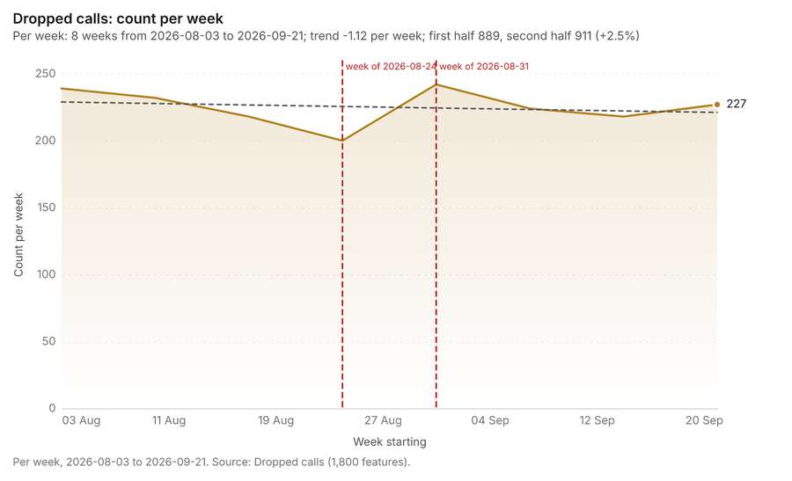
Figure 76. Dropped calls: count per week [199]. Per week, 2026-08-03 to 2026-09-21. Source: Dropped calls (1,800 features). The data is in the appendix.
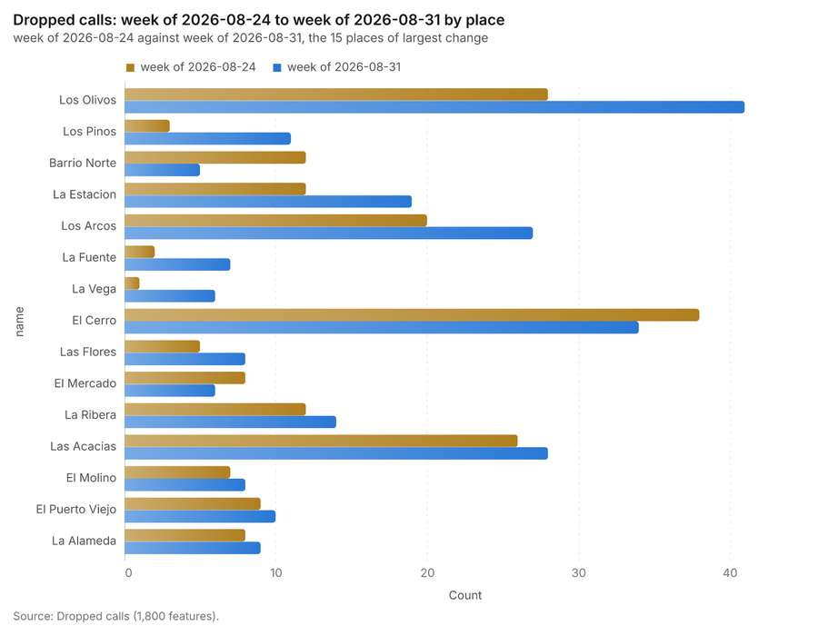
Figure 77. Dropped calls: week of 2026-08-24 to week of 2026-08-31 by place [200]. Source: Dropped calls (1,800 features). The data is in the appendix.
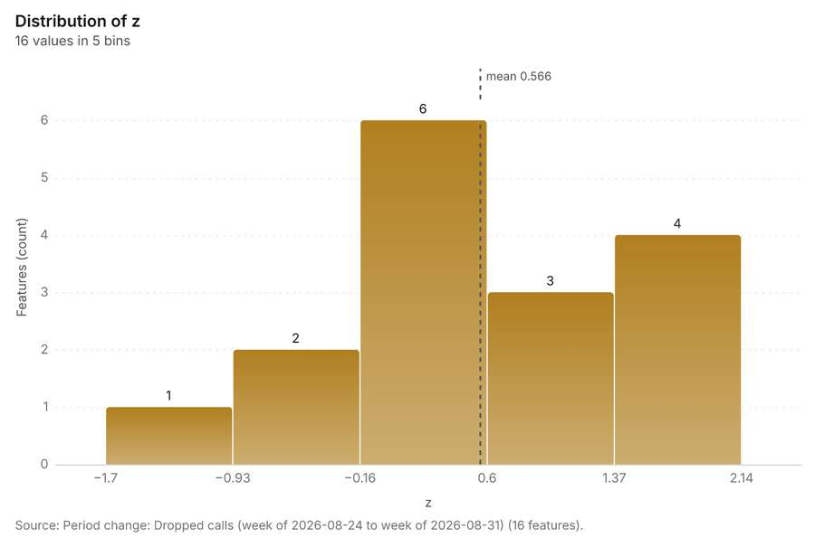
Figure 78. Period change: Dropped calls (week of 2026-08-24 to week of 2026-08-31) [201]. Source: Period change: Dropped calls (week of 2026-08-24 to week of 2026-08-31) (16 features). The data is in the appendix.
Findings
- Evidenced: Period change on Neighborhoods, Dropped calls produced Period change: Dropped calls (week of 2026-08-24 to week of 2026-08-31) (16 features) [7][8][12][14].
- Evidenced: Dropped calls: count per week shows a trend of -1.12 per week; the second half of its weeks has 911 against 889 in the first (+2.5%) [199].
- Evidenced: The chart Dropped calls: week of 2026-08-24 to week of 2026-08-31 by place is drawn from 30 rows [200].
- Evidenced: The chart Period change: Dropped calls (week of 2026-08-24 to week of 2026-08-31) is drawn from 5 rows [201].
Tool gp_period_change; parameters {"by": "area", "areas": {"layer": "Neighborhoods (efbe8937)"}, "period": "week", "project": "bceeca13-52a5-4344-bf84-77a2f9f8e186", "features": {"layer": "Dropped calls (e2f5ccec)"}, "area_field": "name", "time_field": "occurred_at"}

Period change
What this analysis is. Period change: Counts or sums per period (week over week, month over month, any two periods, or before and after a date), per area, per H3 cell or in total, with the places of largest rise and fall and a significance note [197]. In ArcGIS it is Summarize Percent Change (Crime Analysis) or Change Point Detection [197].
Why it was run on this data. Dropped calls carry dates in 'occurred_at' over 8 weeks: the count per week, week over week, with the places of largest rise and fall per feature of Neighborhoods and whether the change is beyond chance [198].
What it found. Period change on Neighborhoods, Coverage complaints produced Period change: Coverage complaints (week of 2026-08-10 to week of 2026-08-17) (8 features) [9][10][12][15]. Coverage complaints: count per week shows a trend of +0.066 per week; the second half of its weeks has 222 against 198 in the first (+12.1%) [202]. The chart Coverage complaints: week of 2026-08-10 to week of 2026-08-17 by place is drawn from 16 rows [203]. The chart Period change: Coverage complaints (week of 2026-08-10 to week of 2026-08-17) is drawn from 5 rows [204].
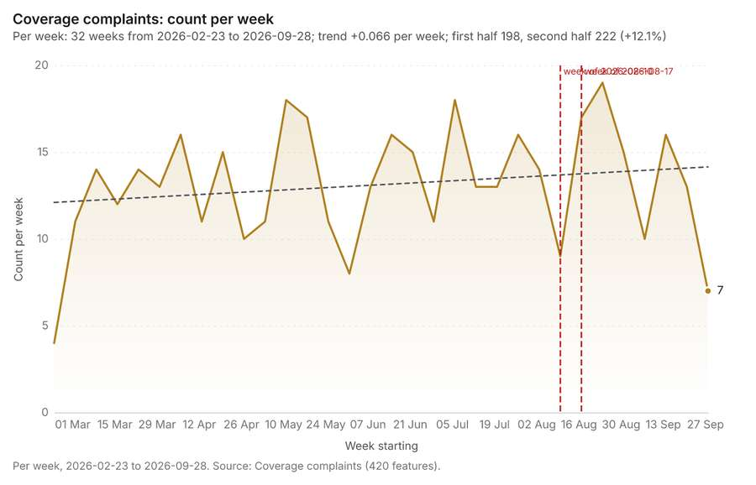
Figure 79. Coverage complaints: count per week [202]. Per week, 2026-02-23 to 2026-09-28. Source: Coverage complaints (420 features). The data is in the appendix.
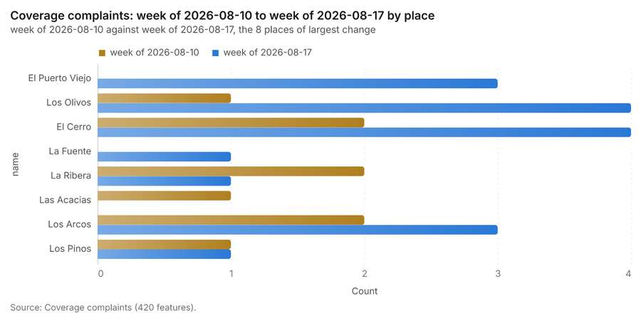
Figure 80. Coverage complaints: week of 2026-08-10 to week of 2026-08-17 by place [203]. Source: Coverage complaints (420 features). The data is in the appendix.
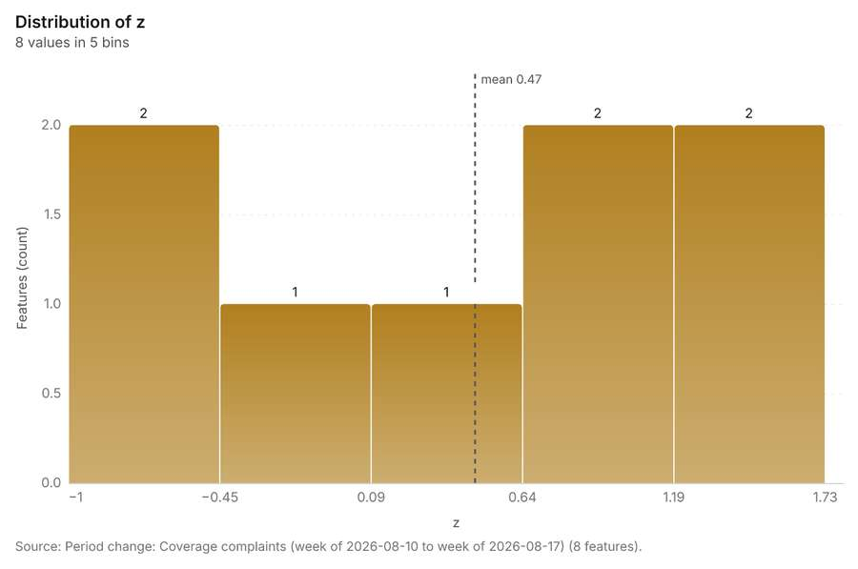
Figure 81. Period change: Coverage complaints (week of 2026-08-10 to week of 2026-08-17) [204]. Source: Period change: Coverage complaints (week of 2026-08-10 to week of 2026-08-17) (8 features). The data is in the appendix.
Findings
- Evidenced: Period change on Neighborhoods, Coverage complaints produced Period change: Coverage complaints (week of 2026-08-10 to week of 2026-08-17) (8 features) [9][10][12][15].
- Evidenced: Coverage complaints: count per week shows a trend of +0.066 per week; the second half of its weeks has 222 against 198 in the first (+12.1%) [202].
- Evidenced: The chart Coverage complaints: week of 2026-08-10 to week of 2026-08-17 by place is drawn from 16 rows [203].
- Evidenced: The chart Period change: Coverage complaints (week of 2026-08-10 to week of 2026-08-17) is drawn from 5 rows [204].
Tool gp_period_change; parameters {"by": "area", "areas": {"layer": "Neighborhoods (efbe8937)"}, "period": "week", "project": "bceeca13-52a5-4344-bf84-77a2f9f8e186", "features": {"layer": "Coverage complaints (a0e6cf38)"}, "area_field": "name", "time_field": "date"}

Seasonality
What this analysis is. Seasonality: Counts by hour of day, day of week and month, with peaks and troughs per cycle and per area [205]. In ArcGIS it is Time Series Clustering or Create Space Time Cube [205].
Why it was run on this data. Dropped calls by hour of day, day of week: the busiest and the quietest per feature of Neighborhoods, and whether the cycle is uneven beyond chance [206].
What it found. Seasonality on Neighborhoods, Dropped calls produced Seasonality of Dropped calls (16 features) [12][14][207][208]. The chart Dropped calls by hour of day is drawn from 24 rows [209]. The chart Dropped calls by day of week is drawn from 7 rows [210]. The chart Seasonality of Dropped calls is drawn from 5 rows [211].
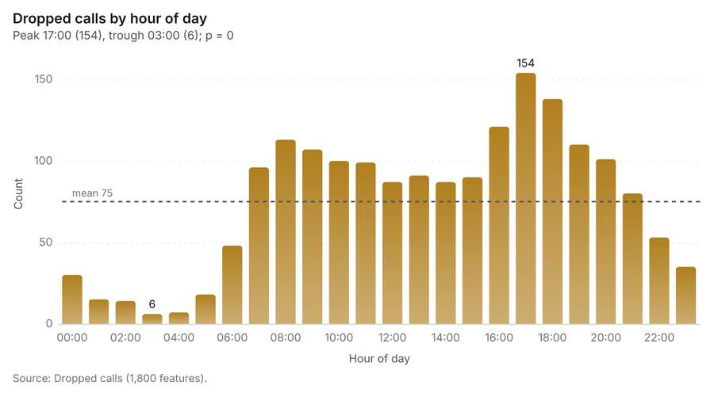
Figure 82. Dropped calls by hour of day [209]. Source: Dropped calls (1,800 features). The data is in the appendix.
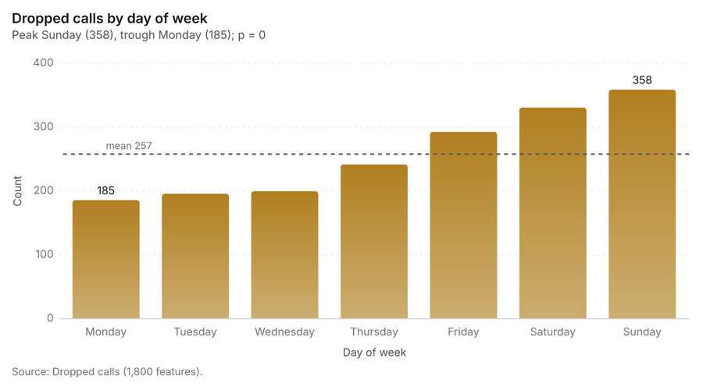
Figure 83. Dropped calls by day of week [210]. Source: Dropped calls (1,800 features). The data is in the appendix.
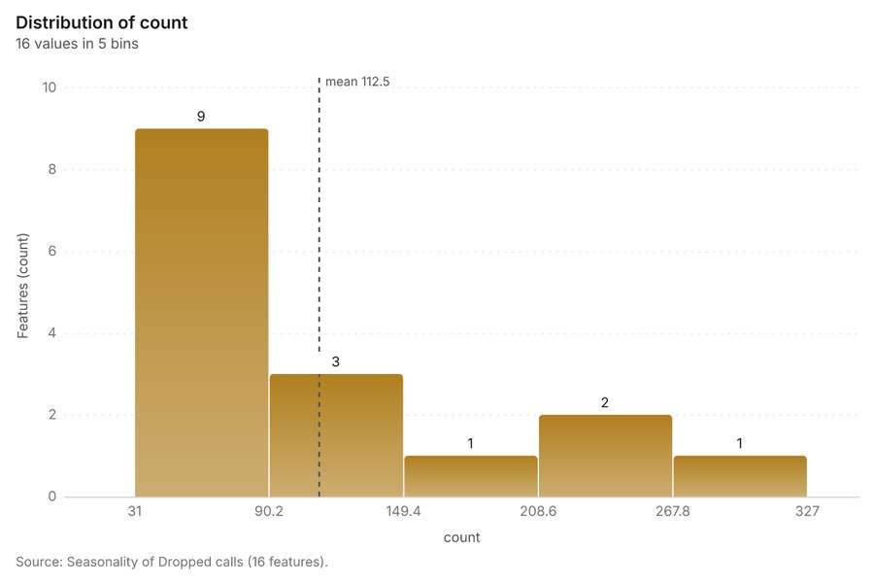
Figure 84. Seasonality of Dropped calls [211]. Source: Seasonality of Dropped calls (16 features). The data is in the appendix.
Findings
- Evidenced: Seasonality on Neighborhoods, Dropped calls produced Seasonality of Dropped calls (16 features) [12][14][207][208].
- Evidenced: The chart Dropped calls by hour of day is drawn from 24 rows [209].
- Evidenced: The chart Dropped calls by day of week is drawn from 7 rows [210].
- Evidenced: The chart Seasonality of Dropped calls is drawn from 5 rows [211].
Tool gp_seasonality; parameters {"by": "area", "areas": {"layer": "Neighborhoods (efbe8937)"}, "cycles": ["hour", "weekday"], "project": "bceeca13-52a5-4344-bf84-77a2f9f8e186", "features": {"layer": "Dropped calls (e2f5ccec)"}, "time_field": "occurred_at"}

Calculate density
What this analysis is. Calculate density: Kernel density per square kilometer on a grid [212]. In ArcGIS it is Calculate Density or Kernel Density; in QGIS, native:heatmapkerneldensityestimation [212].
Why it was run on this data. 1800 points in Dropped calls: a density surface shows where they concentrate [213]. Measured: Dropped calls are clustered (nearest-neighbor ratio 0.87, z = -10.7), median spacing 63 m [213].
What it found. Calculate density on Dropped calls: Calculate density: 1 layer saved: Calculate density: Dropped calls (2034 features) [14][214]. It reported result, count 2,034; result, elapsed ms 40; result, bandwidth m 500; result, cell size m 200; result, excluded null 0; result, max density per km2 368.1 [214].
Result | Value
result, count | 2,034
result, elapsed ms | 40
result, bandwidth m | 500
result, cell size m | 200
result, excluded null | 0
result, max density per km2 | 368.1
billing, cost | 0.086
billing, list price | 0.086
billing, upstream cost | 0

Findings
- Evidenced: Calculate density on Dropped calls: Calculate density: 1 layer saved: Calculate density: Dropped calls (2034 features) [14][214].
- Evidenced: It reported result, count 2,034; result, elapsed ms 40; result, bandwidth m 500; result, cell size m 200; result, excluded null 0; result, max density per km2 368.1 [214].
Tool gp_calculate_density; parameters {"kernel": "quartic", "project": "bceeca13-52a5-4344-bf84-77a2f9f8e186", "features": {"layer": "Dropped calls (e2f5ccec)"}, "bandwidth_m": 500.0, "cell_size_m": 200.0}

Calculate density
What this analysis is. Calculate density: Kernel density per square kilometer on a grid [212]. In ArcGIS it is Calculate Density or Kernel Density; in QGIS, native:heatmapkerneldensityestimation [212].
Why it was run on this data. 420 points in Coverage complaints: a density surface shows where they concentrate [215]. Measured: Coverage complaints are clustered (nearest-neighbor ratio 0.87, z = -5.0), median spacing 123 m [215].
What it found. The density analysis utilized the Coverage complaints data [15] and the gp_calculate_density tool [216]. The coverage complaints dataset contained 383 features [216], and the calculated maximum density per km2 was 68.51 [216].
Result | Value
result, count | 383
result, elapsed ms | 8
result, bandwidth m | 1,000
result, cell size m | 500
result, excluded null | 0
result, max density per km2 | 68.51
billing, cost | 0.0584
billing, list price | 0.0584
billing, upstream cost | 0

Findings
- Evidenced: Calculate density on Coverage complaints: Calculate density: 1 layer saved: Calculate density: Coverage complaints (383 features) [15][216].
- Evidenced: It reported result, count 383; result, elapsed ms 8; result, bandwidth m 1,000; result, cell size m 500; result, excluded null 0; result, max density per km2 68.51 [216].
Tool gp_calculate_density; parameters {"kernel": "quartic", "project": "bceeca13-52a5-4344-bf84-77a2f9f8e186", "features": {"layer": "Coverage complaints (a0e6cf38)"}, "bandwidth_m": 1000.0, "cell_size_m": 500.0}

Calculate density
What this analysis is. Calculate density: Kernel density per square kilometer on a grid [212]. In ArcGIS it is Calculate Density or Kernel Density; in QGIS, native:heatmapkerneldensityestimation [212].
Why it was run on this data. 40 points in Small cells: a density surface shows where they concentrate [217].
What it found. Calculate density on Small cells: Calculate density: 1 layer saved: Calculate density: Small cells (117 features) [17][218]. It reported result, count 117; result, elapsed ms 2; result, bandwidth m 2,000; result, cell size m 1,000; result, excluded null 0; result, max density per km2 2.571 [218].
Result | Value
result, count | 117
result, elapsed ms | 2
result, bandwidth m | 2,000
result, cell size m | 1,000
result, excluded null | 0
result, max density per km2 | 2.571
billing, cost | 0.0508
billing, list price | 0.0508
billing, upstream cost | 0

Findings
- Evidenced: Calculate density on Small cells: Calculate density: 1 layer saved: Calculate density: Small cells (117 features) [17][218].
- Evidenced: It reported result, count 117; result, elapsed ms 2; result, bandwidth m 2,000; result, cell size m 1,000; result, excluded null 0; result, max density per km2 2.571 [218].
Tool gp_calculate_density; parameters {"kernel": "quartic", "project": "bceeca13-52a5-4344-bf84-77a2f9f8e186", "features": {"layer": "Small cells (0b706ff2)"}, "bandwidth_m": 2000.0, "cell_size_m": 1000.0}

Find point clusters
What this analysis is. Find point clusters: Density-based clusters (DBSCAN, HDBSCAN or OPTICS, optionally space-time) with hulls and noise [219]. In ArcGIS it is Find Point Clusters or Density-based Clustering; in QGIS, native:dbscanclustering or native:stdbscanclustering [219].
Why it was run on this data. DBSCAN finds dense groups of Dropped calls and separates noise [220]. Measured: Dropped calls are clustered (nearest-neighbor ratio 0.87, z = -10.7), median spacing 63 m [220]. DBSCAN at 100 m (twice the measured spacing) [220].
What it found. Find point clusters on Dropped calls: Find point clusters: 2 layers saved: Find point clusters: Dropped calls (1800 features); Find point clusters: cluster hulls (2 features) [14][221]. It reported result, count 1,800; result, noise 1,744; result, distance m 100; result, elapsed ms 133; result, min points 20; billing, cost 0.086 [221].
Result | Value
result, count | 1,800
result, noise | 1,744
result, distance m | 100
result, elapsed ms | 133
result, min points | 20
billing, cost | 0.086
billing, list price | 0.086
billing, upstream cost | 0

Findings
- Evidenced: Find point clusters on Dropped calls: Find point clusters: 2 layers saved: Find point clusters: Dropped calls (1800 features); Find point clusters: cluster hulls (2 features) [14][221].
- Evidenced: It reported result, count 1,800; result, noise 1,744; result, distance m 100; result, elapsed ms 133; result, min points 20; billing, cost 0.086 [221].
Tool gp_find_point_clusters; parameters {"method": "dbscan", "project": "bceeca13-52a5-4344-bf84-77a2f9f8e186", "features": {"layer": "Dropped calls (e2f5ccec)"}, "distance_m": 100.0, "min_points": 20}

Find point clusters
What this analysis is. Find point clusters: Density-based clusters (DBSCAN, HDBSCAN or OPTICS, optionally space-time) with hulls and noise [219]. In ArcGIS it is Find Point Clusters or Density-based Clustering; in QGIS, native:dbscanclustering or native:stdbscanclustering [219].
Why it was run on this data. DBSCAN finds dense groups of Coverage complaints and separates noise [222]. Measured: Coverage complaints are clustered (nearest-neighbor ratio 0.87, z = -5.0), median spacing 123 m [222]. DBSCAN at 200 m (twice the measured spacing) [222].
What it found. Find point clusters on Coverage complaints: Find point clusters: 2 layers saved: Find point clusters: Coverage complaints (420 features); Find point clusters: cluster hulls (1 feature) [15][223]. It reported result, count 420; result, noise 320; result, distance m 200; result, elapsed ms 5; result, min points 10; billing, cost 0.0584 [223].
Result | Value
result, count | 420
result, noise | 320
result, distance m | 200
result, elapsed ms | 5
result, min points | 10
billing, cost | 0.0584
billing, list price | 0.0584
billing, upstream cost | 0

Findings
- Evidenced: Find point clusters on Coverage complaints: Find point clusters: 2 layers saved: Find point clusters: Coverage complaints (420 features); Find point clusters: cluster hulls (1 feature) [15][223].
- Evidenced: It reported result, count 420; result, noise 320; result, distance m 200; result, elapsed ms 5; result, min points 10; billing, cost 0.0584 [223].
Tool gp_find_point_clusters; parameters {"method": "dbscan", "project": "bceeca13-52a5-4344-bf84-77a2f9f8e186", "features": {"layer": "Coverage complaints (a0e6cf38)"}, "distance_m": 200.0, "min_points": 10}

Nearest neighbor index
What this analysis is. Average nearest neighbor: Clark-Evans ratio: clustered, dispersed or random [224]. In ArcGIS it is Average Nearest Neighbor; in QGIS, native:nearestneighbouranalysis [224].
Why it was run on this data. The average nearest neighbor ratio says whether Towers are clustered, random or dispersed [225]. Measured: Towers are dispersed (nearest-neighbor ratio 1.82, z = +5.8), median spacing 1.36e+03 m [225]. The profile measured it already; the tool draws it [225].
What it found. Nearest neighbor index on Towers: Average nearest neighbor: done; no map output [13][226]. It reported result, n 14; result, p value 0; result, z score 8.397; result, elapsed ms 0; result, study area m2 23,117,306; result, nearest neighbor ratio 2.173 [226].
Result | Value
result, n | 14
result, p value | 0
result, z score | 8.397
result, elapsed ms | 0
result, study area m2 | 23,117,306
result, nearest neighbor ratio | 2.173
result, expected mean distance m | 642.5
result, observed mean distance m | 1,396
billing, cost | 0.02
billing, list price | 0.02
billing, upstream cost | 0

Findings
- Evidenced: Nearest neighbor index on Towers: Average nearest neighbor: done; no map output [13][226].
- Evidenced: It reported result, n 14; result, p value 0; result, z score 8.397; result, elapsed ms 0; result, study area m2 23,117,306; result, nearest neighbor ratio 2.173 [226].
A model draft was discarded because a sentence did not cite a source of this section.
Tool gp_nearest_neighbor_index; parameters {"project": "bceeca13-52a5-4344-bf84-77a2f9f8e186", "features": {"layer": "Towers (f7206b9b)"}}

Outliers
What this analysis is. Find outliers: Anselin local Moran’s I: HH, LL clusters and HL, LH outliers [227]. In ArcGIS it is Find Outliers or Cluster and Outlier Analysis (Anselin Local Moran’s I) [227].
Why it was run on this data. Local Moran's I maps clusters and outliers of 'population' [228]. Measured: Neighborhoods have 34 neighboring pairs (4.25 neighbors per area, 0 isolated), so neighbors can be compared [228].
What it found. Outliers on Neighborhoods: Find outliers: 1 layer saved: Find outliers: Neighborhoods (16 features) [12][229]. It reported result, count 16; result, elapsed ms 2; result, permutations 199; result, excluded null 0; result, distance band m 1,998; billing, cost 0.05048 [229].
Result | Value
result, count | 16
result, elapsed ms | 2
result, permutations | 199
result, excluded null | 0
result, distance band m | 1,998
billing, cost | 0.05048
billing, list price | 0.05048
billing, upstream cost | 0

Findings
- Evidenced: Outliers on Neighborhoods: Find outliers: 1 layer saved: Find outliers: Neighborhoods (16 features) [12][229].
- Evidenced: It reported result, count 16; result, elapsed ms 2; result, permutations 199; result, excluded null 0; result, distance band m 1,998; billing, cost 0.05048 [229].
Tool gp_outliers; parameters {"field": "population", "project": "bceeca13-52a5-4344-bf84-77a2f9f8e186", "features": {"layer": "Neighborhoods (efbe8937)"}, "aggregation": "hexagon"}

Spatial autocorrelation
What this analysis is. Spatial autocorrelation: Global Moran’s I: is the pattern clustered, dispersed or random [230]. In ArcGIS it is Spatial Autocorrelation (Global Moran’s I) [230].
Why it was run on this data. Global Moran's I says whether similar values of 'population' sit next to each other [231]. Measured: Neighborhoods have 34 neighboring pairs (4.25 neighbors per area, 0 isolated), so neighbors can be compared [231].
What it found. Using the `gp_spatial_autocorrelation` tool [232], an analysis was performed on the Neighborhood
Result | Value
result, n | 16
result, p value | 0.1783
result, z score | 1.346
result, morans i | 0.2856
result, variance | 0.06851
result, elapsed ms | 1
result, expected i | -0.06667
result, excluded null | 0
result, distance band m | 1,998
result, p value normality | 0.1654
result, z score normality | 1.387
result, variance normality | 0.0645
billing, cost | 0.02
billing, list price | 0.02
billing, upstream cost | 0

Findings
- Evidenced: Spatial autocorrelation on Neighborhoods: Spatial autocorrelation: done; no map output [12][232].
- Evidenced: It reported result, n 16; result, p value 0.1783; result, z score 1.346; result, morans i 0.2856; result, variance 0.06851; result, elapsed ms 1 [232].
Tool gp_spatial_autocorrelation; parameters {"field": "population", "project": "bceeca13-52a5-4344-bf84-77a2f9f8e186", "features": {"layer": "Neighborhoods (efbe8937)"}}

What follows from the results
Change beside the counts per neighborhood, from Period change: Dropped calls (week of 2026-08-24 to week of 2026-08-31) and Summarize within: Neighborhoods: the busiest area, El Cerro (327 in all), changed by -4 [235][7][196]. Change of dropped calls where density is high, from Period change: Dropped calls (week of 2026-08-24 to week of 2026-08-31) and Calculate density: Coverage complaints: the largest rise (+13, Los Olivos) is where density averages 13.48 per square kilometer [238][7][216]. Hot cells of dropped calls per neighborhood, from Hot spot analysis: Dropped calls: 6 of 16 areas hold hot spot cells; El Cerro holds the most (49) [241][182]. Nearest tower to each cluster of dropped calls, from Find point clusters: cluster hulls: the 2 clusters lie 1,164 to 1,536 m from the nearest facility (Tower 13 Los Pinos and others) [246][221]. Dense areas of coverage complaints, from Calculate density: Coverage complaints: the densest of five classes joins 77 cells into one area [251][216]. Change of coverage complaints per neighborhood, from Period change: Coverage complaints (week of 2026-08-10 to week of 2026-08-17): Los Olivos rose the most (+3) and La Ribera fell the most (-1) [253][9]. Clusters of all inputs together: dropped calls and coverage complaints, from Find point clusters: Dropped calls and Find point clusters: Coverage complaints: 2220 features from 2 sources [256][221][223]. Towers within 250 m of each cluster of dropped calls, from Find point clusters: cluster hulls: 0 of 2 clusters have one within 250 m [260][221].
Findings
- Evidenced: Change beside the counts per neighborhood, from Period change: Dropped calls (week of 2026-08-24 to week of 2026-08-31) and Summarize within: Neighborhoods: the busiest area, El Cerro (327 in all), changed by -4 [235][7][196].
- Evidenced: Change of dropped calls where density is high, from Period change: Dropped calls (week of 2026-08-24 to week of 2026-08-31) and Calculate density: Coverage complaints: the largest rise (+13, Los Olivos) is where density averages 13.48 per square kilometer [238][7][216].
- Evidenced: Hot cells of dropped calls per neighborhood, from Hot spot analysis: Dropped calls: 6 of 16 areas hold hot spot cells; El Cerro holds the most (49) [241][182].
- Evidenced: Nearest tower to each cluster of dropped calls, from Find point clusters: cluster hulls: the 2 clusters lie 1,164 to 1,536 m from the nearest facility (Tower 13 Los Pinos and others) [246][221].
- Evidenced: Dense areas of coverage complaints, from Calculate density: Coverage complaints: the densest of five classes joins 77 cells into one area [251][216].
- Evidenced: Change of coverage complaints per neighborhood, from Period change: Coverage complaints (week of 2026-08-10 to week of 2026-08-17): Los Olivos rose the most (+3) and La Ribera fell the most (-1) [253][9].
- Evidenced: Clusters of all inputs together: dropped calls and coverage complaints, from Find point clusters: Dropped calls and Find point clusters: Coverage complaints: 2220 features from 2 sources [256][221][223].
- Evidenced: Towers within 250 m of each cluster of dropped calls, from Find point clusters: cluster hulls: 0 of 2 clusters have one within 250 m [260][221].

Change beside the counts per neighborhood
What this analysis is. Spatial join: Attach attributes (or aggregates) of matching features from another layer, by location, distance, time and attributes [233]. In ArcGIS it is Join Features or Spatial Join; in QGIS, native:joinattributesbylocation or native:joinbylocationsummary [233].
Why it was run on this data. Attach the Neighborhoods attributes to each of Towers [234].
What it found. The spatial join tool was executed using Summarize within: Neighborhoods [236] as an input, in conjunction with Period change: Dropped calls (week of 2026-
Result | Value
result, count | 16
result, elapsed ms | 1
billing, cost | 0.01066
billing, list price | 0.01066
billing, upstream cost | 0

Findings
- Evidenced: Spatial join on Summarize within: Neighborhoods, Period change: Dropped calls (week of 2026-08-24 to week of 2026-08-31) produced Change beside the counts per neighborhood (16 features) [8][235][236][237].
- Evidenced: It reported result, count 16; result, elapsed ms 1; billing, cost 0.01066; billing, list price 0.01066; billing, upstream cost 0 [235].
Tool gp_spatial_join; parameters {"join": {"layer": "Summarize within: Neighborhoods (07b9a4cd)"}, "fields": ["count"], "target": {"layer": "Period change: Dropped calls (week of 2026-08-24 to week of 2026-08-31) (9e66bb0d)"}, "project": "bceeca13-52a5-4344-bf84-77a2f9f8e186", "predicate": "largest_overlap", "output_name": "Change beside the counts per neighborhood"}

Change of dropped calls where density is high
What this analysis is. Spatial join: Attach attributes (or aggregates) of matching features from another layer, by location, distance, time and attributes [233]. In ArcGIS it is Join Features or Spatial Join; in QGIS, native:joinattributesbylocation or native:joinbylocationsummary [233].
Why it was run on this data. Attach the Neighborhoods attributes to each of Towers [234].
What it found. Spatial join on Calculate density: Coverage complaints, Period change: Dropped calls (week of 2026-08-24 to week of 2026-08-31) produced Change of dropped calls where density is high (16 features) [8][238][239][240]. It reported result, count 16; result, elapsed ms 1; billing, cost 0.018; billing, list price 0.018; billing, upstream cost 0 [238].
Result | Value
result, count | 16
result, elapsed ms | 1
billing, cost | 0.018
billing, list price | 0.018
billing, upstream cost | 0

Findings
- Evidenced: Spatial join on Calculate density: Coverage complaints, Period change: Dropped calls (week of 2026-08-24 to week of 2026-08-31) produced Change of dropped calls where density is high (16 features) [8][238][239][240].
- Evidenced: It reported result, count 16; result, elapsed ms 1; billing, cost 0.018; billing, list price 0.018; billing, upstream cost 0 [238].
Tool gp_spatial_join; parameters {"join": {"layer": "Calculate density: Coverage complaints (1d475898)"}, "stats": [{"agg": "mean", "field": "density_per_km2"}], "target": {"layer": "Period change: Dropped calls (week of 2026-08-24 to week of 2026-08-31) (9e66bb0d)"}, "project": "bceeca13-52a5-4344-bf84-77a2f9f8e186", "predicate": "intersects", "output_name": "Change of dropped calls where density is high"}

Hot cells of dropped calls per neighborhood
What this analysis is. Summarize within: Count and aggregate the features inside each polygon (or bin), proportionally for lines and polygons [192]. In ArcGIS it is Summarize Within or Aggregate Points; in QGIS, native:countpointsinpolygon or native:sumlinelengths [192].
Why it was run on this data. Count Towers inside each feature of Neighborhoods by technology; the counts map as a choropleth (natural breaks, sequential colors) [193].
What it found. The analysis began with Neighborhoods [12] and incorporated Hot spot analysis: Dropped calls [242].
Result | Value
result, count | 16
result, elapsed ms | 32
billing, cost | 0.04628
billing, list price | 0.04628
billing, upstream cost | 0

Findings
- Evidenced: Summarize within on Hot spot analysis: Dropped calls, Neighborhoods produced Hot cells of dropped calls per neighborhood (16 features) [12][241][242][243].
- Evidenced: It reported result, count 16; result, elapsed ms 32; billing, cost 0.04628; billing, list price 0.04628; billing, upstream cost 0 [241].
Tool gp_summarize_within; parameters {"project": "bceeca13-52a5-4344-bf84-77a2f9f8e186", "features": {"layer": "Hot spot analysis: Dropped calls (1dbf3768)"}, "group_by": "gi_bin", "polygons": {"layer": "Neighborhoods (efbe8937)"}, "output_name": "Hot cells of dropped calls per neighborhood"}

Nearest tower to each cluster of dropped calls
What this analysis is. Find nearest: The k nearest features for each input, with geodesic distance and bearing [244]. In ArcGIS it is Find Nearest or Near; in QGIS, native:joinbynearest or native:nearestneighbouranalysis [244].
Why it was run on this data. It was run toward the goal "Describe the project Sample: Telecom, Medellin: run the analyses that tell the most about its data, draw every result, and write a cited report" [245].
What it found. Find nearest on Towers, Find point clusters: cluster hulls produced Nearest tower to each cluster of dropped calls (2 features) [13][246][247][248]. It reported result, count 2; result, elapsed ms 1; billing, cost 0.01032; billing, list price 0.01032; billing, upstream cost 0 [246].
Result | Value
result, count | 2
result, elapsed ms | 1
billing, cost | 0.01032
billing, list price | 0.01032
billing, upstream cost | 0

Findings
- Evidenced: Find nearest on Towers, Find point clusters: cluster hulls produced Nearest tower to each cluster of dropped calls (2 features) [13][246][247][248].
- Evidenced: It reported result, count 2; result, elapsed ms 1; billing, cost 0.01032; billing, list price 0.01032; billing, upstream cost 0 [246].
Tool gp_find_nearest; parameters {"k": 1, "to": {"layer": "Towers (f7206b9b)"}, "from": {"layer": "Find point clusters: cluster hulls (5313780d)"}, "project": "bceeca13-52a5-4344-bf84-77a2f9f8e186", "output_name": "Nearest tower to each cluster of dropped calls"}

Dense areas of coverage complaints
What this analysis is. Pipeline: Run up to 20 GIS operations in one engine call; a step's params may use "$id" (an earlier step's result) or "$id.key", and layer references [249]. Every step's map outputs are saved as styled layers [249].
Why it was run on this data. Neighborhoods holds population in 'population': Towers per 10,000 people in each feature compares features of different size; mapped as a choropleth (natural breaks, sequential colors) [250].
What it found. Pipeline on Calculate density: Coverage complaints produced Dense areas of coverage complaints (5 features) [239][251][252]. It reported result, count 5; result, elapsed ms 6; billing, cost 0.02767; billing, list price 0.02767; billing, upstream cost 0; list price 0.02767 [251].
Result | Value
result, count | 5
result, elapsed ms | 6
billing, cost | 0.02767
billing, list price | 0.02767
billing, upstream cost | 0
list price | 0.02767

Findings
- Evidenced: Pipeline on Calculate density: Coverage complaints produced Dense areas of coverage complaints (5 features) [239][251][252].
- Evidenced: It reported result, count 5; result, elapsed ms 6; billing, cost 0.02767; billing, list price 0.02767; billing, upstream cost 0; list price 0.02767 [251].
A model draft was discarded because a sentence did not cite a source of this section.
Tool gp_pipeline; parameters {"save": "final", "steps": [{"id": "classes", "params": {"field": "density_per_km2", "method": "quantile", "classes": 5, "features": {"layer": "Calculate density: Coverage complaints (1d475898)"}}, "operation": "classify_field"}, {"id": "areas", "params": {"by": ["class"], "features": "$classes"}, "operation": "dissolve"}], "project": "bceeca13-52a5-4344-bf84-77a2f9f8e186", "output_name": "Dense a

Change of coverage complaints per neighborhood
What this analysis is. Summarize within: Count and aggregate the features inside each polygon (or bin), proportionally for lines and polygons [192]. In ArcGIS it is Summarize Within or Aggregate Points; in QGIS, native:countpointsinpolygon or native:sumlinelengths [192].
Why it was run on this data. Count Towers inside each feature of Neighborhoods by technology; the counts map as a choropleth (natural breaks, sequential colors) [193].
What it found. Summarize within on Period change: Coverage complaints (week of 2026-08-10 to week of 2026-08-17), Neighborhoods produced Change of coverage complaints per neighborhood (16 features) [10][12][253][254]. It reported result, count 16; result, elapsed ms 1; billing, cost 0.0105; billing, list price 0.0105; billing, upstream cost 0 [253].
Result | Value
result, count | 16
result, elapsed ms | 1
billing, cost | 0.0105
billing, list price | 0.0105
billing, upstream cost | 0

Findings
- Evidenced: Summarize within on Period change: Coverage complaints (week of 2026-08-10 to week of 2026-08-17), Neighborhoods produced Change of coverage complaints per neighborhood (16 features) [10][12][253][254].
- Evidenced: It reported result, count 16; result, elapsed ms 1; billing, cost 0.0105; billing, list price 0.0105; billing, upstream cost 0 [253].
Tool gp_summarize_within; parameters {"stats": [{"agg": "sum", "field": "change"}], "project": "bceeca13-52a5-4344-bf84-77a2f9f8e186", "features": {"layer": "Period change: Coverage complaints (week of 2026-08-10 to week of 2026-08-17) (b22b41b5)"}, "polygons": {"layer": "Neighborhoods (efbe8937)"}, "output_name": "Change of coverage complaints per neighborhood"}

Clusters of all inputs together: dropped calls and coverage complaints
What this analysis is. Pipeline: Run up to 20 GIS operations in one engine call; a step's params may use "$id" (an earlier step's result) or "$id.key", and layer references [249]. Every step's map outputs are saved as styled layers [249].
Why it was run on this data. Neighborhoods holds population in 'population': Dropped calls per 10,000 people in each feature compares features of different size; mapped as a choropleth (natural breaks, sequential colors) [255].
What it found. Pipeline on Dropped calls, Coverage complaints produced Find point clusters: cluster hulls (3 features), Clusters of all inputs together: dropped calls and coverage complaints (2,220 features) [14][15][256][257][258]. It reported result, count 2,220; result, noise 2,093; result, distance m 100; result, elapsed ms 24; result, min points 20; billing, cost 0.1044 [256]. Clusters of all inputs together: dropped calls and coverage complaints over time shows a trend of -1.12 per week; the second half of its weeks has 911 against 889 in the first (+2.5%) [259].
Result | Value
result, count | 2,220
result, noise | 2,093
result, distance m | 100
result, elapsed ms | 24
result, min points | 20
billing, cost | 0.1044
billing, list price | 0.1044
billing, upstream cost | 0
list price | 0.1044

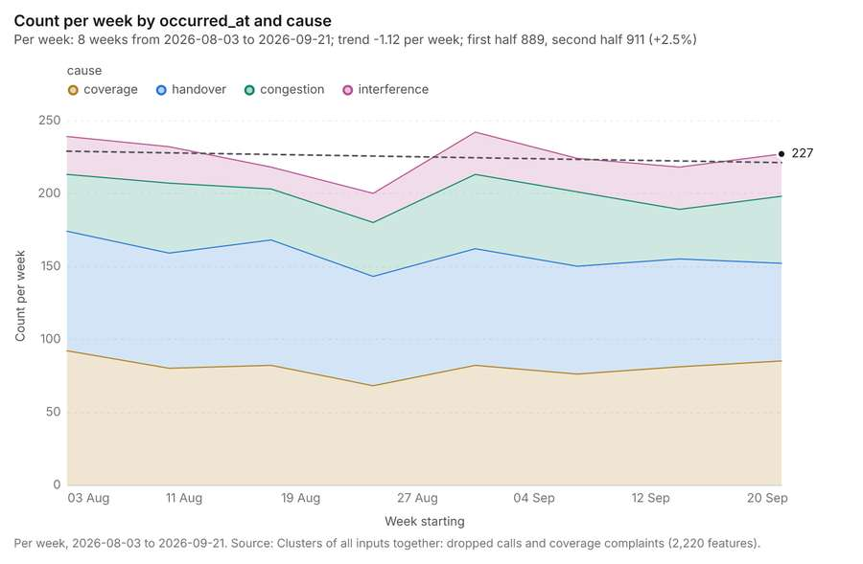
Figure 85. Clusters of all inputs together: dropped calls and coverage complaints over time [259]. Per week, 2026-08-03 to 2026-09-21. Source: Clusters of all inputs together: dropped calls and coverage complaints (2,220 features). The data is in the appendix.
Findings
- Evidenced: Pipeline on Dropped calls, Coverage complaints produced Find point clusters: cluster hulls (3 features), Clusters of all inputs together: dropped calls and coverage complaints (2,220 features) [14][15][256][257][258].
- Evidenced: It reported result, count 2,220; result, noise 2,093; result, distance m 100; result, elapsed ms 24; result, min points 20; billing, cost 0.1044 [256].
- Evidenced: Clusters of all inputs together: dropped calls and coverage complaints over time shows a trend of -1.12 per week; the second half of its weeks has 911 against 889 in the first (+2.5%) [259].
Tool gp_pipeline; parameters {"save": "final", "steps": [{"id": "merged", "params": {"layers": [{"layer": "Dropped calls (e2f5ccec)"}, {"layer": "Coverage complaints (a0e6cf38)"}], "source_field": "source"}, "operation": "merge_layers"}, {"id": "joint", "params": {"method": "dbscan", "features": "$merged", "distance_m": 100.0, "min_points": 20}, "operation": "find_point_clusters"}], "project": "bceeca13-52a5-4344-bf84-77a2f9f

Towers within 250 m of each cluster of dropped calls
What this analysis is. Pipeline: Run up to 20 GIS operations in one engine call; a step's params may use "$id" (an earlier step's result) or "$id.key", and layer references [249]. Every step's map outputs are saved as styled layers [249].
Why it was run on this data. Neighborhoods holds population in 'population': Towers per 10,000 people in each feature compares features of different size; mapped as a choropleth (natural breaks, sequential colors) [250].
What it found. The analysis utilized Towers as input [13] through the `gp_pipeline` tool [260], which found point clusters: cluster hulls [247] as part of its process. This pipeline generated an output layer detailing Towers within 250 m of each cluster of dropped calls, consisting of 2 features [261].
Result | Value
result, count | 2
result, elapsed ms | 0
billing, cost | 0.02034
billing, list price | 0.02034
billing, upstream cost | 0
list price | 0.02034

Findings
- Evidenced: Pipeline on Find point clusters: cluster hulls, Towers produced Towers within 250 m of each cluster of dropped calls (2 features) [13][247][260][261].
- Evidenced: It reported result, count 2; result, elapsed ms 0; billing, cost 0.02034; billing, list price 0.02034; billing, upstream cost 0; list price 0.02034 [260].
Tool gp_pipeline; parameters {"save": "final", "steps": [{"id": "buffer", "params": {"features": {"layer": "Find point clusters: cluster hulls (5313780d)"}, "distance_m": 250}, "operation": "buffer"}, {"id": "count", "params": {"features": {"layer": "Towers (f7206b9b)"}, "polygons": "$buffer"}, "operation": "summarize_within"}], "project": "bceeca13-52a5-4344-bf84-77a2f9f8e186", "output_name": "Towers within 250 m of each clu

Maps and charts
The run also made 22 chart(s) [262][263][264][265][266][267][268][269][270][271][272][273][274][275][276][277][278][279][280][281][282][283].
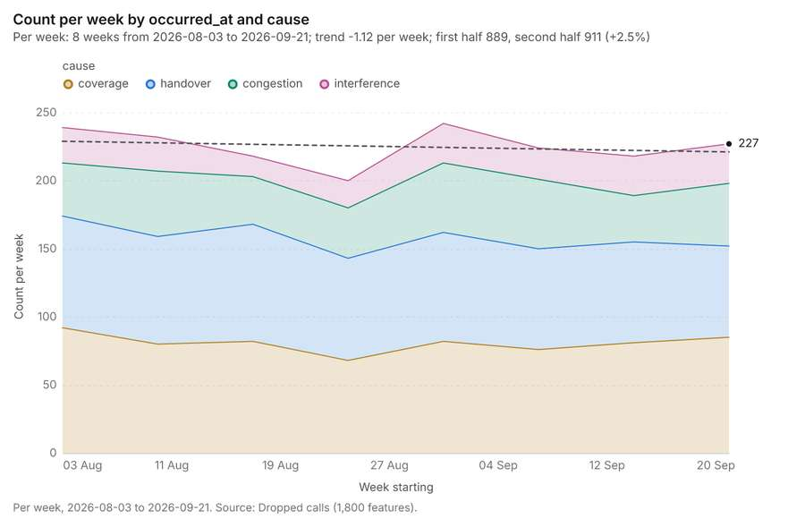
Figure 86. Dropped calls over time (occurred_at) [262]. Per week, 2026-08-03 to 2026-09-21. Source: Dropped calls (1,800 features). The data is in the appendix.
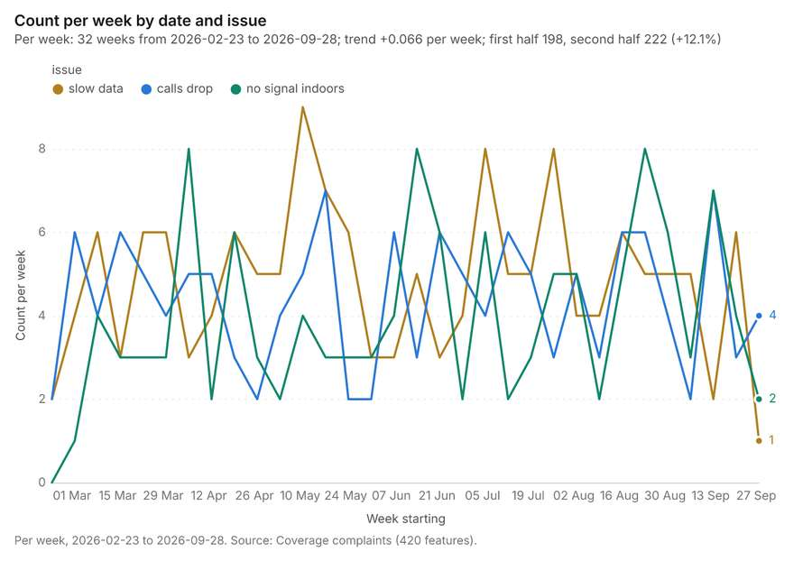
Figure 87. Coverage complaints over time (date) [263]. Per week, 2026-02-23 to 2026-09-28. Source: Coverage complaints (420 features). The data is in the appendix.
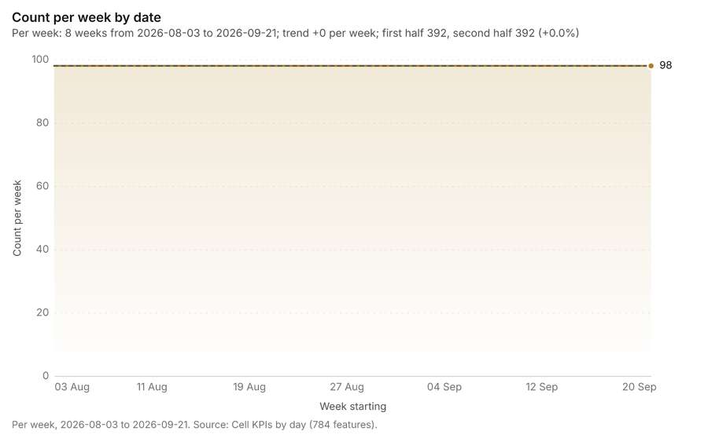
Figure 88. Cell KPIs by day over time (date) [264]. Per week, 2026-08-03 to 2026-09-21. Source: Cell KPIs by day (784 features). The data is in the appendix.
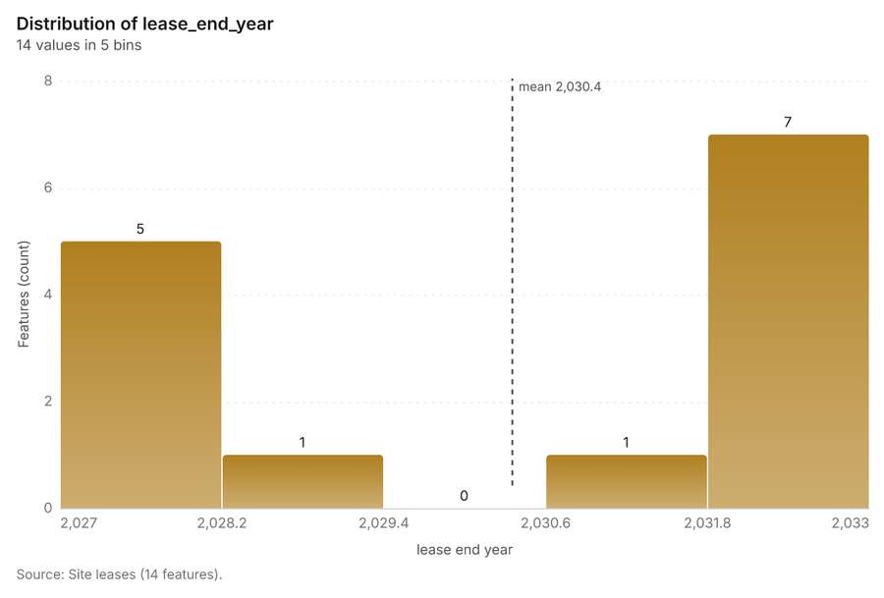
Figure 89. Site leases over time (lease_end_year) [265]. Source: Site leases (14 features). The data is in the appendix.
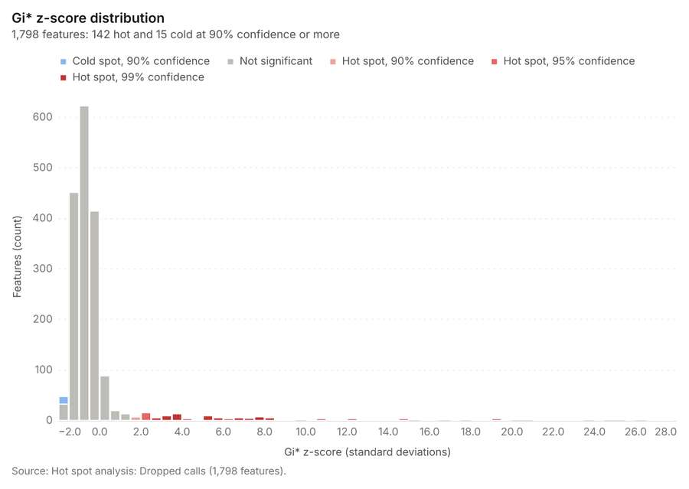
Figure 90. Hot spot analysis: Dropped calls [266]. Source: Hot spot analysis: Dropped calls (1,798 features). The data is in the appendix.
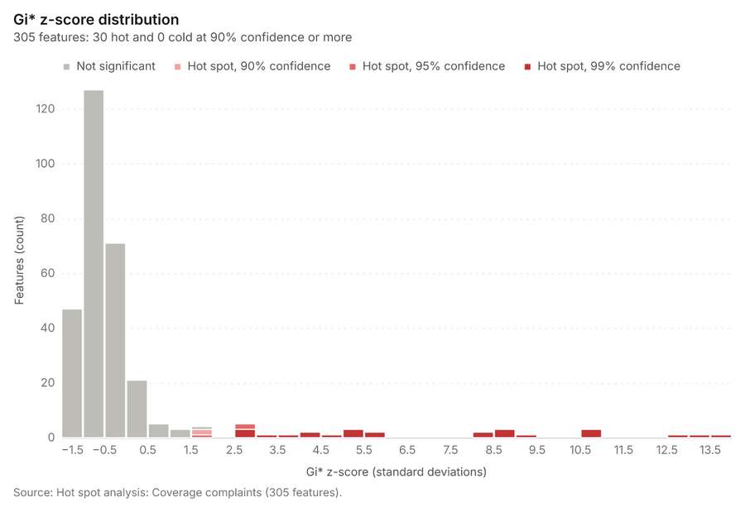
Figure 91. Hot spot analysis: Coverage complaints [267]. Source: Hot spot analysis: Coverage complaints (305 features). The data is in the appendix.
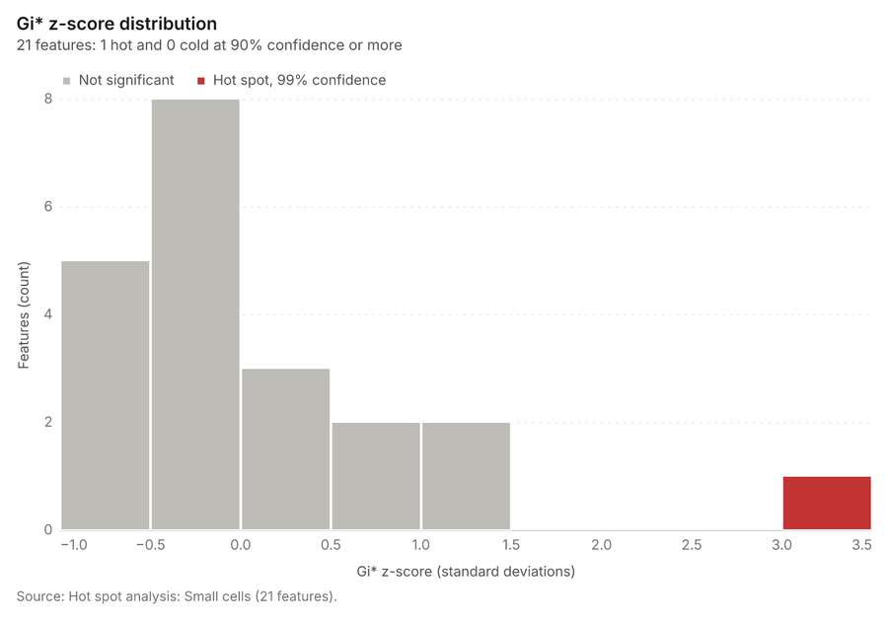
Figure 92. Hot spot analysis: Small cells [268]. Source: Hot spot analysis: Small cells (21 features). The data is in the appendix.
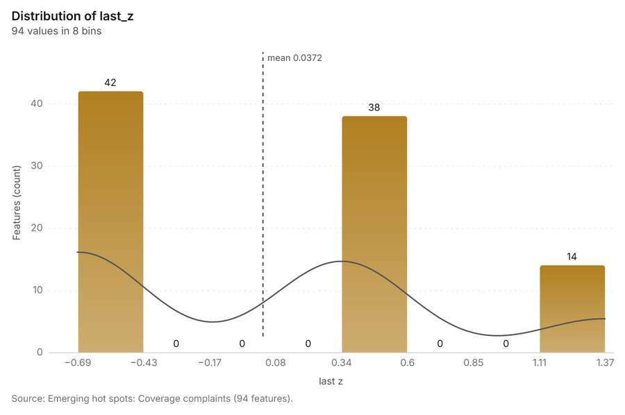
Figure 93. Emerging hot spots: Coverage complaints [269]. Source: Emerging hot spots: Coverage complaints (94 features). The data is in the appendix.
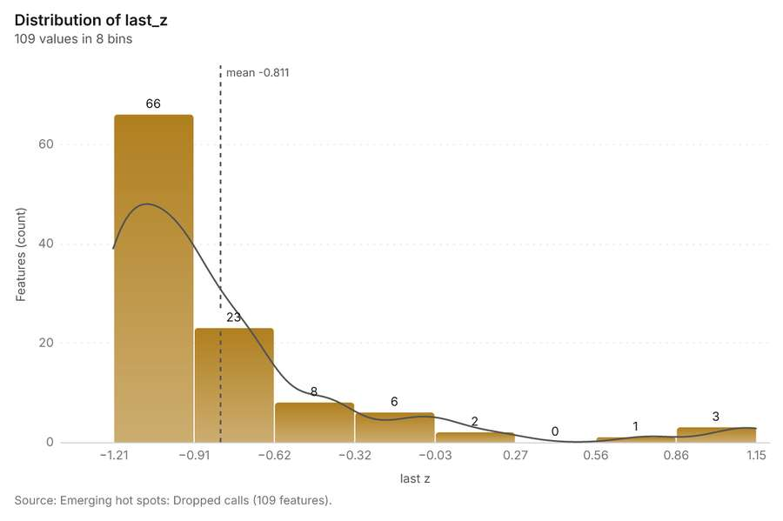
Figure 94. Emerging hot spots: Dropped calls [270]. Source: Emerging hot spots: Dropped calls (109 features). The data is in the appendix.
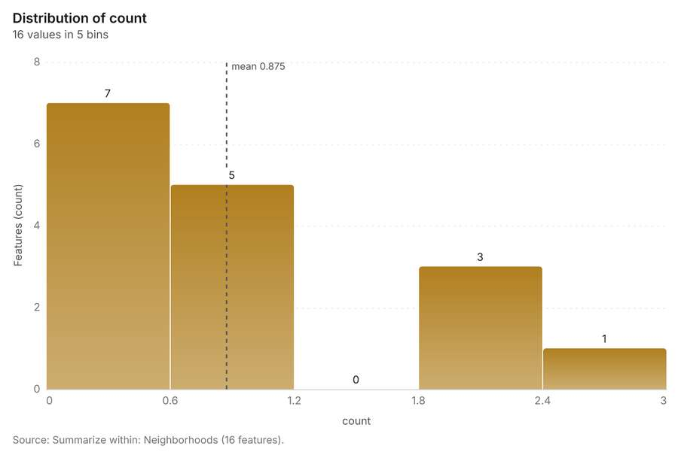
Figure 95. Summarize within: Neighborhoods [271]. Source: Summarize within: Neighborhoods (16 features). The data is in the appendix.
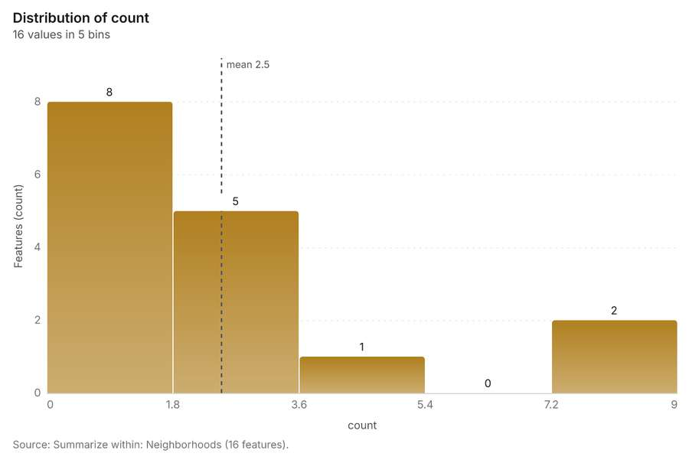
Figure 96. Summarize within: Neighborhoods [272]. Source: Summarize within: Neighborhoods (16 features). The data is in the appendix.
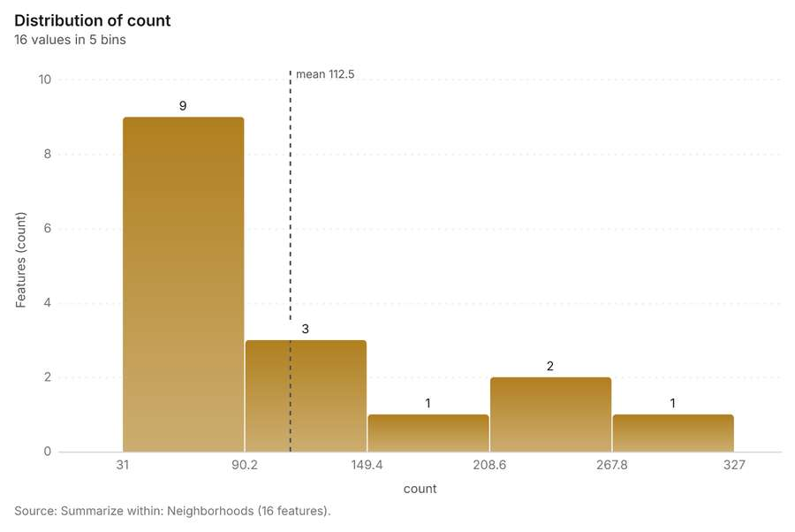
Figure 97. Summarize within: Neighborhoods [273]. Source: Summarize within: Neighborhoods (16 features). The data is in the appendix.
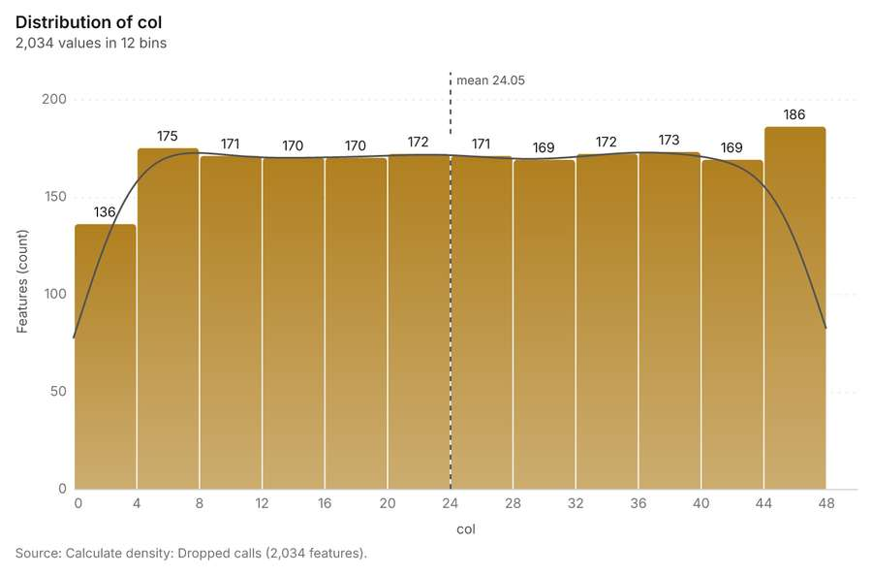
Figure 98. Calculate density: Dropped calls [274]. Source: Calculate density: Dropped calls (2,034 features). The data is in the appendix.
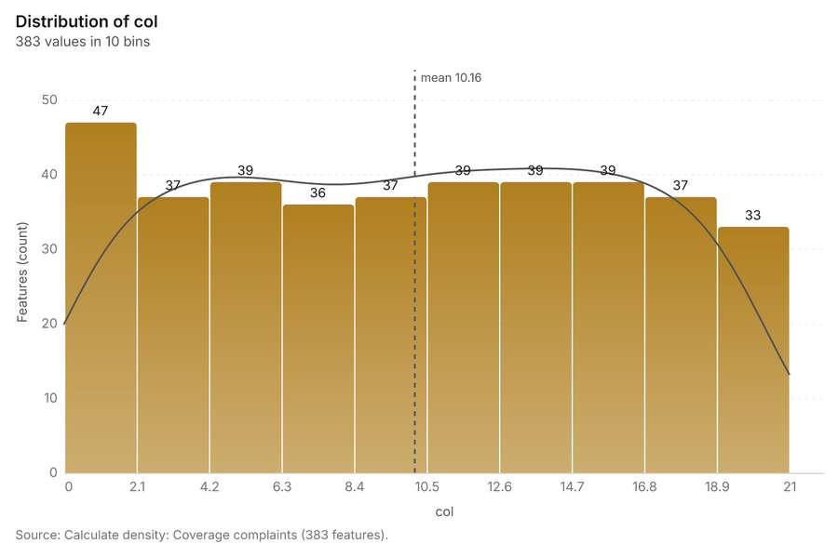
Figure 99. Calculate density: Coverage complaints [275]. Source: Calculate density: Coverage complaints (383 features). The data is in the appendix.
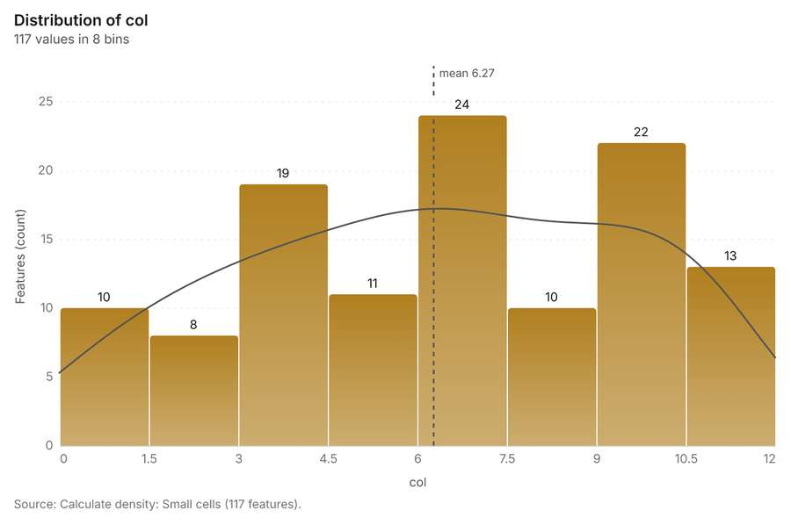
Figure 100. Calculate density: Small cells [276]. Source: Calculate density: Small cells (117 features). The data is in the appendix.
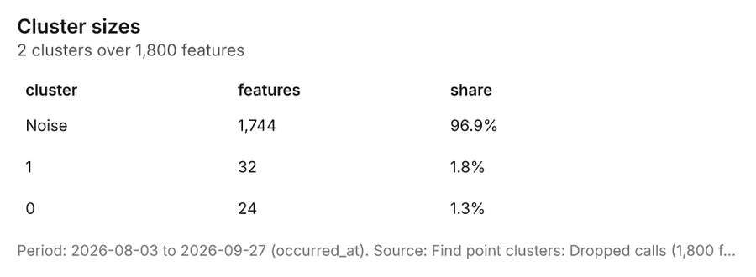
Figure 101. Find point clusters: Dropped calls [277]. Period: 2026-08-03 to 2026-09-27 (occurred_at). Source: Find point clusters: Dropped calls (1,800 features). The data is in the appendix.
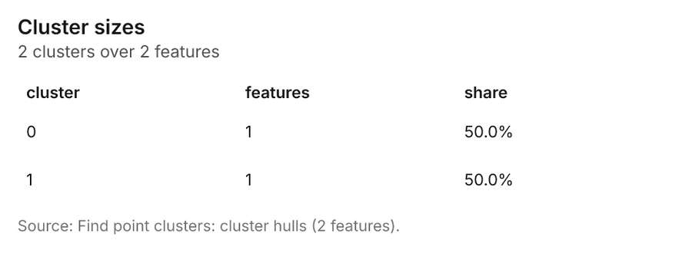
Figure 102. Find point clusters: cluster hulls [278]. Source: Find point clusters: cluster hulls (2 features). The data is in the appendix.
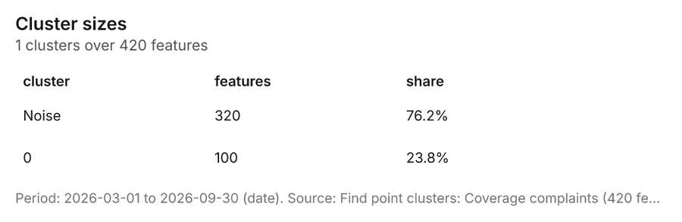
Figure 103. Find point clusters: Coverage complaints [279]. Period: 2026-03-01 to 2026-09-30 (date). Source: Find point clusters: Coverage complaints (420 features). The data is in the appendix.
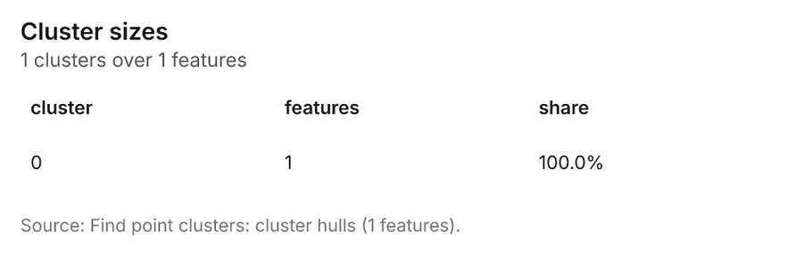
Figure 104. Find point clusters: cluster hulls [280]. Source: Find point clusters: cluster hulls (1 features). The data is in the appendix.
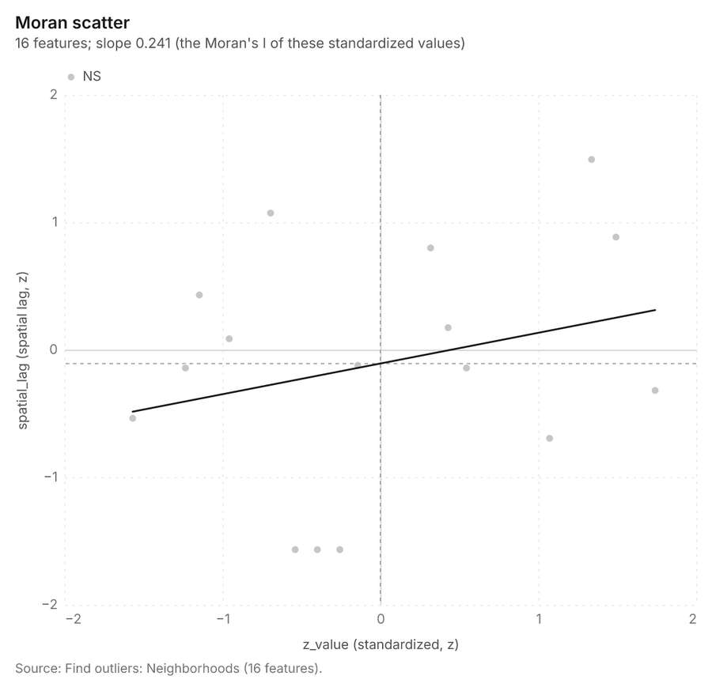
Figure 105. Find outliers: Neighborhoods [281]. Source: Find outliers: Neighborhoods (16 features). The data is in the appendix.
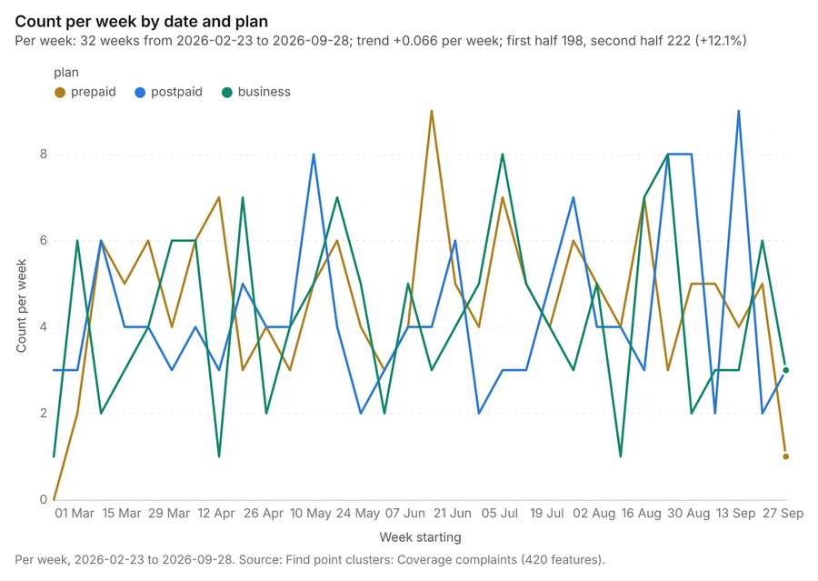
Figure 106. Find point clusters: Coverage complaints over time [282]. Per week, 2026-02-23 to 2026-09-28. Source: Find point clusters: Coverage complaints (420 features). The data is in the appendix.
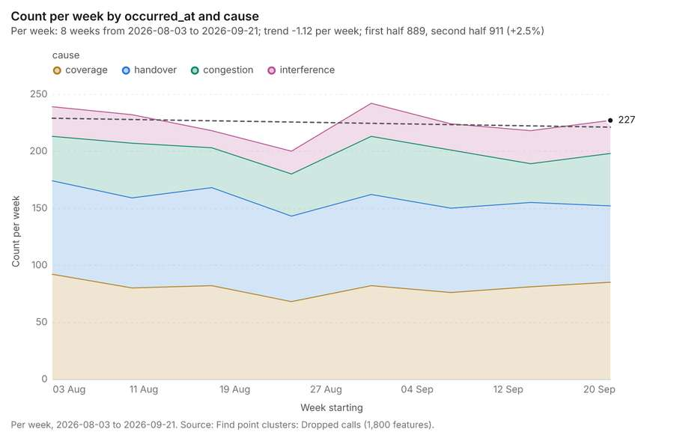
Figure 107. Find point clusters: Dropped calls over time [283]. Per week, 2026-08-03 to 2026-09-21. Source: Find point clusters: Dropped calls (1,800 features). The data is in the appendix.

More maps
43 more map(s), beyond the 24 the report body holds, in the composer's order: Terrain analysis (continued 23) [284]; Terrain analysis (continued 24) [285]; Terrain analysis (continued 25) [286]; Terrain analysis (continued 26) [287]; Terrain analysis (continued 27) [288]; Terrain analysis (continued 28) [289]; Terrain analysis (continued 29) [290]; Terrain analysis (continued 30) [291]; Terrain analysis (continued 31) [292]; Terrain analysis (continued 32) [293]; Terrain analysis (continued 33) [294]; Terrain analysis (continued 34) [295]; Terrain analysis (continued 35) [296]; Terrain analysis (continued 36) [297]; Terrain analysis (continued 37) [298]; Terrain analysis (continued 38) [299]; Terrain analysis (continued 39) [300]; Terrain analysis (continued 40) [301]; Terrain analysis (continued 41) [302]; Slope: valley terrain model (DEM) [303]; Hot spots: dropped calls [304]; Hot spots: coverage complaints [305]; Hot spots: small cells [306]; Emerging hot spots: coverage complaints and dropped calls [307]; Counts: towers, by neighborhood [308]; Counts: small cells, by neighborhood [309]; Counts: dropped calls, by neighborhood [310]; Period change: dropped calls, by neighborhood [311]; Period change: coverage complaints, by neighborhood [312]; Seasonality: dropped calls, by neighborhood [313]; Density: dropped calls [314]; Density: coverage complaints [315]; Density: small cells [316]; Clusters: dropped calls [317]; Clusters: coverage complaints [318]; Outliers: neighborhoods [319]; Change beside the counts per neighborhood [320]; Change of dropped calls where density is high [321]; Hot cells of dropped calls per neighborhood [322]; Nearest tower to each cluster of dropped calls [323]; Change of coverage complaints per neighborhood [324]; Clusters of all inputs together: dropped calls and coverage complaints [325]; Towers within 250 m of each cluster of dropped calls [326].
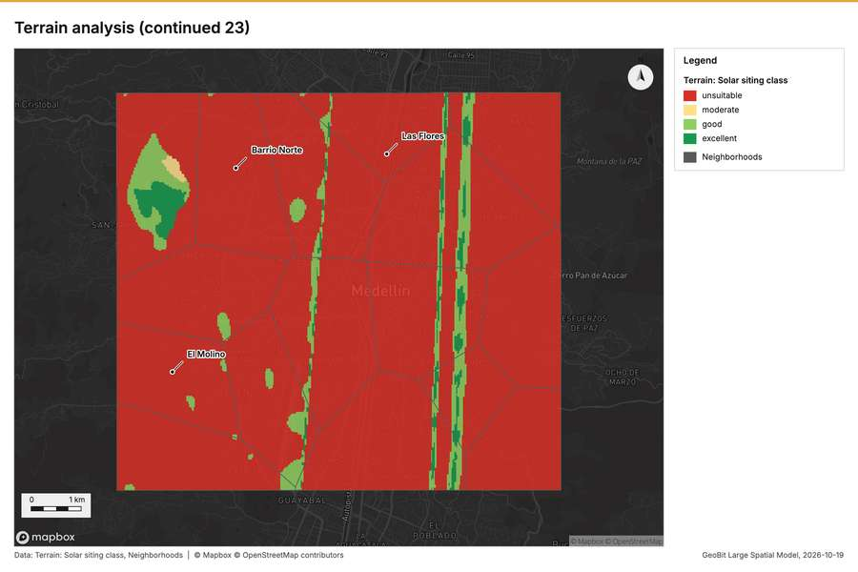
Figure 108. Terrain analysis (continued 23) [284]
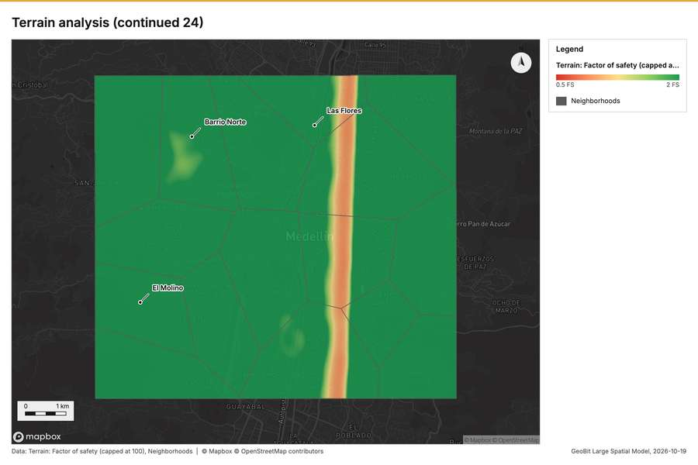
Figure 109. Terrain analysis (continued 24) [285]
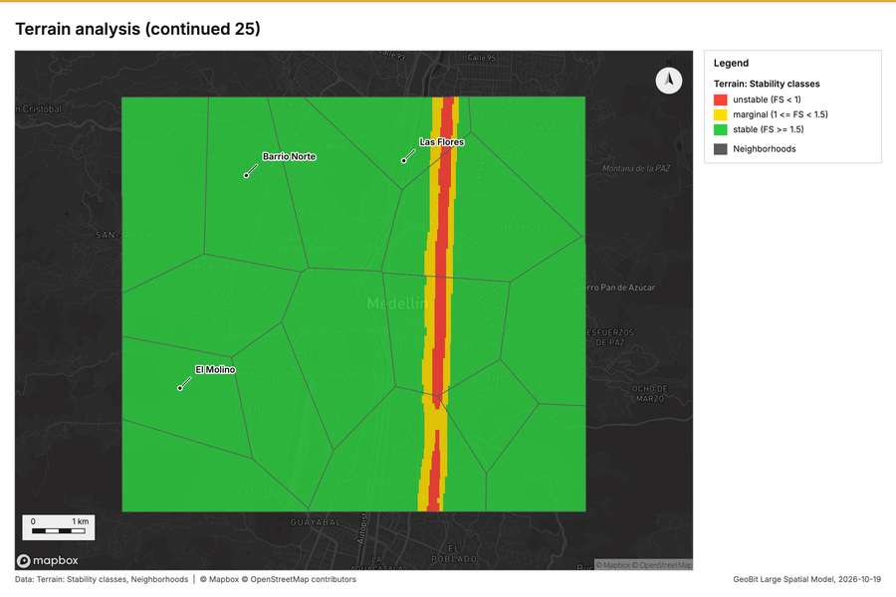
Figure 110. Terrain analysis (continued 25) [286]
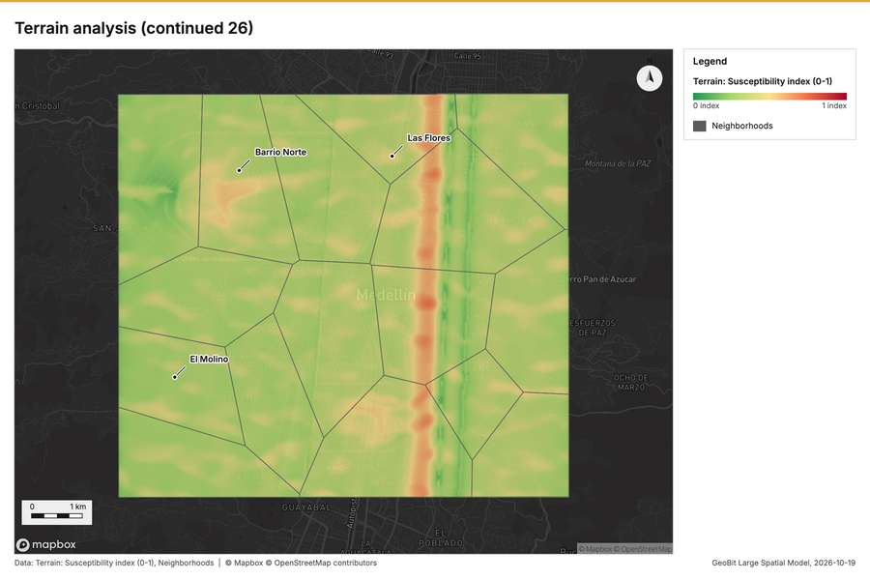
Figure 111. Terrain analysis (continued 26) [287]
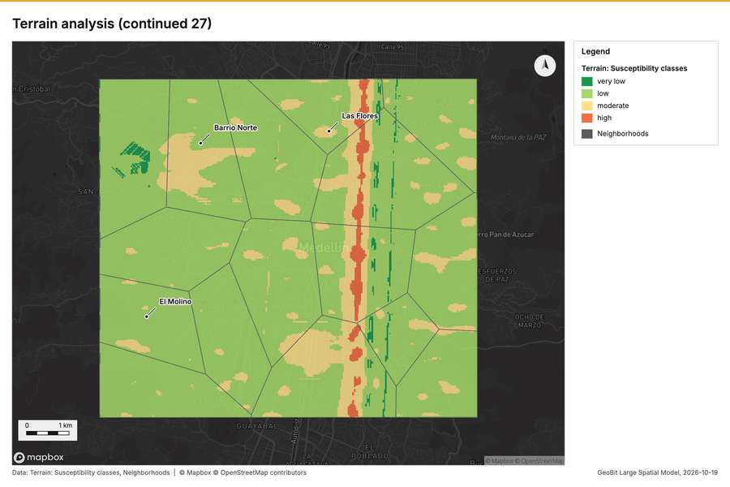
Figure 112. Terrain analysis (continued 27) [288]
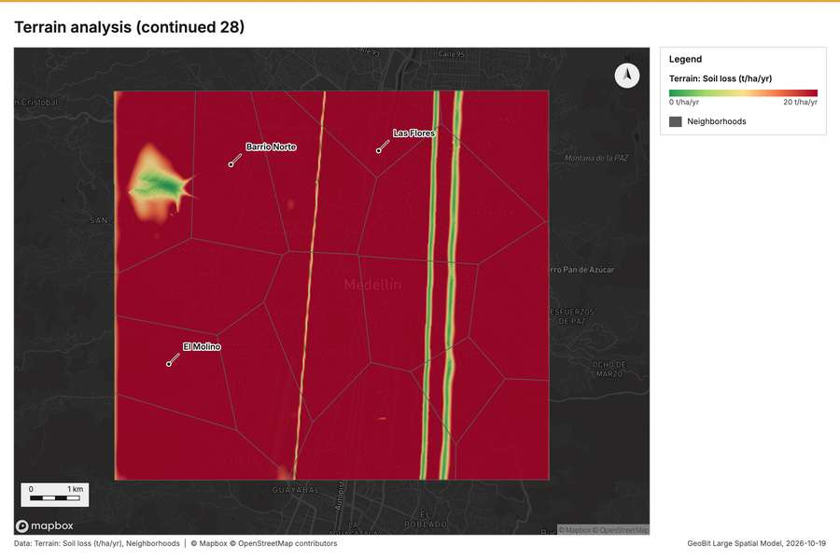
Figure 113. Terrain analysis (continued 28) [289]
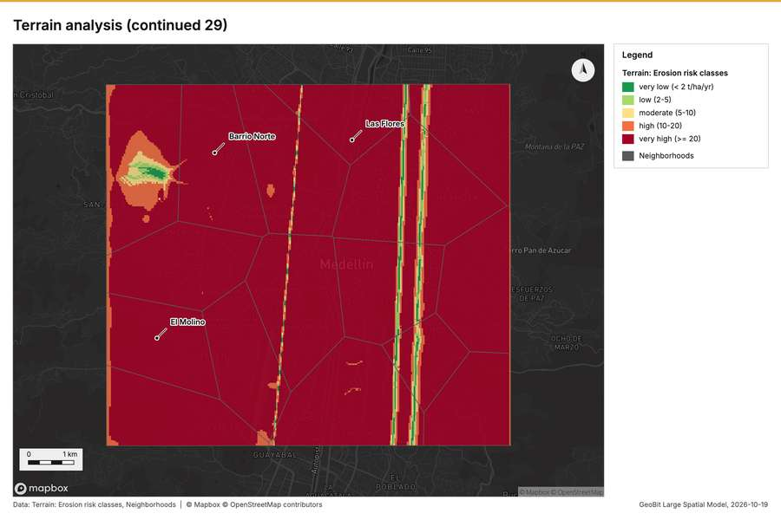
Figure 114. Terrain analysis (continued 29) [290]
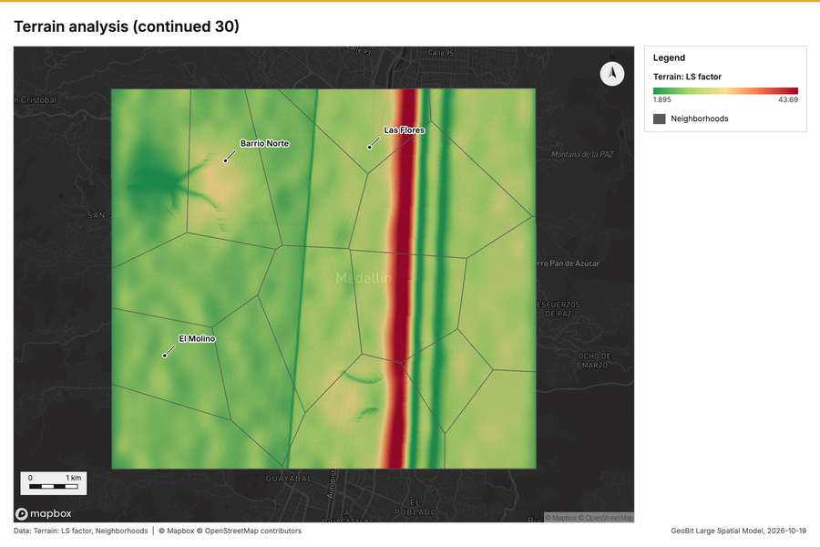
Figure 115. Terrain analysis (continued 30) [291]
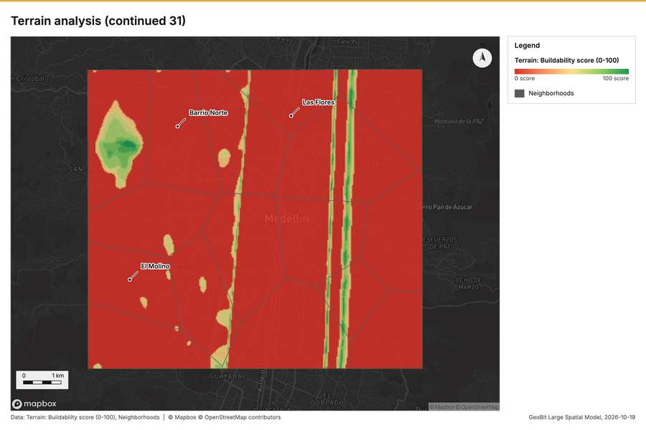
Figure 116. Terrain analysis (continued 31) [292]
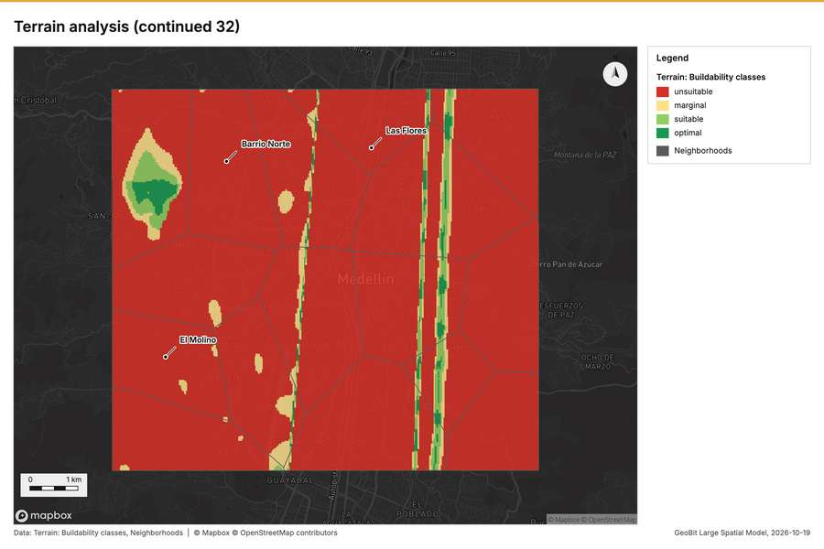
Figure 117. Terrain analysis (continued 32) [293]
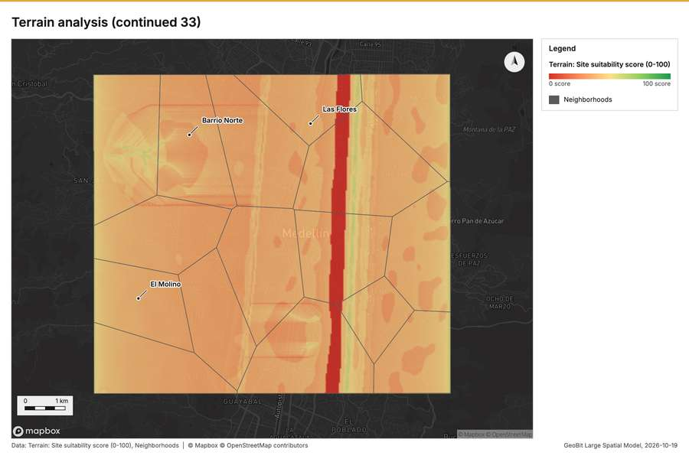
Figure 118. Terrain analysis (continued 33) [294]
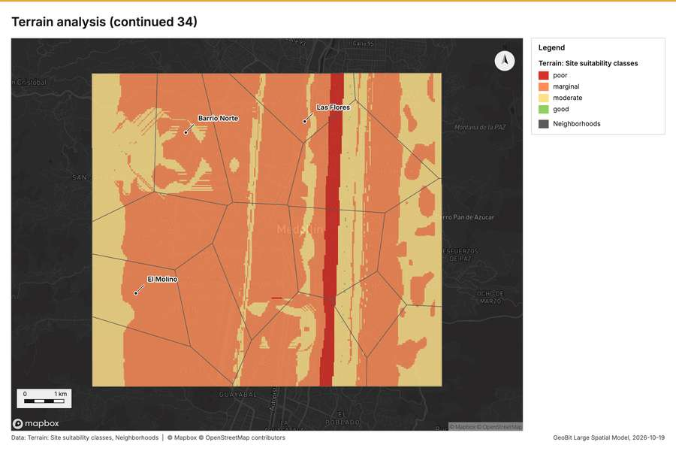
Figure 119. Terrain analysis (continued 34) [295]
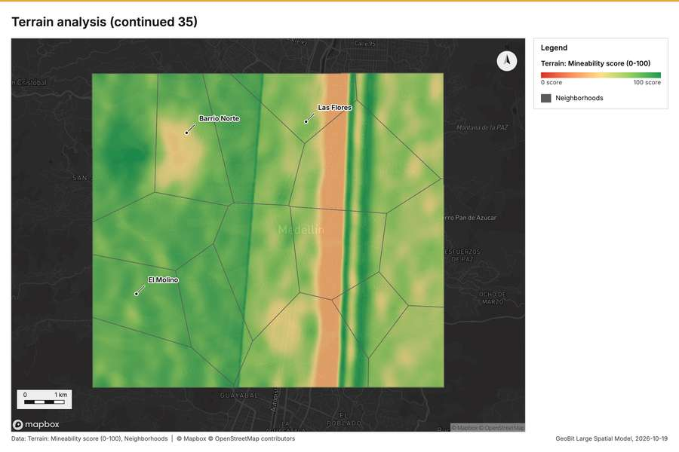
Figure 120. Terrain analysis (continued 35) [296]
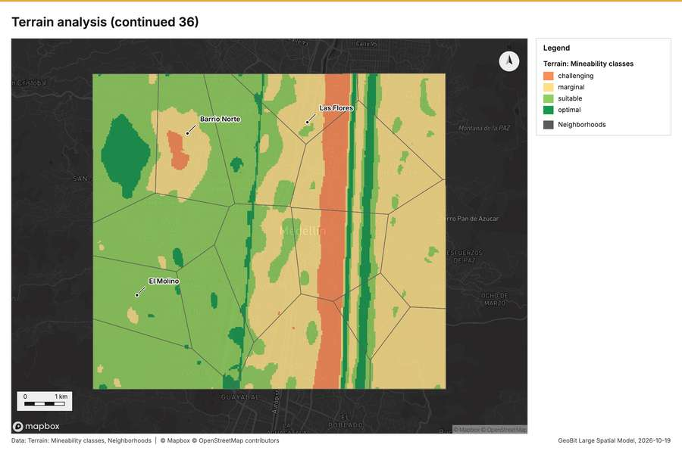
Figure 121. Terrain analysis (continued 36) [297]
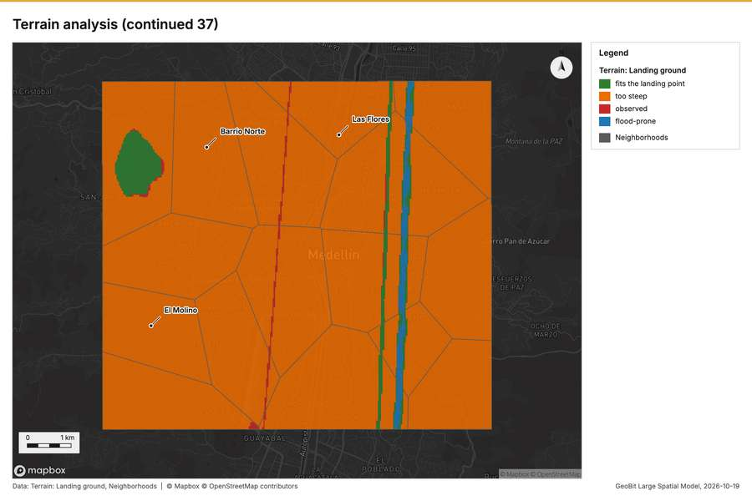
Figure 122. Terrain analysis (continued 37) [298]
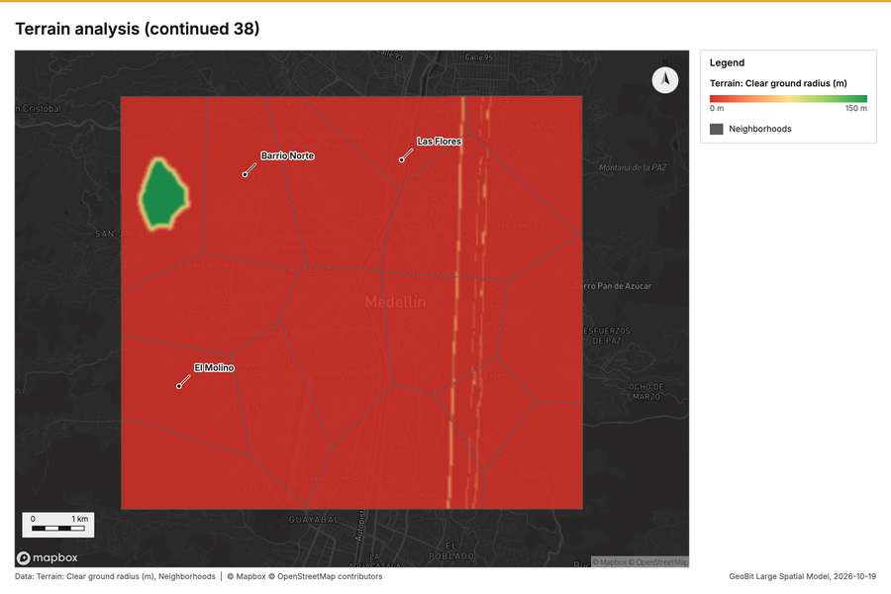
Figure 123. Terrain analysis (continued 38) [299]
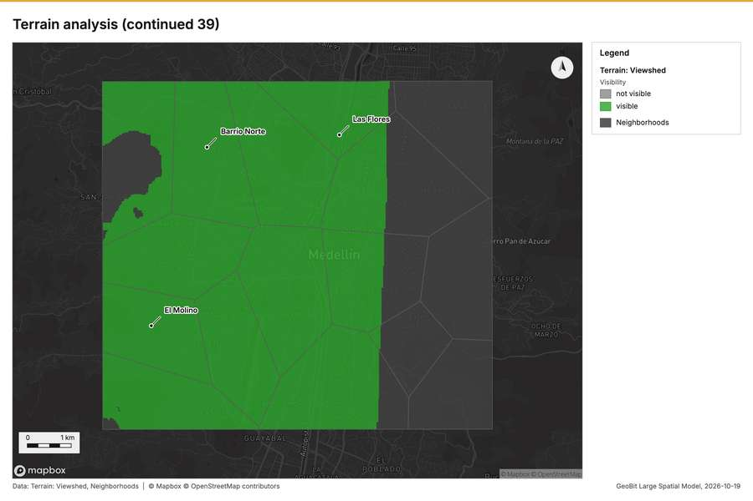
Figure 124. Terrain analysis (continued 39) [300]
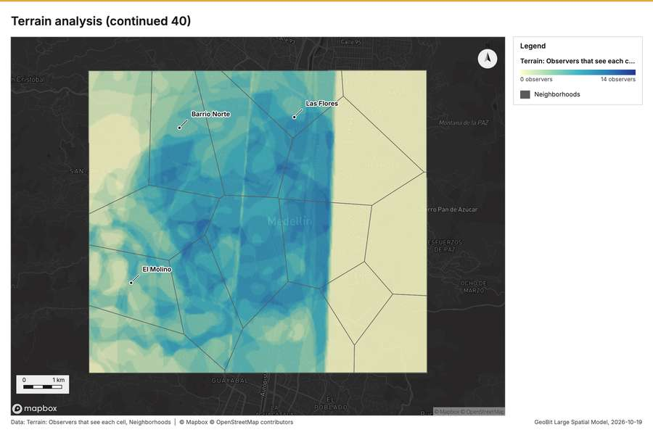
Figure 125. Terrain analysis (continued 40) [301]
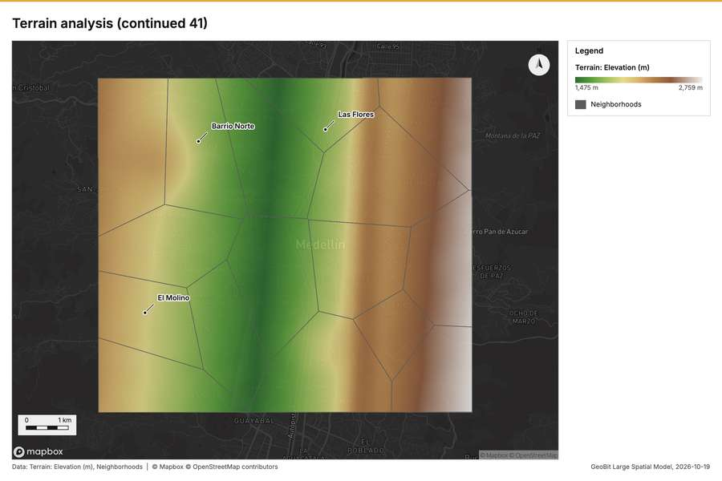
Figure 126. Terrain analysis (continued 41) [302]
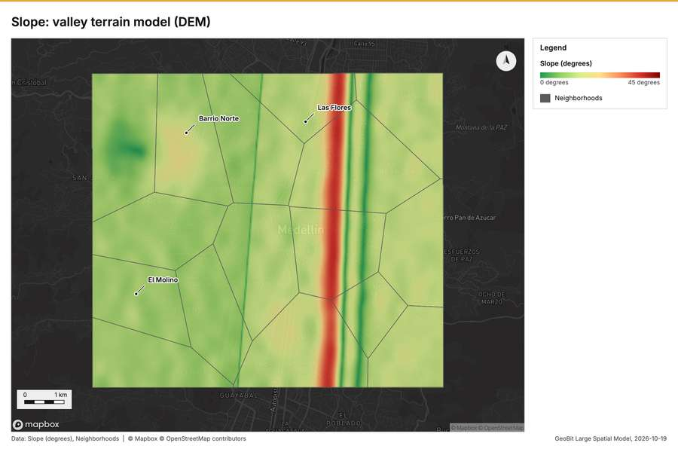
Figure 127. Slope: valley terrain model (DEM) [303]
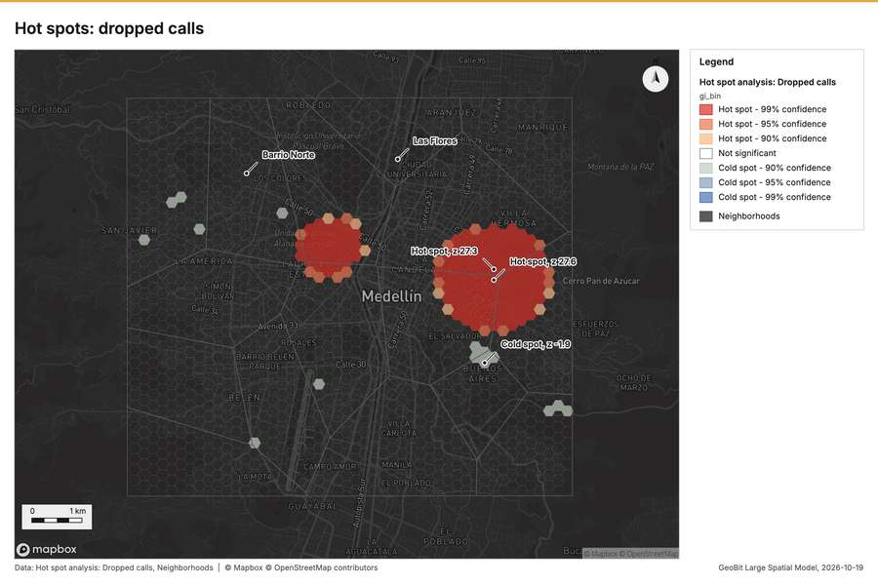
Figure 128. Hot spots: dropped calls [304]
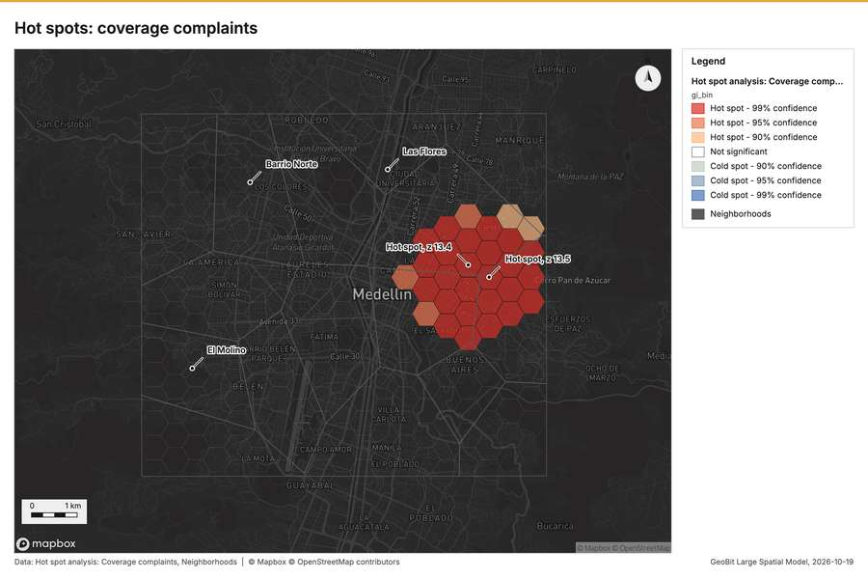
Figure 129. Hot spots: coverage complaints [305]
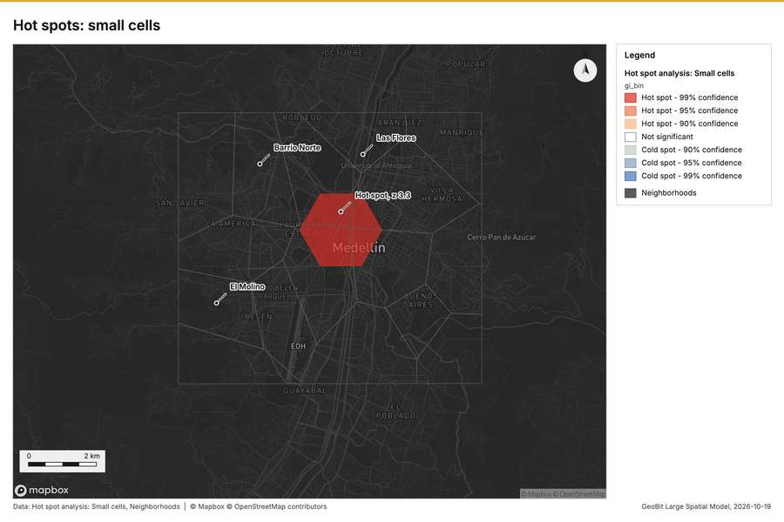
Figure 130. Hot spots: small cells [306]
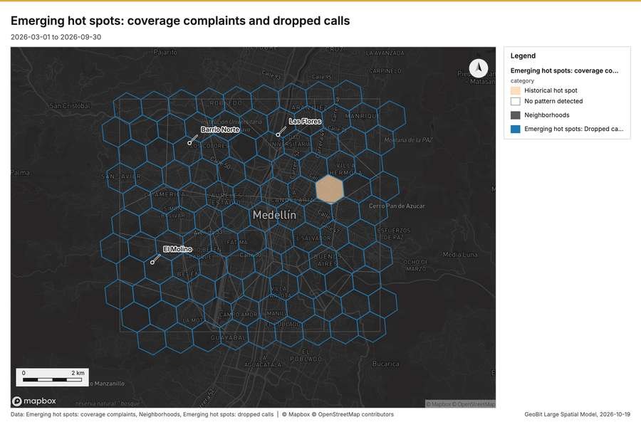
Figure 131. Emerging hot spots: coverage complaints and dropped calls [307]
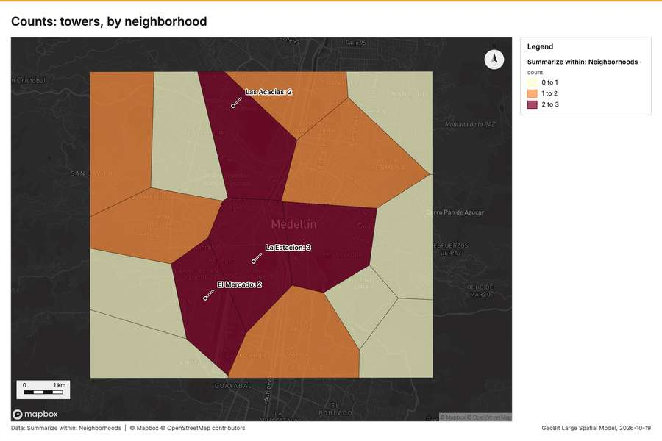
Figure 132. Counts: towers, by neighborhood [308]
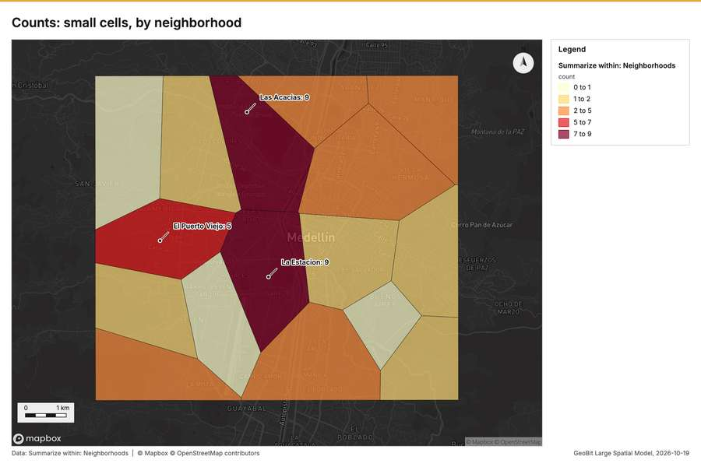
Figure 133. Counts: small cells, by neighborhood [309]
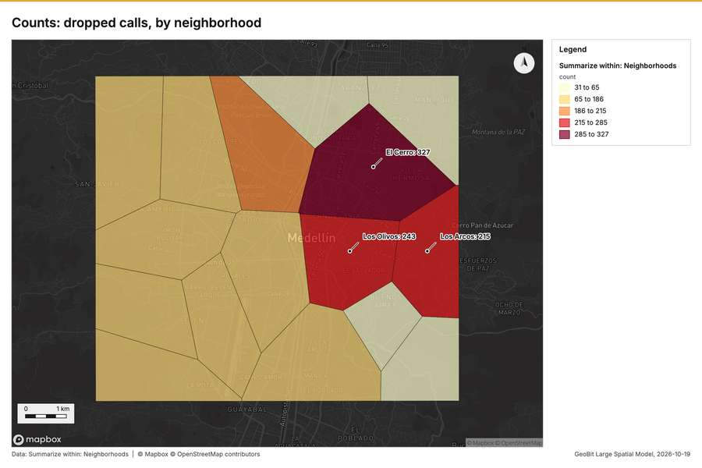
Figure 134. Counts: dropped calls, by neighborhood [310]
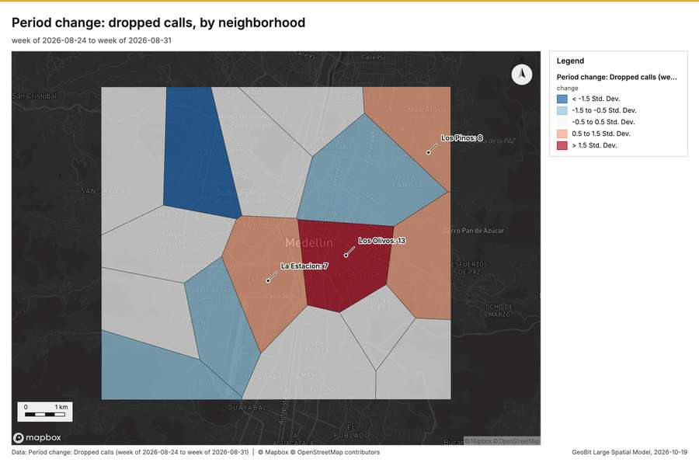
Figure 135. Period change: dropped calls, by neighborhood [311]
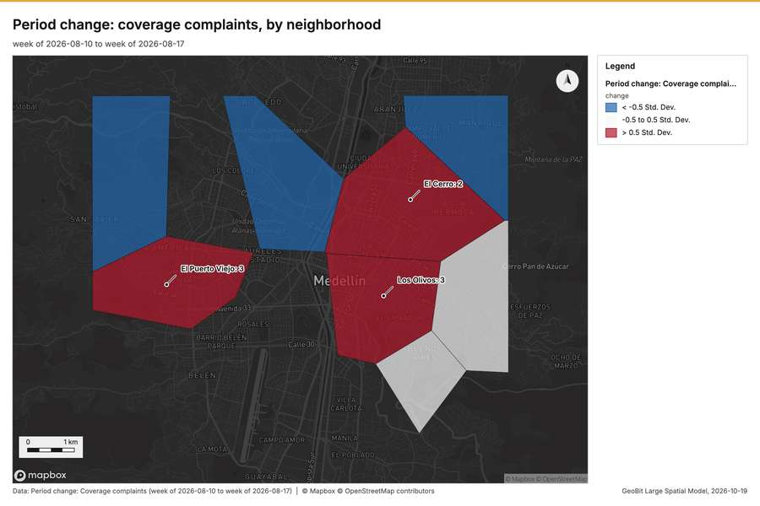
Figure 136. Period change: coverage complaints, by neighborhood [312]
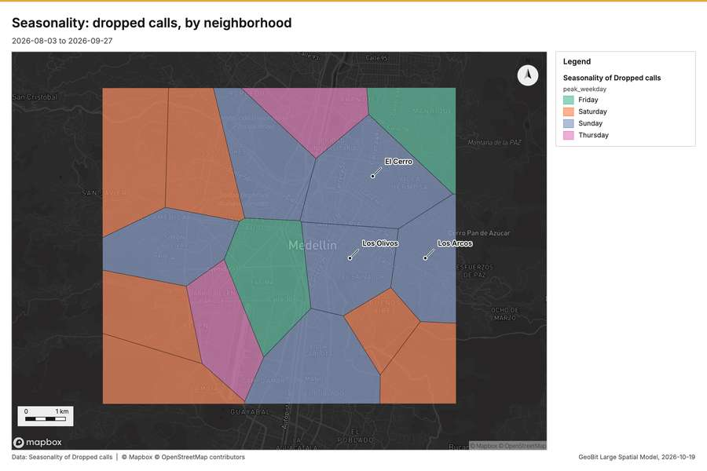
Figure 137. Seasonality: dropped calls, by neighborhood [313]
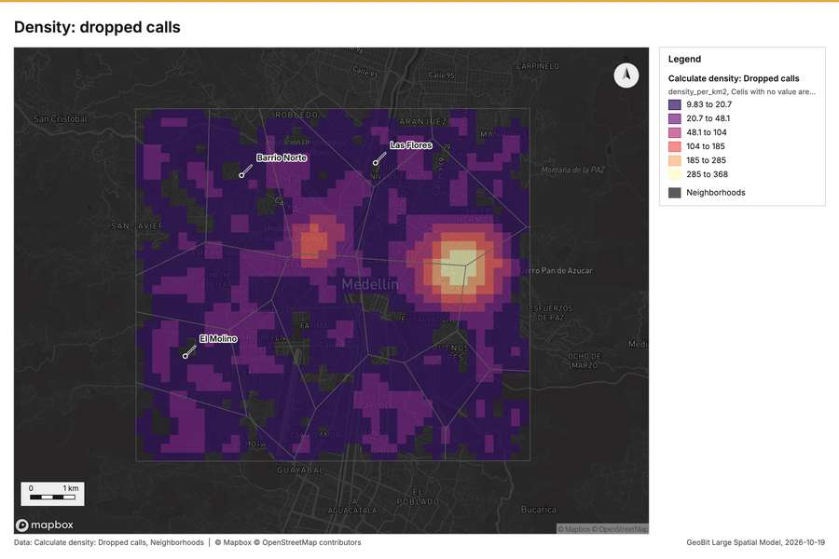
Figure 138. Density: dropped calls [314]
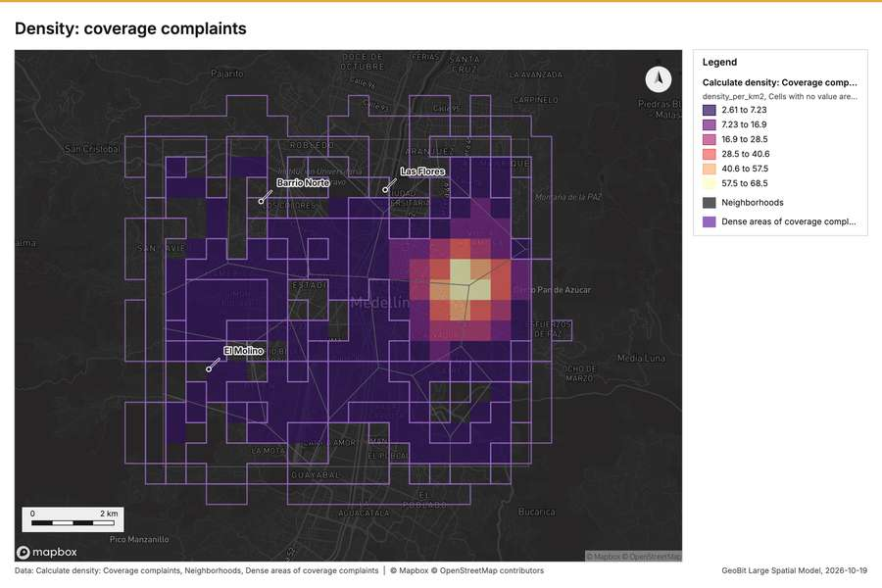
Figure 139. Density: coverage complaints [315]
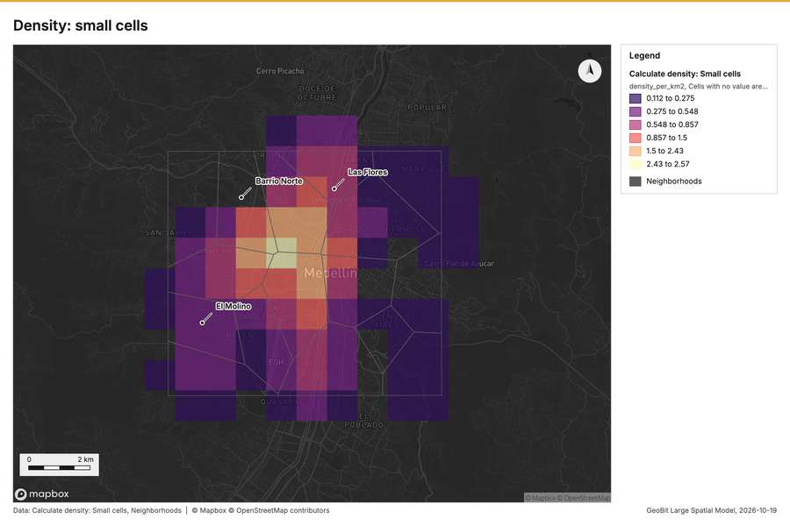
Figure 140. Density: small cells [316]
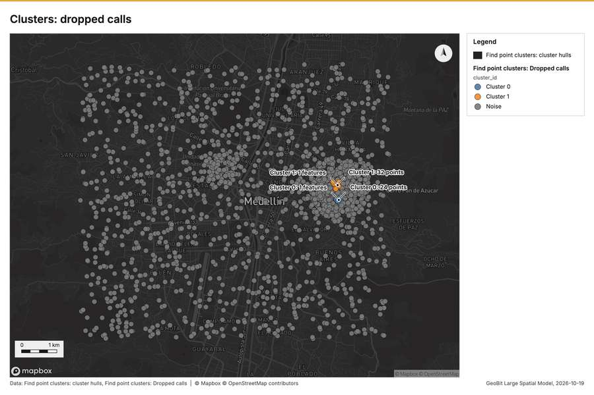
Figure 141. Clusters: dropped calls [317]
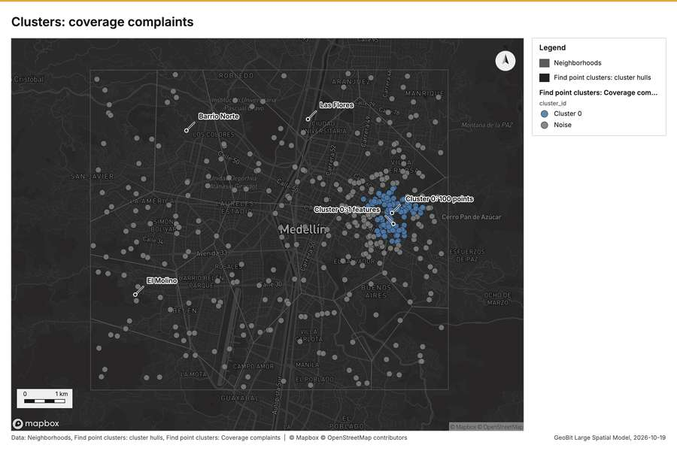
Figure 142. Clusters: coverage complaints [318]
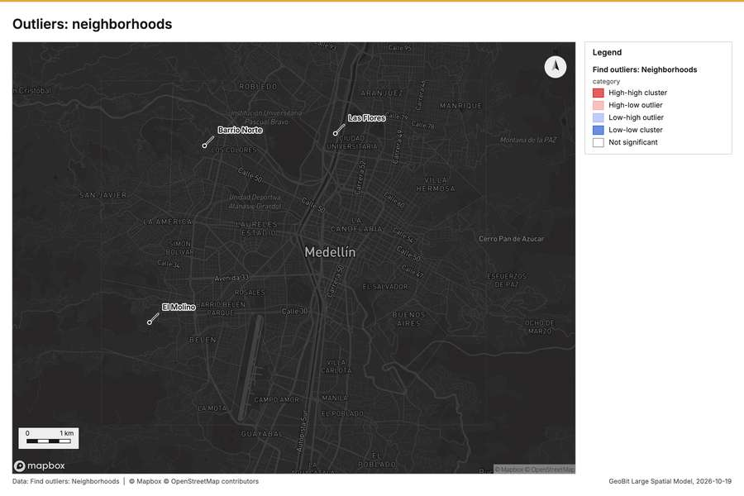
Figure 143. Outliers: neighborhoods [319]
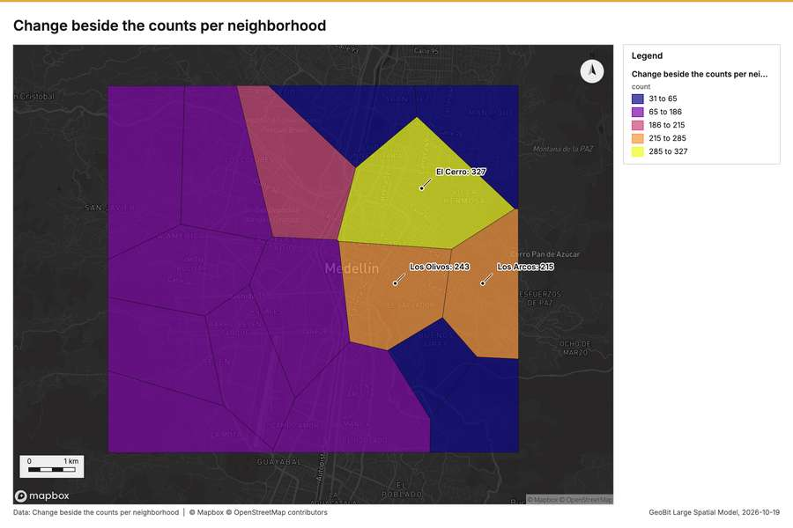
Figure 144. Change beside the counts per neighborhood [320]
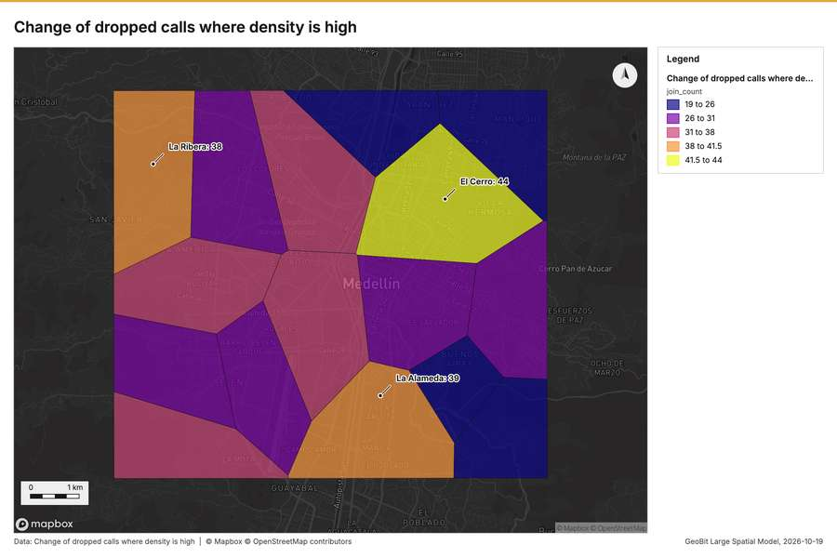
Figure 145. Change of dropped calls where density is high [321]
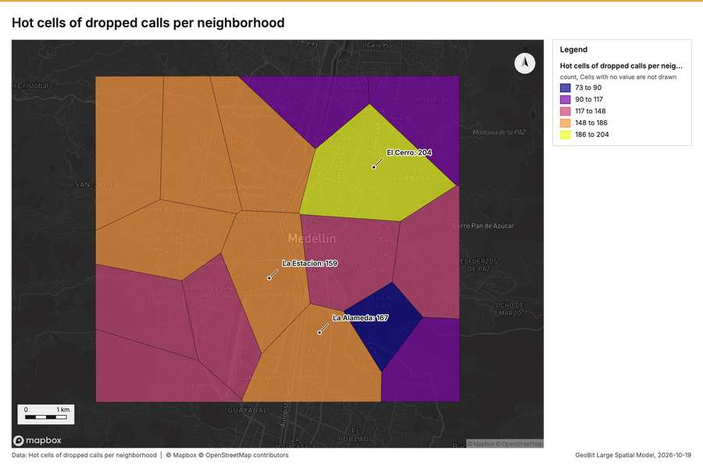
Figure 146. Hot cells of dropped calls per neighborhood [322]
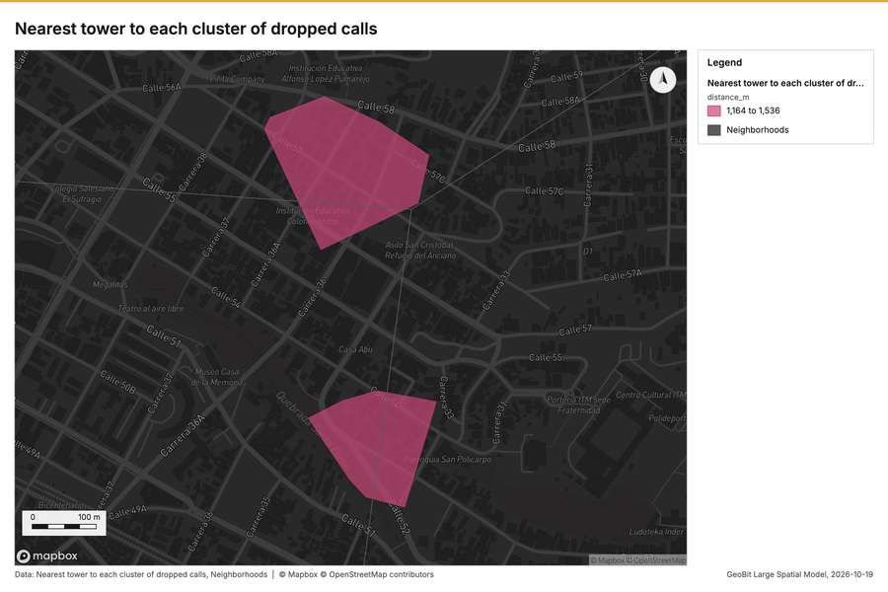
Figure 147. Nearest tower to each cluster of dropped calls [323]
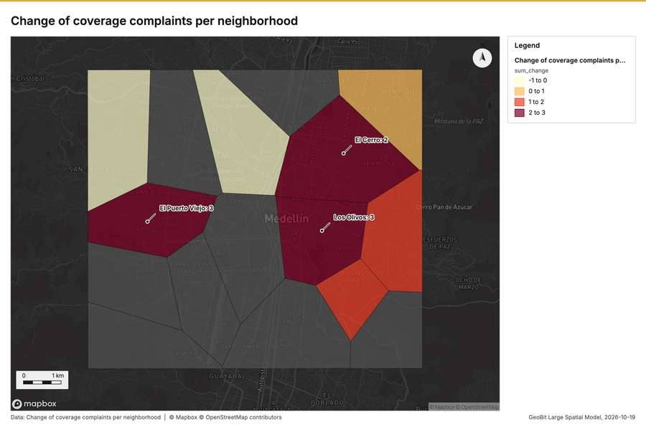
Figure 148. Change of coverage complaints per neighborhood [324]
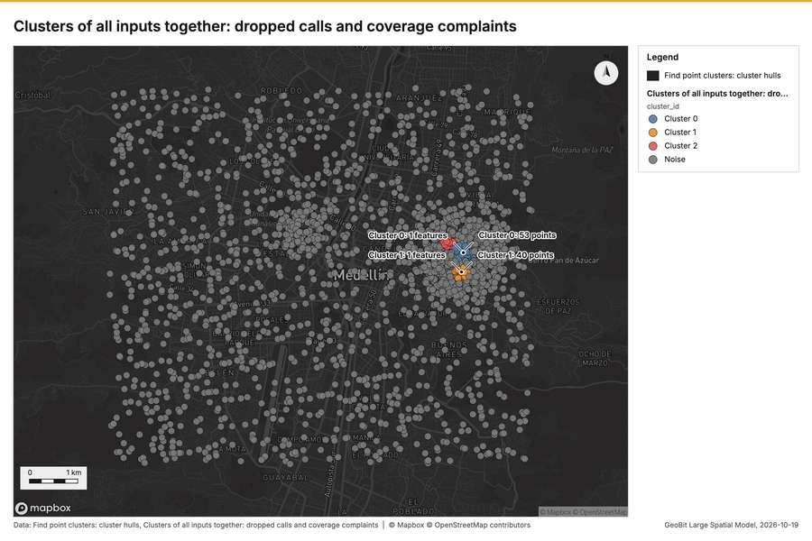
Figure 149. Clusters of all inputs together: dropped calls and coverage complaints [325]
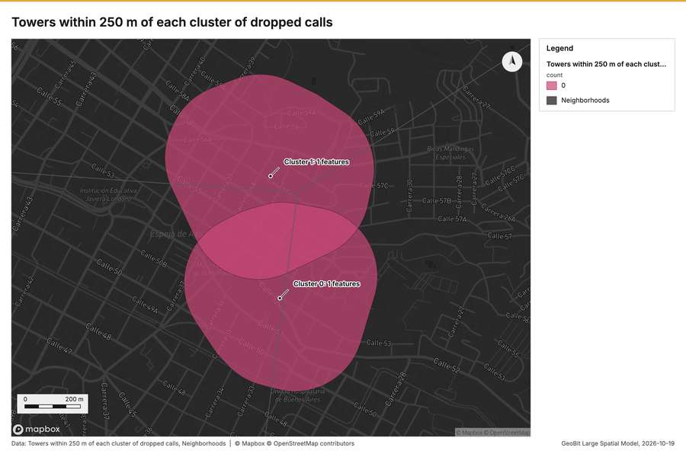
Figure 150. Towers within 250 m of each cluster of dropped calls [326]

Documents
What the documents name. Network performance review, August and September 2026 (1 page, 1 page(s) from the text layer) names 4 event terms and 7 places [327]. Event terms in Network performance review, August and September 2026: coverage (page 1, line 5), congestion (page 1, line 7), planned (page 1, line 10), live (page 1, line 10) [328]. Places named in Network performance review, August and September 2026: Los Olivos (page 1, line 5), 624785, -7555517 (page 1, line 5), Tower 03 La Fuente (page 1, line 7), Tower 13 Los Pinos (page 1, line 9) [328].
Result | Value
Documents | 1
Entities | 11
Event terms | 4
Places | 7

Findings
- Evidenced: Network performance review, August and September 2026 (1 page, 1 page(s) from the text layer) names 4 event terms and 7 places.
- Evidenced: Event terms in Network performance review, August and September 2026: coverage (page 1, line 5), congestion (page 1, line 7), planned (page 1, line 10), live (page 1, line 10).
- Evidenced: Places named in Network performance review, August and September 2026: Los Olivos (page 1, line 5), 624785, -7555517 (page 1, line 5), Tower 03 La Fuente (page 1, line 7), Tower 13 Los Pinos (page 1, line 9).

Changes since the last run
78 number(s) changed since the report of 2026-10-19T04:12:21Z.
Analysis | Measure | Before | After | Change
Hot spots | result, bins | 21 | 1,798 | 1,777
Hot spots | result, count | 21 | 1,798 | 1,777
Hot spots | result, elapsed ms | 2 | 64 | 62
Hot spots | result, cell size m | 2,000 | 200 | -1,800
Hot spots | result, incidents used | 40 | 1,800 | 1,760
Hot spots | result, distance band m | 2,000 | 500 | -1,500
Hot spots | billing, cost | 0.0508 | 0.086 | 0.0352
Hot spots | billing, list price | 0.0508 | 0.086 | 0.0352
Hot spots | result, bins | 21 | 305 | 284
Hot spots | result, count | 21 | 305 | 284
Hot spots | result, elapsed ms | 2 | 11 | 9
Hot spots | result, cell size m | 2,000 | 500 | -1,500
Hot spots | result, incidents used | 40 | 420 | 380
Hot spots | result, distance band m | 2,000 | 1,000 | -1,000
Hot spots | billing, cost | 0.0508 | 0.0584 | 0.0076
Hot spots | billing, list price | 0.0508 | 0.0584 | 0.0076
Space time hot spots | result, count | 109 | 94 | -15
Space time hot spots | result, elapsed ms | 12 | 14 | 2
Space time hot spots | result, features used | 1,800 | 420 | -1,380
Space time hot spots | billing, cost | 0.19 | 0.121 | -0.069
Space time hot spots | billing, list price | 0.19 | 0.121 | -0.069
Space time hot spots | result, elapsed ms | 12 | 13 | 1
Summarize within | billing, cost | 0.0105 | 0.01062 | 0.00012
Summarize within | billing, list price | 0.0105 | 0.01062 | 0.00012
Summarize within | result, elapsed ms | 1 | 0 | -1
Summarize within | billing, cost | 0.0105 | 0.01112 | 0.00062
Summarize within | billing, list price | 0.0105 | 0.01112 | 0.00062
Summarize within | result, elapsed ms | 1 | 3 | 2
Summarize within | billing, cost | 0.0105 | 0.04634 | 0.03584
Summarize within | billing, list price | 0.0105 | 0.04634 | 0.03584
Calculate density | result, count | 117 | 2,034 | 1,917
Calculate density | result, elapsed ms | 3 | 40 | 37
Calculate density | result, bandwidth m | 2,000 | 500 | -1,500
Calculate density | result, cell size m | 1,000 | 200 | -800
Calculate density | result, max density per km2 | 2.571 | 368.1 | 365.6
Calculate density | billing, cost | 0.0508 | 0.086 | 0.0352
Calculate density | billing, list price | 0.0508 | 0.086 | 0.0352
Calculate density | result, count | 117 | 383 | 266
Calculate density | result, elapsed ms | 3 | 8 | 5
Calculate density | result, bandwidth m | 2,000 | 1,000 | -1,000
Calculate density | result, cell size m | 1,000 | 500 | -500
Calculate density | result, max density per km2 | 2.571 | 68.51 | 65.94
Calculate density | billing, cost | 0.0508 | 0.0584 | 0.0076
Calculate density | billing, list price | 0.0508 | 0.0584 | 0.0076
Calculate density | result, elapsed ms | 3 | 2 | -1
Find point clusters | result, elapsed ms | 18 | 133 | 115
Find point clusters | result, count | 1,800 | 420 | -1,380
Find point clusters | result, noise | 1,744 | 320 | -1,424
Find point clusters | result, distance m | 100 | 200 | 100
Find point clusters | result, elapsed ms | 18 | 5 | -13
Find point clusters | result, min points | 20 | 10 | -10
Find point clusters | billing, cost | 0.086 | 0.0584 | -0.0276
Find point clusters | billing, list price | 0.086 | 0.0584 | -0.0276
Outliers | result, elapsed ms | 1 | 2 | 1
Change beside the counts per neighborhood | result, count | 8 | 16 | 8
Change beside the counts per neighborhood | result, elapsed ms | 2 | 1 | -1
Change beside the counts per neighborhood | billing, cost | 0.05086 | 0.01066 | -0.0402
Change beside the counts per neighborhood | billing, list price | 0.05086 | 0.01066 | -0.0402
Change of dropped calls where density is high | result, count | 8 | 16 | 8
Change of dropped calls where density is high | result, elapsed ms | 2 | 1 | -1
Change of dropped calls where density is high | billing, cost | 0.05086 | 0.018 | -0.03286
Change of dropped calls where density is high | billing, list price | 0.05086 | 0.018 | -0.03286
Hot cells of dropped calls per neighborhood | result, elapsed ms | 1 | 32 | 31
Hot cells of dropped calls per neighborhood | billing, cost | 0.0105 | 0.04628 | 0.03578
Hot cells of dropped calls per neighborhood | billing, list price | 0.0105 | 0.04628 | 0.03578
Dense areas of coverage complaints | result, count | 2 | 5 | 3
Dense areas of coverage complaints | result, elapsed ms | 0 | 6 | 6
Dense areas of coverage complaints | billing, cost | 0.02034 | 0.02767 | 0.00733
Dense areas of coverage complaints | billing, list price | 0.02034 | 0.02767 | 0.00733
Dense areas of coverage complaints | list price | 0.02034 | 0.02767 | 0.00733
Clusters of all inputs together: dropped calls and coverage complaints | result, count | 2 | 2,220 | 2,218
Clusters of all inputs together: dropped calls and coverage complaints | result, elapsed ms | 0 | 24 | 24
Clusters of all inputs together: dropped calls and coverage complaints | billing, cost | 0.02034 | 0.1044 | 0.08406
Clusters of all inputs together: dropped calls and coverage complaints | billing, list price | 0.02034 | 0.1044 | 0.08406
Clusters of all inputs together: dropped calls and coverage complaints | list price | 0.02034 | 0.1044 | 0.08406
Documents | Documents | 7 | 1 | -6
Documents | Entities | 7 | 11 | 4
Documents | Event terms | 7 | 4 | -3

Sources
[1] Rendering: Chart: Timeline: events per week by dataset. 96 rows (id e8d57d05-8a24-4bd6-a2ab-205e81cc7b5b)
[2] Dataset: Dropped calls. vector, 1800 rows (id b7e0385f-4de1-4c62-91a2-29066dff0560)
[3] Dataset: Coverage complaints. vector, 420 rows (id d91448d8-ad7a-47b1-ae76-781a60b3553d)
[4] Dataset: Cell KPIs by day. table, 784 rows (id 96119c66-7aa4-458c-ab74-e33724e82359)
[5] Rendering: Chart: Timeline lanes: events per week by dataset. 96 rows (id 2410bb58-e2e4-44f6-98d7-5ae5fa53e3d5)
[6] Rendering: Chart: Timeline: change from one week to the next. 31 rows (id 47ac1dde-c2aa-4746-a6fa-1a3471dbb729)
[7] Tool result: gp_period_change, step 0. The count rose from 200 in week of 2026-08-24 to 242 in week of 2026-08-31 (+21.0%); a change this small is within what chance would give (p = 0.051). (id bca67820-6f58-4df0-a127-c19db4029c06:0)
[8] Layer: Period change: Dropped calls (week of 2026-08-24 to week of 2026-08-31) (id 9e66bb0d-6463-4d72-b91f-8f6581158257)
[9] Tool result: gp_period_change, step 1. The count rose from 9 in week of 2026-08-10 to 17 in week of 2026-08-17 (+88.9%); a change this small is within what chance would give (p = 0.169). (id bca67820-6f58-4df0-a127-c19db4029c06:1)
[10] Layer: Period change: Coverage complaints (week of 2026-08-10 to week of 2026-08-17) (id b22b41b5-3083-4e18-9aaa-cbbc598bb3b8)
[11] Rendering: Map: Overview: the top 3 results. view longitude -75.6498 to -75.51316, latitude 6.19239 to 6.29351 (id 1ba7aad0-e3f3-487c-bc24-6b6c851a83ed)
[12] Layer: Neighborhoods. spatial profile (id efbe8937-3ee5-48ad-a6d7-bc4988d33ee9)
[13] Layer: Towers. spatial profile (id f7206b9b-efe4-4636-af64-2c979a653d20)
[14] Layer: Dropped calls. spatial profile (id e2f5ccec-a668-448b-9e94-445c523f5d04)
[15] Layer: Coverage complaints. spatial profile (id a0e6cf38-0976-4bb9-a3d7-afb7e24830f1)
[16] Layer: Fiber routes. spatial profile (id ecce82d0-ca7c-4a61-a4d1-039ed28c5769)
[17] Layer: Small cells. spatial profile (id 0b706ff2-6fc5-4b0f-ae21-de62a3257715)
[18] Catalog: Terrain analysis (analysis catalog, tr_terrain_analysis). The automatic terrain analysis of an area, with no model call: by default every terrain tool (everything), or a subset (general, mobility, observation, hydrology, site), then the elevation layer, the hypsometric curve, slope distribution, aspect rose and route profiles, the dominant heights, the cit ArcGIS: No single tool (terrain analysis workflow: Surface Parameters, Viewshed, Hydrology, Distance Accumulation). QGIS: No single tool (Processing model of GDAL DEM, r.viewshed, r.watershed and r.c (id tr_terrain_analysis)
[19] Plan: Terrain analysis (everything) (the Start plan's candidate c_cf00353ae2bf). Automatic terrain analysis (everything) on the project's DEM Valley terrain model (DEM); observers from the 14 point(s) of Towers: every terrain tool: relief, slope, aspect, hillshade, curvature, roughness, landforms, ravines and ridges, strategic points, hydrology (flow, streams, pour points, watersheds, flood-prone ground), mobility for every mover, the MCOO, viewsheds and lines of sight from th (id a00dee40-3e85-4150-a19d-0a3dc31dc346:c_cf00353ae2bf)
[20] Tool result: tr_terrain_analysis, step 0. Terrain analysis (everything) of 72.1 km2 at 30 m cells (full resolution), 28 terrain tool(s) in 36 call(s): elevation 1,475 to 2,759 m (1,284 m of relief), mean slope 13.2 degrees, 18.8% steeper than 15 degrees; 55 finding(s): Dominant heights; Key terrain candidate KT-1; Key terrain candidate KT-2 (id 419ad273-47a0-406b-98dd-70082059be86:0)
[21] Layer: Terrain: Terrain findings. 9 features (id 64f7587d-33cb-47a9-a823-1b872e510768)
[22] Layer: Terrain: Dominant heights. 5 features (id d93b6fff-e88a-40a6-bbca-b9d78b84c494)
[23] Layer: Terrain: Elevation (m). 0 features (id 3f517292-420a-44d8-a10f-8a8154a28560)
[24] Layer: Terrain: Observers. 14 features (id f989287c-4dc6-4fab-9c66-43970381745a)
[25] Layer: Terrain: Visible area. 1 features (id 18ddc658-de2c-4ce4-9cd1-75dc8609eb68)
[26] Layer: Terrain: Observers that see each cell. 0 features (id 5b8c4ad6-a388-4fe3-8022-d4b7e99a432d)
[27] Layer: Terrain: Viewshed. 0 features (id 62de0077-4ad4-4e11-a283-465424bf00e9)
[28] Layer: Terrain: Landing points. 6 features (id a3dbcde4-6110-4029-8d1c-20f52328dc41)
[29] Layer: Terrain: Landing zone candidates. 6 features (id f781e9c0-c2e3-4346-9fe2-9287a6473991)
[30] Layer: Terrain: Clear ground radius (m). 0 features (id a502eb89-b29f-4656-a3b2-4d6515c5a474)
[31] Layer: Terrain: Landing ground. 0 features (id 151a88df-55c5-415c-b3d4-3831e52b49a1)
[32] Layer: Terrain: Best mineability areas. 15 features (id 42620538-31db-466b-981e-567e2df4b0fd)
[33] Layer: Terrain: Mineability classes. 0 features (id 8f6dfcc8-cc16-488f-a7e7-c3b12d579f63)
[34] Layer: Terrain: Mineability score (0-100). 0 features (id aae93c06-ce25-4155-8fd0-49fcb0ffb6c4)
[35] Layer: Terrain: Site suitability classes. 0 features (id fada7569-f370-43ff-b45d-d3131aa78ae7)
[36] Layer: Terrain: Site suitability score (0-100). 0 features (id 4410c716-1cbb-4ac7-998f-da034fc0efdc)
[37] Layer: Terrain: Best buildability areas. 88 features (id 7b2f06a0-3d6e-4a69-b054-6e5d63780760)
[38] Layer: Terrain: Buildability classes. 0 features (id 167a3ce8-6088-40f4-ba9b-f8df7813f6b8)
[39] Layer: Terrain: Buildability score (0-100). 0 features (id 92c176c5-149d-4d11-950e-1243fd358dcb)
[40] Layer: Terrain: LS factor. 0 features (id 0aa5d33c-dd82-4782-aa97-79613b1e2542)
[41] Layer: Terrain: Erosion risk classes. 0 features (id f93e34df-402a-4a3a-bd15-bd0955227d99)
[42] Layer: Terrain: Soil loss (t/ha/yr). 0 features (id fbb0b159-a47b-4d2e-8576-838bb2215592)
[43] Layer: Terrain: Susceptibility classes. 0 features (id 9247930a-5e0c-4cf1-8b3f-da8ffe87e457)
[44] Layer: Terrain: Susceptibility index (0-1). 0 features (id f77053eb-b7a3-4c4e-b8ed-eac8c303c8c3)
[45] Layer: Terrain: Stability classes. 0 features (id 5ee7366e-c67d-471c-9964-55f8e97f6018)
[46] Layer: Terrain: Factor of safety (capped at 100). 0 features (id 0defc732-305b-4016-adc0-373a1fb6c748)
[47] Layer: Terrain: Solar siting class. 0 features (id 75e8529d-6f3c-4986-8c9a-e60d4674c38d)
[48] Layer: Terrain: Sky view factor. 0 features (id 1dc6a918-a9a1-484a-be8d-39c89b7f11dc)
[49] Layer: Terrain: Clear-sky insolation (kWh/m2/day). 0 features (id 0cbd6baf-f7bc-49be-8379-4ef999dd1f0e)
[50] Layer: Terrain summits: Profile line. 1 features (id 9d1edd45-0c26-44db-985d-955857e358f9)
[51] Layer: Terrain axis: Profile line. 1 features (id 1d44aafa-d0ac-4bb6-85ce-3d893c286eb4)
[52] Layer: Terrain summits: Least-cost routes. 1 features (id 1bb99841-25a7-4802-b0a0-4cabed0d22f7)
[53] Layer: Terrain axis: Least-cost routes. 1 features (id 085d0ea6-d9a7-4ac9-a3e8-67165f921ce7)
[54] Layer: Terrain DH-2 DH-3: Sightline. 1 features (id 35ba4cc6-548b-475c-a59d-290599c14b11)
[55] Layer: Terrain DH-1 DH-3: Ground visible from the observer. 3 features (id 8ceb14a6-3895-4a1e-8eff-e5770cb9b00a)
[56] Layer: Terrain DH-1 DH-3: Sightline. 1 features (id 62150487-0000-47f0-8959-87abb535b4d4)
[57] Layer: Terrain DH-1 DH-2: Sightline. 1 features (id 7a13753a-a774-4257-8844-dd85c323eace)
[58] Layer: Terrain heights: Observers. 5 features (id 32c922b1-9175-47dd-9a6e-58ffc46de8db)
[59] Layer: Terrain heights: Visible area. 5 features (id 5efef585-b670-412f-a7a6-92214959afe7)
[60] Layer: Terrain heights: Observers that see each cell. 0 features (id 64fdf293-9192-49cc-b33a-efe921c493af)
[61] Layer: Terrain heights: Viewshed. 0 features (id 86c25245-0060-45a6-836f-3ef6dff9547b)
[62] Layer: Terrain: Avenues of approach. 3 features (id 38722c7d-2945-46be-897c-f79dccb0f815)
[63] Layer: Terrain: Corridor constrictions. 3 features (id 80796dff-bc1e-46d5-9ccc-60b23a70d555)
[64] Layer: Terrain: Key terrain candidates. 2 features (id 6957f7f1-3f48-4465-a66b-60326c71a3dc)
[65] Layer: Terrain: Mobility corridors. 2 features (id d3352291-a9d8-4702-9ad7-012a3226cbec)
[66] Layer: Terrain: Obstacles. 1 features (id 896700b6-0875-4060-9f97-29c8394bf9cb)
[67] Layer: Terrain: MCOO going classes. 0 features (id 21004bff-2e9a-49dc-b95b-063324f5bef3)
[68] Layer: Terrain tracked: Obstacles. 1 features (id 9a715b87-0631-435d-9a03-26a2c6f7b8ee)
[69] Layer: Terrain tracked: Off-road speed (km/h). 0 features (id f1e6d12d-083d-45d3-8d37-dd3faf25126b)
[70] Layer: Terrain tracked: Going (tracked). 0 features (id 7a6f7c8a-3133-4197-8784-549396e1f3ae)
[71] Layer: Terrain wheeled: Obstacles. 10 features (id 5ac4471d-dc6b-41dd-bd11-8acbc710e545)
[72] Layer: Terrain wheeled: Off-road speed (km/h). 0 features (id 9066583b-f244-4a65-bbdf-834718a7a6e6)
[73] Layer: Terrain wheeled: Going (wheeled). 0 features (id be24b68c-e229-4940-8dbf-7561b5e88cdd)
[74] Layer: Terrain dismounted: Obstacles. 1 features (id 4ffd4153-0241-4b2e-ad6f-7d2b21fcb3fd)
[75] Layer: Terrain dismounted: Off-road speed (km/h). 0 features (id 3452ea58-133e-4dbf-bd4a-61af08722e64)
[76] Layer: Terrain dismounted: Going (dismounted). 0 features (id df7be58c-68e7-48bc-aa54-c5b589252ea4)
[77] Layer: Terrain: Flood-prone areas. 2 features (id bbec8b91-0c84-4b01-bcfe-882f1a12c3d3)
[78] Layer: Terrain: Streams (Strahler order). 9 features (id ae2ad116-df6d-46ec-b7c2-2309fd59e051)
[79] Layer: Terrain: Flood-prone ground (within 3 m of the stream). 0 features (id fddf365d-48f5-4763-94d4-a69e88ed7035)
[80] Layer: Terrain: Height above the nearest stream (m). 0 features (id defa1a6b-f74b-4017-ae93-d3ca8fbed01f)
[81] Layer: Terrain: Pour points (snapped). 3 features (id 61ab154d-764b-4fb2-a6ee-6efa2a06baa1)
[82] Layer: Terrain: Watershed boundaries. 3 features (id a3b6c484-70b1-4b79-be22-a4689654f971)
[83] Layer: Terrain: Watersheds. 0 features (id 4e35e49c-bbfa-41b6-b679-73f720c483c5)
[84] Layer: Terrain: Pour points. 3 features (id 505eb291-4960-47ac-bb6d-0f447f86be86)
[85] Layer: Terrain: Streams (Strahler order). 9 features (id 4f51959e-b9f0-4789-9a40-24f1944eb354)
[86] Layer: Terrain: Flow direction (D8). 0 features (id 8daeb001-8892-4845-946c-75f45772debc)
[87] Layer: Terrain: Flow accumulation (upstream cells). 0 features (id e1a59966-084b-462b-80ad-dd4874c8356d)
[88] Layer: Terrain: Terrain masking (cover). 5 features (id f39caaee-bbc0-4230-8965-65be5471749e)
[89] Layer: Terrain: Open flat ground. 9 features (id 68022fea-12f0-4a9e-95b1-13c025b99a30)
[90] Layer: Terrain: Observation points. 2 features (id 3194d737-204b-4e37-a010-0e821e7b4828)
[91] Layer: Terrain: Ridges. 36 features (id f133289a-cd9d-4992-a635-256a798ea09c)
[92] Layer: Terrain: Ravines. 5 features (id aec08b2e-c20d-4f44-9b23-9c5492eb97d2)
[93] Layer: Terrain: Landforms (geomorphons). 0 features (id 303cf40d-d75f-429b-b349-339e6d883e3f)
[94] Layer: Terrain: Topographic position (m). 0 features (id a094fca5-4fb3-45d4-b3ba-10735382cc9a)
[95] Layer: Terrain: Terrain ruggedness (m). 0 features (id 05567d4d-f893-4f4a-bd5a-664f0b1b52ff)
[96] Layer: Terrain: Total curvature. 0 features (id 184c848f-d5b6-4ce0-82dd-6a20b3fa5e7c)
[97] Layer: Terrain: Hillshade. 0 features (id 6414263d-2c27-4b12-8d22-61218b247920)
[98] Layer: Terrain: Aspect (degrees from north). 0 features (id cbf8a9da-b18a-4be0-9918-2b1328a7b24e)
[99] Layer: Terrain: Slope (degrees). 0 features (id 28f58e4d-77f7-4cf4-b77a-6f8e30b37c08)
[100] Layer: Terrain: Contours (100 m). 24 features (id 784acbdd-110f-4071-8962-cb1bb55db4ab)
[101] Rendering: Map: Terrain: elevation with hillshade. view longitude -75.64315 to -75.51915, latitude 6.19713 to 6.2889 (id 1a55a586-08b9-48ef-8394-60ebe5810caa)
[102] Rendering: Map: Terrain: slope. view longitude -75.64315 to -75.51915, latitude 6.19713 to 6.2889 (id e367626d-33f0-474e-a3c5-7f7df78baf23)
[103] Rendering: Map: Terrain analysis. view longitude -75.64065 to -75.5217, latitude 6.19781 to 6.28844 (id 17b1e367-da99-4c29-8d63-55019bab1519)
[104] Rendering: Map: Terrain: aspect. view longitude -75.64315 to -75.51915, latitude 6.19713 to 6.2889 (id f3d0f6f5-faa7-415b-a844-0f991cdfacee)
[105] Rendering: Map: Terrain analysis (continued 1). view longitude -75.64065 to -75.5217, latitude 6.19781 to 6.28844 (id c371665a-b095-4e3a-9dbd-b90616d502af)
[106] Rendering: Map: Terrain: landforms. view longitude -75.64315 to -75.51915, latitude 6.19713 to 6.2889 (id a1cf8031-52a6-4b15-b4ee-cf3e745eed10)
[107] Rendering: Map: Terrain analysis (continued 2). view longitude -75.64065 to -75.5217, latitude 6.19781 to 6.28844 (id 9225fa02-4d53-4a57-a87e-d2d52cdff29f)
[108] Rendering: Map: Terrain: hydrology. view longitude -75.64315 to -75.51915, latitude 6.19713 to 6.2889 (id 2f2a9897-e572-46d7-8666-eda1b3283a51)
[109] Rendering: Map: Terrain analysis (continued 3). view longitude -75.64065 to -75.5217, latitude 6.19781 to 6.28844 (id 2384cdfc-e122-405a-b7b9-eb755e0b41dd)
[110] Rendering: Map: Terrain: mobility. view longitude -75.64315 to -75.51915, latitude 6.19713 to 6.2889 (id 3a0e5b65-f602-4b5b-a480-c341031d67aa)
[111] Rendering: Map: Terrain analysis (continued 4). view longitude -75.64065 to -75.5217, latitude 6.19781 to 6.28844 (id b02cbe2a-0579-4df1-9e34-3aca3d025707)
[112] Rendering: Map: Terrain: key terrain. view longitude -75.64315 to -75.51915, latitude 6.19713 to 6.2889 (id 78652fff-41b3-4808-b141-c8afd1f0f5ae)
[113] Rendering: Map: Terrain analysis (continued 5). view longitude -75.64065 to -75.5217, latitude 6.19781 to 6.28844 (id bf0e1f38-c356-46a1-9899-55b1d6b2bec3)
[114] Rendering: Map: Terrain analysis (continued 6). view longitude -75.64065 to -75.5217, latitude 6.19781 to 6.28844 (id 0ebee3ff-88a7-431e-aec0-877d9eae8f13)
[115] Rendering: Map: Terrain analysis (continued 7). view longitude -75.64065 to -75.5217, latitude 6.19781 to 6.28844 (id 230dc29c-dfd0-4a9c-8e10-f9cc3b0f087f)
[116] Rendering: Map: Terrain analysis (continued 8). view longitude -75.64065 to -75.5217, latitude 6.19781 to 6.28844 (id c55d5fbe-283d-41b2-9e3f-e8a5725b9b6d)
[117] Rendering: Map: Terrain analysis (continued 9). view longitude -75.64065 to -75.5217, latitude 6.19781 to 6.28844 (id f44f3325-57c0-4565-85c9-ee10b006b0d0)
[118] Rendering: Map: Terrain analysis (continued 10). view longitude -75.64065 to -75.5217, latitude 6.19781 to 6.28844 (id 24fa41e2-50de-4ff2-81b1-84619bfb79d0)
[119] Rendering: Map: Terrain analysis (continued 11). view longitude -75.64065 to -75.5217, latitude 6.19781 to 6.28844 (id 802a2bb2-78be-4a34-a6b2-b3a59449bcc0)
[120] Rendering: Map: Terrain analysis (continued 12). view longitude -75.64065 to -75.5217, latitude 6.19781 to 6.28844 (id 1fb407ca-f534-4586-8978-fd4047e77b80)
[121] Rendering: Map: Terrain analysis (continued 13). view longitude -75.64065 to -75.5217, latitude 6.19781 to 6.28844 (id e6981d1b-7da7-41fe-8b99-997aa0b201ea)
[122] Rendering: Map: Terrain analysis (continued 14). view longitude -75.64065 to -75.5217, latitude 6.19781 to 6.28844 (id f83927da-5fed-4d09-8ce6-cb534dccc254)
[123] Rendering: Map: Terrain analysis (continued 15). view longitude -75.64065 to -75.5217, latitude 6.19781 to 6.28844 (id b5b3491b-6988-43e9-830d-951ba5bea359)
[124] Rendering: Map: Terrain analysis (continued 16). view longitude -75.64065 to -75.5217, latitude 6.19781 to 6.28844 (id d7455844-c707-433c-b9d5-b58a26da33aa)
[125] Rendering: Map: Terrain analysis (continued 17). view longitude -75.64065 to -75.5217, latitude 6.19781 to 6.28844 (id e50baa1f-836f-4b88-93a5-29a931fc6c53)
[126] Rendering: Map: Terrain analysis (continued 18). view longitude -75.64065 to -75.5217, latitude 6.19781 to 6.28844 (id 9cbcb4d0-93fb-4b3d-b9f3-f1673ff2bdce)
[127] Rendering: Map: Terrain analysis (continued 19). view longitude -75.64065 to -75.5217, latitude 6.19781 to 6.28844 (id 8668638e-0be1-4b36-8bc0-ebe3ed12a8ca)
[128] Rendering: Map: Terrain analysis (continued 20). view longitude -75.64065 to -75.5217, latitude 6.19781 to 6.28844 (id 069405a3-9110-4fde-97b5-36ae343bf384)
[129] Rendering: Map: Terrain analysis (continued 21). view longitude -75.64065 to -75.5217, latitude 6.19781 to 6.28844 (id 62bdae43-4db7-42c5-ab4a-7c5d32a4e2be)
[130] Rendering: Map: Terrain analysis (continued 22). view longitude -75.64065 to -75.5217, latitude 6.19781 to 6.28844 (id 1a560ccb-5eea-4758-aeee-d323f59f07cf)
[131] Rendering: Chart: Hypsometric curve. 20 rows (id e5e031e5-fc02-4cb9-87c4-5d657093c91a)
[132] Rendering: Chart: Slope distribution. 6 rows (id 9e56295d-88cd-44cd-8630-08e4936f60f3)
[133] Rendering: Chart: Aspect rose. 8 rows (id ea79b51a-29a9-4135-954e-7c28dbd95d8a)
[134] Rendering: Chart: Elevation along the routes. 320 rows (id 3be8815f-cfea-46fc-a28f-62e660c15cba)
[135] Rendering: Chart: Terrain: Contours (100 m). 6 rows (id 01c2cc92-53f2-4435-8711-dda67b22e869)
[136] Rendering: Chart: Terrain: Ravines. 5 rows (id 4e03ace2-b9e2-46ed-b1a7-71820529b500)
[137] Rendering: Chart: Terrain: Ridges. 7 rows (id c282ba67-7757-491c-8311-61156f46a608)
[138] Rendering: Chart: Terrain: Observation points. 5 rows (id f3f92aaf-c3bf-497b-8961-18292fdb6869)
[139] Rendering: Chart: Terrain: Open flat ground. 5 rows (id df6bd9ba-3233-44c6-a4c7-4ba1d0c46a07)
[140] Rendering: Chart: Terrain: Terrain masking (cover). 5 rows (id 44151c22-2981-4dce-b555-94fc23861a86)
[141] Rendering: Chart: Terrain: Streams (Strahler order). 5 rows (id 2a91dabb-7741-4c6d-a953-dd41be0eb7f4)
[142] Rendering: Chart: Terrain: Pour points. 5 rows (id 83cccd9d-ff05-4043-835b-2b956cf291d6)
[143] Rendering: Chart: Terrain: Watershed boundaries. 5 rows (id c04b02b6-a9d5-4d02-b1a8-a7d581efe53a)
[144] Rendering: Chart: Terrain: Pour points (snapped). 5 rows (id 4ad65baf-6ca5-48ef-a60d-f752da6b06a6)
[145] Rendering: Chart: Terrain: Streams (Strahler order). 5 rows (id c4acc103-388c-4428-8130-42fad2e589d2)
[146] Rendering: Chart: Terrain: Flood-prone areas. 5 rows (id d5427c83-38af-44db-808b-4ac1fb19a766)
[147] Rendering: Chart: Terrain dismounted: Obstacles. 1 rows (id 7561de58-e199-4e8c-9875-611f6a05acfb)
[148] Rendering: Chart: Terrain wheeled: Obstacles. 5 rows (id 4b3a6bcf-1f20-4e7e-b923-5ffc7f78cdb1)
[149] Rendering: Chart: Terrain tracked: Obstacles. 1 rows (id 121102d0-e17f-44d3-bb0d-1f2f8cf2e480)
[150] Rendering: Chart: Terrain: Obstacles. 1 rows (id d236e46a-f034-4ee6-ba72-f7483db75579)
[151] Rendering: Chart: Terrain: Mobility corridors. 5 rows (id a0ac7a6a-1d24-40e8-b519-fe80a4d54871)
[152] Rendering: Chart: Terrain: Key terrain candidates. 5 rows (id 94071a58-9bb4-47dd-8b89-190cc477165a)
[153] Rendering: Chart: Terrain: Corridor constrictions. 5 rows (id 255dd26d-18c1-44bd-8c77-488f910e1809)
[154] Rendering: Chart: Terrain: Avenues of approach. 5 rows (id 51114a23-313d-4f25-8cba-c310a877a2a6)
[155] Rendering: Chart: Terrain heights: Visible area. 5 rows (id 7b30b248-a730-42d1-8015-680b8291f70f)
[156] Rendering: Chart: Terrain heights: Observers. 5 rows (id fb99e9c1-de50-4fb4-9dc3-051eb48e997c)
[157] Rendering: Chart: Terrain DH-1 DH-2: Sightline. 1 rows (id 5c53666c-3441-46e3-9e48-e4feeecb39e5)
[158] Rendering: Chart: Terrain DH-1 DH-3: Sightline. 1 rows (id 20e635e4-e358-4922-a084-88d129ff5689)
[159] Rendering: Chart: Terrain DH-1 DH-3: Ground visible from the observer. 5 rows (id 2159c102-cbc9-4ad5-a08e-2a88bd6d86f1)
[160] Rendering: Chart: Terrain DH-2 DH-3: Sightline. 1 rows (id ac505eb5-36f8-4ef2-9e91-3b401e3166af)
[161] Rendering: Chart: Terrain axis: Least-cost routes. 1 rows (id 1f375261-a96e-498a-a51d-3384f3820951)
[162] Rendering: Chart: Terrain summits: Least-cost routes. 1 rows (id 1944914b-522c-472d-a4e1-dcd491d602fb)
[163] Rendering: Chart: Terrain axis: Profile line. 1 rows (id 376d8c3d-7f91-47fc-b87a-895adeef2e97)
[164] Rendering: Chart: Terrain summits: Profile line. 1 rows (id 79107e73-e3c6-4174-8be5-189b8ab90821)
[165] Rendering: Chart: Terrain: Best buildability areas. 8 rows (id efee82a2-3a52-48cb-9b63-03421804a245)
[166] Rendering: Chart: Terrain: Best mineability areas. 5 rows (id a476b743-7d5a-4e7c-8c67-31dbcac5f050)
[167] Rendering: Chart: Terrain: Landing zone candidates. 5 rows (id 16ec1cfc-0ab4-46ea-a960-c25fb40c1acc)
[168] Rendering: Chart: Terrain: Landing points. 1 rows (id b37e1a53-ceb1-4f50-8480-589f80216381)
[169] Rendering: Chart: Terrain: Visible area. 1 rows (id e633ba07-0df1-4653-b4cb-76c8c22ce74c)
[170] Rendering: Chart: Terrain: Observers. 5 rows (id bbfd6010-ac3a-4f26-a278-f13d47371c97)
[171] Rendering: Chart: Terrain: Dominant heights. 5 rows (id e9d2c4dd-f36f-4fc1-b56a-17438ee9ccc0)
[172] Catalog: Zonal statistics (analysis catalog, rs_zonal_statistics). count/min/max/mean/std/sum/median/majority per polygon as a table and as GeoJSON. ArcGIS: Zonal Statistics as Table (polygons). (id rs_zonal_statistics)
[173] Plan: Zonal statistics of Valley terrain model (DEM) and Neighborhoods (the Start plan's candidate c_68a579bec9c4). Statistics of Valley terrain model (DEM) inside each feature of Neighborhoods. (id a00dee40-3e85-4150-a19d-0a3dc31dc346:c_68a579bec9c4)
[174] Tool result: rs_zonal_statistics, step 1. Zonal statistics: 16 row(s). zones 16. (id 419ad273-47a0-406b-98dd-70082059be86:1)
[175] Catalog: Slope (analysis catalog, tr_slope). Horn slope in degrees or percent, with the share of ground in six grade classes. ArcGIS: Slope (Spatial Analyst). QGIS: Slope (GDAL DEM). (id tr_slope)
[176] Plan: Slope of Valley terrain model (DEM) (the Start plan's candidate c_11fca56bf708). Slope of the Valley terrain model (DEM) surface. (id a00dee40-3e85-4150-a19d-0a3dc31dc346:c_11fca56bf708)
[177] Tool result: tr_slope, step 2. Slope over 72.09 km2: mean 13.16 degrees, max 38.63 degrees; 92% of the ground is steeper than 15%. DEM: Valley terrain model (DEM) at 30 m. Verified: 2 checks passed. (id 419ad273-47a0-406b-98dd-70082059be86:2)
[178] Layer: Valley terrain model (DEM). 0 features (id 51a68176-b4d4-46a1-82d9-a68cf283d882)
[179] Layer: Slope (degrees). 0 features (id 6b9f18fe-81ec-4e91-9709-e645711ba6b7)
[180] Catalog: Hot spot analysis (operation catalog, gp_hot_spots). Getis-Ord Gi* hot and cold spots with z-scores, p-values and confidence bins. ArcGIS: Find Hot Spots, Hot Spot Analysis (Getis-Ord Gi*). QGIS: qgis:hotspot (plugin). (id gp_hot_spots)
[181] Plan: Hot spots of Dropped calls (the Start plan's candidate c_8b55db0ad281). 1800 points: Getis-Ord Gi* tests whether the concentrations in Dropped calls are statistically significant. Measured: Dropped calls are clustered (nearest-neighbor ratio 0.87, z = -10.7), median spacing 63 m. Cells of 200 m and a band of 500 m from the measured spacing. (id a00dee40-3e85-4150-a19d-0a3dc31dc346:c_8b55db0ad281)
[182] Tool result: gp_hot_spots, step 0. Hot spot analysis: 1 layer saved: Hot spot analysis: Dropped calls (1798 features). (id b57e679d-accb-460f-8334-ed94c27d5123:0)
[183] Plan: Hot spots of Coverage complaints (the Start plan's candidate c_f3733c434ec1). 420 points: Getis-Ord Gi* tests whether the concentrations in Coverage complaints are statistically significant. Measured: Coverage complaints are clustered (nearest-neighbor ratio 0.87, z = -5.0), median spacing 123 m. Cells of 500 m and a band of 1000 m from the measured spacing. (id a00dee40-3e85-4150-a19d-0a3dc31dc346:c_f3733c434ec1)
[184] Tool result: gp_hot_spots, step 1. Hot spot analysis: 1 layer saved: Hot spot analysis: Coverage complaints (305 features). (id b57e679d-accb-460f-8334-ed94c27d5123:1)
[185] Plan: Hot spots of Small cells (the Start plan's candidate c_ed8efb07fcdd). 40 points: Getis-Ord Gi* tests whether the concentrations in Small cells are statistically significant. (id a00dee40-3e85-4150-a19d-0a3dc31dc346:c_ed8efb07fcdd)
[186] Tool result: gp_hot_spots, step 2. Hot spot analysis: 1 layer saved: Hot spot analysis: Small cells (21 features). (id b57e679d-accb-460f-8334-ed94c27d5123:2)
[187] Catalog: Emerging hot spots (operation catalog, gp_space_time_hot_spots). Where hot spots are new, consecutive, intensifying, persistent, diminishing, sporadic, oscillating or historical over time. ArcGIS: Emerging Hot Spot Analysis, Create Space Time Cube. (id gp_space_time_hot_spots)
[188] Plan: Space time hot spots of Coverage complaints (the Start plan's candidate c_a43556cfd61a). Coverage complaints carry dates in 'date': emerging hot spot analysis finds new, intensifying and fading hot spots per week. Measured: the pattern of Coverage complaints changes over time (earlier half clustered, later half random; the center moved 305 m). (id a00dee40-3e85-4150-a19d-0a3dc31dc346:c_a43556cfd61a)
[189] Tool result: gp_space_time_hot_spots, step 0. Emerging hot spots: 1 layer saved: Emerging hot spots: Coverage complaints (94 features). (id 0aca80f2-eb32-4b5f-a142-1245b3cd0716:0)
[190] Plan: Space time hot spots of Dropped calls (the Start plan's candidate c_9336d0c58786). Dropped calls carry dates in 'occurred_at': emerging hot spot analysis finds new, intensifying and fading hot spots per week. (id a00dee40-3e85-4150-a19d-0a3dc31dc346:c_9336d0c58786)
[191] Tool result: gp_space_time_hot_spots, step 1. Emerging hot spots: 1 layer saved: Emerging hot spots: Dropped calls (109 features). (id 0aca80f2-eb32-4b5f-a142-1245b3cd0716:1)
[192] Catalog: Summarize within (operation catalog, gp_summarize_within). Count and aggregate the features inside each polygon (or bin), proportionally for lines and polygons. ArcGIS: Summarize Within, Aggregate Points. QGIS: native:countpointsinpolygon, native:sumlinelengths. (id gp_summarize_within)
[193] Plan: Towers per feature of Neighborhoods (the Start plan's candidate c_bdfa07d4db94). Count Towers inside each feature of Neighborhoods by technology; the counts map as a choropleth (natural breaks, sequential colors). (id a00dee40-3e85-4150-a19d-0a3dc31dc346:c_bdfa07d4db94)
[194] Tool result: gp_summarize_within, step 0. Summarize within: 1 layer saved: Summarize within: Neighborhoods (16 features). (id 55895977-d5af-4ed0-93a7-4667ecec4453:0)
[195] Tool result: gp_summarize_within, step 1. Summarize within: 1 layer saved: Summarize within: Neighborhoods (16 features). (id 55895977-d5af-4ed0-93a7-4667ecec4453:1)
[196] Tool result: gp_summarize_within, step 2. Summarize within: 1 layer saved: Summarize within: Neighborhoods (16 features). (id 55895977-d5af-4ed0-93a7-4667ecec4453:2)
[197] Catalog: Period change (analysis catalog, gp_period_change). Counts or sums per period (week over week, month over month, any two periods, or before and after a date), per area, per H3 cell or in total, with the places of largest rise and fall and a significance note. ArcGIS: Summarize Percent Change (Crime Analysis), Change Point Detection. (id gp_period_change)
[198] Plan: Dropped calls: change per week per feature of Neighborhoods (the Start plan's candidate c_397aae5c8874). Dropped calls carry dates in 'occurred_at' over 8 weeks: the count per week, week over week, with the places of largest rise and fall per feature of Neighborhoods and whether the change is beyond chance. (id a00dee40-3e85-4150-a19d-0a3dc31dc346:c_397aae5c8874)
[199] Rendering: Chart: Dropped calls: count per week. 8 rows (id 8b6df35a-a8cc-4f02-a603-c5478afe381b)
[200] Rendering: Chart: Dropped calls: week of 2026-08-24 to week of 2026-08-31 by place. 30 rows (id ce004650-d7c2-4abe-9510-c14524c8a42a)
[201] Rendering: Chart: Period change: Dropped calls (week of 2026-08-24 to week of 2026-08-31). 5 rows (id ecb4716b-2b8d-4625-8ebb-d1315a2f54af)
[202] Rendering: Chart: Coverage complaints: count per week. 32 rows (id fc7b3206-2928-4581-aba1-cbe77aa1d9ef)
[203] Rendering: Chart: Coverage complaints: week of 2026-08-10 to week of 2026-08-17 by place. 16 rows (id b7f92e26-1eda-453e-af72-cc4f6fa0ca51)
[204] Rendering: Chart: Period change: Coverage complaints (week of 2026-08-10 to week of 2026-08-17). 5 rows (id a5a13c15-5975-47a7-a5ab-5091df90e0fd)
[205] Catalog: Seasonality (analysis catalog, gp_seasonality). Counts by hour of day, day of week and month, with peaks and troughs per cycle and per area. ArcGIS: Time Series Clustering, Create Space Time Cube. (id gp_seasonality)
[206] Plan: Dropped calls: by hour of day and day of week (the Start plan's candidate c_9a33d664ad70). Dropped calls by hour of day, day of week: the busiest and the quietest per feature of Neighborhoods, and whether the cycle is uneven beyond chance. (id a00dee40-3e85-4150-a19d-0a3dc31dc346:c_9a33d664ad70)
[207] Tool result: gp_seasonality, step 2. By the busiest hour is 17:00 (154), the quietest 03:00 (6); the cycle is uneven beyond chance (p = 0); by the busiest day is Sunday (358), the quietest Monday (185); the cycle is uneven beyond chance (p = 0). 1 layer(s) saved, 2 chart(s) drawn. (id bca67820-6f58-4df0-a127-c19db4029c06:2)
[208] Layer: Seasonality of Dropped calls. 16 features (id f3d43000-60b5-49ef-be8f-4f0803c4e504)
[209] Rendering: Chart: Dropped calls by hour of day. 24 rows (id 516522b9-e050-4b6b-bc2e-5e07320c0d35)
[210] Rendering: Chart: Dropped calls by day of week. 7 rows (id 6b9793cf-9228-4a65-b126-95698380635b)
[211] Rendering: Chart: Seasonality of Dropped calls. 5 rows (id 4e472220-de1a-41d3-9eed-7a1f4be76381)
[212] Catalog: Calculate density (operation catalog, gp_calculate_density). Kernel density per square kilometer on a grid. ArcGIS: Calculate Density, Kernel Density. QGIS: native:heatmapkerneldensityestimation. (id gp_calculate_density)
[213] Plan: Kernel density of Dropped calls (the Start plan's candidate c_2f3ee2dea9de). 1800 points in Dropped calls: a density surface shows where they concentrate. Measured: Dropped calls are clustered (nearest-neighbor ratio 0.87, z = -10.7), median spacing 63 m. (id a00dee40-3e85-4150-a19d-0a3dc31dc346:c_2f3ee2dea9de)
[214] Tool result: gp_calculate_density, step 0. Calculate density: 1 layer saved: Calculate density: Dropped calls (2034 features). (id 70a9c435-9218-4c5e-ab09-b6dde608494c:0)
[215] Plan: Kernel density of Coverage complaints (the Start plan's candidate c_0fe7379d27f3). 420 points in Coverage complaints: a density surface shows where they concentrate. Measured: Coverage complaints are clustered (nearest-neighbor ratio 0.87, z = -5.0), median spacing 123 m. (id a00dee40-3e85-4150-a19d-0a3dc31dc346:c_0fe7379d27f3)
[216] Tool result: gp_calculate_density, step 1. Calculate density: 1 layer saved: Calculate density: Coverage complaints (383 features). (id 70a9c435-9218-4c5e-ab09-b6dde608494c:1)
[217] Plan: Kernel density of Small cells (the Start plan's candidate c_966f94aedf49). 40 points in Small cells: a density surface shows where they concentrate. (id a00dee40-3e85-4150-a19d-0a3dc31dc346:c_966f94aedf49)
[218] Tool result: gp_calculate_density, step 2. Calculate density: 1 layer saved: Calculate density: Small cells (117 features). (id 70a9c435-9218-4c5e-ab09-b6dde608494c:2)
[219] Catalog: Find point clusters (operation catalog, gp_find_point_clusters). Density-based clusters (DBSCAN, HDBSCAN or OPTICS, optionally space-time) with hulls and noise. ArcGIS: Find Point Clusters, Density-based Clustering. QGIS: native:dbscanclustering, native:stdbscanclustering. (id gp_find_point_clusters)
[220] Plan: Cluster points of Dropped calls (the Start plan's candidate c_e2399258f4de). DBSCAN finds dense groups of Dropped calls and separates noise. Measured: Dropped calls are clustered (nearest-neighbor ratio 0.87, z = -10.7), median spacing 63 m. DBSCAN at 100 m (twice the measured spacing). (id a00dee40-3e85-4150-a19d-0a3dc31dc346:c_e2399258f4de)
[221] Tool result: gp_find_point_clusters, step 0. Find point clusters: 2 layers saved: Find point clusters: Dropped calls (1800 features); Find point clusters: cluster hulls (2 features). (id 8fe213de-fca0-4038-b67f-2e5e8258f8a9:0)
[222] Plan: Cluster points of Coverage complaints (the Start plan's candidate c_35e276867fc7). DBSCAN finds dense groups of Coverage complaints and separates noise. Measured: Coverage complaints are clustered (nearest-neighbor ratio 0.87, z = -5.0), median spacing 123 m. DBSCAN at 200 m (twice the measured spacing). (id a00dee40-3e85-4150-a19d-0a3dc31dc346:c_35e276867fc7)
[223] Tool result: gp_find_point_clusters, step 1. Find point clusters: 2 layers saved: Find point clusters: Coverage complaints (420 features); Find point clusters: cluster hulls (1 feature). (id 8fe213de-fca0-4038-b67f-2e5e8258f8a9:1)
[224] Catalog: Average nearest neighbor (operation catalog, gp_nearest_neighbor_index). Clark-Evans ratio: clustered, dispersed or random. ArcGIS: Average Nearest Neighbor. QGIS: native:nearestneighbouranalysis. (id gp_nearest_neighbor_index)
[225] Plan: Nearest neighbor index of Towers (the Start plan's candidate c_a6477e52d190). The average nearest neighbor ratio says whether Towers are clustered, random or dispersed. Measured: Towers are dispersed (nearest-neighbor ratio 1.82, z = +5.8), median spacing 1.36e+03 m. The profile measured it already; the tool draws it. (id a00dee40-3e85-4150-a19d-0a3dc31dc346:c_a6477e52d190)
[226] Tool result: gp_nearest_neighbor_index, step 2. Average nearest neighbor: done; no map output. (id 8fe213de-fca0-4038-b67f-2e5e8258f8a9:2)
[227] Catalog: Find outliers (operation catalog, gp_outliers). Anselin local Moran’s I: HH, LL clusters and HL, LH outliers. ArcGIS: Find Outliers, Cluster and Outlier Analysis (Anselin Local Moran’s I). (id gp_outliers)
[228] Plan: Local morans i of Neighborhoods (the Start plan's candidate c_9e138ef27459). Local Moran's I maps clusters and outliers of 'population'. Measured: Neighborhoods have 34 neighboring pairs (4.25 neighbors per area, 0 isolated), so neighbors can be compared. (id a00dee40-3e85-4150-a19d-0a3dc31dc346:c_9e138ef27459)
[229] Tool result: gp_outliers, step 0. Find outliers: 1 layer saved: Find outliers: Neighborhoods (16 features). (id f1786a0f-6480-4be8-a820-014c2118ef8e:0)
[230] Catalog: Spatial autocorrelation (operation catalog, gp_spatial_autocorrelation). Global Moran’s I: is the pattern clustered, dispersed or random. ArcGIS: Spatial Autocorrelation (Global Moran’s I). (id gp_spatial_autocorrelation)
[231] Plan: Global morans i of Neighborhoods (the Start plan's candidate c_efa49aa4d4ca). Global Moran's I says whether similar values of 'population' sit next to each other. Measured: Neighborhoods have 34 neighboring pairs (4.25 neighbors per area, 0 isolated), so neighbors can be compared. (id a00dee40-3e85-4150-a19d-0a3dc31dc346:c_efa49aa4d4ca)
[232] Tool result: gp_spatial_autocorrelation, step 1. Spatial autocorrelation: done; no map output. (id f1786a0f-6480-4be8-a820-014c2118ef8e:1)
[233] Catalog: Spatial join (operation catalog, gp_spatial_join). Attach attributes (or aggregates) of matching features from another layer, by location, distance, time and attributes. ArcGIS: Join Features, Spatial Join. QGIS: native:joinattributesbylocation, native:joinbylocationsummary, native:joinbynearest. (id gp_spatial_join)
[234] Plan: Spatial join of Towers and Neighborhoods (the Start plan's candidate c_da9c22d31964). Attach the Neighborhoods attributes to each of Towers. (id a00dee40-3e85-4150-a19d-0a3dc31dc346:c_da9c22d31964)
[235] Tool result: gp_spatial_join, step 0. Spatial join: 1 layer saved: Change beside the counts per neighborhood (16 features). (id 282f5484-ba5c-44d2-b03d-756e06922d8b:0)
[236] Layer: Summarize within: Neighborhoods. 16 features (id 07b9a4cd-43c0-4d70-b79e-276cfc0fede7)
[237] Layer: Change beside the counts per neighborhood. 16 features (id 22382215-5891-4bf1-a9d6-71d8c9df1834)
[238] Tool result: gp_spatial_join, step 0. Spatial join: 1 layer saved: Change of dropped calls where density is high (16 features). (id 991e949e-b518-4d29-9283-1546ada3ef69:0)
[239] Layer: Calculate density: Coverage complaints. 383 features (id 1d475898-88cc-4539-a8b3-7f7337b37f21)
[240] Layer: Change of dropped calls where density is high. 16 features (id 8222d798-96eb-4799-9dd4-cfd731c8102b)
[241] Tool result: gp_summarize_within, step 0. Summarize within: 1 layer saved: Hot cells of dropped calls per neighborhood (16 features). (id 16f23617-8dd4-409d-b81f-820c4d214646:0)
[242] Layer: Hot spot analysis: Dropped calls. 1,798 features (id 1dbf3768-8a6c-4dd2-9f6d-b0809ff9a4d0)
[243] Layer: Hot cells of dropped calls per neighborhood. 16 features (id 463595c2-81b5-4c44-94f0-feebb8658604)
[244] Catalog: Find nearest (operation catalog, gp_find_nearest). The k nearest features for each input, with geodesic distance and bearing. ArcGIS: Find Nearest, Near, Generate Near Table. QGIS: native:joinbynearest, native:nearestneighbouranalysis. (id gp_find_nearest)
[245] Plan: The run's goal. Describe the project Sample: Telecom, Medellin: run the analyses that tell the most about its data, draw every result, and write a cited report. (id de496ddc-3bd2-4d81-bcc0-e58d35927cfd:goal)
[246] Tool result: gp_find_nearest, step 0. Find nearest: 1 layer saved: Nearest tower to each cluster of dropped calls (2 features). (id dbccc627-646e-4dd0-939c-12424eb9cfff:0)
[247] Layer: Find point clusters: cluster hulls. 2 features (id 5313780d-360e-4198-bb21-0c53f1f586db)
[248] Layer: Nearest tower to each cluster of dropped calls. 2 features (id fc4a51c7-b192-41b2-ba76-b96d587eb562)
[249] Catalog: Pipeline (tool description, gp_pipeline). Run up to 20 GIS operations in one engine call; a step's params may use "$id" (an earlier step's result) or "$id.key", and layer references. Every step's map outputs are saved as styled layers. Never calls Mapbox. (id gp_pipeline)
[250] Plan: Towers per 10,000 people per feature of Neighborhoods (the Start plan's candidate c_fffb26c34f8a). Neighborhoods holds population in 'population': Towers per 10,000 people in each feature compares features of different size; mapped as a choropleth (natural breaks, sequential colors). (id a00dee40-3e85-4150-a19d-0a3dc31dc346:c_fffb26c34f8a)
[251] Tool result: gp_pipeline, step 0. Pipeline of 2 steps (classify_field > dissolve): 1 layer saved. (id 10dc1e9a-829a-440a-9928-c9bafc5cfcfc:0)
[252] Layer: Dense areas of coverage complaints. 5 features (id f989a643-ec4f-442c-97be-8a0fddd52a26)
[253] Tool result: gp_summarize_within, step 0. Summarize within: 1 layer saved: Change of coverage complaints per neighborhood (16 features). (id 10890110-b724-4750-94f1-10fd8c977156:0)
[254] Layer: Change of coverage complaints per neighborhood. 16 features (id d32232a5-46f8-49d5-aa5b-9c9e6b54114b)
[255] Plan: Dropped calls per 10,000 people per feature of Neighborhoods (the Start plan's candidate c_86bee1bc8eec). Neighborhoods holds population in 'population': Dropped calls per 10,000 people in each feature compares features of different size; mapped as a choropleth (natural breaks, sequential colors). (id a00dee40-3e85-4150-a19d-0a3dc31dc346:c_86bee1bc8eec)
[256] Tool result: gp_pipeline, step 0. Pipeline of 2 steps (merge_layers > find_point_clusters): 2 layers saved. (id 1fed814d-2dfa-4cf1-9e16-0e0d10059eb1:0)
[257] Layer: Find point clusters: cluster hulls. 3 features (id ea31f3f4-b400-4d67-9bc9-8c4cf2d61283)
[258] Layer: Clusters of all inputs together: dropped calls and coverage complaints. 2,220 features (id ee796301-5d0a-41a0-bc40-b37c75f8316e)
[259] Rendering: Chart: Clusters of all inputs together: dropped calls and coverage complaints over time. 32 rows (id 0a6729a9-a79e-4eb0-8e24-006b330cef61)
[260] Tool result: gp_pipeline, step 0. Pipeline of 2 steps (buffer > summarize_within): 1 layer saved. (id f9f27f84-f111-4a4c-bbb8-c78cea2257df:0)
[261] Layer: Towers within 250 m of each cluster of dropped calls. 2 features (id aa01efd8-91d6-4e2e-bfe4-e13b7860bd90)
[262] Rendering: Chart: Dropped calls over time (occurred_at). 32 rows (id 0681173b-b38f-4b01-a4d7-2ab74ab91700)
[263] Rendering: Chart: Coverage complaints over time (date). 96 rows (id 6f41bbcd-2031-4ed1-99c1-1ad010efb552)
[264] Rendering: Chart: Cell KPIs by day over time (date). 8 rows (id d725991f-1d8a-4f5c-864a-5486cdb95bbb)
[265] Rendering: Chart: Site leases over time (lease_end_year). 5 rows (id 58f93069-51bd-440b-a9e4-b70009ecd554)
[266] Rendering: Chart: Hot spot analysis: Dropped calls. 52 rows (id 03c9261a-d273-4086-abb3-efd4f10fdf1b)
[267] Rendering: Chart: Hot spot analysis: Coverage complaints. 24 rows (id a9cc4c22-20b0-4f47-858f-699f70dae447)
[268] Rendering: Chart: Hot spot analysis: Small cells. 6 rows (id c67b881d-0bfc-4658-b18c-594033e9650c)
[269] Rendering: Chart: Emerging hot spots: Coverage complaints. 8 rows (id 5ea8ca11-6b11-4e39-bf0a-8997736de7a3)
[270] Rendering: Chart: Emerging hot spots: Dropped calls. 8 rows (id 6303d20b-1860-4709-a0c8-0c0298c5c5a2)
[271] Rendering: Chart: Summarize within: Neighborhoods. 5 rows (id 80783649-c91f-4c92-9276-3d11f50436cb)
[272] Rendering: Chart: Summarize within: Neighborhoods. 5 rows (id 6fc5004d-264e-49e5-ad6c-d4d543dc52fd)
[273] Rendering: Chart: Summarize within: Neighborhoods. 5 rows (id 8facccf9-0a3f-4519-8e85-fd26bf2db6dd)
[274] Rendering: Chart: Calculate density: Dropped calls. 12 rows (id 1c010436-0bb1-4b53-89b8-9698a11dd46c)
[275] Rendering: Chart: Calculate density: Coverage complaints. 10 rows (id f20038e2-e629-4efb-a84a-c466fc2dd82e)
[276] Rendering: Chart: Calculate density: Small cells. 8 rows (id f55923d1-2540-4ccd-8136-64b2079373d5)
[277] Rendering: Chart: Find point clusters: Dropped calls. 3 rows (id 37e96529-f2a3-44ba-862a-6d13759196cc)
[278] Rendering: Chart: Find point clusters: cluster hulls. 2 rows (id bbc68612-5048-4a74-99bd-d51836232dfc)
[279] Rendering: Chart: Find point clusters: Coverage complaints. 2 rows (id ffe9bca7-c681-47f9-9f55-c9cb4efc025a)
[280] Rendering: Chart: Find point clusters: cluster hulls. 1 rows (id 6a62a92f-bead-4280-bda5-84067ec03d9b)
[281] Rendering: Chart: Find outliers: Neighborhoods. 16 rows (id 68e28373-d8c2-4e4a-926a-4ae3bc9e8b75)
[282] Rendering: Chart: Find point clusters: Coverage complaints over time. 96 rows (id 34abe3a8-df38-4071-8fd0-3bd1fd8b5620)
[283] Rendering: Chart: Find point clusters: Dropped calls over time. 32 rows (id fe5f81a0-7b11-4ccf-9ac2-ff9d18c9874b)
[284] Rendering: Map: Terrain analysis (continued 23). view longitude -75.64065 to -75.5217, latitude 6.19781 to 6.28844 (id 7ba2e232-611a-4a54-a5b2-59ca9e6394ea)
[285] Rendering: Map: Terrain analysis (continued 24). view longitude -75.64065 to -75.5217, latitude 6.19781 to 6.28844 (id 91a5bfd8-7f1c-49ee-aa82-92bb8b7006af)
[286] Rendering: Map: Terrain analysis (continued 25). view longitude -75.64065 to -75.5217, latitude 6.19781 to 6.28844 (id bfd30168-038c-4ea7-95c3-e4de3a96656d)
[287] Rendering: Map: Terrain analysis (continued 26). view longitude -75.64065 to -75.5217, latitude 6.19781 to 6.28844 (id 2fdd9996-023b-4d2b-8dd6-518f43e65e90)
[288] Rendering: Map: Terrain analysis (continued 27). view longitude -75.64065 to -75.5217, latitude 6.19781 to 6.28844 (id 9f967a9d-7f16-4b64-87c5-b25cf48385a5)
[289] Rendering: Map: Terrain analysis (continued 28). view longitude -75.64065 to -75.5217, latitude 6.19781 to 6.28844 (id a5090724-5011-4f0c-8d3a-1015010cbddf)
[290] Rendering: Map: Terrain analysis (continued 29). view longitude -75.64065 to -75.5217, latitude 6.19781 to 6.28844 (id 941a89ab-4148-444d-8ac2-d58aa7b4c7fc)
[291] Rendering: Map: Terrain analysis (continued 30). view longitude -75.64065 to -75.5217, latitude 6.19781 to 6.28844 (id 7010e697-e94e-475d-b5b8-cbb9ea19ae0e)
[292] Rendering: Map: Terrain analysis (continued 31). view longitude -75.64065 to -75.5217, latitude 6.19781 to 6.28844 (id 6052254a-99c3-44e1-aead-2e2d7eb8c113)
[293] Rendering: Map: Terrain analysis (continued 32). view longitude -75.64065 to -75.5217, latitude 6.19781 to 6.28844 (id f331279f-2646-46b8-b180-f6a801b825f8)
[294] Rendering: Map: Terrain analysis (continued 33). view longitude -75.64065 to -75.5217, latitude 6.19781 to 6.28844 (id afb22b11-87dd-424e-b451-05d1b841f806)
[295] Rendering: Map: Terrain analysis (continued 34). view longitude -75.64065 to -75.5217, latitude 6.19781 to 6.28844 (id 9ffe9b08-f2f8-430b-989a-39cd2b625e33)
[296] Rendering: Map: Terrain analysis (continued 35). view longitude -75.64065 to -75.5217, latitude 6.19781 to 6.28844 (id ffc6e4c3-c85c-462c-8979-46fd13c3a992)
[297] Rendering: Map: Terrain analysis (continued 36). view longitude -75.64065 to -75.5217, latitude 6.19781 to 6.28844 (id 5185d8c1-a699-46cd-959e-19be9ecb8208)
[298] Rendering: Map: Terrain analysis (continued 37). view longitude -75.64065 to -75.5217, latitude 6.19781 to 6.28844 (id b1b46527-eb1a-440b-aa0f-d980eb201b38)
[299] Rendering: Map: Terrain analysis (continued 38). view longitude -75.64065 to -75.5217, latitude 6.19781 to 6.28844 (id b55b0ffe-007f-4985-b99d-725489b399c0)
[300] Rendering: Map: Terrain analysis (continued 39). view longitude -75.64065 to -75.5217, latitude 6.19781 to 6.28844 (id 894cb6f5-aac8-4566-9903-e1f7d6c859b3)
[301] Rendering: Map: Terrain analysis (continued 40). view longitude -75.64065 to -75.5217, latitude 6.19781 to 6.28844 (id 16f16b10-7162-4331-a6f7-673a54b64d43)
[302] Rendering: Map: Terrain analysis (continued 41). view longitude -75.64065 to -75.5217, latitude 6.19781 to 6.28844 (id 6193886d-7ee4-450b-bbef-c6bc65b6f4b7)
[303] Rendering: Map: Slope: valley terrain model (DEM). view longitude -75.64065 to -75.5217, latitude 6.19781 to 6.28844 (id 9d1771b1-dda8-4425-b2f4-624be210443c)
[304] Rendering: Map: Hot spots: dropped calls. view longitude -75.64245 to -75.521, latitude 6.19662 to 6.28916 (id ba1b1bc8-89c3-4d28-ba5e-4818ae1fac72)
[305] Rendering: Map: Hot spots: coverage complaints. view longitude -75.6474 to -75.51542, latitude 6.19269 to 6.29326 (id 5e496c34-3a8e-4b72-839d-6216c7e20584)
[306] Rendering: Map: Hot spots: small cells. view longitude -75.66626 to -75.50711, latitude 6.17736 to 6.29862 (id a44b5e5c-f7c0-4792-bd5c-081b9430d44c)
[307] Rendering: Map: Emerging hot spots: coverage complaints and dropped calls. view longitude -75.65596 to -75.50436, latitude 6.18436 to 6.29656 (id 380f8a67-2099-4242-a0e6-676ad2a3d706)
[308] Rendering: Map: Counts: towers, by neighborhood. view longitude -75.64065 to -75.5217, latitude 6.19781 to 6.28844 (id a03d1c9b-c252-4d57-9d06-80c0a21d1faa)
[309] Rendering: Map: Counts: small cells, by neighborhood. view longitude -75.64065 to -75.5217, latitude 6.19781 to 6.28844 (id 6304a730-e2b7-42d0-9619-8c47de65575a)
[310] Rendering: Map: Counts: dropped calls, by neighborhood. view longitude -75.64065 to -75.5217, latitude 6.19781 to 6.28844 (id f1d9bd1c-d035-40ff-beb6-d78a53faeb5c)
[311] Rendering: Map: Period change: dropped calls, by neighborhood. view longitude -75.64277 to -75.51963, latitude 6.19749 to 6.28863 (id eb007c4e-5f1b-4ef3-9e68-783b13fe65c7)
[312] Rendering: Map: Period change: coverage complaints, by neighborhood. view longitude -75.63751 to -75.52498, latitude 6.2049 to 6.28818 (id 3a2a010d-def6-40d4-84aa-7e5fac94898c)
[313] Rendering: Map: Seasonality: dropped calls, by neighborhood. view longitude -75.64277 to -75.51963, latitude 6.19749 to 6.28863 (id d59703ba-960c-4164-ac85-b8e9bb5f0559)
[314] Rendering: Map: Density: dropped calls. view longitude -75.64705 to -75.51598, latitude 6.19306 to 6.29293 (id 80eac121-f07a-42c1-8bc2-c1ffe0d6f498)
[315] Rendering: Map: Density: coverage complaints. view longitude -75.65486 to -75.50637, latitude 6.18703 to 6.30018 (id 98b0b8c4-c591-4d09-84d6-457a4f91f94b)
[316] Rendering: Map: Density: small cells. view longitude -75.66793 to -75.49012, latitude 6.17641 to 6.3119 (id f02d869a-03a0-4bf9-a8c3-ccae27642b47)
[317] Rendering: Map: Clusters: dropped calls. view longitude -75.6395 to -75.523, latitude 6.1989 to 6.28767 (id 7b5220df-dadc-42a5-9f23-3e8009c2eddb)
[318] Rendering: Map: Clusters: coverage complaints. view longitude -75.63988 to -75.52338, latitude 6.19877 to 6.28754 (id 7648442d-ff4b-4d97-a890-fc939e3d2d29)
[319] Rendering: Map: Outliers: neighborhoods. view longitude -75.64065 to -75.5217, latitude 6.19781 to 6.28844 (id aa89b4f2-ae09-4e89-80cb-75ab51db9ae1)
[320] Rendering: Map: Change beside the counts per neighborhood. view longitude -75.64065 to -75.5217, latitude 6.19781 to 6.28844 (id 114e78e7-68ad-4862-91ef-02eff7d20604)
[321] Rendering: Map: Change of dropped calls where density is high. view longitude -75.64065 to -75.5217, latitude 6.19781 to 6.28844 (id ec3911c3-7eae-4b38-9527-253d456903d7)
[322] Rendering: Map: Hot cells of dropped calls per neighborhood. view longitude -75.64065 to -75.5217, latitude 6.19781 to 6.28844 (id 79259c3e-1feb-42e5-9349-debbff5e6940)
[323] Rendering: Map: Nearest tower to each cluster of dropped calls. view longitude -75.55941 to -75.5498, latitude 6.24305 to 6.25037 (id 7f662cc4-1d6c-483c-b75a-559a63a39fda)
[324] Rendering: Map: Change of coverage complaints per neighborhood. view longitude -75.64065 to -75.5217, latitude 6.19781 to 6.28844 (id 89d884a1-9030-4a7b-97a0-db01ee450ab4)
[325] Rendering: Map: Clusters of all inputs together: dropped calls and coverage complaints. view longitude -75.6395 to -75.523, latitude 6.19877 to 6.28754 (id 8ef52cb6-2830-4fd8-9733-b7fc8ab4e04f)
[326] Rendering: Map: Towers within 250 m of each cluster of dropped calls. view longitude -75.56316 to -75.54608, latitude 6.24013 to 6.25314 (id 432f6a00-2da5-49a3-9d7a-8e2e691de44e)
[327] Document: Network performance review, August and September 2026. 1 page(s), 1 page(s) from the text layer (id 2ab288be-688c-4831-8e20-a7f05cb66642)
[328] Document page: Network performance review, August and September 2026, page 1. Sample document: synthetic data.* Most coverage drops sit on the eastern slopes in Los Olivos, behind the ridge, around 6.24785, -75.55517; no valley tower sees that slope. (id 2ab288be-688c-4831-8e20-a7f05cb66642:1)
[329] Dataset: Neighborhoods. vector, 16 rows (id b54822d8-c1c1-46ca-9ffb-512aad30de12)
[330] Dataset: Towers. vector, 14 rows (id 444f52fe-8be9-413e-8a92-2dea9c3c3a3a)
[331] Dataset: Fiber routes. vector, 19 rows (id 9b993085-682e-439d-9202-d4e2c5530087)
[332] Dataset: Small cells. vector, 40 rows (id a9c84a25-e7ab-4869-b005-982f041f3080)
[333] Dataset: Valley terrain model (DEM). raster, ? rows (id f309cad9-7065-421d-b65f-542f4ad825d1)
[334] Dataset: Site leases. table, 14 rows (id 6809dc14-fdde-4af8-9d7f-19c5b2ec1403)
[335] Dataset: Network performance review. document, ? rows (id 8d46bafb-b62e-4cfe-826f-6e98f9ba3477)
[336] Record: Sample: Telecom, Medellin (id bceeca13-52a5-4344-bf84-77a2f9f8e186)
[337] Layer: Hot spot analysis: Coverage complaints. 305 features (id 538a875c-9598-4717-a3ca-5b58d23a31fc)
[338] Layer: Hot spot analysis: Small cells. 21 features (id 5f9e6840-03d3-4652-b348-bae22eed19fd)
[339] Layer: Emerging hot spots: Coverage complaints. 94 features (id 4989d796-f544-4fad-90b1-baf86f137f51)
[340] Layer: Emerging hot spots: Dropped calls. 109 features (id afa274cb-c4df-48de-aa11-71ef9b6da39d)
[341] Layer: Summarize within: Neighborhoods. 16 features (id 7156bcb4-52eb-4982-bb91-f6bb82c6cd3a)
[342] Layer: Summarize within: Neighborhoods. 16 features (id 9c7cbc96-f424-400e-a849-c04ea07500ff)
[343] Layer: Calculate density: Dropped calls. 2,034 features (id b06077fa-d8fe-4c22-a048-2be63772bc6a)
[344] Layer: Calculate density: Small cells. 117 features (id f41e0de7-a388-4cc6-b181-c1181ef5abb5)
[345] Layer: Find point clusters: Dropped calls. 1,800 features (id 0ca0a340-90e6-4a5c-9e43-388a97d02b94)
[346] Layer: Find point clusters: cluster hulls. 1 features (id bd39a5f0-c5ae-4773-adc2-68414f3ad727)
[347] Layer: Find point clusters: Coverage complaints. 420 features (id f7460ebf-7b40-4ee2-8594-1d26f54dc5f3)
[348] Layer: Find outliers: Neighborhoods. 16 features (id bea1ed6b-133f-4ba2-aa1d-595e35262e30)

Appendix: the data behind the charts

Figure 1. Timeline: events per week by dataset [1]
period | series | value
2026-02-23 | Dropped calls | 0
2026-02-23 | Cell KPIs by day | 0
2026-02-23 | Coverage complaints | 4
2026-03-02 | Dropped calls | 0
2026-03-02 | Cell KPIs by day | 0
2026-03-02 | Coverage complaints | 11
2026-03-09 | Dropped calls | 0
2026-03-09 | Cell KPIs by day | 0
2026-03-09 | Coverage complaints | 14
2026-03-16 | Dropped calls | 0
2026-03-16 | Cell KPIs by day | 0
2026-03-16 | Coverage complaints | 12
2026-03-23 | Dropped calls | 0
2026-03-23 | Cell KPIs by day | 0
2026-03-23 | Coverage complaints | 14
2026-03-30 | Dropped calls | 0
2026-03-30 | Cell KPIs by day | 0
2026-03-30 | Coverage complaints | 13
2026-04-06 | Dropped calls | 0
2026-04-06 | Cell KPIs by day | 0
2026-04-06 | Coverage complaints | 16
2026-04-13 | Dropped calls | 0
2026-04-13 | Cell KPIs by day | 0
2026-04-13 | Coverage complaints | 11
2026-04-20 | Dropped calls | 0
2026-04-20 | Cell KPIs by day | 0
2026-04-20 | Coverage complaints | 15
2026-04-27 | Dropped calls | 0
2026-04-27 | Cell KPIs by day | 0
2026-04-27 | Coverage complaints | 10
2026-05-04 | Dropped calls | 0
2026-05-04 | Cell KPIs by day | 0
2026-05-04 | Coverage complaints | 11
2026-05-11 | Dropped calls | 0
2026-05-11 | Cell KPIs by day | 0
2026-05-11 | Coverage complaints | 18
2026-05-18 | Dropped calls | 0
2026-05-18 | Cell KPIs by day | 0
2026-05-18 | Coverage complaints | 17
2026-05-25 | Dropped calls | 0
2026-05-25 | Cell KPIs by day | 0
2026-05-25 | Coverage complaints | 11
2026-06-01 | Dropped calls | 0
2026-06-01 | Cell KPIs by day | 0
2026-06-01 | Coverage complaints | 8
2026-06-08 | Dropped calls | 0
2026-06-08 | Cell KPIs by day | 0
2026-06-08 | Coverage complaints | 13
2026-06-15 | Dropped calls | 0
2026-06-15 | Cell KPIs by day | 0
2026-06-15 | Coverage complaints | 16
2026-06-22 | Dropped calls | 0
2026-06-22 | Cell KPIs by day | 0
2026-06-22 | Coverage complaints | 15
2026-06-29 | Dropped calls | 0
2026-06-29 | Cell KPIs by day | 0
2026-06-29 | Coverage complaints | 11
2026-07-06 | Dropped calls | 0
2026-07-06 | Cell KPIs by day | 0
2026-07-06 | Coverage complaints | 18
2026-07-13 | Dropped calls | 0
2026-07-13 | Cell KPIs by day | 0
2026-07-13 | Coverage complaints | 13
2026-07-20 | Dropped calls | 0
2026-07-20 | Cell KPIs by day | 0
2026-07-20 | Coverage complaints | 13
2026-07-27 | Dropped calls | 0
2026-07-27 | Cell KPIs by day | 0
2026-07-27 | Coverage complaints | 16
2026-08-03 | Dropped calls | 239
2026-08-03 | Cell KPIs by day | 98
2026-08-03 | Coverage complaints | 14
2026-08-10 | Dropped calls | 232
2026-08-10 | Cell KPIs by day | 98
2026-08-10 | Coverage complaints | 9
2026-08-17 | Dropped calls | 218
2026-08-17 | Cell KPIs by day | 98
2026-08-17 | Coverage complaints | 17
2026-08-24 | Dropped calls | 200
2026-08-24 | Cell KPIs by day | 98
2026-08-24 | Coverage complaints | 19
2026-08-31 | Dropped calls | 242
2026-08-31 | Cell KPIs by day | 98
2026-08-31 | Coverage complaints | 15
2026-09-07 | Dropped calls | 224
2026-09-07 | Cell KPIs by day | 98
2026-09-07 | Coverage complaints | 10
2026-09-14 | Dropped calls | 218
2026-09-14 | Cell KPIs by day | 98
2026-09-14 | Coverage complaints | 16
2026-09-21 | Dropped calls | 227
2026-09-21 | Cell KPIs by day | 98
2026-09-21 | Coverage complaints | 13
2026-09-28 | Dropped calls | 0
2026-09-28 | Cell KPIs by day | 0
2026-09-28 | Coverage complaints | 7

Figure 2. Timeline lanes: events per week by dataset [5]
lane | period | period_end | value
Dropped calls | 2026-02-23 | 2026-03-02 | 0
Dropped calls | 2026-03-02 | 2026-03-09 | 0
Dropped calls | 2026-03-09 | 2026-03-16 | 0
Dropped calls | 2026-03-16 | 2026-03-23 | 0
Dropped calls | 2026-03-23 | 2026-03-30 | 0
Dropped calls | 2026-03-30 | 2026-04-06 | 0
Dropped calls | 2026-04-06 | 2026-04-13 | 0
Dropped calls | 2026-04-13 | 2026-04-20 | 0
Dropped calls | 2026-04-20 | 2026-04-27 | 0
Dropped calls | 2026-04-27 | 2026-05-04 | 0
Dropped calls | 2026-05-04 | 2026-05-11 | 0
Dropped calls | 2026-05-11 | 2026-05-18 | 0
Dropped calls | 2026-05-18 | 2026-05-25 | 0
Dropped calls | 2026-05-25 | 2026-06-01 | 0
Dropped calls | 2026-06-01 | 2026-06-08 | 0
Dropped calls | 2026-06-08 | 2026-06-15 | 0
Dropped calls | 2026-06-15 | 2026-06-22 | 0
Dropped calls | 2026-06-22 | 2026-06-29 | 0
Dropped calls | 2026-06-29 | 2026-07-06 | 0
Dropped calls | 2026-07-06 | 2026-07-13 | 0
Dropped calls | 2026-07-13 | 2026-07-20 | 0
Dropped calls | 2026-07-20 | 2026-07-27 | 0
Dropped calls | 2026-07-27 | 2026-08-03 | 0
Dropped calls | 2026-08-03 | 2026-08-10 | 239
Dropped calls | 2026-08-10 | 2026-08-17 | 232
Dropped calls | 2026-08-17 | 2026-08-24 | 218
Dropped calls | 2026-08-24 | 2026-08-31 | 200
Dropped calls | 2026-08-31 | 2026-09-07 | 242
Dropped calls | 2026-09-07 | 2026-09-14 | 224
Dropped calls | 2026-09-14 | 2026-09-21 | 218
Dropped calls | 2026-09-21 | 2026-09-28 | 227
Dropped calls | 2026-09-28 | 2026-10-05 | 0
Cell KPIs by day | 2026-02-23 | 2026-03-02 | 0
Cell KPIs by day | 2026-03-02 | 2026-03-09 | 0
Cell KPIs by day | 2026-03-09 | 2026-03-16 | 0
Cell KPIs by day | 2026-03-16 | 2026-03-23 | 0
Cell KPIs by day | 2026-03-23 | 2026-03-30 | 0
Cell KPIs by day | 2026-03-30 | 2026-04-06 | 0
Cell KPIs by day | 2026-04-06 | 2026-04-13 | 0
Cell KPIs by day | 2026-04-13 | 2026-04-20 | 0
Cell KPIs by day | 2026-04-20 | 2026-04-27 | 0
Cell KPIs by day | 2026-04-27 | 2026-05-04 | 0
Cell KPIs by day | 2026-05-04 | 2026-05-11 | 0
Cell KPIs by day | 2026-05-11 | 2026-05-18 | 0
Cell KPIs by day | 2026-05-18 | 2026-05-25 | 0
Cell KPIs by day | 2026-05-25 | 2026-06-01 | 0
Cell KPIs by day | 2026-06-01 | 2026-06-08 | 0
Cell KPIs by day | 2026-06-08 | 2026-06-15 | 0
Cell KPIs by day | 2026-06-15 | 2026-06-22 | 0
Cell KPIs by day | 2026-06-22 | 2026-06-29 | 0
Cell KPIs by day | 2026-06-29 | 2026-07-06 | 0
Cell KPIs by day | 2026-07-06 | 2026-07-13 | 0
Cell KPIs by day | 2026-07-13 | 2026-07-20 | 0
Cell KPIs by day | 2026-07-20 | 2026-07-27 | 0
Cell KPIs by day | 2026-07-27 | 2026-08-03 | 0
Cell KPIs by day | 2026-08-03 | 2026-08-10 | 98
Cell KPIs by day | 2026-08-10 | 2026-08-17 | 98
Cell KPIs by day | 2026-08-17 | 2026-08-24 | 98
Cell KPIs by day | 2026-08-24 | 2026-08-31 | 98
Cell KPIs by day | 2026-08-31 | 2026-09-07 | 98
Cell KPIs by day | 2026-09-07 | 2026-09-14 | 98
Cell KPIs by day | 2026-09-14 | 2026-09-21 | 98
Cell KPIs by day | 2026-09-21 | 2026-09-28 | 98
Cell KPIs by day | 2026-09-28 | 2026-10-05 | 0
Coverage complaints | 2026-02-23 | 2026-03-02 | 4
Coverage complaints | 2026-03-02 | 2026-03-09 | 11
Coverage complaints | 2026-03-09 | 2026-03-16 | 14
Coverage complaints | 2026-03-16 | 2026-03-23 | 12
Coverage complaints | 2026-03-23 | 2026-03-30 | 14
Coverage complaints | 2026-03-30 | 2026-04-06 | 13
Coverage complaints | 2026-04-06 | 2026-04-13 | 16
Coverage complaints | 2026-04-13 | 2026-04-20 | 11
Coverage complaints | 2026-04-20 | 2026-04-27 | 15
Coverage complaints | 2026-04-27 | 2026-05-04 | 10
Coverage complaints | 2026-05-04 | 2026-05-11 | 11
Coverage complaints | 2026-05-11 | 2026-05-18 | 18
Coverage complaints | 2026-05-18 | 2026-05-25 | 17
Coverage complaints | 2026-05-25 | 2026-06-01 | 11
Coverage complaints | 2026-06-01 | 2026-06-08 | 8
Coverage complaints | 2026-06-08 | 2026-06-15 | 13
Coverage complaints | 2026-06-15 | 2026-06-22 | 16
Coverage complaints | 2026-06-22 | 2026-06-29 | 15
Coverage complaints | 2026-06-29 | 2026-07-06 | 11
Coverage complaints | 2026-07-06 | 2026-07-13 | 18
Coverage complaints | 2026-07-13 | 2026-07-20 | 13
Coverage complaints | 2026-07-20 | 2026-07-27 | 13
Coverage complaints | 2026-07-27 | 2026-08-03 | 16
Coverage complaints | 2026-08-03 | 2026-08-10 | 14
Coverage complaints | 2026-08-10 | 2026-08-17 | 9
Coverage complaints | 2026-08-17 | 2026-08-24 | 17
Coverage complaints | 2026-08-24 | 2026-08-31 | 19
Coverage complaints | 2026-08-31 | 2026-09-07 | 15
Coverage complaints | 2026-09-07 | 2026-09-14 | 10
Coverage complaints | 2026-09-14 | 2026-09-21 | 16
Coverage complaints | 2026-09-21 | 2026-09-28 | 13
Coverage complaints | 2026-09-28 | 2026-10-05 | 7

Figure 3. Timeline: change from one week to the next [6]
period | period_end | value | previous | change
2026-03-02 | 2026-03-09 | 11 | 4 | 7
2026-03-09 | 2026-03-16 | 14 | 11 | 3
2026-03-16 | 2026-03-23 | 12 | 14 | -2
2026-03-23 | 2026-03-30 | 14 | 12 | 2
2026-03-30 | 2026-04-06 | 13 | 14 | -1
2026-04-06 | 2026-04-13 | 16 | 13 | 3
2026-04-13 | 2026-04-20 | 11 | 16 | -5
2026-04-20 | 2026-04-27 | 15 | 11 | 4
2026-04-27 | 2026-05-04 | 10 | 15 | -5
2026-05-04 | 2026-05-11 | 11 | 10 | 1
2026-05-11 | 2026-05-18 | 18 | 11 | 7
2026-05-18 | 2026-05-25 | 17 | 18 | -1
2026-05-25 | 2026-06-01 | 11 | 17 | -6
2026-06-01 | 2026-06-08 | 8 | 11 | -3
2026-06-08 | 2026-06-15 | 13 | 8 | 5
2026-06-15 | 2026-06-22 | 16 | 13 | 3
2026-06-22 | 2026-06-29 | 15 | 16 | -1
2026-06-29 | 2026-07-06 | 11 | 15 | -4
2026-07-06 | 2026-07-13 | 18 | 11 | 7
2026-07-13 | 2026-07-20 | 13 | 18 | -5
2026-07-20 | 2026-07-27 | 13 | 13 | 0
2026-07-27 | 2026-08-03 | 16 | 13 | 3
2026-08-03 | 2026-08-10 | 351 | 16 | 335
2026-08-10 | 2026-08-17 | 339 | 351 | -12
2026-08-17 | 2026-08-24 | 333 | 339 | -6
2026-08-24 | 2026-08-31 | 317 | 333 | -16
2026-08-31 | 2026-09-07 | 355 | 317 | 38
2026-09-07 | 2026-09-14 | 332 | 355 | -23
2026-09-14 | 2026-09-21 | 332 | 332 | 0
2026-09-21 | 2026-09-28 | 338 | 332 | 6
2026-09-28 | 2026-10-05 | 7 | 338 | -331

Figure 35. Hypsometric curve [131]
from_m | to_m | elev_m | area_km2 | pct | above_pct
1,475 | 1,539 | 1,507 | 5.148 | 7.141 | 100
1,539 | 1,604 | 1,572 | 5.17 | 7.171 | 92.86
1,604 | 1,668 | 1,636 | 5.033 | 6.981 | 85.69
1,668 | 1,732 | 1,700 | 4.794 | 6.65 | 78.71
1,732 | 1,796 | 1,764 | 4.684 | 6.497 | 72.06
1,796 | 1,860 | 1,828 | 4.461 | 6.189 | 65.56
1,860 | 1,925 | 1,892 | 4.115 | 5.708 | 59.37
1,925 | 1,989 | 1,957 | 3.711 | 5.147 | 53.66
1,989 | 2,053 | 2,021 | 3.446 | 4.78 | 48.52
2,053 | 2,117 | 2,085 | 3.645 | 5.056 | 43.73
2,117 | 2,181 | 2,149 | 4.684 | 6.498 | 38.68
2,181 | 2,246 | 2,214 | 5.809 | 8.057 | 32.18
2,246 | 2,310 | 2,278 | 4.987 | 6.918 | 24.12
2,310 | 2,374 | 2,342 | 2.472 | 3.429 | 17.21
2,374 | 2,438 | 2,406 | 2.039 | 2.829 | 13.78
2,438 | 2,502 | 2,470 | 2.014 | 2.794 | 10.95
2,502 | 2,567 | 2,535 | 1.985 | 2.754 | 8.154
2,567 | 2,631 | 2,599 | 1.913 | 2.654 | 5.4
2,631 | 2,695 | 2,663 | 1.373 | 1.904 | 2.745
2,695 | 2,759 | 2,727 | 0.6066 | 0.841 | 0.841

Figure 36. Slope distribution [132]
class | order | from_deg | to_deg | pct | area_km2 | color
0 to 2 degrees | 1 | 0 | 2 | 0.846 | 0.6102 | #1a9850
2 to 5 degrees | 2 | 2 | 5 | 2.352 | 1.696 | #91cf60
5 to 10 degrees | 3 | 5 | 10 | 17.98 | 12.96 | #d9ef8b
10 to 15 degrees | 4 | 10 | 15 | 59.98 | 43.24 | #fee08b
15 to 30 degrees | 5 | 15 | 30 | 15.13 | 10.91 | #fc8d59
Over 30 degrees | 6 | 30 | 90 | 3.705 | 2.671 | #d73027

Figure 37. Aspect rose [133]
sector | order | center_deg | pct | area_km2 | color
North | 1 | 0 | 0.111 | 0.0801 | #ff0000
Northeast | 2 | 45 | 1.984 | 1.43 | #ffa500
East | 3 | 90 | 45.05 | 32.47 | #ffff00
Southeast | 4 | 135 | 2.357 | 1.699 | #00ff00
South | 5 | 180 | 0.255 | 0.1836 | #00ffff
Southwest | 6 | 225 | 0.195 | 0.1404 | #00a5ff
West | 7 | 270 | 49.01 | 35.33 | #0000ff
Northwest | 8 | 315 | 0.768 | 0.5535 | #ff00ff

Figure 38. Elevation along the routes [134]
route | d_km | elev_m
the longest axis (best path) | 0 | 2,205
the longest axis (best path) | 0.03 | 2,199
the longest axis (best path) | 0.06 | 2,194
the longest axis (best path) | 0.09 | 2,188
the longest axis (best path) | 0.12 | 2,182
the longest axis (best path) | 0.15 | 2,176
the longest axis (best path) | 0.18 | 2,170
the longest axis (best path) | 0.21 | 2,165
the longest axis (best path) | 0.24 | 2,159
the longest axis (best path) | 0.27 | 2,154
the longest axis (best path) | 0.3 | 2,148
the longest axis (best path) | 0.33 | 2,143
the longest axis (best path) | 0.36 | 2,138
the longest axis (best path) | 0.39 | 2,133
the longest axis (best path) | 0.42 | 2,128
the longest axis (best path) | 0.45 | 2,123
the longest axis (best path) | 0.48 | 2,118
the longest axis (best path) | 0.51 | 2,113
the longest axis (best path) | 0.54 | 2,108
the longest axis (best path) | 0.57 | 2,103
the longest axis (best path) | 0.6 | 2,097
the longest axis (best path) | 0.63 | 2,092
the longest axis (best path) | 0.66 | 2,086
the longest axis (best path) | 0.69 | 2,080
the longest axis (best path) | 0.72 | 2,074
the longest axis (best path) | 0.75 | 2,068
the longest axis (best path) | 0.78 | 2,062
the longest axis (best path) | 0.81 | 2,056
the longest axis (best path) | 0.84 | 2,050
the longest axis (best path) | 0.87 | 2,044
the longest axis (best path) | 0.9 | 2,039
the longest axis (best path) | 0.93 | 2,033
the longest axis (best path) | 0.96 | 2,027
the longest axis (best path) | 0.99 | 2,021
the longest axis (best path) | 1.02 | 2,015
the longest axis (best path) | 1.05 | 2,009
the longest axis (best path) | 1.08 | 2,003
the longest axis (best path) | 1.11 | 1,998
the longest axis (best path) | 1.14 | 1,992
the longest axis (best path) | 1.17 | 1,986
the longest axis (best path) | 1.2 | 1,980
the longest axis (best path) | 1.23 | 1,974
the longest axis (best path) | 1.26 | 1,968
the longest axis (best path) | 1.29 | 1,962
the longest axis (best path) | 1.32 | 1,957
the longest axis (best path) | 1.35 | 1,951
the longest axis (best path) | 1.38 | 1,945
the longest axis (best path) | 1.41 | 1,939
the longest axis (best path) | 1.44 | 1,934
the longest axis (best path) | 1.47 | 1,928
the longest axis (best path) | 1.5 | 1,923
the longest axis (best path) | 1.53 | 1,917
the longest axis (best path) | 1.56 | 1,912
the longest axis (best path) | 1.59 | 1,906
the longest axis (best path) | 1.62 | 1,901
the longest axis (best path) | 1.65 | 1,895
the longest axis (best path) | 1.68 | 1,890
the longest axis (best path) | 1.71 | 1,884
the longest axis (best path) | 1.74 | 1,879
the longest axis (best path) | 1.77 | 1,873
the longest axis (best path) | 1.8 | 1,868
the longest axis (best path) | 1.83 | 1,863
the longest axis (best path) | 1.86 | 1,857
the longest axis (best path) | 1.89 | 1,852
the longest axis (best path) | 1.92 | 1,846
the longest axis (best path) | 1.95 | 1,841
the longest axis (best path) | 1.98 | 1,835
the longest axis (best path) | 2.01 | 1,830
the longest axis (best path) | 2.04 | 1,824
the longest axis (best path) | 2.07 | 1,819
the longest axis (best path) | 2.1 | 1,813
the longest axis (best path) | 2.13 | 1,808
the longest axis (best path) | 2.16 | 1,803
the longest axis (best path) | 2.19 | 1,797
the longest axis (best path) | 2.22 | 1,792
the longest axis (best path) | 2.25 | 1,787
the longest axis (best path) | 2.28 | 1,782
the longest axis (best path) | 2.31 | 1,778
the longest axis (best path) | 2.34 | 1,773
the longest axis (best path) | 2.37 | 1,768
the longest axis (best path) | 2.4 | 1,763
the longest axis (best path) | 2.43 | 1,759
the longest axis (best path) | 2.46 | 1,754
the longest axis (best path) | 2.49 | 1,749
the longest axis (best path) | 2.52 | 1,745
the longest axis (best path) | 2.55 | 1,740
the longest axis (best path) | 2.58 | 1,735
the longest axis (best path) | 2.61 | 1,731
the longest axis (best path) | 2.64 | 1,726
the longest axis (best path) | 2.67 | 1,721
the longest axis (best path) | 2.7 | 1,717
the longest axis (best path) | 2.73 | 1,712
the longest axis (best path) | 2.76 | 1,707
the longest axis (best path) | 2.79 | 1,701
the longest axis (best path) | 2.82 | 1,696
the longest axis (best path) | 2.85 | 1,690
the longest axis (best path) | 2.88 | 1,684
the longest axis (best path) | 2.91 | 1,678
the longest axis (best path) | 2.94 | 1,672
the longest axis (best path) | 2.97 | 1,666
the longest axis (best path) | 3 | 1,660
the longest axis (best path) | 3.03 | 1,654
the longest axis (best path) | 3.06 | 1,647
the longest axis (best path) | 3.09 | 1,641
the longest axis (best path) | 3.12 | 1,635
the longest axis (best path) | 3.15 | 1,630
the longest axis (best path) | 3.18 | 1,624
the longest axis (best path) | 3.21 | 1,619
the longest axis (best path) | 3.24 | 1,613
the longest axis (best path) | 3.27 | 1,608
the longest axis (best path) | 3.3 | 1,603
the longest axis (best path) | 3.33 | 1,598
the longest axis (best path) | 3.36 | 1,593
the longest axis (best path) | 3.39 | 1,588
the longest axis (best path) | 3.42 | 1,583
the longest axis (best path) | 3.45 | 1,578
the longest axis (best path) | 3.48 | 1,572
the longest axis (best path) | 3.51 | 1,567
the longest axis (best path) | 3.54 | 1,561
the longest axis (best path) | 3.57 | 1,556
the longest axis (best path) | 3.6 | 1,550
the longest axis (best path) | 3.63 | 1,544
the longest axis (best path) | 3.66 | 1,539
the longest axis (best path) | 3.69 | 1,533
the longest axis (best path) | 3.72 | 1,528
the longest axis (best path) | 3.75 | 1,522
the longest axis (best path) | 3.78 | 1,517
the longest axis (best path) | 3.81 | 1,512
the longest axis (best path) | 3.84 | 1,508
the longest axis (best path) | 3.87 | 1,503
the longest axis (best path) | 3.9 | 1,498
the longest axis (best path) | 3.93 | 1,494
the longest axis (best path) | 3.96 | 1,490
the longest axis (best path) | 3.99 | 1,485
the longest axis (best path) | 4.02 | 1,486
the longest axis (best path) | 4.05 | 1,493
the longest axis (best path) | 4.08 | 1,499
the longest axis (best path) | 4.11 | 1,505
the longest axis (best path) | 4.14 | 1,511
the longest axis (best path) | 4.17 | 1,518
the longest axis (best path) | 4.2 | 1,524
the longest axis (best path) | 4.23 | 1,530
the longest axis (best path) | 4.26 | 1,537
the longest axis (best path) | 4.29 | 1,543
the longest axis (best path) | 4.32 | 1,550
the longest axis (best path) | 4.35 | 1,557
the longest axis (best path) | 4.38 | 1,564
the longest axis (best path) | 4.41 | 1,571
the longest axis (best path) | 4.44 | 1,579
the longest axis (best path) | 4.47 | 1,587
the longest axis (best path) | 4.5 | 1,595
the longest axis (best path) | 4.53 | 1,602
the longest axis (best path) | 4.56 | 1,610
the longest axis (best path) | 4.59 | 1,618
the longest axis (best path) | 4.62 | 1,626
the longest axis (best path) | 4.65 | 1,634
the longest axis (best path) | 4.68 | 1,641
the longest axis (best path) | 4.71 | 1,649
the longest axis (best path) | 4.74 | 1,656
the longest axis (best path) | 4.77 | 1,663
the longest axis (best path) | 4.8 | 1,670
the longest axis (best path) | 4.83 | 1,676
the longest axis (best path) | 4.86 | 1,683
the longest axis (best path) | 4.89 | 1,689
the longest axis (best path) | 4.92 | 1,695
the longest axis (best path) | 4.95 | 1,701
the longest axis (best path) | 4.98 | 1,706
the longest axis (best path) | 5.01 | 1,712
the longest axis (best path) | 5.04 | 1,717
the longest axis (best path) | 5.07 | 1,722
the longest axis (best path) | 5.1 | 1,727
the longest axis (best path) | 5.13 | 1,733
the longest axis (best path) | 5.16 | 1,739
the longest axis (best path) | 5.19 | 1,745
the longest axis (best path) | 5.22 | 1,751
the longest axis (best path) | 5.25 | 1,758
the longest axis (best path) | 5.28 | 1,765
the longest axis (best path) | 5.31 | 1,772
the longest axis (best path) | 5.34 | 1,779
the longest axis (best path) | 5.37 | 1,787
the longest axis (best path) | 5.4 | 1,795
the longest axis (best path) | 5.43 | 1,803
the longest axis (best path) | 5.46 | 1,811
the longest axis (best path) | 5.49 | 1,819
the longest axis (best path) | 5.52 | 1,827
the longest axis (best path) | 5.55 | 1,835
the longest axis (best path) | 5.58 | 1,843
the longest axis (best path) | 5.61 | 1,851
the longest axis (best path) | 5.64 | 1,860
the longest axis (best path) | 5.67 | 1,868
the longest axis (best path) | 5.7 | 1,878
the longest axis (best path) | 5.73 | 1,887
the longest axis (best path) | 5.76 | 1,898
the longest axis (best path) | 5.79 | 1,909
the longest axis (best path) | 5.82 | 1,921
the longest axis (best path) | 5.85 | 1,934
the longest axis (best path) | 5.88 | 1,948
the longest axis (best path) | 5.91 | 1,964
the longest axis (best path) | 5.94 | 1,980
the longest axis (best path) | 5.97 | 1,998
the longest axis (best path) | 6 | 2,017
the longest axis (best path) | 6.03 | 2,038
the longest axis (best path) | 6.06 | 2,059
the longest axis (best path) | 6.09 | 2,082
the longest axis (best path) | 6.12 | 2,104
the longest axis (best path) | 6.15 | 2,128
the longest axis (best path) | 6.18 | 2,151
the longest axis (best path) | 6.21 | 2,173
the longest axis (best path) | 6.24 | 2,195
the longest axis (best path) | 6.27 | 2,215
the longest axis (best path) | 6.3 | 2,233
the longest axis (best path) | 6.33 | 2,249
the longest axis (best path) | 6.36 | 2,262
the longest axis (best path) | 6.39 | 2,273
the longest axis (best path) | 6.42 | 2,280
the longest axis (best path) | 6.45 | 2,285
the longest axis (best path) | 6.48 | 2,286
the longest axis (best path) | 6.51 | 2,285
the longest axis (best path) | 6.54 | 2,282
the longest axis (best path) | 6.57 | 2,277
the longest axis (best path) | 6.6 | 2,271
the longest axis (best path) | 6.63 | 2,263
the longest axis (best path) | 6.66 | 2,255
the longest axis (best path) | 6.69 | 2,247
the longest axis (best path) | 6.72 | 2,239
the longest axis (best path) | 6.75 | 2,232
the longest axis (best path) | 6.78 | 2,225
the longest axis (best path) | 6.81 | 2,220
the longest axis (best path) | 6.84 | 2,215
the longest axis (best path) | 6.87 | 2,212
the longest axis (best path) | 6.9 | 2,211
the longest axis (best path) | 6.93 | 2,210
the longest axis (best path) | 6.96 | 2,211
the longest axis (best path) | 6.99 | 2,213
the longest axis (best path) | 7.02 | 2,215
the longest axis (best path) | 7.05 | 2,219
the longest axis (best path) | 7.08 | 2,224
the longest axis (best path) | 7.11 | 2,229
the longest axis (best path) | 7.14 | 2,235
the longest axis (best path) | 7.17 | 2,241
the longest axis (best path) | 7.2 | 2,248
the longest axis (best path) | 7.23 | 2,256
the longest axis (best path) | 7.26 | 2,263
the longest axis (best path) | 7.29 | 2,271
the longest axis (best path) | 7.32 | 2,279
the longest axis (best path) | 7.35 | 2,287
the longest axis (best path) | 7.38 | 2,295
the longest axis (best path) | 7.41 | 2,303
the longest axis (best path) | 7.44 | 2,311
the longest axis (best path) | 7.47 | 2,318
the longest axis (best path) | 7.5 | 2,326
the longest axis (best path) | 7.53 | 2,333
the longest axis (best path) | 7.56 | 2,340
the longest axis (best path) | 7.59 | 2,347
the longest axis (best path) | 7.62 | 2,354
the longest axis (best path) | 7.65 | 2,361
the longest axis (best path) | 7.68 | 2,368
the longest axis (best path) | 7.71 | 2,375
the longest axis (best path) | 7.74 | 2,382
the longest axis (best path) | 7.77 | 2,389
the longest axis (best path) | 7.8 | 2,397
the longest axis (best path) | 7.83 | 2,404
the longest axis (best path) | 7.86 | 2,411
the longest axis (best path) | 7.89 | 2,419
the longest axis (best path) | 7.92 | 2,426
the longest axis (best path) | 7.95 | 2,434
the longest axis (best path) | 7.98 | 2,441
the longest axis (best path) | 8.01 | 2,449
the longest axis (best path) | 8.04 | 2,456
the longest axis (best path) | 8.07 | 2,464
the longest axis (best path) | 8.1 | 2,472
the longest axis (best path) | 8.13 | 2,479
the longest axis (best path) | 8.16 | 2,487
the longest axis (best path) | 8.19 | 2,495
the longest axis (best path) | 8.22 | 2,503
the longest axis (best path) | 8.25 | 2,511
the longest axis (best path) | 8.28 | 2,518
the longest axis (best path) | 8.31 | 2,526
the longest axis (best path) | 8.34 | 2,534
the longest axis (best path) | 8.37 | 2,542
the longest axis (best path) | 8.4 | 2,550
the longest axis (best path) | 8.43 | 2,558
the longest axis (best path) | 8.46 | 2,566
the longest axis (best path) | 8.49 | 2,574
the longest axis (best path) | 8.52 | 2,582
the longest axis (best path) | 8.55 | 2,591
the longest axis (best path) | 8.58 | 2,599
the longest axis (best path) | 8.61 | 2,607
the longest axis (best path) | 8.64 | 2,615
the longest axis (best path) | 8.67 | 2,623
the longest axis (best path) | 8.7 | 2,631
the longest axis (best path) | 8.73 | 2,640
the longest axis (best path) | 8.76 | 2,648
the longest axis (best path) | 8.79 | 2,656
the longest axis (best path) | 8.82 | 2,665
the longest axis (best path) | 8.85 | 2,673
the longest axis (best path) | 8.88 | 2,681
the longest axis (best path) | 8.91 | 2,689
the two highest summits (best path) | 0 | 2,759
the two highest summits (best path) | 0.03 | 2,759
the two highest summits (best path) | 0.06 | 2,759
the two highest summits (best path) | 0.09 | 2,759
the two highest summits (best path) | 0.12 | 2,759
the two highest summits (best path) | 0.15 | 2,759
the two highest summits (best path) | 0.18 | 2,759
the two highest summits (best path) | 0.21 | 2,759
the two highest summits (best path) | 0.24 | 2,759
the two highest summits (best path) | 0.27 | 2,758
the two highest summits (best path) | 0.3 | 2,758
the two highest summits (best path) | 0.33 | 2,758
the two highest summits (best path) | 0.36 | 2,757
the two highest summits (best path) | 0.39 | 2,757
the two highest summits (best path) | 0.42 | 2,756
the two highest summits (best path) | 0.45 | 2,756
the two highest summits (best path) | 0.48 | 2,756
the two highest summits (best path) | 0.51 | 2,756
the two highest summits (best path) | 0.54 | 2,756
the two highest summits (best path) | 0.57 | 2,756
the two highest summits (best path) | 0.6 | 2,756
the two highest summits (best path) | 0.63 | 2,756

Figure 39. Terrain: Contours (100 m) [135]
bin_start | bin_end | count
1,500 | 1,700 | 4
1,700 | 1,900 | 4
1,900 | 2,100 | 4
2,100 | 2,300 | 5
2,300 | 2,500 | 3
2,500 | 2,700 | 4

Figure 40. Terrain: Ravines [136]
bin_start | bin_end | count
1 | 1.8 | 1
1.8 | 2.6 | 1
2.6 | 3.4 | 1
3.4 | 4.2 | 1
4.2 | 5 | 1

Figure 41. Terrain: Ridges [137]
bin_start | bin_end | count
1 | 6 | 5
6 | 11 | 5
11 | 16 | 5
16 | 21 | 5
21 | 26 | 5
26 | 31 | 5
31 | 36 | 6

Figure 42. Terrain: Observation points [138]
bin_start | bin_end | count
1 | 1.2 | 1
1.2 | 1.4 | 0
1.4 | 1.6 | 0
1.6 | 1.8 | 0
1.8 | 2 | 1

Figure 43. Terrain: Open flat ground [139]
bin_start | bin_end | count
1.08e+04 | 2.988e+04 | 5
2.988e+04 | 4.896e+04 | 2
4.896e+04 | 6.804e+04 | 1
6.804e+04 | 8.712e+04 | 0
8.712e+04 | 1.062e+05 | 1

Figure 44. Terrain: Terrain masking (cover) [140]
bin_start | bin_end | count
3.699e+05 | 5.621e+05 | 2
5.621e+05 | 7.544e+05 | 0
7.544e+05 | 9.466e+05 | 0
9.466e+05 | 1,138,860 | 0
1,138,860 | 1,331,100 | 3

Figure 45. Terrain: Streams (Strahler order) [141]
bin_start | bin_end | count
1 | 2.6 | 2
2.6 | 4.2 | 2
4.2 | 5.8 | 1
5.8 | 7.4 | 2
7.4 | 9 | 2

Figure 46. Terrain: Pour points [142]
bin_start | bin_end | count
1 | 1.4 | 1
1.4 | 1.8 | 0
1.8 | 2.2 | 1
2.2 | 2.6 | 0
2.6 | 3 | 1

Figure 47. Terrain: Watershed boundaries [143]
bin_start | bin_end | count
1.004e+04 | 1.764e+04 | 1
1.764e+04 | 2.524e+04 | 1
2.524e+04 | 3.284e+04 | 0
3.284e+04 | 4.044e+04 | 0
4.044e+04 | 4.805e+04 | 1

Figure 48. Terrain: Pour points (snapped) [144]
bin_start | bin_end | count
9,034,200 | 15,875,640 | 1
15,875,640 | 22,717,080 | 1
22,717,080 | 29,558,520 | 0
29,558,520 | 36,399,960 | 0
36,399,960 | 43,241,400 | 1

Figure 49. Terrain: Streams (Strahler order) [145]
bin_start | bin_end | count
1 | 2.6 | 2
2.6 | 4.2 | 2
4.2 | 5.8 | 1
5.8 | 7.4 | 2
7.4 | 9 | 2

Figure 50. Terrain: Flood-prone areas [146]
bin_start | bin_end | count
7.587e+05 | 7.974e+05 | 1
7.974e+05 | 8.361e+05 | 0
8.361e+05 | 8.748e+05 | 0
8.748e+05 | 9.135e+05 | 0
9.135e+05 | 9.522e+05 | 1

Figure 51. Terrain dismounted: Obstacles [147]
bin_start | bin_end | count
2,498,400 | 2,498,400 | 1

Figure 52. Terrain wheeled: Obstacles [148]
bin_start | bin_end | count
2.16e+04 | 1,103,580 | 9
1,103,580 | 2,185,560 | 0
2,185,560 | 3,267,540 | 0
3,267,540 | 4,349,520 | 0
4,349,520 | 5,431,500 | 1

Figure 53. Terrain tracked: Obstacles [149]
bin_start | bin_end | count
2,498,400 | 2,498,400 | 1

Figure 54. Terrain: Obstacles [150]
bin_start | bin_end | count
2,498,400 | 2,498,400 | 1

Figure 55. Terrain: Mobility corridors [151]
bin_start | bin_end | count
20,304,900 | 25,091,100 | 1
25,091,100 | 29,877,300 | 0
29,877,300 | 34,663,500 | 0
34,663,500 | 39,449,700 | 0
39,449,700 | 44,235,900 | 1

Figure 56. Terrain: Key terrain candidates [152]
bin_start | bin_end | count
1 | 1.2 | 1
1.2 | 1.4 | 0
1.4 | 1.6 | 0
1.6 | 1.8 | 0
1.8 | 2 | 1

Figure 57. Terrain: Corridor constrictions [153]
bin_start | bin_end | count
180 | 246.5 | 1
246.5 | 313 | 1
313 | 379.6 | 0
379.6 | 446.1 | 0
446.1 | 512.6 | 1

Figure 58. Terrain: Avenues of approach [154]
bin_start | bin_end | count
8,241 | 8,583 | 1
8,583 | 8,925 | 0
8,925 | 9,267 | 0
9,267 | 9,609 | 1
9,609 | 9,951 | 1

Figure 59. Terrain heights: Visible area [155]
bin_start | bin_end | count
5.94e+04 | 4,117,320 | 4
4,117,320 | 8,175,240 | 0
8,175,240 | 12,233,160 | 0
12,233,160 | 16,291,080 | 0
16,291,080 | 20,349,000 | 1

Figure 60. Terrain heights: Observers [156]
bin_start | bin_end | count
2,270 | 2,368 | 3
2,368 | 2,466 | 0
2,466 | 2,564 | 0
2,564 | 2,663 | 0
2,663 | 2,761 | 2

Figure 61. Terrain DH-1 DH-2: Sightline [157]
bin_start | bin_end | count
3,840 | 3,840 | 1

Figure 62. Terrain DH-1 DH-3: Sightline [158]
bin_start | bin_end | count
2,694 | 2,694 | 1

Figure 63. Terrain DH-1 DH-3: Ground visible from the observer [159]
bin_start | bin_end | count
329.3 | 799.3 | 1
799.3 | 1,269 | 0
1,269 | 1,739 | 0
1,739 | 2,209 | 0
2,209 | 2,679 | 2

Figure 64. Terrain DH-2 DH-3: Sightline [160]
bin_start | bin_end | count
3,915 | 3,915 | 1

Figure 65. Terrain axis: Least-cost routes [161]
bin_start | bin_end | count
1 | 1 | 1

Figure 66. Terrain summits: Least-cost routes [162]
bin_start | bin_end | count
1 | 1 | 1

Figure 67. Terrain axis: Profile line [163]
bin_start | bin_end | count
2,689 | 2,689 | 1

Figure 68. Terrain summits: Profile line [164]
bin_start | bin_end | count
2,759 | 2,759 | 1

Figure 69. Terrain: Best buildability areas [165]
bin_start | bin_end | count
3,600 | 5.366e+04 | 76
5.366e+04 | 1.037e+05 | 6
1.037e+05 | 1.538e+05 | 1
1.538e+05 | 2.038e+05 | 1
2.038e+05 | 2.539e+05 | 0
2.539e+05 | 3.04e+05 | 0
3.04e+05 | 3.54e+05 | 3
3.54e+05 | 4.041e+05 | 1

Figure 70. Terrain: Best mineability areas [166]
bin_start | bin_end | count
4,500 | 3.492e+05 | 11
3.492e+05 | 6.939e+05 | 0
6.939e+05 | 1,038,600 | 2
1,038,600 | 1,383,300 | 0
1,383,300 | 1,728,000 | 2

Figure 71. Terrain: Landing zone candidates [167]
bin_start | bin_end | count
1 | 2 | 1
2 | 3 | 1
3 | 4 | 1
4 | 5 | 1
5 | 6 | 2

Figure 72. Terrain: Landing points [168]
bin_start | bin_end | count
29.9 | 29.9 | 6

Figure 73. Terrain: Visible area [169]
bin_start | bin_end | count
49,940,100 | 49,940,100 | 1

Figure 74. Terrain: Observers [170]
bin_start | bin_end | count
1,496 | 1,648 | 6
1,648 | 1,800 | 3
1,800 | 1,952 | 2
1,952 | 2,103 | 1
2,103 | 2,255 | 2

Figure 75. Terrain: Dominant heights [171]
bin_start | bin_end | count
1 | 1.8 | 1
1.8 | 2.6 | 1
2.6 | 3.4 | 1
3.4 | 4.2 | 1
4.2 | 5 | 1

Figure 76. Dropped calls: count per week [199]
period | value
2026-08-03 | 239
2026-08-10 | 232
2026-08-17 | 218
2026-08-24 | 200
2026-08-31 | 242
2026-09-07 | 224
2026-09-14 | 218
2026-09-21 | 227

Figure 77. Dropped calls: week of 2026-08-24 to week of 2026-08-31 by place [200]
group | period | value
Los Olivos | week of 2026-08-24 | 28
Los Olivos | week of 2026-08-31 | 41
Los Pinos | week of 2026-08-24 | 3
Los Pinos | week of 2026-08-31 | 11
Barrio Norte | week of 2026-08-24 | 12
Barrio Norte | week of 2026-08-31 | 5
La Estacion | week of 2026-08-24 | 12
La Estacion | week of 2026-08-31 | 19
Los Arcos | week of 2026-08-24 | 20
Los Arcos | week of 2026-08-31 | 27
La Fuente | week of 2026-08-24 | 2
La Fuente | week of 2026-08-31 | 7
La Vega | week of 2026-08-24 | 1
La Vega | week of 2026-08-31 | 6
El Cerro | week of 2026-08-24 | 38
El Cerro | week of 2026-08-31 | 34
Las Flores | week of 2026-08-24 | 5
Las Flores | week of 2026-08-31 | 8
El Mercado | week of 2026-08-24 | 8
El Mercado | week of 2026-08-31 | 6
La Ribera | week of 2026-08-24 | 12
La Ribera | week of 2026-08-31 | 14
Las Acacias | week of 2026-08-24 | 26
Las Acacias | week of 2026-08-31 | 28
El Molino | week of 2026-08-24 | 7
El Molino | week of 2026-08-31 | 8
El Puerto Viejo | week of 2026-08-24 | 9
El Puerto Viejo | week of 2026-08-31 | 10
La Alameda | week of 2026-08-24 | 8
La Alameda | week of 2026-08-31 | 9

Figure 78. Period change: Dropped calls (week of 2026-08-24 to week of 2026-08-31) [201]
bin_start | bin_end | count
-1.698 | -0.9305 | 1
-0.9305 | -0.1634 | 2
-0.1634 | 0.6038 | 6
0.6038 | 1.371 | 3
1.371 | 2.138 | 4

Figure 79. Coverage complaints: count per week [202]
period | value
2026-02-23 | 4
2026-03-02 | 11
2026-03-09 | 14
2026-03-16 | 12
2026-03-23 | 14
2026-03-30 | 13
2026-04-06 | 16
2026-04-13 | 11
2026-04-20 | 15
2026-04-27 | 10
2026-05-04 | 11
2026-05-11 | 18
2026-05-18 | 17
2026-05-25 | 11
2026-06-01 | 8
2026-06-08 | 13
2026-06-15 | 16
2026-06-22 | 15
2026-06-29 | 11
2026-07-06 | 18
2026-07-13 | 13
2026-07-20 | 13
2026-07-27 | 16
2026-08-03 | 14
2026-08-10 | 9
2026-08-17 | 17
2026-08-24 | 19
2026-08-31 | 15
2026-09-07 | 10
2026-09-14 | 16
2026-09-21 | 13
2026-09-28 | 7

Figure 80. Coverage complaints: week of 2026-08-10 to week of 2026-08-17 by place [203]
group | period | value
El Puerto Viejo | week of 2026-08-10 | 0
El Puerto Viejo | week of 2026-08-17 | 3
Los Olivos | week of 2026-08-10 | 1
Los Olivos | week of 2026-08-17 | 4
El Cerro | week of 2026-08-10 | 2
El Cerro | week of 2026-08-17 | 4
La Fuente | week of 2026-08-10 | 0
La Fuente | week of 2026-08-17 | 1
La Ribera | week of 2026-08-10 | 2
La Ribera | week of 2026-08-17 | 1
Las Acacias | week of 2026-08-10 | 1
Las Acacias | week of 2026-08-17 | 0
Los Arcos | week of 2026-08-10 | 2
Los Arcos | week of 2026-08-17 | 3
Los Pinos | week of 2026-08-10 | 1
Los Pinos | week of 2026-08-17 | 1

Figure 81. Period change: Coverage complaints (week of 2026-08-10 to week of 2026-08-17) [204]
bin_start | bin_end | count
-1 | -0.4536 | 2
-0.4536 | 0.09284 | 1
0.09284 | 0.6393 | 1
0.6393 | 1.186 | 2
1.186 | 1.732 | 2

Figure 82. Dropped calls by hour of day [209]
label | count | share
00:00 | 30 | 0.0167
01:00 | 15 | 0.0083
02:00 | 14 | 0.0078
03:00 | 6 | 0.0033
04:00 | 7 | 0.0039
05:00 | 18 | 0.01
06:00 | 48 | 0.0267
07:00 | 96 | 0.0533
08:00 | 113 | 0.0628
09:00 | 107 | 0.0594
10:00 | 100 | 0.0556
11:00 | 99 | 0.055
12:00 | 87 | 0.0483
13:00 | 91 | 0.0506
14:00 | 87 | 0.0483
15:00 | 90 | 0.05
16:00 | 121 | 0.0672
17:00 | 154 | 0.0856
18:00 | 138 | 0.0767
19:00 | 110 | 0.0611
20:00 | 101 | 0.0561
21:00 | 80 | 0.0444
22:00 | 53 | 0.0294
23:00 | 35 | 0.0194

Figure 83. Dropped calls by day of week [210]
label | count | share
Monday | 185 | 0.1028
Tuesday | 195 | 0.1083
Wednesday | 199 | 0.1106
Thursday | 241 | 0.1339
Friday | 292 | 0.1622
Saturday | 330 | 0.1833
Sunday | 358 | 0.1989

Figure 84. Seasonality of Dropped calls [211]
bin_start | bin_end | count
31 | 90.2 | 9
90.2 | 149.4 | 3
149.4 | 208.6 | 1
208.6 | 267.8 | 2
267.8 | 327 | 1

Figure 85. Clusters of all inputs together: dropped calls and coverage complaints over time [259]
period | series | value
2026-08-03 | coverage | 92
2026-08-03 | handover | 82
2026-08-03 | congestion | 39
2026-08-03 | interference | 26
2026-08-10 | coverage | 80
2026-08-10 | handover | 79
2026-08-10 | congestion | 48
2026-08-10 | interference | 25
2026-08-17 | coverage | 82
2026-08-17 | handover | 86
2026-08-17 | congestion | 35
2026-08-17 | interference | 15
2026-08-24 | coverage | 68
2026-08-24 | handover | 75
2026-08-24 | congestion | 37
2026-08-24 | interference | 20
2026-08-31 | coverage | 82
2026-08-31 | handover | 80
2026-08-31 | congestion | 51
2026-08-31 | interference | 29
2026-09-07 | coverage | 76
2026-09-07 | handover | 74
2026-09-07 | congestion | 51
2026-09-07 | interference | 23
2026-09-14 | coverage | 81
2026-09-14 | handover | 74
2026-09-14 | congestion | 34
2026-09-14 | interference | 29
2026-09-21 | coverage | 85
2026-09-21 | handover | 67
2026-09-21 | congestion | 46
2026-09-21 | interference | 29

Figure 86. Dropped calls over time (occurred_at) [262]
period | series | value
2026-08-03 | coverage | 92
2026-08-03 | handover | 82
2026-08-03 | congestion | 39
2026-08-03 | interference | 26
2026-08-10 | coverage | 80
2026-08-10 | handover | 79
2026-08-10 | congestion | 48
2026-08-10 | interference | 25
2026-08-17 | coverage | 82
2026-08-17 | handover | 86
2026-08-17 | congestion | 35
2026-08-17 | interference | 15
2026-08-24 | coverage | 68
2026-08-24 | handover | 75
2026-08-24 | congestion | 37
2026-08-24 | interference | 20
2026-08-31 | coverage | 82
2026-08-31 | handover | 80
2026-08-31 | congestion | 51
2026-08-31 | interference | 29
2026-09-07 | coverage | 76
2026-09-07 | handover | 74
2026-09-07 | congestion | 51
2026-09-07 | interference | 23
2026-09-14 | coverage | 81
2026-09-14 | handover | 74
2026-09-14 | congestion | 34
2026-09-14 | interference | 29
2026-09-21 | coverage | 85
2026-09-21 | handover | 67
2026-09-21 | congestion | 46
2026-09-21 | interference | 29

Figure 87. Coverage complaints over time (date) [263]
period | series | value
2026-02-23 | slow data | 2
2026-02-23 | calls drop | 2
2026-02-23 | no signal indoors | 0
2026-03-02 | slow data | 4
2026-03-02 | calls drop | 6
2026-03-02 | no signal indoors | 1
2026-03-09 | slow data | 6
2026-03-09 | calls drop | 4
2026-03-09 | no signal indoors | 4
2026-03-16 | slow data | 3
2026-03-16 | calls drop | 6
2026-03-16 | no signal indoors | 3
2026-03-23 | slow data | 6
2026-03-23 | calls drop | 5
2026-03-23 | no signal indoors | 3
2026-03-30 | slow data | 6
2026-03-30 | calls drop | 4
2026-03-30 | no signal indoors | 3
2026-04-06 | slow data | 3
2026-04-06 | calls drop | 5
2026-04-06 | no signal indoors | 8
2026-04-13 | slow data | 4
2026-04-13 | calls drop | 5
2026-04-13 | no signal indoors | 2
2026-04-20 | slow data | 6
2026-04-20 | calls drop | 3
2026-04-20 | no signal indoors | 6
2026-04-27 | slow data | 5
2026-04-27 | calls drop | 2
2026-04-27 | no signal indoors | 3
2026-05-04 | slow data | 5
2026-05-04 | calls drop | 4
2026-05-04 | no signal indoors | 2
2026-05-11 | slow data | 9
2026-05-11 | calls drop | 5
2026-05-11 | no signal indoors | 4
2026-05-18 | slow data | 7
2026-05-18 | calls drop | 7
2026-05-18 | no signal indoors | 3
2026-05-25 | slow data | 6
2026-05-25 | calls drop | 2
2026-05-25 | no signal indoors | 3
2026-06-01 | slow data | 3
2026-06-01 | calls drop | 2
2026-06-01 | no signal indoors | 3
2026-06-08 | slow data | 3
2026-06-08 | calls drop | 6
2026-06-08 | no signal indoors | 4
2026-06-15 | slow data | 5
2026-06-15 | calls drop | 3
2026-06-15 | no signal indoors | 8
2026-06-22 | slow data | 3
2026-06-22 | calls drop | 6
2026-06-22 | no signal indoors | 6
2026-06-29 | slow data | 4
2026-06-29 | calls drop | 5
2026-06-29 | no signal indoors | 2
2026-07-06 | slow data | 8
2026-07-06 | calls drop | 4
2026-07-06 | no signal indoors | 6
2026-07-13 | slow data | 5
2026-07-13 | calls drop | 6
2026-07-13 | no signal indoors | 2
2026-07-20 | slow data | 5
2026-07-20 | calls drop | 5
2026-07-20 | no signal indoors | 3
2026-07-27 | slow data | 8
2026-07-27 | calls drop | 3
2026-07-27 | no signal indoors | 5
2026-08-03 | slow data | 4
2026-08-03 | calls drop | 5
2026-08-03 | no signal indoors | 5
2026-08-10 | slow data | 4
2026-08-10 | calls drop | 3
2026-08-10 | no signal indoors | 2
2026-08-17 | slow data | 6
2026-08-17 | calls drop | 6
2026-08-17 | no signal indoors | 5
2026-08-24 | slow data | 5
2026-08-24 | calls drop | 6
2026-08-24 | no signal indoors | 8
2026-08-31 | slow data | 5
2026-08-31 | calls drop | 4
2026-08-31 | no signal indoors | 6
2026-09-07 | slow data | 5
2026-09-07 | calls drop | 2
2026-09-07 | no signal indoors | 3
2026-09-14 | slow data | 2
2026-09-14 | calls drop | 7
2026-09-14 | no signal indoors | 7
2026-09-21 | slow data | 6
2026-09-21 | calls drop | 3
2026-09-21 | no signal indoors | 4
2026-09-28 | slow data | 1
2026-09-28 | calls drop | 4
2026-09-28 | no signal indoors | 2

Figure 88. Cell KPIs by day over time (date) [264]
period | value
2026-08-03 | 98
2026-08-10 | 98
2026-08-17 | 98
2026-08-24 | 98
2026-08-31 | 98
2026-09-07 | 98
2026-09-14 | 98
2026-09-21 | 98

Figure 89. Site leases over time (lease_end_year) [265]
bin_start | bin_end | count
2,027 | 2,028 | 5
2,028 | 2,029 | 1
2,029 | 2,031 | 0
2,031 | 2,032 | 1
2,032 | 2,033 | 7

Figure 90. Hot spot analysis: Dropped calls [266]
bin_start | bin_end | band | band_label | count
-2 | -1.5 | cold_90 | Cold spot, 90% confidence | 15
-2 | -1.5 | not_significant | Not significant | 32
-1.5 | -1 | not_significant | Not significant | 451
-1 | -0.5 | not_significant | Not significant | 622
-0.5 | 0 | not_significant | Not significant | 414
0 | 0.5 | not_significant | Not significant | 88
0.5 | 1 | not_significant | Not significant | 19
1 | 1.5 | not_significant | Not significant | 13
1.5 | 2 | hot_90 | Hot spot, 90% confidence | 7
1.5 | 2 | not_significant | Not significant | 2
2 | 2.5 | hot_95 | Hot spot, 95% confidence | 15
2.5 | 3 | hot_99 | Hot spot, 99% confidence | 5
3 | 3.5 | hot_99 | Hot spot, 99% confidence | 9
3.5 | 4 | hot_99 | Hot spot, 99% confidence | 13
4 | 4.5 | hot_99 | Hot spot, 99% confidence | 3
4.5 | 5 | hot_99 | Hot spot, 99% confidence | 2
5 | 5.5 | hot_99 | Hot spot, 99% confidence | 9
5.5 | 6 | hot_99 | Hot spot, 99% confidence | 5
6 | 6.5 | hot_99 | Hot spot, 99% confidence | 3
6.5 | 7 | hot_99 | Hot spot, 99% confidence | 5
7 | 7.5 | hot_99 | Hot spot, 99% confidence | 4
7.5 | 8 | hot_99 | Hot spot, 99% confidence | 7
8 | 8.5 | hot_99 | Hot spot, 99% confidence | 5
8.5 | 9 | hot_99 | Hot spot, 99% confidence | 2
9 | 9.5 | hot_99 | Hot spot, 99% confidence | 1
10 | 10.5 | hot_99 | Hot spot, 99% confidence | 2
10.5 | 11 | hot_99 | Hot spot, 99% confidence | 3
11 | 11.5 | hot_99 | Hot spot, 99% confidence | 2
11.5 | 12 | hot_99 | Hot spot, 99% confidence | 2
12 | 12.5 | hot_99 | Hot spot, 99% confidence | 3
12.5 | 13 | hot_99 | Hot spot, 99% confidence | 1
13 | 13.5 | hot_99 | Hot spot, 99% confidence | 2
13.5 | 14 | hot_99 | Hot spot, 99% confidence | 1
14 | 14.5 | hot_99 | Hot spot, 99% confidence | 2
14.5 | 15 | hot_99 | Hot spot, 99% confidence | 3
15.5 | 16 | hot_99 | Hot spot, 99% confidence | 1
16 | 16.5 | hot_99 | Hot spot, 99% confidence | 1
17 | 17.5 | hot_99 | Hot spot, 99% confidence | 2
18 | 18.5 | hot_99 | Hot spot, 99% confidence | 2
18.5 | 19 | hot_99 | Hot spot, 99% confidence | 2
19 | 19.5 | hot_99 | Hot spot, 99% confidence | 3
19.5 | 20 | hot_99 | Hot spot, 99% confidence | 1
21 | 21.5 | hot_99 | Hot spot, 99% confidence | 1
21.5 | 22 | hot_99 | Hot spot, 99% confidence | 1
22 | 22.5 | hot_99 | Hot spot, 99% confidence | 1
22.5 | 23 | hot_99 | Hot spot, 99% confidence | 2
23 | 23.5 | hot_99 | Hot spot, 99% confidence | 2
24 | 24.5 | hot_99 | Hot spot, 99% confidence | 2
25.5 | 26 | hot_99 | Hot spot, 99% confidence | 2
26.5 | 27 | hot_99 | Hot spot, 99% confidence | 1
27 | 27.5 | hot_99 | Hot spot, 99% confidence | 1
27.5 | 28 | hot_99 | Hot spot, 99% confidence | 1

Figure 91. Hot spot analysis: Coverage complaints [267]
bin_start | bin_end | band | band_label | count
-1.5 | -1 | not_significant | Not significant | 47
-1 | -0.5 | not_significant | Not significant | 127
-0.5 | 0 | not_significant | Not significant | 71
0 | 0.5 | not_significant | Not significant | 21
0.5 | 1 | not_significant | Not significant | 5
1 | 1.5 | not_significant | Not significant | 3
1.5 | 2 | hot_90 | Hot spot, 90% confidence | 2
1.5 | 2 | hot_95 | Hot spot, 95% confidence | 1
1.5 | 2 | not_significant | Not significant | 1
2.5 | 3 | hot_95 | Hot spot, 95% confidence | 2
2.5 | 3 | hot_99 | Hot spot, 99% confidence | 3
3 | 3.5 | hot_99 | Hot spot, 99% confidence | 1
3.5 | 4 | hot_99 | Hot spot, 99% confidence | 1
4 | 4.5 | hot_99 | Hot spot, 99% confidence | 2
4.5 | 5 | hot_99 | Hot spot, 99% confidence | 1
5 | 5.5 | hot_99 | Hot spot, 99% confidence | 3
5.5 | 6 | hot_99 | Hot spot, 99% confidence | 2
8 | 8.5 | hot_99 | Hot spot, 99% confidence | 2
8.5 | 9 | hot_99 | Hot spot, 99% confidence | 3
9 | 9.5 | hot_99 | Hot spot, 99% confidence | 1
10.5 | 11 | hot_99 | Hot spot, 99% confidence | 3
12.5 | 13 | hot_99 | Hot spot, 99% confidence | 1
13 | 13.5 | hot_99 | Hot spot, 99% confidence | 1
13.5 | 14 | hot_99 | Hot spot, 99% confidence | 1

Figure 92. Hot spot analysis: Small cells [268]
bin_start | bin_end | band | band_label | count
-1 | -0.5 | not_significant | Not significant | 5
-0.5 | 0 | not_significant | Not significant | 8
0 | 0.5 | not_significant | Not significant | 3
0.5 | 1 | not_significant | Not significant | 2
1 | 1.5 | not_significant | Not significant | 2
3 | 3.5 | hot_99 | Hot spot, 99% confidence | 1

Figure 93. Emerging hot spots: Coverage complaints [269]
bin_start | bin_end | count
-0.685 | -0.4285 | 42
-0.4285 | -0.172 | 0
-0.172 | 0.0845 | 0
0.0845 | 0.341 | 0
0.341 | 0.5975 | 38
0.5975 | 0.854 | 0
0.854 | 1.111 | 0
1.111 | 1.367 | 14

Figure 94. Emerging hot spots: Dropped calls [270]
bin_start | bin_end | count
-1.205 | -0.9106 | 66
-0.9106 | -0.6162 | 23
-0.6162 | -0.3219 | 8
-0.3219 | -0.0275 | 6
-0.0275 | 0.2669 | 2
0.2669 | 0.5613 | 0
0.5613 | 0.8556 | 1
0.8556 | 1.15 | 3

Figure 95. Summarize within: Neighborhoods [271]
bin_start | bin_end | count
0 | 0.6 | 7
0.6 | 1.2 | 5
1.2 | 1.8 | 0
1.8 | 2.4 | 3
2.4 | 3 | 1

Figure 96. Summarize within: Neighborhoods [272]
bin_start | bin_end | count
0 | 1.8 | 8
1.8 | 3.6 | 5
3.6 | 5.4 | 1
5.4 | 7.2 | 0
7.2 | 9 | 2

Figure 97. Summarize within: Neighborhoods [273]
bin_start | bin_end | count
31 | 90.2 | 9
90.2 | 149.4 | 3
149.4 | 208.6 | 1
208.6 | 267.8 | 2
267.8 | 327 | 1

Figure 98. Calculate density: Dropped calls [274]
bin_start | bin_end | count
0 | 4 | 136
4 | 8 | 175
8 | 12 | 171
12 | 16 | 170
16 | 20 | 170
20 | 24 | 172
24 | 28 | 171
28 | 32 | 169
32 | 36 | 172
36 | 40 | 173
40 | 44 | 169
44 | 48 | 186

Figure 99. Calculate density: Coverage complaints [275]
bin_start | bin_end | count
0 | 2.1 | 47
2.1 | 4.2 | 37
4.2 | 6.3 | 39
6.3 | 8.4 | 36
8.4 | 10.5 | 37
10.5 | 12.6 | 39
12.6 | 14.7 | 39
14.7 | 16.8 | 39
16.8 | 18.9 | 37
18.9 | 21 | 33

Figure 100. Calculate density: Small cells [276]
bin_start | bin_end | count
0 | 1.5 | 10
1.5 | 3 | 8
3 | 4.5 | 19
4.5 | 6 | 11
6 | 7.5 | 24
7.5 | 9 | 10
9 | 10.5 | 22
10.5 | 12 | 13

Figure 101. Find point clusters: Dropped calls [277]
cluster | features | fraction | share
Noise | 1,744 | 0.9689 | 96.9%
1 | 32 | 0.01778 | 1.8%
0 | 24 | 0.01333 | 1.3%

Figure 102. Find point clusters: cluster hulls [278]
cluster | features | fraction | share
0 | 1 | 0.5 | 50.0%
1 | 1 | 0.5 | 50.0%

Figure 103. Find point clusters: Coverage complaints [279]
cluster | features | fraction | share
Noise | 320 | 0.7619 | 76.2%
0 | 100 | 0.2381 | 23.8%

Figure 104. Find point clusters: cluster hulls [280]
cluster | features | fraction | share
0 | 1 | 1 | 100.0%

Figure 105. Find outliers: Neighborhoods [281]
value | lag | type
1.492 | 0.8836 | NS
-1.146 | 0.4296 | NS
-0.1431 | -0.1232 | NS
1.74 | -0.319 | NS
-0.9566 | 0.0861 | NS
0.3185 | 0.7984 | NS
1.337 | 1.492 | NS
-0.6946 | 1.072 | NS
1.072 | -0.6946 | NS
-1.568 | -0.5375 | NS
0.4296 | 0.1732 | NS
0.5457 | -0.1431 | NS
-0.5388 | -1.568 | NS
-0.3985 | -1.568 | NS
-1.234 | -0.1431 | NS
-0.2563 | -1.568 | NS

Figure 106. Find point clusters: Coverage complaints over time [282]
period | series | value
2026-02-23 | prepaid | 0
2026-02-23 | postpaid | 3
2026-02-23 | business | 1
2026-03-02 | prepaid | 2
2026-03-02 | postpaid | 3
2026-03-02 | business | 6
2026-03-09 | prepaid | 6
2026-03-09 | postpaid | 6
2026-03-09 | business | 2
2026-03-16 | prepaid | 5
2026-03-16 | postpaid | 4
2026-03-16 | business | 3
2026-03-23 | prepaid | 6
2026-03-23 | postpaid | 4
2026-03-23 | business | 4
2026-03-30 | prepaid | 4
2026-03-30 | postpaid | 3
2026-03-30 | business | 6
2026-04-06 | prepaid | 6
2026-04-06 | postpaid | 4
2026-04-06 | business | 6
2026-04-13 | prepaid | 7
2026-04-13 | postpaid | 3
2026-04-13 | business | 1
2026-04-20 | prepaid | 3
2026-04-20 | postpaid | 5
2026-04-20 | business | 7
2026-04-27 | prepaid | 4
2026-04-27 | postpaid | 4
2026-04-27 | business | 2
2026-05-04 | prepaid | 3
2026-05-04 | postpaid | 4
2026-05-04 | business | 4
2026-05-11 | prepaid | 5
2026-05-11 | postpaid | 8
2026-05-11 | business | 5
2026-05-18 | prepaid | 6
2026-05-18 | postpaid | 4
2026-05-18 | business | 7
2026-05-25 | prepaid | 4
2026-05-25 | postpaid | 2
2026-05-25 | business | 5
2026-06-01 | prepaid | 3
2026-06-01 | postpaid | 3
2026-06-01 | business | 2
2026-06-08 | prepaid | 4
2026-06-08 | postpaid | 4
2026-06-08 | business | 5
2026-06-15 | prepaid | 9
2026-06-15 | postpaid | 4
2026-06-15 | business | 3
2026-06-22 | prepaid | 5
2026-06-22 | postpaid | 6
2026-06-22 | business | 4
2026-06-29 | prepaid | 4
2026-06-29 | postpaid | 2
2026-06-29 | business | 5
2026-07-06 | prepaid | 7
2026-07-06 | postpaid | 3
2026-07-06 | business | 8
2026-07-13 | prepaid | 5
2026-07-13 | postpaid | 3
2026-07-13 | business | 5
2026-07-20 | prepaid | 4
2026-07-20 | postpaid | 5
2026-07-20 | business | 4
2026-07-27 | prepaid | 6
2026-07-27 | postpaid | 7
2026-07-27 | business | 3
2026-08-03 | prepaid | 5
2026-08-03 | postpaid | 4
2026-08-03 | business | 5
2026-08-10 | prepaid | 4
2026-08-10 | postpaid | 4
2026-08-10 | business | 1
2026-08-17 | prepaid | 7
2026-08-17 | postpaid | 3
2026-08-17 | business | 7
2026-08-24 | prepaid | 3
2026-08-24 | postpaid | 8
2026-08-24 | business | 8
2026-08-31 | prepaid | 5
2026-08-31 | postpaid | 8
2026-08-31 | business | 2
2026-09-07 | prepaid | 5
2026-09-07 | postpaid | 2
2026-09-07 | business | 3
2026-09-14 | prepaid | 4
2026-09-14 | postpaid | 9
2026-09-14 | business | 3
2026-09-21 | prepaid | 5
2026-09-21 | postpaid | 2
2026-09-21 | business | 6
2026-09-28 | prepaid | 1
2026-09-28 | postpaid | 3
2026-09-28 | business | 3

Figure 107. Find point clusters: Dropped calls over time [283]
period | series | value
2026-08-03 | coverage | 92
2026-08-03 | handover | 82
2026-08-03 | congestion | 39
2026-08-03 | interference | 26
2026-08-10 | coverage | 80
2026-08-10 | handover | 79
2026-08-10 | congestion | 48
2026-08-10 | interference | 25
2026-08-17 | coverage | 82
2026-08-17 | handover | 86
2026-08-17 | congestion | 35
2026-08-17 | interference | 15
2026-08-24 | coverage | 68
2026-08-24 | handover | 75
2026-08-24 | congestion | 37
2026-08-24 | interference | 20
2026-08-31 | coverage | 82
2026-08-31 | handover | 80
2026-08-31 | congestion | 51
2026-08-31 | interference | 29
2026-09-07 | coverage | 76
2026-09-07 | handover | 74
2026-09-07 | congestion | 51
2026-09-07 | interference | 23
2026-09-14 | coverage | 81
2026-09-14 | handover | 74
2026-09-14 | congestion | 34
2026-09-14 | interference | 29
2026-09-21 | coverage | 85
2026-09-21 | handover | 67
2026-09-21 | congestion | 46
2026-09-21 | interference | 29

