GEOBIT LARGE SPATIAL MODEL

Sample: Tourism and events, Barcelona: report
Project: Sample: Tourism and events, Barcelona
Goal: Describe the project Sample: Tourism and events, Barcelona: run the analyses that tell the most about its data, draw every result, and write a cited report.
Run: 31472d20-05f3-4c85-8dd4-6c9178c5f64a (running, 11 agent run(s))
Generated: 2026-10-18T05:55:27Z, version 1
Model cost: USD 0.0000 over 0 model call(s)

Data used
Data | Kind | Rows | Time span | Summary | Source
Venues | vector, Point | 40 |  | 40 point features; 'kind' has 8 values (top: beach 5, stadium 5, market 5); 'capacity' 176 to 8,097 (mean 1090); named by 'name' (e.g. Beach La Estacion, Stadium Los Olivos, Market El Mercado); extent 2.1381,41.3693 to 2.2029,41.4077. Point locations of Venues by kind. | [69]
Footfall counters | vector, Point | 30 |  | 30 point features; 'installed_year' 2,025 to 2,025 (mean 2025); named by 'name' (e.g. Footfall counter FC01, Footfall counter FC02, Footfall counter FC03); extent 2.1471,41.3678 to 2.1956,41.4005. Point locations of Footfall counters. | [70]
Footfall by hour | table | 5,040 | 2026-09-14 to 2026-09-20 | Table of 5,040 rows and 3 columns without geometry; dated by 'timestamp' from 2026-09-14 to 2026-09-20; 'pedestrians' 9 to 8,318 (mean 766.5). A table of Footfall by hour without locations. | [2]
Visitor check-ins | vector, Point | 1,787 | 2026-08-01 to 2026-09-30 | 1,787 point features; dated by 'checked_in_at' from 2026-08-01 to 2026-09-30; 'visitor_origin' has 4 values (top: Americas 497, Asia 464, domestic 424); 'category' has 4 values (top: food 460, event 452, sightseeing 440); 'group_size' 1 to 4 (mean 2.144); extent 2.1351,41.3650 to 2.2048,41.4092. Dated point events by visitor_origin: where and when Visitor check-ins happen. | [3]
Hotels | vector, Point | 120 |  | 120 point features; 'stars' 2 to 5 (mean 3.408); 'rooms' 17 to 363 (mean 104.1); 'adr_eur' 71 to 510 (mean 173.1); extent 2.1363,41.3675 to 2.2041,41.4087. Point locations of Hotels. | [71]
Districts | vector, Polygon | 10 |  | 10 polygon (area) features; 'residents' 13,872 to 162,538 (mean 6.674e+04); 'tourist_beds' 1,594 to 7,527 (mean 4832); named by 'name' (e.g. Valle Hondo, Puente Alto Sur, Las Torres); total area 25.97 km2; extent 2.1338,41.3642 to 2.2059,41.4098. Areas (Districts) with residents to compare and map. | [72]
Transit stations | vector, Point | 25 |  | 25 point features; 'lines' 1 to 3 (mean 1.8); named by 'name' (e.g. Metro station La Fuente, Metro station Las Acacias, Metro station El Puerto Viejo); extent 2.1372,41.3652 to 2.2043,41.4051. Point locations of Transit stations. | [73]
Events | vector, Point | 60 | 2026-06-02 to 2026-10-31 | 60 point features; dated by 'date' from 2026-06-02 to 2026-10-31; 'type' has 5 values (top: exhibition 16, concert 14, match 13); 'expected_attendance' 397 to 17,281 (mean 3696); extent 2.1476,41.3713 to 2.2029,41.4047. Dated point events by type: where and when Events happen. | [4]
Short-term rentals | vector, Point | 359 |  | 359 point features; 'room_type' has 2 values (top: private room 196, entire home 163); 'licensed' has 2 values (top: True 198, False 161); 'nightly_eur' 44 to 363 (mean 125.7); extent 2.1359,41.3649 to 2.2041,41.4087. Point locations of Short-term rentals by room_type. | [74]
Hotel occupancy by district and month | table | 120 | 2025-10-01 to 2026-09-01 | Table of 120 rows and 5 columns without geometry; dated by 'month' from 2025-10-01 to 2026-09-01; 'area_code' has 10 values (top: DT01 12, DT02 12, DT03 12); 'occupancy_pct' 41 to 97.3 (mean 69.54); 'adr_eur' 99 to 219 (mean 152.6); 'beds' 809 to 8,983 (mean 4657). A table of Hotel occupancy by district and month without locations. | [5]
Walking routes | vector, LineString | 7 |  | 7 line features; 'step_free' has 2 values (top: True 5, False 2); 'km' 0.92 to 4.93 (mean 3.107); named by 'name' (e.g. Walking route Gallery Bajo Rio to Market Los Pinos 2, Walking route Stadium La Loma to Market Los Sauces, Walking route Beach El Faro to Concert hall La Ribera); total length 21.75 km; extent 2.1350,41.3690 to 2.2026,41.4072. Lines (Walking routes) such as routes or networks. | [75]
Event mobility plan | document |  |  | 1-page md document 'Event mobility plan: festival weekend 19 and 20 September'; language en; mentions 5 place(s): 41.37806, 2.17872 (1), Stadium Los Olivos (1), Stadium La Alameda (1), Footfall counter FC03 (1), Footfall (1). A document about 41.37806, 2.17872, Stadium Los Olivos, Stadium La Alameda. | [76]
Sample: Tourism and events, Barcelona | record |  |  |  | [77]
Events per 10,000 people by feature | layer, Polygon | 10 |  |  | [78]
Hotels per 10,000 people by feature | layer, Polygon | 10 |  |  | [79]
Hot spot analysis: Events | layer, Polygon | 21 |  |  | [80]
Hot spot analysis: Hotels | layer, Polygon | 35 |  |  | [81]
Emerging hot spots: Events | layer, Polygon | 12 |  |  | [82]
Emerging hot spots: Visitor check-ins | layer, Polygon | 247 |  |  | [83]
Calculate density: Events | layer, Polygon | 105 |  |  | [84]
Calculate density: Hotels | layer, Polygon | 160 |  |  | [85]
Transit stations per 10,000 people by feature | layer, Polygon | 10 |  |  | [86]
Hot spot analysis: Short-term rentals | layer, Polygon | 120 |  |  | [87]
Repeat and near repeat classification: Events | layer, Point | 60 |  |  | [88]
Calculate density: Transit stations | layer, Polygon | 60 |  |  | [89]

Timeline
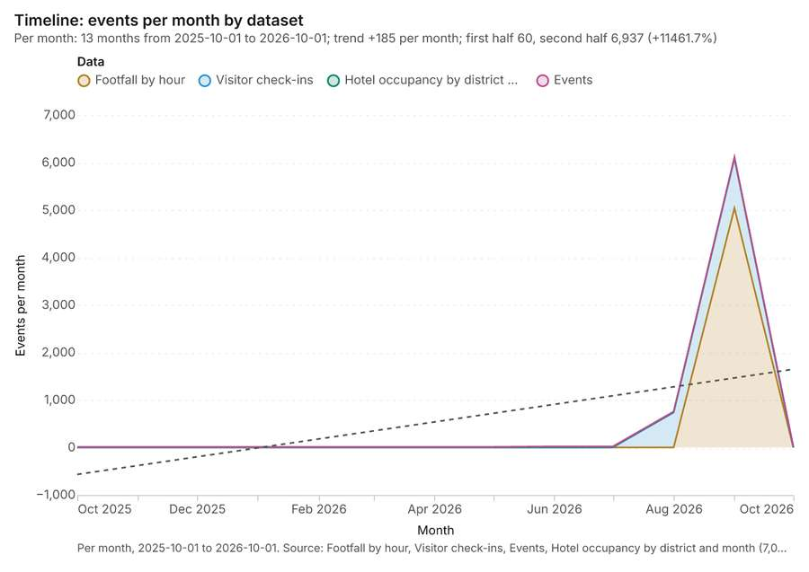
Figure 1. Timeline: events per month by dataset [1]. Per month, 2025-10-01 to 2026-10-01. Source: Footfall by hour, Visitor check-ins, Events, Hotel occupancy by district and month (7,007 features). The data is in the appendix.
The timeline counts 7,007 dated events in Footfall by hour, Visitor check-ins, Events and 1 more per month, from October 2025 to October 2026 [1][2][3][4][5]. By dataset: Footfall by hour 5,040; Visitor check-ins 1,787; Hotel occupancy by district and month 120; Events 60 [1]. The trend is +185 events per month; the second half of the months has 6,937 against 60 in the first (+11461.7%) [1].
Busiest months
- September 2026: 6,112 events [1]
- August 2026: 756 events [1]
- June 2026: 21 events [1]
Quietest months
- October 2025: 10 events [1]
- November 2025: 10 events [1]
- December 2025: 10 events [1]

Pipeline
What this analysis is. Pipeline: Run up to 20 GIS operations in one engine call; a step's params may use "$id" (an earlier step's result) or "$id.key", and layer references [6]. Every step's map outputs are saved as styled layers [6].
Why it was run on this data. Districts holds population in 'residents': Events per 10,000 people in each feature compares features of different size; mapped as a choropleth (natural breaks, sequential colors) [7].
What it found. Pipeline on Events, Districts: Pipeline of 2 steps (summarize_within > calculate_field): 1 layer saved [8][9][10]. It reported result, count 10; result, elapsed ms 0; billing, cost 0.0215; billing, list price 0.0215; billing, upstream cost 0; list price 0.0215 [8].
Result | Value
result, count | 10
result, elapsed ms | 0
billing, cost | 0.0215
billing, list price | 0.0215
billing, upstream cost | 0
list price | 0.0215

Findings
- Evidenced: Pipeline on Events, Districts: Pipeline of 2 steps (summarize_within > calculate_field): 1 layer saved [8][9][10].
- Evidenced: It reported result, count 10; result, elapsed ms 0; billing, cost 0.0215; billing, list price 0.0215; billing, upstream cost 0; list price 0.0215 [8].
Tool gp_pipeline; parameters {"save": "final", "steps": [{"id": "counts", "params": {"features": {"layer": "Events (48b188aa)"}, "polygons": {"layer": "Districts (2a6df822)"}}, "operation": "summarize_within"}, {"id": "rate", "params": {"field": "rate_per_10k", "features": "$counts", "expression": "count * 10000 / residents"}, "operation": "calculate_field"}], "project": "7e086c07-eb20-44ad-b602-c5958e8ee13e", "output_name":

Pipeline
What this analysis is. Pipeline: Run up to 20 GIS operations in one engine call; a step's params may use "$id" (an earlier step's result) or "$id.key", and layer references [6]. Every step's map outputs are saved as styled layers [6].
Why it was run on this data. Districts holds population in 'residents': Events per 10,000 people in each feature compares features of different size; mapped as a choropleth (natural breaks, sequential colors) [7].
What it found. Pipeline on Hotels, Districts: Pipeline of 2 steps (summarize_within > calculate_field): 1 layer saved [10][11][12]. It reported result, count 10; result, elapsed ms 0; billing, cost 0.0227; billing, list price 0.0227; billing, upstream cost 0; list price 0.0227 [11].
Result | Value
result, count | 10
result, elapsed ms | 0
billing, cost | 0.0227
billing, list price | 0.0227
billing, upstream cost | 0
list price | 0.0227

Findings
- Evidenced: Pipeline on Hotels, Districts: Pipeline of 2 steps (summarize_within > calculate_field): 1 layer saved [10][11][12].
- Evidenced: It reported result, count 10; result, elapsed ms 0; billing, cost 0.0227; billing, list price 0.0227; billing, upstream cost 0; list price 0.0227 [11].
Tool gp_pipeline; parameters {"save": "final", "steps": [{"id": "counts", "params": {"features": {"layer": "Hotels (3e8f4b82)"}, "polygons": {"layer": "Districts (2a6df822)"}}, "operation": "summarize_within"}, {"id": "rate", "params": {"field": "rate_per_10k", "features": "$counts", "expression": "count * 10000 / residents"}, "operation": "calculate_field"}], "project": "7e086c07-eb20-44ad-b602-c5958e8ee13e", "output_name":

Hot spots
What this analysis is. Hot spot analysis: Getis-Ord Gi* hot and cold spots with z-scores, p-values and confidence bins [13]. In ArcGIS it is Find Hot Spots or Hot Spot Analysis (Getis-Ord Gi*); in QGIS, qgis:hotspot (plugin) [13].
Why it was run on this data. 60 points: Getis-Ord Gi* tests whether the concentrations in Events are statistically significant [14].
What it found. The hot spot analysis was run using the Events input layer [9], resulting in 1 layer saved labeled hot spot analysis: Events
Result | Value
result, bins | 21
result, count | 21
result, elapsed ms | 2
result, cell size m | 1,000
result, incidents used | 60
result, distance band m | 1,000
billing, cost | 0.0512
billing, list price | 0.0512
billing, upstream cost | 0

Findings
- Evidenced: Hot spots on Events: Hot spot analysis: 1 layer saved: Hot spot analysis: Events (21 features) [9][15].
- Evidenced: It reported result, bins 21; result, count 21; result, elapsed ms 2; result, cell size m 1,000; result, incidents used 60; result, distance band m 1,000 [15].
Tool gp_hot_spots; parameters {"project": "7e086c07-eb20-44ad-b602-c5958e8ee13e", "features": {"layer": "Events (48b188aa)"}, "aggregation": "hexagon", "cell_size_m": 1000.0, "distance_band_m": 1000.0}

Hot spots
What this analysis is. Hot spot analysis: Getis-Ord Gi* hot and cold spots with z-scores, p-values and confidence bins [13]. In ArcGIS it is Find Hot Spots or Hot Spot Analysis (Getis-Ord Gi*); in QGIS, qgis:hotspot (plugin) [13].
Why it was run on this data. 120 points: Getis-Ord Gi* tests whether the concentrations in Hotels are statistically significant [16].
What it found. Hot spots on Hotels: Hot spot analysis: 1 layer saved: Hot spot analysis: Hotels (35 features) [12][17]. It reported result, bins 35; result, count 35; result, elapsed ms 3; result, cell size m 1,000; result, incidents used 120; result, distance band m 1,000 [17].
Result | Value
result, bins | 35
result, count | 35
result, elapsed ms | 3
result, cell size m | 1,000
result, incidents used | 120
result, distance band m | 1,000
billing, cost | 0.0524
billing, list price | 0.0524
billing, upstream cost | 0

Findings
- Evidenced: Hot spots on Hotels: Hot spot analysis: 1 layer saved: Hot spot analysis: Hotels (35 features) [12][17].
- Evidenced: It reported result, bins 35; result, count 35; result, elapsed ms 3; result, cell size m 1,000; result, incidents used 120; result, distance band m 1,000 [17].
A model draft was discarded because a sentence did not cite a source of this section.
Tool gp_hot_spots; parameters {"project": "7e086c07-eb20-44ad-b602-c5958e8ee13e", "features": {"layer": "Hotels (3e8f4b82)"}, "aggregation": "hexagon", "cell_size_m": 1000.0, "distance_band_m": 1000.0}

Space time hot spots
What this analysis is. Emerging hot spots: Where hot spots are new, consecutive, intensifying, persistent, diminishing, sporadic, oscillating or historical over time [18]. In ArcGIS it is Emerging Hot Spot Analysis or Create Space Time Cube [18].
Why it was run on this data. Events carry dates in 'date': emerging hot spot analysis finds new, intensifying and fading hot spots per week [19].
What it found. The analysis of events used a total of 60 features [20]. This process identified 12 emerging hot spots, which were saved into a layer called Emerging hot spots: Events [20]. Overall, the execution was efficient, taking only 2 elapsed milliseconds [20]. The cost calculated for this analysis was 0.103 [20].
Result | Value
result, count | 12
result, elapsed ms | 2
result, resolution | 7
result, features used | 60
result, time neighbors | 0
billing, cost | 0.103
billing, list price | 0.103
billing, upstream cost | 0

Findings
- Evidenced: Space time hot spots on Events: Emerging hot spots: 1 layer saved: Emerging hot spots: Events (12 features) [9][20].
- Evidenced: It reported result, count 12; result, elapsed ms 2; result, resolution 7; result, features used 60; result, time neighbors 0; billing, cost 0.103 [20].
Tool gp_space_time_hot_spots; parameters {"project": "7e086c07-eb20-44ad-b602-c5958e8ee13e", "features": {"layer": "Events (48b188aa)"}, "interval": "week", "bin_shape": "h3", "resolution": 7, "time_field": "date"}

Space time hot spots
What this analysis is. Emerging hot spots: Where hot spots are new, consecutive, intensifying, persistent, diminishing, sporadic, oscillating or historical over time [18]. In ArcGIS it is Emerging Hot Spot Analysis or Create Space Time Cube [18].
Why it was run on this data. Visitor check-ins carry dates in 'checked_in_at': emerging hot spot analysis finds new, intensifying and fading hot spots per week [21].
What it found. The `gp_space_time_hot_spots` tool was run using the `Visitor check-ins` dataset [23].
Result | Value
result, count | 247
result, elapsed ms | 25
result, resolution | 9
result, features used | 1,787
result, time neighbors | 0
billing, cost | 0.1893
billing, list price | 0.1893
billing, upstream cost | 0

Findings
- Evidenced: Space time hot spots on Visitor check-ins: Emerging hot spots: 1 layer saved: Emerging hot spots: Visitor check-ins (247 features) [22][23].
- Evidenced: It reported result, count 247; result, elapsed ms 25; result, resolution 9; result, features used 1,787; result, time neighbors 0; billing, cost 0.1893 [22].
Tool gp_space_time_hot_spots; parameters {"project": "7e086c07-eb20-44ad-b602-c5958e8ee13e", "features": {"layer": "Visitor check-ins (517cd234)"}, "interval": "week", "bin_shape": "h3", "resolution": 9, "time_field": "checked_in_at"}

Calculate density
What this analysis is. Calculate density: Kernel density per square kilometer on a grid [24]. In ArcGIS it is Calculate Density or Kernel Density; in QGIS, native:heatmapkerneldensityestimation [24].
Why it was run on this data. 60 points in Events: a density surface shows where they concentrate [25].
What it found. Calculate density on Events: Calculate density: 1 layer saved: Calculate density: Events (105 features) [9][26]. It reported result, count 105; result, elapsed ms 3; result, bandwidth m 1,000; result, cell size m 500; result, excluded null 0; result, max density per km2 13.52 [26].
Result | Value
result, count | 105
result, elapsed ms | 3
result, bandwidth m | 1,000
result, cell size m | 500
result, excluded null | 0
result, max density per km2 | 13.52
billing, cost | 0.0512
billing, list price | 0.0512
billing, upstream cost | 0

Findings
- Evidenced: Calculate density on Events: Calculate density: 1 layer saved: Calculate density: Events (105 features) [9][26].
- Evidenced: It reported result, count 105; result, elapsed ms 3; result, bandwidth m 1,000; result, cell size m 500; result, excluded null 0; result, max density per km2 13.52 [26].
Tool gp_calculate_density; parameters {"kernel": "quartic", "project": "7e086c07-eb20-44ad-b602-c5958e8ee13e", "features": {"layer": "Events (48b188aa)"}, "bandwidth_m": 1000.0, "cell_size_m": 500.0}

Calculate density
What this analysis is. Calculate density: Kernel density per square kilometer on a grid [24]. In ArcGIS it is Calculate Density or Kernel Density; in QGIS, native:heatmapkerneldensityestimation [24].
Why it was run on this data. 120 points in Hotels: a density surface shows where they concentrate [27].
What it found. Calculate density on Hotels: Calculate density: 1 layer saved: Calculate density: Hotels (160 features) [12][28]. It reported result, count 160; result, elapsed ms 5; result, bandwidth m 1,000; result, cell size m 500; result, excluded null 0; result, max density per km2 19.04 [28].
Result | Value
result, count | 160
result, elapsed ms | 5
result, bandwidth m | 1,000
result, cell size m | 500
result, excluded null | 0
result, max density per km2 | 19.04
billing, cost | 0.0524
billing, list price | 0.0524
billing, upstream cost | 0

Findings
- Evidenced: Calculate density on Hotels: Calculate density: 1 layer saved: Calculate density: Hotels (160 features) [12][28].
- Evidenced: It reported result, count 160; result, elapsed ms 5; result, bandwidth m 1,000; result, cell size m 500; result, excluded null 0; result, max density per km2 19.04 [28].
Tool gp_calculate_density; parameters {"kernel": "quartic", "project": "7e086c07-eb20-44ad-b602-c5958e8ee13e", "features": {"layer": "Hotels (3e8f4b82)"}, "bandwidth_m": 1000.0, "cell_size_m": 500.0}

Pipeline
What this analysis is. Pipeline: Run up to 20 GIS operations in one engine call; a step's params may use "$id" (an earlier step's result) or "$id.key", and layer references [6]. Every step's map outputs are saved as styled layers [6].
Why it was run on this data. Districts holds population in 'residents': Transit stations per 10,000 people in each feature compares features of different size; mapped as a choropleth (natural breaks, sequential colors) [29].
What it found. Pipeline on Transit stations, Districts: Pipeline of 2 steps (summarize_within > calculate_field): 1 layer saved [10][30][31]. It reported result, count 10; result, elapsed ms 0; billing, cost 0.0208; billing, list price 0.0208; billing, upstream cost 0; list price 0.0208 [30].
Result | Value
result, count | 10
result, elapsed ms | 0
billing, cost | 0.0208
billing, list price | 0.0208
billing, upstream cost | 0
list price | 0.0208

Findings
- Evidenced: Pipeline on Transit stations, Districts: Pipeline of 2 steps (summarize_within > calculate_field): 1 layer saved [10][30][31].
- Evidenced: It reported result, count 10; result, elapsed ms 0; billing, cost 0.0208; billing, list price 0.0208; billing, upstream cost 0; list price 0.0208 [30].
Tool gp_pipeline; parameters {"save": "final", "steps": [{"id": "counts", "params": {"features": {"layer": "Transit stations (05c69c10)"}, "polygons": {"layer": "Districts (2a6df822)"}}, "operation": "summarize_within"}, {"id": "rate", "params": {"field": "rate_per_10k", "features": "$counts", "expression": "count * 10000 / residents"}, "operation": "calculate_field"}], "project": "7e086c07-eb20-44ad-b602-c5958e8ee13e", "outp

Hot spots
What this analysis is. Hot spot analysis: Getis-Ord Gi* hot and cold spots with z-scores, p-values and confidence bins [13]. In ArcGIS it is Find Hot Spots or Hot Spot Analysis (Getis-Ord Gi*); in QGIS, qgis:hotspot (plugin) [13].
Why it was run on this data. 359 points: Getis-Ord Gi* tests whether the concentrations in Short-term rentals are statistically significant [32].
What it found. Hot spots on Short-term rentals: Hot spot analysis: 1 layer saved: Hot spot analysis: Short-term rentals (120 features) [33][34]. It reported result, bins 120; result, count 120; result, elapsed ms 6; result, cell size m 500; result, incidents used 359; result, distance band m 500 [33].
Result | Value
result, bins | 120
result, count | 120
result, elapsed ms | 6
result, cell size m | 500
result, incidents used | 359
result, distance band m | 500
billing, cost | 0.05718
billing, list price | 0.05718
billing, upstream cost | 0

Findings
- Evidenced: Hot spots on Short-term rentals: Hot spot analysis: 1 layer saved: Hot spot analysis: Short-term rentals (120 features) [33][34].
- Evidenced: It reported result, bins 120; result, count 120; result, elapsed ms 6; result, cell size m 500; result, incidents used 359; result, distance band m 500 [33].
Tool gp_hot_spots; parameters {"project": "7e086c07-eb20-44ad-b602-c5958e8ee13e", "features": {"layer": "Short-term rentals (cfe7bd58)"}, "aggregation": "hexagon", "cell_size_m": 500.0, "distance_band_m": 500.0}

Near repeat
What this analysis is. Repeat and near repeat classification: Classify incidents as originators, repeats (same place) or near repeats within a distance and time window, with a Knox test table [35]. In ArcGIS it is Repeat and Near Repeat Classification or Near Repeat Calculator [35].
Why it was run on this data. Near repeat analysis tests whether Events close in space also follow each other within 15 days [36].
What it found. Near repeat on Events: Repeat and near repeat classification: 1 layer saved: Repeat and near repeat classification: Events (60 features) [9][37]. It reported result, days 15; result, count 60; result, chains 12; result, distance m 500; result, elapsed ms 4; result, pairs linked 27 [37].
Result | Value
result, days | 15
result, count | 60
result, chains | 12
result, distance m | 500
result, elapsed ms | 4
result, pairs linked | 27
billing, cost | 0.0518
billing, list price | 0.0518
billing, upstream cost | 0

Findings
- Evidenced: Near repeat on Events: Repeat and near repeat classification: 1 layer saved: Repeat and near repeat classification: Events (60 features) [9][37].
- Evidenced: It reported result, days 15; result, count 60; result, chains 12; result, distance m 500; result, elapsed ms 4; result, pairs linked 27 [37].
Tool gp_near_repeat; parameters {"days": 15, "project": "7e086c07-eb20-44ad-b602-c5958e8ee13e", "features": {"layer": "Events (48b188aa)"}, "distance_m": 500.0, "time_field": "date"}

Calculate density
What this analysis is. Calculate density: Kernel density per square kilometer on a grid [24]. In ArcGIS it is Calculate Density or Kernel Density; in QGIS, native:heatmapkerneldensityestimation [24].
Why it was run on this data. 25 points in Transit stations: a density surface shows where they concentrate [38].
What it found. The density calculation was run on the Transit stations input [39]. This process resulted in a count of 60 features, an elapsed time of 2 ms, and a bandwidth of 2,000 m [39]. The analysis reported a maximum density per km2 of 1.239 [39]. The operational cost for the density calculation was 0.0505 [39].
Result | Value
result, count | 60
result, elapsed ms | 2
result, bandwidth m | 2,000
result, cell size m | 1,000
result, excluded null | 0
result, max density per km2 | 1.239
billing, cost | 0.0505
billing, list price | 0.0505
billing, upstream cost | 0

Findings
- Evidenced: Calculate density on Transit stations: Calculate density: 1 layer saved: Calculate density: Transit stations (60 features) [31][39].
- Evidenced: It reported result, count 60; result, elapsed ms 2; result, bandwidth m 2,000; result, cell size m 1,000; result, excluded null 0; result, max density per km2 1.239 [39].
Tool gp_calculate_density; parameters {"kernel": "quartic", "project": "7e086c07-eb20-44ad-b602-c5958e8ee13e", "features": {"layer": "Transit stations (05c69c10)"}, "bandwidth_m": 2000.0, "cell_size_m": 1000.0}

Maps and charts
The run also made 12 map image(s) [40][41][42][43][44][45][46][47][48][49][50][51] and 17 chart(s) [52][53][54][55][56][57][58][59][60][61][62][63][64][65][66][67][68].
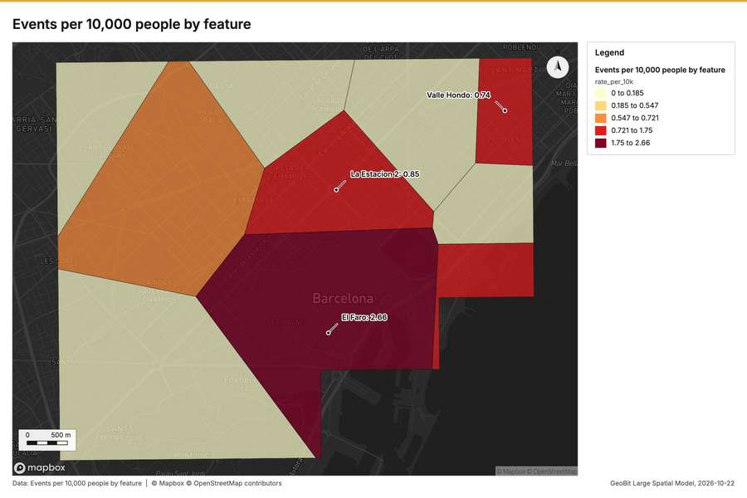
Figure 2. Events per 10,000 people by feature [40]
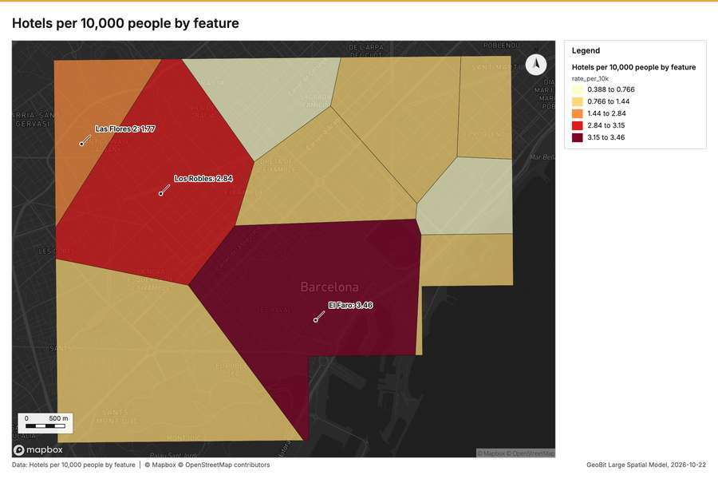
Figure 3. Hotels per 10,000 people by feature [41]
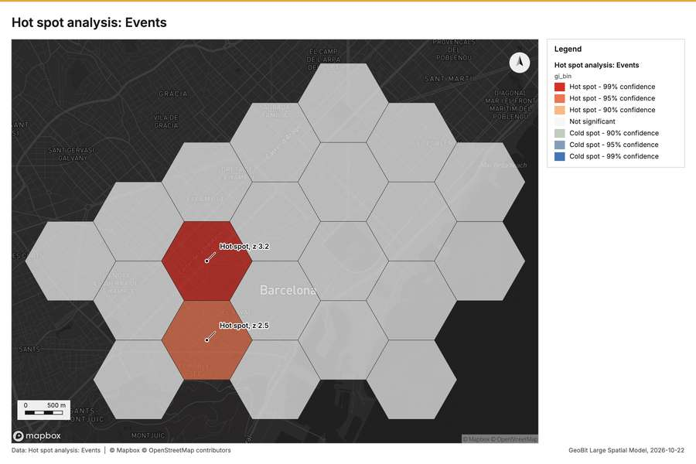
Figure 4. Hot spot analysis: Events [42]
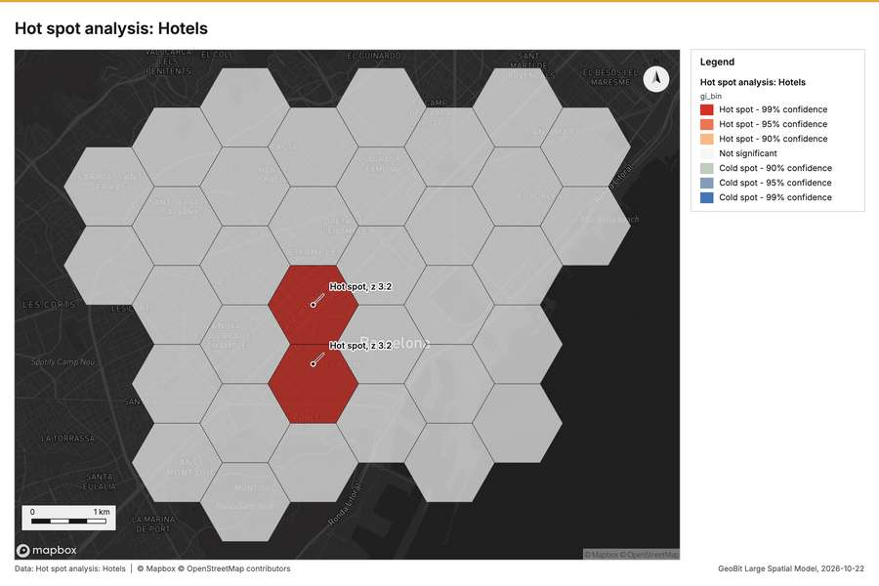
Figure 5. Hot spot analysis: Hotels [43]
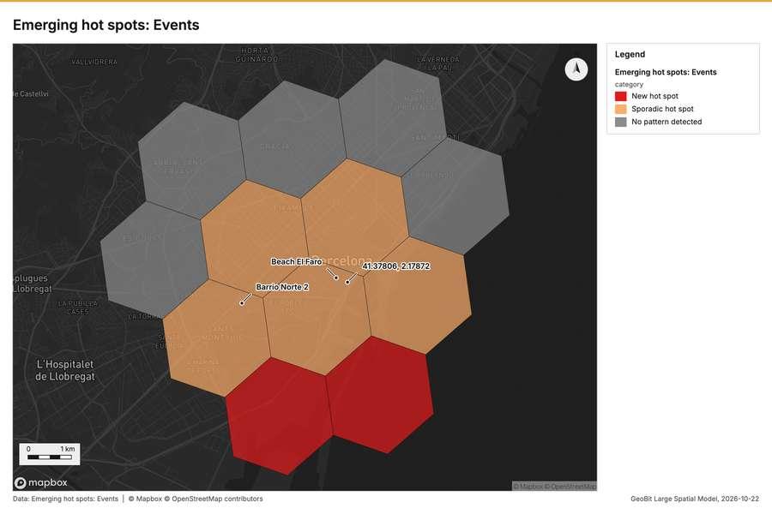
Figure 6. Emerging hot spots: Events [44]
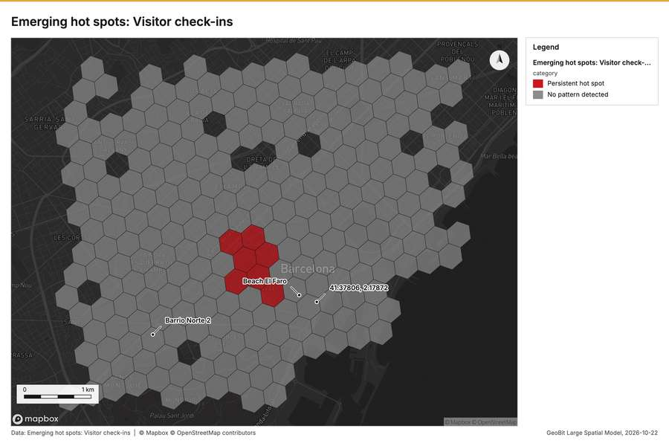
Figure 7. Emerging hot spots: Visitor check-ins [45]
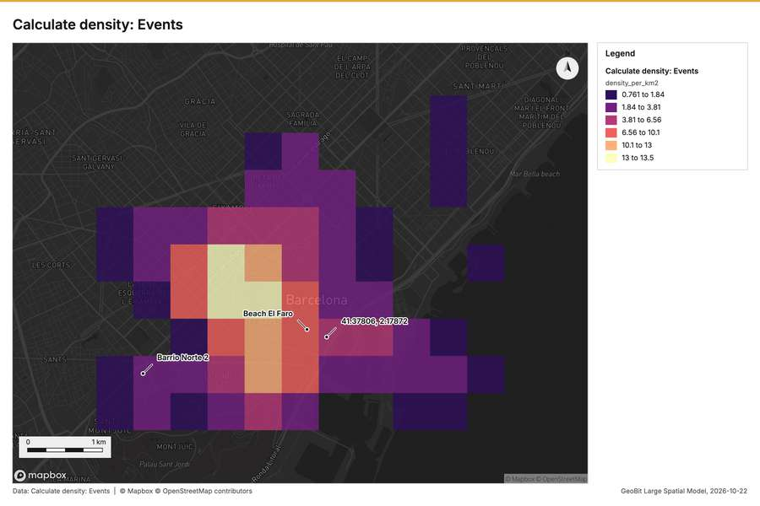
Figure 8. Calculate density: Events [46]
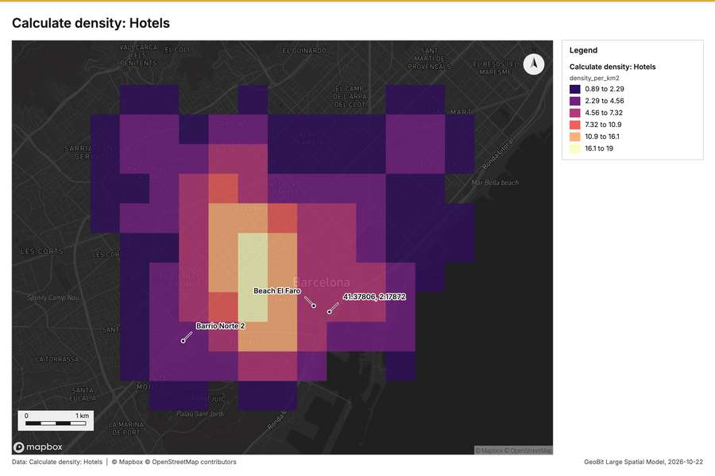
Figure 9. Calculate density: Hotels [47]
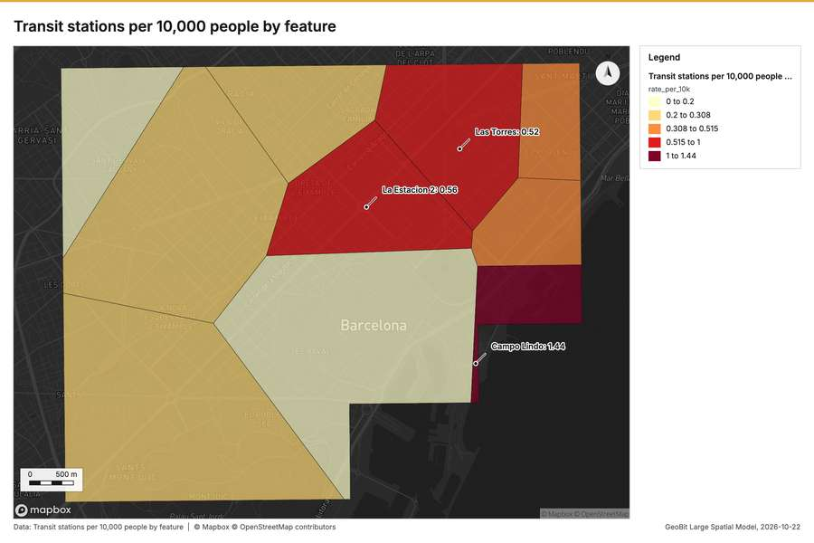
Figure 10. Transit stations per 10,000 people by feature [48]
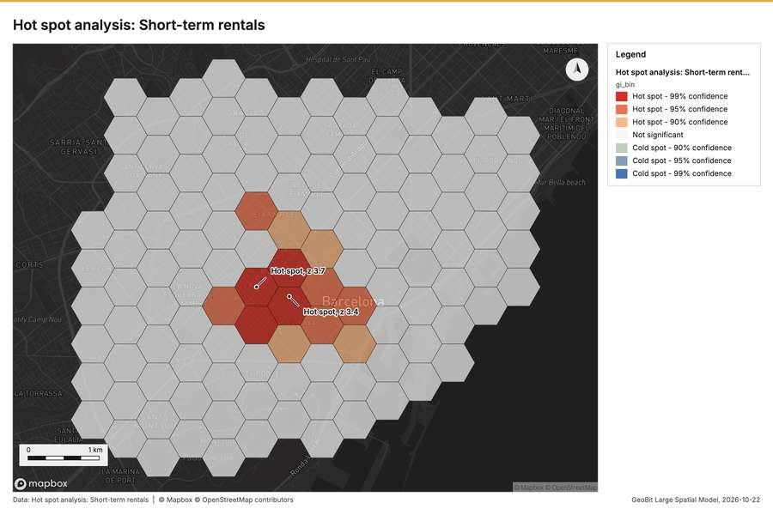
Figure 11. Hot spot analysis: Short-term rentals [49]
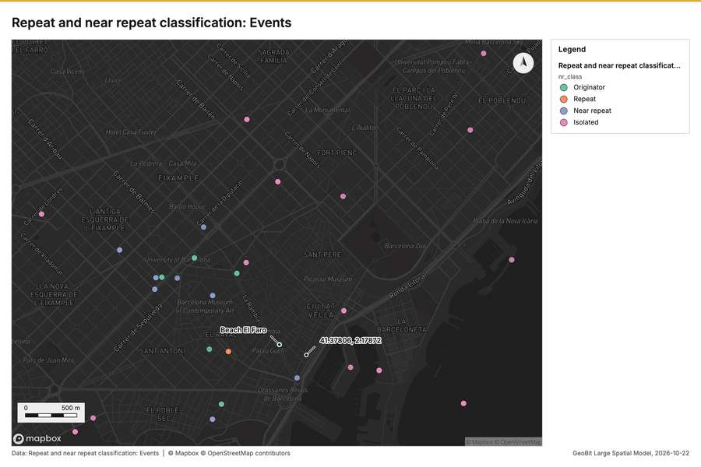
Figure 12. Repeat and near repeat classification: Events [50]
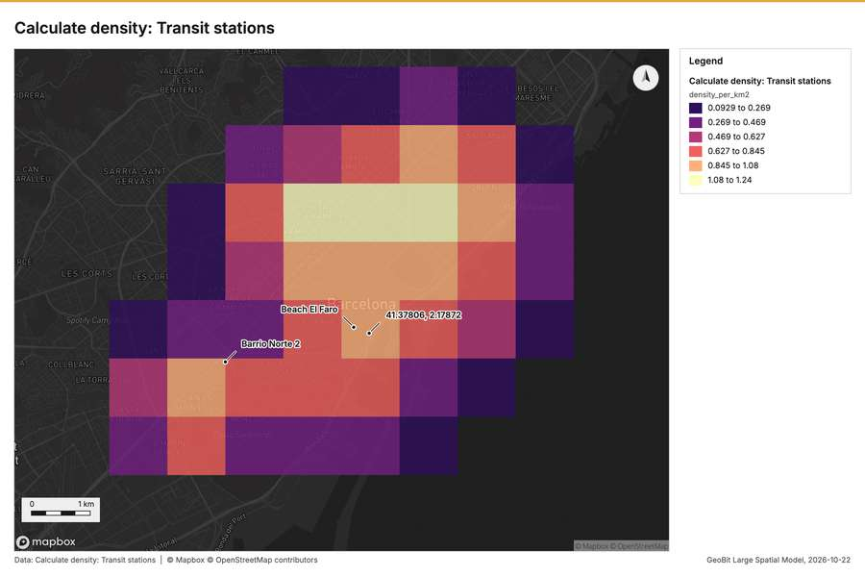
Figure 13. Calculate density: Transit stations [51]
What the map shows. The map displays a [42]
Inferred: read from the image by gemma4:e4b, not evidence.
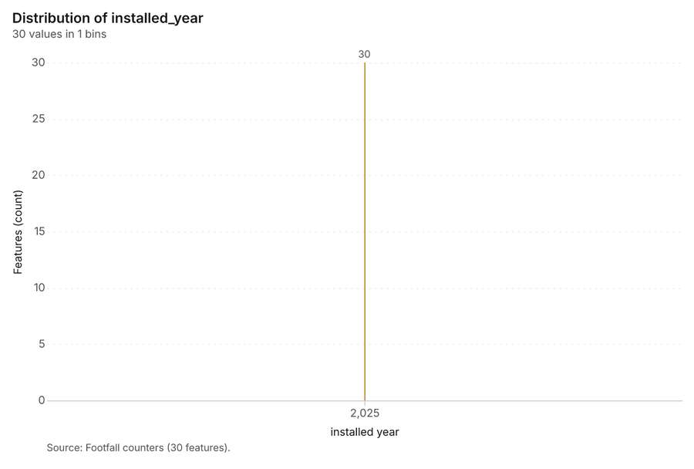
Figure 14. Footfall counters over time (installed_year) [52]. Source: Footfall counters (30 features). The data is in the appendix.
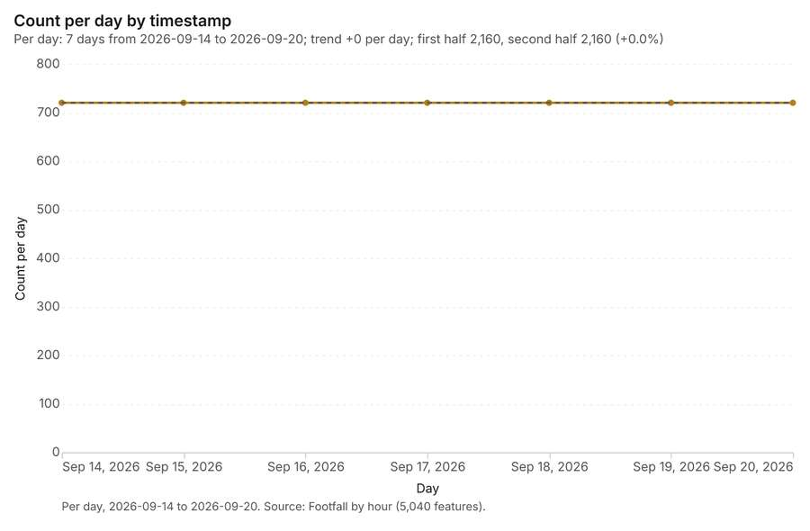
Figure 15. Footfall by hour over time (timestamp) [53]. Per day, 2026-09-14 to 2026-09-20. Source: Footfall by hour (5,040 features). The data is in the appendix.
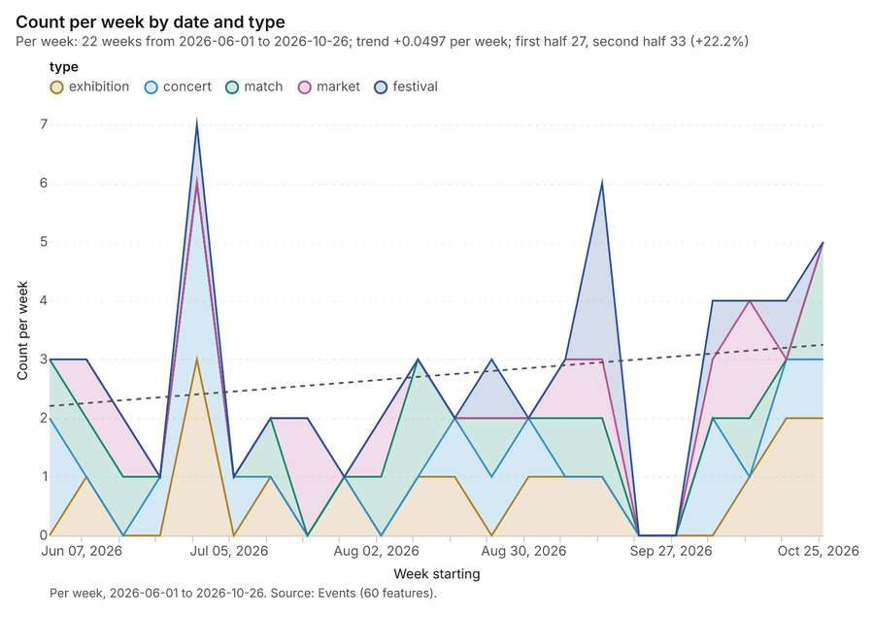
Figure 16. Events over time (date) [54]. Per week, 2026-06-01 to 2026-10-26. Source: Events (60 features). The data is in the appendix.
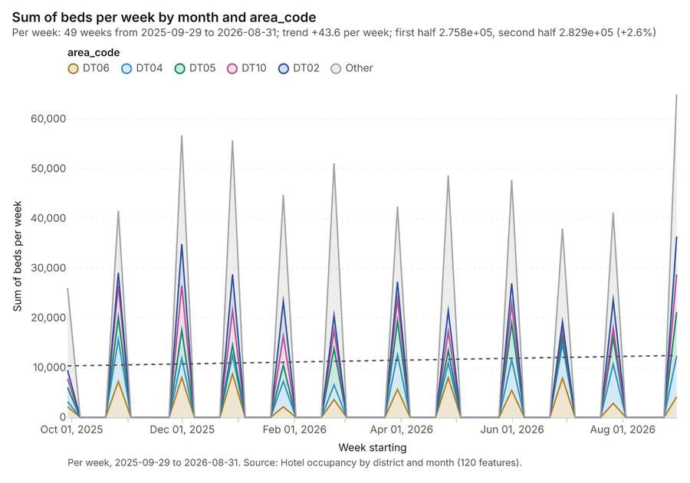
Figure 17. Hotel occupancy by district and month over time (month) [55]. Per week, 2025-09-29 to 2026-08-31. Source: Hotel occupancy by district and month (120 features). The data is in the appendix.
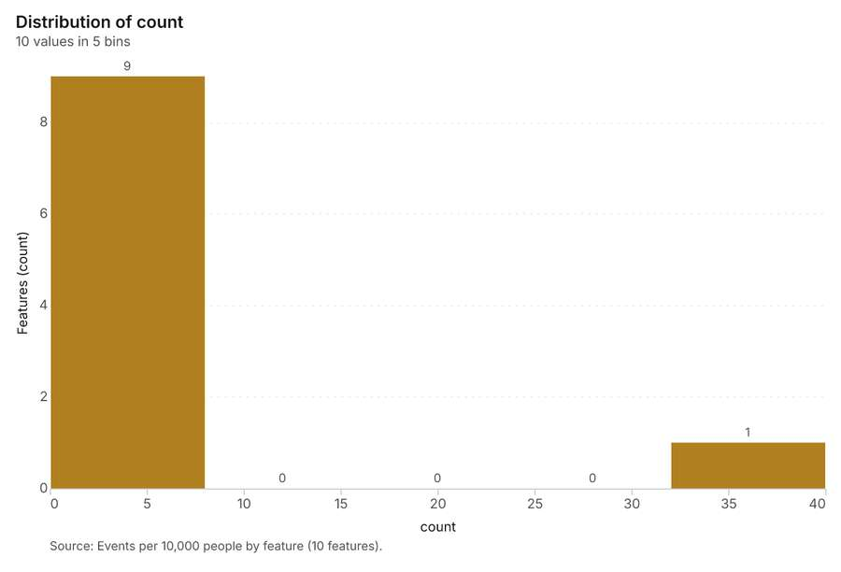
Figure 18. Events per 10,000 people by feature [56]. Source: Events per 10,000 people by feature (10 features). The data is in the appendix.
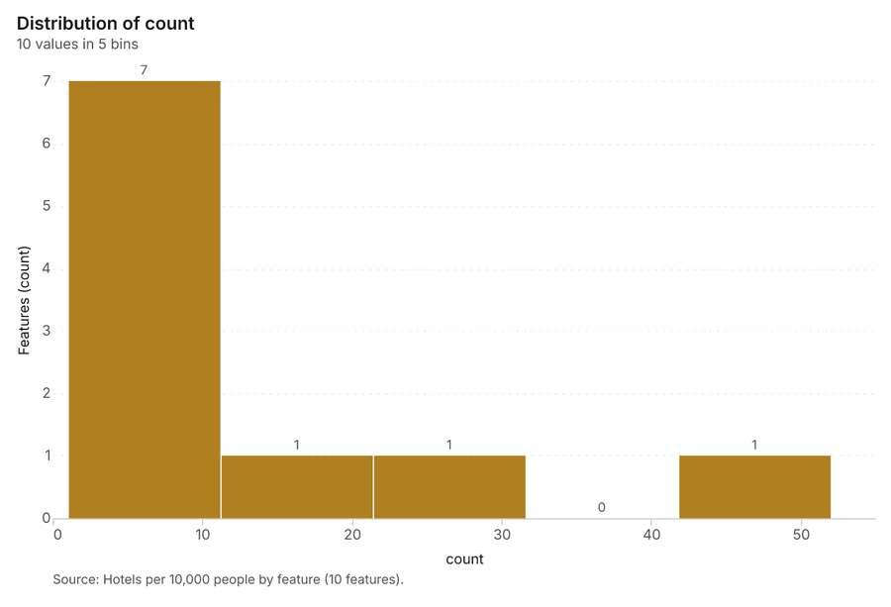
Figure 19. Hotels per 10,000 people by feature [57]. Source: Hotels per 10,000 people by feature (10 features). The data is in the appendix.
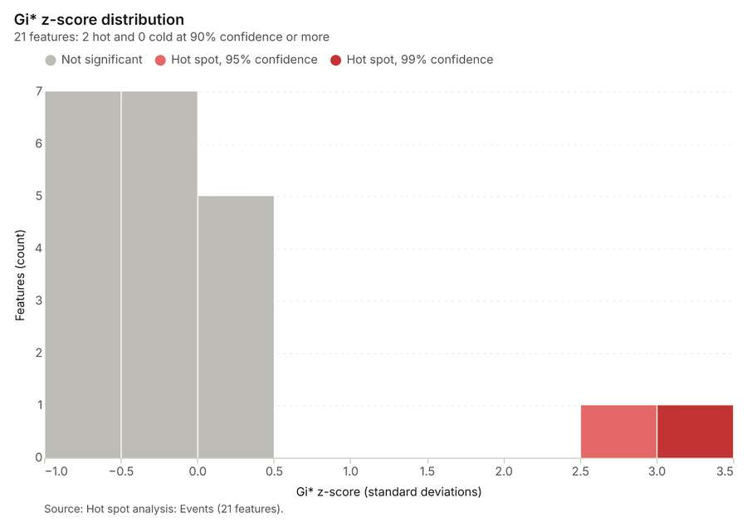
Figure 20. Hot spot analysis: Events [58]. Source: Hot spot analysis: Events (21 features). The data is in the appendix.
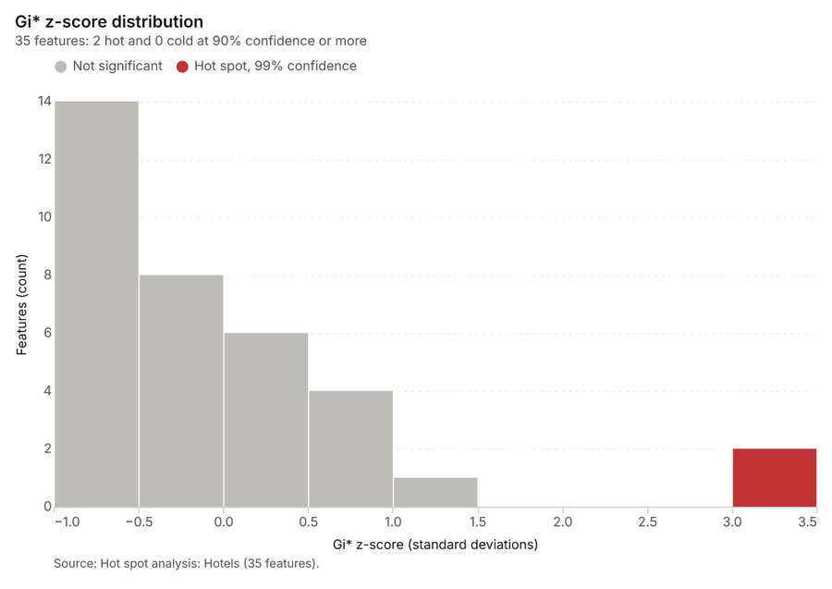
Figure 21. Hot spot analysis: Hotels [59]. Source: Hot spot analysis: Hotels (35 features). The data is in the appendix.
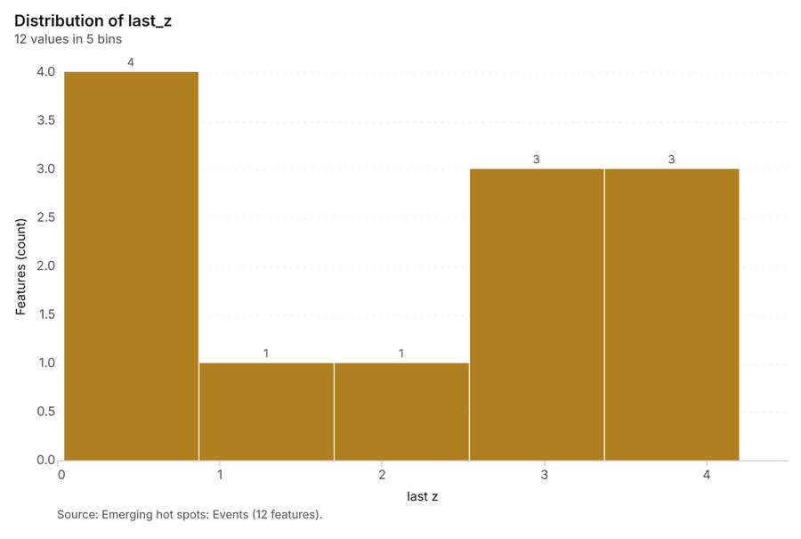
Figure 22. Emerging hot spots: Events [60]. Source: Emerging hot spots: Events (12 features). The data is in the appendix.
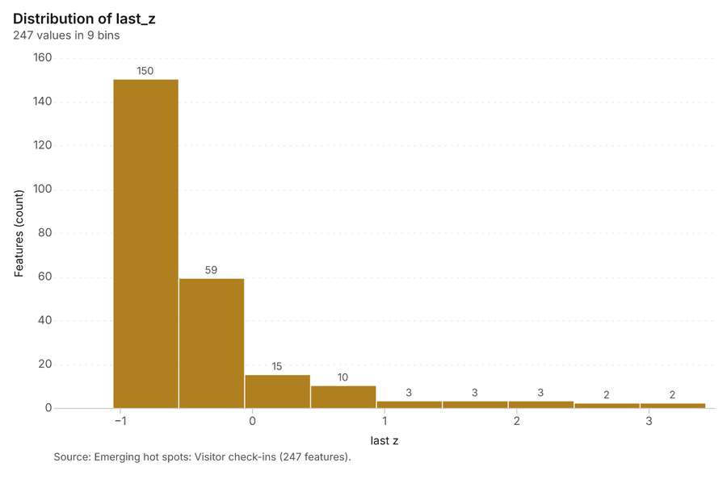
Figure 23. Emerging hot spots: Visitor check-ins [61]. Source: Emerging hot spots: Visitor check-ins (247 features). The data is in the appendix.
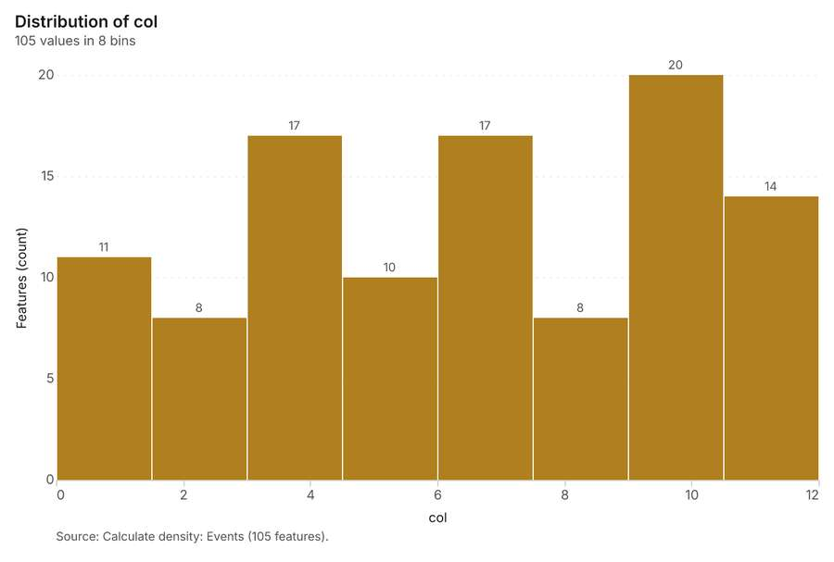
Figure 24. Calculate density: Events [62]. Source: Calculate density: Events (105 features). The data is in the appendix.
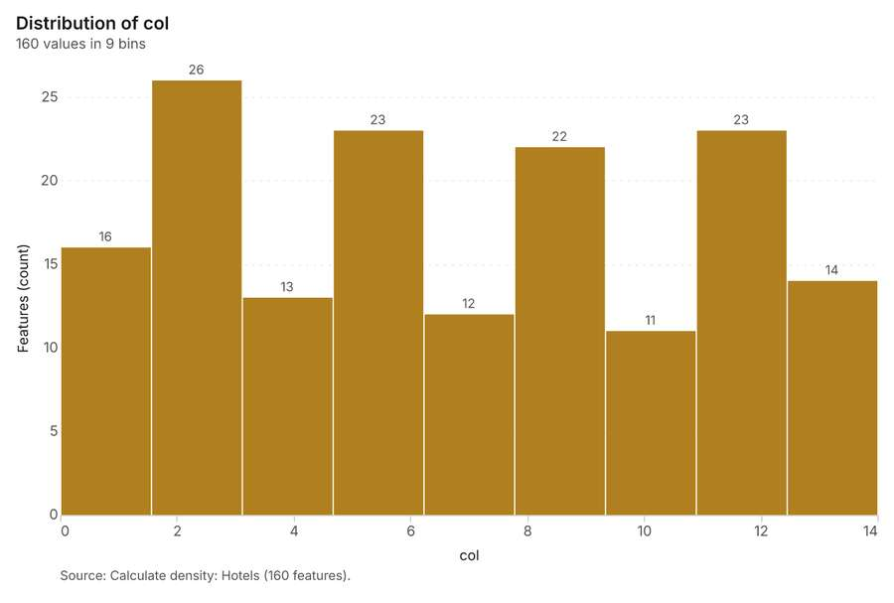
Figure 25. Calculate density: Hotels [63]. Source: Calculate density: Hotels (160 features). The data is in the appendix.
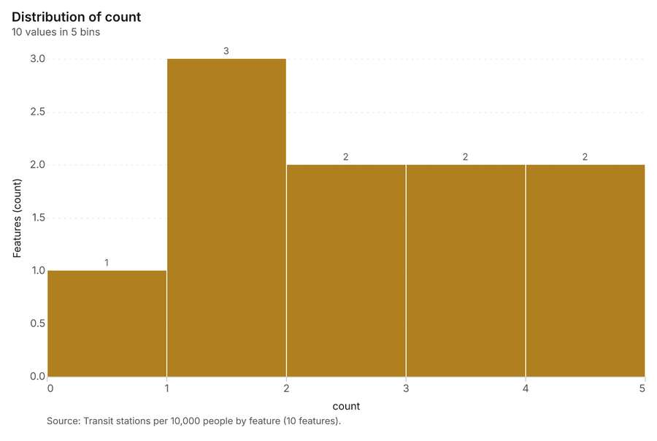
Figure 26. Transit stations per 10,000 people by feature [64]. Source: Transit stations per 10,000 people by feature (10 features). The data is in the appendix.
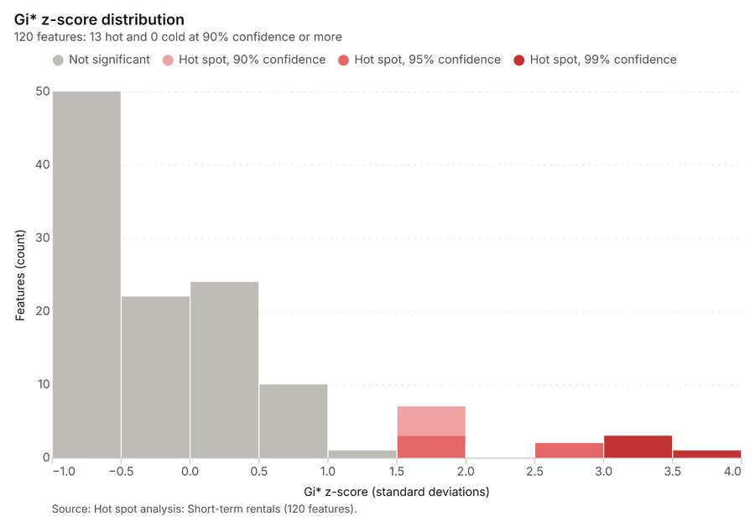
Figure 27. Hot spot analysis: Short-term rentals [65]. Source: Hot spot analysis: Short-term rentals (120 features). The data is in the appendix.
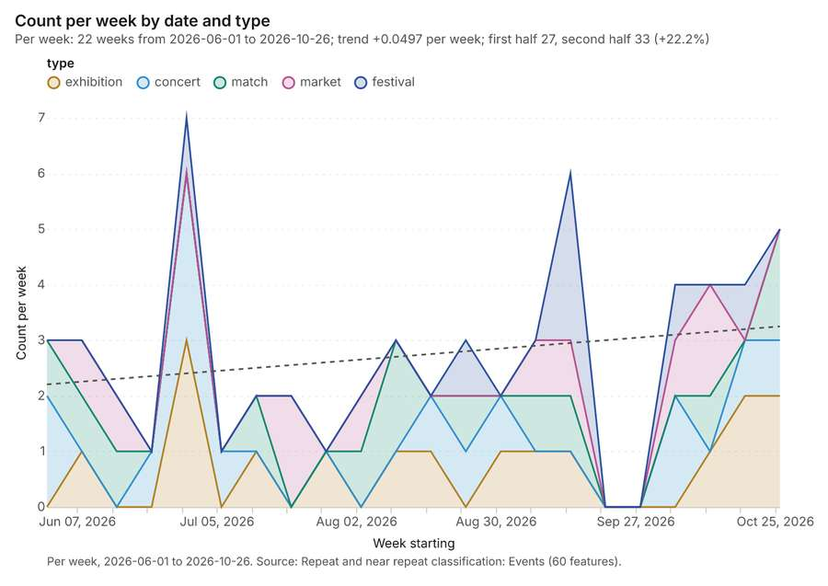
Figure 28. Repeat and near repeat classification: Events [66]. Per week, 2026-06-01 to 2026-10-26. Source: Repeat and near repeat classification: Events (60 features). The data is in the appendix.
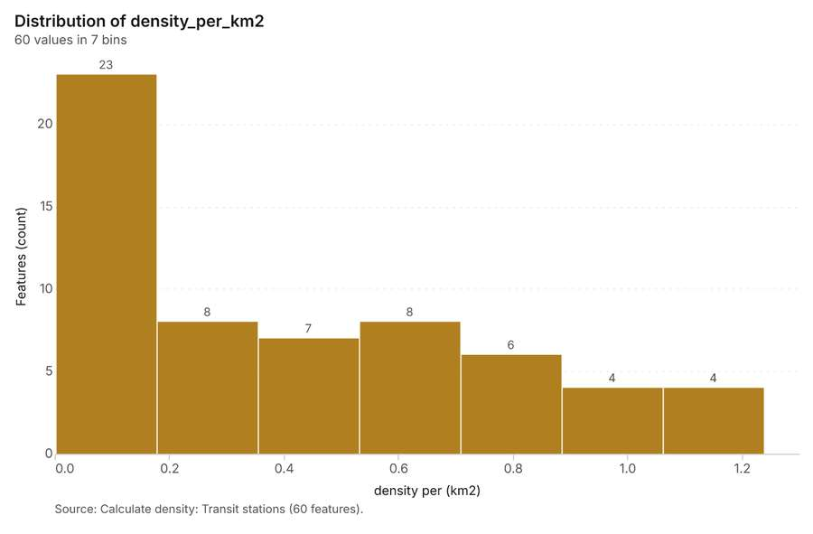
Figure 29. Calculate density: Transit stations [67]. Source: Calculate density: Transit stations (60 features). The data is in the appendix.
Figure 30. Repeat and near repeat classification: Events over time [68]. Per week, 2026-06-01 to 2026-10-26. Source: Repeat and near repeat classification: Events (60 features). The data is in the appendix.

Changes since the last run
This is the first report of this project.

Sources
[1] Rendering: Chart: Timeline: events per month by dataset. 52 rows (id c28dd5e4-8e5d-4f58-bf01-ecf5befa059e)
[2] Dataset: Footfall by hour. table, 5040 rows (id 14c3f63e-f77c-42c5-915f-d9c05adec323)
[3] Dataset: Visitor check-ins. vector, 1787 rows (id c5304978-960d-40ec-bdc4-acd2ea178039)
[4] Dataset: Events. vector, 60 rows (id 19eebb1c-a097-45a3-b65f-454a721735ff)
[5] Dataset: Hotel occupancy by district and month. table, 120 rows (id ddefeb0f-7855-4d3a-bdbc-830daaef4145)
[6] Catalog: Pipeline (tool description, gp_pipeline). Run up to 20 GIS operations in one engine call; a step's params may use "$id" (an earlier step's result) or "$id.key", and layer references. Every step's map outputs are saved as styled layers. Never calls Mapbox. (id gp_pipeline)
[7] Plan: Events per 10,000 people per feature of Districts (the Start plan's candidate c_fc66f1dd9ab5). Districts holds population in 'residents': Events per 10,000 people in each feature compares features of different size; mapped as a choropleth (natural breaks, sequential colors). (id 0b51cb1d-362e-46b9-bce1-ee8d0334d0d1:c_fc66f1dd9ab5)
[8] Tool result: gp_pipeline, step 0. Pipeline of 2 steps (summarize_within > calculate_field): 1 layer saved. (id 6f508d4a-8ac6-43c5-a648-3a317b80b725:0)
[9] Layer: Events. 60 features (id 48b188aa-e96c-47fa-8a28-11e7d0d1265b)
[10] Layer: Districts. 10 features (id 2a6df822-dc6d-48ab-bb94-b4a34b363160)
[11] Tool result: gp_pipeline, step 1. Pipeline of 2 steps (summarize_within > calculate_field): 1 layer saved. (id 6f508d4a-8ac6-43c5-a648-3a317b80b725:1)
[12] Layer: Hotels. 120 features (id 3e8f4b82-1559-4b63-821d-9911e2fb57de)
[13] Catalog: Hot spot analysis (operation catalog, gp_hot_spots). Getis-Ord Gi* hot and cold spots with z-scores, p-values and confidence bins. ArcGIS: Find Hot Spots, Hot Spot Analysis (Getis-Ord Gi*). QGIS: qgis:hotspot (plugin). (id gp_hot_spots)
[14] Plan: Hot spots of Events (the Start plan's candidate c_7a715b334a74). 60 points: Getis-Ord Gi* tests whether the concentrations in Events are statistically significant. (id 0b51cb1d-362e-46b9-bce1-ee8d0334d0d1:c_7a715b334a74)
[15] Tool result: gp_hot_spots, step 0. Hot spot analysis: 1 layer saved: Hot spot analysis: Events (21 features). (id 84b08bee-0a26-46a8-aa31-3ab02a56479b:0)
[16] Plan: Hot spots of Hotels (the Start plan's candidate c_79873e91203b). 120 points: Getis-Ord Gi* tests whether the concentrations in Hotels are statistically significant. (id 0b51cb1d-362e-46b9-bce1-ee8d0334d0d1:c_79873e91203b)
[17] Tool result: gp_hot_spots, step 1. Hot spot analysis: 1 layer saved: Hot spot analysis: Hotels (35 features). (id 84b08bee-0a26-46a8-aa31-3ab02a56479b:1)
[18] Catalog: Emerging hot spots (operation catalog, gp_space_time_hot_spots). Where hot spots are new, consecutive, intensifying, persistent, diminishing, sporadic, oscillating or historical over time. ArcGIS: Emerging Hot Spot Analysis, Create Space Time Cube. (id gp_space_time_hot_spots)
[19] Plan: Space time hot spots of Events (the Start plan's candidate c_8f286e9af1c8). Events carry dates in 'date': emerging hot spot analysis finds new, intensifying and fading hot spots per week. (id 0b51cb1d-362e-46b9-bce1-ee8d0334d0d1:c_8f286e9af1c8)
[20] Tool result: gp_space_time_hot_spots, step 0. Emerging hot spots: 1 layer saved: Emerging hot spots: Events (12 features). (id eb49d63a-8c38-41f3-ab9c-5e8f86d9baac:0)
[21] Plan: Space time hot spots of Visitor check-ins (the Start plan's candidate c_20af318bcde6). Visitor check-ins carry dates in 'checked_in_at': emerging hot spot analysis finds new, intensifying and fading hot spots per week. (id 0b51cb1d-362e-46b9-bce1-ee8d0334d0d1:c_20af318bcde6)
[22] Tool result: gp_space_time_hot_spots, step 1. Emerging hot spots: 1 layer saved: Emerging hot spots: Visitor check-ins (247 features). (id eb49d63a-8c38-41f3-ab9c-5e8f86d9baac:1)
[23] Layer: Visitor check-ins. 1,787 features (id 517cd234-4309-4e40-a7fe-bfcb513649a0)
[24] Catalog: Calculate density (operation catalog, gp_calculate_density). Kernel density per square kilometer on a grid. ArcGIS: Calculate Density, Kernel Density. QGIS: native:heatmapkerneldensityestimation. (id gp_calculate_density)
[25] Plan: Kernel density of Events (the Start plan's candidate c_cf6f233cf11a). 60 points in Events: a density surface shows where they concentrate. (id 0b51cb1d-362e-46b9-bce1-ee8d0334d0d1:c_cf6f233cf11a)
[26] Tool result: gp_calculate_density, step 0. Calculate density: 1 layer saved: Calculate density: Events (105 features). (id ffcce236-4ccf-4454-afd4-62fde6826f22:0)
[27] Plan: Kernel density of Hotels (the Start plan's candidate c_f2a0da30a906). 120 points in Hotels: a density surface shows where they concentrate. (id 0b51cb1d-362e-46b9-bce1-ee8d0334d0d1:c_f2a0da30a906)
[28] Tool result: gp_calculate_density, step 1. Calculate density: 1 layer saved: Calculate density: Hotels (160 features). (id ffcce236-4ccf-4454-afd4-62fde6826f22:1)
[29] Plan: Transit stations per 10,000 people per feature of Districts (the Start plan's candidate c_058536b42c97). Districts holds population in 'residents': Transit stations per 10,000 people in each feature compares features of different size; mapped as a choropleth (natural breaks, sequential colors). (id 0b51cb1d-362e-46b9-bce1-ee8d0334d0d1:c_058536b42c97)
[30] Tool result: gp_pipeline, step 0. Pipeline of 2 steps (summarize_within > calculate_field): 1 layer saved. (id dd7063d1-b363-4d94-9eb7-b0637b02bd44:0)
[31] Layer: Transit stations. 25 features (id 05c69c10-6b81-4264-aa80-dccc82f1a9c9)
[32] Plan: Hot spots of Short-term rentals (the Start plan's candidate c_c8350b01ed0d). 359 points: Getis-Ord Gi* tests whether the concentrations in Short-term rentals are statistically significant. (id 0b51cb1d-362e-46b9-bce1-ee8d0334d0d1:c_c8350b01ed0d)
[33] Tool result: gp_hot_spots, step 0. Hot spot analysis: 1 layer saved: Hot spot analysis: Short-term rentals (120 features). (id 90ed7ab8-143b-43f0-876d-def245599177:0)
[34] Layer: Short-term rentals. 359 features (id cfe7bd58-22ce-4b7e-9b85-2abc3992354a)
[35] Catalog: Repeat and near repeat classification (operation catalog, gp_near_repeat). Classify incidents as originators, repeats (same place) or near repeats within a distance and time window, with a Knox test table. ArcGIS: Repeat and Near Repeat Classification, Near Repeat Calculator. (id gp_near_repeat)
[36] Plan: Near repeat of Events (the Start plan's candidate c_f620f1a254d2). Near repeat analysis tests whether Events close in space also follow each other within 15 days. (id 0b51cb1d-362e-46b9-bce1-ee8d0334d0d1:c_f620f1a254d2)
[37] Tool result: gp_near_repeat, step 0. Repeat and near repeat classification: 1 layer saved: Repeat and near repeat classification: Events (60 features). (id 70382b8c-45cd-4cea-8ff2-7b23d4ff890a:0)
[38] Plan: Kernel density of Transit stations (the Start plan's candidate c_f08aaf8201f4). 25 points in Transit stations: a density surface shows where they concentrate. (id 0b51cb1d-362e-46b9-bce1-ee8d0334d0d1:c_f08aaf8201f4)
[39] Tool result: gp_calculate_density, step 0. Calculate density: 1 layer saved: Calculate density: Transit stations (60 features). (id 2052a837-292a-4b03-bff0-c4b2801afc2e:0)
[40] Rendering: Map: Events per 10,000 people by feature (id eec57722-0ad2-4980-8930-376540984ea4)
[41] Rendering: Map: Hotels per 10,000 people by feature (id 63d6732e-910d-4395-a217-5bcea906df8f)
[42] Rendering: Map: Hot spot analysis: Events (id 54872c4e-d24c-440f-8d17-ea1b17fedf7a)
[43] Rendering: Map: Hot spot analysis: Hotels (id 0332ec77-f165-48dd-8f8b-f78eca70bd2e)
[44] Rendering: Map: Emerging hot spots: Events (id a797e3a3-c203-46a0-adee-6ae0c49df6f7)
[45] Rendering: Map: Emerging hot spots: Visitor check-ins (id c742998e-376d-4428-9cd8-ee43aff334d8)
[46] Rendering: Map: Calculate density: Events (id c4858508-5b9c-4244-9da4-22c00b167e7d)
[47] Rendering: Map: Calculate density: Hotels (id f95cc319-e8fc-4b4d-b94c-0f32f5d881ba)
[48] Rendering: Map: Transit stations per 10,000 people by feature (id 490f3ebb-c4cf-4df7-a6b0-8a2608c0ce37)
[49] Rendering: Map: Hot spot analysis: Short-term rentals (id 5f63f0eb-e874-46e7-9c16-5195d066b68e)
[50] Rendering: Map: Repeat and near repeat classification: Events (id 6ead692c-c1bf-41c9-b506-1b85a1e7c4e7)
[51] Rendering: Map: Calculate density: Transit stations (id 9c9b72cd-660b-4431-a878-d8ce46aa23b5)
[52] Rendering: Chart: Footfall counters over time (installed_year). 1 rows (id c57481bf-4a67-476a-8f46-50e95ee01d34)
[53] Rendering: Chart: Footfall by hour over time (timestamp). 7 rows (id 68fde6c5-f7cb-4519-beb5-fda2f50b9446)
[54] Rendering: Chart: Events over time (date). 110 rows (id 7d7c5e9a-3392-4fe8-abd9-3e23dce93372)
[55] Rendering: Chart: Hotel occupancy by district and month over time (month). 294 rows (id 16057d40-3ace-4329-a918-0640eb5a26c4)
[56] Rendering: Chart: Events per 10,000 people by feature. 5 rows (id 4b2b3fe6-a4cc-4a5a-8f99-df4cfc48d3db)
[57] Rendering: Chart: Hotels per 10,000 people by feature. 5 rows (id a4fb08df-9753-4dfe-ae78-a53901591524)
[58] Rendering: Chart: Hot spot analysis: Events. 5 rows (id df76ff7e-00ff-4fc6-b41d-5534968aa408)
[59] Rendering: Chart: Hot spot analysis: Hotels. 6 rows (id 49c30dd2-4afd-47ce-9cab-fd5b09afd3e2)
[60] Rendering: Chart: Emerging hot spots: Events. 5 rows (id b15107ab-80aa-4641-95b1-be5375aa81e8)
[61] Rendering: Chart: Emerging hot spots: Visitor check-ins. 9 rows (id c4087574-f496-4825-92c9-f13d8ca99c72)
[62] Rendering: Chart: Calculate density: Events. 8 rows (id cd478e87-79f0-4685-a84f-ef9250389ac5)
[63] Rendering: Chart: Calculate density: Hotels. 9 rows (id 01e6882d-fc1c-41fe-b9f0-d4c083f8ce50)
[64] Rendering: Chart: Transit stations per 10,000 people by feature. 5 rows (id 4bfbc9fc-df18-4c54-a1e1-dc5127040af0)
[65] Rendering: Chart: Hot spot analysis: Short-term rentals. 10 rows (id c2f2f8d1-b71f-40d0-96d6-7cd46f9331df)
[66] Rendering: Chart: Repeat and near repeat classification: Events. 110 rows (id ae906476-4bb5-48f7-b8ac-00ca31455f0b)
[67] Rendering: Chart: Calculate density: Transit stations. 7 rows (id d67b5707-4e19-4aa1-9943-011622237776)
[68] Rendering: Chart: Repeat and near repeat classification: Events over time. 110 rows (id 2885d2a0-a6c2-4e19-8f57-418823738ddf)
[69] Dataset: Venues. vector, 40 rows (id fc2cd39e-1054-4c59-b6b6-a2f324d6bb3e)
[70] Dataset: Footfall counters. vector, 30 rows (id e0df87f0-4ea0-4648-bcf4-e339d9dd7a09)
[71] Dataset: Hotels. vector, 120 rows (id 9b34f752-20f9-4be7-a9c5-ca3e89bf6438)
[72] Dataset: Districts. vector, 10 rows (id 3113aeda-04c2-4be2-9eb4-1141e74fcf1d)
[73] Dataset: Transit stations. vector, 25 rows (id a1a99e8d-74be-4d47-b8fc-3d2bc032a85e)
[74] Dataset: Short-term rentals. vector, 359 rows (id bc26f941-1554-4b84-858e-db36a81426a5)
[75] Dataset: Walking routes. vector, 7 rows (id 9c7a2aa2-432b-4ee7-8b1e-0b0bddcece5a)
[76] Dataset: Event mobility plan. document, ? rows (id 552eef78-c8b9-412e-9863-a10cdaee4c8c)
[77] Record: Sample: Tourism and events, Barcelona (id 7e086c07-eb20-44ad-b602-c5958e8ee13e)
[78] Layer: Events per 10,000 people by feature. 10 features (id 405dd996-09a6-48ed-ba23-86c7253d6c5c)
[79] Layer: Hotels per 10,000 people by feature. 10 features (id dafbe175-7ed5-414a-a851-63ce5848851d)
[80] Layer: Hot spot analysis: Events. 21 features (id a5378e74-77ee-4f8e-af6b-f25d1bd7f814)
[81] Layer: Hot spot analysis: Hotels. 35 features (id 5d3f8200-70e1-4127-b473-2986b030c3dc)
[82] Layer: Emerging hot spots: Events. 12 features (id 4ef1cdee-955e-4bd5-8945-dcb53b0bb3b3)
[83] Layer: Emerging hot spots: Visitor check-ins. 247 features (id 0550d911-8aec-447f-ad8b-d74332094159)
[84] Layer: Calculate density: Events. 105 features (id db4f4d27-3ab9-4f41-8da9-01e00e1e05fd)
[85] Layer: Calculate density: Hotels. 160 features (id 6a74aae2-e4d7-44bb-bae5-af7907cd724b)
[86] Layer: Transit stations per 10,000 people by feature. 10 features (id dc9ada02-031c-44ad-aa58-f2cbb1ad1c06)
[87] Layer: Hot spot analysis: Short-term rentals. 120 features (id 4e76223c-ab8d-4217-a68c-42960cd0306d)
[88] Layer: Repeat and near repeat classification: Events. 60 features (id 095f2dfc-b0b5-4811-be3f-338320ff4791)
[89] Layer: Calculate density: Transit stations. 60 features (id 68427dd3-936e-41d3-93aa-54b77e01fe32)

Appendix: the data behind the charts

Figure 1. Timeline: events per month by dataset [1]
period | series | value
2025-10-01 | Footfall by hour | 0
2025-10-01 | Visitor check-ins | 0
2025-10-01 | Hotel occupancy by district and month | 10
2025-10-01 | Events | 0
2025-11-01 | Footfall by hour | 0
2025-11-01 | Visitor check-ins | 0
2025-11-01 | Hotel occupancy by district and month | 10
2025-11-01 | Events | 0
2025-12-01 | Footfall by hour | 0
2025-12-01 | Visitor check-ins | 0
2025-12-01 | Hotel occupancy by district and month | 10
2025-12-01 | Events | 0
2026-01-01 | Footfall by hour | 0
2026-01-01 | Visitor check-ins | 0
2026-01-01 | Hotel occupancy by district and month | 10
2026-01-01 | Events | 0
2026-02-01 | Footfall by hour | 0
2026-02-01 | Visitor check-ins | 0
2026-02-01 | Hotel occupancy by district and month | 10
2026-02-01 | Events | 0
2026-03-01 | Footfall by hour | 0
2026-03-01 | Visitor check-ins | 0
2026-03-01 | Hotel occupancy by district and month | 10
2026-03-01 | Events | 0
2026-04-01 | Footfall by hour | 0
2026-04-01 | Visitor check-ins | 0
2026-04-01 | Hotel occupancy by district and month | 10
2026-04-01 | Events | 0
2026-05-01 | Footfall by hour | 0
2026-05-01 | Visitor check-ins | 0
2026-05-01 | Hotel occupancy by district and month | 10
2026-05-01 | Events | 0
2026-06-01 | Footfall by hour | 0
2026-06-01 | Visitor check-ins | 0
2026-06-01 | Hotel occupancy by district and month | 10
2026-06-01 | Events | 11
2026-07-01 | Footfall by hour | 0
2026-07-01 | Visitor check-ins | 0
2026-07-01 | Hotel occupancy by district and month | 10
2026-07-01 | Events | 11
2026-08-01 | Footfall by hour | 0
2026-08-01 | Visitor check-ins | 736
2026-08-01 | Hotel occupancy by district and month | 10
2026-08-01 | Events | 10
2026-09-01 | Footfall by hour | 5,040
2026-09-01 | Visitor check-ins | 1,051
2026-09-01 | Hotel occupancy by district and month | 10
2026-09-01 | Events | 11
2026-10-01 | Footfall by hour | 0
2026-10-01 | Visitor check-ins | 0
2026-10-01 | Hotel occupancy by district and month | 0
2026-10-01 | Events | 17

Figure 14. Footfall counters over time (installed_year) [52]
bin_start | bin_end | count
2,025 | 2,025 | 30

Figure 15. Footfall by hour over time (timestamp) [53]
period | value
2026-09-14 | 720
2026-09-15 | 720
2026-09-16 | 720
2026-09-17 | 720
2026-09-18 | 720
2026-09-19 | 720
2026-09-20 | 720

Figure 16. Events over time (date) [54]
period | series | value
2026-06-01 | exhibition | 0
2026-06-01 | concert | 2
2026-06-01 | match | 1
2026-06-01 | market | 0
2026-06-01 | festival | 0
2026-06-08 | exhibition | 1
2026-06-08 | concert | 0
2026-06-08 | match | 1
2026-06-08 | market | 1
2026-06-08 | festival | 0
2026-06-15 | exhibition | 0
2026-06-15 | concert | 0
2026-06-15 | match | 1
2026-06-15 | market | 1
2026-06-15 | festival | 0
2026-06-22 | exhibition | 0
2026-06-22 | concert | 1
2026-06-22 | match | 0
2026-06-22 | market | 0
2026-06-22 | festival | 0
2026-06-29 | exhibition | 3
2026-06-29 | concert | 3
2026-06-29 | match | 0
2026-06-29 | market | 0
2026-06-29 | festival | 1
2026-07-06 | exhibition | 0
2026-07-06 | concert | 1
2026-07-06 | match | 0
2026-07-06 | market | 0
2026-07-06 | festival | 0
2026-07-13 | exhibition | 1
2026-07-13 | concert | 0
2026-07-13 | match | 1
2026-07-13 | market | 0
2026-07-13 | festival | 0
2026-07-20 | exhibition | 0
2026-07-20 | concert | 0
2026-07-20 | match | 0
2026-07-20 | market | 2
2026-07-20 | festival | 0
2026-07-27 | exhibition | 1
2026-07-27 | concert | 0
2026-07-27 | match | 0
2026-07-27 | market | 0
2026-07-27 | festival | 0
2026-08-03 | exhibition | 0
2026-08-03 | concert | 0
2026-08-03 | match | 1
2026-08-03 | market | 1
2026-08-03 | festival | 0
2026-08-10 | exhibition | 1
2026-08-10 | concert | 0
2026-08-10 | match | 2
2026-08-10 | market | 0
2026-08-10 | festival | 0
2026-08-17 | exhibition | 1
2026-08-17 | concert | 1
2026-08-17 | match | 0
2026-08-17 | market | 0
2026-08-17 | festival | 0
2026-08-24 | exhibition | 0
2026-08-24 | concert | 1
2026-08-24 | match | 1
2026-08-24 | market | 0
2026-08-24 | festival | 1
2026-08-31 | exhibition | 1
2026-08-31 | concert | 1
2026-08-31 | match | 0
2026-08-31 | market | 0
2026-08-31 | festival | 0
2026-09-07 | exhibition | 1
2026-09-07 | concert | 0
2026-09-07 | match | 1
2026-09-07 | market | 1
2026-09-07 | festival | 0
2026-09-14 | exhibition | 1
2026-09-14 | concert | 0
2026-09-14 | match | 1
2026-09-14 | market | 1
2026-09-14 | festival | 3
2026-09-21 | exhibition | 0
2026-09-21 | concert | 0
2026-09-21 | match | 0
2026-09-21 | market | 0
2026-09-21 | festival | 0
2026-09-28 | exhibition | 0
2026-09-28 | concert | 0
2026-09-28 | match | 0
2026-09-28 | market | 0
2026-09-28 | festival | 0
2026-10-05 | exhibition | 0
2026-10-05 | concert | 2
2026-10-05 | match | 0
2026-10-05 | market | 1
2026-10-05 | festival | 1
2026-10-12 | exhibition | 1
2026-10-12 | concert | 0
2026-10-12 | match | 1
2026-10-12 | market | 2
2026-10-12 | festival | 0
2026-10-19 | exhibition | 2
2026-10-19 | concert | 1
2026-10-19 | match | 0
2026-10-19 | market | 0
2026-10-19 | festival | 1
2026-10-26 | exhibition | 2
2026-10-26 | concert | 1
2026-10-26 | match | 2
2026-10-26 | market | 0
2026-10-26 | festival | 0

Figure 17. Hotel occupancy by district and month over time (month) [55]
period | series | value
2025-09-29 | DT06 | 2,138
2025-09-29 | DT04 | 1,034
2025-09-29 | DT05 | 2,817
2025-09-29 | DT10 | 1,781
2025-09-29 | DT02 | 1,728
2025-09-29 | Other | 1.651e+04
2025-10-06 | DT06 | 0
2025-10-06 | DT04 | 0
2025-10-06 | DT05 | 0
2025-10-06 | DT10 | 0
2025-10-06 | DT02 | 0
2025-10-06 | Other | 0
2025-10-13 | DT06 | 0
2025-10-13 | DT04 | 0
2025-10-13 | DT05 | 0
2025-10-13 | DT10 | 0
2025-10-13 | DT02 | 0
2025-10-13 | Other | 0
2025-10-20 | DT06 | 0
2025-10-20 | DT04 | 0
2025-10-20 | DT05 | 0
2025-10-20 | DT10 | 0
2025-10-20 | DT02 | 0
2025-10-20 | Other | 0
2025-10-27 | DT06 | 7,226
2025-10-27 | DT04 | 8,472
2025-10-27 | DT05 | 4,464
2025-10-27 | DT10 | 6,345
2025-10-27 | DT02 | 2,589
2025-10-27 | Other | 1.248e+04
2025-11-03 | DT06 | 0
2025-11-03 | DT04 | 0
2025-11-03 | DT05 | 0
2025-11-03 | DT10 | 0
2025-11-03 | DT02 | 0
2025-11-03 | Other | 0
2025-11-10 | DT06 | 0
2025-11-10 | DT04 | 0
2025-11-10 | DT05 | 0
2025-11-10 | DT10 | 0
2025-11-10 | DT02 | 0
2025-11-10 | Other | 0
2025-11-17 | DT06 | 0
2025-11-17 | DT04 | 0
2025-11-17 | DT05 | 0
2025-11-17 | DT10 | 0
2025-11-17 | DT02 | 0
2025-11-17 | Other | 0
2025-11-24 | DT06 | 0
2025-11-24 | DT04 | 0
2025-11-24 | DT05 | 0
2025-11-24 | DT10 | 0
2025-11-24 | DT02 | 0
2025-11-24 | Other | 0
2025-12-01 | DT06 | 8,013
2025-12-01 | DT04 | 3,856
2025-12-01 | DT05 | 5,653
2025-12-01 | DT10 | 8,983
2025-12-01 | DT02 | 8,363
2025-12-01 | Other | 2.188e+04
2025-12-08 | DT06 | 0
2025-12-08 | DT04 | 0
2025-12-08 | DT05 | 0
2025-12-08 | DT10 | 0
2025-12-08 | DT02 | 0
2025-12-08 | Other | 0
2025-12-15 | DT06 | 0
2025-12-15 | DT04 | 0
2025-12-15 | DT05 | 0
2025-12-15 | DT10 | 0
2025-12-15 | DT02 | 0
2025-12-15 | Other | 0
2025-12-22 | DT06 | 0
2025-12-22 | DT04 | 0
2025-12-22 | DT05 | 0
2025-12-22 | DT10 | 0
2025-12-22 | DT02 | 0
2025-12-22 | Other | 0
2025-12-29 | DT06 | 8,732
2025-12-29 | DT04 | 3,728
2025-12-29 | DT05 | 2,054
2025-12-29 | DT10 | 6,927
2025-12-29 | DT02 | 7,321
2025-12-29 | Other | 2.694e+04
2026-01-05 | DT06 | 0
2026-01-05 | DT04 | 0
2026-01-05 | DT05 | 0
2026-01-05 | DT10 | 0
2026-01-05 | DT02 | 0
2026-01-05 | Other | 0
2026-01-12 | DT06 | 0
2026-01-12 | DT04 | 0
2026-01-12 | DT05 | 0
2026-01-12 | DT10 | 0
2026-01-12 | DT02 | 0
2026-01-12 | Other | 0
2026-01-19 | DT06 | 0
2026-01-19 | DT04 | 0
2026-01-19 | DT05 | 0
2026-01-19 | DT10 | 0
2026-01-19 | DT02 | 0
2026-01-19 | Other | 0
2026-01-26 | DT06 | 2,115
2026-01-26 | DT04 | 5,118
2026-01-26 | DT05 | 3,277
2026-01-26 | DT10 | 5,816
2026-01-26 | DT02 | 7,018
2026-01-26 | Other | 2.137e+04
2026-02-02 | DT06 | 0
2026-02-02 | DT04 | 0
2026-02-02 | DT05 | 0
2026-02-02 | DT10 | 0
2026-02-02 | DT02 | 0
2026-02-02 | Other | 0
2026-02-09 | DT06 | 0
2026-02-09 | DT04 | 0
2026-02-09 | DT05 | 0
2026-02-09 | DT10 | 0
2026-02-09 | DT02 | 0
2026-02-09 | Other | 0
2026-02-16 | DT06 | 0
2026-02-16 | DT04 | 0
2026-02-16 | DT05 | 0
2026-02-16 | DT10 | 0
2026-02-16 | DT02 | 0
2026-02-16 | Other | 0
2026-02-23 | DT06 | 3,579
2026-02-23 | DT04 | 2,962
2026-02-23 | DT05 | 7,288
2026-02-23 | DT10 | 3,713
2026-02-23 | DT02 | 2,970
2026-02-23 | Other | 3.058e+04
2026-03-02 | DT06 | 0
2026-03-02 | DT04 | 0
2026-03-02 | DT05 | 0
2026-03-02 | DT10 | 0
2026-03-02 | DT02 | 0
2026-03-02 | Other | 0
2026-03-09 | DT06 | 0
2026-03-09 | DT04 | 0
2026-03-09 | DT05 | 0
2026-03-09 | DT10 | 0
2026-03-09 | DT02 | 0
2026-03-09 | Other | 0
2026-03-16 | DT06 | 0
2026-03-16 | DT04 | 0
2026-03-16 | DT05 | 0
2026-03-16 | DT10 | 0
2026-03-16 | DT02 | 0
2026-03-16 | Other | 0
2026-03-23 | DT06 | 0
2026-03-23 | DT04 | 0
2026-03-23 | DT05 | 0
2026-03-23 | DT10 | 0
2026-03-23 | DT02 | 0
2026-03-23 | Other | 0
2026-03-30 | DT06 | 5,650
2026-03-30 | DT04 | 6,950
2026-03-30 | DT05 | 6,796
2026-03-30 | DT10 | 4,404
2026-03-30 | DT02 | 3,479
2026-03-30 | Other | 1.511e+04
2026-04-06 | DT06 | 0
2026-04-06 | DT04 | 0
2026-04-06 | DT05 | 0
2026-04-06 | DT10 | 0
2026-04-06 | DT02 | 0
2026-04-06 | Other | 0
2026-04-13 | DT06 | 0
2026-04-13 | DT04 | 0
2026-04-13 | DT05 | 0
2026-04-13 | DT10 | 0
2026-04-13 | DT02 | 0
2026-04-13 | Other | 0
2026-04-20 | DT06 | 0
2026-04-20 | DT04 | 0
2026-04-20 | DT05 | 0
2026-04-20 | DT10 | 0
2026-04-20 | DT02 | 0
2026-04-20 | Other | 0
2026-04-27 | DT06 | 7,955
2026-04-27 | DT04 | 2,998
2026-04-27 | DT05 | 2,479
2026-04-27 | DT10 | 3,806
2026-04-27 | DT02 | 4,230
2026-04-27 | Other | 2.721e+04
2026-05-04 | DT06 | 0
2026-05-04 | DT04 | 0
2026-05-04 | DT05 | 0
2026-05-04 | DT10 | 0
2026-05-04 | DT02 | 0
2026-05-04 | Other | 0
2026-05-11 | DT06 | 0
2026-05-11 | DT04 | 0
2026-05-11 | DT05 | 0
2026-05-11 | DT10 | 0
2026-05-11 | DT02 | 0
2026-05-11 | Other | 0
2026-05-18 | DT06 | 0
2026-05-18 | DT04 | 0
2026-05-18 | DT05 | 0
2026-05-18 | DT10 | 0
2026-05-18 | DT02 | 0
2026-05-18 | Other | 0
2026-05-25 | DT06 | 0
2026-05-25 | DT04 | 0
2026-05-25 | DT05 | 0
2026-05-25 | DT10 | 0
2026-05-25 | DT02 | 0
2026-05-25 | Other | 0
2026-06-01 | DT06 | 5,440
2026-06-01 | DT04 | 6,136
2026-06-01 | DT05 | 7,347
2026-06-01 | DT10 | 3,873
2026-06-01 | DT02 | 4,157
2026-06-01 | Other | 2.078e+04
2026-06-08 | DT06 | 0
2026-06-08 | DT04 | 0
2026-06-08 | DT05 | 0
2026-06-08 | DT10 | 0
2026-06-08 | DT02 | 0
2026-06-08 | Other | 0
2026-06-15 | DT06 | 0
2026-06-15 | DT04 | 0
2026-06-15 | DT05 | 0
2026-06-15 | DT10 | 0
2026-06-15 | DT02 | 0
2026-06-15 | Other | 0
2026-06-22 | DT06 | 0
2026-06-22 | DT04 | 0
2026-06-22 | DT05 | 0
2026-06-22 | DT10 | 0
2026-06-22 | DT02 | 0
2026-06-22 | Other | 0
2026-06-29 | DT06 | 7,881
2026-06-29 | DT04 | 6,851
2026-06-29 | DT05 | 1,454
2026-06-29 | DT10 | 1,762
2026-06-29 | DT02 | 1,279
2026-06-29 | Other | 1.875e+04
2026-07-06 | DT06 | 0
2026-07-06 | DT04 | 0
2026-07-06 | DT05 | 0
2026-07-06 | DT10 | 0
2026-07-06 | DT02 | 0
2026-07-06 | Other | 0
2026-07-13 | DT06 | 0
2026-07-13 | DT04 | 0
2026-07-13 | DT05 | 0
2026-07-13 | DT10 | 0
2026-07-13 | DT02 | 0
2026-07-13 | Other | 0
2026-07-20 | DT06 | 0
2026-07-20 | DT04 | 0
2026-07-20 | DT05 | 0
2026-07-20 | DT10 | 0
2026-07-20 | DT02 | 0
2026-07-20 | Other | 0
2026-07-27 | DT06 | 2,819
2026-07-27 | DT04 | 7,853
2026-07-27 | DT05 | 5,302
2026-07-27 | DT10 | 1,915
2026-07-27 | DT02 | 5,724
2026-07-27 | Other | 1.762e+04
2026-08-03 | DT06 | 0
2026-08-03 | DT04 | 0
2026-08-03 | DT05 | 0
2026-08-03 | DT10 | 0
2026-08-03 | DT02 | 0
2026-08-03 | Other | 0
2026-08-10 | DT06 | 0
2026-08-10 | DT04 | 0
2026-08-10 | DT05 | 0
2026-08-10 | DT10 | 0
2026-08-10 | DT02 | 0
2026-08-10 | Other | 0
2026-08-17 | DT06 | 0
2026-08-17 | DT04 | 0
2026-08-17 | DT05 | 0
2026-08-17 | DT10 | 0
2026-08-17 | DT02 | 0
2026-08-17 | Other | 0
2026-08-24 | DT06 | 0
2026-08-24 | DT04 | 0
2026-08-24 | DT05 | 0
2026-08-24 | DT10 | 0
2026-08-24 | DT02 | 0
2026-08-24 | Other | 0
2026-08-31 | DT06 | 4,125
2026-08-31 | DT04 | 8,231
2026-08-31 | DT05 | 8,813
2026-08-31 | DT10 | 7,608
2026-08-31 | DT02 | 7,592
2026-08-31 | Other | 2.857e+04

Figure 18. Events per 10,000 people by feature [56]
bin_start | bin_end | count
0 | 8 | 9
8 | 16 | 0
16 | 24 | 0
24 | 32 | 0
32 | 40 | 1

Figure 19. Hotels per 10,000 people by feature [57]
bin_start | bin_end | count
1 | 11.2 | 7
11.2 | 21.4 | 1
21.4 | 31.6 | 1
31.6 | 41.8 | 0
41.8 | 52 | 1

Figure 20. Hot spot analysis: Events [58]
bin_start | bin_end | band | band_label | count
-1 | -0.5 | not_significant | Not significant | 7
-0.5 | 0 | not_significant | Not significant | 7
0 | 0.5 | not_significant | Not significant | 5
2.5 | 3 | hot_95 | Hot spot, 95% confidence | 1
3 | 3.5 | hot_99 | Hot spot, 99% confidence | 1

Figure 21. Hot spot analysis: Hotels [59]
bin_start | bin_end | band | band_label | count
-1 | -0.5 | not_significant | Not significant | 14
-0.5 | 0 | not_significant | Not significant | 8
0 | 0.5 | not_significant | Not significant | 6
0.5 | 1 | not_significant | Not significant | 4
1 | 1.5 | not_significant | Not significant | 1
3 | 3.5 | hot_99 | Hot spot, 99% confidence | 2

Figure 22. Emerging hot spots: Events [60]
bin_start | bin_end | count
0.038 | 0.871 | 4
0.871 | 1.704 | 1
1.704 | 2.537 | 1
2.537 | 3.37 | 3
3.37 | 4.203 | 3

Figure 23. Emerging hot spots: Visitor check-ins [61]
bin_start | bin_end | count
-1.056 | -0.5576 | 150
-0.5576 | -0.05911 | 59
-0.05911 | 0.4393 | 15
0.4393 | 0.9378 | 10
0.9378 | 1.436 | 3
1.436 | 1.935 | 3
1.935 | 2.433 | 3
2.433 | 2.932 | 2
2.932 | 3.43 | 2

Figure 24. Calculate density: Events [62]
bin_start | bin_end | count
0 | 1.5 | 11
1.5 | 3 | 8
3 | 4.5 | 17
4.5 | 6 | 10
6 | 7.5 | 17
7.5 | 9 | 8
9 | 10.5 | 20
10.5 | 12 | 14

Figure 25. Calculate density: Hotels [63]
bin_start | bin_end | count
0 | 1.556 | 16
1.556 | 3.111 | 26
3.111 | 4.667 | 13
4.667 | 6.222 | 23
6.222 | 7.778 | 12
7.778 | 9.333 | 22
9.333 | 10.89 | 11
10.89 | 12.44 | 23
12.44 | 14 | 14

Figure 26. Transit stations per 10,000 people by feature [64]
bin_start | bin_end | count
0 | 1 | 1
1 | 2 | 3
2 | 3 | 2
3 | 4 | 2
4 | 5 | 2

Figure 27. Hot spot analysis: Short-term rentals [65]
bin_start | bin_end | band | band_label | count
-1 | -0.5 | not_significant | Not significant | 50
-0.5 | 0 | not_significant | Not significant | 22
0 | 0.5 | not_significant | Not significant | 24
0.5 | 1 | not_significant | Not significant | 10
1 | 1.5 | not_significant | Not significant | 1
1.5 | 2 | hot_90 | Hot spot, 90% confidence | 4
1.5 | 2 | hot_95 | Hot spot, 95% confidence | 3
2.5 | 3 | hot_95 | Hot spot, 95% confidence | 2
3 | 3.5 | hot_99 | Hot spot, 99% confidence | 3
3.5 | 4 | hot_99 | Hot spot, 99% confidence | 1

Figure 28. Repeat and near repeat classification: Events [66]
period | series | value
2026-06-01 | exhibition | 0
2026-06-01 | concert | 2
2026-06-01 | match | 1
2026-06-01 | market | 0
2026-06-01 | festival | 0
2026-06-08 | exhibition | 1
2026-06-08 | concert | 0
2026-06-08 | match | 1
2026-06-08 | market | 1
2026-06-08 | festival | 0
2026-06-15 | exhibition | 0
2026-06-15 | concert | 0
2026-06-15 | match | 1
2026-06-15 | market | 1
2026-06-15 | festival | 0
2026-06-22 | exhibition | 0
2026-06-22 | concert | 1
2026-06-22 | match | 0
2026-06-22 | market | 0
2026-06-22 | festival | 0
2026-06-29 | exhibition | 3
2026-06-29 | concert | 3
2026-06-29 | match | 0
2026-06-29 | market | 0
2026-06-29 | festival | 1
2026-07-06 | exhibition | 0
2026-07-06 | concert | 1
2026-07-06 | match | 0
2026-07-06 | market | 0
2026-07-06 | festival | 0
2026-07-13 | exhibition | 1
2026-07-13 | concert | 0
2026-07-13 | match | 1
2026-07-13 | market | 0
2026-07-13 | festival | 0
2026-07-20 | exhibition | 0
2026-07-20 | concert | 0
2026-07-20 | match | 0
2026-07-20 | market | 2
2026-07-20 | festival | 0
2026-07-27 | exhibition | 1
2026-07-27 | concert | 0
2026-07-27 | match | 0
2026-07-27 | market | 0
2026-07-27 | festival | 0
2026-08-03 | exhibition | 0
2026-08-03 | concert | 0
2026-08-03 | match | 1
2026-08-03 | market | 1
2026-08-03 | festival | 0
2026-08-10 | exhibition | 1
2026-08-10 | concert | 0
2026-08-10 | match | 2
2026-08-10 | market | 0
2026-08-10 | festival | 0
2026-08-17 | exhibition | 1
2026-08-17 | concert | 1
2026-08-17 | match | 0
2026-08-17 | market | 0
2026-08-17 | festival | 0
2026-08-24 | exhibition | 0
2026-08-24 | concert | 1
2026-08-24 | match | 1
2026-08-24 | market | 0
2026-08-24 | festival | 1
2026-08-31 | exhibition | 1
2026-08-31 | concert | 1
2026-08-31 | match | 0
2026-08-31 | market | 0
2026-08-31 | festival | 0
2026-09-07 | exhibition | 1
2026-09-07 | concert | 0
2026-09-07 | match | 1
2026-09-07 | market | 1
2026-09-07 | festival | 0
2026-09-14 | exhibition | 1
2026-09-14 | concert | 0
2026-09-14 | match | 1
2026-09-14 | market | 1
2026-09-14 | festival | 3
2026-09-21 | exhibition | 0
2026-09-21 | concert | 0
2026-09-21 | match | 0
2026-09-21 | market | 0
2026-09-21 | festival | 0
2026-09-28 | exhibition | 0
2026-09-28 | concert | 0
2026-09-28 | match | 0
2026-09-28 | market | 0
2026-09-28 | festival | 0
2026-10-05 | exhibition | 0
2026-10-05 | concert | 2
2026-10-05 | match | 0
2026-10-05 | market | 1
2026-10-05 | festival | 1
2026-10-12 | exhibition | 1
2026-10-12 | concert | 0
2026-10-12 | match | 1
2026-10-12 | market | 2
2026-10-12 | festival | 0
2026-10-19 | exhibition | 2
2026-10-19 | concert | 1
2026-10-19 | match | 0
2026-10-19 | market | 0
2026-10-19 | festival | 1
2026-10-26 | exhibition | 2
2026-10-26 | concert | 1
2026-10-26 | match | 2
2026-10-26 | market | 0
2026-10-26 | festival | 0

Figure 29. Calculate density: Transit stations [67]
bin_start | bin_end | count
0.001178 | 0.178 | 23
0.178 | 0.3547 | 8
0.3547 | 0.5315 | 7
0.5315 | 0.7083 | 8
0.7083 | 0.8851 | 6
0.8851 | 1.062 | 4
1.062 | 1.239 | 4

Figure 30. Repeat and near repeat classification: Events over time [68]
period | series | value
2026-06-01 | exhibition | 0
2026-06-01 | concert | 2
2026-06-01 | match | 1
2026-06-01 | market | 0
2026-06-01 | festival | 0
2026-06-08 | exhibition | 1
2026-06-08 | concert | 0
2026-06-08 | match | 1
2026-06-08 | market | 1
2026-06-08 | festival | 0
2026-06-15 | exhibition | 0
2026-06-15 | concert | 0
2026-06-15 | match | 1
2026-06-15 | market | 1
2026-06-15 | festival | 0
2026-06-22 | exhibition | 0
2026-06-22 | concert | 1
2026-06-22 | match | 0
2026-06-22 | market | 0
2026-06-22 | festival | 0
2026-06-29 | exhibition | 3
2026-06-29 | concert | 3
2026-06-29 | match | 0
2026-06-29 | market | 0
2026-06-29 | festival | 1
2026-07-06 | exhibition | 0
2026-07-06 | concert | 1
2026-07-06 | match | 0
2026-07-06 | market | 0
2026-07-06 | festival | 0
2026-07-13 | exhibition | 1
2026-07-13 | concert | 0
2026-07-13 | match | 1
2026-07-13 | market | 0
2026-07-13 | festival | 0
2026-07-20 | exhibition | 0
2026-07-20 | concert | 0
2026-07-20 | match | 0
2026-07-20 | market | 2
2026-07-20 | festival | 0
2026-07-27 | exhibition | 1
2026-07-27 | concert | 0
2026-07-27 | match | 0
2026-07-27 | market | 0
2026-07-27 | festival | 0
2026-08-03 | exhibition | 0
2026-08-03 | concert | 0
2026-08-03 | match | 1
2026-08-03 | market | 1
2026-08-03 | festival | 0
2026-08-10 | exhibition | 1
2026-08-10 | concert | 0
2026-08-10 | match | 2
2026-08-10 | market | 0
2026-08-10 | festival | 0
2026-08-17 | exhibition | 1
2026-08-17 | concert | 1
2026-08-17 | match | 0
2026-08-17 | market | 0
2026-08-17 | festival | 0
2026-08-24 | exhibition | 0
2026-08-24 | concert | 1
2026-08-24 | match | 1
2026-08-24 | market | 0
2026-08-24 | festival | 1
2026-08-31 | exhibition | 1
2026-08-31 | concert | 1
2026-08-31 | match | 0
2026-08-31 | market | 0
2026-08-31 | festival | 0
2026-09-07 | exhibition | 1
2026-09-07 | concert | 0
2026-09-07 | match | 1
2026-09-07 | market | 1
2026-09-07 | festival | 0
2026-09-14 | exhibition | 1
2026-09-14 | concert | 0
2026-09-14 | match | 1
2026-09-14 | market | 1
2026-09-14 | festival | 3
2026-09-21 | exhibition | 0
2026-09-21 | concert | 0
2026-09-21 | match | 0
2026-09-21 | market | 0
2026-09-21 | festival | 0
2026-09-28 | exhibition | 0
2026-09-28 | concert | 0
2026-09-28 | match | 0
2026-09-28 | market | 0
2026-09-28 | festival | 0
2026-10-05 | exhibition | 0
2026-10-05 | concert | 2
2026-10-05 | match | 0
2026-10-05 | market | 1
2026-10-05 | festival | 1
2026-10-12 | exhibition | 1
2026-10-12 | concert | 0
2026-10-12 | match | 1
2026-10-12 | market | 2
2026-10-12 | festival | 0
2026-10-19 | exhibition | 2
2026-10-19 | concert | 1
2026-10-19 | match | 0
2026-10-19 | market | 0
2026-10-19 | festival | 1
2026-10-26 | exhibition | 2
2026-10-26 | concert | 1
2026-10-26 | match | 2
2026-10-26 | market | 0
2026-10-26 | festival | 0

