GEOBIT LARGE SPATIAL MODEL

Sample: Real estate and urban planning, Lisbon: report
Project: Sample: Real estate and urban planning, Lisbon
Goal: Describe the project Sample: Real estate and urban planning, Lisbon: run the analyses that tell the most about its data, draw every result, and write a cited report.
Run: 76926ded-9cc8-4578-9472-14b00b3eb370 (running, 11 agent run(s))
Generated: 2026-10-18T06:25:20Z, version 1
Model cost: USD 0.0000 over 0 model call(s)

Data used
Data | Kind | Rows | Time span | Summary | Source
Zoning districts | vector, Polygon | 10 |  | 10 polygon (area) features; 'use' has 4 values (top: residential 5, mixed use 3, commercial 1); 'max_far' 1.2 to 4 (mean 2.32); 'max_height_m' 15 to 40 (mean 23.5); named by 'name' (e.g. Vila Norte, Jardim Primavera, Alto do Moinho); total area 20.02 km2; extent -9.1715,38.7188 to -9.1139,38.7550. Areas (Zoning districts) with max_far to compare and map. | [101]
Parcels | vector, Polygon | 1,100 |  | 1,100 polygon (area) features; 'zone_code' has 6 values (top: I07 282, R09 189, R04 188); 'vacant' has 2 values (top: False 1051, True 49); 'built_far' 0 to 3.87 (mean 1.459); 'area_m2' 752 to 13,841 (mean 4667); 'slope_deg' 0 to 6.8 (mean 2.608); total area 5.138 km2; extent -9.1709,38.7193 to -9.1450,38.7544. Areas (Parcels) with built_far to compare and map. | [102]
Property sales | vector, Point | 950 | 2022-01-01 to 2026-09-30 | 950 point features; dated by 'date' from 2022-01-01 to 2026-09-30; 'type' has 3 values (top: apartment 431, office 268, house 251); 'price_eur_m2' 2,476 to 8,706 (mean 4799); 'price_eur' 78,920 to 1,343,084 (mean 4.309e+05); 'area_m2' 24 to 242 (mean 89.94); extent -9.1704,38.7199 to -9.1457,38.7539. Dated point events by type: where and when Property sales happen. | [2]
Building permits | vector, Point | 380 | 2023-01-01 to 2026-09-01 | 380 point features; dated by 'decision_month' from 2023-01-01 to 2026-09-01; 'type' has 4 values (top: extension 130, new build 127, change of use 88); 'units' 0 to 40 (mean 20.4); extent -9.1702,38.7204 to -9.1457,38.7539. Dated point events by type: where and when Building permits happen. | [3]
Transit stations | vector, Point | 12 |  | 12 point features; 'lines' 1 to 2 (mean 1.333); 'daily_entries' 4,708 to 38,148 (mean 1.733e+04); named by 'name' (e.g. Metro station Jardim Primavera, Metro station Alto do Moinho, Metro station Bairro da Estacao); extent -9.1699,38.7198 to -9.1176,38.7485. Point locations of Transit stations. | [103]
Green spaces | vector, Polygon | 10 |  | 10 polygon (area) features; 'type' has 3 values (top: garden 7, square 2, park 1); 'area_ha' 1.04 to 1.4 (mean 1.219); named by 'name' (e.g. Jardim Jardim Primavera, Jardim Alto do Moinho, Jardim Bairro da Estacao); total area 0.122 km2; extent -9.1688,38.7218 to -9.1188,38.7511. Areas (Green spaces) with area_ha to compare and map. | [104]
Streets | vector, LineString | 151 |  | 151 line features; 'class' has 2 values (top: street 132, avenue 19); 'one_way' has 2 values (top: False 94, True 57); named by 'name' (e.g. Avenida Central, Avenida da Liberdade, Avenida do Mar); total length 272.2 km; extent -9.1710,38.7192 to -9.1145,38.7546. Lines (Streets) such as routes or networks. | [105]
City terrain model (DEM) | raster |  |  | 1-band float32 raster (dem), 333 x 267 cells; resolution 15; band 1 12.08 to 130.7; extent -9.1715,38.7188 to -9.1140,38.7550. An elevation surface for terrain analysis. | [106]
Land values by zone and year | table | 90 | 2018-01-01 to 2026-01-01 | Table of 90 rows and 3 columns without geometry; dated by 'year' from 2018-01-01 to 2026-01-01; 'zone_code' has 10 values (top: R01 9, R02 9, R03 9); 'value_eur_m2' 1,319 to 4,341 (mean 1891). A table of Land values by zone and year without locations. | [4]
Planning applications | table | 160 | 2025-01-01 to 2025-12-28 | Table of 160 rows and 6 columns without geometry; dated by 'submitted' from 2025-01-01 to 2025-12-28; 'use' has 4 values (top: residential 47, mixed 41, hotel 37); 'status' has 3 values (top: approved 84, pending 61, refused 15); 'units' 1 to 120 (mean 55.81). A table of Planning applications without locations. | [5]
Planning committee brief | document |  |  | 1-page md document 'Planning committee brief: riverside regeneration'; language en; mentions 4 place(s): Jardim dos Pinheiros (1), Jardim (1), Ribeira Sul (1), Fonte Nova (1). A document about Jardim dos Pinheiros, Jardim, Ribeira Sul. | [107]
Sample: Real estate and urban planning, Lisbon | record |  |  |  | [108]
Emerging hot spots: Property sales | layer, Polygon | 81 |  |  | [109]
Emerging hot spots: Building permits | layer, Polygon | 90 |  |  | [110]
Repeat and near repeat classification: Property sales | layer, Point | 950 |  |  | [111]
Summarize within: Parcels | layer, Polygon | 1,100 |  |  | [112]
Summarize within: Parcels | layer, Polygon | 1,100 |  |  | [113]
Summarize within: Parcels | layer, Polygon | 1,100 |  |  | [114]
Hot spot analysis: Property sales | layer, Polygon | 213 |  |  | [115]
Hot spot analysis: Building permits | layer, Point | 380 |  |  | [116]
Calculate density: Property sales | layer, Polygon | 867 |  |  | [117]
Calculate density: Building permits | layer, Polygon | 1,211 |  |  | [118]
Find point clusters: Transit stations | layer, Point | 12 |  |  | [119]
Find point clusters: cluster hulls | layer, Polygon | 1 |  |  | [120]
Find point clusters: Property sales | layer, Point | 950 |  |  | [121]
Find point clusters: Building permits | layer, Point | 380 |  |  | [122]
Find point clusters: cluster hulls | layer, Polygon | 14 |  |  | [123]
Find outliers: Parcels | layer, Polygon | 1,100 |  |  | [124]
Find outliers: Green spaces | layer, Polygon | 10 |  |  | [125]
Find outliers: Zoning districts | layer, Polygon | 10 |  |  | [126]

Timeline
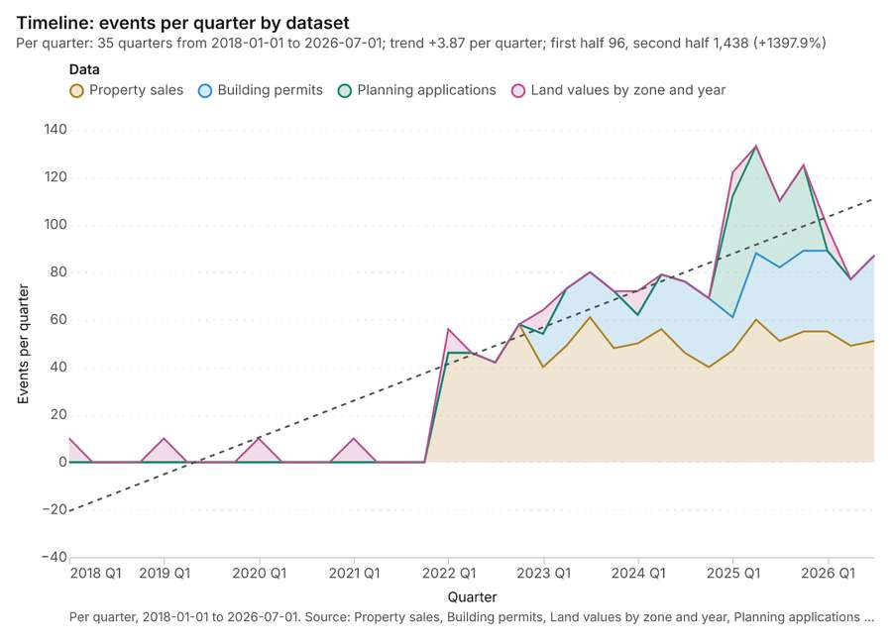
Figure 1. Timeline: events per quarter by dataset [1]. Per quarter, 2018-01-01 to 2026-07-01. Source: Property sales, Building permits, Land values by zone and year, Planning applications (1,580 features). The data is in the appendix.
The timeline counts 1,580 dated events in Property sales, Building permits, Land values by zone and year and 1 more per quarter, from Q1 2018 to Q3 2026 [1][2][3][4][5]. By dataset: Property sales 950; Building permits 380; Planning applications 160; Land values by zone and year 90 [1]. The trend is +3.87 events per quarter; the second half of the quarters has 1,438 against 96 in the first (+1397.9%) [1]. 12 of the 35 quarters had no events [1].
Busiest quarters
- Q2 2025: 133 events [1]
- Q4 2025: 125 events [1]
- Q1 2025: 122 events [1]
Quietest quarters with events
- Q1 2018: 10 events [1]
- Q1 2019: 10 events [1]
- Q1 2020: 10 events [1]

Space time hot spots
What this analysis is. Emerging hot spots: Where hot spots are new, consecutive, intensifying, persistent, diminishing, sporadic, oscillating or historical over time [6]. In ArcGIS it is Emerging Hot Spot Analysis or Create Space Time Cube [6].
Why it was run on this data. Property sales carry dates in 'date': emerging hot spot analysis finds new, intensifying and fading hot spots per month [7].
What it found. The emerging hot spots layer, titled "Emerging hot spots: Property sales," was generated with 9 properties per resolution and involved 950 features [8]. This analysis resulted in 81 features [8]. The process took 21 elapsed milliseconds [8], and the total cost incurred was 0.1475 [8].
Result | Value
result, count | 81
result, elapsed ms | 21
result, resolution | 9
result, features used | 950
result, time neighbors | 0
billing, cost | 0.1475
billing, list price | 0.1475
billing, upstream cost | 0

Findings
- Evidenced: Space time hot spots on Property sales: Emerging hot spots: 1 layer saved: Emerging hot spots: Property sales (81 features) [8][9].
- Evidenced: It reported result, count 81; result, elapsed ms 21; result, resolution 9; result, features used 950; result, time neighbors 0; billing, cost 0.1475 [8].
Tool gp_space_time_hot_spots; parameters {"project": "acfed0f6-9df9-4775-9325-30c0bbed70e9", "features": {"layer": "Property sales (a421b4df)"}, "interval": "month", "bin_shape": "h3", "resolution": 9, "time_field": "date"}

Space time hot spots
What this analysis is. Emerging hot spots: Where hot spots are new, consecutive, intensifying, persistent, diminishing, sporadic, oscillating or historical over time [6]. In ArcGIS it is Emerging Hot Spot Analysis or Create Space Time Cube [6].
Why it was run on this data. Building permits carry dates in 'decision_month': emerging hot spot analysis finds new, intensifying and fading hot spots per month [10].
What it found. The `gp_space_time_hot_spots` tool was run using `Building permits` data [12], resulting in the saving of emerging hot spots containing 90 features [11].
Result | Value
result, count | 90
result, elapsed ms | 19
result, resolution | 9
result, features used | 380
result, time neighbors | 0
billing, cost | 0.119
billing, list price | 0.119
billing, upstream cost | 0

Findings
- Evidenced: Space time hot spots on Building permits: Emerging hot spots: 1 layer saved: Emerging hot spots: Building permits (90 features) [11][12].
- Evidenced: It reported result, count 90; result, elapsed ms 19; result, resolution 9; result, features used 380; result, time neighbors 0; billing, cost 0.119 [11].
Tool gp_space_time_hot_spots; parameters {"agg": "sum", "project": "acfed0f6-9df9-4775-9325-30c0bbed70e9", "features": {"layer": "Building permits (c9732c3b)"}, "interval": "month", "bin_shape": "h3", "resolution": 9, "time_field": "decision_month", "value_field": "units"}

Near repeat
What this analysis is. Repeat and near repeat classification: Classify incidents as originators, repeats (same place) or near repeats within a distance and time window, with a Knox test table [13]. In ArcGIS it is Repeat and Near Repeat Classification or Near Repeat Calculator [13].
Why it was run on this data. Near repeat analysis tests whether Property sales close in space also follow each other within 30 days [14].
What it found. Near repeat on Property sales: Repeat and near repeat classification: 1 layer saved: Repeat and near repeat classification: Property sales (950 features) [9][15]. It reported result, days 30; result, count 950; result, chains 43; result, distance m 100; result, elapsed ms 23; result, pairs linked 51 [15].
Result | Value
result, days | 30
result, count | 950
result, chains | 43
result, distance m | 100
result, elapsed ms | 23
result, pairs linked | 51
billing, cost | 0.0785
billing, list price | 0.0785
billing, upstream cost | 0

Findings
- Evidenced: Near repeat on Property sales: Repeat and near repeat classification: 1 layer saved: Repeat and near repeat classification: Property sales (950 features) [9][15].
- Evidenced: It reported result, days 30; result, count 950; result, chains 43; result, distance m 100; result, elapsed ms 23; result, pairs linked 51 [15].
Tool gp_near_repeat; parameters {"days": 30, "project": "acfed0f6-9df9-4775-9325-30c0bbed70e9", "features": {"layer": "Property sales (a421b4df)"}, "distance_m": 100.0, "time_field": "date"}

Summarize within
What this analysis is. Summarize within: Count and aggregate the features inside each polygon (or bin), proportionally for lines and polygons [16]. In ArcGIS it is Summarize Within or Aggregate Points; in QGIS, native:countpointsinpolygon or native:sumlinelengths [16].
Why it was run on this data. Count Transit stations inside each feature of Parcels; the counts map as a choropleth (natural breaks, sequential colors) [17].
What it found. Summarize within on Transit stations, Parcels: Summarize within: 1 layer saved: Summarize within: Parcels (1100 features) [18][19][20]. It reported result, count 1,100; result, elapsed ms 43; billing, cost 0.03226; billing, list price 0.03226; billing, upstream cost 0 [18].
Result | Value
result, count | 1,100
result, elapsed ms | 43
billing, cost | 0.03226
billing, list price | 0.03226
billing, upstream cost | 0

Findings
- Evidenced: Summarize within on Transit stations, Parcels: Summarize within: 1 layer saved: Summarize within: Parcels (1100 features) [18][19][20].
- Evidenced: It reported result, count 1,100; result, elapsed ms 43; billing, cost 0.03226; billing, list price 0.03226; billing, upstream cost 0 [18].
Tool gp_summarize_within; parameters {"stats": [{"stat": "sum", "field": "lines"}], "project": "acfed0f6-9df9-4775-9325-30c0bbed70e9", "features": {"layer": "Transit stations (400e1561)"}, "polygons": {"layer": "Parcels (ccc22cc1)"}}

Summarize within
What this analysis is. Summarize within: Count and aggregate the features inside each polygon (or bin), proportionally for lines and polygons [16]. In ArcGIS it is Summarize Within or Aggregate Points; in QGIS, native:countpointsinpolygon or native:sumlinelengths [16].
Why it was run on this data. Count Transit stations inside each feature of Parcels; the counts map as a choropleth (natural breaks, sequential colors) [17].
What it found. Summarize within on Property sales, Parcels: Summarize within: 1 layer saved: Summarize within: Parcels (1100 features) [9][20][21]. It reported result, count 1,100; result, elapsed ms 471; billing, cost 0.05102; billing, list price 0.05102; billing, upstream cost 0 [21].
Result | Value
result, count | 1,100
result, elapsed ms | 471
billing, cost | 0.05102
billing, list price | 0.05102
billing, upstream cost | 0

Findings
- Evidenced: Summarize within on Property sales, Parcels: Summarize within: 1 layer saved: Summarize within: Parcels (1100 features) [9][20][21].
- Evidenced: It reported result, count 1,100; result, elapsed ms 471; billing, cost 0.05102; billing, list price 0.05102; billing, upstream cost 0 [21].
Tool gp_summarize_within; parameters {"stats": [{"stat": "sum", "field": "price_eur_m2"}], "project": "acfed0f6-9df9-4775-9325-30c0bbed70e9", "features": {"layer": "Property sales (a421b4df)"}, "group_by": "type", "polygons": {"layer": "Parcels (ccc22cc1)"}}

Summarize within
What this analysis is. Summarize within: Count and aggregate the features inside each polygon (or bin), proportionally for lines and polygons [16]. In ArcGIS it is Summarize Within or Aggregate Points; in QGIS, native:countpointsinpolygon or native:sumlinelengths [16].
Why it was run on this data. Count Transit stations inside each feature of Parcels; the counts map as a choropleth (natural breaks, sequential colors) [17].
What it found. Summarize within on Building permits, Parcels: Summarize within: 1 layer saved: Summarize within: Parcels (1100 features) [12][20][22]. It reported result, count 1,100; result, elapsed ms 49; billing, cost 0.03962; billing, list price 0.03962; billing, upstream cost 0 [22].
Result | Value
result, count | 1,100
result, elapsed ms | 49
billing, cost | 0.03962
billing, list price | 0.03962
billing, upstream cost | 0

Findings
- Evidenced: Summarize within on Building permits, Parcels: Summarize within: 1 layer saved: Summarize within: Parcels (1100 features) [12][20][22].
- Evidenced: It reported result, count 1,100; result, elapsed ms 49; billing, cost 0.03962; billing, list price 0.03962; billing, upstream cost 0 [22].
Tool gp_summarize_within; parameters {"stats": [{"stat": "sum", "field": "units"}], "project": "acfed0f6-9df9-4775-9325-30c0bbed70e9", "features": {"layer": "Building permits (c9732c3b)"}, "group_by": "type", "polygons": {"layer": "Parcels (ccc22cc1)"}}

Zonal statistics
What this analysis is. Zonal statistics: count/min/max/mean/std/sum/median/majority per polygon as a table and as GeoJSON [23]. In ArcGIS it is Zonal Statistics as Table (polygons) [23].
Why it was run on this data. Statistics of City terrain model (DEM) inside each feature of Parcels [24].
What it found. The Zonal statistics tool (rs_zonal_statistics) was used for the analysis [25].
Findings
- Evidenced: Zonal statistics: Zonal statistics: 1100 row(s) [25].
- Evidenced: zones 1100 [25].
Tool rs_zonal_statistics; parameters {"stats": ["mean", "min", "max", "std"], "zones": "Parcels (ccc22cc1)", "raster_id": "City terrain model (DEM) (45e73a8a)"}

Zonal statistics
What this analysis is. Zonal statistics: count/min/max/mean/std/sum/median/majority per polygon as a table and as GeoJSON [23]. In ArcGIS it is Zonal Statistics as Table (polygons) [23].
Why it was run on this data. Statistics of City terrain model (DEM) inside each feature of Parcels [24].
What it found. The zonal statistics tool was utilized for this analysis [26]. A total of 10 row(s) were generated for 10 zones [26]. This calculation was performed as part of the `rs_zonal_statistics` process during step 1 [26].
Findings
- Evidenced: Zonal statistics: Zonal statistics: 10 row(s) [26].
- Evidenced: zones 10 [26].
Tool rs_zonal_statistics; parameters {"stats": ["mean", "min", "max", "std"], "zones": "Green spaces (448e3c1b)", "raster_id": "City terrain model (DEM) (45e73a8a)"}

Zonal statistics
What this analysis is. Zonal statistics: count/min/max/mean/std/sum/median/majority per polygon as a table and as GeoJSON [23]. In ArcGIS it is Zonal Statistics as Table (polygons) [23].
Why it was run on this data. Statistics of City terrain model (DEM) inside each feature of Parcels [24].
What it found. The rs_zonal_statistics tool produced results for 10 rows and 10 zones [27]. This indicator provides zonal statistics for the given dataset [27].
Findings
- Evidenced: Zonal statistics: Zonal statistics: 10 row(s) [27].
- Evidenced: zones 10 [27].
Tool rs_zonal_statistics; parameters {"stats": ["mean", "min", "max", "std"], "zones": "Zoning districts (f84e0e45)", "raster_id": "City terrain model (DEM) (45e73a8a)"}

Hot spots
What this analysis is. Hot spot analysis: Getis-Ord Gi* hot and cold spots with z-scores, p-values and confidence bins [28]. In ArcGIS it is Find Hot Spots or Hot Spot Analysis (Getis-Ord Gi*); in QGIS, qgis:hotspot (plugin) [28].
Why it was run on this data. 950 points: Getis-Ord Gi* tests whether the concentrations in Property sales are statistically significant [29].
What it found. Hot spots on Property sales: Hot spot analysis: 1 layer saved: Hot spot analysis: Property sales (213 features) [9][30]. It reported result, bins 213; result, count 213; result, elapsed ms 37; result, cell size m 200; result, incidents used 950; result, distance band m 200 [30].
Result | Value
result, bins | 213
result, count | 213
result, elapsed ms | 37
result, cell size m | 200
result, incidents used | 950
result, distance band m | 200
billing, cost | 0.069
billing, list price | 0.069
billing, upstream cost | 0

Findings
- Evidenced: Hot spots on Property sales: Hot spot analysis: 1 layer saved: Hot spot analysis: Property sales (213 features) [9][30].
- Evidenced: It reported result, bins 213; result, count 213; result, elapsed ms 37; result, cell size m 200; result, incidents used 950; result, distance band m 200 [30].
Tool gp_hot_spots; parameters {"project": "acfed0f6-9df9-4775-9325-30c0bbed70e9", "features": {"layer": "Property sales (a421b4df)"}, "aggregation": "hexagon", "cell_size_m": 200.0, "distance_band_m": 200.0}

Hot spots
What this analysis is. Hot spot analysis: Getis-Ord Gi* hot and cold spots with z-scores, p-values and confidence bins [28]. In ArcGIS it is Find Hot Spots or Hot Spot Analysis (Getis-Ord Gi*); in QGIS, qgis:hotspot (plugin) [28].
Why it was run on this data. 380 points: Getis-Ord Gi* tests whether the concentrations in Building permits are statistically significant [31].
What it found. Hot spots on Building permits: Hot spot analysis: 1 layer saved: Hot spot analysis: Building permits (380 features) [12][32]. It reported result, count 380; result, elapsed ms 10; result, excluded null 0; result, distance band m 500; billing, cost 0.0576; billing, list price 0.0576 [32].
Result | Value
result, count | 380
result, elapsed ms | 10
result, excluded null | 0
result, distance band m | 500
billing, cost | 0.0576
billing, list price | 0.0576
billing, upstream cost | 0

Findings
- Evidenced: Hot spots on Building permits: Hot spot analysis: 1 layer saved: Hot spot analysis: Building permits (380 features) [12][32].
- Evidenced: It reported result, count 380; result, elapsed ms 10; result, excluded null 0; result, distance band m 500; billing, cost 0.0576; billing, list price 0.0576 [32].
Tool gp_hot_spots; parameters {"field": "units", "project": "acfed0f6-9df9-4775-9325-30c0bbed70e9", "features": {"layer": "Building permits (c9732c3b)"}, "aggregation": "hexagon", "cell_size_m": 200.0, "distance_band_m": 500.0}

Calculate density
What this analysis is. Calculate density: Kernel density per square kilometer on a grid [33]. In ArcGIS it is Calculate Density or Kernel Density; in QGIS, native:heatmapkerneldensityestimation [33].
Why it was run on this data. 950 points in Property sales: a density surface shows where they concentrate [34].
What it found. The calculation utilized the Property sales data [9] and produced a total count of
Result | Value
result, count | 867
result, elapsed ms | 31
result, bandwidth m | 200
result, cell size m | 100
result, excluded null | 0
result, max density per km2 | 364
billing, cost | 0.069
billing, list price | 0.069
billing, upstream cost | 0

Findings
- Evidenced: Calculate density on Property sales: Calculate density: 1 layer saved: Calculate density: Property sales (867 features) [9][35].
- Evidenced: It reported result, count 867; result, elapsed ms 31; result, bandwidth m 200; result, cell size m 100; result, excluded null 0; result, max density per km2 364 [35].
Tool gp_calculate_density; parameters {"kernel": "quartic", "project": "acfed0f6-9df9-4775-9325-30c0bbed70e9", "features": {"layer": "Property sales (a421b4df)"}, "bandwidth_m": 200.0, "cell_size_m": 100.0}

Calculate density
What this analysis is. Calculate density: Kernel density per square kilometer on a grid [33]. In ArcGIS it is Calculate Density or Kernel Density; in QGIS, native:heatmapkerneldensityestimation [33].
Why it was run on this data. 380 points in Building permits: a density surface shows where they concentrate [36].
What it found. The density calculation used the Building permits layer [12]. The process resulted in 1,211 features [37]. This calculation required 41 milliseconds and generated a bandwidth of 500 meters [37]. The resulting max density per $\text{km}^2$ was 2,113 [37].
Result | Value
result, count | 1,211
result, elapsed ms | 41
result, bandwidth m | 500
result, cell size m | 100
result, excluded null | 0
result, max density per km2 | 2,113
billing, cost | 0.0576
billing, list price | 0.0576
billing, upstream cost | 0

Findings
- Evidenced: Calculate density on Building permits: Calculate density: 1 layer saved: Calculate density: Building permits (1211 features) [12][37].
- Evidenced: It reported result, count 1,211; result, elapsed ms 41; result, bandwidth m 500; result, cell size m 100; result, excluded null 0; result, max density per km2 2,113 [37].
Tool gp_calculate_density; parameters {"kernel": "quartic", "project": "acfed0f6-9df9-4775-9325-30c0bbed70e9", "features": {"layer": "Building permits (c9732c3b)"}, "bandwidth_m": 500.0, "cell_size_m": 100.0, "weight_field": "units"}

Find point clusters
What this analysis is. Find point clusters: Density-based clusters (DBSCAN, HDBSCAN or OPTICS, optionally space-time) with hulls and noise [38]. In ArcGIS it is Find Point Clusters or Density-based Clustering; in QGIS, native:dbscanclustering or native:stdbscanclustering [38].
Why it was run on this data. DBSCAN finds dense groups of Transit stations and separates noise [39].
What it found. The `gp_find_point_clusters` tool processed the `Transit stations` layer [19]. This process yielded $12$ point clusters [40]. The resulting noise count was $0$ [40], and the maximum cluster distance was $2,000$ meters [40]. The operation was completed in $5$ milliseconds [40] and included $12$ features in the final output [40].
Result | Value
result, count | 12
result, noise | 0
result, distance m | 2,000
result, elapsed ms | 5
result, min points | 3
billing, cost | 0.05024
billing, list price | 0.05024
billing, upstream cost | 0

Findings
- Evidenced: Find point clusters on Transit stations: Find point clusters: 2 layers saved: Find point clusters: Transit stations (12 features); Find point clusters: cluster hulls (1 feature) [19][40].
- Evidenced: It reported result, count 12; result, noise 0; result, distance m 2,000; result, elapsed ms 5; result, min points 3; billing, cost 0.05024 [40].
Tool gp_find_point_clusters; parameters {"method": "dbscan", "project": "acfed0f6-9df9-4775-9325-30c0bbed70e9", "features": {"layer": "Transit stations (400e1561)"}, "distance_m": 2000.0, "min_points": 3}

Find point clusters
What this analysis is. Find point clusters: Density-based clusters (DBSCAN, HDBSCAN or OPTICS, optionally space-time) with hulls and noise [38]. In ArcGIS it is Find Point Clusters or Density-based Clustering; in QGIS, native:dbscanclustering or native:stdbscanclustering [38].
Why it was run on this data. DBSCAN finds dense groups of Property sales and separates noise [41].
What it found. Find point clusters on Property sales: Find point clusters: 1 layer saved: Find point clusters: Property sales (950 features) [9][42]. It reported result, count 950; result, noise 950; result, distance m 100; result, elapsed ms 12; result, min points 20; billing, cost 0.069 [42].
Result | Value
result, count | 950
result, noise | 950
result, distance m | 100
result, elapsed ms | 12
result, min points | 20
billing, cost | 0.069
billing, list price | 0.069
billing, upstream cost | 0

Findings
- Evidenced: Find point clusters on Property sales: Find point clusters: 1 layer saved: Find point clusters: Property sales (950 features) [9][42].
- Evidenced: It reported result, count 950; result, noise 950; result, distance m 100; result, elapsed ms 12; result, min points 20; billing, cost 0.069 [42].
Tool gp_find_point_clusters; parameters {"method": "dbscan", "project": "acfed0f6-9df9-4775-9325-30c0bbed70e9", "features": {"layer": "Property sales (a421b4df)"}, "distance_m": 100.0, "min_points": 20}

Find point clusters
What this analysis is. Find point clusters: Density-based clusters (DBSCAN, HDBSCAN or OPTICS, optionally space-time) with hulls and noise [38]. In ArcGIS it is Find Point Clusters or Density-based Clustering; in QGIS, native:dbscanclustering or native:stdbscanclustering [38].
Why it was run on this data. DBSCAN finds dense groups of Building permits and separates noise [43].
What it found. Building permits served as the input data for the point cluster analysis [12].
Result | Value
result, count | 380
result, noise | 126
result, distance m | 200
result, elapsed ms | 11
result, min points | 10
billing, cost | 0.0576
billing, list price | 0.0576
billing, upstream cost | 0

Findings
- Evidenced: Find point clusters on Building permits: Find point clusters: 2 layers saved: Find point clusters: Building permits (380 features); Find point clusters: cluster hulls (14 features) [12][44].
- Evidenced: It reported result, count 380; result, noise 126; result, distance m 200; result, elapsed ms 11; result, min points 10; billing, cost 0.0576 [44].
Tool gp_find_point_clusters; parameters {"method": "dbscan", "project": "acfed0f6-9df9-4775-9325-30c0bbed70e9", "features": {"layer": "Building permits (c9732c3b)"}, "distance_m": 200.0, "min_points": 10}

Outliers
What this analysis is. Find outliers: Anselin local Moran’s I: HH, LL clusters and HL, LH outliers [45]. In ArcGIS it is Find Outliers or Cluster and Outlier Analysis (Anselin Local Moran’s I) [45].
Why it was run on this data. Local Moran's I maps clusters and outliers of 'built_far' [46].
What it found. The `gp_outliers` tool was utilized on the Parcels layer [20]. The analysis result reported a count of 1,100 features [47]. This task was completed with an elapsed time of 74 ms [47]. Key metrics generated included a distance band of 86.92 m [47], and the billing cost was 0.083 [47].
Result | Value
result, count | 1,100
result, elapsed ms | 74
result, permutations | 199
result, excluded null | 0
result, distance band m | 86.92
billing, cost | 0.083
billing, list price | 0.083
billing, upstream cost | 0

Findings
- Evidenced: Outliers on Parcels: Find outliers: 1 layer saved: Find outliers: Parcels (1100 features) [20][47].
- Evidenced: It reported result, count 1,100; result, elapsed ms 74; result, permutations 199; result, excluded null 0; result, distance band m 86.92; billing, cost 0.083 [47].
Tool gp_outliers; parameters {"field": "built_far", "project": "acfed0f6-9df9-4775-9325-30c0bbed70e9", "features": {"layer": "Parcels (ccc22cc1)"}, "aggregation": "hexagon"}

Outliers
What this analysis is. Find outliers: Anselin local Moran’s I: HH, LL clusters and HL, LH outliers [45]. In ArcGIS it is Find Outliers or Cluster and Outlier Analysis (Anselin Local Moran’s I) [45].
Why it was run on this data. Local Moran's I maps clusters and outliers of 'area_ha' [48].
What it found. Outliers on Green spaces: Find outliers: 1 layer saved: Find outliers: Green spaces (10 features) [49][50]. It reported result, count 10; result, elapsed ms 3; result, permutations 199; result, excluded null 0; result, distance band m 1,747; billing, cost 0.0503 [49].
Result | Value
result, count | 10
result, elapsed ms | 3
result, permutations | 199
result, excluded null | 0
result, distance band m | 1,747
billing, cost | 0.0503
billing, list price | 0.0503
billing, upstream cost | 0

Findings
- Evidenced: Outliers on Green spaces: Find outliers: 1 layer saved: Find outliers: Green spaces (10 features) [49][50].
- Evidenced: It reported result, count 10; result, elapsed ms 3; result, permutations 199; result, excluded null 0; result, distance band m 1,747; billing, cost 0.0503 [49].
Tool gp_outliers; parameters {"field": "area_ha", "project": "acfed0f6-9df9-4775-9325-30c0bbed70e9", "features": {"layer": "Green spaces (448e3c1b)"}, "aggregation": "hexagon"}

Outliers
What this analysis is. Find outliers: Anselin local Moran’s I: HH, LL clusters and HL, LH outliers [45]. In ArcGIS it is Find Outliers or Cluster and Outlier Analysis (Anselin Local Moran’s I) [45].
Why it was run on this data. Local Moran's I maps clusters and outliers of 'max_far' [51].
What it found. Outliers on Zoning districts: Find outliers: 1 layer saved: Find outliers: Zoning districts (10 features) [52][53]. It reported result, count 10; result, elapsed ms 2; result, permutations 199; result, excluded null 0; result, distance band m 1,435; billing, cost 0.0503 [52].
Result | Value
result, count | 10
result, elapsed ms | 2
result, permutations | 199
result, excluded null | 0
result, distance band m | 1,435
billing, cost | 0.0503
billing, list price | 0.0503
billing, upstream cost | 0

Findings
- Evidenced: Outliers on Zoning districts: Find outliers: 1 layer saved: Find outliers: Zoning districts (10 features) [52][53].
- Evidenced: It reported result, count 10; result, elapsed ms 2; result, permutations 199; result, excluded null 0; result, distance band m 1,435; billing, cost 0.0503 [52].
Tool gp_outliers; parameters {"field": "max_far", "project": "acfed0f6-9df9-4775-9325-30c0bbed70e9", "features": {"layer": "Zoning districts (f84e0e45)"}, "aggregation": "hexagon"}

Maps and charts
The run also made 21 map image(s) [54][55][56][57][58][59][60][61][62][63][64][65][66][67][68][69][70][71][72][73][74] and 26 chart(s) [75][76][77][78][79][80][81][82][83][84][85][86][87][88][89][90][91][92][93][94][95][96][97][98][99][100].
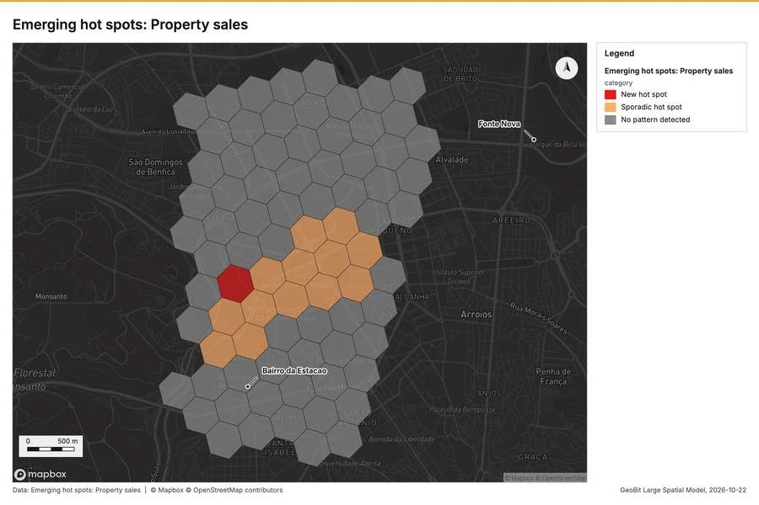
Figure 2. Emerging hot spots: Property sales [54]
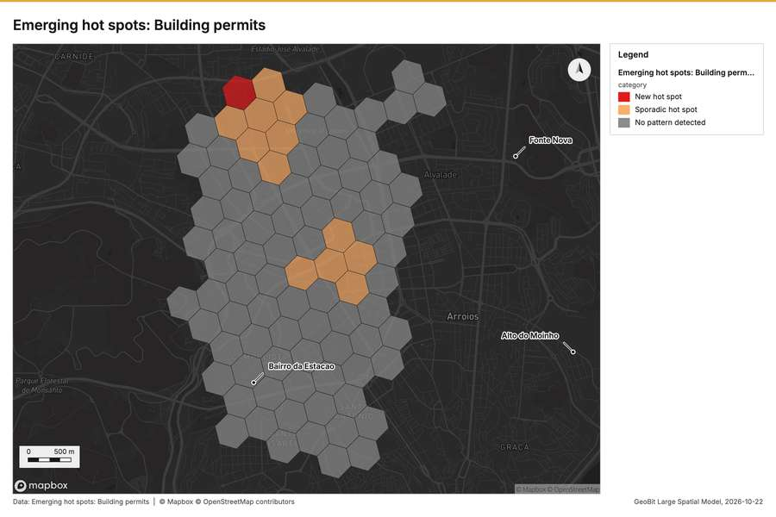
Figure 3. Emerging hot spots: Building permits [55]
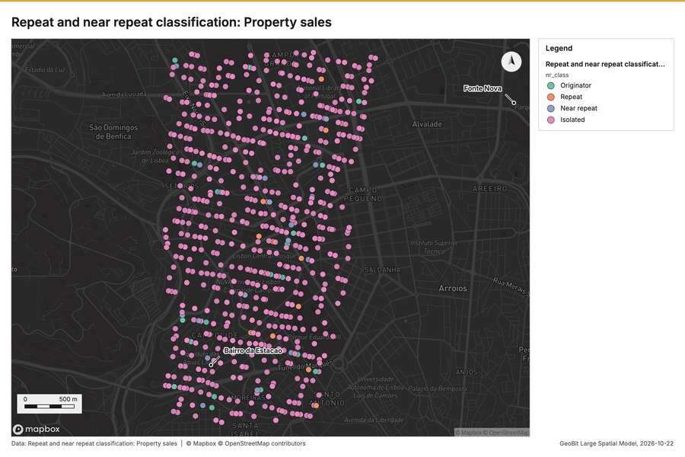
Figure 4. Repeat and near repeat classification: Property sales [56]
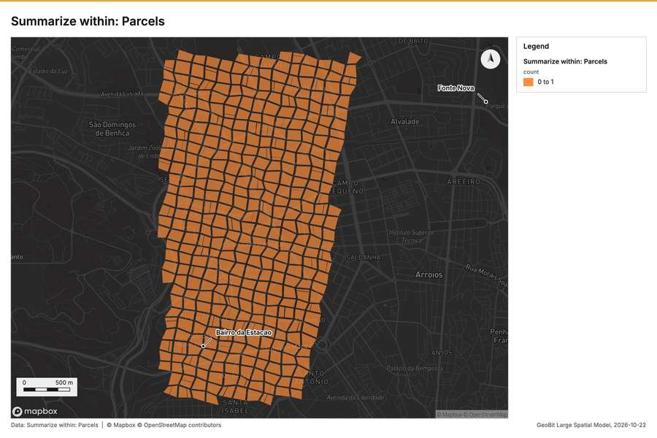
Figure 5. Summarize within: Parcels [57]
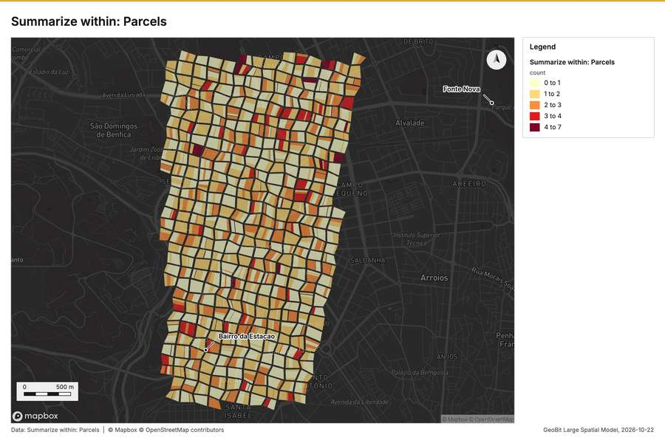
Figure 6. Summarize within: Parcels [58]
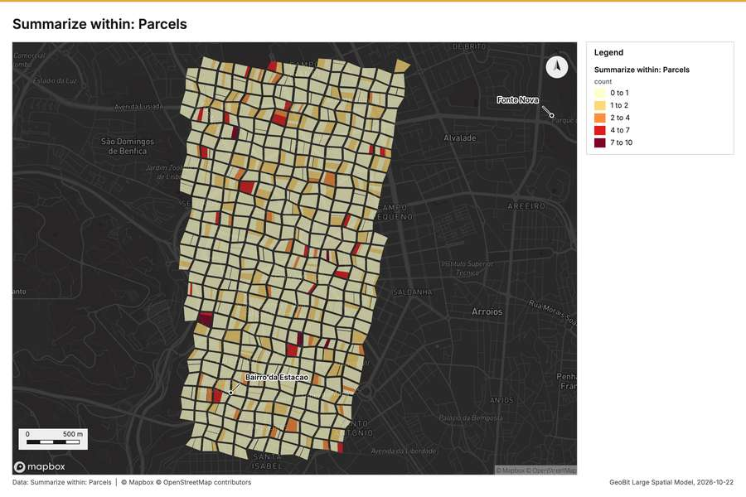
Figure 7. Summarize within: Parcels [59]
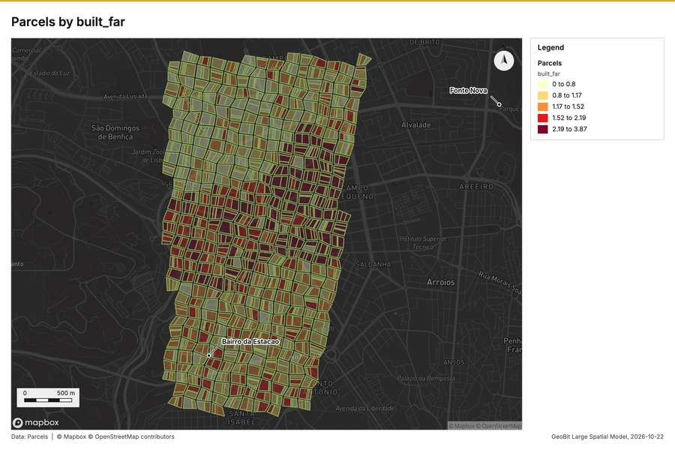
Figure 8. Parcels by built_far [60]
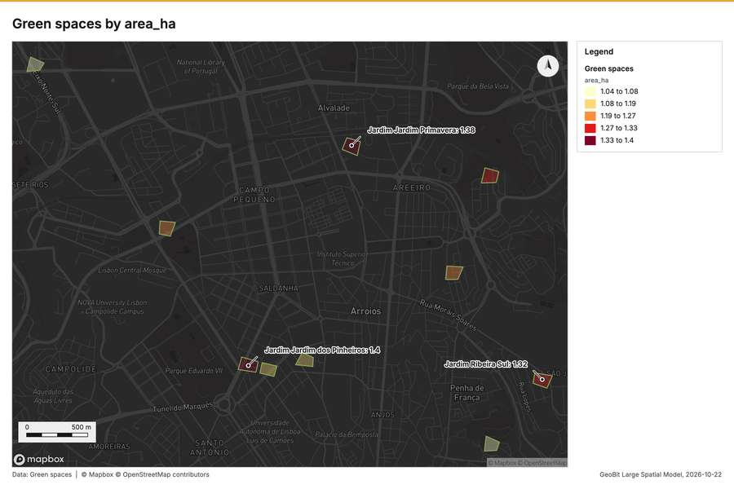
Figure 9. Green spaces by area_ha [61]
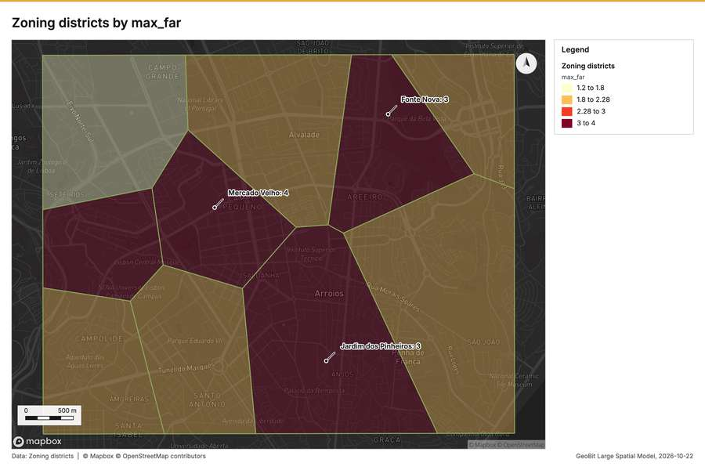
Figure 10. Zoning districts by max_far [62]
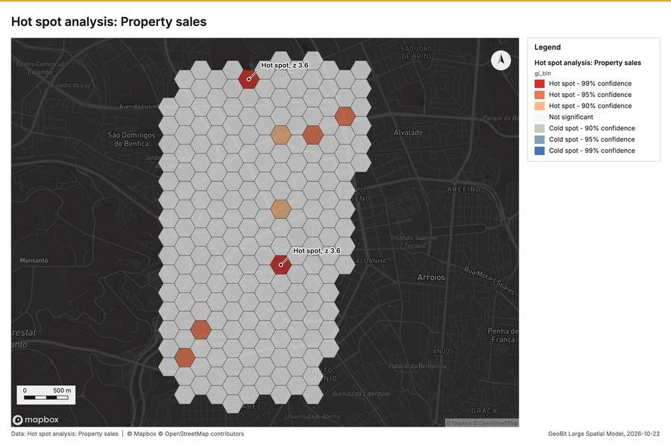
Figure 11. Hot spot analysis: Property sales [63]
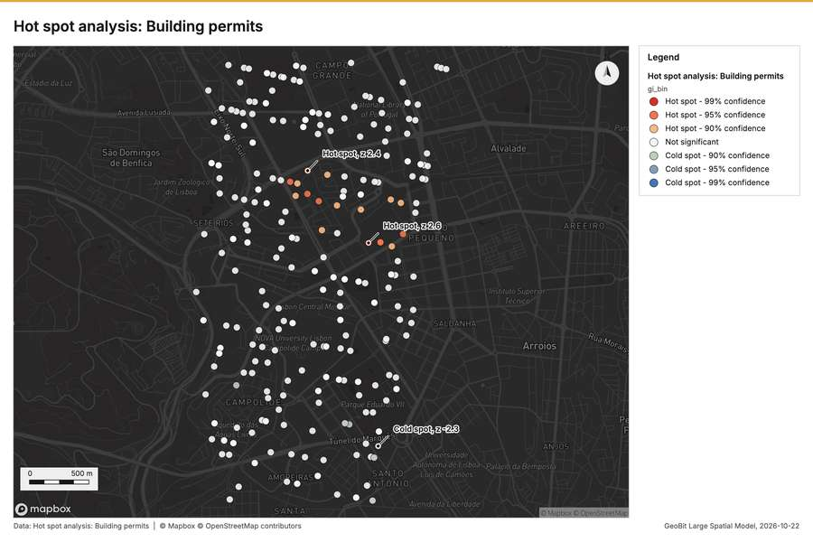
Figure 12. Hot spot analysis: Building permits [64]
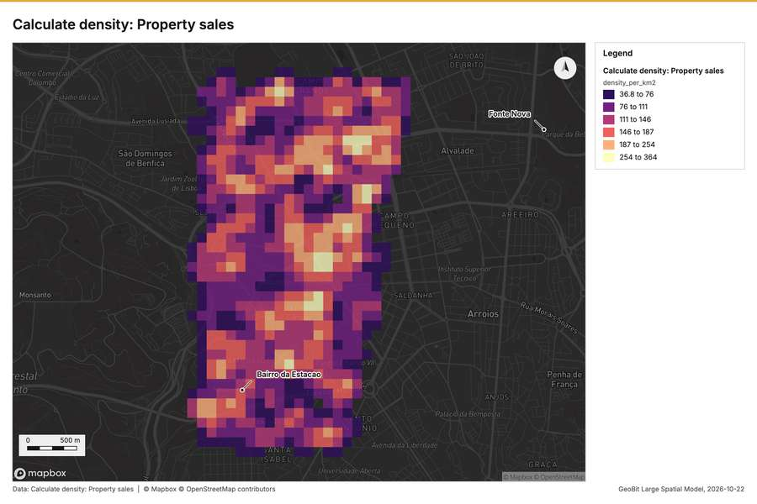
Figure 13. Calculate density: Property sales [65]
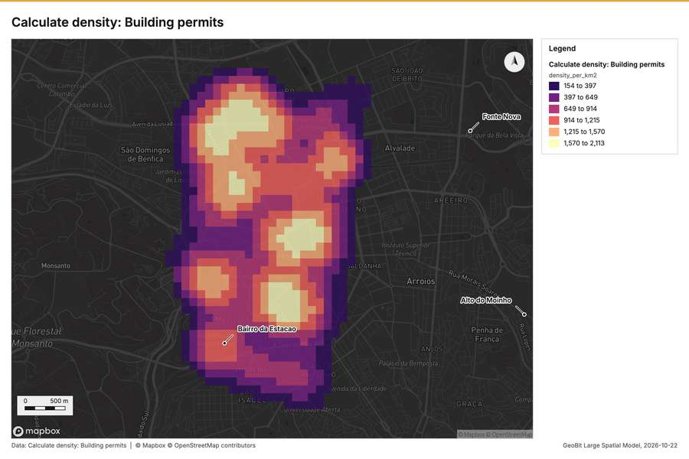
Figure 14. Calculate density: Building permits [66]
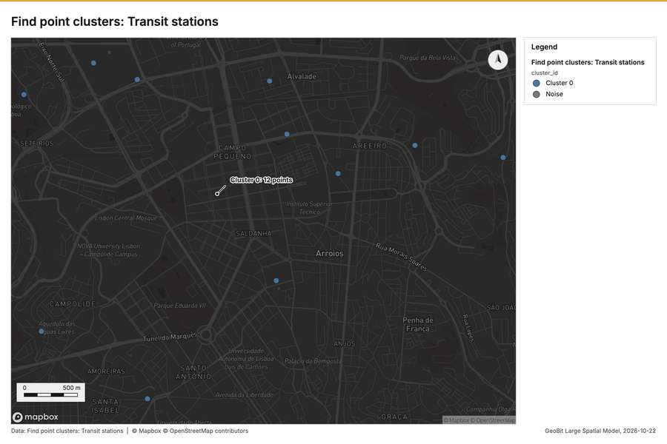
Figure 15. Find point clusters: Transit stations [67]
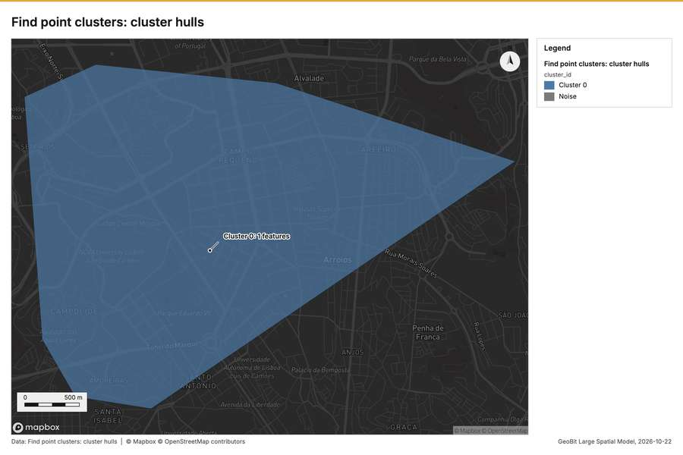
Figure 16. Find point clusters: cluster hulls [68]
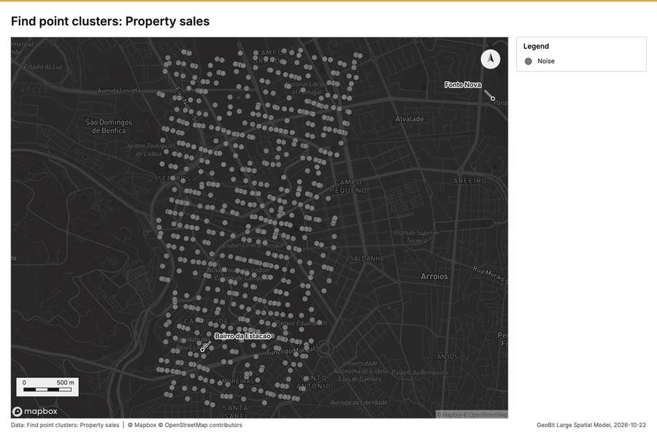
Figure 17. Find point clusters: Property sales [69]
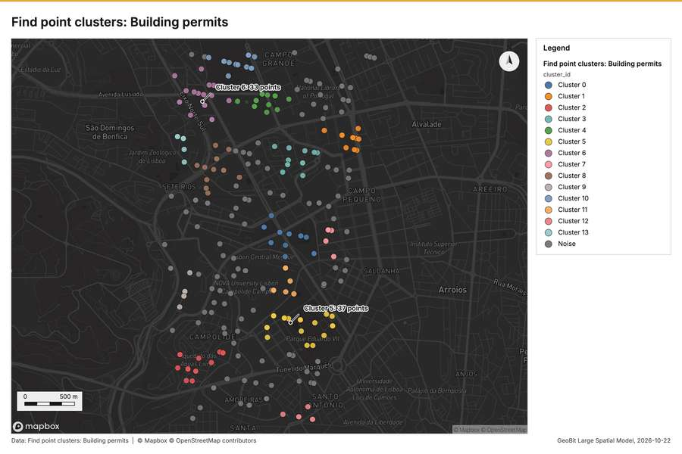
Figure 18. Find point clusters: Building permits [70]
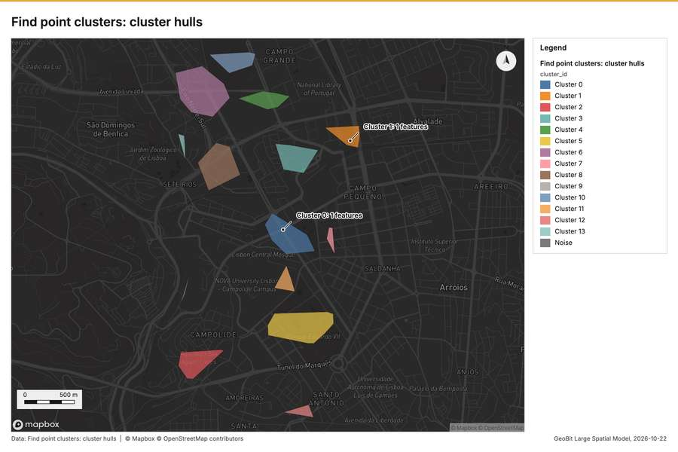
Figure 19. Find point clusters: cluster hulls [71]
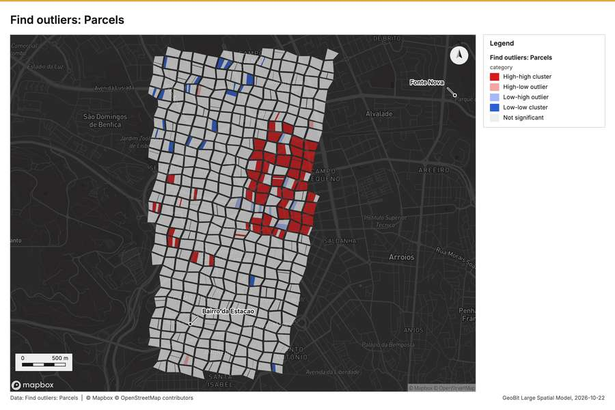
Figure 20. Find outliers: Parcels [72]
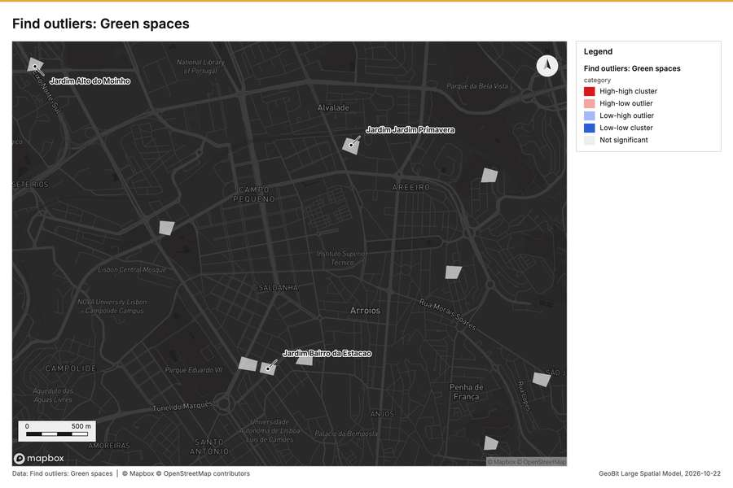
Figure 21. Find outliers: Green spaces [73]
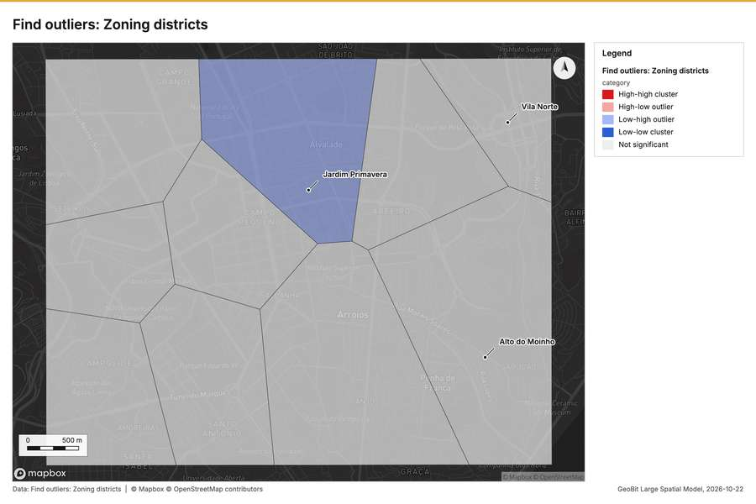
Figure 22. Find outliers: Zoning districts [74]
What the map shows. The map, titled "Emerging hot spots: Property sales," displays the pattern of property sales across a hexagonal grid. The majority of the area is colored grey, indicating that no pattern was detected in these regions. A cluster [54]
Inferred: read from the image by gemma4:e4b, not evidence.
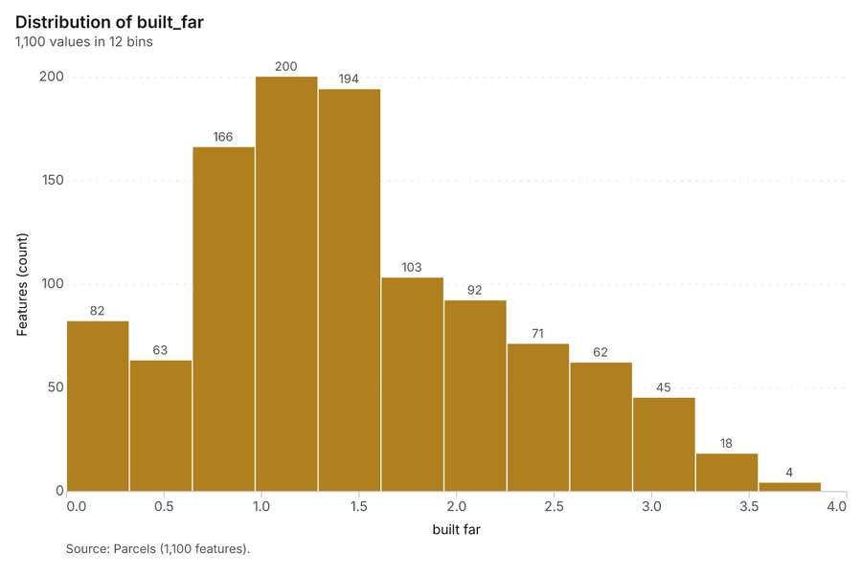
Figure 23. Parcels over time (year_built) [75]. Source: Parcels (1,100 features). The data is in the appendix.
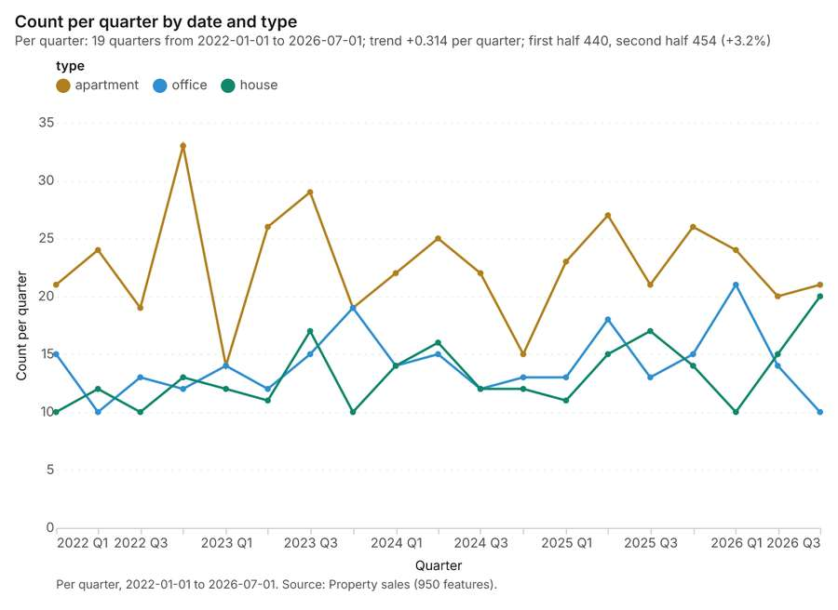
Figure 24. Property sales over time (date) [76]. Per quarter, 2022-01-01 to 2026-07-01. Source: Property sales (950 features). The data is in the appendix.
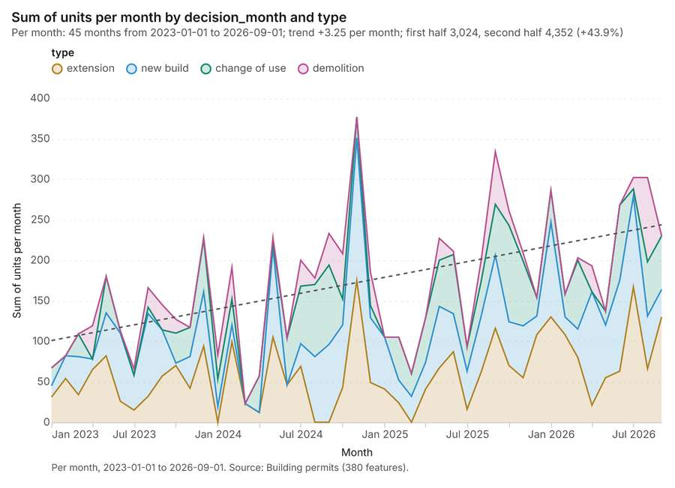
Figure 25. Building permits over time (decision_month) [77]. Per month, 2023-01-01 to 2026-09-01. Source: Building permits (380 features). The data is in the appendix.
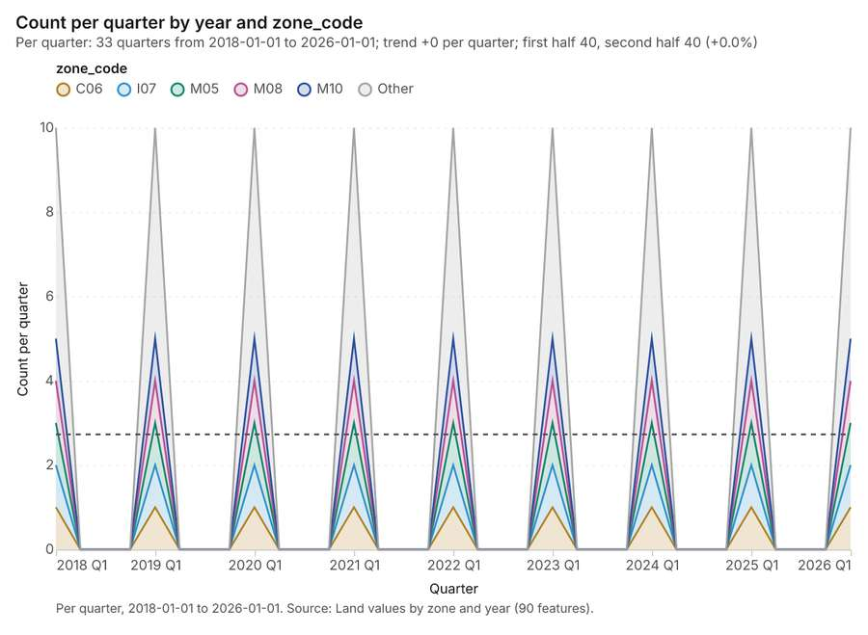
Figure 26. Land values by zone and year over time (year) [78]. Per quarter, 2018-01-01 to 2026-01-01. Source: Land values by zone and year (90 features). The data is in the appendix.
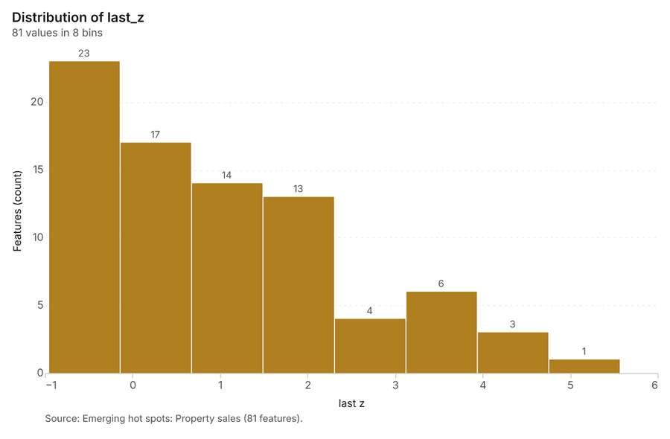
Figure 27. Emerging hot spots: Property sales [79]. Source: Emerging hot spots: Property sales (81 features). The data is in the appendix.
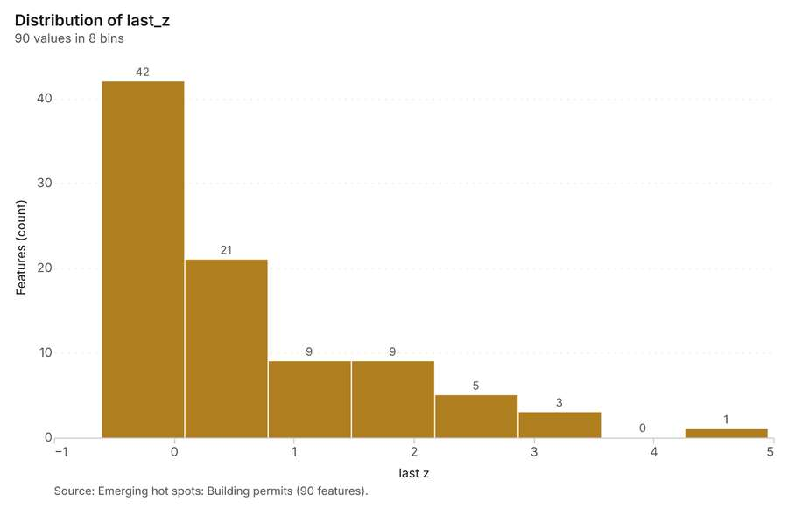
Figure 28. Emerging hot spots: Building permits [80]. Source: Emerging hot spots: Building permits (90 features). The data is in the appendix.
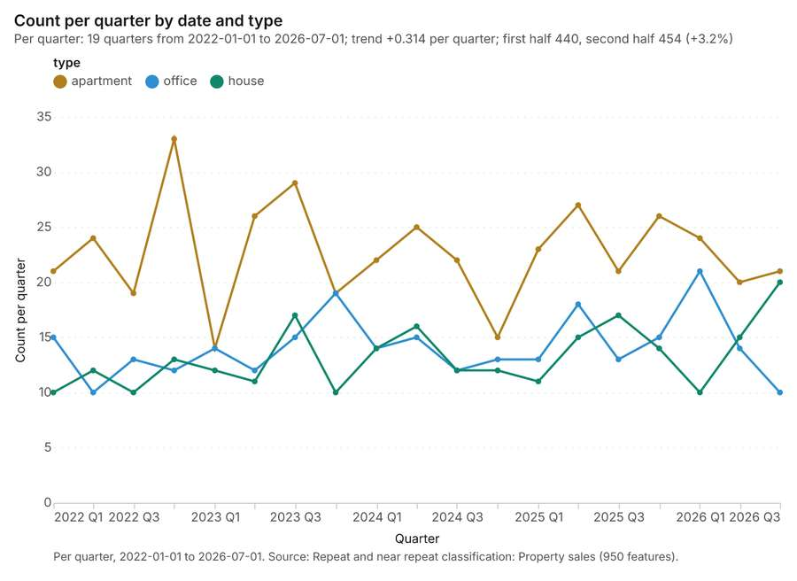
Figure 29. Repeat and near repeat classification: Property sales [81]. Per quarter, 2022-01-01 to 2026-07-01. Source: Repeat and near repeat classification: Property sales (950 features). The data is in the appendix.
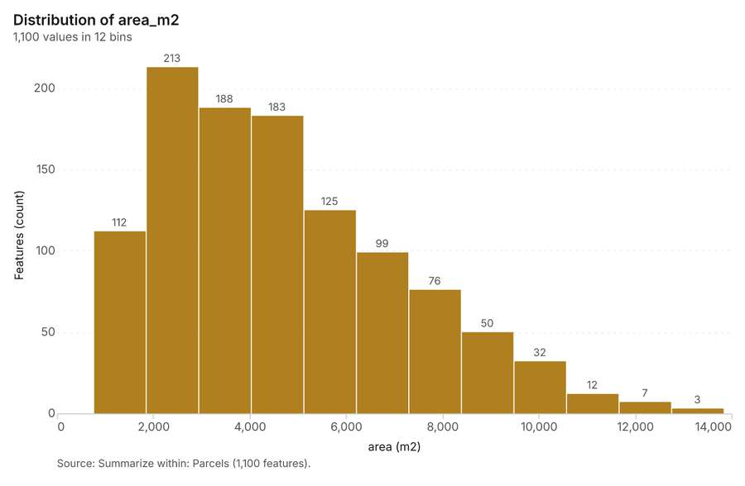
Figure 30. Summarize within: Parcels [82]. Source: Summarize within: Parcels (1,100 features). The data is in the appendix.
Figure 31. Summarize within: Parcels [83]. Source: Summarize within: Parcels (1,100 features). The data is in the appendix.
Figure 32. Summarize within: Parcels [84]. Source: Summarize within: Parcels (1,100 features). The data is in the appendix.
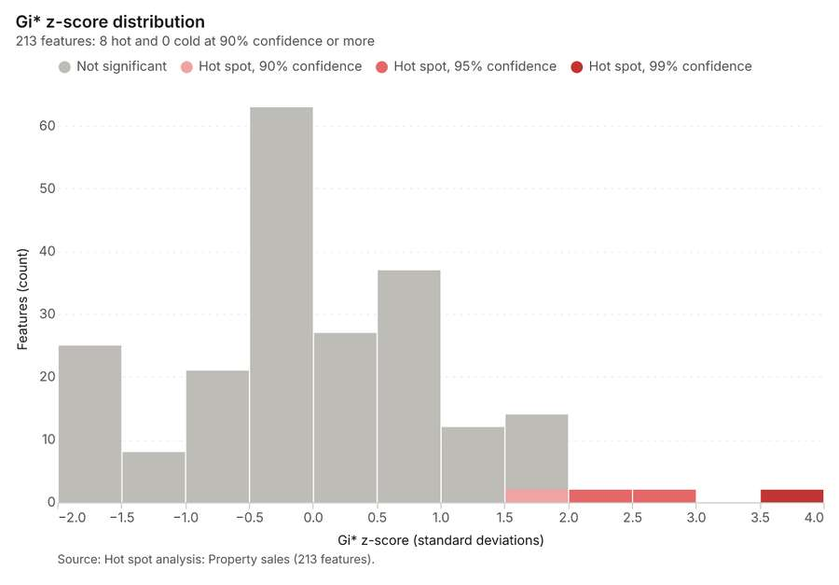
Figure 33. Hot spot analysis: Property sales [85]. Source: Hot spot analysis: Property sales (213 features). The data is in the appendix.
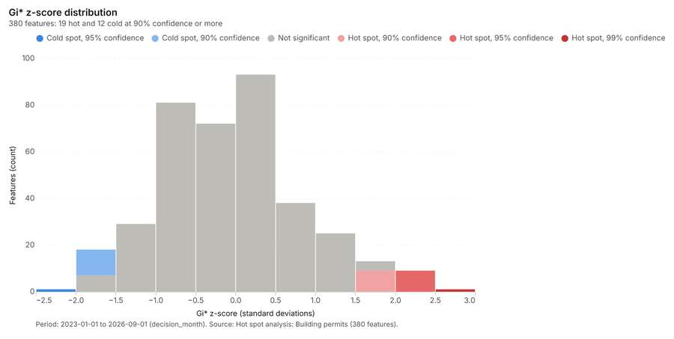
Figure 34. Hot spot analysis: Building permits [86]. Period: 2023-01-01 to 2026-09-01 (decision_month). Source: Hot spot analysis: Building permits (380 features). The data is in the appendix.
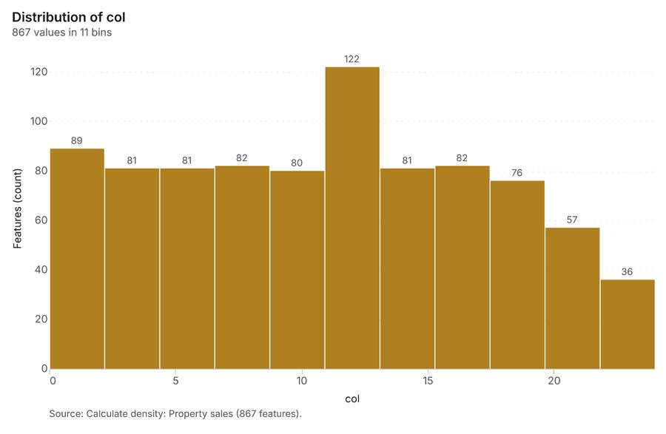
Figure 35. Calculate density: Property sales [87]. Source: Calculate density: Property sales (867 features). The data is in the appendix.
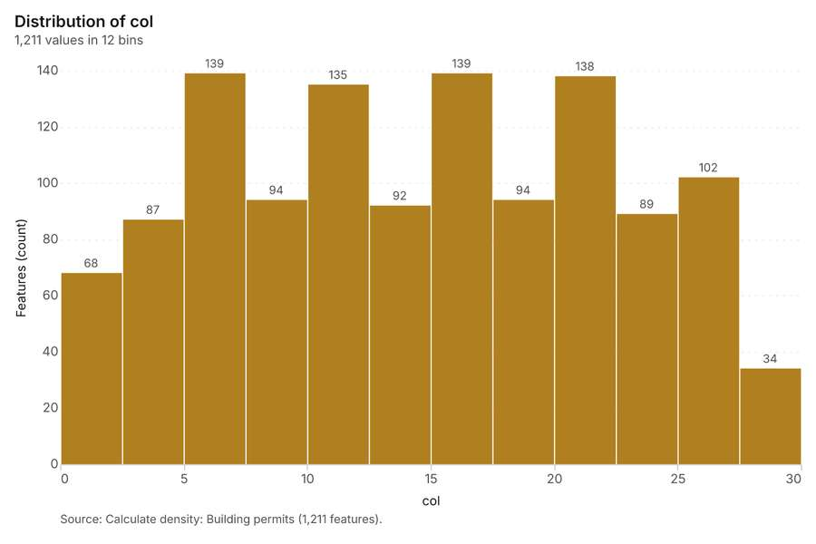
Figure 36. Calculate density: Building permits [88]. Source: Calculate density: Building permits (1,211 features). The data is in the appendix.
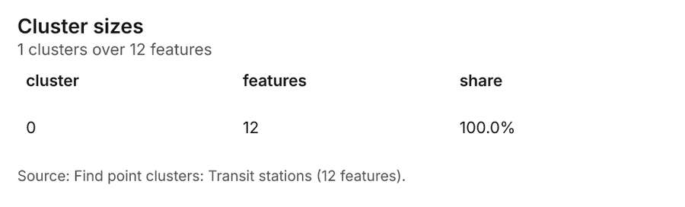
Figure 37. Find point clusters: Transit stations [89]. Source: Find point clusters: Transit stations (12 features). The data is in the appendix.
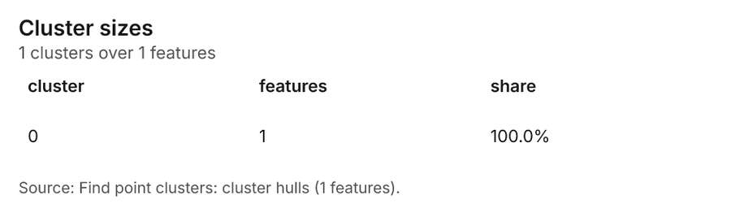
Figure 38. Find point clusters: cluster hulls [90]. Source: Find point clusters: cluster hulls (1 features). The data is in the appendix.
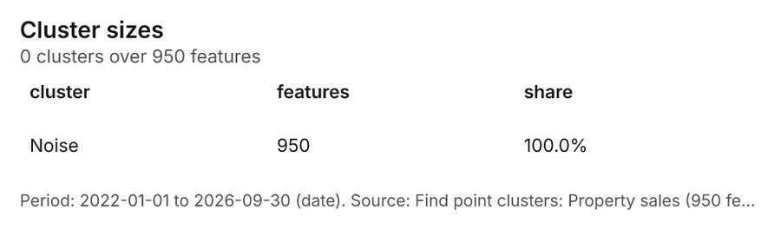
Figure 39. Find point clusters: Property sales [91]. Period: 2022-01-01 to 2026-09-30 (date). Source: Find point clusters: Property sales (950 features). The data is in the appendix.
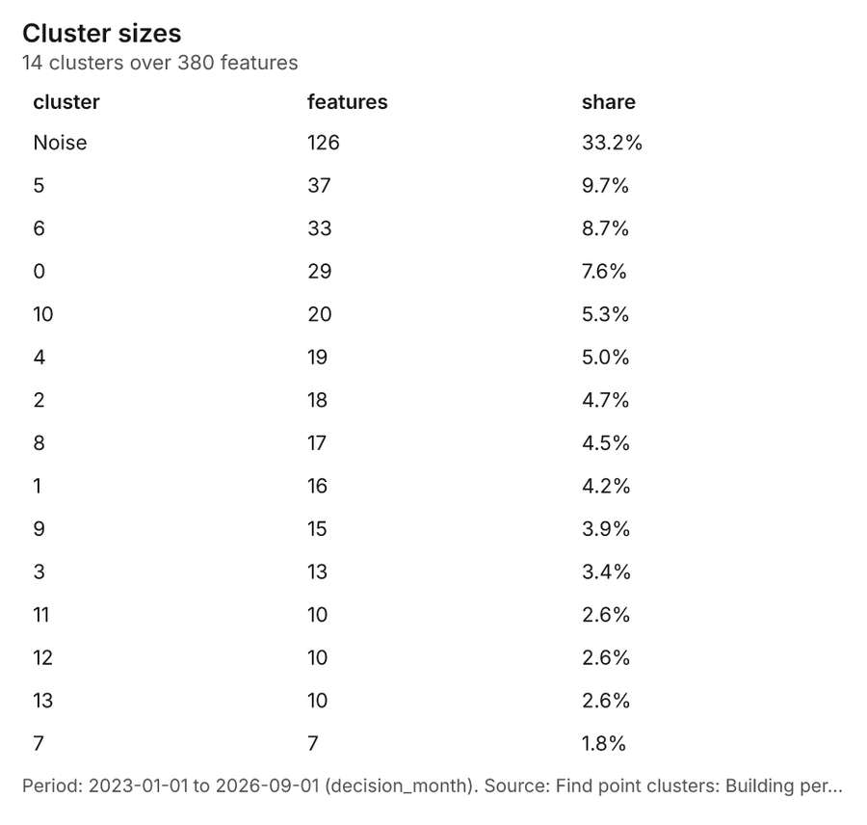
Figure 40. Find point clusters: Building permits [92]. Period: 2023-01-01 to 2026-09-01 (decision_month). Source: Find point clusters: Building permits (380 features). The data is in the appendix.
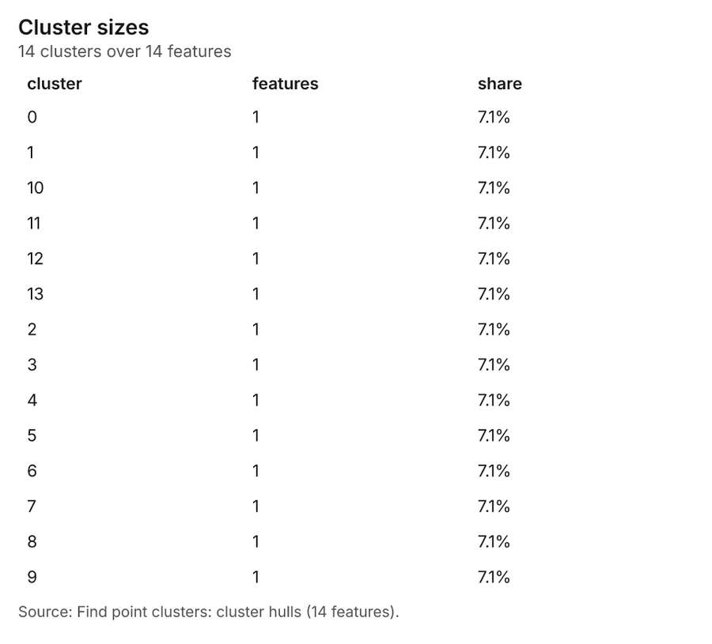
Figure 41. Find point clusters: cluster hulls [93]. Source: Find point clusters: cluster hulls (14 features). The data is in the appendix.
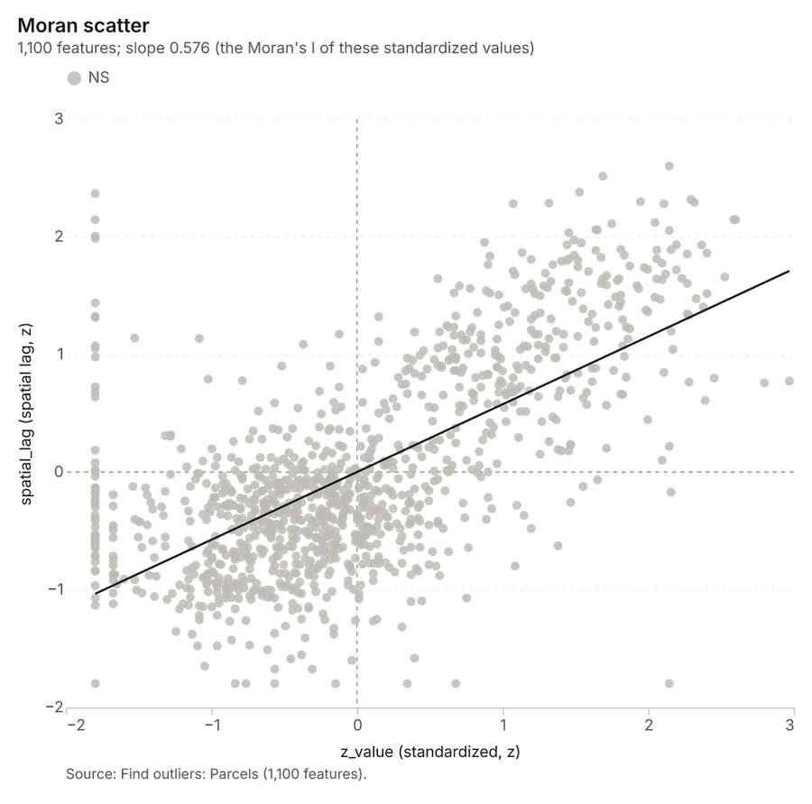
Figure 42. Find outliers: Parcels [94]. Source: Find outliers: Parcels (1,100 features). The data is in the appendix.
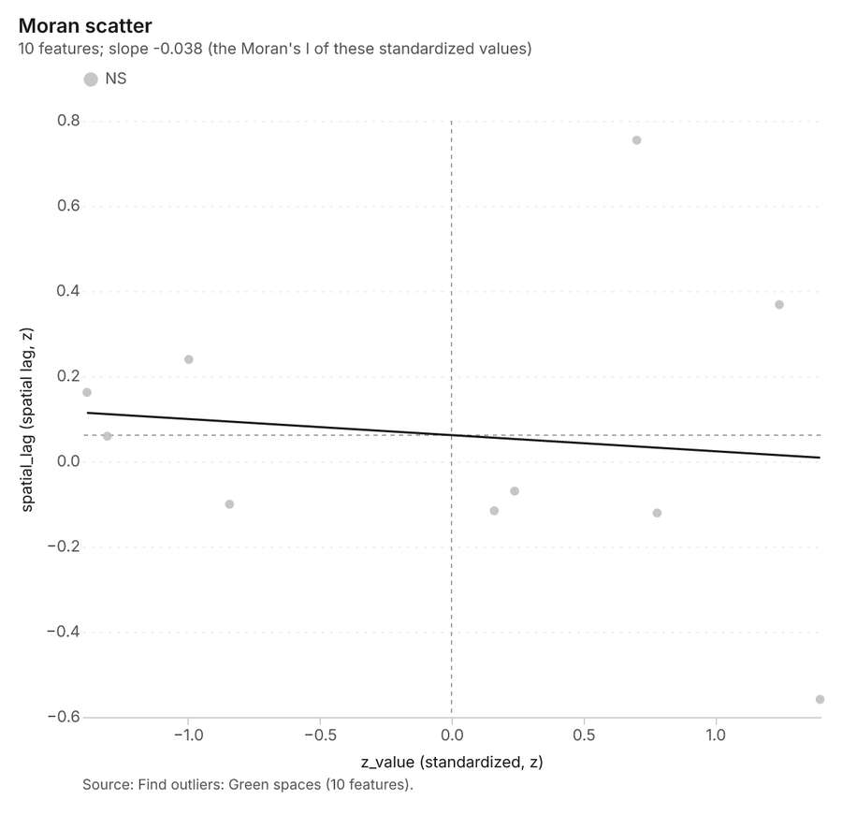
Figure 43. Find outliers: Green spaces [95]. Source: Find outliers: Green spaces (10 features). The data is in the appendix.
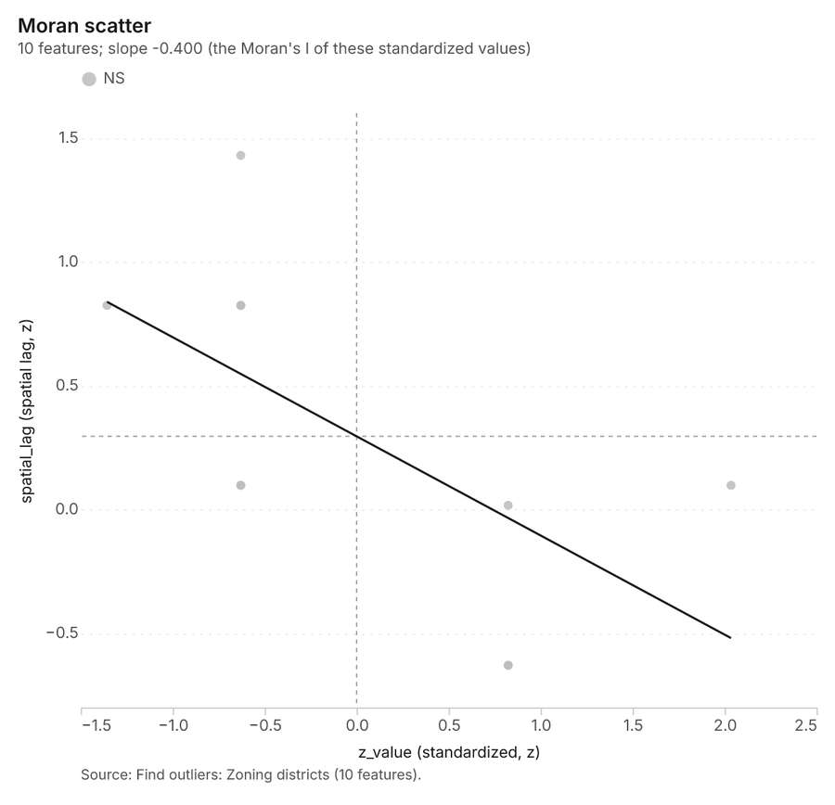
Figure 44. Find outliers: Zoning districts [96]. Source: Find outliers: Zoning districts (10 features). The data is in the appendix.
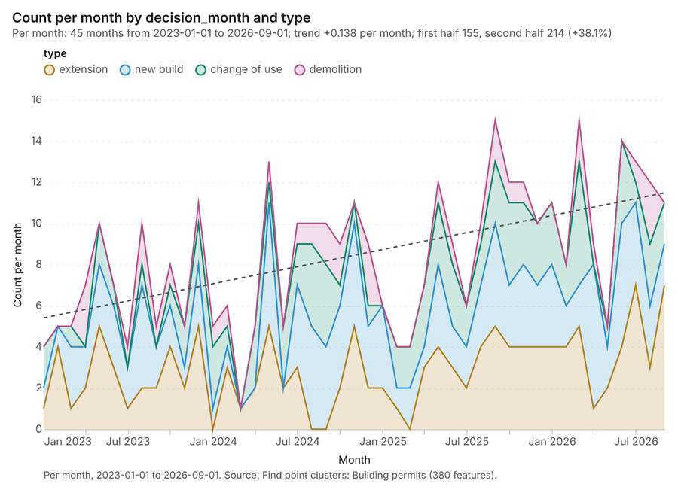
Figure 45. Find point clusters: Building permits over time [97]. Per month, 2023-01-01 to 2026-09-01. Source: Find point clusters: Building permits (380 features). The data is in the appendix.
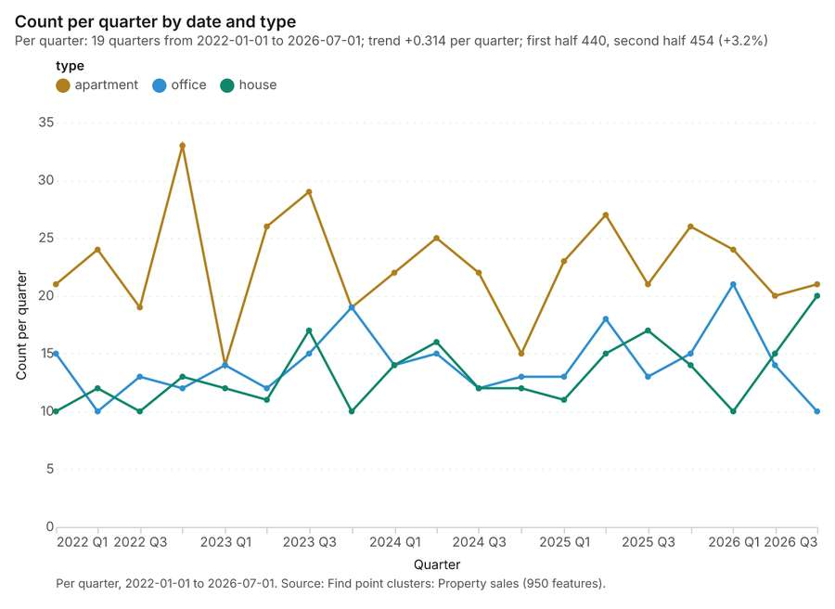
Figure 46. Find point clusters: Property sales over time [98]. Per quarter, 2022-01-01 to 2026-07-01. Source: Find point clusters: Property sales (950 features). The data is in the appendix.
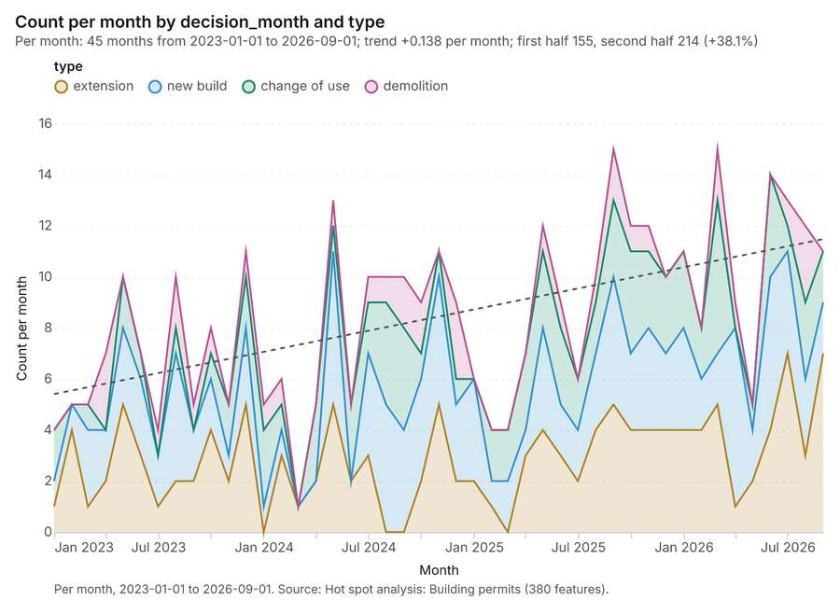
Figure 47. Hot spot analysis: Building permits over time [99]. Per month, 2023-01-01 to 2026-09-01. Source: Hot spot analysis: Building permits (380 features). The data is in the appendix.
Figure 48. Repeat and near repeat classification: Property sales over time [100]. Per quarter, 2022-01-01 to 2026-07-01. Source: Repeat and near repeat classification: Property sales (950 features). The data is in the appendix.

Changes since the last run
This is the first report of this project.

Sources
[1] Rendering: Chart: Timeline: events per quarter by dataset. 140 rows (id efe17a86-8fd3-4c8e-aed1-29ebb025af6d)
[2] Dataset: Property sales. vector, 950 rows (id 8f893170-c6db-4826-83e8-09af6dc89e27)
[3] Dataset: Building permits. vector, 380 rows (id aa79bba6-c73f-4b2f-a79e-176493aa4621)
[4] Dataset: Land values by zone and year. table, 90 rows (id 7cee65a2-b1e0-47a4-98b2-10d181fb8423)
[5] Dataset: Planning applications. table, 160 rows (id ae83bb58-05b5-4b51-b3f8-ca020020f1d5)
[6] Catalog: Emerging hot spots (operation catalog, gp_space_time_hot_spots). Where hot spots are new, consecutive, intensifying, persistent, diminishing, sporadic, oscillating or historical over time. ArcGIS: Emerging Hot Spot Analysis, Create Space Time Cube. (id gp_space_time_hot_spots)
[7] Plan: Space time hot spots of Property sales (the Start plan's candidate c_37c352605313). Property sales carry dates in 'date': emerging hot spot analysis finds new, intensifying and fading hot spots per month. (id f8db5acb-8be1-4e6d-8904-9ee8c04e791a:c_37c352605313)
[8] Tool result: gp_space_time_hot_spots, step 0. Emerging hot spots: 1 layer saved: Emerging hot spots: Property sales (81 features). (id 3b547b3d-4c3c-4444-9020-8c97986c7155:0)
[9] Layer: Property sales. 950 features (id a421b4df-eece-4b35-a40f-e8daf4e77a1e)
[10] Plan: Space time hot spots of Building permits (the Start plan's candidate c_cd867438faaa). Building permits carry dates in 'decision_month': emerging hot spot analysis finds new, intensifying and fading hot spots per month. (id f8db5acb-8be1-4e6d-8904-9ee8c04e791a:c_cd867438faaa)
[11] Tool result: gp_space_time_hot_spots, step 1. Emerging hot spots: 1 layer saved: Emerging hot spots: Building permits (90 features). (id 3b547b3d-4c3c-4444-9020-8c97986c7155:1)
[12] Layer: Building permits. 380 features (id c9732c3b-7527-455c-bfff-16e282af4bf8)
[13] Catalog: Repeat and near repeat classification (operation catalog, gp_near_repeat). Classify incidents as originators, repeats (same place) or near repeats within a distance and time window, with a Knox test table. ArcGIS: Repeat and Near Repeat Classification, Near Repeat Calculator. (id gp_near_repeat)
[14] Plan: Near repeat of Property sales (the Start plan's candidate c_71042b703d0d). Near repeat analysis tests whether Property sales close in space also follow each other within 30 days. (id f8db5acb-8be1-4e6d-8904-9ee8c04e791a:c_71042b703d0d)
[15] Tool result: gp_near_repeat, step 2. Repeat and near repeat classification: 1 layer saved: Repeat and near repeat classification: Property sales (950 features). (id 3b547b3d-4c3c-4444-9020-8c97986c7155:2)
[16] Catalog: Summarize within (operation catalog, gp_summarize_within). Count and aggregate the features inside each polygon (or bin), proportionally for lines and polygons. ArcGIS: Summarize Within, Aggregate Points. QGIS: native:countpointsinpolygon, native:sumlinelengths. (id gp_summarize_within)
[17] Plan: Transit stations per feature of Parcels (the Start plan's candidate c_2a92a76984e1). Count Transit stations inside each feature of Parcels; the counts map as a choropleth (natural breaks, sequential colors). (id f8db5acb-8be1-4e6d-8904-9ee8c04e791a:c_2a92a76984e1)
[18] Tool result: gp_summarize_within, step 0. Summarize within: 1 layer saved: Summarize within: Parcels (1100 features). (id 029a787d-7030-40ee-8bec-78edb55a4233:0)
[19] Layer: Transit stations. 12 features (id 400e1561-f1f1-481c-b9bc-1ac817459feb)
[20] Layer: Parcels. 1,100 features (id ccc22cc1-2735-4cb4-aa2f-5cc33be687bf)
[21] Tool result: gp_summarize_within, step 1. Summarize within: 1 layer saved: Summarize within: Parcels (1100 features). (id 029a787d-7030-40ee-8bec-78edb55a4233:1)
[22] Tool result: gp_summarize_within, step 2. Summarize within: 1 layer saved: Summarize within: Parcels (1100 features). (id 029a787d-7030-40ee-8bec-78edb55a4233:2)
[23] Catalog: Zonal statistics (analysis catalog, rs_zonal_statistics). count/min/max/mean/std/sum/median/majority per polygon as a table and as GeoJSON. ArcGIS: Zonal Statistics as Table (polygons). (id rs_zonal_statistics)
[24] Plan: Zonal statistics of City terrain model (DEM) and Parcels (the Start plan's candidate c_223f208b883c). Statistics of City terrain model (DEM) inside each feature of Parcels. (id f8db5acb-8be1-4e6d-8904-9ee8c04e791a:c_223f208b883c)
[25] Tool result: rs_zonal_statistics, step 0. Zonal statistics: 1100 row(s). zones 1100. (id e1b6768a-3792-454a-b224-e267bd9b2d98:0)
[26] Tool result: rs_zonal_statistics, step 1. Zonal statistics: 10 row(s). zones 10. (id e1b6768a-3792-454a-b224-e267bd9b2d98:1)
[27] Tool result: rs_zonal_statistics, step 2. Zonal statistics: 10 row(s). zones 10. (id e1b6768a-3792-454a-b224-e267bd9b2d98:2)
[28] Catalog: Hot spot analysis (operation catalog, gp_hot_spots). Getis-Ord Gi* hot and cold spots with z-scores, p-values and confidence bins. ArcGIS: Find Hot Spots, Hot Spot Analysis (Getis-Ord Gi*). QGIS: qgis:hotspot (plugin). (id gp_hot_spots)
[29] Plan: Hot spots of Property sales (the Start plan's candidate c_acf84d8d58c2). 950 points: Getis-Ord Gi* tests whether the concentrations in Property sales are statistically significant. (id f8db5acb-8be1-4e6d-8904-9ee8c04e791a:c_acf84d8d58c2)
[30] Tool result: gp_hot_spots, step 0. Hot spot analysis: 1 layer saved: Hot spot analysis: Property sales (213 features). (id ba41b9e6-74d7-45fb-bad3-3f51fe7fca0d:0)
[31] Plan: Hot spots of Building permits (the Start plan's candidate c_3746fcbd31f7). 380 points: Getis-Ord Gi* tests whether the concentrations in Building permits are statistically significant. (id f8db5acb-8be1-4e6d-8904-9ee8c04e791a:c_3746fcbd31f7)
[32] Tool result: gp_hot_spots, step 1. Hot spot analysis: 1 layer saved: Hot spot analysis: Building permits (380 features). (id ba41b9e6-74d7-45fb-bad3-3f51fe7fca0d:1)
[33] Catalog: Calculate density (operation catalog, gp_calculate_density). Kernel density per square kilometer on a grid. ArcGIS: Calculate Density, Kernel Density. QGIS: native:heatmapkerneldensityestimation. (id gp_calculate_density)
[34] Plan: Kernel density of Property sales (the Start plan's candidate c_18bfb4d14078). 950 points in Property sales: a density surface shows where they concentrate. (id f8db5acb-8be1-4e6d-8904-9ee8c04e791a:c_18bfb4d14078)
[35] Tool result: gp_calculate_density, step 0. Calculate density: 1 layer saved: Calculate density: Property sales (867 features). (id 9ca81de6-468a-4ffe-86a2-5163eb3bafa7:0)
[36] Plan: Kernel density of Building permits (the Start plan's candidate c_2c9614b6c24c). 380 points in Building permits: a density surface shows where they concentrate. (id f8db5acb-8be1-4e6d-8904-9ee8c04e791a:c_2c9614b6c24c)
[37] Tool result: gp_calculate_density, step 1. Calculate density: 1 layer saved: Calculate density: Building permits (1211 features). (id 9ca81de6-468a-4ffe-86a2-5163eb3bafa7:1)
[38] Catalog: Find point clusters (operation catalog, gp_find_point_clusters). Density-based clusters (DBSCAN, HDBSCAN or OPTICS, optionally space-time) with hulls and noise. ArcGIS: Find Point Clusters, Density-based Clustering. QGIS: native:dbscanclustering, native:stdbscanclustering. (id gp_find_point_clusters)
[39] Plan: Cluster points of Transit stations (the Start plan's candidate c_5a6f63bcd73b). DBSCAN finds dense groups of Transit stations and separates noise. (id f8db5acb-8be1-4e6d-8904-9ee8c04e791a:c_5a6f63bcd73b)
[40] Tool result: gp_find_point_clusters, step 0. Find point clusters: 2 layers saved: Find point clusters: Transit stations (12 features); Find point clusters: cluster hulls (1 feature). (id f445c7d5-e1f8-40ba-b66a-b6f77ff14617:0)
[41] Plan: Cluster points of Property sales (the Start plan's candidate c_4f023019863a). DBSCAN finds dense groups of Property sales and separates noise. (id f8db5acb-8be1-4e6d-8904-9ee8c04e791a:c_4f023019863a)
[42] Tool result: gp_find_point_clusters, step 1. Find point clusters: 1 layer saved: Find point clusters: Property sales (950 features). (id f445c7d5-e1f8-40ba-b66a-b6f77ff14617:1)
[43] Plan: Cluster points of Building permits (the Start plan's candidate c_8d2b732415a9). DBSCAN finds dense groups of Building permits and separates noise. (id f8db5acb-8be1-4e6d-8904-9ee8c04e791a:c_8d2b732415a9)
[44] Tool result: gp_find_point_clusters, step 2. Find point clusters: 2 layers saved: Find point clusters: Building permits (380 features); Find point clusters: cluster hulls (14 features). (id f445c7d5-e1f8-40ba-b66a-b6f77ff14617:2)
[45] Catalog: Find outliers (operation catalog, gp_outliers). Anselin local Moran’s I: HH, LL clusters and HL, LH outliers. ArcGIS: Find Outliers, Cluster and Outlier Analysis (Anselin Local Moran’s I). (id gp_outliers)
[46] Plan: Local morans i of Parcels (the Start plan's candidate c_c7bf78360ddf). Local Moran's I maps clusters and outliers of 'built_far'. (id f8db5acb-8be1-4e6d-8904-9ee8c04e791a:c_c7bf78360ddf)
[47] Tool result: gp_outliers, step 0. Find outliers: 1 layer saved: Find outliers: Parcels (1100 features). (id 60b5f86e-cffb-436f-9438-0ad7618a186f:0)
[48] Plan: Local morans i of Green spaces (the Start plan's candidate c_f5f393a93740). Local Moran's I maps clusters and outliers of 'area_ha'. (id f8db5acb-8be1-4e6d-8904-9ee8c04e791a:c_f5f393a93740)
[49] Tool result: gp_outliers, step 1. Find outliers: 1 layer saved: Find outliers: Green spaces (10 features). (id 60b5f86e-cffb-436f-9438-0ad7618a186f:1)
[50] Layer: Green spaces. 10 features (id 448e3c1b-11d3-4dc1-ad29-15c041e2af35)
[51] Plan: Local morans i of Zoning districts (the Start plan's candidate c_c8c9fa0162f0). Local Moran's I maps clusters and outliers of 'max_far'. (id f8db5acb-8be1-4e6d-8904-9ee8c04e791a:c_c8c9fa0162f0)
[52] Tool result: gp_outliers, step 2. Find outliers: 1 layer saved: Find outliers: Zoning districts (10 features). (id 60b5f86e-cffb-436f-9438-0ad7618a186f:2)
[53] Layer: Zoning districts. 10 features (id f84e0e45-37e6-4f41-b7d9-ceb30bbc840a)
[54] Rendering: Map: Emerging hot spots: Property sales (id be66919c-5ac4-46fc-9303-3b6ae32d215e)
[55] Rendering: Map: Emerging hot spots: Building permits (id 10e5f0c6-f9d0-4087-bebf-3a342415f755)
[56] Rendering: Map: Repeat and near repeat classification: Property sales (id 3c1c183a-14b4-4c01-b623-ce0905573f25)
[57] Rendering: Map: Summarize within: Parcels (id f5aabbb2-9d66-4cde-936d-0fd21fa0e47f)
[58] Rendering: Map: Summarize within: Parcels (id cf2850e2-e68b-4fe5-9668-bc39c1717ddc)
[59] Rendering: Map: Summarize within: Parcels (id c7c3fa96-6cbc-43c6-9c0d-fe80010b2209)
[60] Rendering: Map: Parcels by built_far (id 225b0a21-d925-4a9c-830d-a8ff465d85f3)
[61] Rendering: Map: Green spaces by area_ha (id d835f68f-d836-45cb-bc1c-330e22a1a5a5)
[62] Rendering: Map: Zoning districts by max_far (id 5c925f5e-357f-42ad-a25b-84fd46efdb28)
[63] Rendering: Map: Hot spot analysis: Property sales (id 27148a64-8d81-466d-ba61-2ae85cfd1868)
[64] Rendering: Map: Hot spot analysis: Building permits (id 5b6f2580-842f-4994-a302-a3bb1b0bf448)
[65] Rendering: Map: Calculate density: Property sales (id 9c3290f3-cc57-4600-9529-82ee062fb61c)
[66] Rendering: Map: Calculate density: Building permits (id 91b2edc2-2bf7-4663-bb16-12595287149f)
[67] Rendering: Map: Find point clusters: Transit stations (id 5608ea02-b2ac-4e51-a075-0e201a1bc4ed)
[68] Rendering: Map: Find point clusters: cluster hulls (id 9864ff42-febc-4252-a0ba-b1ca69720112)
[69] Rendering: Map: Find point clusters: Property sales (id 0d51172d-775f-4364-998b-1f2614c6d6c6)
[70] Rendering: Map: Find point clusters: Building permits (id 450b8dd1-0c4b-4bbf-8e03-6cff33e001f4)
[71] Rendering: Map: Find point clusters: cluster hulls (id 0eabad24-1821-4dea-a840-3e1ce29b5fcb)
[72] Rendering: Map: Find outliers: Parcels (id 32f0c9a9-217e-4701-b234-c3234c26ff02)
[73] Rendering: Map: Find outliers: Green spaces (id bbac1884-3dfd-41d5-99a3-a3dc22b9372a)
[74] Rendering: Map: Find outliers: Zoning districts (id 1ed7248f-0b15-4174-8c9d-e4fcc7ad2031)
[75] Rendering: Chart: Parcels over time (year_built). 12 rows (id a56a4586-993b-4959-8f12-cda5bdc8c1bc)
[76] Rendering: Chart: Property sales over time (date). 57 rows (id d7dcbaa6-e88d-4c73-b1bc-4c18320c9e9e)
[77] Rendering: Chart: Building permits over time (decision_month). 180 rows (id 803ff097-0db7-4dd0-bf88-08718e9b6106)
[78] Rendering: Chart: Land values by zone and year over time (year). 198 rows (id a51cb267-2b59-4303-a275-1b299891614b)
[79] Rendering: Chart: Emerging hot spots: Property sales. 8 rows (id cddb02b3-4f62-47c6-9df5-dead122811ae)
[80] Rendering: Chart: Emerging hot spots: Building permits. 8 rows (id 9b5c350e-1c14-438a-9d63-489450edc2a3)
[81] Rendering: Chart: Repeat and near repeat classification: Property sales. 57 rows (id e0196faa-807f-4c10-88ff-a378a575498f)
[82] Rendering: Chart: Summarize within: Parcels. 12 rows (id 1dbcaea9-a5e4-4882-a88f-ea90a1a7bd7b)
[83] Rendering: Chart: Summarize within: Parcels. 12 rows (id ed9ee8e2-4579-417f-8013-81e91e4a0afb)
[84] Rendering: Chart: Summarize within: Parcels. 12 rows (id 73d109a5-5d83-481d-981e-0be9ffa57bd5)
[85] Rendering: Chart: Hot spot analysis: Property sales. 12 rows (id 517b4c71-81b6-42fe-9408-26c588875b42)
[86] Rendering: Chart: Hot spot analysis: Building permits. 13 rows (id 7a0cc108-0105-4152-b9f4-1796dc1e0c64)
[87] Rendering: Chart: Calculate density: Property sales. 11 rows (id 201493fb-714c-40d2-9a76-ddb22527f9a5)
[88] Rendering: Chart: Calculate density: Building permits. 12 rows (id 741b541a-642f-4d11-af05-b4f10e12c13e)
[89] Rendering: Chart: Find point clusters: Transit stations. 1 rows (id df5f4fbc-f176-4563-8792-c439140abf7d)
[90] Rendering: Chart: Find point clusters: cluster hulls. 1 rows (id ec35aed0-af92-4b16-987b-bc0bb9edc445)
[91] Rendering: Chart: Find point clusters: Property sales. 1 rows (id 420829ca-242a-4203-a03e-1d3c30f92be2)
[92] Rendering: Chart: Find point clusters: Building permits. 15 rows (id a75725d0-4a42-4c03-b775-4841e49a974a)
[93] Rendering: Chart: Find point clusters: cluster hulls. 14 rows (id 19c0352e-e8ce-4b43-b68c-e5d9e727c6d8)
[94] Rendering: Chart: Find outliers: Parcels. 1100 rows (id 22928ec9-70d1-47be-8138-15ef9ace47fc)
[95] Rendering: Chart: Find outliers: Green spaces. 10 rows (id 986b9bba-697e-48c7-ad92-e4319618143d)
[96] Rendering: Chart: Find outliers: Zoning districts. 10 rows (id 74b1b0e7-13ca-4b67-abac-f0beab687357)
[97] Rendering: Chart: Find point clusters: Building permits over time. 180 rows (id f5fafb9d-4abc-4967-900a-fe4195579060)
[98] Rendering: Chart: Find point clusters: Property sales over time. 57 rows (id 633faacd-1c67-43fc-92f7-c5b129144335)
[99] Rendering: Chart: Hot spot analysis: Building permits over time. 180 rows (id 63728d45-bd6d-408e-b13d-19cba683b84d)
[100] Rendering: Chart: Repeat and near repeat classification: Property sales over time. 57 rows (id c2cc74df-5240-4117-b8b3-c351a9f1deb5)
[101] Dataset: Zoning districts. vector, 10 rows (id e41da161-19b5-48ad-9ac1-ec14aba11071)
[102] Dataset: Parcels. vector, 1100 rows (id 334e7daf-16c0-41ea-bad4-945a00366679)
[103] Dataset: Transit stations. vector, 12 rows (id 26d28a13-4955-415e-8c92-76eac9333571)
[104] Dataset: Green spaces. vector, 10 rows (id 3c7e642e-5612-4d39-9522-1784d7abf668)
[105] Dataset: Streets. vector, 151 rows (id 4db290a4-42c5-4245-8ecd-06ec0d874f2a)
[106] Dataset: City terrain model (DEM). raster, ? rows (id b4ace474-faad-4e75-8a4c-267a0401808c)
[107] Dataset: Planning committee brief. document, ? rows (id b40a0012-69f3-4624-bf05-59a0379f41f9)
[108] Record: Sample: Real estate and urban planning, Lisbon (id acfed0f6-9df9-4775-9325-30c0bbed70e9)
[109] Layer: Emerging hot spots: Property sales. 81 features (id dc34ccf4-38d7-4643-8ab2-86b694e35b9c)
[110] Layer: Emerging hot spots: Building permits. 90 features (id a26af55a-a693-4e98-b7a5-ccf061c4b3dd)
[111] Layer: Repeat and near repeat classification: Property sales. 950 features (id e13509b5-d34e-404a-8352-c51480e7869b)
[112] Layer: Summarize within: Parcels. 1,100 features (id d5217ead-227b-4720-8179-db14e5edc246)
[113] Layer: Summarize within: Parcels. 1,100 features (id 7342e67c-cd62-400b-8ac8-e6893f4004f8)
[114] Layer: Summarize within: Parcels. 1,100 features (id 1cffb229-6c6c-459d-afd2-b27e02cafa7a)
[115] Layer: Hot spot analysis: Property sales. 213 features (id e5e5e574-adff-45f1-a500-025bf5057582)
[116] Layer: Hot spot analysis: Building permits. 380 features (id ce1fd16e-c432-424b-8b6e-95c7442a25ea)
[117] Layer: Calculate density: Property sales. 867 features (id f054cd23-8647-44c1-ad3f-df8046f553c7)
[118] Layer: Calculate density: Building permits. 1,211 features (id a54dd906-1fba-477a-b3b4-4b2b57a69d8c)
[119] Layer: Find point clusters: Transit stations. 12 features (id 712ec0c3-8dd4-4826-b637-a5959f8a8bc2)
[120] Layer: Find point clusters: cluster hulls. 1 features (id 8f02c57f-8442-4514-8c69-ad2c271b02b5)
[121] Layer: Find point clusters: Property sales. 950 features (id 060168a0-b1c4-4161-8cf4-2e5e7e616489)
[122] Layer: Find point clusters: Building permits. 380 features (id 1828d446-6bee-4fc7-8d2a-1e9162eab56b)
[123] Layer: Find point clusters: cluster hulls. 14 features (id 1280d1a9-f52c-4411-9b1a-bfe208cf113c)
[124] Layer: Find outliers: Parcels. 1,100 features (id 83bec88a-063d-4158-a3b1-83369d40e2c4)
[125] Layer: Find outliers: Green spaces. 10 features (id e9005658-d31f-457a-bf22-d38615856ba0)
[126] Layer: Find outliers: Zoning districts. 10 features (id 940a4302-ccf6-4dc6-ae17-c77fc0e39f96)

Appendix: the data behind the charts

Figure 1. Timeline: events per quarter by dataset [1]
period | series | value
2018-01-01 | Property sales | 0
2018-01-01 | Building permits | 0
2018-01-01 | Planning applications | 0
2018-01-01 | Land values by zone and year | 10
2018-04-01 | Property sales | 0
2018-04-01 | Building permits | 0
2018-04-01 | Planning applications | 0
2018-04-01 | Land values by zone and year | 0
2018-07-01 | Property sales | 0
2018-07-01 | Building permits | 0
2018-07-01 | Planning applications | 0
2018-07-01 | Land values by zone and year | 0
2018-10-01 | Property sales | 0
2018-10-01 | Building permits | 0
2018-10-01 | Planning applications | 0
2018-10-01 | Land values by zone and year | 0
2019-01-01 | Property sales | 0
2019-01-01 | Building permits | 0
2019-01-01 | Planning applications | 0
2019-01-01 | Land values by zone and year | 10
2019-04-01 | Property sales | 0
2019-04-01 | Building permits | 0
2019-04-01 | Planning applications | 0
2019-04-01 | Land values by zone and year | 0
2019-07-01 | Property sales | 0
2019-07-01 | Building permits | 0
2019-07-01 | Planning applications | 0
2019-07-01 | Land values by zone and year | 0
2019-10-01 | Property sales | 0
2019-10-01 | Building permits | 0
2019-10-01 | Planning applications | 0
2019-10-01 | Land values by zone and year | 0
2020-01-01 | Property sales | 0
2020-01-01 | Building permits | 0
2020-01-01 | Planning applications | 0
2020-01-01 | Land values by zone and year | 10
2020-04-01 | Property sales | 0
2020-04-01 | Building permits | 0
2020-04-01 | Planning applications | 0
2020-04-01 | Land values by zone and year | 0
2020-07-01 | Property sales | 0
2020-07-01 | Building permits | 0
2020-07-01 | Planning applications | 0
2020-07-01 | Land values by zone and year | 0
2020-10-01 | Property sales | 0
2020-10-01 | Building permits | 0
2020-10-01 | Planning applications | 0
2020-10-01 | Land values by zone and year | 0
2021-01-01 | Property sales | 0
2021-01-01 | Building permits | 0
2021-01-01 | Planning applications | 0
2021-01-01 | Land values by zone and year | 10
2021-04-01 | Property sales | 0
2021-04-01 | Building permits | 0
2021-04-01 | Planning applications | 0
2021-04-01 | Land values by zone and year | 0
2021-07-01 | Property sales | 0
2021-07-01 | Building permits | 0
2021-07-01 | Planning applications | 0
2021-07-01 | Land values by zone and year | 0
2021-10-01 | Property sales | 0
2021-10-01 | Building permits | 0
2021-10-01 | Planning applications | 0
2021-10-01 | Land values by zone and year | 0
2022-01-01 | Property sales | 46
2022-01-01 | Building permits | 0
2022-01-01 | Planning applications | 0
2022-01-01 | Land values by zone and year | 10
2022-04-01 | Property sales | 46
2022-04-01 | Building permits | 0
2022-04-01 | Planning applications | 0
2022-04-01 | Land values by zone and year | 0
2022-07-01 | Property sales | 42
2022-07-01 | Building permits | 0
2022-07-01 | Planning applications | 0
2022-07-01 | Land values by zone and year | 0
2022-10-01 | Property sales | 58
2022-10-01 | Building permits | 0
2022-10-01 | Planning applications | 0
2022-10-01 | Land values by zone and year | 0
2023-01-01 | Property sales | 40
2023-01-01 | Building permits | 14
2023-01-01 | Planning applications | 0
2023-01-01 | Land values by zone and year | 10
2023-04-01 | Property sales | 49
2023-04-01 | Building permits | 24
2023-04-01 | Planning applications | 0
2023-04-01 | Land values by zone and year | 0
2023-07-01 | Property sales | 61
2023-07-01 | Building permits | 19
2023-07-01 | Planning applications | 0
2023-07-01 | Land values by zone and year | 0
2023-10-01 | Property sales | 48
2023-10-01 | Building permits | 24
2023-10-01 | Planning applications | 0
2023-10-01 | Land values by zone and year | 0
2024-01-01 | Property sales | 50
2024-01-01 | Building permits | 12
2024-01-01 | Planning applications | 0
2024-01-01 | Land values by zone and year | 10
2024-04-01 | Property sales | 56
2024-04-01 | Building permits | 23
2024-04-01 | Planning applications | 0
2024-04-01 | Land values by zone and year | 0
2024-07-01 | Property sales | 46
2024-07-01 | Building permits | 30
2024-07-01 | Planning applications | 0
2024-07-01 | Land values by zone and year | 0
2024-10-01 | Property sales | 40
2024-10-01 | Building permits | 29
2024-10-01 | Planning applications | 0
2024-10-01 | Land values by zone and year | 0
2025-01-01 | Property sales | 47
2025-01-01 | Building permits | 14
2025-01-01 | Planning applications | 51
2025-01-01 | Land values by zone and year | 10
2025-04-01 | Property sales | 60
2025-04-01 | Building permits | 28
2025-04-01 | Planning applications | 45
2025-04-01 | Land values by zone and year | 0
2025-07-01 | Property sales | 51
2025-07-01 | Building permits | 31
2025-07-01 | Planning applications | 28
2025-07-01 | Land values by zone and year | 0
2025-10-01 | Property sales | 55
2025-10-01 | Building permits | 34
2025-10-01 | Planning applications | 36
2025-10-01 | Land values by zone and year | 0
2026-01-01 | Property sales | 55
2026-01-01 | Building permits | 34
2026-01-01 | Planning applications | 0
2026-01-01 | Land values by zone and year | 10
2026-04-01 | Property sales | 49
2026-04-01 | Building permits | 28
2026-04-01 | Planning applications | 0
2026-04-01 | Land values by zone and year | 0
2026-07-01 | Property sales | 51
2026-07-01 | Building permits | 36
2026-07-01 | Planning applications | 0
2026-07-01 | Land values by zone and year | 0

Figure 23. Parcels over time (year_built) [75]
bin_start | bin_end | count
0 | 0.3225 | 82
0.3225 | 0.645 | 63
0.645 | 0.9675 | 166
0.9675 | 1.29 | 200
1.29 | 1.613 | 194
1.613 | 1.935 | 103
1.935 | 2.257 | 92
2.257 | 2.58 | 71
2.58 | 2.902 | 62
2.902 | 3.225 | 45
3.225 | 3.547 | 18
3.547 | 3.87 | 4

Figure 24. Property sales over time (date) [76]
period | series | value
2022-01-01 | apartment | 21
2022-01-01 | office | 15
2022-01-01 | house | 10
2022-04-01 | apartment | 24
2022-04-01 | office | 10
2022-04-01 | house | 12
2022-07-01 | apartment | 19
2022-07-01 | office | 13
2022-07-01 | house | 10
2022-10-01 | apartment | 33
2022-10-01 | office | 12
2022-10-01 | house | 13
2023-01-01 | apartment | 14
2023-01-01 | office | 14
2023-01-01 | house | 12
2023-04-01 | apartment | 26
2023-04-01 | office | 12
2023-04-01 | house | 11
2023-07-01 | apartment | 29
2023-07-01 | office | 15
2023-07-01 | house | 17
2023-10-01 | apartment | 19
2023-10-01 | office | 19
2023-10-01 | house | 10
2024-01-01 | apartment | 22
2024-01-01 | office | 14
2024-01-01 | house | 14
2024-04-01 | apartment | 25
2024-04-01 | office | 15
2024-04-01 | house | 16
2024-07-01 | apartment | 22
2024-07-01 | office | 12
2024-07-01 | house | 12
2024-10-01 | apartment | 15
2024-10-01 | office | 13
2024-10-01 | house | 12
2025-01-01 | apartment | 23
2025-01-01 | office | 13
2025-01-01 | house | 11
2025-04-01 | apartment | 27
2025-04-01 | office | 18
2025-04-01 | house | 15
2025-07-01 | apartment | 21
2025-07-01 | office | 13
2025-07-01 | house | 17
2025-10-01 | apartment | 26
2025-10-01 | office | 15
2025-10-01 | house | 14
2026-01-01 | apartment | 24
2026-01-01 | office | 21
2026-01-01 | house | 10
2026-04-01 | apartment | 20
2026-04-01 | office | 14
2026-04-01 | house | 15
2026-07-01 | apartment | 21
2026-07-01 | office | 10
2026-07-01 | house | 20

Figure 25. Building permits over time (decision_month) [77]
period | series | value
2023-01-01 | extension | 31
2023-01-01 | new build | 14
2023-01-01 | change of use | 22
2023-01-01 | demolition | 0
2023-02-01 | extension | 54
2023-02-01 | new build | 28
2023-02-01 | change of use | 0
2023-02-01 | demolition | 0
2023-03-01 | extension | 34
2023-03-01 | new build | 47
2023-03-01 | change of use | 28
2023-03-01 | demolition | 0
2023-04-01 | extension | 65
2023-04-01 | new build | 13
2023-04-01 | change of use | 0
2023-04-01 | demolition | 41
2023-05-01 | extension | 82
2023-05-01 | new build | 53
2023-05-01 | change of use | 45
2023-05-01 | demolition | 0
2023-06-01 | extension | 26
2023-06-01 | new build | 84
2023-06-01 | change of use | 3
2023-06-01 | demolition | 0
2023-07-01 | extension | 15
2023-07-01 | new build | 43
2023-07-01 | change of use | 0
2023-07-01 | demolition | 8
2023-08-01 | extension | 32
2023-08-01 | new build | 102
2023-08-01 | change of use | 8
2023-08-01 | demolition | 24
2023-09-01 | extension | 57
2023-09-01 | new build | 57
2023-09-01 | change of use | 0
2023-09-01 | demolition | 31
2023-10-01 | extension | 70
2023-10-01 | new build | 3
2023-10-01 | change of use | 37
2023-10-01 | demolition | 17
2023-11-01 | extension | 42
2023-11-01 | new build | 39
2023-11-01 | change of use | 36
2023-11-01 | demolition | 0
2023-12-01 | extension | 94
2023-12-01 | new build | 67
2023-12-01 | change of use | 65
2023-12-01 | demolition | 2
2024-01-01 | extension | 0
2024-01-01 | new build | 19
2024-01-01 | change of use | 34
2024-01-01 | demolition | 30
2024-02-01 | extension | 99
2024-02-01 | new build | 21
2024-02-01 | change of use | 32
2024-02-01 | demolition | 39
2024-03-01 | extension | 23
2024-03-01 | new build | 0
2024-03-01 | change of use | 0
2024-03-01 | demolition | 0
2024-04-01 | extension | 12
2024-04-01 | new build | 0
2024-04-01 | change of use | 45
2024-04-01 | demolition | 0
2024-05-01 | extension | 105
2024-05-01 | new build | 110
2024-05-01 | change of use | 7
2024-05-01 | demolition | 6
2024-06-01 | extension | 46
2024-06-01 | new build | 0
2024-06-01 | change of use | 58
2024-06-01 | demolition | 0
2024-07-01 | extension | 69
2024-07-01 | new build | 28
2024-07-01 | change of use | 71
2024-07-01 | demolition | 32
2024-08-01 | extension | 0
2024-08-01 | new build | 81
2024-08-01 | change of use | 89
2024-08-01 | demolition | 8
2024-09-01 | extension | 0
2024-09-01 | new build | 96
2024-09-01 | change of use | 98
2024-09-01 | demolition | 39
2024-10-01 | extension | 43
2024-10-01 | new build | 77
2024-10-01 | change of use | 32
2024-10-01 | demolition | 56
2024-11-01 | extension | 175
2024-11-01 | new build | 176
2024-11-01 | change of use | 26
2024-11-01 | demolition | 0
2024-12-01 | extension | 49
2024-12-01 | new build | 80
2024-12-01 | change of use | 15
2024-12-01 | demolition | 41
2025-01-01 | extension | 41
2025-01-01 | new build | 64
2025-01-01 | change of use | 0
2025-01-01 | demolition | 0
2025-02-01 | extension | 24
2025-02-01 | new build | 28
2025-02-01 | change of use | 53
2025-02-01 | demolition | 0
2025-03-01 | extension | 0
2025-03-01 | new build | 32
2025-03-01 | change of use | 28
2025-03-01 | demolition | 0
2025-04-01 | extension | 41
2025-04-01 | new build | 33
2025-04-01 | change of use | 55
2025-04-01 | demolition | 0
2025-05-01 | extension | 67
2025-05-01 | new build | 76
2025-05-01 | change of use | 57
2025-05-01 | demolition | 27
2025-06-01 | extension | 87
2025-06-01 | new build | 47
2025-06-01 | change of use | 73
2025-06-01 | demolition | 4
2025-07-01 | extension | 16
2025-07-01 | new build | 47
2025-07-01 | change of use | 30
2025-07-01 | demolition | 0
2025-08-01 | extension | 62
2025-08-01 | new build | 69
2025-08-01 | change of use | 43
2025-08-01 | demolition | 26
2025-09-01 | extension | 116
2025-09-01 | new build | 90
2025-09-01 | change of use | 63
2025-09-01 | demolition | 65
2025-10-01 | extension | 70
2025-10-01 | new build | 54
2025-10-01 | change of use | 119
2025-10-01 | demolition | 18
2025-11-01 | extension | 55
2025-11-01 | new build | 64
2025-11-01 | change of use | 80
2025-11-01 | demolition | 10
2025-12-01 | extension | 108
2025-12-01 | new build | 23
2025-12-01 | change of use | 23
2025-12-01 | demolition | 0
2026-01-01 | extension | 130
2026-01-01 | new build | 117
2026-01-01 | change of use | 39
2026-01-01 | demolition | 0
2026-02-01 | extension | 108
2026-02-01 | new build | 22
2026-02-01 | change of use | 28
2026-02-01 | demolition | 0
2026-03-01 | extension | 80
2026-03-01 | new build | 35
2026-03-01 | change of use | 85
2026-03-01 | demolition | 3
2026-04-01 | extension | 21
2026-04-01 | new build | 140
2026-04-01 | change of use | 0
2026-04-01 | demolition | 32
2026-05-01 | extension | 55
2026-05-01 | new build | 65
2026-05-01 | change of use | 17
2026-05-01 | demolition | 0
2026-06-01 | extension | 63
2026-06-01 | new build | 112
2026-06-01 | change of use | 93
2026-06-01 | demolition | 0
2026-07-01 | extension | 167
2026-07-01 | new build | 112
2026-07-01 | change of use | 9
2026-07-01 | demolition | 14
2026-08-01 | extension | 66
2026-08-01 | new build | 65
2026-08-01 | change of use | 67
2026-08-01 | demolition | 104
2026-09-01 | extension | 130
2026-09-01 | new build | 34
2026-09-01 | change of use | 66
2026-09-01 | demolition | 0

Figure 26. Land values by zone and year over time (year) [78]
period | series | value
2018-01-01 | C06 | 1
2018-01-01 | I07 | 1
2018-01-01 | M05 | 1
2018-01-01 | M08 | 1
2018-01-01 | M10 | 1
2018-01-01 | Other | 5
2018-04-01 | C06 | 0
2018-04-01 | I07 | 0
2018-04-01 | M05 | 0
2018-04-01 | M08 | 0
2018-04-01 | M10 | 0
2018-04-01 | Other | 0
2018-07-01 | C06 | 0
2018-07-01 | I07 | 0
2018-07-01 | M05 | 0
2018-07-01 | M08 | 0
2018-07-01 | M10 | 0
2018-07-01 | Other | 0
2018-10-01 | C06 | 0
2018-10-01 | I07 | 0
2018-10-01 | M05 | 0
2018-10-01 | M08 | 0
2018-10-01 | M10 | 0
2018-10-01 | Other | 0
2019-01-01 | C06 | 1
2019-01-01 | I07 | 1
2019-01-01 | M05 | 1
2019-01-01 | M08 | 1
2019-01-01 | M10 | 1
2019-01-01 | Other | 5
2019-04-01 | C06 | 0
2019-04-01 | I07 | 0
2019-04-01 | M05 | 0
2019-04-01 | M08 | 0
2019-04-01 | M10 | 0
2019-04-01 | Other | 0
2019-07-01 | C06 | 0
2019-07-01 | I07 | 0
2019-07-01 | M05 | 0
2019-07-01 | M08 | 0
2019-07-01 | M10 | 0
2019-07-01 | Other | 0
2019-10-01 | C06 | 0
2019-10-01 | I07 | 0
2019-10-01 | M05 | 0
2019-10-01 | M08 | 0
2019-10-01 | M10 | 0
2019-10-01 | Other | 0
2020-01-01 | C06 | 1
2020-01-01 | I07 | 1
2020-01-01 | M05 | 1
2020-01-01 | M08 | 1
2020-01-01 | M10 | 1
2020-01-01 | Other | 5
2020-04-01 | C06 | 0
2020-04-01 | I07 | 0
2020-04-01 | M05 | 0
2020-04-01 | M08 | 0
2020-04-01 | M10 | 0
2020-04-01 | Other | 0
2020-07-01 | C06 | 0
2020-07-01 | I07 | 0
2020-07-01 | M05 | 0
2020-07-01 | M08 | 0
2020-07-01 | M10 | 0
2020-07-01 | Other | 0
2020-10-01 | C06 | 0
2020-10-01 | I07 | 0
2020-10-01 | M05 | 0
2020-10-01 | M08 | 0
2020-10-01 | M10 | 0
2020-10-01 | Other | 0
2021-01-01 | C06 | 1
2021-01-01 | I07 | 1
2021-01-01 | M05 | 1
2021-01-01 | M08 | 1
2021-01-01 | M10 | 1
2021-01-01 | Other | 5
2021-04-01 | C06 | 0
2021-04-01 | I07 | 0
2021-04-01 | M05 | 0
2021-04-01 | M08 | 0
2021-04-01 | M10 | 0
2021-04-01 | Other | 0
2021-07-01 | C06 | 0
2021-07-01 | I07 | 0
2021-07-01 | M05 | 0
2021-07-01 | M08 | 0
2021-07-01 | M10 | 0
2021-07-01 | Other | 0
2021-10-01 | C06 | 0
2021-10-01 | I07 | 0
2021-10-01 | M05 | 0
2021-10-01 | M08 | 0
2021-10-01 | M10 | 0
2021-10-01 | Other | 0
2022-01-01 | C06 | 1
2022-01-01 | I07 | 1
2022-01-01 | M05 | 1
2022-01-01 | M08 | 1
2022-01-01 | M10 | 1
2022-01-01 | Other | 5
2022-04-01 | C06 | 0
2022-04-01 | I07 | 0
2022-04-01 | M05 | 0
2022-04-01 | M08 | 0
2022-04-01 | M10 | 0
2022-04-01 | Other | 0
2022-07-01 | C06 | 0
2022-07-01 | I07 | 0
2022-07-01 | M05 | 0
2022-07-01 | M08 | 0
2022-07-01 | M10 | 0
2022-07-01 | Other | 0
2022-10-01 | C06 | 0
2022-10-01 | I07 | 0
2022-10-01 | M05 | 0
2022-10-01 | M08 | 0
2022-10-01 | M10 | 0
2022-10-01 | Other | 0
2023-01-01 | C06 | 1
2023-01-01 | I07 | 1
2023-01-01 | M05 | 1
2023-01-01 | M08 | 1
2023-01-01 | M10 | 1
2023-01-01 | Other | 5
2023-04-01 | C06 | 0
2023-04-01 | I07 | 0
2023-04-01 | M05 | 0
2023-04-01 | M08 | 0
2023-04-01 | M10 | 0
2023-04-01 | Other | 0
2023-07-01 | C06 | 0
2023-07-01 | I07 | 0
2023-07-01 | M05 | 0
2023-07-01 | M08 | 0
2023-07-01 | M10 | 0
2023-07-01 | Other | 0
2023-10-01 | C06 | 0
2023-10-01 | I07 | 0
2023-10-01 | M05 | 0
2023-10-01 | M08 | 0
2023-10-01 | M10 | 0
2023-10-01 | Other | 0
2024-01-01 | C06 | 1
2024-01-01 | I07 | 1
2024-01-01 | M05 | 1
2024-01-01 | M08 | 1
2024-01-01 | M10 | 1
2024-01-01 | Other | 5
2024-04-01 | C06 | 0
2024-04-01 | I07 | 0
2024-04-01 | M05 | 0
2024-04-01 | M08 | 0
2024-04-01 | M10 | 0
2024-04-01 | Other | 0
2024-07-01 | C06 | 0
2024-07-01 | I07 | 0
2024-07-01 | M05 | 0
2024-07-01 | M08 | 0
2024-07-01 | M10 | 0
2024-07-01 | Other | 0
2024-10-01 | C06 | 0
2024-10-01 | I07 | 0
2024-10-01 | M05 | 0
2024-10-01 | M08 | 0
2024-10-01 | M10 | 0
2024-10-01 | Other | 0
2025-01-01 | C06 | 1
2025-01-01 | I07 | 1
2025-01-01 | M05 | 1
2025-01-01 | M08 | 1
2025-01-01 | M10 | 1
2025-01-01 | Other | 5
2025-04-01 | C06 | 0
2025-04-01 | I07 | 0
2025-04-01 | M05 | 0
2025-04-01 | M08 | 0
2025-04-01 | M10 | 0
2025-04-01 | Other | 0
2025-07-01 | C06 | 0
2025-07-01 | I07 | 0
2025-07-01 | M05 | 0
2025-07-01 | M08 | 0
2025-07-01 | M10 | 0
2025-07-01 | Other | 0
2025-10-01 | C06 | 0
2025-10-01 | I07 | 0
2025-10-01 | M05 | 0
2025-10-01 | M08 | 0
2025-10-01 | M10 | 0
2025-10-01 | Other | 0
2026-01-01 | C06 | 1
2026-01-01 | I07 | 1
2026-01-01 | M05 | 1
2026-01-01 | M08 | 1
2026-01-01 | M10 | 1
2026-01-01 | Other | 5

Figure 27. Emerging hot spots: Property sales [79]
bin_start | bin_end | count
-0.963 | -0.1466 | 23
-0.1466 | 0.6697 | 17
0.6697 | 1.486 | 14
1.486 | 2.303 | 13
2.303 | 3.119 | 4
3.119 | 3.935 | 6
3.935 | 4.752 | 3
4.752 | 5.568 | 1

Figure 28. Emerging hot spots: Building permits [80]
bin_start | bin_end | count
-0.609 | 0.08612 | 42
0.08612 | 0.7812 | 21
0.7812 | 1.476 | 9
1.476 | 2.171 | 9
2.171 | 2.867 | 5
2.867 | 3.562 | 3
3.562 | 4.257 | 0
4.257 | 4.952 | 1

Figure 29. Repeat and near repeat classification: Property sales [81]
period | series | value
2022-01-01 | apartment | 21
2022-01-01 | office | 15
2022-01-01 | house | 10
2022-04-01 | apartment | 24
2022-04-01 | office | 10
2022-04-01 | house | 12
2022-07-01 | apartment | 19
2022-07-01 | office | 13
2022-07-01 | house | 10
2022-10-01 | apartment | 33
2022-10-01 | office | 12
2022-10-01 | house | 13
2023-01-01 | apartment | 14
2023-01-01 | office | 14
2023-01-01 | house | 12
2023-04-01 | apartment | 26
2023-04-01 | office | 12
2023-04-01 | house | 11
2023-07-01 | apartment | 29
2023-07-01 | office | 15
2023-07-01 | house | 17
2023-10-01 | apartment | 19
2023-10-01 | office | 19
2023-10-01 | house | 10
2024-01-01 | apartment | 22
2024-01-01 | office | 14
2024-01-01 | house | 14
2024-04-01 | apartment | 25
2024-04-01 | office | 15
2024-04-01 | house | 16
2024-07-01 | apartment | 22
2024-07-01 | office | 12
2024-07-01 | house | 12
2024-10-01 | apartment | 15
2024-10-01 | office | 13
2024-10-01 | house | 12
2025-01-01 | apartment | 23
2025-01-01 | office | 13
2025-01-01 | house | 11
2025-04-01 | apartment | 27
2025-04-01 | office | 18
2025-04-01 | house | 15
2025-07-01 | apartment | 21
2025-07-01 | office | 13
2025-07-01 | house | 17
2025-10-01 | apartment | 26
2025-10-01 | office | 15
2025-10-01 | house | 14
2026-01-01 | apartment | 24
2026-01-01 | office | 21
2026-01-01 | house | 10
2026-04-01 | apartment | 20
2026-04-01 | office | 14
2026-04-01 | house | 15
2026-07-01 | apartment | 21
2026-07-01 | office | 10
2026-07-01 | house | 20

Figure 30. Summarize within: Parcels [82]
bin_start | bin_end | count
752 | 1,843 | 112
1,843 | 2,934 | 213
2,934 | 4,024 | 188
4,024 | 5,115 | 183
5,115 | 6,206 | 125
6,206 | 7,296 | 99
7,296 | 8,387 | 76
8,387 | 9,478 | 50
9,478 | 1.057e+04 | 32
1.057e+04 | 1.166e+04 | 12
1.166e+04 | 1.275e+04 | 7
1.275e+04 | 1.384e+04 | 3

Figure 31. Summarize within: Parcels [83]
bin_start | bin_end | count
752 | 1,843 | 112
1,843 | 2,934 | 213
2,934 | 4,024 | 188
4,024 | 5,115 | 183
5,115 | 6,206 | 125
6,206 | 7,296 | 99
7,296 | 8,387 | 76
8,387 | 9,478 | 50
9,478 | 1.057e+04 | 32
1.057e+04 | 1.166e+04 | 12
1.166e+04 | 1.275e+04 | 7
1.275e+04 | 1.384e+04 | 3

Figure 32. Summarize within: Parcels [84]
bin_start | bin_end | count
752 | 1,843 | 112
1,843 | 2,934 | 213
2,934 | 4,024 | 188
4,024 | 5,115 | 183
5,115 | 6,206 | 125
6,206 | 7,296 | 99
7,296 | 8,387 | 76
8,387 | 9,478 | 50
9,478 | 1.057e+04 | 32
1.057e+04 | 1.166e+04 | 12
1.166e+04 | 1.275e+04 | 7
1.275e+04 | 1.384e+04 | 3

Figure 33. Hot spot analysis: Property sales [85]
bin_start | bin_end | band | band_label | count
-2 | -1.5 | not_significant | Not significant | 25
-1.5 | -1 | not_significant | Not significant | 8
-1 | -0.5 | not_significant | Not significant | 21
-0.5 | 0 | not_significant | Not significant | 63
0 | 0.5 | not_significant | Not significant | 27
0.5 | 1 | not_significant | Not significant | 37
1 | 1.5 | not_significant | Not significant | 12
1.5 | 2 | hot_90 | Hot spot, 90% confidence | 2
1.5 | 2 | not_significant | Not significant | 12
2 | 2.5 | hot_95 | Hot spot, 95% confidence | 2
2.5 | 3 | hot_95 | Hot spot, 95% confidence | 2
3.5 | 4 | hot_99 | Hot spot, 99% confidence | 2

Figure 34. Hot spot analysis: Building permits [86]
bin_start | bin_end | band | band_label | count
-2.5 | -2 | cold_95 | Cold spot, 95% confidence | 1
-2 | -1.5 | cold_90 | Cold spot, 90% confidence | 11
-2 | -1.5 | not_significant | Not significant | 7
-1.5 | -1 | not_significant | Not significant | 29
-1 | -0.5 | not_significant | Not significant | 81
-0.5 | 0 | not_significant | Not significant | 72
0 | 0.5 | not_significant | Not significant | 93
0.5 | 1 | not_significant | Not significant | 38
1 | 1.5 | not_significant | Not significant | 25
1.5 | 2 | hot_90 | Hot spot, 90% confidence | 9
1.5 | 2 | not_significant | Not significant | 4
2 | 2.5 | hot_95 | Hot spot, 95% confidence | 9
2.5 | 3 | hot_99 | Hot spot, 99% confidence | 1

Figure 35. Calculate density: Property sales [87]
bin_start | bin_end | count
0 | 2.182 | 89
2.182 | 4.364 | 81
4.364 | 6.545 | 81
6.545 | 8.727 | 82
8.727 | 10.91 | 80
10.91 | 13.09 | 122
13.09 | 15.27 | 81
15.27 | 17.45 | 82
17.45 | 19.64 | 76
19.64 | 21.82 | 57
21.82 | 24 | 36

Figure 36. Calculate density: Building permits [88]
bin_start | bin_end | count
0 | 2.5 | 68
2.5 | 5 | 87
5 | 7.5 | 139
7.5 | 10 | 94
10 | 12.5 | 135
12.5 | 15 | 92
15 | 17.5 | 139
17.5 | 20 | 94
20 | 22.5 | 138
22.5 | 25 | 89
25 | 27.5 | 102
27.5 | 30 | 34

Figure 37. Find point clusters: Transit stations [89]
cluster | features | fraction | share
0 | 12 | 1 | 100.0%

Figure 38. Find point clusters: cluster hulls [90]
cluster | features | fraction | share
0 | 1 | 1 | 100.0%

Figure 39. Find point clusters: Property sales [91]
cluster | features | fraction | share
Noise | 950 | 1 | 100.0%

Figure 40. Find point clusters: Building permits [92]
cluster | features | fraction | share
Noise | 126 | 0.3316 | 33.2%
5 | 37 | 0.09737 | 9.7%
6 | 33 | 0.08684 | 8.7%
0 | 29 | 0.07632 | 7.6%
10 | 20 | 0.05263 | 5.3%
4 | 19 | 0.05 | 5.0%
2 | 18 | 0.04737 | 4.7%
8 | 17 | 0.04474 | 4.5%
1 | 16 | 0.0421 | 4.2%
9 | 15 | 0.03947 | 3.9%
3 | 13 | 0.03421 | 3.4%
11 | 10 | 0.02632 | 2.6%
12 | 10 | 0.02632 | 2.6%
13 | 10 | 0.02632 | 2.6%
7 | 7 | 0.01842 | 1.8%

Figure 41. Find point clusters: cluster hulls [93]
cluster | features | fraction | share
0 | 1 | 0.07143 | 7.1%
1 | 1 | 0.07143 | 7.1%
10 | 1 | 0.07143 | 7.1%
11 | 1 | 0.07143 | 7.1%
12 | 1 | 0.07143 | 7.1%
13 | 1 | 0.07143 | 7.1%
2 | 1 | 0.07143 | 7.1%
3 | 1 | 0.07143 | 7.1%
4 | 1 | 0.07143 | 7.1%
5 | 1 | 0.07143 | 7.1%
6 | 1 | 0.07143 | 7.1%
7 | 1 | 0.07143 | 7.1%
8 | 1 | 0.07143 | 7.1%
9 | 1 | 0.07143 | 7.1%

Figure 42. Find outliers: Parcels [94]
value | lag | type
-1.428 | -0.8778 | NS
-0.8984 | -0.9939 | NS
-0.615 | -1.065 | NS
-1.12 | -0.8688 | NS
-0.2331 | -0.615 | NS
-0.615 | -0.2331 | NS
-1.133 | -0.6335 | NS
-0.7752 | -0.9292 | NS
-0.4918 | -0.9764 | NS
-0.27 | -0.8203 | NS
-1.527 | -0.4015 | NS
-0.2208 | -0.4548 | NS
-0.923 | -0.1037 | NS
0.0133 | -0.5719 | NS
-0.7998 | -0.7259 | NS
-0.5288 | -0.8614 | NS
-0.923 | -0.6643 | NS
-1.675 | -1.12 | NS
-0.5657 | -1.675 | NS
-1.675 | -1.03 | NS
-0.3316 | -1.157 | NS
-1.317 | -0.6314 | NS
-0.9969 | -0.7382 | NS
-0.5657 | -1.371 | NS
-0.3809 | -1.034 | NS
-1.034 | -0.6889 | NS
-1.219 | -0.96 | NS
-0.96 | -1.219 | NS
-0.8121 | -1.004 | NS
-0.5904 | -1.003 | NS
-1.798 | -0.5616 | NS
-0.2824 | -1.018 | NS
0.0996 | -0.3316 | NS
-0.0852 | -0.2392 | NS
-0.578 | -0.2413 | NS
-0.7259 | -1.083 | NS
-1.391 | -0.7259 | NS
-0.4425 | -0.9846 | NS
-1.675 | -0.4918 | NS
-0.4672 | -0.8943 | NS
-0.5657 | -1.071 | NS
-0.8737 | -1.268 | NS
-1.675 | -0.7957 | NS
-0.8614 | -1.067 | NS
-0.652 | -1.05 | NS
1.381 | 0.6417 | NS
0.5554 | 1.054 | NS
0.7279 | 0.884 | NS
1.036 | 1.412 | NS
0.7156 | 1.165 | NS
2.108 | 0.847 | NS
0.7895 | 1.229 | NS
0.4938 | 0.2105 | NS
-0.2577 | 0.6868 | NS
0.6786 | 0.3747 | NS
0.9374 | 0.3829 | NS
0.3829 | 0.9497 | NS
-1.28 | -0.0206 | NS
-0.578 | -0.1961 | NS
0.3706 | -0.4333 | NS
0.6293 | 0.001 | NS
-0.5041 | -0.4179 | NS
-0.7136 | -0.7197 | NS
-0.9353 | -0.7875 | NS
-1.022 | -0.9271 | NS
-0.9723 | -0.9415 | NS
-0.96 | -0.9446 | NS
-0.8491 | -0.8214 | NS
-1.157 | -1.133 | NS
-1.305 | -1.083 | NS
-0.9477 | -1.114 | NS
-1.145 | -1.065 | NS
-0.8491 | -0.9641 | NS
-0.7752 | -0.6458 | NS
-0.4425 | -1.005 | NS
-1.798 | -0.6479 | NS
-0.3563 | -1.41 | NS
-1.022 | -1.018 | NS
-0.9969 | -0.8429 | NS
-0.652 | -1.009 | NS
-1.022 | -0.7752 | NS
-0.8614 | -0.1715 | NS
-0.1715 | -1.015 | NS
-0.6643 | -0.652 | NS
-1.022 | -0.6643 | NS
-0.7382 | -0.5626 | NS
-0.5534 | -0.716 | NS
-0.578 | -0.7423 | NS
-0.5411 | -0.6427 | NS
-0.7013 | -0.5411 | NS
-1.108 | -0.7937 | NS
-0.8861 | -0.9045 | NS
-0.7013 | -0.9969 | NS
-0.615 | -0.1407 | NS
0.3706 | -0.3994 | NS
-0.1838 | 0.3706 | NS
-0.4672 | -0.2639 | NS
0.038 | -0.5575 | NS
-0.5657 | -0.3563 | NS
-0.6397 | -0.2639 | NS
0.7279 | 1.122 | NS
1.122 | 0.7279 | NS
1.085 | -0.7998 | NS
-1.798 | 0.7238 | NS
0.1981 | 0.0585 | NS
0.8881 | -0.4015 | NS
0.1242 | 0.9312 | NS
0.5924 | 0.654 | NS
1.27 | 0.4281 | NS
0.962 | 0.5801 | NS
0.8018 | 0.6601 | NS
0.3583 | 0.8819 | NS
0.8634 | 0.8203 | NS
0.8511 | 1.116 | NS
0.8881 | 0.3337 | NS
0.5801 | 0.8881 | NS
0.962 | 0.8922 | NS
1.097 | 0.9045 | NS
1.196 | 0.8716 | NS
0.5554 | 0.9086 | NS
1.997 | 1.362 | NS
2.095 | 0.0996 | NS
-1.798 | 1.073 | NS
-1.145 | -0.9969 | NS
-0.9969 | -1.145 | NS
-0.3316 | -0.7813 | NS
-0.7136 | -0.4672 | NS
-0.8491 | -0.6971 | NS
0.001 | -0.5842 | NS
-1.391 | -1.058 | NS
-1.675 | -0.7136 | NS
-0.8984 | -1.04 | NS
-1.058 | -0.8984 | NS
-0.8984 | -1.071 | NS
-0.8121 | -1.075 | NS
-1.379 | -0.8861 | NS
-0.9477 | -1.079 | NS
-1.169 | -0.9846 | NS
-1.798 | -0.578 | NS
-1.798 | -0.7629 | NS
-0.7629 | -1.798 | NS
-0.6889 | -0.9477 | NS
-1.034 | -0.8787 | NS
-0.8984 | -0.9939 | NS
-1.675 | -0.5565 | NS
-1.342 | -0.2947 | NS
-0.1838 | -0.8409 | NS
-0.4056 | -1.025 | NS
-0.7752 | -0.229 | NS
-0.0976 | -0.6397 | NS
-0.5041 | -0.3193 | NS
-0.5411 | -1.151 | NS
-1.798 | -0.2392 | NS
-0.8614 | -0.1653 | NS
0.4199 | -0.5329 | NS
-0.7505 | -0.1427 | NS
0.0133 | -0.4015 | NS
-0.3563 | -0.0976 | NS
-0.0976 | -0.153 | NS
-0.2331 | -0.5103 | NS
-0.8861 | -0.27 | NS
-0.1345 | -0.2454 | NS
-0.2577 | -0.0483 | NS
0.038 | -0.7834 | NS
-0.2947 | -0.1386 | NS
-0.3193 | -0.2146 | NS
-0.1345 | -0.2824 | NS
-0.2331 | -0.424 | NS
-0.7136 | -0.2331 | NS
-0.2084 | 0.1797 | NS
-0.1715 | 0.1612 | NS
0.5308 | -0.076 | NS
-0.5657 | 0.5862 | NS
0.6417 | 0.0215 | NS
-1.798 | -1.798 | NS
-1.798 | 0.079 | NS
1.196 | -0.4795 | NS
0.8388 | 0.1735 | NS
0.3953 | 1.19 | NS
1.849 | 0.8059 | NS
1.356 | 0.9702 | NS
0.6663 | 1.162 | NS
0.5677 | 1.192 | NS
1.714 | 0.5677 | NS
1.097 | 0.7033 | NS
0.7033 | 0.7217 | NS
1.369 | 0.4445 | NS
0.038 | 0.8758 | NS
0.3829 | 0.038 | NS
1.763 | 0.8634 | NS
0.8511 | 1.167 | NS
0.962 | 1.13 | NS
0.7772 | 1.192 | NS
0.4322 | 0.9928 | NS
1.43 | 0.7977 | NS
0.0503 | -0.2084 | NS
0.1489 | 0.2885 | NS
0.3829 | 0.2269 | NS
0.4322 | -0.2762 | NS
-0.2454 | -0.3132 | NS
-1.058 | 0.0934 | NS
-0.6027 | -0.4343 | NS
0.5677 | -0.8799 | NS
-1.157 | -0.3316 | NS
-0.3193 | -0.4713 | NS
-0.6397 | -0.6643 | NS
-0.7752 | -0.6191 | NS
-0.8984 | -0.7074 | NS
-0.036 | -1.601 | NS
-1.527 | -0.9169 | NS
-1.798 | -1.071 | NS
-0.307 | -1.675 | NS
-1.675 | -0.2885 | NS
-1.046 | -0.8861 | NS
-0.8245 | -0.3932 | NS
-0.8861 | -0.3727 | NS
0.7526 | -1.071 | NS
0.0133 | -1.077 | NS
-0.3563 | 0.0133 | NS
-1.317 | 0.309 | NS
0.309 | -1.317 | NS
0.3953 | -1.582 | NS
-1.49 | -0.424 | NS
-1.243 | -1.354 | NS
-1.798 | -0.5842 | NS
-0.7629 | -1.262 | NS
-0.7259 | -0.7629 | NS
-0.3563 | -0.6643 | NS
-1.403 | -0.3152 | NS
-0.4425 | -0.6355 | NS
-0.1468 | -0.7341 | NS
0.0626 | -0.7136 | NS
-0.1222 | -0.652 | NS
-0.2208 | -0.6735 | NS
-1.798 | -0.3932 | NS
-0.1961 | -0.0791 | NS
-0.4548 | 0.0503 | NS
0.2967 | -0.5863 | NS
-0.2331 | -0.0852 | NS
-0.0852 | -0.2331 | NS
-0.8737 | -0.1438 | NS
-0.923 | -0.1797 | NS
0.7649 | -0.6427 | NS
-0.4302 | -0.344 | NS
0.0503 | -0.1037 | NS
-0.1099 | -0.4302 | NS
-0.9107 | -0.2885 | NS
-0.307 | -0.4179 | NS
0.0503 | -0.2516 | NS
-0.1961 | -0.8737 | NS
-1.798 | 0.0215 | NS
0.0133 | -0.5945 | NS
0.0133 | -0.5945 | NS
0.001 | 0.0133 | NS
0.2228 | -0.8121 | NS
-0.8121 | 0.0873 | NS
-0.0483 | -0.8121 | NS
-0.3316 | -0.5164 | NS
-0.5164 | -0.4918 | NS
0.1242 | -0.153 | NS
0.001 | -0.4056 | NS
-0.307 | -0.3029 | NS
0.0996 | 0.2782 | NS
-0.0852 | -0.2146 | NS
-0.27 | -0.1838 | NS
-0.1838 | -0.27 | NS
1.122 | 1.042 | NS
1.245 | 1.171 | NS
1.221 | 1.332 | NS
1.048 | 0.6725 | NS
0.6786 | 0.8634 | NS
0.6786 | 0.2474 | NS
0.3583 | -0.2577 | NS
-0.2577 | 0.3829 | NS
0.346 | 0.6663 | NS
0.6293 | 0.9497 | NS
1.553 | 0.6293 | NS
0.038 | 0.5924 | NS
0.8018 | 0.6088 | NS
0.5924 | 1.073 | NS
1.073 | 0.5924 | NS
1.295 | 1.024 | NS
0.6663 | 1.233 | NS
0.9743 | 0.9805 | NS
0.4815 | 0.8758 | NS
1.578 | 0.5739 | NS
0.6663 | 0.8634 | NS
0.9866 | 0.962 | NS
1.467 | 0.6951 | NS
0.4569 | 1.032 | NS
0.6417 | 0.962 | NS
-0.96 | -0.9785 | NS
-0.7998 | -0.96 | NS
-1.798 | -0.1468 | NS
-0.1468 | -1.798 | NS
-0.615 | -1.51 | NS
-1.058 | -1.145 | NS
-1.675 | -0.9189 | NS
-0.27 | -0.6602 | NS
-0.344 | -0.116 | NS
0.038 | -0.4548 | NS
-1.502 | -0.5534 | NS
-0.7382 | -1.471 | NS
-1.675 | -0.8676 | NS
-0.2331 | -1.206 | NS
-0.7382 | -0.7505 | NS
-0.8861 | -0.9353 | NS
-1.133 | -0.8121 | NS
-1.219 | -1.163 | NS
-1.083 | -1.219 | NS
-0.7629 | -0.6807 | NS
0.0873 | -0.7752 | NS
-1.403 | -0.5863 | NS
-0.4795 | -0.96 | NS
-0.5164 | -0.9723 | NS
-0.8368 | -1.163 | NS
-1.034 | -0.9538 | NS
-1.601 | -0.9107 | NS
-0.8614 | -1.428 | NS
-1.798 | -0.8368 | NS
-0.8368 | -1.798 | NS
-1.108 | -0.0606 | NS
-0.4179 | -0.9785 | NS
-0.5041 | 0.1119 | NS
0.1119 | -0.5041 | NS
-0.344 | -0.0575 | NS
-0.652 | 0.2803 | NS
0.0873 | 0.0339 | NS
1.097 | -0.2824 | NS
-0.4672 | -0.3481 | NS
-0.0852 | -0.2577 | NS
-0.0483 | -0.0647 | NS
-1.798 | -0.4672 | NS
-0.7382 | -0.8245 | NS
-0.1222 | 0.0256 | NS
0.0256 | -0.96 | NS
0.1612 | -0.5288 | NS
-0.5288 | -0.1407 | NS
-0.2331 | -0.385 | NS
-0.9107 | -0.1622 | NS
0.2721 | -0.4384 | NS
-0.1715 | -0.2618 | NS
-1.034 | -0.0976 | NS
0.0133 | -1.034 | NS
-0.5288 | -0.9415 | NS
-1.798 | -0.5288 | NS
-0.0236 | -0.9969 | NS
-0.9969 | 0.1981 | NS
0.4199 | -0.8429 | NS
1.418 | 1.171 | NS
0.6663 | 1.523 | NS
1.627 | 1.11 | NS
-0.1838 | 0.9004 | NS
1.319 | 0.2597 | NS
0.7033 | 0.5677 | NS
0.4076 | 0.2228 | NS
0.7033 | 0.5102 | NS
0.2228 | 0.4528 | NS
0.2474 | 0.6232 | NS
1.024 | 0.6786 | NS
0.6786 | 0.9558 | NS
1.11 | 0.8727 | NS
0.9866 | 0.7772 | NS
1.024 | 0.654 | NS
0.654 | 1.042 | NS
0.999 | 0.7526 | NS
0.7526 | 1.122 | NS
0.5308 | 0.9558 | NS
1.245 | 0.6417 | NS
0.5185 | 0.4322 | NS
0.4322 | -0.6397 | NS
-0.0236 | -0.0113 | NS
-0.0113 | 0.0318 | NS
-0.9723 | -0.1345 | NS
0.309 | -0.7752 | NS
-0.578 | -0.5 | NS
-1.083 | -1.256 | NS
-0.8368 | -0.9436 | NS
-1.169 | -0.8368 | NS
-0.7505 | -0.7197 | NS
-1.477 | -0.6397 | NS
-1.44 | -0.4487 | NS
-0.1592 | -1.379 | NS
-1.317 | -0.1653 | NS
-0.8245 | -0.9477 | NS
-0.9477 | -0.7813 | NS
-0.652 | -0.4302 | NS
-0.4302 | -0.8553 | NS
-1.798 | -1.133 | NS
-1.133 | -1.379 | NS
-0.7875 | -0.8902 | NS
-0.96 | -1.025 | NS
-1.798 | -0.7095 | NS
-0.96 | -1.477 | NS
-1.477 | -1.028 | NS
-1.095 | -1.477 | NS
-1.65 | -0.9538 | NS
-1.046 | -1.65 | NS
-0.2947 | -0.96 | NS
-0.96 | -0.2947 | NS
-0.8491 | -0.2824 | NS
-0.1468 | -0.5041 | NS
-1.798 | -0.1838 | NS
0.1365 | -1.252 | NS
-0.5041 | -0.7875 | NS
-1.453 | -0.1345 | NS
0.5431 | -0.7998 | NS
-0.7998 | -0.0236 | NS
0.3583 | -0.4425 | NS
-0.8368 | -0.7197 | NS
-1.798 | -0.8429 | NS
0.1489 | -0.3255 | NS
0.0873 | 0.1612 | NS
-1.798 | 0.1858 | NS
0.346 | -1.798 | NS
-0.4425 | -1.173 | NS
-1.194 | -1.12 | NS
-1.798 | -0.6355 | NS
-0.1468 | -0.5472 | NS
-0.923 | -0.036 | NS
-1.798 | -0.1386 | NS
-0.307 | -0.6355 | NS
0.1119 | -0.7752 | NS
-0.2208 | -0.6643 | NS
0.0133 | -0.1345 | NS
0.4692 | -0.1222 | NS
-0.7382 | 0.2803 | NS
-0.6889 | -0.1879 | NS
-0.1838 | -0.7444 | NS
-0.7998 | -0.3152 | NS
1.245 | 0.962 | NS
1.393 | 0.6909 | NS
0.1489 | 1.11 | NS
0.6786 | 0.9774 | NS
0.7649 | 1.005 | NS
0.8511 | 1.011 | NS
1.159 | 0.9086 | NS
1.11 | 0.2936 | NS
0.9004 | 0.8326 | NS
0.962 | 0.0708 | NS
-1.798 | 0.9784 | NS
1.147 | -0.3686 | NS
-0.3686 | 1.085 | NS
0.4445 | 0.8142 | NS
0.6417 | 0.3152 | NS
0.1858 | 0.5862 | NS
1.061 | 0.7279 | NS
0.8018 | 1.061 | NS
1.553 | -0.1222 | NS
-0.1222 | 1.171 | NS
0.7895 | 0.6725 | NS
1.147 | 1.073 | NS
1.073 | 0.8018 | NS
0.9743 | 0.6786 | NS
-1.798 | 0.6376 | NS
0.5554 | -0.4364 | NS
0.925 | -0.3111 | NS
0.0873 | 0.1181 | NS
0.2474 | 0.0873 | NS
-1.145 | -0.4179 | NS
-0.4179 | -0.7813 | NS
-0.4179 | -0.8614 | NS
-0.8121 | -0.5103 | NS
-0.5534 | -0.6397 | NS
-0.4672 | -0.6314 | NS
-0.5288 | -0.6355 | NS
0.038 | -0.4856 | NS
-0.1715 | -0.6828 | NS
-0.5041 | -0.3604 | NS
-0.6273 | -0.3193 | NS
-0.2824 | -0.4343 | NS
-0.7382 | -1.052 | NS
-1.157 | -0.9107 | NS
-1.058 | -0.3604 | NS
-0.3193 | -0.7546 | NS
-0.3316 | -0.8429 | NS
-1.157 | -0.5842 | NS
-0.8368 | -0.7444 | NS
-0.3809 | -1.554 | NS
-1.662 | -0.8737 | NS
-1.798 | -0.5934 | NS
-0.4425 | -1.116 | NS
-1.675 | -0.4548 | NS
-0.4548 | -1.588 | NS
0.1981 | -0.7711 | NS
-0.2208 | -0.6314 | NS
-0.4179 | -0.5657 | NS
-1.675 | -0.193 | NS
-0.1715 | -0.1838 | NS
-0.1838 | -0.3809 | NS
-0.1592 | -0.2084 | NS
-0.27 | -0.1592 | NS
-0.036 | -0.845 | NS
-0.578 | -0.036 | NS
-0.5904 | -0.5 | NS
-0.1961 | -0.5472 | NS
-0.5041 | -0.1509 | NS
-0.8491 | -0.6766 | NS
-0.4795 | -0.0688 | NS
0.2474 | -0.3111 | NS
0.3953 | -0.1427 | NS
0.1735 | -0.2741 | NS
-0.6766 | -0.0298 | NS
-0.2331 | -0.3357 | NS
-0.4056 | -0.3378 | NS
0.4938 | -0.7875 | NS
-1.169 | 0.0441 | NS
-0.27 | -0.6848 | NS
0.1489 | -0.4015 | NS
-0.4056 | -0.2167 | NS
0.0749 | -0.1181 | NS
-0.0483 | 0.346 | NS
0.617 | 0.0133 | NS
-0.2947 | -0.0791 | NS
-0.0606 | -0.1961 | NS
-0.0976 | -0.3809 | NS
0.3583 | -0.27 | NS
-0.5411 | 0.3583 | NS
-0.0729 | -0.3039 | NS
-0.1468 | -0.114 | NS
-0.8614 | 0.1242 | NS
0.5924 | -0.4795 | NS
1.122 | 0.5144 | NS
0.7156 | 0.845 | NS
0.5677 | 0.2721 | NS
0.3953 | 0.8388 | NS
0.3337 | 0.8593 | NS
0.925 | 0.3183 | NS
1.258 | 0.1513 | NS
0.8634 | 0.2721 | NS
0.9743 | 1.252 | NS
1.64 | 0.884 | NS
1.024 | 0.4281 | NS
0.999 | 0.8593 | NS
0.654 | 0.9743 | NS
0.9004 | 0.8265 | NS
0.5308 | 0.192 | NS
0.1981 | 0.5308 | NS
0.9004 | 0.5801 | NS
0.5801 | 0.9004 | NS
1.467 | -0.2577 | NS
0.2351 | -0.1653 | NS
-1.798 | 1.052 | NS
0.2844 | 0.8049 | NS
0.4445 | 0.654 | NS
0.7279 | 0.5595 | NS
0.309 | 0.7443 | NS
0.3337 | 0.7484 | NS
0.9743 | 0.7433 | NS
0.962 | 0.8922 | NS
0.1489 | 1.319 | NS
1.319 | 1.135 | NS
-1.022 | 0.7895 | NS
1.405 | 0.1797 | NS
1.381 | 0.192 | NS
-1.28 | 0.3152 | NS
-1.083 | 1.135 | NS
1.714 | 0.2022 | NS
2.97 | 0.7731 | NS
-0.4425 | -0.0154 | NS
0.1365 | -0.3316 | NS
-0.2208 | -0.153 | NS
-1.034 | -0.4056 | NS
-0.4056 | -1.157 | NS
-1.083 | -1.137 | NS
-1.268 | -1.034 | NS
-0.9846 | -0.8573 | NS
-0.8737 | -0.9969 | NS
-1.675 | -0.8737 | NS
-0.7259 | -0.3686 | NS
-0.1715 | -0.385 | NS
-0.5657 | -0.2536 | NS
0.1365 | -0.4631 | NS
0.1119 | -0.923 | NS
-0.5288 | -0.19 | NS
-1.502 | -0.4179 | NS
-0.3809 | -1.25 | NS
-0.3316 | -0.8737 | NS
-0.7382 | -0.27 | NS
-0.2084 | -0.5411 | NS
-0.5904 | -0.5616 | NS
-0.5904 | -1.058 | NS
-0.9107 | -0.9518 | NS
-1.675 | -0.7505 | NS
-0.5041 | -0.6643 | NS
-1.44 | -0.1961 | NS
0.1119 | -0.8614 | NS
-1.009 | -0.3378 | NS
-0.2208 | -0.7321 | NS
-0.4548 | -0.4877 | NS
0.3337 | -0.3316 | NS
-0.1592 | 0.5924 | NS
0.8511 | -0.0421 | NS
-0.1961 | 0.3521 | NS
0.309 | -0.1961 | NS
-0.5041 | -0.2947 | NS
-0.3563 | -0.5041 | NS
0.2474 | 0.0318 | NS
-0.1592 | -0.0318 | NS
0.2228 | -0.1592 | NS
-0.5657 | 0.0318 | NS
-0.5288 | -0.0893 | NS
-0.0113 | -0.5288 | NS
-0.1099 | 0.5554 | NS
0.5554 | -0.4179 | NS
-0.7875 | -0.039 | NS
-0.27 | -0.192 | NS
0.1858 | -0.344 | NS
0.0256 | -0.3932 | NS
-0.1715 | -0.0052 | NS
-0.4302 | 0.1242 | NS
0.4199 | -0.3008 | NS
-0.8368 | 0.0133 | NS
0.0996 | -0.4918 | NS
-0.1592 | -0.4056 | NS
-0.4795 | -0.3119 | NS
-0.1715 | -0.2536 | NS
-0.8984 | -0.0976 | NS
-0.4302 | -0.2536 | NS
0.309 | -0.5452 | NS
-0.7136 | 0.3491 | NS
-0.1838 | -0.0514 | NS
-0.6027 | -0.3481 | NS
-0.1468 | -0.6089 | NS
0.8142 | 0.8018 | NS
0.617 | 0.1037 | NS
0.1489 | -0.0236 | NS
-0.652 | -0.1592 | NS
1.418 | 1.061 | NS
0.8265 | 1.356 | NS
1.295 | 1.065 | NS
0.9497 | 1.036 | NS
0.7772 | 1.56 | NS
-0.1222 | 0.7217 | NS
0.5308 | 0.5472 | NS
0.9127 | 0.4199 | NS
0.8511 | 0.7217 | NS
1.455 | 0.1797 | NS
2.157 | -0.1715 | NS
-1.798 | 1.985 | NS
0.9497 | 0.9949 | NS
1.812 | 1.504 | NS
2.058 | 1.812 | NS
1.369 | 0.9702 | NS
0.9743 | 1.504 | NS
1.64 | 1.229 | NS
2.12 | 1.683 | NS
2.046 | 2.12 | NS
2.268 | 1.344 | NS
1.344 | 1.763 | NS
1.689 | 2.514 | NS
2.058 | 1.886 | NS
2.095 | 1.775 | NS
1.492 | 1.843 | NS
1.59 | 1.278 | NS
-1.28 | 0.3029 | NS
1.011 | 0.5472 | NS
1.332 | 1.301 | NS
-0.2208 | -1.256 | NS
-1.527 | 1.139 | NS
1.812 | 0.6622 | NS
1.824 | 0.6581 | NS
-0.4302 | -0.4056 | NS
-0.4056 | 0.5431 | NS
-0.652 | -0.3932 | NS
-0.923 | -0.652 | NS
-0.4918 | -0.3152 | NS
0.3706 | -0.6397 | NS
-0.7875 | -0.0606 | NS
-0.9969 | -0.7218 | NS
-0.8121 | -0.6766 | NS
-0.9723 | -0.6232 | NS
-0.0606 | -0.923 | NS
-0.5534 | -0.4425 | NS
-0.5288 | -0.5719 | NS
-0.5904 | -0.5411 | NS
-0.1838 | -0.5164 | NS
-0.8984 | -0.2865 | NS
-0.1345 | -0.5657 | NS
-0.6397 | -0.2577 | NS
-0.7505 | -0.6397 | NS
-0.2331 | -0.578 | NS
-0.7013 | -0.3132 | NS
0.0749 | 0.115 | NS
-0.3686 | 0.0174 | NS
0.6047 | -0.1592 | NS
-0.6273 | -0.0705 | NS
-0.8121 | -0.4261 | NS
0.1489 | -0.7464 | NS
-0.7998 | -0.2208 | NS
0.001 | -0.3686 | NS
0.0626 | 0.001 | NS
-1.33 | -0.3686 | NS
-0.1592 | -1.33 | NS
-0.578 | -0.8399 | NS
-0.9723 | -0.5452 | NS
-0.2577 | -0.7834 | NS
-0.7998 | -0.6027 | NS
-0.1838 | -0.1345 | NS
-0.96 | 0.1242 | NS
0.001 | -0.5719 | NS
-0.7013 | -0.2423 | NS
0.1365 | -0.6109 | NS
-0.7013 | -0.3316 | NS
-0.4302 | -0.3624 | NS
-1.798 | -0.7136 | NS
-0.7136 | -1.015 | NS
-0.615 | -0.2741 | NS
-0.0483 | -0.7967 | NS
-0.2947 | -0.8203 | NS
-1.798 | -0.3029 | NS
-0.307 | -0.4179 | NS
-1.145 | -0.1222 | NS
0.1489 | -0.7197 | NS
-1.798 | -0.2331 | NS
-0.2331 | -0.7834 | NS
-0.7013 | -0.4179 | NS
-0.8737 | -0.2651 | NS
-0.5288 | -0.4548 | NS
-0.2824 | -0.4713 | NS
-0.0113 | -0.5411 | NS
-0.5657 | -0.7957 | NS
-0.0606 | -0.9641 | NS
-0.5288 | -0.4487 | NS
-1.798 | -0.1314 | NS
2.169 | 1.042 | NS
1.307 | 1.566 | NS
1.824 | 1.295 | NS
1.135 | 1.865 | NS
1.442 | 0.8265 | NS
1.652 | -0.0668 | NS
2.145 | 0.2187 | NS
-1.798 | 1.313 | NS
1.184 | 0.6909 | NS
0.6293 | 1.231 | NS
1.677 | 1.603 | NS
2.083 | 1.467 | NS
2.095 | 1.635 | NS
1.196 | 1.808 | NS
1.516 | 1.8 | NS
2.268 | 1.603 | NS
1.64 | 2.058 | NS
2.058 | 1.64 | NS
1.258 | 1.352 | NS
0.8881 | 1.541 | NS
1.824 | 1.073 | NS
1.874 | 1.75 | NS
1.442 | 1.8 | NS
0.6786 | -1.798 | NS
-1.798 | 0.6786 | NS
2.404 | 1.516 | NS
1.492 | 1.972 | NS
1.541 | 1.948 | NS
1.689 | 1.644 | NS
1.295 | 1.689 | NS
1.516 | 0.8388 | NS
1.085 | 1.677 | NS
1.837 | 0.9825 | NS
-0.6766 | -0.4918 | NS
-0.5411 | -0.7136 | NS
-0.4425 | -0.5442 | NS
-1.539 | -0.1222 | NS
-0.1468 | -0.6232 | NS
-0.0976 | -0.3963 | NS
-0.9846 | -0.2167 | NS
-0.7382 | -0.4179 | NS
0.1489 | -0.7793 | NS
-0.615 | -0.424 | NS
-0.9969 | -0.615 | NS
-0.5411 | -0.347 | NS
-0.3809 | -0.2577 | NS
0.0256 | -0.5452 | NS
-0.7136 | 0.0256 | NS
-0.2454 | 0.4938 | NS
0.4938 | -0.2454 | NS
-0.3932 | -0.1407 | NS
0.4199 | -0.3932 | NS
0.2844 | 0.2289 | NS
-0.1468 | -0.1222 | NS
0.2597 | -0.8491 | NS
-0.8491 | 0.2597 | NS
0.4199 | 0.2043 | NS
0.5308 | 0.0092 | NS
-0.1222 | 0.2269 | NS
-0.27 | -0.0052 | NS
-0.4302 | -0.1345 | NS
0.001 | -0.3501 | NS
-0.2084 | -0.3316 | NS
-0.3316 | -0.3871 | NS
0.1365 | -0.0544 | NS
-0.5411 | -0.0934 | NS
0.4322 | -0.4179 | NS
-0.1838 | -0.4836 | NS
-0.3932 | -0.4056 | NS
-0.6273 | -0.2885 | NS
-0.2331 | -0.3727 | NS
-0.4918 | -0.0688 | NS
0.0873 | -0.2618 | NS
-0.5657 | -1.798 | NS
-1.798 | -0.6089 | NS
-0.652 | -0.6951 | NS
0.0626 | -0.3029 | NS
0.1858 | 0.0564 | NS
0.0503 | 0.1242 | NS
0.2105 | -0.4579 | NS
-0.6027 | -0.1058 | NS
0.0133 | -0.0483 | NS
-0.5411 | 0.0903 | NS
-0.4795 | -0.1468 | NS
-0.2824 | -0.5596 | NS
-0.6397 | -0.2824 | NS
0.6293 | -0.6766 | NS
0.2967 | 0.1858 | NS
0.7033 | 1.582 | NS
1.985 | 1.377 | NS
1.455 | 1.609 | NS
1.972 | 1.738 | NS
2.33 | 1.473 | NS
1.812 | 1.892 | NS
1.455 | 1.812 | NS
0.8265 | -0.0052 | NS
-1.798 | 2.005 | NS
2.391 | 0.6088 | NS
2.798 | 0.7567 | NS
0.617 | 1.245 | NS
1.245 | 1.079 | NS
1.196 | 1.208 | NS
0.5554 | 1.644 | NS
1.861 | 1.131 | NS
1.208 | 1.553 | NS
1.849 | 1.233 | NS
1.258 | 1.5 | NS
1.442 | 1.535 | NS
1.812 | 1.442 | NS
1.726 | 1.424 | NS
1.405 | 1.792 | NS
1.935 | 1.56 | NS
1.714 | 1.67 | NS
1.073 | 2.28 | NS
2.28 | 1.332 | NS
-1.798 | 1.323 | NS
1.467 | 0.2351 | NS
1.344 | 0.4692 | NS
1.159 | 0.5154 | NS
2.601 | 2.145 | NS
2.145 | 2.601 | NS
0.346 | 0.9682 | NS
0.0996 | 0.192 | NS
0.038 | -0.2762 | NS
-1.022 | -0.3021 | NS
0.0626 | -0.5134 | NS
0.0626 | -0.537 | NS
-0.652 | -0.1622 | NS
-0.2331 | 0.1335 | NS
0.3337 | 0.1119 | NS
0.4445 | 0.1304 | NS
0.5185 | 0.2628 | NS
-0.0729 | 0.1283 | NS
0.3583 | -0.19 | NS
-0.307 | 0.1427 | NS
0.0503 | -0.615 | NS
0.0873 | -0.6335 | NS
-1.317 | -0.5534 | NS
-0.9723 | -0.2146 | NS
-0.3316 | -0.5349 | NS
-0.0976 | -0.2916 | NS
-0.0113 | 0.0256 | NS
0.1489 | -0.1633 | NS
0.2967 | -0.4795 | NS
-0.4795 | 0.2967 | NS
-0.5288 | -0.1099 | NS
0.2228 | -0.4672 | NS
-0.4056 | 0.0215 | NS
0.4445 | -1.095 | NS
-1.095 | -0.0113 | NS
-0.2824 | -0.5534 | NS
-0.5534 | -0.2824 | NS
-0.3932 | -0.7875 | NS
-0.7875 | -0.3932 | NS
-0.5657 | -0.1058 | NS
0.1981 | -0.3748 | NS
-0.1838 | -0.1838 | NS
-0.8491 | -0.2848 | NS
-0.615 | -0.5164 | NS
-0.7752 | -0.4754 | NS
0.0749 | -0.4641 | NS
0.1981 | -0.1386 | NS
-0.5904 | 0.1242 | NS
0.0996 | -0.1961 | NS
-0.0606 | -0.229 | NS
-0.2824 | -0.0606 | NS
0.4076 | -0.8203 | NS
-0.0113 | -0.5904 | NS
-1.798 | 0.0051 | NS
-0.3809 | -0.4117 | NS
0.1242 | -0.307 | NS
-0.6643 | 0.1242 | NS
0.7402 | -0.3891 | NS
-0.6397 | -0.3378 | NS
-0.4179 | -0.307 | NS
-0.307 | -0.4179 | NS
-0.2577 | -0.3501 | NS
-0.9969 | -0.2577 | NS
1.775 | 1.489 | NS
1.615 | 1.344 | NS
0.9127 | 1.52 | NS
-1.798 | 2.145 | NS
2.145 | -1.798 | NS
1.677 | 1.824 | NS
1.8 | 1.644 | NS
0.8758 | 1.952 | NS
1.541 | 1.525 | NS
1.714 | 1.59 | NS
1.615 | 0.768 | NS
1.615 | 0.8819 | NS
1.874 | 1.218 | NS
0.9004 | 1.763 | NS
1.553 | 1.387 | NS
-1.798 | 2.366 | NS
2.28 | 0.7649 | NS
2.453 | 0.7988 | NS
1.64 | 1.883 | NS
1.997 | 1.722 | NS
1.159 | 1.558 | NS
1.48 | 1.451 | NS
2.527 | 1.658 | NS
1.319 | 2.286 | NS
2.046 | 1.486 | NS
1.59 | 1.705 | NS
0.9127 | 1.837 | NS
1.923 | 1.584 | NS
1.788 | 1.627 | NS
1.048 | 1.278 | NS
1.332 | 1.621 | NS
2.194 | 1.72 | NS
1.381 | -0.6273 | NS
-0.6273 | 0.0256 | NS
-0.652 | -0.4138 | NS
-0.652 | -1.026 | NS
-1.798 | -0.27 | NS
0.2474 | -0.2002 | NS
-0.4425 | 0.3706 | NS
0.4938 | -0.1592 | NS
-0.0976 | 0.2135 | NS
0.3706 | -0.0195 | NS
-0.4795 | 0.0749 | NS
-1.022 | -0.8614 | NS
-0.7752 | -0.9846 | NS
-0.9477 | -0.8984 | NS
-1.798 | -0.9661 | NS
-0.615 | -1.001 | NS
-0.8491 | -0.4856 | NS
-0.3563 | -0.7321 | NS
-0.7998 | -0.3008 | NS
-0.1715 | -0.615 | NS
-0.4302 | -0.4856 | NS
-0.3809 | 0.0688 | NS
-0.0113 | -0.7321 | NS
-1.083 | -0.0113 | NS
0.3706 | -0.8737 | NS
-0.4179 | -0.7136 | NS
-1.798 | -0.1797 | NS
-0.4672 | 0.1653 | NS
0.8388 | 0.0544 | NS
0.7526 | 0.0996 | NS
-0.1222 | 0.3614 | NS
0.1858 | 0.0914 | NS
-0.3316 | 0.2638 | NS
0.7279 | -0.2639 | NS
0.0256 | -0.2208 | NS
-0.2208 | 0.0215 | NS
-0.6889 | 0.038 | NS
-1.182 | -0.2454 | NS
-0.2454 | -0.578 | NS
0.038 | -0.2988 | NS
-0.1715 | 0.0441 | NS
0.0503 | -0.0668 | NS
-0.1838 | -0.0606 | NS
-0.0606 | -0.1838 | NS
0.3213 | -0.6643 | NS
-0.6643 | -0.0421 | NS
-0.0483 | -0.3193 | NS
0.2105 | -0.384 | NS
-0.4056 | -0.2799 | NS
-0.7013 | -0.1099 | NS
0.0749 | -0.4733 | NS
-0.9723 | 0.0503 | NS
0.0256 | -0.6181 | NS
-1.416 | -0.2577 | NS
-0.1592 | -0.6951 | NS
-0.0606 | -0.1099 | NS
0.0133 | -0.1345 | NS
-0.1345 | -0.0852 | NS
-0.2084 | -0.1961 | NS
-0.2577 | -0.3748 | NS
-0.5411 | -0.155 | NS
1.171 | 1.067 | NS
1.221 | 1.171 | NS
1.43 | 1.541 | NS
1.8 | 1.41 | NS

100 more rows in the chart's JSON (chart-22928ec9-70d1-47be-8138-15ef9ace47fc.json in the bundle).

Figure 43. Find outliers: Green spaces [95]
value | lag | type
1.243 | 0.3681 | NS
-1.382 | 0.1622 | NS
-0.9962 | 0.2394 | NS
-0.8417 | -0.1004 | NS
-1.305 | 0.0592 | NS
0.78 | -0.121 | NS
1.398 | -0.5586 | NS
0.2394 | -0.0695 | NS
0.1622 | -0.1158 | NS
0.7027 | 0.7542 | NS

Figure 44. Find outliers: Zoning districts [96]
value | lag | type
-0.6299 | 0.8237 | NS
-0.6299 | 1.429 | NS
-0.6299 | 0.8237 | NS
-0.6299 | 0.0969 | NS
0.8237 | 0.0162 | NS
2.035 | 0.0969 | NS
-1.357 | 0.8237 | NS
0.8237 | -0.6299 | NS
-0.6299 | 0.0969 | NS
0.8237 | -0.6299 | NS

Figure 45. Find point clusters: Building permits over time [97]
period | series | value
2023-01-01 | extension | 1
2023-01-01 | new build | 1
2023-01-01 | change of use | 2
2023-01-01 | demolition | 0
2023-02-01 | extension | 4
2023-02-01 | new build | 1
2023-02-01 | change of use | 0
2023-02-01 | demolition | 0
2023-03-01 | extension | 1
2023-03-01 | new build | 3
2023-03-01 | change of use | 1
2023-03-01 | demolition | 0
2023-04-01 | extension | 2
2023-04-01 | new build | 2
2023-04-01 | change of use | 0
2023-04-01 | demolition | 3
2023-05-01 | extension | 5
2023-05-01 | new build | 3
2023-05-01 | change of use | 2
2023-05-01 | demolition | 0
2023-06-01 | extension | 3
2023-06-01 | new build | 3
2023-06-01 | change of use | 1
2023-06-01 | demolition | 0
2023-07-01 | extension | 1
2023-07-01 | new build | 2
2023-07-01 | change of use | 0
2023-07-01 | demolition | 1
2023-08-01 | extension | 2
2023-08-01 | new build | 5
2023-08-01 | change of use | 1
2023-08-01 | demolition | 2
2023-09-01 | extension | 2
2023-09-01 | new build | 2
2023-09-01 | change of use | 0
2023-09-01 | demolition | 1
2023-10-01 | extension | 4
2023-10-01 | new build | 2
2023-10-01 | change of use | 1
2023-10-01 | demolition | 1
2023-11-01 | extension | 2
2023-11-01 | new build | 1
2023-11-01 | change of use | 2
2023-11-01 | demolition | 0
2023-12-01 | extension | 5
2023-12-01 | new build | 3
2023-12-01 | change of use | 2
2023-12-01 | demolition | 1
2024-01-01 | extension | 0
2024-01-01 | new build | 1
2024-01-01 | change of use | 3
2024-01-01 | demolition | 1
2024-02-01 | extension | 3
2024-02-01 | new build | 1
2024-02-01 | change of use | 1
2024-02-01 | demolition | 1
2024-03-01 | extension | 1
2024-03-01 | new build | 0
2024-03-01 | change of use | 0
2024-03-01 | demolition | 0
2024-04-01 | extension | 2
2024-04-01 | new build | 0
2024-04-01 | change of use | 3
2024-04-01 | demolition | 0
2024-05-01 | extension | 5
2024-05-01 | new build | 6
2024-05-01 | change of use | 1
2024-05-01 | demolition | 1
2024-06-01 | extension | 2
2024-06-01 | new build | 0
2024-06-01 | change of use | 3
2024-06-01 | demolition | 0
2024-07-01 | extension | 3
2024-07-01 | new build | 4
2024-07-01 | change of use | 2
2024-07-01 | demolition | 1
2024-08-01 | extension | 0
2024-08-01 | new build | 5
2024-08-01 | change of use | 4
2024-08-01 | demolition | 1
2024-09-01 | extension | 0
2024-09-01 | new build | 4
2024-09-01 | change of use | 4
2024-09-01 | demolition | 2
2024-10-01 | extension | 2
2024-10-01 | new build | 4
2024-10-01 | change of use | 1
2024-10-01 | demolition | 2
2024-11-01 | extension | 5
2024-11-01 | new build | 5
2024-11-01 | change of use | 1
2024-11-01 | demolition | 0
2024-12-01 | extension | 2
2024-12-01 | new build | 3
2024-12-01 | change of use | 1
2024-12-01 | demolition | 3
2025-01-01 | extension | 2
2025-01-01 | new build | 4
2025-01-01 | change of use | 0
2025-01-01 | demolition | 0
2025-02-01 | extension | 1
2025-02-01 | new build | 1
2025-02-01 | change of use | 2
2025-02-01 | demolition | 0
2025-03-01 | extension | 0
2025-03-01 | new build | 2
2025-03-01 | change of use | 2
2025-03-01 | demolition | 0
2025-04-01 | extension | 3
2025-04-01 | new build | 1
2025-04-01 | change of use | 3
2025-04-01 | demolition | 0
2025-05-01 | extension | 4
2025-05-01 | new build | 4
2025-05-01 | change of use | 3
2025-05-01 | demolition | 1
2025-06-01 | extension | 3
2025-06-01 | new build | 2
2025-06-01 | change of use | 3
2025-06-01 | demolition | 1
2025-07-01 | extension | 2
2025-07-01 | new build | 2
2025-07-01 | change of use | 2
2025-07-01 | demolition | 0
2025-08-01 | extension | 4
2025-08-01 | new build | 3
2025-08-01 | change of use | 2
2025-08-01 | demolition | 1
2025-09-01 | extension | 5
2025-09-01 | new build | 5
2025-09-01 | change of use | 3
2025-09-01 | demolition | 2
2025-10-01 | extension | 4
2025-10-01 | new build | 3
2025-10-01 | change of use | 4
2025-10-01 | demolition | 1
2025-11-01 | extension | 4
2025-11-01 | new build | 4
2025-11-01 | change of use | 3
2025-11-01 | demolition | 1
2025-12-01 | extension | 4
2025-12-01 | new build | 3
2025-12-01 | change of use | 3
2025-12-01 | demolition | 0
2026-01-01 | extension | 4
2026-01-01 | new build | 4
2026-01-01 | change of use | 3
2026-01-01 | demolition | 0
2026-02-01 | extension | 4
2026-02-01 | new build | 2
2026-02-01 | change of use | 2
2026-02-01 | demolition | 0
2026-03-01 | extension | 5
2026-03-01 | new build | 2
2026-03-01 | change of use | 6
2026-03-01 | demolition | 2
2026-04-01 | extension | 1
2026-04-01 | new build | 7
2026-04-01 | change of use | 0
2026-04-01 | demolition | 1
2026-05-01 | extension | 2
2026-05-01 | new build | 2
2026-05-01 | change of use | 1
2026-05-01 | demolition | 0
2026-06-01 | extension | 4
2026-06-01 | new build | 6
2026-06-01 | change of use | 4
2026-06-01 | demolition | 0
2026-07-01 | extension | 7
2026-07-01 | new build | 4
2026-07-01 | change of use | 1
2026-07-01 | demolition | 1
2026-08-01 | extension | 3
2026-08-01 | new build | 3
2026-08-01 | change of use | 3
2026-08-01 | demolition | 3
2026-09-01 | extension | 7
2026-09-01 | new build | 2
2026-09-01 | change of use | 2
2026-09-01 | demolition | 0

Figure 46. Find point clusters: Property sales over time [98]
period | series | value
2022-01-01 | apartment | 21
2022-01-01 | office | 15
2022-01-01 | house | 10
2022-04-01 | apartment | 24
2022-04-01 | office | 10
2022-04-01 | house | 12
2022-07-01 | apartment | 19
2022-07-01 | office | 13
2022-07-01 | house | 10
2022-10-01 | apartment | 33
2022-10-01 | office | 12
2022-10-01 | house | 13
2023-01-01 | apartment | 14
2023-01-01 | office | 14
2023-01-01 | house | 12
2023-04-01 | apartment | 26
2023-04-01 | office | 12
2023-04-01 | house | 11
2023-07-01 | apartment | 29
2023-07-01 | office | 15
2023-07-01 | house | 17
2023-10-01 | apartment | 19
2023-10-01 | office | 19
2023-10-01 | house | 10
2024-01-01 | apartment | 22
2024-01-01 | office | 14
2024-01-01 | house | 14
2024-04-01 | apartment | 25
2024-04-01 | office | 15
2024-04-01 | house | 16
2024-07-01 | apartment | 22
2024-07-01 | office | 12
2024-07-01 | house | 12
2024-10-01 | apartment | 15
2024-10-01 | office | 13
2024-10-01 | house | 12
2025-01-01 | apartment | 23
2025-01-01 | office | 13
2025-01-01 | house | 11
2025-04-01 | apartment | 27
2025-04-01 | office | 18
2025-04-01 | house | 15
2025-07-01 | apartment | 21
2025-07-01 | office | 13
2025-07-01 | house | 17
2025-10-01 | apartment | 26
2025-10-01 | office | 15
2025-10-01 | house | 14
2026-01-01 | apartment | 24
2026-01-01 | office | 21
2026-01-01 | house | 10
2026-04-01 | apartment | 20
2026-04-01 | office | 14
2026-04-01 | house | 15
2026-07-01 | apartment | 21
2026-07-01 | office | 10
2026-07-01 | house | 20

Figure 47. Hot spot analysis: Building permits over time [99]
period | series | value
2023-01-01 | extension | 1
2023-01-01 | new build | 1
2023-01-01 | change of use | 2
2023-01-01 | demolition | 0
2023-02-01 | extension | 4
2023-02-01 | new build | 1
2023-02-01 | change of use | 0
2023-02-01 | demolition | 0
2023-03-01 | extension | 1
2023-03-01 | new build | 3
2023-03-01 | change of use | 1
2023-03-01 | demolition | 0
2023-04-01 | extension | 2
2023-04-01 | new build | 2
2023-04-01 | change of use | 0
2023-04-01 | demolition | 3
2023-05-01 | extension | 5
2023-05-01 | new build | 3
2023-05-01 | change of use | 2
2023-05-01 | demolition | 0
2023-06-01 | extension | 3
2023-06-01 | new build | 3
2023-06-01 | change of use | 1
2023-06-01 | demolition | 0
2023-07-01 | extension | 1
2023-07-01 | new build | 2
2023-07-01 | change of use | 0
2023-07-01 | demolition | 1
2023-08-01 | extension | 2
2023-08-01 | new build | 5
2023-08-01 | change of use | 1
2023-08-01 | demolition | 2
2023-09-01 | extension | 2
2023-09-01 | new build | 2
2023-09-01 | change of use | 0
2023-09-01 | demolition | 1
2023-10-01 | extension | 4
2023-10-01 | new build | 2
2023-10-01 | change of use | 1
2023-10-01 | demolition | 1
2023-11-01 | extension | 2
2023-11-01 | new build | 1
2023-11-01 | change of use | 2
2023-11-01 | demolition | 0
2023-12-01 | extension | 5
2023-12-01 | new build | 3
2023-12-01 | change of use | 2
2023-12-01 | demolition | 1
2024-01-01 | extension | 0
2024-01-01 | new build | 1
2024-01-01 | change of use | 3
2024-01-01 | demolition | 1
2024-02-01 | extension | 3
2024-02-01 | new build | 1
2024-02-01 | change of use | 1
2024-02-01 | demolition | 1
2024-03-01 | extension | 1
2024-03-01 | new build | 0
2024-03-01 | change of use | 0
2024-03-01 | demolition | 0
2024-04-01 | extension | 2
2024-04-01 | new build | 0
2024-04-01 | change of use | 3
2024-04-01 | demolition | 0
2024-05-01 | extension | 5
2024-05-01 | new build | 6
2024-05-01 | change of use | 1
2024-05-01 | demolition | 1
2024-06-01 | extension | 2
2024-06-01 | new build | 0
2024-06-01 | change of use | 3
2024-06-01 | demolition | 0
2024-07-01 | extension | 3
2024-07-01 | new build | 4
2024-07-01 | change of use | 2
2024-07-01 | demolition | 1
2024-08-01 | extension | 0
2024-08-01 | new build | 5
2024-08-01 | change of use | 4
2024-08-01 | demolition | 1
2024-09-01 | extension | 0
2024-09-01 | new build | 4
2024-09-01 | change of use | 4
2024-09-01 | demolition | 2
2024-10-01 | extension | 2
2024-10-01 | new build | 4
2024-10-01 | change of use | 1
2024-10-01 | demolition | 2
2024-11-01 | extension | 5
2024-11-01 | new build | 5
2024-11-01 | change of use | 1
2024-11-01 | demolition | 0
2024-12-01 | extension | 2
2024-12-01 | new build | 3
2024-12-01 | change of use | 1
2024-12-01 | demolition | 3
2025-01-01 | extension | 2
2025-01-01 | new build | 4
2025-01-01 | change of use | 0
2025-01-01 | demolition | 0
2025-02-01 | extension | 1
2025-02-01 | new build | 1
2025-02-01 | change of use | 2
2025-02-01 | demolition | 0
2025-03-01 | extension | 0
2025-03-01 | new build | 2
2025-03-01 | change of use | 2
2025-03-01 | demolition | 0
2025-04-01 | extension | 3
2025-04-01 | new build | 1
2025-04-01 | change of use | 3
2025-04-01 | demolition | 0
2025-05-01 | extension | 4
2025-05-01 | new build | 4
2025-05-01 | change of use | 3
2025-05-01 | demolition | 1
2025-06-01 | extension | 3
2025-06-01 | new build | 2
2025-06-01 | change of use | 3
2025-06-01 | demolition | 1
2025-07-01 | extension | 2
2025-07-01 | new build | 2
2025-07-01 | change of use | 2
2025-07-01 | demolition | 0
2025-08-01 | extension | 4
2025-08-01 | new build | 3
2025-08-01 | change of use | 2
2025-08-01 | demolition | 1
2025-09-01 | extension | 5
2025-09-01 | new build | 5
2025-09-01 | change of use | 3
2025-09-01 | demolition | 2
2025-10-01 | extension | 4
2025-10-01 | new build | 3
2025-10-01 | change of use | 4
2025-10-01 | demolition | 1
2025-11-01 | extension | 4
2025-11-01 | new build | 4
2025-11-01 | change of use | 3
2025-11-01 | demolition | 1
2025-12-01 | extension | 4
2025-12-01 | new build | 3
2025-12-01 | change of use | 3
2025-12-01 | demolition | 0
2026-01-01 | extension | 4
2026-01-01 | new build | 4
2026-01-01 | change of use | 3
2026-01-01 | demolition | 0
2026-02-01 | extension | 4
2026-02-01 | new build | 2
2026-02-01 | change of use | 2
2026-02-01 | demolition | 0
2026-03-01 | extension | 5
2026-03-01 | new build | 2
2026-03-01 | change of use | 6
2026-03-01 | demolition | 2
2026-04-01 | extension | 1
2026-04-01 | new build | 7
2026-04-01 | change of use | 0
2026-04-01 | demolition | 1
2026-05-01 | extension | 2
2026-05-01 | new build | 2
2026-05-01 | change of use | 1
2026-05-01 | demolition | 0
2026-06-01 | extension | 4
2026-06-01 | new build | 6
2026-06-01 | change of use | 4
2026-06-01 | demolition | 0
2026-07-01 | extension | 7
2026-07-01 | new build | 4
2026-07-01 | change of use | 1
2026-07-01 | demolition | 1
2026-08-01 | extension | 3
2026-08-01 | new build | 3
2026-08-01 | change of use | 3
2026-08-01 | demolition | 3
2026-09-01 | extension | 7
2026-09-01 | new build | 2
2026-09-01 | change of use | 2
2026-09-01 | demolition | 0

Figure 48. Repeat and near repeat classification: Property sales over time [100]
period | series | value
2022-01-01 | apartment | 21
2022-01-01 | office | 15
2022-01-01 | house | 10
2022-04-01 | apartment | 24
2022-04-01 | office | 10
2022-04-01 | house | 12
2022-07-01 | apartment | 19
2022-07-01 | office | 13
2022-07-01 | house | 10
2022-10-01 | apartment | 33
2022-10-01 | office | 12
2022-10-01 | house | 13
2023-01-01 | apartment | 14
2023-01-01 | office | 14
2023-01-01 | house | 12
2023-04-01 | apartment | 26
2023-04-01 | office | 12
2023-04-01 | house | 11
2023-07-01 | apartment | 29
2023-07-01 | office | 15
2023-07-01 | house | 17
2023-10-01 | apartment | 19
2023-10-01 | office | 19
2023-10-01 | house | 10
2024-01-01 | apartment | 22
2024-01-01 | office | 14
2024-01-01 | house | 14
2024-04-01 | apartment | 25
2024-04-01 | office | 15
2024-04-01 | house | 16
2024-07-01 | apartment | 22
2024-07-01 | office | 12
2024-07-01 | house | 12
2024-10-01 | apartment | 15
2024-10-01 | office | 13
2024-10-01 | house | 12
2025-01-01 | apartment | 23
2025-01-01 | office | 13
2025-01-01 | house | 11
2025-04-01 | apartment | 27
2025-04-01 | office | 18
2025-04-01 | house | 15
2025-07-01 | apartment | 21
2025-07-01 | office | 13
2025-07-01 | house | 17
2025-10-01 | apartment | 26
2025-10-01 | office | 15
2025-10-01 | house | 14
2026-01-01 | apartment | 24
2026-01-01 | office | 21
2026-01-01 | house | 10
2026-04-01 | apartment | 20
2026-04-01 | office | 14
2026-04-01 | house | 15
2026-07-01 | apartment | 21
2026-07-01 | office | 10
2026-07-01 | house | 20

