GEOBIT LARGE SPATIAL MODEL

Sample: Water resources, Chiang Mai: report
Project: Sample: Water resources, Chiang Mai
Goal: Describe the project Sample: Water resources, Chiang Mai: run the analyses that tell the most about its data, draw every result, and write a cited report.
Run: d6604a47-a47a-419f-9baf-8c790e459434 (running, 11 agent run(s))
Generated: 2026-10-18T05:15:55Z, version 1
Model cost: USD 0.0000 over 0 model call(s)

Data used
Data | Kind | Rows | Time span | Summary | Source
River gauge stations | vector, Point | 10 |  | 10 point features; 'river' has 2 values (top: Tributary 7, Main river 3); 'bank_full_m' 270.9 to 1543 (mean 839.8); 'catchment_km2' 41 to 850 (mean 525.9); named by 'name' (e.g. Gauge station P.1, Gauge station P.2, Gauge station P.3); extent 98.9498,18.7638 to 99.0158,18.8219. Point locations of River gauge stations by river. | [82]
Rivers | vector, LineString | 5 |  | 5 line features; 'order' 2 to 4 (mean 2.4); named by 'name' (e.g. Main river, Tributary 1, Tributary 2); total length 46.51 km; extent 98.9306,18.7431 to 99.0167,18.8335. Lines (Rivers) such as routes or networks. | [83]
Sub-catchments | vector, Polygon | 10 |  | 10 polygon (area) features; 'mean_rain_mm' 1,054 to 1,643 (mean 1410); 'forest_pct' 16 to 77 (mean 44.4); 'area_km2' 5.8 to 19.8 (mean 12); named by 'name' (e.g. Sub-catchment 1, Sub-catchment 2, Sub-catchment 3); total area 120.1 km2; extent 98.9283,18.7431 to 99.0422,18.8335. Areas (Sub-catchments) with mean_rain_mm to compare and map. | [84]
Mapped flood extents | vector, Polygon | 3 | 2024-09-28 to 2025-10-06 | 3 polygon (area) features; dated by 'mapped_on' from 2024-09-28 to 2025-10-06; 'max_depth_m' 1.1 to 2.1 (mean 1.6); total area 99.54 km2; extent 98.9659,18.7431 to 99.0328,18.8335. Areas (Mapped flood extents) with max_depth_m to compare and map. | [2]
Citizen flood reports | vector, Point | 900 | 2024-06-02 to 2025-11-30 | 900 point features; dated by 'reported_at' from 2024-06-02 to 2025-11-30; 'type' has 4 values (top: street flooded 241, rescue 234, house flooded 219); 'verified' has 2 values (top: True 536, False 364); 'water_depth_cm' 3 to 332 (mean 37.65); extent 98.9902,18.7433 to 99.0339,18.8333. Dated point events by type: where and when Citizen flood reports happen. | [3]
Rain gauges | vector, Point | 15 |  | 15 point features; 'elevation_m' 301.6 to 1940 (mean 914.3); named by 'name' (e.g. Rain gauge station 1, Rain gauge station 2, Rain gauge station 3); extent 98.9374,18.7503 to 99.0326,18.8271. Point locations of Rain gauges. | [85]
Levees | vector, LineString | 4 |  | 4 line features; 'condition' has 2 values (top: poor 2, good 2); 'crest_m' 286.7 to 346.4 (mean 307.4); total length 4.802 km; extent 99.0043,18.7529 to 99.0184,18.8152. Lines (Levees) such as routes or networks. | [86]
Catchment terrain model (DEM) | raster |  |  | 1-band float32 raster (dem), 400 x 333 cells; resolution 30; band 1 250 to 2062; extent 98.9283,18.7432 to 99.0422,18.8335. An elevation surface for terrain analysis. | [87]
Gauge readings by day | table | 2,740 | 2024-06-01 to 2025-11-29 | Table of 2,740 rows and 4 columns without geometry; dated by 'date' from 2024-06-01 to 2025-11-29; 'level_m' 266.7 to 1544 (mean 837.8); 'discharge_m3s' 2.4 to 1108 (mean 220.3). A table of Gauge readings by day without locations. | [4]
Rainfall by month | table | 360 | 2024-01-01 to 2025-12-01 | Table of 360 rows and 3 columns without geometry; dated by 'month' from 2024-01-01 to 2025-12-01; 'rain_mm' 23 to 444 (mean 126.7). A table of Rainfall by month without locations. | [5]
Flood bulletin | document |  |  | 1-page pdf document 'Flood bulletin'; language en; mentions 8 place(s): Main river (2), Gauge station P.1 (2), Gauge station P.2 (1), Gauge (1), Tributary 2 (1). A document about Main river, Gauge station P.1, Gauge station P.2. | [88]
Sample: Water resources, Chiang Mai | record |  |  |  | [89]
Emerging hot spots: Citizen flood reports | layer, Polygon | 54 |  |  | [90]
Repeat and near repeat classification: Citizen flood reports | layer, Point | 900 |  |  | [91]
Hot spot analysis: Citizen flood reports | layer, Polygon | 192 |  |  | [92]
Hot spot analysis: Sub-catchments | layer, Polygon | 10 |  |  | [93]
Calculate density: Citizen flood reports | layer, Polygon | 1,058 |  |  | [94]
Summarize within: Sub-catchments | layer, Polygon | 10 |  |  | [95]
Summarize within: Sub-catchments | layer, Polygon | 10 |  |  | [96]
Summarize within: Sub-catchments | layer, Polygon | 10 |  |  | [97]
Slope (degrees) | layer | 0 |  |  | [98]
Find point clusters: Citizen flood reports | layer, Point | 900 |  |  | [99]
Find point clusters: River gauge stations | layer, Point | 10 |  |  | [100]
Find point clusters: cluster hulls | layer, Polygon | 2 |  |  | [101]
Find point clusters: Rain gauges | layer, Point | 15 |  |  | [102]
Find point clusters: cluster hulls | layer, Polygon | 1 |  |  | [103]
Flood bulletin | document |  |  |  | [104]

Timeline
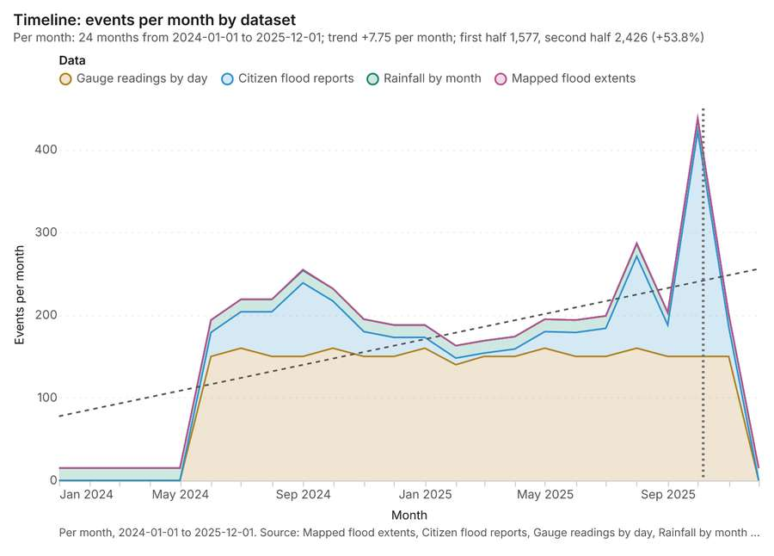
Figure 1. Timeline: events per month by dataset [1]. Per month, 2024-01-01 to 2025-12-01. Source: Mapped flood extents, Citizen flood reports, Gauge readings by day, Rainfall by month (4,003 features). Dotted lines mark dates named in the project's documents. The data is in the appendix.
The timeline counts 4,003 dated events in Mapped flood extents, Citizen flood reports, Gauge readings by day and 1 more per month, from January 2024 to December 2025 [1][2][3][4][5]. By dataset: Gauge readings by day 2,740; Citizen flood reports 900; Rainfall by month 360; Mapped flood extents 3 [1]. The trend is +7.75 events per month; the second half of the months has 2,426 against 1,577 in the first (+53.8%) [1]. Change point detection found no shift in the counts [6]. The project's documents name 2 dates inside this span, drawn as dotted lines; the most named is 2025-10-06 (Flood bulletin, page 1, 1 mention) [7].
Busiest months
- October 2025: 438 events [1]
- August 2025: 287 events [1]
- September 2024: 255 events [1]
Quietest months
- January 2024: 15 events [1]
- February 2024: 15 events [1]
- March 2024: 15 events [1]

Space time hot spots
What this analysis is. Emerging hot spots: Where hot spots are new, consecutive, intensifying, persistent, diminishing, sporadic, oscillating or historical over time [8]. In ArcGIS it is Emerging Hot Spot Analysis or Create Space Time Cube [8].
Why it was run on this data. Citizen flood reports carry dates in 'reported_at': emerging hot spot analysis finds new, intensifying and fading hot spots per month [9].
What it found. The analysis generated 54 features identifying emerging hot spots from the Citizen flood reports [10]. This result utilized 900 features and required 0 time neighbors [10]. The process achieved a resolution of 8 and completed in 15 milliseconds [10]. The associated costs for this operation were 0.145, reflecting that the upstream cost was 0 [10].
Result | Value
result, count | 54
result, elapsed ms | 15
result, resolution | 8
result, features used | 900
result, time neighbors | 0
billing, cost | 0.145
billing, list price | 0.145
billing, upstream cost | 0

Findings
- Evidenced: Space time hot spots on Citizen flood reports: Emerging hot spots: 1 layer saved: Emerging hot spots: Citizen flood reports (54 features) [10][11].
- Evidenced: It reported result, count 54; result, elapsed ms 15; result, resolution 8; result, features used 900; result, time neighbors 0; billing, cost 0.145 [10].
Tool gp_space_time_hot_spots; parameters {"project": "61868fa2-4b0c-4a49-9b21-03b342758885", "features": {"layer": "Citizen flood reports (e21d361b)"}, "interval": "month", "bin_shape": "h3", "resolution": 8, "time_field": "reported_at"}

Near repeat
What this analysis is. Repeat and near repeat classification: Classify incidents as originators, repeats (same place) or near repeats within a distance and time window, with a Knox test table [12]. In ArcGIS it is Repeat and Near Repeat Classification or Near Repeat Calculator [12].
Why it was run on this data. Near repeat analysis tests whether Citizen flood reports close in space also follow each other within 30 days [13].
What it found. Near repeat on Citizen flood reports: Repeat and near repeat classification: 1 layer saved: Repeat and near repeat classification: Citizen flood reports (900 features) [11][14]. It reported result, days 30; result, count 900; result, chains 136; result, distance m 200; result, elapsed ms 25; result, pairs linked 474 [14].
Result | Value
result, days | 30
result, count | 900
result, chains | 136
result, distance m | 200
result, elapsed ms | 25
result, pairs linked | 474
billing, cost | 0.077
billing, list price | 0.077
billing, upstream cost | 0

Findings
- Evidenced: Near repeat on Citizen flood reports: Repeat and near repeat classification: 1 layer saved: Repeat and near repeat classification: Citizen flood reports (900 features) [11][14].
- Evidenced: It reported result, days 30; result, count 900; result, chains 136; result, distance m 200; result, elapsed ms 25; result, pairs linked 474 [14].
Tool gp_near_repeat; parameters {"days": 30, "project": "61868fa2-4b0c-4a49-9b21-03b342758885", "features": {"layer": "Citizen flood reports (e21d361b)"}, "distance_m": 200.0, "time_field": "reported_at"}

Change point detection
What this analysis is. Change point detection: When did the level, count, trend or variability change [15]? For the whole study area or for every bin [15]. In ArcGIS it is Change Point Detection [15].
Why it was run on this data. Change point detection finds when the monthly count of Citizen flood reports shifted [16].
What it found. Change point detection was successfully completed, though no map output was generated for the analysis [6].
Result | Value
result, n changes | 0
result, elapsed ms | 4
result, events used | 900
billing, cost | 0.077
billing, list price | 0.077
billing, upstream cost | 0

Findings
- Evidenced: Change point detection on Citizen flood reports: Change point detection: done; no map output [6][11].
- Evidenced: It reported result, n changes 0; result, elapsed ms 4; result, events used 900; billing, cost 0.077; billing, list price 0.077; billing, upstream cost 0 [6].
Tool gp_change_point_detection; parameters {"method": "count", "project": "61868fa2-4b0c-4a49-9b21-03b342758885", "features": {"layer": "Citizen flood reports (e21d361b)"}, "interval": "month", "time_field": "reported_at"}

Hot spots
What this analysis is. Hot spot analysis: Getis-Ord Gi* hot and cold spots with z-scores, p-values and confidence bins [17]. In ArcGIS it is Find Hot Spots or Hot Spot Analysis (Getis-Ord Gi*); in QGIS, qgis:hotspot (plugin) [17].
Why it was run on this data. 900 points: Getis-Ord Gi* tests whether the concentrations in Citizen flood reports are statistically significant [18].
What it found. Hot spot analysis was performed using the Citizen flood reports [11], resulting in the identification of 192 features [19]. This analysis, which covered 900 incidents, completed with an elapsed time of 17 milliseconds [19].
Result | Value
result, bins | 192
result, count | 192
result, elapsed ms | 17
result, cell size m | 500
result, incidents used | 900
result, distance band m | 500
billing, cost | 0.068
billing, list price | 0.068
billing, upstream cost | 0

Findings
- Evidenced: Hot spots on Citizen flood reports: Hot spot analysis: 1 layer saved: Hot spot analysis: Citizen flood reports (192 features) [11][19].
- Evidenced: It reported result, bins 192; result, count 192; result, elapsed ms 17; result, cell size m 500; result, incidents used 900; result, distance band m 500 [19].
Tool gp_hot_spots; parameters {"project": "61868fa2-4b0c-4a49-9b21-03b342758885", "features": {"layer": "Citizen flood reports (e21d361b)"}, "aggregation": "hexagon", "cell_size_m": 500.0, "distance_band_m": 500.0}

Hot spots
What this analysis is. Hot spot analysis: Getis-Ord Gi* hot and cold spots with z-scores, p-values and confidence bins [17]. In ArcGIS it is Find Hot Spots or Hot Spot Analysis (Getis-Ord Gi*); in QGIS, qgis:hotspot (plugin) [17].
Why it was run on this data. Gi* hot spots of 'mean_rain_mm' across the areas [20].
What it found. Hot spots on Sub-catchments: Hot spot analysis: 1 layer saved: Hot spot analysis: Sub-catchments (10 features) [21][22]. It reported result, count 10; result, elapsed ms 1; result, excluded null 0; result, distance band m 3,807; billing, cost 0.0502; billing, list price 0.0502 [21].
Result | Value
result, count | 10
result, elapsed ms | 1
result, excluded null | 0
result, distance band m | 3,807
billing, cost | 0.0502
billing, list price | 0.0502
billing, upstream cost | 0

Findings
- Evidenced: Hot spots on Sub-catchments: Hot spot analysis: 1 layer saved: Hot spot analysis: Sub-catchments (10 features) [21][22].
- Evidenced: It reported result, count 10; result, elapsed ms 1; result, excluded null 0; result, distance band m 3,807; billing, cost 0.0502; billing, list price 0.0502 [21].
Tool gp_hot_spots; parameters {"field": "mean_rain_mm", "project": "61868fa2-4b0c-4a49-9b21-03b342758885", "features": {"layer": "Sub-catchments (93ab58bf)"}}

Calculate density
What this analysis is. Calculate density: Kernel density per square kilometer on a grid [23]. In ArcGIS it is Calculate Density or Kernel Density; in QGIS, native:heatmapkerneldensityestimation [23].
Why it was run on this data. 900 points in Citizen flood reports: a density surface shows where they concentrate [24].
What it found. Using citizen flood reports as the input, density was calculated with the `gp_calculate_density` tool [11, 25]. This process analyzed 1,058 features [25] and determined a maximum density of 73.99 per km2 [25]. The total cost associated with the density calculation was 0.068 [25].
Result | Value
result, count | 1,058
result, elapsed ms | 245
result, bandwidth m | 500
result, cell size m | 200
result, excluded null | 0
result, max density per km2 | 73.99
billing, cost | 0.068
billing, list price | 0.068
billing, upstream cost | 0

Findings
- Evidenced: Calculate density on Citizen flood reports: Calculate density: 1 layer saved: Calculate density: Citizen flood reports (1058 features) [11][25].
- Evidenced: It reported result, count 1,058; result, elapsed ms 245; result, bandwidth m 500; result, cell size m 200; result, excluded null 0; result, max density per km2 73.99 [25].
Tool gp_calculate_density; parameters {"kernel": "quartic", "project": "61868fa2-4b0c-4a49-9b21-03b342758885", "features": {"layer": "Citizen flood reports (e21d361b)"}, "bandwidth_m": 500.0, "cell_size_m": 200.0}

Summarize within
What this analysis is. Summarize within: Count and aggregate the features inside each polygon (or bin), proportionally for lines and polygons [26]. In ArcGIS it is Summarize Within or Aggregate Points; in QGIS, native:countpointsinpolygon or native:sumlinelengths [26].
Why it was run on this data. Count Citizen flood reports inside each feature of Sub-catchments by type; the counts map as a choropleth (natural breaks, sequential colors) [27].
What it found. Summarize within on Citizen flood reports, Sub-catchments: Summarize within: 1 layer saved: Summarize within: Sub-catchments (10 features) [11][22][28]. It reported result, count 10; result, elapsed ms 2; billing, cost 0.02822; billing, list price 0.02822; billing, upstream cost 0 [28].
Result | Value
result, count | 10
result, elapsed ms | 2
billing, cost | 0.02822
billing, list price | 0.02822
billing, upstream cost | 0

Findings
- Evidenced: Summarize within on Citizen flood reports, Sub-catchments: Summarize within: 1 layer saved: Summarize within: Sub-catchments (10 features) [11][22][28].
- Evidenced: It reported result, count 10; result, elapsed ms 2; billing, cost 0.02822; billing, list price 0.02822; billing, upstream cost 0 [28].
Tool gp_summarize_within; parameters {"stats": [{"stat": "sum", "field": "water_depth_cm"}], "project": "61868fa2-4b0c-4a49-9b21-03b342758885", "features": {"layer": "Citizen flood reports (e21d361b)"}, "group_by": "type", "polygons": {"layer": "Sub-catchments (93ab58bf)"}}

Summarize within
What this analysis is. Summarize within: Count and aggregate the features inside each polygon (or bin), proportionally for lines and polygons [26]. In ArcGIS it is Summarize Within or Aggregate Points; in QGIS, native:countpointsinpolygon or native:sumlinelengths [26].
Why it was run on this data. Count Citizen flood reports inside each feature of Sub-catchments by type; the counts map as a choropleth (natural breaks, sequential colors) [27].
What it found. Summarize within on River gauge stations, Sub-catchments: Summarize within: 1 layer saved: Summarize within: Sub-catchments (10 features) [22][29][30]. It reported result, count 10; result, elapsed ms 0; billing, cost 0.01042; billing, list price 0.01042; billing, upstream cost 0 [29].
Result | Value
result, count | 10
result, elapsed ms | 0
billing, cost | 0.01042
billing, list price | 0.01042
billing, upstream cost | 0

Findings
- Evidenced: Summarize within on River gauge stations, Sub-catchments: Summarize within: 1 layer saved: Summarize within: Sub-catchments (10 features) [22][29][30].
- Evidenced: It reported result, count 10; result, elapsed ms 0; billing, cost 0.01042; billing, list price 0.01042; billing, upstream cost 0 [29].
Tool gp_summarize_within; parameters {"stats": [{"stat": "sum", "field": "bank_full_m"}], "project": "61868fa2-4b0c-4a49-9b21-03b342758885", "features": {"layer": "River gauge stations (78d4554f)"}, "group_by": "river", "polygons": {"layer": "Sub-catchments (93ab58bf)"}}

Summarize within
What this analysis is. Summarize within: Count and aggregate the features inside each polygon (or bin), proportionally for lines and polygons [26]. In ArcGIS it is Summarize Within or Aggregate Points; in QGIS, native:countpointsinpolygon or native:sumlinelengths [26].
Why it was run on this data. Count Citizen flood reports inside each feature of Sub-catchments by type; the counts map as a choropleth (natural breaks, sequential colors) [27].
What it found. Summarize within on Rain gauges, Sub-catchments: Summarize within: 1 layer saved: Summarize within: Sub-catchments (10 features) [22][31][32]. It reported result, count 10; result, elapsed ms 0; billing, cost 0.01052; billing, list price 0.01052; billing, upstream cost 0 [31].
Result | Value
result, count | 10
result, elapsed ms | 0
billing, cost | 0.01052
billing, list price | 0.01052
billing, upstream cost | 0

Findings
- Evidenced: Summarize within on Rain gauges, Sub-catchments: Summarize within: 1 layer saved: Summarize within: Sub-catchments (10 features) [22][31][32].
- Evidenced: It reported result, count 10; result, elapsed ms 0; billing, cost 0.01052; billing, list price 0.01052; billing, upstream cost 0 [31].
Tool gp_summarize_within; parameters {"stats": [{"stat": "sum", "field": "elevation_m"}], "project": "61868fa2-4b0c-4a49-9b21-03b342758885", "features": {"layer": "Rain gauges (3db367dc)"}, "polygons": {"layer": "Sub-catchments (93ab58bf)"}}

Zonal statistics
What this analysis is. Zonal statistics: count/min/max/mean/std/sum/median/majority per polygon as a table and as GeoJSON [33]. In ArcGIS it is Zonal Statistics as Table (polygons) [33].
Why it was run on this data. Statistics of Catchment terrain model (DEM) inside each feature of Sub-catchments [34].
What it found. The analysis utilized the Zonal statistics tool, specifically rs_zonal_statistics [35]. The resulting output contained 10 row(s) [35]. This statistical breakdown successfully processed 10 zones [35].
Findings
- Evidenced: Zonal statistics: Zonal statistics: 10 row(s) [35].
- Evidenced: zones 10 [35].
Tool rs_zonal_statistics; parameters {"stats": ["mean", "min", "max", "std"], "zones": "Sub-catchments (93ab58bf)", "raster_id": "Catchment terrain model (DEM) (8a54f320)"}

Zonal statistics
What this analysis is. Zonal statistics: count/min/max/mean/std/sum/median/majority per polygon as a table and as GeoJSON [33]. In ArcGIS it is Zonal Statistics as Table (polygons) [33].
Why it was run on this data. Statistics of Catchment terrain model (DEM) inside each feature of Sub-catchments [34].
What it found. The analysis utilized the tool rs_zonal_statistics for zonal statistics [36]. Based on the tool summary, the output contained 3 row(s) [36]. Additionally, the process processed 3 zones [36].
Findings
- Evidenced: Zonal statistics: Zonal statistics: 3 row(s) [36].
- Evidenced: zones 3 [36].
Tool rs_zonal_statistics; parameters {"stats": ["mean", "min", "max", "std"], "zones": "Mapped flood extents (32d0b09d)", "raster_id": "Catchment terrain model (DEM) (8a54f320)"}

Slope
What this analysis is. Slope: Horn slope in degrees or percent, with the share of ground in six grade classes [37]. In ArcGIS it is Slope (Spatial Analyst); in QGIS, Slope (GDAL DEM) [37].
Why it was run on this data. Slope of the Catchment terrain model (DEM) surface [38].
What it found. Slope on Catchment terrain model (DEM): Slope over 119.88 km2: mean 8.48 degrees, max 20.58 degrees; 68% of the ground is steeper than 15% [39][40]. DEM: Catchment terrain model (DEM) [39][40]. Verified: 2 checks passed [39][40]. It reported dem, cols 400; dem, rows 333; dem, cell m 30; dem, relief m 1,812; dem, elev max m 2,062; dem, elev min m 250 [39].
Result | Value
dem, cols | 400
dem, rows | 333
dem, cell m | 30
dem, relief m | 1,812
dem, elev max m | 2,062
dem, elev min m | 250
dem, elev mean m | 882.8
dem, missing frac | 0
cost, usd | 0
grid, cols | 400
grid, rows | 333
grid, cell m | 30
stats, max | 20.58
stats, min | 0.01
stats, mean | 8.48
stats, median | 10.33
stats, steeper than 15pct | 68.27
rows left out | 0

Findings
- Evidenced: Slope on Catchment terrain model (DEM): Slope over 119.88 km2: mean 8.48 degrees, max 20.58 degrees; 68% of the ground is steeper than 15% [39][40].
- Evidenced: DEM: Catchment terrain model (DEM) [39][40].
- Evidenced: Verified: 2 checks passed [39][40].
- Evidenced: It reported dem, cols 400; dem, rows 333; dem, cell m 30; dem, relief m 1,812; dem, elev max m 2,062; dem, elev min m 250 [39].
Tool tr_slope; parameters {"dem": {"layer": "Catchment terrain model (DEM) (8a54f320)"}, "project": "61868fa2-4b0c-4a49-9b21-03b342758885"}

Find point clusters
What this analysis is. Find point clusters: Density-based clusters (DBSCAN, HDBSCAN or OPTICS, optionally space-time) with hulls and noise [41]. In ArcGIS it is Find Point Clusters or Density-based Clustering; in QGIS, native:dbscanclustering or native:stdbscanclustering [41].
Why it was run on this data. DBSCAN finds dense groups of Citizen flood reports and separates noise [42].
What it found. Find point clusters on Citizen flood reports: Find point clusters: 1 layer saved: Find point clusters: Citizen flood reports (900 features) [11][43]. It reported result, count 900; result, noise 900; result, distance m 200; result, elapsed ms 13; result, min points 20; billing, cost 0.068 [43].
Result | Value
result, count | 900
result, noise | 900
result, distance m | 200
result, elapsed ms | 13
result, min points | 20
billing, cost | 0.068
billing, list price | 0.068
billing, upstream cost | 0

Findings
- Evidenced: Find point clusters on Citizen flood reports: Find point clusters: 1 layer saved: Find point clusters: Citizen flood reports (900 features) [11][43].
- Evidenced: It reported result, count 900; result, noise 900; result, distance m 200; result, elapsed ms 13; result, min points 20; billing, cost 0.068 [43].
Tool gp_find_point_clusters; parameters {"method": "dbscan", "project": "61868fa2-4b0c-4a49-9b21-03b342758885", "features": {"layer": "Citizen flood reports (e21d361b)"}, "distance_m": 200.0, "min_points": 20}

Find point clusters
What this analysis is. Find point clusters: Density-based clusters (DBSCAN, HDBSCAN or OPTICS, optionally space-time) with hulls and noise [41]. In ArcGIS it is Find Point Clusters or Density-based Clustering; in QGIS, native:dbscanclustering or native:stdbscanclustering [41].
Why it was run on this data. DBSCAN finds dense groups of River gauge stations and separates noise [44].
What it found. Find point clusters on River gauge stations: Find point clusters: 2 layers saved: Find point clusters: River gauge stations (10 features); Find point clusters: cluster hulls (2 features) [30][45]. It reported result, count 10; result, noise 3; result, distance m 2,000; result, elapsed ms 85; result, min points 3; billing, cost 0.0502 [45].
Result | Value
result, count | 10
result, noise | 3
result, distance m | 2,000
result, elapsed ms | 85
result, min points | 3
billing, cost | 0.0502
billing, list price | 0.0502
billing, upstream cost | 0

Findings
- Evidenced: Find point clusters on River gauge stations: Find point clusters: 2 layers saved: Find point clusters: River gauge stations (10 features); Find point clusters: cluster hulls (2 features) [30][45].
- Evidenced: It reported result, count 10; result, noise 3; result, distance m 2,000; result, elapsed ms 85; result, min points 3; billing, cost 0.0502 [45].
Tool gp_find_point_clusters; parameters {"method": "dbscan", "project": "61868fa2-4b0c-4a49-9b21-03b342758885", "features": {"layer": "River gauge stations (78d4554f)"}, "distance_m": 2000.0, "min_points": 3}

Find point clusters
What this analysis is. Find point clusters: Density-based clusters (DBSCAN, HDBSCAN or OPTICS, optionally space-time) with hulls and noise [41]. In ArcGIS it is Find Point Clusters or Density-based Clustering; in QGIS, native:dbscanclustering or native:stdbscanclustering [41].
Why it was run on this data. DBSCAN finds dense groups of Rain gauges and separates noise [46].
What it found. Find point clusters on Rain gauges: Find point clusters: 2 layers saved: Find point clusters: Rain gauges (15 features); Find point clusters: cluster hulls (1 feature) [32][47]. It reported result, count 15; result, noise 0; result, distance m 5,000; result, elapsed ms 2; result, min points 3; billing, cost 0.0503 [47].
Result | Value
result, count | 15
result, noise | 0
result, distance m | 5,000
result, elapsed ms | 2
result, min points | 3
billing, cost | 0.0503
billing, list price | 0.0503
billing, upstream cost | 0

Findings
- Evidenced: Find point clusters on Rain gauges: Find point clusters: 2 layers saved: Find point clusters: Rain gauges (15 features); Find point clusters: cluster hulls (1 feature) [32][47].
- Evidenced: It reported result, count 15; result, noise 0; result, distance m 5,000; result, elapsed ms 2; result, min points 3; billing, cost 0.0503 [47].
A model draft was discarded because a sentence did not cite a source of this section.
Tool gp_find_point_clusters; parameters {"method": "dbscan", "project": "61868fa2-4b0c-4a49-9b21-03b342758885", "features": {"layer": "Rain gauges (3db367dc)"}, "distance_m": 5000.0, "min_points": 3}

Maps and charts
The run also made 16 map image(s) [48][49][50][51][52][53][54][55][56][57][58][59][60][61][62][63] and 18 chart(s) [64][65][66][67][68][69][70][71][72][73][74][75][76][77][78][79][80][81].
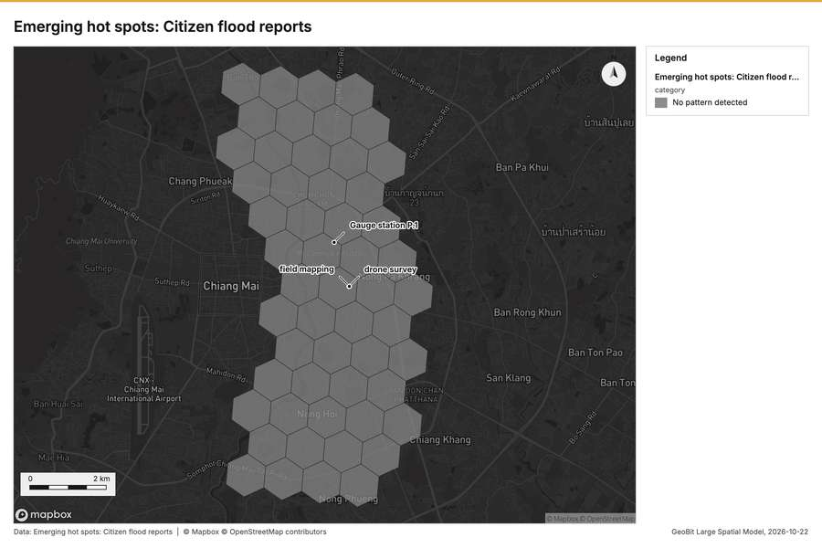
Figure 2. Emerging hot spots: Citizen flood reports [48]
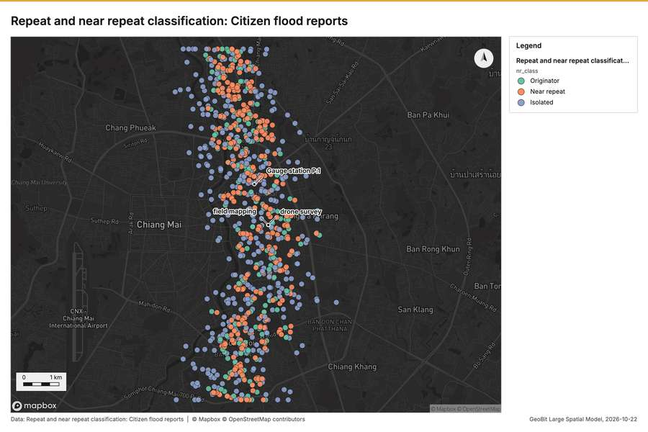
Figure 3. Repeat and near repeat classification: Citizen flood reports [49]
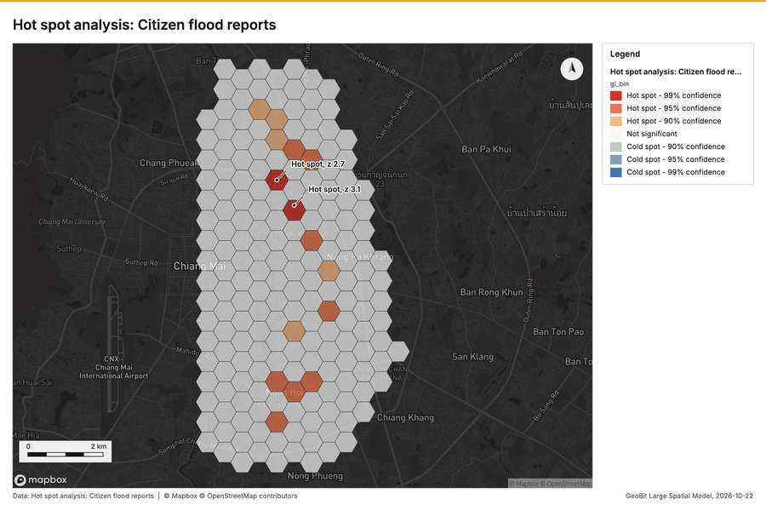
Figure 4. Hot spot analysis: Citizen flood reports [50]
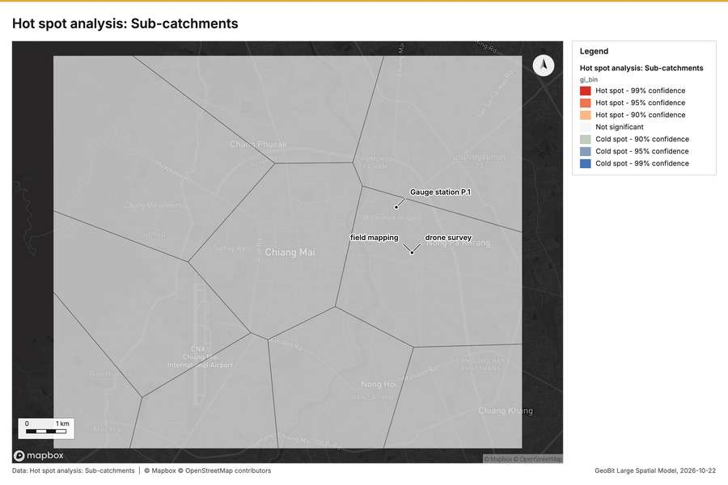
Figure 5. Hot spot analysis: Sub-catchments [51]
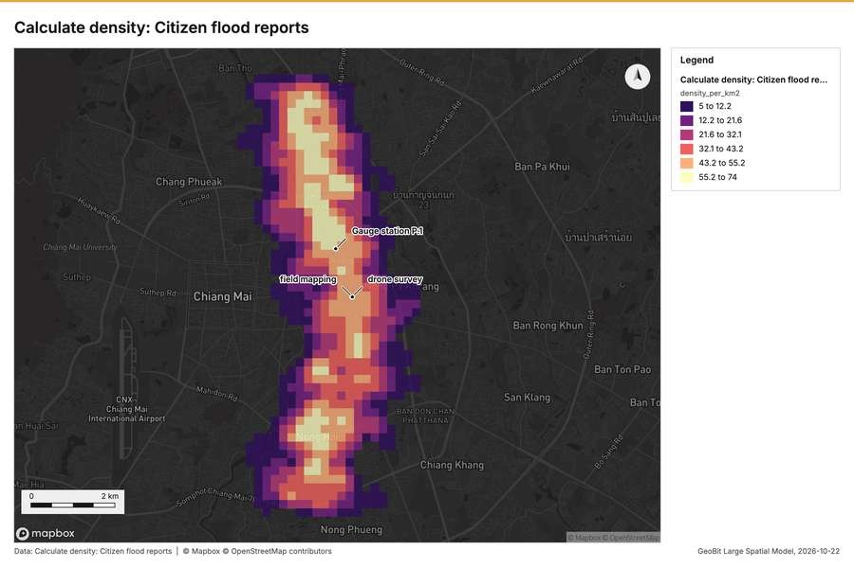
Figure 6. Calculate density: Citizen flood reports [52]
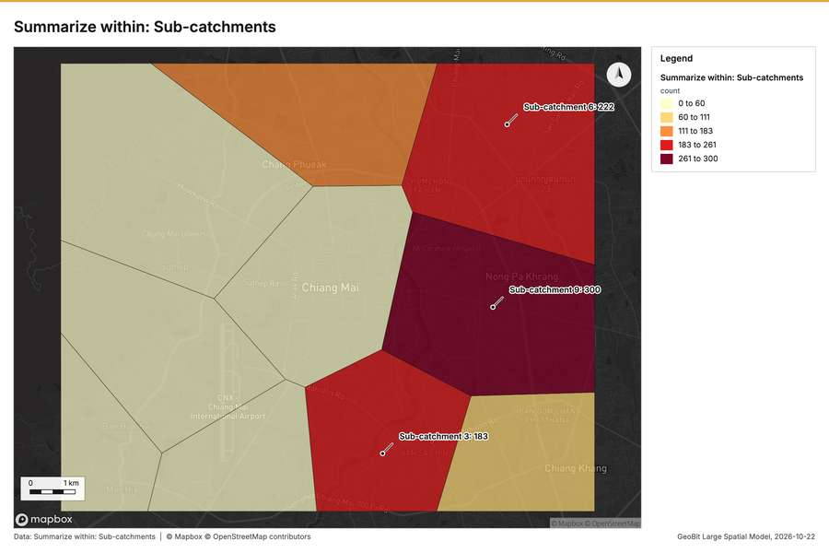
Figure 7. Summarize within: Sub-catchments [53]
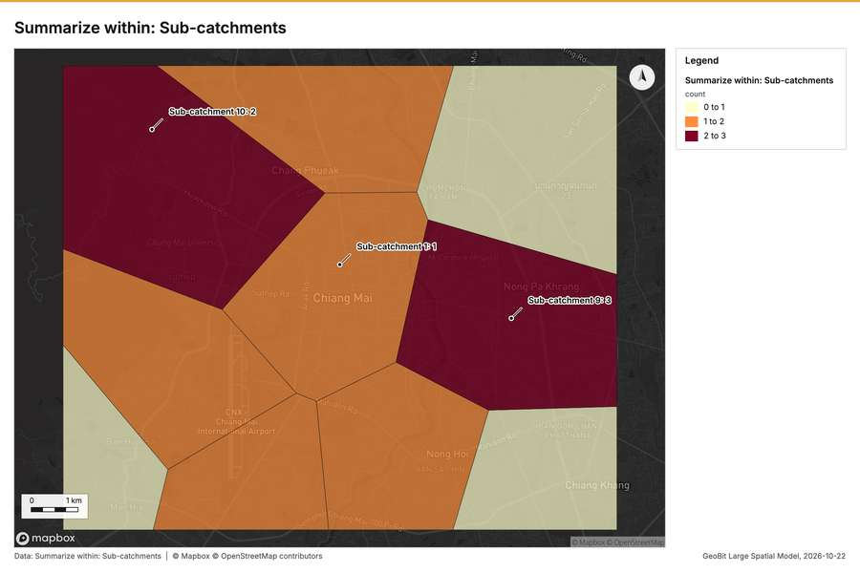
Figure 8. Summarize within: Sub-catchments [54]
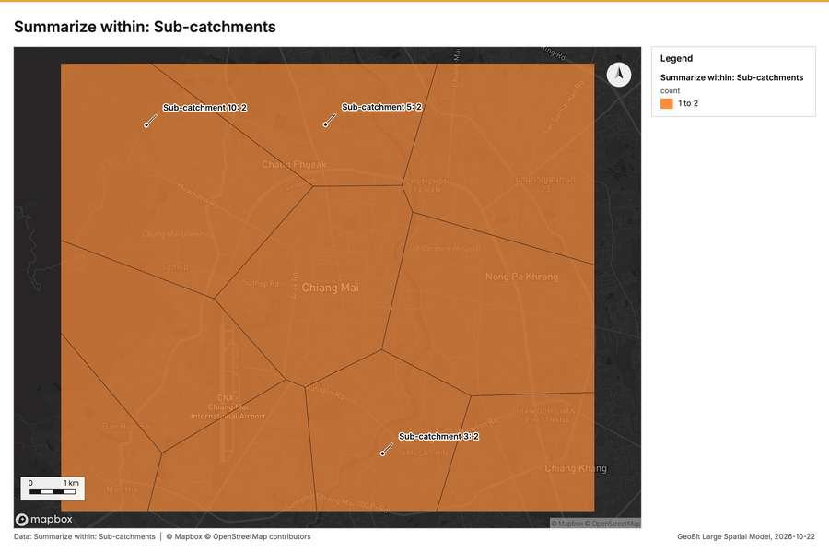
Figure 9. Summarize within: Sub-catchments [55]
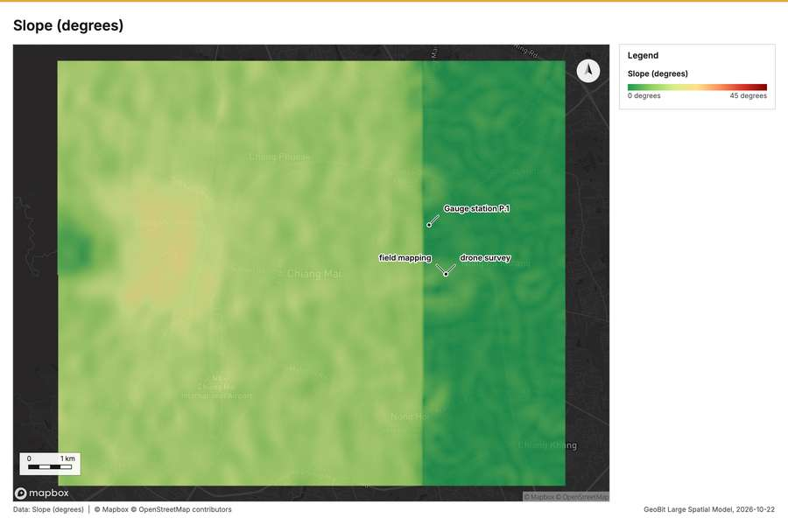
Figure 10. Slope (degrees) [56]
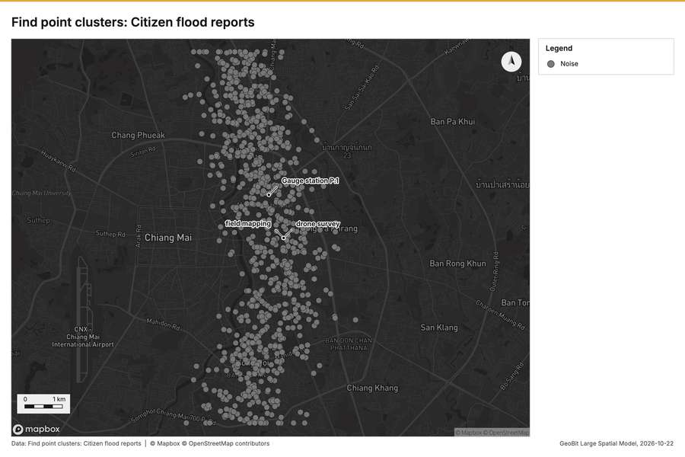
Figure 11. Find point clusters: Citizen flood reports [57]
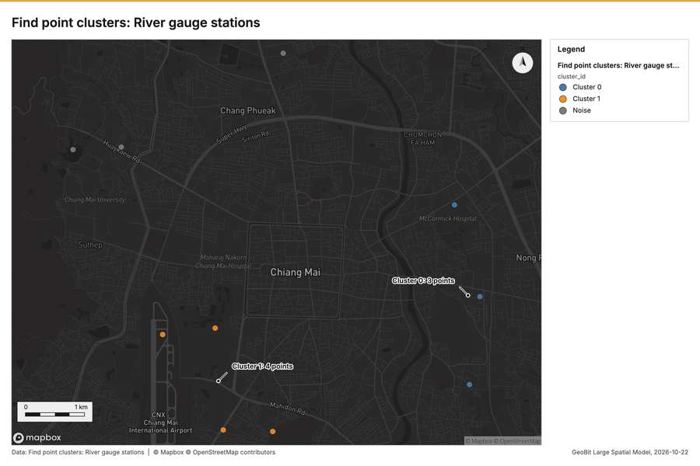
Figure 12. Find point clusters: River gauge stations [58]
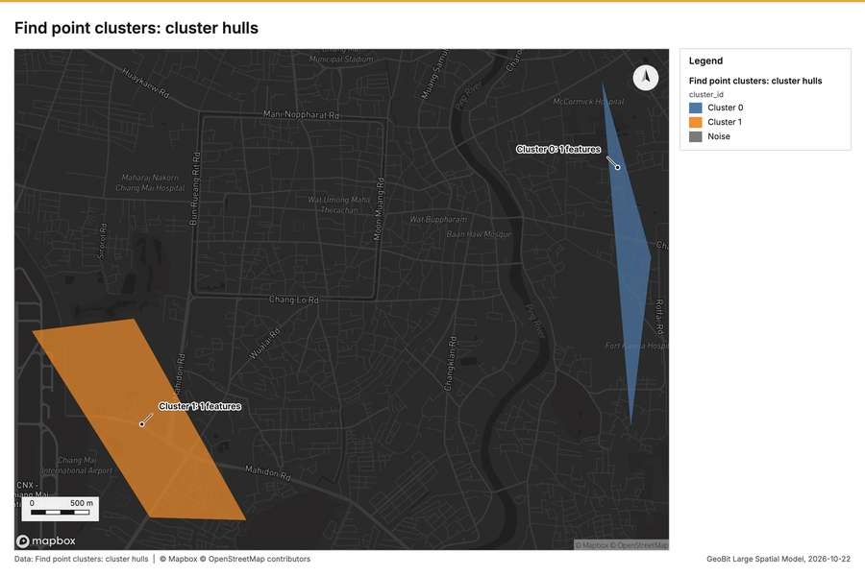
Figure 13. Find point clusters: cluster hulls [59]
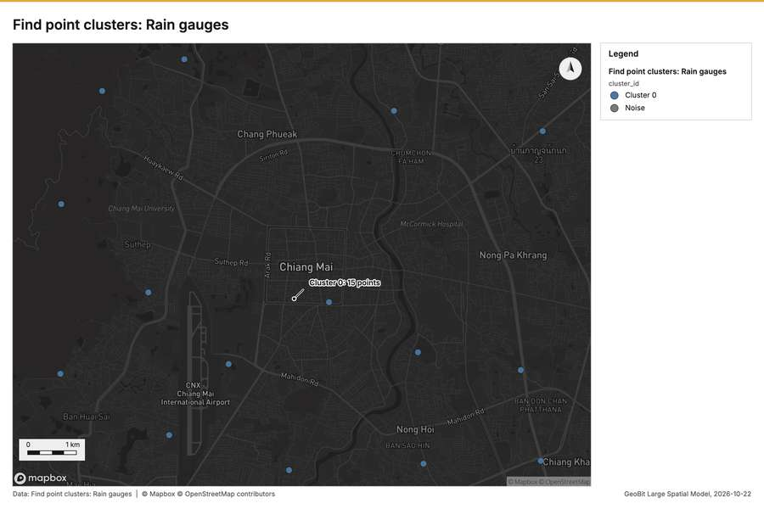
Figure 14. Find point clusters: Rain gauges [60]
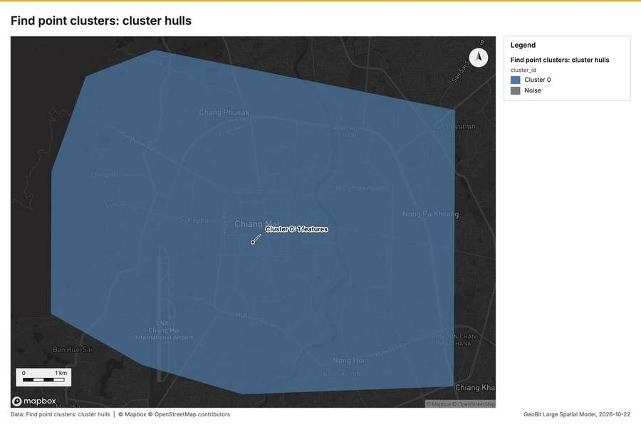
Figure 15. Find point clusters: cluster hulls [61]
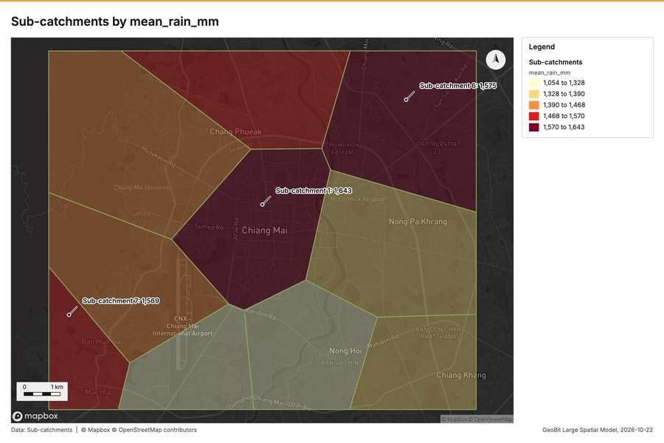
Figure 16. Sub-catchments by mean_rain_mm [62]
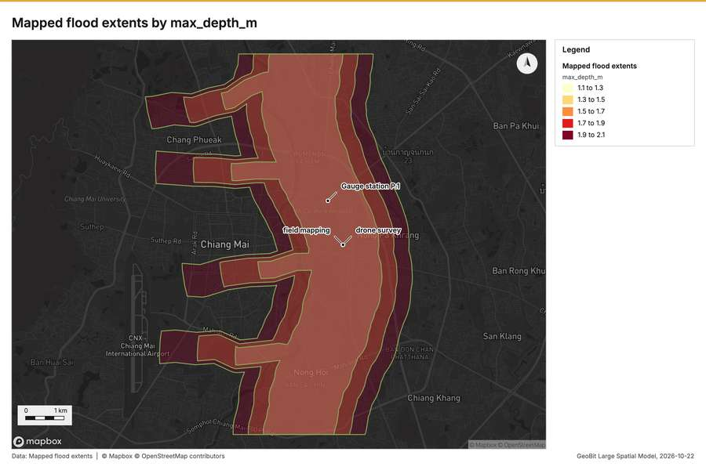
Figure 17. Mapped flood extents by max_depth_m [63]
What the map shows. The map, titled "Emerging hot spots: Citizen flood reports," displays an analysis of potential flood reporting clusters across a gridded area. According to the legend, the pattern result for this analysis is "No pattern detected." Visually, the entire area is covered by a uniform hexagonal grid structure, indicating the scope of the report, but no specific hot spots or distinct groupings are highlighted. The overall reading suggests that citizen flood reports are not concentrated in any specific, statistically significant area within the mapped region. Therefore, the image indicates that [48]
Inferred: read from the image by gemma4:e4b, not evidence.
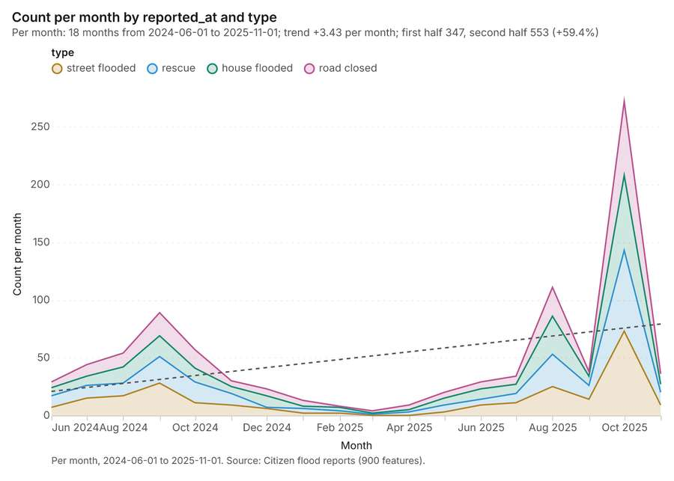
Figure 18. Citizen flood reports over time (reported_at) [64]. Per month, 2024-06-01 to 2025-11-01. Source: Citizen flood reports (900 features). The data is in the appendix.
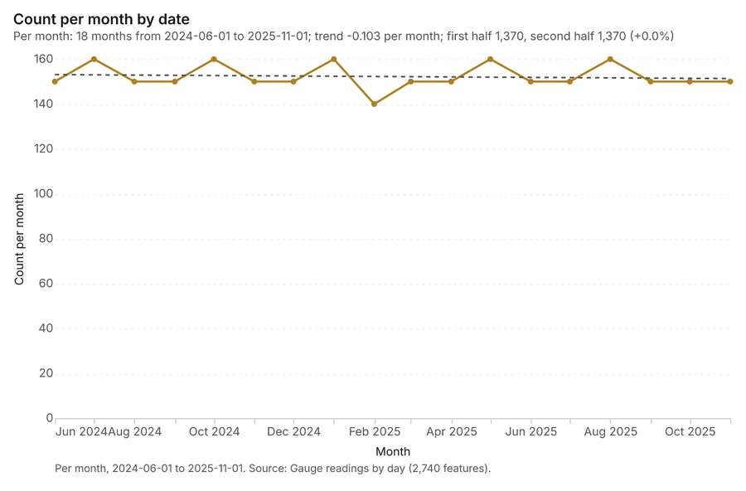
Figure 19. Gauge readings by day over time (date) [65]. Per month, 2024-06-01 to 2025-11-01. Source: Gauge readings by day (2,740 features). The data is in the appendix.
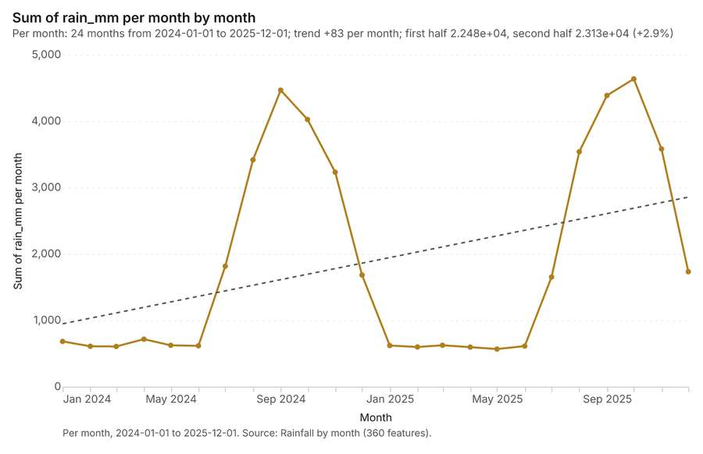
Figure 20. Rainfall by month over time (month) [66]. Per month, 2024-01-01 to 2025-12-01. Source: Rainfall by month (360 features). The data is in the appendix.
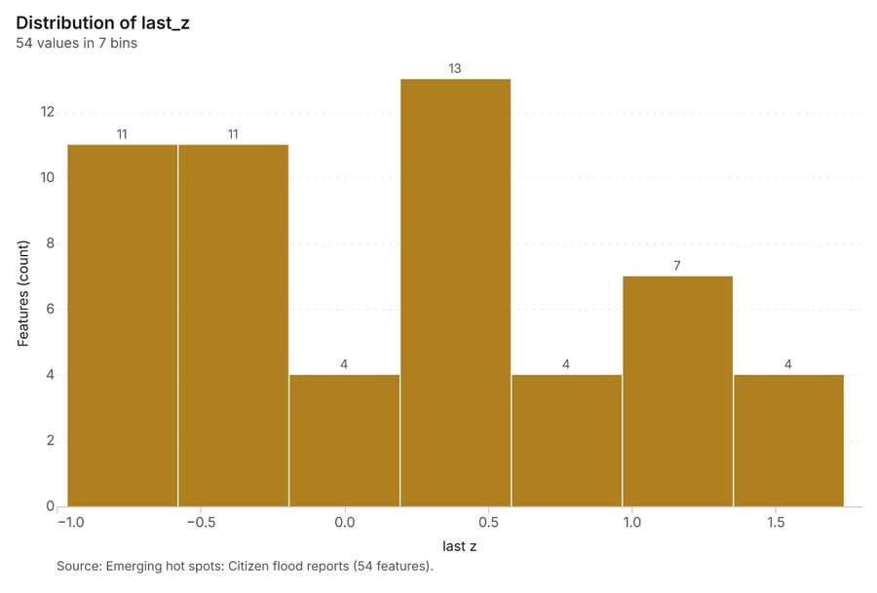
Figure 21. Emerging hot spots: Citizen flood reports [67]. Source: Emerging hot spots: Citizen flood reports (54 features). The data is in the appendix.
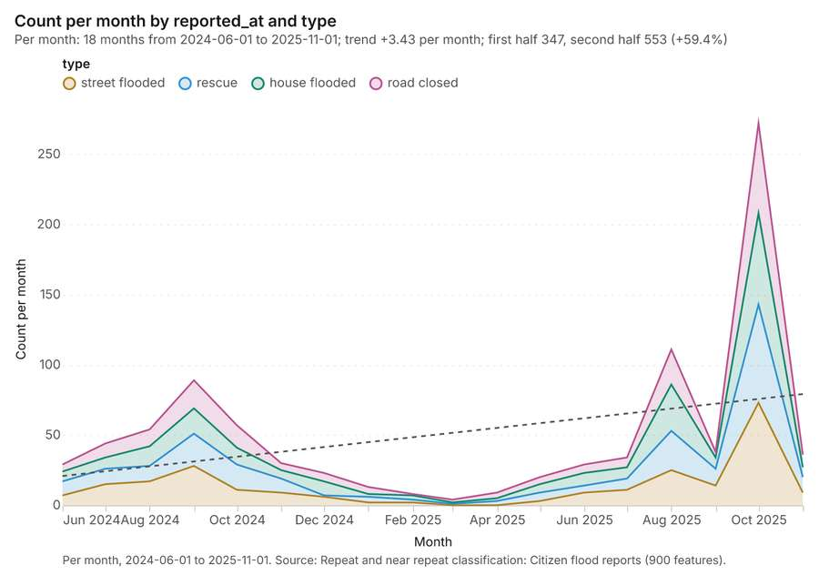
Figure 22. Repeat and near repeat classification: Citizen flood reports [68]. Per month, 2024-06-01 to 2025-11-01. Source: Repeat and near repeat classification: Citizen flood reports (900 features). The data is in the appendix.
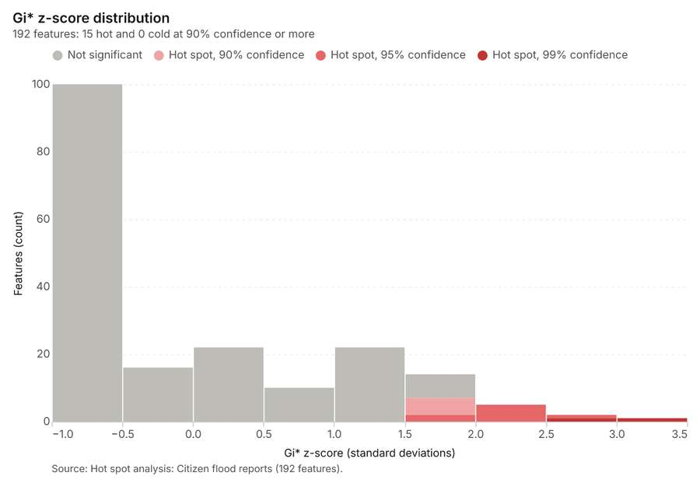
Figure 23. Hot spot analysis: Citizen flood reports [69]. Source: Hot spot analysis: Citizen flood reports (192 features). The data is in the appendix.
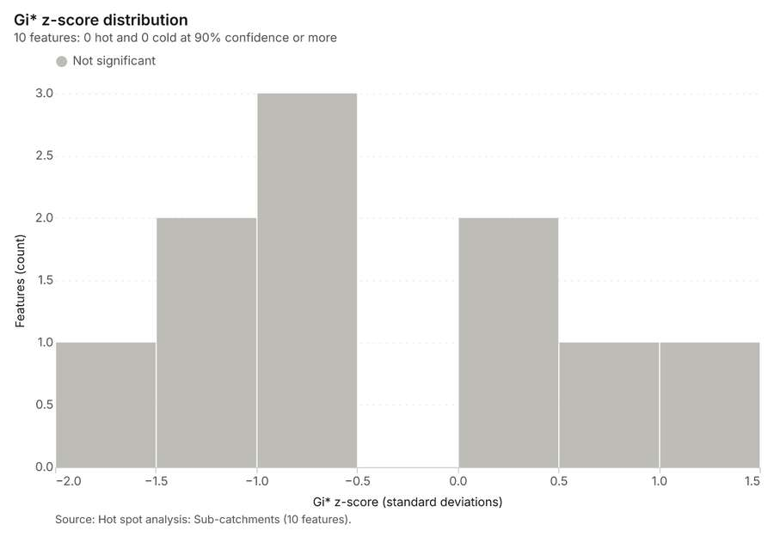
Figure 24. Hot spot analysis: Sub-catchments [70]. Source: Hot spot analysis: Sub-catchments (10 features). The data is in the appendix.
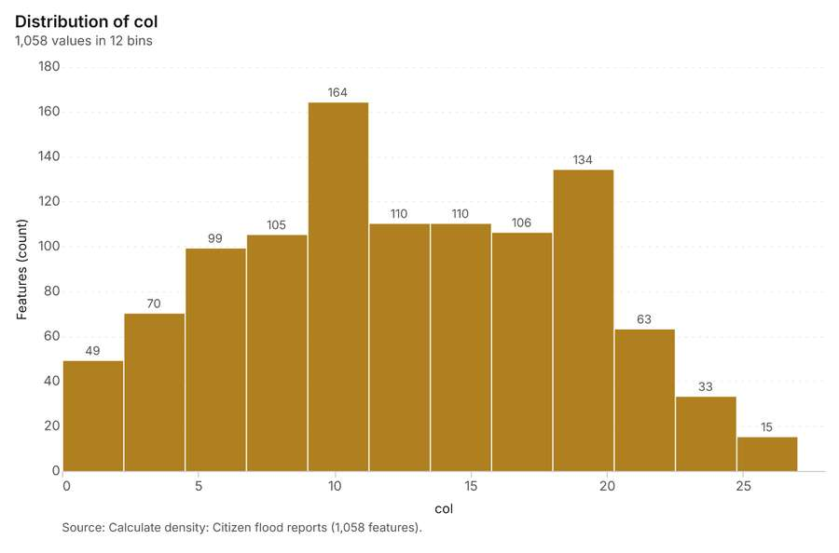
Figure 25. Calculate density: Citizen flood reports [71]. Source: Calculate density: Citizen flood reports (1,058 features). The data is in the appendix.
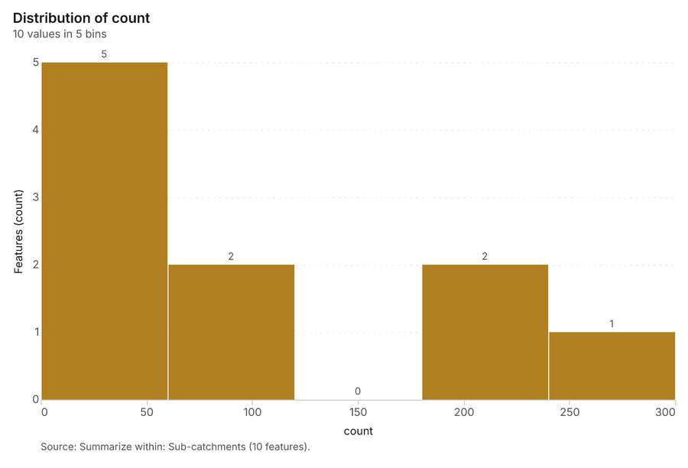
Figure 26. Summarize within: Sub-catchments [72]. Source: Summarize within: Sub-catchments (10 features). The data is in the appendix.
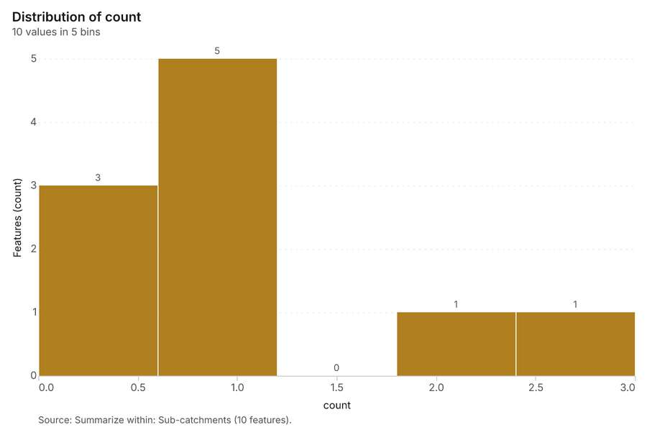
Figure 27. Summarize within: Sub-catchments [73]. Source: Summarize within: Sub-catchments (10 features). The data is in the appendix.
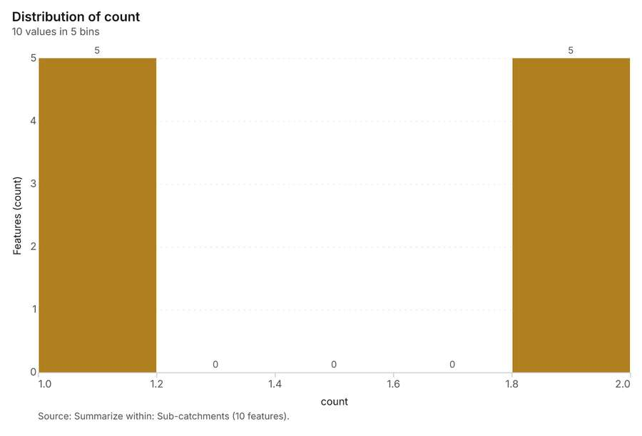
Figure 28. Summarize within: Sub-catchments [74]. Source: Summarize within: Sub-catchments (10 features). The data is in the appendix.
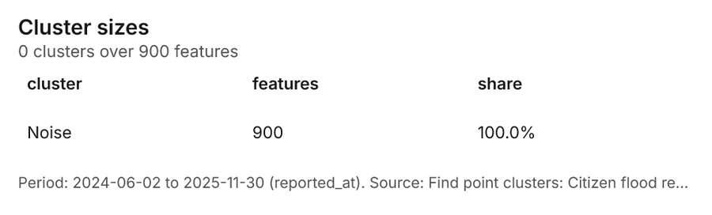
Figure 29. Find point clusters: Citizen flood reports [75]. Period: 2024-06-02 to 2025-11-30 (reported_at). Source: Find point clusters: Citizen flood reports (900 features). The data is in the appendix.
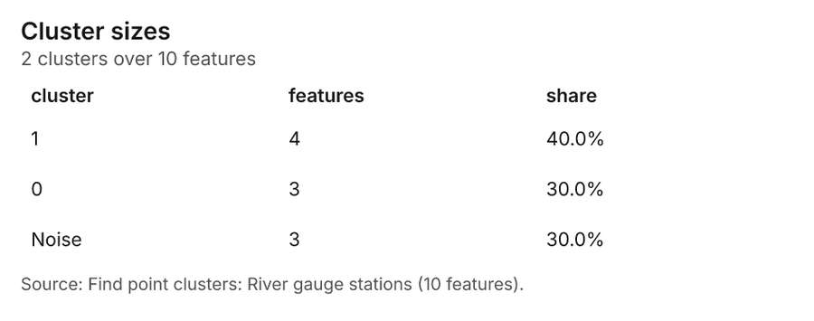
Figure 30. Find point clusters: River gauge stations [76]. Source: Find point clusters: River gauge stations (10 features). The data is in the appendix.
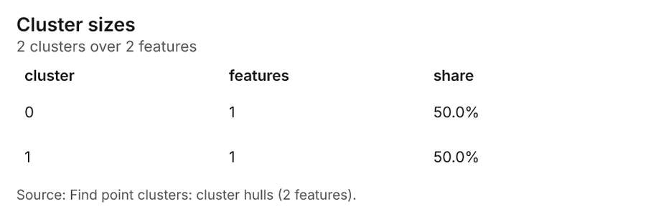
Figure 31. Find point clusters: cluster hulls [77]. Source: Find point clusters: cluster hulls (2 features). The data is in the appendix.
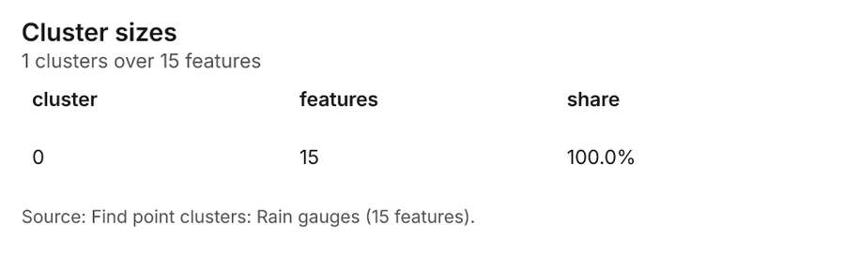
Figure 32. Find point clusters: Rain gauges [78]. Source: Find point clusters: Rain gauges (15 features). The data is in the appendix.
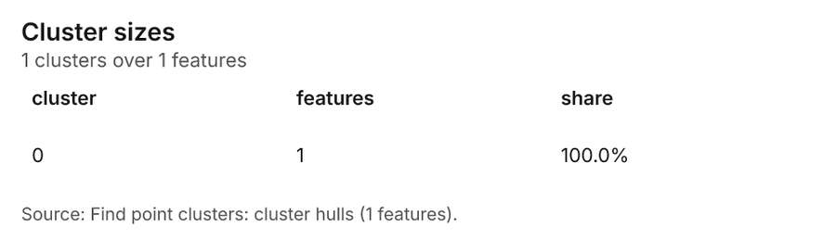
Figure 33. Find point clusters: cluster hulls [79]. Source: Find point clusters: cluster hulls (1 features). The data is in the appendix.
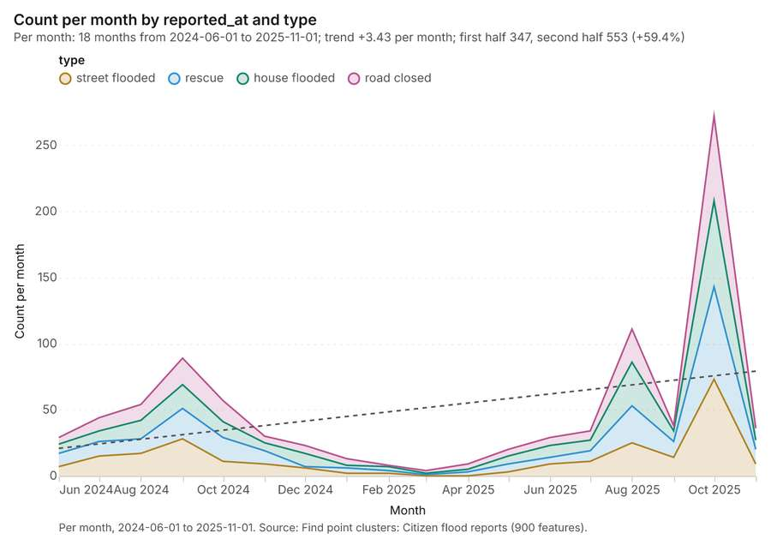
Figure 34. Find point clusters: Citizen flood reports over time [80]. Per month, 2024-06-01 to 2025-11-01. Source: Find point clusters: Citizen flood reports (900 features). The data is in the appendix.
Figure 35. Repeat and near repeat classification: Citizen flood reports over time [81]. Per month, 2024-06-01 to 2025-11-01. Source: Repeat and near repeat classification: Citizen flood reports (900 features). The data is in the appendix.

Changes since the last run
This is the first report of this project.

Sources
[1] Rendering: Chart: Timeline: events per month by dataset. 96 rows (id ab73206e-a519-4180-9535-698e58b41091)
[2] Dataset: Mapped flood extents. vector, 3 rows (id db7dcc69-6952-403c-92c2-c3bc2246001a)
[3] Dataset: Citizen flood reports. vector, 900 rows (id 1efc03c7-deb5-479a-8a37-e719f58c2b20)
[4] Dataset: Gauge readings by day. table, 2740 rows (id 2f1b0f9a-faac-4f0f-a937-14d42ba33293)
[5] Dataset: Rainfall by month. table, 360 rows (id b74ec6fb-9f9c-443c-9bf1-60b415ac2d65)
[6] Tool result: gp_change_point_detection, step 2. Change point detection: done; no map output. (id 2d6ff918-4a3d-4d6b-90bb-880ab63700de:2)
[7] Document page: Flood bulletin, page 1. 6 October 2025 (id 85d1f153-b632-4f92-9c75-e27e602d03cd:1)
[8] Catalog: Emerging hot spots (operation catalog, gp_space_time_hot_spots). Where hot spots are new, consecutive, intensifying, persistent, diminishing, sporadic, oscillating or historical over time. ArcGIS: Emerging Hot Spot Analysis, Create Space Time Cube. (id gp_space_time_hot_spots)
[9] Plan: Space time hot spots of Citizen flood reports (the Start plan's candidate c_8817aba79f40). Citizen flood reports carry dates in 'reported_at': emerging hot spot analysis finds new, intensifying and fading hot spots per month. (id 782d5b2b-9474-44b9-a11b-9d4d784bcedb:c_8817aba79f40)
[10] Tool result: gp_space_time_hot_spots, step 0. Emerging hot spots: 1 layer saved: Emerging hot spots: Citizen flood reports (54 features). (id 2d6ff918-4a3d-4d6b-90bb-880ab63700de:0)
[11] Layer: Citizen flood reports. 900 features (id e21d361b-1aea-4c6c-983a-db6793334e54)
[12] Catalog: Repeat and near repeat classification (operation catalog, gp_near_repeat). Classify incidents as originators, repeats (same place) or near repeats within a distance and time window, with a Knox test table. ArcGIS: Repeat and Near Repeat Classification, Near Repeat Calculator. (id gp_near_repeat)
[13] Plan: Near repeat of Citizen flood reports (the Start plan's candidate c_dc6752c63c8e). Near repeat analysis tests whether Citizen flood reports close in space also follow each other within 30 days. (id 782d5b2b-9474-44b9-a11b-9d4d784bcedb:c_dc6752c63c8e)
[14] Tool result: gp_near_repeat, step 1. Repeat and near repeat classification: 1 layer saved: Repeat and near repeat classification: Citizen flood reports (900 features). (id 2d6ff918-4a3d-4d6b-90bb-880ab63700de:1)
[15] Catalog: Change point detection (operation catalog, gp_change_point_detection). When did the level, count, trend or variability change? For the whole study area or for every bin. ArcGIS: Change Point Detection. (id gp_change_point_detection)
[16] Plan: Change points of Citizen flood reports (the Start plan's candidate c_026cfc884747). Change point detection finds when the monthly count of Citizen flood reports shifted. (id 782d5b2b-9474-44b9-a11b-9d4d784bcedb:c_026cfc884747)
[17] Catalog: Hot spot analysis (operation catalog, gp_hot_spots). Getis-Ord Gi* hot and cold spots with z-scores, p-values and confidence bins. ArcGIS: Find Hot Spots, Hot Spot Analysis (Getis-Ord Gi*). QGIS: qgis:hotspot (plugin). (id gp_hot_spots)
[18] Plan: Hot spots of Citizen flood reports (the Start plan's candidate c_55817c6df3fb). 900 points: Getis-Ord Gi* tests whether the concentrations in Citizen flood reports are statistically significant. (id 782d5b2b-9474-44b9-a11b-9d4d784bcedb:c_55817c6df3fb)
[19] Tool result: gp_hot_spots, step 0. Hot spot analysis: 1 layer saved: Hot spot analysis: Citizen flood reports (192 features). (id d01cf43d-7790-4072-93f9-676ff4a27366:0)
[20] Plan: Hot spots of Sub-catchments (the Start plan's candidate c_65d5fe8b1094). Gi* hot spots of 'mean_rain_mm' across the areas. (id 782d5b2b-9474-44b9-a11b-9d4d784bcedb:c_65d5fe8b1094)
[21] Tool result: gp_hot_spots, step 1. Hot spot analysis: 1 layer saved: Hot spot analysis: Sub-catchments (10 features). (id d01cf43d-7790-4072-93f9-676ff4a27366:1)
[22] Layer: Sub-catchments. 10 features (id 93ab58bf-7296-4170-ad95-b10fa72c5e22)
[23] Catalog: Calculate density (operation catalog, gp_calculate_density). Kernel density per square kilometer on a grid. ArcGIS: Calculate Density, Kernel Density. QGIS: native:heatmapkerneldensityestimation. (id gp_calculate_density)
[24] Plan: Kernel density of Citizen flood reports (the Start plan's candidate c_ae50d36cd0d9). 900 points in Citizen flood reports: a density surface shows where they concentrate. (id 782d5b2b-9474-44b9-a11b-9d4d784bcedb:c_ae50d36cd0d9)
[25] Tool result: gp_calculate_density, step 0. Calculate density: 1 layer saved: Calculate density: Citizen flood reports (1058 features). (id 8747d1d4-2b67-4155-bcb2-a4e53f193c9d:0)
[26] Catalog: Summarize within (operation catalog, gp_summarize_within). Count and aggregate the features inside each polygon (or bin), proportionally for lines and polygons. ArcGIS: Summarize Within, Aggregate Points. QGIS: native:countpointsinpolygon, native:sumlinelengths. (id gp_summarize_within)
[27] Plan: Citizen flood reports per feature of Sub-catchments (the Start plan's candidate c_3b154a6e32f0). Count Citizen flood reports inside each feature of Sub-catchments by type; the counts map as a choropleth (natural breaks, sequential colors). (id 782d5b2b-9474-44b9-a11b-9d4d784bcedb:c_3b154a6e32f0)
[28] Tool result: gp_summarize_within, step 0. Summarize within: 1 layer saved: Summarize within: Sub-catchments (10 features). (id 8dd97c93-e555-418d-a9c0-cfdf74a7bac8:0)
[29] Tool result: gp_summarize_within, step 1. Summarize within: 1 layer saved: Summarize within: Sub-catchments (10 features). (id 8dd97c93-e555-418d-a9c0-cfdf74a7bac8:1)
[30] Layer: River gauge stations. 10 features (id 78d4554f-40bd-482a-8b8e-976f0f3f0fe9)
[31] Tool result: gp_summarize_within, step 2. Summarize within: 1 layer saved: Summarize within: Sub-catchments (10 features). (id 8dd97c93-e555-418d-a9c0-cfdf74a7bac8:2)
[32] Layer: Rain gauges. 15 features (id 3db367dc-7928-4385-9039-bfe0bba84b6d)
[33] Catalog: Zonal statistics (analysis catalog, rs_zonal_statistics). count/min/max/mean/std/sum/median/majority per polygon as a table and as GeoJSON. ArcGIS: Zonal Statistics as Table (polygons). (id rs_zonal_statistics)
[34] Plan: Zonal statistics of Catchment terrain model (DEM) and Sub-catchments (the Start plan's candidate c_252b1099847d). Statistics of Catchment terrain model (DEM) inside each feature of Sub-catchments. (id 782d5b2b-9474-44b9-a11b-9d4d784bcedb:c_252b1099847d)
[35] Tool result: rs_zonal_statistics, step 0. Zonal statistics: 10 row(s). zones 10. (id a7316d79-1e6d-45dd-9d15-38c74be5152e:0)
[36] Tool result: rs_zonal_statistics, step 1. Zonal statistics: 3 row(s). zones 3. (id a7316d79-1e6d-45dd-9d15-38c74be5152e:1)
[37] Catalog: Slope (analysis catalog, tr_slope). Horn slope in degrees or percent, with the share of ground in six grade classes. ArcGIS: Slope (Spatial Analyst). QGIS: Slope (GDAL DEM). (id tr_slope)
[38] Plan: Slope of Catchment terrain model (DEM) (the Start plan's candidate c_7150677d61cb). Slope of the Catchment terrain model (DEM) surface. (id 782d5b2b-9474-44b9-a11b-9d4d784bcedb:c_7150677d61cb)
[39] Tool result: tr_slope, step 2. Slope over 119.88 km2: mean 8.48 degrees, max 20.58 degrees; 68% of the ground is steeper than 15%. DEM: Catchment terrain model (DEM). Verified: 2 checks passed. (id a7316d79-1e6d-45dd-9d15-38c74be5152e:2)
[40] Layer: Catchment terrain model (DEM). 0 features (id 8a54f320-9f63-4fda-934a-2891d0746533)
[41] Catalog: Find point clusters (operation catalog, gp_find_point_clusters). Density-based clusters (DBSCAN, HDBSCAN or OPTICS, optionally space-time) with hulls and noise. ArcGIS: Find Point Clusters, Density-based Clustering. QGIS: native:dbscanclustering, native:stdbscanclustering. (id gp_find_point_clusters)
[42] Plan: Cluster points of Citizen flood reports (the Start plan's candidate c_14cb11cdaf9e). DBSCAN finds dense groups of Citizen flood reports and separates noise. (id 782d5b2b-9474-44b9-a11b-9d4d784bcedb:c_14cb11cdaf9e)
[43] Tool result: gp_find_point_clusters, step 0. Find point clusters: 1 layer saved: Find point clusters: Citizen flood reports (900 features). (id e37a3cf8-9f42-4186-9a30-b91e39fd4753:0)
[44] Plan: Cluster points of River gauge stations (the Start plan's candidate c_850adaee1a23). DBSCAN finds dense groups of River gauge stations and separates noise. (id 782d5b2b-9474-44b9-a11b-9d4d784bcedb:c_850adaee1a23)
[45] Tool result: gp_find_point_clusters, step 1. Find point clusters: 2 layers saved: Find point clusters: River gauge stations (10 features); Find point clusters: cluster hulls (2 features). (id e37a3cf8-9f42-4186-9a30-b91e39fd4753:1)
[46] Plan: Cluster points of Rain gauges (the Start plan's candidate c_880362120631). DBSCAN finds dense groups of Rain gauges and separates noise. (id 782d5b2b-9474-44b9-a11b-9d4d784bcedb:c_880362120631)
[47] Tool result: gp_find_point_clusters, step 2. Find point clusters: 2 layers saved: Find point clusters: Rain gauges (15 features); Find point clusters: cluster hulls (1 feature). (id e37a3cf8-9f42-4186-9a30-b91e39fd4753:2)
[48] Rendering: Map: Emerging hot spots: Citizen flood reports (id df84019c-853e-4480-ae80-4360a5057762)
[49] Rendering: Map: Repeat and near repeat classification: Citizen flood reports (id db30ad7f-93e1-49a6-8051-b2115ddb3932)
[50] Rendering: Map: Hot spot analysis: Citizen flood reports (id 58d7b995-0988-4e8e-9630-4bc577176a92)
[51] Rendering: Map: Hot spot analysis: Sub-catchments (id 235866fd-a134-4c95-9350-8f2aece11b24)
[52] Rendering: Map: Calculate density: Citizen flood reports (id 691e1041-8462-4990-a2b4-333fec815627)
[53] Rendering: Map: Summarize within: Sub-catchments (id 2a79fecc-b8b2-4472-b272-fb43b039dbd2)
[54] Rendering: Map: Summarize within: Sub-catchments (id 857ca1b5-8fec-48a4-b304-266e68d31b94)
[55] Rendering: Map: Summarize within: Sub-catchments (id 1e84fe9a-d7b2-4902-98c6-88f83d1753eb)
[56] Rendering: Map: Slope (degrees) (id 1d6c4200-1fcb-4126-ad0a-641d77b24050)
[57] Rendering: Map: Find point clusters: Citizen flood reports (id 322bd37e-7f71-4ec2-be16-3d3eb394fa1a)
[58] Rendering: Map: Find point clusters: River gauge stations (id 42494457-0017-4176-b060-8c623d818af7)
[59] Rendering: Map: Find point clusters: cluster hulls (id cbd218da-1936-4b2f-928b-583963a4d05b)
[60] Rendering: Map: Find point clusters: Rain gauges (id de3b65e7-1df0-45b3-a9d9-3f16c3ec25e0)
[61] Rendering: Map: Find point clusters: cluster hulls (id bb029bff-1f80-4876-9c36-9f206c27cb52)
[62] Rendering: Map: Sub-catchments by mean_rain_mm (id 629ae5d8-0e0f-40be-8efe-59858715407c)
[63] Rendering: Map: Mapped flood extents by max_depth_m (id 672a21a8-f21f-47d9-915d-f1215f2351ea)
[64] Rendering: Chart: Citizen flood reports over time (reported_at). 72 rows (id 1f057250-f2f3-4444-8ee4-312f7e3f29b8)
[65] Rendering: Chart: Gauge readings by day over time (date). 18 rows (id 1cefadf3-c3b0-4bdc-b14d-0912c06be92b)
[66] Rendering: Chart: Rainfall by month over time (month). 24 rows (id 68e438aa-5686-4857-9a3f-cd8c3cde2386)
[67] Rendering: Chart: Emerging hot spots: Citizen flood reports. 7 rows (id 2f15b311-199d-4056-abbf-7f7d18fe96f7)
[68] Rendering: Chart: Repeat and near repeat classification: Citizen flood reports. 72 rows (id ad285a50-1301-486d-8690-dc043ed0946c)
[69] Rendering: Chart: Hot spot analysis: Citizen flood reports. 12 rows (id 3368b83c-fef0-4ed7-a8a9-0b1b9da8619b)
[70] Rendering: Chart: Hot spot analysis: Sub-catchments. 6 rows (id c9d116d9-5701-464b-b839-63cf43f651de)
[71] Rendering: Chart: Calculate density: Citizen flood reports. 12 rows (id c7966614-d1c9-46e7-8925-8f2f0bac5902)
[72] Rendering: Chart: Summarize within: Sub-catchments. 5 rows (id 8c848fa1-3d91-47af-9649-288a226486ed)
[73] Rendering: Chart: Summarize within: Sub-catchments. 5 rows (id dfeafeea-e8b5-4e66-bec7-146625c650af)
[74] Rendering: Chart: Summarize within: Sub-catchments. 5 rows (id a13f8b52-7627-46cb-b4b5-97051fbb536c)
[75] Rendering: Chart: Find point clusters: Citizen flood reports. 1 rows (id 0788ef2e-51b6-4142-92a3-ee3cbdd4a246)
[76] Rendering: Chart: Find point clusters: River gauge stations. 3 rows (id ec2f47a4-6cfe-4935-ae97-f19fd059d77c)
[77] Rendering: Chart: Find point clusters: cluster hulls. 2 rows (id 0c8ac877-ebc0-43c8-a153-654498de370e)
[78] Rendering: Chart: Find point clusters: Rain gauges. 1 rows (id 28dec6f4-3a37-41d3-901b-dde7b707ca85)
[79] Rendering: Chart: Find point clusters: cluster hulls. 1 rows (id 88019df2-74d5-411f-aa91-914142d1020b)
[80] Rendering: Chart: Find point clusters: Citizen flood reports over time. 72 rows (id 9aed8e2a-dca7-41a3-88ab-dcad1081cc59)
[81] Rendering: Chart: Repeat and near repeat classification: Citizen flood reports over time. 72 rows (id 682239cc-117a-45c4-932d-cd4f72d53c6a)
[82] Dataset: River gauge stations. vector, 10 rows (id 51e6f3e7-39f7-409d-b75a-5e3c4f2111ba)
[83] Dataset: Rivers. vector, 5 rows (id c3beaebe-fab3-43f4-8bd5-fd534de0bc90)
[84] Dataset: Sub-catchments. vector, 10 rows (id 3b3a6800-4b3b-485f-9a6e-9cb94a905fda)
[85] Dataset: Rain gauges. vector, 15 rows (id 798fc52e-f033-441e-89de-9aba95030abe)
[86] Dataset: Levees. vector, 4 rows (id 452fb0cc-8b65-48aa-80fb-aa893b871288)
[87] Dataset: Catchment terrain model (DEM). raster, ? rows (id 1e838159-31fe-49cd-9295-eb56c3c76602)
[88] Dataset: Flood bulletin. document, ? rows (id 0d72e77d-8ce0-4130-85e5-3594ccc48b8b)
[89] Record: Sample: Water resources, Chiang Mai (id 61868fa2-4b0c-4a49-9b21-03b342758885)
[90] Layer: Emerging hot spots: Citizen flood reports. 54 features (id 76aee3c4-5662-40a6-a573-f7385c27cb6f)
[91] Layer: Repeat and near repeat classification: Citizen flood reports. 900 features (id 453b38fc-b031-4019-9f36-cea25aa9d8bc)
[92] Layer: Hot spot analysis: Citizen flood reports. 192 features (id 194f8e1a-bb85-455a-a877-c8e63e1e9706)
[93] Layer: Hot spot analysis: Sub-catchments. 10 features (id 1a25513d-2337-4e12-b048-9964386b8caf)
[94] Layer: Calculate density: Citizen flood reports. 1,058 features (id d06650d9-2045-4364-b4eb-7e2d08340918)
[95] Layer: Summarize within: Sub-catchments. 10 features (id fd0b3217-d60a-47c7-90ab-ea465e8c7c5d)
[96] Layer: Summarize within: Sub-catchments. 10 features (id ea36acc2-c9e4-47d1-ae43-8e8a01796331)
[97] Layer: Summarize within: Sub-catchments. 10 features (id e444fc8a-915a-41cf-b527-64e4d1f433ad)
[98] Layer: Slope (degrees). 0 features (id a753c90d-d085-4dc3-9dbd-73f27c7b0ce4)
[99] Layer: Find point clusters: Citizen flood reports. 900 features (id 74df7279-bf60-476d-a11f-318baf9e29c1)
[100] Layer: Find point clusters: River gauge stations. 10 features (id 206d0831-64d5-4e32-8f3e-6a20b952bafa)
[101] Layer: Find point clusters: cluster hulls. 2 features (id fdb581a7-158f-4075-9090-44eea9d091f3)
[102] Layer: Find point clusters: Rain gauges. 15 features (id c05c732b-60cd-4aa0-9e1c-3c5d0446cfb9)
[103] Layer: Find point clusters: cluster hulls. 1 features (id f339f855-d239-4237-9f3a-0d4890abce5e)
[104] Document: Flood bulletin (id 85d1f153-b632-4f92-9c75-e27e602d03cd)

Appendix: the data behind the charts

Figure 1. Timeline: events per month by dataset [1]
period | series | value
2024-01-01 | Gauge readings by day | 0
2024-01-01 | Citizen flood reports | 0
2024-01-01 | Rainfall by month | 15
2024-01-01 | Mapped flood extents | 0
2024-02-01 | Gauge readings by day | 0
2024-02-01 | Citizen flood reports | 0
2024-02-01 | Rainfall by month | 15
2024-02-01 | Mapped flood extents | 0
2024-03-01 | Gauge readings by day | 0
2024-03-01 | Citizen flood reports | 0
2024-03-01 | Rainfall by month | 15
2024-03-01 | Mapped flood extents | 0
2024-04-01 | Gauge readings by day | 0
2024-04-01 | Citizen flood reports | 0
2024-04-01 | Rainfall by month | 15
2024-04-01 | Mapped flood extents | 0
2024-05-01 | Gauge readings by day | 0
2024-05-01 | Citizen flood reports | 0
2024-05-01 | Rainfall by month | 15
2024-05-01 | Mapped flood extents | 0
2024-06-01 | Gauge readings by day | 150
2024-06-01 | Citizen flood reports | 29
2024-06-01 | Rainfall by month | 15
2024-06-01 | Mapped flood extents | 0
2024-07-01 | Gauge readings by day | 160
2024-07-01 | Citizen flood reports | 44
2024-07-01 | Rainfall by month | 15
2024-07-01 | Mapped flood extents | 0
2024-08-01 | Gauge readings by day | 150
2024-08-01 | Citizen flood reports | 54
2024-08-01 | Rainfall by month | 15
2024-08-01 | Mapped flood extents | 0
2024-09-01 | Gauge readings by day | 150
2024-09-01 | Citizen flood reports | 89
2024-09-01 | Rainfall by month | 15
2024-09-01 | Mapped flood extents | 1
2024-10-01 | Gauge readings by day | 160
2024-10-01 | Citizen flood reports | 57
2024-10-01 | Rainfall by month | 15
2024-10-01 | Mapped flood extents | 0
2024-11-01 | Gauge readings by day | 150
2024-11-01 | Citizen flood reports | 30
2024-11-01 | Rainfall by month | 15
2024-11-01 | Mapped flood extents | 0
2024-12-01 | Gauge readings by day | 150
2024-12-01 | Citizen flood reports | 23
2024-12-01 | Rainfall by month | 15
2024-12-01 | Mapped flood extents | 0
2025-01-01 | Gauge readings by day | 160
2025-01-01 | Citizen flood reports | 13
2025-01-01 | Rainfall by month | 15
2025-01-01 | Mapped flood extents | 0
2025-02-01 | Gauge readings by day | 140
2025-02-01 | Citizen flood reports | 8
2025-02-01 | Rainfall by month | 15
2025-02-01 | Mapped flood extents | 0
2025-03-01 | Gauge readings by day | 150
2025-03-01 | Citizen flood reports | 4
2025-03-01 | Rainfall by month | 15
2025-03-01 | Mapped flood extents | 0
2025-04-01 | Gauge readings by day | 150
2025-04-01 | Citizen flood reports | 9
2025-04-01 | Rainfall by month | 15
2025-04-01 | Mapped flood extents | 0
2025-05-01 | Gauge readings by day | 160
2025-05-01 | Citizen flood reports | 20
2025-05-01 | Rainfall by month | 15
2025-05-01 | Mapped flood extents | 0
2025-06-01 | Gauge readings by day | 150
2025-06-01 | Citizen flood reports | 29
2025-06-01 | Rainfall by month | 15
2025-06-01 | Mapped flood extents | 0
2025-07-01 | Gauge readings by day | 150
2025-07-01 | Citizen flood reports | 34
2025-07-01 | Rainfall by month | 15
2025-07-01 | Mapped flood extents | 0
2025-08-01 | Gauge readings by day | 160
2025-08-01 | Citizen flood reports | 111
2025-08-01 | Rainfall by month | 15
2025-08-01 | Mapped flood extents | 1
2025-09-01 | Gauge readings by day | 150
2025-09-01 | Citizen flood reports | 38
2025-09-01 | Rainfall by month | 15
2025-09-01 | Mapped flood extents | 0
2025-10-01 | Gauge readings by day | 150
2025-10-01 | Citizen flood reports | 272
2025-10-01 | Rainfall by month | 15
2025-10-01 | Mapped flood extents | 1
2025-11-01 | Gauge readings by day | 150
2025-11-01 | Citizen flood reports | 36
2025-11-01 | Rainfall by month | 15
2025-11-01 | Mapped flood extents | 0
2025-12-01 | Gauge readings by day | 0
2025-12-01 | Citizen flood reports | 0
2025-12-01 | Rainfall by month | 15
2025-12-01 | Mapped flood extents | 0

Figure 18. Citizen flood reports over time (reported_at) [64]
period | series | value
2024-06-01 | street flooded | 7
2024-06-01 | rescue | 10
2024-06-01 | house flooded | 7
2024-06-01 | road closed | 5
2024-07-01 | street flooded | 15
2024-07-01 | rescue | 11
2024-07-01 | house flooded | 8
2024-07-01 | road closed | 10
2024-08-01 | street flooded | 17
2024-08-01 | rescue | 11
2024-08-01 | house flooded | 14
2024-08-01 | road closed | 12
2024-09-01 | street flooded | 28
2024-09-01 | rescue | 23
2024-09-01 | house flooded | 18
2024-09-01 | road closed | 20
2024-10-01 | street flooded | 11
2024-10-01 | rescue | 18
2024-10-01 | house flooded | 12
2024-10-01 | road closed | 16
2024-11-01 | street flooded | 9
2024-11-01 | rescue | 10
2024-11-01 | house flooded | 6
2024-11-01 | road closed | 5
2024-12-01 | street flooded | 6
2024-12-01 | rescue | 1
2024-12-01 | house flooded | 10
2024-12-01 | road closed | 6
2025-01-01 | street flooded | 2
2025-01-01 | rescue | 4
2025-01-01 | house flooded | 2
2025-01-01 | road closed | 5
2025-02-01 | street flooded | 2
2025-02-01 | rescue | 2
2025-02-01 | house flooded | 3
2025-02-01 | road closed | 1
2025-03-01 | street flooded | 0
2025-03-01 | rescue | 1
2025-03-01 | house flooded | 1
2025-03-01 | road closed | 2
2025-04-01 | street flooded | 0
2025-04-01 | rescue | 3
2025-04-01 | house flooded | 2
2025-04-01 | road closed | 4
2025-05-01 | street flooded | 3
2025-05-01 | rescue | 6
2025-05-01 | house flooded | 6
2025-05-01 | road closed | 5
2025-06-01 | street flooded | 9
2025-06-01 | rescue | 5
2025-06-01 | house flooded | 9
2025-06-01 | road closed | 6
2025-07-01 | street flooded | 11
2025-07-01 | rescue | 8
2025-07-01 | house flooded | 8
2025-07-01 | road closed | 7
2025-08-01 | street flooded | 25
2025-08-01 | rescue | 28
2025-08-01 | house flooded | 33
2025-08-01 | road closed | 25
2025-09-01 | street flooded | 14
2025-09-01 | rescue | 12
2025-09-01 | house flooded | 8
2025-09-01 | road closed | 4
2025-10-01 | street flooded | 73
2025-10-01 | rescue | 70
2025-10-01 | house flooded | 65
2025-10-01 | road closed | 64
2025-11-01 | street flooded | 9
2025-11-01 | rescue | 11
2025-11-01 | house flooded | 7
2025-11-01 | road closed | 9

Figure 19. Gauge readings by day over time (date) [65]
period | value
2024-06-01 | 150
2024-07-01 | 160
2024-08-01 | 150
2024-09-01 | 150
2024-10-01 | 160
2024-11-01 | 150
2024-12-01 | 150
2025-01-01 | 160
2025-02-01 | 140
2025-03-01 | 150
2025-04-01 | 150
2025-05-01 | 160
2025-06-01 | 150
2025-07-01 | 150
2025-08-01 | 160
2025-09-01 | 150
2025-10-01 | 150
2025-11-01 | 150

Figure 20. Rainfall by month over time (month) [66]
period | value
2024-01-01 | 681
2024-02-01 | 608
2024-03-01 | 605
2024-04-01 | 715
2024-05-01 | 622
2024-06-01 | 615
2024-07-01 | 1,814
2024-08-01 | 3,416
2024-09-01 | 4,465
2024-10-01 | 4,024
2024-11-01 | 3,230
2024-12-01 | 1,681
2025-01-01 | 619
2025-02-01 | 597
2025-03-01 | 623
2025-04-01 | 595
2025-05-01 | 566
2025-06-01 | 611
2025-07-01 | 1,651
2025-08-01 | 3,538
2025-09-01 | 4,386
2025-10-01 | 4,635
2025-11-01 | 3,580
2025-12-01 | 1,731

Figure 21. Emerging hot spots: Citizen flood reports [67]
bin_start | bin_end | count
-0.966 | -0.5799 | 11
-0.5799 | -0.1937 | 11
-0.1937 | 0.1924 | 4
0.1924 | 0.5786 | 13
0.5786 | 0.9647 | 4
0.9647 | 1.351 | 7
1.351 | 1.737 | 4

Figure 22. Repeat and near repeat classification: Citizen flood reports [68]
period | series | value
2024-06-01 | street flooded | 7
2024-06-01 | rescue | 10
2024-06-01 | house flooded | 7
2024-06-01 | road closed | 5
2024-07-01 | street flooded | 15
2024-07-01 | rescue | 11
2024-07-01 | house flooded | 8
2024-07-01 | road closed | 10
2024-08-01 | street flooded | 17
2024-08-01 | rescue | 11
2024-08-01 | house flooded | 14
2024-08-01 | road closed | 12
2024-09-01 | street flooded | 28
2024-09-01 | rescue | 23
2024-09-01 | house flooded | 18
2024-09-01 | road closed | 20
2024-10-01 | street flooded | 11
2024-10-01 | rescue | 18
2024-10-01 | house flooded | 12
2024-10-01 | road closed | 16
2024-11-01 | street flooded | 9
2024-11-01 | rescue | 10
2024-11-01 | house flooded | 6
2024-11-01 | road closed | 5
2024-12-01 | street flooded | 6
2024-12-01 | rescue | 1
2024-12-01 | house flooded | 10
2024-12-01 | road closed | 6
2025-01-01 | street flooded | 2
2025-01-01 | rescue | 4
2025-01-01 | house flooded | 2
2025-01-01 | road closed | 5
2025-02-01 | street flooded | 2
2025-02-01 | rescue | 2
2025-02-01 | house flooded | 3
2025-02-01 | road closed | 1
2025-03-01 | street flooded | 0
2025-03-01 | rescue | 1
2025-03-01 | house flooded | 1
2025-03-01 | road closed | 2
2025-04-01 | street flooded | 0
2025-04-01 | rescue | 3
2025-04-01 | house flooded | 2
2025-04-01 | road closed | 4
2025-05-01 | street flooded | 3
2025-05-01 | rescue | 6
2025-05-01 | house flooded | 6
2025-05-01 | road closed | 5
2025-06-01 | street flooded | 9
2025-06-01 | rescue | 5
2025-06-01 | house flooded | 9
2025-06-01 | road closed | 6
2025-07-01 | street flooded | 11
2025-07-01 | rescue | 8
2025-07-01 | house flooded | 8
2025-07-01 | road closed | 7
2025-08-01 | street flooded | 25
2025-08-01 | rescue | 28
2025-08-01 | house flooded | 33
2025-08-01 | road closed | 25
2025-09-01 | street flooded | 14
2025-09-01 | rescue | 12
2025-09-01 | house flooded | 8
2025-09-01 | road closed | 4
2025-10-01 | street flooded | 73
2025-10-01 | rescue | 70
2025-10-01 | house flooded | 65
2025-10-01 | road closed | 64
2025-11-01 | street flooded | 9
2025-11-01 | rescue | 11
2025-11-01 | house flooded | 7
2025-11-01 | road closed | 9

Figure 23. Hot spot analysis: Citizen flood reports [69]
bin_start | bin_end | band | band_label | count
-1 | -0.5 | not_significant | Not significant | 100
-0.5 | 0 | not_significant | Not significant | 16
0 | 0.5 | not_significant | Not significant | 22
0.5 | 1 | not_significant | Not significant | 10
1 | 1.5 | not_significant | Not significant | 22
1.5 | 2 | hot_90 | Hot spot, 90% confidence | 5
1.5 | 2 | hot_95 | Hot spot, 95% confidence | 2
1.5 | 2 | not_significant | Not significant | 7
2 | 2.5 | hot_95 | Hot spot, 95% confidence | 5
2.5 | 3 | hot_95 | Hot spot, 95% confidence | 1
2.5 | 3 | hot_99 | Hot spot, 99% confidence | 1
3 | 3.5 | hot_99 | Hot spot, 99% confidence | 1

Figure 24. Hot spot analysis: Sub-catchments [70]
bin_start | bin_end | band | band_label | count
-2 | -1.5 | not_significant | Not significant | 1
-1.5 | -1 | not_significant | Not significant | 2
-1 | -0.5 | not_significant | Not significant | 3
0 | 0.5 | not_significant | Not significant | 2
0.5 | 1 | not_significant | Not significant | 1
1 | 1.5 | not_significant | Not significant | 1

Figure 25. Calculate density: Citizen flood reports [71]
bin_start | bin_end | count
0 | 2.25 | 49
2.25 | 4.5 | 70
4.5 | 6.75 | 99
6.75 | 9 | 105
9 | 11.25 | 164
11.25 | 13.5 | 110
13.5 | 15.75 | 110
15.75 | 18 | 106
18 | 20.25 | 134
20.25 | 22.5 | 63
22.5 | 24.75 | 33
24.75 | 27 | 15

Figure 26. Summarize within: Sub-catchments [72]
bin_start | bin_end | count
0 | 60 | 5
60 | 120 | 2
120 | 180 | 0
180 | 240 | 2
240 | 300 | 1

Figure 27. Summarize within: Sub-catchments [73]
bin_start | bin_end | count
0 | 0.6 | 3
0.6 | 1.2 | 5
1.2 | 1.8 | 0
1.8 | 2.4 | 1
2.4 | 3 | 1

Figure 28. Summarize within: Sub-catchments [74]
bin_start | bin_end | count
1 | 1.2 | 5
1.2 | 1.4 | 0
1.4 | 1.6 | 0
1.6 | 1.8 | 0
1.8 | 2 | 5

Figure 29. Find point clusters: Citizen flood reports [75]
cluster | features | fraction | share
Noise | 900 | 1 | 100.0%

Figure 30. Find point clusters: River gauge stations [76]
cluster | features | fraction | share
1 | 4 | 0.4 | 40.0%
0 | 3 | 0.3 | 30.0%
Noise | 3 | 0.3 | 30.0%

Figure 31. Find point clusters: cluster hulls [77]
cluster | features | fraction | share
0 | 1 | 0.5 | 50.0%
1 | 1 | 0.5 | 50.0%

Figure 32. Find point clusters: Rain gauges [78]
cluster | features | fraction | share
0 | 15 | 1 | 100.0%

Figure 33. Find point clusters: cluster hulls [79]
cluster | features | fraction | share
0 | 1 | 1 | 100.0%

Figure 34. Find point clusters: Citizen flood reports over time [80]
period | series | value
2024-06-01 | street flooded | 7
2024-06-01 | rescue | 10
2024-06-01 | house flooded | 7
2024-06-01 | road closed | 5
2024-07-01 | street flooded | 15
2024-07-01 | rescue | 11
2024-07-01 | house flooded | 8
2024-07-01 | road closed | 10
2024-08-01 | street flooded | 17
2024-08-01 | rescue | 11
2024-08-01 | house flooded | 14
2024-08-01 | road closed | 12
2024-09-01 | street flooded | 28
2024-09-01 | rescue | 23
2024-09-01 | house flooded | 18
2024-09-01 | road closed | 20
2024-10-01 | street flooded | 11
2024-10-01 | rescue | 18
2024-10-01 | house flooded | 12
2024-10-01 | road closed | 16
2024-11-01 | street flooded | 9
2024-11-01 | rescue | 10
2024-11-01 | house flooded | 6
2024-11-01 | road closed | 5
2024-12-01 | street flooded | 6
2024-12-01 | rescue | 1
2024-12-01 | house flooded | 10
2024-12-01 | road closed | 6
2025-01-01 | street flooded | 2
2025-01-01 | rescue | 4
2025-01-01 | house flooded | 2
2025-01-01 | road closed | 5
2025-02-01 | street flooded | 2
2025-02-01 | rescue | 2
2025-02-01 | house flooded | 3
2025-02-01 | road closed | 1
2025-03-01 | street flooded | 0
2025-03-01 | rescue | 1
2025-03-01 | house flooded | 1
2025-03-01 | road closed | 2
2025-04-01 | street flooded | 0
2025-04-01 | rescue | 3
2025-04-01 | house flooded | 2
2025-04-01 | road closed | 4
2025-05-01 | street flooded | 3
2025-05-01 | rescue | 6
2025-05-01 | house flooded | 6
2025-05-01 | road closed | 5
2025-06-01 | street flooded | 9
2025-06-01 | rescue | 5
2025-06-01 | house flooded | 9
2025-06-01 | road closed | 6
2025-07-01 | street flooded | 11
2025-07-01 | rescue | 8
2025-07-01 | house flooded | 8
2025-07-01 | road closed | 7
2025-08-01 | street flooded | 25
2025-08-01 | rescue | 28
2025-08-01 | house flooded | 33
2025-08-01 | road closed | 25
2025-09-01 | street flooded | 14
2025-09-01 | rescue | 12
2025-09-01 | house flooded | 8
2025-09-01 | road closed | 4
2025-10-01 | street flooded | 73
2025-10-01 | rescue | 70
2025-10-01 | house flooded | 65
2025-10-01 | road closed | 64
2025-11-01 | street flooded | 9
2025-11-01 | rescue | 11
2025-11-01 | house flooded | 7
2025-11-01 | road closed | 9

Figure 35. Repeat and near repeat classification: Citizen flood reports over time [81]
period | series | value
2024-06-01 | street flooded | 7
2024-06-01 | rescue | 10
2024-06-01 | house flooded | 7
2024-06-01 | road closed | 5
2024-07-01 | street flooded | 15
2024-07-01 | rescue | 11
2024-07-01 | house flooded | 8
2024-07-01 | road closed | 10
2024-08-01 | street flooded | 17
2024-08-01 | rescue | 11
2024-08-01 | house flooded | 14
2024-08-01 | road closed | 12
2024-09-01 | street flooded | 28
2024-09-01 | rescue | 23
2024-09-01 | house flooded | 18
2024-09-01 | road closed | 20
2024-10-01 | street flooded | 11
2024-10-01 | rescue | 18
2024-10-01 | house flooded | 12
2024-10-01 | road closed | 16
2024-11-01 | street flooded | 9
2024-11-01 | rescue | 10
2024-11-01 | house flooded | 6
2024-11-01 | road closed | 5
2024-12-01 | street flooded | 6
2024-12-01 | rescue | 1
2024-12-01 | house flooded | 10
2024-12-01 | road closed | 6
2025-01-01 | street flooded | 2
2025-01-01 | rescue | 4
2025-01-01 | house flooded | 2
2025-01-01 | road closed | 5
2025-02-01 | street flooded | 2
2025-02-01 | rescue | 2
2025-02-01 | house flooded | 3
2025-02-01 | road closed | 1
2025-03-01 | street flooded | 0
2025-03-01 | rescue | 1
2025-03-01 | house flooded | 1
2025-03-01 | road closed | 2
2025-04-01 | street flooded | 0
2025-04-01 | rescue | 3
2025-04-01 | house flooded | 2
2025-04-01 | road closed | 4
2025-05-01 | street flooded | 3
2025-05-01 | rescue | 6
2025-05-01 | house flooded | 6
2025-05-01 | road closed | 5
2025-06-01 | street flooded | 9
2025-06-01 | rescue | 5
2025-06-01 | house flooded | 9
2025-06-01 | road closed | 6
2025-07-01 | street flooded | 11
2025-07-01 | rescue | 8
2025-07-01 | house flooded | 8
2025-07-01 | road closed | 7
2025-08-01 | street flooded | 25
2025-08-01 | rescue | 28
2025-08-01 | house flooded | 33
2025-08-01 | road closed | 25
2025-09-01 | street flooded | 14
2025-09-01 | rescue | 12
2025-09-01 | house flooded | 8
2025-09-01 | road closed | 4
2025-10-01 | street flooded | 73
2025-10-01 | rescue | 70
2025-10-01 | house flooded | 65
2025-10-01 | road closed | 64
2025-11-01 | street flooded | 9
2025-11-01 | rescue | 11
2025-11-01 | house flooded | 7
2025-11-01 | road closed | 9

