GEOBIT LARGE SPATIAL MODEL

Sample: Water utility, Cape Town: report
Project: Sample: Water utility, Cape Town
Goal: Describe the project Sample: Water utility, Cape Town: run the analyses that tell the most about its data, draw every result, and write a cited report.
Run: e33b2a03-f978-4654-94e4-ffd327ff8f7b (running, 11 agent run(s))
Generated: 2026-10-18T05:36:20Z, version 1
Model cost: USD 0.0000 over 0 model call(s)

Data used
Data | Kind | Rows | Time span | Summary | Source
Pressure zones | vector, Polygon | 8 |  | 8 polygon (area) features; 'connections' 6,967 to 15,525 (mean 1.113e+04); 'target_pressure_m' 35 to 50 (mean 42.5); named by 'name' (e.g. Millbrook zone, Canal Side zone, Station Quarter zone); total area 41.98 km2; extent 18.4313,-33.9878 to 18.5086,-33.9322. Areas (Pressure zones) with connections to compare and map. | [96]
Water mains | vector, LineString | 2,130 |  | 2,130 line features; 'material' has 5 values (top: uPVC 655, cast iron 514, asbestos cement 393); 'diameter_mm' 75 to 200 (mean 133.3); 'install_year' 1,938 to 2,024 (mean 1983); 'length_m' 120 to 271 (mean 191.3); total length 408.3 km; extent 18.4321,-33.9871 to 18.5080,-33.9329. Lines (Water mains) such as routes or networks. | [97]
Leak and burst repairs | vector, Point | 950 | 2023-10-01 to 2026-09-30 | 950 point features; dated by 'reported_at' from 2023-10-01 to 2026-09-30; 'type' has 4 values (top: leak 447, burst 273, joint failure 163); 'material' has 5 values (top: cast iron 609, asbestos cement 201, uPVC 71); 'water_lost_kl' 0.6 to 401.9 (mean 24.65); 'repair_hours' 1.1 to 26.8 (mean 5.718); extent 18.4325,-33.9862 to 18.5076,-33.9336. Dated point events by type: where and when Leak and burst repairs happen. | [2]
Reservoirs | vector, Point | 4 |  | 4 point features; 'capacity_ml' 27 to 77 (mean 55.5); 'top_water_level_m' 141 to 228 (mean 175.5); named by 'name' (e.g. Kloof Reservoir, Berg Reservoir, Vlei Reservoir); extent 18.4404,-33.9811 to 18.5008,-33.9377. Point locations of Reservoirs. | [98]
Valves | vector, Point | 300 |  | 300 point features; 'type' has 3 values (top: isolation 148, air release 79, pressure reducing 73); 'status' has 3 values (top: open 178, closed 63, unknown 59); 'exercised_year' 2,008 to 2,026 (mean 2017); extent 18.4322,-33.9863 to 18.5081,-33.9330. Point locations of Valves by type. | [99]
Fire hydrants | vector, Point | 250 |  | 250 point features; 'flow_l_s' 8 to 40 (mean 23.98); 'last_test_year' 2,019 to 2,026 (mean 2023); extent 18.4333,-33.9861 to 18.5076,-33.9337. Point locations of Fire hydrants. | [100]
Customer complaints | vector, Point | 520 | 2025-10-01 to 2026-09-29 | 520 point features; dated by 'date' from 2025-10-01 to 2026-09-29; 'issue' has 4 values (top: low pressure 199, high bill 146, no water 128); extent 18.4339,-33.9870 to 18.5063,-33.9328. Dated point events by issue: where and when Customer complaints happen. | [3]
Zone meter readings by month | table | 192 | 2024-10-01 to 2026-09-01 | Table of 192 rows and 6 columns without geometry; dated by 'month' from 2024-10-01 to 2026-09-01; 'supplied_ml' 3260 to 1.097e+04 (mean 6319); 'billed_ml' 2602 to 7144 (mean 4924); 'nrw_pct' 13.1 to 39 (mean 21.25). A table of Zone meter readings by month without locations. | [4]
Pipe replacement plan | table | 220 |  | Table of 220 rows and 4 columns without geometry; 'priority' 1 to 4 (mean 2.364); 'planned_year' 2,027 to 2,030 (mean 2028); 'est_cost_zar' 568,625 to 1,685,831 (mean 1,043,948). A table of Pipe replacement plan without locations. | [101]
Non-revenue water briefing | document |  |  | 1-page md document 'Non-revenue water briefing'; language en; mentions 3 place(s): Foundry Row zone (3), Foundry Row (2), Kloof Reservoir (1). A document about Foundry Row zone, Foundry Row, Kloof Reservoir. | [102]
Sample: Water utility, Cape Town | record |  |  |  | [103]
Emerging hot spots: Leak and burst repairs | layer, Polygon | 71 |  |  | [104]
Emerging hot spots: Customer complaints | layer, Polygon | 75 |  |  | [105]
Hot spot analysis: Valves | layer, Polygon | 53 |  |  | [106]
Hot spot analysis: Leak and burst repairs | layer, Polygon | 184 |  |  | [107]
Hot spot analysis: Customer complaints | layer, Polygon | 185 |  |  | [108]
Calculate density: Valves | layer, Polygon | 257 |  |  | [109]
Calculate density: Leak and burst repairs | layer, Polygon | 1,220 |  |  | [110]
Calculate density: Customer complaints | layer, Polygon | 1,200 |  |  | [111]
Summarize within: Pressure zones | layer, Polygon | 8 |  |  | [112]
Summarize within: Pressure zones | layer, Polygon | 8 |  |  | [113]
Summarize within: Pressure zones | layer, Polygon | 8 |  |  | [114]
Find point clusters: Valves | layer, Point | 300 |  |  | [115]
Find point clusters: cluster hulls | layer, Polygon | 11 |  |  | [116]
Find point clusters: Leak and burst repairs | layer, Point | 950 |  |  | [117]
Find point clusters: cluster hulls | layer, Polygon | 3 |  |  | [118]
Find point clusters: Customer complaints | layer, Point | 520 |  |  | [119]
Find point clusters: cluster hulls | layer, Polygon | 3 |  |  | [120]
Find outliers: Pressure zones | layer, Polygon | 8 |  |  | [121]
Repeat and near repeat classification: Leak and burst repairs | layer, Point | 950 |  |  | [122]

Timeline
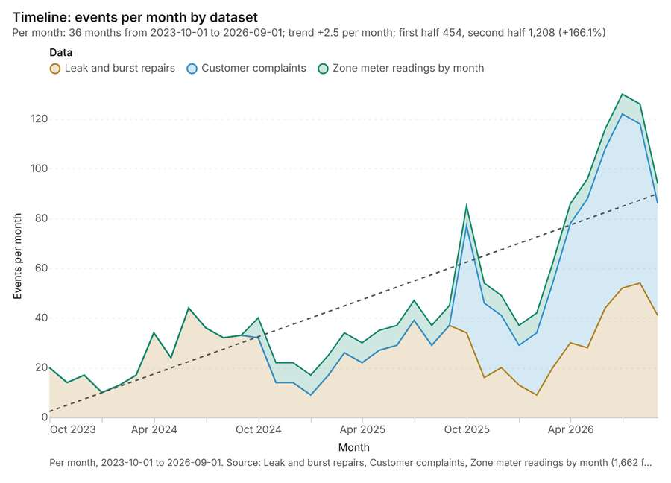
Figure 1. Timeline: events per month by dataset [1]. Per month, 2023-10-01 to 2026-09-01. Source: Leak and burst repairs, Customer complaints, Zone meter readings by month (1,662 features). The data is in the appendix.
The timeline counts 1,662 dated events in Leak and burst repairs, Customer complaints, Zone meter readings by month per month, from October 2023 to September 2026 [1][2][3][4]. By dataset: Leak and burst repairs 950; Customer complaints 520; Zone meter readings by month 192 [1]. The trend is +2.5 events per month; the second half of the months has 1,208 against 454 in the first (+166.1%) [1].
Busiest months
- July 2026: 130 events [1]
- August 2026: 126 events [1]
- June 2026: 116 events [1]
Quietest months
- January 2024: 10 events [1]
- February 2024: 13 events [1]
- November 2023: 14 events [1]

Space time hot spots
What this analysis is. Emerging hot spots: Where hot spots are new, consecutive, intensifying, persistent, diminishing, sporadic, oscillating or historical over time [5]. In ArcGIS it is Emerging Hot Spot Analysis or Create Space Time Cube [5].
Why it was run on this data. Leak and burst repairs carry dates in 'reported_at': emerging hot spot analysis finds new, intensifying and fading hot spots per month [6].
What it found. The analysis generated 1 layer saved named Emerging hot spots: Leak and burst repairs [7]. Processing the Leak and burst repairs data [8] resulted in a count of 71 features [7]. In total, 950 features were used during this execution [7], which took an elapsed time of 19 ms [7]. The billing cost for this operation was 0.1475 [7].
Result | Value
result, count | 71
result, elapsed ms | 19
result, resolution | 8
result, features used | 950
result, time neighbors | 0
billing, cost | 0.1475
billing, list price | 0.1475
billing, upstream cost | 0

Findings
- Evidenced: Space time hot spots on Leak and burst repairs: Emerging hot spots: 1 layer saved: Emerging hot spots: Leak and burst repairs (71 features) [7][8].
- Evidenced: It reported result, count 71; result, elapsed ms 19; result, resolution 8; result, features used 950; result, time neighbors 0; billing, cost 0.1475 [7].
Tool gp_space_time_hot_spots; parameters {"project": "0f6d1895-598a-4c17-a195-fc538533c4a3", "features": {"layer": "Leak and burst repairs (7e6cb18c)"}, "interval": "month", "bin_shape": "h3", "resolution": 8, "time_field": "reported_at"}

Space time hot spots
What this analysis is. Emerging hot spots: Where hot spots are new, consecutive, intensifying, persistent, diminishing, sporadic, oscillating or historical over time [5]. In ArcGIS it is Emerging Hot Spot Analysis or Create Space Time Cube [5].
Why it was run on this data. Customer complaints carry dates in 'date': emerging hot spot analysis finds new, intensifying and fading hot spots per week [9].
What it found. Space time hot spots on Customer complaints: Emerging hot spots: 1 layer saved: Emerging hot spots: Customer complaints (75 features) [10][11]. It reported result, count 75; result, elapsed ms 15; result, resolution 8; result, features used 520; result, time neighbors 0; billing, cost 0.126 [10].
Result | Value
result, count | 75
result, elapsed ms | 15
result, resolution | 8
result, features used | 520
result, time neighbors | 0
billing, cost | 0.126
billing, list price | 0.126
billing, upstream cost | 0

Findings
- Evidenced: Space time hot spots on Customer complaints: Emerging hot spots: 1 layer saved: Emerging hot spots: Customer complaints (75 features) [10][11].
- Evidenced: It reported result, count 75; result, elapsed ms 15; result, resolution 8; result, features used 520; result, time neighbors 0; billing, cost 0.126 [10].
Tool gp_space_time_hot_spots; parameters {"project": "0f6d1895-598a-4c17-a195-fc538533c4a3", "features": {"layer": "Customer complaints (56e8a858)"}, "interval": "week", "bin_shape": "h3", "resolution": 8, "time_field": "date"}

Hot spots
What this analysis is. Hot spot analysis: Getis-Ord Gi* hot and cold spots with z-scores, p-values and confidence bins [12]. In ArcGIS it is Find Hot Spots or Hot Spot Analysis (Getis-Ord Gi*); in QGIS, qgis:hotspot (plugin) [12].
Why it was run on this data. 300 points: Getis-Ord Gi* tests whether the concentrations in Valves are statistically significant [13].
What it found. Hot spots on Valves: Hot spot analysis: 1 layer saved: Hot spot analysis: Valves (53 features) [14][15]. It reported result, bins 53; result, count 53; result, elapsed ms 6; result, cell size m 1,000; result, incidents used 300; result, distance band m 1,000 [14].
Result | Value
result, bins | 53
result, count | 53
result, elapsed ms | 6
result, cell size m | 1,000
result, incidents used | 300
result, distance band m | 1,000
billing, cost | 0.056
billing, list price | 0.056
billing, upstream cost | 0

Findings
- Evidenced: Hot spots on Valves: Hot spot analysis: 1 layer saved: Hot spot analysis: Valves (53 features) [14][15].
- Evidenced: It reported result, bins 53; result, count 53; result, elapsed ms 6; result, cell size m 1,000; result, incidents used 300; result, distance band m 1,000 [14].
Tool gp_hot_spots; parameters {"project": "0f6d1895-598a-4c17-a195-fc538533c4a3", "features": {"layer": "Valves (c6aecae7)"}, "aggregation": "hexagon", "cell_size_m": 1000.0, "distance_band_m": 1000.0}

Hot spots
What this analysis is. Hot spot analysis: Getis-Ord Gi* hot and cold spots with z-scores, p-values and confidence bins [12]. In ArcGIS it is Find Hot Spots or Hot Spot Analysis (Getis-Ord Gi*); in QGIS, qgis:hotspot (plugin) [12].
Why it was run on this data. 950 points: Getis-Ord Gi* tests whether the concentrations in Leak and burst repairs are statistically significant [16].
What it found. Hot spots on Leak and burst repairs: Hot spot analysis: 1 layer saved: Hot spot analysis: Leak and burst repairs (184 features) [8][17]. It reported result, bins 184; result, count 184; result, elapsed ms 11; result, cell size m 500; result, incidents used 950; result, distance band m 500 [17].
Result | Value
result, bins | 184
result, count | 184
result, elapsed ms | 11
result, cell size m | 500
result, incidents used | 950
result, distance band m | 500
billing, cost | 0.069
billing, list price | 0.069
billing, upstream cost | 0

Findings
- Evidenced: Hot spots on Leak and burst repairs: Hot spot analysis: 1 layer saved: Hot spot analysis: Leak and burst repairs (184 features) [8][17].
- Evidenced: It reported result, bins 184; result, count 184; result, elapsed ms 11; result, cell size m 500; result, incidents used 950; result, distance band m 500 [17].
Tool gp_hot_spots; parameters {"project": "0f6d1895-598a-4c17-a195-fc538533c4a3", "features": {"layer": "Leak and burst repairs (7e6cb18c)"}, "aggregation": "hexagon", "cell_size_m": 500.0, "distance_band_m": 500.0}

Hot spots
What this analysis is. Hot spot analysis: Getis-Ord Gi* hot and cold spots with z-scores, p-values and confidence bins [12]. In ArcGIS it is Find Hot Spots or Hot Spot Analysis (Getis-Ord Gi*); in QGIS, qgis:hotspot (plugin) [12].
Why it was run on this data. 520 points: Getis-Ord Gi* tests whether the concentrations in Customer complaints are statistically significant [18].
What it found. Hot spots on Customer complaints: Hot spot analysis: 1 layer saved: Hot spot analysis: Customer complaints (185 features) [11][19]. It reported result, bins 185; result, count 185; result, elapsed ms 9; result, cell size m 500; result, incidents used 520; result, distance band m 500 [19].
Result | Value
result, bins | 185
result, count | 185
result, elapsed ms | 9
result, cell size m | 500
result, incidents used | 520
result, distance band m | 500
billing, cost | 0.0604
billing, list price | 0.0604
billing, upstream cost | 0

Findings
- Evidenced: Hot spots on Customer complaints: Hot spot analysis: 1 layer saved: Hot spot analysis: Customer complaints (185 features) [11][19].
- Evidenced: It reported result, bins 185; result, count 185; result, elapsed ms 9; result, cell size m 500; result, incidents used 520; result, distance band m 500 [19].
Tool gp_hot_spots; parameters {"project": "0f6d1895-598a-4c17-a195-fc538533c4a3", "features": {"layer": "Customer complaints (56e8a858)"}, "aggregation": "hexagon", "cell_size_m": 500.0, "distance_band_m": 500.0}

Calculate density
What this analysis is. Calculate density: Kernel density per square kilometer on a grid [20]. In ArcGIS it is Calculate Density or Kernel Density; in QGIS, native:heatmapkerneldensityestimation [20].
Why it was run on this data. 300 points in Valves: a density surface shows where they concentrate [21].
What it found. Calculate density on Valves: Calculate density: 1 layer saved: Calculate density: Valves (257 features) [15][22]. It reported result, count 257; result, elapsed ms 9; result, bandwidth m 1,000; result, cell size m 500; result, excluded null 0; result, max density per km2 14.42 [22].
Result | Value
result, count | 257
result, elapsed ms | 9
result, bandwidth m | 1,000
result, cell size m | 500
result, excluded null | 0
result, max density per km2 | 14.42
billing, cost | 0.056
billing, list price | 0.056
billing, upstream cost | 0

Findings
- Evidenced: Calculate density on Valves: Calculate density: 1 layer saved: Calculate density: Valves (257 features) [15][22].
- Evidenced: It reported result, count 257; result, elapsed ms 9; result, bandwidth m 1,000; result, cell size m 500; result, excluded null 0; result, max density per km2 14.42 [22].
Tool gp_calculate_density; parameters {"kernel": "quartic", "project": "0f6d1895-598a-4c17-a195-fc538533c4a3", "features": {"layer": "Valves (c6aecae7)"}, "bandwidth_m": 1000.0, "cell_size_m": 500.0}

Calculate density
What this analysis is. Calculate density: Kernel density per square kilometer on a grid [20]. In ArcGIS it is Calculate Density or Kernel Density; in QGIS, native:heatmapkerneldensityestimation [20].
Why it was run on this data. 950 points in Leak and burst repairs: a density surface shows where they concentrate [23].
What it found. The density calculation utilized the Leak and burst repairs data [8], resulting in 1,220 features [24]. The analysis determined that the maximum density observed was 133.9 per km2 [24].
Result | Value
result, count | 1,220
result, elapsed ms | 36
result, bandwidth m | 500
result, cell size m | 200
result, excluded null | 0
result, max density per km2 | 133.9
billing, cost | 0.069
billing, list price | 0.069
billing, upstream cost | 0

Findings
- Evidenced: Calculate density on Leak and burst repairs: Calculate density: 1 layer saved: Calculate density: Leak and burst repairs (1220 features) [8][24].
- Evidenced: It reported result, count 1,220; result, elapsed ms 36; result, bandwidth m 500; result, cell size m 200; result, excluded null 0; result, max density per km2 133.9 [24].
Tool gp_calculate_density; parameters {"kernel": "quartic", "project": "0f6d1895-598a-4c17-a195-fc538533c4a3", "features": {"layer": "Leak and burst repairs (7e6cb18c)"}, "bandwidth_m": 500.0, "cell_size_m": 200.0}

Calculate density
What this analysis is. Calculate density: Kernel density per square kilometer on a grid [20]. In ArcGIS it is Calculate Density or Kernel Density; in QGIS, native:heatmapkerneldensityestimation [20].
Why it was run on this data. 520 points in Customer complaints: a density surface shows where they concentrate [25].
What it found. Calculate density on Customer complaints: Calculate density: 1 layer saved: Calculate density: Customer complaints (1200 features) [11][26]. It reported result, count 1,200; result, elapsed ms 34; result, bandwidth m 500; result, cell size m 200; result, excluded null 0; result, max density per km2 55.38 [26].
Result | Value
result, count | 1,200
result, elapsed ms | 34
result, bandwidth m | 500
result, cell size m | 200
result, excluded null | 0
result, max density per km2 | 55.38
billing, cost | 0.0604
billing, list price | 0.0604
billing, upstream cost | 0

Findings
- Evidenced: Calculate density on Customer complaints: Calculate density: 1 layer saved: Calculate density: Customer complaints (1200 features) [11][26].
- Evidenced: It reported result, count 1,200; result, elapsed ms 34; result, bandwidth m 500; result, cell size m 200; result, excluded null 0; result, max density per km2 55.38 [26].
Tool gp_calculate_density; parameters {"kernel": "quartic", "project": "0f6d1895-598a-4c17-a195-fc538533c4a3", "features": {"layer": "Customer complaints (56e8a858)"}, "bandwidth_m": 500.0, "cell_size_m": 200.0}

Summarize within
What this analysis is. Summarize within: Count and aggregate the features inside each polygon (or bin), proportionally for lines and polygons [27]. In ArcGIS it is Summarize Within or Aggregate Points; in QGIS, native:countpointsinpolygon or native:sumlinelengths [27].
Why it was run on this data. Count Valves inside each feature of Pressure zones by type; the counts map as a choropleth (natural breaks, sequential colors) [28].
What it found. Summarize within on Valves, Pressure zones: Summarize within: 1 layer saved: Summarize within: Pressure zones (8 features) [15][29][30]. It reported result, count 8; result, elapsed ms 1; billing, cost 0.01618; billing, list price 0.01618; billing, upstream cost 0 [29].
Result | Value
result, count | 8
result, elapsed ms | 1
billing, cost | 0.01618
billing, list price | 0.01618
billing, upstream cost | 0

Findings
- Evidenced: Summarize within on Valves, Pressure zones: Summarize within: 1 layer saved: Summarize within: Pressure zones (8 features) [15][29][30].
- Evidenced: It reported result, count 8; result, elapsed ms 1; billing, cost 0.01618; billing, list price 0.01618; billing, upstream cost 0 [29].
Tool gp_summarize_within; parameters {"stats": [{"stat": "sum", "field": "exercised_year"}], "project": "0f6d1895-598a-4c17-a195-fc538533c4a3", "features": {"layer": "Valves (c6aecae7)"}, "group_by": "type", "polygons": {"layer": "Pressure zones (a4c55d18)"}}

Summarize within
What this analysis is. Summarize within: Count and aggregate the features inside each polygon (or bin), proportionally for lines and polygons [27]. In ArcGIS it is Summarize Within or Aggregate Points; in QGIS, native:countpointsinpolygon or native:sumlinelengths [27].
Why it was run on this data. Count Valves inside each feature of Pressure zones by type; the counts map as a choropleth (natural breaks, sequential colors) [28].
What it found. Summarize within on Leak and burst repairs, Pressure zones: Summarize within: 1 layer saved: Summarize within: Pressure zones (8 features) [8][30][31]. It reported result, count 8; result, elapsed ms 2; billing, cost 0.02918; billing, list price 0.02918; billing, upstream cost 0 [31].
Result | Value
result, count | 8
result, elapsed ms | 2
billing, cost | 0.02918
billing, list price | 0.02918
billing, upstream cost | 0

Findings
- Evidenced: Summarize within on Leak and burst repairs, Pressure zones: Summarize within: 1 layer saved: Summarize within: Pressure zones (8 features) [8][30][31].
- Evidenced: It reported result, count 8; result, elapsed ms 2; billing, cost 0.02918; billing, list price 0.02918; billing, upstream cost 0 [31].
Tool gp_summarize_within; parameters {"stats": [{"stat": "sum", "field": "water_lost_kl"}], "project": "0f6d1895-598a-4c17-a195-fc538533c4a3", "features": {"layer": "Leak and burst repairs (7e6cb18c)"}, "group_by": "type", "polygons": {"layer": "Pressure zones (a4c55d18)"}}

Summarize within
What this analysis is. Summarize within: Count and aggregate the features inside each polygon (or bin), proportionally for lines and polygons [27]. In ArcGIS it is Summarize Within or Aggregate Points; in QGIS, native:countpointsinpolygon or native:sumlinelengths [27].
Why it was run on this data. Count Valves inside each feature of Pressure zones by type; the counts map as a choropleth (natural breaks, sequential colors) [28].
What it found. Summarize within on Customer complaints, Pressure zones: Summarize within: 1 layer saved: Summarize within: Pressure zones (8 features) [11][30][32]. It reported result, count 8; result, elapsed ms 1; billing, cost 0.02056; billing, list price 0.02056; billing, upstream cost 0 [32].
Result | Value
result, count | 8
result, elapsed ms | 1
billing, cost | 0.02056
billing, list price | 0.02056
billing, upstream cost | 0

Findings
- Evidenced: Summarize within on Customer complaints, Pressure zones: Summarize within: 1 layer saved: Summarize within: Pressure zones (8 features) [11][30][32].
- Evidenced: It reported result, count 8; result, elapsed ms 1; billing, cost 0.02056; billing, list price 0.02056; billing, upstream cost 0 [32].
Tool gp_summarize_within; parameters {"stats": [], "project": "0f6d1895-598a-4c17-a195-fc538533c4a3", "features": {"layer": "Customer complaints (56e8a858)"}, "group_by": "issue", "polygons": {"layer": "Pressure zones (a4c55d18)"}}

Find point clusters
What this analysis is. Find point clusters: Density-based clusters (DBSCAN, HDBSCAN or OPTICS, optionally space-time) with hulls and noise [33]. In ArcGIS it is Find Point Clusters or Density-based Clustering; in QGIS, native:dbscanclustering or native:stdbscanclustering [33].
Why it was run on this data. DBSCAN finds dense groups of Valves and separates noise [34].
What it found. The analysis utilized the `gp_find_point_clusters` tool [35] with Valves data as the input [15]. This process saved two resulting layers: Find point clusters: Valves with 300 features, and Find point clusters: cluster hulls with 11 features [35].
Result | Value
result, count | 300
result, noise | 114
result, distance m | 500
result, elapsed ms | 8
result, min points | 8
billing, cost | 0.056
billing, list price | 0.056
billing, upstream cost | 0

Findings
- Evidenced: Find point clusters on Valves: Find point clusters: 2 layers saved: Find point clusters: Valves (300 features); Find point clusters: cluster hulls (11 features) [15][35].
- Evidenced: It reported result, count 300; result, noise 114; result, distance m 500; result, elapsed ms 8; result, min points 8; billing, cost 0.056 [35].
Tool gp_find_point_clusters; parameters {"method": "dbscan", "project": "0f6d1895-598a-4c17-a195-fc538533c4a3", "features": {"layer": "Valves (c6aecae7)"}, "distance_m": 500.0, "min_points": 8}

Find point clusters
What this analysis is. Find point clusters: Density-based clusters (DBSCAN, HDBSCAN or OPTICS, optionally space-time) with hulls and noise [33]. In ArcGIS it is Find Point Clusters or Density-based Clustering; in QGIS, native:dbscanclustering or native:stdbscanclustering [33].
Why it was run on this data. DBSCAN finds dense groups of Leak and burst repairs and separates noise [36].
What it found. Find point clusters on Leak and burst repairs: Find point clusters: 2 layers saved: Find point clusters: Leak and burst repairs (950 features); Find point clusters: cluster hulls (3 features) [8][37]. It reported result, count 950; result, noise 830; result, distance m 200; result, elapsed ms 12; result, min points 20; billing, cost 0.069 [37].
Result | Value
result, count | 950
result, noise | 830
result, distance m | 200
result, elapsed ms | 12
result, min points | 20
billing, cost | 0.069
billing, list price | 0.069
billing, upstream cost | 0

Findings
- Evidenced: Find point clusters on Leak and burst repairs: Find point clusters: 2 layers saved: Find point clusters: Leak and burst repairs (950 features); Find point clusters: cluster hulls (3 features) [8][37].
- Evidenced: It reported result, count 950; result, noise 830; result, distance m 200; result, elapsed ms 12; result, min points 20; billing, cost 0.069 [37].
Tool gp_find_point_clusters; parameters {"method": "dbscan", "project": "0f6d1895-598a-4c17-a195-fc538533c4a3", "features": {"layer": "Leak and burst repairs (7e6cb18c)"}, "distance_m": 200.0, "min_points": 20}

Find point clusters
What this analysis is. Find point clusters: Density-based clusters (DBSCAN, HDBSCAN or OPTICS, optionally space-time) with hulls and noise [33]. In ArcGIS it is Find Point Clusters or Density-based Clustering; in QGIS, native:dbscanclustering or native:stdbscanclustering [33].
Why it was run on this data. DBSCAN finds dense groups of Customer complaints and separates noise [38].
What it found. Find point clusters on Customer complaints: Find point clusters: 2 layers saved: Find point clusters: Customer complaints (520 features); Find point clusters: cluster hulls (3 features) [11][39]. It reported result, count 520; result, noise 196; result, distance m 500; result, elapsed ms 8; result, min points 13; billing, cost 0.0604 [39].
Result | Value
result, count | 520
result, noise | 196
result, distance m | 500
result, elapsed ms | 8
result, min points | 13
billing, cost | 0.0604
billing, list price | 0.0604
billing, upstream cost | 0

Findings
- Evidenced: Find point clusters on Customer complaints: Find point clusters: 2 layers saved: Find point clusters: Customer complaints (520 features); Find point clusters: cluster hulls (3 features) [11][39].
- Evidenced: It reported result, count 520; result, noise 196; result, distance m 500; result, elapsed ms 8; result, min points 13; billing, cost 0.0604 [39].
Tool gp_find_point_clusters; parameters {"method": "dbscan", "project": "0f6d1895-598a-4c17-a195-fc538533c4a3", "features": {"layer": "Customer complaints (56e8a858)"}, "distance_m": 500.0, "min_points": 13}

Outliers
What this analysis is. Find outliers: Anselin local Moran’s I: HH, LL clusters and HL, LH outliers [40]. In ArcGIS it is Find Outliers or Cluster and Outlier Analysis (Anselin Local Moran’s I) [40].
Why it was run on this data. Local Moran's I maps clusters and outliers of 'connections' [41].
What it found. Outliers on Pressure zones: Find outliers: 1 layer saved: Find outliers: Pressure zones (8 features) [30][42]. It reported result, count 8; result, elapsed ms 3; result, permutations 199; result, excluded null 0; result, distance band m 2,338; billing, cost 0.05024 [42].
Result | Value
result, count | 8
result, elapsed ms | 3
result, permutations | 199
result, excluded null | 0
result, distance band m | 2,338
billing, cost | 0.05024
billing, list price | 0.05024
billing, upstream cost | 0

Findings
- Evidenced: Outliers on Pressure zones: Find outliers: 1 layer saved: Find outliers: Pressure zones (8 features) [30][42].
- Evidenced: It reported result, count 8; result, elapsed ms 3; result, permutations 199; result, excluded null 0; result, distance band m 2,338; billing, cost 0.05024 [42].
Tool gp_outliers; parameters {"field": "connections", "project": "0f6d1895-598a-4c17-a195-fc538533c4a3", "features": {"layer": "Pressure zones (a4c55d18)"}, "aggregation": "hexagon"}

Spatial autocorrelation
What this analysis is. Spatial autocorrelation: Global Moran’s I: is the pattern clustered, dispersed or random [43]. In ArcGIS it is Spatial Autocorrelation (Global Moran’s I) [43].
Why it was run on this data. Global Moran's I says whether similar values of 'connections' sit next to each other [44].
What it found. The gp_spatial_autocorrelation tool was executed using Pressure zones as input [30], [45].
Result | Value
result, n | 8
result, p value | 0.3743
result, z score | -0.8884
result, morans i | -0.3913
result, variance | 0.07821
result, elapsed ms | 1
result, expected i | -0.1429
result, excluded null | 0
result, distance band m | 2,338
result, p value normality | 0.3878
result, z score normality | -0.8636
result, variance normality | 0.08277
billing, cost | 0.02
billing, list price | 0.02
billing, upstream cost | 0

Findings
- Evidenced: Spatial autocorrelation on Pressure zones: Spatial autocorrelation: done; no map output [30][45].
- Evidenced: It reported result, n 8; result, p value 0.3743; result, z score -0.8884; result, morans i -0.3913; result, variance 0.07821; result, elapsed ms 1 [45].
Tool gp_spatial_autocorrelation; parameters {"field": "connections", "project": "0f6d1895-598a-4c17-a195-fc538533c4a3", "features": {"layer": "Pressure zones (a4c55d18)"}}

Near repeat
What this analysis is. Repeat and near repeat classification: Classify incidents as originators, repeats (same place) or near repeats within a distance and time window, with a Knox test table [46]. In ArcGIS it is Repeat and Near Repeat Classification or Near Repeat Calculator [46].
Why it was run on this data. Near repeat analysis tests whether Leak and burst repairs close in space also follow each other within 30 days [47].
What it found. Near repeat on Leak and burst repairs: Repeat and near repeat classification: 1 layer saved: Repeat and near repeat classification: Leak and burst repairs (950 features) [8][48]. It reported result, days 30; result, count 950; result, chains 114; result, distance m 200; result, elapsed ms 20; result, pairs linked 246 [48].
Result | Value
result, days | 30
result, count | 950
result, chains | 114
result, distance m | 200
result, elapsed ms | 20
result, pairs linked | 246
billing, cost | 0.0785
billing, list price | 0.0785
billing, upstream cost | 0

Findings
- Evidenced: Near repeat on Leak and burst repairs: Repeat and near repeat classification: 1 layer saved: Repeat and near repeat classification: Leak and burst repairs (950 features) [8][48].
- Evidenced: It reported result, days 30; result, count 950; result, chains 114; result, distance m 200; result, elapsed ms 20; result, pairs linked 246 [48].
Tool gp_near_repeat; parameters {"days": 30, "project": "0f6d1895-598a-4c17-a195-fc538533c4a3", "features": {"layer": "Leak and burst repairs (7e6cb18c)"}, "distance_m": 200.0, "time_field": "reported_at"}

Maps and charts
The run also made 20 map image(s) [49][50][51][52][53][54][55][56][57][58][59][60][61][62][63][64][65][66][67][68] and 27 chart(s) [69][70][71][72][73][74][75][76][77][78][79][80][81][82][83][84][85][86][87][88][89][90][91][92][93][94][95].
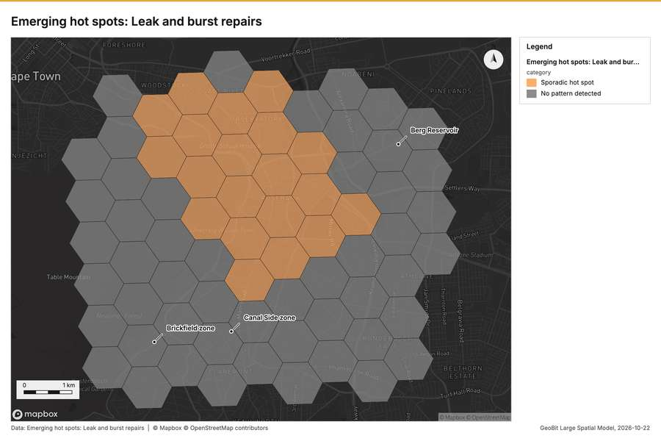
Figure 2. Emerging hot spots: Leak and burst repairs [49]
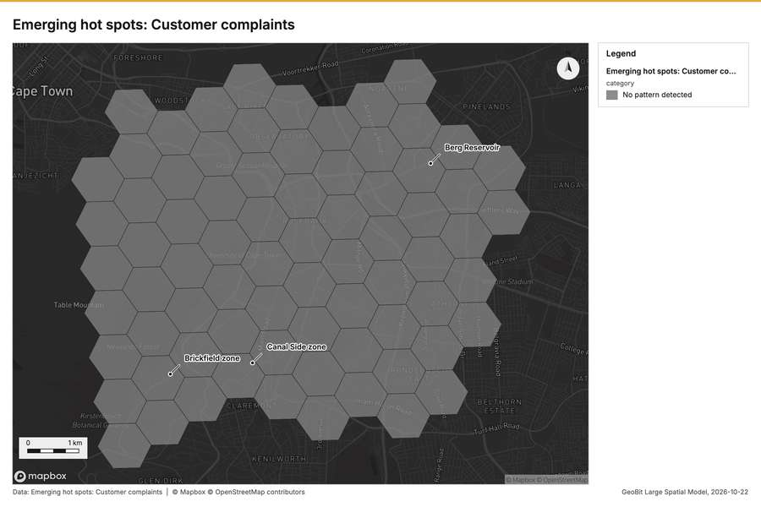
Figure 3. Emerging hot spots: Customer complaints [50]
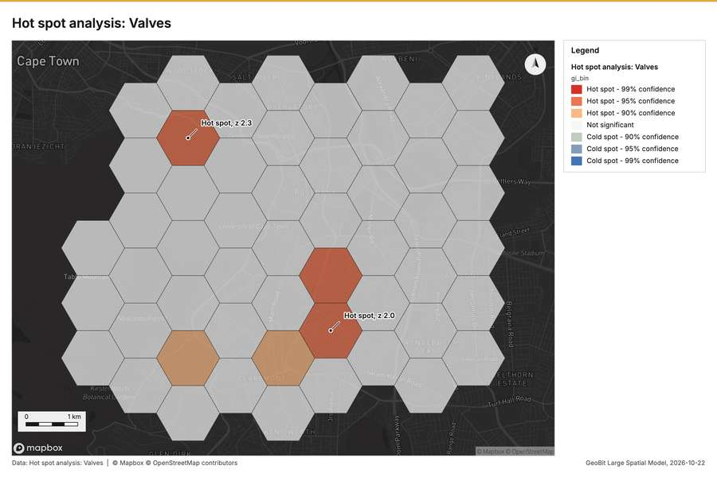
Figure 4. Hot spot analysis: Valves [51]
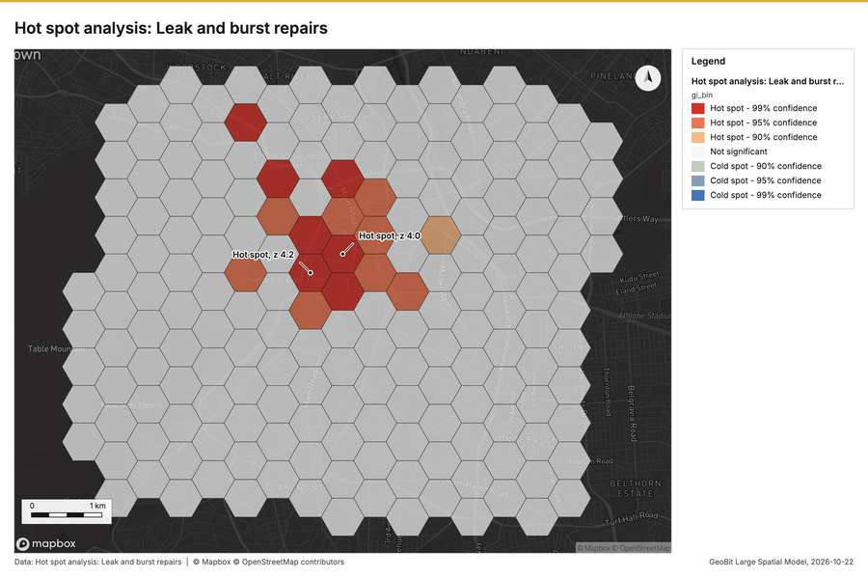
Figure 5. Hot spot analysis: Leak and burst repairs [52]
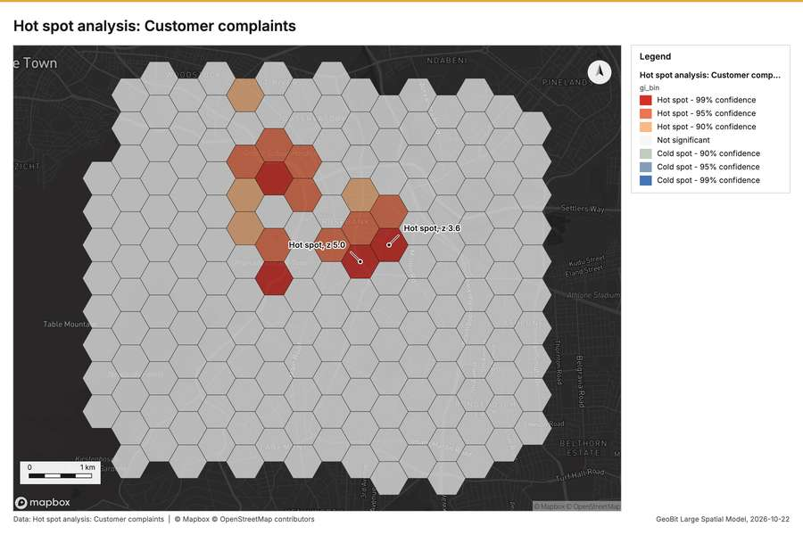
Figure 6. Hot spot analysis: Customer complaints [53]
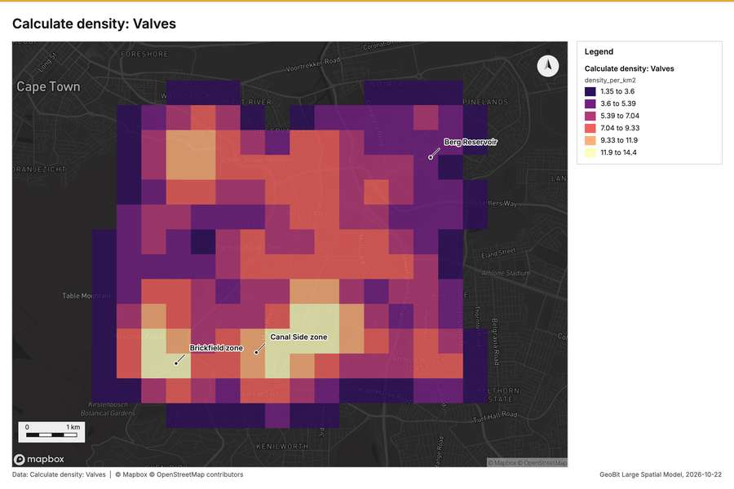
Figure 7. Calculate density: Valves [54]
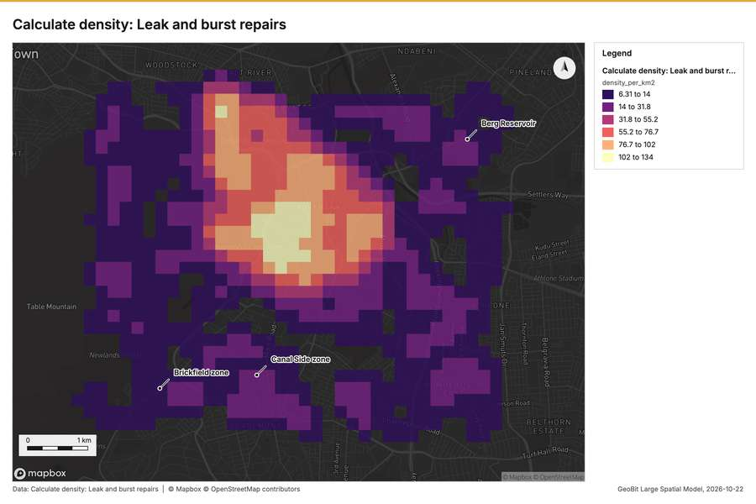
Figure 8. Calculate density: Leak and burst repairs [55]
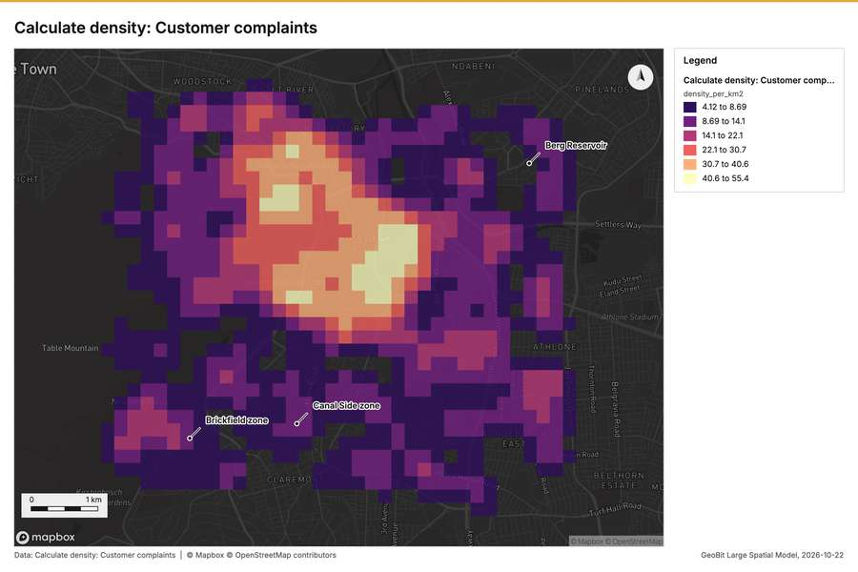
Figure 9. Calculate density: Customer complaints [56]
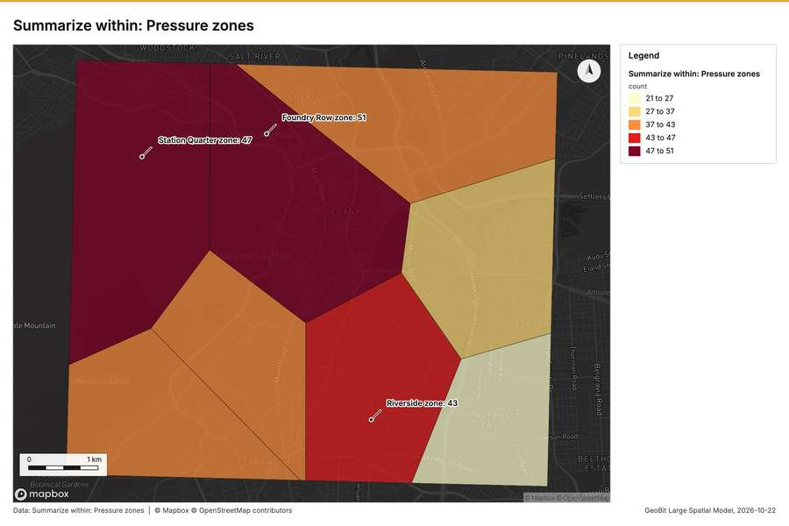
Figure 10. Summarize within: Pressure zones [57]
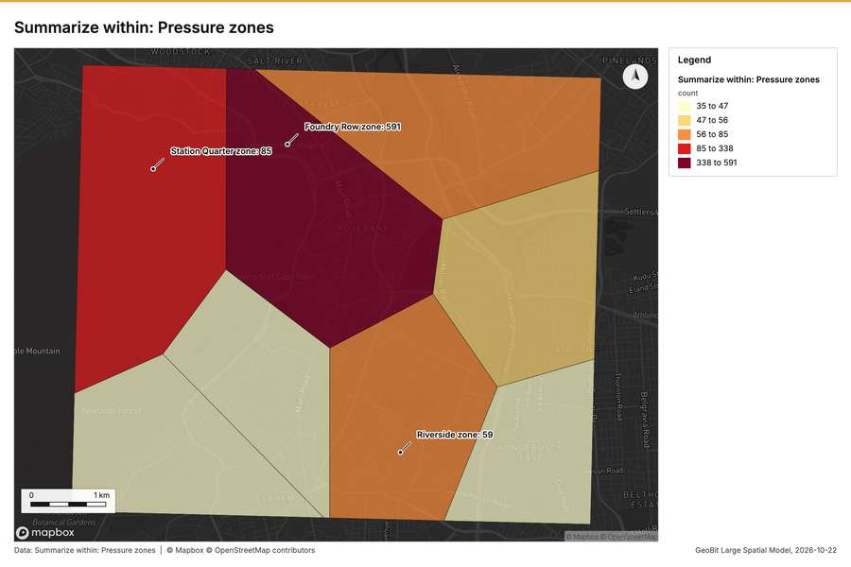
Figure 11. Summarize within: Pressure zones [58]
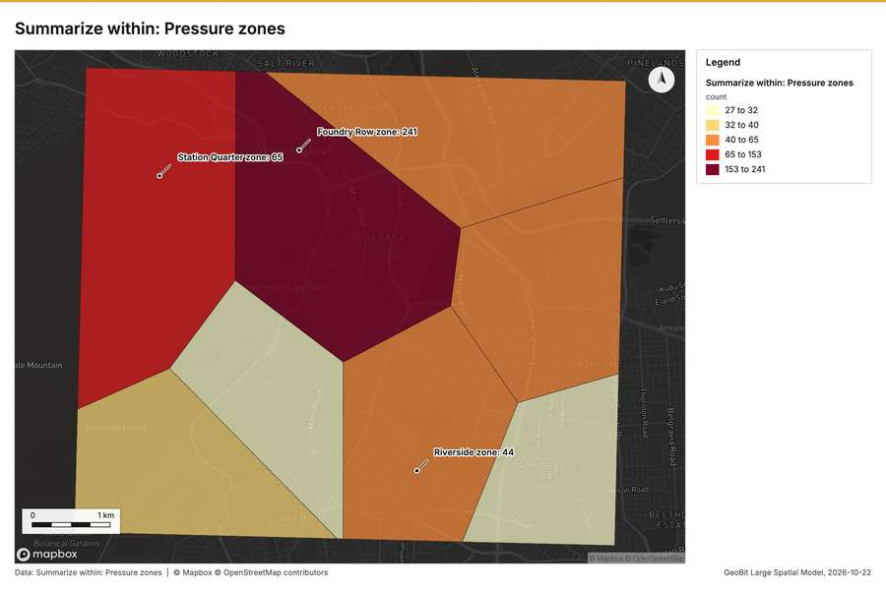
Figure 12. Summarize within: Pressure zones [59]
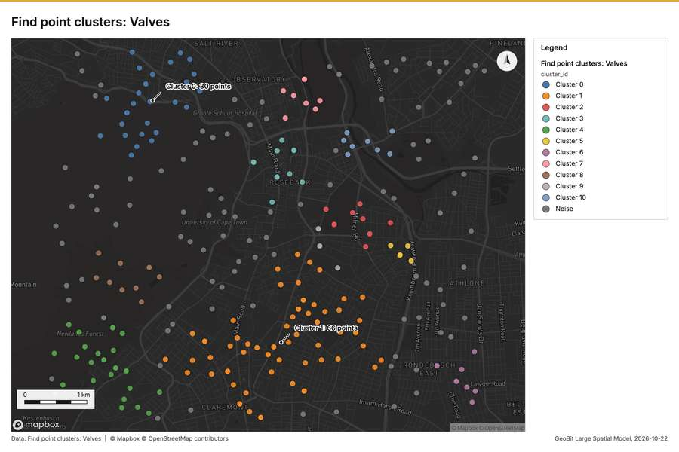
Figure 13. Find point clusters: Valves [60]
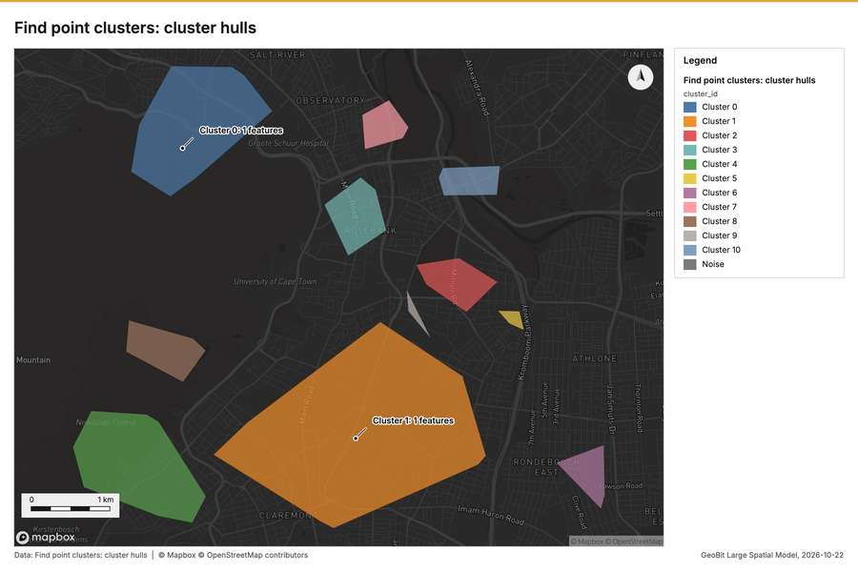
Figure 14. Find point clusters: cluster hulls [61]
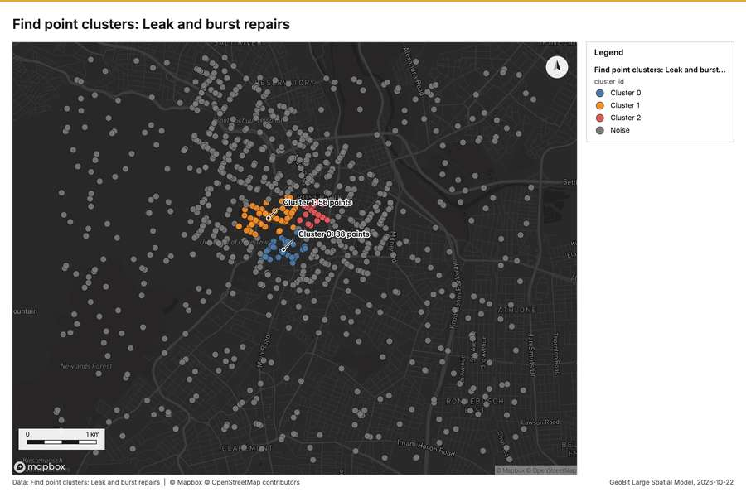
Figure 15. Find point clusters: Leak and burst repairs [62]
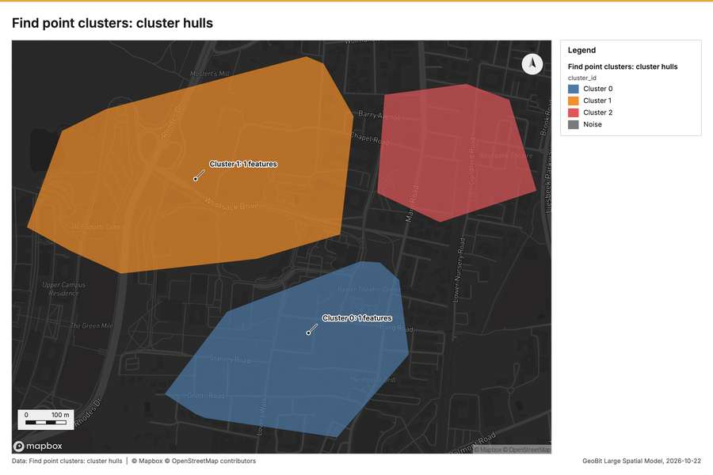
Figure 16. Find point clusters: cluster hulls [63]
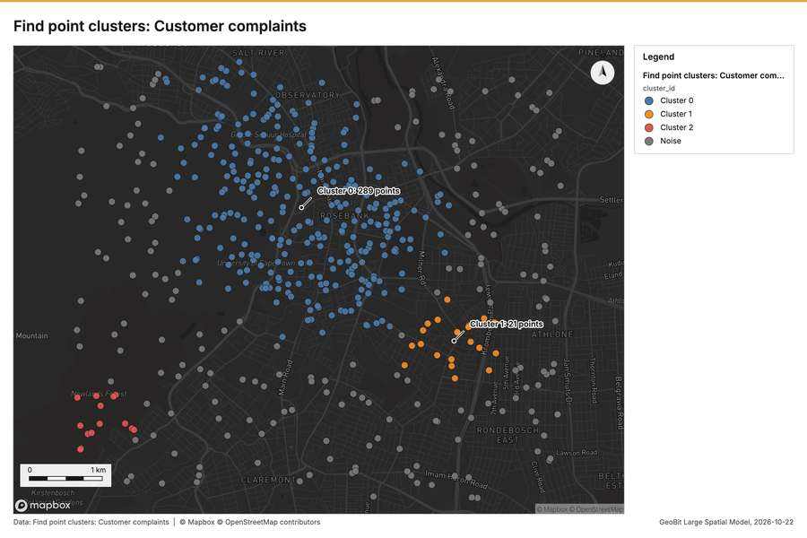
Figure 17. Find point clusters: Customer complaints [64]
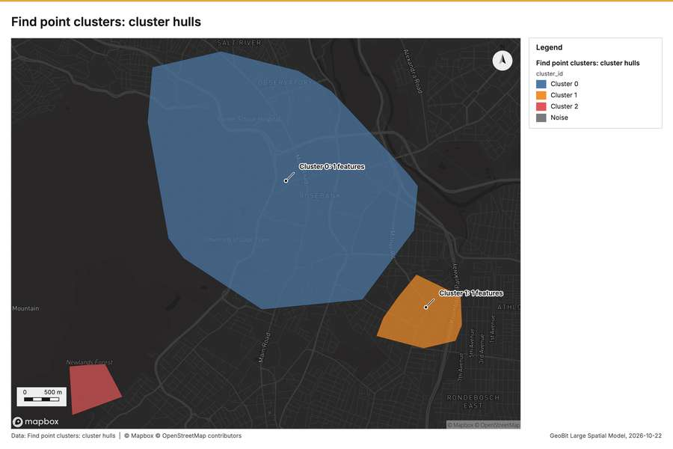
Figure 18. Find point clusters: cluster hulls [65]
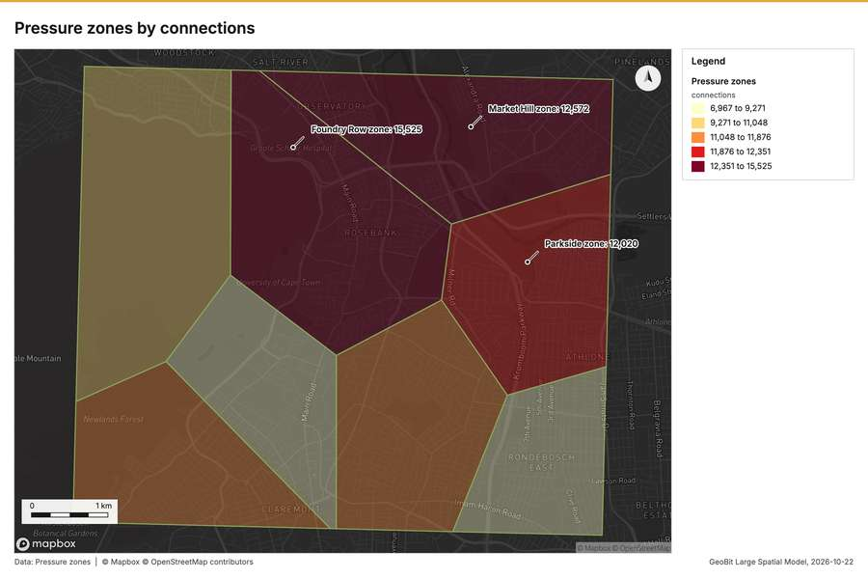
Figure 19. Pressure zones by connections [66]
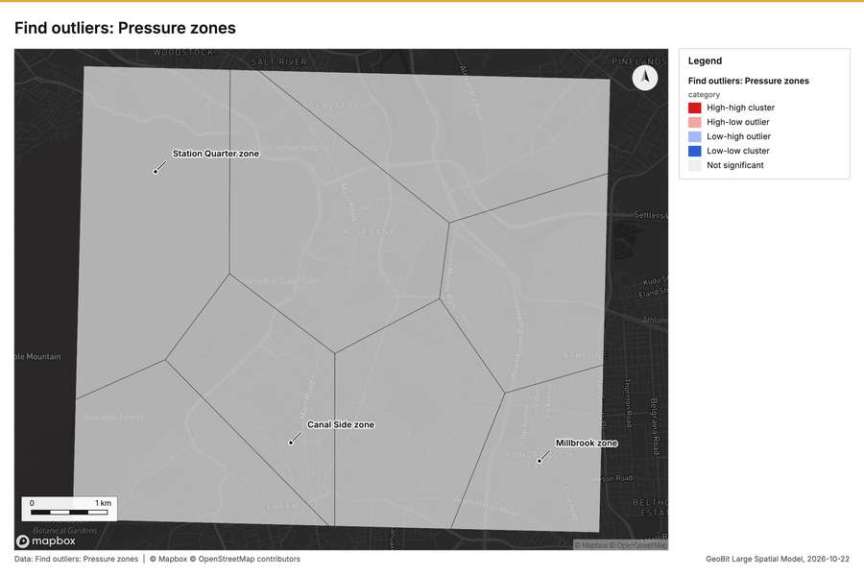
Figure 20. Find outliers: Pressure zones [67]
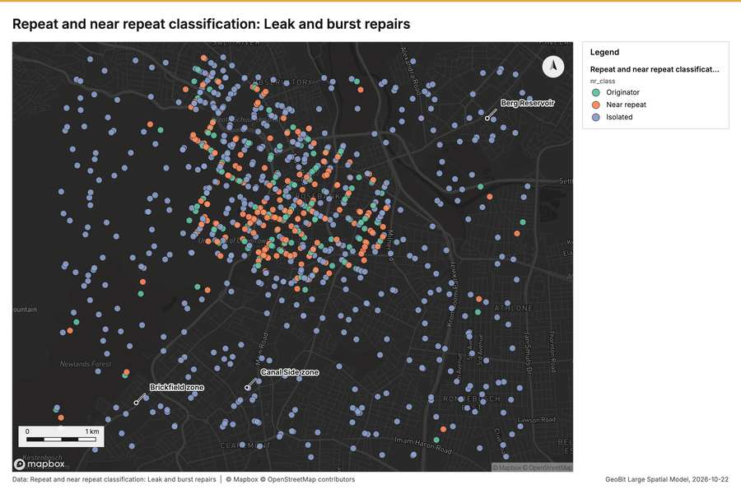
Figure 21. Repeat and near repeat classification: Leak and burst repairs [68]
What the map shows. The map displays emerging hot spots concerning leak and burst repairs, utilizing a classification of 'Sporadic hot spot' and 'No pattern detected.' A noticeable cluster of sporadic hot spots, indicated by the lighter orange coloring, is visible in the central-to-upper portion of the mapped area. In contrast, the majority of the tiles surrounding this central region are colored gray, corresponding to an absence of detected pattern. Overall, the analysis shows a localized concentration of repairs activity surrounded by areas where no significant spatial pattern was detected. [49]
Inferred: read from the image by gemma4:e4b, not evidence.
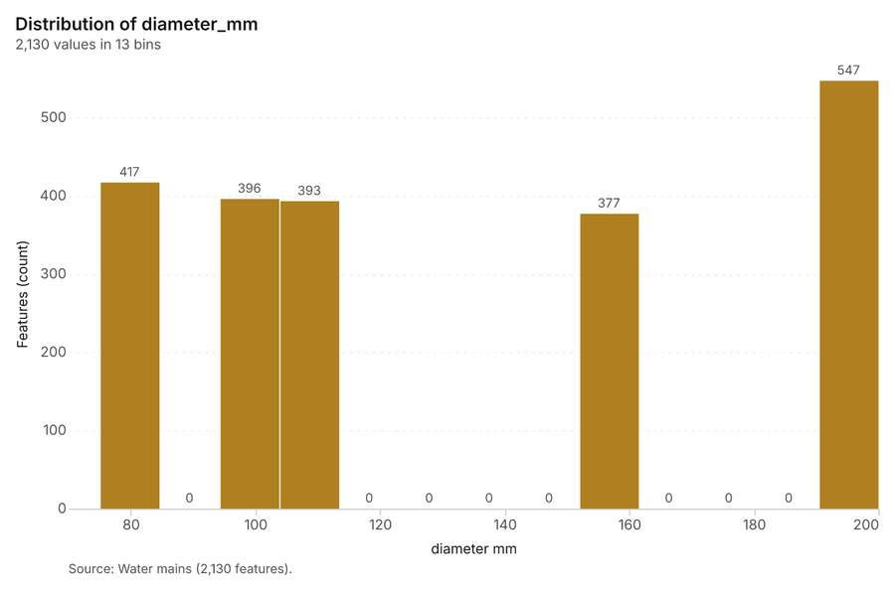
Figure 22. Water mains over time (install_year) [69]. Source: Water mains (2,130 features). The data is in the appendix.
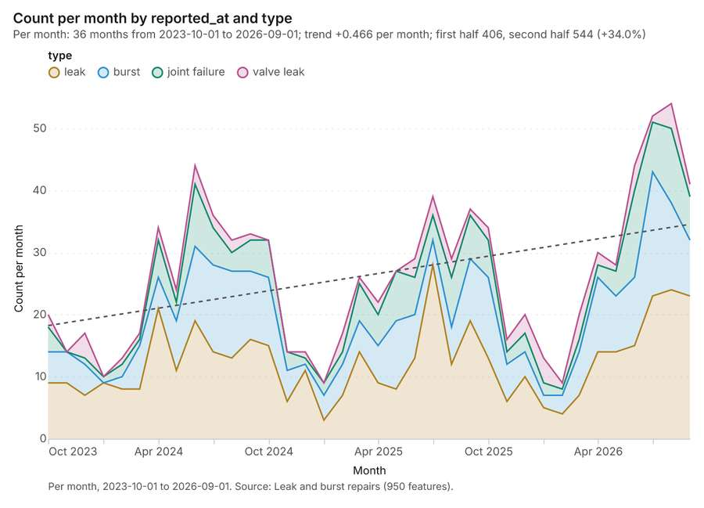
Figure 23. Leak and burst repairs over time (reported_at) [70]. Per month, 2023-10-01 to 2026-09-01. Source: Leak and burst repairs (950 features). The data is in the appendix.
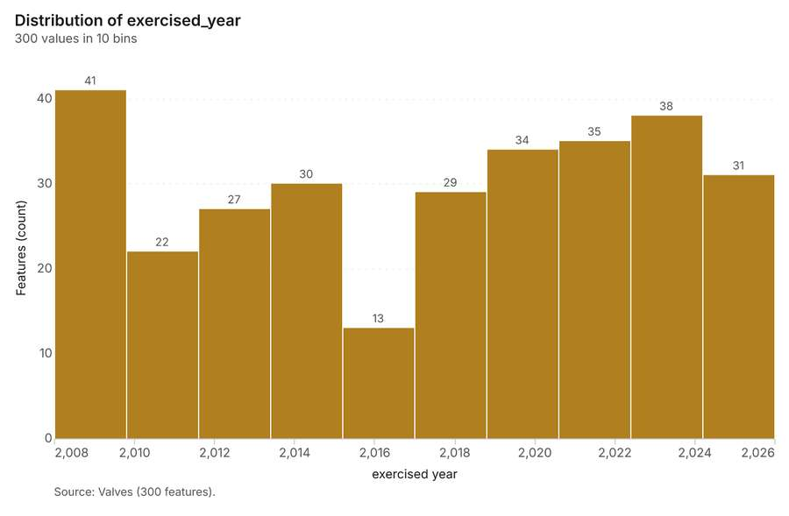
Figure 24. Valves over time (exercised_year) [71]. Source: Valves (300 features). The data is in the appendix.
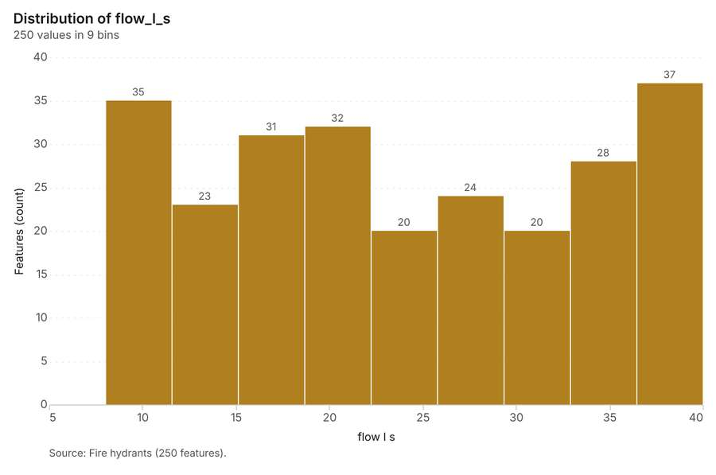
Figure 25. Fire hydrants over time (last_test_year) [72]. Source: Fire hydrants (250 features). The data is in the appendix.
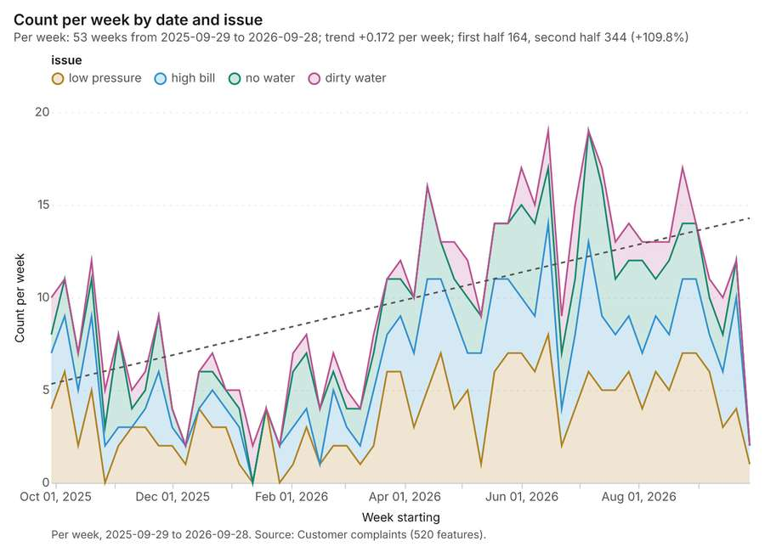
Figure 26. Customer complaints over time (date) [73]. Per week, 2025-09-29 to 2026-09-28. Source: Customer complaints (520 features). The data is in the appendix.
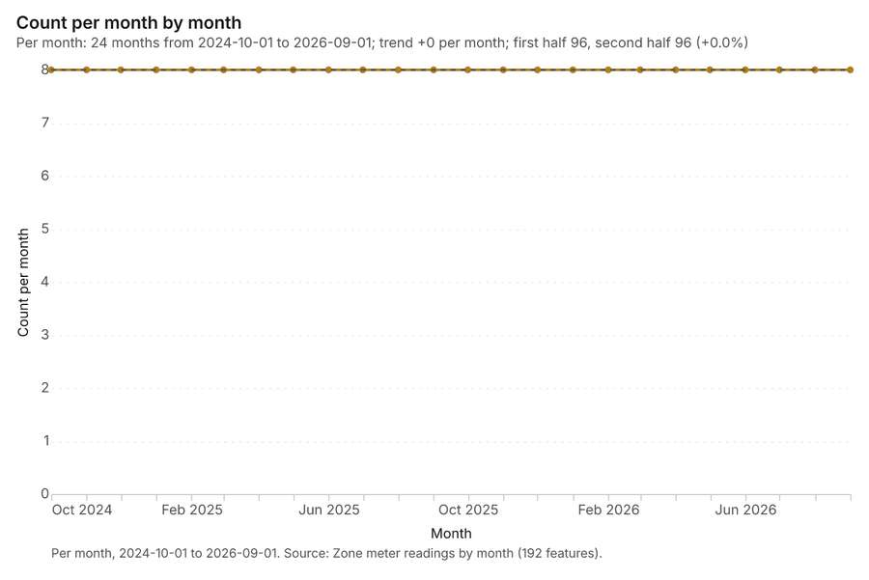
Figure 27. Zone meter readings by month over time (month) [74]. Per month, 2024-10-01 to 2026-09-01. Source: Zone meter readings by month (192 features). The data is in the appendix.
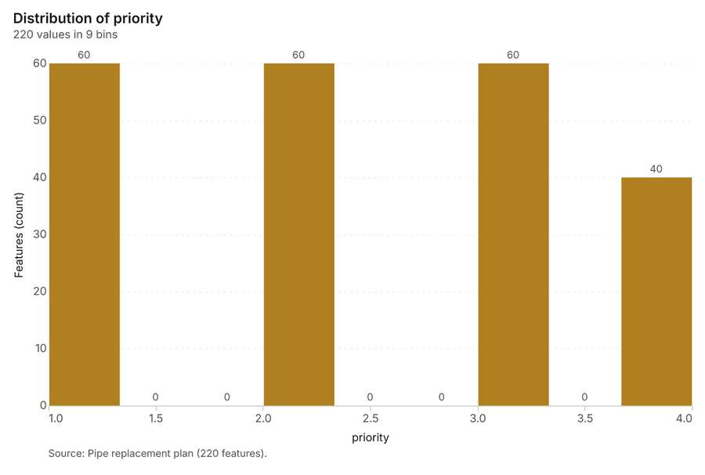
Figure 28. Pipe replacement plan over time (planned_year) [75]. Source: Pipe replacement plan (220 features). The data is in the appendix.
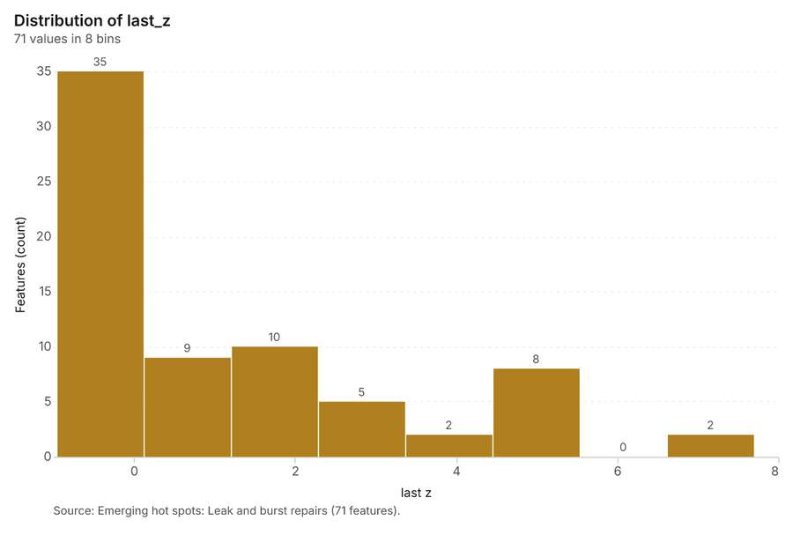
Figure 29. Emerging hot spots: Leak and burst repairs [76]. Source: Emerging hot spots: Leak and burst repairs (71 features). The data is in the appendix.
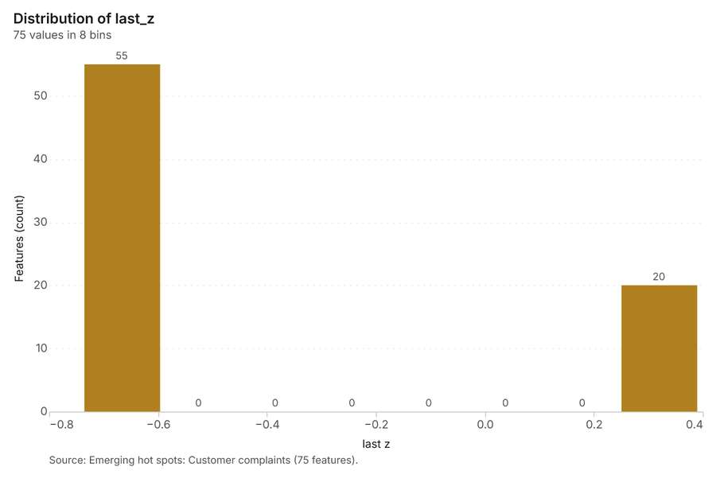
Figure 30. Emerging hot spots: Customer complaints [77]. Source: Emerging hot spots: Customer complaints (75 features). The data is in the appendix.
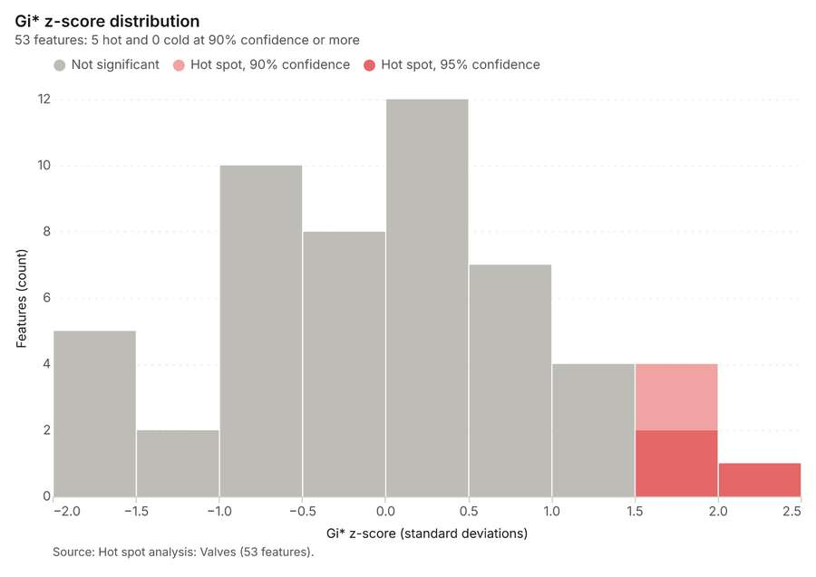
Figure 31. Hot spot analysis: Valves [78]. Source: Hot spot analysis: Valves (53 features). The data is in the appendix.
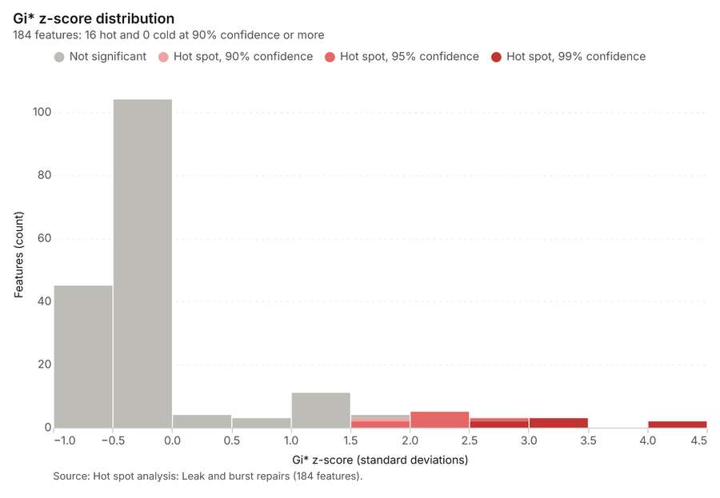
Figure 32. Hot spot analysis: Leak and burst repairs [79]. Source: Hot spot analysis: Leak and burst repairs (184 features). The data is in the appendix.
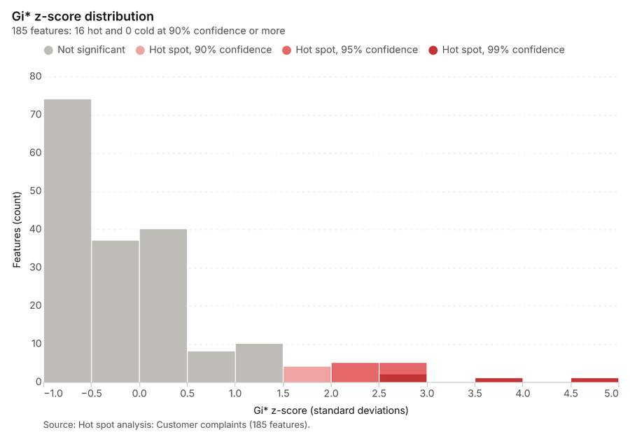
Figure 33. Hot spot analysis: Customer complaints [80]. Source: Hot spot analysis: Customer complaints (185 features). The data is in the appendix.
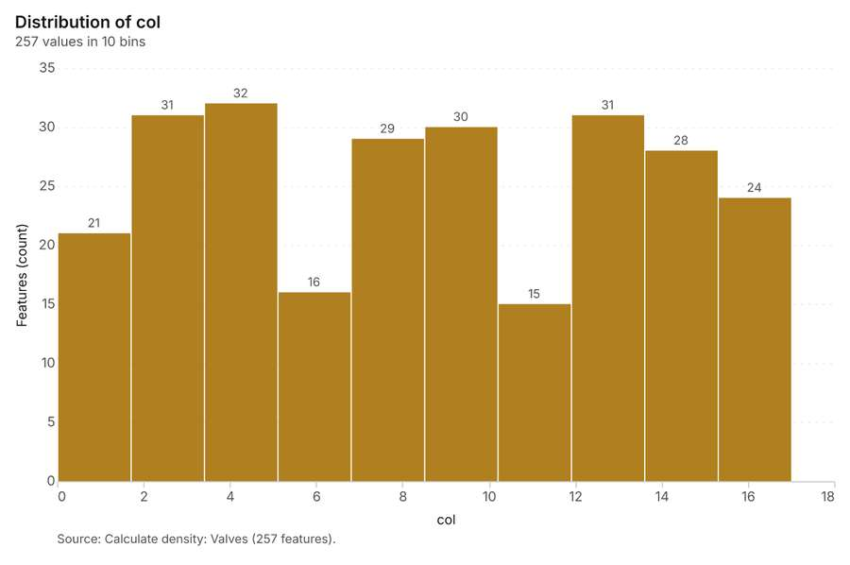
Figure 34. Calculate density: Valves [81]. Source: Calculate density: Valves (257 features). The data is in the appendix.
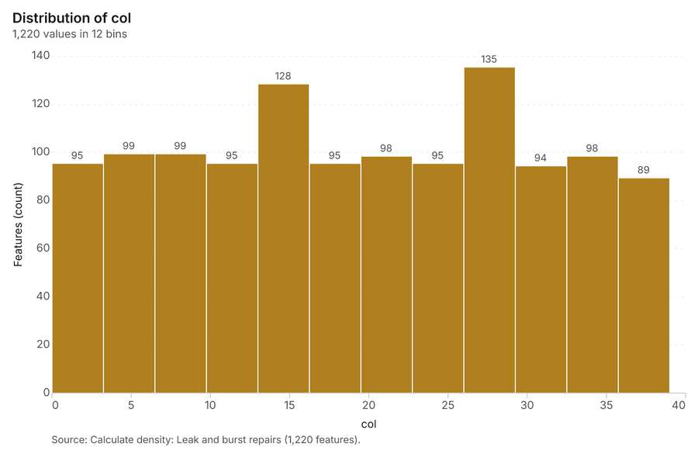
Figure 35. Calculate density: Leak and burst repairs [82]. Source: Calculate density: Leak and burst repairs (1,220 features). The data is in the appendix.
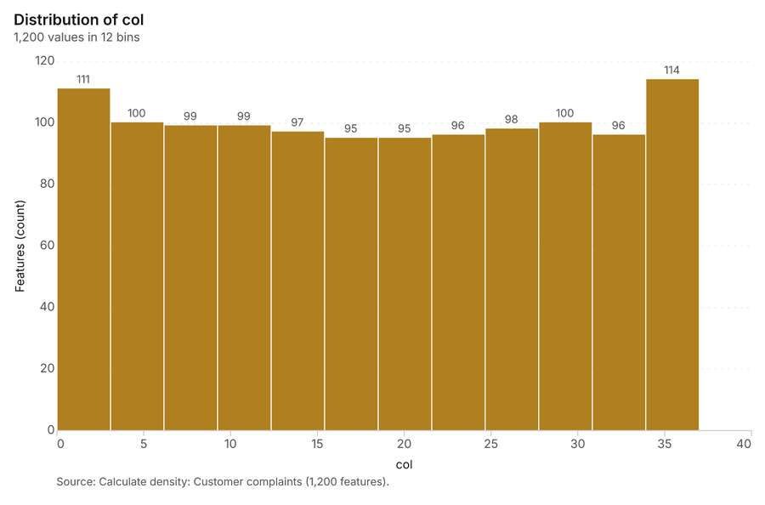
Figure 36. Calculate density: Customer complaints [83]. Source: Calculate density: Customer complaints (1,200 features). The data is in the appendix.
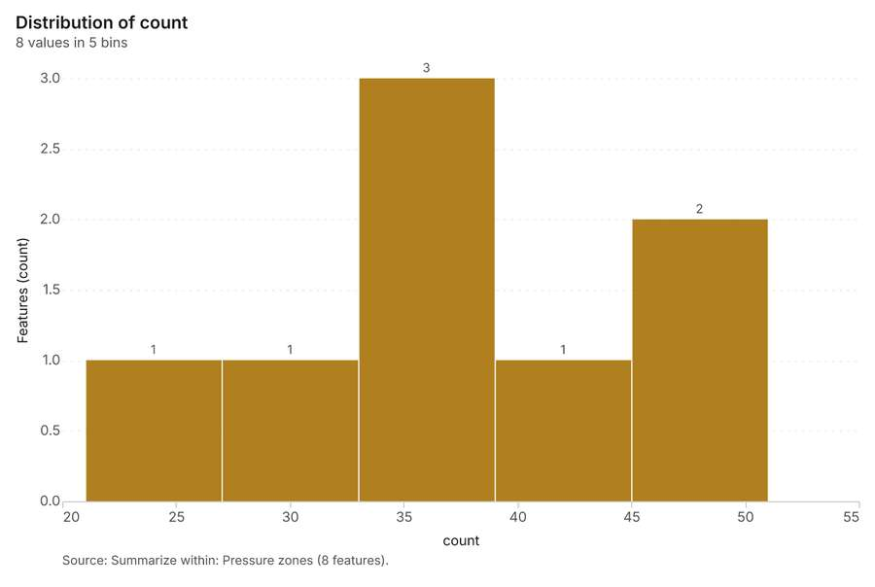
Figure 37. Summarize within: Pressure zones [84]. Source: Summarize within: Pressure zones (8 features). The data is in the appendix.
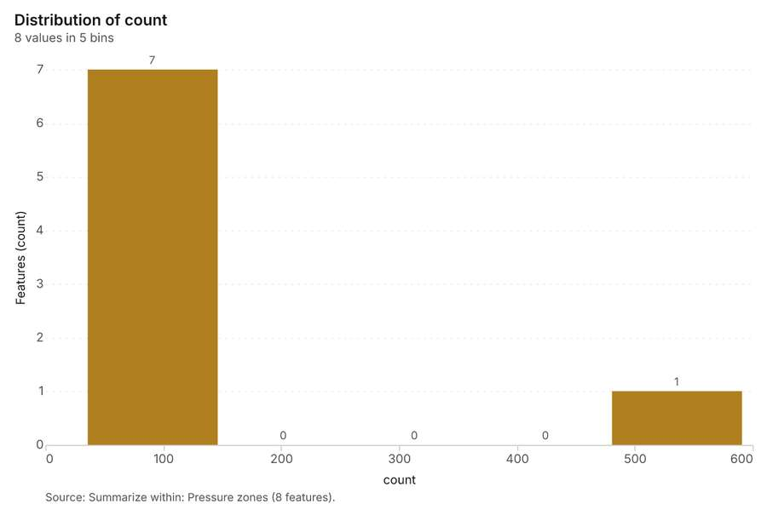
Figure 38. Summarize within: Pressure zones [85]. Source: Summarize within: Pressure zones (8 features). The data is in the appendix.
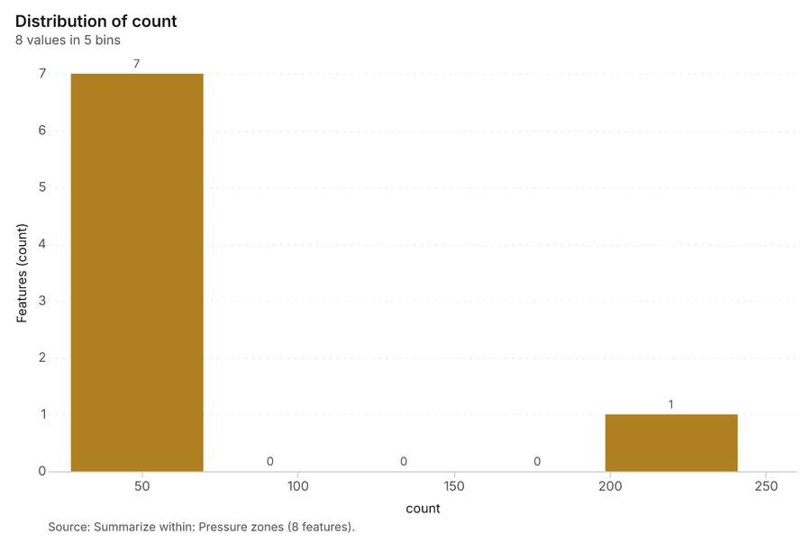
Figure 39. Summarize within: Pressure zones [86]. Source: Summarize within: Pressure zones (8 features). The data is in the appendix.
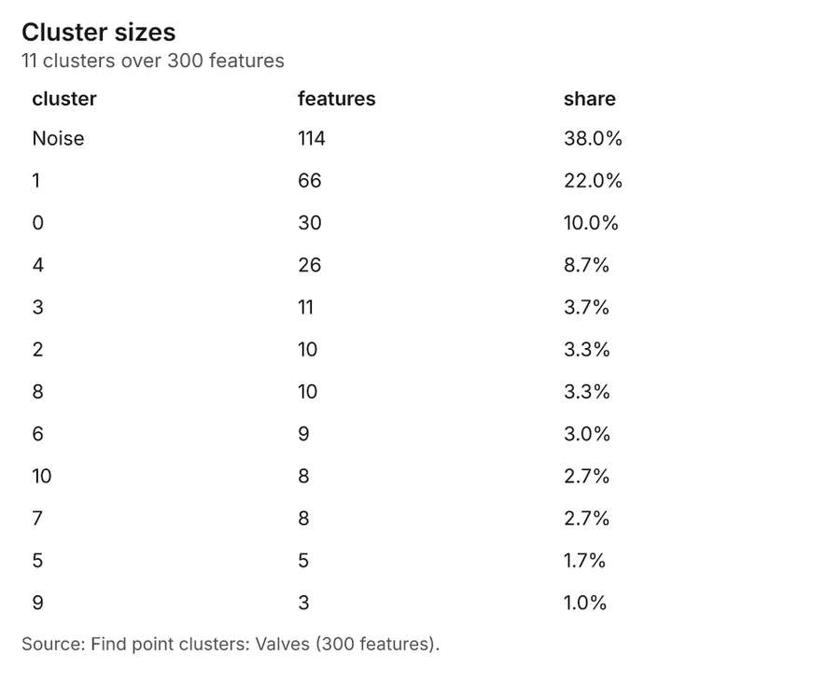
Figure 40. Find point clusters: Valves [87]. Source: Find point clusters: Valves (300 features). The data is in the appendix.
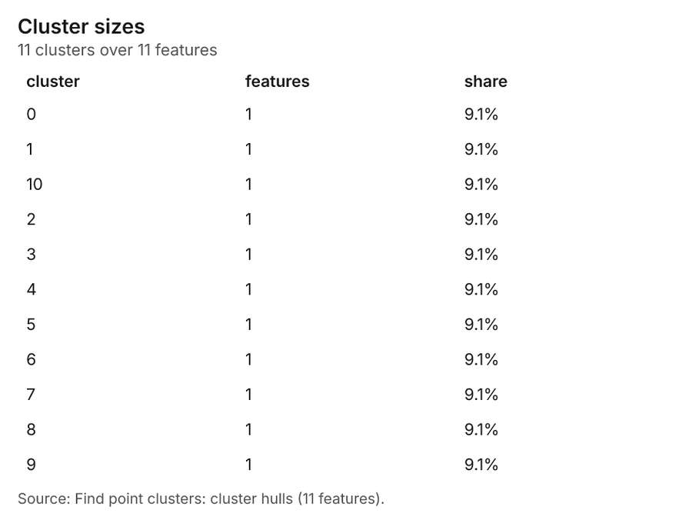
Figure 41. Find point clusters: cluster hulls [88]. Source: Find point clusters: cluster hulls (11 features). The data is in the appendix.
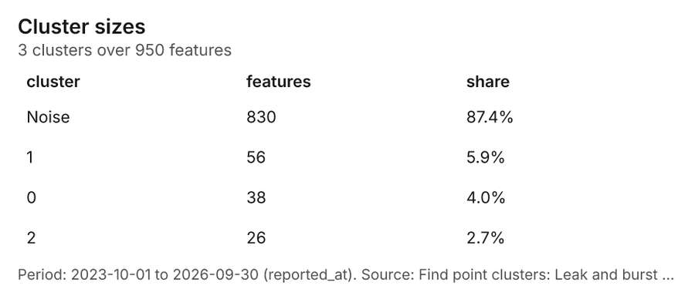
Figure 42. Find point clusters: Leak and burst repairs [89]. Period: 2023-10-01 to 2026-09-30 (reported_at). Source: Find point clusters: Leak and burst repairs (950 features). The data is in the appendix.
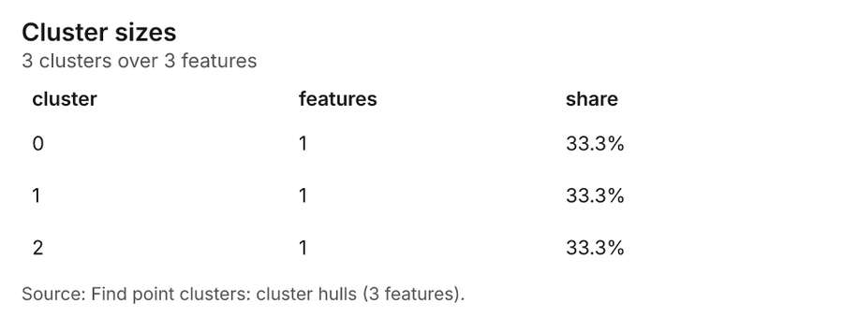
Figure 43. Find point clusters: cluster hulls [90]. Source: Find point clusters: cluster hulls (3 features). The data is in the appendix.
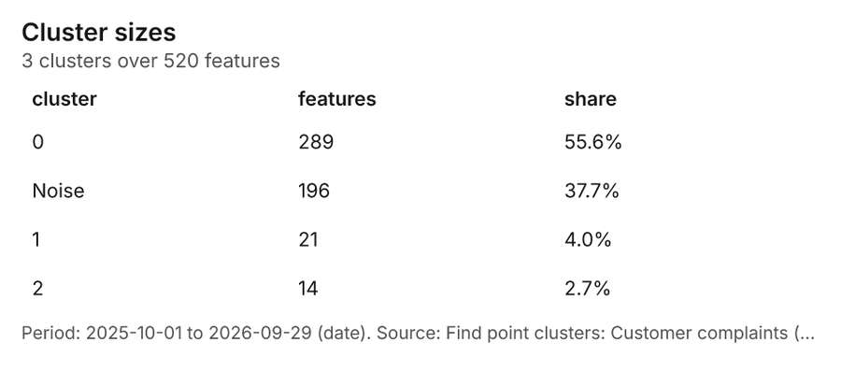
Figure 44. Find point clusters: Customer complaints [91]. Period: 2025-10-01 to 2026-09-29 (date). Source: Find point clusters: Customer complaints (520 features). The data is in the appendix.
Figure 45. Find point clusters: cluster hulls [92]. Source: Find point clusters: cluster hulls (3 features). The data is in the appendix.
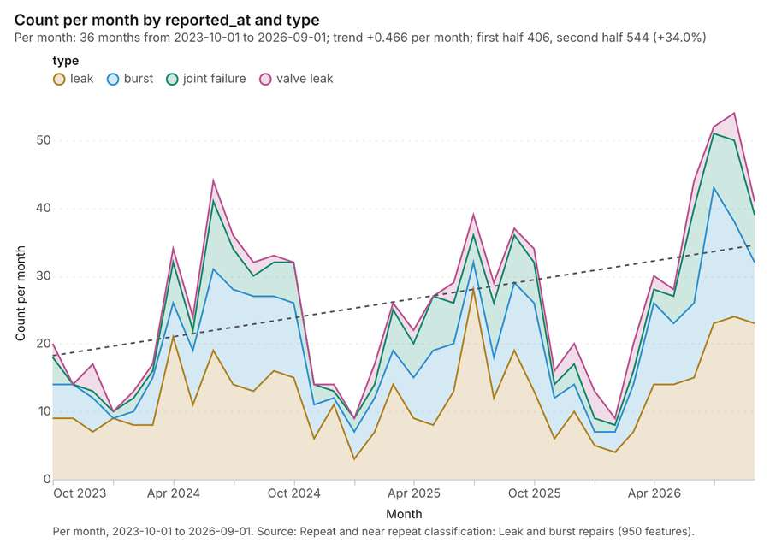
Figure 46. Repeat and near repeat classification: Leak and burst repairs over time [93]. Per month, 2023-10-01 to 2026-09-01. Source: Repeat and near repeat classification: Leak and burst repairs (950 features). The data is in the appendix.
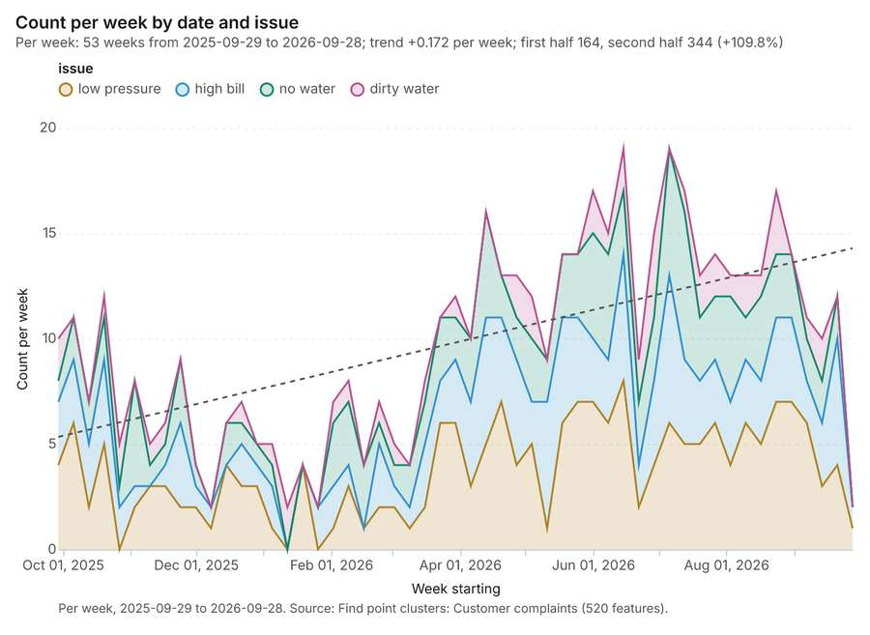
Figure 47. Find point clusters: Customer complaints over time [94]. Per week, 2025-09-29 to 2026-09-28. Source: Find point clusters: Customer complaints (520 features). The data is in the appendix.
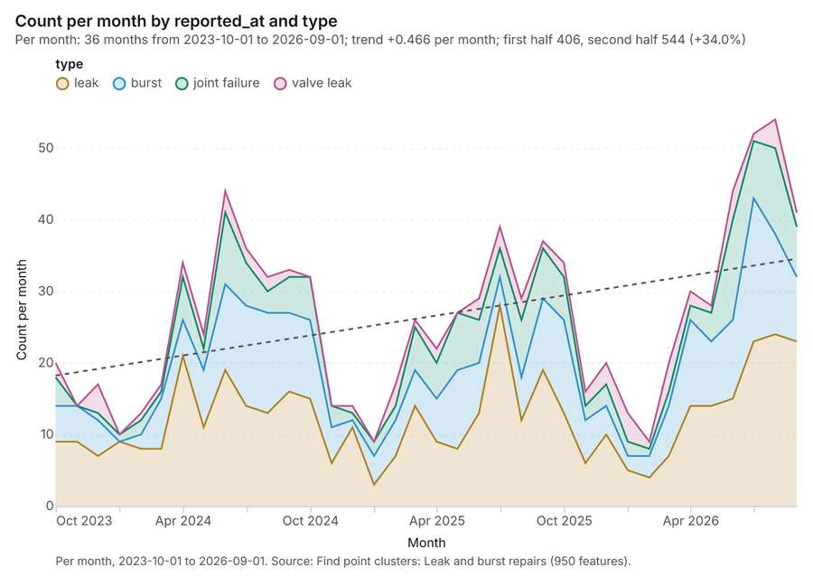
Figure 48. Find point clusters: Leak and burst repairs over time [95]. Per month, 2023-10-01 to 2026-09-01. Source: Find point clusters: Leak and burst repairs (950 features). The data is in the appendix.

Changes since the last run
This is the first report of this project.

Sources
[1] Rendering: Chart: Timeline: events per month by dataset. 108 rows (id 94a93c16-67b9-41a4-8ed2-808fbbf2754f)
[2] Dataset: Leak and burst repairs. vector, 950 rows (id 3f198310-8d97-42f8-b03b-813a838bc233)
[3] Dataset: Customer complaints. vector, 520 rows (id 57e4c410-eab9-4da0-8287-b2acf2ce16ca)
[4] Dataset: Zone meter readings by month. table, 192 rows (id 56bef21a-7861-4acc-b024-b65a14052a40)
[5] Catalog: Emerging hot spots (operation catalog, gp_space_time_hot_spots). Where hot spots are new, consecutive, intensifying, persistent, diminishing, sporadic, oscillating or historical over time. ArcGIS: Emerging Hot Spot Analysis, Create Space Time Cube. (id gp_space_time_hot_spots)
[6] Plan: Space time hot spots of Leak and burst repairs (the Start plan's candidate c_6d3c49125c9a). Leak and burst repairs carry dates in 'reported_at': emerging hot spot analysis finds new, intensifying and fading hot spots per month. (id 4f377cd3-7339-41df-845b-392c7e4b6b94:c_6d3c49125c9a)
[7] Tool result: gp_space_time_hot_spots, step 0. Emerging hot spots: 1 layer saved: Emerging hot spots: Leak and burst repairs (71 features). (id 8c251b5b-c068-49c2-83e1-3ea333425a96:0)
[8] Layer: Leak and burst repairs. 950 features (id 7e6cb18c-a956-4aa0-b060-b927e53b2106)
[9] Plan: Space time hot spots of Customer complaints (the Start plan's candidate c_8348225de6d1). Customer complaints carry dates in 'date': emerging hot spot analysis finds new, intensifying and fading hot spots per week. (id 4f377cd3-7339-41df-845b-392c7e4b6b94:c_8348225de6d1)
[10] Tool result: gp_space_time_hot_spots, step 1. Emerging hot spots: 1 layer saved: Emerging hot spots: Customer complaints (75 features). (id 8c251b5b-c068-49c2-83e1-3ea333425a96:1)
[11] Layer: Customer complaints. 520 features (id 56e8a858-22c0-49f4-ad9c-220e4d9d9989)
[12] Catalog: Hot spot analysis (operation catalog, gp_hot_spots). Getis-Ord Gi* hot and cold spots with z-scores, p-values and confidence bins. ArcGIS: Find Hot Spots, Hot Spot Analysis (Getis-Ord Gi*). QGIS: qgis:hotspot (plugin). (id gp_hot_spots)
[13] Plan: Hot spots of Valves (the Start plan's candidate c_73fb2acb1b6a). 300 points: Getis-Ord Gi* tests whether the concentrations in Valves are statistically significant. (id 4f377cd3-7339-41df-845b-392c7e4b6b94:c_73fb2acb1b6a)
[14] Tool result: gp_hot_spots, step 0. Hot spot analysis: 1 layer saved: Hot spot analysis: Valves (53 features). (id 5758135c-54d5-4daf-a6ef-b217938623cb:0)
[15] Layer: Valves. 300 features (id c6aecae7-984d-4e15-9197-a69b622b052f)
[16] Plan: Hot spots of Leak and burst repairs (the Start plan's candidate c_580c09db1123). 950 points: Getis-Ord Gi* tests whether the concentrations in Leak and burst repairs are statistically significant. (id 4f377cd3-7339-41df-845b-392c7e4b6b94:c_580c09db1123)
[17] Tool result: gp_hot_spots, step 1. Hot spot analysis: 1 layer saved: Hot spot analysis: Leak and burst repairs (184 features). (id 5758135c-54d5-4daf-a6ef-b217938623cb:1)
[18] Plan: Hot spots of Customer complaints (the Start plan's candidate c_00d8b144d9af). 520 points: Getis-Ord Gi* tests whether the concentrations in Customer complaints are statistically significant. (id 4f377cd3-7339-41df-845b-392c7e4b6b94:c_00d8b144d9af)
[19] Tool result: gp_hot_spots, step 2. Hot spot analysis: 1 layer saved: Hot spot analysis: Customer complaints (185 features). (id 5758135c-54d5-4daf-a6ef-b217938623cb:2)
[20] Catalog: Calculate density (operation catalog, gp_calculate_density). Kernel density per square kilometer on a grid. ArcGIS: Calculate Density, Kernel Density. QGIS: native:heatmapkerneldensityestimation. (id gp_calculate_density)
[21] Plan: Kernel density of Valves (the Start plan's candidate c_d636e5cd662d). 300 points in Valves: a density surface shows where they concentrate. (id 4f377cd3-7339-41df-845b-392c7e4b6b94:c_d636e5cd662d)
[22] Tool result: gp_calculate_density, step 0. Calculate density: 1 layer saved: Calculate density: Valves (257 features). (id 15ea63ce-83f8-46f4-930b-a1531b369666:0)
[23] Plan: Kernel density of Leak and burst repairs (the Start plan's candidate c_ab36517e4e0c). 950 points in Leak and burst repairs: a density surface shows where they concentrate. (id 4f377cd3-7339-41df-845b-392c7e4b6b94:c_ab36517e4e0c)
[24] Tool result: gp_calculate_density, step 1. Calculate density: 1 layer saved: Calculate density: Leak and burst repairs (1220 features). (id 15ea63ce-83f8-46f4-930b-a1531b369666:1)
[25] Plan: Kernel density of Customer complaints (the Start plan's candidate c_be075c3460ae). 520 points in Customer complaints: a density surface shows where they concentrate. (id 4f377cd3-7339-41df-845b-392c7e4b6b94:c_be075c3460ae)
[26] Tool result: gp_calculate_density, step 2. Calculate density: 1 layer saved: Calculate density: Customer complaints (1200 features). (id 15ea63ce-83f8-46f4-930b-a1531b369666:2)
[27] Catalog: Summarize within (operation catalog, gp_summarize_within). Count and aggregate the features inside each polygon (or bin), proportionally for lines and polygons. ArcGIS: Summarize Within, Aggregate Points. QGIS: native:countpointsinpolygon, native:sumlinelengths. (id gp_summarize_within)
[28] Plan: Valves per feature of Pressure zones (the Start plan's candidate c_5c2b4f19804e). Count Valves inside each feature of Pressure zones by type; the counts map as a choropleth (natural breaks, sequential colors). (id 4f377cd3-7339-41df-845b-392c7e4b6b94:c_5c2b4f19804e)
[29] Tool result: gp_summarize_within, step 0. Summarize within: 1 layer saved: Summarize within: Pressure zones (8 features). (id 7fbce9f6-226d-43c9-b187-49e18e2f3a63:0)
[30] Layer: Pressure zones. 8 features (id a4c55d18-97e0-4d48-82c0-0a14b5ad5659)
[31] Tool result: gp_summarize_within, step 1. Summarize within: 1 layer saved: Summarize within: Pressure zones (8 features). (id 7fbce9f6-226d-43c9-b187-49e18e2f3a63:1)
[32] Tool result: gp_summarize_within, step 2. Summarize within: 1 layer saved: Summarize within: Pressure zones (8 features). (id 7fbce9f6-226d-43c9-b187-49e18e2f3a63:2)
[33] Catalog: Find point clusters (operation catalog, gp_find_point_clusters). Density-based clusters (DBSCAN, HDBSCAN or OPTICS, optionally space-time) with hulls and noise. ArcGIS: Find Point Clusters, Density-based Clustering. QGIS: native:dbscanclustering, native:stdbscanclustering. (id gp_find_point_clusters)
[34] Plan: Cluster points of Valves (the Start plan's candidate c_5a8770e11140). DBSCAN finds dense groups of Valves and separates noise. (id 4f377cd3-7339-41df-845b-392c7e4b6b94:c_5a8770e11140)
[35] Tool result: gp_find_point_clusters, step 0. Find point clusters: 2 layers saved: Find point clusters: Valves (300 features); Find point clusters: cluster hulls (11 features). (id d14409c4-ceb7-40bf-8118-b4f183221686:0)
[36] Plan: Cluster points of Leak and burst repairs (the Start plan's candidate c_fcbb370f7b11). DBSCAN finds dense groups of Leak and burst repairs and separates noise. (id 4f377cd3-7339-41df-845b-392c7e4b6b94:c_fcbb370f7b11)
[37] Tool result: gp_find_point_clusters, step 1. Find point clusters: 2 layers saved: Find point clusters: Leak and burst repairs (950 features); Find point clusters: cluster hulls (3 features). (id d14409c4-ceb7-40bf-8118-b4f183221686:1)
[38] Plan: Cluster points of Customer complaints (the Start plan's candidate c_ffd68e523286). DBSCAN finds dense groups of Customer complaints and separates noise. (id 4f377cd3-7339-41df-845b-392c7e4b6b94:c_ffd68e523286)
[39] Tool result: gp_find_point_clusters, step 2. Find point clusters: 2 layers saved: Find point clusters: Customer complaints (520 features); Find point clusters: cluster hulls (3 features). (id d14409c4-ceb7-40bf-8118-b4f183221686:2)
[40] Catalog: Find outliers (operation catalog, gp_outliers). Anselin local Moran’s I: HH, LL clusters and HL, LH outliers. ArcGIS: Find Outliers, Cluster and Outlier Analysis (Anselin Local Moran’s I). (id gp_outliers)
[41] Plan: Local morans i of Pressure zones (the Start plan's candidate c_d6bf59d0b92b). Local Moran's I maps clusters and outliers of 'connections'. (id 4f377cd3-7339-41df-845b-392c7e4b6b94:c_d6bf59d0b92b)
[42] Tool result: gp_outliers, step 0. Find outliers: 1 layer saved: Find outliers: Pressure zones (8 features). (id d51ffd20-8b3f-40ae-b231-4aaceda6ee41:0)
[43] Catalog: Spatial autocorrelation (operation catalog, gp_spatial_autocorrelation). Global Moran’s I: is the pattern clustered, dispersed or random. ArcGIS: Spatial Autocorrelation (Global Moran’s I). (id gp_spatial_autocorrelation)
[44] Plan: Global morans i of Pressure zones (the Start plan's candidate c_6ddd928b3a6c). Global Moran's I says whether similar values of 'connections' sit next to each other. (id 4f377cd3-7339-41df-845b-392c7e4b6b94:c_6ddd928b3a6c)
[45] Tool result: gp_spatial_autocorrelation, step 1. Spatial autocorrelation: done; no map output. (id d51ffd20-8b3f-40ae-b231-4aaceda6ee41:1)
[46] Catalog: Repeat and near repeat classification (operation catalog, gp_near_repeat). Classify incidents as originators, repeats (same place) or near repeats within a distance and time window, with a Knox test table. ArcGIS: Repeat and Near Repeat Classification, Near Repeat Calculator. (id gp_near_repeat)
[47] Plan: Near repeat of Leak and burst repairs (the Start plan's candidate c_31a838496880). Near repeat analysis tests whether Leak and burst repairs close in space also follow each other within 30 days. (id 4f377cd3-7339-41df-845b-392c7e4b6b94:c_31a838496880)
[48] Tool result: gp_near_repeat, step 0. Repeat and near repeat classification: 1 layer saved: Repeat and near repeat classification: Leak and burst repairs (950 features). (id 49d484f0-691d-49a8-9795-a8bae9950aef:0)
[49] Rendering: Map: Emerging hot spots: Leak and burst repairs (id 3f3bb028-17f1-44d1-9de6-44fc0a9fc721)
[50] Rendering: Map: Emerging hot spots: Customer complaints (id 9509ddaa-4c98-4096-9c90-32c7d0128ded)
[51] Rendering: Map: Hot spot analysis: Valves (id d9873c2c-3566-4d27-8fb1-3136201c8204)
[52] Rendering: Map: Hot spot analysis: Leak and burst repairs (id cdaff975-dab2-424f-adfa-2274328ed591)
[53] Rendering: Map: Hot spot analysis: Customer complaints (id a6899e22-c5e5-420f-b266-3bc1126baba6)
[54] Rendering: Map: Calculate density: Valves (id ceb559c1-f678-4874-aea2-b7d563cf1fef)
[55] Rendering: Map: Calculate density: Leak and burst repairs (id 8c99a9da-4d30-49f5-a977-12f556499841)
[56] Rendering: Map: Calculate density: Customer complaints (id b9ce5771-f68b-494b-ae0f-5e0d4969f781)
[57] Rendering: Map: Summarize within: Pressure zones (id fd78fee3-ac8d-4b2b-b5ed-f7f57f068c3f)
[58] Rendering: Map: Summarize within: Pressure zones (id e6e4e8f2-04db-41fd-9da6-5906d1ba4b30)
[59] Rendering: Map: Summarize within: Pressure zones (id a4dbb3eb-6f59-462f-b3a9-d07bb0313663)
[60] Rendering: Map: Find point clusters: Valves (id db8344db-3a76-4085-aeb4-dd38135e8607)
[61] Rendering: Map: Find point clusters: cluster hulls (id 49a3caba-0eac-49c0-a96c-a416fb8cffcc)
[62] Rendering: Map: Find point clusters: Leak and burst repairs (id 2ad72120-f06f-49cc-bcfe-1d1f0f3704d0)
[63] Rendering: Map: Find point clusters: cluster hulls (id 1a6807c6-9e63-44e0-b47a-9cfd06d92860)
[64] Rendering: Map: Find point clusters: Customer complaints (id 6cdef5e4-9d12-42ff-9772-03d4ae9d2a31)
[65] Rendering: Map: Find point clusters: cluster hulls (id 0a4f53e6-e3e8-4a99-86a4-49c237e7d264)
[66] Rendering: Map: Pressure zones by connections (id a91f1b3f-c237-43d7-ba64-33ecbd256f0a)
[67] Rendering: Map: Find outliers: Pressure zones (id 44cdd90e-0c9c-4cf3-93b9-7b1f48c5e306)
[68] Rendering: Map: Repeat and near repeat classification: Leak and burst repairs (id 5f3c5bb5-4c59-4d70-a046-4429e3906db9)
[69] Rendering: Chart: Water mains over time (install_year). 13 rows (id 02627da8-8e62-4e80-9719-72a7e2f55e57)
[70] Rendering: Chart: Leak and burst repairs over time (reported_at). 144 rows (id c494397c-b48a-49fb-afa7-7a5504c99947)
[71] Rendering: Chart: Valves over time (exercised_year). 10 rows (id dcd28c89-a9a3-4182-881a-28e358a8b5a7)
[72] Rendering: Chart: Fire hydrants over time (last_test_year). 9 rows (id 9501bf0d-1118-4646-9011-1d6607707f6d)
[73] Rendering: Chart: Customer complaints over time (date). 212 rows (id 7b3d1156-e7a8-493d-9083-daeb182a4c85)
[74] Rendering: Chart: Zone meter readings by month over time (month). 24 rows (id 2ab22dd9-e4bb-48ba-8c04-bc7babef5d0b)
[75] Rendering: Chart: Pipe replacement plan over time (planned_year). 9 rows (id 177c5fda-dc15-4abc-a44e-4ee15d594e8b)
[76] Rendering: Chart: Emerging hot spots: Leak and burst repairs. 8 rows (id 595a0dc9-9c95-4ae1-b0ca-4e5d14d12396)
[77] Rendering: Chart: Emerging hot spots: Customer complaints. 8 rows (id 49549103-57d2-486d-8bd4-4431013cb1b3)
[78] Rendering: Chart: Hot spot analysis: Valves. 10 rows (id 5e1fa7b3-4f72-4f37-b847-44ccfd91b8d8)
[79] Rendering: Chart: Hot spot analysis: Leak and burst repairs. 13 rows (id 4cefd833-0e50-4578-9d0a-70931ac2bf5a)
[80] Rendering: Chart: Hot spot analysis: Customer complaints. 11 rows (id 86d35ebf-41a8-48e6-b171-41a261df419b)
[81] Rendering: Chart: Calculate density: Valves. 10 rows (id 27f5c03d-412f-4e4d-822d-a1df30a1c49a)
[82] Rendering: Chart: Calculate density: Leak and burst repairs. 12 rows (id 4666369b-bfa5-4f04-901c-ec29c5b49d6c)
[83] Rendering: Chart: Calculate density: Customer complaints. 12 rows (id aa86d4c3-c625-4f70-a661-51f8126e6af8)
[84] Rendering: Chart: Summarize within: Pressure zones. 5 rows (id 0d45df48-f878-4529-8914-7b9c943ea003)
[85] Rendering: Chart: Summarize within: Pressure zones. 5 rows (id 502ad046-ea5a-4ca6-9f48-484b32739196)
[86] Rendering: Chart: Summarize within: Pressure zones. 5 rows (id 949001f2-9fc6-4ae2-909c-4b238ba0916e)
[87] Rendering: Chart: Find point clusters: Valves. 12 rows (id 868093f7-066c-469b-baa7-f20941a2f40e)
[88] Rendering: Chart: Find point clusters: cluster hulls. 11 rows (id 84119cbe-b098-4105-bce7-8ddc860ad22d)
[89] Rendering: Chart: Find point clusters: Leak and burst repairs. 4 rows (id 1b45df1b-a05d-4531-ae0d-49c2224a2551)
[90] Rendering: Chart: Find point clusters: cluster hulls. 3 rows (id 5a127efb-1998-463d-8956-bee898322fc9)
[91] Rendering: Chart: Find point clusters: Customer complaints. 4 rows (id ae5b32b2-383a-4be8-bf14-6c6f8449b0b1)
[92] Rendering: Chart: Find point clusters: cluster hulls. 3 rows (id 2b12b071-0f4d-46c7-abc8-69c6b190d0d6)
[93] Rendering: Chart: Repeat and near repeat classification: Leak and burst repairs over time. 144 rows (id 3fc856ce-5d0d-407f-ad64-e3c0cc964288)
[94] Rendering: Chart: Find point clusters: Customer complaints over time. 212 rows (id 1e06545d-de8b-4037-b0da-2de0f7f334fe)
[95] Rendering: Chart: Find point clusters: Leak and burst repairs over time. 144 rows (id b893e1bc-7a5d-4622-8b2d-a1fc99d79142)
[96] Dataset: Pressure zones. vector, 8 rows (id 8e552b2b-0ef5-4c0c-821c-708e0de62375)
[97] Dataset: Water mains. vector, 2130 rows (id b6d4651b-de72-426b-b18e-081f92a20090)
[98] Dataset: Reservoirs. vector, 4 rows (id a4ba7898-6adb-4a62-b4b3-2baa51710fd7)
[99] Dataset: Valves. vector, 300 rows (id 2f9d6af4-8dbc-4919-9c2e-358009680d94)
[100] Dataset: Fire hydrants. vector, 250 rows (id 5c702260-a660-41d8-8aac-adc95c8d4329)
[101] Dataset: Pipe replacement plan. table, 220 rows (id c062d67a-c643-4dbc-bddd-b13a8c563a9e)
[102] Dataset: Non-revenue water briefing. document, ? rows (id 0a3aab36-0977-4c51-a725-7886eccfb7f7)
[103] Record: Sample: Water utility, Cape Town (id 0f6d1895-598a-4c17-a195-fc538533c4a3)
[104] Layer: Emerging hot spots: Leak and burst repairs. 71 features (id fcb15038-1ce5-4dfe-bef3-37f0d0710660)
[105] Layer: Emerging hot spots: Customer complaints. 75 features (id 6cd4cdee-eaed-4536-97a3-8cfcfcea991a)
[106] Layer: Hot spot analysis: Valves. 53 features (id e6e46379-bab5-4be3-b731-f573fbaeaa2b)
[107] Layer: Hot spot analysis: Leak and burst repairs. 184 features (id 1b8c7972-3a5f-43cb-9c04-79be94f68fa2)
[108] Layer: Hot spot analysis: Customer complaints. 185 features (id cc6c04aa-9769-4c55-bffd-23f14fc19e22)
[109] Layer: Calculate density: Valves. 257 features (id 7c69e54b-2611-4108-a8f1-7edbf9681ff2)
[110] Layer: Calculate density: Leak and burst repairs. 1,220 features (id 10a45b3b-e980-47be-9cf9-6b191e7fa957)
[111] Layer: Calculate density: Customer complaints. 1,200 features (id 36b7f8be-2e78-4f25-add1-4c5b63fade60)
[112] Layer: Summarize within: Pressure zones. 8 features (id e1b22dd3-e0d4-4c9f-a4dd-6460b011a8f0)
[113] Layer: Summarize within: Pressure zones. 8 features (id 2c26882f-372c-4dd1-9856-1556ecf83503)
[114] Layer: Summarize within: Pressure zones. 8 features (id 8d6f5fe5-afba-45d0-8676-09532976c3ba)
[115] Layer: Find point clusters: Valves. 300 features (id 4058852d-d252-42dd-b715-c4555264de96)
[116] Layer: Find point clusters: cluster hulls. 11 features (id 01ccf49b-1072-42db-8660-3b6bfa50a885)
[117] Layer: Find point clusters: Leak and burst repairs. 950 features (id 2ace68cb-dd6a-44c4-9784-ec90079bfd14)
[118] Layer: Find point clusters: cluster hulls. 3 features (id cee4dd63-1a39-434b-86a5-dbfe42ae6477)
[119] Layer: Find point clusters: Customer complaints. 520 features (id 7c106e45-1ddc-48c3-bc26-ae9c11c94028)
[120] Layer: Find point clusters: cluster hulls. 3 features (id 5dfd2c79-c5e3-4675-8539-b2fa77d08d7a)
[121] Layer: Find outliers: Pressure zones. 8 features (id e61c7a42-8b9f-473a-8310-bc15178693a5)
[122] Layer: Repeat and near repeat classification: Leak and burst repairs. 950 features (id 9bbadc15-5868-46e4-9005-946ec8a2298c)

Appendix: the data behind the charts

Figure 1. Timeline: events per month by dataset [1]
period | series | value
2023-10-01 | Leak and burst repairs | 20
2023-10-01 | Customer complaints | 0
2023-10-01 | Zone meter readings by month | 0
2023-11-01 | Leak and burst repairs | 14
2023-11-01 | Customer complaints | 0
2023-11-01 | Zone meter readings by month | 0
2023-12-01 | Leak and burst repairs | 17
2023-12-01 | Customer complaints | 0
2023-12-01 | Zone meter readings by month | 0
2024-01-01 | Leak and burst repairs | 10
2024-01-01 | Customer complaints | 0
2024-01-01 | Zone meter readings by month | 0
2024-02-01 | Leak and burst repairs | 13
2024-02-01 | Customer complaints | 0
2024-02-01 | Zone meter readings by month | 0
2024-03-01 | Leak and burst repairs | 17
2024-03-01 | Customer complaints | 0
2024-03-01 | Zone meter readings by month | 0
2024-04-01 | Leak and burst repairs | 34
2024-04-01 | Customer complaints | 0
2024-04-01 | Zone meter readings by month | 0
2024-05-01 | Leak and burst repairs | 24
2024-05-01 | Customer complaints | 0
2024-05-01 | Zone meter readings by month | 0
2024-06-01 | Leak and burst repairs | 44
2024-06-01 | Customer complaints | 0
2024-06-01 | Zone meter readings by month | 0
2024-07-01 | Leak and burst repairs | 36
2024-07-01 | Customer complaints | 0
2024-07-01 | Zone meter readings by month | 0
2024-08-01 | Leak and burst repairs | 32
2024-08-01 | Customer complaints | 0
2024-08-01 | Zone meter readings by month | 0
2024-09-01 | Leak and burst repairs | 33
2024-09-01 | Customer complaints | 0
2024-09-01 | Zone meter readings by month | 0
2024-10-01 | Leak and burst repairs | 32
2024-10-01 | Customer complaints | 0
2024-10-01 | Zone meter readings by month | 8
2024-11-01 | Leak and burst repairs | 14
2024-11-01 | Customer complaints | 0
2024-11-01 | Zone meter readings by month | 8
2024-12-01 | Leak and burst repairs | 14
2024-12-01 | Customer complaints | 0
2024-12-01 | Zone meter readings by month | 8
2025-01-01 | Leak and burst repairs | 9
2025-01-01 | Customer complaints | 0
2025-01-01 | Zone meter readings by month | 8
2025-02-01 | Leak and burst repairs | 17
2025-02-01 | Customer complaints | 0
2025-02-01 | Zone meter readings by month | 8
2025-03-01 | Leak and burst repairs | 26
2025-03-01 | Customer complaints | 0
2025-03-01 | Zone meter readings by month | 8
2025-04-01 | Leak and burst repairs | 22
2025-04-01 | Customer complaints | 0
2025-04-01 | Zone meter readings by month | 8
2025-05-01 | Leak and burst repairs | 27
2025-05-01 | Customer complaints | 0
2025-05-01 | Zone meter readings by month | 8
2025-06-01 | Leak and burst repairs | 29
2025-06-01 | Customer complaints | 0
2025-06-01 | Zone meter readings by month | 8
2025-07-01 | Leak and burst repairs | 39
2025-07-01 | Customer complaints | 0
2025-07-01 | Zone meter readings by month | 8
2025-08-01 | Leak and burst repairs | 29
2025-08-01 | Customer complaints | 0
2025-08-01 | Zone meter readings by month | 8
2025-09-01 | Leak and burst repairs | 37
2025-09-01 | Customer complaints | 0
2025-09-01 | Zone meter readings by month | 8
2025-10-01 | Leak and burst repairs | 34
2025-10-01 | Customer complaints | 43
2025-10-01 | Zone meter readings by month | 8
2025-11-01 | Leak and burst repairs | 16
2025-11-01 | Customer complaints | 30
2025-11-01 | Zone meter readings by month | 8
2025-12-01 | Leak and burst repairs | 20
2025-12-01 | Customer complaints | 21
2025-12-01 | Zone meter readings by month | 8
2026-01-01 | Leak and burst repairs | 13
2026-01-01 | Customer complaints | 16
2026-01-01 | Zone meter readings by month | 8
2026-02-01 | Leak and burst repairs | 9
2026-02-01 | Customer complaints | 25
2026-02-01 | Zone meter readings by month | 8
2026-03-01 | Leak and burst repairs | 20
2026-03-01 | Customer complaints | 34
2026-03-01 | Zone meter readings by month | 8
2026-04-01 | Leak and burst repairs | 30
2026-04-01 | Customer complaints | 48
2026-04-01 | Zone meter readings by month | 8
2026-05-01 | Leak and burst repairs | 28
2026-05-01 | Customer complaints | 60
2026-05-01 | Zone meter readings by month | 8
2026-06-01 | Leak and burst repairs | 44
2026-06-01 | Customer complaints | 64
2026-06-01 | Zone meter readings by month | 8
2026-07-01 | Leak and burst repairs | 52
2026-07-01 | Customer complaints | 70
2026-07-01 | Zone meter readings by month | 8
2026-08-01 | Leak and burst repairs | 54
2026-08-01 | Customer complaints | 64
2026-08-01 | Zone meter readings by month | 8
2026-09-01 | Leak and burst repairs | 41
2026-09-01 | Customer complaints | 45
2026-09-01 | Zone meter readings by month | 8

Figure 22. Water mains over time (install_year) [69]
bin_start | bin_end | count
75 | 84.62 | 417
84.62 | 94.23 | 0
94.23 | 103.8 | 396
103.8 | 113.5 | 393
113.5 | 123.1 | 0
123.1 | 132.7 | 0
132.7 | 142.3 | 0
142.3 | 151.9 | 0
151.9 | 161.5 | 377
161.5 | 171.2 | 0
171.2 | 180.8 | 0
180.8 | 190.4 | 0
190.4 | 200 | 547

Figure 23. Leak and burst repairs over time (reported_at) [70]
period | series | value
2023-10-01 | leak | 9
2023-10-01 | burst | 5
2023-10-01 | joint failure | 4
2023-10-01 | valve leak | 2
2023-11-01 | leak | 9
2023-11-01 | burst | 5
2023-11-01 | joint failure | 0
2023-11-01 | valve leak | 0
2023-12-01 | leak | 7
2023-12-01 | burst | 5
2023-12-01 | joint failure | 1
2023-12-01 | valve leak | 4
2024-01-01 | leak | 9
2024-01-01 | burst | 0
2024-01-01 | joint failure | 1
2024-01-01 | valve leak | 0
2024-02-01 | leak | 8
2024-02-01 | burst | 2
2024-02-01 | joint failure | 2
2024-02-01 | valve leak | 1
2024-03-01 | leak | 8
2024-03-01 | burst | 7
2024-03-01 | joint failure | 1
2024-03-01 | valve leak | 1
2024-04-01 | leak | 21
2024-04-01 | burst | 5
2024-04-01 | joint failure | 6
2024-04-01 | valve leak | 2
2024-05-01 | leak | 11
2024-05-01 | burst | 8
2024-05-01 | joint failure | 3
2024-05-01 | valve leak | 2
2024-06-01 | leak | 19
2024-06-01 | burst | 12
2024-06-01 | joint failure | 10
2024-06-01 | valve leak | 3
2024-07-01 | leak | 14
2024-07-01 | burst | 14
2024-07-01 | joint failure | 6
2024-07-01 | valve leak | 2
2024-08-01 | leak | 13
2024-08-01 | burst | 14
2024-08-01 | joint failure | 3
2024-08-01 | valve leak | 2
2024-09-01 | leak | 16
2024-09-01 | burst | 11
2024-09-01 | joint failure | 5
2024-09-01 | valve leak | 1
2024-10-01 | leak | 15
2024-10-01 | burst | 11
2024-10-01 | joint failure | 6
2024-10-01 | valve leak | 0
2024-11-01 | leak | 6
2024-11-01 | burst | 5
2024-11-01 | joint failure | 3
2024-11-01 | valve leak | 0
2024-12-01 | leak | 11
2024-12-01 | burst | 1
2024-12-01 | joint failure | 1
2024-12-01 | valve leak | 1
2025-01-01 | leak | 3
2025-01-01 | burst | 4
2025-01-01 | joint failure | 2
2025-01-01 | valve leak | 0
2025-02-01 | leak | 7
2025-02-01 | burst | 5
2025-02-01 | joint failure | 2
2025-02-01 | valve leak | 3
2025-03-01 | leak | 14
2025-03-01 | burst | 5
2025-03-01 | joint failure | 6
2025-03-01 | valve leak | 1
2025-04-01 | leak | 9
2025-04-01 | burst | 6
2025-04-01 | joint failure | 5
2025-04-01 | valve leak | 2
2025-05-01 | leak | 8
2025-05-01 | burst | 11
2025-05-01 | joint failure | 8
2025-05-01 | valve leak | 0
2025-06-01 | leak | 13
2025-06-01 | burst | 7
2025-06-01 | joint failure | 6
2025-06-01 | valve leak | 3
2025-07-01 | leak | 28
2025-07-01 | burst | 4
2025-07-01 | joint failure | 4
2025-07-01 | valve leak | 3
2025-08-01 | leak | 12
2025-08-01 | burst | 6
2025-08-01 | joint failure | 8
2025-08-01 | valve leak | 3
2025-09-01 | leak | 19
2025-09-01 | burst | 10
2025-09-01 | joint failure | 7
2025-09-01 | valve leak | 1
2025-10-01 | leak | 13
2025-10-01 | burst | 13
2025-10-01 | joint failure | 6
2025-10-01 | valve leak | 2
2025-11-01 | leak | 6
2025-11-01 | burst | 6
2025-11-01 | joint failure | 2
2025-11-01 | valve leak | 2
2025-12-01 | leak | 10
2025-12-01 | burst | 4
2025-12-01 | joint failure | 3
2025-12-01 | valve leak | 3
2026-01-01 | leak | 5
2026-01-01 | burst | 2
2026-01-01 | joint failure | 2
2026-01-01 | valve leak | 4
2026-02-01 | leak | 4
2026-02-01 | burst | 3
2026-02-01 | joint failure | 1
2026-02-01 | valve leak | 1
2026-03-01 | leak | 7
2026-03-01 | burst | 7
2026-03-01 | joint failure | 2
2026-03-01 | valve leak | 4
2026-04-01 | leak | 14
2026-04-01 | burst | 12
2026-04-01 | joint failure | 2
2026-04-01 | valve leak | 2
2026-05-01 | leak | 14
2026-05-01 | burst | 9
2026-05-01 | joint failure | 4
2026-05-01 | valve leak | 1
2026-06-01 | leak | 15
2026-06-01 | burst | 11
2026-06-01 | joint failure | 14
2026-06-01 | valve leak | 4
2026-07-01 | leak | 23
2026-07-01 | burst | 20
2026-07-01 | joint failure | 8
2026-07-01 | valve leak | 1
2026-08-01 | leak | 24
2026-08-01 | burst | 14
2026-08-01 | joint failure | 12
2026-08-01 | valve leak | 4
2026-09-01 | leak | 23
2026-09-01 | burst | 9
2026-09-01 | joint failure | 7
2026-09-01 | valve leak | 2

Figure 24. Valves over time (exercised_year) [71]
bin_start | bin_end | count
2,008 | 2,010 | 41
2,010 | 2,012 | 22
2,012 | 2,013 | 27
2,013 | 2,015 | 30
2,015 | 2,017 | 13
2,017 | 2,019 | 29
2,019 | 2,021 | 34
2,021 | 2,022 | 35
2,022 | 2,024 | 38
2,024 | 2,026 | 31

Figure 25. Fire hydrants over time (last_test_year) [72]
bin_start | bin_end | count
8 | 11.56 | 35
11.56 | 15.11 | 23
15.11 | 18.67 | 31
18.67 | 22.22 | 32
22.22 | 25.78 | 20
25.78 | 29.33 | 24
29.33 | 32.89 | 20
32.89 | 36.44 | 28
36.44 | 40 | 37

Figure 26. Customer complaints over time (date) [73]
period | series | value
2025-09-29 | low pressure | 4
2025-09-29 | high bill | 3
2025-09-29 | no water | 1
2025-09-29 | dirty water | 2
2025-10-06 | low pressure | 6
2025-10-06 | high bill | 3
2025-10-06 | no water | 2
2025-10-06 | dirty water | 0
2025-10-13 | low pressure | 2
2025-10-13 | high bill | 3
2025-10-13 | no water | 2
2025-10-13 | dirty water | 0
2025-10-20 | low pressure | 5
2025-10-20 | high bill | 4
2025-10-20 | no water | 2
2025-10-20 | dirty water | 1
2025-10-27 | low pressure | 0
2025-10-27 | high bill | 2
2025-10-27 | no water | 1
2025-10-27 | dirty water | 2
2025-11-03 | low pressure | 2
2025-11-03 | high bill | 1
2025-11-03 | no water | 5
2025-11-03 | dirty water | 0
2025-11-10 | low pressure | 3
2025-11-10 | high bill | 0
2025-11-10 | no water | 1
2025-11-10 | dirty water | 1
2025-11-17 | low pressure | 3
2025-11-17 | high bill | 1
2025-11-17 | no water | 1
2025-11-17 | dirty water | 1
2025-11-24 | low pressure | 2
2025-11-24 | high bill | 4
2025-11-24 | no water | 3
2025-11-24 | dirty water | 0
2025-12-01 | low pressure | 2
2025-12-01 | high bill | 1
2025-12-01 | no water | 1
2025-12-01 | dirty water | 0
2025-12-08 | low pressure | 1
2025-12-08 | high bill | 1
2025-12-08 | no water | 0
2025-12-08 | dirty water | 0
2025-12-15 | low pressure | 4
2025-12-15 | high bill | 0
2025-12-15 | no water | 2
2025-12-15 | dirty water | 0
2025-12-22 | low pressure | 3
2025-12-22 | high bill | 2
2025-12-22 | no water | 1
2025-12-22 | dirty water | 1
2025-12-29 | low pressure | 3
2025-12-29 | high bill | 1
2025-12-29 | no water | 1
2025-12-29 | dirty water | 0
2026-01-05 | low pressure | 1
2026-01-05 | high bill | 2
2026-01-05 | no water | 1
2026-01-05 | dirty water | 1
2026-01-12 | low pressure | 0
2026-01-12 | high bill | 0
2026-01-12 | no water | 0
2026-01-12 | dirty water | 2
2026-01-19 | low pressure | 4
2026-01-19 | high bill | 0
2026-01-19 | no water | 0
2026-01-19 | dirty water | 0
2026-01-26 | low pressure | 0
2026-01-26 | high bill | 2
2026-01-26 | no water | 0
2026-01-26 | dirty water | 0
2026-02-02 | low pressure | 1
2026-02-02 | high bill | 2
2026-02-02 | no water | 3
2026-02-02 | dirty water | 1
2026-02-09 | low pressure | 3
2026-02-09 | high bill | 1
2026-02-09 | no water | 3
2026-02-09 | dirty water | 1
2026-02-16 | low pressure | 1
2026-02-16 | high bill | 0
2026-02-16 | no water | 3
2026-02-16 | dirty water | 0
2026-02-23 | low pressure | 2
2026-02-23 | high bill | 3
2026-02-23 | no water | 1
2026-02-23 | dirty water | 1
2026-03-02 | low pressure | 2
2026-03-02 | high bill | 1
2026-03-02 | no water | 1
2026-03-02 | dirty water | 1
2026-03-09 | low pressure | 1
2026-03-09 | high bill | 1
2026-03-09 | no water | 2
2026-03-09 | dirty water | 0
2026-03-16 | low pressure | 2
2026-03-16 | high bill | 3
2026-03-16 | no water | 2
2026-03-16 | dirty water | 1
2026-03-23 | low pressure | 6
2026-03-23 | high bill | 2
2026-03-23 | no water | 3
2026-03-23 | dirty water | 0
2026-03-30 | low pressure | 6
2026-03-30 | high bill | 3
2026-03-30 | no water | 2
2026-03-30 | dirty water | 1
2026-04-06 | low pressure | 3
2026-04-06 | high bill | 4
2026-04-06 | no water | 3
2026-04-06 | dirty water | 0
2026-04-13 | low pressure | 5
2026-04-13 | high bill | 6
2026-04-13 | no water | 5
2026-04-13 | dirty water | 0
2026-04-20 | low pressure | 7
2026-04-20 | high bill | 4
2026-04-20 | no water | 2
2026-04-20 | dirty water | 0
2026-04-27 | low pressure | 4
2026-04-27 | high bill | 5
2026-04-27 | no water | 2
2026-04-27 | dirty water | 2
2026-05-04 | low pressure | 5
2026-05-04 | high bill | 2
2026-05-04 | no water | 3
2026-05-04 | dirty water | 2
2026-05-11 | low pressure | 1
2026-05-11 | high bill | 6
2026-05-11 | no water | 2
2026-05-11 | dirty water | 0
2026-05-18 | low pressure | 6
2026-05-18 | high bill | 5
2026-05-18 | no water | 3
2026-05-18 | dirty water | 0
2026-05-25 | low pressure | 7
2026-05-25 | high bill | 4
2026-05-25 | no water | 3
2026-05-25 | dirty water | 0
2026-06-01 | low pressure | 7
2026-06-01 | high bill | 3
2026-06-01 | no water | 5
2026-06-01 | dirty water | 2
2026-06-08 | low pressure | 6
2026-06-08 | high bill | 3
2026-06-08 | no water | 5
2026-06-08 | dirty water | 1
2026-06-15 | low pressure | 8
2026-06-15 | high bill | 6
2026-06-15 | no water | 3
2026-06-15 | dirty water | 2
2026-06-22 | low pressure | 2
2026-06-22 | high bill | 2
2026-06-22 | no water | 3
2026-06-22 | dirty water | 2
2026-06-29 | low pressure | 4
2026-06-29 | high bill | 4
2026-06-29 | no water | 3
2026-06-29 | dirty water | 4
2026-07-06 | low pressure | 6
2026-07-06 | high bill | 7
2026-07-06 | no water | 6
2026-07-06 | dirty water | 0
2026-07-13 | low pressure | 5
2026-07-13 | high bill | 4
2026-07-13 | no water | 7
2026-07-13 | dirty water | 1
2026-07-20 | low pressure | 5
2026-07-20 | high bill | 3
2026-07-20 | no water | 3
2026-07-20 | dirty water | 2
2026-07-27 | low pressure | 6
2026-07-27 | high bill | 3
2026-07-27 | no water | 3
2026-07-27 | dirty water | 2
2026-08-03 | low pressure | 4
2026-08-03 | high bill | 3
2026-08-03 | no water | 5
2026-08-03 | dirty water | 1
2026-08-10 | low pressure | 6
2026-08-10 | high bill | 3
2026-08-10 | no water | 2
2026-08-10 | dirty water | 2
2026-08-17 | low pressure | 5
2026-08-17 | high bill | 3
2026-08-17 | no water | 4
2026-08-17 | dirty water | 1
2026-08-24 | low pressure | 7
2026-08-24 | high bill | 4
2026-08-24 | no water | 3
2026-08-24 | dirty water | 3
2026-08-31 | low pressure | 7
2026-08-31 | high bill | 4
2026-08-31 | no water | 3
2026-08-31 | dirty water | 0
2026-09-07 | low pressure | 6
2026-09-07 | high bill | 2
2026-09-07 | no water | 2
2026-09-07 | dirty water | 1
2026-09-14 | low pressure | 3
2026-09-14 | high bill | 3
2026-09-14 | no water | 2
2026-09-14 | dirty water | 2
2026-09-21 | low pressure | 4
2026-09-21 | high bill | 6
2026-09-21 | no water | 2
2026-09-21 | dirty water | 0
2026-09-28 | low pressure | 1
2026-09-28 | high bill | 1
2026-09-28 | no water | 0
2026-09-28 | dirty water | 0

Figure 27. Zone meter readings by month over time (month) [74]
period | value
2024-10-01 | 8
2024-11-01 | 8
2024-12-01 | 8
2025-01-01 | 8
2025-02-01 | 8
2025-03-01 | 8
2025-04-01 | 8
2025-05-01 | 8
2025-06-01 | 8
2025-07-01 | 8
2025-08-01 | 8
2025-09-01 | 8
2025-10-01 | 8
2025-11-01 | 8
2025-12-01 | 8
2026-01-01 | 8
2026-02-01 | 8
2026-03-01 | 8
2026-04-01 | 8
2026-05-01 | 8
2026-06-01 | 8
2026-07-01 | 8
2026-08-01 | 8
2026-09-01 | 8

Figure 28. Pipe replacement plan over time (planned_year) [75]
bin_start | bin_end | count
1 | 1.333 | 60
1.333 | 1.667 | 0
1.667 | 2 | 0
2 | 2.333 | 60
2.333 | 2.667 | 0
2.667 | 3 | 0
3 | 3.333 | 60
3.333 | 3.667 | 0
3.667 | 4 | 40

Figure 29. Emerging hot spots: Leak and burst repairs [76]
bin_start | bin_end | count
-0.961 | 0.1214 | 35
0.1214 | 1.204 | 9
1.204 | 2.286 | 10
2.286 | 3.369 | 5
3.369 | 4.451 | 2
4.451 | 5.533 | 8
5.533 | 6.616 | 0
6.616 | 7.698 | 2

Figure 30. Emerging hot spots: Customer complaints [77]
bin_start | bin_end | count
-0.737 | -0.5961 | 55
-0.5961 | -0.4552 | 0
-0.4552 | -0.3144 | 0
-0.3144 | -0.1735 | 0
-0.1735 | -0.03263 | 0
-0.03263 | 0.1082 | 0
0.1082 | 0.2491 | 0
0.2491 | 0.39 | 20

Figure 31. Hot spot analysis: Valves [78]
bin_start | bin_end | band | band_label | count
-2 | -1.5 | not_significant | Not significant | 5
-1.5 | -1 | not_significant | Not significant | 2
-1 | -0.5 | not_significant | Not significant | 10
-0.5 | 0 | not_significant | Not significant | 8
0 | 0.5 | not_significant | Not significant | 12
0.5 | 1 | not_significant | Not significant | 7
1 | 1.5 | not_significant | Not significant | 4
1.5 | 2 | hot_90 | Hot spot, 90% confidence | 2
1.5 | 2 | hot_95 | Hot spot, 95% confidence | 2
2 | 2.5 | hot_95 | Hot spot, 95% confidence | 1

Figure 32. Hot spot analysis: Leak and burst repairs [79]
bin_start | bin_end | band | band_label | count
-1 | -0.5 | not_significant | Not significant | 45
-0.5 | 0 | not_significant | Not significant | 104
0 | 0.5 | not_significant | Not significant | 4
0.5 | 1 | not_significant | Not significant | 3
1 | 1.5 | not_significant | Not significant | 11
1.5 | 2 | hot_90 | Hot spot, 90% confidence | 1
1.5 | 2 | hot_95 | Hot spot, 95% confidence | 2
1.5 | 2 | not_significant | Not significant | 1
2 | 2.5 | hot_95 | Hot spot, 95% confidence | 5
2.5 | 3 | hot_95 | Hot spot, 95% confidence | 1
2.5 | 3 | hot_99 | Hot spot, 99% confidence | 2
3 | 3.5 | hot_99 | Hot spot, 99% confidence | 3
4 | 4.5 | hot_99 | Hot spot, 99% confidence | 2

Figure 33. Hot spot analysis: Customer complaints [80]
bin_start | bin_end | band | band_label | count
-1 | -0.5 | not_significant | Not significant | 74
-0.5 | 0 | not_significant | Not significant | 37
0 | 0.5 | not_significant | Not significant | 40
0.5 | 1 | not_significant | Not significant | 8
1 | 1.5 | not_significant | Not significant | 10
1.5 | 2 | hot_90 | Hot spot, 90% confidence | 4
2 | 2.5 | hot_95 | Hot spot, 95% confidence | 5
2.5 | 3 | hot_95 | Hot spot, 95% confidence | 3
2.5 | 3 | hot_99 | Hot spot, 99% confidence | 2
3.5 | 4 | hot_99 | Hot spot, 99% confidence | 1
4.5 | 5 | hot_99 | Hot spot, 99% confidence | 1

Figure 34. Calculate density: Valves [81]
bin_start | bin_end | count
0 | 1.7 | 21
1.7 | 3.4 | 31
3.4 | 5.1 | 32
5.1 | 6.8 | 16
6.8 | 8.5 | 29
8.5 | 10.2 | 30
10.2 | 11.9 | 15
11.9 | 13.6 | 31
13.6 | 15.3 | 28
15.3 | 17 | 24

Figure 35. Calculate density: Leak and burst repairs [82]
bin_start | bin_end | count
0 | 3.25 | 95
3.25 | 6.5 | 99
6.5 | 9.75 | 99
9.75 | 13 | 95
13 | 16.25 | 128
16.25 | 19.5 | 95
19.5 | 22.75 | 98
22.75 | 26 | 95
26 | 29.25 | 135
29.25 | 32.5 | 94
32.5 | 35.75 | 98
35.75 | 39 | 89

Figure 36. Calculate density: Customer complaints [83]
bin_start | bin_end | count
0 | 3.083 | 111
3.083 | 6.167 | 100
6.167 | 9.25 | 99
9.25 | 12.33 | 99
12.33 | 15.42 | 97
15.42 | 18.5 | 95
18.5 | 21.58 | 95
21.58 | 24.67 | 96
24.67 | 27.75 | 98
27.75 | 30.83 | 100
30.83 | 33.92 | 96
33.92 | 37 | 114

Figure 37. Summarize within: Pressure zones [84]
bin_start | bin_end | count
21 | 27 | 1
27 | 33 | 1
33 | 39 | 3
39 | 45 | 1
45 | 51 | 2

Figure 38. Summarize within: Pressure zones [85]
bin_start | bin_end | count
35 | 146.2 | 7
146.2 | 257.4 | 0
257.4 | 368.6 | 0
368.6 | 479.8 | 0
479.8 | 591 | 1

Figure 39. Summarize within: Pressure zones [86]
bin_start | bin_end | count
27 | 69.8 | 7
69.8 | 112.6 | 0
112.6 | 155.4 | 0
155.4 | 198.2 | 0
198.2 | 241 | 1

Figure 40. Find point clusters: Valves [87]
cluster | features | fraction | share
Noise | 114 | 0.38 | 38.0%
1 | 66 | 0.22 | 22.0%
0 | 30 | 0.1 | 10.0%
4 | 26 | 0.08667 | 8.7%
3 | 11 | 0.03667 | 3.7%
2 | 10 | 0.03333 | 3.3%
8 | 10 | 0.03333 | 3.3%
6 | 9 | 0.03 | 3.0%
10 | 8 | 0.02667 | 2.7%
7 | 8 | 0.02667 | 2.7%
5 | 5 | 0.01667 | 1.7%
9 | 3 | 0.01 | 1.0%

Figure 41. Find point clusters: cluster hulls [88]
cluster | features | fraction | share
0 | 1 | 0.09091 | 9.1%
1 | 1 | 0.09091 | 9.1%
10 | 1 | 0.09091 | 9.1%
2 | 1 | 0.09091 | 9.1%
3 | 1 | 0.09091 | 9.1%
4 | 1 | 0.09091 | 9.1%
5 | 1 | 0.09091 | 9.1%
6 | 1 | 0.09091 | 9.1%
7 | 1 | 0.09091 | 9.1%
8 | 1 | 0.09091 | 9.1%
9 | 1 | 0.09091 | 9.1%

Figure 42. Find point clusters: Leak and burst repairs [89]
cluster | features | fraction | share
Noise | 830 | 0.8737 | 87.4%
1 | 56 | 0.05895 | 5.9%
0 | 38 | 0.04 | 4.0%
2 | 26 | 0.02737 | 2.7%

Figure 43. Find point clusters: cluster hulls [90]
cluster | features | fraction | share
0 | 1 | 0.3333 | 33.3%
1 | 1 | 0.3333 | 33.3%
2 | 1 | 0.3333 | 33.3%

Figure 44. Find point clusters: Customer complaints [91]
cluster | features | fraction | share
0 | 289 | 0.5558 | 55.6%
Noise | 196 | 0.3769 | 37.7%
1 | 21 | 0.04038 | 4.0%
2 | 14 | 0.02692 | 2.7%

Figure 45. Find point clusters: cluster hulls [92]
cluster | features | fraction | share
0 | 1 | 0.3333 | 33.3%
1 | 1 | 0.3333 | 33.3%
2 | 1 | 0.3333 | 33.3%

Figure 46. Repeat and near repeat classification: Leak and burst repairs over time [93]
period | series | value
2023-10-01 | leak | 9
2023-10-01 | burst | 5
2023-10-01 | joint failure | 4
2023-10-01 | valve leak | 2
2023-11-01 | leak | 9
2023-11-01 | burst | 5
2023-11-01 | joint failure | 0
2023-11-01 | valve leak | 0
2023-12-01 | leak | 7
2023-12-01 | burst | 5
2023-12-01 | joint failure | 1
2023-12-01 | valve leak | 4
2024-01-01 | leak | 9
2024-01-01 | burst | 0
2024-01-01 | joint failure | 1
2024-01-01 | valve leak | 0
2024-02-01 | leak | 8
2024-02-01 | burst | 2
2024-02-01 | joint failure | 2
2024-02-01 | valve leak | 1
2024-03-01 | leak | 8
2024-03-01 | burst | 7
2024-03-01 | joint failure | 1
2024-03-01 | valve leak | 1
2024-04-01 | leak | 21
2024-04-01 | burst | 5
2024-04-01 | joint failure | 6
2024-04-01 | valve leak | 2
2024-05-01 | leak | 11
2024-05-01 | burst | 8
2024-05-01 | joint failure | 3
2024-05-01 | valve leak | 2
2024-06-01 | leak | 19
2024-06-01 | burst | 12
2024-06-01 | joint failure | 10
2024-06-01 | valve leak | 3
2024-07-01 | leak | 14
2024-07-01 | burst | 14
2024-07-01 | joint failure | 6
2024-07-01 | valve leak | 2
2024-08-01 | leak | 13
2024-08-01 | burst | 14
2024-08-01 | joint failure | 3
2024-08-01 | valve leak | 2
2024-09-01 | leak | 16
2024-09-01 | burst | 11
2024-09-01 | joint failure | 5
2024-09-01 | valve leak | 1
2024-10-01 | leak | 15
2024-10-01 | burst | 11
2024-10-01 | joint failure | 6
2024-10-01 | valve leak | 0
2024-11-01 | leak | 6
2024-11-01 | burst | 5
2024-11-01 | joint failure | 3
2024-11-01 | valve leak | 0
2024-12-01 | leak | 11
2024-12-01 | burst | 1
2024-12-01 | joint failure | 1
2024-12-01 | valve leak | 1
2025-01-01 | leak | 3
2025-01-01 | burst | 4
2025-01-01 | joint failure | 2
2025-01-01 | valve leak | 0
2025-02-01 | leak | 7
2025-02-01 | burst | 5
2025-02-01 | joint failure | 2
2025-02-01 | valve leak | 3
2025-03-01 | leak | 14
2025-03-01 | burst | 5
2025-03-01 | joint failure | 6
2025-03-01 | valve leak | 1
2025-04-01 | leak | 9
2025-04-01 | burst | 6
2025-04-01 | joint failure | 5
2025-04-01 | valve leak | 2
2025-05-01 | leak | 8
2025-05-01 | burst | 11
2025-05-01 | joint failure | 8
2025-05-01 | valve leak | 0
2025-06-01 | leak | 13
2025-06-01 | burst | 7
2025-06-01 | joint failure | 6
2025-06-01 | valve leak | 3
2025-07-01 | leak | 28
2025-07-01 | burst | 4
2025-07-01 | joint failure | 4
2025-07-01 | valve leak | 3
2025-08-01 | leak | 12
2025-08-01 | burst | 6
2025-08-01 | joint failure | 8
2025-08-01 | valve leak | 3
2025-09-01 | leak | 19
2025-09-01 | burst | 10
2025-09-01 | joint failure | 7
2025-09-01 | valve leak | 1
2025-10-01 | leak | 13
2025-10-01 | burst | 13
2025-10-01 | joint failure | 6
2025-10-01 | valve leak | 2
2025-11-01 | leak | 6
2025-11-01 | burst | 6
2025-11-01 | joint failure | 2
2025-11-01 | valve leak | 2
2025-12-01 | leak | 10
2025-12-01 | burst | 4
2025-12-01 | joint failure | 3
2025-12-01 | valve leak | 3
2026-01-01 | leak | 5
2026-01-01 | burst | 2
2026-01-01 | joint failure | 2
2026-01-01 | valve leak | 4
2026-02-01 | leak | 4
2026-02-01 | burst | 3
2026-02-01 | joint failure | 1
2026-02-01 | valve leak | 1
2026-03-01 | leak | 7
2026-03-01 | burst | 7
2026-03-01 | joint failure | 2
2026-03-01 | valve leak | 4
2026-04-01 | leak | 14
2026-04-01 | burst | 12
2026-04-01 | joint failure | 2
2026-04-01 | valve leak | 2
2026-05-01 | leak | 14
2026-05-01 | burst | 9
2026-05-01 | joint failure | 4
2026-05-01 | valve leak | 1
2026-06-01 | leak | 15
2026-06-01 | burst | 11
2026-06-01 | joint failure | 14
2026-06-01 | valve leak | 4
2026-07-01 | leak | 23
2026-07-01 | burst | 20
2026-07-01 | joint failure | 8
2026-07-01 | valve leak | 1
2026-08-01 | leak | 24
2026-08-01 | burst | 14
2026-08-01 | joint failure | 12
2026-08-01 | valve leak | 4
2026-09-01 | leak | 23
2026-09-01 | burst | 9
2026-09-01 | joint failure | 7
2026-09-01 | valve leak | 2

Figure 47. Find point clusters: Customer complaints over time [94]
period | series | value
2025-09-29 | low pressure | 4
2025-09-29 | high bill | 3
2025-09-29 | no water | 1
2025-09-29 | dirty water | 2
2025-10-06 | low pressure | 6
2025-10-06 | high bill | 3
2025-10-06 | no water | 2
2025-10-06 | dirty water | 0
2025-10-13 | low pressure | 2
2025-10-13 | high bill | 3
2025-10-13 | no water | 2
2025-10-13 | dirty water | 0
2025-10-20 | low pressure | 5
2025-10-20 | high bill | 4
2025-10-20 | no water | 2
2025-10-20 | dirty water | 1
2025-10-27 | low pressure | 0
2025-10-27 | high bill | 2
2025-10-27 | no water | 1
2025-10-27 | dirty water | 2
2025-11-03 | low pressure | 2
2025-11-03 | high bill | 1
2025-11-03 | no water | 5
2025-11-03 | dirty water | 0
2025-11-10 | low pressure | 3
2025-11-10 | high bill | 0
2025-11-10 | no water | 1
2025-11-10 | dirty water | 1
2025-11-17 | low pressure | 3
2025-11-17 | high bill | 1
2025-11-17 | no water | 1
2025-11-17 | dirty water | 1
2025-11-24 | low pressure | 2
2025-11-24 | high bill | 4
2025-11-24 | no water | 3
2025-11-24 | dirty water | 0
2025-12-01 | low pressure | 2
2025-12-01 | high bill | 1
2025-12-01 | no water | 1
2025-12-01 | dirty water | 0
2025-12-08 | low pressure | 1
2025-12-08 | high bill | 1
2025-12-08 | no water | 0
2025-12-08 | dirty water | 0
2025-12-15 | low pressure | 4
2025-12-15 | high bill | 0
2025-12-15 | no water | 2
2025-12-15 | dirty water | 0
2025-12-22 | low pressure | 3
2025-12-22 | high bill | 2
2025-12-22 | no water | 1
2025-12-22 | dirty water | 1
2025-12-29 | low pressure | 3
2025-12-29 | high bill | 1
2025-12-29 | no water | 1
2025-12-29 | dirty water | 0
2026-01-05 | low pressure | 1
2026-01-05 | high bill | 2
2026-01-05 | no water | 1
2026-01-05 | dirty water | 1
2026-01-12 | low pressure | 0
2026-01-12 | high bill | 0
2026-01-12 | no water | 0
2026-01-12 | dirty water | 2
2026-01-19 | low pressure | 4
2026-01-19 | high bill | 0
2026-01-19 | no water | 0
2026-01-19 | dirty water | 0
2026-01-26 | low pressure | 0
2026-01-26 | high bill | 2
2026-01-26 | no water | 0
2026-01-26 | dirty water | 0
2026-02-02 | low pressure | 1
2026-02-02 | high bill | 2
2026-02-02 | no water | 3
2026-02-02 | dirty water | 1
2026-02-09 | low pressure | 3
2026-02-09 | high bill | 1
2026-02-09 | no water | 3
2026-02-09 | dirty water | 1
2026-02-16 | low pressure | 1
2026-02-16 | high bill | 0
2026-02-16 | no water | 3
2026-02-16 | dirty water | 0
2026-02-23 | low pressure | 2
2026-02-23 | high bill | 3
2026-02-23 | no water | 1
2026-02-23 | dirty water | 1
2026-03-02 | low pressure | 2
2026-03-02 | high bill | 1
2026-03-02 | no water | 1
2026-03-02 | dirty water | 1
2026-03-09 | low pressure | 1
2026-03-09 | high bill | 1
2026-03-09 | no water | 2
2026-03-09 | dirty water | 0
2026-03-16 | low pressure | 2
2026-03-16 | high bill | 3
2026-03-16 | no water | 2
2026-03-16 | dirty water | 1
2026-03-23 | low pressure | 6
2026-03-23 | high bill | 2
2026-03-23 | no water | 3
2026-03-23 | dirty water | 0
2026-03-30 | low pressure | 6
2026-03-30 | high bill | 3
2026-03-30 | no water | 2
2026-03-30 | dirty water | 1
2026-04-06 | low pressure | 3
2026-04-06 | high bill | 4
2026-04-06 | no water | 3
2026-04-06 | dirty water | 0
2026-04-13 | low pressure | 5
2026-04-13 | high bill | 6
2026-04-13 | no water | 5
2026-04-13 | dirty water | 0
2026-04-20 | low pressure | 7
2026-04-20 | high bill | 4
2026-04-20 | no water | 2
2026-04-20 | dirty water | 0
2026-04-27 | low pressure | 4
2026-04-27 | high bill | 5
2026-04-27 | no water | 2
2026-04-27 | dirty water | 2
2026-05-04 | low pressure | 5
2026-05-04 | high bill | 2
2026-05-04 | no water | 3
2026-05-04 | dirty water | 2
2026-05-11 | low pressure | 1
2026-05-11 | high bill | 6
2026-05-11 | no water | 2
2026-05-11 | dirty water | 0
2026-05-18 | low pressure | 6
2026-05-18 | high bill | 5
2026-05-18 | no water | 3
2026-05-18 | dirty water | 0
2026-05-25 | low pressure | 7
2026-05-25 | high bill | 4
2026-05-25 | no water | 3
2026-05-25 | dirty water | 0
2026-06-01 | low pressure | 7
2026-06-01 | high bill | 3
2026-06-01 | no water | 5
2026-06-01 | dirty water | 2
2026-06-08 | low pressure | 6
2026-06-08 | high bill | 3
2026-06-08 | no water | 5
2026-06-08 | dirty water | 1
2026-06-15 | low pressure | 8
2026-06-15 | high bill | 6
2026-06-15 | no water | 3
2026-06-15 | dirty water | 2
2026-06-22 | low pressure | 2
2026-06-22 | high bill | 2
2026-06-22 | no water | 3
2026-06-22 | dirty water | 2
2026-06-29 | low pressure | 4
2026-06-29 | high bill | 4
2026-06-29 | no water | 3
2026-06-29 | dirty water | 4
2026-07-06 | low pressure | 6
2026-07-06 | high bill | 7
2026-07-06 | no water | 6
2026-07-06 | dirty water | 0
2026-07-13 | low pressure | 5
2026-07-13 | high bill | 4
2026-07-13 | no water | 7
2026-07-13 | dirty water | 1
2026-07-20 | low pressure | 5
2026-07-20 | high bill | 3
2026-07-20 | no water | 3
2026-07-20 | dirty water | 2
2026-07-27 | low pressure | 6
2026-07-27 | high bill | 3
2026-07-27 | no water | 3
2026-07-27 | dirty water | 2
2026-08-03 | low pressure | 4
2026-08-03 | high bill | 3
2026-08-03 | no water | 5
2026-08-03 | dirty water | 1
2026-08-10 | low pressure | 6
2026-08-10 | high bill | 3
2026-08-10 | no water | 2
2026-08-10 | dirty water | 2
2026-08-17 | low pressure | 5
2026-08-17 | high bill | 3
2026-08-17 | no water | 4
2026-08-17 | dirty water | 1
2026-08-24 | low pressure | 7
2026-08-24 | high bill | 4
2026-08-24 | no water | 3
2026-08-24 | dirty water | 3
2026-08-31 | low pressure | 7
2026-08-31 | high bill | 4
2026-08-31 | no water | 3
2026-08-31 | dirty water | 0
2026-09-07 | low pressure | 6
2026-09-07 | high bill | 2
2026-09-07 | no water | 2
2026-09-07 | dirty water | 1
2026-09-14 | low pressure | 3
2026-09-14 | high bill | 3
2026-09-14 | no water | 2
2026-09-14 | dirty water | 2
2026-09-21 | low pressure | 4
2026-09-21 | high bill | 6
2026-09-21 | no water | 2
2026-09-21 | dirty water | 0
2026-09-28 | low pressure | 1
2026-09-28 | high bill | 1
2026-09-28 | no water | 0
2026-09-28 | dirty water | 0

Figure 48. Find point clusters: Leak and burst repairs over time [95]
period | series | value
2023-10-01 | leak | 9
2023-10-01 | burst | 5
2023-10-01 | joint failure | 4
2023-10-01 | valve leak | 2
2023-11-01 | leak | 9
2023-11-01 | burst | 5
2023-11-01 | joint failure | 0
2023-11-01 | valve leak | 0
2023-12-01 | leak | 7
2023-12-01 | burst | 5
2023-12-01 | joint failure | 1
2023-12-01 | valve leak | 4
2024-01-01 | leak | 9
2024-01-01 | burst | 0
2024-01-01 | joint failure | 1
2024-01-01 | valve leak | 0
2024-02-01 | leak | 8
2024-02-01 | burst | 2
2024-02-01 | joint failure | 2
2024-02-01 | valve leak | 1
2024-03-01 | leak | 8
2024-03-01 | burst | 7
2024-03-01 | joint failure | 1
2024-03-01 | valve leak | 1
2024-04-01 | leak | 21
2024-04-01 | burst | 5
2024-04-01 | joint failure | 6
2024-04-01 | valve leak | 2
2024-05-01 | leak | 11
2024-05-01 | burst | 8
2024-05-01 | joint failure | 3
2024-05-01 | valve leak | 2
2024-06-01 | leak | 19
2024-06-01 | burst | 12
2024-06-01 | joint failure | 10
2024-06-01 | valve leak | 3
2024-07-01 | leak | 14
2024-07-01 | burst | 14
2024-07-01 | joint failure | 6
2024-07-01 | valve leak | 2
2024-08-01 | leak | 13
2024-08-01 | burst | 14
2024-08-01 | joint failure | 3
2024-08-01 | valve leak | 2
2024-09-01 | leak | 16
2024-09-01 | burst | 11
2024-09-01 | joint failure | 5
2024-09-01 | valve leak | 1
2024-10-01 | leak | 15
2024-10-01 | burst | 11
2024-10-01 | joint failure | 6
2024-10-01 | valve leak | 0
2024-11-01 | leak | 6
2024-11-01 | burst | 5
2024-11-01 | joint failure | 3
2024-11-01 | valve leak | 0
2024-12-01 | leak | 11
2024-12-01 | burst | 1
2024-12-01 | joint failure | 1
2024-12-01 | valve leak | 1
2025-01-01 | leak | 3
2025-01-01 | burst | 4
2025-01-01 | joint failure | 2
2025-01-01 | valve leak | 0
2025-02-01 | leak | 7
2025-02-01 | burst | 5
2025-02-01 | joint failure | 2
2025-02-01 | valve leak | 3
2025-03-01 | leak | 14
2025-03-01 | burst | 5
2025-03-01 | joint failure | 6
2025-03-01 | valve leak | 1
2025-04-01 | leak | 9
2025-04-01 | burst | 6
2025-04-01 | joint failure | 5
2025-04-01 | valve leak | 2
2025-05-01 | leak | 8
2025-05-01 | burst | 11
2025-05-01 | joint failure | 8
2025-05-01 | valve leak | 0
2025-06-01 | leak | 13
2025-06-01 | burst | 7
2025-06-01 | joint failure | 6
2025-06-01 | valve leak | 3
2025-07-01 | leak | 28
2025-07-01 | burst | 4
2025-07-01 | joint failure | 4
2025-07-01 | valve leak | 3
2025-08-01 | leak | 12
2025-08-01 | burst | 6
2025-08-01 | joint failure | 8
2025-08-01 | valve leak | 3
2025-09-01 | leak | 19
2025-09-01 | burst | 10
2025-09-01 | joint failure | 7
2025-09-01 | valve leak | 1
2025-10-01 | leak | 13
2025-10-01 | burst | 13
2025-10-01 | joint failure | 6
2025-10-01 | valve leak | 2
2025-11-01 | leak | 6
2025-11-01 | burst | 6
2025-11-01 | joint failure | 2
2025-11-01 | valve leak | 2
2025-12-01 | leak | 10
2025-12-01 | burst | 4
2025-12-01 | joint failure | 3
2025-12-01 | valve leak | 3
2026-01-01 | leak | 5
2026-01-01 | burst | 2
2026-01-01 | joint failure | 2
2026-01-01 | valve leak | 4
2026-02-01 | leak | 4
2026-02-01 | burst | 3
2026-02-01 | joint failure | 1
2026-02-01 | valve leak | 1
2026-03-01 | leak | 7
2026-03-01 | burst | 7
2026-03-01 | joint failure | 2
2026-03-01 | valve leak | 4
2026-04-01 | leak | 14
2026-04-01 | burst | 12
2026-04-01 | joint failure | 2
2026-04-01 | valve leak | 2
2026-05-01 | leak | 14
2026-05-01 | burst | 9
2026-05-01 | joint failure | 4
2026-05-01 | valve leak | 1
2026-06-01 | leak | 15
2026-06-01 | burst | 11
2026-06-01 | joint failure | 14
2026-06-01 | valve leak | 4
2026-07-01 | leak | 23
2026-07-01 | burst | 20
2026-07-01 | joint failure | 8
2026-07-01 | valve leak | 1
2026-08-01 | leak | 24
2026-08-01 | burst | 14
2026-08-01 | joint failure | 12
2026-08-01 | valve leak | 4
2026-09-01 | leak | 23
2026-09-01 | burst | 9
2026-09-01 | joint failure | 7
2026-09-01 | valve leak | 2

