GEOBIT LARGE SPATIAL MODEL

Sample: Forestry and wildfire, Bend: report
Project: Sample: Forestry and wildfire, Bend
Goal: Describe the project Sample: Forestry and wildfire, Bend: run the analyses that tell the most about its data, draw every result, and write a cited report.
Run: 8ded6244-4d76-45b7-a92e-f62fd8a76afe (running, 11 agent run(s))
Generated: 2026-10-18T06:17:30Z, version 1
Model cost: USD 0.0000 over 0 model call(s)

Data used
Data | Kind | Rows | Time span | Summary | Source
Fuel units | vector, Polygon | 36 |  | 36 polygon (area) features; 'fuel_model' has 5 values (top: timber litter 10, timber understory 7, slash 7); 'fuel_load_t_ha' 1.5 to 37.1 (mean 15.26); 'canopy_cover_pct' 7 to 91 (mean 45.36); 'last_burned' 1996 to 2020 (mean 2011); total area 80.03 km2; extent -121.4833,43.9831 to -121.3566,44.0568. Areas (Fuel units) with fuel_load_t_ha to compare and map. | [98]
Fire perimeters | vector, Polygon | 10 | 2017-08-10 to 2026-07-16 | 10 polygon (area) features; dated by 'start_date' from 2017-08-10 to 2026-07-16; 'cause' has 3 values (top: equipment 6, human 3, lightning 1); 'acres' 85 to 378 (mean 219.2); 'containment_days' 2 to 20 (mean 11); named by 'fire_name' (e.g. Westbrook Fire, Station Quarter Fire, Riverside Fire); total area 8.894 km2; extent -121.4744,43.9952 to -121.3725,44.0490. Areas (Fire perimeters) with acres to compare and map. | [2]
Ignitions | vector, Point | 900 | 2018-01-07 to 2026-09-30 | 900 point features; dated by 'detected_at' from 2018-01-07 to 2026-09-30; 'cause' has 7 values (top: lightning 243, campfire 186, vehicle 112); 'final_acres' 0 to 45.9 (mean 1.727); 'elevation_m' 1158 to 1737 (mean 1449); extent -121.4824,43.9841 to -121.3576,44.0560. Dated point events by cause: where and when Ignitions happen. | [3]
Forest roads | vector, LineString | 15 |  | 15 line features; 'surface' has 3 values (top: native 8, gravel 6, paved 1); 'gated' has 2 values (top: False 10, True 5); named by 'name' (e.g. Highway corridor, Forest Road 314, Forest Road 321); total length 74.47 km; extent -121.4826,43.9869 to -121.3584,44.0558. Lines (Forest roads) such as routes or networks. | [99]
Weather stations | vector, Point | 6 |  | 6 point features; 'elevation_m' 1253 to 1663 (mean 1503); named by 'name' (e.g. RAWS weather station 1, RAWS weather station 2, RAWS weather station 3); extent -121.4578,44.0051 to -121.3674,44.0455. Point locations of Weather stations. | [100]
Fire lookouts | vector, Point | 3 |  | 3 point features; 'staffed' has 2 values (top: True 2, False 1); 'tower_height_m' 9 to 12 (mean 11); named by 'name' (e.g. Pine Butte lookout, Cinder Butte lookout, Eagle Butte lookout); extent -121.4430,44.0109 to -121.3763,44.0430. Point locations of Fire lookouts by staffed. | [101]
Fuel treatments | vector, Polygon | 12 | 2019-06-01 to 2025-01-01 | 12 polygon (area) features; dated by 'completed' from 2019-06-01 to 2025-01-01; 'method' has 3 values (top: prescribed burn 7, mastication 3, thinning 2); 'acres' 62 to 188 (mean 119.8); total area 5.842 km2; extent -121.4681,44.0078 to -121.3572,44.0561. Areas (Fuel treatments) with acres to compare and map. | [4]
Forest terrain model (DEM) | raster |  |  | 1-band float32 raster (dem), 333 x 267 cells; resolution 30; band 1 1152 to 1745; extent -121.4833,43.9830 to -121.3568,44.0568. An elevation surface for terrain analysis. | [102]
Station weather by day | table | 918 | 2026-05-01 to 2026-09-30 | Table of 918 rows and 6 columns without geometry; dated by 'date' from 2026-05-01 to 2026-09-30; 'temp_max_c' 14.6 to 42.8 (mean 29.96); 'rh_min_pct' 5 to 56 (mean 25.28); 'wind_kmh' 0 to 29 (mean 13.63). A table of Station weather by day without locations. | [5]
Treatment costs | table | 12 |  | Table of 12 rows and 4 columns without geometry; 'method' has 3 values (top: prescribed burn 7, mastication 3, thinning 2); 'cost_usd_per_acre' 472 to 1,391 (mean 910); 'crew_days' 5 to 40 (mean 25.67). A table of Treatment costs without locations. | [103]
Fuels treatment plan | document |  |  | 1-page pdf document 'Fuels treatment plan'; language en; mentions 5 place(s): Highway corridor (2), Thornbury Vale Fire (1), Queensway Fire (1), Pine Butte lookout (1), Cinder Butte lookout (1). A document about Highway corridor, Thornbury Vale Fire, Queensway Fire. | [104]
Sample: Forestry and wildfire, Bend | record |  |  |  | [105]
Hot spot analysis: Ignitions | layer, Polygon | 344 |  |  | [106]
Hot spot analysis: Fire perimeters | layer, Polygon | 10 |  |  | [107]
Hot spot analysis: Fuel treatments | layer, Polygon | 12 |  |  | [108]
Emerging hot spots: Ignitions | layer, Polygon | 135 |  |  | [109]
Repeat and near repeat classification: Ignitions | layer, Point | 900 |  |  | [110]
Summarize within: Fire perimeters | layer, Polygon | 10 |  |  | [111]
Summarize within: Fire perimeters | layer, Polygon | 10 |  |  | [112]
Summarize within: Fire perimeters | layer, Polygon | 10 |  |  | [113]
Find point clusters: Ignitions | layer, Point | 900 |  |  | [114]
Find point clusters: cluster hulls | layer, Polygon | 1 |  |  | [115]
Calculate density: Ignitions | layer, Polygon | 2,136 |  |  | [116]
Find outliers: Fire perimeters | layer, Polygon | 10 |  |  | [117]
Find outliers: Fuel treatments | layer, Polygon | 12 |  |  | [118]
Find outliers: Fuel units | layer, Polygon | 36 |  |  | [119]

Timeline
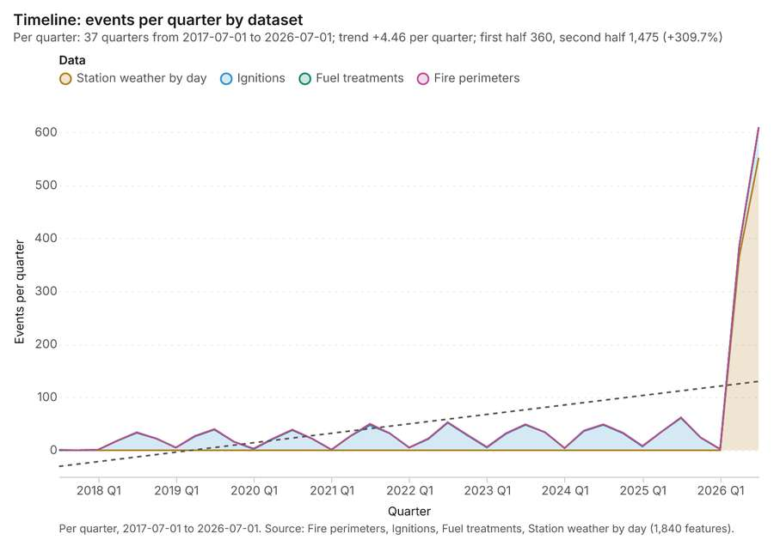
Figure 1. Timeline: events per quarter by dataset [1]. Per quarter, 2017-07-01 to 2026-07-01. Source: Fire perimeters, Ignitions, Fuel treatments, Station weather by day (1,840 features). The data is in the appendix.
The timeline counts 1,840 dated events in Fire perimeters, Ignitions, Fuel treatments and 1 more per quarter, from Q3 2017 to Q3 2026 [1][2][3][4][5]. By dataset: Station weather by day 918; Ignitions 900; Fuel treatments 12; Fire perimeters 10 [1]. The trend is +4.46 events per quarter; the second half of the quarters has 1,475 against 360 in the first (+309.7%) [1]. 1 of the 37 quarters had no events [1]. Change point detection found no shift in the counts [6].
Busiest quarters
- Q3 2026: 610 events [1]
- Q2 2026: 386 events [1]
- Q3 2025: 62 events [1]
Quietest quarters with events
- Q3 2017: 1 event [1]
- Q1 2018: 1 event [1]
- Q1 2021: 1 event [1]

Hot spots
What this analysis is. Hot spot analysis: Getis-Ord Gi* hot and cold spots with z-scores, p-values and confidence bins [7]. In ArcGIS it is Find Hot Spots or Hot Spot Analysis (Getis-Ord Gi*); in QGIS, qgis:hotspot (plugin) [7].
Why it was run on this data. 900 points: Getis-Ord Gi* tests whether the concentrations in Ignitions are statistically significant [8].
What it found. Hot spots on Ignitions: Hot spot analysis: 1 layer saved: Hot spot analysis: Ignitions (344 features) [9][10]. It reported result, bins 344; result, count 344; result, elapsed ms 21; result, cell size m 500; result, incidents used 900; result, distance band m 500 [9].
Result | Value
result, bins | 344
result, count | 344
result, elapsed ms | 21
result, cell size m | 500
result, incidents used | 900
result, distance band m | 500
billing, cost | 0.068
billing, list price | 0.068
billing, upstream cost | 0

Findings
- Evidenced: Hot spots on Ignitions: Hot spot analysis: 1 layer saved: Hot spot analysis: Ignitions (344 features) [9][10].
- Evidenced: It reported result, bins 344; result, count 344; result, elapsed ms 21; result, cell size m 500; result, incidents used 900; result, distance band m 500 [9].
Tool gp_hot_spots; parameters {"project": "721d878b-84af-42eb-9c9c-858bf9a6a75e", "features": {"layer": "Ignitions (73bb3d60)"}, "aggregation": "hexagon", "cell_size_m": 500.0, "distance_band_m": 500.0}

Hot spots
What this analysis is. Hot spot analysis: Getis-Ord Gi* hot and cold spots with z-scores, p-values and confidence bins [7]. In ArcGIS it is Find Hot Spots or Hot Spot Analysis (Getis-Ord Gi*); in QGIS, qgis:hotspot (plugin) [7].
Why it was run on this data. Gi* hot spots of 'acres' across the areas [11].
What it found. Hot spots on Fire perimeters: Hot spot analysis: 1 layer saved: Hot spot analysis: Fire perimeters (10 features) [12][13]. It reported result, count 10; result, elapsed ms 3; result, excluded null 0; result, distance band m 2,652; billing, cost 0.0502; billing, list price 0.0502 [12].
Result | Value
result, count | 10
result, elapsed ms | 3
result, excluded null | 0
result, distance band m | 2,652
billing, cost | 0.0502
billing, list price | 0.0502
billing, upstream cost | 0

Findings
- Evidenced: Hot spots on Fire perimeters: Hot spot analysis: 1 layer saved: Hot spot analysis: Fire perimeters (10 features) [12][13].
- Evidenced: It reported result, count 10; result, elapsed ms 3; result, excluded null 0; result, distance band m 2,652; billing, cost 0.0502; billing, list price 0.0502 [12].
Tool gp_hot_spots; parameters {"field": "acres", "project": "721d878b-84af-42eb-9c9c-858bf9a6a75e", "features": {"layer": "Fire perimeters (4401c868)"}}

Hot spots
What this analysis is. Hot spot analysis: Getis-Ord Gi* hot and cold spots with z-scores, p-values and confidence bins [7]. In ArcGIS it is Find Hot Spots or Hot Spot Analysis (Getis-Ord Gi*); in QGIS, qgis:hotspot (plugin) [7].
Why it was run on this data. Gi* hot spots of 'acres' across the areas [14].
What it found. Hot spots on Fuel treatments: Hot spot analysis: 1 layer saved: Hot spot analysis: Fuel treatments (12 features) [15][16]. It reported result, count 12; result, elapsed ms 2; result, excluded null 0; result, distance band m 2,799; billing, cost 0.05024; billing, list price 0.05024 [15].
Result | Value
result, count | 12
result, elapsed ms | 2
result, excluded null | 0
result, distance band m | 2,799
billing, cost | 0.05024
billing, list price | 0.05024
billing, upstream cost | 0

Findings
- Evidenced: Hot spots on Fuel treatments: Hot spot analysis: 1 layer saved: Hot spot analysis: Fuel treatments (12 features) [15][16].
- Evidenced: It reported result, count 12; result, elapsed ms 2; result, excluded null 0; result, distance band m 2,799; billing, cost 0.05024; billing, list price 0.05024 [15].
Tool gp_hot_spots; parameters {"field": "acres", "project": "721d878b-84af-42eb-9c9c-858bf9a6a75e", "features": {"layer": "Fuel treatments (d603668d)"}}

Space time hot spots
What this analysis is. Emerging hot spots: Where hot spots are new, consecutive, intensifying, persistent, diminishing, sporadic, oscillating or historical over time [17]. In ArcGIS it is Emerging Hot Spot Analysis or Create Space Time Cube [17].
Why it was run on this data. Ignitions carry dates in 'detected_at': emerging hot spot analysis finds new, intensifying and fading hot spots per month [18].
What it found. Space time hot spots on Ignitions: Emerging hot spots: 1 layer saved: Emerging hot spots: Ignitions (135 features) [10][19]. It reported result, count 135; result, elapsed ms 35; result, resolution 8; result, features used 900; result, time neighbors 0; billing, cost 0.145 [19].
Result | Value
result, count | 135
result, elapsed ms | 35
result, resolution | 8
result, features used | 900
result, time neighbors | 0
billing, cost | 0.145
billing, list price | 0.145
billing, upstream cost | 0

Findings
- Evidenced: Space time hot spots on Ignitions: Emerging hot spots: 1 layer saved: Emerging hot spots: Ignitions (135 features) [10][19].
- Evidenced: It reported result, count 135; result, elapsed ms 35; result, resolution 8; result, features used 900; result, time neighbors 0; billing, cost 0.145 [19].
Tool gp_space_time_hot_spots; parameters {"project": "721d878b-84af-42eb-9c9c-858bf9a6a75e", "features": {"layer": "Ignitions (73bb3d60)"}, "interval": "month", "bin_shape": "h3", "resolution": 8, "time_field": "detected_at"}

Near repeat
What this analysis is. Repeat and near repeat classification: Classify incidents as originators, repeats (same place) or near repeats within a distance and time window, with a Knox test table [20]. In ArcGIS it is Repeat and Near Repeat Classification or Near Repeat Calculator [20].
Why it was run on this data. Near repeat analysis tests whether Ignitions close in space also follow each other within 30 days [21].
What it found. The near repeat classification utilized the `gp_near_repeat` tool [22] and processed the Ignitions dataset [10]. The tool yielded overall results showing a count of 900 [22], 63 chains [22], and a maximum distance of 200 m [22]. The execution was efficient, linking 80 pairs in an elapsed time of 18 ms [22]. Financially, the operation incurred a cost of 0.077 [22].
Result | Value
result, days | 30
result, count | 900
result, chains | 63
result, distance m | 200
result, elapsed ms | 18
result, pairs linked | 80
billing, cost | 0.077
billing, list price | 0.077
billing, upstream cost | 0

Findings
- Evidenced: Near repeat on Ignitions: Repeat and near repeat classification: 1 layer saved: Repeat and near repeat classification: Ignitions (900 features) [10][22].
- Evidenced: It reported result, days 30; result, count 900; result, chains 63; result, distance m 200; result, elapsed ms 18; result, pairs linked 80 [22].
Tool gp_near_repeat; parameters {"days": 30, "project": "721d878b-84af-42eb-9c9c-858bf9a6a75e", "features": {"layer": "Ignitions (73bb3d60)"}, "distance_m": 200.0, "time_field": "detected_at"}

Change point detection
What this analysis is. Change point detection: When did the level, count, trend or variability change [23]? For the whole study area or for every bin [23]. In ArcGIS it is Change Point Detection [23].
Why it was run on this data. Change point detection finds when the monthly count of Ignitions shifted [24].
What it found. Change point detection was executed using the tool `gp_change_point_detection` [6]. The input data for the analysis was Ignitions [10]. The tool summary reported that change point detection was successfully done, although no map output was generated [6].
Findings
- Evidenced: Change point detection on Ignitions: Change point detection: done; no map output [6][10].
Tool gp_change_point_detection; parameters {"method": "count", "project": "721d878b-84af-42eb-9c9c-858bf9a6a75e", "features": {"layer": "Ignitions (73bb3d60)"}, "interval": "month", "time_field": "detected_at"}

Summarize within
What this analysis is. Summarize within: Count and aggregate the features inside each polygon (or bin), proportionally for lines and polygons [25]. In ArcGIS it is Summarize Within or Aggregate Points; in QGIS, native:countpointsinpolygon or native:sumlinelengths [25].
Why it was run on this data. Count Ignitions inside each feature of Fire perimeters by cause; the counts map as a choropleth (natural breaks, sequential colors) [26].
What it found. Summarize within on Ignitions, Fire perimeters: Summarize within: 1 layer saved: Summarize within: Fire perimeters (10 features) [10][13][27]. It reported result, count 10; result, elapsed ms 3; billing, cost 0.02822; billing, list price 0.02822; billing, upstream cost 0 [27].
Result | Value
result, count | 10
result, elapsed ms | 3
billing, cost | 0.02822
billing, list price | 0.02822
billing, upstream cost | 0

Findings
- Evidenced: Summarize within on Ignitions, Fire perimeters: Summarize within: 1 layer saved: Summarize within: Fire perimeters (10 features) [10][13][27].
- Evidenced: It reported result, count 10; result, elapsed ms 3; billing, cost 0.02822; billing, list price 0.02822; billing, upstream cost 0 [27].
Tool gp_summarize_within; parameters {"stats": [{"stat": "sum", "field": "final_acres"}], "project": "721d878b-84af-42eb-9c9c-858bf9a6a75e", "features": {"layer": "Ignitions (73bb3d60)"}, "group_by": "cause", "polygons": {"layer": "Fire perimeters (4401c868)"}}

Summarize within
What this analysis is. Summarize within: Count and aggregate the features inside each polygon (or bin), proportionally for lines and polygons [25]. In ArcGIS it is Summarize Within or Aggregate Points; in QGIS, native:countpointsinpolygon or native:sumlinelengths [25].
Why it was run on this data. Count Ignitions inside each feature of Fire perimeters by cause; the counts map as a choropleth (natural breaks, sequential colors) [26].
What it found. The analysis used Fire perimeters [13] and Fire lookouts [29] as inputs for the `gp_summarize_within` function [28].
Result | Value
result, count | 10
result, elapsed ms | 2
billing, cost | 0.01028
billing, list price | 0.01028
billing, upstream cost | 0

Findings
- Evidenced: Summarize within on Fire lookouts, Fire perimeters: Summarize within: 1 layer saved: Summarize within: Fire perimeters (10 features) [13][28][29].
- Evidenced: It reported result, count 10; result, elapsed ms 2; billing, cost 0.01028; billing, list price 0.01028; billing, upstream cost 0 [28].
Tool gp_summarize_within; parameters {"stats": [{"stat": "sum", "field": "tower_height_m"}], "project": "721d878b-84af-42eb-9c9c-858bf9a6a75e", "features": {"layer": "Fire lookouts (81fdbe6e)"}, "group_by": "staffed", "polygons": {"layer": "Fire perimeters (4401c868)"}}

Summarize within
What this analysis is. Summarize within: Count and aggregate the features inside each polygon (or bin), proportionally for lines and polygons [25]. In ArcGIS it is Summarize Within or Aggregate Points; in QGIS, native:countpointsinpolygon or native:sumlinelengths [25].
Why it was run on this data. Count Ignitions inside each feature of Fire perimeters by cause; the counts map as a choropleth (natural breaks, sequential colors) [26].
What it found. Summarize within on Weather stations, Fire perimeters: Summarize within: 1 layer saved: Summarize within: Fire perimeters (10 features) [13][30][31]. It reported result, count 10; result, elapsed ms 2; billing, cost 0.01034; billing, list price 0.01034; billing, upstream cost 0 [30].
Result | Value
result, count | 10
result, elapsed ms | 2
billing, cost | 0.01034
billing, list price | 0.01034
billing, upstream cost | 0

Findings
- Evidenced: Summarize within on Weather stations, Fire perimeters: Summarize within: 1 layer saved: Summarize within: Fire perimeters (10 features) [13][30][31].
- Evidenced: It reported result, count 10; result, elapsed ms 2; billing, cost 0.01034; billing, list price 0.01034; billing, upstream cost 0 [30].
Tool gp_summarize_within; parameters {"stats": [{"stat": "sum", "field": "elevation_m"}], "project": "721d878b-84af-42eb-9c9c-858bf9a6a75e", "features": {"layer": "Weather stations (6b183e69)"}, "polygons": {"layer": "Fire perimeters (4401c868)"}}

Zonal statistics
What this analysis is. Zonal statistics: count/min/max/mean/std/sum/median/majority per polygon as a table and as GeoJSON [32]. In ArcGIS it is Zonal Statistics as Table (polygons) [32].
Why it was run on this data. Statistics of Forest terrain model (DEM) inside each feature of Fire perimeters [33].
What it found. The analysis utilized the zonal statistics tool, specifically tool rs_zonal_statistics [34]. This tool summary indicates that the zonal statistics were run, yielding 10 row(s) for 10 zones [34]. Available source information for this process is provided by rs_zonal_statistics at step 0 [34].
Findings
- Evidenced: Zonal statistics: Zonal statistics: 10 row(s) [34].
- Evidenced: zones 10 [34].
Tool rs_zonal_statistics; parameters {"stats": ["mean", "min", "max", "std"], "zones": "Fire perimeters (4401c868)", "raster_id": "Forest terrain model (DEM) (71497b8b)"}

Zonal statistics
What this analysis is. Zonal statistics: count/min/max/mean/std/sum/median/majority per polygon as a table and as GeoJSON [32]. In ArcGIS it is Zonal Statistics as Table (polygons) [32].
Why it was run on this data. Statistics of Forest terrain model (DEM) inside each feature of Fire perimeters [33].
What it found. The tool rs_zonal_statistics processes 12 rows and 12 zones [35]. It is listed as the function rs_zonal_statistics during step 1 [35].
Findings
- Evidenced: Zonal statistics: Zonal statistics: 12 row(s) [35].
- Evidenced: zones 12 [35].
Tool rs_zonal_statistics; parameters {"stats": ["mean", "min", "max", "std"], "zones": "Fuel treatments (d603668d)", "raster_id": "Forest terrain model (DEM) (71497b8b)"}

Zonal statistics
What this analysis is. Zonal statistics: count/min/max/mean/std/sum/median/majority per polygon as a table and as GeoJSON [32]. In ArcGIS it is Zonal Statistics as Table (polygons) [32].
Why it was run on this data. Statistics of Forest terrain model (DEM) inside each feature of Fire perimeters [33].
What it found. The Zonal statistics analysis utilized the rs_zonal_statistics tool [36]. The tool summary indicates that Zonal statistics generated 36 row(s) [36].
Findings
- Evidenced: Zonal statistics: Zonal statistics: 36 row(s) [36].
- Evidenced: zones 36 [36].
Tool rs_zonal_statistics; parameters {"stats": ["mean", "min", "max", "std"], "zones": "Fuel units (42f78cee)", "raster_id": "Forest terrain model (DEM) (71497b8b)"}

Find point clusters
What this analysis is. Find point clusters: Density-based clusters (DBSCAN, HDBSCAN or OPTICS, optionally space-time) with hulls and noise [37]. In ArcGIS it is Find Point Clusters or Density-based Clustering; in QGIS, native:dbscanclustering or native:stdbscanclustering [37].
Why it was run on this data. DBSCAN finds dense groups of Ignitions and separates noise [38].
What it found. Find point clusters on Ignitions: Find point clusters: 2 layers saved: Find point clusters: Ignitions (900 features); Find point clusters: cluster hulls (1 feature) [10][39]. It reported result, count 900; result, noise 376; result, distance m 500; result, elapsed ms 15; result, min points 20; billing, cost 0.068 [39].
Result | Value
result, count | 900
result, noise | 376
result, distance m | 500
result, elapsed ms | 15
result, min points | 20
billing, cost | 0.068
billing, list price | 0.068
billing, upstream cost | 0

Findings
- Evidenced: Find point clusters on Ignitions: Find point clusters: 2 layers saved: Find point clusters: Ignitions (900 features); Find point clusters: cluster hulls (1 feature) [10][39].
- Evidenced: It reported result, count 900; result, noise 376; result, distance m 500; result, elapsed ms 15; result, min points 20; billing, cost 0.068 [39].
Tool gp_find_point_clusters; parameters {"method": "dbscan", "project": "721d878b-84af-42eb-9c9c-858bf9a6a75e", "features": {"layer": "Ignitions (73bb3d60)"}, "distance_m": 500.0, "min_points": 20}

Nearest neighbor index
What this analysis is. Average nearest neighbor: Clark-Evans ratio: clustered, dispersed or random [40]. In ArcGIS it is Average Nearest Neighbor; in QGIS, native:nearestneighbouranalysis [40].
Why it was run on this data. The average nearest neighbor ratio says whether Ignitions are clustered, random or dispersed [41].
What it found. Nearest neighbor index on Ignitions: Average nearest neighbor: done; no map output [10][42]. It reported result, n 900; result, p value 0; result, z score -9.013; result, elapsed ms 4; result, study area m2 76,190,873; result, nearest neighbor ratio 0.843 [42].
Result | Value
result, n | 900
result, p value | 0
result, z score | -9.013
result, elapsed ms | 4
result, study area m2 | 76,190,873
result, nearest neighbor ratio | 0.843
result, expected mean distance m | 145.5
result, observed mean distance m | 122.6
billing, cost | 0.02
billing, list price | 0.02
billing, upstream cost | 0

Findings
- Evidenced: Nearest neighbor index on Ignitions: Average nearest neighbor: done; no map output [10][42].
- Evidenced: It reported result, n 900; result, p value 0; result, z score -9.013; result, elapsed ms 4; result, study area m2 76,190,873; result, nearest neighbor ratio 0.843 [42].
Tool gp_nearest_neighbor_index; parameters {"project": "721d878b-84af-42eb-9c9c-858bf9a6a75e", "features": {"layer": "Ignitions (73bb3d60)"}}

Nearest neighbor index
What this analysis is. Average nearest neighbor: Clark-Evans ratio: clustered, dispersed or random [40]. In ArcGIS it is Average Nearest Neighbor; in QGIS, native:nearestneighbouranalysis [40].
Why it was run on this data. The average nearest neighbor ratio says whether Weather stations are clustered, random or dispersed [43].
What it found. The nearest neighbor index tool was applied using Weather stations [31] and calculated a nearest neighbor ratio of 2.891 [44].
Result | Value
result, n | 6
result, p value | 0
result, z score | 8.863
result, elapsed ms | 0
result, study area m2 | 26,350,582
result, nearest neighbor ratio | 2.891
result, expected mean distance m | 1,048
result, observed mean distance m | 3,030
billing, cost | 0.02
billing, list price | 0.02
billing, upstream cost | 0

Findings
- Evidenced: Nearest neighbor index on Weather stations: Average nearest neighbor: done; no map output [31][44].
- Evidenced: It reported result, n 6; result, p value 0; result, z score 8.863; result, elapsed ms 0; result, study area m2 26,350,582; result, nearest neighbor ratio 2.891 [44].
Tool gp_nearest_neighbor_index; parameters {"project": "721d878b-84af-42eb-9c9c-858bf9a6a75e", "features": {"layer": "Weather stations (6b183e69)"}}

Calculate density
What this analysis is. Calculate density: Kernel density per square kilometer on a grid [45]. In ArcGIS it is Calculate Density or Kernel Density; in QGIS, native:heatmapkerneldensityestimation [45].
Why it was run on this data. 900 points in Ignitions: a density surface shows where they concentrate [46].
What it found. The density calculation utilized the Ignitions data [10], resulting in 2,136 features [47]. The process was completed in 61 elapsed milliseconds [47], using a 500 meter bandwidth and a 200 meter cell size [47].
Result | Value
result, count | 2,136
result, elapsed ms | 61
result, bandwidth m | 500
result, cell size m | 200
result, excluded null | 0
result, max density per km2 | 102.6
billing, cost | 0.068
billing, list price | 0.068
billing, upstream cost | 0

Findings
- Evidenced: Calculate density on Ignitions: Calculate density: 1 layer saved: Calculate density: Ignitions (2136 features) [10][47].
- Evidenced: It reported result, count 2,136; result, elapsed ms 61; result, bandwidth m 500; result, cell size m 200; result, excluded null 0; result, max density per km2 102.6 [47].
Tool gp_calculate_density; parameters {"kernel": "quartic", "project": "721d878b-84af-42eb-9c9c-858bf9a6a75e", "features": {"layer": "Ignitions (73bb3d60)"}, "bandwidth_m": 500.0, "cell_size_m": 200.0}

Outliers
What this analysis is. Find outliers: Anselin local Moran’s I: HH, LL clusters and HL, LH outliers [48]. In ArcGIS it is Find Outliers or Cluster and Outlier Analysis (Anselin Local Moran’s I) [48].
Why it was run on this data. Local Moran's I maps clusters and outliers of 'acres' [49].
What it found. Outliers on Fire perimeters: Find outliers: 1 layer saved: Find outliers: Fire perimeters (10 features) [13][50]. It reported result, count 10; result, elapsed ms 8; result, permutations 199; result, excluded null 0; result, distance band m 2,652; billing, cost 0.0503 [50].
Result | Value
result, count | 10
result, elapsed ms | 8
result, permutations | 199
result, excluded null | 0
result, distance band m | 2,652
billing, cost | 0.0503
billing, list price | 0.0503
billing, upstream cost | 0

Findings
- Evidenced: Outliers on Fire perimeters: Find outliers: 1 layer saved: Find outliers: Fire perimeters (10 features) [13][50].
- Evidenced: It reported result, count 10; result, elapsed ms 8; result, permutations 199; result, excluded null 0; result, distance band m 2,652; billing, cost 0.0503 [50].
Tool gp_outliers; parameters {"field": "acres", "project": "721d878b-84af-42eb-9c9c-858bf9a6a75e", "features": {"layer": "Fire perimeters (4401c868)"}, "aggregation": "hexagon"}

Outliers
What this analysis is. Find outliers: Anselin local Moran’s I: HH, LL clusters and HL, LH outliers [48]. In ArcGIS it is Find Outliers or Cluster and Outlier Analysis (Anselin Local Moran’s I) [48].
Why it was run on this data. Local Moran's I maps clusters and outliers of 'acres' [51].
What it found. Outliers on Fuel treatments: Find outliers: 1 layer saved: Find outliers: Fuel treatments (12 features) [16][52]. It reported result, count 12; result, elapsed ms 3; result, permutations 199; result, excluded null 0; result, distance band m 2,799; billing, cost 0.05036 [52].
Result | Value
result, count | 12
result, elapsed ms | 3
result, permutations | 199
result, excluded null | 0
result, distance band m | 2,799
billing, cost | 0.05036
billing, list price | 0.05036
billing, upstream cost | 0

Findings
- Evidenced: Outliers on Fuel treatments: Find outliers: 1 layer saved: Find outliers: Fuel treatments (12 features) [16][52].
- Evidenced: It reported result, count 12; result, elapsed ms 3; result, permutations 199; result, excluded null 0; result, distance band m 2,799; billing, cost 0.05036 [52].
Tool gp_outliers; parameters {"field": "acres", "project": "721d878b-84af-42eb-9c9c-858bf9a6a75e", "features": {"layer": "Fuel treatments (d603668d)"}, "aggregation": "hexagon"}

Outliers
What this analysis is. Find outliers: Anselin local Moran’s I: HH, LL clusters and HL, LH outliers [48]. In ArcGIS it is Find Outliers or Cluster and Outlier Analysis (Anselin Local Moran’s I) [48].
Why it was run on this data. Local Moran's I maps clusters and outliers of 'fuel_load_t_ha' [53].
What it found. The outlier analysis was performed on the Fuel units layer using the gp_outliers tool [54], which successfully saved 1 layer and analyzed 36 features [54]. Key results indicate a result count of 36, and the process required an elapsed time of 2 milliseconds [54].
Result | Value
result, count | 36
result, elapsed ms | 2
result, permutations | 199
result, excluded null | 0
result, distance band m | 1,580
billing, cost | 0.05108
billing, list price | 0.05108
billing, upstream cost | 0

Findings
- Evidenced: Outliers on Fuel units: Find outliers: 1 layer saved: Find outliers: Fuel units (36 features) [54][55].
- Evidenced: It reported result, count 36; result, elapsed ms 2; result, permutations 199; result, excluded null 0; result, distance band m 1,580; billing, cost 0.05108 [54].
Tool gp_outliers; parameters {"field": "fuel_load_t_ha", "project": "721d878b-84af-42eb-9c9c-858bf9a6a75e", "features": {"layer": "Fuel units (42f78cee)"}, "aggregation": "hexagon"}

Maps and charts
The run also made 17 map image(s) [56][57][58][59][60][61][62][63][64][65][66][67][68][69][70][71][72] and 25 chart(s) [73][74][75][76][77][78][79][80][81][82][83][84][85][86][87][88][89][90][91][92][93][94][95][96][97].
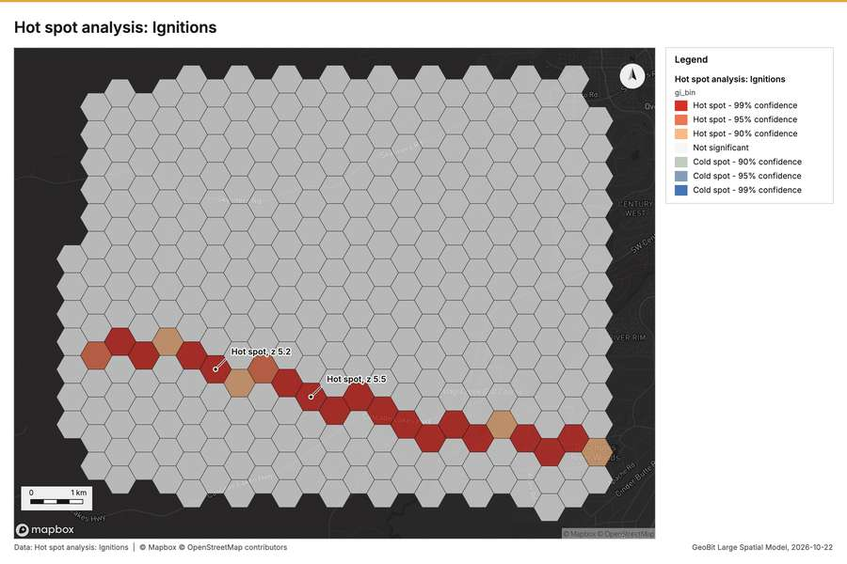
Figure 2. Hot spot analysis: Ignitions [56]
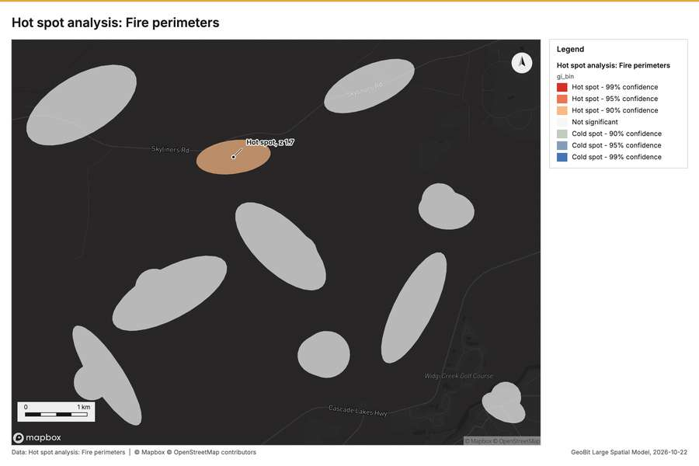
Figure 3. Hot spot analysis: Fire perimeters [57]
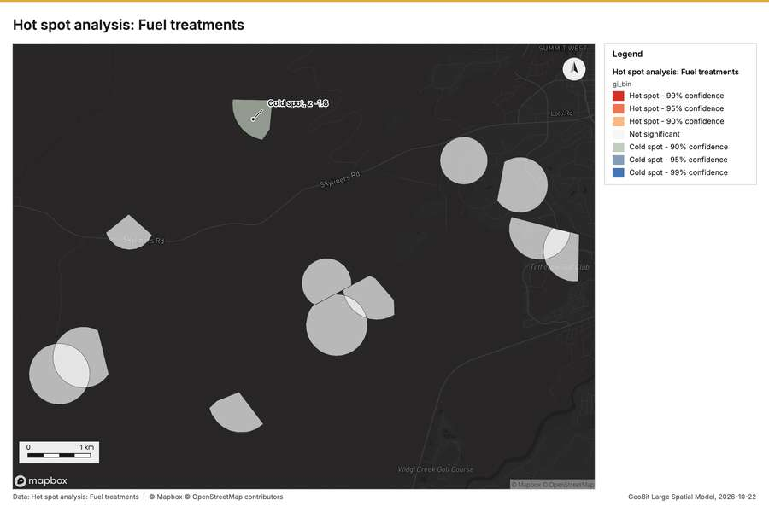
Figure 4. Hot spot analysis: Fuel treatments [58]
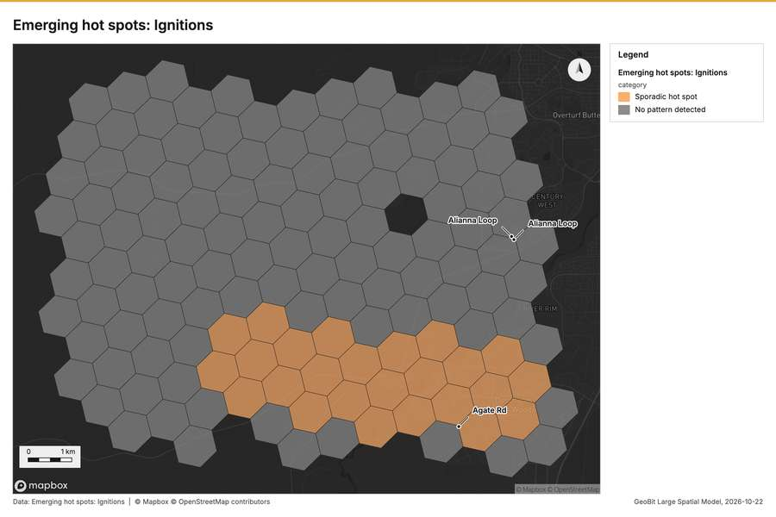
Figure 5. Emerging hot spots: Ignitions [59]
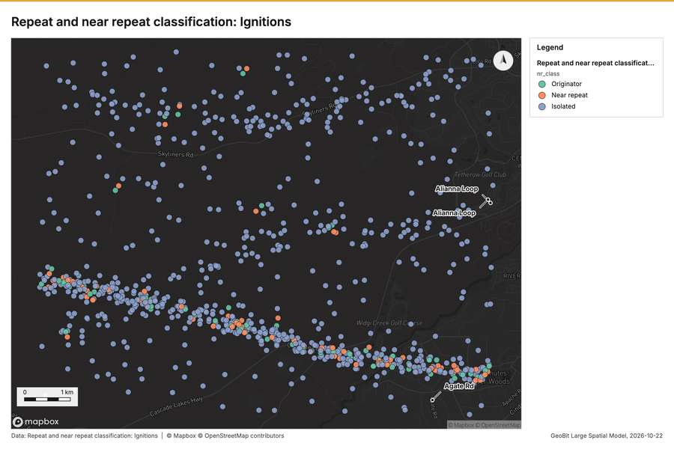
Figure 6. Repeat and near repeat classification: Ignitions [60]
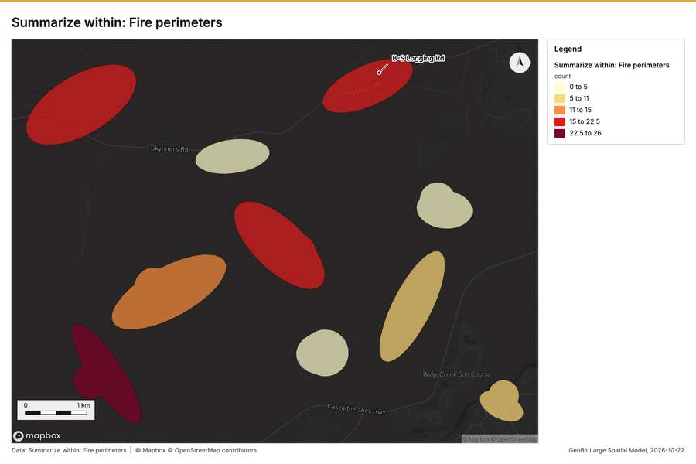
Figure 7. Summarize within: Fire perimeters [61]
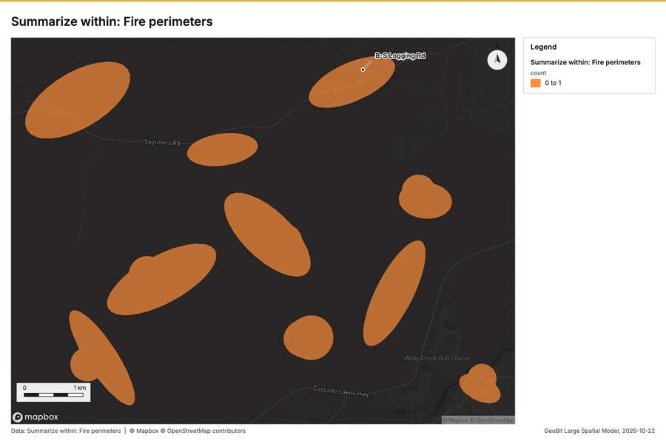
Figure 8. Summarize within: Fire perimeters [62]
Figure 9. Summarize within: Fire perimeters [63]
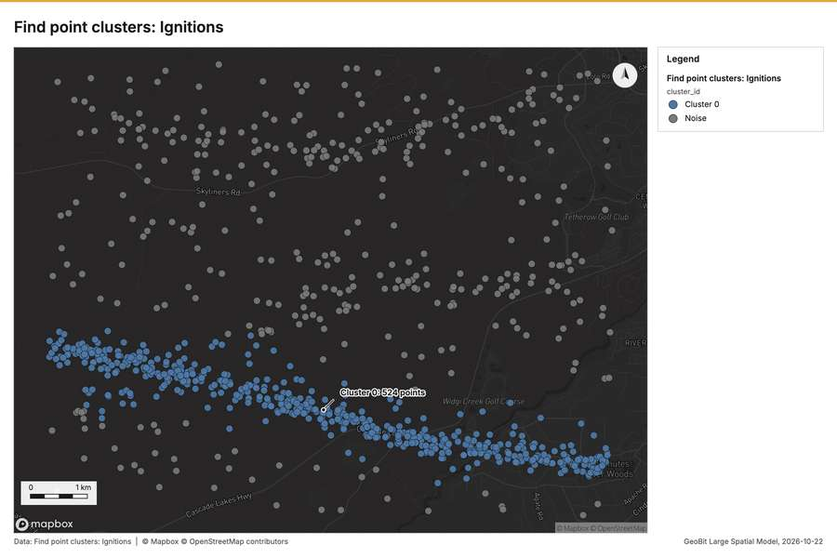
Figure 10. Find point clusters: Ignitions [64]
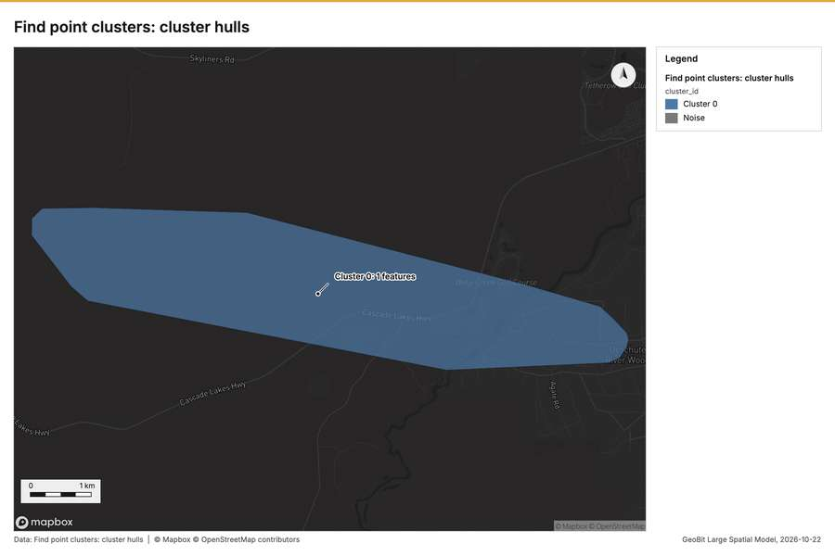
Figure 11. Find point clusters: cluster hulls [65]
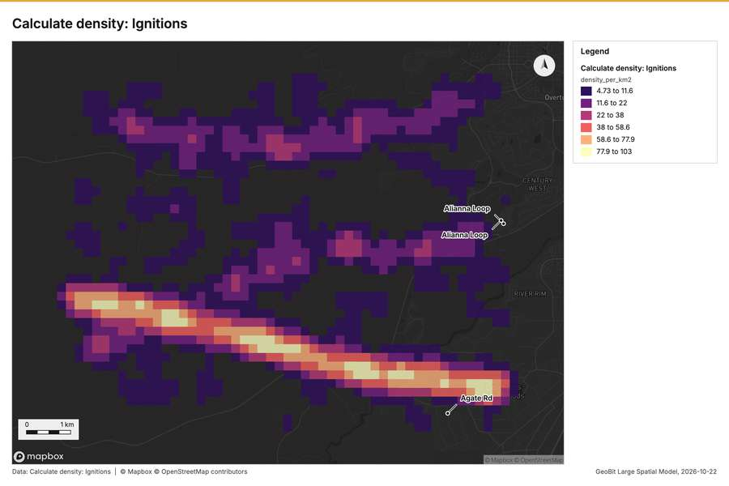
Figure 12. Calculate density: Ignitions [66]
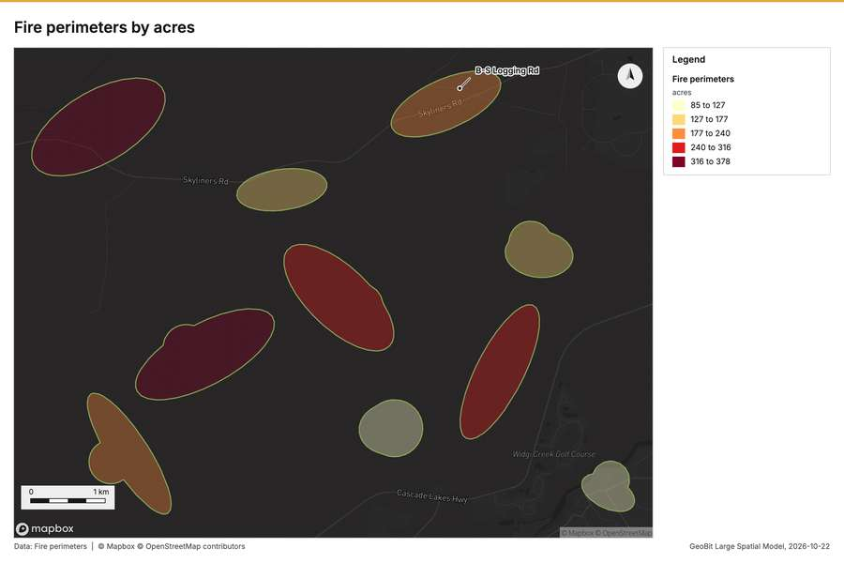
Figure 13. Fire perimeters by acres [67]
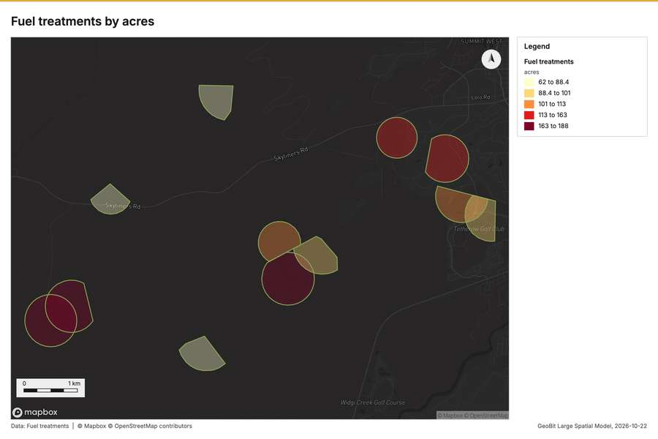
Figure 14. Fuel treatments by acres [68]
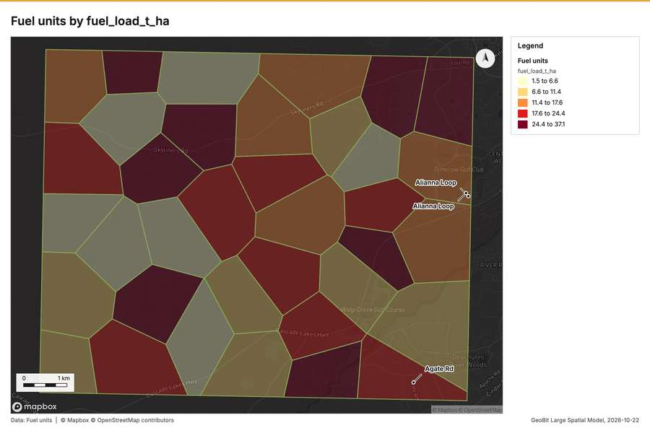
Figure 15. Fuel units by fuel_load_t_ha [69]
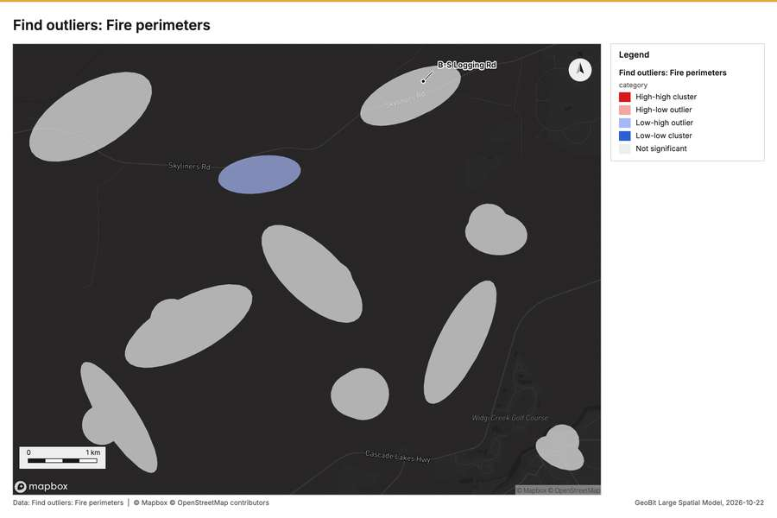
Figure 16. Find outliers: Fire perimeters [70]
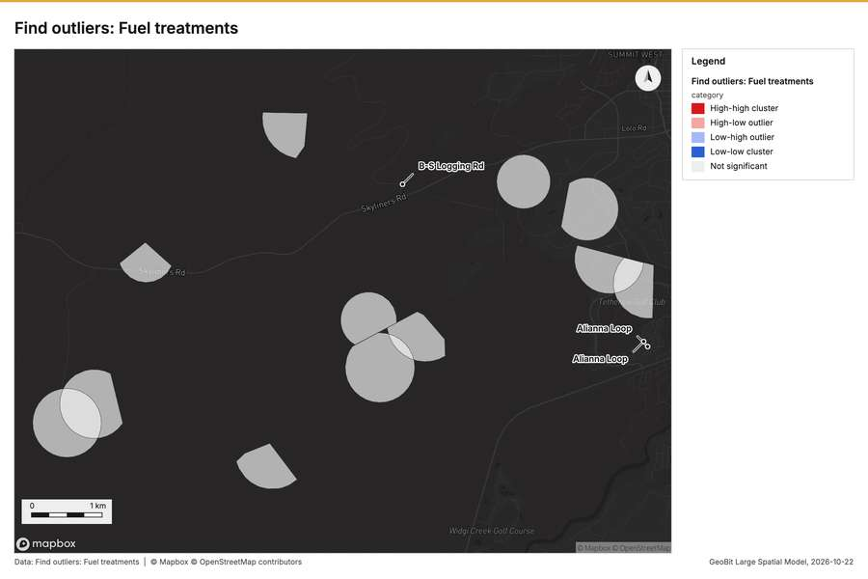
Figure 17. Find outliers: Fuel treatments [71]
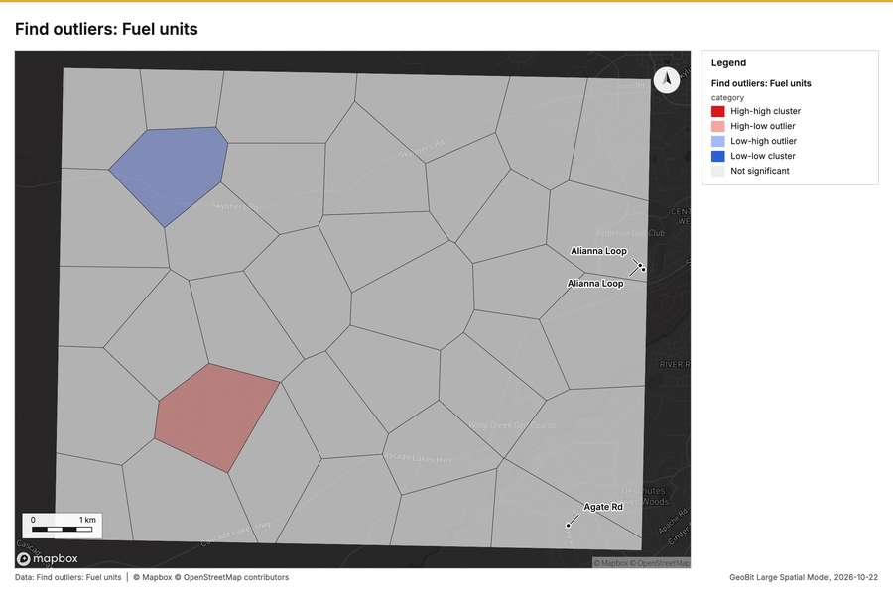
Figure 18. Find outliers: Fuel units [72]
What the map shows. The map displays a clear, concentrated hot spot pattern for ignitions, showing a pronounced band of elevated activity [56]
Inferred: read from the image by gemma4:e4b, not evidence.
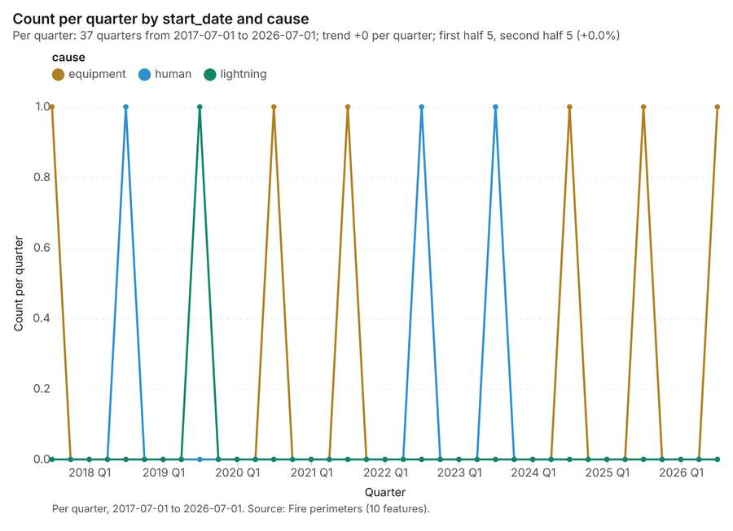
Figure 19. Fire perimeters over time (start_date) [73]. Per quarter, 2017-07-01 to 2026-07-01. Source: Fire perimeters (10 features). The data is in the appendix.
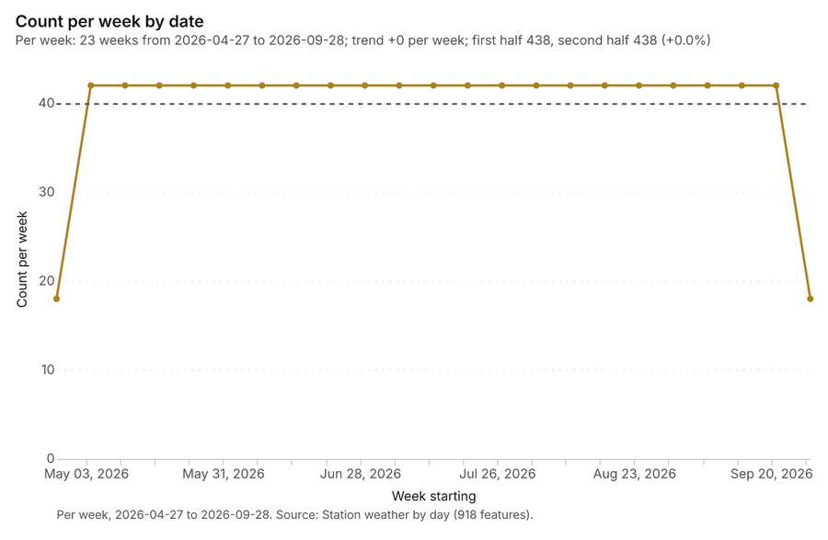
Figure 20. Station weather by day over time (date) [74]. Per week, 2026-04-27 to 2026-09-28. Source: Station weather by day (918 features). The data is in the appendix.
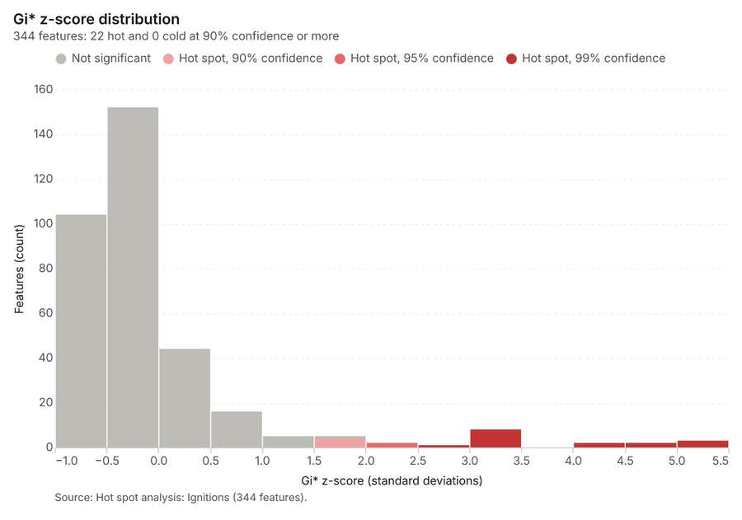
Figure 21. Hot spot analysis: Ignitions [75]. Source: Hot spot analysis: Ignitions (344 features). The data is in the appendix.
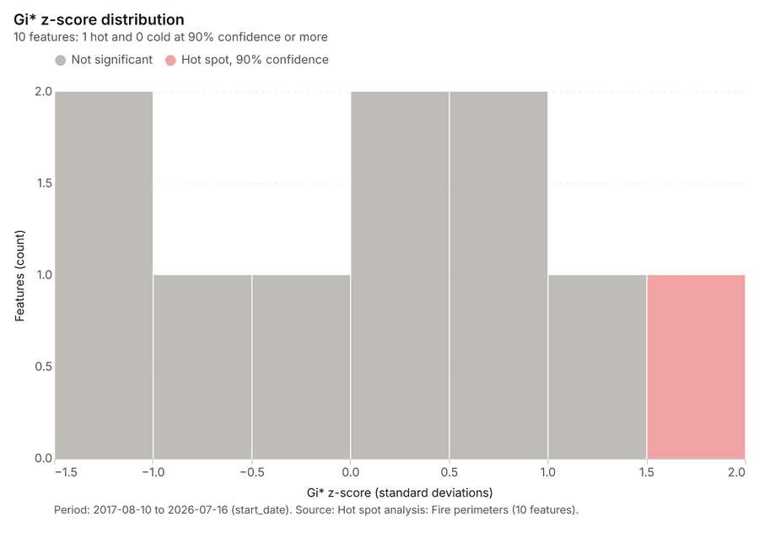
Figure 22. Hot spot analysis: Fire perimeters [76]. Period: 2017-08-10 to 2026-07-16 (start_date). Source: Hot spot analysis: Fire perimeters (10 features). The data is in the appendix.
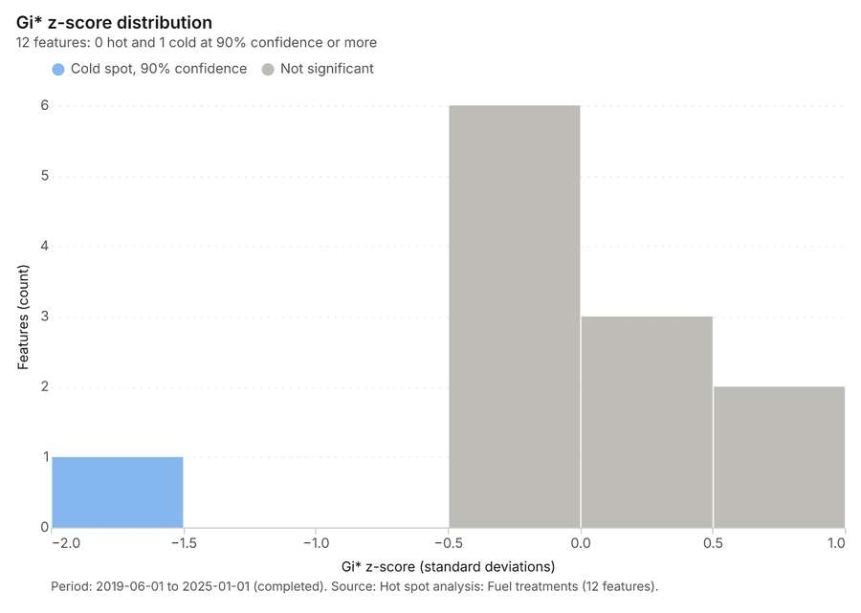
Figure 23. Hot spot analysis: Fuel treatments [77]. Period: 2019-06-01 to 2025-01-01 (completed). Source: Hot spot analysis: Fuel treatments (12 features). The data is in the appendix.
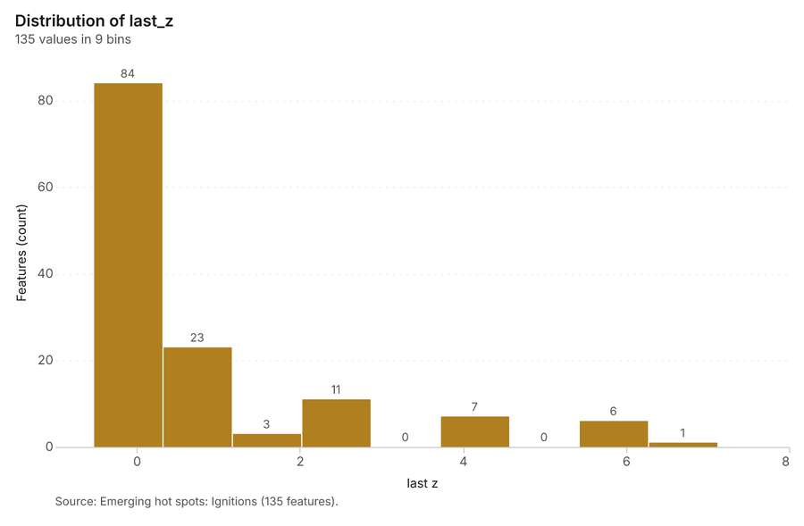
Figure 24. Emerging hot spots: Ignitions [78]. Source: Emerging hot spots: Ignitions (135 features). The data is in the appendix.
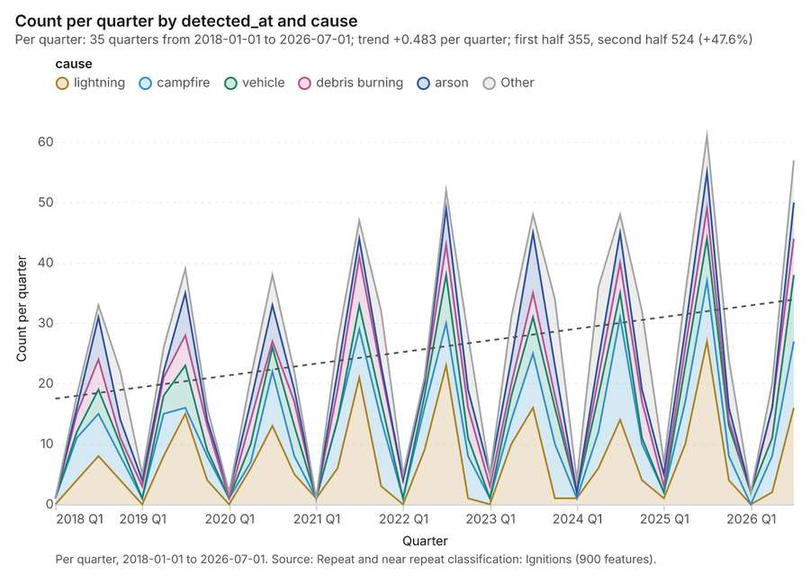
Figure 25. Repeat and near repeat classification: Ignitions [79]. Per quarter, 2018-01-01 to 2026-07-01. Source: Repeat and near repeat classification: Ignitions (900 features). The data is in the appendix.
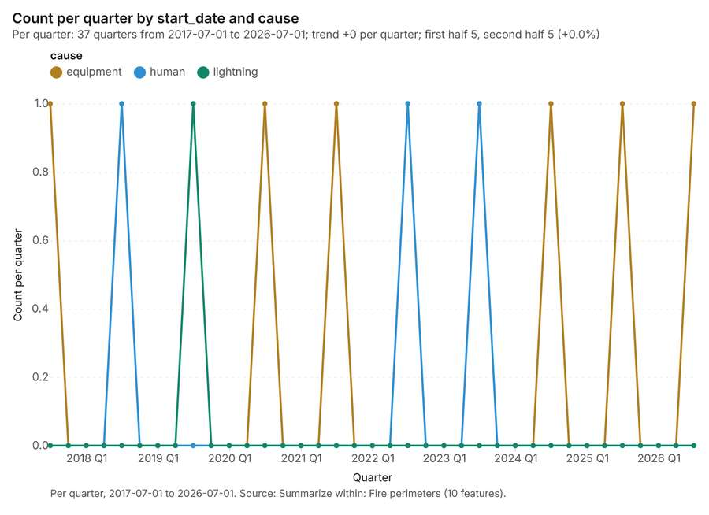
Figure 26. Summarize within: Fire perimeters [80]. Per quarter, 2017-07-01 to 2026-07-01. Source: Summarize within: Fire perimeters (10 features). The data is in the appendix.
Figure 27. Summarize within: Fire perimeters [81]. Per quarter, 2017-07-01 to 2026-07-01. Source: Summarize within: Fire perimeters (10 features). The data is in the appendix.
Figure 28. Summarize within: Fire perimeters [82]. Per quarter, 2017-07-01 to 2026-07-01. Source: Summarize within: Fire perimeters (10 features). The data is in the appendix.
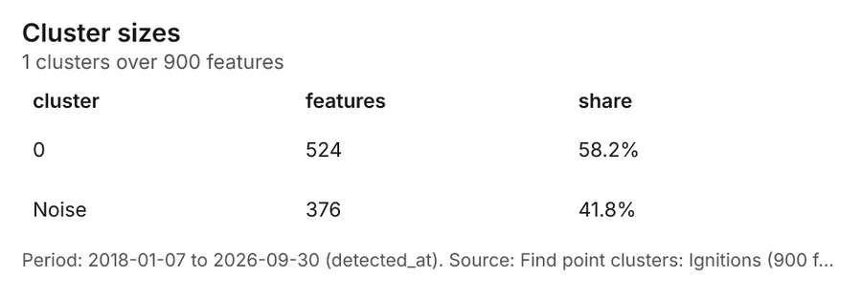
Figure 29. Find point clusters: Ignitions [83]. Period: 2018-01-07 to 2026-09-30 (detected_at). Source: Find point clusters: Ignitions (900 features). The data is in the appendix.
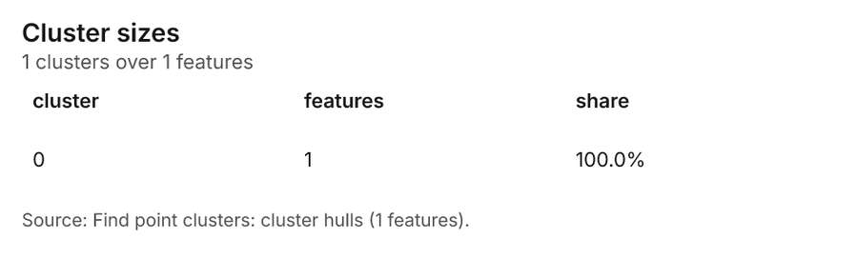
Figure 30. Find point clusters: cluster hulls [84]. Source: Find point clusters: cluster hulls (1 features). The data is in the appendix.
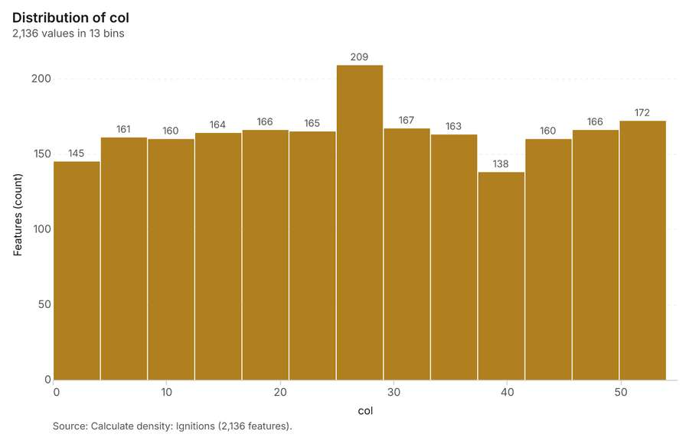
Figure 31. Calculate density: Ignitions [85]. Source: Calculate density: Ignitions (2,136 features). The data is in the appendix.
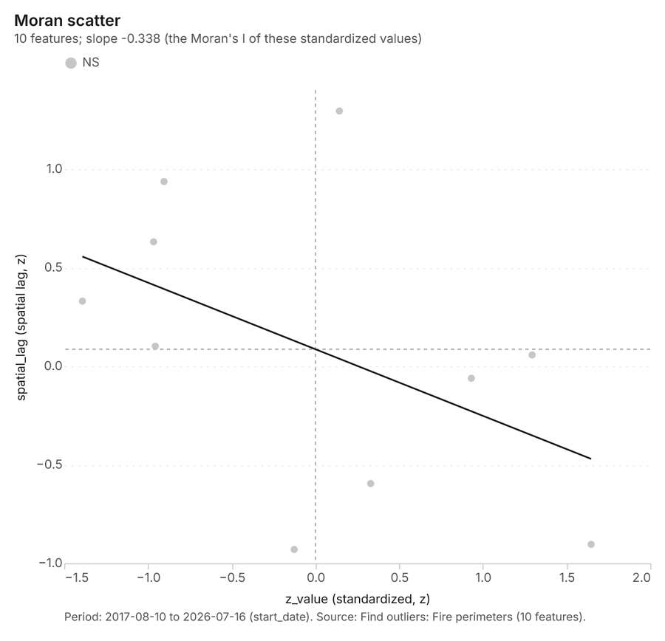
Figure 32. Find outliers: Fire perimeters [86]. Period: 2017-08-10 to 2026-07-16 (start_date). Source: Find outliers: Fire perimeters (10 features). The data is in the appendix.
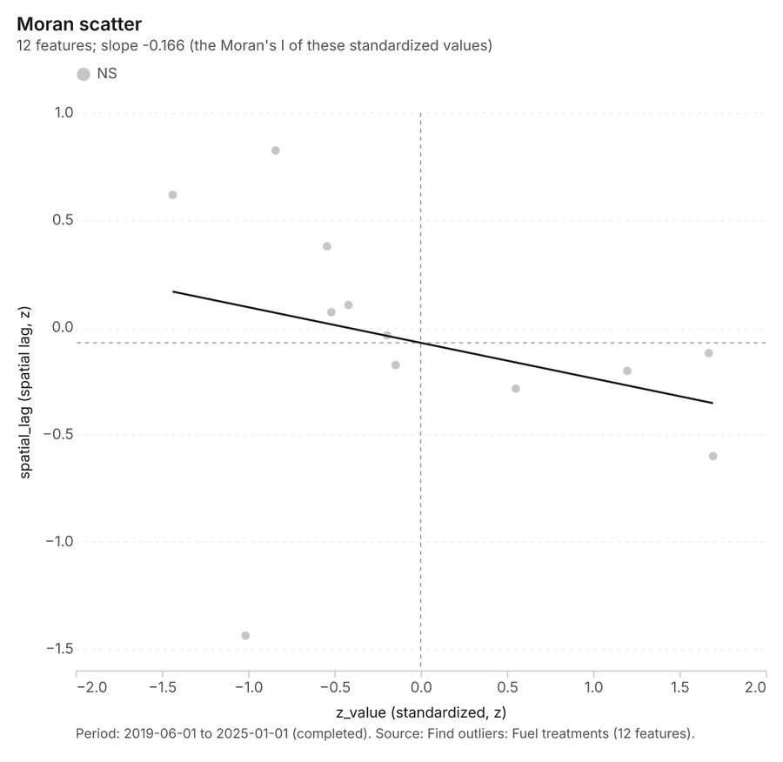
Figure 33. Find outliers: Fuel treatments [87]. Period: 2019-06-01 to 2025-01-01 (completed). Source: Find outliers: Fuel treatments (12 features). The data is in the appendix.
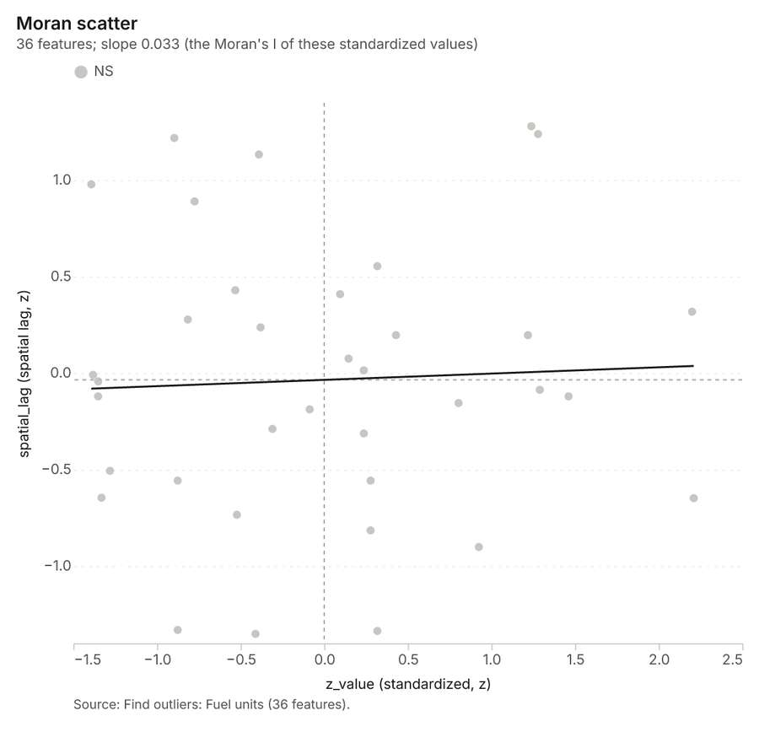
Figure 34. Find outliers: Fuel units [88]. Source: Find outliers: Fuel units (36 features). The data is in the appendix.
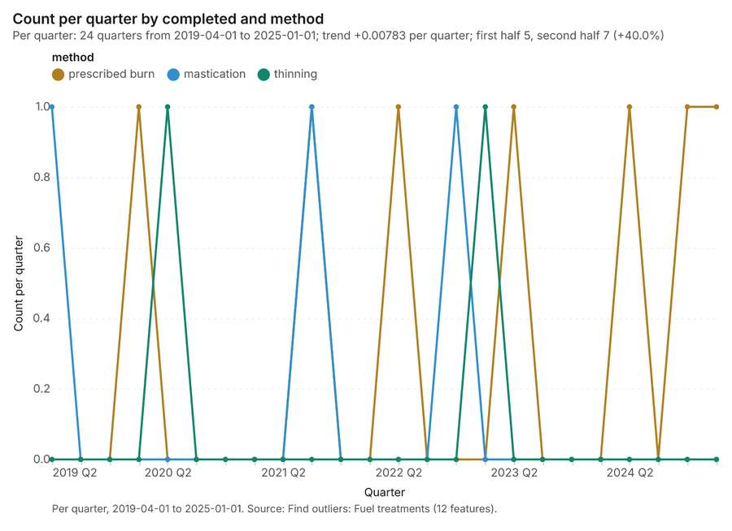
Figure 35. Find outliers: Fuel treatments over time [89]. Per quarter, 2019-04-01 to 2025-01-01. Source: Find outliers: Fuel treatments (12 features). The data is in the appendix.
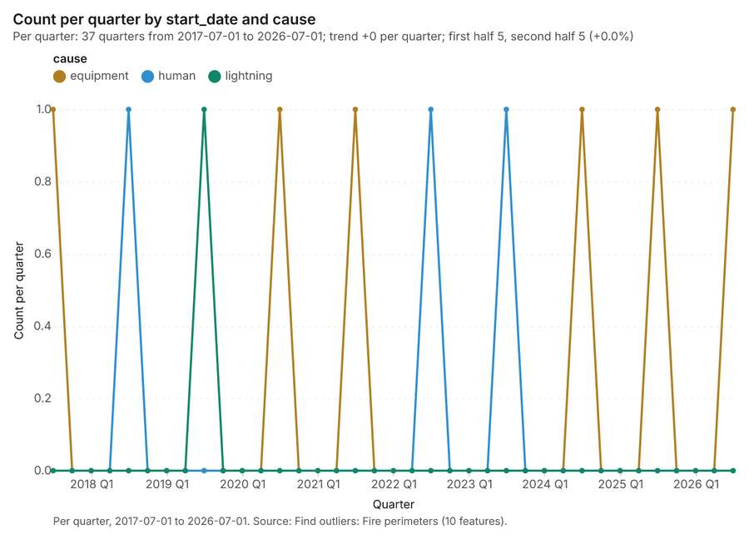
Figure 36. Find outliers: Fire perimeters over time [90]. Per quarter, 2017-07-01 to 2026-07-01. Source: Find outliers: Fire perimeters (10 features). The data is in the appendix.
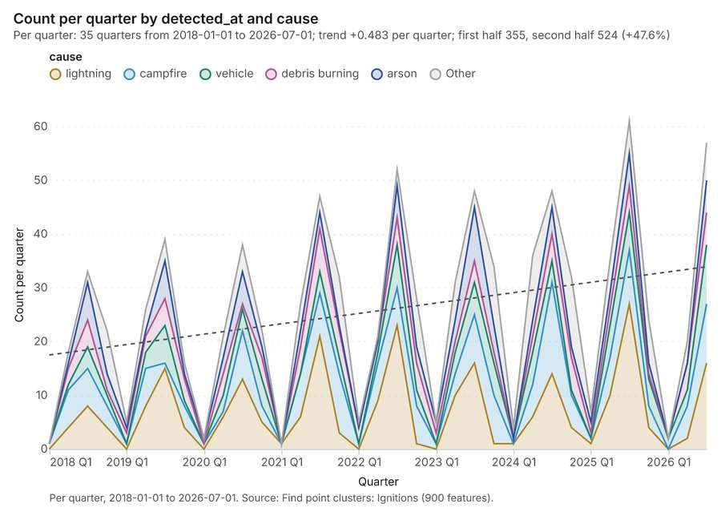
Figure 37. Find point clusters: Ignitions over time [91]. Per quarter, 2018-01-01 to 2026-07-01. Source: Find point clusters: Ignitions (900 features). The data is in the appendix.
Figure 38. Summarize within: Fire perimeters over time [92]. Per quarter, 2017-07-01 to 2026-07-01. Source: Summarize within: Fire perimeters (10 features). The data is in the appendix.
Figure 39. Summarize within: Fire perimeters over time [93]. Per quarter, 2017-07-01 to 2026-07-01. Source: Summarize within: Fire perimeters (10 features). The data is in the appendix.
Figure 40. Summarize within: Fire perimeters over time [94]. Per quarter, 2017-07-01 to 2026-07-01. Source: Summarize within: Fire perimeters (10 features). The data is in the appendix.
Figure 41. Repeat and near repeat classification: Ignitions over time [95]. Per quarter, 2018-01-01 to 2026-07-01. Source: Repeat and near repeat classification: Ignitions (900 features). The data is in the appendix.
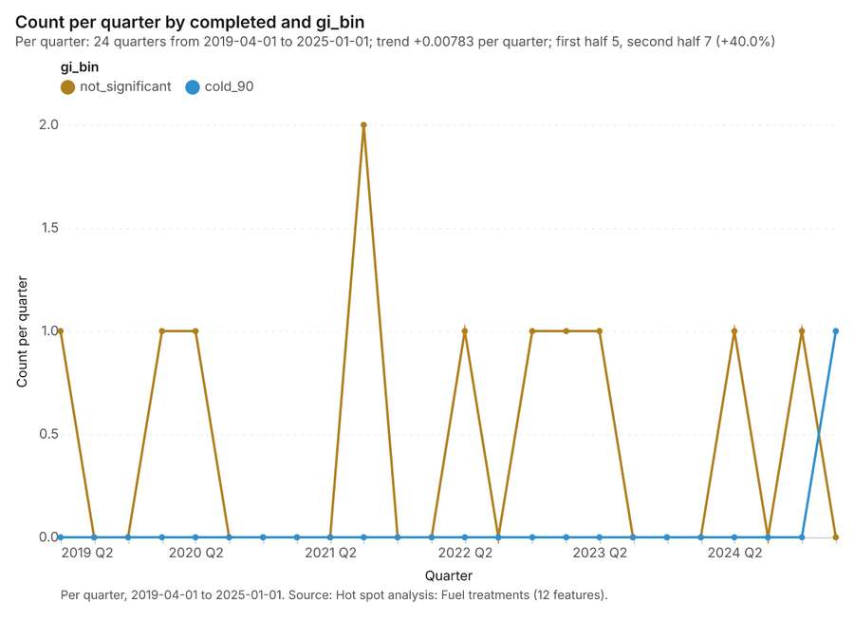
Figure 42. Hot spot analysis: Fuel treatments over time [96]. Per quarter, 2019-04-01 to 2025-01-01. Source: Hot spot analysis: Fuel treatments (12 features). The data is in the appendix.
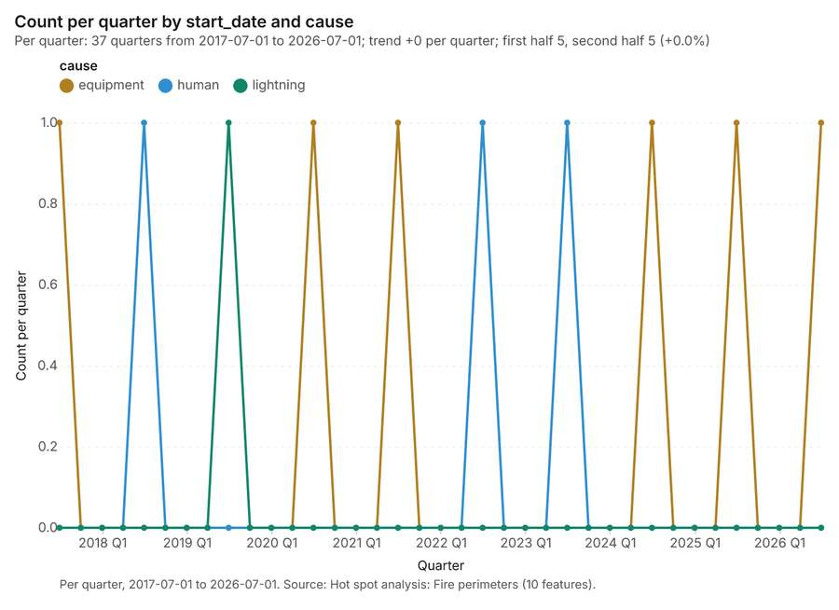
Figure 43. Hot spot analysis: Fire perimeters over time [97]. Per quarter, 2017-07-01 to 2026-07-01. Source: Hot spot analysis: Fire perimeters (10 features). The data is in the appendix.

Changes since the last run
This is the first report of this project.

Sources
[1] Rendering: Chart: Timeline: events per quarter by dataset. 148 rows (id 797c6488-16c8-42a7-904d-8adb7f974668)
[2] Dataset: Fire perimeters. vector, 10 rows (id 0b1e7d40-89ae-4b37-84e1-6536d5653088)
[3] Dataset: Ignitions. vector, 900 rows (id 02464168-4470-4a98-855b-8ef6d9cdbfa9)
[4] Dataset: Fuel treatments. vector, 12 rows (id cfd664dc-8716-42bf-982f-5f1be0e31a76)
[5] Dataset: Station weather by day. table, 918 rows (id 6ea34ef2-dc8d-4e46-8fa7-1ac3431365c9)
[6] Tool result: gp_change_point_detection, step 2. Change point detection: done; no map output. (id 47a00a32-eb67-4c26-bfcb-905c59a0b600:2)
[7] Catalog: Hot spot analysis (operation catalog, gp_hot_spots). Getis-Ord Gi* hot and cold spots with z-scores, p-values and confidence bins. ArcGIS: Find Hot Spots, Hot Spot Analysis (Getis-Ord Gi*). QGIS: qgis:hotspot (plugin). (id gp_hot_spots)
[8] Plan: Hot spots of Ignitions (the Start plan's candidate c_0e0a46dce832). 900 points: Getis-Ord Gi* tests whether the concentrations in Ignitions are statistically significant. (id 186bc213-2630-4d8c-bbef-bc1854404d12:c_0e0a46dce832)
[9] Tool result: gp_hot_spots, step 0. Hot spot analysis: 1 layer saved: Hot spot analysis: Ignitions (344 features). (id 8f951621-3c96-471a-b3ef-37aee18172da:0)
[10] Layer: Ignitions. 900 features (id 73bb3d60-f194-4b32-b9a6-832891cc6297)
[11] Plan: Hot spots of Fire perimeters (the Start plan's candidate c_9b033ea5babc). Gi* hot spots of 'acres' across the areas. (id 186bc213-2630-4d8c-bbef-bc1854404d12:c_9b033ea5babc)
[12] Tool result: gp_hot_spots, step 1. Hot spot analysis: 1 layer saved: Hot spot analysis: Fire perimeters (10 features). (id 8f951621-3c96-471a-b3ef-37aee18172da:1)
[13] Layer: Fire perimeters. 10 features (id 4401c868-dc08-4f13-9bc9-d6e9bb6c8164)
[14] Plan: Hot spots of Fuel treatments (the Start plan's candidate c_a70567ae8653). Gi* hot spots of 'acres' across the areas. (id 186bc213-2630-4d8c-bbef-bc1854404d12:c_a70567ae8653)
[15] Tool result: gp_hot_spots, step 2. Hot spot analysis: 1 layer saved: Hot spot analysis: Fuel treatments (12 features). (id 8f951621-3c96-471a-b3ef-37aee18172da:2)
[16] Layer: Fuel treatments. 12 features (id d603668d-1752-4332-9003-5646b7e22e12)
[17] Catalog: Emerging hot spots (operation catalog, gp_space_time_hot_spots). Where hot spots are new, consecutive, intensifying, persistent, diminishing, sporadic, oscillating or historical over time. ArcGIS: Emerging Hot Spot Analysis, Create Space Time Cube. (id gp_space_time_hot_spots)
[18] Plan: Space time hot spots of Ignitions (the Start plan's candidate c_60f3f9ce8f26). Ignitions carry dates in 'detected_at': emerging hot spot analysis finds new, intensifying and fading hot spots per month. (id 186bc213-2630-4d8c-bbef-bc1854404d12:c_60f3f9ce8f26)
[19] Tool result: gp_space_time_hot_spots, step 0. Emerging hot spots: 1 layer saved: Emerging hot spots: Ignitions (135 features). (id 47a00a32-eb67-4c26-bfcb-905c59a0b600:0)
[20] Catalog: Repeat and near repeat classification (operation catalog, gp_near_repeat). Classify incidents as originators, repeats (same place) or near repeats within a distance and time window, with a Knox test table. ArcGIS: Repeat and Near Repeat Classification, Near Repeat Calculator. (id gp_near_repeat)
[21] Plan: Near repeat of Ignitions (the Start plan's candidate c_10f86c3efd81). Near repeat analysis tests whether Ignitions close in space also follow each other within 30 days. (id 186bc213-2630-4d8c-bbef-bc1854404d12:c_10f86c3efd81)
[22] Tool result: gp_near_repeat, step 1. Repeat and near repeat classification: 1 layer saved: Repeat and near repeat classification: Ignitions (900 features). (id 47a00a32-eb67-4c26-bfcb-905c59a0b600:1)
[23] Catalog: Change point detection (operation catalog, gp_change_point_detection). When did the level, count, trend or variability change? For the whole study area or for every bin. ArcGIS: Change Point Detection. (id gp_change_point_detection)
[24] Plan: Change points of Ignitions (the Start plan's candidate c_03da66dfe7e8). Change point detection finds when the monthly count of Ignitions shifted. (id 186bc213-2630-4d8c-bbef-bc1854404d12:c_03da66dfe7e8)
[25] Catalog: Summarize within (operation catalog, gp_summarize_within). Count and aggregate the features inside each polygon (or bin), proportionally for lines and polygons. ArcGIS: Summarize Within, Aggregate Points. QGIS: native:countpointsinpolygon, native:sumlinelengths. (id gp_summarize_within)
[26] Plan: Ignitions per feature of Fire perimeters (the Start plan's candidate c_2c750e088dcf). Count Ignitions inside each feature of Fire perimeters by cause; the counts map as a choropleth (natural breaks, sequential colors). (id 186bc213-2630-4d8c-bbef-bc1854404d12:c_2c750e088dcf)
[27] Tool result: gp_summarize_within, step 0. Summarize within: 1 layer saved: Summarize within: Fire perimeters (10 features). (id d0d6a5af-89c4-4ed0-a643-2d3531685abc:0)
[28] Tool result: gp_summarize_within, step 1. Summarize within: 1 layer saved: Summarize within: Fire perimeters (10 features). (id d0d6a5af-89c4-4ed0-a643-2d3531685abc:1)
[29] Layer: Fire lookouts. 3 features (id 81fdbe6e-83c1-4f4d-8dc9-e59c43c15d96)
[30] Tool result: gp_summarize_within, step 2. Summarize within: 1 layer saved: Summarize within: Fire perimeters (10 features). (id d0d6a5af-89c4-4ed0-a643-2d3531685abc:2)
[31] Layer: Weather stations. 6 features (id 6b183e69-c85a-4bf5-8192-07431db200f4)
[32] Catalog: Zonal statistics (analysis catalog, rs_zonal_statistics). count/min/max/mean/std/sum/median/majority per polygon as a table and as GeoJSON. ArcGIS: Zonal Statistics as Table (polygons). (id rs_zonal_statistics)
[33] Plan: Zonal statistics of Forest terrain model (DEM) and Fire perimeters (the Start plan's candidate c_f8c34509825d). Statistics of Forest terrain model (DEM) inside each feature of Fire perimeters. (id 186bc213-2630-4d8c-bbef-bc1854404d12:c_f8c34509825d)
[34] Tool result: rs_zonal_statistics, step 0. Zonal statistics: 10 row(s). zones 10. (id 585cf8a3-03c6-4f2b-ae1f-4e561bc33bf0:0)
[35] Tool result: rs_zonal_statistics, step 1. Zonal statistics: 12 row(s). zones 12. (id 585cf8a3-03c6-4f2b-ae1f-4e561bc33bf0:1)
[36] Tool result: rs_zonal_statistics, step 2. Zonal statistics: 36 row(s). zones 36. (id 585cf8a3-03c6-4f2b-ae1f-4e561bc33bf0:2)
[37] Catalog: Find point clusters (operation catalog, gp_find_point_clusters). Density-based clusters (DBSCAN, HDBSCAN or OPTICS, optionally space-time) with hulls and noise. ArcGIS: Find Point Clusters, Density-based Clustering. QGIS: native:dbscanclustering, native:stdbscanclustering. (id gp_find_point_clusters)
[38] Plan: Cluster points of Ignitions (the Start plan's candidate c_03b5374e7f2f). DBSCAN finds dense groups of Ignitions and separates noise. (id 186bc213-2630-4d8c-bbef-bc1854404d12:c_03b5374e7f2f)
[39] Tool result: gp_find_point_clusters, step 0. Find point clusters: 2 layers saved: Find point clusters: Ignitions (900 features); Find point clusters: cluster hulls (1 feature). (id d750a3d5-f804-48d7-a5ab-cea0c64036e0:0)
[40] Catalog: Average nearest neighbor (operation catalog, gp_nearest_neighbor_index). Clark-Evans ratio: clustered, dispersed or random. ArcGIS: Average Nearest Neighbor. QGIS: native:nearestneighbouranalysis. (id gp_nearest_neighbor_index)
[41] Plan: Nearest neighbor index of Ignitions (the Start plan's candidate c_394da09ac152). The average nearest neighbor ratio says whether Ignitions are clustered, random or dispersed. (id 186bc213-2630-4d8c-bbef-bc1854404d12:c_394da09ac152)
[42] Tool result: gp_nearest_neighbor_index, step 1. Average nearest neighbor: done; no map output. (id d750a3d5-f804-48d7-a5ab-cea0c64036e0:1)
[43] Plan: Nearest neighbor index of Weather stations (the Start plan's candidate c_30762cad9c11). The average nearest neighbor ratio says whether Weather stations are clustered, random or dispersed. (id 186bc213-2630-4d8c-bbef-bc1854404d12:c_30762cad9c11)
[44] Tool result: gp_nearest_neighbor_index, step 2. Average nearest neighbor: done; no map output. (id d750a3d5-f804-48d7-a5ab-cea0c64036e0:2)
[45] Catalog: Calculate density (operation catalog, gp_calculate_density). Kernel density per square kilometer on a grid. ArcGIS: Calculate Density, Kernel Density. QGIS: native:heatmapkerneldensityestimation. (id gp_calculate_density)
[46] Plan: Kernel density of Ignitions (the Start plan's candidate c_8031c96859c6). 900 points in Ignitions: a density surface shows where they concentrate. (id 186bc213-2630-4d8c-bbef-bc1854404d12:c_8031c96859c6)
[47] Tool result: gp_calculate_density, step 0. Calculate density: 1 layer saved: Calculate density: Ignitions (2136 features). (id a9724881-6b90-401e-86d3-b3e78a11a086:0)
[48] Catalog: Find outliers (operation catalog, gp_outliers). Anselin local Moran’s I: HH, LL clusters and HL, LH outliers. ArcGIS: Find Outliers, Cluster and Outlier Analysis (Anselin Local Moran’s I). (id gp_outliers)
[49] Plan: Local morans i of Fire perimeters (the Start plan's candidate c_97cb8e0f2668). Local Moran's I maps clusters and outliers of 'acres'. (id 186bc213-2630-4d8c-bbef-bc1854404d12:c_97cb8e0f2668)
[50] Tool result: gp_outliers, step 0. Find outliers: 1 layer saved: Find outliers: Fire perimeters (10 features). (id d2855091-5bee-4e72-92bc-f4d96c2ad80a:0)
[51] Plan: Local morans i of Fuel treatments (the Start plan's candidate c_f3914935665b). Local Moran's I maps clusters and outliers of 'acres'. (id 186bc213-2630-4d8c-bbef-bc1854404d12:c_f3914935665b)
[52] Tool result: gp_outliers, step 1. Find outliers: 1 layer saved: Find outliers: Fuel treatments (12 features). (id d2855091-5bee-4e72-92bc-f4d96c2ad80a:1)
[53] Plan: Local morans i of Fuel units (the Start plan's candidate c_d1cbc9b93230). Local Moran's I maps clusters and outliers of 'fuel_load_t_ha'. (id 186bc213-2630-4d8c-bbef-bc1854404d12:c_d1cbc9b93230)
[54] Tool result: gp_outliers, step 2. Find outliers: 1 layer saved: Find outliers: Fuel units (36 features). (id d2855091-5bee-4e72-92bc-f4d96c2ad80a:2)
[55] Layer: Fuel units. 36 features (id 42f78cee-8de2-430c-8f54-a3b77306f0e7)
[56] Rendering: Map: Hot spot analysis: Ignitions (id bb63cb93-55aa-4f5b-9b90-3bf45d6dc57f)
[57] Rendering: Map: Hot spot analysis: Fire perimeters (id c5abc0f0-1d90-42a7-890d-973a23eae10f)
[58] Rendering: Map: Hot spot analysis: Fuel treatments (id b4e60dce-bab6-4223-a5db-f854367edcc9)
[59] Rendering: Map: Emerging hot spots: Ignitions (id 86125b2e-c24e-46d9-bf32-2bc320dd67bf)
[60] Rendering: Map: Repeat and near repeat classification: Ignitions (id d2b0ab7d-8519-4953-a574-41a63e22f158)
[61] Rendering: Map: Summarize within: Fire perimeters (id 1b0b59ae-d26e-448d-99f4-13f97a2e6e22)
[62] Rendering: Map: Summarize within: Fire perimeters (id 79f494a0-8339-4630-9f2b-1eb51920b75e)
[63] Rendering: Map: Summarize within: Fire perimeters (id 157a695e-39d9-4eda-a959-2757ef39dd1f)
[64] Rendering: Map: Find point clusters: Ignitions (id 769cd190-b6cd-4baf-bb26-89b68980f41b)
[65] Rendering: Map: Find point clusters: cluster hulls (id 39ce8fbd-9d74-4a4f-9be5-a6510ea09ce6)
[66] Rendering: Map: Calculate density: Ignitions (id dc62fd3d-336d-4e9a-b0cb-53b02e35914a)
[67] Rendering: Map: Fire perimeters by acres (id b5a6d9fb-5e10-4e3d-8f27-49001ad00173)
[68] Rendering: Map: Fuel treatments by acres (id ad8c35df-63f5-4cf4-bc47-ecf9d02f74f8)
[69] Rendering: Map: Fuel units by fuel_load_t_ha (id 102ee2da-8af4-42d9-9311-7ee514591e21)
[70] Rendering: Map: Find outliers: Fire perimeters (id 74f7137e-d925-4cf8-8637-4cf18c53ed90)
[71] Rendering: Map: Find outliers: Fuel treatments (id f7d92071-015a-4f7a-853e-6834d900f625)
[72] Rendering: Map: Find outliers: Fuel units (id 2b4bb626-f282-4cd0-9678-a86f686584ce)
[73] Rendering: Chart: Fire perimeters over time (start_date). 111 rows (id 3cb8b4ab-f4bc-4698-939c-3d9a7ff84f07)
[74] Rendering: Chart: Station weather by day over time (date). 23 rows (id ddf56570-bae6-49fc-b4c3-4800008acb48)
[75] Rendering: Chart: Hot spot analysis: Ignitions. 13 rows (id ac627744-6825-4c3d-9670-c93a9bfb2e42)
[76] Rendering: Chart: Hot spot analysis: Fire perimeters. 7 rows (id 3c9aad31-e9ac-49eb-982d-37bc396afad8)
[77] Rendering: Chart: Hot spot analysis: Fuel treatments. 4 rows (id 638ff2d9-34f9-403b-a35d-d9a308e3ec25)
[78] Rendering: Chart: Emerging hot spots: Ignitions. 9 rows (id 0a4caa2f-337b-4a6b-b4d4-b142afafe031)
[79] Rendering: Chart: Repeat and near repeat classification: Ignitions. 210 rows (id 632a779a-47b0-4035-b53d-354cabd5d360)
[80] Rendering: Chart: Summarize within: Fire perimeters. 111 rows (id 22ee21d5-58dc-4e1e-a070-6a67a901c965)
[81] Rendering: Chart: Summarize within: Fire perimeters. 111 rows (id db2f619e-43fa-4d26-9640-fb162068f74e)
[82] Rendering: Chart: Summarize within: Fire perimeters. 111 rows (id b7f0dd9d-22ad-4e93-9b93-cf9a83fadf84)
[83] Rendering: Chart: Find point clusters: Ignitions. 2 rows (id 1e027e4b-22a2-45d5-9086-2a36c8138f69)
[84] Rendering: Chart: Find point clusters: cluster hulls. 1 rows (id 0789a6b7-999c-4f6b-9d42-1cd13d066287)
[85] Rendering: Chart: Calculate density: Ignitions. 13 rows (id 0be10378-cba5-4926-a390-c5d82995b1a3)
[86] Rendering: Chart: Find outliers: Fire perimeters. 10 rows (id 84e826fe-c1a8-45f7-9c15-b536ccc175c6)
[87] Rendering: Chart: Find outliers: Fuel treatments. 12 rows (id 8efc3778-a287-41ed-b887-f7929e06afc2)
[88] Rendering: Chart: Find outliers: Fuel units. 36 rows (id 05890114-2897-4a1f-b199-efec992907fe)
[89] Rendering: Chart: Find outliers: Fuel treatments over time. 72 rows (id af3a74cb-f5e6-45e1-aee7-be2f209870ab)
[90] Rendering: Chart: Find outliers: Fire perimeters over time. 111 rows (id ffd1204d-4f08-4461-8cd1-44fcce92e2c2)
[91] Rendering: Chart: Find point clusters: Ignitions over time. 210 rows (id 2d0515c1-e371-4a5e-aded-37ced56bb910)
[92] Rendering: Chart: Summarize within: Fire perimeters over time. 111 rows (id 3f4630a7-8117-4a45-ad96-0b64158a7db3)
[93] Rendering: Chart: Summarize within: Fire perimeters over time. 111 rows (id 01777e29-c207-4718-a2ee-d69065a84d99)
[94] Rendering: Chart: Summarize within: Fire perimeters over time. 111 rows (id ff1e5279-5ea0-474a-9e56-4e42867284ca)
[95] Rendering: Chart: Repeat and near repeat classification: Ignitions over time. 210 rows (id cb6bd5ac-4983-40a6-adb2-f8cbdca32ee7)
[96] Rendering: Chart: Hot spot analysis: Fuel treatments over time. 48 rows (id 94c4e65c-ee4e-4a2b-9d8c-c1fa5cd5282a)
[97] Rendering: Chart: Hot spot analysis: Fire perimeters over time. 111 rows (id d8ab7b19-e10f-4683-bd70-1708bd93b637)
[98] Dataset: Fuel units. vector, 36 rows (id fc5028cb-a84d-444c-a982-49a4f156c28e)
[99] Dataset: Forest roads. vector, 15 rows (id c0892d0e-cdf3-4371-9e82-477a931a88d7)
[100] Dataset: Weather stations. vector, 6 rows (id 720b6843-88fb-4d45-b04c-efa7b051e0a4)
[101] Dataset: Fire lookouts. vector, 3 rows (id 57d287f4-2d44-451b-9f1c-7e45316002b6)
[102] Dataset: Forest terrain model (DEM). raster, ? rows (id 81d246c7-6131-4938-9f61-f7279a97cc5e)
[103] Dataset: Treatment costs. table, 12 rows (id 8c3b32c2-3535-489c-94ca-7cf557f9e65d)
[104] Dataset: Fuels treatment plan. document, ? rows (id 275ae7d9-0d0b-407c-aa5b-b35298e6ba4e)
[105] Record: Sample: Forestry and wildfire, Bend (id 721d878b-84af-42eb-9c9c-858bf9a6a75e)
[106] Layer: Hot spot analysis: Ignitions. 344 features (id 0fd14c27-6dc5-40ab-9367-9526fed96488)
[107] Layer: Hot spot analysis: Fire perimeters. 10 features (id 712f8542-d935-4ffb-9017-4996ae740395)
[108] Layer: Hot spot analysis: Fuel treatments. 12 features (id 17998548-cdf7-4623-86fa-b34232ee3f92)
[109] Layer: Emerging hot spots: Ignitions. 135 features (id 6cd30a8d-a6bb-41fa-aa35-bde687bf9907)
[110] Layer: Repeat and near repeat classification: Ignitions. 900 features (id e22031fb-e461-400b-8e9e-72ffaa953304)
[111] Layer: Summarize within: Fire perimeters. 10 features (id b8d71f1c-d5f1-49e2-a2bd-f7b2532714da)
[112] Layer: Summarize within: Fire perimeters. 10 features (id f9a795e9-aa11-4cf7-919f-3fd6479f41aa)
[113] Layer: Summarize within: Fire perimeters. 10 features (id 072dac32-c222-4fd9-a81b-67d2bbd389f9)
[114] Layer: Find point clusters: Ignitions. 900 features (id f0f43900-3843-44c7-a966-3fad40f516a7)
[115] Layer: Find point clusters: cluster hulls. 1 features (id 9eb7e362-3675-466c-b2bd-13b526913ffe)
[116] Layer: Calculate density: Ignitions. 2,136 features (id 4c8afb06-e51c-4b81-abd6-8abc0805636a)
[117] Layer: Find outliers: Fire perimeters. 10 features (id 32df7e83-bd50-4624-8151-7a1c53594cda)
[118] Layer: Find outliers: Fuel treatments. 12 features (id d3cbfd02-4bf8-4255-8459-f80c861e5a3c)
[119] Layer: Find outliers: Fuel units. 36 features (id 4f521496-6165-4997-b713-4947d4e59c52)

Appendix: the data behind the charts

Figure 1. Timeline: events per quarter by dataset [1]
period | series | value
2017-07-01 | Station weather by day | 0
2017-07-01 | Ignitions | 0
2017-07-01 | Fuel treatments | 0
2017-07-01 | Fire perimeters | 1
2017-10-01 | Station weather by day | 0
2017-10-01 | Ignitions | 0
2017-10-01 | Fuel treatments | 0
2017-10-01 | Fire perimeters | 0
2018-01-01 | Station weather by day | 0
2018-01-01 | Ignitions | 1
2018-01-01 | Fuel treatments | 0
2018-01-01 | Fire perimeters | 0
2018-04-01 | Station weather by day | 0
2018-04-01 | Ignitions | 18
2018-04-01 | Fuel treatments | 0
2018-04-01 | Fire perimeters | 0
2018-07-01 | Station weather by day | 0
2018-07-01 | Ignitions | 33
2018-07-01 | Fuel treatments | 0
2018-07-01 | Fire perimeters | 1
2018-10-01 | Station weather by day | 0
2018-10-01 | Ignitions | 22
2018-10-01 | Fuel treatments | 0
2018-10-01 | Fire perimeters | 0
2019-01-01 | Station weather by day | 0
2019-01-01 | Ignitions | 5
2019-01-01 | Fuel treatments | 0
2019-01-01 | Fire perimeters | 0
2019-04-01 | Station weather by day | 0
2019-04-01 | Ignitions | 26
2019-04-01 | Fuel treatments | 1
2019-04-01 | Fire perimeters | 0
2019-07-01 | Station weather by day | 0
2019-07-01 | Ignitions | 39
2019-07-01 | Fuel treatments | 0
2019-07-01 | Fire perimeters | 1
2019-10-01 | Station weather by day | 0
2019-10-01 | Ignitions | 16
2019-10-01 | Fuel treatments | 0
2019-10-01 | Fire perimeters | 0
2020-01-01 | Station weather by day | 0
2020-01-01 | Ignitions | 2
2020-01-01 | Fuel treatments | 1
2020-01-01 | Fire perimeters | 0
2020-04-01 | Station weather by day | 0
2020-04-01 | Ignitions | 21
2020-04-01 | Fuel treatments | 1
2020-04-01 | Fire perimeters | 0
2020-07-01 | Station weather by day | 0
2020-07-01 | Ignitions | 38
2020-07-01 | Fuel treatments | 0
2020-07-01 | Fire perimeters | 1
2020-10-01 | Station weather by day | 0
2020-10-01 | Ignitions | 22
2020-10-01 | Fuel treatments | 0
2020-10-01 | Fire perimeters | 0
2021-01-01 | Station weather by day | 0
2021-01-01 | Ignitions | 1
2021-01-01 | Fuel treatments | 0
2021-01-01 | Fire perimeters | 0
2021-04-01 | Station weather by day | 0
2021-04-01 | Ignitions | 27
2021-04-01 | Fuel treatments | 0
2021-04-01 | Fire perimeters | 0
2021-07-01 | Station weather by day | 0
2021-07-01 | Ignitions | 47
2021-07-01 | Fuel treatments | 2
2021-07-01 | Fire perimeters | 1
2021-10-01 | Station weather by day | 0
2021-10-01 | Ignitions | 32
2021-10-01 | Fuel treatments | 0
2021-10-01 | Fire perimeters | 0
2022-01-01 | Station weather by day | 0
2022-01-01 | Ignitions | 5
2022-01-01 | Fuel treatments | 0
2022-01-01 | Fire perimeters | 0
2022-04-01 | Station weather by day | 0
2022-04-01 | Ignitions | 21
2022-04-01 | Fuel treatments | 1
2022-04-01 | Fire perimeters | 0
2022-07-01 | Station weather by day | 0
2022-07-01 | Ignitions | 52
2022-07-01 | Fuel treatments | 0
2022-07-01 | Fire perimeters | 1
2022-10-01 | Station weather by day | 0
2022-10-01 | Ignitions | 28
2022-10-01 | Fuel treatments | 1
2022-10-01 | Fire perimeters | 0
2023-01-01 | Station weather by day | 0
2023-01-01 | Ignitions | 5
2023-01-01 | Fuel treatments | 1
2023-01-01 | Fire perimeters | 0
2023-04-01 | Station weather by day | 0
2023-04-01 | Ignitions | 31
2023-04-01 | Fuel treatments | 1
2023-04-01 | Fire perimeters | 0
2023-07-01 | Station weather by day | 0
2023-07-01 | Ignitions | 48
2023-07-01 | Fuel treatments | 0
2023-07-01 | Fire perimeters | 1
2023-10-01 | Station weather by day | 0
2023-10-01 | Ignitions | 34
2023-10-01 | Fuel treatments | 0
2023-10-01 | Fire perimeters | 0
2024-01-01 | Station weather by day | 0
2024-01-01 | Ignitions | 4
2024-01-01 | Fuel treatments | 0
2024-01-01 | Fire perimeters | 0
2024-04-01 | Station weather by day | 0
2024-04-01 | Ignitions | 36
2024-04-01 | Fuel treatments | 1
2024-04-01 | Fire perimeters | 0
2024-07-01 | Station weather by day | 0
2024-07-01 | Ignitions | 48
2024-07-01 | Fuel treatments | 0
2024-07-01 | Fire perimeters | 1
2024-10-01 | Station weather by day | 0
2024-10-01 | Ignitions | 32
2024-10-01 | Fuel treatments | 1
2024-10-01 | Fire perimeters | 0
2025-01-01 | Station weather by day | 0
2025-01-01 | Ignitions | 7
2025-01-01 | Fuel treatments | 1
2025-01-01 | Fire perimeters | 0
2025-04-01 | Station weather by day | 0
2025-04-01 | Ignitions | 35
2025-04-01 | Fuel treatments | 0
2025-04-01 | Fire perimeters | 0
2025-07-01 | Station weather by day | 0
2025-07-01 | Ignitions | 61
2025-07-01 | Fuel treatments | 0
2025-07-01 | Fire perimeters | 1
2025-10-01 | Station weather by day | 0
2025-10-01 | Ignitions | 24
2025-10-01 | Fuel treatments | 0
2025-10-01 | Fire perimeters | 0
2026-01-01 | Station weather by day | 0
2026-01-01 | Ignitions | 2
2026-01-01 | Fuel treatments | 0
2026-01-01 | Fire perimeters | 0
2026-04-01 | Station weather by day | 366
2026-04-01 | Ignitions | 20
2026-04-01 | Fuel treatments | 0
2026-04-01 | Fire perimeters | 0
2026-07-01 | Station weather by day | 552
2026-07-01 | Ignitions | 57
2026-07-01 | Fuel treatments | 0
2026-07-01 | Fire perimeters | 1

Figure 19. Fire perimeters over time (start_date) [73]
period | series | value
2017-07-01 | equipment | 1
2017-07-01 | human | 0
2017-07-01 | lightning | 0
2017-10-01 | equipment | 0
2017-10-01 | human | 0
2017-10-01 | lightning | 0
2018-01-01 | equipment | 0
2018-01-01 | human | 0
2018-01-01 | lightning | 0
2018-04-01 | equipment | 0
2018-04-01 | human | 0
2018-04-01 | lightning | 0
2018-07-01 | equipment | 0
2018-07-01 | human | 1
2018-07-01 | lightning | 0
2018-10-01 | equipment | 0
2018-10-01 | human | 0
2018-10-01 | lightning | 0
2019-01-01 | equipment | 0
2019-01-01 | human | 0
2019-01-01 | lightning | 0
2019-04-01 | equipment | 0
2019-04-01 | human | 0
2019-04-01 | lightning | 0
2019-07-01 | equipment | 0
2019-07-01 | human | 0
2019-07-01 | lightning | 1
2019-10-01 | equipment | 0
2019-10-01 | human | 0
2019-10-01 | lightning | 0
2020-01-01 | equipment | 0
2020-01-01 | human | 0
2020-01-01 | lightning | 0
2020-04-01 | equipment | 0
2020-04-01 | human | 0
2020-04-01 | lightning | 0
2020-07-01 | equipment | 1
2020-07-01 | human | 0
2020-07-01 | lightning | 0
2020-10-01 | equipment | 0
2020-10-01 | human | 0
2020-10-01 | lightning | 0
2021-01-01 | equipment | 0
2021-01-01 | human | 0
2021-01-01 | lightning | 0
2021-04-01 | equipment | 0
2021-04-01 | human | 0
2021-04-01 | lightning | 0
2021-07-01 | equipment | 1
2021-07-01 | human | 0
2021-07-01 | lightning | 0
2021-10-01 | equipment | 0
2021-10-01 | human | 0
2021-10-01 | lightning | 0
2022-01-01 | equipment | 0
2022-01-01 | human | 0
2022-01-01 | lightning | 0
2022-04-01 | equipment | 0
2022-04-01 | human | 0
2022-04-01 | lightning | 0
2022-07-01 | equipment | 0
2022-07-01 | human | 1
2022-07-01 | lightning | 0
2022-10-01 | equipment | 0
2022-10-01 | human | 0
2022-10-01 | lightning | 0
2023-01-01 | equipment | 0
2023-01-01 | human | 0
2023-01-01 | lightning | 0
2023-04-01 | equipment | 0
2023-04-01 | human | 0
2023-04-01 | lightning | 0
2023-07-01 | equipment | 0
2023-07-01 | human | 1
2023-07-01 | lightning | 0
2023-10-01 | equipment | 0
2023-10-01 | human | 0
2023-10-01 | lightning | 0
2024-01-01 | equipment | 0
2024-01-01 | human | 0
2024-01-01 | lightning | 0
2024-04-01 | equipment | 0
2024-04-01 | human | 0
2024-04-01 | lightning | 0
2024-07-01 | equipment | 1
2024-07-01 | human | 0
2024-07-01 | lightning | 0
2024-10-01 | equipment | 0
2024-10-01 | human | 0
2024-10-01 | lightning | 0
2025-01-01 | equipment | 0
2025-01-01 | human | 0
2025-01-01 | lightning | 0
2025-04-01 | equipment | 0
2025-04-01 | human | 0
2025-04-01 | lightning | 0
2025-07-01 | equipment | 1
2025-07-01 | human | 0
2025-07-01 | lightning | 0
2025-10-01 | equipment | 0
2025-10-01 | human | 0
2025-10-01 | lightning | 0
2026-01-01 | equipment | 0
2026-01-01 | human | 0
2026-01-01 | lightning | 0
2026-04-01 | equipment | 0
2026-04-01 | human | 0
2026-04-01 | lightning | 0
2026-07-01 | equipment | 1
2026-07-01 | human | 0
2026-07-01 | lightning | 0

Figure 20. Station weather by day over time (date) [74]
period | value
2026-04-27 | 18
2026-05-04 | 42
2026-05-11 | 42
2026-05-18 | 42
2026-05-25 | 42
2026-06-01 | 42
2026-06-08 | 42
2026-06-15 | 42
2026-06-22 | 42
2026-06-29 | 42
2026-07-06 | 42
2026-07-13 | 42
2026-07-20 | 42
2026-07-27 | 42
2026-08-03 | 42
2026-08-10 | 42
2026-08-17 | 42
2026-08-24 | 42
2026-08-31 | 42
2026-09-07 | 42
2026-09-14 | 42
2026-09-21 | 42
2026-09-28 | 18

Figure 21. Hot spot analysis: Ignitions [75]
bin_start | bin_end | band | band_label | count
-1 | -0.5 | not_significant | Not significant | 104
-0.5 | 0 | not_significant | Not significant | 152
0 | 0.5 | not_significant | Not significant | 44
0.5 | 1 | not_significant | Not significant | 16
1 | 1.5 | not_significant | Not significant | 5
1.5 | 2 | hot_90 | Hot spot, 90% confidence | 4
1.5 | 2 | not_significant | Not significant | 1
2 | 2.5 | hot_95 | Hot spot, 95% confidence | 2
2.5 | 3 | hot_99 | Hot spot, 99% confidence | 1
3 | 3.5 | hot_99 | Hot spot, 99% confidence | 8
4 | 4.5 | hot_99 | Hot spot, 99% confidence | 2
4.5 | 5 | hot_99 | Hot spot, 99% confidence | 2
5 | 5.5 | hot_99 | Hot spot, 99% confidence | 3

Figure 22. Hot spot analysis: Fire perimeters [76]
bin_start | bin_end | band | band_label | count
-1.5 | -1 | not_significant | Not significant | 2
-1 | -0.5 | not_significant | Not significant | 1
-0.5 | 0 | not_significant | Not significant | 1
0 | 0.5 | not_significant | Not significant | 2
0.5 | 1 | not_significant | Not significant | 2
1 | 1.5 | not_significant | Not significant | 1
1.5 | 2 | hot_90 | Hot spot, 90% confidence | 1

Figure 23. Hot spot analysis: Fuel treatments [77]
bin_start | bin_end | band | band_label | count
-2 | -1.5 | cold_90 | Cold spot, 90% confidence | 1
-0.5 | 0 | not_significant | Not significant | 6
0 | 0.5 | not_significant | Not significant | 3
0.5 | 1 | not_significant | Not significant | 2

Figure 24. Emerging hot spots: Ignitions [78]
bin_start | bin_end | count
-0.534 | 0.3166 | 84
0.3166 | 1.167 | 23
1.167 | 2.018 | 3
2.018 | 2.868 | 11
2.868 | 3.719 | 0
3.719 | 4.569 | 7
4.569 | 5.42 | 0
5.42 | 6.27 | 6
6.27 | 7.121 | 1

Figure 25. Repeat and near repeat classification: Ignitions [79]
period | series | value
2018-01-01 | lightning | 0
2018-01-01 | campfire | 1
2018-01-01 | vehicle | 0
2018-01-01 | debris burning | 0
2018-01-01 | arson | 0
2018-01-01 | Other | 0
2018-04-01 | lightning | 4
2018-04-01 | campfire | 7
2018-04-01 | vehicle | 1
2018-04-01 | debris burning | 3
2018-04-01 | arson | 1
2018-04-01 | Other | 2
2018-07-01 | lightning | 8
2018-07-01 | campfire | 7
2018-07-01 | vehicle | 4
2018-07-01 | debris burning | 5
2018-07-01 | arson | 7
2018-07-01 | Other | 2
2018-10-01 | lightning | 4
2018-10-01 | campfire | 4
2018-10-01 | vehicle | 2
2018-10-01 | debris burning | 1
2018-10-01 | arson | 3
2018-10-01 | Other | 8
2019-01-01 | lightning | 0
2019-01-01 | campfire | 1
2019-01-01 | vehicle | 0
2019-01-01 | debris burning | 2
2019-01-01 | arson | 1
2019-01-01 | Other | 1
2019-04-01 | lightning | 8
2019-04-01 | campfire | 7
2019-04-01 | vehicle | 3
2019-04-01 | debris burning | 3
2019-04-01 | arson | 1
2019-04-01 | Other | 4
2019-07-01 | lightning | 15
2019-07-01 | campfire | 1
2019-07-01 | vehicle | 7
2019-07-01 | debris burning | 5
2019-07-01 | arson | 7
2019-07-01 | Other | 4
2019-10-01 | lightning | 4
2019-10-01 | campfire | 4
2019-10-01 | vehicle | 1
2019-10-01 | debris burning | 4
2019-10-01 | arson | 1
2019-10-01 | Other | 2
2020-01-01 | lightning | 0
2020-01-01 | campfire | 1
2020-01-01 | vehicle | 0
2020-01-01 | debris burning | 0
2020-01-01 | arson | 1
2020-01-01 | Other | 0
2020-04-01 | lightning | 6
2020-04-01 | campfire | 1
2020-04-01 | vehicle | 3
2020-04-01 | debris burning | 4
2020-04-01 | arson | 3
2020-04-01 | Other | 4
2020-07-01 | lightning | 13
2020-07-01 | campfire | 9
2020-07-01 | vehicle | 4
2020-07-01 | debris burning | 1
2020-07-01 | arson | 6
2020-07-01 | Other | 5
2020-10-01 | lightning | 5
2020-10-01 | campfire | 3
2020-10-01 | vehicle | 5
2020-10-01 | debris burning | 4
2020-10-01 | arson | 2
2020-10-01 | Other | 3
2021-01-01 | lightning | 1
2021-01-01 | campfire | 0
2021-01-01 | vehicle | 0
2021-01-01 | debris burning | 0
2021-01-01 | arson | 0
2021-01-01 | Other | 0
2021-04-01 | lightning | 6
2021-04-01 | campfire | 8
2021-04-01 | vehicle | 0
2021-04-01 | debris burning | 5
2021-04-01 | arson | 3
2021-04-01 | Other | 5
2021-07-01 | lightning | 21
2021-07-01 | campfire | 8
2021-07-01 | vehicle | 4
2021-07-01 | debris burning | 8
2021-07-01 | arson | 3
2021-07-01 | Other | 3
2021-10-01 | lightning | 3
2021-10-01 | campfire | 11
2021-10-01 | vehicle | 3
2021-10-01 | debris burning | 5
2021-10-01 | arson | 1
2021-10-01 | Other | 9
2022-01-01 | lightning | 0
2022-01-01 | campfire | 1
2022-01-01 | vehicle | 0
2022-01-01 | debris burning | 3
2022-01-01 | arson | 0
2022-01-01 | Other | 1
2022-04-01 | lightning | 9
2022-04-01 | campfire | 7
2022-04-01 | vehicle | 2
2022-04-01 | debris burning | 2
2022-04-01 | arson | 0
2022-04-01 | Other | 1
2022-07-01 | lightning | 23
2022-07-01 | campfire | 7
2022-07-01 | vehicle | 8
2022-07-01 | debris burning | 5
2022-07-01 | arson | 6
2022-07-01 | Other | 3
2022-10-01 | lightning | 1
2022-10-01 | campfire | 7
2022-10-01 | vehicle | 3
2022-10-01 | debris burning | 5
2022-10-01 | arson | 3
2022-10-01 | Other | 9
2023-01-01 | lightning | 0
2023-01-01 | campfire | 1
2023-01-01 | vehicle | 0
2023-01-01 | debris burning | 2
2023-01-01 | arson | 2
2023-01-01 | Other | 0
2023-04-01 | lightning | 10
2023-04-01 | campfire | 4
2023-04-01 | vehicle | 4
2023-04-01 | debris burning | 2
2023-04-01 | arson | 4
2023-04-01 | Other | 7
2023-07-01 | lightning | 16
2023-07-01 | campfire | 9
2023-07-01 | vehicle | 6
2023-07-01 | debris burning | 4
2023-07-01 | arson | 10
2023-07-01 | Other | 3
2023-10-01 | lightning | 1
2023-10-01 | campfire | 9
2023-10-01 | vehicle | 6
2023-10-01 | debris burning | 2
2023-10-01 | arson | 5
2023-10-01 | Other | 11
2024-01-01 | lightning | 1
2024-01-01 | campfire | 0
2024-01-01 | vehicle | 1
2024-01-01 | debris burning | 0
2024-01-01 | arson | 0
2024-01-01 | Other | 2
2024-04-01 | lightning | 6
2024-04-01 | campfire | 6
2024-04-01 | vehicle | 6
2024-04-01 | debris burning | 3
2024-04-01 | arson | 3
2024-04-01 | Other | 12
2024-07-01 | lightning | 14
2024-07-01 | campfire | 17
2024-07-01 | vehicle | 4
2024-07-01 | debris burning | 5
2024-07-01 | arson | 5
2024-07-01 | Other | 3
2024-10-01 | lightning | 4
2024-10-01 | campfire | 6
2024-10-01 | vehicle | 1
2024-10-01 | debris burning | 6
2024-10-01 | arson | 2
2024-10-01 | Other | 13
2025-01-01 | lightning | 1
2025-01-01 | campfire | 1
2025-01-01 | vehicle | 0
2025-01-01 | debris burning | 1
2025-01-01 | arson | 2
2025-01-01 | Other | 2
2025-04-01 | lightning | 10
2025-04-01 | campfire | 7
2025-04-01 | vehicle | 6
2025-04-01 | debris burning | 3
2025-04-01 | arson | 3
2025-04-01 | Other | 6
2025-07-01 | lightning | 27
2025-07-01 | campfire | 10
2025-07-01 | vehicle | 7
2025-07-01 | debris burning | 5
2025-07-01 | arson | 6
2025-07-01 | Other | 6
2025-10-01 | lightning | 4
2025-10-01 | campfire | 4
2025-10-01 | vehicle | 5
2025-10-01 | debris burning | 1
2025-10-01 | arson | 2
2025-10-01 | Other | 8
2026-01-01 | lightning | 0
2026-01-01 | campfire | 0
2026-01-01 | vehicle | 2
2026-01-01 | debris burning | 0
2026-01-01 | arson | 0
2026-01-01 | Other | 0
2026-04-01 | lightning | 2
2026-04-01 | campfire | 6
2026-04-01 | vehicle | 3
2026-04-01 | debris burning | 5
2026-04-01 | arson | 0
2026-04-01 | Other | 4
2026-07-01 | lightning | 16
2026-07-01 | campfire | 11
2026-07-01 | vehicle | 11
2026-07-01 | debris burning | 6
2026-07-01 | arson | 6
2026-07-01 | Other | 7

Figure 26. Summarize within: Fire perimeters [80]
period | series | value
2017-07-01 | equipment | 1
2017-07-01 | human | 0
2017-07-01 | lightning | 0
2017-10-01 | equipment | 0
2017-10-01 | human | 0
2017-10-01 | lightning | 0
2018-01-01 | equipment | 0
2018-01-01 | human | 0
2018-01-01 | lightning | 0
2018-04-01 | equipment | 0
2018-04-01 | human | 0
2018-04-01 | lightning | 0
2018-07-01 | equipment | 0
2018-07-01 | human | 1
2018-07-01 | lightning | 0
2018-10-01 | equipment | 0
2018-10-01 | human | 0
2018-10-01 | lightning | 0
2019-01-01 | equipment | 0
2019-01-01 | human | 0
2019-01-01 | lightning | 0
2019-04-01 | equipment | 0
2019-04-01 | human | 0
2019-04-01 | lightning | 0
2019-07-01 | equipment | 0
2019-07-01 | human | 0
2019-07-01 | lightning | 1
2019-10-01 | equipment | 0
2019-10-01 | human | 0
2019-10-01 | lightning | 0
2020-01-01 | equipment | 0
2020-01-01 | human | 0
2020-01-01 | lightning | 0
2020-04-01 | equipment | 0
2020-04-01 | human | 0
2020-04-01 | lightning | 0
2020-07-01 | equipment | 1
2020-07-01 | human | 0
2020-07-01 | lightning | 0
2020-10-01 | equipment | 0
2020-10-01 | human | 0
2020-10-01 | lightning | 0
2021-01-01 | equipment | 0
2021-01-01 | human | 0
2021-01-01 | lightning | 0
2021-04-01 | equipment | 0
2021-04-01 | human | 0
2021-04-01 | lightning | 0
2021-07-01 | equipment | 1
2021-07-01 | human | 0
2021-07-01 | lightning | 0
2021-10-01 | equipment | 0
2021-10-01 | human | 0
2021-10-01 | lightning | 0
2022-01-01 | equipment | 0
2022-01-01 | human | 0
2022-01-01 | lightning | 0
2022-04-01 | equipment | 0
2022-04-01 | human | 0
2022-04-01 | lightning | 0
2022-07-01 | equipment | 0
2022-07-01 | human | 1
2022-07-01 | lightning | 0
2022-10-01 | equipment | 0
2022-10-01 | human | 0
2022-10-01 | lightning | 0
2023-01-01 | equipment | 0
2023-01-01 | human | 0
2023-01-01 | lightning | 0
2023-04-01 | equipment | 0
2023-04-01 | human | 0
2023-04-01 | lightning | 0
2023-07-01 | equipment | 0
2023-07-01 | human | 1
2023-07-01 | lightning | 0
2023-10-01 | equipment | 0
2023-10-01 | human | 0
2023-10-01 | lightning | 0
2024-01-01 | equipment | 0
2024-01-01 | human | 0
2024-01-01 | lightning | 0
2024-04-01 | equipment | 0
2024-04-01 | human | 0
2024-04-01 | lightning | 0
2024-07-01 | equipment | 1
2024-07-01 | human | 0
2024-07-01 | lightning | 0
2024-10-01 | equipment | 0
2024-10-01 | human | 0
2024-10-01 | lightning | 0
2025-01-01 | equipment | 0
2025-01-01 | human | 0
2025-01-01 | lightning | 0
2025-04-01 | equipment | 0
2025-04-01 | human | 0
2025-04-01 | lightning | 0
2025-07-01 | equipment | 1
2025-07-01 | human | 0
2025-07-01 | lightning | 0
2025-10-01 | equipment | 0
2025-10-01 | human | 0
2025-10-01 | lightning | 0
2026-01-01 | equipment | 0
2026-01-01 | human | 0
2026-01-01 | lightning | 0
2026-04-01 | equipment | 0
2026-04-01 | human | 0
2026-04-01 | lightning | 0
2026-07-01 | equipment | 1
2026-07-01 | human | 0
2026-07-01 | lightning | 0

Figure 27. Summarize within: Fire perimeters [81]
period | series | value
2017-07-01 | equipment | 1
2017-07-01 | human | 0
2017-07-01 | lightning | 0
2017-10-01 | equipment | 0
2017-10-01 | human | 0
2017-10-01 | lightning | 0
2018-01-01 | equipment | 0
2018-01-01 | human | 0
2018-01-01 | lightning | 0
2018-04-01 | equipment | 0
2018-04-01 | human | 0
2018-04-01 | lightning | 0
2018-07-01 | equipment | 0
2018-07-01 | human | 1
2018-07-01 | lightning | 0
2018-10-01 | equipment | 0
2018-10-01 | human | 0
2018-10-01 | lightning | 0
2019-01-01 | equipment | 0
2019-01-01 | human | 0
2019-01-01 | lightning | 0
2019-04-01 | equipment | 0
2019-04-01 | human | 0
2019-04-01 | lightning | 0
2019-07-01 | equipment | 0
2019-07-01 | human | 0
2019-07-01 | lightning | 1
2019-10-01 | equipment | 0
2019-10-01 | human | 0
2019-10-01 | lightning | 0
2020-01-01 | equipment | 0
2020-01-01 | human | 0
2020-01-01 | lightning | 0
2020-04-01 | equipment | 0
2020-04-01 | human | 0
2020-04-01 | lightning | 0
2020-07-01 | equipment | 1
2020-07-01 | human | 0
2020-07-01 | lightning | 0
2020-10-01 | equipment | 0
2020-10-01 | human | 0
2020-10-01 | lightning | 0
2021-01-01 | equipment | 0
2021-01-01 | human | 0
2021-01-01 | lightning | 0
2021-04-01 | equipment | 0
2021-04-01 | human | 0
2021-04-01 | lightning | 0
2021-07-01 | equipment | 1
2021-07-01 | human | 0
2021-07-01 | lightning | 0
2021-10-01 | equipment | 0
2021-10-01 | human | 0
2021-10-01 | lightning | 0
2022-01-01 | equipment | 0
2022-01-01 | human | 0
2022-01-01 | lightning | 0
2022-04-01 | equipment | 0
2022-04-01 | human | 0
2022-04-01 | lightning | 0
2022-07-01 | equipment | 0
2022-07-01 | human | 1
2022-07-01 | lightning | 0
2022-10-01 | equipment | 0
2022-10-01 | human | 0
2022-10-01 | lightning | 0
2023-01-01 | equipment | 0
2023-01-01 | human | 0
2023-01-01 | lightning | 0
2023-04-01 | equipment | 0
2023-04-01 | human | 0
2023-04-01 | lightning | 0
2023-07-01 | equipment | 0
2023-07-01 | human | 1
2023-07-01 | lightning | 0
2023-10-01 | equipment | 0
2023-10-01 | human | 0
2023-10-01 | lightning | 0
2024-01-01 | equipment | 0
2024-01-01 | human | 0
2024-01-01 | lightning | 0
2024-04-01 | equipment | 0
2024-04-01 | human | 0
2024-04-01 | lightning | 0
2024-07-01 | equipment | 1
2024-07-01 | human | 0
2024-07-01 | lightning | 0
2024-10-01 | equipment | 0
2024-10-01 | human | 0
2024-10-01 | lightning | 0
2025-01-01 | equipment | 0
2025-01-01 | human | 0
2025-01-01 | lightning | 0
2025-04-01 | equipment | 0
2025-04-01 | human | 0
2025-04-01 | lightning | 0
2025-07-01 | equipment | 1
2025-07-01 | human | 0
2025-07-01 | lightning | 0
2025-10-01 | equipment | 0
2025-10-01 | human | 0
2025-10-01 | lightning | 0
2026-01-01 | equipment | 0
2026-01-01 | human | 0
2026-01-01 | lightning | 0
2026-04-01 | equipment | 0
2026-04-01 | human | 0
2026-04-01 | lightning | 0
2026-07-01 | equipment | 1
2026-07-01 | human | 0
2026-07-01 | lightning | 0

Figure 28. Summarize within: Fire perimeters [82]
period | series | value
2017-07-01 | equipment | 1
2017-07-01 | human | 0
2017-07-01 | lightning | 0
2017-10-01 | equipment | 0
2017-10-01 | human | 0
2017-10-01 | lightning | 0
2018-01-01 | equipment | 0
2018-01-01 | human | 0
2018-01-01 | lightning | 0
2018-04-01 | equipment | 0
2018-04-01 | human | 0
2018-04-01 | lightning | 0
2018-07-01 | equipment | 0
2018-07-01 | human | 1
2018-07-01 | lightning | 0
2018-10-01 | equipment | 0
2018-10-01 | human | 0
2018-10-01 | lightning | 0
2019-01-01 | equipment | 0
2019-01-01 | human | 0
2019-01-01 | lightning | 0
2019-04-01 | equipment | 0
2019-04-01 | human | 0
2019-04-01 | lightning | 0
2019-07-01 | equipment | 0
2019-07-01 | human | 0
2019-07-01 | lightning | 1
2019-10-01 | equipment | 0
2019-10-01 | human | 0
2019-10-01 | lightning | 0
2020-01-01 | equipment | 0
2020-01-01 | human | 0
2020-01-01 | lightning | 0
2020-04-01 | equipment | 0
2020-04-01 | human | 0
2020-04-01 | lightning | 0
2020-07-01 | equipment | 1
2020-07-01 | human | 0
2020-07-01 | lightning | 0
2020-10-01 | equipment | 0
2020-10-01 | human | 0
2020-10-01 | lightning | 0
2021-01-01 | equipment | 0
2021-01-01 | human | 0
2021-01-01 | lightning | 0
2021-04-01 | equipment | 0
2021-04-01 | human | 0
2021-04-01 | lightning | 0
2021-07-01 | equipment | 1
2021-07-01 | human | 0
2021-07-01 | lightning | 0
2021-10-01 | equipment | 0
2021-10-01 | human | 0
2021-10-01 | lightning | 0
2022-01-01 | equipment | 0
2022-01-01 | human | 0
2022-01-01 | lightning | 0
2022-04-01 | equipment | 0
2022-04-01 | human | 0
2022-04-01 | lightning | 0
2022-07-01 | equipment | 0
2022-07-01 | human | 1
2022-07-01 | lightning | 0
2022-10-01 | equipment | 0
2022-10-01 | human | 0
2022-10-01 | lightning | 0
2023-01-01 | equipment | 0
2023-01-01 | human | 0
2023-01-01 | lightning | 0
2023-04-01 | equipment | 0
2023-04-01 | human | 0
2023-04-01 | lightning | 0
2023-07-01 | equipment | 0
2023-07-01 | human | 1
2023-07-01 | lightning | 0
2023-10-01 | equipment | 0
2023-10-01 | human | 0
2023-10-01 | lightning | 0
2024-01-01 | equipment | 0
2024-01-01 | human | 0
2024-01-01 | lightning | 0
2024-04-01 | equipment | 0
2024-04-01 | human | 0
2024-04-01 | lightning | 0
2024-07-01 | equipment | 1
2024-07-01 | human | 0
2024-07-01 | lightning | 0
2024-10-01 | equipment | 0
2024-10-01 | human | 0
2024-10-01 | lightning | 0
2025-01-01 | equipment | 0
2025-01-01 | human | 0
2025-01-01 | lightning | 0
2025-04-01 | equipment | 0
2025-04-01 | human | 0
2025-04-01 | lightning | 0
2025-07-01 | equipment | 1
2025-07-01 | human | 0
2025-07-01 | lightning | 0
2025-10-01 | equipment | 0
2025-10-01 | human | 0
2025-10-01 | lightning | 0
2026-01-01 | equipment | 0
2026-01-01 | human | 0
2026-01-01 | lightning | 0
2026-04-01 | equipment | 0
2026-04-01 | human | 0
2026-04-01 | lightning | 0
2026-07-01 | equipment | 1
2026-07-01 | human | 0
2026-07-01 | lightning | 0

Figure 29. Find point clusters: Ignitions [83]
cluster | features | fraction | share
0 | 524 | 0.5822 | 58.2%
Noise | 376 | 0.4178 | 41.8%

Figure 30. Find point clusters: cluster hulls [84]
cluster | features | fraction | share
0 | 1 | 1 | 100.0%

Figure 31. Calculate density: Ignitions [85]
bin_start | bin_end | count
0 | 4.154 | 145
4.154 | 8.308 | 161
8.308 | 12.46 | 160
12.46 | 16.62 | 164
16.62 | 20.77 | 166
20.77 | 24.92 | 165
24.92 | 29.08 | 209
29.08 | 33.23 | 167
33.23 | 37.38 | 163
37.38 | 41.54 | 138
41.54 | 45.69 | 160
45.69 | 49.85 | 166
49.85 | 54 | 172

Figure 32. Find outliers: Fire perimeters [86]
value | lag | type
1.294 | 0.0567 | NS
-0.956 | 0.1016 | NS
1.647 | -0.9042 | NS
-0.9664 | 0.6304 | NS
-1.391 | 0.3297 | NS
-0.9042 | 0.9363 | NS
-0.1265 | -0.9301 | NS
0.1431 | 1.294 | NS
0.9311 | -0.0617 | NS
0.3297 | -0.5957 | NS

Figure 33. Find outliers: Fuel treatments [87]
value | lag | type
-0.4185 | 0.1036 | NS
1.695 | -0.6008 | NS
-0.1947 | -0.0373 | NS
-0.5179 | 0.0704 | NS
-0.8411 | 0.8245 | NS
-1.015 | -1.438 | NS
1.198 | -0.203 | NS
-1.438 | 0.6174 | NS
1.67 | -0.1202 | NS
-0.5428 | 0.3771 | NS
-0.145 | -0.1761 | NS
0.5511 | -0.2859 | NS

Figure 34. Find outliers: Fuel units [88]
value | lag | type
0.2369 | 0.0143 | NS
1.289 | -0.0868 | NS
0.4292 | 0.1965 | NS
0.3179 | 0.554 | NS
-0.3803 | 0.2369 | NS
0.3179 | -1.336 | NS
-0.5219 | -0.7344 | NS
0.8035 | -0.1551 | NS
-1.392 | 0.9781 | NS
0.2774 | -0.8153 | NS
0.0953 | 0.4089 | NS
1.239 | 1.279 | NS
-0.7749 | 0.8895 | NS
2.21 | -0.6484 | NS
-1.352 | -0.043 | NS
1.218 | 0.1965 | NS
-0.876 | -1.331 | NS
-0.3904 | 1.132 | NS
0.9249 | -0.9013 | NS
-1.331 | -0.6459 | NS
-0.532 | 0.4292 | NS
-0.8963 | 1.218 | NS
-0.4106 | -1.352 | NS
2.2 | 0.3179 | NS
-1.281 | -0.5067 | NS
-0.0868 | -0.188 | NS
-1.352 | -0.1206 | NS
0.1459 | 0.075 | NS
1.461 | -0.1206 | NS
-0.876 | -0.5573 | NS
1.279 | 1.239 | NS
-0.8153 | 0.2774 | NS
-0.3094 | -0.2892 | NS
0.2369 | -0.3128 | NS
-1.382 | -0.0093 | NS
0.2774 | -0.5573 | NS

Figure 35. Find outliers: Fuel treatments over time [89]
period | series | value
2019-04-01 | prescribed burn | 0
2019-04-01 | mastication | 1
2019-04-01 | thinning | 0
2019-07-01 | prescribed burn | 0
2019-07-01 | mastication | 0
2019-07-01 | thinning | 0
2019-10-01 | prescribed burn | 0
2019-10-01 | mastication | 0
2019-10-01 | thinning | 0
2020-01-01 | prescribed burn | 1
2020-01-01 | mastication | 0
2020-01-01 | thinning | 0
2020-04-01 | prescribed burn | 0
2020-04-01 | mastication | 0
2020-04-01 | thinning | 1
2020-07-01 | prescribed burn | 0
2020-07-01 | mastication | 0
2020-07-01 | thinning | 0
2020-10-01 | prescribed burn | 0
2020-10-01 | mastication | 0
2020-10-01 | thinning | 0
2021-01-01 | prescribed burn | 0
2021-01-01 | mastication | 0
2021-01-01 | thinning | 0
2021-04-01 | prescribed burn | 0
2021-04-01 | mastication | 0
2021-04-01 | thinning | 0
2021-07-01 | prescribed burn | 1
2021-07-01 | mastication | 1
2021-07-01 | thinning | 0
2021-10-01 | prescribed burn | 0
2021-10-01 | mastication | 0
2021-10-01 | thinning | 0
2022-01-01 | prescribed burn | 0
2022-01-01 | mastication | 0
2022-01-01 | thinning | 0
2022-04-01 | prescribed burn | 1
2022-04-01 | mastication | 0
2022-04-01 | thinning | 0
2022-07-01 | prescribed burn | 0
2022-07-01 | mastication | 0
2022-07-01 | thinning | 0
2022-10-01 | prescribed burn | 0
2022-10-01 | mastication | 1
2022-10-01 | thinning | 0
2023-01-01 | prescribed burn | 0
2023-01-01 | mastication | 0
2023-01-01 | thinning | 1
2023-04-01 | prescribed burn | 1
2023-04-01 | mastication | 0
2023-04-01 | thinning | 0
2023-07-01 | prescribed burn | 0
2023-07-01 | mastication | 0
2023-07-01 | thinning | 0
2023-10-01 | prescribed burn | 0
2023-10-01 | mastication | 0
2023-10-01 | thinning | 0
2024-01-01 | prescribed burn | 0
2024-01-01 | mastication | 0
2024-01-01 | thinning | 0
2024-04-01 | prescribed burn | 1
2024-04-01 | mastication | 0
2024-04-01 | thinning | 0
2024-07-01 | prescribed burn | 0
2024-07-01 | mastication | 0
2024-07-01 | thinning | 0
2024-10-01 | prescribed burn | 1
2024-10-01 | mastication | 0
2024-10-01 | thinning | 0
2025-01-01 | prescribed burn | 1
2025-01-01 | mastication | 0
2025-01-01 | thinning | 0

Figure 36. Find outliers: Fire perimeters over time [90]
period | series | value
2017-07-01 | equipment | 1
2017-07-01 | human | 0
2017-07-01 | lightning | 0
2017-10-01 | equipment | 0
2017-10-01 | human | 0
2017-10-01 | lightning | 0
2018-01-01 | equipment | 0
2018-01-01 | human | 0
2018-01-01 | lightning | 0
2018-04-01 | equipment | 0
2018-04-01 | human | 0
2018-04-01 | lightning | 0
2018-07-01 | equipment | 0
2018-07-01 | human | 1
2018-07-01 | lightning | 0
2018-10-01 | equipment | 0
2018-10-01 | human | 0
2018-10-01 | lightning | 0
2019-01-01 | equipment | 0
2019-01-01 | human | 0
2019-01-01 | lightning | 0
2019-04-01 | equipment | 0
2019-04-01 | human | 0
2019-04-01 | lightning | 0
2019-07-01 | equipment | 0
2019-07-01 | human | 0
2019-07-01 | lightning | 1
2019-10-01 | equipment | 0
2019-10-01 | human | 0
2019-10-01 | lightning | 0
2020-01-01 | equipment | 0
2020-01-01 | human | 0
2020-01-01 | lightning | 0
2020-04-01 | equipment | 0
2020-04-01 | human | 0
2020-04-01 | lightning | 0
2020-07-01 | equipment | 1
2020-07-01 | human | 0
2020-07-01 | lightning | 0
2020-10-01 | equipment | 0
2020-10-01 | human | 0
2020-10-01 | lightning | 0
2021-01-01 | equipment | 0
2021-01-01 | human | 0
2021-01-01 | lightning | 0
2021-04-01 | equipment | 0
2021-04-01 | human | 0
2021-04-01 | lightning | 0
2021-07-01 | equipment | 1
2021-07-01 | human | 0
2021-07-01 | lightning | 0
2021-10-01 | equipment | 0
2021-10-01 | human | 0
2021-10-01 | lightning | 0
2022-01-01 | equipment | 0
2022-01-01 | human | 0
2022-01-01 | lightning | 0
2022-04-01 | equipment | 0
2022-04-01 | human | 0
2022-04-01 | lightning | 0
2022-07-01 | equipment | 0
2022-07-01 | human | 1
2022-07-01 | lightning | 0
2022-10-01 | equipment | 0
2022-10-01 | human | 0
2022-10-01 | lightning | 0
2023-01-01 | equipment | 0
2023-01-01 | human | 0
2023-01-01 | lightning | 0
2023-04-01 | equipment | 0
2023-04-01 | human | 0
2023-04-01 | lightning | 0
2023-07-01 | equipment | 0
2023-07-01 | human | 1
2023-07-01 | lightning | 0
2023-10-01 | equipment | 0
2023-10-01 | human | 0
2023-10-01 | lightning | 0
2024-01-01 | equipment | 0
2024-01-01 | human | 0
2024-01-01 | lightning | 0
2024-04-01 | equipment | 0
2024-04-01 | human | 0
2024-04-01 | lightning | 0
2024-07-01 | equipment | 1
2024-07-01 | human | 0
2024-07-01 | lightning | 0
2024-10-01 | equipment | 0
2024-10-01 | human | 0
2024-10-01 | lightning | 0
2025-01-01 | equipment | 0
2025-01-01 | human | 0
2025-01-01 | lightning | 0
2025-04-01 | equipment | 0
2025-04-01 | human | 0
2025-04-01 | lightning | 0
2025-07-01 | equipment | 1
2025-07-01 | human | 0
2025-07-01 | lightning | 0
2025-10-01 | equipment | 0
2025-10-01 | human | 0
2025-10-01 | lightning | 0
2026-01-01 | equipment | 0
2026-01-01 | human | 0
2026-01-01 | lightning | 0
2026-04-01 | equipment | 0
2026-04-01 | human | 0
2026-04-01 | lightning | 0
2026-07-01 | equipment | 1
2026-07-01 | human | 0
2026-07-01 | lightning | 0

Figure 37. Find point clusters: Ignitions over time [91]
period | series | value
2018-01-01 | lightning | 0
2018-01-01 | campfire | 1
2018-01-01 | vehicle | 0
2018-01-01 | debris burning | 0
2018-01-01 | arson | 0
2018-01-01 | Other | 0
2018-04-01 | lightning | 4
2018-04-01 | campfire | 7
2018-04-01 | vehicle | 1
2018-04-01 | debris burning | 3
2018-04-01 | arson | 1
2018-04-01 | Other | 2
2018-07-01 | lightning | 8
2018-07-01 | campfire | 7
2018-07-01 | vehicle | 4
2018-07-01 | debris burning | 5
2018-07-01 | arson | 7
2018-07-01 | Other | 2
2018-10-01 | lightning | 4
2018-10-01 | campfire | 4
2018-10-01 | vehicle | 2
2018-10-01 | debris burning | 1
2018-10-01 | arson | 3
2018-10-01 | Other | 8
2019-01-01 | lightning | 0
2019-01-01 | campfire | 1
2019-01-01 | vehicle | 0
2019-01-01 | debris burning | 2
2019-01-01 | arson | 1
2019-01-01 | Other | 1
2019-04-01 | lightning | 8
2019-04-01 | campfire | 7
2019-04-01 | vehicle | 3
2019-04-01 | debris burning | 3
2019-04-01 | arson | 1
2019-04-01 | Other | 4
2019-07-01 | lightning | 15
2019-07-01 | campfire | 1
2019-07-01 | vehicle | 7
2019-07-01 | debris burning | 5
2019-07-01 | arson | 7
2019-07-01 | Other | 4
2019-10-01 | lightning | 4
2019-10-01 | campfire | 4
2019-10-01 | vehicle | 1
2019-10-01 | debris burning | 4
2019-10-01 | arson | 1
2019-10-01 | Other | 2
2020-01-01 | lightning | 0
2020-01-01 | campfire | 1
2020-01-01 | vehicle | 0
2020-01-01 | debris burning | 0
2020-01-01 | arson | 1
2020-01-01 | Other | 0
2020-04-01 | lightning | 6
2020-04-01 | campfire | 1
2020-04-01 | vehicle | 3
2020-04-01 | debris burning | 4
2020-04-01 | arson | 3
2020-04-01 | Other | 4
2020-07-01 | lightning | 13
2020-07-01 | campfire | 9
2020-07-01 | vehicle | 4
2020-07-01 | debris burning | 1
2020-07-01 | arson | 6
2020-07-01 | Other | 5
2020-10-01 | lightning | 5
2020-10-01 | campfire | 3
2020-10-01 | vehicle | 5
2020-10-01 | debris burning | 4
2020-10-01 | arson | 2
2020-10-01 | Other | 3
2021-01-01 | lightning | 1
2021-01-01 | campfire | 0
2021-01-01 | vehicle | 0
2021-01-01 | debris burning | 0
2021-01-01 | arson | 0
2021-01-01 | Other | 0
2021-04-01 | lightning | 6
2021-04-01 | campfire | 8
2021-04-01 | vehicle | 0
2021-04-01 | debris burning | 5
2021-04-01 | arson | 3
2021-04-01 | Other | 5
2021-07-01 | lightning | 21
2021-07-01 | campfire | 8
2021-07-01 | vehicle | 4
2021-07-01 | debris burning | 8
2021-07-01 | arson | 3
2021-07-01 | Other | 3
2021-10-01 | lightning | 3
2021-10-01 | campfire | 11
2021-10-01 | vehicle | 3
2021-10-01 | debris burning | 5
2021-10-01 | arson | 1
2021-10-01 | Other | 9
2022-01-01 | lightning | 0
2022-01-01 | campfire | 1
2022-01-01 | vehicle | 0
2022-01-01 | debris burning | 3
2022-01-01 | arson | 0
2022-01-01 | Other | 1
2022-04-01 | lightning | 9
2022-04-01 | campfire | 7
2022-04-01 | vehicle | 2
2022-04-01 | debris burning | 2
2022-04-01 | arson | 0
2022-04-01 | Other | 1
2022-07-01 | lightning | 23
2022-07-01 | campfire | 7
2022-07-01 | vehicle | 8
2022-07-01 | debris burning | 5
2022-07-01 | arson | 6
2022-07-01 | Other | 3
2022-10-01 | lightning | 1
2022-10-01 | campfire | 7
2022-10-01 | vehicle | 3
2022-10-01 | debris burning | 5
2022-10-01 | arson | 3
2022-10-01 | Other | 9
2023-01-01 | lightning | 0
2023-01-01 | campfire | 1
2023-01-01 | vehicle | 0
2023-01-01 | debris burning | 2
2023-01-01 | arson | 2
2023-01-01 | Other | 0
2023-04-01 | lightning | 10
2023-04-01 | campfire | 4
2023-04-01 | vehicle | 4
2023-04-01 | debris burning | 2
2023-04-01 | arson | 4
2023-04-01 | Other | 7
2023-07-01 | lightning | 16
2023-07-01 | campfire | 9
2023-07-01 | vehicle | 6
2023-07-01 | debris burning | 4
2023-07-01 | arson | 10
2023-07-01 | Other | 3
2023-10-01 | lightning | 1
2023-10-01 | campfire | 9
2023-10-01 | vehicle | 6
2023-10-01 | debris burning | 2
2023-10-01 | arson | 5
2023-10-01 | Other | 11
2024-01-01 | lightning | 1
2024-01-01 | campfire | 0
2024-01-01 | vehicle | 1
2024-01-01 | debris burning | 0
2024-01-01 | arson | 0
2024-01-01 | Other | 2
2024-04-01 | lightning | 6
2024-04-01 | campfire | 6
2024-04-01 | vehicle | 6
2024-04-01 | debris burning | 3
2024-04-01 | arson | 3
2024-04-01 | Other | 12
2024-07-01 | lightning | 14
2024-07-01 | campfire | 17
2024-07-01 | vehicle | 4
2024-07-01 | debris burning | 5
2024-07-01 | arson | 5
2024-07-01 | Other | 3
2024-10-01 | lightning | 4
2024-10-01 | campfire | 6
2024-10-01 | vehicle | 1
2024-10-01 | debris burning | 6
2024-10-01 | arson | 2
2024-10-01 | Other | 13
2025-01-01 | lightning | 1
2025-01-01 | campfire | 1
2025-01-01 | vehicle | 0
2025-01-01 | debris burning | 1
2025-01-01 | arson | 2
2025-01-01 | Other | 2
2025-04-01 | lightning | 10
2025-04-01 | campfire | 7
2025-04-01 | vehicle | 6
2025-04-01 | debris burning | 3
2025-04-01 | arson | 3
2025-04-01 | Other | 6
2025-07-01 | lightning | 27
2025-07-01 | campfire | 10
2025-07-01 | vehicle | 7
2025-07-01 | debris burning | 5
2025-07-01 | arson | 6
2025-07-01 | Other | 6
2025-10-01 | lightning | 4
2025-10-01 | campfire | 4
2025-10-01 | vehicle | 5
2025-10-01 | debris burning | 1
2025-10-01 | arson | 2
2025-10-01 | Other | 8
2026-01-01 | lightning | 0
2026-01-01 | campfire | 0
2026-01-01 | vehicle | 2
2026-01-01 | debris burning | 0
2026-01-01 | arson | 0
2026-01-01 | Other | 0
2026-04-01 | lightning | 2
2026-04-01 | campfire | 6
2026-04-01 | vehicle | 3
2026-04-01 | debris burning | 5
2026-04-01 | arson | 0
2026-04-01 | Other | 4
2026-07-01 | lightning | 16
2026-07-01 | campfire | 11
2026-07-01 | vehicle | 11
2026-07-01 | debris burning | 6
2026-07-01 | arson | 6
2026-07-01 | Other | 7

Figure 38. Summarize within: Fire perimeters over time [92]
period | series | value
2017-07-01 | equipment | 1
2017-07-01 | human | 0
2017-07-01 | lightning | 0
2017-10-01 | equipment | 0
2017-10-01 | human | 0
2017-10-01 | lightning | 0
2018-01-01 | equipment | 0
2018-01-01 | human | 0
2018-01-01 | lightning | 0
2018-04-01 | equipment | 0
2018-04-01 | human | 0
2018-04-01 | lightning | 0
2018-07-01 | equipment | 0
2018-07-01 | human | 1
2018-07-01 | lightning | 0
2018-10-01 | equipment | 0
2018-10-01 | human | 0
2018-10-01 | lightning | 0
2019-01-01 | equipment | 0
2019-01-01 | human | 0
2019-01-01 | lightning | 0
2019-04-01 | equipment | 0
2019-04-01 | human | 0
2019-04-01 | lightning | 0
2019-07-01 | equipment | 0
2019-07-01 | human | 0
2019-07-01 | lightning | 1
2019-10-01 | equipment | 0
2019-10-01 | human | 0
2019-10-01 | lightning | 0
2020-01-01 | equipment | 0
2020-01-01 | human | 0
2020-01-01 | lightning | 0
2020-04-01 | equipment | 0
2020-04-01 | human | 0
2020-04-01 | lightning | 0
2020-07-01 | equipment | 1
2020-07-01 | human | 0
2020-07-01 | lightning | 0
2020-10-01 | equipment | 0
2020-10-01 | human | 0
2020-10-01 | lightning | 0
2021-01-01 | equipment | 0
2021-01-01 | human | 0
2021-01-01 | lightning | 0
2021-04-01 | equipment | 0
2021-04-01 | human | 0
2021-04-01 | lightning | 0
2021-07-01 | equipment | 1
2021-07-01 | human | 0
2021-07-01 | lightning | 0
2021-10-01 | equipment | 0
2021-10-01 | human | 0
2021-10-01 | lightning | 0
2022-01-01 | equipment | 0
2022-01-01 | human | 0
2022-01-01 | lightning | 0
2022-04-01 | equipment | 0
2022-04-01 | human | 0
2022-04-01 | lightning | 0
2022-07-01 | equipment | 0
2022-07-01 | human | 1
2022-07-01 | lightning | 0
2022-10-01 | equipment | 0
2022-10-01 | human | 0
2022-10-01 | lightning | 0
2023-01-01 | equipment | 0
2023-01-01 | human | 0
2023-01-01 | lightning | 0
2023-04-01 | equipment | 0
2023-04-01 | human | 0
2023-04-01 | lightning | 0
2023-07-01 | equipment | 0
2023-07-01 | human | 1
2023-07-01 | lightning | 0
2023-10-01 | equipment | 0
2023-10-01 | human | 0
2023-10-01 | lightning | 0
2024-01-01 | equipment | 0
2024-01-01 | human | 0
2024-01-01 | lightning | 0
2024-04-01 | equipment | 0
2024-04-01 | human | 0
2024-04-01 | lightning | 0
2024-07-01 | equipment | 1
2024-07-01 | human | 0
2024-07-01 | lightning | 0
2024-10-01 | equipment | 0
2024-10-01 | human | 0
2024-10-01 | lightning | 0
2025-01-01 | equipment | 0
2025-01-01 | human | 0
2025-01-01 | lightning | 0
2025-04-01 | equipment | 0
2025-04-01 | human | 0
2025-04-01 | lightning | 0
2025-07-01 | equipment | 1
2025-07-01 | human | 0
2025-07-01 | lightning | 0
2025-10-01 | equipment | 0
2025-10-01 | human | 0
2025-10-01 | lightning | 0
2026-01-01 | equipment | 0
2026-01-01 | human | 0
2026-01-01 | lightning | 0
2026-04-01 | equipment | 0
2026-04-01 | human | 0
2026-04-01 | lightning | 0
2026-07-01 | equipment | 1
2026-07-01 | human | 0
2026-07-01 | lightning | 0

Figure 39. Summarize within: Fire perimeters over time [93]
period | series | value
2017-07-01 | equipment | 1
2017-07-01 | human | 0
2017-07-01 | lightning | 0
2017-10-01 | equipment | 0
2017-10-01 | human | 0
2017-10-01 | lightning | 0
2018-01-01 | equipment | 0
2018-01-01 | human | 0
2018-01-01 | lightning | 0
2018-04-01 | equipment | 0
2018-04-01 | human | 0
2018-04-01 | lightning | 0
2018-07-01 | equipment | 0
2018-07-01 | human | 1
2018-07-01 | lightning | 0
2018-10-01 | equipment | 0
2018-10-01 | human | 0
2018-10-01 | lightning | 0
2019-01-01 | equipment | 0
2019-01-01 | human | 0
2019-01-01 | lightning | 0
2019-04-01 | equipment | 0
2019-04-01 | human | 0
2019-04-01 | lightning | 0
2019-07-01 | equipment | 0
2019-07-01 | human | 0
2019-07-01 | lightning | 1
2019-10-01 | equipment | 0
2019-10-01 | human | 0
2019-10-01 | lightning | 0
2020-01-01 | equipment | 0
2020-01-01 | human | 0
2020-01-01 | lightning | 0
2020-04-01 | equipment | 0
2020-04-01 | human | 0
2020-04-01 | lightning | 0
2020-07-01 | equipment | 1
2020-07-01 | human | 0
2020-07-01 | lightning | 0
2020-10-01 | equipment | 0
2020-10-01 | human | 0
2020-10-01 | lightning | 0
2021-01-01 | equipment | 0
2021-01-01 | human | 0
2021-01-01 | lightning | 0
2021-04-01 | equipment | 0
2021-04-01 | human | 0
2021-04-01 | lightning | 0
2021-07-01 | equipment | 1
2021-07-01 | human | 0
2021-07-01 | lightning | 0
2021-10-01 | equipment | 0
2021-10-01 | human | 0
2021-10-01 | lightning | 0
2022-01-01 | equipment | 0
2022-01-01 | human | 0
2022-01-01 | lightning | 0
2022-04-01 | equipment | 0
2022-04-01 | human | 0
2022-04-01 | lightning | 0
2022-07-01 | equipment | 0
2022-07-01 | human | 1
2022-07-01 | lightning | 0
2022-10-01 | equipment | 0
2022-10-01 | human | 0
2022-10-01 | lightning | 0
2023-01-01 | equipment | 0
2023-01-01 | human | 0
2023-01-01 | lightning | 0
2023-04-01 | equipment | 0
2023-04-01 | human | 0
2023-04-01 | lightning | 0
2023-07-01 | equipment | 0
2023-07-01 | human | 1
2023-07-01 | lightning | 0
2023-10-01 | equipment | 0
2023-10-01 | human | 0
2023-10-01 | lightning | 0
2024-01-01 | equipment | 0
2024-01-01 | human | 0
2024-01-01 | lightning | 0
2024-04-01 | equipment | 0
2024-04-01 | human | 0
2024-04-01 | lightning | 0
2024-07-01 | equipment | 1
2024-07-01 | human | 0
2024-07-01 | lightning | 0
2024-10-01 | equipment | 0
2024-10-01 | human | 0
2024-10-01 | lightning | 0
2025-01-01 | equipment | 0
2025-01-01 | human | 0
2025-01-01 | lightning | 0
2025-04-01 | equipment | 0
2025-04-01 | human | 0
2025-04-01 | lightning | 0
2025-07-01 | equipment | 1
2025-07-01 | human | 0
2025-07-01 | lightning | 0
2025-10-01 | equipment | 0
2025-10-01 | human | 0
2025-10-01 | lightning | 0
2026-01-01 | equipment | 0
2026-01-01 | human | 0
2026-01-01 | lightning | 0
2026-04-01 | equipment | 0
2026-04-01 | human | 0
2026-04-01 | lightning | 0
2026-07-01 | equipment | 1
2026-07-01 | human | 0
2026-07-01 | lightning | 0

Figure 40. Summarize within: Fire perimeters over time [94]
period | series | value
2017-07-01 | equipment | 1
2017-07-01 | human | 0
2017-07-01 | lightning | 0
2017-10-01 | equipment | 0
2017-10-01 | human | 0
2017-10-01 | lightning | 0
2018-01-01 | equipment | 0
2018-01-01 | human | 0
2018-01-01 | lightning | 0
2018-04-01 | equipment | 0
2018-04-01 | human | 0
2018-04-01 | lightning | 0
2018-07-01 | equipment | 0
2018-07-01 | human | 1
2018-07-01 | lightning | 0
2018-10-01 | equipment | 0
2018-10-01 | human | 0
2018-10-01 | lightning | 0
2019-01-01 | equipment | 0
2019-01-01 | human | 0
2019-01-01 | lightning | 0
2019-04-01 | equipment | 0
2019-04-01 | human | 0
2019-04-01 | lightning | 0
2019-07-01 | equipment | 0
2019-07-01 | human | 0
2019-07-01 | lightning | 1
2019-10-01 | equipment | 0
2019-10-01 | human | 0
2019-10-01 | lightning | 0
2020-01-01 | equipment | 0
2020-01-01 | human | 0
2020-01-01 | lightning | 0
2020-04-01 | equipment | 0
2020-04-01 | human | 0
2020-04-01 | lightning | 0
2020-07-01 | equipment | 1
2020-07-01 | human | 0
2020-07-01 | lightning | 0
2020-10-01 | equipment | 0
2020-10-01 | human | 0
2020-10-01 | lightning | 0
2021-01-01 | equipment | 0
2021-01-01 | human | 0
2021-01-01 | lightning | 0
2021-04-01 | equipment | 0
2021-04-01 | human | 0
2021-04-01 | lightning | 0
2021-07-01 | equipment | 1
2021-07-01 | human | 0
2021-07-01 | lightning | 0
2021-10-01 | equipment | 0
2021-10-01 | human | 0
2021-10-01 | lightning | 0
2022-01-01 | equipment | 0
2022-01-01 | human | 0
2022-01-01 | lightning | 0
2022-04-01 | equipment | 0
2022-04-01 | human | 0
2022-04-01 | lightning | 0
2022-07-01 | equipment | 0
2022-07-01 | human | 1
2022-07-01 | lightning | 0
2022-10-01 | equipment | 0
2022-10-01 | human | 0
2022-10-01 | lightning | 0
2023-01-01 | equipment | 0
2023-01-01 | human | 0
2023-01-01 | lightning | 0
2023-04-01 | equipment | 0
2023-04-01 | human | 0
2023-04-01 | lightning | 0
2023-07-01 | equipment | 0
2023-07-01 | human | 1
2023-07-01 | lightning | 0
2023-10-01 | equipment | 0
2023-10-01 | human | 0
2023-10-01 | lightning | 0
2024-01-01 | equipment | 0
2024-01-01 | human | 0
2024-01-01 | lightning | 0
2024-04-01 | equipment | 0
2024-04-01 | human | 0
2024-04-01 | lightning | 0
2024-07-01 | equipment | 1
2024-07-01 | human | 0
2024-07-01 | lightning | 0
2024-10-01 | equipment | 0
2024-10-01 | human | 0
2024-10-01 | lightning | 0
2025-01-01 | equipment | 0
2025-01-01 | human | 0
2025-01-01 | lightning | 0
2025-04-01 | equipment | 0
2025-04-01 | human | 0
2025-04-01 | lightning | 0
2025-07-01 | equipment | 1
2025-07-01 | human | 0
2025-07-01 | lightning | 0
2025-10-01 | equipment | 0
2025-10-01 | human | 0
2025-10-01 | lightning | 0
2026-01-01 | equipment | 0
2026-01-01 | human | 0
2026-01-01 | lightning | 0
2026-04-01 | equipment | 0
2026-04-01 | human | 0
2026-04-01 | lightning | 0
2026-07-01 | equipment | 1
2026-07-01 | human | 0
2026-07-01 | lightning | 0

Figure 41. Repeat and near repeat classification: Ignitions over time [95]
period | series | value
2018-01-01 | lightning | 0
2018-01-01 | campfire | 1
2018-01-01 | vehicle | 0
2018-01-01 | debris burning | 0
2018-01-01 | arson | 0
2018-01-01 | Other | 0
2018-04-01 | lightning | 4
2018-04-01 | campfire | 7
2018-04-01 | vehicle | 1
2018-04-01 | debris burning | 3
2018-04-01 | arson | 1
2018-04-01 | Other | 2
2018-07-01 | lightning | 8
2018-07-01 | campfire | 7
2018-07-01 | vehicle | 4
2018-07-01 | debris burning | 5
2018-07-01 | arson | 7
2018-07-01 | Other | 2
2018-10-01 | lightning | 4
2018-10-01 | campfire | 4
2018-10-01 | vehicle | 2
2018-10-01 | debris burning | 1
2018-10-01 | arson | 3
2018-10-01 | Other | 8
2019-01-01 | lightning | 0
2019-01-01 | campfire | 1
2019-01-01 | vehicle | 0
2019-01-01 | debris burning | 2
2019-01-01 | arson | 1
2019-01-01 | Other | 1
2019-04-01 | lightning | 8
2019-04-01 | campfire | 7
2019-04-01 | vehicle | 3
2019-04-01 | debris burning | 3
2019-04-01 | arson | 1
2019-04-01 | Other | 4
2019-07-01 | lightning | 15
2019-07-01 | campfire | 1
2019-07-01 | vehicle | 7
2019-07-01 | debris burning | 5
2019-07-01 | arson | 7
2019-07-01 | Other | 4
2019-10-01 | lightning | 4
2019-10-01 | campfire | 4
2019-10-01 | vehicle | 1
2019-10-01 | debris burning | 4
2019-10-01 | arson | 1
2019-10-01 | Other | 2
2020-01-01 | lightning | 0
2020-01-01 | campfire | 1
2020-01-01 | vehicle | 0
2020-01-01 | debris burning | 0
2020-01-01 | arson | 1
2020-01-01 | Other | 0
2020-04-01 | lightning | 6
2020-04-01 | campfire | 1
2020-04-01 | vehicle | 3
2020-04-01 | debris burning | 4
2020-04-01 | arson | 3
2020-04-01 | Other | 4
2020-07-01 | lightning | 13
2020-07-01 | campfire | 9
2020-07-01 | vehicle | 4
2020-07-01 | debris burning | 1
2020-07-01 | arson | 6
2020-07-01 | Other | 5
2020-10-01 | lightning | 5
2020-10-01 | campfire | 3
2020-10-01 | vehicle | 5
2020-10-01 | debris burning | 4
2020-10-01 | arson | 2
2020-10-01 | Other | 3
2021-01-01 | lightning | 1
2021-01-01 | campfire | 0
2021-01-01 | vehicle | 0
2021-01-01 | debris burning | 0
2021-01-01 | arson | 0
2021-01-01 | Other | 0
2021-04-01 | lightning | 6
2021-04-01 | campfire | 8
2021-04-01 | vehicle | 0
2021-04-01 | debris burning | 5
2021-04-01 | arson | 3
2021-04-01 | Other | 5
2021-07-01 | lightning | 21
2021-07-01 | campfire | 8
2021-07-01 | vehicle | 4
2021-07-01 | debris burning | 8
2021-07-01 | arson | 3
2021-07-01 | Other | 3
2021-10-01 | lightning | 3
2021-10-01 | campfire | 11
2021-10-01 | vehicle | 3
2021-10-01 | debris burning | 5
2021-10-01 | arson | 1
2021-10-01 | Other | 9
2022-01-01 | lightning | 0
2022-01-01 | campfire | 1
2022-01-01 | vehicle | 0
2022-01-01 | debris burning | 3
2022-01-01 | arson | 0
2022-01-01 | Other | 1
2022-04-01 | lightning | 9
2022-04-01 | campfire | 7
2022-04-01 | vehicle | 2
2022-04-01 | debris burning | 2
2022-04-01 | arson | 0
2022-04-01 | Other | 1
2022-07-01 | lightning | 23
2022-07-01 | campfire | 7
2022-07-01 | vehicle | 8
2022-07-01 | debris burning | 5
2022-07-01 | arson | 6
2022-07-01 | Other | 3
2022-10-01 | lightning | 1
2022-10-01 | campfire | 7
2022-10-01 | vehicle | 3
2022-10-01 | debris burning | 5
2022-10-01 | arson | 3
2022-10-01 | Other | 9
2023-01-01 | lightning | 0
2023-01-01 | campfire | 1
2023-01-01 | vehicle | 0
2023-01-01 | debris burning | 2
2023-01-01 | arson | 2
2023-01-01 | Other | 0
2023-04-01 | lightning | 10
2023-04-01 | campfire | 4
2023-04-01 | vehicle | 4
2023-04-01 | debris burning | 2
2023-04-01 | arson | 4
2023-04-01 | Other | 7
2023-07-01 | lightning | 16
2023-07-01 | campfire | 9
2023-07-01 | vehicle | 6
2023-07-01 | debris burning | 4
2023-07-01 | arson | 10
2023-07-01 | Other | 3
2023-10-01 | lightning | 1
2023-10-01 | campfire | 9
2023-10-01 | vehicle | 6
2023-10-01 | debris burning | 2
2023-10-01 | arson | 5
2023-10-01 | Other | 11
2024-01-01 | lightning | 1
2024-01-01 | campfire | 0
2024-01-01 | vehicle | 1
2024-01-01 | debris burning | 0
2024-01-01 | arson | 0
2024-01-01 | Other | 2
2024-04-01 | lightning | 6
2024-04-01 | campfire | 6
2024-04-01 | vehicle | 6
2024-04-01 | debris burning | 3
2024-04-01 | arson | 3
2024-04-01 | Other | 12
2024-07-01 | lightning | 14
2024-07-01 | campfire | 17
2024-07-01 | vehicle | 4
2024-07-01 | debris burning | 5
2024-07-01 | arson | 5
2024-07-01 | Other | 3
2024-10-01 | lightning | 4
2024-10-01 | campfire | 6
2024-10-01 | vehicle | 1
2024-10-01 | debris burning | 6
2024-10-01 | arson | 2
2024-10-01 | Other | 13
2025-01-01 | lightning | 1
2025-01-01 | campfire | 1
2025-01-01 | vehicle | 0
2025-01-01 | debris burning | 1
2025-01-01 | arson | 2
2025-01-01 | Other | 2
2025-04-01 | lightning | 10
2025-04-01 | campfire | 7
2025-04-01 | vehicle | 6
2025-04-01 | debris burning | 3
2025-04-01 | arson | 3
2025-04-01 | Other | 6
2025-07-01 | lightning | 27
2025-07-01 | campfire | 10
2025-07-01 | vehicle | 7
2025-07-01 | debris burning | 5
2025-07-01 | arson | 6
2025-07-01 | Other | 6
2025-10-01 | lightning | 4
2025-10-01 | campfire | 4
2025-10-01 | vehicle | 5
2025-10-01 | debris burning | 1
2025-10-01 | arson | 2
2025-10-01 | Other | 8
2026-01-01 | lightning | 0
2026-01-01 | campfire | 0
2026-01-01 | vehicle | 2
2026-01-01 | debris burning | 0
2026-01-01 | arson | 0
2026-01-01 | Other | 0
2026-04-01 | lightning | 2
2026-04-01 | campfire | 6
2026-04-01 | vehicle | 3
2026-04-01 | debris burning | 5
2026-04-01 | arson | 0
2026-04-01 | Other | 4
2026-07-01 | lightning | 16
2026-07-01 | campfire | 11
2026-07-01 | vehicle | 11
2026-07-01 | debris burning | 6
2026-07-01 | arson | 6
2026-07-01 | Other | 7

Figure 42. Hot spot analysis: Fuel treatments over time [96]
period | series | value
2019-04-01 | not_significant | 1
2019-04-01 | cold_90 | 0
2019-07-01 | not_significant | 0
2019-07-01 | cold_90 | 0
2019-10-01 | not_significant | 0
2019-10-01 | cold_90 | 0
2020-01-01 | not_significant | 1
2020-01-01 | cold_90 | 0
2020-04-01 | not_significant | 1
2020-04-01 | cold_90 | 0
2020-07-01 | not_significant | 0
2020-07-01 | cold_90 | 0
2020-10-01 | not_significant | 0
2020-10-01 | cold_90 | 0
2021-01-01 | not_significant | 0
2021-01-01 | cold_90 | 0
2021-04-01 | not_significant | 0
2021-04-01 | cold_90 | 0
2021-07-01 | not_significant | 2
2021-07-01 | cold_90 | 0
2021-10-01 | not_significant | 0
2021-10-01 | cold_90 | 0
2022-01-01 | not_significant | 0
2022-01-01 | cold_90 | 0
2022-04-01 | not_significant | 1
2022-04-01 | cold_90 | 0
2022-07-01 | not_significant | 0
2022-07-01 | cold_90 | 0
2022-10-01 | not_significant | 1
2022-10-01 | cold_90 | 0
2023-01-01 | not_significant | 1
2023-01-01 | cold_90 | 0
2023-04-01 | not_significant | 1
2023-04-01 | cold_90 | 0
2023-07-01 | not_significant | 0
2023-07-01 | cold_90 | 0
2023-10-01 | not_significant | 0
2023-10-01 | cold_90 | 0
2024-01-01 | not_significant | 0
2024-01-01 | cold_90 | 0
2024-04-01 | not_significant | 1
2024-04-01 | cold_90 | 0
2024-07-01 | not_significant | 0
2024-07-01 | cold_90 | 0
2024-10-01 | not_significant | 1
2024-10-01 | cold_90 | 0
2025-01-01 | not_significant | 0
2025-01-01 | cold_90 | 1

Figure 43. Hot spot analysis: Fire perimeters over time [97]
period | series | value
2017-07-01 | equipment | 1
2017-07-01 | human | 0
2017-07-01 | lightning | 0
2017-10-01 | equipment | 0
2017-10-01 | human | 0
2017-10-01 | lightning | 0
2018-01-01 | equipment | 0
2018-01-01 | human | 0
2018-01-01 | lightning | 0
2018-04-01 | equipment | 0
2018-04-01 | human | 0
2018-04-01 | lightning | 0
2018-07-01 | equipment | 0
2018-07-01 | human | 1
2018-07-01 | lightning | 0
2018-10-01 | equipment | 0
2018-10-01 | human | 0
2018-10-01 | lightning | 0
2019-01-01 | equipment | 0
2019-01-01 | human | 0
2019-01-01 | lightning | 0
2019-04-01 | equipment | 0
2019-04-01 | human | 0
2019-04-01 | lightning | 0
2019-07-01 | equipment | 0
2019-07-01 | human | 0
2019-07-01 | lightning | 1
2019-10-01 | equipment | 0
2019-10-01 | human | 0
2019-10-01 | lightning | 0
2020-01-01 | equipment | 0
2020-01-01 | human | 0
2020-01-01 | lightning | 0
2020-04-01 | equipment | 0
2020-04-01 | human | 0
2020-04-01 | lightning | 0
2020-07-01 | equipment | 1
2020-07-01 | human | 0
2020-07-01 | lightning | 0
2020-10-01 | equipment | 0
2020-10-01 | human | 0
2020-10-01 | lightning | 0
2021-01-01 | equipment | 0
2021-01-01 | human | 0
2021-01-01 | lightning | 0
2021-04-01 | equipment | 0
2021-04-01 | human | 0
2021-04-01 | lightning | 0
2021-07-01 | equipment | 1
2021-07-01 | human | 0
2021-07-01 | lightning | 0
2021-10-01 | equipment | 0
2021-10-01 | human | 0
2021-10-01 | lightning | 0
2022-01-01 | equipment | 0
2022-01-01 | human | 0
2022-01-01 | lightning | 0
2022-04-01 | equipment | 0
2022-04-01 | human | 0
2022-04-01 | lightning | 0
2022-07-01 | equipment | 0
2022-07-01 | human | 1
2022-07-01 | lightning | 0
2022-10-01 | equipment | 0
2022-10-01 | human | 0
2022-10-01 | lightning | 0
2023-01-01 | equipment | 0
2023-01-01 | human | 0
2023-01-01 | lightning | 0
2023-04-01 | equipment | 0
2023-04-01 | human | 0
2023-04-01 | lightning | 0
2023-07-01 | equipment | 0
2023-07-01 | human | 1
2023-07-01 | lightning | 0
2023-10-01 | equipment | 0
2023-10-01 | human | 0
2023-10-01 | lightning | 0
2024-01-01 | equipment | 0
2024-01-01 | human | 0
2024-01-01 | lightning | 0
2024-04-01 | equipment | 0
2024-04-01 | human | 0
2024-04-01 | lightning | 0
2024-07-01 | equipment | 1
2024-07-01 | human | 0
2024-07-01 | lightning | 0
2024-10-01 | equipment | 0
2024-10-01 | human | 0
2024-10-01 | lightning | 0
2025-01-01 | equipment | 0
2025-01-01 | human | 0
2025-01-01 | lightning | 0
2025-04-01 | equipment | 0
2025-04-01 | human | 0
2025-04-01 | lightning | 0
2025-07-01 | equipment | 1
2025-07-01 | human | 0
2025-07-01 | lightning | 0
2025-10-01 | equipment | 0
2025-10-01 | human | 0
2025-10-01 | lightning | 0
2026-01-01 | equipment | 0
2026-01-01 | human | 0
2026-01-01 | lightning | 0
2026-04-01 | equipment | 0
2026-04-01 | human | 0
2026-04-01 | lightning | 0
2026-07-01 | equipment | 1
2026-07-01 | human | 0
2026-07-01 | lightning | 0

